**Design and Implementation of the Albanian Electricity Balancing Market**

**- Implementation -**

**Support with structuring the department of OST which will be operating the ABM**

**Contract no: 7183271**

**Draft, October 15, 2018**

Modifed



**TSO**

**Organization**

**Structure**

**Submitted by:**

**Elia Grid International**



**In association with:**

|  |
| --- |
| **LDK Consultants** |
|  |
| **E-Bridge Consulting** |
|  |

1 Introduction 3

1.1 Scope 3

1.2 General Framework 3

2 BENCHMARK 1: TSO A 5

2.1 System Operations department 5

2.2 Energy Economics department 5

2.2.1 Balancing service team 6

2.2.2 Energy Market Development team 6

2.2.3 Risk management and planning team 6

2.3 Front Office department 6

2.4 Customer Management and Grid Settlement department 7

2.4.1 Grid settlement 7

2.4.2 Grid Access and Quality Management team 8

3 BENCHMARK 2: TSO B 10

3.1 National Control Centre department 10

3.2 Market Development department 11

3.3 Customer Relation department 12

3.4 Business Analysis department 12

3.5 Settlement, Metering, Data and Reporting department 13

# Introduction

In this introductory section, we describe the scope and framework of the work performed in this task.

## Scope

This document corresponds to a deliverable on the implementation phase of the project “Design and Implementation of the Albanian Electricity Balancing Market”. This project phase aims to support OST for setting-up of the required processes and key roles that need to be part of the ABM organization. According to the ToR document, section 2.3 "IMPLEMENTATION" this document covers the following point:

* Support with structuring the department of OST which will be operating the ABM

During the Workshop B at Tirana on March 27-29, the Consultant agreed with OST that the scope of this task should be the “transfer of best practice / examples from other 2 European TSOs, i.e. 50 Hertz & ELIA”. This document therefore presents the best practices from the above-mentioned TSOs on the organisation of all departments related to the balancing market. For the sake of simplicity the two TSOs are named TSO A and B.

## General Framework

When establishing a balancing market, the TSO as the single buyer of ancillary services products and balancing energy, takes a key role in organizing the different processes regarding market design, facilitation, and operation. Consequently, the TSO has to implement new teams and units within the existing organization and to develop new competencies that in order to manage the tasks of facilitation and operation of the balancing market. With the establishment of the balancing market, OST has to adapt the existing organization according to the current and future requirements of the balancing market.

Figure 1 presents an overview of the structure of the balancing market on short-, mid- and long-term timeframes. Short-term tasks are for example the regular tendering, selection of bidders, activation of balancing resources for frequency regulation, the IT and communication platform operation, settlement, and reporting. Mid-term tasks include for example prequalification, dimensioning of needed balancing capacity, the development of the IT and communication platform and the process optimization. Long-term tasks are for example the international TSO cooperation, the compliance with international obligations undertaken by OST as member to international organizations, the balancing market design continuous development, and the market rules development.

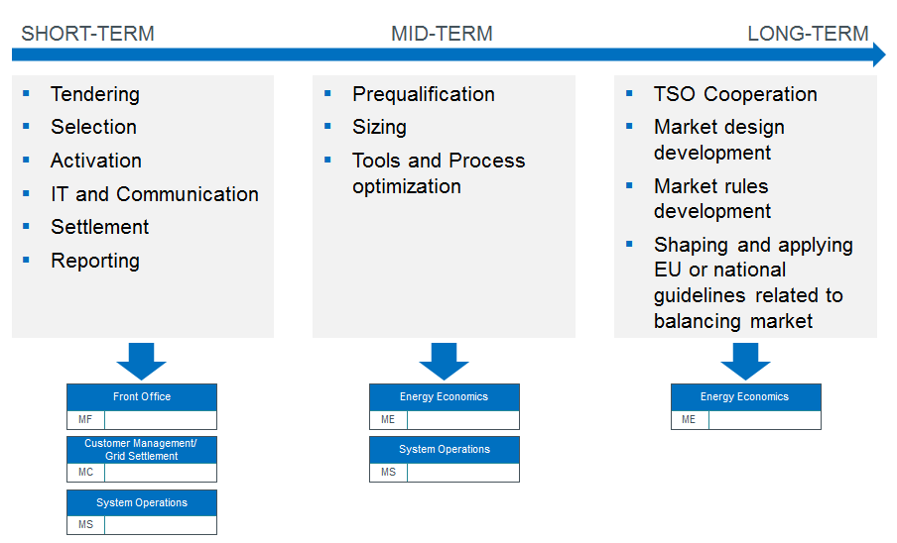

Figure 1: Structure of balancing market related tasks for a TSO

In the following sections, we present two key benchmarks for the organisation of the TSO to perform balancing market tasks as presented above. This organisational restructuring impacts different parts of the organisation at different levels of severity: 1) establishment of new departments, 2) addition of new teams to existing departments and 3) enhancement of the activities of existing teams. In this task, the consultant presents best practices from two European TSOs which are advanced in the design and operation of national balancing markets. These benchmarks show clearly how these tasks can be integrated in the scope of larger departments and in which cases they should form independent teams or departments. The information in this document may serve OST as a template to develop a best-fit solution based on available resources and current and future organisational structure.

# BENCHMARK 1: TSO A

The first TSO is structured in four resorts which are led by four chief officers. One resort is the “Market and System Operation”. Within this resort, the tasks relating to the balancing market operation and development (see Figure 1) are distributed to different departments. Among them, the department of System Operation, Energy Economics, the Front Office, and the Customer Management and Grid Settlement are involved in the balancing market topics (marked in dark blue in Figure 2).

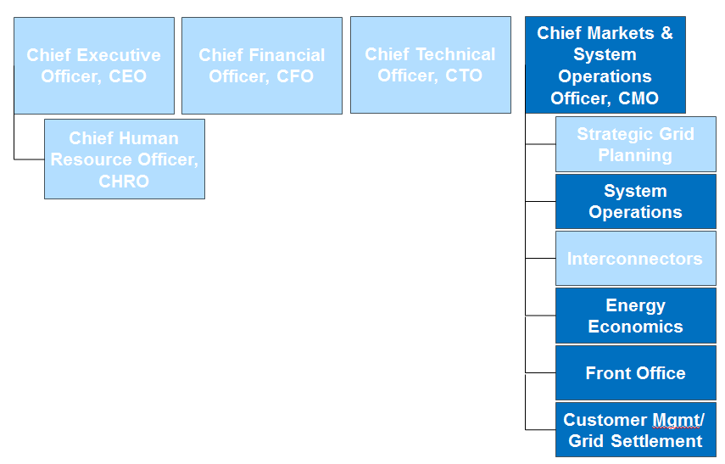

Figure 2: Balancing market relevant organization units of the TSO A

## System Operations department

The department “System Operations” comprises also the team of operators working at the control centre. From the control centre, the TSO sends to and receives information from the technical units providing balancing services. The TSO can control and activate the balancing resources from the control centre automatically, or manually. On the other hand, the TSO collects the measurement values needed for the monitoring and settlement.

## Energy Economics department

The department “Energy Economics” deals with all topics related to the power market design and development. The structure of this department is depicted in the Figure 3 below.

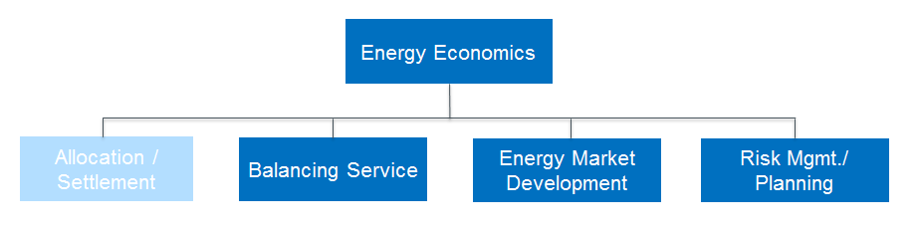

Figure 3: Structure of the department Energy Economics

### Balancing service team

Within this department, the team “Balancing service” works on topics related to the balancing market. The balancing service team operates the central balancing service procurement as well as the central prequalification online platform. Moreover, this team contributes actively in the balancing market development. The team itself has four members, each allocated with certain tasks.

* Member 1 is responsible for the development of balancing power procurement platform and the design of FCR market.
* Member 2 develops the standardized prequalification process and takes care of the prequalification customer services.
* Member 3 is responsible for the design and development of the central prequalification web platform and takes care of the prequalification customer services.
* Member 4 is responsible for the design of aFRR and mFRR markets and for the implementation of European guidelines on balancing services.

Except of these main tasks, the entire team works also on three further strategic topics: Balancing market coupling with neighbouring countries, the challenges of decentralization, and the IT processes.

### Energy Market Development team

The team “Energy Market Development” team supervises European and national regulatory processes with a focus on mid- and long-term developments and supports TSO’s internal cooperation and process improvements. This team has competencies in the market modelling and analysis, market data acquisition and analysis, market design and process optimization. The work of this team is very important for the mid- and long-term balancing market development.

### Risk management and planning team

One of the tasks allocated to the team “Risk management and planning” is to secure the system adequacy of the according regulatory framework. Beyond that, the team is involved in the supply processes for reserve capacity, the market design of reserves. Those reserve capacities are crucial for the system security and play an important role on the balancing market.

## Front Office department

The “Front Office” represents the trading team of the TSO A. Except from the conventional electricity trading activities, this team has also the competence to represent the TSO as the Single Buyer at the balancing market and to operate the auctions for balancing capacity and balancing energy. Furthermore, the Front Office department takes care of the obligation for publishing market information at the central procurement web platform.

In addition, according to previous market design in the TSO A area, the TSO A is dedicated as the BRP for all RES units in its own LFC area. So, the TSO A takes over the task of marketing, scheduling and dispatching RES units within the own LFC area. All trading related activities as the one mentioned are allocated to the Front Office.

## Customer Management and Grid Settlement department

The department of “Customer Management and Grid Settlement” deals with all the interactions between the TSO and its customers, so basically all customers connected at the transmission grid. This department has the competence of performing the BRP and BSP account management settlement, operating and developing the settlement-related IT and communication system, and contributing to the development and management of contracts between the TSO and the BSPs or BRPs. Moreover, this department is responsible for the central billing and reporting system that also includes the documentation and reporting processes in the balancing service procurement and settlement. In the Figure 4 below, the general structure of the department is presented, highlighting the key tasks that are related to the balancing market. These are related to the last phase of the balancing market structure, the settlement and reporting.

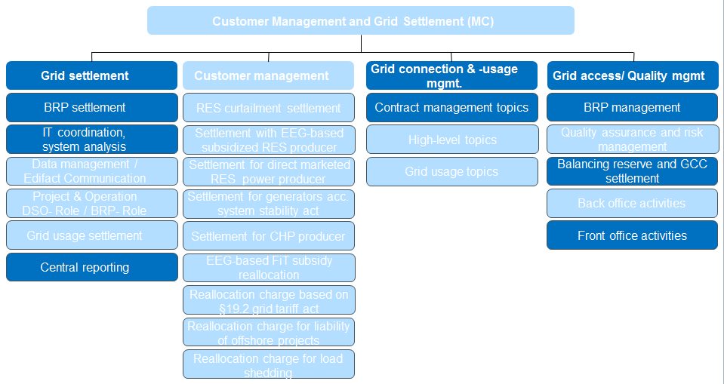

Figure 4: Structure of the department Customer Management and Grid Settlement

### Grid settlement

The team Grid Settlement has developed the competencies about the settlement and reporting process which also comprises the BSP and BRP settlement. All the results of settlement are collected in the central reporting system. If required, the results are reported or published in order to fulfil internal and external reporting obligation. Furthermore, the team works on the analysis and optimization of the IT and communication system, as well as the data management process.

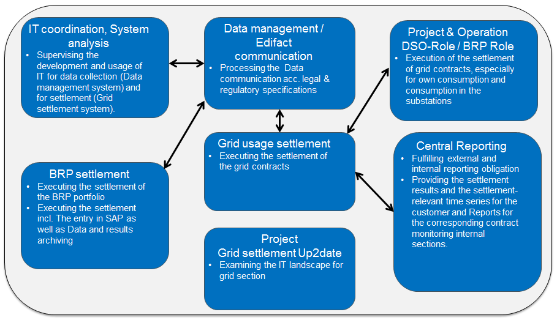

Figure 5 Task scope of the team Grid Settlement

### Grid Access and Quality Management team

Among the tasks assigned to the team Grid Access and Quality Management, the BRP management, balancing energy, and the imbalance calculation (see Figure 5).

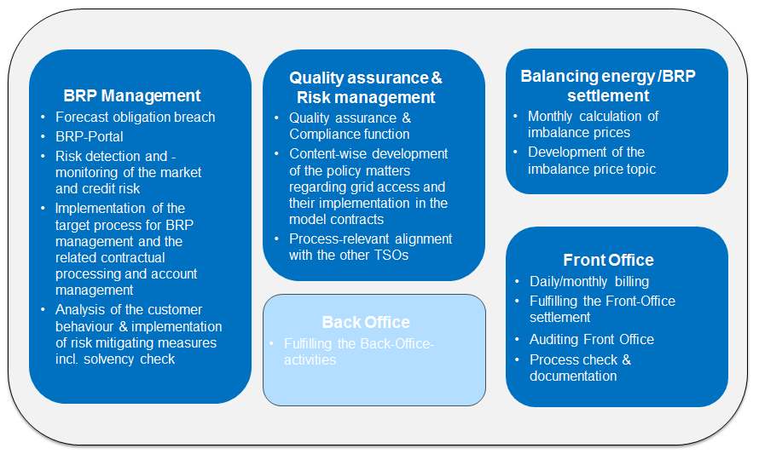

Figure 6: Task scope of the grid access team, and quality management.

The BRP management includes the activities of registering new BRP, accrediting BRPs, analysing the behaviour of the BRPs in order to manage all the relating risks.

The imbalance settlement includes the imbalance volume calculation for each BRP, the imbalance price calculation, the calculation of the payment for the BSP due to their balancing service provision. Moreover, the team has also developed the competence to study and further develop the settlement concept and algorithm.

The front office executes the billing and invoicing of balancing service provision and imbalances.

# BENCHMARK 2: TSO B

The TSO B has in total seven resorts. The resort which is dealing with balancing market topics is the Customer, Market and System. The overview of the organizational structure of TSO B is depicted in Figure 6. In general, the structure and the task allocation of TSO B are very similar to TSO A. Each individual task relating to the balancing service procurement, market design, settlement, reporting, etc. are allocated to different departments across the organization. The departments herein are structured according to the operational and strategical activities of the TSO

By comparing with the structure of the TSO A, the following differences are observed. First, the activity of customer management and settlement are clearly separated. And second, the department Business Analysis takes over all the analysis activities in the TSO coming from the customer management, settlement, market development.

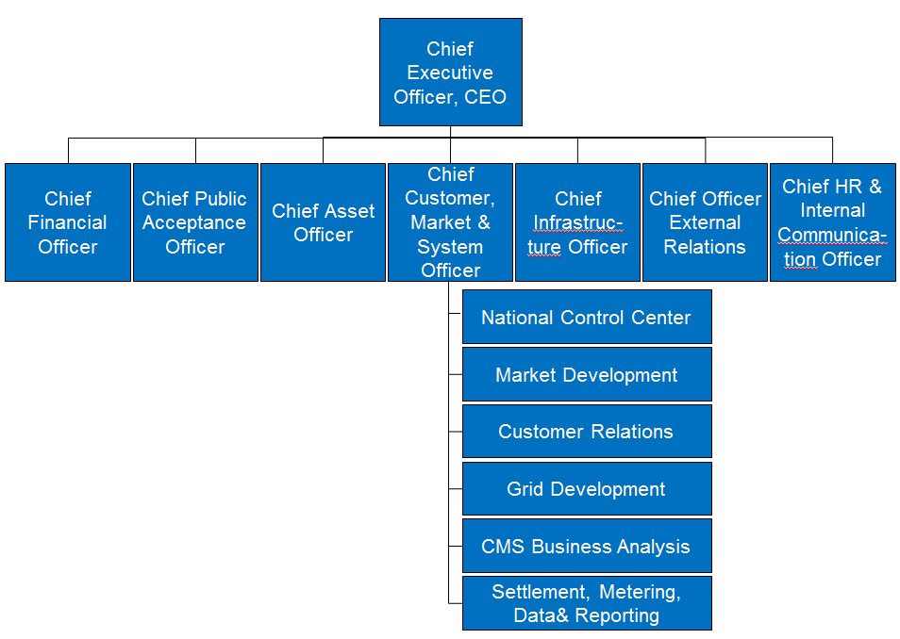

Figure 7: Organizational structure of TSO B

## National Control Centre department

Similar as the System Operations department in TSO A, the National Control Centre is responsible for the operational control and monitoring of the power system. This includes apart from the grid, also the sources of ancillary services, e.g., balancing resources (unlike the regional control centres). The SCADA system located at the NCC is connected with the control units of the balancing resources. Thus, the NCC can automatically or manually control the balancing resources and activate them if needed. The structure of the National Control Centre is illustrated in the figure below.

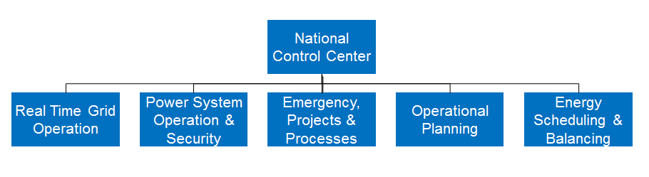

Figure 8: Structure of the department National Control Centre

The relevant team from the NCC working with balancing market topic is the energy scheduling and balancing team. This team deals with the nomination of the BRPs and monitors the system balance. Whenever the system balance is not ensured, this team sends the command for automatically or manually activating the procured balancing resources.

## Market Development department

The Market Development department is responsible for all strategic and long-term market topics including the balancing market design and development. Except of the topics at the national level, the department also works on various initiatives at the European level, e.g., the balancing market integrations.

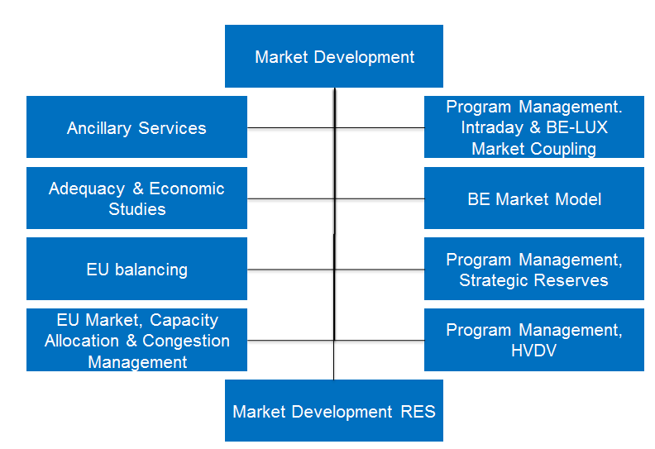

Figure 9: Structure of the Market Development department

The Market Development department works similar as the Energy Economics department of the TSO A on strategic electricity wholesale market design and development topics, the interconnector capacity market, and the ancillary service market. Explicitly, the task of balancing service procurement process development is allocated to the team Ancillary Services (see Figure 10). Furthermore, the department also has a team EU balancing working on the European balancing market integration initiatives, e.g., the common Europe-wide FCR sizing and procurement, or the International Grid Control Operation (IGCC) which represents the imbalance netting among the European countries in aFRR. Also the application of new released rules from at the European Commission for the national context is one of the major tasks of the Market Development department, e.g. the EU Network Code regarding the electricity balancing.

## Customer Relations department

The Customer Relations department manages all the contracts between the TSO and their customers. The department is also assigned with the BRP and BSP Management. This includes the contract management, key account management of the BSP and BRP.

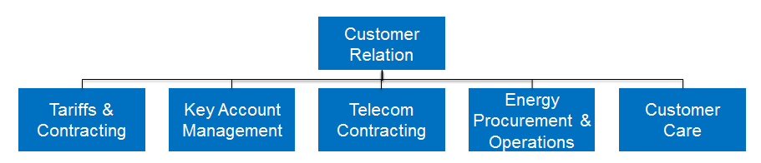

Figure 10: Structure of the Customer Relation department

In case of any operational or technical issue the TSO or the concerned BRP will have to initiate actions via the respective Key Account Managers (note a single KAM can have several BRPs in his portfolio but not the other way around).

## Business Analysis department

The Business Analysis unit takes over all the analysis activites going from customer behavior to market development. A part of the analysis is also regarding to the balancing market activities. Furthermore, the team Business Analysis initiate new major internal projects regarding tools and process optimizations.

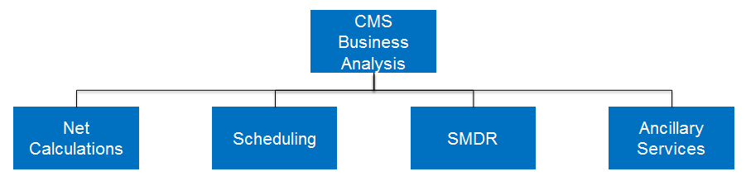

Figure 11: Structure of the Business Analysis department

As illustrated in Figure 11, the Business Analysis department has a team analyzing scheduling behavior at the wholesale market and the behavior of the ancillary service market. Herein, the balancing market plays an important role. The team specifically analyse the behaviour of the market participants in the balancing market like the bidding strategy, the pricing mechanism, etc. The outcome of this team is useful for the other departments which work other activities of the balancing market operation like the development of the balancing market design, the balancing planning, the balancing service procurement, the BSP and BRP management, the settlement.

## Settlement, Metering, Data and Reporting department

The structure of the department SMDR is illustrated in Figure 12. The department is assigned with the task of billing and settlement for the BSPs according to the provided balancing services, as well as for the BRP with regards to the imbalances. Last but not least, the results from the balancing market has to be documented, reported, and published at the website of the TSO.

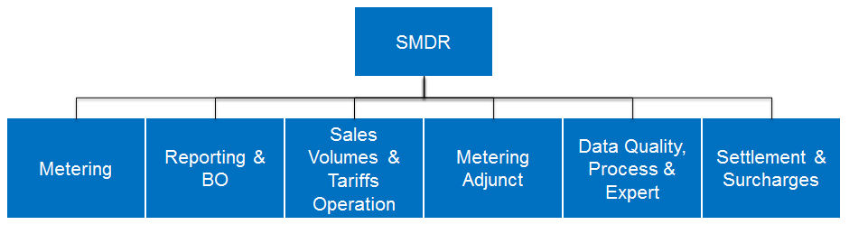

Figure 12: Structure of the Settlement, Metering, Data and Reporting department