FINAL ENVIRONMENTAL AND SOCIAL REVIEW CHECKLIST
SFG3413 V2

Micro-project title: Reconstruction of the water distribution network in
Anker community, partial renovation of the DRR.
Micro-project #: TSQ-02

Is the Environmental and Social management plan (ESMP) developed?
Yes + No _____

Does ESMP provide a full list of potential impacts and establish adequate measures for their mitigation?
Yes + No _____

Conclusion of the Final Environmental and Social Assessment

Conclusion
Micro-project rejected | Micro-project approved (environmental assessment completed)
 | +

PART A: General Project and Site Information
INSTITUTIONAL & ADMINISTRATIVE
Micro-project number and title | TSQ- 02, Reconstruction of the water distribution network in Akner community; partial renovation of the DRR.
Municipality, community | Syunik, marz, Akner community
Scope of site-specific activity | The water is supplied to Akner Community through 4 capitations which start from the “Akner” spring. A steel pipeline of 2.4 km and dy=100mm delivers water is delivered to the water collection reservoir, after which water is delivered to DRR through steel pipes which are 3.4 km nd dy=150mm. The volume of the DRR is 200m3. Water pipelines and DRR were constructed in 1960s and are in sufficient condition. The DRR has a round form and is made of stone. Neither capitations nor DRR have sanitary zones. The distribution network was constructed in 1960-1970s and later partially reconstructed, but currently is damaged. It is constructed by dy=100-150 mm steel pipes; total length is 6.5 km. The total water demand of the Community is 4.5l/sec.  The Micro-project involves the following: reconstruction of distribution networks (6.5 km), partial reconstruction of DRR and construction of a sanitary zone around it.
Institutional arrangements (WB) | Task Team Leader:  Erkin Mamadaliev |  | Safeguards Specialist:  Darejan Kapanadze - Environment  Sophia Georgieva - Social
Implementation arrangements (RoA) | Implementing entity:  ATDF | Works Supervisor:  “GAS-SKTH”- LTD  License N12673, issue on 16.04.15 |  | Works Contractor:  “MASIS”- LTD  License N8941, issue on 18.10.15
SITE DESCRIPTION
Name of institution whose premises are to be rehabilitated | Water Department of Syunik marz (regional governor office), Akner potable water pipeline non-profit organization
Address and site location | Address: Syunik marz, Akner village.
Who owns the land? | Land plots for reconstruction of water supply pipes are the property of the Akner Community. There will be no new land allocation as the water line will only be reconstructed but not expanded.
Description of physical and natural environment around the site (see maps and photo annex 1) | The land plot is a public property. There will be no new land allocation as the water line will only be reconstructed but not expanded. The distribution network will pass through the community roads which are public property. There are no trees, structures or other assets along the route of the pipeline. The ground through which the route of the pipeline is passing is not asphalted. No private land use is needed for the reconstruction of the pipeline.
LEGISLATION
National & local legislation & permits that apply to project activity | Construction of a new potable water pipeline is not subject to the Environmental Impact Assessment and to the issuance of the expert environmental review conclusion.  According to the Armenian legislation, the following permissions are required for this micro-project:  - special permission for water use  - construction permit  - copy of an agreement for construction waste disposal
PUBLIC CONSULTATION
When / where the public consultation process will take /took place | Public consultation was carried out in the village of Akner on 11.08.2016
ATTACHMENTS
Attachment 1: Photos and plan of the construction site
Attachment 2: Minutes of Environmental and Social Public Consultations
Attachment 3: Copy of an agreement for construction waste disposal
Attachment 4: Special permission for water use
Attachment 5: Copy of Construction Permit

PART B: safeguards information
ENVIRONMENTAL /SOCIAL SCREENING
Will the site activity include/involve any of the following? | Activity/Issue | Status | Triggered Actions
 | - Reconstruction of Water Intake System | [+ ] Yes [ ] No | See Section A below
 | - New construction | [ ] Yes [ ] No | See Section A below
 | - Individual wastewater treatment system | [ ] Yes [+] No | See Section B below
 | - Historic building(s) and districts | [ ] Yes [+] No | See Section C below
 | - Acquisition of land | [ ] Yes [+] No | See Section D below
 | - Hazardous or toxic materials | [ ] Yes [+] No | See Section E below
 | - Impacts on forests and/or protected areas | [ ] Yes [+] No | See Section F below
 | - Handling / management of medical waste | [ ] Yes [+] No | See Section G below
 | - Traffic and Pedestrian Safety | [ ] Yes [+] No | See Section H below
PART C: Mitigation measures
ACTIVITY | PARAMETER | MITIGATION MEASURES (provide costs where applicable)
0. General Conditions | Notification and Worker Safety | - The local construction and environment inspectorates and communities have been notified of upcoming activities  - The public has been notified of the works through appropriate notification in the media and/or at publicly accessible sites (including the site of the works)  - All legally required permits have been acquired for construction  - The Contractor formally agrees that all work will be carried out in a safe and disciplined manner designed to minimize impacts on neighboring residents and environment.  - Workers’ PPE will comply with international good practice (always hardhats, as needed masks and safety glasses, harnesses and safety boots)  - Appropriate signposting of the sites will inform workers of key rules and regulations to follow.
A. General Construction Activities | Air Quality | - During interior demolition debris-chutes shall be used above the first floor  - Demolition debris shall be kept in controlled area and sprayed with water mist to reduce debris dust  - During pneumatic drilling/wall destruction dust shall be suppressed by ongoing water spraying and/or installing dust screen enclosures at site  - The surrounding environment (sidewalks, roads) shall be kept free of debris to minimize dust  - There will be no open burning of construction / waste material at the site  - There will be no excessive idling of construction vehicles at sites
 | Noise | - Construction noise will be limited to restricted times agreed to in the permit  - During operations the engine covers of generators, air compressors and other powered mechanical equipment shall be closed, and equipment placed as far away from residential areas as possible
 | Water Quality | - The site will establish appropriate erosion and sediment control measures such as e.g. hay bales and / or silt fences to prevent sediment from moving off site and causing excessive turbidity in nearby streams and rivers.
 | Waste Management | - Waste collection and disposal pathways and sites will be identified for all major waste types expected from demolition and construction activities.  - Mineral construction and demolition wastes will be separated from general refuse, organic, liquid and chemical wastes by on-site sorting and stored in appropriate containers.  - Construction waste will be collected and disposed properly by licensed collectors  - The records of waste disposal will be maintained as proof for proper management as designed.  - Whenever feasible the contractor will reuse and recycle appropriate and viable materials (except asbestos)
B. Individual wastewater treatment system | Water Quality | - The approach to handling sanitary wastes and wastewater from building sites must be approved by the local authorities  - Before being discharged into receiving waters, effluents from individual wastewater systems must be treated in order to meet the minimal quality criteria set out by national guidelines on effluent quality and wastewater treatment  - Monitoring of new wastewater systems (before/after) will be carried out  - Construction vehicles and machinery will be washed only in designated areas where runoff will not pollute natural surface water bodies.
C. Historic building(s) | Cultural Heritage | - If the building is a designated historic structure, very close to such a structure, or located in a designated historic district, notification shall be made and approvals/permits be obtained from local authorities and all construction activities planned and carried out in line with local and national legislation.  - It shall be ensured that provisions are put in place so that artifacts or other possible “chance finds” encountered in excavation or construction are noted and registered, responsible officials contacted, and works activities delayed or modified to account for such finds.
D. Acquisition of land | Land Acquisition Plan/Framework | - If expropriation of land was not expected but is required, or if loss of access to income of legal or illegal users of land was not expected but may occur, that the Bank’s Task Team Leader shall be immediately consulted.  - The approved Land Acquisition Plan/Framework (if required by the project) will be implemented
E. Toxic Materials | Asbestos management | - If asbestos is located on the project site, it shall be marked clearly as hazardous material  - When possible the asbestos will be appropriately contained and sealed to minimize exposure  - The asbestos prior to removal (if removal is necessary) will be treated with a wetting agent to minimize asbestos dust  - Asbestos will be handled and disposed by skilled & experienced professionals  - If asbestos material is stored temporarily, the wastes should be securely enclosed inside closed containments and marked appropriately. Security measures will be taken against unauthorized removal from the site.  - The removed asbestos will not be reused
 | Toxic / hazardous waste management | - Temporarily storage on site of all hazardous or toxic substances will be in safe containers labeled with details of composition, properties and handling information  - The containers of hazardous substances shall be placed in a leak-proof container to prevent spillage and leaching  - The wastes shall be transported by specially licensed carriers and disposed in a licensed facility.  - Paints with toxic ingredients or solvents or lead-based paints will not be used
F. Affected forests, wetlands and/or protected areas | Protection | - All recognized natural habitats, wetlands and protected areas in the immediate vicinity of the activity will not be damaged or exploited, all staff will be strictly prohibited from hunting, foraging, logging or other damaging activities.  - A survey and an inventory shall be made of large trees in the vicinity of the construction activity, large trees shall be marked and cordoned off with fencing, their root system protected, and any damage to the trees avoided  - Adjacent wetlands and streams shall be protected from construction site run-off with appropriate erosion and sediment control feature to include by not limited to hay bales and silt fences  - There will be no unlicensed borrow pits, quarries or waste dumps in adjacent areas, especially not in protected areas.
G. Disposal of medical waste | Infrastructure for medical waste management | - In compliance with national regulations the contractor will insure that newly constructed and/or rehabilitated health care facilities include sufficient infrastructure for medical waste handling and disposal; this includes and not limited to:  - Special facilities for segregated healthcare waste (including soiled instruments “sharps”, and human tissue or fluids) from other waste disposal; and  - Appropriate storage facilities for medical waste are in place; and  - If the activity includes facility-based treatment, appropriate disposal options are in place and operational
H Traffic and Pedestrian Safety | Direct or indirect hazards to public traffic and pedestrians by construction  activities | (a) In compliance with national regulations the contractor will insure that the construction site is properly secured and construction related traffic regulated. This includes but is not limited to  - Signposting, warning signs, barriers and traffic diversions: site will be clearly visible and the public warned of all potential hazards  - Traffic management system and staff training, especially for site access and near-site heavy traffic. Provision of safe passages and crossings for pedestrians where construction traffic interferes.  - Adjustment of working hours to local traffic patterns, e.g. avoiding major transport activities during rush hours or times of livestock movement  - Active traffic management by trained and visible staff at the site, if required for safe and convenient passage for the public.  - Ensuring safe and continuous access to office facilities, shops and residences during renovation activities, if the buildings stay open for the public.

Environmental Monitoring Plan for construction and operation phases.

Activity | What  (Is the parameter to be monitored?) | Where  (Is the parameter to be monitored?) | How  (Is the parameter to be monitored?) | When  (Define the frequency / or continuous?) | Why  (Is the parameter being monitored?) | Who  (Is responsible for monitoring?)
CONSTRUCTION PHASE
1. Supply of construction materials | Purchase of the construction materials from licensed providers | Offices and warehouses of material suppliers, and borrowing sites | Checking documents;  Inspection of material quality | In the process of signing the agreements for material provision | Ensure technical quality of construction;  Protect human health and environment | ATDF
2. Transportation of construction materials and waste  Movement of construction equipment | Technical condition of construction vehicles and machinery;  Adequacy of the loading trucks for transported types of cargo, and canopy coverage of cargo transported in open trucks;  Movement of construction vehicles and machinery along pre-defined routes | Routes for transportation of construction materials and construction wastes | Inspection of roads adjacent to the construction site and included in the agreed-upon routes of transportation | Unannounced checks during the working hours | Avoid air and road pollution with dust and solid matter;  Reduce traffic disruption | ATDF,  Municipality of the village of Akner
3. Generation of construction waste | Temporary storage of inert and hazardous wastes separately at the designated locations;  Timely disposal of waste to the formally designated landfills | Construction site and base (if applicable);  Locations designated for waste disposal | Checking documents;  Visual observation | Entire period of construction | Avoid pollution of the environment | ATDF,  Municipality of the village of Akner
4. Accumulation of household waste | Provision of waste containers on-site;  Agreement with local municipality for regular out-transporting of waste | Construction site and base (if applicable) | Visual inspection | Entire period of construction | Avoid pollution of soil and water with household waste | ATDF,  Municipality of the village of Akner
5. Safety of labor | Provision of uniforms and protective gear to the contractor’s personnel and enforcement of their use by contractor;  Consistency with the rules of exploitation of the construction equipment and usage of private safety means | Construction site | Inspection of the activities | Entire period of construction | Reduce the probability of accidents | ATDF
6. Undertaking works within the settlement | Deparkation and fencing of work site;  Timely backfilling of soil once pipes are laid in trenches;  No parking of construction vehicles and machinery outside work site the way impeding free passage of traffic and pedestrians;  No piling and no scattering of construction materials and waste outside the work site | Construction site and nearly area | Visual inspection | Entire period of construction | Reduce disruption of movement around the work site and decrease probability of accidents | ATDF,  Municipality of the village of Akner
OPERATION PHASE
1. Ensuring smooth operation of water intakes and pipeline | Permanent maintenance of water intakes and pipeline | Water supply scheme | Inspection | During scheme operation | Deliver quality service to water users | Local municipality of the village of Akner
2. Ensuring quality of potable water supplied to the village | Adherence to the national standards of the drinking water | Water supply scheme | Inspection | During scheme operation | Prevent occurrence of water-borne diseases | Sanitary-Epidemiological Station of RA

Attachment 1: Photos of micro-project site and layout of water supply system

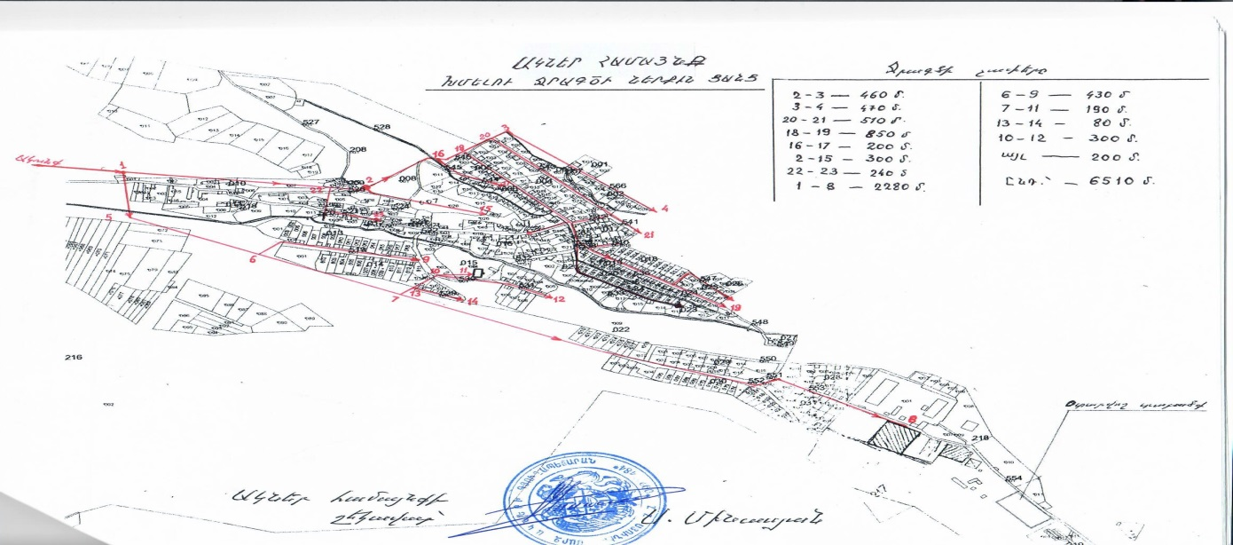

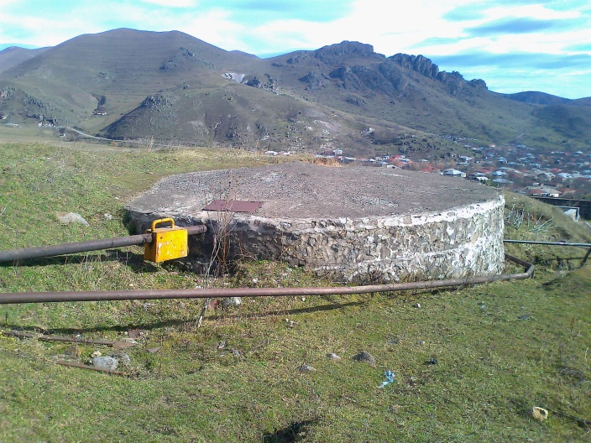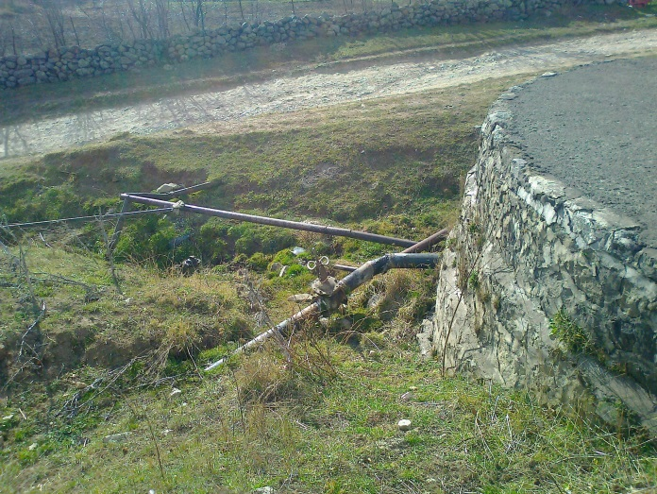

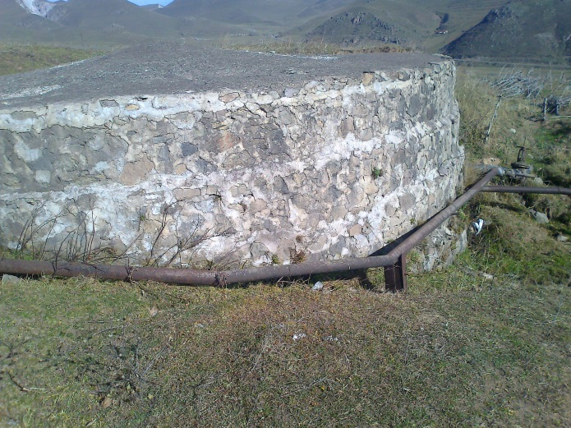
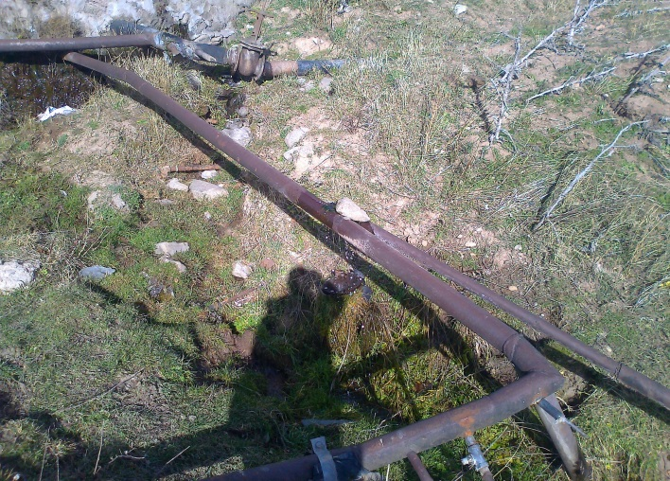

Attachment 2: Minutes of Public Consultation on the Draft ESMP

MINUTES
Of Public Consultations
on draft Environmental and Social Management Plan
for the Reconstruction of water supply system
in Akner Community

A stakeholder consultation meeting on the draft Environmental and Social Management Plan (ESMP) for the construction of a Reconstruction of water supply system in Akner Community was held on August 11 in Akner, Syuniqi Marz.
The announcement for the meeting in Armenian and English languages, including its date and time, was disclosed on the ATDF web page (www.atdf.am). Information on the meeting day and time was posted on information boards of Akner Community Administration Office; in addition, the Administration conducted telephone calls to ensure participants’ attendance.
The public consultation was carried out by ATDF Environmental Specialist Asya Osipova. 25 participants were present at the meeting, among which 7 women.
At the very beginning, Head of the Community Mr. S.Minasyan introduced the main purpose of the consultation and ATDF environmental specialist.
A.Osipova introduced the main purpose as well as World Bank requirements and Armenian legislation on conducting environmental and social assessment. She introduced ESMP for the construction of a Reconstruction of water supply system in Akner Community and outlined likely negative environmental impacts related to the Micro-project implementation. These include pollution of air, generation of construction waste.
Ms. Osipova explained what measures ATDF will apply to mitigate possible negative impacts, including construction waste transportation. It was mentioned that ESMP covers the issue of the transportation and disposal of construction wastes and excessive soil.
Since the construction site is located far from the Community, A. Osipova outlined that disturbance to community life due to construction activities is not anticipated. Technical supervisors on monthly basis will keep under control the fulfillment of all the environmental mitigation measures included in ESMP, and report the deviations to ATDF.
A.Osipova presented the main provisions of the ESMF concerning to the social aspects of the Project. She talked about possible social risks and ways of their mitigation. She emphasized that the project does not involve any resettlement as proposed area of the construction is public property; however she briefly introduced key features of Resettlement Policy Framework.
A.Osipova talked also about main socio-economic challenges including engagement of women, youth and vulnerable groups in distribution of benefits. She outlined that these groups should have equal opportunities to be engaged in project benefits. The concept was welcomed by participants, who suggested involve constructors from the Community mentioning that it will reduce unemployment in Community and labor immigration for seasonal works.
A.Osipova also mentioned those main problems which are connected to the water quality and water preservation. E.g.-mechanical water insoluble particles, sand, sediment, rust that water contains. Their existence fastens the deterioration of the pipes and causes blocking. The unpleasant flavor of the water, change of the color may have affect people and especially children’s health. Osipova mentioned that the water polluted with bacteria may enter into chemical reaction (e.g.-chlorine) and cause poisonous and toxic atmosphere. Osipova just said that it is important to arrange works in the way that it becomes possible to prevent water pollution.
A.Osipova informed the beneficiaries that they also have the option to contact ATDF directly to communicate their grievance if they are unable to, or do not wish to, go through the PIC grievance focal point. A.Osipova explained all the cannels of grievance submition involveing e-mail address, hot line telephone number, postal address and web-site link and outlined that ATDF contact information is reffered on the booklets delivered to the participants, as well as on the information desk already available in public visable places in the Community. A.Osipova introcduced that information on Micro-project details permanently will be available on the information desks, as well as on-going announcements and references. She outlined that these will support to raising public awareness and early identification, assessment and resolution of complaints on Project activities.

List of participants and photo
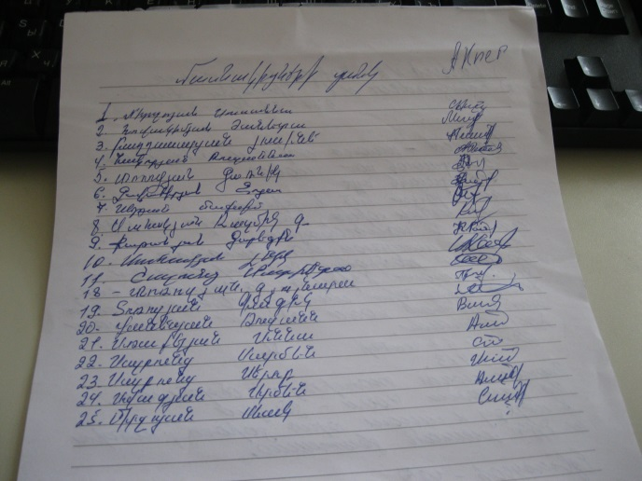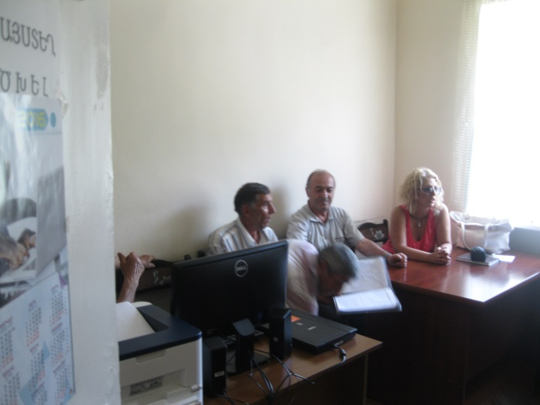

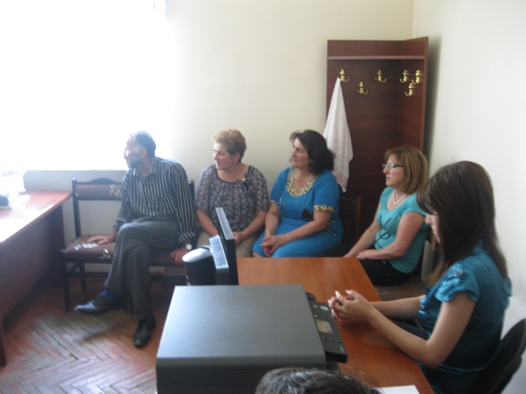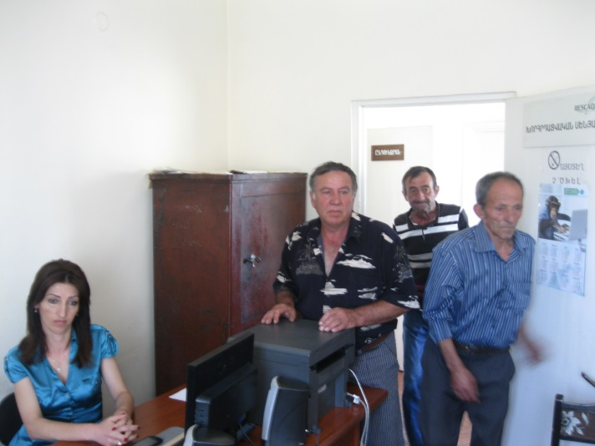

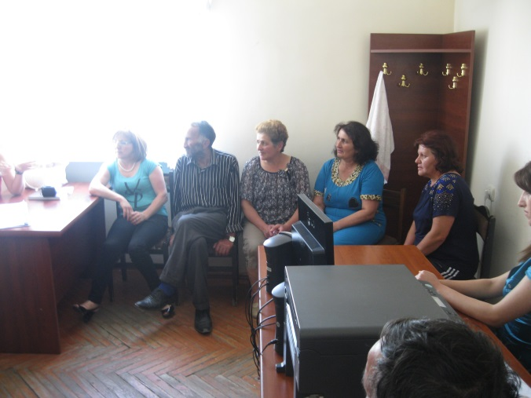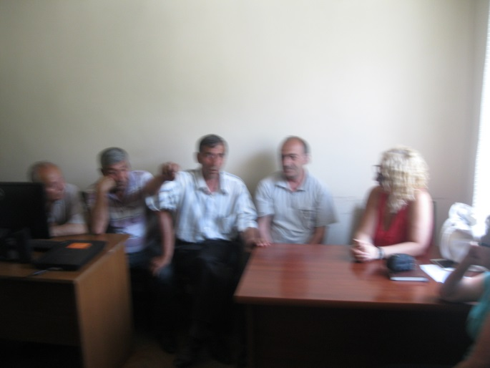
Attachment 3: Copy of agreement for construction waste disposal

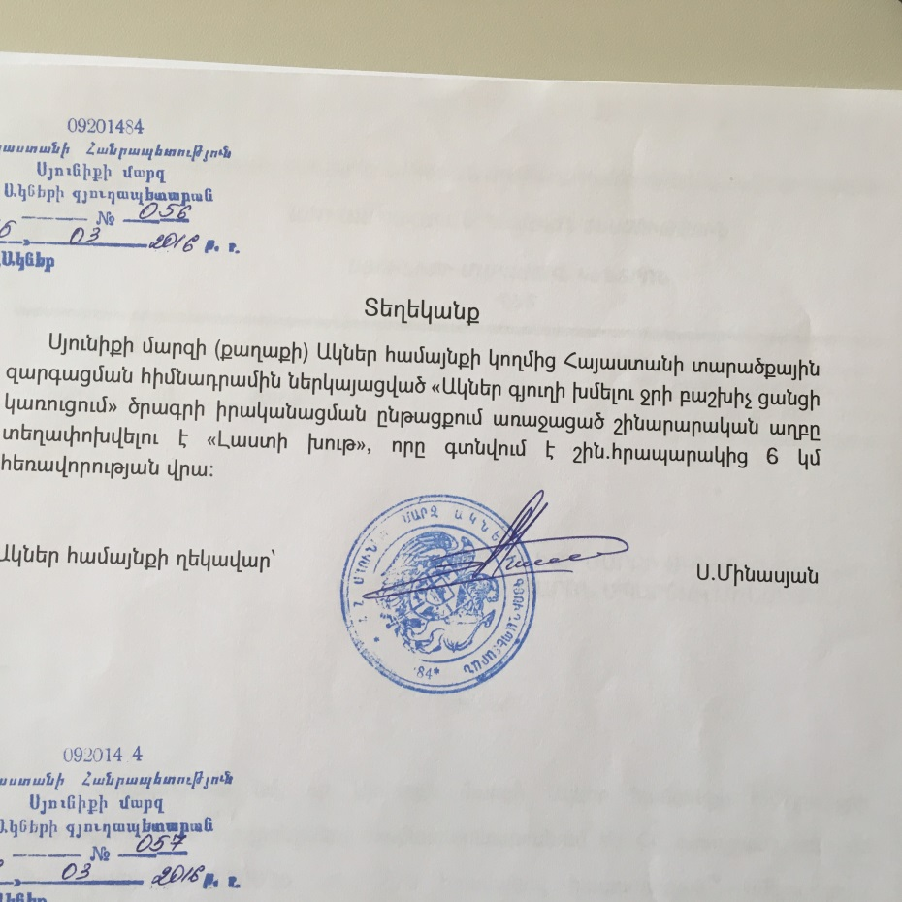

Non-official translation of the above attached document:
Reference

The following reference is given that within the framework of the reconstruction work of drinking water supply system in Akner Community implemented by Armenian Territorial Development Fund the generated waste will be transported to the “Lasti khut” landfill, which is situated 6 km away from the reconstruction site.

Head of Community (signed) S. Minasyan

Attachment 4: Special permission for water use

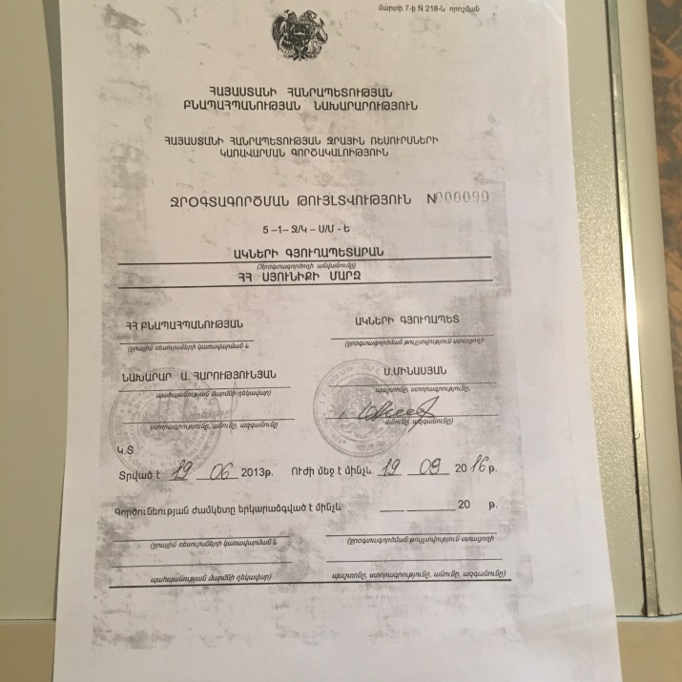

(Non-official translation of the above attached document)
Ministry of Nature Protection
Water Resources Management Agency
Water use permit N000090
5-1 J/K-SM-Y
Akner Community Administrative Office
RA Syunik Reagion
Signed and stamped by
Minister of Ministry of Nature Protection A. Grigoryan
Head of Community S.Minasyan
Give on 19.06.2013
Is in force until 19.09.2016

Attachment 5: Copy of Construction Permit
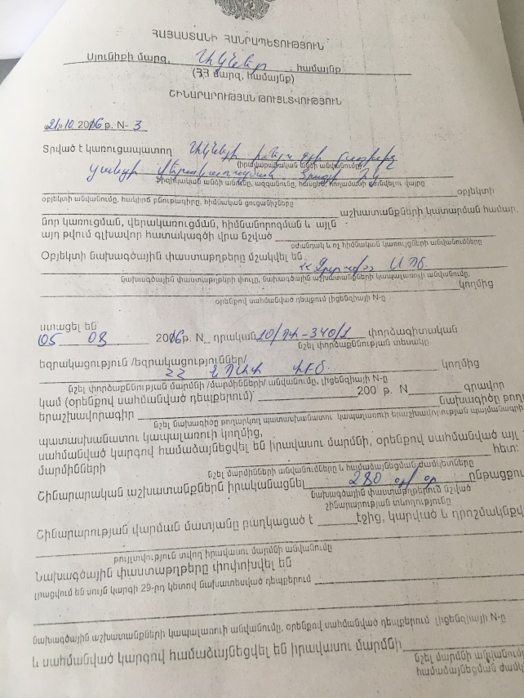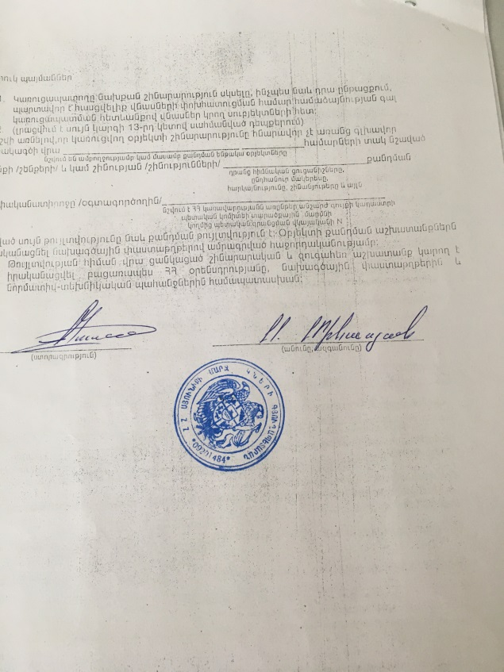
Non-official translation of the above attached document
Republic of Armenia
Syunik Region, Community Akner
Construction Permit N 3, 21.10.2016
This is given for the Reconstruction of the water distribution network in
Anker community, partial renovation of the DRR.
The design documents are developed by “Zrtuk” LTD

- Griqoryan

Land acquisitions includes displacement of people, change of livelihood encroachment on private property this is to land that is purchased/transferred and affects people who are living and/or squatters and/or operate a business (kiosks) on land that is being acquired.
Toxic / hazardous material includes but is not limited to asbestos, toxic paints, noxious solvents, removal of lead paint, etc.

