E4501

WORLD BANK FINANCED
SECOND REGIONAL AND MUNICIPAL INFRASTRUCTURE DEVELOPMENT PROJECT
(P147521)

Environmental and Social Management Framework

March, 2014

Introduction

The present Environmental and Social Management Framework (ESMF) presents the procedures and implementation arrangements for ensuring full consideration of environmental safeguards, in accordance with the World Bank’s environmental assessment guidelines (OP/BP 4.01) and the national environmental regulations of Georgia, in the screening, approval and implementation of investment sub-projects financed under the Regional and Municipal Infrastructure Development Project (RMIDP) II. It describes existing environmental regulations and standards relevant to the Project and makes reference to institutions at the local and national levels responsible for issuing permits, licenses, and enforcing compliance of environmental standards. The ESMF also provides detailed guidelines for the MDF staff and the sub-project proponents on environmental and social screening, appraisal, and monitoring. Each sub-project will be individually screened and reviewed by MDF. Environmental and social review checklists will be completed and environmental categories attached to sub-projects. Sub-project appraisal documents will include specific analysis of environmental issues, prescribed mitigation measures, and associated costs.

1. World Bank Environmental Guidelines

1.1Main Principles

All projects funded by the World Bank must comply with the Bank’s environmental guidelines. The purpose of these guidelines is to establish an environmental review process to ensure that the projects undertaken as part of programs funded under the World Bank loans are environmentally sound, are designed to operate in compliance with applicable regulatory requirements, and, as required by the regulations of the Bank, are not likely to cause a significant environmental, health, or safety hazards.

The World Bank is committed to program design that reflects results of public participation in host countries during all phases of the program, integrating governmental interests with those of private businesses and civil society. In this spirit, MDF will ensure that the preparation of environmental and social impact assessment (ESIA) reports for sub-projects includes consultation with affected parties and public disclosure of the associated documents.

With regard to public consultation and disclosure, MDF will be entitled to incorporate timely, participatory, and meaningful public consultation for the development of EAs. MDF will also be expected to make ESIA reports and Environmental Management Plans (EMPs) publicly available and easily accessible.

Finally, the World Bank is committed to the principles of host-country ownership of a compact, including host-country responsibility for measures to mitigate adverse environmental and social impacts. The Bank for ensuring full consideration of environmental safeguards, in accordance with the World Bank’s environmental assessment guidelines (OP/BP 4.01) and the national environmental regulations of Georgia, in the screening, approval and implementation of investment sub-projects financed under RMID II Project. It describes existing environmental regulations and standards relevant to the Project and makes reference to institutions at the local and national levels responsible for issuing permits, licenses, and enforcing compliance of environmental standards. The ESMF also -funded projects shall, therefore, comply with host-country laws, regulations and standards, as well as with requirements by which the host country is bound under international agreements.

1.2Environmental Screening under WB Guidelines

The purpose of sub-project screening (Attachment 1) is to identify the main threats and benefits it carries for the natural environment, social strata, and cultural heritage. Based on the screening outcomes, the proposed sub-projects shall be classified into environmental Categories A, B, or C. Classification guidance is provided below. No category A sub-project may be supported under RMIDP II. Such sub-projects are ineligible. Category B sub-projects may carry relatively higher or lower risks. Depending on whether a sub-project is carrying higher or lower risks, the due environmental diligence applicable to it may include conduct of an environmental review (including development of an EMP) – for high risk Category B, or be limited to the use of Environmental Management Checklist for Small Construction and Rehabilitation Activities (Attachment 5to this EMF) – for low risk Category B.

World Bank guidelines for environmental categorization of activities are summarized below (for more detailed information refer to OP/BP 4.01 Environmental Assessment):

Category A: A project classified as Category A if it is likely to have significant adverse environmental impacts. These impacts may affect an area broader than the sites or facilities subject to physical works. Category A, in principle, includes projects in sensitive sectors or located in or near sensitive areas. For Category A projects a full EIA, including an EMP is required.

Category B: A project classified as Category B if its potential environmental impacts are less adverse than those of Category A projects. Typically, these impacts are site-specific, mostly not irreversible, and mitigation measures are easier to apply. For Category B projects certain type of EA may be needed, depending on the nature of a project, and an EMP is required.

Category C: A project classified as Category C if it is likely to have minimal or no adverse environmental impacts. For Category C projects, MDF reserves the right to require specific environmental studies, reporting, or training where relevant or where positive environmental impacts may be enhanced.

Category A sub-projects will not eligible for financing from RMIDP II. If, by the Georgian legislation, a Category B sub-project is subject to ecological examination and issuance of an environmental permit, then a full EIA will be required for such sub-project.

Social screening is also part of the sub-projects’ screening and approval process. It allows identifying a need for applying OP/BP 4.12 Involuntary Resettlement to a particular sub-project, in which case the next steps and actions will be guided by the Resettlement Policy Framework prepared for the RMIDP II. Social screening of sub-projects will be carried out using social screening form (Attachment 2).

1.3 World Bank Safeguards Policies Triggered

RMIDP II triggers the following safeguard policies of the World Bank:

OP/BP 4.01 Environmental Assessment
OP/BP 4.11 Physical Cultural Resources
OP/BP 4.12 Involuntary Resettlement
OP/BP 7.50 Projects on International Waterways

The project carries investment components in support to infrastructure development and therefore it triggers OP/BP 4.01 Environmental Assessment. Based on the principles of the OP/BP 4.01, the RMIDP II is classified as environmental Category B and hence all the supported investment sub-projects shall fall under environmental Category B or C.

It is expected that Waste Water Treatment Plants (WWTPs) selected for the project intervention may be discharging into the trans-boundary rivers or rivers flowing into the Black Sea. RMIDP-II will also finance rehabilitation of several water supply schemes in small to medium size provincial settlements and these schemes may be abstracting water from trans-boundary rivers. Therefore, OP/BP 7.50 is triggered. However, implementation of RMIDP II will not adversely change the quality or quantity of water flows to the other riparians, and will not be adversely affected by the other riparians’ possible water use. Therefore, communication to riparians was deemed unnecessary and an exemption of this requirement was obtained from the World Bank’s management.

OP/BP 4.11 Physical Cultural Resources is triggered to ensure that if construction works are to undertaken in the proximity to cultural and historic heritage sites, they do not affect structural stability of the existing constructions and do not depreciate historical and aesthetic value of heritage sites. This safeguard policy also applies to handling of chance finds in case they are encountered in the course of earth works.

OP/BP 4.12 is triggered to address the cases of possible involuntary land acquisition, relocation, or any type of restriction in the use of land and other property caused during construction and/or operation phase of the supported sub-projects. Because the location and footprint of many sub-projects are not known at present, the Resettlement Policy Framework (RPF) is prepared and Resettlement Action Plans (RAPs) for individual sub-projects will be developed, as needed, in line with the RPF. Full compensation of affected people will be completed prior to commencement of civil works at any given sub-project site.

1.4. Environmental and Social Impact Assessment

ESIA will evaluate potential environmental and social risks as well as the positive and negative impacts of a specific sub-project in the area of its influence, examine alternatives to the sub-project, identify ways of improving sub-project siting, planning, design, and implementation by preventing, minimizing, mitigating, or compensating for adverse environmental impacts and enhancing positive impacts. ESIA will cover management and mitigation of adverse environmental and social impacts during the construction and operation of infrastructure supported through implementation of sub-projects.

ESIA should:

- be initiated as early as possible in the project cycle development and be integrated closely with the economic, financial, institutional, social, and technical analyses of a proposed sub-project;
- consider important components of the natural environment (air, water, land, biodiversity and ecosystems), social aspects (human health and safety, access to natural resources and to public services, vulnerability, gender, equity, etc.) and cultural values, as well as trans-boundary and global environmental aspects;
- take into account specific host-country conditions: the findings of environmental studies, National Environmental Action Plans, national legislation, institutional capacity of the project implementing entity and of the State inspection agencies as they relate to managing environmental and social impacts, and obligations of the country under relevant international environmental treaties and agreements.

A full ESIA should be carried out for a sub-project if, although being classified as environmental category B, it carries relatively high risks, and if its adverse impacts are not well known upfront. A full ESIA report should be prepared, also, if the Georgian legislation requires State ecological examination and environmental permitting for a sub-project.
An EMP is an integral part of an ESIA report. A self-standing EMP may be developed for a sub-project if its screening reveals that the associated environmental and social risks are low and the potential negative impacts are well known upfront. The World Bank has developed a simplified Environmental Management Plan Checklist for Small Construction and Rehabilitation Activities, which is recommended for use while preparing self-standing EMPs for low risk sub-projects.

The suggested templates of environmental and social screening forms, the outline of an ESIA report and the template of an EMP are all attached to this ESMF.

1.5 Public Consultation

Consistent with the World Bank’s principles of a host-country ownership of the projects implemented under its Compact, MDF will ensure meaningful public consultation in the process of ESIA. For Category B sub-projects, at least one public consultation meeting shall be held. Information on the stakeholder meetings will be announced in advance and draft documents to be discussed will be placed in a public domain and will be disclosed nation-wide - with particular attention to their availability for local communities, in the language and format convenient for them. MDF will receive feedback from public consultations and ensure incorporation of relevant comments in the ESIA reports and EMPs. All ESIA reports and EMPs shall have documents on the stakeholder consultation process attached to them in order to get final approval.
Public opinion will be considered in finalization of draft EMPs and the documental evidence of the conducted consultation process will be attached to EMPs and kept on file.

1.6 Monitoring

Environmental and social monitoring will be an integral part of MDF’s monitoring work during the supervision of sub-projects under implementation. MDF will be responsible for ensuring that on-site managers of works contractors are familiar with EMPs and instruct workers/personnel on the compliance with these EMPs. MDF will demand from works contractors timely submission of environmental permits for the operation of asphalt plants (if owned); licenses for the extraction of rock, gravel, and sand (if operating quarries); and written agreements with local authorities on the disposal of waste. MDF will conduct regular on-site monitoring of civil works to verify contractors’ adherence to the requirements set out in EMPs, to identify any outstanding environmental issues or risks, and to ensure proper application of the prescribed remedial actions. In case of recorded incompliance with EMPs, MDF will instruct contractors on the corrective measures and closely monitor their further progress.

MDF’s in-house capacity to carry out the above described supervisory functions may be supplemented by a hired international construction supervision company. Oversight on the environmental, cultural, and social aspects of construction works will be an integral part of the terms of reference for such supervision company.

2. Environmental Legislation of Georgia Relevant to Environmental Permitting Procedures and Managing of MDF-Financed Sub-Projects

2.1. Environmental Permitting

At present, the environmental permitting procedure in Georgia is set out in three laws: (i) The Law on Licenses and Permits (2005); (ii) The Law on Environmental Impact Permits (2007), and (iii) The Law on Ecological Examination (2007).

The Law on Licenses and Permits was adopted by Parliament of Georgia, on June 24, 2005. The new Law regulates legally organized activities posing certain threats to human life and health, and addresses specific state or public interests, including usage of state resources. It also regulates activities requiring licenses or permits, determines types of licenses and permits, and defines the procedures for issuing, revising and canceling of licenses and permits (Article 1, Paragraph 1).

The Laws on Environmental Impact Permit and on Ecological Examination have been adopted on 14.12.2007 and entered in force on 01.01.2008. These new laws integrate all the amendments introduced in legislation of Georgia during recent years.

The Law of Georgia on Environmental Impact Permit provides a complete list of activities and projects subject to the ecological examination (clause 4, p.1) and the legal basis for public participation in the process of environmental assessment, ecological examination and decision making on issuance of an environmental permit.

According to the law, activities subject to the ecological examination include construction of new or upgrading of the existing facilities imposing change of technology and operational conditions for the projects and activities included in the list. The routine maintenance works in relation with the same facilities do not require ecological examination and permitting.

If an activity included in the list given in clause 4 p.1 at the same time requires Construction Permit, an administrative body responsible for issuance of the Construction Permit ensures involvement of the Ministry of Environment and Natural Resources Protection (MoENRP), in the administrative procedures initiated for the purpose of issuing a Construction Permit, as provided by the Law on Licenses and Permits. In such cases the MoENRP is issuing a Conclusion of the Ecological Examination of a project based on the documentation provided to the MoENRP by an administrative body issuing the Permit. The Conclusion on the Ecological Examination is adopted by the administrative (executive) legal act of the MoENRP and compliance with the conditions of the Conclusion is obligatory for a project proponent. The conditions of the Conclusion on Ecological Examination are a part of conditions of the Construction Permit.

If an activity included in the list given in clause 4, p.1 does not require Construction Permit, based on the Conclusion on the Ecological Examination the MoENRP will issue an Environmental Impact Permit through an administrative (executive) legal act issued by the minister. The ecological examination is carried out in accordance with the law of Georgia on Ecological Examination and the conditions set forth by the Conclusion are incorporated into the Permit.

The aforementioned laws do not provide details of screening procedure and do not define responsibilities of parties. According to the practice, the screening of project proposals and the preliminary assessment of their environmental impact and proposed mitigation measures (scoping) are being carried out by the project proponent in consultation with the MoENRP.

2.2. Public Consultation Procedures

The 6th clause of the law of Georgia on the Environmental Impact Permit provides detailed requirements and procedures for conducting public consultations and establishes timeframes for information disclosure and discussion. Namely: according to article 6, a developer is obliged to carry out public discussion of the EIA report before its submission to an administrative body responsible for issuing a permit. Developer is obliged to disclose (publish) information before conducting public discussion on the planned activity. Information about planned public disclosure meeting is subject to publication in the central periodical as well as in the local one circulated within the administrative territory of the same rayon (if such exists) where an activity is planned. Information must include:

- name, objectives and location of the planned activity;
- address where the documents (including EIA report) are available for community;
- deadline for the provision of feedback;
- place and time of the public disclosure meeting.

A project proponent is obligated to:

- provide the MoENRP (and in case if Construction Permit is required, also - the relevant administrative body) with the hard copies and electronic versions of the EIA within one week following the announcement of the planned consultation meeting;
- collect and review comments obtained from public and stakeholders within 45 days following the publication of the announcement;
- conduct public consultation meeting and public disclosure of the EIA related to the planned activities no earlier than 50 days after the publication and not later than 60 days;
- send written invitation for participation in the public meeting to the local authorities, representative of MoENRP, Ministry of Economy and Sustainable Development (MoESD) and other interested administrative bodies.

Public disclosure of an EIA report should take place in the municipality, where the project is to be implemented.

According to the article 7 of the law, during 5 days after conducting of a public disclosure meeting, the minutes of the meeting should be prepared to reflect all questions and comments raised and explanations provided by the project proponents in response. Appropriate corrections should be incorporated into the main text of the EIA, if required. If the comments and proposals of stakeholders are not accepted, the letter of explanation should be sent to the authors. The minutes of the meeting, as well as response letters, explanations and corrections should be submitted to the MoENRP or the administrative body responsible for issuing the Permit as supplementary materials to the EIA report. The mentioned documents should be considered as an integral part of the EIA report.

Article 9 of the law describes the procedures of issuing the Environmental Impact Permit:

- According to the law on Licenses and Permits, the MoENRP takes decision on issuing Permit within the 20 days after submission of the request for a permit by a project proponent;
- MoENRP, in accordance with the law on Ecological Examination, ensures expertise of the submitted documentation and issuance of a Conclusion on Ecological Examination;
- The Permit (Environmental Permit or Construction Permit when the latter is required) is issued only in case of a positive conclusion of the Ecological Examination.

3. Environmental Procedures Applied by MDF through the Sub-Project Cycle

MDF will carry out environmental review and monitoring of sub-projects in compliance with the national legislation and the World Bank guidelines. In case the requirements of these two regulatory mechanisms differ in stringency of requirements, MDF shall apply higher environmental standards offered by either of the two.

The screening of sub-project proposals and the assessment of their environmental and social impacts and of the proposed mitigation measures will be carried out by MDF staff. A simple screening of sub-project proposals will determine what type of environmental assessment is required, based on a sub-project typology.

Even those sub-projects, which are designed in an environmentally satisfactory manner, may cause damage or have adverse effects if civil works are carried out neglecting possible environmental and social impacts. This could imply generation of dust, noise and construction waste at the sub-project sites, traffic congestion due to movement of heavy construction machinery, degradation of land and its vegetation cover, etc. To avoid the above, the detailed EMPs, developed on the basis of the attached model (Attachment 3 to this ESMF) shall be provided to contractors engaged in civil works. EMPs must be included into the tender packages, so that bidders are able to incorporate costs associated with mitigation measures into their bills of quantities; and must be attached to civil works contracts, so that their implementation is mandatory for works providers. The client local government and MDF (and, if applicable, MoENRP staff) must monitor construction sites for ensuring that contractors comply with their contractual obligations, including those relating environmental safety. In case of non-compliance, the penalties and sanctions stipulated in a contract must be applied to contractors including - as an extreme measure - suspension of a contract until solutions are found and contractor becomes environmentally compliant.

3.1. Environmental Assessment at Various Stages of the Sub-Project Cycle

There are three stages of the sub-project cycle at which MDF will apply environmental due diligence:

- Identification Stage
- Appraisal Stage
- Implementation Stage

Environmental and Social Screening at the Identification Stage

The main objective of the preliminary environmental and social screening of sub-projects is to ensure that proposals with potentially severe adverse impact on the environment, which cannot be substantially mitigated, are excluded from funding and the sub-projects selected for further review are given a relevant environmental Category. The following steps are carried out at this stage:

- Carry out desk environmental review of a sub-project application in order to identify the general nature and scope of its expected environmental and social impacts;
- Collect evidence that a proposed sub-project is eligible for financing under RMIDP II and that its implementation is lawful in Georgia. In case of problematic sub-projects, explore possible design alternatives and - if such alternatives are unavailable or deemed unfeasible at a reasonable cost - declare a sub-project ineligible for funding from the proceeds of the World Bank loan. In such cases an applying local government may be referred to another concessional funding source if such exists.
- Identify which of the World Bank’s safeguard policies are applicable to a sub-project and what procedures are required by these policies;
- Attach environmental Category A, B, or C to the sub-project and stipulate a relevant type of further environmental work required for processing of this sub-project.

As part of its preliminary review of a proposed sub-project, MDF is expected to:

- assess physical environment at the proposed sub-project site;
- investigate land use and resource use restrictions in the sub-project area;
- estimate a range and scale of potentially harmful environmental and social impacts;
- assess the need for specific prevention and/or mitigation measures;
- make recommendations on the type of environmental and social assessment required for the sub-project feasibility studies and appraisal, including possible involvement of environmental specialist/consultants.

Evaluation is complemented with written comments and recommendations, including: brief description of the expected types of environmental impact. Recommendations are provided on: (i) involving environmental consultant(s), (ii) desirability of considering alternative technical, siting, and other solutions, (iii) the need of specific prevention and/or mitigation measures, and (iv) the desired level of environmental assessment and public involvement at further stages. An Environmental Screening Report will be produced for each sub-project according the standard template provided in Attachment 1 of this ESMF.

The sub-projects which are classified under environmental Category A should be rejected as they are not eligible for financing from RMIDP II.

Final Environmental Assessment at the Appraisal Stage

Objectives of the environmental assessment at the Appraisal are to:

- ascertain that a sub-project has obtained and/or will be able obtain prior to commencement of works all the necessary permits and approvals and does not violate existing environmental regulations;
- check that appropriate prevention and mitigation measures have been planned and necessary budgetary and/or technical resources have been allocated to implement them;
- make recommendations on the scope and mechanism of environmental monitoring in the sub-project implementation phase.

As part of the appraisal MDF environmental specialists/consultants must:

- visit a sub-project site, verify findings of the final environmental assessment, participate in public disclosure meeting(s);
- compare the final sub-project documentation with the results and recommendations of the preliminary environmental review; ascertain that necessary environmental permits (including those for land use, resource use, waste disposal, and sanitary inspection) and approvals are in place or can be obtained;
- summarize conclusions on the results of environmental assessment (see sample in the text box below);
- examine the sub-project documentation to check that: (i) environmental assessment was performed in accordance with regulations and that it followed the recommendations of the preliminary environmental assessment; (ii) all the necessary permits and approvals required at appraisal stage are included; (iii) appropriate prevention and mitigation measures are planned and necessary resources are allocated, or an alternative decision is made (and supported with necessary documents) which makes such measures unnecessary;
- make recommendations on the level and mechanism of environmental monitoring during construction and subsequent use/operation of investments.

Sub-project documentation and findings of the environmental assessment for all Category B sub-projects should be disclosed to public at the appraisal stage and stakeholders be consulted to ensure that their valid comments are duly incorporated and sub-project implementation would not conflict with local community interests.

3.2 Environmental Assessment of Small Construction and Rehabilitation Activities

Environmental Management Checklist offered by the World Bank for small construction and rehabilitation activities may be used for some Category B sub-projects (Attachment 4 of this ESMF). The checklist provides a template for the simplified description of the physical and natural environment at a sub-project site, identification of license and permits required for carrying out planned works, and a need for consultation with local communities. A full list of potential adverse impacts on the environment is provided for checking as applicable and generic types of mitigation measures are also included, which may be revised and/or extended as appropriate.

3.3 Environmental Monitoring at the Implementation Stage

During the construction phase, the main responsibilities of environmental consultants to MDF is to monitor proper implementation of environmental protection and mitigation measures prescribed by the sub-project design documents and EMPs, as well as to identify any unexpected adverse environmental and social impacts which may emerge during sub-project implementation and manage them through appropriate responsive measures.

Documenting of environmental and social supervision of sub-projects is mandatory. Monthly monitoring reports will be generated for each active sub-project on regular basis, reflecting quality and extent of the application of each mitigation measure prescribed by EMPs. Reporting on the outcomes of field environmental and social supervision will be undertaken using a Monthly Field Environmental Monitoring Checklist, supplemented with photo material taken on-site as well as a short write-up (comments) on the problems identified and actions taken to address issues revealed during previous site visits. Template of a Field Environmental Monitoring Checklist is attached to this ESMF.

MDF may conduct environmental and social monitoring of works relaying solely on its in-house human resources, or using supplemental consultant services, as deemed necessary. Under both scenarios, MDF will be responsible for reporting on the status of environmental and social compliance of works under RMDIP II to the World Bank. Such analytical reports, generated based on the monthly inputs from field monitoring, may be included in regular progress reporting on the entire project.

Attachment 1
Environmental Screening Form

(A) IMPACT IDENTIFICATION

Has sub-project a tangible impact on the environment?

What are the significant beneficial and adverse environmental effects of sub-project?

May the sub-project have any significant impact on the local communities and other affected people?

(B) MITIGATION MEASURES

Were there any alternatives to the sub-project design considered?
What types of mitigation measures are proposed?
What lessons from the previous similar projects have been incorporated into the sub-project design?
Have concerned communities been involved and have their interests and knowledge been adequately taken into consideration in sub-project preparation?

(C) RANKING

- Assign an environmental category A, B, or C according to the World Bank environmental safeguard OP/BP 4.01 Environmental Assessment;
- Identify required environmental work: carrying out a full scale EIA, preparing an EMP, or no further action;
- Mention which of the World Bank’s safeguard policies (if any) other than OP/BP 4.01 is triggered. Specifically include or exclude involuntary resettlement.

Attachment 2

Social Screening of Sub-projects

Social safeguards screening information |  | Yes | No
1 | Is the information related to the affiliation, ownership and land use status of the sub-project site available and verifiable? (The screening cannot be completed until this is available)
2 | Will the sub-project reduce people’s access to their economic resources, such as land, pasture, water, public services, sites of common public use or other resources that they depend on?
3 | Will the sub-project result in resettlement of individuals or families or require the acquisition of land (public or private, temporarily or permanently) for its development?
4 | Will the sub-project result in the temporary or permanent loss of crops, fruit trees and  Household infra-structure (such as ancillary facilities, fence, canal, granaries, outside toilets and kitchens, etc.)?
If answer to any above question (except question 1) is “Yes”, then OP/BP 4.12 Involuntary Resettlement is applicable and mitigation measures should follow this OP/BP 4.12 and the Resettlement Policy Framework

Attachment 3

Proposed Structure of the ESIA Report

EXECUTIVE SUMMARY (Not more than 10 pages)

Introduction
Technical and Environmental Standards and Regulations
Environmental and Social Screening
Public Participation
Sensitive Environmental and Social Receptors and Potential Impacts
Project Alternatives
Project Description
Environmental and Social Impact Assessment Methodology
Environmental and Social Baseline
Expected Impacts and Mitigation
Environmental Management Plan
Operation of the infrastructure

CHAPTER 1. Introduction

CHAPTER 2. Legal and Policy Framework

CHAPTER 3. Technical and Environmental Standards and Regulations

CHAPTER 4. Environmental and Social Screening

CHAPTER 5. Project Description

CHAPTER 6. Project Alternatives

CHAPTER 7. Physical and Natural Environment

CHAPTER 8. Sensitive Receptors and Potential Impacts

CHAPTER 9. Impact Mitigation and Residual Impacts

CHAPTER 10. Environmental and Social Management Plan

CHAPTER 11. Environmental and Social Monitoring and Reporting

Annex 1 Environmental and Social Management Matrix (mitigation and monitoring plans)
Annex 2. Public Consultation
Annex 3. References
Annex 4. Maps, Graphs, Pictures

Sample Environmental and Social Management Matrix
(to be included in the ESIA Report)

  - Environmental and Social Management Plan

Activity | Expected Negative Impact | Mitigation Measure | Party Responsible for Mitigation | Party Responsible for Supervision | Cost of Mitigation Measure
1.
2.
n.
1.
2.
n.

  - Environmental and Social Monitoring Plan

Activity | What  (Is the parameter to be monitored?) | Where  (Is the parameter to be monitored?) | How  (Is the parameter to be monitored?) | When  (Define the frequency / or continuous?) | Why  (Is the parameter being monitored?) | Who  (Is responsible for monitoring?)
CONSTRUCTION PHASE
1.
2.
n.
OPERATION PHASE
1.
2.
n.
Attachment 4

Environmental Management Checklist
for Small Construction and Rehabilitation Activities

General Guidelines for use of EMP checklist:

For low-risk topologies, such as school and hospital rehabilitation activities, the ECA safeguards team developed an alternative to the current EMP format to provide an opportunity for a more streamlined approach to preparing EMPs for minor rehabilitation or small-scale works in building construction, in the health, education and public services sectors. The checklist-type format has been developed to provide “example good practices” and designed to be user friendly and compatible with safeguard requirements.

The EMP checklist-type format attempts to cover typical core mitigation approaches to civil works contracts with small, localized impacts. It is accepted that this format provides the key elements of an Environmental Management Plan (EMP) or Environmental Management Framework (EMF) to meet World Bank Environmental Assessment requirements under OP 4.01. The intention of this checklist is that it would be applicable as guidelines for the small works contractors and constitute an integral part of bidding documents for contractors carrying out small civil works under Bank-financed projects.

The checklist has three sections:

Part 1 includes a descriptive part that characterizes the project and specifies in terms the institutional and legislative aspects, the technical project content, the potential need for capacity building program and description of the public consultation process. This section could be up to two pages long. Attachments for additional information can be supplemented when needed.
Part 2 includes an environmental and social screening checklist, where activities and potential environmental issues can be checked in a simple Yes/No format. If any given activity/issue is triggered by checking “yes”, a reference is made to the appropriate section in the following table, which contains clearly formulated management and mitigation measures.
Part 3 represents the monitoring plan for activities during project construction and implementation. It retains the same format required for EMPs proposed under normal Bank requirements for Category B projects. It is the intent of this checklist that Part 2 and Part 3 be included into the bidding documents for contractors, priced during the bidding process and diligent implementation supervised during works execution.

Contents

- General Project and Site Information

- Safeguards Information

- Mitigation Measures

- Monitoring Plan

PART A: General Project and Site Information
INSTITUTIONAL & ADMINISTRATIVE
Country
Project title
Scope of site-specific activity
Institutional arrangements (WB) | Task Team Leader:  (insert) |  | Safeguards Specialist:  (insert)
Implementation arrangements (Borrower) | Implementing entity:  (insert) | Works supervisor:  (tbd) |  | Works contractor:  (tbd)
SITE DESCRIPTION
Name of institution whose premises are to be rehabilitated
Address and site location of institution whose premises are to be rehabilitated
Who owns the land?
Who uses the land (formal/informal)?
Description of physical and natural environment, andof the socio economic context around the site
Locations and distance for material sourcing, especially aggregates, water, stones?
LEGISLATION
National & local legislation & permits that apply to project activity
PUBLIC CONSULTATION
When / where the public consultation process will take /took place
ATTACHMENTS
Attachment 1: Site plan / photo
Attachment 2: Construction permit (as required)
Attachment 3: Agreement for construction waste disposal
Other permits/agreements – as required

Information on works supervisor, works provider (contractor), and the attachments will be provided later, prior to mobilization of a selected works provider to a work site

PART B: safeguards information
ENVIRONMENTAL /SOCIAL SCREENING
Will the site activity include/involve any of the following? | Activity/Issue | Status | Triggered Actions
 | - Building rehabilitation | [ ] Yes [ ] No | See Section A below
 | - New construction | [ ] Yes [ ] No | See Section A below
 | - Individual wastewater treatment system | [ ] Yes [ ] No | See Section B below
 | - Historic building(s) and districts | [ ] Yes [ ] No | See Section C below
 | - Acquisition of land | [ ] Yes [ ] No | See Section D below
 | - Hazardous or toxic materials | [ ] Yes [ ] No | See Section E below
 | - Impacts on forests and/or protected areas | [ ] Yes [ ] No | See Section F below
 | - Handling / management of medical waste | [ ] Yes [ ] No | See Section G below
 | - Traffic and Pedestrian Safety | [ ] Yes [ ] No | See Section H below
PART C: Mitigation measures
ACTIVITY | PARAMETER | MITIGATION MEASURES CHECKLIST
0. General Conditions | Notification and Worker Safety | - The local construction and environment inspectorates and communities have been notified of upcoming activities  - The public has been notified of the works through appropriate notification in the media and/or at publicly accessible sites (including the site of the works)  - All legally required permits have been acquired for construction and/or rehabilitation  - The Contractor formally agrees that all work will be carried out in a safe and disciplined manner designed to minimize impacts on neighboring residents and environment.  - Workers’ PPE will comply with international good practice (always hardhats, as needed masks and safety glasses, harnesses and safety boots)  - Appropriate signposting of the sites will inform workers of key rules and regulations to follow.
A. General Rehabilitation and /or Construction Activities | Air Quality | - During interior demolition debris-chutes shall be used above the first floor  - Demolition debris shall be kept in controlled area and sprayed with water mist to reduce debris dust  - During pneumatic drilling/wall destruction dust shall be suppressed by ongoing water spraying and/or installing dust screen enclosures at site  - The surrounding environment (sidewalks, roads) shall be kept free of debris to minimize dust  - There will be no open burning of construction / waste material at the site  - There will be no excessive idling of construction vehicles at sites
 | Noise | - Construction noise will be limited to restricted times agreed to in the permit  - During operations the engine covers of generators, air compressors and other powered mechanical equipment shall be closed, and equipment placed as far away from residential areas as possible
 | Water Quality | - The site will establish appropriate erosion and sediment control measures such as e.g. hay bales and / or silt fences to prevent sediment from moving off site and causing excessive turbidity in nearby streams and rivers.
 | Waste management | - Waste collection and disposal pathways and sites will be identified for all major waste types expected from demolition and construction activities.  - Mineral construction and demolition wastes will be separated from general refuse, organic, liquid and chemical wastes by on-site sorting and stored in appropriate containers.  - Construction waste will be collected and disposed properly by licensed collectors  - The records of waste disposal will be maintained as proof for proper management as designed.  - Whenever feasible the contractor will reuse and recycle appropriate and viable materials (except asbestos)
B. Individual wastewater treatment system | Water Quality | - The approach to handling sanitary wastes and wastewater from building sites (installation or reconstruction) must be approved by the local authorities  - Before being discharged into receiving waters, effluents from individual wastewater systems must be treated in order to meet the minimal quality criteria set out by national guidelines on effluent quality and wastewater treatment  - Monitoring of new wastewater systems (before/after) will be carried out  - Construction vehicles and machinery will be washed only in designated areas where runoff will not pollute natural surface water bodies.
C. Historic building(s) | Cultural Heritage | - If the building is a designated historic structure, very close to such a structure, or located in a designated historic district, notification shall be made and approvals/permits be obtained from local authorities and all construction activities planned and carried out in line with local and national legislation.  - It shall be ensured that provisions are put in place so that artifacts or other possible “chance finds” encountered in excavation or construction are noted and registered, responsible officials contacted, and works activities delayed or modified to account for such finds.

ACTIVITY | PARAMETER | MITIGATION MEASURES CHECKLIST
D. Acquisition of land | Land Acquisition Plan/Framework | - If expropriation of land was not expected but is required, or if loss of access to income of legal or illegal users of land was not expected but may occur, that the Bank’s Task Team Leader shall be immediately consulted.  - The approved Land Acquisition Plan/Framework (if required by the project) will be implemented
E. Toxic Materials | Asbestos management | - If asbestos is located on the project site, it shall be marked clearly as hazardous material  - When possible the asbestos will be appropriately contained and sealed to minimize exposure  - The asbestos prior to removal (if removal is necessary) will be treated with a wetting agent to minimize asbestos dust  - Asbestos will be handled and disposed by skilled & experienced professionals  - If asbestos material is stored temporarily, the wastes should be securely enclosed inside closed containments and marked appropriately. Security measures will be taken against unauthorized removal from the site.  - The removed asbestos will not be reused
 | Toxic / hazardous waste management | - Temporarily storage on site of all hazardous or toxic substances will be in safe containers labeled with details of composition, properties and handling information  - The containers of hazardous substances shall be placed in an leak-proof container to prevent spillage and leaching  - The wastes shall be transported by specially licensed carriers and disposed in a licensed facility.  - Paints with toxic ingredients or solvents or lead-based paints will not be used
F. Affected forests, wetlands and/or protected areas | Protection | - All recognized natural habitats, wetlands and protected areas in the immediate vicinity of the activity will not be damaged or exploited, all staff will be strictly prohibited from hunting, foraging, logging or other damaging activities.  - A survey and an inventory shall be made of large trees in the vicinity of the construction activity, large trees shall be marked and cordoned off with fencing, their root system protected, and any damage to the trees avoided  - Adjacent wetlands and streams shall be protected from construction site run-off with appropriate erosion and sediment control feature to include by not limited to hay bales and silt fences  - There will be no unlicensed borrow pits, quarries or waste dumps in adjacent areas, especially not in protected areas.
G. Disposal of medical waste | Infrastructure for medical waste management | - In compliance with national regulations the contractor will insure that newly constructed and/or rehabilitated health care facilities include sufficient infrastructure for medical waste handling and disposal; this includes and not limited to:  - Special facilities for segregated healthcare waste (including soiled instruments “sharps”, and human tissue or fluids) from other waste disposal; and  - Appropriate storage facilities for medical waste are in place; and  - If the activity includes facility-based treatment, appropriate disposal options are in place and operational
H Traffic and Pedestrian Safety | Direct or indirect hazards to public traffic and pedestrians by construction  activities | (a) In compliance with national regulations the contractor will insure that the construction site is properly secured and construction related traffic regulated. This includes but is not limited to  - Signposting, warning signs, barriers and traffic diversions: site will be clearly visible and the public warned of all potential hazards  - Traffic management system and staff training, especially for site access and near-site heavy traffic. Provision of safe passages and crossings for pedestrians where construction traffic interferes.  - Adjustment of working hours to local traffic patterns, e.g. avoiding major transport activities during rush hours or times of livestock movement  - Active traffic management by trained and visible staff at the site, if required for safe and convenient passage for the public.  - Ensuring safe and continuous access to office facilities, shops and residences during renovation activities, if the buildings stay open for the public.

PART D: Monitoring Plan

Activity | What  (Is the parameter to be monitored?) | Where  (Is the parameter to be monitored?) | How  (Is the parameter to be monitored?) | When  (Define the frequency / or continuous?) | Why  (Is the parameter being monitored?) | Who  (Is responsible for monitoring?)
CONSTRUCTION PHASE
1.
2.
n.
OPERATION PHASE
1.
2.
n.

Attachment 5
Monthly Field Environmental Monitoring Checklist

Site location
Name of contractor
Name of supervisor
Date of site visit
Status of civil works
Documents and activities to be examined | Status |  |  |  | Comments
Contractor holds license for extraction of natural resources | Yes | Partially | No | N/A
Contractor holds permit for operating concrete/asphalt plant
Contractor holds agreement for final disposal of waste
Contractor holds agreement with service provider for removal of household waste from site
Work site is fenced and warning signs installed
Works do not impede pedestrian access and motor traffic, or temporary alternative access is provided
Working hours are observed
Construction machinery and equipment is in standard technical condition (no excessive exhaust and noise, no leakage of fuels and lubricants)
Construction materials and waste are transported under the covered hood
Construction site is watered in case of excessively dusty works
Contractor’s camp or work base is fenced; sites for temporary storage of waste and for vehicle/equipment servicing are designated
Contractor’s camp is supplied with water and sanitation is provided
Contractor’s camp or work base is equipped with first medical aid and fire-fighting kits
Workers wear uniforms and protective gear adequate for technological processes (gloves, helmets, respirators, eye-glasses, etc.)
Servicing and fuelling of vehicles and machinery is undertaken on an impermeable surface in a confined space which can contain operational and emergency spills
Vehicles and machinery are washed away from natural water bodies in the way preventing direct discharge of runoff into the water bodies
Construction waste is being disposed exclusively in the designated locations
Extraction of natural construction material takes place strictly under conditions specified in the license
Excess material and topsoil generated from soil excavation are stored separately and used for backfilling / site reinstatement as required
Works taken on hold if chance find encountered and communication made to the State agencies responsible for cultural heritage preservation
Upon completion of physical activity on site, the site and contractor’s camp/base cleared of any remaining left-over from works and harmonized with surrounding landscape

Attachment 6
Minutes of Public Consultation Meeting on the ESMF

Regional Municipal Infrastructure Development Project II
Public Consultation on
Environmental and Social Management Framework and Resettlement Policy Framework

M I N U T E S
Municipal Development Fund, Tbilisi
(III floor, conference room)
March 18, 2014
Agenda:
14:00 | Opening
14:10 | Brief overview of the RMIDP II | Shalva Kokochashvili, Donor Relations Team Specialist, Municipal Development Fund of Georgia
14:20 | Overview of Environmental and Social Management Framework | Ana Rukhadze, Environmental Safeguard Specialist, Municipal Development Fund of Georgia
14:40 | Resettlement Policy Framework | Davit Arsenashvili, Social Safeguard Specialist,  Municipal Development Fund of Georgia
15:00 - 17:00 | Discussion
Those present:
- Tengiz Topuridze, Ministry of Regional Development and Infrastructure of Georgia;
- Maya Beradze, Ministry of Environment and Natural Resource Protection of Georgia;
- Besik Basiashvili, Ministry of Economy and Sustainable Development of Georgia;
- Medea Chachkhiani, Solid Waste Management Company - LTD;
- Khatuna Chikviladze, Solid Waste Management Company - LTD;
- Keti Chomakhidze, United Water Supply Company of Georgia;
- Rusudan Lolijashvili, Roads Department of Georgia;
- Maya Vashakidze, Roads Department of Georgia;
- Nugzar Gabelia, Samegrelo, ZemoSvaneti Territorial Administration;
- Nikoloz Chikhladze, Imereti Territorial Administration;
- Davit Khandolishvili, Kakheti Territorial Administration;
- Amiran Shavishvili, ShidaKartli Territorial Administration;
- Natalia Oniashvili, Black Sea Ecoacademy;
- Nino Sulkhanishvili, Ecovision;
- Rusudan Simonidze, Greens Movement of Georgia / Friends of the Earth;
- Mariam Begiashvili, Institute of Social Research (ISR);
- Keti Jibladze, Regional Environmental Center for Caucasus (REC);
- Grigory Mamaladze, „Gergili“ LTD;
- Levan Kakubava, „Gergili“ LTD;
- Nino Metreveli, World Bank, Social Development Specialist;
- Nino Kharazi, Municipal Development Fund, Director Advisor;
- Nino Jangulashvili, Municipal Development Fund;
- Shalva Kokochashvili, Municipal Development Fund;
- Nino Nadashvili, Municipal Development Fund;
- Ana Rukhadze, Municipal Development Fund.

Shalva Kokochashvili opened the meeting, greeted the participants and stated objectives of the meeting. He briefed the public on the Regional MunicipalInfrastructure Development Project II, which will be implemented with the WB support. The RMIDP 2 is mainly aimed at improvement of the municipal infrastructure. He explained that it is a new project of the WB, which actually is the continuation of the existing project and its duration is the following period: 2104-2018. The tentative budget is allotted as follows: WB portion – USD 30 mln., portion of the Government of Georgia - USD 12 mln. He briefly discussed those 7 initial project sites, which were selected for funding under the new program.
Ana Rukhadzepresented information on the natural and social environmental impact management framework. She noted that theRMIDP II falls under Category B and thus only B or C category projects will be eligible within its framework. She briefly discussed safety regulations of the WB applicable to RMIDP II; presented a structure of the natural and social environmental impact management plan, as well as the simplified environmental management plan checklist applicable to low risk sub-projects (small scale construction and rehabilitation works). She reviewed public hearing issue for environmental management plans, and environmental procedures, which are applied by the MDF at the sub-project identification, assessment and implementation stages.
Davit Arsenashvili presented information on the resettlement policy framework. He noted that the document specifies principles and procedures of resettlement and land acquisition under RMIDP II, as well as the categories and rights of persons affected by the sub-project and analytical works and documents to be prepared prior to, during and after Resettlement Action Plan implementation. He also reviewed the main principles of WB safeguard policies (OP/BP 4.12) and Georgian legislation on Involuntary Resettlement and coherent principles of their implementation under RMIDP II, public hearing procedures for the Resettlement Action Plans and grievance redress mechanism.
Following the above mentioned presentations, participants posed questions. Major part of the questions was dedicated to project selection and financing procedures and priorities. In respect of resettlement issues, interest was provoked by compensation and reimbursement mechanisms.
Questions asked and comments made:
Questions: | Comments:
How are projects selected for funding, how are priorities determined, what is the complete cycle, which stages are to be covered from the beginning till the end, are there any time frames? | The participants received clarification on procedures and arrangements of project selection and funding. The projects are selected based on the needs and demands of the municipalities. There are no standard timeframes and limitations set against the selection process. If there is any kind of urgent problem requiring solution, it is possible to retroactively finance the project, provided that it is proposed in line with the required standards and quality. If the municipality is unable to come up with the adequately designed project, than the MDF itself gets involved in the project preparation process and ensures development of the municipality’s demand-oriented projects.
Who is in charge of environmental assessment of the projects? Who develops environmental management plans for the projects? | A full environmental and social impact assesment report is prepared for those sub-projects which, despite of belonging to caregory B, involve relatively high risks and their potential negative impact is not clearly identified in advance, and for such projects, which pursuant to Georgian legislation require State ecological expertise and environmental impact permit. For preparation of the full environmental and social impact assesment report, consultancy service is procured through bidding.  For low risk sub-projects (small scale construction and rehabilitation works) is used a simplified environmental management plan checklists will be prepared by the MDF’s environmental specialists.  Environmental management plan and environmental impact permit requirements constitute part of biddings announced for any of the projects and further become part of the contract.
The EMP checklist specifies that, toxic/ hazardous waste disposal should be performed at the specially licensed landfills, though currently there are no such landfills existing in Georgia, except for the Ialguja closed landfill.  Is it possible for the MDF to consider the landfill arrangement issue, including the one for the disposal of toxic waste? | In case of toxic/hazardous waste generation, services of the organizations holding the appropriate permit will be procured.  As for asbestos containing waste (asbestos sheeting), it will be disposed at the existing landfills, pursuant to the legislation in force.  Only B and C category projects are funded underRMIDP II, therefore arrangement of a new landfill cannot be funded due to its belonging to category A.
In the first question of the social screening form, the word „affiliation and ownership“ should be complemented with the word „land use status“, the following should be added to question 2: “sites of common public use”, and the following should be added to question 3, list of domestic infrastructure: “ancillary facilities, fence, canal”. | Respective changes were made to the social screening form.
Are the municipalities adequately informed by the MDF and do they have sufficient information available on project financing facilities? | Numerous meetings were conducted in the municipalities; their representatives underwent respective training, and were furnished with requisite information. There is permanent media coverage of the MDF completed and ongoing projects.
What are the principles of resettlement and evaluation of the assets of affected persons? | The Resettlement Policy Framework is prepared based on the WB’s Operation Policy and the Georgian legislation in force. Compensation will be granted to every single person, which is directly affected by the project implementation. Registered formal owners of land titles as well as informal land users will be eligible for some compensation, but the type of compensation will differ: cost of the land plot will be paid only to those holding a land title. In other cases, the affected persons will be entitled for compensation of crops, plants and other type of economic activity led without having formal rights to the land.  The assets are valued according to market price or at replacement rates. For example: a land plot is valued at market price, while plants are compensated at the replacement rate.
Is it possible to appeal against the valuation results? | Of course, it is possible. The local grievance redress mechanism and court are designated for this purpose.
What happens when a person claims compensation, which is more than the actual cost of his asset and what happens when a person refuses to relocate? | The procedure of expropriation is applied for both cases. In the process of expropriation, the affected person is entitled to conduct alternative valuation and if the court decides that the mentioned person is eligible for more compensation, than his claim will be met. Otherwise, if agreement is not reached with the owner, the person is subjected to expropriation, which is to be conducted based on a fair compensation rate. Though, all possible mechanisms should be triggered in order to avoid expropriation.
What is the compensation for demolished housing? | Demolished housing is compensated in monetary terms.
What happens in case if the affected person spends the whole amount and remains without housing? | Parties to an agreement are legally capable persons responsible for their own actions. If such danger arises (in respect of the legally incapable person) than social services have to get invloved. Otherwise, we are not entitled to instruct a private individual on means of spending an amount received as a result of compensation.
We have a kindergarten, which is inhabited by IDPs, are we entitled to propose the kindergarten rehabilitation project? | The RPF does not restrict submission of such project proposals on rehabilitation of buildings inhabited by IDP-s. A resettlement action plan will be prepared for such projects. As for the IDPs, their resettlement issue should also be approved by the Ministry of Refugees and Accommodation of Georgia.

Representatives of territorial administrations and other participants of the meeting emphasized the necessity of strengthening cooperation between the MDF, territorial administrations and municipalities. At the end of the meeting, Sh. Kokochashvili wrapped up the suggestions and remarks expressed at the meeting and stated that the final versions of Natural and Social Environmental Impact Management and Resettlement Policy Frameworks will be posted on the MDF website.
Minutes prepared by: Nino Nadashvili and Ana Rukhadze
Participants’ Registration List

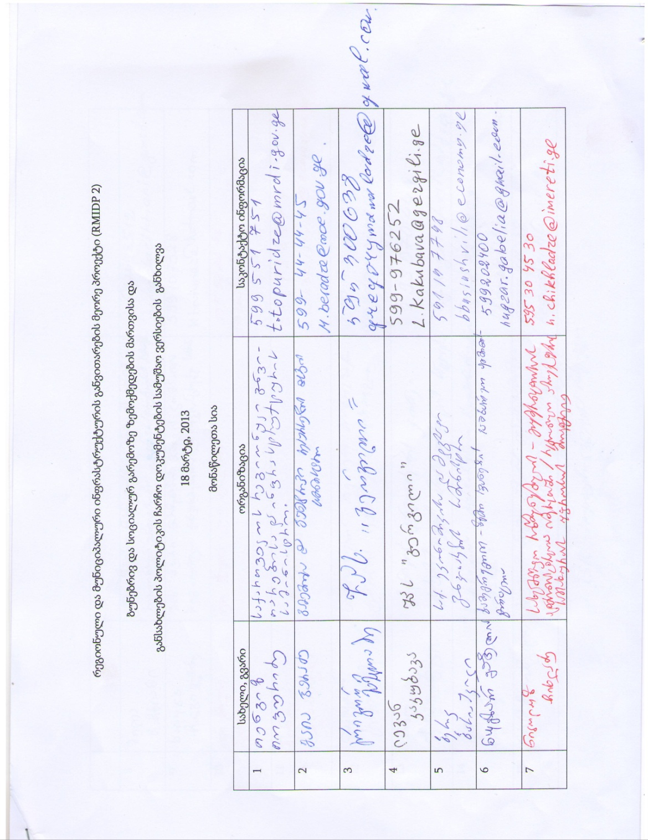
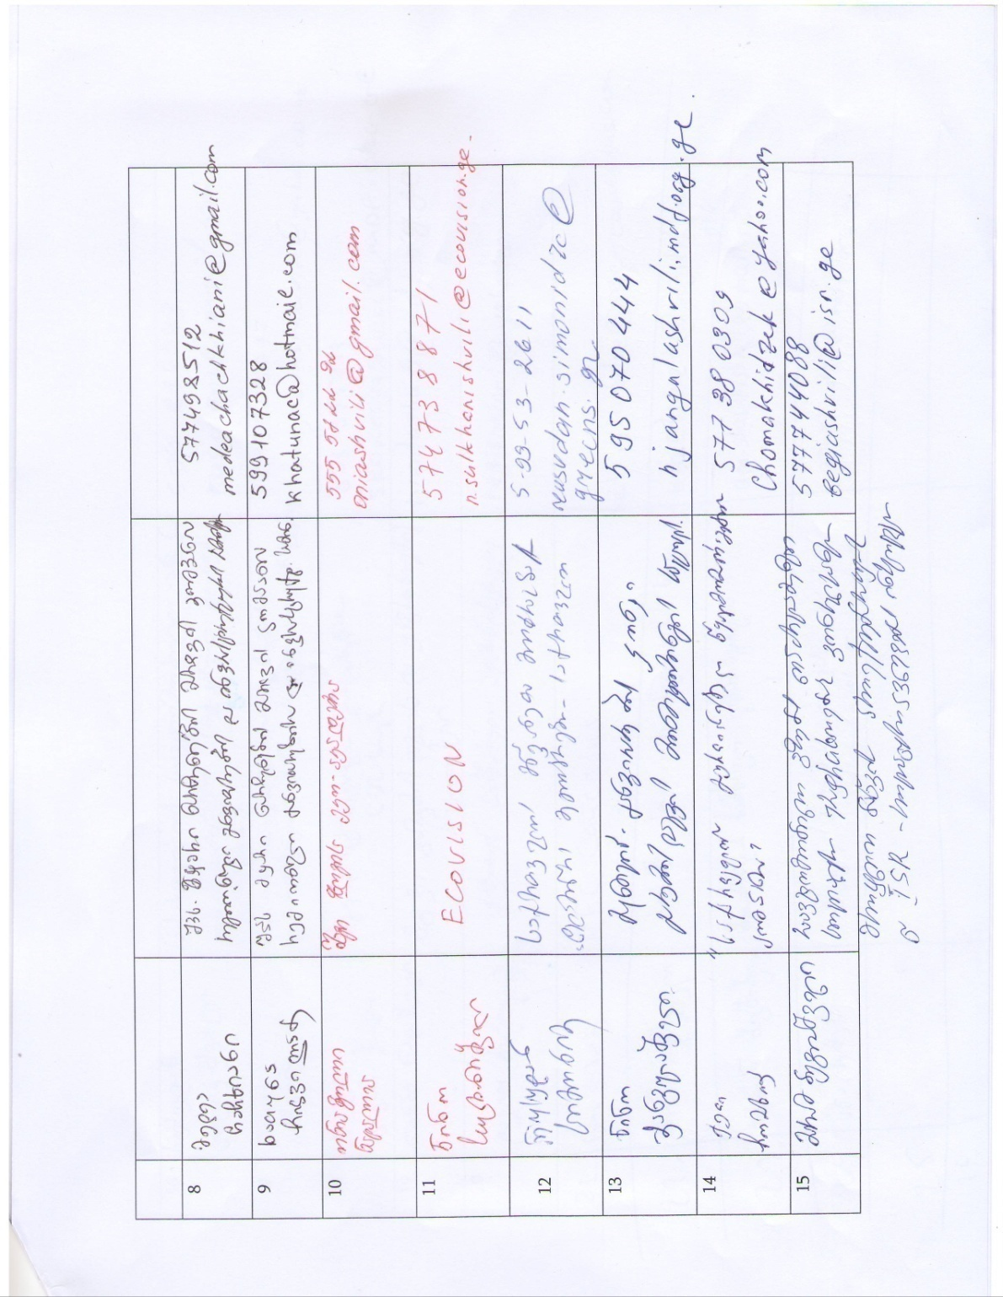

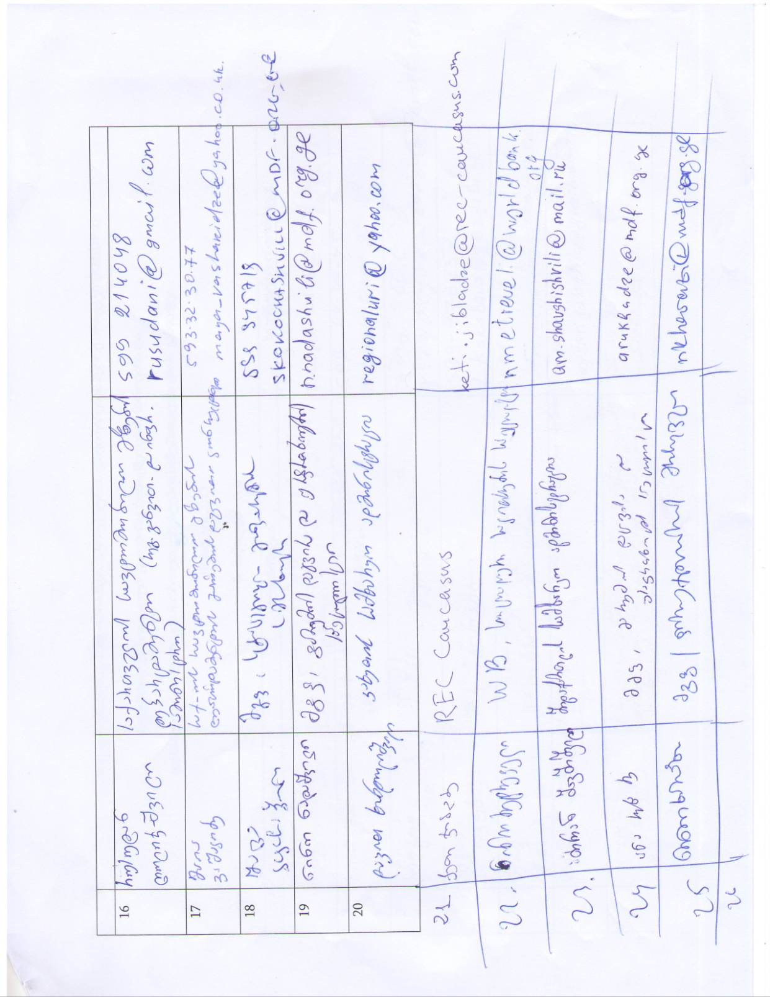

Photo material representing the meeting
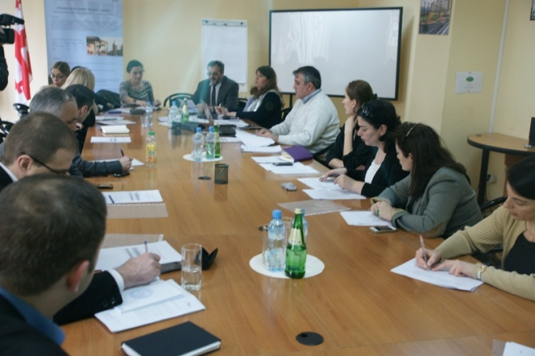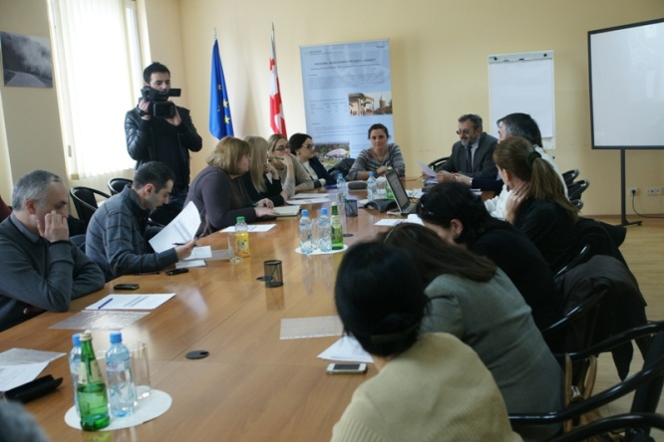
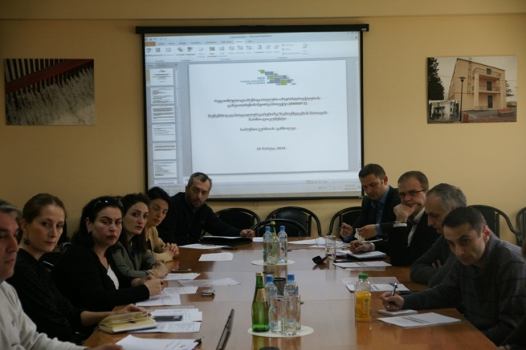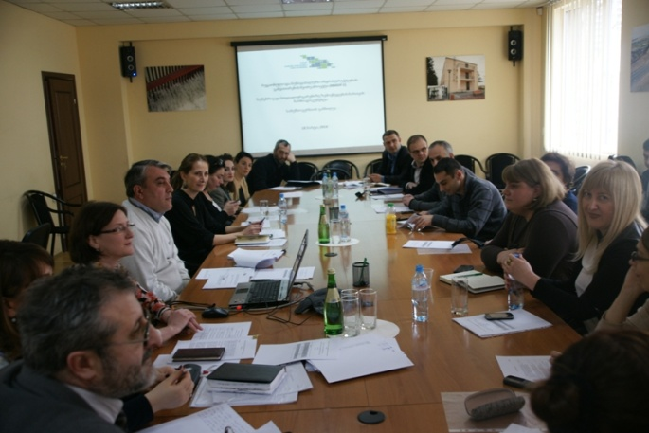
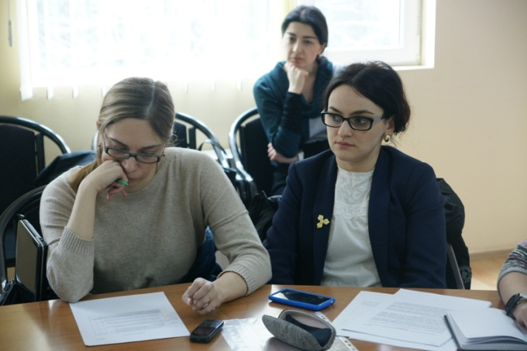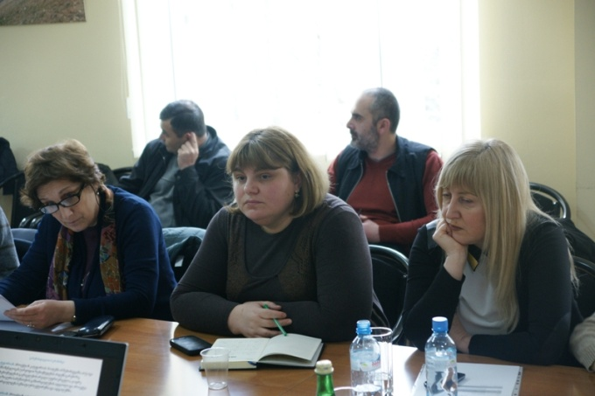

Land acquisitions includes displacement of people, change of livelihood encroachment on private property this is to land that is purchased/transferred and affects people who are living and/or squatters and/or operate a business (kiosks) on land that is being acquired.
Toxic / hazardous material includes but is not limited to asbestos, toxic paints, noxious solvents, removal of lead paint, etc.

