DAM REHABILITATION AND IMPROVEMENT PROJECT (DRIP) II
(Funded by World Bank)

CHHAPI DAM

ENVIRONMENT AND SOCIAL IMPACT ASSESSMENT

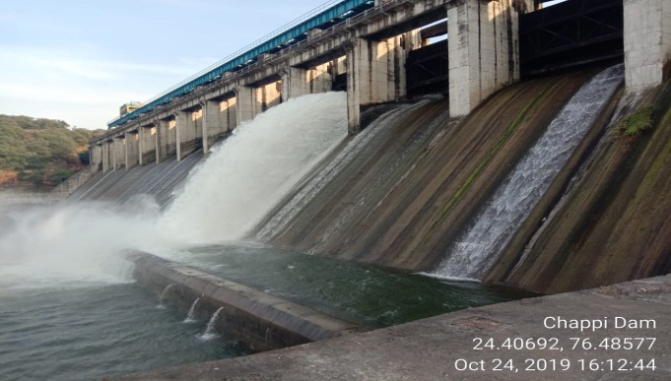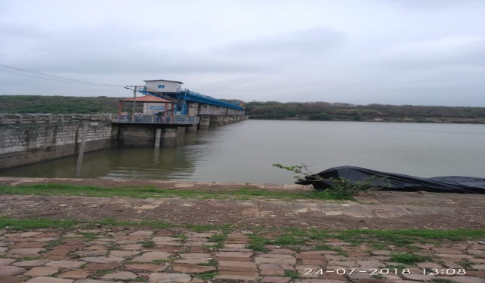
February 2020
(Draft Report)

Office of Additional Chief Engineer
Water Resources Department
Government of Rajasthan
Water Resources Zone, Kota
Tel: Ph. 0744-2327646 E-mail: cewrdkota@gmail.com
CONTENTS
Page No.
CHAPTER 1: INTRODUCTION
  - PROJECT OVERVIEW 1
  - SUB-PROJECT DESCRIPTION – CHHAPI DAM 2
  - PURPOSE OF ESIA 8
1.4 APPROACH AND METHODOLOGY OF ESIA 8

CHAPTER 2: LEGAL, REGULATORY AND INSTITUTIONAL FRAMEWORK
2.1 APPLICABILITY ANALYSIS OF INDIAN REGULATION 9
2.2 APPLICABILITY ANALYSIS OF WB ENVIRONMENTAL AND SOCIAL FRAMEWORK 19
2.3 INSTITUTIONAL FRAMEWORK 23

CHAPTER 3: OVERVIEW OF ENVIRONMENTAL AND SOCIAL CONDITIONS
3.1 PHYSICAL ENVIRONMENT 24
3.2 BIOLOGICAL ENVIRONMENT 26
3.3 PROTECTED AREA 27
3.4 SOCIAL ENVIRONMENT 27
3.5 CULTURAL ENVIRONMENT 29

CHAPTER 4: STAKEHOLDER CONSULTATION
4.1 STAKEHOLDER CONSULTATION 30
CHAPTER 5: ENVIRONMENT & SOCIAL RISKS AND IMPACTS
5.1 ASSESSMENT AND MANAGEMENT OF E&S RISK AND IMPACT (ESS 1) 35
5.2 LABOUR AND WORKING CONDITIONS (ESS 2) 36
5.3 RESOURCE EFFICIENCY AND POLLUTION PREVENTION AND MANAGEMENT (ESS 3) 37
5.4 COMMUNITY HEALTH AND SAFETY (ESS 4) 40

CHAPTER 6: ENVIRONMENT AND SOCIAL MANAGEMENT PLAN
6.1 ENVIRONMENT AND SOCIAL MANAGEMENT PLAN 42
6.2 MONITORING REPORTING AND BUDGETING 46
6.3 ENVIRONMENTAL AND SOCIAL COMMITMENT PLAN (ESCP) AND OTHER REQUIREMENTS 46

List of Tables
Table 2.1: Applicable Analysis 10
Table 2.2: Relevance and requirements ESF Policy, Standards and Directives 20

List of Figures
Figure 1.1: Selected Photographs of Improvement/Intervention Area 6
Figure 1.2: Project Area showing major intervention location 7
Figure 3.1: Land Use and Land Cover Map of 5 Km radius around Dam site 24
Figure 3.2: Map showing distances of protected areas from Chhapi Dam 27

List of Annexures
Annexure I: Water Quality of Chhapi River 47
Annexure II: Socio economic Profile of Proximity villages (Study Area) 48-56

ABBREVIATIONS AND ACRONYMS
AIBP : Accelerated Irrigation Benefit Program
AIDS : Acquired Immunodeficiency Syndrome
ASHA : Accredited Social Health Activist
ASI : Archaeological Survey of India
AWS : Automatic Weather Station
BOCWW : Building and Other Construction Workers Welfare
CCA : Culturable Command Area
CE : Chief Engineer
CPCB : Central Pollution Control Board
CPMU : Central Project Management Unit
CRZ : Coastal Regulation Zone
CWC : Central Water Commission
DEIAA : District Environment Impact Assessment Authority
DRIP : Dam Rehabilitation and Improvement Project
EAP : Emergency Action Plan
ERP : Emergency Response Procedure
ESCP : Environmental and Social Commitment Plan
ESF : Environmental and Social Framework
ESIA : Environmental and Social Impact Assessment
ESS : Environmental and Social Standard
FI : Financial Intermediaries
FSI : Forest Survey of India
GBV : Gender Based Violence
GCA : Gross Command Area
GIS : Geographic Information System
GRM : Grievance Redressal Mechanism
HIV : Human Immunodeficiency Virus
ICDS : Integrated Child Development Services
ID&R : Investigation Design & Research
IGND : Indira Gandhi Nahar Division
IPF : Investment Project Financing
IS : Indian Standards
JICA : Japan International Cooperation Agency
JTU : Jackson Turbidity Unit
LMP : Labour Management Procedure
MCM : Million Cubic Meters
MDDL : Minimum Draw Down Level
MJSA : Mukhyamantri Jal Swavlamban Abhiyan
MOEF&CC : Ministry of Environment, Forest & Climate Change
MSDS : Material Safety Data Sheet
MSIHC : Manufacture Storage & Imports of Hazardous Chemicals
MWL : Maximum Water Level
NAAQS : National Ambient Air Quality Standards
NH : National Highway
NTU : Nephelometric Turbidity Unit
O&M : Operation & Maintenance
OBC : Other Backward Class
OHS : Occupational Health & Safety
PD : Project Director
PESO : Petroleum and Explosives Safety Organization
PMKSY : Pradhan Mantri Krishi Sinchayee Yojana
PMU : Project Management Unit
PPE : Personal Protective Equipment
PST : Project Screening Template
PUC : Pollution Under Control
PWD : Public Work Department
RCC : Reinforced Cement Concrete
SC : Scheduled Castes
SCADA : Supervisory Control and Data Acquisition
SEF : Stakeholder Engagement Framework
SEIAA : State Environment Impact Assessment Authority
SH : State Highway
SHG : Self-Help Group
SPCB : State Pollution Control Board
SPMU : State Project Management Unit
ST : Scheduled Tribes
TMC : Thousand Million Cubic Feet
WLS : Wildlife Sanctuary
WRD : Water Resources Department

Chapter  1 | INTRODUCTION

- PROJECT OVERVIEW
The proposed Dam Rehabilitation and Improvement Project (DRIP-2) would complement the suite of ongoing and pipeline operations supporting India’s dam safety program. The project would continue to finance structural improvements but would break with the prevailing build-neglect-rebuild approach by giving greater emphasis to establishing sustainable mechanisms for financing regular O&M and dam rehabilitation, enhancing State capabilities to manage these critical assets through institutional strengthening, and introducing risk-informed dam safety management. The project development objective (PDO) is to increase the safety of selected dams and to strengthen institutional capacity for dam safety in participating States. Project Components include:

Component 1: Institutional Strengthening (US$ 40 million): This component supports further strengthening of dam safety management in the country through institutional modernization. A major focus of activities under this component will be increasing the oversight of dam safety by developing dam safety guidelines and by strengthening the capacity of various dam safety actors to carry out the regulatory functions defined in the proposed Dam Safety Bill, which has been passed by the Lok Sabha.

Component 2: Risk-informed Asset Management and Sustainable Financing (US$ 25 million): This component supports identifying long-term funding needs for dam safety based on asset management and risk assessment financing for dam safety. This component would focus on: (i) improving the efficiency of public financing; (ii) generating alternative revenue streams Alternative revenue streams that could be developed include tourism and water recreational activities, fisheries, and other innovative schemes such as floating solar panels; and (iii) establishing financing arrangements for dam safety (e.g., dedicated budget lines).

Component 3: Rehabilitation of Dams and Appurtenant Structures (US$ 200 million): This component supports improving the safety of dams through structural and non-structural interventions. Structural measures could include measures for seepage reduction (e.g., grouting, geo-membranes), hydrological and structural safety measures (e.g., additional spillways, fuse plugs), enhancing the reliability of operational facilities (e.g., gates), rehabilitating foundation deficiencies, strengthening dam concrete/embankment structures, and improving basic dam facilities (e.g., access roads). Non-structural measures could include standardized dam safety instrumentation, monitoring, assessment and reporting protocols for dam health; flood forecasting and early warning systems; integrated reservoir operations including streamflow forecasting for climate resilient dam management; preparation and implementation of EAPs; preparation and implementation of sediment management plans; and revised operational rule curves to account for climate change.
Component 4: Project Management (US$ 15 million): This component will ensure effective implementation of project activities and monitoring and evaluating project implementation progress, outputs and outcomes. The component will support: (i) establishment of the Central Project Management Unit (CPMU), which will oversee and coordinate activities of the implementing agencies of the project, supported by a Engineering and Management Consultant (EMC), which is currently being procured; (ii) establishment and operations of State level Project Management Units (SPMUs) within State implementing agencies, which can hire experts in various fields as and when needed on a contractual basis; (iii) setting up of a monitoring and evaluation system; and (iv) establishment of a Quality Assurance and Quality Control system. This component will also finance consultancies, as well as related material, office equipment and incremental operating costs. The project will provide investment and technical support for the establishment of a Management Information System and Information and Communication Technology systems.

- SUB-PROJECT DESCRIPTION – CHHAPI DAM
The Chhapi Irrigation Project across Chhapi river, a tributary of Kali Sindh river was constructed in the year 2003 to create irrigation and drinking water supply capacity. The dam is located Delahanpur Tehsil Aklera District Jhalawar of Rajasthan. The dam supplies Irrigation water to 9642 ha Gross Command Area (9375 ha CCA) and 10.95 MCM annual water supply. The dam site is approachable via village Borkheri on Jhalawar – Aklera road (Jaipur – Jabalpur N.H.52) which is 8.22 km from Borkheri and 54.00 Km from Jhalawar.

Salient features of the project area as reported below:
Project | CHHAPI MEDIUM IRRIGATION PROJECT
River | Chhapi river, a tributary of Chambal river
Lat/Long | 24⁰ 20' 34''/ 76⁰ 28' 20''
GCA | 9642 ha
CCA | 9375 ha
Catchment Area | 800 sq km
Main Dam
Type | Masonry Dam
Length | 312 m
Top elevation | 344.80 m
Height of dam above deepest foundation level | 34.80 m
Deepest foundation level | 310.00 m
Spillway
Type | Ogee spillway
Length | 173.50 m
Location of spillway | Central spillway
Crest level | 335.40 m
Number of bays | 13
Discharge capacity at MWL | 4370 cumec
Size of spillway gate | 11.5 m wide and 7.20 m high
Reservoir
Maximum water level | 342.60 m
Full Reservoir Level | 342.50 m
MDDL | 329.70 m
Live storage | 82.57 MCM
Gross storage | 73.57 MCM
Reservoir spread area | 1141 ha
Year of start of construction | 1980
Date of completion | 02/03/2003
Year of first impoundment | 2005

View of the Dam

Proposed Interventions/ Activities at Chhapi Dam
Approved PST considered the following rehabilitation proposals. Present ESIA report has been prepared considering these proposals/interventions:

Structural Rehabilitation Works

Civil Work
- Renovation of upstream (U/S) pitching at left side bank of dam
- Renovation of upstream( U/S) pitching at right side bank
- Cement Concrete lining of guide wall of downstream (d/s) of dam
- Cleaning/Reaming of Drainage holes (In Dam Body and foundation)
- Repairs to Parapet walls of Dam
- Treatment of Honeycombed area in upstream NOF of Dam.
- Repair of damage to spillway crest of Dam
- Foundation treatment of seepage & renovation of gallery of dam
- Downstream Protection work of dam
- Repairs of gallery & Epoxy paint of dam

Electromechanical Work
- Repairs of hoist
- Repair and up keeping of 13 Nos vertical gates
- Providing and installing 250 KVAR generator (DG Set)
- Providing Lighting And Surrounding Area
- Providing illumination/lighting arrangements in gallery.
- Providing & Fixing of Armored H.T. Service line and L.T. armored cable for Control room, Gallery and Gantry Crane electrical work)

Basic Facilities Enhancement
- Construction of CC road Approach to Gallery on downstream of dam
- Repair and Renovation of Office Building and Rest House
- Construction of Control Room for instrumentation
- Providing and installing of lightning Arrester
- Construction of Bridge on Borkheri to Chhapi Dam Road near village Borkheri P.S. Aklera District Jhalawar
- Construction of Pipe culvert at Nallah near village Pipladi on Borkheri to Chhapi Dam Road P.S. Aklera District Jhalawar.

Instrumentation, SCADA, Surveillance system, etc
Dam Instrumentation (Geo-technical, hydro-meteorological, Seismic, Geodetic, data collection, storage, data transfer, analysis, retrieval, Operation & Maintenance etc.).

Figures 1.1 and 1.2 provide photographs of key infrastructure proposed for rehabilitation works and also major interventions locations.

Implementation Schedule
Timelines for implementing above proposals has been proposed as 24 months.
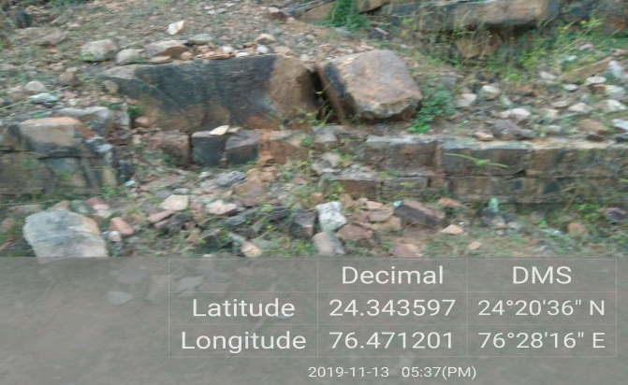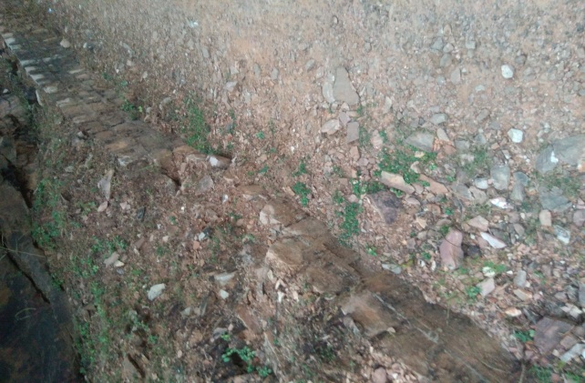
Damaged Upstream Left side of Chhapi Dam Damaged Upstream Right side of Chhapi Dam
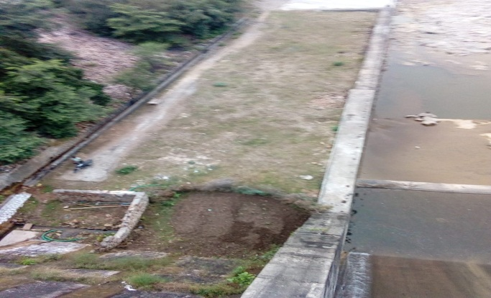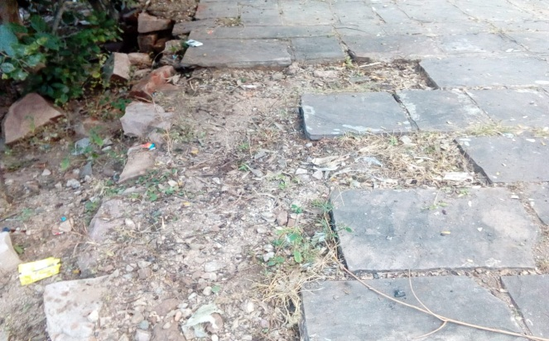
Left flank Downstream side of Chhapi Dam Left flank Upstream side of Chhapi Dam
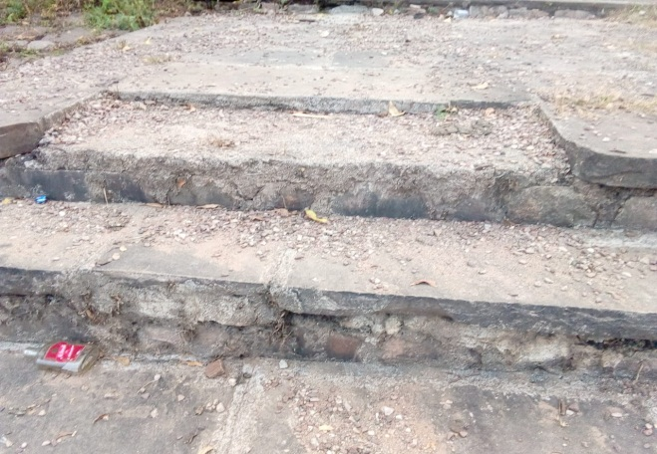 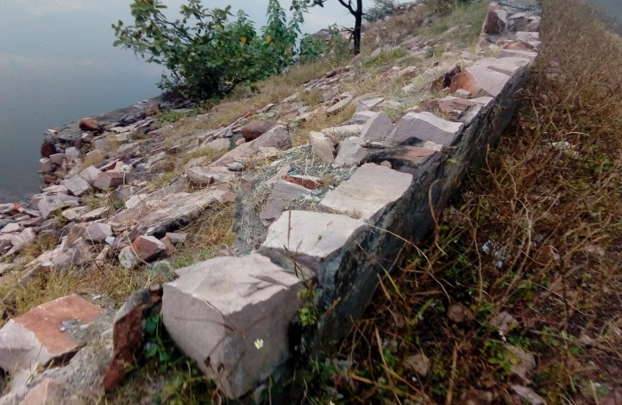 Damaged Rip rap & protection wall at U/s right side
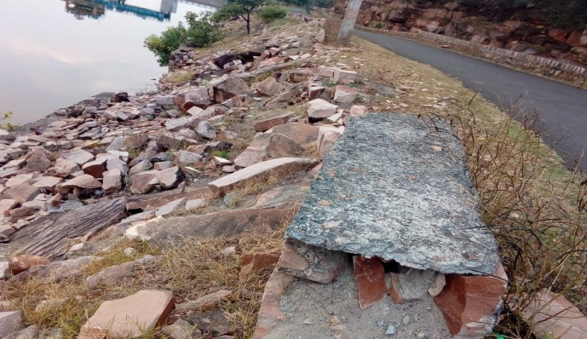 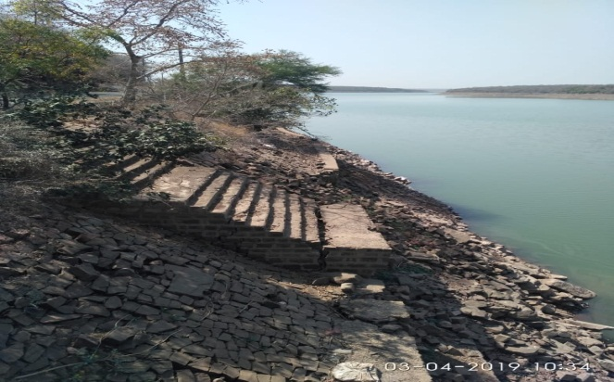Damaged Rip rap of U/s right side of Chhapi Dam
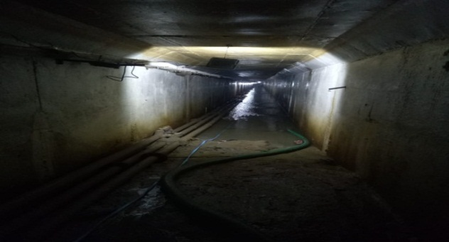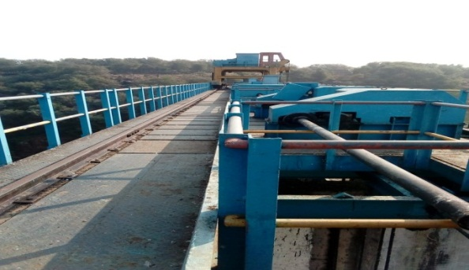
Gallery of Chhapi Dam Hoist Bridge of Chhapi Dam
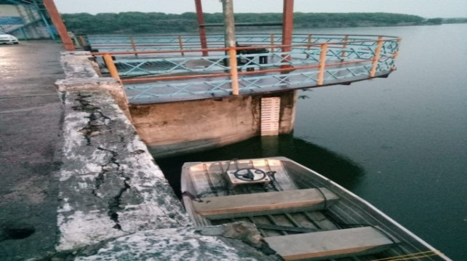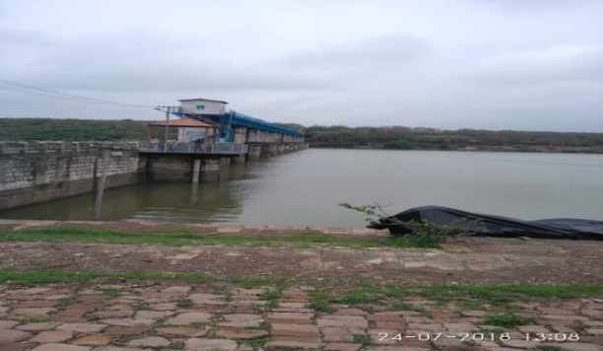
Damaged Railing of Chhapi Dam Damaged NOF portion of Upstream of Left flank
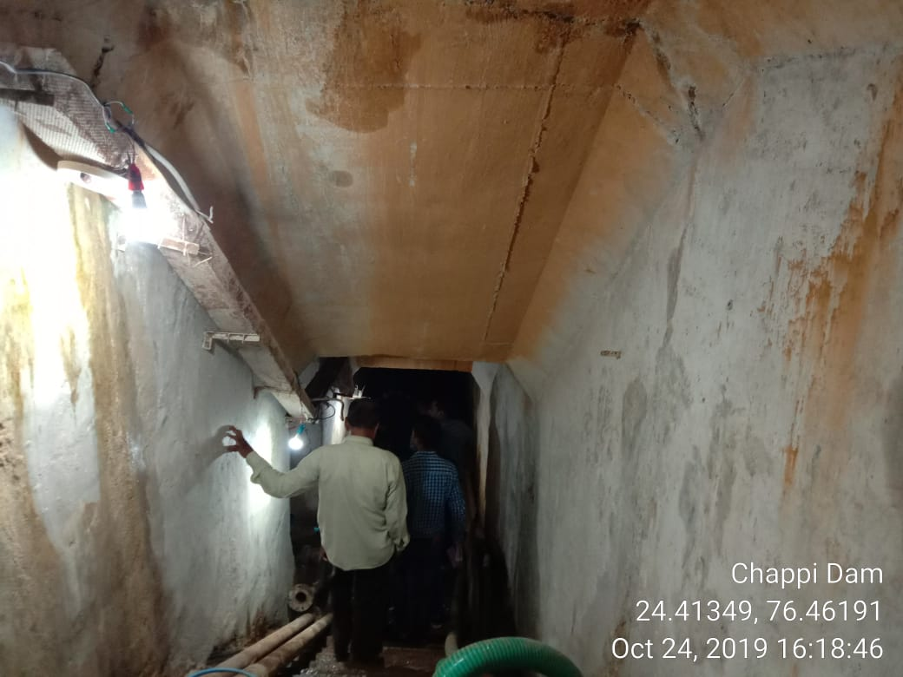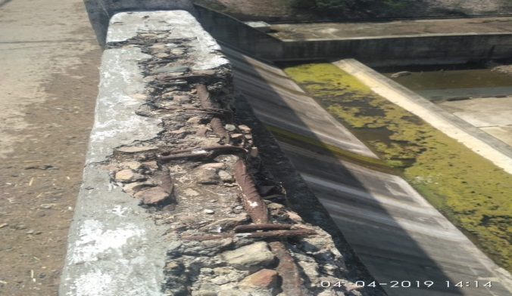
Damaged Gallery Parapet Wall
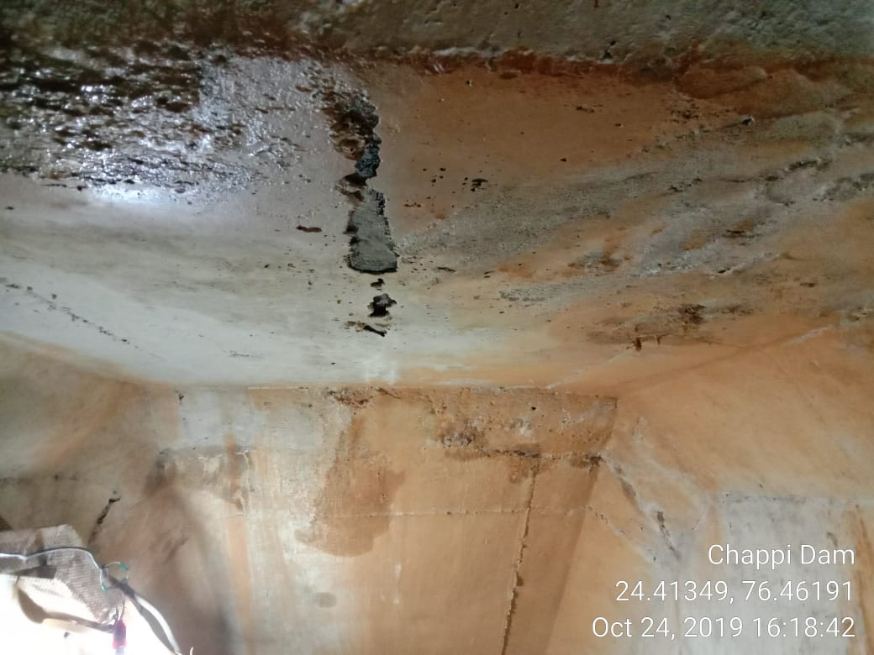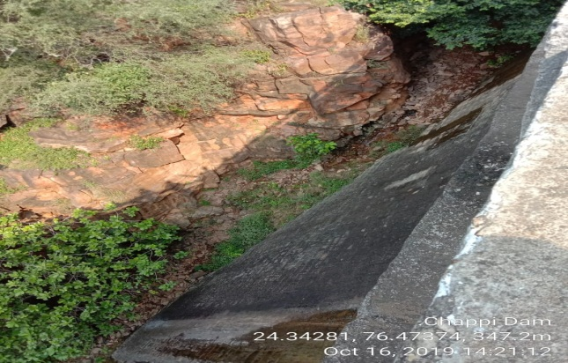
Seepage in Saddle Dam
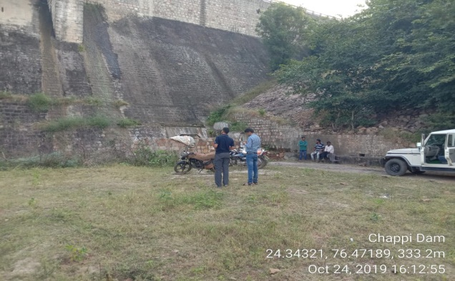
Seepage in vertical crest gate of Dam Seepage in NOF portion R/S
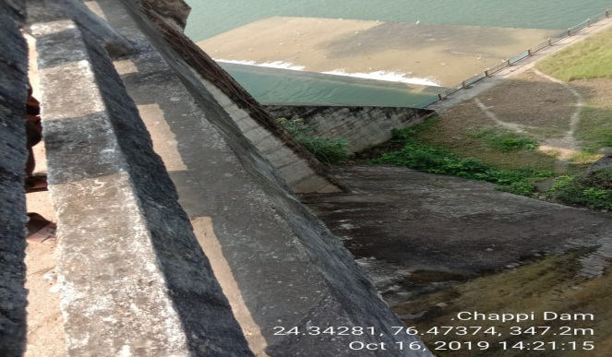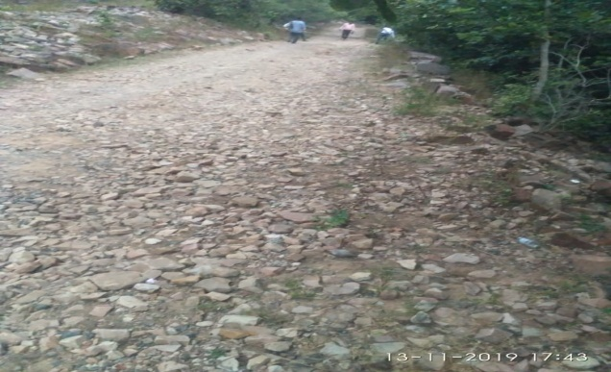
Seepage in NOF at L/S flank Damaged approach road to Gallery

Figure 1.1: Selected Photographs of Improvement/Intervention area

Figure 1.2: Project Area showing major intervention location
- PURPOSE OF ESIA
The overall project (DRIP II) was categorized as High Risk as per the internal Environment and Social Risk Classification of the Bank. Hence, a separate agency was contracted to conduct the Environment and Social Impact Assessment to use it as tool for decision-making on the sub-project. Specifically, the objective of the ESIA is:
- To identify, evaluate and manage the environment and social risks and impacts of the project in a manner consistent with the ESSs;
- To adopt a mitigation hierarchy approach to the project’s E&S risks i.e. a) anticipate and avoid risks and impacts; b) minimize or reduce risks and impacts to acceptable levels, if not avoidable; c) once risks and impacts have been minimized or reduced, mitigate; and (d) where significant residual impacts remain, compensate for or offset them, where technically and financially feasible;
- To help identify differentiated impacts on the disadvantaged or vulnerable and to identify differentiated measures to mitigate such impacts, wherever applicable;
- To assess the relevance and applicability of environmental and social institutions, systems, laws, regulations and procedures in the assessment, development and implementation of projects, whenever appropriate; identify gaps, if any exist, and
- To assess borrower’s existing capacity, gaps therein, and identify areas for enhanced capacity towards management of E&S risks.

- APPROACH AND METHODOLOGY OF ESIA
The following approach has been adopted for ESIA:
- Study sub-project information, proposed interventions, their magnitude and locations and carry out assessment of each proposed intervention to identify the magnitude of E&S risk and impacts;
- Conduct site visit to understand baseline environment and social settings, proposed activities under the sub-project, their location and sensitivity, if any.
- Conduct stakeholder consultations to help identify potential stakeholders; to provide information on the proposed interventions; to identify issues and concerns; and finally ascertain appropriate mechanisms for continued engagement
- Prepare baseline data essential for impact assessment in immediate vicinity area of proposed interventions from secondary sources, such as land-use, protected areas in vicinity, habitation, access roads, ascertain presence of indigenous (schedule tribe)/vulnerable people, etc.
- Review relevance and applicability of national and state legal requirements and Bank’s ESF policy, standards and directives and preliminary assessment of impacts as per ESS framework (2-8), suggest mitigation measures in accordance with the requirements of each applicable standard
- Undertake institutional assessment to identify existing capacities & relevant gaps to manage E&S risks and impacts

Formats used for collection of the above information, checklists used for consultations and photographs towards preparation of the Draft ESIA report are available in the project files

Chapter  2 | LEGAL, REGULATORY, AND INSTITUTIONAL FRAMEWORK

India has well defined environmental and social regulatory framework. The regulation applicability depends on nature of work and location of work. Broadly legislation can be divided into four categories viz environmental, social, wildlife protection, and forests conservation. The applicability of environmental laws to dam are mostly at setting up new dams compared to rehabilitation stage. The applicability analysis of regulations pertaining to all the above four categories is carried out and summarized at section 2.1.

Central Water Commission, Ministry of Jal Shakti, Government of India has also prepared “Operational Procedures for Assessing and Managing Environmental Impacts in Existing Dam Projects” as a guiding document for the dam owners to systematically address in advance the environmental safeguard requirements and have discussed in detail all applicable legal requirement. Reference has been drawn from this document as well while carrying out applicability analysis.

The World Bank ESF comprises Policy, 10 ESSs (ESS1 to ESS10) and 2 Directives. The applicability of each Standard to the proposed rehabilitation proposals and standard specific requirements is analysed and presented at Section 2.2.

APPLICABILITY ANALYSIS OF INDIAN REGULATION
The regulatory applicability analysis to the proposed rehabilitation work has been carried out considering nature of improvements, methodology of construction/improvement, material requirement, sourcing and transportation mode, and waste generation. The regulatory applicability analysis is summarised at Table 2.1 below.

Table 2.1: Applicability Analysis
S. No. | Legislation | Purpose | Applicability | Reason | Type of permit/specific action and stage of applicability | Administrative Authority
1 | Environment Protection Act/Rules-1986 | To protect and improve overall environment | Yes | Applicable to all activities in general | None | MoEF&CC
2 | The Forest (Conservation) Act, 1980 and amendments and The Forest (conservation) Rules 1981 and amendments | To help conserve the country's forests. It strictly restricts and regulates the de-reservation of forests or use of forest land for non-forest purposes without the prior approval of the Government. To this end the Act lays down the pre-requisites for the diversion of forest land for non-forest purposes | No | No diversion of forest land involved | None | Forest Department
3 | Rajasthan Forest Act, 1953 | Conservation of forest and control felling of trees | No | No tree will be felled for proposed intervention | None | Forest Department
4 | Coastal Regulation Zone (CRZ) notification 2011 and amendment till date | To regulate development activities within the 500 m of high tide line in coastal zone and 100 m of tidal influence rivers. | No | Project is not located in coastal area | None | SCZMA,
5 | Air (Prevention and Control of Pollution) Act, 1981, 1987 | An Act to prevent and control Air pollution | Yes | Air pollution from proposed activities  During construction stage | Consent to establish and operate by contractor for operation of DG sets and any other air pollution system like ready mix plant etc. | SPCB
6 | Water Prevention and Control of Pollution) Act, 1974, 1988 | An Act to prevent and control water pollution. | Yes | Water pollution from proposed activities during construction stage | Consent to establish and operate by contractor for setting up construction camp/labour camp | SPCB
7 | Noise Pollution (Regulation and Control Act) 2000 and amendment till date | Ambient Noise Standards for different areas and zones | Yes | Noise emission from proposed activities during construction stage like operation of DG sets | None | CPCB & SPCB
8 | Hazardous & Other Waste ( Management and Trans-boundary Movement) Rules, 2016 | Protection to general public against improper handling storage and disposal of hazardous waste. The rules prescribe the management requirement of hazardous wastes from its generation to final disposal. | Yes | Hazardous waste generation from proposed activities like generation of paints waste, used oil/waste oil | Authorisation for handling and disposal of hazardous wastes | SPCB
9 | Manufacture Storage, & imports of Hazardous Chemicals (MSIHC) Rules, 1989 as amended till date | Usage and storage of hazardous substances | Yes | Painting is proposed which will require use of solvents/thinners which will falls under hazardous chemicals category | Arrange MSDS and store quantity of hazardous chemicals below threshold quantity | Chief Inspector of Factories
10 | The Batteries (Management and Handling) Rules 2001 | To regulate the disposal and recycling of lead acid batteries | No | Batteries will not be used for proposed activities | None | SPCB
11 | Construction and Demolition Waste Management Rules , 2016 | To manage the demolition and construction waste and prevent environmental degradation | Yes | Construction and demolition waste will be generated from proposed activities | Contractor needs to submit plan for reuse or safe disposal | Local bodies of the area
12 | Solid Waste Management Rules, 2016 | To manage solid waste or semi-solid domestic waste, sanitary waste, | Yes | Solid Waste will be generated from proposed activities due to influx of labour | Contractor needs to submit plants for its safe disposal/burial | Local bodies of the area
13 | Motor Vehicle Act 1988 and amendment till date | To minimize the road accidents, penalizing the guilty, provision of compensation to victim and family and check vehicular air and noise pollution. | Yes | Transportation of manpower and material | None | Motor Vehicle Department (Licensing authority, registration authority &State Transport Authorities)
14 | The Gas Cylinder Rules 2016 | To regulate the storage of gas / possession of gas cylinder more than the exempted quantity. | Yes | gas cylinders will be used during welding and other electromechanical work. Storage within threshold quantity and as per capability analysis. Handling with define safe practices | None | PESO
15 | Ancient Monuments and Archaeological Sites and Remains Act, 1958 | Conservation of cultural and historical remains found in India. | Yes | Presence of historical sites of archaeological importance | None | Archaeological Dept. Gol
16 | Building and Other Construction Workers (Regulation of Employment and Conditions of Service) Act, 1996 | To regulate the employment and conditions of service of buildings and other construction workers and to provide for their safety, health and welfare measures and for other matters connected therewith or incidental thereto. | Yes | Involvement of workforce/labour | None | Labour Commissioner
17 | Plastic waste management Rules, 2016 | To manage the plastic waste generated so as it does not affect the water pipeline, animals and other environmental components | Yes | Plastic waste generation from proposed activities. Safe disposal as per Rules | None | Local bodies of the area
18 | E-Waste Management Rules, 2016 | Protection of environment against improper handling storage and disposal of hazardous waste. | Yes | E-waste generation from replacement of instrumentation. Safe disposal as per rules | None | CPCB &SPCB
19 | Rajasthan Minor, Mineral Concession Rules, 2017 | Control of extraction, collection and removal of minor minerals | Yes | requirement of construction material from quarries and borrow areas | None | Mines Department/ DEIAA/SEIAA
20 | The Right to Fair Compensation and Transparency in Land Acquisition, Rehabilitation and Resettlement Act, 2013 | Regulates land acquisition and lays down the procedure and rules for granting compensation, rehabilitation and resettlement to the affected persons | No | Land Acquisition is not involved | None | Revenue Department/District Administration
21 | Rights of Persons with Disabilities Act, 2016 | Ensures that the Persons with Disability (PWD) enjoy the right to equality, life with dignity, and respect for his or her own integrity equally with others. | Yes | Persons with disability | None
22 | Right To Information Act, 2005 | Mandates timely response to citizen requests for government information | Yes | Borrower is government organization | None | Any Government Department
23 | Article 366 (25) of the Constitution of India  Article 244(1) of Constitution of India - The Fifth Schedule under Article 244(1) of a subsequent Act of Constitution  “Scheduled Areas” as such areas as the President may by order declare to be Scheduled Areas after consultation with Governor of that State. | Defines following essential characteristics, for a community to be identified as Scheduled Tribes are;  - Indications of primitive traits;  - Distinctive culture;  - Shyness of contact with the community at large;  - Geographical isolation; and  - Backwardness.  The criteria for declaring any area as a “Scheduled Area” under the Fifth Schedule are; (a) preponderance of tribal population, (b) compactness and reasonable size of the area, (c) a viable administrative entity such as a district, block or Taluka, and (d) economic backwardness of the area as compared to the neighbouring areas. | No | Dam is not located in Scheduled Area | None | Government of India
24 | Scheduled Tribes and Other Traditional Forest Dwellers (Recognition of Forest Rights) Act, 2006 | To recognize and vest the forest rights and occupation in forest land in forest dwelling STs and other traditional forest dwellers who are residing in such forests for generations but whose rights could not be recorded. Its objective is to facilitate the overall development and welfare of the tribal people by empowering them socially, economically, politically without any impact on their culture, habitation and tradition and in terms of their age old rights and privileges. | No | No such activities impacting tribes and their rights are proposed | None | Ministry of Tribal Affairs
25 | Panchayats (Extension to the Scheduled Areas) Act, 1996 | The Gram Sabha or the Panchayats at the appropriate level shall be consulted before making the acquisition of land in the Scheduled Areas for development projects and before re-settling or rehabilitating persons affected by such projects in the Scheduled Areas. | No | No structural intervention is planned. Only awareness generation on EAP preparation and implementation shall take place in these areas. | None | Concerned State Government and Tribal Welfare Department
26 | Major Labour Laws Applicable To Establishments Engaged In Building And Other Construction Work
1 | Employees Compensation Act 1923 | The Act provides for compensation in case of injury, disease or death arising out of and during the course of employment. | Yes | Contractor/Labour engagement | None | Commissioner for Workmen’s Compensation
2 | Payment of Gratuity Act 1972 | Gratuity is payable to an employee under the Act on satisfaction of certain conditions on separation if an employee has completed 5 years’ service or more or on death at the rate of 15 days wages for every completed year of service. The Act is applicable to all establishments employing 10 or more employees. | Yes | Contractor/Labour engagement | None | Chief Labour Commissioner
3 | Employees P.F. and Miscellaneous Provision Act 1952 (since amended) | The Act provides for monthly contribution by the employer plus workers @ 10% or 8.33%. The benefits payable under the Act are: | Yes | Contractor/Labour engagement | None | Ministry of Labour
4 | Maternity Benefit Act 1961 | The Act provides for leave and some other benefits to women employees in case of confinement or miscarriage etc. | Yes | Contractor/Labour engagement | None | Chief Labour Commissioner
5 | Sexual Harassment of Women at the Workplace (Prevention, Prohibition and Redressal) Act, 2013 | This Act defines sexual harassment in the workplace, provides for an enquiry procedure in case of complaints and mandates the setting up of an Internal Complaints Committee or a Local Complaints Committee | Yes | Contractor/Labour engagement | None | District Officer (District Magistrate or Additional District Magistrate or the Collector or Deputy Collector)
6 | Contract Labour (Regulation & Abolition) Act 1970 | The Act provides for certain welfare measures to be provided by the Contractor to contract labour and in case the Contractor fails to provide, the same are required to be provided, by the Principal Employer by law. The Principal Employer is required to take Certificate of Registration and the Contractor is required to take license from the designated Officer. The Act is applicable to the establishments or Contractor of Principal Employer if they employ 20 or more contract labour. | Yes | Contractor/Labour engagement | None | Chief labour Commissioner
7 | Minimum Wages Act 1948 | The Employer is supposed to pay not less than the Minimum Wages fixed by appropriate Government as per provisions of the Act if the employment is a scheduled employment. Construction of Buildings, Roads, Runways are scheduled employments. | Yes | Contractor/Labour engagement | None | Chief labour Commissioner
8 | Payment of Wages Act 1936 | It lays down the mode, manner and by what date the wages are to be paid, what deductions can be made from the wages of the workers. | Yes | Contractor/Labour engagement | None | Chief labour Commissioner
9 | Equal Remuneration Act 1976 | The Act provides for payment of equal wages for work of equal nature to male and female workers and for not making discrimination against Female employees in the matters of transfers, training and promotions etc. | Yes | Contractor/Labour engagement | None | Chief labour Commissioner
10 | Payment of Bonus Act 1965 | The Act is applicable to all establishments employing 20 or more employees. Some of the State Governments have reduced this requirement from 20 to 10. The Act provides for payments of annual bonus subject to a minimum of 8.33% of the wages drawn in the relevant year. It applies to skilled or unskilled manual, supervisory, managerial, administrative, technical or clerical work for hire or reward to employees who draw a salary of Rs. 10,000/- per month or less. To be eligible for bonus, the employee should have worked in the establishment for not less than 30 working days in the relevant year. The Act does not apply to certain establishments. | Yes | Contractor/Labour engagement |  | Chief labour Commissioner
11 | Industrial Disputes Act 1947 | the Act lays down the machinery and procedure for resolution of Industrial disputes, in what situations, a strike or lock-out becomes illegal and what are the requirements for laying off or retrenching the employees or closing down the establishment. | Yes | Contractor/Labour engagement | None | Ministry of Labour and Employment
12 | Trade Unions Act 1926 | The Act lays down the procedure for registration of trade unions of workmen and employers. The Trade Unions registered under the Act have been given certain immunities from civil and criminal liabilities. | Yes | Contractor/Labour engagement | None | Ministry of Labour and Employment
13 | Child Labour (Prohibition & Regulation) Act 1986 | The Act prohibits employment of children below 14 years of age in certain occupations and processes and provides for regulation of employment of children in all other occupations and processes. Employment of Child Labour is prohibited in the Building and Construction Industry. | Yes | Contractor/Labour engagement | None | Chief labour Commissioner
14 | Inter-State Migrant workmen’s (Regulation of Employment & Conditions of Service) Act 1979 | The Act is applicable to an establishment which employs 5 or more inter-state migrant workmen through an intermediary (who has recruited workmen in one state for employment in the establishment situated in another state). The Inter-State migrant workmen, in an establishment to which this Act becomes applicable, are required to be provided certain facilities such as housing, medical aid, traveling expenses from home up to the establishment and back, etc. | Yes | Contractor/Labour engagement | None | Chief labour Commissioner
15 | The Building and Other Construction Workers (Regulation of Employment and Conditions of Service) Act 1996 and the Building and Other Construction Workers Welfare Cess Act, 1996 (BOCWW Cess Act) | All the establishments who carry on any building or other construction work and employ 10 or more workers are covered under these Acts. All such establishments are required to pay cess at the rate not exceeding 2% of the cost of construction as may be notified by the Government. The Employer of the establishment is required to provide safety measures at the building or construction work and other welfare measures, such as Canteens, First – Aid facilities, Ambulance, Housing accommodations for workers near the work place etc. The Employer to whom the Act applies has to obtain a registration certificate from the Registering Officer appointed by the Government. | Yes | Contractor/Labour engagement | None | Chief labour Commissioner
16 | Factories Act 1948 | the Act lays down the procedure for approval of plans before setting up a factory engaged in manufacturing processes, health and safety provisions, welfare provisions, working hours, annual earned leave and rendering information regarding accidents or dangerous occurrences to designated authorities. It is applicable to premises employing 10 persons or more with aid of power or 20 or more persons without the aid of power. | Yes | Contractor/Labour engagement | None | Chief Inspector of Factories
17 | Bonded Labour System (Abolition) Act, 1976 | The Act provides for the abolition of bonded labour system with a view to preventing the economic and physical exploitation of weaker sections of society. Bonded labour covers all forms of forced labour, including that arising out of a loan, debt or advance. | Yes | Contractor/Labour engagement | None | Chief labour Commissioner
18 | Employer’s Liability Act, 1938 | This Act protects workmen who bring suits for damages against employers in case of injuries endured in the course of employment. Such injuries could be on account of negligence on the part of the employer or persons employed by them in maintenance of all machinery, equipment etc. in healthy and sound condition. | Yes | Contractor/Labour engagement | None | Chief labour Commissioner
19 | Employees State Insurance Act 1948 | The Act provides for certain benefits to insured employees and their families in case of sickness, maternity and disablement arising out of an employment injury. The Act applies to all employees in factories (as defined) or establishments which may be so notified by the appropriate Government. The Act provides for the setting up of an Employees’ State Insurance Fund, which is to be administered by the Employees State Insurance Corporation. Contributions to the Fund are paid by the employer and the employee at rates as prescribed by the Central Government. The Act also provides for benefits to dependents of insured persons in case of death as a result of an employment injury. | Yes | Contractor/Labour engagement | None | Chief labour Commissioner
20 | The Personal Injuries (Compensation Insurance) Act, 1963 | This Act provides for the employer’s liability and responsibility to pay compensation to employees where workmen sustain personal injuries in the course of employment. | Yes | Contractor/Labour engagement | None | Chief labour Commissioner
21 | Industrial Employment (Standing Order) Act 1946 | It is applicable to all establishments employing 100 or more workmen (employment size reduced by some of the States and Central Government to 50). The Act provides for laying down rules governing the conditions of employment by the Employer on matters provided in the Act and get the same certified by the designated Authority. | Yes | Contractor/Labour engagement | None | Chief labour Commissioner

APPLICABILITY ANALYSIS OF WB ENVIRONMENTAL AND SOCIAL FRAMEWORK STANDARDS
The World Bank Environmental and Social Framework comprises Policy, 10 standards and 2 Directives. Applicability of these standard vary depending on nature of activities. This applicability analysis is presented at Table 2.2 below.

Table 2.2: Relevance and requirements ESF Policy, Standards and Directives
ESF Policy, Standards and Directives & Guidelines | Applicable Activities | Applicability / Requirements
ESS1: Assessment and Management of Environmental and Social Risks and Impacts | All projects, sub-projects and associated facilities | Applicable  (a) Conduct an environmental and social assessment of the proposed project, including stake- holder engagement;  (b) Undertake stakeholder engagement and disclose appropriate information in accordance with ESS10;  (c) Develop an ESCP, and implement all measures and actions set out in the legal agreement including the ESCP; and  (d) Conduct monitoring and reporting on the environmental and social performance of the project against the ESSs
ESS2: Labour and Working Conditions | Engagement of labour for various civil, paint and electro-mechanical or any other activities as part of rehabilitation proposal. It applies to project workers including full- time, part-time, temporary, seasonal and migrant workers. It covers working conditions, protecting workforce, Grievance Mechanism and Occupational Health and Safety (OHS). | Applicable  - Preparation of Labour Management Procedures applicable to the project.  - Establishing Grievance Mechanism and sharing with all the workers  - Design and Implement OHS measures
ESS3: Resource Efficiency, Pollution Prevention and Management | Resource consumption and pollution generation from proposed activities (civil, electromechanical and paint work). This includes both hazardous and non- hazardous chemical pollutants in the solid, liquid, or gaseous phases | Applicable  - Assess the resource requirement and implement technically and financially feasible measures for improving efficient consumption of energy, water and raw materials, as well as other resources.  - Preparation of Resource Efficiency and Pollution Prevention Plan to assess and minimize/control the concentration of release of pollutants to air, water and land due to routine, non-routine, and accidental circumstances, and with the potential for local, regional, and transboundary impacts.
ESS 4: Community Health and Safety | Applies to potential risks and impacts on communities that may be affected by project activities such as transportation of material to project site through village roads, labour colony housing migrant workers near the project site, pollution generation from civil and electro-mechanical work. | Applicable  - Pollution from project activities and labour colony and traffic causing pollution and road safety risks on village roads during transportation of material  - Preparation of Emergency Response Procedure (ERP) to prevent injuries to health and for safety of the community during and emergency event arising from both natural and man-made hazards, typically in the form of fire, explosions, leaks or spills, flooding etc
ESS 5: Land Acquisition, Restrictions on Land use and Involuntary Resettlement | Applies to permanent or temporary physical and economic displacement resulting from land acquisition or restrictions on land use undertaken or imposed in connection with project implementation. | Not Applicable  - Proposed interventions are limited to the existing dam and will take place on the existing dam structure and within its premises. Any of the proposed activities/interventions, does not involve acquisition of private land and/or private assets. These activities in no way cause restriction on access to land or use of resources by local communities and there is no economic displacement envisaged due to the sub-project.
ESS 6: Biodiversity Conservation and Sustainable Management of Living Natural resources | Applies to all projects that potentially affect biodiversity or habitats, either positively or negatively, directly or indirectly, or that depend upon biodiversity for their success. | Not Applicable  - The present interventions do not involve any tree cutting or impacting any forest area in any way. Activities remain limited to the dam premises only. Impacts on wildlife including that on fish fauna in the reservoir and river are negligible due the nature and location of activities proposed under this sub-project. There is no national park/wildlife sanctuary/Conservation Reserve within 10 Km of the project. No direct or indirect impacts on biodiversity are envisaged due to proposed interventions.
ESS 7: Indigenous Peoples/Sub-Saharan African Historically Underserved Tradition Local Communities | Applies to traditional communities or schedule tribes, if they are present or have collective attachment to a proposed project area, as determined during the environmental and social assessment. This ESS applies regardless of whether such Communities are affected positively or negatively, and regardless of the significance of any such impacts. | Not Applicable - The project interventions do not directly or indirectly impact schedule tribe. Though there are scheduled tribe population in the downstream, assessment indicates that they are mainstreamed into overall society and do not possess characteristics as outlined under this standard. These groups will be taken into account as part of non-structural interventions such as in the preparation of the Emergency Action Plans.
ESS 8: Cultural Heritage | Applies to all projects that are likely to have risks/impacts on cultural heritage | Not Applicable  - Project is not directly or indirectly impacting any cultural heritage as no such sites are in proximity to the project site.  - Access to temples/religious places in surrounding villages will not be blocked/hampered dur to any of the proposed interventions as such activities are limited to dam premises only.
ESS 9: Financial Intermediaries | Applies to Financial Intermediaries (FIs) that receive financial support from the Bank. FIs include public and private financial services providers, including national and regional development banks, which channel financial resources to a range of economic activities across industry sectors. | Not Applicable - Project does not have any FIs
ESS 10: Stakeholder Engagement and Information Disclosure | Applies to all projects supported by the Bank through Investment Project Financing. The Borrower will engage with stakeholders as an integral part of the project’s environmental and social assessment and project design and implementation | Applicable for the interventions on the dam as a whole and in particular in relation to the non-structural interventions involving Early flood Warning system having siren systems, broadcasting facilities, etc.  Preparation of Stakeholder Engagement Plan  Establishment of a project level GRM
Environmental and Social Directive for Investment Project Financing | This Directive applies to the Bank and sets out the mandatory requirements for the implementation of the Environmental and Social Policy for Investment Project Financing (IPF). | Applies to Bank in addressing E&S aspects of this project
Bank Directive Addressing Risks and Impacts on Disadvantaged or Vulnerable Individuals or Groups | This Directive establishes directions for Bank staff regarding due diligence obligations relating to the identification of, and mitigation of risks and impacts on, individuals or groups who, because of their particular circumstances, may be disadvantaged or vulnerable | Applies to Bank in addressing E&S risks and impacts on disadvantaged and vulnerable persons or groups that are identified in this project.
World Bank’s Guidance note on managing the risks of adverse impacts on communities from temporary project induced labor influx, 2016 | The document provides guidelines to address issues and risks arising from influx of migrant labour leading to gender-based violence, forced labour etc. | Applicable as influx of skilled migrant labour in construction works is likely, these labor will operate within the dam premises and beyond in the construction of nallah (piped culvert) and bridge in villages in the proximity. However, GBV related clauses would be included in the bid documents and sensitization/ awareness trainings would be provided to all dam personnel, contractors, etc. during implementation.

- INSTITUTIONAL FRAMEWORK

The sub-project will be implemented by Water Resources Department (WRD, Rajasthan. The department has two distinct divisions – IGND (Indira Gandhi Nahar Division) and Water Resources Division. Water Resources Division is who will be responsible for implementing the project and is headed by Principal Secretary. The functions of WRD are:

- Construction of major, medium and minor irrigation projects,
- Operation and maintenance of existing tanks, canals and other irrigation structures.
- Flood control measures and floods related remedial measures.
- Construction of irrigation structures under various special schemes like PMKSY, MJSA, AIBP, JICA etc.
- Collection of revenue pertaining to sale of water from tanks irrigating more than 1000 ha of land. Collection of irrigation charges in respect of tanks Engineering irrigating less than 1000 ha is assigned to the Patwaris of the Revenue Department.
- Construction and maintenance of the rest houses of irrigation department, office buildings, residential buildings of the staff, gardens, parks, roads etc.

WRD Rajasthan presently does not have inhouse trained manpower to address E&S issues. Chief Engineer at SPMU and Executive Engineer at dam are addressing them on need basis
WRD has a working RTI process to respond to information requests. However, WRD has no formal system in place for redressing external complaints.

.

Chapter  3 | OVERVIEW OF ENVIRONMENTAL AND SOCIAL CONDITIONS

The baseline conditions are analysed based on secondary information and site observations and are presented in following order Physical, Biological, Protected area and Socio-economic profile.

- PHYSICAL ENVIRONMENT

Land Use/ Land Cover
The project surrounding area land use and environmental sensitivity was analysed using Remote Sensing & GIS techniques. Land use/ land cover map within 5 Km radius of dam is presented at Figure 3.1. As can be seen from the map, present land use upstream of dam is waterbody (reservoir) surrounded by deciduous forest on both sides and on downstream side along both the banks there are deciduous and scrub forest area. However, as discussed under Chapter 1 on project description, the project activities will be confined to dam body only and no activities are proposed beyond existing dam boundaries. Villages in proximity i.e. within 5 km distance from dam on downstream side have been identified as Amrit Kheri, Bairagarh, Bindayaka, Haripura, Kher Khera, Sendari, Semli, Uchawada, Dudhiya Kheri, Biloniya and Naya Gaon of Jhalawar District. These are considered as vicinity villages which may get impacted due to project activities.

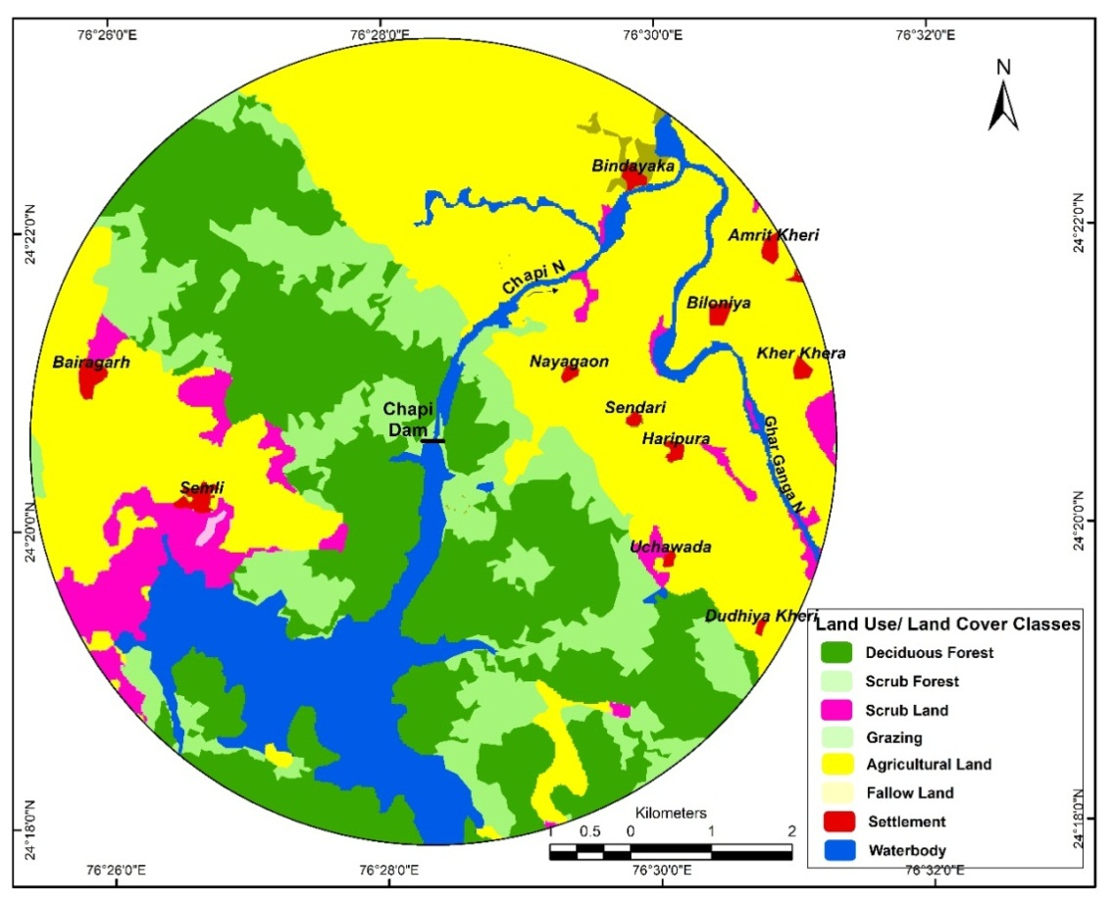
Figure 3.1: Land use/ Land cover Map of 5 km radius around Dam site

Ambient Air Quality and Noise
Site-specific data of ambient air quality and sound levels at project site is not available. However, general observation is made during site visit that area is free of air and noise pollution. This is substantiated by the fact that the dam is away from habitation, traffic and industries and are no anthropogenic sources of air/noise pollution in the vicinity. Road to dam site is private and public access is restricted. Therefore, ambient air is clean and sound levels are observed low. They are expected to be well within the prescribed limits.

Water Quality
Rajasthan State Pollution control Board monitor the status of water quality of Chhapi river near Chhapi Dam site. Result of water quality analysis is given in Annexure I. The water temperature varies from 19 ⁰C to 30 ⁰C. pH or hydrogen ion concentration of water is the measure of Acidity or Alkalinity of water and is an important indicator of its quality. pH of river water is ranged from 7.85 to 8.31 shows alkaline nature of water. Conductivity is a measure of capacity of any substance or solution to conduct electric current. As per the analysis results, the concentration of Conductivity varied in surface water from a maximum level of 370 µmho/cm to 250 µmho/cm. Hardness of river water observed from 80 mg/l to 148 mg/l. Alkalinity can be defined as the capacity of water to neutralize any strong acid. The concentration of the Alkalinity as CaCO3 has varied in surface water from a maximum level of 116 mg/l to a minimum level of 64 mg/l. Chloride occurs naturally in all types of waters. The most important source of Chlorides in the waters is the discharge of domestic sewage. Chloride as Cl has varied in surface water from a maximum level of 76 mg/l to a minimum level of 28 mg/l.

As can be seen from the data, the water quality is reasonably good. A comparison with Water Quality Criteria of Central Pollution Control Board show that samples fall under Class ‘B’. In India, the Central Pollution Control Board (CPCB) has developed a concept of designated best use. According to this, out of the several uses of water of a particular body, the use which demands highest quality is termed its designated best use. Five designated best uses have been identified. This classification helps the water quality managers and planners to set water quality targets and design suitable restoration programs for various water bodies. Class A corresponds to Drinking Water Source without conventional treatment but after disinfection and Class B corresponds Outdoor Bathing (organised).

Natural Hazards
Potential of natural hazards such as flooding and earthquake is not significant. Design flood has been revised from 4370 cumec to 5547 cumec and spillway capacity of the project at MWL has been calculated as 6240 in PST so its adequate to pass the revised flood. Project falls in earthquake zone II, there is no revision and dam design has taken care of this aspect as well. Bureau of Indian Standards [IS 1893 (Part I):2002], has grouped the country into four seismic zones, viz. Zone II, III, IV and V. Zone II is the least active and Zone V is the most active.

- BIOLOGICAL ENVIRONMENT

Flora
Jhalawar is located in the south east corner of Rajasthan at the edge of the Malwa plateau. Major forests are of dry-deciduous or mixed deciduous type consisting of Anogeissus pendula in pure strands or mixed with Diospyros melanoxylon and Tectona grandis, Acacia catechu, Anogeissus latifolia, Butea monosperma and Madhuca indica which are uniformly distributed in the study area (Sharma, 2002). Other common tree species reported from the area are Azadriachta indica, Nyctanthes arbor-tristis, Cassia fistula, Terminalis arjuna, Terminalia chembula, Holoptelea integrifolia, Boswellia serrata, Salvadora oleoides, Lannea coromandelica, Ficus benghalensis, Ficus religiosa, Emblica officinalis, Kydia calycina and Thevatia peruviana, etc. Bamboo is commonly found in the depressions and on moderate slopes. Shrubs in the area were mainly represented by Euphorbia, Lantana camara, Jatropha, Leptadenida pyrotechnica, Calligonum polygonoides, Calotropis procera, Acacia jacquemontti, Ziziphus nummularia, etc.

Fauna & Avifauna

Fauna:
The hillock forests, scrub forest, streams provide habitat for wildlife in the area. Rhesus Monkey, Jungle Cat, Leopard, Common Mongoose, Jackal, Fox, Striped Hyena, Palm civet, Otter, Blue bull, Spotted Dear, Sambhar, Wild Boar, Porcupine, Indian Hare, Grey Musk Shrew and Bats are reported from the forest area (Forest Working Plan (2013-14 to 2022-23), Jhalwar) Indian Palm Squirrel were sighted frequently species in the study area. Indian leopard, Tiger, striped hyena, golden jackal, Bengal fox, jungle cat, porcupine and sloth bear are also reported from the area.

Avifauna:
A total of 140 bird species belonging to 22 orders and 65 families were reported by Yadav (2018) in the Jhalawar Forest Division. The order Passeriformes most dominant with 72 species and 28 families followed by Anatidae family with 14 species. Data for residential status indicates that 133 bird species are resident, 48 bird species are migrant.

Proposed activities remain limited to dam premises and therefore no risk is envisaged on flora and fauna in the surrounding areas.

Fish & Fisheries
Fishes are the integral component of stream and rivers. Chhapi is a reservoir wherein major carps contribute substantially. As per forest working Plan of Jhalawar Forest Division six common species are reported from the area which are Catla catla, Labeo rohita, Labeo bata, Wallaga attu, Aorichthys seenghala, and Hetropneustes fossilis are reported from the area.

These species are present in reservoir and also in river. None of the proposed activities under the sub-project will impact water quality of river/reservoir and therefore, there is no risk/impact on fish fauna.

- PROTECTED AREA

Nearest Protected Area
Darah Wildlife Sanctuary is about 41.50 km and Shergarh Sanctuary is about 31.60 km from the Chhapi Dam location of the Project. The location of Darah Wildlife Sanctuary, Mukundara Tiger Reserve and Shergarh Sanctuary in relation to Chhapi dam Project are shown below.

Figure 3.2: Map showing distances of protected areas from Chhapi Dam

- SOCIAL ENVIRONMENT
The dam is located in the district Jhalawar. Eleven villages namely Amrit Kheri, Bairagarh, Bindayaka, Haripura, Kher Khera, Sendari, Semli, Uchawada, Dudhiya Kheri, Biloniya and Naya Gaon have been identified as falling in 5 km area on downstream side of the dam. The project area does not fall within the ‘Schedule V’ areas of the area.

The district has seven sub-divisions i.e. seven Tehsil Headquarters. The brief demographic characteristic of the district is given in the table below:

No. of Households | 2,83,295 | Household Size | 5
Total Population | 14,11,129 | Population (0-6 age) | 2,08,205
Male | 7,25,143 | Boys (0-6 age) | 1,08,890
Female | 6,85,986 | Girls (0-6 age) | 99,315
Sex Ratio | 946 | Sex Ratio (0-6) | 912
Population (SC) | 2,43,582 | Population (ST) | 1,82,229
Male | 1,25,965 | Male | 94,185
Female | 1,17,617 | Female | 88,044
Literates | 7,39,792 | Literacy Rate | 61.5
Male | 4,66,815 | Male | 75.8
Female | 2,72,977 | Female | 46.5
No. of Workers | 6,85,950 | Cultivators | 3,28,714 (47.9%)
Male | 4,02,825 | Agricultural Labours | 2,09,772 (30.6%)
Female | 2,83,125 | Household Industrial Workers | 11,199 (1.6%)
No. of Main Workers | 4,75,653 | Other Workers | 1,36,265 (19.9%)
No. of Marginal Workers | 2,10,297
Source: Census of India, 2011 (District Handbook)

Data on population, occupation and amenities of vicinity villages have been compiled from Census of India, 2011 (See Annexure II for more details).

According to Census 2011, total population of the study area has been worked out to 9,776. The gender wise distribution of the above population is 5,010 (51.25%) male and 4,766 (48.75%) female. The overall sex ratio of the study area has been worked out to 951 females per 1,000 males.

Total population of the study area is distributed into different social groups like Scheduled Caste (SC), Scheduled Tribe (ST) and General Category (including OBC). The share of these social groups’ population to the total population of the study area is 17.16%, 24.51% and 58.33% respectively.

In the study area, 37.42% of the population is literate in which male literates are 68.48% and that of females are 31.52%. The overall literacy rate in the study area has been worked out to 44.88%. The male literacy rate is 60.04% and female literacy rate is 28.98%, creating a gender gap in literacy rate of 31.06%.

The economic classification of workers as per Census 2011 is saying that total number of workers in the study area is 5,361 which constitute 54.84% of the total population. Of the total workers, 51.24% are males and remaining 48.76% are females. In absolute term, total number of male workers is 2,747 and that of female is 2,614. The gender gap in work participation rate is 2.48%.

Agriculture and allied activities are the main occupation & sources of livelihood and income for most of the local people in the study area. Apart from this, other people are engaged in household industries and ancillary works. Rabi and Kharif, both are the main crops. Maize, jowar, cotton, pulses, groundnut, wheat, barley, gram, oilseeds are the main crops from production point of view in the study area. Vegetable and fruits are also being produced in the study area. Irrigation through wells is the most important and the tube wells are the next most important source of irrigation followed by canals and tanks in the study area.
Basic amenities like water supply for drinking and other uses is available with various sources such as Tap (Treated & Un-treated), Well (Covered & Un-covered), Hand Pump, Tube wells etc. Electricity is available for domestic, agriculture and commercial or industrial uses in almost all over the study area. The study area having approach roads as Black Topped (Paved), Gravel (Kachcha) and Footpath.

- CULTURAL ENVIRONMENT
As per list of National Monuments in Rajasthan and list of State Protected monuments in Rajasthan; there are no protected monuments in and around dam site i.e. within 10 km radius of dam site.

Chapter  4 | STAKEHOLDER CONSULTATION

  - STAKEHOLDERS CONSULTATION
During the field visit, team along with project authorities have interacted with the local people for obtaining response of the communities regarding rehabilitation works of the Chhapi Dam.

List of villagers consulted during the visit are as below:
- Bharo Singh S/o Hira Lal
- Mangi Lal S/o Chayan Singh
- Babu Lal s/o Khanni Ram
- Mukesh Kumar s/o Gulab Chand
- Panna Lal s/o Kisan Lal
- Karan Singh s/o Mohan Lal
- Suresh s/o Mangi Lal
- Parmanand s/o Radha Krishan
- Ander Singh s/o Devi Lal
- Ratan Lal s/o Bhawar Lal

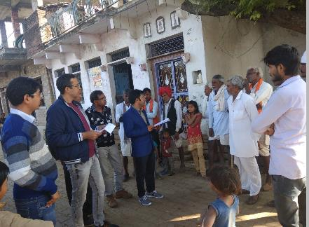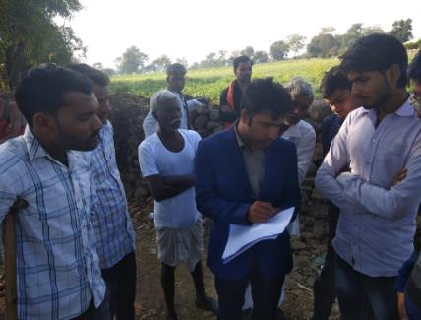

Consultation with Villagers

BRIEF DISCUSSIONS WITH COMMUNITY MEMBERS AT KALI KHEDI VILLAGE:
The villagers proposed the following measures that will help community upliftment and engage with the project actively.

- All the participants welcomed the proposed interventions related to the dam safety.
- The participants explicitly mentioned that the dam is their lifeline and strengthening works will help their long-time livelihood.
- Involvement of the villagers in the rehabilitation works - Provide employment to the local people at the time of construction of project works.
- Development of communication channel/ protocol within dam authorities and local villagers of the down stream villages (appx. 8-10 villages)
- To ensure the protection measures of the existing water bodies within downstream villages because of high water level.
- Government/ Project Authorities should provide the resources to the people for cleanliness of the silt/ clay deposits in the canals due to construction works and opening of gates in case of high-water level.
- Government/ Project Authorities should provide the resources to the villagers for farm lands affected in the down streams due opening of the gates in the rainy season/ flood scenarios.
- Authorities should provide the insurance to the villagers in case of any causality/ accident during rehabilitation works (applicable to villagers who will work on the project works).

Summary of discussions with them:
Questions | Responses
- Is this a tribal area? Is this a Schedule V area? Which tribals live here (name of groups) | No. Other Backward Classes (OBC) – Meena Community
- How many villages are living in the downstream | Appx. 10 number of villages living in the downstream area. Names are as below:  - Kali Khedi  - Manya Khedi  - Bindiaka  - Durjanpura  - Deoli  - Arnya  - Methoon  - Poly  - Banderi
- Were any of you affected when the dam was originally built? If so, what manner? Were you lands taken? If so, how long back and are there any pending compensation issues? | Yes. 1-2 village workers affected due to accidents occurred during the construction of the dam. Compensation is still under judicial process.
- Are any of working with the dam authorities? If so, in what capacity (direct worker or as a contractor) | No
- Are you in any affected by the dam operations? If so, in what manner, e.g. are you fishing communities or having farmlands downstream? | Yes. Some of the farm lands downstream affected due to opening of gates at the time of heavy rainfall. Some farmers are affected due to silt/ clay deposits in the downstream canals.
- Provide some more details on your fishing occupation? | Not Applicable. None of the farmers are involved in the fishery occupation directly or indirectly (contractor).  Fishery Department hold the rights of all fishing activities/ contracts.
- How do you think are women affected by the dam operations? | NA
- Are you aware of any early flood warning system? | Yes. Community is aware of Siren installed at the Dam.  During water discharge, the Sarpanch of the village of the downstream are informed.  Dam authority also inform Sub-Division-Magistrate (SDM) and the department shares the information with the local communities.
- Have there been any dam related accident that you are aware of? | NA
- Have you people suffered? If yes, in what manner; what is the nature of damage? | NA
- Have you had a need to contact the dam authorities on any specific issue such as water release etc. If so, how and what number and whom? What was it about? How long did it take resolve? Who contacted you? | Yes. Villagers are not aware of any grievances mechanism or contact details of dam authorities.  Dam authorities have confirmed for installing a display board at Dam Site for villagers to contact them in case of any emergency, grievance or request for water release.
- What are your concerns about the dam? (Provide some information on the dam safety interventions from the PST) | Villagers are concerned with:  - the heavy loaded vehicles passing over the dam.  - damage of their owned existing water bodies within downstream because of high water level.  - employment at the time of Dam Rehabilitation works. In case contractors does not allow local workers.  - communication channel/ protocol within dam authorities and local villagers  - scarcity of water due to silt/ clay deposits in the canal  - damage of farm lands during heavy rainfalls  - provision of insurance during employment and damages in farm lands.
- Under this project, the dam authorities will be preparing an Emergency Action Plan (EAP). This plan is to address any emergencies that arise; to help build resilience; to do resource mapping e.g. availability of boats during floods. It will involve lots of stakeholders including communities both during preparation and implementation. Would you like to be a part of these plans both during planning and implementation? | Communities are willing to join during preparation and implementation of Emergency Action Plan (EAP).
- If so, how would like to be informed/ engaged? If called for meeting, how would you like to be informed and what prior information would you like to be provided? | Community suggested to create small groups of 5-10 members in all the villages to work together. They are willing to share their mobile numbers with the dam authorities to coordinate.  Existing protocol is also comfortable with community i.e. coordination between Dam authorities, Sub-Division-Magistrate (SDM) Office and local sarpanch.
- If there are any petty contracts, would you like to know about it? | Yes
- Should such opportunities be advertised on the department website or through other means? How much time would you like to have in advance? | Other means. Villagers have no access to internet and awareness regarding departmental website.

CONSULTATION WITH PROJECT/ DAM AUTHORITIES:
During the field visit, team interacted with officials of WRD Aklera, Jhalwar, WRD Kota Zone, Sub Division Dara, and Chhapi Dam Authorities on February 11, 2020.

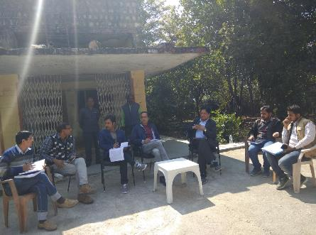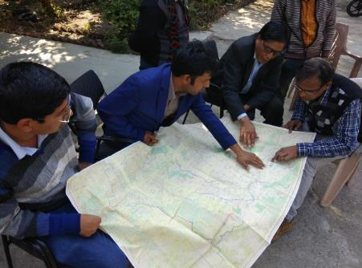

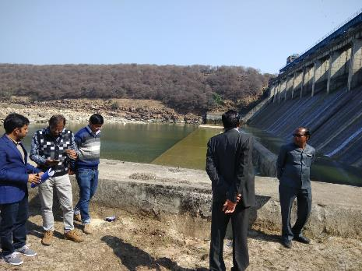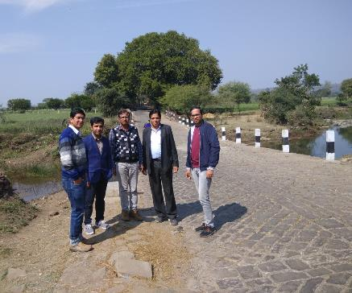

The following officials attended the meeting :
- Dharmander Gupta, Executive Engineer, WR Aklera, Jhalawar
- Jamanalal Hi Meena, AEn , WR Aklera, Jhalawar
- K.C. Trailor, AEn, WR Aklera, Jhalawar
- Anil Yadav, AEn, Sawan Bhado Sub Div I, Dara
- Rajesh Bairwa, JEn , Chappi DAM
- DhanRaj Meena, JEn, sub Div-IV, Aklera, Jhalawar
- Hitesh Kumar Thakur, The World Bank
- Jai Mansukhani, The World Bank

Summary of discussions with them:
Questions | Responses
- Are all the “structural” interventions either on the dam body or within the premises. | Yes, All the "structural" intervention is within the premises.
- Are there any legacy issues relating to displacement or resettlement i.e. pending from the time of dam construction? | NA
- Is all land required for the interventions available with the dam authorities? | Yes
- Are there any encroachments or squatters within the premises? | No
- Do you have staff quarters, guest houses that might be demolished or rebuilt? | No. Renovation of the guest house renovation at dam site as well as head quarter.
- What is the institutional structure to deal with E&S issues? | Environment and Social Consultant at SPMU level will support the project authorities to deal with E&S issues.
- Who will be in charge of these rehabilitation activities? | Mr. K.C. Tailor, Assistant Engineer at DAM Site
- Who or which official deals with communities? | - Rajesh Bairwa, Junior Engineer  - K.C.Tailor, Assistant Engineer  - Dharmander Gupta, Executive Engineer
- Are there any contact numbers for communities to contact dam officials? | Not at present. Dam authorities shared their number during community consultation at one village and proposed to install a display board at Dam Site with all contact information.
- How do you inform downstream communities on water discharge or any other issue? Are there any mechanisms that are currently used? | Siren is already installed at the Dam and authority is using the same for alerting communities.  In case of water discharge, there is a provision of communication between the Sarpanches of the downstream villages.  Dam authority also inform Sub-Division-Magistrate (SDM) to take preventive measures with eth downstream villages at the time of discharge.
- If so, whom do you contact in these areas and do you do any displays? | Sarpanch, SDM, Tehsildar.  No display system at present, but the same has been proposed in the existing PST.
- Are there women employees at the dam sites or at the SPMU? | Presently, there is no woman employee at Dam site. SPMU has 2-3 Project Assistant Directors
- Is there any Grievance mechanism currently used for reporting any kind of grievances? Who receives, what is the process of addressing; what is the nature of grievances received? | Yes, State Government online portal "www.sampark.rajasthan.gov.in/" for all type of grievances.  Grievances received at portal, get assigned to the Assistance Engineer at dam site. Executive engineer, Alkera Water Resource and chief engineer Kota zone are the next in hierarchy to address the critical issues in case not get resolved at AE level.
- Are all areas within the dam restricted access? | Only Dam's Gate operation system and Gallery is restricted area.  Bridge of Dam is being used as local connecting Road. The access is limited to Light motor vehicles only.
- Are there are tribals living in the area? Which are the tribes | No, there are no tribal living in the nearby area. Mostly other backward classes in the downstream villages.
- Is this a Schedule V area | No
- Are there tourist who visit? If yes, when and approximately how many | No. Local communities visit during rainy season to view the gate operations. Very few visit to the nearby archeological site Dalhanpur.
- Tourism component – which are the areas? Do these interventions in any way affected local communities, fishing communities? | There is scope of tourism activities near the dam site. Due to lack of staff and technical knowledge on tourism activities, authorities are unable to establish any tourism interventions as of now. Regarding fishing, the state fishery department holds all the rights.
- Do you advertise such “rehabilitation related” work related opportunities? If so, where and what are the timelines given to respond? | N.A.
- Would you involve communities in these tourism related interventions? How do you propose to approach this | Not applicable as of now. But authorities are willing to develop tourism intervention, and community participation for the same.

Based on these findings relating to both structural and non-structural interventions, potential stakeholders were categorized as follows: Affected, Other interested stakeholders, and disadvantaged and vulnerable stakeholders
Affected parties: There are no affected persons who shall be directly or indirectly adversely affected by the proposed interventions
Other interested stakeholders: In relation to structural interventions, these would be potential contractors, Project Management consultants, either regulatory bodies/institutional stakeholders such as Revenue, Environmental Authorities, etc. In relation to non-structural interventions, these would include: communities living downstream including farmers; village heads (Sarpanchs), community leaders; district administration; police, state disaster management authority, revenue department; electronic and print media, etc. These communities would be key stakeholders requiring to be involved in the preparation and implementation of EAP.
Disadvantaged and vulnerable persons and groups: Illiterate persons, physically challenged, women and elderly would be key stakeholders – requiring special focus and outreach to ensure that they are well informed about the provisions of the EAP.
Communities welcomed such interactions and indicated that they would prefer Dam authorities conduct one such face -to- face meeting once a month at a convenient location to inform of developments/interventions relevant to them. They welcomed other means of information such as advertisements in the local papers etc, but preferred to have face to face interactions at least once a month.

Chapter  5 | ENVIRONMENT & SOCIAL  RISKS AND IMPACTS

Based on the relevance of each Standard, as identified in the chapter on Legal, Regulatory and Institutional Framework, ensuing sections summarize the environmental and social risks and impacts likely due to the proposed interventions followed by the mitigation measures considered, for each relevant Standard. Table below, presents the Risk and impacts grouped in respect of the applicable ESS identified in chapter 3 earlier:

Applicable ESS | Risk and Impacts area assessed
ESS1- Assessment and Management of Environmental and Social Risks and Impacts | The risks and Impacts is carried out as per requirement of this standard
ESS2- Labour and Working Conditions | Types of Workers/labour and working conditions
ESS3- Resource Efficiency, Pollution Prevention and Management | Impact on Physiography/land use/Geology/Soil  Impacts on water resources/Water Quality  Impact on Air quality/Noise levels  Impact due waste generation/disposal
ESS4- Community Health and Safety | Impacts on Community Health and safety

- ASSESSMENT AND MANAGEMENT OF E&S RISK AND IMPACT (ESS 1)
Proposed intervention are categorised as civil, electromechanical and paint work requiring labour involvement for works and their stay at site for a period of about 2 years, use of resources such as water and power during construction, pollution generation from storage and handling of material, generation of waste, use of paints and other chemicals for construction activities, transportation of raw material, etc. In addition, labour intensive work always involves risks of accidents such as working at heights, working on upstream body of dam, underground activities, etc.

As all the proposed structural interventions are within the dam premises or the dam structure itself, no adverse impacts are not envisaged on communities including on the disadvantaged or vulnerable people. On the contrary, all communities including disadvantaged and vulnerable persons and groups will indirectly benefit from these proposed interventions that shall enhance dam safety.

However, in case of non-structural interventions relating to early flood warning systems having siren systems, broadcasting facilities and Emergency Action Plans, project will need to reach out to the disadvantaged and vulnerable persons and groups and involve them mainly during implementation.

- LABOUR AND WORKING CONDITIONS (ESS 2)
Water Resources Department, Rajasthan shall contract agencies to undertake civil works, agencies/firms to support core-functions; primary suppliers of material/equipment and other implementation support partners, engaged from anywhere in the country. Construction works will require labour force and associated goods and services. Based on the construction package sizes and the project implementation schedule, the peak construction workforce/manpower has been estimated as 40-50. These will be skilled and semi-skilled workforce of contractors and expected to stay on site over a period of 2 years. In addition, there will be floating population of suppliers, transporters of material and their labour who will keep on moving in and out of the site during the work period of 2 years. Construction contractors are expected to stay at/near dam, set up construction equipment and machinery near work location at pre-determined /approved sites.

Project shall comprise the following types of workers:

- Direct workers: Direct workers will include the project managers and supervisors, who are employees of WRD. The estimated number of direct workers is not likely to exceed 30 as per existing institutional arrangements and practices of WRD.

- Contracted workers: All the work force deployed by the Contractors will be deemed to be contracted workers. The Contractor(s) might further engage multiple subcontractors. All work force of all such sub-contractors will be also deemed to be contracted workers. These will also include migrant workers as all the required labor will not be fully supplied locally for a number of reasons, such as worker unavailability and lack of technical skills and capacity.

Migrant Workers: The migrant workers are that, who are employed for the Project but does not belong to the Project region and are not normally expected to return to their places of residence after work shift hours. The number of migrant workers in any contract package, would depend on decisions made by contractors, based on the locally available workforce and their skills for Project construction requirements. The migrant workers could be at all levels and include unskilled and semiskilled construction labour and could even comprise combination of male and women labour force. The migrant workers are either directly engaged by the contractor or through labour contractors, who supply the work force as per the needs of the contractors.

- Primary Supply Workers: No primary supplier or primary supply workers are anticipated as all goods and services essential to the core functions of the project shall be provided by the contractor – through a contract by Rajasthan WRD.

- Community Workers: Community workers are envisaged under the Emergency Action Plans, who will be mostly volunteers for implementing parts of the EAP.

Potential Labour risks: Following are the potential risks associated with workers/labours engaged in execution of planned intervention works.

Impact/Risks on Community
- Increased risk of spread of communicable diseases
- Waste generation from labour colony can pollute drinking water sources of community

Impacts/Risks for Workforce
- Safety issues while at work like injuries/accidents/ fatalities leading to even death, while at work;
- Short terms effects due to exposure to dust and noise levels, while at work
- Long term effects on life due to exposure to chemical /hazardous wastes
- Inadequate accommodation facilities at work force camps, including inadequate sanitation and health facilities
- Non-payment of wages
- Discrimination in Employment (e.g. abrupt termination of the employment, working conditions, wages or benefits etc.)
- Sexual harassment at work
- Security of women work force
- Absence or inadequate or inaccessible emergency response system for rescue of labour/workforce in situations of natural calamities.
- Health risks of labour relating to HIV/AIDS and other sexually transmitted diseases

In addition, other risks that would be applicable for all types of workers would be as follows:
- Unclear terms and conditions of employment
- Discrimination and denial of equal opportunity in hiring and promotions/incentives/training opportunities
- Denial for workers’ rights to form workers organizations, etc.
- Absence of a grievance mechanism for labour to seek redressal of their grievances/issues

- RESOURCE EFFICIENCY AND POLLUTION PREVENTION AND MANAGEMENT (ESS 3)

Impact on Physiography
The dam is operational since 2003 and the present interventions involve only civil and electromechanical works to improve dam operation and safety. All the work will be carried out at one location i.e. at dam (including premises), therefore, physiography will not change due to any of the proposed interventions. Therefore, there will be no significant impact on physiography of the region due to the proposed interventions.

Impact on Land/Geology
All project components are proposed to occur within existing dam (and premises) with no land acquisition. Therefore, impact on land and geology will be limited to sourcing of construction material or related to disposal of construction waste only. The civil works will require different construction materials such as earth, aggregate, boulders, and sand. The requirement of such material is not large and will be sourced from already operational and approved mines/quarries. The construction waste generation is also likely to be minimal and will be disposed off or reused for land filling or levelling purposes. However, requisite mitigation measures will be taken to minimise impact further.

The various ‘resource efficacy’ options during design include optimize usage of material generated as construction waste from repair activities and thereby reduce potential impact due to dumping etc., and achieve minimum construction footprint.

Impact on Soil
Repair sites will impact soil due to repair and demolition works such as renovation of disturbed u/s riprap, spillage during repair works of steps on d/s face of dam, parapet walls, spillway crest/glacis, treatment of honey-combed U/S area, lift joints for concrete dam, operation of construction equipment and machinery and waste generation thereof, etc. There is also possibility of contamination of soil from leakage and spillage during handling and storage of fuels and chemicals.

Muck Disposal:
The activities that generate construction debris and/or spoil are removal of damaged rip-raps, other repair activities such as repair works of steps on d/s face of dam, parapet walls, spillway crest/glacis, treatment of honey-combed U/S area, lift joints for concrete dam, etc. This being largely repair work, quantities have not been estimated and they are not expected to be significant to create disposal problem. Nevertheless, all the construction debris/muck generated needs to be disposed off in a planned manner to avoid adverse impacts on soil.

Impacts on Water Resources
The proposed intervention activities are not expected to impact drainage pattern or water resources (ground or surface) in any way as the proposed improvement interventions are neither crossing, altering or disturbing drainages nor impacting ground water resource in any form. The water for construction will be sourced from dam and as such requirement will be limited. However, use of water resources will be optimised before start of work through application of Resource Efficiency and Pollution Prevention techniques which will include optimal use planning, recycle and reuse option.

WRD along with contractor will prepare project specific water use and water balance analysis based on detailed design and prepare an action plan for water conservation and management and submit to SPMU/CPMU/WB for approval.

Impacts on Water Quality
Construction related impacts and risks for water quality include:
- accidental release of fuel or chemicals and contamination from poor waste practices affecting surface and groundwater
- contamination from construction machinery working near water bodies
- discharges and disturbance of soil and sediment that drain into surface waters
- Generation of sanitary wastes from camp site and construction sites finding way to water bodies

Impact on Ambient Air Quality
As discussed in baseline, ambient air quality in the area is pristine and without any significant anthropogenic sources of pollution. Construction activities can give rise to dust emissions if not effectively managed and have the potential to affect receptors near to the main construction sites due to dust generated from demolition, excavation, operation of construction equipment and machinery, increased movement of vehicles, onto the local road network. However, this impact is expected to be localised and temporary Earth works will result in exposed areas of soil which will potentially generate dust when it is windy, with dust potentially being generated when winds blow at all times of day or night, not just during active periods of construction. The level and distribution of dust emissions will vary according to the duration and location of activity, weather conditions, and the effectiveness of suppression measures.

Gaseous emission during construction will be from machinery, equipment and vehicles used for material transportation. The operation of vehicles and equipment will result in emissions of carbon monoxide, sulphur dioxide, and oxides of nitrogen as most of the commercial vehicles use diesel fuel. Impact on air quality due to emissions from vehicles will be in the areas immediately adjacent to work area. Additional vehicle movements generated during the construction phase will have the potential to influence local air quality at sensitive receptors located at close proximity to road and pollutant concentration is likely to reduce with increased distance from road. The impacts will therefore apply mostly to the villages en route the dam.

As the project is presently operational and the interventions are not going to alter the project operation in any manner, no operational phase impacts are envisaged on ambient air quality.

Impact of Noise and Vibration
Sources of noise will be from the vehicles and equipment for construction at the project site. Due to construction activity in the area, noise levels will increase during the period of construction, however, they will remain limited to the work area mainly where construction activity will progress. Additionally, noise levels will increase on approach roads due to increased traffic.

Impact of noise generation due to operation of construction machines and equipment is the exposure of workers operating these machines and other who are working in the surrounding. Such impacts can become significant if these workers are exposed to high noise for long hours continuously.

Impact of Waste Generation
Migratory population is expected to reside in the area during peak construction period. Proper sanitary and solid waste management facilities would be provided at the labour colonies. In the absence of proper solid waste management plan, there can be serious impacts of land and water pollution due to indiscriminate disposal. In addition, there will be odour issues and health impacts. There will be an influx of labourers and other service providers into the project area. Sewage and solid waste will be generated from the colonies. It is essential that from the planning stage, sewage management and solid waste disposal facilities should be conceptualized to maintain the health of the people and the environment. Solid waste generated from the colonies during construction phase will be disposed off as per Solid Wastes Management Rules, 2016.

As most of the proposed activities involve repair and renovation, it is expected that construction and demolition waste in the form of debris will be generated. This being largely repair work, quantities have not been estimated and they are not expected to be significant to create disposal problem. Nevertheless, all the construction debris/muck generated needs to be disposed off in a planned manner to avoid adverse impacts on soil/land. All such wastes will be handled in compliance with Construction and Demolition Waste Rules, 2016.

Project interventions include substantial amount of electro-mechanical work such as repair of hoist, providing standby generator, providing and installing armored H.T. service line and L.T. armored cable for control room, gallery and gantry, epoxy thermal sealing & epoxy paint on vertical gate of dam etc. These activities will generate significant amount of waste in terms of replaced parts, packaging material, empty containers, use and disposal of oil & grease, iron scrap, etc. there will be a mix of hazardous and non-hazardous wastes. It is important to have a plan ready for disposal of such wastes before start of the activity.

Contractor is obliged to provide first-aid/basic medical facilities to labour at site especially during accident/emergency which is likely to generate bio-medical waste, although quantity is not expected to be significant, this needs to be managed to avoid indiscriminate dumping as impacts could be serious.

WRD along with contractor will prepare project specific muck / debris/Solid Waste disposal plan and provide sufficient site for such disposals.

- COMMUNITY HEALTH AND SAFETY (ESS 4)
Heath safety and security risks and impacts on project affected communities especially on vulnerable people are not considered significant as communities are not directly involved or getting impacted. However, the project construction would involve engagement of labour, transportation and handling of material, civil construction and electromechanical works and such activities will impact the community and increase the risks.

Engagement of labour for project work and their stay at site over a 2 years’ time, will increase the risks of crimes including gender based violence. Waste generation from labour camps/colony if not handled properly, will pollute the water resources used by community for drinking leading to health impacts. Migratory workforce may be bringing in new and infectious diseases not known to area.

Transportation of material will increase the traffic on village roads. There are 11 villages in vicinity of dam site where traffic will be impacted due to increased movement of traffic and thus impact the community by way of increased noise and air pollution. In addition, this will also increase the risk of accidents.

Similarly, civil construction and electromechanical works will lead to pollution generation in the form of air emissions and noise generation, which will remain local and are not expected to impact the community. Construction waste and electromechanical work waste, especially the hazardous waste if not disposed off properly have the potential of impacting the surrounding community.

Chapter  6 | ENVIRONMENT AND SOCIAL MANAGEMENT PLAN

  - ENVIRONMENT AND SOCIAL MANAGEMENT PLAN
E&S impacts/risks for this sub-project Dam is Low risk, as identified in the previous chapter. These risks and impacts can be mitigated by appropriately implementing management measures. Based on the ESIA following plans/procedures have been identified to effectively mitigate the environment and social impacts and risks of the proposed interventions:

- Labour Management Procedure including GRM
The Procedure will set out the way in which project workers will be managed, in accordance with the requirements of national law and the bank’s ESS Standards and will address the way in which this ESS will apply to different categories of project workers. It covers the terms and conditions of employment, non-discrimination and equal opportunity, worker’s organization and welfare. Protecting the workforce, establishing minimum age for labour to prevent child labour will be defined in the procedure. The responsibility to manage any adverse impacts would be clearly reflected in the contractual obligations of the Contractor with appropriate mechanisms for addressing non-compliance.

A grievance mechanism will be provided for all direct workers and contracted to raise workplace concerns and workers will be informed of the grievance mechanism at the time of recruitment along with the measures put in place to protect them against any reprisal for its use. Mechanism will be easily accessible to all project workers. It will be designed to address concerns promptly, using an understandable and transparent process that provides timely feedback to those concerned in a language they understand, without any retribution, and will operate in an independent and objective manner.

The document shall be prepared by Rajasthan WRD with support from the E&S staff and shall be applicable for all dams taken under DRIP II in the state. It will be disclosed by Rajasthan WRD one month before mobilization of the Contractor.

- OHS Measures
Measures relating to occupational health and safety applies to the project as it involves engagement of workers. The OHS measures will take into account the General Environment Health and Safety Guidelines and applicable legal requirements. The OHS measures will be designed and implemented to address:
- identification of potential hazards to project workers, particularly those that may be life threatening;
- provision of preventive and protective measures, including modification, substitution, or elimination of hazardous conditions or substances;
- training on occupational safety and health, and maintenance of training records
- Provision of personal protective equipment without expense to the project workers.
- documentation and reporting of occupational accidents, diseases and incidents;
- emergency prevention and preparedness and response arrangements to emergency situations;
- remedies for adverse impacts such as occupational injuries, deaths, disability and disease
- accident reporting and analysis procedure
- system for regular review of OHS performance

The document shall be prepared by Rajasthan WRD with support from E&S Staff and shall be applicable for all dams taken under DRIP 2 in the state. It shall be disclosed by Rajasthan WRD one month before mobilization of the Contractor.

- GBV Risk Mitigation Guidelines
The proposed structural interventions are extremely localized in nature and will be carried out in areas of restricted access – as normally all dams are. These structural interventions will not result in any project interface with local communities, the overall GBV rating for this dam intervention as per the Risk Assessment Tool is low. Hence, in accordance with the overall GBV Risk Mitigation Framework for the project, guidelines will be developed commensurate to the low risk category to address Gender Based Violence Risk before invitation of bids. The Plan will provide a set of measures such as orientation to all categories of labour including department staff/dam site personnel. The document shall be prepared by Rajasthan WRD with support from the E&S Staff of Rajasthan WRD.

- Resource Efficiency and Pollution Prevention Measures
Keeping in view the risks and impacts of the proposed activities, WRD will prepare a set of measures to be implemented by the Contractors to ensure efficient use of resources and avoid/minimize the pollution from proposed interventions. The measures should address all possible impacts identified above, with respect to resource use and pollution generation from civil works including road repair, electromechanical and painting work and also from labour camps and colonies. It should focus on reuse/recycling; energy efficiency such as solar lights and cookers for colony/community kitchen for workers, where possible.

The project’s demand for major raw material such as boulders, aggregate and sand for construction will be sourced through pre-existing authorized quarries, with valid environment clearance. To mitigate air and noise pollution from transportation, material storage and handling and construction activities, following measures should be included:
- To ensure trucks are loaded only up to permitted capacities to prevent high emission
- The ensure trucks used for transportation of material is covered by tarpaulin and provided tail board, so that en-route spillage and generation of fugitive dust are prevented.
- Vehicles in good condition with valid PUC (Pollution Under Control) certificate shall be deployed during construction

Regular sprinkling of the water will be done on construction sites for dust suppression.

Mobile DG sets shall be used for lighting only during construction phase and they should meet emission and noise standards as per guidelines/standards issued by CPCB.

All the construction workers and other staff, who get directly exposed to dust, should necessarily be provided with dust masks. Workers in high noise area, will be provided with ear muffs and their use will be monitored. Workers exposure (time duration) to high noise will also be controlled.

The use of noise producing equipment during night hours will be minimized to avoid the disturbance to locals and wild animals of surrounding area.

To mitigate the risk of wastewater from construction site and colony finding its way to fresh water source without treatment, the following measures should be included:
- All toilets and wash areas in worker’s colony have functional septic tanks and soak pit arrangements, of adequate capacity.
- No discharge from oil/lube storage areas shall be directly discharged in to any open surface water channel/ streams.
- Construction along the river bank/reservoir shall be done when surface water level is receded and clear construction area is available.
- Storage of material and construction equipment should be kept away from the drainages to avoid any spillage and pollution of surface water.

For solid and hazardous waste management, sites should be identified for disposal of construction waste, surplus excavated material, and other solid wastes; and appropriate permissions taken for dumping with restoration plan covering engineering and biological measures as appropriate. No dump site shall be located in forest area.

WRD will share identified locations of muck or debris disposal sites with the contractor. The contractor will develop a muck and debris disposal plan after incorporating longitudinal and cross section references to assess volume or capacity of the disposal site and will submit muck/ debris disposal plan before commencement of the work at site. This action needs to be included in the Bid Document as one of the key requirements.

WRD needs to prepare a plan to identify and quantify all the waste generated from electro-mechanical work include replaced parts with estimated quantities and categorisation as hazardous and non-hazardous waste. The plan should also identify the temporary secured and covered storage location till the time it is removed, contractors/vendors who will pick these parts/wastes; authorisation status of contractors for hazardous wastes.

Measures should also cover cleanliness of the labour colony, provision of basic sold waste collection facilities and restrict dumping of solid waste on land or in water body. Contractor should provide bins for dumping of domestic waste from colony and ensure timely pick up and dumping at authorised location.

The document shall be prepared by Rajasthan WRD with support from the E&S staff and shall be applicable for all dams taken under DRIP II in the state. It shall be disclosed by Rajasthan WRD one month before mobilization of the Contractor.

- Emergency Response Plan
The plan will identify and implement measures to address emergency events, arising from both natural and man-made hazards, typically in the form of fire, explosions, leaks or spills or flooding of downstream area in case of dam break. The measures will be designed to address the emergency event in a coordinated and expeditious manner, to prevent it from injuring the health and safety of the community, and to minimize, mitigate and compensate for any impacts that may occur. ERP will cover emergency preparedness and response activities, resources, and responsibilities, and will disclose appropriate information to affected communities, relevant government agencies, or other relevant parties. The Borrower will assist and collaborate with affected communities, relevant government agencies and other relevant parties in their preparations to respond effectively to an emergency. The plan so prepared should be dovetailed with district disaster management plan and state disaster management plan.

The plan shall be prepared by Rajasthan WRD by engaging expert consultants and is part of DRIP II activities; it should be ready before the invitation of bids.

- Procedures for Stakeholder Engagement
The Stakeholder Engagement Framework (SEF) will describe the timing, methods of engagement with stakeholders and range of information, distinguishing between project-affected parties and other interested parties, as well as the type of information to be sought from them. The procedures developed based on SEF will set out how stakeholders will be engaged throughout project preparation and implementation and describe the measures that will be used to remove obstacles to participation, and how the views of differently affected groups will be captured. Where applicable, the procedures will include differentiated measures to allow the effective participation of those identified as disadvantaged or vulnerable. The draft Framework will be prepared by CWC in discussion with Rajasthan WRD and will be disclosed. The Stakeholder Engagement Procedures will be developed specific to the proposed interventions at the site, prior to invitation of bids.

Institutional Arrangement: As part of institutional strengthening for implementation of sub-projects, Environmental and Social staff will be engaged by the department to enable preparation of management plans as well subsequent implementation of mitigation measures during implementation. IA will hire experts from outside department or seek deputation of staff with relevant experience

- Grievance Mechanism
WRD shall establish and implement a grievance mechanism to receive and facilitate resolution of concerns and grievances, from the communities and other stakeholders including implementation partners. It shall be proportionate to the potential risks and impacts of the project and be accessible and inclusive. The department will establish three levels of Grievance Mechanism:

1. A cell at each of the dam site headed by respective Executive Engineer
2. A cell at the SPMU headed by CE/PD
3. A committee at the state government level headed by Secretary to Government

Details on the processes and procedures for the GRM will be provided in the Stakeholder Engagement Framework.

  - MONITORING REPORTING AND BUDGETING
SPMU will prepare a monitoring, reporting and budgeting requirement to implement above plans and measures, which will be approved by CPMU - CWC. SPMU will prepare a quarterly monitoring report and submit to CPMU - CWC.

  - ENVIRONMENTAL AND SOCIAL COMMITMENT PLAN (ESCP) AND OTHER REQUIREMENTS
WRD, Rajasthan will agree on an Environmental and Social Commitment Plan (ESCP) with the Bank covering the material measures and actions that are required for the project to achieve compliance with the ESSs over a specified timeframe. It will take into account the findings of the environmental and social assessment, the Bank’s environmental and social due diligence and the results of engagement with stakeholders. ESCP will clearly spell out the plans to be prepared with time frame and responsibility.

Annexure I
Water Quality of Chhapi River
Parameter | 16-01-2019 | 19-02-2019 | 05-04-2019 | 28-06-2019 | 26-08-2019 | 18-10-2019
Temperature(0C) | 19 | 20 | 28 | 30 | 30 | 26
pH | 7.85 | 8.02 | 8.16 | 8.31 | 7.96 | 8.02
Conductivity (µmho/cm) | 340 | 330 | 350 | 370 | 250 | 320
Total Dissolved Solids(mg/l) | 212 | 236 | 266 | 282 | 190 | 234
Total Suspended Solids(mg/l) | 13 | 17 | [N/A] | [N/A] | [N/A] | [N/A]
Dissolved Oxygen(mg/l) | 5.92 | 6.204 | 4.64 | 4.85 | 5.71 | 5.3
Total Hardness As CaCO3(mg/l) | 116 | 124 | 136 | 148 | 80 | 92
Calcium as Ca (mg/l) | 28.8 | 30.4 | 33.6 | 32 | 20.8 | 24
Magnesium as Mg (mg/l) | 10.736 | 11.712 | 12.688 | 16.592 | 6.832 | 7.808
Chloride (mg/l) | 68 | 76 | 32 | 40 | 28 | 36
Ammonia Nitrogen (mg/l) | 0.54 | 0.48 | 0.72 | 0.62 | 0.48 | 0.44
Total Alkalinity (mg/l) | 112 | 116 | 96 | 104 | 64 | 68
B.O.D. (mg/l) | 2.44 | 2.256 | 1.75 | 1.14 | 1.12 | 1.2
C.O.D. (mg/l) | 14.76 | 12.8 | 31.82 | 8.95 | 5.69 | 10.4
Nitrate as N(mg/l) | 2.2 | 2.06 | 2.74 | 1.84 | 1.84 | 1.76
Sodium(mg/l) | 37 | 34 | 25.5 | 32 | 21 | 25.5
Sulphate(mg/l) | 38.5 | 43 | 23 | 28.5 | 23 | 30.5
Phosphate As PO4(mg/l) | 0.1 | 0.1 | 0.1 | 0.1 | 0.1 | 0.1
Potassium As K (mg/l) | 1.1 | 1.3 | 2.1 | 1.8 | 1 | 1.3
Fecal Coliform (MPN/100ml) | 9 | 9 | 11 | 11 | 14 | 21
Total Coliform(MPN/100ml) | 28 | 28 | 28 | 28 | 28 | 28
Source: Rajasthan State Pollution Control Board

Annexure II
Socio-economic Profile of Proximity villages (Study Area)

Study area is defined as proximity villages i.e. villages which fall within 5 km distance from dam on downstream side (no upstream villages in 5 km radius). These are Amrit Kheri, Bairagarh, Bindayaka, Haripura, Kher Khera, Sendari, Semli, Uchawada, Dudhiya Kheri, Biloniya and Naya Gaon.

- Demography of Study Area
S. No. | Description | Number |  | Percentage to Respective Total
1 | Total Population | 9776 |  | 100.0
 | Male | 5010 |  | 51.25
 | Female | 4766 |  | 48.75
 | Sex Ratio | 951
2 | Population (0-6 age group) | 1626 |  | 100.0
 | Male | 838 |  | 51.54
 | Female | 788 |  | 48.46
 | Child Sex Ratio | 940
3 | Scheduled Caste (SC) Population | 1678 |  | 100.0
 | Male | 872 |  | 51.97
 | Female | 806 |  | 48.03
 | Sex Ratio | 924
4 | Scheduled Tribe (ST) Population | 2396 |  | 100.0
 | Male | 1252 |  | 52.25
 | Female | 1144 |  | 47.75
 | Sex Ratio | 914
5 | General Category (Including OBC) | 5702 | 100.0
 | Male | 2886 | 50.61
 | Female | 2816 | 49.39
 | Sex Ratio | 976
6 | Total No. of Households | 2028
 | Average Household Size | 5
7 | Total Literates | 3658 |  | 100.0
 | Male | 2505 |  | 68.48
 | Female | 1153 |  | 31.52
 | Overall Literacy Rate | 44.88
 | Male Literacy Rate | 60.04
 | Female Literacy Rate | 28.98
 | Gender Gap in Literacy Rate | 31.06
8 | Total Workers | 5361 |  | 100.0
 | Male | 2747 |  | 51.24
 | Female | 2614 |  | 48.76
 | Gender Gap in Work Participation Rate | 2.48
9 | Main Workers | 3700 |  | 100.0
 | Male | 2322 |  | 62.76
 | Female | 1378 |  | 37.24
 | Gender Gap in Work Participation Rate | 25.52
10 | Marginal Workers | 1661 |  | 100.0
 | Male | 425 |  | 25.59
 | Female | 1236 |  | 74.41
 | Gender Gap in Work Participation Rate | -48.82
11 | Household Industrial Workers | 38 |  | 100.0
 | Male | 18 |  | 47.37
 | Female | 20 |  | 52.63
12 | Cultivators | 2924 |  | 100.0
 | Male | 1697 |  | 58.04
 | Female | 1227 |  | 41.96
13 | Agricultural Labour | 2056 |  | 100.0
 | Male | 765 |  | 37.21
 | Female | 1291 |  | 62.79
14 | ‘Other Workers’ | 343 |  | 100.0
 | Male | 267 |  | 77.84
 | Female | 76 |  | 22.16
Source: Census of India, 2011

- Population Composition
According to Census 2011, total population of the study area has been worked out to 9,776. The gender wise distribution of the above population is 5,010 (51.25%) male and 4,766 (48.75%) female. The overall sex ratio of the study area has been worked out to 951 females per 1,000 males. The entire population of the study area is distributed into approx. 2,028 households and the average household size is five.

Village wise population distribution of the study area is given in the table below:
Village wise Population Distribution with Sex Ratio
S. No. | Village | No. of HH | Population |  |  | Sex Ratio
 |  |  | Total | Male | Female
01 | Amrit Kheri | 282 | 1264 | 668 | 596 | 892
02 | Bairagarh | 587 | 2828 | 1440 | 1388 | 964
03 | Bindayaka | 211 | 1079 | 575 | 504 | 877
04 | Haripura | 99 | 445 | 221 | 224 | 1014
05 | Kher Khera | 84 | 382 | 196 | 186 | 949
06 | Sendari | 29 | 124 | 68 | 56 | 824
07 | Semli | 149 | 701 | 334 | 367 | 1099
08 | Uchawada | 201 | 930 | 480 | 450 | 938
09 | Dudhiya Kheri | 124 | 605 | 309 | 296 | 958
10 | Biloniya | 96 | 568 | 292 | 276 | 945
11 | Naya Gaon | 166 | 850 | 427 | 423 | 991
TOTAL |  | 2028 | 9776 | 5010 | 4766 | 951
Source: Census of India, 2011

- Child Population Distribution
In the study area, the total child population of 0-6 age group has been worked out to 1,626 which represent 16.63% of the total population. Of the total child population, 51.54 % are boys and remaining 48.46% are girl child. The child sex ratio in this age group is 940 girls per 1,000 boys.

Village wise child population distribution of the study area is given in the table below:
S. No. | Village | Child Population (0-6) Age Group |  |  | Sex Ratio
 |  | Total | Boys | Girls
01 | Amrit Kheri | 200 | 104 | 96 | 923
02 | Bairagarh | 437 | 218 | 219 | 1005
03 | Bindayaka | 174 | 100 | 74 | 740
04 | Haripura | 85 | 40 | 45 | 1125
05 | Kher Khera | 57 | 34 | 23 | 676
06 | Sendari | 19 | 10 | 09 | 900
07 | Semli | 143 | 61 | 82 | 1344
08 | Uchawada | 168 | 93 | 75 | 806
09 | Dudhiya Kheri | 106 | 52 | 54 | 1038
10 | Biloniya | 102 | 51 | 51 | 1000
11 | Naya Gaon | 135 | 75 | 60 | 800
TOTAL |  | 1626 | 838 | 788 | 940
Source: Census of India, 2011

- Social Group Population Distribution
Total population of the study area is distributed into different social groups like Scheduled Caste (SC), Scheduled Tribe (ST) and General Category (including OBC). The share of these social groups’ population to the total population of the study area is 17.16%, 24.51% and 58.33% respectively.

- Scheduled Caste (SC) Population: In the study area, Scheduled Caste population has been worked out to 1,678 which constitute about 17.16% of the total population. Of this, 51.97% is male and remaining 48.03% is female. The sex ratio among Scheduled Caste population has been worked out to 924 females per 1,000 males.

Village wise SC population distribution of the study area is given in the table below:
S. No. | Village | SC Population |  |  | Sex Ratio
 |  | Total | Male | Female
01 | Amrit Kheri | 143 | 77 | 66 | 857
02 | Bairagarh | 231 | 114 | 117 | 1026
03 | Bindayaka | 237 | 130 | 107 | 823
04 | Haripura | 00 | 00 | 00 | 000
05 | Kher Khera | 17 | 09 | 08 | 889
06 | Sendari | 08 | 05 | 03 | 600
07 | Semli | 483 | 229 | 254 | 1109
08 | Uchawada | 326 | 176 | 150 | 852
09 | Dudhiya Kheri | 78 | 43 | 35 | 814
10 | Biloniya | 64 | 38 | 26 | 684
11 | Naya Gaon | 91 | 51 | 40 | 784
TOTAL |  | 1678 | 872 | 806 | 924
Source: Census of India, 2011

- Scheduled Tribe Population: The Scheduled Tribe population in the study area has been worked out to 2,396 which represent 24.51% of the total population. Of the total Scheduled Tribe population, 52.25% is male and 47.75% is female. The sex ratio among the Scheduled Tribe population has been worked out to 914 females per 1,000 males.

Village wise ST population distribution of the study area is given in the table below:
S. No. | Village | ST Population |  |  | Sex Ratio
 |  | Total | Male | Female
01 | Amrit Kheri | 903 | 479 | 424 | 885
02 | Bairagarh | 501 | 265 | 236 | 891
03 | Bindayaka | 186 | 99 | 87 | 879
04 | Haripura | 00 | 00 | 00 | 000
05 | Kher Khera | 00 | 00 | 00 | 000
06 | Sendari | 116 | 63 | 53 | 841
07 | Semli | 07 | 01 | 06 | 6000
08 | Uchawada | 71 | 36 | 35 | 972
09 | Dudhiya Kheri | 96 | 49 | 47 | 959
10 | Biloniya | 428 | 215 | 213 | 991
11 | Naya Gaon | 88 | 45 | 43 | 956
TOTAL |  | 2396 | 1252 | 1144 | 914
Source: Census of India, 2011

- General Category (including OBC) Population: The population of this group has been worked out to 5,702 which is 58.33% of the total population of the study area. Of the total population of this group, 50.61% is male and 49.39% is female. The sex ratio among this group of population has been worked out to 976 females per 1,000 males.

Village wise General Category (including OBC) population distribution of the study area is given in the table below:
S. No. | Village | GEN (including ‘OBC’) Population |  |  | Sex Ratio
 |  | Total | Male | Female
01 | Amrit Kheri | 218 | 112 | 106 | 946
02 | Bairagarh | 2096 | 1061 | 1035 | 975
03 | Bindayaka | 656 | 346 | 310 | 896
04 | Haripura | 445 | 221 | 224 | 1014
05 | Kher Khera | 365 | 187 | 178 | 952
06 | Sendari | 00 | 00 | 00 | 000
07 | Semli | 211 | 104 | 107 | 1029
08 | Uchawada | 533 | 268 | 265 | 989
09 | Dudhiya Kheri | 431 | 217 | 214 | 986
10 | Biloniya | 76 | 39 | 37 | 949
11 | Naya Gaon | 671 | 331 | 340 | 1027
TOTAL |  | 5702 | 2886 | 2816 | 976
Source: Census of India, 2011

- Literates, Literacy Rate and Gender Gap in Literacy Rate
In the study area, 37.42% of the population is literate in which male literates are 68.48% and that of females are 31.52%. The overall literacy rate in the study area has been worked out to 44.88%. The male literacy rate is 60.04% and female literacy rate is 28.98%, creating a gender gap in literacy rate of 31.06%.

Village wise literate population and literacy rate is given in the table below:
S. No. | Village | Literate Population |  |  | Literacy Rate (%)
 |  | Total | Male | Female | Total | Male | Female
01 | Amrit Kheri | 567 | 402 | 165 | 53.29 | 71.28 | 33.00
02 | Bairagarh | 982 | 672 | 310 | 41.07 | 54.99 | 26.52
03 | Bindayaka | 534 | 358 | 176 | 59.01 | 75.37 | 40.93
04 | Haripura | 71 | 58 | 13 | 19.72 | 32.04 | 7.26
05 | Kher Khera | 121 | 81 | 40 | 37.23 | 50.00 | 24.54
06 | Sendari | 55 | 41 | 14 | 52.38 | 70.69 | 29.79
07 | Semli | 175 | 124 | 51 | 31.36 | 45.42 | 17.89
08 | Uchawada | 456 | 287 | 169 | 59.84 | 74.16 | 45.07
09 | Dudhiya Kheri | 170 | 119 | 51 | 34.07 | 46.30 | 21.07
10 | Biloniya | 170 | 130 | 40 | 36.48 | 53.94 | 17.78
11 | Naya Gaon | 357 | 233 | 124 | 49.93 | 66.19 | 34.16
TOTAL |  | 3658 | 2505 | 1153 | 44.88 | 60.04 | 28.98
Source: Census of India, 2011

- Workers and Work Participation Rate
The economic classification of workers as per Census 2011 is saying that total number of workers in the study area is 5,361 which constitute 54.84% of the total population. Of the total workers, 51.24% are males and remaining 48.76% are females. In absolute term, total number of male workers is 2,747 and that of female is 2,614. The gender gap in work participation rate is 2.48%.

Further of the total workers, 69.02% are main workers and remaining 30.98% are marginal workers. Of the total main workers, 62.76% are male and remaining 37.24% are female which creates a gender gap in work participation rate of 25.52%. In case of marginal workers, 25.59% are male and 74.41% are female that creates a gender gap of minus (-) 48.82% in this segment of work participation.

Village wise working population of the study area is given in the table below:
Village Name | Total Worker |  |  | Main Worker |  |  | Marginal Worker
 | T | M | F | T | M | F | T | M | F
Amrit Kheri | 574 | 351 | 223 | 441 | 296 | 145 | 133 | 55 | 78
Bairagarh | 1672 | 847 | 825 | 1305 | 718 | 587 | 367 | 129 | 238
Bindayaka | 530 | 286 | 244 | 342 | 268 | 74 | 188 | 18 | 170
Haripura | 249 | 116 | 133 | 130 | 84 | 46 | 119 | 32 | 87
Kher Khera | 253 | 132 | 121 | 188 | 108 | 80 | 65 | 24 | 41
Sendari | 66 | 33 | 33 | 32 | 23 | 09 | 34 | 10 | 24
Semli | 375 | 188 | 187 | 323 | 185 | 138 | 52 | 03 | 49
Uchawada | 491 | 242 | 249 | 250 | 173 | 77 | 241 | 69 | 172
Dudhiya Kheri | 350 | 175 | 175 | 254 | 155 | 99 | 96 | 20 | 76
Biloniya | 318 | 146 | 172 | 222 | 143 | 79 | 96 | 03 | 93
Naya Gaon | 483 | 231 | 252 | 213 | 169 | 44 | 270 | 62 | 208
TOTAL | 5361 | 2747 | 2614 | 3700 | 2322 | 1378 | 1661 | 425 | 1236
Source: Census of India, 2011

The workers are further divided into Cultivators, Agricultural Labours, Household Industrial Workers and ‘Other Workers’. Their shares in the total workers are 54.54%, 38.35%, 0.71% and 6.40% respectively.

Distribution of working population with various occupations is given in table below:
S. No. | Village | Total Workers | Cultivators | Agricultural Labour | Household Industrial Workers | Other Workers
01 | Amrit Kheri | 574 | 473 | 78 | 01 | 22
02 | Bairagarh | 1672 | 969 | 621 | 03 | 79
03 | Bindayaka | 530 | 286 | 206 | 01 | 37
04 | Haripura | 249 | 39 | 197 | 01 | 12
05 | Kher Khera | 253 | 156 | 95 | 00 | 02
06 | Sendari | 66 | 56 | 05 | 00 | 05
07 | Semli | 375 | 76 | 254 | 13 | 32
08 | Uchawada | 491 | 193 | 224 | 00 | 74
09 | Dudhiya Kheri | 350 | 244 | 87 | 05 | 14
10 | Biloniya | 318 | 292 | 24 | 00 | 02
11 | Naya Gaon | 483 | 140 | 265 | 14 | 64
TOTAL |  | 5361 | 2924 | 2056 | 38 | 343
Source: Census of India, 2011

Agriculture and allied activities are the main occupation & sources of livelihood and income for most of the local people in the study area. Rabi and Kharif, both are the main crops. Maize, jowar, cotton, pulses, groundnut, wheat, barley, gram, oilseeds are the main crops from production point of view in the study area. Vegetable and fruits are also being produced in the study area. Apart from this, other people are engaged in household industries and ancillary works.

- Basic Amenities
The basic amenities like education, health, drinking water, electricity, approach road, transportation and other facilities available in the study area are given in the following table:

Basic Amenities Available in the Study Area
EDUCATION
Educational Institutions | Type of Institutes | Number
 | Pre-primary School (Pvt.) | 03
 | Primary School (Govt.) | 07
 | Primary School (Pvt.) | 02
 | Middle School (Govt.) | 03
 | Middle School (Pvt.) | 02
 | Secondary School (Govt.) | 01
HEALTH
Health Facilities | Type of Facilities | Number
 | Primary Health Sub-Centre | 04
 | Maternity and Child Welfare Centre | 01
 | Non-Govt. Medical Facilities (For Out Patient) | 04
 | ASHA | 08
 | Anganwadi Centre (Nutritional Centre) | 08
 | Nutritional Centre- ICDS | 10
WATER
Drinking Water | Means of Drinking Water | No. of Villages
 | Tap (Treated & Un-treated) | 03
 | Well (Covered & Un-covered) | 07
 | Hand Pump | 10
 | Tube wells | 05
ELECTRICITY
Electricity Supply | Types of Electricity Available | No. of Villages
 | Power for Domestic Uses | 11
 | Power for Agriculture Uses | 10
 | Power for Commercial or Industrial Uses | 04
ROAD
Approach Road | Types of Approach Roads | No. of Villages
 | Black Topped (Paved/Pucca) Road | 02
 | Gravel (Mud/Kachcha) Road | 11
 | Footpath Road | 11
TRANSPORTATION
Road Transportation | Types of Road Transportation Available | No. of Villages
 | Private Bus Services | 03
 | Auto/Modified Autos | 01
 | Taxi Services | 01
OTHER AMENITIES
 | Public Distribution System Shop | 05
 | Sub-post Office | 02
 | Open Drainage | 08
 | Closed Drainage | 03
Source: Census of India, 2011

Basic amenities like water supply for drinking and other uses is available with various sources such as Tap (Treated & Un-treated), Well (Covered & Un-covered), Hand Pump, Tube wells etc. Electricity is available for domestic, agriculture and commercial or industrial uses in almost all over the study area. The study area having approach roads as Black Topped (Paved), Gravel (Kachcha) and Footpath.

Scheduled Areas are areas in India with a preponderance of tribal population subject to a special governance mechanism wherein the central government plays a direct role in safeguarding cultural and economic interests of scheduled tribes in the area.

