SFG3426 V6

**Improvement of tourist infrastructure in village Ninotsminda**

**Environmental and Social Screening Report**

**May 2017**

**Sub-Project Description**

The Sub-Project (SP) is planned to be carried out in Ninotsminda village of the Sagarejo municipality. The village with its history and monastery complex attracts tourists. The Ninotsminda Cathedral of St. Nino is a significant monument of the 4th century. The Ninotsminda bell tower is one of the largest in Georgia. It is the best example of brick architecture of XVI -XVIII cc. With its interesting and historical background, the place is visited by foreign and local guests every season. Ninotsminda Monastery is located in the center of the village, about 800 meters away from the main road of Kakheti. The surrounding area is heavily populated. There is no resting place for tourists, where could rest. There are some old benches at resident gates, needing to be replaced by new ones. There is a need to arrange bus shelters in the village. The SP aims to improve the surrounding territory and road infrastructure, leading to the Ninotsminda monastery complex from the village, which will contribute to attracting more tourists. Increasing the tourist flow is very important for the local population as they often take the village fruits, products and sell them to visitors for the additional income.

Various works are necessary to be implemented to arrange surrounding territory infrastructure of the monastery complex of “St. Nino" in village Ninotsminda. The tourist information banner will be installed in two places at the village entrance from the main road. Direction indicator (multi marks) will be installed in the village entrance. 10 sign posts will be installed from the village entrance to the church. One bus shelter will be arranged at the village entrance and another in the village center. Ten benches will be installed on the village road leading to the church (near the waiting areas and in the vicinity of school territory).

Specifically, the following objects will be installed within the SP:

* Installation of three tourist banner with information on Ninotsminda Cathedral (with dual protective glass);
* Installation of one banner with the touristic map;
* Installation of ten signs with one arrow;
* Installation of two signs with 7 arrows at the junction of Kakheti main road and village entrance;
* Installation of ten benches;
* Construction of two bus shelters.

**Environmental Screening and Classification**

**(A) Impact Identification**

|  |  |
| --- | --- |
| Has sub-project a tangible impact on the environment? | The SP construction phase covers 3 months’ period and will have a small-scale and short-term impact on the environment only in the construction phase, while its long-term impact on the natural and social environment will be positive. |
| What are the significant beneficial and adverse environmental effects of the sub-project? | The SP is expected to have positive long-term environmental and social impact through development of touristic infrastructure in village Ninotsminda that will improve touristic attraction of the area.  The expected negative environmental and social impacts are likely to be short-term. As a result of installation of tourist information banners, sign poles, bus shelters and benches, the dust and emissions from the operation of construction machinery will be increased, background noise and vibration levels will rise insignificantly, various types of construction waste is expected to generate.  During the operation phase, presence of bus shelters and tourist infrastructure may increase of the number of tourists and cause additional generation of household waste, and nuisance to nearby residents in case of improper behavior of visitors (loud music, drinking, etc.). It should be noted that noise and shouting is forbidden at the monastery territory. |
| Does the sub-project have any significant potential impact on the local communities? | The long-term social impact of the SP will be beneficial, which will cause significant improvement of the social conditions of local population and tourists. SP will lead to the improvement of the tourist navigation system and infrastructure. As a result of the SP implementation, approximately 100-150 tourists and 2,620 local residents will be served each month.  The main impacts of the SP are:  Physical improvement: the infrastructure of the Ninotsminda village will be improved, information banners, benches and bus shelters will be installed, which will be beneficial for local residents and tourists.  The village Ninotsminda will become more attractive for tourists, who together will be able to rest, buy food and other necessary goods. They will be informed about the touristic sites in the Sagarejo municipality. They can freely travel using direction signs. The information map will show an exact tourist objects location and directions/distances to them.  Income generation: there are shopping facilities (grocery stores) on the Ninotsminda Monastery road of the village, where local products are sold. The increased number of tourists will contribute to the trade and population income growth.  Cultural heritage protection: The SP will help raise awareness on the history and cultural heritage of the area and comfortable touristic infrastructure will attract more visitors.  Other: the relationship between tourists and local population will contribute to disseminate village and monastery history abroad, Georgian culture and history in particular.  Significant social impact of SP, such as change of local demographic structure and influx of new settlers is not envisaged.  The SP will be implemented in village Ninotsminda. No interventions on the structural elements of the Monastery complex are planned. Therefore, there is no risk of negative impacts on the structural integrity and historical value of the Monastery complex. |
| What impact has the sub-project on the human health? | The dust, vibration and noise originated during the small-scale construction works will not have impact on the human health or safety. |

**(B) Impact Mitigation**

|  |  |
| --- | --- |
| What alternatives to the sub-project design have been considered and what mitigation measures are proposed? | During the SP design, a no-project alternative was considered and turned down as the implementation of the SP will help attract both foreign visitors that will have a positive impact on the social conditions of the local population.  Planned works will not cause cutting of trees and preventive measures will be undertaken to avoid any damage to the nearby standing trees. Large tress on and in the vicinity of the construction activities shall be marked and cordoned off with fencing, their root system protected, and any damage to the trees avoided.  Reduction of adverse environmental impact during the installation works will be possible through protecting the following key conditions: fixing the relevant signs throughout the construction perimeter, proper management of waste and constant monitoring, ensuring the technical functionality of machinery used during construction works, selecting less sensitive period for construction works.  In case of chance finds, works will be taken on hold and notification be sent to the Ministry of Culture and Monument Protection of Georgia. Works will resume only upon written consent of the Ministry. |
| Have concerned communities been involved and have their interests and knowledge been adequately taken into consideration in sub-project preparation? | During community mobilization, several priorities were identified, including football stadium and improvement of touristic infrastructure. The latter was selected. |

**(C) CATEGORIZATION AND CONCLUSION**

Conclusion of the environmental screening:

* Sub-project is declined □
* Sub-project is accepted ■
* Sub-project is classified

as environmental Category B

and needs EMP ■

* Sub-project is classified

as environmental Category C

and does not need EMP □

**Social Screening**

|  |  |  |  |  |
| --- | --- | --- | --- | --- |
| **Social safeguards screening information** | | | **Yes** | **No** |
| 1 | Is the information related to the affiliation, ownership and land use status of the sub-project site available and verifiable? (The screening cannot be completed until this is available) | |  |  |
| 2 | Will the sub-project reduce people’s access to their economic resources, such as land, pasture, water, public services, sites of common public use or other resources that they depend on? | |  |  |
| 3 | Will the sub-project result in resettlement of individuals or families or require the acquisition of land (public or private, temporarily or permanently) for its development? | |  |  |
| 4 | Will the sub-project result in the temporary or permanent loss of crops, fruit trees and household infrastructure (such as ancillary facilities, fence, canal, granaries, outside toilets and kitchens, etc.)? | |  |  |
| If answer to any above question (except question 1) is “Yes”, then OP/BP 4.12 Involuntary Resettlement is applicable and mitigation measures should follow this OP/BP 4.12 and the **Resettlement Policy Framework** | | | | |
| **Cultural resources safeguard screening information** | | | **Yes** | **No** |
| 5 | | Will the sub-project be implemented in the vicinity of a cultural heritage site? |  |  |
| 6 | | Will the sub-project require excavation near any historical, archaeological or cultural heritage site? |  |  |
| If answer to question 5 is “yes”, then **OP/.BP 4.11 Physical Cultural Resources** is applicable. In this case, sub-project proponent must provide evidence that consultation was held with and an agreement on this sub-project was obtained from an authorized representative of culture and heritage protection authority.  If answer to question 6 is “Yes”, then **OP/BP 4.11 Physical Cultural Resources** is applicable and possible chance finds must be handled in accordance with OP/BP and relevant procedures provided in this EMF. | | | | |

Environmental Management Plan

**Improvement of tourist infrastructure in village Ninotsminda**

**PART A: General Project and Site Information**

|  |  |  |  |
| --- | --- | --- | --- |
| **INSTITUTIONAL & ADMINISTRATIVE** | | | |
| Project title | Empowering Poor Communities and Micro-Entrepreneurs in the Georgia Tourism Sector | | |
| Sub-Project title | Improvement of tourist infrastructure in village Ninotsminda | | |
| Scope of site-specific activity | The following works will be implemented within the SP:   * Installation of three tourist banner with information on Ninotsminda Cathedral (with dual protective glass); * Installation of one banner with the touristic map; * Installation of ten signs with one arrow; * Installation of two signs with 7 arrows at the junction of Kakheti main road and village entrance; * Installation of ten benches; * Construction of two bus shelters. | | |
| Institutional arrangements (WB) | Task Team Leader:  Gloria La Cava | Safeguards Specialist:  Darejan Kapanadze, Environment  Rebecca Lacroix and David Jijelava, Social | |
| Implementation arrangements  (Borrower) | Implementing entity:  Biological Farming Association “Elkana” | Works supervisor:  Biological Farming Association “Elkana” | Works contractor:  (tbd) |
| **SITE DESCRIPTION** | | | |
| Who owns the building to be constructed/extended/ reconstructed? | Works are not relate to buildings | | |
| Who owns the land allocated for sub-project?  Who uses the land (formal/informal)? | The area were the bus shelters will be placed and the village road are the property of Sagarejo municipality.  The area is used by the local residents and visitors. | | |
| Description of physical and natural environment, and of the socio-economic context around the site | Village Ninotsminda is located in Sagarejo Municipality (Kakhati Region) at an altitude of 800 meter above sea level, 2 kilometers away from town Sagarejo and about 45 km away from Tbilisi.  According to the tectonics, Kakheti region includes three large geotectonic blocks. Sagarejo municipality is located in eastern subsidence zone of Georgian lump (intermontane depression), which is presented by Outer Kakheti sub-zone within the limits of Kakheti. Low- and middle-mountainous TsivGombori ridge (1000-2000 m) of a common Caucasioni direction, which is a large young anticline developed on the substrate of Pliocene Molassa deposits. The given deposits are situated in an unconformity on the Cretaceous and Paleogene complex-folded flysch deposits. In the crest part of Tsiv-Gombori ridge and upper step of its northern slope, there are fragments of plain-wavy watersheds and denudation surfaces surviving. Its surfaces are dissectioned by breakthrough gorges and all of them are characterized by occurrence of strong mudflow processes.  The main river of the municipality is river Iori. Since construction of Sioni water reservoir on the river Iori, the river flow in the lower reaches has been totally regulated. The river Iori crosses the Iori slope from southern side. Geo-botanical district of Iori upland comprises vast territory between rivers Kura-Alazani. It is stretched over 168 km to the south-east of Tbilisi till Azerbaijan border . The maximum width of the area is 55-60 km. Iori upland is bordered with Saguramo-Ialno and Gombori ridges to the north and Azerbaijan border and Eldari lowland from the south, east and north-east. Hydrographic system of the Sagarejo Municipality is fairly poor. Entire Iori upland is dissected with r. Iori, which has almost no tributaries within the district. Only small streams (Lotchiniskhevi, etc.) flow down the upland (slopes of the hills). Dry gorges are also present. They are filled in spring and the water reaches the mother river. Salt lakes (Kajiri, Ujarma, etc.) and salt springs are also present. Old troughs (Shiraki, Taribana, etc.) are filled with Quaternary sediments. Deep horizons contain significant supply of artesian water.  The district is characterized with dry continental climate, which alternates from sub-tropical to temperate along with change of the altitude. Annual temperature in Alazani and Iori gorges is 13-14° and 9-10° in the highest points of the upland. Annual precipitations within the district are fairly different; in the south-eastern part of the territory precipitations are just 200-300 mm and reach 400- 500 mm volume in the north-eastern part, while the maxim falls in the northernmost part – 600-700 mm. The majority of the precipitations occur in May-June. Summer is very hot and droughty.  Soils of Iori upland are characterized with diverse composition. Black soils are most abundant. Their formation started long ago (after destruction of forests). Chestnut and solonchak-solonetz soils are widespread as well. Forest brown and different alternatives of transitional soils after forest destruction are observed. | | |
| Which of the project intervention sites does sub-project related to and how? | The SP is related to the project “Integrated Revitalization of Cultural Heritage Site of Ninotsminda Monastery”. | | |
| **LEGISLATION** | | | |
| National & local legislation & permits that apply to sub-project activity | According to the law of Georgia on Permit on Environmental Impact (2008), the SP does not require preparation of EIA and obtaining of Permit on Environmental Impact.  The SP triggers to the OP/BP 4.01 Environmental Assessment and OP/BP 4.11 Physical Cultural Resources of the World Bank. According to this safeguard policy and the Environmental Management Framework of the Project for Empowering Poor Communities and Micro-Entrepreneurs in the Georgia Tourism Sector, the SP is classified as environmental category B and requires preparation of Environmental Management Plan (EMP). | | |
| **PUBLIC CONSULTATION** | | | |
| When / where the public consultation process took / will take place | SP-specific draft EMP was disclosed for village Ninotsminda and Ninotsminda Monastery residents on May 24th, 2017. | | |
| **ATTACHMENTS** | | | |
| Attachment 1: Cadastral information on the SP site;  Attachment 2: Support letter from Sagarojo Municipality;  Attachment 3: SP location;  Attachment 4: Ninotsminda Community Meeting Minutes | | | |

**PART B: safeguards information**

|  |  |  |  |
| --- | --- | --- | --- |
| **ENVIRONMENTAL /SOCIAL SCREENING** | | | |
| Will the site activity include/involve any of the following? | **Activity/Issue** | **Status** | **Triggered Actions** |
| 1. Building rehabilitation | [ ] Yes [√] No | See Section **A** below |
| 1. New construction | [√] Yes [ ] No | See Section **A** below |
| 1. Individual wastewater treatment system | [ ] Yes [√] No | See Section **B** below |
| 1. Historic building(s) and districts | [√] Yes [ ] No | See Section **C** below |
| 1. Acquisition of land[1] | [ ] Yes [√] No | See Section **D** below |
| 1. Hazardous or toxic materials[2] | [ ] Yes [√] No | See Section **E** below |
| 1. Impacts on forests and/or protected areas | [ ] Yes [√] No | See Section **F** below |
| 1. Handling / management of medical waste | [ ] Yes [√] No | See Section **G** below |
| 1. Traffic and Pedestrian Safety | [√] Yes [ ] No | See Section **H** below |

**PART C: Mitigation measures**

|  |  |  |
| --- | --- | --- |
| **ACTIVITY** | **PARAMETER** | **MITIGATION MEASURES CHECKLIST** |
| **0**. General Conditions | Notification and Worker Safety | 1. The local construction and environment inspectorates and communities have been notified of upcoming activities 2. The public has been notified of the works through appropriate notification in the media and/or at publicly accessible sites (including the site of the works) 3. All legally required permits have been acquired for construction and/or rehabilitation 4. The Contractor formally agrees that all work will be carried out in a safe and disciplined manner designed to minimize impacts on neighboring residents and environment. 5. Workers’ PPE will comply with international good practice (always hardhats, as needed masks and safety glasses, harnesses and safety boots) 6. Appropriate signposting of the sites will inform workers of key rules and regulations to follow. |
| **A.** General Rehabilitation and /or Construction Activities | Air Quality | 1. During interior demolition debris-chutes shall be used above the first floor 2. Demolition debris shall be kept in controlled area and sprayed with water mist to reduce debris dust 3. During pneumatic drilling/wall destruction dust shall be suppressed by ongoing water spraying and/or installing dust screen enclosures at site 4. The surrounding environment (sidewalks, roads) shall be kept free of debris to minimize dust 5. There will be no open burning of construction / waste material at the site 6. There will be no excessive idling of construction vehicles at sites |
| Noise | 1. Construction noise will be limited to restricted times agreed to in the permit 2. During operations the engine covers of generators, air compressors and other powered mechanical equipment shall be closed, and equipment placed as far away from residential areas as possible |
| Water Quality | 1. The site will establish appropriate erosion and sediment control measures such as e.g. hay bales and / or silt fences to prevent sediment from moving off site and causing excessive turbidity in nearby streams and rivers. |
| Waste management | 1. Waste collection and disposal pathways and sites will be identified for all major waste types expected from demolition and construction activities. 2. Mineral construction and demolition wastes will be separated from general refuse, organic, liquid and chemical wastes by on-site sorting and stored in appropriate containers. 3. Construction waste will be collected and disposed properly by licensed collectors 4. The records of waste disposal will be maintained as proof for proper management as designed. 5. Whenever feasible the contractor will reuse and recycle appropriate and viable materials (except asbestos) |
| **B**. Individual wastewater treatment system | Water Quality | 1. The approach to handling sanitary wastes and wastewater from building sites (installation or reconstruction) must be approved by the local authorities 2. Before being discharged into receiving waters, effluents from individual wastewater systems must be treated in order to meet the minimal quality criteria set out by national guidelines on effluent quality and wastewater treatment 3. Monitoring of new wastewater systems (before/after) will be carried out 4. Construction vehicles and machinery will be washed only in designated areas where runoff will not pollute natural surface water bodies. |
| **C**. Historic building(s) | Cultural Heritage | 1. If the building is a designated historic structure, very close to such a structure, or located in a designated historic district, notification shall be made and approvals/permits be obtained from local authorities and all construction activities planned and carried out in line with local and national legislation. 2. It shall be ensured that provisions are put in place so that artifacts or other possible “chance finds” encountered in excavation or construction are noted and registered, responsible officials contacted, and works activities delayed or modified to account for such finds. |
| **D**. Acquisition of land | Land Acquisition Plan/Framework | 1. If expropriation of land was not expected but is required, or if loss of access to income of legal or illegal users of land was not expected but may occur, that the Bank’s Task Team Leader shall be immediately consulted. 2. The approved Land Acquisition Plan/Framework (if required by the sub-project) will be implemented |
| **E**. Toxic Materials | Asbestos management | 1. If asbestos is located on the sub-project site, it shall be marked clearly as hazardous material 2. When possible the asbestos will be appropriately contained and sealed to minimize exposure 3. The asbestos prior to removal (if removal is necessary) will be treated with a wetting agent to minimize asbestos dust 4. Asbestos will be handled and disposed by skilled & experienced professionals 5. If asbestos material is being stored temporarily, the wastes should be securely enclosed inside closed containments and marked appropriately. Security measures will be taken against unauthorized removal from the site. 6. The removed asbestos will not be reused |
| Toxic / hazardous waste management | 1. Temporarily storage on site of all hazardous or toxic substances will be in safe containers labeled with details of composition, properties and handling information 2. The containers of hazardous substances shall be placed in an leak-proof container to prevent spillage and leaching 3. The wastes shall be transported by specially licensed carriers and disposed in a licensed facility. 4. Paints with toxic ingredients or solvents or lead-based paints will not be used |
| **F**. Affected forests, wetlands and/or protected areas | Protection | 1. All recognized natural habitats, wetlands and protected areas in the immediate vicinity of the activity will not be damaged or exploited, all staff will be strictly prohibited from hunting, foraging, logging or other damaging activities. 2. A survey and an inventory shall be made of large trees in the vicinity of the construction activity, large trees shall be marked and cordoned off with fencing, their root system protected, and any damage to the trees avoided 3. Adjacent wetlands and streams shall be protected from construction site run-off with appropriate erosion and sediment control feature to include by not limited to hay bales and silt fences 4. There will be no unlicensed borrow pits, quarries or waste dumps in adjacent areas, especially not in protected areas. |
| **G**. Disposal of medical waste | Infrastructure for medical waste management | 1. In compliance with national regulations the contractor will insure that newly constructed and/or rehabilitated health care facilities include sufficient infrastructure for medical waste handling and disposal; this includes and not limited to:  * Special facilities for segregated healthcare waste (including soiled instruments “sharps”, and human tissue or fluids) from other waste disposal; and * Appropriate storage facilities for medical waste are in place; and * If the activity includes facility-based treatment, appropriate disposal options are in place and operational |
| **H** Traffic and Pedestrian Safety | Direct or indirect hazards to public traffic and pedestrians by construction  activities | (a) In compliance with national regulations the contractor will insure that the construction site is properly secured and construction related traffic regulated. This includes but is not limited to   * Signposting, warning signs, barriers and traffic diversions: site will be clearly visible and the public warned of all potential hazards * Traffic management system and staff training, especially for site access and near-site heavy traffic. Provision of safe passages and crossings for pedestrians where construction traffic interferes. * Adjustment of working hours to local traffic patterns, e.g. avoiding major transport activities during rush hours or times of livestock movement * Active traffic management by trained and visible staff at the site, if required for safe and convenient passage for the public. * Ensuring safe and continuous access to office facilities, shops and residences during renovation activities, if the buildings stay open for the public. |

**PART D: Monitoring Plan**

|  |  |  |  |  |  |  |
| --- | --- | --- | --- | --- | --- | --- |
| **Activity** | **What**  (Is the parameter to be monitored?) | **Where**  (Is the parameter to be monitored?) | **How**  (Is the parameter to be monitored?) | **When**  (Define the frequency / or continuous?) | **Why**  (Is the parameter being monitored?) | **Who**  (Is responsible for monitoring?) |
| Transportation of construction materials and waste movement of construction machinery | Technical condition of vehicles and machinery  Confinement and protection of truck loads with lining  Respect of the established hours and routes of transportation | Construction site | Inspection | Unannounced inspections during work hours and beyond | Limit pollution of soil and air from emissions;  Limit nuisance to local communities from noise and vibration;  Minimize traffic disruption. | Elkana |
| Earthworks (small scale) | Temporary storage of excavated material in the pre-defined and agreed upon locations;  Backfilling of the excavated material and/or its disposal to the formally designated locations;  In case of chance finds immediate suspension of works, notification of the Ministry of Culture and Monument Protection, and resumption of works exclusively upon formal consent of the Ministry. | Construction site | Inspection | In the course of earth works | Prevent pollution of the construction site and its surroundings with construction waste;  Prevent damage and loss of physical cultural resources | Elkana |
| Traffic disruption and limitation of pedestrian access | Installation of traffic limitation/diversion signage;  Storage of construction materials and temporary placement of construction waste in a way preventing congestion of access roads | At and around the construction site | Inspection | In the course of construction works | Prevent traffic accidents;  Limit nuisance to the local residents | Elkana |
| Workers’ health and safety | Provision of uniforms and safety gear to workers;  Ensuring use of the personal protective gear by workers;  Informing of workers and personnel on the personal safety rules and instructions for operating machinery/equipment, and strict compliance with these rules/instructions | Construction site | Inspection | Unannounced inspections in the course of work | Limit occurrence of on-the-job accidents and emergencies | Elkana |

**Attachment 1: Cadastral information**

**a) Extract from public registry**

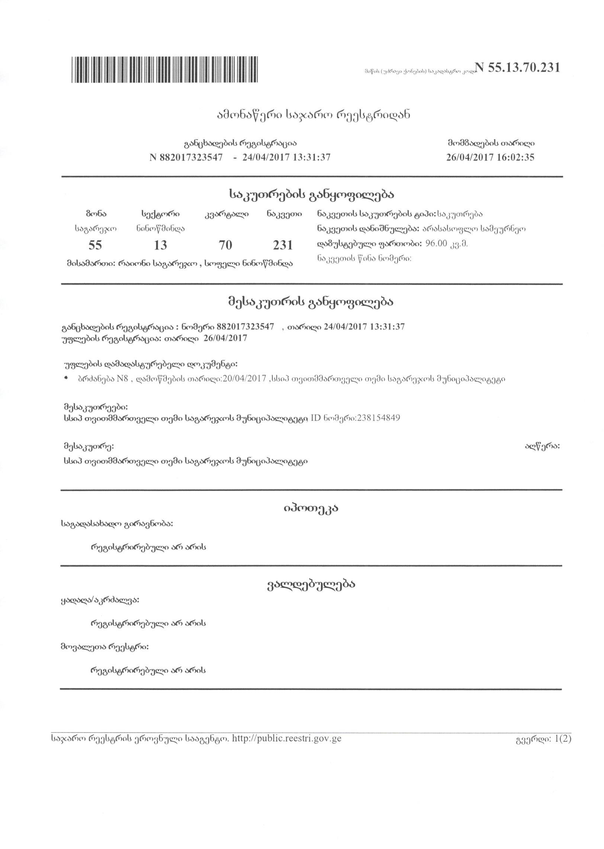

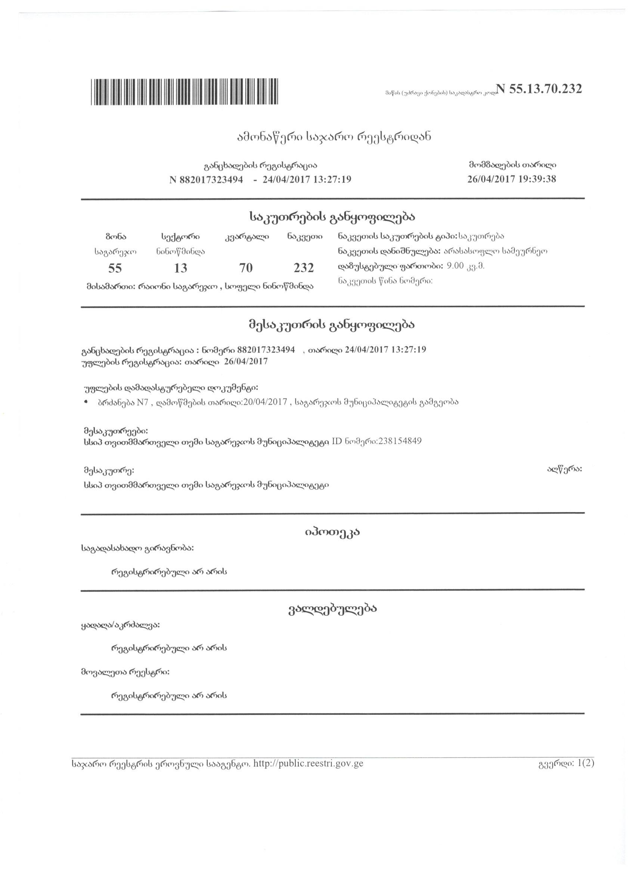

**b) Catastral plan**





**Attachment 2: Support letter from Sagarejo Municipality including arrangements for undertaking works in the vicinity of cultural heritage site**

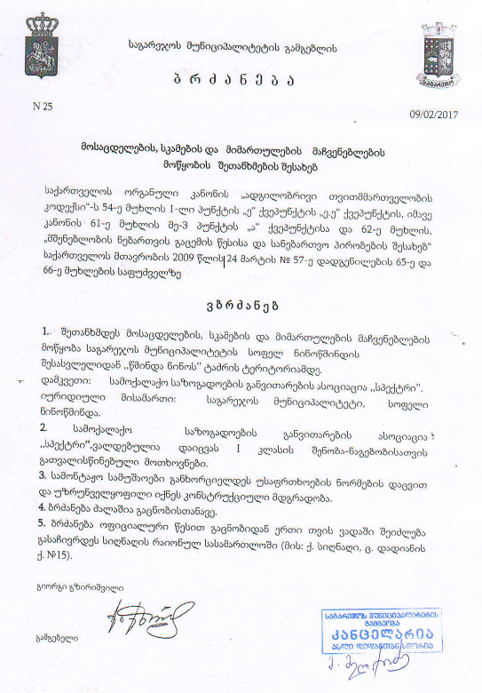

**Attachment 3: Sub-Project location/Plan**

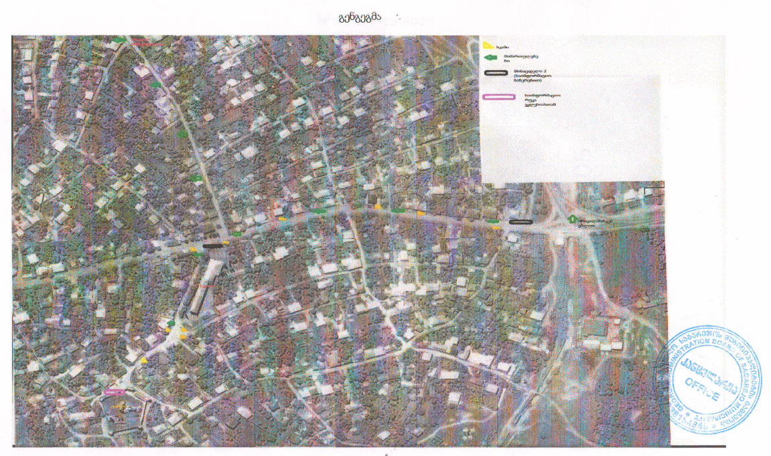

**Attachment 4: Ninotsminda Community Meeting Minutes**

**Date:** May 24, 2017

**Venue:** Sagarejo municipality, Village Ninotsminda

**Donor:** Biological Farming Association “Elkana”, through funding from the Japanese Social Development Fund and the World Bank

**Aim:** Consult with the local community on the Draft Environment and Social Management Plan for the projects “Improvement of touristic infrastructure in the village Ninotsminda”

Elkana Assistant Project Manager, representatives of NGOs “Association of Civic development SPEKTRI” local community attended the meeting. In total 6 people participated in the meeting, including 5 women.

Elkana Assistant Project Manager presented planned projects and activities, as well as the draft Environment Management Plans prepared to mitigate their possible negative impacts on the natural and social environment. After the presentation, meeting participants were given the floor for questions and comments. During the meeting, participants asked the following questions:

Question: Will installation of signs require cutting of any trees?

Answer: Installation of signs will not require tree-cutting.

Question: Since the project site is located in the community, how will the noise be minimized to avoid nuisance to neighbors?

Answer: Construction of bus shelters and installation of signs will be limited to daytime.

Community members were satisfied with the received information and supported implementation of the project.

Signatures of attendees:

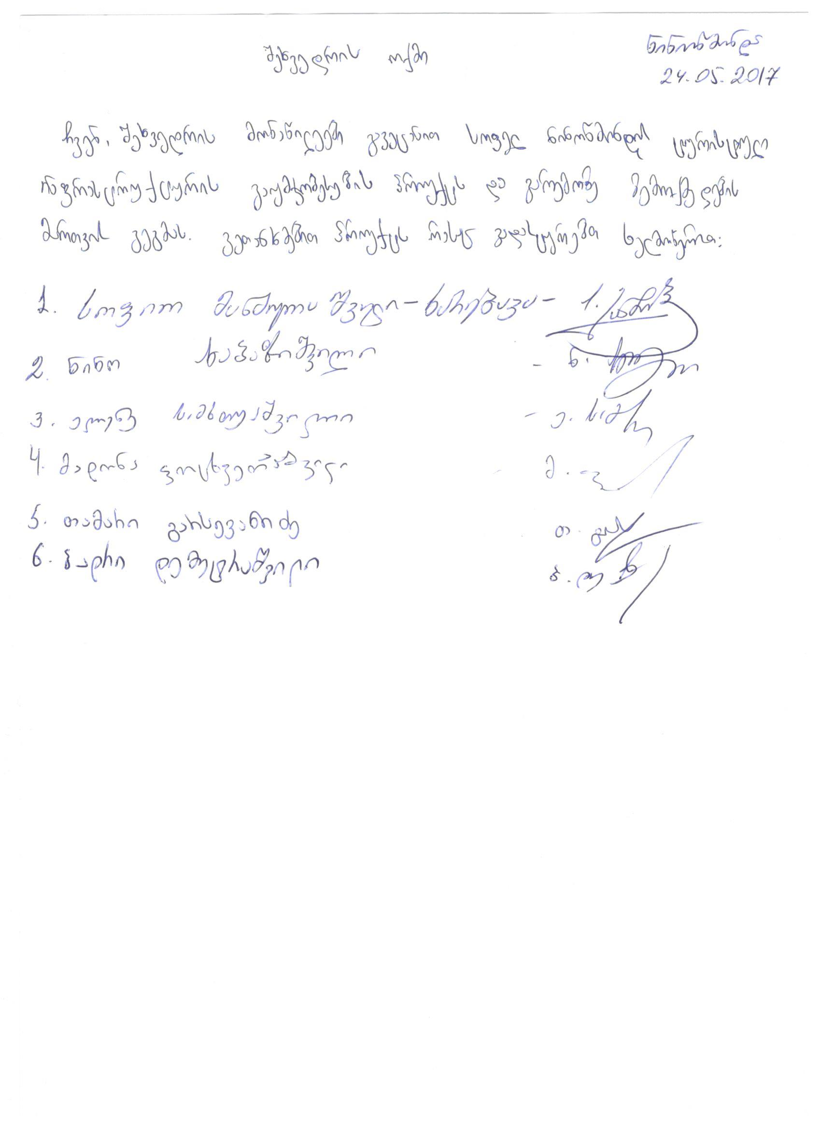

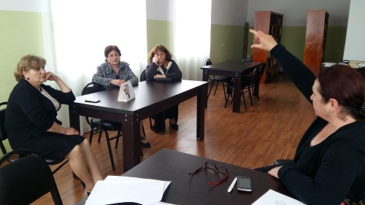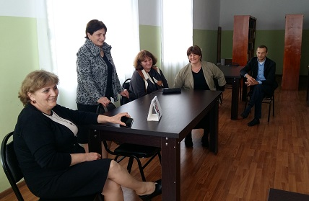

1. Land acquisitions includes displacement of people, change of livelihood encroachment on private property this is to land that is purchased/transferred and affects people who are living and/or squatters and/or operate a business (kiosks) on land that is being acquired.
2. Toxic / hazardous material includes but is not limited to asbestos, toxic paints, noxious solvents, removal of lead paint, etc.