REPORT ON THE PROCEEDINGS OF THE CLIMATE FINANCE TRAINING AND KENYA COUNTRY ENVIRONMENT ANALYSIS (CEA) VALIDATION WORKSHOP

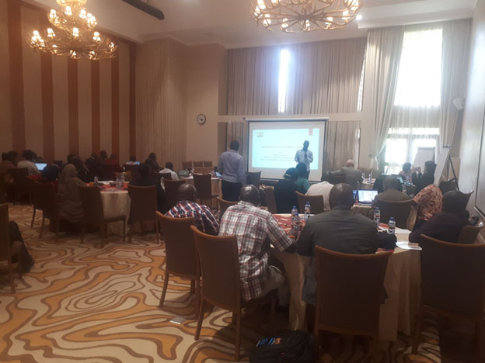
HELD AT THE SAWELA LODGE, NAIVASHA ON 27TH – 30TH MAY 2019.

MAY 2019

Table of Contents
1.0 Introduction 1
1.1 Welcoming Remarks 1
1.2 Objectives of the workshop and Expected Output 1
2.0 Kenya Country Environmental Analysis (CEA): 2
3.0. Overview of KADP programme 7
4.0 Introduction to Climate Change 8
5.0 Climate Financing 8
6.0 Climate Budgeting and Costing 9
7.0 Coding, Tracking and Reporting Climate Finance Flows 9
8.0 National Climate Change Action Plan 10
9.0 County Climate Change Fund Mechanism 10
10.0 County Climate Change Fund Mechanism – A case study of Wajir and
Makueni counties. 11
11. Stakeholder inputs to KADP III formulation 13
12. Next steps and recommendations 15

1.0 Introduction
The Climate Finance Training and Kenya Country Environment Analysis (CEA) Validation Workshop was held at the Sawela Lodge, Naivasha, on the 27th-30th May 2019. The workshop was hosted by the World Bank in collaboration with the National Treasury under Devolution and Locally-Led Climate Change and Disaster Risk Management initiative which is sub-component of Kenya Accountable Devolution Programme. A total of 48 participants attended the workshop drawn from the Ministries, Counties, Departments and Agencies (MCDA), Private Sector, Civil Society Organizations, Development Partners and the Council of Governors (CoG).

1.1 Welcoming Remarks
Mr. Nicholas Soikan from World Bank made the welcoming remarks. He thanked the participants for attending the workshop and mentioned that world bank is keen in supporting the country and counties in areas of climate change and disaster risk management. He highlighted that World Bank has included devolution as one of the three pillars in the country partnership strategy. In the context of the devolution the actions on climate change and disaster risk management at local level is of paramount importance to build the resilience of communities and economy. He stated that the current initiative under KADP on the devolution and locally-led climate and disaster risk management is a technical assistance and the bank is exploring options on engaging further on investment options

1.2 Objectives of the workshop and Expected Output
Mr. Yasin Mahadi from the World Bank presented the key objectives of the workshop and the expected outputs.

Objectives
- Capacity build County Governments, Civil Society Organizations (CSOs) and Private Sector Players on identifying climate change elements, planning, budgeting, coding, tracking and reporting expenditure towards climate adaptation and mitigation within their programs and projects.
- Review the findings of the Kenya Country Environmental Analysis (CEA) and validation of the same document
Expected Output
- Increased understanding on Coding, Tracking and Reporting on Climate Finance Flows.
- Validated Kenya CEA Report
- Roadmap for Next Steps

2.0 Kenya Country Environmental Analysis (CEA):
A Presentation by Edward Dwumfour and Simon Croxton
Edward thanked the participants for attending the workshop and mentioned that this is a second stakeholder consultation workshop on CEA and serve as validation also. The main intent of the stakeholder validation workshop he stated is to
- Share with key stakeholders the draft CEA report,
- Open it up for constructive critiquing, and
- Gather diverse inputs for finalization of the report prior to putting it out there in the public domain.
He highlighted what the Kenya CEA seek to do mainly:
- Undertake a broad review of Kenya’s critical environmental and natural resources including land, climate change, disaster risk management challenges and issues at national and county levels in a devolved context
- Enhance the government’s understanding of Kenya’s critical environmental and natural resource challenges and priorities
- Enhance action and solutions that directly contribute to Kenya’s Vision 2030 strategy.
- Help to inform and coordinate the activities of key stakeholders, including civil society and other development partners in the ENR sector
- Provide analytical inputs, propose policy recommendations and priority investments to help the Government of Kenya
- Define the scope and direction of possible future donor support to strengthen environmental management
- Inform the future WB Strategic Country Diagnostic (SCD) and Country Partnership Framework (CPF) for Kenya
The CEA has taken a pragmatic approach and the key aspects given consideration include:
- Taking stock of the existing environmental issues in Kenya within devolved context
- Reviewing government’s capacity to integrate environmental and natural resource management into planning and development programming
- Assessing counties prioritization of environmental issues
- Examining how trans-boundary environmental issues are addressed
The CEA was conducted employing the following methods
- National stakeholder workshops (July 2016 and May 2019) to collect view and inputs from various stakeholders
- Key informant interviews
- Secondary data and literature review
- Focal group discussions
- Use of deep-dive analytical studies
Key issues that emerged from the July 2016 consultative workshop were highlighted by Edward:
- Community driven investments should be integral part of any programmes developed since government funding is too low to cater for that particular necessity
- Trans‐boundary upstream and downstream environment and natural resources management issues should be incorporated in any future investment programme/project because of the nature of shared natural resources between most counties in Kenya
- Pollution management resulting from both solid and liquid waste. In this way, it will be possible to invest in solid and liquid waste management that came out on top as the leading environmental challenges at the county level
- Proper coordination between the two levels of government - county and national governments for effective implementation of ENR programmes for maximum impact
- Incorporation of studies on invasive plant species both aquatic and terrestrial with a view to integrating them in future programmes. These plant species came out as having significant impact on the economies of the drylands in Kenya
- Climate change continues to manifest itself in various harmful ways including floods, high temperatures, droughts and unpredictable weather patterns. This should be incorporated in all planned investment programmes to sustain community resilience
- Building research capacity in wildlife management: Wildlife Research Institute is key as well as on issues to do with resins and gums with a special focus on value addition including other under‐utilized flora and fauna species thriving in the drylands and other regions.
- Establishment of more sustainable financing mechanisms for liquid and solid waste management to encourage increased ventures especially from private sector
- Private public partnerships as a cross cutting theme. More liaison should be sought to encourage both private sector and public-sector entities engaging in joint investment ventures that encourage and promote entrepreneurship and sustainability in investments
- The nexus in‐migration (refugee influx), natural resource degradation and climate change impacts
- Gender integration with special emphasis on women’s roles and their contribution to future programmes in ENR
- Incorporating marine ecosystems in future conservation programmes
- Tapping into indigenous knowledge towards more effectiveness in ENR management
Simon from his side presented the recent finding and trends on key environmental challenges and opportunities. He mentioned that the core of Kenya’s poverty and environmental problems lies at the nexus of population growth, inequality and high dependence on natural resource- based incomes.
He highlighted the key opportunities for change which are clustered into six distinct areas:
- Expand sustainable land management interventions.
Investment should incentive land uses to invest in land improvement, create an institutional environment and rural services that are conducive to investments; and focus on reducing the high risks for ASAL production systems. The focus should also be on environmental strategy in the county assemblies, county cabinet committees, and the Council of Governors’ Environment Committee to increase prioritizing appropriate funding.

- Integrate data and indicators for natural capital and environmental sustainability into economic planning
Under this section continue developing natural capital accounts for water, wildlife, fisheries and forest resources; identify cross-sector linkages and improve available data to guide economic planning by the National Treasury and utilize the State of Environment report as a tool to provide a comprehensive overview of the natural capital accounts

- Enhance compliance with environmental policies to reduce pollution and improve environmental health
Here the focus should be directed towards:
- Strengthen environmental accountability mechanisms for industry (esp. manufacturing)
- Enhance public sector staffing dedicated to compliance in all development projects
- Public awareness campaigns to facilitate culture change / understanding environmental policies
- Strengthen the formal education programs (esp. engineering, agriculture, energy and transport curricula)
- Better utilization environmental risk management tools (EIAs /SESAs, etc.)

- Strengthen environmental governance and support institutional capacity at all levels
The focus here areas:

- Stricter enforcement of environmental laws and regulations
- Strengthen mandate of County Environment Committees
- Improve quality of County Environment Action Plans: operational clarity, deadlines, budgetary details, and additional funding
- Improve inter- and intra-agency communication for effective collaboration
- Increase community participation in active environmental management e.g.: WRUAs – Water; CFAs – Forests; CPAs – Charcoal; ESMPs in local language

- Build resilience and enhance long-term planning for disaster risk management

- Better preparation in vulnerable communities e.g. Diversify rural livelihoods; teaching practical coping mechanisms;
- Train county-level Disaster Management Officers to ensure timely and effective responses
- Strengthen agriculture early warning systems
- Implement the Water Sector Investment Plan (2008 – 2030) e.g. Enhance irrigation and drainage, address water requirements for production, promote drought-tolerant, high-value crops, etc.
- Strengthen national and county institutional capacity for climate change risk management and coordination
- Prioritize ‘climate smart’ investments: Watershed rehabilitation, afforestation, climate-proof roads

- Increase budgetary allocations and streamline releases to support ENR management
- Budget allocations need to match strategic plans
- Strong and sustainable financial support (from the National Treasury) required to attain Vision 2030 goals: a low-carbon, resource efficient, economic transformation

Key issues raised after the presentations:
- Role of the politicians in environmental degradation
- Conflicting policy from various agencies. Sometimes no direction
- Building the capacity of the counties: build the capacity of county assemblies
- Appropriate land use based on the context: e.g. the movement towards putting all lands under crop lands without the sustainability is a challenge
- Harmonization of the policies required
- Community driven investments angle need to be highlighted and entrenched in the report. The focus has been on the national and county process
- Budgetary allocation proposed: need for the assessment to support the argument. How much is allocated currently and need for the treasury to be sensitized and allocation
- Poor governance issues need to be addressed
- Induced conflict as result of the climate change need to be highlighted. The role of the local communities need to be highlighted
- The role of the management of the forest not clear: mining vs environment, county vs min of the environment
- County to understand the world bank policies on the indigenous people
- Allocation of resource to curb species loss/threatened species: Wildlife climate change adaptation strategy underway
- Climate change impact on wildlife: change in their distribution or range as they adapt
- Capacity building how to take forward: CEA identifies where to focus attention to. Guide WB investment decisions
- Solid wastage management: policy under the development
- Integrated approach needed in handling the environment and link with other sectors to gain more tractions
- Impact assessment need to be public

3.0. Overview of KADP programme
A Presentation by Mr. Yasin Mahadi
Mr. Yasin Mahadi from the World Bank began his remarks by highlighting how KADP is a targeted program with evolving priorities as demonstrated in Phase I (2012-2015), Phase II (2015-2019) and planned Phase II (2019-2025).

He noted that KADP II has six (6) components namely: fiscal knowledge and program; public financial management and human resource management; M&E performance systems and open data; social accountability and citizen engagement; devolved sector support; knowledge and learning, communications and outreach, M&E, and program management. Additionally, he noted that the six (6) components have four (4) cross-cutting themes, i.e. citizen engagement; climate change; gender; conflict and violence prevention; and marginalized county support.

He noted that the Devolution and Locally Led Climate Change Adaptation and Disaster Risk Management Project is sub-component of KADP and seeks to improve county governments’ (Kwale, Siaya, Narok and Makueni) capacity to integrate locally-led climate and disaster risk management into their development planning process, while focusing on social dimensions. The key activities of the KADP II include:
- Technical support to integrate climate and disaster risk management into CIDPs
- Strengthening county government capacity on climate financing, resource mobilization and expenditure tracking
- Training and mainstreaming of climate and disaster risk management functions into county government functions
- Peer-to-peer exchanges among counties (Makueni SSKE held) on KADP, in effort to support County Climate Change Fund establishment
- Decentralize climate finance: County Climate Change Fund mechanism piloted in 5 counties (ADA consortium) are being scaled out to KADP target counties
- Support Council of Governors in readiness phase towards accreditation to Green Climate Fund (GCF) mechanism supported by Climate Finance and Green Economy Unit at the National Treasury
- Explore a joint concept/proposal to fund CC activities?
- Establishment of a mobile-based flood early warning system (Narok) with the Kenyan Red Cross, Metrological Department, Communications Authority and telecommunication partners, and building awareness of the system. Then scale to entire country.
- Prepare County Climate Information Sheets

4.0 Introduction to Climate Change

A Presentation by Mr. Peter Odhengo.

Mr. Peter Odhengo, from the National Treasury began his presentation by giving an overview of basic terms as used in climate change, causes of climate change and impacts of climate change.
Secondly, he gave an insight into the climate change response actions, with a key focus on enablers of climate change, i.e. policies, legislation, strategies and action plans. In addition, he gave a deep-dive on how climate change has been mainstreamed in the Medium Term Plan (MTP III) 2018-2022.
In conclusion, he highlighted on the structure of climate change governance in Kenya and the various stakeholders therein; including the National Climate Change Council (NCCC), National Treasury, Climate Change Directorate, County Governments, NEMA, private sector, civil society, public, academia and research institutions.

5.0 Climate Financing

A Presentation by Mr. Peter Odhengo.
Mr. Peter Odhengo from the National Treasury began his remarks by giving a brief on the evolution of climate finance, the post Paris structure of UNFCC, the key elements for climate finance flows, and sources (public, private, multi-lateral & bi-lateral) and channels of financing. On matters UNFCC financing mechanism, he highlighted the structure and access modalities of the Adaptation Fund, Global Environmental Facility (GEF), Green Climate Fund (GCF) and Sustainable Development Mechanism (SDM).
Secondly, he provided context on other emerging climate financing instruments including: green bonds, blue bonds, result-based financing, blended financing and risk sharing instruments.
Lastly, he gave an overview of Kenya’s Strategic documents for climate finance; with an emphasis on the: Constitution of Kenya, National Policy on Climate Finance, National Climate Change Action Plan and Climate Change Act, 2016

6.0 Climate Budgeting and Costing
A Presentation by Mr. Peter Odhengo.

Mr. Peter Odhengo from the National Treasury began by describing the budgeting process in both National and County Governments. Additionally, he provided clarity on the budgeting calendar/resource allocation stages with a focus on Budget Review and Outlook Paper (BROP); Sector Working Groups (SWGs); Budget Policy Statement (BPS) and County Fiscal Strategy Paper (C-FSP)
Secondly, he expounded on how to mainstream climate change in the budgeting process. This included through: clearly defining climate change mitigation and adaptation interventions to be financed in the MTEF budget proposals; prioritizing climate related expenditures and mainstreaming of the same within programs
Lastly, he highlighted the importance of integrating climate financing in the budgeting process, identify and costing climate change activities for climate financing.

7.0 Coding, Tracking and Reporting Climate Finance Flows

A Presentation by Mr. Peter Odhengo.

Mr. Peter Odhengo from the National Treasury, began his remarks by highlighting the pillars of climate finance tracking and reporting. Additionally, he expounded on why it is important to track climate finances.
Secondly, he gave a brief on the structure of the Standard Chart of Accounts (SCOA) in the IFMIS; highlighting the new analytical segment 8’ has been introduced in IFMIS to tracking of all climate finance flows at the National and County level.
In conclusion, he unpacked the ‘new analytical segment 8’ by giving practical examples on classification of adaptation and mitigation projects/programs under IFMIS.

8.0 National Climate Change Action Plan

A Presentation by Mr. Samuel Muchiri.

Mr. Samuel Muchiri from the Ministry of Environment and Forestry began his presentation by informing participants that Section 13 of the Climate Change Act, 2016 requires the Government to develop five-year National Climate Change Action Plans (NCCAP) to guide the mainstreaming of adaptation and mitigation actions into sector functions of the National and County Governments.
He noted that NCCAP 2018-2022 which builds on the first Action Plan (2013-2017), provides a framework for Kenya to deliver on its Nationally Determined Contribution (NDC) under the Paris Agreement of the United Nations Framework Convention on Climate Change (UNFCCC) through seven (7) key priority actions. The priority actions include: Disaster Risk Management; Food and Nutrition Security; Water and the Blue Economy; Forestry, Wildlife and Tourism; Health, Sanitation and Human Settlements; Manufacturing; Energy and Transport
He further indicated that the main NCCAP 2018-2022 enablers are overarching technology and innovation; capacity development and knowledge management; and climate finance.

9.0 County Climate Change Fund Mechanism

A Presentation by Mr. Hausner Wendo.

Mr. Hausner Wendo from Adaptation Consortium (ADA) noted that the County Climate Change Funds Mechanism had been piloted successfully in counties of Isiolo, Garissa, Kitui, Makueni and Wajir. Based on this, it was noted that the mechanism is being scaled out in Vihiga, Nandi, Bomet, Kisii, Kakamega, Kisumu, Narok, Siaya, Taita-Taveta, Tharaka Nithi, Embu, Machakos, Kilifi and Kwale.
Secondly, he gave a brief on other initiatives ADA has with the counties, more so on: mainstreaming climate change into planning; and delivering user led Climate Information Services (CIS).
In closing, Mr. Wendo highlighted on the CCCF sustainability model as well as some of the successes and challenges under the CCCF mechanism.

10.0 County Climate Change Fund Mechanism – A case study of Wajir and Makueni counties.
Wajir County: Presentation by Ms. Ebla Bashir CEC Environment and Natural Resource
Madam Ebla highlighted the process the county went through in the establishment of the CCCF mechanism including the establishment of the Climate Change Act 2016. The Act envisage to address climate change issues in the county. The Act has various provision and Ms. Ebla highlighted some key ones:
- Establishes Climate Adaptation Fund (CAF) – pulled basket – governments and other donors
- Ring-fence 2% of the County development budget to climate change.
- Creates avenue for accessing International Climate Funds e.g. Global Green Fund, Climate Adaptation Fund etc.
- Creates multi-stakeholders CAF structures (committee) – County, National, NGOs, CBOs, Community.
- Promote community participation in planning and budgeting of public investment.
- Encourages community involvement in monitoring of projects – bottom up approach

The county also established county climate change steering committee. Wajir County Climate Change Fund Steering Committee (WCCCFSC) with membership:
- Governor/Deputy as the chair person
- CEC Environment Energy and Natural Resource
- CEC Finance and Planning
- CEC Water
- CEC Public Health
- CEC Agriculture and Livestock
  - Rep. NGOs dealing with climate issues
- Rep PBO dealing with climate issues in the County
- 2 National Government Agencies – NDMA/KMD/NEMA
- Rep of a County professional body
- Rep of County Business community body

WCCCFSC main mandates and functions are:
- Provide overall guidance for the development of County Climate Finance Framework.
- Facilitate and monitor the implementation of the Climate Finance Framework.
- Develop linkages for the Fund with the National Government and other stakeholders
- Ensure compliance of the Fund administration to the public finance management principles under article 201 of the Constitution of Kenya;
- Ensure projects approved for funding conforms to the Climate Finance Framework;
- Mobilize funding for projects, programs and activities in the Climate Finance Framework;
- Facilitate the coordination of Climate Finance projects and programs with other programs in the County;
- Prepare a Climate Change Awareness strategy for the County;
- Approve the County level proposal/disbursement by the Fund Administrator
- Regularly review the County Climate Finance Framework;
- Any other matter relevant to Climate Finance in the County.
The county within the county climate change fund mechanism established county climate change planning committee and ward climate change planning committee which deals with the climate change issues at the ward level which is the smallest unit of governance at the county level. The county through its climate change act allocates 2% of the annual budget to climate change issues in terms of mainstreaming and taking action on the climate resilience initiatives at the various level with the lowest unit being ward and go down to village structure.

Makueni County: Presentation by Mr. Evans Kisilu
Evans highlighted that the Makueni county is among the first counties to pass climate change regulation which allocate 1% of the annual budget to climate change interventions. The county has in place climate change board which is composed of various actors including the county officials and non-state actors. At the ward level ward climate change committees exist which are the main entry point for climate change issues and other related development agenda. The county has also mainstreamed climate change in all the sectors in its CIDP and work closely with various development actors. Public participation has been a pillar of the county which most activities are anchored on and the climate change deliberations has been done in the participatory manner and county uses participatory vulnerability assessment tools to guide in getting the appropriate climate resilience interventions that are in line with the community aspiration and supported by various county technical teams.

11. Stakeholder inputs to KADP III formulation
Nicholas Soikan and Margaret Arnold of World Bank presented the key focus areas for the KADP III and indicated that the interventions are preliminary and through common understanding and inputs from the stakeholders the activities will be finalized and mentioned that the workshop being a good avenue to give inputs.
The key interventions for the KADP three are anchored or building on the gains from the second phase of the project. There are three results areas for the sub-component on social resilience to climate change and natural hazards:
Result 1: Community climate and disaster resilience strategies better understood, strengthened and supported by county planning processes
- Document and share community-level CCA and DRM strategies
- Develop participatory, integrated resilience plans for selected communities
- Integrate these resilience plans into county development and resilience plans
Result 2: Coordination, planning and reporting mechanisms on climate and disaster risk management investments at county level enhanced
- Strengthen county level capacity for climate finance budgeting, tracking and monitoring
- Support CoG accreditation process
- Strengthen CoG capacity to coordinate and report on county CC activities to national level
Result 3: Learning and knowledge exchange on climate and disaster resilience across counties enhanced
- Learning events to share good practices with other counties
- Capacity building of county and national officials on existing climate and disaster risk management screening tools
- Facilitate dialogue and consultations on key risk and resilience interventions
After the presentation the team engaged the participants to get their inputs based on the following questions:
- Are these activities responding to county needs in regards to institutional support?
- What will be your priority activities in terms of building structures for climate change and DRM?
- What should be the process for selecting counties?

Based on the above questions that participants gave their inputs. Table below captures outcomes of the discussions
Questions/issues | Group response
 | 1 | 2
- Are these activities responding to county needs in regards to institutional support? | - County legislation support (technical, public participations) needed  - Natural resource mapping to include precious and non-precious stone-(gold, green opal, mica), oil, gums and resin, coal  - Scaling regional block-Cross-county landscape approaches- Regional blocks- | Yes, but there is need to include more counties
- What will be your priority activities in terms of building structures for climate change and DRM? | We feel all identified activities are a priority to above | - Support KMD personnel to downscale metrological information at the county level up to the household level through local radio stations and mobile phones  - Every county to have the county climate change secretariat to coordinate climate change issues and agencies like NDMA,red cross, metrological services and this to be housed in the department of environment  - Counties to mainstream NDCs and NCCAP priority actions into the county plans  - Counties should be supported to develop climate change policies and Acts  - Counties to be supported to develop baseline data for county specific climate change.Data that is S.M.A.R.T
- What should be the process for selecting counties? | - Political goodwill-willingness of a County to participate  - Climate vulnerability index and profiles  - Already formed regional economic blocks  Regional balances  - Socio-ecological landscape approach- Mau region | - Based on climate change vulnerability  - Areas prone to natural resource conflicts  - Political goodwill of the county leadership  - Based on the regional blocks  - Consider marginalized communities

12. Next steps and recommendations
The stakeholders who participated in the workshop appreciated the interventions being implemented under devolution and locally led climate and disaster risk management project and urged world bank to expand the interventions to other counties. The World Bank team informed the participants that their views will be incorporated into the design of the KADP III and will continue engaging with stakeholders going forward. The CEA report will be finalized and once the review process is completed the report will be shared widely.

1: ATTENDANCE LIST
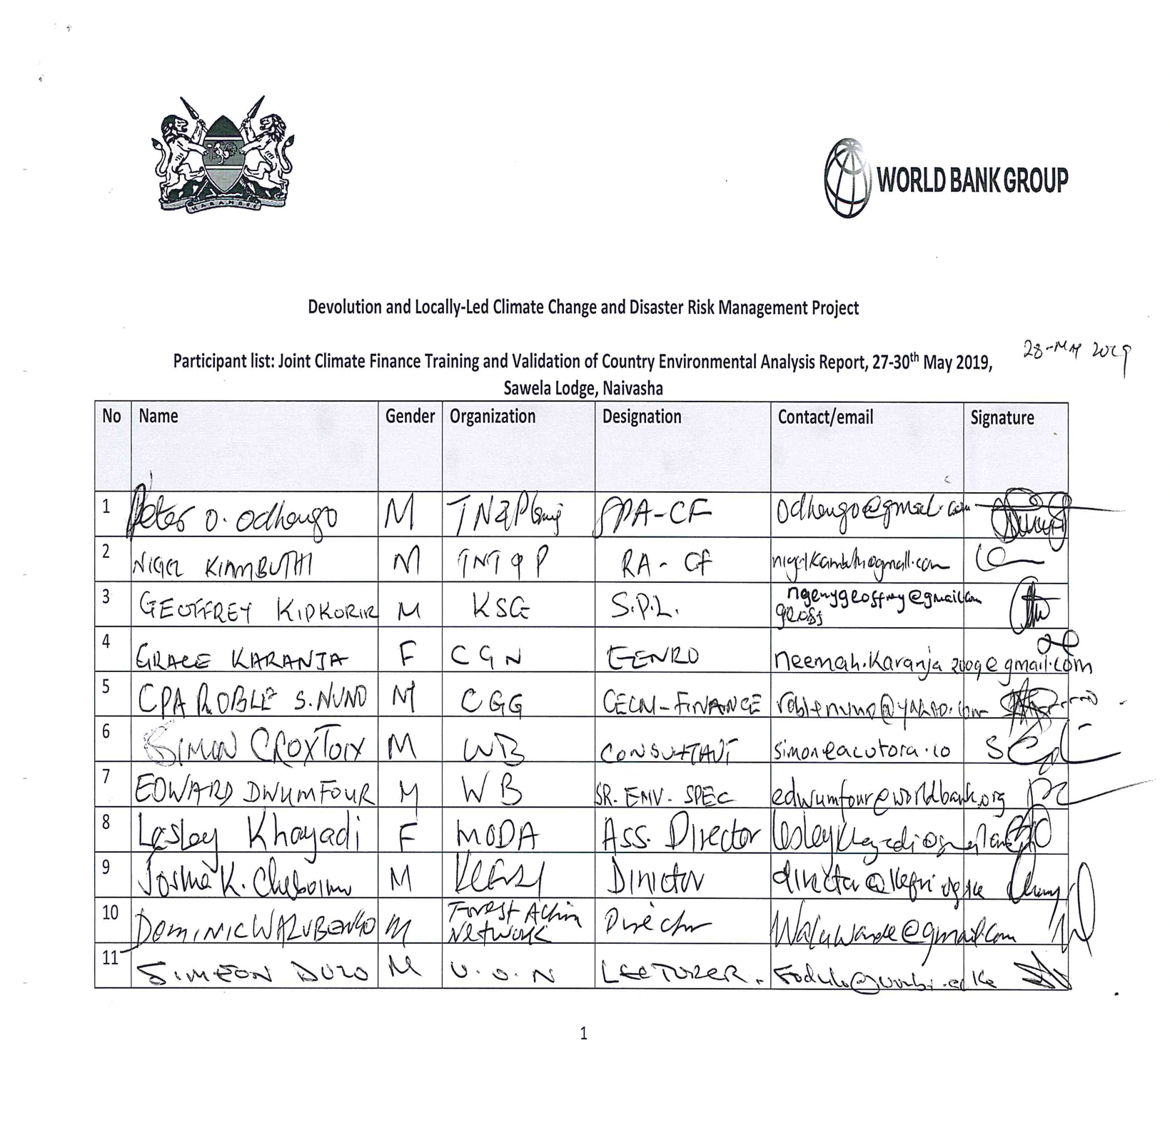
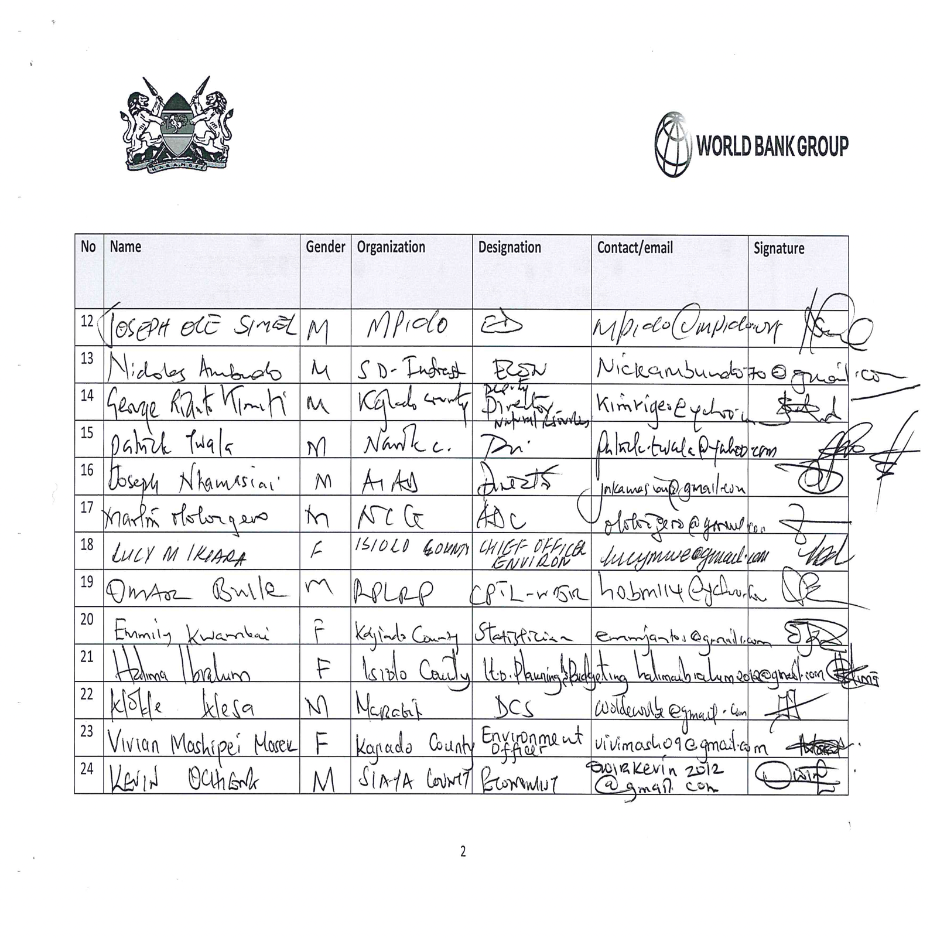
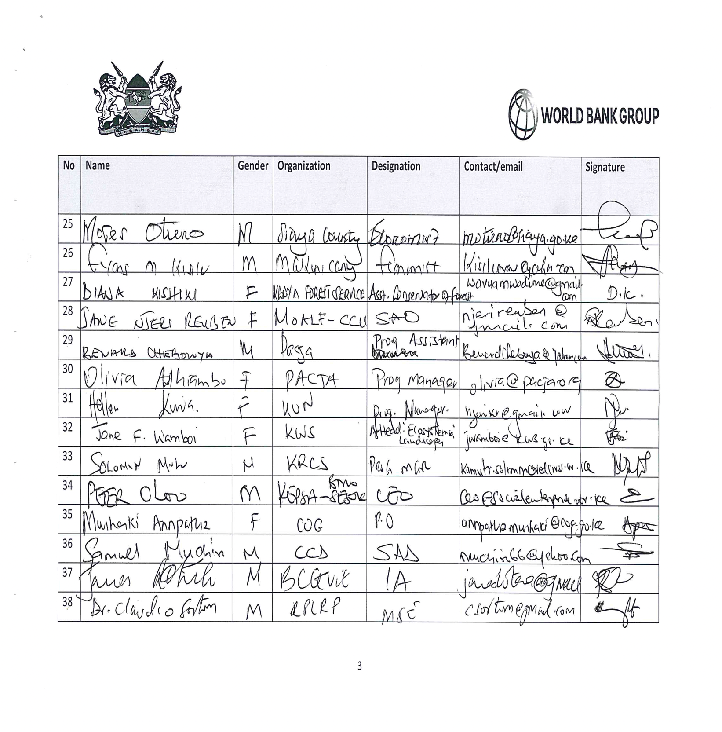
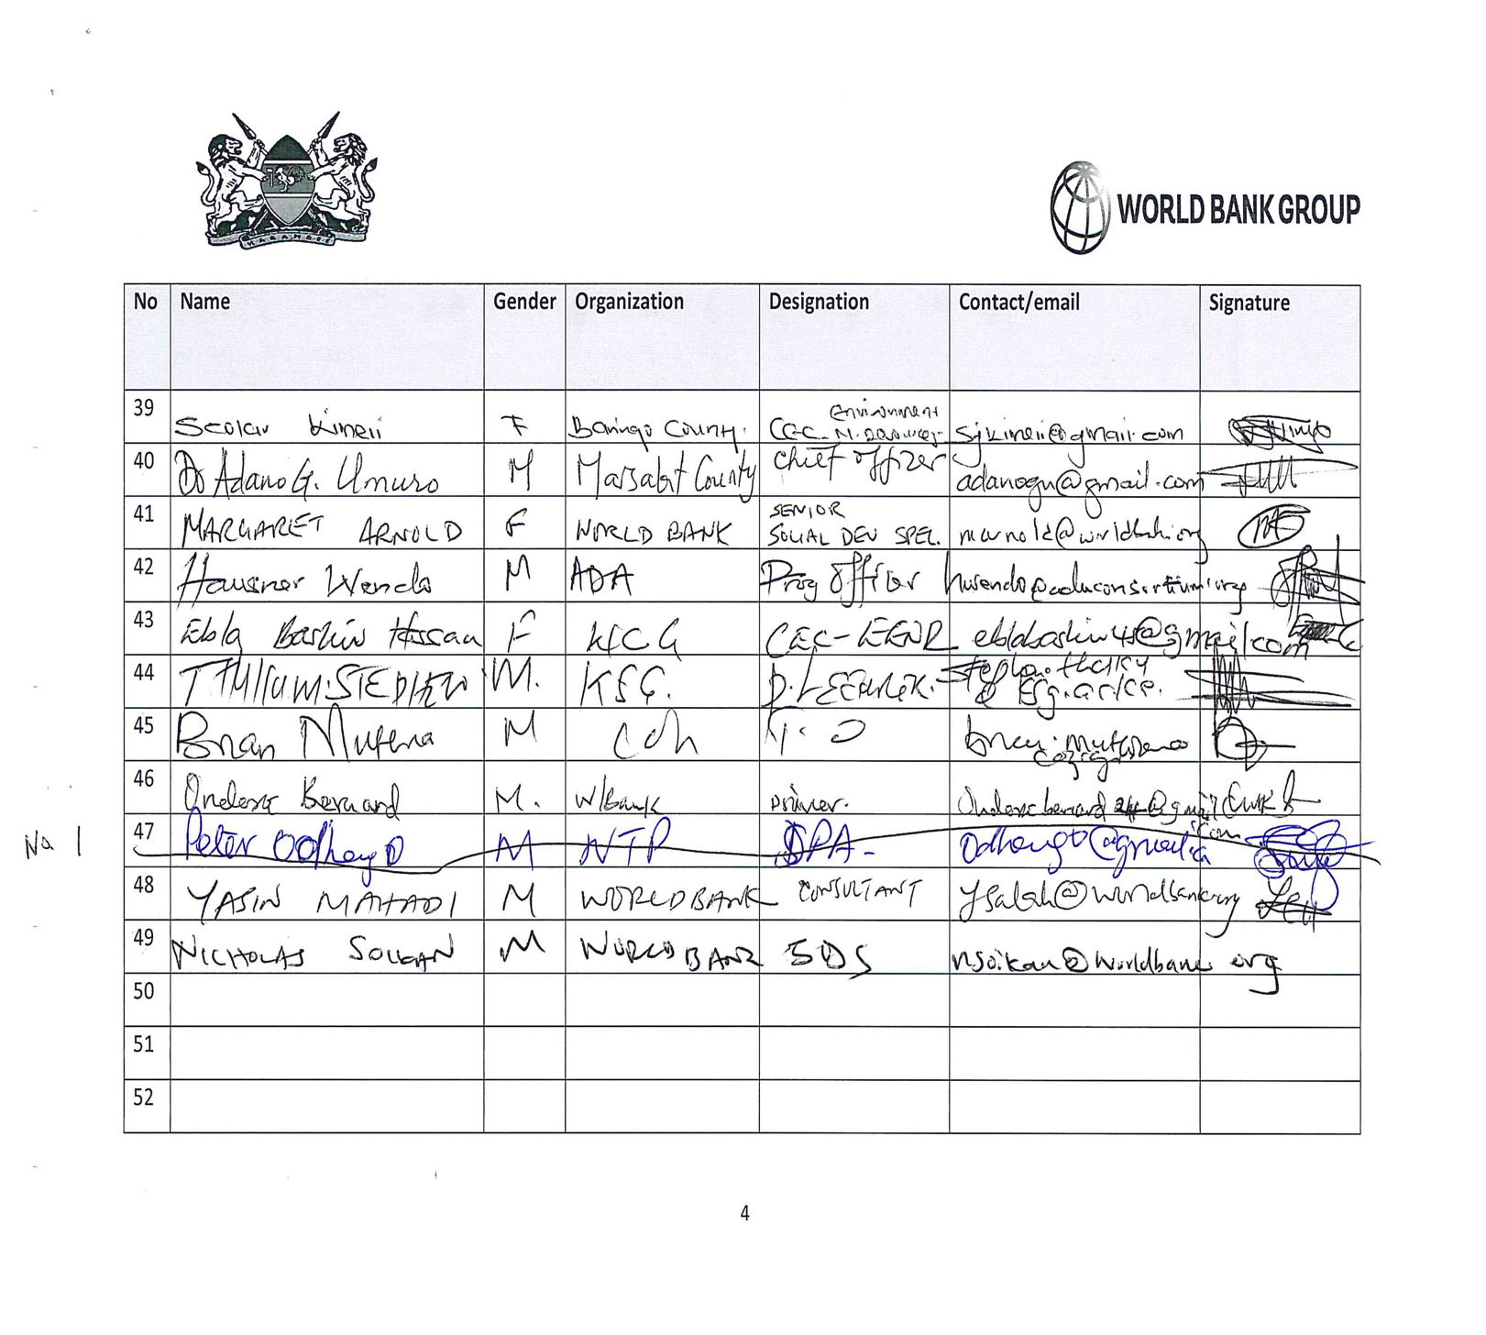

Annex 2: AGENDA

Day 1: Monday 27 May, 2019

TIME | ACTIVITY | BY WHO | SESSION CHAIR
9:00 am – 9:30 am | Registration | World Bank | World Bank
9:30 am – 9:40 am | Welcoming remarks and Expected Outcome | National Treasury
9:40 am–10:20 am | Opening Remarks | World Bank
 |  | KSG
 |  | CCD
 |  | National Treasury
10:20 am – 10:30 am | Photo Session | All
10:30 am – 10:50 am | Tea Break
10:50 am -11:30 am | Kenya Country Environmental Analysis (CEA): Introduction and Context | World Bank
11:30am – 12:10 pm | CEA: Sector-Specific Findings | World Bank
12:10 pm – 12:30 pm | Q&A | All
12:30 pm – 1:30 pm | Lunch Break | All
1:30 pm – 2:00 pm | CEA: Proposed Recommendations | World Bank
2:00 pm -4:00 pm | CEA: Group Work | All
4:00 pm – 4:30 pm | Panel Discussion and Q&A | All

DAY 2: Tuesday 28 May, 2019

TIME | ACTIVITY | BY WHO | SESSION CHAIR
9:00 am-10:30 am | Overview of KADP programme | World Bank | National Treasury
9:30am-10:30 | Introduction to climate change and Climate Financing | National Treasury
10:30 am – 10:50 am | Tea Break | All
10:50 am- 12:00 pm | Climate Financing | National Treasury
12:00 pm – 12:30 pm | Panel Discussion and Q&A | All
12:30 pm – 1:30 pm | Lunch Break | All
1:30 pm - 3:00 pm | Climate budgeting and costing | National Treasury
3:00 pm - 4:00 pm | Panel Discussion and Q&A | All

DAY 3: Wednesday 29 May, 2019

TIME | ACTIVITY | BY WHO | SESSION CHAIR
9:00 -10:00 am | Coding and Tracking and Reporting on climate finance flows | National Treasury | The National Treasury
10:00 – 10:20 am | Tea Break | All
10:20 am- 12:30pm | Coding and Tracking on climate finance flows -continued | National Treasury
12:30 – 1:30 pm | Lunch Break | All
1:30 - 3:30 pm | Coding, tracking and reporting on climate finance flows - continued | National Treasury
3:30 - 4:30 pm | Panel Discussion and Q&A | All

DAY 4: Thursday 30 May, 2019

TIME | ACTIVITY | BY WHO | SESSION CHAIR
9:00 am – 10:30 am | Resilience and social resilience concept | World Bank | World Bank
10:30 am – 11:00 am | Tea Break | All
11:00am-11:30am | National Climate Change Action Plan | CCD
11:30 am -12:00 pm | County Climate Change Fund Mechanism | ADA consortium partners
12:00pm – 1:00 pm | Case Studies (Climate Change Fund Mechanism) | Selected Counties
1:00 pm – 2:00 pm | Lunch Break | All
2:00 pm – 3:00 pm | Panel Discussion and Q&A | All
3:00 pm - 3:30pm | Tea Break | All
3:30 pm – 4:00 pm | Outline of the County Climate Information Sheet | World Bank
4:00 -4:30pm | Way forward and closing remarks | World Bank

