TERMS OF REFERENCE
INEY IPF Component
Strengthening National and Subnational Capacity
to Implement the National Strategy to Accelerate Stunting Reduction (StratNas Stunting)

Background
Stunting is a condition of failure to grow in children under 5 years old due to chronic malnutrition, especially in the first 1,000 days of their life, which is seen from the length or height below the standard of a child of his age (Ministry of Health, 2018). Stunting rates in Indonesia, based on the Basic Health Research of 2013, reached 37.2% or about 9 million children under five. In other words, 1 in 3 Indonesian children under five have stunting. The prevalence of stunting in toddlers is high or very high in almost all provinces. From the 34 provinces, 15 provinces have a prevalence above 40%, whereas the highest is in East Nusa Tenggara (52%). Even in provinces with the lowest prevalence, in the Riau Islands, one in four children has stunting (26%). Since 2007 to 2013, the prevalence of stunting in Indonesia has not changed significantly. Although development in Indonesia has been quite successful, where poverty rates have dropped, access to basic services such as education, health, drinking water and sanitation has increased, but increasing public purchasing power and the availability of basic services have not led to improved nutritional status. Stunting and malnutrition are expected to contribute to a reduction of 2-3% of Gross Domestic Product (GDP) annually. Lessons learned from international good practice have shown that the effectiveness of stunting reduction is determined by program integration and synergy. The Government of Indonesia, both central and regional, already has a variety of programs that can be used to reduce stunting, included in specific or sensitive intervention categories. However, the effectiveness of the program to reduce stunting depends on two things; (a) how comprehensive the program is and the degree of integration and (b) the intensity and quality of the program. Thus, program convergence should be the basis of approach in stunting reduction.

The National Strategy to Accelerate Stunting Reduction, launched by the Vice President on July 12, 2017, is aimed to consolidate political and leadership support at national and regional levels, strengthening the implementation of multi-sector policy frameworks, and encouraging convergence of national, regional and community programs. The National Strategy to Accelerate Stunting Reduction consists of five pillars; (1) Commitment and vision of the country's supreme leader, (2) National campaign focuses on understanding, change, behavior, political commitment, and accountability, (3) Convergence, coordination, and consolidation of national, regional and community programs, (4) nutrition policy and food security, (5) Monitoring and evaluation. This national strategy prioritizes a number of specific nutritional interventions and sensitive nutritional interventions, with the priority target group households with pregnant women and / or children aged 0-24 months (hereinafter termed households of the First 1000 Days of Life). The National Strategy to Accelerate Stunting Reduction sets 100 districts of priority handling locations by 2018, and plans for gradual extension of handling until all districts are handled by 2021.

An IPF component will support implementation of the PforR Program. The IPF component is financed by the Global Financing Facility (GFF) multi-donor trust. The IPF component will finance catalytic investments to jump-start improvements in implementation capacity and strengthen intervention delivery systems that lay foundation for long term reform and implementation sustainability. Particularly, it will (a) strengthen multi-sectoral coordination by the Secretariat of the Vice President (SoVP); (b) strengthen the capacity of Bappenas (National Planning Development Agency) and Ministry of Finance (MoF) to implement its planning and budgeting functions; (c) provide technical support to sector line agencies responsible for nutrition intervention delivery; (d) increase district capacity to converge stunting interventions and monitor its progress; and (e) strengthen the systems for monitoring, evaluation and continuous learning at the TNP2K Secretariat and Bappenas. It will also support the government to mitigate environment and social issues relating to stunting reduction efforts (e.g., gender, social inclusion, access and tailoring of services to meet the needs of traditional indigenous communities) in line with World Bank Policy 4.10 on indigenous peoples.

Scope of Work
GFF grant comprises of 2 components:
- Component 1: Institutional Strengthening at National Level ($16 million). The component will be delivered by SoVP/TNP2K.

  - Sub-Component 1A: Coordination, Delivery Monitoring and Debottlenecking Capacity of SoVP/TNP2K. The multi-sectoral and multi-level nature of SRAS requires a strong leadership and management capacity SoVP/TNP2K on planning, implementation, monitoring and evaluation to ensure sound delivery of convergence program. More specifically, this component will: (i) establish a communication and advocacy team to support Pillar 1 of the SRAS, specifically the national awareness campaign as well as national and subnational advocacy including on issues such as food fortification (Pillar 4); (ii) establish results monitoring team to strengthen performance monitoring systems through setting up a centralized monitoring dashboard and conducting a regular performance review and to improve the capacity for resolving bottlenecks through timely identification of implementation problems; (iii) establish an evaluation and innovation team to undertake implementation research/process evaluation to generate lessons learned and facilitate course-correction and evaluation studies to evaluate program’s impact and effectiveness. It will also conduct pilots and innovations on new interventions that fill critical service delivery gaps and strategic areas such as integrated data system and public-private partnership in nutrition service delivery. This sub-component will also support the advisory panel.

  - Sub-component 1B: Strengthen Capacity of Implementation Agencies. The component will strengthen the capacity of line ministries such as MoH, MoEC, MoSA, MoV to support districts and villages to implement local-level convergence instruments and strategic interventions. More specifically the component will: (i) support MoH for strengthening the interpersonal communication program through improved the quality of cascade training and incorporating the use of ICT-based platform; (ii) support MoSA in improving the nutrition-sensitivity of the food assistance program (BNPT) by improving the mix of food, targeting method and monitoring system; (iii) support MoEC in improving the quality of training systems and the nutrition content in the parenting session curriculum for ECED frontline services; and (iv) support MoV in fine-tuning and refining the implementation and monitoring of village convergence.

  - Sub-component 1C: Strengthen the results-based planning and budgeting. This component will support Bappenas in operationalizing convergence instruments, specifically it will help: (i) strengthen district capacity to adopt a more location specific approach in planning for interventions delivery; (ii) improve the quality of program planning and budget system; (iii) improve the quality of DAK reporting system by standardizing categories of activities and strengthening KRISNA system; (iv) build capacity for performance expenditure review; (v) strengthen district performance assessment systems, including strengthening a technical secretariat in Bappenas to manage the performance assessment; and (vi) support learning and knowledge sharing as the convergence programs are being scaled up.

- Component 2: Strengthen Capacity for District Convergence ($4 million). This component will be delivered by Ministry of Home Affairs. Particularly this component will support the Directorate General of Regional Development in: (a) strengthening the capacity of Provincial and district governments to diagnose the local drivers of stunting, develop local solutions and converge the priority nutrition-intervention delivery at district level; (b) providing technical assistance to sub-district and village level in aligning the Dana Desa utilization for stunting reduction agenda; and (c) developing performance benchmarking for convergence programs across districts; and (d) facilitating the peer-to-peer learning and sharing of best practices across districts. This component will be delivered to priority districts through Technical Assistance Pool at provincial level, with direct responsibility to DG Regional Development-MoHA through daily coordination and supervision of Provincial Bappeda. The World Bank will support DG of Regional Development to pilot the design of this component in 2018 which will be outlined in a ToR for the Provincial Technical Assistance Pool. This component will also cover an environment specialist who will advise the government on coordination and environmental management related to the program, in particular relevant to water resources, sanitation and management of medical waste. This component will be designed in close collaboration with SoVP, Bappenas and all relevant line ministries.

Output

              - Strengthen multi-sectoral coordination by the Secretariat of the Vice President (SoVP);
b. Strengthen the capacity of Bappenas (National Planning Development Agency) and Ministry of Finance (MoF) to implement its planning and budgeting functions;
c. Provide technical support to sector line agencies responsible for nutrition intervention delivery;
d. Strengthen the systems for monitoring, evaluation and continuous learning at the TNP2K Secretariat and Bappenas;
e. Strengthen the role of provincial governments in assisting districts to manage convergence of priorities nutrition intervention; and
f. Strengthen the district government’s capacity to implement 6 district convergence actions, including in assisting sub-district and village level in aligning the Dana Desa utilization for stunting reduction agenda with the scale up plan as follows: 100 districts in 2018, 160 districts in 2019, 390 districts in 2020 and aiming at near full coverage in 2021.

Outcomes

Improve the quality of implementation through support to the key government counterparts in implementing convergence stunting reduction programs at both national and local levels.

Activity Implementation Plan

- Implementation Method
Grant will fund the activities implementation
- Implementation Schedule
From 2018 to 2021

- Disbursement
Disbursement (USD 000) |  |  |  |  | Total
I | II | III | IV | V
500 | 6.000 | 7.000 | 6.500 |  | 20.000

- Allocation per Component and per Category
Component | Category (USD 000)
 | Service | Construction | Goods | Training | Others
Category/Component 1. | 8.000 |  |  | 6.000 | 2.000
Category/Component 2. | 1.5000 |  |  | 1.500 | 1.000

Budget

- Budget Amount
Implementing Organization | Budget (USD) |  | Total Budget (USD)
 | Grant | State Financing
1. Office of the Vice President | 16.000.000 |  | 15.000.000
2. Director General of Regional Development Supervision, Ministry of Home Affairs | 4.000.000 |  | 4.000.000
T O T A L | 20.000.0000 |  | 20.000.0000

Management and Implementing Organization

- Organization Structure

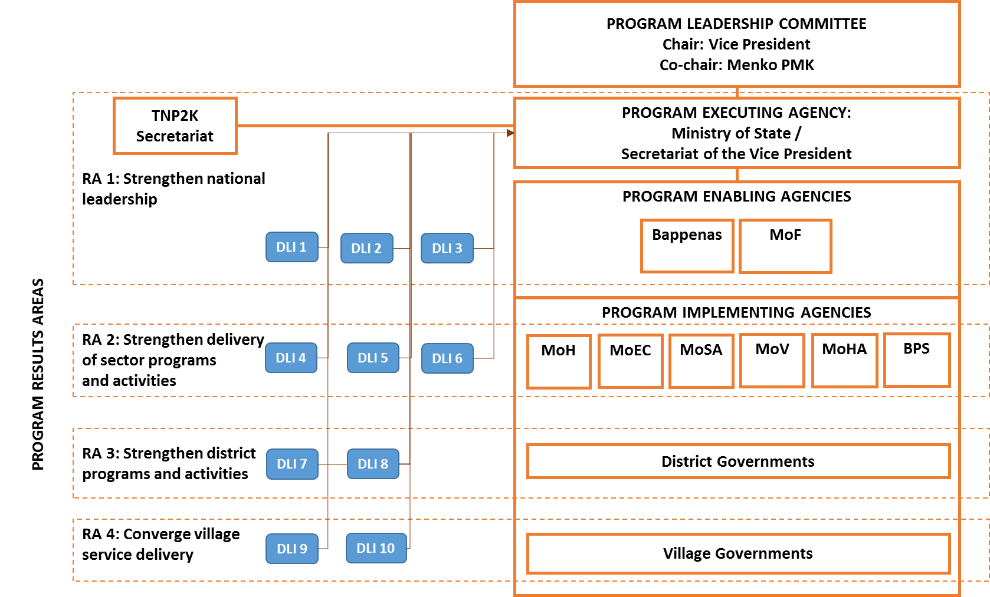

- Implementing Agencies Roles
Chair : Vice President of Republic of Indonesia
Co-Chair : Coordinating Minister for Human Development and Culture
Program Coordinator : National Development Planning Agency (Bappenas), Ministry of Finance
Members : Ministry of Health, Ministry of Education and Culture, Ministry of Social Affairs, Ministry of Home Affairs, Ministry of Villages, Development of Disadvantaged Regions, and Transmigration, Indonesian Central Board of Statistics

