The World Bank’s Partnership with Cameroon

January 2016
number 006
originally published: January 2003
The World Bank Group Archives Exhibit Series contains exhibits originally published on the Archives’ external website beginning in 2002. When the Archives’ website was transferred to a new platform in 2015, it was decided that older exhibits would be converted to pdf format and made available as a series on the World Bank’s external database, Documents & Reports.

These exhibits, authored by World Bank archivists, highlight key events, personalities, and publications in the history of the World Bank. They also bring attention to some of the more fascinating archival records contained in the Archives’ holdings.

To view current exhibits, visit the Exhibits page on the Archives’ website.

The World Bank’s Partnership with Cameroon
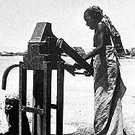
Cameroon is a Central African nation on the Gulf of Guinea, bordered by Nigeria, Chad, the Central African Republic, the Republic of Congo, Equatorial Guinea, and Gabon. Bantu speakers were among the first groups to settle Cameroon, followed by the Muslim Fulani in the 18th and 19th centuries. The land escaped colonial rule until 1884, when treaties with tribal chiefs brought the area under German domination. After World War I, the League of Nations gave the French a mandate over 80% of the area, and the British 20% adjacent to Nigeria.
Water hand pump in Congola near Maroua, supplied as part of Credit 0723 Rural Development Fund Project
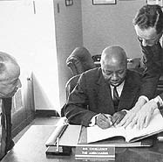
After World War II, when the country came under a UN trusteeship in 1946, self-government was granted. At this time, the Cameroon People's Union emerged as the dominant party by campaigning for reunification and independence. In British Cameroon, unification was also promoted by the leading party, the Kamerun National Democratic Party. France set up Cameroon as an autonomous state in 1957, and the next year its legislative assembly voted for independence by 1960.
Cameroon became an independent republic on Jan. 1, 1960. In 1961 the southern part of the British territory joined the new Federal Republic of Cameroon and the northern section voted for unification with Nigeria. The president of Cameroon since independence, Ahmadou Ahidjo, was replaced in 1982 by the prime minister, Paul Biya, who has remained in power ever since. With the expansion of oil, timber, and coffee exports, the economy has continued to improve, although corruption is prevalent, and environmental degradation remains a concern.
On April 10, 1964, the Federal Republic of Cameroon became a member of the International Development Association (IDA). The Articles of Agreement were signed by His Excellency Jacques Kuoh Moukouri. Also present were IBRD and IDA Secretary Morton Mendels (left) and Mr. Lyle Doucet (right)
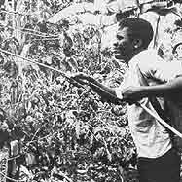
In 2002, Cameroon's population numbered just over 16 million persons. The largest cities are Doula (population 908,000) and Yaounde, the capital city (population 730,000). Life expectancy is 50 years. Mount Cameroon (13,350 ft; 4,069 m), near the coast, is the highest elevation in the country. Total surface area is 475.4 thousand square kilometers, with population per square kilometer of 32. The main rivers are the Benue, Nyong, and Sanaga. French and English are both official languages, and there are 24 major African language groups.
Cameroon joined the World Bank on July 10, 1963, becoming the 86th member of IBRD. The government subsequently joined IDA (April 10, 1964, becoming the 92nd member) and signed as the 29th member of the ICSID Convention on February 7, 1967. On October 1, 1974 Cameroon joined IFC, becoming the 100th member of the Corporation. On October 7, 1988 Cameroon joined MIGA, becoming the 45th member.
Spraying fungicide onto the leaves of coffee plants grown on the Arabica coffee plantation in Bafoussam (Credit 0784 Western Highlands Rural Development Project)
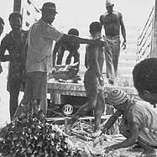
On August 18, 1975, IBRD opened a regional mission in Yaounde, headed by Mr. Michael Palein. IFC opened a regional mission for Central Africa in Douala on May 1, 1990, headed by Mr. Roger Blondel.
The first funding provided by the Bank to Cameroon was Loan 0490, Credit 0100 -- Agriculture Project. The Agriculture Project was based principally on oil palm, Cameroon's most profitable crop, but it included planting or replanting of rubber, tea and pepper, and also included work on existing immature plantings and provision for processing and other facilities. It expanded the area devoted to plantations from 22,400 ha to 33,100 ha.
Over the years, the Bank's financial and technical assistance spanned a wide range of sectors. The 1960s witnessed 3 loans and 3 credits, including ones for agriculture, education, oil palm, and water supply. Projects in the 1970s included 18 loans, 17 credits, and 2 investments for rice development projects, highway and feeder roads, Douala port projects, projects on education, cocoa, oil palm, railways, water supply and livestock.
Root stock for rubber trees is treated at the HEVECAM Rubber Estate in Niete
By the 1980s there were 20 loans, 4 credits, and 9 investments. Projects were related to economic management, structural adjustment, rural development, urban development, forestry, rubber, manpower development, post and telecommunications, and small and medium scale enterprises. In the 1990s the Bank Group made 3 loans, 10 credits, and 6 investments for national agricultural extension and training, food security, higher education, privatization and private sector technical assistance, transport sector technical assistance, economic recovery, and Social Dimensions of Adjustment.
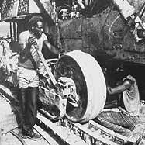 | 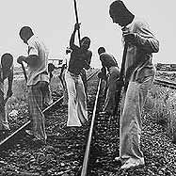 | 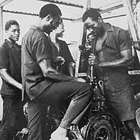
Heavy equipment is maintained and repaired in a garage at the HEVECAM Rubber Estate in Niete | Railway track maintenance for the fourth Railway project in Cameroon | Equipment repair at the palm oil processing mill on the Dibombari estate as part of the World Bank Group’s second SOCAPALM project
In 2000 the Bank agreed to support a $3.7 billion pipeline connecting the oil fields in neighboring Chad with the Cameroon coast, providing $53.4 million to Cameroon for its equity share in the project. Environmentalists feared the giant project would harm rain forests and primarily benefit oil companies and political elites in Cameroon and Chad. President Wolfensohn and the Board of Directors determined that the project would be improved due to World Bank participation, and that an independent body would monitor the project with attention to environmental and social safeguards.
On October 16, 2000, the Bank approved a comprehensive debt reduction package for Cameroon under the Enhanced Heavily Indebted Poor Countries (HIPC) Initiative. Total debt relief from all of Cameroon's creditors was worth around US$2 billion in nominal terms. The debt relief freed about $100 million per year for the next three years for expenditures on health care, primary education HIV/AIDS prevention, and other critical social services.
The Bank Group has produced 16 economic reports on Cameroon, the earliest dating from 1964. Topics of these reports include general economic studies, recent economic development, medium term public development program, industrial sector, development planning, public investment review, social dimensions of adjustment, and diversity, growth, and poverty reduction. (The full text of these reports are available through Imagebank).
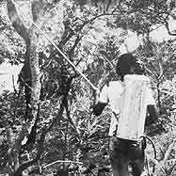
The most recent (2002) Country Assistance Strategy Progress Report for Cameroon had two objectives: a) to complete the implementation of the program set out in the 1996 CAS and the 1998 progress report; and b) to utilize the enhanced Heavily Indebted Poorest Countries (HIPC) initiative and Poverty Reduction Strategy Paper (PRSP) process to support second generation reforms to address poverty reduction issues with particular emphasis on governance, corruption, and the social sectors.
Spraying insecticide against the tsetse fly in Ngaoundere as part of the Livestock Development Project.
The report analyzed the Bank's experience in implementing its assistance strategy since the previous progress report in 1998 and discussed the Bank's interim program for the next 12-18 months, given that Cameroon's PRSP and the next full CAS were to be presented to the Board of Executive Directors. The interim lending program comprised eight operations totaling $183 million. The report concluded that if the government failed to address corruption and governance issues, the entire program could be derailed. Risks could be mitigated by undertaking only limited new lending until there had been satisfactory progress in these areas.
In total, the Bank Group has funded 45 loans, 39 credits, and 25 investments, and 8 trust fund projects for Cameroon. The original principle has totaled $2,618,641,993. Of this amount, $1,994,576,147 has been disbursed and $331,475,468 has been cancelled. $927,463,422 has been repaid, and $979,491,193 remains due.
World Bank Group Archives would like to acknowledge the various sources for the historical and statistical data used in this document: World Bank Group databases (including the Africa Region website, Archives' IRAMS database, CTR Loan KIOSK Imagebank) , the Economist Intelligence Reports, and InfoPlease . In cases of statistical discrepancy, the most recent statistics were chosen.

