Mozambique is experiencing its worst flooding since 2000, primarily in the Limpopo river basin. More than 50,000 people are reported to be affected. The Government has deployed military units and additional resources to rescue and assist populations at risk. The main affected sectors include transport, housing, shelter and health for displaced people. This Situation Report focuses on Mozambique, providing an overview of the situation, and likely response from the Government, donors and the World Bank. A brief overview of the situation in other South African countries is also included.
75394
Disaster Impacts at a glance
(Source: Relief Web, January 24, 2013)
- Deaths - 17
- Affected people – 49,646
- Displaced – 15,776
- Totally destroyed houses – 2,979
Current Situation:
- Currently 17 deaths have been reported with 49,646 people affected. Damage to road infrastructure is reported to be extensive.
- The Central and southern regions are most severely hit, while in Maputo the Municipality estimates damage to infrastructure at US$29 million, primarily housing and drainage.
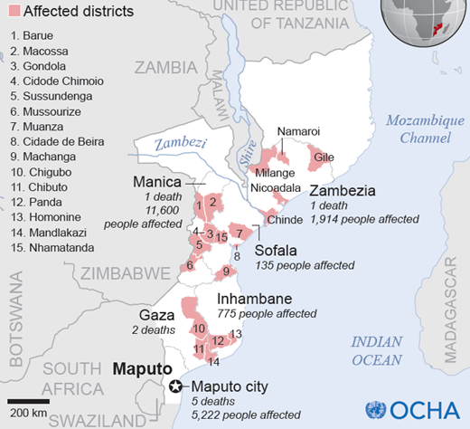
- In Limpopo, the situation is dramatic with inundated cities and villages, and is likely to get worse as the peak flood travels downstream. The city of Chokwé has been completely inundated and tens of thousands of people have fled to high ground. No official figures are yet available of the potential death toll and affected people. Floods are now threatening more than 55,000 people and the Government has deployed military units to rescue and assist populations at risk.
- Most of the roads are impassable and rescue operations are being made by boat. Preliminary economic and social needs estimates (on logistics, food security, hygiene, health care, housing and education) are starting to emerge and require urgent response. Though the Government is still focused on emergency activities, it is urgent to start addressing these issues.
- The situation in Chokwé city and surroundings villages, which have been submerged for two days, is dramatic: authorities say that some 37,000 people (Jan 23) have been evacuated to higher areas of Chiaquelane, a resettlement area created after 2000 floods, and Macia, a district capital city some hundred kilometers away. In Chokwé there is no water, electricity or communications: public services are closed and assistance to those remaining is scarce. Looting is now being reported.
- The peak flood is threatening the provincial capital city of Xai-Xai, with a population 116,000. Authorities are requesting people living in lower areas to move to higher places, as the city is likely to be inundated.
- Several main secondary roads linking districts are impassable and this is now impacting negatively on emergency rescue efforts. Government announced that helicopters will now be used to help rescue operations. As the situation evolves, the condition of the road network is likely to start deteriorate.
- The Incomáti River is now flooding the lower areas of Xinavane and Manhiça, sugar cane plantations, and threatening the national road N1 which acts as barrier to the flow in this area. In 2011 N1 was washed away in this region, paralyzing traffic for several days. Local authorities report displaced families but official figures are not yet available. The Incomáti will soon be flooding Marracuene, near Maputo city. The Maputo River down south is high but stationary. There are also reports of floods in Inhambane Province.
- Key power lines to South Africa were damaged by the flooding of the Limpopo River, cutting of power supply to South Africa, reducing power supply from 1,500 megawatts to 650 Megawatts.
Government and Donor Response
- Government officials are focused on emergency operations.
- The government has issued a red alert in central and southern regions. The CNOE (National Emergency Operation Center) as well UNAPROC (the rescue unit) has been fully activated. The Government is foreseeing the compulsory evacuation of people in areas at risk. The National Disaster Management Institute (INGC) is providing temporary accommodation to 4,300 displaced persons.
- The Humanitarian Country Team composed of UN Agencies and NGOs are currently working closely with Government in coordination, conducting assessments, analyzing and pre-positioning key non-food item stocks in strategic locations.

World Bank Response
- The World Bank team is in touch with the Government officials and is monitoring the situation very closely.
- A quick response team has been identified and is presently on standby to assist the Government in assessing the needs and formulating an implementable recovery plan.
- Based on initial consultations, areas of focus for a potential quick response mission are: transportation, health, education, housing, urban planning and disaster risk reduction.
- Under an ongoing grant from the Global Facility for Disaster Reduction and Reconstruction (GFDRR), and funds from the Pilot Program for Climate Resilience and IDA, the Bank is already supporting Mozambique with extensive interventions in disaster risk management and climate change adaptation. A detailed a remote sensing technique - LIDAR - survey in critical areas of the Limpopo is about to start, coupled with needed improvements in the national hydro meteorological network.

Regional overview:
Several Southern African countries are dealing with the effects of flooding following heavy rains over much of the region in the past week. Malawi experiences extensive floods affecting about 36,000 people as well as northern parts of South Africa. In Namibia, the Zambezi River keeps rising at Katima Mulilo, potentially reaching the levels of the 2011 floods. Zambia is suffering from waterlogging and crop damage in areas that experienced flash floods, but the effect seems to have been mostly localized so far. No reports so far ion impact on Madagascar.

Disaster Risk Management Team Contact:
Doekle Wielinga, AFR DRM Coordinator, AFTN2, WB Washington DC, AfricaDRM@worldbank.org
Disaster Risk Management Website, Sources: Local Governments, UN, OCHA, WFP, ECHO, FEWSNet, Relief Web press releases from various local and int’l media sources, WB Staff

