69482
A Policy Note

DOMESTIC REGULATION AND GLOBAL MOVEMENT OF SKILLED PROFESSIONALS:
A CASE STUDY OF INDIAN PROFESSIONALS IN THE UNITED STATES

South Asia Region: India
June 2006



Document of the World Bank

Table of Contents
I. Introduction 3
II. Cross-Border Movement of Professionals: The View from the Largest Importing Country 5
III. Cross-Border Movement of Professionals: The View from the Largest Exporting Country 12
IV. Regulations for Indian Professionals in the US 17
V. Economics of Regulatory Discrimination In Professional Services 39
VI. Priorities for International Negotiations 46

Tables
Table 1: Correlation coefficient between the share of foreign professionals across different professions 8
Table 2: Availability of Professionals per thousand people 14
Table 3: Comparison of Indian and US Weekly wages using market exchange rates for conversion, 1999/2000 16
Table 4: Comparison of Indian and US Weekly wages using PPP exchange rates for conversion, 1999/2000 16
Table 5: Measures affecting trade in services 40

charts
Chart 1: Flowchart for a Foreign Doctor to become eligible to practice in US 19
Chart 2: Additional Requirements for IMGs 22
Chart 3: Engineer’ Flowchart 23
Chart 4: Process of Engineer in Training (EIT) Certification 24
Chart 5: Professional Engineer Licensure Process 27
Chart 6: Engineers’ Flow chart- Additional Requirements Highlighted 28
Chart 7: Architects flowchart 31
Chart 8: Architecture Flowchart: Additional Requirements Highlighted 34
Chart 9: Flowchart for a Foreign Accountant to become eligible to practice in the US 36
Chart 10: Accountants Flowchart: Additional Requirements Highlighted 37

Figures
Figure 1:United States - The share of foreign-born professionals in total professionals is smaller relative to corresponding share in goods or capital markets (2000) 5
Figure 2:The number of skilled professionals and the share of foreign-born in the US economy 6
Figure 3: The share of foreign professionals varies considerable across US states 7
Figure 4: Share of foreign born professional in US states is influenced by national and sub-national regulations governing the profession 8
Figure 5: Distribution of foreign-born professionals (FBP) in the US by country of their birth 9
Figure 6: The number of skilled professionals and the share of foreign-born in the US economy 10
Figure 7: The annual average wages of professionals based on the country/region of their birth 11
Figure 8: Annual average wages for Indian professionals in comparison to the overall US market 11
Figure 9: Growth of Higher Education Institutions and Enrolment in India 12
Figure 10: Enrolment in higher Education by type of Management 13
Figure 11: Education Specific unemployment rate, 1999/2000 13
Figure 12: Decadal growth in registered Architects and Schools of Architecture in India 15
Figure 13: Identifying de facto discriminatory measures 54
Figure 14: Preferential recognition: Variable cost-increasing measures 68

Executive Summary

I. Emerging Global Market for Professionals: The Broader Trends

- Changes in demographics and patterns of investment in human capital are creating considerable scope for international trade in professional services. As populations in rich countries age, developing countries are seeing an increase in the proportion of working-age people. At the same time, the richest countries are investing proportionally less than middle income countries in engineering and technical human capital. These changes in endowments are creating shifts in comparative advantage that are reversing conventional views on “who can sell what to whom”.

- India and the United States are two countries that are likely to mirror these broader global trends. In India, the largest developing country exporter of skilled services, the supply of educated manpower has been rising rapidly. In the US, the largest single importer of skilled services demand for reasonably-priced, skilled workers like doctors, engineers, accountants and other high skilled professions is outpacing domestic supply.

- The scope for mutually beneficial trade in professional services is huge, but in practice such trade has been frustrated by a number of impediments. While the dramatic developments in information and communication technologies have rendered redundant many such impediments, in the foreseeable future international transactions in professional services will primarily be through the movement of people. And the movement of professionals across countries faces two types of impediments: explicit barriers, such as restrictive visa regimes, prohibitions and quotas on foreign providers, wage-parity conditions that erode the cost advantage of foreign services providers, discriminatory treatment in taxes and government procurement, and implicit impediments in the form of regulatory requirements to obtain qualifications, training and experience and licenses even when a service provider is already qualified and licensed in another jurisdiction.

- Previous work, including policy papers prepared by the World Bank (2004) for the Government of India, has focused on the explicit barriers. This paper focuses on the implicit impediments. Domestic regulations such as licensing and qualification requirements and procedures have a profound effect on services trade, but their analysis has proved elusive. While explicit barriers do not pretend to be anything else, regulations have usually been instituted to serve legitimate objectives, such as remedying market failure, but in some cases have been captured by protectionist interests. Sifting the legitimate from the protectionist is far from straight forward. Nevertheless, we take a first step in this analysis, focusing on how regulatory requirements and procedures impact on Indian doctors, engineers, architects and accountants when they wish to practice their profession in the United States.

Demand for Foreign professionals in The United States

- United States is arguably the largest market for foreign professionals in the world. Foreign professionals in the five services considered here, namely, accountants and auditors, architects, engineers, physicians and surgeons and lawyer, made up 17 percent of the total professionals of the US economy—which is smaller than the share of foreign goods and foreign capital in the US economy, but higher than the share of foreign professionals in most other countries. In absolute numbers, these five professions accounted for nearly 5.1 million jobs in 2000, of which, nearly 4.24 million were held by US-born professionals and the remaining 0.86 million by foreign-born professionals.

- The share of foreign professionals varies considerably across different professions, with professions that are less regulated and more intensive in science and technology-subjects tending to have a larger foreign presence. Foreign presence is the highest in the field of computer software and medicine, with foreign Computer Software Engineers and Physicians and Surgeons accounting for 29 and 27 percent of the total workforce in their respective fields. At the other extreme is the legal profession, where foreign-born Lawyers account for only 6 percent of the total workforce.

- There is wide variation in the share of foreign professionals across different US states, with foreign presence considerably higher in some of the larger and richer coastal and border states. So, for example, California, which is the most populated and the seventh richest state in the US in terms of per capita income and is a border as well as a coastal state, has seen the greatest penetration of foreign professionals in its work force among all the US states, with almost one out of every three professionals in California being foreign-born. On the other extreme, there is not a single foreign-born civil engineer, electrical and electronics engineer or mechanical engineer in the entire states of Arkansas or South Dakota.

- Asians make up nearly half of all the foreign professionals in the US, with India being the largest supplier of professionals to the US. In 2000, out of the 864 thousand foreign professionals working in the US, as many as 472 thousand (i.e. 54 percent of all foreign professionals) were born in Asia. India is the largest supplier of skilled professionals to the US. In 2000, nearly 133 thousand Indian-born professionals were working in the US in these five professions, implying that one out of every 50 professionals in the US was an Indian. But there was considerable variation across professions with three of every four Indian professionals working either as a computer software engineer or a physician or surgeon. On the other hand, only 3.7 percent of foreign-born lawyers, 5.8 percent of the foreign-born architects and 5.9 percent of foreign accountants and auditors were Indian.

III. Supply of Professionals From India

- India’s educated manpower is not only large, it is also growing rapidly. In 1999/00, though only 5.9 percent Indians had graduate degrees or above, this translated into 21.4 million graduate workers. The number of highly educated Indian workers is likely to have increased steeply since then, as enrolment in the higher education system has been rapidly rising since the 1990s. By 2005/06, an estimated 10.5 million students were enrolled in institutions of higher learning. India now has the third largest population enrolled in the higher education system in the world, after the United States and China. According to All India Council of Technical Education, India produced 464,743 engineers in 2004-05, an increase of 16 percent over 2003-04 and more than double the number of engineers produced by the United Sates and Europe combined.

- Notwithstanding the fact that India is endowed with a large and growing base for skilled professionals, there are serious concerns about the uneven quality of its endowment. According to McKinsey (2005), only 25 percent of Indian engineers, 15 percent of its finance and accounting professionals and 10 percent of Indian professionals with general degrees are suitable to work for multinational companies. The fact that at least some Indian professionals do not possess global skills is also evident from the fact that, despite the availability of a pool of middle mangers available at home, some Indian firms are beginning to recruit abroad. Our interactions with Indian professionals working in the US and interviews with human resource managers in Indian companies confirm the heterogeneity in the quality of education and sporadic shortage of professionals with certain skills. There is also broad consensus on the urgent need for reform of higher education in India.

IV. Regulations for Indian Professionals in the US

- A consequence of the federal structure of the US Government is that professional licensing is generally not at the national level but the responsibility of state boards. These boards are specifically formed by the respective state governments for the purpose of regulating different professions. Thus there are State Medical Boards, state Boards of Architecture, State Engineering Boards, and State Accounting Boards. In most cases, these Boards are autonomous bodies and possess wide discretion in matters regarding the eligibility to practice professions. These boards establish the rules for licensure in each profession.

- The application for licensure to practice a profession must be made to the respective state boards. Then there are broadly the following steps – not always clear cut, sometimes fragmented into smaller sub-steps and not always in the same sequence:

- The verification of educational qualifications, training and experience to establish eligibility to take the professional examination. Since no Indian program is accredited, this is a requirement that has to be fulfilled in all professions. The process is not expensive but is reported in certain areas to be of unpredictable duration and not transparent.

- The remedying of any gaps in education, training and experience before taking (all or part of) the examination, with the remedial steps to be taken in large part in the United States. Doctors take initial examinations held in India followed by a clinical skills examination in the United States, and then a period of mandatory graduate medical education in the United States (irrespective of past education and experience, and, in some states for a longer period than graduates of US institutions), and then qualify for a final examination in the United States. Most Indian architects and engineers in certain fields (including civil and mechanical) choose to pursue a masters degree in the United States, and must then (in certain fields) acquire several years of local experience which makes them eligible to take a professional examination. The experience requirements for graduates of non-accredited institutions are in some states significantly longer than those for graduates of accredited institutions.

- Passing the professional examination(s), held entirely or in significant part in the United States.

- In each of the professions, except unregulated engineering fields like software, the final examination must be taken in the United States. In order to take the examination, a candidate needs to obtain a visa and incur the costs of examinations.

- The fulfillment of additional requirements, such as experience or local residency, in order to obtain a professional license. In medicine, a foreign medical graduate on a J1 visa must go through 3 years of work in an underserved area in order to be able to work in the United States. In accountancy, several US states require accountants to be residents in order to be licensed.

- Licensure rules differ not only across professions but across states. Each state has its own requirements for those who have qualified from the state, from other states of the United States and from a foreign country. For example California requires four years of experience for licensure if an engineer is educated from a non-accredited program, whereas Pennsylvania requires a minimum of 12 years of experience. Similarly, international medical graduates (IMGs) are required to complete 3 years of postgraduate training in states such as Alaska, Colorado, Delaware, Washington DC and Missouri whereas the requirement is only 2 years of post graduate training in states such as California, Florida and Illinois. Architecture is an exception in that it has a centralized and strong national body, the National Council for Architectural Registration Boards (NCARB) that works with State Boards to establish qualification, registration and licensing policies.

V. Implications of Regulatory Discrimination in Professional Services

- It is conceivable that at least some of the qualification and licensing requirements imposed by the United States on Indian service providers are not necessary to achieve regulatory objectives. De facto discrimination results when these requirements are waived only for some of the national or foreign providers who deserve the benefit. The United States agreement with Canada eliminates the need for chartered accountants trained in these countries to duplicate all steps in the licensing process, and provides for abbreviated examination requirements. Certain US states impose a shorter residency requirement on doctors trained within the United States than on foreign doctors.

- The analysis of discriminatory treatment in professional services differs from conventional trade analysis in two ways. First, since professional services trade often requires proximity between the supplier and the consumer, we need to consider the impact of discrimination not just on quantities supplied cross-border, but also on the entry into the market of foreign individuals and foreign firms. Secondly, while some forms of discriminatory treatment like taxes on foreign short-term consultants are like tariffs in their effect, others such as burdensome licensing and qualification requirements differ because they affect fixed costs of entry and because they sometimes inflict costs on foreigners without generating rents.

- The positive implications of discriminatory treatment are straightforward: compared to a non-discriminatory regime, in any market we shall observe a relatively higher share of services and service providers from jurisdictions that are exempted from burdensome qualification and licensing requirements than of those from jurisdictions that are not exempted. The normative implications for policy are also simple. Where a country like the United States maintains regulations that impose a cost on foreign providers, without generating a benefit (such as improved quality) or revenue for the government or other domestic entities, welfare is likely to be enhanced by eliminating such regulations even on a preferential basis - as the US has done through the mutual recognition agreements it has concluded in accountancy and engineering or as some US states do visa a visa other states. The presumption that US (or a particularly US state) will benefit from such initiatives is greater if agreements are not exclusionary – i.e. they do not apply restrictive rules of origin. That is, if the US grants recognition to South Africa in engineering then any Indian who has qualified in South Africa must also benefit regardless of citizenship. The greatest benefits arise from the elimination of unnecessary regulatory requirements for providers from all countries, e.g. recognition agreements include all countries that have comparable regulation. That is if India has basically the same educational and training system engineers as South Africa, then it should also be made party to mutual recognition agreements that include South Africa, such as the Washington Accord. The benefits come from both increased competition and greater diversity of services.

- It is possible to demonstrate the impact of differential requirements on foreigners at the state level in the United States thanks to the availability of detailed US census data. Econometric tests show the following: (a) First of all, state-specific variables, like per capita income, size of the population and the state’s geographic location (whether on the coast or on the border), significantly influence a foreign professionals’ choice with regard to place or state of work; and (b) Secondly, regulations governing the recognition of professional qualifications, training and experience and the licensing requirements at the state-level also significantly affect foreign presence in the state, with states that have a more stringent regulatory environment attracting less foreign professionals than states with more liberal regulations.

- In case of accountants and auditors, we find that states which require in-state experience while applying for a Certified Public Accountants (CPA) license are likely to have 5.7 percent less foreign professionals than states that do not impose such a requirement. The states that impose restrictions on in-state residency and experience for license and CPA certified experience are likely to have 9 percent less foreign professionals than states that do not impose any of those restrictions. In case of physicians and surgeons, states that require foreign graduates to spend more years in residency program than natives to take the final professional examination, do not recognize Graduate Medical Examination (GME) completed in foreign countries (other than Canada) for credit towards license, and do not grant licenses to foreign eminent physicians, are likely to have 5 percent less foreign doctors than states that do not impose these restrictions. Unlike accountants and doctors, the impact of state-level regulations is found to be ambiguous in case of engineers. So on one hand, states that require additional experience to appear in the professional engineering (PE) examination for foreign professionals (with a degree that is not accredited by the Accreditation Board for Engineering and Technology, ABET), are found to have lower foreign presence relative to states that do not impose such restrictions; on the other hand, in-state residency requirements is found to be positively associated with foreign presence.

VI. Implications of the Co-existence of Quotas and Regulatory Requirements in the US Market

- Given the excess demand for US visas among foreign professionals, it is reasonable to conclude that, despite the regulatory requirements, the binding constraint on the movement of Indian professionals are the quantitative restrictions imposed by the US on the entry of foreign professionals. These restrictions are implemented through the limitations on the number of specialty occupation visas (H1B) and the number of employment related Green cards. Given the binding quota, the number of Indian professionals in the US market is not affected by the regulatory tax. But the tax eats into the earnings that Indian professionals could have enjoyed and leads to a transfer from Indian professionals to either the US Government (in the form of low public sector salaries for doctors in compulsory jobs), to US training and educational institutions, or to pure dissipation where the measure is a frictional barrier. Of course, if the US were to relax the quota, then it is conceivable that the regulatory requirement would be the binding constraint.

- It is possible to obtain a rough, lower bound estimate of the financial cost of the regulatory burden on Indian professionals. Thus, on average over the period 1995-2000, 1092 Indian doctors entered the US medical system. Each incurred a cost of $4,640 to obtain a visa, take the three steps of the professional examination and in licensing fee. Each had to go through a period or graduate medical education of between 3 to 6 years depending on the specialty and the state, irrespective of prior qualifications and experience. Then those on a J1 visa (most foreign doctors) were obliged to spend 3 years working in an underserved area at relatively low wages. Given that the average earnings of a doctor is shown by the census to be around $125,000, the earnings foregone by a foreign doctor are likely to be at least $100,000. The implication is that all the Indian professionals that entered in a particular year paid a regulatory tax of $114 million. Similar, conservative estimates suggest that the 10,000 or so Indian professionals that entered just the four professions that we are focusing on, paid a regulatory tax of around to $750 million.

VII. Priorities for International Negotiations and domestic reform

- The fundamental regulatory problem faced by Indian professionals is the non-recognition of their qualifications, training and experience. All the other problems stem from this: the costly and time-consuming evaluation of prior qualifications, undertaking costly examinations, taking courses that at least in part repeat prior education, undergoing training that duplicates at least in part prior training, acquiring more experience than their US counterparts, with the added burden that all these requirements can in certain cases only be met in US locations, by obtaining US visas. In these circumstances, India’s strategy must be:

- To secure as far as possible recognition for existing qualifications, training and experience.
- To ensure that any additional requirements can be fulfilled in the least burdensome manner.

Bilateral Approaches

- All existing mutual recognition agreements in the world today are bilateral or concluded among a small group of countries. It is inconceivable that a forum with such diverse membership as the WTO can in the foreseeable feature deliver meaningful mutual recognition agreements. How difficult it can be to achieve mutual recognition in professional services among a group of even relatively similar countries is demonstrated by the disappointing experience of the European Union - the recent Services Directive could only be accepted once the powerful “country of origin” principle, which would have implied de fact mutual recognition, was abandoned.

- There is no doubt that ultimately liberalization depends on full recognition and that India must continue to seek recognition from its major trading partners in a bilateral context. But past experience does not provide basis for optimism for this approach. Its overtures in engineering (seeking membership of the Washington Accord), for example, have been ignored for a number of years. The key incentive problem is that foreign professionals have so far had limited interest in securing access to the Indian market, and have felt threatened in their own markets, because of the high level of competitiveness of Indian professionals. And the power of organized professional associations has so far trumped the benefits to diffuse consumer interests. But the situation may be changing. First, India’s own economic growth and willingness to contemplate allowing greater access to the Indian market to foreign professional firms may have created greater commonality of interests. Increased incomes and increasing diversity of preferences may also create the possibility of foreign professionals serving some segments of the Indian market. Second, certain developments are leading to the mobilization of consumer interests within the United States. The increased demand for accountants in the wake of the Sarbanes-Oxley Act has induced the large accountancy firms lobby for more liberalized access to the US market. Similarly, the soaring cost of health-care has created an opportunity to mobilize hospitals and health maintenance organizations to lobby for increased trade in health care through all modes.

- The second and more legitimate impediment to recognition is the heterogeneity of standards within India which has undermined the case for securing recognition on a national basis. In effect, poor quality institutions penalize the high quality institutions. India must certainly contest excessively burdensome regulations in the US market. But it must also reform its own regulations. Here it may well face a dilemma. Setting domestic standards at a level that enhances the case for foreign recognition may lead to standards that are inappropriately “high” from a domestic perspective. The tension will be greatest in areas like medicine where sections of the domestic market are underserved. In these circumstances, dual or multiple standards may be a solution. That is one standard is set at a level that creates a credible case for foreign recognition, and another at a level that is appropriate to domestic needs. This would eliminate the conflict arising from trying to meet two objectives with one standard. Furthermore, by accepting a lower standard, a segment of the population would receive the benefit of actual rather than notional service – because there is a lower probability of the provider emigrating abroad or to an urban area. At the same time, “export quality” standard(s) (assigned by examination or institution) can be targeted at specific export markets, and liberated from the need to be locally appropriate. The feasibility and desirability of such an approach, from both the political and regulatory perspective, and the design of domestic regulatory reform, must be a key area for future research.

Multilateral Approach
- Given the difficulty of securing recognition bilaterally, it is important that India make parallel efforts in the current negotiations under the General Agreement on Trade in Services (GATS) to strengthen commitments and rules on trade in professional services. We would recommend:
(a) Leveraging mutual recognition agreements (MRAs) concluded by partner countries through the MFN principle.

- Even with no new multilateral commitments or rules, India still has an avenue to challenge restrictive regulations faced by its professionals by invoking the fundamental GATS provision of MFN (stipulating that a country may not discriminate between trading partners) as embodied in the GATS provision on recognition agreements (Article VII). This opportunity arises because some of its trading partners have already concluded mutual recognition agreements in professional services. For example, the US has made four notifications (required under Article VII.4 of the GATS): on accounting with Canada and Australia; on architecture with Canada; and the Washington Accord, on engineering with Australia, Canada, Hong Kong, Ireland, New Zealand, South Africa, and the United Kingdom. One issue, on which India should press for greater clarity, is the applicability of Article VII to MRAs concluded by entities other than the central Government.

(b) Securing and enforcing national treatment commitments by trading partners.

- The cornerstone of the multilateral trading system is the national treatment obligation, GATS Article XVII, which requires Members to offer no less favorable treatment to foreign services and service suppliers than that it accords to its own like services and service suppliers. In goods, under GATT 1994, national treatment is a general obligation allowing for no exceptions. In services, under the GATS, Members can choose whether to make such a commitment in a particular sector under a particular mode. None of the four large Members of the WTO, Canada, EU, Japan and US have made commitments to guarantee national treatment under mode 4 (presence of natural persons) in any of the four professions being studied here - something that India offers in its revised offer in the current negotiations. National treatment is potentially the most important guard against regulatory protectionism. If a country retains the right to discriminate, then negotiating an elaborate set of rules for domestic regulations would be like creating a building with no edifice. Hence, in addition to pushing for greater market access in professional services, India should attach the highest priority in the current negotiations to securing commitments from its main trading partners on national treatment.

(c) Negotiating deeper disciplines on domestic regulations either under Article VI:4 of the GATS or in the form of additional commitments under Article XVIII of the GATS.

- The Council for Trade in Services is currently in the process of negotiating horizontal disciplines on domestic regulations. But these negotiations, in which India has been an active participant, have so far made little progress, largely due to the reluctance of a number of countries to assume any further disciplines in this area. The prospects for developing deeper disciplines are not bright. Nevertheless, given the nature of the regulatory impediments identified in the US market, and the reasonable presumption that Indian professionals face similar impediments in other markets, India should strive to negotiate certain key disciplines.

(d) Ensuring fairness and objectivity in both the evaluation of competence and the recommendations for remedial action

- Building on the existing requirement under GATS Article VI:6 to institute procedures to verify the competence of foreign professionals, at least industrial country Members of the WTO should be required to justify the denial of recognition to foreign professionals on objective grounds and identify precisely why they are not deemed competent to practice. In so far as there are legitimate reasons to doubt the competence of a foreign provider, there would be a presumption in favor of a test of competence as a means of assessing compliance with local requirements. Where there are objectively verifiable gaps in education or training, then a foreign service supplier could be required to fill these gaps. Re-qualification, and substantial repetition of training and experience should only be required if it can be demonstrated to be necessary to ensure the desired quality of a service. Similarly, local residency requirements should be no more burdensome than needed to ensure the desired quality of service and consumer protection. Finally, it should be possible to take any of these remedial actions, including examinations, filling gaps in education, training and experience in the home country of the service provider unless it can be demonstrated that local fulfillment is necessary to ensure the quality of a service.

(e) Other procedural disciplines

- At least industrial country Members should set up a “one-stop website” for each profession where a foreign professional can obtain all the relevant information on licensing and qualification requirements and procedures.

- Members would ensure that verification and assessment are carried out efficiently and transparently and the processes do not themselves constitute an unnecessary barrier to foreign professionals.

- Ideally the examinations should be held in the home countries of foreign professionals or in countries that have less restrictive visa regimes than that of the United States. Where coming to the US is necessary, a candidate who needs to obtain a visa to fulfill a qualification or licensing requirement or both should be granted one. For doctors the restrictive J1 visa should be replaced by a more efficient and equitable visa.

- Members shall ensure that fees charged are no higher than those necessary to cover the administrative costs of services, and the licensing process is no longer than that necessary to ensure the competence of foreign professionals.

DOMESTIC REGULATION AND Global Movement of Skilled Professionals:
A Case Study of Indian professionals in the United States

I. Introduction

- Changes in demographics and patterns of investment in human capital are creating considerable scope for international trade in professional services. As populations in rich countries age, developing countries are seeing an increase in the proportion of working-age people. At the same time, the richest countries are investing proportionally less than middle income countries in engineering and technical human capital (Sequeira, 2003). These changes in endowments are creating shifts in comparative advantage that are reversing conventional views on “who can sell what to whom.” According to some estimates, over the next decade, nearly three-fourths of professional jobs will be created in industrial countries, whereas nearly two-third of professionals will come from the emerging market economy, thereby setting the stage for large and rapidly growing trade in skilled professionals.

- India and the United States are two countries that mirror these broader global trends. In India, the largest developing country exporter of skilled services, the supply of educated manpower has been rising rapidly, but employment in domestic industry and government, traditionally the main absorbers of such workers, has been growing slowly. For example, according to the All India Council of Technical Education, India produced 464,743 engineers in 2004-05, an increase of 16 percent over 2003-04 and more than double the number of engineers produced by the United Sates and Europe combined. In the United States, the largest single importer of skilled services demand for reasonably-priced, skilled workers like doctors, engineers, accountants and other high skilled professions is outpacing domestic supply.

- Even though there seems to be significant scope for mutually-beneficial international transactions in professional services, some have questioned both the feasibility and desirability of such transactions. First of all, there is concern that only some of the professionals trained in developing countries possess the skills to provide services to industrial country firms and consumers. Thus, a study by McKinsey and Co. (2005) finds that only 25 percent of Indian engineers, 15 percent of its finance and accounting professionals and 10 percent of Indian professionals with general degrees are suited for work for multinational companies. Secondly, there are reports suggesting that Indian and Chinese firms are themselves facing shortages for certain categories of managers and professionals and are beginning to hire abroad, so the “exportable surplus” is limited. Thirdly, some have argued that since skills are scarce in developing countries, and temporary cross-border movement often ends up as permanent emigration, it is not in the interest of developing countries to encourage such “trade” because it leads to brain drain. Finally, there is concern that increased trade in professional services will lead in the short run to adjustment costs in industrial countries and in the long run to diminished incentives for their citizens to acquire professional skills.

- While there is some truth in each of these assertions, the balance of current opinion among economists is that there are significant gains from freer trade in the services of the skilled for all participating countries (Bhagwati, 2004, Winters et al, 2003, World Bank, 2004). There is, nevertheless, a need to address these concerns, because they have implications for social welfare, and because concerns about quality in developing countries and adjustment in the industrial countries are often used to justify protectionist measures. Such concerns are ideally addressed through a combination of reforms in higher education in developing countries and creation of a more flexible labor markets in industrial countries, but a discussion of these policies is beyond the scope of this report.

- The dramatic developments in information and communication technologies have rendered redundant many impediments to trade and facilitate rapid growth in some digitized services. In the foreseeable future, however, international transactions in professional services, will primarily be through the movement of people. And unfortunately, the enormous mutual benefits from such transactions are today frustrated by the range of impediments to the movement of people across countries. These impediments are fairly uniform across countries and include: explicit barriers, such as restrictive visa regimes, prohibitions and quotas on foreign providers, wage-parity conditions that erode the cost advantage of foreign services providers, discriminatory treatment in taxes and government procurement, and implicit impediments in the form of regulatory requirements to obtain qualifications, training and experience and licenses even when a service provider is already qualified and licensed in another jurisdiction.

- Previous work, including policy papers prepared by the World Bank (2004) for the Government of India, has focused on the explicit barriers. This paper focuses on the implicit impediments. Domestic regulations such as licensing and qualification requirements and procedures have a profound effect on services trade, but their analysis has proved elusive. While explicit barriers do not pretend to be anything else, regulations have usually been instituted to serve legitimate objectives, such as remedying market failure, but in some cases have been captured by protectionist interests. Sifting the legitimate from the protectionist is far from straight forward.

- We first undertake the less ambitious but nevertheless challenging task of identifying comprehensively the regulatory requirements and procedures imposed on doctors, engineers, architects and accountants licensed to practice in India if they wish to practice in the United States. These requirements include obtaining (where feasible) recognition of prior educational qualifications, training and experience, undertaking written and oral exams, and fulfilling the requirements and procedures for obtaining a license. A key dimension of the exercise is to document sub-Federal requirements and how they differ across jurisdictions. The report then takes a first step in trying to asses whether the regulatory requirements are more burdensome than necessary to achieve the stated regulatory objectives. The report attempts to provide a first estimate the cost of complying with regulations. An attempt has also been made to demonstrate how variations across states in the presence of foreign professionals can be attributed at least in part to stringency of regulations. Finally, we examine how regulatory barriers are best addressed, bilaterally and/or through creating deeper disciplines in international agreements.

- The issue of international movement of professionals, while important from a policy perspective, has not provoked much empirical research. Thus there is not a well-established methodology and little information and data to fall back upon. Much of the work in this paper is based on primary data collected for this report. However, both the data and the estimates must at this stage be seen as a work in progress. We will continue to search for data and to refine and develop a more precise methodology.
- The structure of the policy note is as follows. Section II examines the trend and market conditions of the foreign professionals operating in the US, with particular emphasis on the Indian professionals. Section III presents a brief overview of India’s education system and discusses the supply side story of the professionals and also discusses the relative costs of professionals in India and the US. Section IV identifies the regulatory barriers that foreign professionals face in the US market—both at the national as well as sub-national level—and Section V provides a theoretical framework for regulatory discrimination. In Section VI we present the economic cost of regulations and the final Section examines who India can address regulatory impediments to the export of professional services through bilateral and multilateral avenues.

II. Cross-Border Movement of Professionals: The View from the Largest Importing Country

II.a. Cross-border movement of skilled professionals is small when compared to the amount of goods and capital that are traded between countries.

- United States in arguably the largest market for foreign professionals in the world. But foreign professionals constitute a much smaller share of total market for professionals relative to the corresponding share for foreign goods or for foreign capital. As shown below, in 2000, imports of goods and capital made up as much as 44 and 32 percent of the total goods produced and investment made in the US economy respectively. On the other hand, foreign professionals in the five services considered here, namely, accountants and auditors, architects, engineers, physicians and surgeons and lawyer, made up 17 percent of the total professionals in the US economy. In absolute numbers, these five professions accounted for nearly 5.1 million jobs in 2000, of which, nearly 4.24 million were held by US-born professionals and the remaining 0.86 million by foreign-born professionals. The share of foreign professionals in the US is also low relative to other developed countries, as Canada, UK and EU13 have higher percentage of professionals in the labor force that than the US (figure-1).

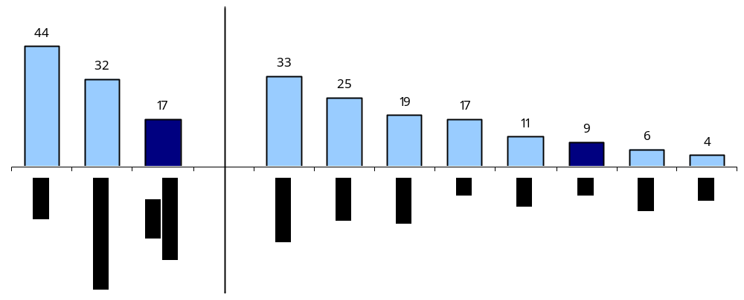
Figure 1:United States - The share of foreign-born professionals in total professionals is smaller relative to corresponding share in goods or capital markets (2000)

Source: US Census 2000, Authors’ calculation

II.b. The share of foreign professionals varies considerably across different professions, with professions that are less regulated and more intensive in science and technology-subjects tending to have a larger foreign presence.

- While the foreign-born professionals constitute 17 percent of total market for professionals in the US, there is large variation in foreign presence across different professional streams. A profession-wise breakdown of the 5.1 million workers working in the US in 2000 reveals the following (figure-2): 1.7 million Accountants and Auditors, 871 thousand Lawyers, 715 thousand Physicians and Surgeons, 702 thousand Computer Software Engineers, 309 thousand Electrical and Electronics Engineers, 273 thousand Civil Engineers, 270 thousand Mechanical Engineers and 194 thousand Architects. The foreign presence is the highest in the field of computer software and medicine, with foreign Computer Software Engineers and Physicians and Surgeons accounting for 29 and 27 percent of the total workforce in their respective fields. On the other extreme is the legal profession, where foreign-born Lawyers account for only 6 percent of the total market size. The three other engineering professions also have large foreign presence: 20 percent for Electrical and Electronics Engineers, 17 percent for Civil Engineers and 16 percent for Mechanical Engineers. The foreign presence in the two other non-science and technology professions—Accountants (14 percent) and Architects (15 percent)—is close to the national average for all professionals.

Figure 2: The number of skilled professionals and the share of foreign-born in the US economy
(Number of professionals) (Share of foreign professionals)
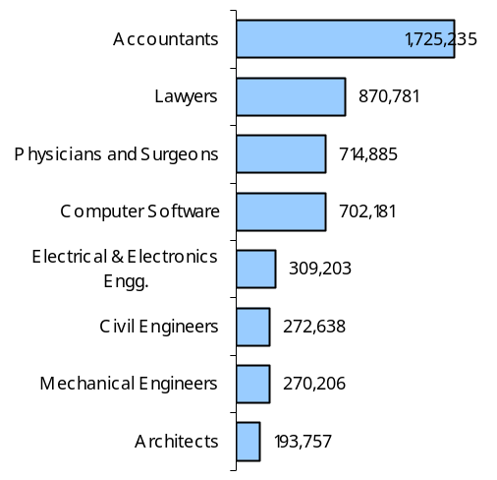
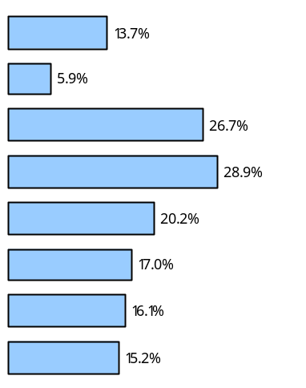

Source: US Census 2000, Authors’ calculation

- There are three broad factors that seem to explain the large inter-professional variation in the foreign presence in the US market. First, there has been a significant change in the global landscape of tertiary education, with the US share in the global population with tertiary education falling from 31 percent in 1980 to 27 percent in 2000 and the a doubling of the corresponding share of China and India. And within tertiary education, if one only looks only at the science and technology education, the decline in the share of US has been even greater. And within it, the share of native students in the science and technology stream has witnessed a dramatic decline in recent years (see Borjas, 2005). Thus part of the reason for the relatively large foreign presence in professional streams involving science and technology subjects can be attributed to the sluggish supply response within the US economy. The second factor explaining the cross-professional variation in foreign presence is the inherent nature of the profession, i.e., some professional services require more country-specific knowledge than others (e.g., the legal profession requires a deep understanding of the constitution and legal provision in the destination country, a knowledge that foreign professionals may lack), which serve as a natural barrier for cross-border movement of professionals. Finally, some of the variations in foreign presence across professional services can be explained by the nature of regulation, with less regulated professions likely to see higher share of foreign professionals and vice-versa. It is the last of three explanations that will be investigated in the next section.

II.c. There is wide variation in the share of foreign professionals across different US states, with some of the larger and relatively richer states on the coast and on the border, as well as states with less stringent regulation, tending to exhibit larger foreign presence than other states.

- There is considerable inter-state variation in the distribution of foreign-born professionals within the US economy. As is normally the case, states that are relatively rich, large (in terms of population) and are on the coast (e.g., California and New York) or on the border with Canada and Mexico (e.g., Illinois and Texas respectively) tending to have a larger share of foreign professionals in their work force than the relatively poorer, small and/or inland states (e.g., Arkansas and South Dakota) – as illustrated in the figure below. So, for example, California, which is the most populated and the seventh richest state in the US in terms of per capita income and is a border as well as a coastal state, has seen the greatest penetration of foreign professionals in its work force among all the US states, with almost one out of every three professionals in California being foreign-born. New York, which has similar characteristics as California, has also been a major recipient of foreign professionals, with nearly one out of every four professionals in its work force being foreign-born. On the other extreme, there is not a single foreign-born civil engineer, electrical and electronics engineer or mechanical engineer in the entire states of Arkansas or South Dakota.
Figure 3: The share of foreign professionals varies considerable across US states
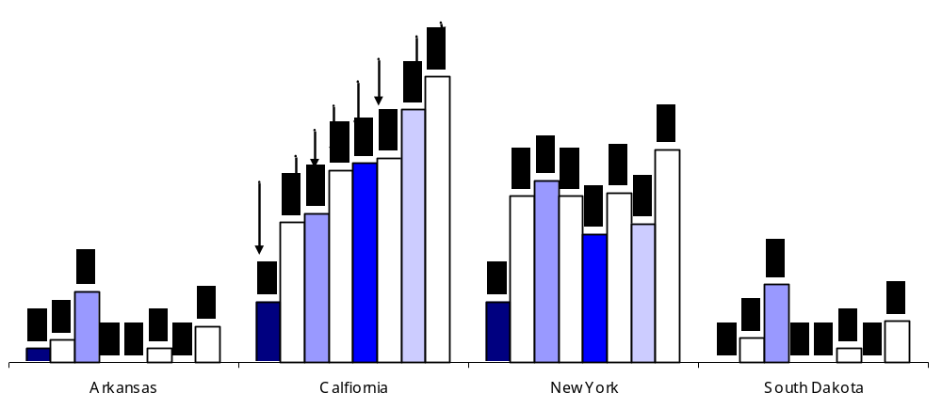

Source: US Census 2000, Authors’ calculation
- The share of foreign-born professionals across different professions is found to be highly correlated across the US states, indicating the importance of state-specific factors as explanations for this variation. For example, the correlation between share of foreign accountants and auditors and architecture across different US states is found to be 0.88 and between civil engineers and software engineers in 0.78 and so on (see Table-1). Clearly, the highly positive correlation between the extent of foreign presence for different professions across the US states indicate that it is the characteristics of the states (e.g., size, income and geography of the state) that significantly influence the foreign professionals’ decision of which place or state to work in.

Table 1: Correlation coefficient between the share of foreign professionals across different professions
across 50 US States and the District of Columbia - 2000
 | Accountancy | Architecture | Civil Engg. | Physician & Surgeon | Electrical &Electronics | Lawyer | Mechanical Engg | Software Engineer
Accountancy | 1.0 | 0.88 | 0.83 | 0.63 | 0.81 | 0.84 | 0.74 | 0.79
Architecture |  | 1.0 | 0.84 | 0.81 | 0.72 | 0.96 | 0.52 | 0.67
Civil Engineering |  |  | 1.0 | 0.72 | 0.72 | 0.61 | 0.70 | 0.78
Physicians and Surgeons |  |  |  | 1.0 | 0.49 | 0.44 | 0.52 | 0.57
Electrical and Electronics |  |  |  |  | 1.0 | 0.63 | 0.65 | 0.73
Lawyer |  |  |  |  |  | 1.0 | 0.59 | 0.59
Mechanical Engineering |  |  |  |  |  |  | 1.0 | 0.56
Software Engineering |  |  |  |  |  |  |  | 1.0
Source: US Census 2000, Authors’ calculation

- Some of the variation in foreign presence between states can also be attributed to the differential nature of regulation at the state-level. As shown below, both New Jersey and Pennsylvania are large, relatively well off states on the east coast and yet their share of foreign-born accountants and auditors varies widely: 21 percent in New Jersey as compared to 5 percent in Pennsylvania. Similarly large variation can be seen between Michigan and Massachusetts for accountancy services. It turns out that this is mostly because Pennsylvania and Michigan have a residency requirement for those obtaining the CPA license, while all other coastal states including New Jersey and Massachusetts do not have such restrictions.
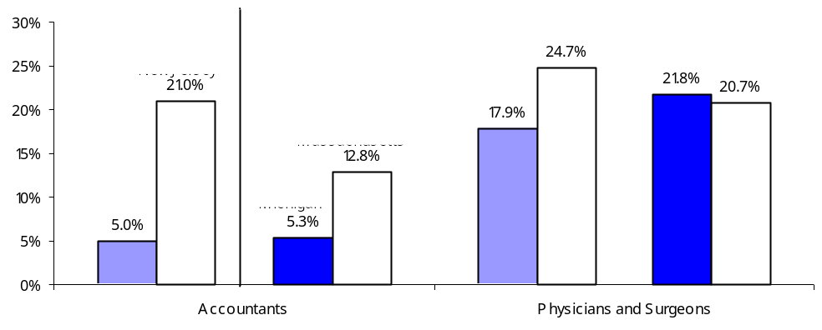
Fig 4: Share of foreign-born professional in US states is influenced by national and sub-national regulations

Source: US Census 2000, Authors’ calculation
II.d. Asians make up nearly half of all the foreign professionals in the US, with India being the largest supplier of professionals to the US

- In 2000, out of the 864 thousand foreign professionals working in the US, as much as 472 thousand (i.e. 54 percent of all foreign professionals) were born in Asia. The Europeans constitute the second largest group of foreign professionals in the US, with 19 percent market share. The third largest group in professionals from Caribbean and Mexico, with 10 percent market share. Professionals from South America and Africa each make up 5 percent of the professionals in the US. Among the Asian professionals, Indians form the largest group, followed by professionals from China and Hong Kong, Philippines, Vietnam, Taiwan, Iran, Japan and Pakistan.

Figure 5: Distribution of foreign-born professionals (FBP) in the US by country of their birth

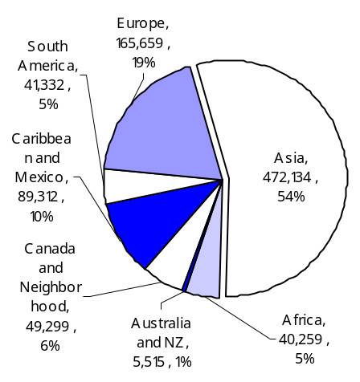
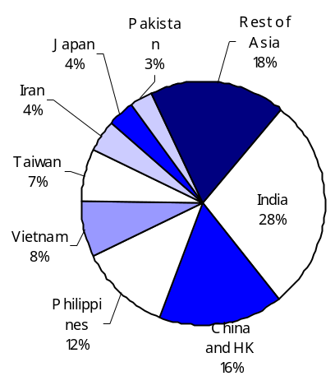
(Native vs. Foreign) (Composition of FBP by Continent) (Composition of Asian by Country)

Source: US Census 2000, Authors’ calculation

- India is the largest supplier of skilled professionals to the US, with three-quarter of them being either a computer software engineer or a doctor. In 2000, nearly 133 thousand Indian-born professionals were working in the US in these five professions, which imply that one out of every 50 professionals in the US was an Indian. But there was considerable variation across professions with three of every four Indian professional working either as a computer software engineers or as a physician or surgeon. On the other hand, only 3.7 percent of foreign-born lawyers, 5.8 percent of the foreign-born architects and 5.9 percent of foreign accountants and auditors were Indian. In case of computer software, 1 out of every 10 professionals in the field was an Indian by 2000. Since it is well known that the flow of computer software professionals from India has continued after 2000, the recent numbers are likely to be much larger (see figure-6).

- Indian professionals in the US, along with professionals from several Asian countries including China, Vietnam, Taiwan, South Korea, Pakistan and Bangladesh tend to be younger than professionals from Europe, Canada, Japan, Philippines and also are likely to have more years of schooling than the latter group of countries. As we discuss later, since educational qualification and work experience earned by professional in the originating country is often not recognized in the destination country, partly explains why foreign professionals tend to have more years of schooling than the natives.

Figure 6: The number of skilled professionals and the share of foreign-born in the US economy
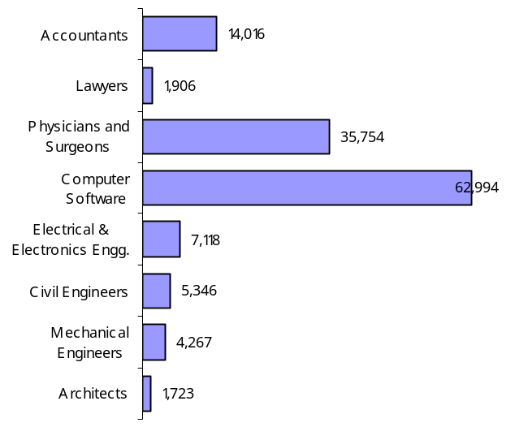
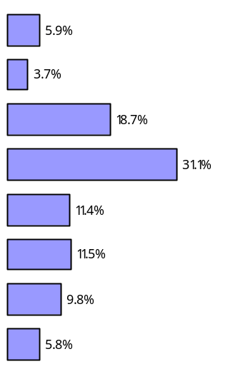
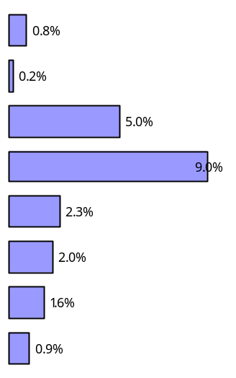
(Number of professionals) (% of foreign) (% of total)

Source: US Census 2000, Authors’ calculation

II.e. Foreign-born professionals command a small wage premium over the natives, though there is considerable difference in the wages between foreign professionals originating from developed and the developing countries.

- The wage gap between US-born and foreign-born professionals is rather small, with foreign-born professionals on average earning nearly 5 percent more than the natives. The average wage of the 846 thousand professionals examined for this study was found to be $68,870 and for the 4.3 million US-born professionals it was found to be $65,569 (figure-7). One possible explanation for this wage premium is that, since educational degrees and work experience earned abroad are not recognized in the US, the foreign professionals are forced to repeat some of the course work in the US universities and the wage premium is thus a reflection of the more years of education that the foreign professionals posses relative to the natives.

- The average wage of foreign professionals however masks the large variation between professionals originating from different countries. The professionals from the developed countries (e.g., Australia, UK, Canada, Germany and Japan) tend to have higher earnings that their counterparts from the developing countries. And within developing countries, professionals from Latin America and Africa tend to receive lower earnings, while Eastern Europeans and Asians command relatively higher earnings. The annual average earnings of Indian professionals is found to be $76,811 (in 2000), which is significantly higher than the national average and is closer to the wage for professionals from developed countries. Indian professionals tend to command a considerable wage premium in science and technology-related professions—electrical and electronics, civil and mechanical engineering—as well as in architecture. Indian professionals however receive lower wages in two fields in which they are most commonly represented, namely physicians and surgeons and computer software professionals. If the earnings ar a reflection of the quality and standard of service delivery of the concerned professional, then the wide variation in the earnings of professionals across different countries raises issue about the heterogeneity in the quality and standards of the service providers originating from different countries—an issue that we discuss in greater details in the next section.

Figure 7: The annual average wages of professionals based on the country/region of their birth
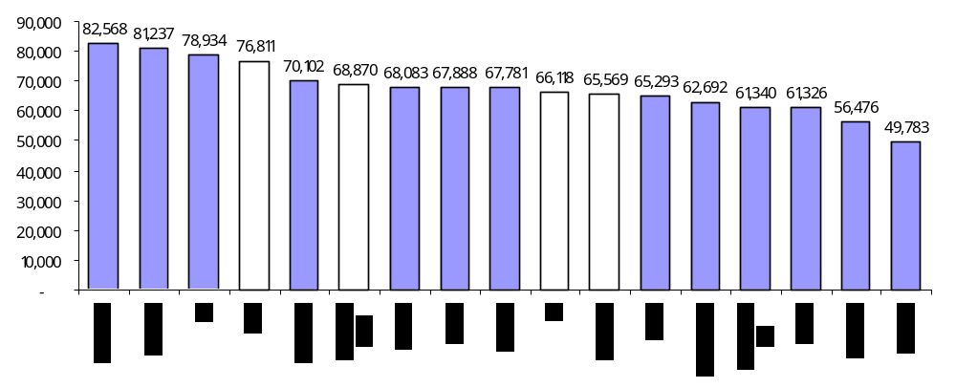
(in US$, 2000)
Annual average wages for Indian professionals in comparison to the overall US market
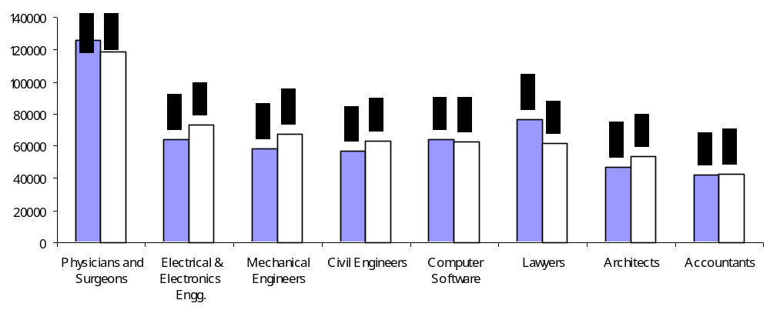
Source: US Census 2000, Authors’ calculation

III. Cross-Border Movement of Professionals: The View from the Largest Exporting Country

III.a. Large and growing manpower of India

- India’s educated manpower is not only large, it is also growing rapidly. In 1999/00, while only 5.9 percent Indians had graduate degrees or above, this translated into 21.4 million graduate workers. The number of highly educated Indian workers is likely to have increased steeply since then, as enrolment in the higher education system has been rapidly rising since the 1990s (figure 9). By 2005/06, an estimated 10.5 million students were enrolled in institutions of higher learning. India now has the third largest population enrolled in the higher education system in the world, after the United States and China.
Figure 8: Growth of Higher Education Institutions and Enrolment in India
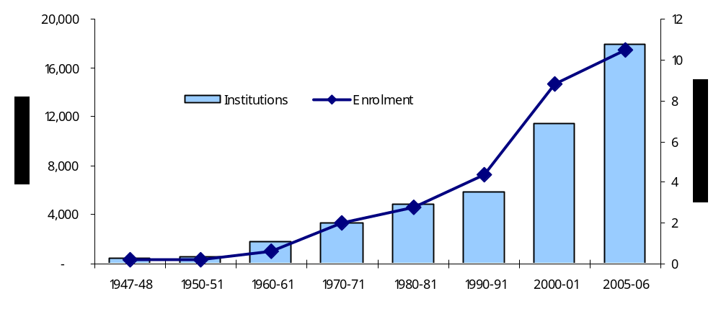

Source: Agarwal, 2006

- The structure of the higher education sector in the country has also become more oriented towards meeting labor market needs. Till the 1980s, growth in the sector was largely confined to subjects such as liberal arts, science and commerce. Around that time, however, demand started rising for quality professional education, more directly relevant to the needs of business and industry. This was in keeping with the changing structure of the economy, and the growing importance of industry and the services sector. Public resources to feed this demand were however limited, so the period saw the entry of private players. Most private institutions were aimed at providing professional/vocational training. Their earnings came mostly from tuition, and they were costlier than government-aided institutions. However rising incomes among the middle class meant that there was enough demand for these seats. Over the 1990s, the private sector has gradually become more important. Over the initial half of the present decade, most new seats have been created in private unaided institutions (figure 10). Such institutes have spurred a huge increase in capacity, to the extent that for some professional courses, excess capacity has been created. For instance, thousands of seats in many engineering colleges in the country have gone vacant in recent years (Agarwal, 2006).

Figure 9: Enrolment in higher Education by type of Management
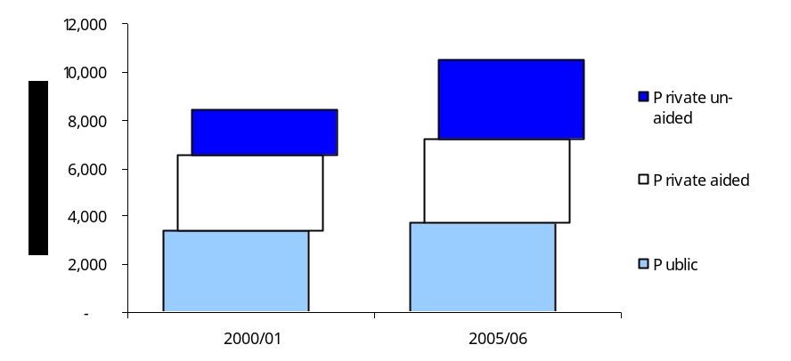

Source: Agarwal, 2006

- At the same time, unemployment remains high among the more educated workforce, suggesting that India is underutilizing its human capital (World Bank, 2006). Surprisingly, this holds true even for professions in high demand such as engineers and doctors. For example, unemployment rate among engineering graduates was 6.8 and 1.5 percent among medical graduates, compared to an aggregate unemployment rate of 2.8 percent. Unemployment rates were even higher for diploma holders (figure 10).

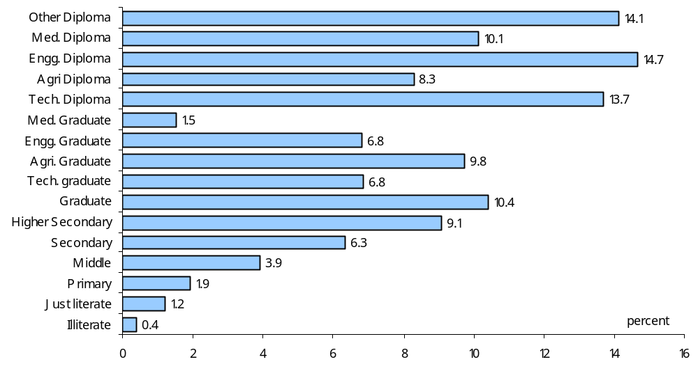
Figure 10: Education Specific unemployment rate, 1999/2000

Source: Mathur and Mamgain, 2004

- In some professions such as medicine or engineering, both the number of graduates and their unemployment rate are high. A number of factors may be responsible. Firstly, high unemployment among professionals may simply reflect their higher capacity to wait for a suitable job. Second, this may be a product of unobserved quality differences among graduates from different institutions, which reduces their employability in both domestic as well as international markets. Thirdly, the excess supply may be transitory as the Indian economy grows and demand for professionals increases. In many professions, high unemployment currently coincides with low per capita availability compared to other countries (Table 2).
Table 2: Availability of Professionals per thousand people
 | US  (2000) | India (2002) | China (1990)
Doctors | 2.5 | 0.6 | 0.4
Lawyers | 3.1 | 0.7 | 0.03
Architects | 0.76 | 0.02 | 0.04
Accountants | 5.6 | 0.1 | NA
Chemical Engineers | 0.3 | 0.1 | 0.2
Civil Engineers | 1.0 | 0.5 | 0.5
Electric and Electronic Engineers. | 2.6 | 0.8 | 0.6
Mechanical Engineers | 1.2 | 0.6 | 0.7
Engineers | 7.4 | 2.6 | NA
Source: ILO Laborsta database, Indiastat.com website

- Turning now to the supply of specific professions considered in this study. There is no apex body covering engineers in India. However in 2002, it is estimated that India had a stock of 2.7 million engineers. In addition it graduated 0.2 million engineers in that year, split roughly half and half between degree and diploma holders. This was a third higher than the number graduating just three years earlier. This period also saw a sharp increase in the number of teaching institutions (India Manpower Profile, 2004). Annex-1 provides a detailed account of all the key institutions that regulate higher education and professional services in India.

- The Institute of Chartered Accountants of India (ICAI) is the apex body governing auditing and accounting profession in India. As of now the institute has about 0.13 million registered members. Roughly about 5000-7000 new members are added every year, which is an increase over previous levels. The institute wants to increase supply even more in response to market demand, and is devising strategies to make this available.

- Registration with the Indian Council of Architecture is mandatory for a person to carry out services as an ‘Architect’ in India. As of December 31st, 2004, there are about 26,240 architects in India registered under the Council of Architecture. An average of 2000 new architects registered annually over the past decade. The current target is to increase the number of new graduates to 10,000 annually. This is sought to be achieved both by increasing the number of institutions, as well as expanding the number of seats and courses offered by existing institutions.

- Similarly doctors in India are required to register with the Medical Council of India, which was set up under the Indian Medical Council Act, 1956. As of July 27th, 2005, there were about 0.65 million practicing doctors registered with the Medical Council of India, and about 21,000 new doctors register every year.

- Practicing lawyers in India need to be registered with their respective State Bar Councils. As of March 31st, 2001 there are about 0.85 million advocates registered with the State Bar Councils. Roughly about 40, 000 to 50,000 new lawyers register every year.
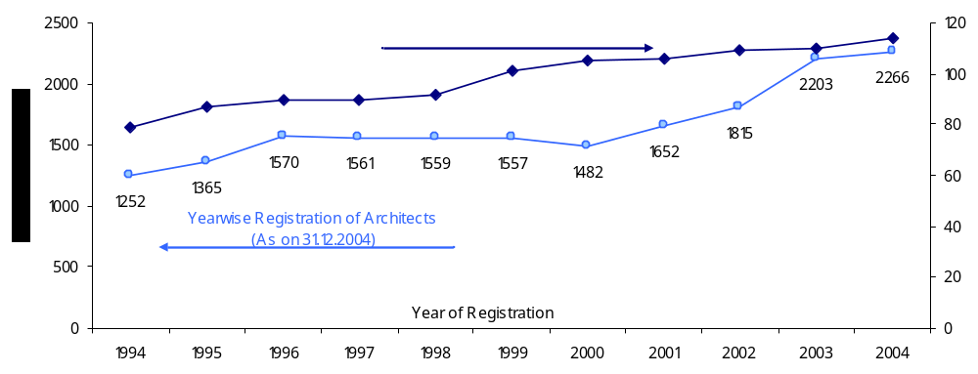
Figure 11: Decadal growth in registered Architects and Schools of Architecture in India
Source: Handbook of Professional Documents-2005, Council of Architecture

III.b. The Quality of Indian Professionals

- While India is endowed with a large and growing base for skilled professionals, there are conflicting views about the quality of its endowment. According to McKinsey (2005), only 25 percent of Indian engineers, 15 percent of its finance and accounting professionals and 10 percent of Indian professionals with general degrees are suitable to work for multinational companies. The fact that many Indian professionals do not possess the global skill and quality is also evident from the fact that, despite large pool of middle mangers available at home, some Indian firms are beginning to recruit them from abroad.

- Our interactions with Indian professionals working in the US and interviews with human resource managers in Indian companies indicated differing views on this subject. Many Indian professionals were of the view that, the engineering students from more well known institutes in India (e.g., from one of the Indian Institute of Technology) are generally perceived by the employers in the US to be of better quality than engineering students from lesser-known institutes (e.g., from one of the Regional Engineering Colleges). But at the same time, they were of the view that, engineering graduates from India on average are as much or more qualified than the natives in the US, but tend to be at a disadvantage in terms of non-technical knowledge, including language skills. The large disparity in the quality of professionals originating from different educational institutes in India was also echoed by the human resource managers in India.

- The reasons for large within country heterogeneity among professionals and the lack of abundant supply of suitable Indian professionals in certain professions can be attributed to: (i) lack of trained faculty, poor infrastructure in educational institutes and low level of spending on research and technology in higher education; (ii) the inability of the regulatory agencies to ensure high and uniform quality across all educational institutes in face of rapidly expanding institutes imparting higher education; (iii) outdated curriculums, limited ability to impart practical skills and inadequate focus on language skills at the level of primary and secondary education; and so on. The Government of India has taken a number of initiatives to address these problems, a detailed discussion of which is beyond the scope of this policy note.

III.c. Cost of Skilled Professionals in India

- Indian professionals enjoyed a clear wage advantage over their counterparts in the US going by the last comprehensive information available for the year 1999-2000 (Table 2). Though this information is dated, given that there has been limited trade in these professions, wage distributions may not have moved too much.

- There is little overlap between the wage distribution: for all professions, the 90th percentile wage in India is lower than the cut-off wage for the bottom decile in the US. The gap is quite large when dollar wages are converted to rupees using market exchange rates, as would be relevant if a professional earns in the US, but spends in India (Table 3). This suggests that Indian professional wages are very competitive, and Indian professionals have a lot to gain from cross-border transactions (Mode 1), and also from temporary access under mode 4.

- But would professionals like to live and work abroad for long periods? For this the US and Indian wages need to be compared using the Purchasing Power Parity (PPP) exchange rate. When this is done, there is a slight overlap between the two wage distributions for certain professions (Table 4). While the differential between the Indian 90th percentile and the US 10th percentile remains large for doctors, they are smaller in the case of architects and negligible in the case of accountants. If one were to assume that Indian professionals moving to the US would initially start in the bottom decile of wage earners there, this suggests that the immediate gain for accountants and architects from moving abroad permanently is small, while the gains are more significant in the case of doctors and lawyers. However at the median wage, US wages remain attractive.

Table 3: Comparison of Indian and US Weekly wages using market exchange rates for conversion, 1999/2000
 | Weekly Wages by Profession in India (INR) |  |  | Weekly Wages by Profession in US (INR)
 | 10th percentile | 50th percentile | 90th percentile | 10th percentile | 50th percentile | 90th percentile
Doctor | 100 | 650 | 2800* | 24901 | 90473 | 267269
CA | 200 | 1001 | 2500 | 12035 | 30462 | 63912
Architect | 163 | 350 | 2100* | 15771 | 38845 | 80513

Table 4: Comparison of Indian and US Weekly wages using PPP exchange rates for conversion, 1999/2000
 | Weekly Wages by Profession in India (INR) |  |  | Weekly Wages by Profession in US (INR)
 | 10th percentile | 50th percentile | 90th percentile | 10th percentile | 50th percentile | 90th percentile
Doctor | 100 | 650 | 2800 | 5178 | 18814 | 55578
CA | 200 | 1001 | 2500 | 2503 | 6335 | 13290
Architect | 163 | 350 | 2100 | 3279 | 8078 | 16742
Source: NSS 55th Round, US Census

IV. Regulations for Indian Professionals in the US

- We have seen that changes in demographics and patterns of investment in human capital are creating considerable scope for trade in professional services between industrial and certain developing countries. Furthermore, despite the dramatic development in technologies for electronic delivery, trade through the “temporary presence of natural persons”(mode 4) will remain important for a range of professional services. Rough estimates suggest that there are substantial economic gains from the liberalization of trade through mode 4. However, negotiations on the “temporary presence of natural persons” (mode 4), which first took place during the Uruguay Round of trade talks under the General Agreement on Trade in Services (GATS), have so far not been particularly successful. In fact, they served primarily to facilitate exploratory business visits and the movement of high-level personnel within multinational corporations

- Today Mode 4 continues to face a range of stringent barriers. These barriers are fairly uniform across countries and fall into the following broad categories.

- Visa formalities are in themselves a significant obstacle, and the conditions attached are used to implement some of the restrictions listed below. One source of the problem is that the temporary movement of service providers invariably comes under the purview, not of international trade policy, but of immigration legislation and labor market policy.
- Prohibitions and quotas on foreign providers are imposed either explicitly or through requirements of a prior adequate search for national service providers (e.g. in the United States only 65,000 specialty occupation (H1-B) visas are issued each year). A somewhat weaker requirement is that employers take timely and significant steps to recruit and retain sufficient national workers and that no worker be laid off for a certain period preceding and following the filing of any work permit or visa application. In fact, the widespread use of economic needs tests has emerged as one of the major barriers to the free movement of service providers (OECD, 2002). The discretionary and non-transparent nature of such tests certainly reduces the predictability of trading conditions.

- Wage-parity conditions imply that wages paid to foreign workers should be similar to the existing wages paid to nationals in that profession (e.g. in the US). Although this requirement is intended to provide a non-discriminatory environment, it tends to erode the cost advantage of hiring foreigners and works like a de facto quota.

- Discriminatory treatment is implemented through a variety of internal instruments and is also a major impediment. Residency or citizenship requirements are frequently imposed as eligibility conditions, putting foreign providers at an immediate disadvantage). Then there is discrimination through social security contributions and taxes. For example, in the United States, foreign service providers have to pay Social Security and other taxes for which they do not get adequate tax credits in their home countries. Discrimination also often takes the form of preferences in government procurements granted to domestic service providers over foreigners.

- Non-recognition of professional qualifications, training and experience and burdensome licensing requirements can be an impediment in regulating professions. The requirement of registration with, or membership of, professional organizations also constitutes an obstacle for a person wishing to provide the service on a temporary basis. Certain services, such as those of IT service providers, are not regulated, and many that are regulated allow for some trade through subcontracting (e.g., a U.S. consumer may be obliged to use a U.S. architect, but the U.S. architect may buy the services of a foreign architect). More stringent barriers exist in other regulated professions, ranging from doctors to lawyers. The difficulty here is in distinguishing between the legitimate denial of recognition and the denial that has a protectionist motive.

- Previous work, including policy papers prepared by the World Bank (2004) for the Government of India, has focused on the first four categories of barriers. This paper addresses the last, whose importance is widely recognized but whose analysis has proved elusive. We focus on the barriers facing Indian professionals (the largest developing country exporter of skilled services) in the US market (the largest importer of skilled services). Future work will widen the scope of study.

- A consequence of the federal structure of the US Government is that professional licensing is generally not at the national level but the responsibility of state boards. These boards are specifically formed by the respective state governments for the purpose of regulating different professions. Thus there are State Medical Boards, state Boards of Architecture, State Engineering Boards, and State Accounting Boards. In most cases, these Boards are autonomous bodies and possess wide discretion in matters regarding the eligibility to practice professions. These boards establish the rules for licensure in each profession.

- The application for licensure to practice a profession must be made to the respective state boards. Then there are broadly the following steps – not always clear cut, sometimes fragmented into smaller sub-steps and not always in the same sequence:

- The verification of educational qualifications, training and experience to establish eligibility to take the professional examination.

- The remedying of any gaps in education, training and experience before taking (all or part of) the examination, with the remedial steps to be taken in large part in the United States.

- Passing the professional examination(s), held entirely or in significant part in the United States.

- The fulfillment of additional requirements, such as experience or local residency, in order to obtain a professional license.

- Licensure rules differ not only across professions but across states. Each state has its own requirements for those who have qualified from the state, from other states of the United States and from a foreign country. For example California requires four years of experience for licensure if an engineer is educated from a non-accredited program (no Indian program is accredited), whereas Pennsylvania requires a minimum of 12 years of experience. Similarly, international medical graduates (IMGs) are required to complete 3 years of postgraduate training in states such as Alaska, Colorado, Delaware, Washington DC and Missouri whereas the requirement is only 2 years of post graduate training in states such as California, Florida and Illinois. Architecture is an exception in that it has a centralized and strong national body, the National Council for Architectural Registration Boards (NCARB) that works with State Boards to establish qualification, registration and licensing policies. These standards have been recognized by every state board as adequately rigorous to allow the state board to register the NCARB certificate holder.

IV.a. Regulations for Foreign Medical Professionals

- Documentary Evidence of Foreign Medical Degree: International graduates must show proof of having graduated from a medical college listed in the International Medical Education Directory (IMED). There are 163 medical schools in India that are listed in IMED.

IV.a.i. Description of the Flow Chart

- USMLE (United States Medical Licensing Examination) is a three-step examination for medical licensure in the United States. The USMLE assesses a physician's ability to apply knowledge, concepts, and principles that are important in health and disease and that constitute the basis of safe and effective patient care. Each of the three steps complements the others; no step can stand alone in the assessment of readiness for medical licensure.

- USMLE Step 1 Exam: The Step 1 exam has approximately 350 multiple-choice test items, divided into seven 60-minute blocks, administered in one eight-hour testing session. The purpose of USMLE step 1 is to test the understanding and application of important concepts in basic biomedical sciences, with an emphasis on principles and mechanisms of health, disease, and modes of therapy. USMLE Step 1 is a one-day Computer-based Test. The exam is offered at Thomson Learning’s Prometric testing centers at multiple locations in India. The fee for taking the examination is $ 685. Students from India have to pay an additional $120 of International Test Delivery Surcharge.

Chart 1: Flowchart for a Foreign Doctor to become eligible to practice in US
Foreign Medical Degree

Appear In USMLE Step 1 Exam
Cost for Indian Medical Graduate: $805; Location: Multiple- India

Appear in USMLE Step 2 CK
Cost for Indian Medical Graduate: $805, Location: Multiple- India

Appear in USMLE Step 2 CS
Fees for taking the exam for Indian Medical Graduate: $1200, Travel Costs, living Costs, Visa expenses extra; Location: USA

Index

USMLE: United States Medical Licensing Examination
CK: Clinical Knowledge
CS: Clinical Skills;
ERAS: Electronic Residency Application Service
NRMP: National Resident Matching Program;
GME: Graduate Medical Education (also called Residency)
ECFMG: Educational Council for Foreign Medical Graduates
J1 Visa: Visitor Exchange Visa
Licensure: License to practice medicine granted by state medical boards
J1 Waiver: Waiver of J1 Visa to stay in US and keep working in US.

ECFMG Certification

Application for Residency Using ERAS – Electronic Residency Application Service
Fees: $60 for 10 applications + ECFMG Fees of $75 for transmittal of all ECFMG records to various residency positions

NRMP: National Residency Matching Program
Fees: $30 Per Program if ranking the program over 15

Graduate Medical Education

Appear in USMLE Step 3,
Approximate Cost: $625

Licensure
Fees: Approx. $500

J1 Waiver

- USMLE Step 2 - Clinical Knowledge (CK): The USMLE Step 2 is broken into two sections. The first section is designed to test the knowledge of the clinical fundamentals needed for the practice of medicine and is known as "Clinical Knowledge" also USMLE Step 2 CK. Step 2 CK has approximately 370 multiple-choice test items, divided into eight 60-minute blocks, administered in one nine-hour testing session. This is also a computer based test and can be taken at Prometric testing Centers at Multiple locations in India. The fee for taking the examination is $ 685. The students from India have to pay extra $120 of International Test Delivery Surcharge.

- USMLE Step 2- Clinical Skills (CS): The second section is known as USMLE Step 2 CS, also "Clinical Skills”. This is a "live" exam in which the candidate has to examine 11 or 12 patient cases. The candidate has 15 minutes for each patient encounter and 10 minutes to record the patient note. The testing session is approximately eight hours. The goal of this part of the exam is to determine if the candidate has the basic skills in physical examination and history taking .This type of examination used to be limited to foreign medical graduates, but has been recently expanded so that all graduates must take the exam. Step 2 CS is administered at Clinical Skills Evaluation Centers in Atlanta, Chicago, Houston, Los Angeles, and Philadelphia. The fee for taking this test is $1200.

- ECFMG Certification: The first two steps of USMLE for international students and graduates are conducted by ECFMG- Educational Commission for foreign Medical Graduates. Through its program of certification, the Educational Commission for Foreign Medical Graduates (ECFMG) assesses the readiness of international medical graduates to enter residency or fellowship programs in the United States that are accredited by the ACGME-Accreditation Council for Graduate Medical Education. After clearing the first two steps of USMLE, an international Medical Graduate (IMG) is awarded ECFMG certification that is essential for an IMG to apply for fellowship or residentship positions. ECFMG certification allows a physician to work in a hospital in a training capacity or in a residency program with supervision.

- Application for Residency Using ERAS: The Electronic Residency Application Service (ERAS) is a service that transmits residency applications, letters of recommendation, Dean's Letters, transcripts, and other supporting credentials from applicants and medical schools to Fellowship, Osteopathic Internship and Residency programs using the Internet. The fee for ERAS is $60 for first ten applications. The fee increases proportionately with the number of applications.

- National Residency Matching program (NRMP): NRMP is a program that matches applicants' and programs' preferences.

- Graduate Medical Education: This is also known as Residency and USMLE 1 & 2 exams are meant to test candidates to enter into GME in USA. The duration of residency depends on the specialty chosen. It varies from 3 years to 6 years across different US states.

- USMLE Step 3: This exam is administered by the medical board in each state. The exam is taken over the course of two days. One must complete each day of testing within 8 hours. The first day of testing includes approximately 350 multiple-choice questions divided into blocks of 25 to 50 questions that have to be completed within 30 to 60 minutes. There is a maximum of 7 hours of testing on the first day. The second day of testing includes approximately 150 multiple-choice questions and computer-based case simulations (CCS). The fee for the examination varies from state to state.

- Licensure: The state boards authorize a candidate to practice in that state after a candidate has cleared all the steps of USMLE and has also met all the requirements of the board.

(x) J1 Waiver: Since all the candidates sponsored by ECFMG enter US on J1 visa, they have to obtain a J1 waiver if they wish to stay in US and work. J1 waivers are awarded only if an Interested Government Agency (IGA) sponsors the candidate and the candidate agrees to work in Health professional Shortage area (HPSA) or in medically undeserved area (MUA) for a minimum period of three years.

IV.a.ii. Additional Requirements on Foreign Medical Professionals

- Compared to a native medical professional, there are several additional requirements for a foreign professional to work in the US, starting from getting a visa to enter the US to getting a license to practice. The following is a brief discussion of these additional requirements and the possible ways to deal with them:
- Visa Formalities: After taking USMLE 1 and 2 (Clinical Knowledge) in India, a candidate has to obtain a visa to enter the US to write USMLE 2 (Clinical Skills). While the examination per se is not an additional requirement, but the fact that the examination is held only in the US and getting a visa to enter the visa could become a potential barrier. Possible ways to deal with this problem is to have more examination centers worldwide, relaxing visa requirements for the candidates appearing in USMLE step 2 examinations.
(ii) J1 Visa: After a candidate has secured admission in a GME, she is sponsored by ECFMG on a J1 visa. In order to obtain the J1 visa, the candidate has to provide a statement of need from the Ministry of Health of the country of most recent legal permanent residence. Furthermore, the J1 visa mandates a candidate to return to his “country of last residence” after he completes his GME.

(iii) Differential Requirements to Appear in Step 3 of USMLE: The requirements for the foreign professionals differ from state to state. Many states require more years of GME from foreign trained students relative to US educated students before the former can appear in Step 3 of USMLE. For example in Washington DC, international medical graduates (IMGs) are required to do 2 more years of GME than their American/Canadian counterparts to qualify for taking the Step 3 USMLE. There are many ways to deal with this problem. Since all the candidates are tested on the identical tests of USMLE 1 and 2, either there should be no differential treatments between native and foreign professionals or the difference should be justified on the basis of objective criteria.

(iv) Differential Requirements for Licensure: The “number of years of GME needed for Licensure” for the IMGS and the USMGs vary considerably across the states, with the average difference being approximately two years. Since all the candidates are tested on the identical tests of USMLE 1 and 2, as we have indicated earlier, either there should be no differential treatments between native and foreign professionals or the difference should be justified on the basis of objective criteria

(v) Additional Requirement due to the provisions of J1 Visa: J1 visa mandates a candidate to return to her “country of last residence” after she completes his GME. ECFMG is authorized by US Government to only issue J1 Visa. If a candidate after completing the residency in the US wants to continue working in the country, she can do so only by obtaining waivers form an Interested Government agency (IGA). An IGA only applies only when the physician agrees to work for at least 3 years in Medically Underserved Areas or in designated shortage areas. From the perspective of foreign professionals, things would be less constraining if J1 waiver can be obtained easily and its conversion into H-1B is made easy. In place of J1, the foreign professionals may also be allowed to hold an F1 visa where candidates are allowed a year to stay in the US after completion of the program on OPT (optional practical training) and it is possible to obtain an H-1B during that time.

(vi) Working in underserved areas or rural communities for three years: This additional requirement arises when a doctor in lieu of waiver of requirements of J1 has to serve in medically underserved areas. According to our interview with various doctors of Indian origin, this is a restrictive requirement as it has a high opportunity cost in terms of the foregone practice worth as much as half a million dollar over the period of three years (given the annual income of doctors in the US is around $125,000). The grant of waiver should be made easy and the requirement to serve underserved areas if necessary should be imposed equally on domestic and foreign doctors on equal terms. Moreover, ECFMG should be allowed to sponsor candidates on F1 Visa, as proposed above.

Chart 2: Additional Requirements for International Medical Graduates (IMGs)
USMLE 1 &2 CK
(Location: India)
USMLE 2 CS
(Location: USA)
NRMP
ERAS

ECFMG Certification
First Additional
Requirement - Visa

ECFMG J1 Sponsorship
USMLE Step 3
GME

Second Additional
Requirement - J 1 Visa barrier
Third Additional
Requirement- Differential requirements for steps 3
Fourth Additional
Requirement - Inequality of requirements for Licensure

J 1 Waiver & H1B Grant
Licensure

Sixth Additional Requirement: Work in underserved areas or in rural communities for 3 years
Fifth Additional Requirement- Due to provisions of J1 Visa requirements to return to the country of origin

IV. b. Regulations for Foreign Engineering Professionals

- There are two broad ways the Indian engineers seem to enter the US labor market (flowchart-3):

(i) The engineers who have obtained their undergraduate degree from prestigious institutes like the Indian Institute of Engineers (IITs) or who have superior technical experience are found to enter the US on H-1B visa, since they are able to find US employers willingly to sponsor them for such a visa. If these engineers belong to an engineering field (e.g., civil or mechanical) where professional engineering (PE) is valued, then they have to gain few years of experience in the US before writing the Foundation of Engineering (FE) exam. Since no Indian degree is recognized as substantially equivalent to ABET accredited US engineering degree, almost all Indian engineers irrespective of the institution they received their engineering degree in India are required to earn several years of experience before they can write the PE examination. Thus, while the America firms recognize the degree of these candidates and are willing to sponsor them for an H-1B visa, the state boards do not recognize their degrees as substantially equivalent to ABET.
(ii) The engineers who obtain their degree in less prestigious and well-known engineering schools in India are more likely to take admission into a graduate engineering program in the US and subsequently find an employer to sponsor them on an H-1B visa. Those specializing in civil, mechanical, agricultural and geological engineering may go on to secure PE certification, as PE in these fields is necessary for further career progression and growth. According to the National Society of Professional Engineers, as much as 44 percent of civil engineers, 23 percent of mechanical engineers, 13 percent of agricultural engineers and 17 percent of geological engineers receive PE certification.

IV.b.i. Description of the Flow Chart

- Branch 1: This branch depicts the path of candidates who have obtained their undergraduate engineering degree from prestigious engineering colleges such as IITs and arrive in the US directly on an H-1B visa sponsored by the employers. Discussions with Indian professionals indicated that these engineers tend to encounter fewer barriers than engineers graduating from lesser known institutes.

- Branch 2: This branch depicts the path of candidates have obtained their undergraduate degree from less well-known engineering colleges. These engineers tend to enroll in the MS (Master in Science) program in the US. There are some overlaps between Branch 1 and Brach 2 as some of the students from IITs also do MS in US to improve their job prospects.

i. Graduate Records Examination: Graduate Records Examination (GRE) measures critical thinking, analytical writing, verbal reasoning, and quantitative reasoning skills that have been acquired over a long period of time and that are not related to any specific field of study. The exam can be taken at multiple locations in India and costs approximately $160. The cost of preparation and time consumed vary from candidate to candidate.

ii. Applications: Applications are made to respective engineering schools in US. On interviewing a number of candidates we found that each generally applies to a minimum of ten schools in US and on that basis spends close to $1500 on applications, GRE score transmittal, sending the applications and finally appearing for the interview.

iii. Acceptance: Based on the performance in the GRE and various other considerations the candidate is offered admission.

iv. Visa: After getting the admission letter and I-20 from the engineering school the candidate applies for a visa. Fees for the F1 –student visa is approximately $160. The cost of preparing paperwork for the visa again varies from candidate to candidate.

v. Graduate Engineering Education: This is a two year Master of Science (MS) degree that a candidate undertakes. The tuition fees and cost of living differ significantly across various universities, with overall cost of education being higher for better known private universities than in public / state universities. Based on discussion with students, we estimate the average cost of acquiring an MS degree to be around $40,000--$7,000 tuition per semester and living expense of $500 per month for 24 months.

vi. H-1B visa. The students with electrical, chemical, industrial, electronics and computer engineering generally are hired by employers and are sponsored on an H-1B visa.
Chart 3: Flowchart for Foreign Engineers

Bachelor of Engineering in India

Branch-1
Branch-2

GRE: Cost of writing: $160, Costs/time spent in Preparation for GRE is extra
Degree from Prestigious College or some quality technical experience

H1B
Applications: Cost: $ 1000-1500 for sending 10 applications

For regulated engineering Professions (Where PE is necessary for career growth)
Acceptance

F1 Visa, Cost: $160 approx

Graduate Engineering Education
Cost: Approx $ 40,000

H1 B- In fields where PE is not necessary for career advancement
H1 B- In fields where PE is necessary for career advancement

Few Years of Experience

Degree Evaluations
Cost : $500 approx.
Foundations of Engineering Exam
Cost: Fee range from $70-$300-differs from state to state

Engineer in Training
Experience
Professional Engineering Exam

Licensure

vii. Pursue PE Certification. The students with civil, mechanical, agricultural and geological engineering degree generally start working on H-1B visa, but after gaining some experience, many of them pursue the PE certification.

viii. Experience: Many US states require that a candidate who has not completed her undergraduate engineering degree from an ABET accredited program undertakes a few years of additional experience in the US, in some cases the experience has to be earned within the state, before they can take the FE exam.

ix. Degree Evaluations: The candidates who have obtained their degrees in an engineering school that are not ABET accredited have to get their degrees evaluated. Some state boards require the degrees to be evaluated before a candidate writes FE exam and some other boards require evaluation to be done after a candidate has written the FE exam. The cost of the evaluation is approximately $500.

x. Fundamentals of Engineering Exam: The first examination in the licensure procedure is the Fundamentals of Engineering (FE). This exam is offered in April and October every year. The FE exam is a national examination and is constructed by National Council of Examiners for Engineering and Surveying (NCEES). Even though the examination is national, each state still administers its own licensing process. Therefore, rules and procedures (for example, who can take the examination, experience requirements etc.) vary from state to state:

- The examination centers are located only in the state in which a student wants to practice engineering.

- Many state boards have engaged professional credential services (PCS) for application processing, examination administration and score reporting of the engineering examinations and many others undertake these functions themselves.

- The examination fee differs from state to state.

- Content of the examination: Each examination is 8 hours long, with one 4-hour session in the morning and another in the afternoon. Examinees must participate in both sessions on the same day. Both exams are closed book, and reference material is supplied. The examination consists of 180 multiple-choice questions. During the morning session, all examinees take a general examination common to all disciplines. During the afternoon session, examinees can opt to take a general exam or a discipline-specific (chemical, civil, electrical, environmental, industrial, or mechanical) exam.

xi. Steps in taking the examination: (a) Application is made to the respective state board in the format prescribed by the board; (b) Approval has to be obtained from the board regarding the fulfillment of eligibility condition for taking the exam; and (c) In some states, the board itself conducts the examination that is constructed by NCEES, and in other cases, the board hires an outside agency to conduct the examination. In the latter, after getting the approval from the board an applicant applies to the designated agency to obtain an appointment to sit in the test.

xii. Engineer in Training: Once a candidate passes the exam, he is known as Engineering Intern (EI) or Engineer-in-Training (EIT).

xiii. Experience: The requirement of work experience differs from state to state. Generally four years of qualifying experience is required after a candidate has taken the FE exam. If the candidate is not a graduate of an accredited four-year engineering program (which most Indian engineers are not), she is required to acquire four years of qualifying experience (often 8-12 years depending on the nature of the candidate's education) to be eligible for engineering licensure. In order to constitute qualifying experience, the experience must meet the following criteria:
Chart 4: Process of Engineer in Training (EIT) Certification

Undergraduates of Unaccredited engineering programs
AEBT Approved 4 year engineering Program
Graduates of the Programs of Washington Accord
Graduates of program adjudged substantially equivalent by ABET
Graduates of MS-Engineering program whose undergraduate program is ABET Accredited

Recommendation for certification by a Professional Engineer

0 Year
Experience
At least 2 Years of
Experience

Fundamentals of Engineering Exam

Certification by the Board

Engineer in Training

Engineer-In-Training Certification (EIT)

- First, the experience should be in a major branch of engineering in which the candidate claims proficiency.
- Second, the experience must be supervised. That is, it must take place under the ultimate responsibility of one or more qualified engineers.
- Third, the experience must be of a high quality, requiring the candidate to develop technical skill and initiative in the application of engineering principles and sound judgment in reviewing such applications by others. The experience must be of a nature that the candidate develops the capacity to assume professional responsibility for engineering work.
- Fourth, the experience must be broad enough in scope to provide the candidate with a reasonably well-rounded exposure to many facets of professional engineering. Along with highly specialized skill in a particular branch of engineering, the candidate should acquire an acceptable level of competence in his or her basic engineering field, as well as the accessory skills necessary for adequate performance as a professional.
- Finally, the experience must progress from relatively simple tasks with less responsibility to work of greater complexity involving higher levels of responsibility. As the level of complexity and responsibility increases, the candidate should show evidence of increasing interest in broader engineering questions and continuing effort toward further professional development and advancement.
ix. In assessing whether the candidate is sufficiently competent and responsible to be entrusted with, or independently engage in engineering work, or to supervise engineering work, the state engineering licensure boards look for evidence of independent decision-making and assumption of personal accountability in design and application.

Chart 5: Professional Engineer Licensure Process
Engineering Intern (EIT)
Applicant meets the Requirement & Experience of Engineering Intern
Applicant possess valid license to practice engineering in other state.
And
The state or territory must accept license issued by the board on the comity basis.
Verifiable Progressive Experience of 4 years or more of the level satisfactory to the board.
Recommendation by 5 references, 3 of whom shall be PEs, who have personal knowledge of the applicant’s experience, character and ability.
Written exam in principles and practice of engineering (PE) in the discipline in which the licensure is sought
Decision of the board to give the license in the regular board meeting
Professional Engineering License (PE)
x. Professional Engineering Exam (PE): This is the final step of the Professional Licensure and broadly has three requirements:

- References: Applicant is generally required to be recommended by at least five persons out of which three must be Professional Engineers (PE) who have personal knowledge of applicant’s experience, character and ability.
- Qualifying experience: The applicant should have requisite qualifying experience as an engineering intern.
- FE exam: The applicant should have cleared the FE examination.

xi. Applicant then has to pass the written exam in principles and practice of engineering (PE) in the discipline in which the licensure is sought. The exam is constructed by NCEES and administered by state boards. The procedure of the application is as follows: (a) Application to the Board in the required application format; (b) Approval obtained from the board regarding the eligibility to take the exam; (c) In some states, the board itself conducts the examination that is constructed by NCEES and in other cases the board hires an outside agency to conduct the examination. In the latter case after getting the approval from the board an applicant applies to the designated agency to obtain an appointment to sit the test; (d) The examination is generally conducted in the same state where an applicant wants to practice.

IV.b.ii. Additional Requirements on Foreign Engineering Professionals

- There are several potential barriers that a foreign engineering professional could encounter during her search process and the following is a brief discussion of these barriers and the possible ways to resolve them (as illustrated in flowchart-6):

(i) The requirements from 1 to 5 are created as a result of the following: (a) The engineering programs of these nations are not recognized by employers in the US and therefore the candidates graduating from these programs are not sponsored by employers in US; (b) The engineering programs in these nations are not recognized by the recognizing agency such as ABET. (No engineering programs in India are recognized by ABET). According to a communiqué received from ABET, no engineering college in India have requested for such accreditation. As a result a candidate is forced to take alternate route of doing MS and then finally getting employed.

Proposed approach: The schools in the India should seek to be accredited by ABET so that the engineering degrees of India are recognized in US. This can be done in either of two ways. The request for such accreditation could come from Indian engineering schools or ABET may approach the engineering schools in India to prompt them to get accredited. Alternatively, All India Council for Technical Education (AICTE) may become part of the Washington Accord (see Box-1).

(ii) 6th Requirement - H1B Barrier: The companies that sponsor candidates on H1 generally pay less to these candidates. Moreover, H1B expires at the end of three years and can be renewed only once for another period of three years. After a stay of 6 years on H1B, a candidate is obliged to leave the country at least for one year. These provisions place these candidates in a disadvantageous position and reduce their bargaining power.

Proposed approach: There needs to be more flexibility in the grant of the H1B visa and the conditions for its renewal, as well as greater freedom for employees to switch jobs without losing their visa or standing in the green card cue.
Chart 6: Engineers’ Flow Chart- Barriers Highlighted

Bachelor of Engineering in India
Degree from Prestigious College or some quality technical experience

1st Requirement: Preparation Costs + Examination Costs

GRE
2nd Requirement: Application Costs
H1B
Applications
H1 B- In fields where PE is not necessary for career advancement
8th Requirement: This is a costly and tedious process

Acceptance
3rd Requirement: Visa Barrier, Visa Costs
7th Requirement: Larger number of years of experience required as compared to local candidates

F1 Visa
4th Requirement: Traveling & Relocation costs
For Regulated engineering Professions

Graduate Engineering Education

5th Requirement: Tuition & Living expenses + Opportunity Costs

H1 B- In fields where PE is necessary for career advancement

6th Requirement: H1B Visa

Few Years Experience
9th Requirement: Larger number of years of experience required as compared to local candidates

Degree Evaluations
Foundations of Engineering Exam
Engineer in Training
Experience

Professional Engineering Exam

(iii) 7th Requirement: In many states, the candidates who have done their undergraduate degree from foreign engineering schools are required to undergo some years of practical experience before they can write the FE. The candidates who have done their undergraduate degree from an ABET accredited engineering school are not required to undergo any practical experience before they write FE.

Proposed approach: A foreign degree may be evaluated before a foreign candidate applies for FE. If substantial equivalency is established the candidate should be allowed to take the FE exam. If it is not established, the candidate may be asked to fill the gaps by taking courses of deficiency in his own nation or in US. Once these gaps are filled, he should be allowed to take FE exam without obtaining extra experience.

Box -1 Washington Accord
The Washington Accord was signed in 1989 to accord the equivalency of the programs in some nations that were accredited by respective foreign bodies in their respective nations. It is an agreement between the bodies responsible for accrediting professional engineering degree programs in each of the signatory countries. It recognizes the substantial equivalency of programs accredited by those bodies, and recommends that graduates of accredited programs in any of the signatory countries be recognized by the other countries as having met the academic requirements for entry to the practice of engineering. The Washington Accord covers professional engineering undergraduate degrees. Engineering technology and postgraduate-level programs are not covered by the Accord.
The signatory countries of the Washington Accord are Australia, Canada, Ireland, Hong Kong, New Zealand, South Africa, United Kingdom, and the United States. Washington Accord signatories recognize only engineering programs accredited by the respective signatories. The Signatory organizations are Institution of Engineers, Australia, Canadian Engineering Accreditation Board of the Canadian Council of Professional Engineers, Hong Kong Institution of Engineers, Institution of Engineers of Ireland, Institution of Professional Engineers New Zealand, Engineering Council of South Africa, Engineering Council, UK, and Accreditation Board for Engineering and Technology (ABET), USA.

(iv) 8th Requirement- Degree Valuations: In many cases the degree evaluation becomes a tedious process and may consume a lot of time. Many state only accept evaluation from ECEI which is the evaluation arm of ABET.

Proposed approach: The state should be more flexible in accepting the evaluation score of different evaluating agencies and not only the ECEI.

(v) 9th Requirement: A larger number of years of experience are required by many states before a candidate who has done his/her undergraduate engineering degree from a non-accredited program is allowed to appear in professional engineering exam (PE). Usually a candidate from an accredited program is required to have four years of required quality experience. A candidate of a non-accredited program in some states like Pennsylvania is required to have at least 12 years of required quality experience before he/she can write the PE examination.

Proposed appraoch: Since all the candidates reach this stage by completing graduate education, passing FE examination and after having attained requisite experience, there can not be a significant difference between the abilities of the candidates of ABET accredited programs and those of non-ABET accredited programs. Therefore the requirement of the candidates of non-ABET accredited programs to have a larger number of years of experience before they can write PE exam seems unreasonable.

(vii) Other Requirements
- Both the examinations of licensure are conducted in the USA.
- Some states require references to be given by Professional Engineers before a candidate can take the examination of FE. This may be impossible for an international engineer who has had all his experience in his native country.
- Almost all the states need the international degrees to be evaluated by the evaluating services of the AEBT. This process is time consuming and carries a cost. The evaluation costs $425 in fees. Evaluation does not mean approval to take the exam. The decision to regard the evaluation favorably rests with the respective state boards.
- For the purpose of taking the PE exam the boards requires a candidate to obtain five references of which 3 must come from professional engineers. While some states do not impose strict requirements that the candidate must have worked under the active supervision of PEs, some states do impose this restriction. Obtaining such references is difficult for even Native American students and it is all the more difficult to international candidates.

IV.c. Regulations for Foreign Architecture Professionals

- “In the United States, the right to practice architecture and the right to use the title “architect” are only granted by state registration boards. The National Council of Architectural Registration Boards is the national agency representing those state boards and works with its member boards to establish registration or licensing policies”.

IV.c.i. Description of the Flow Chart

- Employed by US based architect firm on H1 Visa: Only way to come directly from a foreign nation and work in architect field in US is to get employment sponsorship from a US based architect firm. Once a professional gets an HI visa, he/she can work in US however, they are not authorized to sign the documents without an architect license in that particular jurisdiction. This limitation also applies to US nationals.

- Masters in Architecture from US: Getting an H1 visa sponsorship from a US employer is very difficult in the architecture field, therefore, most foreign candidates choose a different route to come to the US for architecture. They obtain a Masters in Architecture degree from a US university, which takes around 2 years and costs approximately $40-$70K.

- Work for US employer on Optional Practical Training/ H1 Visa: After obtaining a Masters degree from a US university, a foreign professional can work in the US for one year in optional practical training and can also obtain employment sponsorship from a US employer.

- Positive Evaluation by EESA- NAAB - $900: If a professional who came directly from a foreign nation on H1 visa wishes to practice architecture in the US, he/she has to obtain a license in the particular state in which he/she wishes to practice. For the licensure process, a professional with foreign education has to get his credentials approved by the EESA. This step is not required if the person has obtained a Masters degree in the US.

- Intern Development Program (IDP) Training Cost: $285 – NCARB fees: Intern Development Program (IDP) is run by NCARB. IDP specifications of requirements are accepted by almost all states for the purpose of eligibility to take ARE. IDP specifies that a candidate undertake 700 training units. One Training Unit is equal to eight hours of acceptable activity in an acceptable work setting. Therefore 700 units are equal to 5600 training hours.

- Counting Foreign Experience towards IDP Requirement: No more than 235 Training Units may be earned in a firm engaged in the practice outside the US or Canada. These credits may be earned provided the candidate is working under the direct supervision of a person practicing architecture who is neither registered in any jurisdiction in USA nor in a Canadian Jurisdiction. Every training activity, the setting in which it took place, and the time devoted to that activity must be verifiable and should be verified by an architect who supervised that activity.

Chart 7: Architects Flowchart

Foreign Professional Degree in Arch. / another discipline/ Experienced Professional

Employed by US architect on H1 Visa
Masters in Architecture from US
Costs: $40-70K
Time: 2 years

Work for US employer on Optional Practical Training/ H1 Visa
Positive Evaluation by EESA- NAAB ($900)

Intern Development Program (IDP) Training Cost: $285 – NCARB fees

Applications to the State Board of Education for Appearing in Architects Registration Examination (ARE)

Approval by Board and subsequent application for obtaining appointment for the Exam

ARE; Costs: $1071
Time: varies. Candidate might take all the sections in 9 days

Licensure by State Board
Costs: $200-300

NCARB Certification ; Costs: $455; Time: 3-4 weeks

- Applications to the State Board of Education for Appearing in Architects Registration Examination (ARE): Every state member board requires architects to pass NCARB's Architect Registration Examination (ARE). Candidates have to register in a specific state board to take the exam. The ARE consists of nine divisions—six multiple-choice divisions and three graphic divisions. All divisions of the examination do not need to be taken at the same time. After completing IDP requirement, the candidate applies to particular state board in which he/she wants to practice architecture. The board evaluates the candidate’s experience and education credentials. Even though IDP requirements are uniform across different states, requirement differs in terms of education/ experience credits for example, Also California allow a candidate to apply for ARE exam before completing IDP requirements, however states such as New York, Maryland does not approve ARE application before IDP requirements have been fulfilled. Refer to appendix A for a snapshot of requirement comparisons across different state boards.

- Architects Registration Examination – Costs: $1071: Once the application is approved from the state board, the candidate takes the ARE exam.

- Licensure by state board: State boards have additional experience requirements for architect license. After successful completion of ARE and fulfilling all other requirements, candidate gets the license to practice in that state

- NCARB Certificate: After getting license from the state board, he/she can obtain NCARB certificate. While this is optional, the NCARB certificate helps in reciprocity among different states.

IV.c.ii. Additional Requirements on Foreign Architecture Professionals

- Visa: Entry in US: The licensure process for practicing architect in US is almost similar for foreign as well as US national professionals. However the biggest hurdle that foreign nationals face is – entry into the US in order to work in architecture field to gain experience that is required for obtaining architect license in US and to sit for ARE exam. Personal interviews with Indian architects based in the United States suggest that it is very difficult to get employment sponsorship (H1 visa) for a professional who is foreign based. At present, it is difficult to establish how far this is attributable to the potential US employer’s reluctance to sponsor an architect with only foreign qualifications and how far it is due to the employer’s anticipation of difficulties in obtaining an H1 visa for such an architect (see flowchart-8).

- Education Evaluation - Most state registration boards require an accredited degree in architecture from the NAAB before registering an applicant for licensure. All foreign-educated architects need to have all of their post-secondary education evaluated through the Education Evaluation Services for Architects (EESA) of the NAAB. The evaluation fee for the EESA is $900 with additional fees of $ 200 for re-consideration (evaluation of any additional materials that have not previously been submitted). The evaluation process takes a minimum of five months after submission of the completed application form and all requested documentation. After the evaluation, if there are any deficiencies, then those gaps have to be filled by taking additional course work in US.

- Graduate education in architecture: To overcome the visa barrier, foreign nationals choose a different and a longer route – Masters in Architecture from a US university. This course takes approximately 2 years and costs around $40,000- $70,000 depending upon the university. Though Masters Degree offers advantages to foreign professionals, it may be an unnecessary burden because US national with B. Arch from a US university does not need Masters Degree in order to work for a firm while foreign national has to earn a Masters in order to work in US.

- US Experience Requirement: IDP requirements cannot be fulfilled without gaining US experience. As previously mentioned, no more than 235 Training Units (out of 700) may be earned in a firm engaged in the practice outside the US or Canada. This requirement puts experienced foreign professional at disadvantage because to get their license in US they have to undergo additional training experience under different fields of architecture in order to fulfill the requirement.

IV.c.iii. What could be done to deal with these requirements?

- Accreditation of Indian Architecture Program: Indian universities should pursue accreditation of Indian studies with NAAB and state boards. This will eliminate the difficulty involved in evaluation of foreign education.

In June 1999, Barcelona Accord was adopted by the Union of International Architects (UIA) to define best practice for the architectural profession and the standards in order to make it easier for different nations to negotiate mutual recognition and/or free trade agreements allowing portability of architectural credentials and/or services. The UIA has members in over 100 countries in 5 regions of the world and include India. However, the Accord is voluntary and not an agreement with architectural boards of states and countries. The US National Council of Architectural Boards (NCARB) has signed an agreement with the Committee of Canadian Architectural Councils (CCAC) that provides for the reciprocal registration of architects in US and Canada. Most jurisdictions in US and Canada have signed a Letter of Undertaking which provides for the acceptance of the conditions of the NCARB/CCAC.To extend such portability of professional practice beyond US- Canada, there is a strong need to develop formal agreements along the lines of the US-Canada agreement. Such agreements should encourage examination in the foreign countries for example, an Indian applicant has to come to US for ARE exam. Such mutual agreements should also call for better recognition of foreign experience

- Architects’ firms are usually smaller in size as compared to firms in industries such as software. As a result, it is possible that firms are either not aware of or are unwilling to incur the fixed costs of the visa process.

- If the employer does not view a foreign Bachelor degree as favorably as a US Bachelor degree, then one option is to institute a standardized examination which would assess a candidates knowledge of the architecture field according to US standards. This could be a joint effort between foreign universities, the governing bodies in US and US employers. Until such an examination is instituted, foreign universities can begin programs that would help US firms to become more familiar with the abilities of foreign-trained architects, for example through periods of internship. Through such programs, US employers may eventually be encouraged to sponsor H1 visas for foreign-trained architects.

Chart 8: Architectures’ Flow Chart- Requirements Highlighted

Foreign Professional Degree in Arch. / another discipline/ Experienced Professional

1. Visa
2. Application Costs, Time, Preparation Costs, Visa Barrier, Traveling and Relocation, Opportunity Costs, Tuition and Living expenses

Employed by US architect on H1 Visa
Masters in Architecture from US
Costs: $40-70K
Time: 2 years

Positive Evaluation by EESA- NAAB ($900)

3. Evaluation

Intern Development Program (IDP) Training Cost: $285 – NCARB fees

Applications to the State Board of Education for Appearing in Architects Registration Examination (ARE)

Approval by Board and subsequent application for obtaining appointment for the Exam

ARE; Costs: $1071
Time: varies. Candidate might take all the sections in 9 days

Licensure by State Board; Costs: $200-300

NCARB Certification ; Costs: $455; Time: 3-4 weeks

IV.d. Regulations for Foreign Accountancy Professionals

- The accounting profession is regulated by 54 State Boards of Accountancy, the American Institute of Certified Public Accountants (AICPA) and the 54 state societies of Certified Public Accountants (CPA). The State Boards of Accountancy are agencies of state governments and laws for accounting practice differs across different states in terms of requirement of experience, education for practicing accountancy in respective states. Following paragraphs discuss the process followed by foreign professionals for CPA examination (flowchart-9).
IV.d.i. Description of the Flow Chart

- Evaluation of Education Credential: Candidates evaluate his/her education credentials via board approved credential services. The costs varies from $100-$200. The evaluation process may take up to 3-4 weeks depending upon the evaluation service provider and applicants credentials.

- Application to Board for CPA Exam: Once the foreign education is evaluated via credential services, he/she submits an application to the Board of Examiners for evaluation and to be authorized to take one to four different parts of the CPA exam. The Uniform CPA Examination is the examination that individuals must pass in order to qualify for licensure as Certified Public Accountants in any of the 55 U.S. jurisdictions (the 50 states, the District of Columbia, Puerto Rico, U.S. Virgin Islands, Guam, and the Commonwealth of Northern Mariana Islands). The scope of the exam includes four areas: auditing and attestation, business environments & concepts, financial accounting & reporting and regulation. It may make up to 4-8 weeks (depends on state board) and evaluation costs is $100 (depends on the board).

- Once eligibility to take the examination is determined, an approval letter is sent to the candidate. One to two days later, an Authorization To Test (ATT) is sent to the National Candidate Database maintained by NASBA (National Association of State Boards of Accountancy). The Authorization To Test is valid for 90 days: candidates must pay examination fees to NASBA within 90 days of the date of issue of the ATT. Fee depends on the how many exams candidates wants to appear for. Since foreign candidates from India have to travel to USA for exam, they usually attempt all the exams in one sitting. Combined fees for all four sections are approximately $500-$800 depending on the board.

- Once board approves the application, the candidate prepares for the CPA exam via self study or review course. This might take up to 6 months depending on candidate capability. These review courses are expensive and may costs in range of Rs. 50000-100000.

- After NASBA receives the Board’s Authorization To Test, NASBA sends a payment coupon to the candidate via email or US mail (as specified by the candidate) to request additional fees for grading, computer test (seat) time, digital photo at the test center and their processing fee. That payment coupon will state the amount of examination fees to be paid by the candidate and method of payment based upon the sections the candidate has been authorized to take. Candidate will be required to pay the full amount for all parts approved in the Authorization to Test.

- Once a candidate receives the ATT, the candidate applies for US visitor visa.

- Within the 90 day period after candidate receives ATT, he/she makes payment to NASBA. Once correct fees are received from the candidate, NASBA issues a Notice to Schedule. (NTS) to the candidate and also informs the Board of Examiners. The candidate is instructed to contact the Prometric Testing Center to schedule a day and time for testing for each section. The NTS is valid for six months from the date of issue. This means that the candidate must schedule and take all sections that were authorized within six months of the NTS issue date.

- Once Visa is approved, candidate travels to US to appear for exam. The cost of travel ranges from $900-$1300. There are some additional lodging expenses which depend on the candidate.

- If candidate passes the exam, he/she gets the score but may or may not get the certificate (depends on state board). If the CPA licensing structure is two-tier, candidate will receive the certificate otherwise not. If the candidate fails any of the sections, he/she would have to reappear for the respective section and pay the additional fees.

Chart 9: Flowchart for a Foreign Accountant to become eligible to practice in the US

Evaluate his/her education credentials via board approved credential services.

Submit an application to the Board of Examiners for credentials evaluation and to be authorized to take one to four different parts of the CPA exam.
Time: 4-8 weeks (depends on state board)
Cost: $100
Candidate has one year to correct deficiencies
Not approved

Approved
Board sends Authorization To Test (ATT) to NASBA (National Association of State Boards of Accountancy).

Candidate prepares for exam through self study or review course
Cost: $1000 - $2500

NASBA sends a payment coupon to the candidate via email to request additional fees for grading, computer test (seat) time, digital photo at the test center and their processing fee.

Candidate applies for Visitor or B1 visa
Costs: Rs. 4600 (application), $2600 (issuance fee)

Approved
Candidate makes the payment to NASBA

NASBA sends the Notice to Schedule (NTS) to the candidate and the board. NTS is valid for six months from the date of issue. This means that the candidate must schedule and take all sections that were authorized within six months of the NTS issue date.

Candidate takes exam in USA. Scores will be released to the candidate a short time after receipt in the Board office.
Traveling Costs: $1000
Lodging Cost: Depends

Lodging Coosts

Reappear in the failed sections and pay subsequent fee additionally.

If all four sections are completed and passed, CPA certificate is issued depending upon state regulation.

Pass
Fail
Apply to state board for CPA license
Cost: $300
Time: 10- 14 weeks

- Licensure for CPA Practice. After passing the CPA exam, the professional has to apply for CPA license in order to practice accountancy in US. Candidate applies for licensure by sending an application to the particular state board with all the necessary documentation including transcripts, experience documentation, etc. Candidate might also have to take additional exam such as Ethic exam. Some states allow foreign experience however some states require in-state residency or office for licensure. An extreme barrier is the requirement of citizenship in some states such as Alabama. Application fee for license is approximately $300 depending upon the state board. Once all the requirements are met, applicant is issued a license to practice in respective state. The process may take up to 14 weeks after submitting the application. Appendix 1 presents the statewide comparison of CPA requirements.

IV.d.ii. Additional Requirements on Foreign Accountancy Professionals

- Experience Requirement: for CPA exam some states require 150 semester university hours and some CPA certified experience (1-2 yrs). While the education requirement is not so burdensome because it can be met by taking additional coursework in a foreign nation and is equally applicable to US nationals, the experience requirement seems burdensome because it has to be local CPA certified (see flowchart-10).

- Visa: The biggest hurdle for an Indian national in order to appear for CPA exam is obtaining a visa. At present, there is no special category for such an examination or special organization unlike in the case of medical profession. Since the candidate has to come to the US for the examination, he/she has to go through the visa-related difficulties.
First of all there is no guarantee that a candidate will receive the visa. Also since a candidate cannot apply for a visa more than 3 months before traveling dates, a candidate has to start preparing for exam before applying for the visa. Since its costs around $1000 to prepare for the exam, this amount will go waste if candidate does not get the visa.

- Residency & Citizenship Requirements: Some states have more stringent requirements which make the licensure process extremely tough for foreigners. For example, Alabama has citizenship requirement for CPA license, Nebraska has residency requirement whereas California state board requires SSN for all licensure applicants. Approximately 16 states require in-state residency for CPA license.

IV.d.iii. What could be done to deal with these requirements?

- Allow International Uniform CPA Qualification Examination (IQEX) testing in India: Many foreign countries such as Australia, Canada, Ireland and Mexico have developed mutual agreements with many US state boards for reciprocal recognition. Within these countries NASBA facilitates CPA examination process via IQEX. The IQEX program is a function of the National Association of State Boards of Accountancy (NASBA). The examination is a four and one-half hour objective item examination prepared by the American Institute of Certified Public Accountants (AICPA). The examination is offered only in English and is administered as a Computer Based Test (CBT) once a year in November. This exam eliminates the need of coming to US for exam and all other hassles. Similar reciprocity agreements should be pursued between Indian chartered accountancy board and US state board of accountancy.

- More favorable visa terms for exam candidates: If the visa process can be more favorable and transparent for exam candidates, it will somehow reduce the risks involved.
Flowchart 10: Accountants’ Flowchart: Requirements Highlighted

Evaluate his/her education credentials via board approved credential services.
1. Requirement: CPA certified experience requirement in some states

Submit an application to the state board for credentials evaluation and to be authorized for CPA exam.
Time: 4-8 weeks (depends on state board)
Cost: $100

Candidate has one year to correct deficiencies

Board sends Authorization To Test (ATT) to NASBA (National Association of State Boards of Accountancy).

Candidate prepares for exam through self study or review course
Cost: $1000 - $2500

NASBA sends a payment coupon to the candidate via email to request additional fees for grading, computer test (seat) time, digital photo at the test center and their processing fee.

2. Visa
Candidate applies for Visitor or B1 visa
Costs: Rs. 4600 (application), $2600 (issuance fee)

Visa approved
Candidate makes the payment to NASBA
3. Residency & citizenship requirement in some states
NASBA sends the Notice to Schedule (NTS) to the candidate.

Candidate takes exam in USA.
Traveling Costs: $1000
Lodging Cost: Depends

If all four sections are completed and passed, CPA certificate is issued depending upon state regulation.
Apply to state board for CPA license
Cost: $300
Time: 10- 14 weeks
Reappear in the failed sections and pay subsequent fee.

- Experience Requirement: Some states require CPA certified experience for license application and/or CPA exam. This is an excessive barrier because for most of the professionals who are residing in foreign nations it is difficult to obtain CPA certified experience unless they come to US. This creates a vicious cycle because professionals face barriers in getting the visa. To overcome this barrier, it is recommended that experience which is obtained under foreign accountancy board certified professional should also be recognized.

- Residency Requirements: Such requirements should be subject to a test of necessity.

V. Implications of Regulatory Discrimination in Professional Services

- Before we consider the empirical evidence, it is useful to consider conceptually how the barriers identified above can be expected to affect trade. The analysis of discriminatory treatment in professional services differs from conventional trade analysis in two ways. First, since professional services trade often requires proximity between the supplier and the consumer, we need to consider discrimination not just in cross-border trade, but also to foreign individual service providers and foreign firms. Secondly, discriminatory treatment could be granted not through tariffs (which are rare in services trade), but through the discriminatory application of a variety of domestic regulations, such as technical standards, licensing and qualification requirements. The consequences of discriminatory tariff arrangements are well understood. Does discrimination through alternative instruments, impacting both on product and factor mobility, raise new issues?

- It is conceivable that at least some of the qualification and licensing requirements imposed by the United States on Indian service providers are not necessary to achieve regulatory objectives. De facto discrimination results when these requirements are waived only for some of the national or foreign providers who deserve the benefit. The United States agreement with Canada eliminates the need for chartered accountants trained in these countries to duplicate all steps in the licensing process, and provides for abbreviated examination requirements. Certain US states impose a shorter residency requirement on doctors trained within the United States than on foreign doctors.

- In the analysis that follows, we present an analysis in terms of one country X allowing better access to providers from a country Y than from a third country Z. The same analysis holds if we think in terms of two provinces (e.g. US states) X and Y, and a third country Z.

Table 5: Measures affecting trade in services
 |  | Generating domestic rents | Not generating domestic rents
Measures which  increase … | … variable costs of foreign professionals | (1) | (2)
Measures which  increase … | … fixed costs of foreign professionals | (3) | (4)

- Table 1 provides a classification of the measures affecting trade in professional services. Traditional trade theory has focused on the impact of preferences when barriers are of type (1), essentially on cross border trade. We wish to highlight three forms of discrimination that seem particularly relevant to trade in services:

- Through variable cost-increasing protectionist measures that do not generate rents (“frictional barriers”) (2), most relevant for short-term presence, e.g. procedural hassles for foreign consultants each time they come to fulfill specific contracts.

- Through measures that affect the fixed cost of supply (3) and (4)– most relevant for once-only qualification and training requirements.

V.a. Discrimination through variable cost-increasing frictional barriers

- A number of measures that the US maintains have the effect of increasing the variable costs of operation without generating (equivalent) rents. Most obvious examples are the visa and registration costs that must be incurred by professionals that come to fulfill short-term contracts. The problem is that it would not usually be correct to treat all the additional costs imposed on Indian services or service suppliers of conforming to local recognitions as a form of protection. It is necessary to distinguish between the regulatory burden imposed on the foreign supplier that is necessary to ensure the desired quality of the service and that which is excessive.

- We illustrate the implications of discrimination by considering the case where the discrimination is a consequence of the preferential recognition of some national or foreign regulations pertaining to standards, qualifications or licensing. We can think of any standard as made up of two parts: a "universal" element, consisting of u units of quality, which is identical between countries, and a country-specific element equal to v_{i} units – reflecting either the preference for a higher quality or a different variety. Within certain professional services, like medicine and engineering, the universal component is also likely to be high, whereas in other professions, like law and accountancy, the country-specific component is higher.

- Let us also assume that the cost of meeting a unit of the standard in country i is constant at c_{i}. The variations in c_{i} are meant to capture inherent advantages that certain countries have in certain areas. If a foreign provider wished to provide a service in country i, it would necessarily have to accept an increase in costs by c_{i}v_{i}. But it is possible that the first country also refuses to acknowledge the equivalence of the universal part of the standard, and insists on full re-qualification, implying costs c_{i}(u + v_{i}). In this case, c_{i}u would be a measure of the excessive regulatory burden. More subtle forms of protection could involve understatement of the universal element u, and exaggeration of the country specific element v_{i}. Preferential recognition agreements may exempt certain suppliers from incurring whole or part of these costs.

- In situations where the impact of regulation is on variable costs, as is assumed here, the analysis of discriminatory regulation is to some extent analogous to the analysis of tariffs (see Annex-2). As we know, when tariffs are the instruments of protection, the costs of trade diversion can be an important disincentive to conclude preferential liberalization agreements. The displacement of high-tariff imports from third countries by low or no-tariff imports from preferential sources implies lost revenue, which may offset the gains in consumers' surplus from any liberalization. The same reasoning also applies to other regulations which imply a transfer from foreign suppliers to domestic interest groups. However, the situation is different when the protectionist instrument is a regulatory barrier that imposes a cost on the exporter without yielding a corresponding revenue for the government or other domestic entity. There is then no cost to granting preferential access because there is no revenue to lose. Therefore, preferential liberalization would necessarily be welfare-enhancing.

- However, countries outside the preferential arrangement may lose. The exemption from a wasteful regulation implies reduced costs for a class of suppliers and hence a decline in prices in the importing country. This decline in prices hurts third country suppliers who suffer reduced sales and a decline in producers' surplus. Interestingly, preferential exemptions are likely to increase global welfare even though excluded suppliers lose. The gain to consumers from any decline in price is necessarily greater than the loss to a subset of suppliers. This makes intuitive sense: eliminating wasteful duplication should enhance global welfare. Through, of course, a non-preferential recognition agreement would enhance national and world welfare even more, because the service would be supplied by producers from the most efficient locations.

- Policy implications Where a country like the United States maintains regulations that impose a cost on foreign providers, without generating any benefit (such as improved quality) or revenue for the government or other domestic entities, welfare would necessarily be enhanced by preferential liberalization. However, non-preferential liberalization would lead to an even greater increase in welfare nationally and globally because the service would then be supplied by the most efficient locations.

V.b. Preferential access and the fixed costs of entry or establishment

- A number of measures that countries maintain can have the effect of increasing the fixed costs of entry or establishment. For instance, the need to requalify for foreign professionals, the requirement to establish a local presence, or license fees for entry into the market. Again some of these costs may be justified by the regulatory objective. The requirements may apply to foreign individuals of foreign firms or both, an in the analysis below we use “provider” to cover all possibilities.

- To analyze the impact of fixed costs, we need to move away from the perfectly competitive model presented in the previous section. Consider a professional service where providers face constant marginal costs and two types of fixed costs, a provider- specific fixed cost of setting up production (unrelated to policy) and a fixed cost of selling to each market (related to policy). The three countries – home (X), partner (Y) and rest of world (Z), are assumed ex ante identical to reduce complexity. Marginal costs are initially assumed to be identical. The three markets are assumed to be segmented – which is plausible where cross-border delivery is not feasible.

- We assume that each market has its own norm and complying with these costs F in each market. To highlight the impact of the regulatory barriers, we assume that there are no other restrictions on entry and exit in any of the markets, so the number of providers can change as policy changes. This depicts a situation where explicit barriers to entry are eliminated but local qualification or licensing requirements remain. In equilibrium, each provider’s profits or earnings will just cover fixed costs of entry.

- Initially the same fixed-cost regulation applies on a non-discriminatory basis. Any provider that wants to sell in more than one market must incur a fixed cost of F in each. So a provider from any country (X, Y or Z) that wishes to sell in all three markets has to pay a total of 3F, and in any two markets (say X and Y) a total of 2F. Say liberalization takes the form of mutual recognition between X and Y, and a service/services provider that complies with either X’s or Y’s norms, can sell freely in both markets. That is, X-providers and Y-providers have to pay only a total of F to access both the X and Y markets.

- This mutual-recognition privilege may or may not extend to Z-providers. Say it does not, and only X and Y providers benefit. In practice, this exclusion is often enforced by restrictive rules of origin. That is, X and Y providers only need to meet the norm in their home market and then they can sell in both markets, but Z providers must meet the norm in each market separately. This means that X and Y providers pay only F to access the combined X-Y market, but Z-providers must continue to pay 2F. This results in improved profitability for X and Y providers, that will lead to new entry by, and an increase in the number of, X and Y providers. The increased competition will lead to a decline in prices, and a drop in Z providers. Thus, exclusionary mutual recognition will imply that new X-based and Y-based providers crowd out Z-based providers.

- But consider the situation where Z-providers too are allowed to sell to both X and Y markets after certifying their product in either. Then the fixed cost liberalization benefits all providers equally. This is because now any provider that wishes to sell in the X-Y market need only incur a fixed cost of F – i.e. Z providers are no longer disadvantaged. And any provider that wishes to sell in all three markets must incur a fixed cost of 2F – non-exclusionary recognition has reduced the costs of selling to all three markets for each provider from 3F to 2F. This raises profits and attracts new entrants in all countries. Given symmetry, the number of providers in each market rise equally.

- It is evident that even mutual recognition among a sub-set of countries improves the market outcome by leading to increased competition. But does it matter for country X whether recognition is exclusionary or open? First, if the excluded Z providers have a lower marginal cost of production, then their displacement would lead to an increase in average marginal costs of the providers operating in the market. This increase could even offset the benefits of increased entry and hence competition, created by reducing the fixed costs for X and Y providers. Hence, discrimination through fixed costs would be particularly costly if it were directed against the more efficient provider. Second, even if providers from each country are identical but there are certain technological fixed costs of entry that limit the total number of providers, X could still be better off with open recognition. With exclusionary recognition, Z providers get crowded out of the X-Y market leading to less competition in each market than if Z providers had been allowed to benefit from the mutual recognition agreement.

- Finally, consider the situation where all three countries participate in the recognition agreement. Now a provider in any country must incur a cost of only F in order to sell in all three markets. This raises profits and earnings even more and leads to greater entry and competition than in any of the previous cases. Furthermore, there is now no risk of crowding out the more efficient provider. Clearly mutual recognition among all countries is the most desirable outcome. Its desirability is even greater if we allow for product differentiation across countries and the fact that consumers of services benefit from greater diversity.

- Policy implications:

- A country like the United States is likely to benefit from eliminating, even on a preferential basis, any excessive fixed costs of entry imposed on foreign providers - e.g. by removing unnecessary qualification, licensing and local-establishment requirements in professional services.
- The gains from a particular preferential agreement leading to the elimination of fixed-costs of entry depend on the competitiveness of the partner countries’ service providers.
- Regardless of the chosen partners, the presumption that a country will benefit from such initiatives is greater if agreements are not exclusionary – i.e. they do not apply restrictive rules of origin.
- The greatest benefits arise if the elimination of unnecessary fixed costs extends to providers from all countries, e.g. recognition agreements include all countries that have comparable regulation. The benefits come from both increased competition and greater diversity of services.

V.c. Evidence of Discriminatory Impact: Impact of State-Level Regulation on Foreign Presence

- In this Section, we econometrically assess the impact of state–level regulations on the presence of foreign professionals across the US States. This is done by estimating a regression equation in which the share of foreign professionals in the total is regressed on a number control variables and state-specific regulatory variables. The results show that some of the regulatory restrictions, especially those at the stage of licensing are negatively associated with foreign presence. Thus, keeping all other things constant, states with more stringent regulatory environment are found to have less foreign professionals than states with more liberal regulations. We also find that the restrictions are more binding in regulated professions like accountancy and medicine and less binding in unregulated professionals, which include most of the sub-categories within the engineering profession.

V.c.i. Foreign Accountancy Professionals

- For the empirical exercise we limit the discussion to the following key regulations that are likely to restrict the presence of foreign accountants:

(i) R1: In-state residency for obtaining the CPA license;
(ii) R2: CPA certified experience for taking the CPA examination; and
(iii) R3: In-state experience for applying for the CPA license.

- We measure the above regulations using three dummy variables—R1, R2 and R3—each of which takes a value of 1 for the states that impose the restriction and 0 otherwise. We use three control variables in all our regressions—per capita income of the state, size of its population and a state-dummy, which takes a value of 1 if the state is on the coast or on the border and 0 otherwise. The explanatory variable is the share of foreign professionals in total professionals. The results with and without regulatory restrictions are reported below.

- The states with a more restrictive regulatory environment are found to have lower foreign presence than states with less restrictive regulations and the difference is statically significant (table-1). For example, states which require in-state experience for applying for a CPA license are likely to have 5.7 percent less foreign professionals than states that do not impose such a requirement. The states that have all the three restrictions—in-state residency, CPA certified experience and in-state experience for license—are likely to have 9 percent less foreign professionals than states that do not impose any of those restrictions.

Table 6: Regression results for Accountancy Professionals
Dependent Variable: Ratio of Foreign to Total Accountants and Auditors
Mean of the dependent variable = 8.04%
Method: Least Squares
Observations: 51 (50 US States + District of Columbia)
Method: Weighted Least Squares (with white heteroskedasticity-consistent standard errors & covariance)
Explanatory Variable | Only Control Variables |  | Control Variables + Regulatory Restrictions
Explanatory Variable | Coefficient | t-Statistic | Coefficient | t-Statistic
Constant | -0.175*** | -4.227 | -0.0918* | -1.912
Per capita income (in $10,000) | 0.008*** | 4.262 | 0.007*** | 4.079
Population (in million) | 0.005*** | 3.341 | 0.005*** | 3.435
Border or Coastal State Dummy | 0.024* | 1.703 | 0.0169 | 1.395
R1 – Restriction on Residency | - | - | -0.0215** | -1.934
R2 – Restriction at the time of Examination | - | - | -0.0109 | -1.026
R3 – Restriction at the time of License | - | - | -0.057** | -2.043
R-square | 0.63 |  | 0.71
***.**,* denote statistically significant at 1,5 and 10 percent significant level respectively.

V.c.ii. Foreign Medical Professionals

- In case of physicians and surgeons, we estimate the impact of the following three state-level regulations on the share of foreign professionals in the states:

(i) R1: Difference between foreign and native professionals in terms of the number of years of accredited US or Canadian GME required to take USMLE Step 3;
(ii) R2: Recognition of medical degree in foreign countries for credit towards license; and
(iii) R3: License physicians through recognition of eminence in medical education and practice.

- As was the case with the accountants, we use three control variables in the regression—per capita income of the state, size of its population and a state-dummy which takes a value of 1 if the state is on the coast or on the border and 0 otherwise. The explanatory variable is the share of foreign professionals in the total professionals. The results with and without regulatory restrictions are reported below.

- All the three variables measuring regulatory restrictions are found to be negatively associated with foreign presence, though only one of them, i.e., the one representing the states that do not accept GME completed in foreign countries (other than Canada) for credit towards license, is found to be statistically significant. Interestingly, the coefficient for border/coastal dummy is not significant, which in may be due to the requirement that foreign doctors have to work in underserved areas for 3 years before getting license—a requirement that compels the foreign doctors to work in interior states as well, resulting in a more even distribution of doctors across all states. A state that has all three restrictions—require foreign graduates to spend more years in residency program that natives to take USMLE step 3, do not accept GME completed in foreign countries (other than Canada) for credit towards license, and do not give license to foreign eminent physicians—is likely to have 5 percent less foreign doctors than a state that does not impose any such restrictions, holding everything else constant between the two states.

Table 7: Regression results for Physicians and Surgeons
Dependent Variable: Ratio of Foreign to Total Accountants and Auditors
Mean of the dependent variable = 15.2%
Method: Least Squares
Observations: 51 (50 US States + District of Columbia)
Method: Weighted Least Squares (with white heteroskedasticity-consistent standard errors & covariance)
Explanatory Variable | Only Control Variables |  | Control Variables + Regulatory Restrictions
Explanatory Variable | Coefficient | t-Statistic | Coefficient | t-Statistic
Constant | -0.011 | -0.254 | -0.006 | -0.139
Per capita income (in $10,000) | 0.005*** | 3.1754 | 0.005*** | 3.181
Population (in million) | 0.004*** | 3.4264 | 0.004*** | 3.545
Border or Coastal State Dummy | -0.002 | -0.1224 | -0.004 | -0.245
R1 – Restriction on Residency | - | - | -0.007 | -0.868
R2 – Restriction at the time of Examination | - | - | -0.024** | -1.965
R3 – Restriction at the time of License | - | - | -0.022 | -1.335
R-square | 0.45 |  | 0.51
***.**,* denote statistically significant at 1,5 and 10 percent significant level respectively.

V.c.iii. Foreign Engineering Professionals

- As discussed before, regulations for engineers vary considerably across different fields of engineering. In a number of fields, like electrical, chemical, industrial, electronics and computer-related, there is very little regulation and most professionals work on an H-1B visa without ever requiring any license. However, some of the engineering fields, like civil and mechanical engineering, require securing professional engineering (PE) certification and are thus likely to be more affected by government regulation. In case of engineers we estimate the effect of the following three regulations:

(i) R1: In-state residency requirement for examination;
(ii) R2: Number of attempts at Fundamentals of Engineering (FE) examination; and
(iii) R3: Minimum years of experience required after a non-Accreditation Board for Engineering and Technology (ABET) degree to appear in the professional engineering (PE) examination.

- Since we have three sub-categories of engineering fields—civil, electrical and mechanical—we undertake a panel regression with field-specific fixed effects. The control variables are the same as before. The results with and without regulatory restrictions are reported below.

- The impact of regulation is mixed in case of engineers. While states that require additional experience to appear in the professional engineering (PE) examination when the professional has a degree that is not accredited by the Accreditation Board for Engineering and Technology (ABET), have a lower foreign presence than other states, in-state residency requirements appear to positively affect foreign presence. This implies that a greater percentage of foreign engineers elect to work in the same state where they went to school. Finally, the fact that some states allow a finite number of attempts to clear FE exam does not seem to have any effect on foreign presence.

- The two main findings of the econometric analysis are, therefore: (i) state-specific variables, like per capita income, size of the population and being on the coast or on the border, have significant influence on which state the decision foreign professional choose as her state of work; and (ii) regulations at the state-level also significantly impact this decision, with states that have more stringent regulatory environment have less foreign professionals than states with more liberal regulations.

Table 8: Results from Panel Regression for Civil, Electrical and Mechanical Engineers
Dependent Variable: Ratio of Foreign to Total Accountants and Auditors
Mean of the dependent variable = 10.8%
Method: Least Squares
Observations: 103- 51 States (50 US States + District of Columbia) times 3 engineering fields
Method: Weighted Least Squares (with white heteroskedasticity-consistent standard errors & covariance)
Explanatory Variable | Only Control Variables |  | Control Variables + Regulatory Restrictions
Explanatory Variable | Coefficient | t-Statistic | Coefficient | t-Statistic
Constant | -0.139*** | -4.569 | -0.134*** | -4.729
Civil Engineering Fixed Effects | -0.011 | -1.019 | -0.012 | -1.173
Mechanical Engineering Fixed Effects | 0.007 | 0.549 | 0.007 | 0.578
Per capita income (in $10,000) | 0.007*** | 6.243 | 0.007*** | 7.061
Population (in million) | 0.005*** | 6.365 | 0.005*** | 5.559
Border or Coastal State Dummy | 0.022** | 2.133 | 0.029*** | 2.867
R1 – Restriction on Residency |  |  | 0.021** | 2.103
R2 – Restriction at the time of Examination |  |  | -0.001 | -0.059
R3 -- Restriction at the time of License |  |  | -0.023** | -2.048
R-square | 0.52 |  | 0.55
***,**,* denote statistically significant at 1,5 and 10 percent significant level respectively.

VI. Implications of the coexistence of Quotas and Regulatory requirements

- Given the excess demand for US visas among foreign professionals, it is fair to conclude that, despite the regulatory requirements, the binding constraint on the movement of Indian professionals are the quantitative restrictions imposed by the US on the entry of foreign professionals. These restrictions are implemented either through the limitations on the number of specialty occupation visas (H1B) or the number of employment related Green cards. What is the impact of the coexistence of quotas and regulatory barriers? Figure 12 depicts the situation. US demand is the curve D, and the Indian supply

Figure – 12: Rents generated from regulatory restrictions are not available to the foreign professionals but to the agencies granting visa, conducting examination and giving licenses
D
S
10,234
Q
Regulatory tax on Indian professionals
Q
w*
t₁
t₂
Price / wages

curve S is shown as horizontal up to a certain maximum capacity. (Indian demand and US supply are not shown for simplicity). The limit on the number of Indian professionals is set at Q by US visa policy. The regulatory tax on Indian professionals is t1. Note that given the binding quota, the number of Indian professionals in the US market is not affected by the regulatory tax. But the tax eats into the quota rents that Indian professionals could have enjoyed and leads to a transfer from Indian professionals to either the US Government (in the form of low public sector salaries for doctors in compulsory jobs), to US training and educational institutions, or to pure dissipation where the measure is a frictional barrier. Of course, if the US were to relax the quota, then it is conceivable that the regulatory requirement would be the binding constraint.

VI.a. Estimating the Transfer from Indian Professionals to US Entities

- It is possible to obtain a rough, lower bound estimate of the financial cost of the regulatory burden on Indian professionals (table-9). Take the example of doctors. According to the US census, on average over the period 1995-2000, 1092 Indian doctors entered the US medical system. Each incurred a cost of $4,640 to obtain a visa, take the three steps of the professional examination and in licensing fee. Each had to go through a period or graduate medical education of between 3 to 6 years depending on the specialty and the state, irrespective of prior qualifications and experience. Then those on a J1 visa (most foreign doctors) were obliged to spend 3 years working in an underserved area at relatively low wages. Given that the average earnings of a doctor is shown by the census to be around $125,000, the earnings foregone by a foreign doctor are likely to be at least $100,000. The implication is that all the Indian professionals that entered in a particular year paid a regulatory tax of $114 million. Similar, conservative estimates suggest that the 10,000 or so Indian professionals that entered just the four professions that we are focusing on, paid a regulatory tax of close to $700 million.

Table 9: Crude Estimate of Potential Financial Cost of Regulations on Indian Professionals
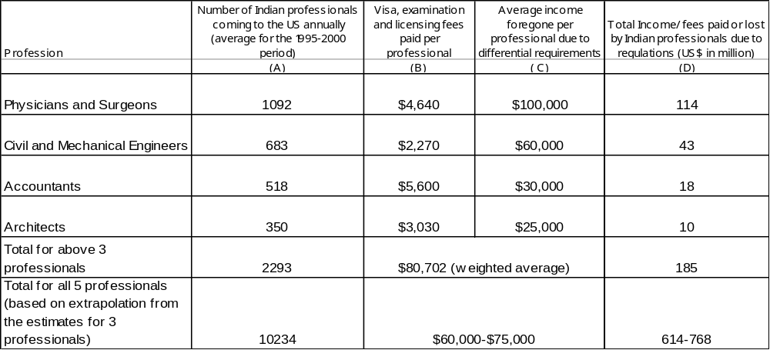

VII. Priorities for International Negotiations

VII.a. The Economics of Regulatory Cooperation: International Rules, Harmonization and Mutual Recognition

- The economic case for regulation in professional services, as in the case of goods, arises essentially from market failure attributable to asymmetric information. National remedial measures by the US and India can themselves become an impediment to trade. In order to ensure that domestic regulations at home and abroad support trade, India must decide on the appropriate forum (multilateral, regional, bilateral) and the approach (international rules, mutual recognition or harmonization) to pursue in each service sector.

- First of all, in dealing with trade impeding domestic regulations the role of international rules, discussed more fully below, could be to ensure that (a) the v component (where a difference in quality or incompatibility is the issue) is not exaggerated at the expense of the u component (which reflects a certain universal requirement); and (b) that the measures necessary to ensure compliance with the u and v components are not unduly trade restrictive.

- However, there are limits to what can be accomplished through international rules. First, national regulators (especially in the US, but also in India) may object to what they regard as excessive international scrutiny (e.g. by the WTO) of their judgments regarding whether certain universal requirements (the u component) have been fulfilled. And more seriously, there is little that international rules can do to address differences across jurisdictions in country-specific requirements (the v component) pertaining to: vertical standards, where differences between countries arise because of different quality standards, such as for instance, in the training of doctors; and horizontal standards, where differences between countries arise because of incompatibility, e.g. because of differences in their legal systems or accounting standards. Differences may reflect national preferences for certain levels of quality or particular varieties, or simply be a legacy of history.

- As noted above, international rules can do little to address impediments to trade arising from fundamental differences across the US and India in standards. In such circumstances, two approaches are usually proposed: harmonization and mutual recognition. Even though these approaches are sometimes presented as alternatives, the former is either a precondition or a result of the latter. Where differences in mandatory quality standards matter, recognition can only happen once there is a certain degree of harmonization (to establish mutually acceptable minimum standards). Where differences in mandatory standards are so narrow that they do not matter, recognition can be granted and then harmonization happens via a race to the minimum standard. A similar logic applies to compatibility standards, but there may be no alternative to full harmonization if differences matter, as for instance in the case of differences in legal procedures.

- There is little, if any, empirical guidance on the payoffs to regulatory cooperation. What are the costs and benefits of deeper harmonization of regulatory standards and/or the establishment of mutual recognition agreements? The lack of empirical evidence complicates the task of deciding on the scope and depth, as well as the geographical reach and the institutional form of cooperation. Nonetheless, several conceptual considerations may assist a country in formulating a strategy for regulatory cooperation.

- First of all, if national standards in India are not optimal, as they may not be in some areas of engineering, then international harmonization can be a way of improving national standards. In such situations, the best partners for regulatory cooperation are those with the soundest regulatory framework. Secondly, sometimes standards are captured by protectionist interests, in which case harmonization can serve as a purely liberalizing device. Third, if standards in India are separable, in the sense that it is possible to have one standard for export and another for domestic consumption, then regulatory cooperation is less of a challenge. But standards may not be separable: economies of scale or monitoring may make it prohibitively expensive to have separate standards for export production; or a trading partner may make the adoption of country-wide higher standards (e.g. of privacy) a condition for trade – as the EU has done in some cases.

- If national standards optimally serve national objectives and are not separable between markets, there is a trade-off between the gains from integrated markets (or access to the US market) and the costs of transition and of departing from nationally optimal standards. For instance, a poor country like India may prefer to maintain a lower mandatory standard for certain services, such as medicine, because that reflects the socially optimal trade-off between price and quality whereas the socially optimal trade-off in the rich country like the United States leads to a higher standard. Harmonization of standards would create benefits in terms of increased competition in integrated markets (as discussed earlier), but would necessarily impose a social cost in at least one market.

- The aggregate adjustment cost of harmonization depends on the distance between the policy-related standards of the countries. The costs are likely to be smallest when foreign regulatory preferences are similar and regulatory institutions are compatible. The benefits of eliminating policy differences through harmonization depend on the prospects of creating a truly integrated market, which depends on the natural ties between countries, and that in turn depends on geographic proximity, legal systems and language, etc. We can conceive of an optimum harmonization area that defines the set of countries for which aggregate welfare would be maximized by regulatory harmonization. However, whether an individual country benefits from harmonization, and its willingness to participate in such an area, depends on where the standard is set - which determines who will bear the costs of transition.

- Policy implications: There are gains for a country from regulatory cooperation, but also costs. The former will dominate where national regulation can be improved, or is excessively burdensome in all countries. Once national regulations are optimal, the benefits of international harmonization in terms of greater competition in integrated markets must be weighed against the costs of departing from nationally desirable regulations.

VII.b. Negotiating Priorities and Legal Issues

- As the previous section has demonstrated, the fundamental regulatory problem faced by Indian professionals is the non-recognition of their qualifications, training and experience. All the other problems stem from this: the costly and time-consuming evaluation of prior qualifications, undertaking costly examinations, taking courses that at least in part repeat prior education, undergoing training that duplicates at least in part prior training, acquiring more experience than their US counterparts, with the added burden that all these requirements can in certain cases only be met in US locations, by obtaining US visas.

- In these circumstances, India’s strategy must be:

- To secure as far as possible recognition for existing qualifications, training and experience.
- To ensure that any additional requirements can be fulfilled in the least burdensome manner.

Box 2: Regulation of Professionals Services
Regulation is a response to the problem of asymmetric information in professional services. Buyers are often inadequately informed about the true attributes of sellers and cannot easily assess the competence of professionals like doctors, architects and lawyers. But the case for regulation does not automatically follow. The problem could in principle be addressed by the adequate dissemination of information to consumers (as happens through rating agencies), performance related contracts between consumers and sellers (witness medical malpractice litigation in the US), and by service suppliers developing reputations for quality through repeated interaction with consumers (as happens anyway). But it may be too expensive to communicate the necessary information to the individual buyers, hard to enforce performance contracts given the sometimes weak relationship between outcomes and effort, and reputations take time to develop. The case for regulation rests on these problems.

Furthermore, regulating the output of a service industry, often invisible and customized, is usually more difficult than regulating inputs. That is, it may be easier to regulate suppliers rather than to educate consumers. The imposition of certain minimum regulatory conditions on suppliers reflects a certain uniformity of preferences among consumers about the quality of services. Thus regulators ensure that all professionals attain a certain threshold of competence. Such regulation of inputs takes the form of restrictions on entry into the market.

As UNCTAD and World Bank (1994) argues, "…service providers are likely to prefer the higher incomes that result from control of entry into their occupation, or form restrictions on competition between those who are admitted to it… whenever regulation is judged necessary, a major concern must be to ensure that regulatory powers are not captured by the existing providers of a service and used to further their interests."

VII.c. Bilateral Initiatives

- All existing mutual recognition agreements are bilateral or concluded among a small group of countries. Indeed, it is inconceivable that a forum with such diverse membership as the WTO can in the foreseeable feature deliver meaningful mutual recognition agreements. How difficult it can be to achieve mutual recognition in professional services among a group of even relatively similar countries is demonstrated by the experience of the European Union. The recent Services Directive could only be accepted once the powerful “country of origin” principle was abandoned. That principle would have implied de facto mutual recognition of licensing and qualification requirements within the European Union, because any provider licensed to practice in any one country would have been free to provide services throughout the European Union.

- There is no doubt that ultimately true liberalization depends on full recognition and that India must continue to seek recognition from its major trading partners in a bilateral context. But past experience does not provide basis for optimism for this approach. Its overtures in engineering (seeking membership of the Washington Accord), for example, have been ignored for a number of years.

- The key incentive problem is that foreign professionals have so far had limited interest in securing access to the Indian market, and have felt threatened in their own markets, because of the high level of competitiveness of Indian professionals. And the power of organized professional associations has so far trumped the benefits to diffuse consumer interests. But the situation may be changing. First, India’s own economic growth and willingness to contemplate allowing greater access to the Indian market to foreign professional firms may have created greater commonality of interests. Increased incomes and increasing diversity of preferences may also create the possibility of foreign professionals serving some segments of the Indian market. Second, certain developments are leading to the mobilization of consumer interests within the United States. The increased demand for accountants in the wake of the Sarbanes-Oxley Act has induced the large accountancy firms lobby for more liberalized access to the US market. Similarly, the soaring cost of health-care has created an opportunity to mobilize hospitals and health maintenance organizations to lobby for increased trade in health care through all modes.

- The second and more legitimate impediment to recognition is the heterogeneity of standards within India which has undermined the case for securing recognition on a national basis. In effect, poor quality institutions penalize the high quality institutions. India must certainly contest excessively burdensome regulations in the US market. But it must also reform its own regulations. Here it may well face a dilemma, as discussed in V.c above. Setting domestic standards at a level that enhances the case for foreign recognition may lead to standards that are inappropriately “high” from a domestic perspective. The tension will be greatest in areas like medicine where sections of the domestic market are underserved. In these circumstances, dual or multiple standards may be a solution. That is set one standard at a level that creates a credible case for foreign recognition, and another that is appropriate to domestic needs. This would eliminate the conflict arising from trying to meet two objectives with one standard. By accepting a lower standard, a segment of the population would receive the benefit of actual rather than notional service – because there is a lower probability of the provider emigrating abroad or to an urban area. At the same time, “export quality” standard(s) (assigned by examination or institution) can be targeted at specific export markets, and liberated from the need to be locally appropriate.

- Even as India contemplates reform of its own standards, a key issue for further research must be: would it make sense for India to have dual or multiple standards for certain professions? What are the disadvantages of multiple standards? Are there diseconomies of scale in monitoring? Are there political economy problems?

VII.d. Multilateral Approaches

- Given the difficulty of securing recognition bilaterally, it is important that India make parallel efforts in the current negotiations under the General Agreement on Trade in Services (GATS) to strengthen commitments and rules on trade in professional services. We would recommend:

- Leveraging mutual recognition agreements concluded by partner countries through the MFN principle.

- Securing and enforcing national treatment commitments by trading partners.

- Negotiating deeper disciplines on domestic regulations either under Article VI:4 of the GATS or in the form of additional commitments under Article XVIII of the GATS.

VII.d.i Leveraging mutual recognition agreements (MRAs) concluded by partner countries through the non-discriminatory requirements embodied in Article XVII of the GATS

- Even with no new multilateral commitments or rules, India still has an avenue to challenge restrictive regulations faced by its professionals by invoking the fundamental GATS provision of MFN (stipulating that a country may not discriminate between trading partners) as embodied in the GATS provision on recognition agreements (Article VII). This opportunity arises because some of its trading partners have already concluded mutual recognition agreements in professional services. For example, the US has made four notifications (required under Article VII.4 of the GATS): on accounting with Canada and Australia; on architecture with Canada; and the Washington Accord, on engineering with Australia, Canada, Hong Kong, Ireland, New Zealand, South Africa, and the United Kingdom.

- Article VII of the GATS, dealing with recognition, attempts to strike a difficult balance. On the one hand, it is permissive. Thus, Article VII:1 states:

“ For the purposes of the fulfillment, in whole or in part, of its standards or criteria for the authorization, licensing or certification of services suppliers, and subject to the requirements of paragraph 3, a member may recognize the education or experience obtained, requirements met, or licenses or certifications granted in a particular country. Such recognition, which may be achieved through harmonization or otherwise, may be based upon an agreement or arrangement with the country concerned or may be accorded autonomously.”

- This provision would seem to allow a Member at any point of time to recognize standards of one or more Members and not of others, without violating its GATS obligations - even though services and service suppliers of the former group have easier access than those of the latter group. The remaining paragraphs of Article VII seek to ensure that this freedom is not abused. Article VII:2 requires a Member who enters into a mutual recognition agreement (MRA) to afford adequate opportunity to other interested Members to negotiate their accession to such an agreement or to negotiate comparable ones. If a Member grants recognition autonomously, then it is obliged to give any other Member adequate opportunity to demonstrate that education, experience, licenses, or certifications obtained in that other Member's territory should be recognized. In this respect, Article VII mandates an openness vis-à-vis third countries that Article V, dealing with economic integration agreements, does not. One issue, on which India should press for greater clarity, is the applicability of Article VII to MRAs concluded by entities other than the central Government (OECD, 2003, pp 15.16).

- The more powerful discipline is contained in Article VII:3 which stipulates that a Member must not grant recognition in a manner which would constitute a means of discrimination between countries in the application of its standards or criteria for the authorization, licensing or certification of services suppliers, or a disguised restriction on trade in services. While recognition, unilateral or through an MRA, amounts to an acceptance of likeness vis-à-vis certain suppliers, it also defines a standard of treatment vis-à-vis other suppliers. In terms of the example in Section VI, if X recognizes the universal element u obtained in Y, then an individual supplier from Z should have the possibility of demonstrating equivalent training obtained in Z. As is argued below, if X has legitimate doubts about the authenticity of the training, then the incremental burden imposed on such a supplier should be no greater than that necessary to achieve the regulatory objective.

- Such a bold interpretation of Article VII would ensure that the liberalizing effect of MRAs can be generalized. At present, given the weakness of Article VI, if a Member has not made a commitment to grant national treatment, then the Member is free to impose uniformly burdensome regulations on all foreigners. However, if a Member concludes an MRA or grants recognition to one foreign country, then this provides all others with a potentially valuable foothold by defining a standard of treatment.

VII.d.ii Securing and enforcing national treatment commitments by trading partners

- The cornerstone of the multilateral trading system is the national treatment obligations, stated in Article XVII:1:

"In the sectors inscribed in its Schedule, and subject to any conditions and qualifications set out therein, each Member shall accord to services and service suppliers of any other Member, in respect of all measures affecting the supply of services, treatment no less favorable than that it accords to its own like services and service suppliers".

- In goods, under GATT 1994, national treatment is a general obligation allowing for no exceptions. In services, under the GATS, Members can choose whether to make such a commitment in a particular sector under a particular mode. None of the four large Members of the WTO, Canada, EU, Japan and US have made commitments to guarantee national treatment under mode 4 (presence of natural persons) in any of the four professions being studied here - something that India offers in its revised offer in the current negotiations. National treatment is potentially the most important guard against regulatory protectionism. If a country retains the right to discriminate, then negotiating an elaborate set of rules for domestic regulations would be like creating a building with no edifice. Hence, in addition to pushing for greater market access in professional services, India should attach the highest priority in the current negotiations to securing commitments from its main trading partners on national treatment.

- National treatment (Article XVII) is a powerful discipline. It captures all forms of discrimination. Any measure that modifies conditions of competition to the detriment of foreign services and service suppliers would be considered inconsistent with national treatment, regardless of whether it extends formally different or formally identical treatment. Thus full commitments on national treatment would preclude both de jure and de facto discrimination that can arise from the application of regulatory measures on licensing and qualification.

Figure 12: Identifying de facto discriminatory measures
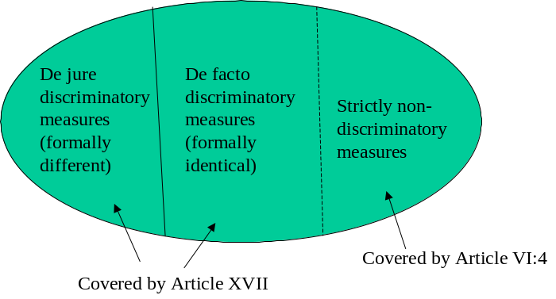
- But the application of national treatment to licensing and qualification requirements is not straightforward, and if Members are to be persuaded to make new commitments, and these commitments are to lead to a more predictable policy environment, then WTO Members need to agree on how the provision is to be interpreted. It would seem to be in India’s interest to seek such clarification. In order to see the difficulty, consider the hypothetical case of a medical doctor from X who arrives in Y with a view to practicing medicine there. To place the problem in a stark context, imagine that the Y licensing authorities ask him to re-qualify from scratch in order to have the right to practice. Would such a requirement be consistent with national treatment? The national treatment obligation requires that foreign services and service suppliers receive no less favorable treatment than the like national services and suppliers. If we apply the traditional GATT/WTO two-step approach of first establishing likeness and then determining whether “like” foreign suppliers are receiving less favorable treatment, then we end up in a legal cul-de-sac. If a doctor from X is deemed to be like a doctor from Y, then Y would not have the right to impose even a slightly greater burden on the X doctor. This position is hardly sustainable, and could with some justification be seen as a threat to regulatory autonomy. If, on the other hand, a doctor from X is deemed not to be like a Y doctor, the national treatment discipline simply does not apply, and the licensing authorities in X are given a free rein to do whatever they want. This is also an unsatisfactory outcome, as it may all too easily lead to the (deliberate) enactment of needlessly burdensome regulatory requirements and render the national treatment provision meaningless.

- There is a solution to this problem which involves, on the one hand, accepting the right of regulators to pursue a legitimate objective, but on the other hand, ensuring that the objective is not pursued in a manner which unfairly discriminates against foreigners. In effect, the question of whether two services or service suppliers are treated differently must not be separated from how they are treated differently.

- A two stage test can be suggested:

(i) Stipulate an a priori definition of like services based on similarity of end-uses, and a clear relationship of substitutability in consumption and direct competition,, based on market conditions.

  - The criterion of end-uses serves to demarcate the class of services or service suppliers within which a particular measure may give rise to protection. For example, a higher regulatory burden on doctors than on accountants would clearly not arouse concern in the same way that a higher burden on accountants qualified in one country rather than another would. But, even within the class of similar end-use, a criterion is needed to distinguish between situations in which discriminatory effect is an incidental consequence of a domestic measure and those in which it is not.

(ii) If a Member takes measures that distinguish between what could be regarded as a priori like services or service suppliers, then that Member must assume the burden of proving that any resultant unfavorable treatment of foreigners is necessary. In other words, that the Member could not have achieved the stated objective through any other reasonably available measure which did not disadvantage foreign services or foreign suppliers, or did not disadvantage them as much.

- This approach represents a middle road between extreme intrusiveness and extreme permissiveness. It is based on the reasonable question: what is it that the Y licensing authorities really need to do to ensure that foreign doctors do not constitute a threat to the health of Y citizens? There are, in principle, a range of instruments which could achieve the objective of ensuring adequate quality of medical services. The optimal instrument would be one which achieved the objective of remedying the problem of asymmetric information about foreign suppliers' abilities at least cost: say through a comprehensive test of competence (possibly coupled with a brief period of internship). Even if Country X's doubts about foreign qualifications are accepted, the instrument chosen, full training in Y, modifies conditions of competition excessively even in the light of the objective, which could be attained through a less discriminatory instrument. Thus, any reasonable application of national treatment will unavoidably pose an excessiveness test in order to determine whether there is de facto discrimination., Note that this is quite different from imposing a “necessity test” on measures that are not discriminatory any way, an issue we address in the next section.

- To see the full implications of this approach, consider another hypothetical example of compulsory residence requirements imposed on, say, software programmers and architects. Let us assume that residence is an irrelevant attribute for the provision of software services but a certain period T of residence is needed for the provision of architectural services, to ensure adequate protection of consumers. Then a non-resident foreign software programmer is like a domestic software programmer, and the imposition of any residence requirement is inconsistent with national treatment. But given our assumption, the imposition of a residence requirement of a period T on a foreign architect is not inconsistent with national treatment while a greater residence requirement would be.

VII.d.iii Negotiating deeper disciplines on domestic regulations either under Article VI:4 of the GATS or in the form of additional commitments under Article XVIII of the GATS.

- Article VI deals with origin-neutral national regulatory measures that do not fall within the scope of Articles XVI (market access) and XVII (national treatment). This Article was included in the GATS in recognition of the fact that even in the absence of discriminatory or quantitative measures, international trade in services could be obstructed by certain aspects of national regulations.

Box 3: The "temporary" weakness of GATS Article VI
Article VI of the GATS which deals with domestic regulation seeks to address the problem of standards which are unduly trade-restrictive. Today Article VI primarily provides a mandate (in Article VI:4) to develop disciplines under the GATS to ensure "that measures relating to qualification requirements and procedures, technical standards and licensing requirements do not constitute unnecessary barriers to trade in services." Pending the entry into force of disciplines developed pursuant to Article VI:4, the only current disciplines are contained in Article VI:5, which requires that
"...the Member should not apply licensing and qualification requirements and technical standards that nullify or impair any existing sectoral commitments in a manner which:
(i) does not comply with the criteria outlined in subparagraphs 4(a) [objectivity and transparency], 4(b) [not more burdensome than necessary to ensure the quality of the service], and 4(c) [in the case of licensing procedures, of not being in themselves a restriction on the supply of the service]; and
(ii) could not reasonably have been expected of that Member at the time the specific commitments in those sectors were made." (emphasis added)
The requirements in (i) could have constituted a powerful discipline, but element (ii) renders them toothless. In the extreme, it could be read as "grandfathering" all existing restrictive requirements. Thus country X could argue that training in medical schools in Y had always been a requirement to practice in X and it could, therefore, "reasonably have been expected" when the specific commitments were made. This provision seriously limits the scope for translating the commitments under GATS into non-discriminatory market access.

- The Working Party on Professional Services (WPPS) was set up to begin work on the Article VI:4 mandate with instructions to give priority to elaborating disciplines for the accountancy sector which it has completed. The Council for Trade in Services is currently in the process of negotiating horizontal disciplines on domestic regulations. But these negotiations, in which India has been an active participant, have so far made little progress, largely due to the reluctance of a number of countries to assume any further disciplines in this area. In order to assess the feasibility and desirability of developing deeper disciplines on domestic regulations, it is useful to take stock of what has been accomplished so far in the accountancy sector - which is now regarded as representing an exceptionally ambitious outcome.

- Section I, paragraph 2 (General Provisions) of the accountancy disciplines contains a rule of necessity for domestic regulatory measures, similar to the rule contained in the TBT Agreement:

“Members shall ensure that measures not subject to scheduling under Articles XVI or XVII of the GATS, relating to licensing requirements and procedures, technical standards and qualification requirements and procedures are not prepared, adopted or applied with a view to or with the effect of creating unnecessary barriers to trade in accountancy services. For this purpose, Members shall ensure that such measures are not more trade-restrictive than necessary to fulfil a legitimate objective. Legitimate objectives are, inter alia, the protection of consumers (which includes all users of accounting services and the public generally), the quality of the service, professional competence, and the integrity of the profession.”

- The necessity rule is without doubt the most substantial provision in the accountancy disciplines. WTO jurisprudence has established that “necessity” is a powerful test that can weed out most measures that have protectionist content. The rest of the disciplines add limited value to existing GATS Articles (III, Transparency) beyond reiterating the application of the necessity test to types of measures. However, in some key cases the specific application of necessity to a set of measures goes in the direction of weakening the test, rather than strengthening of clarifying it. For example Paragraph 9 on residency requirements says that Members “shall consider” whether less trade restrictive means could be employed to achieve the same policy objective, effectively transforming the binding necessity test of Paragraph 2 into a mere endeavor clause. Similarly Paragraph 25 on technical standards requires Members to ensure that measures relating to technical standards are prepared adopted and applied only to fulfill a legitimate objective. In this case it appears that the necessity test has altogether disappeared, as the only technical standards which would be illegal under the new rule are either those serving non-legitimate objectives or those serving no purpose at all.

- The key provision in the Qualification Requirements Section (VI) of the disciplines, Paragraph 19, states that:

“A Member shall ensure that its competent authorities take account of qualifications acquired in the territory of another Member, on the basis of equivalency of education, experience and/or examination requirements.”

- In reality this provision adds little to Article VI of the GATS, which requires Members to provide for adequate procedure to verify the competence of professionals. If paragraph 19 is read alone, a competent authority remains free to determine the level of equivalency between the qualification possessed by the applicants and those it requires. Such determination might lead to full or partial recognition as well as to no recognition at all and to a full re-qualification requirement.

- The relatively modest result in accountancy can be attributed to the fact that those who had a real stake in liberalization lost interest in these negotiations when it became apparent that the more explicit barriers could not be addressed in this context. This opened the way for the capture of the negotiations by the sectoral regulators who had little wish to see a dilution of their powers.

VII.e. Looking Ahead

- Deeper disciplines on domestic regulations would clearly enhance access to foreign markets by complementing (or even giving greater force to) the basic market access and national treatment obligations. But a critical mass of WTO Members, ranging from the European Union and the United States to Argentina, Brazil, Indonesia and Malaysia, seem unwilling to assume any stringent disciplines in this area and wish to preserve a significant degree of regulatory autonomy. Chile, India, Mexico, Pakistan and Thailand have pushed for stronger rules, and made a submission on “Proposed Disciplines on Qualification Requirements and Procedures” (WTO, 1 May 2006). Whether greater ambition is realistic in the current political climate remains to be seen.

- Given the nature of the regulatory impediments identified in the US market, and the reasonable presumption that Indian professionals face similar impediments in other markets, India should strive to negotiate disciplines in the following areas.

VII.e.i Fairness and objectivity in both the evaluation of competence and the recommendations for remedial action

- Key problems in the US market: None of the Indian degrees are technically recognized by the state boards as substantial equivalent to American degrees, and a lower or zero weight is attached to training and experience obtained outside the United States. Perceived deficiencies in general education must in some cases be addressed by either working for extra number of years or by taking other courses in the US. For example in Pennsylvania, US engineers of an accredited institute just need to go through 4 years of experience whereas Indian Engineers have to go through 12 year of experience before they can write PE exam. Doctors who have been trained in India, regardless of the length of their experience, have to undergo full three years of residency requirements in USA before being eligible to take final exam of USMLE-3 for the licensing purposes. For each of the four professions studied here, all examinations, except the initial licensing examinations for doctors, are held inside the United States creating the need for foreign professionals to obtain visas and travel to the United States even thought all the examinations except the USMLE Clinical Skills test for Doctors are computer adaptive and can be held at international locations.

- Existing rules and proposals: Members shall provide for adequate procedure to verify the competence of professionals (Article VI:1 of the GATS) and establish mechanisms for the verification and assessment of qualifications of foreign service providers. Where there are deficiencies in qualifications, Members shall identify additional requirements relating to course work, training or work experience service providers must fulfill and provide them with an opportunity to do so through examinations, course work, practical training and professional experience. Members shall provide opportunity for the review of decisions relating to fulfillment of qualification requirements.

VII.e.ii. Our additional proposals

- Building on the existing requirement under Article VI:6 to institute procedures to verify the competence of foreign professionals, at least industrial country Members should be required to justify the denial of recognition to foreign professionals on objective grounds and identify precisely why they are not deemed competent to practice. This task may be entrusted to the professional regulator or a special body created for the purpose. The key objective of this rule would be to enforce the suggested interpretation of national treatment presented above, in particular the second part of the proposed test, and place the burden of proof on the host country to justify the discriminatory treatment of a priori like service suppliers.

- In so far as there are legitimate reasons to doubt the competence of a foreign provider, there would be a presumption in favor of a test of competence as a means of assessing compliance with local requirements. This would strengthen the principle articulated above in the context of national treatment that the least trade restrictive means be used to address perceived differences between national and foreign services providers. Where there are objectively verifiable gaps in education or training, then a foreign service supplier could be required to fill these gaps. Re-qualification, and substantial repetition of training and experience should only be required if it can be demonstrated to be necessary to ensure the desired quality of a service. Similarly, local residency requirements should be no more burdensome than needed to ensure the desired quality of service and consumer protection.

- It should be possible to take any of these remedial actions, including examinations, filling gaps in education, training and experience in the home country of the service provider unless it can be demonstrated that local fulfillment is necessary to ensure the quality of a service. Some examinations like the Clinical Skills Examination of USMLE that test the behavioral ability of candidates should be held at several locations worldwide.

- Members should provide an opportunity to appeal against, and for the independent review of decisions, relating to fulfillment of qualification and licensing requirements.

VII.e.ii Transparency: a one stop website for each profession

- Key problems identified in the US market: Each state has a different set of rules and the information regarding various licensure processes in different states is spread across the codes of respective state boards, the sites of the state boards, sites of the evaluator, sites of the testing agency, and sites of the respective colleges and various other associations and bodies. Obtaining and compiling this information poses a challenge for an applicant.

- Existing rules and proposals: These require WTO Members to make publicly available, including through enquiry and contact points established under Articles III and IV of the GATS, regulatory measures of general applications; the names and addresses of competent regulatory authorities; and the provision, upon request, of relevant information on regulations, including documentation for qualification requirements and examinations.

- Our additional proposal: At least industrial country Members should set up a “one-stop website” for each profession where a foreign professional can obtain all the relevant information on licensing and qualification requirements and procedures.

VII.e.iii Transparent and efficient processes for the evaluation of qualifications

- Key problem identified in the US market: For the purpose of licensure the State Boards ask the candidates to undertake evaluation of their Degrees. In many cases the procedures for evaluation are costly, time-consuming and nontransparent.

- Existing proposals: Members should ensure that verification and assessment of qualifications are completed in a reasonable timeframe.

- Our additional proposal: Members would ensure that verification and assessment are carried out efficiently and transparently and the processes do not themselves constitute an unnecessary barrier to foreign professionals.

VII.e.iv A more liberal visa regime to fulfill qualification and licensing requirements

- Key problem identified in the US market: Quite apart from the difficulty of obtaining a visa to provide services in the United States (an issue that has been discussed in a previous policy note), the need to fulfill qualification and licensing requirements locally interacts with the restrictive visa regime to create a host of problems for foreign professionals. In the case of doctors, reportedly, only a small proportion of the total number who pass the first two steps of the USMLE, at significant cost, obtain a visa to take the third step which is held only in the US. The gradual medical education must be undertaken on a J1 visa. Continuing to work in the USA requires a waiver form an Interested Government agency (IGA) which is granted in rare cases and only when the physician agrees to work for at least 3 years in medically underserved areas – a requirement that is not imposed on US professionals.

- Our proposal: As suggested above, ideally the examinations should be held in the home countries of foreign professionals or in countries that have less restrictive visa regimes than that of the United States. Where coming to the US is necessary, a candidate who needs to obtain a visa to fulfill a qualification or licensing requirement or both should be granted one. For doctors the restrictive J1 visa should be replaced by a more efficient and equitable visa.

VII.e.v Reducing the costs in terms of money and time

- Key problem identified in the US market: The qualification and licensing procedures in each profession are costly. For example, the first two steps of USMLE cost $800 each. The third step costs $1200 and is undertaken at USA. The cost of traveling to USA and taking the examination is a significant expense. There is an even greater cost in terms of earnings foregone during the time that it takes a foreign professional to requalify.

- Existing proposal: Members shall ensure that verification and assessment are carried out in a reasonable time frame, and that fees charged reflect administrative costs and are not in themselves an impediment to engaging in the activity.

- Our additional proposal: Members shall ensure that fees charged are no higher than those necessary to cover the administrative costs of services, and the licensing process is no longer than that necessary to ensure the competence of foreign professionals.

Annex-1
India: Institutions Regulating Standards and Accreditation of Higher Education

- The University Grants Commission (UGC) was established by an Act of Parliament in 1956 and is the apex body for higher education in India. It discharges the duties of coordination, determination, and maintenance of standards of teaching, examination and research in universities, serving as a vital link between the Union and State Governments and the institutions of higher learning, monitoring developments in the field of collegiate and university education, disbursing grants to the universities and colleges, advising Central and State Governments on the measures necessary for the improvement of university education and framing regulations such as those on the minimum standards of instruction. It also lays down the rules and regulations for determining the fitness of universities and for determining the minimum standards of instruction.

- Based on the recommendations of the National Policy in Education (1986), the National Assessment and Accreditation Council (NAAC) was established in 1994 by the UGC as an autonomous body. It has a mandate to assess and accredit higher education institutions in the country with a view to upholding the quality of higher education in India. NAAC assesses the quality of institutions of higher education through an internationally accepted methodology. The various criteria for assessment and hence certification of the quality of education are: curriculum, teaching aspects and evaluation, infrastructure and learning resources, research consultancy and extension services, student support and progression, organization and management and healthy practices. Currently accreditation is carried out for colleges/universities on a voluntary basis and is valid for a period of five years. At present, there are a total number of 124 universities and 2743 colleges that have been accredited by NAAC.

Accounting Services

- The International Accounting Standards Board (IASB) has the mandate to bring about uniformity, comparability, rationalization and transparency in accounting standards and formulate internationally acceptable standards. As a member country, India also has the task of prescribing similar accounting standards. The Institute of Chartered Accountants of India (ICAI) is the apex body governing auditing and accounting profession in India. It constituted an Accounting Standards Board in 1977, to pronounce standards on accounting issues in India. The Board has also formulated Accounting Standards Interpretations (ASIs) on matters relating to accounting standards.

- ICAI is a statutory body that has been established under the Chartered Accountants Act, 1949. This Act gives the rules and regulations that govern the chartered accountancy profession in India. The main functions of the institute are: prescribing qualifications for membership, holding examination and arranging practical training of candidates, enrollment of members, publication and maintenance of register of members qualified to practice the profession, carrying on activities for development of the profession and regulation and maintenance of status and standard of professional qualification of the members. The Institute conducts examinations all over the country, provides postal coaching, oral coaching and arranges practical training, enabling students to qualify for the profession. It also organizes seminars, workshops etc. and conducts research. In addition, it issues certificates of practice to its members and exercises disciplinary Jurisdiction as quasi-judicial authority over their profession and their conduct. The Institute coordinates with Universities on shaping their accountancy curriculum linked with the Chartered Accountancy course.

- The proposed overall scheme of pre-qualification education of the Institute are: (a) To enroll with the Board of Studies for the Common Proficiency Test (CPT) after passing Class X examination (or its equivalent) or thereafter and (b) taking the Common Proficiency Test after appearing in 10+2 examination (or its equivalent) or thereafter and passing both. After enrolment, an articled/audited clerk must obtain prior permission of the Council before they can engage in other courses of study or engage in other occupations.

- The Institute of Chartered Accountants of India has recently decided to remove the restriction on practicing chartered accountants or accountancy firms from taking up audit or certification work in the US even if they are members of the American Institute of Certified Public Accountants (AICPA). This decision was taken so that Indian chartered accountants who are also AICPA certified do not lose any advantage especially when work flow from the US is on the rise. As per the existing regulations of ICAI, an Indian chartered accountant or a chartered accountancy firm registered with the institute cannot undertake attestation functions for any US-related work even if they are members of the AICPA. This is because ICAI has so far not allowed its practicing members to use any other qualification or description for attestation functions. But with the latest move, Indian chartered accountants and accountancy firms with AICPA membership can also look forward to getting mandates for the US Generally Accepted Accounting Principles (GAAP) compliance certification, which is required for raising resources from the US markets. Thus ICAI now allows Indian chartered accountants to hold both the Indian and the US certification of practice.

- As of now the Institute has about 1.3 lakh registered members and about 2.5 lakh students are currently pursuing this course. The last four to five years have seen an increase in the number of certified chartered accountants passing out, which is the range of 5000-7000 annually. Of the total members about 70 per cent of them are in practice and only about 5-6 percent of them have relocated abroad (mainly to Middle East). Recent trends show that newly qualified Chartered Accountants have mainly been recruited in BPOs, IT sector and in banks and financial institutions. The average salary package offered during campus placements lie in the range of Rs 5-7 lakh per annum.

Architecture Services

- Professional architects in India are guided by the Architects’ Act, 1972 and the Council of Architecture incorporated under this legislation. The Council has the power to set standards for education in Architecture, inspect and make guidelines as it deems fit, to define qualifications that are to be recognized and to set standards for practicing architecture in India.

- There are currently 114 (as of December 31st, 2004) institutions which impart architectural education in India leading to qualifications that are recognized. The standards of education being imparted in these institutions is governed by Council of Architecture, COA, (Minimum Standards of Architectural Education) Regulations, 1983, which set forth the requirement of eligibility for admission, course duration, course content, examination, standards of staff & accommodation, etc. The duration of approval under the Council of Architecture ranges from three to five years. The COA also oversees the maintenance of these standards periodically (after every three years or so) by way of conducting inspections through Committees of Experts.

- Admission to the course is after the completion of senior secondary level of education (10+2). In India, duration of architectural education is of five academic years and inclusive of sixteen working weeks of practical training in a professional office. The Council has also prescribed a suggestive curriculum which gives the minimum courses that are to be taught by the architectural institutions in India. Colleges are then allowed to prescribe additional courses that can be taught.

- The recognition of foreign qualification granted by any foreign institution not covered under the scheme of reciprocity of recognition of architectural qualification is subject to the notification of such recognition by the Central Government made in consultation with the Council in the Official Gazette. This has been stipulated in section 15 of the Architects’ Act. So far there have been no Mutual Recognition Agreements (MRAs) signed with another country. As a result there is no suo-moto recognition of Indian qualifications abroad. For example, in the

- Registration with the Council of Architecture is mandatory for a person to carry out services as an ‘Architect’ in India. For the purpose of registration, one must possess the requisite qualification as recognized by the Council and must necessarily be a resident of India. The registration entitles a person to use the title and style of ‘Architect’. The title and style of architect can also be used by a firm of architects, of which all partners are registered with COA. Limited Companies, Private/Public Companies, societies and other juridical persons are not entitled to use the title and style of architect nor are they entitled to practice the profession of architecture. Any misuse of the title of ‘Architect’ is tantamount to committing of a criminal offence and is punishable under section 36 or 37 (2) of the Architects Act, 1972.

- The Council of Architecture has also prescribed the Conditions of Engagement and Scale of Charges under the Architects (Professional Conduct) Regulations, 1989. These documents stipulate the parameters within which the Architect is required to function. These define the responsibilities, the scope of work and services, and prescribe the mandatory minimum scale of professional charges. As such there is negligible scope of cross-border trade via GATS Mode I because any building plan in India must have a statutory approval. The Council of Architecture has prescribed the Conditions of Engagement based on general practice of the profession in India.

Medical Services

- Doctors in India are guided by the norms set by the Medical Council of India which was set up under the Indian Medical Council Act, 1956. The main functions of the Council include setting of minimum standards of medical education in India, registration of professionals, professional conduct, recognition/de-recognition of Indian and foreign qualifications, etc.

- The Regulations on Graduate Medical Education, 1997 provide the admission criteria for a candidate to be admitted to the Bachelor of Medicine and Bachelor of Surgery (MBBS) course. Regulations 1 and 2 provide age and educational criteria where a student is required to have completed 10+2 or equivalent with Physics, Chemistry and Biology, Mathematics and English. Where the course content is not as prescribed as per 10+2 education structure of the National Committee, the candidates will have to undergo a period of one year pre-professional training before admission to the Medical colleges. As of March 3rd, 2006, there are a total of 242 medical colleges that are recognized by the Medical Council for the award of an MBBS degree. The recognition of colleges/universities by the Council is valid and would continue to be recognized only after a mandatory inspection of infrastructural facilities, laboratory equipments, teaching standards etc. after every five years. The Medical Council has also prescribed a model curriculum which lays down the mandatory syllabus that is to be followed by the medical colleges. This syllabus is prescribed after extensive consultation with Indian and foreign experts, the latest amendment of which was carried out in 1997. Currently, efforts are on to revise the syllabus and a proposal has been submitted to the Central Government in 2004.

- An Indian citizen, who has passed the qualifying examination either from India or an equivalent examination from abroad and is desirous of joining an undergraduate medical course in any foreign medical institution on or after 15th March, 2002 would have to approach the Council for issue of an Eligibility Certificate for that purpose. Foreign Medical Institution Regulations, 2002, lays down guidelines for obtaining an MBBS degree from abroad. The Indian Medical Council does not provide for a direct admission into any foreign university but an approval has to be sought by the student from the Council. The medical student has to send an application to the Indian Medical Council along with details of the admissions and university and other details as may be required in order to receive and Eligibility Certificate. After verification of the applicant, the Indian Medical Council may issue the Eligibility Certificate for admission in an undergraduate degree in a foreign institution where the certificate shall indicate that on return after obtaining the foreign primary medical qualification, the candidate shall have to undergo a screening test, subject to fulfillment of the conditions prescribed in the Screening Test Regulations, 2002, and that passing this test shall only entitle him to provisional/permanent registration by the Medical Council of India or the State Medical Councils.

- Any applications for the setting up of a new medical college in India is required to fulfill qualifying criteria as prescribed in the Establishment of Medical College Regulations, 1999. These criteria include quality of staff, infrastructural facilities and the regulations lay down certain year-wise targets that are required to be achieved by these new applicant colleges.

- The MCI has also laid down code of medical ethics that is to be followed by practicing doctors as stipulated in the Indian Medical Council (Professional Conduct, Etiquette and Ethics) Regulations, 2002. It lays down in detail the duties of physicians towards their patients, responsibilities of physicians towards each other, duties of physicians towards the public and to the paramedical profession etc. It also specifies the punishment and disciplinary action that can be initiated towards physicians when there is a case of professional misconduct against him/her.

- There are currently no mutual recognition schemes of medical qualifications with any foreign country. However, there is a reciprocal scheme which exists with certain universities in Ireland, Bangladesh and Nepal. This means that a medical practitioner registered and recognized by the following universities can practice in the any of the other countries.

- As of July 27th, 2005, there are about a total of 6.5 lakh practicing doctors who are registered with the Medical Council of India. Any medical professional desirous of practicing in India must be compulsorily registered with the Medical Council of India. The MCI grants registration to professionals who have the requisite qualifications that are awarded by a college/university that is recognized by the Council.

Engineering Services

- The All India Council for Technical Education (AICTE) was set-up in 1945 as a national level Apex Advisory Body to promote development in the field of technical education in India in a coordinated and integrated manner. This mission was reinforced by the recommendations of the National Policy of Education (1986) and AICTE was vested with the statutory authority for planning, formulation and maintenance of norms and standards, quality assurance through accreditation, funding in priority areas, monitoring and evaluation, maintaining parity of certification and awards and ensuring coordinated and integrated development and management of technical education in the country.

- The Government of India (Ministry of Human Resource Development) also constituted a National Working Group to look into the role of AICTE in the context of proliferation of technical institutions, maintenance of standards and other related matters. Pursuant to the recommendations of the same, the AICTE Bill was introduced in both the Houses of Parliament and passed as the AICTE Act No. 52 of 1987. The Act came into force in 1988 and the statutory All India Council for Technical Education was established on May 12th, 1988, with a view to plan and coordinate development of technical education system throughout the country, to promote of qualitative improvement of such education and regulate and maintain norms and standards in the technical education system. The purview of AICTE (the Council) covers programmes of technical education including training and research in Engineering, Technology, Architecture, Town Planning, Management, Pharmacy, Applied Arts and Crafts, Hotel Management and Catering Technology etc. at different levels.

- AICTE lays down rules and regulations for approval/recognition of courses that can be introduced, admission to engineering courses, entry and operation of foreign universities in India etc. Upto 2004, there are a total of 1346 institutions that are recognized by AICTE for awarding a degree in engineering and 1244 institutions that are recognized for awarding of a diploma in engineering. It also prescribes a model curriculum which serves as the minimum standard of syllabus to be followed by engineering colleges/institutions in India. This model curriculum is formulated on the basis of extensive consultation with domestic and foreign experts and keeping in mind the changing needs of the industry.

- The National Board of Accreditation (NBA) was established as an autonomous body by the AICTE under the AICTE Act and it aims to bring standards of some of the programs offered in technical Institutions on par with programs offered in Institutions across USA and Europe, by introducing a quality auditing system and establishing a datum for measuring the quality and excellence in engineering education. The National Board of Accreditation periodically conducts evaluation of technical institutions and programs on the basis of guidelines, norms and standards specified by the Board and recommends to the Council regarding recognition or de-recognition of the Institution or program.

- Realizing the value of accreditation, several institutions have volunteered to go through the rigorous process of audit. The uniqueness of the process is that the duration for which any program or institution wishes to retain their accredited standard they would have to maintain the quality and standard. The accreditation exercise is designed to be rigorous with several inputs such as quality of teaching, level of research, faculty expertise, evaluation of teachers, standard of infrastructure available in the campus, such as hostel facility, library, medical facility etc. These are taken into consideration in order to help the visiting accreditation team of experts to have holistic approach and arrive at a rational evaluation.

- The Institution of Engineers (India) is the largest multi-disciplinary professional institution of engineers that has been certifying Professional Engineers (PEs) for over a decade. With increasing globalization and trade in services, the necessity of engineers acquiring international level certification has become essential. The Institution of Engineers (India), responding to the requirement has modified systems and procedures of "Certification of Professional Engineers" in line with international norms and has obtained provisional membership of the Engineers Mobility Forum (EMF). The Professional Engineers so certified to the international level and placed on the International Register after due process, would be eligible to practice their profession internationally without additional scrutiny or certification beyond what is applicable to domestic engineers in the receiving countries.
ANNEXE –2
I. Preferential recognition: Variable cost-increasing measures
- Assume that there are three countries : country X is an importing country, facing an upward sloping domestic supply of a particular service (say because of increasing opportunity costs) and countries Y and Z are potential exporters. Let us say that c_{x} > c_{y} > c_{z}, and that in the absence of any trade the prevailing price in country X is p*. Assume now that country X recognizes the equivalence of the universal component of the standard obtained in country Y, but not in country Z. There are several possibilities, but we consider only two:

- No trade prior to recognition: Prior to recognition, service providers from both countries Y and Z were required to meet the full standards in country 1 but neither found it worthwhile to do so, i.e. c_{y}(u + v_{y}) + c_{x}(u + v_{x}) > p* and c_{z}(u + v_{z}) + c_{x}(u + v_{x}) > p*. But c_{y}(u + v_{y}) + c_{x} v_{x} < p*, i.e. when the universal component of standards in country Y is recognized as equivalent to that in country X, then suppliers from Y find it worthwhile to export to country X, and the price in X will fall. Hence, if all foreign suppliers had been completely deterred from supplying to country X by the absence of recognition, then any recognition agreement is necessarily trade creating.

- Country Z exports to country X prior to any recognition: In this case, c_{z}(u + v_{z}) + c_{x}(u + v_{x}) < p* < c_{y}(u + v_{y}) + c_{x}(u + v_{x}), i.e. when all foreign suppliers were required to requalify, only those from the third country were willing to supply country 1. But c_{y}(u + v_{y}) + c_{x} v_{x} < c_{z}(u + v_{z}) + c_{x}(u + v_{x}), i.e. once the second country suppliers are exempted from the basic qualification requirement, they gain a competitive edge over the third country. That is, if suppliers from the third country were already present in the first country, then the recognition of second country suppliers would put them at a competitive disadvantage and could lead to trade diversion.

- This situation is depicted in Figure 14. The pre-recognition situation involves domestic output q₂, consumption q₃, and imports from Z, q₃ – q₂. After country X recognizes qualifications in country Y, domestic output declines to q₁, consumption increases to q₄, and imports from Y, q₄ – q₁, displace imports from Z. The welfare effects are straightforward. Consumer surplus rises by A + B + C + D as consumption expands from q₃ to q₄. The area A is a gain at the expense of domestic suppliers, whose surplus falls with their output. Area D is the gain from the better allocation of consumption expenditures; area B the gain from the resources released as inefficient domestic supply contracts; and area C the gain arising from the elimination of wasteful requalification.

- The area C + E is of crucial significance, and can be interpreted in several different ways. It helps to recall the analysis of preferential arrangements when tariffs are the instruments of protection. In that case, area C + E would be the loss in government revenue because preferential imports displace high tariff imports. While C is gained by consumers, E is completely lost because supply comes from the more expensive source, and is the loss due to trade diversion. The net gain to the country is only B + D – E, and could be positive or negative. Thus, when tariffs are the instruments of protection, the costs of trade diversion can be an important disincentive to conclude preferential liberalization agreements.

- In the example here, C + E were the costs of requalification for country Z suppliers when they supplied country X. If these costs were completely dissipated, then they do not enter the welfare calculus of country X. That is, there is no cost of trade diversion for the importing country and the net gain to the importing country from the recognition agreement is B + C + D. Therefore, preferential liberalization would necessarily be welfare-enhancing. If, however, part of these requalification costs (say a fraction α) were appropriated by country X, perhaps as the producer surplus of its qualification granting industry or as some form of regulatory rent, then they would be foregone with trade diversion and would need to be taken into account: the net gain to the importing country from the agreement would be B + C + D – α(C + E).

II. Preferential recognition: Fixed cost-increasing measures
- Following Baldwin (2001), we consider an industry characterized by Cournot oligopolistic competition with providers facing constant marginal costs and two types of fixed costs, a provider-specific fixed cost of setting up production (unrelated to policy) and a fixed cost of selling to each market (related to policy). The three countries – home (X), partner (Y) and rest of world (Z), are assumed ex ante identical to reduce complexity. The inverse demand function of a typical nation is pj=1-Qj, where pj and Qj are the price and total sales in market j (j=X, Y or Z). The total quantity in market j is (niqij) where qij is sales of a typical i-based provider in market j; ni is the corresponding number of i-based providers. Marginal production costs are initially assumed to be identical. The three markets are assumed to be segmented – which is plausible where cross-border delivery is not feasible. Domestic regulations impose an additional fixed cost on non-local providers. To capture this simply, we assume that each market has its own norm and complying with these costs F in each market.

- The equilibrium price in market X, px, equals the sum of two terms. The first term, 1/(1+ni), reflects the level of overall competition. The second term, (nicix)/(1+ni), reflects the average marginal cost of providers active in the market (cix is the market-specific marginal cost). It is assumed that the number of X and Y providers are identical, n, and n* is the number of Z providers. It is intuitively obvious (and easy to show) (i) that the equilibrium number of X and Y providers, i.e. n, falls as their fixed cost F rises, and (ii) that n rises as the Z-providers' fixed cost F* rises. Similarly, the equilibrium number of Z providers, i.e. n*, falls as F* rises and as F falls.

Figure 13: Preferential recognition: Variable cost-increasing measures
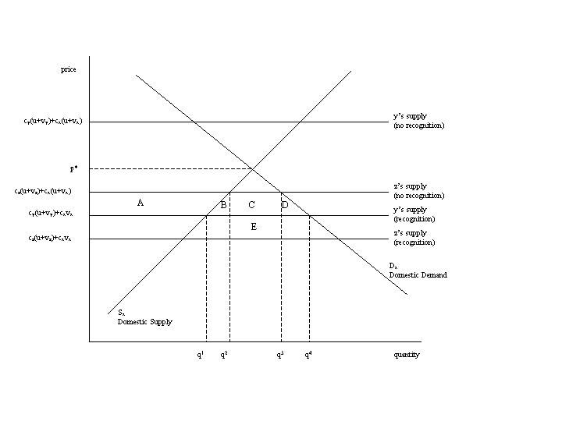

For example, see Economic Times (June 15, 2006) and Financial Times (June 17, 2006), Christian science Monitor (May, 2006).
McKinsey & Co. (2005).
See Rediff.com (http://ia.rediff.com/money/2006/jun/09bspec.htm?q=bp&file=.htm)
For example, see Economic Times (June 15, 2006) and Financial Times (June 17, 2006), Christian science Monitor (May, 2006).
For example, based on a three country study of India, Israel and Ireland, Kapur and McHale (2003) conclude that the evidence is strongly suggestive that the benefits of skilled migration have outweighed the costs for these three countries. The Indian experience in Silicon Valley, for example, shows how the diaspora can be a valuable national asset in facilitating international commerce, especially where the business is transactionally complex and reputation concerns are paramount……. (thus) highly skilled Indian emigration has played a key part in the development of an internationally competitive Indian software sector.
These five professionals were chosen following discussion with our counterparts in the Ministry of Commerce, India, on whose request the Bank has undertaken the preparation of this policy note.
For details, see Science and Engineering Indicator, 2006. The information regarding the tertiary education is reproduced below: 1980 2000 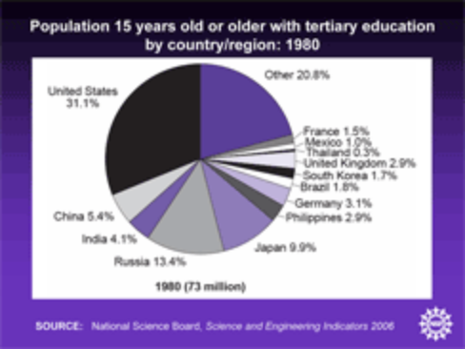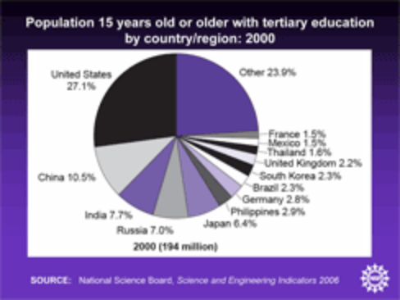
1999/2000 is the year when the last comprehensive labor survey was conducted in India for which results are available.
Education beyond Senior Secondary level
Source: Institute of Chartered Accountants in India (ICAI) website http://www.icai.org/icairoot
Source: Handbook of Professional Documents-2005, Council of Architecture
Source: www.indiastat.com
Source: Bar Council of India website http://barcouncilofindia.nic.in
Although the study by McKinsey found that, Indian professionals are more suitable to work in multinational companies than their counterparts in China, Russia or Brazil. The professionals from Easter Europe (Czech Republic, Hungary and Poland) are the only group that appeared more suitable than the Indian professionals.
For example, see Economic Times (June 15, 2006) and Financial Times (June 17, 2006), Christian science Monitor (May, 2006).
See U. R. Rao Committee Report on higher education in India.
This comparison however does not take account of the future earnings potential from building a career in the US.
For example, each state legislature has in place a Medical Practice Act that defines the proper practice of medicine and the responsibility of the medical board to regulate that practice. Federation of State medical boards (FSMB) is trying to help member boards develop uniform policies and procedures.
A medical school is listed in IMED after the Foundation for Advancement of International Medical Education and Research (FAIMER) – a non-profit foundation of the Educational Commission for Foreign Medical Graduates – receives confirmation from the Ministry of Health or other appropriate agency that the medical school is recognized by the Ministry or other agency.
ABET, Inc., the recognized accreditor for college and university programs in applied science, computing, engineering, and technology, is a federation of 28 professional and technical societies representing these fields.
? Engineers who obtain their degree in some less prestigious engineering school but who arrive in US based on their long field experience. These kind of engineering professionals form very small percentage of population and therefore will not be covered for the purpose of this study.
ABET also publishes the list of equivalent programs from the following countries: Chile, Mexico, Germany, Kuwait, Netherlands, Saudi Arabia, UAE, Singapore, Turkey and Spain.
http://ncarb.org/forms/regulation.pdf
Interviewed 4 Indian professionals who are working in architecture field in US
Education Evaluation Services for Architects (EESA) of the NAAB.
For the purpose of evaluation, EESA requires a total of 160 semester hours of study out of which 40 semester credit hours are required in English, Humanities, Mathematics, Natural Sciences, and Social Studies. Indian Students typically undertake all these modules in school before entering the professional course. But as these modules are not taught in the professional courses, knowledge of these modules is not recognized by the evaluation agency.
To obtain a clearer picture of this barrier, more research is needed to establish why US employers are not hiring foreign nationals directly.
http://www.aia.org/SiteObjects/files/PracticeinaHostNation.pdf
Barriers to movement of natural persons: a study of federal, state, and sector-specific restrictions to Mode 4 in the United States of America, Debjani Ganguly
Refer to Appendix A for statewide comparison of CPA requirements
http://www.nysscpa.org/cpajournal/1999/1299/f401299a.html
The analysis of discriminatory regulation is also relevant to quantitative restrictions on the sales of services. In the case of goods, the quota rents can be appropriated by domestic intermediaries like the importer rather than the foreign exporter. However, in many services, intermediation is difficult because the service is not storable and directly supplied by producers to consumers. Rents are, therefore, usually appropriated by exporters rather than domestic importers. As in the case of frictional measures, there can be no cost of trade diversion to the preference-granting country.
This means, for example, that an Indian engineer who has qualified in South Africa would not benefit from recognition in the United States in the same way that a South African engineer would.
That is, if India has basically the same educational and training system engineers as South Africa, then it should also be made party to mutual recognition agreements that include South Africa, such as the Washington Accord.
In this section, we have not addressed the issue of whether fixed costs of entry generate rents for the host country. If all providers have identical costs and there are no other barriers to entry, then even preferential liberalization of fixed cost-increasing barriers are likely to increase welfare. Consider the less obvious case when measures generate rents, as in the case of license fees. Recall that if there are no restrictions on entry then in equilibrium, aggregate industry profits are equal to total fixed costs. If a reduction in fixed costs induces new entry, then the increased competition implies a lower price. The loss in rents from liberalization is equal to the decline in aggregate industry profits which is necessarily lower than the increase in consumer surplus.
Interviews with Indian medical professionals in the US indicated that, lack of mutual reorganization affects their earnings in two ways: (i) the Indian professionals spend at least a year or more in residency than perhaps would be needed to fill their skills and knowledge gaps; and (ii) the wages lost while working in the underserved areas is around 10-15 percent (i.e., $15-20,000 annually). Some of them felt that, more than the loss in earnings, the real issue is about their safety and security while serving in certain underserved areas.
A much fuller discussion of mutual recognition agreements is to be found in “Service Providers on the Move: Mutual Recognition Agreements”, a document of the OECD Working Party of the Trade Committee, TD/TC/WP(2002)48/FINAL, 6 February 2003. This document describes existing MRAs, as well as the practical and legal issues arising in the negotiation of MRAs.
In fact, a key barrier to consumption abroad of health care is not the failure to recognize professional services but the non-portability of health insurance (Mattoo and Rathindran, 2006).
There are already successful examples of fragmenting qualification requirements. A “doctor” does not always and everywhere need to be a “doctor” in the sense of having six years of training and mastery of a range of subjects? Consider the examples of Chinese barefoot doctors, the training of Indian village doctors for short periods, etc.
Notified in, respectively, WTO documents S/C/N/51, S/C/N/68, S/C/N/52, and S/C/N/52.
Interestingly, mutual recognition of qualifications is also mentioned as an element of a number of regional integration agreements, notified under GATS Article V:7(a). These agreements include the one establishing the European Union, agreements between the European Union and neighboring countries, and the Closer Economic Relations Treaty between Australia and New Zealand. This raises the question of whether MRAs concluded in the context of a regional integration agreements are still subject to the disciplines in Article VII:2 and 3. One view may be that Article V provides an exception to the fundamental non-discrimination obligation in Article II and therefore an exemption also to similar obligations contained in other GATS provisions, including Article VII. Alternatively, and this is the view that would seem to be the one that India should support, it could be argued that all MRAs, regardless of whether they are concluded by parties to a regional integration agreement or other Members, are covered by Article VII and these disciplines cannot be circumvented by recourse to Article V.
One potential problem is that if it is rationally expected that extending recognition to one Member would eventually require extending it to many, then even the recognition of one may be deterred. This would be undesirable since even limited preferential liberalization through MRAs may be welfare enhancing in a second-best world, as demonstrated above. The tendency of Members to notify MRAs under Article V rather than Article VII may reflect an attempt to share these gains on a limited reciprocal basis by avoiding the obligation to extend recognition more widely.
The US schedule does indicate “none” no limitations on national treatment in the sector-specific commitments, but scheduling convention dictates that such general sector-specific commitments are overridden by limitations in the horizontal section, where the US has inscribed “unbound”, i.e. it reserves the right to discriminate.
If the exceptions provision, Article XIV, listed all objectives that regulators might legitimately pursue, then it would be possible to take a tough line on any difference in treatment under XVII and allow it to be justified under Article XIV. However, because the Article XIV list is limited, regulators cannot be denied the freedom to invoke unlisted regulatory objectives as a basis for difference in treatment in the context of Article XVII. But if this freedom is not to be abused, then the regulators invoking unlisted objectives under XVII must be held to at least the same standard as would be applied when invoking mutually agreed legitimate objectives under XIV.
In this guise, an excessiveness test could be used more generally to encourage the adoption of economically efficient policy choices in remedying market failures.
The current legal status of the accountancy disciplines is explained in a Decision by the Council for Trade in Services adopting the text of the Disciplines on Domestic Regulation in the Accountancy Sector. The Decision requires Members to integrate the accountancy disciplines into the GATS only by the conclusion of the next round of services negotiations together with other sectoral or horizontal disciplines which might be further developed by the WPPS in professional services.
In order to assess the feasibility and desirability of developing deeper disciplines on domestic regulations, it is useful to take stock of what has been accomplished so far in the accountancy sector.
For example in the accounting profession such a test has been put in place for certified accountants from Australia, Ireland, Mexico and Canada. If certified accountants from these countries pass the examination of IQEX (international uniform CPA qualification examination), these accountants are accorded the same status as that of the US candidates.
AICPA is one of the organizations that regulate the chartered accountancy profession in the US
Source: Institute of Chartered Accountants in India (ICAI) website http://www.icai.org/icairoot
Source: Handbook of Professional Documents-2005, Council of Architecture
The Schedule inserted as per approval for notification in the Gazette of India accorded by the Government of India vide letter no F.No. 35-6/98 TS IV. dated 28.12.1998 provides details of recognized degrees and diplomas awarded by Indian and foreign architectural institutions
Source: Medical Council of India, New Delhi
Source: www.indiastat.com
Source: AICTE website: http://www.aicte.ernet.in/ApprovedInstitute.htm
It may be asked why some individuals from countries Y and Z do not directly meet the standard in country X instead of first qualifying at home. One reason is that providers are often allowed to enter foreign markets only on a temporary basis (as under the GATS), so they need to be qualified also to serve the home market. Where longer term movement of providrs is allowed, we need to assume that the individual elements of qualifications are not separable, and that there is a part, say w, which is universally recognized as equivalent. The incentive to meet the standard at home arises as long as c_{y}w and c_{z}w are sufficiently smaller than c_{x}w. The w element is suppressed here to keep the notation simple. Non-separability is indeed an aspect of many qualifications: a student can usually not switch institutions after doing only part of a course.
The initial part of the following discussion resembles closely the discussion in Pelkmans and Winters (1988).
The equilibrium is found by solving the nine segmented market first order conditions for the nine levels of sales. The model’s linearity allows us to find solutions for prices, consumption, welfare, the numbers of firms, trade flows, etc.

