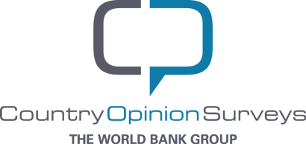

**March 2016**



**The world bank group**

**Public Opinion Research Group**

FY15 Tunisia Country Opinion Survey Report

**Acknowledgements**

The Tunisia Country Opinion Survey is part of the County Opinion Survey Program series of the World Bank Group. This report was prepared by the Public Opinion Research Group (PORG) team led by Sharon Felzer (Senior Communications Officer, Head of PORG), Svetlana Markova, Jing Guo, and Jessica Cameron. Calita Woods and Dania Mendoza provided data support. The report was prepared under the overall guidance and supervision of Sumir Lal (Director, ECRGP). PORG acknowledges the significant contribution from the Tunisia country team and the local fielding agency Sigma Conseil. In particular, PORG is grateful for the support from Donia Jemail (Communications Associate) who coordinated the survey related activities from Tunis, Tunisia.

### https://www.cia.gov/library/publications/the-world-factbook/graphics/flags/large/ts-lgflag.gif

### 

### 

### Table of Contents

### I. Objectives 3

II. Methodology 3

### III. Demographics of the Sample 4

### IV. General Issues Facing Tunisia 8

### V. Overall Attitudes toward the World Bank Group 13

### VI. Sectoral Effectiveness 21

### VII. How the World Bank Group Operates 25

### VIII. World Bank Group’s Knowledge and Instruments 31

### IX. The Future Role of the World Bank Group in Tunisia 35

### X. Communication and Outreach 40

### XI. Appendices 50

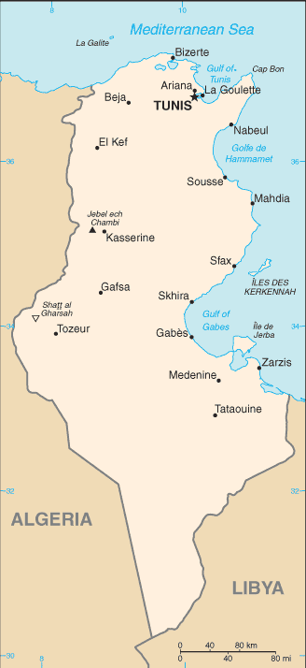

### I. Objectives

This survey was designed to assist the World Bank Group (WBG) in gaining a better understanding of how stakeholders in Tunisia perceive the WBG. The survey explored:

*General Issues Facing Tunisia*

*Overall Attitudes toward the World Bank Group*

*World Bank Group’s Effectiveness and Results*

*The World Bank Group’s Knowledge Work and Activities*

*Working with the World Bank Group*

*The Future Role of the World Bank Group in Tunisia*

*Communication and Information Sharing*

*Background Information*

### II. Methodology

From May to June 2015, 763 stakeholders of the WBG in Tunisia were invited to provide their opinions on the WBG’s work in the country by participating in a country opinion survey. Participants were drawn from the Office of the President, the Office of the Prime Minister; office of a minister; office of a parliamentarian; ministries/ministerial departments/implementation agencies; Project Management Units (PMUs) overseeing implementation of WBG projects; consultants/contractors working on WBG-supported projects/programs; local governments; bilateral/multilateral agencies; private sector organizations; private foundations; the financial sector/private banks; NGOs/community based organizations; the media; independent government institutions; trade unions; faith-based groups; youth groups; academia/research institutes/think tanks; the judiciary branch; and other organizations. A total of 202 stakeholders participated in the survey (27% response rate).

Respondents filled out the questionnaire with a representative of the fielding agency in person. Respondents were asked about: general issues facing Tunisia; their overall attitudes toward the WBG; the WBG’s effectiveness and results; the WBG’s knowledge work and activities; working with the WBG; the WBG’s future role in Tunisia; and the WBG’s communication and information sharing.

Every country that engages in the Country Opinion Survey (COS) must include specific indicator questions that will be aggregated for the World Bank Group’s annual Corporate Scorecard. These questions are identified throughout the survey report.

The results in this year’s Country Survey were compared to those in the Country Survey conducted in FY’12 (response rate is 44%, N=58). As a rule, the COS data are weighted for year comparisons in order to reach the same stakeholder composition in two fiscal years. However, in the case of Tunisia, due to the small number of respondents in the FY’12 Country Survey, weighting would have been statistically unsound. Therefore, only basic comparisons of the unweighted data from the FY’15 and FY’12 Country Surveys are presented in the report and should be considered provisional. For the FY’15 and FY’12 stakeholder breakdown and year comparison results, please see appendix D (page 111).

### III. Demographics of the Sample

#### **Current Position**

* For further analyses, respondents from the Office of the President/Prime Minister were combined with respondents from the office of a minister; respondents from private sector organizations were combined with those from the financial sector/private banks; and few respondents from independent government institutions, local governments, private foundations, youth groups, and other organizations were included in the “Other” category. Note that there were no respondents from trade unions, faith-based groups, and the judiciary branch.

#### 

### III. Demographics of the Sample (continued)

#### **Area of Primary Specialization**

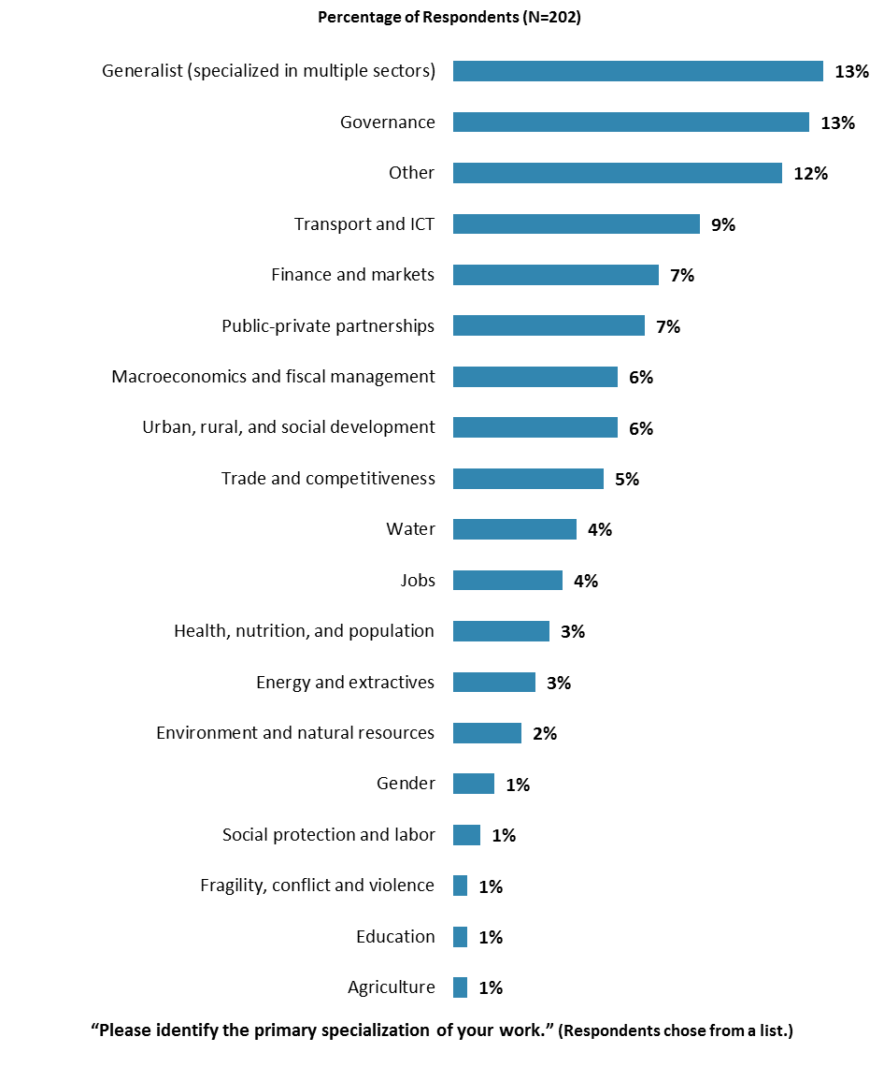

### III. Demographics of the Sample (continued)

#### **Geographic Locations**

* ***Note:*** Because of the small number of respondents from coastal cities, other urban centers, and other areas, analyses comparing geographic locations would not be statistically reliable and, therefore, were not conducted. There were no respondents from rural/mountainous areas.

#### 

#### **Exposure to Agencies within the World Bank Group**

#### 

#### III. Demographics of the Sample (continued)

#### **Familiarity with the World Bank Group**

* **Year comparison:** Respondents in this year’s Country Survey and the FY’12 Country Survey had statistically similar levels of familiarity with the WBG (mean familiarity rating in FY’15 = 5.76; mean familiarity rating in FY’12 = 5.34)[1].
* Respondents’ levels of familiarity with the WBG were significantly, strongly correlated with their ratings of the WBG’s overall effectiveness in Tunisia and the extent to which the WBG plays a relevant role in development in Tunisia, and significantly, moderately correlated with their ratings of the extent to which the WBG helps to achieve development results in Tunisia.

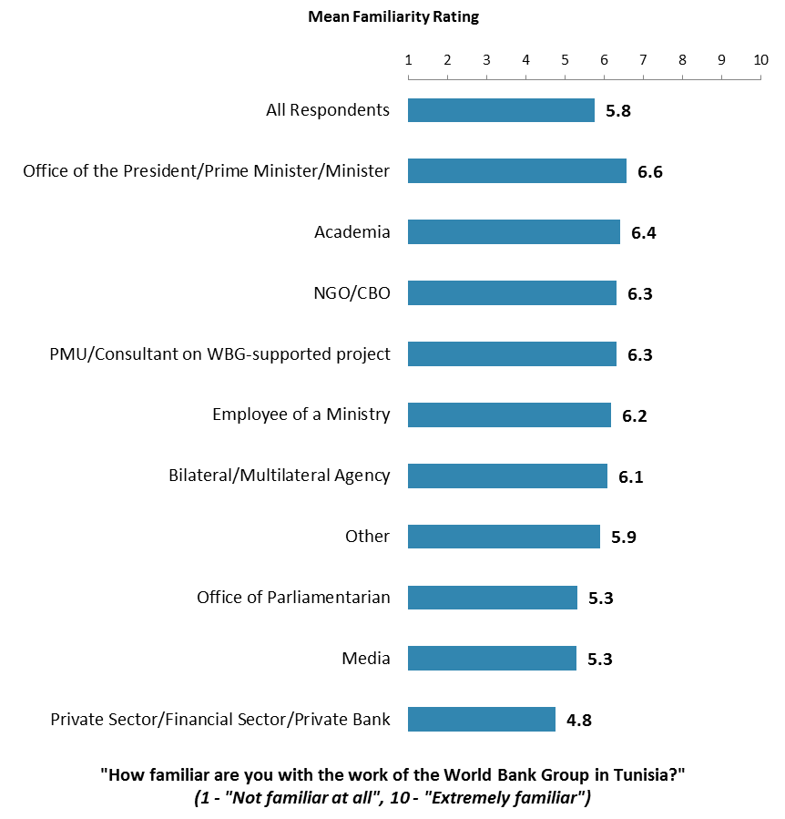

IV. General Issues Facing Tunisia

#### **Headed in the Right Direction**

* **Year comparison:** This year’s respondents were significantly more likely to indicate that Tunisia is headed in the right direction, compared to respondents in the FY’12 Country Survey.
* **Stakeholder groups:** In this year’s Country Survey, respondents from the Office of the President/Prime Minister/Minister and the office of a parliamentarian were most positive about the prospect of Tunisia.

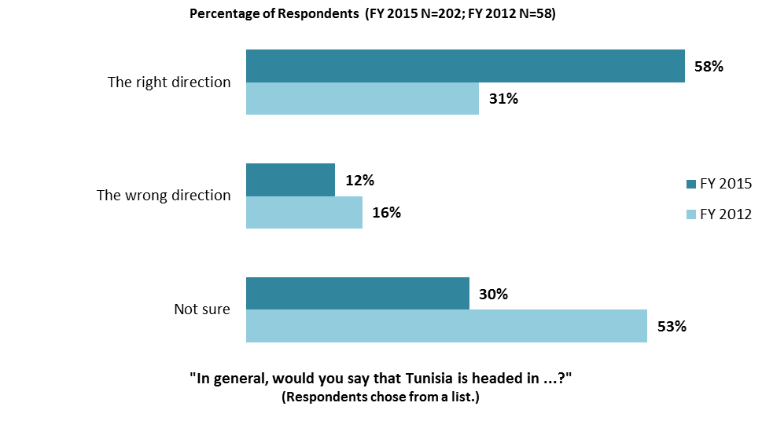

IV. General Issues Facing Tunisia (continued)

#### **Development Priority**

* **Year comparison:** Respondents in the previous FY’12 Country Survey indicated that the most important development priorities in Tunisia were “*job creation/employment*” (56%), “*poverty reduction*” (36%), “*economic growth*” (32%), and “*governance*” (30%).

#### 

IV. General Issues Facing Tunisia (continued)

#### **What Would Contribute Most to Reducing Poverty**

* **Year comparison:** Respondents in the previous FY’12 Country Survey indicated that the key factors contributing to poverty reduction in Tunisia were “*economic growth*” (57%), “*job creation/employment*” (43%), and “*rural/agricultural development*” (40%).

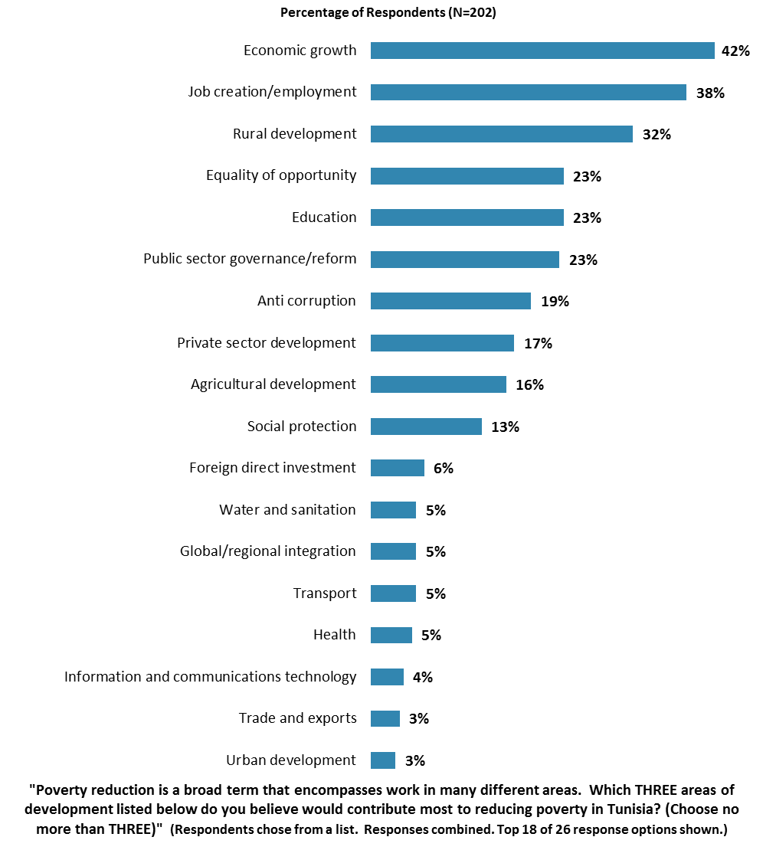

IV. General Issues Facing Tunisia (continued)

**Factors Contributing to “Shared Prosperity”**

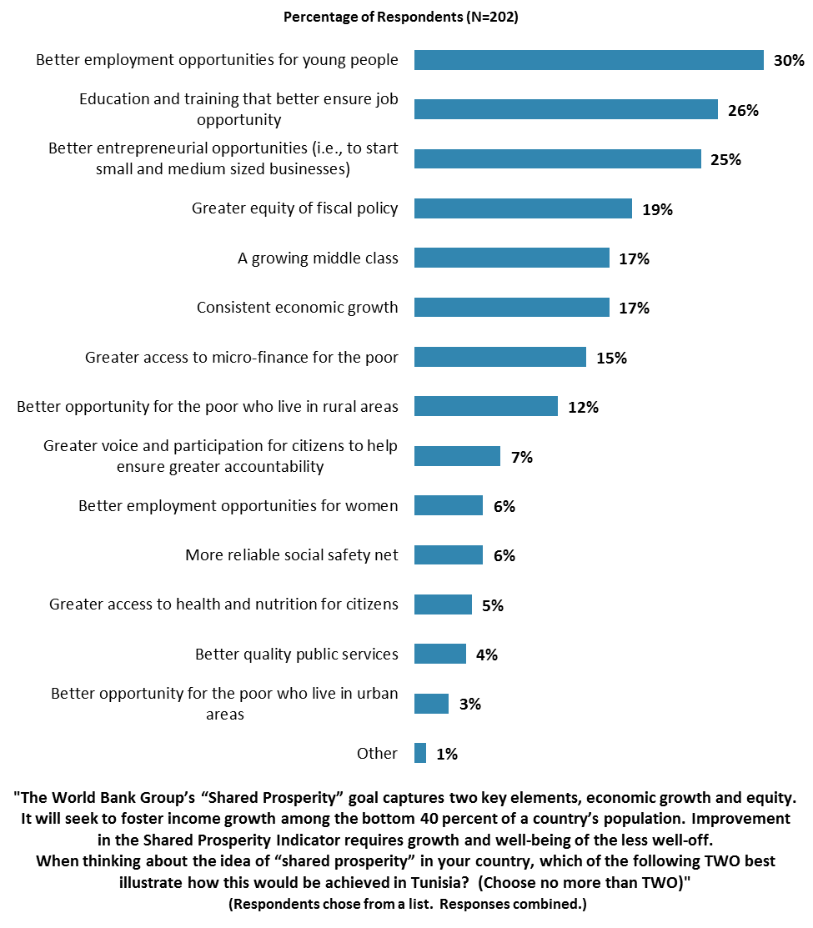

IV. General Issues Facing Tunisia (continued)

**Gap between the Rich and the Poor**

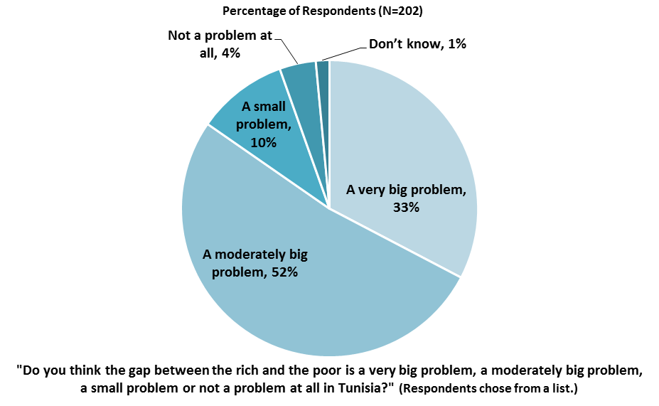

**Global Climate Change**

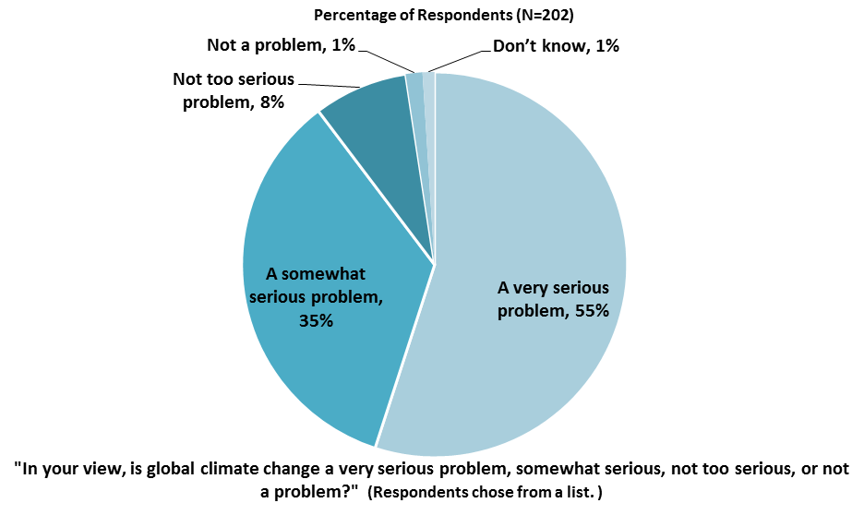

### V. Overall Attitudes toward the World Bank Group

#### **Attributing Failed/Slow Reform Efforts**

* **Year comparison:** Respondents in the previous FY’12 Country Survey indicated that they most often attributed failed or slow World Bank assisted reform efforts to “*the Government working inefficiently*” (47%).
* **Stakeholder groups:** Among this year’s respondents, respondents from NGOs/CSOs were significantly more likely to attribute failed or slow WBG assisted reform efforts to that “*there is not an adequate level of citizen/civil society participation*” compared to respondents from other stakeholder groups.

### 

### V. Overall Attitudes toward the World Bank Group (continued)

#### ***As noted in the “Methodology” section, the indicator questions referred to throughout the survey report are questions that are asked in every country that engages in the Country Opinion Survey. These will be aggregated for the World Bank Group’s annual Corporate Scorecard.***

#### **The World Bank Group’s Overall Effectiveness *(Indicator Question)*[2]**

#### 

#### **Achieving Development Results *(Indicator Question)***

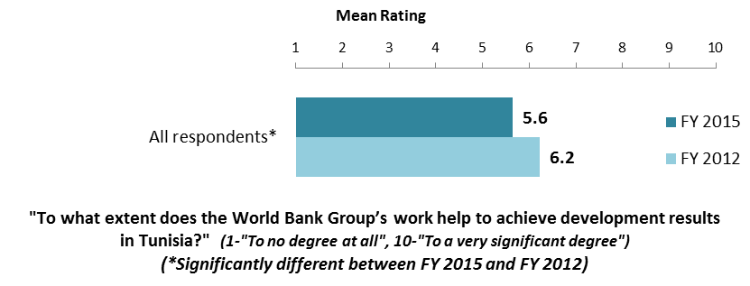

#### **WBG’s Support during the Transition Period**

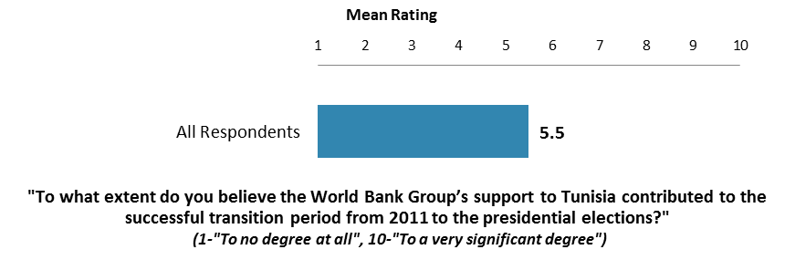

V. Overall Attitudes toward the World Bank Group (continued)

#### **WBG Staff Preparedness**

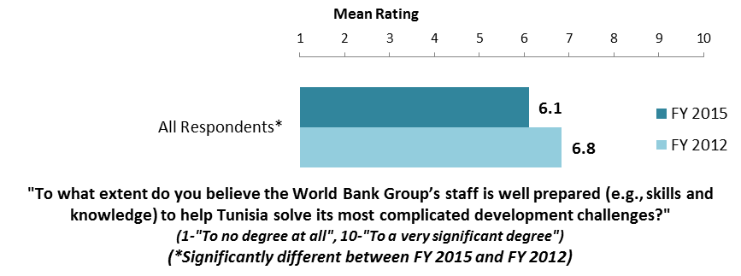

#### **The World Bank and the IFC Working Together**

* Only those stakeholders who responded “*Yes*” to the question “*Do your projects involve both the World Bank and the IFC?*” provided their views on the working relationship between the World Bank and the IFC.

#### 

#### 

### V. Overall Attitudes toward the World Bank Group (continued)

#### **Overall Ratings for Indicator Questions by Stakeholder Groups[3]**

* **Stakeholder groups:** Respondents across stakeholder groups gave statistically similar overall ratings for the twenty five indicator questions.
* **Collaboration:** Respondents who professionally collaborate with the WBG gave significantly higher overall ratings (mean = 6.4) for the twenty five indicator questions than respondents who do not work with the institution (mean = 5.6).

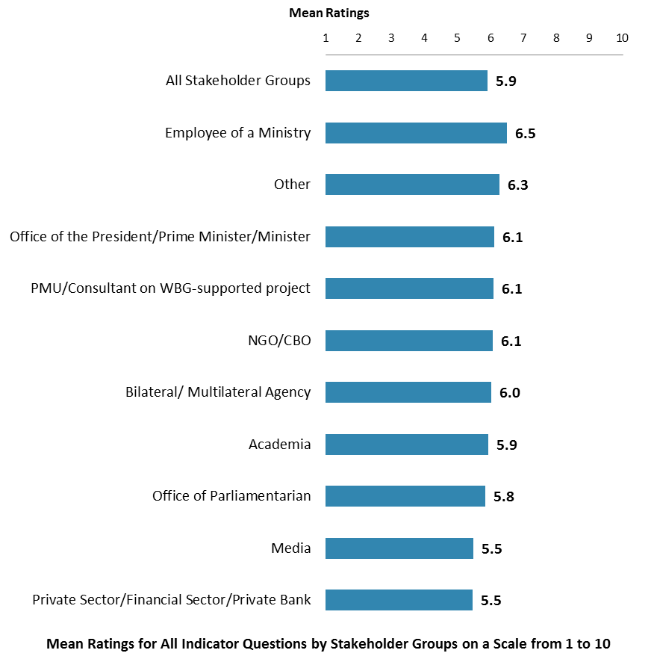

### V. Overall Attitudes toward the World Bank Group (continued)

#### **Greatest Value**

* **Year comparison:** Respondents in the previous FY’12 Country Survey indicated that the World Bank‘s greatest values to Tunisia were its “*financial resources*” (55%) and “*technical assistance*” (45%).

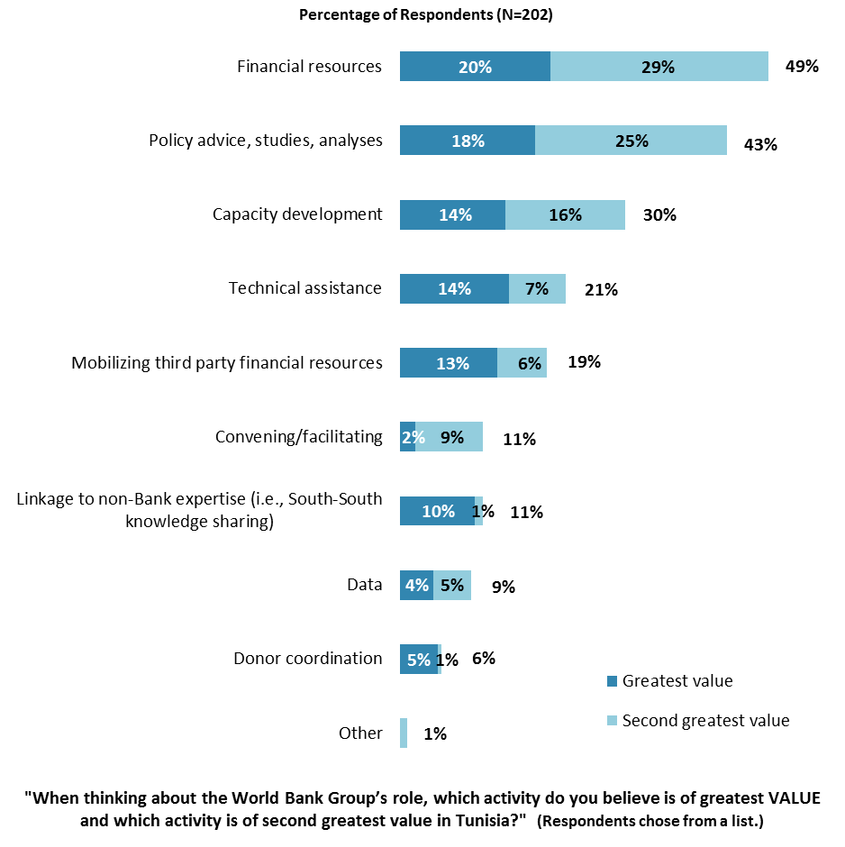

### V. Overall Attitudes toward the World Bank Group (continued)

#### **Most Effective Instruments in Reducing Poverty**

* **Year comparison:** Respondents in the previous FY’12 Country Survey indicated that the World Bank‘s most effective instruments in reducing poverty were “*technical assistance*” (50%), “*investment lending*” (50%), and “*capacity development*” (50%).

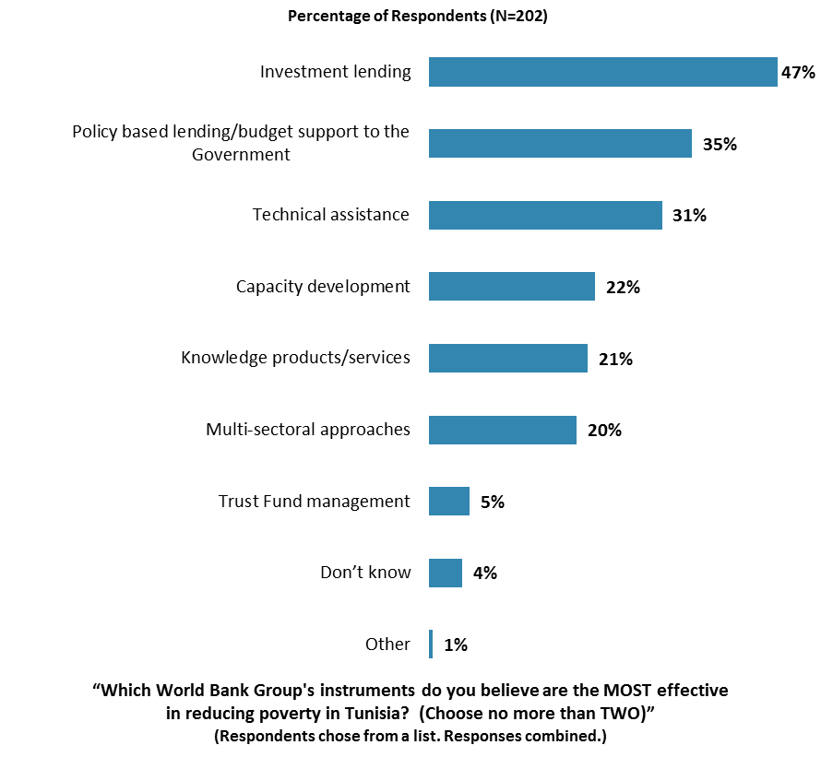

### V. Overall Attitudes toward the World Bank Group (continued)

#### **Importance and Effectiveness of WBG’s Capacity Building Work**

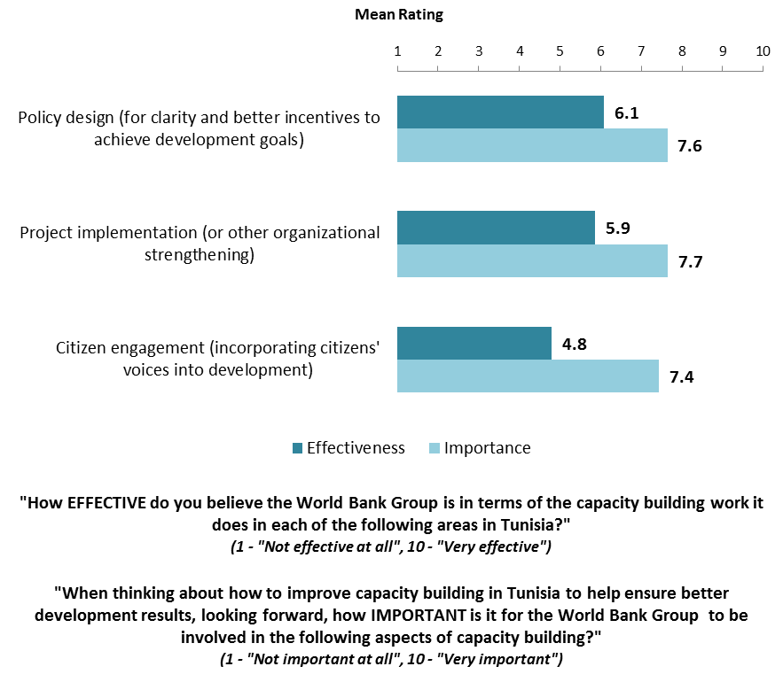

### V. Overall Attitudes toward the World Bank Group (continued)

#### **Greatest Weakness**

* **Year comparison**: Respondents in the previous FY’12 Country Survey indicated that the World Bank’s greatest weakness in its work in Tunisia was “*not enough public disclosure of its work*” (40%).

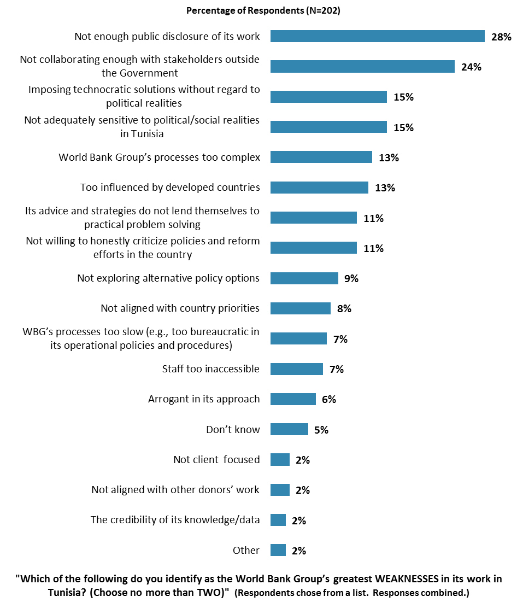

### VI. Sectoral Effectiveness

### **Effectiveness of WBG’s Support in Sectoral Areas: Year Comparison**

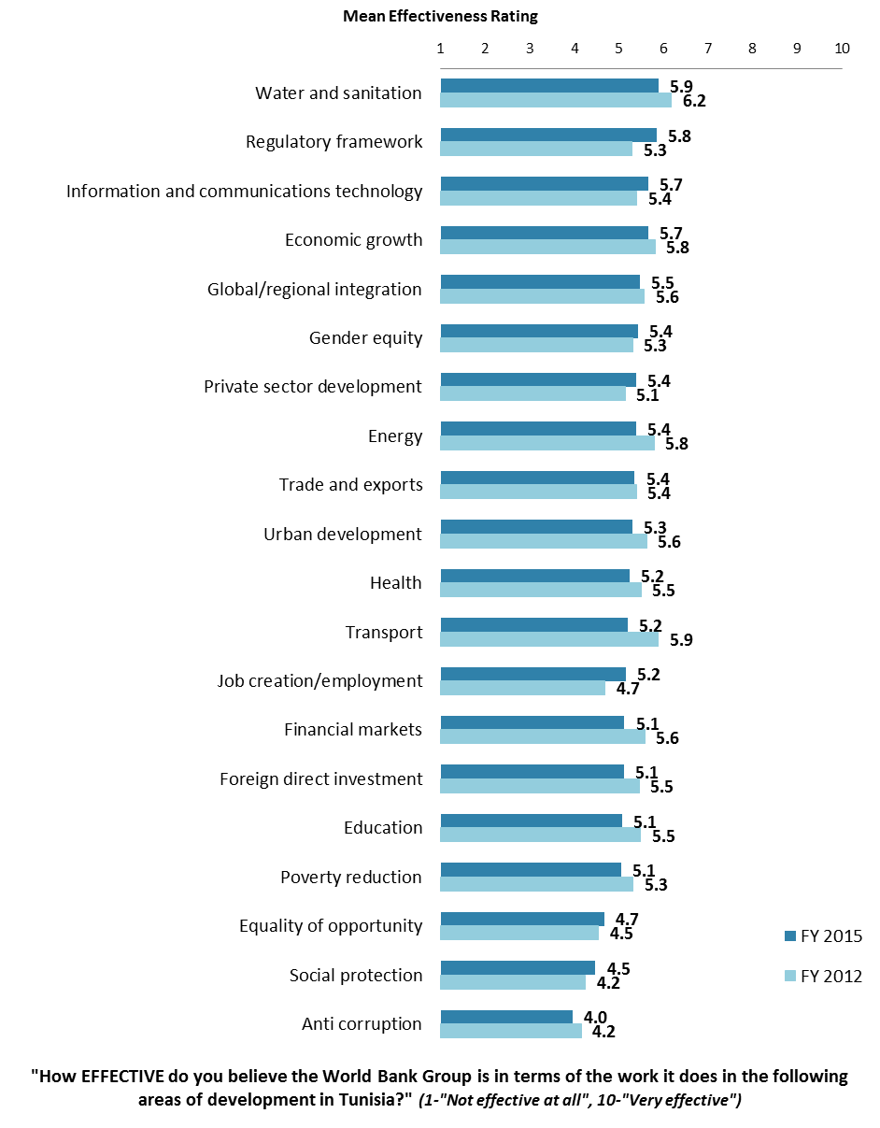

### VI. Sectoral Effectiveness (continued)

### **Effectiveness of WBG’s Support in Sectoral Areas: Collaboration[4]**

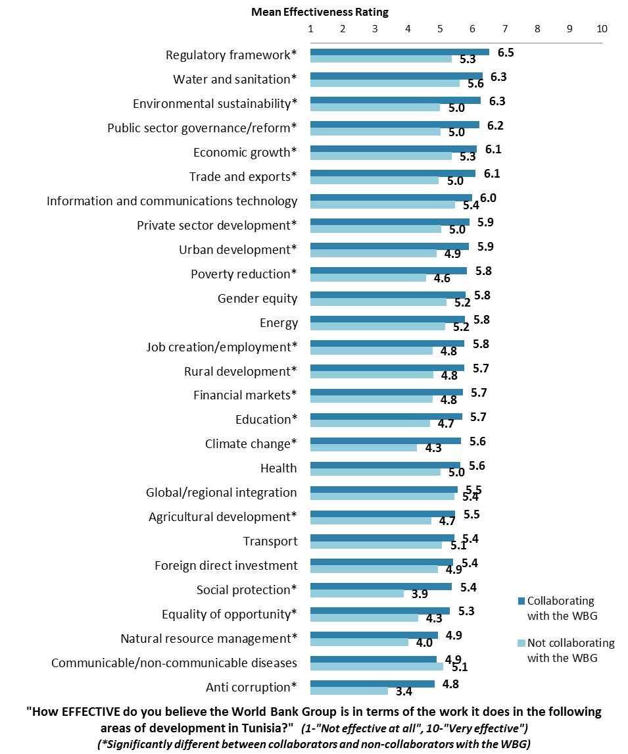

### VI. Sectoral Effectiveness (continued)

#### **WBG Promoting Private Public Partnerships**

### 

**Helping the Poorest in Tunisia**

### 

### VI. Sectoral Effectiveness (continued)

#### **Drivers of Effectiveness**

To determine the key drivers of respondents’ ratings of the World Bank Group’s overall effectiveness and ratings of its ability to help achieve development results in Tunisia, bivariate correlational analyses were conducted using respondents’ ratings of the twenty seven specific areas of effectiveness.

Correlational analyses, however, are not able to tell us exactly what is causing respondents’ ratings of the World Bank Group’s overall effectiveness or ratings of its ability to help achieve development results. Rather, these analyses tell us that as ratings of effectiveness in one area increase, respondents’ ratings of the WBG’s overall effectiveness increase, or as ratings of effectiveness in one area increase, ratings of the WBG’s ability to help achieve development results increase. Thus, it can be inferred that respondents’ perceptions of effectiveness in one specific area are related to, or drive, respondents’ perceptions of the WBG’s overall effectiveness or perceptions of the WBG’s ability to help achieve development results.

* Overall Effectiveness: Those specific areas with the highest Pearson Product-Moment correlations were determined to be the most closely related to perceptions of the WBG’s overall effectiveness, suggesting that ratings of effectiveness in those specific areas are drivers of perceptions of the WBG’s overall effectiveness in Tunisia. The areas determined to be key drivers from these analyses were:
  + The WBG’s effectiveness at poverty reduction; and
  + The WBG’s effectiveness at social protection.
* Achieving Development Results: Those specific areas with the highest Pearson Product-Moment correlations were determined to be the most closely related to perceptions of the WBG’s ability to help achieve development results in Tunisia, suggesting that ratings of effectiveness in those specific areas are drivers of perceptions of the WBG’s ability to help achieve development results. The areas determined to be key drivers from these analyses were:
  + The WBG’s effectiveness at job creation/employment;
  + The WBG’s effectiveness at social protection;
  + The WBG’s effectiveness at economic growth; and
  + The WBG’s effectiveness at trade and exports.

VII. How the World Bank Group Operates

#### **The World Bank Group’s Work in Tunisia: Year Comparison**

* **Year comparison**: Respondents in this year’s Country Survey had significantly higher levels of agreement with the statement “*Overall the World Bank Group currently plays a relevant role in development in Tunisia*” (indicator question) compared to respondents in the FY12 Country Survey.

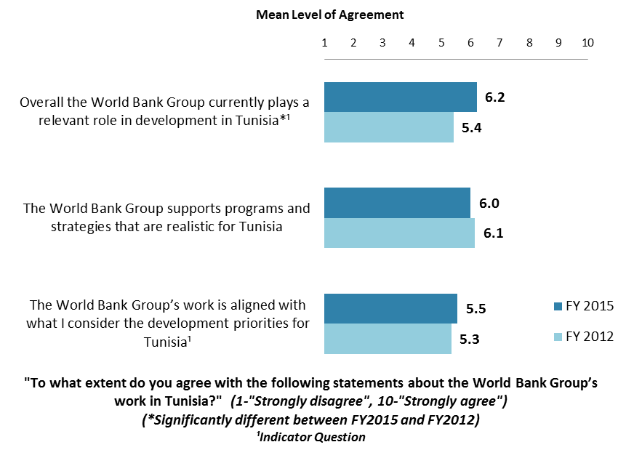

VII. How the World Bank Group Operates (continued)

#### **The World Bank Group’s Work in Tunisia: Collaboration**

* **Collaboration**: Respondents who collaborate with the WBG had significantly higher levels of agreement with all three statements below compared to respondents who do not collaborate with the WBG.

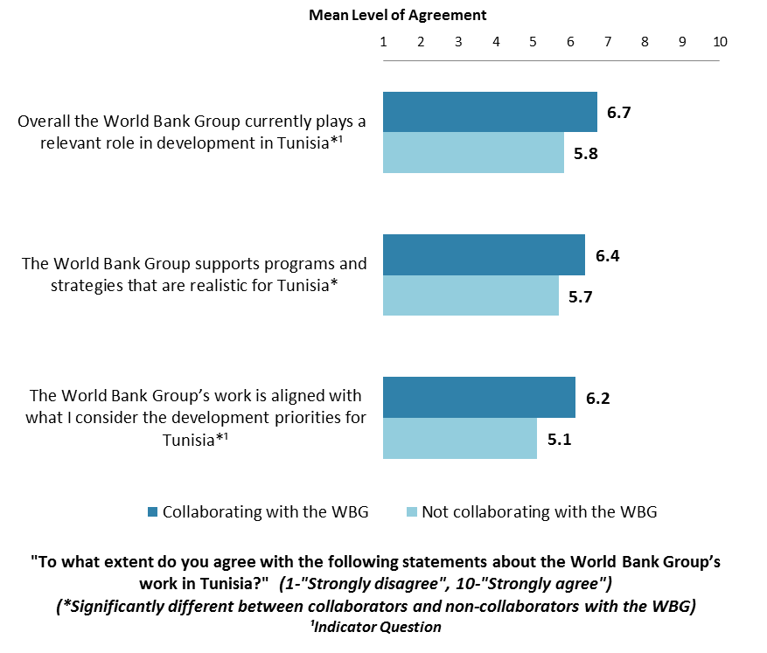

### VII. How the World Bank Group Operates (continued)

#### **Overall Perceptions: Year Comparison**

* **Year comparison**: As indicated in the chart below, respondents in this year’s Country Survey had significantly lower levels of agreement with a number of statements regarding the WBG’s work in Tunisia compared to respondents in the FY’12 Country Survey.

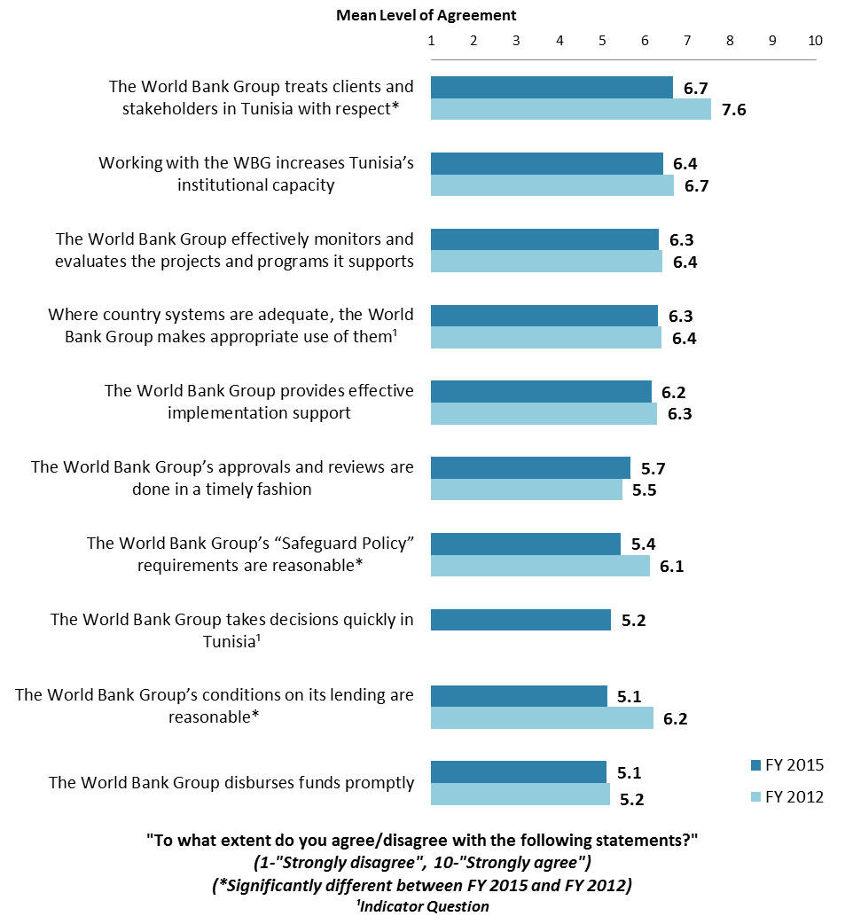

### VII. How the World Bank Group Operates (continued)

**Overall Perceptions: Collaboration**

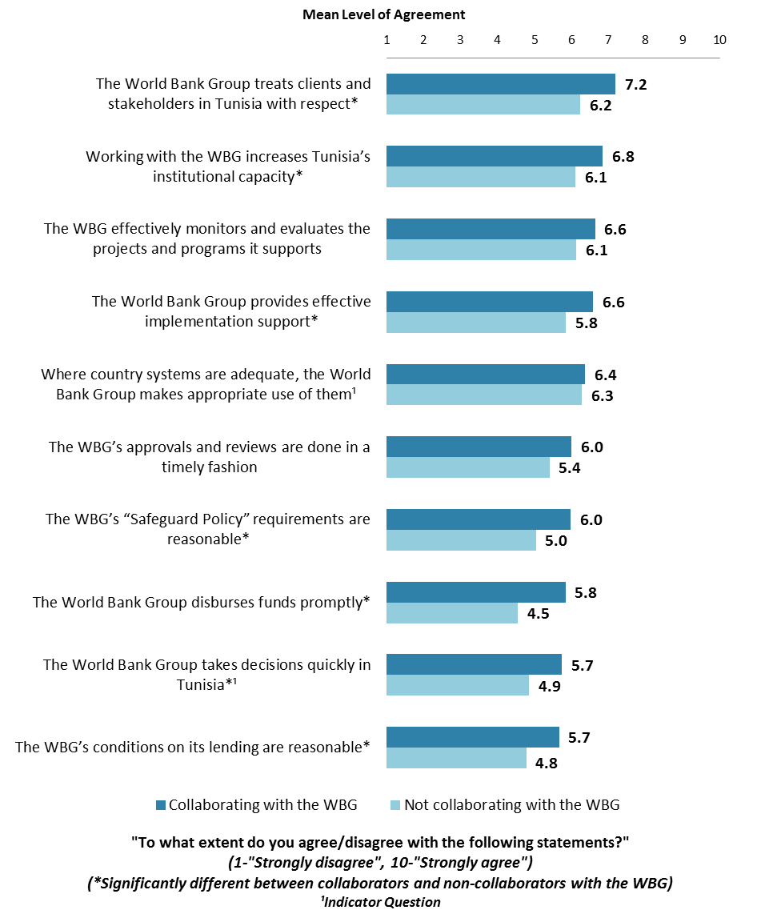

### VII. How the World Bank Group Operates (continued)

#### **The WBG as an Effective Development Partner: Year Comparison**

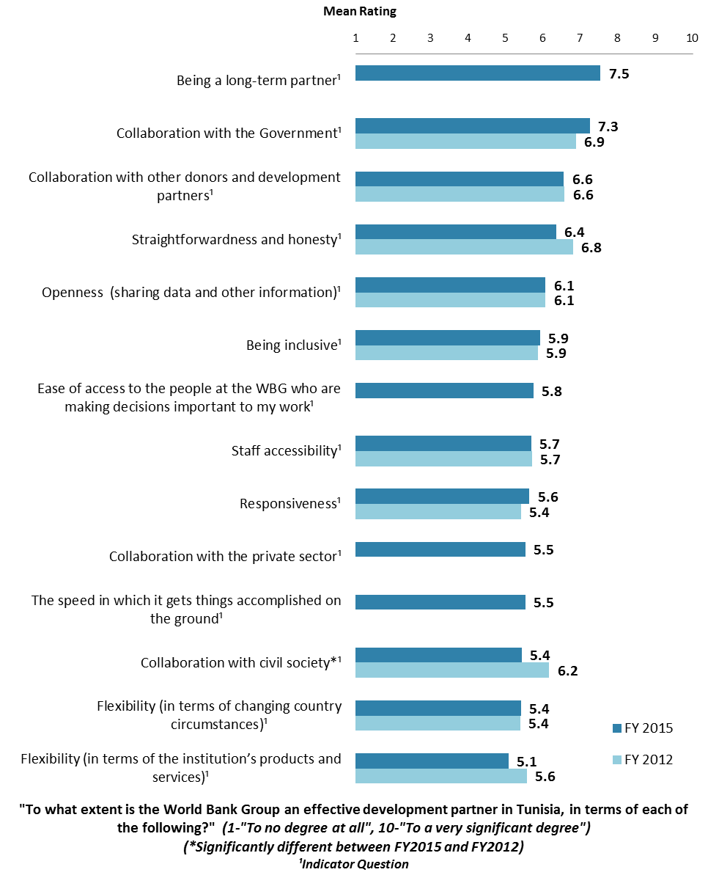

### VII. How the World Bank Group Operates (continued)

#### **The WBG as an Effective Development Partner: Collaboration**

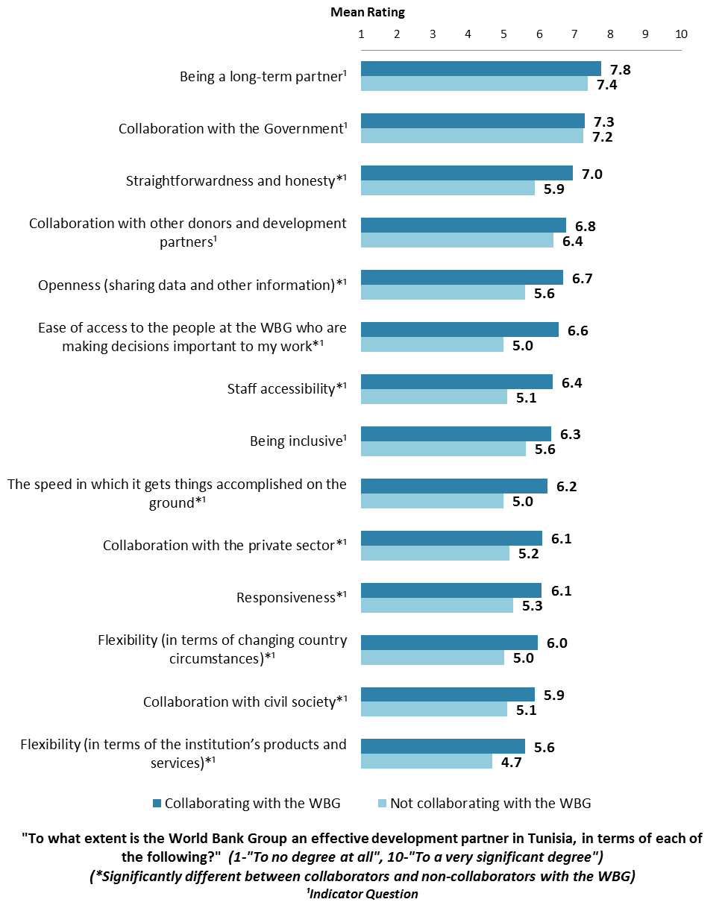

### VIII. World Bank Group’s Knowledge and Instruments

### **Frequency of Consulting WBG Knowledge Work and Activities**

* **Stakeholder groups:** Among this year’s respondents, respondents from the Office of the President/Prime Minister/Minister, PMUs, academia, and the media indicated the most frequent usage of the WBG’s knowledge work and activities (“*weekly/monthly*”) compared to respondents from other stakeholder groups.

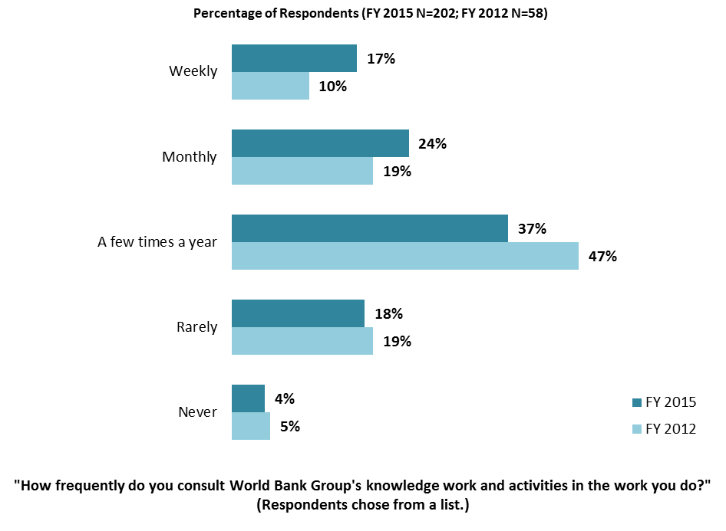

### VIII. World Bank Group’s Knowledge and Instruments (continued)

#### **Meeting Tunisia’s Knowledge Needs *(Indicator Question)***

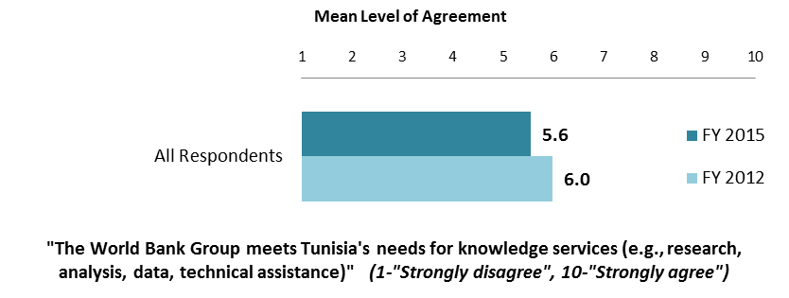

#### **Contribution of the WBG’s Knowledge Work and Activities *(Indicator Question)***

#### 

#### **Technical Quality of the WBG’s Knowledge Work and Activities *(Indicator Question)***

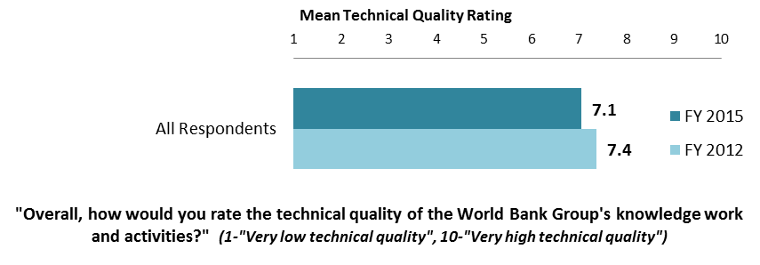

### VIII. World Bank Group’s Knowledge and Instruments (continued)

#### **Qualities of the WBG’s Knowledge Work and Activities**

* **Year comparison**: As indicated in the chart below, respondents in this year’s Country Survey gave significantly higher ratings for the “*timeliness*” of the WBG’s knowledge work and activities and significantly lower ratings for the WBG’s knowledge “*leading to practical solutions*” and “*being translated enough into local language*” compared to respondents in the FY’12 Country Survey.

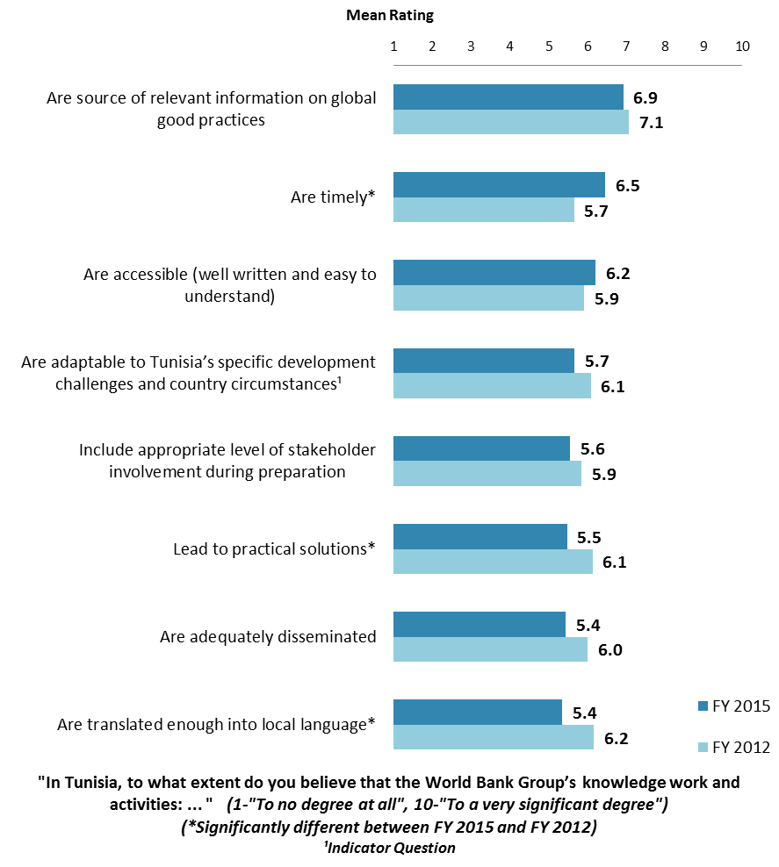

### VIII. World Bank Group’s Knowledge and Instruments (continued)

#### **Meeting Tunisia’s Needs for Financial Instruments *(Indicator Question)***

#### 

**Internal Measuring and Monitoring**

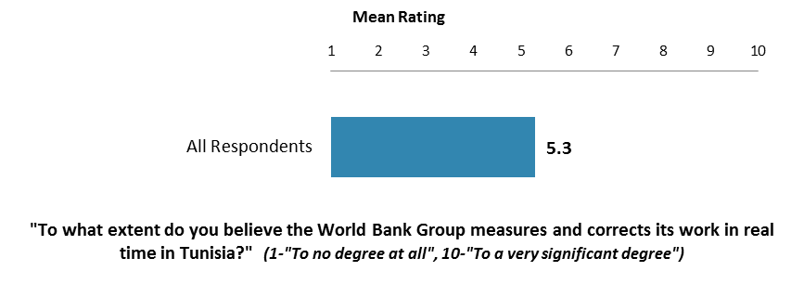

IX. The Future Role of the World Bank Group in Tunisia

#### **The World Bank Group’s Local Presence in Tunisia**

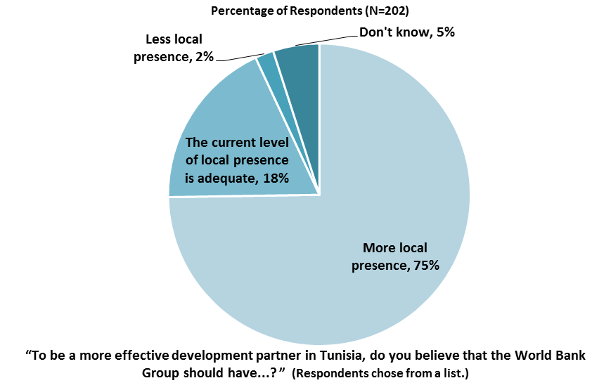

#### **Selectivity of the World Bank Group’s Support**

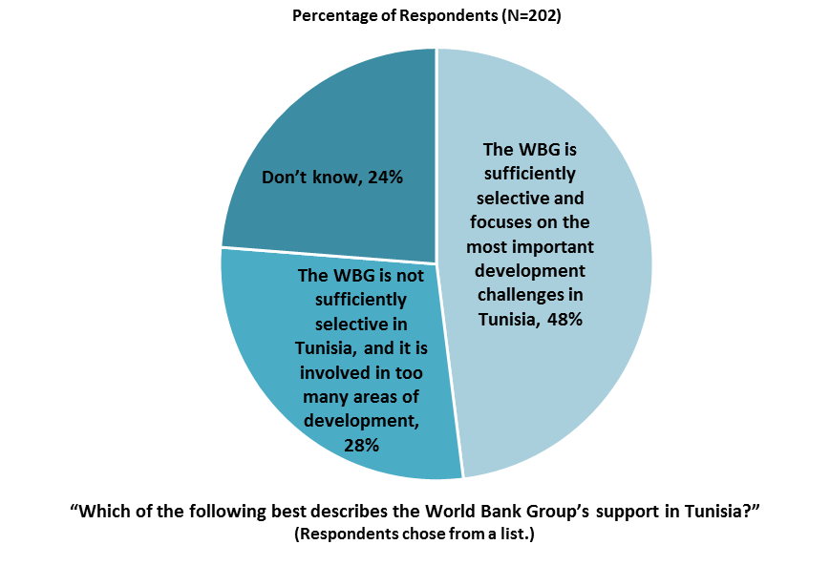

IX. The Future Role of the WBG in Tunisia (continued)

**Making the World Bank Group of Greater Value**

* **Year comparison**: Respondents in the previous FY’12 Country Survey indicated that the World Bank should “*reduce the complexity of obtaining its financing*” (40%) and “*improve the quality of its experts as related to Tunisia’s specific challenges*” (38%) to make itself of greater value in the country.

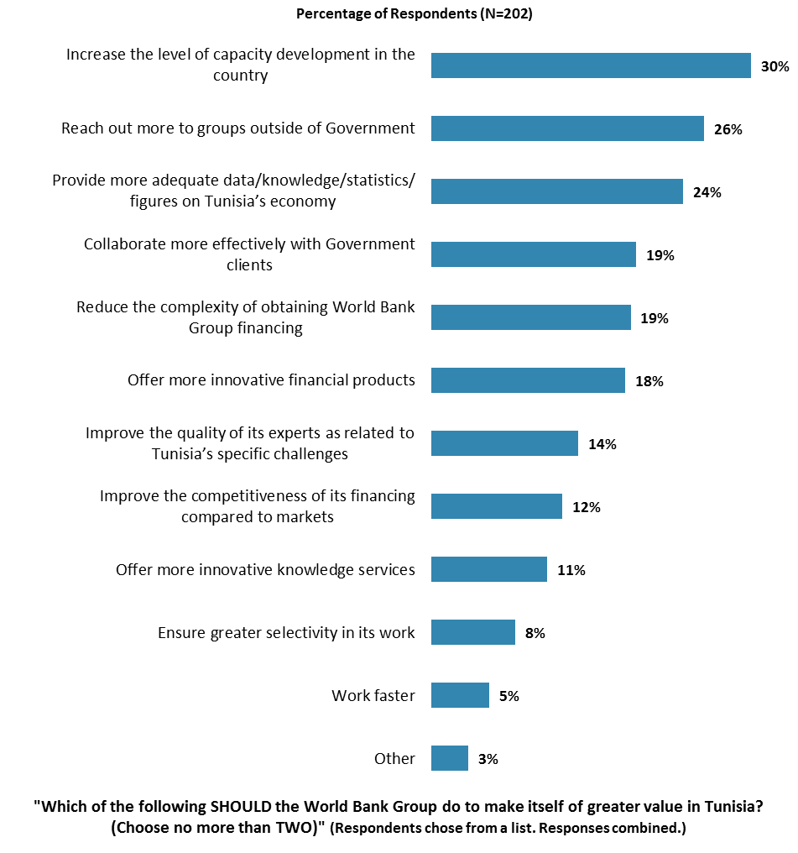

IX. The Future Role of the WBG in Tunisia (continued)

**The World Bank Group Should Collaborate More with …**

* **Year comparison**: Respondents in the previous FY’12 Country Survey indicated that the World Bank should work more with “*NGOs*” (44%) and “*private sector*” (35%) to ensure better development results in Tunisia.

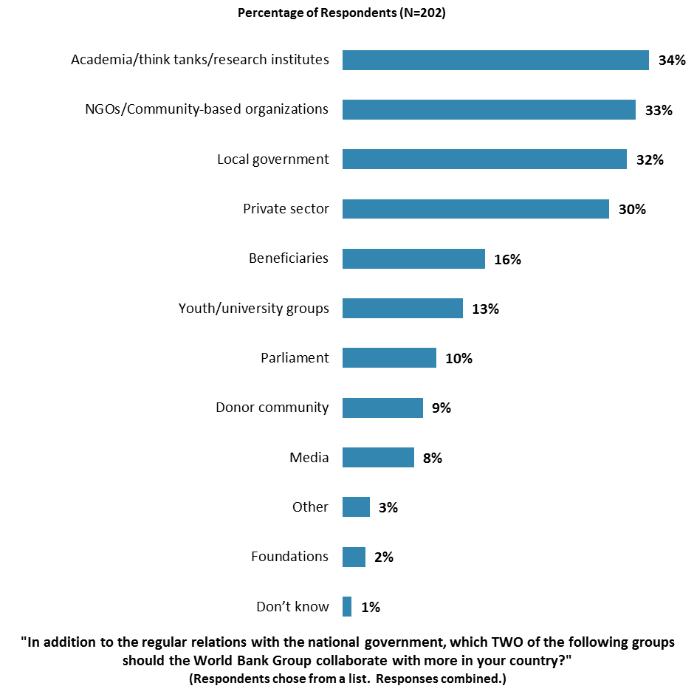

IX. The Future Role of the WBG in Tunisia (continued)

#### **Where the World Bank Group Should Focus its Resources**

* **Year comparison:** Respondents in the previous FY’12 Country Survey indicated that the World Bank should focus its resources on “*rural/agricultural development*” (42%) and “*governance*” (30%).

### 

### IX. The Future Role of the WBG in Tunisia (continued)

#### **Future Combination of the WBG Services**

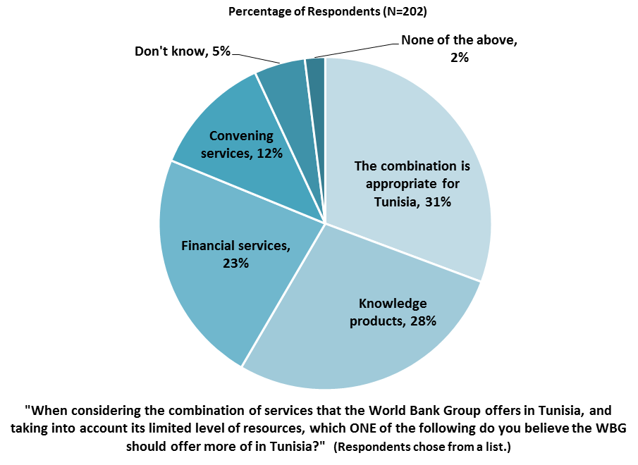

X. Communication and Outreach

***Note****:* ***When considering the World Bank Group’s future outreach with key constituencies, please see Appendix B (page 70) for all responses by stakeholder groups.***

#### **General Information Sources**

* **Year comparison**: Respondents in the previous FY’12 Country Survey indicated that they got most of their information about economic and social development issues in Tunisia from “*Internet* (65%)” and “*local newspapers*” (44%).

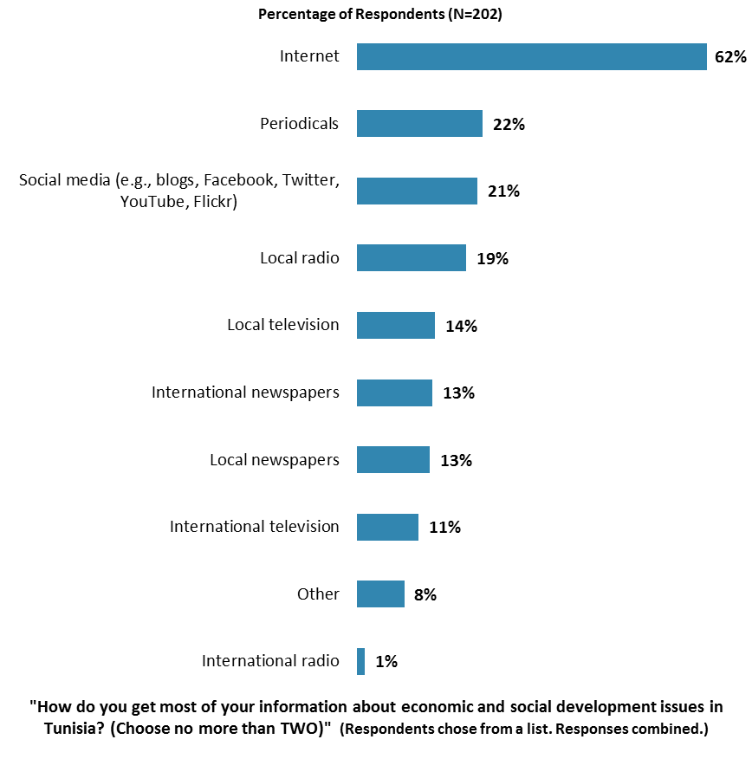

### X. Communication and Outreach (continued)

#### **Preferred Information Sources**

* **Year comparison**: Respondents in the previous FY’12 Country Survey indicated that they would prefer to receive information from the World Bank through “*e-Newsletters*” (41%) and “*World Bank seminars/workshops/conferences*” (38%).

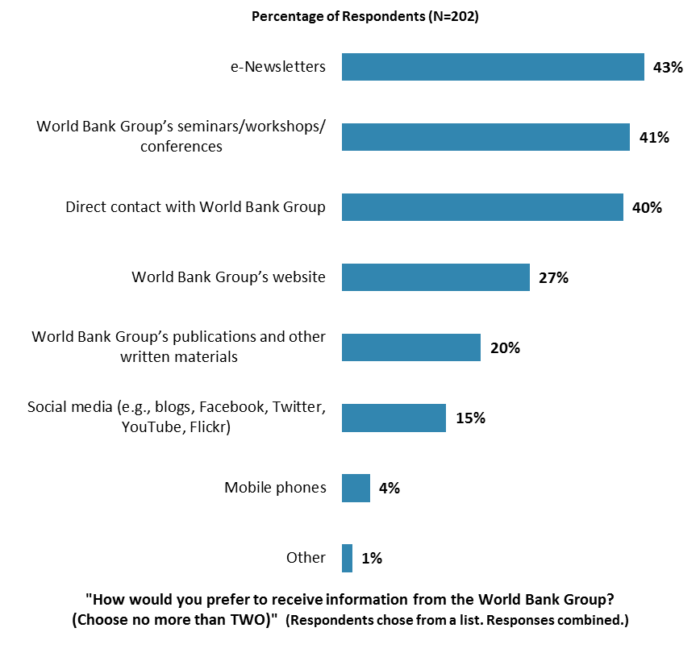

### 

### X. Communication and Outreach (continued)

#### **Access to Information**

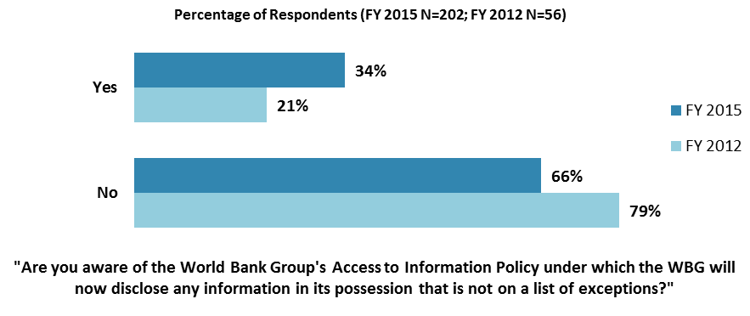

### 

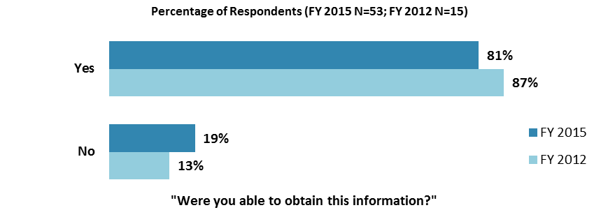

### X. Communication and Outreach (continued)

### **Access to the Internet**

### 

### 

### X. Communication and Outreach (continued)

### **WBG Website Usage**

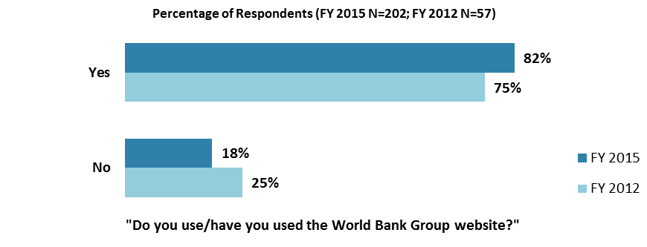

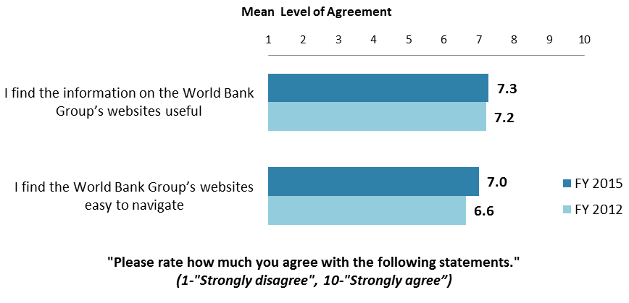

### X. Communication and Outreach (continued)

**Use and Evaluation of the WBG’s Social Media Channels**

### 

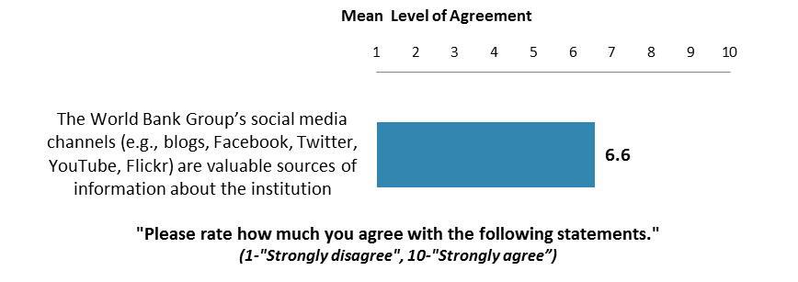

#### **Information Sharing**

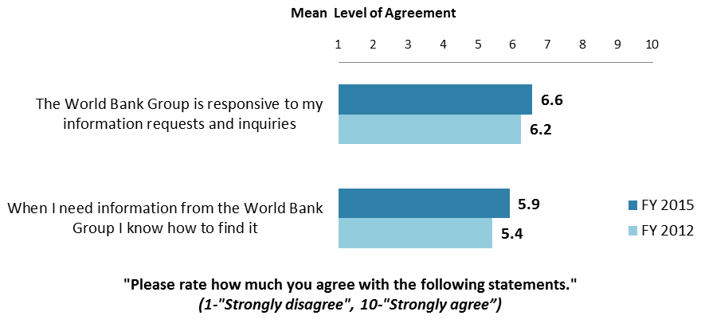

### X. Communication and Outreach (continued)

**WBG’s Publication: Development Policy Review (DPR)**

* Only those who indicated that they had heard or read about the WBG’s most recent DPR were asked to complete the remaining questions in this section.

### 

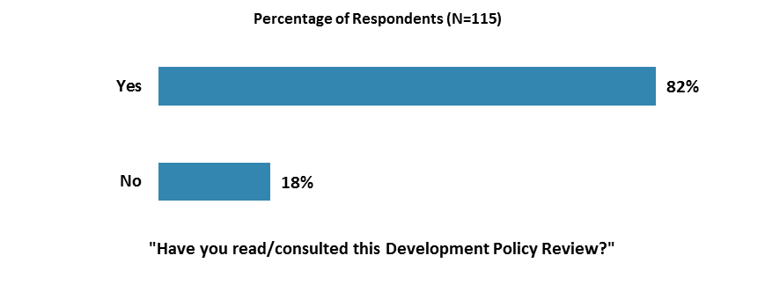

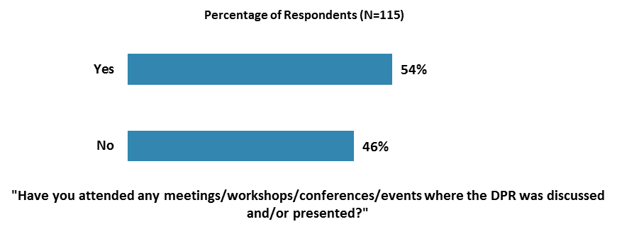

### X. Communication and Outreach (continued)

**WBG’s Publication: Development Policy Review (continued)**

### 

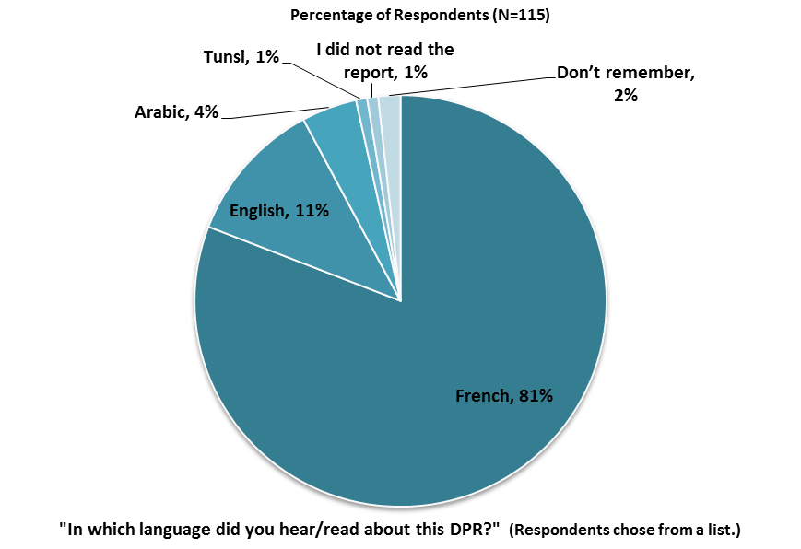

### X. Communication and Outreach (continued)

**WBG’s Publication: Development Policy Review (continued)**

### 

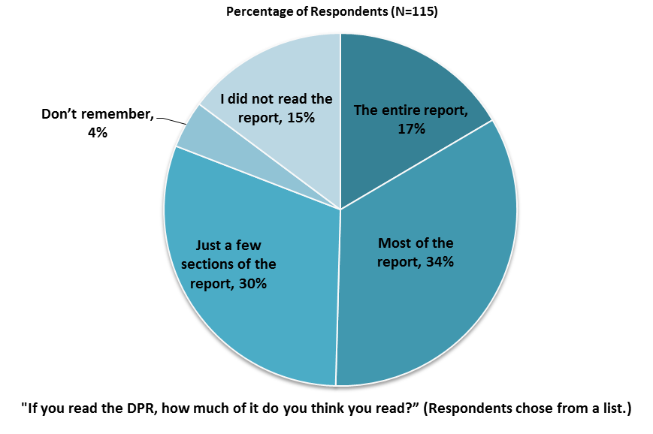

### X. Communication and Outreach (continued)

**WBG’s Publication: Development Policy Review (continued)**

### 

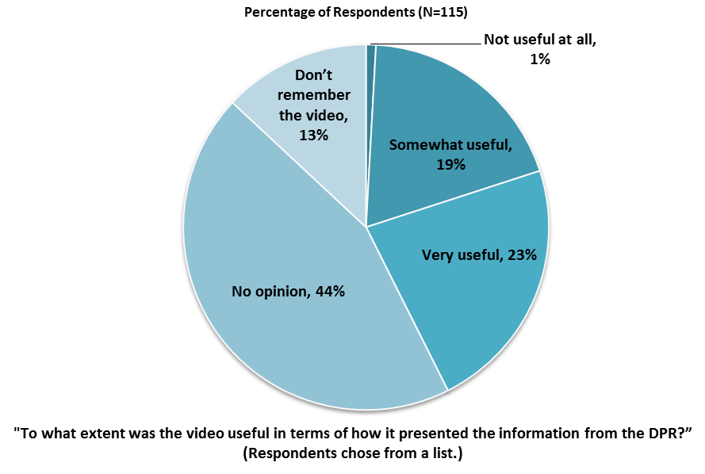

### XI. Appendices

### Responses to All Questions across All Respondents 51

1. Responses to All Questions by Stakeholder Groups 68
2. Responses to All Questions by Level of Collaboration with the World Bank Group 93
3. Responses to Selected Questions by Year 109
4. Indicator Questions as a Function of Exposure to the WBG 115
5. The WBG COS FY’15 – Tunisia Questionnaire 116

**Tunisia**

#### https://www.cia.gov/library/publications/the-world-factbook/graphics/locator/afr/ts_large_locator.gif

#### Appendix A: Responses to All Questions across All Respondents (N=202)

*All rating scale questions are presented with the total number of respondents that provided a rating (N), the number of respondents who indicated that they “Don’t know” (DK), the mean rating across all respondents (Mean), and the standard deviation of this mean (SD). Indicator questions are noted with an asterisk (*).*

#### ***A. General Issues Facing Tunisia***

|  |  |
| --- | --- |
| **1. In general would you say that Tunisia is headed in ... ?** | **Percentage of Respondents (N=202)** |
| The right direction | 58.4% |
| The wrong direction | 11.9% |
| Not sure | 29.7% |

|  |  |
| --- | --- |
| **2. Listed below are a number of development priorities in Tunisia. Please identify which of the following you consider the most important development priorities in Tunisia? (Choose no more than THREE)** | **Percentage of Respondents  (Responses Combined; N=202)** |
| Public sector governance/reform (i.e., government effectiveness, public financial management, public expenditure, fiscal system reform) | 75.2% |
| Job creation/employment | 35.6% |
| Anti corruption | 33.7% |
| Education | 27.7% |
| Economic growth | 21.8% |
| Private sector development | 18.3% |
| Poverty reduction | 9.9% |
| Foreign direct investment | 8.4% |
| Rural development | 8.4% |
| Information and communications technology | 8.4% |
| Regulatory framework | 7.4% |
| Global/regional integration | 6.9% |
| Equality of opportunity (i.e., equity) | 5.9% |
| Agricultural development | 5.0% |
| Natural resource management (e.g., oil, gas, mining) | 4.0% |
| Social protection (e.g., pensions, targeted social assistance) | 3.5% |
| Environmental sustainability | 3.0% |
| Trade and exports | 3.0% |
| Financial markets | 2.5% |
| Water and sanitation | 1.5% |
| Health | 1.5% |
| Transport (e.g., roads, bridges, transportation) | 1.5% |
| Gender equity | 1.0% |
| Urban development | 1.0% |
| Energy | 0.5% |
| Communicable/non-communicable diseases | 0.5% |
| Climate change (e.g., mitigation, adaptation) | 0.0% |

#### ***A. General Issues Facing Tunisia (continued)***

|  |  |
| --- | --- |
| **3. Poverty reduction is a broad term that encompasses work in many different areas. Which THREE areas of development listed below do you believe would contribute most to reducing poverty in Tunisia? (Choose no more than THREE)** | **Percentage of Respondents  (Responses Combined; N=202)** |
| Economic growth | 41.6% |
| Job creation/employment | 38.1% |
| Rural development | 31.7% |
| Equality of opportunity (i.e., equity) | 23.3% |
| Education | 23.3% |
| Public sector governance/reform (i.e., government effectiveness, public financial management, public expenditure, fiscal system reform) | 22.8% |
| Anti corruption | 19.3% |
| Private sector development | 17.3% |
| Agricultural development | 16.3% |
| Social protection (e.g., pensions, targeted social assistance) | 13.4% |
| Foreign direct investment | 6.4% |
| Water and sanitation | 5.4% |
| Global/regional integration | 5.4% |
| Transport (e.g., roads, bridges, transportation) | 5.4% |
| Health | 5.0% |
| Information and communications technology | 4.0% |
| Trade and exports | 3.5% |
| Urban development | 3.0% |
| Regulatory framework | 2.5% |
| Gender equity | 1.5% |
| Energy | 1.5% |
| Natural resource management (e.g., oil, gas, mining) | 1.5% |
| Financial markets | 1.0% |
| Communicable/non-communicable diseases | 0.5% |
| Environmental sustainability | 0.5% |
| Climate change (e.g., mitigation, adaptation) | 0.0% |

#### ***A. General Issues Facing Tunisia (continued)***

|  |  |
| --- | --- |
| **4. When thinking about the idea of “shared prosperity” in your country, which of the following TWO best illustrate how this would be achieved in Tunisia?  (Choose no more than TWO)** | **Percentage of Respondents  (Responses Combined; N=202)** |
| Better employment opportunities for young people | 30.2% |
| Education and training that better ensure job opportunity | 26.2% |
| Better entrepreneurial opportunities (i.e., to start small and medium sized businesses) | 24.8% |
| Greater equity of fiscal policy | 18.8% |
| A growing middle class | 16.8% |
| Consistent economic growth | 16.8% |
| Greater access to micro-finance for the poor | 14.9% |
| Better opportunity for the poor who live in rural areas | 12.4% |
| Greater voice and participation for citizens to help ensure greater accountability | 7.4% |
| Better employment opportunities for women | 5.9% |
| More reliable social safety net | 5.9% |
| Greater access to health and nutrition for citizens | 5.0% |
| Better quality public services | 4.5% |
| Better opportunity for the poor who live in urban areas | 3.0% |
| Other | 1.0% |

|  |  |
| --- | --- |
| **5. Do you think the gap between the rich and the poor is a very big problem, a moderately big problem, a small problem or not a problem at all in Tunisia?  (Select only ONE response)** | **Percentage of Respondents  (Responses Combined; N=202)** |
| A very big problem | 32.7% |
| A moderately big problem | 52.0% |
| A small problem | 9.9% |
| Not a problem at all | 4.0% |
| Don’t know | 1.5% |

|  |  |
| --- | --- |
| **6. In your view, is global climate change a very serious problem, somewhat serious, not too serious, or not a problem? (Select only ONE response)** | **Percentage of Respondents  (Responses Combined; N=202)** |
| A very serious problem | 55.0% |
| A somewhat serious problem | 34.7% |
| Not too serious problem | 7.9% |
| Not a problem | 1.5% |
| Don’t know | 1.0% |

***B. Overall Attitudes toward the World Bank Group***

|  |  |  |  |  |
| --- | --- | --- | --- | --- |
| Familiarity | **N** | **DK** | **Mean** | **SD** |
| 1. How familiar are you with the work of the World Bank Group in Tunisia? *(1-Not familiar at all, 10-Extremely familiar)* | 202 | 0 | 5.76 | 2.23 |

|  |  |  |  |  |
| --- | --- | --- | --- | --- |
| Effectiveness* | **N** | **DK** | **Mean** | **SD** |
| 1. Overall, please rate your impression of the World Bank Group’s effectiveness in Tunisia? *(1-Not effective at all, 10-Very effective)* | 181 | 21 | 5.77 | 2.04 |

***B. Overall Attitudes toward the World Bank Group (continued)***

|  |  |  |  |  |
| --- | --- | --- | --- | --- |
| Contribution to Successful Presidential Elections | **N** | **DK** | **Mean** | **SD** |
| 1. To what extent do you believe the World Bank Group’s support to Tunisia contributed to the successful transition period from 2011 to the presidential elections? *(1-To no degree at all, 10-To a very significant degree)* | 166 | 36 | 5.49 | 2.17 |

|  |  |  |  |  |
| --- | --- | --- | --- | --- |
| Staff Preparedness | **N** | **DK** | **Mean** | **SD** |
| 1. To what extent do you believe the World Bank Group’s staff is well prepared to help Tunisia solve its most complicated development challenges? *(1-To no degree at all, 10-To a very significant degree)* | 174 | 28 | 6.10 | 1.90 |

|  |  |
| --- | --- |
| **5. When thinking about how the World Bank Group can have the most impact on development results in Tunisia, in which sectoral areas do you believe the World Bank Group should focus most of its resources (financial and knowledge services) in Tunisia? (Choose no more than THREE)** | **Percentage of Respondents  (Responses Combined; N=202)** |
| Public sector governance/reform (i.e., government effectiveness, public financial management, public expenditure, fiscal system reform) | 43.6% |
| Education | 27.7% |
| Job creation/employment | 26.7% |
| Economic growth | 24.3% |
| Rural development | 18.3% |
| Poverty reduction | 17.3% |
| Anti corruption | 17.3% |
| Transport (e.g., roads, bridges, transportation) | 16.8% |
| Agricultural development | 16.3% |
| Private sector development | 16.3% |
| Information and communications technology | 14.4% |
| Regulatory framework | 7.9% |
| Global/regional integration | 5.9% |
| Equality of opportunity (i.e., equity) | 5.9% |
| Foreign direct investment | 5.4% |
| Health | 4.5% |
| Environmental sustainability | 4.0% |
| Social protection (e.g., pensions, targeted social assistance) | 4.0% |
| Trade and exports | 4.0% |
| Energy | 3.5% |
| Financial markets | 3.5% |
| Urban development | 2.5% |
| Water and sanitation | 2.5% |
| Gender equity | 1.5% |
| Natural resource management (e.g., oil, gas, mining) | 1.0% |
| Climate change (e.g., mitigation, adaptation) | 0.5% |
| Communicable/non-communicable diseases | 0.0% |

***B. Overall Attitudes toward the World Bank Group (continued)***

|  |  |  |  |
| --- | --- | --- | --- |
| **6. When thinking about the World Bank Group’s role, which activity do you believe is of greatest VALUE and which activity is of second greatest value in Tunisia?** | **Percentage of Respondents (N=202)** | | |
| **Greatest Value** | **2nd Greatest Value** | **Combined** |
| Financial resources | 19.8% | 28.7% | 48.5% |
| Policy advice, studies, analyses | 17.8% | 25.2% | 43.1% |
| Capacity development | 13.9% | 15.8% | 29.7% |
| Technical assistance | 14.4% | 7.4% | 21.8% |
| Mobilizing third party financial resources | 12.9% | 6.4% | 19.3% |
| Convening/facilitating | 2.0% | 8.9% | 10.9% |
| Linkage to non-Bank expertise (i.e., South-South knowledge sharing) | 9.9% | 1.0% | 10.9% |
| Data | 4.5% | 5.0% | 9.4% |
| Donor coordination | 5.0% | 0.5% | 5.4% |
| Other | 0.0% | 1.0% | 1.0% |

|  |  |  |  |  |
| --- | --- | --- | --- | --- |
| **How EFFECTIVE do you believe the World Bank Group is in terms of the capacity building work it does in each of the following areas in Tunisia?** *(1-Not effective at all, 10-Very effective)* | **Effectiveness** | | | |
| **N** | **DK** | **Mean** | **SD** |
| 1. Project implementation (or other organizational strengthening) | 149 | 53 | 5.86 | 1.80 |
| 1. Citizen engagement (incorporating citizens' voices into development) | 135 | 67 | 4.79 | 2.29 |
| 1. Policy design (for clarity and better incentives to achieve development goals) | 159 | 43 | 6.09 | 1.79 |

|  |  |  |  |  |
| --- | --- | --- | --- | --- |
| **When thinking about how to improve capacity building in Tunisia to help ensure better development results, looking forward, how IMPORTANT is it for the World Bank Group to be involved in the following aspects of capacity building?** *(1-Not important all, 10-Very important)* | **Importance** | | | |
| **N** | **DK** | **Mean** | **SD** |
| 1. Project implementation (or other organizational strengthening) | 178 | 24 | 7.66 | 1.67 |
| 1. Citizen engagement (incorporating citizens' voices into development) | 177 | 25 | 7.43 | 2.17 |
| 1. Policy design (for clarity and better incentives to achieve development goals) | 186 | 16 | 7.64 | 1.83 |

***B. Overall Attitudes toward the World Bank Group (continued)***

|  |  |
| --- | --- |
| **13. Which of the following do you identify as the World Bank Group’s greatest WEAKNESSES in its work in Tunisia? (Choose no more than TWO)** | **Percentage of Respondents (Responses Combined; N=202)** |
| Not enough public disclosure of its work | 28.2% |
| Not collaborating enough with stakeholders outside the Government | 24.3% |
| Imposing technocratic solutions without regard to political realities | 15.3% |
| Not adequately sensitive to political/social realities in Tunisia | 15.3% |
| World Bank Group’s processes too complex | 13.4% |
| Too influenced by developed countries | 12.9% |
| Its advice and strategies do not lend themselves to practical problem solving | 11.4% |
| Not willing to honestly criticize policies and reform efforts in the country | 11.4% |
| Not exploring alternative policy options | 8.9% |
| Not aligned with country priorities | 7.9% |
| World Bank Group’s processes too slow (e.g., too bureaucratic in its operational policies and procedures) | 7.4% |
| Staff too inaccessible | 6.9% |
| Arrogant in its approach | 5.9% |
| Don’t know | 5.0% |
| Not client focused | 2.5% |
| Not aligned with other donors’ work | 2.5% |
| The credibility of its knowledge/data | 2.0% |
| Other | 2.0% |

|  |  |
| --- | --- |
| **14. Which World Bank Group’s instruments do you believe are the MOST effective in reducing poverty in Tunisia? (Choose no more than TWO)** | **Percentage of Respondents (Responses Combined; N=202)** |
| Investment lending (financing specific projects) | 46.5% |
| Policy based lending / budget support to the Government | 35.1% |
| Technical assistance (advice, best practice, international experience, etc.) | 31.2% |
| Capacity development | 22.3% |
| Knowledge products/services (analytical work, studies, surveys, etc.) | 21.3% |
| Multi-sectoral approaches | 19.8% |
| Trust Fund management | 5.4% |
| Don’t know | 4.5% |
| Other | 0.5% |

|  |  |
| --- | --- |
| **15. To what extent do you believe that the World Bank Group’s work and support help the poorest in Tunisia? (Select only ONE response)** | **Percentage of Respondents (N=202)** |
| To a fully sufficient degree | 3.0% |
| To a somewhat sufficient degree | 24.3% |
| To a somewhat insufficient degree | 39.1% |
| To a very insufficient degree | 22.3% |
| Don't know | 11.4% |

***B. Overall Attitudes toward the World Bank Group (continued)***

|  |  |
| --- | --- |
| **15. In addition to the regular relations with the national government, which TWO of the following groups should the World Bank Group collaborate with more in your country? (Choose no more than TWO)** | **Percentage of Respondents (Responses Combined; N=202)** |
| Academia/think tanks/research institutes | 34.2% |
| NGOs/Community-based organizations (CBOs) | 32.7% |
| Local government | 31.7% |
| Private sector | 29.7% |
| Beneficiaries | 15.8% |
| Youth/university groups | 13.4% |
| Parliament | 10.4% |
| Donor community | 8.9% |
| Media | 7.9% |
| Other | 3.0% |
| Foundations | 2.5% |
| Don’t know | 1.0% |

|  |  |  |  |  |
| --- | --- | --- | --- | --- |
| **To what extent do you agree with the following statements about the World Bank Group’s work in Tunisia?** *(1-Strongly disagree, 10-Strongly agree)* | **Level of Agreement** | | | |
| **N** | **DK** | **Mean** | **SD** |
| 1. Overall the World Bank Group currently plays a relevant role in development in Tunisia* | 189 | 13 | 6.20 | 2.03 |
| 1. The World Bank Group’s work is aligned with what I consider the development priorities for Tunisia* | 181 | 21 | 5.54 | 2.11 |
| 1. The World Bank Group supports programs and strategies that are realistic for Tunisia | 184 | 18 | 5.99 | 2.06 |
| 1. The World Bank Group treats clients and stakeholders in Tunisia with respect | 166 | 36 | 6.66 | 2.16 |

|  |  |  |  |  |
| --- | --- | --- | --- | --- |
| **To what extent is the World Bank Group an effective development partner in Tunisia, in terms of each of the following?** *(1-To no degree at all, 10-To a very significant degree)* | **Level of Agreement** | | | |
| **N** | **DK** | **Mean** | **SD** |
| 1. Responsiveness* | 157 | 45 | 5.64 | 2.03 |
| 1. Flexibility (in terms of the institution’s products and services)* | 158 | 44 | 5.09 | 1.94 |
| 1. Flexibility (in terms of changing country circumstances)* | 156 | 46 | 5.42 | 1.93 |
| 1. Being inclusive* | 135 | 67 | 5.93 | 2.09 |
| 1. Openness (sharing data and other information)* | 161 | 41 | 6.07 | 2.27 |
| 1. Staff accessibility* | 156 | 46 | 5.69 | 2.57 |
| 1. Straightforwardness and honesty* | 161 | 41 | 6.35 | 2.26 |
| 1. Ease of access to the people at the World Bank Group who are making decisions important to my work* | 148 | 54 | 5.75 | 2.53 |
| 1. Collaboration with civil society* | 151 | 51 | 5.44 | 2.14 |
| 1. Collaboration with the Government* | 174 | 28 | 7.26 | 1.72 |
| 1. Collaboration with other donors and development partners* | 140 | 62 | 6.56 | 1.87 |
| 1. Collaboration with the private sector* | 138 | 64 | 5.54 | 2.24 |
| 1. The speed in which it gets things accomplished on the ground* | 145 | 57 | 5.54 | 1.85 |
| 1. Being a long-term partner* | 162 | 40 | 7.54 | 1.98 |

***B. Overall Attitudes toward the World Bank Group (continued)***

|  |  |
| --- | --- |
| **34. To be a more effective development partner in Tunisia, do you believe that the World Bank Group should have…? (Select only ONE response)** | **Percentage of Respondents (N=202)** |
| More local presence | 74.8% |
| The current level of local presence is adequate | 18.3% |
| Less local presence | 2.0% |
| Don't know | 5.0% |

|  |  |
| --- | --- |
| **35. When World Bank Group assisted reform efforts fail or are slow to take place, which of the following would you attribute to? (Choose no more than TWO)** | **Percentage of Respondents (Responses Combined; N=202)** |
| Reforms are not well thought out in light of country challenges | 31.7% |
| The World Bank Group is not sensitive enough to political/social realities on the ground | 30.7% |
| There is not an adequate level of citizen/civil society participation | 26.7% |
| Political pressures and obstacles | 26.7% |
| Lack of/inadequate levels of capacity in Government | 24.8% |
| The Government works inefficiently | 15.3% |
| The World Bank Group does not do adequate follow through/follow-up | 14.9% |
| Poor donor coordination | 7.9% |
| The World Bank Group works too slowly | 5.4% |
| Other | 4.0% |

***C. World Bank Group’s Effectiveness and Results***

|  |  |  |  |  |
| --- | --- | --- | --- | --- |
| **1. How EFFECTIVE do you believe the World Bank Group is in terms of the work it does in the following areas of development in Tunisia?***(1-Not effective at all, 10-Very effective)* | **Effectiveness** | | | |
| **N** | **DK** | **Mean** | **SD** |
| 1. Anti corruption | 130 | 72 | 3.95 | 2.31 |
| 1. Information and communications technology | 125 | 77 | 5.66 | 2.04 |
| 1. Transport (e.g., roads, bridges, transportation) | 127 | 75 | 5.19 | 2.28 |
| 1. Urban development | 129 | 73 | 5.29 | 2.03 |
| 1. Environmental sustainability | 137 | 65 | 5.54 | 2.16 |
| 1. Regulatory framework | 146 | 56 | 5.84 | 2.04 |
| 1. Communicable/non-communicable diseases | 83 | 119 | 5.02 | 2.38 |
| 1. Poverty reduction | 149 | 53 | 5.05 | 2.12 |
| 1. Gender equity | 113 | 89 | 5.42 | 2.23 |
| 1. Private sector development | 142 | 60 | 5.38 | 2.18 |
| 1. Foreign direct investment | 126 | 76 | 5.10 | 2.00 |
| 1. Water and sanitation | 130 | 72 | 5.89 | 1.93 |
| 1. Trade and exports | 124 | 78 | 5.35 | 2.11 |
| 1. Economic growth | 152 | 50 | 5.65 | 1.90 |
| 1. Energy | 117 | 85 | 5.38 | 2.08 |
| 1. Public sector governance/reform (i.e., government effectiveness, public financial management, public expenditure, fiscal system reform) | 159 | 43 | 5.49 | 2.19 |
| 1. Job creation/employment | 151 | 51 | 5.16 | 2.00 |
| 1. Financial markets | 122 | 80 | 5.12 | 1.91 |
| 1. Equality of opportunity (i.e., equity) | 118 | 84 | 4.67 | 2.14 |
| 1. Health | 116 | 86 | 5.24 | 2.21 |
| 1. Rural development | 136 | 66 | 5.15 | 2.16 |
| 1. Global/regional integration | 119 | 83 | 5.46 | 1.96 |
| 1. Education | 133 | 69 | 5.06 | 2.08 |
| 1. Social protection (e.g., pensions, targeted social assistance) | 118 | 84 | 4.47 | 2.10 |
| 1. Climate change (e.g., mitigation, adaptation) | 106 | 96 | 4.78 | 2.23 |
| 1. Agricultural development | 125 | 77 | 4.99 | 1.96 |
| 1. Natural resource management (e.g., oil, gas, mining) | 106 | 94 | 4.32 | 1.98 |

|  |  |
| --- | --- |
| **2. Where are the World Bank Group’s decisions made primarily that support the program in Tunisia? (Select only ONE response)** | **Percentage of Respondents (N=202** |
| At the Headquarters (in Washington D.C.) | 65.8% |
| In the country | 7.9% |
| Don't know | 26.2% |

|  |  |  |  |  |
| --- | --- | --- | --- | --- |
| Achieving Development Results* | **N** | **DK** | **Mean** | **SD** |
| 1. To what extent does the World Bank Group’s work help to achieve development results in Tunisia? *(1-To no degree at all, 10-To a very significant degree)* | 185 | 17 | 5.64 | 1.65 |

***C. World Bank Group’s Effectiveness and Results (continued)***

|  |  |  |  |  |
| --- | --- | --- | --- | --- |
| To what extent do you agree with the following statements about the World Bank Group in Tunisia? *(1-Strongly disagree, 10-Strongly agree)* | **N** | **DK** | **Mean** | **SD** |
| 1. The World Bank’s financial instruments meet the needs of Tunisia* | 176 | 26 | 5.45 | 2.06 |
| 1. The World Bank Group meets Tunisia’s needs for knowledge services* | 178 | 24 | 5.55 | 2.09 |

|  |  |  |  |  |
| --- | --- | --- | --- | --- |
| Measuring and Correcting Work | **N** | **DK** | **Mean** | **SD** |
| 1. To what extent do you believe the World Bank Group measures and corrects its work in real time in Tunisia? *(1-To no degree at all, 10-To a very significant degree)* | 149 | 53 | 5.30 | 2.08 |

***D. The World Bank Group’s Knowledge Work and Activities***

|  |  |
| --- | --- |
| **1. How frequently do you consult World Bank Group’s knowledge work and activities in the work you do?** | **Percentage of Respondents (N=202)** |
| Weekly | 16.8% |
| Monthly | 23.8% |
| A few times a year | 37.1% |
| Rarely | 17.8% |
| Never | 4.5% |

|  |  |  |  |  |
| --- | --- | --- | --- | --- |
| **In Tunisia, to what extent do you believe that the World Bank Group’s knowledge work and activities:** *(1-To no degree at all, 10-To a very significant degree)* | **Degree** | | | |
| **N** | **DK** | **Mean** | **SD** |
| 1. Are timely | 172 | 30 | 6.46 | 1.98 |
| 1. Include appropriate level of stakeholder involvement during preparation | 158 | 44 | 5.56 | 1.87 |
| 1. Lead to practical solutions | 174 | 28 | 5.48 | 1.94 |
| 1. Are accessible (well written and easy to understand) | 183 | 19 | 6.22 | 2.14 |
| 1. Are source of relevant information on global good practices | 182 | 20 | 6.93 | 2.10 |
| 1. Are adequately disseminated | 176 | 26 | 5.44 | 2.34 |
| 1. Are translated enough into local language | 163 | 39 | 5.35 | 2.56 |
| 1. Are adaptable to Tunisia’s specific development challenges and country circumstances* | 178 | 24 | 5.67 | 1.92 |

|  |  |  |  |  |
| --- | --- | --- | --- | --- |
| **Overall Evaluations** | **N** | **DK** | **Mean** | **SD** |
| 1. Overall, how significant a contribution do you believe the World Bank Group’s knowledge work and activities make to development results in your country?* *(1-Not significant at all, 10-Very significant)* | 179 | 23 | 6.20 | 1.74 |
| 1. Overall, how would you rate the technical quality of the World Bank Group’s knowledge work and activities?*  *(1-Very low technical quality, 10-Very high technical quality)* | 175 | 27 | 7.05 | 1.67 |

***E. Working with the World Bank Group***

|  |  |  |  |  |
| --- | --- | --- | --- | --- |
| **To what extent do you agree/disagree with the following statements?**  *(1-Strongly disagree, 10-Strongly agree)* | **Level of Agreement** | | | |
| **N** | **DK** | **Mean** | **SD** |
| 1. The World Bank Group disburses funds promptly | 134 | 68 | 5.10 | 2.46 |
| 1. The World Bank Group effectively monitors and evaluates the projects and programs it supports | 171 | 31 | 6.33 | 2.06 |
| 1. The World Bank Group’s approvals and reviews are done in a timely fashion | 152 | 50 | 5.66 | 1.94 |
| 1. The World Bank Group’s “Safeguard Policy” requirements are reasonable | 126 | 76 | 5.44 | 1.80 |
| 1. The World Bank Group’s conditions on its lending are reasonable | 157 | 45 | 5.11 | 2.24 |
| 1. The World Bank Group takes decisions quickly in Tunisia* | 136 | 66 | 5.21 | 2.11 |
| 1. Working with the World Bank Group increases Tunisia’s institutional capacity | 181 | 21 | 6.42 | 1.86 |
| 1. Where country systems are adequate, the World Bank Group makes appropriate use of them* | 137 | 65 | 6.31 | 2.07 |
| 1. The World Bank Group provides effective implementation support | 158 | 44 | 6.15 | 1.91 |

|  |  |  |  |  |
| --- | --- | --- | --- | --- |
| WBG Promoting PPP in Tunisia | **N** | **DK** | **Mean** | **SD** |
| 1. To what extent do you believe that the World Bank Group’s work helps to find solutions that promote private public partnerships in Tunisia?  *(1-To no degree at all, 10-To a very significant degree)* | 155 | 47 | 5.77 | 2.04 |

|  |  |
| --- | --- |
| **11. Which of the following best describes the way the World Bank Group operates in Tunisia? (Select only one response)** | **Percentage of Respondents (N=202)** |
| The World Bank Group takes too much risk in Tunisia | 3.0% |
| The World Bank Group does not take enough risk in Tunisia | 48.0% |
| The World Bank Group’s approach to risk is appropriate | 31.2% |
| Don't know | 17.8% |

|  |  |
| --- | --- |
| **12. Which of the following best describes the World Bank Group’s support in Tunisia? (Select only one response)** | **Percentage of Respondents (N=202)** |
| The World Bank Group is sufficiently selective and focuses on the most important development challenges in Tunisia | 48.0% |
| The World Bank Group is not sufficiently selective in Tunisia, and it is involved in too many areas of development | 28.2% |
| Don’t know | 23.8% |

***F. The Future Role of the World Bank Group in Tunisia***

|  |  |
| --- | --- |
| **1. Which of the following SHOULD the World Bank Group do to make itself of greater value in Tunisia? (Choose no more than TWO)** | **Percentage of Respondents (Responses Combined; N=202)** |
| Increase the level of capacity development in the country | 30.2% |
| Reach out more to groups outside of Government | 25.7% |
| Provide more adequate data/knowledge/statistics/figures on Tunisia’s economy | 23.8% |
| Collaborate more effectively with Government clients (e.g., national, state, local) | 19.3% |
| Reduce the complexity of obtaining World Bank Group financing | 18.8% |
| Offer more innovative financial products | 18.3% |
| Improve the quality of its experts as related to Tunisia’s specific challenges | 13.9% |
| Improve the competitiveness of its financing compared to markets | 12.4% |
| Offer more innovative knowledge services | 10.9% |
| Ensure greater selectivity in its work | 7.9% |
| Work faster | 5.4% |
| Other | 3.5% |

|  |  |
| --- | --- |
| **2. When considering the combination of services that the World Bank Group offers in Tunisia, and taking into account its limited level of resources, which ONE of the following do you believe the World Bank Group should offer more of in Tunisia? (Select only ONE response)** | **Percentage of Respondents (N=202)** |
| The combination is appropriate for Tunisia | 30.7% |
| Knowledge products | 27.7% |
| Financial services | 22.8% |
| Convening services | 11.9% |
| Don't know | 5.0% |
| None of the above | 2.0% |

***G. Communication and Information Sharing***

|  |  |
| --- | --- |
| **1. How do you get most of your information about economic and social development issues in Tunisia? (Choose no more than TWO)** | **Percentage of Respondents (Responses Combined; N=202)** |
| Internet | 61.9% |
| Periodicals | 22.3% |
| Social media (blogs, Facebook, Twitter, YouTube, Flickr) | 21.3% |
| Local radio | 19.3% |
| Local television | 13.9% |
| International newspapers | 13.4% |
| Local newspapers | 12.9% |
| International television | 10.9% |
| Other | 8.4% |
| International radio | 1.5% |

***G. Communication and Information Sharing (continued)***

|  |  |
| --- | --- |
| **2. How would you prefer to receive information from the World Bank Group?**  **(Choose no more than TWO)** | **Percentage of Respondents (Responses Combined; N=202)** |
| e-Newsletters | 43.1% |
| World Bank Group’s seminars/workshops/conferences | 41.1% |
| Direct contact with World Bank Group | 40.1% |
| World Bank Group’s website | 26.7% |
| World Bank Group’s publications and other written materials | 19.8% |
| Social media (blogs, Facebook, Twitter, YouTube, Flickr) | 14.9% |
| Mobile phones | 4.0% |
| Other | 1.5% |

|  |  |
| --- | --- |
| **3. Are you aware of the World Bank Group’s Access to Information Policy under which the WBG will now disclose any information in its possession that is not on a list of exceptions?** | **Percentage of Respondents (N=202)** |
| Yes | 34.2% |
| No | 65.8% |

|  |  |
| --- | --- |
| **4. Have you requested information from the World Bank Group on its activities in the past year?** | **Percentage of Respondents (N=202)** |
| Yes | 26.2% |
| No | 73.8% |

|  |  |
| --- | --- |
| **5. Were you able to obtain this information?** | **Percentage of Respondents (N=53)** |
| Yes | 81.1% |
| No | 18.9% |

|  |  |
| --- | --- |
| **6. Do you have access to the Internet?** | **Percentage of Respondents (N=202)** |
| Yes | 95.5% |
| No | 4.5% |

|  |  |
| --- | --- |
| **7. Do you use/have you used the World Bank Group website?** | **Percentage of Respondents (N=202)** |
| Yes | 81.7% |
| No | 18.3% |

|  |  |
| --- | --- |
| **8. Do you currently consult the World Bank Group social media sites (e.g., blogs, Facebook, Twitter, YouTube, Flickr)?** | **Percentage of Respondents (N=202)** |
| Yes | 37.6% |
| No | 62.4% |

|  |  |
| --- | --- |
| **9. Which Internet connection do you use primarily when visiting a World Bank Group website?** | **Percentage of Respondents (N=202)** |
| High speed/WiFi | 89.6% |
| Dial-up | 10.4% |

***G. Communication and Information Sharing (continued)***

|  |  |  |  |  |
| --- | --- | --- | --- | --- |
| **Please rate how much you agree with the following statements.** *(1-Strongly disagree, 10-Strongly agree)* | **Level of Agreement** | | | |
| **N** | **DK** | **Mean** | **SD** |
| 1. I find the World Bank Group’s websites easy to navigate | 153 | 49 | 7.00 | 1.92 |
| 1. I find the information on the World Bank Group’s websites useful | 155 | 47 | 7.28 | 1.52 |
| 1. The World Bank Group’s social media channels (e.g., blogs, Facebook, Twitter, YouTube, Flickr) are valuable sources of information about the institution | 95 | 107 | 6.55 | 2.38 |
| 1. When I need information from the World Bank Group I know how to find it | 165 | 37 | 5.90 | 2.78 |
| 1. The World Bank Group is responsive to my information requests and inquiries | 107 | 95 | 6.56 | 2.41 |

***H. World Bank Group’s Publication: Development Policy Review (DPR)***

|  |  |
| --- | --- |
| **1. Have you heard or read anything about the World Bank Group’s most recent Development Policy Review (DPR) titled “The Unfinished Revolution: Bringing opportunity, good jobs and greater wealth to all Tunisia”?** | **Percentage of Respondents (N=202)** |
| Yes | 56.9% |
| No | 43.1% |

***Only those who indicated that they had heard or read about the WBG’s most recent DPR were asked to complete the remaining questions in this section.***

|  |  |
| --- | --- |
| **2. Have you read/consulted this Development Policy Review?** | **Percentage of Respondents (N=115)** |
| Yes | 81.7% |
| No | 18.3% |

|  |  |
| --- | --- |
| **3. Have you attended any meetings/workshops/conferences/events where the DPR was discussed and/or presented?** | **Percentage of Respondents (N=115)** |
| Yes | 53.9% |
| No | 46.1% |

|  |  |
| --- | --- |
| **4. Where did you first hear/read about this DPR? (Select only ONE response)** | **Percentage of Respondents (N=115)** |
| World Bank Group’s event | 31.3% |
| Internet | 27.0% |
| Other | 13.9% |
| Word of mouth | 10.4% |
| Don’t remember | 8.7% |
| World Bank Group’s website | 4.3% |
| Newspaper | 2.6% |
| Television | 1.7% |

***H. World Bank Group’s Publication: Development Policy Review (DPR) (continued)***

|  |  |
| --- | --- |
| **5. In which language did you hear/read about this DPR? (Select only ONE response)** | **Percentage of Respondents (N=115)** |
| French | 80.9% |
| English | 11.3% |
| Arabic | 4.3% |
| Don’t remember | 1.7% |
| Tunsi | .9% |
| I did not read the report | .9% |

|  |  |  |  |  |
| --- | --- | --- | --- | --- |
| **Development Policy Review***(1-To no degree at all, 10-To a very significant degree)* | **Mean Rating** | | | |
| **N** | **DK** | **Mean** | **SD** |
| 1. To what extent do you believe this Development Policy Review raised substantive new information and insight about economic conditions in Tunisia, that you were not aware of prior to reading? | 99 | 16 | 6.24 | 2.09 |
| 1. To what extent do you believe that this Development Policy Review provided you with information that you could use and apply practically in the work you do? | 97 | 18 | 6.14 | 2.36 |

|  |  |
| --- | --- |
| **8. If you read the DPR, how much of it do you think you read?**  **(Select only ONE response)** | **Percentage of Respondents (N=115)** |
| The entire report | 16.5% |
| Most of the report | 33.9% |
| Just a few sections of the report | 30.4% |
| Don’t remember | 4.3% |
| I did not read the report | 14.8% |

|  |  |
| --- | --- |
| **9. Did you have the opportunity to see the DPR’s accompanying video?** | **Percentage of Respondents (N=115)** |
| Yes | 46.5% |
| No | 53.5% |

|  |  |
| --- | --- |
| **10. To what extent was the video useful in terms of how it presented the information from the DPR? (Select only ONE response)** | **Percentage of Respondents (N=115)** |
| Not useful at all | .9% |
| Somewhat useful | 19.1% |
| Very useful | 22.6% |
| No opinion | 44.3% |
| Don’t remember the video | 13.0% |

***I. Background Information***

|  |  |
| --- | --- |
| **1. Which of the following best describes your current position?  (Select only ONE response)** | **Percentage of Respondents (N=202)** |
| Private Sector Organization | 16.3% |
| Media | 13.9% |
| Employee of a Ministry, Ministerial Department or Implementation Agency | 10.9% |
| NGO/ Community-Based Organization | 9.4% |
| Academia/Research Institute/Think Tank | 8.4% |
| PMU overseeing implementation of project/Consultant/Contractor working on WBG supported project/program | 7.9% |
| Office of Parliamentarian | 6.4% |
| Bilateral/ Multilateral Agency | 6.4% |
| Office of Minister | 5.0% |
| Independent Government Institution | 4.0% |
| Other | 4.0% |
| Financial Sector/Private Bank | 3.0% |
| Local Government Office or Staff | 2.5% |
| Office of the President/Prime Minister | 1.0% |
| Private Foundation | .5% |
| Youth Group | .5% |

|  |  |
| --- | --- |
| **2. Please identify the primary specialization of your work. (Select only ONE response)** | **Percentage of Respondents**  **(N=202)** |
| Generalist (specialized in multiple sectors) | 13.4% |
| Governance | 12.9% |
| Other | 11.9% |
| Transport and ICT | 8.9% |
| Finance and markets | 7.4% |
| Public-private partnerships | 6.9% |
| Macroeconomics and fiscal management | 5.9% |
| Urban, rural, and social development | 5.9% |
| Trade and competitiveness | 5.4% |
| Water | 4.5% |
| Jobs | 4.0% |
| Health, nutrition, and population | 3.5% |
| Energy and extractives | 3.0% |
| Environment and natural resources | 2.5% |
| Gender | 1.5% |
| Social protection and labor | 1.0% |
| Fragility, conflict and violence | .5% |
| Education | .5% |
| Agriculture | .5% |

|  |  |
| --- | --- |
| **3. Which of the following best describes your level of interaction with the World Bank Group (IBRD, IFC, or MIGA) in your country? (Select only ONE response)** | **Percentage of Respondents (N=202)** |
| I have previously collaborated with the World Bank Group | 30.20% |
| I have never collaborated with the World Bank Group | 29.70% |
| I currently collaborate with the World Bank Group | 23.30% |
| Both of the above (I currently collaborate and previously have collaborated with the World Bank Group) | 16.80% |

***I. Background Information (continued)***

|  |  |
| --- | --- |
| **4. Which of the following agencies of the World Bank Group do you primarily engage with in Tunisia? (Select only ONE response)** | **Percentage of Respondents (N=202)** |
| The World Bank (IBRD) | 69.8% |
| Other | 20.8% |
| The International Finance Corporation (IFC) | 8.9% |
| The Multilateral Investment Guarantee Agency (MIGA) | .5% |

|  |  |
| --- | --- |
| **5. Do your projects involve both the World Bank and the IFC?** | **Percentage of Respondents (N=202)** |
| Yes | 23.8% |
| No | 76.2% |

|  |  |
| --- | --- |
| **6. If yes, what was your view of how the two institutions work together in Tunisia? (Select only ONE response)** | **Percentage of Respondents (N=48)** |
| The two institutions work well together | 31.3% |
| Don't know | 31.3% |
| The way the two institutions work together needs improvement | 29.2% |
| The two institutions do not work well together | 8.3% |

|  |  |
| --- | --- |
| **7. Which of the following describes most of your exposure to the World Bank Group in Tunisia? (Choose no more than TWO)** | **Percentage of Respondents (Responses Combined; N=202)** |
| Collaborate as part of my professional duties | 40.6% |
| Engage in World Bank Group related/sponsored events/activities | 36.6% |
| Use World Bank Group reports/data | 31.2% |
| Use World Bank Group website for information, data, research, etc. | 24.3% |
| Observer | 21.8% |

|  |  |
| --- | --- |
| **8. What’s your gender?** | **Percentage of Respondents**  **(N=202)** |
| Female | 33.7% |
| Male | 66.3% |

|  |  |
| --- | --- |
| **9. Which best represents your geographic location?** | **Percentage of Respondents**  **(N=202)** |
| Tunis | 87.6% |
| Coastal cities | 8.4% |
| Other urban centers | 3.0% |
| Other | 1.0% |

#### Appendix B: Responses to All Questions by Stakeholder Groups

**Office of the President/Prime Minister/Minister N= 12** ● **Office of Parliamentarian N= 13** ● **Employee of a Ministry N=22**  ●   
**PMU/Consultant on WBG project N=16** ● **Bilateral/Multilateral Agency N=13** ● **Private Sector/Financial** **Sector/Private Bank N=39** ●

**NGO/CBO N=19** ● **Media N=28** ● **Academia N=17**  ● **Other N=23**

***A. General Issues facing Tunisia***

**In general, would you say that Tunisia is headed in...?**

|  |  |  |  |  |  |  |  |  |  |  |
| --- | --- | --- | --- | --- | --- | --- | --- | --- | --- | --- |
| **Percentage of Respondents** | **Office of the President/ PM/Minister** | **Office of Parliamentarian** | **Employee of  a Ministry** | **PMU/ Consultant on WBG project** | **Bilateral/ Multilateral Agency** | **Private Sector/ Financial Sector/ Private Bank** | **NGO/CBO** | **Media** | **Academia** | **Other** |
| The right direction | 75.0% | 84.6% | 63.6% | 43.8% | 69.2% | 56.4% | 57.9% | 50.0% | 47.1% | 56.5% |
| The wrong direction | 8.3% | - | 4.5% | 12.5% | - | 7.7% | 26.3% | 28.6% | 11.8% | 8.7% |
| Not sure | 16.7% | 15.4% | 31.8% | 43.8% | 30.8% | 35.9% | 15.8% | 21.4% | 41.2% | 34.8% |

#### ***A. General Issues Facing Tunisia (continued)***

**Listed below are a number of development priorities in Tunisia. Please identify which of the following you consider the most important development priorities in Tunisia.   
(Choose no more than THREE)**

|  |  |  |  |  |  |  |  |  |  |  |
| --- | --- | --- | --- | --- | --- | --- | --- | --- | --- | --- |
| **Percentage of Respondents (Responses combined)** | **Office of the President/ PM/Minister** | **Office of Parliamentarian** | **Employee of  a Ministry** | **PMU/ Consultant on WBG project** | **Bilateral/ Multilateral Agency** | **Private Sector/ Financial Sector/ Private Bank** | **NGO/CBO** | **Media** | **Academia** | **Other** |
| Public sector governance/reform | 83.3% | 61.5% | 77.3% | 56.3% | 76.9% | 71.8% | 73.7% | 78.6% | 82.4% | 87.0% |
| Global/regional integration | 8.3% | 23.1% | 0.0% | 6.3% | 7.7% | 10.3% | 5.3% | 7.1% | 5.9% | 0.0% |
| Gender equity | 0.0% | 0.0% | 0.0% | 6.3% | 0.0% | 2.6% | 0.0% | 0.0% | 0.0% | 0.0% |
| Private sector development | 25.0% | 15.4% | 13.6% | 25.0% | 23.1% | 20.5% | 0.0% | 14.3% | 23.5% | 26.1% |
| Foreign direct investment | 8.3% | 7.7% | 13.6% | 6.3% | 0.0% | 5.1% | 0.0% | 10.7% | 5.9% | 21.7% |
| Water and sanitation | 0.0% | 0.0% | 0.0% | 12.5% | 0.0% | 2.6% | 0.0% | 0.0% | 0.0% | 0.0% |
| Anti corruption* | 41.7% | 61.5% | 18.2% | 31.3% | 15.4% | 33.3% | 57.9% | 39.3% | 23.5% | 21.7% |
| Job creation/employment* | 16.7% | 61.5% | 31.8% | 50.0% | 53.8% | 17.9% | 42.1% | 28.6% | 29.4% | 52.2% |
| Rural development | 8.3% | 0.0% | 4.5% | 18.8% | 30.8% | 10.3% | 5.3% | 7.1% | 5.9% | 0.0% |
| Financial markets | 0.0% | 15.4% | 0.0% | 6.3% | 0.0% | 0.0% | 5.3% | 0.0% | 0.0% | 4.3% |
| Urban development | 0.0% | 0.0% | 0.0% | 0.0% | 0.0% | 2.6% | 0.0% | 0.0% | 0.0% | 4.3% |
| Environmental sustainability | 0.0% | 0.0% | 9.1% | 0.0% | 0.0% | 0.0% | 10.5% | 0.0% | 0.0% | 8.7% |
| Equality of opportunity | 16.7% | 0.0% | 13.6% | 12.5% | 0.0% | 5.1% | 5.3% | 3.6% | 5.9% | 0.0% |
| Health | 0.0% | 0.0% | 4.5% | 6.3% | 0.0% | 2.6% | 0.0% | 0.0% | 0.0% | 0.0% |
| Social protection | 8.3% | 7.7% | 0.0% | 6.3% | 0.0% | 2.6% | 5.3% | 0.0% | 5.9% | 4.3% |
| Education* | 8.3% | 0.0% | 50.0% | 12.5% | 30.8% | 33.3% | 31.6% | 25.0% | 47.1% | 17.4% |
| Poverty reduction | 8.3% | 15.4% | 4.5% | 12.5% | 0.0% | 7.7% | 26.3% | 10.7% | 17.6% | 0.0% |
| Energy | 0.0% | 0.0% | 4.5% | 0.0% | 0.0% | 0.0% | 0.0% | 0.0% | 0.0% | 0.0% |
| Transport | 0.0% | 0.0% | 0.0% | 0.0% | 0.0% | 5.1% | 0.0% | 3.6% | 0.0% | 0.0% |
| Climate change | 0.0% | 0.0% | 0.0% | 0.0% | 0.0% | 0.0% | 0.0% | 0.0% | 0.0% | 0.0% |
| Agricultural development | 0.0% | 0.0% | 9.1% | 6.3% | 0.0% | 5.1% | 5.3% | 14.3% | 0.0% | 0.0% |
| Trade and exports | 0.0% | 0.0% | 4.5% | 0.0% | 7.7% | 5.1% | 0.0% | 0.0% | 5.9% | 4.3% |
| Economic growth | 16.7% | 15.4% | 27.3% | 12.5% | 23.1% | 28.2% | 10.5% | 25.0% | 5.9% | 34.8% |
| Regulatory framework | 16.7% | 0.0% | 0.0% | 12.5% | 0.0% | 10.3% | 0.0% | 14.3% | 17.6% | 0.0% |
| Communicable/non-communicable diseases | 8.3% | 0.0% | 0.0% | 0.0% | 0.0% | 0.0% | 0.0% | 0.0% | 0.0% | 0.0% |
| Natural resource management | 0.0% | 0.0% | 9.1% | 0.0% | 7.7% | 2.6% | 5.3% | 7.1% | 0.0% | 4.3% |
| Information and communications technology | 25.0% | 0.0% | 4.5% | 0.0% | 7.7% | 10.3% | 10.5% | 3.6% | 17.6% | 8.7% |

*\*Significantly different between stakeholder groups*

#### ***A. General Issues Facing Tunisia (continued)***

**Poverty reduction is a broad term that encompasses work in many different areas. Which THREE areas of development listed below do you believe would contribute most to reducing poverty in Tunisia? (Choose no more than THREE)**

|  |  |  |  |  |  |  |  |  |  |  |
| --- | --- | --- | --- | --- | --- | --- | --- | --- | --- | --- |
| **Percentage of Respondents (Responses combined)** | **Office of the President/ PM/Minister** | **Office of Parliamentarian** | **Employee of  a Ministry** | **PMU/ Consultant on WBG project** | **Bilateral/ Multilateral Agency** | **Private Sector/ Financial Sector/ Private Bank** | **NGO/CBO** | **Media** | **Academia** | **Other** |
| Water and sanitation | 0.0% | 7.7% | 9.1% | 12.5% | 15.4% | 5.1% | 0.0% | 0.0% | 5.9% | 4.3% |
| Equality of opportunity | 41.7% | 15.4% | 22.7% | 37.5% | 7.7% | 12.8% | 31.6% | 17.9% | 35.3% | 26.1% |
| Economic growth | 33.3% | 53.8% | 40.9% | 37.5% | 30.8% | 38.5% | 21.1% | 64.3% | 47.1% | 39.1% |
| Climate change | 0.0% | 0.0% | 0.0% | 0.0% | 0.0% | 0.0% | 0.0% | 0.0% | 0.0% | 0.0% |
| Global/regional integration | 8.3% | 0.0% | 4.5% | 6.3% | 0.0% | 10.3% | 5.3% | 0.0% | 5.9% | 8.7% |
| Gender equity | 8.3% | 0.0% | 0.0% | 0.0% | 7.7% | 0.0% | 0.0% | 0.0% | 5.9% | 0.0% |
| Rural development | 33.3% | 15.4% | 31.8% | 18.8% | 46.2% | 33.3% | 36.8% | 42.9% | 23.5% | 26.1% |
| Urban development | 0.0% | 0.0% | 0.0% | 0.0% | 0.0% | 7.7% | 0.0% | 3.6% | 5.9% | 4.3% |
| Regulatory framework | 8.3% | 0.0% | 0.0% | 0.0% | 0.0% | 5.1% | 0.0% | 0.0% | 5.9% | 4.3% |
| Social protection | 16.7% | 15.4% | 9.1% | 12.5% | 38.5% | 7.7% | 10.5% | 3.6% | 17.6% | 21.7% |
| Transport | 0.0% | 7.7% | 9.1% | 0.0% | 0.0% | 12.8% | 5.3% | 7.1% | 0.0% | 0.0% |
| Communicable/non-communicable diseases | 0.0% | 0.0% | 0.0% | 0.0% | 0.0% | 2.6% | 0.0% | 0.0% | 0.0% | 0.0% |
| Information and communications technology | 16.7% | 7.7% | 9.1% | 0.0% | 0.0% | 0.0% | 0.0% | 7.1% | 0.0% | 4.3% |
| Anti corruption | 25.0% | 15.4% | 18.2% | 18.8% | 23.1% | 15.4% | 36.8% | 25.0% | 5.9% | 13.0% |
| Private sector development | 8.3% | 30.8% | 4.5% | 25.0% | 7.7% | 23.1% | 15.8% | 17.9% | 17.6% | 17.4% |
| Foreign direct investment | 0.0% | 0.0% | 13.6% | 12.5% | 0.0% | 5.1% | 0.0% | 14.3% | 0.0% | 8.7% |
| Education | 16.7% | 7.7% | 31.8% | 25.0% | 30.8% | 35.9% | 10.5% | 10.7% | 23.5% | 26.1% |
| Energy | 0.0% | 0.0% | 4.5% | 0.0% | 0.0% | 2.6% | 0.0% | 0.0% | 0.0% | 4.3% |
| Public sector governance/reform* | 8.3% | 38.5% | 27.3% | 12.5% | 46.2% | 5.1% | 57.9% | 21.4% | 11.8% | 21.7% |
| Natural resource management | 8.3% | 7.7% | 0.0% | 0.0% | 7.7% | 0.0% | 0.0% | 0.0% | 0.0% | 0.0% |
| Environmental sustainability | 0.0% | 0.0% | 0.0% | 0.0% | 0.0% | 0.0% | 0.0% | 0.0% | 0.0% | 4.3% |
| Health | 0.0% | 15.4% | 9.1% | 0.0% | 0.0% | 7.7% | 0.0% | 0.0% | 11.8% | 4.3% |
| Agricultural development | 16.7% | 46.2% | 9.1% | 25.0% | 7.7% | 17.9% | 15.8% | 14.3% | 11.8% | 8.7% |
| Job creation/employment | 8.3% | 15.4% | 36.4% | 31.3% | 30.8% | 46.2% | 47.4% | 35.7% | 58.8% | 43.5% |
| Financial markets | 0.0% | 0.0% | 4.5% | 0.0% | 0.0% | 0.0% | 5.3% | 0.0% | 0.0% | 0.0% |
| Trade and exports | 16.7% | 0.0% | 4.5% | 0.0% | 0.0% | 2.6% | 0.0% | 7.1% | 5.9% | 0.0% |

*\*Significantly different between stakeholder groups*

#### ***A. General Issues Facing Tunisia (continued)***

**When thinking about the idea of “shared prosperity” in your country, which of the following TWO best illustrate how this would be achieved in Tunisia? (Choose no more than TWO)**

|  |  |  |  |  |  |  |  |  |  |  |
| --- | --- | --- | --- | --- | --- | --- | --- | --- | --- | --- |
| **Percentage of Respondents (Responses combined)** | **Office of the President/ PM/Minister** | **Office of Parliamentarian** | **Employee of  a Ministry** | **PMU/ Consultant on WBG project** | **Bilateral/ Multilateral Agency** | **Private Sector/ Financial Sector/ Private Bank** | **NGO/CBO** | **Media** | **Academia** | **Other** |
| Better employment opportunities for young people | 25.0% | 23.1% | 27.3% | 37.5% | 7.7% | 23.1% | 36.8% | 35.7% | 47.1% | 34.8% |
| Better employment opportunities for women | 8.3% | 0.0% | 13.6% | 6.3% | 7.7% | 0.0% | 5.3% | 3.6% | 17.6% | 4.3% |
| Greater access to micro-finance for the poor | 16.7% | 23.1% | 18.2% | 6.3% | 7.7% | 12.8% | 10.5% | 21.4% | 17.6% | 13.0% |
| Greater voice and participation for citizens to help ensure greater accountability | 16.7% | 7.7% | 4.5% | 12.5% | 15.4% | 0.0% | 0.0% | 14.3% | 5.9% | 8.7% |
| Greater access to health and nutrition for citizens | 8.3% | 15.4% | 4.5% | 0.0% | 7.7% | 7.7% | 5.3% | 0.0% | 0.0% | 4.3% |
| Better entrepreneurial opportunities | 33.3% | 38.5% | 13.6% | 25.0% | 7.7% | 25.6% | 31.6% | 25.0% | 23.5% | 26.1% |
| A growing middle class | 16.7% | 15.4% | 18.2% | 12.5% | 30.8% | 12.8% | 5.3% | 21.4% | 17.6% | 21.7% |
| Better opportunity for the poor who live in rural areas | 8.3% | 0.0% | 13.6% | 12.5% | 7.7% | 17.9% | 21.1% | 3.6% | 11.8% | 17.4% |
| Better opportunity for the poor who live in urban areas | 0.0% | 0.0% | 0.0% | 0.0% | 0.0% | 5.1% | 5.3% | 7.1% | 0.0% | 4.3% |
| Consistent economic growth | 16.7% | 15.4% | 18.2% | 18.8% | 0.0% | 17.9% | 21.1% | 10.7% | 11.8% | 30.4% |
| More reliable social safety net | 8.3% | 0.0% | 0.0% | 12.5% | 23.1% | 7.7% | 0.0% | 0.0% | 0.0% | 13.0% |
| Greater equity of fiscal policy | 8.3% | 23.1% | 36.4% | 6.3% | 30.8% | 23.1% | 26.3% | 21.4% | 0.0% | 4.3% |
| Education and training that better ensure job opportunity | 25.0% | 15.4% | 22.7% | 43.8% | 30.8% | 30.8% | 26.3% | 25.0% | 29.4% | 13.0% |
| Better quality public services | 0.0% | 7.7% | 0.0% | 0.0% | 7.7% | 7.7% | 5.3% | 7.1% | 5.9% | 0.0% |
| Other | 0.0% | 0.0% | 4.5% | 6.3% | 0.0% | 0.0% | 0.0% | 0.0% | 0.0% | 0.0% |

**Do you think the gap between the rich and the poor is a very big problem, a moderately big problem, a small problem or not a problem at all in Tunisia? (Select only ONE response)\***

|  |  |  |  |  |  |  |  |  |  |  |
| --- | --- | --- | --- | --- | --- | --- | --- | --- | --- | --- |
| **Percentage of Respondents** | **Office of the President/ PM/Minister** | **Office of Parliamentarian** | **Employee of  a Ministry** | **PMU/ Consultant on WBG project** | **Bilateral/ Multilateral Agency** | **Private Sector/ Financial Sector/ Private Bank** | **NGO/CBO** | **Media** | **Academia** | **Other** |
| A very big problem | 33.3% | 15.4% | 36.4% | 25.0% | 53.8% | 23.1% | 63.2% | 42.9% | 23.5% | 17.4% |
| A moderately big problem | 58.3% | 76.9% | 59.1% | 56.3% | 30.8% | 46.2% | 26.3% | 50.0% | 58.8% | 65.2% |
| A small problem | 8.3% | 7.7% | - | 18.8% | 7.7% | 15.4% | 10.5% | 7.1% | 11.8% | 8.7% |
| Not a problem at all | - | - | 4.5% | - | 7.7% | 12.8% | - | - | 5.9% | - |
| Don’t know | - | - | - | - | - | 2.6% | - | - | - | 8.7% |

*\*Significantly different between stakeholder groups*

#### ***A. General Issues Facing Tunisia (continued)***

**In your view, is global climate change a very serious problem, somewhat serious, not too serious, or not a problem? (Select only ONE response)**

|  |  |  |  |  |  |  |  |  |  |  |
| --- | --- | --- | --- | --- | --- | --- | --- | --- | --- | --- |
| **Percentage of Respondents** | **Office of the President/ PM/Minister** | **Office of Parliamentarian** | **Employee of  a Ministry** | **PMU/ Consultant on WBG project** | **Bilateral/ Multilateral Agency** | **Private Sector/ Financial Sector/ Private Bank** | **NGO/CBO** | **Media** | **Academia** | **Other** |
| A very serious problem | 75.0% | 53.8% | 54.5% | 56.3% | 76.9% | 41.0% | 63.2% | 53.6% | 52.9% | 52.2% |
| A somewhat serious problem | 25.0% | 46.2% | 36.4% | 31.3% | 15.4% | 35.9% | 31.6% | 35.7% | 41.2% | 39.1% |
| Not too serious problem | - | - | 4.5% | 6.3% | 7.7% | 17.9% | 5.3% | 10.7% | - | 8.7% |
| Not a problem | - | - | - | 6.3% | - | 2.6% | - | - | 5.9% | - |
| Don’t know | - | - | 4.5% | - | - | 2.6% | - | - | - | - |

***B. Overall Attitudes toward the World Bank Group***



*(1-Not familiar at all, 10-Extremely familiar)*



*(1-Not effective at all, 10-Very effective)*



*(1-To no degree at all, 10-To a very significant degree)*

 *(1-To no degree at all, 10-To a very significant degree)*

***B. Overall Attitudes toward the World Bank Group (continued)***

**When thinking about how the World Bank Group can have the most impact on development results in Tunisia, in which sectoral areas do you believe the World Bank Group should focus most of its resources (financial and knowledge services) in Tunisia? (Choose no more than THREE)**

|  |  |  |  |  |  |  |  |  |  |  |
| --- | --- | --- | --- | --- | --- | --- | --- | --- | --- | --- |
| **Percentage of Respondents (Responses combined)** | **Office of the President/ PM/Minister** | **Office of Parliamentarian** | **Employee of  a Ministry** | **PMU/ Consultant on WBG project** | **Bilateral/ Multilateral Agency** | **Private Sector/ Financial Sector/ Private Bank** | **NGO/CBO** | **Media** | **Academia** | **Other** |
| Transport | 25.0% | 7.7% | 18.2% | 6.3% | 15.4% | 23.1% | 10.5% | 14.3% | 11.8% | 26.1% |
| Agricultural development | 0.0% | 23.1% | 4.5% | 18.8% | 0.0% | 28.2% | 10.5% | 25.0% | 5.9% | 21.7% |
| Global/regional integration | 0.0% | 0.0% | 4.5% | 0.0% | 15.4% | 7.7% | 0.0% | 3.6% | 17.6% | 8.7% |
| Gender equity | 0.0% | 0.0% | 0.0% | 0.0% | 7.7% | 0.0% | 5.3% | 0.0% | 5.9% | 0.0% |
| Public sector governance/reform | 41.7% | 46.2% | 50.0% | 31.3% | 61.5% | 25.6% | 57.9% | 53.6% | 41.2% | 43.5% |
| Health | 0.0% | 7.7% | 13.6% | 6.3% | 0.0% | 5.1% | 5.3% | 0.0% | 5.9% | 0.0% |
| Rural development | 16.7% | 15.4% | 27.3% | 25.0% | 23.1% | 15.4% | 15.8% | 17.9% | 11.8% | 17.4% |
| Foreign direct investment | 0.0% | 7.7% | 4.5% | 6.3% | 0.0% | 5.1% | 0.0% | 10.7% | 5.9% | 8.7% |
| Education | 8.3% | 30.8% | 31.8% | 25.0% | 30.8% | 35.9% | 26.3% | 25.0% | 35.3% | 17.4% |
| Energy | 8.3% | 0.0% | 0.0% | 0.0% | 0.0% | 7.7% | 0.0% | 3.6% | 0.0% | 8.7% |
| Job creation/employment* | 33.3% | 38.5% | 9.1% | 37.5% | 23.1% | 15.4% | 47.4% | 21.4% | 17.6% | 43.5% |
| Financial markets | 8.3% | 7.7% | 4.5% | 0.0% | 7.7% | 5.1% | 0.0% | 3.6% | 0.0% | 0.0% |
| Urban development | 0.0% | 0.0% | 0.0% | 0.0% | 7.7% | 2.6% | 0.0% | 3.6% | 5.9% | 4.3% |
| Environmental sustainability | 0.0% | 7.7% | 9.1% | 0.0% | 0.0% | 5.1% | 0.0% | 3.6% | 0.0% | 8.7% |
| Social protection | 0.0% | 0.0% | 0.0% | 12.5% | 7.7% | 2.6% | 5.3% | 3.6% | 11.8% | 0.0% |
| Equality of opportunity | 0.0% | 0.0% | 9.1% | 18.8% | 0.0% | 7.7% | 10.5% | 3.6% | 5.9% | 0.0% |
| Private sector development | 33.3% | 7.7% | 18.2% | 12.5% | 23.1% | 17.9% | 0.0% | 21.4% | 17.6% | 13.0% |
| Water and sanitation | 0.0% | 0.0% | 0.0% | 12.5% | 0.0% | 0.0% | 0.0% | 0.0% | 5.9% | 8.7% |
| Climate change | 0.0% | 0.0% | 0.0% | 0.0% | 0.0% | 2.6% | 0.0% | 0.0% | 0.0% | 0.0% |
| Poverty reduction | 16.7% | 7.7% | 13.6% | 18.8% | 15.4% | 7.7% | 42.1% | 21.4% | 29.4% | 8.7% |
| Trade and exports | 8.3% | 7.7% | 9.1% | 12.5% | 0.0% | 2.6% | 0.0% | 0.0% | 0.0% | 4.3% |
| Economic growth | 25.0% | 7.7% | 31.8% | 18.8% | 23.1% | 28.2% | 26.3% | 25.0% | 17.6% | 26.1% |
| Regulatory framework | 25.0% | 7.7% | 4.5% | 6.3% | 7.7% | 12.8% | 0.0% | 3.6% | 11.8% | 4.3% |
| Communicable/non-communicable diseases | 0.0% | 0.0% | 0.0% | 0.0% | 0.0% | 0.0% | 0.0% | 0.0% | 0.0% | 0.0% |
| Natural resource management | 8.3% | 0.0% | 0.0% | 0.0% | 0.0% | 0.0% | 5.3% | 0.0% | 0.0% | 0.0% |
| Anti corruption | 8.3% | 23.1% | 9.1% | 25.0% | 7.7% | 23.1% | 21.1% | 17.9% | 17.6% | 13.0% |
| Information and communications technology | 33.3% | 30.8% | 22.7% | 0.0% | 15.4% | 12.8% | 5.3% | 14.3% | 11.8% | 8.7% |

*\*Significantly different between stakeholder groups*

***B. Overall Attitudes toward the World Bank Group (continued)***

**When thinking about the World Bank Group’s role, which activity do you believe is of greatest VALUE in Tunisia?**

|  |  |  |  |  |  |  |  |  |  |  |
| --- | --- | --- | --- | --- | --- | --- | --- | --- | --- | --- |
| **GREATEST VALUE**  **Percentage of Respondents** | **Office of the President/ PM/Minister** | **Office of Parliamentarian** | **Employee of  a Ministry** | **PMU/ Consultant on WBG project** | **Bilateral/ Multilateral Agency** | **Private Sector/ Financial Sector/ Private Bank** | **NGO/CBO** | **Media** | **Academia** | **Other** |
| Convening/facilitating | 0.0% | 0.0% | 4.5% | 0.0% | 7.7% | 0.0% | 0.0% | 7.1% | 0.0% | 0.0% |
| Data | 8.3% | 0.0% | 0.0% | 0.0% | 15.4% | 0.0% | 5.3% | 3.6% | 11.8% | 8.7% |
| Policy advice, studies, analyses | 25.0% | 23.1% | 22.7% | 25.0% | 7.7% | 17.9% | 10.5% | 14.3% | 23.5% | 13.0% |
| Financial resources | 8.3% | 23.1% | 13.6% | 6.3% | 7.7% | 25.6% | 26.3% | 21.4% | 5.9% | 39.1% |
| Capacity development | 8.3% | 30.8% | 4.5% | 12.5% | 0.0% | 15.4% | 15.8% | 14.3% | 11.8% | 21.7% |
| Technical assistance | 25.0% | 7.7% | 31.8% | 6.3% | 15.4% | 12.8% | 10.5% | 17.9% | 11.8% | 4.3% |
| Mobilizing third party financial resources | 0.0% | 0.0% | 13.6% | 25.0% | 30.8% | 10.3% | 5.3% | 21.4% | 11.8% | 8.7% |
| Donor coordination | 16.7% | 0.0% | 4.5% | 0.0% | 0.0% | 10.3% | 5.3% | 0.0% | 5.9% | 4.3% |
| Linkage to non-Bank expertise (i.e., South-South knowledge sharing) | 8.3% | 15.4% | 4.5% | 25.0% | 15.4% | 7.7% | 21.1% | 0.0% | 17.6% | 0.0% |
| Other | 0.0% | 0.0% | 0.0% | 0.0% | 0.0% | 0.0% | 0.0% | 0.0% | 0.0% | 0.0% |

**When thinking about the World Bank Group’s role, which activity do you believe is of SECOND greatest VALUE in Tunisia?**

|  |  |  |  |  |  |  |  |  |  |  |
| --- | --- | --- | --- | --- | --- | --- | --- | --- | --- | --- |
| **2nd GREATEST VALUE**  **Percentage of Respondents** | **Office of the President/ PM/Minister** | **Office of Parliamentarian** | **Employee of  a Ministry** | **PMU/ Consultant on WBG project** | **Bilateral/ Multilateral Agency** | **Private Sector/ Financial Sector/ Private Bank** | **NGO/CBO** | **Media** | **Academia** | **Other** |
| Convening/facilitating | 8.3% | 15.4% | 9.1% | 0.0% | 15.4% | 7.7% | 15.8% | 7.1% | 17.6% | 0.0% |
| Data | 0.0% | 7.7% | 4.5% | 0.0% | 0.0% | 5.1% | 10.5% | 7.1% | 5.9% | 4.3% |
| Policy advice, studies, analyses | 50.0% | 38.5% | 13.6% | 18.8% | 15.4% | 17.9% | 15.8% | 32.1% | 35.3% | 30.4% |
| Financial resources | 25.0% | 15.4% | 31.8% | 43.8% | 38.5% | 35.9% | 21.1% | 25.0% | 17.6% | 26.1% |
| Capacity development | 8.3% | 7.7% | 36.4% | 6.3% | 15.4% | 12.8% | 10.5% | 14.3% | 23.5% | 17.4% |
| Technical assistance | 8.3% | 7.7% | 0.0% | 12.5% | 7.7% | 10.3% | 10.5% | 3.6% | 0.0% | 13.0% |
| Mobilizing third party financial resources | 0.0% | 7.7% | 0.0% | 12.5% | 7.7% | 10.3% | 5.3% | 7.1% | 0.0% | 8.7% |
| Donor coordination | 0.0% | 0.0% | 0.0% | 0.0% | 0.0% | 0.0% | 5.3% | 0.0% | 0.0% | 0.0% |
| Linkage to non-Bank expertise (i.e., South-South knowledge sharing) | 0.0% | 0.0% | 4.5% | 0.0% | 0.0% | 0.0% | 0.0% | 3.6% | 0.0% | 0.0% |
| Other | 0.0% | 0.0% | 0.0% | 6.3% | 0.0% | 0.0% | 5.3% | 0.0% | 0.0% | 0.0% |

*\*Significantly different between stakeholder groups*

***B. Overall Attitudes toward the World Bank Group (continued)***

**How EFFECTIVE do you believe the World Bank Group is in terms of the capacity building work it does in each of the following areas in Tunisia?** *(1-Not effective at all, 10-Very effective)*



**When thinking about how to improve capacity building in Tunisia to help ensure better development results, looking forward, how IMPORTANT is it for the World Bank Group to be involved in the following aspects of capacity building?** *(1-Not important all, 10-Very important)*



***B. Overall Attitudes toward the World Bank Group (continued)***

**Which of the following do you identify as the World Bank Group’s greatest WEAKNESSES in its work in Tunisia? (Choose no more than TWO)**

|  |  |  |  |  |  |  |  |  |  |  |
| --- | --- | --- | --- | --- | --- | --- | --- | --- | --- | --- |
| **Percentage of Respondents (Responses combined)** | **Office of the President/ PM/Minister** | **Office of Parliamentarian** | **Employee of  a Ministry** | **PMU/ Consultant on WBG project** | **Bilateral/ Multilateral Agency** | **Private Sector/ Financial Sector/ Private Bank** | **NGO/CBO** | **Media** | **Academia** | **Other** |
| Staff too inaccessible | 8.3% | 15.4% | 4.5% | 12.5% | 0.0% | 0.0% | 10.5% | 10.7% | 5.9% | 8.7% |
| Not exploring alternative policy options* | 8.3% | 7.7% | 9.1% | 12.5% | 7.7% | 0.0% | 10.5% | 3.6% | 35.3% | 8.7% |
| Not collaborating enough with stakeholders outside the Government* | 8.3% | 30.8% | 0.0% | 25.0% | 23.1% | 28.2% | 36.8% | 21.4% | 52.9% | 17.4% |
| Its advice and strategies do not lend themselves to practical problem solving | 8.3% | 0.0% | 22.7% | 12.5% | 0.0% | 10.3% | 10.5% | 7.1% | 17.6% | 17.4% |
| Not enough public disclosure of its work* | 33.3% | 46.2% | 9.1% | 6.3% | 30.8% | 33.3% | 42.1% | 42.9% | 11.8% | 21.7% |
| Arrogant in its approach | 0.0% | 0.0% | 9.1% | 12.5% | 23.1% | 5.1% | 0.0% | 7.1% | 0.0% | 4.3% |
| Not client focused | 0.0% | 0.0% | 4.5% | 12.5% | 0.0% | 0.0% | 0.0% | 0.0% | 5.9% | 4.3% |
| The credibility of its knowledge/data | 8.3% | 0.0% | 0.0% | 0.0% | 0.0% | 2.6% | 5.3% | 3.6% | 0.0% | 0.0% |
| World Bank Group’s processes too complex* | 25.0% | 23.1% | 13.6% | 37.5% | 15.4% | 12.8% | 0.0% | 3.6% | 17.6% | 4.3% |
| Not willing to honestly criticize policies and reform efforts in the country | 0.0% | 7.7% | 9.1% | 12.5% | 0.0% | 12.8% | 15.8% | 21.4% | 11.8% | 8.7% |
| Too influenced by developed countries | 8.3% | 7.7% | 13.6% | 0.0% | 7.7% | 12.8% | 10.5% | 32.1% | 5.9% | 13.0% |
| Imposing technocratic solutions without regard to political realities | 16.7% | 7.7% | 22.7% | 12.5% | 23.1% | 17.9% | 10.5% | 10.7% | 5.9% | 21.7% |
| World Bank Group’s processes too slow (e.g., too bureaucratic in its operational policies and procedures) | 8.3% | 0.0% | 4.5% | 12.5% | 15.4% | 10.3% | 5.3% | 3.6% | 0.0% | 13.0% |
| Not aligned with other donors’ work | 8.3% | 0.0% | 4.5% | 0.0% | 7.7% | 0.0% | 0.0% | 3.6% | 0.0% | 4.3% |
| Not aligned with country priorities | 8.3% | 7.7% | 9.1% | 0.0% | 7.7% | 15.4% | 10.5% | 0.0% | 5.9% | 8.7% |
| Not adequately sensitive to political/social realities in Tunisia | 25.0% | 15.4% | 27.3% | 6.3% | 7.7% | 15.4% | 15.8% | 17.9% | 5.9% | 13.0% |
| Other | 0.0% | 7.7% | 0.0% | 0.0% | 0.0% | 2.6% | 0.0% | 3.6% | 0.0% | 4.3% |
| Don’t know | 8.3% | 7.7% | 9.1% | 0.0% | 7.7% | 5.1% | 0.0% | 0.0% | 5.9% | 8.7% |

*\*Significantly different between stakeholder groups*

***B. Overall Attitudes toward the World Bank Group (continued)***

**Which World Bank Group’s instruments do you believe are the MOST effective in reducing poverty and promoting “shared prosperity” in Tunisia? (Choose no more than TWO)**

|  |  |  |  |  |  |  |  |  |  |  |
| --- | --- | --- | --- | --- | --- | --- | --- | --- | --- | --- |
| **Percentage of Respondents (Responses combined)** | **Office of the President/ PM/Minister** | **Office of Parliamentarian** | **Employee of  a Ministry** | **PMU/ Consultant on WBG project** | **Bilateral/ Multilateral Agency** | **Private Sector/ Financial Sector/ Private Bank** | **NGO/CBO** | **Media** | **Academia** | **Other** |
| Trust Fund management | 8.3% | 0.0% | 4.5% | 12.5% | 7.7% | 7.7% | 5.3% | 3.6% | 0.0% | 4.3% |
| Knowledge products/services (analytical work, studies, surveys, etc.) | 8.3% | 23.1% | 9.1% | 31.3% | 15.4% | 23.1% | 26.3% | 28.6% | 29.4% | 13.0% |
| Investment lending (financing specific projects) | 50.0% | 61.5% | 50.0% | 31.3% | 38.5% | 56.4% | 47.4% | 32.1% | 41.2% | 52.2% |
| Technical assistance (advice, best practice, international experience, etc.) | 8.3% | 23.1% | 50.0% | 31.3% | 15.4% | 33.3% | 42.1% | 28.6% | 29.4% | 30.4% |
| Capacity development | 25.0% | 7.7% | 18.2% | 18.8% | 7.7% | 28.2% | 15.8% | 28.6% | 29.4% | 26.1% |
| Policy based lending / budget support to the Government | 50.0% | 61.5% | 31.8% | 25.0% | 46.2% | 25.6% | 31.6% | 42.9% | 17.6% | 39.1% |
| Multi-sectoral approaches | 16.7% | 23.1% | 22.7% | 18.8% | 46.2% | 7.7% | 15.8% | 10.7% | 35.3% | 26.1% |
| Other | 0.0% | 0.0% | 4.5% | 0.0% | 0.0% | 0.0% | 0.0% | 0.0% | 0.0% | 0.0% |
| Don’t know | 8.3% | 0.0% | 0.0% | 6.3% | 7.7% | 5.1% | 0.0% | 7.1% | 5.9% | 4.3% |

**To what extent do you believe that the World Bank Group’s work and support help the poorest in Tunisia? (Select only ONE response)**

|  |  |  |  |  |  |  |  |  |  |  |
| --- | --- | --- | --- | --- | --- | --- | --- | --- | --- | --- |
| **Percentage of Respondents** | **Office of the President/ PM/Minister** | **Office of Parliamentarian** | **Employee of  a Ministry** | **PMU/ Consultant on WBG project** | **Bilateral/ Multilateral Agency** | **Private Sector/ Financial Sector/ Private Bank** | **NGO/CBO** | **Media** | **Academia** | **Other** |
| To a fully sufficient degree | 8.3% | 7.7% | 4.5% | - | - | 2.6% | 5.3% | - | 5.9% | - |
| To a somewhat sufficient degree | 8.3% | 38.5% | 31.8% | 37.5% | 30.8% | 17.9% | 21.1% | 21.4% | 29.4% | 17.4% |
| To a somewhat insufficient degree | 58.3% | 23.1% | 36.4% | 43.8% | 30.8% | 30.8% | 47.4% | 39.3% | 41.2% | 47.8% |
| To a very insufficient degree | 8.3% | 15.4% | 18.2% | - | 30.8% | 30.8% | 26.3% | 32.1% | 11.8% | 26.1% |
| Don't know | 16.7% | 15.4% | 9.1% | 18.8% | 7.7% | 17.9% | - | 7.1% | 11.8% | 8.7% |

***B. Overall Attitudes toward the World Bank Group (continued)***

**In addition to the regular relations with the national government, which TWO of the following groups should the World Bank Group collaborate with more in your country?**

**(Choose no more than TWO)**

|  |  |  |  |  |  |  |  |  |  |  |
| --- | --- | --- | --- | --- | --- | --- | --- | --- | --- | --- |
| **Percentage of Respondents (Responses combined)** | **Office of the President/ PM/Minister** | **Office of Parliamentarian** | **Employee of  a Ministry** | **PMU/ Consultant on WBG project** | **Bilateral/ Multilateral Agency** | **Private Sector/ Financial Sector/ Private Bank** | **NGO/CBO** | **Media** | **Academia** | **Other** |
| Academia/think tanks/research institutes* | 41.7% | 15.4% | 27.3% | 12.5% | 7.7% | 46.2% | 31.6% | 39.3% | 76.5% | 21.7% |
| Donor community* | 0.0% | 0.0% | 22.7% | 6.3% | 38.5% | 2.6% | 5.3% | 3.6% | 5.9% | 13.0% |
| Media | 16.7% | 15.4% | 0.0% | 6.3% | 0.0% | 5.1% | 5.3% | 21.4% | 5.9% | 4.3% |
| Local government* | 58.3% | 46.2% | 63.6% | 25.0% | 30.8% | 20.5% | 31.6% | 10.7% | 23.5% | 34.8% |
| Private sector* | 33.3% | 23.1% | 13.6% | 37.5% | 15.4% | 53.8% | 10.5% | 32.1% | 17.6% | 30.4% |
| Parliament* | 8.3% | 61.5% | 4.5% | 0.0% | 15.4% | 10.3% | 5.3% | 7.1% | 5.9% | 4.3% |
| NGOs/Community-based organizations (CBOs)* | 25.0% | 15.4% | 22.7% | 56.3% | 46.2% | 28.2% | 68.4% | 21.4% | 17.6% | 34.8% |
| Youth/university groups | 8.3% | 15.4% | 9.1% | 12.5% | 0.0% | 15.4% | 21.1% | 21.4% | 17.6% | 4.3% |
| Beneficiaries | 8.3% | 0.0% | 13.6% | 25.0% | 30.8% | 5.1% | 10.5% | 21.4% | 23.5% | 26.1% |
| Foundations | 0.0% | 0.0% | 0.0% | 6.3% | 0.0% | 5.1% | 5.3% | 0.0% | 0.0% | 4.3% |
| Other | 0.0% | 0.0% | 0.0% | 0.0% | 7.7% | 5.1% | 0.0% | 0.0% | 5.9% | 8.7% |
| Don’t know | 0.0% | 0.0% | 4.5% | 0.0% | 0.0% | 0.0% | 0.0% | 0.0% | 0.0% | 4.3% |

*\*Significantly different between stakeholder groups*

#### **To what extent do you agree with the following statements about the World Bank Group’s work in Tunisia?** *(1-Strongly disagree, 10-Strongly agree)*

#### 

*\*Significantly different between stakeholder groups*

***B. Overall Attitudes toward the World Bank Group (continued)***

#### **To what extent is the World Bank Group an effective development partner in Tunisia, in terms of each of the following?** *(1-To no degree at all, 10-To a very significant degree)*



**To be more effective development partner in Tunisia, do you believe that the World Bank Group should have? (Select only ONE response)**

|  |  |  |  |  |  |  |  |  |  |  |
| --- | --- | --- | --- | --- | --- | --- | --- | --- | --- | --- |
| **Percentage of Respondents** | **Office of the President/ PM/Minister** | **Office of Parliamentarian** | **Employee of  a Ministry** | **PMU/ Consultant on WBG project** | **Bilateral/ Multilateral Agency** | **Private Sector/ Financial Sector/ Private Bank** | **NGO/CBO** | **Media** | **Academia** | **Other** |
| More local presence | 91.7% | 69.2% | 68.2% | 68.8% | 69.2% | 76.9% | 78.9% | 85.7% | 64.7% | 69.6% |
| The current level of local presence is adequate | 8.3% | 23.1% | 22.7% | 25.0% | 23.1% | 15.4% | 5.3% | 7.1% | 35.3% | 26.1% |
| Less local presence | - | 7.7% | - | - | - | - | 10.5% | 3.6% | - | - |
| Don't know | - | - | 9.1% | 6.3% | 7.7% | 7.7% | 5.3% | 3.6% | - | 4.3% |

***B. Overall Attitudes toward the World Bank Group (continued)***

**When World Bank Group assisted reform efforts fail or are slow to take place, which of the following would you attribute this to? (Choose no more than TWO)**

|  |  |  |  |  |  |  |  |  |  |  |
| --- | --- | --- | --- | --- | --- | --- | --- | --- | --- | --- |
| **Percentage of Respondents (Responses combined)** | **Office of the President/ PM/Minister** | **Office of Parliamentarian** | **Employee of  a Ministry** | **PMU/ Consultant on WBG project** | **Bilateral/ Multilateral Agency** | **Private Sector/ Financial Sector/ Private Bank** | **NGO/CBO** | **Media** | **Academia** | **Other** |
| The World Bank Group does not do adequate follow through/follow-up | 8.3% | 23.1% | 13.6% | 12.5% | 7.7% | 10.3% | 5.3% | 25.0% | 29.4% | 13.0% |
| Poor donor coordination | 8.3% | 7.7% | 9.1% | 6.3% | 23.1% | 7.7% | 0.0% | 3.6% | 11.8% | 8.7% |
| The World Bank Group is not sensitive enough to political/social realities on the ground | 25.0% | 46.2% | 18.2% | 37.5% | 30.8% | 33.3% | 21.1% | 35.7% | 29.4% | 30.4% |
| Lack of/inadequate levels of capacity in Government | 25.0% | 23.1% | 18.2% | 37.5% | 38.5% | 20.5% | 26.3% | 17.9% | 29.4% | 26.1% |
| There is not an adequate level of citizen/civil society participation* | 33.3% | 30.8% | 22.7% | 18.8% | 15.4% | 20.5% | 73.7% | 32.1% | 11.8% | 13.0% |
| The World Bank Group works too slowly | 8.3% | 0.0% | 9.1% | 12.5% | 7.7% | 12.8% | 0.0% | 0.0% | 0.0% | 0.0% |
| The Government works inefficiently | 16.7% | 7.7% | 18.2% | 6.3% | 15.4% | 25.6% | 0.0% | 14.3% | 17.6% | 17.4% |
| Political pressures and obstacles | 33.3% | 23.1% | 27.3% | 25.0% | 15.4% | 25.6% | 31.6% | 32.1% | 11.8% | 34.8% |
| Reforms are not well thought out in light of country challenges | 33.3% | 38.5% | 45.5% | 25.0% | 15.4% | 25.6% | 31.6% | 21.4% | 41.2% | 43.5% |
| Other | 0.0% | 0.0% | 0.0% | 6.3% | 15.4% | 7.7% | 0.0% | 3.6% | 5.9% | 0.0% |

*\*Significantly different between stakeholder groups*

***C. World Bank Group’s Sectoral Effectiveness and Results***

**How EFFECTIVE do you believe the World Bank Group is in terms of the work it does in the following areas of development in Tunisia?** *(1-Not effective at all, 10-Very effective)*



*\*Significantly different between stakeholder groups*

**Where are the World Bank Group’s decisions made primarily that support the program in Tunisia? (Select only ONE response)**

|  |  |  |  |  |  |  |  |  |  |  |
| --- | --- | --- | --- | --- | --- | --- | --- | --- | --- | --- |
| **Percentage of Respondents** | **Office of the President/ PM/Minister** | **Office of Parliamentarian** | **Employee of  a Ministry** | **PMU/ Consultant on WBG project** | **Bilateral/ Multilateral Agency** | **Private Sector/ Financial Sector/ Private Bank** | **NGO/CBO** | **Media** | **Academia** | **Other** |
| At the Headquarters (in Washington D.C.) | 41.7% | 61.5% | 68.2% | 62.5% | 61.5% | 66.7% | 63.2% | 85.7% | 52.9% | 69.6% |
| In the country | 16.7% | - | 4.5% | 12.5% | - | 10.3% | 5.3% |  | 17.6% | 13.0% |
| Don't know | 41.7% | 38.5% | 27.3% | 25.0% | 38.5% | 23.1% | 31.6% | 14.3% | 29.4% | 17.4% |

***C. World Bank Group’s Effectiveness and Results (continued)***



*(1-To no degree at all, 10-To a very significant degree)*

**To what extent do you agree with the following statements about the World Bank Group in Tunisia?** *(1-Strongly disagree, 10-Strongly agree)*





*(1-To no degree at all, 10-To a very significant degree)*

***D. The World Bank Group’s Knowledge Work and Activities***

**How frequently do you consult World Bank Group’s knowledge work and activities in the work you do? (Select only ONE response)**

|  |  |  |  |  |  |  |  |  |  |  |
| --- | --- | --- | --- | --- | --- | --- | --- | --- | --- | --- |
| **Percentage of Respondents** | **Office of the President/ PM/Minister** | **Office of Parliamentarian** | **Employee of  a Ministry** | **PMU/ Consultant on WBG project** | **Bilateral/ Multilateral Agency** | **Private Sector/ Financial Sector/ Private Bank** | **NGO/CBO** | **Media** | **Academia** | **Other** |
| Weekly | 25.0% | - | 22.7% | 31.3% | 15.4% | 15.4% | 15.8% | 14.3% | 29.4% | 4.3% |
| Monthly | 33.3% | 15.4% | 18.2% | 18.8% | 23.1% | 2.6% | 21.1% | 39.3% | 41.2% | 39.1% |
| A few times a year | 33.3% | 38.5% | 36.4% | 37.5% | 46.2% | 53.8% | 52.6% | 17.9% | 17.6% | 30.4% |
| Rarely | 8.3% | 38.5% | 18.2% | 12.5% | 7.7% | 25.6% | 10.5% | 21.4% | 5.9% | 17.4% |
| Never | - | 7.7% | 4.5% | - | 7.7% | 2.6% | - | 7.1% | 5.9% | 8.7% |

***D. The World Bank Group’s Knowledge Work and Activities (continued)***

**In Tunisia, to what extent do you believe that the World Bank Group’s knowledge work and activities:** *(1-To no degree at all, 10-To a very significant degree)*





*(1-Not significant at all, 10-Very significant; 1-Very low technical quality, 10-Very high technical quality)*

***E. Working with the World Bank Group***

**To what extent do you agree/disagree with the following statements?** *(1-Strongly disagree, 10-Strongly agree)*



*\*Significantly different between stakeholder groups*



*(1-To no degree at all, 10-To a very significant degree)*

#### **Which of the following best describes the way the World Bank Group operates in Tunisia? (Select only ONE response)**

|  |  |  |  |  |  |  |  |  |  |  |
| --- | --- | --- | --- | --- | --- | --- | --- | --- | --- | --- |
| **Percentage of Respondents** | **Office of the President/ PM/Minister** | **Office of Parliamentarian** | **Employee of  a Ministry** | **PMU/ Consultant on WBG project** | **Bilateral/ Multilateral Agency** | **Private Sector/ Financial Sector/ Private Bank** | **NGO/CBO** | **Media** | **Academia** | **Other** |
| The World Bank Group takes too much risk in Tunisia | 8.3% | 7.7% | 4.5% | - | - | 2.6% | 5.3% | - | - | 4.3% |
| The World Bank Group does not take enough risk in Tunisia | 33.3% | 46.2% | 27.3% | 43.8% | 53.8% | 56.4% | 36.8% | 71.4% | 47.1% | 43.5% |
| The World Bank Group’s approach to risk is appropriate | 33.3% | 30.8% | 36.4% | 37.5% | 23.1% | 25.6% | 36.8% | 14.3% | 35.3% | 47.8% |
| Don't know | 25.0% | 15.4% | 31.8% | 18.8% | 23.1% | 15.4% | 21.1% | 14.3% | 17.6% | 4.3% |

***E. Working with the World Bank Group (continued)***

#### **Which of the following best describes the World Bank Group’s support in Tunisia? (Select only ONE response)**

|  |  |  |  |  |  |  |  |  |  |  |
| --- | --- | --- | --- | --- | --- | --- | --- | --- | --- | --- |
| **Percentage of Respondents** | **Office of the President/ PM/Minister** | **Office of Parliamentarian** | **Employee of  a Ministry** | **PMU/ Consultant on WBG project** | **Bilateral/ Multilateral Agency** | **Private Sector/ Financial Sector/ Private Bank** | **NGO/CBO** | **Media** | **Academia** | **Other** |
| The World Bank Group is sufficiently selective and focuses on the most important development challenges in Tunisia | 25.0% | 38.5% | 36.4% | 56.3% | 53.8% | 56.4% | 36.8% | 35.7% | 47.1% | 78.3% |
| The World Bank Group is not sufficiently selective in Tunisia, and it is involved in too many areas of development | 50.0% | 30.8% | 27.3% | 18.8% | - | 23.1% | 47.4% | 32.1% | 41.2% | 17.4% |
| Don’t know | 25.0% | 30.8% | 36.4% | 25.0% | 46.2% | 20.5% | 15.8% | 32.1% | 11.8% | 4.3% |

***F. The Future Role of the World Bank Group in Tunisia***

**Which of the following SHOULD the World Bank Group do to make itself of greater value in Tunisia? (Choose no more than TWO)**

|  |  |  |  |  |  |  |  |  |  |  |
| --- | --- | --- | --- | --- | --- | --- | --- | --- | --- | --- |
| **Percentage of Respondents (Responses combined)** | **Office of the President/ PM/Minister** | **Office of Parliamentarian** | **Employee of  a Ministry** | **PMU/ Consultant on WBG project** | **Bilateral/ Multilateral Agency** | **Private Sector/ Financial Sector/ Private Bank** | **NGO/CBO** | **Media** | **Academia** | **Other** |
| Provide more adequate data/knowledge/ statistics/figures on Tunisia’s economy | 8.3% | 30.8% | 9.1% | 31.3% | 23.1% | 23.1% | 21.1% | 35.7% | 41.2% | 13.0% |
| Ensure greater selectivity in its work | 0.0% | 15.4% | 9.1% | 0.0% | 0.0% | 5.1% | 10.5% | 17.9% | 11.8% | 4.3% |
| Offer more innovative financial products | 16.7% | 38.5% | 13.6% | 25.0% | 15.4% | 12.8% | 5.3% | 21.4% | 23.5% | 21.7% |
| Improve the competitiveness of its financing compared to markets | 25.0% | 15.4% | 13.6% | 12.5% | 15.4% | 15.4% | 5.3% | 17.9% | 0.0% | 4.3% |
| Reach out more to groups outside of Government* | 16.7% | 15.4% | 0.0% | 6.3% | 15.4% | 35.9% | 52.6% | 25.0% | 41.2% | 30.4% |
| Work faster | 0.0% | 0.0% | 4.5% | 6.3% | 0.0% | 7.7% | 0.0% | 14.3% | 5.9% | 4.3% |
| Improve the quality of its experts as related to Tunisia’s specific challenges | 16.7% | 7.7% | 18.2% | 6.3% | 15.4% | 17.9% | 10.5% | 7.1% | 17.6% | 17.4% |
| Offer more innovative knowledge services | 8.3% | 15.4% | 22.7% | 6.3% | 23.1% | 5.1% | 15.8% | 0.0% | 17.6% | 8.7% |
| Collaborate more effectively with Government clients (e.g., national, state, local) | 16.7% | 23.1% | 31.8% | 25.0% | 7.7% | 12.8% | 26.3% | 7.1% | 17.6% | 30.4% |
| Increase the level of capacity development in the country | 41.7% | 23.1% | 45.5% | 43.8% | 30.8% | 33.3% | 21.1% | 21.4% | 11.8% | 30.4% |
| Reduce the complexity of obtaining World Bank Group financing | 41.7% | 15.4% | 13.6% | 25.0% | 30.8% | 20.5% | 21.1% | 17.9% | 0.0% | 13.0% |
| Other | 8.3% | 0.0% | 0.0% | 6.3% | 15.4% | 0.0% | 0.0% | 3.6% | 5.9% | 4.3% |

*\*Significantly different between stakeholder groups*

***F. The Future Role of the World Bank Group in Tunisia (continued)***

**When considering the combination of services that the World Bank Group offers in Tunisia, and taking into account its limited level of resources, which ONE of the following do you believe the World Bank Group should offer more of in Tunisia? (Select only ONE response)**

|  |  |  |  |  |  |  |  |  |  |  |
| --- | --- | --- | --- | --- | --- | --- | --- | --- | --- | --- |
| **Percentage of Respondents** | **Office of the President/ PM/Minister** | **Office of Parliamentarian** | **Employee of  a Ministry** | **PMU/ Consultant on WBG project** | **Bilateral/ Multilateral Agency** | **Private Sector/ Financial Sector/ Private Bank** | **NGO/CBO** | **Media** | **Academia** | **Other** |
| Financial services | 16.7% | 30.8% | 18.2% | 25.0% | 23.1% | 20.5% | 15.8% | 35.7% | 11.8% | 26.1% |
| Knowledge products | 33.3% | 7.7% | 22.7% | 18.8% | 15.4% | 35.9% | 26.3% | 35.7% | 47.1% | 17.4% |
| Convening services | 8.3% | 30.8% | 4.5% | 18.8% | - | 7.7% | 5.3% | 10.7% | 29.4% | 13.0% |
| None of the above | - | - | - | - | - | 2.6% | 10.5% | - | 5.9% | - |
| The combination is appropriate for Tunisia | 41.7% | 30.8% | 45.5% | 25.0% | 38.5% | 25.6% | 42.1% | 17.9% | 5.9% | 43.5% |
| Don't know* | - | - | 9.1% | 12.5% | 23.1% | 7.7% | - | - | - | - |

*\*Significantly different between stakeholder groups*

***G. Communication and Information Sharing***

**How do you get most of your information about economic and social development issues in Tunisia? (Choose no more than TWO)**

|  |  |  |  |  |  |  |  |  |  |  |
| --- | --- | --- | --- | --- | --- | --- | --- | --- | --- | --- |
| **Percentage of Respondents (Responses combined)** | **Office of the President/ PM/Minister** | **Office of Parliamentarian** | **Employee of  a Ministry** | **PMU/ Consultant on WBG project** | **Bilateral/ Multilateral Agency** | **Private Sector/ Financial Sector/ Private Bank** | **NGO/CBO** | **Media** | **Academia** | **Other** |
| Periodicals* | 33.3% | 15.4% | 27.3% | 25.0% | 23.1% | 10.3% | 15.8% | 10.7% | 58.8% | 26.1% |
| International newspapers | 8.3% | 15.4% | 4.5% | 6.3% | 23.1% | 12.8% | 15.8% | 17.9% | 11.8% | 17.4% |
| Local radio | 33.3% | 23.1% | 18.2% | 6.3% | 15.4% | 28.2% | 15.8% | 25.0% | 11.8% | 8.7% |
| International radio | 0.0% | 0.0% | 4.5% | 0.0% | 0.0% | 2.6% | 0.0% | 0.0% | 5.9% | 0.0% |
| Local television* | 16.7% | 15.4% | 18.2% | 18.8% | 0.0% | 2.6% | 36.8% | 10.7% | 5.9% | 21.7% |
| International television* | 0.0% | 7.7% | 4.5% | 0.0% | 15.4% | 2.6% | 21.1% | 25.0% | 0.0% | 26.1% |
| Local newspapers | 0.0% | 23.1% | 9.1% | 6.3% | 7.7% | 25.6% | 5.3% | 14.3% | 5.9% | 13.0% |
| Internet* | 66.7% | 46.2% | 59.1% | 75.0% | 92.3% | 71.8% | 42.1% | 46.4% | 76.5% | 52.2% |
| Social media | 33.3% | 30.8% | 18.2% | 37.5% | 0.0% | 17.9% | 36.8% | 21.4% | 11.8% | 13.0% |
| Other | 8.3% | 15.4% | 18.2% | 6.3% | 7.7% | 7.7% | 5.3% | 10.7% | 0.0% | 4.3% |

*\*Significantly different between stakeholder groups*

**How would you prefer to receive information from the World Bank Group? (Choose no more than TWO)**

|  |  |  |  |  |  |  |  |  |  |  |
| --- | --- | --- | --- | --- | --- | --- | --- | --- | --- | --- |
| **Percentage of Respondents (Responses combined)** | **Office of the President/ PM/Minister** | **Office of Parliamentarian** | **Employee of  a Ministry** | **PMU/ Consultant on WBG project** | **Bilateral/ Multilateral Agency** | **Private Sector/ Financial Sector/ Private Bank** | **NGO/CBO** | **Media** | **Academia** | **Other** |
| Direct contact with World Bank Group | 41.7% | 38.5% | 36.4% | 56.3% | 38.5% | 35.9% | 52.6% | 46.4% | 23.5% | 34.8% |
| e-Newsletters | 41.7% | 61.5% | 45.5% | 18.8% | 69.2% | 51.3% | 26.3% | 39.3% | 41.2% | 39.1% |
| WBG’s seminars/workshops/ conferences | 41.7% | 38.5% | 40.9% | 37.5% | 38.5% | 46.2% | 47.4% | 39.3% | 35.3% | 39.1% |
| WBG’s publications and other written materials | 33.3% | 15.4% | 18.2% | 18.8% | 23.1% | 7.7% | 31.6% | 17.9% | 41.2% | 13.0% |
| World Bank Group’s website | 8.3% | 23.1% | 27.3% | 43.8% | 15.4% | 23.1% | 26.3% | 17.9% | 41.2% | 39.1% |
| Social media | 16.7% | 15.4% | 4.5% | 12.5% | 7.7% | 25.6% | 10.5% | 17.9% | 5.9% | 17.4% |
| Mobile phones | 0.0% | 0.0% | 13.6% | 6.3% | 7.7% | 0.0% | 0.0% | 0.0% | 5.9% | 8.7% |
| Other | 0.0% | 0.0% | 4.5% | 0.0% | 0.0% | 2.6% | 0.0% | 0.0% | 0.0% | 4.3% |

***G. Communication and Information Sharing (continued)***

**Are you aware of the World Bank Group's Access to Information Policy under which the WBG will now disclose any information in its possession that is not a list of exceptions?**

|  |  |  |  |  |  |  |  |  |  |  |
| --- | --- | --- | --- | --- | --- | --- | --- | --- | --- | --- |
| **Percentage of Respondents** | **Office of the President/ PM/Minister** | **Office of Parliamentarian** | **Employee of  a Ministry** | **PMU/ Consultant on WBG project** | **Bilateral/ Multilateral Agency** | **Private Sector/ Financial Sector/ Private Bank** | **NGO/CBO** | **Media** | **Academia** | **Other** |
| Yes | 41.7% | 7.7% | 22.7% | 50.0% | 38.5% | 25.6% | 52.6% | 35.7% | 47.1% | 30.4% |
| No | 58.3% | 92.3% | 77.3% | 50.0% | 61.5% | 74.4% | 47.4% | 64.3% | 52.9% | 69.6% |

**Have you requested information from the World Bank Group on its activities in the past year?**

|  |  |  |  |  |  |  |  |  |  |  |
| --- | --- | --- | --- | --- | --- | --- | --- | --- | --- | --- |
| **Percentage of Respondents** | **Office of the President/ PM/Minister** | **Office of Parliamentarian** | **Employee of  a Ministry** | **PMU/ Consultant on WBG project** | **Bilateral/ Multilateral Agency** | **Private Sector/ Financial Sector/ Private Bank** | **NGO/CBO** | **Media** | **Academia** | **Other** |
| Yes | 58.3% | 7.7% | 27.3% | 25.0% | 38.5% | 20.5% | 21.1% | 39.3% | 17.6% | 17.4% |
| No | 41.7% | 92.3% | 72.7% | 75.0% | 61.5% | 79.5% | 78.9% | 60.7% | 82.4% | 82.6% |

**Were you able to obtain this information?**

|  |  |  |  |  |  |  |  |  |  |  |
| --- | --- | --- | --- | --- | --- | --- | --- | --- | --- | --- |
| **Percentage of Respondents** | **Office of the President/ PM/Minister** | **Office of Parliamentarian** | **Employee of  a Ministry** | **PMU/ Consultant on WBG project** | **Bilateral/ Multilateral Agency** | **Private Sector/ Financial Sector/ Private Bank** | **NGO/CBO** | **Media** | **Academia** | **Other** |
| Yes | 85.7% | 100.0% | 83.3% | 100.0% | 80.0% | 75.0% | 100.0% | 81.8% | 33.3% | 75.0% |
| No | 14.3% | - | 16.7% | - | 20.0% | 25.0% | - | 18.2% | 66.7% | 25.0% |

**Do you have access to the Internet?**

|  |  |  |  |  |  |  |  |  |  |  |
| --- | --- | --- | --- | --- | --- | --- | --- | --- | --- | --- |
| **Percentage of Respondents** | **Office of the President/ PM/Minister** | **Office of Parliamentarian** | **Employee of  a Ministry** | **PMU/ Consultant on WBG project** | **Bilateral/ Multilateral Agency** | **Private Sector/ Financial Sector/ Private Bank** | **NGO/CBO** | **Media** | **Academia** | **Other** |
| Yes | 91.7% | 100.0% | 95.5% | 100.0% | 100.0% | 94.9% | 94.7% | 100.0% | 94.1% | 87.0% |
| No | 8.3% | - | 4.5% | - | - | 5.1% | 5.3% | - | 5.9% | 13.0% |

**Do you use/have used the World Bank Group website?**

|  |  |  |  |  |  |  |  |  |  |  |
| --- | --- | --- | --- | --- | --- | --- | --- | --- | --- | --- |
| **Percentage of Respondents** | **Office of the President/ PM/Minister** | **Office of Parliamentarian** | **Employee of  a Ministry** | **PMU/ Consultant on WBG project** | **Bilateral/ Multilateral Agency** | **Private Sector/ Financial Sector/ Private Bank** | **NGO/CBO** | **Media** | **Academia** | **Other** |
| Yes | 100.0% | 69.2% | 90.9% | 87.5% | 92.3% | 76.9% | 73.7% | 75.0% | 88.2% | 78.3% |
| No | - | 30.8% | 9.1% | 12.5% | 7.7% | 23.1% | 26.3% | 25.0% | 11.8% | 21.7% |

**Do you currently consult the World Bank Group social media sites?**

|  |  |  |  |  |  |  |  |  |  |  |
| --- | --- | --- | --- | --- | --- | --- | --- | --- | --- | --- |
| **Percentage of Respondents** | **Office of the President/ PM/Minister** | **Office of Parliamentarian** | **Employee of  a Ministry** | **PMU/ Consultant on WBG project** | **Bilateral/ Multilateral Agency** | **Private Sector/ Financial Sector/ Private Bank** | **NGO/CBO** | **Media** | **Academia** | **Other** |
| Yes | 66.7% | 38.5% | 45.5% | 43.8% | 30.8% | 35.9% | 36.8% | 42.9% | 29.4% | 17.4% |
| No | 33.3% | 61.5% | 54.5% | 56.3% | 69.2% | 64.1% | 63.2% | 57.1% | 70.6% | 82.6% |

***G. Communication and Information Sharing (continued)***

**Which Internet connection do you use primarily when visiting a World Bank Group website?**

|  |  |  |  |  |  |  |  |  |  |  |
| --- | --- | --- | --- | --- | --- | --- | --- | --- | --- | --- |
| **Percentage of Respondents** | **Office of the President/ PM/Minister** | **Office of Parliamentarian** | **Employee of  a Ministry** | **PMU/ Consultant on WBG project** | **Bilateral/ Multilateral Agency** | **Private Sector/ Financial Sector/ Private Bank** | **NGO/CBO** | **Media** | **Academia** | **Other** |
| High speed/WiFi | 100.0% | 92.3% | 81.8% | 87.5% | 92.3% | 100.0% | 89.5% | 85.7% | 88.2% | 78.3% |
| Dial-up | - | 7.7% | 18.2% | 12.5% | 7.7% | - | 10.5% | 14.3% | 11.8% | 21.7% |

**Please rate how much you agree with the following statements.** *(1-Strongly disagree, 10-Strongly agree)*



*\*Significantly different between stakeholder groups*

***H. World Bank Group’s Publication: Development Policy Review (DPR)***

**Have you heard or read anything about the World Bank Group’s most recent Development Policy Review (DPR) titled “The Unfinished Revolution: Bringing opportunity, good jobs and greater wealth to all Tunisia”?**

|  |  |  |  |  |  |  |  |  |  |  |
| --- | --- | --- | --- | --- | --- | --- | --- | --- | --- | --- |
| **Percentage of Respondents** | **Office of the President/ PM/Minister** | **Office of Parliamentarian** | **Employee of  a Ministry** | **PMU/ Consultant on WBG project** | **Bilateral/ Multilateral Agency** | **Private Sector/ Financial Sector/ Private Bank** | **NGO/CBO** | **Media** | **Academia** | **Other** |
| Yes | 66.7% | 30.8% | 50.0% | 75.0% | 69.2% | 48.7% | 63.2% | 46.4% | 82.4% | 56.5% |
| No | 33.3% | 69.2% | 50.0% | 25.0% | 30.8% | 51.3% | 36.8% | 53.6% | 17.6% | 43.5% |

***Only those who indicated that they had heard or read about the WBG’s most recent DPR were asked to complete the remaining questions in this section.***

**Have you read/consulted this Development Policy Review?**

|  |  |  |  |  |  |  |  |  |  |  |
| --- | --- | --- | --- | --- | --- | --- | --- | --- | --- | --- |
| **Percentage of Respondents** | **Office of the President/ PM/Minister** | **Office of Parliamentarian** | **Employee of  a Ministry** | **PMU/ Consultant on WBG project** | **Bilateral/ Multilateral Agency** | **Private Sector/ Financial Sector/ Private Bank** | **NGO/CBO** | **Media** | **Academia** | **Other** |
| Yes | 87.5% | 50.0% | 81.8% | 91.7% | 100.0% | 63.2% | 75.0% | 92.3% | 100.0% | 69.2% |
| No | 12.5% | 50.0% | 18.2% | 8.3% | - | 36.8% | 25.0% | 7.7% | - | 30.8% |

***H. World Bank Group’s Publication: Development Policy Review (DPR) (continued)***

**Have you attended any meetings/workshops/conferences/events where the DPR was discussed and/or presented?\***

|  |  |  |  |  |  |  |  |  |  |  |
| --- | --- | --- | --- | --- | --- | --- | --- | --- | --- | --- |
| **Percentage of Respondents** | **Office of the President/ PM/Minister** | **Office of Parliamentarian** | **Employee of  a Ministry** | **PMU/ Consultant on WBG project** | **Bilateral/ Multilateral Agency** | **Private Sector/ Financial Sector/ Private Bank** | **NGO/CBO** | **Media** | **Academia** | **Other** |
| Yes | 75.0% | - | 72.7% | 75.0% | 55.6% | 47.4% | 33.3% | 38.5% | 78.6% | 38.5% |
| No | 25.0% | 100.0% | 27.3% | 25.0% | 44.4% | 52.6% | 66.7% | 61.5% | 21.4% | 61.5% |

*\*Significantly different between stakeholder groups*

**Where did you first hear/read about this DPR? (Select only ONE response)**

|  |  |  |  |  |  |  |  |  |  |  |
| --- | --- | --- | --- | --- | --- | --- | --- | --- | --- | --- |
| **Percentage of Respondents** | **Office of the President/ PM/Minister** | **Office of Parliamentarian** | **Employee of  a Ministry** | **PMU/ Consultant on WBG project** | **Bilateral/ Multilateral Agency** | **Private Sector/ Financial Sector/ Private Bank** | **NGO/CBO** | **Media** | **Academia** | **Other** |
| Television | - | - | - | - | - | - | 8.3% | - | - | 7.7% |
| Newspaper | 12.5% | - | - | - | - | - | 8.3% | - | 7.1% | - |
| Internet | 12.5% | 25.0% | 27.3% | 25.0% | 22.2% | 36.8% | 25.0% | 46.2% | 14.3% | 23.1% |
| World Bank Group’s website | - | - | 9.1% | - | - | - | 8.3% | 15.4% | 7.1% | - |
| World Bank Group’s event | 62.5% | - | 36.4% | 58.3% | 44.4% | 26.3% | 8.3% | 23.1% | 35.7% | 15.4% |
| Word of mouth | - | 25.0% | 9.1% | 8.3% | 11.1% | 10.5% | 8.3% | 7.7% | 7.1% | 23.1% |
| Other | 12.5% | 25.0% | 9.1% | - | - | 26.3% | 25.0% | 7.7% | 14.3% | 15.4% |
| Don’t remember | - | 25.0% | 9.1% | 8.3% | 22.2% | - | 8.3% | - | 14.3% | 15.4% |

**In which language did you hear/read about this DPR? (Select only ONE response)**

|  |  |  |  |  |  |  |  |  |  |  |
| --- | --- | --- | --- | --- | --- | --- | --- | --- | --- | --- |
| **Percentage of Respondents** | **Office of the President/ PM/Minister** | **Office of Parliamentarian** | **Employee of  a Ministry** | **PMU/ Consultant on WBG project** | **Bilateral/ Multilateral Agency** | **Private Sector/ Financial Sector/ Private Bank** | **NGO/CBO** | **Media** | **Academia** | **Other** |
| Arabic | - | - | 9.1% | 16.7% | - | 10.5% | - | - | - | - |
| English | - | - | - | 8.3% | 22.2% | 5.3% | - | 30.8% | 21.4% | 15.4% |
| French | 100.0% | 100.0% | 90.9% | 75.0% | 77.8% | 78.9% | 100.0% | 69.2% | 71.4% | 69.2% |
| Tunsi | - | - | - | - | - | 5.3% | - | - | - | - |
| Don’t remember | - | - | - | - | - | - | - | - | 7.1% | 7.7% |
| I did not read the report | - | - | - | - | - | - | - | - | - | 7.7% |

***H. World Bank Group’s Publication: Development Policy Review (DPR) (continued)***



*(1-To no degree at all, 10-To a very significant degree)*

**If you read the DPR, how much of it do you think you read? (Select only ONE response)**

|  |  |  |  |  |  |  |  |  |  |  |
| --- | --- | --- | --- | --- | --- | --- | --- | --- | --- | --- |
| **Percentage of Respondents** | **Office of the President/ PM/Minister** | **Office of Parliamentarian** | **Employee of  a Ministry** | **PMU/ Consultant on WBG project** | **Bilateral/ Multilateral Agency** | **Private Sector/ Financial Sector/ Private Bank** | **NGO/CBO** | **Media** | **Academia** | **Other** |
| The entire report | 25.0% | 25.0% | - | - | 22.2% | 21.1% | 25.0% | 7.7% | 21.4% | 23.1% |
| Most of the report | 37.5% | - | 36.4% | 41.7% | 33.3% | 15.8% | 25.0% | 46.2% | 71.4% | 15.4% |
| Just a few sections of the report | 25.0% | 50.0% | 45.5% | 41.7% | 44.4% | 21.1% | 33.3% | 30.8% | 7.1% | 30.8% |
| Don’t remember | - | - | - | 8.3% | - | 10.5% | - | 7.7% | - | 7.7% |
| I did not read the report | 12.5% | 25.0% | 18.2% | 8.3% | - | 31.6% | 16.7% | 7.7% | - | 23.1% |

**Did you have the opportunity to see the DPR’s accompanying video?**

|  |  |  |  |  |  |  |  |  |  |  |
| --- | --- | --- | --- | --- | --- | --- | --- | --- | --- | --- |
| **Percentage of Respondents** | **Office of the President/ PM/Minister** | **Office of Parliamentarian** | **Employee of  a Ministry** | **PMU/ Consultant on WBG project** | **Bilateral/ Multilateral Agency** | **Private Sector/ Financial Sector/ Private Bank** | **NGO/CBO** | **Media** | **Academia** | **Other** |
| Yes | 62.5% | 25.0% | 27.3% | 75.0% | 55.6% | 36.8% | 36.4% | 38.5% | 50.0% | 53.8% |
| No | 37.5% | 75.0% | 72.7% | 25.0% | 44.4% | 63.2% | 63.6% | 61.5% | 50.0% | 46.2% |

**To what extent was the video useful in terms of how it presented the information from the DPR? (Select only ONE response)**

|  |  |  |  |  |  |  |  |  |  |  |
| --- | --- | --- | --- | --- | --- | --- | --- | --- | --- | --- |
| **Percentage of Respondents** | **Office of the President/ PM/Minister** | **Office of Parliamentarian** | **Employee of  a Ministry** | **PMU/ Consultant on WBG project** | **Bilateral/ Multilateral Agency** | **Private Sector/ Financial Sector/ Private Bank** | **NGO/CBO** | **Media** | **Academia** | **Other** |
| Not useful at all | - | - | - | - | - | - | - | - | - | 7.7% |
| Somewhat useful | 25.0% | - | 18.2% | 41.7% | 22.2% | 21.1% | - | 15.4% | 28.6% | 7.7% |
| Very useful | 37.5% | 25.0% | - | 33.3% | 33.3% | 15.8% | 33.3% | 15.4% | 21.4% | 23.1% |
| No opinion | 37.5% | 75.0% | 54.5% | 16.7% | 22.2% | 52.6% | 58.3% | 61.5% | 35.7% | 38.5% |
| Don’t remember the video | - | - | 27.3% | 8.3% | 22.2% | 10.5% | 8.3% | 7.7% | 14.3% | 23.1% |

***I. Background Information***

**Which one of the following best describes your level of interaction with the World Bank Group in your country? (Select only ONE response)\***

|  |  |  |  |  |  |  |  |  |  |  |
| --- | --- | --- | --- | --- | --- | --- | --- | --- | --- | --- |
| **Percentage of Respondents** | **Office of the President/ PM/Minister** | **Office of Parliamentarian** | **Employee of  a Ministry** | **PMU/ Consultant on WBG project** | **Bilateral/ Multilateral Agency** | **Private Sector/ Financial Sector/ Private Bank** | **NGO/CBO** | **Media** | **Academia** | **Other** |
| I currently collaborate with the World Bank Group | 33.3% | - | 36.4% | 62.5% | 15.4% | 17.9% | 26.3% | 14.3% | 17.6% | 17.4% |
| I have previously collaborated with the WBG | 16.7% | 61.5% | 18.2% | 12.5% | 46.2% | 35.9% | 21.1% | 25.0% | 41.2% | 30.4% |
| Both of the above (I currently collaborate and previously have collaborated with the WBG) | 33.3% | - | 31.8% | 25.0% | 30.8% | 5.1% | 5.3% | 10.7% | 17.6% | 26.1% |
| I have never collaborated with the WBG | 16.7% | 38.5% | 13.6% | - | 7.7% | 41.0% | 47.4% | 50.0% | 23.5% | 26.1% |

*\*Significantly different between stakeholder groups*

**Which of the following agencies of the World Bank Group do you primarily engage with in Tunisia? (Select only ONE response)\***

|  |  |  |  |  |  |  |  |  |  |  |
| --- | --- | --- | --- | --- | --- | --- | --- | --- | --- | --- |
| **Percentage of Respondents** | **Office of the President/ PM/Minister** | **Office of Parliamentarian** | **Employee of  a Ministry** | **PMU/ Consultant on WBG project** | **Bilateral/ Multilateral Agency** | **Private Sector/ Financial Sector/ Private Bank** | **NGO/CBO** | **Media** | **Academia** | **Other** |
| The World Bank (IBRD) | 50.0% | 76.9% | 90.9% | 93.8% | 76.9% | 48.7% | 68.4% | 64.3% | 82.4% | 69.6% |
| The International Finance Corporation (IFC) | 33.3% | - | 4.5% | 6.3% | 7.7% | 15.4% | 5.3% | 3.6% | 5.9% | 8.7% |
| The Multilateral Investment Guarantee Agency (MIGA) | - | - | - | - | - | - | - | 3.6% | - | - |
| Other | 16.7% | 23.1% | 4.5% | - | 15.4% | 35.9% | 26.3% | 28.6% | 11.8% | 21.7% |

*\*Significantly different between stakeholder groups*

**Do your projects involve both the World Bank and the IFC?**

|  |  |  |  |  |  |  |  |  |  |  |
| --- | --- | --- | --- | --- | --- | --- | --- | --- | --- | --- |
| **Percentage of Respondents** | **Office of the President/ PM/Minister** | **Office of Parliamentarian** | **Employee of  a Ministry** | **PMU/ Consultant on WBG project** | **Bilateral/ Multilateral Agency** | **Private Sector/ Financial Sector/ Private Bank** | **NGO/CBO** | **Media** | **Academia** | **Other** |
| Yes | 50.0% | 30.8% | 31.8% | - | 30.8% | 25.6% | 21.1% | 14.3% | 29.4% | 17.4% |
| No | 50.0% | 69.2% | 68.2% | 100.0% | 69.2% | 74.4% | 78.9% | 85.7% | 70.6% | 82.6% |

**If yes, what was your view of how the two institutions work together in Tunisia? (Select only ONE response)**

|  |  |  |  |  |  |  |  |  |  |  |
| --- | --- | --- | --- | --- | --- | --- | --- | --- | --- | --- |
| **Percentage of Respondents** | **Office of the President/ PM/Minister** | **Office of Parliamentarian** | **Employee of  a Ministry** | **PMU/ Consultant on WBG project** | **Bilateral/ Multilateral Agency** | **Private Sector/ Financial Sector/ Private Bank** | **NGO/CBO** | **Media** | **Academia** | **Other** |
| The two institutions work well together | 66.7% | 25.0% | - | - | 50.0% | 40.0% | 50.0% | 25.0% | 20.0% | - |
| The way the two institutions work together needs improvement | 16.7% | 50.0% | 14.3% | - | 50.0% | 10.0% | 25.0% | 50.0% | 20.0% | 75.0% |
| The two institutions do not work well together | - | 25.0% | - | - | - | 20.0% | - | - | 20.0% | - |
| Don't know | 16.7% | - | 85.7% | - | - | 30.0% | 25.0% | 25.0% | 40.0% | 25.0% |

***I. Background Information (continued)***

**Which of the following describes most of your exposure to the World Bank Group in Tunisia? (Choose no more than TWO)**

|  |  |  |  |  |  |  |  |  |  |  |
| --- | --- | --- | --- | --- | --- | --- | --- | --- | --- | --- |
| **Percentage of Respondents (Responses combined)** | **Office of the President/ PM/Minister** | **Office of Parliamentarian** | **Employee of  a Ministry** | **PMU/ Consultant on WBG project** | **Bilateral/ Multilateral Agency** | **Private Sector/ Financial Sector/ Private Bank** | **NGO/CBO** | **Media** | **Academia** | **Other** |
| Observer* | 8.3% | 38.5% | 9.1% | 12.5% | 7.7% | 25.6% | 26.3% | 42.9% | 5.9% | 21.7% |
| Use World Bank Group reports/data* | 50.0% | 7.7% | 9.1% | 18.8% | 38.5% | 35.9% | 36.8% | 25.0% | 76.5% | 21.7% |
| Engage in World Bank Group related/sponsored events/activities | 33.3% | 46.2% | 27.3% | 37.5% | 30.8% | 30.8% | 31.6% | 35.7% | 41.2% | 56.5% |
| Collaborate as part of my professional duties* | 50.0% | 38.5% | 72.7% | 62.5% | 69.2% | 30.8% | 31.6% | 14.3% | 23.5% | 43.5% |
| Use World Bank Group website for information, data, research, etc. | 8.3% | 0.0% | 27.3% | 12.5% | 7.7% | 30.8% | 15.8% | 35.7% | 35.3% | 34.8% |

*\*Significantly different between stakeholder groups*

**What’s your gender?\***

|  |  |  |  |  |  |  |  |  |  |  |
| --- | --- | --- | --- | --- | --- | --- | --- | --- | --- | --- |
| **Percentage of Respondents** | **Office of the President/ PM/Minister** | **Office of Parliamentarian** | **Employee of  a Ministry** | **PMU/ Consultant on WBG project** | **Bilateral/ Multilateral Agency** | **Private Sector/ Financial Sector/ Private Bank** | **NGO/CBO** | **Media** | **Academia** | **Other** |
| Female | 33.3% | 61.5% | 63.6% | 31.3% | 53.8% | 23.1% | 10.5% | 28.6% | 23.5% | 30.4% |
| Male | 66.7% | 38.5% | 36.4% | 68.8% | 46.2% | 76.9% | 89.5% | 71.4% | 76.5% | 69.6% |

*\*Significantly different between stakeholder groups*

#### Appendix C: Responses to All Questions by Level of Collaboration with the WBG[5]

**Collaborating with the WBG N=81** ● **Not collaborating with the WBG N=121**

***A. General Issues facing Tunisia***

**In general, would you say that Tunisia is headed in...?**

|  |  |  |
| --- | --- | --- |
| **Percentage of Respondents** | **Collaborating  with the WBG** | **Not collaborating  with the WBG** |
| The right direction | 63.0% | 55.4% |
| The wrong direction | 4.9% | 16.5% |
| Not sure | 32.1% | 28.1% |

**Listed below are a number of development priorities in Tunisia. Please identify which of the following you consider the most important development priorities in Tunisia. (Choose no more than THREE)**

|  |  |  |
| --- | --- | --- |
| **Percentage of Respondents (Responses combined)** | **Collaborating  with the WBG** | **Not collaborating  with the WBG** |
| Public sector governance/reform | 76.5% | 74.4% |
| Global/regional integration | 3.7% | 9.1% |
| Gender equity | 1.2% | 0.8% |
| Private sector development | 21.0% | 16.5% |
| Foreign direct investment | 7.4% | 9.1% |
| Water and sanitation | 2.5% | 0.8% |
| Anti corruption | 28.4% | 37.2% |
| Job creation/employment | 42.0% | 31.4% |
| Rural development | 8.6% | 8.3% |
| Financial markets | 2.5% | 2.5% |
| Urban development | 1.2% | 0.8% |
| Environmental sustainability | 4.9% | 1.7% |
| Equality of opportunity | 8.6% | 4.1% |
| Health | 1.2% | 1.7% |
| Social protection | 4.9% | 2.5% |
| Education | 29.6% | 26.4% |
| Poverty reduction | 11.1% | 9.1% |
| Energy | 0.0% | 0.8% |
| Transport | 0.0% | 2.5% |
| Climate change | 0.0% | 0.0% |
| Agricultural development | 6.2% | 4.1% |
| Trade and exports | 1.2% | 4.1% |
| Economic growth | 18.5% | 24.0% |
| Regulatory framework | 3.7% | 9.9% |
| Communicable/non-communicable diseases | 1.2% | 0.0% |
| Natural resource management | 3.7% | 4.1% |
| Information and communications technology | 8.6% | 8.3% |

#### ***A. General Issues Facing Tunisia (continued)***

**Poverty reduction is a broad term that encompasses work in many different areas. Which THREE areas of development listed below do you believe would contribute most to reducing poverty in Tunisia? (Choose no more than THREE)**

|  |  |  |
| --- | --- | --- |
| **Percentage of Respondents (Responses combined)** | **Collaborating  with the WBG** | **Not collaborating  with the WBG** |
| Water and sanitation | 6.2% | 5.0% |
| Equality of opportunity | 25.9% | 21.5% |
| Economic growth | 38.3% | 43.8% |
| Climate change | 0.0% | 0.0% |
| Global/regional integration | 4.9% | 5.8% |
| Gender equity | 2.5% | 0.8% |
| Rural development | 25.9% | 35.5% |
| Urban development* | 7.4% | 0.0% |
| Regulatory framework | 1.2% | 3.3% |
| Social protection | 16.0% | 11.6% |
| Transport* | 1.2% | 8.3% |
| Communicable/non-communicable diseases | 0.0% | 0.8% |
| Information and communications technology | 6.2% | 2.5% |
| Anti corruption | 19.8% | 19.0% |
| Private sector development | 19.8% | 15.7% |
| Foreign direct investment | 6.2% | 6.6% |
| Education | 27.2% | 20.7% |
| Energy* | 3.7% | 0.0% |
| Public sector governance/reform | 18.5% | 25.6% |
| Natural resource management | 2.5% | 0.8% |
| Environmental sustainability | 0.0% | 0.8% |
| Health | 2.5% | 6.6% |
| Agricultural development | 13.6% | 18.2% |
| Job creation/employment | 37.0% | 38.8% |
| Financial markets | 1.2% | 0.8% |
| Trade and exports | 6.2% | 1.7% |

*\*Significantly different between those who collaborate with the WBG and those who do not*

**When thinking about the idea of “shared prosperity” in your country, which of the following TWO best illustrate how this would be achieved in Tunisia? (Choose no more than TWO)**

|  |  |  |
| --- | --- | --- |
| **Percentage of Respondents (Responses combined)** | **Collaborating  with the WBG** | **Not collaborating  with the WBG** |
| Better employment opportunities for young people | 35.8% | 26.4% |
| Better employment opportunities for women | 9.9% | 3.3% |
| Greater access to micro-finance for the poor | 16.0% | 14.0% |
| Greater voice and participation for citizens to help ensure greater accountability* | 12.3% | 4.1% |
| Greater access to health and nutrition for citizens | 3.7% | 5.8% |
| Better entrepreneurial opportunities (i.e., to start small and medium sized businesses) | 24.7% | 24.8% |
| A growing middle class* | 9.9% | 21.5% |
| Better opportunity for the poor who live in rural areas | 13.6% | 11.6% |
| Better opportunity for the poor who live in urban areas | 1.2% | 4.1% |
| Consistent economic growth | 19.8% | 14.9% |
| More reliable social safety net | 6.2% | 5.8% |
| Greater equity of fiscal policy | 21.0% | 17.4% |
| Education and training that better ensure job opportunity* | 18.5% | 31.4% |
| Better quality public services | 1.2% | 6.6% |
| Other | 1.2% | 0.8% |

*\*Significantly different between those who collaborate with the WBG and those who do not*

#### ***A. General Issues Facing Tunisia (continued)***

**Do you think the gap between the rich and the poor is a very big problem, a moderately big problem, a small problem or not a problem at all in Tunisia? (Select only ONE response)**

|  |  |  |
| --- | --- | --- |
| **Percentage of Respondents** | **Collaborating  with the WBG** | **Not collaborating  with the WBG** |
| A very big problem | 27.2% | 36.4% |
| A moderately big problem | 58.0% | 47.9% |
| A small problem | 9.9% | 9.9% |
| Not a problem at all | 3.7% | 4.1% |
| Don’t know | 1.2% | 1.7% |

**In your view, is global climate change a very serious problem, somewhat serious, not too serious, or not a problem?   
(Select only ONE response)**

|  |  |  |
| --- | --- | --- |
| **Percentage of Respondents** | **Collaborating  with the WBG** | **Not collaborating  with the WBG** |
| A very serious problem | 56.8% | 53.7% |
| A somewhat serious problem | 32.1% | 36.4% |
| Not too serious problem | 7.4% | 8.3% |
| Not a problem | 1.2% | 1.7% |
| Don’t know | 2.5% | - |

***B. Overall Attitudes toward the World Bank Group***



*(1-Not familiar at all, 10-Extremely familiar) *Significantly different between those who collaborate with the WBG and those who do not*



*(1-Not effective at all, 10-Very effective) *Significantly different between those who collaborate with the WBG and those who do not*



*(1-To no degree at all, 10-To a very significant degree) *Significantly different between those who collaborate with the WBG and those who do not*

 *(1-To no degree at all, 10-To a very significant degree) *Significantly different between those who collaborate with the WBG and those who do not*

***B. Overall Attitudes toward the World Bank Group (continued)***

**When thinking about how the World Bank Group can have the most impact on development results in Tunisia, in which sectoral areas do you believe the World Bank Group should focus most of its resources (financial and knowledge services) in Tunisia? (Choose no more than THREE)**

|  |  |  |
| --- | --- | --- |
| **Percentage of Respondents (Responses combined)** | **Collaborating  with the WBG** | **Not collaborating  with the WBG** |
| Transport | 14.8% | 18.2% |
| Agricultural development | 13.6% | 18.2% |
| Global/regional integration | 4.9% | 6.6% |
| Gender equity* | 3.7% | 0.0% |
| Public sector governance/reform | 43.2% | 43.8% |
| Health | 6.2% | 3.3% |
| Rural development | 18.5% | 18.2% |
| Foreign direct investment | 3.7% | 6.6% |
| Education | 29.6% | 26.4% |
| Energy | 2.5% | 4.1% |
| Job creation/employment | 27.2% | 26.4% |
| Financial markets | 3.7% | 3.3% |
| Urban development | 3.7% | 1.7% |
| Environmental sustainability | 4.9% | 3.3% |
| Social protection* | 7.4% | 1.7% |
| Equality of opportunity | 6.2% | 5.8% |
| Private sector development | 16.0% | 16.5% |
| Water and sanitation | 4.9% | 0.8% |
| Climate change | 0.0% | 0.8% |
| Poverty reduction | 16.0% | 18.2% |
| Trade and exports | 3.7% | 4.1% |
| Economic growth | 25.9% | 23.1% |
| Regulatory framework | 3.7% | 10.7% |
| Communicable/non-communicable diseases | 0.0% | 0.0% |
| Natural resource management | 1.2% | 0.8% |
| Anti corruption | 14.8% | 19.0% |
| Information and communications technology | 16.0% | 13.2% |

*\*Significantly different between those who collaborate with the WBG and those who do not*

**When thinking about the World Bank Group’s role, which activity do you believe is of greatest VALUE in Tunisia?**

|  |  |  |
| --- | --- | --- |
| **GREATEST VALUE**  **Percentage of Respondents** | **Collaborating  with the WBG** | **Not collaborating  with the WBG** |
| Convening/facilitating | 1.2% | 2.5% |
| Data | 1.2% | 6.6% |
| Policy advice, studies, analyses | 22.2% | 14.9% |
| Financial resources | 19.8% | 19.8% |
| Capacity development | 11.1% | 15.7% |
| Technical assistance | 13.6% | 14.9% |
| Mobilizing third party financial resources | 12.3% | 13.2% |
| Donor coordination | 7.4% | 3.3% |
| Linkage to non-Bank expertise (i.e., South-South knowledge sharing) | 11.1% | 9.1% |
| Other | 0.0% | 0.0% |

***B. Overall Attitudes toward the World Bank Group (continued)***

**When thinking about the World Bank Group’s role, which activity do you believe is of SECOND greatest VALUE in Tunisia?**

|  |  |  |
| --- | --- | --- |
| **2nd GREATEST VALUE**  **Percentage of Respondents** | **Collaborating  with the WBG** | **Not collaborating  with the WBG** |
| Convening/facilitating | 7.4% | 9.9% |
| Data | 2.5% | 6.6% |
| Policy advice, studies, analyses | 24.7% | 25.6% |
| Financial resources | 34.6% | 24.8% |
| Capacity development | 13.6% | 17.4% |
| Technical assistance | 11.1% | 5.0% |
| Mobilizing third party financial resources | 3.7% | 8.3% |
| Donor coordination | 0.0% | 0.8% |
| Linkage to non-Bank expertise (i.e., South-South knowledge sharing) | 1.2% | 0.8% |
| Other | 1.2% | 0.8% |

**How EFFECTIVE do you believe the World Bank Group is in terms of the capacity building work it does in each of the following areas in Tunisia?** *(1-Not effective at all, 10-Very effective)*



*\*Significantly different between those who collaborate with the WBG and those who do not*

**When thinking about how to improve capacity building in Tunisia to help ensure better development results, looking forward, how IMPORTANT is it for the World Bank Group to be involved in the following aspects of capacity building?***(1-Not important all, 10-Very important)*



***B. Overall Attitudes toward the World Bank Group (continued)***

**Which of the following do you identify as the World Bank Group’s greatest WEAKNESSES in its work in Tunisia? (Choose no more than TWO)**

|  |  |  |
| --- | --- | --- |
| **Percentage of Respondents (Responses combined)** | **Collaborating  with the WBG** | **Not collaborating  with the WBG** |
| Staff too inaccessible | 8.6% | 5.8% |
| Not exploring alternative policy options | 11.1% | 7.4% |
| Not collaborating enough with stakeholders outside the Government* | 14.8% | 30.6% |
| Its advice and strategies do not lend themselves to practical problem solving | 9.9% | 12.4% |
| Not enough public disclosure of its work* | 19.8% | 33.9% |
| Arrogant in its approach | 8.6% | 4.1% |
| Not client focused | 3.7% | 1.7% |
| The credibility of its knowledge/data | 2.5% | 1.7% |
| World Bank Group’s processes too complex | 18.5% | 9.9% |
| Not willing to honestly criticize policies and reform efforts in the country | 12.3% | 10.7% |
| Too influenced by developed countries | 7.4% | 16.5% |
| Imposing technocratic solutions without regard to political realities | 17.3% | 14.0% |
| World Bank Group’s processes too slow (e.g., too bureaucratic in its operational policies and procedures) | 7.4% | 7.4% |
| Not aligned with other donors’ work | 2.5% | 2.5% |
| Not aligned with country priorities | 7.4% | 8.3% |
| Not adequately sensitive to political/social realities in Tunisia | 16.0% | 14.9% |
| Other | 1.2% | 2.5% |
| Don’t know | 6.2% | 4.1% |

*\*Significantly different between those who collaborate with the WBG and those who do not*

**Which World Bank Group’s instruments do you believe are the MOST effective in reducing poverty and promoting “shared prosperity” in Tunisia? (Choose no more than TWO)**

|  |  |  |
| --- | --- | --- |
| **Percentage of Respondents (Responses combined)** | **Collaborating  with the WBG** | **Not collaborating  with the WBG** |
| Trust Fund management* | 9.9% | 2.5% |
| Knowledge products/services (analytical work, studies, surveys, etc.) | 19.8% | 22.3% |
| Investment lending (financing specific projects) | 40.7% | 50.4% |
| Technical assistance (advice, best practice, international experience, etc.) | 38.3% | 26.4% |
| Capacity development | 21.0% | 23.1% |
| Policy based lending / budget support to the Government | 35.8% | 34.7% |
| Multi-sectoral approaches | 18.5% | 20.7% |
| Other | 0.0% | 0.8% |
| Don’t know | 2.5% | 5.8% |

*\*Significantly different between those who collaborate with the WBG and those who do not*

**To what extent do you believe that the World Bank Group’s work and support help the poorest in Tunisia?   
(Select only ONE response)**

|  |  |  |
| --- | --- | --- |
| **Percentage of Respondents** | **Collaborating  with the WBG** | **Not collaborating  with the WBG** |
| To a fully sufficient degree | 1.2% | 4.1% |
| To a somewhat sufficient degree | 32.1% | 19.0% |
| To a somewhat insufficient degree | 42.0% | 37.2% |
| To a very insufficient degree | 13.6% | 28.1% |
| Don't know | 11.1% | 11.6% |

***B. Overall Attitudes toward the World Bank Group (continued)***

**In addition to the regular relations with the national government, which TWO of the following groups should the World Bank Group collaborate with more in your country? (Choose no more than TWO)**

|  |  |  |
| --- | --- | --- |
| **Percentage of Respondents (Responses combined)** | **Collaborating  with the WBG** | **Not collaborating  with the WBG** |
| Academia/think tanks/research institutes | 30.9% | 36.4% |
| Donor community | 12.3% | 6.6% |
| Media* | 2.5% | 11.6% |
| Local government | 38.3% | 27.3% |
| Private sector | 25.9% | 32.2% |
| Parliament* | 4.9% | 14.0% |
| NGOs/Community-based organizations (CBOs) | 38.3% | 28.9% |
| Youth/university groups | 13.6% | 13.2% |
| Beneficiaries | 19.8% | 13.2% |
| Foundations | 1.2% | 3.3% |
| Other | 1.2% | 4.1% |
| Don’t know | 2.5% | 0.0% |

*\*Significantly different between those who collaborate with the WBG and those who do not*

#### **To what extent do you agree with the following statements about the World Bank Group’s work in Tunisia?** *(1-Strongly disagree, 10-Strongly agree)*

#### 

*\*Significantly different between those who collaborate with the WBG and those who do not*

***B. Overall Attitudes toward the World Bank Group (continued)***

#### **To what extent is the World Bank Group an effective development partner in Tunisia, in terms of each of the following?** *(1-To no degree at all, 10-To a very significant degree)*



*\*Significantly different between those who collaborate with the WBG and those who do not*

**To be more effective development partner in Tunisia, do you believe that the World Bank Group should have?   
(Select only ONE response)**

|  |  |  |
| --- | --- | --- |
| **Percentage of Respondents** | **Collaborating  with the WBG** | **Not collaborating  with the WBG** |
| More local presence | 67.9% | 79.3% |
| The current level of local presence is adequate | 27.2% | 12.4% |
| Less local presence | 1.2% | 2.5% |
| Don't know | 3.7% | 5.8% |

**When World Bank Group assisted reform efforts fail or are slow to take place, which of the following would you attribute this to? (Choose no more than TWO)**

|  |  |  |
| --- | --- | --- |
| **Percentage of Respondents (Responses combined)** | **Collaborating  with the WBG** | **Not collaborating  with the WBG** |
| The World Bank Group does not do adequate follow through/follow-up | 12.3% | 16.5% |
| Poor donor coordination | 6.2% | 9.1% |
| The World Bank Group is not sensitive enough to political/social realities on the ground | 32.1% | 29.8% |
| Lack of/inadequate levels of capacity in Government* | 32.1% | 19.8% |
| There is not an adequate level of citizen/civil society participation | 24.7% | 28.1% |
| The World Bank Group works too slowly | 6.2% | 5.0% |
| The Government works inefficiently | 12.3% | 17.4% |
| Political pressures and obstacles | 22.2% | 29.8% |
| Reforms are not well thought out in light of country challenges | 33.3% | 30.6% |
| Other | 3.7% | 4.1% |

*\*Significantly different between those who collaborate with the WBG and those who do not*

***C. World Bank Group’s Sectoral Effectiveness and Results***

**How EFFECTIVE do you believe the World Bank Group is in terms of the work it does in the following areas of development in Tunisia?** *(1-Not effective at all, 10-Very effective)*



*\*Significantly different between those who collaborate with the WBG and those who do not*

**Where are the World Bank Group’s decisions made primarily that support the program in Tunisia? (Select only ONE response)**

|  |  |  |
| --- | --- | --- |
| **Percentage of Respondents** | **Collaborating  with the WBG** | **Not collaborating  with the WBG** |
| At the Headquarters (in Washington D.C.) | 66.7% | 65.3% |
| In the country | 9.9% | 6.6% |
| Don't know | 23.5% | 28.1% |



*(1-To no degree at all, 10-To a very significant degree) *Significantly different between those who collaborate with the WBG and those who do not*

***C. World Bank Group’s Effectiveness and Results (continued)***

**To what extent do you agree with the following statements about the World Bank Group in Tunisia?**



*(1-Strongly disagree, 10-Strongly agree) *Significantly different between those who collaborate with the WBG and those who do not*



*(1-To no degree at all, 10-To a very significant degree)*

***D. The World Bank Group’s Knowledge Work and Activities***

**How frequently do you consult World Bank Group’s knowledge work and activities in the work you do? (Select only 1 response)\***

|  |  |  |
| --- | --- | --- |
| **Percentage of Respondents** | **Collaborating  with the WBG** | **Not collaborating  with the WBG** |
| Weekly | 30.9% | 7.4% |
| Monthly | 24.7% | 23.1% |
| A few times a year | 35.8% | 38.0% |
| Rarely | 6.2% | 25.6% |
| Never | 2.50% | 5.8% |

*\*Significantly different between those who collaborate with the WBG and those who do not*

**In Tunisia, to what extent do you believe that the World Bank Group’s knowledge work and activities:**



*(1-To no degree at all, 10-To a very significant degree) *Significantly different between those who collaborate with the WBG and those who do not*

***D. The World Bank Group’s Knowledge Work and Activities (continued)***



*(1-Not significant at all, 10-Very significant; 1-Very low technical quality, 10-Very high technical quality)*

***E. Working with the World Bank Group***

**To what extent do you agree/disagree with the following statements?** *(1-Strongly disagree, 10-Strongly agree)*



*\*Significantly different between those who collaborate with the WBG and those who do not*



*(1-To no degree at all, 10-To a very significant degree) *Significantly different between those who collaborate with the WBG and those who do not*

#### **Which of the following best describes the way the World Bank Group operates in Tunisia? (Select only ONE response)**

|  |  |  |
| --- | --- | --- |
| **Percentage of Respondents** | **Collaborating  with the WBG** | **Not collaborating  with the WBG** |
| The World Bank Group takes too much risk in Tunisia | 3.7% | 2.5% |
| The World Bank Group does not take enough risk in Tunisia | 37.0% | 55.4% |
| The World Bank Group’s approach to risk is appropriate | 40.7% | 24.8% |
| Don't know | 18.5% | 17.4% |

#### **Which of the following best describes the World Bank Group’s support in Tunisia? (Select only ONE response)**

|  |  |  |
| --- | --- | --- |
| **Percentage of Respondents** | **Collaborating  with the WBG** | **Not collaborating  with the WBG** |
| The World Bank Group is sufficiently selective and focuses on the most important development challenges in Tunisia | 51.9% | 45.5% |
| The World Bank Group is not sufficiently selective in Tunisia, and it is involved in too many areas of development | 27.2% | 28.9% |
| Don’t know | 21.0% | 25.6% |

***F. The Future Role of the World Bank Group in Tunisia***

**Which of the following SHOULD the World Bank Group do to make itself of greater value in Tunisia? (Choose no more than TWO)**

|  |  |  |
| --- | --- | --- |
| **Percentage of Respondents (Responses combined)** | **Collaborating  with the WBG** | **Not collaborating  with the WBG** |
| Provide more adequate data/knowledge/statistics/figures on Tunisia’s economy | 21.0% | 25.6% |
| Ensure greater selectivity in its work | 7.4% | 8.3% |
| Offer more innovative financial products | 16.0% | 19.8% |
| Improve the competitiveness of its financing compared to markets (e.g., cost, timeliness, other terms) | 16.0% | 9.9% |
| Reach out more to groups outside of Government | 21.0% | 28.9% |
| Work faster | 3.7% | 6.6% |
| Improve the quality of its experts as related to Tunisia’s specific challenges | 16.0% | 12.4% |
| Offer more innovative knowledge services | 13.6% | 9.1% |
| Collaborate more effectively with Government clients (e.g., national, state, local) | 18.5% | 19.8% |
| Increase the level of capacity development in the country | 32.1% | 28.9% |
| Reduce the complexity of obtaining World Bank Group financing | 17.3% | 19.8% |
| Other | 4.9% | 2.5% |

**When considering the combination of services that the World Bank Group offers in Tunisia, and taking into account its limited level of resources, which ONE of the following do you believe the World Bank Group should offer more of in Tunisia? (Select only ONE response)**

|  |  |  |
| --- | --- | --- |
| **Percentage of Respondents** | **Collaborating  with the WBG** | **Not collaborating  with the WBG** |
| Financial services | 19.8% | 24.8% |
| Knowledge products | 33.3% | 24.0% |
| Convening services | 7.4% | 14.9% |
| None of the above | - | 3.3% |
| The combination is appropriate for Tunisia | 32.1% | 29.8% |
| Don't know | 7.4% | 3.3% |

***G. Communication and Information Sharing***

**How do you get most of your information about economic and social development issues in Tunisia?   
(Choose no more than TWO)**

|  |  |  |
| --- | --- | --- |
| **Percentage of Respondents (Responses combined)** | **Collaborating  with the WBG** | **Not collaborating  with the WBG** |
| Periodicals | 19.8% | 24.0% |
| International newspapers | 11.1% | 14.9% |
| Local radio | 16.0% | 21.5% |
| International radio | 2.5% | 0.8% |
| Local television | 16.0% | 12.4% |
| International television* | 4.9% | 14.9% |
| Local newspapers | 13.6% | 12.4% |
| Internet | 65.4% | 59.5% |
| Social media (blogs, Facebook, Twitter, YouTube, Flickr) | 24.7% | 19.0% |
| Other | 8.6% | 8.3% |

*\*Significantly different between those who collaborate with the WBG and those who do not*

***G. Communication and Information Sharing (continued)***

**How would you prefer to receive information from the World Bank Group? (Choose no more than TWO)**

|  |  |  |
| --- | --- | --- |
| **Percentage of Respondents (Responses combined)** | **Collaborating  with the WBG** | **Not collaborating  with the WBG** |
| Direct contact with World Bank Group | 45.7% | 36.4% |
| e-Newsletters | 39.5% | 45.5% |
| World Bank Group’s seminars/workshops/ conferences | 46.9% | 37.2% |
| World Bank Group’s publications and other written materials | 18.5% | 20.7% |
| World Bank Group’s website | 25.9% | 27.3% |
| Social media (blogs, Facebook, Twitter, YouTube, Flickr)* | 8.6% | 19.0% |
| Mobile phones | 4.9% | 3.3% |
| Other | 1.2% | 1.7% |

*\*Significantly different between those who collaborate with the WBG and those who do not*

**Are you aware of the World Bank Group's Access to Information Policy under which the WBG will now disclose any information in its possession that is not a list of exceptions?\***

|  |  |  |
| --- | --- | --- |
| **Percentage of Respondents** | **Collaborating  with the WBG** | **Not collaborating  with the WBG** |
| Yes | 50.6% | 23.1% |
| No | 49.4% | 76.9% |

*\*Significantly different between those who collaborate with the WBG and those who do not*

**Have you requested information from the World Bank Group on its activities in the past year?\***

|  |  |  |
| --- | --- | --- |
| **Percentage of Respondents** | **Collaborating  with the WBG** | **Not collaborating  with the WBG** |
| Yes | 39.5% | 17.4% |
| No | 60.5% | 82.6% |

*\*Significantly different between those who collaborate with the WBG and those who do not*

**Were you able to obtain this information?**

|  |  |  |
| --- | --- | --- |
| **Percentage of Respondents** | **Collaborating  with the WBG** | **Not collaborating  with the WBG** |
| Yes | 87.5% | 71.4% |
| No | 12.5% | 28.6% |

**Do you have access to the Internet?**

|  |  |  |
| --- | --- | --- |
| **Percentage of Respondents** | **Collaborating  with the WBG** | **Not collaborating  with the WBG** |
| Yes | 93.8% | 96.7% |
| No | 6.2% | 3.3% |

**Do you use/have used the World Bank Group website?\***

|  |  |  |
| --- | --- | --- |
| **Percentage of Respondents** | **Collaborating  with the WBG** | **Not collaborating  with the WBG** |
| Yes | 93.8% | 73.6% |
| No | 6.2% | 26.4% |

*\*Significantly different between those who collaborate with the WBG and those who do not*

**Do you currently consult the World Bank Group social media sites?\***

|  |  |  |
| --- | --- | --- |
| **Percentage of Respondents** | **Collaborating  with the WBG** | **Not collaborating  with the WBG** |
| Yes | 46.9% | 31.4% |
| No | 53.1% | 68.6% |

*\*Significantly different between those who collaborate with the WBG and those who do not*

***G. Communication and Information Sharing (continued)***

**Which Internet connection do you use primarily when visiting a World Bank Group website?**

|  |  |  |
| --- | --- | --- |
| **Percentage of Respondents** | **Collaborating  with the WBG** | **Not collaborating  with the WBG** |
| High speed/WiFi | 87.7% | 90.9% |
| Dial-up | 12.3% | 9.1% |

**Please rate how much you agree with the following statements.** *(1-Strongly disagree, 10-Strongly agree)*



*\*Significantly different between those who collaborate with the WBG and those who do not*

***H. World Bank Group’s Publication: Development Policy Review (DPR)***

**Have you heard or read anything about the World Bank Group’s most recent Development Policy Review (DPR) titled “The Unfinished Revolution: Bringing opportunity, good jobs and greater wealth to all Tunisia”?\***

|  |  |  |
| --- | --- | --- |
| **Percentage of Respondents** | **Collaborating  with the WBG** | **Not collaborating  with the WBG** |
| Yes | 71.6% | 47.1% |
| No | 28.4% | 52.9% |

*\*Significantly different between those who collaborate with the WBG and those who do not*

***Only those who indicated that they had heard or read about the WBG’s most recent DPR were asked to complete the remaining questions in this section.***

**Have you read/consulted this Development Policy Review?**

|  |  |  |
| --- | --- | --- |
| **Percentage of Respondents** | **Collaborating  with the WBG** | **Not collaborating  with the WBG** |
| Yes | 87.9% | 75.4% |
| No | 12.1% | 24.6% |

**Have you attended any meetings/workshops/conferences/events where the DPR was discussed and/or presented?\***

|  |  |  |
| --- | --- | --- |
| **Percentage of Respondents** | **Collaborating  with the WBG** | **Not collaborating  with the WBG** |
| Yes | 75.9% | 31.6% |
| No | 24.1% | 68.4% |

*\*Significantly different between those who collaborate with the WBG and those who do not*

***H. World Bank Group’s Publication: Development Policy Review (DPR) (continued)***

**Where did you first hear/read about this DPR? (Select only ONE response)**

|  |  |  |
| --- | --- | --- |
| **Percentage of Respondents** | **Collaborating  with the WBG** | **Not collaborating  with the WBG** |
| Television | 1.7% | 1.8% |
| Newspaper | 1.7% | 3.5% |
| Internet | 17.2% | 36.8% |
| World Bank Group’s website | 5.2% | 3.5% |
| World Bank Group’s event | 48.3% | 14.0% |
| Word of mouth | 10.3% | 10.5% |
| Other | 8.6% | 19.3% |
| Don’t remember | 6.9% | 10.5% |

**In which language did you hear/read about this DPR? (Select only ONE response)\***

|  |  |  |
| --- | --- | --- |
| **Percentage of Respondents** | **Collaborating  with the WBG** | **Not collaborating  with the WBG** |
| Arabic | 8.6% | - |
| English | 17.2% | 5.3% |
| French | 72.4% | 89.5% |
| Tunsi | - | 1.8% |
| Don’t remember | - | 3.5% |
| I did not read the report | 1.7% | - |

*\*Significantly different between those who collaborate with the WBG and those who do not*



*(1-To no degree at all, 10-To a very significant degree)*

**If you read the DPR, how much of it do you think you read? (Select only ONE response)**

|  |  |  |
| --- | --- | --- |
| **Percentage of Respondents** | **Collaborating  with the WBG** | **Not collaborating  with the WBG** |
| The entire report | 20.7% | 12.3% |
| Most of the report | 37.9% | 29.8% |
| Just a few sections of the report | 27.6% | 33.3% |
| Don’t remember | 1.7% | 7.0% |
| I did not read the report | 12.1% | 17.5% |

**Did you have the opportunity to see the DPR’s accompanying video?\***

|  |  |  |
| --- | --- | --- |
| **Percentage of Respondents** | **Collaborating  with the WBG** | **Not collaborating  with the WBG** |
| Yes | 64.9% | 28.1% |
| No | 35.1% | 71.9% |

*\*Significantly different between those who collaborate with the WBG and those who do not*

***H. World Bank Group’s Publication: Development Policy Review (DPR) (continued)***

**To what extent was the video useful in terms of how it presented the information from the DPR? (Select only ONE response)\***

|  |  |  |
| --- | --- | --- |
| **Percentage of Respondents** | **Collaborating  with the WBG** | **Not collaborating  with the WBG** |
| Not useful at all | 1.7% | - |
| Somewhat useful | 24.1% | 14.0% |
| Very useful | 34.5% | 10.5% |
| No opinion | 27.6% | 61.4% |
| Don’t remember the video | 12.1% | 14.0% |

*\*Significantly different between those who collaborate with the WBG and those who do not*

***I. Background Information***

**Which of the following agencies of the World Bank Group do you primarily engage with in Tunisia? (Select only ONE response)\***

|  |  |  |
| --- | --- | --- |
| **Percentage of Respondents** | **Collaborating  with the WBG** | **Not collaborating  with the WBG** |
| The World Bank (IBRD) | 81.5% | 62.0% |
| The International Finance Corporation (IFC) | 14.8% | 5.0% |
| The Multilateral Investment Guarantee Agency (MIGA) | - | .8% |
| Other | 3.7% | 32.2% |

*\*Significantly different between those who collaborate with the WBG and those who do not*

**Do your projects involve both the World Bank and the IFC?\***

|  |  |  |
| --- | --- | --- |
| **Percentage of Respondents** | **Collaborating  with the WBG** | **Not collaborating  with the WBG** |
| Yes | 38.3% | 14.0% |
| No | 61.7% | 86.0% |

*\*Significantly different between those who collaborate with the WBG and those who do not*

**If yes, what was your view of how the two institutions work together in Tunisia? (Select only ONE response)\***

|  |  |  |
| --- | --- | --- |
| **Percentage of Respondents** | **Collaborating  with the WBG** | **Not collaborating  with the WBG** |
| The two institutions work well together | 41.9% | 11.8% |
| The way the two institutions work together needs improvement | 32.3% | 23.5% |
| The two institutions do not work well together | - | 23.5% |
| Don't know | 25.8% | 41.2% |

*\*Significantly different between those who collaborate with the WBG and those who do not*

**Which of the following describes most of your exposure to the World Bank Group in Tunisia? (Choose no more than TWO)**

|  |  |  |
| --- | --- | --- |
| **Percentage of Respondents (Responses combined)** | **Collaborating  with the WBG** | **Not collaborating  with the WBG** |
| Observer* | 3.7% | 33.9% |
| Use World Bank Group reports/data | 25.9% | 34.7% |
| Engage in World Bank Group related/sponsored events/activities* | 49.4% | 28.1% |
| Collaborate as part of my professional duties* | 61.7% | 26.4% |
| Use World Bank Group website for information, data, research, etc.* | 14.8% | 30.6% |

*\*Significantly different between those who collaborate with the WBG and those who do not*

**What’s your gender?**

|  |  |  |
| --- | --- | --- |
| **Percentage of Respondents** | **Collaborating  with the WBG** | **Not collaborating  with the WBG** |
| Female | 38.3% | 30.6% |
| Male | 61.7% | 69.4% |

#### Appendix D: Responses to Selected Questions by Year

#### ***Comparing responses across Country Opinion Surveys (COS) reflect changes in attitudes over time, but also changes in respondent samples and changes to the survey instrument itself. To reduce the influence of the latter factor, only those questions with similar response scales/options were analyzed. Unfortunately, only 58 respondents completed the FY12 COS. Hence, the comparisons presented here should be considered provisional.***

|  |  |  |  |  |
| --- | --- | --- | --- | --- |
| **Respondent Distribution** | **FY12** | | **FY15** | |
|  | **N** | **%** | **N** | **%** |
| Office of the President/Minister | 1 | 1.7% | 12 | 5.9% |
| Government institutions (includes Office of Parliamentarian, employees of ministries, independent government institutions, and PMU/Consultants on WBG supported projects) | 16 | 27.6% | 59 | 29.2% |
| Local government | 0 | 0.0% | 5 | 2.5% |
| Bilateral/multilateral agencies (includes international partners) | 2 | 3.4% | 13 | 6.4% |
| Private sector (includes financial sector/private banks) | 9 | 15.5% | 9 | 19.3% |
| Academia | 3 | 5.2% | 17 | 8.4% |
| Media | 18 | 31.0% | 28 | 13.9% |
| Civil society (includes NGOs/CBOs, trade unions, and youth groups) | 4 | 6.9% | 21 | 10.4% |
| Other | 5 | 8.6% | 8 | 4.0% |
| **Total Number of Respondents** | **58** | **100%** | **202** | **100%** |

***A. General Issues facing Tunisia***

**In general, would you say that Tunisia is headed in...?**

|  |  |  |
| --- | --- | --- |
| **Percentage of Respondents** | **FY12** | **FY15** |
| The right direction* | 31.0% | 58.4% |
| The wrong direction | 15.5% | 11.9% |
| Not sure* | 53.4% | 29.7% |

*\*Significantly different between FY15 and FY12*

***B. Overall Attitudes toward the World Bank Group***



*(1-Not familiar at all, 10-Extremely familiar)*



*(1-Not effective at all, 10-Very effective)*

#### 

*(1-To no degree at all, 10-To a very significant degree) *Significantly different between FY15 and FY12*

***B. Overall Attitudes toward the World Bank Group***

#### **To what extent do you agree with the following statements about the World Bank Group’s work in Tunisia?**

#### 

#### *(1-Strongly disagree, 10-Strongly agree) *Significantly different between FY15 and FY12*

#### **To what extent is the World Bank Group an effective development partner in Tunisia in terms of each of the following?**



#### *(1-To no degree at all, 10-To a very significant degree) *Significantly different between FY15 and FY12*

***C. World Bank Group’s Effectiveness and Results***

**How EFFECTIVE do you believe the World Bank Group is in terms of the work it does in the following areas of development in Tunisia?** *(1-Not effective at all, 10-Very effective)*





*(1-To no degree at all, 10-To a very significant degree) *Significantly different between FY15 and FY12*

**To what extent do you agree with the following statements about the World Bank Group in Tunisia?**



*(1-Strongly disagree, 10-Strongly agree)*

***D. The World Bank Group’s Knowledge Work and Activities***

**How frequently do you consult World Bank Group’s knowledge work and activities in the work you do? (Select only one response)**

|  |  |  |
| --- | --- | --- |
| **Percentage of Respondents** | **FY12** | **FY15** |
| Weekly | 10.3% | 16.8% |
| Monthly | 19.0% | 23.8% |
| A few times a year | 46.6% | 37.1% |
| Rarely | 19.0% | 17.8% |
| Never | 5.2% | 4.5% |

**In Tunisia, to what extent do you believe that the World Bank Group’s knowledge work and activities:**



*(1-To no degree at all, 10-To a very significant degree) *Significantly different between FY15 and FY12*

 *(1-Not significant at all, 10-Very significant; 1-Very low technical quality, 10-Very high technical quality)*

***E. Working with the World Bank Group***

**To what extent do you agree/disagree with the following statements?** 

*(1-Strongly disagree, 10-Strongly agree) *Significantly different between FY15 and FY12*

***G. Communication and Information Sharing***

**Are you aware of the World Bank Group's Access to Information Policy under which the WBG will now disclose any information in its possession that is not a list of exceptions?**

|  |  |  |
| --- | --- | --- |
| **Percentage of Respondents** | **FY12** | **FY15** |
| Yes | 21.4% | 34.2% |
| No | 78.6% | 65.8% |

**Have you requested information from the World Bank Group on its activities in the past year?**

|  |  |  |
| --- | --- | --- |
| **Percentage of Respondents** | **FY12** | **FY15** |
| Yes | 27.5% | 26.2% |
| No | 72.5% | 73.8% |

**Were you able to obtain this information?**

|  |  |  |
| --- | --- | --- |
| **Percentage of Respondents** | **FY12** | **FY15** |
| Yes | 83.9% | 92.6% |
| No | 16.1% | 7.4% |

**Do you have access to the Internet?**

|  |  |  |
| --- | --- | --- |
| **Percentage of Respondents** | **FY12** | **FY15** |
| Yes | 93.0% | 95.5% |
| No | 7.0% | 4.5% |

**Do you use/have used the World Bank Group website?**

|  |  |  |
| --- | --- | --- |
| **Percentage of Respondents** | **FY12** | **FY15** |
| Yes | 75.4% | 81.7% |
| No | 24.6% | 18.3% |

***G. Communication and Information Sharing***

**Please rate how much you agree with the following statements.** *(1-Strongly disagree, 10-Strongly agree)*



***H. Background Information***

**Which one of the following best describes your level of interaction with the World Bank Group in your country?**

|  |  |  |
| --- | --- | --- |
| **Percentage of Respondents** | **FY12** | **FY15** |
| I currently collaborate with the WBG | 53.4% | 40.1% |
| I am not currently collaborating with the WBG | 46.6% | 59.9% |

**Which of the following describes most of your exposure to the World Bank Group in Tunisia? (Choose no more than TWO)**

|  |  |  |
| --- | --- | --- |
| **Percentage of Respondents**  **(Responses combined)** | **FY12** | **FY15** |
| Observer | 21.1% | 21.8% |
| Use World Bank Group reports/data | 38.6% | 31.2% |
| Engage in World Bank Group related/sponsored events/activities | 50.9% | 36.6% |
| Collaborate as part of my professional duties | 29.8% | 40.6% |
| Use World Bank Group website for information, data, research, etc. | 22.8% | 24.3% |

#### Appendix E Indicator Questions as a Function of Exposure to the World Bank Group



*Yellow highlight indicates significant difference between Yes and No means.*

#### Appendix F: Tunisia FY 2015 Questionnaire



**World Bank Group Country Survey FY15 – Tunisia**

The World Bank Group is interested in gauging the views of clients and partners who are either involved in development in Tunisia or who observe activities related to social and economic development. The following survey will give the World Bank Group’s team that works in Tunisia, greater insight into how the Bank’s work is perceived. This is one tool the World Bank Group uses to assess the views of its stakeholders, and to develop more effective strategies that support development in Tunisia.

A local independent firm has been hired to oversee the logistics of this survey. This ensures anonymity and confidentiality. We hope you’ll be candid.

Finally, the survey relates to the World Bank Group’s work. The World Bank Group consists of IBRD, IDA, IFC, MIGA, and ICSID. When responding to the survey, please consider the area of the World Bank Group with which you are most familiar.

**To complete the survey, please circle/check the response that most accurately reflects your opinion. If you prefer not to answer a question, please leave it blank. If you feel that you do not have an adequate amount of information on a subject, please check “Don’t know”.**

**PLEASE NOTE: IN SOME CASES THE SURVEY WILL ASK FOR A SPECIFIC NUMBER OF RESPONSES. PLEASE DO NOT CHOOSE ANY MORE THAN REQUESTED. IF MORE RESPONSES ARE CHOSEN, DATA CANNOT BE INCLUDED IN ANALYSIS.**

**Section A: General Issues facing Tunisia**

|  |  |
| --- | --- |
| **A1. In general would you say that Tunisia is headed in ... ?** | |
| 1 | The right direction |
| 2 | The wrong direction |
| 3 | Not sure |

**Section A: General Issues**

|  |  |  |  |
| --- | --- | --- | --- |
| **A2. Listed below are a number of development priorities in Tunisia.** | | | |
| **Please identify which of the following you consider the most important development priorities in Tunisia? (Choose no more than THREE)** | | | |
| 1 | Public sector governance/reform (i.e., government effectiveness, public financial management, public expenditure, fiscal system reform) | 15 | Social protection (e.g., pensions, targeted social assistance) |
| 2 | Global/regional integration | 16 | Education |
| 3 | Gender equity | 17 | Poverty reduction |
| 4 | Private sector development | 18 | Energy |
| 5 | Foreign direct investment | 19 | Transport (e.g., roads, bridges, transportation) |
| 6 | Water and sanitation | 20 | Climate change (e.g., mitigation, adaptation) |
| 7 | Anti corruption | 21 | Agricultural development |
| 8 | Job creation/employment | 22 | Trade and exports |
| 9 | Rural development | 23 | Economic growth |
| 10 | Financial markets | 24 | Regulatory framework |
| 11 | Urban development | 25 | Communicable/non-communicable diseases |
| 12 | Environmental sustainability | 26 | Natural resource management (e.g., oil, gas, mining) |
| 13 | Equality of opportunity (i.e., equity) | 27 | Information and communications technology |
| 14 | Health |

|  |  |  |  |
| --- | --- | --- | --- |
| **A3. Poverty reduction is a broad term that encompasses work in many different areas.** | | | |
| **Which THREE areas of development listed below do you believe would contribute most to reducing poverty in Tunisia? (Choose no more than THREE)** | | | |
| 1 | Water and sanitation | 14 | Anti corruption |
| 2 | Equality of opportunity (i.e., equity) | 15 | Private sector development |
| 3 | Economic growth | 16 | Foreign direct investment |
| 4 | Climate change (e.g., mitigation, adaptation) | 17 | Education |
| 5 | Global/regional integration | 18 | Energy |
| 6 | Gender equity | 19 | Public sector governance/reform (i.e., government effectiveness, public financial management, public expenditure, fiscal system reform) |
| 7 | Rural development | 20 | Natural resource management (e.g., oil, gas, mining) |
| 8 | Urban development | 21 | Environmental sustainability |
| 9 | Regulatory framework | 22 | Health |
| 10 | Social protection (e.g., pensions, targeted social assistance) | 23 | Agricultural development |
| 11 | Transport (e.g., roads, bridges, transportation) | 24 | Job creation/employment |
| 12 | Communicable/non-communicable diseases | 25 | Financial markets |
| 13 | Information and communications technology | 26 | Trade and exports |

**Section A: General Issues**

|  |  |
| --- | --- |
| **A4. The World Bank Group’s “Shared Prosperity” goal captures two key elements, economic growth and equity. It will seek to foster income growth among the bottom 40 percent of a country’s population. Improvement in the Shared Prosperity Indicator requires growth and well-being of the less well-off. When thinking about the idea of “shared prosperity” in your country, which of the following TWO best illustrate how this would be achieved in Tunisia? (Choose no more than TWO)** | |
| 1 | Better employment opportunities for young people |
| 2 | Better employment opportunities for women |
| 3 | Greater access to micro-finance for the poor |
| 4 | Greater voice and participation for citizens to help ensure greater accountability |
| 5 | Greater access to health and nutrition for citizens |
| 6 | Better entrepreneurial opportunities (i.e., to start small and medium sized businesses) |
| 7 | A growing middle class |
| 8 | Better opportunity for the poor who live in rural areas |
| 9 | Better opportunity for the poor who live in urban areas |
| 10 | Consistent economic growth |
| 11 | More reliable social safety net |
| 12 | Greater equity of fiscal policy |
| 13 | Education and training that better ensure job opportunity |
| 14 | Better quality public services |
| 15 | Other (please specify):_____________________________________ |

|  |  |
| --- | --- |
| **A5. Do you think the gap between the rich and the poor is a very big problem, a moderately big problem, a small problem or not a problem at all in Tunisia? (Select only ONE response)** | |
| 1 | A very big problem |
| 2 | A moderately big problem |
| 3 | A small problem |
| 4 | Not a problem at all |
| 5 | Don’t know |

|  |  |
| --- | --- |
| **A6. In your view, is global climate change a very serious problem, somewhat serious, not too serious, or not a problem? (Select only ONE response)** | |
| 1 | A very serious problem |
| 2 | A somewhat serious problem |
| 3 | Not too serious problem |
| 4 | Not a problem |
| 5 | Don’t know |

**Section B: Overall attitudeS toward the world bank** **GROUP**

|  |  |  |  |  |  |  |  |  |  |
| --- | --- | --- | --- | --- | --- | --- | --- | --- | --- |
| **B1. How familiar are you with the work of the World Bank Group in Tunisia?** | | | | | | | | | |
| 1 | 2 | 3 | 4 | 5 | 6 | 7 | 8 | 9 | 10 |
| **Not familiar at all** |  | | | | | | | | **Extremely familiar** |

|  |  |  |  |  |  |  |  |  |  |  |
| --- | --- | --- | --- | --- | --- | --- | --- | --- | --- | --- |
| **B2. Overall, please rate your impression of the World Bank Group’s effectiveness in Tunisia.** | | | | | | | | | | |
| 1 | 2 | 3 | 4 | 5 | 6 | 7 | 8 | 9 | 10 | ◻ |
| **Not effective at all** |  | | | | | | | | **Very effective** | Don't know |

|  |  |  |  |  |  |  |  |  |  |  |
| --- | --- | --- | --- | --- | --- | --- | --- | --- | --- | --- |
| **B3. To what extent do you believe the World Bank Group’s support to Tunisia contributed to the successful transition period from 2011 to the presidential elections?** | | | | | | | | | | |
| 1 | 2 | 3 | 4 | 5 | 6 | 7 | 8 | 9 | 10 | ◻ |
| **To no degree at all** |  | | | | | | | | **To a very significant degree** | Don't know |

|  |  |  |  |  |  |  |  |  |  |  |
| --- | --- | --- | --- | --- | --- | --- | --- | --- | --- | --- |
| **B4. To what extent do you believe the World Bank Group’s staff is well prepared (e.g., skills and knowledge) to help Tunisia solve its most complicated development challenges?** | | | | | | | | | | |
| 1 | 2 | 3 | 4 | 5 | 6 | 7 | 8 | 9 | 10 | ◻ |
| **To no degree at all** |  | | | | | | | | **To a very significant degree** | Don't know |

|  |  |  |  |
| --- | --- | --- | --- |
| **B5. When thinking about how the World Bank Group can have the most impact on development results in Tunisia, in which sectoral areas do you believe the World Bank Group should focus most of its resources (financial and knowledge services) in Tunisia? (Choose no more than THREE)** | | | |
| 1 | Transport (e.g., roads, bridges, transportation) | 15 | Social protection (e.g., pensions, targeted social assistance) |
| 2 | Agricultural development | 16 | Equality of opportunity (i.e., equity) |
| 3 | Global/regional integration | 17 | Private sector development |
| 4 | Gender equity | 18 | Water and sanitation |
| 5 | Public sector governance/reform (i.e., government effectiveness, public financial management, public expenditure, fiscal system reform) | 19 | Climate change (e.g., mitigation, adaptation) |
| 6 | Health | 20 | Poverty reduction |
| 7 | Rural development | 21 | Trade and exports |
| 8 | Foreign direct investment | 22 | Economic growth |
| 9 | Education | 23 | Regulatory framework |
| 10 | Energy | 24 | Communicable/non-communicable diseases |
| 11 | Job creation/employment | 25 | Natural resource management (e.g., oil, gas, mining) |
| 12 | Financial markets | 26 | Anti corruption |
| 13 | Urban development | 27 | Information and communications technology |
| 14 | Environmental sustainability |

**Section B: Overall attitudes toward the world bank GROUP**

|  |  |  |  |
| --- | --- | --- | --- |
| **B6. When thinking about the World Bank Group’s role, which activity do you believe is of greatest VALUE and which activity is of second greatest value in Tunisia?** | | | |
|  | | **Greatest Value (Choose only ONE)** | **Second Greatest Value (Choose only ONE)** |
| 1 | Convening/facilitating | ◻ | ◻ |
| 2 | Data | ◻ | ◻ |
| 3 | Policy advice, studies, analyses | ◻ | ◻ |
| 4 | Financial resources | ◻ | ◻ |
| 5 | Capacity development | ◻ | ◻ |
| 6 | Technical assistance | ◻ | ◻ |
| 7 | Mobilizing third party financial resources | ◻ | ◻ |
| 8 | Donor coordination | ◻ | ◻ |
| 9 | Linkage to non-Bank expertise (i.e., South-South knowledge sharing) | ◻ | ◻ |
| 10 | Other (please specify): ________________________ | ◻ | ◻ |

|  |  |  |  |  |  |  |  |  |  |  |  |  |  |  |
| --- | --- | --- | --- | --- | --- | --- | --- | --- | --- | --- | --- | --- | --- | --- |
| **How EFFECTIVEdo you believe the World Bank Group is in terms of the capacity building work it does in each of the following areas in Tunisia?** *(If you have NO exposure to/experience in any of the areas listed below, please respond “Don’t know”)* | | | | | | | | | | | | | | |
|  | | **Not effective**  **at all** | | | |  | |  | |  |  | **Very  effective** | | Don't know |
| **B7** | Project implementation (or other organizational strengthening) | 1 | 2 | 3 | 4 | | 5 | | 6 | 7 | 8 | 9 | 10 | ◻ |
| **B8** | Citizen engagement (incorporating citizens' voices into development) | 1 | 2 | 3 | 4 | | 5 | | 6 | 7 | 8 | 9 | 10 | ◻ |
| **B9** | Policy design (for clarity and better incentives to achieve development goals) | 1 | 2 | 3 | 4 | | 5 | | 6 | 7 | 8 | 9 | 10 | ◻ |

|  |  |  |  |  |  |  |  |  |  |  |  |  |  |  |
| --- | --- | --- | --- | --- | --- | --- | --- | --- | --- | --- | --- | --- | --- | --- |
| **When thinking about how to improve capacity building in Tunisia to help ensure better development results, looking forward, how IMPORTANT is it for the World Bank Group to be involved in the following aspects of capacity building?** *(If you have NO exposure to/experience in any of the areas listed below, please respond “Don’t know”)* | | | | | | | | | | | | | | |
|  | | **Not important**  **at all** | | | |  | |  | |  |  | **Very  important** | | Don't know |
| **B10** | Project implementation (or other organizational strengthening) | 1 | 2 | 3 | 4 | | 5 | | 6 | 7 | 8 | 9 | 10 | ◻ |
| **B11** | Citizen engagement (incorporating citizens' voices into development) | 1 | 2 | 3 | 4 | | 5 | | 6 | 7 | 8 | 9 | 10 | ◻ |
| **B12** | Policy design (for clarity and better incentives to achieve development goals) | 1 | 2 | 3 | 4 | | 5 | | 6 | 7 | 8 | 9 | 10 | ◻ |

**Section B: Overall attitudes toward the world bank GROUP**

|  |  |
| --- | --- |
| **B13. Which of the following do you identify as the World Bank Group’s greatest WEAKNESSES in its work in Tunisia? (Choose no more than TWO)** | |
| 1 | Staff too inaccessible |
| 2 | Not exploring alternative policy options |
| 3 | Not collaborating enough with stakeholders outside the Government |
| 4 | Its advice and strategies do not lend themselves to practical problem solving |
| 5 | Not enough public disclosure of its work |
| 6 | Arrogant in its approach |
| 7 | Not client focused |
| 8 | The credibility of its knowledge/data |
| 9 | World Bank Group’s processes too complex |
| 10 | Not willing to honestly criticize policies and reform efforts in the country |
| 11 | Too influenced by developed countries |
| 12 | Imposing technocratic solutions without regard to political realities |
| 13 | World Bank Group’s processes too slow (e.g., too bureaucratic in its operational policies and procedures) |
| 14 | Not aligned with other donors’ work |
| 15 | Not aligned with country priorities |
| 16 | Not adequately sensitive to political/social realities in Tunisia |
| 17 | Other (please specify): __________________________________________________ |
| 18 | Don’t know |

|  |  |
| --- | --- |
| **B14. Which World Bank Group’s instruments do you believe are the MOST effective in reducing poverty in Tunisia? (Choose no more than TWO)** | |
| 1 | Trust Fund management |
| 2 | Knowledge products/services (analytical work, studies, surveys, etc.) |
| 3 | Investment lending (financing specific projects) |
| 4 | Technical assistance (advice, best practice, international experience, etc.) |
| 5 | Capacity development |
| 6 | Policy based lending / budget support to the Government |
| 7 | Multi-sectoral approaches |
| 8 | Other (please specify): __________________________________________________ |
| 9 | Don’t know |

|  |  |
| --- | --- |
| **B15. To what extent do you believe that the World Bank Group’s work and support help the poorest in Tunisia? (Select only ONE response)** | |
| 1 | To a fully sufficient degree |
| 2 | To a somewhat sufficient degree |
| 3 | To a somewhat insufficient degree |
| 4 | To a very insufficient degree |
| 5 | Don’t know |

**Section B: Overall attitudes toward the world bank** **GROUP**

|  |  |  |  |
| --- | --- | --- | --- |
| **B16. In addition to the regular relations with the national government, which TWO of the following groups should the World Bank Group collaborate with more in your country?**  **(Choose no more than TWO)** | | | |
| 1 | Academia/think tanks/research institutes | 7 | NGOs/Community Based Organizations (CBOs) |
| 2 | Donor community | 8 | Youth/university groups |
| 3 | Media | 9 | Beneficiaries |
| 4 | Local Government | 10 | Foundations |
| 5 | Private sector | 11 | Other (please specify): _____________________ |
| 6 | Parliament | 12 | Don’t know |

|  |  |  |  |  |  |  |  |  |  |  |  |  |
| --- | --- | --- | --- | --- | --- | --- | --- | --- | --- | --- | --- | --- |
| **To what extent do you agree with the following statements about the World Bank Group’s work in Tunisia?** | | | | | | | | | | | | |
|  |  | **Strongly disagree** | |  | | | | | | **Strongly  agree** | | Don't know |
| **B17** | Overall the World Bank Group currently plays a relevant role in development in Tunisia | 1 | 2 | 3 | 4 | 5 | 6 | 7 | 8 | 9 | 10 | ◻ |
| **B18** | The World Bank Group’s work is aligned with what I consider the development priorities for Tunisia | 1 | 2 | 3 | 4 | 5 | 6 | 7 | 8 | 9 | 10 | ◻ |
| **B19** | The World Bank Group supports programs and strategies that are realistic for Tunisia | 1 | 2 | 3 | 4 | 5 | 6 | 7 | 8 | 9 | 10 | ◻ |
| **B20** | The World Bank Group treats clients and stakeholders in Tunisia with respect | 1 | 2 | 3 | 4 | 5 | 6 | 7 | 8 | 9 | 10 | ◻ |

|  |  |  |  |  |  |  |  |  |  |  |  |  |
| --- | --- | --- | --- | --- | --- | --- | --- | --- | --- | --- | --- | --- |
| **To what extent is the World Bank Group an effective development partner in Tunisia, in terms of each of the following?** | | | | | | | | | | | | |
|  |  | **To no degree at all** | |  | | | | | | **To a very significant degree** | | Don't know |
| **B21** | Responsiveness | 1 | 2 | 3 | 4 | 5 | 6 | 7 | 8 | 9 | 10 | ◻ |
| **B22** | Flexibility (in terms of the institution’s products and services) | 1 | 2 | 3 | 4 | 5 | 6 | 7 | 8 | 9 | 10 | ◻ |
| **B23** | Flexibility (in terms of changing country circumstances) | 1 | 2 | 3 | 4 | 5 | 6 | 7 | 8 | 9 | 10 | ◻ |
| **B24** | Being inclusive | 1 | 2 | 3 | 4 | 5 | 6 | 7 | 8 | 9 | 10 | ◻ |
| **B25** | Openness (sharing data and other information) | 1 | 2 | 3 | 4 | 5 | 6 | 7 | 8 | 9 | 10 | ◻ |
| **B26** | Staff accessibility | 1 | 2 | 3 | 4 | 5 | 6 | 7 | 8 | 9 | 10 | ◻ |
| **B27** | Straightforwardness and honesty | 1 | 2 | 3 | 4 | 5 | 6 | 7 | 8 | 9 | 10 | ◻ |
| **B28** | Ease of access to the people at the World Bank Group who are making decisions important to my work | 1 | 2 | 3 | 4 | 5 | 6 | 7 | 8 | 9 | 10 | ◻ |
| **B29** | Collaboration with civil society | 1 | 2 | 3 | 4 | 5 | 6 | 7 | 8 | 9 | 10 | ◻ |
| **B30** | Collaboration with the Government | 1 | 2 | 3 | 4 | 5 | 6 | 7 | 8 | 9 | 10 | ◻ |
| **B31** | Collaboration with other donors and development partners | 1 | 2 | 3 | 4 | 5 | 6 | 7 | 8 | 9 | 10 | ◻ |
| **B32** | Collaboration with the private sector | 1 | 2 | 3 | 4 | 5 | 6 | 7 | 8 | 9 | 10 | ◻ |
| **B33** | The speed in which it gets things accomplished on the ground | 1 | 2 | 3 | 4 | 5 | 6 | 7 | 8 | 9 | 10 | ◻ |
| **B34** | Being a long-term partner | 1 | 2 | 3 | 4 | 5 | 6 | 7 | 8 | 9 | 10 | ◻ |

**Section B: Overall attitudes toward the world bank** **GROUP**

|  |  |  |  |
| --- | --- | --- | --- |
| **B35. To be a more effective development partner in Tunisia, do you believe that the World Bank Group should have… ? (Select only ONE response)** | | | |
| ◻ More local presence | ◻ The current level of local presence is adequate | ◻ Less local presence | ◻ Don't know |  |  |  |  |  |  |  |

|  |  |
| --- | --- |
| **B36. When World Bank Group assisted reform efforts fail or are slow to take place, which of the following would you attribute this to? (Choose no more than TWO)** | |
| 1 | The World Bank Group does not do adequate follow through/follow-up |
| 2 | Poor donor coordination |
| 3 | The World Bank Group is not sensitive enough to political/social realities on the ground |
| 4 | Lack of/inadequate levels of capacity in Government |
| 5 | There is not an adequate level of citizen/civil society participation |
| 6 | The World Bank Group works too slowly |
| 7 | The Government works inefficiently |
| 8 | Political pressures and obstacles |
| 9 | Reforms are not well thought out in light of country challenges |
| 10 | Other (please specify): ________________________________________ |

**Section C: WORLD BANK GROUP’S EFFECTIVENESS AND RESULTS**

|  |  |  |  |  |  |  |  |  |  |  |  |  |  |  |
| --- | --- | --- | --- | --- | --- | --- | --- | --- | --- | --- | --- | --- | --- | --- |
| **C1. How EFFECTIVE do you believe the World Bank Group is in terms of the work it does in the following areas of development in Tunisia?**  *(If you have NO exposure to/experience in working in any of the sectors listed below, please respond “Don’t know”)* | | | | | | | | | | | | | | |
|  | | **Not effective**  **at all** | | | |  | |  | |  |  | **Very  effective** | | Don't know |
| **1** | Anti corruption | 1 | 2 | 3 | 4 | | 5 | | 6 | 7 | 8 | 9 | 10 | ◻ |
| **2** | Information and communications technology | 1 | 2 | 3 | 4 | | 5 | | 6 | 7 | 8 | 9 | 10 | ◻ |
| **3** | Transport (e.g., roads, bridges, transportation) | 1 | 2 | 3 | 4 | | 5 | | 6 | 7 | 8 | 9 | 10 | ◻ |
| **4** | Urban development | 1 | 2 | 3 | 4 | | 5 | | 6 | 7 | 8 | 9 | 10 | ◻ |
| **5** | Environmental sustainability | 1 | 2 | 3 | 4 | | 5 | | 6 | 7 | 8 | 9 | 10 | ◻ |
| **6** | Regulatory framework | 1 | 2 | 3 | 4 | | 5 | | 6 | 7 | 8 | 9 | 10 | ◻ |
| **7** | Communicable/non-communicable diseases | 1 | 2 | 3 | 4 | | 5 | | 6 | 7 | 8 | 9 | 10 | ◻ |
| **8** | Poverty reduction | 1 | 2 | 3 | 4 | | 5 | | 6 | 7 | 8 | 9 | 10 | ◻ |
| **9** | Gender equity | 1 | 2 | 3 | 4 | | 5 | | 6 | 7 | 8 | 9 | 10 | ◻ |
| **10** | Private sector development | 1 | 2 | 3 | 4 | | 5 | | 6 | 7 | 8 | 9 | 10 | ◻ |
| **11** | Foreign direct investment | 1 | 2 | 3 | 4 | | 5 | | 6 | 7 | 8 | 9 | 10 | ◻ |
| **12** | Water and sanitation | 1 | 2 | 3 | 4 | | 5 | | 6 | 7 | 8 | 9 | 10 | ◻ |
| **13** | Trade and exports | 1 | 2 | 3 | 4 | | 5 | | 6 | 7 | 8 | 9 | 10 | ◻ |
| **14** | Economic growth | 1 | 2 | 3 | 4 | | 5 | | 6 | 7 | 8 | 9 | 10 | ◻ |
| **15** | Energy | 1 | 2 | 3 | 4 | | 5 | | 6 | 7 | 8 | 9 | 10 | ◻ |
| **16** | Public sector governance/reform (i.e., government effectiveness, public financial management, public expenditure, fiscal system reform) | 1 | 2 | 3 | 4 | | 5 | | 6 | 7 | 8 | 9 | 10 | ◻ |
| **17** | Job creation/employment | 1 | 2 | 3 | 4 | | 5 | | 6 | 7 | 8 | 9 | 10 | ◻ |
| **18** | Financial markets | 1 | 2 | 3 | 4 | | 5 | | 6 | 7 | 8 | 9 | 10 | ◻ |
| **19** | Equality of opportunity (i.e., equity) | 1 | 2 | 3 | 4 | | 5 | | 6 | 7 | 8 | 9 | 10 | ◻ |
| **20** | Health | 1 | 2 | 3 | 4 | | 5 | | 6 | 7 | 8 | 9 | 10 | ◻ |
| **21** | Rural development | 1 | 2 | 3 | 4 | | 5 | | 6 | 7 | 8 | 9 | 10 | ◻ |
| **22** | Global/regional integration | 1 | 2 | 3 | 4 | | 5 | | 6 | 7 | 8 | 9 | 10 | ◻ |
| **23** | Education | 1 | 2 | 3 | 4 | | 5 | | 6 | 7 | 8 | 9 | 10 | ◻ |
| **24** | Social protection (e.g., pensions, targeted social assistance) | 1 | 2 | 3 | 4 | | 5 | | 6 | 7 | 8 | 9 | 10 | ◻ |
| **25** | Climate change (e.g., mitigation, adaptation) | 1 | 2 | 3 | 4 | | 5 | | 6 | 7 | 8 | 9 | 10 | ◻ |
| **26** | Agricultural development | 1 | 2 | 3 | 4 | | 5 | | 6 | 7 | 8 | 9 | 10 | ◻ |
| **27** | Natural resource management (e.g., oil, gas, mining) | 1 | 2 | 3 | 4 | | 5 | | 6 | 7 | 8 | 9 | 10 | ◻ |

**Section C: WORLD BANK GROUP’S EFFECTIVENESS AND RESULTS**

|  |  |
| --- | --- |
| **C2. Where are the World Bank Group’s decisions made primarily that support the program in Tunisia? (Select only ONE response)** | |
| 1 | At the Headquarters (in Washington D.C.) |
| 2 | In the country |
| 3 | Don’t know |

|  |  |  |  |  |  |  |  |  |  |  |
| --- | --- | --- | --- | --- | --- | --- | --- | --- | --- | --- |
| **C3. To what extent does the World Bank Group’s work help to achieve development results in Tunisia?** | | | | | | | | | | |
| 1 | 2 | 3 | 4 | 5 | 6 | 7 | 8 | 9 | 10 | ◻ |
| **To no degree at all** |  | | | | | | | | **To a very significant degree** | Don't know |

|  |  |  |  |  |  |  |  |  |  |  |  |  |
| --- | --- | --- | --- | --- | --- | --- | --- | --- | --- | --- | --- | --- |
| **To what extent do you agree with the following statements about the World Bank Group in Tunisia?** | | | | | | | | | | | | |
|  |  | **Strongly disagree** | |  | | | | | | **Strongly agree** | | Don't know |
| **C4** | The World Bank Group’s financial instruments (i.e., investment lending, Development Policy Loan, Trust Funds, Program 4 Result, etc.) meet the needs of Tunisia | 1 | 2 | 3 | 4 | 5 | 6 | 7 | 8 | 9 | 10 | ◻ |
| **C5** | The World Bank Group meets Tunisia’s needs for knowledge services (e.g., research, analysis, data, technical assistance) | 1 | 2 | 3 | 4 | 5 | 6 | 7 | 8 | 9 | 10 | ◻ |

|  |  |  |  |  |  |  |  |  |  |  |
| --- | --- | --- | --- | --- | --- | --- | --- | --- | --- | --- |
| **C6. To what extent do you believe the World Bank Group measures and corrects its work in real time in Tunisia?** | | | | | | | | | | |
| 1 | 2 | 3 | 4 | 5 | 6 | 7 | 8 | 9 | 10 | ◻ |
| **To no degree at all** |  | | | | | | | | **To a very significant degree** | Don't know |

**PLEASE NOTE: IN SOME CASES THE SURVEY WILL ASK FOR A SPECIFIC NUMBER OF RESPONSES. PLEASE DO NOT CHOOSE ANY MORE THAN REQUESTED. IF MORE RESPONSES ARE CHOSEN, DATA CANNOT BE INCLUDED IN ANALYSIS.**

**Section D: THE WORLD BANK GROUP’S KNOWLEDGE work and activities (i.e., analysis, studies, research, data, reports, conferences)**

|  |  |
| --- | --- |
| **D1. How frequently do you consult World Bank Group’s knowledge work and activities in the work you do?** | |
| 1 | Weekly |
| 2 | Monthly |
| 3 | A few times a year |
| 4 | Rarely |
| 5 | Never |

|  |  |  |  |  |  |  |  |  |  |  |  |  |  |
| --- | --- | --- | --- | --- | --- | --- | --- | --- | --- | --- | --- | --- | --- |
| **In Tunisia, to what extent do you believe that the World Bank Group’s knowledge work and activities:** | | | | | | | | | | | | | |
|  |  | | **To no degree at all** | |  | | | | | | **To a very significant degree** | | Don't know |
| **D2** | Are timely | 1 | | 2 | 3 | 4 | 5 | 6 | 7 | 8 | 9 | 10 | ◻ |
| **D3** | Include appropriate level of stakeholder involvement during preparation | 1 | | 2 | 3 | 4 | 5 | 6 | 7 | 8 | 9 | 10 | ◻ |
| **D4** | Lead to practical solutions | 1 | | 2 | 3 | 4 | 5 | 6 | 7 | 8 | 9 | 10 | ◻ |
| **D5** | Are accessible (well written and easy to understand) | 1 | | 2 | 3 | 4 | 5 | 6 | 7 | 8 | 9 | 10 | ◻ |
| **D6** | Are source of relevant information on global good practices | 1 | | 2 | 3 | 4 | 5 | 6 | 7 | 8 | 9 | 10 | ◻ |
| **D7** | Are adequately disseminated | 1 | | 2 | 3 | 4 | 5 | 6 | 7 | 8 | 9 | 10 | ◻ |
| **D8** | Are translated enough into local language | 1 | | 2 | 3 | 4 | 5 | 6 | 7 | 8 | 9 | 10 | ◻ |
| **D9** | Are adaptable to Tunisia’s specific development challenges and country circumstances | 1 | | 2 | 3 | 4 | 5 | 6 | 7 | 8 | 9 | 10 | ◻ |

|  |  |  |  |  |  |  |  |  |  |  |
| --- | --- | --- | --- | --- | --- | --- | --- | --- | --- | --- |
| **D10. Overall, how significant a contribution do you believe the World Bank Group's knowledge work and activities make to development results in your country?** | | | | | | | | | | |
| 1 | 2 | 3 | 4 | 5 | 6 | 7 | 8 | 9 | 10 | ◻ |
| **Not significant at all** |  | | | | | | | | **Very significant** | Don't know |

|  |  |  |  |  |  |  |  |  |  |  |
| --- | --- | --- | --- | --- | --- | --- | --- | --- | --- | --- |
| **D11. Overall, how would you rate the technical quality of the World Bank Group's knowledge work and activities?** | | | | | | | | | | |
| 1 | 2 | 3 | 4 | 5 | 6 | 7 | 8 | 9 | 10 | ◻ |
| **Very low technical quality** |  | | | | | | | | **Very high technical quality** | Don't know |

**Section E: WORKING WITH THE WORLD BANK GROUP**

|  |  |  |  |  |  |  |  |  |  |  |  |  |
| --- | --- | --- | --- | --- | --- | --- | --- | --- | --- | --- | --- | --- |
| **To what extent do you agree/disagree with the following statements?** | | | | | | | | | | | | |
|  |  | **Strongly disagree** | |  | | | | | | **Strongly  agree** | | Don't know |
| **E1** | The World Bank Group disburses funds promptly | 1 | 2 | 3 | 4 | 5 | 6 | 7 | 8 | 9 | 10 | ◻ |
| **E2** | The World Bank Group effectively monitors and evaluates the projects and programs it supports | 1 | 2 | 3 | 4 | 5 | 6 | 7 | 8 | 9 | 10 | ◻ |
| **E3** | The World Bank Group’s approvals and reviews are done in a timely fashion | 1 | 2 | 3 | 4 | 5 | 6 | 7 | 8 | 9 | 10 | ◻ |
| **E4** | The World Bank Group’s “Safeguard Policy” requirements are reasonable | 1 | 2 | 3 | 4 | 5 | 6 | 7 | 8 | 9 | 10 | ◻ |
| **E5** | The World Bank Group’s conditions on its lending are reasonable | 1 | 2 | 3 | 4 | 5 | 6 | 7 | 8 | 9 | 10 | ◻ |
| **E6** | The World Bank Group takes decisions quickly in Tunisia | 1 | 2 | 3 | 4 | 5 | 6 | 7 | 8 | 9 | 10 | ◻ |
| **E7** | Working with the World Bank Group increases Tunisia’s institutional capacity | 1 | 2 | 3 | 4 | 5 | 6 | 7 | 8 | 9 | 10 | ◻ |
| **E8** | Where country systems (e.g., procurement, financial management, etc.) are adequate, the World Bank Group makes appropriate use of them | 1 | 2 | 3 | 4 | 5 | 6 | 7 | 8 | 9 | 10 | ◻ |
| **E9** | The World Bank Group provides effective implementation support (i.e., supervision of projects) | 1 | 2 | 3 | 4 | 5 | 6 | 7 | 8 | 9 | 10 | ◻ |

|  |  |  |  |  |  |  |  |  |  |  |
| --- | --- | --- | --- | --- | --- | --- | --- | --- | --- | --- |
| **E10. To what extent do you believe that the World Bank Group’s work helps to find solutions that promote private public partnerships in Tunisia?** | | | | | | | | | | |
| 1 | 2 | 3 | 4 | 5 | 6 | 7 | 8 | 9 | 10 | ◻ |
| **To no degree at all** |  | | | | | | | | **To a very significant degree** | Don't know |

|  |  |
| --- | --- |
| **E11. Which of the following best describes the way the World Bank Group operates in Tunisia?**  **(Select only one response)** | |
| 1 | The World Bank Group takes too much risk in Tunisia |
| 2 | The World Bank Group does not take enough risk in Tunisia |
| 3 | The World Bank Group’s approach to risk is appropriate |
| 4 | Don’t know |

|  |  |
| --- | --- |
| **E12. Which of the following best describes the WBG’s support in Tunisia?**  **(Select only one response)** | |
| 1 | The World Bank Group is sufficiently selective and focuses on the most important development challenges in Tunisia |
| 2 | The World Bank Group is not sufficiently selective in Tunisia, and it is involved in too many areas of development |
| 3 | Don’t know |

**Section F: The future role of the world bank GROUP in Tunisia**

|  |  |
| --- | --- |
| **F1. Which of the following SHOULD the World Bank Group do to make itself of greater value in Tunisia? (Choose no more than TWO)** | |
| 1 | Provide more adequate data/knowledge/statistics/figures on Tunisia’s economy |
| 2 | Ensure greater selectivity in its work |
| 3 | Offer more innovative financial products |
| 4 | Improve the competitiveness of its financing compared to markets (e.g., cost, timeliness, other terms) |
| 5 | Reach out more to groups outside of Government |
| 6 | Work faster |
| 7 | Improve the quality of its experts as related to Tunisia’s specific challenges |
| 8 | Offer more innovative knowledge services |
| 9 | Collaborate more effectively with Government clients (e.g., national, state, local) |
| 10 | Increase the level of capacity development in the country |
| 11 | Reduce the complexity of obtaining World Bank Group financing |
| 12 | Other (please specify): ______________________________________________ |

|  |  |
| --- | --- |
| **F2. When considering the combination of services that the World Bank Group offers in Tunisia, and taking into account its limited level of resources, which ONE of the following do you believe the World Bank Group should offer more of in Tunisia? (Select only ONE response)** | |
| 1 | Financial services |
| 2 | Knowledge products |
| 3 | Convening services |
| 4 | None of the above |
| 5 | The combination is appropriate for Tunisia |
| 6 | Don’t know |

**Section G: cOMMUNICATION AND INFORMATION SHARING**

|  |  |  |  |
| --- | --- | --- | --- |
| **G1. How do you get most of your information about economic and social development issues in Tunisia? (Choose no more than TWO)** | | | |
| 1 | Periodicals | 6 | International television |
| 2 | International newspapers | 7 | Local newspapers |
| 3 | Local radio | 8 | Internet |
| 4 | International radio | 9 | Social media (blogs, Facebook, Twitter, YouTube, Flickr) |
| 5 | Local television | 10 | Other (please specify): ___________________ |

|  |  |  |  |
| --- | --- | --- | --- |
| **G2. How would you prefer to receive information from the World Bank Group?**  **(Choose no more than TWO)** | | | |
| 1 | Direct contact with World Bank Group (i.e., face to face meetings/discussions) | 5 | World Bank Group’s website |
| 2 | e-Newsletters | 6 | Social media (blogs, Facebook, Twitter, YouTube, Flickr) |
| 3 | World Bank Group’s seminars/workshops/ conferences | 7 | Mobile phones |
| 4 | World Bank Group’s publications and other written materials | 8 | Other (please specify): ___________________ |

|  |  |  |  |
| --- | --- | --- | --- |
| **G3** | Are you aware of the World Bank Group’s Access to Information Policy under which the Bank will now disclose any information in its possession that is not on a list of exceptions? | **Yes** | **No** |
| **G4** | Have you requested information from the World Bank Group on its activities in the past year? **(If YES please go to Question G5; if NO please go to G6)** | **Yes** | **No** |
| **G5** | Were you able to obtain this information? | **Yes** | **No** |
| **G6** | Do you have access to the Internet? | **Yes** | **No** |
| **G7** | Do you use/have you used the World Bank Group website? | **Yes** | **No** |
| **G8** | Do you currently consult the World Bank Group social media sites (e.g., blogs, Facebook, Twitter, YouTube, Flickr)? | **Yes** | **No** |

|  |  |
| --- | --- |
| **G9. Which Internet connection do you use primarily when visiting a World Bank Group website?** | |
| 1 | High speed/WiFi |
| 2 | Dial-up |

|  |  |  |  |  |  |  |  |  |  |  |  |  |
| --- | --- | --- | --- | --- | --- | --- | --- | --- | --- | --- | --- | --- |
| **Please rate how much you agree with the following statements.** | | | | | | | | | | | | |
|  |  | **Strongly disagree** | |  | | | | | | **Strongly  agree** | | Don't know |
| **G10** | I find the World Bank Group’s websites easy to navigate. *(Only answer if you have used a World Bank Group website)* | 1 | 2 | 3 | 4 | 5 | 6 | 7 | 8 | 9 | 10 | ◻ |
| **G11** | I find the information on the World Bank Group’s websites useful. *(Only answer if you have used a World Bank Group website)* | 1 | 2 | 3 | 4 | 5 | 6 | 7 | 8 | 9 | 10 | ◻ |
| **G12** | The World Bank Group’s social media channels (e.g., blogs, Facebook, Twitter, YouTube, Flickr) are valuable sources of information about the institution | 1 | 2 | 3 | 4 | 5 | 6 | 7 | 8 | 9 | 10 | ◻ |
| **G13** | When I need information from the World Bank Group I know how to find it (e.g., whom to call, where to reach them, etc.) | 1 | 2 | 3 | 4 | 5 | 6 | 7 | 8 | 9 | 10 | ◻ |
| **G14** | The World Bank Group is responsive to my information requests and inquiries | 1 | 2 | 3 | 4 | 5 | 6 | 7 | 8 | 9 | 10 | ◻ |

**Section H: world bank GROUP’s publication: Development Policy Review (DPR)**

|  |  |  |  |
| --- | --- | --- | --- |
| **H1** | Have you heard or read anything about the World Bank Group’s most recent Development Policy Review (DPR) titled “The Unfinished Revolution: Bringing opportunity, good jobs and greater wealth to all Tunisia”? **(If YES please go to Question H2; if NO please go to Section I: Background Information)** | **Yes** | **No** |
| **H2** | Have you read/consulted this Development Policy Review? | **Yes** | **No** |
| **H3** | Have you attended any meetings/workshops/conferences/events where the DPR was discussed and/or presented? | **Yes** | **No** |

|  |  |  |  |
| --- | --- | --- | --- |
| **H4. Where did you first hear/read about this DPR? (Select only ONE response)** | | | |
| 1 | Television | 5 | World Bank Group’s event |
| 2 | Newspaper | 6 | Word of mouth |
| 3 | Internet | 7 | Other (please specify):________________________ |
| 4 | World Bank Group’s website | 8 | Don’t remember |

|  |  |  |  |
| --- | --- | --- | --- |
| **H5. In which language did you hear/read about this DPR? (Select only ONE response)** | | | |
| 1 | Arabic | 4 | Tunsi |
| 2 | English | 5 | Don’t remember |
| 3 | French | 6 | I did not read the report |

|  |  |  |  |  |  |  |  |  |  |  |  |
| --- | --- | --- | --- | --- | --- | --- | --- | --- | --- | --- | --- |
| **H6. To what extent do you believe this Development Policy Review raised substantive new information and insight about economic conditions in Tunisia, that you were not aware of prior to reading?** | | | | | | | | | | | |
| 1 | 2 | 3 | 4 | 5 | 6 | 7 | 8 | 9 | | 10 | ◻ |
| **To no degree at all** |  | | | | | | | | **To a very significant degree** | | Don't know |

|  |  |  |  |  |  |  |  |  |  |  |  |
| --- | --- | --- | --- | --- | --- | --- | --- | --- | --- | --- | --- |
| **H7. To what extent do you believe that this Development Policy Review provided you with information that you could use and apply practically in the work you do?** | | | | | | | | | | | |
| 1 | 2 | 3 | 4 | 5 | 6 | 7 | 8 | 9 | | 10 | ◻ |
| **To no degree at all** |  | | | | | | | | **To a very significant degree** | | Don't know |

|  |  |
| --- | --- |
| **H8. If you read the DPR, how much of it do you think you read? (Select only ONE response)** | |
| 1 | The entire report |
| 2 | Most of the report |
| 3 | Just a few sections of the report |
| 4 | Don’t remember |
| 5 | I did not read the report |

**Section H: world bank GROUP’s publication: Development Policy Review (DPR)**

|  |  |  |  |
| --- | --- | --- | --- |
| **H9** | **Did you have the opportunity to see the DPR’s accompanying video?** | **Yes** | **No** |

|  |  |
| --- | --- |
| **H10. To what extent was the video useful in terms of how it presented the information from the DPR? (Select only ONE response)** | |
| 1 | Not useful at all |
| 2 | Somewhat useful |
| 3 | Very useful |
| 4 | No opinion |
| 5 | Don’t remember the video |

**Section I: Background Information**

|  |  |  |  |
| --- | --- | --- | --- |
| **I1. Which of the following best describes your current position? (Select only ONE response)** | | | |
| 1 | Office of the President, Prime Minister | 11 | NGO/Community Based Organization |
| 2 | Office of Minister | 12 | Media (press, radio, TV, web, etc.) |
| 3 | Office of Parliamentarian | 13 | Independent Government Institution (i.e., Regulatory Agency, Central Bank/oversight institution) |
| 4 | Employee of a Ministry, Ministerial Department or Implementation Agency | 14 | Trade Union |
| 5 | Project Management Unit (PMU) overseeing implementation of project/  Consultant/Contractor working on World Bank Group supported project/program | 15 | Faith-Based Group |
| 6 | Local Government Office or Staff | 16 | Youth Group |
| 7 | Bilateral/Multilateral Agency | 17 | Academia/Research Institute/Think Tank |
| 8 | Private Sector Organization | 18 | Judiciary Branch |
| 9 | Private Foundation | 19 | Other (please specify): ________________________ |
| 10 | Financial Sector/Private Bank |

|  |  |  |  |
| --- | --- | --- | --- |
| **I2. Please identify the primary specialization of your work. (Select only ONE response)** | | | |
| 1 | Water | 12 | Gender |
| 2 | Social protection and labor | 13 | Transport and ICT |
| 3 | Fragility, conflict and violence | 14 | Urban, rural, and social development |
| 4 | Environment and natural resources | 15 | Governance |
| 5 | Public-private partnerships | 16 | Poverty |
| 6 | Education | 17 | Jobs |
| 7 | Health, nutrition, and population | 18 | Agriculture |
| 8 | Energy and extractives | 19 | Climate change |
| 9 | Macroeconomics and fiscal management | 20 | Generalist (specialized in multiple sectors) |
| 10 | Trade and competitiveness | 21 | Other (please specify): ____________________ |
| 11 | Finance and markets |

|  |  |
| --- | --- |
| **I3. Which one of the following best describes your level of interaction with the World Bank Group (IBRD, IFC, or MIGA) in your country? (Select only ONE response)** | |
| 1 | I currently collaborate with the World Bank Group |
| 2 | I have previously collaborated with the World Bank Group |
| 3 | Both of the above (I currently collaborate and previously have collaborated with the World Bank Group) |
| 4 | I have never collaborated with the World Bank Group |

**Section I: Background Information**

|  |  |
| --- | --- |
| **I4. Which of the following agencies of the World Bank Group do you primarily engage with in Tunisia? (Select only ONE response)** | |
| 1 | The World Bank (IBRD) |
| 2 | The International Finance Corporation (IFC) |
| 3 | The Multilateral Investment Guarantee Agency (MIGA) |
| 4 | Other (please specify):___________________________ |

|  |  |
| --- | --- |
| **I5. Do your projects involve both the World Bank and the IFC?**  ***(If YES please go to Question H6; If NO please go to H7)*** | |
| 1 | Yes |
| 2 | No |

|  |  |
| --- | --- |
| **I6. If yes, what was your view of how the two institutions work together in Tunisia?**  **(Select only ONE response)** | |
| 1 | The two institutions work well together |
| 2 | The way the two institutions work together needs improvement |
| 3 | The two institutions do not work well together |
| 4 | Don’t know |

|  |  |
| --- | --- |
| **I7. Which of the following describes most of your exposure to the World Bank Group in Tunisia? (Choose no more than TWO)** | |
| 1 | Observer (i.e., follow in media, discuss in informal conversations, etc.) |
| 2 | Use World Bank Group reports/data |
| 3 | Engage in World Bank Group related/sponsored events/activities |
| 4 | Collaborate as part of my professional duties |
| 5 | Use World Bank Group website for information, data, research, etc. |

|  |  |
| --- | --- |
| **I8. What’s your gender?** | |
| 1 | Female |
| 2 | Male |

|  |  |
| --- | --- |
| **I9. Which best represents your geographic location?** | |
| 1 | Tunis |
| 2 | Coastal cities |
| 3 | Rural/mountainous areas |
| 4 | Other urban centers |
| 5 | Other: ____________________________________________ |

**Thank you for completing the survey!**

1. Please refer to Appendix D (page 111) for more details on data comparisons across years.
2. Please refer to Appendix D for details on data comparisons across FY’15 and FY’12 years.
3. Responses to all twenty five indicator questions by stakeholder levels of collaboration with the WBG can be found in Appendix E (page 117).
4. Note in the Appendix on the sectoral effectiveness (Appendix A, page 61) that primarily informed stakeholders responded to this question. Respondents were given the option of “don’t know” if they did not have exposure to the WBG’s work in certain development areas.
5. *For question H3, response options “I currently collaborate with the WBG” and “both of the above” were combined as “Collaborating with the WBG” for the comparisons in this appendix. “I have previously collaborated with the WBG,” and “I have never collaborated with the WBG” were combined as “Not collaborating with the WBG”.*