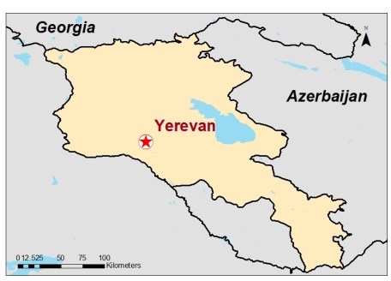
The Republic of Armenia
73332

CLIMATE CHANGE AND
AGRICULTURE
COUNTRY NOTE

June 2012

www.worldbank.org/eca/climateandagriculture
This Country Note for Armenia is part of a series of country briefs that summarize information relevant to climate change and agriculture for three pilot countries in the Southern Caucasus Region, with a particular focus on climate and crop projections, adaptation options, policy development and institutional involvement. The Note series has been developed to provide a baseline of knowledge on climate change and agriculture for the countries participating in the Regional Program on Reducing Vulnerability to Climate Change in Southern Caucasus Agricultural Systems. This note for Armenia was shared with the Government and other agricultural sector stakeholders and used as an engagement tool for a National Awareness Raising and Consultation Workshop, held in Yerevan in April 2012. Feedback and comments on the Note from this consultation process have been incorporated into this updated version in collaboration with the Armenian Ministry of Agriculture.
In this Note
- Introduction 2
- Agriculture 5
- Agriculture and Adaptation Deficit 6
- Agriculture and the Economy 7
- Agriculture and the Environment 7
- The Climate Context 7
- Impact of Climate Change on
Agriculture and Water Resources 10
- Potential Adaptation Measures for the
Agriculture Sector 12
- Impacts of Agriculture on Greenhouse
Gas Emissions 13
- The Policy Context 16
- The Institutional Context 18
- Ways Forward 19
- References 20

Climate Change Exposure and Risk for Armenia
Armenia is especially vulnerable to climate change, with 44.2% employment in agriculture in 2008,¹ and 22% of total GDP in agriculture in 2011.⁶ Agriculture is a highly climate sensitive sector, and therefore Armenia’s rural population and their livelihoods are vulnerable to climate change. Armenia is a mountainous country with vulnerable ecosystems, has a history of droughts and uneven distribution of water resources, and experiences soil erosion and natural disasters, making the nation particularly susceptible to global environmental changes.² Additionally, as of 2010, 35.8% of the population had an income below the national poverty line.¹ Future climate projections indicate that Armenia will be exposed to:
- Average temperature increases of 1°C by 2030, 2°C by the 2070, and 4°C by the 2100,² with a range from 1.5ºC to 3ºC in 2050;³⁶
- Precipitation decreases of 3% by 2030, 6% by 2070, and 9% by 2100,² but the forecasts can vary substantially by month and by climate model;³⁶
- River flow decreases of 6.7% by 2030, 14.5% by 2070, and 24.4% by 2100 compared to the 1961 to 1990 baseline period;²
- Snow cover decreases of 7% in 2030, 16 to 20% in 2070, and 20 to 40% in 2100;²
- A more marginal and risky agricultural production environment, as increases in temperatures and reduced precipitation during critical crop and pasture growth periods will cause a large moisture deficit;
- An increased exposure to new pests and diseases for crops and livestock due to temperature increases.
- Climate change will create risks for the sector, but also opportunities – both need to be assessed.

Armenia at a Glance
(World Development Indicators 2012 and National Statistical Service 2011)

Population | 3.27 million
Population below the  poverty line | 35.8%
GDP | 10.14 billion USD
GDP Per Capita | 3,102 USD
Agriculture as a % of  GDP | 22%

- Introduction
Some work has been done to address climate change in Armenia and in the Southern Caucasus region. Armenia, as a transition country (Non-Annex 1), has submitted two National Communications to the United Nations Framework Convention on Climate Change (UNFCCC). Climate change is an essential issue for Armenia due to the exacerbation of droughts and soil degradation, and the potential for water scarcity in the region. Armenia is already experiencing the effects of the changing climate on nature and on its people. Currently, the country experiences non-sustainable use of natural resources, significant land degradation (from overgrazing, soil pollution, and erosion), and deforestation, and lacks access to safe drinking water in some areas. The expected changes in climate, such as increasing temperature, decreasing water availability, and increasing frequency and magnitude of extreme events, will intensify these issues and impede development. Integrating climate change into development goals will help reduce some of these impacts.⁴

Agriculture is of great importance to Armenia, accounting for a large portion of employment, rural livelihoods, food security, rural growth, and exports. However, the sector is highly climate sensitive and with potential adverse changes in temperature, precipitation, and frequency of extreme events (e.g. droughts, heat waves, floods). Due to climate change, existing inequalities between rich and poor populations and vulnerable communities within Armenia will be exacerbated and place a strain on institutions, food supply, and rural growth. Additionally, the country’s weak financial position and institutional capacity to respond to natural climate hazards also poses a threat to future sustainable agricultural production and rural development.

Figure 1 displays nine climate change vulnerability indicators and compares Armenia to the Europe and Central Asia (ECA) Region average for transition economies. Although Armenia is near the ECA average for several indicators, the country has a significantly higher percentage of the population employed in the agricultural sector, a larger fraction of the population living in poverty, and a larger share of the economy that is derived from agriculture. European countries have an average of just 4.5% of the population employed in agriculture as opposed to 44.2% in Armenia, and the average GDP derived from agriculture for high income European countries is significantly lower than Armenia, at 2%.¹ Additionally, 35.8% of the Armenian population has an income below the national poverty line.¹ These factors make the nation particularly vulnerable to climate change.
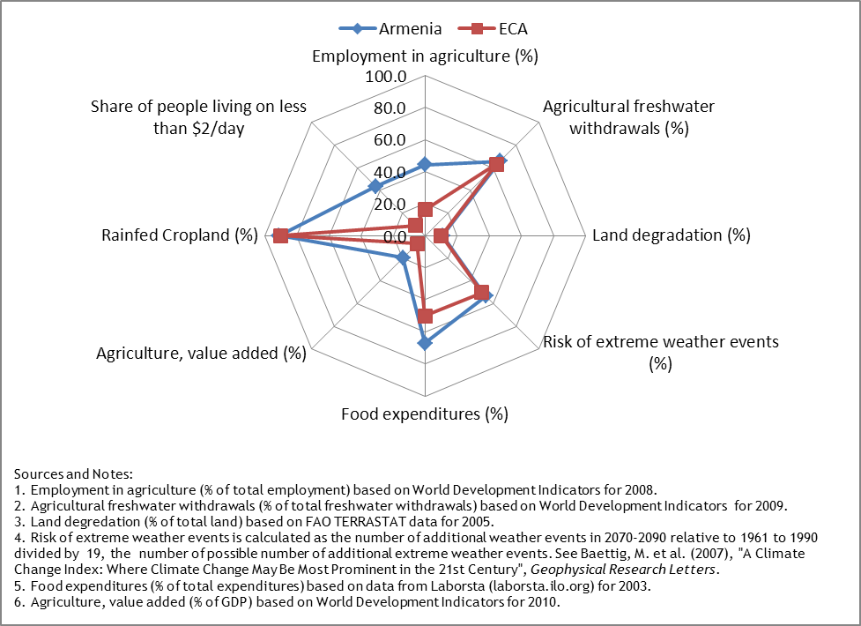
Figure 1: Armenia Vulnerability Indicators

Geography

Armenia is a small, landlocked country located in the Caucasus region. As can be seen in Figure 2, Armenia is bordered by Azerbaijan to the east and southwest, Georgia to the north, Iran to the south and Turkey to the west. Administratively, Armenia is divided into 10 provinces plus Yerevan, the capital city.⁵ The country has an area of 29,800 km² with the majority of its landscape comprised of highlands and mountains separating narrow valleys⁵, as can be seen in Figure 2. About 77% of Armenia’s land area is between 1,000 and 2,500 meters above sea level, with an average altitude of 1,850 meters.⁵ Forests cover 9.2% of the country¹ and agricultural land accounts for 62% of total land area.¹ Vegetation conditions are shown in Figure 3 and the variety of ecosystems in Armenia is displayed in Figure 4. The most common ecosystem in Armenia is steppe, found in the middle-mountainous belt on unforested mountain slopes and terraces at altitudes of 1,000 to 2,400 meters above sea level. Steppes occur in dry areas with fertile soil cover. Many species of endemic and rare plants and animals, and almost half of the flora of Armenia are found in the steppe ecosystem.² There are two major river basins in the country: the Araks in the southwest and the Kura in the northeast.⁵ Lake Sevan, one of the highest fresh-water lakes in the world, is by far the largest lake in Armenia with a volume of 33.4 km³.² In addition to Lake Sevan, there are roughly 100 other lakes in the mountains of Armenia with a combined volume of 0.8 km³.²

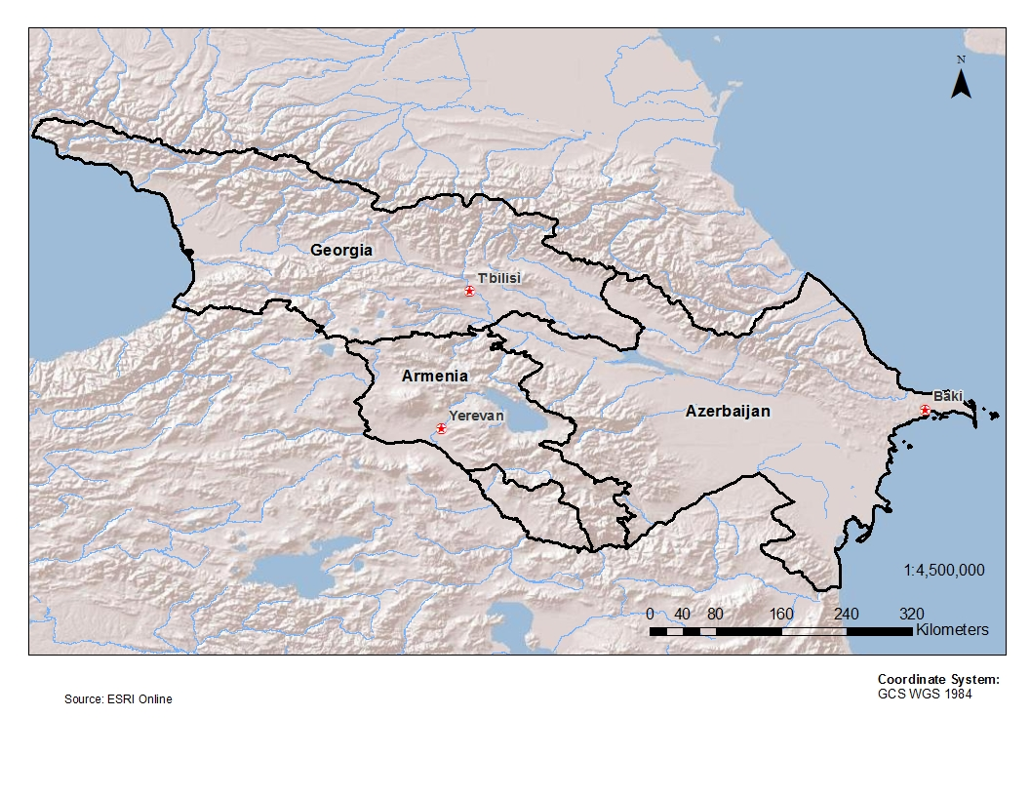The landscape of Armenia varies by region. Central and Northern Armenia is rocky high mountain ranges with narrow fertile valleys. In the South, the broad, flat and fertile Ararat valley is along the left bank of the Araks River on the border of Turkey. The western area of the country is mostly rolling with rocky outcrops, while the southeast contains small irregular-shaped valleys surrounded by high mountain ranges, and the higher altitudes are generally pastures.⁵ The warmest region of the country is the Ararat lowlands and the belt stretching from the border of Georgia south-east to Lake Sevan.⁴
Figure 2: Relief Map the Southern Caucasus
Source: ESRI Online and IEc analysis

Demography
The population of Armenia in September 2011 was approximately 3.27 million. In total, 36% of the population lives in rural areas, which has been a similar proportion for the past decade. Overall population size is relatively stagnant with an increase of 1.5% from 2000 to 2011; however, the population decreased by 0.3% from 2000 to 2003.⁶ Poor Armenians may be significantly impacted by rising food prices because food consists of more than 60% of their total expenses.⁸

- Agriculture
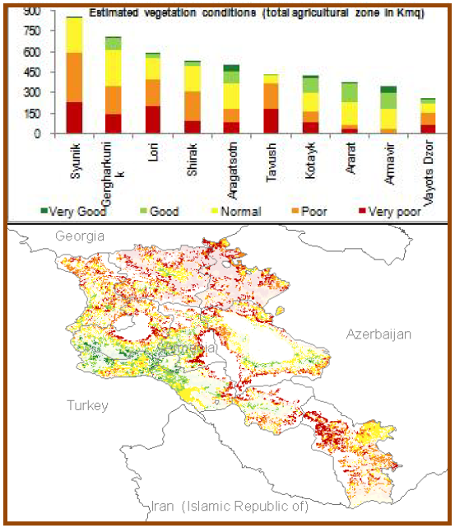

Figure 3: Estimated Vegetation Conditions
Source: FAO Highlights
Agricultural lands in Armenia include annual crops (11% of the total country land area),⁹ permanent crops (2%), and permanent meadows and pastures (44%). The breakdown of land use as of 2009 is displayed in Figure 5.⁹ The main agricultural crops are cereals, potato, fruits, grape and vegetables,² and the main livestock are cattle and sheep.⁶ The agricultural outputs with the highest value of production in 2009 were cow milk, cattle meat, grapes, and tomatoes – potatoes are also a very important crop, as indicated in Figure 7.⁹ The country also relies on irrigation, mostly in the Ararat Valley where the majority of agricultural land is irrigated. A relative shortage of land and a need for better management of water resources make agriculture and irrigated agriculture in Armenia vulnerable to changes in conditions.⁵

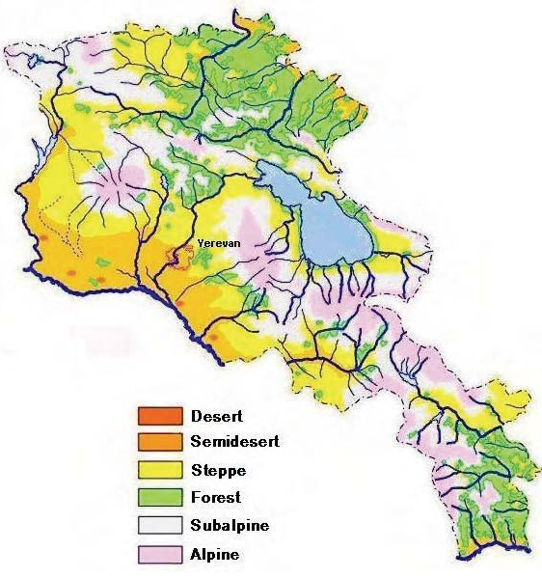
Figure 4: Main Ecosystems
Source: UNFCCC 2

In the period immediately after 1990, agricultural production fell due to agrarian reform and land privatization, which caused the breakup of large agricultural farms into 338,000 small farms.² The area of irrigated lands decreased by half and the use of fertilizers decreased by two-thirds. The number of livestock also declined.

Many of these trends have since been reversed; between 2000 and 2006 agricultural production grew, on average, 7.7% per year.² In 2010, however, agricultural production fell due to early spring frost, hail, heavy rains, high humidity, and a lack of high quality seeds.⁸

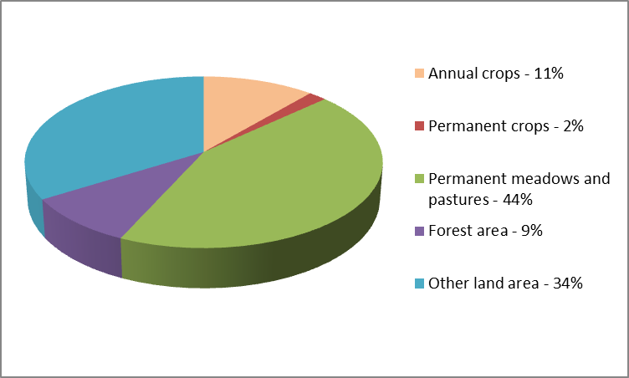Areas and gross production value of land planted with different crops over time are shown in Figures 6 and 7. Overall, land area devoted to cereals declined over the past decade, with an 18% decrease from 2001 to 2010, where land area devoted to fruits increased by 25%, and land area devoted to vegetables, including melons, increased by 21% from 2001 to 2010. Production was quite variable over the past decade, but overall production increases, including a 31% increase in cereal production, a 17% increase in fruit production and a 67% increase in vegetable production from 2001 to 2010.⁹
Figure 5: Land use in Armenia, 2009
Source: FAOSTAT. ResourceSTAT. http://faostat.fao.org/site/377/default.aspx#ancor
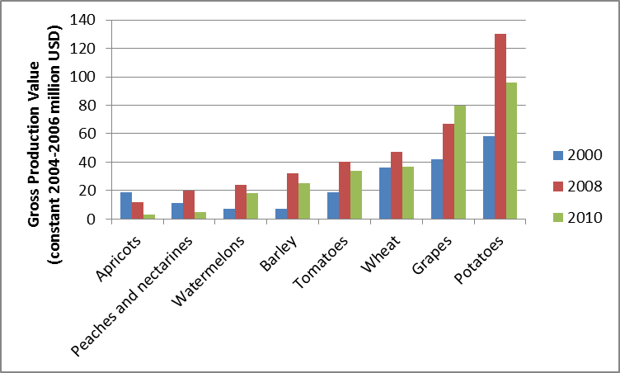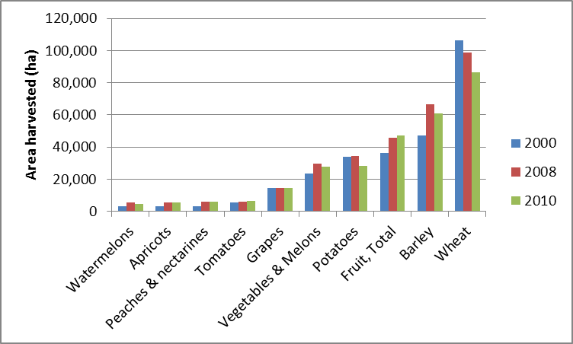
Figure 7: Gross Production Value by Crop in Armenia
Source: FAOSTAT
Figure 6: Area Planted by Crop in Armenia
Source: FAOSTAT

- Agriculture and the Adaptation Deficit
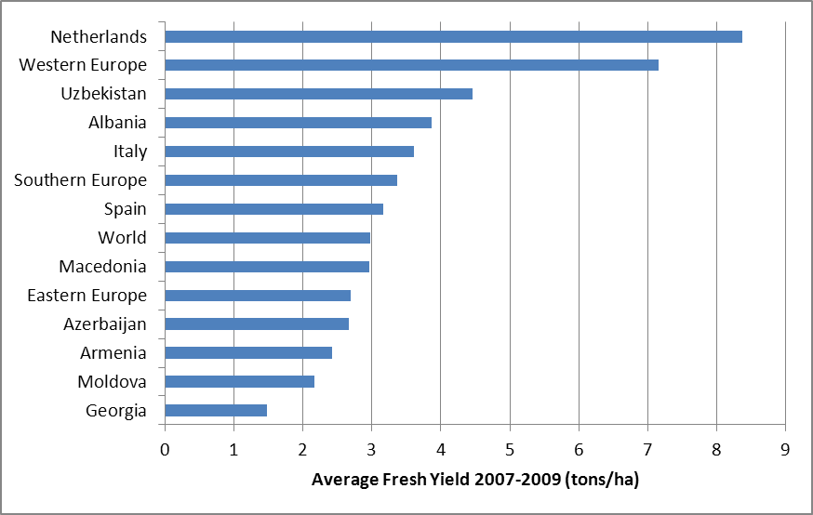The sensitivity of the agriculture sector to climate has important implications in Armenia. With 35.8% of the population under the poverty line (according to World Bank estimates), a 28.6% unemployment rate, 44.2% of employment in the agricultural sector,¹ and 36% of the population living in rural areas,⁶ rural communities are especially vulnerable to and at risk from climate change. This risk is further exacerbated by the relatively low productivity stemming from a lack of adaptive capacity to the present climate, also known as adaptation deficit. This is best illustrated by a comparison of wheat yields from other countries in the region, as displayed in Figure 8. For example, the average wheat yields 2007-2009 for Armenia are 33.9% of those in Western Europe.⁹ This underperformance can be attributed to a complex set of factors, including distortions and imperfections in agricultural output and input markets; poor quality public services in areas like agricultural education, extension, research, and market information systems; delays in farm restructuring and undeveloped agricultural land markets; lack of access to finance; unsustainable management of soils; insufficient irrigation; and high vulnerability to natural hazards like droughts, floods, frosts, and severe storms. Some of these factors are directly linked with climate and the adaptation deficit – others are associated with a low level of economic development in the sector, but if addressed they would also improve the sector’s adaptive capacity. The challenges created by this unfavorable environment for agriculture will increase significantly as a result of climate change. It is therefore fundamental that action should be taken to address the adaptation deficit as part of any climate change adaptation strategy.
Figure 8: Average Wheat Yields in Select Countries, Averaged from 2007-2009
Data Source: FAOSTAT

- Agriculture and the Economy
Agriculture as a share of the Armenian economy has declined from 37% of GDP in 1994¹ to roughly 22% in 2011.⁶ In 2011, the overall growth rate of GDP was 4.7%.⁶ The agricultural sector comprises 44.2% of the labor force, which is a slight decrease over the past five years.² The composition of the agricultural sector also changed, with crops accounting for 55.8% and livestock for 44.2% of agriculture in 2003, compared to 49.4% and 50.6%, respectively, in 1990.⁵ A decline in agricultural output in 2010 stemmed, in part, from economic troubles. Factors included limited access to credit for farmers, a 32% decrease in agricultural support from the Armenian government, and a shortage of fuel, fertilizer, and quality seeds.⁸ Additionally, little governmental support to farmers in marginal areas existed.⁸ Attempts to address these problems are being made; for example, new governmental agricultural policies aim to boost local production by subsidizing credit rates, resulting in low credit rates for farmers, with the lowest rates for the poor.⁸ Subsidies have been in place for irrigation for some time, and more recently, in 2006, the government initiated a subsidy for agriculture. Agricultural subsidies were aimed at convincing farmers to use non-cultivated land lots and improve competitiveness of small farms.¹⁰ The ‘Wheat Seed Production Development Program’ allocated 1.44 million USD to produce high quality seeds from 2010 to 2014.⁸

Though the nation is not part of the European Union (EU), Armenia started negotiations in July 2010 on an Association Agreement to succeed the Partnership and Cooperation Agreement in order to strengthen Armenia’s political and economic involvement with the EU. The EU already provides policy advice to Armenia in important areas such as human rights and democracy, justice, liberty and security and the EU eventually plans to have a Deep and Comprehensive Free Trade Area (DCFTA) with Armenia.¹¹

- 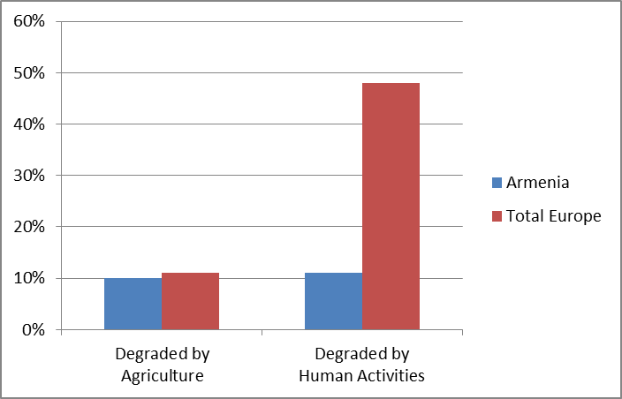Agriculture and the Environment
Figure 9: Land Degradation by Type, as a Percent of Total Land Degradation
Sources: FAO Land and Water Development Division TERRASTAT http://www.fao.org/ag/agl/agll/terrastat/
In the agriculture sector, Armenia’s most serious environmental problems are water losses due to irrigation inefficiencies, soil salinization, erosion, crop fertility loss due to improper irrigation, overgrazing, inappropriate cultivation practices, pollution from industrial and agricultural wastes, and health threats such as food contamination and pollutants.¹³ Additionally, Armenian agriculture is considered at high risk due to limited land resources and inadequate moisture to support plant growth.² Approximately 11% of land degradation in Armenia is due to human activities, as illustrated in Figure 9, but most of the human-induced degradation is due to agriculture, compared to only 23% of human-induced degradation due to agriculture in Europe overall (comparing the height of the two red bars). Severe climatic phenomena occur with increasing frequency and duration and also threaten agriculture. Extreme events such as hail, spring frosts, and mudflows in recent years have cost 15 to 20 million USD annually for agricultural damage, with most of this damage due to hail.² Other estimates indicate that from 2000 through 2005, drought, frost, and floods have cost Armenia 107 million USD in the agricultural sector. In September 2006 alone, droughts and forest fire cost Armenia 9 million USD in economic losses.¹⁴
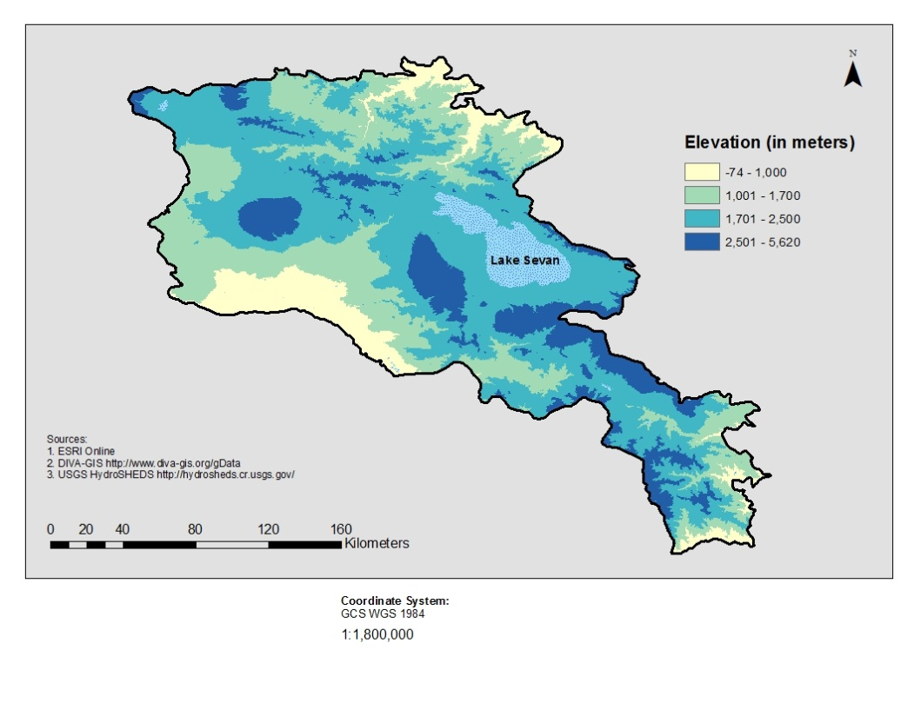
Figure 10: Agricultural Zones of Armenia
Sources: ESRI online, DIVA-GIS, WWF Caucasus Region, and author analysis
- The Climate Context

Climate Description
In general, Armenia has a highland continental climate, meaning hot summers and cold winters.⁵ The mean temperature in Armenia is 5.5°C, with the hottest regions averaging 12 to 14°C and the coldest regions averaging temperatures below zero.² Summers are warm with a mean temperature of 16 to 17°C; however, the hottest regions, such as the Ararat Valley, typically have a high around 24 to 26°C,⁵ and extremes there can reach 38 to 40°C. Average winter temperatures are approximately -7°C. Precipitation also varies by region. Armenia on average receives 592 millimeters of precipitation annually but, in the Ararat Valley and Meghri region, annual precipitation is only about 200 to 250 millimeters while some mountain regions can receive 1,000 millimeters each year.⁵ The average precipitation in the Ararat Valley during the summer is generally no greater than 32 to 36 mm.²

Because elevation is a major determinate of climate, and therefore of agricultural production, Armenia can be divided into three agricultural zones based on elevation. Figure 10 shows these three agricultural zones, which have significant differences in topography, temperature, humidity and precipitation from the surrounding region. The highest elevation region, in blue, is over 2,500 meters, where agricultural production is limited, and therefore will not be analysed in this study. The mountainous region in blue-green encompasses areas with an elevation between 1,700 and 2,500 meters, the intermediate region in light green is 1,000 to 1,700 meters, and the lowlands range in yellow ranges from below sea level to 1,000 meters, and includes the Ararat valley. The agricultural zones match relatively closely to ecological zones for the country, as developed by a consortium of local organizations working with the World Wildlife Fund, which are shown in Figure 11.
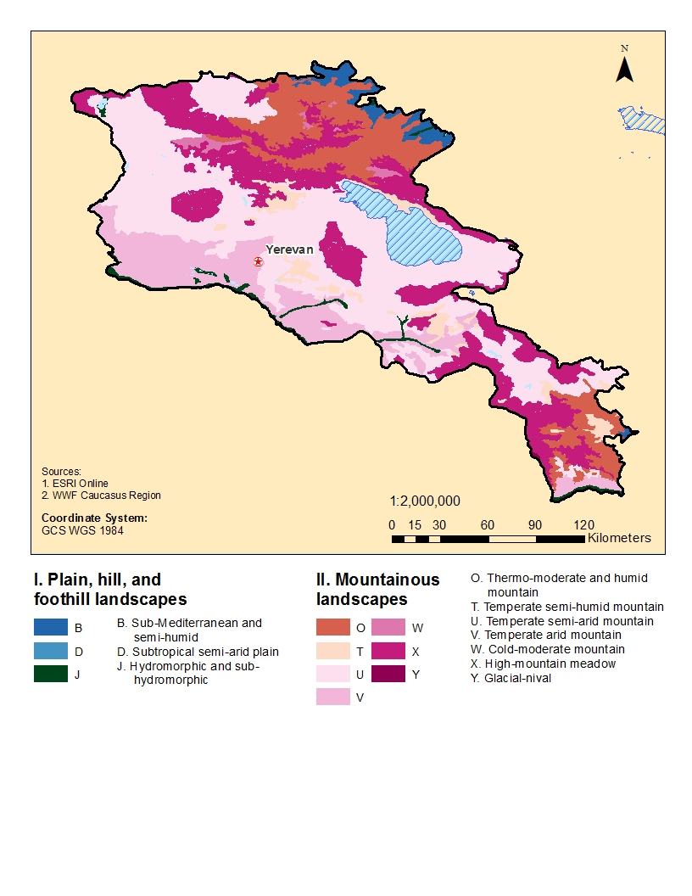Historical Climate Trends
Figure 11: Ecological Zones of Armenia
Sources: ESRI online, WWF Caucasus
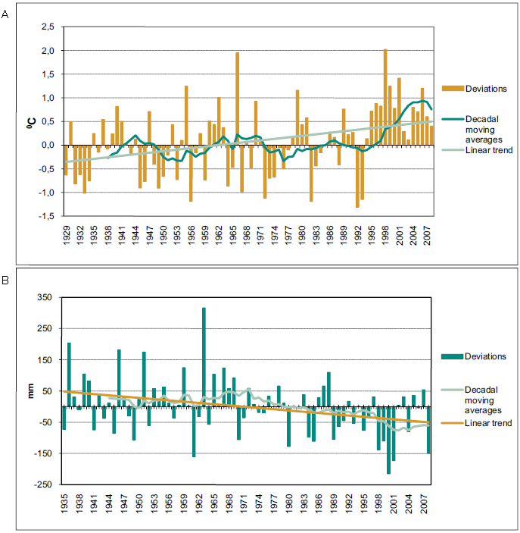Changes in climate in the Southern Caucasus region seen thus far include increasing temperatures, shrinking glaciers, sea level rise, reduction and redistribution of river flows, decreasing snowfall, and an upward shift of the snowline. In the past ten years the region has also experienced more extreme weather events with flooding, landslides, forest fires, and coastal erosion which resulted in economic losses and human casualties.⁴ Over the last 80 years, Armenia’s mean annual temperature has increased 0.85°C.² Concurrently, annual precipitation decreased by 6% compared to the 1961-1990 baseline period.² This decrease in precipitation has not been distributed uniformly around the country with the northeastern and central (Ararat valley) regions becoming more arid and the southern and north-western areas and Lake Sevan basin experiencing increased precipitation.² Historic deviation in temperature and precipitation are displayed in Figure 12. Extreme events such as droughts and storms have become more common in Armenia. In the last 30 years, there has been an increase of 1.2 severe hydro-meteorological phenomena per year, and in the last 20 years there has been an increase of 1.8 cases annually. These events cause 10% to 15% crop losses in certain regions within the country.² Additionally, the glaciers are melting rapidly in the region, as they are globally. The volume of glaciers of the Caucasus has been reduced by 50% over the last century, and 94% of the glaciers have retreated 38 meters per year.¹⁵ Changes in glacier composition can potentially reduce long term river flow in Armenia. Irregular rainfall patterns lead to heavy downpours which result in flooding and large economic losses.⁴ Analysis of temperature indicators suggested a trend of increased number of days per annum with a daily maximum over 25°C in over 80% of the stations analyzed. No trend was seen in the remaining stations.¹⁴ In Armenia, from 2000 to 2005 climate related economic losses in the agricultural sector included: drought causing a loss of 67 million USD, frost damage to fruit production and viticulture causing a loss of 25 million USD, and impacts of hail, floods and frost on crop yields causing a loss of 15 million USD. Additionally, over 30,000 ha of the Ararat Valley, which comprises Armenia’s most valuable farm land, is at risk from salinization associated with its irrigation.¹⁶
Figure 12: Deviations of (a) annual temperature and (b) precipitation from the average values for 1961 to 1990
Source: UNFCCC Second National Communication

Climate Projections
According to Armenia’s Second National Communication, temperatures have increased by 0.85°C over the past 80 years and precipitation has decreased by 6%. Additionally, the frequency of severe hydro-meteorological phenomena has increased by 1.2 cases over the past 30 years and by 1.8 cases annually in the last 20 years. Through application of the PRECIS model, temperature is expected to increase by 1°C by 2030, 2°C by 2070, and 4°C by 2100; the corresponding decreases in atmospheric precipitation are 3, 6 and 9%, respectively (see Figure 13 below).² World Bank analyses, relying on a broader range of climate models, indicate temperature increases could range from 1.5ºC to 3ºC in 2050.³⁶

Water resource availability is also projected to change. River flow is expected to decrease by 6.7% by 2030, 14.5% by 2070, and 24.4% by 2100 compared to the 1961-1990 base period; and snow cover is expected to decrease by as much as 20 to 40% by the end of the century.² Ecosystem changes expected to occur with climatic shifts include the following: a decrease in the area of the alpine zone by 21%, and a vertical shift of 100 to 150 meters; an expansion of semi-desert and desert areas by 30%; a vertical shift by 150 to 200 meters and a 4% expansion of the steppe belt; a vertical movement of the forest belt by 100 to 200 meters; and an increase in evaporation from Lake Sevan of 13 to 14%.⁴

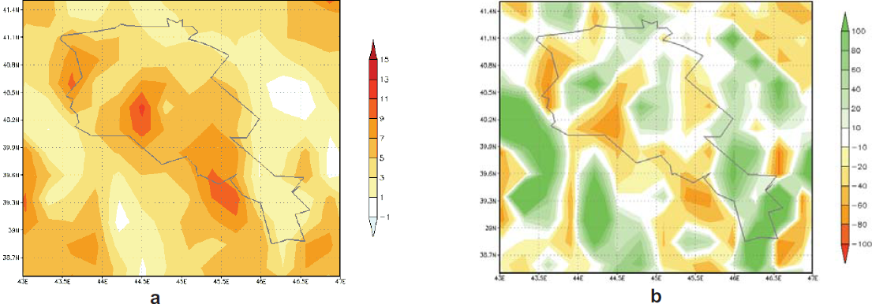A recent World Bank report “Adapting to Climate Change in Europe and Central Asia” developed a series of indices to assess the exposure, sensitivity and adaptive capacity of countries to climate change in the ECA Region. The indices are based on a range of relevant parameters. For example, the exposure index was based on an extreme event dataset that combines the average additional number of 1:20 year events for hot, dry and wet years; hot, dry and wet summers; and hot, dry and wet winters projected over the 2070 to 2099 period relative to the 1961 to 1990 period. The vulnerability index displayed in Figure 14 is a combination of the exposure, sensitivity and adaptive capacity indices. The vulnerability of Armenia to climate change based on this index is high compared to other countries in the region. The main underlying drivers of vulnerability identified were the limited adaptive capacity and particular social and productive structures, which increase the sensitivity of Armenia to climate change.¹⁷
Figure 13: Annual (a) air temperature (°C) and (b) precipitation (%) changes in 2071-2100 compared to the average for 1961-1990, according to PRECIS model under A2 scenario of IPCC

Source: UNFCCC Second National Communication
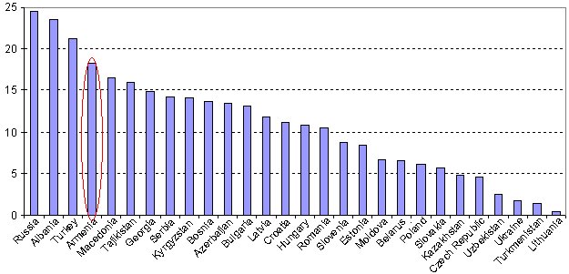
Figure 14: Climate Change Vulnerability Index, ECA Region
Source: The World Bank, 2009. Adapting to Climate Change in Europe and Central Asia, Washington DC
- Impacts of Climate Change on Agriculture and Water Resources

Agricultural Risks and Opportunities
Agriculture in Armenia is particularly at risk due to already existing environmental hardships and new challenges. Higher temperature and reduced precipitation in areas requiring irrigation, increased evaporation from the soil due to secondary salinization (an anthropogenic increase of the salt to water ratio) of land plots, heavy rains and floods increasing water-induced erosion, and droughts and hot dry winds worsening wind erosion of lands are expected by 2030. Reduced fodder in the winter may cause animal grazing to start earlier and end later, which can result in increased degradation of pastures. Soil humidity is expected to decrease by 10 to 30%, moisture availability for various crops will decline by 7 to 13%, and the water deficit of land will increase by 25 to 30%. Therefore, rain-fed farming in pre-mountainous and lower mountainous areas may decline.² In addition to a general change in the climate, severe weather events and outbreaks of crop diseases and pests are predicted to occur. Particularly vulnerable areas to various extreme events are mapped in Figure 15 by marze, which is a type of administrative region. As indicated in the figure, which is derived from the Second National Communication, mountainous areas in the north, east, and southern parts of the country (in light blue) are subject to seasonal flooding, hailstorms, and drought. The Ararat valley region (in light brown) is subject to droughts, early frosts, and dry conditions. The central region north of Yerevan is subject to hailstorms, drought, and early frosts. The northwest region (in orange) is subject to all these types of extreme events.
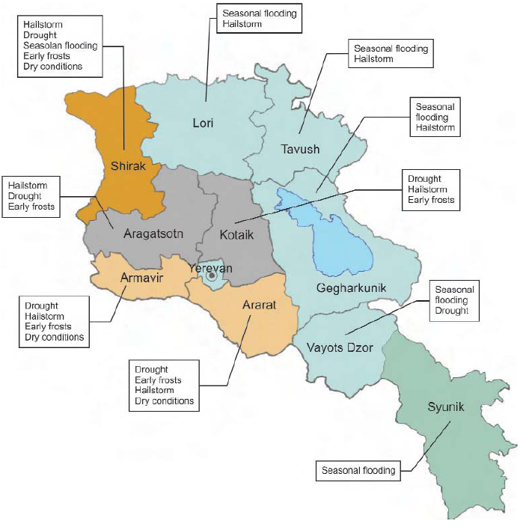
Projected Crop Yield Impacts
Figure 15: Vulnerability of Armenia's Regions (Marzes) to Hazardous Hydro-Meteorological Phenomena

Source: UNFCCC Second National Communication
Agricultural yields are expected to decline with climate change, if adaptation actions are not taken. By 2030, yields of main agricultural crops are predicted to decrease by 8 to 14% without adaptation (9 to 13% for cereals, 7 to 14% for vegetables, 8 to 10% for potato and 5 to 8% for fruits). Pasture area and yields are forecasted to decline by 4 to 10%, including 19 to 22% in the most valuable pastures in the subalpine and alpine zones. Grassland yield could potentially decrease by 7 to 10% which could reduce fodder production. Additionally, outbreaks of crop diseases and pests are likely to become more severe, owing to changes in the range of pests and diminished winter dieback.² Some opportunities may also be presented by climate change – for example, while pasture yields may decline in existing areas, the areas of these pastures could expand as the growing season lengthens. In addition, temperatures may rise in the foothill areas, where precipitation may increase or hold steady, enhancing the environment for fruit tree production.

Projected Water Resources Impacts
As noted above, if the climate changes as forecasted, river flow in Armenia is forecast to decrease by 6.7%, or 0.6 billion m³, by 2030, 14.5%, or 1.2 billion m³, by 2070, and 24.4%, or 1.8 billion m³, by 2100 compared to the 1961 to 1990 baseline period. The volume of precipitation in the form of snow in most of Armenia is predicted to decline by 7 to 11% by 2030, 16 to 20% by 2070, and 20 to 40% by 2100 compared to the 1961 to 1990 baseline period. The largest changes are expected in altitudes of 1,700 to 1,800 meters and higher, which are the main areas of river flow formation. The forecasted climate change will result in significant changes to the water balance of Lake Sevan, which will negatively affect the lake. Figures 16 and 17 below show the results of assessments of river flow for the nation and within individual river basins for 2030, 2070, and 2100, based on a regression model and selected climate scenarios.² In Figure 17, brown shades show forecast decreases in river flow volumes, and blue/green shades show forecast increases. The brown areas tend to dominate in the early, mid-, and late-century periods, and these areas expand over time as do the overall river flow estimates at the national level (flow estimates are in Figure 16).
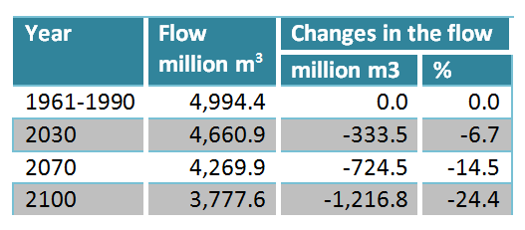
Figure 16: Forecasted changes in river flow
Source: UNFCCC Second National Communication
An independent study forecasting future impacts on water supply indicates similar trends. Streamflow is predicted to decline by 45 to 65% in the Khrami-Debed basin and by 59 to 72% in the Aghstev basin. The decline in streamflow and precipitation, and increase in evapotranspiration will lead to changes in water requirements. In the Ararat Valley region, crop water requirements for winter wheat and vegetables are predicted to increase by 19 to 22% and by 19 to 23%, respectively, by 2100 compared to the period 1967 to 1982. Irrigation water requirement is also expected to increase, by 35 to 36% and 38 to 42% for winter wheat and vegetables, respectively.¹⁴

Potential impacts on the Livestock Sector
Figure 17: Forecast Changes in Riverflow by Basin
Source: UNFCCC Second National Communication
2030
2070
2100
Impacts to livestock will result, in part, from impacts to the pastures used for grazing. Climate change scenarios forecast that, by 2030, total pasture yield will decrease between 4 and 10%.² In the same time period, the productivity of the most valuable pastures, those in the sub-alpine and alpine zones, will decline by 19 to 22%.² Availability of fodder resources by 2030 is projected to be adequate.² However, the overall conditions of the majority of pastures are insufficient and if conditions are not improved, degradation could worsen. Livestock diseases may also increase, especially natural-outbreak sites and contagious diseases. Non-contagious pathologies of animals will be less affected by warming and only some diseases with cold etiology are predicted to decline.²

- Potential Adaptation Measures for the Agricultural Sector – Adaptive Capacity
Armenia’s First and Second Communication, as well as other documents, propose a range of adaptation options for the natural resource sectors, including agriculture, forestry, and water resources. A number of the adaptation options discussed are ready for implementation and are also technologies proven to increase productivity presently – a “win-win” situation. Unfortunately, many of these options have not been implemented because of constraints associated with a variety of economic and social factors. With low levels of productivity and a highly variable climate, Armenia has a significant food security risk. With growing global demand and increased agricultural vulnerability under climate change, this food security risk could increase substantially for Armenia. Poor rural communities are particularly exposed, as they have limited purchasing power in global food markets. Consequently, if adaptation options are implemented, the risks associated with the current climate, projected climate change and food security can be minimized jointly.

The risks to the agriculture sector are significant under climate change projections, much more so than the opportunities.¹⁷ At the sector level, the focus for interested stakeholders should be on reducing the adaptation deficit by increasing efficiency, productivity, and adaptive capacity of agriculture to the present climate, whilst developing effective long-term adaptation options for a range of farming and livestock systems across the three agricultural zones of Armenia. Given the uncertainties of climatic developments, these adaptation options need to be evaluated robustly under a range of different future climate scenarios. With limited finances, it is also imperative that (a) adaptation options that give the greatest return on investment from an economic, social, and environmental perspective be prioritized and (b) that adaptation options are developed not only at the national scale but at the agricultural zone scale, so that sub-national regions and local communities have adaptation options that specifically address the climate change challenges that they face. This will ensure that human and economic capital is directed towards the development and implementation of adaptation strategies that are relevant, targeted, and effective.

At the farm level, rural communities have constantly adapted to changes in weather and seasons throughout history; however, the projections under climate change are highly likely to exceed even the most innovative farmers’ ability to autonomously adapt. Although there are many field-ready innovations that could rapidly improve the resilience of agricultural systems in Armenia immediately, the lack of financial resources at the farm level is a considerable barrier to adoption. Additionally, significant investments will be required by the state and development partners to build the infrastructure, knowledge, and policy systems that will support and develop an array of adaptation options to increase the resilience of the farm sector in the future.

Specifically in terms of climate and water resources, some suggestions have been made for adaptation options. For climate, these include: increased investment in weather and climate services; data exchange among countries in the region on climate-related data, river discharge, lake levels, and more; and technical workshops to share regional expertise and innovative technologies. For water resources, the UNFCCC Second National Communication recommends adaptation measures that may reduce the joint effects of land degradation and climate change. Recommendations include: (1) improve and rehabilitate irrigation systems to increase capacity and efficiency; (2) plant windbreaks to decrease erosion; (3) increase productivity through weed control and seeding of degraded areas with new seed types, and remove stones in pastures; (4) improve soil fertility by using gypsum in alkali soils: and (5) increase water storage from May through October. Additionally, UNDP notes that in order to reduce water demand, incentives such as water pricing or enforcement of water quantity limits are necessary. Extension and research should also play a role - the rate of return to investment in research and extension for agriculture are high.¹⁴

At the national policy level, the Ministry of Nature Protection recommends several specific adaptation measures including: (1) research and use drought- and heat-resistant species and hybrids, especially local species; (2) increase use of high mountainous pastures and decrease relative unit loads; (3) change (optimize) fertilizer use; (4) move agriculture to areas of the country with more moisture and rotate crops; (5) use moisture preservation and irrigation technologies that conserve water; (6) use disease- and pest-resistant crop species; (7) employ hail and flood protection measures; (8) create early warning on extreme hydro-meteorological events; and (9) adjust vaccination practices of livestock and change livestock breeds.² Specifically for water resources, the UNFCCC notes the following capacity building needs: vulnerability assessment, improvement of climate scenarios and projections including regional effects; creation of new methodologies for determining flood flows and inundation, and introduction of a monitoring system for groundwater. For agriculture, the Ministry of Nature Protection suggests choosing and applying models to determine the vulnerability of crop yields with climate change, mapping and understanding priorities for changing crops, and strengthening the existing insurance program.² Adaptations are also recommended for areas vulnerable to mudflows, landslides and floods, including: a legal framework for an insurance system for natural disasters and compensations; public financing for studies on natural disasters; and a bulletin for economic activity on water bodies and impacts of climate change including forecasts of natural disasters and probabilities.²

Adaptation measures for the agricultural sector have also been suggested by the Climate Change Information Center of Armenia. These include changing crops and adapting farming management practices to new and more effective irrigation schemes.¹⁶

It is important to keep in mind that adaptation measures mentioned above have not yet been evaluated for their costs and their relative effectiveness in improving yields, increasing resilience to climate change, and/or reducing emissions of greenhouse gases. They have not yet been prioritized by benefit-cost or feasibility criteria, and so do not necessarily represent recommendations for adoption, but instead are a menu of options that will be assessed in the study.

- Impacts of Agriculture on Greenhouse Gas Emissions
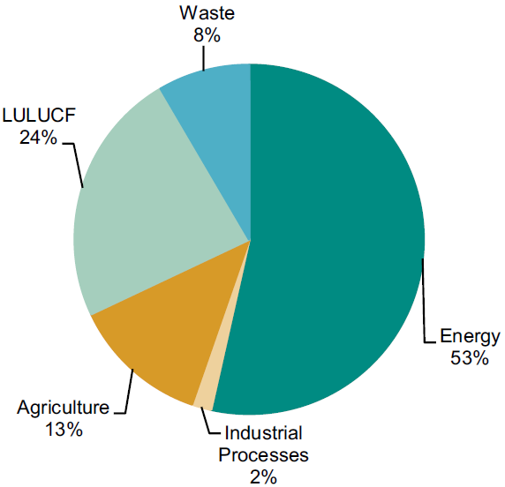Greenhouse gas emissions from the agricultural sector increased from 4% of Armenia’s total GHG emissions in 1990 to 17% of the country’s total emissions in 2000 and 2005. As is shown in Figure 18, agricultural activity accounted for 13% of total greenhouse gas emissions in Armenia in 2000, but an additional 4% is attributed to agriculture from within the LULUCF category (land use, land use change, and forestry). Additionally, Figure 19 reveals that in 2000, agricultural emissions contributed more than any other sector to CH₄ and N₂O emissions nationwide, at 42% and 67%, respectively. In total, methane accounts for roughly 88 to 90% of all agricultural emissions on a CO₂ equivalent basis, because methane is a more potent greenhouse gas than CO₂.
Figure 18: Distribution of Greenhouse Gas Emissions by Sector (2000, CO₂ eq)
Source: UNFCCC Second National Communication

The breakdown of emissions and trends within the agricultural sector can be seen in Figure 20, where the majority of agricultural emissions are from CH₄, and emissions have mainly been increasing since 1997. Methane emissions come from two sources during livestock production: intestinal fermentation in livestock and organic waste from livestock. Future emissions are forecasted through the number of livestock and the main suggestion for reducing emissions from the agricultural sector is through the management of organic waste. It is estimated that, by using livestock waste to produce biogas, emissions from the agricultural sector could be reduced by 8% from 2000 to 2020.²

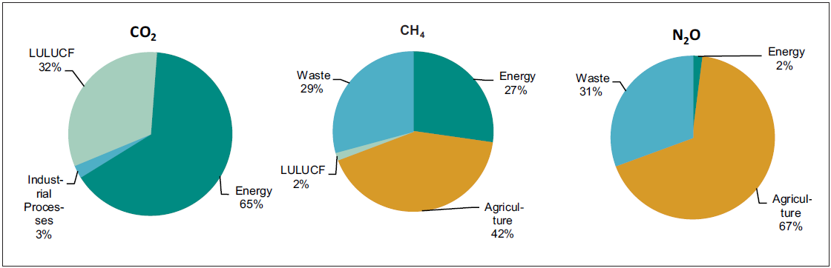
Figure 19: Distribution of Greenhouse Gases Emissions in Sectors by Gases (2000)
Source: UNFCCC Second National Communication
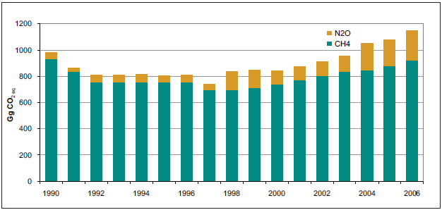Mitigation Potential in Agriculture
Figure 20: Greenhouse Gas Emissions by Gases in the Agricultural Sector (1990-2006)
Source: UNFCCC Second National Communication
Some examples of mitigation measures in the agricultural sector and their mitigation potential at three cost thresholds are shown in Figure 21. While restoring cultivated organic soils has the largest mitigation potential overall (dark green bar), there are many options related to cropland management that are less expensive (light green bar).¹⁹ Various techniques exist to mitigate emissions in the agricultural sector of Armenia. These can include policy, legislative, capacity building, financial, technical, research and development, education and public awareness measures, some of which include:³

- Crop Production Management
  - Improve crop varieties, extend crop rotation, avoid or reduce use of bare fallow, and add nutrients when there exist deficits.
  - Adopt integrated nutrients management in order to reduce emissions in production.
  - Plant temporary vegetation between tree or vine crops to capture carbon.
  - Improve nitrogen use efficiency to reduce N₂O emissions from fertilizer use and greenhouse gas emissions from production.
  - Reduced- or no-till agriculture can reduce CO₂ emissions from the soil, and can eliminate burning of plant residues.
  - Increase irrigation efficiency to enhance carbon storage.
  - Revert cropland to other types of land cover similar to native vegetation to increase carbon storage.
- Grazing Land and Livestock Management
  - Optimally graze lands to capture carbon
  - Increase productivity of grazing lands to increase carbon storage
  - Reduce biomass burning and change timing to decrease CH₄, N₂O, tropospheric ozone, smoke aerosols, and changes in the albedo of land surface
  - Introduce grass species with higher productivity or carbon allocation to deeper roots
  - Feed livestock more concentrates, and use specific agents and dietary additives to reduce methane emissions in livestock. For example, feeding livestock high nutritional quality fodder crops, such as alfalfa, has the potential to allow better digestion, and therefore reduce methane emissions.
  - Change to animal breeds that produce less methane output per unit of animal product
  - Institute manure management to reduce N₂O and CH₄ emissions. These can include digestion, covering manures, altering feeding practices, and composting

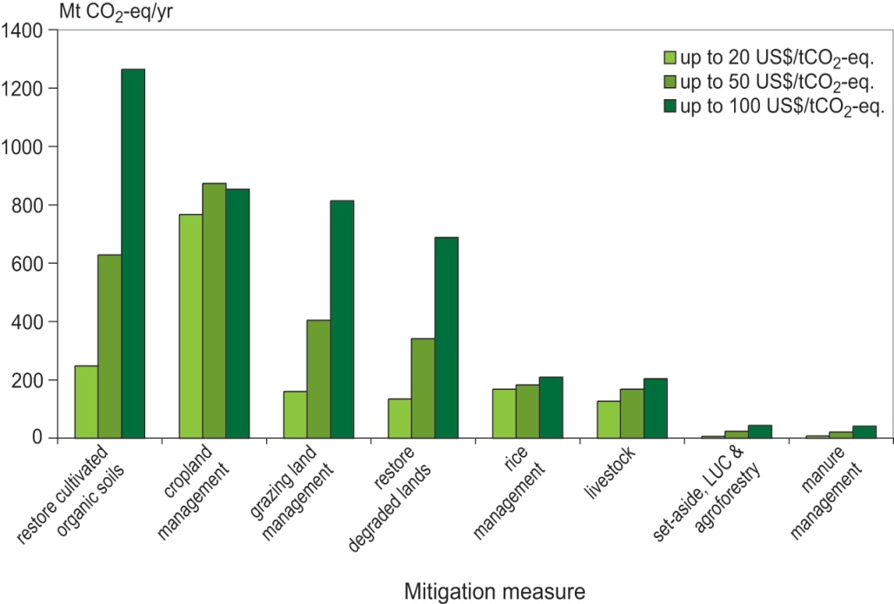Investments in these mitigation techniques have the potential to result in the benefits of reduction of greenhouse gas emissions, climate resilience, and increased productivity, making them priority options.
Figure 21: Potential for Agricultural Greenhouse Gas Mitigation (excluding bioenergy and improved energy efficiency) at a Range of Prices of CO₂-eq

Source: Smith, P. et al. 2007: Agriculture. In Climate Change 2007. Mitigation. Contribution of Working Group III to the Fourth Assessment Report of the Intergovernmental Panel on Climate Change [B. Metz, O.R. Davidson, P.R. Bosch, R. Dave, L.A. Meyer (eds)], Cambridge University Press, Cambridge, United Kingdom and New York, NY, USA.

Some mitigation projects in Armenia are already underway. One World Bank project that addresses mitigation is the Natural Resources Management and Poverty Reduction Project in Armenia, which promotes the adoption of sustainable natural resource management practices and the alleviation of rural poverty in places where there was severe environmental degradation. The global environmental objective is to preserve the mountain, forest and grassland ecosystems in the southern Caucasus, through enhanced protection and sustainable management. Specifically to mitigate climate change, the project proposes demonstrations of bio-gas production installations that would reduce methane emissions while reducing the use of timber.²⁰

Carbon Trading and Agriculture
The Clean Development Mechanism (CDM) allows developed (Annex I) countries to implement mitigation projects in developing (non-Annex I) countries in order to instigate investment and promote transfer of environmentally friendly technologies. In Armenia, CDM projects go through a submission procedure that includes two stages: a voluntary stage of preparing a Project Idea Note and a mandatory stage of submitting Project Design Documentation for consideration and approval (Renewable Energy Armenia). The six priority sectors identified in Armenia for CDM projects are energy, industry, waste, agriculture, forestry and transport (Implementation of the Kyoto Protocol’s CDMs). Thus far, five projects are registered by the CDM executive board, eight projects are approved by the designated national authority, three projects are endorsed by the designated national authority, and two projects have Project Design Documentation under development. An example of a CDM project in the agriculture sector is the Lusakert Biogas Plant. At the Lusakert Pedigree Poultry Plant, methane from animal effluent is captured and combusted in order to reduce emissions.¹⁶

- The Policy Context
The First and Second National Communications of the Republic of Armenia on climate change are the primary policy documents that assess the impact and outline adaptation options to respond to the projected future climate hazard. The First National Communication includes the 1990 greenhouse gas inventory, 1994 to 1996 greenhouse gas emissions trends, mitigation measures, projection of emissions until 2010, assessment of Armenia’s vulnerability to climate change, and the general characteristics of adaptation measures. The Second National Communication guides the national communications of non-Annex I Parties to the Convention. Data in this document includes the period from 1998 through 2006. This document expands upon studies and assessments related to climate change from the First National Communication, including improvements and updates to the greenhouse gas inventory and emission trends, mitigation strategies, development of climate change scenarios, evaluation of vulnerabilities and priority adaptation areas, monitoring systems, and public awareness of climate change. The Second National Communication therefore provides an excellent launching point for further work on adaptation in the agricultural sector.²

National Plans, Strategies, Programs, and Analytical Studies
Some programs are already in place to raise awareness of climate change. For example, the Ministry of Education and Sciences and the Ministry of Nature Protection institute environmental education at the preschool to postgraduate level. Education includes climate change related issues. Broader public awareness efforts are carried out through seminars, publications, television programs, and discussions with various stakeholders. Both governmental and non-governmental organizations also provide environmental education and public awareness in Armenia.²

Several laws have been passed in Armenia in an attempt to help curb the negative effects of climate change; however, they generally do not address the intersection of climate change and development. Many of these laws are listed in the table below. Additionally, the National Action Plan for Combating Desertification in Armenia, the Sustainable Development Program, and the financing agreement between the Republic of Armenia and the European community were part of the Food Security Program of Armenia from 2005 to 2006. Other measures include an insurance system for agricultural production and a weather forecast warning system. The goal of many of these programs, especially the Strategy for Agricultural Development, is to achieve food security and self-sufficiency.

Some laws have been established to address the environment in farming practices. Specifically for water resource management and rehabilitation, a Water Code aims for sustainable, integrated water resource management, and a Law on Water User Associations assists operations and maintenance of irrigation systems. Some similar laws in this area are listed below. Fertilizer and chemical pesticide use are relatively low, so this is not a major concern.¹³

Some agricultural policies have had a significant impact shaping the agricultural sector. Since the 1990s, the Armenian Government has carried out liberal reform policies such as abolishing subsidies, liberalizing food prices, and liberalizing international trade. The government continues to support farmers with VAT and land tax exemptions, and subsidies for irrigation water and seed loans. Some examples of the most important agricultural programs are described below. In general, a key issue in this context is that laws and policies are well-thought out and thorough, but enforcement and implementation can be inadequate, owing to limitations in resources, capacity, outreach, and/or relevant knowledge.

The Strategy on Sustainable Development of Agriculture (SSDA) from 2004 is a document that is linked to the Poverty Reduction Strategy Paper (PRSP). The major goals are to increase rural incomes, increase sustainable agriculture, improve food safety and security, improve infrastructure, increase pedigree breeding, and improve animal health. Certain parts of the SSDA focus on the environment including limiting the use of fertilizers and other agro-chemicals, promoting soil conservation measures, improving water collection and irrigation methods, and improving pasture management.¹³ SSDA also aims to forecast and mitigate the effects of natural disasters, as well as implement measures to mitigate the impacts of climate change.¹⁶

The Strategy on National Security was formed in 2007. The goals of the plan include creating an environment suitable for activities of present and future generations, conservation and efficient use of natural resources, coordination of improved environmental conditions, integration of the country into organizations to monitor and prevent natural and technological disasters, reliable forecasting, prevention and mitigation of natural and technological risks, and ensuring safety, reliability and stability of town-planning systems.¹⁶

The 2005 Food Security Policy encompasses important environmental issues including climate change, desertification, biodiversity protection and biological security. The policy states that agricultural policy should take the changing climate and its impacts into account. The program includes: creating a data bank on natural resource use, assessing and monitoring of natural resources, developing and implementing land consolidation projects, regeneration of valuable and rare ecosystems, and creating early warning systems to prevent crop damage.¹⁶

Existing Law or Policy In Armenia | Year adopted
Law of the Republic of Armenia on Atmospheric Air Protection | 1994
The law of the Republic of Armenia on protecting selection achievements | 1999
The Land Code | 2001
The Law of the Republic of Armenia on Energy | 2001
The law of the Republic of Armenia on eliminating the consequences of droughts | 2001
Integrated pest management began | 2002
The National Action Plan to Combat Desertification in Armenia | 2002
The Strategy on Specialty Protected Areas | 2002
The Strategy on Sustainable Development of Agriculture (SSDA) | 2004
The Law of the Republic of Armenia on Energy Saving and Renewable Energy | 2004
The Law of the Republic of Armenia on Waste | 2004
The Forest Code of the Republic of Armenia | 2005
The law of the Republic of Armenia on Seeds | 2005
The Food Security Program of Armenia | 2005-2006
The Strategy on National Security | 2007
Decree No. 248-N “On regulations for organization of emergency assistance to the population during  droughts and other natural disasters and technologic accidents” and the “Program for protecting the  population, settlements and infrastructures from the risks of inundations, mudflows and floods” | 2008

International Efforts
A wide range of international organizations have undertaken or funded projects in Armenia to mitigate the effects of climate change, adapt to changing climate conditions, and to generally improve the agricultural sector. Some of these programs include the following:

Organizations | Programs
UNDP, GEF, Ministry of  Nature Protection | Preparation of Initial (1998) and Second (2010) Communications^{2,21}
World Bank | The Rural Enterprise and Small Scale Commercial Agriculture (RESCA) Project to promote  rural development²²
World Bank | Initiatives to assist in the transition to a market economy and enhanced rural growth:  - FY98 Agricultural Reform Support Credit, which assisted the Republican Agricultural  Support Center  - FY99 Title Registration Project, the FY99 Irrigation Dam Safety  - FY02 Irrigation Development project, and studies on rural productivity and  infrastructure  - FY04 Health and Education projects  - Trans-Caucasus Tourism Initiative²³
World Bank | Community Agricultural Resource Management and Competitiveness Project (Community  Pasture/Livestock Management System) aims to improve productivity and  sustainability of pasture and livestock livelihood systems in selected rural communities.²⁴
World Bank | Irrigation Rehabilitation Project, 2010-2011 aims to improve efficiency of water use while  fostering rural employment.²⁵
FAO, the European  Commission and World Organization for Animal  Health Experts | The Emergency Prevention System for Transboundary Animal and Plant Pests (EMPRES)  helps protect livestock from diseases and prevent them from spreading across borders.²⁶
U.S. Department of  Agriculture (USDA) | The Caucasus Agribusiness Development Initiative (CADI) in Armenia and Georgia helps  farmers and agribusinesses in rural areas to grow, raise incomes, and create jobs to create  sustainable livelihoods. Additionally, CADI ensures quality assurance in the supply chain, and  helps governments to improve trade capacity and market-based agricultural policy.²⁷
USAID | The Armenia Small to Medium Enterprise Market Development Project (ASME), 2000  helped to expand export markets or increase local sales of otherwise imported items²⁸
USAID | The Micro Enterprise Development Initiative (MEDI), 2004, improved the environment for  micro-financing organizations²⁹
ACDI/VOCA | Farmer to Farmer (FtF) program has been in place since 1992. Program teaches basic skills  and new techniques to Armenian organizations and farmers.³⁰
European Investment  Bank (EIB) | EIB, the World Bank, and the European Bank for Reconstruction and Development  commit to providing financial resources to central and eastern Europe in 2009. They aim to  create a facility allowing investments in energy and environmental projects.
The Millennium  Challenge Corporation | Improve performance in the agricultural sector to reduce rural poverty through rehabilitation of  irrigation infrastructure and helping increase productivity through improved water supply,  higher yields, higher-value crops, and a more competitive sector³¹
The International  Development  Association (IDA) | Projects included: rehabilitation of 4,000 km of irrigation canals, productivity increases of  140,000 ha, or 74% of irrigated land, maintenance of 760 km of road, and small community  projects for schools, potable water systems, irrigation systems, and rural health facilities³²
A variety of public and  private organizations | Investing 77 million USD in 13 mitigation projects relating to landfill gas capture, biogas,  afforestation, small hydropower stations, and the improvement of heat and hot water supply.³³
European Commission | Budget Support Component of the AM FSP 2007 to improve allocative and technical efficiency  for animal health and phytosanitary policy, 2009-2013³⁴
REC Caucasus | Support Development of Biodiversity Conservation Policies and Practices in  Mountain Regions of the South Caucasus, 2011-2014³⁵

Also, in Armenia a number of export companies have adopted private codes of global good agricultural practices (GGAP), allowing customers to trace husbandry practices and product origination. However, a national system of good agricultural practices is currently not implemented.

- The Institutional Context
Generally, the institutional arrangements in Armenia with regard to climate change and adaptation have significant room for improvement, especially from coordination, funding, and effectiveness perspectives. The complexity and multi-disciplinary nature of climate change makes it difficult for the issue to be fully addressed by a single institution; rather, a number of institutions are each focused on different aspects of the issue and associated challenges. However, to address climate change in an efficient and systematic way, there is a need to create formal structures for coordination across relevant ministries that will ensure a better overview of climate change policy and its implementation. The Ministry of Finance would be an important stakeholder in coordination activities, because of its critical position in terms of resource allocation. Ministries of the Republic of Armenia that are relevant to the effects of climate change on agriculture as well as policies related to adaptation measures, include:

- Ministry of Agriculture develops and implements the government’s policies in the field of agriculture and forestry management;
- Ministry of Nature Protection formulates and implements policies in environmental protection and sustainable use of natural resources, and is the focal point for UNFCCC communications;
- State Committee for Water Management under the Ministry of Territorial Administration – in charge for irrigation and drinking water outside Yerevan city;
- Ministry of Economy works on economic development policies within the nation;
- Ministry of Education and Science formulates and implements policies in the education and science sectors;
- Ministry of Emergency Situations develops, implements and coordinates policies in civil defense and protection of the population in emergency situations, including natural disasters;
- Ministry of Energy and Natural Resources formulates and implements policies in the energy sector;
- Ministry of Finance formulates and implements policies in fiscal revenue, collection, and public finance administration; and
- Ministry of Transport and Communication formulates and implements policies in transport, communication, and information technologies sectors, which might conceivably include new information dissemination regarding weather or climate data.

In Armenia, the Ministry of Agriculture develops and implements policies in agriculture and forestry. However, environmental protection within the country is neither complete nor well-enforced. The most important goals remain production and food security. Problems in the sector include: insufficient transfer of information and inadequate coordination among agencies to create policies and carry out projects. The Agricultural Academy of Armenia within the government, and the Regional Agricultural Support Centers provide extension services; however, agriculture research, extension services, and training on farming and management need improvement.¹³

The World Bank lists some priority needs for the agricultural sector. These actions include: improving the legislative framework and environmental control; strengthening environmental education and the transfer of information and coordination between the government, businesses, and the public; conduct environmental impacts statements to programs and projects; expand agricultural research, extension services, interventions and financial assistance; and develop pilot projects and programs for agro-environmental issues.

- Ways Forward

In May 2012, an Awareness-Raising and Consultation workshop on Reducing Vulnerability to Climate Change in Armenian Agricultural Systems was held in Yerevan Armenia. During this event, a draft version of the Climate Change and Agriculture Country Note was discussed and disseminated to agricultural sector stakeholders and helped generate a groundswell of support and interest for further analytical work to reduce the vulnerability of the agricultural sector to climate change.

The next step involves Armenia working jointly with the World Bank to develop the Armenian Response to Climate Change for Agriculture program. Broadly, this work involves rigorous analysis and economic modeling to assess both the impacts of climate change and potential adaptation and mitigation measures for a range of farming, livestock, and production systems at both national and sub national levels. More specifically, the analysis involves collecting current local data on climate, water resources, soils, and agricultural practices; developing climate scenarios; modeling crop yields and water resource supply and demand; and assessing the costs and benefits of specific adaptation and mitigation measures. The result is a prioritized list of actions to improve the climate resiliency, greenhouse gas efficiency, and yield productivity of the agricultural sector, results which can then be reviewed with farmers and local experts to gather their insights. This analysis will be performed by expert staff from the international consulting firm Industrial Economics, Inc. (IEc), in close consultation with local experts across a range of organizations, under the direction of the World Bank. IEc will also deliver training and capacity building services to local experts and has organized sub-national consultation meetings with farmers, policymakers, and researchers to raise awareness of the risks and opportunities posed by climate change on the agricultural sector.

This work will culminate in the development of an Agriculture and Climate Change Impact Assessment & Menu of Adaptation and Mitigation Options that will highlight the physical, economic, and social impacts of climate change on the agricultural sector and identify adaptation priorities for investments, capacity development, and policy improvement. These options will be practical and operational, with a focus on “win-win-win” options that have benefits for adaptation, mitigation, and the local economy. This analysis will be discussed at a high-level National Dissemination and Consensus Building Conference to be jointly hosted by the Ministry of Agriculture and the World Bank in the fall of 2012. The conference will help build consensus on the way forward by identifying practical priorities for action.

A Regional Knowledge Exchange Conference will follow, wherein Armenian experts can share their experiences and results while simultaneously learning from experts from other countries in the Southern Caucasus. The main objective of this conference will be to assist Armenian experts in developing an Agricultural Sector Climate Adaptation and Mitigation Action Plan. In addition, World Bank staff will help identify possible financing sources for the highest priority actions. This forum will also explore opportunities for greater regional collaboration and assist with the establishment of communities of practice for experts working on agriculture and climate change issues. Finally, the World Bank team will prepare a regional synthesis report that can serve as a guide to further work.

Acknowledgements: This Country Note was prepared by Industrial Economics, Inc. under the direction of a World Bank team led by Nicolas Ahouissoussi, compromising Jitendra Srivastava and Arusyak Alaverdyan and the overall guidance from ECSSD Sector Manager Dina Umali-Deininger. Funding was provided by the Bank-Netherlands Partnership Program (BNPP). For more information, please visit our website at worldbank.org/eca/climateandagriculture

- References

- World Bank: World Development Indicators, 2012, http://data.worldbank.org/country/armenia. Note that this document does not indicate the income level for determining the poverty line in Armenia.
- United Nations Framework Convention on Climate Change (UNFCCC). 2010. Second National Communication. Republic of Armenia Ministry of Nature Protection.
- IPCC. AR4, Chapter 8: Agriculture. http://www.ipcc.ch/pdf/assessment-report/ar4/wg3/ar4-wg3-chapter8.pdf /Intergovernmental Panel on Climate Change. Fourth Assessment Report: Climate Change 2007. Working Group I Report “The Physical Science Basis.” Note: World Bank consultant Industrial Economics, Inc. analyzed the data across the 56 available options to develop a mid-range scenario.
- WWF Norway, WWF Caucasus Programme. July 2008. Sylven, M., Reinvang, R., and Andersone-Lilley, Z.Climate Change in Southern Caucasus: Impacts on Nature, People and Society. http://assets.wwf.no/downloads/climate_changes_caucasus___wwf_2008___final_april_2009.pdf
- FAO: AquaStat Survey, 2008. http://www.fao.org/nr/water/aquastat/countries_regions/armenia/index.stm
- National Statistical Service of the Republic of Armenia. http://www.armstat.am/en/
- Salt, J. 2005. Current Trends in International Migration in Europe. The Council of Europe, Paris. http://www.coe.int/t/dg3/migration/documentation/Migration%20management/2005_Salt_report_en.pdf
- FAO, 2011. Food Security and Agricultural Highlights - Armenia. Food Security Information for Decision Making. www.foodsec.org
- FAOSTAT. 2010. Production. http://faostat.fao.org/default.aspx?PageID=567#ancor.
- Economic Development Research Center (EDRC). 2007. Subsidies in Armenia: White Paper #1. Paper 02(07), Yerevan, Armenia. http://www.edrc.am/WP/WhitePaper1.ENG.pdf
- United Nations (UN). 2011. Regional Climate Change Impacts Study for the South Caucasus Region. Tblisi, Georgia.
- CIA World Factbook: Armenia, 2011. https://www.cia.gov/library/publications/the-world-factbook/geos/am.html
- World Bank Review: Integrating Environment into Agriculture and Forestry, 2007 [Armenia].
- UNDP. 2011. Regional Climate Change Impacts Study for the South Caucasus Region. Tblisi, Georgia.
- C.R. Stokes, S.D. Gurney, M. Shahgedanova and V. Popovnin, Journal of Glaciology (52): 99-109, 2006.
- Climate Change Information Center of Armenia. “Climate change impacts on Armenian agriculture: vulnerability and adaptation assessment measure.”
- The World Bank, 2009. Adapting to Climate Change in Europe and Central Asia, Washington DC.
- WRI. 2011. Climate Analysis Indicators Tool (CAIT) version 8.0. Washington: World Resources Institute.
- Smith, P., D. Martino, Z. Cai, D. Gwary, H. Janzen, P. Kumar, B. McCarl, S. Ogle, F. O’Mara, C. Rice, B. Scholes, O. Sirotenko, 2007: Agriculture. In Climate Change 2007. Mitigation. Contribution of Working Group III to the Fourth Assessment Report of the Intergovernmental Panel on Climate Change [B. Metz, O.R. Davidson, P.R. Bosch, R. Dave, L.A. Meyer (eds)], Cambridge University Press, Cambridge, United Kingdom and New York, NY, USA.
- World Bank. 2002. Armenia-Natural Resources Management and Poverty Reduction Project. Europe and Central Asia Region. Report number: PID8646
- United Nations Framework Convention on Climate Change (UNFCCC). 1998. First National Communication of the Republic of Armenia, under the United Nations Framework Convention on Climate Change. Ministry of Nature Protection of the Republic of Armenia, United Nations Development Program Office in Armenia, and Global Environment Facility. World Bank. 2007. Integrating Environment into Agriculture and Forestry Progress and Prospects in Eastern Europe and Central Asia: Volume II, Armenia Country Report. http://www.worldbank.org/eca/pubs/envint/Volume%20II/English/Review%20ARM-final.pdf
- World Bank. 2005. Rural Enterprise and Small-Scale Commercial Agriculture Development Project. Europe and Central Asia Region. Report No. 32351-AM.
- World Bank. 2007. Integrating Environment into Agriculture and Forestry Progress and Prospects in Eastern Europe and Central Asia: Volume II, Armenia Country Report. http://www.worldbank.org/eca/pubs/envint/Volume%20II/English/Review%20ARM-final.pdf
- World Bank. 2010. Community Agricultural Resource Management and Competitiveness Project. http://www-wds.worldbank.org/external/default/main?pagePK=64193027&piPK=64187937&theSitePK=523679&menuPK=64187510&searchMenuPK=64187283&theSitePK=523679&entityID=000104615_20101206121403&searchMenuPK=64187283&theSitePK=523679
- World Bank. 2009. Irrigation Rehabilitation Project, 2010-2011. http://www-wds.worldbank.org/external/default/main?pagePK=64193027&piPK=64187937&theSitePK=523679&menuPK=64187510&searchMenuPK=64187283&theSitePK=523679&entityID=000333037_20090719235820&searchMenuPK=64187283&theSitePK=523679
- Food and Agriculture Organization of the United Nations (FAO). 2011. Armenia: FAO’s Main In-Country Programmes. http://www.fao.org/countries/55528/en/arm/
- U.S. Department of Agriculture. 2010. Caucasus Agribusiness Development Initiative in Armenia and Georgia. USDA Foreign Agricultural Services. http://www.fas.usda.gov/icd/drd/armenia_georgia.asp
- USAID. 2011. Armenian Small and Medium Enterprise Market Development Program. Office of Economic Growth. http://egateg.usaid.gov/armenian-small-and-medium-enterprise-market-development-program
- USAID. 2004. Armenia Micro Enterprise Development Initiative: Year 1 Annual Report http://pdf.usaid.gov/pdf_docs/PDACL133.pdf .
- ACDI/VOCA. Armenia – Farmer-to-Farmer Program (FtF). http://www.acdivoca.org/site/ID/armeniaFtF/
- Millennium Challenge Corporation, USA. 2011. Armenia: From Reliable Irrigation to Profitable Agriculture. http://www.mcc.gov/documents/reports/countrybrief-2011002093601-armenia.pdf
- World Bank. 2007. Integrating Environment into Agriculture and Forestry Progress and Prospects in Eastern Europe and Central Asia: Volume II, Armenia Country Report. http://www.worldbank.org/eca/pubs/envint/Volume%20II/English/Review%20ARM-final.pdf
- WWF Norway, WWF Caucasus Programme. July 2008. Sylven, M., Reinvang, R., and Andersone-Lilley, Z.Climate Change in Southern Caucasus: Impacts on Nature, People and Society. http://assets.wwf.no/downloads/climate_changes_caucasus___wwf_2008___final_april_2009.pdf
- Delegation of the European Union to Armenia. Budget Support Component of the AM FSP 2007. http://eeas.europa.eu/delegations/armenia/projects/list_of_projects/164587_en.htm
- The Regional Environmental Centre for the Caucasus (REC Caucasus). Support Development of Biodiversity Conservation Policies and Practices in Mountain Regions of the South Caucasus. http://www.rec-caucasus.org/projects.php?lang=en
- World Bank. 2012. Climate Change Knowledge Portal. http://sdwebx.worldbank.org/climateportal/index

For more information please visit our website at www.worldbank.org/eca/climateandagriculture

