Romania

Systematic Country Diagnostic

Background Note

Education

June 2018



# Acknowledgments

This note was prepared by Mariana Doina Moarcas, Alina Sava, Roberta Malee Bassett, and Janssen Edelweiss Teixeira.

Contents

Introduction 2

Addressing Equity Issues and Promoting Inclusion 2

Delivering Quality Education for All and Relevant Skills for the Labor Market 5

Addressing financing and governance of the education sector 8

***List of figures***

Figure 1. PISA Scores in Romania, 2000–2015 3

Figure 2. Difference in PISA math performance between top and bottom socioeconomic quintile, 2015 3

Figure 3. Dropout Rates in Lower Secondary Education by County 4

Figure 4. TOWES Scores and Proficiency Levels 6

Figure 5. Average Document Literacy Scores per VET School 7

Figure 6. Employer Perceptions of Romania’s Education System 7

Figure 7. Expenditure on education as percent of GDP 8

## Introduction

1. **Key education strategies are in place, but their implementation has been slow.** Since 2015–2016, the Romanian government has been making progress in adopting a set of education strategies to reduce early school leaving, improve quality and efficiencies in tertiary education, vocational education, and lifelong learning, and expand measures for the inclusion of disadvantaged groups, especially Roma persons. More recently, a strategy for modernizing education infrastructure has also been finalized. However, the slow implementation pace of these strategies and the constant underfinancing of the education sector will have long term implications for the country’s human capital and economic development.
2. **The OECD Programme for International Student Assessment (PISA) survey has found that underachievement among disadvantaged students is almost three times higher than the top socioeconomic quintiles**. Persistent disparities are evidenced by the high difference between early school leaving rates in rural areas (26.6 percent) and urban areas (6.2 percent in cities and 17.4 percent in towns and suburbs). In addition to regional, urban-rural, and socioeconomic inequalities, Romania is confronted with a rapidly declining and aging population.
3. **Indeed, Romania’s population declined to around 21.3 million, out of which the school population totaled about 3.5 million students in 2017**. Complicating matters, more than 2 million people of working age (25 percent of the labor force) are estimated to have emigrated in search of better job opportunities in Europe and elsewhere. Action is needed to compensate for this demographic change with a more skilled, active, and healthy labor force, and to integrate those segments of the population that remain excluded. Concerning inequalities in education and labor, a profile of the Romanian working poor indicates that 92 percent of them are in rural areas, and that 95 percent have at most a secondary education.
4. **In this context, the most critical challenges in the education sector in Romania pertain to**: (i) addressing equity challenges and promoting the inclusion of students from rural areas, Roma communities, low socio-economic backgrounds, and lagging regions; (ii) delivering quality education for all, and relevant skills for the labor market; and (iii) addressing financing and governance of the education sector as key enabling conditions for improving educational outcomes in Romania.

## Addressing Equity Issues and Promoting Inclusion

1. **The quality of education in Romania lags behind EU and OECD countries, while underachievement in basic skills is the result of educational factors coupled with equity challenges.** Romania’s scores on PISA improved significantly across all subjects between 2009 and 2012, and remained stagnant in 2015 (Figure 1). Romania’s PISA scores are substantially lower than other EU countries. About 40 percent of Romanian students are functionally innumerate and illiterate, in contrast to roughly 23 percent of students in the EU. Romanian students are broadly one-and-a-half years of schooling behind students in EU countries.[1] Students in rural areas, from disadvantaged socioeconomic backgrounds, and those with foreign languages spoken at home are more likely to underperform.

Figure 1. PISA Scores in Romania, 2000-2015

Source*:* World Bank staff calculation using harmonized PISA data, 2000–2015

1. **Significant differences in performance are found among students from the top and bottom socioeconomic quintiles, equivalent to three years of schooling on PISA 2015** (Figure 2). This gap is quite like those found in the EU, although it is one of the highest among the Europe and Central Asia (ECA) countries. A draft Romania Public Expenditure Review shows that the correlation between student socioeconomic status and the school average was 59 percent in 2015, the second highest in the ECA region. This is challenging, because it suggests that most of the learning is associated with individual background.

|  |
| --- |
| Figure 2. Difference in PISA math performance between top and bottom socioeconomic quintile, 2015 |
| Source: World Bank staff calculation using harmonized PISA data, 2015 |

1. **The integration of Roma persons in education remains an important challenge while it is closely associated with low social inclusion and employment**. Data cited by the European Commission (EC) Education and Training (E&T) Monitor 2017 shows that the Roma children’s participation in early childhood education and care decreased form 45 percent in 2011 to 38 percent in 2016. At the same time, the proportion of early school leavers among Roma decreased from 90 percent in 2011 to 77 percent, but is remaining high. At the same time, 64 percent of Roma youth ages 16–24 are out of employment, education, and training. Twenty-nine percent of Roma children are educated in segregated schools, where all or most of the students are Roma. While this proportion is the lowest among peer countries, more efforts are needed for desegregation and its monitoring through standard methodologies.
2. **The E&T Monitor 2017 recently issued by the European Commission (EC) also focuses on the overlap between rural–urban disparities and inequality in education**. More specifically, access to quality mainstream education—in particular for Roma and children in rural areas—is highlighted as a major challenge. The gap in educational outcomes is also evidenced by national examination results. In 2016, 37.5 percent of 8th grade students in rural schools had poor results (under the 5-mark level) at the national evaluation, compared with 15 percent in urban schools.
3. **While 45 percent of all Romanian school children live in rural areas, only 24 percent of students enrolled in higher education come from rural areas**. One in five of those who are 18–24 years old leave the system before completing lower secondary education, with the highest early school leaving rates among those in rural areas (26.6 percent). Early warning systems to prevent early school leaving need to be put in place and rigorously monitored. These challenges require more efforts to promote school and after-school programs to support disadvantaged students and prevent early school leaving. At the same time, flexible second-chance programs are needed for those who have already left school, including programs for those who are not in the educational system, employed, or in training (NEET).
4. **Dropouts are an important predictor of early school leaving**. The geographic analysis of this phenomenon in Romania demonstrates that the issue is very uneven across the country. Analysis of dropout rates carried out by the World Bank in 2017 revealed a pattern in which counties that record top quintile dropout rates do so for multiple levels of the education system, while counties with the lowest dropout rates (bottom quintile) maintain low dropout rates throughout the system. At the extremes, Galati County has a dropout rate of 6.8 percent, while Harghita County’s dropout rate is 3.1 percent on average (Figure 3).

Figure 3. Dropout Rates in Lower Secondary Education by County

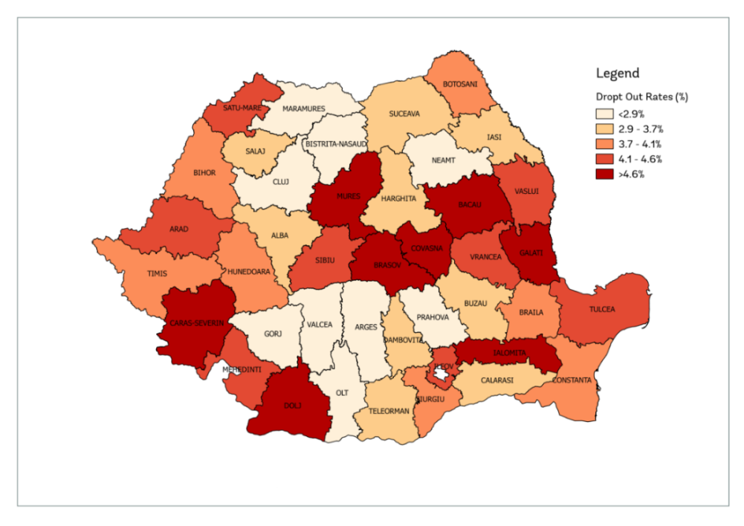

Source*:* World Bank staff calculation based on SIIIR[2] data for school year 2014/15

1. **The urban–rural divide in Romania’s education system can be considered through the lens of grade repetition, which contributes to inefficiencies in the system**. Data show that repetition is more common in rural areas at all levels of education and in low-income areas. In Romania, students in rural areas—regardless of education cycle or county of residence—are more likely to repeat a grade than students in urban areas. For primary education, the repetition rate in rural areas is 3.3 percent, compared with 1.7 percent in urban areas, and grows at the gymnasium level to 6.1 percent versus 3.8 percent. A statistically significant positive correlation of 0.32 also exists between average repetition and the degree of area marginalization, meaning that localities with high degrees of area marginalization, where there are high shares of populations with disadvantaged socioeconomic backgrounds, also have high repetition rates. This is consistent with the urban–rural divide, as high degrees of area marginalization are more common in rural areas.
2. **Data also show that differences in educational infrastructure can lead to gaps in education quality between urban and rural schools**. More than 348,000 students enrolled in rural schools are currently affected by the lack of libraries, versus approximately 152,000 urban students, absence of laboratories in 72 percent of rural and 30 percent of urban schools, lack of gyms in 32 percent of rural and 71 percent of urban areas. Much more needs to be done to secure safe and modern educational learning environments, including new spaces, to address shortages—especially for early childhood education and care.

## Delivering Quality Education for All and Relevant Skills for the Labor Market

1. **The proportion of top-performing students is the lowest in the EU**. The EC’s E&T Monitor 2017 points out that the proportion of top performing students in Romania—those capable of solving complex problems—is the lowest in the EU (at 2 percent in reading, 3.3 percent in mathematics, and 0.7 percent in science). In this context, the OECD 2017 Reviews of Evaluation and Assessment in Education suggests that current teaching approaches do not foster complex, higher-order skills. Given the ongoing phased implementation of a competence-based school curriculum, there is a need to strengthen learning standards to encourage changes in teaching and ensure a continuous professional development to train teachers to teach the new competence-based curriculum.
2. **Challenges also remain related to pre-service teacher training as well to attracting and retaining best graduates in the system, especially in most disadvantaged schools**. The OECD 2017 report highlights the need for more pre-service teacher preparation in practical domains as well as the importance of following a two-year master’s programme in education—an existing requirement in the current Education Law of 2011 that has not yet been implemented. At the same time, while teacher salaries have been slightly increasing, and some incentives exist, high-performing teachers are not attracted to disadvantaged schools.
3. **The delivery of relevant skills for the labor market is a hot topic on the public agenda**. In 2016, the employment rate of graduates aged 20–34 who left education 1–3 years before was 69.3 percent, compared with the EU average of 78.2 percent. At the same time, the tertiary education attainment of 30–34 year old persons had not increased since 2015, and remained at 25.6 percent in 2016—the lowest in the EU. While Romania’s target of 26.7 percent by 2020 is achievable, this remains a low percentage compared with the EU average of 39.1 percent in 2016. This is coupled with insufficient quality and labor market-relevant study programs, and with the emigration of highly skilled workers. Skills shortages are already identified in key professions, especially in ICT, health, and education, as reported by the European Centre for the Development of Vocational Training (CEDEFOP) 2017 Report. To address such challenges, there is a need to implement measures both for quality and participation in higher education as already promoted by the 2015–2020 Strategy for Tertiary Education. At the same time, excellence in higher education and research highly depends on quality assurance in universities and in doctoral schools.
4. **There is little information about skills supply and demand in Romania,** but a recent analysis carried out by the World Bank to inform strategic decisions in educational infrastructure shows relevant challenges on both fronts. On the demand side, Romanian employers strongly believe that current employees as well as students and graduates entering the labor market lack key socioemotional skills. Skills that are in high demand include motivation, empathy, tolerance, self-management, problem-solving, teamwork, communication, learning to learn, accountability, planning, engagement, and commitment. Importantly, many employers identify socioemotional skills as among the most important skills for the following categories of occupations: professional, services, and manufacturing.
5. **Regarding cognitive and job-related skills, university graduates were generally perceived by Romanian employers to possess sufficient, though overly theoretical, academic skills**, while Vocational Education and Training (VET) students and graduates have outdated skills. In the IT industry, employers described university graduates as lacking basic knowledge of business operation and insufficient business analysis skills. The employer perception of a lack of technical or job-related skills among VET graduate employees stems in part from outdated equipment in school workshops as well as outdated teaching methods and teaching experiences. To compensate for graduates’ lack of “job-ready” skills, employers described the need to heavily complement these skills by using different strategies and methods of skills upgrading, for example internships, practical training in firms’ premises, and in-firm targeted training and courses.
6. **In many countries, including Romania, the automation of production processes is driving the demand for higher levels of cognitive skills**. This change will displace large numbers of workers whose jobs involve the routine application of procedural knowledge.[3] The Romanian economy is particularly vulnerable to this trend, as it currently has a disproportionate share of these types of jobs in the manufacturing, IT, and agricultural sectors. The evidence shows that students with high levels of literacy skills are more likely to persist to the point of graduation, and are more productive when they enter the labor market. When these students enter the labor market, it is expected that they will possess at least level 3 literacy skills—or 275 on the 500-point international proficiency scale—to meet the demands of a globally competitive market.
7. **The literacy skills of Romanian VET and university students are also low by international standards**, as evidenced by an assessment carried out by the World Bank in 2017. Participating students had their document literacy skills assessed using the Test of Workplace Essential Skills (TOWES)[4], which is an adaptive, computer-based instrument broadly used worldwide whose results are reported on a 500-point proficiency scale that is divided into five proficiency levels (Figure 4). Even small differences in both dimensions have been shown to have a significant impact on outcomes. Students with literacy skills below level 3 are four times less likely to persist to the point of post-secondary graduation.

Figure 4. TOWES Scores and Proficiency Levels

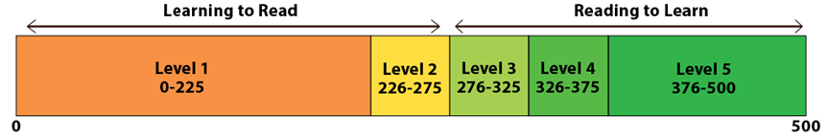

Source*:* Measurement framework used in [IALS](http://www5.statcan.gc.ca/olc-cel/olc.action?lang=en&ObjId=89M0014X&ObjType=2) (International Adult Literacy Survey)

1. **The assessment of document literacy skills carried out by the World Bank in 2017 shows that an estimated 90 percent of VET students fail to reach the level needed to get full value from study at the tertiary level** and to satisfy the demands of the jobs that are being created. When students’ results were considered at the level of their respective institutions, 97.5 percent of these schools fell into the lowest possible literacy level, obtaining average scores below 226. In fact, the total mean score of tested schools was 168, significantly below the level 2 threshold. Figure 5 presents the average score of students at the sampled VET schools. It reveals VET schools’ consistently low literacy scores, where students do not obtain proficiency beyond the most basic level. This has an impact on the efficiency of learning, and on post-graduation productivity.

Figure 5. Average Document Literacy Scores per VET School

Source*:* TOWES test scores applied to a random sample of VET students enrolled in their last year of professional education, in the school year 2016/2017

.

1. **The World Bank’s analysis to inform decisions about education infrastructure shows that Romanian employers are generally critical about the relevance of the education system, for several reasons**. First, the curriculum for both secondary and tertiary education was reported by many different types of employers to be overly theoretical, with a focus on abstract concepts and the accumulation of information rather than on practical applications. Second, in line with the overly theoretical curriculum, teaching methods were also described as being outdated and highly traditional, with a focus on memorization rather than application. Finally, employers noted that the education system is highly resistant to change, both at the pre-university and university levels. The perceptions of Romanian employers about the relevance of the education system in the country are illustrated in Figure 6.

Figure 6. Employer Perceptions of Romania’s Education System

Source*:* World Bank’s Online Employer Survey (2017).

1. **At the same time, the World Bank’s System Approach for Better Education Results (SABER) - Workforce Development (WfD) Report for Romania (2017) shows that despite significant efforts to identify skills needs in priority economic sectors, employer engagement in setting WfD priorities, and upskilling the existing workforce is rather weak**. The mandates of WfD stakeholders are well defined, but coordination challenges persist. Importantly, a lot of effort needs to be made to address some important policy goals currently evaluated at an emerging level in Romania, related to: fostering a demand-led approach to WfD; ensuring efficiency and equity in funding; enabling diversity and excellence in training provision; fostering relevance in public training programs; and enhancing evidence-based accountability for results. In this context, it is important to continue improvements in the VET area, with focus on the recently promoted dual VET system, also aiming at increasing the attractiveness of VET as a career choice, and its relevance for the labor market.
2. **Finally, adult participation in learning also remains very low in Romania, at 1.2 percent compared with the EU average of 10.8 percent, while there is an important need for upskilling**. The lifelong learning system remains fragmented, and there is a limited culture of participation in adult learning, especially among the population in rural areas where learning opportunities are very limited. Therefore, the implementation of the measures promoted by the Strategy for Lifelong Learning 2015–2020 should be speeded up, especially in the operationalization of the community centers for lifelong learning.

## Addressing Financing and Governance of the Education Sector

1. **Financing levels for education in Romania are among the lowest in Europe.** Romania’s public expenditure for education as a percentage of GDP was 3.1 percent in 2015, far below the EU average of 4.9 percent, and the lowest in the EU. The financing level slightly increased in 2016, but reverted to 3.1 percent in 2017. From 2008 to 2015, spending on pre-primary and primary education decreased by almost half, from 1.1 to 0.6 percent of GDP; spending on secondary education was the least reduced from 1.5 to 1.2 percent of GDP; and spending on university education declined from 1.3 to 0.8 percent of GDP. Moreover, the total public expenditure on education per student is only 15 percent of the EU average of 6,540 EUR, which highlights the underfinancing of the sector. In the absence of adequate funding, it will be difficult to address challenges as equity, quality, and relevance faced in the education sector. The key drivers for better education outcomes are the increase in the public funding of education—prioritizing the most in need, and joined by provision of transparent and equitable spending—in a context of reduced politicization and more accountability of key players.

Figure 7. Expenditure on education as percent of GDP

Source*:* World Bank staff calculation using EUROSTAT data for 2009-2015 and Budget Law estimates for 2016-2017

1. **The per capita formula should be upheld, but the allocation of total funds should not be guided by a per capita formula only.** In 2016, the state budget financed 78 percent of the total education expenditure, of which 67 percent was allocated by local governments. Although a cumbersome process, decentralization seeks to increase educational performance and transparency to promote equity and efficiency. However, the principle of the per-student formula seems not to uphold as much in practice, because of the financing mechanisms, and thus expenditures per student correlates positively with the number of teachers. In this context, attention needs to be paid to the needs of vulnerable groups, schools, and localities. Revising and refining the per-capita financing is needed, and also to reinforce its application, with close monitoring provided by the Ministry of National Education as the key governmental player accountable for educational results. The revised financing mechanism will reflect the kind of support should be best provided, and through which channels and modalities it should be delivered.
2. **Integrated and complementary investment in education is the result of good cooperation among governments, International Financial Institutions (IFIs), and private investors**. Full realization of the Education 2030 agenda requires sustained, innovative, and well-targeted financing, and efficient implementation arrangements for achieving quality education for all, at all levels. Efforts to close the funding gap must start with domestic funding, allocating at least 4 percent to 6 percent of the GDP to education. At the same time, EU funds play an important role in complementing the efforts of Romania to mobilize public resources to the poorest and most vulnerable groups. Clear commitment of the government is required, to provide equitable financing commensurate with national educational priorities established by recent adopted education strategies, with needs and capacities to advance the EU education agenda. IFIs should better coordinate, seeking to leverage external finance and to complement the funding gaps with access to resources, instruments, and knowledge, aiming to provide a more effective integrated investment environment.
3. **Special measures and increased finance are needed to address the needs of adult learners and of the millions of children, youth, and adults who remain illiterate.** Moreover, all youth and adults should be provided with the opportunities to achieve relevant and recognized functional literacy and numeracy proficiency levels, and acquire skills for life and decent work. It is equally necessary and urgent to boost financing for youth and adult literacy programs, as well as for adult learning, education, and training opportunities, in a lifelong learning perspective.
4. **Improved governance and partnerships are essential to focus investments on equity inclusion and quality, as this remains an innovation in most systems**. Education investments should be provided to all. Children, youth, and adults, including the most marginalized and vulnerable, should acquire the knowledge, attitudes, and skills they need for their lives and livelihoods. The education of key players at central and regional levels needs support and partnerships to improve their capacity, and to modernize in order to invest smartly and boost results. The spending on education from the private sector, especially investing in the VET area, should be oriented toward serving the children and youth most in need, and on reinforcing education as a public good. More support and partnership is needed, as in 2016 the state spent only 1 percent of total education expenses on VET education. Successful partnerships in dual educational systems with the private sector will require effective coordination and regulatory mechanisms to ensure transparency and accountability.
5. **Limited funds received for the education sector require more efficient and transparent planning, monitoring, and evaluation**. Strengthen the planning capacity within the sector, through regular institutional strategic planning exercises that associate policy measures and actions with the needed funds, both from the EU resources and from the national budget. Given the limited funds available for education, an adequate monitoring and tracking of spending may significantly decrease the inefficiency of funds that schools actually receive through local and central authorities. Direct commitment to a coordinated approach and mutual accountability system, including transparent monitoring and reporting on education financing, is required. This would include attention to identify whether financial resources are reaching the most vulnerable students.
6. **The first important step towards transparency has been taken by the Ministry of Finance trough the National System of Reporting “Forexebug”** where all schools report regularly their budget allocations and expenses. Such reports must be associated annually with numbers on enrollments, dropouts, teachers, and results. The Ministry of Education will be able to monitor and evaluate the statistics as well as translate them into policies and actions if properly staffed and capacitated.

1. According to the OECD, a 30-point score difference in PISA 2015 is equivalent to one year of schooling.
2. SIIIR - Integrated Education Information System, Sistemul Informatic Integrat al Învăţământului
3. The literature suggests that upwards of 60 percent of all jobs will be replaced by machines over the coming two decades. See: Acemoglu, D., and P. Restrepo. 2016. “The Race between Machine and Man: Implications of Technology for Growth, Factor Shares, and Employment.” National Bureau of Economic Research (NBER) Working Paper No. 22252. Cambridge, MA.
4. TOWES Canada's Essential Credential is a literacy& essential skills measurement tool, the sole property of Bow Valley College, Canada.