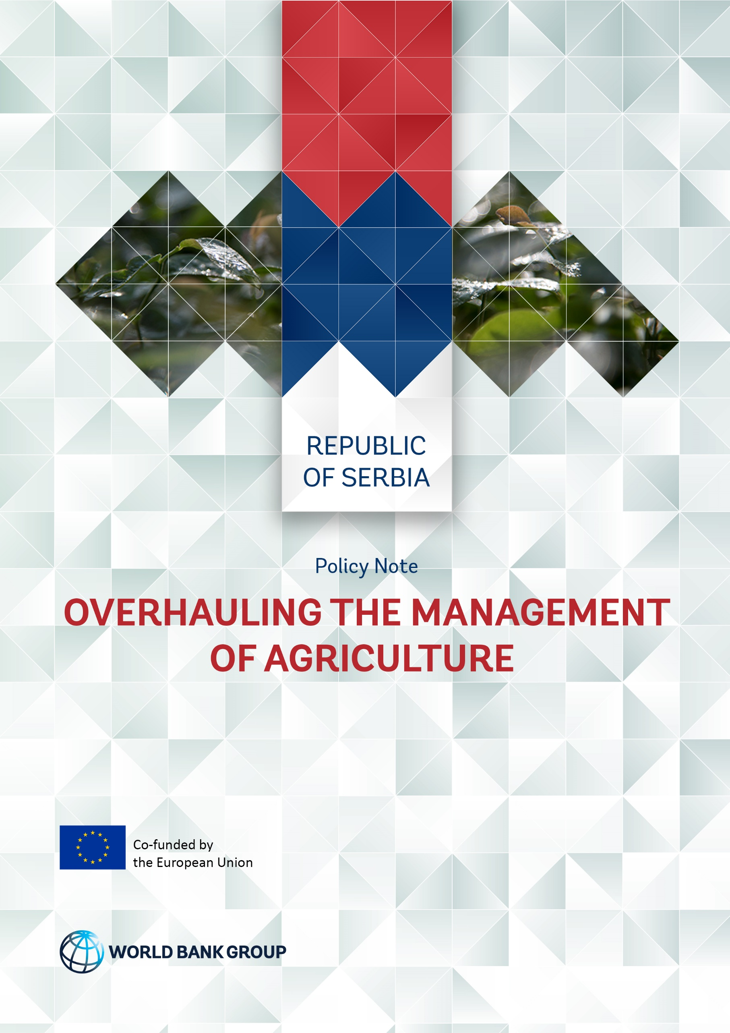

Report No.

This note is a summary of the reports prepared by the World Bank and funded by the European Commission.
Contacts
Bekzod Shamsiev, Senior Agriculture Economist (bshamsiev@worldbank.org)

© 2018 International Bank for Reconstruction and Development / The World Bank
1818 H Street NW
Washington DC 20433
Telephone: 202-473-1000
Internet: www.worldbank.org

This work is a product of the staff of The World Bank with external contributions. The findings, interpretations, and conclusions expressed in this work do not necessarily reflect the views of The World Bank, its Board of Executive Directors, or the governments they represent.
The World Bank does not guarantee the accuracy of the data included in this work. The boundaries, colors, denominations, and other information shown on any map in this work do not imply any judgment on the part of The World Bank concerning the legal status of any territory or the endorsement or acceptance of such boundaries.
Rights and Permissions
The material in this work is subject to copyright. Because the World Bank encourages dissemination of its knowledge, this work may be reproduced, in whole or in part, for noncommercial purposes as long as full attribution to this work is given.
Any queries on rights and licenses, including subsidiary rights, should be addressed to World Bank Publications, The World Bank Group, 1818 H Street NW, Washington, DC 20433, USA; fax: 202-522-2625; e-mail: pubrights@worldbank.org.

OVERHAULING THE MANAGEMENT OF AGRICULTURE
An otherwise bright spot in the Serbian economy the agri-food sector has not benefited from a steady policy environment. Since 2000, the Ministry of Agriculture has had no less than 13 ministers against a backdrop of accession negotiations for European Union membership and ongoing reforms. To make the sector more productive and competitive several actions the Government of Serbia should consider the following:
- Rethinking the role of government in agriculture;
- Mending the broken policy cycle and positioning staff appropriately; and
- Addressing data collection storage and use, and decentralizing
- Solving the staffing problem and getting the inspection process right

Challenges
Key challenges to be addressed include:
- Rethinking the role of government in agriculture
- Mending the broken policy cycle, positioning staff appropriately, and straightening the road to Europe
- Addressing data collection, storage and use, and right sizing decentralization

Rethink the Role of the State in the Sector

European Union governments tend to involve themselves in agriculture in ways they would not in other sectors. This is however restricted to correcting market failures. In Serbia, much of the ministry’s work in the sector involves the management of state-owned land and administration of 170 different types of subsidies ranging from chickens to beehives to fruit saplings (see Figure 1).

Figure 1. Subsidies dominate the ministry’s expenditures - MoAEP Budget Expenditures for 2016

Policy Priorities
If agriculture has to take their share of cuts in government staffing and expenditure, then it is essential to have a clear idea of priorities so that the most critical areas get first call on limited resources and any cuts fall on areas where their impact will be least. Redesigning the subsidy system to reduce administrative costs, increase efficiency and strengthen markets rather than distort them, will be a serious analytical and political challenge requiring a stronger and more integrated policy system.

Fixing the broken policy cycle, positioning staff, and straightening the road to Europe

Implementation and enforcement must form part of the policy cycle. Policy making is haphazard, policies are made by external advisors with little reference to permanent policy staff, and components of the ministry often operate in a vacuum. Inspection appears to be an external task and feedback is lacking improper staffing practices, especially those in legal, economic and information technology (IT) cadre also undermine effectiveness.
The accession workload facing the ministry is as big as that of the entire rest of the government. Many offices and agencies oversee the process. The current arrangement has so many different units involved in EU integration that they risk getting into each other’s way.

Policy Priorities
There is need to create senior policy positions in lands, food-chain, and program evaluation sections of the ministry. Skills of staff in policy units need systematic strengthening to eliminate ad hoc approach to policy analysis, design, and monitoring. Proper policy procedures and a regular program of policy workshops should be established, and procedures for regular information flow from implementing and inspection unit to policy units should be created.
Regarding staff positioning, professionals can be grouped in specialized units -- legal, economics and IT – that support line departments on project and working group basis, instead of departments having their own specialists who tend to work in isolation. This would also address the practical problems of recruiting and retaining the specialists needed. At the same time, the ministry should build its EU expertise more rationally, in each relevant sector and agency, and reduce the role Sector for International Cooperation and review the role of the Serbian European Integration Office (SEIO).

Addressing Data Collection, Storage and Use, and Right Sizing Decentralization

The ministry handles a tremendous amount of data in many different systems but very little or no thought has gone into how the data might be used by whom or its value strengthened through analysis. Routine systems through which to obtain data are lacking and data can be accessed only after an official request even by different departments and sectors within the ministry.
On decentralization, interaction between the ministry and local authorities is problematic. In some cases, such as rural land administration, the role of the Sector for Rural Development in approving local rural development plans, or the role of the Administration for Agricultural land in approving land lease contracts, is largely unnecessary.

Policy Priorities
A systematic review of data sources throughout the ministry, and identification of potential users, to make data available to anyone in the ministry who needs them, without any special request is suggested. In the long term, an office dedicated to management of data in the ministry including access should be created.
On decentralization, review of responsibilities to determine at which level they would be best handled, central or local, should be carried out. In environment, for example, the usual problem is that municipalities have been delegated responsibilities without sufficient capacity to discharge them effectively. It is highly recommended that highly technical issues such as permitting of industrial insulations be done by ministry rather than local authorities.

Solving the Staffing Problem, Getting the Inspection Process Right

The blanket ban on staff recruitment is seriously hampering the effectiveness of the ministry and holding back its transition to a modern and efficient organization. Because of the ban, the ministry is increasingly reliant on short-term contract staff. Departments such as inspection services that prohibit use of contracted employees, and whose staff are aging, are even more affected. Of the ministry’s 1,358 staff, almost half (643) are inspectors. It follows that inspection processes should be among the top priorities for review.

Policy Priorities
Managers should be provided a staff budget rather than rigid numbers of staff. Budgets might be set in terms of civil service pay scale pay points, rather than actual cash, to avoid yearly updates. Managers should also be granted leeway to recruit new staff with needed skills. A significant proportion of contacted staff should be employed permanently, within the overall staff budget.
Inspection is viewed as an isolated task and not part of the policy cycle. The effectiveness of inspection should be judged, not by the number of inspection visits, but rather by the extent to which it increases compliance with policy goals. Part of the solution could be better cooperation with the Public Prosecutor’s office agreeing to more consistent use of inspectors’ reports. Better sentencing guidelines could be instituted so that judges use the entirety of the penalty scale laid down in law, according to the seriousness of violations and the level of financial advantage gained in cases of farmers applying for more subsidy they are entitled or using state land that has not been leased to them. The recommendations have implications beyond the ministry, and so this issue should be discussed at government level.

