Report No. 36307-PA

Panama Poverty Assessment:
Toward Effective Poverty Reduction

June 25, 2007

A Joint Report by the United Nations Development Programme and the Latin America and the Caribbean Region of World Bank




CURRENCY EQUIVALENTS
Currency Unit = Panamanian Balboa
US$1 = 1 Balboa
(As of June 29, 2006)
FISCAL YEAR
January 1 – December 31
ACRONYMS AND ABBREVIATIONS
ASMUN | Ngobe Women’s Association
BADEINSO | Database of Social Statistics and Indicators (Base de Estadísticas e Indicadores Sociales)
CSS | Social Security Administration (Caja de Seguro Social)
CCT | Condicional Cash Transfer
CEFACEI | Community and Family Centres for initial Education
CGK | General Kuna Congress
CIF | Cost, Insurance and Freight
COIF | (Centros Integrales de Desarrollo Infantil)
ECLAC | Economic Commission for Latin America (Comisión Económica para América Latina)
EIH | Initial Education at Home
EPH | Permanent Household Survey (Encuesta Permanente de Hogares)
ENV | National Household Survey (Encuesta Nacional de Vida)
FGT | Foster Greer Thorbecke
GDP | Gross Domestic Product
GIC | Growth Incidence Curve
GoP | Government of Panama
GNI | Gross National Income
IDAAN | National Sewers and Aqueducts Institute (Instituto de Acueductos y Alcantarillados Nacionales)
IDB | Inter-American Development Bank
IMF | International Monetary Fund
INADHE | National Institute for Human Resource Development (Instituto Nacional de Formación Profesional y Capacitación para el Desarrollo Humano)
INAFORP | National Institute of Vocational Training (Instituto Nacional de Formación Profesional) Name changed to INADHE
INEC | National Statistics and Census Institute (Instituto Nacional de Estadísticas y Censos)
INFAD/FIDA | International Fund for Agriculture Development
IFARHU | Instituto para la Formación y Aprovechamiento de Recursos Humanos
IPEA | Institute of Applied Economic Research (Instituto de Pesquisa Econômica Aplicada)
LA | Latin America
LAC | Latin America and the Caribbean
LPG | Liquidfied Petroleum Gas
LSMS | Living Standards Measurement Study
M & E | Monitoring and Evaluation
MEDUCA | Ministry of Education (Ministerio de Educación)
MEF | Ministry of Economy and Finance
MICI | Ministry of Commerce and Industries
MIDA | Ministry of Agricultural Development (Ministro de Desarrollo Agropecuario)
MIDES | Ministry of Social Development
MIC | Middle Income Countries
MINSA | Ministry of Health (Ministerio de Salud)
MIVI | Ministry of Housing (Ministerio de Vivienda)
NAS | Panama National Accounts
NGO | Non-Governmental Organization
OECD | Organization for Economic Cooperation and Development
PARVIS | Programa de Ayuda Rápida de Viviendas de Interés Social
PMT | Proxy Means Testing
PER | Public Expenditure Review
PRAF | Family Allowance Program (Programa de Asignaciones Familiares).
PROMEBA | Integral Improvement Neighborhood Program
PROINLO | Program of Local Investments
PROVISOL | Housing Solidarity Program
SA | Social Assistance
SC | Social Cabinet
SENAPAN | National Secretariat for Food and Nutrition
SENADIS | Secretaría Nacional para la Integración Social de las Personas con Discapacidad
SI | Social Insurance
SIF | Social Investment Fund
SP | Social Protection
SPS | Social Protection System (Sistema de Protección Social)
TSF | Tariff Stabilization Fund
UNDP | United Nations Development Programme
UNFPA | United Nations Population Fund
UNICEF | United Nations Children’s Fund
WDI | World Development Indicators

Vice President: Pamela Cox
Country Director: Jane Armitage
Director PREM: Ernesto May
Lead Economist: David Gould
Sector Manager PREM: Jaime Saavedra
Task Manager: Pedro Olinto

TABLE OF CONTENTS
Executive Summary i
1. Assessing the Trends of Growth, Inequality, and Poverty in PanamA - 1997-2003 1
Annual Growth Rates: How Well Do the Survey and National Accounts Agree? 2
Trends in Poverty, Growth, and Inequality 4
Poverty Trends 4
Who are the neediest in Panama? 5
Inequality Trends 7
Changes in Poverty and Inequality: Decomposition Analysis 8
Decomposition Analysis of Growth and Inequality 8
Regional Decomposition of Changes in Poverty 10
Poverty Reduction Through 2015 11
Final Comments 12
2. Human Capital, Employment and Earnings 14
Introduction 14
Education 15
The Accumulation of Educational Stock Overtime: the Indigenous are Lagging More and More Behind 15
Educational Services: Changes in Coverage and Supply 17
Internal Efficiency: Repetition and Dropout 21
Health 21
Immunization 22
Malnutrition 23
Illnesses and Injuries 25
General Health: Incidence of Illnesses and Access to Health Care Services 25
Conclusion and Policy Implications 28
3. Social Protection in Panama 30
Introduction 30
Review of the Current Social Protection System in Panama 30
Assessment of Social Protection Programs in Panama 32
Relevance and scope 32
Coverage 33
Targeting 33
Cost-effectiveness 36
Programs that could be consolidated into finance a CCT program 37
Conditional Cash Transfer: A New Approach to Social Protection in Panama 39
Targeting Strategy for Panama’s SPS 39
Assessing the SPS targeting strategy 43
Assessing the design of the individual transfer amounts 47
The long run impact of SPS 48
Would CCTs be effective in indigenous areas 52
Conclusions and Policy Implications 53
Nutrition Programs 53
Education 54
Housing, Water and Energy Subsidies 54
Pensions 54
Monitoring and Evaluation 54
Institutional Arrangements 54
Annex 1.1: Additional Results on Growth and Poverty 56
Annex 1.2: Annual Production and Consumption Growth Rates: How Well Do the Survey and National Accounts Agree? 61
Annex 1.3: Are the Changes in Poverty and Inequality Significantly Significant? 68
Annex 2.1: Rates of Chronic Malnutrition in Same Age Cohort (between 1997 and 2003) 71
Annex 3.1: Assessing Social Protection in Panama: A Framework 72
Annex 3.2: Identifying the extreme poor population: Constructing a Proxy Means test 93
Annex 3.3: Ex Ante Method to Evaluate the Program: Red de Oportunidades 97
Annex 3.4: Methodology USED TO perform the Long Run Impact simulations of RdO 100
Annex 3.5: Indigenous poverty: Relevance of a Conditional Cash Transfer Program 105
Annex 3.6: Estimation of the marginal propensity to consume 133

Tables

Table 1.1: Annual Growth Rate, 1997-2003 2
Table 1.2 Who Are the Extreme Poor in 2003? 6
Table 1.3: Inequality Measures of Per Capita Consumption by Area 8
Table 1.4: Growth and Inequality Extreme Poverty Decomposition by Area 8
Table 1.5: Regional Decomposition of the Change in Extreme Poverty by Area 10
Table 2.1: Net Enrollment Rates by Level, 1997 and 2003 18
Table 2.2: Changes in Education Services, Teachers and Student Ratios, 1996 to 2005 20
Table 2.3: Repetition and Dropout Rates by Poverty, Geographic 21
Location and Gender, 1997-2003
Table 2.4: Vaccination Rates by Poverty, 2003 - (Ages 0 to 5) 22
Table 2.5: Changes in Malnutrition Rates in Children 0-5 24
Table 2.6: Chronic Malnutrition among Children Aged 6-11 24
Table 2.7: Incidence of Illness among 0 to 5 Year Olds, 2003 25
Table 2.8: Self-reported Illness and Injury in 2003 26
and Percent Change from 1997
Table 2.9: Reasons for Not Seeking Health Care when Needed, 1997-2003 26
Table 2.10: Time to Health Facility and Waiting in Health Facility, 2003 27
Table 3.1: International Comparison of Social Spending 31
Table 3.2: Distribution of Social Assistance Resources, by Group Age Group, 2005 32
Table 3.3: Fuel Use for Cooking, 2003 35
(Percentage)
Table 3.4: Expenses on Gasoline, 2003 36
(Percentage)
Table 3.5: Relative Cost of Nutrition Interventions 36
Table 3.6: Coverage and Costs of Program 38
Table 3.7: IFARHU Assistance Programs, 2005, 2006 38
Table 3.8: Potential Savings from Reduced Subsidies 38
Table 3.9: Types of Interventions 39
Table 3.10: Targeting Accuracy: Coverage, Leakage and Total Cost 46
Table 3.11: Targeting Accuracy 46
Comparison Between alternatives Selections Criteria
Table 3.12:Transfer as % of the Total Average Consumption 47
Comparison between Different CCT Programs in LAC

Figures
Figure 1.1: Poverty Measures by Area –Headcount Ratio 5
Figure 1.2: Distribution of monthly per capita consumption of the extreme poor 7
Figure 1.3: Gini Coefficient for Consumption 7
Figure 1.5: Extreme Poverty Impact of Different Growth Scenarios – Exercise 1 12
Figure 1.6: Extreme Poverty Impact of Different Growth Scenarios – Exercise 2 12
Figure 2.1: Average years of schooling by year of birth 16
Figure 2.2: Percentage that Completed Primary School by Year of Birth 17
Figure 2.3: Percentage that Completed Secondary School by year of Birth 17
Figure 2.4: Enrollment Numbers by Level of Schooling, 1996-2005 18
Figure 2.5: Enrollment by Poverty Group 19
Figure 2.6: Key Health Indicators 1990-2003 22
Figure 2.7: Percentage Change in Vaccination Coverage by Poverty 23
(Children ages 0 to 5)
Figure 2.8: Changes in the Incidence of Diarrhea and Respiratory Illness 25
Among 0 to 5 year olds, 1997 to 2003 25
Figure 2.9: Changes in Health Facility Use among Those 27
Who Sought Treatment, 1997-2003
Figure 2.9a: Number of Public Health Facilities by Type, 1994 to 2004 27
Figure 2.9b: Public Health Care Facilities by Corregimiento 28
Figure 3.1: Targeting of Nutrition Programs 34
Figure 3.2: Targeting of Education Assistance Programs 35
Figure 3.4: Extreme Poverty by Corregimiento 42
Figure 3.5: Extreme Poverty Ratios by `Corregimiento’ and Geographic Area 43
Figure 3.6: Distributional Impact of the Program: Poverty Reduction Gains Link to Total Cost. Comparison between Different Transfer Schemes 49
Figure 3.7: Distributional impact of the Program assuming a Change in the Household Behavior Due to the Participation in the Program 50
Figure 3.8: Distributional Impact of the Program Assuming a Change in the Household Behavior Due to the Participation in the Program 51

Boxes

Box 1.1 Measuring Welfare in Panama 3
Box 1.2: Understanding the Evolution of Rural Poverty in Panama 9
Box 3.1: Conditional Cash Transfers 41
Box 3.2: Geographic and Household Targeting. The Case of PRAF in Honduras 44

Acknowledgments
This Poverty Assessment is the product of a collaborative effort between the World Bank, UNDP, IPEA, the Inter-American Development Bank, and Panama’s Ministry of Finance and the Ministry of Social Development. From the World Bank, Magdalena Bendini (LCSPP), Monserrat Bustelo (LCSPP), Benedicte de la Briere (LCSHS), Jose Marcio Camargo (Consultant), Mirela Carvalho (IPEA), Gabriel Demombynes (LCSPP), Samuel Franco (Consultant), Anna Fruttero (LCSPP), Gillette Hall (LCSHS), Jose Marques (Consultant), Marcos Robles (IDB), Kinnon Scott (DECRG), Pedro Olinto (Team Leader), participated under the overall guidance of David Gould (LCC2C) and Jaime Saavedra (LCSPP). From IPEA, Ricardo Paes de Barros and Mirela Carvalho contributed. From UNDO, Maribel Landau provided critical support. From IDB, Marcos Robles collaborated. From MEF, Nuvia de Jarpa, Zuleika Bustos, Roberto Gonzalez and, Margarita Aquino helped with the analysis. From MIDES, Alexis Rodriguez and Julio Dieguez supported the analyis of the CCT. Lucy Bravo and Anne Pillay contributed significantly to the production of the report. The Peer Reviewers were Kathy Lindert (LCSHS); Peter Lanjouw (DECRG); and William Maloney (LCRCE). In addition to the guidance and advice received from peer reviewers, the team is grateful for the helpful comments from Jessica Poppele, David Gould, Laura Rawlings (LCC2C), Helena Ribe, Manuel Salazar (LCSHS) and Jaime Saavedra (LCSPP). Special thanks are also due to Francisco Ferreira (DECRG) and Phillipe Leite (consultant) for their technical assistance.

Executive Summary

I. Introduction
With a population of about 3 million, Panama is one of the fastest growing and best managed economies in Latin America. A per capita Gross National Income of US$ 4,630 in 2005 places the country among the upper-middle income nations in the world, despite the fact that it does not produce oil or other valuable non-renewable resources, and has no major commodity exports. In terms of real GDP per capita, only Chile grew faster than Panama in Latin America between 1975 and 2004 (Figure 1).
But Panama is indeed a country of disparities and puzzles. Its dynamic internationally-oriented service sector coexists with the inefficient and protected agriculture sector. It enjoys sophisticated private financial services, but its public administration system remains largely ineffective. It has more hospital beds, doctors and nurses per inhabitant than most upper middle-income countries, but malnutrition, child and female mortality in indigenous areas match those of poor countries in Sub-Saharan Africa. The country has grown faster than most Latin American economies, but average household consumption has declined and poverty has remained high.
Figure 1 – Per Capita Growth in Panama and LAC
2000
3000
4000
5000
6000
7000
8000
9000
10000
11000
1975
1977
1979
1981
1983
1985
1987
1989
1991
1993
1995
1997
1999
2001
2003
Per Capita GDP in 2000 PPP
Panama
Chile
Costa Rica
Latin America & Caribbean
Source: World Bank’s staff calculations based on World Development Indicators 2006

Why growth has not been translated into effective poverty reduction in Panama?
Despite its high overall per capita growth, Panama’s economy has not been capable to generate sufficient employment to meet national goals in poverty reduction and improving standards of living. More than one third of its population still lives in poverty and more than one sixth in extreme poverty. Traditionally, Panama has been characterized by a tripartite economy, a dual economy plus an indigenous economy, which generates growth mainly from its exports and services sectors, but continues to rely on import substitution policies to shelter its manufacturing and agricultural sectors. Since the few growing areas of the economy generate very little employment, it is not surprising that formal employment growth has stagnated. Between 1997 and 2003 the protected agricultural and industrial sectors have further lost competitiveness even though the manufacturing sector was significantly opened up to foreign competition in the 1990s. Consequently, average per capita consumption has declined by approximately 0.7 percent annually.

Should Panama invest more in the social sectors to accelerate poverty reduction?
Our analysis suggests that Panama does not need to invest more in the social sectors, it needs to invest better. Remarkably, the country spends almost 17 percent of its GDP in the social sectors. This is higher than the 14 percent average in Latin America, and equals Costa Rica’s spending, a country known for its high investment in social programs, and for successfully reducing poverty in the past. In fact, if the amount currently spent in the social sectors were to be distributed in cash to the whole population, poverty, as defined by living on less than $2 a day, would disappear. Of course, this is not a long-term solution to poverty, but it illustrates that at the current levels of spending, significant progress could be made in enhancing the effectiveness of spending in the social sectors.
A major challenge for Panama is, therefore, to formulate and implement policies that help translate its solid growth performance into effective and sustainable poverty reduction, without increasing its overall level of social spending. As discussed in more detail below and throughout this report, improving the targeting, efficiency and effectiveness of social spending will be crucial if Panama is to achieve effective poverty reduction.
The main objective of this Poverty Assessment is to provide a tool for the Panamanian government to use when devising its poverty reduction strategy. It is based on extensive consultations and collaboration with the government. Key components of the process around this report include:
  - Analyzing the evolution of poverty, inequality, human development and other social indicators between 1997 and 2003, paying particular attention to the puzzle of persistent poverty and inequality despite real GDP growth;
  - Providing analytical and advisory support to the government of Panama, with a focus on refining and implementing its new strategic vision for poverty reduction and growth, and
  - Supporting the country in capacity building in poverty diagnostics and policy evaluation.
In addition to the objectives above, and through collaborative efforts in writing this report, the Bank assisted the government of Panama in building its capacity for social policy analysis, with particular emphasis on creating local capacity on poverty diagnostics and on techniques for the ex-ante evaluation of government programs. Toward that goal, the work was carried-out in close collaboration with the staff of the Social Policy Directorate at the Ministry of Economy and Finance and the Ministry of Social Development.

The analysis in the report is primarily based on the Living Standards Measurement Surveys (LSMS, Encuesta de Niveles de Vida in Spanish) conducted in Panama in 1997 and 2003, by the Ministry of Economy and Finance (MEF), with funding from the Government of Panama, the World Bank, the Inter-American Development Bank, the Swiss Agency for Development and Cooperation, Japan’s Policy and Human Resource Development Fund, and the United Nations Development Program. With technical support from the World Bank and the Inter-American Development Bank, the Government also updated its national poverty map that now combines data from the 2003 LSMS with the 2000 National Census. The map is already serving as a policy tool for the targeting of the new conditional cash transfers program, the Sistema de Proteccion Social (SPS)

II. The Evolution of Consumption Growth, Poverty and Inequality in Panama

Can Panama rely on economic growth alone to reduce poverty?
There is a solid consensus amongst international development experts that growth must be at the center of any successful poverty reduction strategy. As documented in the World Bank’s recent Flagship Report Poverty Reduction and Growth: Virtuous and Vicious Circle (Perry et. al. 2006), while in the long-run all pro-growth policies will lead to lower poverty, in the short-run the poor will be left behind if severe inequality is not addressed. Moreover, obtaining significant poverty reduction in the long-run may require growth policies that also help reduce inequality while the economy grows. Hence, countries with high income inequality and severe poverty like Panama may need to focus on a combination of growth and social policies that directly support the poorest segments of society if sustained poverty reduction is to be attained. The Flagship Report finds that targeted pro-poor policies, such as increased access to education and direct conditional transfers to the poor, have had direct positive and self-reinforcing impacts, not only on inequality and poverty, but also on growth.

Our analysis indicates that the recommendations of the flagship report are largely applicable to Panama. Despite strong recent economic performance, poverty in Panama (at slightly below LAC average of 40 percent) remains persistently high with only slight declines in recent years. Between 1997 and 2003, real per capita GDP grew at 1.5 percent per annum, but, during the same period, poverty fell only by about a half a percentage point, from 37.3 to 36.8 percent (Figure 2). This slight drop in poverty appears to be associated almost entirely with a small drop in inequality, since GDP growth has not been translated into consumption growth by the average Panamanian. Indeed, the Gini coefficient has dropped from 48.5 to 46.9 between 1997 and 2003.

Figure 2: Poverty Measures by Area –Headcount Ratio
Poverty | Extreme poverty
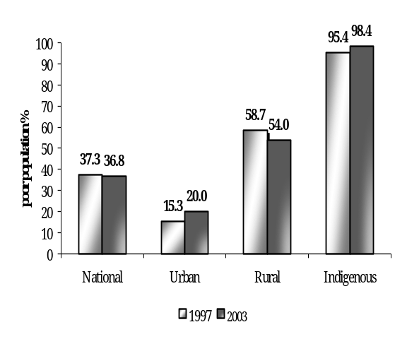 | 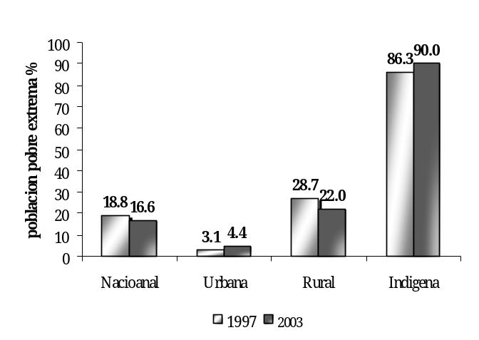
Note: Extreme poor refers to the population with per capita consumption below the extreme poverty line value. Moderate poor refers to the population with per capita consumption below the poverty line value.
Source: World Bank staff calculations based on ENV 1997 and 2003 data.

Despite the slight decline in average per capita consumption and an unwavering moderate poverty rate, as seen in Figure 1 above, extreme poverty has dropped more notably than moderate poverty between 1997 and 2003. The extreme poverty headcount ratio, which measures the share of the population that is not able to afford an adequate daily diet, has dropped 12 percent, from 18.8 to 16.6 percent.

Where do the neediest in Panama live?
In 1997, the majority of the extreme poor, 56 percent, lived in non-indigenous rural areas. Slightly more than one third of them, 35 percent, lived in indigenous areas and a few, 9 percent, lived in urban areas. By 2003 this picture had changed substantially. The share of the extreme poor living in indigenous and non-indigenous rural areas became identical at 42 percent. And the share of the extreme poor living in urban areas almost doubled to 16 percent (Figure 3). Migration from rural to urban areas also appears to have played an important role in the decline of extreme poverty in rural areas and the increase in extreme poverty in urban areas.

The indigenous are by far the most destitute in Panama.
The already high poverty rate of Panamanians living in indigenous areas has deteriorated even further. Nearly all (98.4 percent) of those living in indigenous areas now live in poverty, and 90 percent live in extreme poverty. Because of the very high rate of extreme poverty in indigenous areas, even though they account for just 8 percent of the overall population, 42 percent of the nation’s extreme poor lived in indigenous zones.

Figure 3: Who are the Extreme Poor?
1997 | 2003
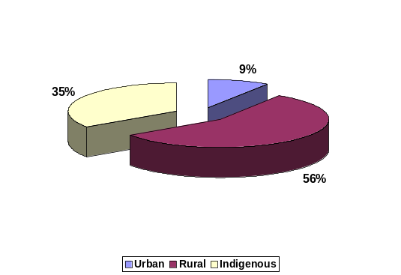 | 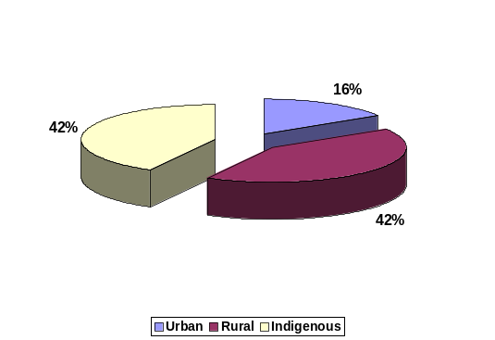
Source: World Bank staff calculation based on ENVs 1997 and 2003

Moreover, the vast majority of the residents of indigenous areas exhibit consumption levels that are far below the extreme poverty line. In other words, poverty is much deeper in indigenous areas. To see this, note that the median per capita consumption of extremely poor individuals living in indigenous areas (B.\238 per year) is less than half the extreme poverty line (B.\534 per year). For the extreme poor living in urban and rural areas, the median per capita consumptions are substantially higher, at B.\440 and B.\339 respectively. This means that it would cost considerably more to lift an average indigenous person out of extreme poverty than it would to lift a rural or urban resident. Not surprisingly, as we discuss in more detail below, the levels of chronic malnutrition in indigenous areas are much higher than the levels in urban and non-indigenous rural areas.

Because of the deep poverty observed in indigenous areas, economic growth and non-targeted anti poverty programs may have limited impact on the wellbeing of the most destitute in Panama. For instance, despite the 12 percent drop in the extreme poverty rate between 1997 and 2003 (a measure of the number in poverty), the extreme poverty gap (an indicator of the depth of poverty that measures how far below the poverty line the average poor is located) was lowered only by 6 percent. In other words, growth and non-targeted poverty programs have tended to lift those that were closer to the extreme poverty line out of extreme poverty. However, many were left well below the extreme poverty line, particularly the indigenous. Therefore, policies and programs to assist the poor should not be judged only by their success in reducing the number of poor, but should also be evaluated by how far they bring the poorest of the poor closer to the poverty line.

The implications for policy formulation are three fold:

- First, given that a large proportion of the poor consume far less than what is needed to afford an adequate diet, policies aimed at promoting faster economic growth per se are unlikely to have significant impacts on the welfare of the poor in the short and medium runs. Instead, poverty reduction policies should be formulated to reduce the depth of poverty by focusing on those who live with consumption levels which are far below the poverty line. Otherwise, as our analysis indicates, even if average national consumption per capita grew at a high rate of 3 percent per year, extreme poverty would be reduced only by 7 percentage points by 2015, and 70 percent of the indigenous population would still live in extreme poverty, not being able to afford an adequate diet.

- Second, universal compensatory policies aimed at regulating prices, such as minimum wage policies and programs subsidizing the prices of electricity, cooking gas, gasoline and water, are unlikely to significantly affect poverty rates given that the poor consume little of these goods and largely work outside the formal sector. Furthermore, such policies would distort relative prices in the economy, leading to inefficiencies in resource allocation and possibly hindering growth.

- Finally, well targeted direct transfer programs are likely to be more effective in improving poverty indicators in the short and medium runs. Nevertheless, given the depth of poverty in the country, policymakers should consider not setting targets for these programs in terms of reducing only the extreme poverty rate. Instead, it would be prudent to select other more responsive measures as success indicators, as for example the extreme poverty gap or the poverty severity index. In fact, policy options designed to minimize the incidence of poverty alone should be avoided since they are unlikely to affect the poorest of the poor, who are too far from the extreme poverty line.

III. Boosting the Labor Power of the Poor: Human Capital and Employment
Human capital, which in its broadest sense encompasses education, health and nutrition, is essential for enhancing the productivity of the poor and is generally considered one of the key determinants of growth. Human capital formation is a process that starts very early in life. Adequate health and nutrition are needed for developing cognitive capacity, readiness to learn at school, and greater productivity in adult life. Schooling and training from childhood to adulthood further develop marketable skills. Moreover, productive human capital not only depends on the level, but also the quality of nutrition, health and education services accessed during infancy, childhood, and adolescent years.

Why is Panama underperforming on health and nutrition indicators?
Panama makes the largest investment in health compared to any other Latin American country, devoting 6.6 percent of GDP to this sector. However outcomes are below what would be expected from a country with this level of investment and economic development. Panama lags behind other countries with similar per capita incomes in several important health indicators, including infant mortality, maternal mortality rate, and malnutrition. The declining rate of child immunization among the poor and the extreme poor is of particular concern. Deficiencies in the quality, efficiency and equity of public spending on health have led to poor outcomes despite the country being well endowed with human and physical capital in the health sector.

Figure 4: Stunting and GDP per Capita
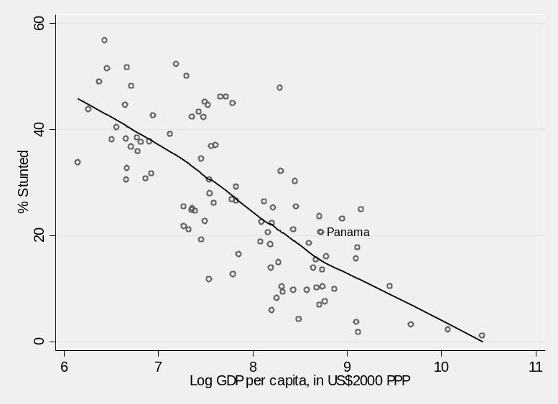
Source: World Bank calculation based on ENV 2003 and WDI (2006).
Note: Mean line not a straight line because it was estimated via non-parametric Lowess regression. The predicted level of stunting for Panama is 15.3%. The actual level is 20.6%.

Malnutrition indicators in Panama have not improved between 1997 and 2003 and remain exceptionally high for a country with its level of income per capita. As seen in Figure 4, chronic malnutrition, and the resulting stunting in growth, is 35 percent higher in Panama than the average country with similar GDP per capita. We can also conclude from the graph that the levels of malnutrition in Panama are more in line with countries with 34 percent lower per capita GDP.

The high levels of poverty in indigenous areas have translated into very high levels of malnutrition among children under 5. While the national prevalence of stunting is at 21 percent, in indigenous areas it affects approximately 57 percent of children under five years of age. Thus, chronic malnutrition in indigenous areas are almost three times as high as the national average, four times as high as the incidence in rural areas, and five times as high as the incidence of stunting in urban areas. Chronic malnutrition levels in indigenous communities is comparable to levels of stunting in countries with less than one tenth of Panama’s GDP per capita, such as Burundi and Ethiopia. Hence, the high incidence of chronic malnutrition corroborates the evidence that extreme poverty is especially severe and deep in indigenous areas. Claims that per capita consumption is not an adequate measure of welfare for the indigenous are therefore unwarranted, since chronic malnutrition levels clearly confirm their state of extreme destitution.

In addition to suffering from chronic malnutrition, the extreme poor have very little access to basic health services. Long distances to health facilities are a main obstacle preventing the extreme poor from accessing publicly funded health. Compared to the non-poor, twice as many of them stated that the time and cost of travel was the main reason for not visiting a health care facility when needed. Also, the average travel time to health facilities by the extreme poor (45 minutes) is 80 percent higher than the average travel time for the non-poor.

As a consequence, immunization rates for the extreme poor have reached perilously low levels. About 30 percent of extreme poor children are not vaccinated for measles, and 15 percent are not immunized for Polio, DPT and tuberculosis. In contrast, only 3 percent of non-poor children are not covered by DPT, tuberculosis and polio, and only 16 percent are not immunized against measles. These results show that access to basic health services in Panama is unmistakably biased toward the non-poor, leaving the poor and the extreme poor much more susceptible to easily preventable diseases.

These findings are even more troubling given that public health spending in Panama, which, as discussed above, is twice as high as the average for middle income countries in Latin America. Furthermore, Panama’s health sector is well endowed with human and physical capital: it has more hospital beds, doctors and nurses per inhabitant than the other upper middle-income countries in the region. But most resources are directed to secondary and tertiary care facilities, which are generally less cost effective than primary care facilities, and are largely provided in urban areas where few of the extremely poor live. Even though the Ministry of Health, MINSA, is mandated to provide health services for free to all, the poor and indigenous communities often face significant barriers because they are located in remote rural areas, and mostly require primary care which tends to be underserved.

The health sector would likely see large efficiency gains in delivery of services if incentives were provided to managers to improve service delivery performance and mechanisms of accountability were implemented. Providers should also receive incentives to deliver quality health services. Managers could be made accountable for results and the penalties and incentives should be made explicit and known to all in advance. Moreover, they could be given resources and independence in decision making to achieve results.

Disparities in Basic Education: A success for most of the country, but a dismal performance in indigenous areas
Panama is one of the countries in Latin America with the highest educated labor force as measured by average years of schooling and secondary completion rates. The stock of human capital has been growing over time, and given the tremendous investments being made in the expansion of basic education, it should continue to grow in the future. The improvements are very robust as the changes can be seen in a variety of areas. The share of children attending school increased for all ages between the census of 1990 and 2000.

Noteworthy, perhaps, is the country’s investment in early childhood education. It has increased considerably between 1996 and 2004. During this period, pre-school enrollments rose by more than 144 percent. Even more remarkable is the fact that changes in pre-primary and primary enrollment have benefited the poor more than the non-poor. For pre-school, the increase has been the greatest among the extreme poor for whom enrollments rates have increased almost four-fold. For all poor, enrollments rates have more than doubled in pre-school during the same period.

The observed increase in overall enrollment rates in Panama between 1997 and 2003 appears to be associated with a widespread increase in the supply of school services. For instance, the large increase in children attending pre-school education since 1997 is associated with a sizeable increase in the number of pre-school programs. While the number of pre-school programs almost tripled, the number of teachers in pre-school programs has more than quadrupled. Thus, as the coverage of pre-schools increased, the ratio of students to teacher dropped from an average of 39 children per teacher to 22.

Primary coverage is now almost universal in urban and rural areas, and secondary coverage is one of the highest in Latin America. However, the disparities between the rate of human capital accumulation of the indigenous and the non-indigenous are striking. While rural workers have been converging to their urban peers in terms of average years of schooling and primary and secondary completion rates, the indigenous are lagging further and further behind. A concerted effort to improve access to basic and secondary education for the indigenous is needed if the country is to eradicate extreme poverty and reduce its high inequality in the long run. But more access to schools will not produce the expected outcomes if indigenous students continue to suffer from chronic malnutrition. A parallel concerted effort to eradicate chronic malnutrition will therefore be required to ensure that schooling investments do pay off in terms of poverty reduction and growth.

How to make spending education spending more efficient and equitable?
Growing returns to primary and secondary schooling, which have increased by 95 and 44 percent, respectively since 1997, are likely to continue to boost the demand for education in Panama. Nevertheless, incremental returns to post-secondary school in Panama seem to be lower than in similar middle income countries. While demand side factors could be at play, this may also be an indication that the quality of tertiary education in the country is lower than abroad.

Low returns to tertiary education are especially worrisome given the amount of public resources allocated to higher education. As reported in the recent Public Expenditure Review (World Bank, 2006), the country spends almost one-third of its public education budget on higher education to finance the studies of the 105,000 students who attend public universities. In contrast, the Government allocates about the same amount of resources to finance secondary education for twice as many students. Moreover, very few students from low-income families manage to attend universities; of the total number of students enrolled in public universities, only 0.4 percent comes from families in the first (poorest) quintile of consumption and 0.2 percent from indigenous areas. The level public spending on tertiary education in Panama is highly regressive.

Given that in tertiary education, private returns tend to be higher than social returns, greater cost recovery from university students via higher tuitions to non-poor students, combined with scholarships targeted to the poor, should not only improve equity but also the efficiency of overall public spending on education. Equity would be improved because more resources would be freed up to be invested in public primary and secondary schools. Efficiency would be enhanced because tuition paying students tend to demand higher quality of teaching not only in universities, but also in secondary schools. The University of Panama, which enrolls about two-thirds of all the students attending public universities, is expected to spend B. / 130 million in 2006, of which only B. / 5.5 million (4.2%) are expected to be financed by tuition and lab fees. At the Universidad Especializada de las Américas, for example, students pay a registration fee of only B./ 27.5 and tuition costs range from B./ 180 to B./194 per semester, depending on the career path.

In sum, while education indicators have been consistently and significantly improving in Panama, there are clear opportunities for improving the effectiveness of spending in the sector. For instance, as discussed in more detail in the recent World Bank’s Panama: Public Expenditure Review, efficiency of educational spending could be enhanced by:
- Enhancing budget planning capacity in the sector;
- Implementing cost recovery from the non-poor at the tertiary level;
- Decentralizing key decision making activities to local levels;
- Establishing performance incentives for teachers and school directors;
- Improving human resource management, and;
- Adopting systematic testing and performance monitoring.

Returns to Human Capital: Improving Employment Opportunities and Earnings
Human capital accumulation decisions are influenced not only by supply factors, but also by demand side factors related to the functioning of labor markets. When students observe that new entrants to the labor force have difficulties in accessing higher-paying jobs, their demand for higher-quality schools, their attitudes toward schooling and their scholastic performance can be affected. Thus, to ensure that returns to, and demand for, education continues to grow in Panama, young entrants to the labor force must be able to find adequate employment commensurate to their schooling investments.

Labor market regulation and rigidities affect disproportionately the youth in Panama. Youth are three times more likely to be unemployed than older adults, and when employed, they are considerably less likely to work in the formal sector. Labor markets should be free to adjust to a rising labor supply—not constrained by rules or policies that delay or unduly restrict employment opportunities for young people. Rigid employment legislation, high minimum wages, and high tax wedges that raise hiring and firing costs put young people at a greater disadvantage in the labor market. Since arriving at politically feasible labor reforms is always challenging, the government might initiate a national debate on the issue, bringing the international experience into a broad-based dialogue.

IV . Protecting the Most Vulnerable: Toward Effective Social Protection in Panama
As in most countries in Latin America, social protection spending in Panama is mainly limited to social insurance (SI) programs, which are typically aimed at mitigating unemployment, health and old age poverty risks (e.g., health insurance, unemployment insurance and old age pension). Eligibility to SI in Panama requires participation in the formal labor market through which some contribution to fund these programs is made via payroll taxes.
Because of the low coverage of the poor in SI programs, Panama, as most Latin American countries, has developed and expanded social assistance (SA) programs aimed at relieving the distress of the poor. These range from untargeted price subsidies and/or food-based programs, to the more recently developed targeted conditional cash transfers (CCTs). CCTs provide cash assistance to poor families in exchange for beneficiary compliance with key human development actions such as school attendance, vaccines, prenatal care and child growth monitoring.

Panama’s total spending in social protection (i.e., SP=SI+SA) is relatively high when compared to other countries in Latin America, and even when compared to the United States. It spends 6.7 percent of GDP in social protection, with 5 percent spent in SI and 1.7 percent on SA. The average in Latin America is 5.7 percent of GDP for total SP, 4.7 percent for SI, and 1 percent for SA (see Table 1). The United States spends 8.3 percent of GDP in total SP, but has a much larger elderly population (12 percent aged 65 or above) that absorb much more resources per capita than the younger population in Panama, where only 7 percent of the population are elderly citizens. More impressive perhaps is the 1.7 percent of GDP that Panama spends on social assistance. This is 70 percent higher than the Latin American average, and is substantially higher than what countries like Mexico, Chile and Costa Rica spend on social assistance.

Why is social assistance so ineffective in reducing poverty in Panama?

Given the relatively large amounts spent on social assistance, it is remarkable that poverty, and especially extreme poverty remains high in Panama. This is a clear indication that social protection spending in Panama is ineffective. Either SA programs are not being well targeted to the neediest, or, when well targeted, they are not effective in reducing poverty. Emphasis should be given to looking for opportunities to better use existing resources in order to raise the efficiency and the impact of the SP system – for example, by reducing program overlap, improving program design and targeting – before additional resources are put into the social protection system.

For instance, the country has a large program of subsidies for electricity, water, cooking gas and gasoline, which accounts for almost two-thirds of spending in social assistance. These subsidies mostly benefit the non-poor, and spending is not focused on the most vulnerable groups, such as small children and pregnant or lactating mothers. Targeting these groups would more effectively contribute to breaking the intergenerational transmission of poverty.
Table 1: International Comparison of Social Spending as % of GDP
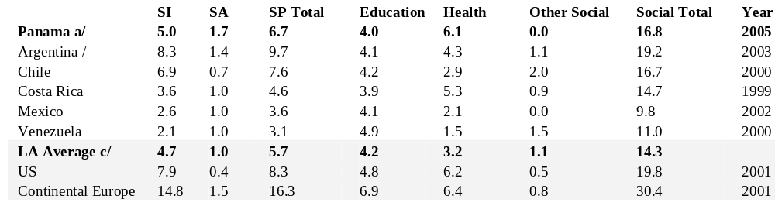

Source: World Bank reports, OECD, and staff estimates for Panama.

a/ Education and health spending is adjusted to eliminate double counting with SA. b/ Five LA countries.

The social protection system in Panama therefore suffers from multiple programs with duplicating objectives and overlapping target populations, and weak to non-existent program monitoring and impact evaluation. Substantial gains in the fight against poverty in the country could be made by phasing out some of these programs and focusing on a new well-designed social assistance package for major at-risk groups, including the extreme poor and the indigenous. Preliminary simulations indicate that significant cost savings of at least B.\28 million per year could be generated by phasing out some of the untargeted subsidies and redundant programs with overlapping target population.

Conditional Cash Transfers: A new vision for Social Assistance in Panama
The proposed conditional cash transfer program being piloted by the Ministry of Social Development (MIDES) seems to be a step in the right direction for developing a clear social protection strategy in Panama. Robust international evidence has shown that CCT programs are considerably more effective than untargeted subsidies in fighting poverty, malnutrition and inequality.

The key to successful CCT programs is to ensure good targeting of the extreme poor. Our analysis indicates that combining Proxy Means Testing (PMT) and geographic targeting techniques would be the best approach to ensure that transfers reach the neediest. The targeting method selected by MIDES should ensure that at least 75 percent of the extreme poor would be reached if the CCT program currently being piloted were to be expanded to the country as a whole. More importantly, the simulation results show that 88 percent of the poorest 10 percent of the population, and 95 percent of the poorest 5 percent, can be included in a nation wide program using feasible and cost effective Proxy Means targeting mechanisms. While approximately 30 percent of the national program budget may not reach the extreme poor, 80 percent of such leakage would go to the moderate poor, and only 20 percent would go to the non poor. These targeting outcomes, are favorable compared to the international experience and could be further improved if measures are undertaken to increase self exclusion of the non-poor. For instance, imposing conditions on program usage for adults, such as demanding attendance to periodic health and nutrition classes, may increase the level of self exclusion of the non poor, as they tend to have a higher opportunity cost of personal time.

Simulations regarding the national CCT program that could follow the current pilot being implemented by MIDES show that the program is likely to reduce the headcount index of extreme poverty by approximately 10 percent in 6 years, and 13 percent in 12 years. However, as discussed above, because of the high depth and severity of poverty in Panama, the headcount index should not be the metric used to evaluate the success of the program. It is more important to measure its long run impact on the extreme poverty gap and the severity of poverty. As currently designed, our analysis suggests that a national CCT program would reduce the national extreme poverty gap by approximately 20 percent, from B.\104 to B.\83 million, and the severity of poverty index by 25 percent.

A slightly higher benefit amount per beneficiary family than is currently being piloted by MIDES would enhance the impact of the program without altering the overall budget if a narrower target of beneficiaries was specified. Nevertheless, given that it is always politically easier to increase rather than decrease benefit amounts, it would perhaps be prudent to start the program with the smaller transfer currently specified by MIDES, rather than a larger one. A more informed decision of whether or not to increase benefit amounts should await the results of the evaluation of the pilot.

A CCT program would also be an effective tool in fighting extreme poverty and malnutrition in indigenous areas since cash constraints represent a main barrier to access schools and health centers. The interrelated challenges of breaking the vicious circle of low nutrition, low health outcomes, low education and high poverty of the indigenous call for a combined policy intervention. For such an intervention to fully function in indigenous communities, complementary programs to raise the supply of adequate health and education services for indigenous people would also be required. More than a short-term decrease in poverty headcount numbers, such combination of interventions would tackle some of the roots of the inter-generational transmission of poverty. In the medium-term, it will not only lift households from their deep poverty, but will also yield significant welfare impacts.
Conditional cash transfer programs would also be relevant due to the demand-side issues faced both in education and health. To understand further the constraints facing indigenous people in accessing services and the relevance of a CCT program in these communities, eighteen focus groups with community leaders, community representatives and women took place in two communities of each of the three demarcated indigenous (comarcas). Communities were purposively selected with the support of traditional authorities and MIDES to include a community with some access to basic services and one without basic services in all three comarcas. All groups used a similar interview guide so as to identify differences of perception and representation between stakeholders.

The themes covered included:
- Access to education and gender differences
- Access to health services for illnesses and maternal and child health (pregnancy, birth, well-infant and baby services)
- Community organization
- Decision-making processes
- Previous experience with direct transfer programs
- Women as cash transfer recipients: rationale and potential conflicts
All focus groups provided clear examples of how cash constraints represent a main barrier to access schools and health centers because of transportation costs, uniform and school supplies costs, medicine and treatment costs. Providing cash, however, will only address some of the issues and the program will need to coordinate with sector ministries in health and education to ensure a greater access of quality services especially at the prenatal, infant and pre-school stages. This will require collaboration between traditional healers, birth attendants and doctors so as to accommodate some practices (e.g., presence of the birth attendant during institutional births, burial of the umbilical cord) and address child-feeding practices (delay in breast-feeding) and early child stimulation.

Local consultation and involvement of leadership are also likely to be key to program success. While communities consulted were open to the idea of a CCT, the local operation of the program and its success will crucially hinge on the support of local leaders, whom have been known to refuse access to programs and service providers. This stems both from a general suspicion towards the central government seen as encroaching on the indigenous communities (comarcas) autonomy and from a deep-seated reluctance of undermining some traditional power balances inside households but also at the community level. A transparent targeting mechanism will be a key element of the trust-building. Greater participation in the management of service provision would also help.

In sum, given current levels and patterns of public social sector spending in Panama, there is considerable scope for improving social protection outcomes for the poor, even within the current budget envelope. This could be achieved through strategic reallocations of resources to areas of high impact and the strengthened use of targeted approaches to ensure access to programs and services by the poorest and most vulnerable Panamanians. To this end, it is important to develop a clear social protection strategy with specific targets, consolidating redundant programs, and replacing ineffective and costly programs with well-designed ones focused on major at-risk groups, including the extreme poor and the indigenous. Decentralization of key components of some programs could also help enhance efficiency. For instance, the purchase of foodstuff in the SIF school lunch program could be decentralized to local communities to avoid costly logistical problems in delivering and storing food. Also, creating non-contributive systems to cover poor elderly citizens that do not have access to pensions or other source of income could generate savings from the current social protection budget envelope. Finally, concentrating the responsibility for the Social Cabinet agenda and results within one ministry to allow for better management and coordination of poverty reduction interventions could helps boost the effectiveness social spending.

V. Policy Options: Towards Effective Poverty Reduction
Panama’s slow progress in reducing poverty is not a consequence of a lack of public resources, but is rather due to their inefficient use. Considerable scope under current spending is available for Panama’s public sector to become more effective in the fight against poverty. Our analysis suggests that the following themes are key elements to successful poverty reduction strategies:

- Pursuing structural reforms and preserving macroeconomic stability to foster stronger sustained levels of economic growth, which is necessary, though not sufficient, for sustained poverty reduction.
- Improving the effectiveness and transparency of public sector spending, especially spending in the social sectors.
- Enhancing educational opportunities to reduce the disparity in the rate of human capital accumulation between the poor and the non-poor, and particularly between the indigenous and the non-indigenous.
- Generating more robust employment opportunities for the youth via better functioning and less restrictive labor markets.
- Developing a more effective social protection system that targets more destitute and vulnerable groups, especially the indigenous, and ensures some cost recovery from the non-poor (which has already started with the implementation of the Red de Oportunidades).
Fostering economic growth. Macroeconomic stability, fiscal discipline, and economic growth that is distributed widely to all segments of the population are key ingredients for achieving sustained poverty reduction. This requires widening Panama’s economic base in ways that would permit broader participation of poorer segments of the population and a more concerted effort toward improving social indicators.

Panamanian authorities are aware of the need to improve fiscal balances and strengthen the overall foundations for sustaining broad-based economic growth. To this effect, the Torrijos administration introduced a fiscal reform (“Ley de Equidad Fiscal,” passed in February 2005) that contained revenue-raising and expenditure-cutting elements, and pension reform (passed in June 2005 and revised in December 2005) designed to balance the finances of the social security institute. In seeking to restore fiscal equilibrium, these measures constitute an important effort toward creating a more sustainable basis for growth and could be complemented by the following policy options detailed in the recent Panama Public Expenditure Review (World Bank, 2006):

- Strengthening of the government’s tax audit capacity and avoiding the re-emergence of new tax incentive regimes, thereby ensuring that the fiscal gains obtained from the 2005 fiscal reforms are sustained.
- Expanding free trade opportunities, such as the proposed free trade agreement with the United States, to help improve investor confidence, and to open up previously protected sectors of the economy, thus diversifying Panama’s sources of growth.
- Adoption of fiscal measures to raise the primary surplus and thereby achieve a faster reduction in the public debt would help to reduce public financing costs by reaching investment grade status, especially in light of the proposed investment in canal-widening.
- Improving public infrastructure in the ports, urban transport, sewerage and power.

Improving the effectiveness of public sector spending. The maintenance of macroeconomic stability and fiscal discipline could be enhanced through savings and efficiency gains if public spending in the social sectors was more effective in reducing poverty and enhancing human capital accumulation. Better targeted and more effective spending in education, health and social protection ought to put the country on a virtuous cycle in which social spending relative to GDP would persistently decrease, as growth driven by faster human capital accumulation accelerates, and fiscal requirements for poverty alleviation gradually decline. Key options for improving the quality of spending include:

- Improving the efficiency of education spending by enhancing budget planning capacity in the sector, implementing cost recovery from the non-poor at the tertiary level, decentralizing key decision making activities to local levels, establishing performance incentives for teachers and school directors, improving human resource management, and adopting systematic testing and performance monitoring.
- Improving efficiency of health spending by upgrading the budgeting process and resource allocation, redirecting sector resources from secondary and tertiary care facilities in the major cities to primary care facilities in rural and indigenous areas, eliminating duplication of programs, and establishing appropriate regulation and remuneration in the health referral system.
- Reorienting social assistance spending away from costly untargeted subsidies on electricity, water, cooking gas, and gasoline, and towards programs targeted to the poor.

- Strengthening monitoring and evaluation systems in all government institutions in charge of social programs, to facilitate a transparent and easy to monitor use of public resources, and to ensure that the benefits of social programs are received by the targeted groups and have the desired impacts.
- Introducing more effective targeting tools to all ongoing social programs.

Reducing disparities in the rate of human capital accumulation and improving the employability of the youth. Strengthening human capital accumulation and improving the returns to education, with special emphasis on improving the educational, health and nutritional status of the indigenous, should be a key part of enhancing the effectiveness of Panama’s development strategy. Key policy options include:

- Improving access to basic health services in rural areas, with especial attention to enhancing immunization, nutritional monitoring and education in rural and indigenous areas.
- Continuing to expand the supply of primary and secondary education in rural and indigenous areas, while insuring relevance and quality of teaching.
- Delivering targeted conditional cash transfers in order to alleviate liquidity constraints and provide incentives for the poor to attend school and periodically visit basic health service providers, especially in rural and indigenous areas.
- Initiating a national debate on increasing labor market flexibility, including less burdensome labor market legislation and rationalization of minimum wage rules for young workers.

Designing a more effective social protection system. Given current levels and patterns of public social sector spending in Panama, there is considerable scope for improving social protection outcomes for the poor, even within the current budget envelop, this could be achieved through strategic reallocations of resources to areas of high impact, improvements in spending efficiency, and the strengthened use of targeted approaches to ensure access to programs and services by the poorest, most vulnerable Panamanians. A critical function of Panama’s social protection system is to ensure that the country’s poorest are covered against risks that hinder their ability to escape poverty, ill-health, and old age poverty. In this context, several priorities can be identified:

- Developing a clear social protection strategy with specific targets, consolidating redundant programs, and replacing ineffective and costly programs with well-designed ones focused on major at-risk groups, including the extreme poor and the indigenous.
- Continue to gradually and carefully expand the new CCT program as lessons from the current pilot experience are learned and are applied to refining the design of the program in terms of targeting mechanisms, transfer amounts and conditionality monitoring.
- Decentralizing the purchase of foodstuffs in the SIF school lunch program to promote local communities and avoid costly logistical problems in delivering and storing foodstuffs.
- Creating non-contributive systems to cover poor elderly citizens that do not have pensions or other source of income, with savings from current social protection budget envelope.
- Concentrating the responsibility for the Social Cabinet agenda and results within one ministry to allow for better management of poverty reduction strategy. The Social Cabinet could initiate an in-depth review of existing programs, eliminate ineffective practices, and reorient resources toward established strategic objectives.

Assessing the Trends of Growth, Inequality, and Poverty in PanamA - 1997-2003
  - This chapter examines changes in growth, inequality, and poverty in Panama. Over the years 1997-2003, the fraction of the population living below the moderate poverty line was essentially unchanged, while extreme poverty fell slightly, as did inequality. Considering the substantial growth in national income that took place during the period, the changes in poverty were puzzling. The difference reflects a divergence between GDP growth in the National Accounts and consumption growth as measured in household surveys. During 1997-2003, rural areas saw substantial drops in poverty, which may reflect recent gains in education levels. National extreme poverty fell as a consequence of rural growth and rural-to-urban migration. The situation for indigenous areas, by far the poorest regions of the country, grew worse during this period. In 2003, 42 percent of the extreme poor lived in indigenous areas, although they are home to just 8 percent of the overall population. The great concentration of extreme poor in indigenous zones suggests that anti-poverty efforts should focus on those areas.
  - As in many countries, the GDP growth figures for Panama are at odds with estimates of growth in household consumption derived from survey data. Because these differences necessarily enter into the question of how growth and poverty reduction are related, the first part of this chapter explores the potential sources of these differences. The disconnect between GDP growth and poverty is due to the fact that changes of consumption levels in household surveys, on which poverty estimates are based, differ markedly from GDP growth rates based on National Accounts data. During 1997-2003, GDP per capita grew by an annual rate of 1.5 percent per person while consumption as measured in household surveys fell by 0.7 percent per year. The analysis finds that the differences are most likely due to measurement error and/or differences of coverage for specific sectors between the survey and National Accounts. The remainder of the chapter is based entirely on consumption data from the survey.
  - The second section of the chapter presents several diagnostics to consider the relationship between poverty, growth, and inequality from various angles. These analyses include the following: (i) a decomposition of changes in poverty into growth and inequality, (ii) a decomposition of poverty changes by urban and rural sectors, (iii) growth incidence curves; and (iv) a poverty simulation analysis to assess the likely trajectory of poverty rates under different growth and redistribution scenarios. We also estimate the elasticity of poverty to growth.
  - The overall pattern observed in Panama is one of convergence between the rural and urban sectors. Pro-poor growth in rural Panama reduced the ranks of the poor and particularly the extreme poor, while in urban areas the combination of stagnant growth and a small increase in inequality caused poverty rates to grow. Indigenous areas remained by far the poorest in the country, with the vast majority of their residents living well below the extreme poverty line. The poverty elasticity estimates imply that growth in Panama leads to substantial drops in poverty. The simulation exercise shows that under an optimistic scenario of sustained annual growth per capita of three percent, with no increase in inequality, the extreme poverty rate would drop from its 2003 level of 16.6 percent to 9.7 percent in 2015.

Annual Growth Rates: How Well Do the Survey and National Accounts Agree?
  - The poverty and inequality analysis in this report is based primarily on consumption data from the 1997 and 2003 ENV surveys. For a variety of reasons, consumption is generally preferred to income for the analysis of household welfare in developing countries (see Box 1.1). Macroeconomic growth data comes from a different source: the National Accounts. Panama’s National Accounts (NAS) include estimates of GDP and private consumption for the nation as a whole. Table 1.1 shows estimates of annual growth rates of various consumption and income figures, calculated from the ENV surveys and the national accounts. Growth rates are shown both for national totals and for the measures calculated on a per capita basis.
  - The Table 1.1 illustrates two points. First, there are huge differences between growth rates shown in the survey and those in the NAS. NAS growth rates for private consumption and GDP are far higher than those for both consumption and income in the survey. The NAS show very rapid growth in private consumption, while the survey shows a decline in consumption, calculated on a per capita basis. Second, in the survey by itself, income and consumption show markedly different growth rates. On a per capita basis, survey-based consumption declined by 0.7 percent, while income grew slightly, by 0.3 percent.
Table 1.1: Annual Growth Rate, 1997-2003
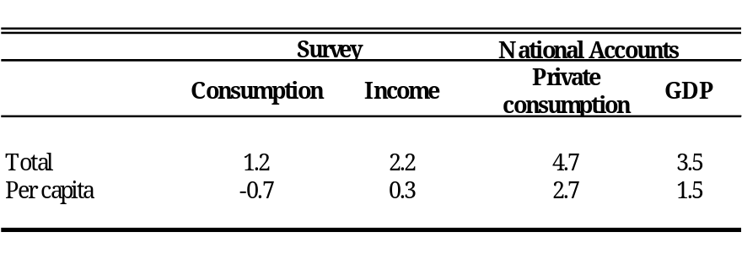
Source: National Accounts, Contraloria General de la Republica de Panama.
Note: Own estimate based on ENV 1997 and 2003 data.

  - NAS and survey-based measures may differ for a variety of reasons. Across countries, it is often the case that household survey-based measures of consumption and income differ greatly from measures based on the National Accounts (see Figure A1.1.2 in Annex 1.1). Reasons for differences include underestimation of consumption/income in the household survey, measurement error in the National Accounts, and differences in coverage and accounting practices between the two sources. On the whole, these factors are likely to result in downward biases in survey measures and upwards biases in national accounts. Deaton (2005) found that consumption measured from household surveys grows less rapidly than consumption measured in national accounts, both in the world as a whole and in large countries.
Box 1.1 Measuring Welfare in Panama
The welfare measure used in Panama and throughout this study is per capita consumption. Consumption is preferred over income as a measure of household welfare for several reasons. First, consumption tends to be less variable than income over the course of time (due to consumption smoothing) and thus provides a better measure of long-term welfare. Second, household surveys in developing countries typically measure consumption more accurately than income. Third, consumption of the household’s own production, which is often a large portion of consumption for agricultural households, is usually not captured well (if at all) in income data. Ignoring home-produced food would greatly understate the consumption levels of rural households.
In this report, consumption includes; (i) the value of all food consumption, whether the food is purchased, home produced or received as a gift or donation; (ii) the use value of durable goods, (iii) the use value of housing, (iv) expenditures on utilities, (v) expenditures for education, (vi) health expenditures, and (vii) expenditures on other consumption items and services. Total household consumption is divided by the number of household members to provide the per capita consumption measure of welfare. This measure is then adjusted for spatial cost of living differences by region to ensure comparability of the measure across the country.
Poverty is defined as having per capita consumption below the poverty line, while extreme poverty or food poverty is defined as having per capital consumption below the level of the extreme poverty line. For 1997 the extreme poverty line was set to B.\519 per capita per year, while the poverty line was set to B.\905 per capita. For 2003, these values were set to B.\534 and B.\953, respectively.
The extreme poverty line is set at the cost of obtaining the minimum requirement of calories in a form that is acceptable to local tastes and preferences. To calculate this poverty line, the first step was to determine the food consumption patterns of the population, specifically those in the 11-39th percentile who are expected to seek out a relatively inexpensive diet (compared to those in higher percentiles) but who are also not so constrained that their diet does not reflect preferences (as the diet of those in the bottom decile might). This ‘food basket’ is then analyzed for caloric content and adjusted to ensure that the minimum daily requirements of calories are obtained. Finally, the resulting basket is costed using price data from the household survey. The general poverty line is simply the extreme line plus an allowance for non-food consumption. This allowance is calculated by, first, determining the share of total consumption devoted to non-food consumption among those whose total consumption is at or near the extreme poverty line. This percentage is added to the value of the food poverty line.
Several efforts were made to ensure the comparability of the poverty estimates between 1997 and 2003. First, the questions on consumption were kept the same in the two rounds of the survey. The consumption aggregate was also constructed in the same way, with only minor changes that reflected new items having come on the market in Panama since 1997. The same poverty lines from 1997 were used in 2003 updated for changes in prices. For the extreme poverty line, the same basket of food items was used, but costed using 2003, not 1997, prices. For the general poverty line, the non-food component was inflated using the regional consumer prices indices of the country given the difficulty of calculating this from the household survey data itself. In short, the comparison of poverty rates between the two surveys can be correctly done given the way in which both the welfare measure was constructed and the poverty lines were updated.
For a much more detailed description of the methods used to construct the welfare measure and the poverty lines, see Pobreza y Desigualdad en Panamá: La equidad-Un reto impostergable, Ministerio de Economía y Finanzaz, Dirección de Políticas Sociales, Ciudad de Panamá, 2005 and Panama: Poverty Assessment: Priorities and Strategies for Poverty Reduction, World Bank, Human Development Department, Latin America and the Caribbean Region, Washington D.C. 1999.
  - The survey-NAS differences in Panama are in line with the general pattern internationally: the growth rates of the NAS measures are higher than those of survey-based measures. Furthermore, as Figure A1.1.2 in the Annex shows the differences in growth rates between the NAS and household survey measures are typically greater for other countries in the LAC region. Detailed analysis of the possible factors behind these differences (shown in Annex 1.2) suggests that changes in non-response by rich households probably do not explain the divergence between the survey and the NAS. A comparison of growth rates by sector suggests that differences between GDP growth rates and survey income growth may be attributable to differences in particular sectors. Unfortunately, as with similar cases in other countries, we are left with an incomplete understanding of NAS-survey differences. As Ravallion (2003) notes, “When the levels or growth rates from these two data sources differ, there can be no presumption that the NAS is right and the surveys are wrong, or vice versa, since they are not really measuring the same thing and both are prone to errors.”
  - We also consider the difference between the growth rates of consumption and income within the survey (see Annex 1.2 for detailed analysis.) Our analysis shows that the divergence between income and consumption in the survey is not explained by changes among households in any particular sector nor those with particular characteristics. Rather, the decline in consumption relative to income was a generalized phenomenon and not specific to any particular sector. This may either reflect an overall increase in savings or general errors in either the income or the consumption term.

Trends in Poverty, Growth, and Inequality

Poverty Trends
  - Figure 1.1 shows headcount poverty rates for 1997 and 2003, using both the moderate and the extreme poverty lines for 1997 and 2003. For the nation as whole, the fraction of the population living below the moderate poverty line was nearly unchanged, dropping from 37.3 percent to 36.8. The extreme poverty rate had a slightly larger fall, dropping from 18.8 to 16.6 percent.
  - Regionally, the country shows markedly different patterns of poverty change. Urban areas, which traditionally have had the lowest poverty rates, saw a marked increase in both poverty and extreme poverty between 1997 and 2003, with poverty rates jumping from 15.3 to 20.0 percent. At the same time, rural Panama experienced a substantial drop in both poverty and extreme poverty. The percentage of rural residents living in extreme poverty plunged from 27.4 to 22.0 percent. The already abysmally high poverty rate for Panamanians living in indigenous areas increased further. Essentially all (98.4 percent) of those living in indigenous areas now live in poverty, and 90.0 percent live in extreme poverty.
Figure 1.1: Poverty Measures by Area –Headcount Ratio
(i) Poverty | (ii) Extreme poverty
 | 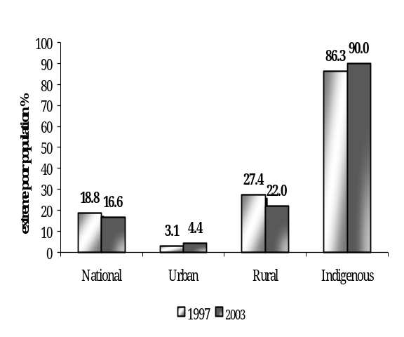
Note: Extreme poor refers to the population with per capita consumption below the extreme poverty line value. Moderate poor refers to the population with per capita consumption below the poverty line value.
Source: Own estimate based on ENV 1997 and 2003 data.

Who are the neediest in Panama?
  - Because of the very high rate of extreme poverty in indigenous areas, a large fraction of the country’s extreme poor are located there even though they account for just 8 percent of the overall population. As Table 1.2 shows, 42 percent of the nation’s extreme poor live in indigenous zones. Rural areas, while home to a much larger share of the population, are where another 42 percent of the extreme poor reside.
  - More importantly, however, is to note that the vast majority of indigenous area residents consume much less than the urban and rural non-indigenous extreme poor. As a consequence, poverty measures which are sensitive to the level of consumption—namely the poverty gap index and the poverty severity index—show an even greater contrast between indigenous areas and the rest of the country. In a decomposition of national poverty by area, indigenous areas account for 58 percent of the national poverty gap and 68 percent of the poverty severity index.
  - To help one visualize the depth and severity of poverty among the indigenous, Figure 1.2 plots the distribution of monthly per capita consumption for all extreme poor population. That is, the distribution of all the population exhibiting monthly consumption below B.\ 44 per capita, the monthly extreme poverty line in 2003 (i.e., B.\534 divided by 12). As it can be seen, while the consumption per capita of the median urban extreme poor is B.\8 below the extreme poverty line, the distance of the median rural extreme poor is 50% larger (i.e., they consume B.\12 below the poverty line). More strikingly, however, for the median indigenous the distance is 200% larger when compared to the urban extreme poor, and 100% larger when compared to the rural non-indigenous (i.e., they consume B.\24 below the poverty line).
Table 1.2 Who Are the Extreme Poor in 2003?
Extreme Poverty Rates and Contributions to National Extreme Poverty by Geographic Area
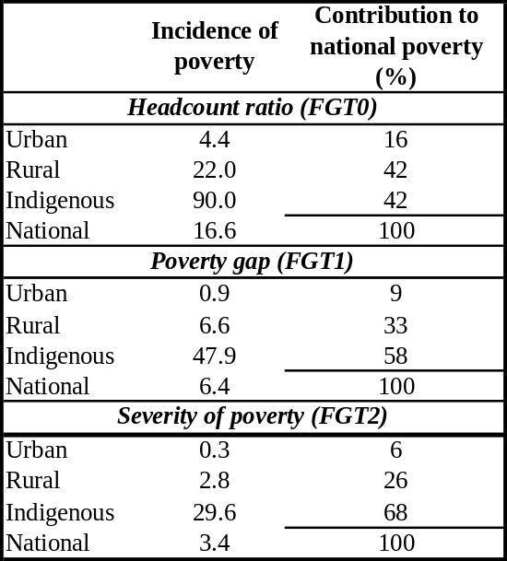
Source: Own estimate based on ENV 1997 and 2003 data.
Note: Extreme poor refers to the population with per capita consumption below the extreme poverty line value.

  - As Figure 1.2 helps us visualize, future consumption growth without redistribution among the extreme poor is likely to result in an increasing contribution of the indigenous to extreme poverty. To see this, note that consumption growth without redistribution can be seen as a movement to the right of the whole distribution in Figure 1.2. As this happens, it is straightforward to see that extreme poverty will become more and more of an indigenous problem. This implies that, to be effective, future poverty reduction policies will have to increasingly target the indigenous.

Figure 1.2: Distribution of monthly per capita consumption of the extreme poor
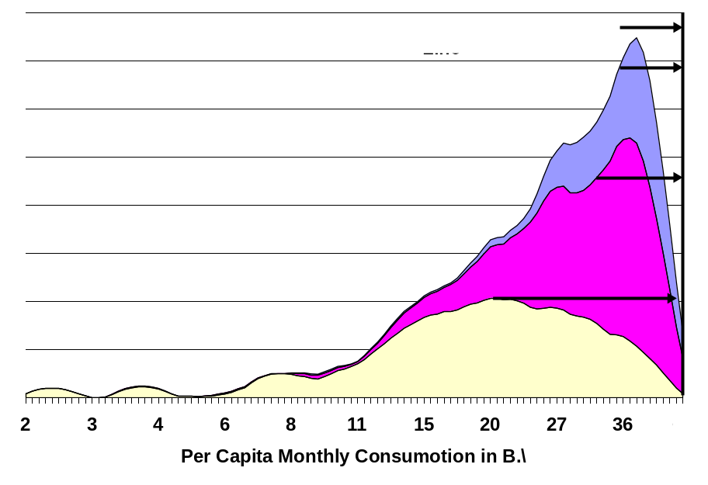
Source: Own estimate based on ENV 2003 data.

Inequality Trends
  - Changes in poverty presented above were accompanied by parallel changes in inequality. Figure 1.3 shows changes in the Gini coefficient, while Table 1.3 displays estimates for a variety of inequality measurements. Patterns are similar for all inequality indicators.
Figure 1.3: Gini Coefficient for Consumption
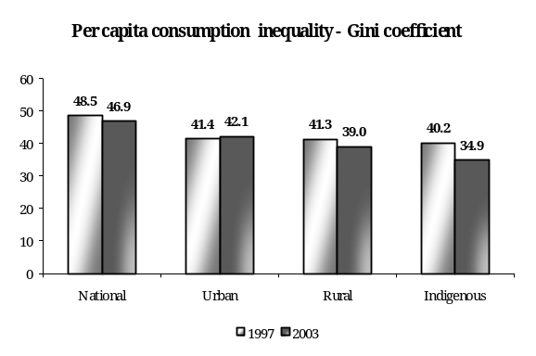
Source: Own estimate based on ENV 1997 and 2003 data. Note: Figures are calculated for individuals, based on per capita household consumption levels.

  - Nationally, inequality declined between 1997 and 2003. The Gini coefficient dropped from 48.5 to 46.9. Regionally, inequality increased slightly within urban areas, fell in rural areas, and fell substantially in indigenous areas. As discussed in more detail below, it seems that a drop in agriculture labor income for the rural non-indigenous and the indigenous, and a concurrent increase in rural-urban migration, have together led to compression in welfare in indigenous areas (with the poorest staying behind), and the alleviation of poverty in rural non-indigenous areas (with the poorest leaving the non-indigenous rural areas to urban centers).

Table 1.3: Inequality Measures of Per Capita Consumption by Area
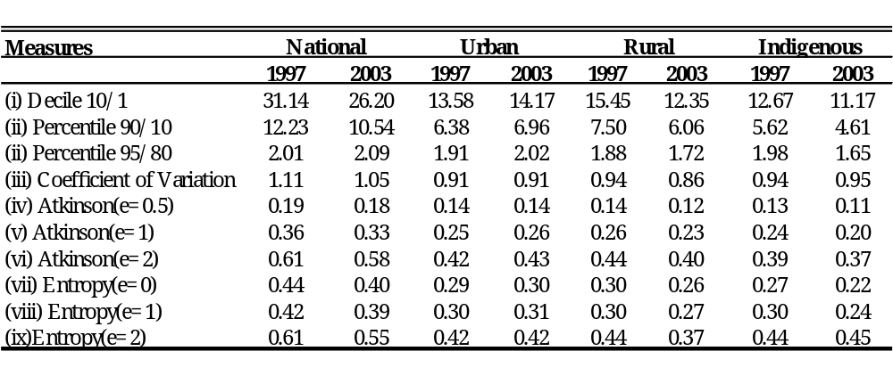
Note 1: Inequality figures are calculated for individuals.
Note 2: (i)=consumption ratio between deciles 10 and 1; (ii)=consumption ratio between percentiles 90 and 10; (iii)=consumption ratio between percentiles 95 and 80; (iv, v and vi) Atkinson(ε) refers to the Atkinson index with parameter ε; (vii, viii and ix) Entropy(ε) refers to the Generalized Entropy index with parameter ε. Entropy(1)=Theil index.
Source: Own estimate based on ENV 1997 and 2003 data.

Changes in Poverty and Inequality: Decomposition Analysis
  - In this section, we examine the nature of changes in poverty, decomposing the changes by various components. Because the changes in overall poverty are small, we focus our analysis on the more substantial drop in extreme poverty.

Decomposition Analysis of Growth and Inequality
  - A useful way to examine the impact of growth on poverty is to decompose the change in the headcount rate into changes due to consumption growth and changes in inequality. We report the results from these decompositions for extreme poverty in Panama are shown in Table 1.4.
  - As it can be seen, at the national level, the small drop in extreme poverty is due almost entirely to changes in the distribution. That is, despite negative average consumption growth, the distribution of consumption per capita shifted in favor of the poorest resulting in a slight drop in extreme poverty.
Table 1.4: Growth and Inequality Extreme Poverty Decomposition by Area
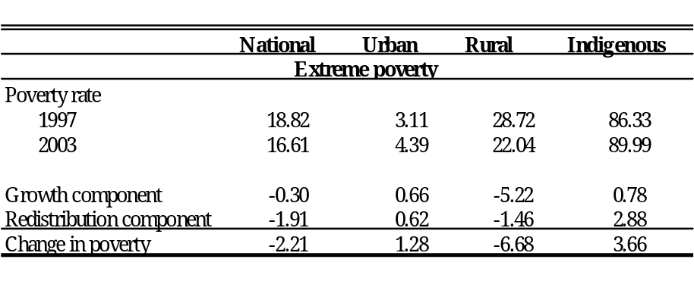
Note: Decompositions were calculated using the approach of Datt and Ravallion (1992)
Source: Own estimate based on ENV 1997 and 2003 data
Box 1.2: Understanding the Evolution of Rural Poverty in Panama

There is a considerable duality between the indigenous and the non-indigenous areas in rural Panama. With a fourth of the per capita income of the non-indigenous, poverty is twice as high in indigenous areas. Levels of malnutrition and illnesses are also substantially higher in indigenous areas, and schooling levels are significantly lower.

A study prepared by the United Nations Development Program (UNDP) and the Brazilian National Institute for research in Applied Economics (IPEA) examined the main sources of this duality. The main findings of the study are the following.

Between 1997 and 2003, poverty increased in indigenous and decreased in non-indigenous areas. Inequality, however, decreased significantly in both areas. This drop in inequality contributed to the reduction in extreme poverty in non-indigenous areas, but did not improve poverty in indigenous areas. The drop in inequality was so strong in both areas, that even with the increased disparities between both areas, overall rural inequality decreased.

The factors behind the changes in poverty in both indigenous and non-indigenous areas were the same: non-labor income, and non-agricultural labor income. However, these factors affected the indigenous and non-indigenous in opposite ways.

The analysis indicates that the increase in poverty in indigenous areas was mostly caused by a sharp drop in both non-labor and non-agricultural labor income. Both dropped by approximately 20 percent between 1997 and 2003. For non-indigenous areas, however, the same two factors were responsible three fourths of the drop in extreme poverty. Non-labor and non-agricultural labor income increase by more than 20 percent in the non-indigenous rural areas.

While agricultural labor income cannot explain the changes in rural poverty, it does explain most of the changes in inequality within indigenous and non-indigenous rural areas. It seems that the productivity of the high wage agricultural jobs has declined, while the productivity of the low wage jobs has increased. While more research is needed, anecdotal evidence suggest that some large agribusiness have left the sector, which could explain the drop in productivity of the higher wage jobs in rural areas. Also, the increase in rural to urban migration may be a sign that those earning low wages in rural areas have decided to leave to the city, which could explain some of the increase in the productivity of the low wage jobs in rural areas.

  - For urban areas, one the other hand, the small increase in extreme poverty can be equally attributed to distributional changes against the poor and negative consumption. In rural areas, however, the large drop in poverty can be mostly attributed to consumption growth.
  - For the indigenous comarcas, the decomposition tells a different and puzzling story. Despite the fact that average consumption dropped between 1997 and 2003 in the comarcas, our results indicates that most of the observed increase in extreme poverty was due to the drop in inequality. That is, there has been a drop in the dispersion and a shift downwards of the consumption distribution of the indigenous. This is likely a result of migration of the few top earners out of the comarcas.

Regional Decomposition of Changes in Poverty
  - Another way of breaking down the overall change in national extreme poverty rates over time is by considering the contribution of changes in poverty in each region. Such a decomposition attributes the national level change to 1) changes in poverty within the urban/rural/indigenous regions, 2) changes in poverty due to changes in the population shares of the regions, or population-shift effects, and 3) and an interaction effect. Results from this decomposition are shown in Table 1.5. They show that most of the drop at the national extreme poverty was caused by a decline in poverty in rural areas.
Table 1.5: Regional Decomposition of the Change in Extreme Poverty by Area
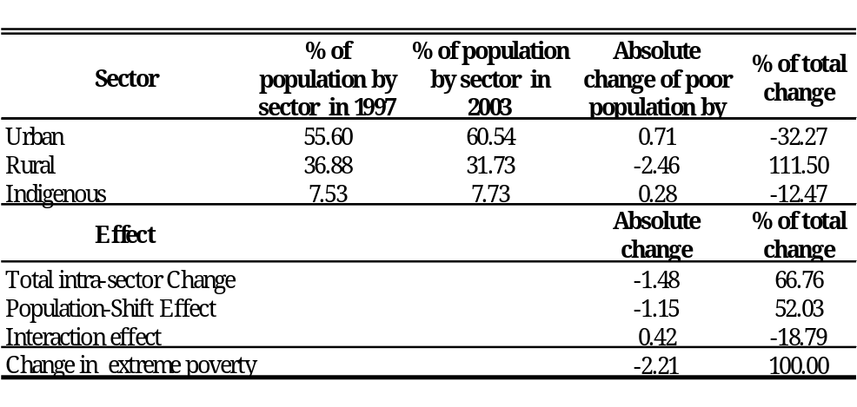
Source: Own estimate based on ENV 1997 and 2003 data
  - The results above suggest that rural-urban migration may have been a major factor in bringing down extreme poverty in rural areas and up in urban areas. We explore the plausibility of this hypothesis further by looking at migration data in both the 1997 and 2003 ENV surveys. Indeed, as shown in Figure 1.4, the flow of rural-urban migrants seems to have increased. As it can be seen, the fraction of urban residents that had lived in rural areas five years before the survey increased by 66 percent between 1997 and 2003, from 1.3 to 2.2 percent of all urban residents. On the other hand, the fraction of rural residents that were living in urban areas 5 years before the survey stayed the same at 1.7 percent. This suggests a significant increase in the flow of rural residents to urban areas.
Figure 1.4: Urban and Rural Migration
Population Aged 10 and Older
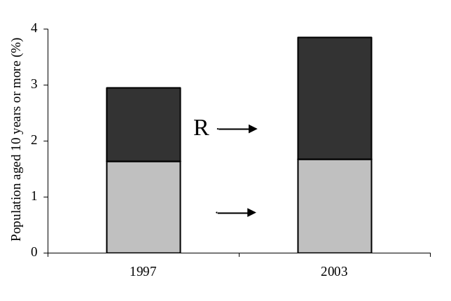
Source: Own estimate based on ENV 1997 and 2003 data.
Note: The definition used for migrant is by place of residency 5 years ago.

Poverty Reduction Through 2015
  - This section considers the prospects for extreme poverty reduction through 2015, under various growth and inequality scenarios by simulating changes in consumption. We project forward year-by-year changes in poverty by applying various growth rate assumptions to the consumption data in the household survey. The simulated changes are for per capita consumption. Panel (i) of Figure 1.5 shows the poverty impact of annual growth rates of 1, 2 and 3 percent, assuming that inequality remains unchanged. Panel (ii) shows the simulated impact on poverty using the same growth rates but assuming that inequality, as measure by the Gini coefficient, declines by 1 percentage point (from 0.42 in 2003 to 0.41 in 2015).
  - With no change in inequality, rapid growth will be required to substantially bring down the extreme poverty rate. With consumption growth of 1 percent per year and constant inequality, the extreme poverty headcount will drop only slightly, from 16.6% in 2003 to 13.8% in 2015. Under a much more optimistic scenario of 3 percent annual growth, the extreme poverty headcount will drop to 9.7% by 2015. A drop in inequality of 1 percentage point would reduce extreme poverty further. With a 1 percent growth rate and a 1 percentage point drop in inequality, the national extreme poverty rate would fall to 12.7% in 2015.
Figure 1.5: Extreme Poverty Impact of Different Growth Scenarios – Exercise 1
(i) Simulated changes in extreme poverty using three different growth scenarios with no associated changes in inequality | (ii) Simulated changes in extreme poverty using three different growth scenarios with an associated decrease in inequality of 1 percent between 2003 and 2015
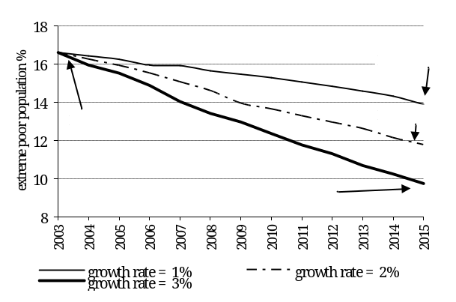 | 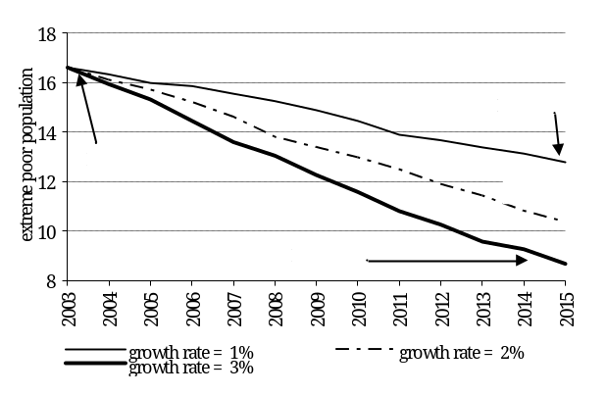
Source: Own estimate based on ENV 1997 and 2003 data.

  - We can summarize the potential poverty reduction of various combinations of growth and inequality changes using iso-poverty curves. Each curve of the Figure 1.6 depicts combinations of Gini coefficients and growth rates that yield a constant poverty headcount in 2015. To reach a certain level of extreme poverty in 2015, higher growth is necessary when inequality increases. For example, if the Gini coefficient were to rise to 49, Panama would need to generate an annual per capita consumption growth rate of 6% through 2015 to reduce poverty to half of its 2003 level.
Figure 1.6: Extreme Poverty Impact of Different Growth Scenarios – Exercise 2
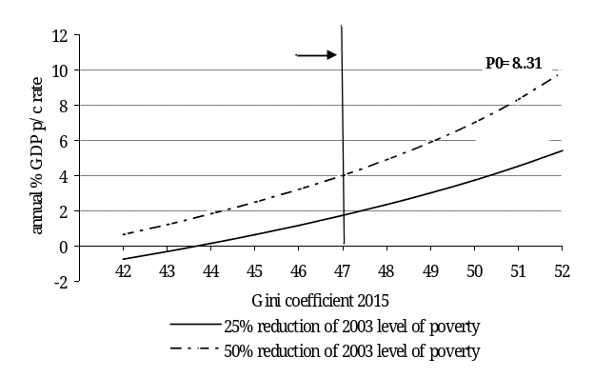
Source: Own estimate based on ENV 1997 and 2003 data.

Final Comments
  - This chapter has examined the evolution of poverty, growth, and inequality in Panama over the period 1997-2003 and considered various scenarios for poverty reduction through 2015. As in many countries, the growth rate of GDP in Panama diverges substantially from the growth rate of consumption in household surveys. Unfortunately, there is no clear explanation for these differences. The pattern in Panama is similar to that observed in other countries and in line with the known tendency of GDP growth rates to be biased upwards and survey-based consumption growth rates to be biased downwards. Our empirical analysis suggests that the differences are probably not due to changes in survey coverage of wealthy households. The alternative explanation is that the differences are due to a combination of errors and differing coverage between the National Accounts and the survey data. A comparison of GDP growth with survey income growth shows that the main sources of growth for the two measures differ substantially also. Unfortunately, it is not possible to judge which measure is more correct. The remainder of the growth and poverty analysis focuses on growth of consumption in the household survey.
  - Overall, the survey data shows a mixed pattern. Consumption growth in rural areas led to a significant decline in rural extreme poverty. On the other hand a drop in consumption and a worsening of inequality in urban areas led to a increase in urban extreme poverty. In indigenous areas both a drop in consumption and a decrease in inequality resulted in a significant increase in extreme poverty. For the country as a whole, the result was a small drop in extreme poverty and drop in inequality, as the gap between rural and urban areas declined. Part of the decline in extreme poverty was due to the shift of population from rural areas to urban areas.
  - In terms of policy, the results in this chapter point to one clear conclusion: because extreme poverty is so highly concentrated in indigenous areas, and because the indigenous are so far below the extreme poverty line, it is vital to target future anti-poverty policies and programs to the indigenous comarcas. Our results also show that the indigenous are less likely to benefit from economic growth and therefore will tend to contribute more and more to extreme poverty.. Rural areas, which witnessed substantial declines in poverty 1997-2003, but are still home to large numbers of the poor, should be the secondary focus of anti-poverty programs.

Human Capital, Employment and Earnings

Introduction
  - The source of a nation’s wealth is the skill and labor power of its people. Growth in the quality of the work force has been the main source of productivity growth and economic mobility in OECD countries in the past century. Therefore, public investment in health and education are key components of both growth and poverty reduction strategies.
  - Panama’s underperformance in poverty and inequality reduction, however, cannot be attributed to the lack of social spending, particularly in health and education. The country spends more than 18% of its GDP in the social sector. This level of social spending is substantially higher than the average in Latin America (14%) and matches Costa Rica, 18%, a country known for its considerable investment in social programs. In fact, if the amount currently spent on social programs were to be distributed in cash to the whole population, no one in Panama would live with less than $2.4 dollars a day, that is, poverty would be completely eradicated. Thus, if Panama is to compete with other middle income countries and to converge to rich countries in terms of the welfare of its people, it will have to become considerably more efficient on its hefty investments in the education and health of its population.
  - The purpose this chapter is to examine the evolution of health and education indicators between 1997 and 2003 in Panama. Previous analysis in Panama (World Bank 2000) depicted a country with a large degree of inequality in individual’s access to public services, depending on their geographic location or welfare status. To what extent has this changed? Clearly, understanding the changes that have occurred is the first step to identifying means to further improve existing policy and the nation’s pace of human capital accumulation.
  - The chapter is organized as follows: In the next section we examine education. We look at changes in educational outcome indicators, and changes in disparities in access between the poor and the non-poor. We conclude that while educational outcome indicators have substantially improved in Panama, striking inequalities still persist between the poor and the non-poor, and especially between the indigenous and the non-indigenous.
  - In the following section, we look at changes in health outcomes, and disparities between the poor and the non-poor. Health indicators have not changed significantly, despite substantial increases in spending and in the supply of health care services. Inequities in access to services between wealth and ethnic lines also remain largely unchanged.
  - We find the following:
    - Panama should continue to be one of the countries in LAC with the highest qualified labor force, as the stock of human capital has been growing consistently generation after generation, and given the tremendous investments being made in the expansion of basic education it should continue to grow in the future.
    - Disparities between the rate of human capital accumulation between the indigenous and the non-indigenous are striking. While rural workers have been converging to their urban peers, in terms of average years of schooling and primary and secondary completion rates, the indigenous are lagging further and further behind.
    - Stunting in indigenous communities reach levels comparable to countries like Burundi and Ethiopia, which have less than one-tenth the per capita GDP of Panama. A concerted effort to eradicate chronic malnutrition will therefore be required to ensure that schooling investments do pay off in indigenous areas.
    - Finally, despite being by far the biggest spender in health in Latin America, Panama’s health outcomes are incredibly weak. It lags behind other countries with similar per capita incomes in several important health indicators, including infant mortality, maternal mortality rate, and malnutrition. The declining coverage of immunization among the poor and the extreme poor is of particular concern. Deficiencies in the quality, efficiency and equity of public spending on health have led to such poor outcomes despite the country being well endowed with human and physical capital in the health sector.

Education
  - The formal education system in Panama consists of basic education, secondary and higher education. Basic education is free and compulsory and comprises two years of pre-primary, six years of primary (grades 1-6) and three years of lower secondary education (grades 7-9). Upper secondary education is also free and consists of three years of studies in diversified careers for those that want to proceed to higher education or to enter the labor market. Primary education consists of six grades and currently serves 430,000 students. Ninety percent of these students are in public schools. Of the total number of students in public schools, two-thirds are in single-grade schools and the other third (103,230) in multi-grade schools. The latter modality is offered mostly in rural and indigenous areas.

The Accumulation of Educational Stock Overtime: the Indigenous are Lagging More and More Behind
  - Panama is one of the countries with the highest stock of educated workers in LAC. About 92 percent of its adult population is able to read, and approximately 60 percent of them have had some secondary education. In Mesoamerica, only Costa Rica has better literacy rates, and no other country has higher net enrollment rates in secondary school. Relatively few people in the country have no schooling at all.
  - Average schooling has increased dramatically in Panama across generations. As seen in Figure 2.1, while adults born in the 1930s exhibit in average 5 years of schooling, those born in the 1980s and entering the labor force today have accumulated twice as much schooling in average (10.5 years). For urban dwellers, the average years of schooling has more than doubled between the 1930s and 1980s cohorts. Young adults in urban areas today have in average close to 12 years of schooling.
  - While rural adults still have significantly less schooling than their urban peers, they seem to be catching up. For those born in the 1930s, the average years of schooling is less than half of their in urban peers. But for younger adults, born in the 1980s, average schooling is now closer to 75 percent of the urban average.
  - The average level of education for adults living in indigenous Comarcas has also been increasing, but at a significantly lower pace. As seen in Figure 2.1, while the average schooling of adults in rural and urban areas have converged closer to the national average, average schooling for the indigenous seems to be lagging behind. This suggests that that educational programs targeted to the indigenous areas will be needed if schooling levels of indigenous peoples are to converge to the national average.
Figure 2.1: Average years of schooling by year of birth
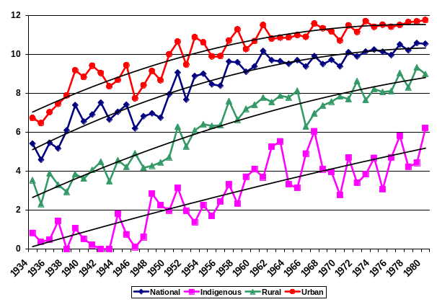
Source: World Bank staff calculation based on the 2003 ENV

  - The growing inequity in education between the indigenous and the non-indigenous are also evident for primary and secondary school completion rates. As shown in Figure 2.2, while primary completion rates for new entrants to the labor force in urban and rural areas is approaching universality, less than half of the indigenous young adults have completed primary school.
Figure 2.2: Percentage that Completed Primary School by Year of Birth
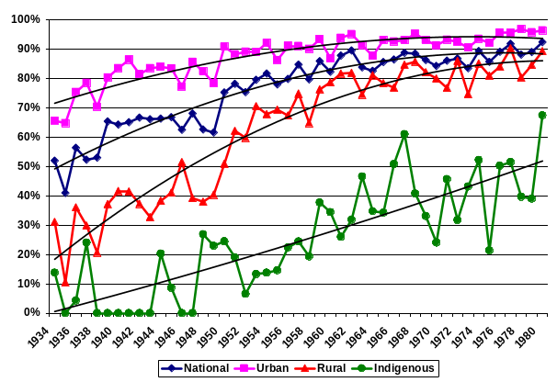
Source: World Bank staff calculation based on 2003 ENV

  - This inequality is even more striking for secondary completion rates (Figure 2.3). While respectively 60 and 35 percent of new urban and rural adults have completed secondary school, only 10 percent of the indigenous in the same cohort have similar levels of schooling.
Figure 2.3: Percentage that Completed Secondary School by year of Birth
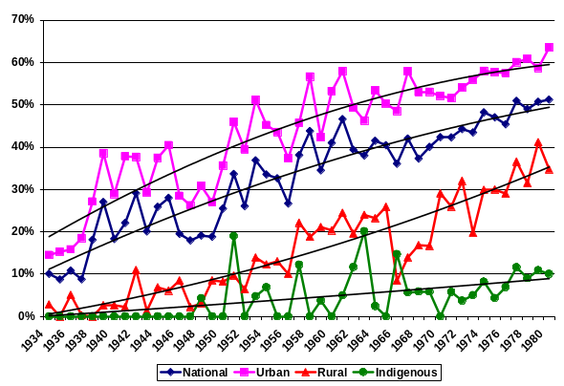
Source: World Bank staff calculation based on 2003 ENV

Educational Services: Changes in Coverage and Supply
  - Because the share and the numbers of children attending all levels of schooling have increased considerably in recent years, human capital accumulation in Panama should continue to improve significantly in the foreseeable future. Panama has also increased its investment in early childhood education considerably. Between 1996 and 2004 pre-school enrollments have risen by over 144 percent. Primary and secondary enrollments gains were substantially smaller in relative terms (14.8 and 17.8 respectively).

Figure 2.4: Enrollment Numbers by Level of Schooling, 1996-2005

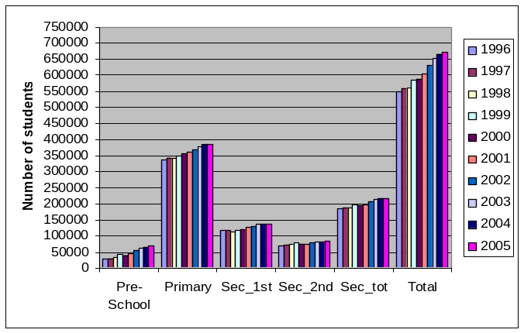
Source: Ministry of Education data bases, calculations by authors.
Note: Pre-school here includes all levels, not just kindergarten. Sec_1st refers to ciclo basico of secondary; sec_2nd refers to the last three years of secondary education, or, in present terms now that ciclo basico is part of primary, to secondary.

  - Even more remarkable is the fact that changes in enrollment have benefited the poor more than the non-poor. As shown in Table 2.1, enrollments rates for all levels have increased between 1997 and 2003. For pre-school, the increase, in relative terms, has been the greatest among the extreme poor for whom enrollments rates have increased almost four-fold. For all poor, enrollments rates have more than doubled in pre-school between during the same period.
  - While primary enrollments rates have also increased among the poor, among the extreme poor enrollment rates are still below 90 percent. This is mostly due to the fact that indigenous children are lagging behind. If a concerted effort to substantially increase the supply of education in indigenous areas is not undertaken, Panama will not be able to ensure primary education to all its population, and sharp inequities will persist between the indigenous and non-indigenous population in the country.
  - At the secondary level, however, improvements in enrollment have not been as dramatic. Nevertheless, they have happened in the groups with the lowest initial conditions, i.e., the extreme poor and the poor in general. Secondary enrollment rates for the extreme poor increased by more that 12 percentage points between 1997 and 2003. For the poor overall, the increase was of 13 percentage points.
Table 2.1: Net Enrollment Rates by Level, 1997 and 2003
 | National |  |  | Non-Poor |  |  | All Poor |  |  | Extreme Poor
 | 1997 | 2003 |  | 1997 | 2003 |  | 1997 | 2003 |  | 1997 | 2003
Pre-primary | 32.2 | 49.9 | ** | 47.4 | 60.4 | ** | 18.1 | 39.3 | ** | 9.2 | 35.6 | **
Primary | 92.1 | 93.9 | ** | 94.2 | 96.0 | ** | 89.8 | 91.7 | * | 87.3 | 87.7
Secondary | 62.1 | 69.8 | ** | 81.5 | 84.9 | ** | 37.1 | 50.1 | ** | 19.1 | 31.8 | **
Higher | 21.1 | 23.6 | * | 31.2 | 33.4 |  | 2.7 | 4.6 | ** | 0.8 | 2.2

Source: ENV 1997 and 2003, calculations by authors’.
** Significant at .01 level / * Significant at .05 level
  - Despite this recent progress, Panama has still a long way to go to ensure universal access to schooling to all its children. As can be seen in Figure 2.5, in spite of the strong improvements in average rates, enrollment for children eleven and older are still very low, especially for the poor. The graph shows clearly the tight correlation that exists between welfare status and school attendance. At age 11, the gap between the extreme poor and the non-poor is 6.6 percentage points. At age 12 the gap increases to 14.3 percentage points. By age 15 it reaches 49 percentage points. Low access to secondary school in rural and indigenous comarcas is likely to be behind these disparities between the poor and the non-poor.
  - The observed increase in overall enrollment rates in Panama between 1997 and 2003 seems to be associated to a concurrent widespread increase in the supply of school services offered (see Table 2.4). As a direct consequence to the 1995 educational reform, there has been a large increase in coverage of public pre-school education. , Between 1996 and 2005, pre-school enrollment rose by 144 percent, while the number of pre-school programs rose by more than 185 percent. During the same period the number of teachers in pre-school programs has more than quadrupled. Thus, while the coverage of pre-schools increased, the ratio of students to teacher dropped from an average of 39 children per teacher to 22.
Figure 2.5: Enrollment by Poverty Group
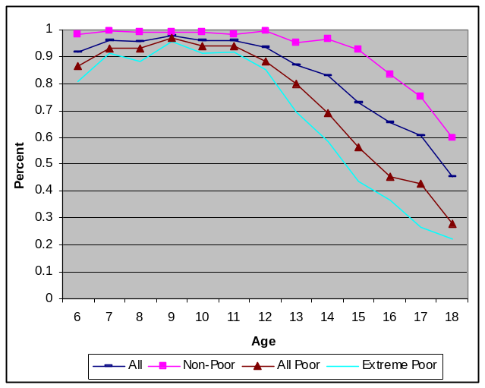
Source: ENV 2003, authors’ calculations.
  - Increased coverage at primary level, however, seems to have come from the combination of more efficient use of resources and expansion of the system. While student enrollments increased by approximately 15 percent, the number of school programs rose by only 10.5 percent. Thus, the number of students per primary school program increased slightly. But this increase in crowding is unlikely to have reduced the quality of teaching since the number of teachers has also increased, making student-teacher ratios slightly lower.
  - In contrast, secondary enrollment has risen more through the creation of new secondary services than by greater use of existing services or more educators. The rate of growth of secondary school services was more than twice as high the rate of growth in enrollment (56 and 20 percent, respectively). This led to a dramatic drop in the number of students per school service (down from 532 to 384). The number of teachers increased only slightly more than the number of students (25 percent) which led to a small decline in student-teacher ratios.
Table 2.2: Changes in Education Services, Teachers and Student Ratios, 1996 to 2005
 | Number of School Services |  |  |  | Average Students  Per School Service
Year | Pre-School | Primary | Secondary | Total | Pre school | Primary | Secondary
1996 | 742 | 2908 | 347 | 3997 | 38 | 115 | 532
1997 | 768 | 2927 | 355 | 4050 | 37 | 117 | 527
1998 | 1055 | 2924 | 363 | 4342 | 30 | 118 | 513
1999 | 1163 | 2937 | 383 | 4483 | 35 | 119 | 511
2000 | 1084 | 2995 | 390 | 4469 | 37 | 119 | 493
2001 | 1229 | 3048 | 401 | 4678 | 38 | 118 | 492
2002 | 1508 | 3120 | 417 | 5045 | 36 | 118 | 498
2003 | 1772 | 3157 | 467 | 5396 | 34 | 120 | 460
2004 | 2047 | 3214 | 516 | 5777 | 32 | 120 | 419
2005 | 2111 | 3213 | 566 | 5890 | 33 | 120 | 384
Percent Change
1996-2005 | 184.5 | 10.5 | 62.0 | 47.3 | -14 | 4 | n.a.
1996-2004 | 175.9 | 10.5 | 48.7 | 44.5 | -16 | 4 | 28
 | Number of Teachers |  |  |  | Average Number of  Students Per Teacher
 | Pre-School | Primary | Secondary | Total | Pre school | Primary | Secondary
1996 | 709 | n.a. | n.a. | n.a. | 39.6 | n.a. | n.a
1997 | 1164 | 13604 | n.a. | n.a. | 24.6 | 25.1 | n.a
1998 | 1356 | 13666 | 9906 | 24928 | 23.1 | 25.2 | 18.8
1999 | 1790 | 13699 | 10299 | 25788 | 22.7 | 25.5 | 19.0
2000 | 1794 | 13704 | 10397 | 25895 | 22.3 | 25.9 | 18.5
2001 | 2026 | 14271 | 10767 | 27064 | 23.1 | 25.3 | 18.3
2002 | 2450 | 14899 | 11178 | 28527 | 22.4 | 24.7 | 18.6
2003 | 2751 | 15305 | 11623 | 29679 | 22.2 | 24.7 | 18.5
2004 | 3089 | 15830 | 12011 | 30930 | 21.1 | 24.3 | 18.0
2005 | 3155 | 15636 | 12336 | 31127 | 21.8 | 24.6 | 17.6
Percent Change
1996-2005 | 345.0 | n.a. | n.a. | n.a. | -45.1 | n.a. | n.a.
1997-2005 | 171.0 | 14.9 | n.a. | n.a. | -46.6 | -2.0 | n.a.
1998-2005 | 132.7 | 14.4 | 24.5 | 24.9 | -5.9 | -2.0 | -6.2

Source: Data from the Ministry of Education, authors’ calculations

Note: School ‘services’ refers to the provision of services, not the actual number of physical structures. One school building may provide several different services (separate morning and afternoon primary school, pre-school in the primary school building, etc

Internal Efficiency: Repetition and Dropout
  - The substantial increase in enrollment in public primary and secondary schools could have been of concern if it had resulted in overcrowding and decreased internal efficiency. However, the internal efficiency of the school system does not seem to have suffered with the expansion of supply. In fact, repetition and drop out rates seemed to have dropped slightly or remained stable between 1997 and 2003. The analysis based on the 1997 and 2003 LSMS data suggests that there has been a decline in repetition rates for both primary and secondary students (see Table 2.3). For dropout rates, at the primary level the data suggest a drop, while at the secondary level there is no evidence of change.
Table 2.3: Repetition and Dropout Rates by Poverty, Geographic
Location and Gender, 1997-2003
Repetition rates
 | National |  |  | Non-Poor |  |  | All Poor |  |  | Extreme Poor
 | 1997 | 2003 |  | 1997 | 2003 |  | 1997 | 2003 |  | 1997 | 2003
Primary | 7.1 | 6.3 |  | 4.4 | 3.2 |  | 9.1 | 8.9 |  | 11.6 | 11.3
Secondary | 8.3 | 6.3 | ** | 8.4 | 6.2 | ** | 8.2 | 6.5 |  | 8.4 | 6.7
Dropout rates
 | National |  |  | Non-Poor |  |  | All Poor |  |  | Extreme Poor
 | 1997 | 2003 |  | 1997 | 2003 |  | 1997 | 2003 |  | 1997 | 2003
Primary | 4.8 | 3.2 | ** | 5.9 | 3.5 | ** | 3.9 | 2.8 |  | 4 | 3.1
Secondary | 5.1 | 5.9 |  | 5.5 | 5.7 |  | 4.2 | 6.4 |  | 4.7 | 6.3
Source: ENV 1997 and 2003, authors’ calculations
Notes: Rural includes all non-urban areas not including comarcas. Although the comarcas are largely rural they are analyzed separately.
* Differences significant at the .05 level.
** Differences significant at the .01 level

Health
  - Panama’s public health spending is significantly greater than most countries in the Latin America and Caribbean region with similar per capita income levels. During 1990-2003, the upper middle-income countries in LAC devoted an average of 3.1 percent of GDP to health spending, while Panama spent almost twice as much. Only Costa Rica comes close to Panama in terms of health spending, while Chile spends less than one-half as much.
  - Despite spending more on than any other LAC country, with the exception of Argentina, Panama performs worse than other middle income countries in the region in terms of infant, child and maternal mortality (Figure 2.6). Infant and child mortality have declined steadily since 1990, but this decline has not been as dramatic as in other middle-income countries. And if relative to the LAC average this may be explained by better initial indicators, relative to middle-income countries in LAC, Panama started off with worse rates. Moreover maternal mortality has risen substantially, from 55 in 1990 to 160 in 2000.
  - The problems in the health system are compounded, from an equity perspective, by the negative changes in the health status of the poor. The household survey data provide insights on the distribution of the effects of public spending on health. In the following sub-sections, we first look at data for children under six years of age, focusing on key indicators of vaccination, nutrition, and sickness (as reported by an adult caretaker). We then look more generally at the use of the health care system.
Figure 2.6: Key Health Indicators 1990-2003
Panel 1: Infant Mortality | Panel 2: Under 5 Mortality | Panel 3: Maternal Mortality
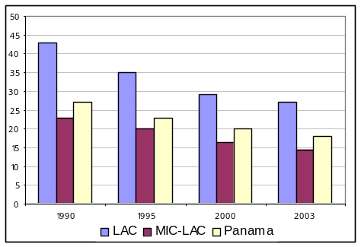 | 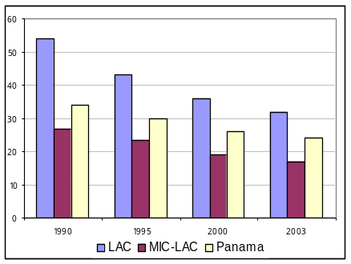 | 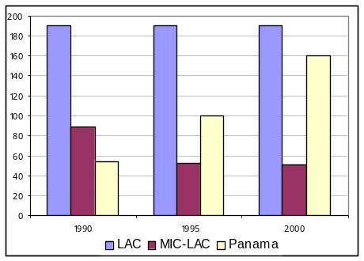
Source: UNICEF in ECLAC BADEINSO, authors’ calculations.
Note: Infant mortality is rate per 1000 live births as is under-five mortality. Maternal mortality is per 100,000 live births. LAC is an average of 33 countries in Latin American and the Caribbean (although in some years the number of countries varies). MIC-LAC is an average of six middle income countries in Latin America (Argentina, Chile, Costa Rica, Mexico, Uruguay and the BR of Venezuela).

Immunization
  - While immunization rates are quite high in Panama, they are still far from universal, especially among the poor and the extreme poor (Table 2.4). Moreover, this disparity is getting worst. Between 1997 and 2003, only the non-poor have experienced positive changes in immunization (Figure 2.7). For the extremely poor, except for BCG, all other immunization rates for children have declined substantially. This is particularly disturbing given the fact that immunization rates among children of non-poor families have improved substantially. This result points to the marked inequalities in access to basic health services still present in Panama.
Table 2.4: Vaccination Rates by Poverty, 2003 - (Ages 0 to 5)
 | Total | Non Poor | All Poor | Ext. Poor
Tuberculosis (BCG) | 93.6 | 97.0 | 90.7 | 87.2
Diptheria, Pertussis, Tetanus (DPT) | 92.1 | 96.1 | 88.7 | 85.7
Polio | 93.4 | 97.7 | 89.7 | 84.8
Measles | 78.6 | 83.6 | 74.3 | 71.1
Source: ENV-2003, Calculations by authors.
Note: Refers to children who have received at least one dosage of the vaccine.

Figure 2.7: Percentage Change in Vaccination Coverage by Poverty
(Children ages 0 to 5)
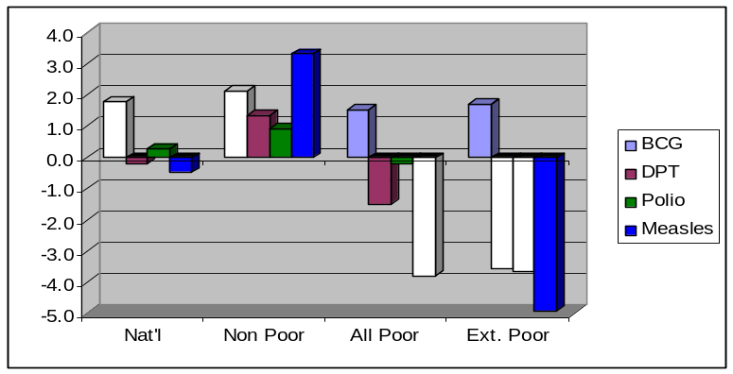
Source: ENV- 1997 and 2003, Calculations by authors.
Note: Refers to children who have received at least one dosage of the vaccine.
Striped bars indicate differences that are significant at the .01 level (with the exception of measles coverage among the poor where the striped bar indicates a difference that is statistically significant at the .05 level). Positive values indicate an increase in coverage, while negative ones indicate a decrease.

Malnutrition
  - Indicators of malnutrition provide a somewhat mixed picture of what has happened between 1997 and 2003 in Panama. The overall levels of malnutrition have remained high during the period. But chronic malnutrition seems to have increased by levels that suggest the occurrence of a natural disaster. In 2003, chronic malnutrition as measure by height for age z-scores was estimated to affect one-fifth of all children under five. However, in 1997 the estimated incidence of chronic malnutrition was only 14 percent (see Table 2.5). This finding has been questioned by observers in Panama and abroad because poverty has not increased accordingly, and other malnutrition indicators have remained unchanged. Moreover, chronic malnutrition appears to have increased equally across the consumption distribution, which is very counterintuitive.
  - It turns out that there are some discrepancies between different data sources. The best comparable source is the Censo de Talla (School Height Census). It tabulates the age and height of all children six years old up to ten years of age in primary school. The results from the last three school censuses are shown in Table 2.6. For 2000, the overall rate of chronic malnutrition is very similar to that of the 2003 ENV. However, the trend in chronic malnutrition shown in the Censo de Talla and the ENVs does not match. The ENV shows a rising rate while the Censo de Talla shows a slightly falling rate.
Table 2.5: Changes in Malnutrition Rates in Children 0-5
 | Chronic  (height for age) |  |  | Underweight  (weight for age) |  |  | Acute  (weight for height)
 | Mean 1997 | Mean 2003 | Diff. | Mean 1997 | Mean 2003 | Diff. | Mean 1997 | Mean 2003 | Diff.
National | 14.3 | 20.6 | -6.3** | 6.7 | 6.8 | -0.1 | 1.1 | 1.3 | -0.2
Urban | 5.7 | 13.8 | -8.1** | 2.8 | 4.1 | -1.3 | 0.9 | 1.3 | -0.4
Rural | 14.5 | 18.4 | -3.9** | 7.1 | 5.6 | 1.5 | 1.1 | 1.4 | -0.3
Comarca | 48.5 | 56.7 | -8.2** | 21.0 | 21.5 | -0.4 | 1.8 | 1.2 | 0.6
Q1 | 32.0 | 37.5 | -5.5** | 15.1 | 0.8 | 14.4 | 1.9 | -0.1 | 2.0
Q2 | 9.6 | 16.7 | -7.1** | 3.6 | 0.2 | 3.5 | 1.5 | -0.5 | 2.0
Q3 | 5.0 | 13.3 | -8.3** | 3.4 | -0.8 | 4.2 | 0.7 | -0.2 | 0.8
Q4 | 4.4 | 9.6 | -5.2** | 1.0 | -0.1 | 1.1 | 0.8 | -0.2 | 1.0
Q5 | 2.1 | 5.9 | -3.8* | 1.3 | -0.1 | 1.4 | 0.7 | -0.1 | 0.8
Source: ENV 1997 and 2003. Authors’ calculations.
Note: Q1 is the poorest consumption quintile while Q5 is the richest.
** Significant at .01 level
* Significant at l05 level

Table 2.6: Chronic Malnutrition among Children Aged 6-11
 | 1988 | 1994 | 2000
Chronic Malnutrition | 24.4 | 23.9 | 21.9
Moderate levels | 18.6 | 17.7 | 16.0
Severe levels | 5.8 | 6.2 | 5.9

  - One hypothesis offered to explain this discrepancy is that the 1997 indicator might have been badly constructed due to measurement errors in the field. Annex 2.1, examines this hypothesis carefully by looking at the malnutrition rates among children who were aged six to eleven at the time of the ENV-2003, i.e. children who are in the cohort that was in the 0 to 5 years of age range at the time of the ENV-1997. As discussed in the annex, at the national level the differences in chronic malnutrition in the age cohort are very small between the two points in time. However, when we look at the differences within specific subgroups (by geographic area) the differences are striking. Thus, assuming that the 2003 data is more reliable, we conclude that chronic malnutrition has remained high and stable in Panama, hurting especially the extreme poor. In fact, more than one-third of all children in the first consumption quintile suffer from chronic malnutrition, compared to less than six percent in the top quintile. In the indigenous Comarcas, where extreme poverty reached 90 percent in 2003, more than half of all children under five suffered from chronic malnutrition, and one-fifth are underweight. Again, a concerted effort is needed to address poverty and malnutrition in indigenous areas, perhaps via targeted conditional cash transfers which seem to have succeeded in reducing malnutrition in Mexico and Nicaragua.

Illnesses and Injuries
  - While the incidence of respiratory illnesses has increased among poor and the non poor children under five, the increase has been substantially higher for the poor and extremely poor (see Table 2.7 and Figure 2.8). On the other hand, the incidence of diarrhea has decreased substantially for the non-poor, and has increased significantly for the extreme poor. While the 1997 and 2003 surveys were not carried during the same period of the year (the 2003 survey was fielded a bit further into the rainy season), the differences are unlikely to be caused by seasonality.
Table 2.7: Incidence of Illness among 0 to 5 Year Olds, 2003
 | Total | Non Poor | All Poor | Extreme Poor
Diarrhea | 20.8 | 16.8 | 24.2 | 29.3
Respiratory Ailment | 45.4 | 44.8 | 46.0 | 46.7
Source: ENV 2003. Authors’ calculations

Figure 2.8: Changes in the Incidence of Diarrhea and Respiratory Illness
Among 0 to 5 year olds, 1997 to 2003
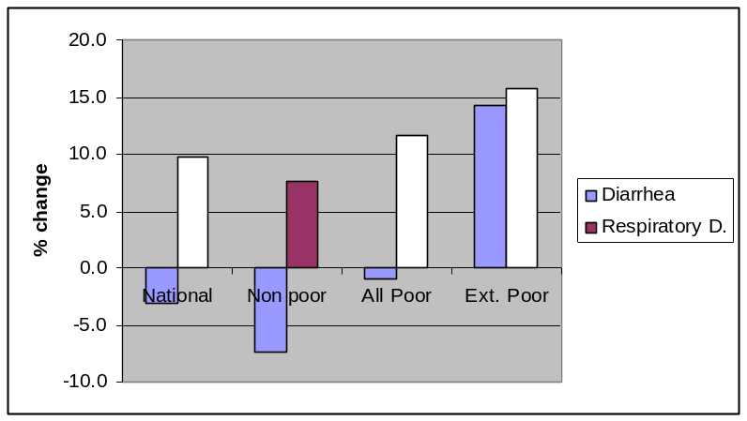
Source: ENV 2003. Authors’ calculations
Note: striped bars indicate changes that are statistically significant at the .01 level.

General Health: Incidence of Illnesses and Access to Health Care Services
  - As indicated in Table 2.8, there has been almost no change in the incidence of self-reported illnesses and injuries among the population older than six between 1997 an 2003. Moreover, while counterintuitive, the lower incidence among the poor and the extreme poor is typical to self-reported data, since the poor are less likely to visit health centers and be diagnosed. Interestingly, however, the change in the incidence of illnesses and injuries between the two surveys suggests a substantial improvement in health status of the whole population in Panama. On average, the incidence of illnesses and injuries fell by 13 percent overall, with the highest drop observed for the poor.
Table 2.8: Self-reported Illness and Injury in 2003
and Percent Change from 1997
 | National | Non poor | All Poor | Ext. Poor
Percent Sick | 28.4 | 29.3 | 26.6 | 25.4
Change from 1997 | -13.2** | -12.1** | -15.6** | -13.5**
Source: ENV 2003. Authors’ calculations
** Significant at the .01 level.

  - Among those who reported being ill or injured in the four weeks prior to the field interview and did not seek care cited high costs as the primary reason for not doing so. As expected, high costs are particularly constraining for the poor and the extreme poor (Table 2.9). For the poor, while considerations of health care quality were not important in 1997, in 2003 they have become considerably more critical of the services offered. For the non-poor, distance has become a more important reason for not seeking health cares in the last six years. For the poor, however, distance has become less important.
Table 2.9: Reasons for Not Seeking Health Care when Needed, 1997-2003
 | National | Non-Poor | All Poor | Ext. Poor
Percent
Distance | 12.7 | 9.8 | 14.5 | 20.9
Cost | 48.0 | 35.1 | 56.3 | 59.7
Quality | 7.0 | 8.6 | 5.9 | 5.9
Other | 32.4 | 46.5 | 23.3 | 13.5
% change 1997-2003
Distance | -7.2 | 161.4** | -25.5** | -20.1*
Cost | 2.8 | 38.0** | -4.8 | 0.6
Quality | 15.5 | -24.9 | 108.4** | 149.8**
Other | -3.8 | -21.7** | 25.7* | 10.9
Source: ENV-97 and 2003, authors’ calculations.
** significant at the .01 level
* significant at the .05 level

  - Also, poor and extreme poor families spend more time traveling to health facilities and waiting in line than non-poor families (Table 2.10). Thus, it is no surprise that the poor are less likely so seek health care when ill. These results indicate that better rural roads and increased public transportation could considerably improve access to health care by the poor.

Table 2.10: Time to Health Facility and Waiting in Health Facility, 2003
 | Total | Non Poor | All Poor | Ext. Poor
Average time to health facility | 30.2 | 24.8 | 36.2 | 45.2
Average wait in health facility | 71.9 | 67.9 | 82.4 | 81.3
Source: ENV 2003

  - Between 1997 and 2003 we observe a large shift on the sources of health care utilized by the population. As it can be seen in Figure 2.9, there has been a relative large increase in clinic and hospital use for all poverty groups. Even more puzzling is the fact that concurrently to this shift, there has been a substantial increase in the number of new primary health facilities available in the country (see Figure 2.9a).
Figure 2.9: Changes in Health Facility Use among Those
Who Sought Treatment, 1997-2003
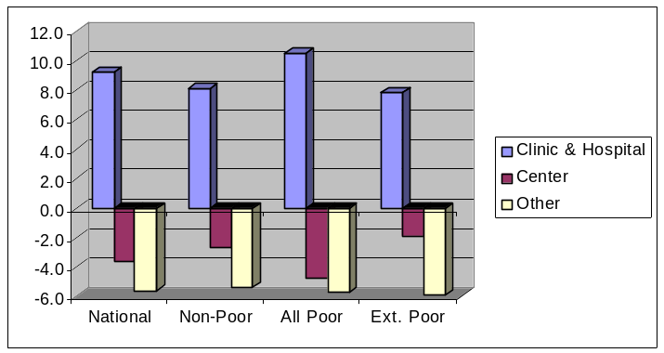
Source: ENV-97 and 2003, authors’ calculations.
Note: All changes are significant at the .01 level except the decrease in use of centers and ‘other’ facilities among the extreme poor: these changes are only significant at the .05 level.

Figure 2.9a: Number of Public Health Facilities by Type, 1994 to 2004
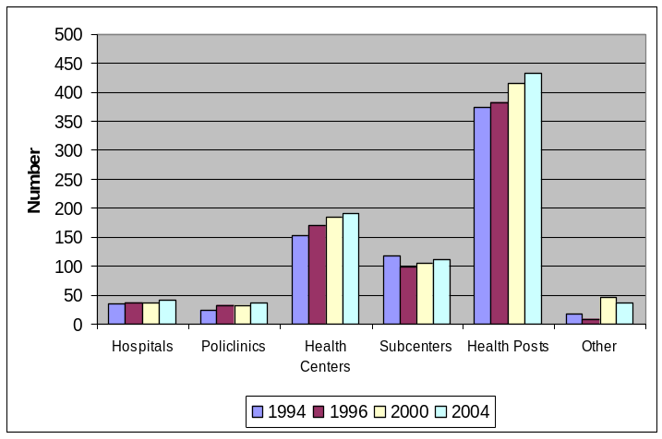
Source: Data from the Ministry of Health, authors’ calculations.

  - Figure 2.9b shows the distribution of public health facilities in the country in 2004. Each corregimiento is classified as (i) having no public health facility, (ii) having only primary level public health facilities (dispensaries, health posts, health sub-centers) and (iii) having higher levels of public health care (from health centers up to hospitals). As can be seen, very few areas have no services at all, and the higher levels of care are fairly well distributed throughout the country.
Figure 2.9b: Public Health Care Facilities by Corregimiento
NO FACILITIES PRIMARY FACILITIES ONLY > PRIMARY

Source: Ministry of Health, MEF, authors’ calculations.

Conclusion and Policy Implications
  - Our analysis of human capital accumulation and access to schooling in this chapter indicates that Panama should continue to be one of the countries in LAC with the highest qualified labor force. The stock of human capital has been growing consistently generation after generation, and given the tremendous investments being made in the expansion of basic education it should continue to grow in the future.
  - However, the disparities between the rate of human capital accumulation between the indigenous and the non-indigenous are striking. While rural workers have been converging to their urban peers, in terms of average years of schooling and primary and secondary completion rates, the indigenous are lagging further and further behind. A concerted effort to improve access to basic and secondary education by the indigenous people is likely needed if the country is to eradicate extreme poverty and reduce its high levels of inequality.
  - But more access to schools will not produce the expected outcomes if indigenous students continue to suffer from chronic malnutrition. Stunting in indigenous communities reach levels comparable to countries like Burundi and Ethiopia, which have less than one-tenth the per capita GDP of Panama. A parallel concerted effort to eradicate chronic malnutrition will therefore be required to ensure that schooling investments do pay off in terms of poverty reduction and growth.
  - Finally, despite being by far the biggest spender in health in Latin America, Panama’s health outcomes are incredibly weak. It lags behind other countries with similar per capita incomes in several important health indicators, including infant mortality, maternal mortality rate, and malnutrition. The declining coverage of immunization among the poor and the extreme poor is of particular concern. Deficiencies in the quality, efficiency and equity of public spending on health have led to such poor outcomes despite the country being well endowed with human and physical capital in the health sector. The sector needs a thorough rethinking, and clear incentives to improve performance and accountability must be introduced. Providers must receive incentives to deliver quality health services, and patients must have incentives to use resources in rational manner. Managers must be made accountable for results and the penalties and premia (incentives) should be made explicit and known to all in advance. Managers should be given the resources and independence in decision making to achieve the results. If manager are not empowered to make decisions on how to deploy the resources, particularly human resources, they cannot be made accountable for the results.

Social Protection in Panama

Introduction
  - Panama’s underperformance in poverty and inequality reduction cannot be attributed to the lack of social spending. The country spends more than 18% of its GDP in the social sector. This level of social spending is higher than the average in Latin America (14%) and matches Costa Rica, a country known for its considerable investment in social programs and for having achieved substantial poverty reduction in the past. In fact, if the overall amount currently spent on the social sectors were to be distributed in cash to the whole population, no one in Panama would live with less than $2 dollars a day, that is, poverty would be practically eradicated.
  - In this chapter we examine social protection spending in Panama. The first section of the chapter presents a broad assessment of Panama’s Social Protection (SP) System. It focuses on the major public social insurance (SI) and social assistance (SA) programs. Other smaller assistance programs, particularly those implemented by NGOs, are not covered.
  - In the second part of the chapter we assess the Government’s proposal for increasing the effectiveness of its poverty reduction strategy by revamping Panama’s social protection system via the introduction of Conditional Cash Transfers (CCTs). The Red de Oportunidad (RdO) is a conditional cash transfer program that is being targeted to the extreme poor following the molds of Oportunidades in Mexico and Bolsa Familia in Brazil. We examine several aspects of the design of CCTs with particular attention to: (i) targeting mechanisms, and (ii) the design of optimal transfer amounts. Utilizing data from the 2003 ENV, we simulate the short and medium run impacts of different design options, aiming at advising the government on the best design for its pilot CCT.

Review of the Current Social Protection System in Panama
  - While most social spending in Panama goes to health and education (about 10 percent of GDP), the rest (7 percent of GDP) goes to social protection (SP). Social protection spending encompasses spending on both social insurance (SI) and social assistance (SA). As in most countries in Latin America, social protection spending in Panama is mainly limited to social insurance (SI) programs, which are typically aimed at mitigating unemployment, health and old age poverty risks (e.g., health insurance, unemployment insurance and old age pension). Eligibility to SI in Panama requires participation in the formal labor market through which some contribution to fund these programs is made via payroll taxes.
  - Because the majority of the poor work in the informal sector (Galiani, 2006), they have de facto been excluded from formal SI programs in Panama. Thus, as it is typical in most Latin American countries, Panama has developed a variety of social assistance (SA) programs to help the poor, regardless whether they are unemployed or not, health or ill, old or young. These programs range from untargeted price subsidies to targeted food-based programs. More recently the GoP has followed other countries like Brazil, Mexico, Colombia and Nicaragua, and is piloting a targeted CCTs. CCTs provide cash assistance to poor families in exchange for beneficiary compliance with key human development actions such as school attendance, vaccines, prenatal care and child growth monitoring.
  - Although not exempt of difficulties, international comparisons of spending on social sectors in general and on social protection in particular, provide a first approximation to the relative importance that countries attach to these sectors. Panama’s total spending in social protection (i.e., SP=SI+SA) is relatively high when compared to other countries in Latin America, and even when compared to the United States. The country spends 6.7 percent of GDP in social protection, with 5 percent spent in SI and 1.7 percent on SA. The average in Latin America is 5.7 percent of GDP for total SP, 4.7 percent for SI, and 1 percent for SA (see Table 3.1). The United States spends 8.3 percent of GDP in total, but has a much larger elderly population (12 percent aged 65 or above) that absorb much more resources per capita than the younger population in Panama where only 7 percent of its inhabitants are elderly citizens.
  - More impressive perhaps is the 1.7 percent of GDP that Panama spends on social assistance. This is 70 percent higher than the Latin American average, and is substantially higher than countries like Mexico, Chile and Costa Rica, known for large and effective social programs, spend on social assistance. It is even higher than the level of social assistance spending in Continental Europe.
Table 3.1: International Comparison of Social Spending

Source: World Bank reports, OECD, and staff estimates for Panama.

a/ Education and health spending is adjusted to eliminate double counting with SA. b/ Five LA countries.

  - Given the relatively large amounts spent on social assistance in Panama, it is remarkable that poverty, and especially extreme poverty and malnutrition remain at high levels. This is a clear indication that social protection spending in Panama is ineffective. Either programs are not being well targeted to the most in need, or, when well targeted, they are not efficient in the sense that they do not generate the expected impacts on beneficiary outcomes.
  - In this section we assess the social protection system in Panama by examining the likely effectiveness of several social programs. This is only a partial analysis as it is not based on systematic evaluations. Indeed, very few programs in Panama, if any, are carefully evaluated to determine whether they are well targeted, effective and efficient in engendering the expected impacts. A key overall recommendation transpiring from this analysis is that Panama needs to design and implement a national system for monitoring and evaluating social spending, especially spending in social protection.

Assessment of Social Protection Programs in Panama
  - In Annex 3.1 we carry a detailed assessment of the various social protection programs in Panama. This assessment focuses on aspects related to the size, costs, relevance, scope, coverage, targeting, cost effectiveness, monitoring and evaluation, and institutional arrangements. It is based on the comparison of the population at-risk and the exiting programs. Here we summarize some of the main findings.

Relevance and scope
  - Existing SA programs in Panama seek to address the main risks affecting the poor and, therefore, are generally relevant. However, given the lack of progress in poverty reduction and malnutrition, the effectiveness of most SA programs is likely to be low and not commensurate to the amount of resources spent. For instance, children chronic malnutrition remained extremely high between 1997 and 2003, despite the existence of several programs to address the problem.
  - Moreover, the distribution of resources appears biased against the most vulnerable groups: small children and pregnant or lactating mothers. Table 3.2 indicates that while young children represented 13 percent of the population, they only received 2 percent of the SA resources in 2005. Also, while seniors represent 8 percent of the population, poor seniors do not benefit from any significant SA program. In contrasts, about two-thirds of the SA resources are spent on subsidies, which in general are not well targeted on the poor, as discussed below.
Table 3.2: Distribution of Social Assistance Resources, by Group Age Group, 2005
Age Group | Annual Cost  B/ 000 | % of Resources | % of Population
0-5 | 5,169 | 2 | 13
6-17 | 76,744 | 30 | 25
18-61 | 10,620 | 4 | 54
62+ | 0 | 0 | 8
Households | 166,996 | 64 | 100
(SIF) | 13,458 | 5
(Subsidies) | 153,538 | 59
Total | 259,529 | 100
Source: Table 3.1

Coverage
  - Relevant programs cover a quite limited portion of the poor, leaving a large number vulnerable. For instance, MINSA’s Complementary Feeding program which focus on infants and pregnant and lactating women, covers only 9 percent of poor children at risks; MEDUCA initial, preschool and secondary education programs also leave a large number of poor and indigenous students out of school; and the housing programs are small compared to existing housing deficit. In contrast, the coverage of MEDUCA snack program is near universal, while the scholarship program is quite large compared to similar programs in other countries in the region. The coverage of MIDES programs are generally very small which limits their impact at the national level. Finally, most of water and energy subsidies do not reach the poor.
  - Panama social security coverage is high compared to most Latin American countries, though one million Panamanians are still not covered by the CSS and about 111,400 seniors do not have a pension. The recent reform of CSS seeks to restore the financial viability of the system, while at the same time increasing its coverage. The reform obliges all self-employed workers to contribute to CSS and facilitates the voluntary affiliation of other workers. The specific impact of these reforms on coverage is not clear, but they will not benefit the poor seniors that do not have a pension. In this context, consideration should be given to institute, as fiscal conditions permit, a non-contributive pension system similar to those in place in other Upper Middle Income Latin America counties (Argentina, Chile, and Costa Rica). The pension in these non-contributive systems varies between US$ 33 and US$ 60 per month at a cost of 0.2 to 1.3 percent of GDP. In Panama, if the non-contributive system offered initially, for example, a pension of B/ 60 per month to the 26,000 seniors that are in extreme poverty and presumably have no pension, it would cost B/ 18.7 million annually, or about 0.1 percent of GDP.

Targeting
  - Panama’s poverty map was recently updated with the 2003 LSMS. MINSA and SIF routinely use the poverty map to target their programs at the poor and vulnerable groups. MINSA’s Complementary and Micro nutrients programs are well targeted as they use health controls to screen for poor population at risk. The SIF lunch program is geographically targeted to the poorest districts with emphasis on rural and indigenous areas, using poverty, malnutrition, and education indicators. MEDUCA snack program (milk and cookies) is becoming increasingly universal because the 1995 law mandates an expansion of the program to cover the entire preschool and primary school population.
  - Figure 3.1 presents a comparison of the targeting effectiveness of MINSA and MEDUCA/SIF nutrition programs. It plots the percentage of children that received food from MINSA (less than 6 years) and students that received food in schools (over 6 years) each divided by the distribution of population under 6 for MINSA and population of 6-11 years for MINSA/SIF. With this normalization, a result greater than 1 for a particular group indicates that it benefits relatively more from the program than its representation in the overall population. The MINSA program is quite well targeted on the poor with relatively few non-poor benefiting from the program. In contrast, MEDUCA/SIF program parallels the distribution of the underlying population, as MEDUCA’s snack program is nearly universal.
Figure 3.1: Targeting of Nutrition Programs

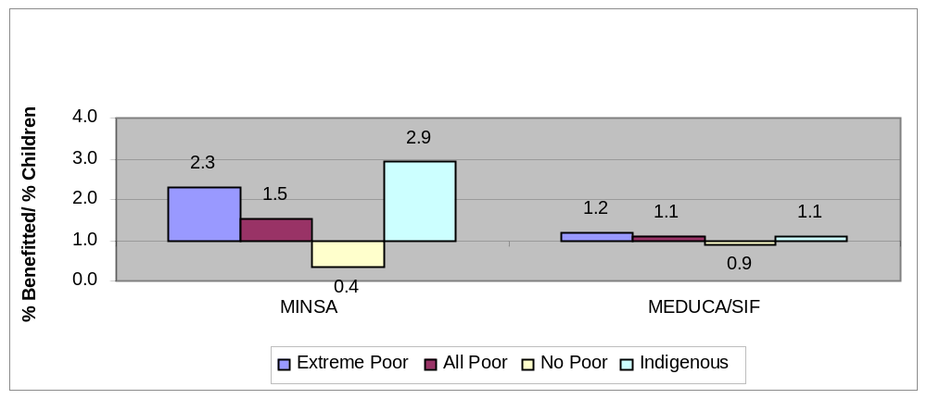

Source: LSMS 2003

Note: Percentage of Children under 6 years that indicated that they received food from MINSA and children 6 and older that indicated that they received food in schools (MEDUCA/SIF), divided by the percentage of children under 6 years for MINSA, and children 6-11 years for MEDUCA/SIF.
  - Figure 3.2 presents the distribution of the beneficiaries of education assistance (scholarships, exemption of registration fees, monthly stipend, or any discounts) for secondary and higher education students compared with the distribution of the population in the secondary (12-17 years) and higher education (18-24 years) age groups, respectively. The non-poor benefit disproportionably more from education assistance than the poor and those that live in indigenous areas. This reflects the poor targeting of these programs on the most needed as well as the fact that the poor and indigenous have much lower enrollment rates than the non-poor at these levels.
  - Most existing subsidies, which account for almost two-thirds of total spending on SA programs, are not targeted to the poor. The large subsidy on housing mortgage rates which represents two thirds of the identified housing subsidies (B/ 44.7 million) do not benefit the poorest households as they do not qualify for commercial housing loans. The cost of water subsidies amounts to more than B/ 72 million per year, but only about one tenth (B/ 7 million) of these subsidies (water delivered in tankers, special tariff, tariff adjustment and tariff discount) is meant to reach the poor. The other 90 percent of the subsidies – mainly granted in the form of unremunerated equity and payment of bulk water bills – are not targeted. As for electricity, only about one-third of the B/ 41 million spent on subsidies are meant to reach the poor (subsidies for those that consume less than 100 Mwh per month and for seniors). Indeed, the untargeted subsidies mostly benefit the more affluent consumers who tend to consume more water and electricity than the poor. This comes at the expense of those not connected, who are predominantly poor.

Figure 3.2: Targeting of Education Assistance Programs

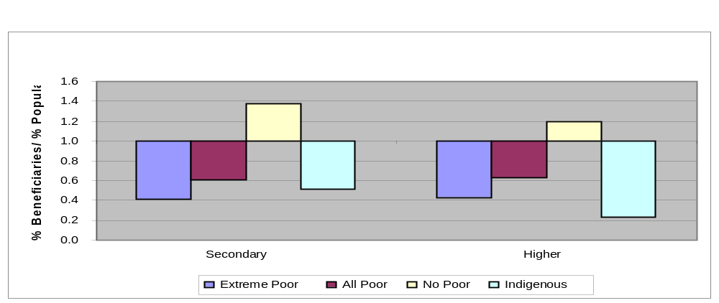
Source: LSMS 2003
Note: Percentage of secondary and higher education students that indicated that they received assistance for registration, tuition, scholarships or other related assistance divided by the percentage of the population of 12-17 years for secondary and 18-24 years for higher education.
  - The subsidies on LPG also benefit mostly the non-poor. About 45 percent of the poor and 72 percent of the extreme poor households still use wood for cooking in Panama (Table 3.3); and 90 percent of the households in indigenous areas. LPG for cooking is used by 54 percent of the poor, 27 percent of the extreme poor and 10 percent of the indigenous households. In contrast, 93 percent of non-poor households use LPG for cooking. While the subsidy applies only to the smaller container in an attempt to target the poorest consumers, many non-poor consumers have switched to the small LPG cylinder to benefit from the subsidy. Indeed, about 90 percent of all LPG sold in Panama is subsidized.
Table 3.3: Fuel Use for Cooking, 2003
(Percentage)
 | Total | Extreme Poor | All Poor | Non-poor | Urban Areas | Rural  (non indigenous) | Indigenous
LPG | 82.7 | 27.4 | 54.2 | 92.6 | 96.1 | 64.9 | 9.9
Wood | 14.9 | 71.6 | 44.3 | 4.6 | 1.3 | 32.6 | 89.6
Electricity | 0.5 | 0.0 | 0.1 | 0.6 | 0.8 | 0.0 | 0.0
Does not cook | 1.8 | 0.8 | 1.2 | 2.0 | 1.7 | 2.3 | 0.2
Other | 0.1 | 0.2 | 0.2 | 0.1 | 0.1 | 0.2 | 0.4
Total | 100.0 | 100.0 | 100.0 | 100.0 | 100.0 | 100.0 | 100.0
Total No. HHs | 758,378 | 72,503 | 196,217 | 562,161 | 487,763 | 238,753 | 31,862
Source: LSMS 2003

  - Finally, the subsidy on gasoline/diesel, which cost the Treasury B/ 20.9 million in 2005, benefits the poor consumers to the extent that it has averted increases in public transportation fares. It benefits mostly the consumers of gasoline who are not poor. Indeed, LSMS data indicates that less than 3 percent of the poor households spend money on gasoline which contrasts to 70 percent of the non-poor (Table 3.4).
Table 3.4: Expenses on Gasoline, 2003
(Percentage)
 | Total | Extreme Poor | All Poor | Non-poor | Urban Areas | Rural  (non indigenous) | Indigenous
HH that didn’t buy gasoline | 77.0 | 98.9 | 97.4 | 69.8 | 70.6 | 87.4 | 96.9
HH that bought gasoline | 23.0 | 1.1 | 2.6 | 30.2 | 29.4 | 12.6 | 3.1
Total | 100.0 | 100.0 | 100.0 | 100.0 | 100.0 | 100.0 | 100.0
Source: LSMS 2003

Cost-effectiveness
  - A detailed analysis of the cost-effectiveness of the SA programs is beyond the scope of this review. Nonetheless, a few considerations can be advanced in this respect. First, given the overall estimates of the population that remains at risk, there is substantial room to increase the effectiveness of several programs. A point in case is the school lunch program. As already mentioned in the World Bank’s Poverty Assessment 2000 and corroborated in the recent SENEPAN nutrition study, the cost of the glass of milk per calorie or protein provided is much higher than the other foodstuffs, as can be appreciated in Table 3.5. The glass of milk in individual containers could be replaced by a more cost effective alternative such a powder milk or other fortified beverage, at savings of more than B/ 4 million a year, or about one-third of the cost of the program.
Table 3.5: Relative Cost of Nutrition Interventions
Foods/Ration | Cost of Ration  B/ | 1,000 Kcal  B/ | 10 g of Proteins  B/
Foods
Glass of Milk (240 ml) a/ | 0.26 | 1.64 | 0.32
Crema (45 g) | 0.08 | 0.44 | 0.13
Cookie (34 g) | 0.08 | 0.53 | 0.33
Rice (88 g) | 0.07 | 0.22 | 0.11
Beans and lentils (48 g) | 0.05 | 0.32 | 0.04
Oil (10 ml) | 0.02 | 0.22 | -
Snack of Lunch
Milk and cookie | 0.34 | 1.10 | 0.32
Crema and cookie | 0.16 | 0.48 | 0.19
Crème | 0.08 | 0.44 | 0.13
SIF lunch | 0.14 | 0.25 | 0.08
Source: Atalah, Eduardo y Rosario Ramos “Evaluación de Programas Sociales Con Componentes Alimentarios y/o Nutricionales en Panamá”, Informe de Consultaría, SENAPAN, Octubre 2005, Table 16, p. 25.
a/ Provided in an individual container.

  - MEDUCA and SIF face major logistical problems for the delivery and storage of foods. MEDUCA reports that classrooms are used for food storage and it is not infrequent that foodstuffs spoil and must be discarded. SIF should consider transferring funds directly to schools so that they can buy locally the foodstuff for the school lunches rather then send them rice, grains, oil, etc. This will have a positive impact on the local economy and eliminate some of existing logistic problems.
  - Program duplication and overlap appears to be a major source of inefficiency in Panama; there are too many agencies implementing similar programs. Nutrition or related programs are run by the Presidency, SIF, MEDUCA, MINSA, MIDES, MIDA, etc. A cursory review of the budget indicates that many institution have resources for scholarships, while at the same time there is an agency with a large budget —IFARHU, with over 652 employees, responsible for this area. On the other hand, agencies such as MIDES run small programs that have little impact on the intended beneficiaries, as most resources are absorbed by central administration.

Programs that could be consolidated into finance a CCT program
  - As argued above, lack of public resources does not seem to be the main constraint to effective social protection in Panama. What transpires from the analysis above is that SA resources are mostly applied to poorly targeted, badly designed and overlapping programs. The current government has decided to explore innovative approaches to increase the effectiveness of the social protection budget. It is currently piloting a new CCT program, the Sistema de Proteccion Social, and depending on the results of such experiment, it is considering the consolidation of existing intervention into a single CCT program.
  - The following programs target the same group as the proposed CCT pilot, and intervene in similar areas (health, nutrition and education) with similar expected impacts. These programs face coordination costs between implementing agencies, administration cost in each agency with duplication of functions such as targeting, registration, payment mechanisms and inefficiencies in operations. They are expected to provide similar impacts but miss the potential synergy between health and nutrition interventions and education at the individual and household level.
  - We estimate the savings that could be realized if these programs were integrated and the funds channeled though a structure such as the SPS. The potential candidates include:
  - MEDUCA Snack Program- Milk and Cookies (three types of interventions). Components 2 and 3 are targeted at poor regions. Component 1 (milk and cookies) is offered mostly in urban areas and it is not targeted. If this component is integrated into a targeted CCT, about US$ 9.9 million could be saved annually (Table 3.6).
Table 3.6: Coverage and Costs of Program
Item | No. of Students | % | Cost  (US$ m)
Milk and cookie | 216,284 | 46 | 9.9
Crema and cookie | 58,772 | 12.5 | 1.3
Crema | 195,125 | 41.5 | 2.7
Total | 470,183 |  | 13.9
Source: Atalah, Eduardo y Rosario Ramos “Evaluación de Programas Sociales Con Componentes Alimentarios y/o Nutricionales en Panamá”, Informe de Consultaría, SENAPAN, Octubre 2005

  - IFARHU Education Assistance. IFARHU provides scholarships and education assistance to low income students (Table 3.7). IFARHU program of assistance to vulnerable groups, financed by the Seguro Educativo, has similar objectives to those of the CCT which are to facilitate the access of poor students to schooling and stimulate demand. Accordingly, US$ 5.7 million could be redirected to a CCT with an education component.
Table 3.7: IFARHU Assistance Programs, 2005, 2006
 | New Assistance in  2005 |  | New Assistance Planned for 2006
Program | No. | Amount  (B/million) | No. | Amount  (B/million)
1. Scholarships | 4,923 | 2.6 | 7,114 | 4.0
2. Student Loans | 1,393 | 5.6 | 2,922 | 12.6
3. Assistance Vulnerable Groups | 5,944 | 2.6 | 13,907 | 5.7
4. Economic Support |  |  | 506 | 0.3
Total |  | 10.8 a/ |  | 22.6
Source: IFARHU

  - Various subsidies. The housing, electricity, LPG and gasoline subsides are not targeted to the poor. If those subsidies financed by MEF are reduced by 10% of their 2005 amount, the savings could reach US$ 12 million; if the reduction is 20% the saving would be US$ 24 million. The amount saved could be re-allocated to a CTT program, with greater distributional impact (Table 3.8).
Table 3.8: Potential Savings from Reduced Subsidies
Sector | Program | Financed by | Annual Cost  (US$ million) | Savings with 10% reduction | Saving with  20%  reduction
Housing | Preferential Interest rate | MEF/tax credit | 35.2 | 3.5 | 7.0
Electricity | Reduction in tariff hikes | MEF/Tariff Stabilization Fund | 24.9 | 2.5 | 5.0
LPG | Subsidy on 25 lbs cylinders | MEF/ tax credit to companies | 39.4 | 3.9 | 7.9
Gasoline | Subsidy on diesel and gasoline | MEF/reduction in tax | 20.9 | 2.1 | 4.2
Total |  |  | 120.4 | 12.0 | 24.0

  - This cursory review of three types of interventions identifies between US$ 28 million and US$ 40 million in potential savings if poorly targeted programs were modified or phased out (Table 3.9). This points to the potential efficiency gains to be realized through the implementation of a well-targeted, operationally efficient program focusing on key factors affecting poverty and lack of human capital. The next section discusses aspects that should be taken into account when designing a new CCT program. It also simulates the expected short and long term impact of a hypothetical national CCT on different welfare and poverty measures.
Table 3.9: Types of Interventions
Sector | Annual Cost  (US$ million)
Nutrition (milk and cookie) | 9.9
Education Assistance | 5.7
Subsidies | 12-24
Total | 27.6-39.6

Conditional Cash Transfer: A New Approach to Social Protection in Panama
  - As argued in the previous section, Panama stands to gain substantially in terms of poverty and inequality reduction from improving the effectiveness of its social expenditures, especially its social assistance spending. In this section we analyze a new program being piloted by the GoP, the Red de Oportunidades, or RdO. The RdO is a conditional cash transfer program that is being targeted to the extreme poor following the molds of Oportunidades in Mexico and Bolsa Familia in Brazil.
  - Conditional Cash Transfer (CCT) programs have become pervasive in Latin American and the Caribbean. They currently reach approximately 60 million people representing approximately 60 percent of the extremely poor in LAC (Lindert, Skoufias and Shapiro, 2005). In Mexico and Brazil alone, OPORTUNIDADES and Bolsa Familia take approximately 0.35 percent of these nations’ GDP. Empirically solid impact evaluations have demonstrated that these programs are cost effective in terms of reducing poverty, malnutrition and increasing human capital accumulation by the poor (see Box 3.1). CCT programs originated as substitutes for untargeted subsidies for food, cooking gas, water and electricity, which were phased out in most adopting countries as a result of economic reforms. They have shown to be considerably more progressive and effective in reducing poverty and inequality than non targeted subsidies (World Bank, 2006).
  - In this section we examine several aspects of the design of CCTs with particular attention to: (i) targeting mechanisms, and (ii) the design of transfer amounts. Utilizing data from the 2003 ENV, we simulate the short and medium run impacts of different design options, aiming at recommending the best design to the government of Panama.

Targeting Strategy for Panama’s SPS
  - The first step in designing a CCT program is to define its target population. In the case of Panama, the government has decided to target all families living under the annual extreme poverty line of B.\533 per capita consumption. Therefore, 16.6 percent of the population should be targeted to receive RdO.
  - Once the target population is defined, the next step is to develop a method for selecting eligible families to be included in the program. As it is well known, however, surveys carried to measure household consumption are rather costly since they take in average more than two hours per household to be completed (Grosh and Munoz, 1996). Therefore, it would be prohibitively expensive to survey all likely program candidates in the country, compute their total household consumption values, and then verify which households consume less than B.\533 per capita per year. This would indubitably hinder the registration process and render the program very expensive and logistically unworkable.
  - An alternative to verifying actual household consumption is to utilize a predictor of household consumption and the associated probability of being extremely poor. A technique commonly used to predict household consumption is the Proxy Means Test (PMT) method (see World Bank/IPEA/UNDP, 2005, Castaneda, 2005, Ahmed and Bouis, 2002, and Grosh and Baker, 1995). This approach relies on easily observable variables that are highly correlated with total household consumption, and yet are quick to measure and verify. Utilizing regression analysis, coefficients are estimated for a few selected variables that are strongly correlated with household consumption. Then, the predicted household consumption is computed for each applicant household and the eligibility for program benefits is determined on the basis of a total score linked to predicted consumption.
  - The details of the PMT model developed for the SPS program in Panama is presented in the Annex 3.2 and in World Bank/IPEA/UNDP, 2005. To measure welfare, the model utilizes per capita household consumption as the dependent variable in the regression analysis. But the household specific score, or puntajen, is the predicted probability of being extremely poor. That is, each applying household is given a score varying from 0 to 100 which represents the estimated probability that a given household is extremely poor. A score of 10 means that the household has a 10 percent chance of being extremely poor, a score of 50, 50 percent, and so on. The government needs then to select a cut off point, say 50, and then select into the program all households for which the estimated probability of being poor is equal or above 50 percent.
  - Estimating the probability of individual households being poor inherently entails estimation errors. That is, a given household for which the model predicts a high probability of being poor may in fact be rich. This is a risk which is intrinsic to any statistical inference. But as suggested in Elbers, Lanjouw and Lanjouw (2003), this risk may be reduced if one moves from estimating the probability of one household being poor based on proxy variables, to estimating the incidence of poverty in a larger geographic area. Because the estimation errors “average out” Proxy Means procedures are more precise in estimating “village” level poverty rates than the probability of an individual household being poor.
  - Thus, PMT-like procedures can also be adopted to construct poverty maps to identify geographic areas with high incidence of poverty and extreme poverty. Selecting areas with high levels of extreme poverty to target social programs is termed geographic targeting. The Ministry of Economy and Finance in Panama has recently constructed such map, based on the ENV 2003 the 2000 Census data sets, which can be used in the selection of priority areas in which the new SPS could start being rolled out. The extreme poverty map relating extreme poverty levels to corregimentos (or districts) is shown in Figure 3.4. The corregimientos in gray with the highest incidence of poverty are mostly indigenous areas.
Box 3.1: Conditional Cash Transfers
Over the past decade, numerous countries in LAC have introduced “conditional cash transfers” (CCTs), which have the dual objectives of (a) reducing current poverty and inequality through the provision of cash transfers to poor families (redistributive effect); and (b) reducing the inter-generational transmission of poverty by conditioning these transfers on beneficiary compliance with key human capital investments (structural effect).
Initiated in Brazil at the municipal level in the mid-1990s, Mexico developed the first large-scale CCT program, originally called Progresa, now Oportunidades. Brazil then expanded its municipal programs to the national level, first as Bolsa Escola, which focused on school attendance, then with Bolsa Alimentaçao, which introduced health-related conditionalities. In 2003, these programs were merged with two others to form the Bolsa Família Program, which integrated these transfers, as well as the health and education conditionalities for greater synergies. CCTs have spread to other countries in LAC, including: Argentina, Colombia, Chile, Dominican Republic, Ecuador, Honduras, and Jamaica. Interest extends beyond the region, with similar schemes emerging in countries such as Turkey, the West Bank and Gaza, Pakistan, Bangladesh, Cambodia, Burkina Faso, Ethiopia, and Lesotho.
Eligibility rules vary, but most programs seek to channel CCT benefits to poor families, with significant efforts to develop strong targeting mechanisms, usually combining geographic targeting with some sort of household assessment mechanisms, such as proxy means testing (using multi-dimensional indicators that are correlated with poverty as a way to screen for eligibility).
Conditionalities vary, but usually include minimum daily school attendance, vaccines, prenatal care, and growth monitoring of young children. Mexico’s Oportunidades has also added bonuses for school graduation and participation in health-awareness seminars.
The programs range in size. Brazil’s Bolsa Familia is now the largest, covering 8 million families (32 million people, or close to a fifth of its population), followed by Mexico’s Oportunidades (5 million families). Others are smaller, such as Chile’s Solidario Program, which covers over 200,000 families, and Colombia’s Familias en Acción program, which covers about 400,000 families.
All are fairly lean, in terms of resource use. CCTs in both Mexico and Brazil represent about 0.37% of GDP. With higher unit transfers, Argentina’s Jefes claims a slightly larger share of GDP (0.85%), though still less than one percent. Programs in Chile (0.08% of GDP) and Colombia (0.1%) claim an even smaller share. As discussed below, administrative costs of these programs are fairly low, averaging about 5% of total program outlays (for mature programs; start-up costs are higher), as compared, say, with an average of 36% for food-based programs.
Despite their relative economies, CCTs are showing impressive impacts. This paper demonstrates that, as a class of programs, CCTs are by far the best targeted to the poor (vis-a-vis: all other social assistance programs, utilities subsidies, social insurance, and public spending on health and education). With the majority of CCT benefits actually reaching the poor (no small feat in LAC), their redistributive impacts are muted only by the relatively small size of the unit transfers in most countries, which dampens their potential impact on current poverty. Moreover, their structural impact on breaking the inter-generational transmission of poverty is impressive. Experimental and quasi-experimental evaluations suggest important impacts, well beyond the redistributive impacts discussed in this paper:
- On health and nutrition: (a) increased total and food expenditures (Brazil BA, Mexico, Honduras, Nicaragua); (b) increased calorie intake and improved dietary diversity (Brazil BA, Mexico, Nicaragua); (c) improved child growth (Mexico, Nicaragua, Brazil BA); (d) increase in use of prenatal care and reduced maternal mortality (Mexico); (e) reduced incidence of smoking and alcohol consumption (Mexico); and (f) improved treatment of diabetes (Mexico).
- On education: (a) improved primary enrolment among the poor who were not previously enrolled (Nicaragua, Honduras, Brazil); (b) increased secondary enrolment (Mexico, Colombia); (c) reduced drop-out rates and repetition (Mexico, Nicaragua, Honduras); and (d) reduced child labor (Mexico-boys, Nicaragua, Honduras-boys, Colombia, Brazil).
Source: World Bank (2006)

Figure 3.4: Extreme Poverty by Corregimiento
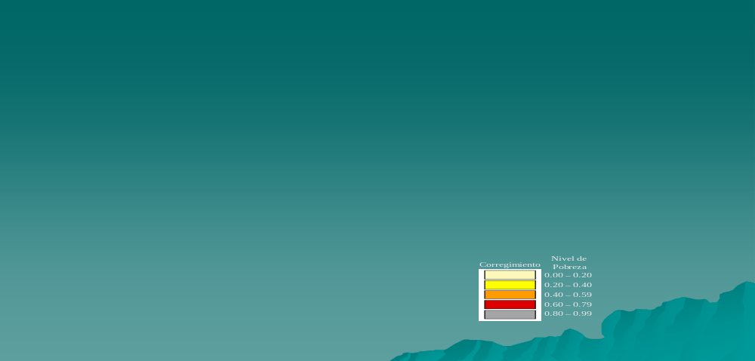Source: Poverty Map 2003, MEF

  - Also, as shown in Figure 3.5, corregimentos with high extreme poverty are also areas with high unmet basic needs. That is, there is a very strong correlation between the basic needs index and the estimated extreme poverty rates by corregimento. Hence, prioritizing areas for program rollout based in either indicator should yield similar results. Nevertheless, if the objective of the program is to reduce extreme poverty, it might be wise to rank priority areas in terms of estimated extreme poverty to insure stronger impacts on poverty reduction.
  - As shown in Figures 3.4 and 3.5 above, several corregimientos, mostly in rural and indigenous areas exhibit extreme poverty rates beyond 80 percent. In fact, extreme poverty headcount ratios in all indigenous areas are above 80 percent.
  - As a recent study in Honduras has shown (Olinto, Shapiro and Skoufias, 2006), the welfare gains obtained from trying to identify the few non poor households in geographic areas in which poverty rates are extremely high are too small to justify the fiscal and political costs of doing so (see Box 3.2). Therefore, in such areas it is recommended that all residents are considered eligible for the program, regardless of their individual estimated probability of being extreme poor.
  - In sum, a common approach to targeting social programs is to combine geographic targeting in which areas of high poverty incidence are identified and all residents are considered eligible, with household level targeting in areas with lower poverty rates in which a score is given to each household. To target extreme households for the SPS program, the Government of Panama is entertaining a target strategy that would select all households living in indigenous areas, where extreme poverty rates are all above 80 percent, and would apply a household level PMT in non indigenous areas. In the exercise below we assess the accuracy of such targeting strategy.

Figure 3.5: Extreme Poverty Ratios by `Corregimiento’ and Geographic Area
(i) National level | (ii) Urban level
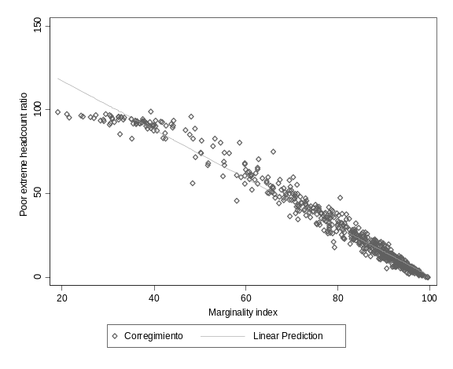 | 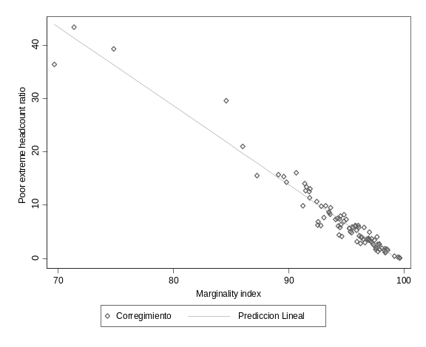
(iii) Rural level | (iv) Indigenous level
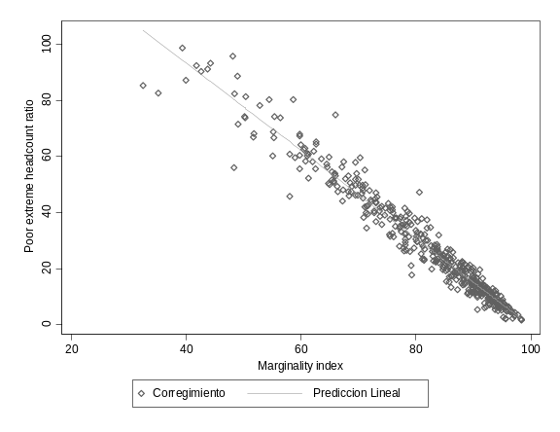 | 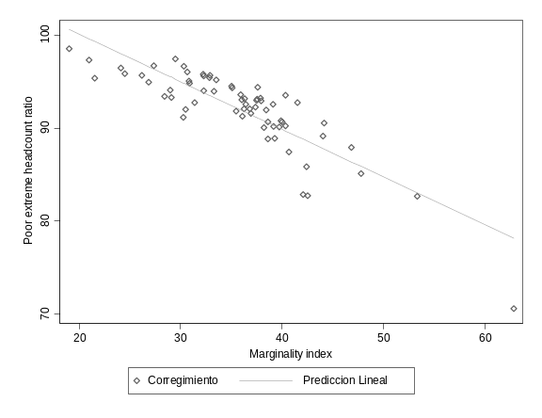
Source: Poverty ratio: Encuesta de Niveles de Vida (ENV) 2003. Ministerio de Economía y Finanzas (MEF)-Dirección de Políticas Sociales (DPS). Information from the 2000 population census adjusted by results obtained by the 2003 ENV poverty maps.
Marginality index: Constructed by Dirección de Políticas Sociales del Ministerio de Economía y Finanzas, October 2005.

Assessing the SPS targeting strategy
  - To assess the implications of combining household level PMT and geographic targeting in indigenous areas we utilize the data in the 2003 ENV to estimate coverage and leakage ratios for different choices of cut off points. The results are presented in Table 3.11.
  - To interpret the results, start with the cut off point set at zero. At this level of cut off, all households for which the estimated probabilities of being extremely poor is greater than or equal to zero would be selected to participate in the program. Under this extreme scenario, the program would be universal and would benefit all Panamanians. The coverage ratio would be 100 percent since all targeted extreme poor households would participate in the program. Assuming a program that transfers B.\35 per beneficiary household per month, approximately 2.6 percent of Panama’s GDP would need to be budgeted. Moreover, 90 percent of the transfers would “leak” to the non extreme poor, and 74 percent to the non poor. While a universal program as this one is the only way to guarantee the coverage to 100 percent of the extreme poor population, it is prohibitively expensive and would likely be fiscally unsustainable.
Box 3.2: Geographic and Household Targeting. The Case of PRAF in Honduras
The PRAF program is a CCT program that gives small cash transfers to households, contingent on children attending school and mothers attending health checkups. PRAF offers benefits to all residents of 40 poor rural municipalities, so its targeting is exclusively geographic. In contrast, most other prominent conditional cash transfer programs in Latin America combine geographic and household targeting, or rely exclusively on household targeting.

Olinto, Shapiro and Skoufias (2005) simulate the welfare and efficiency gains of adding household targeting to the PRAF Program in Honduras. Household targeting involves observing household-specific factors which correlate with income and allow analysts to decide whether each household is eligible for a program. Household targeting might not be advisable if the design of the program generates self-selection of non-poor people out of the program, or if most of the population in the region selected for the program is poor. Hence, it is relevant to investigate whether combining household targeting in poor areas with self-selection of non-poor households out of the program can improve welfare.

To answer this question the authors measure the benefits from targeting in two stages. First, they estimate the social welfare gain from distribution of PRAF’s budget according to the geographic targeting that the program actually uses. Then, they identify the amount of transfer budget which would be required to achieve the same social welfare gain if PRAF had used an improved targeting system. If a transfer given to the indigent generates more social welfare than a transfer given to the affluent, then for a given level of social welfare impact, a transfer which is retargeted to give a greater portion of its benefits to poor people will require a smaller budget than the original transfer did. The difference between the original budget and the estimated smaller budget is the monetary value of the benefit from targeting. As long as the benefit from targeting exceeds the cost of targeting, governments can efficiently invest in targeting.

The authors find that by denying transfers to the wealthy and increasing the size of transfers for the poor, household targeting could decrease the budget of this program by 5-10 percent without affecting its welfare impact. Thus, some investment in targeting for a program like PRAF does increase welfare. A simple proxy means test which denies benefits to households predicted to have incomes above the poverty line can create welfare benefits by giving larger transfers to poorer households. Since this test can be generated through an already-existing census used to identify potential beneficiaries, it would require little additional cost.

Although these potential gains serve as an economic argument for household targeting, the political economy disadvantages of household targeting suggest that it may be unadvisable for this program. Even a sophisticated targeting system will deny transfers to some poor households. A program like PRAF survives for political reasons: PRAF beneficiaries vote, and political sponsors of PRAF would benefit if Hondurans saw PRAF as a fair and effective program. The threat to the existence of PRAF from denying transfers to households within beneficiary municipalities may outweigh the small welfare gains that household targeting would produce.
  - Consider now a scenario in which the government chooses 10 as the eligibility cut off. In this case, all households with an estimated probability of living in extreme poverty greater than or equal to 10 percent would be eligible, except for residents of indigenous areas which are all eligible regardless of their predicted probabilities. As a result of this increased selection pressure, 95 percent of the extreme poor would be covered and 5 percent would be erroneously excluded. Note however that 100 percent of the poor belonging to the first decile of the consumption distribution would still be included. This implies that mistakenly excluded households are not the poorest of the poor, but are closer to the extreme poverty line. More importantly, however, is to note the reduction in cost. The cost of the program would be reduced by approximately 80%, from 2.6 to 0.55 percent of GDP. Thus, for a relatively small price, i.e., the exclusion of 5 percent of the target population, the program would cost 80 percent less, making it fiscally and politically more viable. Still, under this scenario, 60 percent of the resources would leak to the non extreme poor, 40 percent going to the moderate poor and 20 percent to the non poor.
  - As shown in Table 3.10, the only way to reduce leakage of resources to the non extremely poor is to increase selection pressure by choosing higher and more restrictive cut off values. For instance, suppose that the Government of Panama decides to select into the program only applicant households for which the estimated probability of being extremely poor is equal to 100 (in addition to all households living in indigenous areas). While leakage would be drastically reduced to approximately 15 percent of the transfered resources, only 44 percent of the targeted population would be included. That is, 56 percent of the extremely poor would be erroneously excluded. The cost of the program would also be drastically reduced to 0.11 percent of GDP.
  - In sum, the exercise above illustrates an important trade off that must be faced by policy makers entertaining targeted transfer: any measure undertaken to reduce program leakage will almost certainly result in increased undercoverage. The converse is also true: any measure undertaken to increase coverage of the targeted population is likely to increase leakage of program resources to non targeted households. There is no perfect targeting strategy that reduces leakage and undercoverage to zero.
  - Ultimately, the choice of cut off value will depend on the budget available and the desired average transfer amount per household. As seen in Table 3.11, for a monthly transfer of B.\35 per household, each choice of cut off point will imply in a different overall budget. For instance, if the GoP has a annual budget of B.\30 million available, which could be obtained by consolidating some of the ineffective and overlapping SA programs discussed in the previous section, a cut off of 40 could be selected. In this case, 75 percent of the households living in extreme poverty would be included, and 25 percent of them would erroneously be excluded. Note however that the excluded are not likely to be those in the bottom of the income distribution since 88 and 95 percent of the households in the bottom 10 and 5 percent of the distribution would be included. Also, at this level of cut off, while approximately 30 percent of the transfers would leak to the non-extremely poor, 80 percent of this leakage would go to the moderate poor, and only 20 percent would go to the non poor.
  - In addition to geographic targeting and the PMT scores, SPS managers may decide to utilize other household observed characteristics to exclude households that they see as unlikely to be part of the targeted population. For instance, the government of Panama entertained excluding households that contribute to social security system or that own land above a certain acreage levels. But, as indicated in Table 3.11 below, while the gains in terms of restricting leakages of such ad hoc criteria would be minimal, the losses in terms of reduced coverage would be substantial. Therefore, the results suggest that the implementation of these additional targeting restrictions should be avoided.
Table 3.10: Targeting Accuracy: Coverage, Leakage and Total Cost
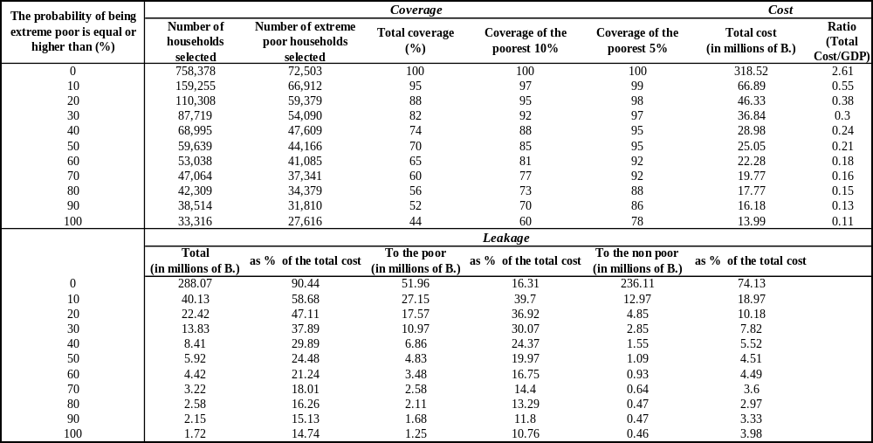
Source: National Accounts, Contraloria General de la Republica de Panama. Own estimation based on ENV 2003 data Note: Coverage is the proportion of extreme poor population that is included in the program. Leakage is the amount of money spends on those who are reached by the program who are classified as non extreme poor (errors of inclusion). To estimate the annual total cost we assume a monthly monetary transfer of 35B. per household.

Table 3.11: Targeting Accuracy
Comparison Between alternatives Selections Criteria
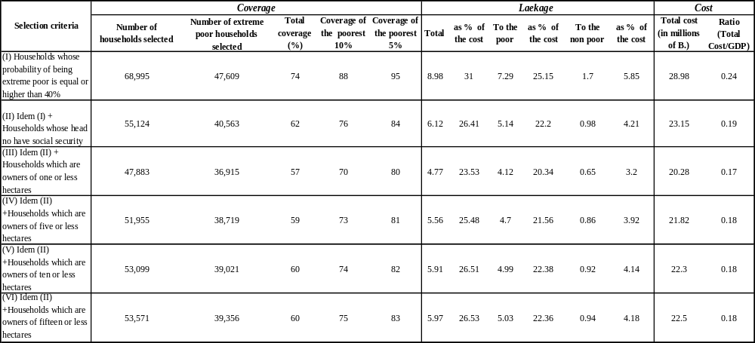
Source: National Accounts, Contraloria General de la Republica de Panama. Own estimation based on ENV 2003 data.

Assessing the design of the individual transfer amounts
  - As shown in Table 3.12 below, most CCT programs in LAC transfer between 10 and 30 percent of the average household consumption of the targeted population. Based on this international experience, the government of Panama has decided to pilot the new RdO program distributing B.\35 monthly for each selected household, regardless of its demographic composition. This represents 18 percent of the average monthly consumption of extreme poor families in Panama.
Table 3.12:Transfer as % of the Total Average Consumption
Comparison between Different CCT Programs in LAC
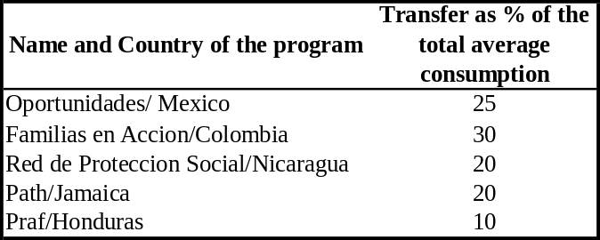
Source: Handa y Davis (2006)
  - However, a question that may be posed to those designing the RdO program is: with the same budget, would it best to increase (or reduce) the average transfer amount and narrow (expand) the program in order to decrease leakage (increase coverage)? For instance, with a budget of B.\30 million, should the government increase the average transfer per household from B.\35 to B.\42 and restrict the program to those with an estimated probability of being poor greater than 50 percent (instead of 40 percent)? We address this question by simulating the impacts on poverty outcomes of different levels and format of transfers and different targeting criteria. The details of the simulation model are presented in Annex 3.3.
  - We examine three levels of monthly transfers per household: B.\35, B.\42 and B.\95, respectively. The B.\35 scenario is the status quo, that is, it is the design being currently used. The B.\42 is a scenario under consideration by the government of Panama. Finally, the B.\95 scenario is a design that was initially under consideration by the government.
  - Figure 3.6 below presents the simulated impacts of the three scenarios in three poverty indicators: (i) extreme poverty headcount ratio, (ii) extreme poverty gap, and (iii) the extreme poverty severity index (or the square of the extreme poverty gap). As seen, for budgets up to B.\25 million per year, all three designs exhibit very similar impacts on extreme poverty headcount. However, Scenarios 2 (i.e., B.\42 per household per month) would have greater impacts on reducing the poverty gap and the severity index with budgets under B.\25 million. Therefore, the new design under consideration by the GoP is likely to improve the effectiveness of the program. However, before moving to a higher transfer amount, it is perhaps advisable to validate the results of these simulations with ex-post retrospective impact evaluations.
  - For budgets greater than B.\30 million per year, however, the designs in Scenario 3 is strictly better than Scenarios 1 and 2 for all three indicators. That is, as budget constraints are relaxed above B.\30 million, instead of increasing the coverage of the RdO by relaxing the targeting criteria, the GoP should increase the transfer amounts to those already being targeted.
  - Thus, while our results indicate that the design chosen by the government of Panama (Scenario 1) is inferior to a design that distribute higher amounts to a larger pool of beneficiary families (Scenario 3), it is probably wise to start the program with a smaller transfer amount since it is always more politically feasible to increase rather than reduce benefits. If ex-post evaluations confirm that higher amounts may indeed have greater impacts on the welfare indicators discussed, the benefits could then bee increased accordingly.

The long run impact of SPS
  - In the exercise above, we evaluate the immediate short run impacts of different designs of the SPS on welfare indicators. However, by imposing behavioral conditionalities, CCTs aim at reducing both short run and long run poverty by inducing accumulation of human capital by the poor. In this section we estimate these long run effects for a hypothetical cohort of beneficiaries that would have entered the program in 2006. We simulate the impact on welfare indicators at to future dates, 2012 and 2018. The details of the simulation model are in Annex 3.4.
  - We simulate 3 scenarios: Scenario 1 simulates the impact of an increase from 6 to 10 in the mean years of schooling of the population selected to participate in the program. Scenario 2 adds to this increase in schooling a rise in the total monthly income of B.\35 per household. Scenario 3 is equal to Scenario 2 but assumes perfect target. That is, it assumes that whatever budget is available is given first to the poorest household in the population, next to the second poorest household and so on. We simulate this unrealistic scenario to provide us with limit bounds for the impacts of the program on the different welfare indicators.
  - As indicated in Figures 3.7 and 3.8 below, because of the depth and severity of poverty in Panama, the government should not expect large impacts in terms of drops in extreme poverty gap ratios. The analysis shows that the program should reduce the headcount index of extreme poverty by approximately 10 percent in 6 years, and 13 percent in 12 years. But as discussed above, because of the high depth and severity of poverty, the headcount index should not be the metrics through which this program is evaluated. It is more important to measure its long run impact on the extreme poverty gap and the severity of poverty. As the analysis indicates, as currently designed, a national CCT program would reduce the national extreme poverty gap by approximately 20 percent, from B.\104 to B.\83 million, and the severity of poverty index by 25 percent. More importantly, for each B.\1 spent annually in the program, there would be a B.\0.61 reduction in the annual extreme poverty gap. Narrowing the focus of the program those even more likely to be extreme poor would increase this ratio to a maximum of B.\0.73 per B.\1. But such a narrowly targeted program would imply in excluding many of the extreme poor, which would be politically hard to sustain.
Figure 3.6: Distributional Impact of the Program: Poverty Reduction Gains Link to Total Cost. Comparison between Different Transfer Schemes
Panel (i): Extreme poor population vs Total cost | Zoom of panel (i)
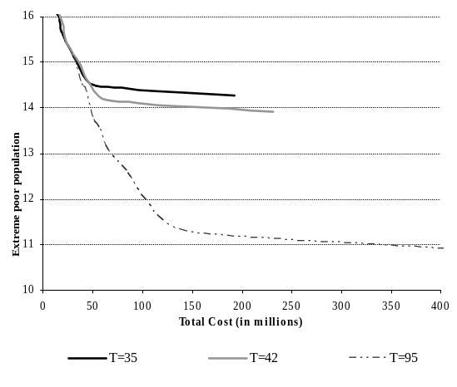 | 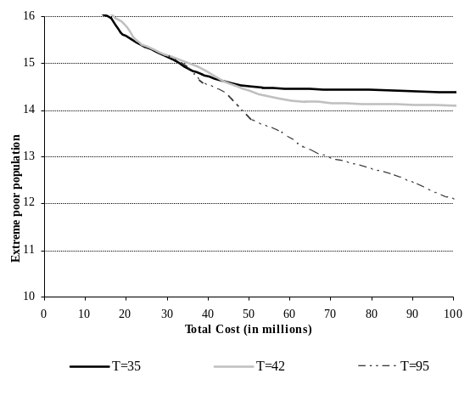
Panel (ii): Extreme poverty gap vs Total cost | Zoom of panel (ii)
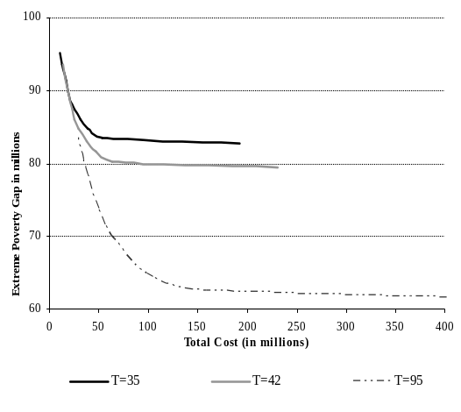 | 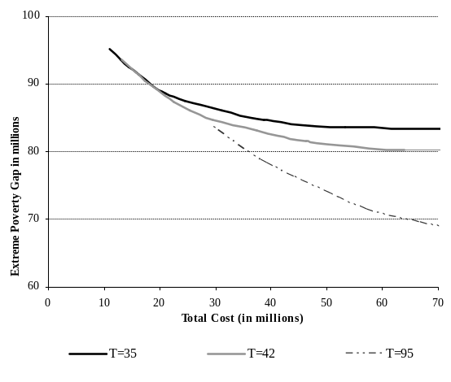
Panel (iii): Severity index vs Total cost | Zoom of panel (iii)
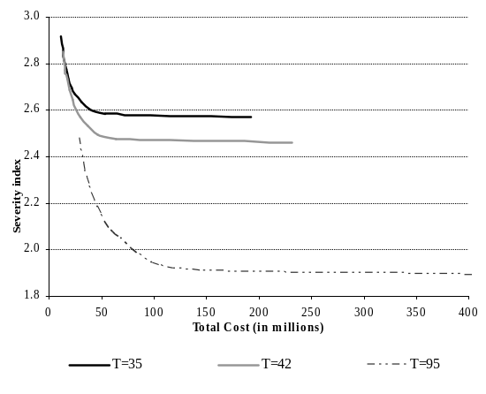 | 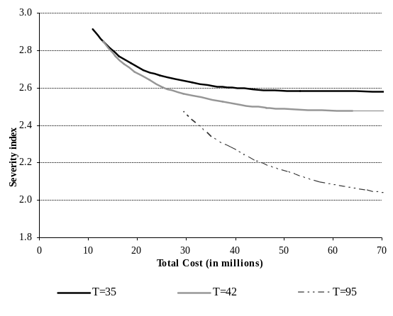
Source: Own estimation based on ENV 2003 data
  - The simulation analysis also indicates that a slightly higher benefit amount per beneficiary family than is currently being piloted in the SPS would enhance the impact of the program without altering the overall budget. But again, given that it is always politically easier to increase rather than decrease benefit amounts, we conclude that the design currently adopted by SPS is indeed the most advantageous. The decision of whether or to not increase benefit amounts should await the results of the pilot evaluation.
Figure 3.7: Distributional impact of the Program assuming a Change in the Household Behavior Due to the Participation in the Program
Comparison Between Two Different Transfer Schemes (Cohort 18-23)
Poverty impact – Transfer of 35B. p/H. | Poverty impact – Transfer of 42B. p/H.
(i) | (ii)
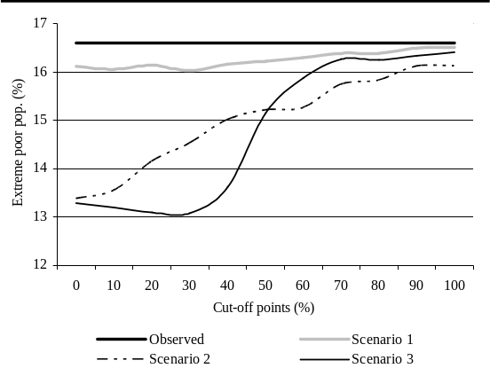 | 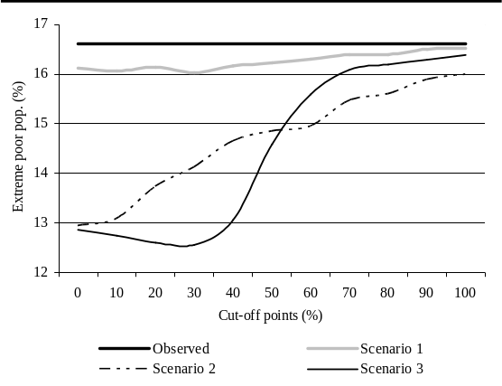
(iii) | (iv)
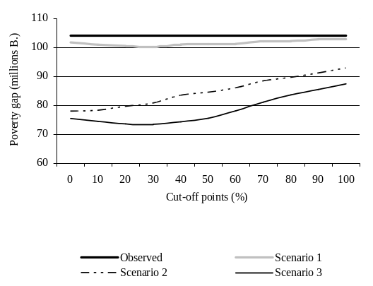 | 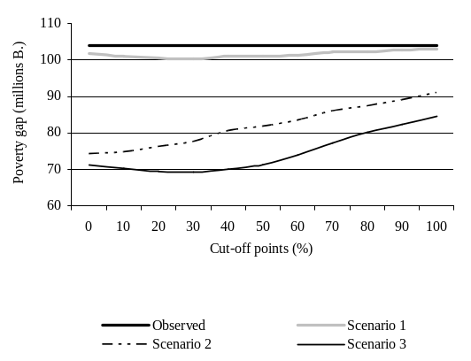
(v) | (vi)
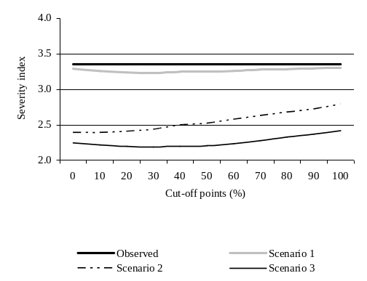 | 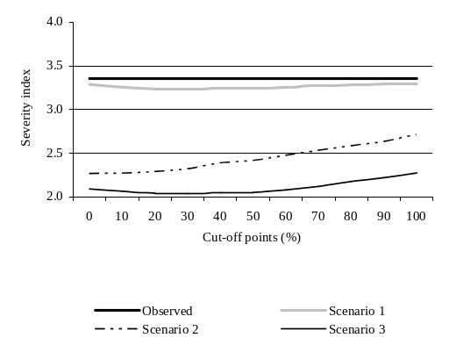
Source: Own estimation based on ENV 2003 data.
Note: Scenario 1 assumes an increase to ten in the mean of years of schooling of the population selected to participate in the program in each aged cohort. Scenario 2 assumes an increase to ten in the mean of years of schooling of the population selected to participate in the program in each aged cohort plus a rise in the total monthly income due to the transfer per household below each cutoff. Scenario 3 assumes an increase to ten in the mean of years of schooling of the population selected to participate in the program in each aged cohort plus a rise in the total household monthly income due to the transfers till the budget in each cutoff point runs out. In scenario 3 the household where sort from the most extreme poor to the less extreme poor. This scenario leads to greater gains in reducing the poverty gap and the severity of poverty (FGT1 and FGT2); Scenario 1 and 2 assumes a value of the marginal propensity to consume of 0.82 (see Annex 3.6 for further explanations). Simulation 3 assumes that the entire increase in the total household income goes to the household consumption; (*) For the population age 18 and older. (**) For the female population.

Figure 3.8: Distributional Impact of the Program Assuming a Change in the Household Behavior Due to the Participation in the Program
Comparison Between two Different Transfer Schemes
Cohort 18-29
Poverty impact – Transfer of 35B. p/H. | Poverty impact – Transfer of 42B. p/H.
(i) | (ii)
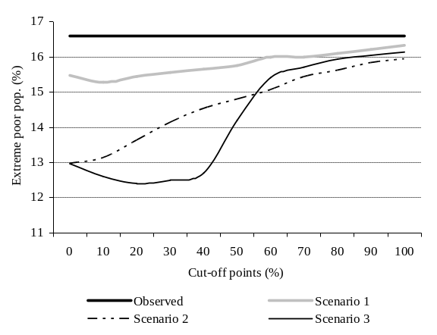 | 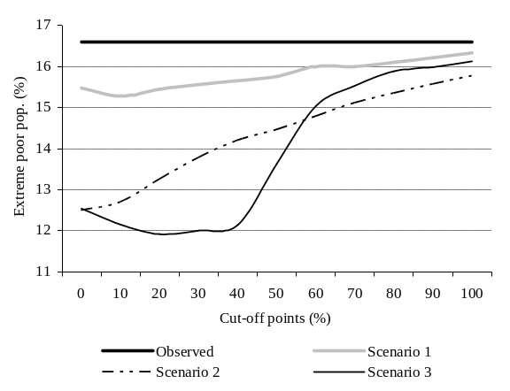
(iii) | (iv)
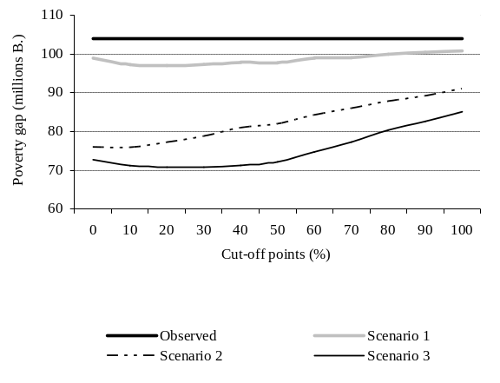 | 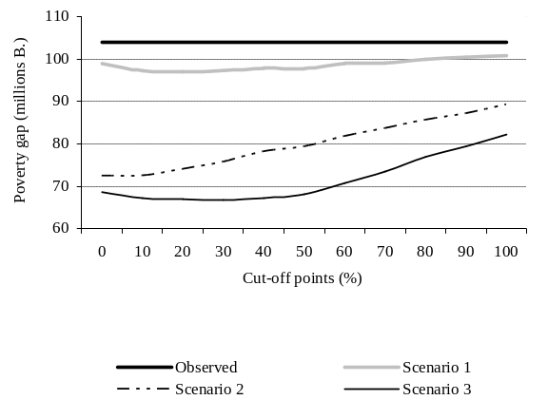
(v) | (vi)
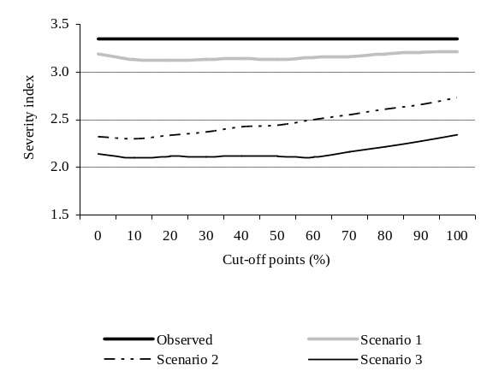 | 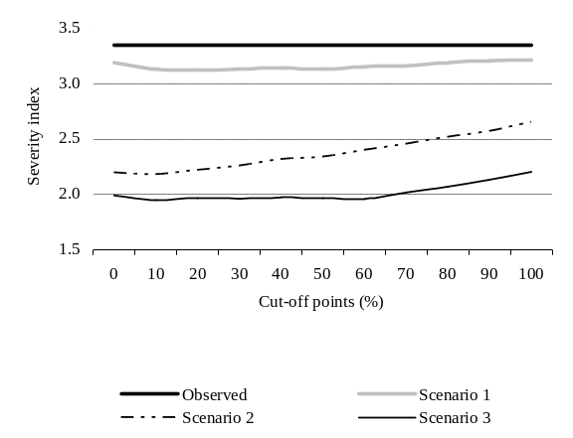
Source: Own estimation based on ENV 2003 data; Note: Scenario 1 assumes an increase to ten in the mean of years of schooling of the population selected to participate in the program in each aged cohort. Scenario 2 assumes an increase to ten in the mean of years of schooling of the population selected to participate in the program in each aged cohort plus a rise in the total monthly income of 35B per household below each cutoff. Scenario 3 and 4 assumes an increase to ten in the mean of years of schooling of the population selected to participate in the program in each aged cohort plus a rise in the total household monthly income of 35B till the budget in each cutoff point runs out. In scenario 3 the household where sort from the most extreme poor to the less extreme poor. This scenario leads to greater gains in reducing the poverty gap and the severity of poverty (FGT1 and FGT2). In scenario 4 the household where sort from the least poor of the extreme poor to the poorest of one. This scenario leads to greater gains in reducing the number of poor in the population; Scenario 1 and 2 assumes a value of the marginal propensity to consume of 0.82 (see annex 3,6 for further explanations). Simulation 3 and 4 assumes that the entire increase in the total household income goes to the household consumption; (*) For the population age 18 and older. (**) For the female population

Would CCTs be effective in indigenous areas
  - Poverty among indigenous people in Panama is pervasive. Indigenous people function at extremely low levels of welfare, barely eking out a survival, with no access to basic services at the household or individual levels. Beyond the numbers of the headcount measures, the depth of poverty on a number of characteristics is astounding and reflects the extremely high inequality in the country, with a potential worrisome widening education gap between the indigenous and non-indigenous. As discussed above, CCTs should in principle be targeted to the indigenous areas because it currently contributes to 42% of the extreme poverty head count , and it is expected to contribute more and more in the future. More over, extreme poverty is deeper and more severe in indigenous areas. But would CCTs be effective in reducing poverty in indigenous areas? Can cultural barriers hamper the impacts of the program? Would the indigenous be able to use cash to increase their consumption levels? In Annex 3.5 we present a detailed qualitative study of the situation of the indigenous people in Panama, and try to derive recommendations for the implementation of CCTs in indigenous areas. Here we summarize the main findings.
  - Would the indigenous be able to comply with the conditionalities imbedded in CCT programs? Our analysis in Annex 3.5 indicates that for CCTs to fully function in indigenous areas, complementary programs to raise the supply of adequate health and education services will be required. Given the current state of supply of services, it would be advisable to award a grace period to beneficiaries living in the indigenous comarcas until an adequate network of schools and health centers is in place.
  - However, CCT would be relevant because of the demand-side issues faced both on education and health. All focus groups provide clear examples of how cash constraints represent a main barrier to access schools and health centers because of transportation costs, uniform and school supplies costs, medicine and treatment costs. Providing cash will only address some of the issues and the program will need to coordinate with sector ministries in health and education to help ensure a greater access of quality, culturally pertinent services especially at the pre-natal, infant and pre-school stages.
  - Local consultation and involvement of leadership will be key to program success. While the communities we consulted were open to the idea of a CCT, the local operation of the program and its success will crucially hinge on the support of local leaders, who have been known to refuse access to programs and service providers. A transparent targeting mechanism will be a key element of the trust-building. Greater participation in the management of service provision would also help.
  - It is possible for women to receive the benefits but the community will have to let it happen. Because of their natural responsibilities for child-rearing, women are recognized as the best decision-makers regarding children’s welfare issues. But in most of these communities, women have low voice and little bargaining power. Therefore, a communication strategy to reach out to local leaders, older people and men will a crucial element of the program implementation. In the case of extended multi-generational household, the relationship mother-child should determine the beneficiary unit rather than the household headship.
  - Continuous support to beneficiary and capacity-building of them and their household about their rights and responsibilities in the program will help them fulfill their corresponsibilities and may even yield greater empowerment and inclusion. The design of the “acompañamento familiar” in indigenous communities will require careful thinking so that the person in charge is able to interact successfully both with the beneficiaries, household decision-makers, community leadership and service providers. Changes in behaviors will not only concern beneficiaries but also their community and the health and education providers at the local level.

Conclusions and Policy Implications
  - Panama spends substantial amounts of resources on the social sectors in general, and in the SP in particular, but the results obtained are not commensurable with this spending. Indeed, not only has poverty failed to decline in recent years but it remains extremely high and severe in indigenous areas. Moreover, malnutrition in children increased between 1997 and 2003. A considerable number of infants, pregnant and lactating women, school age children, and senior are still facing multiple risks, which condemn them to a life of poverty and exclusion. At the root of this weak performance is the lack of clearly defined strategic objectives, weak targeting, and low cost-effectiveness of the country’s social protection system.
  - Panama has a large program of subsidies, which accounts for almost two-thirds of spending in SA, but these subsidies mostly benefit the non-poor. Poor infant and mothers and poor seniors are clearly at disadvantage. Consequently, there is a need to develop a clear Social Protection strategy with specific targets which should drive the process of resource allocation in the sector. These targets should be consistent with the Government’s commitment under the Millennium Development Goals. A more comprehensive and in depth review of existing programs should be undertaken, cost ineffective practices eliminated, and available resources targeted at the most needed and vulnerable groups as shown in the preliminary exercise above.
  - Other more program specific recommendations follow:

Nutrition Programs
- Increase substantially the coverage of MINSA’s Complementary Feeding program to reach the majority of the poor children and pregnant and lactating women at risk.
- Introduce targeting of MEDUCA snack program.
- Replace milk with a more cost-effective alternative in MEDUCA snack program.
- If the SIF school lunch program is maintained, decentralize the purchase of foodstuffs to the communities to avoid costly logistical problems in delivering and storing foodstuffs and promote local economies.
- Design and pilot comprehensive nutrition interventions which, in addition to food distribution activities, also include behavioral modification and educational interventions targeted to mothers and pregnant women.

Education
- Continue to expand the coverage of cost effective programs as the Initial Education and CEFACEIs.
- Reorient the sizable student assistance program (scholarship, loan and other assistance) to benefit the poor student.
- Eliminate the duplication of scholarships/ education assistance programs.

Housing, Water and Energy Subsidies
- Reduce the number and amount of subsidies and target the remaining ones on the poor. Before defining which subsidies are to be cut or revised, it would be useful to prepare a social impact analysis to advert any potentially adverse impact on the poor.

Pensions
- Promote CSS coverage of seasonable workers and those in the informal sector.
- Consider, when the fiscal situation permits, the creation of a non-contributive systems to cover poor seniors that do not have pensions or other source of income.

Monitoring and Evaluation
- Strengthen the M&E systems in all institutions. These systems are necessary tools to ensure that the benefits of the programs are received by the groups at risk and not by other groups, that the benefits delivered have the desired impact, that the administrative costs of the programs are reasonable, and that the unit costs of the programs can be calculated in order to determine the most cost-effective modalities. The Social Cabinet needs this information to make strategic decisions on resource allocation.

Institutional Arrangements
- Consider making one Minister responsible for the Social Cabinet agenda and results. Set as a priority in the SC agenda the in depth review of existing programs, the elimination of cost ineffective practices, the development of Social Protection Strategy, and the reorientation of resources towards the established strategic objectives.

  - The proposed conditional cash transfer program being piloted by MIDES seems to be a step in the right direction for developing a clear social protection strategy in Panama. As several other countries have done in LAC, Panama is starting to move away from untargeted subsidies towards conditional transfers targeted to the poor. Robust international evidence has shown that these CCT programs are considerably more effective than untargeted subsidies in fighting poverty, malnutrition and inequality.
  - Combining Proxy Means Testing (PMT) and geographic targeting techniques seems to be the best approach to ensure that the transfers reach the neediest. As the analysis above indicates, the targeting method selected by MIDES should ensure that at least 75 percent of the extreme poor would be reached if the program currently being piloted were to be expanded to the country as a whole. More importantly, the simulation results show that 88 percent of the poorest 10 percent of the population, and 95 percent of the poorest 5 percent, would be included in such a nation wide program. While approximately 30 percent of the program budget would not reach the extreme poor, 80 percent of such leakage would go to the moderate poor, and only 5 percent would go to the non poor. These targeting outcomes, while favorably compare to the international experience, could be improved even further if measures were undertaken to increase the self exclusion of the non-poor. For instance, imposing conditionality for adults, as demanding attendance to periodic health and nutrition classes for instance, may increase the level of self exclusion of the non poor, as they tend to exhibit a higher opportunity cost of personal time.
  - The preceding analysis also indicates that a national CCT program that follows the current pilot design of the Sistema de Proteccion Social being implemented by MIDES should reduce the headcount index of extreme poverty by approximately 10 percent in 6 years, and 13 percent in 12 years. But as discussed above, because of the high depth and severity of poverty in Panama, the headcount index should not be the metrics through which such transfer program is evaluated. It is more important to measure its long run impact on the extreme poverty gap and the severity of poverty. Also, as currently designed, a national CCT program would reduce the national extreme poverty gap by approximately 20 percent, from B.\104 to B.\83 million, and the severity of poverty index by 25 percent. More importantly, for each B.\1 spent annually in the program, there would be a B.\0.61 reduction in the annual extreme poverty gap. Narrowing the focus of the program to those even more likely to be extreme poor would increase this ratio to a maximum of B.\0.73 per B.\1. But such a narrowly targeted program would imply in excluding many of the extreme poor, which would be politically hard to sustain.
  - The simulation analysis above also indicates that, with the same budget currently available to MIDES, higher benefit amounts per beneficiary family would enhance the impact of the program. Nevertheless, given that it is always politically easier to increase rather than decrease benefit amounts, we conclude that the design currently adopted by MIDES is indeed the most advantageous. The decision of whether or to not increase benefit amounts should await the results of the pilot evaluation. Also, if the budget envelope available for the RdO were to be substantially increased to levels above B.\30 million per year, our simulations indicate that he GoP should substantially increase the amounts to those who are already being targeted by the program, instead of relaxing targeting criteria and expanding coverage to the less poor.

ANNEXES

Annex 1.1: Additional Results on Growth and Poverty

Figure A.1.1.1: Annual Growth Rates of GDP-National Accounts and Income–EH Survey, 1997-2003
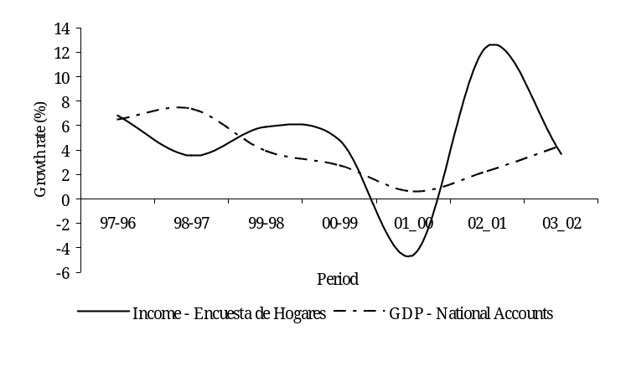
Source: Nationals Accounts, Contraloria General de la República de Panama. Own estimates based on Encuesta de Hogares (EH), 1996-2003 data.

Figure A.1.1.2: Difference Between Growth Rate Per Capita GDP and Per Capita Income From Household Surveys
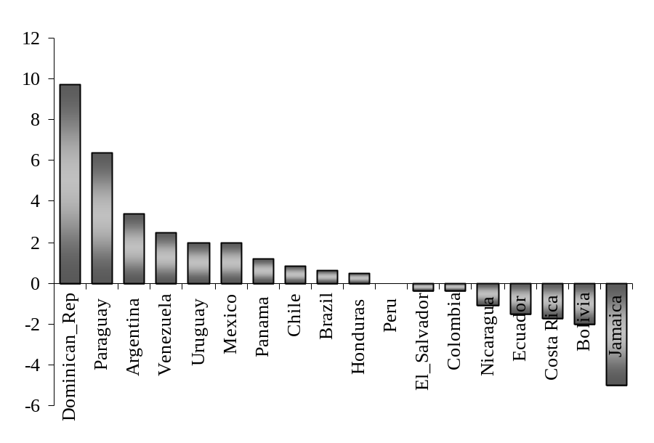
Source: Gasparini, Gutierrez and Tornarrolli (2005).
Note : The period of reference for the growth rate p/c GDP and income survey is: Argentina;1992-2004, Bolivia; 1993-2002, Brazil; 1990-2003, Chile; 1990-2003, Colombia; 1992-2004, Costa Rica;1992-2003, Dominican Republic; 2000-2004, Ecuador; 1994-198, El Salvador; 1991-2003; Honduras; 1997-2003, Jamaica; 1990-2002, Mexico; 1992-2002, Nicaragua; 1993-2001, Paraguay; 1997-2002, Peru; 1997-2002, Uruguay; 1989-2003, Venezuela;1989-2003.

Figure A.1.1.3: Correlation by Sector of Activity Between
(i) Annual Growth rates of GDP-National Accounts and labor income-survey | (ii) Decomposition of the change of GDP-National Accounts and labor income-survey
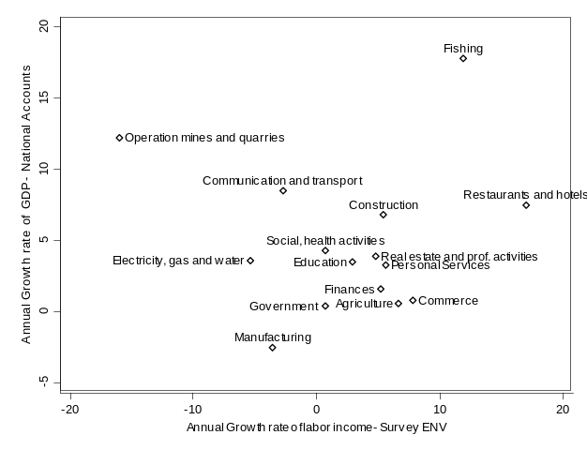 | 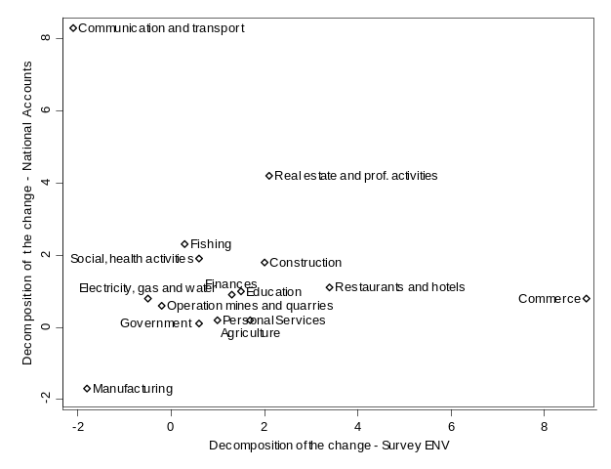
Source: Nationals Accounts, Contraloria General de la República de Panama.
Own estimate based on ENV 1997 and 2003 data.

Table A.1.1.1: Annual Growth Rates of Survey – Agriculture Income, 1997-2003
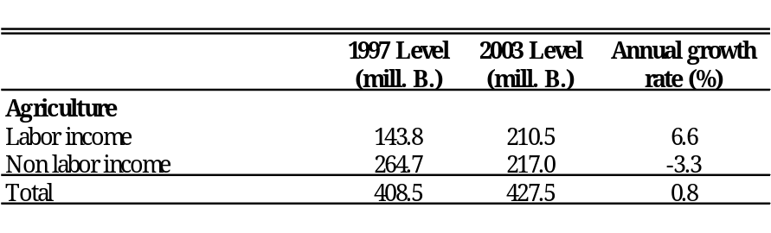
Source: Own estimates on ENV 1997 and 2003 data.

Figure A.1.1.4: Distribution of Per Capita Consumption by Area - Kernels Function
1997, 2003
- National  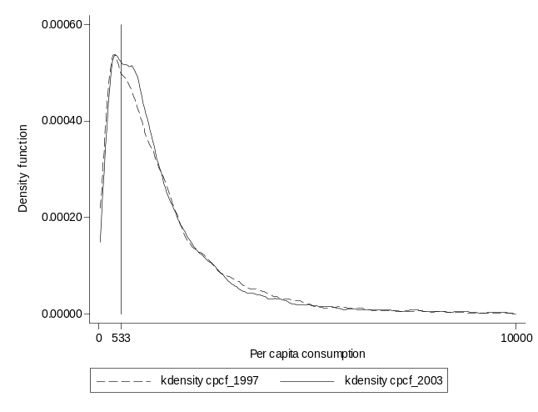 | - Urban  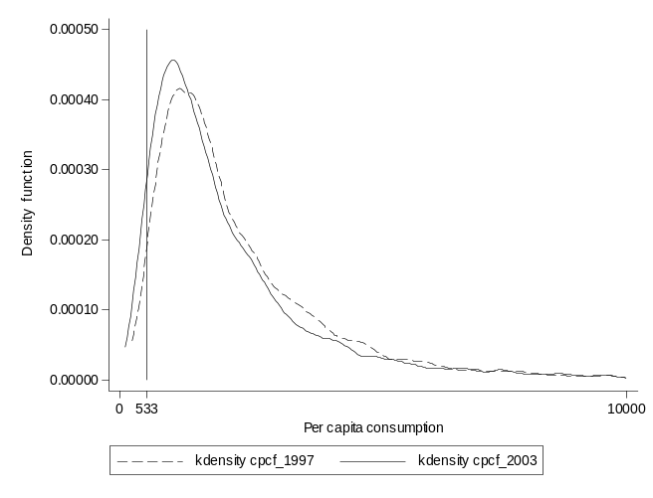
- Rural  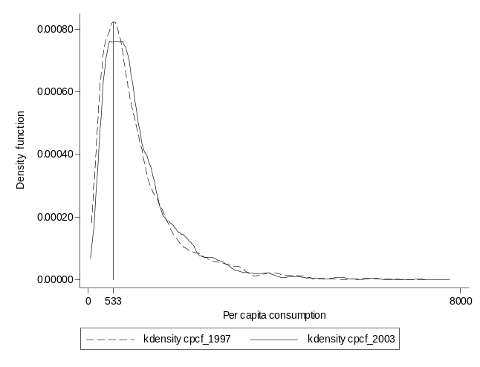 | - Indigenous  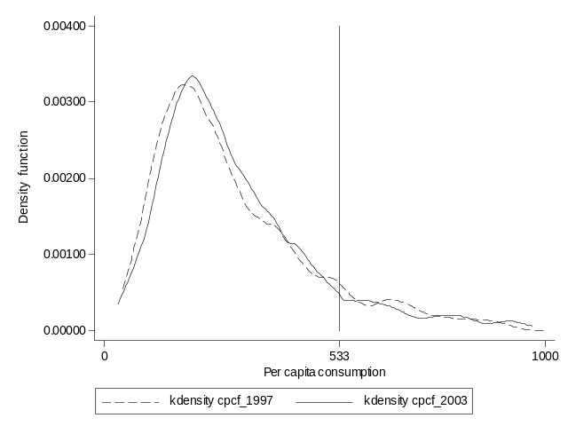
Source: Own estimate based on ENV 1997 and 2003 data.
Note: The vertical line in the graphs indicates the value of the extreme poverty line in 2003.

Table A.1.1.2: Who are the extreme poor in 1997?
Decomposing the Extreme Poverty, Poverty Gap, and Severity by Area
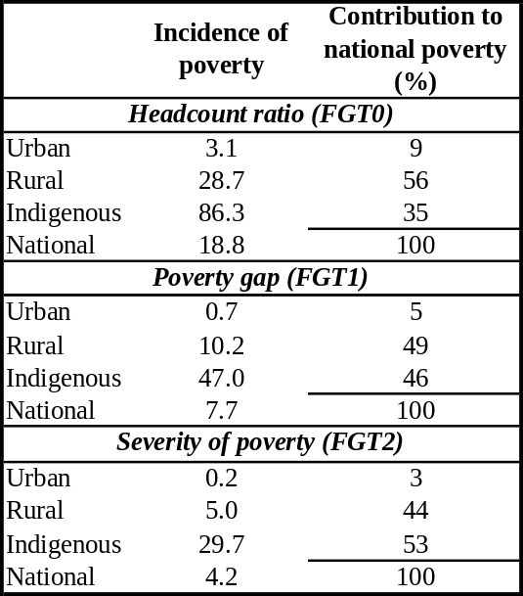
Source: Own estimate based on ENV 1997 and 2003 data.
Note: Extreme poor refers to the population who has its per capita consumption below the extreme poverty line value.

Figure A.1.1.5: Extreme Poverty Impact of Different Growth Scenarios – Exercise 1
(i) Simulating changes in extreme poverty using three different growth scenarios with an associated increase in inequality of 1 percent between 2003 and 2015
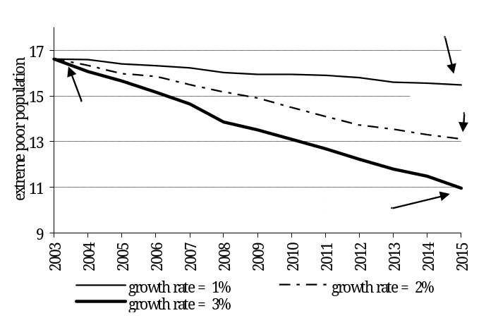
Source: Own estimate based on ENV 1997 and 2003 data.

Table A.1.1.3: Poverty Impact of Different Growth Scenarios – Exercise 2
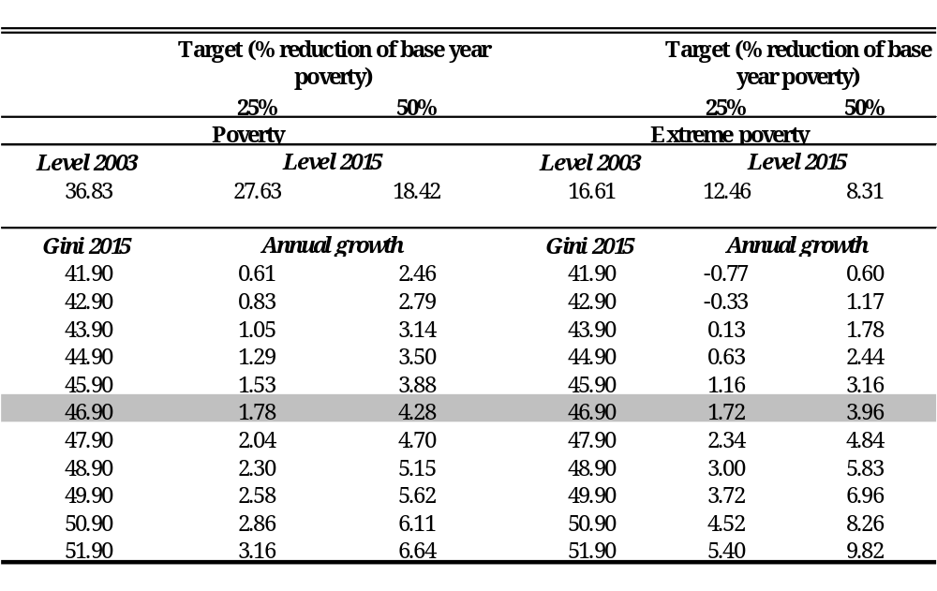
Source: Own estimate based on ENV 1997 and 2003 data.

Annex 1.2: Annual Production and Consumption Growth Rates: How Well Do the Survey and National Accounts Agree?

The poverty and inequality analysis in this report is based primarily on consumption data from the 1997 and 2003 ENV surveys. For a variety of reasons, consumption is generally preferred to income for the analysis of household welfare in developing countries (see Box B.1.2.1). Macroeconomic growth data comes from a different source: the National Accounts. Panama’s National Accounts (NAS) include estimates of GDP and private consumption for the nation as a whole. Table A.1.2.1 shows estimates of annual growth rates of various consumption and income figures, calculated from the ENV surveys and the national accounts. Growth rates are shown both for national totals and for the measures calculated on a per capita basis.
Box A.1.2.1: Why Measure Poverty with Consumption Instead of Income?
Consumption is preferred over income as a measure of household welfare for several reasons. First, consumption tends to be less variable than income over the course of time (due to consumption smoothing) and thus provides a better measure of long-term welfare. Second, household surveys in developing countries typically measure consumption more accurately than income. Third, consumption of the household’s own production, which is often a large portion of consumption for agricultural households, is usually not captured well (if at all) in income data. Ignoring home-produced food would greatly understate the consumption levels of rural households.

The table illustrates two points. First, there are huge differences between growth rates shown in the survey and those in the NAS. NAS growth rates for private consumption and GDP are far higher than those for both consumption and income in the survey. The NAS show very rapid growth in private consumption, while the survey shows a decline in consumption, calculated on a per capita basis. Second, in the survey by itself, income and consumption show markedly different growth rates. On a per capita basis, survey-based consumption declined by 0.7 percent, while income grew slightly, by 0.3 percent.
Figure A.1.2.1: Annual Growth Rate, 1997-2003
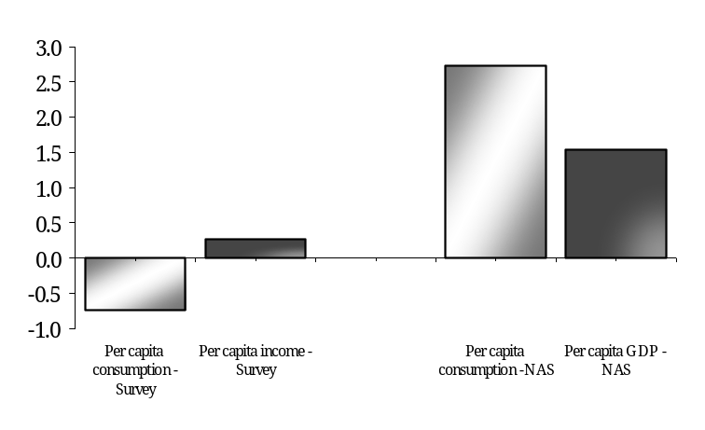
Source: National Accounts, Contraloria General de la Republica de Panama.
Own estimate based on ENV 1997 and 2003 data.

Table A.1.2.1: Annual Growth Rate, 1997-2003
Source: National Accounts, Contraloria General de la Republica de Panama.
Own estimate based on ENV 1997 and 2003 data.

Of greatest concern is the difference between growth rates of survey-based consumption and GDP. The consumption data underlies this report’s estimate of poverty and inequality, and GDP growth is the figure most commonly used to assess economic performance at the macro-level. We consider two issues separately: 1) the differences between the survey and the NAS growth rates, and 2) the difference between income and consumption growth rates in the survey.

Why might NAS and survey-based measures differ? Across countries, it is often the case that household survey-based measures of consumption and income differ greatly from measures based on the national accounts (see Figure A.1.1.2 in Annex 1.1). In principle, private consumption as measured in the NAS should correspond fairly closely (with some caveats) to consumption as measured in the survey. However, private consumption is generally estimated as a residual in NAS calculations, so it may be subject to greater error than other measures of the NAS. For this reason, GDP growth rates are sometimes taken as the closer analog of survey consumption growth. Unless there are sharp changes in savings behavior, growth in private consumption and GDP should track fairly closely.

There are three main reasons why levels and/or growth rates from a household survey and national accounts may not coincide?:
- Underestimation in the household survey. Household survey-based levels may be underestimated if respondents forget or choose not to reveal part of their consumption or income. Also, non-compliance with surveys is a substantial problem in many countries. There is some evidence that well-off households are less likely to comply with household surveys. According to one study, the mean income of the 10 highest-income households in each of 18 surveys conducted in Latin American countries was no more than the average salary of the manager of a medium- to large-size firm in the country. This suggests that incomes may be typically underestimated. If the relative compliance rates of wealthier households change over time, the survey-based growth rates may deviate from true changes in mean income/consumption.

- Measurement error in the National Accounts. There are substantial problems in measuring illegal, informal, household-based, and subsistence outputs in the NAS in developing economies. Typically, these parts of the economy are not measured well, if at all. Over time in a developing economy, household-based and other activity that is not captured well in the NAS becomes formalized, which tends to bias NAS growth rates upwards. Additionally, NAS estimates are subject to imprecision due to a variety of potential errors.

- Differences in coverage and accounting practices. The NAS private consumption measure includes spending on goods and services by unincorporated businesses and nonprofit organizations that are not captured in household surveys. In international guidelines for NAS calculations, this spending is distinguished from household consumption, but in practice it is generally difficult to draw this distinction with developing country data. In a country with a large and growing nonprofit sector—a characterization which may fit Panama—the growth rate of private consumption in the NAS may be markedly higher than the growth rate in household consumption.

On the whole, these shortcomings are likely to result in downward biases in survey measures and upwards biases in national accounts. Deaton (2005) found that consumption measured from household surveys grows less rapidly than consumption measured in national accounts, both in the world as a whole and in large countries.

The survey-NAS differences in Panama are in line with the general pattern internationally: the growth rates of the NAS measures are higher than those of survey-based measures. To a limited extent, it is possible to examine the possible sources of these differences. If the differences were due to increasing non-response by wealthy households, we would expect to see a shrinking number of wealthy households in the survey data over time. This would appear as a declining share of income/consumption for the richest percentiles of the population. Table A.1.2.2 shows shares of income and consumption in the survey in both 1997 and 2003 by decile and for the richest percentiles. The shares of total income and consumption in the richest three deciles (deciles 8, 9, and 10) did indeed decline slightly between 1997 and 2003. However, the shares of the five richest percentiles, displayed in part (ii) of the graph, show no clear trend. For example, for the 99th percentile, the income share increased while the consumption share decreased. These patterns suggest that changes in non-response by rich households probably do not explain the divergence between the survey and the NAS.

To further examine the NAS-survey differences, we compare growth rates of GDP and survey labor income by sector. We focus on labor income because non-labor income in the survey cannot be attributed to particular sectors. Clearly, capital-labor ratios vary by sector, and consequently the portion of income by sector that goes to labor income naturally also varies. However, if capital-labor ratios within sectors are fairly stable over time, sector-specific growth rates of labor income and GDP should be similar. We decompose observed changes in GDP and survey-based income in the following way:

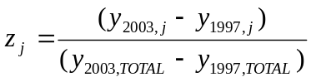

Here z_{j} is the fraction of the growth in overall GDP or survey income attributable to sector j, y_{1997,TOTAL} denotes total GDP or survey income, and y_{t,j} is output or income in year t and sector of activity j.
Table A.1.2.2: Shares of Income and Consumption in Household Survey
(i) By Decile | (ii) Five Richest Percentiles
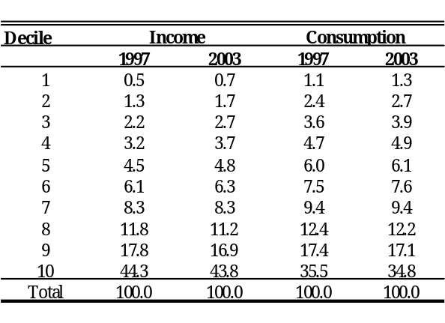 | 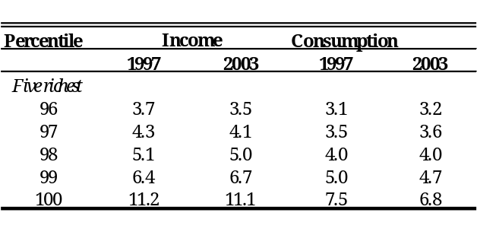
Source: Own estimate based on ENV 1997 and 2003 data.

Table A.1.2.3 and Figure A.1.2.1 show annual growth rates by sector for GDP and labor income. Between 1997 and 2003 GDP grew by a total of 22.5 percent, while labor income grew by 18.7 percent. The table shows decompositions by sector, and for both GDP and labor income, the five sectors contributing the most to growth are highlighted. Growth in the communications and transport sector accounts for more than a third (37%) of total GDP growth. The other sectors which contributed substantially to overall GDP growth are real estate and professional activities, fishing, and social and health activities, and construction.

The sectoral growth patterns in survey income have little overlap with those for GDP. Survey income actually declined for communications and transport, the primary growth sector for GDP. Likewise, nearly half of the labor income growth in the survey was in the commerce sector, which was stagnant for GDP. GDP and survey income growth patterns are similar, however, for the construction and real estate and professional activities sectors.

Most non-labor income in the survey cannot be attributed to sectors. The exception is non-labor agricultural income, which is captured separately in the survey. We can construct total agricultural income in the survey by summing labor and non-labor income (see Table A.1.1.1 in Annex 1.1). This total figure grew at an annual rate of 0.8%, very close to the 0.6% rate for agriculture in the national accounts. (As Table A.1.2.3 shows, agricultural labor income in the survey grew at 6.6%). This suggests that the survey-NAS differences are not due to differences in measurements of agricultural income.

Table A.1.2.3: Sectoral Contributions to Growth of GDP (National Accounts)
and Labor Income (Household Survey) by Sector of Activity
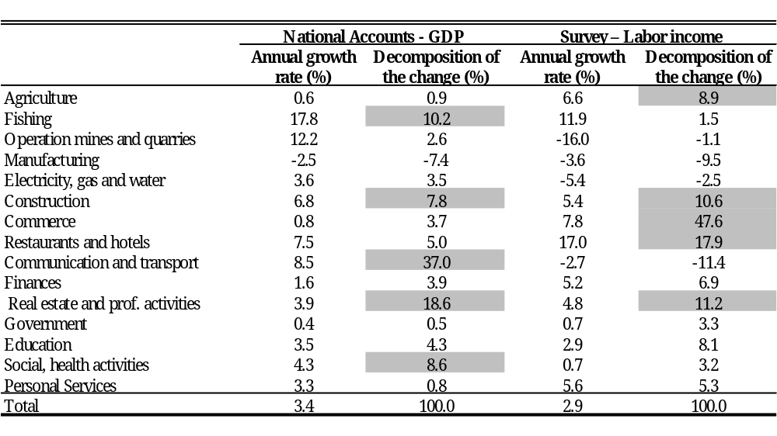
Source: Nationals Accounts, Contraloria General de la República de Panama.
Own estimate based on ENV 1997 and 2003 data. The five sectors with the highest growth levels (separately determined for the National Accounts and the survey) are highlighted.

As a whole, this comparison shows that differences between GDP growth rates and survey income growth may be attributable to differences in particular sectors. Errors in the measurement of the size of the commerce or communications and transport sectors could explain much of the differences. Unfortunately, as with similar cases in other countries, we are left with an incomplete understanding of NAS-survey differences. As Ravallion (2003) notes, “When the levels or growth rates from these two data sources differ, there can be no presumption that the NAS is right and the surveys are wrong, or vice versa, since they are not really measuring the same thing and both are prone to errors.”

Next, we consider the separate question of the difference between the growth rates of consumption and income within the survey. Consumption and income could diverge for three reasons: 1) changes in savings behavior, 2) changes in consumption of own production, which is included in consumption but not captured in income, and 3) measurement errors in either term. If the difference between the 0.7 percent drop in consumption and the 0.3 percent growth in consumption were entirely due to changes in saving behavior, the savings rate (fraction of income saved) would have to have increased by 1 percentage point per year. While such a change in savings behavior is possible, it is unlikely that savings would increase during a period in which consumption is declining. To explore how the relationship between consumption and income may have changed over time, we estimate an econometric model at the household level that has as a dependent variable the ratio of the difference between consumption and income to consumption. The dependent variable is regressed on variables that denote the sector of activity of the household head; the maximum educational level achieved by a member of the household and, household’s demographics characteristics. We estimate separate regressions for the two survey years.
Figure A.1.2.2: Annual Growth Rates of GDP and Labor Income
by Sector of Activity 1997-2003 (%)
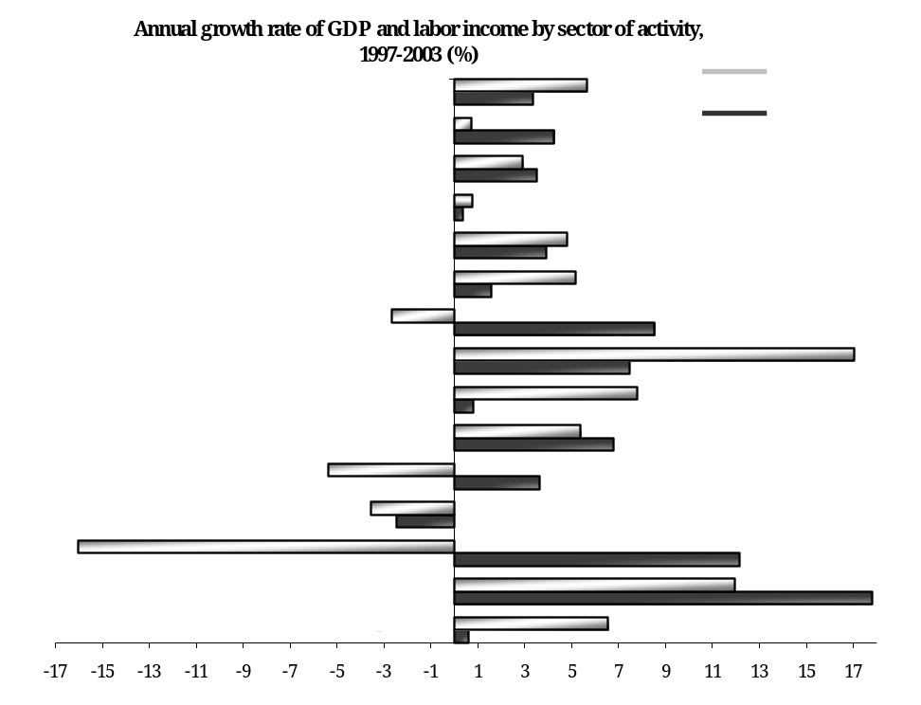
Source: Survey – Own estimate based on ENV 1997 and 2003 data.
National Accounts - Contraloría General de la República de Panama.

Table A.1.2.4 shows results from these regressions, and the third column shows the difference in the coefficients for 2003 and 1997. Because income has grown while consumption has declined, on average the value of the dependent variable has declined. This is reflected in the drop in the value of the constant term in the regression. Unfortunately, almost all the other coefficients which show significant changes go in the opposite direction of the overall change in the dependent variable. Controlling for education and household characteristics, consumption grew relative to income for households with inactive household heads as well as those with heads in agriculture; manufacturing; communications and transport; social, education, and health activities; and personal services. The only significant coefficient change which does follow the pattern of the overall relative decline in consumption is for female-headed households.

As a whole, this analysis shows that the divergence between income and consumption in the survey is not explained by changes among households in any particular sector nor those with particular characteristics. The fact that consumption declined for agricultural households less than for other households indicates that the difference is not due to different growth rates for own-consumption.

The analysis shows, then, that the decline in consumption relative to income was a generalized phenomenon and not specific to any particular sector. This may either reflect an overall increase in savings or general errors in either the income or the consumption term.

Table A.1.2.4: Decomposition of the Change of GDP (National Accounts) and Labor Income
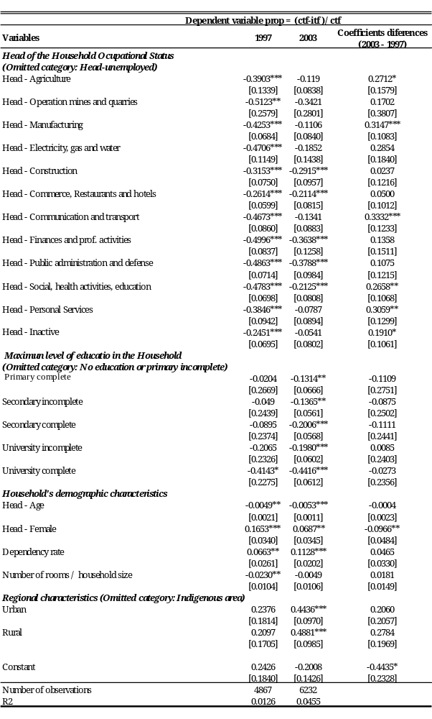
Source: Own estimate based on ENV 1997 and 2003 data.
Note: Robust standard errors in brackets - * significant at 10%; ** significant at 5%; *** significant at 1%; the regressions are estimated for households. We include dummies to capture the occupational status of the head of the household and the maximum educational level achieved by a member of the household. The age and the gender dummy of the head of the household are also included in the regressions. The equations include the dependent ratio and the number of rooms divided by household size. Finally, we incorporate, as control, three regional dummies.

Annex 1.3: Are the Changes in Poverty and Inequality Significantly Significant?
Because poverty and inequality indices calculated from household survey data are based on only a sample of the population, both the point estimates at a given point in time and estimated changes over time are subject to sampling error. This section presents confidence intervals and tests for the statistical significance of changes in the welfare measures. Confidence intervals were calculated using bootstrap resampling methods.

Table A.1.3.1 shows the results of the test of statistical significance for the changes in the Gini coefficient between 1997 and 2003. Tables A.1.3.2 and A.1.3.3 display the results for the three FGT poverty measures, calculated using both the moderate and extreme poverty lines. Each table shows the change between the estimated measures for each year, the standard error of the change, and the corresponding confidence interval at a 95 percent level of significance. The change is statistically significant if it is possible to reject the null hypothesis of equality between the measure in 1997 and 2003. Each row indicate with an asterisk (*) whether the change is statistically significant.

For the Gini, the changes are statistically significant nationally, for rural areas, and for indigenous areas, but not for urban areas. Among FGT measures, only the moderate poverty headcount at a national level and the extreme poverty gap and severity of poverty in the indigenous area show no statistically significant change between 1997 and 2003.

Table A.1.3.1: Tests of Statistical Significance for Changes in the Gini Coefficient
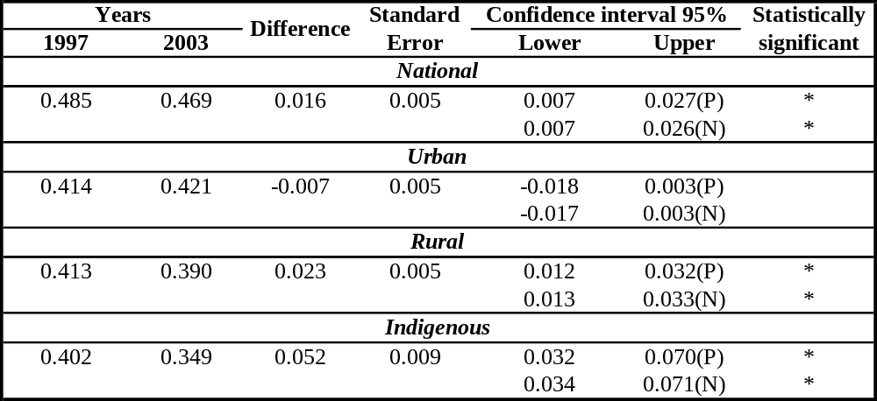
Source: Own estimation based in 1997 and 2003 ENV data.
Note: (P) denote the percentile method and (N) denote the normal-approximation method.

Table A.1.3.2: Tests of Statistical Significance for Changes in the FGT Poverty Measures Calculated with the Moderate Poverty Line
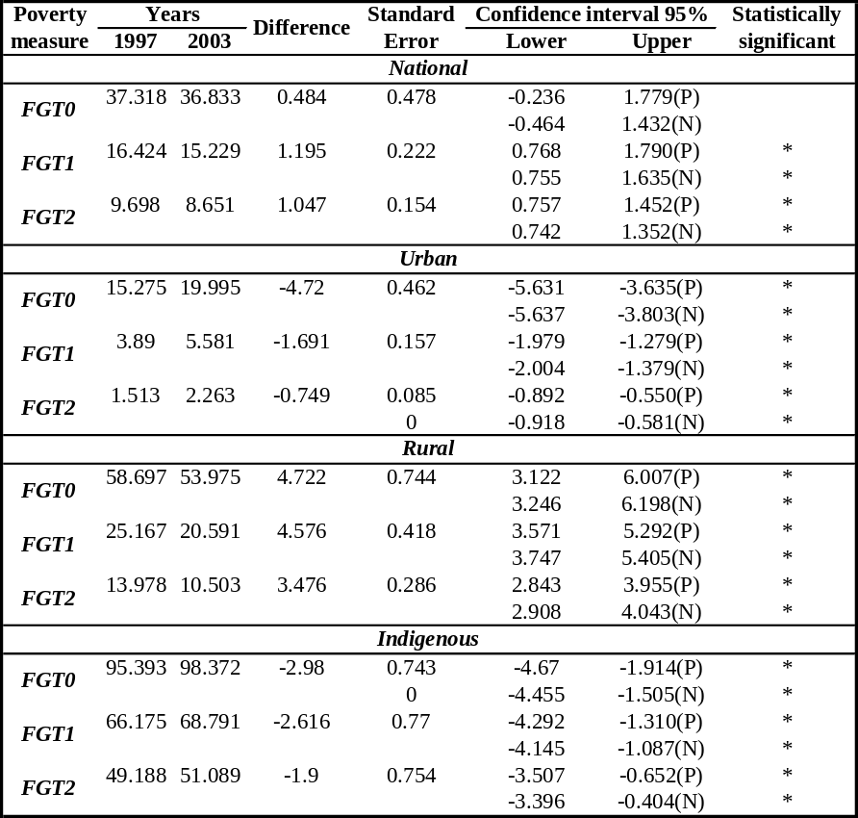
Source: Own estimation based in 1997 and 2003 ENV data.
Note: (P) denote the percentile method and (N) denote the normal-approximation method.

Table A.1.3.3 - Tests of Statistical Significance for Changes in the FGT Poverty Measures Calculated with the Extreme Poverty Line
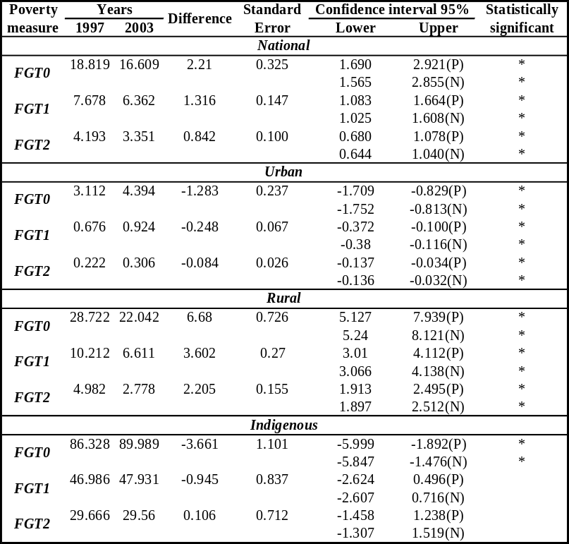
Source: Own estimation based in 1997 and 2003 ENV data.
Note: (P) denote the percentile method and (N) denote the normal-approximation method.

Annex 2.1: Rates of Chronic Malnutrition in Same Age Cohort (between 1997 and 2003)

One hypothesis offered to explain this discrepancy is that the 1997 indicator might have been badly constructed due to measurement errors in the field. To examine this, we look at the malnutrition rates among children who were aged six to eleven at the time of the ENV-2003, i.e. children who are in the cohort that was in the 0 to 5 years of age range at the time of the ENV-1997. As can be seen in Table A.2.1.1, at the national level the differences in chronic malnutrition in the age cohort are very small between the two points in time. However, when we look at the differences within specific subgroups (by geographic area) the differences are striking.
Table A.2.1.1: Rates of Chronic Malnutrition in Same Age Cohort
between 1997 and 2003
 | 1997: Children ages 0 to 5 | 2003: Children ages 6 to 11 | Differences 1997 to 2003
Chronic (height for age)
National | 14.3 | 15.4 | -1.1
Urban | 5.7 | 6.2 | -0.5
Rural | 14.5 | 15.8 | -1.3
Comarca | 48.5 | 58.7 | -10.2
Underweight (Weight for Age)
National | 6.7 | 4.2 | 2.5
Urban | 2.8 | 2.4 | 0.4
Rural | 7.1 | 4.1 | 3
Comarca | 21 | 12.9 | 8.1
Acute (weight for height)
National | 1.1 | 0.8 | 0.3
Urban | 0.9 | 1.1 | -0.2
Rural | 1.1 | 0.4 | 0.7
Comarca | 1.8 | 0.5 | 1.3

Source: Censo de Talla, MINSA/ MEDUC, 2001.

Annex 3.1: Assessing Social Protection in Panama: A Framework

A Social Risks and Groups-At-Risk

This section discusses the main risks facing the different age groups in Panama as well as the risks facing households. This review is not comprehensive but focuses on the major “microeconomic” risks that can contribute, if not addressed, to perpetuating the intergenerational transmission of income poverty. The main finding is that risks occur population wide, but are particularly prevalent among indigenous peoples. The exposure to key risks in childhood fuels the intergenerational transmission of poverty, as malnutrition and lack of sufficient schooling combine to limit income generating potential across the lifecycle.

Children between 0 and 5 years of age

Poor children 0-5 years of age, and particularly the indigenous, suffer from inadequate diet and lack of early stimulation, both of which will impair their development and may maintain them as poor adults.

Malnutrition in children. Low birth-weight due to inadequate maternal food intake may cause poor development in the early years of life and lead to premature death. A recent study commissioned by SENEPAN shows that 20 percent of pregnant women have low weight in the Provinces, with this proportion increasing to 50 percent in the Kuna Yala Comarca. Ten percent of newborns nationwide have low birth weight, but this percentage is higher in indigenous areas.

Low food intake in infants is a critical risk because it can lead to stunting, illness and early death. In 2003, about 21 percent of children under 5 years of age (62,300) suffered from chronic malnutrition (height for age) (Table A.3.1.1). The prevalence is twice as high for indigenous children, with near 57 percent of children affected. Chronic malnutrition has increased for all groups since 1997, but particularly among indigenous and urban children.
Table A.3.1.1: Chronic Malnutrition Among Children Under 5 Years, 1997, 2003 a/
 | Total | Extreme Poor | All Poor | Non-Poor | Urban Areas | Rural  (non indigenous) | Indigenous
1977 (%) | 14.4 | 34.5 | 24.4 | 4.3 | 5.6 | 13.7 | 48.7
2003 (%) | 20.6 | 39.4 | 29.9 | 9.8 | 13.8 | 18.6 | 56.7
2003 (no.) | 68,272 | 37,923 | 53,566 | 14,922 | 25,037 | 19,597 | 25,303
Source: LSMS 1997 and 2003.
a/ Height for age. Children whose height is at least two standard deviations below the reference value.

Low coverage of preschool. There is ample evidence that good child care and preschool increase children's school preparedness. Children who have attended preschool have lower repetition rates in primary school and their overall educational attainment is higher. MEDUCA data indicate that the increase in preschool enrollment between 2000 and 2004, from 36 to 52 percent, was accompanied by a 22 percent reduction in the first grade repetition rate (from 10.9 to 8.6 percent) during the same period. MEDUCA preschool enrollment estimates for 4 and 5-year-olds is 57 percent in 2005 (Table A.3.1.2). This implies that 58,000 children do not access preschool and therefore are at risk.
Table A.3.1.2: Preschool Enrollment Estimates, 2005
 | No. of Children
 | Age 4 | Age 5 | Ages 4-5
Children Ages 4 and 5 years | 67667 | 67567 | 135234
Total Enrolled | 21466 | 55937 | 77403
Public schools | 16605 | 47078 | 63683
Private schools | 4861 | 8859 | 13720
Not Enrolled | 46201 | 11630 | 57831
Memo: % Enrolled, Total | 31.7 | 82.8 | 57.2
Panama Province | 26.2 | 82.7 | 54.4
Kuna Yala Comarca | 57.0 | 75.5 | 66.3
Source: MEDUCA’s Planning Department

Children between 6 and 17 years of age

For primary school age children (6-11 years) and secondary school age teenagers (12-17 years), the major risk they face is that they do not attend school, or drop out. Low schooling generally means poor job market prospects, low salaries, and, possibly, a life in poverty.

Deficient primary education. According to MEDUCA, net primary enrolment in Panama is very close to 100 percent. Measures of the educational system internal efficiency of indicate, however, that repetition and desertion rates at primary level continue to be high, particularly for the extreme poor and indigenous population. For instance, while the nationwide average repetition rate in primary is 5.6 percent, it reaches 13.2 percent in the Kuna Yala Comarca (Table A.3.1.3). Primary drop out rates average 2.7 percent nationwide, but reach 7.2 percent in the Kuna Yala Comarca. These higher drop out rates imply that many extreme poor and indigenous children conclude only a few years of schooling, which adversely affects their future earning potential.
Table A.3.1.3: Primary Education Efficiency Indicators, 2004
(Percentages)
 | Grades
 | 1 | 2 | 3 | 4 | 5 | 6 | Total
Repetition rate | 8.6 | 8.5 | 6.3 | 4.3 | 2.9 | 1.2 | 5.6
Province of Panama |  |  |  |  |  |  | 3.5
Comarca of Kuna Yala |  |  |  |  |  |  | 13.2
Drop out rate | 5.0 | 2.5 | 1.5 | 2.2 | 2.7 | 1.2 | 2.7
Province of Panama |  |  |  |  |  |  | 1.4
Comarca of Kuna Yala |  |  |  |  |  |  | 7.2
Source: MEDUCA data base
a/ For public and private schools based on reconstructed cohort method.
b/ To complete primary.

Low secondary coverage. Net enrollment declines to 64 percent in secondary school. This means that about 133,000 teenagers (12-17 years) do not attend school at this level, with a disproportional number of those in indigenous areas. According to the 2003 LSMS data, net secondary enrollment for the extreme poor and indigenous is about one-half the national average. Thirty-four percent of children say that they did not attend primary school because of cash constraints; 43 percent give this reason for not attending secondary school (Table A.3.1.4).

Vulnerable children/teens. Child workers and pregnant teens are two particularly vulnerable groups. Child workers often do not attend school, which condemns them to a life in poverty and may be employed in hazardous activities. According to IFARHU, Panama counts 52,000 child workers (ages 5 to 17 years). Many of these children are forced to work in the streets of the major cities or in the fields.
Table A.3.1.4: Reasons For Not Attending School, 2003
 | Total | Extreme Poor | All Poor | Non- Poor | Urban Areas | Rural | Rural  Indigenous
 |  |  |  |  |  | Non indigenous
Primary (boys and girls)
Lack of Money | 34 | 36 | 34 | 32 | 39 | 42 | 25
Work | 0 | 0 | 0 | 0 | 0 | 1 | 0
Domestic duties | 1 | 1 | 1 | 0 | 0 | 0 | 2
Not interested | 3 | 4 | 3 | 0 | 0 | 0 | 7
Sickness | 8 | 5 | 7 | 17 | 15 | 9 | 3
Distance/transport | 8 | 11 | 8 | 0 | 0 | 1 | 18
Other | 30 | 31 | 32 | 12 | 32 | 18 | 37
Group Total | 100 | 100 | 100 | 100 | 100 | 100 | 100
Secondary (boys and girls)
Lack of Money | 43 | 51 | 39 | 29 | 34 | 47 |  | 46
Work | 9 | 7 | 6 | 16 | 10 | 9 |  | 6
Domestic duties | 5 | 7 | 4 | 1 | 3 | 6 |  | 5
Not interested | 19 | 17 | 24 | 19 | 21 | 19 |  | 18
Sickness | 2 | 2 | 3 | 2 | 2 | 3 |  | 2
Distance/transport | 1 | 0 | 1 | 1 | 0 | 1 |  | 0
Pregnancy/girls only | 8 | 6 | 5 | 17 | 14 | 6 |  | 5
Other | 9 | 8 | 9 | 12 | 10 | 5 |  | 13
Group Total | 100 | 100 | 100 | 100 | 100 | 100 |  | 100
Source: LSMS 2003

Poor teenagers that become pregnant face a similar set of risks. Poor teenage mothers usually have to leave school and must work to raise their children. Teenage pregnancy is a major cause of the intergenerational transmission of poverty. According to MINSA data, there were 11,921 newborns to adolescents in 2003. or about 18 percent of all newborns. Table A.3.1.5, based on 2003 LSMS data, indicates that while the overall prevalence of pregnancies among girls age 15-17 years is 10 percent, this rate is three times higher for the extreme poor and indigenous girls. Eight percent of the girls that do not assist to secondary school (14 percent in urban areas) give pregnancy as a reason (Table A.3.1.4).
Table A.3.1.5: Incidence of Teenage Pregnancies, 2003
 | Total | Extreme Poor | All Poor | Non-poor | Urban Areas | Rural  (non indigenous) | Indigenous
In girls 15-17 | 8,754 | 4,704 | 6,975 | 1,779 | 2,786 | 3,604 | 2,364
Total no. of girls 15-17 | 84,778 | 17,109 | 35,769 | 49,009 | 48,500 | 29,283 | 6,995
% | 10.3 | 27.5 | 19.5 | 3.6 | 5.7 | 12.3 | 33.8
Source: LSMS 2003

Working age population

The principal risk facing the poor working population is low and unstable income because they have low paid and insecure jobs, often because of their low educational achievement.

Low and unstable income. The most important indicator of low income is the extent of poverty. The headcount measure indicates that 36.8 percent of all Panamanians are poor and 16.6 percent are extremely poor. In indigenous areas, these rates reach 98.4 percent and 90 percent, respectively, but poverty and extreme poverty are also present in other rural areas and in some urban neighborhoods.

The rates of unemployment and underemployment are good indicators of the poor capacity to generate income since labor is their main productive asset. In 2004, about 160,000 persons (12 percent of the labor force) were unemployed and 229,000 persons (18 percent) were underemployed (Table A.3.1.6). Unemployment among youth (27 percent) was about twice the national average. The highest rates of youth unemployment were in Colón (43 percent) and Panama (32 percent) provinces.
Table A.3.1.6: Employment and Underemployment, 2003, 2004
(No. and Percentages)
 | 2003  No. | 2004  No. | 2003  % | 2004  %
Economically Active Population | 1,250,874 | 1,285,122 | 100.0 | 100.0
Employed | 1,080,523 | 1,126,816 | 86.4 | 87.7
Full time | 688,150 | 748,771 | 55.0 | 58.3
Part time | 146,523 | 149,408 | 11.7 | 11.6
Underemployment | 245,850 | 228,637 | 19.7 | 17.8
Unemployment | 170,351 | 158,306 | 13.6 | 12.3
Source: “Panamá en Cifras 2000-04”. Dirección de Estadística y Censos, Noviembre 2005, (Cuadro 441-02), 212.

Lack of skills and education usually leads to low productivity and low paid jobs. Illiteracy in Panama is estimated at 7 percent of the working age population. Nonetheless, this national average masks large disparities. Table A.3.1.7 indicates that for the extreme poor and indigenous population illiteracy reaches 27 and 39 percent, respectively. In indigenous areas, one-third of men and more than one-half of women are illiterate.
Table A.3.1.7: Male and Female Literacy a/, 2003
 | Total | Extreme Poor | All Poor | Non-poor | Urban Areas | Rural  (non indigenous) | Indigenous
Total | 93 | 73 | 83 | 97 | 98 | 89 | 61
Male | 94 | 79 | 86 | 97 | 98 | 89 | 76
Female | 92 | 66 | 80 | 97 | 98 | 89 | 46
Source: LSMS, 2003
a/ Percentage of those 15 and older who can read and write (UNESCO definition)

The extreme poor and the indigenous also lag substantially behind the non-poor in educational attainment (Table A.3.1.8). While at the national those with 25 years and more attain 8.6 years of schooling, the extreme poor and indigenous only average 3.7 and 3.1 years, a gap of 5.5 years for the indigenous population. An encouraging sign is that the education gap between these groups is smaller for younger cohorts. For example, for the 18-24 cohort the gap between the indigenous population and the national average is 4.7 and for the 12-17 cohort, 2 years.

Senior citizens

The major risk for senior citizens is that they do not have a pension when they leave the labor market and must depend on relative or charity for their survival.
Table A.3.1.8: Education Attainment a/, 2003
 | Total | Extreme Poor | All Poor | Non-poor | Urban Areas | Rural  (non indigenous) | Indigenous
Years 12-17
Total | 6.9 | 5.4 | 6.1 | 7.6 | 7.4 | 6.7 | 4.9
Male | 6.7 | 5.1 | 5.8 | 7.4 | 7.2 | 6.4 | 4.9
Female | 7.1 | 5.7 | 6.3 | 7.8 | 7.7 | 6.9 | 4.9
Years 18-24
Total | 10.0 | 6.2 | 7.5 | 11.3 | 11.1 | 8.8 | 5.3
Male | 9.6 | 6.4 | 7.4 | 10.9 | 10.6 | 8.2 | 6.2
Female | 10.5 | 5.9 | 7.7 | 11.7 | 11.5 | 9.4 | 4.3
Years 25 +
Total | 8.6 | 3.7 | 5.3 | 9.9 | 10.2 | 6.2 | 3.1
Male | 8.5 | 4.3 | 5.4 | 9.8 | 10.2 | 6.1 | 4.1
Female | 8.7 | 3.2 | 5.2 | 10.0 | 10.2 | 6.3 | 2.1
Source: LSMS 2003
a/ Average number of years of schooling.

Lack of pension. Panama’s social security institute or Caja de Seguro Social (CSS), was established in 1941 and offers insurance to about two-thirds of the population under three programs: health (Enfermedad y Maternidad); professional risks (Riesgos Professionales); and pensions (Invalidez, Vejez y Muerte). The pension system consists of an obligatory defined-benefit pay-as-you-go scheme with partial collective capitalization funded through compulsory contributions. Although social security coverage in Panama (51 percent of the labor force) is similar to Costa Rica (49 percent) and greater than Argentina (21 percent) and Mexico (30 percent), 1.2 million Panamanians are still not covered.

In 2003, according to the Directorate of Statistics and Census, there were about 274,000 seniors of retiring age or more (57 years for women and 62 years for man), about 9 percent of the total population. That year, CSS counted 162,600 beneficiaries in those ages, of which 145,046 were pensioners and the remainder 17,554 active members or dependents (Table A.3.1.9). Therefore, about 111,400 seniors are without pension or access to CSS benefits.

About 25 percent and 9.5 percent of the population above 62 are in poverty and extreme poverty, respectively. Applying these rates to the retiring age population (274,000) yields 68,500 poor and 26,000 extreme poor seniors, who are likely among those without pensions.

Table A.3.1.9: Population with Pensions, 2003
 | Total | Extreme Poor | All Poor | Non-poor | Urban Areas | Rural  (non indigenous) | Indigenous
No. Pensioners a/ | 145,046 | 1,987 | 10,427 | 132,632 | 118,246 | 25,952 | 848
Population 62 + | 256,843 | 24,432 | 63,600 | 193,243 | 152,665 | 93,866 | 10,312
% | 56.5 | 8.1 | 16.4 | 68.6 | 77.5 | 27.6 | 8.2
Average Pension b/ | 426 | 206 | 222 | 442 | 453 | 308 | 232
Source: No. of Pensioners (CSS; “Panama en Cifras 2000-04” Dirección de Estadística y Censo, 2005 (Cuadro 421-01) and LSMS 2003
a/ Includes the professional risk (Riesgos Professionales). b/ B/ month

Households

The major risks facing households are to isolation and exclusion or no access to basic services such as health, shelter, water and sanitation, and energy.

Geographic isolation and social exclusion. These risks are difficult to quantify but easily identifiable in the Comarcas. For instance, in the Ngöbe Buglé Comarca, road transportation links are very poor or inexistent and many communities are isolated. Reaching the southern parts of the Comarca requires a boat ride on the Atlantic to an adjacent Province; reaching a main road; and then backtracking to the south. Besides these physical barriers, other dimensions of isolation, marginalization, and social exclusion characterize many of these communities including lack of access to many essential services and low participation in community activities, school and neighborhood associations, or political activities.

Precarious health services. Most of the poor are not covered by health insurance. CSS data indicates that nearly 1.2 million people do not receive CSS benefits including its medical insurance (Table A.3.1.10). Most likely, these include the very rich and the very poor. According to the 2003, only 4 percent of the population has private health insurance. Therefore, at least 1 million people are without health insurance.
Table A.3.1.10: CSS’s Coverage, 2001-2004
 | Population  Covered by CSS | Population Covered  % of total | Population Not Covered
2001 | 1931368 | 64.3 | 1,072,586
2002 | 1952059 | 63.8 | 1,108,031
2003 | 1959163 | 62.9 | 1,157,114
2004 | 2014699 | 63.5 | 1,157,661
Source: CSS; “Panama en Cifras 2000-04” Dirección de Estadística y Censo, 2005 (Cuadro 421-01).

Most of the poor do not have health insurance and must use the Ministry of Health (MINSA) facilities. The poor and the indigenous are less likely to seek medical treatment when sick than the non-poor. Table A.3.1.11 presents the reasons people gave for not visiting MINSA facilities when they became sick. One-half indicated that service was expensive or they could not afford transportation costs. Cost-related reasons were given by 50 percent of the extreme poor and 57 percent of those in the indigenous areas. Seven percent gave reasons related to the quality of service (lack of doctors or nurses, lack of trust in health personnel).
Table A.3.1.11: Motives for Not Visiting MINSA Facilities a/, by Poverty Group and Geographic Area, 2003
(Percent of Ill that not Visit Facilities)
Motives | Total | Extreme Poor | All Poor | Non-Poor | Urban Areas | Rural  (non-indigenous) | Indigenous
Lack of money for transport | 32 | 38 | 38 | 22 | 21 | 42 | 33
Service is expensive | 16 | 22 | 19 | 13 | 17 | 10 | 24
Place of attention distant | 12 | 20 | 14 | 10 | 2 | 15 | 23
There is no transport | 0 | 1 | 1 | 0 | 0 | 1 | 0
There are no doctors/ nurses | 2 | 2 | 2 | 3 | 2 | 4 | 1
Does not believe in these people | 5 | 4 | 4 | 6 | 5 | 4 | 4
Had not time | 11 | 3 | 6 | 20 | 20 | 8 | 3
Other | 21 | 11 | 18 | 27 | 33 | 16 | 13
Total | 100.0 | 100.0 | 100.0 | 100.0 | 100.0 | 100.0 | 100.0
Source: LSMS 2003
a/ Excludes the reason that the illness was not sufficiently serious.

Distance to health facilities appears to be a significant deterrent to access health services (12% of responses), particularly in the indigenous and rural areas. According to LSMS data, in rural areas, it takes on average 40 minutes to reach the nearest health facility, compared to 23 minutes in urban areas and 58 minutes in indigenous areas.

Inadequate housing. Poor housing poses several risks for households. Houses that are deteriorated, built with inadequate or improvised materials, or built in critical areas, are more susceptible to destruction in case of adverse weather, floods, or fires, and threaten the physical security of dwellers. Housing overcrowding involves other social risks and is not conducive to a healthy development of household members. To quantify these risks, MIVI uses three indicators: i) partially deteriorated housing units, ii) totally deteriorated units, and iii) overcrowded units (more than 2 persons per room). Table A.3.1.12 shows that about 30 percent of the housing units are overcrowded (231,932). Nine percent of all housing units (68,526) are totally deteriorated and would need to be replaced.
Table A.3.1.12: Inadequate Housing, 2000, 2003, 2005
 | 2000 | 2003 | 2005
 | % | % | No of Units | %
Partial deterioration | 8.5 | 7.5 | 56,139 | 7.1
Total deterioration | 10.8 | 9.4 | 68,526 | 8.7
Overcrowded a/ | 37.7 | 32.8 | 231,932 | 29.4
Total No. Units | N/A | N/A | 788,015 | 100.0
a/ More than 2 persons per room.
Source: “Segundo Informe de la Metas del Milenio”, Gabinete Social, 2005” (Recuadro 19) and MIVI.

Lack of other basic services. Many of the poor in Panama still lack other essential services such as safe water, sewerage and electricity. The poor that do not have access to these basic services must incur in extra costs or extra time to obtain them. Table A.3.1.13 indicates that there are still 43,640 poor households without safe water, 154,300 without sewerage, and 87,400 without electricity in Panama.
Table A.3.1.13: Access to Basic Services, 2003
(Number of Households and %)
 | Total | Extreme Poor | All Poor | Non-Poor
Without Safe Water a/ | 65,269 | 25,237 | 43,641 | 21,628
% of total | 8.6 | 34.8 | 22.2 | 3.8
Without Sewerage b/ | 314,588 | 65,677 | 154,296 | 160,292
% of total | 41.5 | 90.6 | 78.6 | 28.5
Without Electricity | 120,486 | 52,301 | 87,398 | 33,088
% of total | 15.9 | 72.1 | 44.5 | 5.9
Total No. HHs | 758365 | 72498 | 196232 | 562132
Source: LSMS 2003
a/ Households with access to safe water are those that have access to either public,
community of private piped water. b/ Households with access to sewerage.

Social Protection Programs

This section reviews briefly the public programs that seek to address the main risks identified above. The coverage of programs discussed here is not comprehensive; rather it focuses on the programs that were identified with the help of the institutions responsible for the respective areas.

Programs for children under 5 years of age

The main risks facing this age group are malnutrition and lack of early stimulation. Because of the relatively greater impact of malnutrition on very young children, adequate nutrition for children under 3 and for pregnant and lactating women is the most important priority. For children 4-5 years, adequate food intake should continue together with attendance to preschool.

MINSA has two nutrition programs that focus on poor mother-infant groups and reinforce each other: the Complementary Feeding program and the Micronutrients program. The Complementary Feeding Program delivers a precooked corn meal (nutricereal) enriched with vitamins and minerals. The program targets poor children between 6 to 59 months, and low-weight pregnant and lactating. In indigenous areas, the program covers children that attend check-ups in health facilities; in the other priority poor districts, the beneficiaries are those that suffer from, or are at risk of malnutrition; in no priority districts the beneficiaries are only those that suffer from malnutrition. Each beneficiary receives 6 pounds of nutriceral per month, which permits 45 gram daily rations. Children receive the complement for six months; pregnant women since their first prenatal control until the sixth month of breast-feeding. In 2005, the Complementary Feeding program covered 34,340 children and 9,560 pregnant women at a cost of B/ 1.8 million.

The Micronutrient program delivers mega doses of vitamin A and iron supplements to vulnerable groups. The mega doses of vitamin A is given to children age 6 to 59 months and pregnant women that attend health controls. The iron supplement is given to children 4 to 59 months and pregnant women during the health controls and distributed once a week by teachers to students. The program also distributes antiparasites to infants in health centers and children in schools. In 2005, the Micronutrient program covered 390,000 children and 43,550 pregnant women with iron and vitamin A supplements, and 450,000 children with antiparasites at a cost of B/ 538,000.

In late 2005, the National Secretariat for Food and Nutrition (SENEPAN) with the support of UNICEF, launched a pilot program in two of the poorest districts --Santa Fé and Mironó--. The program covers about 4,000 families for a duration of 30 months. The program provides women in the poorest families with children with 7 B/5-vouchers per month (B/ 35) on the condition that: i) children attend school, (ii) children keep immunizations up to date; (iii) women in fertile age keep their health controls up to date (pregnancy and pap smear); and (iv) one household member participates in a MIDA-sponsored training program on foodstuffs production. With the vouchers, women recipients can buy the following products in participating local stores: rice, pasta, beans, iodized salt, sugar, milk, tuna, sardine, chicken, eggs, soap and matches. The program counts with the participation of local governments, community organizations, and central government organizations including MINSA, MEDUCA, and MIDA. The pilot established a base line, is being closely monitored, and will be evaluated to assess its impact.

MIDES manages 108 COIFs (Centros Integrales de Desarollo Infantil) Centers for children under 4 years of age. The COIFs use mostly community facilities or host organizations (universities, enterprises, ministries), and are financed by parents, host organiztions, and MIDES. In 2005, 3,710 children attended the COIFs. MIDES spent B/ 112,000 in the program including B/48,000 in investment to improve some facilities. MIDES also manages a small program to improve community kitchens (Comedores Comunitarios) in which it spend B/ 60,000 in 2005.

Since the 1995 education reform, preschool attendance by all children age 4 and 5 years is mandatory and free in Panama. MEDUCA has two programs of informal education that seek to increase the coverage of preschool and complement the efforts of the formal education system: Initial Education at Home (EIH) and Community and Family Centers for Initial Education (CEFACEI). The cost and coverage of these programs and the formal preschool program are summarized in Table A.3.1.14.
Table A.3.1.14: Preprimary Programs, 2005
 | No. of Children |  |  | % | Unit Cost | Total Cost  (B/000)
 | Age 4 | Age 5 | Ages 4-5 | Ages 4-5 | B/year
Public schools | 16605 | 47078 | 63683 | 100.0
Formal | 5946 | 35381 | 41327 | 64.9 | 414 | 17,109
EIH | 876 | 807 | 1683 | 2.6 | 70 | 118
CEFACEI | 7334 | 9722 | 17056 | 26.8 | 150 b/ | 2,558
Other a/ | 2449 | 1168 | 3617 | 5.7 | N/A | N/A
Source: MEDUCA
a/ Municipal, MIDES, and Institutional
b/ Excludes infrastructure cost.

Initial Education at Home is a community based program targeted at rural and indigenous communities. It provides training and educational materials to parents of children less than 6 years of age to improve their child care practices and help them guide their children's early cognitive and social development. In 2005, 3,200 children participated in about 150 organized groups, including 1,683 children of 4 and 5 years of age at an estimated cost of B/ 118,000.

CEFACEIs offer preschool education in rural and indigenous areas for children 4-5 years. A community educator (promotora) --with or without formal training-- attends to 15-20 children in a school or other community infrastructure. In 2005, over 700 CEFACEIs enrolled 17,056 children age 4 and 5 years at a cost of B/ 2.6 million (excluding infrastructure).

Programs for youth and teenagers

For youth and teenagers, the principal risk they face is that they drop out of school and fail to acquire the required level of knowledge to secure a good job in the labor market. As mentioned, children’s attendance and permanence in school is directly related to their poverty status; and some become child workers to generate income.

In addition to the SENAPAN’s pilot program mentioned above, two main school feeding programs seek to attract and retain children in school: an early-morning snack program managed by MEDUCA and a lunch program managed by the Social Investment Fund (SIF). These programs constitute an income transfer to the families for preschool and primary school age children alimentation. To facilitate access to schools, IFRARHU administers student assistance programs for primary, secondary and higher education, which are financed by Seguro Educativo, a payroll tax (2.75 percent). These programs are described below and their coverage and costs summarized in Tables A.3.1.15 and A.3.1.16.

MEDUCA’s snack program began in 1987. Currently, there are three types of interventions. First, whole liquid milk and a nutritionally fortified cookie are distributed in schools with high density of population but that lack the conditions to prepare and distribute foods. Second, a nutritionally fortified mixture (crema) and cookie are distributed in rural indigenous areas with population in extreme poverty and higher levels of malnutrition. And third, crema is distributed to the rest of schools in areas of difficult access. In 2005, this program covered 471,000 children at a cost of B/ 14 million.

SIF’s school lunch program (almuerzo escolar) initiated in 1991 and consisted of a lunch made from rice, beans, and oil. The foods are distributed to the schools and the meals cooked with the support of the communities. Each ration provides no less than 20 percent of each recipient's daily recommended calorie and protein intake. Usually, the same poor students benefit from both MEDUCA snack and SIF school lunch. In 2005, this program covered 163,600 children at a cost of B/ 1.9 million.
Table A.3.1.15: School Lunch Program, 2005
 | Coverage  (students) | Cost  B/ 000 | Poverty Targeting
A. MEDUCA | 485,473 | 14,694
1. Snack | 471,058 | 13,908 | Universal
Milk& cookie | 216,437 | 9,911 | Universal
Crema & Cookie | 58,700 | 1,331 | Universal
Crema | 195,921 | 2,665 | Universal
(2. Lunch) a/ | (14,415) | (786) | (yes)
B. SIF- Lunch | 163,592 | 1,900 | Yes
Source: MEDUCA and SIF
a/ Discontinued in 2006

IFARHU runs three major programs: scholarships, student loans and direct economic assistance to vulnerable groups. In 2005, its resources amounted to B/ 60 million; from the Seguro Educativo payroll tax (B/ 39.3 million), the recovery of education loans (B/ 9 million) and other transfers. Its operating costs were B/ 7.8 million and it investment B/ 52.2 million.

The scholarship program targets students from primary, secondary and higher education that finish at the top of their classes, achieve high grades, or excel in sports or arts. Table 16 indicates that during 2005, IFARHU gave 4,923 scholarships at a cost of B/ 2.6 million. The loan program is directed at students in public or private universities, with preference given to the students that choose IFARHU priority areas of study. In 2005, the institution extended 1,393 loans at a cost of B/ 5.6 million. The third is a program of non-reimbursable assistance to students in vulnerable positions such as orphans, children of unemployed or single parents, students with physical disabilities, extreme poor students, or any other vulnerable students. In 2005, there were 5,944 beneficiaries at a cost of 2.6 million. In 2006, IFARHU began two new programs: one for its employees’ relatives (503 scholarships planned at a cost of B/ 300,000) and another one for child workers, as discussed below.
Table A.3.1.16: IFARHU Assistance Programs, 2005, 2006
 | Accumulated  Dec. 2005 | New Assistance in  2005 |  | New Assistance Planned for 2006
Program | No. | No. | Amount  (B/million) | No. | Amount  (B/million)
1. Scholarships | 14,552 | 4,923 | 2.6 | 7,114 | 4.0
2. Student Loans | 2,232 | 1,393 | 5.6 | 2,922 | 12.6
3. Assistance Vulnerable Groups | 7,782 | 5,944 | 2.6 | 13,907 | 5.7
4. Economic Support |  |  |  | 506 | 0.3
Total |  |  | 10.8 a/ |  | 22.6
Source: IFARHU
a/ Total expenditures in 2005 were B/ 60 million.

In April 2006, IFARHU initiated a “scholarship” program for working children. The program consists in 1,000 scholarships of B/ 35 per month during three years for children that work in urban areas (supermarkets, carwash) or rural areas (i.e, coffee plantations) against the commitment to attend school. The program began in the capital city, where IFARHU distributed scholarships to 150 children, selected with the support of Casa Esperanza, an NGO. Priority was given to the most vulnerable children, particularly to orphans. The program will be extended gradually to the rest of the country.

MIDES manages a few programs for youth including the Meeting Point Program (Puntos de Encuentro) that promotes healthy leisure such as sports or cultural events. In 2005, the program reached almost 4,000 youth at a cost of B/ 150,000.

Programs for the working Age population

The major risks to this group is low and unstable income because of unemployment, underemployment, or low paying jobs that often are linked to low productivity and lack of skills and/or low education. The principal public provider of vocational training is the National Institute of Vocational Training (INAFORP). INAFORP resources come from its share of 10.95 percent on the Seguro Educativo (payroll tax). In 2005 its budget was B/ 10.6 million, of which B/ 2.5 was for general administration and the remaining for other recurrent expenditures (B/ 5.5 million) and investment (B/ 2.6 million). It offers several training modalities: center-based, firm-based, mobile, and distance learning. It runs 16 training centers in the country, which offer courses in: automotive mechanics; industrial maintenance and repairs; electro mechanics; cooking, and administration.

MIDES manages a small program that prepares young adults for the job market. In 2005, MIDES reports training 1,600 persons at a cost of B/ 20,000.

Programs for senior citizens

The principal risk facing seniors is that they do not have a pension or other any other source of income once they retire. Since 2002, the CSS had been experiencing rising cash flow deficits that threatened its future financial viability. A reform of the social security system was approved in December 2005 (Law 51). It consists of parametric changes applied to the existing pay-as-you-go scheme and the introduction of new individual savings accounts. It will: (i) gradually increase the contribution rate to 13.5 percent (from 9.5 percent); (ii) increase the minimum quotas (contributions) required to retire from 180 to 240 (20 years); (iii) introduce a solidarity contribution (3.5 percent) levied on wages in excess of B/ 500 to partly offset the loss of contribution channeled to the individual savings accounts; (iv) increase the minimum pension from B/ 175/ month to B/185 in 2010 and every five years thereafter; and (iv) provide for substantial transfer from the Central Government to the defined benefit scheme (B/ 75 million a year in 2007-09; B/ 100 million a year in 2010-12; and B/ 140 million a year in 2013-60). Preliminary estimates by the IMF suggest that the reforms lead to a slight improvement in the CSS balance during 2006-2010.

The reform also contemplates several provisions to increase the coverage. The reform makes it obligatory to all self-employed workers to contribute to CSS (Article 77). It facilitates the voluntary affiliation of foreigners that work in Panama, Panamanians that work for foreign entities, housekeepers, and other workers that are not required to affiliate. For some of these workers, the new law makes an exception and allows the quota to be based on their actual salary which could be lower than the minimum pension (B/ 175). Also, beginning in 2008, agricultural and construction workers who did not reach the minimum 180 quotas because of the nature of their seasonable work will be allowed, if they have a minimum of 125 quotas, to retire with a pension, potentially below the minimum pension.

Programs for households

The main risks facing the poor households are that they are isolated or excluded and lack access to basic services. The government has several programs directed at vulnerable households and programs that seek to increase the access of the poor to basic services.

Geographic isolation and social exclusion. The Social Investment Fund (SIF) has five programs directed at the poor population which suffer from social exclusion or lack access to basic services. These programs are briefly described below and their costs summarized in Table A.3.1.17.
- Poverty Alleviation and Community Development Program. This program (B/ 66 million) was initiated in 1999 with IDB support. Its objectives are to finance local infrastructure priority needs and to support the development of community driven planning, while decentralizing SIF activities to the community level. The program has two sub-components: local investments (social and economic infrastructure projects that are community priorities) and Community Development (community planning and decentralization of SIF). The budget for 2005 was B/ 4.5 million.
- Program of Sustainable Development of the Ngöbe Buglé Comarca and Nearby Poor Corregimientos. This is a program (B/ 33 million) to be executed during 2003-11 with support from the International Fund for Agriculture Development (IFAD/FIDA). Its objectives are to: (i) improve the living conditions of the indigenous dwellers of the area while conserving their cultural identity; (ii) strengthen indigenous management capacity; and (iii) incorporate the indigenous population to the institutional framework of the country. It provides support to organization and training, social infrastructure, productive development, environment, and a capitalization fund. The beneficiaries are 96,000 indigenous people in poverty and extreme poverty. Its budget for 2005 was B/ 2.4 million.
- Program for Vulnerable Groups. This program was initiated in 1997 with the support of IDB and the World Bank. It finances initiatives of NGOs that support vulnerable groups (persons with disabilities, poor women, youth at-risk, poor seniors, vulnerable children, poor indigenous people). The 10 projects financed in 2005 included provision of construction material, construction of contention walls, support to sport and cultural youth activities, literacy program, etc. The budget for 2005 was B/ 361,500.
- Program of Local Investments (PROINLO). This program is financed at the request of the 621 local representatives. The projects are selected on the basis of popular consultations and may include infrastructure projects or provision of basic inputs. The budget for 2005 was B/ 4.2 million.
- Rural Electrification Program. This program initiated in 1997 and provides electricity to the communities that are more than 500 meters from the distribution line or to isolated houses. The solutions include connection to the distribution line, thermal plants, hydro plants, or solar panels. The SIF subsidizes the connection or installation and beneficiaries are responsible for paying the energy. The amount of subsidy provided in 2005 was B/ 2 million.
Table A.3.1.17: SIF Programs, 2005
Name of Program | Amount  ( B/000) | Poverty Targeting
Poverty Alleviation and Community Development Program | 4,496 | Yes
Program of Sustainable Development of the Ngöbe Buglé | 2, 368 | Yes
Program for Vulnerable Groups | 362 | Intended
PROINLO | 4,232 | No
Rural Electricity | 2,000 | Intended
Total | 13,458
Source: SIF

Medical Insurance. Most of the poor do not have access to health insurance and must attend MINSA facilities. However, cash constraints prevent the poor and the indigenous to seek medical treatment when they are sick. The CSS is seeking to expand its coverage to the 30 percent of uninsured population. MINSA is also seeking to increase its outreach to the poor in rural and indigenous areas. The pilot program initiated by SENAPAN that provides transfers to poor families conditioned on attendance to health facilities is receiving strong support from MINSA.

Housing Subsidies. In 2005, four housing programs distributed direct or indirect subsidies to families. Some of these programs target low income families, others not. Their total cost in 2005 was B/ 45 million. These programs are described briefly below and summarized in Table A.3.1.18.

Housing assistance. This program was initiated in 1973 (Law 29) and modified in 1986. It distributes materials to families that need aid to build a minimum house or to repair or reconstruct their house after a natural disaster. All families qualify but with preference given to poor, needy families. In 2005, the program spent B/ 3.5 million and supported the rehabilitation of 1,223 units.

Dignified National Housing Plan (Plan Nacional de Vivienda Digna). This program supported 281 families, whose house was damaged by natural disasters in 2004, in the eastern part of Panama Province. The works were executed in Tanara, Chepo. It supported households with housing materials in San Carlos, Capira y Chame. It rehabilitated 365 units and helped the construction of 511 low incomes houses in the rest of the country: 335 in Chiriquí, 102 in Veraguas, 20 in Coclé, 24 in the Comarcas, 20 in Los Santos, and 10 in Darién. In 2005, the program financed 1,157 housing solutions at a cost of B/ 3.3 million.
- Measurement and legalization. This program was initiated at the beginning of the 1980s and expanded in the 1990s. Its objective is to legalize unauthorized settlements in public land, particularly in major urban areas. The program legalizes the plots which are then sold by the National Mortgage Bank. More recently the program has also helped legalize communities occupying private land. In 2005, it financed 1,890 solutions at a cost of B/ 2.6 million.

Table A.3.1.18: Housing Subsidies, 2005
Program/  Financing | Explanation | Type | Rationale | Poverty  Targeting | 2005
 |  |  |  |  | Output | B/000
Housing Assistance (MIVI) | Support with materials and reallocation | Direct | Help to recover from disaster | Intended | Rehabilitation: 1,223 units | 3,511
Plan of Dignified Housing (MIVI) | Materials or complete units | Direct | Affordability | Intended | Solutions: 1,157 | 3,293
Measurement and Legalization  (MIVI) | Legalization of “spontaneous” settlements | Direct | Improve urban and settlers conditions | Intended | Solutions: 1,890 | 2,584
Preferential Interest rate  (Treasury) | Subsidized mortgage rates | Direct | Affordability | No | N/A | 35,200
Total |  |  |  |  |  | 44,688
Source: MIVI and MEF (Preferential Interests)

- Preferential interest rate. This program, which was initiated in 1985, subsidizes the interest rate on commercial mortgages. The Treasury credits the participating banks with the interest rate differential against their income tax liabilities. To qualify for the subsidy the house must be new and under B/ 62,500, and the mortgage over 15 years of duration. The Treasury pays up to 4 percent point for loans between B/ 25,000 and B/ 62,500; up to 5 percent for loans between B/16,000 and B/ 25,000 and up to 6.5 percent for loans up to B/ 16,000. The subsidy is applied on the difference between the reference rate (7 percent in the first quarter of 2006) determined by the Superintendence of Banks and the actual rate applied by lender below the reference rate, within the set limits. The reference rate is calculated on the basis of the average rate applied to similar loans by the Caja de Ahorro and the five largest private mortgage banks during the previous month. In 2005 this program cost the Treasury B/ 35.2 million.

Water Subsidies. One in each of every five poor households has no access to safe water and three in every four do not have access to sewerage. There are six subsidies in water and sanitation. These are described below and summarized in Table A.3.1.19.
- Unremunerated equity. The government transfers almost all investment funds to IDAAN in the form of grants, relieving the company of any debt service or dividend obligations that would otherwise have to be paid. While also common in many other countries, this practice constitutes a substantial hidden subsidy. The opportunity cost of this “free” government contribution is estimated at B/ 41 million in 2004.
- Payment of bulk water bills. The government pays IDAAN’s unpaid bills to ACP for bulk water purchases, which amounted to B/ 24 million in 2004.
- Water delivered in tankers. IDAAN pays private tankers to deliver water for free in unserved urban areas. This subsidy costs B/ 3 million per year.
- Special tariff. A tariff discount of 15 percent to about 43 percent of residential users in certain zones of the Metropolitan area, making their tariff equal to the tariff paid by urban users in the interior. It is not clear who determines the beneficiaries and the level of the discount, and on what basis. The cost of this “special” tariff is estimated at B/ 1.5 million in 2004.
- Tariff adjustment (seniors). IDAAN provides an “adjustment” to retirees and seniors, lowering their tariffs 25 percent at a total cost of B/ 1.35 million in 2004.
Table A.3.1.19: IDAAN Subsidies, 2004
Subsidy | Explanation | Type | Rationale | Poverty Targeting | Amount  (B/000)
Unremunerated equity | The government does not require a dividend on its capital contribution | Hidden | Not specified | No | 41,000
Payment of bulk water bills | The government pays bills by ACP that are not paid by IDAAN | Indirect | Bail-out | No | 24,000
Water delivered in tankers | Free water delivered by tankers to un-served neighborhoods | Direct | Universal service | Yes | 3,000
Special tariff | Applied to certain zones in the Metropolitan area | “Cross-subsidy” | Affordability | Intended | 1,500
Tariff adjustment | Granted to seniors and retirees | “Cross-subsidy” | Affordability | Intended | 1,350
Tariff discount | Granted to users unable to pay their bills | “Cross-subsidy” | Affordability | Yes | 1,300
Total |  |  |  |  | 72,150
Source: Public Expenditure Review, 2006, World Bank (Table 8.4)

- Tariff discount. There is a “discount” for needy users, costing B/ 1.3 million in 2004. A team of social workers at IDAAN headquarters verifies on site if these requests are justified before the discounts are applied.

The total cost of these subsidies amounts to more than B/ 72 million per year. The subsidies are funded in various ways. The two most important subsidies are funded by the Treasury by not requiring dividends on the government’s equity and by paying ACP for IDAAN’s unpaid water bills. The family subsidy is paid through the Fondo Fiduciario para el Desarrollo. The remaining three subsidies are funded by IDAAN and contribute to its losses.

Electricity Subsidies. In addition to the rural electrification subsidies discussed above, there are other three electricity subsidies in Panama. Two of the subsidies are cross financed and the third subsidy is financed by the Tariff Stabilization Fund, which resources originate from the dividends the government receives from the privatized electricity companies. These programs are described briefly below and summarized in Table A.3.1.20.
- Discount to small consumers. All households with consumption below 100 kwh receive a 20 percent discount on the electricity bill which is paid by those that consume more than 500 kwh per months. These latter consumers pay the subsidy up to a 0.5 percent of their bill, with the amount paid to finance the subsidy explicitly shown in their bill. This additional amount has been sufficient to pay for the subsidy. In 2005, the subsidy benefits 252,016 consumers (or 37 percent of total residential consumers) at an estimated annual cost of B/ 8.8 million.
- Discount to seniors. All retirees or seniors older than the retiring age (62 man and 57 women) receive a 25 percent reduction in their electricity bill for the first monthly 600 kwh consumed. It is paid by all other consumers since it is taken into account by the companies when calculated their maximum allowed income (Ingreso Maximum Permitido) and corresponding tariffs. To receive the subsidy, the house must be in the name of the retiree. In 2005, about 30,000 senior citizens may have benefited from this subsidy at an estimated cost of B/ 7.8 million annually.
- Reduction in tariff hikes. Consists of a reduction in proposed tariff hikes which are covered by the Tariff Stabilization Fund (TSF). All consumers benefit. In the last tariff increase (April 2006) those that consumed less than 200 kwh per month (464,922 or 67 percent of all commercial consumers) were not affected by the increase while those who consume more than 200 kwh per month saw their tariff increase limited to 10.6%. The cost to TSF of this “stabilized” tariff was B/ 24.9 million in 2005 and should increase to B/ 52.6 million in 2006.
Table A.3.1.20: Electricity Subsidies, 2005
Subsidy | Explanation | Type | Rationale | Poverty Targeting | Amount  B/ 000
Discount to small consumers | 20% discount on consumption < 100 kwh/ month. | “Cross-subsidy” | Affordability | Yes | 8,800
Discount to seniors | 25% discount to retirees | “Cross-subsidy” | Affordability | Intended | 7,800
Reduction in tariff hikes | Granted to all consumers | Direct | Affordability | No | 24,900
Total |  |  |  |  | 41,400
Source: Comisión de Política Energética, MEF

LPG for cooking and gasoline subsidies. Since 1993, the liquefied petroleum gas (LPG) subsidy is given to all consumers purchasing the 25 pound LPG cylinders, the smaller size available. The Treasury recognizes a fiscal credit to the gas companies to be applied against their Consumption of Fuel and Petroleum Derivates tax or other import taxes. The Directorate of Hydrocarbons in the Ministry of Commerce and Industries (MICI) establishes the sale price to the public and the import parity price for LPG (and other petroleum products), which is the maximum CIF price that the companies should buy the product for sale in Panama (Table A.3.1.21). In 2005, the LPG subsidy costs the Treasury B/ 39.4 million.
Table A.3.1.21: Price of LPG, May 3, 2006
Product | Import Parity Price | Controlled Sale Price in Panama City
25 LBS. | 8.4374 | 4.37
60 LBS. | 20.2497 | N/A
100 LBS. | 33.7495 | N/A
Source: MICI

Since 2002, petroleum products are subject to a specific tax (Consumption of Fuel and Petroleum Derivates of B/ 0.60 per gallon for gasoline and B/ 0.25 for diesel. LPG is exempt from this tax. As a result of the recent increase in world petroleum prices, the Government reduced the taxes on gasoline and diesel, by 20 cents and 10 cents, respectively. This cost B/ 20.9 million to the Treasury in 2005.

Assessment of Social Protection Programs in Panama

This assessment of Panama’s Social Protection programs focuses on aspects related to the size or amount spent, relevance and scope, coverage, targeting, cost effectiveness, monitoring and evaluation, and institutional arrangements. It is based on the comparison of the population at-risk and the exiting programs, as summarized in Table A.3.1.22.
Table A.3.1.22: Population at Risk, Program Coverage and Program Cost, 2005
Age Group/Risk  Indicator | Population at Risk | Programs | Program Coverage  2005 | Program Cost  2005 (US$ 000)
0-5  Atrophy in physical, psychological, and cognitive development  Children malnutrition (chronic U-5)  Coverage of pre-school (4-5) | Total Pop : 395,552  Ext Poor: 115,666  All Poor: 213,958  Indigenous: 53,427  Total : 20.6%; 68,272  43% not enrolled: 57,831 | Complementary Feeding Program (MINSA)  Micronutrients Program (MINSA)  Pilot in Santa Fe and Mironó (SENAPAN) a/  Rehabilitation of Community Kitchens (MIDES)  COIFs (MIDES)  Initial Education at Home b/  CEFACEI b/ | 34,343 Children <5  9,556 pregnant women  387,977 (children) iron+ vit A  43,545 (pregnant.) iron+vitA  449,634 (children) antiparasites  4,000 families  N/A  3,710  1,683  17,056 | 1,783  538  N/A  60  112  118  2,558
6-17  Deficient Primary Education  Desertion Rate  Low secondary schooling  Coverage  Vulnerable children/Teens  Child labor/Orphans  Teenage pregnancies | Total Pop : 760,105  Ext Poor: 169,682  All Poor: 355,589  Indigenous: 80,934  Grades 1-6: Kuna Yala: 7.2%  36.2% not enrolled: 132,786 (12-17 years)  52,000 (5- 17 years)  11,921 newborns (18% of total) | School snack (MEDUCA)  School lunch (MEDUCA) c/  National Program of School Nutrition (FIS)  Student Scholarships (IFARHU)  Student Loans (IFARHU)  Economic Assistance (IFARHU)  Child labor scholarships (IFARHU) e/  Meeting Point (MIDES) | 471,058 Preschool+primary  14,415 Preschool +primary  163,592 Preschool +primary  4,923 (new in 2005)  1,393 (new in 2005)  5,944 (new in 2005)  e/  3,960 | 13,908  786  1,900  60,000 d/  e/  150
18-61  Low and unstable income  Unemployment  Underemployment  Years of schooling | Total Pop : 1,643,794  Ext Poor: 195,019  All Poor: 490,296  Indigenous: 88,166  12.3% of labor force: 158,306  17.8% of labor force: 228,623  Total (25+): 8.6 years  Ext Poor: 3.7  All Poor: 5.3  Indigenous: 3.1 | Preparation for Job Market (MIDES)  INAFORP | 1,600  N/A | 20  10,600

Age Group/Risk  Indicator | Population at Risk | Programs | Program Coverage  2005 | Program Cost  2005 (US$ 000)
62+  Lack of income  No pensions | Total Pop: 256,843  Ext Poor: 24,432  All Poor: 63,600  Indigenous:10,312  Total: 118,000 | Reforms to CSS to expand coverage | 151,282 pensioners (2004)
Population in General  Geographic Isolation, Social Exclusion and Vulnerability  Incidence of poverty | Total Pop: 3,063,474 f/  Ext Poor: 508,823  All Poor: 1,128,382  Indigenous: 236,800  Ext Poor: 16.6%  All Poor: 36.8%  Indigenous: 98.4% | Poverty Alleviation and Community Development (FIS)  Sustainable Development of the Ngöbe Buglé (FIS)  Vulnerable Groups (FIS)  PROLINDO (FIS)  Rural Electricity (FIS) |  | 4,496  2,368  362  4,232  2,000
Precarious health services  Lack of insurance | No. of people: 1,000,000 | Reforms to CSS to expand coverage and facilitate access of seasonal workers (CSS)
Inadequate housing  Partially Deteriorated  Totally Deteriorated  Overcrowded | Total Units: 788,015  Partial: 7.1%; 56,139  Total: 8.7%; 68,526  Overcrowded: 29.4%; 231,932 | Housing assistance (MIVI)  Plan of Dignify Housing (MIVI)  Measurement and Legalization (MIVI)  Preferential interest (MEF) | 1,223 solutions  1,157 solutions  1,890 solutions  N/A | 3,511  3,293  2,584  35,200
Lack of basic infrastructure  Households without safe water  Households without electricity | Total No. of HHs: 758,378  Ext Poor: 72,503  All Poor: 196,217  Indigenous: 31,862  Total: 8.6%; 65,269  Ext Poor: 34.8%; 25,237  All Poor: 22.2 %; 43,641  Total: 15.9%; 120,486  Ext Poor: 72.1%; 52,301  All Poor: 44.5%; 87,398 | Water subsidies: g/  Water delivered in tankers (IDAA)  Special Tariff (IDAA)  Tariff adjustment (seniors) (IDAA)  Tariff discount (IDAA)  Discount to small consumers (<100 kwh) (MEFE)  Discount to seniors (MEFE)  Reduction in Tariff hikes (MEFE)  Cooking gas subsidy (MEFE)  Gasoline (MEFE) | 252,922  30,000  Universal (685,711 consumers) | 3,000  1,500  1,350  1,300  8,800  7,800  24,900  39,400  20,900
a/ Initiated November 2005. b/ The annual cost per student is estimates at B/ 70 for the Initial Education Program and B/ 150 for CEFACEI (excluding infrastructure). c/ Program discontinued in 2006. d/ Total expenditure in 2005 including new and old scholarships/loans; e/ Program initiated in 2006: 1,000 scholarships, B/ 35/month for 3 years. f/ the partials do no sum to the total because there are some individuals that did not report their age (75 prior to expansion of results). g/ Excludes hidden and indirect water subsidies

Annex 3.2: Identifying the extreme poor population: Constructing a Proxy Means test

Once the target group is established, a methodology must be found for identifying individuals or households that are in that group and for excluding those who are not. For instance, if the extreme poor population is identified as the target group for the program, one must be able to make a precise judgment about the level of welfare of the means of the recipient. In practice, it is difficult, time consuming, and costly to collect that information for each household of the country.

An alternative method used to measure household welfare is to administer a Proxy Means Test (PMT). This approach relies on indicators that are highly correlated with total consumption expenditure, yet are easy to collect, observe, and verify. With statistical analysis, weights can be assigned to the selected indicators. Then the eligibility for program benefits can be determined on the basis of a total score, as a proxy for household consumption.

To measure welfare, we use per capita household consumption expenditure. In development literature, consumption expenditure is generally considered a more accurate measure of welfare than income because consumption expenditures tend to be less variable than income over seasons. Additionally, in practice consumption is generally measured with far greater accuracy than income in household surveys.

Estimation strategy

We first identify variables that exist in the surveys that are highly correlated with household consumption, that can be easily observed and that cannot be easily manipulated by the households in an attempt to get into the program. We use four groups of independent variables given by: quality of the household, ownership of durable goods, family characteristics, and location.

A two step-strategy is used for the estimation. In the first one, we use a stepwise function to eliminate from the regression those variables that are not statistically significant. In the second one, we estimate an Ordinary Least Squares (OLS) regression using the selected variables.

Given that the explanatory variables have a different impact in the household consumption depending on the region where the household is located, we propose the estimation of two separate models. The first one takes into account the urban population while the second one considers the rural area. It is important to note that we do not estimate a regression for the indigenous area since it is implicitly supposed that the entire household population resident in that area is eligible to participate in the program. As Figure A.3.3.1 shows, this design does not provoke larger targeting error given that most of the population in this area is living in extreme poverty. The extreme poverty ratios in the indigenous ‘corregimientos’ reach levels superior to 0.8 points.

Table A.3.2.1: Estimation of the Total Household Consumption - Proxy Means Test
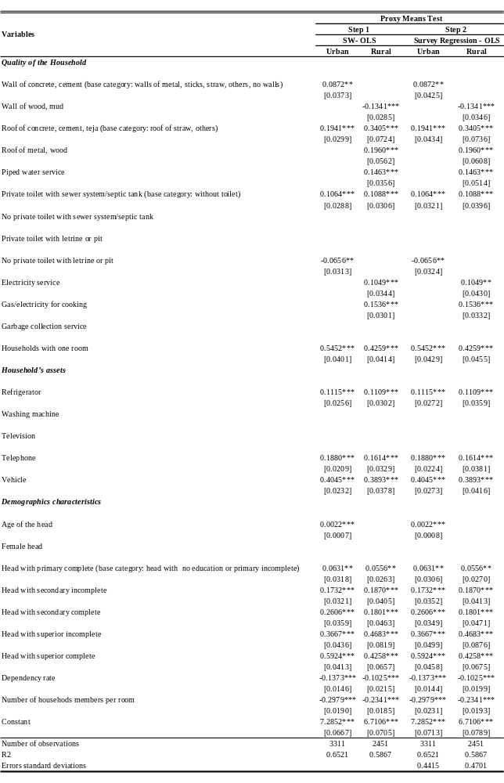
Source: Own estimation based on ENV 2003 data.
Note 1: Robust standard errors in brackets. * significant at 10%; ** significant at 5%; *** significant at 1%
Note 2: We used two steps to estimate the household’s welfare. In the fist one, we used a stepwise function to eliminate from the regression those variables that are not statistically significant. In the second one, we estimated an Ordinary Least Squares (OLS) regression using the selected variables.
Note 3: Household population

The estimations of the household per capita consumption are shown in Table A.3.2.1. Considering the inherent characteristics of each household, we constructed its level of welfare. Using this information we can estimate the probability of being extreme poor. This probability is the score attributable to each household. In the following section we develop a briefly analytical explanation of the `household score estimation’.

Estimation of the household score
Using the regression results shows in Table A.3.2.1, it is possible to construct for each household a score based on its characteristics.

As it is known, the OLS estimation can be resumed in the following equation:

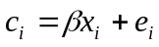 (1)

where means per capita household consumption, 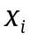 represents the vector of observe characteristics that affects the consumption, and is a random error with normal distribution, 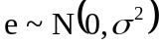

The main idea of the score computation is the estimation of the probability of being extreme poor for each household given its characteristics. This idea can be resumed in the following expression:

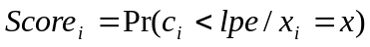 (2)

where 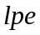 is the extreme poverty line.

Using the parameters obtained in the OLS estimation, 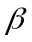 and 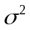 , and the vector of observed characteristics 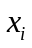, it is possible to estimate the equation (2) in the following way:

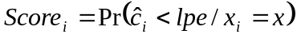

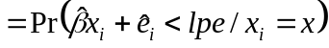

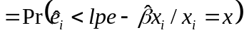

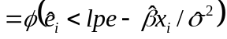 (3)

where 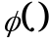 is the cumulative normal standard distribution.

Then, the beneficiary population is selected comparing the estimated score with a determinate cutoff value. If the value of the household score is higher than the value of the cutoff, the household result to be eligible to participate in the program.

Annex 3.3: Ex Ante Method to Evaluate the Program: Red de Oportunidades
This appendix is largely based on Bourguignon, Ferreira and Leite (2003).

We propose the use of the methodology presented in Bourguignon, Ferreira and Leite (2003), henceforth BFL model, to simulate the effects of transfers using the actual program design, and transfers of different magnitudes on poverty. Specifically, this model has been evaluated using Mexican, Ecuadorian and Brazilian data producing credibly estimated when predictions were compared with those estimated in the standard Ex Post evaluation

The Model
This model consists of simulating the effects of the Red de Oportunidades program on the basis of a model of the household behavior using national representative dataset.

Denote j = 0 the occupational category “not attending school”; j =1 “attending school and working”, and j = 2 denoting “attending school only”. In this case, the utility function for each category j of the child i is specified by:

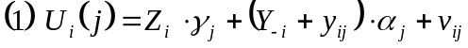
where 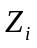stands for characteristics of both the child and the household; 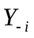 is the household income without the child’s earnings; 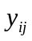 is the child income earned in alternative j; and 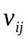is the random term that stands for idiosyncratic preferences.

Then, child earnings, , is defined in alternative j = 0 as the observed market earnings of the child, 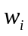. In alternative j = 1, children can work and study, spending less time in the labor market than children from category j = 0. In this case, for j = 1, children can only receive a proportion M of the total time of category j = 0. The observed market earnings of a child in j = 1 is, then, on average equal to 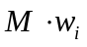. Similar specification can be made to children in j = 2 because if he is not working in the labor market it doesn’t prevent him from contributing to domestic production. Then, considering D a proportion of time devoted to domestic production, can be set as 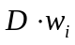.

Replacing these values on equation 1 we have the following:
Where 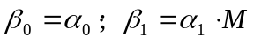 and 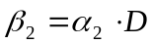.

Assuming that we now all parameters of equation 2, the child select its occupation by maximizing its utility function, i.e., 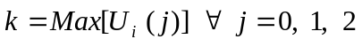. If a CCT is implemented, the amount T is added to household income when child i is studying.

Hence, the equation 2 can be re-written by:
with 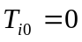 and 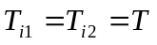.
The Equation 2 must be estimated by using a Multinomial Logistic Model. However, is unobservable for those out of the labor market . Besides that, the value of M or D are also unobservable. To correct that, the BFL model uses a simple approach, which has an advantage of transparence and robustness (OLS regression) to estimate the potential wage, , for all children in order to avoid any type of complexity that would be generated by any correction of potential selection bias.

Finally the simulation of the likely effects of a given CCT program is represented by equation 4, here below, by taking into account the means-test that identify the potential beneficiaries. So taking everything in account, conditionality and means-test, the simulation of the new occupational choice of a child is given by:
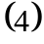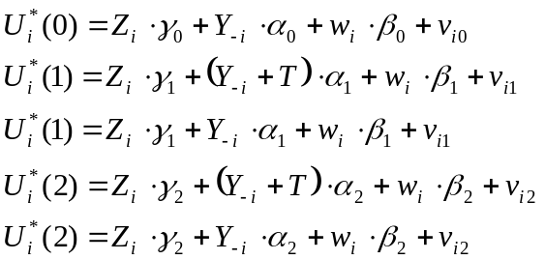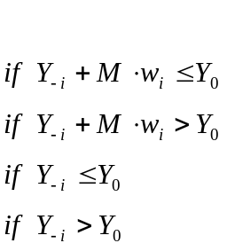
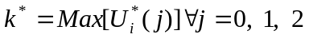

This framework can simulate a wide variety of CCT programs conditional to schooling enrollment. Both the means-test and the transfer T could be made dependent of individual or household characteristics (different transfer per age and / or per gender of the child). It is important to have in mind that this model ignores multi-children interaction for the enrollment rate simulation, assuming that households were single-child for the behavioral point of view.
Besides that, the household income is treated as exogenous but this hypothesis can be very unrealistic. It is possible that the means-test may affect adult labor supply if they consider that is more interest to qualify for a CCT program instead of work. However, when the means-test is based on score-based proxy for permanent income this problem is not a real weakness of the model.

As final step, the Ex Ante estimator generated by the BFL model compares the simulated school enrollment and child labor participation of the children with their status-quo. Besides, by applying household ceiling to the transfers, the model allows the estimation of poverty and inequality index based on the “new” income or consumption obtained by the addition of the transfer amount for each beneficiary household in the sample, respecting the household ceiling transfer when necessary.

Annex 3.4: Methodology USED TO perform the Long Run Impact simulations of RdO
This appendix is largely based on Ferreira and Leite (2002). In order to understand the impact of a substantial expansion of education for the eligible population aged between 18-23 and 18-29, we estimate a simple model of household income determination. This model is recursive and consists of five blocks.

- Block 1:

The per capita household income is given by

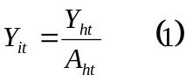

where 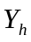 denotes total income of household h and 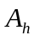 is the family size.

The total household income is the sum of labor 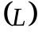and non-labor incomes 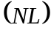of all household members.

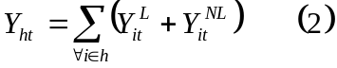

- Block 2:

It is assumed that the non-labor incomes are exogenously determined. Depending on the individual 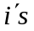 occupational choice, labor income is 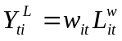 or 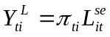, where denotes the labor earnings of individual in sector and 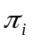 denotes the profits of individual in the self-employment sector. 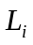 is a 0-1 participation dummy.

Both and depend on observable 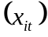 and unobservable 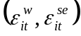 characteristics, and the vectors of parameters 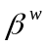 and 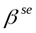 determine how observable characteristics affect the labor earnings or the profits, respectively.

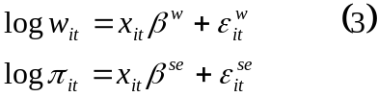

Notice that expressions (3) are standard Mincerian earnings equations. The estimation results for both equations are reported in table A.3.4.2

- Block 3:

This block models the choice of occupation into wage employment, self-employment or inactive. For this purpose, using a discrete choice model (multinomial logit) we estimate the probability of choice of each occupation as a function of a set of family and personal variables. Table A.3.4.1 shows the estimation result.

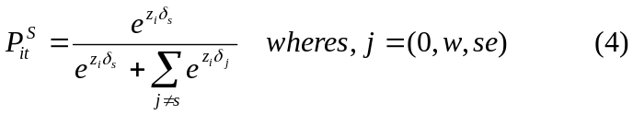

- Block 4:

In this blocks we estimate the probability of choosing a certain number of children (0, 1, 2, 3, 4, 5, +) using a discrete choice model as in block 3. The variable used for the number of children in the estimation refers to the number of sons and daughters of the mother who are aged 14 or less and live in the household.

The per capita income of individual is affected by fertility decisions. The increase in the number of children increases the denominator in equation 1 and thus, keeping other thing constant, reduces the per capita income of all household members. Additionally, the number of children affects the labor participation decision of some household members; generally the mother’s modifying the probability of being in the labor market and thus affecting the numerator of equation (1). The estimation results are showed in table A.3.4.3.

- Block 5:

This block models and individual’s choice of final education attainments in terms of years of schooling. For this purpose we use an ordered probit model (OPM). Table A.3.4.4 shows the estimation results.

Changes in the years of schooling of individual could affect the per capita income of the family by several ways. The fertility decisions are likely to depend of the level of education of individual , hence the occupational choice are likely to depend on the number of children in the household and the level of education of individual . Finally, the labor earnings are likely to depend on the occupational choice and the level of education of individual .

To assess the reduction observed in both short run and long run poverty induced by the accumulation of human capital due to the CCT conditionalities, we simulate the impact of an increase to 10 in the average of years of schooling of the population selected to participate in the program. We estimate this rise implementing the computer algorithm proposed by Ferreira and Leite which take into account through the OPM estimated that the educational attainment is distributed jointly with age, gender and spatial location. See Bourguignon, Ferreira and Leite (2002) and Ferreira and Leite (2002) for more detailed statistical discussion of this kind of counterfactual analysis.

Table A.3.4.1: The Estimated Occupational Choice - Multinomial logit
Population between 18-64 years old
Dependent Variable: Occupational Category
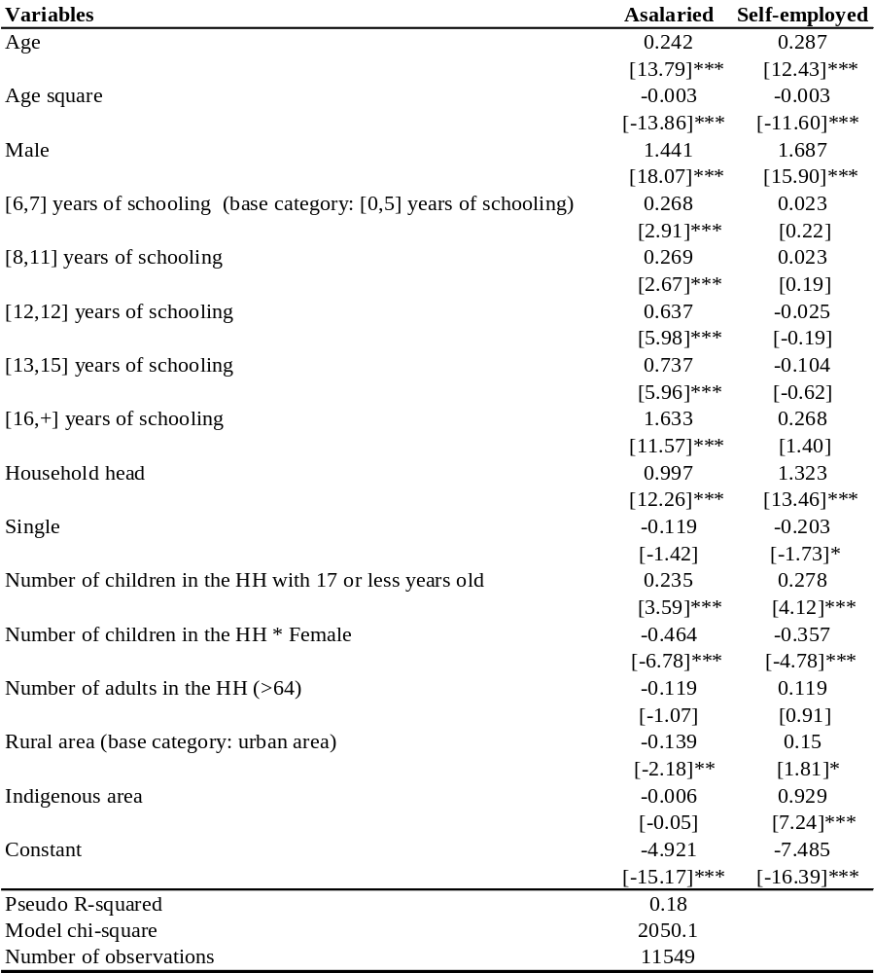
Source: Own estimation based on ENV 2003 data.
Note 1: Out of labor force is the reference category
Note 2: t values in brackets. * significant at 10%; ** significant at 5%; *** significant at 1%

Table A.3.4.2: The Estimated Fertility Choice - Multinomial Logit
Female Population between 18-64 years old - Dependent Variable: Number of Children in the HH. aged 17 and less
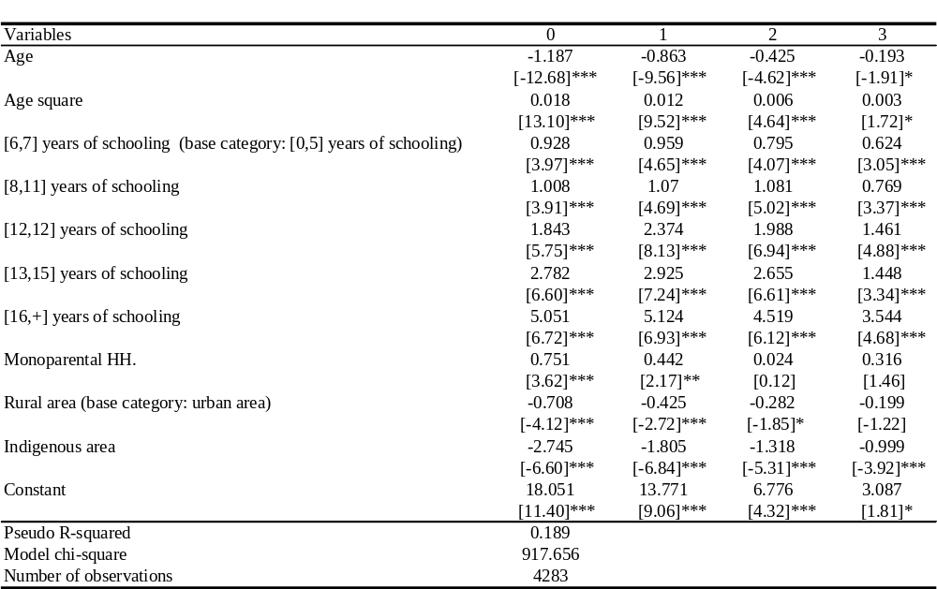
Source: Own estimation based on ENV 2003 data.
Note 1: 4 or + number of children in the HH. is the reference category
Note 2: t values in brackets. * significant at 10%; ** significant at 5%; *** significant at 1%

Table A.3.4.3: Earnings Equation - OLS Model
Worker Population between 18-64 years old - Dependent Variable: Log Labor Income
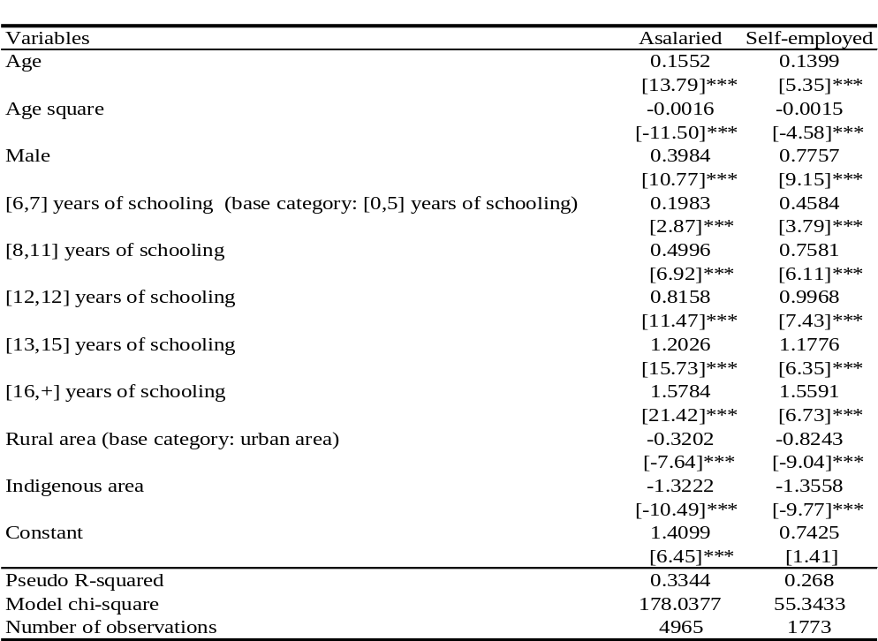
Source: Own estimation based on ENV 2003 data.
Note 1: t values in brackets. * significant at 10%; ** significant at 5%; *** significant at 1%
Table A.3.4.4: Ordered Probit Model for Years of Schooling
Worker Population between 18-64 Years Old
Dependent Variable: Years of Schooling
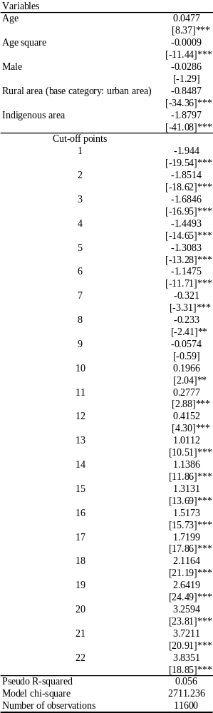
Source: Own estimation based on ENV 2003 data.
Note 1: t values in brackets. * significant at 10%; ** significant at 5%; *** significant at 1%

Annex 3.5: Indigenous poverty: Relevance of a Conditional Cash Transfer Program
As mentioned in chapter 2, the source of a nation’s wealth is the skill and labor power of its people. While Panama has registered important advances in education and, one group of its citizens, the indigenous people, has failed to benefit from this progress. In health, the persistent inequities in access translate in high levels of chronic malnutrition among indigenous children, and the increase in maternal mortality is a vivid reality for indigenous mothers. On the whole, the country’s inequality is wide because of the very deep poverty and bottom welfare levels among the indigenous people.

The purpose of this chapter is to document the extent and depth of poverty among indigenous people and some of the differences between the three main groups. With chronic malnutrition affecting 57 percent of children under five years of age, average educational attainment limited to the first cycle of primary school and extreme poverty ranging from 77 to 90%, the welfare levels of indigenous people are more similar to the ones observed in Sub-saharan Africa than those of an upper-middle income country. Poverty among indigenous people in Panama is not only a matter of extremely low consumption levels, it also translates into a multitude of very low welfare indicators.

The depth of poverty and its multi-dimensional characteristics will require holistic interventions, which address health, nutrition and education and build on their synergies so that indigenous people can share into the development of Panama, at least in terms of welfare. We undertake a preliminary qualitative examination of some of the barriers that indigenous people face to access health and education and then discuss the potential for a conditional cash transfer program. While the logistics of implementing such a program in remote areas with little supply of basic services will be challenging, the instrument of delivering cash transfers to women provided the household undertakes a series of activities linked to the welfare of children should be supported by these populations if they are involved in its operations. By helping beneficiaries address some of their most pressing cash constraints and stimulating innovative extension of coverage, the program has the potential for strong impacts on child malnutrition, school enrollment and use of health services as the Nicaraguan Red de Protección Social, which targets a similarly extreme poor population.

Overview of Panama’s Indigenous People and Institutions
The 2003 Living Standards Measurement Survey identified close to 300,000 indigenous individuals in Panama, or 9.6 percent of the population. These individuals belong to seven indigenous groups of various sizes in the country. The three most numerous have obtained demarcated semi-autonomous comarcas: Ngobe-Bugle near the border of Costa Rica, Kuna in the San Blas archipelago, and Embera-Woonan in Darién, near the border with Colombia.

The Ngobe-Bugle, also known as Guaymi, while the largest group (approximately 175,000 people), have the least political leverage because of their loose organization. They live in and around the comarca, in the mountains of the Bocas del Toro and Chiriquí provinces. Their main income derives from agriculture, either from own production or as migrant manual labor on coffee and banana plantations or livestock farms. When their family migrates, children interrupt their schooling to also provide labor during the harvest. Own production is based on rice, corn, beans, bananas, yam and high altitude coffee. Water availability is a serious constraint for production. Land ownership is based on inheritance and user rights.

Communities are very small: 6 to 8 extended families (comprising an average of 7.4 members) linked by kinship. People identify more with their community than with ethnicity. The dispersion of settlements and the remoteness of their mountainous habitats make input purchases and processing and commercialization of products very difficult. The same factors also seriously hamper the provision of basic services such as health and education, resulting in very high rates of maternal mortality and child malnutrition (48 percent of under five children are stunted) as well as illiteracy (47 percent of the population is illiterate and the average of schooling is 2.4 years).

Reflecting the dispersed structure of settlements, traditional governments are fairly decentralized with yearly congresses in which the whole population participates and votes on important decisions. With the establishment of the comarca, Law 10 in March 1997 recognized the general congress and three regional congresses (Bocas del Toro, Chiriquí and Veraguas). It also created a number of positions like the comarca governor and regional and local caciques, who are the interlocutors of the Panama government. The Ngobe-Bugle comarca also elects three deputies in Parliament.

While the comarca is autonomous in enforcing cultural and societal norms and resolving local disputes, its budget depends on transfers from the Panamenian government, which determines the main investments according to plans developed between government agencies and indigenous authorities. For example, the Ministry of Housing has a program of popular housing, which model is based on the traditional Ngobe house. The Social Fund is the main provider of social infrastructure in the comarca, through an IDB supported program.

The Ngobe women’s association has achieved some important advances in women and reproductive health with funding from UNFPA and the collaboration of traditional healers and birth attendants with health center staff. The association generates its own projects through fund-raising. They are promoting handicrafts (embroidery, bag weaving) as income-generating activities for women. They also try to address domestic violence and women’s empowerment issues.

While sharing the same territory and organizational systems, the Ngobe and the less numerous Buglere actually speak different languages and some of their traditions differ (polygamy occurs among the Ngobe but not the Bugle for example). In the remainder of the chapter, we consider them as one group.

On the whole, the Ngobe-Bugle are under threat because of their isolation, encroachment by settlers and generalized poverty. The 19 percent of individuals outside the comarca may face even greater vulnerability.

The Kuna form the second largest group (approximately 92,000 individuals in 2003) and they remain one of the most politically mobilized and active indigenous groups in Latin America. The majority (60 percent) lives in the autonomous Comarca Kuna Yala, in the San Blas archipelago on the Caribbean coast, which was recognized in 1938. In 1996, the Madugandi comarca was established on a 226-km Caribbean coast strip from the Province of Colón to Colombia. Households maintain activities both on their island and on the mainland, which provides them with water, firewood and agricultural land. Their main income derives from agriculture and seafood farming and fishing. Main agricultural crops are corn, bananas and plantains, coconuts (a cash crop sold to the Colombians) and avocadoes. Lobster and shrimps are the main seafood products. Women contribute significantly to household income with the sales of embroidered shirts (molas) and ceramics. Land tenure is based on private inherited property, communal land managed by the community congress and less frequently by occupation of unused land.

Communities are traditionally based on islands (approximately 40 of the 365 islands of the San Blas archipelago are inhabited) and are both quite autonomous and very cohesive, with a strong political and administrative structure. Urban Kuna migrant communities (which constitute 40 percent of the total population) tend to maintain this structure. The General Kuna Congress (CGK) is the interlocutor of the Panamenian government, with three Caciques Generales elected for life. The Kuna Yala comarca is free from taxation. There are dedicated seats for two Kuna Yala legislators in the National Assembly. Each recognized community participates in the bi-yearly meetings with a five-member delegation lead by the sahíla, traditional leader. In each community, a local congress is in charge of the community government, from maintaining cultural integrity to resolving disputes and organizing communal tasks with a parallel political representation structure.

The Kuna have been relatively successful at enforcing their territorial boundaries and maintaining their cultural integrity. A General Cultural Congress is responsible for maintaining and strengthening the culture, with a documentation center hosted in the CGK building. In addition, CGK has set up an NGO (Onmaked Dummad) as its executing arm, which raises funds from donors and implements projects in the comarca. These have included a pilot bilingual education project and a marine resources environmental education project, both supported by Spain. CGK is also negotiating a tourism development plan with the GoP to support sustainable ecotourism development. At the local level, professional groups are common (agriculture, cafeteria, cooperative shops or public phones, etc…).

The islands are only accessible by air and boat, which has helped the communities to preserve their traditions. On the other hand, this continues to limit the provision of health and education services. Garbage disposal and sanitation facilities are quickly becoming an issue for public health. Also as the GoP military is not permitted to patrol the waters around the islands, drug traffickers are increasingly using the islands as a transfer point between South and North America.

On the whole, the Kuna have used their autonomy to preserve their culture and develop some economic independence, thanks to their strong leadership, which enforces territorial boundaries and maintains cultural integrity. Threats include settlers’ encroachment of the mainland comarca with deforestation, high rates of youth migration to Panama City and increasing violence linked to the drug trade.

The Embera-Woonan or Choco number approximately 33,000 with half of the population residing in the rainforest area of the Darién and Panamá provinces. Their political situation, while better than the Ngobe-Bugle is less strong than the Kuna. The comarca was recognized in 1983 but is split by the Panamerican highway. The main sources of income are agriculture, hunting and fishing. Agriculture crops include rice, beans, corn, yam on slash-and-burn plots and bananas, plantains, coconuts, avocadoes on plantations. Women also engage in handicrafts such as baskets and men are skilled wood carvers and sculptors.

Traditionally the Embera-Woonan lived in semi-nomadic clan-based settlements. These arrangements have been undermined by the security issues around the conflict in Colombia, with regular waves of refugees crossing the border in attempt to settle on their land and guerillas and paramilitary groups using the area as a base camp. The GoP has generally failed to attend specific indigenous property and resource use rights problems. The Embera-Woonan are struggling to protect their intellectual property in medicinal plants. The traditional authority of Jaibaná with medical and spiritual responsibilities is now complemented by a local congress in the more permanent village settlements. A comarca governor is the political interlocutor of the GoP. The Embera-Woonan comarca does not have a dedicated legislator in the National Assembly.

Most of the communities in Darién are only accessible by boat, which again presents serious challenges for service delivery and trade. Only 18 percent of children between the ages of 15 and 19 have schooling beyond the sixth grade. While sharing the same territory and institutions and authorities, the Embera and the Woonan actually speak different languages.

On the whole, the Embera-Woonan livelihoods are under threat because of lawlessness and safety situation, encroachment by settlers and generalized poverty. This has led to a strong out-migration, mostly to Panama City.

Other indigenous groups. The much smaller Bri-Bri and Naso (Teribe) tribes, residing near the border with Costa Rica, do not have officially recognized territories. The Teribe are governed by a monarchy. In the remainder of the chapter, they are lumped together with the Embera-Woonan.

Indigenous Rights and Institutions in Panama.
The law affords indigenous people the same political and legal rights as other citizens, protects their ethnic identity and requires the government to provide bilingual literacy programs in indigenous communities. A law on bilingual education was passed in 2005 but is not implemented. Only the Kuna seem have organized, largely on their own initiative, some bilingual primary education curriculum.

The Ministry of Government and Justice contains an Office of Indigenous Policy and the Ministry of Social Development is creating a Direction for Indigenous Peoples. Although the federal law is the ultimate authority, local groups especially in the comarcas maintain considerable autonomy. For example, the GoP recognized traditional Kuna marriage rites as a civil wedding and the Kuna started a project on clarifying the domains of communal vs. federal law. The law also protects indigenous property rights on artwork (the Kuna are developing their own brand name for clothing) and establishes regulation for artisan fairs.

Despite formal equality and legal recognition, indigenous people suffer from astonishingly higher and sometimes worsening rates of poverty, disease, malnutrition, maternal mortality and illiteracy than the rest of the population. Because a lot of them do not have an adequate command of Spanish, they often misunderstand their rights and fail to employ legal channels when threatened.

Social and employment discrimination are rampant. Indigenous laborers in coffee, sugar and banana plantations work under worse conditions than their non-indigenous counterparts. They are less likely to receive quality housing or food and their children are more likely perform long hours of heavy farm work. Employers also often do not afford indigenous workers basic rights such as minimum wage, termination benefits, job security, etc… especially in domestic work.

Operational Definition of Ethnicity in the LSMS
Two general definitions are used to identify ethnicity in the ENV 2003 household Survey. The first one considers that a person is indigenous if s/he speaks an indigenous language as first or second language. The survey only collects language information for the population aged 6 and older. We thus assigned the ethnicity of children according to the following criteria: a child is assigned his or her mother’s answer on language if the mother is present in that household. In the absence of his/her mother, the child is assigned the language of the household head.

The second definition identifies a person as indigenous if s/he lives in a territory that is mostly populated by persons from certain ethnic groups. (The interviewer always answers the question regarding “region”).

Using the first definition tends to increase the number of indigenous people (302,850) since it provides a finer identification measure and also since indigenous households tend to have more children than non-indigenous households (Table A.3.5.1).

Table A.3.5.1: Distribution of the Indigenous Population by Maternal or Second Language
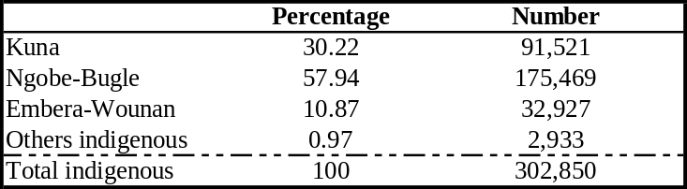
Source: Own estimate based on 2003 ENV data.

Table A.3.5.2 presents the distribution of indigenous people by province. Less than 6 percent of residents of comarcas are non-indigenous. The Ngobe-Bugle are mainly concentrated in their comarca (68 percent) and in the provinces around, mainly in Bocas del Toro. In contrast, a significant share of the Kuna (48 percent) and the Embera-Woonan (70 percent) live outside of the comarcas. The Kuna mainly migrate to Panama City while the Embera-Woonan are found in all areas of the country.

Table A.3.5.2: Geographic Distribution of the Indigenous Population by Maternal or Second Language
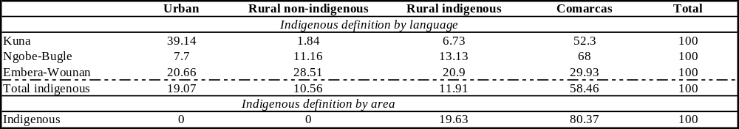
Source: Own estimate based on 2003 ENV data.

Migration in both groups is most often a household strategy to increase income through the migration of one or several members (typically the father as well as secondary school age students among the Kuna). While Embera-Woonan are traditionally semi-nomadic tradition, their migration patterns today are also driven by safety issues in the Darién area. Poverty seems indeed lower among indigenous people in urban areas, as shown in Table A.3.5.2

Language Abilities of Indigenous Groups
Command of Spanish among indigenous groups. Limited command of Spanish may limit access to employment, education, health services, social programs and justice. Under both definitions, only 43 percent of the indigenous population is monolingual indigenous speaker. While the Embera-Wounan has the highest proportion of bilingual speakers (75 percent), the Kuna with the lowest one (47 percent) seem to preserve more their own language (Table A.3.5.3).
Residents of the comarcas are more likely to not speak Spanish, especially among the Ngobe-Bugle and the Kuna. Indigenous women in all groups are more likely to be monolingual. Older people are also more likely to speak only their indigenous language. Children are increasingly exposed to Spanish through preschool and primary schools.

Table A.3.5.3: Indigenous Population Who Speaks Spanish
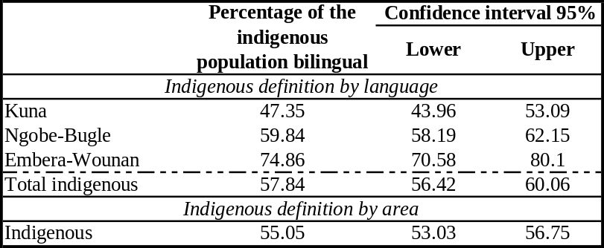
Source: Own estimate based on 2003 ENV data.

Loss of indigenous languages. Reflecting migration patterns to urban areas, the Kuna have the highest share of monolingual Spanish speakers, especially among school-age children (up to 45 percent in Panama City). The share is lowest among the Ngobe-Bugle probably reflecting both the fact that they mostly live in the comarca but also their lower access to schools. The Kuna authorities are well aware of this phenomenon and are pushing for bilingual education in the comarca. To be successful, a well-designed conditional cash transfer program, with a co-responsibility linked to school attendance, should work in coordination with education providers so as to promote bilingual education at the pre-school and primary school levels.

Indigenous Poverty in Panama
Poverty among indigenous groups in Panama remains very high. Up to 94 percent to indigenous people live below the poverty line (Table A.3.5.3.4) as compared to 31 percent among non-indigenous people. Most indigenous people are extremely poor, whichever definition is used (77 percent by language and 90 percent by area). This is a stark contrast to the 10 percent extreme poverty among non-indigenous people.

Table A.3.5.4: Poverty by Ethnicity
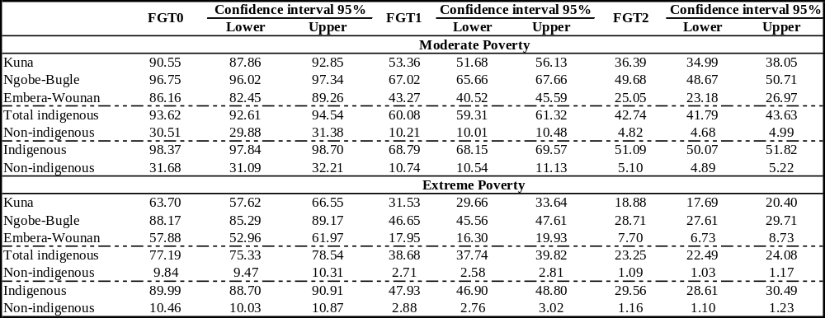
Note 1: Extreme poor is the population with per capita consumption below the extreme poverty line value. Moderate poor is the population with per capita consumption below the poverty line value and above the extreme poverty line value.
Source: Own estimate based on 2003 ENV data.

Comparing the three main groups, poverty and extreme poverty are highest in the Ngobe-Bugle comarca, a pattern which already held in the 1997 survey. Poverty is lower among the Embera-Woonan, probably reflecting higher migration to urban areas.

Poverty among indigenous people is very deep, especially in the comarcas. Using the definition by language, Table A.3.5.5 shows that the Ngobe-Bugle group accounts for 66 percent of the indigenous extreme poverty. This contribution is even sharper when using poverty decomposition measures which are more sensitive to the consumption level of the population (FGT1 and FGT2). The Ngobe-Bugle group explains 70 percent of the indigenous extreme poverty gap and 72 percent of the indigenous extreme severity index. Not only are indigenous poor, they are also very distant from the poverty and extreme poverty lines, with a large number of people especially among the Ngobe-Bugle living in near absolute destitution.

Overall poverty is far higher among indigenous people living in the comarcas compared to those living in non-indigenous rural areas and urban areas. While a staggering 98 percent of comarca residents (indigenous areas) are poor, “only” 79 percent of urban residents live in poverty. These effects are particularly marked for the Embera. Poverty among the Kuna and the Ngobe-Bugle who live outside the comarcas remain quite high.

This geographical distribution of extreme poverty provides support for geographic targeting of a potential conditional cash transfer program. By intervening in comarcas, such a program would reach the extreme poor. Besides operational and cost-saving arguments, this has the advantage of avoiding to use ethnicity as an explicit targeting criterion, which may be politically very charged and difficult to implement in practice.

Table A.3.5.5: Extreme Poverty Rates and Contributions to Indigenous Extreme Poverty by Ethnicity Indigenous Definition by Language
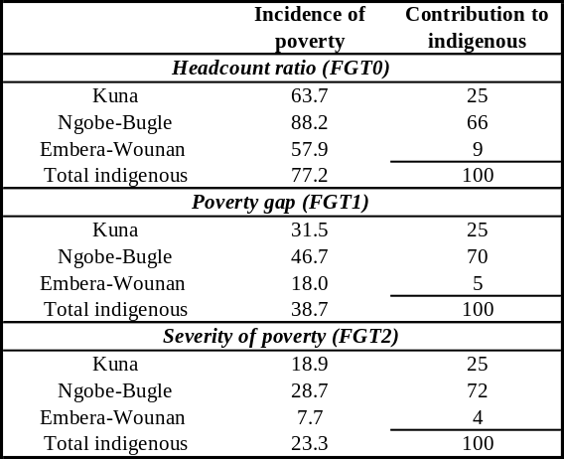
Source: Own estimate based on 2003 ENV data.

Reflecting the extreme poverty, poverty gap and severity index, consumption among indigenous people is only roughly one-fifth of consumption among non-indigenous. These numbers hide stark differences between ethnic groups, with the Embera consuming more than twice as much as the Ngobe-Bugle. Again, people in the comarcas fare worse, a result driven by the Ngobe-Bugle figures (Table A.3.5.6).

Table A.3.5.6: Average Per Capita Consumption by Ethnic Group
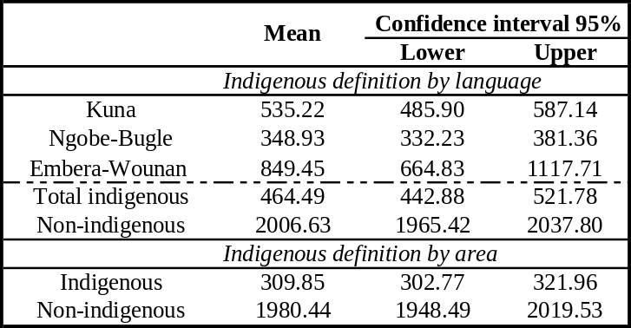
Source: Own estimate based on 2003 ENV data.

Having established the level and depth of poverty in the indigenous population, we now turn to a number of other welfare indicators related to poverty at the household and individual levels.

At 7.0 members, indigenous household size is nearly double the size of households in non-indigenous population (3.9). This reflects both higher fertility and more co-residence arrangement among extended families, especially among the Ngobe-Bugle, who are the largest households. As discussed in part III, this will need to be considered when designing a conditional cash transfer so that the benefits are not diluted among many individuals, which would also reduce the household’s incentive to comply with the conditionalities.

While indigenous household heads are more likely to be married than non-indigenous heads, female headship is more frequent among the Kuna, probably reflecting the higher rate of migration of males to urban areas. As observed in other Latin American countries, female headship may not be correlated with lesser access to education and health for children but if Kuna single mothers are less likely to speak Spanish, this may affect their children’s access to school.

Table A.3.5.7: Demographics Characteristics by Ethnicity
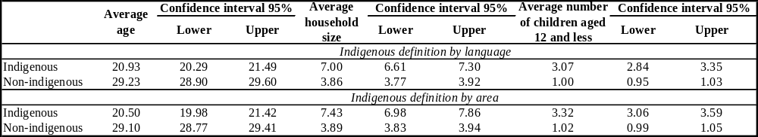
Source: Own estimate based on 2003 ENV data.

Given the structure of indigenous households, interventions targeting children are very relevant. Indigenous households are younger than their non-indigenous counterparts, particularly because of fewer elderly members, especially among the Ngobe-Bugle and more children below 12 years of age. Indigenous households have three times as many children aged 12 or less as non-indigenous households. The average age in comarcas is nearly 10 years less than in non-indigenous areas.

Housing Characteristics

Indigenous households are larger but their houses are smaller by one room than non-indigenous dwellings. This translates in crowding rates four times as high as in non-indigenous houses (Table A.3.5.8). Crowding is especially an issue for the Kuna in the islands of the San Blas Archipelago Crowding in itself has adverse consequences on the welfare of household members and on disease transmission. In the comarcas, nearly all households own their house. While this proportion decreases outside the comarcas, indigenous households more often own their house than non-indigenous.

Table A.3.5.8: Housing by Ethnic Group
Household Population
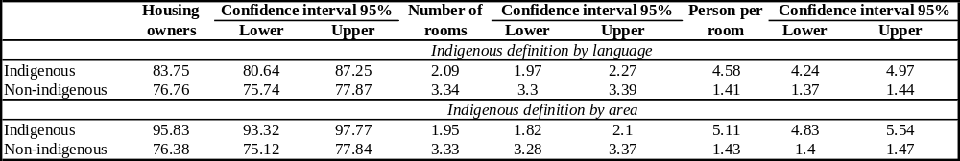
Source: Own estimate based on 2003 ENV data.

To harness the potential health benefits of a conditional cash transfer, complementary interventions to address water and sanitation issues should not be forgotten, given the low levels of access among indigenous households. One-third of indigenous households obtain water from a river, compared to less than 5 percent of non-indigenous people. As illustrated during the focus groups narrated in part III, this entails significant time costs for adults and children and may be a leading cause of morbidity. Only 61 percent of indigenous households have access to piped water. (Table A.3.5.9).

Table A.3.5.9: Water Source by Ethnic Group
Household Population
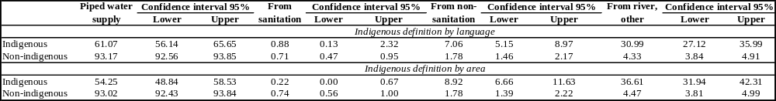
Source: Own estimate based on 2003 ENV data.

Approximately half of all indigenous households do not have access to latrine or sewer, which presents significant health risks (Table A.3.5.10). Again the situation seems the direst in the comarcas. Garbage collection concerns at most one fourth of households, again the highest among the Embera. Apart from food consumption levels, given these levels of access to clean water and sanitation, morbidity and high rates of infection must also account for a large proportion of the chronic malnutrition facing indigenous children.

Table A.3.5.10: Sanitary Services by Ethnic Group
Household Population
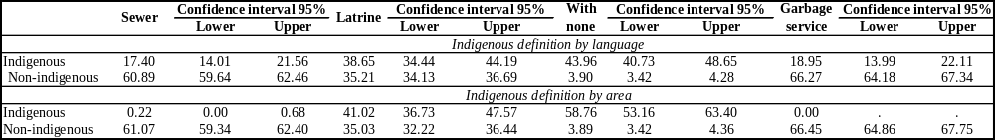
Source: Own estimate based on 2003 ENV data.

Three-fourths of indigenous households rely on kerosene lamps and candles to light their houses. This proportion reaches 93 percent in the comarcas. Approximately a fourth of households have access to electricity, with the Ngobe-Bugle among the least served. Firewood is the main cooking fuel, used by two-thirds of indigenous households and 90 percent of those in the comarcas. The Ngobe-Bugle are again the main users of firewood for cooking, which is a time-consuming household chore for women and children (Table A.3.5.11).

Table A.3.5.11: Energy Source by Ethnic Group
Household Population
(i) Lighting source
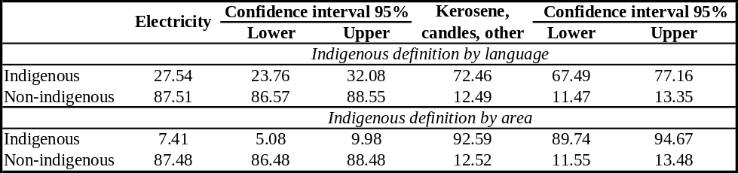
(ii) Cooking with
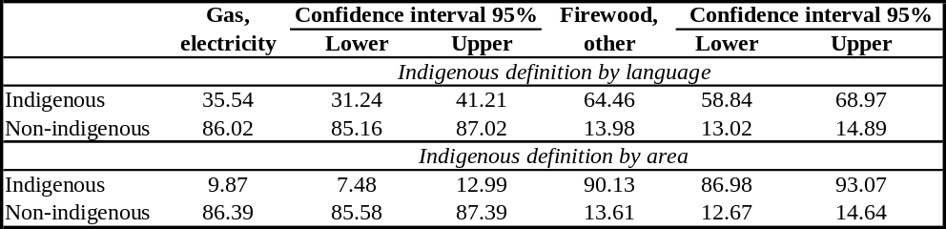
Source: Own estimate based on 2003 ENV data.

Household level indicators in terms of household size and housing characteristics, while variable among indigenous groups and between the comarcas and other areas, all confirm the severity of poverty among indigenous people. We now turn to individual level indicators of welfare, starting with the most vulnerable members of the households.

Indigenous children face chronic malnutrition on proportions similar to sub-saharan African countries. As mentioned in Chapter 2, malnutrition rates among indigenous people are staggering, reaching the same proportion as African low-income countries such as Burundi. More than half of all children suffer from chronic malnutrition and one fifth are underweight. Despite their slightly smaller extreme poverty rates, the Embera-Woonan record the highest rate of chronic malnutrition: at 58 percent, it is ten percentage points higher than the Ngobe Bugle rate. This stands in contrast to the 1997 results where the Ngobe-Bugle presented the highest rates of malnutrition. Underweight is most frequent among Kuna children with 35 percent of children under 5 affected (Table A.3.5.12).

Table A.3.5.12: Malnutrition by Ethnic Group
Children Population Aged 5 or Less

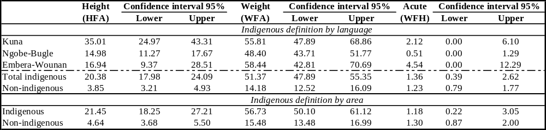
Source: Own estimate based on 2003 ENV data.
This raises again the need for a concerted effort to address poverty and malnutrition at the household level in indigenous areas. Children that are so severely malnourished are also more likely to have suffered impaired psychosocial development and their school preparedness is lower, which condemns them to low levels of schooling attainment and poverty as adults. Targeted conditional cash transfers in Nicaragua have yielded impressive results in decreasing chronic malnutrition: 5 percent in two years.

Only half of the indigenous population can read and write, as depicted in Table A.3.5.13. On average, while non-indigenous people average nearly 7 years of schooling which corresponds to completion of primary school, indigenous people do not manage to complete three years, the first cycle of primary. The Ngobe-Bugle are again the least favored with the lowest literacy rate and the lowest average of schooling. As for malnutrition, the situation seems worse in the comarcas than outside.

As mentioned in Chapter 2, schooling attainment among indigenous has been increasing but at a slower pace than the national average. Educational programs targeted to the indigenous areas will be needed to reverse this trend and enable indigenous population to catch-up. As corroborated in Part III, a conditional cash transfer would be an adequate instrument to address some of the cash constraints facing indigenous children to access schools.

An encouraging trend is the increase in pre-school enrollment among indigenous children. It still concerns only one fourth of children but it is four-fold increase since 1997. Among groups, one third of the Kuna children in that age group attend pre-school while only one fifth of the Embera children do.

Table A.3.5.13: Literacy and Average years of schooling by Ethnic group
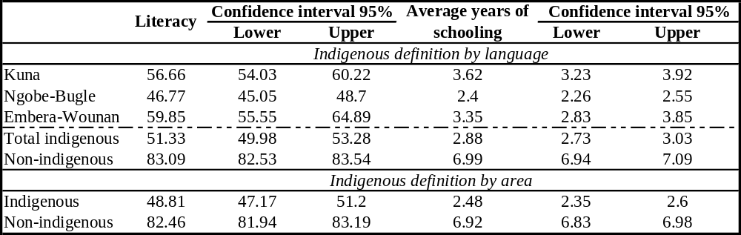
Source: Own estimate based on 2003 ENV data.

While primary school enrollment rates are relatively high (81 percent), they fall sharply at the secondary level. The inter-ethnic ranking reverses in primary school, with a rate of 90 percent among the Embera and 75 percent among the Kuna. Only a third of secondary school age children are in secondary school, with the scarcity of secondary schools in indigenous areas one of the causes of this drop. Reflecting their greater urban migration, Kuna and Embera are more likely to pursue some secondary school although very few are able to complete (Table A.3.5.14).

Table A.3.5.14: Net schooling Rates by Ethnic Group
(i) Pre-school and Primary level
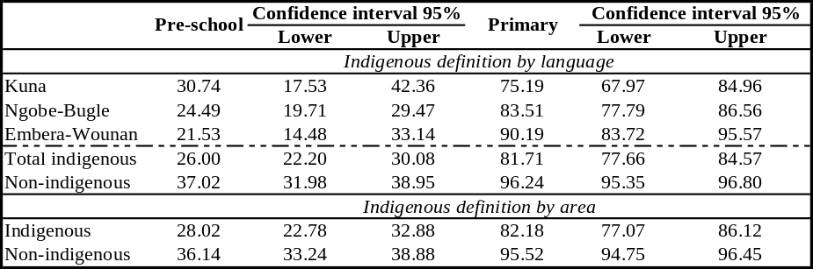
(ii) Secondary level
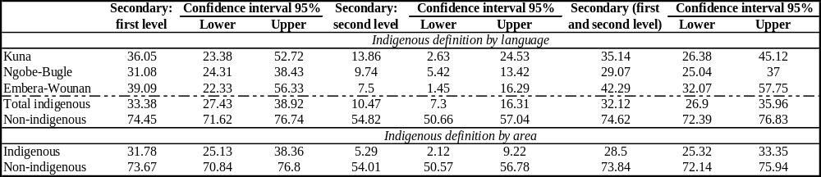
Source: Own estimate based on 2003 ENV data.
Poverty among indigenous people in Panama remains stubbornly pervasive. Indigenous people function at extremely low levels of welfare, barely eking out a survival, with no access to basic services at the household or individual levels. Beyond the numbers of the headcount measures, the depth of poverty on a number of characteristics is astounding and reflects the extremely high inequality in the country, with a potential worrisome widening education gap between the indigenous and non-indigenous.

The interrelated challenges of breaking the vicious circle of low nutrition, low health and low education call for an intervention that can help address the three of them, such a cash transfer conditioned on the household undertaking some investments in human capital. For such an intervention to fully function, complementary programs to raise the supply of adequate health and education services for indigenous people will also be required. More than a short-term decrease in poverty headcount numbers, such combination of interventions would tackle some of the roots of the inter-generational transmission of poverty.

In the next part, we provide some preliminary evidence on the barriers facing indigenous people in comarcas to access health and education services and discuss the relevance of conditional cash transfers with potential beneficiaries, to highlight some of the challenges and opportunities.

Qualitative Analysis of Access to Services, Organization and Decision-Making Processes, and Cash Transfer Projects
Field Work Methodology
Focus groups with community leaders, community representatives and women took place in 2 communities of each of the three demarcated indigenous comarcas between March 14 and 30, 2006. Communities were purposively selected with the support of traditional authorities and MIDES to include a community with some access to basic services and one without basic services in all three comarcas. The communities had to be reasonably accessible. Trained female bilingual native speakers conducted the groups in their own language and recorded notes in Spanish. Five to thirty-five participants joined the focus groups. Birth attendants joined the women group in one of the Ngobe community and in the Embera communities.

The focus group guide was similar for all groups so as to identify differences of perception and representation between the different stakeholders. The themes covered included:
- Access to education and gender differences
- Access to health services for illnesses and maternal and child health (pregnancy, birth, well-infant and baby services)
- Community organization
- Decision-making processes
- Previous experience with direct transfer programs
- Women as cash transfer recipients: rationale and potential conflicts

Basic Community Characteristics
All six communities are rural, ranging in size from 235 to 2500 residents. Men work in agriculture and fisheries (Kuna, Embera) and women make handicrafts (Kuna “molas” to be sold to cruising ships, Ngobe traditional embroidery and bags, Embera baskets) and take care of the home and the children. Both genders raise poultry and pigs.

Access to basic infrastructure is low in all communities as shown in Table A.3.5.3.15. The two Ngobe communities and one Embera receive piped water while the others depend on river water. The availability of water in the selected Ngobe communities may be linked to their relative accessibility since access to water is a major general concern in the comarca. No community collects trash. Only two communities have electricity.

Human capital and social services are in scarce supply. Health and education services remain basic with no middle school in the Embera communities and no school in one of the Kuna islands. All communities but one have traditional healer and/or birth attendants and four communities have access to a health post or center. Access to all communities is not easy and gets worse during the rainy season, because of impassable roads or choppy waters. Communications are difficult for lack of phone or post office in four of the communities.

The definition of households varied across comarcas. In the Kuna comarca, complete nuclear families are one type of households. In the event of separation, the newly single mother may return to live with her parents for greater support with child care. Some households are also split across locations with the father (or an older child) working in Panama and sending remittances to the remaining parent for household maintenance and some teenage children (mainly boys) pursuing secondary education. The community is well demarcated by the island.

In the Embera comarca, the two dominant types of households are complete and incomplete nuclear families. When migration occurs, all members seem to leave. The community is demarcated around the village, itself probably structured around the basic services: school and health.

The Ngobe present a great variation of household structure. Some households are multi-generation, multi-siblings extended households in which an older couple lives with some of their adult children and the spouses and children of these. These households may become quite large and are the unit of reference for their members. Decision-making seems shared between the elder woman and the elder man. Other households are multi-siblings. Nuclear families also exist. In the case of separation, the woman tends to return to her parents or a brother’s household. Probably reflecting this variety of living arrangements, some participants mentioned that a transfer geared at promoting education and health for children should go to a child’s main caregiver. The community is a much looser concept as individuals identify first with their extended family.

In all three comarcas, given the variety of situations, a conservative operational definition of the targeted unit may be the mother-children group. In the case of extended families, it would avoid giving a single benefit to several nuclei living under the same roof therefore diluting the value of the cash so as to cancel its effects. It may also avoid intra-household discrimination against some family groups, especially those headed by a single mother, who may not have as much bargaining power inside an extended household.

Access to Education:
Barriers to education are rooted both on the demand and supply sides, with cash constraints and poverty the main reasons for low registration and drop-out.

- Poverty and cash constraints (all groups) affect:
- Children’s food intake and their learning capacity. “Food also affects children. If he is malnourished, how will he be able to focus on the teacher in the class, if a hungry adult does not work well, a child can study even less.”(xxx)
- Parents’ capacity to purchase uniforms and school supplies.

Leaders in particular resent the obligation of the uniform, which increased costs of access to schools.

Several participants appreciated the IFARHU fellowship program, which provided up to three years of support to meriting students. These students definitely benefited from the program and were able to advance their studies further than most children in their community. The Embera communities also mentioned a recent First Lady program which also distributed supplies.

- Parental lack of commitment: this explanation was most often provided in the leaders’ groups. This may come from the parents’ own illiteracy but also from the necessity of putting children to work to contribute to the household income.

- Household issues: Conflicts, separation and household break-up as well as inexperience of teenage and young parents all contribute to lesser school enrollment and attendance. Older children in broken households will be more likely to drop-out and to engage in risky behaviors (unprotected sex, drug consumption were mentioned in the Kuna communities)

- Distance to school and infrastructure capacity: Even if Carti Yandup is a five minutes rowboat ride from Carti Sugdup, the crossing is not safe during bad weather so distance becomes an issue. Distance is also an issue in the mountains of the Ngobe Comarca as the dirt paths become slippery and dangerous during the rainy season. Some participants also mentioned crowded classrooms and lack of proper tables and chairs for the students.

- Teachers’ quality: absenteeism, alcoholism, little attention to students were mentioned in all comarcas. “The teachers, especially in primary, drink a lot of alcohol, and they don’t give homework to the students.”

- Language of study and few indigenous teachers. “The failure is due to the communication between the student and the teacher, who feels that children should already know they have to speak Spanish.”

Embera communities also report safety issues, because of the Colombian guerilla. A specific issue for the Ngobe is the annual migration for coffee harvest, which prevents children to complete the school year. In addition to the move, these children are often working in coffee harvest to supplement their families’ income. As they interrupt their schooling, they are also less likely to take it up again upon their return in the comarcas.

The first and main demand-side barrier – poverty and cash constraint -- could be alleviated through a well-designed CCT program. Attitudes towards schooling may also change as a result of parental involvement in the program and local norms may also evolve with greater enrollment and attendance in the community.

Reasons linked to distance, infrastructure capacity and quality of services sharply bring to the fore the importance of inter-institutional coordination with the education sector. For the CCT full potential impact to materialize, some supply-side measures to ensure access to quality culturally relevant education will be required. This may require innovative mechanisms for expanding coverage, hiring of indigenous teachers, and implementation of the bilingual education law and greater involvement of the communities.

Gender Differences in Access to Schooling:

All groups reported increased girls’ enrollment since the 1960s.
“In earlier times, parents restricted their daughters a lot, because it was the tradition, the used to think that if their daughter studied, they would become loose, marry a campuriaor distanced themselves from the family and in fear of all these, they did not send her but today parents don’t think about it, they want their son or daughter to study so that in the future they are professionals. ”

Despite this progress, in all comarcas, some participants reported that girls still attend less than boys: “Lots of cultural barriers, they don’t want to keep them in school, they only wait for her to grow and get married to sustain and help the family in the household. ”

Women themselves recognize that girls face more difficulties in pursuing schooling after 6th grade for cultural reasons or claims on their labor. “Some fathers are still very jealous of their daughters, they think if she leaves she is abandoning them, she runs loose and will not study, she only will look for a husband so she only finishes 6th grade and they don’t send her to secondary school”. “Girls don’t matter, so that she stays at home and help me.”

These initial comments point to the need of additional support to encourage girls’ attendance, especially at later ages. It also underscores the importance of involving the local leadership to help convince reticent parents.

An underlying issue is also the challenge of the primary to secondary transition when secondary schools are only available in cities. Some participants mention the possibility of boarding schools which could be trusted. The lack of secondary schools in the communities is definitely a huge barrier to girls’ continuation of schooling.

Access to Health Services for Illnesses and Maternal and Child Health (pregnancy, birth, well-infant)
In all communities, participants use both traditional and occidental medicine providers. Traditional healers have a better record for some illnesses, which vary across comarcas. While slower than occidental medicine, traditional plant-based medicine is cheaper. If one type of provider does not solve the problem, patients will see the other type.

Barriers to access health post or centers include:
- Lack of money: people can not pay for medicines, transportation (gas for the boats), for services even though they are officially free: “I go to the traditional healer because the health center is very expensive, here they can give you a remedy, while there they only ask me for money and when I don’t have, I return without my nose rings.”

- Cultural practices: Women are ashamed to have to show their body to male doctors (many request more female doctors and nurses), some husbands also refuse that their wife be examined by a man. Language barriers are an additional complication.
“I prefer traditional medicine with a traditional birth attendant because I do not want doctors to see my intimate parts.” “Sometimes some men do not want their wife to go the doctor because he examines them.” “Because of fear of the doctor because we don’t know how to speak Spanish and I do not understand it.”

- Lack of medicines and of qualified personnel in health posts and centers: This points to quality shortages in the supply. Having the infrastructure in place is a necessary but not sufficient step to guarantee access to health services. “I don’t go to the health center for lack of medicines and why would I go if they don’t give me anything, on the other hand since I have traditional medicine, it can also help me.”“There are no doctors in the health post.” “One is not treated well by the staff in charge.”

- Distance and access to health centers
“Because of the strong wind and when I arrive the next morning the doctors reprimand me for not arriving in time.”

As in the case of access to education, a cash transfer would alleviate the cash constraints to access health services, in particular the costs of transportation and medicines. In addition, well-designed preventative materials and community interventions may help lower some of the cultural barriers to access reproductive health services.

Acting on the demand side will have limited effects if the supply does not also adjust both in quantity and quality. Training of staff working in indigenous areas to respect and collaborate with traditional health providers is an important element as well as language proficiency. If it is not possible to expand fixed infrastructure, mobile units may also play an important role and have been recognized in some groups for providing immunizations and routine check-ups.

Prenatal care practices and attitudes during difficult births vary significantly across communities. Because of widespread generalized poverty, participants lamented that the community was not always able to help a family in difficulty. Everything depends on the family itself and its capacity to mobilize relatives in the city (be it Panama, David, Yaviza or any other city with a hospital). If the family is not able to access resource, the woman and her baby are likely to die.

Some communities appreciated nutritional supplementation programs for malnourished pregnant women although they were not systematic. Women complained about the lack of attention to lactating mothers and under 2 year old children. As the situation varies by comarca, we report the comments separately.

Comarca Kuna Yala: Some women do get prenatal care in their health center. The traditional birth attendant accompanies them for the birth and women feel more secure when the attendant works with the doctor. In case of difficult birth, the community helps as much as it can. Respondent also mentioned that they use the “injection” as birth control method, on their own decision. “The doctors work together with the birth attendants, that is they have to be present during the birth and women are more in confidence and tranquil.”

Comarca Ngobe: Women most often give birth (85 to 90%) at home, helped by a birth attendant, their mother and/or their husband. Distance and access to health centers is an issue as is the quality of attention they receive in the health centers. If the birth is difficult, they depend on their husband’s decision and the community capacity to organize itself. Access then becomes a life or death issue “Many women die because there is no transportation”. In the first two months of 2006, 7 mothers had already died in the comarca.

Comarca Embera: Women in the focus group communities seem to trust giving birth at the health center but lack of transportation obliges women to give birth at home. In one community, women reported that the family does not receive community help in a difficult birth, which lowers the probability that the mother reaches the center in time. In the other community, the whole community helps as much as it can afford to. “It is very alarming because the family that we are all women and men, we don’t know what to do in this case, think about the hospital which is so far with many transportation expenses and expenses in the hospital.”

Cash constraints are again one of the core reasons for not accessing prenatal care. While these issues deserve a much more in-depth analysis, women in general value prenatal care in health centers and at least in the Embera and Kuna comarcas are conscious of the lower risks of birth with medical attention. While expanding coverage may not be feasible everywhere, training traditional birth attendants and setting-up referral systems for high-risk pregnancies may help address the ultimately unacceptably high rates of maternal mortality in indigenous communities. If supply issues are addressed, including a condition on prenatal care may provide an incentive for early investment in human capital and improve the birth outcomes. In the Ngobe community, the challenges may be slightly different.

Focus group participants value basic health services such immunization campaign and disease surveillance (malaria). While mothers value prenatal, postnatal and infant care, they face both supply shortages but also some quality issues. To make the most of a CCT program, complementary actions will be necessary on the supply side to increase the presence of qualified staff and the number of female health providers and to improve the quality of basic attention. In remote communities, such as the Ngobe and Embera communities, partnership with and training of birth attendants is urgent. Informal payment for services practices should also be addressed.

Community Organization
As described in Table A.3.5.16, organizations in the communities can be grouped in the following categories:
- Decision-making and local governments: the juntas and local congress. These are decision-making bodies for the community. All participants mention that both men and women participate in the congress level consultations. Decisions are then taken by the leadership, which is restricted to men – at least formally. These local government bodies are sometimes complemented by “sectorial” committees for health, water, education.
- Producers’ association: Men organize themselves for agricultural production either for work-sharing or to apply to projects or programs. Women who work on handicrafts use their association for purchasing inputs and selling their products but also for capacity-building. Women also run a few cooperative businesses such as cafeteria, children kitchen to raise money for cultural events or to sustain other activities. In one case, youth were involved in the community telephone. Airports and other transport services are also run cooperatively.
- Cultural groups: traditional chanting, theater with a high participation of women
- Sport groups are a male attribution
- Churches other than the traditional religions are also quite frequent and increasing enrollment.

A recurrent theme is the lack of participation of the youth, possibly reflecting an erosion of the traditional practices with the increasing migration.

The community as such gets together in crises such as death of a household member, loss of housing, difficult birth. Poverty severely limits the amount of support the community is able to provide to its members and as a result kinship relationship with people in urban areas seem to provide the best form of insurance. In all comarcas, the communities also get together to construct a new house or to launch agricultural activities. There are sharp differences between the Ngobe and the other two groups since the Ngobe refer more to their extended family.

These variations in the communities’ organizational structures are important to keep in mind for the design of a family support component: While it may be possible to organize “promotoras” or “leader mothers” in the Kuna or Embera comarcas, these characters may not be as clear among the Ngobe. On the other hand, the Ngobe have a very strong women’s organization with a large experience in addressing sensitive issues around reproductive health, domestic violence, women’s income generation.

As women have little voice in the communities, it will be crucial to involve the leadership in all aspects regarding a CCT program operation so as to ensure buy-in. In both Kuna communities, women’s opinion is that community organization is in fact a male prerogative. Decisions regarding the community are discussed in the congress with the sáhila/cacique giving the ultimate word. "They do not let women make decisions, they do not consult with us at all, they themselves just take their decisions.”(Kuna woman)
Participants in the Ngobe communities mentioned that while community decisions are taken by traditional authorities, on a given program or issues, decisions may be taken by the group or extended family involved.
In the Embera communities, decision power is shared between the local congress and the community leader, who is chosen by the community and invested with power to make decisions. Some women also mentioned the leading women and the elderly as decision-makers while others only mention men: “ Only the men (…) because they are the highest authority and since that’s the way things are we do not discuss them.”

The traditional authorities my bear a lot of weight in households’ decision to take-up a program. For example, the sahíla may refuse the entrance of a program into his community. As we describe below, the “traditional” design of a CCT, by which money is given to the women, so as to promote investments in the human capital of children, will be a new experience for most of these communities. For the program to succeed, it will need the support of the leaders, who in turn may yield crucial influence on husbands and fathers, who take decisions on female members of their households.

Experience with Direct Transfers Programs
These communities have had limited experience with direct benefits but value them. They also value transparent program allocation mechanisms and selection of beneficiaries. In these communities, IFARHU school fellowships are the main direct benefit program known by the focus group participants. As the fellowships are managed by the schools, families do not feel involved and consulted on beneficiary selection (for merit, disability or poverty). Beneficiary households value the three-year support for school materials and acknowledge its positive impact on children’s permanence in school. In the Embera and Ngobe communities, participants perceive and lament a recent politicization of the program.

In one of the Embera community, a rotating agricultural credit fund was set-up but the harvests were lost to a flood and participants were not able to replenish the fund.

Women’s Management of Cash Transfers
In all eighteen focus groups, some participants mentioned that women should manage the money, mainly because of their natural responsibilities towards children in the household. Reasons varied: “I prefer that my wife manage the money since she sees the needs inside the family.” “Better would be us, men sin a lot.” “I believe it would be successful to give it to mothers since we know how to manage our funds and men spend a lot.” “Men work and do not know what needs the family faces while women manage the family.” “The recipient should be the mother, she is more careful with money and more concerned with food.” “The mother of the beneficiary children, she should be the program recipients.” “Women are better because they are the ones in the house, they do not party like men, they do not drink and therefore can administer money well but they don’t like to participate.”

Other potential recipients were mentioned, such as:
- The person with more schooling (5 groups). “I would choose somebody, who at least would know how to read and write so that s/he can manage better.”
- The couple (2 groups). “I would manage it with my wife so that she does not feel burdened with the responsibility.”
- Men (6 groups). “We men relieve that we manage projects better because women do not want to stand up, when we meet they do not want to participate, they are shy while men are not, we direct the community”.
- The child’s main caregiver (2 groups) in the Ngobe-Bugle comarca.
Even though women’s capacity to administer the money is acknowledged, a few leaders, maybe more traditional, warned against possible conflicts since traditional decision mechanisms would be changed (“Some men respect their wife, others don’t) and even the role of the congress could change (Kuna). Other leaders trust women: “When it is directed to women, for them to manage the money; if they choose the women who are always active, conflicts will not occur.” “I don’t think we will face conflicts because we would have the support of the sáhila and of the community.”

Embera and Ngobe leaders emphasize the necessity for capacity-building and continued support for the program to be successful and for beneficiaries to fully participate. “Yes it works, one needs to give instructions to the mother so that she manages the money.” “Yes it works if one gives to the women with a complete seminar about the money they will receive and what the objectives of the program are.” “We trust women, they can manage funds, the only thing is that they need training in managing money.”
Some women are aware of potential conflicts and think training can help resolve some of them. “Good men will be happy because they are conscious but a selfish man is a problem, then the training is good so that resources are properly used and give good results.”

In these communities, women are recognized as managers of money focused on children’s education and nutrition but for them to realize this role, the program will need to work carefully with the leadership. Given the variety of positions revealed in the focus groups, the program will have to first work with the community leadership to help garner their support for that design. The program should also undertake a parallel communication campaign to strengthen female participation in the community and the households. Beneficiary information and training will be key to prevent conflicts and mismanagement. In that regard, the local program managers will need to be aware and take into account community heterogeneity inside a given comarca. Our limited experience leads us to believe that more work will be needed in the Ngobe-Bugle area where we had more difficulties in organizing the focus groups. The program will need to adapt its strategy to the local conditions.

Summary and Recommendations
Poverty among indigenous people in Panama remains stubbornly pervasive. Indigenous people function at extremely low levels of welfare, barely eking out a survival, with no access to basic services at the household or individual levels. Beyond the numbers of the headcount measures, the depth of poverty on a number of characteristics is astounding and reflects the extremely high inequality in the country, with a potential worrisome widening education gap between the indigenous and non-indigenous.

On nearly all counts, the Ngobe-Bugle fare the worst, probably because of the remoteness of the comarca and the dispersed structure of their communities which makes service provision more difficult and limits economic opportunities. They also are less organized politically. They represent more than half of the indigenous population and contribute to three-fourths of the severity index, a vivid illustration of their destitution.

The interrelated challenges of breaking the vicious circle of low nutrition, low health and low education call for an intervention that can help address the three of them, such a cash transfer conditioned on the household undertaking some investments in human capital. For such an intervention to fully function, complementary programs to raise the supply of adequate health and education services for indigenous people will also be required. More than a short-term decrease in poverty headcount numbers, such combination of interventions would tackle some of the roots of the inter-generational transmission of poverty. In the medium-term, it may only lift households from their deep poverty but will definitely yield significant welfare impacts.

CCT would also be relevant because of the demand-side issues faced both on education and health. All focus groups provide clear examples of how cash constraints represent a main barrier to access schools and health centers because of transportation costs, uniform and school supplies costs, medicine and treatment costs. Providing cash will only address some of the issues and the program will need to coordinate with sector ministries in health and education to help ensure a greater access of quality, culturally pertinent services especially at the pre-natal, infant and pre-school stages.

Local consultation and involvement of leadership will be key to program success. While the communities we consulted were open to the idea of a CCT, the local operation of the program and its success will crucially hinge on the support of local leaders, who have been known to refuse access to programs and service providers. A transparent targeting mechanism will be a key element of the trust-building. Greater participation in the management of service provision would also help.

It is possible for women to receive the benefits but the community will have to let it happen. Because of their natural responsibilities for child-rearing, women are recognized as the best decision-makers regarding children’s welfare issues. But in most of these communities, women have low voice and little bargaining power. Therefore, a communication strategy to reach out to local leaders, older people and men will a crucial element of the program implementation. In the case of extended multi-generational household, the relationship mother-child should determine the beneficiary unit rather than the household headship.

Continuous support to beneficiary and capacity-building of them and their household about their rights and responsibilities in the program will help them fulfill their corresponsibilities and may even yield greater empowerment and inclusion. The design of the “acompañamento familiar” in indigenous communities will require careful thinking so that the person in charge is able to interact successfully both with the beneficiaries, household decision-makers, community leadership and service providers. Changes in behaviors will not only concern beneficiaries but also their community and the health and education providers at the local level.
Table A.3.5.15: Basic Description of the Communities
 | Kuna |  | Ngobe |  | Embera
 | Carti Yandup | Carti Sugdup | Soloy/ Jebay | Quebrada Guabo | Unión Choco | El Puente
Access | Sea  20 mn from airport | Sea  15 mn from airport | Dirt road | Dirt road, 15 mn of Panamericana road | River (6 hours of Yaviza) | River (4 hours from Unión Choco)
Population | 400 | 1500 | 2500 | 1000 | 800 | 235
Water | River (1 hour) | River (1 hour or 30mn if motor) | Piped water | Piped water | River | Piped water
Light | Kerosene lamps | Electricity from 6 to 11 pm (community generator) | Kerosene lamp | Kerosene lamp | Kerosene lamp | Electricity
Cooking | Wood | Wood and gas | Wood | Wood | Wood | Wood
Sanitation | 4 public latrines on the sea | Public latrines on the sea | Private latrines | Private latrines | Private latrines | Private latrines  River
Trash | Sea | Sea | Burnt | Burnt | Burnt and river | Burnt and river
 | Rats | Rats
Social services
Pre-school | None | CEFACEI and pre-school | Pre-school | Pre-school | Pre-school | CEFACEI and Pre-school
Primary school | None – C. Sungdup | Yes | Yes | Yes | Yes | Yes
Middle school |  | Yes | Yes
Health providers | One traditional birth attendant and healer | Traditional birth attendant and healers, pharmacy | Traditional birth attendant and healers | Traditional birth attendant | Traditional birth attendant and healers | Traditional birth attendant and healers
Health post | None
Health center | None –C. Sungdup | Yes | Yes | Yes | Yes
Other services |  | 3 phones, civil registry, church, cooperative, police
Income sources
Men | Agriculture, fishing | Agriculture, fishing | Agriculture |  | Agriculture | Agriculture
Women | Domestic work, Sale of “molas” |  | Domestic work, embroidery | Domestic work, embroidery | Basket, domestic work and agriculture | Basket, domestic work

Table A.3.5.16: Inventory of Organizations Available in the Communities
Organizations | Identification and participation
 | Leaders | Community | Women
Kuna comarca
Congress | All participate | All participate | All participate
Sports club | Membership is decreasing for lack of youth interest | Only men because football is not allowed to women
Agriculture | Less participation | Only men who work in agriculture. Divided by age: over 50 and 30-40 years old
Cemetery – Mutual help society | Do sales for fund-raising and maintain the grounds | Only men because cleaning the cemetery is not allowed to women
Mola vendors | Women’s organization to sell to cruise ships
Chicha Fuerte festival |  | All participate but women cook | They call us to participate
Traditional chanting |  |  | Women cook for other islands guests
Cafeteria | Both men and women
Airport | Monthly turns for both men and women
Local board “junta” | Only leaders and men
Kummu Bruñí (traditional dance) | Everybody | Young men and women 16-25
Parents’ association | Only men
Churches | Everybody
Tule revolution |  | Theater group for youth 20-40 years old
Kalu Mosquito |  | Agriculture. Youth below 30 years old
Children’s comedor |  |  | With the support of the pries
Ngobe comarca
Development center | x
Handicrafts association | x | x | x
Aqueduct committee | x | x | x
Parents’association | x | x | x
Catholic, Evangelical and Bahai’ churches | x
Elderly group | x | x
Family Committee | x
Vocal congress | x
Health committee |  | x | x
Housing committee |  | x
Ngobe Women’s association ASMUN |  | x | Men and women

Table A.3.5.3.16: Inventory of Organizations Available in the Communities (continued)
Community welfare |  |  | x
Casa Esperanza | Men and women
CEFACEI | Men and women
Funeral society | Men
Nutre Hogar |  | Women and children | Child care center
Multiple services cooperative |  | Men and women | Men and women
Sports club |  | Men | Men
Transport committee |  | Men and women
Embera comarca
Producers association Unión Chocó - APAUCH | The whole community participates since agriculture is a community activity | Both sexes participate as the funder required women’s participation
Committee JAAR | Committee which Works with MoH
Handicrafts’ association | Women’s organization because handicrafts are women’s activities. Some NGOs bring capacity-building to these artisans. | Only women | Only women who produce and sell baskets
Tourism committee | Women and men participate since local development is a concern of all. | Women and men participate since it is community interest and the local congress requested it
Local congress | Supreme local authority | Directors: president, vice-president, secretary, treasurer, speaker. Women and men participate to discuss any community issue
Junta comunal | The whole community | Directors: president, vice-president, secretary, treasurer, speaker. Only to meet with the corregimiento representative. Women and men
Parents’ association | The whole community on education issues

Annex 3.6: Estimation of the marginal propensity to consume
Poverty measures in Panama are based on consumption. Given that the Panama CCT program supposes a monetary benefit, to estimate the `contrafactual’ or `post-transfer’ consumption distribution, it is necessary to know the effect caused by the increase in the household income into its consumption.

To this aim, we estimate the total household consumption as a function of its income. An easy way to compute this relation is to assume a constant marginal propensity along the entire income distribution. This idea can be resumed in the following equation:

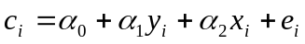 (4)

where and 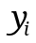 means the total household consumption and income respectively, represents the vector of observed characteristics that affects the consumption, represents the vector of non observed characteristics (errors) and 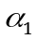 is the marginal propensity to consume.

It is known that in equation (4) the income might be correlated with the error term (if the error term contains omitted variables that are correlated with the variables included, if contains measurement errors, or if are determined jointly with). This causes inconsistent OLS estimation.

To go beyond this problem, we also propose to estimate equation 4 using the method of Instrumental Variables (IV). This technique is the standard prescription for correcting such cases and it gives:

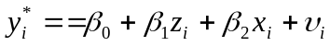

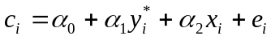 (5)

where is called the instrument for 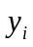 and it have the following two properties: (i) it is correlated with , 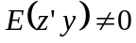, and (ii) it is uncorrelated with , 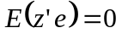.

Following Deaton (1997), we used as instrumental variable the average income of the village where the household is placed estimated without the income of the household (expresses in log.). Hence, z is determinate by the following expression:

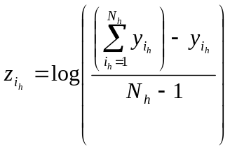 con h = 1,…,75 (7)

Where the subindex i means household, the subindex h means the village where the household is placed and, N_{h} means the household population of each village.

Table A.3.6.1 shows four specifications using both IV and OLS methods. Model 1 is the simplest specification where total consumption (in log.) is estimated as a function of its total income (in log) and the household size. Model 2 adds regional controls. Model 3 included controls for demographics characteristics. Finally, model 4 incorporates educational controls.

Performing a Hausman test we confirm that the OLS estimation results to be inconsistent under these models (Table A.3.6.2). As we mention before, the income coefficient denotes the marginal propensity to consume. This coefficient results to be statically significant in all IV models. Moreover, these estimations show that the value of the marginal propensity in Panama is between [0.7460, 0.8243].

Table A.3.6.1: Estimation of the Marginal Propensity to Consume

Source: Own estimation based on ENV 2003 data.
Note: OLS means Ordinay Least Square estimation, IV means Instrumental Variables estimation

Table A.3.6.2: Hausman Test
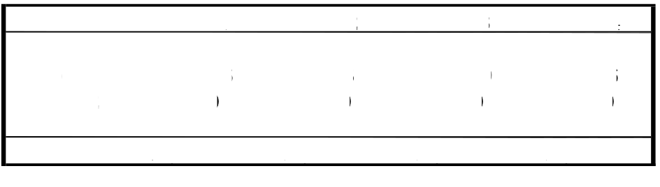
Source: Own estimation based on ENV 2003 data.

The extreme poverty line, which equals the cost of an adequate minimum food basked, for 1997 was estimated at B.\519 and for 2003 at B.\534.
B.\ 1= US$1.
More precisely, a program that does not affect the poverty rate but that reduces the poverty gap significantly by bringing those far below the poverty line closer to it, may be preferable to a program that reduces the poverty rate, but leaves many of the neediest unaffected (e.g., by lifting those close to the poverty line to just above it).
The poverty severity index measures the contribution of the very poor to the poverty gap.
Social Assistance programs are programs aimed at maintaining households out of poverty, are usually targeted to the poor, and are not linked to previous contribution to an insurance pool. Social Insurance programs, on the other hand, are programs designed to mitigate the impact of unexpected income shortfalls due to unemployment, health problems, disability and old age.
For any measure, the growth rate per capita is equal to the total growth rate minus the population growth rate.
For discussion of the reasons for these differences, see Deaton (2005) and Ravallion (2003).
For 1997, the poverty and the extreme poverty lines were set to B.\905 and B.\519. For 2003, there were set to B.\953 and B.\534, respectively.
Tests for statistical significance of the changes in poverty and inequality are given in Annex 1.3. The changes are generally significant, with the following exceptions: changes in the Gini coefficient for urban areas, the national headcount poverty rate using the moderate poverty line, and the poverty gap and poverty severity index for indigenous areas using the extreme poverty line.
The approach followed here is that off Datt and Ravallion (1992).
See the study prepared by Barros, Carvalho, Franco and Mendonca (2006) in Annex 3 for further details.
This analysis follows Huppi and Ravallion (1991).
The simulations follow the procedure of Datt and Walker (2003).
See Annex 1.1, Figure A1.1.4 for the poverty impact of three different growth scenarios with an associated increase in inequality of 1 percent. The inequality reductions referred to here are percentage reductions in the Gini coefficient. In the simulations, inequality is reduced through a proportional shift in the Lorenz curve which adjusts the consumption level of each household relative to its deviation from the mean. The adjustment effectively redistributes consumption from households with consumption above the mean to those with consumption below the mean. The precise formula can be found in Datt and Walker (2003).
Article 35 of Law 34 of 1995 made obligatory and free (in public schools) the two years of pre-primary (ages 4-5 years); it also made free in public schools the three years of upper secondary.
Note here that we refer to school services as opposed to schools. Many of the pre-school programs are physically located within a primary school. Also, many schools have one set of classes while others have separate morning and afternoon programs. The data are presented at the level of school services. Thus a primary school that has both a morning and an afternoon pre-school program would be considered to be three school services, even though all of this activity is taking place in one physical space.
This rise appears in several data sources but it is not clear what the explanation is for such a startling increase.
Obviously, the first consideration was to ensure that the calculations themselves were correctly done: several checks have been done to ensure that the results reported in the table reflect the reality of malnutrition and are not simply measurement errors. The calculations of the various indicators (z scores and standard deviations) have been done using the Anthro software and the construction has been done several times by different individual. Additionally, tests of significance of the differences have been carried out to ensure that the results are statistically significant and not simply due to the fact that malnutrition is a relative rare event and the number of children in the analysis (zero to five year olds) is not large. As is shown in the previous table, the differences in chronic malnutrition are significant for all geographic levels although none of the other indicators show a significant change.
Clearly this is not exactly comparable as the age group measured is different and, to the extent that there is not global primary school attendance, the universe of children is itself different. It may be that the children who do not attend primary school are the very poor and the most likely to be malnourished. Thus a school census could understate the problem of malnutrition.
One could assume, just to see the effect, that chronic malnutrition in indigenous areas was measured badly in 1997. For both rural and urban areas, the 6-11 year olds show, on average an increase of 8.9 percent over the 1997 figures for 0 to 5 year olds. For this same relationship to exist within indigenous areas, the 1997 figure would have to be 53.9 percent chronic malnutrition. If that were the case, then the overall malnutrition rate for 1997 would have been slightly higher, but not enough higher to contradict the finding of a large increase in chronic malnutrition. So this does not appear to be a solution either.
There has been no change between 1997 and 2003 for these quality indicators
This does not mean that that there is no public health care provided in the corregimiento, the Ministry of Health has several modalities of mobile care.
Social Assistance programs are programs aimed at maintaining households out of poverty, are usually targeted to the poor, and are not linked to previous contribution to an insurance pool. Social Insurance programs, on the other hand, are programs designed to mitigate the impact of unexpected income shortfalls due to unemployment, health problems, disability and old age.
For a discussion of some of these difficulties see Marques, José Silvério “Central America, Cross-Country Evaluation of Social Safety Net Assessments (SSNAs)- Issues Paper”, paper prepared for the World Bank, November 2002.
Various subsidies (water, electricity, etc) are directed at seniors but these subsidies are generally not targeted on the poor.
Mesa, Alberto Arenas “ Alternativas de Políticas para la Reforma y Modernización del Sistema de Pensiones en la CSS en Panamá”, Septiembre 2004, p. 53.
B/ 60.00 is equivalent to one-half the existing minimum wage of B/ 119 for domestic work in the capital or to one third of the minimum pension of B/ 175
Cuevas, Fernando “Precios Combustibles en América Central”, Presentation to the Fuel Pricing Policies in Latin America and their Economic and Environmental Implications” December, 2002, Chile.
Some have argued that in many poor and isolated communities this is not possible because there is not local supply of the needed foodstuffs. Although this could be true in a few instances, it should not hold in most cases. Indeed, the new SENAPAN pilot program which targets the poorest communities includes among the eligible products that the beneficiary families can buy locally, the very same products that are distributed in kind to the schools.
A positive development in 2006 was the elimination of MEDUCA school lunch program, which duplicated the SIF program.
If only milk is replaced by a cheaper alternative, about US$ 4 million could be saved annually.
The water and electricity subsidies for seniors are also not targeted; only 16% of the seniors above 62 years are poor. If existing subsidies are targeted only on poor senior additional savings could be realized. However, since these subsidies are cross financed in principle the saving would accrue to other consumers.
Argentina’s Jefes de Hogares program is a bit different in that the “conditionalities” involve work-related and labor training actions on behalf of beneficiaries rather than school attendance and health care. Argentina also operates a smaller CCT, called the Income for Human Development Program (IDH), which conditions cash transfers on schooling and health care.
See: Maluccio (2004), Olinto (2004), Rawlings and Rubio (2004) and Rawlings (2004) for summaries of the impacts of CCTs.
Assuming a concave welfare function, or aversion to inequality, it can be shown that the welfare loss from erroneously excluding a extreme poor household is greater than the welfare gain from the reduction in program cost coming from excluding a non poor household.
These impacts are the short run immediate impacts assuming an average income elasticity of consumption of 0.8. We also take into account the targeting errors simulated above. In the next simulation exercise we look into long run impacts that take the effects of human capital accumulation into account. But if w assume that all three designs tested have the same impact on the demand for education and health services, then in order to chose the best design all we need is to simulate the short run immediate impact on welfare.
This recommendation was made in the 2000 World Bank Poverty Assessment and corroborated in the recent SENAPAN nutrition study. It may require a modification to the law.
Ibid.
For any measure, the growth rate per capita is equal to the total growth rate minus the population growth rate.
For discussion of the reasons for these differences, see Deaton (2005) and Ravallion (2003).
See Székely and Hilgert (1999). Among the 18 countries examined is a 1997 income survey in Panama.
Labor income accounted for 62.6% of total income in the 1997 survey and 64.4% of total income in the 2003 survey.
These are equivalent to annual growth rates of 3.5 percent for GDP and 2.7 percent for labor income. Note that labor income grew more rapidly than income overall, which grew at a rate of 2.2 percent.
See Moran (2005) and Gasparini and Sosa Escudero (1999) for references related to this topic.
One could assume, just to see the effect, that chronic malnutrition in indigenous areas was measured badly in 1997. For both rural and urban areas, the 6-11 year olds show, on average an increase of 8.9 percent over the 1997 figures for 0 to 5 year olds. For this same relationship to exist within indigenous areas, the 1997 figure would have to be 53.9 percent chronic malnutrition. If that were the case, then the overall malnutrition rate for 1997 would have been slightly higher, but not enough higher to contradict the finding of a large increase in chronic malnutrition. So this does not appear to be a solution either.
Atalah, Eduardo and Rosario Ramos “Evaluación de Programas Sociales Con Componentes Alimentarios y/o Nutricionales en Panamá”, Informe de Consultaría, SENAPAN, October 2005.
Secondary education is organized in two cycles of three years each. The lower secondary education (grades 7-9) is mandatory and covers general subjects. The second cycle or upper secondary (grades 10-12) is voluntary and has two tracks: academic and professional-technical.
The estimate of population not covered at secondary level includes 35,194 overage students (12-14 years) that attend primary school. Estimates from MEDUCA’s Planning Department.
“Objetivos de Desarrollo del Milenio, Segundo Informe”,Gabinete Social de la Republica de Panama, 2005, Box 9, p. 75,
Total newborns in 2003 were 61,743. “Panamá en Cifras 2000-04”. Dirección de Estadística y Censos, Noviembre 2005, p. 42.
Data for 2003. “Objetivos de Desarrollo del Milenio, Segundo Informe”, Gabinete Social de la Republica de Panamá, 2005.
Contributors relative to the labor force. See Caroline Crabble, editor, “A Quarter Century of Pension Reform in Latin American and Caribbean: Lessons Learned and Next Steps”, IDB, 2005, (Table 1.12, p. 36).
“Situación de la Seguridad Social,” Dirección de Estadística y Censo, 2003 (Cuadro 421-03). “Panama-Selected Issues and Statistical Appendix”, IMF, February 2006, Table 7, p.34.
Nutricereal provides 350 calories, 12 grams of proteins, 220 micrograms of vitamin A, 5.7 milligrams of iron, and 250 grams of calcium per 100 grams.
In 2005, there was another school lunch program managed by MEDUCA which was discontinued in 2006. This program transferred funds to the schools to finance the purchase of foodstuffs. In 2005 it transferred B/ 786,000 and benefitted 14,415 students.
Law No. 8 of March 2006 changed the name of INAFORF to INADHE or National Institute for Human Resource Development. (Instituto Nacional de Formación Profesional y Capacitación para el Desarrollo Humano). The Law contemplates that the resources that were previously assigned to the Ministry of Labor, Panama Institute of Tourism, and the Authority for the Medium, Small and Micro Enterprises for training will be reassigned to INADEH, which will train the personnel needed for the expansion of the Canal if the project materializes. INADEH budget could reach B/ 37 million.
Information on INSAFORT is based on its web page. No detailed information on the programs (cost or coverage) is available.
Other electricity subsidies are detailed below.
An IDB supported program which also involves direct subsidies has been recently initiated. This program for US$ 12.6 million (including US$ 2.6 million in counterpart funding) seeks to develop new instruments that will expand access to suitable housing for poor population. It includes four components: (i) improvement of neighborhoods (Integral Improvement of Neighborhood Program, PROMEBA); (ii) Construction of basic units of 36 m2 at an approximated cost of US$3,000 for families with monthly incomes of less than US$ 300 (Improved PARVIS). The component will benefit approximately 500 families in rural and indigenous areas considered high-priority by the country’s SPS. Units will be delivered fully terminated (turn key solution) with no cost to the beneficiary. Preference will be given to poor single mother with children with disabilities and senior. This component is expected to disburse B/ 1.2 million in 2006. (iii) Urbanization of macro lots to be sold to private developers that will build 600 low income houses below US$ 13,000 (Program of Provision of Basic Infrastructure, PROBIDA); (iv) Provision of a subsidy up to US$ 2,000 per family to facilitate the acquisition of low income housing (below US$ 16,000). Eligible families must have a monthly income of less than US$ 300 and demonstrate that they can obtain a commercial mortgage to complete the purchase. The Program will finance 1,000 subsidies at a cost of US$ 2 million (Housing Solidarity Program, PROVISOL).
Law No. 3 of May 24, 1985.
This section is based on Chapter VIII of the Panama- Public Expenditure Review, World Bank, 2006.
Law No. 15 of 2001.
The estimate is base on the following calculations. Number of consumers of less than 100 kwh: 252,016 (COPE); the average tariff in the second semester of 2005 (source ERSP) was: first 10 kwh : B/ 1.67; next 90 kwh: B/ 0.144 kwh; the monthly bill would be: B/14.63; the discount (20%): B/ 2.926; the monthly subsidy 252,016 x 2.926= B/ 737,398; and the annual subsidy: B/ 737,398 x 12= B/ 8.8 million.
Law No. 37 of 2001.
The estimate is base on the following calculations. Persons in retiring age represent 8.7 percent of the population (Departament of Statistics and Census). If same proportion applies to electricity consumers the number of seniors that are consumers of electricity would be: 685,711x0.087= 59,656; assuming that there are two senior for each house, the number of beneficiaries are: 59,656/2= 29,828. The average tariff (ERSP) in the second semester of 2005 was as follows: first 10 kwh : B/ 1.67; next 490 kwh: B/ 0.144 kwh; other 100 kwn B/ 0.150 kwh. Monthly cost would be: B/87.23; the discount (25%), B/ 21.8; the monthly subsidy 29,828 x 21.8= B/ 650,250; and the annual subsidy: B/ 650,250 x 12= B/ 7.8 millions.
The subsidy was created by Executive Decree No. 13 of April 7, 1993, and modified by the Executive Decree No. 30 of March 25, 1998.
Executive Decree No. 36 of September 17, 2003 (Article 78)
Instrumenting earnings with a selection bias procedure requires instruments that are not readily available. The standard correction using standard two stage procedure is weak in the case of more than two category choices.
Martha Rodríguez led the fieldwork for the qualitative análisis with Cecibel Flor de Liz Arias, Deici Guainara Guainara, Lineth Marilin Herrera, Enelía Mezúa Apochita, Filomena Miranda, Maritza Rodríguez. We thank the Ministry of Social Development (MIDES) and in particular the Social Protection Secretary (SPS) and the Direction for Indigenous People for their support. We also acknowledge the support of the Social Policy Division of the Ministry of Economy and Finance. We are grateful for the collaboration of the Kuna General Congress, the Embera comarca governor and community leaders in the comarca Ngobe. We are indebted to the Kuna Yala communities of Carti Yandup and Carti Sugdup, Ngobe communities of Soloy/Jebay, Oma and Quebrada de Guabo, and the Embera communities of Unión Choco y Puente for their support and participation in focus groups.
This section draws largely on Vakis and Lindert (2000), University of Maryland Minorities At Risk Project (2004) and US Department of State (2006) and from the 2003 LSMS.
Traditionally, the Kuna leadership fixes the price of coconuts and severely enforces it so as to maintain a predictable income for the islands.
In March 2005, authorities detained tour high-ranking Panamenian National Police stationed in Darién Province on charges of sexual abuse of minors. At year’s end, one officer was dismissed and the other three remained under investigation (US State Department, 2006)
Interestingly, no group commented on the possibility of using traditional dress in school.
Campuria means non-indigenous people.
This growth refers to puberty.
Nose rings are traditional gold jewels which Kuna wear with their traditional dress.
Men go by boat every other day to collect water in 20l containers
En ASMUN participan mujeres y hombres
It is possible to suppose a non lineal relation (cuadratic, cubic) between the consumption and income. This supposition implies that marginal propensity consumption can varies when we move along the income distribution.
It is important to issue that we also estimate models which contemplates non-lineal specifications assuming quadratic and cubic relations between the consumption and income. We not take into account these models given the fact that the propensity to consume resulted to rise along the income distribution.

