SFG3426 V20

Marking 79 km hiking trail in Imereti Region

Environmental and Social Screening Report

August 2017

Sub-Project Description
The Sub-Project (SP) for Marking 79 km hiking trail is planned to be implemented in Imereti Region. Marking of trails will increase the tourist potential, improve orientation in the environment, enabling tourists to plan their adventure tours and other activities better. The routes are planned by the National Tourism Agency and represent the part of Imereti tourist routes - the network of Jaji Lake.
Within SP, Didmaghali-Jaji Lake-Sairme-Upper Surebi trail will be marked. Length of the trail is 79 km. The planned route is popular for pedestrians, camping and adventure tour lovers. Its popularity is also caused by the fact that it borders Borjomi-Kharagauli National Park. The same network is connected by the route from Abastumani and Sairme resort. These routes connect Imereti with Guria and Samtskhe-Javakheti and create a single pedestrian-tourist network for three regions.
The trail will be marked within the SP, according to technical regulations of planning and marking pedestrian paths, adopted by the Georgian National Tourist Agency (GNTA).
Marking trails include the following interventions:
- installation of 26 double-inscription boards;
- installation of 6 single-inscription boards;
- installation of indicating poles;
- installation of 3 single-sided information boards;
- installation of 3 camping indicating boards;
- installation of 58 poles for marking;
- marking path indications with paint.

Environmental Screening and Classification

(A) Impact Identification
Has sub-project a tangible impact on the environment? | The SP construction phase covers 4 months’ period. The SP will have a small-scale and short-term impact on the environment only in the installation phase, while its long-term impact on the natural will be positive.
What are the significant beneficial and adverse environmental effects of the sub-project? | The SP is expected to have a positive long-term environmental impact through supporting organized movement of tourists within the area aimed at decreasing environmental footprint of visitation.  The expected negative environmental impacts are likely to be short-term. As a result of installation of information boards, indicating poles and other activities, the dust and emissions from the operation of construction machinery will increase, background noise and vibration levels will rise insignificantly. However, the flow of traffic will not be obstructed.
Does the sub-project have any significant potential impact on the local communities? | The long-term social impact of the SP will be beneficial, which will cause significant improvement of the social conditions of nearby population and tourists. As a result of the SP implementation, nearby local community members, visitors and tourists will be served.  In total 79 km trail will be marked. Marking of the trail will help locals to engage in tourism activities in the region as some areas run through settlements and they will have opportunities to gain economic benefits through offering various goods and services to tourist.  Marking will promote the popularity of several destinations in Imereti and increase tourist flows. Marking of trails will connect several routes with each other and create a network of routes that will cover the regions of Imereti, Guria and Samtskhe-Javakheti, which will also positively affect the country's tourism potential. The implementation of the SP will create the direct tourist product - marked tourist routes.  Significant social impact of SP, such as change of local demographic structure, influx of new settlers, secondary development is not envisaged.
What impact has the sub-project on the human health? | The dust, vibration and noise originated during the small-scale installation works will not have impact on the human health or safety.

(B) Impact Mitigation
What alternatives to the sub-project design have been considered and what mitigation measures are proposed? | At the design, a no-project alternative was considered and turned down as the implementation of the SP will help attract both, the local and foreign visitors that will have a positive impact on the social standing of the local population.  Reduction of adverse environmental impact during the initialization works will be possible through protecting the following key conditions: proper management of waste and constant monitoring, ensuring the technical functionality of machinery used during installation works.  Planned works will not cause cutting of trees and preventive measures will be undertaken to avoid any damage to the nearby standing trees.  In case of chance finds, works will be taken on hold and notification be sent to the Ministry of Culture and Monument Protection of Georgia. Works will resume only upon written consent of the Ministry.  If before, during or after SP implementation concerned community members have complaints / questions / recommendations, these can be addressed to the sub-grantee, contractor, or Elkana, whose contact information will be made available at the SP site.
Have concerned communities been involved and have their interests and knowledge been adequately taken into consideration in sub-project preparation? | During community mobilization, the project team met with GNTA, Bagdati municipality and population. During the meetings several priorities were identified, including rehabilitation of stadiums and marking trails. The latter was prioritized.
(C) CATEGORIZATION AND CONCLUSION
Conclusion of the environmental screening:
- Sub-project is declined □
- Sub-project is accepted ■

- Sub-project is classified
as environmental Category B
and needs EMP ■

- Sub-project is classified
as environmental Category C
and does not need EMP □
Social Screening
Social safeguards screening information |  |  | Yes | No
1 | Is the information related to the affiliation, ownership and land use status of the sub-project site available and verifiable? (The screening cannot be completed until this is available)
2 | Will the sub-project reduce people’s access to their economic resources, such as land, pasture, water, public services, sites of common public use or other resources that they depend on?
3 | Will the sub-project result in resettlement of individuals or families or require the acquisition of land (public or private, temporarily or permanently) for its development?
4 | Will the sub-project result in the temporary or permanent loss of crops, fruit trees and household infrastructure (such as ancillary facilities, fence, canal, granaries, outside toilets and kitchens, etc.)?
If answer to any above question (except question 1) is “Yes”, then OP/BP 4.12 Involuntary Resettlement is applicable and mitigation measures should follow this OP/BP 4.12 and the Resettlement Policy Framework
Cultural resources safeguard screening information |  |  | Yes | No
5 |  | Will the sub-project be implemented in the vicinity of a cultural heritage site?
6 |  | Will the sub-project require excavation near any historical, archaeological or cultural heritage site?

If answer to question 5 is “yes”, then OP/ BP 4.11 Physical Cultural Resources is applicable. In this case, sub-project proponent must provide evidence that consultation was held with and an agreement on this sub-project was obtained from an authorized representative of culture and heritage protection authority.
If answer to question 6 is “Yes”, then OP/BP 4.11 Physical Cultural Resources is applicable and possible chance finds must be handled in accordance with OP/BP and relevant procedures provided in this EMF.

Environmental Management Plan

Marking 79 km hiking trail in Imereti Region

PART A: General Project and Site Information
INSTITUTIONAL & ADMINISTRATIVE
Project title | Empowering Poor Communities and Micro-Entrepreneurs in the Georgia Tourism Sector
Sub-Project title | Marking 79 km hiking trail in Imereti Region
Scope of site-specific activity | The following works are necessary to be implemented to arrange the tourist infrastructure (mark the 76 km hiking trail) in Imereti Region for three routs:  - installation of 26 double-inscription boards;  - installation of 6 single-inscription boards;  - installation of indicating poles;  - installation of 3 single-sided information boards;  - installation of 3 camping indicating board;  - installation of 58 poles for marking;  - marking path indications with paint.
Institutional arrangements (WB) | Task Team Leader:  Gloria La Cava | Safeguards Specialist:  Darejan Kapanadze, Environment  Rebecca Lacroix and David Jijelava, Social
Implementation arrangements  (Borrower) | Implementing entity:  Biological Farming Association “Elkana” | Works supervisor:  Biological Farming Association “Elkana” | Works contractor:  (tbd)
SITE DESCRIPTION
Who owns the building to be constructed/extended/ reconstructed? | Works are not related to buildings.
Who owns the land allocated for sub-project?  Who uses the land (formal/informal)? | The SP area is located in Baghdati municipality.  The area is not under any type of formal or informal private use.
Description of physical and natural environment, and of the socio-economic context around the site | The SP aims to mark Didmaghali-Jaji Lake-Sairme-Upper Surebi trail in Baghdati municipality of Imereti region.  The small section of the SP site is located near the Borjomi-Kharagauli National Park, one of the largest national parks in Georgia, it includes six administrative districts stretching from the resort of Borjomi to the town of Kharagauli. The park has impressive and diverse landscapes and lots of possible activities for tourists.
Which of the project intervention sites does sub-project related to and how? | The SP project is related to the touristic infrastructure rehabilitation in Imereti region through II Regional Development Project, funded by the World Bank and implemented by the Municipal Development Fund of Georgia.
LEGISLATION
National & local legislation & permits that apply to sub-project activity | According to the law of Georgia on Permit on Environmental Impact (2008), the SP does not require preparation of EIA and obtaining of Permit on Environmental Impact.  The SP triggers to the OP/BP 4.01 Environmental Assessment of the World Bank. According to this safeguard policy and the Environmental Management Framework of the Project for Empowering Poor Communities and Micro-Entrepreneurs in the Georgia Tourism Sector, the SP is classified as environmental category B and requires preparation of Environmental Management Plan (EMP).
PUBLIC CONSULTATION
When / where the public consultation process took / will take place | SP-specific draft EMP was made available for the concerned population and discussed in a consultation meeting.
ATTACHMENTS
Attachment 1: Support letter from Baghdati Municipality;
Attachment 2: Support letter from Georgian National Tourism Administration regarding trail operation and maintenance;
Attachment 3: SP location and site plan;
Attachment 4: Community meeting minutes.

PART B: safeguards information
ENVIRONMENTAL /SOCIAL SCREENING
Will the site activity include/involve any of the following? | Activity/Issue | Status | Triggered Actions
 | - Building rehabilitation | [ ] Yes [√] No | See Section A below
 | - New construction | [√] Yes [ ] No | See Section A below
 | - Individual wastewater treatment system | [ ] Yes [√] No | See Section B below
 | - Historic building(s) and districts | [ ] Yes [√] No | See Section C below
 | - Acquisition of land | [ ] Yes [√] No | See Section D below
 | - Hazardous or toxic materials | [ ] Yes [√] No | See Section E below
 | - Impacts on forests and/or protected areas | [√ ] Yes [ ] No | See Section F below
 | - Handling / management of medical waste | [ ] Yes [√] No | See Section G below
 | - Traffic and Pedestrian Safety | [√] Yes [ ] No | See Section H below
PART C: Mitigation measures
ACTIVITY | PARAMETER | MITIGATION MEASURES CHECKLIST
0. General Conditions | Notification and Worker Safety | - The local construction and environment inspectorates and communities have been notified of upcoming activities  - The public has been notified of the works through appropriate notification in the media and/or at publicly accessible sites (including the site of the works)  - All legally required permits have been acquired for construction and/or rehabilitation  - The Contractor formally agrees that all work will be carried out in a safe and disciplined manner designed to minimize impacts on neighboring residents and environment.  - Workers’ PPE will comply with international good practice (always hardhats, as needed masks and safety glasses, harnesses and safety boots)  - Appropriate signposting of the sites will inform workers of key rules and regulations to follow.
A. General Rehabilitation and /or Construction Activities | Air Quality | - During interior demolition debris-chutes shall be used above the first floor  - Demolition debris shall be kept in controlled area and sprayed with water mist to reduce debris dust  - During pneumatic drilling/wall destruction dust shall be suppressed by ongoing water spraying and/or installing dust screen enclosures at site  - The surrounding environment (sidewalks, roads) shall be kept free of debris to minimize dust  - There will be no open burning of construction / waste material at the site  - There will be no excessive idling of construction vehicles at sites
 | Noise | - Construction noise will be limited to restricted times agreed to in the permit  - During operations the engine covers of generators, air compressors and other powered mechanical equipment shall be closed, and equipment placed as far away from residential areas as possible
 | Water Quality | - The site will establish appropriate erosion and sediment control measures such as e.g. hay bales and / or silt fences to prevent sediment from moving off site and causing excessive turbidity in nearby streams and rivers.
 | Waste management | - Waste collection and disposal pathways and sites will be identified for all major waste types expected from demolition and construction activities.  - Mineral construction and demolition wastes will be separated from general refuse, organic, liquid and chemical wastes by on-site sorting and stored in appropriate containers.  - Construction waste will be collected and disposed properly by licensed collectors  - The records of waste disposal will be maintained as proof for proper management as designed.  - Whenever feasible the contractor will reuse and recycle appropriate and viable materials (except asbestos)
B. Individual wastewater treatment system | Water Quality | - The approach to handling sanitary wastes and wastewater from building sites (installation or reconstruction) must be approved by the local authorities  - Before being discharged into receiving waters, effluents from individual wastewater systems must be treated in order to meet the minimal quality criteria set out by national guidelines on effluent quality and wastewater treatment  - Monitoring of new wastewater systems (before/after) will be carried out  - Construction vehicles and machinery will be washed only in designated areas where runoff will not pollute natural surface water bodies.
C. Historic building(s) | Cultural Heritage | - If the building is a designated historic structure, very close to such a structure, or located in a designated historic district, notification shall be made and approvals/permits be obtained from local authorities and all construction activities planned and carried out in line with local and national legislation.  - It shall be ensured that provisions are put in place so that artifacts or other possible “chance finds” encountered in excavation or construction are noted and registered, responsible officials contacted, and works activities delayed or modified to account for such finds.
D. Acquisition of land | Land Acquisition Plan/Framework | - If expropriation of land was not expected but is required, or if loss of access to income of legal or illegal users of land was not expected but may occur, that the Bank’s Task Team Leader shall be immediately consulted.  - The approved Land Acquisition Plan/Framework (if required by the sub-project) will be implemented
E. Toxic Materials | Asbestos management | - If asbestos is located on the sub-project site, it shall be marked clearly as hazardous material  - When possible the asbestos will be appropriately contained and sealed to minimize exposure  - The asbestos prior to removal (if removal is necessary) will be treated with a wetting agent to minimize asbestos dust  - Asbestos will be handled and disposed by skilled & experienced professionals  - If asbestos material is being stored temporarily, the wastes should be securely enclosed inside closed containments and marked appropriately. Security measures will be taken against unauthorized removal from the site.  - The removed asbestos will not be reused
 | Toxic / hazardous waste management | - Temporarily storage on site of all hazardous or toxic substances will be in safe containers labeled with details of composition, properties and handling information  - The containers of hazardous substances shall be placed in an leak-proof container to prevent spillage and leaching  - The wastes shall be transported by specially licensed carriers and disposed in a licensed facility.  - Paints with toxic ingredients or solvents or lead-based paints will not be used
F. Affected forests, wetlands and/or protected areas | Protection | - All recognized natural habitats, wetlands and protected areas in the immediate vicinity of the activity will not be damaged or exploited, all staff will be strictly prohibited from hunting, foraging, logging or other damaging activities.  - A survey and an inventory shall be made of large trees in the vicinity of the construction activity, large trees shall be marked and cordoned off with fencing, their root system protected, and any damage to the trees avoided  - Adjacent wetlands and streams shall be protected from construction site run-off with appropriate erosion and sediment control feature to include by not limited to hay bales and silt fences  - There will be no unlicensed borrow pits, quarries or waste dumps in adjacent areas, especially not in protected areas.
G. Disposal of medical waste | Infrastructure for medical waste management | - In compliance with national regulations the contractor will insure that newly constructed and/or rehabilitated health care facilities include sufficient infrastructure for medical waste handling and disposal; this includes and not limited to:  - Special facilities for segregated healthcare waste (including soiled instruments “sharps”, and human tissue or fluids) from other waste disposal; and  - Appropriate storage facilities for medical waste are in place; and  - If the activity includes facility-based treatment, appropriate disposal options are in place and operational
H Traffic and Pedestrian Safety | Direct or indirect hazards to public traffic and pedestrians by construction  activities | (a) In compliance with national regulations the contractor will insure that the construction site is properly secured and construction related traffic regulated. This includes but is not limited to  - Signposting, warning signs, barriers and traffic diversions: site will be clearly visible and the public warned of all potential hazards  - Traffic management system and staff training, especially for site access and near-site heavy traffic. Provision of safe passages and crossings for pedestrians where construction traffic interferes.  - Adjustment of working hours to local traffic patterns, e.g. avoiding major transport activities during rush hours or times of livestock movement  - Active traffic management by trained and visible staff at the site, if required for safe and convenient passage for the public.  - Ensuring safe and continuous access to office facilities, shops and residences during renovation activities, if the buildings stay open for the public.

PART D: Monitoring Plan
Activity | What  (Is the parameter to be monitored?) | Where  (Is the parameter to be monitored?) | How  (Is the parameter to be monitored?) | When  (Define the frequency / or continuous?) | Why  (Is the parameter being monitored?) | Who  (Is responsible for monitoring?)
Transportation of construction materials and waste movement of construction machinery | Technical condition of vehicles and machinery  Confinement and protection of truck loads with lining  Respect of the established hours and routes of transportation | Construction site | Inspection | Unannounced inspections during work hours and beyond | Limit pollution of soil and air from emissions;  Limit nuisance to local communities from noise and vibration;  Minimize traffic disruption. | Elkana
Earthworks (small scale) | Temporary storage of excavated material in the pre-defined and agreed upon locations;  Backfilling of the excavated material and/or its disposal to the formally designated locations;  In case of chance finds immediate suspension of works, notification of the Ministry of Culture and Monument Protection, and resumption of works exclusively upon formal consent of the Ministry. | Construction site | Inspection | In the course of earth works | Prevent pollution of the construction site and its surroundings with construction waste;  Prevent damage and loss of physical cultural resources | Elkana
Traffic disruption and limitation of pedestrian access | Storage of construction materials and temporary placement of construction waste in a way preventing congestion of access roads | At and around the construction site | Inspection | In the course of construction works | Prevent traffic accidents;  Limit nuisance to nearby residents | Elkana
Workers’ health and safety | Provision of uniforms and safety gear to workers;  Ensuring use of the personal protective gear by workers;  Informing of workers and personnel on the personal safety rules and instructions for operating machinery/equipment, and strict compliance with these rules/instructions | Construction site | Inspection | Unannounced inspections in the course of work | Limit occurrence of on-the-job accidents and emergencies | Elkana
Effect on protected area | Informing staff regarding restrictions on hunting, foraging, logging or other damaging activities;  Ensuring marking and cordoning off with fencing in case of large tress, and protecting their root system in the vicinity of the construction activity; | At and around the construction site | Information sharing, inspection | Unannounced inspections in the course of work | Protect recognized natural habitats, and protected areas in the immediate vicinity of the activity;  Protect trees and avoid damages to their root systems; | Elkana

Attachment 1: Support letter from Baghdati Municipality
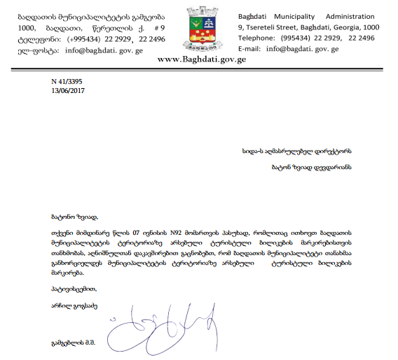

Attachment 2: Support letter from Georgian National Tourism Administration regarding trail operation and maintenance
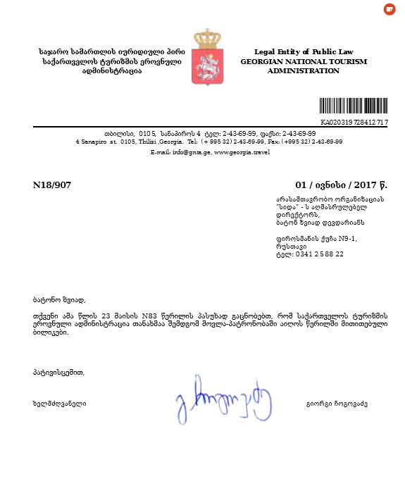

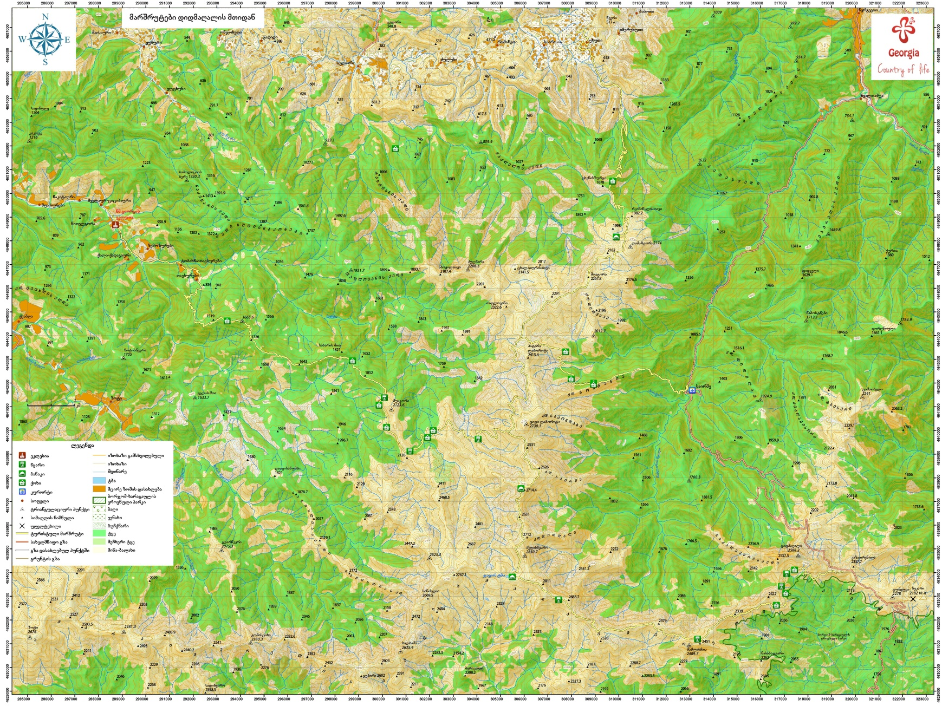
Attachment 3: Sub-Project location/Site Plan

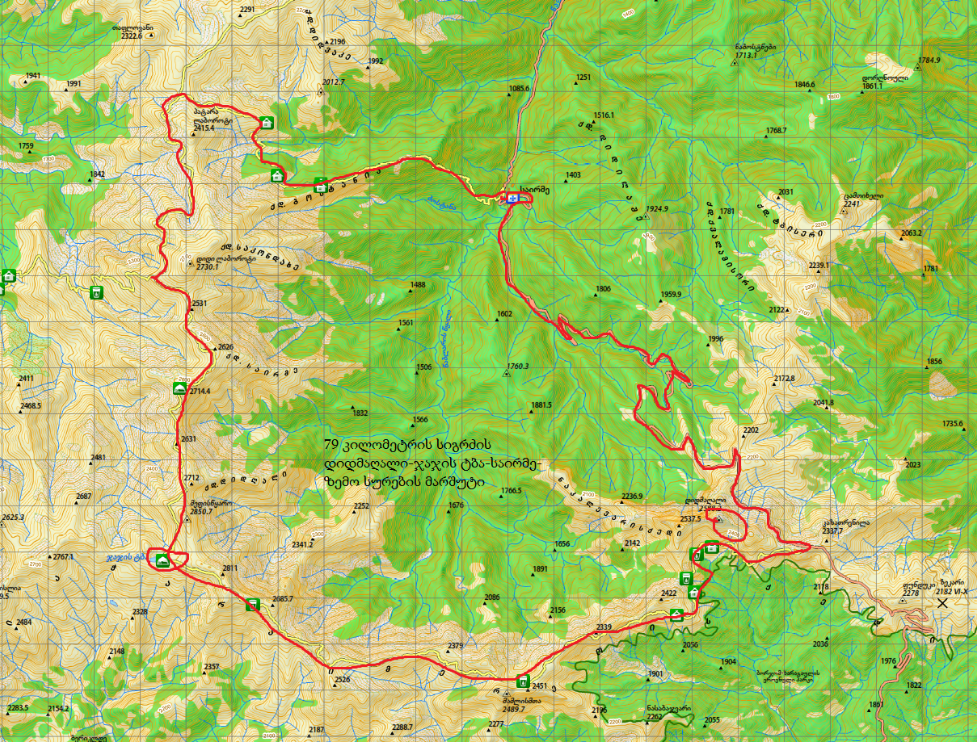

Attachment 4: Community meeting minutes
Date: August 8, 2017
Venue: Baghdati Municipality, village Khani
Donor: Biological Farming Association “Elkana”, through funding from the Japan Social Development Fund and the World Bank
Aim: Consult with the local community on the Draft Environment and Social Management
Plan for the project “marking 79 km hiking trail”.
Elkana Regional Coordinator in Imereti, representative of NGO Civil Development Agency, local authority and community members attended the meeting. In total 17 people participated in the gathering, including seven women.
Elkana Regional Coordinator presented planned project and activities, as well as the draft Environment Management Plans prepared to mitigate their possible negative impacts on the natural and social environment. After the presentation, meeting participants were given the floor for questions and comments. During the meeting, participants asked the following questions:

Question: Will the trail marking result any cutting of trees or branches?
Answer: Cutting of trees or branches will not be required.

Question: Will the trail cross private property and cause any damage to private property?
Answer: The trail will not cross any private property and will be within the boundaries of the municipal property.

Community members were satisfied with the received information and supported implementation of the project.

Signatures of attendees:

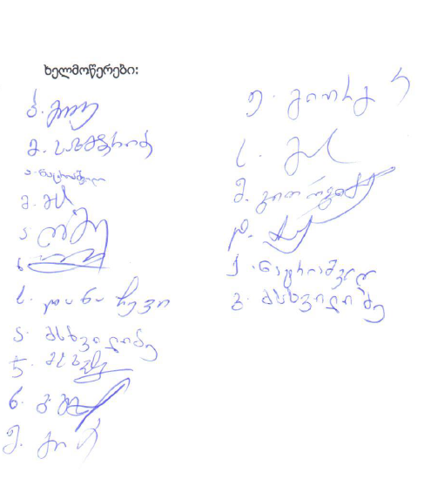

Photo materials
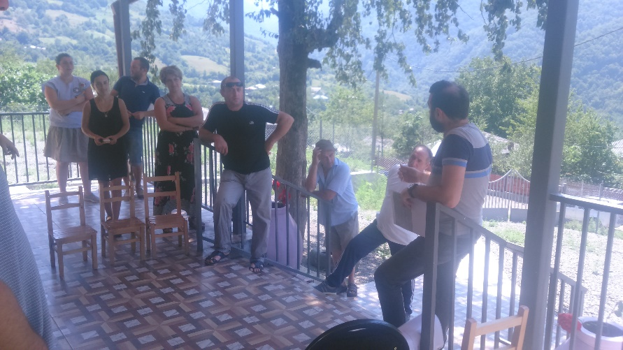
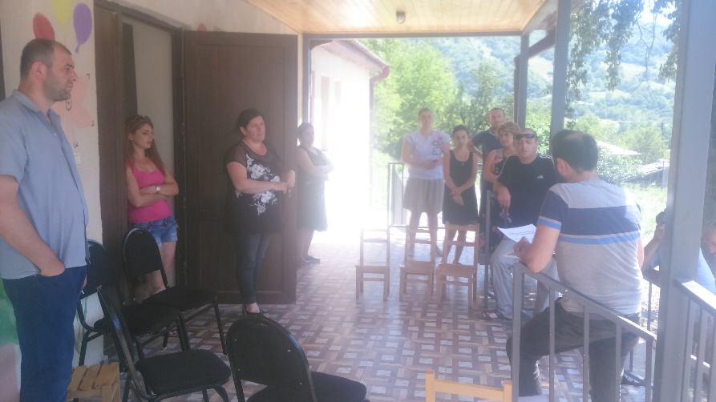

Land acquisitions includes displacement of people, change of livelihood encroachment on private property this is to land that is purchased/transferred and affects people who are living and/or squatters and/or operate a business (kiosks) on land that is being acquired.
Toxic / hazardous material includes but is not limited to asbestos, toxic paints, noxious solvents, removal of lead paint, etc.

