Oswajamy jutro:
Mierzenie się wyzwaniami polskiej starzejącej się populacji
Taming tomorrow:
Meeting the challenges of Poland’s aging population

- Zarządzanie potencjalnym wzrostem wydatków na zdrowie dla starzejącej się populacji
Managing potential increases in spending on health for an aging population

- Przygotowanie systemu opieki zdrowotnej w celu zapewnienia lepszej opieki pacjentom chorym na raka
Preparing the health system to provide better care for patients with cancer

- Zwiększenie doświadczenia pacjentów i zaufania w interakcjach z systemem opieki zdrowotnej
Enhancing patient experience and trust in interactions with the health system

- The Context

Poland is facing a cancer epidemic. Four hundred and fifty thousand people already struggle with cancer in Poland, a number that is predicted to exceed 600,000 by 2025. As mortality rates decrease faster for circulatory system diseases, cancer will become the leading cause of death in Poland in the next 10 years (Didkowska et al. 2013, Kalbarczyk et al. 2015, Wojtyniak et al. 2012, Osowiecka 2018). Expenditures associated with cancer are not inconsequential either, costing the Polish healthcare system around 1.2 billion euros in 2012. Incidence of cancer and costs associated with cancer care are only a small part of the problem; the much bigger issue is the mortality/incidence ratio, which is one of the highest among the countries in the European Union. Relative to other EU countries, in fact, the incidence of cancer in Poland is low – but in terms of cancer disease outcomes, Poland performs worse than the EU average on five-year relative survival rates (42.7 percent vs. 54.6 percent, respectively). A report by the Karolinska Institute (Karolinska Institutet 2009) and the results from a EUROCARE study (Sant et al 2009) also find that the 5-year cancer survival rates in Poland are one of the lowest in Europe.

Much of the quality differential in cancer care between Poland and other EU countries can be explained by general health system issues, such as waiting times, case management and follow-up, as well as by the substantial differences in expenditure on cancer care in each country (Gatta et al 2013). The Euro Health Consumer Index (EHCI), which evaluates health systems according to standards of care, availability and quality of services, as well as availability of innovative therapies, ranked Poland 27th out of the 33 European countries it analyzed in 2012 (Bjornberg 2013). One in four cancer patients in Poland experienced treatment delays of five to six months in 2012, contributing to its low five-year survival rate and one of Europe’s worst cancer mortality/incidence ratios. And as far as expenditures on cancer care are concerned, Poland spends considerably less, both on health spending in general and on spending on cancer care in particular. Relative to the EU average, however, per capita expenditure on oncology therapy in Poland is low (37 euros compared to 102 euros per year) (De Angelis 2014, Kalbarczyk et al. 2015, Osowiecka 2018).

Cancer care is a key public priority and triggers strong public emotions. A six-nation survey of cancer knowledge and attitudes carried out in the U.S., Great Britain, France, Italy, Japan, and Germany (PACE 2014) reports that both patients with cancer and providers of cancer care have a strong desire for speedy and facilitated access to modern oncologic treatment. Most people in Poland believe that they are not provided with the same modern treatment as their counterparts in other European Union countries. Only one-in-fourteen patients and one-in-thirty-three families of cancer patients believes that access to cancer therapies in Poland is the same as in other European Union countries. In consequence, two-thirds of all of cancer patients in Poland believe that they are not provided with the same modern treatment as their EU counterparts. Cancers are considered amenable to medical treatment and as such, higher mortality rates associated with the disease indicate a failure of health system effectiveness (OECD and the European Observatory on Health Systems and Policies 2017). Cancer treatments have been advancing at an accelerated pace in recent years, offering notable improvements in clinical benefit to patients. With Europe’s fastest-aging population, Poland must quickly find ways to address the challenges in cancer care before the epidemic overwhelms the country’s health system and it finds itself as an outlier with the worst incidence/mortality ratio among all European Union countries.
This chapter provides an overview of oncology in Poland and is organized as follows. Section 2 provides and overview of the incidence of cancer and care outcomes in Poland. Section 3 discusses cancer care in Poland, while Section 4 presents an analytical approach for improving patient outcomes. Section 5 concludes.

- Cancer Incidence and Care Outcomes in Poland

Cancer is the second leading cause of death in Poland, after diseases of the circulatory system, accounting for 27.7 percent of deaths in 2017, up from 20.2 percent in 1990. Due to the incompleteness of the National Cancer Registry data the incidence of cancer is likely to be higher than what is reported (Więckowska et al 2016). This section provides an overview of cancer, incidence, morbidity and mortality in Poland.

Cancer morbidity
In 2018, around 500,000 individuals had cancer in Poland, 185,630 of which were new cancer cases were detected in 2018. A little over half (51.4 percent) of all cancers were reported in men. Ninety percent of cancer cases in Poland arise due to solid tumors (PwC 2017); the remaining cases correspond to hematological cancers in adults (9 percent) and pediatric tumors of any type (1 percent). The age standardized incidence rate of cancer is 253.8 per 100,000 population, while the risk of developing cancer before the age of 75 years is 26.2 percent. The most common cancer sites of new cases are lung (16 percent), colorectum (13 percent), breast (11 percent), prostate (8.3 percent) and bladder (6 percent), together accounting for 53.7 percent of all new cases (Global Cancer Observatory 2019) (Figure 1). Lung cancer is the most prevalent cancer in Poland and although there are several risk factors, tobacco smoking is well-established as the main cause of this disease (Didkowska et al. 2011).

Figure 1. Incidence of new cancer cases
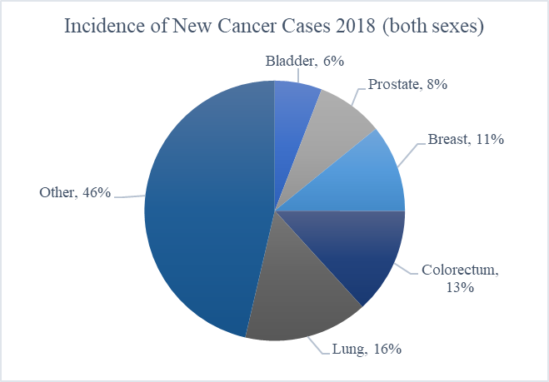
Source: Staff Visualization, using data from the Global Cancer Observatory and International Agency for Research on Cancer (WHO) (Factsheet): Poland 2018)

Poland, with an age-standardized incidence rate of 254 per 100,000 population, has the sixth lowest incidence of cancer among European Union member states, surpassing only Romania (222.4), Bulgaria (242.8), Austria (247.7), Malta (249.4), and Cyprus (250.8) (Global Cancer Observatory 2019). Figure 2 presents the incidence rate for all EU countries. Despite the comparatively low cancer incidence, Poland has one of the highest rates of cancer mortality. This outcome could be due to differences in national policies regarding cancer screening to detect different types of cancer as early as possible, including differences in the quality of cancer surveillance and reporting (OECD/EU 2018).

Figure 2. Age-standardized incidence rates per 100,000 in 2018 in European Union member countries, all cancers, both sexes, all ages.
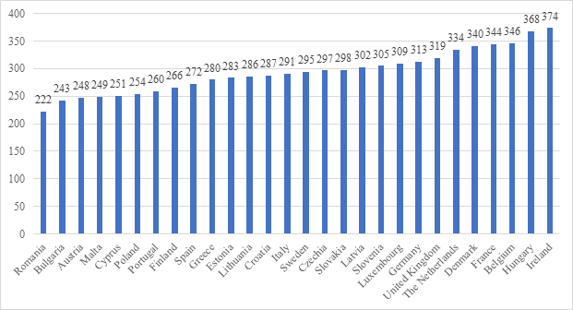
Source: Staff Visualization, using Global Cancer Observatory Data, 2019

There are significant differences in the burden of cancer between genders. Cancer prevalence was higher in women than in men in 2018. Out of the total number of cases, 259,295 were attributed to women, while 230,826 were attributed to men. Nevertheless, the age-standardized incidence rate per 100,000 population is higher in men (292.5) than in women (229.2). Additionally, the risk of developing cancer before the age of 75 years is also higher for men (30 percent) than for women (23.3 percent). The five most frequent cancers also vary among men and women (Figure 3). As in the rest of Europe, breast cancer is the most frequently diagnosed cancer among women, accounting for 22.4 percent of all new cancer cases diagnosed in women, followed by lung cancer, colorectal cancer, uterus cancer and ovarian cancer. In males, lung cancer is the most frequent, followed by prostate cancer (expected to cause 16 percent of all new cancer cases diagnosed in men), colorectal cancer, bladder cancer, and stomach cancer (Global Cancer Observatory 2019) (Figure 4). As the risk factors for breast cancer are not fully understood, and can include age, family history, breast density, exposure to estrogen, being overweight or obese, alcohol intake, radiation and hormone replacement therapy, it is important that screening is effective, and diagnosis is timely (OECD/EU 2018). Likewise, prostate cancer risk factors are not widely known and require further research to ensure preventative measures can be taken.

Figure 3. Incidence of new cancer cases in Poland (2018)
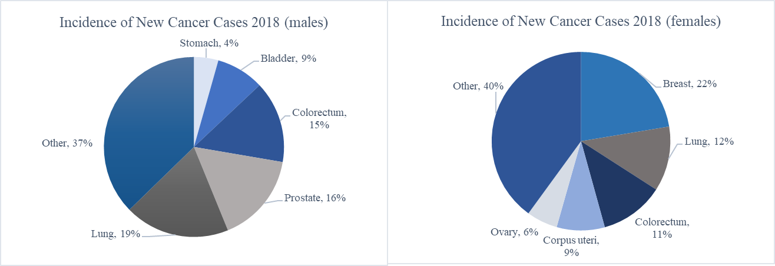
Source: Staff Visualization, using data from the Global Cancer Observatory and International Agency for Research on Cancer (WHO) (Factsheet): Poland 2018)

Figure 4. Age-standardized incidence rates in Poland, top 10 cancers, 2018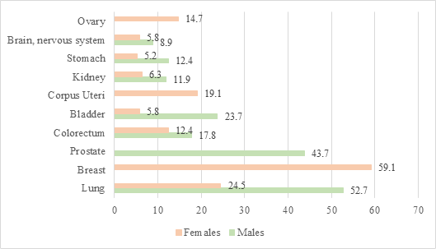
Source: Staff Visualization, using data from the Global Cancer Observatory, 2019

Cancer mortality
Cancer is the second leading cause of death in Poland, accounting for 26.5 percent of all deaths, and is only surpassed by circulatory diseases, which account for 41.5 percent of all deaths. The mortality rate caused by cancer increased by 3 percentage points between 2000 (23.4 percent) and 2017 (26.5 percent) while, during the same period, the share of deaths caused by circulatory diseases fell by 6 percentage points, from 47.7 percent in 2000 to 41.5 percent in 2017 (GUS 2000-2017). The increasing share of deaths caused by cancer is a result of, inter alia, the relatively high decrease in mortality rates from other diseases (namely circulatory diseases) compared to cancer (OECD/EU 2018). However, age-standardized cancer mortality rates have increased since the 1960s in Poland by 77.6 percent in males and 30.4 percent in females, although from around the 1990s cancer mortality rates started to decrease. Relative to other EU countries, cancer mortality is very high in Poland (Figure 5).

Figure 5. Projected age-standardized mortality rates per 100,000 in 2018 in European Union member countries, all cancers, both sexes, all ages.
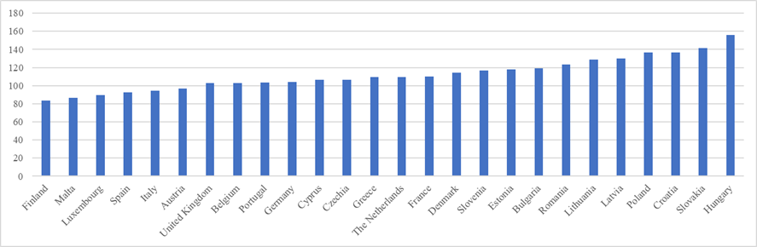
Source: Staff Visualization, using data from the Global Cancer Observatory, 2019

As in all European Union member countries, cancer mortality in Poland is consistently higher in men than in women (Figure 6). Overall, around 113,388 individuals were estimated to die from various types of cancer during 2018 in Poland, with men accounting for 62,606 deaths and women accounting for 50,782 deaths. The age standardized mortality rate was equal to 136.5 deaths per 100,000 individuals for both sexes in 2018, although is considerably higher for males than for females: 180.2 per 100,000 men and 105.6 per 100,000 women, respectively (Global Cancer Observatory 2019). This gender gap is also notable among European Union member states, where age standardized mortality rates were 70 percent higher among men than in women (OECD/EU 2018).

Figure 6. Estimated age-standardized mortality rates per 100,000 in 2018 in EU member countries, all cancers, both sexes, all ages.
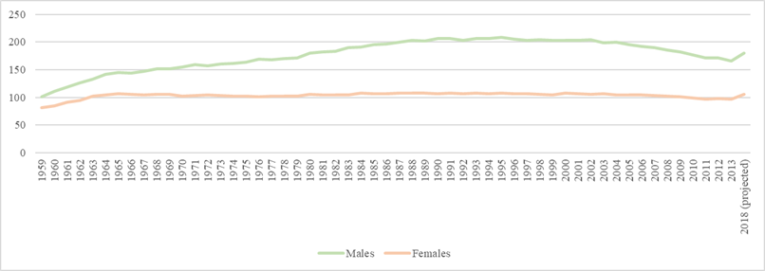
Source: Staff Visualization, using data from the Global Cancer Observatory, 2019

The risk of dying from cancer before the age of 75 years in Poland is 14.9 percent, which is higher in men (18.9 percent) than women (11.5 percent) (Global Cancer Observatory 2019). This gender gap can be explained, inter alia, by the higher prevalence of risk factors among men (i.e., smoking and alcohol consumption), and the more limited availability or use of screening programs for cancers affecting men, leading to lower survival rates after diagnosis (OECD/EU 2018). However, there have been positive changes in recent years: the rate of tobacco-related tumors, including lung cancer, are decreasing due to a reduction in smoking. Eating habits also appear to be improving, which contributes to reduction in the incidence of stomach cancer (Koblańska 2019).

Among the various types of cancers, lung cancer imposes the highest mortality burden, accounting for 23.4 percent of all cancer deaths across Poland. Around 26,509 people were expected to have died from lung cancer in 2018 and, from 2017 estimations, more than 70 percent of lung cancer deaths were in men (Global Cancer Observatory 2019, Institute for Health Metrics and Evaluation 2017). The next most fatal cancers are colon cancer (7.8 percent of all cancer deaths), breast cancer (6.1 percent of all deaths and 13.6 percent among women deaths), stomach cancer (5.1 percent), and prostate cancer (5.1 percent) (Global Cancer Observatory 2019). These results are not very dissimilar from global averages (Figure 7).

Figure 7. Age-standardized (World) incidence and mortality rates, top 10 cancers, 2018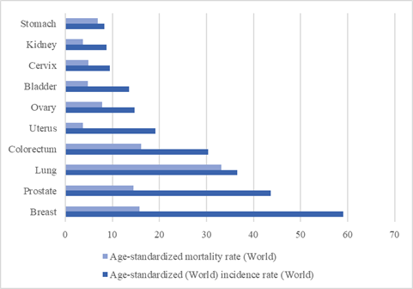
Source: Staff Visualization, using data from the Global Cancer Observatory, 2019

The percentage of deaths caused by cancer varies widely among voivods. Data from the Polish Local Data Bank of the Central Statistical Office (GUS) shows that in 2017 the percentage of all deaths caused by cancer ranged from 23.4 percent in Podlaskie to 29.3 percent in Kujawsko-Pomorskie (GUS 2017). However, disparities between voivods have shrunk in the last two decades, from 8.5 percentage points in 2000 to 5.0 percentage points in 2017 (Figure 8).

Figure 8. Percentage of deaths caused by cancer, 2000 - 2017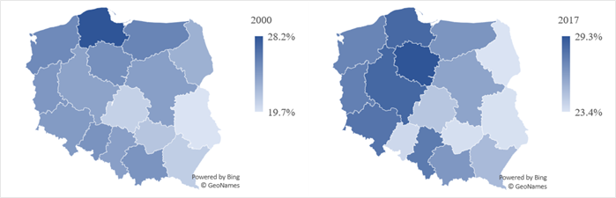
Source: Staff Visualization, using data from the Central Statistical Office (GUS), 2017

- Cancer Care in Poland

Cancer care in Poland is provided at multiple levels of the healthcare system, and depends on cancer type, i.e., solid and hematological tumors, and patient age, i.e., adult and pediatric tumors. The system of care provision for cases of adult solid tumors (90 percent of cases) is highly centralized in the National Institute of Oncology and its three regional branches in Warsaw, Gliwice and Cracow (PwC 2017). In addition, there are specialized oncological centers in most of Polish voivodships (PwC 2017, Dela et al. 2019). Multidisciplinary and general hospitals also have oncological wards that offer a more limited amount of services, including image diagnostics, clinical oncology or radiotherapy (Dela et al. 2019, Najwyzsza 2018). Although clinical hospitals play a vital role in cancer care, radiation therapy – which is used to treat many types of cancers such as head and neck, breast, cervix, prostate, and eye (National Cancer Institute 2019) – is only offered in 2 clinical hospitals. Cancer care is also provided by smaller satellite centers and some services (preventive, diagnostic and therapeutic) are provided by private entities. Palliative care is provided through inpatient services in stand-alone hospices or in the palliative medicine hospital departments, outpatient services such as hospice-at-home, and outpatient services provided by the palliative medicine clinics. (PwC 2017).

Poland introduced a comprehensive 10-year Cancer Strategy in 2015 aimed at improving effectiveness of cancer prevention and decreasing the number of avoidable deaths. The Strategy outlines a range of objectives focusing on the governance of cancer care, promoting prevention, diagnosis and treatment, and improving patients’ quality of life (OECD and the European Observatory on Health Systems and Policies 2017). It emphasized a multisectoral approach and established guidelines for cancer control and the provision of cancer healthcare. The Strategy identified 31 operational targets related to diverse aspects of cancer control, such as system level organization and governance, cancer research, prevention and treatment, and patients' quality of life (Dela et al. 2019). The reform identified and enforced the implementation of maximum waiting time limits and introduced innovative patient pathways that includes multidisciplinary medical consultations and a cancer care coordinator. The National Oncology Council was established to, inter alia, monitor the Strategy and develop a national cancer action program (Dela et al. 2019).

A National Programme Against Cancer for the period 2016 to 2024 was adopted following the reform in 2015, which replaced the former program iteration that ran from 2006 to 2015 (Dela et al. 2019, Uchwała nr 2018). Financed from the State budget at an annual cost of 250 million PLN, the main objective of the program was to improve 5‐year survival rates for cancer sites with the highest number of deaths (lung, breast, colorectal, prostate, and cervical cancer). The program defined five priority areas: (i) health promotion and primary prevention; (ii) secondary prevention including diagnostics and screening; (iii) cancer treatment; (iv) oncology professionals’ education; and (v) cancer registry. For each priority, a set of tasks and outcome indicators were defined. In addition, the Ministry of Health published an oncology healthcare needs map based on cancer incidence and services provided per region in 2016 to improve healthcare provision planning against patients’ needs (Dela et al. 2019).

As elsewhere, oncological care in Poland begins with an early diagnosis, i.e., identification of the presence of non-specific symptoms that can have various causes, not only cancerous ones (Koblańska 2019). When a primary care or specialist physician suspects that a patient may have a malignant cancer, an oncological diagnostic and treatment card, known as the Karta Diagnostyki i Leczenia Onkologicznego, or DiLO, is issued. The card provides the patient with access to fast track oncological therapy, commonly known as the “oncological package”. This fast track facility aims to improve access to and systematize diagnosis and treatment of cancer by setting maximum waiting times to 28 days for initial diagnosis to confirm or exclude cancer and 21 days for in-depth diagnostics to assess the severity of the disease. To enforce compliance with waiting time limits, a financial penalty corresponding to 30 percent of the services contracted value is levied for providers surpassing waiting time limits. In addition, cardholders’ benefits are not restricted by public payer financial limits (Dela et al. 2019).

Following the diagnosis, the treatment process starts with the coordination of a multidisciplinary team consultation meeting. Depending on cancer location, the team may involve an oncological surgery specialist, a clinical oncologist and/or hematologist. Prior to 2017, participation of a radiology physician was also mandated, but it is no longer a requirement. At these meetings, the patient treatment process (to be initiated within 14 days) is discussed, identified and proposed. Patients diagnosed with cancer are categorized into two groups: younger patients where cancer is their sole disease or older patients that tend to suffer from multiple comorbidities. The approach for managing care of these two patient groups is different (Koblańska 2019). A cancer care coordinator also participates in the meetings and is responsible for the coordination of the treatment process, providing information to the patient and ensuring completeness of patient's medical records – in general, ensuring efficiency of the treatment process until the patient reaches recovery (Dudek-Godeau et al. 2016). The treatment process ends with the decision to cease treatment and close the DiLO card, which is returned by the coordinator to the patient’s primary care physician. On completion of treatment, the patient returns to the primary health care doctor (Dudek-Godeau et al. 2016). In the event of unsuccessful treatment, the final stage for care of a cancer patient is hospice care (Koblańska 2019).

Approximately 233,000 DiLO cards were issued in 2015, 190,000 in 2016 and 216,000 in 2017. These numbers exceed cancer incidence due to the registry of patients with confirmed cancer prior to the reform implementation. As a result of the reform, waiting times for diagnosis and treatment significantly decreased also (Najwyższa 2017, Watch Health Care Onko Barometre (2017). However, preliminary assessments of reform results performed by the Supreme Audit Office indicate that no positive effect on detection at early stages and quality and/or comprehensiveness of care had been identified, suggesting also that lack of results may be due to the low intensity of diagnostic procedures performed by primary care physicians (Najwyższa 2017).

Costs of cancer care in the form of preventive health programs, diagnostics, treatment, rehabilitation, palliative care and drug reimbursement are mostly covered through the national system of guaranteed health services, which is financed by general and obligatory statutory health insurance system (PwC 2017). Więckowska et al (2016) found that cancer spending in Poland represents 6 percent of total healthcare spending, of which only 8 percent is on ambulatory care, reflecting the very low proportion of day cases in Poland compared to other EU countries. This is in part due to the excessive rates of hospitalization for patients undergoing chemotherapy, the largest area of cancer care. In Poland, chemotherapy episodes undertaken as day cases or in an ambulatory setting represent 62 percent of total versus 92 percent in France. Więckowska et al 2016 reports estimates that “excessive inpatient hospitalization in chemotherapy, radiotherapy and for diagnosis accounts for approximately 23 percent of total cancer spending. Inpatient chemotherapy service costs were 535 million PLN, radiotherapy hospitalization 238 million PLN, and medical admissions for diagnostics 637 million PLN (2013). The same medical care, provided in an ambulatory setting, would cost 25–30 percent of the current inpatient service cost.”

There are issues along the patient pathway of care as well, especially because internists are rarely present in the early stages of diagnosis. This has implications for efficient oncological diagnosis, which requires the inclusion of internists and general surgeons. This phase of pathomorphology diagnoses is a neglected stage of diagnosis in Poland, and registration of cancer at the time of diagnosis remains on a low level (60 to 80 percent, depending on tumor location), and presently patients are referred to hospice in an acute manner (PwC 2017, Koblańska 2019).

Factors contributing to poor outcomes
In Poland, the results of cancer treatment are worse that the European average (Osowiecka et al. 2018). Effectiveness of screening programs for cancers, such as breast, colorectal and cervical cancer, needs to be improved. The five-year survival rate for breast cancer, for example, if diagnosed early and treated before it spreads, is 99 percent. Likewise, if cervical cancer is found early, it is highly treatable and associated with long survival and good quality of life; and several screening tests detect colorectal cancer early, when it can be more easily and successfully treated. (Prevent Cancer Foundation 2019). However, for a variety of reasons such as low compliance with evidence-based standards for diagnosis and treatment of cancer and slow and fragmented diagnostic processes, early diagnosis is one of the most significant challenges of cancer care in Poland (PwC 2017).

Inefficiency in the provision of cancer care in Poland is a well-documented problem. Specifically, long waiting times for cancer treatment are acknowledged as a key failing in care provision. In 2014, the average wait was 6.5 months for a magnetic resonance imaging (MRI) and 5.3 months for a colonoscopy (Dela et al. 2019). Osowiecka et al. (2018) found that the longer a breast cancer patient waits for treatment after the demonstration of the initial symptoms, the lower is their chance of survival. In Poland, a higher mortality rate of 5 to 7 percent corresponds to long waiting times relative to patients with wait times of less than 3 months and between 3 - 6 months. Osowiecka et al (2018) finds than in 60 percent of cases the waiting time for treatment exceeded nine weeks from the initial date of cancer suspicion. A quarter of the patients bypassed this delayed process by opting to purchase private medical services (Osowiecka et al. 2018).

In addition, Poland has fewer doctors compared to other EU countries, who are further overburdened with administrative bureaucracy (Osowiecka et al. 2018). The latter point is evidenced by the ineffective introduction of the DiLO card, a means of referral to the hospital. The DiLO card takes about 30 minutes to complete – requiring more than 50,000 working hours of specialist doctors to fill 100,000 cards (Koblańska 2019). This has recently been simplified, but other inefficiencies in the use of time of specialists persist. The number of general specialists has increased significantly over the past decades, but stark regional disparities are observed making it challenging to access selected specialists (PwC 2017). The Polish system for oncology treatment is also criticized as overly relying on mono-specialist oncological hospitals, a critical drawback of which is that they lack the competencies to address serious comorbidities generally suffered by older patient groups (Koblańska 2019).

A holistic approach that spans various levels of the healthcare system needs to be taken to improve the coordination of care (Osowiecka et al. 2018). Oncological specialists are spending their limited time with patients who have a history of cancer that remain under their supervision. This reduces specialists’ ability to provide care to patients undergoing active treatment. General practitioners are distant from their patient’s oncological treatment process, often receiving information from the patients themselves or through reviewing medical documentation. Patients with suspected cancer attempt to step-over these system blockages by making appointments in more than one center and visiting multiple physicians in subsequent phases of the diagnostic process (PwC 2017).

When comparing Poland to other European countries and even those specifically in the Eastern Bloc, the healthcare system is underfinanced (Osowiecka et al. 2018). Access to cancer treatment is constrained by available funds from the already small pool of funding resources available for healthcare; the system is also inflexible to events where the best treatment is non-standard therapy (PwC 2017). Innovations in cancer care cannot be implemented without meaningful financing. The current focus for cancer care improvement revolves around organizational and operational aspects but neglects the demand for new solutions – both diagnostic and curative (Koblańska 2019).

An analysis of the economic burden of cancer across the European Union finds that cancers cost the Polish healthcare system around 1.2 billion euros in 2012. Inpatient care was the highest cost driver, accounting for 41.4 percent (513,845,000 euros) of cancer care spending, followed by expenditures on outpatient care, accounting for 25.4 percent of total cancer care costs (314,960,000 euros). Costs associated with cancer represent 5 percent of all expenditures incurred by the healthcare sector. Productivity losses due to cancer mortality and morbidity in 2012 were estimated at 2.1 billion euros (1.6 billion euros and 500 million euros, respectively) and costs associated with informal caregiving were estimated to be 561 million euros. In other words, total direct and indirect costs associated with cancer aggregated to 3.9 billion euros, or 1 percent of total GDP in Poland in 2012. This translates to a per-cancer-case cost in Poland of 3,541 euros in 2012 (Leal et al. 2016).

Poland spends very little on cancer compared to other countries in the European Union (Figure 9). Poland spends about a quarter of what is spent in Luxemburg per prevalent case and around half of the average spent in the European Union countries. These differences in the spending on cancer care could be explained by differences across countries in the configuration of their health systems, differences in the introduction and use of new drugs and technologies, differences in the types of medicines offered, different price setting and reimbursement mechanisms, and in variations in clinical practice. A more detailed analysis is necessary to identify the most efficient public policy initiatives and health care systems capable of achieving the best cancer outcomes (Leal et al. 2016).

Figure 9. Cancer health care costs per prevalent cancer case, EU countries, 2014
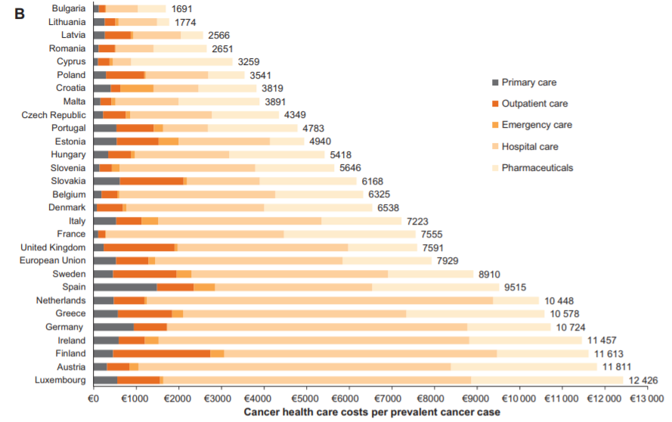
Source: Leal et al. 2016

In a survey comparing the public perception of cancer treatment in Poland versus Austria, cancer is considered the most challenging problem of the healthcare system. Only 18 percent of Poles agreed with the notion that the available cancer treatment in their countries was of a standard comparable to that of other EU countries. About 25 percent of the Polish individuals surveyed considered that cancer-diagnosing methods were generally effective, while almost half of the individuals assessed hospital care positively. Regarding treatment received in outpatient settings, 18 percent of the Polish population judged it as good. A quarter also agreed with the statement that the country’s insurance system provides good cancer care, a much lower value than the response of the Austrian population, i.e., 72 percent (Jȩdrzejewski 2015).

- An Analytical Approach to Improving Outcomes for Cancer Patients

Following individual patients and providers through the continuum of services necessary to control the disease may throw some insights into practical management of improving care in Poland. Bottlenecks and chokepoints are the points along the critical path to effective service delivery and better health outcomes where the system slows down, fails or stops, and identifying where these bottlenecks and chokepoints happen and fixing them is vital for the health system. One such approach is the “implementation cascade”, which focuses on the sequence of steps or stages of care that people go through from diagnosis to disease control, and studies patient, provider and institutional barriers along the way to help identify practical ways of improving care. Applying this tool to cancer care in Poland provides a practical way of identifying and removing barriers that affect clients and providers along the health service delivery cascade. Tables 1 and 2 provide an illustration of the types of client- and provider-related chokepoints in the critical path to effective service delivery.

Table 1. Improvements in health service delivery cascade: Client-related barriers
Barriers | Options
Cognitive | Improve knowledge and understanding of results, disease and treatment options
Affective | Address depression, anxiety, denial, lack of motivation, stigma and fear of violence
Behavioral | Allow for forgetfulness, alcohol and drug consumption, missed appointments
Medical | Be mindful of pill burden & regimen complexity, adverse effects, drug toxicity
Social support | Pair with social support, community involvement, work with partners
Social demographic | Take into account patient age, sex, socio-economic status, level of education, sensitivity to stigma, etc.
Source: World Bank Presentation made by David Wilson, Ukraine, 2017

Table 2. Improvements in health service delivery cascade: Provider-related barriers
Barriers | Options
Service quality | Diagnose and address shortfalls, e.g., through:  - Job aids for health care workers  - Monitoring of clients  - Tracing of lost clients
Communication | Strengthen client - provider communication  Also: proper assessment of non-adherence to treatment
Behavioral | Correct attitudes of health care providers towards clients  - Engagement and empathy
Training | Capacitate staff in supporting clients better  Also: Identify mental illness
Organizational | Configure and adapt services and systems, e.g., through:  - Outreach and integrate services  - Availability of medicines  - Clinic opening times
Source: World Bank Presentation made by David Wilson, Ukraine, 2017

Table 3 provides a comprehensive framework for the systematic identification of bottlenecks and failures along the critical path for the effective delivery of cancer care. The cascade relies on the assumption that cancer outcomes must be interpreted beyond survival rates or levels of resources and should be assessed along the continuum of care that goes from prevention to treatment of cancer patients in advanced stages of the disease. Cancer care is broken down into the following consecutive stages: finding patients, linking patients, treating patients, retaining patients, and disease control.

Table 3. The Cancer Care Cascade: Identifying Bottlenecks and Solutions
Cascade | Challenges | Options
Find | Identify those at risk/ill | Community-based screening
 | Make diagnostics accessible | Strengthen laboratory equipment, logistics, POC
 | Confidence in health services | Strengthen community engagement
Link | Awareness of risk | Strengthen community outreach/communication
 | Asymptomatic illness | Promote awareness of health seeking behavior
 | Affordability of care | Reduce out-of-pocket expenses
 | Psychosocial factors | Understand/address psychosocial barriers
 | Distance from health services | Decentralize/strengthen primary care services
 | Quality/confidence in health services | Improve engagement/quality
Treat | Affordability of care | Reduce out-of-pocket expenses
 | Physical infrastructure/equipment | Strengthen decentralized, primary infrastructure
 | Human resources | Improve chronic management capacity
 | Medicine stock-outs/unaffordability | Ensure drug availability/affordability reduce OOP
 | Integrated electronic records | Establish integrated electronic medical records
 | Quality/confidence in health services | Strengthen training/quality/supervision
Retain | Awareness of risk | Strengthen community outreach/communication
 | Affordability of care | Reduce out-of-pocket (OOP) expenses
 | Asymptomatic illness | Increase awareness/health seeking
 | Psychosocial factors | Understand/address psychosocial retention barriers
 | Integrated electronic records | Establish integrated electronic medical records
 | Health system capacity | Strengthen management capacity for follow-up
Disease control | Improved health outcomes | Strengthen measurement of improved health outcomes
Source: World Bank Presentation made by David Wilson, Ukraine, 2017

Figures 10 to 12 below illustrate the results of the barriers that patients face in moving through the diagnostic process and into treatment. Consider, for example, the cervical cancer screening program, which was initiated in 2006 and which targets women between the ages of 25 and 59 for screening every 3 years. The program is fully funded, and screening is provided free of charge. For cervical cancer screening, the drop-off rate of those intended for screening and those invited for screening is 2.3 percent, which equates to around 75,786 women. The number of women invited for screening that attend the appointment then drops by a further 78.4 percent. The EU reference acceptable standard for participation in cervical cancer screening is 70 percent (desired standard is 85 percent) compared to 21.5 percent observed in Poland. Of the women referred for colposcopy, only 39.7 percent have one performed.

Figure 10. Cervical Cancer Screening in Poland: Cascade Analysis
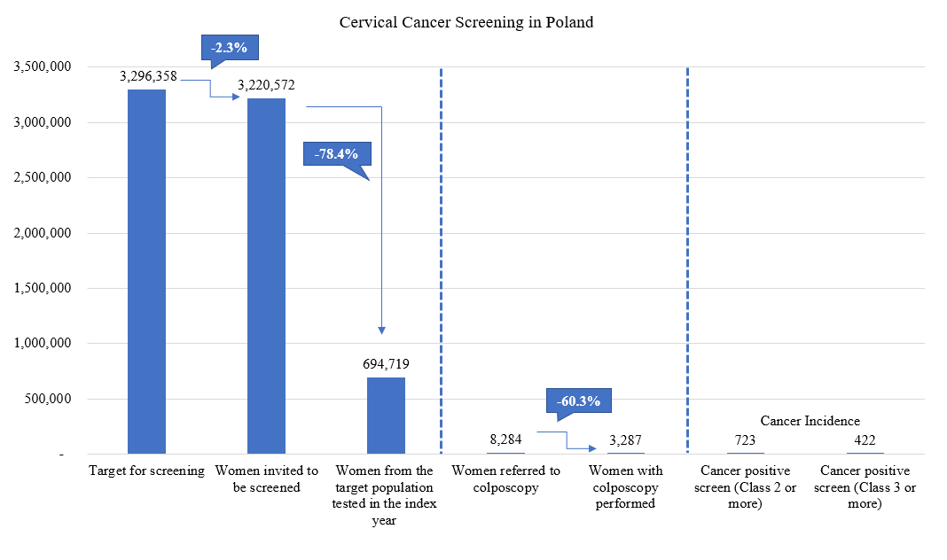
Source: Staff Visualization, using data from Ponti et al 2017

Another example is the breast screening program which was initiated in 2006 and which targets women aged 50-69 years for a biennial screening (Ponti et al. 2017). Like cervical cancer screening, the program is fully funded, and is provided free of charge. Individuals are invited by letter, but it does not contain an appointment date, unlike in the UK, Germany and several other European countries. Three-quarters of breast screenings in Poland are conducted using digital mammography; in most other European countries this rate is 100 percent. For breast cancer screening, approximately 101.8 percent of the target population are invited which indicates that some 45,474 women are invited for screening from outside the target group. The number of invited women attending a screening then drops to 43.3 percent. The EU reference acceptable standard for participation in breast cancer screening is 70 percent (desired standard 75 percent). Approximately 96 percent of women demonstrating with a positive screening test have a further test performed.

Figure 11. Breast Cancer Screening in Poland: Cascade Analysis
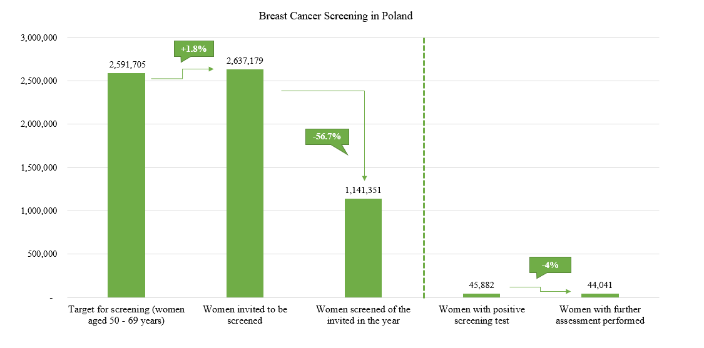
Source: Staff Visualization, using data from Ponti et al 2017

A third example is the colorectal cancer screening program, which was introduced in 2012 and which targets individuals aged between 55 and 64 years of age (Ponti et al. 2017). The program is fully funded and provided free of charge. Screening is performed by total colonoscopy (TC), for which Poland is the only European country in the survey offering TC as the sole screening mechanism. The screening interval is 10+ years. The EU reference acceptable standard for participation in colorectal cancer screening is 45 percent (desired standard 65 percent). At the time of the collection of data used in Figure 12, the program roll-out was designed as an experimental study to assess the impact of screening: eligible men and women were randomized every year to immediate, or delayed (by 5 years) screening, or controls (never invited). However, of those invited, less than 17 percent participated in the colorectal screening.

Along the cascade of cancer care, improvements in finding patients suffering from cancer is of utmost importance. Studies in high-income countries have shown that treatment for cancer patients who have been diagnosed early are 2 to 4 times less expensive compared to treating people diagnosed with cancer at more advanced stages (WHO 2017). The time between diagnosis and treatment is critical. Early diagnosis requires systematic improvements in the primary health care structure and through the roles of PHC gatekeepers – notably the role of GPs in strengthening community engagement and supporting access to these programs. Few women attending screening mammography and cytology tests were informed of these tests by their family doctors or general physician (PwC 2017). Oncology awareness must be promoted by primary healthcare providers, which would include sending each patient for whom a primary care doctor is suspicious of a malignant cancer to an oncology specialist as soon as possible for a diagnosis verification. Early diagnosis of disease must be pursued to improve disease outcomes, which would require directing enough resources to the primary health care level to absorb this heightened responsibility (Wawryka, Ziobro and Tyszko 2016).

Figure 12. Colorectal Cancer Screening in Poland: Cascade Analysis
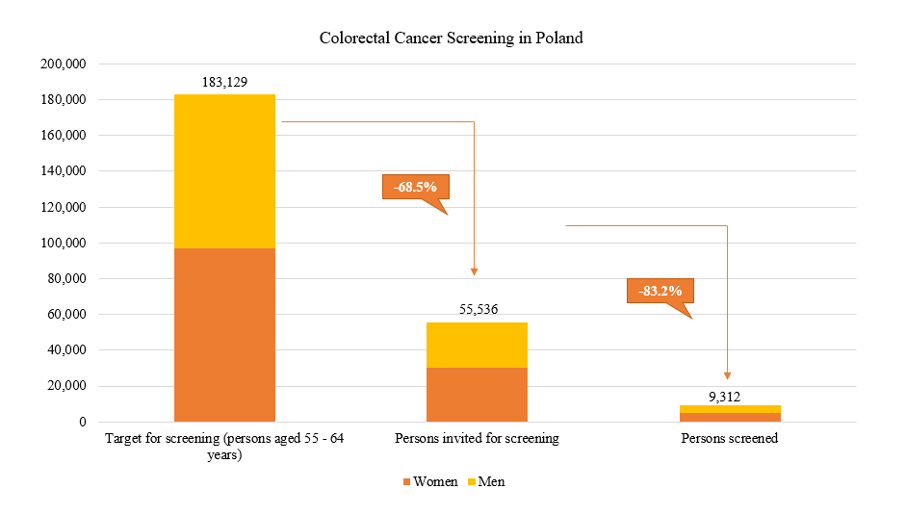
Source: Staff Visualization, using data from Ponti et al 2017

Access to healthcare services can also be improved by the development of a network of cancer centers offering early rapid and comprehensive diagnosis services based on existing infrastructure. Screening programs (breast, cervical and colorectal cancer screenings) must be more deliberately assessed in terms of value and for effectiveness of diagnosis using known and newly identified risk factors (PwC 2017).

The process of linking suspect patients to care must involve a multi-disciplinary team from the onset of the symptoms. This team should create (in a coordinated and efficient manner) a treatment plan for the individual. The pathway from diagnosis to treatment must be standardized and be supported by normative guidelines to minimize inefficiencies along a patient’s care pathway. Measures to improve the linking process could include providing tools to family doctors and general physicians to enhance their role in the diagnostic and follow-up phase; strengthening the function of the cancer care coordinator in early phases; establishing a network of specialized centers providing rapid diagnosis; and creating guidelines with diagnosis and treatment standards (PwC 2017). Understanding and addressing psychosocial barriers for patients’ participation can bridge the gap between referral and treatment. Anxiety, fear and uncertainty are common feelings among patients with suspected or diagnosed cancer and family members, specially at the beginning of the process. Providing clear and comprehensive information on what to expect regarding patient treatment, diagnosis and treatment centers, as well as frequent side effects of therapy would help in reducing the negative psychosocial effects. Brochures, helplines and specific websites are some of the resources that could be used with this aim. These interventions should be adopted not only when referring patients to treatment but also throughout the process to ensure retention of patients and improved care outcomes. Improving access to care means ensuring that family doctors and internists are empowered to provide care to the many patients need outpatient care and periodic hospital care near to ensure that it is near their homes (Koblańska 2019).

Improving management and efficacy of treatment relies on a robust system of data collection and monitoring to assess the quality, outcomes and costs of cancer care. Data on cancer care in Poland is limited and does not currently support essential analyses. Family doctors and general physicians struggle to follow their patients through the treatment process and patients themselves utilizing multiple services to try and overcome the sluggish diagnosis process. Poland lacks systematic and connected histopathological databases, which delays initiation of treatment. The standardization and informatization of histopathological reports by all histopathological laboratories, and the centralization of collection and analysis of these data would improve the availability and use of data and could also serve as an input for cancer research. Information on costs of cancer and treatment outcomes is collected by the NHF and the NCR respectively. The latter only reports the most basic indicator, i.e., five-year survival rates by region and nationally. The establishment of easy-to-use, integrated electronic medical records is vital for improving care outcomes, enhancing the process of care provision, and preparing cost-benefit analyses. As part of the Cancer Control Strategy for Poland 2015-2024, one recommendation pertains to improving the healthcare IT system to extend the selection of indicators reported to include those related to quality and effectiveness of treatment. Improving chronic management capacity involves identifying gaps in specialist staff availability at regional and national levels. Human resources and appropriate training need to be better distributed at both the national and regional levels to ensure adequate numbers of healthcare professionals with the appropriate knowledge to support the implementation of the Cancer Control Strategy. Improving technologies to support care should be viewed as a long-term investment with the potential to improve patient, society and health systems outcomes, although they may require affecting the status quo of practices or healthcare delivery (Wait et al. 2017). Improvements in chronic management capacity should also consider patients with rare cancers. In such cases, it has been recommended to identify five to six centers that could have a role as centers of excellence and aspire to be included in the European Network of Centers of Excellence. These centers could provide care for rare malignant tumors at the earliest possible stage of the disease (PwC 2017).

Respecting the area of cancer treatment and care provision, efforts should be made to obtain a comprehensive, exhaustive record of all legal acts and regulations that influence cancer care and the Cancer Strategy. A process of prioritization, unification and quality improvement should be carried out, starting from those acts and regulations that have a higher impact in the process of cancer care and control in Poland. This would also help reduce fragmentation of the current system of cancer care and control (PwC 2017).

Affordability of care can be a barrier to retaining patients in treatment. One way to reduce the cost of cancer care in Poland would be to gradually replace the dominant treatment of patients in inpatients settings to outpatient settings. An incentive for this shift to ambulatory care could come from a coverage structure which provide reimbursement or increased financial support for patients with care provided at the ambulatory level. Improvements in the management of care will also support the retaining of patients. Where there is a failure to manage the patient’s illness and they need to transition from treatment to hospice care, this process should be made more gradual instead of an abrupt change that can lead to further distress. Understanding and addressing psychosocial retention barriers means perceiving the cancer patient pathway through the patient’s eyes, which could be done through the implementation of periodic, standardized patient satisfactions surveys (PwC 2017).

Monitoring cancer treatment outcomes has so far not been carried out in a comprehensive way; this is partly due to disconnect between the National Cancer Registry (NCR) data and oncology expenditure data. Most countries that have population-based programs have screening registries (Lithuania is an exception); however, Poland is among the countries where the linkage between the screening registry is missing from the cancer registry (Ponti et al. 2017). Currently, analysis of NCR information is insufficient. Further analysis should include epidemiological forecasting and prevalence analyses and analysis of survival rates. Additionally, more attention needs to be paid to analyzing patient perception of the quality of cancer treatment. This requires the establishment of benchmarks to assess quality of treatment and patient satisfaction, which should be based on periodic, systematic, coordinated and standardized surveys of patient satisfaction levels. To improve quality of care, regional differences need to be tackled through the gathering of thorough information on the outcomes of treatment by region or oncological centers (PwC 2017). Currently, only information on 5-year overall survival is available in the NCR. Big data analytics is a field that is likely to transform our ability to scrutinize and improve the quality and efficiency of cancer care. A case in point is the use of big data to understand the patient’s cancer care pathway in the UK, which launched the Systemic Anti-Cancer Therapy Dataset (SACT) in April 2012 which records cancer outcomes and prescribed treatment regimens from all NHS hospitals in England to map a complete patient care pathway with the outcomes reported. SACT facilitates a transparent comparison of mortality outcomes among different hospitals and promotes a review of the current care delivery for those with higher mortality rates (Wait et al 2017).

Other considerations
Reducing regional inequalities in availability of medical specialists would also reduce the restrictions in access to healthcare. Some regions are significantly under-staffed, such as Podkarpackie, where the number of oncology specialists per 100,000 inhabitants is more than two times lower than in the Mazowieckie region. Reducing such inequalities by providing sufficient resources for staffing and training in needed regions, would reduce barriers to cancer care provision (PwC 2017).

Improving health care structure to improve care provision to both ensure a holistic and managed approach to patient care and to improve equities is vital for achieving better care outcomes. Reliance on mono-specialist oncology centers does not support the coordinate and holistic care required by – typically older – patients suffering from cancer and other serious comorbidities. Oncology centers should be established in both multidisciplinary hospitals and clinics (Koblańska 2019). In this set-up, oncologists can leverage other expertise in-house and transfer the patient according to the illness; this will also support knowledge sharing between specializations but can also improve cancer diagnosis. The role of PHC providers should be reinforced to address specific oncological activities including: health promotion and education on the risks of cancer; assessment of risk factors in populations, prevention and early detection; diagnostic process coordination and follow-up post-treatment; and care for patients in remission, cured or in advanced stages of the disease (PwC 2017). Adequate empowerment of family doctors and general physicians is critical as in the past, general practitioners’ responsibilities in oncological care have been increased without additional training (Holecki and Romaniuk 2015). Shifting the burden to the primary health care system while reducing specialist oncological care waiting times, must be met with enough staffing resources to not overburden the primary care system. Another issue identified is the underestimation of patients using public services for cancer care due to the incomplete record of new patients in the NCR, which leads to an underestimation of incidence of about 30 percent. These errors can influence cancer analyses and projections, which in turn could lead to inadequate resources earmarked for cancer care diagnosis and treatment (Więckowska et al 2016). In Poland, regulations exist that mandate the updating of data in the NCR with all new cancer cases, but enforcement is insufficient.

The causes of cancer are not completely understood, but it is estimated that around half of the avoidable risk factors have already been identified. These risk factors include: tobacco smoking, alcohol abuse; poor eating habits; low physical activity; excess weight and obesity; environmental and occupational carcinogenic risk factors; biological carcinogenic factors; and UV radiation (PwC 2017). Therefore, eliminating or reducing exposure to these factors should lead to the reduction of cancer incidence. Poland has witnessed marked success in the reduction of smoking. But much more work needs to be done to mitigate threats to population health and reduce the risk to developing cancer. Raising awareness among the public and healthcare professionals of these various risk factors will not only promote necessary behavior change but will also ensure more engagement from the population with preventative programs and increase uptake of screening tests. Family doctors and general physicians are strategically positioned in the healthcare system to identify risk factors in their patients and to monitor high-risk groups. Guidelines and public awareness campaigns on healthy eating habits, physical activity, tobacco use and others for the reduction of risk factors’ prevalence should be developed and promoted among patients to effectively reduce cancer incidence (PwC 2017).

- Conclusion

The Economist Intelligence Unit studied national cancer preparedness in 28 countries around the world to understand the essential elements that are relevant to cancer control. It’s enquiry yielded four essential cornerstones of cancer preparedness: essential investment concerning sufficiency in financing; an essential roadmap for cancer control that is operational rather than aspirational; an essential foundation of cancer control embedded in an accessible, general health system and appropriately linked to the primary care level; and essential intelligence to understand the nature of the challenge as well as an indication of how well interventions are doing (EIU 2019). The EIU report postulates that these cornerstones are already well-understood but require strong and committed political leadership to achieve better outcomes. There is no room for complacency on cancer in Poland, and it must adopt these four essential cornerstones of cancer preparedness to get ahead of the war on cancer.

References
(in order in which they appear in the text)

Didkowska, J.; Wojciechowska, U.; Zatonski, W. Malignant Neoplasms in Poland in 2011; Centrum Onkologii–Instytut im. M. Skłodowskiej–Curie: Warsaw, Poland, 2013.

Kalbarczyk,W.P.; Gujski, M.; Brzozowski, S.; Tytko, Z.; Scibek, A.Walka z Nowotworami i Opieka Onkologiczna w Polsce Wobec Wyzwan´ Demograficznych i Epidemiologicznych—Propozycje Rozwia˛zan´ ; Instytut Ochrony Zdrowia: Warsaw, Poland, 2015.

Wojtyniak, B.; Gorynski, P.; Moskalewicz, B. Sytuacja Zdrowotna Ludno´sci Polski i jej Uwarunkowania; Narodowy Instytut Zdrowia Publicznego—Pa´nstwowy Zakład Higieny: Warsaw, Poland, 2012.

Osowiecka, K., Rucinska, M., Nowakowski, J J., Nawrocki, S. (2018). How Long Are Cancer Patients Waiting for Oncological Therapy in Poland? Int. J. Environ. Res. Public Health 2018, 15, 577; doi:10.3390/ijerph15040577

Prevent Cancer Foundation (2019). Education. Preventable Cancers. Breast Cancer. Accessed at: https://preventcancer.org/education/preventable-cancers/breast-cancer/

Karolinska Institutet Comparator Report on Patient Access to Cancer Drugs in Europe. 2009. Available at http://www.comparatorreports.se/Comparator%20report%20on%20patient% 20access%20to%20cancer%20drugs%20in%20Europe%2015%20feb%2009.pdf. Accessed September 26, 2013.

Sant M, Allemani C, Santaquilani M, et al. EUROCARE-4: Survival of cancer patients diagnosed in 1995–1999: Results and commentary. Eur J Cancer. 2009;45:931–991. [PubMed] [Google Scholar]

Gatta G, Trama A, Capocaccia R. Variations in cancer survival and patterns of care across Europe: Roles of wealth and health-care organization. J Natl Cancer Inst Monogr. 2013;2013:79–87. [PubMed] [Google Scholar]

Malvezzi, M., Carioli, G., Bertuccio, P., Boffetta, P., Levi, F., La Vecchia, C., and Negri, E. (2019). European cancer mortality predictions for the year 2019 with focus on breast cancer. Annals of Oncology 00: 1–7, 2019 doi:10.1093/annonc/mdz051

Bjornberg A. European Health Consumer Index 2012 Report, Health Consumer Powerhouse. Available at http://www.healthpowerhouse.com/files/Report-EHCI-2012.pdf

De Angelis, R., Sant, M., Coleman, M.P., Francisci, S., Baili, P., Pierannunzio, D., Trama, A., Visser, O., Brenner, H., Ardanaz, E. et al. Cancer survival in Europe 1999–2007 by country and age: Results of EUROCARE—5-a population-based study. Lancet Oncol. 2014, 15, 23–34.

PACE: A Six-Nation Survey of Cancer Knowledge and Attitudes Among the General Population, Patients and Caregivers. Available at https://pacenetwork.com/lilly_pace_global_report_nov_30.pdf.

OECD & the European Observatory on Health Systems and Policies. (2017). State of Health in the EU. Poland Country Health Profile 2017. Accessed at: https://ec.europa.eu/health/sites/health/files/state/docs/chp_poland_english.pdf

Koblańska, M. (2019). Profesora Wiesława Jędrzejczaka plan naprawczy dla polskiej onkologii. Accessed at: https://www.termedia.pl/mz/Profesora-Wieslawa-Jedrzejczaka-plan-naprawczy-dla-polskiej-onkologii,33794.html

Więckowska, B., Tolarczyk, A., and Dagiel, J. (2016). Cancer care in Poland: Activity and spending analysis as a forerunner to oncology reform. Journal of Cancer Policy. Volume 8, June 2016, Pages 42-50. DOI: https://doi.org/10.1016/j.jcpo.2016.03.003

Dela, Roksana, Katarzyna Dubas‐Jakóbczyk, Ewa Kocot, Christoph Sowada (2018). Improving oncological care organization in Poland—The 2015 reform evaluation in the context of European experiences. Accessed at https://onlinelibrary.wiley.com/doi/epdf/10.1002/hpm.2635

Pricewaterhouse Coopers (PwC). (2017). Cancer Control Strategy for Poland 2015 – 2024.
Uchwała nr 208 Rady Ministrów z dnia 3 listopada 2015 r. w sprawie ustanowienia programu wieloletniego na lata 2016–2024 pod nazwą “Narodowy Program Zwalczania Chorób Nowotworowych”. Warszawa 2015.

Didkowska, J., Wojciechowska, U., Koskinen, H., Tavilla, A., Tadeusz, Dyba., and Hakulinen, T. (2011). Future lung cancer incidence in Poland and Finland based on forecasts on hypothetical changes in smoking habits. Acta Oncologica, 2011; 50: 81–87. Accessed at: https://www.tandfonline.com/doi/pdf/10.3109/0284186X.2010.488247

GUS (2000-2017). Deaths by causes 2000-2017. Warsaw. Accessed at: https://bdl.stat.gov.pl/BDL/metadane/cechy/1344?back=True

GUS (2017). Deaths by causes 2000-2017. Warsaw. Accessed at: https://bdl.stat.gov.pl/BDL/metadane/cechy/1344?back=True

Najwyzsza Izba Kontroli. (2018). Dostępnośc i efekty leczenia nowotworów, Warszawa 2018

Najwyższa Izba Kontroli (2017). Przygotowanie i wdrożenie pakietu onkologicznego, Warszawa 2017

National Cancer Institute (NCI). (2019). Radiation Therapy to Treat Cancer. Accessed at: https://www.cancer.gov/about-cancer/treatment/types/radiation-therapy

World Health Organization (WHO). (2017). Early cancer diagnosis saves lives, cuts treatment costs. 3 February 2017 | News Release | Geneva. Accessed at: https://www.who.int/news-room/detail/03-02-2017-early-cancer-diagnosis-saves-lives-cuts-treatment-costs

Dorota Dudek-Godeau, D., Kieszkowska-Grudny, A., Kwiatkowska, K., Bogusz, J., Wysocki, M J., Bielska-Lasota, M. (2016). Analysis of Changes in Cancer Health Care System in Poland Since the Socio-Economic Transformation In 1989. Rocz Panstw Zakl Hig 2016;67(4):445-454. Accessed at: http://yadda.icm.edu.pl/yadda/element/bwmeta1.element.agro-d93c207c-1f13-4919-adc8-8177fcfa245e/c/RPZH_2016_Vol_67_No_4_pp._445-454.pdf

Watch Health Care Onko Barometre (2017). Dostęp do gwarantowanych świadczeń onkologicznych. Kraków 2017

Leal J, Luengo-Fernandez R, Sullivan R, Witjesc JA. (2016). Economic Burden of Bladder Cancer Across the European Union. European Urology, Volume 69, Issue 3, March 2016, Pages 448-449. DOI: https://doi.org/10.1016/j.eururo.2015.10.024

Jȩdrzejewski, M., Thallinger, C., Mrozik, M., Kornek, G., Zielinski, C. and, Jassem J. (2015). Public perception of cancer care in Poland and Austria. Oncologist. 2015;20(1):28–36. doi:10.1634/theoncologist.2014-0226

Ponti, A., Anttila, A., Gugliemo, R., and Senore, C. (2017). Cancer Screening in the European Union (2017). Report on the implementation of the Council Recommendation on cancer screening. Accessed at: https://ec.europa.eu/health/sites/health/files/major_chronic_ diseases/docs/2017_cancerscreening_2ndreportimplementation_en.pdf

Wawryka, J., Ziobro, P., and Tyszko, M. (2016). Cancer Education in Poland: Current Status and Suggestions for Improvement. Journal of Cancer Education. September 2017, Volume 32, Issue 3, pp 669–675. Accessed at: https://link.springer.com/article/10.1007/s13187-016-1033-2

Wait, S., Han, D., Muthu, V., Oliver, K., Chrostowski, S., Florindi, F., de Lorenzo, F., Gandouet, B., Spurrier, G., Ryll, B., Wierincki, L., Szucs, T., Hess, R., Rosvall-Puplett, T., Roediger, A., Arora, J., Yared, W., Hanna, S., Steinmann, K., Aapro, M. (2017). Towards sustainable cancer care: Reducing inefficiencies, improving outcomes – A policy report from the All.Can initiative. Journal of Cancer Policy. Volume 13, September 2017, Pages 47-64. DOI : https://doi.org/10.1016/j.jcpo.2017.05.004

Holecki, T., and Romaniuk, P. (2015). The oncological package: a new source of concern in Poland's health system. The Lancet. Oncology. Correspondence| Volume 16, Issue 3, PE104, March 01, 2015. DOI:https://doi.org/10.1016/S1470-2045(15)7003 DOI: https://doi.org/10.1016/S1470-2045(15)70030-60-6 https://www.cancer.gov/about-cancer/treatment/types/radiation-therapy

Economist Intelligence Unit (EIU). (2019). Cancer preparedness around the world: National readiness for a global epidemic. The Economist Intelligence Unit Limited 2019. Accessed at: https://worldcancerinitiative.economist.com/pdf/Cancer_preparedness_around_the_world.pdf

