SFG3426 V8

Installation of tourist information signs and sculptures in Vani

Environmental and Social Screening Report

March 2017

Sub-Project Description
Vani is an attractive town for visitors as several remarkable touristic attractions are located there, like:
- Vani Archeological Museum-Reserve;
- Church of the Archangels Michael and Gabriel of the XII-XIII cc;
- Galaktion Tabidze House Museum;
- Titsian Tabidze House Museum;
- Kalistrate Tsintsadze House Museum;
- Korneli Kekelidze House Museum;
- Sulori Balneal Resort.
Due to the lack of tourist information signs, the above listed objects are not visible for tourists. In order to attract tourists, the sub-project (SP) intends to install the tourist information signs and banners, and support the development of navigation infrastructure in Vani. In addition, SP aims to improve the appearance of the town center and parks of Vani through molding and installing replica of the V century BC sculptures of four archaeological exhibits – Bull, Deer, Tamada (toastmaster) and Eagle – found in Vani. There will be a contest to design and make sculptures. Members of Kutaisi Regional Organization of Painters and Sculptors, who have a vast experience in designing and making sculptures for Kutaisi and other cities of West Georgia, will be invited to participate in the contest. Conceptual drawings will be agreed with Vani Municipality and the Administration of the Archaeological Museum.
As Vani Municipality center has two entrances (road entering Vani from Kutaisi and road entering Vani from Samtredia), the tourist information banner and information sign pole with seven arrows, pointing to all seven above mentioned touristic sites will be installed in the town center (in front of the 8th August War Heroes' Park) that will be visible for tourists, helping them to orient themselves easily. One tourist banner will be placed at the town entrance and another banner with a tourist map will be installed in the village Shuamta, on the route from Samtredia to Vani, near the road junction. Immediately at the road junction in the village Shuamta, information guiding poles with 4 arrows will be installed, as the guide to the four museums from this junction point. One information sign pole with one arrow will be installed at the turning road of each Museum. The sign pole will have the name of each museum and a small information board with the brief information about the particular museum in Georgian, English and Russian languages. In the center of Zemo (upper) Vani, at the turning road to the Church of Archangels’ Michael and Gabriel, the sign pole with one arrow and information board will be installed. The sign pole with two guide arrows will be installed in the Vani center at the beginning of the road giving directions to the Archeological Museum-Reserve and Sulori Balneal Resort.
In overall, the following objects will be installed within the SP:
- 1 Tourist banner/light box with a tourist map
- 1 travel direction sign pole with 7 arrows;
- 1 travel direction sign pole with 4 arrows,
- 5 travel direction sign poles with 1 arrow;
- 4 Information boards;
- 2 Information boards for sculptures;
- 4 sculptures (including concrete foundation).

Environmental Screening and Classification

(A) Impact Identification
Has sub-project a tangible impact on the environment? | The SP construction phase covers 4 months’ period. Consequently, the SP will have a small-scale and short-term impact on the environment only in the construction phase, while its long-term impact on the natural and social environment will be positive.
What are the significant beneficial and adverse environmental effects of the sub-project? | The SP is expected to have positive long-term environmental and social impact through installation of tourist information signs, banners and sculptures in Vani Municipality that will improve touristic attraction of the area.  The expected negative environmental and social impacts are likely to be short-term. As a result of installation of tourist banner, travel direction sign poles, information boards and sculptures, the dust and emissions from the operation of construction machinery will be increased, background noise and vibration levels will rise insignificantly, however the flow of traffic will not be obstructed.
Does the sub-project have any significant potential impact on the local communities? | The long-term social impact of the SP will be beneficial, which will cause significant improvement of the social conditions of local population and tourists. SP will lead to the improvement of the tourist navigation system. Placement of the ancient Georgian exhibits in the open air will contribute to the growth of the tourist flows that will certainly contribute to the increased museum incomes, employment of guides, development of agro-tourism, better realization of agricultural products, more intense production of handicrafts and increased number of cafes, restaurants, hotels and hostels. As a result of the SP implementation, approximately 5,000 persons will be served every year. Currently the number of tourists using the park is below 500.  The main impacts of the SP are:  Physical improvement: The SP implementation will have positive results on the physical environment. The installation of tourist information signs and banners, sculptures will improve the touristic infrastructure in the center of Vani and its surrounding villages, where the museums are located. In the long term, a well-functioning navigation system and improved city appearance will attract more tourists. Increased number of visitors in the town and their stay for several hours means more products sale. In addition, more tourist movement will stimulate the local government to renew, improve the town appearance. The placement of sculptures in the parks will be more memorable to foreigners. The Tamada sculpture will especially attract their attention as Georgian technique of wine making is intangible cultural heritage recognized by “UNESCO”. The activities, carried out within the SP, will have no negative impact on town appearance. On the contrary, it will contribute to improve the appearance of the central parks.  Tourist product: The tourist navigation system improvement and display of exhibits in the open air will help to increase the flow of tourists, that itself will:  - turn exhibits into brand and improve awareness among foreign tourists;  - make local cuisine popular. It will be especially attractive for vegetarians as they prepare various vegetarian meals there;  - support sales of local handicrafts;  - increase awareness of and promote kvevri winemaking method and local wine as part of the national heritage of global importance.  Income generation: The growth of the tourist flow will help to increase revenues from the visitation of heritage sites, employ guides, develop agro tourism, increase sales of local agro-products and handicrafts, increase the number of cafes, restaurants, hotels, hostels, and improve their service quality. All of these will contribute to the improvement of local people's income, which in turn will positively affect their social and economic life.  Cultural heritage protection: In Vani there are 30 buildings listed as cultural heritage sites, which are either castles or churches, but presently they are highly damaged and tourist rarely visit them. Carrying out the measures for creating an attractive environment for tourists within the SP will stimulate the local government to rehabilitate the unique cultural monuments.  Significant social impact of SP, such as change of local demographic structure and influx of new settlers is not envisaged.
What impact has the sub-project on the human health? | The dust, vibration and noise originated during the small-scale construction works will not have impact on the human health or safety.

(B) Impact Mitigation
What alternatives to the sub-project design have been considered and what mitigation measures are proposed? | Planned works will not cause cutting of trees and preventive measures will be undertaken to avoid any damage to the nearby standing trees. Reduction of adverse environmental impact during the installation works will be possible through protecting the following key conditions: fencing the construction site in the parks where the sculptures should be installed, fixing the relevant signs throughout the construction perimeter, proper management of waste and constant monitoring, ensuring the technical functionality of machinery used during construction works, selecting less sensitive period (night time) for construction works.  If at any stage of the SP cycle the affected community members have complaints/ questions/ recommendations, these can be addressed to the sub-grantee, contractor, or Elkana, whose contact information will be made available at the SP site.
Have concerned communities been involved and have their interests and knowledge been adequately taken into consideration in sub-project preparation? | During community mobilization, several priorities were identified, including installation of artistic lighting in the town center, renovation of central park and renovation of park on Peace Hill. Installation of the tourist information signs was selected.

(C) CATEGORIZATION AND CONCLUSION
Conclusion of the environmental screening:
- Sub-project is declined □
- Sub-project is accepted ■

- Sub-project is classified
as environmental Category B
and needs EMP ■

- Sub-project is classified
as environmental Category C
and does not need EMP □
Social Screening
Social safeguards screening information |  |  | Yes | No
1 | Is the information related to the affiliation, ownership and land use status of the sub-project site available and verifiable? (The screening cannot be completed until this is available)
2 | Will the sub-project reduce people’s access to their economic resources, such as land, pasture, water, public services, sites of common public use or other resources that they depend on?
3 | Will the sub-project result in resettlement of individuals or families or require the acquisition of land (public or private, temporarily or permanently) for its development?
4 | Will the sub-project result in the temporary or permanent loss of crops, fruit trees and household infrastructure (such as ancillary facilities, fence, canal, granaries, outside toilets and kitchens, etc.)?
If answer to any above question (except question 1) is “Yes”, then OP/BP 4.12 Involuntary Resettlement is applicable and mitigation measures should follow this OP/BP 4.12 and the Resettlement Policy Framework
Cultural resources safeguard screening information |  |  | Yes | No
5 |  | Will the sub-project require excavation near any historical, archaeological or cultural heritage site?
6 |  | Will the sub-project require excavation near any historical, archaeological or cultural heritage site?

If answer to question 5 is “yes”, then OP/BP 4.11 Physical Cultural Resources is applicable. In this case, sub-project proponent must provide evidence that consultation was held with and an agreement on this sub-project was obtained from an authorized representative of culture and heritage protection authority.
If answer to question 6 is “Yes”, then OP/BP 4.11 Physical Cultural Resources is applicable and possible chance finds must be handled in accordance with OP/BP and relevant procedures provided in this EMF.

Draft Environmental Management Plan

Installation of tourist information signs and sculptures in Vani
PART A: General Project and Site Information
INSTITUTIONAL & ADMINISTRATIVE
Project title | Empowering Poor Communities and Micro-Entrepreneurs in the Georgia Tourism Sector
Sub-Project title | Installation of tourist information signs and sculptures in Vani
Scope of site-specific activity | Activities include installation of the following:  - 1 Tourist banner/light box with a tourist map;  - 1 travel direction sign pole with 7 arrows;  - 1 travel direction sign pole with 4 arrows,  - 5 travel direction sign poles with 1 arrow;  - 4 Information boards;  - 2 Information boards for sculptures;  - 4 sculptures (including arranging concrete foundation).
Institutional arrangements (WB) | Task Team Leader:  Gloria La Cava | Safeguards Specialist:  Darejan Kapanadze, Environment  Rebecca Lacroix and David Jijelava, Social
Implementation arrangements  (Borrower) | Implementing entity:  Biological Farming Association “Elkana” | Works supervisor:  Biological Farming Association “Elkana” | Works contractor:  (tbd)
SITE DESCRIPTION
Who owns the building to be constructed/extended/ reconstructed? | N/A
Who owns the land allocated for sub-project?  Who uses the land (formal/informal)? | The park area, where the sculptures will be placed, is the property of Vani municipality.  The area is used by the local residents and visitors.
Description of physical and natural environment, and of the socio-economic context around the site | Vani town is locate in Imereti Region (Western Georgia). It is located 60 m above the sea level, 19 km away from Samtredia Railway Station, 41 km away from the regional center Kutaisi, 35 km from the nearest airport Kopitnari and 80 km from the nearest Poti port. Town Vani is located at left tributary of Rioni at Sulori rivers. Sulori River is 33 km long, basin area – 189 m². It is supplied through snow, rain and underground waters. Flashflood is noted throughout the year, flood – in spring. Average annual discharge is 3.95 m³/sec. Other rivers near the SP sites (Villages: Shuamta, Tobanieri, Mikeleponi and Zemo/upper Vani) are Chishura, Kumuri, Nasirala and Dudgaunasghele.  The climate in Vani is humid subtropical. It is characterized with warm winter and hot summer. Average annual air temperature is - 14.4⁰C, in January which is the coldest month - 4.7⁰C and in July which is the hottest month of the year - 23.2⁰C. Absolute minimum of air temperature is -17⁰C and absolute maximum - 41⁰C. An annual total precipitation is – 1530 mm.  Diversity of the climate of the region is characterized with diversity of plants. Vani Municipality is rich with flora and fauna. The significant part of the territory is occupied by forests, which is combined with mountainous landscapes of the region. The height above sea level is between 2500-2800 meters. There are broad-leaved, coniferous and mixed woods as well as animals characteristic to the Caucasian region: Caucasian bear, wild goat, deer, roe, wolf, jackal and fox. Birds are also widely represented. Environmental cleanness and untouched wild nature makes it interesting for tourists. Such zones are: Mephischala (Valley of the Kings), massive woods of villages Kumuri, Sulori, Ukhuti, Kortkha.  Vani Municipality is rich with historical remains and monuments of medieval period.  The installation of sculptures within the SP is planned in two different parks of the town Vani. The two sculptures will be located at 8th of August War Heroes' Park and two sculptures will be placed at the Park in front of the Vani Municipality City Hall (See Annex 3b). The information banners and sign poles are planned to be installed in the town Vani and villages Shuamta, Tobanieri, Mikeleponi and Zemo/Upper Vani (See Annex 3a).
Which of the project intervention sites does sub-project related to and how? | The SP is related to the rehabilitation/reconstruction of Vani archeological museum financed from the Second Regional Development Project.
LEGISLATION
National & local legislation & permits that apply to sub-project activity | According to the law of Georgia on Permit on Environmental Impact (2008), the SP does not require preparation of EIA and obtaining of Permit on Environmental Impact.  The SP triggers to the OP/BP 4.01 Environmental Assessment of the World Bank. According to this safeguard policy and the Environmental Management Framework of the Project for Empowering Poor Communities and Micro-Entrepreneurs in the Georgia Tourism Sector, the SP is classified as environmental category B and requires preparation of Environmental Management Plan (EMP).
PUBLIC CONSULTATION
When / where the public consultation process took / will take place | SP-specific draft EMP was discussed during consultation meeting with town Vani population on June 5th, 2017.
ATTACHMENTS
Attachment 1: Cadastral information on the SP site;
Attachment 2: Support letter from Vani Municipality;
Attachment 3: Locations selected for:
- information banners and direction sign poles to be installed in the town Vani and villages Shuamta, Tobanieri, Mikeleponi and Zemo/Upper Vani
- sculptures to be installed in the Parks of the town Vani
Attachment 4: Minutes of consultation meeting

PART B: safeguards information
ENVIRONMENTAL /SOCIAL SCREENING
Will the site activity include/involve any of the following? | Activity/Issue | Status | Triggered Actions
 | - Building rehabilitation | [ ] Yes [√] No | See Section A below
 | - New construction | [√] Yes [ ] No | See Section A below
 | - Individual wastewater treatment system | [ ] Yes [√] No | See Section B below
 | - Historic building(s) and districts | [ ] Yes [√] No | See Section C below
 | - Acquisition of land | [ ] Yes [√] No | See Section D below
 | - Hazardous or toxic materials | [ ] Yes [√] No | See Section E below
 | - Impacts on forests and/or protected areas | [ ] Yes [√] No | See Section F below
 | - Handling / management of medical waste | [ ] Yes [√] No | See Section G below
 | - Traffic and Pedestrian Safety | [√] Yes [ ] No | See Section H below
PART C: Mitigation measures
ACTIVITY | PARAMETER | MITIGATION MEASURES CHECKLIST
0. General Conditions | Notification and Worker Safety | - The local construction and environment inspectorates and communities have been notified of upcoming activities  - The public has been notified of the works through appropriate notification in the media and/or at publicly accessible sites (including the site of the works)  - All legally required permits have been acquired for construction and/or rehabilitation  - The Contractor formally agrees that all work will be carried out in a safe and disciplined manner designed to minimize impacts on neighboring residents and environment.  - Workers’ PPE will comply with international good practice (always hardhats, as needed masks and safety glasses, harnesses and safety boots)  - Appropriate signposting of the sites will inform workers of key rules and regulations to follow.
A. General Rehabilitation and /or Construction Activities | Air Quality | - During interior demolition debris-chutes shall be used above the first floor  - Demolition debris shall be kept in controlled area and sprayed with water mist to reduce debris dust  - During pneumatic drilling/wall destruction dust shall be suppressed by ongoing water spraying and/or installing dust screen enclosures at site  - The surrounding environment (sidewalks, roads) shall be kept free of debris to minimize dust  - There will be no open burning of construction / waste material at the site  - There will be no excessive idling of construction vehicles at sites
 | Noise | - Construction noise will be limited to restricted times agreed to in the permit  - During operations the engine covers of generators, air compressors and other powered mechanical equipment shall be closed, and equipment placed as far away from residential areas as possible
 | Water Quality | - The site will establish appropriate erosion and sediment control measures such as e.g. hay bales and / or silt fences to prevent sediment from moving off site and causing excessive turbidity in nearby streams and rivers.
 | Waste management | - Waste collection and disposal pathways and sites will be identified for all major waste types expected from demolition and construction activities.  - Mineral construction and demolition wastes will be separated from general refuse, organic, liquid and chemical wastes by on-site sorting and stored in appropriate containers.  - Construction waste will be collected and disposed properly by licensed collectors  - The records of waste disposal will be maintained as proof for proper management as designed.  - Whenever feasible the contractor will reuse and recycle appropriate and viable materials (except asbestos)
B. Individual wastewater treatment system | Water Quality | - The approach to handling sanitary wastes and wastewater from building sites (installation or reconstruction) must be approved by the local authorities  - Before being discharged into receiving waters, effluents from individual wastewater systems must be treated in order to meet the minimal quality criteria set out by national guidelines on effluent quality and wastewater treatment  - Monitoring of new wastewater systems (before/after) will be carried out  - Construction vehicles and machinery will be washed only in designated areas where runoff will not pollute natural surface water bodies.
C. Historic building(s) | Cultural Heritage | - If the building is a designated historic structure, very close to such a structure, or located in a designated historic district, notification shall be made and approvals/permits be obtained from local authorities and all construction activities planned and carried out in line with local and national legislation.  - It shall be ensured that provisions are put in place so that artifacts or other possible “chance finds” encountered in excavation or construction are noted and registered, responsible officials contacted, and works activities delayed or modified to account for such finds.
D. Acquisition of land | Land Acquisition Plan/Framework | - If expropriation of land was not expected but is required, or if loss of access to income of legal or illegal users of land was not expected but may occur, that the Bank’s Task Team Leader shall be immediately consulted.  - The approved Land Acquisition Plan/Framework (if required by the sub-project) will be implemented
E. Toxic Materials | Asbestos management | - If asbestos is located on the sub-project site, it shall be marked clearly as hazardous material  - When possible the asbestos will be appropriately contained and sealed to minimize exposure  - The asbestos prior to removal (if removal is necessary) will be treated with a wetting agent to minimize asbestos dust  - Asbestos will be handled and disposed by skilled & experienced professionals  - If asbestos material is being stored temporarily, the wastes should be securely enclosed inside closed containments and marked appropriately. Security measures will be taken against unauthorized removal from the site.  - The removed asbestos will not be reused
 | Toxic / hazardous waste management | - Temporarily storage on site of all hazardous or toxic substances will be in safe containers labeled with details of composition, properties and handling information  - The containers of hazardous substances shall be placed in an leak-proof container to prevent spillage and leaching  - The wastes shall be transported by specially licensed carriers and disposed in a licensed facility.  - Paints with toxic ingredients or solvents or lead-based paints will not be used
F. Affected forests, wetlands and/or protected areas | Protection | - All recognized natural habitats, wetlands and protected areas in the immediate vicinity of the activity will not be damaged or exploited, all staff will be strictly prohibited from hunting, foraging, logging or other damaging activities.  - A survey and an inventory shall be made of large trees in the vicinity of the construction activity, large trees shall be marked and cordoned off with fencing, their root system protected, and any damage to the trees avoided  - Adjacent wetlands and streams shall be protected from construction site run-off with appropriate erosion and sediment control feature to include by not limited to hay bales and silt fences  - There will be no unlicensed borrow pits, quarries or waste dumps in adjacent areas, especially not in protected areas.
G. Disposal of medical waste | Infrastructure for medical waste management | - In compliance with national regulations the contractor will insure that newly constructed and/or rehabilitated health care facilities include sufficient infrastructure for medical waste handling and disposal; this includes and not limited to:  - Special facilities for segregated healthcare waste (including soiled instruments “sharps”, and human tissue or fluids) from other waste disposal; and  - Appropriate storage facilities for medical waste are in place; and  - If the activity includes facility-based treatment, appropriate disposal options are in place and operational
H Traffic and Pedestrian Safety | Direct or indirect hazards to public traffic and pedestrians by construction  activities | (a) In compliance with national regulations the contractor will insure that the construction site is properly secured and construction related traffic regulated. This includes but is not limited to  - Signposting, warning signs, barriers and traffic diversions: site will be clearly visible and the public warned of all potential hazards  - Traffic management system and staff training, especially for site access and near-site heavy traffic. Provision of safe passages and crossings for pedestrians where construction traffic interferes.  - Adjustment of working hours to local traffic patterns, e.g. avoiding major transport activities during rush hours or times of livestock movement  - Active traffic management by trained and visible staff at the site, if required for safe and convenient passage for the public.  - Ensuring safe and continuous access to office facilities, shops and residences during renovation activities, if the buildings stay open for the public.

PART D: Monitoring Plan
Activity | What  (Is the parameter to be monitored?) | Where  (Is the parameter to be monitored?) | How  (Is the parameter to be monitored?) | When  (Define the frequency / or continuous?) | Why  (Is the parameter being monitored?) | Who  (Is responsible for monitoring?)
Transportation of construction materials and waste movement of construction machinery | Technical condition of vehicles and machinery  Confinement and protection of truck loads with lining  Respect of the established hours and routes of transportation | Construction site | Inspection | Unannounced inspections during work hours and beyond | Limit pollution of soil and air from emissions;  Limit nuisance to local communities from noise and vibration;  Minimize traffic disruption. | Elkana
Earthworks (small scale) | Backfilling of the excavated material and/or its disposal to the formally designated locations;  In case of chance finds immediate suspension of works, notification of the Ministry of Culture and Monument Protection, and resumption of works exclusively upon formal consent of the Ministry. | Construction site | Inspection | In the course of earth works | Prevent pollution of the construction site and its surroundings with construction waste;  Prevent damage and loss of physical cultural resources | Elkana
Workers’ health and safety | Provision of uniforms and safety gear to workers;  Ensuring use of the personal protective gear by workers;  Informing of workers and personnel on the personal safety rules and instructions for operating machinery/equipment, and strict compliance with these rules/instructions | Construction site | Inspection | Unannounced inspections in the course of work | Limit occurrence of on-the-job accidents and emergencies | Elkana

Attachment 1: Cadastral information on the Sub-Project site
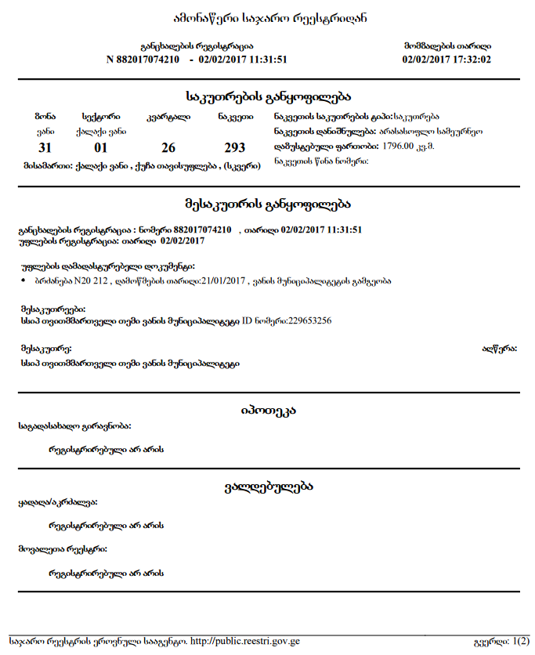

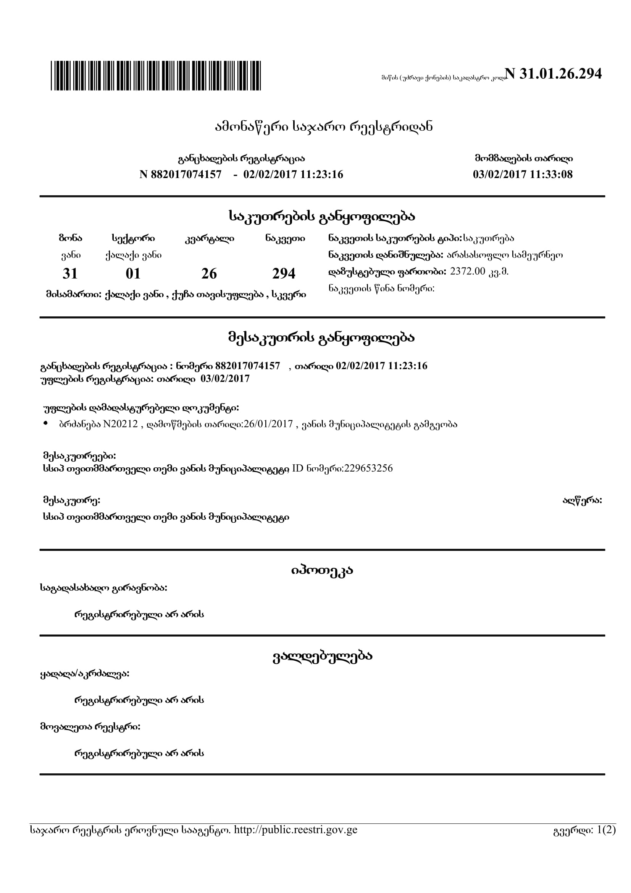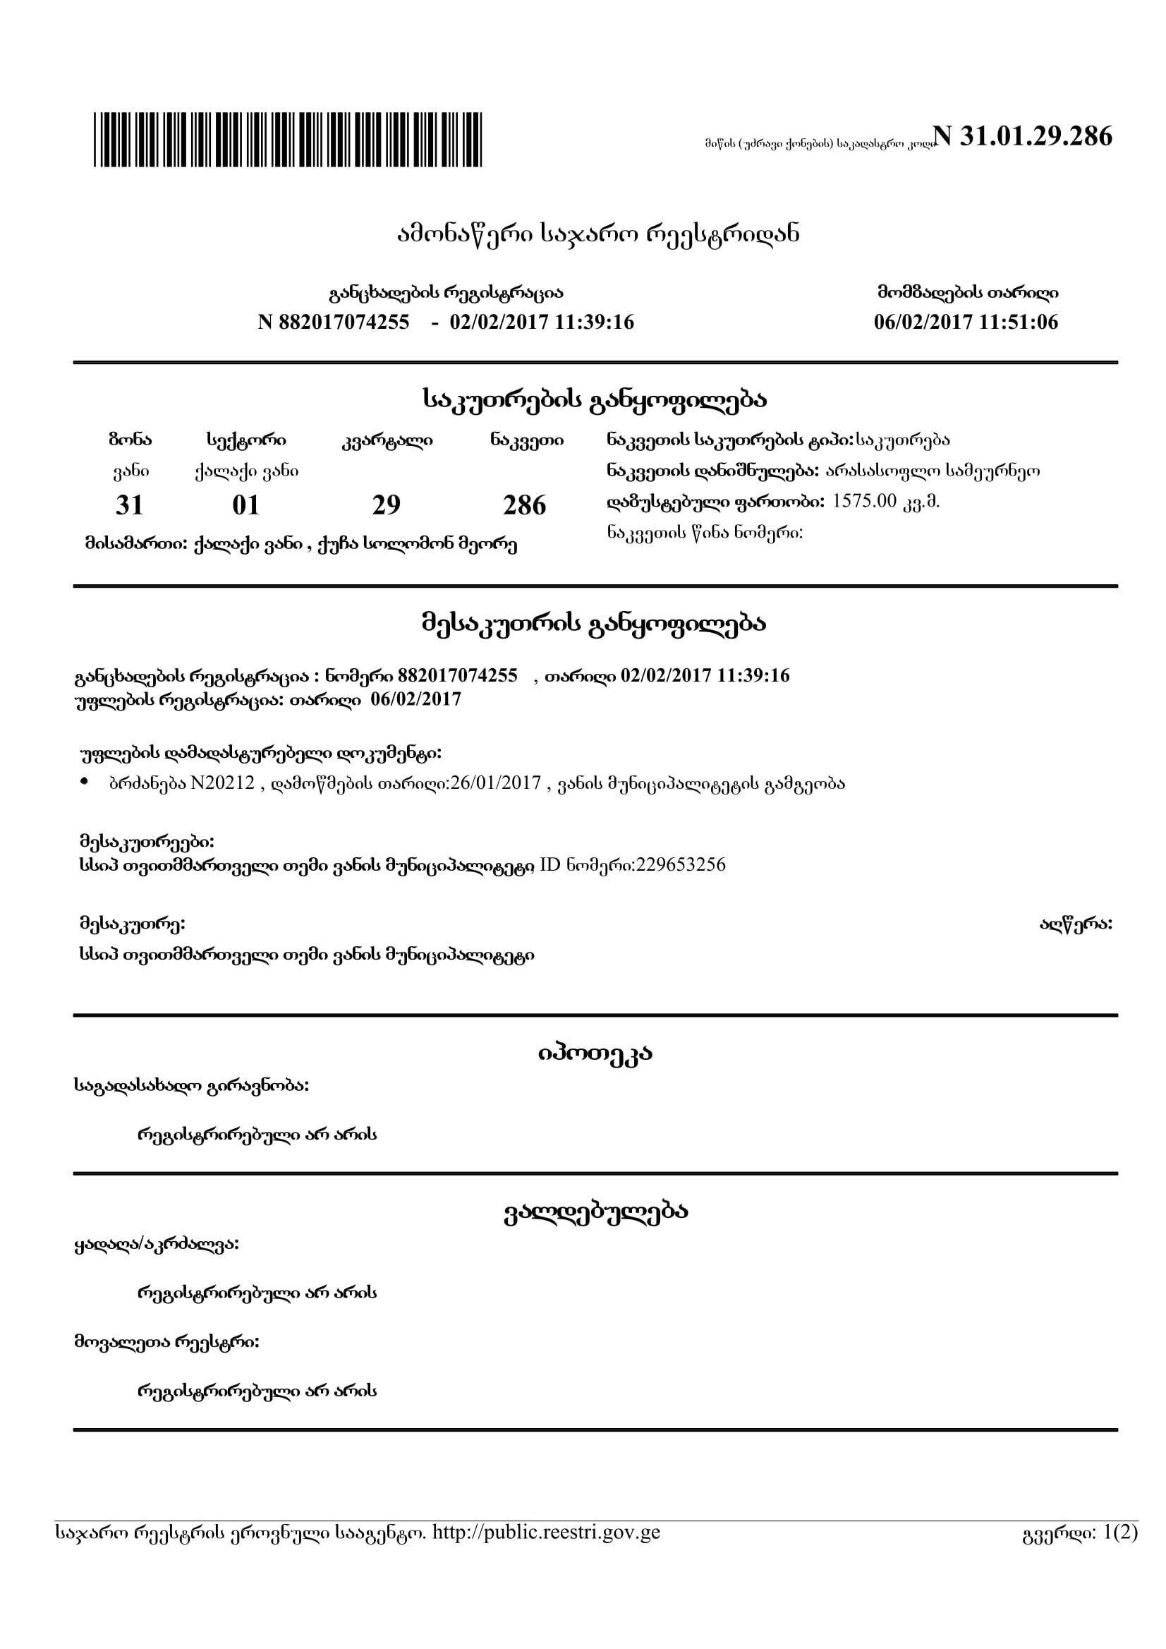

Attachment 2: Support letter from Vani Municipality

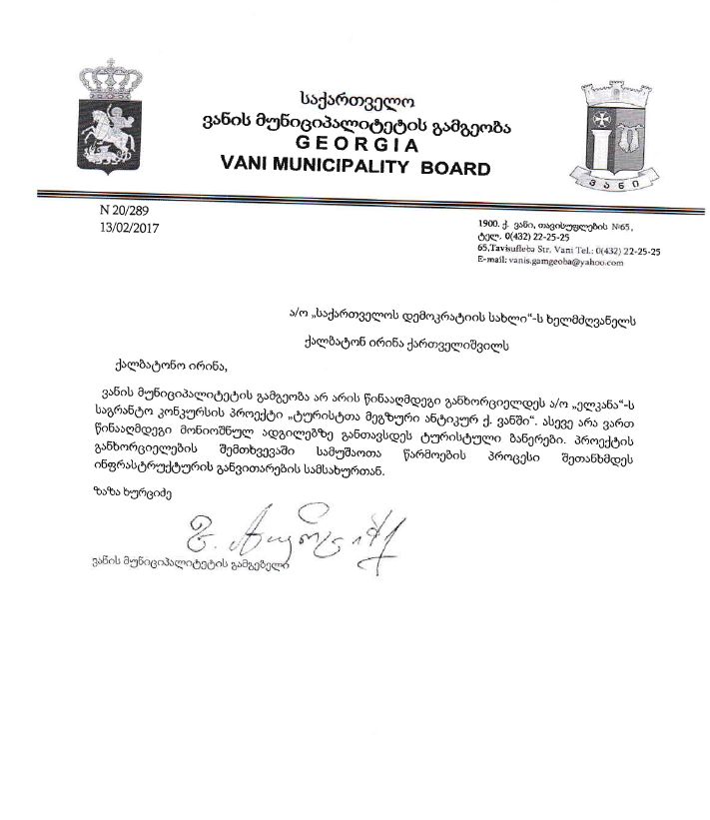

Attachment 3: Locations of Sculptures to be installed in the Parks of the town Vani
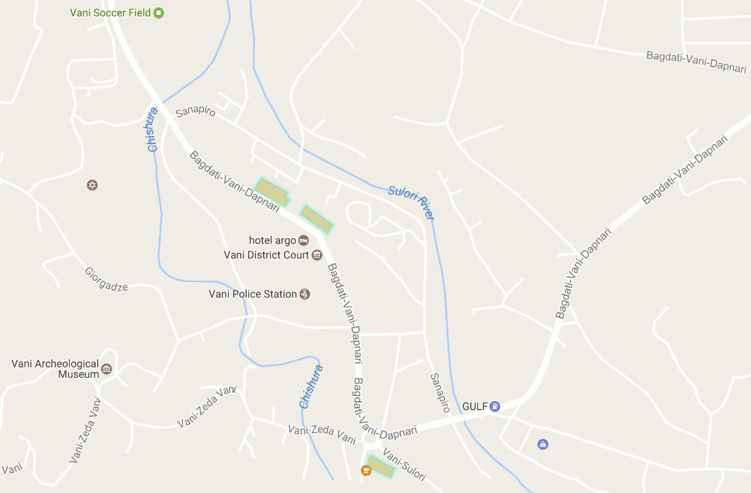
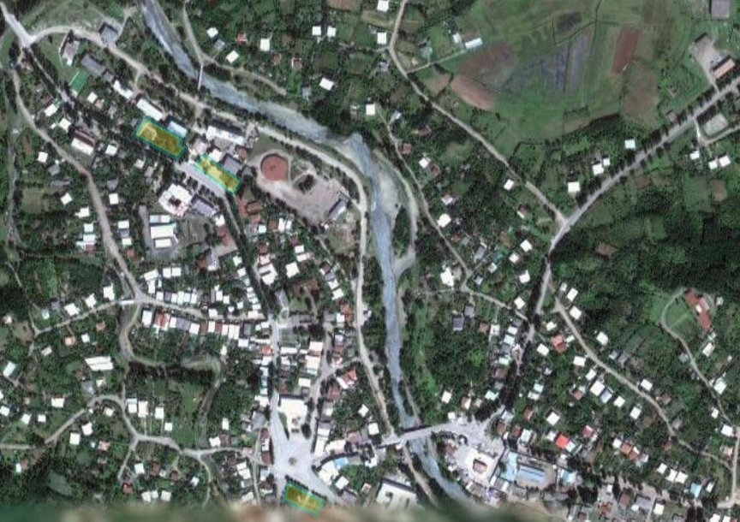

Attachment 4: Minutes of consultation meeting
Date: June 5th, 2017
Venue: Vani town
Donor: Biological Farming Association “Elkana”, through funding from the Japanese Social Development Fund and the World Bank
Aim: Consult with the local community on the Draft Environment and Social Management Plan for the projects “Installation of tourist information signs and sculptures in Vani”

Elkana Regional Coordinator in Imereti, representatives of NGO “House of Democracy” and local community attended the meeting. In total 27 people participated in the gathering, including 2 women.
Elkana Regional Coordinator presented planned projects and activities, as well as the draft Environment Management Plans prepared to mitigate their possible negative impacts on the natural and social environment. After the presentation, meeting participants were given the floor for questions and comments. During the meeting participants asked the following questions:

Question: Who will implement the project?
Answer: Georgian Non-Governmental Organization, House of Democracy applied for grant. Works will be implemented by the contractor, who will be selected through competitive bidding process.

Question: How will the project contribute to income generation?
Answer: The signage will increase visibility of local cultural and historic monuments and tourists will spend more time in Vani. Thus, they will require various services and local population will be able to offer these, which will generate income.

Question: Will installation of signs require cutting of trees or branches?
Answer: Location of signs will be selected with the view to avoid any harm to environment.

Community members were satisfied with the received information and supported implementation of the project.
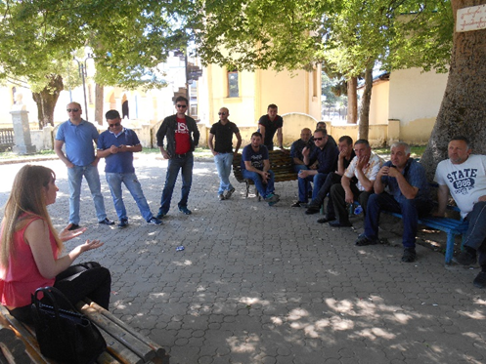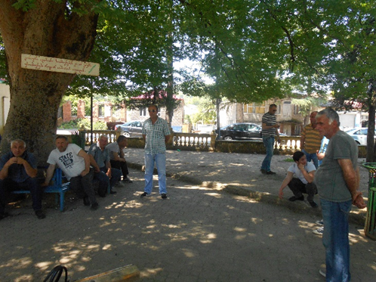
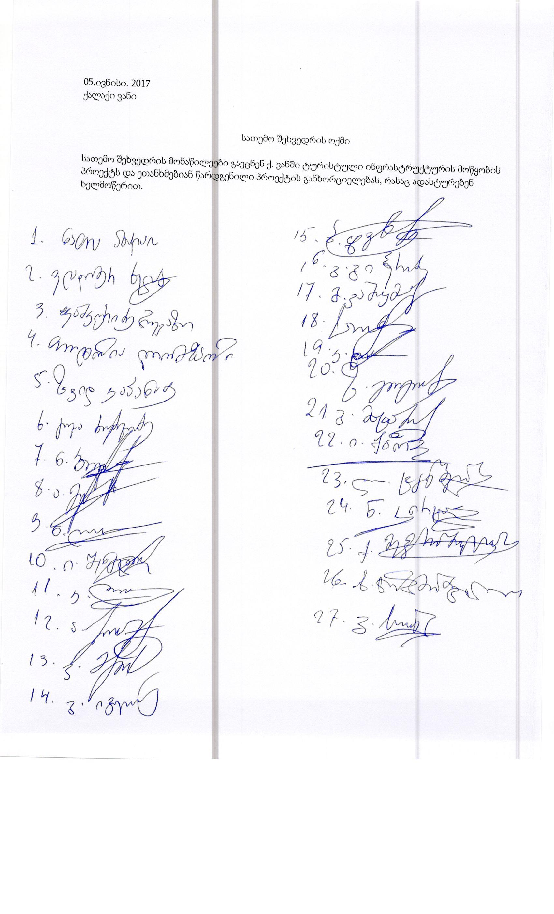

Land acquisitions includes displacement of people, change of livelihood encroachment on private property this is to land that is purchased/transferred and affects people who are living and/or squatters and/or operate a business (kiosks) on land that is being acquired.
Toxic / hazardous material includes but is not limited to asbestos, toxic paints, noxious solvents, removal of lead paint, etc.

