MINISTRY OF ROAD TRANSPORT AND HIGHWAYS
(Government of India)

GREEN NATIONAL HIGHWAYS CORRIDOR PROJECT
Social Impact Assessment and Resettlement Action Plan for NH 516 E Paderu to Araku (upto Bhalluguda)

TABLE OF CONTENTS
E. EXECUTIVE SUMMARY 1.1
E1. Introduction 1.1
E2. Project Purpose 1.1
E3. Approach and Methodology 1.1
E4. Land Acquisition and Impacts 1.1
E5. Anticipated Social Impacts and Mitigation Measures 1.2
E6. Mitigation Measures 1.3
E7. Cost Estimation 1.3
E8. Grievance Redress Mechanism 1.3
1 DETAIL PROJECT DESCRIPTION 1.4
1.1 Introduction 1.4
1.2 Project (GHNCP) Purpose 1.4
1.3 The Project Road Description 1.5
1.4 Existing Road Conditions 1.6
1.5 Proposed Project Road 1.10
1.6 Proposed Improvement 1.10
2 APPROACH AND METHODOLOGY 19
2.1 Introduction 19
2.2 Census and Socio-economic survey 19
2.3 Stakeholder Consultations 20
2.4 Tribal People Participation and Development (TPPD) 23
2.5 Social Impacts 23
2.6 Resettlement Policy Framework 23
3 ANALYSIS OF ALTERNATIVES AND PROPOSED IMPROVEMENT PLAN 24
3.1 Need For Minimisation Of Impact 24
3.2 Design Consideration 24
3.3 Analysis of Alternative 26
4 SOCIO- ECONOMIC PROFILE OF THE PROJECT AREA 29
4.1 Socio-Economic Base line 29
4.2 Socio-Economic Profile of the Influence Zone 29
4.3 Socio-Economic Features of Visakhapatnam District 30
4.4 Socio Economic Characteristics of the Project Corridor 32
5 LAND ACQUISITION AND IMPACTS 36
5.1 Introduction 36
5.2 Land Acquisition Estimates For The Project Stretch 36
5.3 Impacts on Structures 37
5.4 Impact on Structure by Typology of Structure 38
5.5 Socio Economic Profile of Project Affected Household 38
6 ANTICIPATED IMPACTS AND MITIGATION MEASURES 44
6.1 Introduction 44
6.2 Impacts 44
6.3 Impacts on Vulnerable Communities 45
6.4 Impacts during the construction Stage 46
6.5 Impacts during the Operation Stage 46
7 POLICY, LEGAL AND ADMINISTRATIVE FRAMEWORK 49
7.1 Introduction 49
7.2 Some Important legal provisions to safeguard tribal interests 49
7.3 Right to Fair Compensation and Transparency in Land Acquisition, Rehabilitation and Resettlement Act (RFCT in LARR), 2013 50
8 ENTITLEMENTS, ASSISTANCE AND BENEFITS 58
8.1 Introduction 58
8.2 Cut-off-Date for Entitlement 58
8.3 Project Entitlements 58
8.4 Entitlement Matrix 61
8.5 Comparison between World Bank Policy and RFCT LARR ACT 67
9 STAKEHOLDERs CONSULTATIONS AND DISCLOSURE 77
9.1 Introduction 77
9.2 Methodology for Public Consultation 77
9.3 Stakeholders Consultations 78
9.4 Public Consultation 78
9.5 Key Findings of Consultations 78
9.6 OUTCOME OF THE CONSULTATIONS 80
9.7 PLANS FOR FURTHER CONSULTATION AND DISCLOSURE 87
9.8 Information Disclosure 88
9.9 Framework for Continued Consultation 89
10 COST AND BUDGET 91
10.1 Introduction 91
10.2 Calculation Process 91
10.3 RAP Implementation and Support Cost 92
10.4 Resettlement Budget 93
11 INSTITUTIONAL ARRANGEMENT FOR RAP IMPLEMENTATION 95
11.1 Introduction 95
11.2 Central Level 96
11.3 State Level/Regional Office 96
11.4 Sub-Project/PIU Level 97
11.5 RAP Implementation Support Agency 98
11.6 Replacement Cost Committee at District Level 99
11.7 Mechanism for Implementation of RAP, Training and Capacity Building – at Project and Sub-project Level 100
12 GRIEVANCE REDRESSAL MECHANISM 101
12.1 Grievance Redressal Committee (GRC) 101
12.2 Suggestion and Complaint Handling Mechanism (SCHM) 103
13 IMPLEMENTATION SCHEDULE 104
13.1 Introduction 104
13.2 Schedule for Project Implementation 104
13.3 RP & TDP Implementation Schedule 104
14 MONITORING AND EVALUATION 107
14.1 Introduction 107
14.2 Institutional Arrangement for M & E 107
14.3 Monitoring and Evaluation (M&E) at Project and Sub-project Level 108
14.4 Process & Performance Monitoring 109
14.5 Evaluation 110
LIST OF FIGURES
Figure 1-1: Key Map Showing Project Road 1.6
Figure 1-2: Typical Road Cross Section for Paderu- Araku (Up to Bhalluguda) Section Road 13
Figure 3-1: Analysis of Alternative at Hukumpet 27
Figure 3-2: Analysis of Alternative at Araku 28
Figure 9-1: Public Consultations/Gram Sabha at Hukumpet on 03.10.2018 84
Figure 9-2: Public Consultations/Gram Sabha with women group at Chintalaveedi on 03.10.2018 84
Figure 9-3: Public Consultations/Gram Sabha at Araku Valley on 03.10.2018 85
Figure 9-4: Public Consultations/Gram Sabha at Paderu on 03.10.2018 85
Figure 9-5: Participants during FGD’s and Consultations in the project road 86
Figure 11-1: Institutional Arrangement for RAP Implementation 95
Figure 12-1: Grievance Redressal Mechanism 102

LIST OF TABLES
Table E-1: Impact of the project on affected structures 1.2
Table E-2: Identification of Social Impacts at Various stages of the project. 1.3
Table 1-1: Details of Villages along the Project Road in Paderu- Araku Section 1.6
Table 1-2: Various Intersections in project road 1.8
Table 1-3: Existing carriageway Details of Project Road 1.8
Table 1-4: Summary of Existing Features of Project Road 1.9
Table 1-5: Design Speed as per Standards 1.11
Table 1-6: Proposed Realignments in Project Road 1.11
Table 2-2: Engagement Techniques 22
Table 3-1. 24
Table 3-1: Project Improvement plan of NH-516E 25
Table 4-2: Demographic profile of Visakhapatnam District of Andhra Pradesh 31
Table 4-3: Gender wise Literacy Rate in Visakhapatnam District of Andhra Pradesh 31
Table 4-4: Percentage of Workers and Non-Workers in Visakhapatnam District of Andhra Pradesh (w.r.t. Total Population) 32
Table 4-5: Occupation profile of Visakhapatnam District of Andhra Pradesh (w.r.t. Total Main Workers) 32
Table 4-6: Details of the Revenue Villages in the Study Area 33
Table 5-1: Land Acquisition Type by Area 36
Table 5-2: Details of Land Survey numbers of the total land 37
Table 5-3: Impact of the project on affected structures 37
Table 5-4: Type and Area of Structures Affected along project 38
Table 5-5: Socio-cultural characteristics of the affected households 39
Table 5-6: Occupational pattern and income profile of affected households 40
The expenditure pattern for the affected household’s shows that a majority of them are having an average monthly expenditure above Rs.30000 per month. Details are given in Table 5-7. 40
Table 5-7: Monthly Expenditure 40
Table 5-8: Financial Deposits 41
Table 5-9: Indebtedness & Source of loan 41
Table 5-10: Health Status of PAFs 41
Table 5-11: Vulnerable Category 42
Table 5-12: Details Likely displaced households 43
Table 6-1: Summary of Impacts 47
Table 7-1: Applicability of Key Legislation Policies relating to social aspects 55
Table 8-1: Entitlement Matrix 61
Table 9-1: Type of Consultation with different Groups 78
Table 9-2: Village wise Tribal consultation details and outcome of Consultations 80
Table 10-1: Estimated Resettlement Cost 93
Table 14-1: Performance Monitoring for RAP Implementation 109

ABBREVIATIONS
APRDC | – | Andhra Pradesh Road Development Corporation
BPL | – | Below Poverty Line
CPR | – | Common Property Resources
DPR | – | Detailed project report
GoAP | – | Government of Andhra Pradesh
GoI | – | Government of India
GRC | – | Grievance Redressal Committee
GBV | – | Gender Based Violence
IAY | – | Indira Awaas Yojana
LARR | – | Land Acquisition, Rehabilitation and Resettlement
LPS | – | Land Plan Schedules
MoRTH | – | The Ministry of Road Transport and Highways
NGO | – | Non-Government Organization
NHAI |  | National Highway Authority of India
OBC | – | Other Backward Class
PAF's | – | Project Affected Family
PAP's | – | Project Affected Person's
PDF's | – | Project Displaced Family
PDPs | – | Project Displaced Persons
PESA | – | Panchayats (Extension to Schedule Areas) Act,1996
PIU | – | Project Implementation Unit
PMC | – | Project Management Consultants
PRoW | – | Proposed Right-of-Way
R&B | – | Roads and Building
R&R | – | Rehabilitation and Resettlement
RDO | – | Revenue Divisional Officer
RFCTLARR | – | Right to Fair Compensation and Transparency in Land Acquisition, Rehabilitation and Resettlement, 2013 Act
RoW | – | Right-of-Way
SC | – | Scheduled Caste
SIA | – | Social Impact Assessment
SMU | – | Social Management Unit
SPS | – | Safeguard Policy Statement
SSR | – | Standard Schedule of Rates
ST | – | Scheduled Tribe
TPPD | – | Tribal People Participation and Development Plan
VAC | – | Violence Against Children
WB | - | World Bank

EXECUTIVE SUMMARY

Introduction
Ministry of Road Transport & Highways (MoRT&H) “the Authority” with an aim to provide better connectivity of various existing National Highways, has launched National Green Highways Mission (NGHM) following the promulgation of ‘Green Highways Policy’ in September 2015. Its objectives include developing a systematic framework for integrated green corridor development along NHs and building resilient ecosystems in form of green corridors for combating climate change effects.
The Ministry of Road Transport & Highways, MORT&H (“Authority”), GoI is intended to develop National Highway 516E, an inter-state highway lying in the state Andhra Pradesh. It connects Bharatmala Corridor viz NH-16 at Rajahmundry and NH-26 at Vizianagaram respectively. Out of total stretch in A.P a length of 209.74 km of NH-516E spread in three stretches have been selected: i) Bowdara to Vizianagaram road (26.93 KM) ii) Paderu to Araku (upto Bhalluguda) 49.37 KM and iii) Koyyuru to Paderu (133.09). In this project rehabilitation and up gradation of existing highway to two lanes / two lanes with paved shoulders have been proposed for three stretches, whereas this report deals with the Paderu – Araku stretch of NH- 516E ( 49.37 Km). The project road starts from Paderu at existing chainage Km 2+416 to 27+450 on Other District Road (ODR), 27+450 to 40+000 on State Highway (SH-8), and 118+400 to 104+400 on State Highway (SH-39) ends at Araku on NH 516E in Visakhapatnam district of Andhra Pradesh.

Project Purpose
The project is envisaged to augment capacity for safe and efficient movement of traffic in the National Highways (NH-516E) corridor where the intensity of traffic has increased significantly. Improvements of these selected national highways would improve connectivity, facilitate speedy and smooth transportation with less interruption at a lesser transport cost and in less time, induce economic development of existing growth centres, provide impetus for the development of new growth centres, employment generation and as a consequence poverty alleviation in the project areas.

Approach and Methodology
The approach underlying the assessment of social impacts and developing appropriate mitigation strategies is based on the principles of local participation and consultations with stakeholders, including vulnerable groups. The SIA study has been carried out with a participatory approach by involving the stakeholders, particularly the project beneficiaries and likely affected persons through a series of consultative processes and techniques. The impacts have been assessed by collecting both quantitative and qualitative types of data.

Land Acquisition and Impacts
Land acquisition is adopted as per the final alignment designs and the proposed RoW which is considered to be 24 m in the existing road, 30 m at realignment/bypasses and 17 m in the forest locations. Land is to be acquired for bypass, realignments, junction improvement, curve improvements, widening. The additional land required as per final design, which is 46.65 ha, includes both government and private land. Of the total land (46.65 ha), 31.19 ha is private land, 14.46 ha is government land and 1ha is forest land which will be required for the project.
As per the Census survey, a total of 299 structures will be impacted including 252 private structures, 35 government structures and 12 CPRs; all 252 structures belong to private owners, no structures found on government land; no squatters and encroachers are getting affected; majority of the CPRs are religious temples. Summary of the total affected structures are given in Table E-1.
Table E-1: Impact of the project on affected structures
Paderu Araku
Impact Category | Likely Impact
Titleholder Residential
- Residential | 89
- Commercial | 84
- Residential + Commercial | 15
Others (Compound walls, Cattle Sheds, Toilets, Sheds) | 64
Sub-Total | 252
Common Property Resources
School | 5
School – Compound Walls | 6
Religious (Including Tombs) | 12
Bus Stand/ Shelter | 15
Government Buildings | 3
Others (Pump house, Shed, Toilets) | 6
Sub-Total | 47
Grand Total | 299
Source: Feb – March census Survey, 2018

Anticipated Social Impacts and Mitigation Measures
The social impact management measures shall be implemented during the various stages of the project viz. Pre-construction Stage, Construction Stage and Operational Stage. Descriptions of the various likely impacts during various stages of proposed project road are presented in Table E-2.

Table E-2: Identification of Social Impacts at Various stages of the project.
Before Construction | During Construction | Post Construction
- Acquisition of agricultural lands  - Acquisition of trees  - Loss of Residential/ commercial structures, kiosks, temporary structures, shops, commercial, compound walls,  - Loss of livelihood  - Loss of common properties (Gram Panchayat buildings, schools, Taps, Hand pumps, Bore wells, Temples, community halls) | - Dust pollution  - Noise pollution  - labour employment & small & medium scale markets in coffee sector, forest produce like Tandu leaf, Mahua, Tamrind, honey etc trade enhances with transportation products to cities. Which boost their livelihood opportunities during construction. | Social, Economic and Infrastructural Development which will improve the quality of life. Development in tourism.

Mitigation Measures
Conscious efforts have been made for avoidance of land acquisition and minimize the adverse social impacts as integral part of the entire project preparation and design of the proposed road. Wherever unavoidable, efforts to minimize impacts through design interventions have worked out for the project. Improvements are planned within the available EROW/ land width. The cross sections are designed to accommodate with the existing ROW/ land width.
As per the width required in the Corridor of Impact (CoI) for the actual construction of the road, which include carriageway, shoulders and embankments, the social inputs to the project design shall ensure that the COI is reduced, within the acceptable design principle and standards, to minimize the adverse social impacts.

Cost Estimation
A broad resettlement budget has been estimated taking into account the ongoing market rate and its guidelines for compensation for land; R&R assistance and administrative costs. The estimated Resettlement Budget INR 43.52 Crores.

Grievance Redress Mechanism
In the project RP implementation there is a need for an efficient Grievance Redress Mechanism (GRM) that will assist the DPs in resolving their queries and complaints. Therefore, formation of Grievance Redress Committee (GRC) will be most important for grievance redress and it is anticipated that most, if not all grievances, would be settled by the GRC. The grievance redress committee members and their responsibilities are given in details in Chapter 12 of GRM.

DETAIL PROJECT DESCRIPTION

Introduction
Ministry of Road Transport & Highways (MoRT&H) “the Authority” with an aim to provide better connectivity of various existing National Highways, has launched National Green Highways Mission (NGHM) following the promulgation of ‘Green Highways Policy’ in September 2015. Its objectives include developing a systematic framework for integrated green corridor development along NHs and building resilient ecosystems in form of green corridors for combating climate change effects. The green corridors, relevant from both climate mitigation and adaptation perspective, are being seen as the solution to fulfill India’s commitment for voluntary reduction of carbon emissions. The Government of India (GoI) plans to carry out plantation along the NHs with participation of the local communities, farmers, NGOs, private sector, government agencies and Forest Departments (state level).
The Ministry of Road Transport & Highways, MORT&H (“Authority”), GoI is intended to develop National Highway 516E, an inter-state highway lying in the State Andhra Pradesh. It connects Bharatmala Corridor viz NH-16 at Rajahmundry and NH-26 at Vizianagaram respectively. The project road starts from Rajahmundry and connects the habitations of Rampachodovaram – Koyyuru- Paderu- Araku – Bhalluguda – Bowdara- Vizianagarm. This National Highway covers a distance of 375.90 km in Andhra Pradesh. Out of total stretch in A.P a length of 209.74 km of NH-516E spread in three stretches have been selected: i) Bowdara to Vizianagaram road (26.93 KM) ii) Paderu to Araku (upto Bhalluguda) 49.37 KM and iii) Koyyuru to Paderu (133.09).
M/s SATRA Infrastructure Management Services Private Limited has been appointed to establish the technical, economical and financial viability of the project and prepare Feasibility and Preliminary Design report for rehabilitation and up gradation of existing highway to two lanes / two lanes with paved shoulders for Paderu – Araku stretch of NH- 516E of a total length of 49.37 Km. The project road starts from Paderu at existing chainage Km 2+416 to 27+450 on Other District Road (ODR), 27+450 to 40+000 on State Highway (SH-8), and 118+400 to 104+400 on State Highway (SH-39) ends at Araku on NH 516E in Visakhapatnam district of Andhra Pradesh.

Project (GHNCP) Purpose
The project is envisaged to augment capacity for safe and efficient movement of traffic in the National Highways (NH-516E) corridor where the intensity of traffic has increased significantly. Improvements of these selected national highways would improve connectivity, facilitate speedy and smooth transportation of bulk goods with less interruption at a lesser transport cost and in less time, induce economic development of existing growth centres, provide impetus for the development of new growth centres, employment generation and as a consequence poverty alleviation in the project areas. In this context, some of the major social development objectives of the project comprise the following:
- Everybody concerned is a partner in the development process;
- No one is adversely affected due to the implementation of the project; any adverse impact is to be appropriately mitigated;
- Maximization of the benefits to the people arising from the road rehabilitation and capacity augmentation programme while minimizing the negative social impacts on the affected people by incorporating the social safety measures.
The objectives of GNHCP are
- To develop a systematic framework for Integrated Green Corridor Development along the proposed National Highways.
- To provide better connectivity of the various existing national highways in the country and induce socio-economic development’s in the project area.
- Build resilient ecosystem in the form of green Corridor along the national highways for combating global warming and climate change effects, optimum Green House Gasses sequestration, off site conservation of RET species of the region.
- To create sustainable employment to the locals in the project area.

The Project Road Description
The project road section has lane configuration from single lane to two lane. It has Single lane width of 22.27km length, intermediate lane to a length of 5.5km and two lane of 21.6 Km length. It passes through major habitations in schedule areas like Paderu, Hukumpeta, Dumbriguda, Araku. The terrain is the rolling plain for the entire length. The Condition of road is poor (70% of the section is average or poor) to very poor condition with earthen shoulders (width is between 0.4 m and 0.75 m) except at a few isolated built-up locations. The built-up section along the project road constitutes to a length of 4.45 Km. Congestion due to vehicular and pedestrian movements have increased vulnerability to accidents and safety issues to the road users. There are many locations along the road alignment which requires geometric improvements to maintain the riding quality and hindrance free movements of the vehicles to avoid accidents. Geometric Improvement of the highway is proposed for the entire stretch. All the geometrically deficient curves are proposed for the realignment and curve improvements.
A total 12 major/minor bituminous road meet the project road at various locations. The land along the project road is mostly agricultural land, except at built up areas, where there is nominal barren land. There is an additional land requirement for about 31.19 ha from a total land parcel of 312 approximately. The total numbers of families affected due to impact on structures are 252 and all of them are located on private lands and the project has no non-titleholders squatting or encroaching on public land. The affected structures include all types of categories such as residential, commercial, residential cum commercial besides others such as cattle sheds, toilets, compound walls, etc. In addition there are 47 CPRs that comprise of 5 schools, 6 school compound walls, 12 religious structures, 15 bus stands, 3 government buildings and others 6 such as compound walls, toilets, hand pumps, taps etc. Among the affected households there 67 vulnerable families comprising of 60 Schedule Tribes, 1 Schedule Caste and 6 old age.
The project road is located in Vishakhapatnam district of Andhra Pradesh State. The index map of the proposed corridor on NH-516E shown in Figure 1-1.
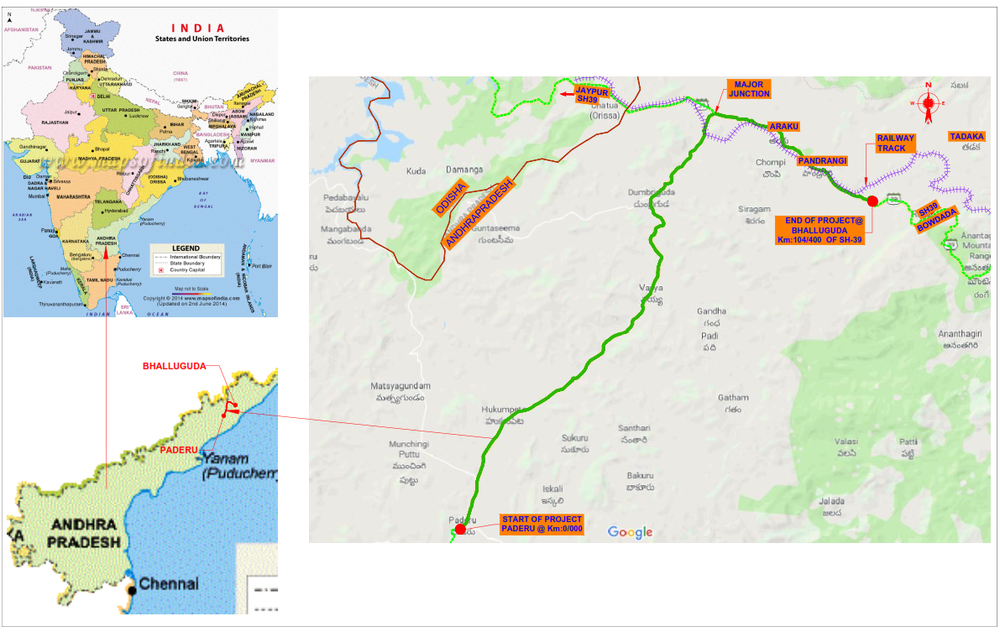
Figure 1-1: Key Map Showing Project Road

Existing Road Conditions
- Right-of-Way
The existing RoW on the project corridor varies from minimum of 20m and maximum of 32m as per the village revenue maps.
(b) Major Village/town on Project Road:
There are 37 revenue villages on either side of the project road. The length of settlements along the stretch is 5.1 km and the average length between settlements is 2.5 km. whereas the minimum distance between two consecutive villages is about 800m. The details of villages along the project road are presented in Table 1-1.
Table 1-1: Details of Villages along the Project Road in Paderu- Araku Section
Paderu_Araku Road
S.No | District | Mandal | Village name | Chainage |  | Length (KM) | Remarks
 |  |  |  | From | To
1 | VISAKHAPATNM | PADERU | TALARISINGI | 2.400 | 2.700 | 0.300
2 |  |  | CHINTALAVEEDHI | 2.700 | 4.450 | 1.750
3 |  | HUKUMPETA | PATIMAMIDI | 4.450 | 4.875 | 0.425
4 |  |  | BARAMANGUDA | 4.875 | 6.000 | 1.125
5 |  |  | MULAIPUT | 6.000 | 6.120 | 0.120
6 |  |  | KONTELI | 6.120 | 7.760 | 1.640
7 |  |  | HUKUMPETA | 7.760 | 9.600 | 1.840
8 |  |  | CHATRAYAPUTTU | 9.600 | 10.095 | 0.495
9 |  |  | GODUGUPALLI | 10.095 | 11.710 | 1.615
10 |  |  | URRADA (463 ) | 11.710 | 12.320 | 0.610
11 |  |  | KOTNAPALLI | 12.320 | 14.350 | 2.030
12 |  |  | MATCHAPURAM & PEDDAGARUVU | 14.350 | 15.800 | 1.450
13 |  |  | MASADA | 15.800 | 16.830 | 1.030
14 |  |  | BALARODA | 16.830 | 19.880 | 3.050
15 |  |  | RANGASILA | 19.880 | 22.950 | 3.070
16 |  |  | RESERVE FOREST | 22.950 | 24.000 | 1.050
17 |  | Dumbriguda | KINCHUMANDA | 24.000 | 26.260 | 2.260
18 |  |  | BILLAPUT | 26.260 | 26.810 | 0.550
19 |  |  | ARAMA FOREST LAND | 26.810 | 27.390 | 0.580
20 |  |  | GONDIGUDA | 27.390 | 27.750 | 0.360
21 |  |  | RESERVE FOREST | 27.750 | 28.290 | 0.540
22 |  |  | KOSANGI | 28.290 | 29.820 | 1.530
23 |  |  | DUMRIGUDA | 29.820 | 31.330 | 1.510
24 |  |  | RESERVE FOREST | 31.330 | 32.150 | 0.820
25 |  |  | ANTRIGUDA | 32.150 | 32.950 | 0.800
26 |  |  | PANTALACHINTA | 32.950 | 34.450 | 1.500
27 |  |  | KURIDI | 34.450 | 36.400 | 1.950
28 |  |  | NIMMAGEDDA | 34.450 | 37.300 | 2.850
29 |  |  | ARAKU | 37.300 | 41.190 | 3.890
30 |  | Araku Valley | BANDAPONUVALASA | 33.940 | 34.450 | 0.510
31 |  |  | YENDAPALLIVALASA | 41.190 | 43.200 | 2.010
32 |  |  | KANTABHANSAGUDA | 43.200 | 44.720 | 1.520
33 |  |  | RAVVALAGUDA | 44.720 | 46.200 | 1.480
34 |  |  | PANIRANGI | 46.200 | 48.100 | 1.900
35 |  |  | BOSUBEDA | 48.100 | 50.490 | 2.390
36 |  |  | GADYAGUDA | 50.490 | 51.150 | 0.660
37 |  |  | NEW BALLAGUDA 293 | 51.150 | 51.895 | 0.745

(c) Junctions
The list of various types of junctions in the project road in the proposed corridor is given below in Table 1-2.
Table 1-2: Various Intersections in project road
Major Junctions
S.No | Existing Chainage (km) | Road leading to LHS | Road leading to RHS | Type of Junction
1 | 31/000 | Dumbriguda | Araku | T
2 | 38/220 | Jeypore | Araku | Y

Minor Junctions
S.No | Existing Chainage (km) | Road leading to LHS | Road leading to RHS | Type of Junction
1 | 2/900 | Cheedimetta | Araku | T
2 | 4/000 | Araku | Sanyasammapallem | Y
3 | 5/350 | Malaguda | Araku | T
4 | 7/600 | Marripetu | Araku | Y
5 | 8/200 | Hukumpeta | Araku | Y
6 | 8/700 | Araku | Muliaputtu | Y
7 | 9/700 | Araku | Chatraiputta | Y
8 | 13/950 | Araku | Boddaputta | Y
9 | 15/300 | Araku | Matchyapuram | Y

(d) Carriageway
The existing project road has substandard lane configuration varying from single lane, intermediate lane and two lanes road. In the existing project corridor the carriageway width varies from 3.3 to 9.9 m, details given in Table 1-3.
Table 1-3: Existing carriageway Details of Project Road
S.No | Existing Chainage(km) |  | Width (m) | Remarks
 | From | To
1 | 2/416 | 4/000 | 3.4 | ODR
2 | 4/000 | 5/400 | 3.3
3 | 5/400 | 9/300 | 3.4
4 | 9/300 | 10/000 | 5.4
5 | 10/000 | 13/800 | 3.6
6 | 13/800 | 20/300 | 3.5
7 | 20/300 | 25/700 | 3.4
8 | 25/700 | 26/900 | 8.4
9 | 26/900 | 27/450 | 5.4
10 | 27/450 | 29/100 | 5.4 | SH-8
11 | 29/100 | 34/200 | 3.3
12 | 34200 | 34/600 | 7.2
13 | 34/600 | 35/100 | 3.5
14 | 35/100 | 35/600 | 6.5
15 | 35/600 | 39/600 | 3.5
16 | 39/600 | 40/000 | 6.5
17 | 118/400 | 115/600 | 6.7 | SH-39
18 | 115/600 | 113/600 | 6.9
19 | 113/600 | 112/000 | 9.9
20 | 112/000 | 105/300 | 6.9
21 | 105/300 | 104/400 | 5.6

(e.) Salient Features of the Existing Project Road
The existing features of the project road are summarised in Table 1-4 below.
Table 1-4: Summary of Existing Features of Project Road
Sl. No. | Description of Item | Details
1. | Road Sections | Paderu-Araku
2. | Location | Visakhapatnam District, Andhra Pradesh
3. | Major Villages/Towns | Paderu, Hukumpeta, Kinchumanda and  Dumbriguda, Araku
4. | Terrain | Rolling plain
5. | Land use | The land along the project road is mostly agricultural land, except at built up areas, where there is nominal barren land.
6. | Junctions | 2 major junctions, 9 minor junctions
7. | Carriageway width (m) | 3.3 m to 9.9 m
8. | Shoulder width (m) | Single lane, Intermediate lane and two lane
9. | Right of way (m) | 20 to 32 m
10. | Type of soil | Silty clay, Sandy Silty clay and clay
11. | Structures | Major Bridge: 2  Minor Bridge: 16  Culverts: 119  - 40 pipe  - 76 Slab/Arch  RoB/RuB: 1  Causeway: 1
12. | Predominant Tree Species | Neem (Azadirachta indica), Jamun (Syzygium cumini), Tamarind (Tamarindus indica), Bargad (Ficus benghalensis), Mango ( Magnifera Indica)

Proposed Project Road
MoRTH has taken up the development of the NH-516E Paderu to Araku (Upto Bhallaguda) section in the state of Andhra Pradesh into 2-lane with the paved shoulder configuration. The proposed up-gradation of the NH-516E aims to:
- Improve horizontal and vertical alignment of the existing road
- The quality of existing pavement condition is poor and proposed for reconstruction
- Increase the carrying capacity of the existing traffic volume and enable it to cater to future traffic
- Enhance mobility to the remote places and improve accessibility of the existing highways
- Boosts Tourism in hill stations Araku, Lambasinghi and Borra Caves

Proposed Improvement
Design improvement in the project road is done taking into consideration the lane configuration, widening scheme, speed, embankment height and the urban or rural setting of the road. Improvements in the geometric design have been proposed in rural area to eliminate the substandard curvatures along the project road.
(a) Design Speed
Design speed in general depends on the function of the road and terrain conditions and shall be as per schedule B Clause 2.2 The design speed shall be the minimum design speed of 100/80 km per hour for plain/rolling terrain. As per Clause 2.1, IRC SP: 73 - 2015, the design speeds adopted for various terrain classifications are presented in below table (Terrain is classified by the general slope of the ground across the highway alignment).
Table 1-5: Design Speed as per Standards
Nature of Terrain | Cross slope of the ground (%) | Design speed (km/hr)
 |  | Ruling | Minimum
Plain& Rolling | Upto 25 | 100 | 80
Mountainous& Steep | >25 | 60 | 40
In general, the ruling design speed is adopted for the various geometric design features of the road. Minimum design speed is adopted where site conditions are restrictive and adequate land width is not available.
The proposed design speed varies from 80-50 km/h in rolling terrain and 50 km/h in hilly terrain. Adopted design standards are given in Table 1-6.
(b) Embankment Height
The embankment height shall be fixed in such a way that the difference between the elevation of top of sub grade and High Flood Level (HFL) is not less than 1.0m. Where there is no flooding observed, the existing road may be retained.
In many sections, the road top level is almost equal to the adjacent ground level or the embankment height is less than 0.5 m. from adjoining ground. Some locations may need raising to address drainage problem. However the proposed FRL shall be designed in such a way that nowhere the edge of proposed roadway goes below the ground adjacent to toe of embankment slope. In this respect special care shall be taken at the locations of super elevated curves.
(c) Bypasses in the Project Road
Two (2) bypasses have been planned at Km 7+300 to Km 9+200 at Hukumpet and Km 40+250 to Km 48+000 at Araku Valley with total length of 9.500 km.
(d) Realignments in the Project Road
Realignments in 12 sections have been proposed of 6.122 Km length to improve horizontal alignment of the road geometry and for the safety of the road users. Details in Chainage-wise are given below in Table 1-6.
Table 1-6: Proposed Realignments in Project Road
S.no | Design Chainage (CH) |  | Length (m)
 | From | To
1 | 13+550 | 14+200 | 650
2 | 15+500 | 16+000 | 500
3 | 19+350 | 19+600 | 250
4 | 20+800 | 21+200 | 400
5 | 22+400 | 22+750 | 350
6 | 25+300 | 25+700 | 400
7 | 27+300 | 27+900 | 600
8 | 28+200 | 29+100 | 900
9 | 31+900 | 32+700 | 800
10 | 34+950 | 35+350 | 400
11 | 50+600 | 51+100 | 500
12 | 51+400 | 51+772 | 372
 | Total Length |  | 6122

(d) Space for Utility and Plantation
In general, the space for utility-cum-plantation shall be 2.0 m as per IRC guidelines. This may, however, be reduced to a minimum of 1.0 m if necessary land is not available or cannot be acquired and if there is no need for afforestation.
(e) Proposed Lane Configuration
Based on the traffic demand forecast and considering a Level of Service (LoS) “B” as the desired LoS, as recommended by IRC. It is apparent that the existing 2-lane roadway needs capacity augmentation to a roadway with 2-lane plus 1.5 m wide paved shoulder and 2m earthen shoulder on either side.
Apart from capacity increase, paved shoulders play a big role in roadway safety as well as protection of carriageway pavement. Therefore, the existing road is proposed for widening to 2 lane + 1.5 m paved shoulder and 2m earthen shoulder on either side.
The improvement proposal envisages widening of the existing road to standard two-lane carriageway having paved carriage shall be 10 m (7.0m CW/1.5m PS & 2m Earthern Shoulder on either side) in accordance with the typical cross section drawings. The typical cross section has been shown in Figure 2 below for Project road.

Figure 1-2: Typical Road Cross Section for Paderu- Araku (Up to Bhalluguda) Section Road
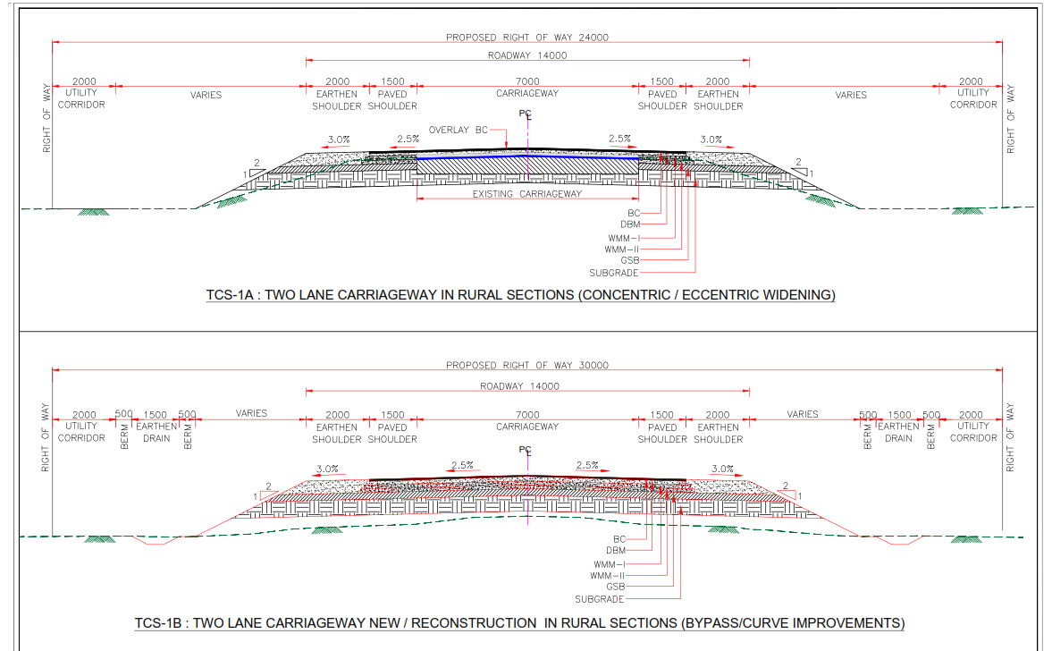
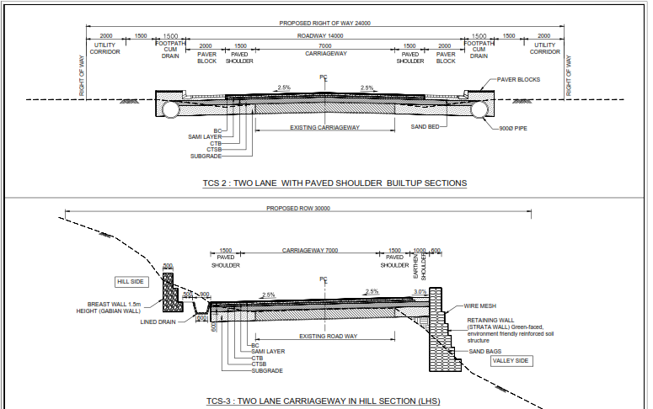
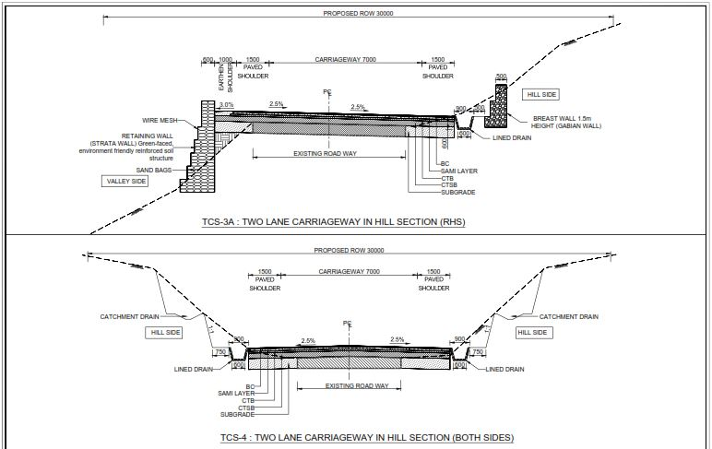
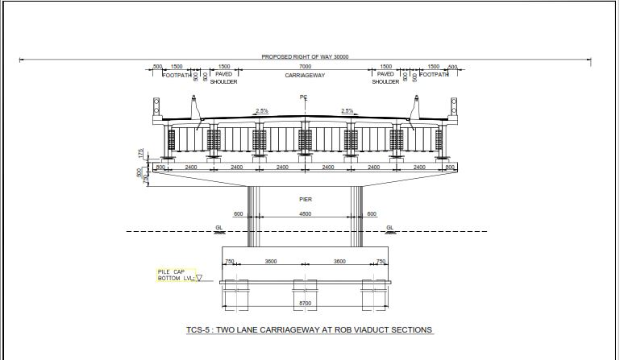
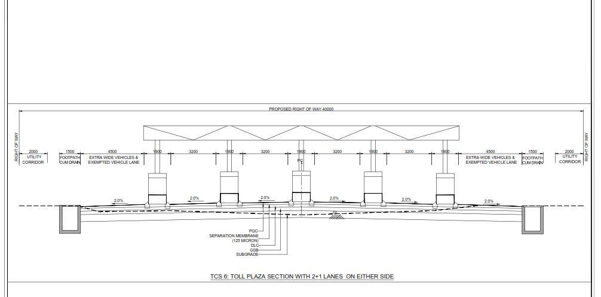

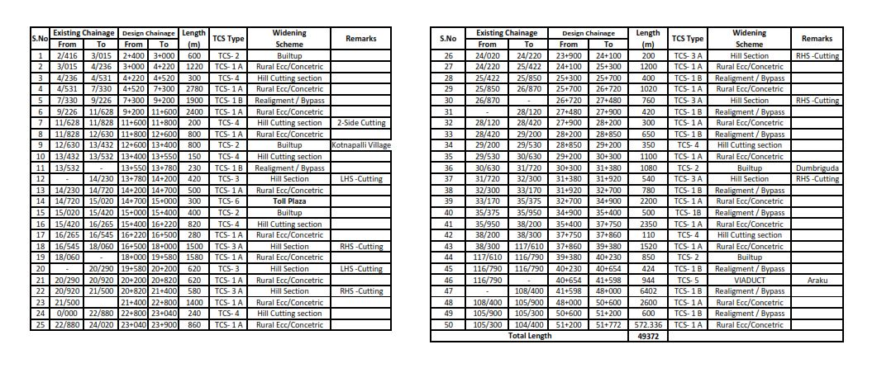

APPROACH AND METHODOLOGY

Introduction
The approach underlying the assessment of social impacts and developing appropriate mitigation strategies is based on the principles of local participation and consultations with stakeholders, including vulnerable groups. The SIA study has been carried out with a participatory approach by involving the stakeholders, particularly the project beneficiaries and likely affected persons through a series of consultative processes and techniques with the following objectives.
- Collect information using suitable tools regarding project impacts;
- Differentiate the properties and assets likely to be affected by type of ownership and
construction, etc;
- Assess the extent of loss of properties (land, structure and others) of individual as
well as that of community and loss of livelihood;
- Conduct meaningful consultations with likely PAPs, community and other
stakeholders;
- Establish a baseline profile of population, social structure, employment, sources of
income, access to social services and facilities, etc.
The methods that were adopted during the survey and social analysis and assessment are given below.

Census and Socio-economic survey
A socio-economic profile for the project area has been prepared based on the information collected from various secondary sources. Census and socio-economic survey was conducted to generate baseline information on socio-economic conditions of the PAPs and to assess the extent of impacts due to proposed upgrading of project road for each structures and properties. The survey was carried out by using a Census and Socioeconomic survey questionnaire (Annexure 2.1). A Resettlement Action Plan has also been prepared for the project, based on Census baseline survey and socio-economic survey of 35% of affected families.. The approach adopted is as follows:
- Zeroing-in on the project impact zone, covering all the villages and other habitations falling within area.
- Collecting base line socio-economic survey includes the collection of information from primary and secondary sources for impact zone. Information with respect to the villages in the project impact zone in terms of census village code, name of the tehsil in which a particular village falls, number of households, population level and growth of village population during the last decade, Household Information, Social Status Type of Family, Income from Various sources, Vulnerable category of the household, Type of inventory losses, impact category etc.
- Collection of secondary information from different government sources like Census of India, Economic and Statistics department, agriculture department, social welfare & women development department
- Gathering macro level socio-economic information, at Mandal/Tahsil level, with the help of secondary data.
- Identifying critical knowledge/information gaps which impede an objective and reliable assessment of the socio-economic impacts of the project.
- Zeroing-in on the data/information to be collected for a fair impact assessment and deciding upon the sources and means to collecting the same.
- Identifying the key stakeholders and potential respondents for collecting the required information.
- Drawing a sampling frame and size specifying sample villages/municipal wards, number of households to be contacted for primary data/information collection and agencies to be contacted for eliciting information on various aspects relevant to the SIA.
- Finalisation of survey instruments, constitution of a survey team and orientation of field investigators.
- Carrying out field surveys in the sample villages/municipal wards and simultaneously carrying out data accuracy and reliability checks.
- Analysis of primary and secondary information collected from different sources. On the basis of primary data, analysis has been done on potential social and economic impacts, categorization of impacts, risks, potentials impacts and alternatives etc .
- Processing, tabulation and analysis of data with the help of appropriate statistical tools.
- Interpretation of data to arrive at valid conclusions. The process involves documentation of social assessment process and impact information.

Stakeholder Consultations
To identify social impacts and concerns, consultations were undertaken with primary stakeholders: beneficiaries, poor and vulnerable groups, people who may potentially be impacted adversely by the project, and the implementing agency. Consultations were also carried out with secondary stakeholders: local community based organizations (CBOs), Integrated Tribal Development Authority (ITDA) and community representatives as well as government departments etc A team comprising of various social development professionals carried out these consultations. Prior to the commencement of consultations extensive training of the field teams by a social scientist on the approach, methodology and tools was carried out. Types of consultations conducted are as follows:
Community consultations were held along major settlements near to the proposed alignment and with those who are likely to be connected because of implementation of the proposed project. Meetings have been held with affected titleholders, cultivators, shopkeepers etc. at few important junctions along the project stretch
Focus group discussions were conducted with a cross-section of men and women in the community. The objective of these discussions was to gain an in-depth understanding of project issues and concerns from homogeneous groups of discussants, including people who may be affected from loss of land/livelihood. The consultations focused on: inclusiveness in participation of community members, perceptions and concerns about the positive and negative social impacts of the project, and willingness of community members in providing land.
Gender Analysis has been given proper emphasis during public consultation discussions. Separate discussions were held with women so that they could share their experience on issues such as by pass, bus bays, employment, transportation issues. Their collective perception about project impacts and probable benefits particularly for the women was recorded and separate document on Gender Based Violence (GBV) has been prepared separately in Volume 2
Individual Level Consultations were conducted enabling the stakeholders to speak freely and confidentially about controversial and sensitive issues and to build personal relations with stakeholders and record the interviews. The purpose is to understand the social concerns of the directly or indirectly impacts persons.
Individual consultation at this level will gathers opinion and views of the directly or indirectly impacted families. During the social survey, with the interview based questionnaire the consultations were carried out along the project road with PAP’s. Stakeholder’s engagement techniques for gathering information are presented in table 2.2.
The outcomes of the public consultations were helpful in three major aspects of project design and the tools of consultations have been presented in table 2.1.
Table 2-1: Tools of Consultations
Tools of Consultation | Purpose | Stakeholders
Public meeting, Focus Group Discussion | Discuss the objective of the project | Tribal Community, Other homogeneous groups, civil society organizations, NGOs, local leaders, Government officials
Public meeting, Focus Group Discussion | Social impact  - Land  - Structure  - CPR | Tribal Community, Other homogeneous groups, civil society organizations, NGOs, local leaders, Government officials
Public meeting, Focus Group Discussion | Social Concern  - Road Safety  - Critical Junctions  - Rural Roads  - Slow moving vehicles  - Fare/Festival Traffic  - Environmental improvement | Tribal Community, Other homogeneous groups, civil society organizations, NGOs, local leaders, Government officials, women groups, Truckers, vulnerable road users etc.
Table 2-2: Engagement Techniques
Stakeholders Group | Key characteristics | Language | Engagement Technique
Government Officials | Managers, Engineers, Supervisors etc | Official language/Local Language, English | - Phone / email / text messaging  - One-on-one interviews  - Formal meetings
Neighboring communities | Affected Household of the adjoining locality | Telugu /Local Language | - Print media, text messaging and radio announcements  - Public meetings  - Focus group meetings  - Surveys  - Information Centre
Vulnerable Groups | Women, children, person with disability, old age & tribal population | Telugu/Local Language | - Print media, text messaging and radio announcements  - Public meetings  - Focus group meetings  - Surveys  - Information Centre
Employees and Managers | Project Managers, Site Engineers, technicians, supervisors, safety staff, multipurpose staff | Official language / Telugu | - Phone / fax / email / text messaging  - Print media and radio announcements  - Workshops  - Focus group meetings  - Surveys
Village panchayat members/ local NGO’s and Conversation Organization | Community workers, Sarpanch, ANMs etc. | Telugu/Local Language | - Phone / fax / email / text messaging  - One-on-one interviews  - Focus group meetings  - Information Centre

Tribal People Participation and Development (TPPD)
TPPD ensures smooth implementation of proposed project in Fifth Schedule area of Vishakhapatnam district of Andhra Pradesh. TPPD and its plan are prepared to adhere to national legislations and its policies and World Bank Policy OP 4.10 Indigenous people. It suggests for assessment of impacts and preparation of mitigation measures where Scheduled Tribes population are involved. The anticipated adverse impacts are due to land acquisition and partially affected structures which may cause sort of relocation that have traditional ownership or that are under customary occupation. The tribe population play a role in enhancing/promoting the cultural heritage of the project area and its ST community of the proposed road development interventions.
The villages under the scheduled areas of “PESA Act” protect the tribal population from exploitation by making Gram Sabha’s and Gram Panchayat centers for self-governance and exclusively empowers local which safeguard and preserve the tradition and customs of the people and their cultural identity, community resources, and customary mode of dispute resolution.
TPPD suggests carrying out Free, Prior, and Informed Consultations (FPIC)/Gram Sabha for proposed project which are in Fifth Schedule Areas. This is with the objective of obtaining their views and suggestions regarding the proposed project interventions. Gram Sabha’s and Panchayats consultations under ‘PESA act’ intends to fully identify the views of affected community and ascertain their broad community support for the project during various stages such as project preparation, implementation and maintenance. In consultation with the affected Tribal population in the project area, potential adverse impact were identified and a Tribal Development Plan has been prepared as detailed in Volume 2.

Social Impacts
Social impacts identify the potential for loss of land, assets/structures, livelihoods, willingness of the community to provide land to the project, and other significant social impacts. Where the extent of adverse social impacts is minor and no displacement or loss of assets or livelihoods is expected, no further action is required. However, where the social impact indicates that land acquisition and/or loss of assets are unavoidable, appropriate resettlement plans will be prepared.

Resettlement Policy Framework
Major resettlement is unlikely under the project. However, in order to address the impacts on land acquisition and involuntary Resettlement under this project, Resettlement Policy Framework (RPF) has been followed which addresses all impacts arising from: (i) loss of land; (ii) loss of homes/structures; (iii) loss of livelihood systems/income opportunity; and (iv) loss of community property resources such as religious and cultural structures. RPF lays down the principles and procedures for management of social impacts caused by the project and guide the social impact assessment and preparation of mitigation plans including Resettlement Action Plans and Tribal Development Plans for the project in accordance with GoI policies, State laws and World Bank OP.

ANALYSIS OF ALTERNATIVES AND PROPOSED IMPROVEMENT PLAN

Need For Minimisation Of Impact
Development of infrastructure projects like National Highways/State Highways improvements and upgradation of the existing roads will have adverse impacts on the society. Such adverse impacts are considered as issues that are directly and indirectly affects residents which includes loss of land and structure, loss of livelihood, loss of community property along with the fragmentation of the society. If such negative issues are not addressed properly, it may happen that the outcome of the project negative impacts would outweigh the project positive impacts, thus putting a question mark on the project sustainability.
However, efforts were made to minimize negative impacts through intervention of world Bank policies and Rehabilitation and Resettlement measures by exploring all the feasible options without compromising the safety aspects. The spirit of the policies has been followed by while preparing the RAP for this project.

Design Consideration

Proposed Design Standards for Highways
The project road generally runs in rolling plain terrain in the state of Andhra Pradesh. As per IRC design manual for 2 lanes and 4 lanes, 30m in widening of existing road to 2lane with paved shoulder has been proposed. At isolated locations like junctions, rest areas, high embankments, entry and exit location of service road etc the safety aspects to be considered for the proposed designs.
The design criteria, method applied for important components of the project are as follows: Geometric Design : IRC Standards and MoRT&H Manuals as well as circulars on National Highways supplemented by AASHTO policy on geometric design.
New Pavement
- IRC 37-2012 and AASHTO Design guide, for design of flexible pavements
- IRC 58-2015 for design of rigid pavements
Structure Design : Bridge Codes as mentioned in QAP Road Furniture & : Related standards of IRC & MoRT&H publications Road side Facilities Besides the above, standards and specifications mentioned in IRC:SP:73-2015 and IRC:SP:84-2014 shall be followed strictly wherever applicable
Based on the outcome of the surveys/investigations, design considerations, Road safety audit, social and environment screening of the existing section, the improvement plan for proposed highway has been prepared by the technical design team.
The improvement/up-gradation proposals of Existing Road to two lane Paved shoulder include the provisions Geometric Improvements, realignments, widening proposals and reconstruction, Grade separators, Pavement, Road Junctions, Bridges and Cross-Drainages, Special Problems and Road Appurtenances. In some cases new alignments (by-pass) and realignments may also be required. The adopted cross sectional elements as per the design standards and salient features of the project are presented below Table 3-1.
Table 3-1: Project Improvement plan of NH-516E
S.No | Particulars | Existing | Proposed
1 | Project Stretch | Km 2.400 to Km 104.00 | Km 2.400 to Km 51.772
2 | Project Length | 50.768 km | 49.37 km
3 | Carriageway | 3.3 to 9.9 m | 7.0 m + earthen shoulders  7.0 m + paved shoulders
4 | ROW (m) | 20 to 32 m | 24 m existing road and 30 m in bypass and realignment
5 | Realignment | - | 6.1 Km
6 | Junctions | 1 | 1 – Jeypore junction improved at-grade
7 | Major Bridges | 2 | 2 Retain,2 New proposals
8 | Minor Bridges | 17 | 9 Reconstruction, 2 Retain and 13 new proposals.
9 | Culverts | 74 | Pipe Culverts:,13 widening.  Box Culverts: 49 new proposals and 64 Reconstruction
10 | Toll Plaza | - | 1
11 | Bypass | - | 1– Hukumpeta, 1- Araku town

By-Passes and Alternative Alignments
Analysis of alternatives involves the systematic study of the possible future conditions in the project area in response to the set of the alignment options. The comparative evaluation to select the final alignment will be depended largely on the site constraints and construction methodology.
Some of the key factors to conduct of these studies to locate potential alternative bypass alignments and realignments are as follows:
- Land use and availability of land
- Minimum impact on the existing settlements, Commercial property and public utilities
- Minimizing interface with the religious structure such as temple, mosque, churches and crematories
- Optimum utilization of the existing pavement and RoW at the location of the curve improvement
- Traffic capacity and road safety should be optimized
- Minimize changes to the existing drainage system
Based on the above factors, the following Cross Sections have been adopted
- Widening is done along the existing alignment eccentrically/Concentrically in the rural areas and built-up areas.
- In the absence of the adequate RoW, the deficient curves are improved as per the guides of the MoRTH.
- Efforts made to keep the additional land requirement to bare minimum through accommodating the widening within the existing RoW.
- Number of realignments proposed in compatible with the geometric improvements and operational requirements as per site conditions. Two bypasses are proposed to avoid the dense build-up areas at Hukumpet and Araku Valley.
- In transition build up area, the widening has been proposed in the existing RoW to restrict future encroachments.
Many section of the project road are passing through the congested towns. Possibility of realignment/ bypass along the project road has been examined through field verification and surveys. As stated earlier, where the RoW is not sufficient to improve the geometrics and there is congestion and poor traffic condition. Then bypasses are proposed at Hukumpet (Km 7+300 to Km 9+500 – 1.8km) and Araku (Km 40+350 to Km 48+140 – 7.8 km) and realignments and curve improvements of length 6.6 Km to improve the sub-standards curves and poor geometry.

Analysis of Alternative

Hukumpet
The existing road in this section fall Km 7+320 to Km 9+200 and passes through the very congested places with commercial cum residential activities along the project road. The available width between the building line to building line is only 10.0 m. Initial public consultation was conducted on 03.10.2018 at two location on the existing alignment. Figure 3-1 gives the satellite imagery of the Hukumpet and alignment options explored for the bypass.
The alignment bypass proposed is to avoid the congested areas with the design length of 1.850 km and area to be acquired is 5.3 ha on RHS found to be suitable. While the conditions are not feasible for any other option as bypass to pass through the LHS as the length increases besides overall costs for the resettlement and rehabilitation.
Figure 3-1: Analysis of Alternative at Hukumpet
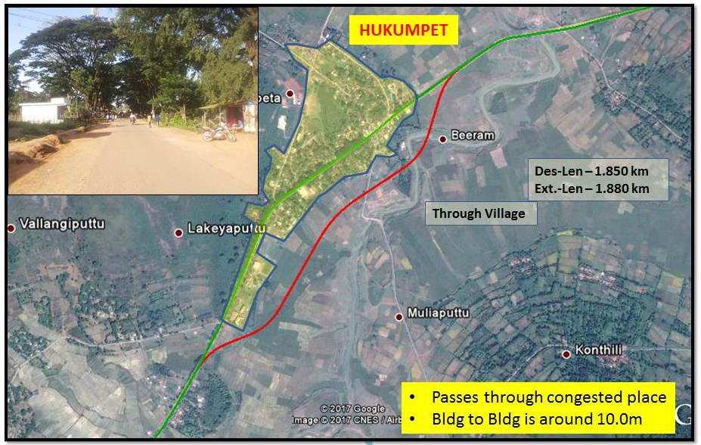

Araku
This existing road in this section fall Km 116+750 to Km 108+500 and passes through the very congested places with commercial cum residential activities along the project road. The available width between the building line to building line is only 12.0 m to 18.0 m with the poor existing geometry with lower speed. Initial public consultation was conducted on 03.10.2018 at two location on the existing alignment. Figure 3-2 gives the satellite imagery of the Araku valley and alignment options explored for the bypass.
The alignment bypass proposed is to avoid the dense build-up areas and improve geometry curves with speed and road safety along design length of 7.8 km, connecting to the existing RUB and area to be acquired is 20.9 ha on RHS found to be suitable. While the conditions are not feasible for any other option as bypass to pass through the LHS as the length of road increases considering the railway track and congested areas besides overall costs for the resettlement and rehabilitation.

Figure 3-2: Analysis of Alternative at Araku
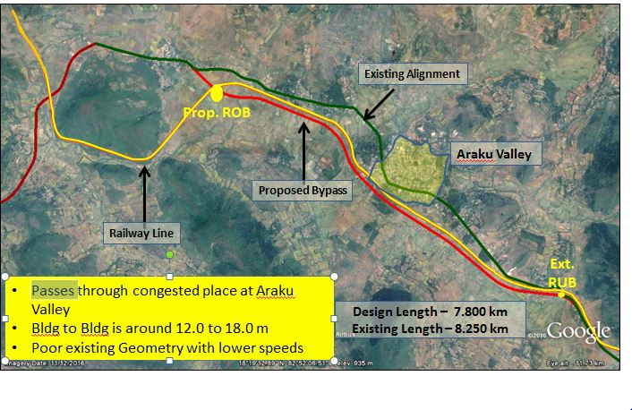

Conclusion
Alternatives alignments options have been studies for the bypasses on the left hand side and found not feasible as the alignment passes through the dense build up area and congestions, high cutting of the hills, railway track and the length and cost is also high. For the suitable alignments no structure will be affected and also reduces the overall road length as compared to the existing length.

SOCIO- ECONOMIC PROFILE OF THE PROJECT AREA

Socio-Economic Base line
The base line socio-economic information has been collected from various primary sources like socio-economic condition of the population, impact on private structures (residential, commercial and encroachments) in addition, detailed information on impact on community assets has also been collected(religious structure, educational institutions are collected). The influence area has been considered as the surrounding mandal’s of the project corridor and Visakhapatnam district of Andhra Pradesh. The existing corridor length of 49.37 km covers Paderu, Hukumpeta, Dumbriguda Araku Valley Mandal’s.
The proposed project road will improve the accessibility of the inhabitants of the rural areas to education, health, employment, and trading opportunities and will consequently alleviate poverty in the process. The improvement will help to increase new economic and employment opportunities by providing improved linkages to markets, production centers and other areas of economic opportunities. As a result, people will have wider options in buying and selling their commodities. The villagers would be able to transport their produce faster and get more profit margins instead of depending solely on local ‘markets’ and middlemen. Fourth, improved connectivity will facilitate travel to tehsil headquarters and other local government/development agencies. Women will especially benefit, since their mobility will be augmented both in terms of access to social services, as well as access to higher levels of schooling. Women’s access to higher levels of health care outside the village particularly during the time of childbearing will also improve considerably. Hence, the proposed Project will bring in economic and social changes in the area, which in turn would bring economic prosperity and would lead to poverty alleviation. Within this given background, this section has made an attempt to understand the social, economic and demographic characteristics of Paderu –Araku road which starts at existing chainage of 2+416 after the Paderu bypass on the Other District Road (ODR) and continue on SH-8 & SH-39 to end at Km 104+400 at Araku of the proposed NH 516E which connects Bharatmala Corridor viz NH-16 at Rajahmundry and NH-26 at Vizianagaram respectively.

Socio-Economic Profile of the Influence Zone
As mentioned earlier, considering influence zone to study the developments taking place within the region, and noted possible improvements in the connectivity to major tourism locations etc., falling within the proposed road. The details covered under the influence zone are demographic, socio economic and cultural details from the secondary source of information from the District Handbook Census 2015 of GoAP of post bifurcation of Andhra Pradesh in 2014 and census 2011.
After the bifurcation of Andhra Pradesh the geographical area covers is 1, 62,760 sq km and ranks as the 7th largest State in the country. Situated in a tropical region, the state has the 2nd longest coastline in the country with a length of 974 km. The State has a forest area of 34,572 Sq km as per the forest records, which accounts for 21.58% the total geographical area. The largest city in Andhra Pradesh is the Visakhapatnam and “Telugu” is the major and official language of this state.
Visakhapatnam is the North Eastern coastal district of Andhra Pradesh and it is bounded on North partly by the Orissa State and partly by the Vizianagaram District, on the South by the East Godavari District, on the West by Orissa state and on the East by Bay of Bengal. There are two distinct geography divisions. The strip of the land along the coast and the interior called the plains divisions, and the hilly area of the Eastern Ghats adjoining on the North and West called the Tribal Agency Divisions.
The Scheduled Areas in Andhra Pradesh is covered under the provisions of V Schedule of Constitution of India. In the State scheduled areas extend over 14132.56 Sq. Kms in (5) districts of Srikakulam, Vizianagaram, Visakhapatnam, East Godavari, West Godavari, covering (4,444) villages. The total mandals covered by Panchayats Extension to Scheduled Area Act is 35 of total 660. The PESA Act is applicable to 588 Gram Panchayats of the total 12919. The Scheduled Tribe population in the State of Andhra Pradesh is 26.31 lakhs as per District Handbook Census 2015. They constitute 5.53% of the total population of the State. There are (35) Scheduled Tribes, out of which (6) tribal groups are categorized as Particularly Vulnerable Tribal Groups (PVTGs) like Kondh, Kondareddi, Savara, Gadaba, Chenchu and Porja etc. The PVTG are characterised by smaller in size and diminishing in number, backwardness and isolation, use of pre agriculture technology and very low literacy.
The demographic profile of Visakhapatnam district is summarized from Table 4-1 to 4-5 below:
Table 4-1: Geographical Area and Population of Project District
Sl. No. | District | Area in sq. km. | Population | No. of HHs
1 | Visakhapatnam | 11161 | 4290589 | 1097042
Andhra Pradesh State |  | 1,62,760 | 84580777 | 21022588
Source: District Handbook Census, GoAP, 2015.

Socio-Economic Features of Visakhapatnam District

Demographic Profile
Demographic profile has an important bearing on the development process. According to the 2011 census, the total population of Visakhapatnam district is around 42.90 lakhs. The proportion of urban population is 47.45% in Visakhapatnam district. The number of households in Visakhapatnam district is 1097042 of which around 52.82 percent are in Rural area and the remaining 47.18 percent are in Urban areas. The average household size is 3.91 in Visakhapatnam district. The Sex ratio is 1006 in total. The proportion of SC population is around 7.68 percent. The ST population in Visakhapatnam district is around 14.42 percent. The basic demographic details are presented in below Table 4-2.
Table 4-2: Demographic profile of Visakhapatnam District of Andhra Pradesh
Description |  | Total | Rural | Urban
No. of Households |  | 1097042 | 579417 | 517625
Population | Persons | 4290589 | 2254667 | 2035922
 | Males | 2138910 | 1113234 | 1025676
 | Females | 2151679 | 1141433 | 1010246
Sex ratio (Females per 1000 Males) |  | 1006 | 1025 | 985
Proportion of SC Population (%) |  | 7.68 | 6.74 | 8.72
Proportion of ST Population (%) |  | 14.42 | 25.72 | 1.89
Source: Primary Census Abstract, Census of India, 2011

Literacy
The literacy rate of Visakhapatnam district as per 2011 census is around 59.86 percent. It is observed that the literacy rate of male in both Rural and urban areas are higher as compared to female literacy rate in the district. A variation across the rural and urban areas and the gender gap in literacy for the project district is presented in the following Table 4-3.
Table 4-3: Gender wise Literacy Rate in Visakhapatnam District of Andhra Pradesh
Literacy Rate % | Total | Rural | Urban
Persons | 59.86 | 47.55 | 73.48
Males | 66.52 | 55.55 | 78.43
Females | 53.23 | 39.75 | 68.46
Gender gap in literacy | 13.29 | 15.80 | 9.98
Source: Primary Census Abstract, Census of India, 2011

Work Participation
The occupational classification as per 2011 Census shows that the percent total workers in Visakhapatnam district account for 44.05 percent of total population of the district. The proportion of main workers to total population in Visakhapatnam district is around 34.52 percent. Out of the total main workers, male main workers accounted for 49.08 percent and female main workers are around 20.05 percent. Of the remaining total population, around 9.53 percent are marginal workers. It can be seen from the below table that, in the project district that nearly 55.95 percent of the total population are non-workers. The details across gender are presented in the following Table 4-4.

Table 4-4: Percentage of Workers and Non-Workers in Visakhapatnam District of Andhra Pradesh (w.r.t. Total Population)
Description | Total | Male | Female
Work Participation Rate (%) | 44.05 | 57.93 | 30.25
Proportion of Main Workers (%) | 34.52 | 49.08 | 20.05
Proportion of Marginal Workers (%) | 9.53 | 8.85 | 10.20
Proportion of Non Workers (%) | 55.95 | 42.07 | 69.75
Source: Primary Census Abstract, Census of India, 2011

Occupation Profile
The occupation classification in Visakhapatnam district shows that, out of the total main workers, cultivators comprising (19.23 Percent), Agricultural Labourers (25.42 percent), Household Industries workers (2.55 percent) and other workers (52.80 percent). Table 13 below gives the details of the occupation across gender.
Table 4-5: Occupation profile of Visakhapatnam District of Andhra Pradesh (w.r.t. Total Main Workers)
Occupation | Total | Male | Female
Cultivators | 19.23 | 17.33 | 23.84
Agricultural labourers | 25.42 | 20.11 | 38.36
Household Industries | 2.55 | 2.28 | 3.20
Other workers | 52.80 | 60.28 | 34.60
Source: Primary Census Abstract, Census of India, 2011

Socio Economic Characteristics of the Project Corridor
The proposed road passes through plane and hilly terrain of scheduled areas of Visakhapatnam. The majority of the tribal populations in this region are Bagata, Konda Dora, Kondha, Valmiki, Mukha Dora, Proja tribes. These areas are governed by the provision of fifth schedule under the constitution and PESA (Panchayat Extended to Schedule Area) ensure self-governance through traditional Gram Sabhas for people living in Schedule areas. There are about 3373 villages under the Panchayat Extension to the Scheduled areas under Integrated Tribal Development Authority (ITDA) Paderu/Visakhapatnam. About an average of 90% in these areas belong to the schedule tribes. These are tribes who are categorized as most vulnerable in nature without having much contact with the outer world know as primitive tribes or Particularly Vulnerable Tribal Groups (PVTG). These are very less developed among the tribal groups.
The project road improvement and upgradation will have significant impacts on the standard of living of the people, their assets, livelihoods, and way of life, health, wellbeing, culture and community. Planned development project impacts could be negative, as well as positive. The socio-economic assessments seek to identify the impacts of the proposed project and focus on the ways and means to minimize the incidents of negative impacts and suggest the mitigation measures.
Therefore it is vital to understand the existing baseline socio-economic scenario in the study area to analysis the magnitude of the possible impacts. The basic socio-economic profile of the study area is presented as follows;

Geographical Coverage of Project Road
The construction starts from Paderu at existing chainage Km 2+416 to 27+450 on Other District Road (ODR), 27+450 to 40+000 on State Highway (SH-8) and 118+400 to 104+400 on State Highway (SH-39) ends at Araku on NH 516E . The geographical coverage of the project extends over 49.37 km upgradation to two lanes/ two lanes with paved shoulders configuration from Paderu to Araku (upto bhalluguda) section comprises as many as forty one (41) villages in four (4) Mandal’s/Tehsil’s as detailed below.
Table 4-6: Details of the Revenue Villages in the Study Area
Socio-Economic details of proposed Project
Details of the Revenue Villages in the Study Area
S.NO | Name | Rural/Urban | No_HH | Population | Total Male | Total Female | SC | ST
 | Paderu Mandal Visakhapatnam Distrcit of A.P
1 | Talarisingi | Rural | 237 | 2858 | 1351 | 1507 | 90 | 2465
2 | Chintala Veedhi | Rural | 427 | 1317 | 615 | 702 | 8 | 981
 | Sub total |  | 664 | 4175 | 1966 | 2209 | 98 | 3446
 | Hukumpeta Mandal Visakhapatnam District of A.P
3 | Patimamidi | Rural | 26 | 90 | 34 | 56 | 0 | 90
4 | Burmanguda | Rural | 57 | 190 | 89 | 101 | 0 | 174
5 | Muliaputtu | Rural | 80 | 310 | 149 | 161 | 0 | 304
6 | Konthili | Rural | 243 | 754 | 371 | 383 | 0 | 701
7 | Hukumpeta | Rural | 470 | 2408 | 1212 | 1196 | 36 | 1722
8 | Chatraiputtu | Rural | 92 | 352 | 152 | 200 | 0 | 341
9 | Gadugupalle | Rural | 190 | 603 | 303 | 300 | 0 | 597
10 | Urrada | Rural | 42 | 154 | 69 | 85 | 0 | 153
11 | Kontapalle | Rural | 206 | 718 | 337 | 381 | 0 | 702
12 | Pedagaruvu | Rural | 58 | 759 | 108 | 651 | 0 | 728
13 | Barapalle | Rural | 165 | 529 | 271 | 258 | 0 | 527
14 | Masada | Rural | 128 | 505 | 239 | 266 | 0 | 500
15 | Matchyapuram | Rural | 40 | 159 | 73 | 86 | 0 | 158
16 | Baluroda | Rural | 145 | 463 | 213 | 250 | 0 | 462
17 | Rangaseela | Rural | 272 | 950 | 461 | 489 | 0 | 929
 | Sub total |  | 2214 | 8944 | 4081 | 4863 | 36 | 8088
 | Dumbriguda Mandal, Visakhapatnam District of A.P
18 | Kinchumanda | Rural | 400 | 2141 | 1293 | 848 | 3 | 2016
19 | Billaputtu | Rural | 136 | 550 | 258 | 292 | 0 | 540
20 | Gondiguda | Rural | 14 | 48 | 21 | 27 | 0 | 44
21 | Kusumavalasa | Rural | 58 | 241 | 109 | 132 | 0 | 240
22 | Kosangi | Rural | 149 | 583 | 290 | 293 | 0 | 575
23 | Dumbriguda | Rural | 280 | 1795 | 812 | 983 | 17 | 1692
24 | Pedapadu | Rural | 58 | 252 | 124 | 128 | 0 | 251
25 | Antriguda | Rural | 45 | 187 | 88 | 99 | 0 | 185
26 | Pantalachinta | Rural | 23 | 98 | 52 | 46 | 0 | 97
27 | Araku | Rural | 574 | 2279 | 1086 | 1193 | 6 | 1682
28 | Kuridi | Rural | 106 | 461 | 223 | 238 | 0 | 330
29 | Nimmagedda | Rural | 260 | 1023 | 502 | 521 | 0 | 1010
 | Sub total |  | 2103 | 9658 | 4858 | 4800 | 26 | 8662
 | Araku Mandal, Visakhaptanam District of A.P
30 | Yandapallivalasa | Rural | 678 | 3850 | 1235 | 2615 | 115 | 2827
31 | Padmapuram | Rural | 472 | 2022 | 1034 | 988 | 22 | 1911
32 | Kottavalasa | Rural | 115 | 453 | 212 | 241 | 0 | 447
33 | Kantabamsuguda | Urban | 1433 | 6714 | 3921 | 2793 | 180 | 4313
34 | Panirangini | Rural | 226 | 973 | 468 | 505 | 0 | 967
35 | Littiguda | Rural | 34 | 134 | 71 | 63 | 0 | 132
36 | Ravvalaguda | Rural | 89 | 371 | 171 | 200 | 0 | 358
37 | Sarabhaguda | Rural | 244 | 1008 | 478 | 530 | 5 | 983
38 | Bosubeda | Rural | 145 | 587 | 272 | 315 | 0 | 555
39 | Gadyaguda | Rural | 123 | 467 | 223 | 244 | 2 | 445
40 | Boduguda | Rural | 16 | 59 | 25 | 34 | 0 | 59
41 | Kothaballuguda | Rural | 193 | 1321 | 384 | 937 | 0 | 1289
 | Sub total |  | 3768 | 17959 | 8494 | 9465 | 324 | 14286
 | Grand Total |  | 8749 | 40736 | 19399 | 21337 | 484 | 34482
Source: Census 2011

Demographic Profile
The sociological aspects of this study include human settlements, demography, and social strata such as Scheduled Castes and Scheduled Tribes and literacy levels besides infrastructure facilities available in the study area. The economic aspects include occupational structure and income levels of workers. The profile comprises of the study area.
- The total population of 41 villages covering four Mandal’s are 40736 in which the male population is 19399 (47.62%) and the female population is 21337 (52.38%). This shows that the female population slightly higher in ratio, Yandapallivalasa female population is double the size of male population as per census 2011.
- The male and female ratio of the study area is 1099 females per every 1000 males.
- Among the total population 84.65% (34482) consists of Scheduled Tribes, 1.19% (484) are of the Scheduled caste population and 14.16% (5770) people belong to other castes and mainly backward communities.
- Among the total population, 50.02% (20377) of the people are literate and 39.76% (16198) of the people are illiterate. This shows that nearly half of the population is literate
- Among the literates 57.18% (11094) are males and 43.50% (9283) are females. This shows that the male literates are more than the female literates.
- Totally the illiterate constitute 39.76% (16198) of which the female cover 32% (6209) and the male 46.8% (9989) of the population. This shows that the female illiterates are more than the male illiterates.
- Average Household Size is 4.6 in the project road.
- The study area had an average family size of 4.6 persons per house hold on 2011. This is moderate family size and is in comparison with the other part of the district.
The village wise population breakup and literacy levels of study area of the project, as per 2011 census is enclosed as Annexure-4.1

Occupational Distribution
The tribal population in the region earn major incomes through agriculture which is facing number of challenges. About 70 to 80 per cent of the tribal farm holdings in these villages fall under the category of the small and marginal land holdings. The average farm size is about two-thirds of an acre. The main crop is paddy followed by cereals and millets (Ragi, Sama, Maize, Rajamah). The total working population of the district in comparison with the Andhra Pradesh state is 18.89%, out of which 5.76% is Agriculture and 13.10 non agriculture workers. A large number of the tribal households restore to subsidiary occupation for meeting their minimum requirements. Unskilled manual labour is taken up by large number of tribal’s. They even migrate to the surrounding urban area for work.
Main source of cash income of the majority of the tribals is from the collection and sale of firewood and other minor forest produce. These are collected from the forest surroundings of the villages. The tribals collect Hill Brooms, Honey, Addaleaf, Tamarind, Myrobalan, Mahuva seed and other minor products of forest produce. The district working population is 44.04% which is close to the project area working population of 43.46%. Whereas the women working population is 20.00%.
In the project road, among the total population 56.54% (23031) are non-workers and remaining constitute the working population i.e 43.46% (17705). And out of the working population 28.38% (11559) are main workers and 15.09% (6146) are marginal workers.

LAND ACQUISITION AND IMPACTS

Introduction
The improvement/up-gradation of 49.37 Km of this project road will have direct as well as indirect impacts. The direct losses likely to be experienced by the people are loss of residential structure, loss of commercial structure, loss of agricultural land, loss of fruit bearing and non-fruit bearing trees, loss of common property etc. Similarly, widening of the existing roads and acquisition of land have many likely indirect affects. In India ribbon development / congestion along the state highways and other roads are an uncontrolled phenomenon and this project road is not an exception. There are areas where education, health and religious institutions are constructed within the RoW of the project road. Nevertheless, the social benefits arising due to the project shall trigger improved accessibility to various services such as easy access to markets, health facilities, schools, workplace etc. It will in turn increase the income of the local people and elevate their standard of living. In this project road, the impact is only on land owners and the project road has no non-titleholders that includes squatters and encroachers. The land intake is due to proposed bypasses, realignments and curve improvements.
A detailed census survey for all likely affected structures was conducted followed by socio economic survey for 35% of affected families. The census and socio economic survey was conducted only for structure owners and the survey for land owners was not able to be conducted as the land surveys/Joint Measurement Surveys by Revenue department has not yet been conducted. .

Land Acquisition Estimates For The Project Stretch
Based on field verification and assessment of revenue maps, it has been found that the land width in project section is varying between 20m to 32m. A total of 46.65 ha is to be acquired for the project. Of the total 46.65 ha, private land constitutes 31.19 ha, government land constitutes 14.46 ha and forest land 1 ha. A district-wise Land Acquisition detail of 35 affected villages in the project stretch is given in Table 5-1 below.
Table 5-1: Land Acquisition Type by Area
S.No | Name of the district | Name of the Mandal | No. of Villages (Land to be Acquired) | Land to be Acquired (ha)
 |  |  |  | Government | Private | Forest | Total
1 | Vishakhapatnam | Paderu | 2 | 1.01 | 0.13 | 0 | 1.14
2 |  | Hukumpeta | 13 | 0.38 | 11.29 | 0 | 11.67
3 |  | Dumbriguda | 12 | 5.83 | 3.42 | 1 | 10.25
4 |  | Araku Valley | 8 | 7.24 | 16.35 | 0 | 23.59
Total |  |  | 35 | 14.46 | 31.19 | 1 | 46.65
Source: As per LA Plan May, 2019
Private land required for the project shall be acquired as per the provisions of the National Highway Act 1956 or as per the direct land purchase policies of the project states. Government land shall be transferred as per established procedures.
Table 5-2: Details of Land Survey numbers of the total land
District | Mandal | No of Survey numbers for private land | No of Survey numbers for Govt. land | Total
Visakhapatnam | Paderu | 8 | 3 | 11
 | Hukumpeta | 97 | 14 | 111
 | Dumbriguda | 57 | 67 | 124
 | Araku Valley | 150 | 44 | 194
Total |  | 312 | 128 | 440
Source: As per LA Plan May, 2019

Impacts on Structures
As per the Census survey, a total of 299 structures will be impacted due to project activities. The 299 structures include 252 private structures 35 government structures and 12 CPRs. All 252 structures belong to private owners and the survey found no structures on government land. The project therefore has no squatters and encroachers. Among the CPRs affected majority are religious temples and bus shelters. The table 5-3 below gives categories of various structures likely to get affected. The census and socio economic list of likely affected PAP’s are given in Annexure 5.1.
Table 5-3: Impact of the project on affected structures
Paderu Araku
Impact Category | Likely Impact
Titleholder Residential
- Residential | 89
- Commercial | 84
- Residential + Commercial | 15
Others (Compound walls, Cattle Sheds, Toilets, Sheds) | 64
Sub-Total | 252
Common Property Resources
School | 5
School – Compound Walls | 6
Religious (Including Tombs) | 12
Bus Stand/ Shelter | 15
Government Buildings | 3
Others (Pump house, Shed, Toilets) | 6
Sub-Total | 47
Grand Total | 299
Source: Feb – March census Survey, 2018

Impact on Structure by Typology of Structure
Of the total 252 affected structures, 109 (36.45%) are pucca and 89 (29.77%) are Semi-pucca and 62 (20.74%) of the kutcha structures covering an area of 6589.65 square meters. Details are presented in Table 5-4 below.
Table 5-4: Type and Area of Structures Affected along project
Sl. No. | Type | Total Structures Affected |  | Total Area affected (Sq.mts)
 |  | No | % | No | %
1 | Pucca | 109 | 36.45 | 4832.49 | 73.33
2 | Semi pucca | 89 | 29.77 | 962.88 | 14.61
3 | Kutcha | 54 | 20.74 | 794.28 | 12.05
Total |  | 252 | 100.00 | 6589.65 | 100.00
Source: Feb – March census Survey, 2018

Socio Economic Profile of Project Affected Household
As mentioned above the socio economic survey was conducted only for structure owners. The survey for land owners shall be conducted soon after the availability of land owners list. The following section presents socio economic profile of 35% (92) of structure owners.
The average household size of the affected households is 5.1. A total of 461 people are getting affected which includes 220 (47.72%) males and 241 (52.28%) females which shows that females representation is more than the males. Majority (79.35 %) of PAHs are residing in the project area since more than 10 years, 9.78% are residing since last 5-10 years and rest of them are residing since less than 4 years.
Analysis on literacy level of the head of the affected household shows that most of them are literates except around 26.09% is illiterate. A majority 22.83%head of the households are educated upto high school level.
The affected population is dominantly Hindu’s which is 87 %, followed by 10 % are Christians and 2 % are Muslims. More than fifty percentage i.e., 60(65.22%) households are Schedule Tribe. it is also found majority of the families are joint families i.e, 49 (53.26%) and remaining 43(46.74%) of the affected households are nuclear families . The details are given in Table no 5-5 below:
Table 5-5: Socio-cultural characteristics of the affected households
Item | Description | No | % of total
Population | Male | 220 | 47.72
 | Female | 241 | 52.28
 | Total | 461 | 100.00
Religious Group | Hindu | 80 | 86.96
 | Muslim | 2 | 2.17
 | Christian | 10 | 10.87
 | Total | 92 | 100.00
Social Group | General | 8 | 8.70
 | BC | 23 | 25.00
 | SC | 1 | 1.09
 | ST | 60 | 65.22
 | Total | 92 | 100.00
Family Type | Joint | 43 | 46.74
 | Nuclear | 49 | 53.26
 | Total | 92 | 100.00
Years of stay | Up to 4 year | 10 | 10.86
 | 5 to 6 years | 7 | 7.60
 | 7 to 9 years | 2 | 2.19
 | 10 and above years | 73 | 79.35
 | Total | 92 | 100.00
Education level of HH | Illiterate | 24 | 26.09
 | Literate | 3 | 3.26
 | Primary | 13 | 14.13
 | Middle Class | 10 | 10.87
 | SSC | 21 | 22.83
 | Inter | 5 | 5.43
 | Degree | 14 | 15.22
 | PG | 2 | 2.17
 | Total | 92 | 100.00
Source: Feb – March Census Survey, 2018

Economic Profile
Majority of the PAP’s are engaged in commercial activities like Petty Shop Keeping (41.30%) followed by Agriculture labour (17.39%), Non-Agriculture Labour (10.87%) Self-employed (9.78%) and other occupations. Details are presented in Table 5-6 below.
The income levels of majority of the households fall under middle income category earning of Rs 1800000 to Rs 2500000 per annum (56.52%). The incidence of lower-income families is about 17.40 % who earn below 180000 per annum. About 26.08 % of them are higher middle income families who are earning above Rs. 250000 per annum.
Table 5-6: Occupational pattern and income profile of affected households
Item | Description | Number of HH | % of total
Occupation of HH | Farmers | 3 | 3.26
 | Trade/Business | 4 | 4.35
 | Petty shop keeping | 38 | 41.30
 | Agri labour | 16 | 17.39
 | Non-Agri labour | 10 | 10.87
 | HH Industries/Artisan activity | 1 | 1.09
 | Govt service | 5 | 5.43
 | Private service | 1 | 1.09
 | Self employed | 9 | 9.78
 | Others | 5 | 5.43
 | Total | 92 | 100.00
Annual income (Rs) | Up to 18000000 | 16 | 17.40
 | >1800000 to 2500000 | 52 | 56.52
 | Above 2500000 | 24 | 26.08
 | Total | 92 | 100.00
Source: Feb – March Census Survey, 2018

The expenditure pattern for the affected household’s shows that a majority of them are having an average monthly expenditure above Rs.30000 per month. Details are given in Table 5-7.
Table 5-7: Monthly Expenditure
Monthly Expenditure (Rs) | Description | No of HH | % of HH
 | <5000 | 2 | 0.40
 | 5000 to 10000 | 3 | 0.61
 | 10000 to 20000 | 10 | 2.02
 | Total | 495 | 100.00
Source: Feb – March census Survey, 2018

Savings, Indebtedness and Loan
Out of the 92 enumerated households, 33 households have long term deposits and only 2 have short term deposits in the banks. The details are given below in Table no 5-8
Table 5-8: Financial Deposits
Type of Deposit | Institution where deposited | No's
Long Term | Bank, LIC | 33
Short term | Bank | 2
 | Total | 35
Source: Feb – March Census Survey, 2018
As per socio-economic survey, out of the total 92 affected households 55 families who have taken some form of loan out of which 28 (50.09%) families have taken loan from money lenders and 27 (49.09%) families have taken a loan from Banks. Details of source of loan are mentioned in Table 5-9.
Table 5-9: Indebtedness & Source of loan
S.No | Indebtedness | Number | %
1 | Yes | 55 | 58.69
2 | No | 38 | 41.31
 | Total | 92 | 100

S. NO | Source of Loan | Number | %
1 | Bank | 27 | 49.09
2 | Money Lender | 28 | 50.09
 | Total | 55 | 100

Health Status
As per the response it shows that nearly 3.26% of the families have some form of illness recorded during the month of March, 2018. No major illness has been reported as per the survey results except some chronic diseases. There is no HIV/ AIDS case reported during survey and around 95% households indicated knowledge about HIV/AIDS and the source of information have been print media, Television, NGO, Govt. Campaign etc. Details of health status are mentioned in Table 5-10.
Table 5-10: Health Status of PAFs
S. NO | Health Status of PAFs | Number | %
1 | Illness | 3 | 3.26
2 | No illness | 89 | 96.74
 |  | 92 | 100.0
Source: Feb – March Census Survey, 2018

Vulnerable Group
The information on vulnerable groups was also collected during / Socio-economic survey. A total of 67 households are falling under vulnerable category and these households need special consideration so that they can be benefitted from the project and do not further get socially and economically marginalised. Majority of the households belongs to Schedule Tribe and other vulnerable categories include Women Headed Households (WHH), Schedule Caste and Below Poverty Level (BPL) categories. The affected households falling within any of these groups has been considered as vulnerable. The project road falls under schedule area hence maximum of 60 vulnerable households belong to Schedule Tribe’s included of 19 WHH, 6 BPL households and 1 household belong to the category of schedule caste. Table 5-11 gives the details of the vulnerability.
Table 5-11: Vulnerable Category
Vulnerability Category | No of Persons
Scheduled Tribe (which also includes 19 WHH and 6 BPL) | 60
Scheduled Caste | 1
Total | 61
Source: Feb – March, Census Survey, 2019

Impact on Women
Project would impact 19 Women Headed Households who belongs to Schedule tribe. The percentages of such families affected are around 11% from the total affected households. For the cause of compensation and assistance to be provided to these households, it is better to consider the absolute number of such families in the affected and displaced categories. Chapter 6 provides details on mitigation and other support measures regarding gender issues.

Displaced Households
Out of the total 252 affected structures, 65 structures are likely to be displaced completely and majority of them are used for commercial purposes. Details of the 65 displaced households are shown in the table 5-12 below:

Table 5-12: Details Likely displaced households
S. No. | Descriptions | Nos. | % of Displaced HH
1 | Losing Total House | 20 | 30.77
3 | Losing Total Plot and Total House | 4 | 6.15
4 | Losing Total Commercial Structure | 30 | 46.15
5 | Losing Total Commercial Structure and Total Plot | 4 | 6.15
6 | Losing Total House and Total Commercial Structure | 7 | 10.77
 | Total | 65 | 100.00
Source: Feb – March census Survey, 2018

ANTICIPATED IMPACTS AND MITIGATION MEASURES

Introduction
The construction and operation of the proposed national highways involves various activities. The impacts of these activities on environmental and social attributes have been identified and discussed with respective mitigation measures under separate headings in EIA report and continued in this chapter. The impacts have been assessed both quantitatively and qualitatively for various environmental and social components. The impacts are identified by the development and operational activities resulting from the proposed project.

Impacts
After a series of consultations held with community in project influence zone, people are found to be in favour of construction of roads under the project, primarily since the approach roads will improve the urban and rural connectivity to key economic centers of the state, development of tourism and thus will improve their day to day affairs. The overall social, economic and political status of the tribal community in tribal areas shows that they are trying to integrate with the mainstream society and their lifestyle.

Positive Impacts
- Improved pavements will invite transport operation connecting remote areas improving access to markets, jobs, education and health services
- Crop pattern may change so that the perishable cash crops can have an easy access to the markets and get better prices for their agriculture products.
- Tourism will improve contributing to the local economic activities
- Better accessibility to infrastructure and services in the project influence area
- Reduce travel time, fuel consumption and pollutants emitted from the operated vehicles.
- Access to transportation on safe roads has direct impacts on economic standing and quality of life in affected community.
- Some of the barriers in the agency areas are access to good health care, medical assistance and education facilities. Provided better roads, maternal mortality in affected communities and cost of transportation is reduced, and improves health and educational services.
- Enhancement in the well-being, women become more independent and lessen the risks associated with their vulnerabilities, promoting gender and social equality.
- Reduction in road accidents resulting in reducing deaths and injuries
- Increased industrial, business and commercial activities
- Direct or indirect increase in job/ employment opportunities

Negative Impacts
- Improvement of existing roads requires acquisition of agriculture lands and landed assets.
- Temporary or permanent loss of livelihood due to acquisition of lands and involuntary relocation of the project affected families.
- Conflicts due to influx of construction workers
- Likely adverse impacts due to the noise and vibrations in the surrounding areas during construction phase
- Some of the common property likes religious structures, schools, hospitals, bus shelters, government and communities building are impacted during the construction of the project
- A variety of utilities serving in the regional needs like electricity poles, transformers, telephones towers/poles, water pipelines, and drainage and sewage systems which are within the impact zone shall be impacted.

Mitigation Measures
Adoption of Corridor of Impact approach to ensure that the width required for the actual construction of the road, including carriageway, shoulder and embankments is retained and the social inputs to project design shall ensure that the corridor of impact is reduced, within acceptable design principles and standards, towards avoidance of land acquisition and minimize adverse social impacts. Some of the significant steps towards this will be:
- The acquisition of land and private properties shall be carried out in accordance with the RAP and entitlement framework of the Project. Concerned owners will be informed in advance to shift the utilities in coordination with the project proponents before construction starts to avoid disruption of regional services.
- Alignment shift to minimise the impact on the religious and community structures, if unavoidable relocation will be undertaken after adequate consultations.
- Participatory approach taken up for discussions with the various stakeholders for building community consensus to to resolve project related impacts on the community at large.

Impacts on Vulnerable Communities
The study found that a large section of the affected community belongs to tribal groups who are socially and economically weaker and prone to vulnerable conditions other than SC’s and backward castes. These communities earn on daily basis for their livelihood. Many of them do not have access to social infrastructure facilities, hence literacy and income levels are low etc. The most vulnerable of them are the women, though they work more than men.

Mitigation Measures
In order to strengthen the government schemes to tackle social exclusion and poverty. Special emphases shall be given to health and educational facilities in tribal region. Adivasi educational institution should be promoting safe and inclusive school environment. Traditional knowledge of women including healing practices shall be promoted for indigenous treatment systems. Training and skill development programs to be given to empower their abilities for promoting gender equality and social, economic and political inclusion.

Impacts during the construction Stage
During construction phase, various types of equipment will be brought to the site. These include D G Sets, batching plant, drillers, earthmovers, rock bolters, etc. The storing and working space requirement of this construction equipment’s would be significant. In addition, land will also be temporarily acquired for the duration of project construction for storage of the quarried material before crushing, crushed material, cement rubble, etc.
The proposed road project would envisage construction of temporary camps to accommodate construction workers from outside. This immigration of the labours for the project is known to cause the problem for arranging the space for their stay and livelihood. Labour camps require space nearby construction site to house the laborers. The immigration of large number of labour force will create problems of storing, treating and disposing the sewage waste and solid waste management. This may result in discharge of sewage into the nearby water body spreading water borne diseases such as malaria and pathogenic diseases.

Mitigation Measures
The Contractor shall preferably use unskilled labour drawn from local communities to give maximum benefits to the local community.
The Contractor as per prevalent rules shall carry out negotiations with the Panchayat member and the land owners in fair manner for obtaining their consent for temporary use of lands for construction camp/construction/borrow areas etc. Temporary land arrangements shall not be from the forest reserves except under special permission circumstances where it is unavoidable due to the vast forest reserves in Project Influence Area. He should also ensures Sewage system for the camp are designed, built and operated in such a manner that no health hazards occurs and no pollution to the air, ground water or adjacent water courses take place. Adequate water supply, safe and convenient passage for vehicles, pedestrians and livestock to and from roadsides and property access connecting the project road, providing temporary connecting road is to be provided for all.

Impacts during the Operation Stage
Most of the project road stretch passes through agricultural areas, frequented by transportation of agricultural equipment’s, harvested crops and domestic animals for grazing purposes. The common traffic – animal conflict is accidents by rash driving or breakdown of vehicles leading to death of cattle and domestic animals. Most significant issues at this stage are pedestrian safety, traffic safety, and emergency preparedness that may impact the terrestrial ecology.

Mitigation Measures
Commuters and road using community will be educated on the road safety issues to reduce the accidents involving traffic animal. PWD shall ensure that all drains (side drains, median drain and all cross drainages) are periodically cleared especially before monsoon season to facilitate the quick passage of rainwater and avoid flooding.
Public awareness are necessary on noise levels and health affects through newspapers, regular consultations and pamphlet during the operation stage.
Table 6-1: Summary of Impacts
S.No | Parameters | Negative Impacts | No Impacts | Positive Impacts
A. Impacts in the Project location
1 | Displacement of people | ×
2 | Loss of cultural and religious Structures | ×
3 | Loss of livelihood and landed Assets | ×
4 | Loss of partial agriculture lands | ×
5 | Relocation of Community utilities and Common Property Resources | ×
6 | Relocation of the Utilities | ×
7 | Tree Cutting | ×
B. Impact due to Project Construction
8 | Air Pollution, Noise Pollution | ×
9 | Water Pollution from construction waste | ×
10 | Disposal of Debris from dismantling structures and road surface | ×
11 | Health Risks at Construction Site | ×
12 | Temporary Traffic Diversions/ detours and Risk of existing structures | ×
13 | Dust Generation | ×
14 | Labour Camp | ×
15 | Employment Generation (direct/indirect) |  |  | ×
C. Impacts due to Project Operation
16 | Employment Opportunity |  |  | ×
17 | Traffic congestion reduce |  |  | ×
18 | Mobility |  |  | ×
19 | Safety- Sign boards
20 | Less fuel consumption/ Reduction in Vehicular Emission |  |  | ×
21 | Enhancement of Economy |  |  | ×
22 | Reduce travel time and better comfort |  |  | ×
23 | Tourism Development |  |  | ×
24 | Access to medical assistance and emergency services |  |  | ×
25 | Access to Social Infrastructure (Schools, collages, Hospitals etc) |  |  | ×
26 | Social and Gender Equality |  |  | ×

POLICY, LEGAL AND ADMINISTRATIVE FRAMEWORK

Introduction
The legal framework and principles adopted for addressing resettlement issues in the project have been guided by the existing legislation and policies of the Government of India (GOI), the State Government of Andhra Pradesh. Prior to the preparation of the RAP, a detailed analysis of the existing national and state policies was undertaken and the section below provides details of the various national and state level legislations studied and their applicability for the project. This RAP is prepared based on the review and analysis of all applicable legal and policy frameworks of the country.

Some Important legal provisions to safeguard tribal interests

The Agency Tracts Interest and Land Transfer Act, 1917: Enacted in 1917
This act checked transfers of land in the Agency tracts of Ganjam (presently in Orissa), Visakhapatnam (covering the present Srikakulam, Vizianagarm and Visakhapatnam districts) and Godavari (covering the present East and West Godavari districts) districts. It regulated debt and interest on the borrowings by the hill tribes and transfer of their immovable property. It was enacted primarily to safeguard the interest of hill tribes of the area over which it extended and to protect them from exploitation by non-tribals and moneylenders. It permitted transfer of land only among tribal and laid down that the interest accrued over the debts borrowed by the tribal shall not exceed the principal amount. The land acquisition in the proposed project will be abided by the PESA Act.

The Andhra Pradesh Scheduled Areas Land Transfer Regulation, 1959
This promulgation extended the provisions of the Agency Tracts Interest and Land Transfer Act, 1917 of the former Madras presidency to the scheduled areas of the Andhra region (Srikakulam, Vizianagarm, Visakhapatnam, East Godavari and West Godavari districts) of the reorganized state of Andhra Pradesh (Andhra Pradesh was reorganized with effect from 1st November 1956 duly including the telugu speaking areas of the then Madras Presidency and the former Hyderabad State). Through a separate Regulation it was further extended to the tribal tracts of Telangana region (Adilabad, Warangal, Khammam and Mahabubnagar districts) with effect from 1st December 1963.

The Scheduled Tribes and Other Traditional Forest Dwellers (Recognition of Forest Rights) Act, 2006
This is an act to recognize and vest the forest rights and occupation in forest land in forest dwelling scheduled tribes and other traditional forest dwellers who have been residing in such forests for generations but whose rights could not be recorded; to provide for a framework for recording the forest rights so vested and the nature of evidence required for such recognition and vesting in respect of forest land.

The Provision of Panchayat Extension to Scheduled Areas (PESA) Act
The 73rd and 74th Constitutional (Amendments of 1992), accommodate special powers to PRIs, were later extended, with separate provisions to the Scheduled Areas as well through the Panchayat (Extension to the Scheduled Areas) Act of 1996. With the strength and support of PESA Act, 1996 the PRI bodies at the district and village level have been endowed with special functional powers and responsibilities to ensure effective participation of the tribal people in their own development. This would also help preserve/ conserve their traditional rights over natural resources. A brief summary of powers given to PRIs under PESA Act is given below:
Powers Given to Gram Sabha under PESA Act
- Listing of development projects for execution through Gram Panchayats.
- Identification and recommendation of beneficiaries under poverty alleviation programs.
- Any proposal/plan presented by the Gram Panchayat needs prior consultation and approval with the Gram Sabha
- Prior approval for collection of taxes
- Wherever necessary asking for information from gram Panchayat
- Intervene in conflict resolution through traditional and customary traditional methods if required
- Gram Sabha has power to safeguard the cultural identity, community resources and dispute resolution per traditional customs and regulations
- Control and supervision of functions and powers of Gram Panchayat

Right to Fair Compensation and Transparency in Land Acquisition, Rehabilitation and Resettlement Act (RFCT in LARR), 2013
The Right to Fair Compensation and Transparency in Land Acquisition, Rehabilitation and Resettlement Act, 2013 (RFCT in LARR Act - 2013) has been effective from January 1, 2014 after receiving the assent of the President of Republic of India. This Act extends to the whole of India except the state of Jammu and Kashmir. The Act replaced the Land Acquisition Act, 1894.
The aims and objectives of the Act include: (i) to ensure, in consultation with institutions of local self-government and Gram Sabhas established under the constitution of India, a humane, participative, informed and transparent process for land acquisition for industrialization, development of essential infrastructural facilities and urbanization with the least disturbance to the owners of the land and other affected families; (ii) provide just and fair compensation to the affected families whose land has been acquired or proposed to be acquired or are affected by such acquisition; (iii) make adequate provisions for such affected persons for their rehabilitation and resettlement; (iv) ensure that the cumulative outcome of compulsory acquisition should be that affected persons become partners in development leading to an improvement in their post-acquisition social and economic status and for matters connected therewith or incidental thereto.
Section 27 of the Act defines the method by which market value of the land shall be computed under the proposed law. Schedule I outlines the proposed minimum compensation based on a multiple of market value. Schedule II through VI outline the resettlement and rehabilitation entitlements to land owners and livelihood losers, which shall be in addition to the minimum compensation per Schedule I.
The Chapter II and III of the RFCT in LARR Act - 2013 regarding determination of social impact assessment and public purpose and special provision to safeguard food security shall not apply to the project such as (a) vital to national security or defense of India and every part thereof, including preparation for defense or defense production; (b) rural infrastructure including electrification; (c) affordable housing and housing for the poor people; (d) industrial corridors ; and (e) infrastructure and social infrastructure projects including projects under public private partnership where the ownership of land continues to vest with the Government.
- The five year period set by the principal Act in Section 24 under sub-section (2), for lapse of 1894 Act shall exclude the cases where acquisition process is held up on account of any stay or injunction issued by any court or the period specified in the award of a Tribunal for taking possession.
- The five year period set by the principal Act for any land acquired and unused is now will be a period specified for the setting up of any project or five years, whichever is later.

R&R Principles for the Project
Based on the above analysis of government provisions, the following resettlement principles are adopted for this Project:
- Screen the project early on to identify past, present, and future involuntary resettlement impacts and risks. Determine the scope of resettlement planning through a survey and/or census of displaced persons, including a gender analysis, specifically related to resettlement impacts and risks. Measures to avoid and minimize involuntary resettlement impacts include the following: (i) explore alternative alignments or locations which are less impacting, (ii) ensure the appropriate technology is used to reduce land requirements, (iii) modify the designs, cross sections, and geometrics of components to minimize the ROW and ensure involuntary resettlement is avoided or minimized.
- Carry out meaningful consultations with stakeholders, Project Affected Persons, host communities, and concerned nongovernment organizations. Inform all displaced persons of their entitlements and resettlement options. Ensure their participation in planning, implementation, and monitoring and evaluation of resettlement programs. Pay particular attention to the needs of vulnerable groups, especially those below the poverty line, the landless, the elderly, women and children, and indigenous peoples, and those without legal title to land, and ensure their participation in consultations. Establish a grievance redress mechanism to receive and facilitate resolution of the concerns of displaced persons. Support the social and cultural institutions of displaced persons and their host population. Where involuntary resettlement impacts and risks are highly complex and sensitive, compensation and resettlement decisions should be preceded by a social preparation phase.
- Improve, or at least restore, the livelihoods of all displaced persons through; (i) land-based resettlement strategies when affected livelihoods are land based where possible or cash compensation at replacement cost for land when the loss of land does not undermine livelihoods, (ii) prompt replacement of assets with access to assets of equal or higher value, (iii) prompt compensation at full replacement cost for assets that cannot be restored, and (iv) additional revenues and services through benefit sharing schemes where possible.
- Provide physically and economically displaced persons with needed assistance, including the following: (i) if there is relocation, secured tenure to relocation land, better housing at resettlement sites with comparable access to employment and production opportunities, integration of resettled persons economically and socially into their host communities, and extension of project benefits to host communities; (ii) transitional support and development assistance, such as land development, credit facilities, training, or employment opportunities; and (iii) civic infrastructure and community services, as required.
- Improve the standards of living of the displaced poor and other vulnerable groups, including women, to at least national minimum standards. In rural areas provide them with legal and affordable access to land and resources, and in urban areas provide them with appropriate income sources and legal and affordable access to adequate housing.
- Develop procedures in a transparent, consistent, and equitable manner if land acquisition is through negotiated settlement to ensure that those people who enter into negotiated settlements will maintain the same or better income and livelihood status.
- Ensure that displaced persons without titles to land or any recognizable legal rights to land are eligible for all compensation, relocation and rehabilitation measures, except land.
- Prepare a resettlement plan elaborating on the entitlements of displaced persons, the income and livelihood restoration strategy, institutional arrangements, monitoring and reporting framework, budget, and time-bound implementation schedule. This resettlement plan will be approved by World Bank prior to contract award.
- Disclose a draft resettlement plan, including documentation of the consultation process in a timely manner, before project appraisal, in an accessible place and a form and language(s) understandable to displaced persons and other stakeholders. Disclose the final resettlement plan and its updates to displaced persons and other stakeholders.
- Conceive and execute involuntary resettlement as part of a development project or program. Include the full costs of resettlement in the presentation of project’s costs and benefits. For a project with significant involuntary resettlement impacts, consider implementing the involuntary resettlement component of the project as a stand-alone operation.
- Pay compensation and provide other resettlement entitlements before physical or economic displacement. Implement the resettlement plan under close supervision throughout project implementation.
- Monitor and assess resettlement outcomes, their impacts on the standard of living of displaced persons, and whether the objectives of the resettlement plan have been achieved by taking into account the baseline conditions and the results of resettlement monitoring. Disclose monitoring reports.

Procedure for Land Acquisition under the Project
The land acquisition in this project context will be as per the National Highway Act, 1956 and later amendments or as per MoRT&H circular date 28th December, 2017.

The process for land acquisition under NH Act, 1956 is as follows
- Submission of requisition for particular land is needed for a “public purpose” along with other required document to concerned District Authority. For issue of preliminary notification as known as ‘intention notification’.
- Preliminary Notification, section (3A) – intention of Central Govt. to acquire land and commencement of secondary level of consultations with the PAP’s.
- Completion of SIA study culminating in SIA report.
- To Conduct public hearing for SIA and RAP
- Preparation and disclosure of the R&R schemes
- Updating of land records by LA Authority
- Issue of 3B notification for power to entry for survey
- Notification of 3C for Hearing of objection under NH act.
- Declaration that land is required for public purpose u/s 3D.
- Power to take possession under section 3E of the Act.
- Power to enter the land where land has vested in the Central Government u/s 3F
- Determination of the compensation as per schedule II & III of the land acquisition act of 2013 and NH Act 1965 u/s 3G.
- Payment of full amount of compensation u/s 3F
- Taking possession of land acquired.
- Infrastructural component of R&R package to be provided.

The process of Land Acquisition as per MoRT&H circular date 28th December, 2017
The project States HP, AP, UP & Rajasthan can follow the direct land purchase policies and procedures of the respective States. As per this circular the land can be purchased directly following the acts, policies and procedures prevailing in the respective project States

World Bank’s Safeguard Policies
- Indigenous People (OP 4.10)
This policy contributes to the Bank's mission of poverty reduction and sustainable development by ensuring that the development process fully respects the dignity, human rights, economies, and cultures of Indigenous Peoples. For all projects that affect Indigenous Peoples the borrower is required to engage in a process of free, prior, and informed consultation, resulting in broad community support to the project by the affected Indigenous Peoples. This policy include measures to (a) avoid potentially adverse effects on the Indigenous Peoples’ communities; or (b) when avoidance is not feasible, minimize, mitigate, or compensate for such effects, to ensure that the Indigenous Peoples receive social and economic benefits that are culturally appropriate and gender and intergenerationally inclusive.
- Involuntary Resettlement (OP 4.12)
Involuntary resettlement under development projects, if unmitigated, often gives rise to severe economic, social, and environmental risks: production systems are dismantled; people face impoverishment when their productive assets or income sources are lost; people are relocated to environments where their productive skills may be less applicable and the competition for resources greater; community institutions and social networks are weakened; kin groups are dispersed; and cultural identity, traditional authority, and the potential for mutual help are diminished or lost. This policy includes safeguards to address and mitigate these impoverishment risks.
The policies and requirements which are most relevant in the context of this project are provided in below Table 7-1

Table 7-1: Applicability of Key Legislation Policies relating to social aspects
Applicable Indian Legislations/Guidelines / International Guidelines | Agency Responsible | Remarks
National Highway Act, 1956 | MoRTH | All the activities which require to be complied with rules.
Comprehensive guidelines issued by MORTH relating to LA under NH Act 1956  Dated 28th December 2017 | MoRTH | All the activities which require to be complied with rules.
The Scheduled Tribes and Other Traditional Forest Dwellers (Recognition of Forest Rights) Act, 2006 | MoTA  ITDA  MoEFCC | The law provides the recognition of forest rights to the schedule tribes and other traditional inhabitants in occupation of the forest lands. Protection of the rights of the Forest dwellers.
The Provision of Panchayat Extension to Scheduled Areas (PESA) Act | MoPR  ITDA | One of the important provision of the Act states “ Gram Sabha or Panchayat at the appropriate level shall be consulted before making the acquisition of land in the schedule areas for development projects before resettling or rehabilitations
The Forest (Conservation) Act 1980 | APPCB  MoEFCC | All efforts are made to minimize the conversion of the forest area into non-forest area. Reduce deforestation. Green Highway initiative is to restore the environment through aesthetic greening.
The Child Labour (Prohibition and Regulation) Act, 1986 Bonded labour (Abolition) Act 1976. Minimum Wages Act, 1948.  Equal Remuneration Act, 1976.  Workmen’s compensation Act, 1923.  Maternity Benefit Act,1961 | Department officials from Factories | NH Wing and Contractor have to comply with the requirement of the rules.
The Ancient Monuments and Archaeological Sites and Remains Act 1958 and Amended later | Competent Authority - Archaeological Department, Gol.  Indian National Trust for Art and Culture Heritage (INTACH) | The proposed project does not attract to the conditions of the Ancient Monuments Act.
The Right to Information Act, 2005 | MoRTH | Guidelines of GoI
World Bank guidelines/polices  O.P 4.12 Involuntary Settlement  O.P 4.10 Indigenous People Plan. | MoRTH | The methodology of the ESIA for Green National Highway Projects of NH-516E has been developed on the basis of the O.P 4.12 & O.P 4.10.
The Right to Fair Compensation and Transparency in Land Acquisition, Rehabilitation and Resettlement Act, 2013. | R&R Commissioner – Vijaywada &  District Magistrate – Visakhapatnam & APNH - MoRTH

ENTITLEMENTS, ASSISTANCE AND BENEFITS

Introduction
The project will have three types of displaced persons i.e., (i) persons with formal legal rights to land lost in its entirety or in part; (ii) persons who lost the land they occupy in its entirety or in part who have no formal legal rights to such land, but who have claims to such lands that are recognized or recognizable under national laws; and (iii) persons who lost the land they occupy in its entirety or in part who have neither formal legal rights nor recognized or recognizable claims to such land. The involuntary resettlement requirements apply to all three types of displaced persons and the RP describes provision for all type of PAPs.

Cut-off-Date for Entitlement
In case of land acquisition, the date of publication of preliminary notification for acquisition under section 3(A) of the NH Act 1956 will be treated as the cut-off date. For loss of structures to the titleholders and non-titleholders, the cut-off date of Census and Social Survey which is 28th February 2018. PAP’s who settle in the affected areas after the cut-off date will not be eligible for compensation and assistance. Non –titleholders will be given sufficient advance notice, requested to vacate premises and dismantle affected structures prior to project implementation. Their dismantled structures materials will not be confiscated and they will not pay any fine or suffer any sanction.

Project Entitlements
In accordance with the R&R measures outlined in the previous chapter, all displaced households and persons will be entitled to a combination of compensation packages and resettlement assistance depending on the nature of ownership rights on lost assets and scope of the impacts including socio-economic vulnerability of the displaced persons and measures to support livelihood restoration if livelihood impacts are envisaged. The PAP’s will be entitled to the following five types of compensation and assistance packages:
- Compensation for the loss of land, crops/ trees at their replacement cost;
- Compensation for structures (residential/ commercial/mix) and other immovable assets at their replacement cost;
- Assistance in lieu of the loss of business/ wage income and income restoration assistance;
- Assistance for shifting and compensation for loss of livelihood/involuntary displacement and
- Rebuilding and/ or restoration of community resources/facilities.
Loss of land will be compensated at replacement cost plus refund of transaction cost (land registration cost, stamp duties etc.) incurred for purchase of replacement land. DPs with traditional title/occupancy rights will also be eligible for full compensation for land at replacement value. If the residual plot(s) is (are) not viable, i.e., the PAP’s becomes a marginal farmer, three options are to be given to the DP, subject to his acceptance which are (i) The PAP’s remains on the plot, and the compensation and assistance paid to the tune of required amount of land to be acquired, (ii) Compensation and assistance are to be provided for the entire plot including residual part, if the owner of such land wishes that his residual plot should also be acquired by the Executive Agency, it will acquire the residual plot and pay the compensation for it and (iii) If the PAP’s is from vulnerable group, compensation for the entire land by means of land for land will be provided if PAP’s wishes so, provided that land of equal productive value is available. The replacement of land option will be considered by the District Collector while acquiring land where ever feasible alternate land is available. All fees, stamp duties, taxes and other charges, as applicable under the relevant laws, incurred in the relocation and rehabilitation process, are to be borne by the executive agency. Each families losing land will be entitled for following assistances.
- One time resettlement allowance of Rs. 60,000.
- One time assistance option from: (I) Annuity policies that shall pay not less than two thousand rupees per month Per family for twenty years with appropriate indexation to the Consumer Price Index; or (ii) one-time payment of Rs. 600,000. (iii) There is no provision for job.
- Scheduled Caste (SC) and Scheduled Tribe (ST) families will receive additional one-time Rs. 60,000 as subsistence allowance.
Loss of Structures will be compensated at replacement value with other assistance to both titleholders and non-titleholders. The details of entitlement will be as:
- Compensation for structure at the replacement cost to be calculated as per latest prevailing basic schedules of rates (BSR) without depreciation. In rural area, the displaced family will be provided with the option of constructed house as per Indira Awaas Yojana (IAY) specifications in lieu of cash compensation.
- In urban area, the displaced family will be provided with the option of constructed house of minimum 50 sq. m. plinth area in lieu of cash compensation. Fees, taxes, and other charges related to replacement structure.
- Right to salvage materials from structure and other assets with no deductions from replacement value.
- One-time Resettlement allowance of Rs. 60,000
- One time financial assistance of Rs. 28,000 to the families losing cattle sheds for reconstruction
- One time shifting assistance of Rs. 60,000 towards transport costs etc.
- Scheduled Caste (SC) and Scheduled Tribe (ST) will receive additional one-time Rs. 60,000 as subsistence allowance.
Loss of livelihood due to loss of primary source of income will be compensated through rehabilitation assistances. There are various categories of entitled persons under this category which are (i) titleholders losing income through business, (ii) titleholders losing income through agriculture, (iii) non-titleholders losing primary source of income. Details of entitlements for the above categories are described below:
- One time financial assistance of minimum Rs. 28,000.
- Skill up-gradation training to PAP’s opted for (one member of the affected family) income restoration.
- Preference in employment under the project during construction and implementation.
- Monthly Subsistence allowance of Rs. 3,000 for one year (total Rs. 38,000) from the date of award
- Displaced families belong to Scheduled Caste (SC) and Scheduled Tribe (ST) will receive additional one-time Rs. 60,000 as subsistence allowance.
Loss trees and crops will be compensated by cash compensation. The entitlements to the PAP’s losing trees and crops will be:
- Advance notice to harvest crops, fruits, and timbers.
- Compensation for standing crops in case of such loss, based on an annual crop cycle at market value
- Compensation for trees based on timber value at market price, and compensation for perennial crops and fruit trees at annual net product market value multiplied by remaining productive years; to be determined in consultation with the Forest Department for timber trees and the Horticulture Department for other trees/crops.
Additional assistance to vulnerable households (Vulnerable households includes BPL, SC, ST, WHH, disabled and elderly) will be paid with special assistance as detailed below.
- One time lump sum assistance of Rs. 28,000 to vulnerable households. This will be paid above and over the other.
- Receive preference in income restoration training program under the project.
- Preference in employment under the project during construction and implementation.
- Access to basic utilities and public services.
Loss of community infrastructure/common property resources will be compensated either by cash compensation at replacement cost to the community (registered trust, society or village committee as appropriate) or reconstruction of the community structure in consultation with the affected community.
Temporary Impacts on agricultural land due to plant site for contractor etc will be eligible for cash compensation for loss of income potential including:
- Any land required by the Project on a temporary basis will be compensated in consultation with the landholders.
- Rent at market value for the period of occupation
- Compensation for assets at replacement cost
- Restoration of land to previous or better quality
- Location of construction camps will be fixed by contractors in consultation with Government and local community.
- 60 days advance notice regarding construction activities, including duration and type of temporary loss of livelihood.
- Cash assistance based on the minimum wage/average earnings per month for the loss of income/livelihood for the period of disruption, and contractor’s actions to ensure there is no income/access loss consistent with the EMP.
- Assistance to mobile vendors/hawkers to temporarily shift for continued economic activity.
Any unanticipated impacts due to the project will be documented during the implementation phase and mitigated based on provision made in the Entitlement Matrix of this RP.

Entitlement Matrix
An Entitlement Matrix has been developed, that summarizes the types of losses and the corresponding nature and scope of entitlements; and is in compliance with National/ State Laws.
Table 8-1: Entitlement Matrix
Sl.  No. | Impact | Entitled Unit | Entitlement Details
A. Loss of Private Agricultural, Home-Stead & Commercial Land
1 | Loss of Land  (agricultural, homestead, commercial or otherwise)  within the Corridor of Impact  (COI) | Titleholder/owner/families with traditional land right/occupiers | For all land acquired under NH Act; Compensation/lease amount shall be calculated and payable in accordance with Sections 26 to 30 and Schedule I of RFCTLARR Act 2013  - Partial Impact on Land: In case only part of any land plot is affected, and its owner desires the whole plot be acquired on grounds that the plot has become uneconomic or has been severed due to LA (under Section 94 and Note C), the competent authority can award compensation for remaining part of the plot or award 25% of actual value upto of the remaining land holding as additional compensation, allowing the owner to retain the remaining land plot, if agreeable.  For all land acquired under NH Act; or direct purchase or acquisition of missing land parcels/plot (MoRT&H circular date 28th Decemebr, 2017), Rehabilitation and Resettlement Assistance shall be as follows ( Schedule II of Act 2013):  - If as a result of land acquisition, the land owner becomes landless or is reduced to the status of a “small” or “marginal” farmer, assistance amount of Rs. 6 lakhs  OR  annuity policies that shall pay not less than two thousand rupees per month for each affected land owner for twenty years with appropriate indexation to the Consumer Price Index for Agricultural Labourers.  - Each land owner shall be given a one-time "Resettlement Allowance" of Rs. 60,000/- only.  - Refund of stamp duty and registration charges incurred for replacement land to be paid by the project; replacement land must be bought within a year from the date of payment of compensation to project affected persons
B. Loss of Private Structures (Residential/Commercial)
2 | Structure within the Corridor of  Impact (CoI) | Title Holder/ Owner | - Compensation in accordance with Sections 26 to 30 and Schedule I of RFCTLARR Act 2013  - Right to salvage material from affected structures  - Three months advance notice to vacate structure  - For those losing cattle shed, a one-time assistance of Rs. 28,000/- would be payable  - For each affected family of an artisan or self-employed or own non-agricultural land, that is displaced and must relocate, a one-time assistance of Rs. 28,000/- would be payable; and  - One-time subsistence grant of Rs. 40,000/- for each displaced family who are displaced and require to relocate;  - One-time financial assistance of Rs. 60,000/- for each displaced family towards shifting/transportation cost for shifting of the family, building materials, belongings and cattle  - Refund of stamp duty and registration charges for purchase of new alternative houses/shops at prevailing rates on the market value as determined. Alternative houses/shops must be bought within a year from the date of payment of compensation  - For a house lost, a constructed house shall be provided as per the Indira Awas Yojana Specifications or equivalent cost of the constructed house in lieu, shall be payable.  - In case of partial impact, 25% additional award to be paid on compensation award for the affected part of the structure to enable damage repair where the owner/occupier of his/her own will, interested to retain the remaining part of the structure, provided the unimpaired continuous use of the such structure is possible without hazards
3 | Structure within the  Corridor of Impact (CoI) | Tenants/  Lease Holders | - Registered lessees will be entitled to an apportionment of the compensation payable to structure owner as per applicable local laws.  - One-time financial assistance of Rs. 60,000/- as transportation and relocation assistance.  - Three months notice to vacate structures.
C. Loss of Trees and Crops
4 | Standing  Trees, Crops within the Corridor of Impact  (CoI) | Owners and beneficiaries (Registered/ Un-registered tenants, contract cultivators, leaseholders  &  sharecroppers | - Cash compensation as estimated under Section 29(3) of Act to be paid at the rate estimated by:  - The Forest Department for timber trees  - The State Agriculture Extension Department for crops  - The Horticulture Department for fruit/flower bearing trees.  - Three months advance notice to project affected persons to harvest fruits, standing crops and removal of trees, or compensation in lieu as determined above.  Registered tenants, contract cultivators & leaseholders & sharecroppers will be eligible for compensation for trees and crops as per the agreement document between the owner and the beneficiaries.  Un-registered tenants, contract cultivators, leaseholders & sharecroppers will be eligible for compensation for trees and crops as per mutual understanding between the owner and the beneficiaries
D. Loss of Residential/ Commercial Structures to Non-Title Holders
5 | Structures within the Corridor of Impact (CoI) or Govt. land | Owners of  Structures or Occupants of structures (Encroachers, Squatters) identified as per Project Census Survey | For loss of House  - Compensation at PWD BSR without depreciation for structure  - One-time resettlement allowance of Rs. 28,000 /-  - Shifting/transportation assistance of Rs. 60,000/-  - Encroachers shall be given three months’ notice to vacate occupied land or cash assistance at replacement cost for loss of structures.  - Right to salvage the affected materials  For loss of shop  - Compensation at PWD BSR without depreciation for structure  - One-time subsistence grant of Rs. 40, 000/-  - Oneitme rehabilitation grant of Rs. 28,000/-  - Shifting/transportation assistance of Rs. 60,000/-  - Encroachers shall be given three months’ notice to vacate occupied land or cash assistance at replacement cost for loss of structures.  - Right to salvage the affected materials
F. Additional Support to Vulnerable Group
6 | Families within the Corridor of  Impact (CoI) | Vulnerable affected families | - One-time Resettlement Allowance of Rs. 60,000/-  - Training for skill development. This assistance includes cost of training and financial assistance for travel/conveyance and food.  - Additional Subsistence Grant of Rs. 60,000/- for displaced families belonging to Scheduled Caste and Scheduled Tribe Category  - Displaced vulnerable households will be linked to the government welfare schemes, if found eligible and not having availed the scheme benefit till date.
G. Loss of Community Infrastructure/Common Property Resources
7 | Structures & other resources  (e.g. land, water, access to structures etc.) within the Corridor of Impact (CoI) | Affected communities and groups | Reconstruction of community structure and common property resources, will be done in consultation with community
H. Temporary Impact During Construction
8 | Land and assets temporarily impacted during construction | Owners of land and assets | - Compensation for temporary impact during conversion e.g. diversion of normal traffic, damage to adjacent parcel of land/assets (crops, trees, structures, etc.) due to movement of heavy machinery and plant site  - Contractor shall bear the cost of compensation of any impact on structure or land due to movement of machinery during construction or establishment of construction plant.  - All temporary use of land outside ROW, would be done based on written approval/ prior approval landowner and contractor

Comparison between World Bank Policy and RFCT LARR ACT
Comparison between World Bank Policy Requirements and RFCTLARR Act 2013 with Gap filling measures in GNHCP is presented in below table 8-2.
Table 8-2: Comparison of World Bank Policy and RFCTLARR Act 2013
S.No | World Bank Involuntary Resettlement Requirement | RFCTLARR Act 2013 | Remarks and provisions in RFCTLARR Act 2013 | Measures to bridge the Gap in the RPF
Policy Objectives
1 | Avoid involuntary resettlement (IR) wherever feasible |  | Social Impact assessment (SIA) should include: (i) whether the extent of land proposed for acquisition is the absolute bare minimum extent needed for the project; (ii) whether land acquisition at an alternate place has been considered and found not feasible  [Ref: Section 4 sub-section 4(d) and 4(e)]
2 | If IR is unavoidable, minimize involuntary resettlement by exploring viable alternate project design | X |  | Para 15 principles of RPF addresses this requirement.
3 | Where resettlement cannot be avoided, resettlement activities should be conceived and executed as a development programme by providing sufficient resources to enable DPs to share in project benefits. |  | The cumulative outcome of compulsory acquisition should be that affected persons become partners in development leading  [Ref: Preamble of the RFCTLARR ACT]
4 | DPs should be meaningfully consulted and provided opportunities to participate in planning and implementing resettlement programs. |  | Whenever a SIA is required, the appropriate Government shall ensure that a public hearing is held at the affected area, after giving adequate publicity about the date, time and venue for the public hearing, to ascertain the views of the affected families to be recorded and included in the SIA Report.  [Ref: Section 5]
5 | DPs should be assisted in their efforts to improve their livelihoods and standards of living, or at least restore them, to pre-displacement levels or to pre-project levels |  | The cumulative outcome of compulsory acquisition should be that affected persons become partners in development leading to an improvement in their post-acquisition social and economic status and for matters connected therewith or incidental thereto  [Ref: Preamble of the RFCTLARR ACT] | -
Impacts Covered
6 | Involuntary taking of land resulting in relocation or loss of shelter
7 | Involuntary taking of land resulting in loss of assets or access to assets |  | In the definition of affected family, it includes ‘a family whose land or other immovable property has been acquired’  [Ref: Section 3 sub-section c (i)]
8 | Involuntary taking of land resulting in loss of income sources or means of livelihood, if the affected persons must move to another place |  | In the definition of affected family in includes ‘a family which does not own any land but a member or members of such family may be agricultural labourers, tenants including any form of tenancy  or holding of usufruct right, share-croppers or artisans or who may be working in the affected area for three years prior to the acquisition of the land, whose primary source of livelihood stand affected by the acquisition of land; and further, a distinction is made between affected family and displaced family in the definition (i.e.) a displaced family means any family, who because acquisition of land has to be relocated and resettled from the affected area to the resettlement area  [Ref: Section 3 sub-section c (ii) and k]
9 | Involuntary restriction of access to of access to legally designated parks and protected areas resulting in adverse impacts on the livelihoods of the displaced persons. |  | In the definition of affected family in includes ‘family whose primary source of livelihood for three years prior to the acquisition of the land is dependent on forests or water bodies and includes gatherers of forest produce, hunters, fisher folk and boatmen and such livelihood is affected due to acquisition of land’ [Ref: Section 3 sub-section c (vi)]
Policy Applicability
10 | The policy applies to all components of the project that result in IR, regardless of the source of financing. |  | The provisions of this Act relating to land acquisition, compensation, rehabilitation and resettlement, shall apply, when the appropriate Government acquires land for its own use, hold and control, including for Public Sector Undertakings and for public purpose (defined)  However, for PPP projects and private companies requiring land for public purpose (defined), then prior consent of affected families is required.  [Ref: Section 2 sub-section 1 and 2]
11 | It also applies to other activities resulting in IR that are: (i) directly and significantly related to the Bank-assisted project; (ii) necessary to achieve its objectives as set forth in the project documents; and (iii) carried out, or planned to be carried out, contemporaneously with the project. |  | Same as above
Eligibility Criteria
12 | Those who have formal legal rights to land (including customary and traditional rights recognized under the laws of the country) |  | In the definition of affected family, it includes ‘a family whose land or other immovable property has been acquired’  [Ref: Section 3 sub-section c (i)]
13 | Those who do not have formal legal rights to land at the time the census begins but have a claim to such land or assets--provided that such claims are recognized under the laws of the country or become recognized through a process identified in the resettlement plan |  | In the definition of affected family, it includes ‘the Scheduled Tribes and other traditional forest dwellers who have lost any of their forest rights recognized under the Scheduled Tribes and Other Traditional Forest Dwellers (Recognition of Forest Rights) Act, 2006 due to acquisition of land’; and also includes ‘a member of the family who has been assigned land by the State Government or the Central Government under any of its schemes and such land is under acquisition’.  [Ref: Section 3 sub-section c(iii) and (v)]
14 | Those who have no recognizable legal right or claim to the land they are occupying. | X |  | In para 20 of the RPF, under eligibility criteria, this is addressed.
15 | Persons who encroach on the area after the cut-off date are not entitled to compensation or any other form of resettlement assistance. | X |  | In Section VII of the RPF, the cut-off date has been defined.
Required Measures
16 | Ensure DPs are informed about their options and rights pertaining to resettlement |  | Whenever a SIA is required, the appropriate Government shall ensure that a public hearing is held at the affected area, after giving adequate publicity about the date, time and venue for the public hearing, to ascertain the views of the affected families to be recorded and included in the SIA Report.  [Ref: Section 5]
17 | Ensure DPs are consulted on, offered choices among, and provided with technically and economically feasible resettlement alternatives |  | Same as above
18 | Ensure DPs are provided prompt and effective compensation at full replacement cost for losses of assets attributable directly to the project. | X | Not explicitly stated | In Para 15, addresses this requirement.
19 | If there is physical relocation, provide DPs with (i) assistance (such as moving allowances) during relocation; and (ii) residential housing, or housing sites, or, as required, agricultural sites for which a combination of productive potential, locational advantages, and other factors is at least equivalent to the advantages of the old site. |  | The Rehabilitation and Resettlement Award shall include all the following: .......... (c) of house site and house to be allotted, in case of displaced families; (d) of land allotted to the displaced families; (e) of one-time subsistence allowance and transportation allowance in case of displaced families; ..................  [Ref: Section 31 sub-section 2(c), (d) and (e)]
20 | Particular attention to be paid to the needs of vulnerable groups among those displaced, especially those below the poverty line, the landless, the elderly, women and children, indigenous peoples, ethnic minorities, or other displaced persons who may not be protected through national land compensation legislation | (partly) | The act provides for special provisions and assistance for scheduled caste and scheduled tribe in scheduled area.  [Ref: Section 41]  Further the act recognizes widows, divorcees and women deserted by families as separate families  [Ref: Section sub-section (m)]  The act does not recognize other vulnerable category and SC/ST from non-scheduled areas. | Special provision for vulnerable have been provided in Entitlement matrix.
21 | Provision of compensation and of other assistance required for relocation, prior to displacement, and preparation and provision of resettlement sites with adequate facilities, where required. In particular, taking of land and related assets may take place only after compensation has been paid and, where applicable, resettlement sites and moving allowances have been provided to the displaced persons. | X |  | Para 22 of RPF stipulated that all compensation and assistance will be paid to DPs at least 1 month prior to displacement or dispossession of assets
22 | Preference should be given to land-based resettlement strategies for displaced persons whose livelihoods are land-based. |  | Land for land is recommended in irrigation projects and in projects where SC/ST is involved equivalent land.  [Ref: Second Schedule S.No.2] | Land for land has not been offered in this project as acquisition is linear.  Choice of taking full or part compensation by those PAPs who are losing agriculture land is included in EM
23 | Cash compensation levels should be sufficient to replace the lost land and other assets at full replacement cost in local markets. | (partly) | Not explicitly stated, but the method of valuation of land and considering the higher among the 2-methods, the multiplying factor and the 100 solatium with 12% interest will be near equivalent to replacement cost for land. For structure, tree and crops, valuation by appropriate authority will be near equivalent to replacement value, but is silent about depreciation.  [Ref: Section 26 sub-section 1 and 2, Section 29 and Section 30] | EM provides for the replacement cost for land and assets
24 | Displaced persons and their communities, and any host communities receiving them, are provided timely and relevant information, consulted on resettlement options, and offered opportunities to participate in planning, implementing, and monitoring resettlement |  | The appropriate Government shall ensure that the Social Impact Assessment study report and the Social Impact Management Plan, are prepared and made available in the local language to the Panchayat, Municipality or Municipal Corporation and the offices of the District Collector, the Sub-Divisional Magistrate and the Tehsil, and shall be published in the affected areas, in such manner as may be prescribed, and uploaded on the website of the appropriate Government.  [Ref: Section 6 sub-section 1]
25 | Appropriate and accessible grievance mechanisms are established for these groups. |  | For the purpose of providing speedy disposal of disputes relating to land acquisition. Compensation, rehabilitation and resettlement, establish, by notification. one or more Authorities to be known as "the Land Acquisition, Rehabilitation and Resettlement Authority"  [Ref: Section 51 sub-section 1] | The RPF provides for a project level GRC to resolve grievances as one step internal dispute resolution mechanism prior to approaching courts.
26 | In new resettlement sites or host communities, infrastructure and public services are provided as necessary to improve, restore, or maintain accessibility and levels of service for the displaced persons and host communities. |  | In every resettlement area as defined under this Act, the Collector shall ensure the provision of all infrastructural facilities and basic minimum amenities specified in the Third Schedule of the RFCTLARR Act. [Ref: Section 32]

STAKEHOLDERs CONSULTATIONS AND DISCLOSURE

Introduction
Stakeholder’s consultations are essential for the planning and designing of highway projects and the practice of involving the communities in the planning process has been recognized as an effective tool for mitigating the negative impacts due to the project and ensuring timely completion of the projects. In context of the highway projects, which are primarily linear in nature, the issue of involving people in the planning and designing process is significant, as the nature and extent of impact on the social, economic and cultural fabric of the society spread across a larger and a highly varied group of the society. The project will therefore ensure that the affected population and other stakeholders are informed, consulted, and allowed to participate actively in the development process. Stakeholder’s consultation will be done throughout the project cycle, both i.e. during preparation, implementation, and monitoring of project results and impacts stages.
RAP document will be prepared and disclosed in English and other local languages, as required, describing the main project features, project interventions, including the entitlements for the affected families, implementation schedule etc, to project affected persons and other key stakeholders in appropriate ways and shall be separately disclosed at the concerned Panchayat Offices/ Urban Local Bodies, District Collector Offices, Block development Offices, District Public Relations Offices (at the state and district levels), Project office, and any other relevant offices, etc.

Methodology for Public Consultation
Consultations and discussions were held along the project with the affected families and other stakeholders. Different techniques of consultation with stakeholders were used during project preparation, viz., in-depth interviews, public meetings, group discussions etc. To understand the socio-economic profile of the society, questionnaires were designed and information was collected from the individuals on one-to-one basis. The consultations have also been carried out with special emphasis on the tribal community and various other vulnerable groups. Some of the key informants included are:
• People in the influence zone likely to be affected, local residents, agricultural communities, shopkeepers, Tribal and vulnerable groups
• Panchayat members, Sarpanch and ward members
• Local voluntary organizations and NGOs
• Government agencies and departments like ITDA, CALA, Agricultural department, PIU, PMU
• Other project stakeholders with special focus on women and PAPs belonging to the vulnerable group.
Project Affected people were consulted through census & socio-economic survey carried out in the month of Feb-March 2018, followed by various focused group discussions (FGD), individual meetings/ consultations to get wider public input from both the primary and secondary stakeholders. The consultation methods followed to elicit required information (their views & opinions) are given below in Table 9-1.
Table 9-1: Type of Consultation with different Groups
Level | Type | Participants
Individual | Local level Consultation | Residents along the project corridor
Individual | Door to Door | ‘Transact Walk’ in the project area - PAPs/ PAHs
Community/ Social Groups | Focus Group Discussion (FGD’s) / Gram Sabha’s | PAPs, Shopkeepers, Village Heads, Panchayat members & Tribal associations, vulnerable groups, Hoteliers
Institutional | Stakeholder Discussion | Line Departments, NGO

Stakeholders Consultations
The Stakeholder consultation will assist Project Management Unit with managing and facilitating future engagement through the various stages of the Project. This is an initial guide to engagement and will need to be revised following Project approval to inform on-going stakeholder engagement through the various stages of Project development, construction, operation and closure/rehabilitation.
It shall provide a platform to participants to express their views, concerns and apprehensions that might affect them positively or negatively. Engagement of stakeholders in the project started since the inception period from the time of social surveys during the month of Feb - March 2018. All the survey’s and consultation meetings organized with free and prior information to the likely PAP’s and participants. The intimation letters are provided in Annexure 9.1. The notices regarding the consultation were placed at the conspicuous places and distributed to the Gram Panchayat heads and other local representatives and leader. Details of village level consultations organized in the impact area at Gram Panchayat’s of tribal areas of Paderu, Chintalaveedhi, Hukumpet, Araku Valley are presented in sections below.

Public Consultation
The Village level consultations were held in Paderu, Humkumpeta, Araku, Chintalavedi Gram Panchayat, where impacts were significant, and PAP’s from all villages along the subproject road were intimated about the proposed consultation meetings. All relevant aspects of subproject design, details of land required and impact to private property were discussed with the affected communities. As a part of the public empowerment through public consultations the stakeholders have expressed their views on the impact of the project, and the anticipated adverse impacts.

Key Findings of Consultations
The consultations have helped in not only achieving the social assessment objectives, but also assisted in gathering suggestions for mitigation of adverse impacts, improvement in designs and facilitating inputs for the resettlement plan preparation and implementation.
The broad findings are as follows
- The people wanted to know what the compensation and assistance package was for the project. The resettlement principles and policies under consideration in the APNH were explained.
- People are apprehensive about the timely payment of assistance and compensation. In all the meetings they have asked to pay compensation on time.
- Some of the likely affected persons have requested the project not to affect their livelihood – as they will be left with no alternatives. This is especially in the case of those losing their land and commercial shops. In some cases families will be losing their total agricultural land and will not have any other source of livelihood.
- There was unanimous opinion that geometric improvement through curve straightening is leading to a large number of structures being affected. In all the meeting the people asked the project to widen the road limiting to the available land on RoW.
- Where houses/structures were getting affected, people asked for replacement cost of the structure.
- The people wanted village specific issues to be considered in the designs.
- People wanted the project to built realignments and bypasses where ever it was passing through congested villages. However there was no clear consensus from the people who would be losing their land for the bypass/realignment.
- Safety was another common issue raised. The people wanted to know what safety measures will be adopted by the project in villages and built up area. The people are apprehensive that an improved road will lead to vehicles moving at greater speeds, leading to accidents in the village.
- They have informed about the traffic congestions on the existing road and requested to solve.
- People wanted to know how the project will replace affected community structures. In most cases the people were willing to identify available government land for the same. People were largely concerned about replacement of drinking water source. In some places temples are seen as important part of their social fabric, and people have requested to retain them as far as possible.
- Major issue facing all women was lack of toilet facilities along the corridor. All the women group meetings have revealed that the panchyat would maintain the toilets, once built.
- Discussions were also initiated on possible market sites which could help relocate those losing shops and commercial establishments.
- Responses from the public were in general positive.
- They have responded that widening is not required as the existing road fulfill the present requirement.
- Requests have been made to explore the possibilities of convergence of other development programmes by government agencies.
- Discussions on construction of parking places/vehicle lay bay, improvement of rural roads in junction points, approach roads for schools, religious institutions, community halls, pedestrian passes etc. were taken up enthusiastically;
- Suggestions were given on locations of Bypass, realignments, underpass, junction improvement etc. in the congested locality, market centers etc;
- Due to acquisition of agricultural land, farmers will get affected; people asked for suitable livelihood support and compensation for these categories of affected persons.

OUTCOME OF THE CONSULTATIONS
People were aware about the proposed subproject and the two lanes/ two lanes with paved shoulders of the road but were not aware about specific details of the Prow, shift in centre-line and the method of valuation for structures and building, payment of compensation and other rehabilitation and resettlement measures. The outcomes of village consultations are given in Table 7.2 (Annexure 9.2: Attendance Sheet). The photographs are given below in Figure 9-1 to Figure 9-5.
Table 9-2: Village wise Tribal consultation details and outcome of Consultations
S.NO | Public Consultations Date, Place and No. of participants | Outcome of Public Consultations
1 | Place : Paderu (Gram Panchayat)  Date: 03.10.2018  No. of Participants: 54, Male 39 Female 15. | - People wanted to widen the road equally from the centerline. They wanted know what compensation will be paid to title holder and non-title holders  - Those losing house wanted to know what alternative would be provided by the project. Most of the people asked for alternative house/site.  - The people asked the project authority not to impact the build-up locations and markets (Santha) at the Paderu as it was considered major location in the village, and was used for various activities of trade and business.  - The people asked the project authorities to consider available open land wherever it was available instead of impacting their house and land.  - The people asked for safety measures in hospital and school zones.  - At Paderu bypass there are about 30 commercial shops getting affected. The people asked to minimized the impact.  - People said that if the existing road is maintained there will be no problem. However they mentioned that sufficient land is available on both side of the alignment.  - The Road is congested and requires improvement.  - Few temples are along the road should not be damaged, rather should be enhanced by provisions of some sitting arrangements and drainage pipe from water sink.  - Road development will improve the socio-economic conditions of the people. During construction phase also people will be benefitted as they will get jobs.  - Provisions for parking are must in the Market areas.  - There must be a provision of street lights upto 300 m, where a controlled atmospheric system (CAS) is under construction.  - Drainage must be provided on upgraded road.  - Bus stops including bus lays must also be provided on improved road.  - Executing agency should take up the structural works (bridges and culverts) in priority during the early phase of the project cycle or otherwise these works mostly gets delayed.  - Junction at Paderu bypass must be developed.
2 | Place: Hukumpeta (Gram Panchayat)  Date: 03.10.2018  No. of Participants: Male 18,Female 7,Total 25 | - The school campus will become prone to an accident during construction and operation phase. Some measures must be provided to avoid that.  - It was suggested that all vehicle to be halt at sujatha theatre for safe usage of public mode of transportation as there is traffic congestion created on the road.  - The people have informed that widening of road should not be affect the residential and commercial structures and suggested to take bypass.  - They wanted the weekly market areas to be developed for trade and business  - Also requested the famous Modamamba temple not to be disturbed.  - Fair Compensation to be paid as per the act for the affected families.
3 | Place: Chintalavedi (Gram Panchayat)  Date: 03.10.2018  No. of Participants: 44.  Male 15, Female 29 | - Accident reported are very less  - Most of the cases brought to the panchayat regarding crime are disputes related to lands.  - The bridge near Chatrayaputta is an accident prone area.  - Women requested for the safety during the road crossing and at work place.  - Additional welfare schemes of skill development to be provided for especially to Tribal Women & girls.
4 | Place: SLO, Coffee Board, Paderu  Date: 04.10.2018  No. of Participants: 4, Male 3,Female 1 | - The coffee board members said the tribal women in the region work in coffee plantation and men in trade and transportation.  - Few women workers said the wage being paid by coffee makers is lesser and demanded for better pay from the board.
5 | Place: Araku Valley  Date:03.10.2018  No. of Participants: 36, Male 24,Female 12 | - The Road is congested and requires improvement.  - The settlement in the Araku Valley not to be disturbed and requested to take a bypass to avoid impacts on the residential and commercial structures of about 300.  - This school is very old and has been existing since long. Any property of the School, if damaged must be restored.  - Some suggested to existing road fulfill the present requirement and does not require any widening and disturb the peace and harmony in the region.  - There is a problem of lot of waste generated due to tourist in the region and informed proper measures to be taken waste management and disposal.  - There is a problem of noise pollution and it needs to ensure that noise barrier be provided to control the same.  - Fair compensation to be paid for the affected families  - Temples affected along the road need to be restored or minimized the impacts.

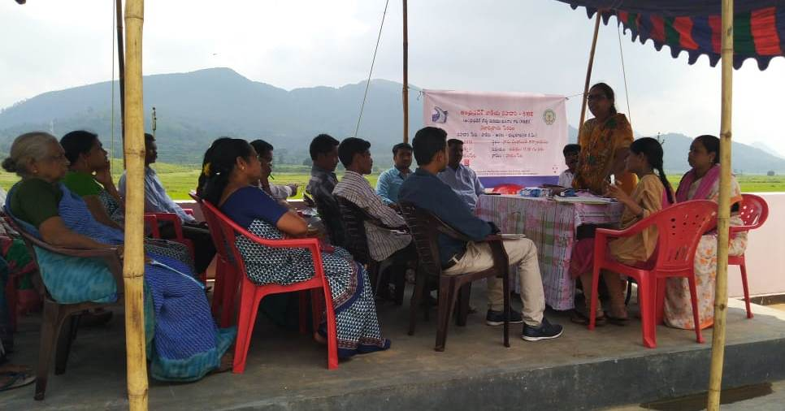
Figure 9-1: Public Consultations/Gram Sabha at Hukumpet on 03.10.2018
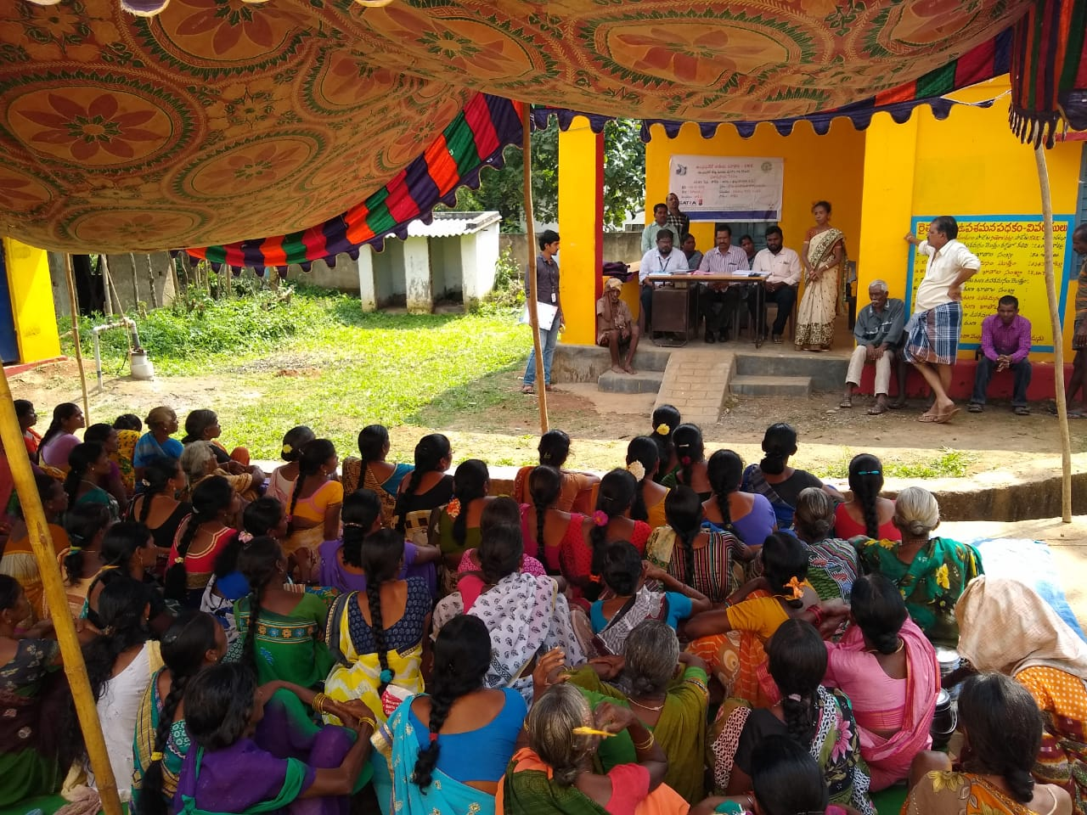
Figure 9-2: Public Consultations/Gram Sabha with women group at Chintalaveedi on 03.10.2018
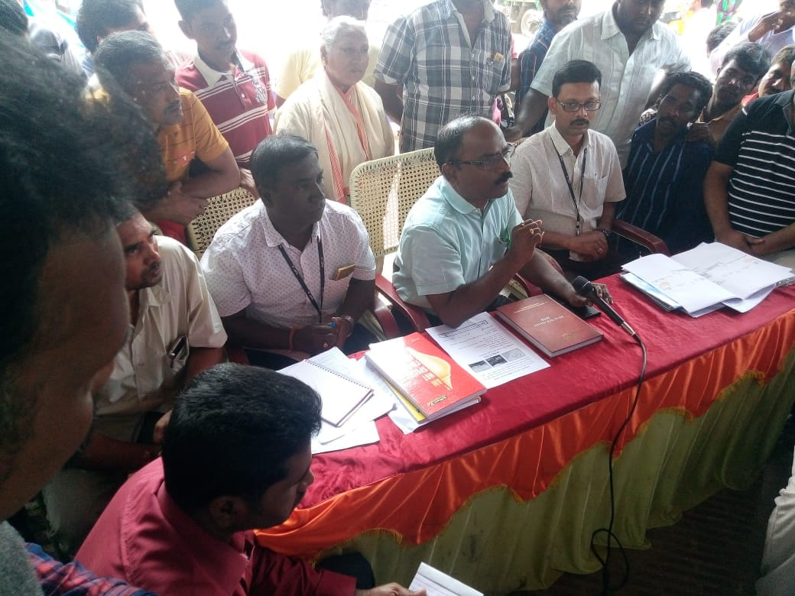
Figure 9-3: Public Consultations/Gram Sabha at Araku Valley on 03.10.2018
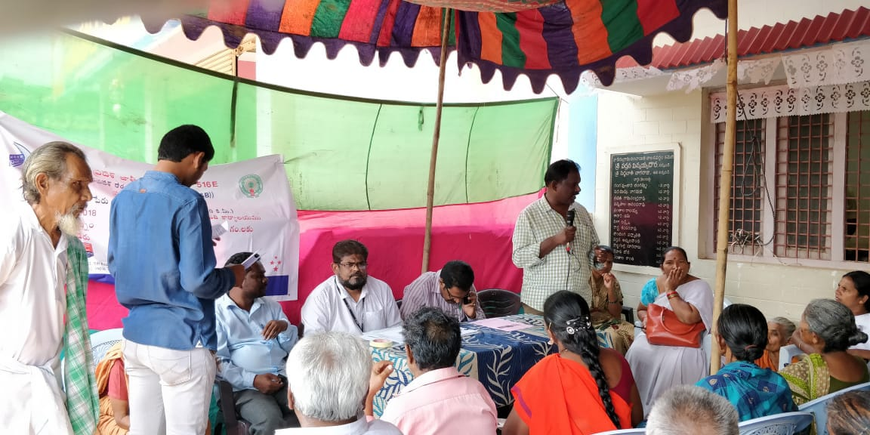
Figure 9-4: Public Consultations/Gram Sabha at Paderu on 03.10.2018

Figure 9-5: Participants during FGD’s and Consultations in the project road
Consultations at Hukumpeta, Dumbriguda, Paderu, Araku, and Kinchumunda from 28th February to 20th March (Photos from Left to Right)

PLANS FOR FURTHER CONSULTATION AND DISCLOSURE
The effectiveness of the R&R program is directly related to the degree of continuing involvement of those affected by the Project. Several additional rounds of consultations with PAP’s will form part of the further stages of project preparation and implementation. The consultation will continue throughout the project implementation period. The following set of activities will be undertaken for effective implementation of the RP:
- In case of any change in engineering alignment planning the PAP’s and other stakeholders will be consulted in selection of road alignment for minimization of resettlement impacts, development of mitigation measures etc.
- The Community Seva center Field Office will conduct information dissemination sessions in the project area and solicit the help of the local community/leaders and encourage the participation of the AP’s in Plan implementation.
- During the implementation of Resettlement Plan, public meetings will be organized, and will appraise the communities about the progress in the implementation of project works, including awareness regarding road construction.
- To make reasonable representation of women in the project planning and implementation they will be specifically involved in consultation.
A Public Consultation and Disclosure Plan will be prepared by CSC (Community Seva Center) for the project as per the format below in Table 9.3.
Table 9-3: Consultation and Disclosure Plan by CSC
Activity | Task | Timing  (Date/Per | Agencies | Rem
Public Notification | Notify eligibility cut-off date. |  | CSC/NGO
Disclosure of RP | Translate RP in local language and disclose at CSC Office and Panchayat |  | CSC /NGO
Distribution of R&R  information leaflet | Prepare R&R information leaflet and distribute to APs |  | CSC/NGO
Internet disclosure of the RP | Post RP on r EA website |  | CSC
Consultative meetings during joint measurement survey | Face to face meetings with APs |  | CSC /NGO
Disclosure of updated RP | Disclosure after joint measurement survey |  | CSC /NGO
Internet disclosure of the updated RP | Updated RP posted on EA website |  | CSC

Information Disclosure

Disclosure
The SIA and Draft Resettlement Action Plan (RAP) would be disclosed on MoRTH website as well at the World Bank Infoshop/ Public Information Centre. Feedback if any would be incorporated into the final RAP document, following which the final RAP will be re-disclosed. Further to enhance transparency in implementation, the list of PAPs for disbursement of benefits shall be separately disclosed at the concerned Panchayat Offices/ Urban Local Bodies, District Collector Offices, Block development Offices, District Public Relations Offices (at the state and district levels), Project office, and any other relevant offices, etc. The Resettlement Policy Framework, Executive Summary of the SIA and RAP will be placed in vernacular language in the District Collector’s Office.

CONSULTATION & PARTICIPATION PLAN
To ensure peoples’ continued participation in the implementation phase and aiming at promotion of public understanding and fruitful solutions of developmental problems such as local needs of road users, problem and prospects of resettlement, various sections of PAPs and other stakeholders will be engaged in implementation. Key actions would be as follows:
- Communicating and informing PAPs and beneficiary households in the project area of resettlement policy provisions and grievance redress mechanism through village level public meetings;
- Holding one to one meeting with the PAPs to explain their eligibility;
- Placing of micro plan in affected villages for review and minimizing grievances;
- Payment of R&R assistance to PAPs during public meetings to maintain transparency; and
- Household consultation to identify skill improvement training needs, counsel for usage of assistance amount and other activities towards livelihood restoration.
Information dissemination would be carried out through printed leaflets/ information booklets that would be prepared by the RAP Implementation Support Agency in local language. These would be distributed not only to PAPs but also to people (residents, businessmen and others) within the immediate project influence area and the local community in advance so that people discuss issues among themselves and prepare themselves for the meeting. On the day of public meeting, once again leaflets would be distributed among the people present for dissemination of information so as to ensure that all present at the meeting, get to know about the project in case they did not get the leaflet/ information booklet.
The leaflet/ information booklet would provide the following:
- Brief description of the project and its objectives;
- A summary of adverse impacts (including land acquisition, and impacts on common property resources, etc);
- The details of the laws/polices under which land has been acquired;
- Resettlement & Rehabilitation provisions of the project and specific benefits available to vulnerable communities;
- Different ways and means of involving local communities;
- Expectations from local communities;
- Role of NGO and RRO; and
- Grievance redresses mechanisms, suggestion and complain handling mechanism, etc.
Information dissemination would be carried out at least once in a month by organizing public meetings at suitable locations involving PAPs, local communities, institutions and line departments at people’s door step on a pre-decided date and time. Wide publicity for the meeting would be carried out by beating of drums and announcement through loud speakers in the adjoining areas. The LA cum Social Development Officer & RRO with assistance from RAP implementation agency would describe all aspects of the project, importance of consultations and also seek their participation and co-operation in the project. In these public meetings various aspects of the project would be explained and also the status of the project (technical, social & environmental) would be revealed. People in general and PAPs in particular, would be given opportunity to provide suggestions and raise issues which concern them and as a consequence maintain good rapport with local community. Land Acquisition cum Social Development Officer (State level), RRO, and RAP Implementation Support Agency shall be present in these meetings.
After the public meeting, Minutes of Meeting (MoM)/ resolution would be prepared and read out to people present in the meeting. The MoM would be signed by the officials and participants present at the meeting. The MoM would be kept in project file for documentation purpose.

Framework for Continued Consultation
- Dissemination and consultation will be held during RAP implementation, monitoring and evaluation stages.
- The Social officer at state level will also carry out consultations with PAPs, local community and other government department officials at suitable time intervals directly with support from NGO and R&R Officer at site.
- The date, time and venue for holding consultations will be intimated to PAPs, local community and local authorities at least 7 days in advance. The timing of consultation shall be fixed as per the suitability of villagers giving due consideration to peak working time. The intimation for the consultation shall be done by way of drum beating, announcement by loud speaker and by putting up information on the notice board of concerned village/town, and other such public places.
- The team of NGO to be involved must have women and tribal members while carrying out consultations. Separate/additional consultations/interactions with the women, tribal and other vulnerable groups shall be organized.
- APNH will provide relevant resettlement information in a timely manner, in an accessible place, and in a form and Telugu language understandable to stakeholders at the time implementation.
- Notification on project information will be disclosed in the local newspaper. The draft RAP and other safeguard documents will be made available in relevant local government offices and in AP (R&B) NH Wing.
- A Project level grievance redress mechanism has been developed at PIU for potential use by external stakeholders. To ensure that complaints and grievances are addressed in good faith and through a transparent and impartial process.
- Monitoring and evaluation of the stakeholder process is considered vital to ensure APNH is able to respond to identified issues and alter the schedule and nature of engagement activities to make them more effective.

COST AND BUDGET

Introduction
A Detailed budget estimates for RAP to be implemented has been presented in this chapter. The budget will be included in the overall sub-project cost. The chapter includes i) detailed costs of land acquisition, relocation, and livelihood and income restoration and improvement, ii) source of funding, iii) arrangements for approval, and iv) the flow of funds and contingency arrangements. All costs for implanting Land Acquisition and R&R will be borne by the MoRTH funding.

Calculation Process
Land: The cost has been calculated as per the schedule I of the RFCT LARR Act, 2013. Total cost for land acquisition resettlement and rehabilitation is estimated at Rs. 43.52 crore.
For the compensation of land, calculations following steps are adopted
- step 1, the average market value is worked out based on the published rates from the Revenue Department of Andhra Pradesh.
- step 2 then the multiplier factor 1.50 (MoRTH NH-11011/30/2015-LA dated 28.12.2017) is added as per sub section (2) of section 26 of the RFCTLARR Act, 2013.
- step 3 calculate the value of the assets (buildings, trees etc.) based on PWD basic schedule rates.
- step 4 solatium (100%) provided to the cost of the land and structure.
- step 5 Interest 12% is provided on the average market value of the land in pursuance of section 30(3) of the Act and arrived at total compensation.
R&R Assistance: The Resettlement and Rehabilitation entitlement are calculated as per the schedule II of the RFCT LARR Act, 2013. The various R&R assistance amounts as follows.
- One time resettlement allowance of Rs. 60,000 for affected families.
- One time assistance payment of Rs. 600,000 for all displaced or become marginal land holders after land acquisition.
- One time assistance of Rs. 60,000 to all Vulnerable families.
- the displaced family will be provided Rs. 1.5 lakhs towards constructing a house as per Indira AwaasYojana (IAY) specifications.
- Right to salvage materials from structure and other assets with no deductions from
- One time financial assistance of Rs. 28,000 to the families losing cattle sheds for reconstruction
- One time shifting/transportation assistance of Rs. 60,000 for all displaced.
CPR Replacement cost
The cost for constructing all displaced CPR is estimated at Rs.500000/- approx.

RAP Implementation and Support Cost
The cost for hiring of the implementing NGO for a minimum of 3 years has been calculated at 2% of total land and R&R implementation cost. A 3% contingency has been added in order to adjust any cost escalation during project implementation. For grievance redress process and carrying out consultation during project implementation is estimated at 1% of total R&R implementation cost. Budget for RAP is 43.52 crores. The detailed budget estimates has been shown in table 10.1

Resettlement Budget
A broad resettlement and rehabilitation cost estimate amounting to INR 43.52 Cr. has been summarised in Table-10.1.
Table 10-1: Estimated Resettlement Cost
S.No | Cost Items | Unit | Rate-Rs | Quantity | Amount (in Rs.) | Amount (in Cr.)
1 | Compensation for Land | Acres | 500000 | 77.07 | 38535000 | 3.85
2 | Multiplication factor value as per rule 28 Chapter IV of Act 30/2013 is 1.5 time of the land value (rural area) |  |  |  | 57802500 | 5.78
3 | Structure Value | Sqm |  | 6589.65 | 6738217 | 0.67
 | Pucca Structure | Sqm | 1100 | 4832.49
 | Semi Pucca Structure | Sqm | 900 | 962.88
 | Kutcha Structure | Sqm | 700 | 794.28
4 | 100% Solatium (2+3) |  |  |  | 129081434 | 12.91
5 | 12% addl. market value on Col.1 from date of 11(1) to passing of award (Probable for one year) |  |  |  | 4624200 | 0.46
 | A-Sub -total: Land Acquisition Cost as per section 31 of LAR&R Act, 2013 |  |  |  | 133705634 | 13.37
6 | Provision in case of Displacement - Choice of Annuity / Employment - /Loss of Livelihood PAF's -6 Lakh onetime payment or 2000/- per month for 20 years | No's | 600000 | 327 | 196200000 | 19.62
7 | One time Subsistence Grant for DP | No's | 40000 | 65 | 2600000 | 0.26
8 | Transportation Cost | No's | 60000 | 65 | 3900000 | 0.39
9 | Cattle Shed or Petty Shop | No's | 28000 | 34 | 952000 | 0.10
10 | Resettlement Allowance | No's | 60000 | 468 | 28080000 | 2.81
11 | Vulnerability Allowance | No's | 60000 | 468 | 28080000 | 2.81
13 | CPR Rehabilitation Cost | No's | 500000 | 26 | 13000000 | 1.30
 | B- Sub-total: R&R Entitlement's |  |  |  | 272812000 | 27.28
 | A+B: Compensation and R&R Entitlement |  |  |  | 406517634 | 40.65
14 | Hiring of NGO for Implementation (2%) |  |  |  | 8130353 | 0.81
15 | Hiring of Independent Agency for Monitoring and Evaluation (Lump Sum) |  |  |  | 4065176 | 0.41
16 | Grievance and Redress (Lump Sum) |  |  |  | 800000 | 0.08
17 | Estimated cost for implementation of GBV, SEP, LMP |  |  |  | 3000000 | 0.30
 | C. Sub-total: Implementation Support Cost |  |  |  | 15995529 | 1.60
 | Total: Compensation, Entitlement and Administration Cost (A+B+C) |  |  |  | 422513163 | 42.25
18 | C. Add- 3% Contingency of total compensation , Entitlement and Administration Cost |  |  |  | 12675395 | 1.27
 | Total Budget for Implementation of Resettlement Plan and LA |  |  |  | 435188558 | 43.52

INSTITUTIONAL ARRANGEMENT FOR RAP IMPLEMENTATION

Introduction
The key elements of institutional arrangements are co-operation/ support, collaboration and sharing of responsibilities with clearly defined roles, involvement of key stakeholders and vertical and horizontal linkages amongst different agencies. The Institutional Arrangements for implementation of RPF and RAPs are detailed below. The Institutional Arrangements are required at three levels viz., MoRT&H (Central Govt.), State Level and Sub-Project Level and this is presented in the below figure 11-1.
Figure 11-1: Institutional Arrangement for RAP Implementation

EE (Designated Nodal Social Officer)
MoRTH

Project Authority
CE (
EAP
, MoRTH
)

Social

Development
Specialist (SDS), PMC

Regional Officer, MoRT&H (Supported by Land Acquisition cum Social Development Officer)

SCHM (CE)
(
general
project
related
M&E Agency

(
Third party
)

GRC at
District Level
(
R&R

related
issues)

P
IU
--

AEE/AE (Designated as
R&R Officer)

District Level
Replacement Cost
Committee

NGO /
Consultancy Firm

Central Level
At Central Level, the Chief Engineer (EAP), MoRTH, Govt. of India will be overall responsible for the implementation of RAP. CE (EAP) will have all delegated administrative and financial decisions with regard to implementation of the project as well as land acquisition, RAP including TDP/VCDP implementation.
Institutional arrangement at Central Level will include augmenting the capacity of MoRTH with regard to resettlement and rehabilitation. A team comprising Executive Engineer designated as Social Officer along with a Social Development Specialist (SDS) from Project Management Consultant (PMC) with required Technical and Secretarial Staff will assist CE (EAP). The designated Social Officer will be directly involved in the implementation of RAP. The Social Officer will ensure that all resettlement and rehabilitation issues are complied with as per the RPF. The roles and responsibilities of the Social Officer would broadly include the following:
- Ensure preparation and disclosure of SIA, RAP and Land Acquisition Plan for sub projects as per RPF.
- Ensure adequate staffing at state and sup project level to ensure timely implementation of RAP.
- Guide and supervise in matters related to resettlement and rehabilitation to state and sub-project level offices.
- Compile data related to resettlement and rehabilitation activities received from field offices and update Chief Engineer (CE) and suggest suitable measures to be taken.
- Interact with implementation agencies at state and sup project level on a regular basis.
- Undertake field visits as and when required.
- Facilitate necessary help needed at site with regard to LA and R&R issues.
- Co-ordinate with state government department in matters related to implementation of R&R.
- Ensure budgetary provision for resettlement and rehabilitation of PAPs and relocation, rehabilitation and reconstruction of common property resources (CPRs).
- Ensure timely release of budget for implementation of RAP.
- Monitor implementation of RAP carried out by the agency through RRO.
- Perform other roles and responsibilities related to implementation of RAP as assigned by the CE (EAP) from time to time.
- Ensure free, prior and informed consultation with vulnerable groups along the project and also ensure that sufficient supporting documentation is maintained.
- Ensure third party audit of RPF implementation.

State Level/Regional Office
At State Level, a Land Acquisition cum Social Development Officer will be appointed to provide assistance to the Regional Officer MoRT&H. The roles and responsibilities of the LA cum SDO would broadly include the following:
- Facilitate preparation and implementation of land acquisition and RAP in compliance with RPF,
- Ensure consultation and stakeholder participation in finalisation of RAP,
- Guide and supervise RAP implementation at sub-project level,
- Interact with RAP implementation support agencies and undertake field visits for first-hand information,
- Guide and supervise the RAP implementing agency to roll out HIV prevention activities,
- Compile data on LA progress and RAP implementation activities received from field offices and update EE (Designated Social Officer), MoRTH and suggest suitable measures to be taken,
- Co-ordinate with various government departments in matters related to implementation of RAP,
- Check implementation of RAP carried out by the agency from time to time by undertaking site visits and consultations with PAPs,
- Perform other roles and responsibilities related to implementation of RAP as assigned by the EE (Designated Social Officer), MoRTH from time to time,
- Facilitate and cooperate in Third party Audit of RPF implementation.

Sub-Project/PIU Level
A Project Implementation Unit (PIU) comprising officials of State Road Construction Department will be constituted at Sub-project level headed by the Superintending Engineer/ Executive Engineer designated as Project Director. The PIU will be responsible for the project execution including RAP & TDP/VCDP implementation. There will be a designated or appointed Resettlement & Rehabilitation Officer (RRO) at respective PIUs who will be responsible only for the implementation of RAP and TDP at site. No other roles and responsibilities will be assigned to RRO other than resettlement and rehabilitation. RRO will assist Project Director at PIU and SDS at Central Level in all matters related to resettlement and rehabilitation. The roles and responsibilities of the Resettlement and Rehabilitation Officer are as under:
- Ensure RAP including TDP implementation with assistance from implementation agency as per the time line agreed upon.
- Interact with RAP implementation agency on a regular basis.
- Undertake field visits with implementation agency from time to time.
- Facilitate necessary help needed at site with regard to LA and R&R, HIV issues to implementation agency.
- Co-ordinate with district administration and other departments in matters related to implementation of R&R.
- Ensure distribution of Resettlement and Rehabilitation Policy and entitlement matrix for the project to PAPs.
- Ensure preparation and distribution of photo identity cards.
- Ensure and attend meetings organised by implementation agency on thematic areas related to resettlement and rehabilitation policy and entitlements and awareness generation.
- Ensure inclusion of PAPs who could not be enumerated during census but have documentary evidence to be included in the list of PAPs.
- Ensure preparation of identity cards, and approval from the Head Office and distribution of the same to PAPs.
- Ensure timely preparation of micro-plan from RAP implementation agency and approval from Head Office.
- Ensure disbursement of resettlement and rehabilitation assistance in a transparent manner.
- Participate in meetings related to resettlement and rehabilitation issues.
- Facilitate in opening of joint account of PAPs.
- Prepare monthly progress report related to physical and financial progress of implementation of RAP & submit to Head Office.
- Ensure release of compensation and assistance before taking over the possession of land for start of construction work.
- Ensure relocation, rehabilitation and reconstruction of CPRs before dismantling through proper mechanism.
- Attend and participate in Grievance Redress Committee meetings for redressal of grievances of PAPs and other committees involving R&R matters,
- Liaison with government and other agencies for inclusion of PAPs in employment and income generation programme/scheme.
- Carry out any other work related to resettlement and rehabilitation that may be entrusted from time to time by the PCU for compliance of R&R.
- Provide all necessary information and data related to R&R on monthly basis to Designated Social Officer at Central Level through Project Director.
- Ensure that vulnerable families get equal opportunity to participate during implementation and become overall beneficiaries in the project.
Besides, other institutional arrangements required for the implementation of RAP include engagement of RAP IA for the implementation of RAP, formation of District level committee to fix the replacement cost of affected properties as required, Grievance redressal mechanism, Suggestion and Complaint handling mechanism, engagement of monitoring and evaluation agency, etc. Roles and responsibilities of each agency are discussed below.

RAP Implementation Support Agency
To implement RAP, the Project Authority [CE (EAP), MoRTH] will engage the services of NGOs/Consultancy firms having experience in resettlement and rehabilitation issues. Broad roles and responsibilities of implementation agency would be as:
- The RAP implementation agency will be the main link between the Project Authority and PAPs,
- Shall be responsible for verification of PAPs as prepared by the DPR consultants,
- Undertake public information campaign along with RRO at the commencement of the RAP & TDP,
- Develop rapport with PAPs,
- Distribute pamphlets of R&R Policy to PAPs, Panchayat Raj Institutions, and concerned Govt. Offices in the project area, etc.
- Include PAPs who could not be enumerated during census cum socio-economic survey and certification from R&R Officer,
- Distribute identity cards for PAPs,
- Preparation of micro-plan,
- Submission of micro-plan to RRO for approval from Head Office,
- Organize consultations at regular interval with PAPs with regard to resettlement and rehabilitation,
- Organize training program for skill up gradation of the PAPs,
- Assist PAPs in all matters related to compensation and R&R,
- Assist and facilitate aggrieved PAPs (for compensation and assistance) by bringing their cases to GRC,
- Facilitate in opening of joint account of PAPs,
- Generate awareness about the alternative economic livelihood and enable PAPs to make informed choice,
- Consultations with PAPs regarding the choice of resettlement (i.e. self or assisted), development of resettlement site, participation of women, etc.
- Identify training needs of PAPs for income generation and institutions for imparting training,
- Undertake outreach activities for HIV prevention for awareness and behaviour change as per RAP
- Consultations with local people and Panchayat Raj Institutions with regard to relocation, rehabilitation, reconstruction of affected CPRs as well as provision of new facilities under the project,
- Participate in various meetings, relating to RAP and TDP/VCDP preparation and implementation
- Submit monthly progress report, and
- Any other activities that may be required for the implementation of RAP, etc.

Replacement Cost Committee at District Level
A committee at district level will be constituted to fix the replacement cost of land in case of lands acquired through Direct Purchase method or Land lease, structures and other properties (trees, crops and other assets, tube well, hand pump, etc). The committee may be chaired by the District Collector/ Dy. Commissioner or his designated representative (not below the rank of SDM), Project Director-cum-Executive Engineer of the concerned PIU, District Agriculture Officer, Range Officer (Forest Department, if required), an independent certified valuer, Executive Engineer of the concerned District, elected representative (MLA) of the concerned area and Team Leader of RAP implementation agency.
The highest value of land obtained by the three methods mentioned in Section 26 and Schedule 1 of RFCTLARR will be presented by the Project Authority and approved by the committee as the replacement cost. Similarly, latest schedule of rates of the concerned districts shall be used for obtaining replacement cost of structures. For items not available in the schedule of rates, for those items market rates shall be collected from three different sources and then replacement cost shall be fixed by the committee. For replacement costs of crops, trees and other such items similar methods will be followed.
The committee will be constituted through an executive order and or other suitable instrument within one month (30 days) from the date of mobilization of RAP implementation agency at site.

Mechanism for Implementation of RAP, Training and Capacity Building – at Project and Sub-project Level
Training and development of project staff is an integral part for implementing GNHCP. A training needs identification shall carried out at Central, Regional and Site level, based on which focused training modules will be developed in the first six months of project implementation;
- Strengthening in house capacity to implement the provisions of RPF/RAP,
- Creating Awareness, providing the tools for implementation of RAP, and accompanying set of management procedures to all departments,
- Developing competence within key officials to provide training in their respective level.
Based on skill requirement/improvement at all levels for proper implementation of RPF, a training programme focusing project implementing partners at Centre, State and field PIUs has been developed which will be implemented by the Project Authority (MoRTH) in the next two years. These training programs, which will be zeroed down after a quick training needs assessment, are to be conducted with the help of local and national training institutions and experts in various aspects of social management. MoRTH will also identify courses offered by the premier institutions in India and abroad on social management and inter-phase these with identified programme. There is a provision for separate budget for this activity. The budget reported under “institutional” head includes the cost estimates of training programs discussed above.

GRIEVANCE REDRESSAL MECHANISM
The Resettlement Policy Framework (RPF) mandates formation of Grievance Redressal Mechanism in order to resolve disputes in an effective manner and at the door steps of the PAPs. Compensation and assistance as per eligibility is provided in the entitlement matrix of the approved RPF. The Grievances will be redressed at the PIU level, if not can be referred to the court by the aggrieved. The first contact person at PIU to review and redress the grievance is the RRO. If not resolved, the aggrieved can reach to the Grievance Redress Committee formed at the PIU level. The decision of the GRC will be binding, unless vacated by court of law.

Grievance Redressal Committee (GRC)
The GRC at PIU level will be constituted by the Project Authority with the aim to settle as many disputes as possible on Land Acquisition (LA) and R&R through consultations and negotiation. There will be one GRC for each PIU. The GRC will comprise six members headed by a retired Revenue officer /Social Welfare officer not below Group I officer rank). Other members of the GRC will include the concerned Project Director-cum-Executive, a retired PWD Officer (not below the rank of Executive Engineer), RRO, representative of PAPs and Sarpanch (Elected Head of Village) of the concerned village. 45. Grievances of PAPs in writing will be brought to GRC for redressal by the RAP implementation agency The RAP implementation agency will provide all necessary help to PAPs in presenting his/her case before the GRC. The GRC will respond to the grievance within 15 days. The GRC will normally meet once in a month but may meet more frequently, if the situation so demands. A time period of 45 days will be available for redressing the grievance of PAPs. The decision of the Grievance Committees will not be binding on the DPs and they will have the option of taking recourse to court of law, if s/he so desires at his or her own expense.Broad functions of GRC are as under:
- Record the grievances of PAPs, categorize and prioritize them and provide solution to their grievances related to resettlement and rehabilitation assistance.
- The GRC may undertake site visit, ask for relevant information from Project Authority and other government and non-government agencies, etc in order to resolve the grievances of PAPs.
- Fix a time frame within the stipulated time period of 45 days for resolving the grievance.
- Inform PAPs through implementation agency about the status of their case and their decision to PAPs and Project Authority for compliance.
The GRC will be constituted within 3 months by an executive order from competent authority (centre/ state) from the date of mobilization of RAP implementation agency. The RRO will persuade the matter with assistance from implementation agency in identifying the suitable persons from the nearby area for the constitution of GRC. Secretarial assistance will be provided by the PIU as and when required. The flow diagram (Figure.12-1) shows the entire process of grievance redressal.

Figure 12-1: Grievance Redressal Mechanism
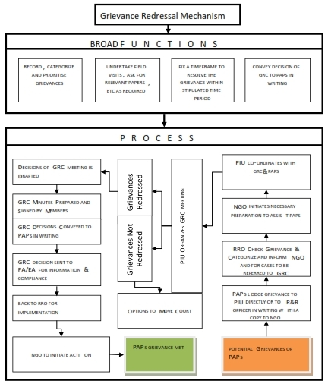
PAPs will be fully made aware about the GRM for effective, inexpensive and amicable settlement of claims for compensation and assistance by holding meetings with PAPs, public meetings and distributing leaflets containing salient features and procedures of GRM. The RAP IA will assist the PAPs in getting their record of rights updated in case of disputes related to land. The RRO with support from RAP IA will make all possible efforts for amicable settlement. The RAP IA will document all cases brought to GRC and maintain the records of the proceedings of the grievance redressal committee meetings.

Suggestion and Complaint Handling Mechanism (SCHM)
The MoRTH recognizes the importance of this and hence intends to establish a SCHM for the GNHCP. The communication channels to report project related complaints/concerns will be disclosed at all levels of institutions—MoRTH, State and Sub-project levels.
Through the Right to Information Act, 2005 an Act of the Parliament of India provides for setting out the practical regime of right to information for citizens. The Act applies to all States and Union Territories of India. Under the provisions of the Act, any citizen may request information from a "public authority" (a body of Government or "instrumentality of State") which is required to reply expeditiously or within thirty days. The Act also requires every public authority to computerize their records for wide dissemination and to pro-actively publish certain categories of information so that the citizens need minimum recourse to request for information formally. In other words under the act, citizens have right to seek information from concerned agencies by following the set procedures. However, it is quite likely that many people may not use the provisions of this Act, only in limited cases covering serious concerns. Being an inter-state project involving several states and large scale of civil works along with R&R and Environment issues, the project is likely to receive many suggestions, complaints, inquiries, etc through the project implementation period. Therefore, MoRTH has agreed to establish SCHM as a good practice to address public concerns pertaining to various issues. SCHM will report all project related LA and R&R of the PAPs for redressal through the concerned PIU or GRC as appropriate. Several communication channels viz., toll free phone number, dedicated email, mechanism for on line submission of suggestions/complaints/inquiries, provision of suggestion/complaint box (at site and project office), post and other suitable means shall be set up for suggestion and complaint handling.

IMPLEMENTATION SCHEDULE

Introduction
Implementation of RAP mainly consists of compensation to be paid for private land, compensation for structures, assistance for loss of homestead resulting in physical displacement, loss of livelihood resulting in economic displacement, obtaining options and choices from the Displaced Families, development of resettlement sites, relocation to resettlement sites and additional assistance to vulnerable household. Public consultation, monitoring and grievance redressal will be an ongoing process throughout the RP implementation period but will happen intermittently.

Schedule for Project Implementation
The proposed RP implementation activities are divided into three broad phases viz. project preparation phase, RP implementation phase, and monitoring and reporting phase, and the activities envisaged in each phase is discussed below.
Project Preparation Phase: The activities to be performed in this phase include: (i) establishment of PIU with a designated officer (SS) in charge of safeguards; (ii) submission of RP to IFC/World Bank for approval (iii) appointment of NGO in PIU and (iv) establishment of GRC. The information dissemination and stakeholder consultations will commence in this stage and continue till the end of the project.
RP & TDP Implementation Phase: In this phase, key activities will be carried out including: (i) joint verification (ii) valuation of structures (iii) preparation of micro plan (iv) R&R award enquiry (v) approval of final micro plan (vi) identification and development of resettlement site (vii) payment of compensation for land and structure (viii) payment of other rehabilitation assistances (ix) relocation of PDFs to resettlement site and (x) issuing site clearance certificate to enable commencement of civil works.
Monitoring and Reporting Phase: Internal monitoring will commence as soon as RP implementation begins and continue till end of RP implementation. External monitoring will also commence from the beginning of RP implementation.

RP & TDP Implementation Schedule
An implementation schedule for land acquisition, payment of compensation and resettlement and rehabilitation activities in the project including various sub tasks and time line matching with civil work schedule is provided in the work plan. The following are the key implementation activities that are presented in the work plan.
- Updating of RP based on design changes, if any
- Approval of RP and Disclosure
- Appointment of NGOs, Nodal NGO and Package NGOs and External Monitoring consultants
- Constitution and notification of GRCs
- SIA Notification
- Verification of DPs and Notification of DP list
- Obtaining options for resettlement and choice of resettlement site location
- MIS in operational for tracking LA and R&R Implementation progress
- Structure Valuation
- Disclosure of Microplan (list of eligible PAPs and their entitlements)
- Issue of Identity cards
- R&R Award including assistance for non-title holders
- Relocation of CPRs
- Payment of R&R assistance
- Allotment of house sites or development of Resettlement sites
- Shifting of DPs of alternative resettlement sites
- LA Award
- Certification of payment of R&R assistance for first milestone
- Certification of payment of LA and R&R assistance for second milestone
- Impact Evaluation

Coordination during the Implementation Stages: The land acquisition and resettlement implementation will be co-coordinated with the timing of procurement and commencement of civil works. The required co-ordination has contractual implications, and will be linked to procurement and bidding schedules, award of contracts, and release of encumbrance free land to the contractors. The project will provide adequate notification, counseling and assistance to PDF’s so that they are able to move or give up their assets without undue hardship before commencement of civil works and after receiving the compensation and R&R assistances.
The construction of resettlement sites should commence well in advance, as it would take about 12-months to complete the construction and relocation of the physically displaced. The land acquisition and corresponding payment of compensation and R&R assistance with encumbrance free certification will be available prior to award of contract. The relocation of common property resources will be linked to handing over of encumbrance free land to the contractors.

Table 13-1: Proposed Resettlement and Implementation Schedule
Particulars of activity | 2018 |  | 2019 |  |  |  | 2020 |  |  |  | 2021
 | Q3 | Q4 | Q1 | Q2 | Q3 | Q4 | Q1 | Q2 | Q3 | Q4 | Q1
Impact Assessment & SIA Notification
Preparation of LAP & strip mapping
Baseline survey of affected persons
Draft NotifIcation of the 3(A) Land Acqusition
Appointment of NGO & External Monitor
Identification & Verification of PAPs by NGO
Valuation of structure
Preparation of Micro Plans for Rehabilitation & Resettlement by the NGO
Disclosure of Micro Plans
Issuance of ID Cards
Update draft Resettlement Plan to reflect surveys, consultations, design changes, and due diligence results
Consultations disclosure, & awareness generation
Development of Resettlement Site
R&R Award for Titleholders & Non-Titleholders
Issue notice to affected persons
Skill training as required for Tribals & Non-Tribals
Disbursement of R&R assistance amounts
Relocation of CPRs
Certification of full payment and completion of all R&R activities
Handover of land to contractors first & second milestone

MONITORING AND EVALUATION

Introduction
Monitoring and evaluation are important activities of infrastructure development project particularly, those involving involuntary resettlement. It helps making suitable changes, if required during the course of implementation of RAP and also to resolve problems faced by the PAPs. Monitoring is periodical checking of planned activities and provides midway inputs, facilitates changes, if necessary and provides feedback to project authority for better management of the project activities. Evaluation on the other hand assesses the resettlement effectiveness, impact and sustainability of R&R activities. In other words, evaluation is an activity aimed at assessing whether the activities have actually achieved their intended goals and purposes. Thus monitoring and evaluation of resettlement action plan implementation are critical in order to measure the project performance and fulfillment of project objectives.
The monitoring and evaluation of RAP implementation will ensure monitoring of key indicators on inputs, outputs, project processes and evaluation of impact indicators. The overall purpose of the monitoring is to keep track of the implementation processes and progress, achievement of performance targets fixed in the annual work plans, learning lessons and taking corrective actions to deal with emerging constraints and issues. Monitoring and evaluation will constitute the following:
- Implementation progress (physical and financial aspects), monitoring of inputs, and outputs;
- Process documentation (case studies and lessons learnt);
- Impact evaluation based on sample survey and consultations; and
- Thematic studies.

Institutional Arrangement for M & E
The Resettlement Policy Framework (RPF) stipulates hiring services of an external agency (third party) for monitoring and evaluation of RAP implementation. This means the project authority through an external agency will carry out monitoring and evaluation from the subsequent month of the mobilization of RAP IA at project site. Internal monitoring will be carried out by the Social Officer of Project Coordination Unit (PCU) with assistance from R&R officer and RAP IA whereas external monitoring and evaluation will be carried by the third party engaged for the purpose. This will help monitor project activities closely. Regular monitoring by undertaking site visits and consultations with PAPs will help identify potential difficulties and problems faced in the implementation and accordingly help take timely corrective measures including deviations, if needed.
Components of monitoring will include performance monitoring i.e., physical progress of the work and impact monitoring and external evaluation. Indicative indicators to be monitored related to performance are provided in the following sections. In case during the project implementation, if some other indicators are found relevant they will also be considered for monitoring.

Monitoring and Evaluation (M&E) at Project and Sub-project Level
The Resettlement Action Plan contains indicators and benchmarks for achievement of the objectives under the resettlement programme. These indicators and benchmarks will be of three kinds:
(1) Proposed indicators, indicating project inputs, expenditures, staff deployment, etc.
(2) Output indicators, indicating results in terms of numbers of affected People compensated and resettled, training held, credit disbursed, etc,
(3) Impact indicators, related to the longer-term effect of the project on People’s lives.
The benchmarks and indicators will be limited in number, and combine quantitative and qualitative types of data. Some of these indicators may include, percentage of PAPs actually paid compensation before any loss of assets; percentage of PAPs whose incomes after resettlement are better than, or at least same as before resettlement; percentage of assets valued at replacement cost compensation; percentage grievances resolved; and/or percentage of cases to court. The first two types of indicators, related to process and immediate outputs and results, will be monitored to inform project management about progress and results, and to adjust the work programme where necessary if delays or problems arise. The results of this monitoring will be summarized in reports which will be submitted to the World Bank on a regular basis. Provision will be made for participatory monitoring involving the project affected people and beneficiaries of the resettlement programme in assessing results and impacts. The Project Authority will engage services of an external agency (third party), which will undertake independent concurrent evaluations at least twice a year during the project implementation period. At the end of the project an impact evaluation will be carried out as part of the project completion report. Such independent evaluation will focus on assessing whether the overall objectives of the project are being met and will use the defined impact indicators as a basis for evaluation. Specifically, the evaluation will assess: (i) The level of success (including the constraints and barriers) in land acquisition programme, resettlement plan, and income recovery of the PAPs after they have been displaced from the project affected area, and, (ii) the types of complaints/ grievances and the success of the handling of grievance and public complaints towards the construction of project’s infra-structures, means of redress for assets and lands and the amount of compensation, resettlement, and other forms of complaints.
Summarizing, M&E would be carried out for regular assessment of both process followed and progress of the RAP implementation. The internal monitoring will be carried out by the State PCU by the Land Acquisition cum Social Development Officer with assistance from RAP Implementation Support Agency and a quarterly report will be submitted to MoRTH. Each quarterly report would also be uploaded on the MoRTH website. The external agency (third party) however, would conduct assessment six monthly for each sub-project by undertaking field visits and all other necessary activities including consultations. The six monthly reports would cover detailed information on process and progress of RAP implementation. The report would highlight issues, if any that need attention of the Project Authority and suggest corrective measures that may be followed for better implementation of RAP.

Process & Performance Monitoring
Process monitoring would enable the project authority to assess whether the due process are being followed or not, whereas performance monitoring would mainly relate to achievement in measurable terms against the set targets. Monitoring report will also provide necessary guidance and inputs for any changes, if required during the course of the implementation. A list of indicators is given in Table 14-1.
Table 14-1: Performance Monitoring for RAP Implementation
Sr. No. | Indicators | Target | Status | Achievement (in %) | Remarks
1 | Land acquisition (Private)
 | Notification published u/s 3D
 | Award declared u/s ……. for
 | Land area (ha)
 | Land owners (No.)
 | Compensation disbursed by Competent Authority to land owners (No.)
 | Govt. land transfer (ha)
2 | Verification of identified PAPs completed (No.)
3 | New PAPs added, if any (who could not  be enumerated at the time of survey)
4 | Consultations held with regard to RAP (dissemination of information, awareness generation, entitlements, HIV/ AIDS, SCHM, etc) – No.
5 | Leaflets, containing salient features of RAP, hand bills, fliers and other awareness materials distributed (No.)
6 | Measurement of structures likely to be affected completed (No.)
7 | Date of formation of DLC
8 | Meetings held by DLC for fixing the replacement cost (No.)
9 | Valuation of affected properties completed (No.)
10 | Micro plan submitted for THs for approval (No.)
11 | Identity cum entitlement card issued to PAPs (No.)
12 | Consultations held with local community regarding relocation or rehabilitation of CPRs (No.)
13 | Estimate submitted for relocation/ rehabilitation of CPRs for approval
14 | Agency to carryout relocation/ rehabilitation of CPRs as agreed by the project authority
15 | R&R assistances disbursed to PAPs (THs – No.
16 | PAPs re-established their shops/ business (No.)
17 | PAPs covered under income generation schemes (No.)
18 | PAPs provided training for alternate livelihood (No.)
19 | CPRs relocated/ rehabilitated (No.)
20 | Grievance/ complaints brought to GRC for redressal (No.)
21 | GRC meeting held and cases resolved (No.)
22 | Various channels of SCHM used by category (No.)
23 | Consultation meetings held by LA cum SDO of Project Coordination Unit (PCU) (No.)

Evaluation
The external agency engaged by the Project Authority shall carry out the evaluation at two stages viz., mid-term and after the completion of RAP implementation. The evaluation will be carried out under a set term of reference. The evaluation study would involve both quantitative and qualitative surveys and compare results before and after the implementation of the project. It will focus on assessing whether the overall objectives of the project are being met and will use the defined impact indicators as a basis for evaluation. The evaluation study would undertake the following but not limited to:
- Review monthly progress report submitted by RAP Implementation Agency (RAP IA);
- Undertake consultations with PAPs in order to assess their point of view with regard to overall process;
- Intensity and effectiveness of information dissemination with regard to RAP implementation covering eligibility of different categories of PAPs, frequency of interactions by RAP IA personnel with PAPs, deployment of RAP IA staff, quality of rapport maintained by RAP IA personnel with PAPs, capability of RAP IA personnel, behavior of RAP IA staff, availability of RAP IA staff, level of satisfaction as regards the work of RAP IA, etc;
- Collect information about distribution of awareness generation materials, entitlements, distribution of identity cum entitlement card, adequacy of dissemination of information, consultations meetings with regard to policy and eligibility for entitlement, alternatives and relocation related issues, measurement and valuation of affected properties, understanding and use of grievance procedure, disbursement of assistance, and other R&R related issues, compliance of resettlement policy, etc;
- Conduct sample survey (25% of PAPs) for making comparative analysis substantiated by qualitative surveys and case studies, etc.
It may be noted that one of the key objectives of the project is improvement or at least restoration of economic status of the PAPs to the pre project level. An illustrative list of indicators is given in Table 14.2, which would be measured against the baseline data collected for the preparation of RAP. The M&E agency would finally select the indicators for the evaluation of the project depending upon the progress of R&R activities.
Table 14.2 - Impact Indicators
Sr. No. | Indicator | Unit | Before Project Implementation | During/after RAP Implementation
1 | Monthly income of family/household
2 | Consumer durables/material Assets owned
3 | Ownership of Transport and farm implements owned
4 | Occupation of head of Household and other members
5 | Type of dwelling units
6 | Number of Earning members/households
7 | Family under debt
8 | Size of loan
9 | Households purchased loans
10 | Households with various sizes of land
11 | Ownership/tenancy of dwelling units (owner, encroacher, squatter)
12 | Access to water and sanitation facilities
13 | Access to modern sources of lighting and cooking
14 | Animal and poultry birds owned
15 | Migration for employment

13. 5 Reporting
Monthly Progress Reports on the progress of RAP implementation including mobilization of staff members, opening of site offices, etc of the project would be prepared by RAP IA and submitted to the R&R Officer at sub-project level.
Quarterly Monitoring Reports shall be compiled by the LA cum SDO of Project Coordination Unit (PCU) and submitted to MoRTH for review and onward submission to World Bank
Six monthly reports shall be prepared by the M&E agency by undertaking site visits and review of progress report, consultations, etc.
Evaluation Report shall be prepared by the M&E agency at the end of the project implementation as part of the project completion report.

Annexure 2.1: Social Impact Assessment Survey Format
Form No.
Social Impact Assessment Survey
(Census & Socio-economic Data)
Name of the Enumerator: ___________________________
Field Supervisor: _________________________________ Structure No.: _____________
1.0 | GENERAL IDENTIFICATION:
1.1 | Road section (Name): | 1.6 | Side: 1 - Left 2 - Right
1.2 | District: | 1.7 | Chainage:  From Kms.____________  to Kms. ___________
1.3 | Block:
1.4 | Village/Town:
1.5 | Location:  (1-Rural, 2-Semi-urban, 3-Town)

2.0 |  | HOUSEHOLD IDENTIFICATION:
2.1 | Name of the head of the Household: |  |  |  |  |  |  | _______________________________________
2.2 | Name of the Respondent: |  |  |  |  |  |  | _______________________________________
2.3 | Relationship of the respondent with the head of the household:
3.0 | DETAILS OF AFFECTED STRUCTURE:
Sl. No. |  |  | Type of Loss* |  |  | Typology of Structure  1.Katcha 2.Semi Pucca 3.Pucca |  |  |  |  | Present use  1 - In use, 2 - Not use
1 | Residential |  |  |  | 7 |  | Toilets |  |  | 13 | Well/Tubewell
2 | Commercial (Shop) |  |  |  | 8 |  | Bus Stand |  |  | 14 | Hand Pump
3 | Resi.-Cum-Comm. |  |  |  | 9 |  | Govt. Building (Specify) |  |  | 15 | Kiosks (Mudakara)
4 | Factory |  |  |  | 10 |  | Cattle Shed |  |  | 16 | Orchard
5 | Petrol Pump |  |  |  | 11 |  | Pvt. Hospital |  |  | 17 | Agricultural Land
6 | Religious Structure |  |  |  | 12 |  | Boundary Wall |  |  | 18 | Others (Specify)
3.1 | Measurement of the structure
 | a) Touching Point from Center of the Road __________________ (in mtrs.)
 | b) Along the Road ________________ (in mtrs.)
 | c) Perpendicular to the Road ______________ (in mtrs.)
3.2 | Topology of Construction
 | (a) Roof |  |  | (b) Floor |  |  |  |  | (c) Wall |  |  | (d) Boundary wall
 | 1. RCC/RBC |  |  | 1. Mud |  |  |  |  | 1. Mud |  |  | 1. Barbed fencing
 | 2. Tin/Zinc sheets |  |  | 2. Stone |  |  |  |  | 2. Brick Masonry |  |  | 2. Stone Masonry
 | 3. Stone masonry |  |  | 3. Concrete |  |  |  |  | 3. Stone Masonry |  |  | 3. Brick Masonry
 | 4. Thatched |  |  | 4. Others (specify) |  |  |  |  | 4. Others |  |  | 4. Stone/Bricks
 |  |  |  |  |  |  |  |  |  |  |  | 5. Mud
3.3 | Number of storey: ___________
3.3 | Do you have legal rights of this affected structure? |  |  |  |  |  |  |  |  |  |  | 1 - Yes 2 - No
3.4 | Is there any tenant in this affected structure? |  |  |  |  |  |  |  |  |  |  | 1 - Yes 2 - No
3.5 | If ‘Yes’ number of tenants: ____________
3.6 | What is the market value of this affected structure as on today? |  |  |  |  |  |  |  |  |  |  | ___________________
3.7 | How much house tax you are paying? |  |  |  |  |  |  |  |  |  |  | ___________________

4.0 | SOCIO-ECONOMIC PROFILE OF HOUSEHOLD
4.1 | Religious Group:
 | 1. Hindu 2. Muslim 3. Sikh  4. Christian 5. Jain 6. Others (specify) |  |  |  |  |  | _______________________
4.2 | Social Stratification:
 | 1. SC 2. ST 3. OBC 4. General 5. Others (specify): ______________
4.3 | Name of Caste: |  |  |  |  |  | _______________________
4.4 | Type of family:  1. Nuclear 2. Joint 3. Extended
5.0 | RESETTLEMENT AND REHABILITATION OPTION
5.1 | What is your opinion about resettlement and rehabilitation option:
 | In case of Structure Loss |  |  |  | In case of Agricultural Land Loss
 | 1. | Constructed structure |  |  | 1. |  | Land for land
 | 2. | Land for structure |  |  | 2. |  | Cash compensation
 | 3. | Cash compensation |  |  | 3. |  | Assistance for allied activities
 | 4. | Employment |  |  | 4. |  | Employment
 | 5. | Others (specify) : |  |  | 5. |  | Others (specify) :
6.0 | DETAILS OF BELOW POVERTY LEVEL (BPL):
6.1 | Do you have a BPL card? 1. Yes 2. No
6.2 | Do you have land? 1. Yes 2. No
 | a) If ‘Yes’, please give us details?
 | Land |  | Acre |  |  |  |  | Katha
 | Irrigated
 | Non-irrigated
 | Barren
 | Others
6.3 | Do you have Pucca house?  1. Yes 2. No
6.4 | Details of household assets
 | a) Do you have following items in your house? |  |  |  |  | b) Do you have following Agriculture Implements?
 | Items |  |  | 1-Yes, 2-No |  | Items |  |  | 1-Yes, 2-No
 | i) Television |  |  |  |  | i) Tractor
 | ii) Refrigerator |  |  |  |  | ii) Power tiller
 | iii) Ceiling fan |  |  |  |  | iii) Thresher
 | iv) Motorcycle / Scooter |  |  |  |  | iv) Harvester
 | v) Car/Jeep |  |  |  |  | v) Harvester-cum-Combiner

Annexure 5.1: List of Affected Structures: Paderu – Araku - Bhalluguda of Visakhapatnam Section
Sl.No | Proposed Chainage | Side | Distance From CL | Name of the village | Type of Structure | Use | Impact Category Design | Length Along the Road (m) | Affected Area (sq.m/m) | Total Area (sq.m/m)
1 | 2+688 | L | 4.12 | Chintalaveedhi | Semi-Perm | CPR | Major |  | 12.17 | 13.95
2 | 2+697 | L | 8.06 | Chintalaveedhi | Permanent | Res | Minor |  | 0.76 | 104.5
3 | 2+697 | L | 6.79 | Chintalaveedhi | Permanent | Others |  | 11.23
4 | 2+702 | R | 6.61 | Chintalaveedhi | Permanent | Others |  | 4.73
5 | 2+775 | R | 7.85 | Chintalaveedhi | Semi-Perm | Res | Minor |  | 0.01 | 22.3
6 | 2+781 | R | 8.18 | Chintalaveedhi | Semi-Perm | Res & Com | Minor |  | 0.21 | 27.8
7 | 2+784 | L | 4.3 | Chintalaveedhi | Semi-Perm | Res & Com | Major |  | 21.86 | 27.82
8 | 2+794 | L | 7.4 | Chintalaveedhi | Semi-Perm | Res | Major |  | 23.17 | 31.09
9 | 2+834 | L | 4.88 | Chintalaveedhi | Semi-Perm | Res & Com | Major |  | 8.65 | 8.65
10 | 2+856 | L | 7.51 | Chintalaveedhi | Semi-Perm | Res & Com | Minor |  | 1.4 | 15.18
11 | 2+966 | R | 4.47 | Chintalaveedhi | Permanent | Others |  | 23.21
12 | 2+978 | L | 4.37 | Chintalaveedhi | Permanent | Others |  | 22.05
13 | 3+216 | R | 2.9 | Chintalaveedhi | Permanent | Others |  | 21.82
14 | 3+257 | R | 4.7 | Chintalaveedhi | Permanent | Others |  | 100.17
15 | 3+390 | L | 10.1 | Chintalaveedhi | Temporary | Res | Major |  | 22.61 | 22.61
16 | 3+405 | L | 13.02 | Chintalaveedhi | Semi-Perm | Res | Major |  | 9.8 | 16.65
17 | 3+416 | L | 12.73 | Chintalaveedhi | Permanent | Comm | Major |  | 6.46 | 9.14
18 | 3+420 | R | 6.01 | Chintalaveedhi | Permanent | Others |  | 8.35
19 | 3+429 | R | 7.53 | Chintalaveedhi | Permanent | CPR | Major |  | 18.14 | 18.14
20 | 3+435 | R | 7.78 | Chintalaveedhi | Permanent | Others |  | 3.65
21 | 3+449 | L | 12.83 | Chintalaveedhi | Temporary | Res & Com | Major |  | 20.98 | 41.45
22 | 3+451 | L | 7.94 | Chintalaveedhi | Temporary | Comm | Major |  | 22.17 | 22.17
23 | 3+464 | L | 14.07 | Chintalaveedhi | Temporary | Res | Minor |  | 7.04 | 28.14
24 | 3+472 | L | 10.98 | Chintalaveedhi | Permanent | Res | Major |  | 15.96 | 22.42
25 | 3+476 | L | 10.2 | Chintalaveedhi | Permanent | Res | Major |  | 27.89 | 28.37
26 | 3+476 | L | 8.2 | Chintalaveedhi | Permanent | Others |  | 12.71
27 | 3+487 | L | 13.01 | Chintalaveedhi | Semi-Perm | Res | Minor |  | 6 | 16.02
28 | 3+518 | R | 11.56 | Chintalaveedhi | Semi-Perm | Others | Major |  | 2.44 | 2.44
29 | 3+524 | L | 12.03 | Chintalaveedhi | Permanent | Res | Minor |  | 11.41 | 29.16
30 | 4+096 | R | 11.56 | Chintalaveedhi | Permanent | Others |  | 24.08
31 | 4+347 | L | 15.52 | Patimamidi | Semi-Perm | CPR | Minor |  | 2.1 | 34.51
32 | 4+546 | L | 14.54 | Patimamidi | Permanent | Res | Minor |  | 0.09 | 56.43
33 | 4+562 | L | 13.03 | Patimamidi | Permanent | Res | Minor |  | 2.93 | 32.31
34 | 5+345 | R | 10.09 | Baramanuguda | Semi-Perm | Res | Major |  | 24.52 | 33.72
35 | 5+351 | L | 14.32 | Baramanuguda | Semi-Perm | Res | Minor |  | 3.94 | 47.45
36 | 5+352 | R | 7.43 | Baramanuguda | Semi-Perm | CPR | Major |  | 24.46 | 24.46
37 | 5+358 | L | 12.75 | Baramanuguda | Semi-Perm | Res | Minor |  | 7.78 | 52.54
38 | 5+361 | R | 15.31 | Baramanuguda | Semi-Perm | Res | Minor |  | 7.82 | 63.84
39 | 5+365 | L | 9.1 | Baramanuguda | Semi-Perm | Comm | Major |  | 18.9 | 32.98
40 | 5+417 | L | 12.55 | Baramanuguda | Permanent | Res | Minor |  | 2.64 | 11.63
41 | 5+420 | L | 13.49 | Baramanuguda | Semi-Perm | Others | Minor |  | 1.92 | 20.91
42 | 5+431 | L | 13.62 | Baramanuguda | Permanent | Res | Minor |  | 2.58 | 31.33
43 | 5+442 | L | 10.43 | Baramanuguda | Semi-Perm | Others | Major |  | 5.11 | 5.11
44 | 5+451 | L | 14.22 | Baramanuguda | Permanent | Res | Minor |  | 0.43 | 27.22
45 | 5+457 | L | 14.1 | Baramanuguda | Permanent | Res | Minor |  | 0.57 | 27.82
46 | 5+462 | L | 9.52 | Baramanuguda | Permanent | Others |  | 15.25
47 | 5+468 | R | 11.32 | Baramanuguda | Semi-Perm | Others | Major |  | 18.56 | 37.6
48 | 7+152 | R | 6.09 | Konthili | Permanent | CPR | Major |  | 15.87 | 15.87
49 | 7+153 | R | 13.08 | Konthili | Permanent | Others |  | 10.53
50 | 7+164 | R | 13.01 | Konthili | Permanent | Others |  | 15.34
51 | 7+170 | R | 12.61 | Konthili | Semi-Perm | Others | Major |  | 4.91 | 7.18
52 | 7+186 | R | 13.82 | Konthili | Semi-Perm | Others | Minor |  | 2.52 | 12.09
53 | 7+310 | R | 7 | Konthili | Permanent | Others |  | 8.18
54 | 7+815 | R | 5.52 | Hukumpeta | Permanent | Others |  | 10
55 | 7+829 | R | 12.25 | Hukumpeta | Permanent | Others |  | 2.53
56 | 8+147 | R | 11.18 | Hukumpeta | Permanent | Others |  | 0.72
57 | 8+148 | R | 10.98 | Hukumpeta | Temporary | Res | Minor |  | 1.77 | 26.1
58 | 8+275 | L | 7.09 | Hukumpeta | Semi-Perm | Res & Com | Minor |  | 1.23 | 44.4
59 | 8+300 | R | 5.35 | Hukumpeta | Permanent | Others |  | 4.07
60 | 8+381 | L | 7.12 | Hukumpeta | Semi-Perm | Res & Com | Minor |  | 2.85 | 17.77
61 | 8+525 | L | 5.12 | Hukumpeta | Semi-Perm | Comm | Major |  | 6.83 | 12.11
62 | 8+542 | L | 7.54 | Hukumpeta | Semi-Perm | Comm | Minor |  | 1.56 | 12.23
63 | 8+583 | R | 6.6 | Hukumpeta | Temporary | Comm | Minor |  | 6.39 | 21.68
64 | 8+589 | R | 7.89 | Hukumpeta | Temporary | Res | Minor |  | 0.53 | 30.05
65 | 8+596 | R | 7.27 | Hukumpeta | Semi-Perm | Comm | Minor |  | 7.91 | 33.09
66 | 8+620 | R | 7.65 | Hukumpeta | Semi-Perm | Comm | Minor |  | 1.92 | 13.28
67 | 8+621 | L | 7.41 | Hukumpeta | Semi-Perm | Comm | Minor |  | 2.46 | 16.91
68 | 8+650 | L | 8.43 | Hukumpeta | Permanent | Comm | Minor |  | 3.78 | 22
69 | 8+650 | R | 6.45 | Hukumpeta | Semi-Perm | Comm | Minor |  | 2.3 | 31.02
70 | 8+724 | L | 8.28 | Hukumpeta | Semi-Perm | Comm | Minor |  | 0.92 | 7.17
71 | 8+739 | L | 6.46 | Hukumpeta | Semi-Perm | Comm | Major |  | 12.15 | 15.3
72 | 8+759 | R | 7.06 | Hukumpeta | Temporary | Comm | Minor |  | 2.99 | 16.2
73 | 8+773 | R | 6.36 | Hukumpeta | Temporary | Comm | Minor |  | 9.38 | 40.86
74 | 8+802 | L | 6.25 | Hukumpeta | Semi-Perm | Comm | Minor |  | 4.93 | 10.49
75 | 8+813 | L | 6.41 | Hukumpeta | Temporary | Comm | Major |  | 2.96 | 5.9
76 | 8+823 | L | 7.79 | Hukumpeta | Permanent | Others |  | 11.76
77 | 8+831 | L | 7.36 | Hukumpeta | Permanent | Res | Minor |  | 0.93 | 42.63
78 | 9+650 | L | 8.08 | Hukumpeta | Semi-Perm | Comm | Major |  | 2.76 | 2.76
79 | 9+652 | L | 9.65 | Hukumpeta | Temporary | Comm | Major |  | 7.64 | 7.64
80 | 10+628 | R | 4.55 | Hukumpeta | Permanent | Others |  | 25.95
81 | 10+631 | L | 3.91 | Kadugupalli | Permanent | Others |  | 22
82 | 10+663 | R | 4.33 | Kadugupalli | Permanent | Others |  | 35.2
83 | 10+664 | L | 4.61 | Kadugupalli | Permanent | Others |  | 32.5
84 | 10+752 | R | 13.83 | Kadugupalli | Permanent | Res | Minor |  | 2.28 | 28.43
85 | 10+775 | R | 9.37 | Kadugupalli | Semi-Perm | Res | Major |  | 16.34 | 16.97
86 | 11+126 | R | 8.38 | Kadugupalli | Semi-Perm | Comm | Major |  | 6.4 | 6.4
87 | 11+171 | R | 12 | Kadugupalli | Temporary | Comm | Major |  | 16.14 | 24.28
88 | 11+193 | R | 12.88 | Kadugupalli | Permanent | Others | Minor |  | 3.36 | 9.89
89 | 11+280 | R | 6.18 | Kadugupalli | Permanent | Comm | Major |  | 11.26 | 11.26
90 | 11+300 | R | 8.16 | Kadugupalli | Permanent | Comm | Major |  | 10.16 | 10.16
91 | 11+333 | R | 13.89 | Kadugupalli | Semi-Perm | Others | Minor |  | 3.83 | 23.24
92 | 11+340 | R | 12.11 | Kadugupalli | Temporary | Others | Major |  | 10.58 | 16.48
93 | 11+381 | L | 12.62 | Kadugupalli | Semi-Perm | Res | Major |  | 16.44 | 26.34
94 | 11+422 | L | 9.19 | Kadugupalli | Temporary | Comm | Major |  | 6.12 | 6.12
95 | 12+800 | L | 12.11 | Kotnapalli | Temporary | Res | Major |  | 16.79 | 23.51
96 | 12+814 | R | 9.66 | Kotnapalli | Semi-Perm | Res | Minor |  | 33.88 | 85.51
97 | 12+823 | L | 7.29 | Kotnapalli | Semi-Perm | Res & Com | Major |  | 20.41 | 20.41
98 | 12+828 | R | 12.71 | Kotnapalli | Permanent | Others |  | 7.42
99 | 12+830 | L | 7.25 | Kotnapalli | Semi-Perm | Res & Com | Major |  | 6.29 | 6.29
100 | 12+833 | L | 9.75 | Kotnapalli | Semi-Perm | Comm | Major |  | 12.3 | 12.3
101 | 12+840 | L | 14.81 | Kotnapalli | Permanent | Res & Com | Minor |  | 2.47 | 15.33
102 | 12+854 | L | 14.64 | Kotnapalli | Permanent | Res | Minor |  | 2.63 | 7.44
103 | 12+854 | R | 6.95 | Kotnapalli | Semi-Perm | Comm | Major |  | 24.17 | 24.17
104 | 12+860 | L | 13.48 | Kotnapalli | Permanent | Res | Minor |  | 20.92 | 82.1
105 | 12+872 | L | 11.4 | Kotnapalli | Permanent | Others |  | 25.77
106 | 12+886 | R | 11.72 | Kotnapalli | Permanent | Others | Major |  | 4.7 | 4.7
107 | 12+889 | R | 11.69 | Kotnapalli | Permanent | Others |  | 18.41
108 | 12+891 | L | 13.89 | Kotnapalli | Permanent | Res | Minor |  | 10.34 | 41
109 | 12+925 | R | 12.4 | Kotnapalli | Temporary | Res | Major |  | 12.48 | 18.42
110 | 12+986 | L | 11.54 | Kotnapalli | Permanent | Others |  | 6.33
111 | 12+986 | L | 15.46 | Kotnapalli | Permanent | Res | Minor |  | 19.15 | 72.61
112 | 12+993 | L | 11.08 | Kotnapalli | Semi-Perm | Others | Major |  | 2.22 | 2.22
113 | 13+000 | L | 10.85 | Kotnapalli | Permanent | Others |  | 6.2
114 | 13+008 | L | 10.75 | Kotnapalli | Permanent | Others |  | 11.74
115 | 13+059 | R | 11.17 | Kotnapalli | Permanent | Others |  | 25.32
116 | 13+065 | R | 12.75 | Kotnapalli | Permanent | Others | Major |  | 5.66 | 5.66
117 | 13+070 | L | 7.87 | Kotnapalli | Permanent | Res | Major |  | 24.22 | 24.22
118 | 13+071 | R | 12.2 | Kotnapalli | Permanent | CPR | Minor |  | 36.6 | 114.62
119 | 13+075 | L | 11.64 | Kotnapalli | Permanent | Res | Minor |  | 10.86 | 28.54
120 | 13+093 | L | 10.43 | Kotnapalli | Permanent | Res & Com | Major |  | 10.88 | 15.75
121 | 13+095 | R | 10.22 | Kotnapalli | Temporary | Res | Minor |  | 27.69 | 38.71
122 | 13+144 | R | 12.9 | Kothavalasa | Temporary | Others | Major |  | 11.02 | 11.02
123 | 13+158 | R | 15.31 | Kothavalasa | Temporary | Others | Minor |  | 0.9 | 105.9
124 | 13+214 | R | 12.9 | Kothavalasa | Semi-Perm | Others | Minor |  | 16.29 | 77.61
125 | 15+252 | R | 7.02 | Pedagaruvu | Permanent | CPR | Minor |  | 13.26 | 13.26
126 | 15+275 | L | 12.95 | Pedagaruvu | Semi-Perm | Res | Minor |  | 6.36 | 26.04
127 | 15+282 | R | 10.86 | Pedagaruvu | Semi-Perm | Comm | Major |  | 25.36 | 25.36
128 | 15+289 | R | 11.83 | Pedagaruvu | Permanent | Comm |  | 99.59
129 | 15+292 | R | 14.8 | Pedagaruvu | Permanent | CPR | Minor |  | 35.96 | 142.41
130 | 15+297 | R | 5.43 | Pedagaruvu | Permanent | CPR | Major |  | 20.39 | 20.39
131 | 15+298 | L | 12.59 | Pedagaruvu | Semi-Perm | Comm | Major |  | 11.27 | 15.72
132 | 15+338 | L | 11.41 | Pedagaruvu | Permanent | Res | Major |  | 17.8 | 35.88
133 | 15+358 | L | 4.4 | Pedagaruvu | Permanent | CPR | Major |  | 21.64 | 21.64
134 | 15+378 | R | 14.65 | Pedagaruvu | Permanent | CPR | Minor |  | 7.42 | 272.81
135 | 15+417 | R | 8.28 | Pedagaruvu | Permanent | CPR | Major |  | 4.08 | 4.08
136 | 15+440 | R | 9.36 | Pedagaruvu | Temporary | Others | Major |  | 87.06 | 95.52
137 | 16+120 | L | 12.05 | Masada | Permanent | Others |  | 26.14
138 | 16+142 | L | 12.73 | Masada | Permanent | Others | Major |  | 7.43 | 13.15
139 | 16+146 | L | 12.88 | Masada | Permanent | Others |  | 18.63
140 | 16+230 | L | 13.9 | Masada | Permanent | CPR | Major |  | 3.41 | 4.47
141 | 19+111 | L | 11.15 | Titungavalasa | Semi-Perm | Res | Major |  | 33.5 | 48.49
142 | 19+124 | L | 15.26 | Titungavalasa | Temporary | Res | Minor |  | 0.14 | 31.25
143 | 19+194 | L | 11.86 | Titungavalasa | Permanent | Res | Minor |  | 5.85 | 15.11
144 | 19+201 | L | 12.43 | Titungavalasa | Permanent | Res | Minor |  | 3.76 | 57.76
145 | 20+046 | R | 8.19 | Rangasila | Temporary | Others |  | 47.18
146 | 20+049 | L | 8.94 | Rangasila | Semi-Perm | Res | Major |  | 36.08 | 56.55
147 | 20+052 | R | 8.59 | Rangasila | Permanent | Others |  | 6.45
148 | 20+055 | R | 9.04 | Rangasila | Permanent | Res | Major |  | 37.83 | 37.93
149 | 20+061 | L | 10 | Rangasila | Permanent | Res | Major |  | 20.14 | 23.94
150 | 20+065 | R | 14.05 | Rangasila | Permanent | CPR | Minor |  | 3.98 | 29.1
151 | 20+080 | L | 8.51 | Rangasila | Permanent | Res | Major |  | 27.55 | 29.65
152 | 20+089 | L | 9.58 | Rangasila | Semi-Perm | Res | Major |  | 10.66 | 10.66
153 | 20+089 | L | 11.63 | Rangasila | Semi-Perm | Others | Minor |  | 13.01 | 29.96
154 | 20+090 | R | 13.65 | Rangasila | Semi-Perm | Comm | Minor |  | 1.76 | 7.01
155 | 20+096 | L | 10.34 | Rangasila | Semi-Perm | Others | Major |  | 12.36 | 12.36
156 | 20+103 | L | 8.37 | Rangasila | Semi-Perm | Res | Major |  | 14.83 | 14.83
157 | 20+108 | L | 12.2 | Rangasila | Semi-Perm | CPR | Major |  | 9.7 | 9.7
158 | 20+116 | L | 14.24 | Rangasila | Semi-Perm | Res | Minor |  | 2.88 | 9.36
159 | 21+215 | L | 15.03 | Bodigaputtu | Temporary | Res | Major |  | 7.84 | 15.91
160 | 21+232 | R | 10.15 | Bodigaputtu | Permanent | CPR | Minor |  | 22.66 | 55.32
161 | 23+284 | L | 10.51 | Kinchumanda | Permanent | CPR | Major |  | 18.03 | 18.03
162 | 23+886 | L | 12.67 | Kinchumanda | Permanent | Res | Major |  | 22.23 | 38.81
163 | 23+950 | R | 7.36 | Kinchumanda | Permanent | Others |  | 7.53
164 | 23+952 | L | 7.2 | Kinchumanda | Permanent | Res | Minor |  | 2 | 57.26
165 | 23+981 | L | 7.17 | Kinchumanda | Semi-Perm | Comm | Minor |  | 2.13 | 55.1
166 | 24+027 | L | 7.72 | Kinchumanda | Permanent | Others |  | 4.21
167 | 24+031 | R | 6.83 | Kinchumanda | Temporary | Comm | Minor |  | 6.95 | 15.5
168 | 24+041 | R | 6.2 | Kinchumanda | Temporary | Comm | Major |  | 5.41 | 6.2
169 | 24+051 | R | 5.18 | Kinchumanda | Temporary | Comm | Major |  | 7.56 | 7.56
170 | 24+056 | R | 5.48 | Kinchumanda | Temporary | Comm | Major |  | 25.6 | 25.6
171 | 24+069 | R | 5.59 | Kinchumanda | Temporary | Comm | Major |  | 12.61 | 12.61
172 | 24+086 | R | 6.77 | Kinchumanda | Temporary | Comm | Minor |  | 2.52 | 19.4
173 | 24+121 | R | 6.26 | Kinchumanda | Temporary | Comm | Minor |  | 9.19 | 68.92
174 | 24+139 | R | 7.67 | Kinchumanda | Permanent | Res | Minor |  | 15.6 | 38.41
175 | 24+597 | R | 7.52 | Kinchumanda | Permanent | Comm | Minor |  | 5.18 | 77.87
176 | 24+606 | R | 6.14 | Kinchumanda | Permanent | Res | Minor |  | 8.77 | 32.54
177 | 24+616 | L | 7.69 | Kinchumanda | Permanent | Res & Com | Minor |  | 0.39 | 49
178 | 24+618 | L | 7.87 | Kinchumanda | Temporary | Comm | Minor |  | 0.76 | 4.5
179 | 24+628 | L | 7.95 | Kinchumanda | Semi-Perm | Res | Minor |  | 0.83 | 4.95
180 | 24+635 | R | 5.84 | Kinchumanda | Permanent | Res | Minor |  | 4.46 | 20.24
181 | 24+642 | R | 7.26 | Kinchumanda | Permanent | Comm | Minor |  | 0.38 | 93.8
182 | 24+646 | L | 7.49 | Kinchumanda | Semi-Perm | Comm | Minor |  | 0.54 | 8.54
183 | 24+656 | L | 6.65 | Kinchumanda | Semi-Perm | Comm | Minor |  | 2.03 | 34.2
184 | 24+657 | R | 5.51 | Kinchumanda | Semi-Perm | Res | Minor |  | 12.83 | 38.62
185 | 24+663 | L | 7.29 | Kinchumanda | Permanent | Comm | Minor |  | 4.24 | 46.04
186 | 24+664 | R | 7.68 | Kinchumanda | Temporary | Comm | Minor |  | 0.83 | 8.01
187 | 24+669 | L | 7.09 | Kinchumanda | Semi-Perm | Comm | Minor |  | 0.59 | 12.77
188 | 24+672 | L | 4.5 | Kinchumanda | Permanent | Others |  | 5.63
189 | 24+673 | R | 4.7 | Kinchumanda | Semi-Perm | Res | Major |  | 14.72 | 14.72
190 | 24+678 | R | 4.46 | Kinchumanda | Temporary | Comm | Major |  | 16.32 | 16.32
191 | 24+685 | R | 6.08 | Kinchumanda | Permanent | Comm | Major |  | 27.74 | 27.74
192 | 24+687 | L | 6.4 | Kinchumanda | Semi-Perm | Comm | Minor |  | 0.24 | 3.83
193 | 24+697 | R | 6.72 | Kinchumanda | Semi-Perm | Comm | Minor |  | 15.57 | 48.4
194 | 24+708 | R | 6.49 | Kinchumanda | Semi-Perm | Res | Major |  | 18.97 | 25.25
195 | 24+715 | R | 5.99 | Kinchumanda | Semi-Perm | Comm | Major |  | 16.36 | 19.74
196 | 24+721 | R | 7.53 | Kinchumanda | Semi-Perm | Comm | Minor |  | 9.62 | 23.93
197 | 24+740 | R | 8.25 | Kinchumanda | Semi-Perm | Comm | Minor |  | 2.24 | 27.58
198 | 24+766 | L | 6.42 | Kinchumanda | Permanent | Others |  | 13.02
199 | 24+780 | L | 6.74 | Kinchumanda | Semi-Perm | Res | Minor |  | 3.07 | 11.91
200 | 24+785 | L | 6.23 | Kinchumanda | Permanent | Others |  | 4.4
201 | 25+650 | R | 4.42 | Kinchumanda | Permanent | Others |  | 47.55
202 | 26+422 | R | 8.34 | New ballaguda | Permanent | CPR | Major |  | 34.82 | 41.01
203 | 26+847 | R | 3.4 | New ballaguda | Permanent | Others |  | 126
204 | 26+978 | R | 3.16 | New ballaguda | Permanent | Others |  | 31.65
205 | 27+029 | R | 3.86 | New ballaguda | Permanent | Others |  | 11.48
206 | 27+046 | R | 3.28 | New ballaguda | Permanent | Others |  | 302
207 | 29+288 | L | 7.94 | Chempa pattu Village | Permanent | CPR | Major |  | 16.12 | 16.12
208 | 29+786 | L | 13.64 | BalluGuda | Permanent | Others |  | 10.27
209 | 29+793 | R | 4.17 | Dumbriguda | Permanent | Others |  | 23.45
210 | 30+750 | R | 6.32 | Dumbriguda | Permanent | Comm | Minor |  | 8.94 | 39.17
211 | 30+757 | R | 5.18 | Dumbriguda | Permanent | Comm | Major |  | 7.68 | 7.68
212 | 30+827 | L | 7.83 | Dumbriguda | Semi-Perm | Comm | Minor |  | 5.06 | 27.67
213 | 30+857 | R | 5.52 | Dumbriguda | Temporary | Comm | Minor |  | 3.88 | 19.52
214 | 30+875 | R | 6.38 | Dumbriguda | Permanent | Comm | Minor |  | 1.03 | 9.26
215 | 30+900 | R | 7.3 | Dumbriguda | Temporary | Comm | Minor |  | 0.44 | 10.99
216 | 30+903 | R | 6.97 | Dumbriguda | Temporary | Comm | Minor |  | 1.61 | 7.8
217 | 30+907 | R | 6.96 | Dumbriguda | Temporary | Comm | Minor |  | 0.84 | 2.64
218 | 30+910 | R | 6.28 | Dumbriguda | Temporary | Comm | Major |  | 7.98 | 11.11
219 | 30+923 | R | 4.8 | Dumbriguda | Temporary | Comm | Major |  | 8.05 | 8.05
220 | 30+925 | L | 6.28 | Dumbriguda | Permanent | Comm | Minor |  | 10.6 | 31.21
221 | 30+931 | R | 7.85 | Dumbriguda | Temporary | Comm | Minor |  | 2.22 | 13.78
222 | 30+948 | R | 6.01 | Dumbriguda | Temporary | Comm | Major |  | 9.39 | 18.11
223 | 31+280 | L | 10.13 | Dumbriguda | Semi-Perm | Res | Minor |  | 8.25 | 104.54
224 | 31+473 | R | 3.78 | Chapa Rai | Permanent | Others |  | 102.19
225 | 31+574 | R | 5.41 | Chapa Rai | Permanent | Comm | Major |  | 5.12 | 5.12
226 | 31+578 | R | 4.03 | Chapa Rai | Permanent | Others |  | 77.92
227 | 31+588 | L | 10.82 | Chapa Rai | Permanent | CPR | Major |  | 19.62 | 19.62
228 | 31+613 | R | 6.83 | Chapa Rai | Permanent | Res | Major |  | 9.42 | 9.42
229 | 31+643 | R | 5.06 | Chapa Rai | Permanent | Comm | Major |  | 27.4 | 27.4
230 | 31+655 | R | 3.46 | Chapa Rai | Permanent | Others |  | 18.32
231 | 33+952 | R | 11.13 | Pantalachinta | Semi-Perm | CPR | Major |  | 5.77 | 5.77
232 | 35+128 | R | 4.54 | Narinjavalasa | Permanent | Others |  | 25.22
233 | 38+980 | R | 12.72 | Jaypur Junction | Permanent | CPR | Major |  | 18.59 | 23.23
234 | 40+256 | R | 9.69 | Nereduvalasa | Permanent | Others |  | 9.39
235 | 40+280 | R | 12.98 | Nereduvalasa | Permanent | Others |  | 9.63
236 | 40+280 | R | 11.39 | Nereduvalasa | Permanent | CPR | Minor |  | 14.21 | 122.99
237 | 40+295 | R | 8.55 | Nereduvalasa | Permanent | Others |  | 12.16
238 | 40+302 | R | 10.06 | Nereduvalasa | Permanent | Others | Major |  | 7.57 | 7.57
239 | 40+320 | L | 12.25 | Nereduvalasa | Permanent | Res | Minor |  | 10.15 | 97.66
240 | 40+344 | R | 10.04 | Nereduvalasa | Permanent | Others |  | 5.88
241 | 40+380 | L | 12.75 | Nereduvalasa | Temporary | Res & Com | Major |  | 24.8 | 24.8
242 | 40+380 | L | 9.17 | Nereduvalasa | Temporary | Res | Major |  | 14.07 | 14.07
243 | 40+380 | R | 13.46 | Nereduvalasa | Permanent | CPR | Major |  | 9.54 | 9.54
244 | 40+386 | L | 8.38 | Nereduvalasa | Temporary | Others |  | 9.05
245 | 40+395 | L | 16.07 | Nereduvalasa | Permanent | Res | Minor |  | 58.41 | 199.21
246 | 40+410 | R | 15.79 | Araku | Permanent | CPR | Major |  | 3.14 | 3.14
247 | 41+900 | R | Bypass | Araku | Permanent | CPR | Major |  | 11.28 | 11.28
248 | 43+356 | Center | Bypass | Araku | Permanent | CPR | Minor |  | 2973.05 | 6158.33
249 | 43+700 | L | Bypass | Araku | Permanent | CPR | Major |  | 43.67 | 57.72
250 | 43+710 | Center | Bypass | Araku | Permanent | Others |  | 920
251 | 43+735 | R | Bypass | Araku | Permanent | Others |  | 13.498
252 | 43+750 | L | Bypass | Araku | Permanent | Others | Major |  | 62.22 | 62.22
253 | 43+766 | L | Bypass | Araku | Permanent | Others | Major |  | 68.35 | 68.35
254 | 43+778 | R | Bypass | Araku | Temporary | Res | Minor |  | 4.34 | 23.77
255 | 43+785 | R | Bypass | Araku | Permanent | Others | Major |  | 14.7 | 26.84
256 | 43+785 | L | Bypass | Araku | Permanent | Others | Minor |  | 14.26 | 58.62
257 | 43+800 | L | Bypass | Araku | Permanent | Others | Major |  | 63.31 | 63.31
258 | 43+812 | L | Bypass | Araku | Temporary | Res | Major |  | 1.02 | 1.02
259 | 43+815 | R | Bypass | Araku | Permanent | Others | Major |  | 46.29 | 46.29
260 | 43+815 | L | Bypass | Araku | Permanent | Others | Major |  | 47.35 | 47.35
261 | 43+815 | R | Bypass | Araku | Permanent | Others |  | 20.66
262 | 43+840 | L | Bypass | Araku | Permanent | Res | Major |  | 51.81 | 90.15
263 | 43+841 | L | Bypass | Araku | Temporary | Res | Major |  | 34.12 | 34.12
264 | 43+844 | R | Bypass | Araku | Permanent | Others | Major |  | 62.97 | 62.97
265 | 43+851 | L | Bypass | Araku | Temporary | Res | Minor |  | 24.28 | 68.96
266 | 43+861 | L | Bypass | Araku | Temporary | Res | Major |  | 50.41 | 50.41
267 | 43+862 | R | Bypass | Araku | Semi-Perm | Others | Major |  | 40.78 | 40.78
268 | 43+864 | R | Bypass | Araku | Permanent | Res | Major |  | 61.12 | 61.12
269 | 43+864 | R | Bypass | Araku | Permanent | Others |  | 24.04
270 | 43+870 | R | Bypass | Araku | Temporary | Res | Major |  | 40.56 | 40.56
271 | 43+872 | L | Bypass | Araku | Temporary | Res | Major |  | 2.18 | 2.18
272 | 43+890 | R | Bypass | Araku | Temporary | Res | Major |  | 42.02 | 42.02
273 | 43+895 | L | Bypass | Araku | Temporary | Res | Major |  | 18.21 | 18.21
274 | 43+897 | R | Bypass | Araku | Temporary | Res | Major |  | 15.22 | 15.22
275 | 43+902 | L | Bypass | Araku | Permanent | Res | Major |  | 26.81 | 43.52
276 | 43+905 | L | Bypass | Araku | Permanent | Others | Major |  | 33.67 | 33.67
277 | 43+912 | L | Bypass | Araku | Permanent | Others |  | 2.54
278 | 44+146 | L | Bypass | Araku | Permanent | Others | Major |  | 31.83 | 31.83
279 | 45+277 | R | Bypass | Araku | Permanent | CPR | Major |  | 11.32 | 11.32
280 | 47+927 | L | Bypass | Araku | Permanent | Others |  | 942
281 | 48+703 | R | 15.08 | Bosubeda | Permanent | Comm | Minor |  | 1.91 | 32.11
282 | 48+709 | R | 8.39 | Bosubeda | Permanent | CPR | Major |  | 30.04 | 30.04
283 | 49+911 | L | 11.23 | Bosubeda | Permanent | Others |  | 106.07
284 | 50+033 | L | 24.6 | Bosubeda | Permanent | CPR | Minor |  | 9.76 | 92.65
285 | 50+102 | R | 9.39 | Bosubeda | Permanent | CPR | Minor |  | 8 | 32.08
286 | 50+112 | L | 14.99 | Bosubeda | Semi-Perm | Res | Minor |  | 12.81 | 29.55
287 | 50+112 | R | 11.42 | Bosubeda | Permanent | Comm | Minor |  | 5.28 | 66.48
288 | 50+126 | L | 9.25 | Bosubeda | Semi-Perm | Res | Major |  | 32.2 | 32.2
289 | 50+132 | L | 6.71 | Bosubeda | Temporary | Comm | Major |  | 23.56 | 23.56
290 | 50+136 | R | 11.23 | Bosubeda | Permanent | CPR | Minor |  | 27.17 | 87.47
291 | 50+153 | R | 7.03 | Bosubeda | Permanent | Others |  | 25.11
292 | 50+167 | R | 12.99 | Bosubeda | Permanent | Comm | Minor |  | 21.57 | 125.76
293 | 50+181 | R | 12.99 | Bosubeda | Permanent | Res | Minor |  | 19.02 | 55.29
294 | 50+197 | R | 11.43 | Bosubeda | Semi-Perm | Res | Minor |  | 23.01 | 59.26
295 | 50+208 | R | 11.35 | Bosubeda | Semi-Perm | Res | Major |  | 22.95 | 39.15
296 | 50+219 | R | 12.43 | Bosubeda | Semi-Perm | Res | Minor |  | 18.59 | 44.3
297 | 50+236 | R | 14.06 | Bosubeda | Semi-Perm | Res | Minor |  | 2.43 | 84.6
298 | 51+163 | L | 9.41 | Gadyaguda | Permanent | Others |  | 20.13
299 | 51+683 | L | 7.84 | Gadyaguda | Permanent | Others |  | 28.19
300 | 52+270 | R | 8.81 | New ballaguda | Semi-Perm | Res | Major |  | 52.67 | 56.19
301 | 52+277 | R | 9.1 | New ballaguda | Semi-Perm | Comm | Major |  | 15.9 | 15.9
302 | 52+286 | L | 5.55 | New ballaguda | Semi-Perm | Comm | Major |  | 9.81 | 9.81
303 | 52+296 | R | 9.93 | New ballaguda | Semi-Perm | Comm | Major |  | 16.8 | 21.17
304 | 52+302 | R | 11.05 | New ballaguda | Permanent | CPR | Major |  | 15.7 | 15.7

Annexure-9.1: Intimation Letters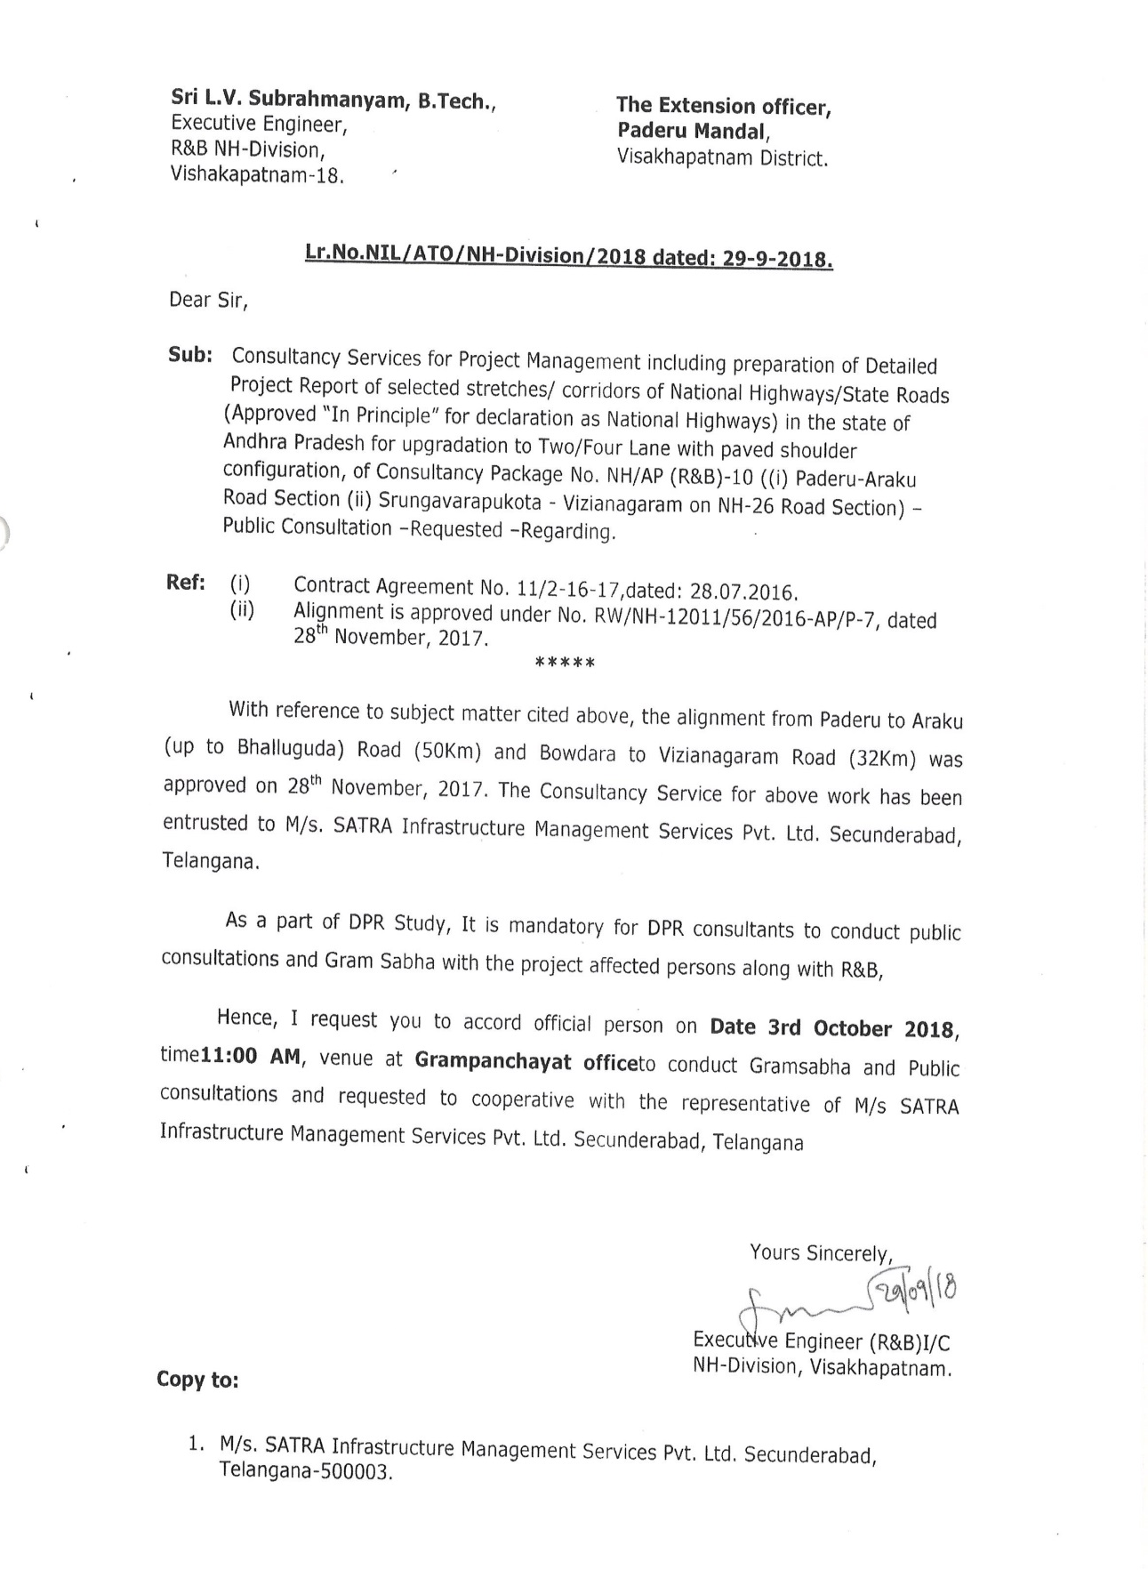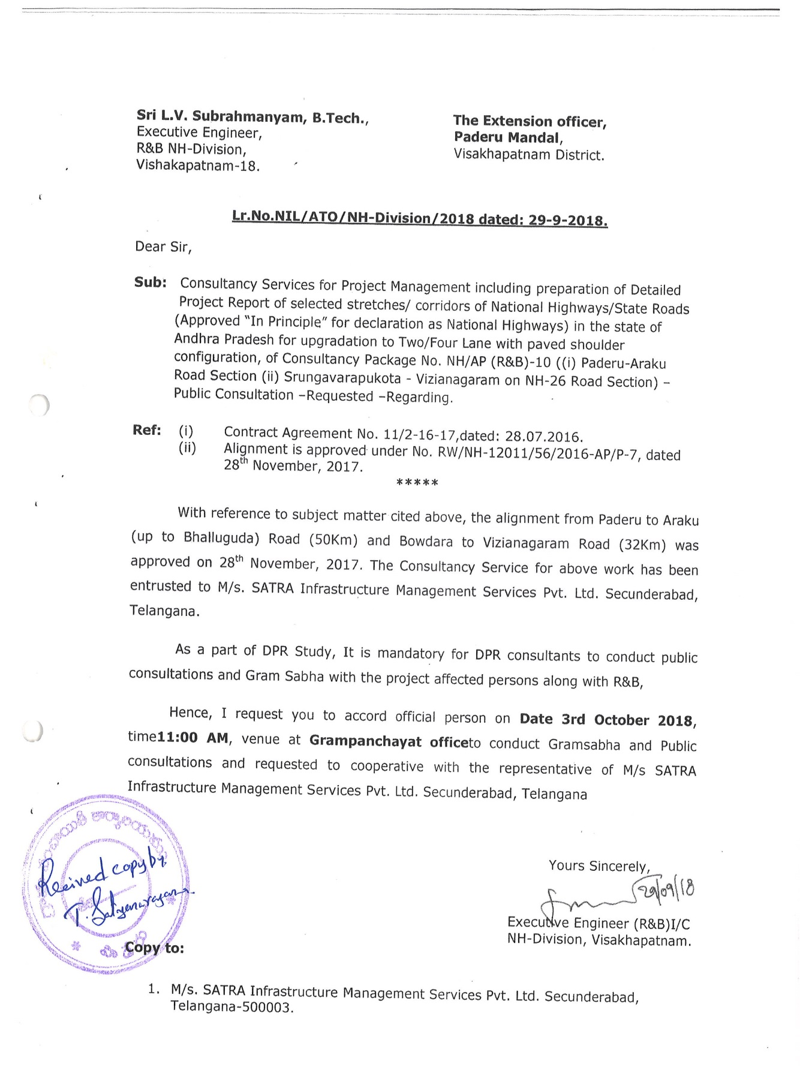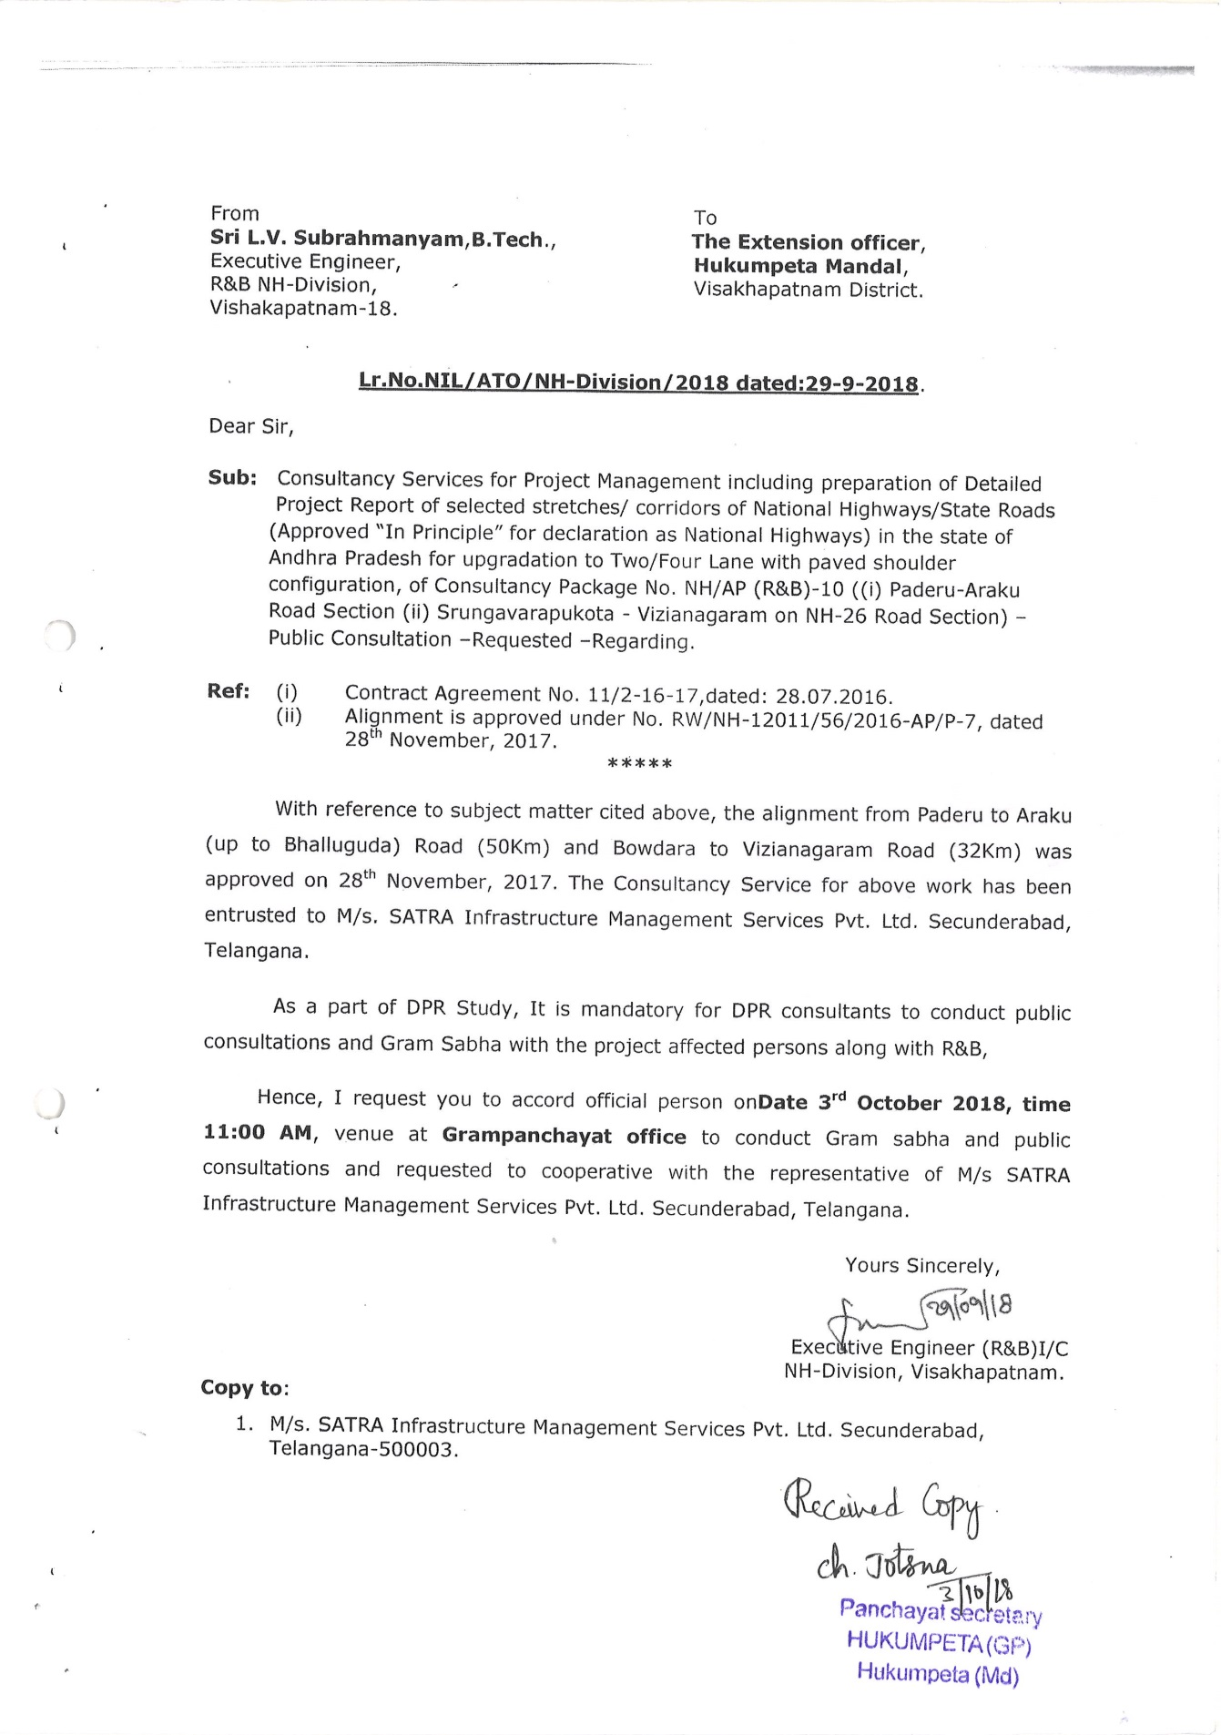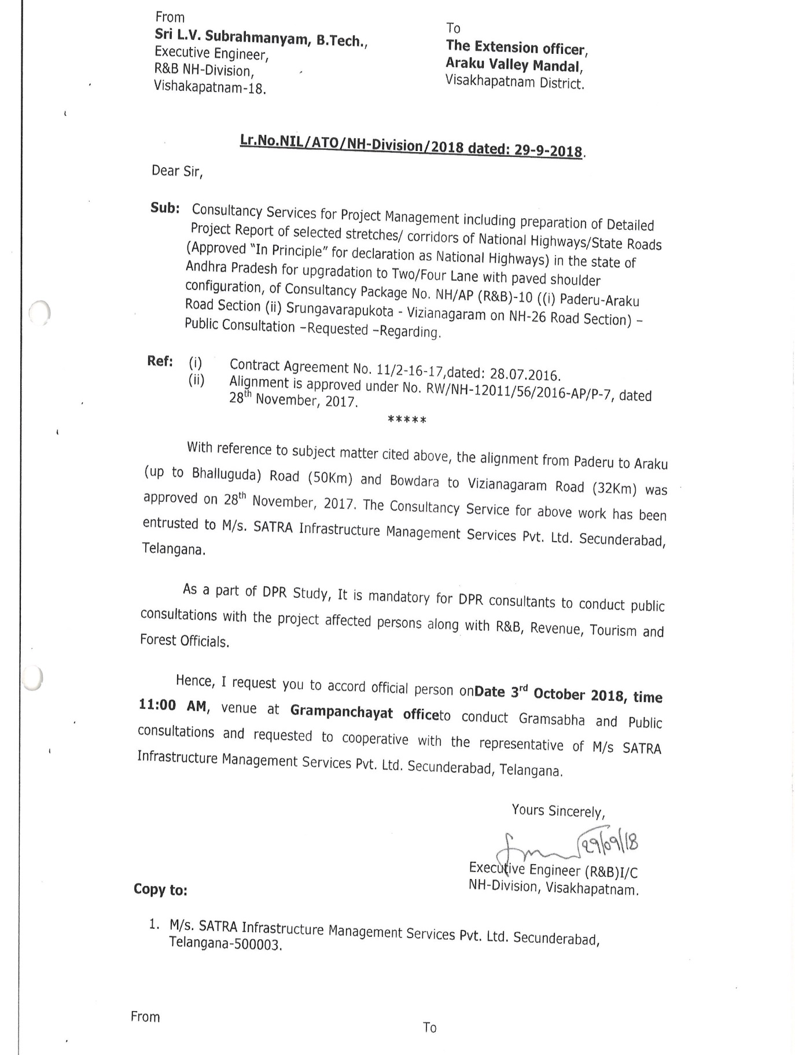

Annexure-9.2: Attendance Sheets 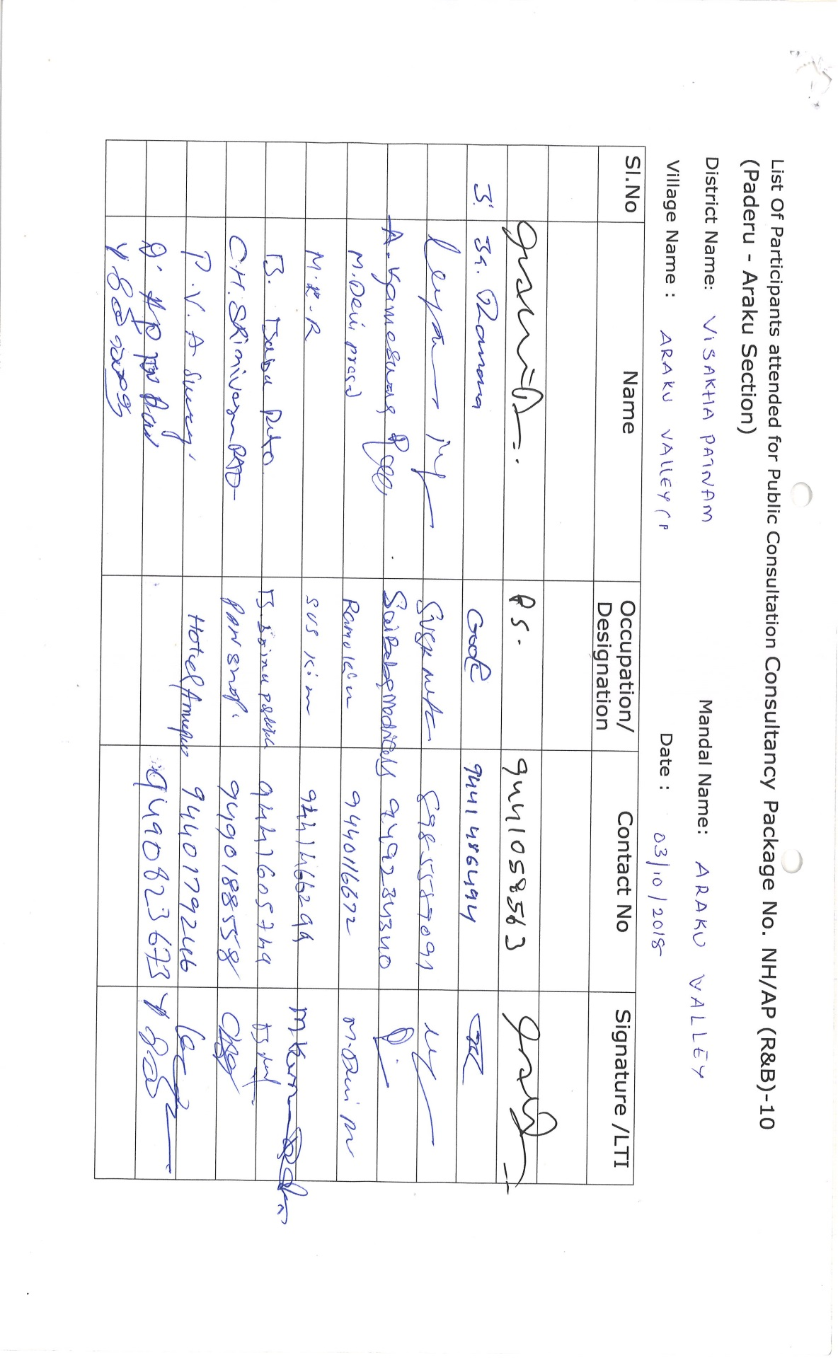
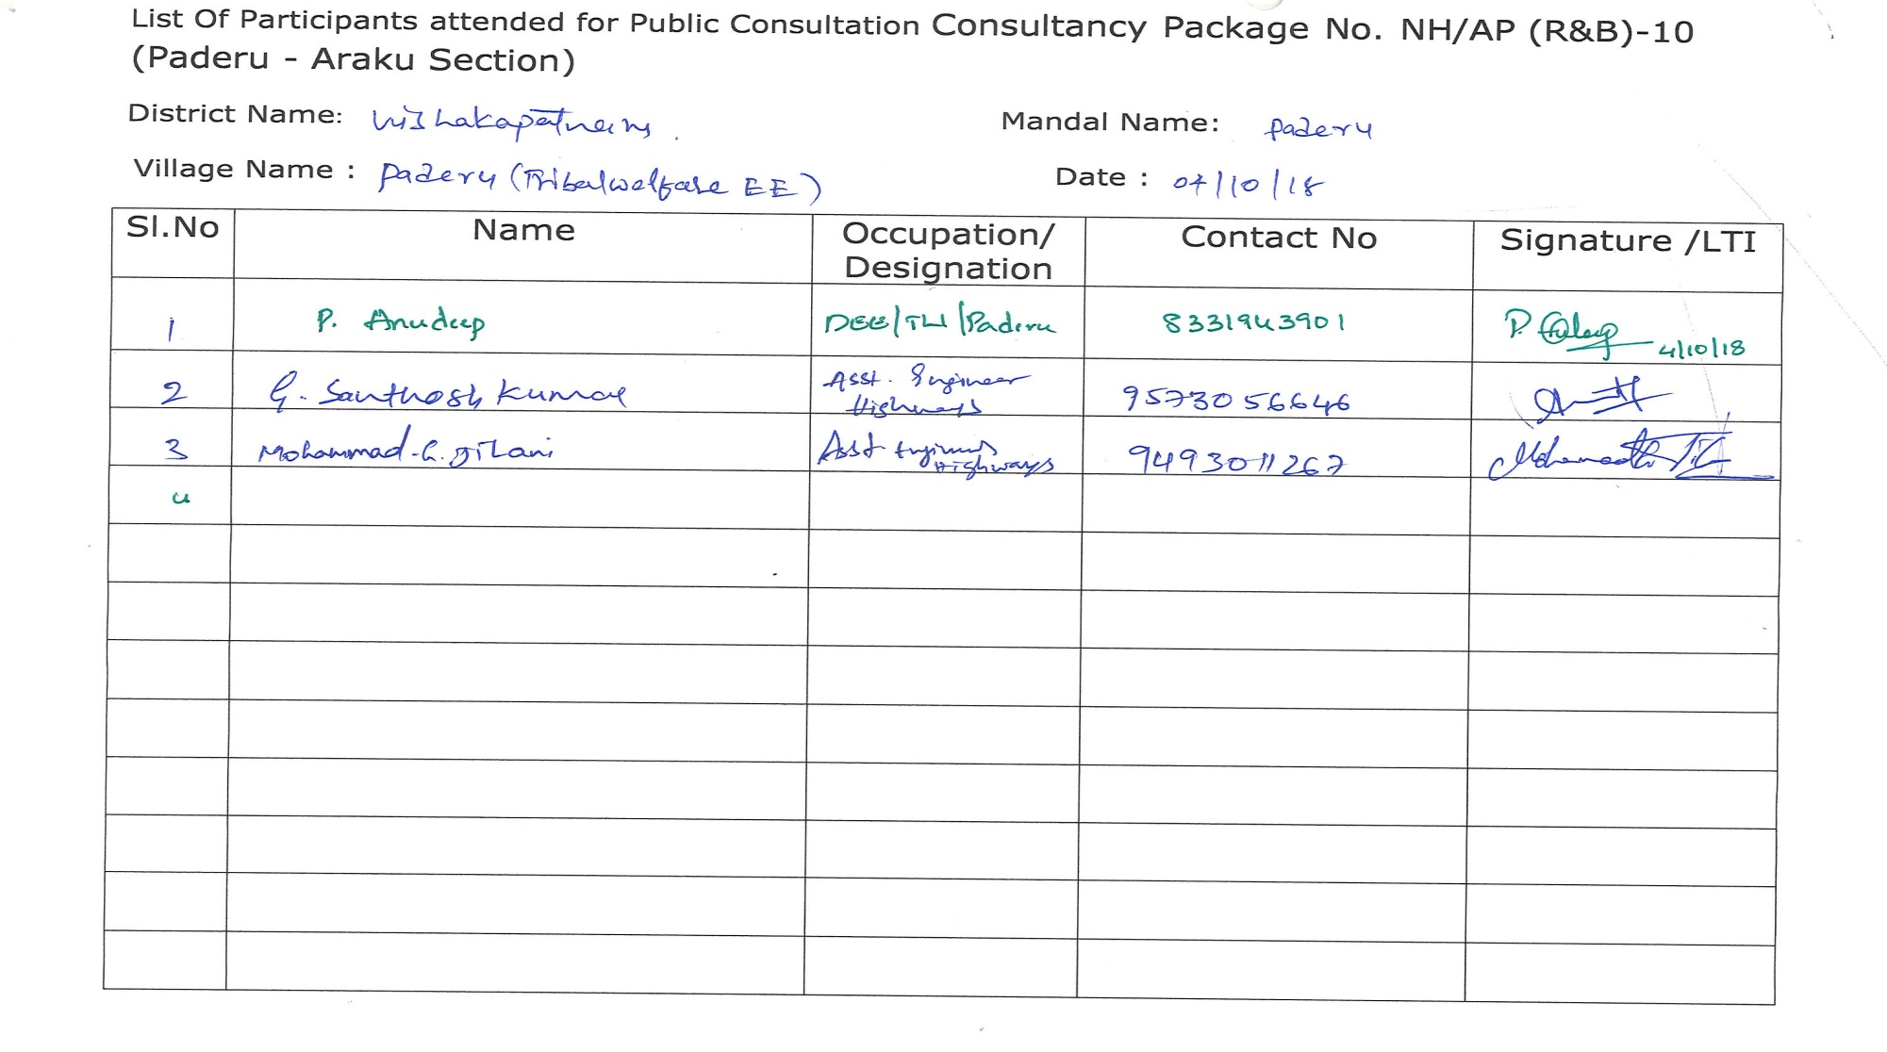
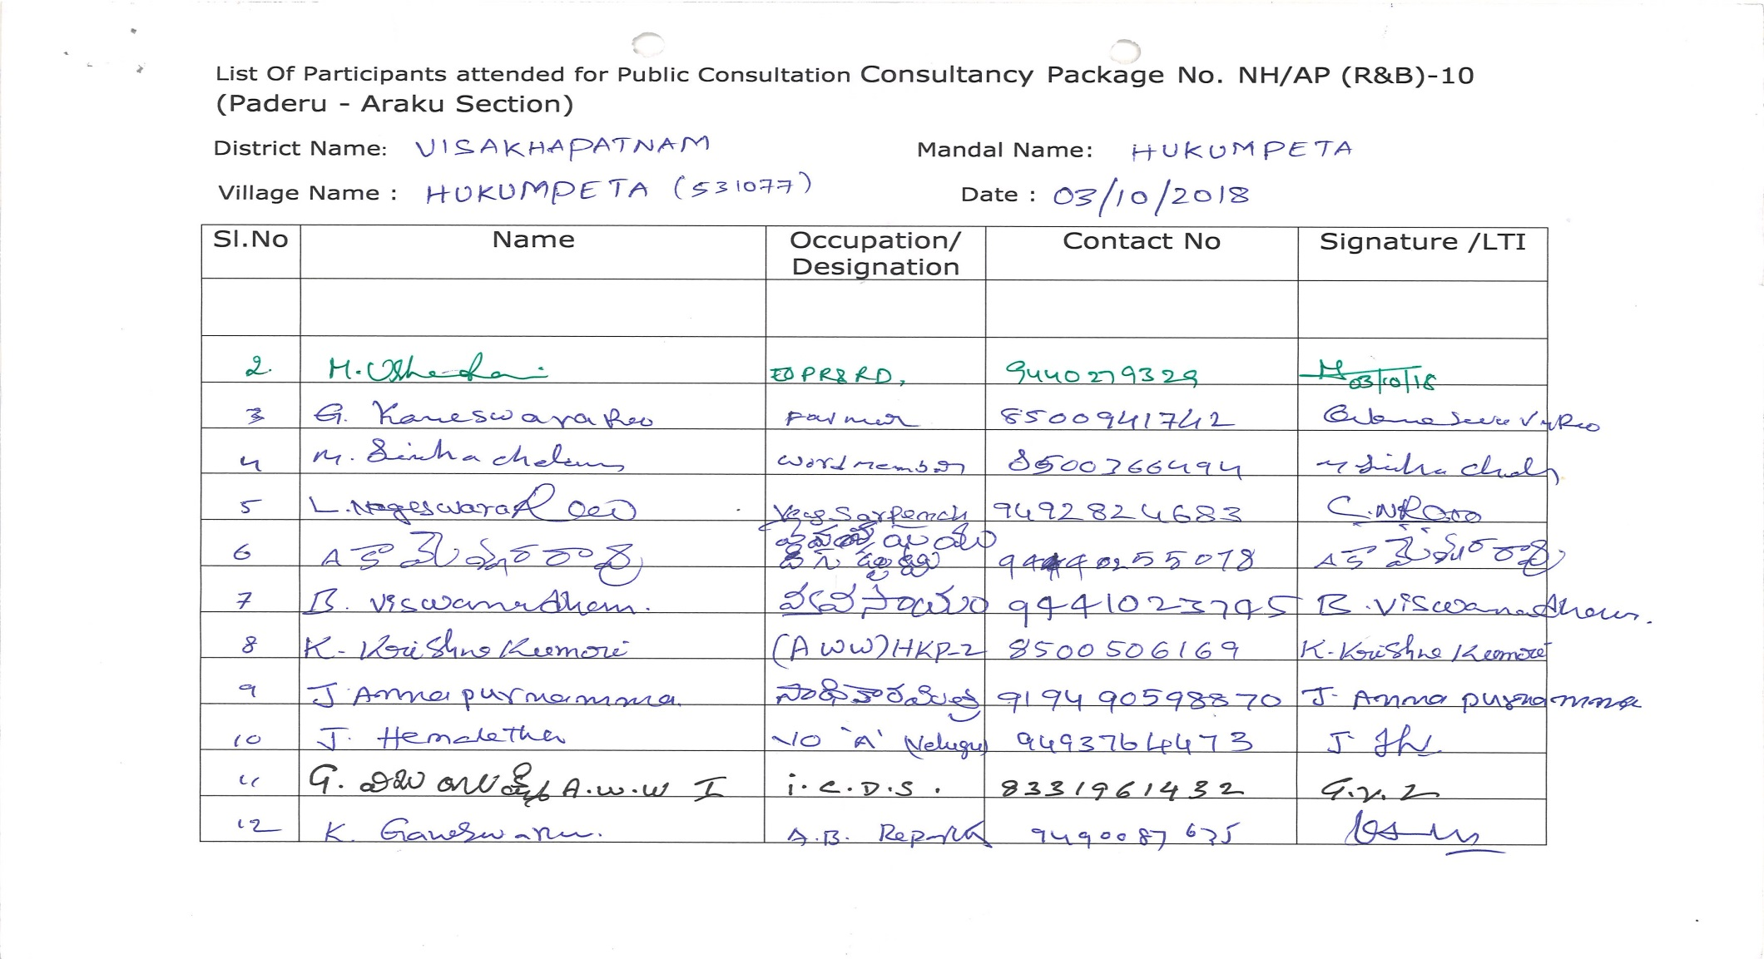
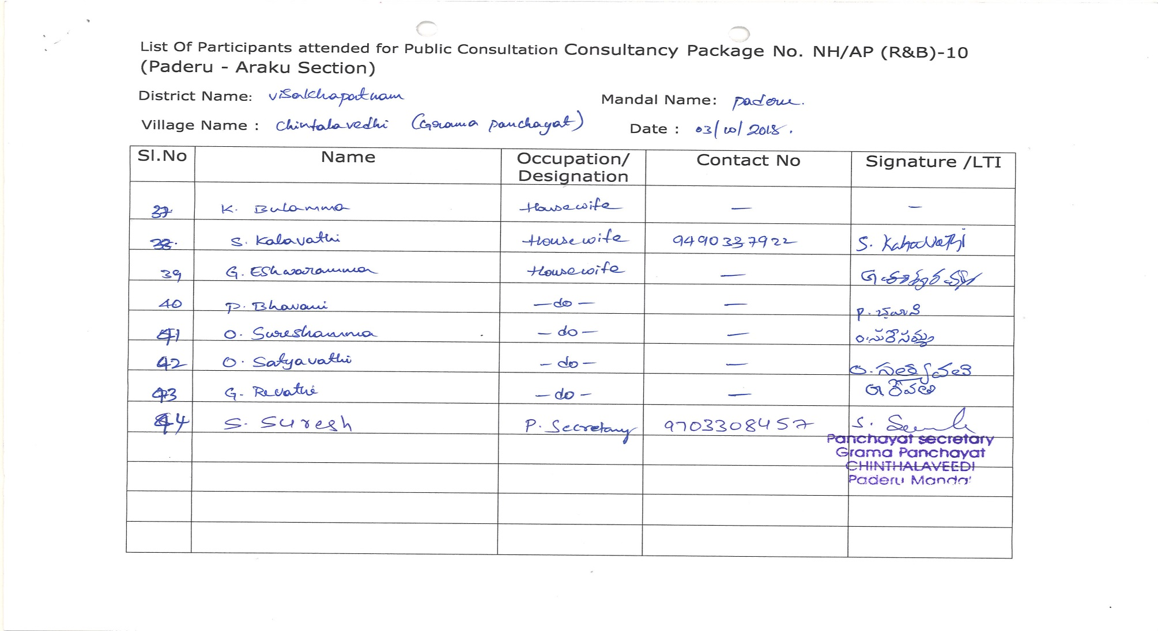
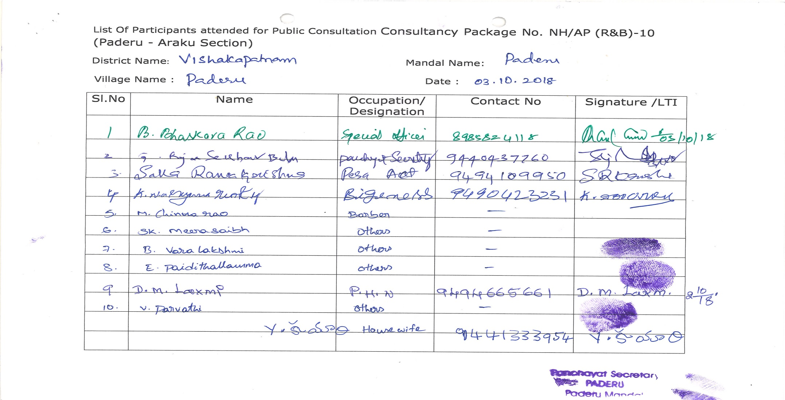

Directorate of Economic and Statistics, Vijayawada, GoIAP, 2016 & Census 2011 data.
The data excludes the ST population of the schedule villages of the 7 mandals from Khammam district of the A.P state (as per the Reorganisation Act, 2014.
AP Tribal Welfare Department, GoAP

