Report 43203 - LA

Community-Driven Approaches in
Lao PDR

Moving beyond service delivery

(In Two Volumes) Volume II: Main Report

April 2008

Human Development Sector Unit
East Asia and Pacific Region

Table of Contents

Abstract vii

Overview ix
CDD can work in Lao PDR… xii
Impact xii
Cost effectiveness of CDD sub-projects xiv
Cost of setting up a CDD operation xvi
…Although challenges remain xvii
Challenge I: Harmonizing CDD approaches xvii
Challenge II: Achieving an inclusive participatory planning approach xxi
Challenge III: Supporting livelihood activities xxv
Conclusions and recommendations xxix

1 The CDD Panorama in Lao PDR 1
1.1 Geographic and sectoral distribution of CDD projects 3
1.2 CDD projects supported by the World Bank 5
1.3 Comparison of CDD projects in Lao PDR 8
2 Scope and Design of the Poverty Reduction Fund 13
2.1 Background 13
2.2 Project objectives and design 14
2.3 Methodology and activity cycle 17
3 Evaluation of the PRF design 21
3.1 Characteristics of PRF sub-projects 24
3.2 Cost of PRF sub-projects and communities’ willingness to contribute 26
3.3 Evaluation of the village participatory selection process 28
Perceptions on the gender approach 31
3.4 The selection process from village to district 32
Perceptions on the project selection process 35
The role of the government in sub-project selection 36
Who does PRF benefit most? 41
Villages without support 46
3.5 Empowerment, inclusion, and participation from the beneficiaries’ perspective 47
Capacity building and project socialization 52
3.6 Perceived impact of sub-projects 54
3.7 Cost of the PRF 58
3.8 Issues on operations & maintenance 62
3.9 Conclusions 63
4 Impact Evaluation of the Poverty Reduction Fund 67
4.1 Summary of methodology and findings 67
Main Findings 68
4.2 Data description 70
4.3 Methodology 72
4.4 Estimated impact 76
Health 76
Education 77
Consumption 80
Access to Roads 81
Social Capital 82
5 Livelihood Activities and CDD: the VDF and the VIP 85
5.1 Design of the Village Development Fund 87
5.2 Implementation of the Village Development Fund 92
Perceptions on the planning process 92
The perceived project selection process 93
Who benefits from the VDF 95
Perceived impact of the VDF 98
Building capacity of the VDF Committee 99
Salient features and issues of the VDF 100
5.3 Design of the Village Investment for the Poor 102
5.4 Implementation of the Village Investment for the Poor 103
Perceived participatory planning process 103
Who benefits from the VIP 105
Perceived impact of livestock husbandry 107
Issues related to Credit and Savings Groups 108
Capacity building 110
Conclusions 111
References 115
Appendix 119

Acknowledgments

This report was prepared by a team led by Jamele Rigolini and including Helle M. Alvesson, Seth Gitter, Natsuko Kiso, Jennica Larrison, and Emiko Apichaya Naka. The team would like to thank all project beneficiaries, officials and project staff who willingly shared their ideas and experiences with the development projects evaluated in this Note; Mr. Sivixay Saysanavongphet, Executive Director of the Poverty Reduction Fund; Mr. Olivier Ducourtieux, Senior Technical Advisor; the Monitoring and Evaluation team; and all Poverty Reduction Fund staff for their contributions and support.

The team would also like to express its gratitude to Andrew Adam, Caridad Araujo, Luis Benveniste, Samaychanh Boupha, Gillian Brown, Robert Chase, Tipsavanh Intharack, Emmanuel Jimenez, Manichanh Keoviriyavong, Xayxana Latsabouth, Mingngakham Pangnasak, Khamlien Pholsena, Pairach Piboonrungroj, Ana Revenga, Maryam Salim, Ulrich Schmitt, Bounloy Sengkhamyong, Oula Somchanmavong, Thipasone Soukhathammavong, Chansada Souvanlasy, Akarapong Unthong, Yavang Vachoima, Renos Vakis, Kongkeo Vongpaseuth, Syvilay Vorachak, and Phoxay Xayyavong for invaluable comments and support. All errors are ours.

Finally, financial support from the Trust Fund for Environmentally and Socially Sustainable Development, the Danish Consultant Trust Fund, and the Japanese Consultant Trust Fund is gratefully acknowledged.

Abstract

This report reviews Community Driven Development (CDD) projects in Lao PDR to determine their effectiveness in channeling resources to communities for poverty reduction. The study examines three CDD projects in depth: the Poverty Reduction Fund, the Village Investment for the Poor (both supported by the World Bank), and the Government-financed Village Development Fund. Through close analysis of these projects and cursory analysis of other CDD projects, the report concludes that overall, the CDD approach in Lao PDR improves the well-being of communities in a cost-effective manner.

The study, however, identifies three challenges that remain for CDD projects to be wholly successful. The first challenge is a call for harmonization of CDD mechanisms within the country. CDD approaches are not currently coordinated geographically, technically, or financially. This leaves communities who need help without resources, an excess of skills in some areas and a dearth of skills in others, and funding allocated towards operations, which could be redirected to communities. The report recommends coordinating and consolidating CDD approaches.

The second challenge is the achievement of inclusive participation. While empowerment has proven to improve the well-being of communities, not all local officials recognize the benefits of a participatory approach. The report recommends operating in districts on a long-term basis to develop sustained empowerment and extensive training to local officials and communities on participatory approaches.

The final challenge for CDD projects is the funding of livelihood activities, which is necessary for sustained poverty reduction. Evidence has demonstrated that CDD backing of livelihood activities through loans, however, is unsuccessful. The report recommends administering grants for livelihood activities and ensuring technical support along with a participatory approach.

Overview

For Lao PDR, Community Driven Development (CDD) is a new and promising way of improving welfare and service delivery in traditionally underserved rural communities. Community driven development projects seek to reduce poverty by empowering communities to assess and provide for their own needs through community participation and decentralized decision-making. To achieve this goal, CDD projects support local infrastructure, services, and livelihood programs. In addition to being one of the most cost effective ways to respond to communities’ infrastructure needs, community-driven approaches have proven, among others, to increase school enrollment, access to clean water, and the use of latrines; improve health outcomes; and reinforce social capital.

Community driven development can help the Lao government in its attempt to reach its national poverty reduction targets and achieve the Millennium Development Goals (MDGs) by 2015. Growth has been an important driver of poverty reduction in Lao PDR, averaging 6.3 percent between 1996 and 2006, and during this period human development indicators improved significantly. Nonetheless, Lao PDR continues to have some of the poorest human development indicators in the region. Primary gross enrollment rates were 79.8% in 2002/03, and 40% of children under-five were malnourished. Two-thirds of households have no electricity, and about half lack access to safe water (World Bank, 2006). Community Driven Development (CDD) can be an effective mechanism to tackle these issues, as it has the capacity to channel in a cost-effective manner funds to remote and poor communities to improve local infrastructure and the quality of service delivery.

Community-Driven Development is also an effective mechanism to promote the government’s National Growth and Poverty Eradication Strategy (NGPES). The NGPES lays out the country’s overall development framework, poverty reduction objectives, and a medium-term roadmap for reaching these objectives. The Sixth National Socio Economic Development Plan (NSEDP) for 2006-10 is the successor poverty reduction strategy to the NGPES. It describes the underlying strategies and policies supporting the country’s vision of graduating from Least Developed Country status by 2020, and provides specific targets and indicators. Community-driven development can help supporting the NSEDP objectives to (i) promote participation of the poor in making decisions about their future, which is seen as being essential for their empowerment; (ii) foster decentralization as a means to ensure sustained participation of the people, including the poor and women in local affairs; and (iii) promote informed participation of the poor through improved flows of information, communication, and education (IEC).

Demand-driven development has its roots in the l980s, but it is only in the last few years that CDD projects have been growing in Lao PDR. In 2004, 6 projects within Lao PDR maintained a community-driven component; two years later about twenty-five projects implemented by multilateral and bilateral donors and International Non-Governmental Organizations (INGO) possessed a community-driven component. Active donors include the International Fund for Agricultural Development (IFAD), the Canadian International Development Agency (CIDA), the United Nations Development Program (UNDP), the European Union (EU), the World Bank, the German Agro Action (GAA), Village Focus International (VFI), World Concern, as well as other International NGOs.

The unprecedented expansion of CDD projects fuels the need to analyze the efficiency of the various approaches, and to discuss a medium to long term strategy for harmonizing participatory approaches in Lao PDR. As this report will show, CDD projects in Lao PDR currently promote a variety of participatory approaches. While each approach maintains its own strengths and weaknesses, the harmonization of participatory approaches could open the way for a much-needed institutionalization of community participation.

This report aims to provide a platform for an informed discussion about harmonizing and improving the effectiveness of participatory approaches in Lao PDR. The report analyzes in detail three CDD projects: the Poverty Reduction Fund (PRF), the Village Investment for the Poor (VIP) component of the Agricultural Development Project (both supported by the World Bank), and the Government-financed Village Development Fund (VDF). Although it does not provide a comprehensive evaluation of all CDD approaches in Lao PDR, the report provides a picture of the most relevant challenges community-driven projects are facing.

The findings and recommendations are based on a qualitative study of 32 randomly selected villages in Huaphan and Saravane provinces in which one of the three CDD projects was implemented; quantitative data from the PRF Monitoring Information System (MIS) database; a PRF impact evaluation conducted in 150 villages; and, for the overall examination of CDD projects, on the review of Operations Manuals, and interviews with government, donors, and project staff.

The Overview is structured as follows. Section 2 looks at the effectiveness of CDD projects. It shows that CDD can improve communities’ well-being and deliver local infrastructure in a cost-effective manner. It also reviews the cost of managing a CDD operation. Section 3 reviews the three main challenges CDD projects are facing in Lao PDR: the harmonization of CDD approaches, achieving inclusive participatory approaches, and supporting livelihood activities. Section 4 concludes by suggesting how these challenges could be faced.

Box 1. Description of studied CDD projects

The Poverty Reduction Fund (PRF) aims to assist villagers in developing community infrastructure and gaining improved access to services; build capacity and empower poor villages in poor districts to identify needs, and plan, manage, and implement their own public investments in a decentralized and transparent manner; and strengthen local institutions to support participatory decision-making and conflict resolution processes at the village, koumban, and district levels.

The principles and the objectives of the PRF depend upon and encourage a high degree of participation by the people themselves. At each local level the PRF begins with a strong process of “socialization” – introducing and explaining the PRF principles and objectives to the villagers and the wider public. Radio broadcasts, posters, pamphlets, and other tools are used to disseminate information about the project. Subsequently, with the assistance of elected PRF koumban facilitators, all villages in target districts organize Village Needs Priority Assessment (VNPA) meetings to define their priorities, and to elect three village representatives. Village needs and priorities are then discussed and prioritized by village representatives at a higher level, during the koumban prioritization meeting. Koumban sub-project proposals are themselves discussed by village representatives during district decision meetings where all proposals are ranked. Finally, the PRF evaluates the feasibility of the top-ranked proposals, after which another district meeting is held to decide which projects to implement. Villages are then responsible for project implementation, but PRF staff assists them with periodic cross-village assessment visits, monitoring, and reporting.

Between February 2003 and June 2007, the PRF built 354 schools, 50 bridges, 64 health dispensaries, 1012 water supplies, 119 irrigation schemes, and upgraded 2420 km of roads. It also provided 939 school packages and 1480 training sessions. Due to its widespread coverage (12 percent of the Lao population in 5 provinces, 21 of the 72 poor districts in Lao PDR, and 1,984 villages), the PRF is one of the most important community-driven programs in the country.

The Village Development Fund (VDF) supports the creation of revolving funds to promote livelihood activities related to cultivation and animal husbandry, the clearing of land for agricultural production, handicraft, processing, and trade. The VDF aims to (i) promote village participation and ownership of the funds; (ii) increase household production; (iii) provide opportunities for individuals in poor villages to improve their capacity and economic situation; and (iv) promote decentralization. In 2003/04, the Government initiated Village Funds in all 47 first priority districts. As of the end of June 2007, VDF operated in 315 villages.

The Village Investment for the Poor (VIP) component of the Agricultural Development Project finances block-grants to villages for small-scale projects identified by the community. The grants range between US$500 and US$1500 per sub-activity, with the objectives to: (i) support rural communities where poverty is high; (ii) strengthen capacity for designing and implementing small projects at the village level; and (iii) facilitate a closer link between the District Agricultural and Forestry Office (DAFO) staff and the communities. Implementation and supervision of the VIP is the responsibility of the extension unit in DAFO, and the implementing body at the village level is the Village Committee (VC), in collaboration with Village Volunteers (VV). The ADP started in early 2002. To date, a total of 204 villages in 15 districts have received 601 sub-activities. Unanticipated in the design of the VIP, the block grants were utilized to establish Credit and Savings groups providing low interest rates in all interviewed villages, making de facto the VIP very similar to the VDF.

CDD can work in Lao PDR…

The study of the PRF, VDF, and VIP shows that community-driven approaches can work in Lao PDR. Nonetheless, existing CDD projects are facing significant, although not insurmountable, challenges. Existing CDD projects in Lao PDR are effective in delivering to remote communities the local infrastructure requested, and a positive impact has been observed on health, education, and transportation outcomes. Nonetheless, as the following sections will reveal, significant challenges remain when it comes to empowerment and livelihood support. This section reviews the effectiveness of CDD approaches in delivering local infrastructure. It mostly draws from the quantitative and qualitative evaluation of the PRF.

Impact

A quantitative impact evaluation found that the PRF improved health and education outcomes, and access to roads. In the North, PRF water and sanitation projects decreased the incidence of diarrhea in beneficiary villages among children. Given the high prevalence of diarrhea in the sampled villages, this appears to be an important accomplishment of the PRF. In the South (where literacy rates were comparatively low), PRF facilities also had an impact on literacy rates in beneficiary villages, however no such impact was detected in the North, where overall education levels were initially higher and sampled villages only recently requested and received schools from the PRF. Finally, the analysis also found a positive impact on access to roads in the North, but no impact in the South. The difference in impact is very likely to stem from the differential need of roads between the North and the South. Before the PRF intervention, only 60 percent of the sampled villages had access to roads in the North, while the proportion was much higher in the South (80 percent).

In contrast, no robust impact has been observed on social capital outcomes, which is consistent with the challenges CDD projects face in empowering communities. The impact evaluation did not find a robust impact of the PRF on social capital outcomes. As the next sections detail, this is consistent with the difficulties CDD projects are encountering in empowering remote communities.

Box 2. Conducting impact evaluations in low capacity settings

CDD projects tend to be cross-sectoral by nature, and therefore “dilute” their impact over several indicators. This problem has led to most evaluations of CDD projects finding low levels of impact (see, for instance, Rawlings et al., 2003). In addition, problems in finding statistically significant impacts have been exacerbated in the PRF impact evaluation by the quality of data collected in this study. Data collection and data entry of both base- and end-line surveys were of poor quality, resulting in a relatively high proportion of outliers and missing data. The poor quality of data collected in both surveys has generated significant “noise,” increased standard errors, and therefore lowered the likelihood of finding significant impacts.

Problems encountered during the design of the evaluation, data collection, and data entry indicate the importance of allocating more time and resources to impact evaluations in low capacity settings. Limited budget, commitments made during the collection of the baseline survey data, and strong time constraints to ensure that the baseline survey would be in the field before the project started, have led to a poorly designed and implemented impact evaluation.

In the future, high returns in quality and significant savings could be achieved by training a local champion in impact evaluation techniques. At the moment, few firms are able to perform impact evaluations in Lao PDR, and all firms need strong support. If more impact evaluations will be performed in the future, high returns in quality and cost efficiency could be achieved by training a local firm in impact evaluation techniques.

If little time and resources are available, other types of cheaper evaluations may in fact provide better quality and more useful information. While impact evaluations are the state of the art technique to identify whether a project had an impact on the community, many policy relevant questions – especially the ones leading to improvements in project design – can be answered by using other evaluation techniques, such as the qualitative evaluation also performed for this report, that are cheaper and more reliably implemented in low capacity settings.

Qualitative interviews confirm the main findings of the impact evaluation: communities that received infrastructure sub-projects reported that their everyday life improved due to the sub-project. In project districts, the PRF led to significant developments of road networks, water supplies, schools, and health facilities. Beneficiaries, PRF staff, and government officials agree to a very large extent that the PRF has improved access to basic infrastructure in the participating districts. Overall, beneficiaries expressed strong satisfaction with the sub-projects they received. In all surveyed villages in Huaphan, beneficiaries expressed that their livelihoods had improved after the local infrastructure sub-projects were implemented, and in Saravane, two-thirds of the villages expressed that a positive impact occurred. These beneficiaries viewed the project positively to the degree that they were willing to apply for new sub-projects in subsequent years. Water and sanitation, transportation, and education sub-projects were the most frequently implemented PRF sub-projects. Water supply systems relieve women from a significant burden of time and work, permit the cultivation of cash crops, and lower the incidence of diarrhea; roads and bridges provide remote villages with better access to markets and public services; and the construction of schools embodies the hopes of parents that children will do better than they have themselves (see Box 3).

Box 3. Perceived impact of PRF sub-projects

Water & Sanitation
“Before we had to walk very far to get water – now it is in the middle of the village. Children can wash themselves at any time – even at night time.” […] “Now our village is a healthy village.”

“The village has benefited from the project, especially when it comes to the livelihood, because villagers will have more time for agricultural production and increase the household income.”

Access Roads
“Now I can go to the district during any season and sell vegetables and forest products [mushrooms and bamboo]. I can walk to the district from my village.”

Schools
“We want them to become teachers and nurses and come to work in the village.”

“It is good to have a school where the children can learn Lao.”

“We would like children to go to school, so they in the future can become government staff.”

Cost effectiveness of CDD sub-projects

Average construction costs of PRF infrastructure demonstrate that well-structured participatory approaches can cost less than other forms of project delivery, with the added benefits of building capacity and ownership. On average, each sub-project funded by the PRF totals US $8,295, where the PRF contributes 83 percent, and the remaining 17 percent is funded by the community in cash, labor, and materials (Figure 1). On average, communities co-finance sub-projects by a higher amount than what is required by PRF regulation (10 percent). Findings from the qualitative study indicate however that the majority of villages perceive in-kind and labor contributions as being appropriate in scope.
Figure 1. Average cost of sub-projects in the PRF
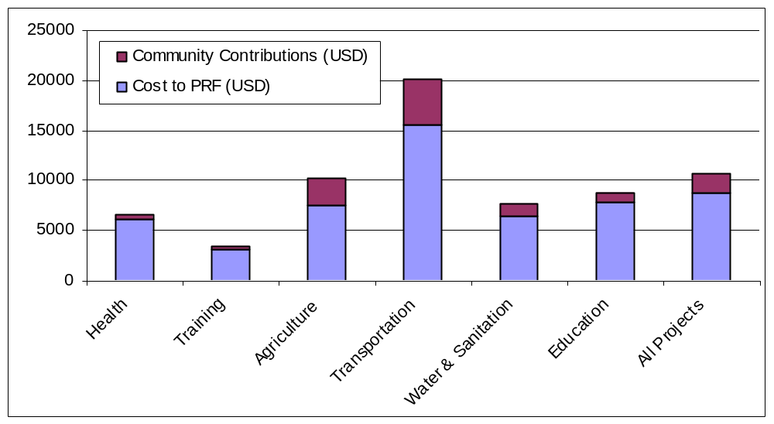
Source: Authors’ own calculations from M&E data, cycles I to III.

These overall construction costs are comparable, if not lower, to construction costs of non-CDD sub-projects (see Table 1; the cost comparison does not control for construction quality, but overall, PRF construction quality has been deemed appropriate). In-kind community contributions, community-based procurement founded on a detailed knowledge of local costs, and cost checks through comparisons with a centrally managed unit costs database help maintain construction costs below many other development projects.

Table 1. Unit cost comparison

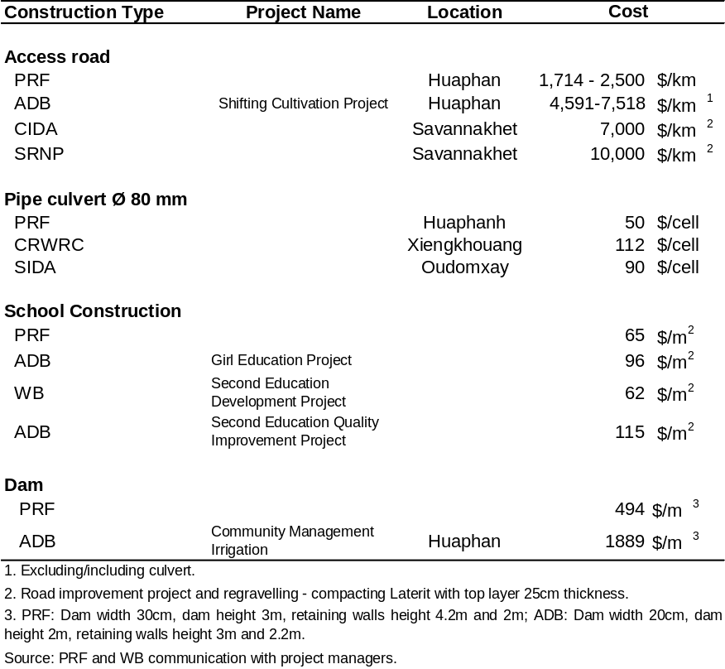

The PRF experience shows that construction costs in CDD projects can remain low even when including the costs of operating the project, with the added benefits of better responding to communities needs, building communities capacity to implement their own sub-projects, and promoting participatory planning. In its first five cycles of activity, the cost of operating the PRF amounted to 25 percent of the total budget. Operating costs include the costs of building capacity and empowering communities to assess their own needs and implement local infrastructure subprojects themselves, which are also objectives of the project. But even by adding these overhead expenditures to the construction costs of local infrastructure, total costs remain close to construction costs of other non-CDD projects (see Table 1).

A need, however, exists to ensure that local infrastructure sub-projects are complemented with Operation and Maintenance (O&M) plans to guarantee utilization and sustainability. The quality of O&M varies significantly among the different types of sub-projects. The O&M of gravity fed water and irrigation systems has been found to work well, with maintenance of gravity fed and irrigation systems executed by project beneficiaries. In contrast, the maintenance of roads, bridges, and schools is more demanding in terms of the technical capacity required and costs incurred. School sub-projects already receive supplementary grants to buy desks and teaching/learning materials, but the upkeep is not guaranteed. Maintenance plans are often lacking or poorly designed, and, although beneficiaries are willing to maintain PRF infrastructure through in-kind and labor contributions, they do not always have the necessary resources for proper maintenance.

Cost of setting up a CDD operation

CDD projects tend to have high set-up costs, but low variable costs. In the initial phase of a CDD project, central and regional offices have to be organized, cars bought, and staff trained for the capacity building activities. Accordingly, in Cycles I and II the operating costs of PRF corresponded to 38 percent of the total yearly budget. Conversely, variable costs, which approximately correspond to the operating costs in Cycle IV, were less than half of the initial cycles, at 18 percent of the total yearly budget.

Low operating costs (again expressed as a percentage of the total budget) in CDD programs can only be achieved if the project has wide coverage, a long horizon, and disburses a significant amount of grants. A large proportion of operating costs is usually spent on running the national office, whose size does not vary significantly with coverage. Therefore, low operating costs can only be achieved if CDD projects have wide coverage, a long horizon (which minimizes set up costs), and disburse a significant amount of grants (which minimizes variable costs). Small scale, limited budget interventions for short periods of time are instead likely to exhibit disproportionate operating costs.

Savings in operating costs and efficiency gains could therefore be achieved by grouping CDD projects with similar objectives. Even among World Bank projects, the PRF, the Village Development component of the SUFORD project, and the Village Investment for the Poor share common goals but have separate logistics, leading to relatively high operating costs in each project. As all three projects are active in some provinces - such as Saravane - coordinating actions to avoid overlaps, and pooling resources would be likely to lead to significant savings in operating costs, leaving more money available to fund village projects.

…Although challenges remain

Despite the success of some CDD projects in delivering local infrastructure to local communities in a cost effective manner, important challenges persist that hamper CDD’s development objectives. The analysis identifies three significant challenges: harmonizing CDD approaches across projects; achieving an inclusive participatory planning approach, especially in remote areas with non-Lao speaking ethnic groups; and supporting livelihood activities.

Challenge I: Harmonizing CDD approaches

The current CDD panorama in Lao PDR is scattered and dysfunctional. Project location decisions do not necessarily depend on provinces’ and communities’ needs and poverty status, and there is little or no geographical, technical, and financial coordination across CDD projects. In choosing where to locate CDD projects, the government and donors rarely consider communities’ needs and poverty statuses, and the type of support communities are already receiving on the ground in a comprehensive manner. Interviews with project staff reveal that CDD projects tend to operate in accessible villages with communities that have better capacity to carry out projects; in provinces where donors had past working experience; and in provinces that were affected by the war. Consistently, the 25 projects with CDD components currently implemented in Lao PDR are mainly concentrated in the northernmost provinces, the provinces bordering Vietnam, and in the southern provinces (see Figure 1). Although there is a fair correlation between poverty incidence and CDD coverage, provinces such as Champassak, Xiengkhouang and Savannakhet also benefit from a high number of projects despite being less poor. Meanwhile, coverage is lower in some provinces with high proportions of non-Lao speaking ethnic groups, which, due to language barriers, often face strong difficulties in their dialogue with local authorities, and therefore would greatly benefit from CDD projects (see Chamberlain, 2007).

In almost all provinces, CDD projects support education, health, livelihood activities, and agriculture. The education sector (infrastructure, support of formal and non-formal education, curriculum development, teaching materials) receives the greatest support, followed by the health sector (infrastructure, family planning and reproductive health support, health education and training, water and sanitation, mother and child care), agriculture (agricultural training, food crop and livestock production, irrigation), and livelihood activities.

Each project possesses different strengths and shortcomings in their approach and implementation. Some donors have extensive knowledge of local conditions, and strong relationships with local authorities, but face a lack of project staff or financial capacity. Other donors have access to more funds, but have difficulties in communicating with local communities or coordinating with district authorities. Finally, most of the current CDD projects are small in scale and scope. The largest CDD projects are currently the District Development Fund (DDF; see Box 4), and the Poverty Reduction Fund.

Box 4. A major new player: the District Development Fund (DDF)

The DDF, supported by UNCDF and UNDP, has been piloted in Saravane since 2005 and will expand in 2008 to five other Northern provinces. The DDF strategy comprises two components. On the one hand, block grants are allocated as annual development budget support to districts, calibrated to population and poverty, and linked to district compliance with agreed measures of performance. On the other hand, bottom-up planning and public expenditure management innovations are introduced, which feed into the annual district budget cycle. Sub-project proposals are fed up from villages, through koumban committees, to the district. During annual meetings, a District Planning Committee (DPC) makes final decisions on sub-project approvals to be included for financing within the district investment budget. The DPC is comprised of district officials and also with a two thirds quorum of village representatives (koumban heads and women representatives). The District Planning Team (DPT) – which comprises district department heads and staff, as well as sector technicians – is the key project implementer, responsible for training village and koumban committees, for sub-project preparation, and support to implementation. Financial management is handled by district Departments of Finance. Compared to standard CDD projects that focus on building capacity at the community level, the DDF puts a stronger emphasis on working through and building capacity of district authorities in sub-project selection, monitoring, and implementation.

Strong similarities, however, are present across projects in the main design, and in the objectives to reduce poverty by improving local governance and empowering local communities. Out of the seven reviewed projects, all encourage community participation and ownership in sub-project identification, design, and implementation; all involve local authorities in their planning decisions; and most have dedicated staff on the field, and provide capacity building to communities. Village contributions such as labor, local material, and even cash are required in some cases as means of promoting ownership, and a village development committee, oftentimes consisting of the village head and local village facilitators, is usually formed to handle the general management of sub-projects (see Table 2). Apart from the Poverty Reduction Fund, however, no project has universal coverage in targeted districts.

Significant efficiency gains and savings could therefore be achieved by increased coordination and harmonization of CDD approaches in terms of participatory methods, coverage, and implementation design. Currently, each CDD project has its own approach, and approaches differ even within projects financed by the same donor (including World Bank projects). Greater efficiency could therefore be achieved by harmonizing the different participatory approaches, coordinating areas of intervention, and merging implementation units. A common participatory approach, with a single consultation process (in opposition to multiple consultations which are often carried out at the moment), would lead to a more coherent and efficient training of communities and local officials on participatory methods (in contrast, at the moment local officials are often left with little advice and training in how to consult communities, and therefore continue to lean towards top-down planning approaches); the coordination of targeting areas of intervention would allow covering poor communities nationwide, instead of only in the provinces preferred by donors; and merging implementation units – at least within provinces – would lead to significant savings because of reduced staff needs, and, equally important, would permit more time for dialogue with local officials and communities as each district would only have a single counterpart.

Figure 2. Distribution of CDD Projects in Lao PDR
Sekong

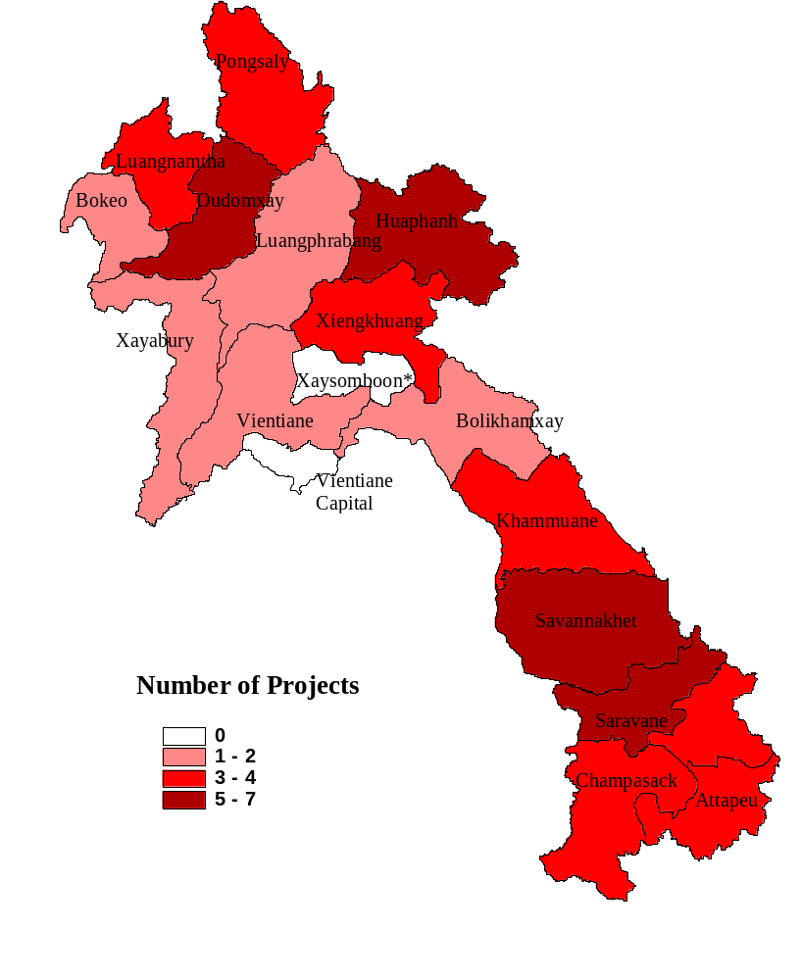
* Xaysomboon province was dissolved in 2006. However, the updated map of Lao was not yet available at the time this report was written. Data have been compiled by the World Bank in January 2006.

Table 2. Comparison of selected CDD projects
 | PRF | VDF | IFAD | UNDP / SEPD | GAA | VFI | UNCDF / DDF
Target population:
Ethnic group |  |  | X | X | X | X
Poor | X | X | X |  | X | X | X
Remote areas | X |  | X |  | X
Implementing Agency:
Project Implementation Unit at  central level | X | X |  | X
Project office in target province | X | X | X |  | X | X
Local authorities |  | X | X |  |  |  | X
Local Planning & Monitoring:
Local authorities | X | X | X | X | X | X | X
Mass organization |  | X | X | X | X | X | X
Project staff | X |  | X | X | X | X
Village Committee/Representatives | X | X | X | X | X | X | X
Village Selection Criteria:
Universal coverage | X
Priority needs and urgency |  |  | X
Accessibility |  |  |  | X |  | X
Ethnic diversity/ethnic population |  |  |  | X |  | X
Submission of proposals |  |  |  |  | X
Potential capacity in carrying out  implementation and self-reliance |  |  |  |  | X | X
Village commitment in training |  |  |  |  |  | X
Not a recipient of other grants |  |  |  |  |  | X
Province/District consultation |  | X | X |  |  | X | X
Capacity Building:
Training to villagers | X | X | X | X | X | X
Training to local government officials | X | X | X |  |  | X | X
Challenges:
Lack of local government staff  capacity and/or availability | X |  | X | X |  | X
Lack of integration of project  activities in government plan |  |  |  | X
Low capacity in poor villages | X | X | X |  | X | X | X
Lack of project staff |  |  |  |  | X
Difficulties to access to villages | X |  | X | X | X |  | X
Lack of funds or delays in transfer |  | X |  |  |  | X
Limited Local Private sector supply in remote areas | X |  |  |  |  |  | X
Maintenance | X |  |  | X |  |  | X
Lack of local authorities’ understanding of community  participatory approach | X
Source: Interviews with each donor organization and project documents if available.

Challenge II: Achieving an inclusive participatory planning approach

Empowerment and participation are key factors for engendering development. Empowerment implies enlarging peoples’ capabilities for making informed choices and taking actions that can have great impact on their welfare, and is as such, a goal of development in itself. In addition, a growing body of evidence is also showing the importance of empowerment in enhancing development effectiveness (World Bank, 2002). Empowerment, for instance, is recognized to affect good governance (and growth) in a two-way relationship in that good governance promotes empowerment, and empowerment further enhances good governance. Another key area in which empowerment plays a relevant role is poverty reduction: among others, when growth strategies are combined with pro-poor arrangements, development outcomes tend to improve. Finally, empowerment is important for project effectiveness and improved service delivery – a finding confirmed in this study.

Even though there is no single model for the advancement of empowerment, experience from many different settings demonstrates that access to information, inclusion/participation of poor people, accountability of governments and the private sector, and a capacity of local organizations to support communities in mobilizing voices and resources are four key elements of empowerment. The findings of this study indicate that these elements also play a critical role in Lao PDR.

The success of the PRF participatory approach varies between Huaphan and Saravane, and depends to a great extent on the existing structures and institutions. The new positions of PRF village representatives and koumban facilitators would ideally add the communities’ perspective on development needs to the existing institutions. This is quite an ambitious goal, and requires that district and provincial officials, who normally decide on the delivery of basic services, take a step back and create space for the new agents to participate directly. While district officials, beneficiaries, and PRF staff in Huaphan have, to a large extent, embraced the bottom up, participatory approach of the PRF, some skepticism remains among district officials and PRF staff in Saravane regarding the ability of communities to assess their own needs. Accordingly, district and province based planning is still perceived as the most efficient approach to development in Saravane.

Box 5. Successes and failures of promoting participation

Huaphan: a “success story”
A koumban facilitator in Huaphan province shows understanding of the participatory planning process and his role: “A meeting was conducted to select three of the six proposals [three from the men’s group and three from the women’s group]. So the six proposals were reduced to three and each village made their decision in their own way. The three proposals selected by villagers were considered the most important for the needs in the village […] These three proposals from each village were then collected from the whole koumban and presented at the koumban meeting. At the meeting, the village heads, representatives from each village, and the district PRF staff were present. The final decision was based on the needs of each village with the consent of the representatives of the village.” His own role was described as follows: “Our role was to present what the village needs are and submit it to the district PRF…all projects were decided at the district meeting.”

Saravane: a “long way to go”
One village head described the selection process in this way: “I knew before the village meeting what project activity would be chosen and implemented in our village. It was already decided by the district officials what support our village would receive.”

A koumban facilitator, when asked what his role was at the koumban and district meetings, replied: “At the koumban meeting we collected proposals from villages and I did not say anything and did not participate much in the discussion.” He was then asked “Why?” and replied: “Because I knew the decision was not taken at the koumban.”

Part of the differences in success can be explained by the length of PRF support, and geography. At the time of the review, in Saravane the PRF had only been operational for one cycle, hence local PRF staff and authorities may not yet had the time to acquaint themselves with participatory methods. In addition, geographical differences are also marked between the two provinces. Although located in a mountainous province, district centers and villages in Huaphan are easier to access and are less isolated than in the districts supported by the PRF in Saravane. As a result, in Huaphan communication is easier and the capacity of communities, civil servants and locally recruited staff to implement and run the project is higher.

In some of the ethnic minority communities access to information about the PRF and its conditions were hindered by a lack of common language. The difficulties of launching the participatory process in ethnic minority communities with limited knowledge of the Lao language were clearly conveyed from beneficiaries, staff and district officials alike. As a result, it was difficult for the communities to understand the principles of the PRF, to defend their proposals at district decision meetings, and to follow the project selection process (in Saravane, few villagers interviewed could mention which stage their proposals had reached). The lack of proficiency in Lao was a constraint in particular for female koumban facilitators, who could therefore not play their facilitation role between the district and communities. The assumption that ethnic minority communities understand Lao, or alternatively ought to speak Lao, was found to be a very unfortunate and inefficient starting point for dialogue.

A third obstacle was the introduction of new concepts that were translated and understood by beneficiaries only with considerable difficulty. In Saravane, dissemination of the project objectives and methods was difficult to achieve. The meaning of concepts such as “participation”, “ranking of needs”, “sub-project menu”, “competition between villages” and “poverty reduction” are only now starting to be known. One woman explained: “I did not understand anything at the meeting. I came to the meeting because the village head asked that at least one from my family should come. I heard they asked what we need and all the time they said the word “poverty” [in Lao] but I did not understand anything. I agreed to do whatever.” Such quotes show the need to develop tailored IEC tools to better build communities’ capacity to embrace participatory planning.

The largest observed obstacle was however the lack of understanding by district officials and some PRF staff of the benefits of participatory planning. In Saravane in particular, district officials and PRF staff largely believe that villagers are unable to define their most pressing needs. Some of the comments from district and PRF staff on the difficulties of sub-project selection included such perspectives as: “Villagers did not know and understand the project process and the proposed method because they have a low level of knowledge. They did not know how to use the different facilities and had no idea about what they wanted to do. So, it is better if the district takes care of them and thinks for them.” Another official also explained that “Villagers did not know what they wanted. They saw other villages receiving a project and they just wanted to receive the same themselves.” However, instead of increasing efforts to empower these communities, local officials in Saravane often found it easier to select sub-projects according to the district development plan, an observation also reported by koumban facilitators and beneficiaries.

The absence of training and supervision caused the performance of the participatory planning approach in the VDF and the VIP to be even poorer. Both in the VDF and the VIP, the province and district government officials selected the villages that would receive assistance. Community participation was described as limited, and the importance of the villages being located close to the district capital was often emphasized by district officials (and, in the VIP, was explicitly part of the selection design). The district officials also explained that, although selected villages were all deemed poor, the funds were not intended for the poorest villages since it is important that villages show potential for increased production, and that villagers are able to reimburse the loans. In the VDF, district officials also often chose which activities the loan would support based on the existing expertise of the village, and sometimes even bought the livestock for the villagers, leading to lengthy litigations (see Box 6).

Box 6. Purchase of livestock by district officials

In three of the five VDF villages receiving support for livestock husbandry (including fish), the district bought the livestock in lieu of giving households the money to buy the livestock themselves. In one village, the purchased goats died after a long and tiresome transport; in two other villages, the fish died after a storm broke the pond. No agreement was reached on how to solve this problem. The districts wanted the residents to pay back the livestock, while residents claimed that the animals were in too poor conditions, or that the natural disaster should relieve them from returning the credit.

A strong relationship exists between villager’s ability to choose and their satisfaction. In most of the VDF villages that were able to select the activity of their choice, the fund had been revolving for two years. In these villages, households had chosen several investment activities (such as livestock husbandry, cash crop production, weaving, and paddy field extension), and perceived that living conditions had improved. In one of the villages, an emergency fund was created from which members, as well as non-members, could borrow a limited amount interest-free. The fund was also providing support to the maintenance of the local school.

In contrast, in villages where district officials chose activities to implement, the benefits of the credits were described as limited. Two villages initiated basketry and blacksmith activities, which were perceived as having generated little income: only a minority of the households receiving support had reportedly been able to sell some products, and to repay the loan. Problems of low market prices were perceived as an important issue. Moreover, since basketry did not require any start-up costs (bamboo was collected in the forest), the loan was often initially spent on family essentials. It was explained that: “It was good to receive support for basketry even if it was a small amount because we used this fund to buy sugar, salt, and chili.” In another village, VDF members engaged in silk worm raising, but due to the limited availability of funds (approximately US $30 per household), each member had received a very limited number of silkworms that was not sufficient to initiate or expand serious silk production.

In this context, the fact that in the PRF poor villages received sub-projects with the same likelihood as non-poor ones should be interpreted as an accomplishment. Figure 3 shows for each province and cycle the proportion of PRF grants awarded to poor villages, versus the proportion of poor villages in PRF districts. Poor and non poor villages have similar likelihoods of receiving a project. This behavior seems to be generalized across provinces and cycles, as little time and regional variation is observed. The finding is further confirmed by the qualitative study, which illustrates that high coverage of the project throughout the district was important to stakeholders, although priority was initially given to villages with road access.

Higher implementation costs were often mentioned as the main reason for not selecting proposals from remote villages without road access. A koumban facilitator explained, for instance, that “We selected five villages because they are poor and are in need of support. We chose the villages that were not located too far away because in the beginning we needed to learn how the process of the project should work. If we would have provided support to a remote village it would have been costly and we did not yet have any experience. The remaining villages in our koumban will receive a project later on.” Another explained that “Each koumban received a different number and amount of sub-projects. There are three remote koumbans, and they are the poorest. These three koumbans did not receive any sub-projects from the PRF because there is no road access.” Consistently, remote villages often receive road access as their first sub-project. In the extended phase of PRF, targeting of poor communities will therefore be strengthened and only the poorest villages will be eligible for infrastructure sub-projects (although all villages will be eligible for training activities).

Figure 3. Distribution of sub-projects across poor villages
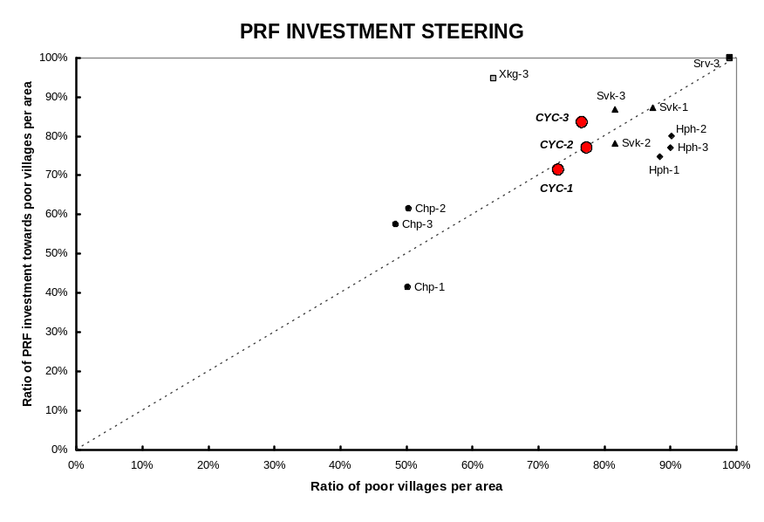
Source: PRF calculations from M&E and NSC data, cycles I to III. The poverty definition follows NSC criteria.

Findings from the three projects show that the goal of empowering communities through participatory planning is a lengthy and costly process requiring dedicated field-based staff working with communities as well as district officials. After completing three cycles of PRF activities, one-fourth of beneficiaries in Huapanh mentioned the participatory planning process as an advantage of the project. In contrast, in Saravane, a poorer province where PRF had completed only one cycle of activities, the participatory approach of PRF was not well understood, and communities’ empowerment remained weak. These differences suggest that to generate sustained results, comprehensive capacity building efforts at both the community and district level, and a long term perspective, are needed. These high costs of empowering communities are yet another reason to harmonize the CDD approach in Lao PDR.

Challenge III: Supporting livelihood activities

CDD projects are facing strong pressure to support livelihood activities through loans to individuals. All three projects have either implemented or piloted the implementation of village revolving funds to support household livelihood activities. The government’s strong interest in livelihood support is based on the well-recognized argument that, to eradicate poverty, communities need both better public services and support of income generating activities, and that a major obstacle is credit constraints.

The rationale for administering loans instead of grants stems however from the incorrect belief that, with loans, multiple households can be helped with the same pool of money. In theory, if households would repay the loans, such a belief is correct. In practice, however, all over the world CDD projects have performed very poorly in the administration of loans, for two reasons: first, because they lack the technical expertise to perform the task in a transparent way, and second, because by giving grants for infrastructure on the one hand, and loans to individuals on the other hand, CDDs send conflicting messages to communities. Lao PDR does not seem to be an exception: a recent study by the Asian Development Bank on Microfinance in Lao PDR observes that most Revolving Funds that have been set up have closed after external supervision and financing ended (see Coleman and Wynne-Williams, 2006).

Loans do in fact help their recipients. Credit and Savings groups from the VDF and the VIP saved beneficiaries considerable amounts of money. The alternative sources for loans in the villages were stated to be relatives, business men, or richer families in the village or in neighboring villages. But relatives were not always able to help, and the private loans were very expensive. The loans from the Credit and Savings groups, in contrast, were perceived as offering good conditions with reasonable interest rates in all villages.

Box 7. Why beneficiaries appreciate loans

“Now we can borrow from the village fund to buy fertilizer or when we are sick. Before, we purchased three bags of fertilizer from a private company for about US $150. Now we can buy three bags of fertilizer from the VIP fund for US $82. That is almost 50 percent cheaper.”

“Before the project came we borrowed US $20 from rich people in the village to buy the fertilizer. In return, they asked us to give them 20 boxes of paddy [one box of paddy is equal to 10 kg, and the price of 1 kg was US $0.2]. Thus, it meant we paid US $40 to them. Now, we can borrow US $20 from the VC to buy the fertilizer, with an interest rate of 1 percent. We will pay back to the VC US $20.20 after the harvest. You see how big a difference it is. It is certain that the VIP project is very efficient in reducing poverty in the community.”

Nonetheless, revolving funds do not help the poorest villages or the poorest in the villages. In addition, the funds are subject to elite capture and political pressure to keep interest rates low which makes them unsustainable in the long run. Findings from the review of the livelihood support of the VDF and the VIP consistently show that the poorest villagers and the poorest in the village do not benefit from revolving funds; that capture of the funds by the village elite is a serious concern; and that funds are rapidly depleted. The remaining part of this section reviews in details each of these points.

VDF’s objective appears to lean more towards promoting income generation, which largely assists middle income families, than to reduce extreme poverty. The selection of villages and households appears to be primarily governed by their capacity to generate income and to reimburse loans. Accordingly, the proportion of participating households per village varied from one-third to two-thirds. In all villages, the lack of sufficient credit was stated to be one of the main reasons for low coverage, but the other major factor was the financial situation of the households. In general, the richest households tended to exclude themselves because of the low amounts available per family, while the poorest households were excluded due to the risk involved in granting the loan.

Inability to offer collateral, remoteness, lack of information, and high penalties for non-compliance are among the main reasons for excluding poor households. Poor households cannot offer collateral, and generally, are perceived to have more difficulties in reimbursing the credit. Remoteness and lack of access to information about the rules and regulations of the fund were other reasons for non-membership. A fourth factor mentioned by non-members was the risk of monetary penalties for non-compliance of repayment of the loans.

Box 8. Non-members explain why they do not participate to the VDF

“We know about the VDF but we are not members because we don’t know much about the management of money. We are afraid that we will not be able to return the money to the fund.”

“In my opinion, the richest households are members while the poorest households are not. They [poor members] are not members because they don’t have property to put as a guarantee for the credit.”

“We did not get involved in the VDF meetings because we have many difficulties; our family condition is not good. We don’t clearly understand the rules about the fund, and we are afraid that we will have nothing to return.”

A village head also explains: “None of the poorest families are members of the fund. In terms of economic status of the members of the fund, there are only mid-level income families and up. This is in accordance with the directives of the district to make sure that the money will be returned on time, so that other people can borrow.”

Excluding the poorest households appears to have some rationale – in VIP villages where poor families succeeded in obtaining a loan, they often had problems in sustaining the investment. In some VIP villages the poorest families received a loan, but were forced to return the investment due to their inability to pay the installments, or their lack of cash to buy food for the purchased animals. In these cases, the families claimed the investment did not improve their livelihood. Investments were however fairly large, and the extent to which these poor households could afford smaller types of investments remains unknown.

Elite capture also appears to be significant when funds are invested in large and expensive types of livestock, in part because approving loans to wealthier families lowers the risk of default. In VIP villages where large livestock were purchased, problems arose with the unequal distribution of loans. The extreme case was in a large village where eight out of eleven buffalos were granted to members of the Village Committee, and of the three remaining families receiving buffalos, only one was considered poor. When explaining how the families were chosen, Village Committee members explained: “We agreed with the members from the village authority who should get the loan. We looked at who would have been able to return the money in three years. We also considered those who are poor, but if they were not able to return the money, we did not give them funding. We were afraid that they could not pay back.” In another village where pigs were purchased, half of the selected households had members in the Village Committee.

Despite the strong focus on targeting creditworthy households, the sustainability of Credit and Savings groups was deemed to be at risk in all VIP villages. In all villages, the sustainability of the Credit and Savings groups was observed by the study team to be at risk. All participating villages established Credit and Savings groups between 2004 and 2006. In all villages, a decreasing number of households were reported to make deposits, and Village Committee members confirmed that the mobilization of households to make deposits and collecting installments on the loans were their most difficult tasks.

Low interest rates – although certainly appreciated by beneficiaries – caused the borrowing demand to be much larger than the supply of funds, leading to credit-rationing, increased nepotism, and to a higher risk of default of the Credit and Savings groups. Most Credit and Savings groups appeared to be trapped in a vicious cycle where low interest rates led the demand for loans to be much higher than the available funds, and, at the same time, discouraged households from contributing to the fund, making replenishment of the fund difficult when borrowers defaulted. Village Committee members also had to choose whom to give the credit, and appeared more and more to approve larger loans to better off households (in part, to decrease the likelihood of default, which would have made the fund even less sustainable). As one woman explains:

“I put US $0.50 regularly for five months, and after that I asked to borrow US $10 when my child was sick. But the VC said that there was no money for borrowing. Since then I did not put money anymore in the fund. At the same time, I saw that other families borrowed up to US $150 for 6 months. I am not happy with the VC.”

Credit-rationing fostered rumors of nepotism and lack of transparency, which resulted in even fewer households making deposits and further threatened the sustainability of the Credit and Savings groups. Such a pattern was also observed in the VDF and in most projects supporting revolving funds in Lao PDR (see Coleman and Wynne-Williams, 2006).

Applying low interest rates often reflects the dual desire of “doing good” and allowing several households to benefit from the same pool of money; but in poor and remotes settings, grants are often a more efficient solution. Loans should be administered by institutions that have the capacity to do so. If CDDs have to support livelihood activities, they should do so through grants. Grants are easier and cheaper to administer and, since they are given once, if administered well they are less likely to be subject to elite capture. Also, international experience shows that the poorest households often have serious problems in repaying loans, and this study appears to confirm these findings. In remote areas of the uplands, where financial management capacity is low and supervision is costly, it is therefore very likely that grants would have a greater impact than loans, at least on the poorest households (see also Ritchie, 2006a and 2006b).

Conclusions and recommendations

The review of three of the larger CDD projects in Lao PDR shows that CDD in Lao PDR improves remote communities’ well-being in a cost-effective manner, but that challenges consistently observed across the three projects are hampering their development effectiveness. This section reviews each of these challenges and suggests ways to overcome them.

Challenge I: Harmonizing CDD approaches
The current scattered CDD panorama leads to high operating costs, and makes it difficult to intensify a dialogue with local officials on adopting participatory planning approaches. To gain efficiency, it would be important to:

- Coordinate CDD coverage. By coordinating coverage, more regions could benefit from CDD support, leading to greater poverty reduction.
- Consolidate implementing agencies. Although it may not be realistic to have one single implementing agency leading all the CDD projects, the high cost of managing CDD projects calls for some degree of consolidation of implementing agencies. It could be envisaged, for instance, that in the medium term the PRF and the DDF, the two largest CDD programs in Lao PDR, would be managed by a single implementing agency.
- Harmonize the design of the participatory approach. With each CDD having its own participatory planning approach, it is difficult to effectively train communities and local officials in participatory planning methods and to achieve further, much needed institutionalization of these approaches.

Challenge II: Achieving an inclusive participatory planning approach
Where it works, empowerment through participation has shown to improve communities’ well-being and the impact of development projects. Nonetheless, not all local officials have yet adopted and recognized the benefits of participatory planning approaches, and some communities still have difficulties in understanding the principles. It is therefore important to:

- Train both communities and local officials in participatory planning methods. Many CDD projects only focus on building capacity at the community level. But as this study has shown, building capacity of local officials is equally important, as they are ultimately responsible for planning.
- Develop Information, Education, and Communication tools for non-Lao speaking communities. Empowerment and participation is not possible if communities do not understand the principles, and are not able to sustain a dialogue with local officials. As this study has shown, particular attention should be devoted to non-Lao speaking communities, which in the current projects tend to be excluded.
- Operate in districts long enough to achieve sustained empowerment. Empowerment is a long and costly process that moves community driven development beyond service delivery. Significant resources have to be invested in supervision and capacity building both at the village and district level to ensure sustainability.

Challenge III: Supporting livelihood activities
Supporting livelihood activities is essential for achieving sustained poverty eradication. Nonetheless, the way livelihood activities are currently supported, with little community participation, through loans, and often with little technical assistance, leads to low development impact. To increase the effectiveness of livelihood support it would be important to:

- Administer grants, not loans, through CDD programs. Currently, no CDD program in Lao PDR has the necessary expertise to administer loans, leading to poor performance of livelihood support activities that are unsustainable in the medium to long run and subject to strong elite capture. If there is pressure to support livelihood activities through CDD programs, it should be done through grants, not loans, backed by strong technical support. The administration of loans should be left to institutions that have the expertise and capacity to do so.
- Ensure community participation. Ensuring a participatory approach and adequate technical support is important in public services, but is even more critical in livelihood programs. Safeguards should be created to guarantee that the poor have a voice and will benefit from livelihood programs. Livelihood programs should also be tailored to the capacity of communities and extension services to ensure their sustainability.

The CDD Panorama in Lao PDR

Community Driven Development is considered an effective poverty reduction mechanism to promote local development and capacity building, improve service delivery, and provide risk management instruments to the poor. Compared to an earlier generation of community-based rural development projects where communities acted as rather passive beneficiaries, recent CDD projects give communities more voice and place communities at the center of the development process (Wong and Guggenheim, 2005).

In Lao PDR, donors have increasingly used CDD components in their projects to promote effectiveness and efficiency of poverty reduction efforts. According to a social protection and community development project inventory compiled by the World Bank, 6 projects within Lao PDR maintained a CDD component in 2004; two years later, about twenty-five projects implemented by multilateral and bilateral donors, and INGOs, possessed a CDD component. Active donors include the International Fund for Agricultural Development (IFAD), the Canadian International Development Agency (CIDA), the United Nations Development Program (UNDP), the European Union (EU), the World Bank, the German Agro Action (GAA), Village Focus International (VFI), World Concern, as well as other INGOs.

CDD projects are mainly concentrated in the northernmost provinces, the provinces bordering Vietnam, and in the southern provinces. Figure 1.1 shows the distribution of CDD projects by province. A higher concentration of projects with a CDD component is observed in the uplands compared to the lowlands. With seven, Saravane province has the highest number of active projects with a CDD component.

CDD projects aim to empower communities, reduce poverty, and improve economic and social conditions of the poor in rural and remote areas. These programs seek to enhance village capacity and increase local ownership by helping communities to identify and prioritize their needs, and develop and implement community development plans. Community-based participatory planning and implementation is a common feature of CDD projects, usually accompanied by efforts to ensure women’s participation.

Understanding diversity in approaches both in terms of their conceptualization and implementation could improve efficiency and synergies of CDD projects. Currently, each CDD project has its own approach, and approaches differ even within projects financed by the same donor. Greater efficiency could most likely be achieved by harmonizing the different approaches, coordinating areas of intervention, and learning from each project.

Figure 1.1. Distribution of CDD Projects in Lao PDR

0
1

-

2
3

-

4
5

-

7
Number of Projects
Pongsaly
Luangnamtha
Oudomxay
Bokeo
Huaphanh
Luangphrabang
Xiengkhuang
Xaysomboon*
Vientiane
Vientiane Capital
Xayabury
Bolikhamxay
Khammuane
Savannakhet
Saravane
Attapeu
Champasack
Sekong

*Xaysomboon province was dissolved in 2006. However, the updated map of Lao was not yet available at the time this report was written.

Source: Number of CDD projects compiled by the World Bank in January 2006.

Geographic and sectoral distribution of CDD projects

In almost all provinces, CDD projects support education, health, livelihood activities, and agriculture. The education sector (infrastructure, support of formal and non-formal education, curriculum development, teaching materials) receives the greatest support, followed by the health sector (infrastructure, family planning and reproductive health support, health education and training, water and sanitation, mother and child care), agriculture (agricultural training, food crop and livestock production, irrigation), and livelihood activities (see Figure 1.2). These activities account for 24%, 22%, 21% and 20%, respectively, of all sector support. Infrastructure and environment cover a small part of the overall support, with 9% and 4%, respectively.

Most CDD projects support activities in the poorest provinces, but not necessarily in provinces with a high proportion of ethnic minorities. Most provinces receiving multiple projects with CDD components, such as Huaphan, Pongsaly, Oudomxay, Luangnamtha, Attapeu, and Sekong, face high poverty incidence; nonetheless, provinces such as Champasak, Xiangkuang and Savannakhet also receive a high number of projects despite being less poor. Overall, however, we can observe a fair correlation between poverty incidence, and CDD coverage, as shown in Figure 1.3. In contrast, CDD projects do not necessarily cover provinces with high proportions of ethnic minorities, and, despite being strongly active in the education and health sectors, these projects are not necessarily located in provinces with low literacy rates or high mortality rates.

In fact, the selection of target provinces strongly depends on additional factors such as capacity, accessibility, and past working experience. Donors’ (including the World Bank) location decisions of CDD project support do not seem to rely merely on provinces’ social and poverty statuses, but rather several factors are usually taken into consideration. According to interviews and information collected from donors, many CDD projects tend to operate in accessible villages with communities that have better capacity to carry out projects. This is partly due to the fact that reaching remote villages is a time and money consuming task. Some projects also determined their target provinces according to past working experience in the province, or targeted provinces that were affected by the war.

Figure 1.2. Distribution of CDD projects by Sector
V
i
e
n
t
i
a
n
e
S
a
v
a
n
n
a
k
h
e
t
Vientiane
Capital
Pongsaly
Bokeo
Huaphanh
Khammouane
Attapeu
Sekong
Saravane
Champasack
Xaysomboon*
Luangnamtha
Bolikhamxay
L
u
a
n
g
p
h
r
a
b
a
n
g

Percentage of Sub-projects by Sector

Environment
Education
Health

Income Generation
Agriculture

Infrastructure
Xayabury
Oudomxay
Xiengkhuang

*Xaysomboon province was dissolved in 2006. However, the updated map of Lao was not yet available at the time this report was written.

Source: Number of CDD projects compiled by the World Bank in January 2006.
Note: The size of the pie charts represents the number of CDD projects within the province.

Figure 1.3. Number of CDD projects and provincial characteristics
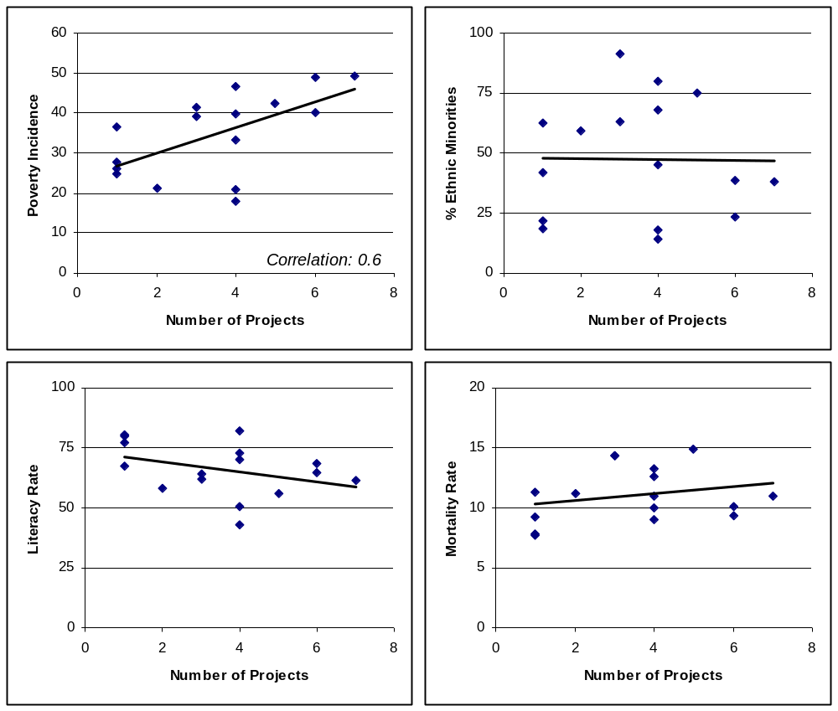
Source: Number of CDD projects compiled by the World Bank in January 2006; Poverty Incidence from LECS 2002/03; Percentage of ethnic population from UNESCO (2005); Crude Mortality Rate (per 1,000) and Literacy rate (per 100; population over 15 years old) from the National Statistics Center Population and Housing Census, 2005.

CDD projects supported by the World Bank

The World Bank supports five out of the twenty-five reviewed CDD projects in Lao PDR. The largest Bank’s CDD project is the Poverty Reduction Fund (PRF), which assists the development of small-scale, community-based infrastructure and other activities in the water, transportation, education, health, and agricultural sectors to reduce poverty in rural villages. In addition to PRF, four other projects include components that utilize community-based approaches in the human development, rural development, and environmental sectors. All of these projects provide community grants for implementation of sub-projects. Background and description of each project are described next, and summarized in Table 1.1.

- The Poverty Reduction Fund Project (PRF) has been the World Bank’s primary instrument for supporting community-driven rural development in poor upland districts. Building on the experience of a UNDP-supported pilot on participatory planning approaches in 2000, the PRF adapted and developed tools and detailed methodologies appropriate to the context of the poorest districts. The objectives of the PRF are to: (i) Assist villagers to develop community infrastructure and gain improved access to services; (ii) Build capacity and empower poor villages in poor districts to plan, manage, and implement their own public investments in a decentralized and transparent manner; and (iii) Strengthen local institutions to support participatory decision-making and conflict resolution processes at the village, khet, and district levels, involving a broad range of villagers including women, the poor, and ethnic minorities.

- The Village Investment for the Poor (VIP) component of the Agricultural Development Project provides block grants to districts for small-scale projects identified by villagers. The objectives are to: (i) Support rural communities where poverty is high; (ii) Strengthen capacity for designing and implementing small projects at the village level; and (iii) Facilitate a closer link between the District Agricultural and Forestry Office (DAFO) staff, and the communities. The component helps villagers mitigate risk by assisting them in agricultural management for sustenance and income.

- The Lao Environment and Social Project (LENS) includes a community and biodiversity investment component to strengthen the management of protected areas, ensure sustainable livelihoods, and support community environmental management projects in central Lao PDR. Over the last decade, a consistent approach to participatory management of protected areas has emerged, building on the connection between local rural livelihoods and biodiversity. The project utilizes this approach and provides grants to communities to support the development of “reduced-impact livelihood options” and small environment and resource projects. The approach pursued by LENS is intended to foster: (i) Community empowerment through decision-making and resource management capacity; (ii) Inclusiveness and equitable outcomes; and (iii) Adaptive management. Communities are eligible for general livelihood support activities if they have developed village agreements with protected area management units or are engaged in the process of developing an agreement. Villages not actively involved in protected area agreements are eligible to receive grants for activities that directly contribute to positive conservation or environmental impacts.

Table 1.1. Summary of the World Bank’s CDD Portfolio in Lao PDR
Project | Component | Use of Community Grants | Location
Poverty Reduction Fund (PRF) | CDD project | To support villagers to develop small-scale, community-based infrastructure and gain improve access to services; including transport, education, health, and agriculture sectors. | Champasak, Savannakhet, Saravane, Xiengkuang, Huaphan
Agricultural Development Project (ADP) | Village Investment for the Poor (VIP) | To support small scale projects, mainly agricultural-related projects which range from animal raising to well drilling. | Attapeu, Champasak, Saravane, Khammouane
Lao Environment and Social Project (LENS) | Community and Biodiversity Investment | To strengthen the management of protected areas, ensure sustainable livelihoods and support community environmental management projects. | Savannakhet, Khammouane, Bolikhamxay
Second Education Development Project (EDP II) | Community-based Contracting (CBC) and Community Grant (CG) | To increase classrooms and latrines (CBC), and to support community initiatives to increase enrollment and completion (CG). | Attapeu, Sekong, Huaphan, Luangnamtha, Oudomxay, Pongsaly
Sustainable Forestry for Rural Development Project (SUFORD) | Village Development Grant | To support villagers in preparing and implementing plans to use available resources, projected forest revenues, other sources of funding for village development projects. | Champasak, Savannakhet, Saravane, Khammouane

- The Second Education Development Project includes community-based contracting (CBC) and community grants (CG) for primary education. The CBC component provides grants to communities to increase classrooms and latrines, and to reduce the construction maintenance workload of the poorest communities. Eligible villages must have been in existence for over three years, possess a Village Development Committee, maintain an existing school which does not serve all five grades, and 36 or more school-aged children must reside in the village. To be eligible, schools must also be made of temporary materials, or have a leaky roof, unsuitable furniture, dark surfaces, or be too cold for the climate. The Community Grant program accompanies the CBC. The objective is to encourage increased enrollment and completion through improved learning conditions and reducing the cost of education for the very poor. Each village in the construction program will receive 3 million kip to use as they see fit in order to increase enrollment and completion. The villagers are given a negative list of items for which funds cannot be used, but not a positive list. The two components together initially provide support for coping with risks, but upon completion of the project, are expected to assist the villages in mitigating risk.

- The Sustainable Forestry for Rural Development Project (SUFORD) includes Village Development (VD) grants to assist villagers in developing and implementing plans to use available resources, projected forest revenues, and other sources of funding. The project uses participatory techniques to identify villagers’ development needs and helps to prepare the development plans. A participatory approach was chosen based on the long-term interest villagers have in maintaining sustainable forests and their better placement for monitoring ongoing activities near their villages than government officials, who only visit periodically. Women, ethnic minorities, and the poor are targeted to ensure the participation and receipt of benefits by these groups. The criteria for choosing village development projects include (i) The degree of benefit to the entire village or majority of households, and the benefit of the project to the poorest households; (ii) The contribution to enhanced food security at the household level; (iii) The contribution to enhanced livelihood security and/or promotion of income-generation at the household level; and (iv) The contribution to rural infrastructure projects. Villages will be given the option to receive funds directly or to work with the district to contract necessary procurement of services and equipment.

Comparison of CDD projects in Lao PDR

Understanding objectives and approaches of different CDD projects by the World Bank and other partners can offer important lessons for community-based approaches in Lao PDR. This section reviews the structure of seven CDD projects: PRF (supported by the World Bank), the Village Development Fund (supported by the Lao government), the Agricultural Development Project (IFAD), the Sekong Ethnic People Development Project (UNDP), the Small Scale Project fund (German Agro Action), the Village Life and Leadership Project (Village Focus International), and the District Development Fund (UNCDF). Although an in-depth review of these projects falls out of the scope of this chapter, the reviews highlight similarities that could strengthen the CDD approaches in Lao PDR. Information on these projects has been obtained primarily through interviews with representatives from each donor mentioned above and review of project documents.

A comparison of the reviewed community-based projects reveals strong similarities across CDD projects. All projects encourage community participation and ownership in sub-project design and implementation. Assistance is given in grants, and projects are implemented through project monitoring units within line ministries, directly by project offices based in target provinces, or by local authorities. Village contributions such as labor, local material, and even cash are required in some cases as means of promoting ownership. Village groups identify their own needs, and request for support is made through bottom-up planning processes. A village development committee, oftentimes consisting of district line ministry staff and local village facilitators, is usually formed to handle the general management of sub-projects. For more details on project design, see Table 1.2.

Table 1.2. Comparison of selected CDD projects
 | PRF | VDF | IFAD | UNDP / SEPD | GAA | VFI | UNCDF / DDF
Target population:
Ethnic group |  |  | X | X | X | X
Poor | X | X | X |  | X | X | X
Remote areas | X |  | X |  | X
Implementing Agency:
Project Implementation Unit at  central level | X | X |  | X
Project office in target province | X | X | X |  | X | X
Local authorities |  | X | X |  |  |  | X
Local Planning & Monitoring:
Local authorities | X | X | X | X | X | X | X
Mass organization |  | X | X | X | X | X | X
Project staff | X |  | X | X | X | X
Village Committee/Representatives | X | X | X | X | X | X | X
Village Selection Criteria:
Universal coverage | X
Priority needs and urgency |  |  | X
Accessibility |  |  |  | X |  | X
Ethnic diversity/ethnic population |  |  |  | X |  | X
Submission of proposals |  |  |  |  | X
Potential capacity in carrying out  implementation and self-reliance |  |  |  |  | X | X
Village commitment in training |  |  |  |  |  | X
Not a recipient of other grants |  |  |  |  |  | X
Province/District consultation |  | X | X |  |  | X | X
Capacity Building:
Training to villagers | X | X | X | X | X | X
Training to local government officials | X | X | X |  |  | X | X
Challenges:
Lack of local government staff  capacity and/or availability | X |  | X | X |  | X
Lack of integration of project  activities in government plan |  |  |  | X
Low capacity in poor villages | X | X | X |  | X | X | X
Lack of project staff |  |  |  |  | X
Difficulties to access to villages | X |  | X | X | X |  | X
Lack of funds or delays in transfer |  | X |  |  |  | X
Limited Local Private sector supply in remote areas | X |  |  |  |  |  | X
Maintenance | X |  |  | X |  |  | X
Lack of local authorities’ understanding of community  participatory approach | X
Source: Interviews with each donor organization and project documents if available.

Criteria for selecting target districts are roughly similar across projects. The main criteria are: high ratios of poor population and ethnic minority groups, remoteness of the area, and in some projects, high rates of slash and burn activities and opium production. In practice, however, reaching these areas oftentimes proves difficult during implementation, and therefore, some projects choose to work in more accessible villages. In some cases, donor decisions on where to engage are also based on previous working relationships and experience within particular provinces. To identify target villages, most multilateral agencies use baseline assessments, while INGOs tend to select communities through the selection of proposals, or consult district authorities for the selection of villages.

Box 1.1. Example: the District Development Fund (DDF)

The DDF, supported by UNCDF & UNDP, has been piloted in Saravane since 2005 and will expand in 2008 to five other Northern provinces. The DDF strategy comprises two components. On one hand, block grants are allocated as annual development budget support to Districts, calibrated to population & poverty, and linked to District compliance with agreed measures of performance. On the other hand, bottom-up planning and public expenditure management innovations are introduced, which feed into the annual District budget cycle. Sub-project proposals are fed up from Villages, through Kum Ban committees, to the District. During annual meetings, a District Planning Committee (DPC) makes final decisions on sub-project approvals to be included for financing within the District investment budget The DPC is comprised of District officials and also with a two thirds quorum of Village representatives (koumban heads and women representatives). The District Planning Team (DPT) – which comprises district department heads and staff, as well as sector technicians – is the key project implementer, responsible for training Village and koumban committees, for sub-project preparation, and support to implementation. Financial management is handled by District Dept of Finance. Compared to standard CDD projects that focus on building capacity at the community level, the DDF puts a stronger emphasis on working through and building capacity of district authorities in sub-project selection, monitoring and implementation, and at mainstreaming innovations in participatory planning and local public expenditure management. The World Bank will also be replicating this approach in Khammouane province (Khammouane Rural Livelihood Project).

To solve project maintenance issues, funds are usually provided to villages, or collected from villagers. One of the major challenges of CDD projects is project sustainability. In order to enhance it, some donors, such as IFAD, apply a combination of grants and village revolving funds (VRF). Some NGOs also collect small fees as development funds or seed funds for project maintenance. However, sustainability remains one of the key concerns in Lao PDR as elsewhere in the world (World Bank 2005).

Although all donors collaborate with district line agencies for technical assistance on sub-project implementation, the level of coordination and its effectiveness vary. Local governments usually play an important role by providing technical services for planning projects to ensure their feasibility. In some cases, the donor already has a close relationship with district staff due to previous experience in the district. Some donors also involve district staff as members of their district development team, and promote community participation within existing government structures. In addition to training provided to district staff, additional incentives such as per diems may be offered to ensure participation.

The level of communities and district authorities’ involvement in selecting villages differs by project. Some projects align their village selection with provincial and district development plans. In this case, villages are pre-selected based upon consultation with district government. In some projects, such as the PRF, proposals are selected through a bottom up process, i.e. based on demand from villagers. Proposals are then prioritized upon discussion at khet- or intra-district levels, and final decision is made at the district level where representatives of all villages meet. Other selection processes such as that of GAA rely solely on submission of proposals on a first-come first-serve basis, without pre-selection of target villages (however, the village submitting a proposal must form a village group, which meets certain criteria; i.e. 10-15 families as a group, with experience and capacity to implement the proposed activities).

Although varying in design, CDD projects share similar objectives to reduce poverty by improving local governance and empowering local people; hence, these projects could be further coordinated. Each project has different strengths and shortcomings in their approach and implementation. Some donors have extensive knowledge of local conditions, and strong relationships with local authorities, but face a lack of project staff or financial capacity. Other donors have access to more funds but have difficulties in communicating with local communities or coordinating with district authorities. Finally, most of the current CDD projects are small in scale and scope; thus, as many of these projects are complementary and share common goals, further collaboration should be encouraged to gain effectiveness and scale.

Scope and Design of the Poverty Reduction Fund

The previous chapter illustrated the heterogeneity in design and geographic diversity of CDD projects within Lao PDR. This chapter will focus on the specific project design of the largest CDD-type project within the World Bank portfolio in Lao PDR, the Poverty Reduction Fund. The chapter will elucidate the context under which operational design choices were made and why.

Background

In 2001, at the time of project conception, Lao PDR was the lowest ranking East Asian country on the UNDP Human Development Index, placing 131st out of a total of 148 countries. The latest known figures showed 38.6% of the population living below the national poverty line. Regional differences were acute, with the North having a poverty incidence of 53% compared to the Southern and Central Regions, which maintained poverty incidences of 38% and 35% respectively. Rural poverty rates were 2-3 times higher than urban poverty rates, with the rural poor accounting for 90 percent of all poor. With regard to human development indicators, 40% of children under 5 were underweight, only 59.9% of children who began grade 1 completed grade 5; and the under-5 mortality rate was 106 per 1000 live births. Despite some improvements in the previous decade, most of Lao’s social indicators fell well below the average of low-income and East Asian countries.

The reasons behind the extremely low social outcomes were multiple, inter-related and cut across social sectors. The causes included widespread poverty and high levels of vulnerability, which rendered many social services unaffordable to the poor; language and cultural barriers in accessing social services; geographic isolation and inadequate infrastructure which hindered physical access; and poor service quality due to low level of resources and low capacity of providers.

Furthermore, the formal safety net system in Lao PDR was underdeveloped and vulnerability to shocks of a diverse nature was very high. The 1997/98 Lao Economic and Consumption Survey indicated that 87% of the country’s consumption-poor population lived in households headed by farmers. The vast majority of these farmers were subsistence rice cultivators who produced barely enough to meet their own consumption needs and lived in rural and remote areas. Thus, any kind of shock could push these families into extreme poverty. Villagers in the 2001 Participatory Poverty Assessment conducted by the Asian Development Bank also identified poor health as the most serious threat. As 79% of the population lived in rural areas, shocks that affected rice yields and livestock were also important. Poor Lao villagers also employed a range of coping mechanisms such as selling livestock and hiring out labor which increased their vulnerability in the long term. Moreover, a widespread lack of social services and physical infrastructure strongly affected income levels and standards of living among the rural population.

Through the National Government Poverty Eradication Strategy (NGPES), the Government of Lao PDR (GOL) signaled a commitment to reducing poverty and vulnerability via a multi-sector approach. The GOL began attempting to install policies and laws facilitating social protection measures, and specified the need for a poverty reduction fund to assist in eradicating poverty by 2020. Despite these efforts, formal social safety nets remained virtually nonexistent. NGOs and donors were attempting to fill the gaps, but initiatives tended to be limited in scope and focused on food security.

In this environment, the Lao Poverty Reduction Fund was developed to improve village level development, deliver small-scale infrastructure and investments, build capacity at the local level, and contribute to national poverty targets. The Poverty Reduction Fund was legally established as an autonomous entity, formed and run in accordance with the Prime Minister Decree No. 73/PM dated May 31, 2002. The PRF is supported by the World Bank in the form of an IDA loan, repayable over a forty-year term. The approved credit (15.3 million SDR) equaled approximately US US $19,345,000 at the time of loan signing with a counterpart contribution from GOL of US US $1,330,000. The total funding for PRF at the time of loan effectiveness, February 3, 2003, was around US US $21,700,000.

Project objectives and design

The PRF has three main objectives: delivering resources to communities efficiently and effectively; empowering and building capacity in poor villages; and strengthening local institutions in poverty reduction strategies. PRF aims to assist villagers in developing community infrastructure and gaining improved access to services; build capacity and empower poor villages in poor districts to plan, manage and implement their own public investments in a decentralized and transparent manner; and strengthen local institutions to support participatory decision-making and conflict resolution processes at the village, sub-district or khet, and district levels, involving a broad range of villagers, including women, the poor and ethnic minorities.

Villagers are expected to decide on how resources are allocated, manage project funds and the implementation of sub-projects. Extensive facilitation and training is to be provided through the project to ensure that poor villagers participate in the decision-making process and benefit from project inputs. The project aspires to build local community capacity to help solve problems and resolve conflicts by providing technical support for villagers over a number of years. The project also seeks to create stronger links between the local government and the aspirations of villagers with project staff at the district, province, and national levels coordinating and building linkages.

To achieve these requirements, the Poverty Reduction Fund Project was designed around seven key principles, which provide the basis for project implementation and supervision, as well as for local innovations and the evaluation of the project.

1. Simplicity. The project design, rules and regulations should be simple. This ensures greater transparency and local ownership of the project.

2. Wide Menu of Options. The project can provide funding for a wide range of village infrastructure and training. Villagers, taking into account the limited resources and capacities available locally, prioritize their own proposals, and the project staff and local government agencies provide villagers with the information required to make informed choices. Aside from training, and two pilots on livestock and revolving funds, the menu has been limited to community public capital goods. The village infrastructure allowed includes: access and transport infrastructure (such as roads, bridges, culverts, etc.); schools and nurseries; clinics; community halls and other public buildings (but not village administrative offices); communal water supply systems or structures (wells, gravitational flow systems with tanks and piping, small ponds or reservoirs, etc.); irrigation and drainage systems; and local markets. Larger infrastructure and district level infrastructure is not allowed.

3. Participation. The project is based on a principle of broad-based participation, and the decision-making process must include the entire community. Assistance and information is provided to villagers by facilitators and consultants as well as local government technical staff, but the communities themselves decide priority sub-projects for funding. All village decisions must be disseminated and widely known, with a chance for complaints to be addressed openly. Once funding is allocated, all decisions on sub-project prioritization and funding are local and finalized through the inter-village forum’s deliberations.

4. Ownership. Villagers must be willing to contribute to sub-projects to show their support and ownership of the activity. The local contributions can be in cash, in kind, and/or in labor, and should be equal to approximately 10% of the total cost of the sub-project.

5. Transparency and Accountability. Transparency and local accountability are essential. Villagers own the grants and they must be satisfied that the funds are used properly. All complaints will be taken seriously and investigated by the PRF staff. At every stage and at routine meetings, villagers must be informed how the funds are being used.

6. Wise Investment (sustainable, replicable, and complementary). The aim of the PRF is to provide a mechanism for financing locally determined and community-managed development interventions in all poor areas: interventions that are wise investments. The scope of the initial project and the PRF itself is not meant to supplant other, larger development efforts but to complement such efforts with small, local community investments.

7. Empathy (“Siding with the Poor”). For each planned and implemented activity, in all processes and all procedures, preference will be given to the poorest people in the community.

Box 2.1. Social Fund or Community Driven Development Design?

The conceptual design of the Poverty Reduction Fund provided for an innovative marriage of two service delivery project models under implementation in East Asia at the time of preparation: the Community Driven Development (CDD) model and the Social Fund model. Social funds have a strong top-down planning approach, but are noted for their effective mechanisms of technical control, such as unit cost controls, technical quality controls, rigorous contract management, and agile management information systems. While designing PRF, the Cambodia Social Fund II, the Philippines Szopad Social Fund, and the Thailand Social Investment Fund were actively supported by the World Bank. In contrast, CDD projects emphasize social controls through community participation, decentralized decision making and accountability, larger number of staff to build local capacity, and transparency. At the time of design, the Indonesia Kecamatan Development Project was the largest CDD in the region, and was gaining momentum.

Obvious trade offs exist in the choice of one model over the other. Social fund sub-projects sometimes lack community ownership and commitment; community development projects sometimes suffer technical quality problems. Social funds encounter procurement and contractor driven problems, while CDD projects meet with misuse of funds by inexperienced or unethical community members. Social funds incur low overhead, due to low capacity building objectives, while community development projects expend higher proportions on staff and technical assistance. Both models have a track record of rapid disbursement, under both stable and turbulent national conditions; both are based on competitive vetting of sub projects proposed by communities; both are separately staffed vertical structures; and both can be scaled readily to national coverage.

To match the Poverty Reduction Fund Project design to Lao conditions and the agreed project objectives, the World Bank and counterpart teams agreed to the following principal features of the sub-project cycle:

- To maximize sustainability and local ownership, the PRF assigns all sub-project decision making and funds management to beneficiaries at the village and inter village (up to the district) level;
- To allow for both community and contractor execution, village sub project teams decide which procurement method is most appropriate (enhanced shopping or community participation) with advice from PRF staff;
- To achieve acceptable sub project proposal quality, PRF maintains decentralized staff at provincial and district levels, where they advise village teams on sub-project preparation, design, procurement method, and costs;
- To contain technical and financial risks, the sub project menu is limited to a positive list of small scale infrastructure and services sub projects;
- To achieve technical quality of sub-project infrastructure, decentralized staff approve jointly with village participants the release of sub-project payments against physical progress;
- To contain costs, PRF established and applied a standardized unit cost data base and ceiling for all infrastructure sub projects;
- To monitor independently these outcomes, village teams visit and monitor each other, as will independent firms contracted by the PRF.

Similar to Social Funds around the world, the Poverty Reduction Fund Project was developed to be autonomous, managed by a legally established autonomous board (where, however, members would mostly be government officials), staffed by consultants hired through the project, and operational partners were chosen on the basis of skill and capacity. The day-to-day management of consultant services and responsibility for project implementation and quality rests with the consultants hired by the project. The field consultants have a direct line of command and report to the Executive Director of the Fund.

The project was further designed to potentially support micro-credit and/or revolving funds, but, aside from a pilot in 90 villages, PRF chose not to support these activities. The decision of not extending the revolving funds pilot was taken after encountering problems similar to issues faced by the Village Development Funds (see Chapter V). A livestock pilot is also currently being evaluated.

Methodology and activity cycle

The principles and the objectives of the Poverty Reduction Fund depend upon and encourage a high degree of participation by the people themselves. At each local level the PRF begins with a strong process of “socialization” - introducing and explaining the PRF to the villagers and the wider public. Radio broadcasts, a specially designed flipchart, posters, pamphlets and other tools are used to disseminate information about the Project. As a result of the socialization process, people will be informed about the principles of the project. This will help encourage interest and participation, and having large numbers of people informed and involved assists in keeping the process transparent and accountable throughout implementation of the sub-projects. (See the Annex for the complete activity cycle).

Subsequently, all villages in target districts organize Village Needs Priority Assessment (VNPA) meetings to define their priorities. In each target district, PRF khet facilitators will visit all villages and inform villagers about PRF objectives, activities and principles so that most villagers understand the project and better understand their rights and responsibilities. PRF khet facilitators also help villagers identify main problems and priorities of the village during a Village Needs Priority Assessment (VNPA) meeting, fill in the VNPA form, collect information about the village (Village Profile data form), and elect three Village Representatives.

While assisting in data collection, this process also seeks to boost participation. Men and women first hold separate meetings to discuss the main problems, needs and priorities of the village. The men and women are then expected to reach a consensus as to which three priorities will be retained for this year. The results of the three deliberations are then recorded on the VNPA form, and three village representatives are elected and mandated to present the village needs and priorities at the next level meeting (the khet prioritization meeting).

Village needs and priorities are then discussed and prioritized by village representatives at a higher level, during the khet prioritization meeting. All villages in a targeted district are eligible to participate. The villages in a chosen district participate through pre-existing khets, or clusters of villages where khets do not already exist. On average, a khet comprises approximately seven villages (though the smallest khets comprise as few as four villages while the largest khets comprise up to 16 villages). Where a khet does not previously exist, district sub-divisions will comprise communities whose ethnic groups, dialects, social and religious customs are compatible. Based on the priorities brought forth by the village representatives at the khet meeting, the representatives and villagers present at the meeting determine the six most important priorities for the khet. Khet sub-project proposals are then discussed by village representatives during district decision meetings.

Next, a district level meeting is held to consider and rank together all proposals. Khet representatives select priority sub-projects and discuss their plans with PRF staff and relevant district technical departments. In most cases, not all proposals can be funded in one year, and not all activities will cost the same; some will be larger than others. Some sub-projects will benefit only one village; while others will benefit many or all villages within a khet. Each khet can submit up to six proposals per year. Sub-project proposals cannot exceed US $25,000, but in the case of investments proposed jointly by more than one khet the upper limit is raised from US $25,000 to US $50,000.

Finally, the PRF evaluates the feasibility of each prioritized proposal, after which another district meeting is held. After proposals are ranked, they are sent to the District Technician, who, with the province support team, will assist villagers to prepare designs and budgets for a limited number of sub-projects, and propose a method of procurement. Another district (inter-khet) meeting is held to finalize and ratify funding decisions, based on priorities established in the previous district level meeting, and the feasibility studies.

Villages are responsible for project implementation, but PRF staff assists them with periodic cross-village assessment visits, monitoring, and reporting. Implementation begins with a preparation phase to ensure quality and that construction is in line with PRF principles. A contract will then be signed between the PRF and the khet forum (the recipient of the grant), which will define the terms of the agreements on the outputs to be realized, as well as the roles and responsibilities of both parties. Next, workers and local contributions will be mobilized, and khet teams will be established to carry out various responsibilities and duties prior to receiving appropriate training from the PRF (implementation, maintenance, procurement, accounting, etc.). In the implementation of approved sub-projects, the following principles are to be observed:

- The community is the owner of the sub-project and therefore any implementation decision is the responsibility of the villagers. For instance, procurement at village level is managed by the participating communities themselves, and villagers can choose to implement their sub-projects either by contracting out the civil works through a competitive bidding process, or through Community Participation (CP) contracting. Before a community can take action, mandatory training about basic financial management and community procurement is provided.
- Where labor is to be paid, the village poor should receive priority as laborers.
- When parts of the work are beyond the ability of the community, the community can utilize outside skilled labor or experts as long as it has been previously agreed and included in the approved sub-project proposal.

Accountability meetings are also to be held before every fund withdrawal from the bank. These meetings are to review progress, problems and the use of all funds expended to date. Each cycle is designed to last one year from the Village Needs Priority Assessment Meeting to the completion of the implemented sub-project. At the end of the each cycle and before any funds can flow for the following cycle, a district meeting must be held to account for funds spent.

Additional details on the geographic targeting of the PRF, the allocation of funds across districts and provinces, and implementation can be found in the Appendix.

Evaluation of the PRF design

This chapter combines two different data sources: quantitative data from the PRF Management Information System (MIS), and data collected through a qualitative study in PRF villages. The MIS contains data on all participating villages and districts independently from whether participating villages received a sub-project. It contains information about village characteristics, the sub-project selection process (i.e., village priorities disaggregated by men and women, and results from the khet and district prioritization meetings), and information about sub-project implementation (i.e., costs and completion stage). The MIS provides for a detailed study of the sub-project selection process as it entails information about both selected and non selected villages. Nonetheless, only basic variables have been used as data collection has been poorly performed in some districts leading to high levels of missing observations for some community variables.

The qualitative study includes 18 PRF villages, of which 15 received at least one sub-project and three had not yet received support during the period 2003-2007. The villages were located in four districts, two in Saravane province and two in Huaphan province (see Box 3.1 and the Appendix for more information). Table 3.1 below presents background information on the included villages.

The qualitative study captures two very different realities of the locations in which PRF operates by examining both Huaphan and Saravane provinces. There are significant differences in poverty status and in the length of PRF activity between Huaphan and Saravane provinces. In Huaphan province, the participating villages are populated by ethnic groups belonging to Tai Kadai ethnolinguistic groups and the residents understand Lao. The proportion of households that are defined as poor according to the village head authorities is on average 32 percent. As much as 77 percent of villages have access to public or private sources of electricity. In contrast, residents of the participating villages in Saravane province are members of ethnic minorities, few of whom speak Lao. On average, 70 percent of households are defined by the village authorities as being poor. In 45 percent of villages, all households are considered poor. The majority of villages in both provinces are located more than 10 kilometers away from the district capital (see Table 3.1). Moreover, Saravane province was, at the time of the study, in the midst of its second cycle of PRF activities, while Huaphan was in the middle of its 4th cycle.

Although the qualitative analysis is on a strict basis representative for Huaphan and Saravane provinces only, the consistency of many findings across projects, provinces, and with other existing studies suggests that it provides a fair picture of the salient issues that CDD and livelihood projects face in the uplands.
Table 3.1. Characteristics of PRF villages participating in the qualitative study
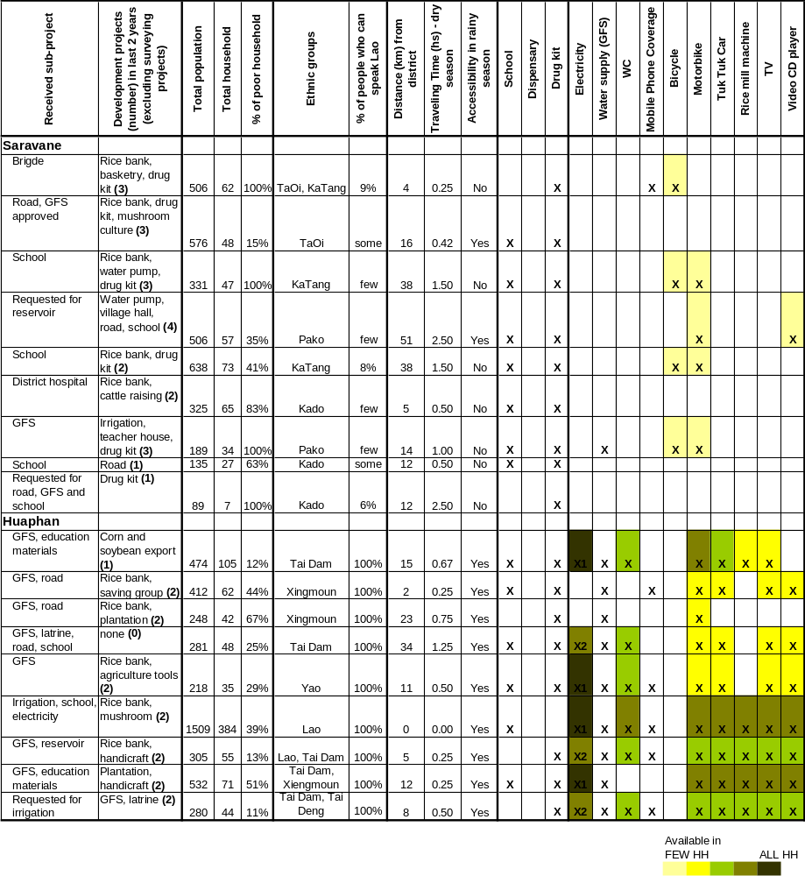

Mobile phone coverage means signal is receivable, but provides no information on mobile phone use. Electricity: X1 means electricity from public source, X2 means small household hydropower generators. The table is primarily based on information collected from the village authorities in each participating village. The remaining data are based on the study team’s own observations during the fieldwork.

Box 3.1. Methodology of the Qualitative study

The objective of the qualitative study was to provide an assessment of how three Community Driven Development projects in Lao PDR (PRF, VDF and VIP), that aim to foster community involvement, reach the poor, and provide an opportunity to improve living conditions in targeted villages, are working in the field. The study presents the experiences and perceptions of both direct and potential beneficiaries, as well as those of the village-, khet- and district-based personnel who supported the implementation of the projects. The study findings contribute to the broader objectives of this Note on the following issues:

1. To what extent was community participation in the decision-making processes during planning and implementation achieved?

2. To what extent are the projects perceived by beneficiaries and others to be beneficial to poor individuals and communities?

3. To what extent are the projects perceived as meeting the needs of the village?

At the beginning of the study, a decision was made to select a Northern (Huaphan) and a Southern (Saravane) province in order to ensure the basic geographical distribution of participating villages. Second, seven districts were selected based on their poverty rating, accessibility, and study costs. In four of the districts, it was possible to study two of the three projects. Third, district-based lists of villages in which the projects were active were the basis for a quasi-random selection of 30 villages (it was later decided to also include two VDF villages from Vientiane province that were visited during the pre-testing of the data collection tools). In order to provide anonymity to all participants in the study - project beneficiaries, project managers as well as district officials - the districts and villages included in the study will not be named in this report.

The primary concept, on which the study design is based, is that similar questions on project planning and implementation are posed to people with different types and degrees of exposure to the projects. The objective was to capture gender differentiated experiences and for the VDF and VIP also member/non-member based differences. In addition, the different entry points served as an opportunity to validate the major findings in each village. Data was mainly collected through focus group discussions (FGD) in order to involve a larger number of quasi-randomly selected beneficiaries in a relatively short time. In addition, semi-structured interviews were carried out with participating district office and project staff. The field team spent one or two days in each village, where they also carried out informal discussions with residents and observed the use of the local infrastructure. Both of these activities provided additional sources of information.

36 FGDs were held with beneficiaries, in which a total of 149 women and 155 men participated in gender separate discussions. In addition, 33 khet facilitators representing the 18 PRF villages, 60 village representatives, and 48 members of village authorities were interviewed individually or in groups during the period from February to April 2007.

Characteristics of PRF sub-projects

The PRF is one of the most important community-driven programs in Lao PDR. Between February 2003 and June 2007, the PRF built 354 schools, 50 bridges, 64 health dispensaries, 1012 water supplies, 119 irrigation schemes, and upgraded 2420 km of roads. It also provided 939 school packages, and 1480 training sessions. Due to its widespread coverage (12 percent of the Lao population in 5 provinces, 21 of the 72 poor districts in Laos, and 1,984 villages), the PRF is one of the most important community-driven programs in Lao PDR.

According to the MIS data, Education, Transportation, and Water & Sanitation were the most frequently implemented sub-projects within the first three cycles of the PRF. 29.6 percent of the implemented sub-projects were in the education sector (building and rehabilitating schools, and buying teaching material); 27.2 percent were water and sanitation projects; 23.9 percent were transportation projects; and the remaining projects were in health, training, and agriculture (see Figure 3.1).

Figure 3.1: Characteristics of implemented sub-projects

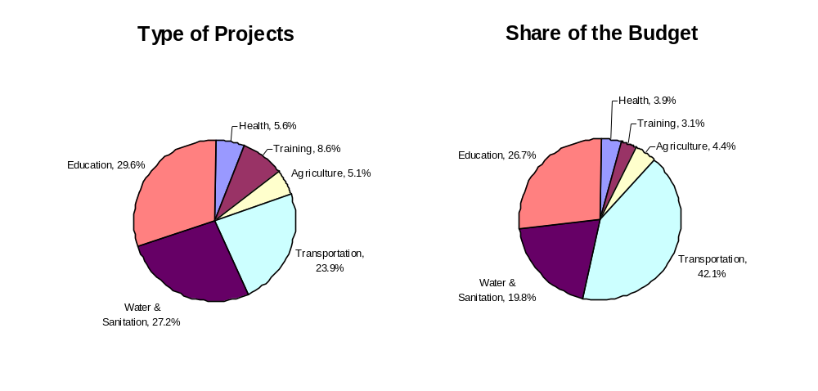
Source: Authors’ own calculations from M&E data, cycles I to III.

The type of implemented sub-projects is similar between poor and non poor villages. Poor villages slightly favor more transportation and water & sanitation sub-projects, while the non poor have relatively higher preferences for training and education sub-projects. Differences remain small, however, as indicated by the overall high correlation between implemented projects in poor and non poor villages (0.79; see Table 3.2). The high correlation may be explained by the often little income differences between poor and non poor villages, who therefore have similar needs. In fact, the only noticeable difference is in vocational training sub-projects, which are four times more likely to be implemented in non poor villages than in poor ones. One explanation may lie in the higher investment capacity of non poor villages, leading community opinion leaders to promote training, widening the range of investment opportunities.

Figure 3.2. Types of implemented sub-projects in poor and non poor villages
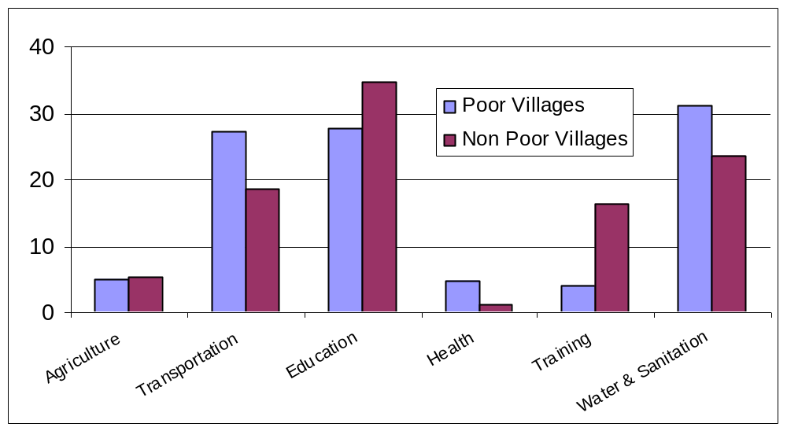
Poor villages are classified as such by NSC. Source: Authors’ own calculations from M&E and NSC data, cycles I to III.

Differences in the type of sub-projects implemented are actually higher across provinces than across poor and non-poor villages. In Huaphan, for instance, 27 percent of implemented sub-projects are transportation ones, against 10 percent in Champassak; in contrast, 49 percent of implemented sub-projects are education related in Champassak, against 20 percent in Huaphan. Huaphan also has a much higher share of implemented water and sanitation sub-projects (36 percent). To a great extent, this differential implementation of sub-projects across provinces reflects topological differences between provinces leading to different needs.

Cost of PRF sub-projects and communities’ willingness to contribute

On average, each sub-project funded by the PRF costs 8,295 US Dollars, where the PRF contributes 83 percent, and the remaining 17 percent is funded by the community (see Figure 3.3). The PRF funded 1,212 sub-projects for Cycles I, II and III, for a total investment of US $8,335,000 (respectively US $1,070,000; US $3,101,000; and US $4,164,000 for cycles I to III); while communities contributed US $1,719,000 (respectively US $214,000; US $638,000; and US $867,000 for cycles I to III) in cash, labor, and materials. Note that, on average, communities co-financed sub-projects by a higher amount than what is required by PRF regulation (10 percent).

Figure 3.3. Cost of sub-projects
Source: Authors’ own calculations from M&E data, cycles I to III.

Large differences in sub-project costs and in community contributions are observed depending on the type of sub-project. The least expensive sub-projects are training. They cost on average US $3,465, and the community contributes only 8 percent. In contrast, the most expensive sub-projects are transportation ones. Typical transportation sub-projects include upgrading existing roads and building bridges, and cost on average US $20,104. Transportation sub-projects also exhibit the highest level of community contributions (23 percent). This may be because villagers see tangible benefits in such work; however, it is also likely connected with the community contributing capacity, which is higher for labor-intensive sub-projects, like roads, than for activities such as vocational training.

Findings from the qualitative study indicate that the majority of villages in both Saravane and Huaphan provinces perceived in-kind and labor contributions as being appropriate in scope. However, a few khet facilitators in Saravane province expressed some concern over the burden placed on the poorest households. Villagers willingly made in-kind and labor contributions in the majority of villages in both provinces. On the other hand, contributions of cash were not perceived as appropriate. In all villages, the in-kind and labor contributions were explained to be managed by the village authority, rarely with the help of the village representatives. Contributions were reportedly made by the vast majority of the households in the villages. However, it was reported by a few khet facilitators in Saravane province that the poorest households face constraints on contributing, and beneficiaries in the Focus Group Discussions (FGD) mentioned that a few households in each village were not capable of helping due to physical constraints or lack of time and resources.

Box 3.2. Transportation sub-projects

Transportation sub-projects are, on average, far more expensive than all other projects, and represent almost half of the budget. 42.1 percent of PRF grants budget is allocated to transportation sub-projects (Figure 3.1). It is difficult to judge whether this represents an excessive share of the budget. On the one hand, for each transportation sub-project financed, a higher number of other sub-projects could have been realized: for instance, each transportation sub-project costs on average as much as 2.3 education sub-projects (Figure 3.3). On the other hand, transportation sub-projects – such as roads or bridges - tend to benefit a larger proportion of people, who otherwise would often remain isolated for long periods, especially during the rainy season. Moreover, having road access also appears to be a prerequisite for being able to implement other sub-projects (see below for details).

Comprehensive cost-benefit analyses are therefore of the utmost importance when evaluating the financing of transportation sub-projects. Attention should also be given to the scale of the project compared to the needs of the population. Also, field visits demonstrated that most roads and bridges in mountainous areas with disperse populations were built to permit truck access; however, it may be more cost effective to build smaller roads and bridges with limited access.

Community-based contributions in rural villages are traditionally a way to improve living conditions in the villages, a factor on which the PRF is capitalizing. The contributions to the sub-projects were in general interpreted by the beneficiaries as a way to improve living conditions, and it was stated in the majority of villages that contributions for new infrastructure projects (such as building a new house for a relative or improving a school house) were considered to be standard practice. An analysis of the social organization and the differences associated with distinct ethnic minorities is unfortunately beyond the scope of this study.

District officials in Saravane province reported that villagers are more willing to contribute to PRF sub-projects than they had been previously. District officials in Saravane province explained that the previous reluctance of villagers to contribute to district initiatives had diminished greatly in the context of the PRF-related activities. The districts were very pleased with this change in their relations with the villages and interpreted it as a positive sign that the poor villagers aspired to see development take place. It became clear that the PRF maintains a good reputation for delivering funding for projects among villages. PRF staff observed nonetheless in a few villages delays in the contributions.

Box 3.3. The need for a gender-sensitive approach to community contributions

In 13 percent of the villages in the qualitative study, problems with excessively high community contributions were reported. A more gender-sensitive assessment of the type of community contributions requested could be warranted.

In one village where a school had been constructed, many residents, in particular women, complained about the scope of the expected contributions. When the district became aware of the reluctance of the village to contribute, the vice district governor reportedly paid a visit to explain the arrangement and the imperative to contribute. The village complied accordingly. One woman summed it up: “It was too hard for me to contribute to the building of the school. I had to bring sand, gravel, and water from very far away to the construction site. You see, it must be more than one kilometer. At that time my family had not enough rice to feed our children. But never mind, I have to contribute because I think of the future of my children.” Men in the focus groups did not mention these constraints on the women, but simply stated that they were willing to contribute. This illustrates the need for a gender-sensitive approach in future discussions on the type of contributions requested by the project.

Problems related to the scope of contributions in a second village were linked to a lack of transparency and possibly corruption, since (according to village representatives) the contractor had asked that more wood be brought to the school than was actually needed for construction. The village had not accepted this arrangement and the school had not yet been built. There is a risk that all community contributions involving high-quality wood could be exploited due to the limited right that exists to cut the few old trees that remain.

Evaluation of the village participatory selection process

The qualitative study confirms that to a great extent, the PRF activity cycle is carried out in both provinces. The village, khet and district-based institutions are all involved in the process. Every village has appointed three or four village representatives (one of whom is a woman), khet facilitators have been appointed by the district in each khet, and district-based PRF consultants are establishing work routines with the district and khet administrators.

Experiences and perceptions of the participatory planning process, however, differ significantly between Huaphan and Saravane. While beneficiaries and PRF staff in Huaphan have, to a large extent, embraced the bottom up, participatory approach of the PRF, some skepticism among district officials and PRF staff in Saravane remains regarding the appropriateness of the PRF approach given local conditions. These differences will be described in detail below.

In both provinces, village authorities (village heads and village committees) have taken an active role in the participatory planning process, leaving little room for village representatives to participate in the project selection process. The design of PRF requires three village representatives to be members of village delegations, none of whom can hold any position in the village administration. However, village representatives had only limited success in representing the village at the khet and district meetings, as the village head and the village committee have taken an active role in project selection and implementation.

In Huaphan province, enough qualified people lived in the villages to elect skilled village representatives. Nonetheless, only 50 percent of participants in Focus Group Discussions knew the identity of the village representatives. This is a surprisingly low estimate. In some villages, the process of electing village representatives was based on recommendations of five different candidates by the village head. “The capacity of the candidate, courage of the candidate and the experience of the candidate” were some of the qualities sought in village representatives, according to village heads. In all nine participating villages, the village representatives spoke Lao.

In Huaphan, village representatives view their role as limited to mobilization in the village, while the participatory planning process is managed by the village head. They perceive project selection, however, to be made by the whole village. One village representative explains the different roles and responsibilities as follows: “The khet facilitator attends the meeting when the sub-projects are selected. He will support the coordination of the funding for the PRF. The facilitator assists the process with the village head and has no interference on the selection of project. That is the right of villagers.”

In Saravane province, village representatives are appointed by the village head authority rather than elected by the community. They were given a limited role during the project activities, and in most villages only 25-30 percent of the participants in each FGD knew who their village representatives were. In the nine surveyed villages in Saravane, the village head appointed village representatives. Village representatives believed they were chosen because they are dynamic individuals, and demonstrated initiative. According to the village heads in Saravane province, it was difficult to get women involved as village representatives due to their lack of fluency in Lao. Consistently, the surveyed female village representatives did not speak Lao, which limited possibilities for interaction with district and project staff. In addition, women’s ability to travel was limited, as they often had to be accompanied by their husbands or male relatives.

Village representatives in Saravane did not play an important role during the activity cycle, which can partly be explained by their lack of experience in representing the village and the leading role taken by the village authority in the villages. The majority of representatives in the nine villages explained that their tasks were not comprehensive or time consuming. Their main tasks were to participate in khet and district meetings during the planning phase. It was also the village head who organized the community contributions to the sub-projects, since he has the respect and authority to initiate such activities. These findings suggest that villages with weaker village authorities are more likely to face constraints in getting access to PRF funds.

The participation rates of men and women in the prioritization meetings were high in both provinces. Residents, however, claimed that the meeting imposed a time burden. In the remote villages, the meetings were carried out over a two-day period, while in villages closer to the district capital, meetings only took one day. In the remote villages, two days was perceived as an unnecessarily long time, a view most likely linked to the fact that the meetings lacked translation services in some villages (see below). In all villages, it was explained that the village head informed residents that, in keeping with the procedures established during the Indochina war, at least one representative from each household should participate (the reference to the Indochina war was made by village heads when explaining why the participation rate was high regardless of poverty status). All interviewed sources in both provinces estimated that men participated in higher numbers than women, especially in the afternoon hours when women would leave to work in the fields.

In a quarter of the villages in Saravane province, the time burden was perceived to be large, a factor that one woman explained in this way: “We had too many village meetings in my village; it was not useful for me. I have to look for rice and food for my children.” The cultivation season is a very inconvenient time of the year for beneficiaries to participate in the prioritization meetings and therefore results in lower participation rates overall, but especially by women. The intensive, two-day form of participation could be shortened in order to enable women to take part to the full assessment.

Participation was also high among the poorest households or households from satellite clusters, as village head reportedly tell residents that they are obligated to send one representative from each household to the village meetings. Reasons for not attending the meeting were traveling, staying overnight in the rice fields, visiting relatives for a ceremony or other event, or illness and pregnancy. Also, young people under 16-18 years of age and the oldest residents in the village were not expected to participate. Participation was high also among households from satellite clusters: the focus group moderators specifically inquired about their participation rates and no differences in attendance was reported. The study teams themselves experienced how randomly selected participants in the focus group discussions who came from satellite clusters actually were mobilized within a short time frame. It was, however, also clear that this outcome could be achieved only through the authority of the village head.

Perceptions on the gender approach

In all but one of the 18 villages participating in the qualitative study separate meetings for gender groups had been carried out. Nonetheless, the rationale for this set-up was not well understood by beneficiaries in both provinces. The PRF seeks to have a gender-sensitive approach, and during the planning process it was required that men and women define their three prioritized needs in separate groups. Villages are accustomed to the village meeting as a forum for discussion or information sharing, and view it as an effective form of communication. However, separating discussion groups by gender had not been tried before. The meetings were therefore described as different from what participants experienced previously in both provinces, and the village head often had to enforce the separate group arrangement.

The appreciation of the separate village meetings is growing, but it is not perceived as the most important part of the participatory process. It became clear during the village visits that generally in traditional village meetings women have limited possibilities to speak. The separate meeting arrangement had clearly given women an opportunity to discuss questions among themselves, a factor that was appreciated. Some of the reasons most often mentioned with regard to the usefulness of the separate meetings were: “It was good because men and women think differently,” “Women can express their view,” and “If we don’t have the separate groups, the men will influence.” Beneficiaries, however, found it more important for them to have a family member present at the meetings, than having separate discussion groups.

In Huaphan province, beneficiaries appeared more used to the new arrangement. A general comment was: “Separate meetings for men and women were a good idea because each group of men and women were able to think for themselves. After, the proposals were compared and we made the selection [of the three proposals] through the majority.” In addition, men mentioned several advantages with the new arrangement. Men commented that the separate meetings made it possible for women to express their ideas. The arrangement also provided the opportunity for some participants to comment on the relationship between husband and wife. For example: “Separate meetings between men and women are better to avoid rumor from women after the meeting. They will say that men spoke too much.”

Data from the MIS shows that 88 percent of the implemented sub-projects were in the list of priorities of both men’s and women’s discussion groups (see Figure 3.4). Such a high proportion of sub-projects chosen by both the men and women’s discussion groups indicate that men and women have common priorities. A potential reason is that the range of sub-projects offered by PRF consists of public goods satisfying basic necessities; therefore, it is more likely that gender groups identify the same priorities. It may also signal that villagers tend to take a “conciliatory” approach, and choose to bring forward at the khet meeting sub-projects that both discussion groups have identified as important (See below).

Consensus among men and women in the proposed priorities is believed to increase the likelihood of having a project approved. In a few FGDs, men were concerned that the variations in prioritization between men and women would decrease their chances of receiving a project. One man expressed this general concern as follows: “I prefer to have one meeting. It is good to help women and for them to suggest projects for village development. But if we suggest different activities between men and women, do you think the project will provide us with all we suggested at the meeting?” This point of view reflects the general concern of beneficiaries of not receiving a sub-project, and shows that villages have their own strategies for increasing the likelihood of success.

Figure 3.4. Discussion groups that proposed an implemented sub-project
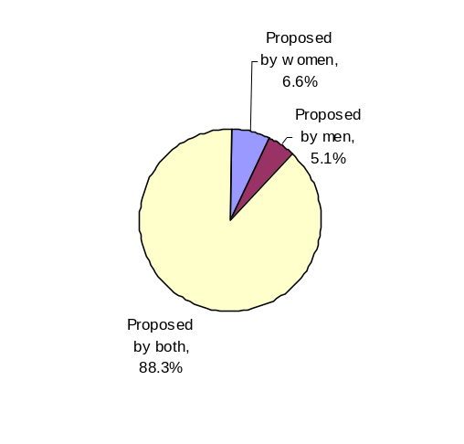
Source: Authors’ own calculations from M&E data, cycles I to III.

In Saravane province, the lack of translation services between Lao and the ethnic minority languages is a major constraint, especially on women’s participation. As a result, in half of the villages the meetings were not conducted well. Women complained that the meetings had been carried out in Lao, which almost none of the women understood well. They described that it had been very difficult to understand what was expected from them and that, as a result, a mixed group arrangement was preferable. As one woman explained, “Men and women together are good. Women can not speak Lao and men can help us.” In these villages, both men and women participating in the FGDs agreed that it would have been better to have mixed village meetings. Khet facilitators in Saravane province also were of the opinion that mixed groups would be better in areas where previous contact with the district had been limited and few residents understand Lao.

The selection process from village to district

According to the MIS data, only 51 percent of the implemented sub-projects had been identified as sub-projects with the highest priority by the villages (see Figure 3.5). Instead, 21 percent of sub-projects were added during the khet decision meeting. Most sub-projects added at the khet level tend to benefit more than one village (for instance, the construction of a bridge, or the rehabilitation of a road). Therefore, a high proportion of sub-projects added at the khet level may suggest that khet committee members tend to consider the positive externalities of the projects. On the other hand, a high number of sub-projects added at the khet level may also suggest a strong degree of government intervention.

Figure 3.5: Priorities of implemented sub-projects
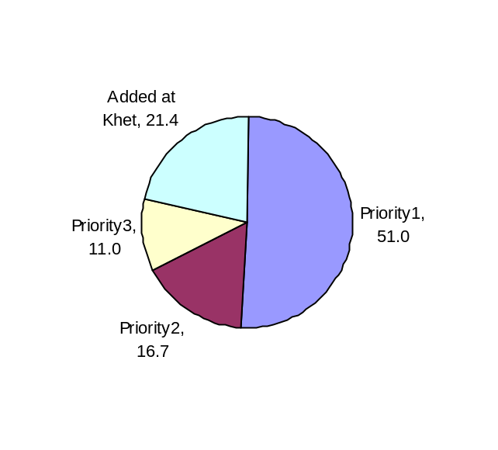
Source: Authors’ own calculations from M&E data, cycles I to III.

A high share of sub-projects introduced at the khet level may reflect a respectful rationalization of village priorities, but also a deficiency in the participatory approach of the PRF selection process. 62 percent of the implemented sub-projects that have been added at the khet level fall into the same category as the sub-project listed as the village’s first priority. Thus, in half of the cases the khet appears to ask for a modification of the original sub-project (such as a secondary school instead of a primary one), rather than for the implementation of a different kind of sub-project. The khet meeting may actually be an occasion for a compromise between village priorities. For example, if two nearby villages request a school, it can be discussed at the khet level to merge the priorities into one common school/sub-project. It is also a level for rationalizing investment; for example, if four villages request a water supply scheme, it could be decided at the khet meeting to request only one sub-project, comprising implementation in four sites, to minimize procedures and administration workload and cost. Results from the qualitative study, however, also suggest some deficiencies in the PRF participatory approach (see next section for details).

Overall, the distribution of implemented sub-projects matches the distribution of proposed sub-projects, which were the villages’ first priority (see Figure 3.6). The PRF implements slightly more Education and Water & Sanitation sub-projects than the ones proposed as first priority ones, and slightly less Transportation and Agricultural sub-projects. Overall, however, the distributions of proposed sub-projects with priority I and the distribution of implemented sub-projects are quite similar, suggesting that the PRF as a project does not appear to have any bias for specific sub-project types. This does not preclude, however, any shortcomings or biases in the community selection process which may occur upstream of the village meetings (e.g. instructions given by local authorities before the VNPA).

Figure 3.6. Implemented sub-projects vs. sub-projects listed as priority 1
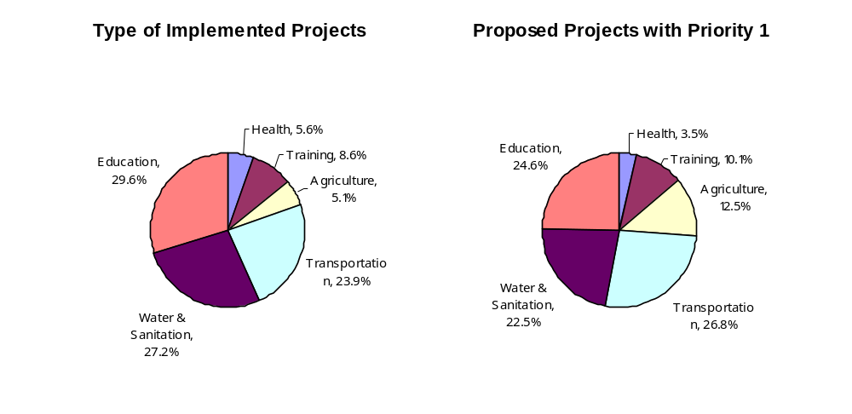
Source: Authors’ own calculations from M&E data, cycles I to III.

Villages with a high ratio of poor households have a higher likelihood of asking (and receiving) water & sanitation sub-projects. Table 3.2 looks at the (multivariate) relationship between sub-projects listed as priority I, implemented sub-projects, and village characteristics. It shows that, everything else being equal, villages with a higher ratio of poor households tend to ask (and receive) more water & sanitation sub-projects. Interestingly, everything else being equal, villages without access to potable water seem to prefer roads to water & sanitation sub-projects. This may relate to unobserved village characteristics (such as no easy access to a spring or close proximity to other water sources) that may lead villages with no access to clean water to prefer other sub-projects.

Having road access also appears to be a prerequisite for being able to implement other sub-projects. Table 3.2 also shows that, everything else being equal, villages not having road access ask (and receive) a transportation sub-project with a much higher likelihood, at the expense of other types of sub-projects. In addition to the intrinsic relevance of road access for villagers, the strong preference for transportation sub-projects in villages with no road access can also be explained by the fact that many sub-projects are much more difficult to implement without access to the village.

Table 3.2. Project selection and village characteristics

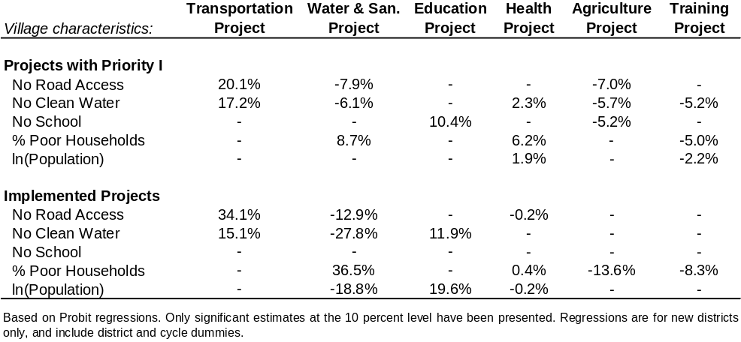

Source: Authors’ own calculations from M&E and NSC data.

Perceptions on the project selection process

One of the objectives of the PRF project design is to build capacity and voice of the khet and village administration to bring the decision making process closer to beneficiaries. This section evaluates how far the PRF has been able to achieve this goal.

The success of the PRF participatory approach is to a great extent dependent on the existing structures and institutions. The new positions of village representatives and khet facilitators would ideally add to the existing institutions from the villages’ perspective on development needs. This is quite an ambitious goal, and would require that district and provincial officials, who normally make the decisions on the delivery of basic services, take a step back and create space for the new agents to participate directly. As the practices described by beneficiaries illustrate, however, achievements towards this goal are progressing slowly. In Saravane province, it was found that the decision-making process is far from being shielded from the influence of district officials. In contrast, khet facilitators seem to gain some space in Huaphan province. In both provinces, however, the risk that local government officials could attempt to influence khet decision-making processes is well-recognized, and was identified as a serious concern.

Khet facilitators and khet administrators are perceived to strengthen communication between the village and district in Huaphan province, while this institutional set-up is perceived as less effective in Saravane. In Huaphan province, PRF staff had mainly positive experiences with the khet. In one of the districts in Huaphan, the khet appeared to work particularly well. PRF staff explained that “It was good to involve the khet. The khet was active and took responsibility for their tasks;” “The khet was a very important body that helped to make the work of the PRF run smoothly;” and “The khet was strong and worked very well in the district – the coordination between khet and the district was good.” In the second district, it was confirmed that the khet played an important role in coordinating sub-project planning and implementation, even though their management capacity needed improvement (see below for more on this point).

Box 3.4. A khet facilitator in Huaphan province shows understanding of the participatory
planning process and his role

“A meeting was conducted to select three of the six proposals [three from the men’s group and three from the women’s group]. So the six proposals were reduced to three and each village made their decision in their own way. The three proposals selected by villagers were considered the most important for the needs in the village […] These three proposals from each village were then collected from the whole khet and presented at the khet meeting. At the meeting the village head, representatives for each village, and the district PRF staff were present. The final decision is based on the needs of each village with the consent of the representatives of the village.”

His own role was described as follows: “Our role was to present what the village needs are and submit it to the district PRF…all projects were decided at the district meeting.”

In contrast, district officials and PRF staff in Saravane province generally perceive the khet facilitators as weak and in need of more training. Their role is described as important in the participatory planning process, but less so during implementation of the selected sub-projects. Khet facilitators are described in the two included districts as important in mobilizing residents in the planning phase. But during the project implementation phase, during which several meetings are held, the fact that many khets are dispersed makes access to the village a major constraint for the facilitators, who do not necessarily live in the selected villages. In addition, their capacity was described as limited and in need of improvement.

Female khet facilitators in Huaphan spoke Lao and were able to travel to villages. In contrast, female khet facilitators in Saravane province rarely went to the villages, although they participated in the district meetings. In one village where a female khet facilitator actually went to the villages, beneficiaries commented that she did not speak during the meetings. As mentioned above, the lack of proficiency in Lao was another constraint for the female khet facilitators in Saravane province, especially during district meetings.

The role of the government in sub-project selection

Promoting participatory planning is a central objective of the PRF. It has, however, not always encountered much support from local governments. During the Focus Group Discussions, stakeholders were asked to describe the observed criteria of sub-project selection. Interestingly, the observed criteria differed between the two provinces and the different participating stakeholders. In Huaphan province, poverty status and equal distribution of sub-projects among villages are perceived as very important, along with respecting villages’ priorities (see Table 3.3). Accordingly, 95 percent of the villages had received at least one sub-project. As one khet facilitator described it: “All villages have received support for one of their priorities – at least two sub-projects and maximum five sub-projects.” In Saravane province, obeying the district development plans appears to be the most important selection factor, and high coverage comes second (coverage in Saravane was 53 percent after less than two years of project implementation). It is interesting to note that PRF staff do not mention following the district development plan as a project selection factor; possibly, as a consequence of training received, PRF staff may indicate what the selection criteria should be, rather than what they actually are. In Saravane, poverty status is more difficult to discuss since all villages are perceived as poor.

Table 3.3. Observed criteria for sub-project selection
Stakeholders’ observations | Huaphan Province | Saravane Province
PRF staff | Target poor villages  Respect villages’ priority proposals  Costs  Easy access | Equal distribution  Costs  Target poor villages
District  Officials | - | District Development Plan  Easy access  Higher coverage/low costs more important than targeting remote villages  Equal distribution
Khet facilitators | Equal distribution  Village priority proposals  Costs  Poor villages | District Development plan  Equal distribution
Beneficiaries | Poor village  Significant needs  Prepared good proposals | Plan of the Party  Poorer than other villages  Significant needs

The districts in Huaphan province allowed more room for decision making at the khet level than in Saravane. In 38 percent of the villages in Huaphan, it was reported by the khet facilitators that the khet administrators had succeeded in ranking the village proposals at the khet level largely without interference by district-based officials, and khet facilitators were in general able to describe the planning process from village to district. In the remaining 62 percent of the villages, it was found that the district was more active in the prioritization process at the khet level: district officials were participating at the khet meetings and took part in the discussions, which reportedly influenced the process.

Box 3.5. Easy access to the villages was mentioned in both provinces as an important factor in sub-project selection.

“We have 10 villages in this khet [from Saravane province]. Seven villages have received support from the PRF: well, bridge, weir for irrigation, gravity-fed supply and irrigation systems, the repair of one system, and a health center. But three villages have not received it because they are located far away from the district. The lack of an access road is their main problem.”

Similarly, a PRF staff in one of the districts in Huaphan described that some of the poorest khets had not yet received support for the same reason: “Each khet received a different number and amount of sub-projects. There are three remote khets, and they are the poorest. These three khets did not receive any sub-projects from the PRF because there is no road access.”

Central planning is largely perceived as the most efficient approach to development in Saravane province. According to GoL district officials and some provincial and district PRF staff, the district development plan provides efficient sub-project allocation. In one of the participating districts in Saravane province, 17 government officials (including the vice governor and two PRF staff) participated in a FGD. The vice governor and his staff in general complained that the PRF is managed independently from the district administration, and implemented largely in tandem with the institutional structure at the district level. They expressed a preference to have the PRF be an integral part of the district development plan. It was clearly stated that the participatory planning process was not perceived as the best available option. The district government staff in Saravane was critical of the number of meetings that took place among villagers, khets, and the district during sub-project selection. They claimed that the district plan saw a strong need for health, education, agriculture, and infrastructure development, and that the plan could be used when allocating sub-projects.

The vice governor also stated, however, that the PRF provides a good opportunity to motivate villagers. When explaining about the positive aspects of the PRF, he said: “The local coordination process has improved and the infrastructures provided by the project are improving people’s access to education and health, and making traveling more convenient.”

Accordingly, the influence of Saravane district officials on the selection of villages receiving sub-projects is strong. The influence of district officials is easiest to observe in villages close to the district capital, where contact between village heads, district, and project staff was easiest to achieve. One village head described the selection process in this way: “I knew before the village meeting what project activity would be chosen and implemented in our village. It was already decided by the district officials what support our village would receive.” Remoteness was also described by district officials as a problem, especially when transporting construction materials (consequently, most proposals from remote villages were not approved during the first cycle of the PRF in Saravane). In one of the two districts, it was therefore suggested that the PRF should mainly focus on expanding the network of roads and bridges.

In Saravane province, the khet meeting primarily served as a way to collect the proposals. The descriptions of the planning process from village to district in Saravane indicated that the main task performed by khet facilitators was to collect the three sub-project proposals from each village. These documents were then handed over to district staff. According to all participating khet facilitators, the presumed discussion on the prioritization of sub-projects was very limited.

Box 3.6. The strategic khet facilitator.

One of the 12 participating khet facilitators in Saravane province stood out in terms of demonstrating ownership of his role as facilitator. The moderator asked him: “What was your role at the khet and district meeting?”

He replied: “At the khet meeting we collected proposals from villages and I did not say anything and did not participate much in the discussion.”

He was then asked “Why?” and replied: “Because I knew the decision was not taken at the khet.”

“How did you play it during the district meeting?” the moderator asked.

He answered: “I tried as much as I could to get support from the PRF to my khet. That is why I got a 3 kilometer long access road between two villages for 2007 and another access road to connect two other villages for 2008. It was not an easy task to explain and convince them.”

Interestingly, the village in which he lived himself had not yet received any sub-projects.

A proxy measure of the extent to which the PRF has achieved its objective of promoting participatory planning is the proportion of sub-projects that were approved as the villages’ first priority. The MIS data (as presented above) showed that 51 percent of the implemented sub-projects had been identified as the highest priority of the villages.

According to khet facilitators in Huaphan province, the priority of proposals was described as an important factor when approving sub-projects; while in Saravane province khet facilitators recall only to a limited extent whether the received sub-projects were a high priority of the villagers or if they were added at the district meeting. The lack of recall of priority status in Saravane reveals the low importance khet facilitators place on whether villages received what they requested or not. The study team was very surprised when the first khet facilitators did not recall the priorities of the villages, resulting in the application of different interview strategies. Drawing a map of the khet and then adding information on each village, including whether the village had received a sub-project or not, proved to be the most successful approach, but acquiring information from the facilitators remained difficult. It appeared that the concern of the facilitators was to ensure that sub-projects reached the khet, rather than which type of sub-project was received. In the context of a low sub-project density and a high level of poverty among the villages, this can be seen as a rational strategy in Saravane province. Issues of ownership and future maintenance, however, have a greater probability of arising if the village did not receive its desired sub-projects. Data from Huaphan show that the first priority of villages was respected to a greater extent. The stated priority proposals were, however, very homogenous in Huaphan, where according to beneficiaries in FGD all villages requested gravity fed water supply (GFS) or irrigation systems, a priority that might have been shared by the district.

It was acknowledged by khet facilitators in Huaphan province that projects occasionally were added at the khet level. It was explained that these projects in the two participating districts most often were related to training opportunities such as training to strengthen the khet or the community, training on environmental issues and/or on mushroom cultivation.

In both provinces, “state capture” at the district level appears far more influential on project selection than elite capture in villages. As stated, the interference of district officials in Saravane province was comprehensive, and did not leave much room for ranking projects by the local elite and party members. In one village in which respected district officials themselves lived, it was clear from the statements of beneficiaries that the choice of a road to the village was largely due to the officials. Nonetheless, in the remaining villages with more limited contact and relationships with district staff members, it appeared just as difficult for the local elite as for villagers to create a space in which to discuss the proposals. The main difference between the villages located close to or far away from the district capital appears to be that in villages close to the district capital, the village head was better informed about the decisions being taken by the district.

In Huaphan province, on the other hand, the districts left some room for prioritization at the khet level. For these villages, the issue of elite capture at the village level could be in principle more relevant. Statements from village representatives and beneficiaries, however, do not support this hypothesis, and were more focused on the usefulness of the projects they received. A village representative from Huaphan explained the issue in the following way: “In my view, everybody wanted to participate in the project because they want to change the poverty status. We are all from the same ethnic group with good solidarity; we speak the same language and there are no rich people. We are all poor.”

In fact, about 80 percent of the participating villages in the study were composed of only one ethnic group; the remaining 20 percent comprised two different ethnic groups, reportedly sharing a common language. In villages where large differences in the language spoken and type of livelihood exist, it is possible that more attention should be paid to the representation of each cluster. Also, the nature of projects such as roads and schools is less prone to elite capture than other projects (not supported by the PRF) such as livelihood activities.

Larger villages have problems in mobilizing residents and ensuring that all segments of the village have a voice in the village meetings. One participating village was a district capital with more than 350 households. Village representatives explained that it would be better to hold village meetings with the village head in each section of the village and not simply separate men and women from the whole village.

Who does PRF benefit most?

One of the stated purposes of PRF is “to side with the poor.” But to what degree has this objective been achieved? And do the funds reach the neediest or the better prepared communities? The funds allocation up to the district level is determined by a formula that directly takes into account the poverty rate of the district, and the level to which the district has allocated funds to the poorest villages in the previous cycle. During prioritization meetings, village representatives have however some discretion in choosing which villages receive the funds. This section utilizes the MIS data to look at village and khet determinants influencing the likelihood of receiving a sub-project.

The way PRF allocates funds within districts appears to be “poverty-neutral:” that is, poor and non poor villages have a similar likelihood to receive a grant. Figure 3.7 shows the distribution of poor households among villages that received a PRF grant, and among all villages in districts where PRF is active. Both distributions look very similar, indicating that, de facto, the poverty level of a village influences little its likelihood of receiving a project. The same picture emerges when using the NSC definition of a poor village (Figure 3.8): poor and non poor villages have the same likelihood of receiving a project. This behavior seems to be generalized across provinces and cycles, as little time and regional variation is observed. This finding is further confirmed by the qualitative study which illustrated that high coverage of the project throughout the district was important to the stakeholders.

A multivariate analysis confirms that poverty levels do not influence the project selection process. In fact, few factors do affect the process. The M&E data contain a list of all proposals submitted by all villages within PRF districts. By looking at which proposals have been accepted, and at the characteristics of the villages that submitted these proposals, it is therefore possible to discern the characteristics that influenced the acceptance of a proposal. Results are presented in Figure 3.9, which shows the sub-project and village characteristics that influence the likelihood of a sub-project being selected. The red bars represent significant estimates, while the white bars represent estimates that are not significantly different from zero (meaning that the hypothesis that the community or project characteristic in question has no impact on the selection process cannot be excluded). Notice that all regressions include cycle and district dummies, so that the relevant comparison group consists of villages in the same district/cycle. Next, the significant effects that are relevant for our analysis are discussed.

Figure 3.7. Distribution of projects across poor households
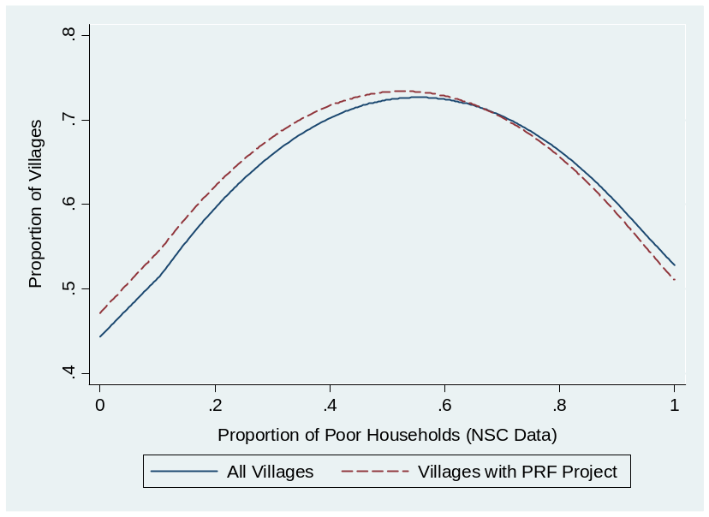
Source: Authors’ own calculations from M&E and NSC data, cycles I to III.

Figure 3.8. …and across poor villages

Poor villages are classified as such by NSC. Source: PRF from M&E and NSC data, cycles I to III.

Sub-projects proposed by larger villages are more likely to be accepted, and a high level of intra-khet competition seems to be present. In Cycle III, everything else being equal, doubling the size of a village increases by 2.1 percent the likelihood of a sub-project being accepted (see Figure 3.9 and the Appendix). As each village submits three projects, this implies that villages with 80 households have a 9.6 percent higher probability of receiving at least one sub-project than villages with 20 households. Also, everything else being equal, sub-projects originating from a village in a more populous khet have a lower probability of being accepted. For instance, a village in a khet of 40 households has a 12.7 percent higher probability of receiving a sub-project than the same village in a khet of 160 households: this effect is most likely due to the village’s diminished importance because of its smaller relative size. In contrast, the absolute number of villages in a khet does not appear to influence the likelihood of receiving a sub-project, suggesting that the relative size of a village compared to the whole khet has more importance than how many villages are in a khet (estimation is not presented).

A strong bias towards transportation, education, and water & sanitation sub-projects exists. Holding all other factors constant, transportation, education, and water & sanitation sub-projects have a higher likelihood of being selected than other types of sub-projects. While the bias towards transportation sub-projects may be justified by the fact that roads and bridges potentially benefit several villages, the bias towards education and water & sanitation sub-projects is more likely to reflect district or PRF preferences.

Villages that received a sub-project in Cycle I are more likely to receive a sub-project in Cycle II as well; the effect, however, disappears for Cycle III. A village that received a sub-project in Cycle I has a 12 percent higher probability of receiving a sub-project in Cycle 2. This is likely to be a reflection of unobserved village characteristics, or of the fact that villages that already completed the selection process are better prepared in submitting successful proposals. Interestingly, in Cycle III this effect disappeared, suggesting a potential “preference” during district decision meetings for villages that had not received sub-projects yet. This hypothesis is in fact confirmed by the qualitative analysis that showed a tendency of attributing projects equally among villages.

Figure 3.9 Determinants of project selection
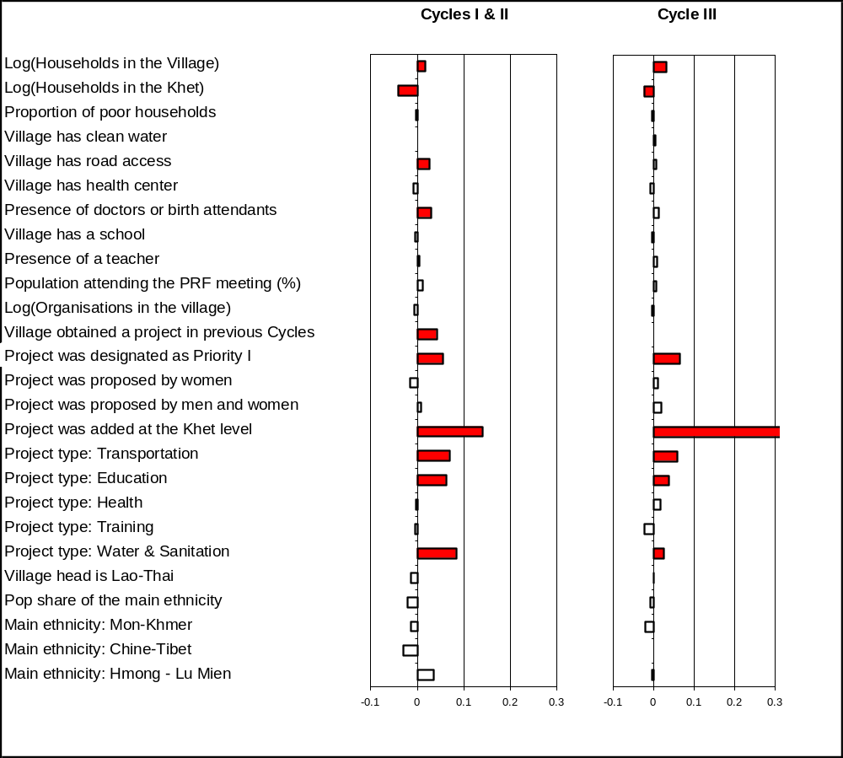
Based on Probit regressions. The values represent the marginal increase in the probability of getting a a sub-project for a proposal with mean characteristics. The red-colored estimates are significant at the 10 percent level (the white-colored estimates are insignificant). Data for Cycle III only include finished projects. Source: Authors’ own calculations from M&E and NSC data.

In Cycles I and II, villages with road access have a higher likelihood of receiving a sub-project. This confirms the results of the qualitative study. Note that the effect loses significance in Cycle III: this is also consistent with the observed tendency of eventually attributing sub-projects to all villages, giving, however, priority to villages with road access.

Ethnicity, poverty, and social capital variables do not influence the project selection process. Neither the ethnicity of the village head, nor the villages’ ethnicity, appears to influence the selection process. Similarly, variables such as the percentage of the population who attended the PRF meetings or the number of organizations in a village do not appear to have a positive impact on the likelihood of a project being selected. Finally, the proportion of poor households also carries an insignificant effect, confirming the results of Figure 3.7 and 3.8.

A similar picture emerges when looking at sub-projects received by khets. Figure 3.10 repeats the analysis with observations aggregated at the khet level. Similar to the village-level analysis, more populous khets receive less sub-projects, possibly because they are more likely to have their basic needs covered (in terms of infrastructure); for the same reason, villages that have a higher number of schools per capita receive less sub-projects. The poverty level only marginally (but positively) impacts the number of sub-projects received.

Overall, the selection process seems to be “neutral” in the sense that sub-projects are allocated with the same likelihood to all villages (with, possibly, a slight negative bias for large, and remote villages). With the exception of village size, remoteness, and the type of project, no relevant village characteristic appears to influence the selection process (see Figure 3.9). Such a finding is consistent with the “neutral” selection process described by the qualitative study, where in district meetings, sub-projects are allocated with the same likelihood to all villages, although they are given to remote villages last.

Figure 3.10. Determinants of project selection at the khet level
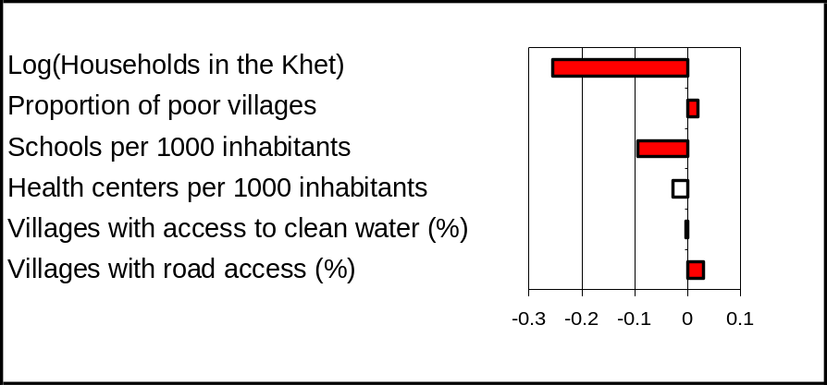
The dependent variable is the log of one plus the number of sub-projects at the khet level for Cycles I-III. The red-colored estimates are significant at the 10 percent level (the white-colored estimates are insignificant). Source: Authors’ own calculations from M&E and NSC data.

Villages without support

Data from the qualitative study illustrated that the participatory planning process in villages not receiving a sub-project did not differ from the process followed in the villages that received a sub-project. In villages without sub-projects, village meetings were carried out; women and men agreed on three proposals to present at the khet meeting; and khet facilitators and village representatives were appointed.

“Planning fatigue” is currently low in both provinces, but could quickly swell if project density does not increase in Saravane. Of the three villages interviewed that applied for a sub-project but had not yet received one, two expressed some degree of “planning fatigue,” especially among the women. In one village in particular, the women’s focus group and discussions with the village head indicated discontent with the fact that residents had spent time defining their proposals while not being supported. They questioned why the district would ask the village what they needed but not provide it with anything, when district representatives knew that the villagers were poor. The three villages, however, had been told they would receive a sub-project at a later time, which most likely is the reason why the attitude toward the planning process was still relatively positive. Indeed, in one of the three villages, residents had specifically been promised a road during 2008. If the district in fact intends to construct the road, it would be a violation of the formal procedures to have it planned at this early stage. It is not known however if the district simply is trying to buy some time and if the road will be funded through PRF.

The sub-project density was very high in Huaphan province (as previously mentioned, 95 percent of the villages in the two districts included in the study had received at least one sub-project); a factor that decreases the risk of planning fatigue. In contrast, only 53 percent of the total villages in the included districts in Saravane had received a sub-project (after two cycles). It was assessed that willingness to participate in a planning process would decrease substantially if the villages in Saravane were to go through another project cycle without receiving a sub-project, yet simultaneously observe that other villages had already received second projects. In keeping with this finding, PRF staff in Saravane suggested that villages that had already received one sub-project should be taken out of the pool of eligible villages for the next project cycle.

District and project staff in Saravane province were concerned about their ability to mobilize villagers without the guarantee of receiving a sub-project. It was described as unnecessary for all villages in a khet to go through a planning process that includes village meetings when the district knew there would only be enough funding for at most two of the villages within the khet.

Box 3.7. Three examples of villages that had not yet received support from PRF

In one village in Saravane, sub-project approval was in the hands of the district, which (according to the khet facilitators) wanted to increase literacy in the area. Consequently, this particular khet had received five school projects, but none went to the village because it already had a school financed by another donor.

A second village in Saravane had been promised a road at a later date when funding will be available.

A third village in Hauphan was most likely excluded because it had recently received a GFS system and latrines from another donor, in addition to having benefited from a new school constructed by the PRF in a neighboring village.

Empowerment, inclusion, and participation from the beneficiaries’ perspective

Empowerment and participation are key factors for engendering development. Empowerment implies enlarging peoples’ capabilities for making informed choices and taking actions that can have great impact on their welfare, and is as such a goal of development in itself. A growing body of evidence is in addition also showing the importance of empowerment in enhancing development effectiveness (World Bank, 2002). Among others, empowerment is recognized to impact good governance and growth in a two-way relationship in that good governance promotes empowerment, and empowerment further enhances good governance. Another key area in which empowerment plays a relevant role is poverty reduction: when growth strategies are combined with pro-poor arrangements, for instance, development outcomes tend to improve. Finally, empowerment is important for project effectiveness and improved service delivery – a finding this study confirms. Even though there is no single model for the advancement of empowerment, experience from many different settings shows that access to information, inclusion/participation of poor people, accountability of governments and the private sector, and a capacity of local organizations to support communities in mobilizing voices and resources, are four key elements of empowerment. The findings of this study indicate that these elements also could play a critical role in Lao PDR.

According to khet facilitators and beneficiaries, lack of understanding of the menu of eligible sub-projects created initial confusion among beneficiaries in both provinces. After several years of project implementation these issues have been addressed in Huaphan. In Saravane, communication problems between district officials, program managers, and villagers were high due to the lack of a common language. In addition, it was found that beneficiaries and program managers do not necessarily share the same conceptual understanding of poverty reduction. When asked how he supported beneficiaries in formulating their proposals, a khet facilitator replied: “I asked them to think first, to suggest priorities in the village in an appropriate manner.” The moderator asked for clarification on this point, and he replied: “I meant that they should not suggest something like a big car or a paved road, but something that was appropriate to our local conditions.”

In many villages in Saravane, it proved to be a difficult exercise to simultaneously ask villagers to identify their six most important needs, and to then explain that only certain types of proposals would have been supported. This was particularly difficult during the first phase of contact between beneficiaries and PRF. District staff, project managers, and beneficiaries alike complained about the discrepancy between the two aspects and the difficulties involved in explaining the difference. As a result, the majority of villages identified initial needs that could not be covered by the project (such as rice fields, rice, motorcycles, livestock husbandry, and saving funds). One woman in Saravane describes this dilemma in the following way: “I came for meetings three times; if I did not go then my husband did. We were often asked the same questions about what the village needs. Several times we replied that we need cattle. We were then asked the same questions again but they never gave us cattle.”

District GoL and PRF staff in Saravane believe that villagers are unable to define their most pressing needs. Within this context, it is clear that the PRF objective to empower poor villages is very ambitious and requires a long-term perspective. Some of the comments from district and PRF staff on the difficulties of sub-project selection included such perspectives as: “Villagers did not know and understand the project process and the proposed method because they have a low level of knowledge. They did not know how to use the different facilities and had no idea about what they wanted to do. So, it is better if the district takes care of them and thinks for them.” Another added: “Villagers did not know what they wanted. They saw other villages receive a project and they just wanted to receive the same themselves.” Such attitudes toward poor and remote villages should be addressed, for instance by strengthening communication and cooperation with the villages.

Beneficiaries’ perceptions about the participatory approach and their voice in the planning process are also more positive in Huaphan than in Saravane. One way to measure these perceptions is to ask beneficiaries in the FGDs to compare the sub-projects they received with what they (according to themselves) proposed during the VNPAs. This would reflect their stated, or recollected, priority proposals as described in the FGDs, which might differ from what has been registered in the M&E system as their formal priority proposals. The focus of this exercise is on how beneficiaries have reconstructed the participatory planning process and compare it to their perceived satisfaction with the project.

In Huaphan, 84 percent of the villages received what both men and women stated were their first priority proposal – GFS or irrigation systems. For the remaining 16 percent, the first priority was received later. The villages in Huaphan were very content with the received sub-projects. The stated first priorities between men and women also overlapped completely except in one village (Table 3.4). It should be noted, however, that some recall bias may exist in terms of whether participants remember either the three proposals from the gender separate meetings or the three village proposals that had been agreed on by both men and women. Nonetheless, the findings do correspond well with the M&E system, which shows that 88 percent of the implemented projects were in the list of priorities of both men and women.

Table 3.4. Beneficiaries’ stated priorities in Huaphan
Approved sub-project per village | Women’s stated priority | Men’s stated priority
GFS system  Education materials | GFS system  School  Latrines | GFS system  School  Latrines
GFS system | GFS system | GFS system  Repair of old GFS system  Latrines
GFS system  Road | GFS system  Road | GFS system  Road  Bridge
Irrigation system  Road | Road  GFS system | Road  GFS system  School  Latrines  Plantation fund
GFS system  Latrines  Education materials  School | GFS system  Road  Latrines  School | GFS system  Latrines  School and education materials
Irrigation system  Education materials  Electricity  School | Irrigation system  Repair of school  New school  Electricity | Irrigation system  Repair of school  New school  Electricity
GFS system  Weir | GFS system  Weir  Drug Kit  Savings group | Weir
GFS system  Education materials | GFS system | GFS system
No support | Irrigation system | Irrigation system

In contrast, in Saravane only 43 percent of the villages received a sub-project that was men’s, women’s, or both groups’ first priority. The same proportion received a project that was among the six priority proposals put forth by the village; while the remaining villages received a project they had not requested (Table 3.5). Similar to Huaphan, villagers stated that their livelihoods had improved, but in Saravane, a question remained regarding why the first priority proposal was not approved for the majority of the villages.

In Saravane, focus group participants expressed disappointment with the fact that they had not received sub-projects that were their first priority. In a village that received a bridge instead of their priority of GFS system and a school, one man explained: “Our first priority was GFS, second was school, and third was a road and a bridge. The district staff came to explain about the need to have the bridge as the first thing, then water could be the next. The reason was that the bridge is necessary for better access to the district center so that we would be able to sell products such as vegetables at the market. Receiving the bridge was also a good thing for us but what we really needed was the water supply.” A similar experience was expressed in a second village: “Because this was the plan of the party and government, so we have received the road.”

Table 3.5. Beneficiaries’ stated priorities in Saravane.
Approved sub-project per village | Women’s stated priority | Men’s stated priority
Bridge | GFS system  School  Road/bridge  Livestock husbandry | GFS system  School  Road/bridge  Livestock husbandry
Road  GFS system (approved but not implemented) | GFS system  Road | GFS system  Road
GFS system | GFS system  Road  Livestock husbandry  Electricity | GFS system  Road  Livestock husbandry  Electricity
School  Road | Livestock husbandry  GFS system  Road | Road  Rice  School
School | GFS system  School  Irrigation system  Health Center | School  GFS system  Health Center
School | GFS system  School  Irrigation system  Health Center | GFS system  School  Irrigation system  Health Center
District hospital | Rice  Goat raising  GFS system | Rice  Goat raising
No support | Road  School  Health Center | Rice  Goat raising
No support | Irrigation system  GFS system  Solar generated electricity | Irrigation system  Solar generated electricity  Livestock husbandry

Box 3.8. PRF: gift or empowerment?

Beneficiaries do not differentiate between project and district staff. They are all described as officials coming from the district. The project is recognized as a government intervention and it is known that government policies apply, for example with regard to the right to collect wood to make the community contribution. In keeping with this association to the government, it was found that khet facilitators and village heads tend to present the sub-projects as a type of gift from the government.

In one khet in Saravane the facilitators expressed it this way: “We are happy to be khet facilitators, and that we can bring water and a road to this village, and other projects to other villages.” A male participant in an FGD described what he remembered about the village meeting: “At the meeting they asked us if we need support, and all people replied “YES.” When they asked what type of support, the village authority replied a school, a gravity-fed water supply system, a health center. More than one year later, we were informed that we will get support for the school building with village contributions.” The connotations of the gift were expressed by one of the village heads: “I am very happy about the projects. All the residents have more confidence in the government policy and also in my role as the village head.”

Participants in Huaphan province mentioned far more strengths than weaknesses in the PRF, and the participatory process was emphasized as a strength in 25 percent of the villages. As a final question in the FGD, beneficiaries were asked to think of their experiences with the project, and to discuss strengths and weaknesses of the PRF. The study team succeeded in getting responses primarily in Huaphan province.

Table 3.6. Strengths/weaknesses of PRF as stated by beneficiaries in Huaphan
Mentioned in villages (%) | Strengths or weaknesses of PRF
100 | Improved livelihood in the village  Project did not address all needs
25 | We selected the activities ourselves  We have become more active in improving the living conditions in the village  Not all households participated in the planning process  Lack of transparency in community contribution / procurement with contractor
12.5 | Not all households are active in the maintenance of facilities

All villages in Huaphan mentioned that the main strength is the improvement of livelihoods due to improved infrastructure. Interestingly, explicit appreciation of the participatory approach was expressed in 25 percent of the villages, but only in the men’s FGDs (it is important to note that these answers were given without the FGD moderators prompting different examples). On the weaknesses side, in 25 percent of the villages it was mentioned that not all households were participating, and in another 12.5 percent that more households could participate in the maintenance of the facilities (see Table 3.6). These responses illustrate in a simple way how villages emphasized and understood the different aspects of the project and indicate the relative weight of each issue.

In sum, in Huaphan inclusion and participation in the project activities is an important reason for satisfaction with the project. Beneficiaries in Huaphan stated that the village meetings and the prioritization process were greatly appreciated. Among others, this is likely to be related to the fact that almost all villages in the sample had received their stated first priority proposal. Beneficiaries also stated that the planning process made sense when they looked at improvements in the villages.

In contrast, beneficiaries in half of the villages in Saravane were not satisfied with the participatory planning process. As outlined in this chapter, this is likely to be related to poor implementation of the participatory process, and to the fact that only 11 percent of the villages in Saravane had received their stated first priority proposal. The disrespect of communities’ stated priorities also gave the impression to beneficiaries that participation in the planning process was more a project requirement, than an important tool to improve their livelihoods.

Suspicion of corruption by contractors and a lack of transparency in contracts were in general poorly tolerated by villagers. This suggests that empowerment is also a good manner to prevent the misuse of funds. Different degrees of lack of transparency in the selection and implementation processes (such as excessive community contributions to the contractor, or discrepancies between the planned budget of a sub-project and the contractor’s winning bid) have been found in both provinces in about a fifth of the villages. It was clearly expressed to the study team that problems related to misused budget were of great concern. In two cases, the villages had for that reason not completed implementation of the projects. In a third case, the arrangement with a contractor was already a fact when the village found out about it, something that the village clearly regretted.

The case of the misplaced district hospital also suggests that greater empowerment could prevent the misuse of funds. Out of the eighteen PRF villages visited, only one case of sub-project misallocation was identified: in Saravane, a district hospital was defined as a project for a village located 5 kilometers away from the planned hospital. While the construction of a health center is certainly on the list of eligible projects, a district hospital is not. In addition it is hard to define the construction as belonging to a village that is actually located a two-hour walk from the site. The hospital is still under construction (the village in question had been contracted to help with clearing the construction site, and residents received rice as payment for their work). The selected khet facilitator was aware that the district hospital had been defined as this particular village’s project, but did not want to express any specific opinion on the matter. The reactions of the beneficiaries were quite neutral. When the moderator asked if they were happy to get the district hospital, one man replied: “Not really. It would have been better if we had gotten a health center in our village. But what can we do?”

In reconstructing how this came about, it became clear that the planning process was very poorly implemented. The village meeting was completed with fewer than 30 participants including ten women, and villagers had only been informed about the decision when they were asked to clear the field for the construction site. The village had no access to information about the rules and regulations and was not given the opportunity to participate. In addition, rumors circulated that a dam was going to be built by foreign investors, which eventually would have flooded the district hospital. The district’s response to this particular case was that it was still uncertain that the whole area would be flooded and if that happened, the company would provide compensation. Findings from other community-driven development projects clearly show that empowerment is one effective way to reduce the inefficient use of funds (World Bank 2002).

Capacity building and project socialization

The project procedures were initially demanding for all partners involved. Although Saravane is only in its second year of PRF operation, strong evidence suggests that learning achievements about PRF rules and participatory procedures began slowly and in a limited capacity. Facilitators in one khet from Saravane provided an illustrative example. When the moderator asked how they selected the 5 out of the 14 villages that had received support in their khet, they said: “Yes, we selected five villages because they are poor and are in need of support. We chose the villages that were not located too far away because in the beginning we needed to learn how the process of the project should work. If we provided support to a remote village it would be costly and we did not yet have any experience. The remaining villages in our khet will receive a project later on. This is what we have been told by the project staff at the district.”

The socialization process also involved the introduction of new concepts that were translated and understood by beneficiaries only with considerable difficulty. Dissemination of the project objectives and methods was also difficult to achieve. The meaning of concepts such as participation, ranking of needs, sub-project menu and poverty reduction are only now starting to be known. One woman from Saravane gave an example: “I did not understand anything at the meeting. I came to the meeting because the village head asked that at least one from my family should come. I heard they asked what we need and all the time they said the word “poverty” [in Lao] but I did not understand anything. I agreed to do whatever.”

In both provinces people did not understand the project concept of competition between villages. The competing aspect was only mentioned by one of the total 60 village representatives participating in the study. It was difficult for the study team to induce beneficiaries and village representatives to retell the different steps in the planning process. Accordingly, khet facilitators assessed that none of the villages would be able to carry out the village meetings without support from facilitators or others in both provinces.

It will take several project cycles in Saravane to ensure that beneficiaries understand the rationale of the project design. According to beneficiaries in Huaphan province, they remembered that the first time they performed the village meetings the project concepts were difficult to grasp, even without the same level of language barriers as in Saravane.

Reportedly, khet facilitators in both provinces received three days of training on the project process, implementation, and management. As with beneficiaries, large differences in performance can be observed between Huaphan and Saravane. The khet facilitators in Huaphan describe that their tasks were in general well-defined and well-coordinated between the district and the villages. In Saravane province, the facilitators in all participating khets complained that their tasks were difficult and that the set-up and concepts were all new to them. Financial management was emphasized as being particularly challenging in both provinces.

In Saravane, the cascade-training design combined with a low proportion of qualified khet facilitators reduced the relevance of village representatives, and left beneficiaries partially uninformed about the project activities and design. Village heads and representatives are not provided with separate training opportunities apart from the actual village meetings. This situation has contributed to the existence of communication gaps about project activities and proceedings. For instance, often village residents were not rapidly informed about the outcome of the district decision meeting. This task was in fact delegated to the participating village heads, who rarely gave feedback to the whole village. As mentioned earlier, village representatives are not perceived by residents as supporting the participatory planning process in a significant way.

Perceived impact of sub-projects

According to the qualitative study, the perceived impact of the PRF sub-projects is substantial. In all participating villages in Huaphan, beneficiaries expressed that their livelihoods had improved after the local infrastructure sub-projects were implemented, and in Saravane, two-thirds of the villages expressed that a positive impact had occurred.

GFS systems are working well and are highly appreciated in both provinces. Of the six completed GFS systems in Huaphan, two operate to the full satisfaction of the beneficiaries; three of the systems work well except during April and May; and only one has too few faucets to provide all clusters in the village with sufficient access. The one GFS system in Saravane is very much appreciated as well. Access to water is perceived as one of the most essential local infrastructure elements to have in both provinces. Because of this, participants in FGDs in villages in Saravane province that asked for a water supply system but received something else had difficulty understanding why they would not get water first. Easy access to water is perceived as a major improvement in their basic needs. A gap still exists, however, between the needs of poor villagers, and what the PRF is capable of providing.

Water systems relieve women from a significant burden of time and work in both provinces. The clear division of labor between men and women implies that easier access to water directly benefits women in rural villages in both provinces. All seven villages receiving GFS systems mentioned that the women – who are responsible for providing water to the household - have been relieved of a tremendous work load. The moderator in a focus group with men asked participants why they had not helped their wives with getting water before the project provided the GFS system. One man explained: “Ha! The men who will get water for their family will lose their face, it looks bad on you. And also, my wife would not allow me to do that. My wife has to get the water, find wood for cooking for the family, and clean the rice paddy. Me, I go to the forest for hunting, and collecting vegetables and insects for eating.”

As a result, it was participants in the women’s FGDs who specifically mentioned that they now have more time for other activities that can help generate food and income (such as handicrafts and work in the fields). In addition, they explained that children and the elderly particularly enjoy the convenience of having access to water in the middle of the village. “Before we had to walk very far to get water – now it is in the middle of the village. Children can wash themselves at any time – even at night time.” In a few focus groups, participants mentioned that children are healthier and suffer from fewer episodes of diarrhea with the clean water nearby, and that living conditions in general have improved. As the village head in one of the villages stated: “Now our village is a healthy village.” Residents in two of the seven villages mentioned that neighboring villages also benefit from the water supply system. It is clear that the systems are greatly appreciated by all, but especially by women. For example, residents from one other village mentioned that they hope that the two neighboring villages without water access will eventually succeed in getting a similar system.

Box 3.9. Perceptions of PRF impact from different stakeholders in one village receiving a GFS system and education materials

Khet facilitator: “The village has benefited from the sub-projects, especially the women, children, the elderly and the neighboring villages. The procedures and the selection of the sub-projects were good and the next sub-project needed is the primary school, because at present the school is located 7 km away from the village.”

Village representative: “The village has benefited from the project, especially when it comes to the livelihood, because villagers will have more time for agricultural production and increase the household income.” […] “It has been a good opportunity to get support for education but it is not sufficient to cover the needs of the students in the village. The next priority is more educational materials.”

Village head: “We are happy about the better living standards.” […] “Now we need a primary school and an extension of the reservoir to collect water for April and May.”

Women (moderator notes from FGD): The women are satisfied with the GFS, as they can avoid the burden of collecting water, and in the evening they have water for washing the children and the elderly.

Male beneficiary: “It is better now, we can save the time of water collection and spend it on finding food.”

Irrigation systems lead to new agricultural activities in Huaphan province. A third of the villages that received an irrigation system or weir in Huaphan have been able to start or re-start agricultural activities including cultivating rice in two seasons, initiating fruit tree plantations, and producing cash crops such as corn and soybeans for export to Vietnam.

Box 3.10. Transitioning to cash crops

Two of the villages in Huaphan Province received first road access to a neighboring village in 2005, and an irrigation system in 2006. The beneficiaries explained that as a result, they have started to export corn and soybeans to Vietnam. According to the village head, around one-third of the households were involved in the production, and the villages had entered into a direct contract with traders in Vietnam. Production was still on a relatively small scale, which is a recognized way to minimize risk among farmers. In addition, the raising of cattle has increased in the villages, although these particular villages remained very poor. One of the villages had as its first priority for the next cycle getting access to more rice fields, and a school.

Bridges and roads (six in total) were described as being valuable in providing better access to markets and public services in both provinces, even though in one-third of the cases in Saravane, the related infrastructure had not been requested by the villagers. It is clear that access to the district capital or to Vietnam is highly appreciated as a social, as well as an economic, improvement. When commenting on the impact of the bridge, one woman said: “Now I can go to the district during any season and sell vegetables and forest products [mushrooms and bamboo]. I can walk to the district from my village.” Another village that had received road access noted the convenience of the road, although the lack of a bridge on the way to the district was still a problem.

The perceived impact of the two constructed bridges was limited to easier access to the district capital when selling vegetables or buying essentials, and being able to reach the health center during the rainy season. In one of the two villages, village representatives pointed out that they were happy about the bridge even though it had not been their first priority, but that they still thought they needed other infrastructure projects (such as a school or GFS system) more than the bridge.

Box 3.11. Perceptions on impact from roads and bridges constructed under the PRF.

Comments from beneficiaries:

“The access road is necessary to go to the district center. Now we are able to go to the market for selling products such as vegetables, corn and soy beans.”

“After the road was constructed, traveling to the district center is much more convenient than before…..we are happy about this.”

“We are all using the bridge”

Comments from a village representative:

“PRF provided access road with community contribution in labor. It is now more convenient to travel to the district center to sell and buy goods throughout the whole year or to go to the hospital when someone is sick.”

The construction of schools embodies the hopes of parents that children will learn Lao and do better than they have themselves. Two schools were completed at the time of the study and two were still under construction; a fifth school project had run into difficulties related to the contribution villagers should make to its construction. The completed primary school had concerns about the permanence of the teacher. Both women and men in the village estimated that only half of the children were going to school when the teacher was present. While he was considered to be a good teacher, he did not live in the village – a circumstance that was described as unsustainable for everyday teaching. The need for improved service delivery (teachers, salary and materials) is most likely more general in remote areas than what has been documented in the study.

The completed secondary school was located in the district capital, and was considered to be a big improvement for the children. As a result, the village wanted to construct a new primary school in the district capital as well. Educational materials were, however, still lacking. Education was clearly valued by participants in four of the five villages approved to receive a school. One woman stated: “If my children go to school then one day they will be project staff like you.” According to another, “We want them to become teachers and nurses and come to work in the village.” Other typical statements included: “It is good to have a school where the children can learn Lao” and “We would like children to go to school so they in the future can become government staff.”

Educational materials were received and used in the four villages that had been approved to receive them. The materials were greatly appreciated. Residents of one village that had received materials expressed a strong interest in receiving more for both the children and the teachers.

Community electrical supply was provided to one large village in Saravane (the district capital), and was proposed during the planning process by several villages in Huaphan province. The electrical supply was financed by the project and through large household contributions (approximately 18.50 USD). The village head authority estimated that as many as 85 percent of the households had been able to participate. It is not known if the remaining households, which are most likely the poorest households, are benefiting indirectly from the project.

Beneficiaries mentioned the goal of benefiting all households in the village as one of the strongest aspects of the PRF. During the last two years, the surveyed villages have on average received support from two other sources in addition to PRF, most often from non governmental organizations (only one village had not received any additional support). These projects, however, tended to involve a limited number of households, while PRF would benefit the whole village, which was appreciated by beneficiaries. In fact, among the khet facilitators that understood their role well, one of the strategies used to mobilize the beneficiaries during the planning process was to emphasize that the whole village would benefit from PRF.

Cost of the PRF

Overall, operating costs of the PRF – which also include consultant costs for capacity building – correspond to 26 percent of the total budget, with the remaining 74 percent consisting of village grants. This compares fairly well with similar projects (see Figure 3.11). It is difficult to compare operating costs of CDD projects, as some projects (such as the PRF) consider consultant costs for capacity building as part of operating costs, while other do not. These differences notwithstanding, it appears that operating costs of the PRF are in line with the ones of similar projects. Operating costs of the Village Investment for the Poor (VIP), for instance, are equal to 39 percent of the total budget, and operating costs of the Sri Lanka Gemidiriya CDD project constitute 42 percent of the total budget. The project in the region which PRF most emulates, the Indonesia Kecamatan Development Project (KDP), maintained a 75%-25% sub-grant/operating cost split during its first phase of operations. The Cambodia Social Fund was a much less expensive program; however, being a social fund it displays a far lower level of decentralization and of capacity building, which represents a key component of the PRF (see Box 2.1). Similarly, microfinance programs are on average cheaper to run: typical microfinance programs that target the very poor manage to cover around 90 percent of their operating costs (Morduch, 1999). Nonetheless, this figure does not consider the fact that a large share of the operating costs are borne by consumers via high interest rates.

Figure 3.11. Operating costs of the PRF and other programs
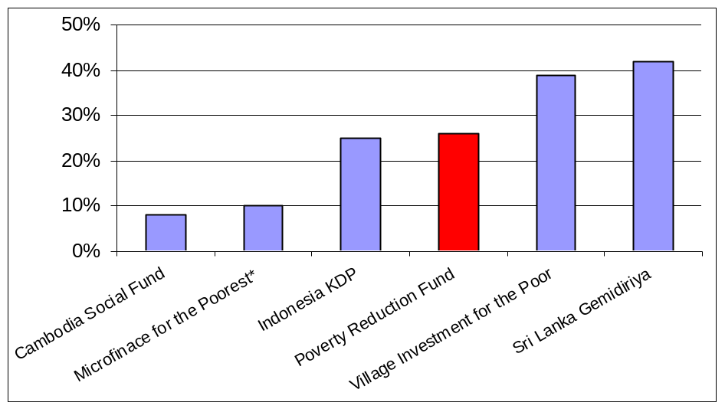
* The operating costs of microfinance do not include the share of operating costs paid by consumers via the interest rate. Source: WB administrative documents and Morduch (1999).
Construction costs also remain below the costs of most development projects, even when including PRF operating costs. As Table 3.7 illustrates, unit costs remain below costs of most development projects in Lao even when 26 percent operating costs are included. In-kind community contributions, community-based procurement founded on a deep knowledge of local costs, and PRF cost checks through comparisons with a centrally managed unit costs database help maintain construction costs below most other development projects.

Table 3.7. Unit cost comparison

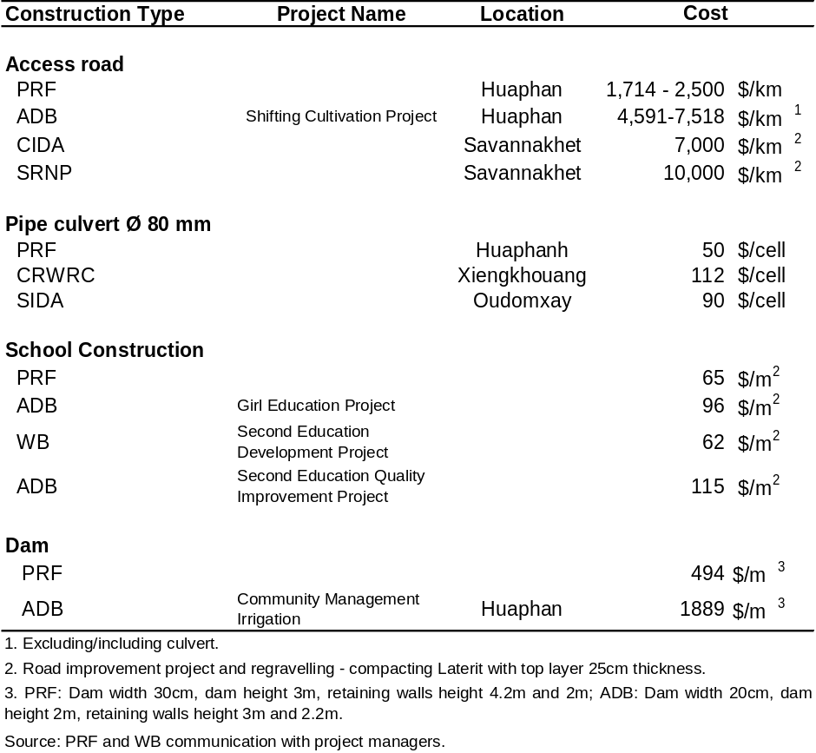

Well-structured participatory approaches do not necessarily cost more than other forms of project delivery, with the added benefits of building capacity and ownership. The costs noted in Table 3.7 do not control for quality, but overall, PRF construction quality has been deemed appropriate and to respond to community needs. Low construction costs appear to be a frequently observed feature of CDD projects. For instance, an independent evaluation of infrastructure projects in 2001 found that infrastructure projects for the Indonesia Kecamatan Development Project were 23 percent less expensive than comparable government projects. This difference was primarily due to lower transaction costs, costs of labor and technical assistance, pricing of goods, materials and equipment.

Operating costs of the PRF are also tied to its coverage of sparsely populated areas. PRF covers many poor and remote districts in the uplands and, by design, covers all villages within a district. As implementing PRF activities for a 15 or a 200-household village requires approximately the same process of meetings and the same support from PRF teams, the operating cost per beneficiary (and per sub project) are very high in the Lao uplands, where most of the population lives in small villages without road access.

Operating costs of CDD programs such as the PRF depend more on the coverage area than on the amount of sub-grants allocated to the project. Table 3.8 lists the set up and operating costs of the PRF. Setting up a provincial office costs on average US $50,000 in office renovation, cars, and computers; and a district office costs US $7,000 in motorcycles and computers. Average annual operating costs are then equal to US $46,000 per provincial office (most of which is spent on wages and transportation) and US $18,000 per district office. Operating costs per province/district vary little with the sub-grant budget allocated to it. The reason is simple: province and district staff, as well as equipment, are with few exceptions the same in every province/district, as the required number of staff depends more on the type of tasks assigned to the office than on the amount of sub-grants. In contrast, covering new provinces increases operating costs significantly (see Table 3.8).

The national office, which can be considered a fixed cost, is the most expensive item in the PRF budget. Operating the national office costs US $415,000 per year. That comprises a foreign technical assistant (US $72,000/year), and all Vientiane-born costs even when the involved activities deal with all PRF sites (e.g. evaluation, audit, etc.). As most expenditures of the national office do not depend heavily on coverage, expanding the coverage area would therefore lower average operating costs of the central office.

CDD programs (including the PRF) tend to have high set up costs, but much lower variable costs. In the initial phase of a CDD project, central and regional offices have to be organized, cars bought, and staff trained. Accordingly, in Cycles I and II the operating costs of PRF corresponded to 38 percent of the total budget (see Figure 3.12). Conversely, variable costs (which approximately correspond to the operating costs in Cycle IV, where only one district was added) are less than half, at 18 percent of the total budget. Notice that in Cycle V operating costs are expected to rise again due to a shortage of grants funds, and also to the closing phase of PRF where no grants will be allocated.

Table 3.8. Investment and variable costs of the PRF
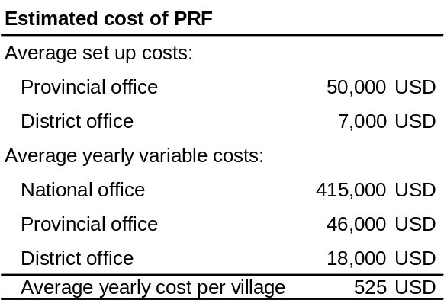
Source: PRF estimations.

To achieve low operating costs it is therefore necessary to disburse a large sum of grants. Figure 3.12 demonstrates how the ratio of operating costs to total costs would vary if the amount of grants was doubled, keeping the same coverage. By doubling the amount of sub-grants, operating costs in Cycles I & II would decrease by 40 percent (from 38 to 23 percent of total costs), variable costs would decrease by 46 percent (from 18 to 10 percent of total costs), and average operating costs over the lifespan of the project would decrease by 43 percent (from 27 to 15 percent of total costs).

Low operating costs in CDD programs such as the PRF can therefore only be achieved if they have wide coverage, a long horizon, and disburse a significant amount of grants. Small scale, limited budget interventions for short periods of time are instead likely to exhibit disproportionate operating costs. The previous paragraphs illustrate the point for the PRF, but the argument can be generalized to most CDD operations.

For the same reason, large savings in operating costs and efficiency gains could be achieved by grouping similar programs. For instance, among World Bank projects, PRF, the Village Development component of the SUFORD project, and the Village Investment for the Poor share common goals but have separate logistics, leading to high operating costs in each project. As there are provinces - such as Saravane - where all three projects are active, coordinating actions to avoid overlaps, and pooling resources would be likely to lead to significant savings in operating costs, leaving more money available to fund village projects.

Figure 3.12. Evolution of operating costs
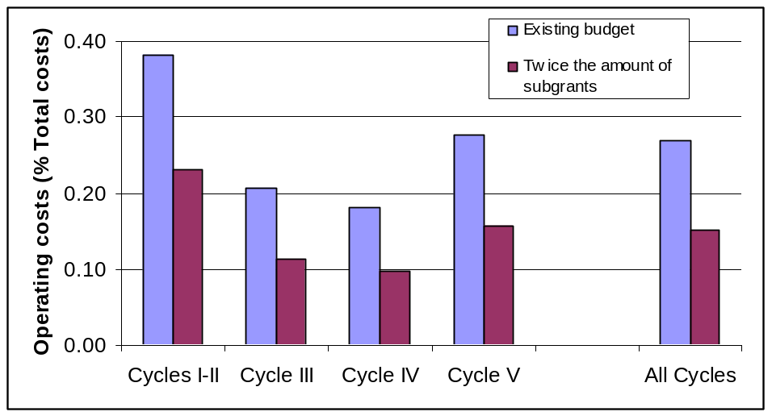
Source: Authors’ and PRF calculations from M&E data.

Issues on operations & maintenance

The quality of Operations and Maintenance (O&M) varies among the different types of sub-projects in both provinces. The O&M of GFS and irrigation systems is working well in both provinces, with maintenance of GFS and irrigation systems being executed by project beneficiaries. All of the systems were observed to work well, which was also confirmed during the FGDs. In all villages (except for one more recently involved), contributions were collected for minor repairs (most often 2000 kip (0.21 USD) per household per year, or 500 kip (0.05 USD) per person in each household per year), an amount that focus group participants considered appropriate. The contributions were collected by the village authorities, while the village representatives do not appear to have been active in maintenance. Men are primarily responsible for the maintenance of reservoirs, pipes and faucets: two to three times a year they clean the structures and make repairs. Women are in general expected to keep livestock out of the reservoirs and clean around the taps on a regular basis. It was clear from both project beneficiaries and khet facilitators that minor repairs were perceived to be the responsibility of the village.

Support for larger repairs of water systems was perceived to be important for sustainability in both provinces. All focus group participants in the villages, as well as the khet facilitators, agreed that support from PRF or the district is needed to conduct larger repairs. For example, one of the villages had received support for the reconstruction of an old GFS system that had been out of service for an unknown period of time. In another village it was mentioned that a GFS system financed by the province was not in working order, which points to the importance of maintenance support in the long term.

O&M of roads, bridges, and schools are more demanding in terms of the technical capacity required and costs incurred. Unexpectedly, only one khet facilitator strongly advocated for more support for maintenance from the district due to prohibitively high costs for the villagers. The other khet facilitators did not see this as a problem, even if PRF staff in both provinces raised O&M as an issue to improve. In fact, the majority of khet facilitators in both provinces think that this ought to be the responsibility of the villagers. In Saravane province they admitted that no specific plans for O&M had been developed (although all infrastructure projects had been completed about one year previously and were still in good condition). A plan was also lacking in the case of the bridges and roads that had been built on the recommendation of the district, rather than in accordance with priorities set by the villages, and even if multiple villages benefited from access to a constructed road and bridge, it appeared that only the village formally receiving the infrastructure project was expected to maintain it. Overall, although beneficiaries were willing to maintain PRF infrastructure through in-kind and labor contributions, they clearly stated that repairs involving more specific skills would be difficult for them to arrange.

Conclusions

There are significant differences in poverty status between villages included in the qualitative study in Saravane and in Huaphan. The proportion of poor households in Saravane province is more than 70 percent, less than 10 percent of the population speaks Lao, and road access during the rainy season is possible for only a fifth of the surveyed villages. In Huaphan province, around a third of the households are defined as poor, all residents reportedly speak Lao, and all villages have road access to the district capital during the rainy season. These factors reflect different levels of poverty, which in turn affects how well the project fits the villages.

In both provinces, PRF led to significant developments of road networks, schools, and health facilities. Beneficiaries, implementers and government officials agree to a very large extent that the PRF has improved access to basic infrastructure in the participating districts. Water supply systems relieve women from a significant burden of time and work, irrigation systems lead to new agricultural activities, roads and bridges provided remote villages with better access to markets and public services, and the construction of schools embodies the hopes of parents that children will do better than they have themselves.

PRF is perceived as an intervention that supports all households in the targeted villages. While many beneficiaries had past experience with development projects that only supported a limited number of households (often with income-generating activities), the local infrastructure provided by the project is appreciated as an attempt to reach all households in a village.

Equal distribution of sub-projects to all villages in the targeted district is one of the most important observed criteria for project selection. 95 percent of all villages in both districts interviewed in Huapanh had received at least one sub-project, and 53 percent of all villages in both districts of Saravane had been reached after two cycles of activities. Targeting of poor villages is also mentioned as important, but it was not reported as the main selection criteria.

While the objective of improving access to local infrastructure has been achieved in the majority of the participating villages, the goal of empowering communities and building capacity at the community level requires a longer term perspective to generate sustained results. The PRF is designed to strengthen the capacity of communities to take decisions affecting their own livelihood. For instance, the use of the khet as an attempt to decentralize the decision making processes is one of the innovative features of the PRF design. This process was found to be well underway in Huaphan, where, after four years of implementation, beneficiaries in a fourth of the villages mentioned the participatory planning process as one of the strengths of the project. In contrast, in Saravane, the participatory approach of PRF was not well understood, and communities’ empowerment remains weak.

Clearer articulations of the rationale of the approach, and sharing experiences between successful and less successful districts, could strengthen the project. The findings in Huaphan province indicated that the PRF methodology requires time and practice to adjust to the local conditions. During the time of the study, Saravane province had only completed one cycle of sub-project selection, and district officials, project managers and beneficiaries had limited opportunities in working together on these tasks. Findings from Vietnam, Nepal, and other countries similarly suggest that government officials often do not perceive communities’ control over investment decisions and resources as the most efficient way of developing these communities. Reasons include perceived lack of communities’ capacity to prepare development plans, but also government officials’ perceived risk of loosing control over the decisions. (World Bank, 2005)

Accordingly, state capture in village and sub-project selection was found to be substantial in Saravane, but less so in Huaphan. One-third of the participating village heads in Saravane complained that their village had not received the requested sub-project, while such complaints were not reported from village authorities in Huaphan. Requiring district officials to leave room for the new stakeholders at khet and village meetings is a process that requires time to unfold and strong efforts among PRF facilitators and village representatives. In the majority of the villages, the village authorities were showing strong ownership of the implementation of PRF, which on the one hand was beneficial for establishing a link between the village and the district, but on the other hand limited the village representatives’ roles in the participatory processes.

Improved contextualization of the project design in the participating districts could accelerate the social changes the project attempts to achieve. Language barriers were found to be a major constraint for non-Lao speaking communities’ participation. Living in remote and dispersed villages also limits access to the project resources. Villages with very high proportions of poor households were found in the qualitative study to have difficulties in participating in the planning process. Perceived weak village authorities were reported by project managers to limit the participation of these villages in the project. Accordingly, a 2005 evaluation on the effectiveness of World Bank supported CDD operations found that projects are more successful in enhancing community capacity when projects include “indigenously matured” participatory approaches or when the project provides sustained support to the community (World Bank, 2005).

Empowerment also appears to be a good way to prevent the misuse of funds. In around one-fifth of the participating villages, beneficiaries reported problems of excessive community contributions to the contractor, or discrepancies between the planned budget of a sub-project and the contractor’s winning bid, and lack of transparency was perceived by beneficiaries to have fostered misunderstandings and increased the risk of corruption. In fact, when villagers became aware of the misuse of funds, they often managed to block project implementation.

Impact Evaluation of the Poverty Reduction Fund

Drawing on different evaluation methodologies, this chapter analyzes the impact of sub-projects financed by the Poverty Reduction Fund. After a brief non technical summary of the methodology and findings, the chapter reports the observed impacts of the PRF water and sanitation, education, and transportation sub-projects on health, education, consumption, access to roads, and social capital.

Summary of methodology and findings

A baseline survey prior to the PRF intervention in 2003 and a follow-up survey in 2007 were collected in Huaphan and Phongsaly provinces in the North, and in Savannakhet and Champassak provinces in the South. In total, 2869 households in 150 villages were interviewed. Of the 150 villages, 75 villages were in districts where PRF operates, while the remaining 75 villages were in districts not covered by the PRF, but with characteristics similar to the ones of treatment districts. Throughout the analysis, impacts are estimated and reported separately for Northern and Southern regions due to distinct differences in impact and poverty levels (see the previous chapters for more details).

The diverse scope of the implemented subprojects and the demand-driven nature of the PRF have increased the difficulty of observing an impact. CDD projects tend to be cross-sectoral by nature, and therefore “dilute” their impact over several indicators. This problem has led to most evaluations of CDD projects finding low levels of impact (see, for instance, Rawlings et al., 2003). As an attempt to tackle this issue, we estimate the effect of “treatment on the treated (TOT)” in addition to the effect of “intent to treat (ITT).” The TOT estimates the impact of the project on direct beneficiaries, while the ITT is expected to serve as a lower bound of the true impact of the intervention by looking at the diluted impact all over PRF districts (for more details, see the methodology section). Also, like other CDD projects, the demand-driven nature of the project poses particular challenges in identifying the causal effect of the PRF on observed outcomes. To cope with this selection issue, we apply difference-in-difference (DD) and propensity score matching (PSM) techniques to estimate both TOT and ITT effects. Validity of the estimators will nonetheless depend on strong assumptions on unobservables often imposed in the literature to support the methodology.

Issues in finding statistically significant impacts have been exacerbated by the quality of data collected. Data collection and data entry of both surveys was of poor quality, resulting in a relatively high proportion of outliers and missing data (see Box 4.1). The poor quality of data collected in both surveys has generated significant “noise,” increased standard errors, and therefore lowered the likelihood of finding significant impacts.

Problems encountered during the design of the evaluation, data collection, and data entry indicate the importance of allocating more time and resources to impact evaluations in low capacity settings. Limited budget, commitments made during the collection of the baseline survey data, and strong time constraints to ensure that the baseline survey would be in the field before the project started, have led to a poorly designed and implemented impact evaluation, and made it difficult to switch data collection firms or to reinforce the given firm’s capacity to collect better quality surveys. The quality of the impact evaluation would have significantly improved if more resources were allocated to design a proper survey (instead of collecting three stand alone surveys in each period; see below), and more funding and time would have been available to assist the data collection firm.

In the future, high returns in quality and significant savings could be achieved by training a local champion in impact evaluation techniques. At the moment, few firms are able to perform impact evaluations in Lao PDR, and all firms need strong supervision. If more impact evaluations will be performed in the future, high returns in quality and cost efficiency could be achieved by training a local firm in impact evaluation techniques. This local firm could then be involved during project preparation to design a proper evaluation strategy, and collect and analyze the data.

If little time and resources are available, other types of cheaper evaluations – such as the qualitative evaluation presented in the previous section – may in fact provide better quality and more useful information. While impact evaluations are the state of the art technique to identify whether a project had an impact on the community, many policy relevant questions – especially the ones leading to improvements in project design – can be answered by using cheaper techniques that are also more reliably implemented in low capacity settings.

Main Findings
The results indicate that the estimation strategy and adopted settings make considerable differences in the estimated impact. Our preferred point estimates for health, education, and access to roads will thus be the impact of the “treatment on the treated,” capturing the effect of PRF subprojects on direct beneficiaries. For the impact on consumption and social capital, we rely on estimates for the “intent to treat,” measuring the exposure to PRF intervention and participatory process.

Health
PRF Water & Sanitation subprojects have reduced the incidence of diarrhea in the North. In the North, a significant impact was found in reduced diarrhea for infants and children, who tend to be the most vulnerable risk group for such diseases. An impact was also found in reduced incidence of cough and cold.

Education
Significant and substantial impacts on educational spending, attendance, and literacy outcomes are attributable to PRF education subprojects in the South, but not in the North. The results can be explained by the regional differences in project duration and educational levels prior to the intervention. Overall, enrollment rates of primary and lower-secondary school-aged children have improved in both treatment and control groups since the baseline period, with a larger increase in the treatment group. However, more detailed analyses reveal regional differences. In the South – where literacy rates were low to start with – the estimation finds that PRF educational subprojects significantly increased literacy outcomes. In contrast, no significant impact was found in the North, where in sampled villages all primary school construction took place in cycle IV and where literacy outcomes were higher to begin with.

Consumption
Overall, the evaluation does not find a significant and consistent impact of PRF on consumption. Although some results point to an improvement in consumption in the North, the results are not robust. Given the nature of the PRF intervention which focuses on providing small-scale public infrastructure, it is not surprising to find little consumption impact in the short term.

Access to roads
The analysis finds a positive impact on the access to roads in the North, but no impact in the South. The difference in impact is very likely to stem from the differential need of roads between the North and the South. Before the PRF intervention, only 60 percent of the sampled villages had access to roads in the North, while the proportion was much higher in the South (80 percent).

Cooperative behavior and social capital
In accordance with the results of the qualitative analysis, the PRF appears to have had a stronger impact on cooperative behavior in the North than in the South. Results, however, are significant only with propensity score matching estimation, which questions their robustness. A positive impact on participation rates in community meetings and community organizations, and an increased likelihood in contributing money towards community goals are observed in the North, while no such results are observed in the South. The Northern region also experienced an impact in terms of lower perceived inequality in the village, and in people’s subjective well-being. These geographically differentiated results are consistent with the findings of the qualitative evaluation, which finds the participatory approach to work better in the North. Most of the impacts, however, are observed by using propensity score matching estimation, while difference-in-difference estimation does not find a significant impact. As the latter controls for time and location fixed effects, the lack of observed impact under difference-in-difference estimation may indicate that, overall, PRF had only a limited impact on social capital.

Data description

The evaluation is based on responses from individuals, households, and village leaders to three surveys conducted prior to PRF intervention in 2003 and again in 2007 after four years of PRF intervention. The respondents live in treatment and control districts, which were identified before project intervention in 2003. The surveys included: (i) an Expenditure and Consumption Survey (ECS) based on the third Lao Expenditure and Consumption Survey (LECS III), a multi-purpose survey undertaken nationally every 5 years by the National Statistics Center (NSC); (ii) a Social Survey (SS) collected at the household-level containing questions on social capital, trust, and cooperation; and (iii) a Village Profile (VP) survey collected at the community-level. The three surveys were administered at the same time but as stand-alone surveys, and the 2003 data were entered by two different entities, which made it impossible to track households across surveys and periods (the problem was fixed in the 2007 wave).

From the provinces involved in the project, 75 villages were chosen randomly from districts covered by the PRF, while another 75 villages were randomly chosen from districts not covered by the PRF to act as a control sample. The universal coverage rule of the PRF did not allow designing randomized treatment and control groups within districts, but treatment and control districts were selected such that they would have similar observable characteristics (see Table 4.2 and the Appendix for a comparison). Still, as the PRF districts are determined through a non-random selection process based on a district poverty measure, selection issue at the district level should also be considered in the analysis. The evaluation will thus use different methodologies to further mitigate the selection bias on observed characteristics at a district as well as at a village level.

Approximately 20 households were then randomly selected from each village, totaling 2869 households. The treatment and control samples were stratified based on location (urban, rural, and road accessibility). All villages were revisited in 2007 (January-March) to collect the follow-up surveys, and a new random sample of 20 households was taken from each. Villages that did not exist anymore in 2007 were replaced with new villages of similar characteristics. The sample size of the baseline survey is summarized in Table 4.1, and shows that more villages were surveyed in the South, than in the North.

Table 4.1. Sample Size of the Surveys.
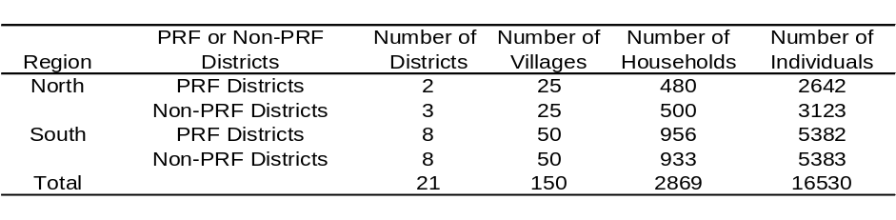
Source: ECS 2003.

While the whole sample is used to estimate the effect of “intent to treat (ITT),” only a sub-sample of villages has been used for the analysis of the “treatment on the treated (TOT)” impact. Specifically, under the ITT estimation the treatment (control) group consists of districts that are (not) covered by the PRF. Instead, under the TOT estimation the treatment group consists of villages that received a specific type of PRF subproject, while the control group consists of villages in PRF districts that did not receive that type of subproject (see Table 4.2).

Table 4.2. Sample size for the analysis of TOT.
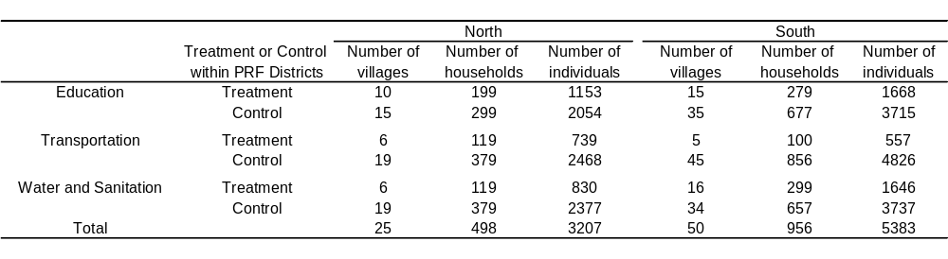
Source: ECS 2003.

In addition, administrative data from the PRF Management and Information System (MIS) were used to determine what type of sub-project each PRF village obtained between 2003 and 2007, and to distinguish between direct and indirect beneficiaries by identifying which villages actually received the sub-projects. On average, treatment villages in the North received 1.08 sub-projects per village, while in the South they received 0.96 sub-projects. Tables 4.3 and 4.4 present summary statistics of basic household characteristics and information on the type of sub-projects obtained by villages (see also the Appendix for more details).

Table 4.3. Summary statistics in 2003.
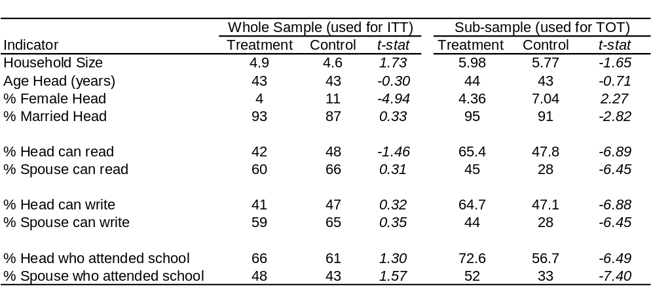
Source: ECS 2003.

Total sample size is 2869 households for the whole sample and 1454 for the sub-sample. Figures for the treatment group in sub-sample are estimates generated from households residing in villages that received PRF grants of any type, including education, water and sanitation, and transportation subprojects. Source: ECS 2003.

Table 4.4. PRF projects received by treatment villages.

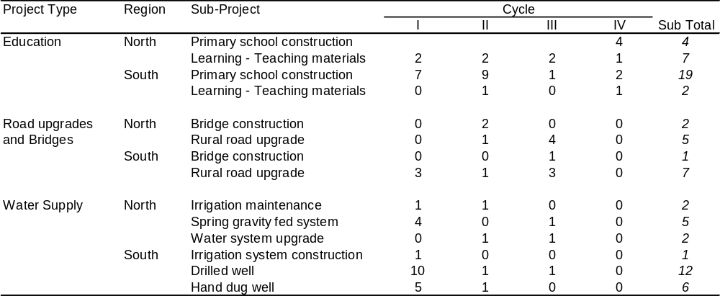
Source: PRF MIS.

Methodology

The quality of impact evaluations depends largely on the quality of the control (or comparison) groups, which represents proxies for the counterfactual state of the beneficiaries without intervention. As the PRF impact evaluation was designed prior to the intervention, the study had the advantage of a baseline survey which includes predetermined treatment and control groups based on the eligibility criteria (see the previous section). However, the analysis of the baseline survey shows that there are differences between the two groups across a variety of measures prior to the intervention (Table 4.3), large enough to refrain from simply comparing means to evaluate the impact of the PRF (for instance, pre-matching propensity scores show differences between treatment and control villages; see the Appendix). Moreover, selection issues arise from a non-random allocation process targeting poor districts and through demand driven selection process of projects by the communities, local government, and the project staff.

Our empirical strategy is therefore two-faceted. First, to estimate the effect of PRF, we rely on two specifications of impacts with different measures of exposure to the intervention. The first specification, based on the original choice of evaluation design at the time of sample selection stage, captures the effect of the “intent to treat (ITT),” whereas the second specification uses the sub-sample of the data and measures the impact of the “treatment on the treated (TOT).” Then, to address the issue of non-random selection, we apply difference-in-difference (DD) and propensity score matching (PSM) techniques for each specification. Details are explained below.

Intent to Treat (ITT)
Under this specification all villages in PRF districts, regardless of whether they were provided with actual PRF grants or not, are included in the treatment group, while the control group is constructed from the pool of villages in non-PRF districts. This methodology produces the average effect of “intent to treat (ITT).” By defining the entire PRF districts as a treatment group, this methodology is expected to produce groups balanced on unobserved characteristics across villages. Thus, under the assumption that the distribution of remaining unobserved characteristics that affect outcomes in eligible and ineligible districts are similar after controlling for observed characteristics, this strategy should generate unbiased estimates of ITT. Observed characteristics will be controlled for by applying DD and PSM techniques.

Although the effect of ITT may be relevant for policy concern, the downside is that the impact does not necessarily represent the effect of PRF for those who actually received the PRF grants for their investment. In particular, as the estimated impact is averaged over the entire sampled villages that were offered PRF projects including both direct and indirect beneficiaries, they are likely to underestimate the impact of the project. Thus, we also estimate the more direct impact of “treatment on the treated” by constructing treatment groups solely from the pools of direct beneficiaries of specific types of PRF infrastructure.

Treatment on the Treated (TOT)
To estimate the direct effect of receiving PRF grants for community investments, the treatment group is narrowed by including only the direct beneficiaries, i.e., villages that actually received the PRF grants and completed the implementation of specific types of subprojects. The control group is then reconstructed from the pool of indirect beneficiaries, i.e., villages exposed to the PRF intervention, but which did not actually receive a specific type of infrastructure. Observe that, as both treatment and control groups belong to the poor districts eligible for intervention, they are expected to have similar pre-intervention characteristics.

This specification will on average produce comparable groups so long as the decision to assign a specific type of subproject to a village was not influenced by variables that might also affect measured project outcomes. However, the villages that received specific types of sub-projects, in addition of potentially being more organized and more capable of assembling a committee and preparing proposals, were also likely to be the ones that needed these types of subprojects the most. Thus, those that have received grants might have achieved higher outcomes even in the absence of the project. Simple comparison between those who received grants and those that did not would then falsely attribute differences in outcomes to the program when in fact these measured differences would be partly due to a failure to control for observable and unobservable differences between treatment and control groups. To overcome the selection issue, Difference-in-Difference (DD) and Propensity Score Matching (PSM) techniques will also be applied for this set of treatment and control group specifications. Each methodology is detailed next.

Difference-in-difference (DD)
DD estimates the impact while differencing out village-level time invariant fixed effects and time trends common to both treatment and control groups. The regression equation used is the following:

(1)

where 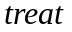 is a dummy equal to one if a village is included in districts where PRF is active in case of ITT, and equal to one if a village is a direct beneficiary in case of TOT estimation (ITT estimation thus measures the effect of exposure to the PRF, whereas TOT estimates the effect of receiving a specific type of sub-project); 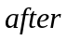 is a dummy equal to one if the outcome y is observed after the intervention, capturing the effect of aggregate shock common to both treatment and control groups;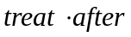 is the interaction of the two variables and captures the treatment effect, and is the error term. In all regressions, error terms are clustered at the village-level to consider within-village correlations. Although this technique allows for both village-specific and time-specific effects, the unbiasedness of the estimator requires that the PRF treatment not be systematically related to unobservables that affect the outcomes.

Propensity score matching (PSM)
A propensity score matching (PSM) technique is used as an alternative methodology to control for observed differences across villages. The technique predicts the probability of treatment on the basis of observed covariates for the treatment and control group samples, which are then used to match each treatment village with control villages (see the Appendix for more details on matching). By applying PSM, we are controlling for imbalances in observed covariates, which does not rule out the possibility of selection bias on unobservables. Note that the estimation is valid based on the often made assumption that selection on observed and unobserved characteristics affect outcomes in the same direction, so that eliminating selection on observables also eliminates part of the selection bias due to unobserved characteristics. The tables presenting impacts will report the mean differences between the treatment and comparison groups generated by the PSM.

Box 4.1. Reliability of the data and implications for the analysis

In both surveys, the collected data were of poor quality. In the baseline survey, for instance, household IDs did not match between various sections of the survey; and during data entry of the follow-up survey, two-thirds of the observations had to be manually re-entered a second time due to being erroneously erased by the data entry firm, leading to a poorly supervised data entry process during the second round of entry. Moreover, the intense village relocation occurring in the uplands has led some villages to disappear physically or by name, and in the remaining villages households interviewed in the follow-up and baseline surveys differed because the data collection firm had jettisoned the paper questionnaires of the baseline survey containing household names.
The team also encountered problems with village IDs. In the baseline survey, it was not possible to identify all 150 villages in the Village Profile. This was due to problems with the variable that identifies the village along with the omission of the province Phongsaly in the data. In the end, the team was able to identify only 114 of the 150 villages from the Village Profile Survey. Second, village identifiers were inconsistent across the three surveys, which prohibited the examination of the effect on the full set of indicators using all three datasets. The follow-up survey had consistent identifiers across the different surveys; however, inconsistencies in village codes used between the surveys and the PRF administrative data were present. Therefore, the actual number of villages in the treatment and control groups did not match the original number of villages designed to be included in these groups, and, although an attempt has been made to re-match villages, the original mismatch could have led to some biases in the estimated impact.

Table 4.5. Missing observations in selected variables.
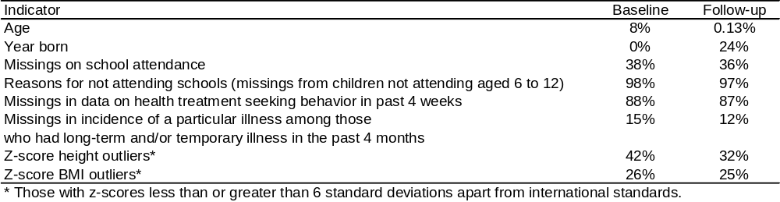
Outliers are included in the number of missing. Source: ECS 2003, 2007.

Poor data collection and data entry also resulted in a significant proportion of the data being outliers or missing. As Table 4.5 illustrates, the number of missing observations was overall significant, and extreme for selected variables. The team did not use variables with a high proportion of missing observations to perform the evaluation, but Table 4.5 provides an idea of overall data quality.
Identifying significant impacts depends heavily on the data quality, which is affected by measurement errors, errors occurring during the data entry process, and coding errors (such as mixing missing data with zeros). Therefore, although finding limited impact on outcome indicators for CDD projects is common (see Rawlings et al., 2003), the limited impact found for the PRF is also due to the large standard errors resulting from the poor quality of the data. Moreover, if observations are missing in a non-random manner, the direction of some of the impacts found may stem from biases instead of being the result of the PRF intervention.

Estimated impact

This section reports the estimated impact of the PRF interventions by sector. Besides access to roads, consumption and variables on social capital (which have been collected only at the village or household level), impact has been measured at the individual level.

Health

Water supply is often the first priority identified by villages, and comprises 81 percent of the sub-projects in the health sector. This section therefore examines the impact of water and sanitation projects, such as spring gravity fed systems, water systems upgrades, and the construction of drilled and hand dug wells on selected health outcomes.

The results show that PRF generated few significant differences in health outcomes, possibly reflecting the small sample sizes and the short duration of the project operation.
In the North, however, we do find significant impact in reducing the incidence of diarrhea for children under the age of five, commonly referred to as the age group at high risk of death from diarrhea.

There is evidence that the project had also a substantial positive impact in reducing the incidence of cough and cold. The result also provides evidence of reduced temporary illness in the South by 4 percent.

In the North, we find a significant and substantial improvement in reducing the incidence of diarrhea by almost 50 percent when restricting the sample to infants and children below age five. Given that all family members are not at equal risk of death from diarrhea and children younger than five years old are at much higher risk, this should be the relevant age range to examine the impact on the incidence.

The intervention also appears to have had a positive impact in reducing cough and cold in both regions. In the South, the result is proven robust by DD and PSM, although the magnitude varies largely between 19 percent (by PSM) and 48 percent (by DD). Given the high prevalence of cold in the sampled villages in the pre-intervention period, this may be an important accomplishment of the PRF intervention. A similar impact is also observed in the North – the DD estimate shows that direct beneficiaries were 24 percent less likely than indirect beneficiaries in suffering from cough and cold. There is also evidence in the South of reduced temporary illness by 4 percent.

Table 4.6. Impact of Water and Sanitation Projects on Health (ITT).
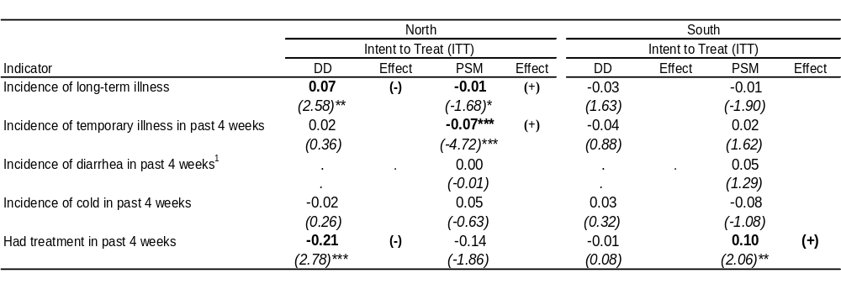
Errors are clustered at the village-level. * significant at the 10% level; ** significant at the 5% level; *** significant at the 1% level. (+)/(-) signs in "Effect" columns indicate significant improvements in treatment/control group.
1: Sample is restricted to those younger than age 5.
Source: ECS 2007.

Table 4.7. Impact of Water and Sanitation Projects on Individual Health (TOT ).
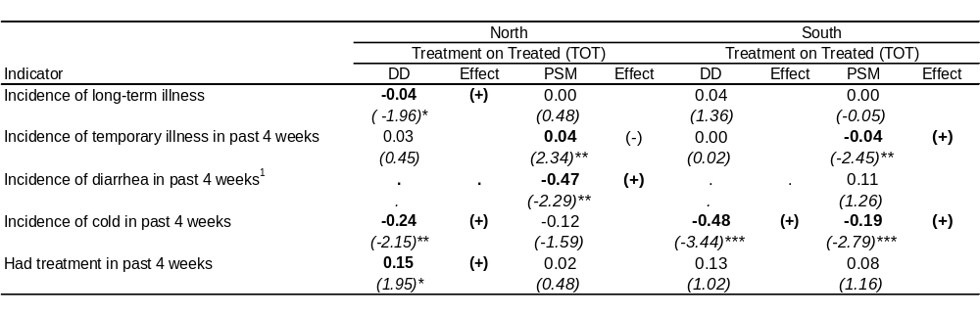
Robust z statistics in brackets. Errors are clustered at the village-level. * significant at the 10% level; ** significant at the 5% level; *** significant at the 1% level. (+)/(-) signs in "Effect" columns indicate significant improvements in treatment/control group.
1: Sample is restricted to those younger than age 5.
Source: ECS 2003 and 2007.

Education

PRF-financed education sub-projects include the construction or renovation of schools, and the provision of teaching materials. The average impact of PRF education subproject is estimated for several educational outcome indicators – educational spending, attendance, and literacy. In the South, where most of the PRF primary schools were built in the first two cycles (16 out of 19) and where literacy rates were low prior to the intervention, we see significant and substantial impacts on all outcomes. Especially striking are the impacts on literacy outcomes for school-aged children – results show that the ability to read and write increased by 15 percent due to the PRF educational intervention. In contrast, an impact is not observed in the North, where in sampled villages all primary school construction took place in cycle IV and where literacy outcomes were higher at the outset.

To estimate the impact on educational outcomes, we consider children between ages 6 and 15 to look at the impact on educational spending and attendance, and children between 11 and 15 to examine the impact on literacy outcomes. The age range for literacy outcomes is restricted based on the assumption that the impacts are better captured after a few years of operation - even if the majority of children starts primary school at age 6-7, it would take several years for them to develop the ability to read and write.

Enrollment rates of school aged children have increased in both treatment and control groups since the baseline period (Figure 4.1). However, a few regional differences are observed in estimated impacts.

Figure 4.1. Changes in Enrollment Rates (all regions combined).

ITT Specification TOT Specification
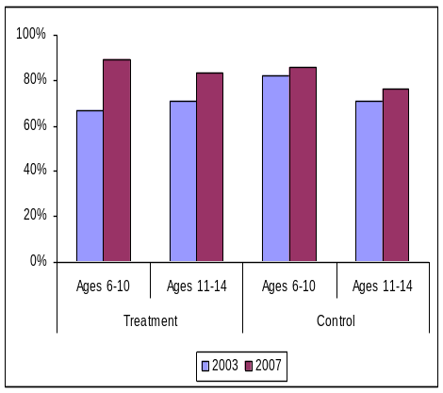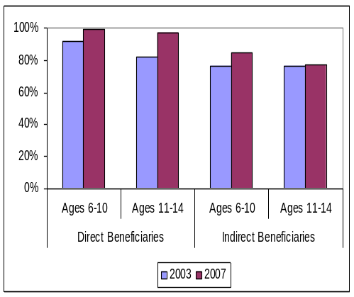
Percent of children ages 6-10 and 11-14 registered in school in year 2003 and 2007. Source: ECS 2003, 2007.

We find consistent and fairly robust results confirming the positive impact on educational spending, attendance, and literacy outcomes attributable to PRF education subprojects in the South, where in sampled villages PRF primary schools have been operating for a few years (see Table 4.4).

First, education spending has increased by approximately 40 percent in nominal terms and attendance by almost 20 percent when comparing PRF districts with non-PRF districts. And a substantial part of these impacts can be attributed to PRF educational intervention – TOT estimates show almost 40 percent and 10 percent increase in educational spending and attendance, respectively.

Second, significant increases in educational spending and school attendance appear to have lead to improvements in literacy outcomes. Again, district-level analysis shows 30 percent increases in literacy outcomes. By examining the difference between ITT and TOT, we can then isolate the effect of PRF education subprojects, abstracting away the other district-level factors affecting outcomes, and TOT estimates confirm that a significant part of the increase can be attributed to PRF education subprojects – the ability to read, write, and read and write without difficulty have all increased by an additional 15 percent among direct beneficiaries. Given the low literacy rate in Lao PDR, this is an important accomplishment of the PRF intervention.

In the North, however, we find no significant impact attributable to the PRF educational intervention (although educational spending increased in treatment districts under ITT, the insignificant TOT estimates lead to believe that the effect is not attributable to the PRF intervention). This can be explained, at least partially, by two factors. First, all primary schools in sampled villages were constructed in cycle IV, just before the follow-up survey was collected. As it may take weeks, or even months, for schools to be equipped with supplies such as desks, chairs, textbooks, and teachers, we expect to see small impacts on short-term outcomes such as attendance as well as on longer-term outcomes such as literacy. Second, detailed analysis reveals that there were also regional differences in educational outcomes – for instance, while 60 percent of respondents could initially read in the North, only 42 percent were able to read in the South. The differential impact of PRF education subprojects between the North and the South could therefore be related to “decreasing marginal returns” in investing in education.

Table 4.8. Impact of Education Sub-projects on Educational Outcomes (ITT).
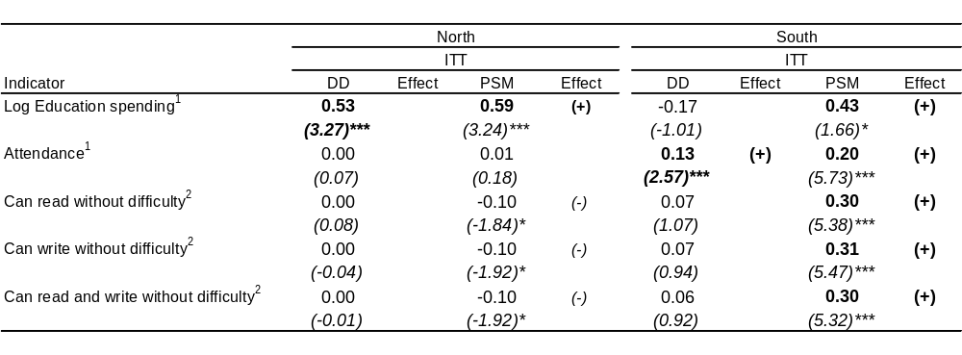
Robust z statistics are in brackets. Errors are clustered at the village-level. * significant at the 10% level; ** significant at the 5% level; *** significant at the 1% level. (+)/(-) signs in "Effect" columns indicate significant improvements in treatment/control group.
1: Sample restricted to those between ages 6 and 15.
2: Sample restricted to those between ages 11 and 15.
Source: ECS 2003, 2007.

Table 4.9. Impact of Education Sub-projects on Educational Outcomes (TOT).
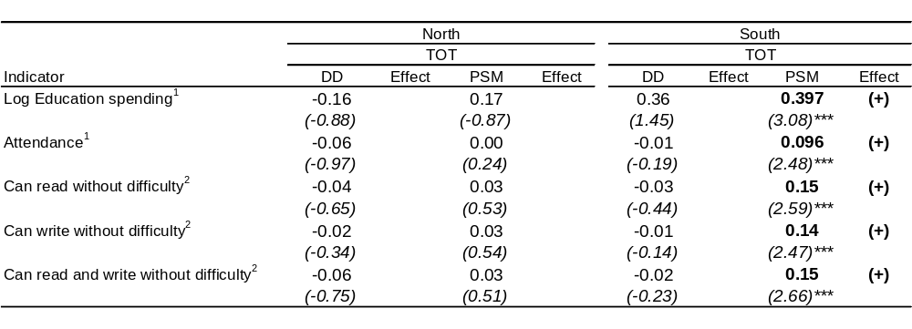
Errors are clustered at the village-level. * significant at the 10% level; ** significant at the 5% level; *** significant at the 1% level. (+)/(-) signs in "Effect" columns indicate significant improvements in treatment/control group.
Note 1: Sample restricted to those between ages 6 and 15.
Note 2: Sample restricted to those between ages 11 and 15.
Source: ECS 2007.

Consumption

The impact of the PRF intervention has been estimated for different consumption items – aggregate consumption, food consumption, and rice consumption. The ECS 2003 and 2007 collected consumption diaries for a month at the household-level from which the consumption aggregates were derived. Overall, a significant impact on consumption is not observed. Given the nature of the PRF intervention, which focuses on providing small-scale public infrastructure, the finding is not surprising.

By restricting the analysis to direct beneficiaries, aggregate consumption appears to have increased in the North by almost 20 percent in nominal terms as a result of the PRF intervention, a result also supported by the PSM estimate for ITT. For food and rice consumption, however, significant results are found only for the PSM method under the ITT estimation, implying that the consumption increase may be attributed to factors other than the PRF intervention.

In the South, it is difficult to capture the effects of the PRF intervention, as, although PSM estimates for TOT are significant, they carry the opposite sign than the DD estimates. The only, fairly robust result across different methodologies is the negative impact on rice consumption, confirmed by both ITT (29 percent) and TOT (6 percent) estimates.

Table 4.10. Impact of PRF sub-projects on consumption.
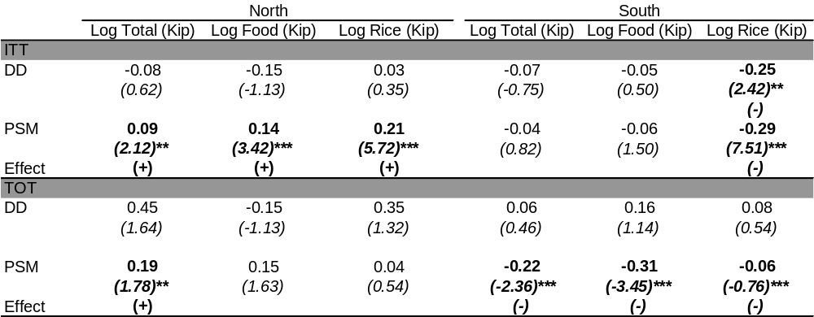
Robust z statistics in brackets for Difference-in-Difference and t-statistics for propensity score matching. Errors are clustered at the village-level. * significant at the 10% level; ** significant at the 5% level; *** significant at the 1% level. Source: ECS 2003, 2007.

Access to Roads

Relative land abundance, low population density, and multiple ethnicities are associated with small and highly scattered settlements. Studies have shown that this pattern can result in extremely high transportation and communication costs, leading to high development costs. Accordingly, PRF has invested heavily in transportation sub-projects, especially in upgrading roads and in the construction of bridges. Difference-in-difference estimates find a positive impact of residing in PRF districts on access to roads in the North, but no impact in the South (see Table 4.11). The regional difference in impact is likely to stem from the differential need of roads between the North and the South. Before the PRF intervention, only 60 percent of the sampled villages had access to roads in the North, while the proportion was much higher in the South (80 percent).

Table 4.11. Access to roads – Village level DD.
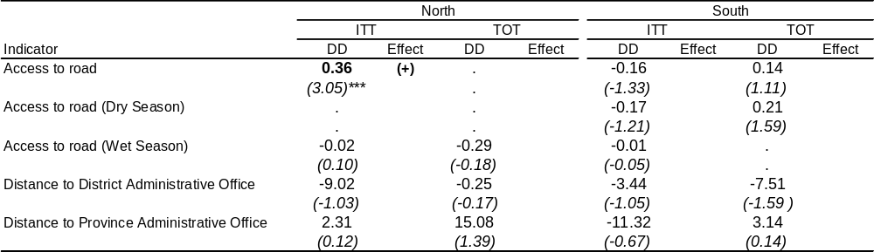
* significant at the 10% level; ** significant at the 5% level; *** significant at the 1% level. (+)/(-) signs in "Effect" columns indicate significant improvements in treatment/control group. All distances are measured in minutes. Note: Missing estimates are caused by PRF subprojects being perfectly related to the dependent variable. Source: ECS 2003, 2007.

Social Capital

In its broadest interpretation, social capital comprises participation, cooperative norms, interpersonal trust, and membership to associations. As with many CDD interventions, the PRF has as an explicit objective the promotion of community empowerment. Theory suggests that in order to achieve this goal, the project must first catalyze change in the characteristics of social capital, i.e., transforming the foundations of local institutions. Recent studies have found that CDD projects can affect positively social capital, and the PRF can also be expected to do so, as it promotes collective decision-making allowing for broader participation in community meetings and discussions.

In this section, we examine the impact of the PRF on indicators that measure the level of social capital within a village – variables that capture the level of cooperative behavior (such as the number of village organizations/committees, and participation rates), and measures of solidarity. As all villages in PRF districts obtain training on the PRF participatory process regardless of receiving grants or not, we focus on ITT estimates in this section, i.e., construct treatment group from all villages in eligible districts, including indirect beneficiaries.

In accordance with the results of the qualitative evaluation (although areas investigated did not necessarily overlap), the PRF appears to have had a stronger impact on cooperative behavior in the North than in the South: a positive impact on participation rates in community meetings and community organizations, and an increased likelihood in contributing money towards community goals are observed in the North, while no such impact is observed in the South. In the North, an impact has also been observed in terms of lower perceived inequality in the village, and in people’s subjective well-being. The results are consistent with previous findings in the literature – more unequal communities tend to trust each others less, possibly discouraging people to cooperate and take collective action.

Most of the impacts, however, are observed using propensity score matching techniques (which only compare the 2007 surveys), while difference-in-difference estimation does not find a significant impact. As the latter controls for differences in location and time, the lack of observed impact under difference-in-difference techniques may indicate that PRF had only a limited impact on social capital.

Only PSM estimates are presented, as under DD the only significant impact of the PRF intervention on social capital was higher participation in community organizations in the South.

Table 4.12. Impact of PRF Projects on Social Capital (PSM).
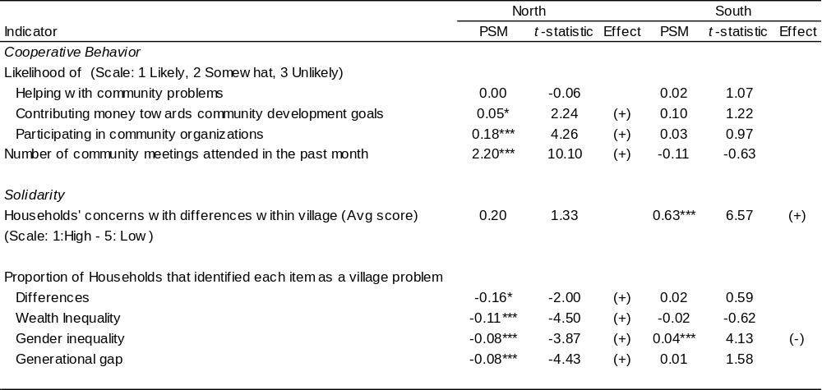
Errors are clustered at the village-level. * significant at the 10% level; ** significant at the 5% level; *** significant at the 1% level. (+)/(-) signs in the “Effect” columns indicate significant improvements in the
treatment/control group.
Source: ECS 2007.

The first set of indicators in Table 4.12 measures the ability of villagers to cooperate and engage in collective actions. In the North, villagers in the PRF districts (treatment group) are more likely to contribute money towards community development goals, to participate in community organizations, and to attend community meetings, while no such impact is observed in the South.

In the North, positive impacts can also be observed in perceived differences within villages. Perceived wealth inequality, gender inequalities, and problems related to the generational gap were all lower in the treatment group with respect to the control group. In contrast, besides an improvement in the average score in households’ concern over differences in the village, in the South we see no sign of improvement in solidarity: gender inequality has in fact become a concern for a larger proportion of households.

In both regions, subjective well-being indicators also appear to be higher in the treatment than control group, but more so in the North (Table 4.13). In the North, an impact can be observed in people’s perception about food consumption, clothing situation, housing, and health; and in the South, improvements are observed in people’s perception about their income and education status, but a deterioration can be observed for food consumption.

Table 4.13. Impact of PRF Projects on Subjective Well-Being (PSM).
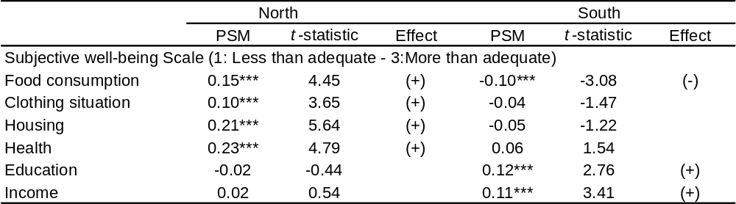
Errors are clustered at the village-level. * significant at the 10% level; ** significant at the 5% level; *** significant at the 1% level. (+)/(-) signs in "Effect" columns indicate significant improvements in treatment/control group.
Source: ECS 2007.

Livelihood Activities and CDD: the VDF and the VIP

This chapter discusses the challenges in promoting Livelihood or Income Generating Activities (IGAs) in the context of CDD projects in Lao PDR. As will be illustrated, the issues faced are quite different from those tackled by the PRF, which largely focuses on public infrastructure. To illustrate these issues, the upcoming chapter will examine the Governments’ Village Development Fund, and the Village Investment for the Poor component of the World Bank’s Agricultural Development Project, and provide the opportunity to learn how supporting IGAs works in the context of rural villages in Lao PDR.

The chapter focuses on the empowerment, coverage, and welfare improvement aspects of the two projects offering IGAs to communities. It does not, however, discuss much financial management and sustainability issues of these projects. Several reasons lead to this choice. First, the empowerment, coverage, and welfare improvement aspects of these programs are stated objectives that can be compared with the objectives of PRF. Second, both programs were too young to conduct a proper evaluation of their sustainability, as most loans were disbursed between 2004 and 2006 for a period of up to three years. Moreover, retrieving all of the proper financial information would require significantly higher resources. And finally, the Asian Development Bank recently issued a thorough study about microfinance in Lao PDR, which examines sustainability issues in depth (see Coleman and Wynne-Williams, 2006).

Data sources consist of project and program descriptions; informal interviews with government officials and program managers; and focus group discussions (FGD) with beneficiaries. The qualitative study included eight VDF villages and six VIP villages, which had received support during the period 2004-2006 (See the Annex for further details on the methodology). The VDF villages were located in the same four districts of the PRF study (two in Saravane and two in Huaphan). In addition, two villages in Vientiane province were also included. All VIP villages were in Saravane province. Tables 5.1 and 5.2 present background information on the included villages.

Table 5.1. Participating VDF villages in Huaphan, Saravane and Vientiane
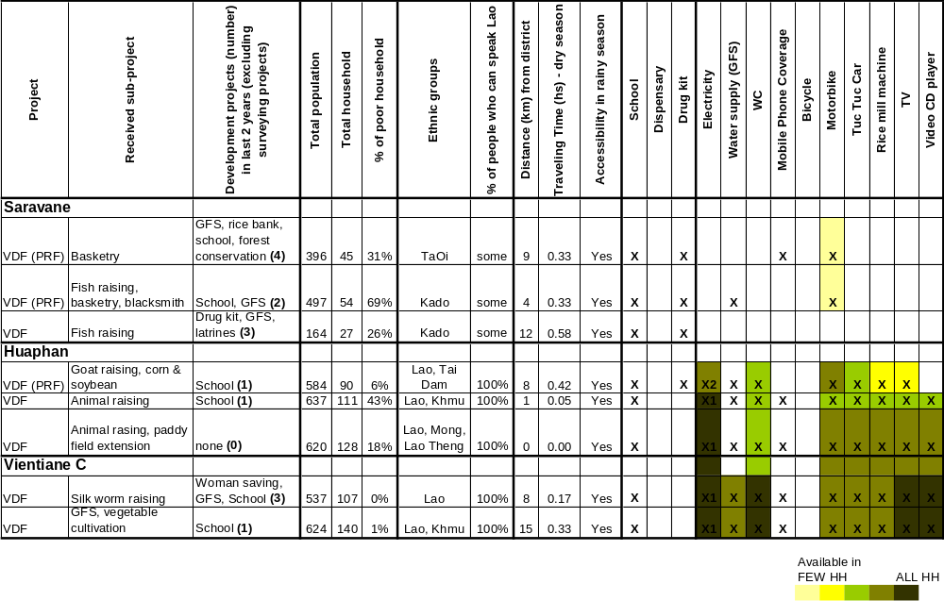

Table 5.2. Participating VIP villages in Saravane.
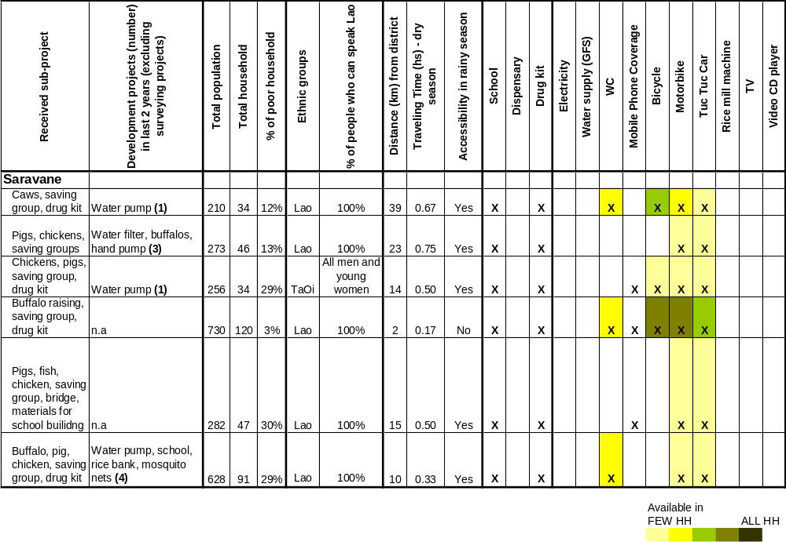
Mobile phone coverage means signal is receivable, but provides no information on mobile phone use. Electricity: X1 means electricity from public source, X2 means small household hydropower generators. The table is primarily based on information collected from the village authorities in each participating village. The remaining data are based on the study team’s own observations during the fieldwork.

As with surveyed PRF villages, significant differences in poverty status were evident between surveyed villages in Huaphan and Vientiane, and Saravane. While villages in Huaphan and Vientiane have access to GFS systems, electricity, and also some TVs, villages in Saravane have limited access to these services. Residents in Huaphan and Vientiane provinces speak Lao, while only some of the residents from the Kado and Ta Oi ethnic minority groups in Saravane speak Lao. All villages except one have road access during the rainy season. The estimated proportion of poor households in the six VIP villages is below one-third, while poverty rates in surveyed VDF villages vary from 0 to 69 percent (as we shall see, large variance in poverty rates is due to VDF village selection rules).

Design of the Village Development Fund

The VDF is a key component of the government’s poverty eradication strategy. Under the aforementioned National Growth and Poverty Eradication Strategy (NGPES, 2005) the government intends to encourage “development funds,” in particular village and district funds, in the poorest districts to enable households and villages to engage in income generating activities. As indicated in the Sixth National Socio Economic Development Plan 2006-2010 (NESDP), the VDF is therefore a key component of the government’s poverty eradication strategy.

By providing revolving funds to individuals through VDF, the government attempts to address the inability of – or the high costs to – households accessing capital. This inability is believed to be a major cause of poverty. VDF supports activities related to cultivation and animal husbandry, the clearing of land for agricultural production, handicraft, processing, and trade. Guidelines for the establishment of the VDF were issued by the Committee for Planning and Investment (CPI) in 2004. The funds are allocated from the national budget to villages via CPI, provinces, and districts, and aim to i) promote village participation and ownership of the funds; ii) increase household production; iii) provide opportunities for individuals in poor villages to improve their capacity and economic situation; and iv) promote decentralization.

In 2003/2004, the Government initiated Village Funds in all 47 first priority districts. As of the end of June 2007, VDF operated in a total of 315 villages, 50 percent of which are poor. VDF therefore covers 7 percent of the total 2,114 poor villages in the 47 priority districts. The first priority districts are mainly rural and have a weak road network. About 75 percent of villages in these districts are poor. More than half of the population in these districts lives in the northern, central, and southern highlands, and nearly half along the border with Vietnam. Subject to the availability of funds and the effectiveness of the program, VDF will be expanded to cover the 25 secondary priority districts, which are urbanized to a greater extent, and have a lower poverty incidence.

Each year, the VDF program aims at expanding to two additional villages in each of the 47 priority districts – one poor and one non-poor village. The rationale for implementing VDF in both poor and non-poor villages is twofold. First, it allows for comparison of how the program works in different village conditions. Second, it reduces the risk of non-performing loans in poor villages, which reportedly could affect the sustainability of the program. CPI plans to conduct an extensive evaluation covering all 47 districts.

District authorities and mass organizations should play key roles in VDF implementation. District officials lead the selection of villages, the establishment of the village fund committee, organize staff training, and assist villagers in the preparation of proposals. The four mass organizations, The Lao Woman’s Union, Lao Front, Lao Youth Association, and Lao Labor Association at the provincial level help the district to manage the program. Specifically, these organizations assist local authorities in the selection of eligible villages and provide technical assistance and capacity building.

The selection of villages eligible to receive funds is determined at the district level. Following the guidelines issued by the CPI and the provincial government, the VDF committee at the district level (which comprises a deputy district governor, officials from the district planning and statistics office and district agriculture departments, and representatives from the mass organization) selects the eligible villages, which typically consist of a poor and a non poor village. The eligible villages are then informed about their status by the district VDF Committee. As a prerequisite to receiving funds, the villages are required to form a Village Committee to monitor the program, and the Village Committee should be approved by the district VDF authority. The supervision of VDF cascades from the central level down to the provincial and district levels. District officials should perform the actual supervision visits once a month, or no less than once every 3 months. Progress in the implementation of the program is presented in semi-annual and annual reports drafted by the districts, revised at the provincial level, and submitted to the CPI.

There are two implementation bodies at the village level – the implementation committee and the consulting committee. Residents select the committee members. Once the target villages are selected, village chiefs invite all villagers to an introductory session on VDF. The district VDF chief (or the deputy village chief) explains the objectives and the guidelines of the VDF, after which the residents vote for committee members. According to government officials, committee members are usually senior citizens, knowledgeable and respected members in the village, or retirees from the district sectoral offices, such as the office of agriculture. These initial activities usually take one day, during which representatives from mass organizations also assist villagers in the process of setting up the village committee.

The Implementation Committee consists of a deputy chief from the village or a senior person elected by villagers as head of the unit. In addition, an accountant, a treasurer, and a secretary are selected. The Implementation Committee is responsible for the general management and allocation of funds. The Consulting Committee supervises the Implementation Committee and provides advice on the implementation process. The Consulting Committee comprises the head of the village or a senior person elected by villagers as the unit head, as well as staff from the mass organizations. Changes in the committee members can be made if at least two-thirds of the members agree. After the village fund committees are set up, a two-day training is organized for the committee members on VDF guidelines, regulations, and accounting.

Training on VDF guidelines, regulations, and accounting is provided in a cascade manner. Mass organizations at the central level conduct training to provincial and district VDF committee members; provincial and district VDF committee members are then responsible for providing training to VDF committee members at the village level. The training focuses mainly on the guidelines of the fund and accounting skills. Training on technical subjects such as animal husbandry and cultivation has not yet been completed.

Any resident in eligible villages can apply for membership through a request to the village chief and the village fund committee. Village Fund guidelines indicate that members have to be over 18 years of age and must be diligent, healthy, and faithful individuals who have the capacity to perform agricultural activities, produce crafts, or carry out small-scale industrial activities. All members have the right to vote, participate in the management of the fund, receive technical support, and access loans without collateral requirements. Members are also obliged to follow the village fund’s regulations such as participate in training and workshops in agriculture or handicrafts; participate in the management of the fund; report progress in the implementation of the village fund, and repay loans and interests in a timely manner. Each member is subject to a monthly deposit of 10 cents per household, but the fund does not provide dividends.

The village implementation committee selects loan proposals and computes interest rates. Credit requests are considered on a first-come, first-served basis. Proposals are reviewed and selected by the implementation committee at the beginning of every month, and the accountant keeps track of the funds flow. The treasurer of the committee is responsible for withdrawing funds from the village account at the nearest bank. The treasurer is not allowed to hold petty cash of more than 200 USD. After pre-selection, and for the initial round of VDF, proposals are submitted to the district and provincial authorities, who review and submit them to CPI for final approval. For the second and later rounds of the village's VDF loan requests, the loan approvals can be determined at village committee level, without submitting them to CPI. A family may obtain a maximum credit of 500 USD. Base interest rates are set at 6 percent per annum for periods of less than one year, and at 8 percent per annum for periods between one and two years. The exact interest rate for each proposal is calculated by the implementation committee by adjusting the base annual interest rate to the lending period.

Revenues from interests are used to pay for allowances to VDF committee members, operating costs, and reserves. Revenues from interests are allocated as follows: (i) 30 percent for allowances to members of the implementation committee; (ii) 15 percent for allowances to members of the consulting committee; (iii) 25 percent is used to cover operating costs of the VDF office at the village level; (iv) 25 percent feeds into the village fund reserves; and (v) 5 percent is spent on community improvements, for example on the renovation of temples, schools and health centers. An assessment of loan repayment rates has not yet been carried out.

Since the program started, US $4.5 million has been allocated to the program, but only US $3.2 million has been disbursed to VDF districts. In the first year of the project, 2003/04, US $2.5 million was approved for VDF activities, but only US $1.23 million was disbursed. Each of the 47 priority districts expected to receive US $50,000, but only 18 districts received the funds. The un-disbursed amount of approximately 1.3 million USD was transferred back to the Ministry of Finance for redistribution to other sources. In the second year, US $1 million was approved and disbursed with an additional 21 districts receiving US $50,000 each. In 2005/06, an additional 1 million USD was approved and disbursed for the remaining 8 districts in the 47 priority districts who had not previously received the US $50,000, and another US $15,000 was distributed to each of the 47 districts. Total disbursements for the VDF are equivalent to US $3.2 million: US $3 million for local allocation divided into 90% for credit to VDF members and 10% for local operating costs at the provincial and district level. The remaining US $200,000 was allocated to the CPI to pay for operating costs, including M&E, staff training, and contributions to mass organizations to cover their operating and monitoring costs.

The government recognizes the need to ensure the efficiency and sustainability of the VDF. In response to these challenges, CPI indicated that in collaboration with the Ministry of Finance, quality control measures will be applied to accounting in the 47 districts in order to improve fund monitoring. In addition, training courses on accounting, cultivation, and animal husbandry will be further provided to the members of funds in target districts. The VDF committees at the village level will also identify training needs and organize training in coordination with district line ministries on technical subjects. Furthermore, to enhance better coordination among agencies, CPI is planning to organize a regional consultation workshop in three regions with central and local governments in 2007. The village fund guidelines will be revised accordingly.

Box 5.1. Government’s perceived challenges faced by VDF.

Although VDF has expanded its outreach to multi-ethnic villages, and enhanced community development in priority districts, a recent status report of VDF by CPI (2006) suggests that a number of challenges remain, including:

- Disbursements have been delayed considerably due in part to late submission of loan requests. Problems with the Ministry of Finance (MoF) revenue collection also delayed transfers from provinces to districts and villages, preventing credit from being released to members in due time for the production season.
- Second, although activities are supposed to rely on assistance from line ministries, the number of civil servants is insufficient and they are in need of capacity strengthening in order to provide support.
- M&E activities have not yet been conducted systematically.
- Products generated with VDF support could not be sold, and herds of animals sustained casualties, due to lack of information on marketability, reliable sources of seeds and animal species, and production methods (e.g., in cultivation, animal husbandry).
- Training was not adequately provided to members before releasing funds, leading to poor productivity.
- Rules for fund allocation were generally poorly applied: for example, actual lending terms are usually inconsistent with regulations, the release of credit exceeds the set ceiling of 500 USD, and some villages call for excessively high contributions to the fund, thereby restricting access to the richest families.
- Insufficient advertisement of VDF also resulted in limited understanding of the program’s purpose.

In the same status report, CPI indicated that in response to these challenges, quality control measures will be applied in the 47 districts in collaboration with the Ministry of Finance to improve fund monitoring. In addition, training courses on accounting, cultivation, and animal husbandry will be further provided to the members of funds in target districts. The VDF committees at the village level will also identify training needs and organize training in coordination with district line ministries on technical subjects. Furthermore, to enhance better coordination among agencies, CPI is planning to organize a regional consultation workshop in three regions with central and local governments in 2007. The village fund guidelines will be revised accordingly.

Implementation of the Village Development Fund

The following evaluation of the implementation of the VDF is based on qualitative data collected in eight randomly selected villages in Huaphan, Vientiane, and Saravane provinces and on interviews with government officials in five districts.

Perceptions on the planning process

The province and district government officials selected the villages that would receive the VDF. According to district officials, the villages were selected on the basis of their poverty status, their potential for generating income, and easy access from the district capital. The selected villages were deemed by district officials as being poor: the rule of selecting poor and non-poor villages as dictated by the guidelines was not mentioned. In addition, especially in Huaphan province, the importance of the villages being located close to the district capital was emphasized. The district officials also explained that the fund is not intended for the poorest villages since it is important that potential for increased production is identified. In addition, it was considered important that the funding be returned. The districts were therefore reluctant to take high risks by selecting the poorest and most remote villages.

Box 5.2. Remote villages are less likely to receive support.

In the two participating districts in Huaphan, the constraints of remoteness were emphasized. In one of the districts, the officials explained that the four villages being supported could all be reached without too much of an inconvenience for the district staff. They had initially considered including a village located far away, but reconsidered due to fears that the village would be unable to manage the fund.

In the second district, in which a total of four villages also were supported, one village was located in a remote area. The district VDFC was unhappy about this since it had put strains on their limited budget for supervision. The decision of including this particular village had been made by the District Party Committee.

The district officials in the three participating provinces had already discussed which activities could be supported during the village selection process. Before the villages were officially contacted, the district carried out an assessment of the potential attributes of the village and which activities were feasible to support. The district officials’ general knowledge about the villages was also described as important inputs during the selection of villages.

After villages had been selected, district officials explained the conditions necessary to receive support during village meetings. A participatory planning process was not followed; although residents were asked for suggestions on which activities they would prefer to focus. According to beneficiaries, the main objectives of the meeting were to describe the rules and regulations of the membership of the VDF. The residents, however, were also briefly asked about the activities for which they would like to receive support. In Saravane and Vientiane provinces, these questions were perceived as more rhetorical than an actual possibility to influence the choice of activities, while the meetings in Huaphan province were described as a forum for discussing which activities should be supported. In all three provinces, it was explained during FGDs that the actual recipients of the credit often were not present during the initial meeting but later heard about the VDF through friends or relatives in the village.

The selected villages were asked to establish a Village Development Fund Committee (VDFC) before receiving support. The first task for the villages was to select a VDFC to supervise and manage the fund. No reference was made in the villages to the difference between the implementation committee and the consulting committee as mentioned in the VDF guidelines. The village authorities most often suggested candidates. In the surveyed villages, the president of the VDFC was usually the village head or a respected person with experience in organizing village activities; other members included one accountant, the person in charge of petty cash, and two inspectors (who typically were representatives from the Lao Front and Lao Women’s Union).

About half of the households reportedly participated in the village meeting. According to beneficiaries, in seven of the eight villages, the participation rate was estimated to be half of the households. In one village, fewer than 10 persons reportedly participated in the village meetings.

Male residents were much more likely to participate in the village meetings than women. Women were reported to participate in fewer numbers than men and only in the morning hours before leaving to work in the fields. One man explained why: “In the majority of meetings, the participants were men – the head of the family – because they are the ones that will receive the fund.”

The perceived project selection process

Members pay an initial member fee, monthly fees, installments, and interest rates on the credit. The interest rates are perceived to be excessively high by beneficiaries and village heads. As shown in Table 5.3, the disbursed grants to villages differ largely between the three participating provinces. Villages in Huaphan received up to 15,000 USD, while some of the villages in Saravane province only received around 500 USD. The VDF guidelines also require an initial fee of USD 0.5 per household to be paid, but beneficiaries in two of the villages reported much higher initial fees, up to 1.50 USD. The monthly fee was 0.1 USD or 0.2 USD in all villages except one, where no fee was paid.

The interest rates differed among the provinces and differed among activities in the same village. In Huaphan, the interest rate was eight percent during two years (which would be close to the interest rate offered in the private sector). In Saravane, it was five percent during two or three years depending on the type of activity. Beneficiaries had expected interest rates between two and three percent per year and, especially in the FGDs with non-members, it was mentioned that the costs of the revolving loans were more than what they could afford. One of the interviewed village heads suggested that the poorest families should be offered interest free loans in order to make it possible for them to participate.

Table 5.3. Comparison of activities proposed and supported according to FGD
Province and amount received from the VDF | Activity supported | Activity proposed
Huaphan  (around USUS $3000) | Cash crop cultivation (corn,  soybeans)  Livestock husbandry | Livestock husbandry  Cash crop cultivation
Huaphan  (USUS $15,000) | Livestock husbandry  Fish ponds  Cash crop cultivation (corn, soy beans)  Tree plantation  Weaving | Livestock husbandry  Fish ponds  Cash crop cultivation  Tree plantation  Weaving
Huaphan  (USUS $15,000) | Livestock husbandry (big and small)  Cash crop cultivation (corn,  soybeans) | Livestock husbandry  Cash crop cultivation
Vientiane  (USUS $2500) | Silk worms | Livestock husbandry
Vientiane (USUS $3000) | GFS system  Credit group | GFS system  Credit group
Saravane  (around USUS $500) | Basketry | Livestock husbandry
Saravane  (around USUS $1500) | Fish ponds  Basketry  Blacksmith | Livestock husbandry
Saravane  (around USUS $1500) | Fish ponds | Livestock husbandry

In half of the villages, mostly in Saravane, beneficiaries stated in the FGDs that they would have preferred a different activity than what was received. The study team asked village heads, the VDFC, beneficiaries, and residents who were not members of VDF how the activities were selected. In four of the eight surveyed villages, including three villages in Saravane, sources stated that the district had decided to provide support for a different activity than what beneficiaries requested. Although district officials listened to the residents’ proposals, they ultimately decided which activities to support.

Notice that a village in Vientiane province received a GFS system, which is not an IGA (see Table 5.3). It is not known why the village was permitted to spend the VDF support to improve local infrastructure rather than activities directly linked to income generation.

In the other half of the villages, mostly in Huaphan, beneficiaries reported that they received the requested support. Nonetheless, it was not possible to establish if the needs assessment of the district officials and the beneficiaries were overlapping, or if the residents in fact had been able to decide which activities they wanted to initiate independently of the district officials’ suggestions.

In all provinces, VDFCs and district officials expressed a preference toward village-based activities, while beneficiaries preferred support for multiple and diverse activities. The VDFC perceived it as easier to limit the number of activities, as by allowing multiple activities, households would spend the credit on other items than the agreed activities. Therefore, the number of activities supported by the initial VDF credit was typically constrained to one or two. In Saravane, however, where district officials reportedly decided the activities to be supported, both VDFC and beneficiaries complained about the centrally governed decision making process.

Livestock husbandry is the activity for which support is asked most frequently, but which is least often supported by the VDF. In Huaphan, villages were allowed to implement various activities, including livestock husbandry. In contrast, according to beneficiaries, in Saravane the activity was chosen exclusively by district officials, who decided not to support livestock husbandry. Beneficiaries clearly expressed disappointment about that decision. Nonetheless, beneficiaries in Saravane acknowledged that the VDF did not have enough resources to support livestock husbandry, while in Huaphan, where larger grants were given to villages, this activity could be supported.

In the majority of villages beneficiaries would like to borrow money for activities other than those approved. In Saravane and in one village in Vientiane province, beneficiaries stated that they would like to borrow money for other activities than the activities directly approved. But also in Huaphan province, beneficiaries expressed preferences toward greater choice in managing the credit. Only one village in Vientiane province reportedly had no limitations in the approved credits.

In all three provinces, district officials appeared to suggest restarting or expanding activities that were previously practiced in the villages, rather than supporting new activities. The villages receiving support for livestock husbandry in Huaphan, for instance, had experience in raising large animals. Such a behavior is likely to follow from the intention of minimizing risk.

Who benefits from the VDF

The proportion of participating households per village varied from one-third to two-thirds (see Table 5.4). In all villages, the lack of sufficient credit was stated to be one of the main reasons for low coverage. The other major factor was the financial situation of the households. In general, the richest households tended to exclude themselves due to too low amounts available per family, while the poorest households were excluded due to high interest rates, the short credit period, and perceived problems in repaying the loan. Therefore, households with mid-level incomes were the primary beneficiaries of the credits (see below for details).

In Saravane and Huaphan, only households that already had the skills or resources for the selected activity (fish pond, collateral, experience with livestock husbandry, etc.) were approved for support. One VDFC member in Saravane explained: “We knew that the funding was not sufficient for livestock husbandry. Thus, they [the district] gave loans to five households that have permanent water, four households who know how to work as blacksmiths, and eight households who can weave baskets.” Households in Huaphan that received support to purchase livestock also reported that they had experience in raising animals, which again would indicate that grants were offered mostly to families with mid-level incomes.

Table 5.4. Project coverage
Province | Activities | Total number of HH | Number of members | Received funding | Poor HHs members
Huaphan | Livestock husbandry  Cultivation | 90 | 2  30 | 2  27-32 | None  Different number of members were stated in the different FGD
Huaphan | Livestock husbandry  Cultivation | 128 | 50-52 | 47 | Some
Huaphan | Livestock husbandry  Cultivation | 111 | 54 | 54-56 | Some but not poorest
Vientiane | Silk worms | 107 | 97 | 81 | None
Vientiane | GFS  Credit group | 140 | 106 | 99 | None but two using GFS system
Saravane | Basketry | 45 | 14 | 10 | One
Saravane | Basketry  Blacksmith  Fish | 128 | 50 | 47 | Some
Saravane | Fish pond | 27 | 15 | 15 | None

Box 5.3: Tigers and sustainability

One village in Huaphan province that received support for livestock husbandry found tigers to be their major investment risk:

“We haven’t had any big problems with animal raising because we raise buffalos, cows, goats and pigs which are easy to raise and strong against diseases. We have only had a small problem of a tiger killing our animals.”

In Huaphan, the conditions of the credit excluded many households from participating in the loan program. The credit plus eight percent interest should be returned after two years. The households that were considered able to return the credit announced their desire to borrow different amounts from the VDFC. The size of the loan depended on the size of the family and their financial capacity. It was suggested by beneficiaries and village heads that a credit during 3-4 years with an interest rate of six percent would provide the possibility for more households to apply for a loan.

It was clearly expressed in all villages by members and non-members that the VDF is targeting families with potential for generating income rather than the poorest families. This was also confirmed by district officials in the participating districts. One district official explained: “The selected households were households that will be able to return the money. The first condition we have is that the persons do not have a criminal record; and second that they will be able to return the money.”

Insufficient budget, lack of information about the VDF, inability to repay the loan, and high penalties for delayed repayments were the most common reported reasons why poor families were excluded from the VDF. The most common explanation for being excluded from the VDF was that the budget was not sufficient to support all households. Poor households also claimed that they were not well enough informed about the fund to become members, and that the VDFC feared that they would not be able to repay the loan. In addition, VDFCs are reported to impose penalties on households who do not repay the loan in a timely manner, which also discouraged the poorest households from becoming members (in the FGDs with non-members, this issue was often discussed). Below are some of the typical explanations for non-membership made by non-members themselves:

“We know about the VDF but we are not members because we don’t know much about the management of money. We are afraid that we will not be able to return the money to the fund.”

“In my opinion, the richest households are members while the poorest households are not. They [poor members] are not members because they don’t have property to put as a guarantee for the credit.”

“We did not get involved in the VDF meetings because we have many difficulties; our family condition is not good. We don’t clearly understand the rules about the fund, and we are afraid that we will have nothing to return.”

On the other hand, the richest families are usually not interested in participating, either. In villages with broad coverage and limited amounts available for each household, it was reported by beneficiaries that businessmen and other better-off families were not interested in membership. In contrast, in the two villages in Huaphan receiving around USUS $300 per household for livestock husbandry the richer families were also members. The VDF tends therefore to benefit mid-level income families. As one village head explained: “None of the poorest families are members of the fund. In terms of economic status of the members of the fund, there are only mid-level income families and up. This is in accordance with the directives of the district to make sure that the money will be returned on time, so that other people can borrow.” In another village, the targeting of mid-level income families was explicit: beneficiaries explained that businessmen and families with a government employee were not eligible for the VDF, nor were the richest and the poorest households.

Elite capture was a serious concern in one of the villages that received the lowest credit amount. In one village, 40 percent of the receiving households were members of the village authority. The amount received was very limited, but the credit was still very unequally divided.

In another village, satellite clusters were excluded. This decision was made by the village head, who determined that it would be too difficult to supervise and control the fund due to the distance from the main cluster to the satellite (6 km). When asked if these families were not upset about this situation, the village head said that they expected to receive support during a later stage. However, the VDFC explained that the cluster simply was not informed about the VDF and had therefore not participated in the village meetings. The lack of means for supervising remote clusters appears to be a general constraint.

Perceived impact of the VDF

Living conditions were perceived to have improved in three out of four villages where households were allowed to invest in the activity of their choice. In most of these villages the fund had been revolving for two years, and households had chosen several investment activities (such as livestock husbandry, cash crop production, weaving, and paddy field extension: see Table 5.3). The VDFC confirmed that the families decided the activities themselves, which was perceived as important for the sustainability of the fund. In one of the villages, an emergency fund was created from which members, as well as non-members, could borrow a limited amount interest-free. In addition, the fund was also providing support to the maintenance of the local school. One of the villages invested in a GFS-system, which was described as a very big improvement in their livelihood, despite the lack of transparency in the spending of user fees (see below). In the remaining village where households invested in the activity of their choice, it was too early to measure any impact: the village had received funding later than anticipated, so that cattle raising and cultivation only begun two months before the evaluation.

In the remaining four villages (of which three were located in Saravane), the benefits of the credits were described as limited or non-existent, although this is partly due to unrelated events. A major storm unfortunately destroyed fish ponds in two of the villages; the ponds were not reconstructed, and no earnings had been achieved before the storm. But also basketry and blacksmith activities were perceived as having generated little income. Only a minority of the households receiving this type of support had reportedly been able to sell some products, and to repay the loan. Problems of low market prices were perceived as an important issue. Moreover, since basketry did not require any start-up costs (bamboo was collected in the forest), the loan had initially been spent on family essentials. It was explained that: “It was good to receive support for basketry even if it was a small amount because we used this fund to buy sugar, salt, and chili.” The credit was however not perceived as having generated much income. Finally, due to the low amount available for each household (30 USD), members from the village engaged in silk worm raising had each received a very limited number of silkworms that was not sufficient to initiate or expand serious silk production.

In general, the funding was perceived as too limited, the interest rate too high, and the lending period too short for generating sufficient income. This was the general perception in all participating villages, independent of whether the actual lending time was one or three years. One man said: “If I can borrow 25 USD for basketry activities for a one year period, I am willing to borrow. But I would much rather prefer to borrow 7-800 USD with an interest rate of 5 USD per year for 7 to 8 years. I would like to raise cattle.” Other beneficiaries would have preferred to borrow around 2-300 USD during three to four years.

Although it would be economically unsustainable to offer households lower interest rates, such concerns show the need for better information, more training, better tailored loans, and for a more rigorous approach to lending based on international experience. International experience shows that it would be economically unsustainable to offer households lower interest rates: typical microfinance interest rates are actually much higher than the ones applied by the VDF. Such concerns suggest, however, that a more rigorous approach to lending, with better tailored loans, more training, and possibly grants for the poorest households and villages could add much to the efficiency of the VDF (see also Ritchie, 2006a and 2006b).

Box 5.4. Purchase of livestock by district officials

In three of the five villages receiving support for livestock husbandry (including fish), the district bought the livestock in lieu of giving households the money to buy the livestock themselves. In one village, the purchased goats died after a long and tiresome transport; in another village, the fish died after a storm broke the pond. No agreement was reached on how to solve this problem. The districts wanted the residents to pay back the livestock, while residents claimed that the animals were in too poor conditions, or that the natural disaster should relieve them from the return of the credit.

Building capacity of the VDF Committee

In each village, two members of the VDFC received two days of training in administration and financial management. VDFC members found to have improved their accounting and financial management skills (such as their ability of calculating interest rates). Supervision of the activities and advice on community mobilization and communication did not appear to take place. One VDFC member summed it up as follows: “The difficulties we are facing are that: 1) We [the VDFC] are still not so familiar with the fund; 2) some of the members do not understand how the fund should be run and have made some problems; and 3) some members are talking bad about the VDFC. But we don’t think it is a big problem – we can solve it.” District officials reportedly visited each VDFC every three months, but the objective of the visits was described as primarily to examine the financial management of the VDFC and collect interest rate payments that were due to the district, while the critical task of solving issues was left to the VDFC.

Technical support in livestock husbandry and cash crop cultivation was requested by the VDFC and beneficiaries, but was not delivered. In Huaphan province, where the credits for livestock husbandry were approved, the need for agricultural extension services and veterinarians was high. Nonetheless, these services were not delivered.

VDFC members described the VDF application forms as difficult to fill out. The village residents reported that the district extension workers helped them to fill out the forms necessary for submittal, but even with their help filling the forms remained difficult. The VDFC was sometimes asked for additional information before district approval was given.

Among beneficiaries, a lack of information about VDF rules and regulations could be observed. Better information and transparency could improve the fund’s efficiency and increase participation. The study team was asked many questions (especially by women) regarding regulations of the fund, such as: “Can we use the fund for trade?” “Can we use the fund to buy a rice field?” “Can we use the fund for other activities such as producing corn or soybeans?”, “Can we use the fund for buying a different animal? Or “Do we all have to buy pigs?” Other questions concerned if the fund would revolve to other villages when they paid their loans.

Salient features and issues of the VDF

VDF’s objective appears to lean more towards promoting income generation than towards supporting poor households, which are often excluded from the VDF. The selection of villages and of households appears to be primarily governed by their capacity to generate income. Also, to minimize the risks of unsuccessful investments and guarantee the sustainability of the VDF resources, middle income families are the preferred beneficiaries, while the poorest families are often excluded from the VDF. A thorough study of repayment rates was however not performed, and falls outside the purpose of this study.

Inability to offer collateral, remoteness, lack of information, and high penalties for non-compliance are among the main reasons for exclusion. Poor households cannot offer collateral, and, more generally, are perceived to have more difficulties in reimbursing the credit. Remoteness and lack of access to information about the rules and regulations of the fund were other reasons for non-membership. A fourth factor mentioned by non-members was the risk of monetary penalties for non-compliance of repayment of the loans.

The total credit size per village varied significantly between the eight participating villages. While some of the differences are explained by declining resources in the VDF since its initial implementation, this does not explain all of the discrepancies. The decision on the size of each credit was made at the district and provincial level, and does not necessarily follow a predetermined rule.

In five of the eight villages, the VDFC was strongly influenced by the provincial and district officials when selecting activities. In general, discussions between district officials and beneficiaries about their preferences appeared to be very limited. A long tradition of central governance can be one reason for high state capture, but district officials also lacked experience and training in working directly with the villages on their assessments and proposals. These results reiterate the difficulty of building capacity and empowerment at the village level, and the need for investing more energy and funds into such a process.

In only three of the eight villages, the beneficiaries initiated the activities of their choice. These villages had received substantive amounts (up to 15,000 USD per village) during the earlier cycles of VDF. Members of the fund reported to have improved their living conditions. Non-members of the savings groups considered access to small interest free loans to be the only improvement their livelihood brought by the VDF.

Beneficiaries expressed a preference towards having multiple activities supported by the VDF, and the analysis suggests that a more participative decision process would improve the income generating aspect of the VDF. Beneficiaries appeared to have very firm ideas on which type of activity would generate income. VDFCs and district officials, however, associated diversification with higher credit risks, which suggests that residents are not perceived to be fully capable of assessing their income generating capabilities. While there is a clear rationale for supervision and harmonization of activities (for instance, to save on training costs), the comparison of villages that had some freedom in choosing which activity to initiate, with villages whose activities had been dictated by the district, suggests that a more participative decision process would improve the income generating aspect of the VDF.

Finally, there is a strong need for more support and supervision of the initiated activities. The visits from district officials mostly focused on the financial management aspects, while limited resources were available to supervise and improve the technical and participatory aspects of the VDF.

Design of the Village Investment for the Poor

The Agricultural Development Project (ADP) includes a component supporting small-scale projects in poor villages, the Village Investment for the Poor (VIP). The primary objective of the ADP is to reduce rural poverty by improving and increasing agricultural production. Four provinces were selected on the basis of their agricultural potential and relatively high poverty incidence: Khammouane, Champassak, Saravane, and Attapeu. The ADP mostly focuses on capacity building of local government staff and communities in relation to existing irrigation structures and other related infrastructure.

The ADP also provides development assistance for ethnic minority groups through the VIP. The irrigation schemes in the ADP mainly targeted Lao ethnic groups in the lowland areas on the Mekong plain, while the VIP component of the project served to include ethnic minority groups living in mountainous areas, which are not suitable for irrigation. Given the limited implementation capacity of districts and villages, the VIP was initially implemented in villages with irrigation but targeted households that did not own irrigated plots. It was then expanded to villages without irrigation, and which usually were among the poorest in the district.

To date, the VIP has been implemented in 15 districts, of which one-third are poor according to the NGPES criteria. The ADP started in early 2002. To date, a total of 204 villages have received 601 sub-activities. Due to weak financial management at all levels, the majority of the sub-activities were not approved until 2004 and 2005. The ADP will close on June 30, 2008.

The VIP component provides poor villages with small scale projects – ranging between US $500 and US $1500 per sub-activity. Funding is provided as grants to districts, which forward it to the villages. At least 80 percent of the fund should be used for agriculture related activities, and at least one activity should target the whole village. The activities should be demand driven and meet community preferences, in addition to meeting essential technical, economic, financial and social parameters. Beneficiaries are expected to contribute 10 percent of the total sub-project costs as a means to demonstrate project ownership.

Unanticipated in the design of the VIP, the block grants were utilized to establish Credit and Savings groups in all interviewed villages. Unanticipated in the design of the VIP, in all interviewed villages the VIP grants were used to support the creation of Credit and Savings group to finance household’s activities through revolving loans that can be spent on income generating activities, mostly livestock husbandry. In practice, the VIP block grants conform therefore more to the design of the VDF.

By design, the VIP targets poor but not remote villages. According to the operations manual, villages are selected by province and district officials in accordance with the following criteria: (i) The village is defined as poor (ii) The maximum walking distance from the district must not exceed one hour (iii) The village’s subsistence lifestyle is under pressure (iv) If an NGO is already active in the village, their activities should not include labor intensive agricultural activities (v) The village shows development potential in terms of social conditions and motivation. In addition, households receiving assistance from ADP’s irrigation component are not eligible for the VIP. Implementation and supervision of the VIP is the responsibility of the extension unit in the District Agricultural and Forestry Office (DAFO).

The implementing body at the village level is the Village Committee, in collaboration with Village Volunteers. The Village Committee (VC) has the responsibility of managing the fund. The VC can be pre-existing, but should include the following persons: the village head or the deputy, a women union’s representative, a senior representative, and a youth representative. Village Volunteers (VV) should facilitate contacts between residents and the district, and be responsible for a broad range of important key tasks during the project cycle, which include: disseminating information about the project, assisting in village assessments and need prioritizations, assisting villagers in preparing proposals and plans, and project supervision, including collecting M&E data, and O&M support. The VVs are appointed by the VC and when performing well, are eligible for receiving a service bonus of three percent of the sub-activity value. VCs should receive technical assistance from DAFO, which in turn are assisted by the provincial and central level Agricultural and Forestry Office.

Implementation of the Village Investment for the Poor

As detailed at the beginning of the Chapter, the following evaluation of the VIP implementation is based on interviews with project managers and qualitative data collection in 6 randomly selected villages in Saravane province, out of a total of 39 villages receiving support from the VIP in this province.

Perceived participatory planning process

Province and district government officials selected the villages to receive support, based on the districts’ lists of poor villages. According to VIP project managers in Saravane, each of the three districts in Saravane that received support from the VIP selected thirteen villages for support. Selection did not involve consultations with beneficiaries or village authorities.

Village meetings were initially held in collaboration with DAFO officials and village authorities. During the meetings, the conditions and objectives of the project were presented and appropriate candidates were chosen for the VC and the VV. The selected VV usually had strong connections with the village authorities, and were recognized as being active, Lao speaking, and capable of supporting the activities. No guidelines about gender were applied.

VC members reported participation rates at village meetings to be quite high - around two-thirds of the households were usually represented. Village needs were at first discussed by the whole village, and, in a second step, separate meetings were held with women and men. Beneficiaries in the FGDs appreciated the village meetings and the possibility to propose activities.

The proposals were usually homogenous in the surveyed villages. Analogous to the findings for PRF, villagers easily agreed on what the priorities for the village were: every village proposed to receive buffalos (it was explained in the FGD that buffalos bring both economic and social benefits). In addition to buffalos, men suggested other large animals for husbandry, and improved infrastructure. Women had more diverse proposals, and suggested weaving, extending rice fields, or raising smaller livestock, which typically covered their domain of work.

Beneficiaries reported little association between their proposed activities and the district final decisions, which was often motivated by budget constraints. Two of the villages received their requested activity, while the remaining four villages only partly received support for the activities identified during the village meetings. One VC member explains: “The women needed pigs, more rice fields, weaving activity, learning how to cook. The men needed irrigation, road access, electricity, more rice fields, cattle, and buffalos. The district took record of all suggestions of the two groups. Then after three months, they came back to the village again. The district staff said they will support 17 households with pig husbandry.” In these villages, DAFO informed the residents that the funding would not be sufficient for implementing the requested activity and alternative proposals were therefore evaluated. In addition to budget constraints, DAFO’s top-down approach could also reflect the extension workers’ limited experience with participatory approaches (see also Box 5.5).

Box 5.5: The VIP participatory process according to district officials

“We held separate meetings between men and women. One or two representatives from each household attended each meeting. During the meeting, each villager was asked to identify her problems and needs, which were written on the blackboard. Discussions were then held in order to identify the major problems and needs of the community. Then the selection of activities that would be provided by the project was carried out. We sometimes convinced villagers to select appropriate activities, i.e. villagers wanted to raise buffalos, but we suggested raising chicken as they can be raised faster.”

VIP support was appreciated even though it did not correspond to the proposed activities when large funding per household was available. One quote from a male beneficiary illustrates this finding. The moderator asked: “Do you think the VIP activities responded to the need of the community?” He replies: “Not really because at the beginning of the meeting we mainly proposed to get buffalos. But because the fund was limited they changed it to cows. It was also good to raise cows because we all here have a lot of experience in raising cows.” However, in villages that received smaller amounts per household and only were able to raise chickens or other small animals, several beneficiaries in each FGD complained about this fact. One beneficiary exemplified: “The weakness was that we suggested getting buffalos but we received small chickens.” Or “We needed buffalos but they gave us fish.”

Who benefits from the VIP

In all villages, household’s activities were financed by means of loans. To this purpose, Credit and Savings groups were eventually initiated in all six villages. In all villages the VIP was expected to finance household’s activities through revolving loans that eventually will have to be paid back to the VC. In four out of six villages Credit and Savings groups were therefore initiated when the VIP grant to the village was received. In the remaining two villages, Credit and Savings groups were initiated when the initial installments were returned from households. On average, the loans were to be returned in 3 installments, over a period of no more than two years. Interest rates depended on the type of activities for which the loan was intended, and varied from 0.5 percent for loans due to sickness (with no interest for the first 3 months), to 1 percent for agriculture projects, to 2 percent for small commerce projects. In all villages the recommended savings deposit was 0.50 USD per month and household.

The proportion of participating households per village varies from 10 to 100 percent depending on the village size and the type of income generating activity. The broadest coverage was seen in villages with less than 50 households, and where small animal livestock husbandry was initiated (Table 5.5). Large villages with more than 50 households had the lowest coverage rates. This is partly explained by the necessity of providing minimal funding to each household.

In two out of six villages, credit was given to all households at once upon receiving the VIP funds. In one village, cows were initially purchased. As the village head describes:

“In 2003, the [district official] returned to the village with 3,128 USD that he gave from his fund to the village head. We then asked villagers [every household] to come and get the amount of 92 USD per family as agreed in the contract with the district. Villagers went to buy cows, but the money was not enough to buy a cow [for each household]. Thus, some families added their own money, while other families coordinated with another family to buy the cow together. In total there were 27 cows bought with funding from the VIP project [out of 34 households in the village].”

In the other village, smaller animals such as chickens, pigs and fish were first purchased. The collected installments and interests were then used to initiate a Credit and Savings group. In both villages, beneficiaries appreciated the fact that all households benefited from the initial credit; however, the relatively small size of these villages certainly helped in assisting all households. Although giving access to credit equally to all households shows strong solidarity and high levels of cohesion, it is unlikely that all residents from these villages will be able to repay the loan, placing the sustainability of the Credit and Savings group in peril. In fact, sustainability issues have already been observed by the study team (see below for details).

Table 5.5. Household coverage as stated in FGDs
Activities | Total number of HH in the village | Number of members | Poor HHs members | Comments
Cows  Credit and Savings group | 34 | 34  34 | 4 poorest | Poorest bought cows together but had to later sell them back
Pigs  Credit and Savings group | 46 | 17  46 | Not poorest | Goats also requested but not approved
Chicken  Credit and Savings group | 34 | 20  26 | Not poorest
Buffalo  Credit and Savings group | 120 | 11  70 | 1 poor  Not poorest | 8 of 11 households receiving buffalos were members of the VC
Chicken  Fish  Pigs  Credit and Savings group  Bridge | 47 | 22  13  12  32 | Yes, but poorest are not members in the Credit and Savings group | 6 of 12 households receiving pigs were members of the VC
Buffalo  Pigs  Chicken  Credit and Savings group | 91 | 6  10  26  90 | Not poorest | Buffalo to 6 relatively poor HH out of 14 with rice field but without buffalo

Comparable to the findings from the VDF, in the remaining villages the poorest households were either excluded from the Credit and Savings groups, or were prevented from accessing loans due to their high default risk. In villages where data were available, only 40 percent of the households typically received a loan. It was clearly stated in FGDs, especially in the larger villages, that the members of the Credit and Savings groups were middle income households. Similar to the VDF, lack of collateral, inability to repay, and mistrust towards the VC were stated as reasons for non-membership; and, as in the VDF, relatively rich households were also under-represented. A quote from a member illustrates these points: “They [non-members] think the fund is too small and that the divided interest rate is too small. They are quite rich families and they did not want to borrow. Some other families were poor and also did not want to borrow. They were afraid that they would not be able to pay back.” Lack of a steady cash income was stated as another constraint for the poorest families to become members.

In fact, when poor families succeeded in benefiting from the credit, they often ran into other difficulties in sustaining the investment. In four of the six villages, poor families had been forced to return the investment due to their inability to pay the installments, or their lack of cash to buy food for the purchased animals. In both cases, they claimed the investment did not improve their livelihood.

Unequal access to the credit was also claimed by non-members as a third reason for their lack of participation. One resident, when asked why he was not a member, explained: “We wondered whether we could pay back the loan every month. And also, we don’t like the village authority who gave the buffalos to the households that already had buffalos.” In another village, only six out of 26 families who had requested a buffalo were approved. In this case, the families, who received loans, had rice fields, but no buffalos. It was explained that the loans could not be given to excessively poor families because they would not be able to repay the loan to the VC.

Elite capture appears to be significant when funds are invested in large and expensive types of livestock, as approving loans to wealthier families lowers the risk of default. In many villages where large livestock were purchased, significant problems arose with the unequal distribution of loans. The extreme case was in a large village where eight out of eleven buffalos were granted to members of the VC, and of the three remaining families receiving buffalo, only one was considered poor. When explaining how the families were chosen, VC members explained: “We agreed with the members in the village authority who should get the loan. We looked at who will be able to return the money in three years. We also considered those who are poor, but if they were not able to return the money, we did not give them funding. We were afraid that they could not pay back.” In another village where pigs were purchased, 50 percent of the selected households had one of their members in the VC.

In half of the villages, the district officials did not transfer the agreed amount of the credit, but instead bought the livestock for the beneficiaries. In one of these cases, members explained that they had agreed to let the district staff, together with the village head, purchase the livestock. In the remaining cases, beneficiaries had expected to receive cash to buy the livestock.

Perceived impact of livestock husbandry

In the two villages where members were granted loans to buy buffalos, members were very content with their investment. It was explained that each family could avoid paying 100 USD annually for renting a buffalo. One of the few women who had benefited explained: “Before, I did not have a buffalo. I had to spend 840 kg of paddy to hire a buffalo for rice cultivation. I had sufficient rice for consumption for about 5 months – now I have for 10-11 months thanks to the project.”

In the remaining villages, livestock husbandry led to significantly smaller gains. In two out of three villages investing in pigs, the investments were not successful. Villagers claimed that the district officials bought a type of pig very susceptible to disease, and the majority of the animals died. In the third village where pigs did not die, however, families reported selling several pigs per family. In the three villages where chickens were invested in, the chickens died from different types of epidemics. Fish ponds in one village also failed according to the direct beneficiaries. The fourth village, however, invested in cows, and for the majority of households this investment generated some income.

Issues related to Credit and Savings Groups

Credit and Savings groups saved beneficiaries considerable amounts of money. The Credit and Savings groups were appreciated in most FGDs. The alternative sources for loans in the villages were stated to be relatives, business men, or richer families in the village or in neighboring villages. But relatives were not always able to help, and the private loans were very expensive. The loans from the Credit and Savings groups, in contrast, were perceived as offering good conditions with reasonable interest rates in all villages. The following quotes illustrate the significant impact for those benefiting from the loans:

“Now we can borrow from the village fund to buy fertilizer or when we are sick. Before, we purchased three bags of fertilizer from a private company for about 150 USD. Now we can buy three bags of fertilizer from the VIP fund for 82 USD. That is almost 50 percent cheaper.”

“Before the project came we borrowed 20 USD from rich people in the village to buy the fertilizer. In return, they asked us to give them 20 boxes of paddy [one box of paddy is equal to 10 kg, and the price of 1 kg was 0.2 USD]. Thus, it meant we paid 40 USD to them. Now, we can borrow 20 USD from the VC to buy the fertilizer, with an interest rate of 1 percent. We will pay back to the VC 20.20 USD after the harvest. You see how big a difference it is. It is certain that the VIP project is very efficient in reducing poverty in the community.”

Transparency in the implementation and exclusive membership benefits are stated by VC members to be the most effective mobilization strategies. Transparency was mentioned by both beneficiaries and VC members as a key element in sustaining the Credit and Savings groups. VC members also saw exclusive membership benefits as an efficient mobilization strategy. One VC member answered as follows when he was asked how they mobilized the households: “We made efforts to convince them to be members. First, if they are not members, we did not allow them to borrow even when they were sick – well, except if they were very sick. Second, we [the VC] have to be honest and frank with villagers and make them have confidence in our team – we have to share in an honest way the interest at the end of the year.” In general, however, appropriate management of Credit and Savings groups was very difficult to accomplish, and the VCs would have benefited from greater supervision and training.

Sustainability of Credit and Savings groups, however, was deemed to be at risk in all villages. In all villages the sustainability of the Credit and Savings groups was observed by the study team to be at risk. Credit and Saving groups had been established in all participating villages between 2004 and 2006. In all villages, a decreasing number of households were reported to make these deposits, and the VC members confirmed that the mobilization of households to make the deposits were their most difficult tasks along with collecting installments on the loans.

This is consistent with the overall trend in Lao PDR, where most revolving funds appear to have strong sustainability issues. All over Lao PDR many revolving funds have terminated their activities soon after outside funding ended, and it has proven to be extremely difficult to sustain them without appropriate supervision and on-site assistance (Coleman and Wynne-Williams, 2006).

Low interest rates – although certainly appreciated by beneficiaries – caused the borrowing demand to be much larger than the supply of funds, leading to credit rationing, increased nepotism, and to a higher risk of default of the Credit and Savings groups. Most Credit and Savings groups appeared to be trapped in a vicious cycle where the low interest rates and the restricted supply of loans reduced the number of households willing to contribute to the fund, decreasing even further the availability of funds. This effect can be largely attributed to excessively low interest rates that led the demand for loans to be much higher than the available funds. The VCs had thus to choose whom to give the credit, and appeared more and more to approve larger loans to better off households (in part, to decrease the likelihood of default, which would have made the fund even less sustainable). This resulted in rumors of nepotism and lack of transparency (as expressed in FGDs), and in even fewer households making deposits. This vicious cycle seems difficult to stop. One woman explains: “I put 0.50 USD regularly for five months, and after that I asked to borrow 10 USD when my child was sick. But the VC said that there was no money for borrowing. Since then I did not put money anymore in the fund. At the same time, I saw that other families borrowed up to 150 USD for 6 months. I am not happy with the VC.”

When the study team confronted the VCs about the rumors of nepotism, the VCs gave their side of the story: “Yes, someone said we approved the loans to those we knew. In fact it wasn’t like that. If we did not give them a loan, it was because we did not have the money.” It seems clear that more transparency could be useful in improving the trust between the members and the VC. Also, to cover the demand for loans with the available funds, interest rates should be increased. Note that low interest rates applied by the Credit and Savings groups are also likely to endanger further the sustainability of the groups because they cannot cover the households’ defaults, and therefore the pool of available funds is likely to shrink over time.

Applying low interest rates often reflects the dual desire of “doing good” and allowing several households to benefit from the same pool of money at the same time. Unfortunately, this almost inevitably leads to unsustainable situations, and, ex post, giving grants instead of loans could have benefited households more. Grants are easier and cheaper to administer and, since they are given once, if administered well are less likely to be subject to elite capture. Also, international experience shows that the poorest households often have serious problems in repaying loans. The study of the VIP (and VDF) appears to confirm these findings. In remote areas of the uplands, where financial management capacity is low and supervision is costly, it is very likely that grants would have a greater impact than loans, at least on the poorest households (see also Ritchie, 2006a and 2006b).

Capacity building

On-site supervision and training have significantly improved the VC’s capacity. The one day hands-on training of VC members in the villages by DAFO staff was highly appreciated and perceived as more effective than the two days of training in the district capital. While training in the districts was organized in large groups of more than 40 persons and was described as a very difficult exercise, all interviewed VC members agreed that training in the village was preferable, and better enabled them to understand how they should apply the rules of the VIP in practice. VC members still experience some problems with accounting and calculations of interest rates, where more supervision would be needed. Supervision visits every two months were described as the minimum requirement.

Box 5.6. The quality of training received by the VIP

Training is an ongoing process that requires time. A one-time training session is often not sufficient and further supervision and on-site training is required. A discussion with VC members clarified this point.

The moderator asked VC members in a focus group discussion: “Did you receive training?”

“Yes, two of us went to the district for training for two days of accounting, recording numbers, on how to fill out forms, and make a report.”

Moderator: “Did you understand what was explained?”

“Not very well. I think we understood about 50 percent. But we have regularly received supervision from the district. Now we understand about 70 percent.”

Advice on livestock husbandry including the importance of vaccination services was provided by DAFO staff prior to the arrival of the animals. Unfortunately, beneficiaries experienced that vaccinations were not enough to keep the animals alive and technical support on fish ponds and chickens seemed especially limited.

Inter-village study tours are highly appreciated even though infrequently carried out. VCs expressed interest in study tours to other villages with experience in managing saving groups or other IGAs. One village was very inspired by a visit to another village that reportedly was better organized than the visiting village. Overall, training both on- and off-site is essential to not only, capacity building, but to the effectiveness and sustainability of IGAs.

Conclusions

The effectiveness of the reviewed CDD approaches in reaching the poor and vulnerable, and strengthening risk management has varied. The findings of this assessment should help inform current and future community-based interventions by the Government, donors, and NGOs as to which mechanisms are successful and which components are less so in the context of the country. The overall lessons learned from this analysis can be broken down into various categories.

Operating CDD approaches

CDD approaches can lead to significant developments of road networks, schools, and health facilities. For instance, beneficiaries, PRF staff, and government officials agree to a very large extent that the PRF has improved access to basic infrastructure in the participating districts. Water & sanitation, transportation, and education projects were the most frequently implemented PRF projects. Water supply systems relieve women from a significant burden of time and work, roads and bridges provide remote villages with better access to markets and public services, and the construction of schools embodies the hopes of parents that children will do better than they have themselves.

A need, however, exists to ensure that infrastructure projects are complemented with supplementary grants for maintenance to guarantee utilization and sustainability. Some projects, such as schools, already receive supplementary grants to buy desks and teaching/learning materials; nonetheless, maintenance plans are often poorly designed, and villagers receiving road upgrades or water supply systems do not always have the necessary resources to maintain the infrastructure.

Well-structured participatory approaches often cost less than other forms of project delivery, with the added benefits of building capacity and ownership. On average, each sub-project funded by the PRF costs US $8,295, where the PRF contributes 83 percent, and the remaining 17 percent is funded by the community in cash, labor, and materials. These costs are comparable, if not lower, to construction costs of non-CDD projects, even when including an additional 26 percent of operating costs. In-kind community contributions, community-based procurement founded on a deep knowledge of local costs, and PRF cost checks through comparisons with a centrally managed unit costs database help maintain construction costs below most other development projects. Note that, on average, communities co-finance projects by a higher amount than what is required by PRF regulation (10 percent). Findings from the qualitative study indicate however that the majority of villages perceive in-kind and labor contributions as being appropriate in scope.

However, low operating costs in CDD programs are only achieved if they have wide coverage, a long horizon, and disburse a significant amount of grants. The operating costs in CDD projects for a given area are fixed, as they are largely comprised of maintaining the office, staff and equipment, and these costs do not fluctuate greatly whether villages have 50 or 200 households, or whether provinces receive 500,000 USD or 1 million USD. Moreover, initial investment costs in equipment and infrastructure tend to be significant. For these reasons, low operating costs are best maintained within CDD programs when projects have a long horizon and disburse a significant amount of grants per district.

Participatory approach

Village ownership through participation increases satisfaction and sustainability. When the participatory approach proves to be successful, the community appreciates having a voice in the decision process, and gaining skills in planning, managing, and implementing their own public investments. In the PRF, villagers are also more likely to maintain the project if they chose the infrastructure and assisted in its establishment, and IGAs are more successful when villagers have strong voice in the choice of activities.

The goal of benefiting all households in the village is also perceived to be a strong aspect of PRF. During the last two years, the surveyed villages have on average received support from two other sources in addition to PRF, most often from non governmental organizations (only one village had not received any additional support). These projects, however, tended to involve a limited number of households, while PRF would benefit the whole village, which was appreciated by beneficiaries.

(Assisted) community-managed procurement has often proven to be more efficient than centrally managed procurement. Under the assistance of PRF staff, communities manage the procurement of PRF projects, leading to comparable, if not lower, unit costs than in non-CDD projects. Locally managed procurement also increases accountability: in PRF villages, lack of transparency was perceived by beneficiaries to foster misunderstandings and increasing the risk of corruption, and in some villages residents expressed reluctance to continue implementation until suspicions of corruption were handled. In contrast, in the reviewed livelihood programs villagers reported that the purchasing of livestock by the district often resulted in sickly livestock.

Nonetheless, while the objective of improving access to local infrastructure was achieved in the majority of PRF villages, the goal of empowering communities and building capacity at the community level requires a longer term perspective to generate sustained results. The findings in Huaphan, where PRF activities initiated four years ago, and in Saravane, which went through only one cycle of activities, indicate that participatory approaches require time and practice to adjust to the local conditions. Clearer articulations of the rationale of the approach, and sharing experiences between successful and less successful districts, could strengthen the project.

The success of participatory approaches also depends, to a great extent, on the existing structures and institutions. The new positions of PRF village representatives and khet facilitators would ideally add to the existing institutions the communities’ perspective on development needs. This is quite an ambitious goal, and requires that district and provincial officials, who normally make the decisions on the delivery of basic services, take a step back and create space for the new agents to participate directly. While district officials, beneficiaries, and PRF staff in Huaphan have, to a large extent, embraced the bottom up, participatory approach of PRF, some skepticism remains among district officials and PRF staff in Saravane regarding the ability of communities to assess their own needs.

In provinces, such as Saravane, where communities’ capacity to assess their own needs and to interact with the local government is perceived to be limited, central planning is often preferred as a more “efficient” alternative than investing in empowering communities. According to district officials and some district PRF staff in Saravane, villagers (often from ethnic minorities that do not speak Lao) are unable to assess their needs. But, instead of investing in empowering these communities, district officials perceive continuing with the (easier) top-down approach they have been trained with as a better alternative.

The appreciation of gender differentiated village meetings is growing, but it is not perceived as the most important part of the participatory process. In traditional village meetings women have limited possibilities to speak. The separate meeting arrangement had clearly given women an opportunity to discuss questions among themselves, a factor that was appreciated. Some of the reasons most often mentioned with regard to the usefulness of the meetings were: “It was good because men and women think differently,” “Women can express their view,” and “If we don’t have the separate groups, the men will influence.” Beneficiaries, however, found it more important for them to have a family member present at the meetings, than having separate discussion groups.

In Saravane, a major constraint on women’s participation is the lack of translation services between Lao and the ethnic minority languages. In ethnic minority villages of Saravane province, women complained that the meetings had been carried out in Lao, which almost none of the women understood well. They described that it had been very difficult to understand what was expected from them, and both men and women participating in the FGDs agreed that it would have been better to have mixed village meetings. Khet facilitators in Saravane province also were of the opinion that mixed groups would be better in areas where previous contact with the district had been limited and few residents understand Lao.

Data from the PRF MIS also show that men and women have often common priorities. In the PRF, 88 percent of the implemented projects were in the list of priorities of both men’s and women’s discussion groups. A potential reason is that the range of projects offered by PRF consists of public goods satisfying basic necessities; therefore, it is more likely that gender groups identify the same priorities. Villagers also tend to take a “conciliatory” approach, and to increase chances of success choose to bring forward at the khet meeting projects that both discussion groups have identified as important.

Targeting

CDD programs in Lao PDR target poor districts, but not necessarily the most vulnerable in the districts. In the VIP, only villages that are close to the district capital are selected, and half of the selected VDF villages are non-poor. Moreover, in both projects the likelihood of the poorest households receiving loans remains low. PRF targeting is better, but still not pro-poor: within districts, poor and non poor villages have similar likelihoods to receive sub-projects, and remote villages are likely to receive projects only after more accessible villages have received one. The focus on targeting every village is not necessarily negative when decisions are derived from discussions amongst the villages showing strong project ownership, as is the case in Huaphan. Nonetheless, to avoid project capture from the richest villages, safeguards should be put in place to guarantee coverage of remote areas.

Mistargeting is partly due to the high costs – financial and technical – of reaching the most remote areas of the country. Areas close to the district capital have often received preferential treatment because they are more easily accessible, and therefore relatively fewer resources have to be devoted to supervision and capacity building, and more can be given to financing sub-projects. While the argument has a rationale, it is important to weigh in the targeting process the relative needs of all communities, which are often much stronger in remote areas. It is therefore key to push for programs like the PRF to maintain universal coverage.

Livelihood programs

Strong pressure is present for livelihood programs to lend money, rather than administer grants. Unanticipated in the design of the VIP, in all villages the VIP grants were used to support the creation of Credit and Savings group to finance household’s activities through revolving loans that can be spent on income generating activities, mostly livestock husbandry. In practice, the VIP block grants conformed therefore more to the design of the VDF.

Lending however often assists the middle class, forgoing the poorest. In most Credit and Savings groups, being capable of repaying the loan is a condition for obtaining a loan; therefore, the poorest households were either excluded from the Credit and Savings groups, or were prevented from accessing loans due to their high risk of default. High supervision costs also excluded remote villages from receiving assistance from the VDF or VIP.

In both the VDF and VIP, interest rates are kept low. This causes demand to be larger than the supply of funds, leading to credit rationing, increased nepotism, and threatening the sustainability of Credit and Savings groups. Low interest rates and the restricted supply of loans tend to reduce the number of households willing to contribute to the Credit and Savings groups, and make it difficult to replenish the funds when borrowers default. Credit rationing also increases the risk of nepotism in attributing loans.

References

Adam, Sarah (2006), Social Fund Impact Evaluation Toolkit, World Bank, Washington, DC.

Arcand, Jean-Louis, and Léandre Bassole (2007), “Does Community Driven Development Work? Evidence from Senegal,” mimeo.

Asian Development Bank (2001), “Participatory Poverty Assessment for Lao People's Democratic Republic,” Asian Development Bank, Manila.

Bloom, Howard S. (2006), “The Core Analytics of Randomized Experiments for Social Research,” MDRC Working Papers on Research Methodology (August 2006), MDRC.

Chamberlain, J.R. (2007), Participatory Poverty Assessment, www.adb.org.

Chase, Robert S. (2002), “Supporting Communities in Transition: The Impact of the Armenian Social Investment Fund,” The World Bank Economic Review, Vol.16, No.2, pp.219-240.

Chase, Robert, and Michael Woolcock (2005), Social Capital and the Micro-Institutional Foundations of CDD Approaches in East Asia: Evidence, Theory, and Policy Implications, Paper prepared for the conference on ‘New Frontiers in Social Policy: Development in a Globalizing World’ Arusha, Tanzania.

Chase, Robert, Rikke Nording Christensen, and Maniemai Thongyou (2006), “Picking Winners or Making Them? Evaluating the Social Capital Impact of CDD in Thailand,” mimeo, The World Bank.

Coleman, B. E. and J. Wynne-Williams (2006), “Rural Finance in the Lao PDR: Demand, Supply, and Sustainability,” Asian Development Bank, Manila.

Committee for Planning and Investment (2006), “Draft Village Development Fund Establishment Status Report 2003-2006,” Planning Department, Vientiane, Lao PDR.

Evans, Grant eds. (2000), Laos. Culture and Society, Institute of Southeast Asian Studies, Singapore.

Esrey, Steven A. (1996), “Water, Waste, and Well-Being: A Multicountry Study,” American Journal of Epidemiology, Vol. 143, pp.608-23.

Government of Lao PDR (2005), “National Growth and Poverty Eradication Strategy,” Vientiane.

Gender Resource Information & Development Center (GRID; 2005), Lao PDR Gender Profile.

Isham, J., and S. Kähkönen (2002), “Institutional Determinants of the Impact of Community-Based Water Services: Evidence from Sri Lanka and India,” Economic Development and Cultural Change, Vol.50, No.3, pp.667-691.

Krueger, Richard A. (1994), Focus Groups. A Practical Guide for Applied Research, Sage Publications.

Labonne, Julien, Dan Biller and Rob Chase (2007), “Inequality and Relative Wealth: Do They Matter for Trust? Evidence from Poor Communities in the Philippines,” Social Development Papers, No. 103, March 2007.

Labonne, Julien, and Robert S. Chase (2008), “Do Community-Driven Development Projects Improve Local Governance and Enhance Social Capital? Evidence from the Philippines,” mimeo, The World Bank.

Luby, Stephen P., Mubina Agboatwalla, John Painter, Arshad Altaf, Ward L. Billhimer, and Robert M. Hoekstra (2004), “Effect of Intensive Handwashing Promotion on Childhood Diarrhea in High-Risk Communities in Pakistan,” Journal of American Medical Association, Vol. 291, No. 21, pp. 2547-2554.

Lyttleton, Chris, Paul Cohen, Houmphanh Rattanavong, Bouakham Thongkhamhane, and Souriyanh Sisaengrat (2004), Watermelons, bars and trucks: dangerous intersections in Northwest Lao PDR, Institute of Cultural Research of Laos and Macquarie University.

Maluccio, John, John Hoddinott, Jere R. Behrman, Reynaldo Martorell, Agnes R. Quisumbing, Aryeh D. Stein (2006), “The Impact of Nutrition during Early Childhood on Education among Guatemalan Adults,” Middlebury College Economics Discussion Paper, No. 06-14.

Mansuri, Ghazala and Vijayendra Rao (2003), “Evaluating Community-Based and Community-Driven Development: A Critical Review of the Evidence,” mimeo, The World Bank.

Newman, John, Menno Pradhan, Laura B. Rawlings, Geert Ridder, Ramiro Coa and Jose Luis Evia (2002), “An Impact Evaluation of Education, Health, and Water Supply Investments by the Bolivian Social Investment Fund,” The World Bank Economic Review, Vol. 16, No.2, pp.241-274.

Ovesen, Jan (2003a), “Indigenous Peoples and Development in Laos: Ideologies and Ironies,” Moussons, No. 6.

Ovesen, Jan (2003b), “All Lao? Minorities in the Lao People’s Democratic Republic,” In C. Duncan (ed), Legislating Modernity among the Marginalized: Southeast Asian Government Programs for Developing Minority Ethnic Groups, Ithaca: Cornell University Press, 2003.

Paxson, Christina, and Norbert R. Shady (2002), “The Allocation and Impact of Social Funds: Spending on School Infrastructure in Peru,” The World Bank Economic Review, Vol. 16, No.2, pp.297-319.

Platteau, Jean-Philippe (2000), Institutions, Social Norms, and Economic Development, Harwood Academic Publishers, The Netherlands.

Pradhan, Menno, and Laura B. Rawlings (2002), “The Impact and Targeting of Social Infrastructure Investments: Lessons from the Nicaraguan Social Fund,” The World Bank Economic Review, Vol. 16, No.2, pp.275-295.

Rao, Vijayendra, and Ana María Ibáñez (2005), “The Social Impact of Social Funds in Jamaica: A ‘Participatory Econometric’ Analysis of Targeting, Collective Action, and Participation in Community-Driven Development,” The Journal of Development Studies, Vol.41, No.5, (July, 2005), pp.788-838.

Rawlings, L. B., L. Sherburne-Benz and J. Van Domelen (2004), “Evaluating Social Funds: A Cross-Country Analysis of Community Investments,” The World Bank, Washington, D.C.

Ravallion, Martin, 2001, “The Mystery of the Vanishing Benefits: An Introduction to Impact Evaluation,” The World Bank Economic Review, Vol.15, No.1, pp.115-140.

Rigg, Johanthan (2005), Living with transition in Laos. Market integration in Southeast Asia, Routhledge, London.

Ritchie, A. (2006a), “Community-based Financial Organizations: A Solution to Access in Remote Rural Areas?,” Agriculture and Rural Development Discussion Paper 34.

Ritchie, A. (2006b), “Grants for Income Generation,” Agriculture and Rural Development Notes 20.

Stuart-Fox, Martin eds. (1982), Contemporary Laos. Studies in the Politics and Society of the Lao people’s Democratic Republic, University of Queensland Press, Queensland.

Stuart-Fox, Martin (1986), Laos. Politics, Economics and Society, Frances Pinter, London.

UNESCO (2005), “Education for All: National Plan of Action 2003-2015,” UNESCO (Bangkok).

Wong, S. and S. Guggenheim (2005), “Community Development: Decentralization’s Accountability Challenge”, in East Asia Decentralizes, The World Bank, Washington, DC.

World Bank (2002), “Empowerment and Poverty Reduction: A Sourcebook,” Washington, DC.

World Bank (2003), “Implementation Completion Report for a Kecamatan Development Project, No. 26163,” Washington, DC.

World Bank Operations Evaluation Department (2005), “The Effectiveness of World Bank Support for Community-Based and –Driven Development: An OED Evaluation,” Washington, DC.

World Bank (2006), Poverty Assessment Report, Lao PDR: From Valleys to Hilltops – 15 Years of Poverty Reduction, Washington, DC.

World Bank (2006b), Thailand Social Capital Evaluation: A Mixed Methods Assessment of the Social Investment Fund’s Impact on Village Social Capital, Washington, DC.

World Bank (2007), Enabling East Asian Communities to Drive Local Development: East Asia Region CDD Flagship Report, Washington, DC.

Appendix

Chapter 2

Funds allocation rules and geographical targeting of the PRF

Phasing of operations. The GOL, along with the WB, determined ten districts for a previous operation that did not proceed. As these districts had already been identified and promised activities, it was agreed that PRF would begin in these preordained districts. The ten districts initially chosen for implementation of the project were Sepone, Nong and Vilabuly in Savannakhet province, Sukuma, Mounlapamok, Khong and Pathoumphone in Champassak province and Xiengkhor, Add and Sopbao in Huaphan province.

PRF was designed to expand into 14 more districts and an additional two provinces, with the objective of selecting locations that had high poverty rates and both high population and good potential for development using the project methodologies. The actual phase of operations varied slightly from the original design. At the time of design, the 2002/2003 Lao Expenditure Consumption Survey (LECS), prepared by the National Statistical Centre (NSC) was expected to provide accurate data on poverty at the national and provincial levels. Using this data, provinces could be reliably ranked as to their poverty rates, using a standard poverty line of minimum per capita consumption. The data was not available during the preparation for Cycle II, when PRF originally intended to expand to two new provinces. PRF therefore decided to accelerate expansion in the existing provinces and wait for the LECS data in order to properly target the poorest provinces. Once the data was available, PRF utilized this information in determining which provinces to target. Saravane and Xiengkhuang provinces were chosen based on their high poverty incidence and low levels of current donor investment within the provinces.

In addition to the LECS, a new survey was being implemented to compile basic village statistics on an annual basis. District targeting proceeded on the following basis: (i) Districts in the selected provinces were ranked by poverty rate, from poorest to richest; using the most accurate data and methodologies available, by the province level authorities; and (ii) Only those districts with significantly high poverty rate were considered for PRF operations. The designed phasing of operations compared to the actual phasing is illustrated in Table A.1:
Table A.1. Planned Phasing versus Actual Phasing of Operations.
Province | Cycle I (2003) |  | Cycle II (2004) |  | Cycle III (2005) |  | Cycle IV (2006) |  | Cycle V (2007) |  | TOTAL
 | Planned | Actual | Planned | Actual | Planned | Actual | Planned | Actual | Planned | Actual | Actual
Huaphan | 3 | 3 | 3 | 6 | 5 | 6 | 8 | 7 | 8 | 7 | 7
Savannakhet | 3 | 3 | 3 | 4 | 3 | 4 | 4 | 4 | 4 | 4 | 4
Champasack | 4 | 4 | 4 | 4 | 4 | 4 | 4 | 4 | 4 | 4 | 4
Saravane | -- | -- | 2 | -- | 4 | 3 | 4 | 3 | 4 | 3 | 3
Xiengkhouang | -- | -- | 2 | -- | 4 | 3 | 4 | 3 | 4 | 3 | 3
Total Districts | 10 | 10 | 14 | 14 | 20 | 20 | 24 | 21 | 24 | 21 | 21
Total Khets | 98 | 121 | 140 | 188 | 200 | 239 | 240 | 252 | 240 | 161 | N/A
Total Sub projects | 294 | 248 | 420 | 431 | 600 | 533 | 720 | 548 | 720 | TBD | TBD

By design, at least 75% of total project funds must be used for sub-project financing and no more than 25% of project funds can be used for operational support, monitoring and administrational costs. The project funds allocation reflects the mixed design of PRF. While Social Funds typically have lower operating costs, in PRF the 25% allocation also covers the capacity building component, which requires a high number of staff to supervise village activities.

Each district receives a block grant at the beginning of the cycle to conduct operations for the year. District allocations are based on the number of poor people living in the district, past performance, and other factors. For the first year of implementation the resource allocation was calculated per district by taking the village population multiplied by US $5, multiplied by a weight depending on poverty levels (the poverty levels were determined by using the indicators set forth by the Prime Minister’s Instruction No. 010/PM). In subsequent years, the district allocation formula was expanded to include the district’s championship of the poor (percentage of previous year’s funds distributed to poor villages), the district’s capacity to spend the previous year’s allocated funds, and the recipient district’s past management of the process.

This method of calculation does not pre-determine the final allocations per village nor pre-decide the ineligibility of non-poor villages for PRF assistance. The allocation is at the district level and determines only the amount of money that the district receives. All villages within a PRF target district are eligible to participate and the forum at the district decision meetings determine which proposed khet sub-projects will be funded within the district allocation. The use of these funds is then decided based on the results of the district meetings. This feature has proven to hurt poor villages in richer districts, as richer districts receive fewer funds, but funds are then allocated among all villages.

Additional details of the PRF design

The PRF established a number of mechanisms to ensure that communities were receiving and maintaining sub-projects in a fair and equitable manner. These mechanisms include a complaint resolution system, monitoring and evaluation databases, and a unit cost database.

The project was designed to comprise a Complaint Resolution Mechanism. Conflict resolution processes and procedures were devised to assist communities to solve possible problems and conflicts with regard to PRF sub-project implementation. Complaints resolution guidelines were prepared and a recommendation box is installed on each information board in each khet center. In practice, few complaints were rendered through the official channels, but rather complaints were handled at the local level.

Recurrent costs are not usually provided by the PRF, and operations and maintenance of the sub-project is the responsibility of the khet and villages. The maintenance plan and arrangements should be described in the original village/khet proposal and considered by the inter-village forum when determining priorities. User fees can be assessed but will be managed by the village’s O & M team, and are not forwarded to the district or provincial government. These arrangements are used as an indicator of community ownership and sustainability of project outcomes.

The monitoring and evaluation (M&E) system uses a range of methods for collecting and processing data. Various kinds of forms have been designed in order to capture data at each step of the process. Data monitored include process and progress indicators, as well as indicators designed to measure the outcome and impact of the sub-projects. The M&E unit at the national and provincial levels has a responsibility to monitor and follow-up on the sub-projects implemented in the community.

A price survey was also conducted prior to the start of the project to serve to create a unit cost database (UCD) that contains data on activity unit costs for sub-project types on a regional basis. The database allows the TA Teams to assist the villagers in calculating the total cost of the project, helps ensuring that the cost of each project is within the standards of the local area, thereby preventing a situation where prices become highly inflated, which can occur when undertaking construction of civil works.

PRF activity cycle

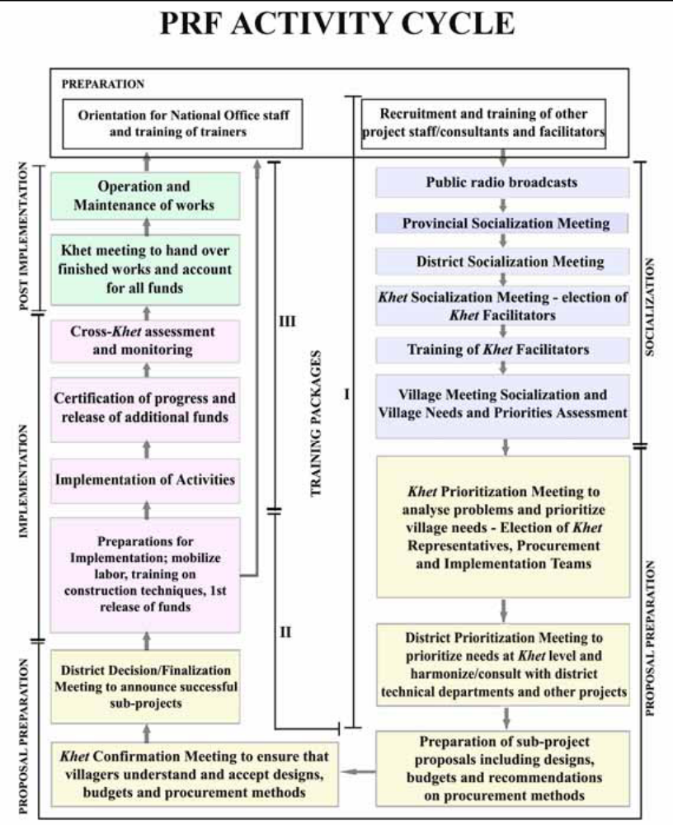

Chapter 3

Table A.2. Determinants of project selection.

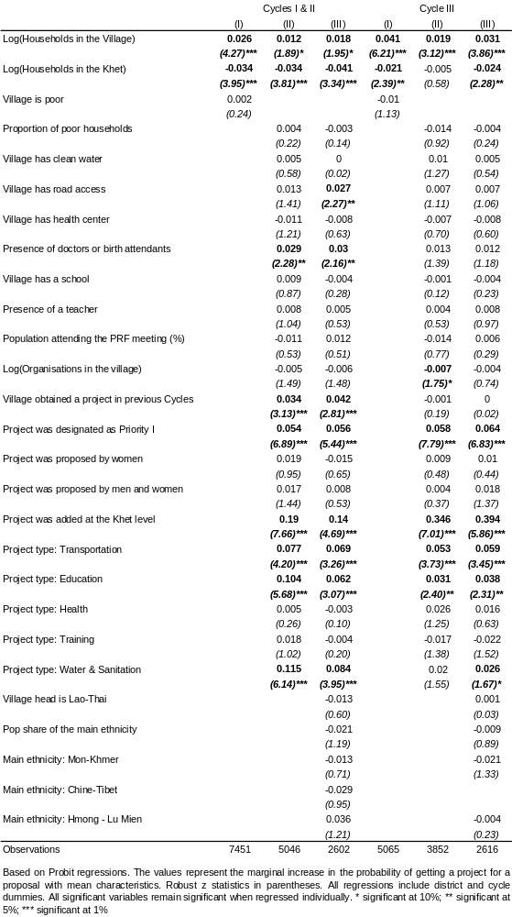

Methodology of the qualitative study

Objective The objective of the qualitative study is to provide an assessment of how three Community Driven Development projects in Lao PDR, that aim to foster community involvement, reach the poor and provide an opportunity to improve living conditions in targeted villages, are working in the field (Poverty Reduction Fund, Village Development Fund, The Village Investment for the Poor component of the Agricultural Development Project). The study presents the experiences and perceptions of both direct and potential beneficiaries, as well as those of the village-, khet- and district-based personnel who supported the implementation of the projects. The study findings will contribute to the review of the broader objectives of this Note on the following issues:

- To what extent was community participation in the decision-making processes during planning and implementation achieved?
- To what extent are the projects perceived by beneficiaries and others to be beneficial to poor individuals and communities?
- To what extent are the projects perceived as meeting the needs of the village?

Additional topics specific to the Poverty Reduction Fund (PRF) include perceptions on the effectiveness of the khet administration as a link between communities and districts, and the extent to which participatory planning processes lead to better operation and maintenances practices in sub-projects.

Study structure The study was designed by the World Bank and carried out by a Consulting Firm in Lao PDR. The data collection tools were contextualized and translated by the firm, while training on and pre-testing of the tools were conducted collaboratively by the firm and the World Bank in the field.

Two field teams were established that were led by two focus group discussion moderators and assisted by note takers and field managers. In addition, in all 8 PRF and 3 VDF villages in Saravane province, a local interpreter who was not associated with the village head authority and did not play a leading role during the planning phase of the project, helped with interpretation between the local language and Lao.

During the entire study period, direct and transparent communication was established with the Consulting firm. The goal in choosing a third party to carry out data collection was to enhance data quality, as during the design phase, it became evident that the presence of the World Bank and/or the Government would likely have a negative effect on the findings. The objective of the study is to give project beneficiaries and implementers a chance to speak equally freely about positive as well as negative aspects of the projects, a condition that is normally easier to achieve when discussions are anonymous and official representatives are not present. In the field, project managers and district staff were also encouraged to let field teams work independently, a goal that was achieved to a large degree.

In order to provide anonymity to all participants in the study, project beneficiaries and district-representatives, the districts and villages included in the study will not be named in this report.

Sample size and selection process The sample size for this study was based on information received from each of the three projects. Initially, 30 villages were selected to form the basis of the data collection. It was later decided to also include in the VDF study two villages that were visited during the pre-testing of the data collection tools. The breakdown of participating villages is as follows:

14 PRF villages that received at least one sub-project
4 PRF villages that applied for a sub-project but were not approved
6 VIP villages
8 VDF villages

At the beginning of the study, a decision was made to select a Northern (Houaphan) and a Southern (Saravanne) province in order to ensure the basic geographical distribution of participating villages. Second, seven districts were selected based on their poverty rating, accessibility, and study costs. In four of the districts, it was possible to study two of the three projects. Third, district-based lists of participating villages were the basis for a quasi-random selection of 30 villages. The selection of PRF villages was limited to villages that had received a road or bridge, a school or a water related sub-project (i.e. the three most frequently funded types of sub-projects). The selection of VIP villages was limited to villages that had received at least two micro-credit schemes. No information was available at the time of the selection on the types of projects that were funded in the VDF villages.

All participants in focus group discussions in the villages were selected through a quasi-random process. Lists of inhabitants in the villages were obtained from the village head authorities or constructed by the field team with the help of such authorities. The households were typically listed by cluster. Women and men were alternately allocated by selecting every fifth household (depending on the number of households), an approach that secured a geographical as well as an ethnic and kinship-based distribution of participants. If there was more than one man or woman living in the selected household it was up to the household to decide who would participate in the study.

Data collection tools The primary concept, on which the study design is based, is that similar questions on project planning and implementation are posed to people with different types and degrees of exposure to the projects (GRID, 2005, Adam, 2006, World Bank, 2006b). Data was mainly collected through focus group discussions in order to involve a larger number of beneficiaries in a relatively short time (Krueger, 1994) (See example of data collection tool for beneficiaries below). The focus group discussions were recorded but not transcribed, except for selected quotes by participants. In addition, semi-structured interviews were carried out with participating district office and project staff.

In each village, the group representing the village authority was first contacted to inform them about the intended data collection. At that time, a limited number of questions were asked about characteristics of the village, such as main ethnic groups, recent resettlements, the number of poor households, and current development projects. The village or an appointed person was identified to help the field team with the randomization process for selecting participants.

a) PRF: In 14 PRF villages, focus groups were held with village representatives, randomly selected women and men in separate groups, and the teacher of schools that had been constructed and financed by the program. A goal was set of having at least eight participants in the focus groups with men and women, and, to maximize the chance of achieving this goal, ten participants were randomly selected. In addition, discussions were held with khet facilitators on the implementation of the project in both the participating village and neighboring villages. Finally, PRF management staffs at the district and provincial level were interviewed, as well as district officials who had been involved with the project.

In addition to the 14 villages in which a PRF sub-project had been received, four villages that had applied for a sub-project but had not received one were included in the study. The same groups of people were interviewed or mobilized for discussions using modified guides appropriate to their exposure to the program. The rationale for including these four villages was to assess any adverse effects of the broad mobilization process on the PRF districts.

36 focus groups were held with beneficiaries, in which a total of 149 women and 155 men participated. In addition, 33 khet facilitators representing the 18 PRF villages, 60 village representatives, and 48 members in the village head authority were interviewed individually or in group.

b) VIP: In six villages, focus groups were held with people who were recognized by the village head as having led the selection and planning process. Two focus group discussions were then held with randomly selected members of a VIP micro credit project and one focus group with non-members. Finally, district-based staffs were interviewed about their contact with the project as well as project managers at the district and provincial levels. In total 20 focus groups were carried out, with the participation of 122 members and 30 non-members.

c) VDF: In eight villages, focus groups were held with the Village Development Fund Committee (VDFC) as well as with members and non-members of the VDF. Staff at the district and provincial level was also interviewed. In total, 19 focus groups were carried out and 85 members and 87 non-members participated.

The field team spent one or two days in each village carrying out informal discussions with residents and observing the use of the local infrastructure (6 villages were completed in one day while 2 days were spent in the remaining 26 villages). Both of these activities provided additional sources of information. In each village, a map was drawn by the field team in order to understand the location of infrastructure in relation to the location of the different number of family clusters, including satellite clusters of recently resettled residents (see below for an example). Pictures were taken of the infrastructures as well.

Data analysis. In a first step, the field teams (under the leadership of the two moderators) prepared Village Cases Study Summaries and presented finding on all main topics from the data collection activities carried out in each village. Content analyses on the six main topics were then carried out, which formed the basis of the findings presented in Chapter 4. In each village, comparison between the discussions with women, men, village implementers and the village head authority was carried out.

The findings are primarily presented in a narrative form. In order to give estimates of how common certain findings were, percentages were added when relevant. It should be noted that each focus group is perceived as one unit, in contrast to representing a percentage of the number of beneficiaries. The focus group discussion is a qualitative data collection method that cannot be translated to represent a proportion of the participating beneficiaries.

Issues during data collection. The data was collected during February and March, 2007. This was the dry season and all villages except one, which only was reached after two hours walk, could be reached by car.

The moderators invited all beneficiaries in the focus group discussions to participate but faced difficulties in engaging everybody. The moderators explained the reasons why they wanted to speak with the group as a whole and attempted to create as enabling an environment as possible by sitting in a secluded place.

The field team received excellent coordination and cooperation from local government and project representatives in all districts and the two provinces, which made the field work experience much easier.

Village maps. Attached below are two examples of maps of the participating villages in which the received facility or infrastructure is included. The maps were very useful during the data analysis for validation of access or constraints thereof between the clusters in the villages.

Figure A.1. Example of a village map (1).

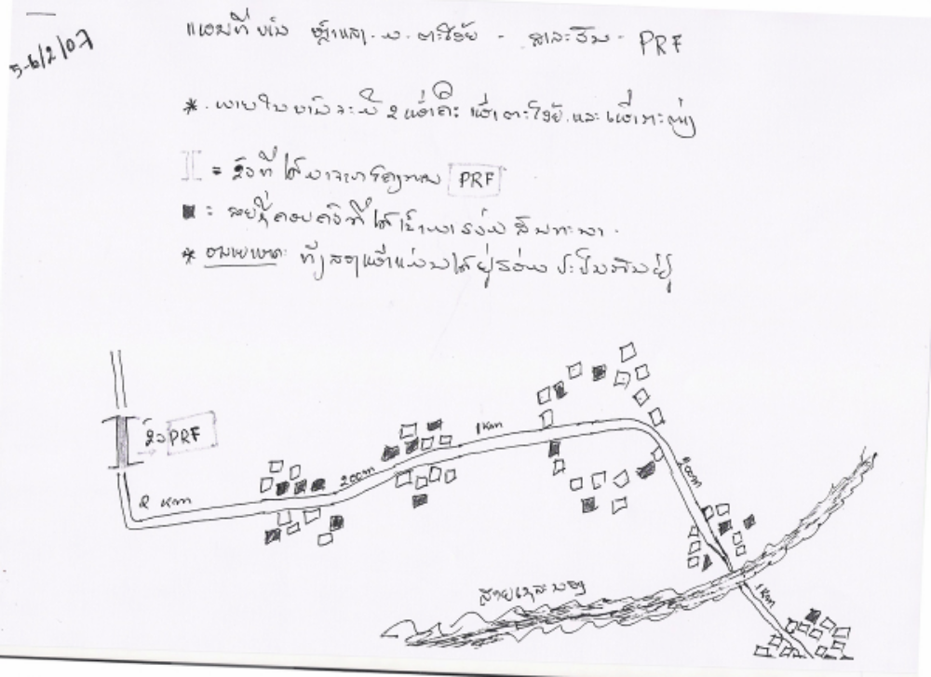

Note:
- There are 2 ethnic groups, but mixed together
- There are 5 village groups

Figure A.2. Example of a village map (2).
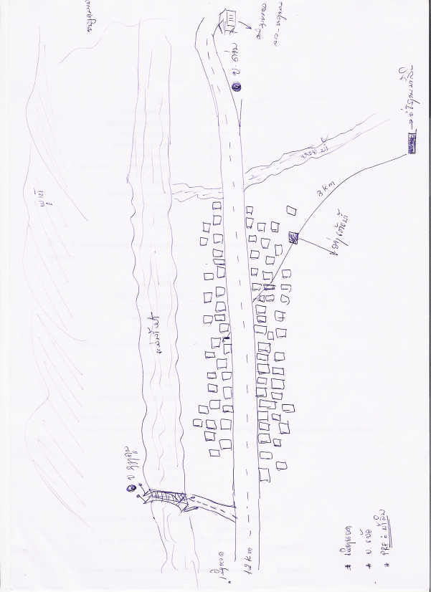
Mar River
Mountain
Road to Dongdok
Road to Dongdok

Ban Dane Border
Huaphan Province
PRF Village

Vietnam
Source
Tank
Village

Focus group discussion guide: randomly selected beneficiaries

INTRODUCTION

My name is _________ and this is _______________. We work for the firm Indochina Research based in Vientiane. We have been hired by the World Bank to learn how the needs of villages have been met during the last years and what challenges you meet in this villages. We have in particular questions on the Poverty Reduction Fund/ Village Investment for the Poor/ Village Development Fund. The information gathered here will not be used to reward or to punish any village. The results will be used to improve the ways in which the programs are delivered. We are visiting 30 different villages in this district and also in other provinces in the country. Your village has been selected by chance.
We would like to discuss the development of the village with different groups of people in the village and would like to ask your help to identify them.

INITIAL CONTACT WITH THE PRF
- We would like to hear about the activities financed by the PRF. What (or which) facility was built in the PRF-program? [ Ask each participant if they have used the facility (road, well, clinic, school and how often) - this is mainly for giving all participants a chance to speak a few words and confirm that they will be understood and secondly to get a first impression of the usefulness of the facility]

- Thinking back to when the PRF started – how was the program presented to you and by whom? [Reassure that we want to know how they remember it, and how it was presented to them. There is no right or wrong answer]

PARTICIPATION IN THE IDENTIFICATION PROCESS
- We would like to hear how the village needs were identified. We understand that separate identification meetings were held for men and women. What do you think of this set up – was it a good or bad idea? [probe what was good about the set up and what was less good]

- Did the khet facilitator participate in any of the meetings? If yes, which? Was it helpful? Please explain. If he/she did not participate, would you have preferred him to? What about the village head? If they participated, to what extent do you think they influenced the decision being made in the village?

- Which government officials were present at the different meetings? What was their role?

- In community projects, the number of people who participate in the planning often varies. We would like to understand how things worked in your village – how many was not participating?

- How would you describe the households that did not participate? [probe for certain kin groups or neighborhoods, speaking different language, minority, richer or poorer households, aged persons, groups that recently moved into the village][Encourage people to think about the different households that were not participating]

- From what you know or have heard, what were some of the reasons why they did not participate? Again, if you did not participate yourself, feel free to tell about your own reasons. [probe did not know about the meetings, do normally not participate in village meetings, disagreed, was not invited]

- What could have been done to have more families participate? Do you have any suggestions?

PROJECT SELECTION
- We understand that the men first prepared a list of three proposals and the women did the same. The six proposals were then reduced to three. Is this correct? Will you mention the proposals?

- Each village makes decisions in its own way. We would like to understand how your village managed to decide which three proposals should be prioritized. Would you say it was difficult to agree? [If it was difficult, how did you reach an agreement?]

- You received a ____________ [mention sub-project]. Was that the village’s first priority, second, third or not on the list of proposals?

- If the village received their first priority, what were the main reasons for your choice? [When one reason is explained, probe if other reasons were mentioned?]

- If the village did not receive the first priority, what explanations were you given? Who told you? What were the reactions in the village?

- How many men/women in the village agreed on the choice of the three ranked proposals? Would you say that a few, half or the majority of the men/women in the village agreed?

PROJECT OPERATIONS AND MAINTENANCE
- What is the status of the facility? If it is working well, how does your village manage to keep the facility in good condition? If it is not working well, what problems do you have? Who has been contacted to solve the problem? Were the problems solved? [Remember that we are looking for the local perceptions on the quality of the maintenance]

- We would like to ask about the ways in which people in the village contribute to the upkeep of the facility? You are welcome to tell about your own experience, if you have been involved. [Probe for time, money, labor, materials. When more than one person has described their own experiences, ask if these examples are typical for this village? When yes, ask]: Were these contributions considered high, just right or low?

- We would like to understand what groups of people in the village are active in sustaining the facility. Who is contributing and what are the main reasons for not contributing? Are there households in this village who can not afford to contribute?

- In the villages where contributions for the upkeep of the facility are asked for: who in the village organizes the contributions? Are the contributions mandatory? If mandatory, how enforced?

PROGRAM SUPPORT
- As you know, this program is managed through the khet with the help of four village-representatives. We would like to understand how well this arrangement works. Was it a good set-up? What were the advantages? And the problems?

- Has any groups in the village who normally do not participate in village issues, been more active after the program started? If yes, have they influenced the decisions taken? How? [Please provide examples on which groups, women, new ethnic groups, poor, others]

- We would like you to compare the responsiveness of the District to your khet’s needs during the years of PRF involvement. Do the district representatives visit more often?

- Do you contact the district more often? [If no changes for the better ask] how would you prefer to communicate with the program managers and the district government?

- Are there any persons you would like to see more involved in the work [probe local representatives for mass organizations, other]?

PERCEPTIONS ON IMPACT
- Has the village benefited from this facility? [If yes, probe for ways in which life has changed in the village after the facility was constructed. If no, probe for explanation]

- [If yes in 24] Has the facility benefited some groups/families in the village more than others? [Probe on men/women, young/older inhabitants, land owners, persons involved in trade, households in certain parts of the village, certain neighborhoods]

- Knowing what you know today – did the village make the right/best choice when deciding on building this facility? If no, what would have been the better activity for your village? If yes, if a new application for projects could be submitted, what do you think the village would suggest?

- Has this village initiated and/or implemented other activities during the last two years to improve living conditions in the village? [we are looking for small as well as larger activities that were initiated without the direct support of projects] If yes, has any been inspired by the participatory process as promoted by the PRF?

CLOSURE
- We have discussed many details about the program. Now as the last questions, we would like you to lean back and think more in general on all your experiences with the PRF: what are the strongest aspects of the program? What are the weakest sides? [we are probing after the things that stands out as particularly good and bad]

- Last but not least, is there anything we did not ask about the program or about the village that you would like us to know?

We have asked you many questions, now; do you have any questions for us?

Chapter 4

Table A.3. Summary statistics.
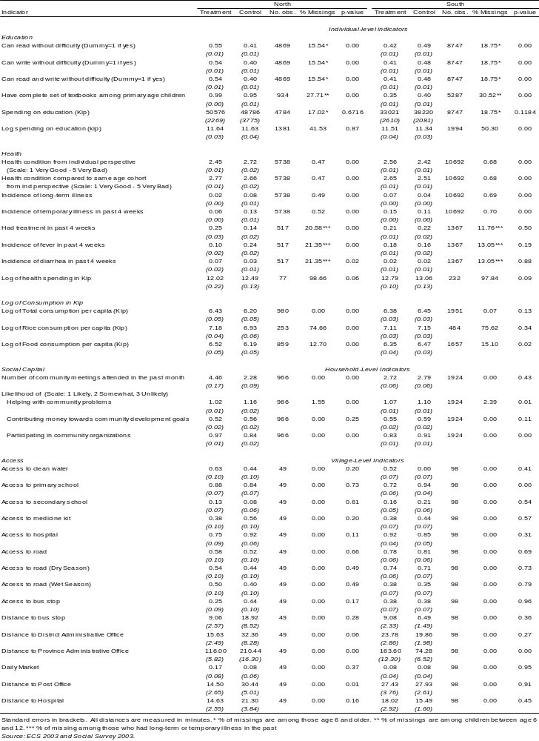

Impacts of community-demand-driven (CDD) projects reported in other studies

Rawlings et al. (2003) provides an overview of 5 community driven social investment funds that are located in a diverse set of countries (Armenia, Bolivia, Honduras, Nicaragua, and Peru). Similar to the evaluation presented in this paper, both propensity score matching and difference-in-differences techniques are used. The results presented are summarized below, and highlight the fact that because community driven development programs target a broad range of objectives, the impact in each sector is often small.

Table A.4. Summary of impact of CDD projects.
Country | Program | Increase in  School Enrollment | Impact on Water Access | Impact on  Reports of Diarrhea
Armenia | Social Investment Fund | 3-8%* | 5% | 4%
Bolivia | Social Investment Fund | 0% | 18% | 0%
Honduras | Social Investment Fund | 0% | 5% | 0%
Nicaragua | Emergency  Social Investment Fund | 5-10%* | 28% | 2%
Peru | Fund for Social Compensation and Social Development | 0 | 20% | 3%*
Source: Rawlings et al. (2003).

Distributions of propensity scores

Diagrams below show the distributions of propensity scores using pre-intervention variables without and with matching (nearest neighbor). Variables used to match treatment with control groups in the South are: dummy for urban/rural with accessibility, dummy for upland/lowland, total number of households in the village, number of poor households in the village, number of children born in the past 12 months, number of deaths in the past 12 months, number of immigrants and emigrants in the past 12 months. For the matching procedure in the North, we restricted the number of variables as the number of observations is half the size of the South: dummy for urban/rural with accessibility, dummy for upland/lowland, total number of households in the village, and number of poor households in the village.

Figures A.3, A.4, and table A.5 illustrate the results for ITT estimation, and figures A.5, A.6, and table A.6 for TOT estimation.

Figure A.3. Distributions of propensity scores in the South (ITT).
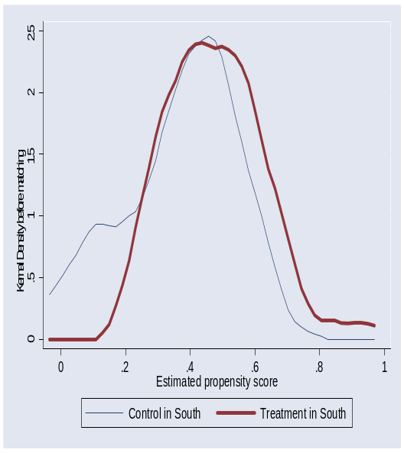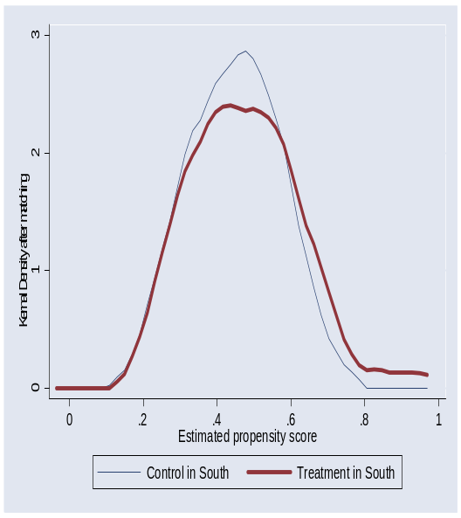

Figure A.4. Distributions of propensity scores in the North (ITT).
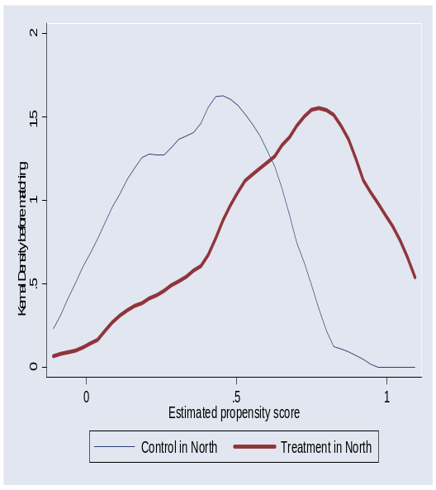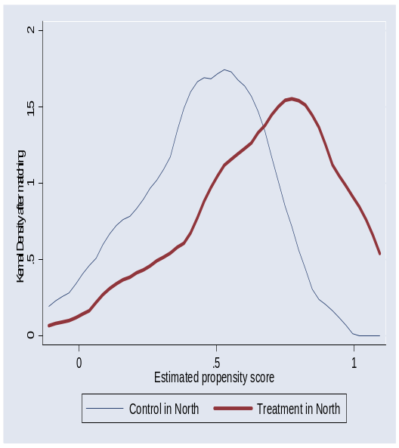

Table A.5. Variables used to construct the propensity scores (ITT).

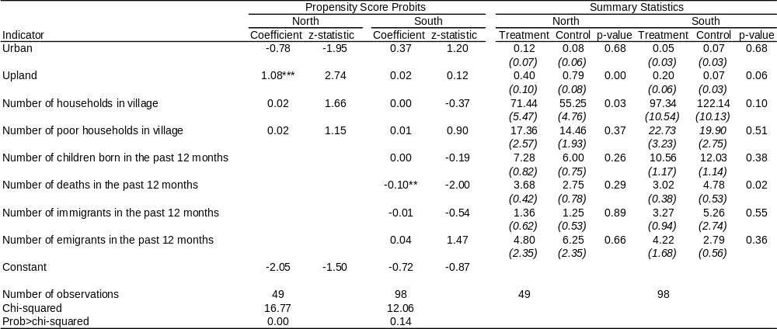
Source: ECS 2003.

Figure A.5. Distributions of propensity scores in the South (TOT).

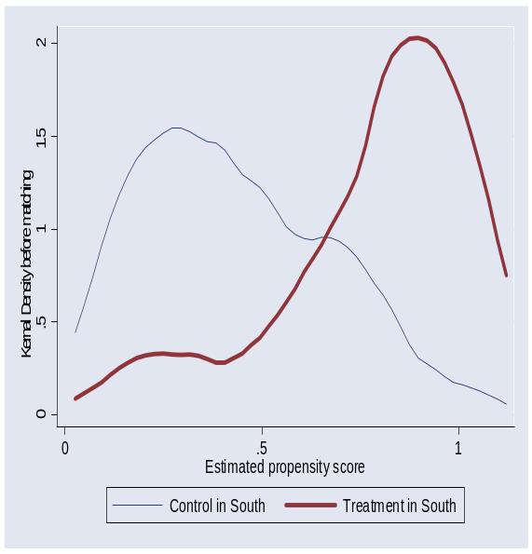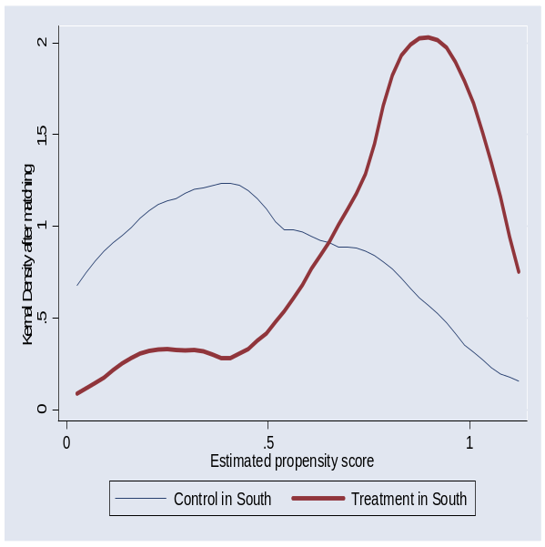

Figure A.6. Distributions of propensity scores in the North (TOT).

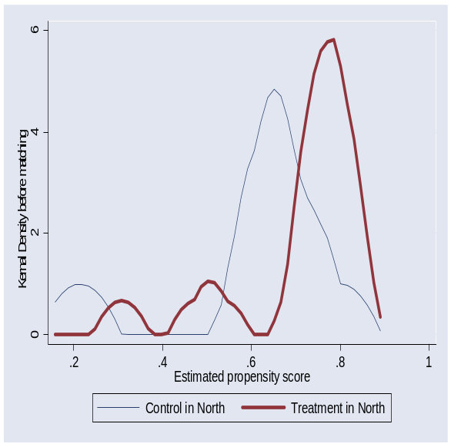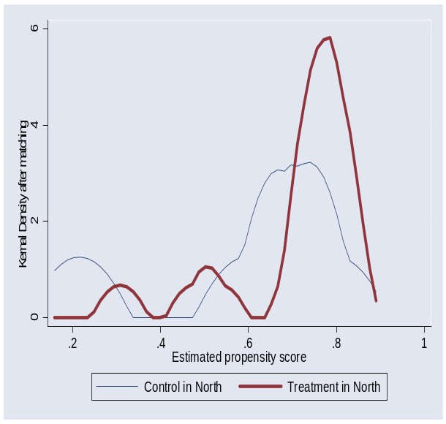

Table A.6. Variables used to construct the propensity scores (ITT).

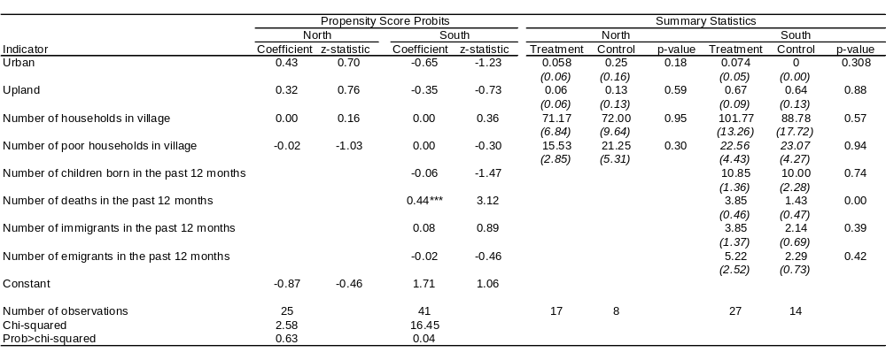
Source: ECS 2003.

See, among others, Chase (2002), Isham and Kakhonen (2002), Newman et. al (2002), Paxson and Schady (2002), Pradhan and Rawlings (2002), Rao and Ibanez (2005), Arcand and Bassole (2007), and Labonne and Chase (2008). For a more critical review, see also Mansuri and Rao (2003).
An additional objective of the study was to feed into the design of the second phase of the PRF. The following chapters therefore provide more technical details about issues faced in the implementation of community-driven approaches in remote areas.
In total, 3000 households in 150 villages were surveyed in Huaphan and Phongsaly provinces in the North, and in Savannakhet and Champassak in the South. Of the 150 villages, 75 villages were in PRF-active treatment districts, while the remaining 75 were in control districts not implementing PRF activities. For more details, see the following chapters.
The qualitative study covered 18 randomly selected PRF villages in Huaphan and Saravane provinces; eight VDF villages in Huaphan, Saravane and Vientiane provinces; and six VIP villages in Saravane province. Although the qualitative analysis is on a strict basis representative for Huaphan and Saravane provinces only, the consistency of many findings across projects, provinces, and with other existing studies suggests that it provides a fair picture of the salient issues that CDD and livelihood projects face in the uplands. See the following chapters for more details.
Low construction costs are a frequently observed feature of CDD projects. For instance, an independent evaluation of infrastructure projects in 2001 found that infrastructure projects for the Indonesia Kecamatan Development Project were 23 percent less expensive than comparable government projects (World Bank, 2003).
The significantly lower construction costs of PRF roads do however stem in part from the use of simpler construction techniques that require more frequent maintenance.
Evans (2000), Lyttleton et al. (2004), Ovesen (2003a, 2003b), Rigg (2005), and Stuart-Fox (1982, 1986) provide additional information about Lao.
According to Instruction No. 010/PM from the Prime Minister’s Office, a village is considered poor if one or more of these conditions apply: over 51% of the households are poor; the village lacks an accessible primary school; the village is without a dispensary, traditional medicine practitioner or requires over 6 hours of travel to the nearest hospital; the village does not possess a safe water supply; the village lacks road access, at the minimum trails accessible by car during the dry season.
Unfortunately, we do not have reliable information on villages’ infrastructure before PRF started.
One of the villages that had not yet received a sub-project, however, claimed to be willing to also contribute cash if necessary. The other exception of willingness to contribute in cash was a village that had received an electricity sub-project.
That is, the Village Head and the Village Committee.
All quotes have been translated from the local language to Lao and afterwards to English by the Focus Group moderators.
The question was challenging to ask, especially in Huaphan province, where four years of project implementation has in fact resulted in greater awareness of the objectives of, regulations pertaining to, and expectations from the project. In contrast, responses in Saravane province did not appear to be influenced by these expectations.
More precisely, the regression coefficient is equal to 0.031, and .
The effect also disappeared in Cycle III when the sample was restricted to exclude districts that were added to the Project in that Cycle.
In Saravane province, the moderator unfortunately did not have time to ask this final question due to more difficulties with the FGD guidance.
This problem could reflect a methodological shortfall in the study structure, but it is more likely that the procedures were difficult for people to grasp (when explaining what the village had proposed as their priorities, both male and female participants and village representatives could describe the circumstances without major difficulties).
A sixth school was visited in a village receiving support from the Village Development Fund. According to statements from the village head, the school was only attended by students from one out of the three clusters in the village due to long distances between the student’s homes and the school.
World Bank (2003), “Implementation Completion Report for a Kecamatan Development Project, No. 26163,” Washington, DC.
Also, this figure does not include the cost of capital, which is often subsidized.
World Bank, 2003.
A regression analysis shows that the number of projects in a district does not influence significantly operating costs. Nonetheless, in the simulation we presume that by doubling the amount of sub-grants, each district and provincial office needs one more staff, the national office needs four more staff, and operating costs per district increase by 50 percent due to more travelling.
Instrumental variables (IV) could have corrected for selection biases, but were dropped as there was no good candidate for valid IV that satisfied exclusion restrictions.
A second firm was hired to assist the first firm during data entry of the second survey, but data quality remained poor.
Geographic areas investigated, however, did not exactly overlap.
25 PRF treatment villages were randomly chosen from each of three PRF provinces, Huaphanh, Savannakhet and Champassak. Because in Savannakhet, and Champassak the PRF did not cover all districts, in each of these two provinces located in the southern region, 25 control villages were sampled from non PRF districts. For Huaphanh, located in the northern region, 25 villages in the province of Phongsaly were chosen as a comparison group.
See for example, Pradhan and Rawlings (2002), Newman et al. (2002), Paxson and Schady (2002), and Ravallion (2001).
See for example, Maluccio et al. (2006), Bloom (2006) and Arcand and Bassole (2007).
See for example, Luby et al. (2004).
The inflation rate between 2003 and 2007 was around 23 percent based on IMF International Financial Statistics (IFS) database.
See, for example, Platteau (2000).
In Cycle IV, 81 percent of the “Access and Energy Sector” intervention was allocated to rural road upgrades and 11 percent to bridges. The pattern was similar for Cycle III.
Chase and Woolcock (2005).
See for instance, Labonne and Chase (2008) on KALAHI-CIDSS in the Philippines, Chase et al. (2006) on the Thailand Social Investment Fund, and Rao and Ibáñez (2005) on the Social Fund in Jamaica.
Labonne et al. (2007).
Although regional comparisons may not be appropriate due to the subjective nature of the question, the average score is significantly worse in the South compared to the North (4.5 and 3.5 in the North and the South, respectively).
Two of these eight villages were originally chosen for pre-testing of the data collection tools but were then selected for inclusion.
As explained in the Village Fund Guidelines.
The VDF guideline consists of government circulars to local authorities and mass organizations regarding objectives, rules and regulations for establishment of VDF as well as examples of VDF forms such as the village registration form, the loan application form, and the village committee approval request form. It provides general guidelines on how the VDF is established and implemented but is not presented as a detailed implementation manual.
Each mass organization is responsible for supporting a number of provinces as follows: Lao Front works in Khammouane, Bolikhamxay, Xiangkuang, Savannakhet, Champasak, Xekong, and Saravane; Lao Youth works in Huaphan, Pongsaly, Bokeo; Lao Women’s Union works in Vientiane province, Vientiane Municipality, Luangpabang, Xayabuly; and Lao Labor Union works in Oudomxay, Attapeu, Luangnamtha.
VDF Status Report, 2006.
Basketry and blacksmith activities were described as seasonal activities, and were at the time of the survey not active.
Livestock husbandry was the activity most often requested (and approved), while infrastructure proposals had less support from DAFO.
Membership does not guarantee that the household will be able to get a loan, but that they intend to make a deposit on a regular basis, and have the right to a loan when funding is available.
It was explained that this family had been forced to give the buffalo to another family due to delays in repayments.

