Final Terms of Reference
for
Preparation of an Environmental and Social Impact Assessment (ESIA)
for
Romania: Ploiesti – Brasov Motorway Preparation Project

Background
Transport infrastructure networks in Romania are in poor condition, offer insufficient coverage, are not efficiently maintained, and generally do not support the country’s aspirations on growth and job creation. The rail sector is not cost effective, receives a very significant share of EU funding given EU priorities and needs a thorough reform to increase its efficiency. However, based on current traffic trends and situation in all other EU countries, the backbone of traffic flows uses and will use the road network. However, compared to all EU countries, Romania’s 700 km of motorways offer very little coverage. Driving conditions along main national roads are poor and unsafe. Romania has a long history of insufficient construction of motorways. Historically, Romania has also not managed any road sector PPP (only some port and rail cargo operations are private). There is a lack of credible pipeline for motorways to this day, while the size of the country and its main centers for growth would justify many sections economically. There is an acute need to restructure Romania’s transport infrastructure and associated services with priority given to economically critical routes and better overall connectivity.
To address these challenges, the Government of Romania approved on September 19, 2016 a Governmental Decision for the approval of the General Transport Master Plan (GTMP), which provides the strategy for the development of Romania’s transport sector for the next 20 years. The Master Plan identified the projects and policies which best meet Romania's National transport needs over the next 5-20 years, for all modes of transport, and provides a sound, analytical basis for the choice of those policies and projects.
Romania’s General Transport Master Plan (GTMP) is ambitious with respect to both funding and the envisaged pace of implementation. It targets EUR 27 billion in road sector investment though 2030. According to the approved GTMP, 11 motorways (estimated at EUR 13.3 billion), 19 expressways (estimated at EUR 10.4 billion), tens of modernizations (EUR 2.5 billion), and bypasses (EUR 0.46 billion) are to be delivered by 2030. However, funding sources have been identified for just a portion of the planned investments. For the period 2014 - 2020, the road sector financing needs as per the GTMP amount to EUR 12.8 billion. Approximately EUR 4.6 billion is to be secured from EU funds and national counterpart funding. The balance of EUR 8.2 billion is yet to be identified. Investments that are envisaged for the 2021-2030 period also show a EUR 7.9 billion funding gap. Projected expenditure levels also appear ambitious considering past experience. For example, during 2012 when Romania’s greatest level of annual road infrastructure investment to date took place along 1,623 km of the network, annual capital investment amounted to EUR 1.15 billion. The GTMP envisages implementation of more than EUR 2 billion worth of investment per year through 2020.
The 110 km Ploiesti-Brasov Motorway is included in the GTMP and forms part of the comprehensive Trans-European Transport Network (TEN-T). It is a flagship project for Romania’s government. The project would complement the existing 60 km Bucharest-Ploiesti Motorway and would link Bucharest with the regional center of the Brasov area. More strategically, this would fundamentally change connectivity between two of Romania’s most economically vibrant areas. There have been three prior failed attempts at developing the project under some form of private concession. The most recent attempt in 2014 did not reach closure due to higher than expected costs for the government as well as perceived governance issues surrounding the deal. Experience of this attempt showed that deficient project preparation placed the Government of Romania at a severe disadvantage when negotiating with prospective Project sponsors. It also demonstrated that many technical constraints envisaged during the 2006 feasibility study have become outdated. For example, the 2006 feasibility study set an alignment that avoided any tunnel in excess of 300 meters.
The Government of Romania (GoR) intends to receive a loan from the World Bank to finance preparation and technical assistance activities relevant to the implementation of the Ploiesti-Brasov Motorway under the following two components:
Component 1: Preparation of the Ploiesti-Brasov Motorway delivery
This component will support financing of the necessary studies/activities, all related to the construction of the Ploiești-Braşov Motorway from the current end of the A3 motorway in Ploiești to Rȃșnov: feasibility studies, technical surveys, engineering conceptual and detailed design studies; relevant safeguard instruments (ESIA, Environmental and Social Management Plan, Resettlement Policy Frameworks, Resettlement Action Plans); and preparation of all bidding documents to facilitate the construction of the Ploiești - Braşov motorway from the current end of the A3 motorway in Ploiești to Rȃșnov. At the time of drafting of this ToR a financing source of this motorway construction is still not finalized.
Component 2: Institutional strengthening and sector initiatives
This component will support financing of activities related to the project management, external technical support for improving government project management processes, training and skills enhancement relating to motorways development with a particular focus on tunneling, complex structures, and road safety, etc.
The Project will seek to use the Ploiesti-Brasov Motorway Project’s preparation as a demonstration for improved project preparation of major projects as well as a platform for the development of boarder sector-wide funding and delivery strategies for Romania’s motorways, roads and bridge network.
The road construction proposed for technical preparation in this project is in a region with three major tourist cities (Bușteni, Predeal and Sinaia) and several villages and communes. The topography consists of flat areas and steep mountains possing challenges for engineering designs. The project affected area also has well known nature reserves and parks and important historical, archeological and cultural resources. The project area also contains numerous utilities (gas and oil pipelines, electrical transmission lines, and sewage systems. Important reservoirs used for drinking water servicing significant metropolitan centers and sources of irrigation systems are also in the project area.

The TA will update the previous road corrider designs, determine alternative engineering designs based on modern EU road construction standards, propose alternative cost benefit options and undertake preliminary scoping of environmental and social impacts and risks. Based on these results, final road construction proposals will be developed.
The location of Ploiesti – Brasov motorway
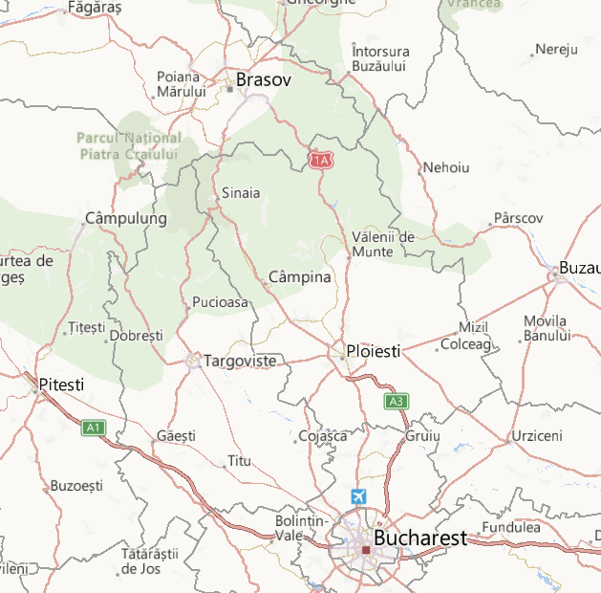
A3: Bucharest-Ploiesti Section (60 km)
Under Operation since 2012
Ploiesti-Brasov Section (110 km)
Proposed Project
Rasnov-Cristian (Brasov) Section (6.3 km)
Under Design-Build Contract since Oct 2017
A3: Bucharest-Ploiesti Inner Ring Road Section (3 km)
Under Construction toward mid-2018 Opening
A3: Bucharest-Brasov Corridor
Comarnic

*For internal use only: This is not a certified map for publication.

The country has experience in implementing IFI (such as EU and EBRD) supported road projects including World Bank financed projects. The TA will also support capacitity enhancement for the Project Implementation Unit (PIU) staff within the Ministry of Transport. The PIU will coordinate and implement,project planning, budgeting, procurement, disbursement, construction and environmental and social due diligence oversight, auditing, monitoring and evaluation, and implementation progress reports.
Objectives of the assignment
The objectives of the assignment are:
- To prepare an Environmental and Social Impact Assessment (ESIA) and a General Environmental and Social Management Plan (ESMP) for the whole Project, which will outline the main procedures and responsibilities to manage environmental and social risks associated with the implementation of the Project activities. This document will guide the development of general ESMP for those sections of motorway whose design will not be available at the early stage of project preparation;
- To prepare a Social Assessment based on (a) existing socio-economic studies of the roadway area; (b) a census of settlements, entities (businesses, households, vendors (particularly informal vendors and squatters), etc.), farms and agricultural businesses, etc. along the motorway; (c) public consultations with Project Affected People (PAPs) along the motorway.
- To prepare Environmental and Social Impact Assessment Reports and Management Plans for each motorway section to be supported by the proposed Project, which would identify and assess the potential environmental and social risks of the proposed Project, determine adequate mitigation measures.
All work undertaken and outputs produced must comply with:
- World Bank safeguard policies, while taking into consideration the environmental and social procedures of the Government of Romania
- World Bank guidance on the conduct of public consultations with PAPs along the proposed alignment (right-of-way) of the Ploiesti-Brasov motorway.
- World Bank guidance and structure provided on Social Assessments, ESIAs.
- World Bank Environmental Health and Social (EHS) Guidelines for General and Toll Roads.

Required Contents of the Environmental and Social Impact Assessment
This section provides a summary of the required contents of each section of the ESIA. The contents of the ESIA Report should follow the outline listed below, subject to any comments for addition or amendment from appropriate permitting and the relevant national environmental agencies:
Title Page
Executive Summary
Abbreviations and Acronyms
Table of Contents
List of Tables
List of Figures
List of Annexes
Section 1 Description of the Project
Section 2 Legal, Regulatory and Policy Framework
Section 3 Environmental and Social Baseline Information and Data
Section 4 Impacts and Risks Statement
a) Socio-economic Impacts and Risks Assessment
b) Assessment of Environmental and Social Impacts and Risks
Section 5 Analysis of Alternatives
Section 6 Environmental and Social Mitigation Measures
Section 7 Environmental and Social Monitoring and Management Plan
Section 8 Community and Social Risk Management Plan
Section 9 Public Consultation and Disclosure Plan
Appendices
List of ESIA Preparers/Consultants and Their Qualifications
List of References
Record and Documentation of Agency Meetings and Agreements
Record and Documentation of Consultation Meetings

Overview of ESIA Report Contents
i) Title Page and Table of Contents The title page and table of contents shall be consistent with the proposed outline (previous section).
ii) Executive Summary A summary of the project objectives; a brief project description; a brief description of significant findings and recommendations for environmental and social management that will be adopted to eliminate or minimize adverse impacts to acceptable levels as defined by the appropriate authorities and standards. This product will serve as the main consultation document and should be available in Romanian and English.
iii) Section 1 Description of the Project
Provides a brief overview of the Project background and specific description of the Project components. The following technical information shall be included: the study area, size and capacity of the Project; all associated infrastructure (construction and operation workforce, housing, water supply, gravel sources, batching plants, machine and maintenance yards, technological roads, borrow pits, building materials deposits, etc.); description of the construction and operation activities (phased construction activities, associated manpower size and skill levels necessary, opportunities for local labor, size and skill of local workforce as per Feasibility Study assessment); hazardous waste use, handling, and storage (diesel, fuel gasoline, lubricants); worker health and safety, emergency preparation and response (including community response and notification); temporary construction areas; site location alternatives considered; clean-up activities; implementation schedule; staffing and support, and worker facilities and services.
Maps (in a common GIS format) are required at appropriate scales to show project-related development sites, pre-construction and construction activities as well as surrounding areas likely to be impacted. These maps should include topographic contours as well as locations of major surface waters, roads, railways, villages and communities, administrative boundaries, existing land use and all critical habitats including parks and recreation areas, and historical and cultural resources.
iv) Section 2 Legal, Regulatory and Policy Framework
- WB policies, EHS guidelines, including a gap analysis explaining what additional efforts are needed to meet the WB requirements. The gap analysis should be expanded to the WB safeguards requirements, which include emissions thresholds into the Environment, Health and Safety Guidelines, and these should be compared against national standards as the most stringent requirements should be identified and further applied.
- The Laws on Environmental Impact Assessment (GD No. 445/2009, Law No. 49/2011, Order no. 19/2010 will be followed. Also, the provisions of the Directive 2014/52/EU transposed in the national legislation and the requirements of the Competent Environmental Protection Agency –National Environmental Protection Agency) will be followed. These laws incorporate relevant Romanian and EU Directives that apply to this project, where relevant Annexes make clear compliance to meet national/regional permitting requirements.
- Describe applicable environmental policy and administrative requirements and associated regulations and standards of the Government of Romania and the EU. Particular reference should be made to requirements governing environmental quality, protection of sensitive areas, protection of endangered species, land use controls, etc., at national, regional and local levels.
Legal and institutional framework relevant for social aspects (i.e. legislation on land acquisition, land tenure, expropriation, building codes and legislation relevant to universal accessibility of new infrastructure, legislation pertinent to ethnic minorities and particularly Roma, legislation regarding consultations, labor laws, etc.).
v) Section 3 Environmental and Social Baseline Information and Data
- The Consultant shall assemble, evaluate and present baseline data on relevant environmental characteristics of the study area as it relates to the Project. The environmental description should be concise and focused on the potential impacts of the Project, clearly defining the area of influence. Detailed baseline data should be presented when it is relevant to corresponding mitigation measures. When extensive background information is required for documentation purposes, and/or for project files, this information should be provided in appendices. In addition, the Consultants will carry out any field surveys, interviews, and consultations needed to fill information gaps critical to the potential impacts and to development of mitigation measures. Such information should be assimilated in illustrative maps at an appropriate scale. The following will be included as part of this activity:
Physical environment: Geology; topography; soils; climate and meteorology; ambient air quality; surface and groundwater hydrology; existing sources of noise and air emissions; existing water and air pollution discharges; receiving water quality; all existing operational and past associated processing facilities (as described in existing technical documents);
Biological environment: Flora; fauna; rare or endangered species; sensitive habitats, including parks or preserves, significant natural sites, etc.; species of commercial importance; and species with potential to become nuisances, vectors or dangerous;

Socio-economic baseline: Any earlier social assessments in the area and the initial findings and baseline should be used to update any needed social assessment and provide a clear scoping statement of the anticipated impacts arising from the Project. This updated social assessment will describe current social and economic impacts on directly- and indirectly-affected communities. This socio-economic information will provide a baseline for evaluation of impacts and mitigation measures to reduce negative impacts and to enhance positive impacts and opportunities. Data will be obtained from a combination of secondary sources and suitable primary data, such as personal interviews and household or community surveys as relevant. The assessment will verify and update as needed: where likely impacts are identified; social and economic baselines; social and economic impacts; mitigation of adverse impacts and enhancement of positive impacts; and identification of community development opportunities. The following will be included as part of this activity:
Socio-cultural environment (include both present and projected where appropriate): Population; land use; planned development activities; settlement and community structures; employment; distribution of income, goods, and services; recreation; public health; and historical, archeological and cultural resources.
The Consultant shall ensure that any specialized anthropological and sociological experts contributing to the Social Assessment is experienced to address issues relevant to World Bank requirements (this effort shall be linked to the RPF and RAP studies).
- Socio‐Economic Conditions: Identify and map nearby human settlements in the proposed road corridor, paying special attention to communities or people potentially affected by the road widening including bypasses, if any. For such it will be necessary to collect socio-economic data as may be necessary to assess potential impacts on their income, livelihood status etc. Demographic data would include: population (size, gender and age distribution); cultural characteristics (religion, ethnic composition, languages spoken, etc.); population migration over the last few years, livelihood and economic activities; literacy rates and levels of education; community organizations and social networks; public health and safety;
- Infrastructure: For each settlement potentially affected, describe the infrastructure such as access roads linking main road corridor and traffic patterns on existing roads. Public health, education infrastructure as appropriate if it is to be used or adversely affected:
- Poverty and Social Risks- For each settlement potentially affected, analyze the level of poverty and vulnerability including social risks such as prevalence of sexual and gender based violence (SGBV), high-risk behaviors among youth, child and forced labor in the construction sector, community cohesiveness etc.;
- Cultural, archaeological, spiritual structures, and historic resources: identify all cultural, archaeological, ceremonial and historic resources in the impact zone/within the area of influence;
- Indigenous People/Religious Groups and Ethnic/Other Minorities -Information on marginalized and vulnerable groups living in settlements along the road corridor, including indigenous communities, ethnic or other minority groups or other traditional cultural groups, if any.
- Vulnerable or disadvantaged groups (if any) and if relevant, social data should be disaggregated accordingly to the extent it is technically and financially feasible. To the extent possible demographic data should report on HHs with members with disabilities legacy issues on land take for the project and associated facilities.
- Legacy issues related to land use, property rights etc.
The documents and reports noted in Annex 1 contain useful baseline data, but the Consultant will need to identify what additional data and any data gaps may have become available since those studies were completed and document any relevant changes to include them in this ESIA (e.g. such targeted information may include population dynamics, archeological finds, etc.). Should any additional land be required for the Project it is particularly important that this is accurately identified. In such cases, it would be essential to identify any involuntary relocation of people and any individuals who may have livelihoods affected by the Project. The numbers, locations, and socio-economic conditions of affected people, if any, should be fully documented in order to assist Romanian authorities in meeting acceptable international standards for compensation, which would be equivalent to objectives of World Bank OP 4.12.
vi) Section 4 Scoping Statement
o the RPF and RAP studies).
Assessment of Environmental and Social Impacts
The Consultant shall present a risk/impact assessment methodology that will help identify and assess the Project’s likely environmental impacts and social influences (including cumulative impacts – see also Section 6 and Section 7 below), both positive and negative, based on changes brought about by all the project components to the baseline conditions described above in the area of influence. They shall quantify these impacts to the extent possible, in terms of costs and benefits and distinguish between positive and negative impacts, direct and indirect impacts, and immediate and long-term impacts. Additional information to be provided will include:
      - Scenarios under normal conditions, start-up and shut-down activities during construction and commissioning and emergency situations;
      - Identification of the type, relative likelihood and broad consequences of major hazards or accidents that might occur;
      - Mitigation measures and any residual negative impacts that cannot be mitigated;
      - Opportunities for environmental enhancement;
Impact on the natural protected area (land occupation, habitats degradation or fragmentation, increase of the visitor number);
- Impact on land use - particularly the requirement of lands for road expansion, impacts of road construction on access and livelihood of various categories of people (businesses, households, vendors (informal vendors and squatters), etc.), farms and agricultural businesses, etc. along the motorway; (This will be further explored under the RPF preparation as well);
Labor Influx – if there are additional labor requirements, potential labor influx issue, estimates of number of outside labor requirements, the areas where constructions camps are to be located, etc.; and
      - The quality of available quantitative data, key data gaps, and uncertainties associated with predictions, and specify topics that do not require further attention.
Environmental impacts and social influences should also be categorized based on construction and operational phases, and summarized according to issues and themes in the main report text, with the detailed findings documented in appendixes. Although not exhaustive, the main impacts and influences of the following illustrative list of key potential environmental (and socio-economic) impacts must be addressed. Especially, positive social impacts and opportunities for the people and benefits to the PAPs. The illustrative list of aspects should also refer to labor management and working conditions, OHS, social tensions/conflict, livelihoods impacts, road safety etc.

PHASE | ASPECT
Construction | Air quality  Soil and subsoil, surface water and groundwater  Waste, including hazardous waste  Spoil management and disposal
 | Involuntary Resettlement/land acquisition
Occupational health and safety and community health and safety impacts (especially related to presence of large workforce and use of worker camps)
Traffic disruption
 | Noise, dust and vibration
 | Archaeology
Flora, Fauna (including permeability and connectivity for large carnivores), Natural Habitats (especially protected elements, species included in the Red Book, Red Lists), trees removal (removing lands from forest land), Protected Area
Landscape
Public consultation/communications
Operations | Noise  Re-vegetation for Natural Habitats / temporary affected areas
Involuntary Resettlement (if required)
Impacts on water, including water consumption, changes to surface water and groundwater
Soil contamination
Flora, fauna, habitats (fragmentation), protected area
Landscape
Work force safety records
 | Emergency Preparedness/Response Plan
 | Public consultation/communication

Description of Cumulative and Associated Effects. This ESIA will include a discussion of cumulative effects as they affect air, groundwater and surface water, soil, biodiversity, human settlements which focuses on the Project. This should include projections of changes to environmental impacts and the potential livelihoods impacts.
      - scoring or weighting of the magnitude and significance of cumulative effects;
      - identification of potential actions to avoid, minimize or mitigate significant cumulative effects; and
      - how these are proposed to be included into the Environmental and Social Management Plan (next section).
      - Social Mitigation measures, especially suggested actions to mitigate adverse impacts to community safety, vulnerable groups, labor camp management etc
      - Indicative time frame for implementation of social and environmental mitigation plans

vii) Section 5 Analysis of Alternatives
- The Consultant shall compare the alternatives examined above in terms of potential environmental and social impacts assuming reasonable implementation of environmental and social mitigation measures and environmental and social monitoring. When describing impacts, indicate which are irreversible or unavoidable, and which can be mitigated. To the extent possible, quantify the environmental and socio-economic costs and benefits of each alternative, incorporating the estimated costs of any associated mitigating measures. Include the alternative of not carrying out the construction of the motorway. State the basis for selecting the proposed design over alternatives.
- This explanation will include diagrams, maps, tables, and descriptive text based on the existing information. A shorter text, understandable to the non-technical audience that also includes diagrams, maps, and tables of the Project alternatives will be prepared for use in public consultations.
viii) Section 6 Environmental and Social Mitigation Measures
For each potential impact identified as significant in the section above, a mitigating measure will be identified and the collection of all such mitigation measures will constitute the Mitigation Plan. The Consultant shall provide a matrix of all impacts organized into construction and operational phase for all key project components, and will be further reflected in the ESMP (section 7). The matrix will include: i) the potentially significant impact; ii) proposed mitigation measure(s); iii) when action is to be taken (timeframe for the mitigation measures); iv) who is responsible for incorporating the mitigating measure into the project during construction and operation; and v) associated costs for these measures. As appropriate, mitigation measures will be presented in a spatial representation, such as map or diagram, with precise location of such measures. In addition, will be presented the eventual residual impacts that might result following the implementation of the proposed mitigation measures.
ix) Section 7 Environmental and Social Monitoring and Management Plan
- Based on the Mitigation Plan, the Consultant shall prepare a general Environmental and Social Management Plan (ESMP). This ESMP will apply to the entire road or segments of the road as determined in the future for design and build options. The ESMP should address organizational roles and responsibilities, including an organogram and reporting lines for implementation of all mitigation measures (based on the matrix presented in Section 6 above), and should identify: i) a set of mitigation responses to potentially adverse impacts; ii) institutional structure and strengthening required to implement the mitigation measures; iii) responsibility for implementation of each proposed mitigation measure; and iv) a monitoring program to verify compliance with the recommended mitigation and measure the level of impacts produced. Measures also need to address emergency response requirements for accidental construction events. As detailed below, there should be clear distinction of measures associated with the construction and operation phases of the project. Each mitigation measure should be described in as much technical detail as possible, to the level of preliminary engineering drawings and specifications where possible. Include the type of impact to be minimized, the conditions under which it is required, along with designs, equipment descriptions, and operating procedures. Also, will be evaluated the feasibility of the proposed measures and the action needed to increase the likelihood of their effectiveness; For impacts that cannot be mitigated (residual impact), compensation to affected parties should be considered where relevant. Will be forecasted the residual negative impacts that cannot be mitigated and rate their significance and assess the acceptability of these remaining risks.
- With regard to the relevant phases, the general ESMP should at a minimum address:
  - Construction Phase: Construction Spoils Management Mitigation Plan to manage the disposal of construction spoils generated in an environmentally-friendly manner; Erosion and Sediment Control Mitigation Plan to describe the measures during construction to minimize sediment carried by runoff from entering downstream surface water drainage systems; Fugitive Dust Control Mitigation Plan to control fugitive dust control emissions during construction activities; Noise Control Mitigation Plan to control noise impacts on the surrounding communities construction activities; Occupational Health and Safety Plan to ensure workers and local communities protection; Re-vegetation and Natural/Wildlife Habitat Management Mitigation Plan to ensure proper re-vegetation of areas disturbed by construction activities; Traffic Control Mitigation, Public Safety and Public Communications Plan to minimize the disruption of daytime traffic flows along important access roads in the area; Archaeology/Cultural Resources Mitigation Plan to manage any archeological or cultural impacts that may be encountered during construction; Worker Safety Plan to identify standards for protection of workers including onsite training and proper safety equipment; Labor Influx Management Plan and/or a Workers’ Management Plan that outlines measures to manage laborers without hindering social and community life of the road corridor during construction period, Grievance Redress Mechanism (GRM) that allows the public and PAPs to lodge their concerns and complaints if any, and Public Consultation and Community Communications Plan for Construction Activities that takes into account all impacts and mitigation identified during preparation of the Final ESIA. Will be followed up the provision of the Environment and Forest Ministry no 135/2010 on informing the public, will be completed the annexes 14 and 15 provided in this order. In addition, the mitigation measures for land acquisitions and resettlement impacts should be covered under RAPs, livelihood restoration plans etc. In the Environmental and Social Monitoring Plan will be made provisions regarding the implementation of the public requirements;
  - Operations Phase: Traffic Safety Plan to cover all aspects of road transport and pedestrian use; and Updated Public Consultation and Community Communications Plan for Operations Activities that considers all impacts and mitigation identified during preparation of the Final ESIA.
- In line with the Mitigation Plan, the Consultant shall prepare an Environmental and Social Monitoring Plan to monitor the implementation of mitigating measures established for the Project during construction and operation. This plan will include a description and technical details of the monitoring program, including simple implementation progress criteria. The plan should also include recommended monitoring and reporting procedures, parameters to be monitored and periodicity, and should specify the responsibility for implementation of each measure to: a) ensure early detection of conditions that require particular mitigation measures; and b) furnish information on the progress and results of mitigation. The plan should also include a description of other inputs (e.g., training and institutional strengthening) required to carry out the monitoring plan; at a minimum, this monitoring plan should provide measures to determine the status of the elements presented in the list under Section 4 above. The monitoring plan should include sufficient inspections during construction to ensure compliance with recommendations in the ESMP and should clearly indicate roles and responsibilities. Monitoring plan may include GRM and the reporting systems, Monitoring criteria should be specified for choice of parameters, quantitative performance standards and frequencies (e.g., noise levels, noise reduction, dust management, surface area for re-vegetation, etc.) based on Romanian and EU regulations. During operations, monthly monitoring reports would be synthesized and the annual report (the synthesized report) would be submitted to National Environmental Protection Agency (NEPA) per agreed procedures.
- The ESMP will consider and recommend a Scope of Work for an independent Environmental and Social Supervision Contractor (ESSC) during the construction and operations phases of the project. The ESMP will include allocation of responsibility, budget and sources of funding, monitoring and evaluation, including measures for non-compliances. The goal of the ESC would be to provide independent third-party verification on progress of the mitigation measures and when needed technical advice on effective implementation of the ESMP.ESSC also need to supervise on social mitigation measures including the implementation of RAPs (as needed), restoration of livelihoods, performance of grievance redress and stakeholder engagement, etc The ESSC may also provide training and capacity building for relevant staff for NEPA and MOT, other relevant Government bodies, and NGOs other interested parties, as relevant.
x) Section 8 Public Participation and Consultation Plan
  - The Consultant shall prepare a Public Consultation and Participation Plan (PCPP), which describes a methodology for addressing substantive issues with national and local government, residents of the project area of influence, academic and applied research institutes, non-governmental organizations and interested individual citizens. This consultation process shall build on extensive documentation and procedures previously developed in other projects. The PCPP process will include standard record keeping for each meeting: a formal record should be made including the agenda, a list of participants, a summary of the issues discussed, and copies of materials provided to the participants. PCPP should also include a stakeholder mapping, including identifying representatives of potentially disadvantaged or vulnerable groups (i.e. Disabled Peoples Organizations, organizations representing Roma, etc.). The design of the consultation process must be directed to build public confidence in the anticipated environmental and social assessment process through a well-designed communications and participation program. These measures shall be incorporated as part of early information collection process. The Plan should include timing and methods of engaging, including minimum requirements for information disclosure, differentiated requirements (if any) to reach vulnerable or disadvantaged groups, etc. The PCPP should describe in detail how the public consultations will be conducted, and how a special attention to the persons with disabilities, and to the vulnerable groups will be given.
Additional steps required to be undertaken by the consultant under this process include:
- Assist to disclose the present TOR as well as drafts of ESIA report in Romanian and English languages through the web page of MoT and other media, as relevant, with due consideration of convenient access to published documents by project-affected communities;
- Organize consultation meetings, including advertising them, inviting participants, arranging the venue and providing presentation equipment;
- Organize consultation with the custodian / conservator of the natural protected areas;
- Chair each meeting and give an introductory presentation, and chair and participate in discussions as appropriate.
- The consultant will:
  - Prepare and deliver an MS Power Point presentation in Romanian at each meeting describing their work;
  - Produce summaries of their work in Romanian to be distributed at each meeting;
  - Produce a written record of each meeting in Romanian and English languages, noting attendance, stakeholders’ affiliations, points raised in discussion and answers given;
  - Incorporate an account of the consultation process in the ESIA report, identifying how each point was addressed in the ESIA report and/or engineering design, and providing valid reasons why any points were not addressed.
- The Consultant will be expected to assist the client with the above procedures, as requested. The Consultant’s work may imply various types of consultations, interviews, thematic group meetings and other interaction with the project beneficiary communities on the environmental and social aspects of the project informing client on such meetings in advance. Small meetings and ad hoc discussions on site will not require the client’s involvement, however all meetings should be documented and included in the ESIA report.

Coordination
The Consultant will coordinate with the client, the Ministry of Transport (MoT), the World Bank, and the engineering design team hired by the client to ensure fulfillment of the ToR requirements as outlined above. The client will facilitate initial contacts with each agency, and should be invited to all subsequent meetings with MoT and the Bank so that they have the opportunity to attend. It is anticipated that the MoT will assist the consultants in identifying appropriate permit requirements.
Coordination with the engineering team is extremely important to ensure that the environmental and social impacts and risks are considered in the final road designs. This coordination is also necessary to ensure that ESIA contains detailed information on the designs. The ESIA Consultant also needs to communicate with the consultants undertaking the involuntary resettlement work.
Reporting Requirements
No later than three (3) weeks from contract award, an Inception Report shall be submitted that presents the Consultant’s Work Plan, defines the Implementation Schedule by task, specifies submission dates in draft for each of the required reports, and assigns personnel by name and date to each task. The proposed project schedule shall be broken down by tasks and sub-tasks and presented in chart form in accordance with program evaluation and review technique (PERT) or equivalent format (e.g. Microsoft Project Manager). A proposed table of contents for the Draft Environmental and Social Impact Assessment (ESIA) reports as called for in this TOR will also be submitted at this time. The timing of each draft and final ESIS is also presented in the table below.
Monthly Progress Reports shall be submitted which present a brief overview of progress in completing tasks, any difficulties affecting ability to achieve work as agreed in the Work Plan, proposed alternate means to achieve project objectives, major scheduled milestones, and any other relevant information to ensure effective implementation. Monthly Progress Reports will be 5 pages maximum in length.
Draft and final ESIA Reports shall be submitted in Romanian and English, with two (2) hard copies and two (2) electronic copies at the times as agreed in the Work Plan.

Deliverable | Schedule
1. Inception Report  With detailed work plan, staffing, methodology and budget | Within 3 weeks of signing of the contract
2. Final Work plan  Validated and disclosed | Within 3 weeks from the Inception Report
3. Data on the current state of the environmental factors (desk study – literature review) | Within 2 months from the Inception Report
3. Draft ESIA * | Within 2 months of the general designer will release all the data necessary as per current legislation (Order no. 135/2010, order 19/2010, order 863/2002)
4. Final ESIA | Within 4 months of the general designer will release all the data necessary as per current legislation (Order no. 135/2010, order 19/2010, order 863/2002)

* Beside the ESIA Report, the Consultant must draw up the environmental protection studies according to Romanian Legislation, respectively the appropriate assessment study (according to Ministry of Environment and Forests Order no. 19/2010 provisions) and the environmental impact assessment report (according to Ministry of Water and Environmental Protection Order no. 863/2002).
The guide for the appropriate assessment study recommend that the field studies to be carried out during four seasons. Data acquisition (field study and desk study) must start after signing the feasibility study contract. Also, the Consultant must collaborate with the general designer (for the feasibility study) in order to improve the technical solution and to mitigate the environmental impact.
The Directive 2014/52/EU on the assessment of the effects of certain public and private projects on the environment is currently being transposed in the national legislation. The National Environmental Protection Agency could require further studies (such the vulnerability of the project to climate change and the impact assessment on the water bodies). These studies should be prepared by the Consultant. Also, the Consultant must comply with provisions of the legislation in force at the time of the studies.

Additional information:
- The consultant should closely collaborate with Client since the commencement of services and preliminarily discuss and agree core design decisions;
- The Client will ensure to review submitted reports within 5-6 working days and will provide the consultant with comments and suggestions, if necessary;
- The consultant must consider comments and remarks of the Client and accordingly adjust respective reports design and bidding documents.
- The consultant must take into account that the reports should be simultaneously submitted in English, as well as necessarily in Romanian language
Consultant’s profile:
This assignment is expected to require around 6 staff/months of key staff and to be delivered over a 12 months’ period. It is expected that the Consultant would establish a strong core team of specialists. It is envisaged that an experienced environmental or social specialist would serve as the ESIA Project Team Leader. The Consultant should complement the skills of the core team with other social, environmental, technical, and institutional specialists with experience in Romania and/or internationally. Ideally, the social specialists will have previous experience working with the World Bank’s social safeguards requirements and prior experience in developing a RAP. The team is expected to provide pragmatic and insightful planning to complete the above scope of work.
The Consultant shall propose and justify the range of disciplines to be included in the core Project team and the complementary skills of other short-term specialists. The inputs of all specialists shall be clearly indicated as it is anticipated that the majority of the work program would be carried out by individuals highly experienced in their professional fields and aligned with the tasks assigned.
Primary skills and specialties of the team are suggested below:
1. Team Leader (Road Engineer / Civil works engineering / Hydrotechnical engineer) - with at least 10 years of international professional experience in environmental and/or social assessment of projects, with proven records of managerial experience in projects of a similar nature and magnitude; ability to work with government officials, transport / road and environmental specialists, familiarity with environmental and social assessments for equivalent size projects, and a proven track record in managing and coordinating a diverse group of professionals.
The team shall include specialists who are highly familiar with specifying detailed mitigation measures, focused training programs, and structured monitoring programs. The entire proposed Project Team should be able to cover the areas listed below:
List of Suggested Specialists:
Key Specialists
- Environmental assessment;
- Road engineering;
- Biologist (large carnivores specialist / mammals specialist);
- Environmental health and safety;
- Social Development and Safeguards Specialist.
Non-key specialists
- Environmental Engineering;
- Emissions and dispersion specialist;
- Terrestrial ecology / natural habitats / forest habitats specialist;
- Biologist;
- Geologist;
- Hydrotechnical engineer.
Also, the Consultant could include other specialists.
The Consultant shall name individuals to participate in specified roles within the Project Team and provide full curricula vitae and any other information considered relevant by the Consultant. The Consultant shall name the Project Leader, and the other core team members and key short-term specialists, and provide an assurance that all members of the proposed team will be made available as specified in the proposal, if the Consultant is named. The team members should have experience in environmental assessment of large scale infrastructure projects, preferably in the Europe and Central Asia (ECA) Region, and must have familiarity with the World Bank requirements and guidelines. Familiarity with the GoR environmental guidelines is an asset. The Consultant should have experience in social and environmental studies and be fully familiar with World Bank Safeguard policies, as well as other related guidelines and procedures. The key specialists should have at least 5 years of experience in complex ESIAs (EIA for similar projects will be an advantage), and the short-term key specialist should have at least 3 years of experience in the field study required.

No | Key Expert | Minimum qualification and experience
1 | Team Leader | The candidate should have master degree or upper level degree in engineering sciences (road construction, civil works or hydrotechnical) with minimum 10 years of international professional experience in environmental and/or social assessment of projects, with proven records of managerial experience in projects of a similar nature and magnitude
2 | Road engineering | The candidate should have bachelor's degree in engineering sciences (road construction) and to have 5 years of experience in complex ESIAs (EIA for similar projects will be an advantage)
3 | Environmental assessment | The candidate should have bachelor's degree, to be registered for EIA study and to have 5 years of experience in complex ESIAs (EIA for similar projects will be an advantage)
4 | Biologist (large carnivores specialist / mammals specialist) | The candidate should have bachelor's degree in Biology and to have 5 years of experience in complex ESIAs (EIA for similar projects will be an advantage)
5 | Environmental health and safety | The candidate should have bachelor's degree and to have 5 years of experience in complex ESIAs (EIA for similar projects will be an advantage)
6 | Social Development and Safeguards Specialist | The candidate should have bachelor's degree in Social Science and to have 5 years of experience in complex ESIAs (EIA for similar projects will be an advantage)

The duration of the services by the individual experts should be clearly defined in the Consultant’s proposal and verified in the Inception Report. The consultant is expected to make full use, where possible, of appropriately qualified local staff, and work closely with and transfer knowledge to the Client staff. The Consultant team will be required to provide its own computers, printers, and office supplies.
All information, data and reports obtained from the Client in the execution of the services of the Consultant shall be properly reviewed and analyzed by the Consultant. The responsibility for the correctness of using such data shall rest with the Consultant. All such information, data and reports shall be treated as confidential.
Annex 2 (Reference Documents) provides a list of relevant documents that are required to be reviewed to properly assimilate the required ESIA documents for each and all the above project activities.

Annex 1
Public Consultations

MINUTES
of the meeting held on 18 Jan. 2018, at 11:00 hours, on the premises of Cantacuzino Castle in Bușteni, Prahova county, for the presentation debate over the ToR concerning the evaluation of the social and environmental impact of the ”Ploiești – Brașov Motorway” Project

PARTICIPANTS:
The list of the participants is attached hereto.

The opening speeches were delivered by Mr. Irinel GHIȚĂ, mayor of Bușteni, who welcomed the participants, and Ms. Maria Magdalena GRIGORE, secretary of state, who presented the purpose of the meeting.
Mr. Robert DOBRE, senior adviser to the Directorate General for Management and Strategy (of the Ministry of Transport), delivered the first presentation that covered the motorway alignment as suggested by the analyses done by the Ministry, starting from an FS prepared in 2006 and then updated to reflect the later developments of the administrative and territorial unit whose administrative territory is crossed by the motorway. The presentation provided details of the elements covered by the analysis, more specifically the restrictive factors: geological, geomorphological, the use of land, the protected areas, the utility networks, whose knowledge and approach from the very beginning of the project is necessary in order to accelerate the implementation of this project.
Coming next was a presentation of the ToR underlying the evaluation of the social and environmental impact, delivered by Mr. Laurențiu BULIMAR (adviser to the Ministry of Transport - MoT), and also a presentation of the ToR concerning the evaluation of the relocation policies, delivered by Ms. Mariana IONIȚĂ, Director; both presentations spoke about the objectives of the two studies, their structure, as well as the role of the General Management Plan and the future Report on the Social, Environmental and Relocation Policies impact, including the impact mitigation plan and the communication plan.
The speakers highlighted that the presented alignment was not the final route, but the outcome of the analysis done by the MoT.
A debate followed, opened by Mr. Gheorghe RICHEA, the mayor of Breaza, who pointed out that the alignment should be established as soon as possible and that the construction permits had been issued in compliance with the motorway routing established before.
Also in order to ease the traffic in the Comarnic – Bușteni area, the mayor said that the pedestrian passageways have to be considered; in Bușteni, pedestrians avoid the passageway and take the crossing instead. The first pedestrian crossing that contributes to creating a bottleneck is the one in Comarnic, then Sinaia, the deviation of the traffic to the belt road contributed to reducing this risk. That is why, solving the bottlenecks in Comarnic and Breaza are a priority.
He concluded by raising two questions - referring to the way in which the performance of the motorway works will affect traffic and to the alternative routes that can be used while works are carried out on the motorway.
Further on, Mr. Alin MOLDOVEANU, mayor of Poiana Câmpina, reminded the audience about the water treatment station that will be built near the route of the future motorway, as well as about the future emergency hospital, which will be a Swiss-level hospital and which will need connections with the motorway and with the national road, therefore a new interchange shall have to be built in the area.
The mayor also requested that all communities should have access to the motorway: Câmpina, Poiana Câmpina, Breaza and Bănești, explaining that the motorway shall have a greatest impact upon the future development of these communities.
Mr. Sorin Nicolae POPA, mayor of Comarnic, stated that the routing should be maintained as taken from the land development documentations prepared for the county and in the General Zoning Plans.
Mr. Gicu COJOCARU, the mayor of Cristian, requested clarifications about the routing of the motorway and about the way in which the motorway will affect his commune, including during the time of the works, as well as to their connection with the national road to Sibiu; he asked whether this routing remains final, considering that the routing should be considered when building permits are issued. He also asked the implementation team to visit Cristian in order to have a hands-on discussion.
Ms. Luminița IATAN, chief architect of Prahova county, came up with a number of questions about the routing, she asked whether the routing had been taken from GIS and whether the routing was the one indicated by Search Corporation; she asked about the changes, considering that the zoning documentation were being prepared (general zoning plans) and explained that such documentations take a long time to prepare.
Ms. Maria Magdalena GRIGORE, a secretary of state, mentioned that the presented proposal considers the on-site (social and environmental) realities. This the reason why the routing needs to be updated, considering that the urban areas have changed and that the legislation has changed too. For that reason, the MoT requests the long- and medium-term projects of the local authorities, so that the best routing solution can be found.
Mr. Adrian VEȘTEA, president of the Brașov County Council pointed out how important the permanent discussions among authorities and with the stakeholders were, and he mentioned the alternatives to Doftanei Valley, that should insure the accessibility in the area.
Ms. Rodica PARASCHIV, deputat de Prahova, a amintit că acum 15 ani a fost prezentată prima variantă de traseu. The mayors presented the corridor. There was a presentation in spring at the MoT, and the conclusion was that the best option is the one established in 2006. In conclusion, the routing has to be established first and only then will be communicated as the last option.
There is a FS dating back to 2001, plus an alternative routing. CNAIR (the road company) prepared two options. Solutions have to be found for some belt roads.
Mr. Radu OPREA, a Prahova county senator, considered that now the correct procedures were respected and that the project could become financeable and mentioned that that was the best thing that could happen in Romania these days. He also saluted the presence of the World Bank and told the MoT that the legislative power will support that project, yet drawing the attention that - if works start - the national road No. 1 (DN1) will become a construction site road. Just like the president of Brasov County Council, senator Oprea said that Doftana Valley option should be considered too.
Mr. Kurt NEUSCHITZER, CEO of Zamora Estate, said that the only solution is to have an exit to Sinaia and that the tunnel option was best for Busteni, reminding the audience that in Europe a motorway had chased the tourists away, an experience which should not be repeated.
Ms. Maria Magdalena GRIGORE, secretary of state, proposed to have another meeting at the MoT on the following week. Madam secretary of state asked a question to the audience: “What would you like the author of the FS to deliver for your community?” and invited them on Thursday, 25 Jan. 2018 at 11.00 hours, on a visit where to also bring along the projects that should be considered when the FS is prepared.
Ms. Nadia BADEA, from the World Bank, specified that updating the FS as just one activity and that - if any other suggestions exist about the ToR’s, they should be sent by 25 Jan. 2018.
Also, Ms. Maria Magdalena GRIGORE, secretary of state, specified that the ToR’s were to be found on website of the MoT.
CONCLUSIONS:
After all these discussions, the MoT will centralise all observations and proposals and will organise a technical meeting on the premises of the MoT on 25 Jan. 2018, at 11.00 hours, that will also be attended by the chief architects.

LIST OF PARTICIPANTS
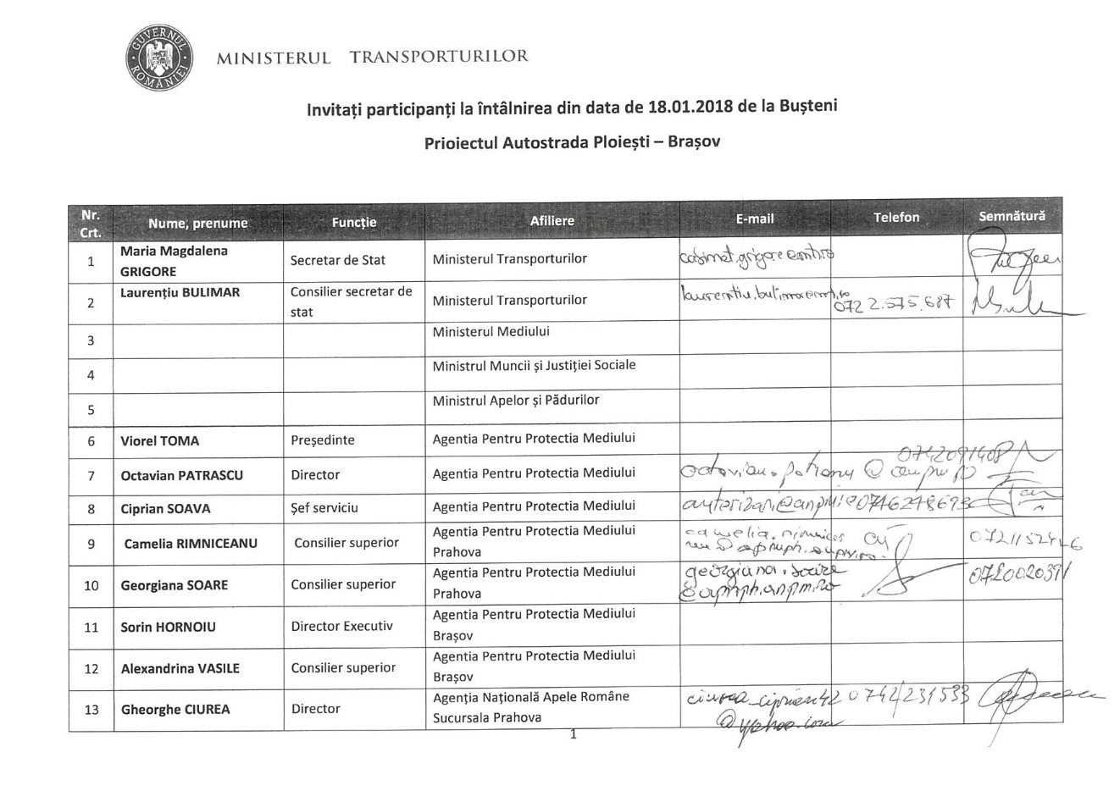
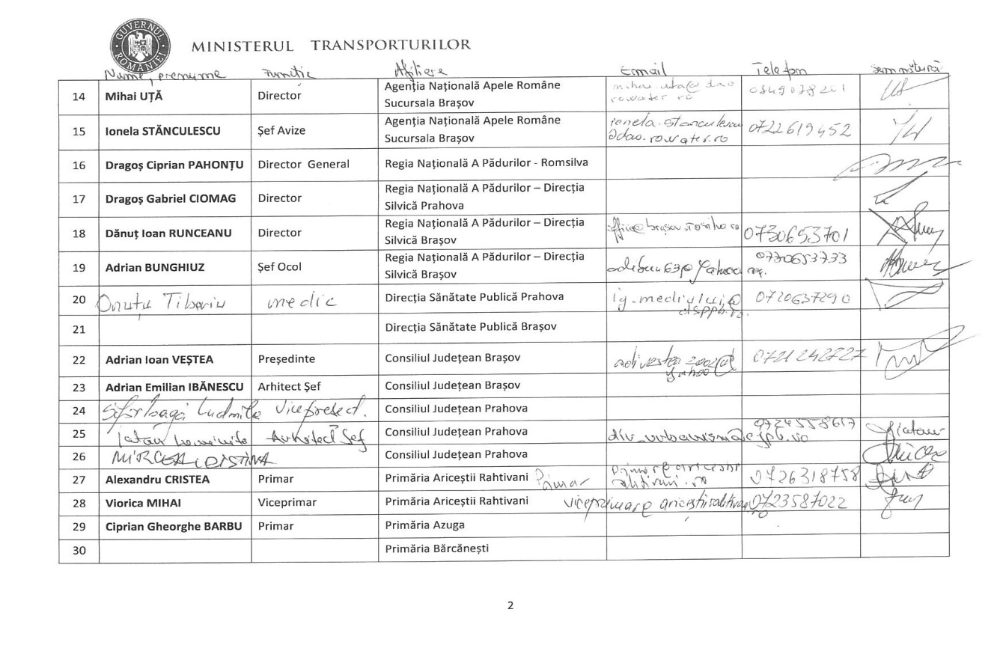

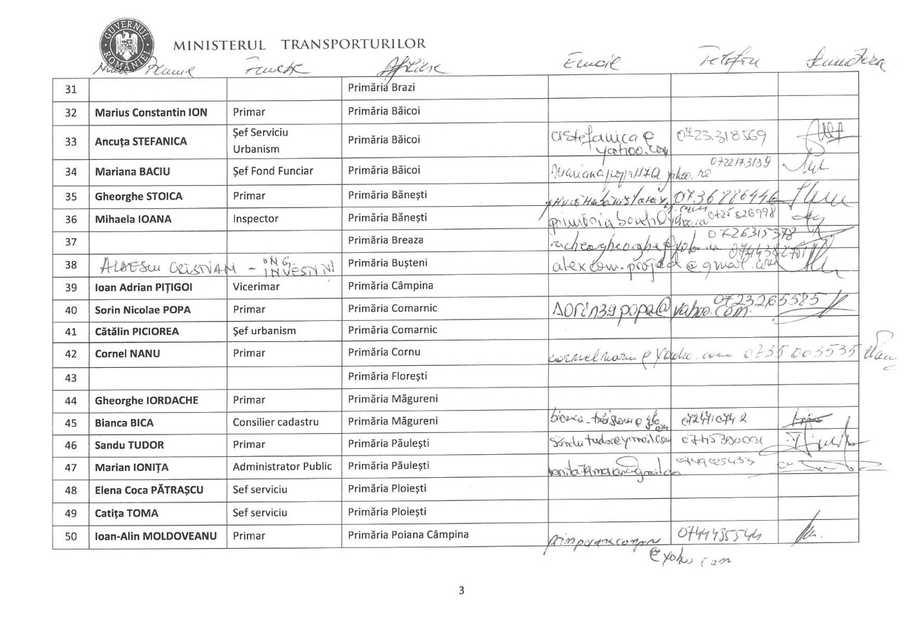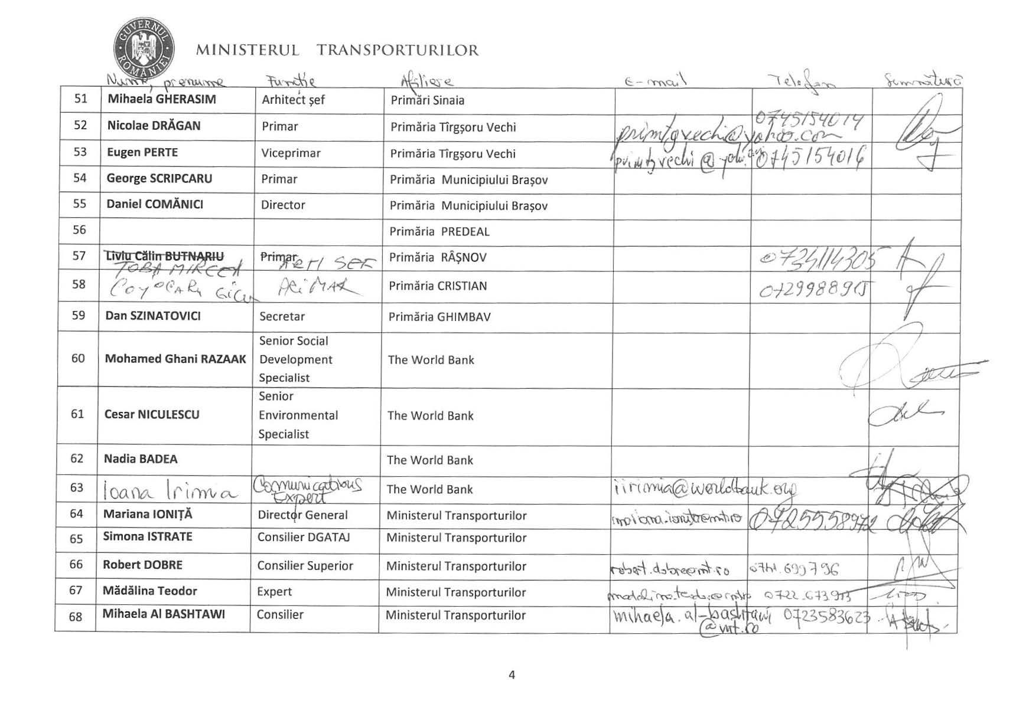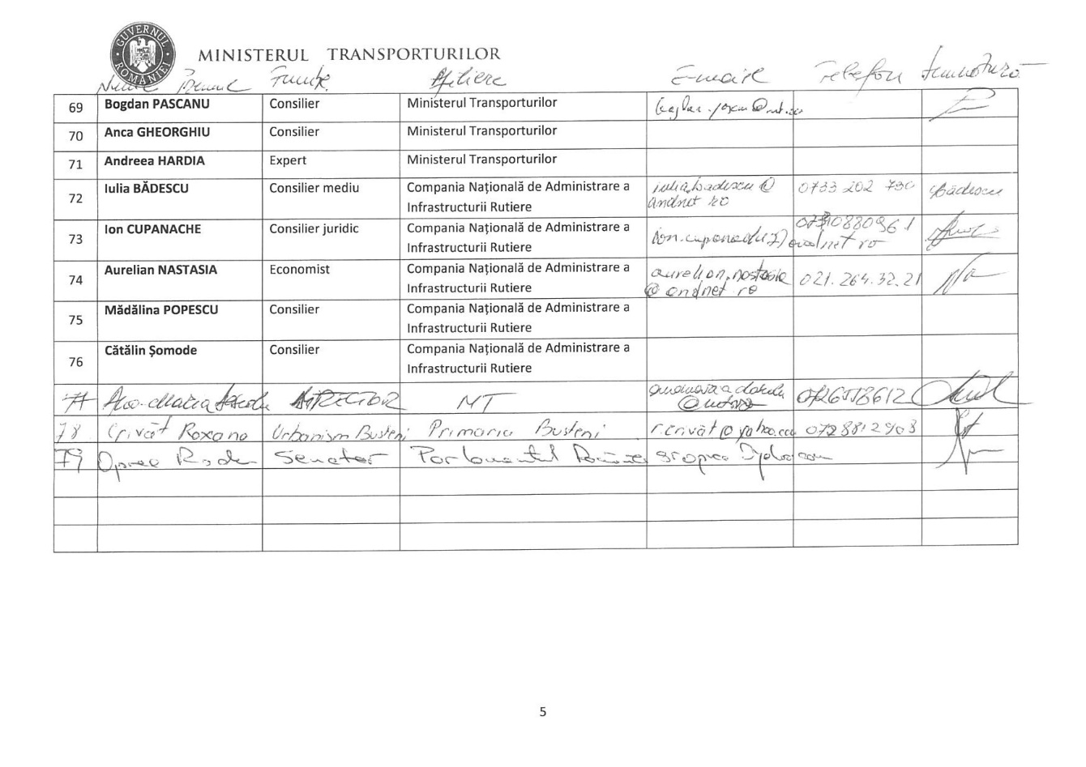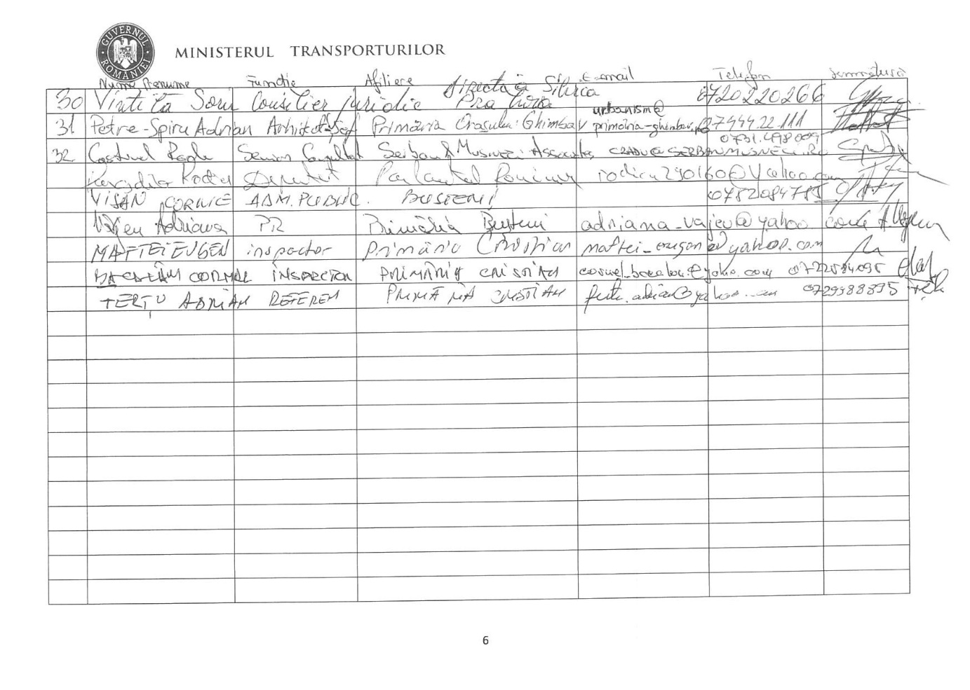
MINUTES
of the meeting held to continue the debate on the ToR concerning the assessment of the social and environmental impact of the project” Ploiești – Brașov Motorway”

DATE: 25 Jan. 2018, 11:00 hours
VENUE: Ministry of Transport, 1st floor, conference room No. 29 right
PARTICIPANT:
Ministry of Transport (MT):
Maria Magdalena GRIGORE, State Secretary
Laurențiu BULIMAR, HR Adviser
Mariana IONIȚĂ, Director (Directorate for Investment, Technical Regulations, and Building Permits)
Robert DOBRE, Senior adviser (Directorate General for Management and Strategy)
Mădălina TEODOR, Expert (Directorate General for Management and Strategy)
Mihaela AL-BASHTAWI, Senior Adviser (Directorate for Investment, Technical Regulations, and Building Permits)

Compania Nationala de Administrare A Infrastructurii Rutiere S.A. / National Company for Roads Infrastructure Administration (CNAIR):
Ion CUPANACHE, Head of the Expropriation Service
Aurelian NASTASIA, Engineer
Marian MANEA, Head of (CESTRIN - Centre for Technical Road Studies and Information)
IULIA BĂDESCU, environment adviser

Prahova County Council:
CRISTINA MIRCEA (Directorate General for Technical and Heritage Matters)
Cristina MOGOȘ, Head of the Service (SPTUC service)

Mayors from several communities in Prahova county:
Gheorghe RICHEA, mayor of BREAZA
Ioan-Alin MOLDOVEANU, mayor of POIANA CÂMPINA
Alexandra NEAGU, Urban Planning Inspector – POIANA CÂMPINA mayor’s office
Didona CĂLIMAN, Chief architect, CÂMPINA mayor’s office
Roxana CRIVĂȚ, Urban Planning, BUȘTENI mayor’s office
George BARBU, mayor of AZUGA
Sorin Nicolae POPA, mayor of COMARNIC

Brașov County Council:
Adrian IBĂNESCU, Chief architect
Radu VOINEA, Head of Permitting

Mayors from several communities in Brașov county:
Liviu COCOȘ, mayor of PREDEAL
Adrian PETRE-SPIRU, Chief architect, GHIMBAV mayor’s office
Mircea-Sorin TOBĂ, Chief architect, RÂȘNOV mayor’s office
Eugen-Claudiu MAFTEI, urban planning inspector, CRISTIAN mayor’s office
Marius COMĂNICI, Executive Director, BRAȘOV mayor’s office
Cătălin PICIOREA, Head of Urban Planning, BRAȘOV mayor’s office

Ms. Director Mariana IONIȚĂ (MT) delivered the opening speech and referred to the analysis presented in the previous meeting in Bușteni, on 18 Jan. 2018.
Further on, Mr. Alin MOLDOVEANU, mayor of Poiana Câmpina, mentioned that the mayor’s offices of Câmpina, Poiana Câmpina, Cornu and Breaza wrote a joint letter to express their opinions and submitted it to the MT, asking the MT people to consider their letter.
[The letter was sent separately to the MoT and refers to a formal common request to include in the project for Ploiesti-Brasov highway a traffic junction (node) in the administrative area of these localities to serve them. This measure is considered as having a positive social and environmental impact on local communities – a very diverse development of those localities, with existing facilities for health, tourism, education, religious, with numerous small businesses, but also with available public or private land having a high potential for development and job creation.]
Mr. Laurențiu BULIMAR (Adviser to the MT) specified that MT would not provide new solutions, they would come from consultants to whom MT would send all of the viewpoints provided by the mayors’ offices and by the affected persons, and the tourist facilities and targets, the protected areas, cultural sites and historical monuments will be taken into consideration, as well as the usage of the mountain landscape (as it was specified in Bușteni, where somebody recommended to dig a tunnel) and also that the plan was to start working in March 2019 and divide the site in simpler field-based lots.
Mr. Sorin POPA, mayor of Comarnic proposed that works should start in Comarnic.
Mr. Robert DOBRE, (MT) reminded the participants that - according to the master plan - the priorities are the following: Comarnic, Azuga, Bușteni and Sinaia, with nodes on their ends, as belt roads, up to their integration with the motorway, and pointed that the traffic could be 1 x 1 (half-profile or mini-motorway), which - in the case of tunnels - would mean to have one gallery used in order to ensure the continuity of the routing. Bușteni belt road and Comarnic belt road could use the same space as the motorway.
Mr. Alin MOLDOVEANU, mayor of Poiana Câmpina, said that works should start in the Ploiești-Comarnic area and explained that there is room for the site facilities in this area, an opinion that Mr. Gheorghe RICHEA, mayor of Breaza, shared; mayor Richea added that the 2005 project had been considered that far when building permits were issued and that this project could be used in the future too, with some improvement.
In the meantime, two micro power plants had been built in (Gura Beliei and Nistorești), and for that reason the motorway should be built a little closer to the river and also a little closer to the point of entrance into Poiana Câmpina, where a water treatment plant is scheduled to be built with EU funds. This plant will server several communities in the area and has already been cleared by the MT.
Mr. Robert DOBRE (MT) asked to have the location of the treatment plant.
Mr. Marian MANEA (CESTRIN - Centre for Technical Road Studies and Information) mentioned that the Transgaz pipeline was considered too, since the current plant was authorised as early on as 2010.
Mr. Alin MOLDOVEANU, mayor of Poiana Câmpina, reminded about the general zoning plan, that was approved in 2014.
Mr. Marian MANEA, (CESTRIN) specified that in 2014 the motorway corridor was reserved, therefore the two Transgaz pipelines and the high voltage cables were taken into consideration, plus that consultation were held back then with the authorities of Comarnic and the local Office for Cadastre and Land Registration about the reserved corridor.
Mr. Gheorghe RICHEA, mayor of Breaza, explained that the micro power plant and the treatment plant are far apart. He also reminded about the weekend road traffic which is caused by the villa owners, most of which are people from Bucharest. He concluded that a new node was necessary to the South.
Mr. Marian MANEA, (CESTRIN) explained that this matter was taken into consideration.
Mr. Alin MOLDOVEANU, mayor of Poiana Câmpina, reminded the participants about the road connecting that area to Dâmbovița county, that had also been built with EU funds.
Mr. Gheorghe RICHEA, mayor of Breaza, said a new node was necessary between Breaza, Cornu and Câmpina.
He also specified that although the motorway corridor had been preserved as per the older zoning plan, the MT version presented by Mr. Robert Dobre was better.
So he proposed that the neighbourhoods should be connected to each other by means of a road built under the motorway. He raised the issue of the lakes that ensure the unsilting of the water and should not be damaged, therefore he proposed that the motorway should not be close to the railway from Nistorești onwards.
Mr. Robert DOBRE, (MT) said that the nodes should be within practicable distances from each other and that the current trend is to build nodes at closer distances in order for them to be able to serve local communities too. Yet these nodes will be substantiated by the traffic study reports. In any case, it will be more difficult to build the nodes later, when the motorway is used, than it is to build them at the very beginning.
All proposals (Poiana Câmpina – South, Bănești intermediate node) will be analysed by the consultant. Also, DN1 (with 2 or 4 lanes) will take over some of the traffic.
Mr. Alin MOLDOVEANU, mayor of Poiana Câmpina, said that the positive impact upon the development of the local communities need to be considered too, the connection to Dâmbovița county is important, too, because some of the traffic will be offloaded to Dâmbovița and - not lastly - the new hospital, which he considered to be of a Switzerland level...
Mr. Sorin POPA, mayor of Comarnic, started by reminding the audience that Comarnic was the gate to the chain of mountain resorts and that this community would become more modern to match the other communities on Prahova River Valley. Some land was expropriated in Comarnic too, based on a 2014 project.
Mr. Ion CUPANACHE (CNAIR), said that the land had been expropriated based on the 2006 feasibility study, in Comarnic entry and exit areas. He also reminded the audience that the same objections against the routing were made about Comarnic even back in 2006.
Ms. Maria Magdalena GRIGORE, Secretary of State, invited all participants to think of the issues/matters that the consultant should consider when they review the feasibility study. She also requested from participants to identify the alternative routes in order to offload the traffic and reassured the participants that all proposals would be submitted to the consultant that would be reviewing the 2006 feasibility study.
The 2006 corridor is the legal one until reviewed. It has a legal basis and has been cleared.
Some deviations from the original routing may be made, but the final version is not yet available.
The question for the time being is that what was it that the consultant should study?
All projects and proposals of local authorities will be considered.
Mr. Adrian IBĂNESCU, (Chief architect - Brașov County Council) reminded participants that a meeting had been held on Monday (22 Jan. 2018) to review what had been discussed in Bușteni. Both sides should be lenient. He concluded by saying that he would like to see this motorway ready before other motorways.
Ms. Maria Magdalena GRIGORE, Secretary of State, said that Ploiești-Brașov was a priority, alongside Iași-Tg. Mureș, and Ploiești-Bacău. All have to be done.
Mr. Adrian PETRE-SPIRU, Chief architect, of the Ghimbav mayor’s office mentioned that Ghimbav would like to see the initial routing maintained (the traffic should be offloaded into DN1 national road), and not stopped in Cristian.
Mr. Robert DOBRE, (MT) explained that the offload to DN1 stayed as planned and the subsequent development of the motorway to Sibiu had to be considered too, and that this one is just a temporary offload solution. Ploiești-Brașov will go beyond Brașov, not tapping the entire potential of the motorway would be a pity.
Also the traffic management will be very important during the entire implementation period.
Mr. Adrian IBĂNESCU, (Chief architect of the Brașov County Council) proposed to have an offload near Predeal (unplanned), and said that the offloads are very remote.
Mr. George BARBU, mayor of Azuga, considered that the problem of the heavy traffic between Sinaia and Predeal would not be solved, and that the issue at Predeal has to be treated very seriously. In addition to that, the expropriation corridor (as per the 2006 feasibility study) involves the demolition of about 40 houses in Azuga, that are located behind the railway station. If possible, no demolition should be involved. Unless the demolition may be avoided, what solutions could be found for the relocation and resettlement of the locals?
Other than that, Azuga is not affected since its axis is perpendicular on the motorway and no other projects are envisaged along that route. There is also the area of the Azuga hospital, which is not affected.
Azuga’s the narrowest gorge. The railway splits the motorway lateral areas and a site road has to be built for the machines. There is a site road along the railway, since the railway has been modernised.
Mr. Robert DOBRE, (MT) said the alignment of 2006 is pretty flexible, with some limitations.
Mr. Laurențiu BULIMAR (adviser to the MT) said the excavation tailings have to be evacuated and stored and solutions need to be found for that purpose (the storage capacity needs to be the double of the excavated volume). The site roads also need to be well designed.
Mr. George BARBU, mayor of Azuga said that it was important to have the coordinates of the corridor and that there is a project to build an industrial park in the future, which cannot be developed unless the corridor location is unknown. Ultimately, he said Azuga did not have a node to the motorway.
Mr. Liviu COCOȘ, the mayor of Predeal, said Predeal wanted to be connected to the highway. He explained the connection was needed because of the skiing area and the biathlon track (to Râșnov, on the left-hand side).
Mr. Marian MANEA, (CESTRIN) said these matters had been considered when the studies were conducted in 2014.
Mr. Eugen MAFTEI, Cristian mayor’s office, said the contractor had requested a building permit for the Râșnov-Cristian motorway segment. Yet the local council does not agree to the proposed solution because the solution involves splitting some land perimeters that will not have access to the roads.
Ms. Mariana IONIȚĂ (Director in MT) said the World Bank had requested information about all segments that were under construction.
Mr. Mircea TOBĂ, chief architect of Râșnov, said the 2006 routing was located close to Postăvarul - Cheile Râșnoavei protected area. The current routing is unknown (the 2014 version did not involve a vicinity with Trei Brazi).
He also mentioned a Zoning Plan that had been approved (with CNAIR’s clearance, on the 2006 routing) based on which a building permit was requested now.
Mr. Robert DOBRE, (MT) said that the current proposals tried to avoid the protected areas. Some of the proposals - on the left-hand side of Râșnoava Valley - reached the same point, to the South.
One of the recommendation was to also have a look at the Southern slope.
Another problem was that the current routing divided that community into two areas and that the motorway was as near to houses as 30 meters, in some areas.
The recommendation was to move it westwards. That Proposal was written and would be submitted to the MT.

CONCLUSIONS:
Further to the discussions, the MT would centralise the remarks and proposals and would submit them to the future consultant.

Annex 2
EU Road ESIA guidance
EBRD Road construction guidance
Appropriate IFC ESHS guidelines to be listed from
http://www.ifc.org/wps/wcm/connect/topics_ext_content/ifc_external_corporate_site/sustainability-at-ifc/policies-standards/ehs-guidelines
IFC Environmental, Health, and Safety Guidelines for Toll Roads
Previous feasibility design proposals
Preliminary ESIA Studies – (Report to the Environmental Impact Assessment Study drafted by Ecoterra in 2006, Study on analysis of permeability and connectivity of large carnivore populations in the Bucharest - Brasov Motorway – drafted by Forest Research and Development Institute in 2008, Presentation report for project modification drafted in 2016 available at the following link: http://www.anpm.ro/documents/12220/2231306/Memoriu+de+prezentare+05+09+2016.pdf/63901ac3-23f3-4933-be7e-1a646927c488, presentation report for project modification drafted in 2013 available at the following link: http://www-old.anpm.ro/upload/97852_Completari%20la%20Memoriu%20de%20prezentare-titular%20CNADNR.pdf
All previous maps
MANAGING THE RISKS OF ADVERSE IMPACTS ON COMMUNITIES FROM TEMPORARY PROJECT INDUCED, 2016
Example ESIAs

The final draft TOR was subject to public disclosure on the MoT’s website and distributed to the local communities potentially affected by the project; it was also subject to disclosure on the Bank’s website. Subsequently, MoT organized on January 18 and 25, 2018 two public consultations meetings in Busteni and Bucharest for debating the final draft TOR for ESIA – see Annex 1. The actual TOR represent the FINAL version which incorporates in annex the minutes of public consultations carried out by the MoT, and the Consultant is requested to take into consideration all the information presented/asked that is relevant to the ESIA content and analysis.
The consultations meeting in Busteni was announced on the MoT website, and also through mails sent by MoT to all local administration authorities within the project’s corridor, and to other interested parties.
The consultations meeting at the Ministry of Transport was announced through mails sent by the ministry to all local administration authorities within the project’s corridor, and to other interested parties.

