Report No. 39885 – EG
Arab Republic of Egypt
Poverty Assessment Update

(In Two Volumes)

Volume II: Annexes

September 16, 2007
Ministry of Economic Development
Government of the Arab Republic of Egypt


Social and Economic Development Group
Middle East and North Africa Region
The World Bank

Document of the World Bank

Currency Equivalents
(Exchange Rate as of September 10, 2007)


Fiscal Year
July 1- June 30

Vice President: Daniela Gressani
Country Director: Emmanuel Mbi
Sector Director: Mustapha Nabli
Sector Manager: Miria Pigato
Task Team Leader: Sherine Al-Shawarby

ANNEXES

Methodology
Tables
Figures
Table of Contents
Annex Methodology, Data and Sampling 1

Annex 1.1: Household Income, Expenditure, and Consumption, Survey-
Data and Sampling Design 1
A. HIECS Sample Design.. 1
B. The HIECS Questionnaire: 3
Annex 1.2: Community Survey 4
Annex 1.3: Estimation of Household Specific Poverty Line 5
Annex 1.4: Developing a Poverty Map 7
A. The Consumption Model 8
B. Model Application….. 9

Annex 2.1: Assesment of Vulnerability to Poverty…………………………………………..13

Annex 3.1: The Empirical Framework of Estimating the Welfare Implications
of the Depreciation Induced Inflation 14
Step 1: Estimation of the Pass-Trough Effect………………………………………………………14
Step 2: Estimation of the Welfare Effect of the Changes in Prices Induced by
Movements in the Exchange Rate…………………………………………………………….16
Annex 3.2: Methodology of Simulating the Poverty Path…………………………………. 17

Annex 4.1: Estimating Household Income Poverty 19
A. Identifying Household Characteristics Available in the HIECSs and the ELMSs 19
B. Estimating Per Capita Consumption Using the HIECSs Data…………………………………...19
C. Predicting Per Capita Consumption for the ELMSs Samples…………………………………....19

Annex Tables 20
Table A.1.1: Daily Caloric Requirments by Age, Sex and Location 20
Table A.1.2: Quantities and Calories Generated by the Reference Food Bundle 20
Table A.1.3 Cost of 100 Calories by Region 21
Table A.1.4: Sample Size of 1995/96, 1999/00 and 2004/05 Surveys 21
Table A.1.5: Regression Results (Dependent Variable ln Household Expenditure),
1995/96, Metropolitan 22
Table A.1.6: Regression results (Dependent Variable ln Household Expenditure),
1995/96, Lower Urban 23
Table A.1.7: Regression results (Dependent Variable ln Household Expenditure),
1995/96, Lower Rural 24
Table A.1.8: Regression Results (Dependent Variable ln Household Expenditure),
1995/96, Upper Urban 25
Table A.1.9: Regression Results (Dependent Variable ln Household Expenditure),
1995/96, Upper Rural 26
Table A.1.10: Regression Results (Dependent Variable ln Household Expenditure),
1995/96, Border Urban 27
Table A.1.11: Regression Results (Dependent Variable ln Household Expenditure),
1995/96, Border Rural 27
Table A.1.12: Distribution of Poorest 50, 100 and 200 Sub-Districts by Governorate, 1996 28
Table A.1.13: Distribution of Poorest 50, 100 and 200 Sub-Districts by Governorate,2006 29
Table A.1.14: Distribution of Poorest 100, 500 and 1000 Villages by Governorate, 1996 30
Table A.1.15: Distribution of Poorest 100, 500 and 1000 Villages by Governorate, 2006 31
Table A.2.1 (a): Poverty Measurements by Educational Attainment of Individuals, 2004-05 32
Table A.2.1 (b): Poverty Measurements by Educational Attainment of Individuals 2004-05 33
Table A.2.2 (a): Educational Status of Individuals by Region by Poverty Status, 2004-05 34
Table A.2.2 (b): Educational Status of Individuals by Region by Poverty Status 2004-05 35
Table A.2.3 (a): Poverty Measurements by Employment Status of Individuals, 2004-05 36
Table A.2.3 (b): Poverty Measurements by Employment Status of Individuals 2004-05 37
Table A.2.4 (a): Employment Status of Individuals by Region by Poverty Status 2004-05 38
Table A.2.4 (b): Employment Status of Individuals by Region by Poverty Status, 2004-05 39
Table A.2.5 (a): Employment Status of Labor Force by Region by Poverty Status 2004-05 40
Table A.2.5 (b): Employment Status of Labor Force by Region by Poverty Status 2004-05 41
Table A.2.6 (a): Poverty Measurements by Sector of Employment of Individuals 2004-05 42
Table A.2.6 (b): Poverty Risk by Sector of Employment of Individuals 2005 43
Table A.2.7 (a): Sector of Employment of Labor Force by Region by Poverty Status 2004-05 44
Table A.2.7 (b): Sector of Employment of Labor Force by Region by Poverty Status 2004-05 45
Table A.2.8 (a): Poverty Measurements by Economic Activity of Individuals 2004-05 46
Table A.2.8 (b): Poverty Measurements by Economic Activity of Individuals,2004-05 47
Table A.2.9 (a): Economic Activity of Labor Force by Region by Poverty Status 2004-05 48
Table A.2.9 (b): Economic Activity of Labor Force by Region by Poverty Status 2004-05 49
Table A.2.10 (a): Poverty Measurements by Employment Type of Individuals 2005 50
Table A.2.10 (b): Poverty Risk by Employment Type of individuals and by Region, 2005 51
Table A.2.11 (a): Type of Employment of Individuals in Labor Force by
Region by Poverty Status 2004-05 52
Table A.2.11 (b): Type of Employment of Individuals in Labor Force by
Region by Poverty Status 2004-05 53
Table A.2.12 (a): Poverty Measurements by Household Size 2004-05 54
Table A.2.12 (b): Poverty Measurements by Household Size 2004-05 55
Table A.2.13 (a): Distribution of Individuals by Household Size, by Region
and by Poverty Status 2004-05 56
Table A.2.13 (b): Distribution of Individuals by Household Size, by Region
and by Poverty Status 2004-05 57
Table A.2.13 (c): Poverty Risk of Households By Number of Children, by Region
and Poverty Status, 2005 58
Table A.2.14: Average Household Size by Poverty Status for 2004-05 and 1999-00 59
Table A.2.15 (a): Demographic Characteristics by Poverty Status and Region 2004-05 59
Table A.2.15 (b): Demographic Characteristics by Poverty Status and Region 2004-05 60
Table A.2.16: Poverty Measurements by Household Structure and Gender
of Household Head, 2004-05 61
Table A.2.17: Distribution of Individuals by Household Structure, by
Gender of Household Head and by Poverty Status, 2004-05 62
Table A.2.18 (a): Poverty Measurements by Gender of Household Head, 2005 63
Table A.2.18 (b): Poverty Risk by Gender of Household Head, 2005 64
Table A.2.19 (a): Distribution of Individuals by Gender of Household Head,
by Region and Poverty Status, 2005 65
Table A.2.19 (b): Distribution of Individuals by Gender of Household Head,
by Region and Poverty Status, 2005 66
Table A.2.20: Illiteracy Rate among Children of Age 12-15 Years Old by
Poverty Status and Region 2004-05 67
Table A.2.21: Percentage of Working Children Aged 6-15 Years by Poverty
Status and Gender, 2004-05 68
Table A.2.22: Net Enrolment Rate in Basic Education by Poverty Status and Gender 2004-05 69
Table A.2.23: Shares of Different Income Sources by Poverty Status and
Gender of Household Head 2004-05 70
Table A.2.24: Percentage Shares of Different Types of Transfers , Out of Total
Income, by Poverty Status and Gender of Household Head 2004-05 71
Table A.2.25: Percentage of Households with Public Amenities
Characteristics by Poverty Status 2004-05 72
Table A.2.26: Percentage of Households by Ownership of Durable Goods
and by Poverty Status 2004-05 73
Table A.2.27: Share of Various Expenditure Items to Total Expenditure by Poverty Status 2005 74
Table A.2.28: Fertility Rate and Under Five Mortality Rate by Poverty Status, 2004-05 75
Table A.2.29: Unemployment Rate of Youth (15-24 years) by Educational
Status and Poverty, 2005 75
Table A.2.30: Net Enrolment Rate by School Type and Poverty Status for
Different Levels of Education, 2004-05 76
Table A.2.31: Regression of Log Welfare Measure (Consumption/Poverty Line)
on Characteristics of Household and Household Head for 2004-05 and 1999-00 77
Table A.2.32: Impact of Changes in Household Characteristics and
Characteristics of the Household Head on Poverty 78

Table A.3.1: Exchange Rates and Consumer Prices, 2000-2005 79
Table A.3.2: Disaggregated Price Change 79

Table A.4.1: Estimated Per-Capita Region-Specific Poverty Lines (L.E. Per
Year) for 1999/2000 and 2004/2005 80
Table A.4.2: Employment Structure and Growth Rate by Type of
Employment, Sex and Urban/Rural Location, 1998-2006 81
Table A.4.3: Employment Structure and Growth Rate by Economic Activity,
Sex and Urban/Rural Location 1998-2006 82
Table A.4.4: Cross-Sectional and Longitudinal Method of Calculating the
Growth in Agriculture Wage and Agriculture Non-Wage Work
by Sex and Urban/Rural Location 1998-2006 83
Table A.4.5: Distribution of Real Monthly Earnings for Wage and Salary
Workers by Background Characteristics, 1988-2006 84
Table A.4.6: Distribution of Real Monthly Wage for Wage and Salary Workers
by Institutional Sector and Economic Activity, 1998-2006 85
Table A.4.7: Share of Low Monthly Wage Earners, Wage and Salaried Workers 1998-2006 86
Table A.4.8: Transition Across Low/High Earnings by Sex, 1998, 2006
from Wage Employment in 1998 to Wage Employment in 2006 87
Table A.4.9: Transition across Low/High Earnings by Institutional Sector, 1998, 2006 87

Annex Figures 88
Figure A.1.1: Predicted Poverty Rates at Village Level and Their Confidence
Intervals, in Rural Areas, 1996 88
Figure A.1.2: Predicted Poverty Rates at the Sub-District Level and Their
Confidence Intervals, in Urban Areas, 1996 88

Figure A.3.1: Distribution of Estimated Long-Run Exchange Rate Pass-Through
to Consumer Prices 89
Figure A.3.2: Direct Effects of Price Changes on Welfare (Compensating Variation
Calculated as Percent Change in Total Expenditure Required
to Purchase Initial Consumption Basket) 89

Figure A.4.1: Distribution of Real Monthly Earnings in Relation to a Low
Earnings Threshold by Sex, 1998-2006 (Using CPI) 90
Figure A.4.2:Distribution of Real Monthly Earnings in Relation to a Low Earnings
Threshold by Institutional Sector of Employment, 1998-2006 (Using the CPI) 91
Figure A.4.3: Distribution of Real Monthly Earnings in Relation to a Low
Earnings Threshold, 1998-2006 (Using the FPI) 92
Figure A.4.4: Distribution of Real Monthly Earnings in Relation to a Low
Earnings Threshold by Institutional Sector of Employment, 1998-2006 93

Annex Methodology, Data and Sampling

Annex 1.1: Household Income, Expenditure, and Consumption Survey- Data and Sampling Design
Egypt conducted household budget surveys since 1957/58. It was intended to perform these surveys every five years. But because of .unavailability of funds, these surveys were stopped for some time. Dates for these surveys are 1957/58, 1964/65, 1974/75, 19981/82, 1990/91, 1995/96, 1999/2000 and 2004/2005.
Household Income, expenditure and consumption surveys (HIECS) present the single most important source of information for poverty analysis. They record information on household income and consumption expenditures on more than 600 items of goods and services, and are therefore a good source of information on the distribution of welfare within the society. These surveys are particularly important because of their comparability, in terms of survey design and administration, and hence the opportunity they offer in making comparisons over time.
However, the three surveys are slightly different in terms of sample selection and topics covered by the questionnaires. But differences do not affect comparability of them.

A. HIECS Sample Design
The samples of the three surveys are stratified multistage random samples. The sample designs of all surveys were nationally representative and the size for both surveys is large enough to allow for inferences at the regional and governorate levels, with the exception of Border governorates where the sample size is small. Levels of bias and imprecision for both surveys are within statistically acceptable margins. Using the variance and mean expenditure of previous survey, it was estimated that the sampling errors in the 1999/2000 survey were 0.7 percent in urban areas and 0.9 percent in rural areas, with 95 percent confidence level.
The sample design is stratified, multistage design can be explained as follows: The master sample is stratified such that urban and rural areas are self-independent strata. Each strata (urban or rural) is divided into internal layers (being the governorates), with probability proportion to size from an updated population Census of the closest year. PSU’s (areas) were systematically selected, using sampling interval and a random start. Using maps, these areas were further subdivided into a number of chunks of about certain number of households each and one chunck is chosen randomly from each area. Household lists for the selected Chuncks were prepared. Finally, households were selected randomly from each chunk.

Sampling design of 2004/05 Survey
The 2004/05 HIECS sample is multi stages self weighted area sample of 1223 PSU of about 700 household each. Total PSUs were distributed among urban and rural areas using proportion to size criteria, and then Urban and rural PSUs were distributed proportionally between governorates. Thus each governorate is represented in the master sample; however the number of PSUs in Border governorates may be very small.
1
Selection of Primary sampling units
The first sampling stage is selecting a sample from villages from rural areas frame and Shiakh (or part of it) and capital of Markaz(district) from urban areas frame. Master sample of 1223 PSUs was distributed between urban and rural stratum such that the share of each stratum in PSUs equals its population share and assuming that there are 600 households in each PSU according to 1996 Census. However, some small villages were pooled together to ensure the required size of PSU (600 households). In urban areas, sub districts were arranged geographically using zigzag method to ensure balanced spread of the sample within each governorate. While, in rural areas illiteracy rate was used to arrange villages, where village in the first Markaz are arranged in descending order, then villages in the second Markaz were arranged ascending, and so on. Systematic sampling criteria was used in this stage.
The selected villages or sub districts were divided into small areas of similar number of households of 600, according to 1996 population Census, and then one area is chosen at random from each PSU. A list of all households within the selected area unit was prepared, where quick count showed that every selected area include about 700 households. A sample of 40 households was selected randomly from each area sampling unit.
Although the 1999/2000 and 1995/96 sampling designs were similar to that of 2004/05 sample, there are some differences; first the sample is self weighted within Urban and rural stratum but not at the national level; second the number of PSUs in 600 in 1999/00 and 500 in 1995/96, where 80 and 30 households were randomly chosen from each PSU in 1999/00 and 1995/96 respectively., see table A1.1.1 for sample size and distribution; and 1999/2000 and 2004/2005 HIECS were based on the1996 Census sample frames while 1995/96 sample was based on a 1993 update of 1986 Census data.
One interesting characteristic of the sample selection method is that all governorates in urban and rural areas are represented in each quarter (three successive months), thus sample surveyed during each quarter is also nationally represented and therefore no seasonal bias can be detected in any areas.
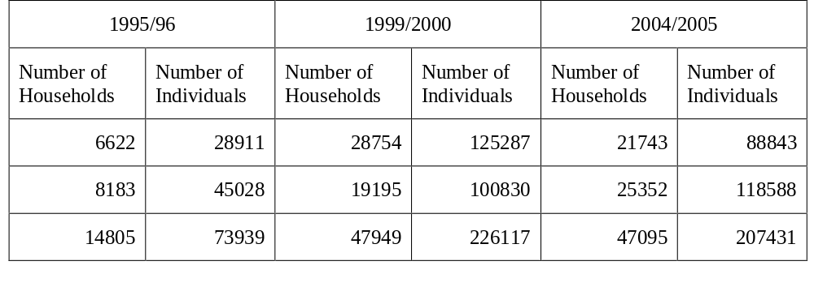
Table A1.1.1 Sample Size of 1995/96, 1999/00 and 2004/05 Surveys
Data of the 2004/05 survey was collected from July 2004 to June 2005, while data for 1999/00 and 1995/96 was collected from October of 1999 and 1995 to September 2000 and 1996, respectively.

B. The HIECS questionnaire:
The survey was administered over 12 months, with 10 visits to each household over a period of one month. This is the largest survey ever conducted in Egypt. The last three surveys of 1995/96, 1999/2000 and 2004/05 are highly comparable in terms of data collection procedures. The measure of total consumption used in this report is quite extensive and draws upon responses of several sections of the survey. Two survey forms were used in HIECS, a diary and a main questionnaire. Each household was visited ten times over the course of one month. The enumerator gave the household a diary in the first visit and asked the respondent to report each of the food expenditure items that the household makes every day, for a period of one month. The sum of the daily expenditure was then recorded in the main questionnaire at the end of the interview cycle. Expenditure of non food items were collected for the previous three month or the previous year depending on the type of commodity. The annualized sum of monthly or quarterly household expenditures was then used to construct the consumption basket for total annual household expenditures. Interviewers took down household demographic information at the first interview and household income at the last two interviews. In brief, consumption is measured as the total sum of food consumption (home produced and markedly purchased), total non food expenses, an actual or imputed rental value of housing.
The questionnaire consists of seven sections on a series of topics which integrate monetary to non monetary measures of household welfare and a variety of household behavioral characteristics. The first section is concerned about the basic information of all household members such as age, sex, relation to head of household, education and employment status. In the second section information on housing and basic amenities are collected. Possession of durable goods is reported in section three. Food consumption includes food which the household has purchased, grown and received from other sources for 279 items, where these data are reported in section four. Non food consumption is the sum of expenditure of 298 non food items, including expenditure on fuel, clothing, schooling, health, and several miscellaneous items. Information on consumption on non food goods and services is registered in section five. Section six is concerned with Transfer and credit expenditure, while income by detailed income sources is obtained from special income questionnaire. Although the three surveys follow the similar format almost exactly and total consumption definitions and recall periods are similar in all survey years, additional important information was collected in 2004/05 survey. Namely, first: in kind received goods were reported separately, second: information on school enrolment and household education expenditure on public or private education were reported, third: evaluation of the existing assets and changes in them were reported to allow for evaluating savings and dis-savings, and forth; the household questionnaire was supplemented by a community questionnaire as will be discussed below.
In terms of quality, the survey data can be judged “better than average”. The samples are nationally representative. They were randomly and systematically chosen, and a stratified multiple stage sampling was used. The sample size for the survey is large enough to allow for inferences at the regional and governorate levels, with the exception of Border governorates where the sample size is small. Levels of bias and imprecision for the survey are within statistically acceptable margins.
Annex 1.2: Community Survey

Integrated with HIECS, community data were also collected for all communities of PSUs in CAPMAS master sample of HIECS. Community data provided by the Community Survey include data on water and sewerage systems, health posts and schools and quality of agricultural land and main crops grown.
The Community Survey was administered in all 1223 PSUs of the CAPMAS master sample. However, satellite villages were considered as separate communities and thus the total number of communities in the rural sample was 1095 communities (mother or satellite villages) rather than 675 PSUs. Besides, there is no clear distinction between sub-districts (shiakha) in urban areas, so it was decided to collect information at the district (kism) level in urban areas. Thus, the total number of communities is 1390 communities from the master sample of CAPMAS.
The community questionnaire covers the following areas:
- Availability, accessibility, and quality of facilities in the community such as schools, health units, police stations, etc.;
- Availability, accessibility, and quality of infrastructure in the community such as potable water, electricity, sewerage system, etc.;
- Information on SFD interventions and other community interventions;
- Perceptions on community participation in the project. This section sought to characterize the community’s participation in the project cycle. Were they consulted? How? Were they able to make decisions? What type of decisions? Would they use the facility?
- Community perceptions on the impact of the project. This component sought to establish the community’s perception of the benefits and disadvantages of the project. The participants were asked to evaluate the priority (i.e. relative importance) and usefulness of the project, the quality of the installation, the benefits at household and community levels, and those received by neighboring communities.

Annex 1.3 Estimation of the Household Specific Poverty Line

The report follows the cost of basic needs methodology to construct household region-specific poverty lines. This methodology, which was adopted also in the World Bank 2002 report, takes into account: (i) ‘economies of scale’ within households – the fact that non-food items can be shared among household members; (ii) differences in non food consumption patterns and prices across regions in Egypt; and (iii) differences in ‘basic needs’ requirements of different household members – young versus old, male versus female.
For consistent poverty comparisons, this report adopts the same methodology in estimating food and non food basic needs. This method is outlined below. It was preferred to use different food baskets that reflect the consumption preferences of the second quintile of the year under consideration rather than using one food basket for both years and evaluated at the corresponding prices. In fact the period of 2000-2005 exhibited large increase in food prices following Egyptian pound devaluation on 2003, and the Government of Egypt responded to this change by subsidizing several pulses and grains. Price changes and subsidizing food items that are largely consumed by the poor, may have caused changes in consumption patterns, thus we preferred to use different food baskets that reflect consumption behaviour of the second quintile.

Household-specific poverty lines
Differences in poverty lines reflect variations in the food and non-food prices across the seven regions. They also incorporate household differences in the size, gender and age composition, and their food and non-food consumption preferences.

1. Caloric Requirements
The FAO has been concerned with the issue of determining the nutritional norms of individuals in different age and sex groups. These norms vary from country to country (and even amongst different groups within a country). Nutritional needs of individuals are the starting point to construct food poverty lines. It must be emphasized that these needs of individuals depend on several factors such as age, sex, location conditions and activity levels.
We first estimate minimum caloric requirements for different types of individuals. Using tables from WHO, caloric needs are separately specified for urban and rural individuals, by sex and 13 age categories. For individuals over 18 years of age, WHO's recommended daily allowances are differentiated by weight and activity levels. The estimates used in this paper assume the average weight of men over 18 years of age is 70 kg and 60 kg for women. Urban individuals are assumed to need 1.8 times the average basal metabolic rate and rural individuals are assumed to need 2.0 times average BMR. Thus, each household has its own caloric requirements depending on its location, age, gender decomposition, table (A.1).

2. Food Poverty Line
Once the minimum caloric needs have been estimated, the next step is to determine the cost of obtaining the minimum level of calories. Cost is determined by how the calories are obtained on average by the first two quintiles, rather than by pricing out the cheapest way of obtaining the calories or following a recommended diet. For the first two quintiles of households ranked by nominal per capita consumption, average quantities of all food items are constructed. Total calories generated by this bundle are calculated using calories contents in every food item. Table A.2 demonstrates quantities and calories generated by the reference food basket. These quantities represent the bundle used to estimate the food poverty lines, which reflect consumption preferences of the poor. The bundle was priced using unit prices prevailing in each region. Dividing cost of the chosen bundle by calories generated by it, the costs per calorie in each region were obtained Household specific food poverty line is derived by multiplying calorie requirements for all household members by relevant cost of calories. Food poverty line takes into account household gender and age composition as well as its residential region. Food poverty line is used define extreme poverty, where households whose total actual consumption are below their food poverty lines, are considered ultra poor.
This stage can be explained mathematically as follows: let Z denote the actual food consumption vector of the reference group of households initially considered poor; first two quintiles. The corresponding caloric values are represented by the vector k, and the food energy intake of the reference group is then k_{z} = k.Z'. Let cost of this bundle for region r is P_{r} , and caloric requirements of household h is C_{h}, thus the cost of one calorie in region r is given by (k_{z} /Pr). Food poverty line for household h is then given by (k_{z} /Pr)* C_{h,} thus the relative quantities in the diet of the poor are preserved in setting the poverty line. Table A.3 shows regional cost of 100 calories generated by the reference bundle.

3. Non food Poverty Line
While the cost of the minimum food bundle is derived from estimated physiological needs, there is no equivalent methodology for determining the minimum non-food bundle. Following Engel’s law, food shares are regressed against logarithm of total household expenditure relative to food poverty line and its square, logarithm of household size and its square, share of small and older children, share of adult males and females, and share of elderly.
That is , (1)

Where s_{i} denotes food share of household i, x_{i} is its actual consumption, z^{f} if the food poverty line and h_{i} is vector of household demographic characteristics.
The non-food allowance for each household can be estimated in two ways: (i) regressing the food share against total expenditures and identifying the non-food share in the expenditure distribution of households in which expenditure on food is equivalent to the food poverty line; or (ii) by identifying the share of non-food expenditure for households in which total expenditure is equivalent to the food poverty line. The former approach yields an “upper” bound of the poverty line, while the latter yields a “lower” bound, since it defines the total poverty line in terms of those households which had to displace food consumption to allow for non-food expenditures, considered to be a minimum indispensable level of non-food requirements. Thus lower poverty line =(2-S_{i})*Z_{f} (2).
Upper poverty line is obtained by solving equation (1) iteratively.
By this approach household regional specific poverty lines are estimated (households with the same gender and age composition in each region have the same poverty lines). Obviously this approach takes into account location, age and gender composition as well as economies of scale; as food shares and hence non food estimates vary according to household size, age and gender composition. Hence differences in food shares result from the addition of members of specific age and gender. The sharing behaviors among household members are also reflected.
Annex 1.4 Developing a Poverty Map

Poverty maps, as developed by Elbers et al. (2002), are based on a statistical procedure that combines both household survey data with population census data. On the one hand, household surveys provide statistically reliable spatial estimates of consumption (as an indicator of welfare) at the regional level, separately for urban and rural areas. On the other hand, the extensive coverage of the census, which does not contain any information on consumption, provides more disaggregated data. The Elbers et al. (2002) statistical procedure also allows for heteroskedasticity in the household component.

In a nutshell, survey data are first used to estimate a prediction model for consumption and then the parameters are applied to census data to derive an imputed value for consumption, employing a set of explanatory variables which are common to the survey and the census. This allows defining a set of welfare indicators based on consumption such as headcount poverty. Finally, the welfare indicators are constructed for geographically defined subgroups of the population using these predictions. Although the approach is conceptually simple, properly accounting for spatial autocorrelation in the first stage model and estimating standard errors for the welfare estimates requires additional elaboration. Although the approach is conceptually simple, properly accounting for spatial autocorrelation in the first stage model and estimating standard errors for the welfare estimates requires additional elaboration.

The Method in Details:
The method in this study can be thought of as being divided into three stages that occur in sequence. The three-stage procedure is implemented using HIECS 1995/96 data and Census 1996 data. The first stage in the poverty mapping exercise involves a rather painstaking comparison of common explanatory variables across the household survey and the population census. A concurrent exercise that was carried out in parallel to the exercise described above is the compilation of a database at a level of aggregation higher than the household, which can be inserted into the household level census and the household survey databases. The two tasks described above yield a good and reasonably large set of common household-level variables, supplemented by a series of additional variables at a slightly higher level of disaggregation. A set of common variables to both the survey and the census is selected. Using the household survey and the variables selected in the first stage, the second stage analysis involves the econometric estimation of models predicting household consumption on the set of household-level and community variables. Each region was treated separately thus seven models are built for the seven regions. Tables A1.5 to A.1.11 provide the semi-log models of household expenditure in the seven regions of Egypt based on HIECS 2004/2005 Survey. Successful completion of the second-stage analysis permits one to take the parameter estimates and attendant statistical outputs to the third stage. The estimated parameters are transferred to the data from the population census to simulate the consumption level of each and every household enumerated in the population census. The simulated household consumption is then used as the basis for calculating poverty and other welfare indicators at a variety of levels of spatial disaggregation. Statistical precision of the welfare estimates is also gauged in this stage. Finally, the welfare indicators are constructed for geographically defined subgroups of the population using these predictions. Once the poverty map exercise has been completed for all regions in the country, the resulting databases which provide estimates of poverty and inequality (and their standard errors) at a variety of levels of geographic disaggregation can be projected onto geographic maps using GIS (Geographic Information Systems) mapping techniques.

When inspecting these maps it should be kept in mind that they have been created using the expected headcount. The true headcount for a location will differ from the expected headcount because of sampling and modeling error. One of the key advantages of poverty maps technique is that estimates of welfare are obtained, but also standard errors associated with those estimates are derived. A general impression of overall precision levels can be gauged from Figures 4.4 and 4.5. To show what precision can be achieved at the sub-district level/ village, Figures 4.4. and 4.5. show the village/sub-district level predicted poverty headcount, using along with brackets giving confidence interval; two standard error below and two standard error above the point estimate.

A. The Consumption Model
To estimate household consumption levels, a standard reduced-form framework in which log household consumption is regressed on household characteristics, including human and physical capital, as well as on community-level characteristics. Community characteristics are specified at the village level. The HIECS contains a limited but important set of variables that can be used to explain households' consumption levels. Variables include demographic variables, variables that characterize the household's human capital such as literacy rates, employment variables such as agricultural employment, housing characteristics and the availability of basic amenities. The final specification included only those variable that were significant at least at 95 per cent. The resulting residuals are then checked to see if there are some outliers in the observation. The location residuals were then regressed on a set of census means at village level. A selection criterion of significance at 95% was applied. Following the inclusion of these additional variables, the GLS (Generalized Least Squares) regression was re-estimated in order to reduce the size of the location effect.
Following Elbers et al. (2001, 2002), the empirical model of household consumption is defined as 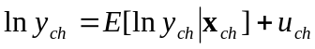 (1), where Ln 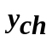 is the logarithm of consumption of household h in village c, 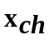 is a vector of observed characteristics of this household (including village level variables), and 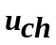 is the error term. Note that is uncorrelated with .
This model is simplified by using a linear approximation to the conditional expectation 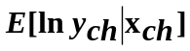and decomposing into uncorrelated terms 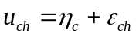 (2), where 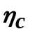 represents a village level error term common to all households within the village, and 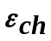  is a household specific error terms. It is further assumed that the are uncorrelated across villages and are uncorrelated across households.
With these assumptions, equation (1) reduces to 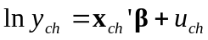 (3). Estimation of the parameters underlying this equation, in particular the vector of parameters  and the distributional characteristics of the error terms, can be done by using standard tools from econometric analysis (see Elbers et al., 2002).
The consumption model specification in equation (3) allows for an intra-village correlation in the error terms. Household income or consumption is certainly affected by the location where the household lives. Even though has some variables representing village level characteristics, it is quite plausible that some of the location effects will remain unexplained. The consequence of failing to take into account this within-village correlation of the error terms can result in biased welfare estimates and will generally lead to underestimation of standard errors of welfare estimates.
As mentioned above, the estimate of for each cluster in the census dataset is not applicable, therefore we must estimate the deviation of 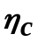. Taking the arithmetic expectation of (3) over village c 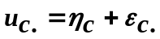 (4), hence . Assuming and are normally distributed and independent each other, Elbers et al gave an estimate of variance of the distribution of the location effect:
(5).
When the location effect does not exist, equation (3) is reduced to 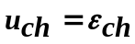.

B. Model Application
This section outlines the stages and procedures implemented in applying the model to obtain poverty maps for governorate, district, sub district and village/city levels. Five models were estimated, separately, for the five regions.

Stage 1: Matching Variables in the Survey and the Census
In order to obtain rigorous estimates of consumption levels of the households in the census, the explanatory variables selected in the consumption determination model have to exist and are measured in the same way in both the household survey and in the census. If the sample of the household survey was randomly selected and nationally representative, the distribution of each explanatory variable in the household survey can be expected to be the same as its distribution in the census.

Stage 2: Selecting Explanatory Variables for the Consumption Model
The procedure in selecting the explanatory variables of equation (3) starts by running a regression of log consumption on the matched variables identified in Stage 1, plus some variables that can be created from those variables such as the square of household size or the square of age of household head. In order to obtain a robust specification, variables are only selected for inclusion in equation (3) if they contribute significantly to the explanation of (log) household consumption. Hence variables with low t-values are dropped.
After the appropriate set of variables has been selected in this way, the regression is run again and the residuals of this regression are saved. These residuals need to be scrutinized to check if there are some outliers in the observation. If indeed there are some residual values which are far out of the range of most residual values, then these observations must be checked for coding or other errors. Ultimately it may be necessary to delete them from the data. Fortunately, this is extremely rare.
The next step is to select village-level independent variables to complete the consumption model specification. The village level variables are obtained from either the census data aggregated at the village level (for example the total number of individuals in the population or means of age of household heads in each village). These variables are then grouped into several sets such as demographic variables, village infrastructure variables, and village economic variables.
The residuals of the last regression are then aggregated at the village level to calculate the mean of these residuals for each village. The variable selection is then done by running separate regressions of the village-level mean of residuals on each set of the village-level variables. The variables with significant t-values are selected as the candidates for inclusion in the consumption model.

Stage 3: Estimating the Consumption Model
The result of stage 2 is a complete specification of the consumption model, incorporating both household-level and village-level independent variables of the model. The next step is to test whether there is heteroskedascity in the data. This will determine the method to be employed to estimate the model. The first step to do this is to estimate the model of equation (3) using Ordinary Least Squares (OLS) and save the residuals as a variable 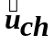 .
Based on equation (2) the residuals  are then decomposed into uncorrelated components as 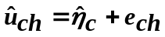. To investigate the presence of heteroskedasticity in the data, a set of potential variables that best explain the variations in 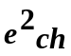 are used to estimate the following logistic model 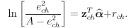 (6) where A set to equal 1.05*max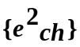 as in Elbers et al., (2002). This specification puts bounds on the predicted variance of 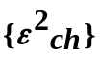.
In the case where homoskedasticity is rejected, a household specific variance estimator for 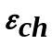is calculated as 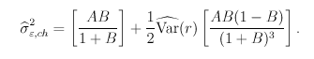 (7) where 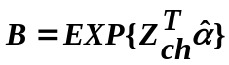.
The result from above indicates a violation of assumptions for using the OLS in model (3), so a GLS regression is needed. In GLS the variance-covariance matrix is a diagonal block matrix with structure:
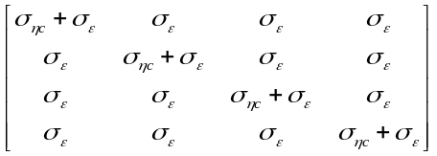 (8).

Overall, the procedure for estimating the consumption model of the poverty mapping computation can be listed as:

- Estimate model (3).
- Calculate the location effect (2).
- Calculate the variance estimator 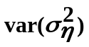 (4).
- Prepare the residual term for estimating model (6).
- Estimate GLS model with (8).

- Use a singular value decomposition to break down the variance-covariance matrix from previous step. This will be used for generating a vector of a normally distributed random variable such that the joint variance-covariance matrix will be in the form of (8).
- Read in census data, eliminate records containing missing values, generate all census variables needed for models (2) and (6).
- Save all datasets needed for the simulation.

Stage 4: Simulations on Census Data
The purpose of this procedure is to apply the parameters estimated in the previous procedure to the census data. However, since the values of these parameters are obtained through estimations, they are not the precise values of these parameters and subject to sampling error. This needs to be taken into account in applying the parameters to the census data by taking into account the sampling error of the coefficient estimates.
To start, recall that the purpose is to calculate the simulated version of equation (3): 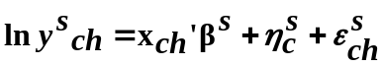, (9) where the superscript s refers to simulated version of each parameter or variable and now refers to characteristics of the households in the population census data.
Simulation of 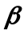
The simulated value of  is obtained through a random draw, assuming
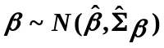. Note that the draw has to take into account the covariance across’s. The randomly drawn parameter is defined as 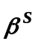. The next step is then to apply this simulated parameter to each household in the census data to calculate the value of 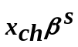.
Simulation of
The process of obtaining the simulated value of  requires two steps of simulations. This is because the variance of 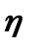 itself is estimated with error. Hence, the first step is to obtain the simulated variance of 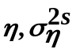. Elbers et al. (2002) propose to draw 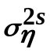 from a gamma distribution 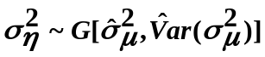. Accordingly, a random draw of the variance for the whole sample is exercised and its mean is defined as . Then the second step is to randomly draw 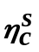⬅ for each village in the census data, assuming 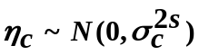.
Simulation of 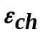
The process of obtaining the simulated value of  requires the use of the results of estimation of equation (6). Assuming 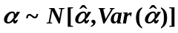, a random draw of  is made and defined as 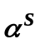 . Like in the case of , the draw has to take into account the covariance across’s. The simulated parameter is then used to simulate the household specific variance estimator for  as defined in equation (7) for each household in the census data. Finally, the simulated value of household specific idiosyncratic shock, 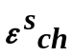 for every household in the census data is obtained by taking a random draw, assuming 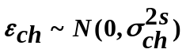.
Collecting
Now all the three components of equation (9) have been simulated, the value of 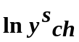 for all households in the census data can be calculated by summing up the values of 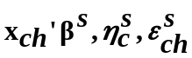 that have been obtained. The whole set of simulations is then repeated a number (100) of times, so that in the end a database of 100 simulated values of (log) household expenditure of all the households in the census data is created.

Stage 5: Calculation of Poverty and Inequality Indicators
The final output of stage 4, a database of 100 simulated values of household expenditure of all households in the census data, is used as the basis for calculating various poverty and inequality measures at the provincial, district, sub-district, and village/city levels. The point estimate of each measure is the mean of the calculated measure over the 100 simulation values. Meanwhile, the standard error of this estimate is equal to the standard deviation of the calculated measure over the 100 simulation values.
ANNEX 2.1 Assessment of Vulnerability to Poverty

To assess the vulnerability of households in Egypt we rely on a two-step approach. Let welfare measure (total household consumption deflated by poverty line). W_{i} be a function of household characteristics X_{i} and assume that W_{i} is log-normally distributed. In the log form:
ln(W_{i})=X_{i}β+ε_{i}, (1)
where ε_{i} is a normally distributed error term. Then the probability of household i to be poor, or, in our definition, the vulnerability of household i is
V_{i}=prob(ln(W_{i})<0))=Φ((- X_{i}β)/σ), (2)
where Φ is a standard normal distribution function. Thus, in the first stage we model the determinants of household consumption in the form of equation (1). In the second stage, we simulate the effect of the covariates from the consumption regression on the probability that a household will be poor. The poverty profile presented in the previous section provides guidelines for the selection of the potential variables to be included in this regression.
It was assumed that vulnerability can be affected by four sets of variables : education, employment, demography and housing characteristics, such that policy implications of educational investments, employment patterns, and investment in family planning can be evaluated. The set of explanatory variables includes household size, household demographic variables, shares of individuals with university degrees and illiterate household members, share of unemployed, characteristics of the household head that include gender, age, age squared, and a set of dummies for the head’s educational level as well as working status and sector of employment. We run separate regressions for four urban and three rural regions of Egypt. Similar to Datt and Jolliffe (1998) we use a fixed effect regression specification on region level to correct the bias in the estimated coefficients due to potential endogeneity or omitted variable bias. Local characteristics, such as the degree of infrastructure development, geographical location, fertility of land, etc., while not registered in our data, might affect the level of consumption of the households living in particular locality. Omitting these variables in our specification could lead to inconsistency of parameter estimates. The fixed effect specification should control for this type of omitted variable bias.

Estimation of Household Welfare
Two models were estimated for 2004/2005. The first includes households' socio economic characteristics as well as housing conditions, while in the second model, the characteristics of communities where households live, were also used as explanatory variables. The first model was used to compare results of 2004/05 survey with 1999/2000 and 2004/05 surveys.
Table A.2.31 demonstrates the results of regression for years 1999/2000 and 2004/05. Most of the variables were highly significant (except the gender and out of human force variables) and adjusted R2 exceed 50 percent. Table A.2.32 shows the mean and standard deviation of all the variables included in the model.

ANNEX 3.1 The empirical framework of estimating the welfare implications of the depreciation induced inflation

A two-step methodology was adopted. The first step consists of isolating the component of observed price changes during this period that are due to the depreciation for 160 different price indices. Disaggregation of the exchange rate pass-through to this level is important, as there is considerable heterogeneity across commodities in the response of domestic consumer prices to the exchange rate. The second step was to then bring the estimated price changes due the depreciation for each of these 160 different price indices to the household survey for Egypt, to investigate their welfare effects.

Step 1: Estimation of the Pass-Trough Effect
Monthly disaggregated data on the consumer price index are used to calculate “pass through estimates”. Because of difficulties in mapping the expenditure items in the CPI to the household survey, a somewhat more aggregated set of 20 of these expenditure items that correspond to expenditure categories in the household survey are used. The consumer price of item i in region r in month t is modeled as follows:
(1) | 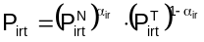
where P^{N} denotes the price of the non-traded component and P^{T} denotes the price of the traded component of that item. To simplify notation, the non-traded component captures both purely non-traded goods within this item, as well as non-traded distribution costs associated with the traded goods. Accordingly P^{T} is considered as the price of imported goods "on the dock" in Egypt. Concretely, one of the disaggregated items is fruit. P^{T} would therefore be the price of imported fruit "on the dock", while P^{N} is a price index of non-traded fruit as well as the distribution costs associated with both kinds of fruit.
Following the large empirical literature on exchange rate pass-through, the logarithm of this import price is modeled as a linear function of the log exchange rate and a measure of foreign marginal costs of production:
(2)
where E is the exchange rate, C is a proxy for foreign marginal costs, and u is an error term that I assume is independent of the exchange rate. No direct measure of foreign marginal costs of production disaggregated by product is available. An aggregate foreign cost variable, which is a trade-weighted average of the monthly producer price index in Egypt's five largest trading partners for which this data exist, is introduced. The extent of foreign cost pressures on export prices is made to vary by product and region. β₁(L) and β₂(L) are polynomials in the lag operator, so that current and lagged values of the exchange rate and foreign costs are allowed to affect import prices in order to capture slow adjustment.
Taking log differences of (1) and using (2) gives the growth rate of the consumer price as a function of the growth rate of the exchange rate:
(3)
The effect of current and lagged changes in the exchange rate on consumer prices is given by , and this is the key parameter of interest for this section. It is important to note that the sensitivity of consumer prices to the exchange rate is likely to be substantially smaller than the sensitivity of border prices to the exchange rate. This is because consumer prices contain a substantial non-traded component, both in the form of non-traded items themselves, as well as distribution costs. Not have direct information on the size of these distribution margins is available in the case of Egypt, although in principle these can be extracted from input-output tables for Egypt. In industrial countries, these distribution margins are typically quite substantial, averaging 30-50 percent of the prices paid by consumers (Campa and Goldberg (2006).
To address this problem an assumption is made that the growth rate of the non-traded component of the price of each item in each region consists of a common component and an idiosyncratic component that is orthogonal to movements in the exchange rate:
(4) | 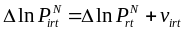
Another assumption is the common component of non-traded goods prices can be approximated by a simple average of a few items in the consumer price index that appear to be primarily non-traded on a priori grounds. These are Domestic Services, and Restaurant and Hotel Services. These two assumptions (of a common component in non-traded goods prices, approximated by these two particular prices) are clearly strong ones and open to debate. However, it is not clear what good alternatives might be available.
In any case, denoting the growth rate of the simple average of these items in each region as 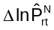, the following empirical specification is obtained:
(5)
where 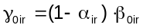 is the intercept; 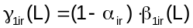 captures the effect of the exchange rate on consumer prices; 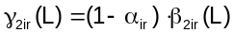 captures the effect of foreign costs on consumer prices; captures the contribution of changes in non-traded goods prices; and is the error term. Equation (5) is estimated by ordinary least squares.

In practice, all growth rates are measured as monthly observations on quarterly log differences, and it was allowed for 3, 6, and 9 month lags of these growth rates in the estimation. Since monthly data from July 2000 through July 2005 are available, this gives 60 monthly data points on which to estimate this specification for each item and region.

Step 2: Estimation of the Welfare Effect of the Changes in Prices Induced By Movements in the Exchange Rate
The next step is to take the estimates of the changes in prices induced by movements in the exchange rate and calculate their welfare effects in terms of the compensating variation (a standard measure of welfare effects of price changes).
To do this, we bring the estimated price changes due the devaluation for each of these 160 different price indices to the household survey for Egypt. This way we are able to empirically construct estimates of the compensating variation associated with these price changes for each household. In particular, we estimate how much higher (or lower) each household's total expenditure would have to be in order to attain the pre-devaluation level of utility at post-devaluation prices. This compensating variation consists of two parts. The first is the change in the cost of households' initial consumption bundles as a result of devaluation-induced price changes. Considering only this direct effect would overstate the welfare effect of the price changes because it does not take into account how households change their spending patterns in response to price changes. If households can substitute away from goods that become relatively more expensive, then the direct effect of the price changes will exaggerate the welfare effects since it assumes no such substitution is possible. Therefore, there is a second component that captures changes in household behavior in response to these price changes. Estimating these substitution effects is therefore important, although substantially more involved for two reasons. The first is data limitations that would make results somewhat difficult to interpret. The second is that we need an estimate of substitution effects in response to depreciation-induced price changes, not one of substitution effects in response to overall price changes.
The poverty line is compared to the counterfactual "post-depreciation" distribution of expenditure, to calculate the proportional change in the headcount between the two distributions. Thus, for example, for a choice of poverty line which delivers an initial headcount of 20 percent for Egypt as a whole, the effect of the depreciation was to raise the headcount by 23 percent, to 24.6 percent. Since we saw earlier that the average welfare effect of the depreciation was largest in Rural Upper Egypt, it is not surprising that the estimated poverty effects are largest here too.
Finally, the role of substitution effects in response to the price changes induced by the depreciation is considered. Cohort techniques are used to estimate the change in household spending share using the 2000 and 2005 household surveys and from this the substitution effects. Cohorts are constructed based on four education categories, five age categories and seven regional categories, for a total of 140 cohorts. For each cohort, the average spending shares across the 20 expenditure items in the 2000 and 2005 surveys are calculated. Using the household-level variation within each cohort in the 2000 survey, cohort-specific income elasticities for each expenditure share are calculated. Finally, all these ingredients are combined with our estimates of the devaluation-induced price changes, to estimate the substitution effect.
Annex 3.2 Methodology of Simulating the Poverty Path

C_{i,t} is per capita consumption for sample household i in year t, where t=0 represents the survey year and g_{t} is the consumption growth rate in year t. The basic form of the projections is to calculate per adult equivalent consumption recursively, C_{i,t}= C_{i,t-1}(1+ g_{t}). In order to take into account changes in inequality, adjustment of consumption for each household within each sector year-by-year is made after the growth projection for each year. Take the percentage change in the Gini coefficient in year t as DG_{t} The adjusted level of per capita consumption for household i is then C_{i,t}, ^{adj}= C_{i,t}-DG (C_{t}- C_{i,t}), Where C_{t} is mean consumption in year t. This produces a proportional shift in Lorenz curve by adjusting consumption for each household relative to its deviation from the sector-specific mean.
The Datt and Walker approach outlined above was designed to project changes in poverty based national growth data and a single household survey, in the absence of data from multiple household surveys. For the analysis constructed in this section, the goal is to understand changes in the distribution during the period between two household surveys. While in the Datt and Walker general case the distribution of consumption is known only at the beginning of the simulated period, for Egypt the full distribution is known both at the beginning and the end of the period 2000-2005. An extension of the Datt and Walker method was developed by Demombynes and Hoogeveen, and used to force the distribution at the end of the simulation to closely match that of the survey data. Specifically, extend the notation from above to reference each household’s quantile, with n the number of fractions in which the distribution is broken down. For instance if n equals five, the distribution would broken down in quintiles.
Let g_{t}^{Qi} is the consumption growth rate for the quantile of household i in year t. The simulation is carried out using these growth rates: 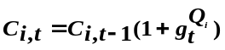.
Because these year-by-year sector-quantile growth rates are not directly observed, estimates must be used. What is observed (via survey-based estimates) is quantile’s growth in mean household consumption between the two surveys, denoted by G^{Q}.
Then 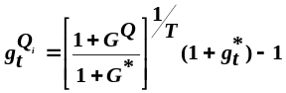. An asterisk is used here to refer to overall growth versus growth in particular quantile.
The effect is to scale the year-by-year growth rates from the national accounts for each quantile such that they cumulatively produce the growth observed in the survey for that quantile. When year-by-year growth rates calculated this way by sector and quantile are applied in the simulation, starting with the initial year survey data, they should produce a distribution in the final year which closely matches the final year survey data. For the analysis in this section, 50 quantiles are used, thus the simulated distribution in the final year is more closely matched with that in the final survey year data.
Note that the initial and final years of the simulation will match the “true” distributions in survey data, and consequently the simulation’s cumulative change in mean consumption will match the change implied by the survey data. If cumulative growth in per capita consumption differs from cumulative consumption growth in the survey data, the simulated year-by-year changes in mean consumption will not be equal to the year-by-year per capita changes. In Egypt, the overall per capita consumption growth (36 percent) is close to growth in consumption per capita in the survey (30 percent). As a result, the difference between the per capita consumption changes and simulated mean consumption changes in each year is not large.
ANNEX 4.1: Estimating Household Income Poverty
To examine the interlinkage between labor market outcomes and household poverty, we need to estimate poverty levels for the ELMS 98 and ELMPS 06 household samples. Apart from looking at reported earnings and household asset index, household income poverty is estimated in this study using a two-stage estimation technique. This technique allows us to combine detailed income and expenditure information available from the HIECSs, with the rich labor market information available from the LMSs. The two stage approach will combine the HIECS 99 with the ELMPS 98, and HIECS 04 with the ELMPS 06 to estimate per capita consumption for the LMS samples. This will typically involve the following three steps:

A. Identifying household characteristics available in the HIECSs and the ELMSs
This stage involves comparing the HIECS and the ELMS questionnaires to identify common household variables found in the four datasets. This has not been a major constraint on the analysis, because a large set of common variables is available in all four datasets. In this paper, the choice of the final set of explanatory variables is based on a thorough review of the poverty literature and a careful investigation of the descriptive statistics of the common set of explanatory variables and their correlation with the poverty measures.

B. Estimating per capita consumption using the HIECSs data
This stage is the first step of the two-step estimation approach. In this first-step, each of the two HIECS data is used to estimate per capita consumption as a function of the chosen common set of household characteristics. A log-linear function of per capita consumption of household i, y_{i}, is estimated for each of the HIECS samples:
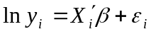
where X_{i} is a vector of cluster-level characteristics of household i; and ε_{i} is a disturbance term that is distributed as N(0, σ²). Of course, some of the explanatory variables selected in the first stage are endogenous, which would bias the estimation results. For instance, the ownership of durables are particularly among the set of endogenous variables, since it is closely determined by the household living standard and thus by the poverty status (Astrup and Dessus 2001). However, as discussed in Minot (2000), the possible endogeneity of some of the explanatory variables is less of a concern in the current analysis since the main objective here is to predict the level of poverty (or ln y_{i}), rather than to study the determinants of poverty or to assess the impact of each explanatory variable.

C. Predicting per capita consumption for the ELMSs samples
In this stage, the regression models developed in the previous step and the ELMSs data are used to predict per capita consumption for each of the two rounds of ELMSs.

Annex Tables
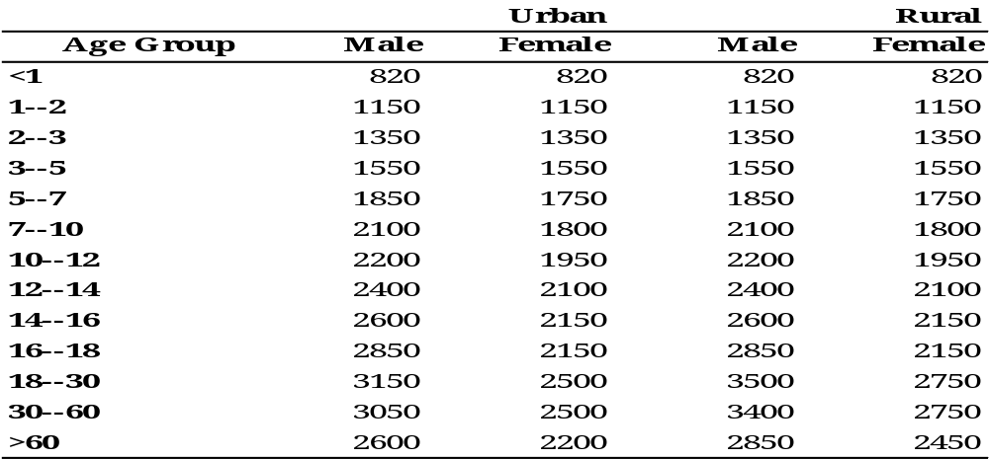
Table A.1.1: Daily Caloric Requirements by Age, Sex and Location

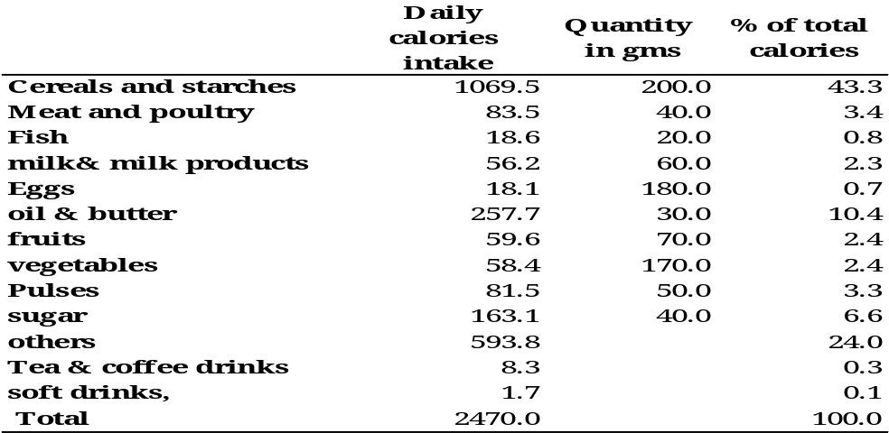
Table A.1.2: Quantities and Calories Generated by the Reference Food Bundle

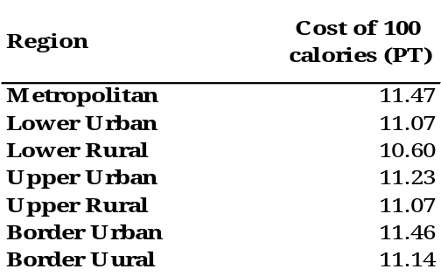
Table A.1.3: Cost of 100 Calories by Region

Table A.1.4: Sample Size of 1995/96, 1999/00 and 2004/05 Surveys

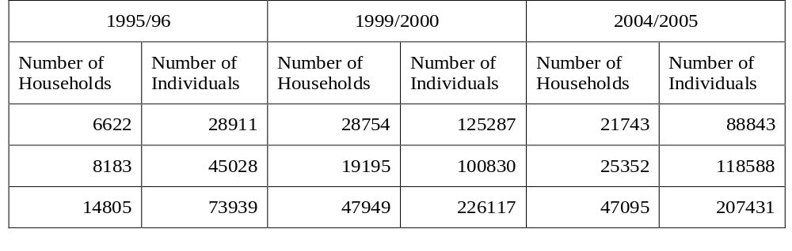

Table A.1.5: Regression Results (Dependent Variable ln Household Expenditure), 1995/96, Metropolitan

 | Coefficient | Std. Err. | t | |Prob|>t
 | 8.457 | 0.104 | 81.012 | 0.000
Cairo | 0.590 | 0.050 | 11.882 | 0.000
Alexandria | -0.035 | 0.021 | -1.662 | 0.097
Suez | 0.321 | 0.046 | 6.979 | 0.000
Age of the head of household | -0.302 | 0.079 | -3.834 | 0.000
Head has above secondary education | 1.399 | 0.566 | 2.472 | 0.013
head is self employed | 0.658 | 0.138 | 4.777 | 0.000
head is illiterate | 0.155 | 0.106 | 1.470 | 0.142
head has other than secondary education | -0.251 | 0.040 | -6.283 | 0.000
head is male | -0.235 | 0.108 | -2.189 | 0.029
head has university degree | 0.349 | 0.050 | 6.977 | 0.000
head is government employee | -0.537 | 0.040 | -13.541 | 0.000
head works in agriculture activity | -0.341 | 0.038 | -8.921 | 0.000
Has private kitchen | 0.315 | 0.036 | 8.694 | 0.000
ln household size | -0.290 | 0.040 | -7.287 | 0.000
squared ln household size | 0.243 | 0.045 | 5.377 | 0.000
has private bathroom | 0.005 | 0.001 | 6.360 | 0.000
Share of adult females | -0.106 | 0.022 | -4.731 | 0.000
Share of adult males | -0.142 | 0.042 | -3.382 | 0.001
Has no sewerage system | 0.074 | 0.043 | 1.744 | 0.081
share of children of age 6 and under | -0.117 | 0.038 | -3.118 | 0.002
share of employed persons | -0.075 | 0.023 | -3.339 | 0.001
share of employers in agricultural activities | -0.083 | 0.047 | -1.773 | 0.076
share of employers in non agricultural activities | -0.108 | 0.052 | -2.077 | 0.038
share of self employed persons in non agricultural activities | -0.154 | 0.051 | -2.996 | 0.003
share of employed persons in private sector | 0.224 | 0.067 | 3.349 | 0.001
share of illiterates | 0.111 | 0.051 | 2.179 | 0.029
share of out of labor force persons | -0.050 | 0.028 | -1.789 | 0.074
share of unemployed persons | -0.057 | 0.023 | -2.429 | 0.015
share of university graduates | -0.074 | 0.040 | -1.837 | 0.066
has tapped water | -0.047 | 0.031 | -1.517 | 0.129
Adjusted R² | 0.590
Number of households | 3095

Table A.1.6: Regression Results (Dependent Variable ln Household Expenditure), 1995/96, Lower Urban

 | Coefficient | Std. Err. | t | |Prob|>t
 | 6.995 | 0.159 | 43.888 | 0.000
has electricity | 0.369 | 0.150 | 2.459 | 0.014
Sharkia | -0.205 | 0.030 | -6.767 | 0.000
Qualiobia | -0.245 | 0.026 | -9.273 | 0.000
Garbeyya | 0.053 | 0.028 | 1.925 | 0.054
Menoufia | -0.095 | 0.035 | -2.706 | 0.007
Beheira | -0.098 | 0.030 | -3.265 | 0.001
Ismailia | 0.176 | 0.038 | 4.644 | 0.000
head has no basic education | 0.108 | 0.036 | 2.970 | 0.003
head is employed | -0.063 | 0.026 | -2.405 | 0.016
head is literate | 0.293 | 0.030 | 9.754 | 0.000
head has a degree in education | 0.192 | 0.028 | 6.949 | 0.000
head is male | -0.104 | 0.031 | -3.394 | 0.001
head has university degree | 0.152 | 0.030 | 5.054 | 0.000
head is employed in private sector | 0.111 | 0.024 | 4.722 | 0.000
has kitchen | 0.130 | 0.026 | 4.911 | 0.000
ln household size | 0.614 | 0.022 | 28.406 | 0.000
share of adult males | -0.203 | 0.050 | -4.043 | 0.000
share of children | -0.398 | 0.050 | -8.045 | 0.000
share of government employees | 0.225 | 0.073 | 3.103 | 0.002
share of employers in agriculture | 0.641 | 0.238 | 2.695 | 0.007
share of wage workers not in agricultural activities | 0.156 | 0.063 | 2.472 | 0.014
share of employers not in agricultural activities | 0.979 | 0.113 | 8.673 | 0.000
share of out of labor force persons | 0.163 | 0.039 | 4.150 | 0.000
has tapped water | 0.084 | 0.035 | 2.412 | 0.016
Adjusted R² | 0.534
Number of households | 1766

Table A.1.7: Regression Results (Dependent Variable ln Household Expenditure), 1995/96, Lower Rural

 | Coefficient | Std. Err. | t | |Prob|>t
 | 6.664 | 0.079 | 84.291 | 0.000
has electricity | 0.102 | 0.028 | 3.646 | 0.000
Sharkia | -0.059 | 0.013 | -4.532 | 0.000
Qualiobia | -0.171 | 0.016 | -10.440 | 0.000
Garbeyya | 0.045 | 0.014 | 3.089 | 0.002
Beheira | -0.155 | 0.014 | -11.291 | 0.000
Ismailia | 0.150 | 0.034 | 4.486 | 0.000
ln household size | 0.028 | 0.005 | 5.609 | 0.000
age of head | 0.002 | 0.000 | 5.610 | 0.000
head has no basic education | 0.138 | 0.028 | 4.974 | 0.000
head is literate | 0.304 | 0.023 | 13.104 | 0.000
head has a degree in education | 0.223 | 0.023 | 9.825 | 0.000
head has no secondary education degree | 0.112 | 0.023 | 4.945 | 0.000
head is employer in agricultural activities | 0.046 | 0.021 | 2.235 | 0.025
head is government employee | -0.111 | 0.018 | -6.342 | 0.000
has kitchen | 0.143 | 0.010 | 13.885 | 0.000
ln household size | 0.473 | 0.025 | 18.941 | 0.000
has access to public water network | 0.026 | 0.015 | 1.729 | 0.084
Share of adult females | 0.117 | 0.028 | 4.211 | 0.000
Share of adult males | 0.306 | 0.030 | 10.271 | 0.000
share of children of age 6 and under | -0.111 | 0.044 | -2.548 | 0.011
share of government employees | 0.396 | 0.055 | 7.136 | 0.000
share of wage workers in agricultural activities | -0.277 | 0.049 | -5.663 | 0.000
share of employers in agricultural activities | 0.127 | 0.077 | 1.646 | 0.100
share of self employed in agricultural activities | 0.121 | 0.068 | 1.779 | 0.075
share of unpaid workers in agricultural activities | -0.192 | 0.061 | -3.144 | 0.002
share of employers in non agricultural activities | 0.766 | 0.099 | 7.720 | 0.000
share of employed persons in private sector | 0.099 | 0.039 | 2.506 | 0.012
share of out of labor force persons | 0.124 | 0.030 | 4.114 | 0.000
has tapped water | 0.039 | 0.014 | 2.785 | 0.005
Adjusted R² | 0.627
Number of households | 4570

Table A.1.8: Regression Results (Dependent Variable ln Household Expenditure), 1995/96, Upper Urban

 | Coefficient | Std. Err. | t | |Prob|>t
 | 8.138 | 0.225 | 36.242 | 0.000
squared age of head | 0.000 | 0.000 | -3.054 | 0.002
age of the head | 0.021 | 0.006 | 3.618 | 0.000
head has no above secondary education | -0.224 | 0.053 | -4.209 | 0.000
head is illiterate | -0.084 | 0.033 | -2.509 | 0.012
head has secondary degree | -0.153 | 0.031 | -4.885 | 0.000
head has university degree | 0.320 | 0.054 | 5.948 | 0.000
head is not employer in agricultural activities | -0.102 | 0.056 | -1.818 | 0.069
head is not self employed in agricultural activities | -0.307 | 0.134 | -2.296 | 0.022
head is not government employee | 0.147 | 0.031 | 4.785 | 0.000
head is not employer in non agricultural activities | -0.170 | 0.055 | -3.084 | 0.002
head is not employed in private sector | -0.077 | 0.029 | -2.657 | 0.008
ln household size | 0.635 | 0.063 | 10.143 | 0.000
squared household size | -0.047 | 0.026 | -1.841 | 0.066
does not have private bath | -0.201 | 0.025 | -8.015 | 0.000
Share of adult females | 0.190 | 0.058 | 3.262 | 0.001
Share of adult males | 0.294 | 0.055 | 5.395 | 0.000
share of children of age 6 and under | -0.359 | 0.082 | -4.371 | 0.000
share of wage workers in agricultural activities | -0.508 | 0.274 | -1.852 | 0.064
share of self employed in agricultural activities | -0.805 | 0.270 | -2.976 | 0.003
share of employers in non agricultural activities | 0.291 | 0.177 | 1.641 | 0.101
share of illiterates | -0.283 | 0.048 | -5.879 | 0.000
share of unemployed persons | -0.682 | 0.118 | -5.792 | 0.000
shares of university graduates | 0.361 | 0.074 | 4.903 | 0.000
has tapped water | -0.078 | 0.028 | -2.758 | 0.006
Adjusted R² | 0.596
Number of households | 1643

Table A.1.9: Regression Results (Dependent Variable ln Household Expenditure), 1995/96, Upper Rural

 | Coefficient | Std. Err. | t | |Prob|>t
 | 7.179 | 0.062 | 115.793 | 0.000
head is wage worker | -0.044 | 0.023 | -1.932 | 0.053
head is employer | 0.147 | 0.033 | 4.432 | 0.000
head is literate | 0.041 | 0.017 | 2.334 | 0.020
head is male | 0.064 | 0.020 | 3.149 | 0.002
head has university degree | 0.252 | 0.038 | 6.668 | 0.000
head is not employer in agricultural activities | 0.109 | 0.035 | 3.123 | 0.002
head is self employed in agricultural activities | 0.085 | 0.032 | 2.683 | 0.007
head is not government employee | 0.036 | 0.020 | 1.756 | 0.079
squared ln household size | 0.721 | 0.044 | 16.520 | 0.000
ln household size | -0.167 | 0.037 | -4.495 | 0.000
has private bathroom | -0.065 | 0.012 | -5.385 | 0.000
share of adult males | 0.178 | 0.044 | 4.038 | 0.000
has sewerage system | 0.156 | 0.023 | 6.866 | 0.000
share of children | -0.086 | 0.045 | -1.883 | 0.060
share of children of age 6 and under | -0.090 | 0.056 | -1.628 | 0.104
share of employed persons | 0.186 | 0.051 | 3.681 | 0.000
share of wage workers in agricultural activities | -0.328 | 0.073 | -4.503 | 0.000
share of employers in non agricultural activities | 0.178 | 0.085 | 2.088 | 0.037
share of self employed in non agricultural activities | -0.158 | 0.087 | -1.810 | 0.070
share of wage workers in non agricultural activities | 0.184 | 0.067 | 2.770 | 0.006
share of illiterates | -0.178 | 0.030 | -5.829 | 0.000
share of out of labor force persons | 0.092 | 0.037 | 2.506 | 0.012
share of unemployed persons | -0.269 | 0.108 | -2.503 | 0.012
has tapped water | -0.124 | 0.012 | -10.218 | 0.000
mean years of schooling | 0.002 | 0.001 | 3.220 | 0.001
Adjusted R² | 0.683
Number of households | 3504

Table A.1.10: Regression Results (Dependent Variable ln Household Expenditure), 1995/96, Border Urban

 | Coefficient | Std. Err. | t | |Prob|>t
 | 7.163 | 0.176 | 40.808 | 0.000
head has above secondary degree | 0.724 | 0.093 | 7.817 | 0.000
head is unemployed | 0.005 | 0.002 | 2.832 | 0.006
head has a degree in education | 0.731 | 0.189 | 3.861 | 0.000
ln household size | -1.223 | 0.361 | -3.385 | 0.001
share of employed persons | 0.205 | 0.078 | 2.638 | 0.010
share of employers in agricultural activities | -1.952 | 1.100 | -1.775 | 0.079
mean years of schooling | -0.223 | 0.141 | -1.581 | 0.117
Adjusted R² | 0.626
Number of households | 118

Table A.1.11: Regression Results (Dependent Variable ln Household Expenditure), 1995/96, Border Rural

 | Coefficient | Std. Err. | t | |Prob|>t
 | 7.018 | 0.286 | 24.575 | 0.000
squared age of head | 0.000 | 0.000 | 1.756 | 0.082
head is unemployed | -0.904 | 0.331 | -2.735 | 0.007
head is out of labor force | -0.464 | 0.159 | -2.923 | 0.004
head is literate | 0.271 | 0.109 | 2.472 | 0.015
head has no secondary degree | -0.375 | 0.130 | -2.892 | 0.005
head is not government employee | 0.484 | 0.106 | 4.555 | 0.000
ln household size | 0.567 | 0.093 | 6.116 | 0.000
has access to public water network | 0.304 | 0.098 | 3.115 | 0.002
has private kichen | 0.434 | 0.187 | 2.319 | 0.022
has access to sewerage system | 0.429 | 0.110 | 3.912 | 0.000
Adjusted R² | 0.518
Number of households | 109

Table A.1.12 Distribution of Poorest 50, 100 and 200 Sub-Districts
by Governorate, 1996

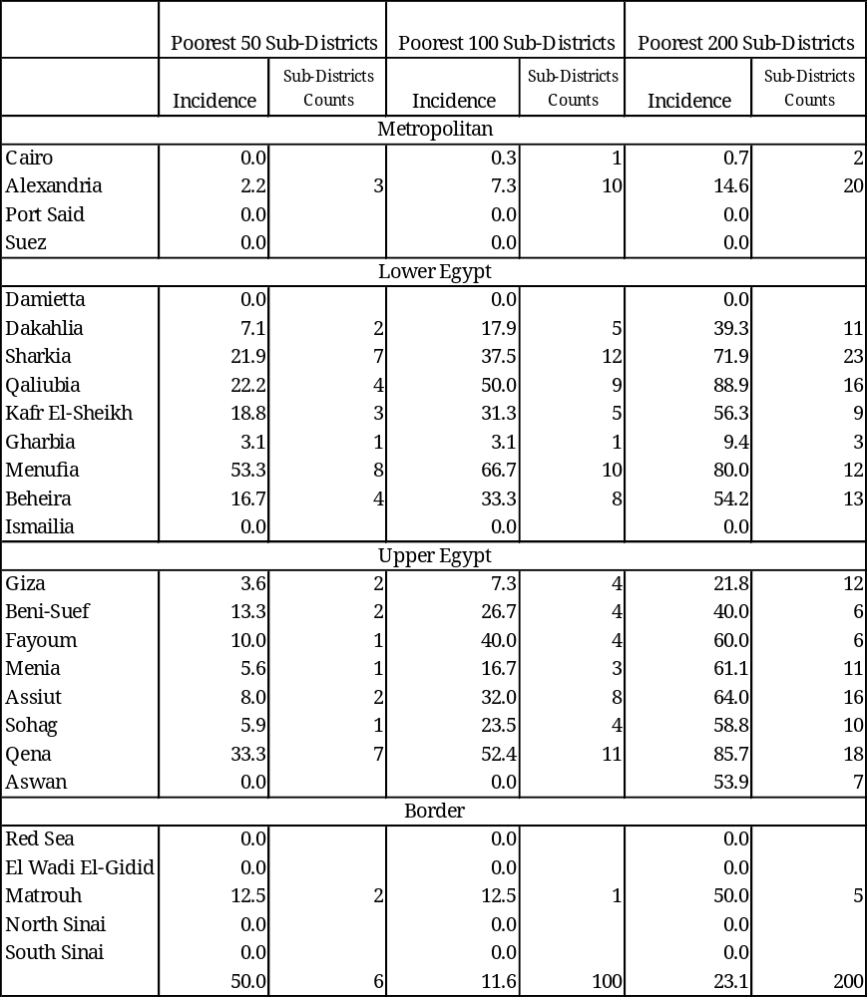
Table A.1.13 Distribution of Poorest 50, 100 and 200 Sub-Districts
by Governorate, 2006

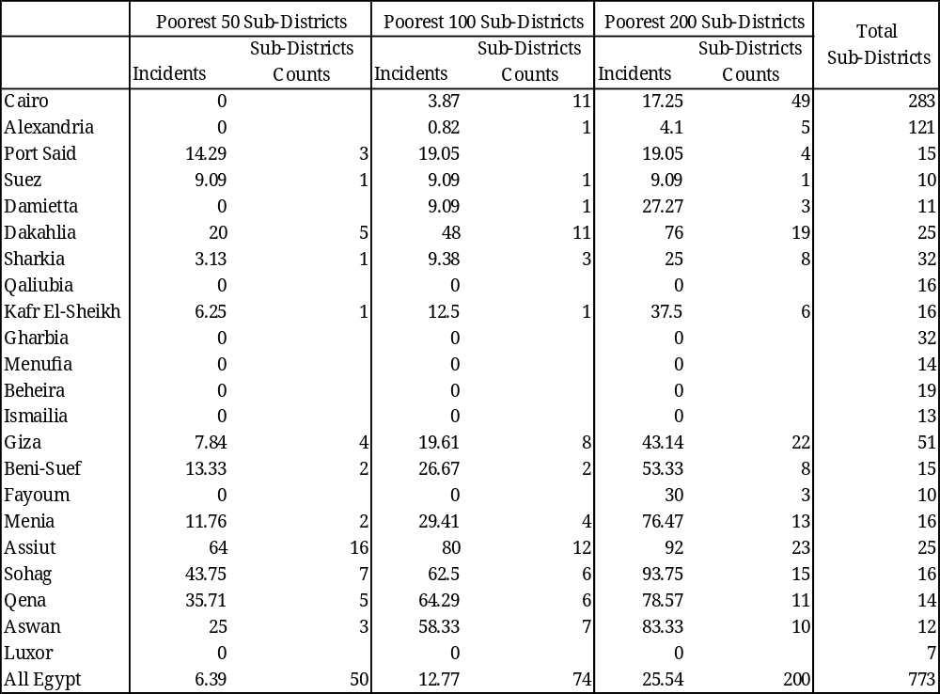

Table A.1.14 Distribution of Poorest 100, 500 and 1000 Villages
by Governorate, 1996
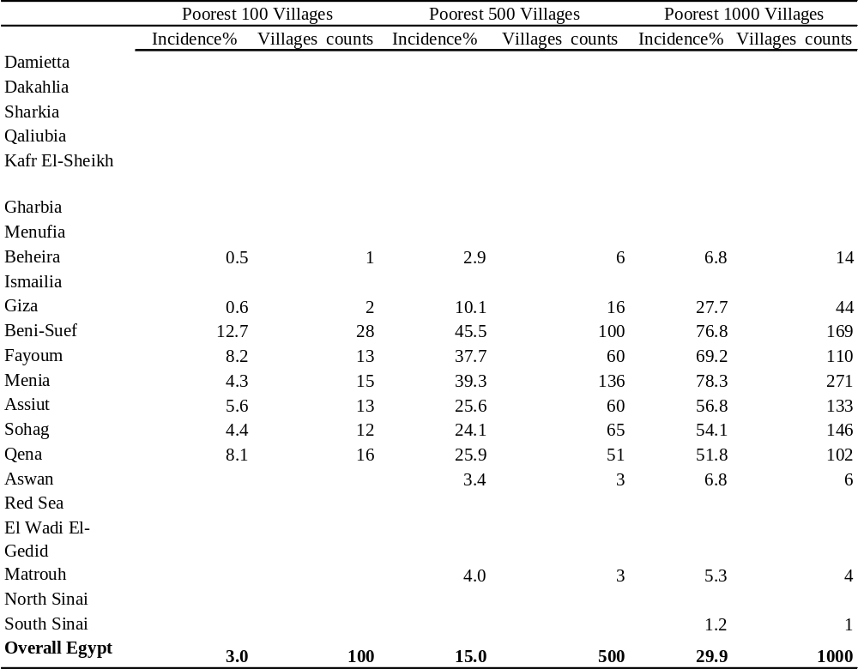

Table A.1.15 Distribution of Poorest 100, 500 and 1000 Villages
by Governorate, 2006

Incidents
villages
Counts
Incidents
villages
Counts
Incidents
villages
Counts
Damietta
6.25
4
20.31
13
34.38
22
64
Dakhlia
0.48
2
1.45
6
4.1
17
415
Sharkia
0
0
1.45
7
484
Qualyoubia
0
0
0
191
Kafr Elsheikh
0
0
1.94
4
206
Garbia
0
0
0
314
Menofia
0
0
0.96
3
311
Behera
0
0.24
1
0.24
1
419
Ismailia
0
0
0
20
Giza
4.83
7
24.14
35
52.41
76
145
Beni-Suef
0
5.45
12
36.36
80
220
Fayoum
0
0
0
144
Menia
4.05
14
50.87
176
92.2
319
346
Assuit
1.71
4
24.36
57
85.47
200
234
Sohag
24.42
63
72.48
187
94.19
243
258
Qena
0
0
3.35
6
179
Aswan
6.98
6
15.12
13
25.58
22
86
Luxor
0
0
0
10
All Egypt
2.47
100
12.36
500
24.72
1000
4046
Total
number of
villages
Poorest 100 villages
Poorest 500 villages
Poorest 1000 villages
Table A.2.1 (a): Poverty Measurements by Educational Attainment of Individuals,
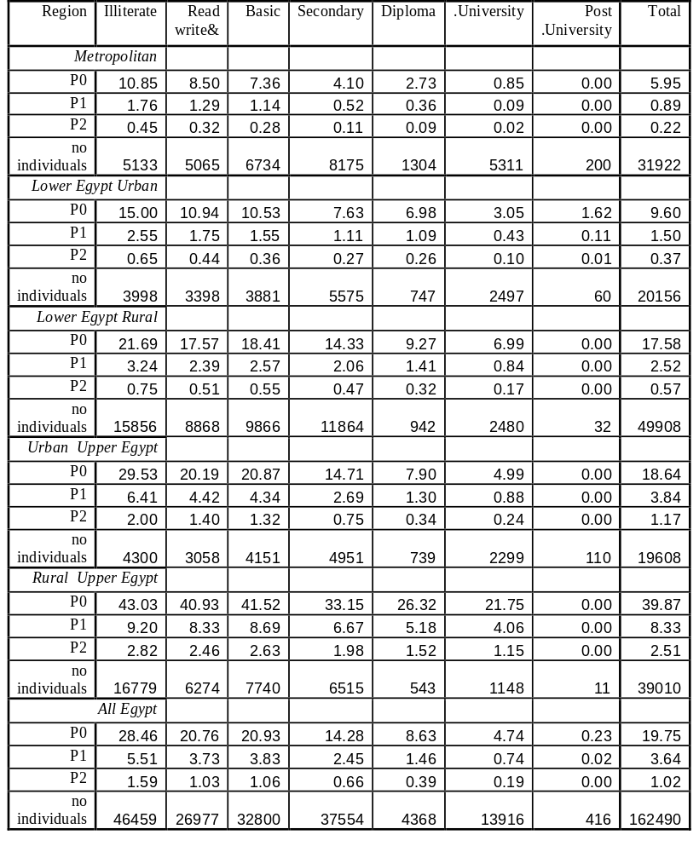
2004-05 (percent)

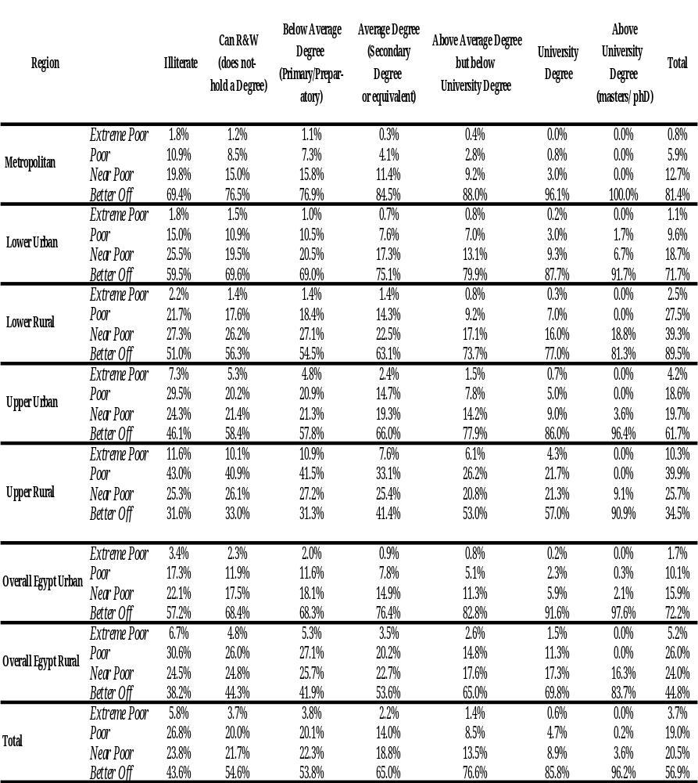
Table A.2.1 (b): Poverty Measurements by Educational Attainment of Individuals 2004-05 (percent)

Table A.2.2 (a): Educational Status of Individuals by Region by Poverty Status, 2004-05 (percent)

 | Illiterate | Read &write | Primary | Secondary | Diploma | University | Post  University | Total Individuals
Mertopolitan
Non-poor | 15.24 | 15.43 | 20.78 | 26.11 | 4.22 | 17.54 | 0.67 | 30023
Poor | 29.33 | 22.70 | 26.07 | 17.64 | 1.90 | 2.37 |  | 1899
All | 16.08 | 15.87 | 21.10 | 25.61 | 4.08 | 16.64 | 0.63 | 31922
Lower Urban
Non-poor | 18.65 | 16.61 | 19.05 | 28.26 | 3.81 | 13.29 | 0.32 | 18221
Poor | 31.01 | 19.22 | 21.14 | 21.96 | 2.69 | 3.93 | 0.05 | 1935
All | 19.84 | 16.86 | 19.25 | 27.66 | 3.71 | 12.39 | 0.30 | 20156
Lower Rural
Non-poor | 30.19 | 17.77 | 19.57 | 24.71 | 2.08 | 5.61 | 0.08 | 41135
Poor | 39.20 | 17.76 | 20.70 | 19.38 | 0.99 | 1.97 |  | 8773
All | 31.77 | 17.77 | 19.77 | 23.77 | 1.89 | 4.97 | 0.06 | 49908
Upper Urban
Non-poor | 18.99 | 15.30 | 20.59 | 26.47 | 4.27 | 13.69 | 0.69 | 15952
Poor | 34.74 | 16.90 | 23.69 | 19.94 | 1.59 | 3.15 |  | 3656
All | 21.93 | 15.60 | 21.17 | 25.25 | 3.77 | 11.72 | 0.56 | 19608
Upper Rural
Non-poor | 40.75 | 15.80 | 19.30 | 18.57 | 1.71 | 3.83 | 0.05 | 23456
Poor | 46.42 | 16.51 | 20.66 | 13.88 | 0.92 | 1.61 |  | 15554
All | 43.01 | 16.08 | 19.84 | 16.70 | 1.39 | 2.94 | 0.03 | 39010
All Egypt
Non-poor | 25.49 | 16.39 | 19.89 | 24.69 | 3.06 | 10.17 | 0.32 | 130403
Poor | 41.21 | 17.46 | 21.39 | 16.71 | 1.17 | 2.06 | 0.00 | 32087
All | 28.59 | 16.60 | 20.19 | 23.11 | 2.69 | 8.56 | 0.26 | 162490

Table A.2.2 (b): Educational Status of Individuals by Region by Poverty Status 2004-05 (percent)
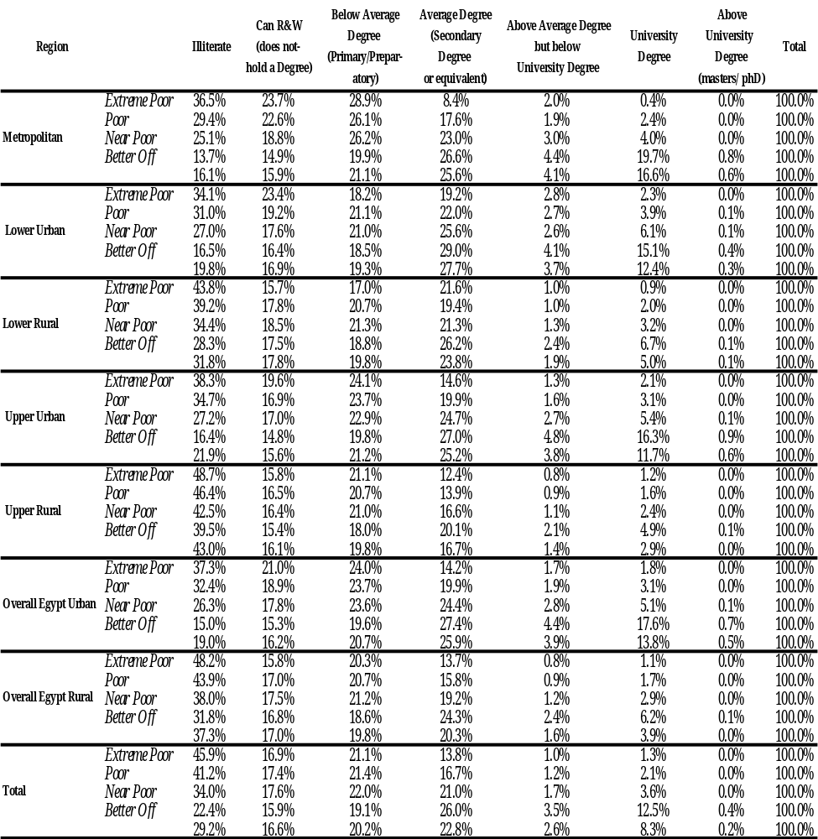

Table A.2.3 (a): Poverty Measurements by Employment Status of individuals, 2004-05 (percent)

 | Wage Workers | Employer | Self employed | Unpaid Worker | Unemployed | Out of labor force | Out of human force | Total
Metropolitan
P0 | 4.98 | 1.97 | 6.89 | 12.68 | 10.26 | 6.39 | 3.97 | 5.67
P1 | 0.70 | 0.30 | 1.25 | 3.31 | 1.85 | 0.96 | 0.57 | 0.85
P2 | 0.16 | 0.08 | 0.32 | 1.19 | 0.57 | 0.23 | 0.13 | 0.21
No. Individuals | 9850 | 999 | 1207 | 119 | 865 | 19719 | 5883 | 38642
Lower Urban
P0 | 7.79 | 8.11 | 8.61 | 21.81 | 13.32 | 9.79 | 6.07 | 9.00
P1 | 1.22 | 1.08 | 1.47 | 3.17 | 2.22 | 1.53 | 0.81 | 1.38
P2 | 0.31 | 0.22 | 0.40 | 0.72 | 0.58 | 0.38 | 0.17 | 0.34
No. Individuals | 5741 | 1088 | 1358 | 602 | 788 | 11543 | 3991 | 25111
Lower Rural
P0 | 16.73 | 13.61 | 13.15 | 22.93 | 24.12 | 18.13 | 12.33 | 16.66
P1 | 2.45 | 1.85 | 1.82 | 3.33 | 4.20 | 2.56 | 1.70 | 2.38
P2 | 0.56 | 0.40 | 0.40 | 0.78 | 1.11 | 0.56 | 0.38 | 0.53
No. Individuals | 11661 | 4573 | 5613 | 5321 | 1318 | 24538 | 10635 | 63659
Upper Urban
P0 | 15.71 | 12.53 | 22.53 | 28.90 | 26.55 | 20.08 | 15.42 | 18.60
P1 | 3.16 | 2.50 | 4.27 | 5.52 | 5.37 | 4.27 | 3.06 | 3.83
P2 | 0.95 | 0.74 | 1.17 | 1.52 | 1.59 | 1.32 | 0.89 | 1.15
No. Individuals | 5380 | 815 | 1309 | 437 | 712 | 11946 | 3937 | 24536
Upper Rural
P0 | 42.30 | 28.67 | 33.54 | 35.99 | 42.87 | 43.82 | 33.29 | 39.06
P1 | 9.26 | 5.34 | 6.45 | 6.82 | 9.77 | 9.32 | 6.53 | 8.07
P2 | 2.90 | 1.49 | 1.83 | 1.94 | 3.05 | 2.84 | 1.90 | 2.42
No. Individuals | 7403 | 3600 | 4166 | 4530 | 688 | 22113 | 9995 | 52495
All Egypt
P0 | 17.03 | 16.82 | 19.30 | 28.36 | 22.57 | 21.01 | 16.55 | 19.56
P1 | 3.18 | 2.82 | 3.40 | 4.85 | 4.41 | 3.96 | 2.96 | 3.60
P2 | 0.91 | 0.73 | 0.91 | 1.29 | 1.28 | 1.13 | 0.81 | 1.01
No. Individuals | 40586 | 11166 | 13767 | 11083 | 4419 | 91056 | 34955 | 207032

Table A.2.3 (b): Poverty Measurements by Employment Status of Individuals
2004-05 (percent)

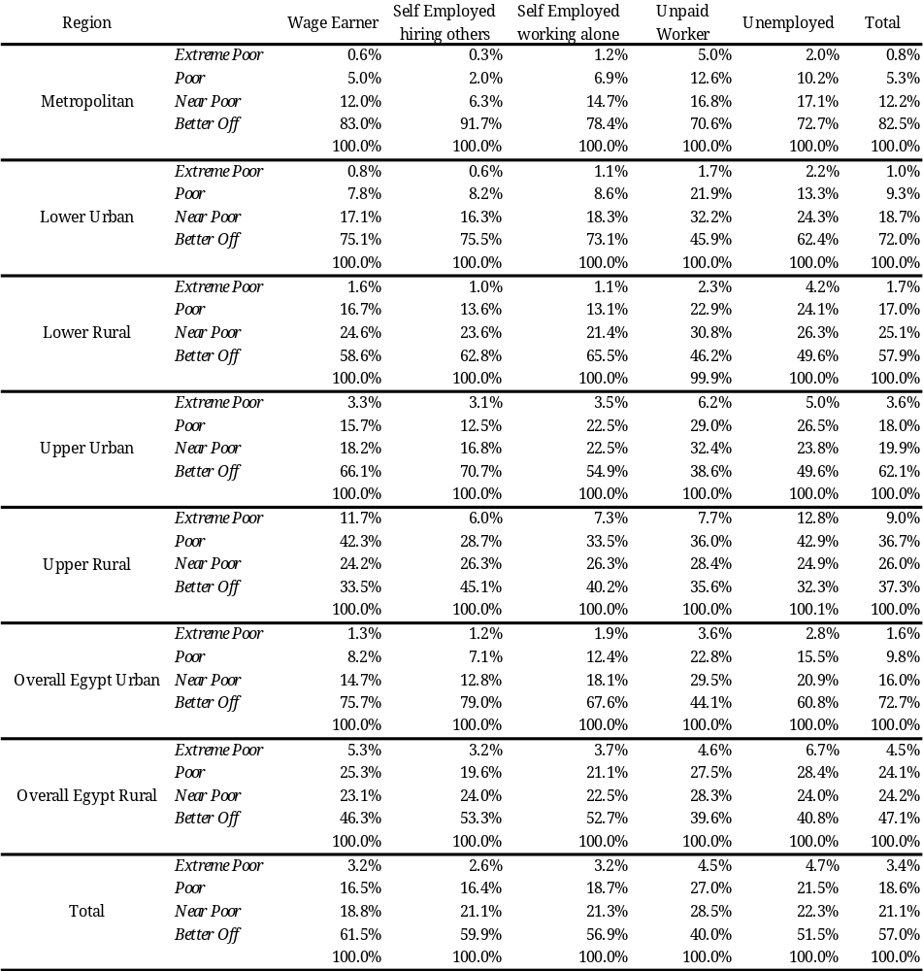
Table A.2.4 (a): Employment Status of Individuals by Region by Poverty Status 2004-05 (percent)

 | Wage Workers | Employer | Self employed | Unpaid Worker | Unemployed | Out of labor force | Out of human force | Total
Metropolitan
Non poor | 25.68 | 2.69 | 3.08 | 0.29 | 2.13 | 50.64 | 15.50 | 36451
Poor | 22.36 | 0.91 | 3.79 | 0.68 | 4.06 | 57.51 | 10.68 | 2191
Total | 25.49 | 2.59 | 3.12 | 0.31 | 2.24 | 51.03 | 15.22 | 38642
Lower Urban
Non poor | 23.17 | 4.38 | 5.43 | 2.06 | 2.99 | 45.57 | 16.41 | 22851
Poor | 19.78 | 3.89 | 5.18 | 5.80 | 4.65 | 50.00 | 10.71 | 2260
Total | 22.86 | 4.33 | 5.41 | 2.40 | 3.14 | 45.97 | 15.89 | 25111
Lower Rural
Non poor | 18.30 | 7.45 | 9.19 | 7.73 | 1.89 | 37.87 | 17.58 | 53050
Poor | 18.39 | 5.86 | 6.96 | 11.50 | 3.00 | 41.94 | 12.36 | 10609
Total | 18.32 | 7.18 | 8.82 | 8.36 | 2.07 | 38.55 | 16.71 | 63659
Upper Urban
Non poor | 22.71 | 3.57 | 5.08 | 1.56 | 2.62 | 47.80 | 16.67 | 19973
Poor | 18.52 | 2.24 | 6.47 | 2.76 | 4.14 | 52.58 | 13.30 | 4563
Total | 21.93 | 3.32 | 5.34 | 1.78 | 2.90 | 48.69 | 16.05 | 24536
Upper Rural
Non poor | 13.35 | 8.03 | 8.66 | 9.06 | 1.23 | 38.83 | 20.84 | 31992
Poor | 15.27 | 5.03 | 6.81 | 7.95 | 1.44 | 47.27 | 16.23 | 20503
Total | 14.10 | 6.86 | 7.94 | 8.63 | 1.31 | 42.12 | 19.04 | 52495
All Egypt
Non poor | 20.22 | 5.58 | 6.67 | 4.77 | 2.05 | 43.19 | 17.52 | 166530
Poor | 17.07 | 4.64 | 6.56 | 7.76 | 2.46 | 47.23 | 14.29 | 40502
Total | 19.60 | 5.39 | 6.65 | 5.35 | 2.13 | 43.98 | 16.88 | 207032

Table A.2.4 (b): Employment Status of Individuals by Region by Poverty Status, 2004-05 (percent)

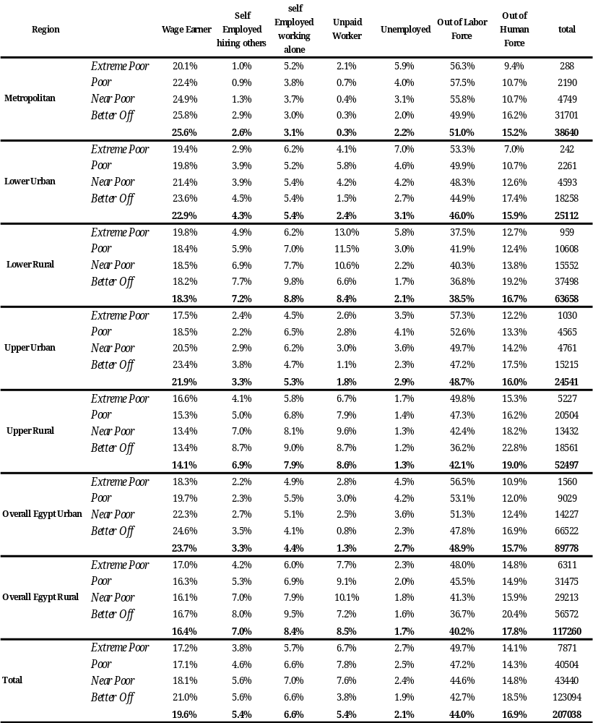

TableA.2.5 (a): Employment Status of Labor Force by Region by Poverty Status 2004-05 (percent)

 | Wage Worker | Employer | self employed | Unpaid worker | Unemployed | Total Labor Force
Metropolitan
Non poor | 75.83 | 7.93 | 9.11 | 0.84 | 6.29 | 12343
Poor | 70.30 | 2.87 | 11.91 | 2.15 | 12.77 | 697
Total | 75.54 | 7.66 | 9.26 | 0.91 | 6.63 | 13040
Lower Urban
Non poor | 60.93 | 11.51 | 14.28 | 5.42 | 7.86 | 8689
Poor | 50.34 | 9.91 | 13.18 | 14.75 | 11.82 | 888
Total | 59.95 | 11.36 | 14.18 | 6.29 | 8.23 | 9577
Lower Rural
Non poor | 41.08 | 16.72 | 20.62 | 17.35 | 4.23 | 23637
Poor | 40.24 | 12.83 | 15.22 | 25.16 | 6.56 | 4849
Total | 40.94 | 16.05 | 19.70 | 18.68 | 4.63 | 28486
Upper Urban
Non poor | 63.91 | 10.05 | 14.29 | 4.38 | 7.37 | 7096
Poor | 54.27 | 6.55 | 18.95 | 8.09 | 12.14 | 1557
Total | 62.17 | 9.42 | 15.13 | 5.05 | 8.23 | 8653
Upper Rural
Non poor | 33.11 | 19.90 | 21.46 | 22.48 | 3.05 | 12902
Poor | 41.83 | 13.79 | 18.66 | 21.78 | 3.94 | 7485
Total | 36.31 | 17.66 | 20.43 | 22.22 | 3.37 | 20387
All Egypt
Non poor | 51.46 | 14.19 | 16.98 | 12.14 | 5.23 | 65434
Poor | 44.34 | 12.05 | 17.05 | 20.16 | 6.40 | 15587
Total | 50.09 | 13.78 | 16.99 | 13.68 | 5.45 | 81021

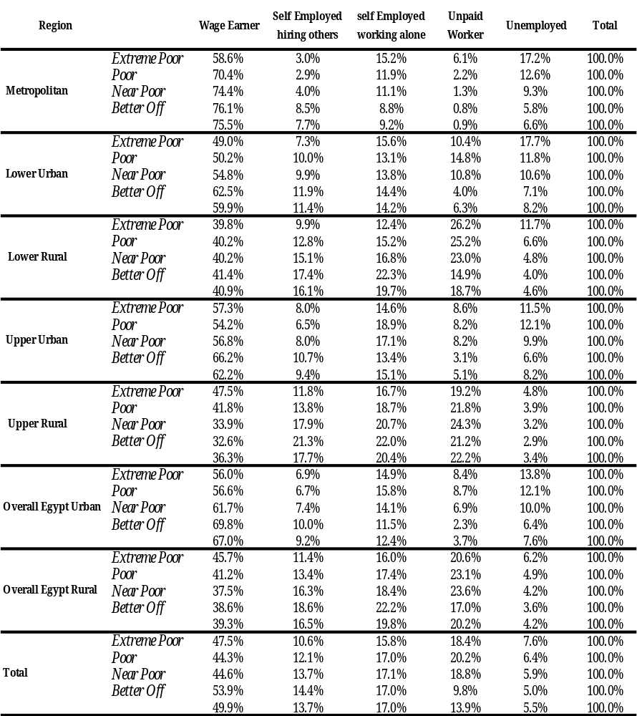
Table A.2.5 (b): Employment Status of Labor Force by Region by Poverty Status 2004-05 (percent)

Table A.2.6 (a): Poverty Measurements by Sector of Employment of Individuals 2004-05 (percent)

 | Government | Investment | Public | Private | Co-operative | NGO | Foreign | Outside Establishments | Total
Metropolitan
P0 | 1.89 | 2.92 | 2.67 | 6.61 | 0.00 | 0.00 | 1.52 | 8.99 | 5.07
P1 | 0.22 | 0.46 | 0.32 | 1.04 | 0.00 | 0.00 | 0.05 | 1.27 | 0.76
P2 | 0.05 | 0.07 | 0.07 | 0.26 | 0.00 | 0.00 | 0.00 | 0.29 | 0.18
No. Individuals | 3354 | 64 | 1035 | 6975 | 8 | 14 | 68 | 743 | 12261
Lower Urban
P0 | 3.98 | 0.00 | 6.02 | 10.52 | 26.34 | 0.00 | 0.00 | 14.72 | 8.92
P1 | 0.47 | 0.00 | 0.73 | 1.68 | 0.19 | 0.00 | 0.00 | 2.42 | 1.37
P2 | 0.09 | 0.00 | 0.15 | 0.43 | 0.00 | 0.00 | 0.00 | 0.60 | 0.34
No. Individuals | 2671 | 18 | 380 | 4456 | 4 | 4 | 12 | 1277 | 8822
Lower Rural
P0 | 10.24 | 3.39 | 12.62 | 17.59 | 3.50 | 24.39 | 0.00 | 19.90 | 16.67
P1 | 1.33 | 0.27 | 1.67 | 2.53 | 0.31 | 4.04 | 0.00 | 2.98 | 2.39
P2 | 0.28 | 0.02 | 0.34 | 0.56 | 0.03 | 0.67 | 0.00 | 0.72 | 0.54
No. Individuals | 5030 | 30 | 603 | 14629 | 27 | 4 | 7 | 6873 | 27203
Upper Urban
P0 | 10.48 | 14.41 | 9.95 | 17.66 | 22.31 | 28.97 | 8.52 | 29.96 | 17.22
P1 | 1.84 | 1.91 | 1.57 | 3.53 | 9.61 | 8.61 | 1.30 | 6.34 | 3.41
P2 | 0.49 | 0.29 | 0.37 | 1.05 | 4.14 | 3.08 | 0.20 | 1.94 | 1.00
No. Individuals | 2493 | 21 | 286 | 3789 | 4 | 14 | 21 | 1358 | 7986
Upper Rural
P0 | 30.57 | 18.29 | 26.37 | 34.22 | 40.87 | 43.56 | 27.05 | 40.81 | 36.50
P1 | 5.89 | 5.31 | 4.82 | 6.71 | 8.01 | 7.92 | 6.50 | 8.58 | 7.39
P2 | 1.68 | 2.22 | 1.34 | 1.96 | 1.96 | 1.84 | 2.68 | 2.61 | 2.20
No. Individuals | 2518 | 10 | 345 | 8155 | 20 | 11 | 18 | 8645 | 19722
All Egypt
P0 | 10.52 | 5.45 | 9.22 | 18.34 | 17.34 | 20.50 | 6.03 | 29.41 | 19.04
P1 | 1.72 | 0.92 | 1.40 | 3.16 | 3.25 | 4.67 | 1.15 | 5.69 | 3.41
P2 | 0.44 | 0.24 | 0.34 | 0.84 | 0.88 | 1.38 | 0.41 | 1.65 | 0.94
No. Individuals | 16423 | 143 | 2677 | 38363 | 64 | 47 | 126 | 18983 | 76826

Table A.2.6 (b): Poverty Risk by Sector of Employment of Individuals
2005 (percent)

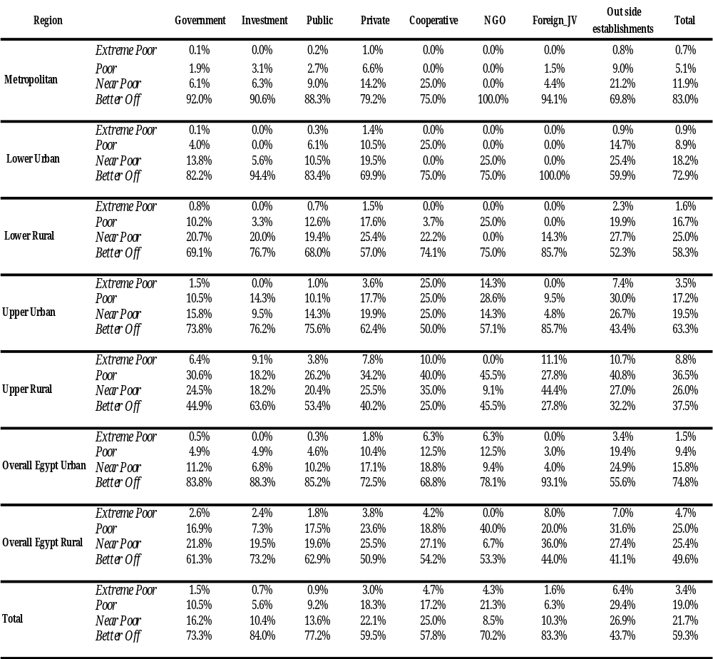

Table A.2.7 (a): Sector of Employment of Labor Force by Region by Poverty Status 2004-05 (percent)

 | Government | Investment | Public | Private | Co-operative | NGO | Foreign | Outside Establishments | Total
Metropolitan
Non poor | 28.28 | 0.53 | 8.65 | 55.97 | 0.07 | 0.12 | 0.58 | 5.81 | 11639
Poor | 10.13 | 0.32 | 4.50 | 74.12 |  |  | 0.16 | 10.77 | 622
Total | 27.36 | 0.52 | 8.44 | 56.89 | 0.07 | 0.11 | 0.55 | 6.06 | 12261
Lower Urban
Non poor | 31.92 | 0.22 | 4.44 | 49.62 | 0.04 | 0.05 | 0.15 | 13.55 | 8035
Poor | 13.47 |  | 2.92 | 59.59 | 0.13 |  |  | 23.89 | 787
Total | 30.28 | 0.20 | 4.31 | 50.51 | 0.05 | 0.05 | 0.14 | 14.48 | 8822
Lower Rural
Non poor | 19.92 | 0.13 | 2.32 | 53.18 | 0.11 | 0.01 | 0.03 | 24.29 | 22667
Poor | 11.35 | 0.02 | 1.68 | 56.75 | 0.02 | 0.02 |  | 30.16 | 4536
Total | 18.49 | 0.11 | 2.22 | 53.78 | 0.10 | 0.01 | 0.03 | 25.27 | 27203
Upper Urban
Non poor | 33.76 | 0.27 | 3.90 | 47.19 | 0.05 | 0.15 | 0.29 | 14.39 | 6611
Poor | 18.98 | 0.22 | 2.04 | 48.65 | 0.07 | 0.29 | 0.15 | 29.60 | 1375
Total | 31.22 | 0.26 | 3.58 | 47.45 | 0.05 | 0.18 | 0.26 | 17.00 | 7986
Upper Rural
Non poor | 13.96 | 0.06 | 2.03 | 42.84 | 0.10 | 0.05 | 0.10 | 40.86 | 12522
Poor | 10.69 | 0.03 | 1.26 | 38.76 | 0.11 | 0.07 | 0.07 | 49.00 | 7200
Total | 12.77 | 0.05 | 1.75 | 41.35 | 0.10 | 0.06 | 0.09 | 43.83 | 19722
All Egypt
Non poor | 23.63 | 0.22 | 3.91 | 50.37 | 0.09 | 0.06 | 0.19 | 21.54 | 62196
Poor | 11.80 | 0.05 | 1.69 | 48.09 | 0.08 | 0.07 | 0.05 | 38.17 | 14630
Total | 21.38 | 0.19 | 3.48 | 49.93 | 0.08 | 0.06 | 0.16 | 24.71 | 76826

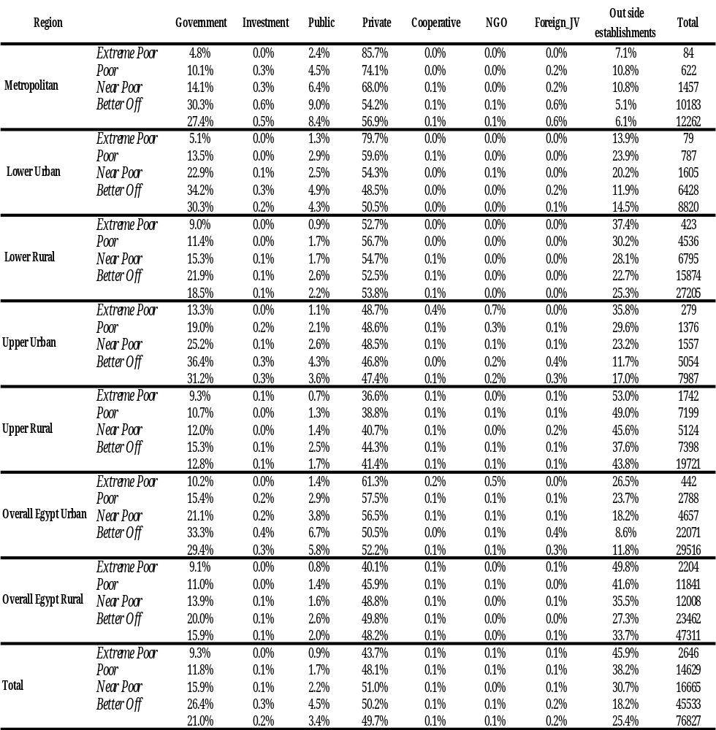
Table A.2.7 (b): Sector of Employment of Labor Force by Region by Poverty Status 2004-05 (percent)

Table A.2.8 (a): Poverty Measurements by Economic Activity of Individuals
2004-05 (percent)

 | Agriculture | Mining | Manufacturing | Electricity | Construction | Trade | Transportation | Finance | Services | Total
Metropolitan
P0 | 7.49 | 0.00 | 6.51 | 4.32 | 8.52 | 6.58 | 3.47 | 2.60 | 2.80 | 5.07
P1 | 1.28 | 0.00 | 0.87 | 0.53 | 1.17 | 1.06 | 0.59 | 0.31 | 0.43 | 0.76
P2 | 0.33 | 0.00 | 0.19 | 0.12 | 0.27 | 0.28 | 0.16 | 0.06 | 0.11 | 0.18
No. Individuals | 217 | 57 | 2379 | 171 | 1213 | 2672 | 1469 | 473 | 3610 | 12261
Lower Rural
P0 | 12.60 | 7.41 | 10.81 | 3.57 | 13.30 | 11.01 | 7.02 | 3.56 | 4.44 | 8.92
P1 | 1.85 | 0.84 | 1.82 | 0.44 | 2.38 | 1.72 | 1.11 | 0.83 | 0.54 | 1.37
P2 | 0.41 | 0.10 | 0.50 | 0.07 | 0.69 | 0.42 | 0.29 | 0.27 | 0.10 | 0.34
No. Individuals | 1551 | 13 | 1412 | 113 | 655 | 1609 | 658 | 191 | 2618 | 8820
Upper Urban
P0 | 19.18 | 3.94 | 16.24 | 7.71 | 19.05 | 14.82 | 14.29 | 6.01 | 10.72 | 16.67
P1 | 2.81 | 0.46 | 2.38 | 0.90 | 2.70 | 2.13 | 1.97 | 0.69 | 1.38 | 2.39
P2 | 1 | 0 | 1 | 0 | 1 | 0 | 0 | 0 | 0 | 1
No. Individuals | 14881 | 26 | 2298 | 172 | 1409 | 2199 | 1192 | 199 | 4827 | 27203
Upper Rural
P0 | 30.73 | 7.70 | 17.93 | 10.30 | 27.03 | 16.32 | 14.21 | 6.77 | 11.07 | 17.22
P1 | 6.12 | 1.57 | 3.79 | 1.85 | 5.72 | 3.13 | 3.02 | 1.15 | 2.01 | 3.41
P2 | 1.83 | 0.62 | 1.12 | 0.42 | 1.83 | 0.87 | 0.98 | 0.26 | 0.54 | 1.00
No. Individuals | 1084 | 24 | 993 | 74 | 682 | 1697 | 711 | 217 | 2506 | 7988
All Egypt
P0 | 37.49 | 52.90 | 31.50 | 25.25 | 48.10 | 35.70 | 27.56 | 13.23 | 31.12 | 36.50
P1 | 8 | 15 | 6 | 4 | 11 | 7 | 5 | 2 | 6 | 7
P2 | 2.23 | 5.00 | 1.79 | 1.27 | 3.45 | 2.21 | 1.39 | 0.65 | 1.77 | 2.20
No. Individuals | 12289 | 15 | 1073 | 106 | 1467 | 1552 | 678 | 101 | 2440 | 19721
P0 | 26.76 | 9.16 | 14.65 | 9.17 | 24.70 | 15.42 | 11.65 | 4.93 | 10.91 | 19.04
P1 | 4.84 | 1.99 | 2.51 | 1.38 | 4.86 | 2.77 | 1.99 | 0.77 | 1.82 | 3.41
P2 | 1.34 | 0.64 | 0.66 | 0.34 | 1.46 | 0.75 | 0.54 | 0.19 | 0.48 | 0.94
No. Individuals | 30251 | 142 | 8181 | 652 | 5464 | 9815 | 4778 | 1200 | 16337 | 76820

Table A.2.8 (b): Poverty Measurements by Economic Activity of Individuals, 2004-05 (percent)
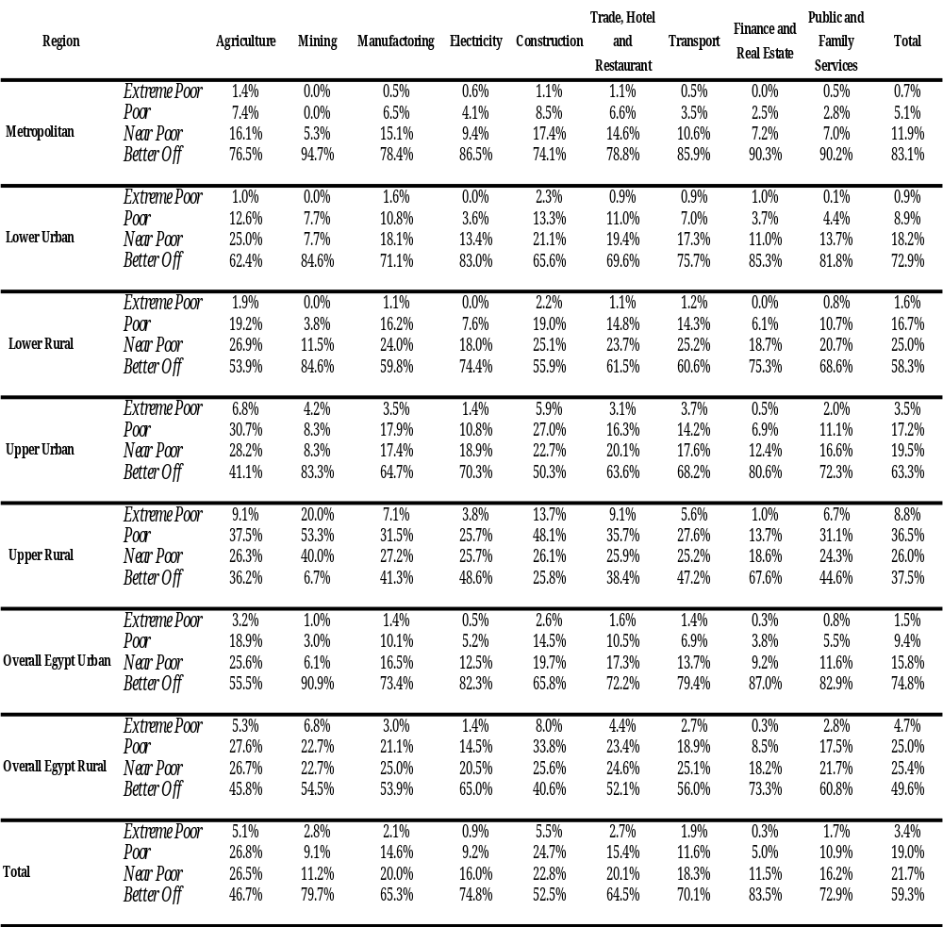

Table A.2.9 (a): Economic Activity of Labor Force by Region by Poverty Status
2004-05 (percent)

 | Agriculture | Mining | Manufacturing | Electricity | Construction | Trade | Transportation- | Finance | Services | Total
Metropolitan
Non-poor | 1.73 | 0.49 | 19.11 | 1.41 | 9.54 | 21.44 | 12.18 | 3.96 | 30.15 | 11640
Poor | 2.58 |  | 24.96 | 1.13 | 16.59 | 28.34 | 8.21 | 1.93 | 16.26 | 621
All | 1.77 | 0.46 | 19.40 | 1.39 | 9.89 | 21.79 | 11.98 | 3.86 | 29.44 | 12261
Lower Urban
Non-poor | 16.88 | 0.15 | 15.67 | 1.36 | 7.07 | 17.82 | 7.62 | 2.29 | 31.14 | 8034
Poor | 24.81 | 0.13 | 19.47 | 0.51 | 11.07 | 22.52 | 5.85 | 0.89 | 14.76 | 786
All | 17.59 | 0.15 | 16.01 | 1.28 | 7.43 | 18.24 | 7.46 | 2.17 | 29.68 | 8820
Lower Rural
Non-poor | 53.05 | 0.11 | 8.49 | 0.70 | 5.03 | 8.26 | 4.51 | 0.82 | 19.01 | 22669
Poor | 62.95 | 0.02 | 8.23 | 0.29 | 5.91 | 7.19 | 3.75 | 0.26 | 11.40 | 4534
All | 54.70 | 0.10 | 8.45 | 0.63 | 5.18 | 8.08 | 4.38 | 0.73 | 17.74 | 27203
Upper Urban
Non-poor | 11.36 | 0.33 | 12.33 | 1.00 | 7.53 | 21.48 | 9.23 | 3.06 | 33.70 | 6612
Poor | 24.20 | 0.15 | 12.94 | 0.58 | 13.37 | 20.13 | 7.34 | 1.09 | 20.20 | 1376
All | 13.57 | 0.30 | 12.43 | 0.93 | 8.54 | 21.24 | 8.90 | 2.72 | 31.37 | 7988
Upper Rural
Non-poor | 61.35 | 0.06 | 5.87 | 0.63 | 6.08 | 7.97 | 3.92 | 0.70 | 13.42 | 12522
Poor | 63.99 | 0.11 | 4.70 | 0.38 | 9.81 | 7.70 | 2.60 | 0.18 | 10.54 | 7199
All | 62.31 | 0.08 | 5.44 | 0.54 | 7.44 | 7.87 | 3.44 | 0.51 | 12.37 | 19721
All Egypt
Non-poor | 35.63 | 0.21 | 11.23 | 0.95 | 6.62 | 13.35 | 6.79 | 1.83 | 23.40 | 62196
Poor | 55.34 | 0.09 | 8.20 | 0.41 | 9.22 | 10.35 | 3.80 | 0.40 | 12.18 | 14624
All | 39.38 | 0.18 | 10.65 | 0.85 | 7.11 | 12.78 | 6.22 | 1.56 | 21.27 | 76820

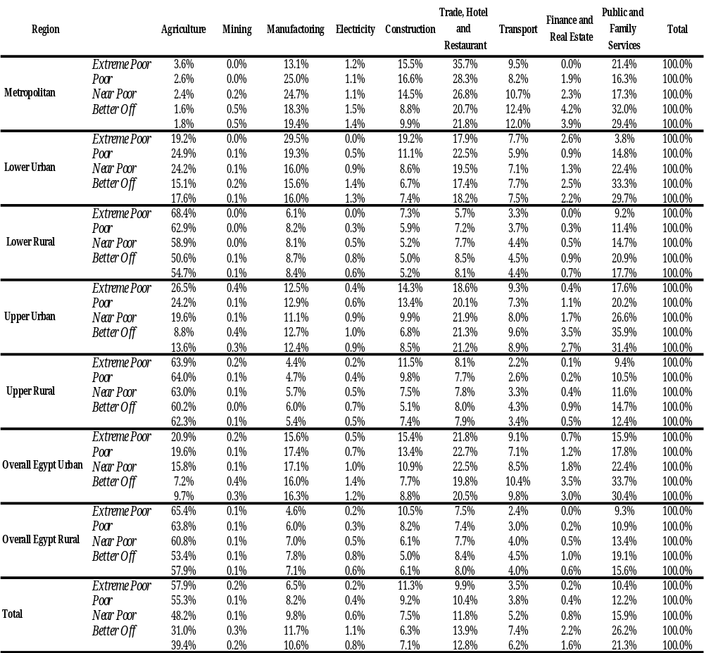
Table A.2.9 (b): Economic Activity of Labor Force by Region by Poverty Status
2004-05 (percent)

Table A.2.10 (a): Poverty Measurements by Employment Type of Individuals
2005 (percent)

 | Permanent | Temporary | Seasonal | Occasional | Total
Metropolitan
P0 | 4.27 | 10.38 | 11.56 | 16.19 | 4.99
P1 | 0.61 | 1.50 | 2.34 | 2.92 | 0.75
P2 | 0.14 | 0.35 | 0.64 | 0.83 | 0.18
No. Individuals | 11209 | 408 | 61 | 498 | 12176
Lower Urban
P0 | 8 | 8 | 31 | 18 | 9
P1 | 1.26 | 1.39 | 5.78 | 3.08 | 1.37
P2 | 0.31 | 0.45 | 1.10 | 0.80 | 0.34
No. Individuals | 8044 | 272 | 27 | 447 | 8790
Lower Rural
P0 | 15.59 | 18.17 | 23.54 | 30.08 | 16.68
P1 | 2.18 | 2.48 | 3.47 | 5.09 | 2.39
P2 | 0 | 0 | 1 | 1 | 1
No. Individuals | 24505 | 687 | 119 | 1856 | 27167
Upper Urban
P0 | 15.00 | 18.96 | 9.00 | 40.27 | 17.23
P1 | 2.90 | 3.79 | 1.56 | 8.65 | 3.41
P2 | 0.83 | 1.05 | 0.52 | 2.79 | 1.00
No. Individuals | 6867 | 379 | 43 | 653 | 7942
Upper Rural
P0 | 32.85 | 36.77 | 37.83 | 58.92 | 36.50
P1 | 6 | 8 | 8 | 14 | 7
P2 | 1.80 | 2.18 | 2.72 | 4.63 | 2.19
No. Individuals | 16455 | 481 | 89 | 2675 | 19700
All Egypt
P0 | 16.94 | 19.42 | 26.19 | 41.61 | 19.05
P1 | 2.89 | 3.43 | 4.93 | 9.05 | 3.41
P2 | 0.764 | 0.907 | 1.423 | 2.835 | 0.938
No. Individuals | 67801 | 2259 | 378 | 6168 | 76606

Table A.2.10 (b): Poverty Risk by Employment Type of Individuals and by Region,
2005 (percent)

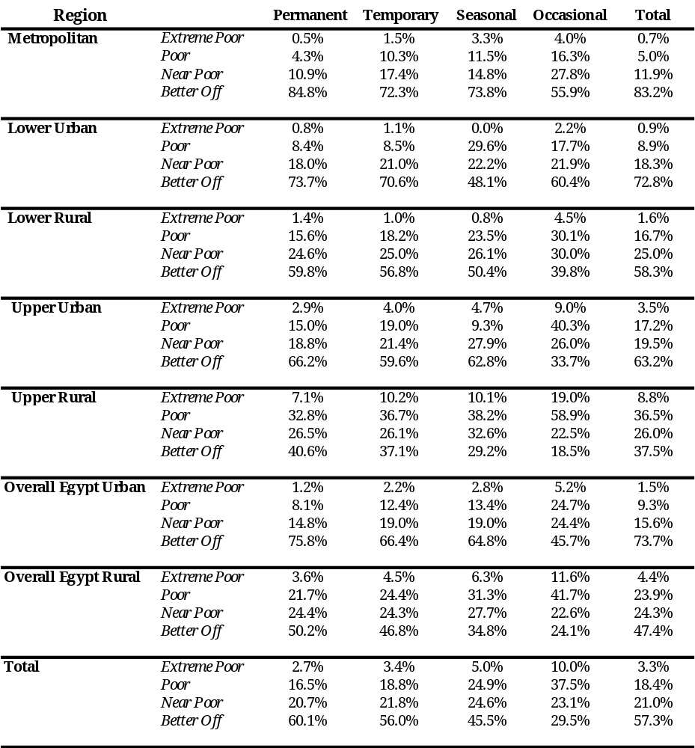

Table A.2.11 (a): Type of Employment of Individuals in Labor Force by Region by Poverty Status 2004-05 (percent)

 | Permanent | Temporary | Seasonal | Occasional | Total
Metropolitan
Non poor | 90.63 | 3.49 | 0.68 | 5.20 | 11568
Poor | 76.43 | 7.01 | 1.91 | 14.65 | 608
Total | 89.88 | 3.68 | 0.74 | 5.70 | 12176
Lower Urban
Non poor | 90.47 | 3.87 | 0.31 | 5.35 | 8007
Poor | 85.02 | 2.20 | 0.44 | 12.33 | 783
Total | 89.90 | 3.70 | 0.32 | 6.08 | 8790
Lower Rural
Non poor | 90.43 | 2.44 | 0.72 | 6.40 | 22636
Poor | 79.28 | 4.51 | 0.58 | 15.63 | 4531
Total | 88.99 | 2.71 | 0.70 | 7.60 | 27167
Upper Urban
Non poor | 87.33 | 5.29 | 1.02 | 6.37 | 6573
Poor | 74.00 | 4.75 | 0.25 | 21.00 | 1369
Total | 84.75 | 5.18 | 0.87 | 9.20 | 7942
Upper Rural
Non poor | 87.85 | 2.86 | 0.89 | 8.40 | 12508
Poor | 75.78 | 3.75 | 1.18 | 19.28 | 7192
Total | 83.24 | 3.20 | 1.00 | 12.56 | 19700
All Egypt
Non poor | 90.81 | 2.93 | 0.45 | 5.81 | 62013
Poor | 78.73 | 3.01 | 0.68 | 17.58 | 14592
Total | 88.51 | 2.95 | 0.49 | 8.05 | 76605

Table A.2.11 (b): Type of Employment of Individuals in Labor Force by Region by Poverty Status 2004-05 (percent)

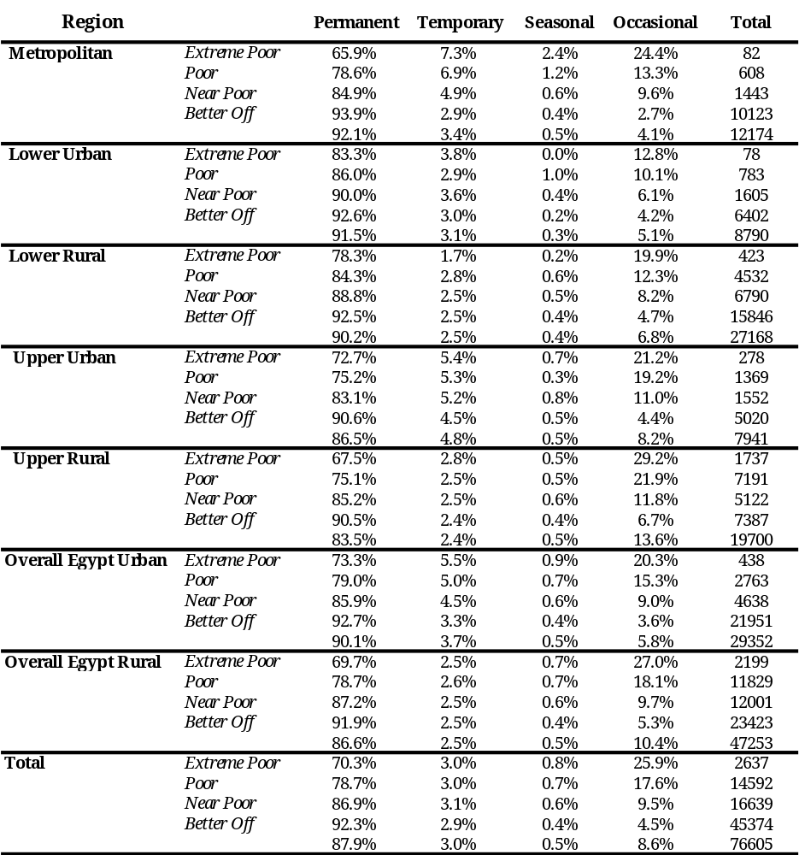

Table A.2.12 (a): Poverty Measurements by Household Size
2004-05 (percent)

 | One person | Two persons | Three persons | Four persons | 5 persons | 6 or 7 persons | 8 persons or more | Total
Metropolitan
P0 | 0.00 | 0.84 | 0.75 | 2.46 | 4.64 | 12.57 | 21.44 | 5.67
P1 | 0.00 | 0.14 | 0.10 | 0.31 | 0.74 | 2.10 | 3.62 | 0.91
P2 | 0.00 | 0.04 | 0.02 | 0.08 | 0.23 | 0.57 | 1.09 | 0.26
 | 879 | 2725 | 4861 | 9851 | 10346 | 8233 | 1746 | 38641
Lower Urban
P0 | 0.26 | 0.58 | 1.74 | 3.33 | 7.72 | 17.78 | 27.44 | 9.00
P1 | 0.03 | 0.14 | 0.35 | 0.45 | 0.99 | 2.86 | 4.65 | 1.38
P2 | 0.00 | 0.04 | 0.11 | 0.11 | 0.30 | 0.70 | 1.30 | 0.37
 | 394 | 1439 | 2893 | 5844 | 7015 | 6228 | 1301 | 25114
Lower Rural
P0 | 0.15 | 1.76 | 3.65 | 6.78 | 12.02 | 24.84 | 41.88 | 16.66
P1 | 0.02 | 0.24 | 0.33 | 0.77 | 1.29 | 3.31 | 6.87 | 2.24
P2 | 0.00 | 0.06 | 0.07 | 0.15 | 0.27 | 0.73 | 1.80 | 0.51
 | 670 | 2757 | 6217 | 12097 | 15894 | 19342 | 6682 | 63659
Upper Urban
P0 | 0.24 | 2.34 | 4.28 | 5.90 | 12.44 | 26.23 | 53.47 | 18.60
P1 | 0.01 | 0.29 | 0.57 | 0.92 | 1.99 | 5.00 | 13.17 | 3.76
P2 | 0.00 | 0.07 | 0.13 | 0.22 | 0.53 | 1.45 | 4.58 | 1.16
 | 404 | 1381 | 2553 | 4591 | 5692 | 6827 | 3089 | 24537
Upper Rural
P0 | 2.40 | 8.59 | 16.48 | 22.02 | 28.36 | 44.85 | 62.72 | 39.06
P1 | 0.56 | 1.36 | 2.41 | 3.51 | 4.83 | 8.68 | 14.53 | 7.84
P2 | 0.20 | 0.36 | 0.60 | 0.93 | 1.36 | 2.54 | 5.01 | 2.44
 | 671 | 2413 | 4012 | 6484 | 8714 | 18033 | 12167 | 52494
All Egypt
P0 | 0.63 | 2.96 | 5.21 | 7.58 | 12.78 | 28.50 | 51.00 | 19.56
P1 | 0.13 | 0.46 | 0.71 | 1.08 | 1.85 | 4.91 | 10.99 | 3.50
P2 | 0.05 | 0.12 | 0.17 | 0.26 | 0.49 | 1.34 | 3.63 | 1.02
 | 3050 | 10823 | 20840 | 39234 | 48154 | 59427 | 25504 | 207032

Table A.2.12 (b): Poverty Measurements by Household Size
2004-05 (percent)

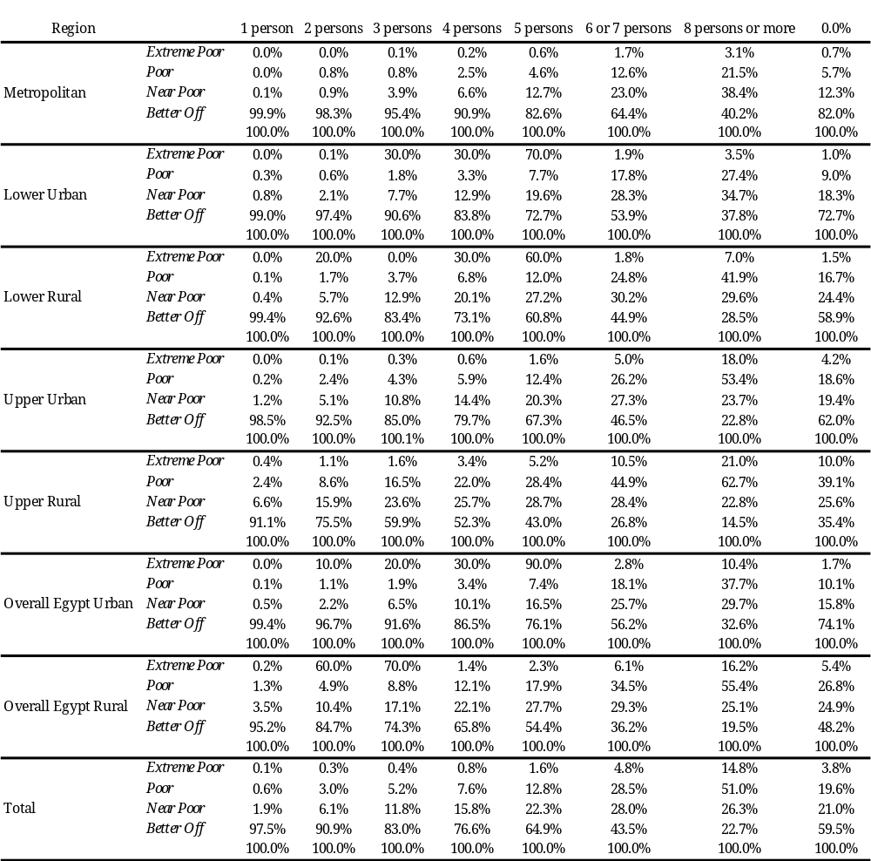

Table A.2.13 (a): Distribution of Individuals by Household Size, by Region and by Poverty Status 2004-05 (percent)

 | One person | Two persons | Three persons | Four persons | 5 persons | 6 or 7 persons | 8 persons or more | Total
Metropolitan
Non poor | 2.41 | 7.41 | 13.23 | 26.36 | 27.07 | 19.75 | 3.76 | 36450
Poor |  | 1.05 | 1.69 | 11.05 | 21.91 | 47.24 | 17.07 | 2191
Total | 2.27 | 7.05 | 12.58 | 25.49 | 26.77 | 21.31 | 4.52 | 38641
Lower Urban
Non poor | 1.72 | 6.26 | 12.44 | 24.72 | 28.32 | 22.40 | 4.13 | 22853
Poor | 0.04 | 0.35 | 2.21 | 8.62 | 23.97 | 49.00 | 15.79 | 2261
Total | 1.57 | 5.73 | 11.52 | 23.27 | 27.93 | 24.80 | 5.18 | 25114
Lower Rural
Non poor | 1.26 | 5.10 | 11.29 | 21.26 | 26.36 | 27.40 | 7.32 | 53050
Poor | 0.01 | 0.46 | 2.14 | 7.73 | 18.00 | 45.28 | 26.37 | 10609
Total | 1.05 | 4.33 | 9.77 | 19.00 | 24.97 | 30.38 | 10.50 | 63659
Upper Urban
Non poor | 2.02 | 6.75 | 12.24 | 21.63 | 24.95 | 25.21 | 7.19 | 19973
Poor | 0.02 | 0.70 | 2.39 | 5.94 | 15.51 | 39.24 | 36.20 | 4564
Total | 1.65 | 5.63 | 10.40 | 18.71 | 23.20 | 27.82 | 12.59 | 24537
Upper Rural
Non poor | 2.05 | 6.90 | 10.47 | 15.80 | 19.51 | 31.09 | 14.18 | 31991
Poor | 0.08 | 1.01 | 3.22 | 6.96 | 12.06 | 39.45 | 37.22 | 20503
Total | 1.28 | 4.60 | 7.64 | 12.35 | 16.60 | 34.35 | 23.18 | 52494
All Egypt
Non poor | 1.82 | 6.31 | 11.86 | 21.77 | 25.22 | 25.51 | 7.50 | 166530
Poor | 0.05 | 0.79 | 2.68 | 7.34 | 15.20 | 41.82 | 32.12 | 40502
Total | 1.47 | 5.23 | 10.07 | 18.95 | 23.26 | 28.70 | 12.32 | 207032

Table A.2.13 (b): Distribution of Individuals by Household Size, by Region and by Poverty Status 2004-05 (percent)
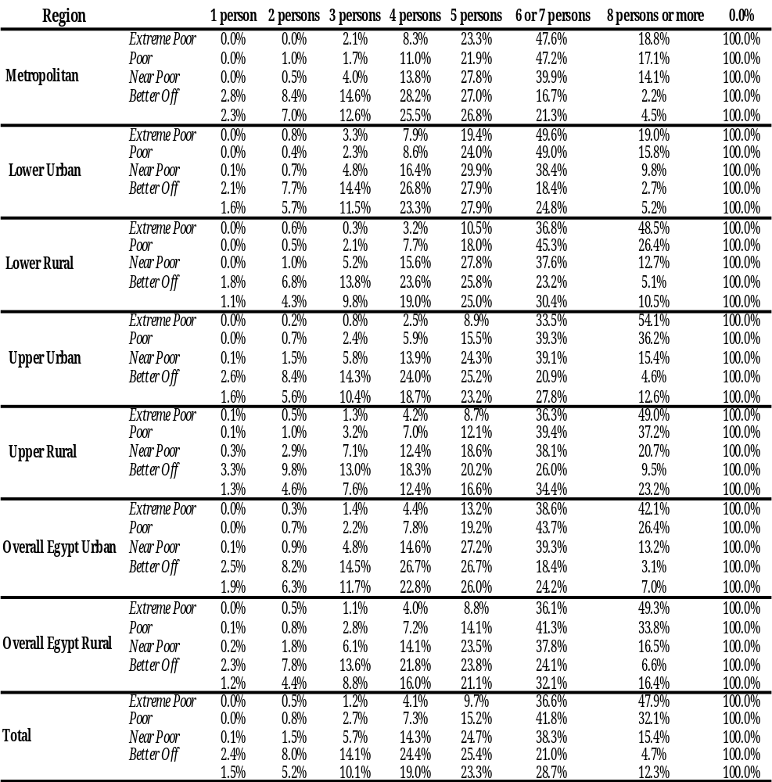
Table A.2.13 (c) Poverty Risk of Households by Number of Children, by Region and Poverty Status, 2005 (percent)

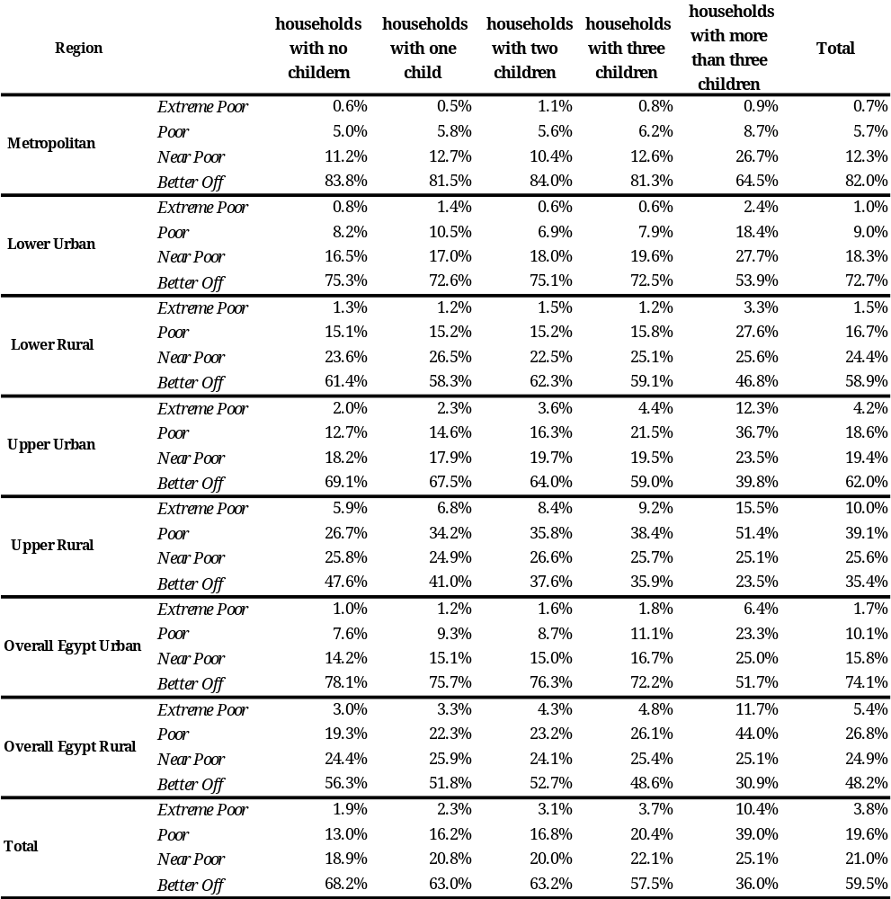
Table A.2.14: Average Household Size by Poverty Status for 2004-05 and 1999-00

 | 2004-05 |  |  | 1999-2000 |  |  |  | Change
 | Non  Poor | Poor | All |  | Non  Poor | Poor | All |  | Non Poor | Poor | All
Metropolitan | 3.82 | 5.68 | 3.90 |  | 3.96 | 5.98 | 4.14 |  | -0.14 | -0.30 | -0.24
Lower Urban | 4.02 | 5.76 | 4.13 |  | 4.31 | 6.89 | 4.45 |  | -0.29 | -1.13 | -0.32
Lower Rural | 4.29 | 6.09 | 4.51 |  | 5.05 | 7.32 | 5.41 |  | -0.76 | -1.23 | -0.90
Upper Urban | 4.04 | 6.28 | 4.33 |  | 4.37 | 7.05 | 4.56 |  | -0.33 | -0.77 | -0.23
Upper Rural | 4.28 | 6.23 | 4.88 |  | 5.07 | 7.43 | 5.59 |  | -0.79 | -1.20 | -0.71
All Egypt | 4.11 | 6.15 | 4.40 |  | 4.66 | 7.15 | 4.99 |  | -0.55 | -1.00 | -0.59

Table A.2.15 (a) Demographic Characteristics by Poverty Status and Region
2004-05

 | Average Number of children <15 | Average Number of adult males 15-60 | Average Number of adult females 15-60 | Average Number of elderly >=60 | Average Household Size
Metropolitan
Non Poor | 1.00 | 1.25 | 1.25 | 0.32 | 3.82
Poor | 1.34 | 2.04 | 1.96 | 0.34 | 5.68
Total | 1.02 | 1.28 | 1.28 | 0.32 | 3.90
Lower Urban
Non Poor | 1.21 | 1.27 | 1.27 | 0.27 | 4.02
Poor | 1.52 | 2.16 | 1.83 | 0.25 | 5.76
Total | 1.23 | 1.32 | 1.31 | 0.27 | 4.13
Lower Rural
Non Poor | 1.41 | 1.32 | 1.30 | 0.25 | 4.29
Poor | 1.82 | 2.20 | 1.83 | 0.25 | 6.09
Total | 1.46 | 1.43 | 1.37 | 0.25 | 4.51
Upper Urban
Non Poor | 1.22 | 1.27 | 1.27 | 0.29 | 4.04
Poor | 2.13 | 2.05 | 1.84 | 0.26 | 6.28
Total | 1.33 | 1.37 | 1.34 | 0.29 | 4.33
Upper Rural
Non Poor | 1.63 | 1.16 | 1.19 | 0.30 | 4.28
Poor | 2.49 | 1.84 | 1.64 | 0.26 | 6.23
Total | 1.90 | 1.37 | 1.33 | 0.29 | 4.88
All Egypt
Non Poor | 1.31 | 1.26 | 1.26 | 0.28 | 4.11
Poor | 2.15 | 1.99 | 1.74 | 0.26 | 6.15
Total | 1.43 | 1.36 | 1.33 | 0.28 | 4.40

Table A.2.15 (b): Demographic Characteristics by Poverty Status and Region
2004-05
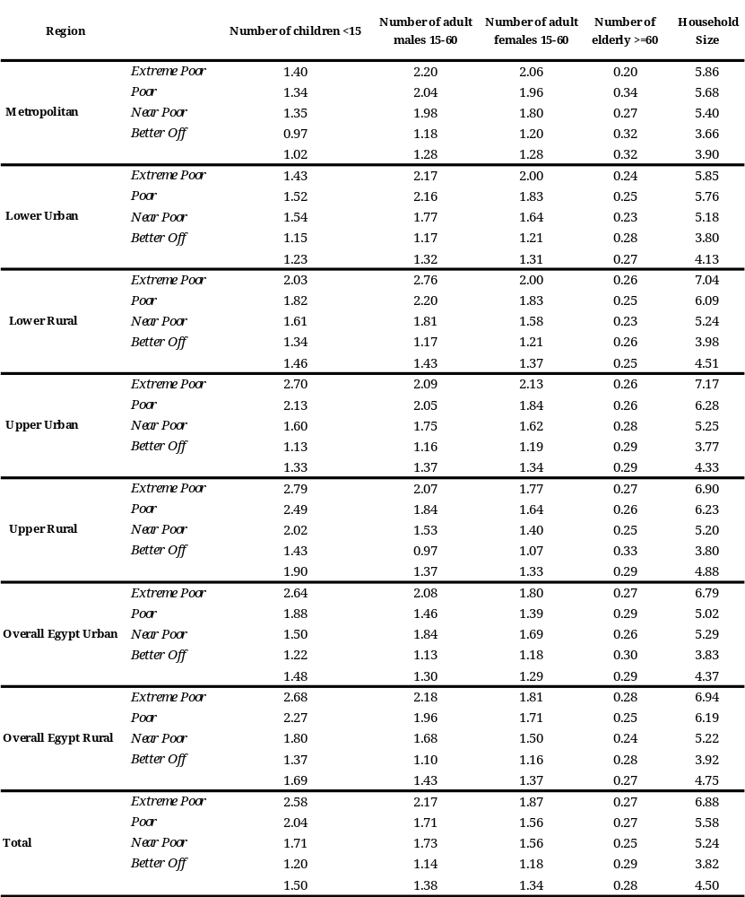

Table A.2.16: Poverty Measurements by Household Structure and Gender of Household Head, 2004-05 (percent)
 | Married with no children | Married with 1-3 children | Married with more than three children | Widowed with no children | Widowed with 1-3 children | Widowed with more than three children | Never married | Others | Total
Male Headed Households in Urban Areas
P0 | 8.48 | 9.31 | 23.66 | 4.44 | 11.63 | 0.00 | 6.62 | 2.37 | 10.19
P1 | 1.31 | 1.59 | 5.20 | 0.62 | 1.84 | 0.00 | 1.33 | 0.18 | 1.80
P2 | 0.36 | 0.44 | 1.72 | 0.32 | 0.59 | 0.00 | 0.38 | 0.02 | 0.52
 | 20493 | 49376 | 6799 | 895 | 397 | 34 | 1554 | 377 | 79925
Female Headed Households in Urban Areas
P0 | 4.54 | 4.57 | 6.98 | 5.80 | 14.69 | 31.00 | 5.42 | 12.66 | 9.00
P1 | 0.57 | 1.17 | 1.75 | 1.23 | 2.99 | 7.17 | 0.19 | 2.50 | 1.86
P2 | 0.11 | 0.37 | 0.45 | 0.39 | 0.96 | 2.73 | 0.01 | 0.79 | 0.60
 | 288 | 829 | 168 | 4845 | 2557 | 193 | 215 | 757 | 9852
All Households in Urban Areas
P0 | 8.42 | 9.23 | 23.26 | 5.59 | 14.28 | 26.31 | 6.47 | 9.24 | 10.06
P1 | 1.30 | 1.58 | 5.12 | 1.13 | 2.83 | 6.08 | 1.19 | 1.73 | 1.81
P2 | 0.36 | 0.43 | 1.69 | 0.38 | 0.91 | 2.32 | 0.33 | 0.53 | 0.53
 | 20781 | 50205 | 6967 | 5740 | 2954 | 227 | 1769 | 1134 | 89777
Male Headed Households in Rural Areas
P0 | 20.73 | 23.84 | 44.79 | 18.09 | 34.73 | 32.80 | 27.06 | 22.58 | 27.56
P1 | 3.16 | 3.98 | 9.11 | 3.74 | 5.89 | 5.81 | 4.57 | 3.51 | 4.88
P2 | 0.87 | 1.11 | 2.81 | 1.27 | 1.46 | 1.48 | 1.36 | 0.64 | 1.41
 | 17759 | 63826 | 20910 | 612 | 604 | 201 | 1173 | 189 | 105274
Female Headed Households in Rural Areas
P0 | 13.51 | 10.59 | 21.36 | 13.92 | 31.23 | 57.68 | 17.36 | 21.56 | 20.55
P1 | 2.03 | 1.93 | 4.54 | 2.45 | 5.98 | 12.70 | 3.08 | 5.69 | 3.98
P2 | 0.45 | 0.57 | 1.30 | 0.72 | 1.86 | 5.00 | 0.74 | 1.73 | 1.25
 | 342 | 2524 | 933 | 3987 | 3135 | 530 | 116 | 413 | 11980
All Households in Rural Areas
P0 | 20.59 | 23.34 | 43.79 | 14.47 | 31.79 | 50.83 | 26.19 | 21.88 | 26.84
P1 | 3.14 | 3.90 | 8.92 | 2.62 | 5.96 | 10.80 | 4.44 | 5.01 | 4.79
P2 | 0.86 | 1.09 | 2.74 | 0.80 | 1.79 | 4.03 | 1.30 | 1.39 | 1.39
 | 18101 | 66350 | 21843 | 4599 | 3739 | 731 | 1289 | 602 | 117254
Male Headed Households in All Egypt
P0 | 14.17 | 17.51 | 39.60 | 9.98 | 25.57 | 28.03 | 15.41 | 9.12 | 20.06
P1 | 2.17 | 2.94 | 8.15 | 1.89 | 4.28 | 4.96 | 2.72 | 1.29 | 3.55
P2 | 0.60 | 0.81 | 2.54 | 0.70 | 1.12 | 1.26 | 0.80 | 0.22 | 1.03
 | 38252 | 113202 | 27709 | 1507 | 1001 | 235 | 2727 | 566 | 185199
Female Headed Households in All Egypt
P0 | 9.41 | 9.11 | 19.17 | 9.46 | 23.80 | 50.58 | 9.61 | 15.80 | 15.34
P1 | 1.36 | 1.74 | 4.12 | 1.78 | 4.63 | 11.23 | 1.20 | 3.63 | 3.03
P2 | 0.29 | 0.52 | 1.17 | 0.54 | 1.45 | 4.39 | 0.27 | 1.12 | 0.95
 | 630 | 3353 | 1101 | 8832 | 5692 | 723 | 331 | 1170 | 21832
All Households in All Egypt
P0 | 14.09 | 17.26 | 38.82 | 9.54 | 24.06 | 45.03 | 14.79 | 13.62 | 19.56
P1 | 2.16 | 2.90 | 8.00 | 1.79 | 4.58 | 9.68 | 2.56 | 2.87 | 3.50
P2 | 0.59 | 0.81 | 2.49 | 0.57 | 1.40 | 3.62 | 0.74 | 0.83 | 1.02
 | 38882 | 116555 | 28810 | 10339 | 6693 | 958 | 3058 | 1736 | 207031
Table A.2.17: Distribution of Individuals by Household Structure, by Gender of Household Head and by Poverty Status, 2004-05 (percent)
 | married with no children | married with 1-3 children | married with more than three children | widowed with no children | widowed with 1-3 children | widowed with more than three children | never married | others | Total
Male Headed Households in Urban Areas
Non poor | 26.13 | 62.38 | 7.23 | 1.19 | 0.49 | 0.05 | 2.02 | 0.51 | 71783
Poor | 21.35 | 56.46 | 19.76 | 0.49 | 0.56 | 0.00 | 1.27 | 0.11 | 8142
Total | 25.64 | 61.78 | 8.51 | 1.12 | 0.50 | 0.04 | 1.94 | 0.47 | 79925
Female Headed Households in Urban Areas
Non poor | 3.07 | 8.82 | 1.74 | 50.91 | 24.33 | 1.48 | 2.26 | 7.37 | 8964
Poor | 1.46 | 4.28 | 1.35 | 31.64 | 42.34 | 6.76 | 1.35 | 10.81 | 888
Total | 2.92 | 8.41 | 1.71 | 49.18 | 25.95 | 1.96 | 2.18 | 7.68 | 9852
All Households in Urban Areas
Non poor | 23.57 | 56.44 | 6.62 | 6.71 | 3.14 | 0.21 | 2.05 | 1.27 | 80747
Poor | 19.39 | 51.33 | 17.95 | 3.55 | 4.67 | 0.66 | 1.27 | 1.16 | 9030
Total | 23.15 | 55.92 | 7.76 | 6.39 | 3.29 | 0.25 | 1.97 | 1.26 | 89777
Male Headed Households in Rural Areas
Non poor | 18.46 | 63.74 | 15.14 | 0.66 | 0.52 | 0.18 | 1.12 | 0.19 | 76262
Poor | 12.69 | 52.46 | 32.28 | 0.38 | 0.72 | 0.23 | 1.09 | 0.15 | 29012
Total | 16.87 | 60.63 | 19.86 | 0.58 | 0.57 | 0.19 | 1.11 | 0.18 | 105274
Female Headed Households in Rural Areas
Non poor | 3.11 | 23.71 | 7.71 | 36.05 | 22.65 | 2.35 | 1.01 | 3.40 | 9519
Poor | 1.87 | 10.85 | 8.09 | 22.55 | 39.78 | 12.43 | 0.81 | 3.62 | 2461
Total | 2.85 | 21.07 | 7.79 | 33.28 | 26.17 | 4.42 | 0.97 | 3.45 | 11980
All Households in Rural Areas
Non poor | 16.76 | 59.30 | 14.31 | 4.58 | 2.97 | 0.42 | 1.11 | 0.55 | 85781
Poor | 11.84 | 49.20 | 30.39 | 2.12 | 3.78 | 1.18 | 1.07 | 0.42 | 31473
Total | 15.44 | 56.59 | 18.63 | 3.92 | 3.19 | 0.62 | 1.10 | 0.51 | 117254
Male Headed Households in All Egypt
Non poor | 22.18 | 63.08 | 11.30 | 0.92 | 0.50 | 0.11 | 1.56 | 0.35 | 148045
Poor | 14.59 | 53.33 | 29.54 | 0.41 | 0.69 | 0.18 | 1.13 | 0.14 | 37154
Total | 20.65 | 61.12 | 14.96 | 0.81 | 0.54 | 0.13 | 1.47 | 0.31 | 185199
Female Headed Households in All Egypt
Non poor | 3.09 | 16.49 | 4.82 | 43.26 | 23.46 | 1.93 | 1.62 | 5.33 | 18483
Poor | 1.76 | 9.11 | 6.30 | 24.96 | 40.46 | 10.93 | 0.96 | 5.52 | 3349
Total | 2.89 | 15.36 | 5.04 | 40.45 | 26.07 | 3.31 | 1.52 | 5.36 | 21832
All Households in All Egypt
Non poor | 20.06 | 57.91 | 10.58 | 5.62 | 3.05 | 0.32 | 1.56 | 0.90 | 166528
Poor | 13.52 | 49.68 | 27.62 | 2.44 | 3.98 | 1.07 | 1.12 | 0.59 | 40503
Total | 18.78 | 56.30 | 13.92 | 4.99 | 3.23 | 0.46 | 1.48 | 0.84 | 207031

Table A.2.18 (a): Poverty Measurements by Gender of Household Head,
2005(percent)

 | Male Headed Households | Female Headed Households | Total
Metropolitan
P0 | 5.52 | 6.74 | 5.67
P1 | 0.81 | 1.15 | 0.85
P2 | 0.20 | 0.30 | 0.21
 | 33929 | 4711 | 38640
Lower Urban
P0 | 9.06 | 8.49 | 9.00
P1 | 1.35 | 1.73 | 1.38
P2 | 0.32 | 0.50 | 0.34
 | 22636.00 | 2476.00 | 25112.00
Lower Rural
P0 | 17.11 | 12.13 | 16.66
P1 | 2.43 | 1.88 | 2.38
P2 | 0.54 | 0.46 | 0.53
 | 57995.00 | 5663.00 | 63658.00
Upper Urban
P0 | 19.14 | 13.97 | 18.60
P1 | 3.93 | 2.95 | 3.83
P2 | 1.18 | 0.92 | 1.15
 | 21972.00 | 2567.00 | 24539.00
Upper Rural
P0 | 40.55 | 28.09 | 39.06
P1 | 8.39 | 5.75 | 8.07
P2 | 2.51 | 1.77 | 2.42
 | 46226.00 | 6270.00 | 52496.00
All Egypt
P0 | 20.06 | 15.34 | 19.56
P1 | 3.68 | 2.95 | 3.60
P2 | 1.02 | 0.86 | 1.01
 | 185202 | 21830 | 207032

Table A.2.18 (b): Poverty Risk by Gender of Household Head,
2005 (percent)
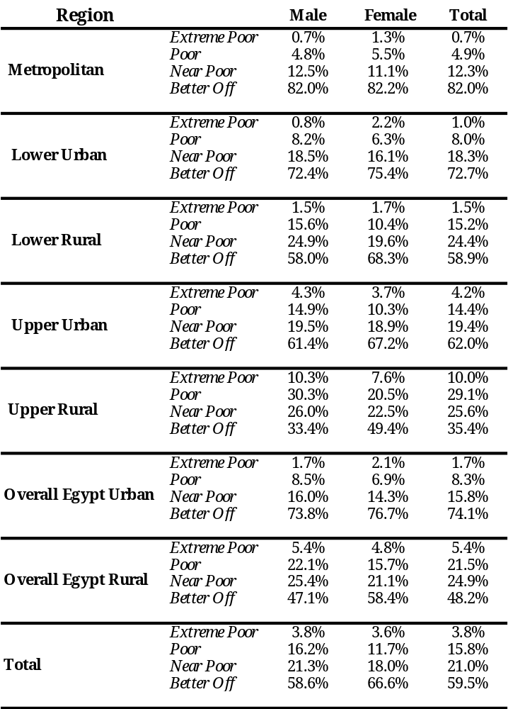
Table A.2.19 (a): Distribution of Individuals by Gender of Household Head,
by Region and Poverty Status, 2005

 | Male Headed Households | Female Headed Households | Total
Metropolitan
Non poor | 87.95 | 12.05 | 36450
Poor | 85.53 | 14.47 | 2190
Total | 87.81 | 12.19 | 38640
Lower Urban
Non poor | 90.08 | 9.92 | 22852
Poor | 90.71 | 9.29 | 2260
Total | 90.14 | 9.86 | 25112
Lower Rural
Non poor | 90.62 | 9.38 | 53049
Poor | 93.52 | 6.48 | 10609
Total | 91.10 | 8.90 | 63658
Upper Urban
Non poor | 88.95 | 11.05 | 19974
Poor | 92.14 | 7.86 | 4565
Total | 89.54 | 10.46 | 24539
Upper Rural
Non poor | 85.91 | 14.09 | 31992
Poor | 91.41 | 8.59 | 20504
Total | 88.06 | 11.94 | 52496
Upper Rural
Non poor | 88.90 | 11.10 | 166529
Poor | 91.73 | 8.27 | 40503
Total | 89.46 | 10.54 | 207032

Table A.2.19 (b): Distribution of Individuals by Gender of Household Head,
by Region and Poverty Status, 2005

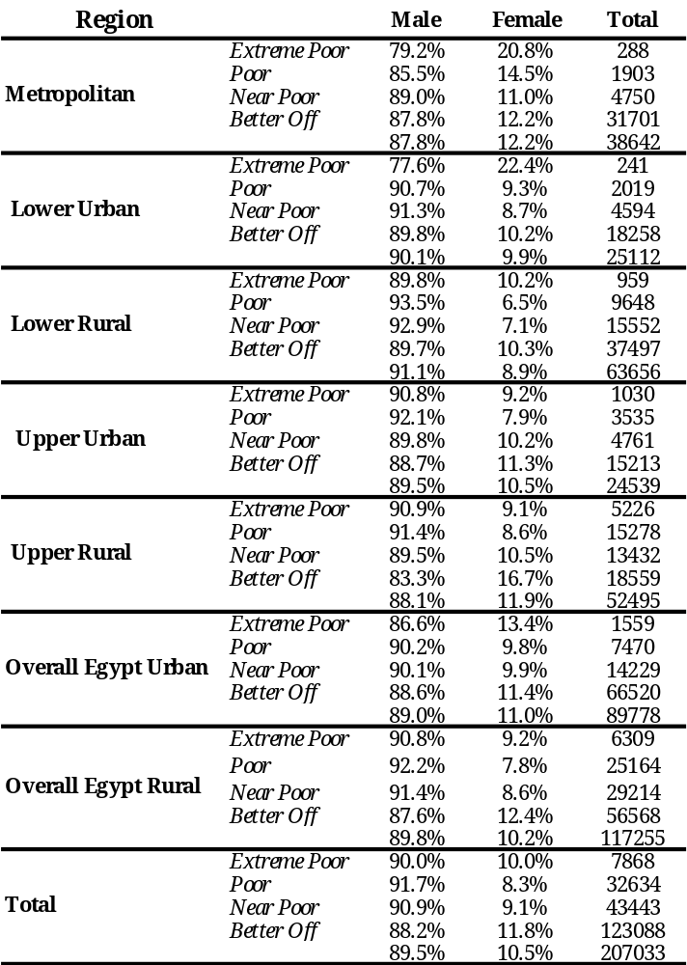

Table A.2.20: Illiteracy Rate among Children of Age 12-15 Years Old by Poverty Status and Region 2004-05
 | Boys | Girls | Total | Male headed households | Female headed households
Metropolitan
Non Poor | 2.63 | 2.62 | 2.63 | 2.42 | 4.26
Poor | 17.79 | 12.98 | 15.29 | 13.22 | 27.70
Total | 3.72 | 3.47 | 3.60 | 3.22 | 6.46
Lower Urban
Non Poor | 4.45 | 2.13 | 3.31 | 3.47 | 1.74
Poor | 10.50 | 6.36 | 8.49 | 8.38 | 10.62
Total | 5.13 | 2.60 | 3.89 | 4.04 | 2.26
Lower Rural
Non Poor | 4.85 | 5.78 | 5.31 | 5.04 | 7.82
Poor | 10.81 | 15.32 | 12.98 | 12.77 | 16.38
Total | 6.15 | 7.81 | 6.96 | 6.76 | 9.02
Upper Urban
Non Poor | 3.48 | 3.50 | 3.49 | 3.41 | 4.19
Poor | 10.16 | 13.88 | 11.96 | 12.20 | 9.54
Total | 5.18 | 6.08 | 5.62 | 5.64 | 5.43
Upper Rural
Non Poor | 7.51 | 16.15 | 11.57 | 11.68 | 11.00
Poor | 11.51 | 29.04 | 20.21 | 20.11 | 21.12
Total | 9.36 | 22.45 | 15.68 | 15.83 | 14.65
All Egypt
Non Poor | 4.75 | 6.53 | 5.61 | 5.44 | 7.01
Poor | 11.47 | 22.35 | 16.82 | 16.60 | 19.10
Total | 6.51 | 10.75 | 8.58 | 8.45 | 9.63

Table A.2.21: Percentage of Working Children Aged 6-15 Years by Poverty Status and Gender, 2004-05

 | Boys | Girls | Total | Male headed households | Female headed households
 | Metropolitan
Non Poor | 1.98 | 0.42 | 1.21 | 1.05 | 2.91
Poor | 6.58 | 0.95 | 3.70 | 3.01 | 8.35
Total | 2.26 | 0.45 | 1.37 | 1.17 | 3.39
 | Lower Urban
Non Poor | 2.83 | 0.10 | 1.49 | 1.49 | 1.45
Poor | 5.10 | 0.00 | 2.56 | 2.03 | 9.28
Total | 3.05 | 0.09 | 1.59 | 1.54 | 2.18
 | Lower Rural
Non Poor | 3.88 | 1.15 | 2.55 | 2.39 | 4.45
Poor | 7.37 | 2.64 | 5.15 | 5.12 | 5.73
Total | 4.55 | 1.42 | 3.04 | 2.91 | 4.61
 | Upper Urban
Non Poor | 2.62 | 0.11 | 1.41 | 1.27 | 3.05
Poor | 5.49 | 1.02 | 3.34 | 3.53 | 0.99
Total | 3.29 | 0.32 | 1.87 | 1.81 | 2.58
 | Upper Rural
Non Poor | 5.03 | 0.92 | 3.09 | 3.05 | 3.35
Poor | 6.60 | 1.90 | 4.29 | 4.31 | 4.09
Total | 5.73 | 1.37 | 3.64 | 3.65 | 3.60
 | All Egypt
Non Poor | 3.45 | 0.68 | 2.11 | 1.98 | 3.33
Poor | 6.56 | 1.83 | 4.26 | 4.23 | 4.61
Total | 4.21 | 0.96 | 2.64 | 2.54 | 3.59

Table A.2.22: Net Enrolment Rate in Basic Education by Poverty Status and Gender 2004-05 (percent)

 | Boys | Girls | Total | Male headed households | Female headed households
 | Metropolitan
Non Poor | 96.28 | 96.54 | 96.41 | 96.76 | 92.77
Poor | 82.21 | 83.95 | 83.10 | 84.11 | 76.31
Total | 95.44 | 95.72 | 95.58 | 96.00 | 91.30
 | Lower Urban
Non Poor | 95.47 | 96.82 | 96.13 | 96.17 | 95.66
Poor | 88.92 | 92.86 | 90.88 | 91.35 | 84.96
Total | 94.83 | 96.43 | 95.61 | 95.69 | 94.67
 | Lower Rural
Non Poor | 94.57 | 94.58 | 94.57 | 94.79 | 92.12
Poor | 89.05 | 85.83 | 87.53 | 87.73 | 83.81
Total | 93.51 | 92.99 | 93.26 | 93.43 | 91.10
 | Upper Urban
Non Poor | 95.58 | 96.11 | 95.83 | 95.91 | 95.00
Poor | 89.67 | 84.06 | 86.97 | 86.63 | 90.98
Total | 94.19 | 93.25 | 93.74 | 93.71 | 94.10
 | Upper Rural
Non Poor | 93.15 | 86.27 | 89.90 | 89.96 | 89.58
Poor | 88.49 | 73.54 | 81.17 | 81.23 | 80.55
Total | 91.07 | 80.35 | 85.92 | 85.83 | 86.56
 | All Egypt
Non Poor | 94.86 | 93.64 | 94.26 | 94.50 | 92.05
Poor | 88.45 | 78.64 | 83.68 | 83.82 | 82.06
Total | 93.29 | 89.96 | 91.68 | 91.85 | 89.97

Table A.2.23: Shares of Different Income Sources by Poverty Status and Gender of Household Head 2004-05

 | wages and salaries | agricultural projects | non-agricultural projects | financial assets | non financial assets | imputed rent for houses | transfers | Total
 | Female Headed households in Urban Areas
Non Poor | 29.33 | 1.12 | 7.86 | 1.79 | 2.93 | 7.62 | 49.36 | 100
Poor | 38.55 | 1.20 | 0.77 | 5.88 | 8.69 | 0.00 | 2.04 | 100
Total | 29.61 | 0.83 | 0.31 | 3.97 | 4.09 | 1.73 | 2.90 | 100
 | Male Headed households in Urban Areas
Non Poor | 50.80 | 1.85 | 0.53 | 14.90 | 8.86 | 2.47 | 2.34 | 100
Poor | 54.32 | 5.00 | 2.06 | 8.18 | 11.23 | 0.10 | 0.60 | 100
Total | 50.95 | 1.98 | 0.59 | 14.63 | 8.95 | 2.38 | 2.27 | 100
 | All households in Urban Areas
Non Poor | 48.14 | 1.73 | 0.50 | 13.54 | 8.25 | 2.39 | 2.42 | 100
Poor | 52.78 | 4.63 | 1.94 | 7.96 | 10.98 | 0.09 | 0.74 | 100
Total | 48.32 | 1.84 | 0.56 | 13.32 | 8.36 | 2.30 | 2.35 | 100
 | Female Headed households in Rural Areas
Non Poor | 15.91 | 13.91 | 5.20 | 1.96 | 3.04 | 0.44 | 3.77 | 100
Poor | 30.20 | 16.63 | 7.34 | 1.49 | 3.41 | 0.02 | 0.94 | 100
Total | 17.57 | 14.23 | 5.44 | 1.90 | 3.08 | 0.39 | 3.44 | 100
 | Male Headed households in Rural Areas
Non Poor | 35.88 | 27.42 | 4.76 | 7.23 | 6.12 | 0.47 | 2.22 | 100
Poor | 43.01 | 26.55 | 5.86 | 3.82 | 5.32 | 0.07 | 0.54 | 100
Total | 37.11 | 27.27 | 4.95 | 6.65 | 5.98 | 0.40 | 1.93 | 100
 | All households in Rural Areas
Non Poor | 33.51 | 25.82 | 4.81 | 6.61 | 5.75 | 0.47 | 2.40 | 100
Poor | 42.01 | 25.77 | 5.98 | 3.64 | 5.17 | 0.06 | 0.57 | 100
Total | 34.92 | 25.81 | 5.01 | 6.11 | 5.65 | 0.40 | 2.10 | 100
 | Female Headed households in All Egypt
Non Poor | 23.94 | 6.07 | 2.26 | 3.13 | 3.58 | 1.25 | 3.27 | 100
Poor | 32.43 | 12.53 | 5.59 | 2.66 | 4.82 | 0.01 | 1.23 | 100
Total | 24.51 | 6.51 | 2.48 | 3.10 | 3.66 | 1.17 | 3.13 | 100
 | Male Headed households in All Egypt
Non Poor | 44.63 | 12.42 | 2.28 | 11.73 | 7.72 | 1.65 | 2.29 | 100
Poor | 45.52 | 21.76 | 5.02 | 4.79 | 6.63 | 0.08 | 0.55 | 100
Total | 44.72 | 13.35 | 2.55 | 11.04 | 7.62 | 1.49 | 2.12 | 100
 | All Households in All Egypt
Non Poor | 42.12 | 11.65 | 2.28 | 10.68 | 7.22 | 1.60 | 2.41 | 100
Poor | 44.44 | 20.99 | 5.07 | 4.61 | 6.48 | 0.07 | 0.61 | 100
Total | 42.34 | 12.54 | 2.54 | 10.10 | 7.15 | 1.45 | 2.24 | 100

Table A.2.24: Percentage Shares of Different Types of Transfers , Out of Total Income, by Poverty Status and Gender of Household Head 2004-05

 | Government pension | Social insurance | Sadat pensions | Pensions from unions | Social guaranty | Transfers from outside the country | Transfers within the country | Other periodical revenues-donations | Total transfers
Female Headed households in Urban Areas
Non Poor | 28.27 | 1.11 | 0.47 | 0.24 | 0.07 | 10.57 | 4.69 | 1.77 | 49.30
Poor | 21.58 | 3.51 | 1.13 | 0.07 | 0.45 | 0.90 | 4.06 | 3.64 | 37.40
Total | 28.06 | 1.18 | 0.49 | 0.24 | 0.08 | 10.27 | 4.67 | 1.82 | 48.93
Male Headed households in Urban Areas
Non Poor | 8.36 | 0.24 | 0.04 | 0.05 | 0.01 | 0.77 | 1.28 | 0.16 | 11.87
Poor | 7.73 | 0.61 | 0.22 | 0.02 | 0.07 | 0.33 | 1.29 | 0.69 | 11.94
Total | 8.34 | 0.26 | 0.05 | 0.05 | 0.01 | 0.75 | 1.28 | 0.18 | 11.87
All households in Urban Areas
Non Poor | 10.83 | 0.35 | 0.10 | 0.07 | 0.02 | 1.98 | 1.70 | 0.36 | 16.50
Poor | 9.07 | 0.89 | 0.31 | 0.03 | 0.11 | 0.39 | 1.56 | 0.98 | 14.42
Total | 10.76 | 0.37 | 0.10 | 0.07 | 0.02 | 1.92 | 1.70 | 0.39 | 16.42
Female Headed households in Rural Areas
Non Poor | 13.28 | 1.81 | 1.67 | 0.08 | 0.31 | 19.00 | 3.02 | 1.06 | 43.44
Poor | 9.29 | 2.36 | 2.60 | 0.16 | 0.95 | 8.12 | 3.72 | 1.57 | 30.24
Total | 12.82 | 1.88 | 1.78 | 0.09 | 0.38 | 17.74 | 3.10 | 1.12 | 41.91
Male Headed households in Rural Areas
Non Poor | 3.21 | 0.33 | 0.16 | 0.01 | 0.05 | 0.67 | 0.73 | 0.18 | 6.10
Poor | 2.44 | 0.51 | 0.37 | 0.02 | 0.15 | 0.34 | 0.79 | 0.56 | 5.77
Total | 3.08 | 0.36 | 0.20 | 0.01 | 0.06 | 0.61 | 0.74 | 0.24 | 6.04
All households in Rural Areas
Non Poor | 4.40 | 0.50 | 0.34 | 0.02 | 0.08 | 2.84 | 1.00 | 0.28 | 10.53
Poor | 2.98 | 0.65 | 0.54 | 0.03 | 0.21 | 0.95 | 1.02 | 0.64 | 7.69
Total | 4.17 | 0.53 | 0.38 | 0.02 | 0.10 | 2.53 | 1.00 | 0.34 | 10.06
Female Headed households in All Egypt
Non Poor | 22.25 | 1.39 | 0.95 | 0.18 | 0.16 | 13.95 | 4.02 | 1.48 | 46.95
Poor | 12.56 | 2.66 | 2.21 | 0.13 | 0.82 | 6.20 | 3.81 | 2.12 | 32.15
Total | 21.60 | 1.48 | 1.04 | 0.17 | 0.21 | 13.43 | 4.00 | 1.52 | 45.95
Male Headed households in All Egypt
Non Poor | 6.23 | 0.28 | 0.09 | 0.03 | 0.02 | 0.73 | 1.05 | 0.17 | 9.48
Poor | 3.61 | 0.53 | 0.33 | 0.02 | 0.13 | 0.34 | 0.90 | 0.59 | 7.14
Total | 5.97 | 0.30 | 0.12 | 0.03 | 0.04 | 0.69 | 1.04 | 0.21 | 9.25
All Households in All Egypt
Non Poor | 8.18 | 0.41 | 0.20 | 0.05 | 0.04 | 2.34 | 1.41 | 0.33 | 14.04
Poor | 4.35 | 0.71 | 0.49 | 0.03 | 0.19 | 0.83 | 1.14 | 0.72 | 9.21
Total | 7.82 | 0.44 | 0.23 | 0.05 | 0.06 | 2.19 | 1.39 | 0.37 | 13.58

Table A.2.25: Percentage of Households with Public Amenities Characteristics by Poverty Status 2004-05

 | urban |  |  | Rural
 | non poor | poor | Total | non poor | poor | Total
public network | 99.05 | 95.36 | 98.68 | 88.11 | 78.40 | 85.50
tap inside dwelling | 96.27 | 82.03 | 94.84 | 75.41 | 55.44 | 70.05
connected to sewerage network | 86.97 | 58.82 | 84.14 | 29.61 | 16.13 | 25.99
have electricity | 99.90 | 98.96 | 99.81 | 99.32 | 97.76 | 98.90
have private kitchen | 93.00 | 71.95 | 90.88 | 77.10 | 51.84 | 70.32
have proper means of garbage collection | 87.83 | 65.82 | 85.61 | 26.59 | 14.85 | 23.44
abnormal water color | 3.72 | 4.03 | 3.74 | 9.21 | 12.89 | 9.95
abnormal water smell | 2.83 | 4.97 | 2.98 | 9.43 | 13.96 | 10.34
there is an obstruction or superabundance in the system | 66.71 | 71.13 | 66.93 | 48.91 | 58.63 | 50.86
No health office | 4.72 | 8.36 | 4.97 | 60.05 | 63.85 | 60.82
no public health center | 31.73 | 43.82 | 32.55 | 40.59 | 41.31 | 40.74

Table A.2.26: Percentage of Households by Ownership of Durable Goods and by Poverty Status 2004-05

 | Urban |  |  | Rural |  |  | All Egypt
 | Non poor | Poor | Total | Non poor | Poor | Total | Non poor | Poor | Total
private car | 10.74 | 0.51 | 10.04 | 1.34 | 0.19 | 1.10 | 6.09 | 0.27 | 5.28
bicycles | 6.91 | 10.58 | 7.17 | 11.26 | 11.43 | 11.30 | 9.06 | 11.24 | 9.37
motocycle | 1.06 | 0.48 | 1.02 | 1.31 | 0.53 | 1.15 | 1.18 | 0.52 | 1.09
telephone | 64.51 | 30.05 | 62.15 | 32.07 | 16.00 | 28.82 | 48.48 | 19.21 | 44.38
cellular phone | 27.73 | 2.86 | 26.03 | 4.87 | 0.72 | 4.03 | 16.43 | 1.21 | 14.30
Internet | 4.57 | 0.39 | 4.28 | 0.47 | 0.10 | 0.39 | 2.54 | 0.16 | 2.21
Refrigerator | 93.85 | 75.16 | 92.57 | 74.91 | 51.74 | 70.21 | 84.49 | 57.09 | 80.65
Deep Freezer | 10.21 | 1.48 | 9.61 | 1.94 | 1.08 | 1.76 | 6.12 | 1.18 | 5.43
Gas bottles/Electricity/ microwave | 96.23 | 90.37 | 95.83 | 90.02 | 77.57 | 87.50 | 93.16 | 80.50 | 91.39
normal electric washing machine | 69.44 | 86.72 | 70.62 | 86.29 | 75.67 | 84.14 | 77.77 | 78.20 | 77.83
Automatic washing machine | 33.57 | 3.41 | 31.50 | 3.88 | 0.68 | 3.23 | 18.90 | 1.30 | 16.44
electric dish machine | 4.44 | 0.27 | 4.15 | 0.41 | 0.18 | 0.36 | 2.45 | 0.20 | 2.13
Gas/electric water heater | 64.02 | 20.57 | 61.05 | 18.64 | 3.05 | 15.48 | 41.60 | 7.05 | 36.76
vacuum sweeper | 25.94 | 1.49 | 24.27 | 3.12 | 0.13 | 2.52 | 14.67 | 0.44 | 12.68
Air condition | 9.95 | 1.00 | 9.34 | 1.02 | 0.61 | 0.94 | 5.54 | 0.70 | 4.86
Electric Fan | 88.09 | 75.16 | 87.20 | 80.65 | 69.70 | 78.43 | 84.41 | 70.95 | 82.53
Electric/ gas bottle/ Kerosene heater | 9.51 | 2.91 | 9.06 | 3.43 | 1.63 | 3.06 | 6.50 | 1.92 | 5.86
electric Iron | 85.28 | 59.17 | 83.49 | 63.90 | 39.77 | 59.01 | 74.71 | 44.20 | 70.44
colored Television | 87.02 | 62.29 | 85.33 | 62.72 | 40.08 | 58.13 | 75.01 | 45.15 | 70.84
Black/white Television | 11.45 | 29.90 | 12.71 | 29.23 | 45.94 | 32.61 | 20.24 | 42.27 | 23.32
Video | 19.15 | 3.62 | 18.09 | 3.46 | 1.03 | 2.97 | 11.40 | 1.62 | 10.03
Cassette (Normal/stereo/Radio) | 84.25 | 62.23 | 82.74 | 72.91 | 56.37 | 69.57 | 78.65 | 57.71 | 75.72
Dish Cable | 32.34 | 12.16 | 30.96 | 9.72 | 3.56 | 8.47 | 21.16 | 5.52 | 18.97
Personal Computer | 12.99 | 0.74 | 12.15 | 1.31 | 0.16 | 1.08 | 7.22 | 0.29 | 6.25
Normal Camera- Video Camera | 9.74 | 0.75 | 9.12 | 1.56 | 0.25 | 1.29 | 5.70 | 0.37 | 4.95
Water Filter | 4.18 | 0.14 | 3.90 | 0.45 | 0.04 | 0.37 | 2.34 | 0.06 | 2.02

Table A.2.27: Share of Various Expenditure Items to Total Expenditure by Poverty Status 2005
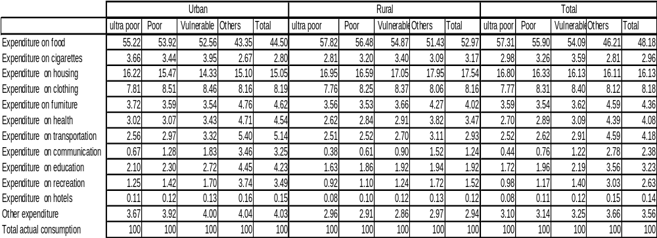

Table A.2.28: Fertility Rate and Under Five Mortality Rate by Poverty Status, 2004-05.
 | Fertility Rate | Under Five Mortality Rate
Urban
Non Poor | 3.05 | 11.45
Poor | 4.83 | 19.91
Total | 3.31 | 12.76
Rural
Non Poor | 3.45 | 19.10
Poor | 4.72 | 27.86
Total | 3.85 | 21.80
All Egypt
Non Poor | 3.31 | 16.84
Poor | 4.74 | 26.70
Total | 3.69 | 19.50

Table A.2.29: Unemployment Rate of Youth (15-24 years) by Educational Status and Poverty, 2005.

 | Urban |  | Rural |  | All Egypt
 | Non Poor | Poor | Non Poor | Poor | Non Poor | Poor
Illiterate | 1.78 | 4.90 | 0.52 | 1.08 | 0.81 | 1.73
Can read and write | 1.95 | 10.19 | 0.74 | 1.65 | 1.20 | 3.60
Basic Education | 7.11 | 9.26 | 2.08 | 4.02 | 4.30 | 5.47
secondary degree or equivalent | 31.93 | 37.18 | 21.10 | 25.75 | 25.39 | 28.58
Higher than Secondary degree but below university degree | 36.79 | 48.78 | 32.20 | 34.21 | 35.08 | 39.32
university degree and higher | 45.34 | 53.03 | 42.12 | 37.93 | 44.24 | 43.41
All | 26.01 | 24.89 | 13.71 | 13.47 | 18.74 | 16.12
Table A.2.30: Net Enrolment Rate by School Type and Poverty Status for Different Levels of Education, 2004-05.
 | Primary Schools |  |  | Preparatory Schools
 | Net Enrollment Rate | Girls 'Net Enrollment Rate | Net Enrollment in Public Schools | Net Enrollment Rate | Girls 'Net Enrollment Rate | Net Enrollment in Public Schools
 | Urban Areas
Non Poor | 96.68 | 96.47 | 83.58 | 65.66 | 65.28 | 59.58
Poor | 90.27 | 88.34 | 88.39 | 56.86 | 56.65 | 55.59
Total | 95.94 | 95.53 | 84.13 | 64.43 | 64.07 | 59.03
 | Rural Areas
Non Poor | 95.30 | 94.49 | 94.40 | 66.07 | 66.28 | 65.31
Poor | 87.98 | 83.43 | 87.02 | 54.50 | 49.75 | 53.80
Total | 93.03 | 91.07 | 92.12 | 62.07 | 60.50 | 61.33
 | All Egypt
Non Poor | 95.92 | 95.39 | 89.55 | 65.89 | 65.83 | 62.75
Poor | 88.42 | 84.38 | 87.28 | 54.97 | 51.12 | 54.16
Total | 94.16 | 92.82 | 89.02 | 62.97 | 61.87 | 60.45
 | Secondary Schools |  |  | Universities
 | Urban Areas
Non Poor | 67.88 | 67.28 | 62.29 | 37.86 | 36.80 | 39.86
Poor | 47.36 | 47.24 | 44.97 | 12.86 | 13.56 | 14.72
Total | 64.76 | 64.41 | 59.66 | 34.25 | 33.81 | 36.22
 | Rural Areas
Non Poor | 60.58 | 58.28 | 59.65 | 19.74 | 18.20 | 22.14
Poor | 44.73 | 40.44 | 44.37 | 9.91 | 9.59 | 11.48
Total | 55.12 | 52.32 | 54.39 | 16.61 | 15.83 | 18.74
 | All Egypt
Non Poor | 63.95 | 62.48 | 60.87 | 28.46 | 27.10 | 30.66
Poor | 45.32 | 41.98 | 44.50 | 10.65 | 10.63 | 12.30
Total | 58.96 | 57.22 | 56.49 | 24.10 | 23.62 | 26.17
Table A.2.31: Regression of Log Welfare Measure (Consumption/Poverty Line) on Characteristics of Household and Household Head for 2004-05 and 1999-00.

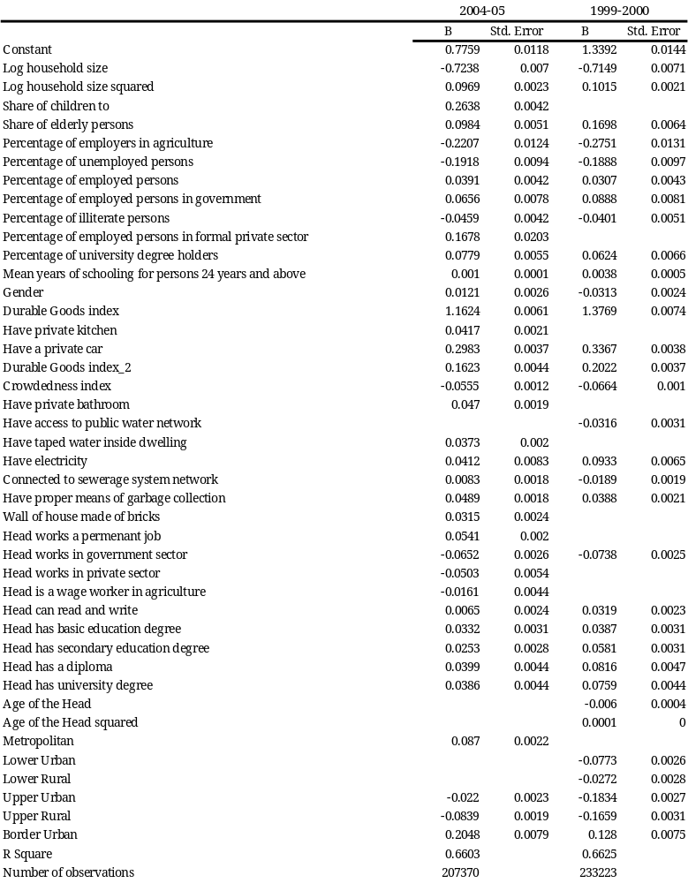

Table A.2.32: Impact of Changes in Household Characteristics and Characteristics of the Household Head on Poverty. (Percent Change).

 | Metropolitan | Lower Urban | Lower Rural | Upper Urban | Upper Rural
2004-05
New born child | 12.67 | 12.05 | 12.05 | 11.90 | 11.47
Head work in agriculture | 9.49 | 9.04 | 9.04 | 8.92 | 8.61
House connected to sewerage system | -1.26 | -1.21 | -1.21 | -1.19 | -1.15
head became unemployed | 7.69 | 7.33 | 7.33 | 7.24 | 6.98
increase number of employed persons by one | -6.19 | -5.92 | -5.92 | -5.85 | -5.67
Head has a secondary degree | 0.97 | 0.93 | 0.93 | 0.92 | 0.88
Head has a university degree | -3.63 | -3.47 | -3.47 | -3.43 | -3.31
Female headed households | 1.86 | 1.77 | 1.77 | 1.75 | 1.69
1999-2000
New born child | 16.33 | 15.64 | 16.08 | 14.70 | 14.86
Head work in agriculture | 11.38 | 10.91 | 11.21 | 10.27 | 10.38
House connected to swewrage system | 3.08 | 2.96 | 3.04 | 2.79 | 2.82
head became unemployed | -0.45 | -0.44 | -0.45 | -0.41 | -0.42
increase number of employed persons by one | -8.28 | -7.97 | -8.17 | -7.55 | -7.62
Head has a secondary degree | -3.99 | -3.84 | -3.94 | -3.63 | -3.67
Head has a university degree | -7.62 | -7.34 | -7.52 | -6.95 | -7.02
Female headed households | -4.95 | -4.77 | -4.89 | -4.51 | -4.55

Table A.3.1: Exchange Rates and Consumer Prices, 2000-2005 (Annual Change, December over December)

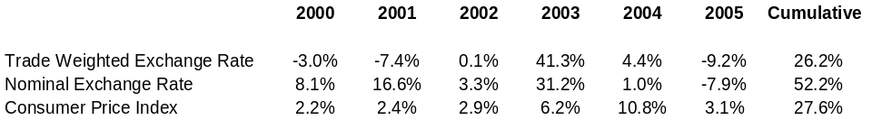

Table A.3.2 Disaggregated Price Change (Cumulative Growth Rate
July 2000-June 2005)

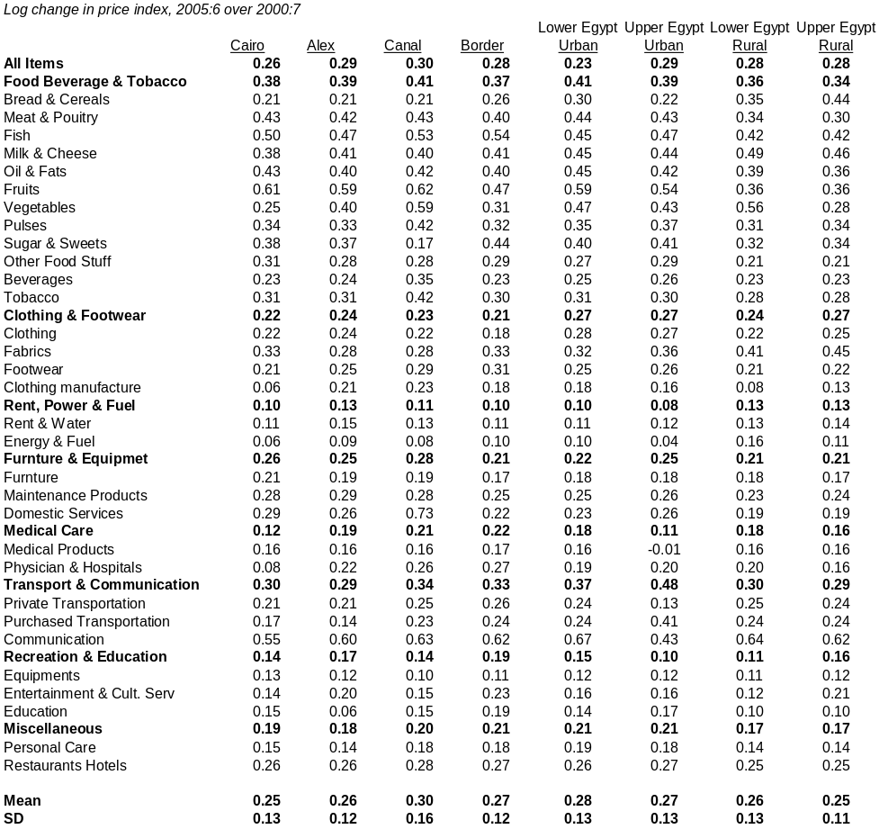

Table A.4.1: Estimated Per-Capita Region-Specific Poverty Lines (L.E. Per Year) for 1999/2000 and 2004/2005

Region | Lower poverty line  (LE. Per capita per year) |  | Governorates
Region | 1999/2000 | 2004/2005 | Governorates
Metropolitan | 1,109 | 1,453 | Cairo, Alexandria, Port Said, Suez
Lower Egypt Urban | 1,015 | 1,430 | Damiette, Dakhalia, Sharkia, Kalyoubia, Kafr El-Shaikh, Gharbia, Menoufia, Behera, Ismaila
Lower Egypt Rural | 978 | 1,429
Upper Egypt Urban | 1,031 | 1,416 | Giza, Beni-Suef, Fayoum, Menia, Assyout, Suhag, Quena, Aswan
Upper Egypt Rural | 964 | 1,408 | Giza, Beni-Suef, Fayoum, Menia, Assyout, Suhag, Quena, Aswan

Table A.4.2: Employment Structure and Growth Rate by Type of Employment, Sex and Urban/Rural Location, 1998-2006, Age 15-64 (in thousands)
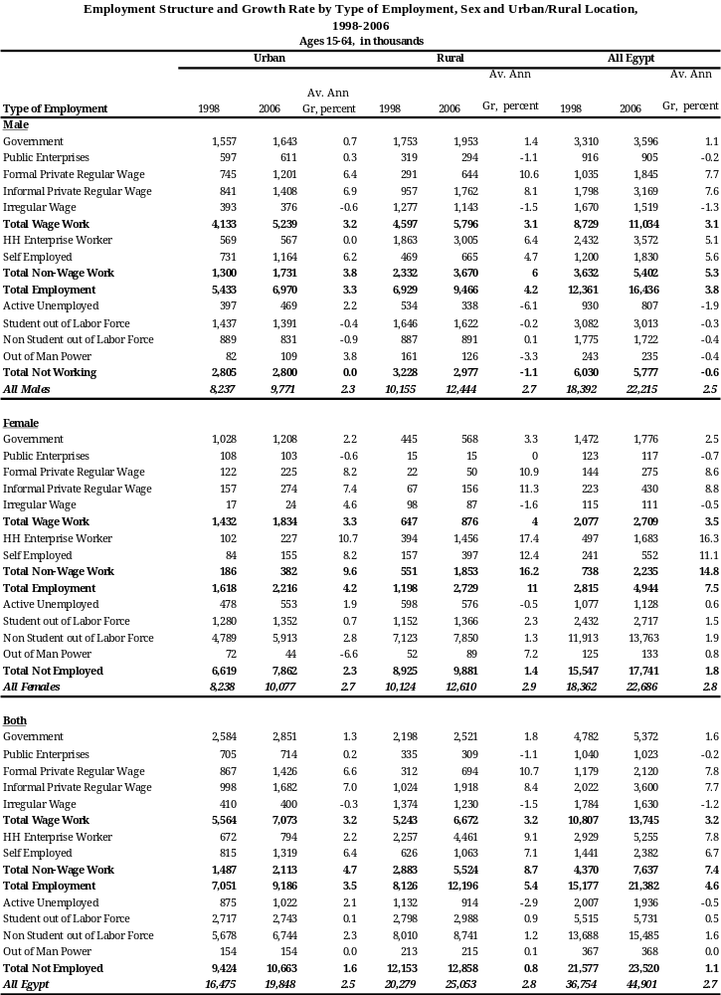
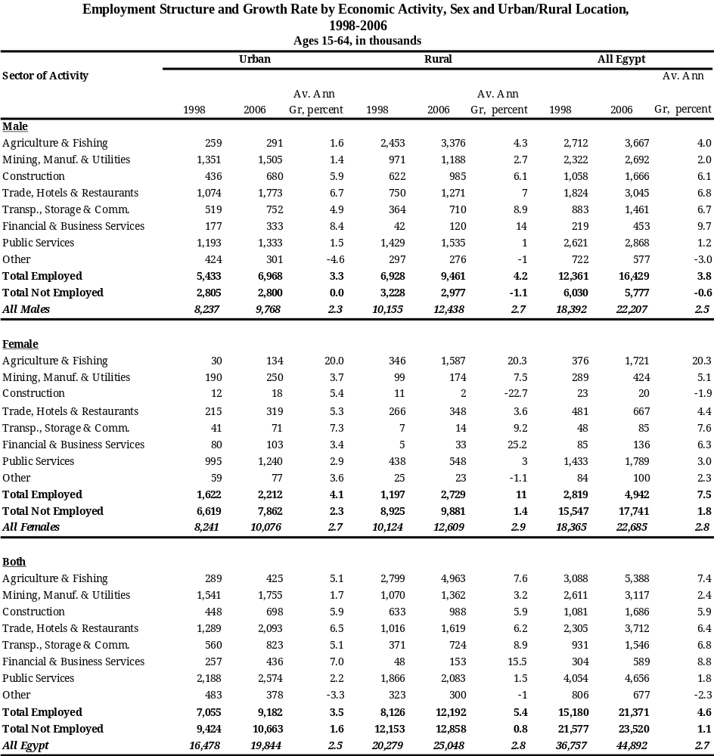
Table A.4.3: Employment Structure and Growth Rate by Economic Activity, Sex and Urban/Rural Location 1998-2006

Table A.4.4: Cross-Sectional and Longitudinal Method of Calculating the Growth in Agriculture Wage and Agriculture Non-Wage Work by Sex and Urban/Rural Location
1998-2006 (in thousands)
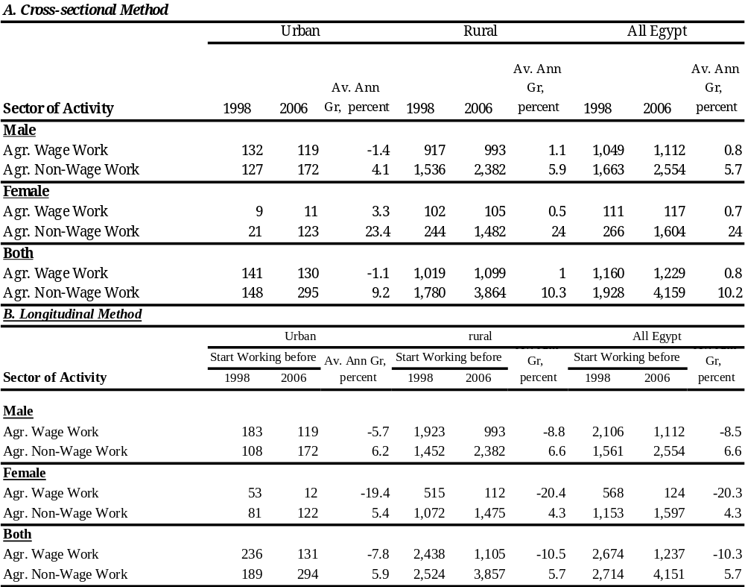

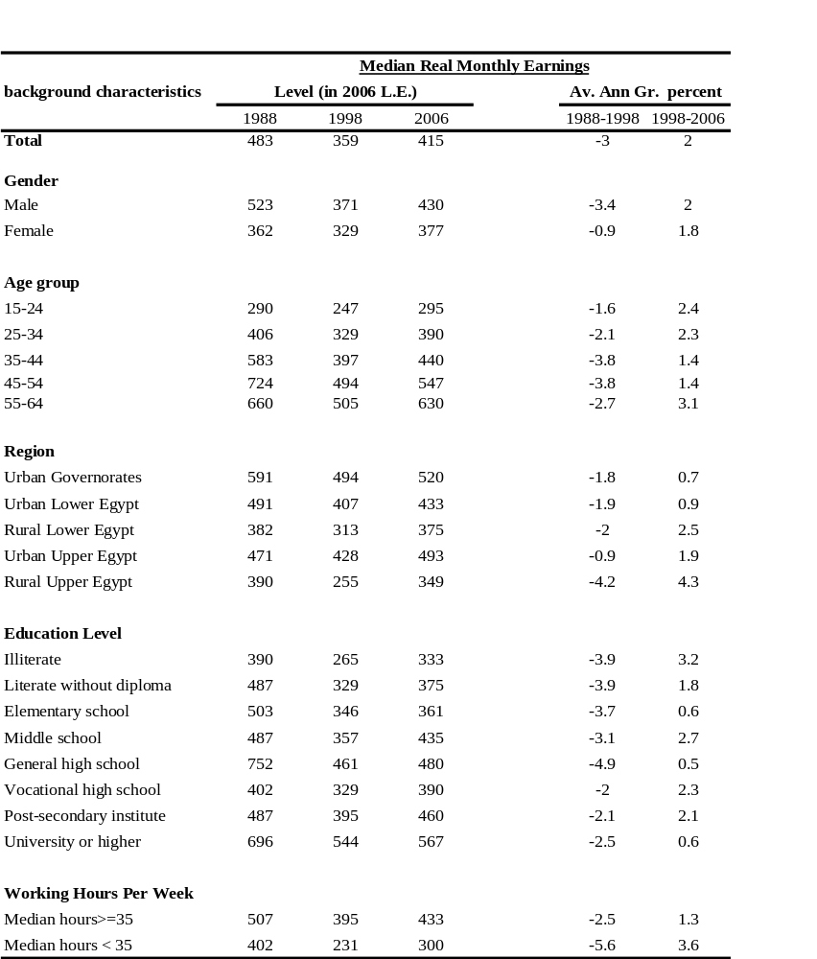
Table A.4.5: Distribution of Real Monthly Earnings for Wage and Salary Workers by Background Characteristics (2006=100), 1988-2006 (using the FPI)

Note: As mentioned in the main report, for the sake of comparability, all 1988 and 1998 monetary wages are inflated to 2006 Egyptian pounds using both CPI and FPI. The earning tables and figures reported in the previous sections of the paper uses the CPI inflation factor. The equivalent tables and figures using the FPI are summarized in this appendix. The FPI Inflation factor applied in this analysis is 1.65 from 1998 to 2006, and 4.83 from 1988 to 2006
Table A.4.6: Distribution of Real Monthly Wage for Wage and Salary Workers by Institutional Sector and Economic Activity (2006=100), 1998-2006 (Using FPI)

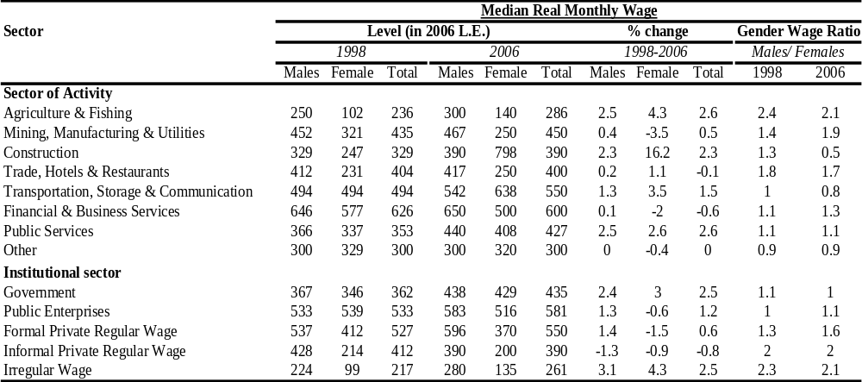

Table A.4.7: Share of Low Monthly Wage Earners, Wage and Salaried Workers
1998-2006
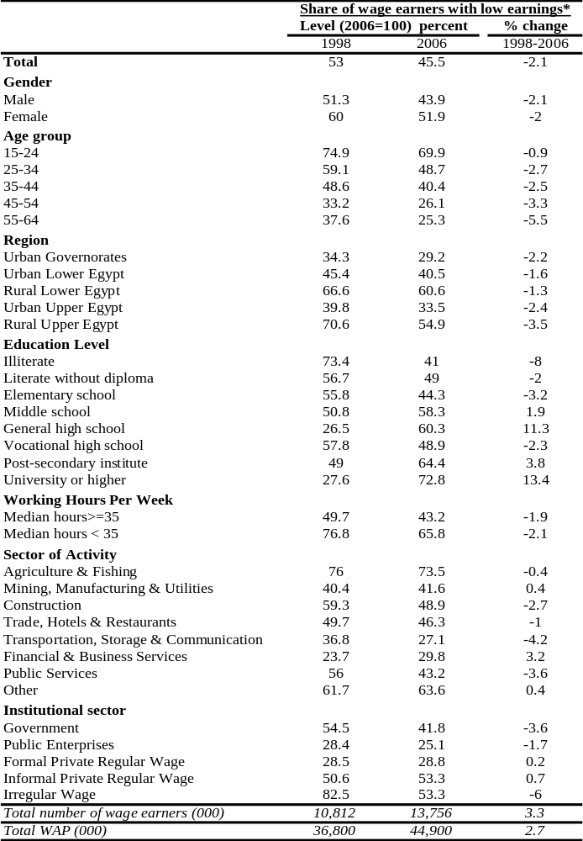

Table A.4.8: Transition Across Low/High Earnings by Sex, 1998, 2006
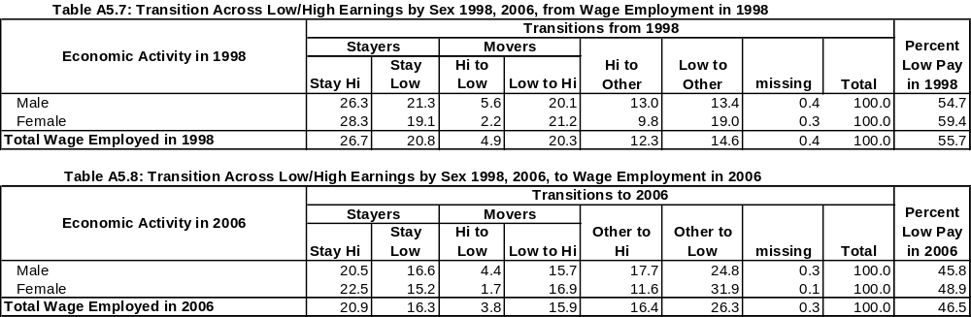
from Wage Employment in 1998 to Wage Employment in 2006
(Using FPI)

Table A.4.9: Transition Across Low/High Earnings by Institutional Sector, 1998, 2006
(Using FPI)

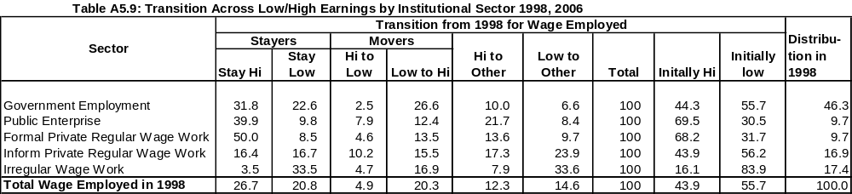

Annex Figures

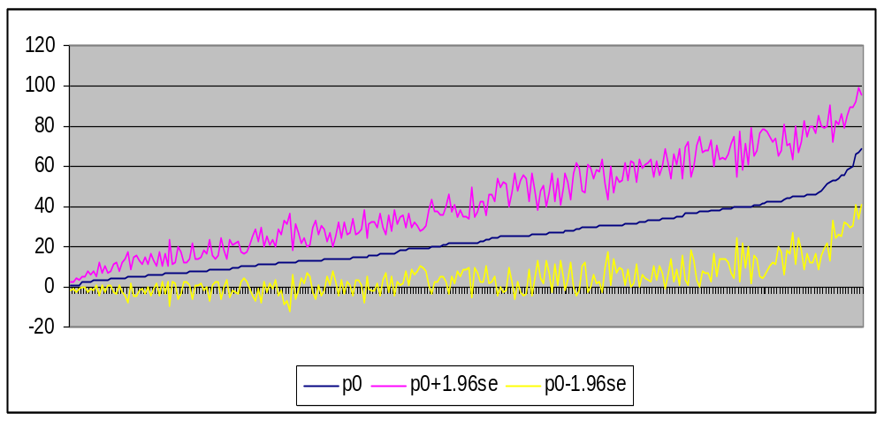
Figure A.1.1: Predicted Poverty Rates at Village Level and Their Confidence Intervals; in Rural Areas, 1996

Figure A.1.2: Predicted Poverty Rates at the Sub-District Level and Their Confidence Intervals; in Urban Areas, 1996

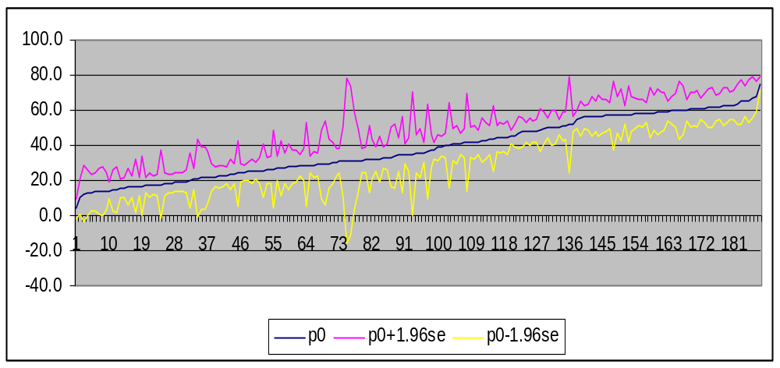

Figure A.3.1: Distribution of Estimated Long-Run Exchange Rate Pass-Through to Consumer Prices

Aggregate Items
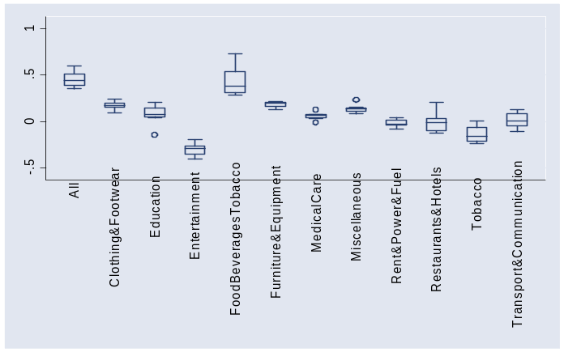
Disaggregated Food Items
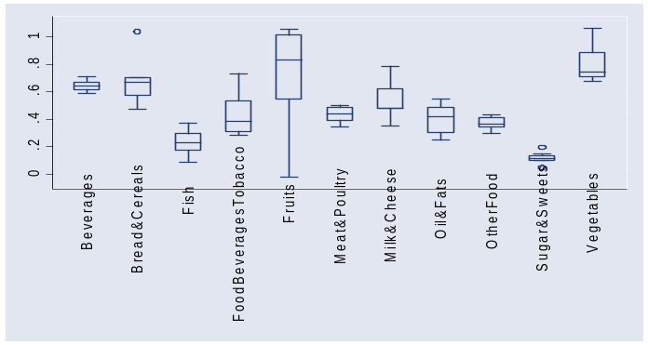

Figure A.3.2: Direct Effects of Price Changes on Welfare (Compensating Variation Calculated as Percent Change in Total Expenditure Required to Purchase Initial Consumption Basket)
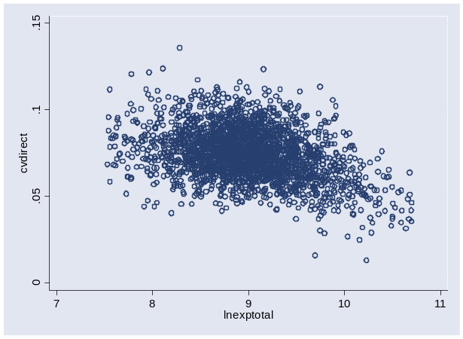

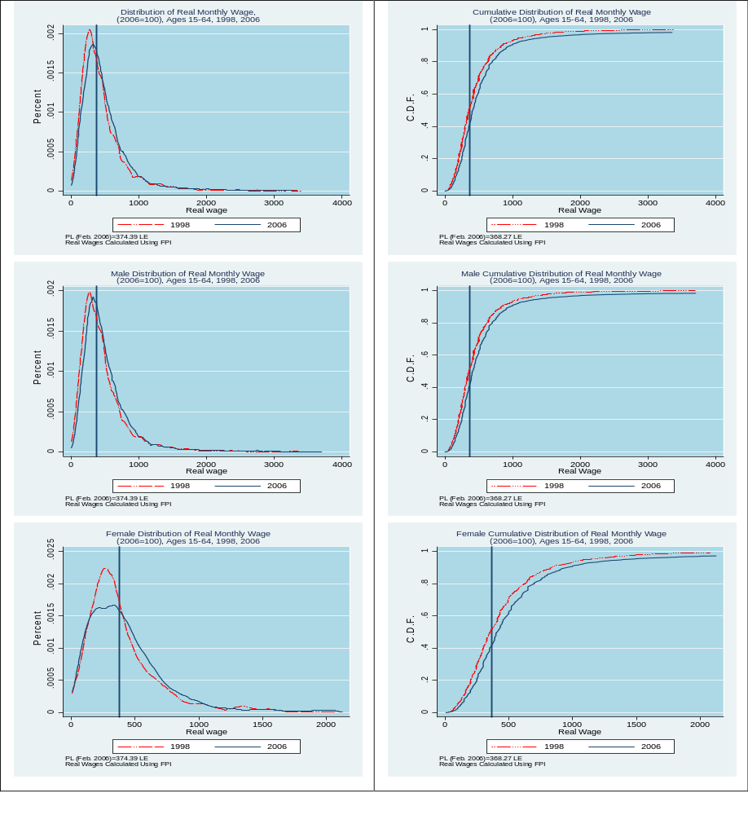
Figure A.4.1: Distribution of Real Monthly Earnings in Relation to a Low Earnings Threshold by Sex, 1998-2006 (Using CPI)

Figure A.4.2: Distribution of Real Monthly Earnings in Relation to a Low Earnings Threshold by Institutional Sector of Employment, 1998-2006
(Using the CPI).
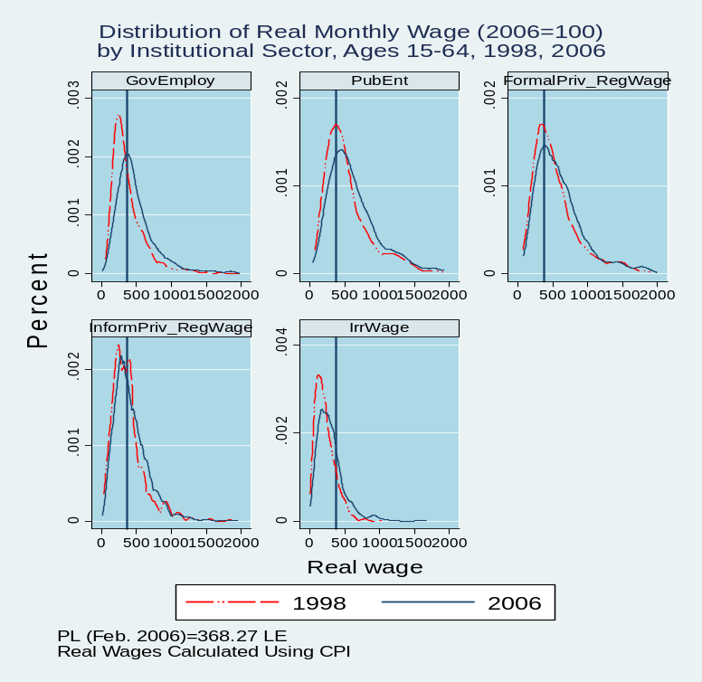

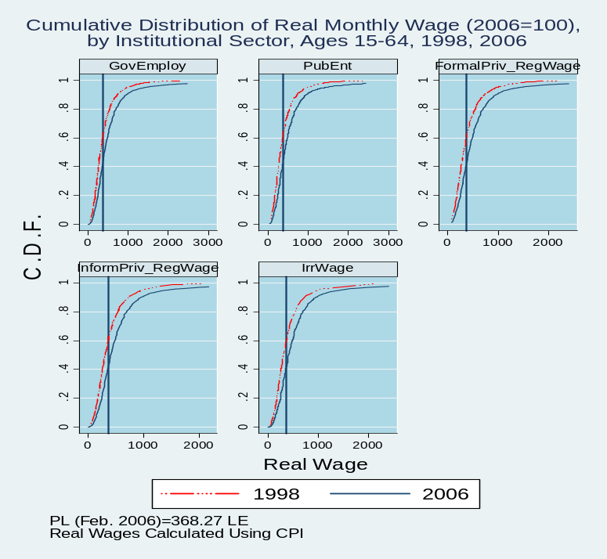

FigureA.4.3: Distribution of Real Monthly Earnings in Relation to a Low Earnings Threshold, 1998-2006 (Using the FPI)

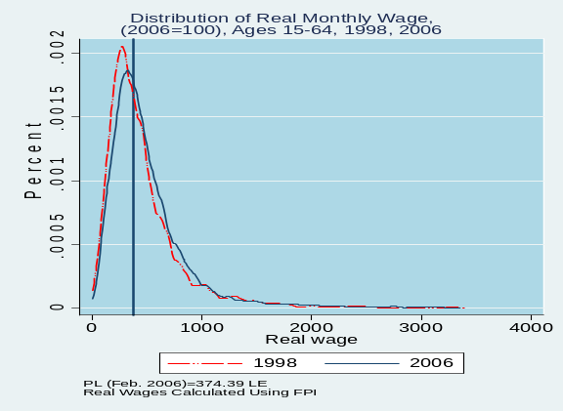  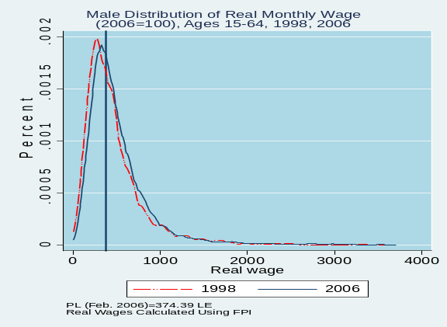  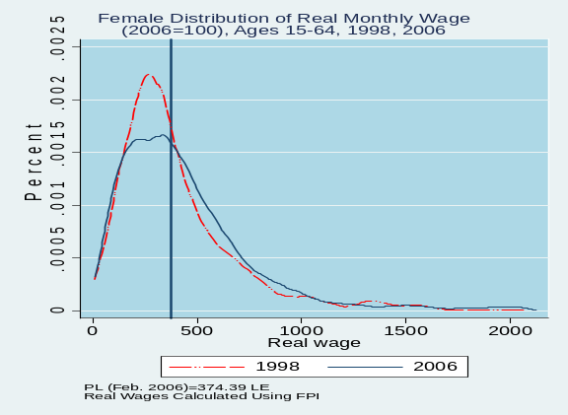 | 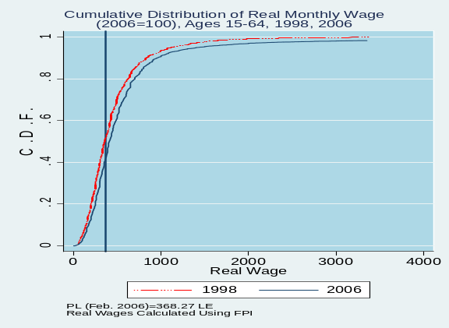  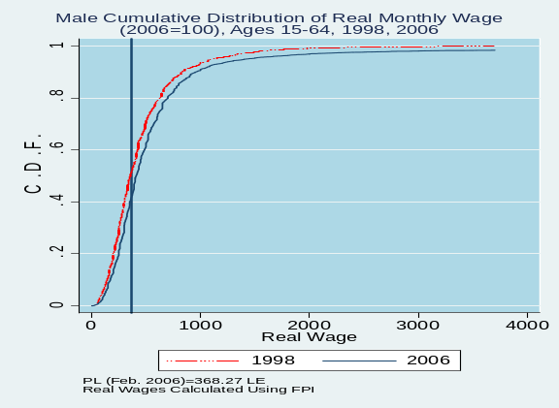  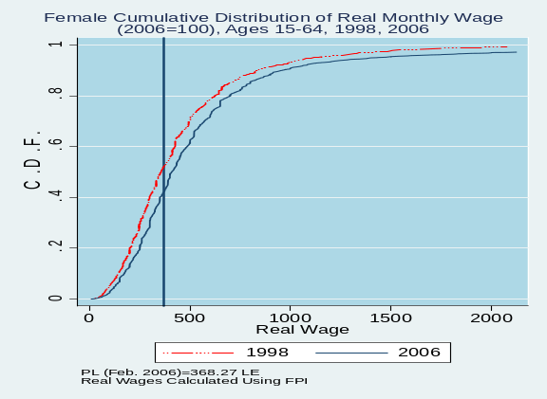

Figure A.4.4: Distribution of Real Monthly Earnings in Relation to a Low Earnings Threshold by Institutional Sector of Employment, 1998-2006
(Using the FPI)
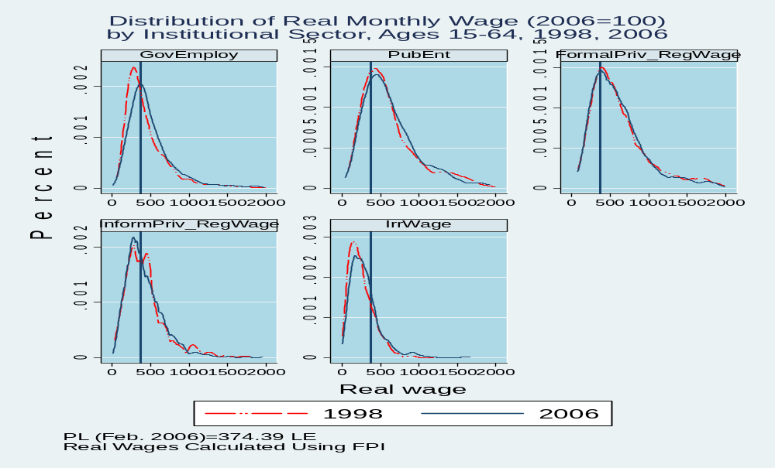

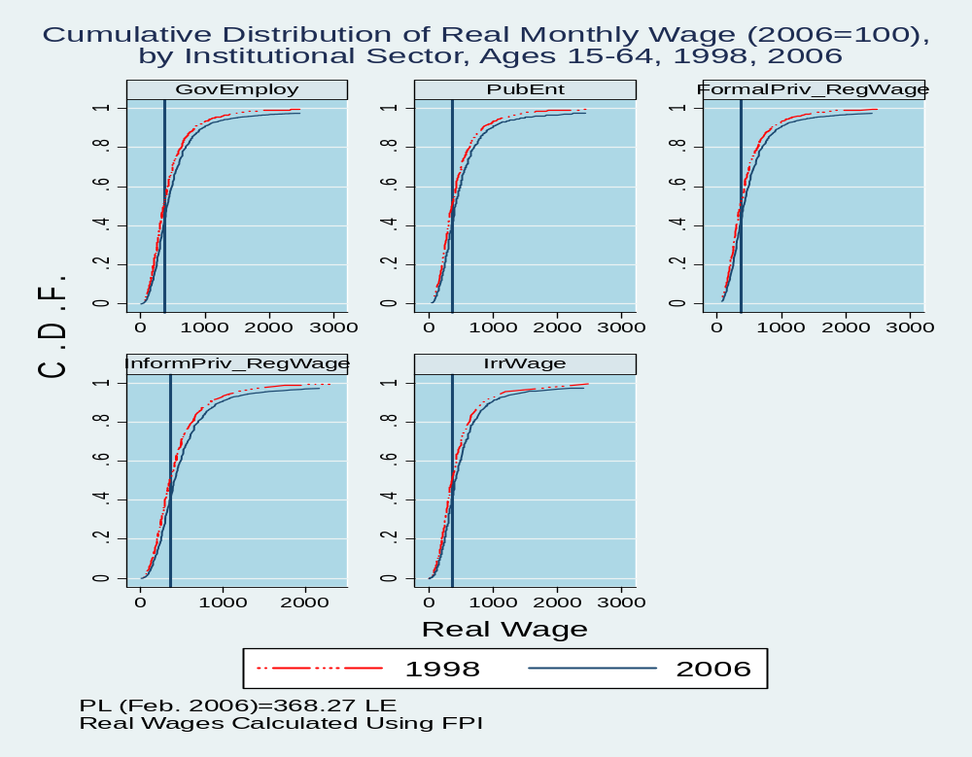

Disaggregated monthly consumer price indices into 31 goods and services, for 8 regions in Egypt from July 2000 through July 2005 were used to isolate the impact of the exchange rate changes on consumer prices.
See for example Campa and Goldberg (2005) for a justification of this particular specification. Burstein, Eichenbaum and Rebelo (2005) document the importance of non-traded components of traded goods prices and their role in real exchange rate fluctuations.
These are the United States, Germany, Italy, Great Britain, and Japan. Saudi Arabia and France are among Egypt's top 5 sources of imports in 2000 but do not report monthly producer price indices.
Other clearly largely-non-traded items are rent and education. However prices of these items are tightly controlled in Egypt and movements in them are unlikely to properly reflect movements in overall non-traded goods prices.
See Friedman and Levinsohn (2002) for a similar exercise investigating the welfare effects of relative price changes following in Indonesia during the East Asian crisis of 1997.
Gabriel Demombynes and Johannes G. Hoogeveen, "Growth, Inequality and Simulated Poverty Paths for Tanzania, 1992-2002"WPS3432.
This paper uses consumption rather than income to measure household welfare. Consumption is often preferred over income when measuring welfare, since consumption data is likely to be subject to less fluctuation over time and to fewer measurement errors (see Deaton 1997).

