Report No. 39885 – EG
Arab Republic of Egypt
Poverty Assessment Update

(In Two Volumes)

Volume I: Main Report

September 16, 2007
Ministry of Economic Development
Government of the Arab Republic of Egypt


Social and Economic Development Group
Middle East and North Africa Region
The World Bank

Document of the World Bank
Currency Equivalents
(Exchange Rate as of September 10, 2007)
Cu
rrency Unit

=

Egyptian Pound (LE)

LE 1

=

US$ 0.18

US$ 1

=

LE 5.65

Fiscal Year
July 1- June 30

Vice President: Daniela Gressani
Country Director: Emmanuel Mbi
Sector Director: Mustapha Nabli
Sector Manager: Miria Pigato
Task Team Leader: Sherine Al-Shawarby

Acronyms and Abbreviations

CAPMAS Central Agency for Public Mobilization and Statistics
CBE Central Bank of Egypt
CPI Consumer Price Index
CSO Civil Society Organizations
DERG-PO Development Economics Research Group, Poverty Cluster
ECES Egyptian Center for Economic Studies
EDHS Egypt Demographic and Health Survey
ELMS 98 Egypt Labor Market Survey 1998
ELMPS 06 Egypt Labor Market Panel Survey 2006
ERF Economic Research Forum for the Arab Countries, Iran and Turkey
FDI Foreign Direct Investment
FAO Food Agricultural Organization
FHH Female-Headed Households
FPL Food Poverty Line
GALAE General Authority for Literacy and Adult Education
GDP Gross Domestic Product
GIS Geographic Information Systems
GOE Government of Egypt
HH Households
HIECS Household Income, Expenditure and Consumption Survey
ILO International Labor Organization
IMF International Monetary Fund
INP Institute of National Planning
Km Kilometer
L.E. Livre Egyptienne (Egyptian Pound)
LFSS Labor Force Sample Survey
LMS Labor Market Survey
MDG Millennium Development Goals
MENA Middle East and North Africa
MHH Male-Headed Households
MOED Ministry of Economic Development
MOHP Ministry of Health and Population
MSS Ministry of Social Solidarity
M&E Monitoring and Evaluation
NA National Accounts
NBC New Budget Classification
NGO Non-Governmental Organization
P0 Headcount Index
P1 Poverty Gap Index
P2 Poverty Severity Index
p.a. Per Annum
PPP Purchasing Power Parity
SFD Social Fund for Development
TFP Total Factor Productivity
TPL Total Poverty Line
UPL Upper Poverty Line
UNDP United Nations Development Programme
WAP Working-Age Population
WB World Bank
WPI Wholesale Price Index
y.o. Years old
Table of Contents

Acknowledgments i
Executive Summary ii
Main Findings ii
Main Lessons from 2000-2005 and Policy Implications vi
Remaining Data Gaps and Strategy to Address Them ix
Overview of the Report x

Chapter 1: Poverty Evolution in Egypt (2000-2005) 1
I Introduction 1
II The Poverty Measurement: Methodology 1
III Poverty in 2005 4
A. Poverty Lines for Egypt ……………………………………………………………………...4
B. Overall Poverty and Inequality Measurement………………………………… 5
C. Spatial Dimension of Poverty……………………………………………. 7
IV Poverty Trends: 1996- 2005 9
V Increase in Poverty Is Not A Statistical Artifact 12
VI Survey and National Accounts Data 16
VII Growth and Distribution 17
VIII Elasticity of Poverty Measures 20
IX Poverty Map For Egypt 21
A. Why Develop a Poverty Map for Egypt?................................................................................. 21
B. Why a New Poverty Map?............................................................................................................21
C. Egypt's Poverty Maps for 1996 and 2006....................................................................................22
C1. Poverty Map in Urban Areas.......................................................................................................23
C2. PovertyMap in Rural Areas..........................................................................................................25
D Conclusion………………………………………………………………………………….26

Chapter 2: Characteristics of the Poor 28
I Introduction 28
II Who Are the Poor? 28
A. Location and Demographics are Crucial Determinants of Poverty….. 28
B. Consumption Patterns………………………………………………….. 31
C. Educational Attainment Makes a Considerable Difference…………….. 33
D. Income and Labor Markets…………………………………………….. 36
D.1 Sources of Income…………………………………………………………… 36
D.2 Unemployment and Type of Employment…………………………………………………....37
E. Household Head Characteristics: Education, Age and Gender……………… 39
III Housing Conditions and Access to basic Services 41
IV Children in Poverty 43
V Measuring Exposure to Poverty Risk 45

Chapter 3: Poverty and Macroeconomic Policies 47
I Introduction: Connecting The Poor To Growth 47
II Economic Growth And Poverty In Egypt………………………… 48
A. Long-term Growth Determinants and Reform Efforts……………….. 48
B. Growth and Poverty Reduction ……………………………………. 50
C. Sources of Growth and the Poor ……………………………………… 53
D. Growth of Agriculture and the Rural Poor…………………………….. 54
III Macroeconomic Environment, Policies and Living Standards 56
A. Policies Stance in the 1990s……………………………………….. 56
B. Shocks, Devaluation and the Poor between 2000 and 2005……………. 56
C. Fiscal Polices, Social Safety Nets and Subsidies…………………….. 60
IV Most recent developments and outlook for the future 65
A. How is the Most Recent Acceleration of Growth Likely to Affect Poverty? 65
B. How Likely Is It that the Growth Will Be Sustained? ………………….. 65
C. Outlook for the Future………………………………………………… 67

Chapter 4. Labor Market Trends and Living Standards in Egypt 69
I Introduction: Poverty and Labor market in Egypt 69
A. Poverty by Type of Employment ……………………………………………………………69
B. Poverty by Sector of Employment……….…………………………………………………..70
C. Changes between 2000 and 2005………………………………………………………….72
II Data and Methodology for Labor market Analysis…………………………..73
III Dynamics of Employment and Wages Growth 75
A. Labor Force Participation, Employment and Unemployment………….. 75
B. Evolution of the Earnings Profile………………………………………. 80
IV Evolution of the Share of Low Earners 84
A. Transition across Low and High Paying Jobs: A Longitudinal Analysis 86
B. Transition Pattern across Pay Categories by Institutional Sector...............................................88
C. Transition Pattern across Pay Categories by Economic Activity………… 88
D. Transition Pattern across Pay Categories by Sector of Economic Activity within Private
Employment.................................................................................................................................89
V Conclusion: Labor Market Trends and Poverty Reduction 90

Chapter 5: Poverty Monitoring and Evaluation 92
I Introduction 92
II The Reason for a Monitoring and Evaluation System 92
III The Current Status of Social Statistical and Institutional Capacity. 93
IV Problems Facing the institutional Capacity of Poverty M&E 94
V Challenges for the Future 96

TABLES

Table 1: Poor and Better-Off in Egypt in 2000 and 2005, in percent and thousands iii
Table 2: Percentage of Children (6-15 years) Not Enrolled in School and Illiteracy Rates
(Percent of 12-15 years) by Poverty and Location..…………………………………….....vi

Table 1. 1: Estimated Average per Capita Annual Poverty Lines in 2005,by Region……………...4
Table 1. 2: Poverty Measurements, by Region 8
Table 1. 3: Poverty Rates across Regions 10
Table 1. 4: Gini Inequality Coefficients 11
Table 1. 5: Share of Expenditure by Decile 11
Table 1. 6: Nutritional Status of Children (Percentage of Children under 5) 14
Table 1. 7: Confidence Intervals for Poverty Estimates, by Region 15
Table 1. 8: Poverty Estimates of 2000 based on the Deflated 2005-Food Basket 15
Table 1. 9: Regional Contributions to Changes in Poverty between 2000 and 2005 19
Table 1.10: Inequality "Between"and "Within" Regions 20
Table 1. 11: Elasticity of Poverty Measures to Mean Consumption and Inequliy ……………………... 20
Table 1.12: Transition In/Out of Poverty of the Poorest Sub-Districts in Egypt, 1996- 2006 24
Table 1.13: Transition In/Out of Poverty of the Poorest Villages in Egypt, 1996- 2006 26

Table 2. 1: Share of Expenditure on Food to Total Expenditure by Region and Poverty Status, 2000 and 2005 32
Table 2. 2: Poverty is the Highest, Most Severe and Deepest for Illiterates 34
Table 2. 3: Correlation Coefficients of Average Real Income and Years of Schooling 2000 and 2005 34
Table 2. 4: Elasticity of Poverty Changes to Years of Schooling 35
Table 2. 5: Income Structure by Poverty Status, 2000-2005 (Percent) 36
Table 2. 6: Profile of the Poor by Housing Conditions and Durable Assets, 2000-2005 42
Table 2. 7: Percentage of Children (6-15 years) Not Enrolled in School and Illiteracy Rates
(Percent of 12-15 years) by Poverty and Location, 2005 44

Table 3. 1: Simulated Year by Year Poverty Incidence All Egypt 53
Table 3. 2: Poverty Impacts of Depreciation-Induced Prices Changes:
Expected Poverty by 2005 59
Table 3. 3: Projected Poverty Incidence for 2006 starting from 19.6% in 2005
Assuming 3% per-Capita Real Consumption Growth 67

Table 4. 1: Comparison between Labor Market Surveys and HIECS (thousand and percent) 74
Table 4. 2: Labor Force Participation Rates for Working-age Population (15-64) by Sex and Urban/Rural Location, Percentage 75
Table 4. 3: Unemployment Rate by Urban and Rural Location and Sex, 1998 and 2006 76
Table 4. 4: Unemployment Rate by Region and Sex, 1998 and 2006 76
Table 4. 5: Unemployment Rate of Youth (15-24 Years) by Education and Poverty, 2004-05 76
Table 4. 6: Employment to Population Ratios by Urban/Rural Location and Sex
(1998 and 2006)………………………………………………………………………..78
Table 4. 7: Employment Growth Rate by Type of Employment, Economic Activity, Sex and Urban/Rural Location, 1998- 2006 (percent) 80
Table 4. 8: Real Median Wages: Comparison between the Labor Market Surveys and HIECSs (LE/month in 2006 Prices) 81
Table 4. 9: Median Real Monthly Earnings by Background Characteristics 1988- 2006 83
Table 4. 10: Distribution of Real Monthly Wage for Wage and Salary Workers by Institutional Sector and Economic Activity (2006=100), 1998- 2006 83
Table 4. 11: Share of Low Monthly Wage Earners, Wage and Salaried Workers, 1998- 2006 85
Table 4. 12: Transitions across High-and-Low Paying Jobs for Wage Workers in 1998 by Sex, 1998-2006 87
Table 4. 13: Transitions across High-and-Low Paying Jobs for Wage Workers in 2006, by Sex, 1998-2006 87
Table 4. 14: Transitions across Pay Categories for Wage Workers in 1998 by Institutional Sector, 1998-2006 88
Table 4. 15: Transitions across Pay Categories for Wage Workers in 1998 by Sector of Economic Activity, 1998-2006 89
Table 4. 16: Transitions across Pay Categories for Private Formal Wage Workers in 1998 by
Economic Activity, 1998-2006………………………………………………………90

FIGURES

Figure 1. 1: Examples of Household Specific Poverty Lines 5
Figure 1. 2: Distribution of Egypt's Population, 2005 5
Figure 1. 3: Poverty Incidence: Egypt in an International Perspective (%) 6
Figure 1. 4: Distribution of Expenditure 7
Figure 1. 5: Distribution of Poverty Groups Across Regions, 2005 8
Figure 1. 6: Poverty Incidence by Governorate 9
Figure 1. 7: Changes in Regional Poverty Incidence 10
Figure 1. 8: Poverty Change by Governorate 2000-2005 12
Figure 1. 9: Annual Real Growth in Per Capita Expenditure, 1996-2005 12
Figure 1.10:Nominal Increase in Average Household Income over 2000- 2005, by Region and Poverty Status 13
Figure 1.11: Poverty Incidence and Severity of Poverty Curves 14
Figure 1.12: US$1/day and US$2/day Poverty Incidence over Time 15
Figure 1.13: Per Capita Nominal Consumption: NAs Versus HH Survey 16
Figure 1.14: Growth Incidence Curve by Region 18
Figure 1.15: Growth Incidence Curve in Rural Regions 18
Figure 1.16: Growth Incidence Curve in Urban Lower Egypt 19
Figure 1.17: Egyptian Sub Districts, by Poverty Level and Region 23
Figure 1.18: Egypt's Poorest Sub-Districts by Poverty Level and Region, 2006 23
Figure 1.19: Egypt's Villages by Poverty Level and Region, 1996 25
Figure 1.20: Egypt's Villages by Poverty Level and Region, 2006 25

Figure 2. 1: Regional and Urban-Rural Poverty Divide 29
Figure 2. 2: Poor Households Tend to Be Larger 30
Figure 2. 3: Poverty Risk by Household Size is Higher in Rural Area 30
Figure 2. 4: Increased Incidence of Poverty with Increased Family Size 30
Figure 2. 5: Poverty Risk over the Life Cycle, by region, 2005 31
Figure 2. 6: Food Consumption Pattern by Poverty Status 32
Figure 2. 7 Individual Educational Profile by Poverty Status, 2005 33
Figure 2. 8: Educational Gaps with the Better off, 2005 33
Figure 2. 9: Change in Poverty Incidence for Individuals by Educational Attainment 35
Figure 2.10: Labor Participation Rate, 2005 38
Figure 2.11: Unemployment Rates by Poverty and Location, 2000-2005 38
Figure 2.12: Unemployment Rate by Poverty Status and Region 2005 38
Figure 2.13: Poverty Incidence by Education of Household Head, 2005 39
Figure 2.14: The Poverty Risk is Highest Among the Middle-Age Groups, 2005 40
Figure 2.15: Poverty Risk is Lower for Female Headed Households in All Regions Except for Metropolitans 40
Figure 2.16: Percentage of Working Children Aged 6-15 Years 45

Figure 3. 1: Connecting the Poor to Growth 47
Figure 3. 2: Evolution of Real Per Capita GDP (% Growth and LE) and
Consumption 1996-2006 48
Figure 3. 3: Average Annual Growth (%) 48
Figure 3. 4: The Downward Trend of Investment that Started in 1999 and Reversed in 2005 49
Figure 3. 5: Growth Incidence Curves over Time 51
Figure 3. 6: Economic Growth and Poverty 52
Figure 3. 7: The Sectoral Composition of GDP 54
Figure 3. 8: Agricultural Producer Price Indices, 1991-2003 55
Figure 3. 9: The Exchange Rate Difficulties Seem to Have Fed Through Prices 57
Figure 3. 10: The Weakening Fiscal Situation Slightly Improved with Economic Recovery 60
Figure 3. 11: Large Share of Wages and Interest Payments Limited Independent Fiscal
Policy, FY00-FY05 61
Figure 3. 12: Evolution of Food Subsidies 62
Figure 3. 13: Percentage of Poor Who Are Not Reached by Food Subsidies 62
Figure 3. 14: Distribution of Food Subsidies between the Poor and the Better off 63
Figure 3. 15: Percentage of Those Lifted Out of Poverty by Food Subsidies 63

Figure 4. 1: Wage Earners by Poverty Status, 2005 (% of Labor Force) 69
Figure 4. 2: Non-Wage Earners by Poverty Status, 2005 (% of Labor Force) 69
Figure 4. 3: Poverty Incidence by Type of Employment, 2005 (%) 70
Figure 4. 4: Distribution of Poor by Sector, 2005 71
Figure 4. 5: Poverty Incidence by Sector, 2005 71
Figure 4. 6: Employment Growth by Sector and Sex,1998-2006(Average Annual Growth Rate).. 79
Figure 4. 7: Growth Rates of the CPI-Deflated Average Wage, 1998-2006 (1997=100) 81

BOXES

Box 1. 1: What is an Appropriate Poverty Line for Egypt? 2
Box 1. 2: Aggregate Poverty Measurements 6
Box 1. 3: How Well Do National Accounts and Survey Agree? 17

Box 2. 1: Why Do Girls Have Higher Illiteracy Rates in Rural Areas? 43

Box 3. 1: How Are Exchange Rate Variations Transmitted to Prices? 58
Box 3. 2: Types of Ration Cards 64

Box 4. 1: Data Sources on Labor Market: Labor Market Surveys 73
Box 4. 2: Youth Unemployment 77
Box 4. 3: Is the Improvement in the Female Employment Status a Result of Better Measurement of Market Activities? 78
Box 4. 4: Methodology of the Longitudinal Analysis 86

Box 5. 1: Improving the HIECS for Poverty Analysis 99

Acknowledgments

This report was prepared by a team led by Sherine Al-Shawarby (Senior Economist) and comprising Aart Kraay (Lead Economist) and Alexander Kremer (Senior Economist) from the World Bank; Dr Heba El-Laithy and Dr May Bargout (Consultants from Cairo University); and Ragui Assaad (MENA Director of the Population Council). Hoda Selim and Taheya Sakr provided research assistance to the team. Amira F. Zaky of the Bank’s Cairo Office and Angela Hawkins of the Bank’s Washington Office provided administrative and desktop publishing assistance.
Dominique Van de Walle (Lead Economist) and Peter Lanjouw (Lead Economist) of the World Bank were peer reviewers. Special thanks go to Ruslan Yemtsov (Senior Economist) for providing extensive comments and written inputs on the final draft of the report.
The team also benefited from feedback and guidance by Miria Pigato (Sector Manger, MNSED). Valuable inputs are gratefully acknowledged from Farrukh Iqbal (advisor to the team, Sector Manger, MNSED), Prof. Hanaa Kheir-El-Din (ECES, Director), and Prof. Heba Handoussa. Useful technical inputs and support were received from Shaohua Chen and Prem Sangraula (DECRG).
The team wishes to express its sincere gratitude for the close cooperation and generosity in sharing information provided by Egyptian officials, particularly Their Excellencies Minister Osman M. Osman (Economic Development) and Minister Moselhy (Social Solidarity). Thanks also go to a group from academia at the Workshop held at the INP in June 2006; officials from the Ministry of Economic Development and Ministry of Social Solidarity; the Central Agency for Public Mobilization and Statistics (CAPMAS); General Abou Bakr El-Guindy (Director of CAPMAS); Mrs. Effat Shoukry (Director of Statistics Sector, CAPMAS); Dr Bahey El-Din Mortaguy (Director of IT Sector, CAPMAS); and Ms. Rawya El-Batrawy (Director of the Central Department of Demographic Studies and Research, CAPMAS). Special thanks go also to Dr. Mahmoud Abdel-Hay (National Institute of Planning) for his work on developing the poverty map in a GIS form.
Finally, the team benefited from the views expressed during the regular meetings of the DAG sub-poverty group on the critical issues related to poverty in Egypt. Special thanks go to Miss Ghada Wali (UNDP) and Miss Rania Hedeya (UNDP).
Emmanuel Mbi (Country Director, MNCO3) and Mustapha Kamel Nabli (Chief Economist and Sector Director, MNSED) provided overall guidance

Executive Summary
- With one in every five citizens falling behind the overall poverty threshold, poverty reduction remains a priority and a challenge for Egypt. This report is a contribution to the strategy of poverty alleviation pursued by the Government of Egypt. Using data from the two household surveys in 2000 and 2005, this report assesses the nature and dimensions of poverty in Egypt, and discusses the role of macroeconomic policies and labor markets in improving living standards. This is the first time the 2005 survey, the latest available source of information on poverty in Egypt, has been analyzed in detail.
- The report updates the findings of “Poverty Reduction in Egypt: Diagnosis and Strategy,” published by the World Bank in 2002. Over the last two years Egypt has achieved remarkably high economic growth. Should this turnaround be sustained, there is hope that poverty can be dramatically reduced. Even though the report does not cover this most recent period, it is important to learn from the lessons of the recent past, and the report provides new information and insights that could be useful for policy-makers:
  - It identifies the overall scope and trends in poverty between 2000 and 2005, focusing on material aspects, but also assessing progress in non-income dimensions;
  - It isolates key correlates to poverty and economic vulnerability, providing detailed analysis of how inflation affected the poor in this period;
  - It links the labor market's developments with changes in living standards and poverty; and
  - It provides the analytical base for mapping poverty in Egypt, which can improve the targeting of social programs.

Main Findings
- Poverty is not a uniform state, and the poor are not all alike. Different forms of poverty are measured with different poverty lines. The methodology and data for measuring poverty used in this report are consistent with those of the 2002 Poverty report, which covered the period 1996-2000. Following an established consensus on methodology, this report uses three different definitions: extreme poverty, which means inability to provide even for basic food, absolute poverty, which consists of spending less than needed to cover absolutely minimal food and non-food needs (this group is called “poor” in this report), and near-poverty, which is equivalent to spending barely enough to meet basic food and slightly more than essential non-food needs. All three groups combined represent “all poor”. Each form of poverty has a corresponding poverty line and can be assessed by comparing actual household consumption as measured by a representative survey (HIECS) with the extreme, lower, and upper poverty lines. Results are presented in Table 1.

Table 1: Poor and Better-Off in Egypt in 2000 and 2005, in percent and thousands

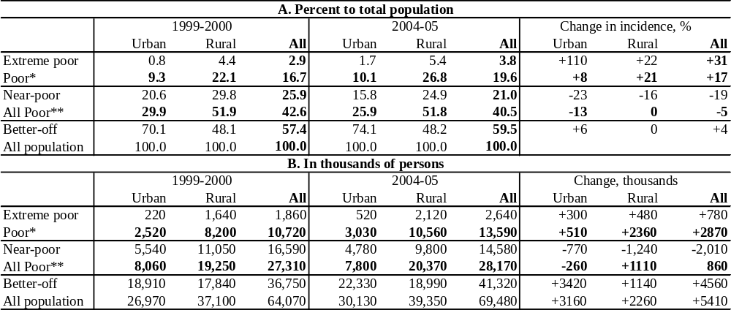
* includes extreme poor and those in absolute poverty ** includes poor and near-poor (all population below upper poverty line) *** population numbers differ form official estimates due to survey coverage.
Source: CAPMAS, HIECS 2000 and 2005.

- Poverty is widespread in Egypt, affecting 40 percent of the population, and there are deep pockets of poverty. The 40 percent overall poverty rate in 2005 represents 28 million people, of which 13.6 million (19.6 of population) are in absolute poverty, and even more, 14.5 million (21.0 percent), are near-poor. Furthermore, 2.6 million of the poor (3.8 percent of population) are extremely poor (see Table 1, panels A and B). Many people are also concentrated around the poverty line, meaning that a miniscule decline in monthly consumption of just LE 4 will make additional 2.3 percent of the population poor. By the same token, concentration of the poor around the poverty line means that even a small income boost can move more than 2 percent of the population out of poverty.
- During 2000-2005 absolute poverty increased, but there was a reduction in the number of near-poor, leading to a decrease in the “all poor” ratio. Absolute poverty in Egypt increased from 16.7 percent in 2000 to 19.6 percent in 2005. However, the percentage of the near-poor to the total population declined to 21 percent of the population (from almost 26 percent in 2000), and their number fell by 2 million, reflecting that some people managed to escape poverty. This resulted in a decrease in the risk of poverty and near poverty by about 2 percentage points (from 42.6 to 40.5 percent – see Table 1).
- The decline in "all poor" is due to an increase in employment. Overall employment growth over the 1998-2006 was between 3 and 5 percent p.a., faster than the growth rate of the working-age population. As a result, there was a drop in the unemployment rate from 12 to 8 percent and an increase in labor-force participation. The share of workers with a wage level below the threshold necessary to bring an average household above the poverty line has also declined. Labor market trends have favored the urban near-poor, some of whom have managed to escape poverty.
- Living standards, access to education, and quality of life have also improved. The poor have made large gains in literacy (a 4.5-percentage-point decline in the illiteracy rate). Possession of major durables, especially among the poor in urban areas, has also expanded. The connections to water and sewerage improved between 2000 and 2005, yet large disparities between urban and rural areas and between the poor and better-off remain. Data on nutritional status of children from the EDHS 2000 and 2005 show a more complex picture, with some indicators improving and others deteriorating. Such complex dynamics reflect complex distributional changes over the period.
- Distributional changes over the period 2000-2005 affected the poor and the non-poor differently. The analysis of inequality dynamics shows that the bottom 5 percent of the population experienced large losses over the period. While equalizing changes in other parts of the distribution caused the inequality index (measured by the Gini coefficient) to fall from 36 to 32, the number of extreme poor increased. As a result, the depth and severity of poverty have noticeably increased. However, these general trends require further examination to reveal important rural/urban differences.
- Poverty is becoming more concentrated in rural areas. There were striking differences between urban and rural areas, with the number of “all poor” decreasing in the former, while increasing in the latter by about 2.3 million. While the rate of extreme poverty in urban areas nearly doubled over the five years, it remains a fundamentally rural problem. Migration increased the share of urban population in Egypt between 2000 and 2005, but the distribution of the poor shifted further from cities to villages, as rural areas account for more than 78 percent of the poor and 80 percent of the extreme poor (Table 1).
- Poverty tends to be more concentrated in Upper Egypt. There is a particular concentration of poor in the rural Upper Egypt region, which accounts for 66 percent of the extreme poor in the country, 51 percent of its poor, and 31 percent of the near-poor, far exceeding its population share (25 percent). However, not all Upper Egypt is increasingly poor. Contrary to national trends, poverty rates declined in the Fayoum and Giza governorates. Thus, assessing and understanding regional variation of poverty is essential to providing inputs to policies.
- Poverty mapping suggests the concentration of poverty in specific "pockets", even within rural Upper Egypt. Based on combining data of the Population Censuses and household surveys, the poverty maps for 1996 and 2006 at the sub-governorate level show that both urban and rural poverty are fairly densely concentrated in very specific areas. Yet, variation in living standards is greater from one village to another, some of which are characterized by very high poverty rates. Almost one-third of all the Egyptian poor are in the poorest villages of Menia, Assiut, and Suhag governorates (762 villages altogether). Comparison of the 1996 and 2006 maps reveals a striking degree of dynamism at the local level: among the poorest locations only one-half was as poor in 2006 as 10 years ago, and one-half of those who were poor in 1996 managed escape poverty by 2006.
- Poverty maps, though very useful, are just one of many targeting mechanisms. The poorest locations (poorest 1,000 villages and poorest 200 urban sub-districts) account for only 57 percent of all poor in Egypt. This means that a large share of the poor live in locations with "average" poverty incidence. Hence poverty mapping needs to be complemented with other targeting methods, especially in urban areas.
- Poverty increased following the fall in average real consumption per capita triggered by inflation. The observed decline of consumption occurred for two reasons. First, the period was dominated by a protracted economic slowdown with weak demand over 2000-2003, followed by a short spell of recovery by the end of the period. Second, inflation shock, triggered by the devaluation of national currency, led to a high inflation episode that disproportionately affected the poor. The differential impact of inflation on the poor was driven by a 10 percent increase in the relative price of food. Faster increases in food prices were disastrous for poor households, because food occupies a larger share in their budgets and because most of them are net consumers of food, even in rural areas. Devaluation itself provided incentives for fast subsequent recovery and accelerated growth, suggesting that these losses were of a temporary nature.
- Increased employment opportunities mitigated the impact of the price shock, but only for those with access to wage employment. Using different sources of data on the labor market, the study depicts a steady improvement in employment opportunities. The analysis reveals intensive movement of workers across sectors and occupations. Those with better human capital took advantage of the increased number of high-paid jobs. However, about half of all new employment opportunities created over the period were in irregular and informal occupations with very low incomes, or unpaid work in household enterprises. The latter form of employment was the main absorber of new entrants, especially in rural areas. For poor farmers such new employment often came at a price of falling productivity and depressed local wages. In urban areas, casual informal-sector workers, who are over-represented among the poor and extreme poor, experienced little upward mobility and no increase in real wages. Formal private employment and individual self-employment grew rapidly by absorbing movers from other sectors. These job-to-job movements benefited the near-poor, but bypassed the poor and extreme poor. Although the unemployment rate fell for the country as a whole, it increased for the extreme poor and the poor.
- Spending on safety-net programs increased but without much benefit for the poor. Social spending, broadly defined (including education, health, food subsidies, social transfers), increased from an average of 7.5 percent of GDP in the 1996-2000 period to 9.8 percent in the 2001-2005 period. However, in 2005 very little was spent on cash transfers (0.1 percent of GDP) compared to subsidies on food (1.7 percent of GDP) and on energy products (5.4 percent of GDP). All transfers, public and private, represented only 11 percent of income for the poor, as opposed to over 20 percent for the better-off. The share was stable for the poor between 2000 and 2005, but it increased for the non-poor. Most of the transfers (about two-thirds) is accounted for by pensions, and 85 percent of pension spending accrued to the non-poor. Only 4 percent of all transfers is accounted for by social-assistance payments, but even then as much as 70 percent goes to the non-poor. Therefore public safety nets in the form of cash transfers do not play a large role for the poor. Both the remittances and the in-kind support in form of subsidies occupy a larger share in the budgets of poor households.
- Egypt’s food-subsidies system protects some poor but has many loopholes. The HIECS survey data demonstrate that some poor do benefit from the food subsidies. Without them, an additional 7 percent of the population would have been poor (including the 4.3 percent of the population who would have become extremely poor). Yet, the poorest quintile of the population receives only 16 percent of the benefits, less than their share in the population, while the wealthiest quintile receives a full 28 percent. At the same time, as many as one-third of the poor and near-poor do not have ration cards and do not purchase subsidized food items (more analysis of the subsidy system and suggestions for its reform are provided in World Bank, 2005).
- Non-income dimensions of poverty have improved. Spending on social services and especially education achieved some visible impact on the lives of many poor. The literacy rates among children improved. There was a better access to education for all, with an increase of 13 percentage points in net primary enrolment rate between 1996 and 2005. As a result, fewer than 3 percent of children worked, and enrolments increased, with a narrowing gender gap, especially in urban areas. But challenges remain: still every tenth child in Egypt does not know how to read and write, and most of those children are from poor and near-poor families (Table 2). Unfortunately, data from the HIECS do not allow assessing directly the access to health care by the poor and exposure of the poor to health risks – an issue of increasing concern to policy-makers.
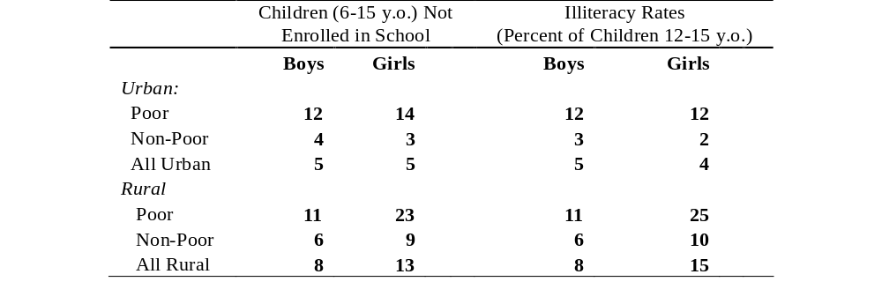
Table 2: Percentage of Children (6-15 years) Not Enrolled in School and Illiteracy Rates (Percent of 12-15 years) by Poverty and Location
Source: CAPMAS, Household, Income, Expenditure, and Consumption Survey (HIECS) 2005.
- Education continues to play an important role as a determinant of earnings, and exclusion of children from education may perpetuate their poverty. The educational level of individuals or the household head strongly determines the degree to which a household is vulnerable to poverty, particularly in urban areas. With more market opportunities one can expect a stronger link between the acquisition of skills and the resources that parents are willing to devote to their children’s education. The increasing wage gap between better-educated and illiterate workers suggests that those who are dropping out of school will face increasingly inferior outcomes in terms of future employment prospects and pay. When combined, these two trends may contribute to the persistence of poverty across generations.

Main Lessons from 2000-2005 and Policy Implications
- Poverty reduction remains a challenge for Egypt. To address poverty affecting 40 percent of the population, the Government can rely only on shared economic growth to help the poor and near-poor. To address pockets of severe deprivation, and to include more of the vulnerable and disadvantaged groups that are unable to participate in the mainstream of economic growth or who are adversely affected by economic reforms, targeted programs must be developed .
- Growth is likely to be the main driving force behind poverty reduction and economic vulnerability. Growth elasticity of poverty in Egypt as a whole is quite high (-3), meaning that growth in real per-capita consumption of 3 percent could result in half a million people moving out of poverty (poverty falling from 19.6 to 17.5 percent, or by 10 percent). Sustaining equitable growth of 3 percent in per-capita consumption per year over the period 2007-2011 is likely to reduce poverty in Egypt to around 10 percent of the population. Rapid shared growth can help reduce poverty through three channels. First, it will raise the incomes of the working poor, giving them an opportunity to escape poverty. Second, it will provide employment opportunities for unemployed and inactive workers – a group facing especially high poverty risks. Third, it will provide the tax base for programs to alleviate poverty among those who cannot otherwise escape it. None of these channels will operate automatically, but requires action by the Government to activate it.
- Broad economic reforms pursued by the Government of Egypt create an environment conducive to accelerated growth. Reforms launched in 2004 seem to focus on key constraints to growth – reducing red tape and tax rates, and improving access to foreign exchange (Elbers 2007). Growth rose to 6.9 percent in FY06 and is expected to continue at close to 7 percent in FY07. Continued strong performance of the world economy provides a boost to the national economy as it opens up. Benefits of demographic transition can help to sustain these growth rates. Egypt’s new five-year plan (2006/07-2010/11) projects an 8 percent average annual growth rate, which makes the very ambitious target of halving poverty attainable, if economic and social policies provide conditions for equitable distribution of gains from growth. These high growth rates, combined with prudent macroeconomic management to tame inflationary pressures and actions to improve targeting, will make reduction of poverty and vulnerability robust and sustainable.
- Connecting the lagging regions with the growth poles can help to sustain poverty reduction. Investment has been rising since 2004, with increasing FDI (doubling in 2006 compared to 2005 and doubling in the first nine months of 2007 compared to 2006). New investments help Egypt integrate with world markets and increase labor demand. So far investments have been concentrated in the Metropolitan and Lower Egypt regions, pulling the local economies up. With already relatively low poverty rates the ongoing growth spell can eliminate widespread poverty in those areas in five to seven years. As poverty becomes increasingly concentrated in rural Upper Egypt, specific policies and programs will need to be developed by the Government to address the causes of its continuing poverty.
- Vitality of the labor market is the key to ensure that the poor are participating in the growth process; it is provided by private-sector growth. Between 1998 and 2006 the private sector has proven to be the most resilient engine for job creation, driven by export growth and increased tourism. Non-agricultural employment in the private sector grew between 1998 and 2006 by 3.3 million and its share increased from 41 to 45 percent of all employment. Over this period, new job creation in the private sector more than compensated for falling employment in public enterprises. Not only did employment opportunities expand, but productivity and average earnings increased. There was significant upward earnings mobility for the employed in the private sector between 1998 and 2006: a quarter of the private-sector workforce moved from low-earnings jobs to high-paid jobs.
- Targeting is an important part of sharing higher growth with the most disadvantaged and protecting the near-poor from sudden spells of poverty. The efficiency of the existing social-protection system can be improved; as well, overall spending on programs directly targeted to the poor can be increased. Because of the limited fiscal space, this will involve restructuring current subsidy mechanisms and using new methods to direct assistance to the neediest. At the same time, the discussion of social spending should be informed by the acknowledgement that deficit financing of the pension funds is a diversion of budget resources that could otherwise be redirected towards the poor. More attention could be devoted to strengthening public institutions for better targeting of public spending. The initial results of poverty mapping using the new Census data (2006) provide the most current information to help the design of targeted interventions by identifying villages and urban sub-districts with high poverty. The potential poverty reduction from reallocating part of the resources now directed to subsidies to targeted programs is large, and complements policies aimed at sustaining high growth.
- The strategy for investing in human capital needs to be aligned with labor market incentives. Poverty in Egypt now includes more literate people: more than one half of the poor are literate and a sizeable fraction of them have completed primary and secondary education. As in the past, education attainment above secondary education reduces poverty risk below the average, but the effect of education on reducing poverty varies markedly across regions. The elasticity of poverty with respect to increasing education attainment is the highest in the Metropolitan areas and Lower Egypt due to buoyant labor demand. This highlights the importance of labor demand for realizing the benefits of higher education. This report documents that youth unemployment receded somewhat between 1998 and 2006, but at the same time there are signs of mismatches between the needs of the economy and the skills profile of the labor force: technical high school graduates on average can only find jobs with wages that are not only lower than general high-school graduates, but also lower than middle-school graduates.
- While facilitating the process of growth and investment in human capital it is important to be guided by a lesson of the early 2000s: inflation is bad for the poor. There is nothing surprising in the fact that acceleration of inflation hurts the poor more than other groups. The contribution of this report is to demonstrate that there is considerable heterogeneity in the effects of inflation across households, even among the poor: not all poor and near-poor lose equally. This heterogeneity means that it would have been difficult to institute any kind of public program that would target the most vulnerable to inflation and protect them against the effects of rising prices. A particularly alarming development in this context is the most recent acceleration of inflation: a price-index increase to 7.6 percent for 2006, rising to 12.8 percent in March 2007.
- The analysis of poverty in this report provides evidence to support the orientation of Egypt’s poverty-reduction strategy, which is aimed at growth with equity through:
- Ensuring that fiscal and monetary policy are consistent with the requirements of macroeconomic stability;
- Harnessing the growth-enhancing potential of the private sector (including small businesses) through improving the business climate using a broad range of policies (covering trade, finance, and taxation, among others);
- Increasing growth potential through education and inclusive labor-market policies; and
- Redesigning social policies by strengthening the targeting of the social safety net system.

Remaining Data Gaps and Strategy to Address Them
- To successfully attack poverty, Egypt is establishing an effective system for monitoring poverty-reduction actions and their outcomes, based on the systematic collection and analysis of information. This report documents existing gaps, which include, most importantly, the low frequency of data on poverty, and limited access to survey data. Low frequency of data (the survey is conducted only every five years) hampers differentiation between longer-term trends and cyclical fluctuations. Limited access means that the potential of data to generate information for policy-makers is not fully exploited and data are not used to arrive at publicly shared views of poverty characteristics and priorities in poverty alleviation.
- Poverty in Egypt is a problem clearly recognized by policy-makers. There is a consensus on poverty as deprivation in material well-being. Egypt follows a best-practice approach that places poverty reduction in the centre of its medium-term economic development strategy. Researchers accept the view of poverty as encompassing low levels of consumption, and have developed an objective absolute poverty line as a minimum living standard. Yet, there is no official poverty line in Egypt and no system for poverty monitoring. This report advocates creating such a system based on solid principles: objectivity in poverty definition, conceptualization based on national norms and values, integration in the system of statistical reporting, simplicity of key steps, and open access to data.
- Improvement of poverty data may become a part of a broader effort geared towards improving quality of economic data. The poor quality of the statistical data base bedevils the Government’s efforts to formulate policies. With the support of the IMF, the World Bank, and bilateral donors, the Government needs to undertake the necessary steps to improve the quality and coverage of economic data in general, and poverty and inequality data in particular.
- Substantial progress has been made by CAPMAS in the collection of household-level data, but gaps remain. These surveys include the Household Income, Expenditure and Consumption Surveys (HIECS), which is the main source of data for poverty monitoring in Egypt, and has the great advantage of a large sample size; this allows estimating poverty at the governorate and district levels, not just the national level. In 2006, with the support of international Population Council, CAPMAS conducted a Labor Market Panel Survey (LMPS06), which was intensively drawn upon in this report. The sample design for household surveys is identical across the HIECS and LMPS, allowing the comparability of these two surveys. Notwithstanding these positive developments, in a number of areas challenges remain. Non-income dimensions are insufficiently covered in the income and consumption survey instruments to allow disaggregation of indicators to monitor the MDGs.
- Monitoring and evaluation of public programs, especially the food and energy subsidies schemes, suffers from non-existent information to check whether program objectives are being met.
- Data on migration and commuting is not collected. With expanding off-farm job opportunities, it is important to collect data on migrants and commuters and focus on the barriers for greater mobility.
- There are very limited attempts to combine qualitative and quantitative data to overcome the household surveys’ inability to analyze the gender dimension.

- The report proposes a strategy for filling in those gaps consisting of:
- Increasing frequency of surveys while sustaining their quality by introducing annual or biannual household surveys with a smaller sample size.
- Collecting more detailed and consistent data on employment and unemployment characteristics; agricultural activities, value of inputs, access to markets; private business activities; and access to credit.
- Better tracking and assessment of the non-income dimensions of poverty.
- Making data freely available to researchers.
- Conducting evaluation of public programs.
- Enhancing the use of community-level data.

Overview of the Report
The first chapter examines the evolution of living standards in Egypt during the period of analysis – 2000 to 2005. It also gives the details of the poverty map and where the poor live.
Chapter 2 describes who the poor are and provides the poverty correlates: looking at the characteristics of the poor, and the relation of these characteristics to education (and access to education), employment, gender, age, or asset characteristics.
Chapter 3 continues by providing some background on economic developments between 2000 and 2005 and identifies possible areas of policy interventions in light of economic and social policies and developments after 2005.
Chapter 4 offers in-depth analysis of the labor market to attempt to discern longer-term trends in living standards, and links employment with poverty levels.
Finally, Chapter 5 looks at the capacity of the monitoring system, and lays the foundations for a future analytical program.

Chapter 1: Poverty Evolution in Egypt (2000-2005)
The aim of this chapter is to assess the dynamics of poverty and inequality in Egypt since the last Poverty Assessment, which covered the period 1995-2000. The chapter presents the main poverty and inequality statistics of the 2005 Household Income, Expenditure and Consumption Survey and their comparability to 2000 figures, compares Egypt to its neighbors, and discusses geographical patterns of poverty. As it did a decade ago, poverty still affects one-fifth of Egyptian citizens, and some of the gains in poverty reduction over 1995-2000 have been lost. Meanwhile, the distribution of the poor across the country has changed. To further understand the spatial variation of living standards, the chapter presents in the last section new tools, never used before in the analysis of poverty in Egypt: maps of poverty by villages and urban sub-districts in 1996 and 2006.

Introduction
- Poverty reduction remains an important challenge for Egypt. This chapter discusses the methodological issues involved with measuring poverty, updates the measurement of poverty in Egypt, and traces the changes in poverty trends over the period 1996- 2005, leaving the discussion of the characteristics of individual poor to the following chapter. This chapter also presents the first-ever poverty maps of Egypt for 1996 and 2006, which help identify the poorest urban sub-districts and villages. To assess changes in poverty on the ground, the chapter also compares the poorest villages and urban sub-districts in 1996 and in 2006.

The Poverty Measurement: Methodology
- There is no unique definition of poverty, and therefore no perfect indicator to measure it. Poverty is not confined to a limited income; it is, rather, a state of deprivation involving multiple dimensions. These could include a wide range of aspects: lack of access to services, vulnerability in the face of sudden shocks, and more broadly, lack of capabilities (e.g., few possibilities to participate in collective decision-making, inability to command resources, and, especially, a sense of humiliation, and lack of respect by others). Measuring each of these aspects in an uncontroversial way is problematic, but additionally, aggregating these different dimensions into a single index or poverty measure is probably impossible.
- Yet, a general consensus on poverty measures is needed. Academic interest in measuring poverty in Egypt started in the 1980s (Adams 1985; and Radwan and Lee, 1986). Several studies have used the “money-metric” concept for measuring the poverty line and thus the poverty incidence in Egypt. The money-metric indicator of poverty was considered a powerful tool to understand the scope of deprivation and to compare across many dimensions. Yet, to understand poverty well, one has to monitor non-monetary indicators alongside monetary poverty (see Chapter 5).
- The Household Income, Expenditures and Consumption Surveys (HIECS) have been the only source for analyzing poverty and inequality at the national and regional levels. The calculation of poverty estimates is based on data from the HIECS conducted by the Central Agency for Statistics and Mobilization (CAPMAS), the official statistical agency in Egypt. The HIECS, which began in 1957/58, was conducted irregularly in the beginning (1964/65, 1974/75, and 19981/82), but every five years afterward (1990/91, 1995/96, 1999/2000 and 2004/05). The HIECS contains information on household income and consumption expenditures on more than 600 items of goods and services, and is therefore a good source of information on the distribution of welfare within the society. This chapter focuses on the period from 1999/2000 to 2004/05, but also includes, for comparative purposes, HIECS data for 1995/1996. These three surveys consist of large samples, especially the latter two, which collected data for almost 48,000 households drawn quarterly from the whole country. Despite the disaggregation of only a few food items, which account for only a minor share of total consumption expenditure, the last three surveys are believed to be highly comparable in terms of sample design, data administration, and recall periods, allowing for robust poverty comparisons. Details of the questionnaire and other design elements of the surveys are in Annex 1.1.
Box 1.1: What is an Appropriate Poverty Line for Egypt?
One way to measure poverty is to use a poverty line – a threshold below which a given household or individual will be classified as poor, thus separating the poor from the non-poor. Egypt follows the tradition of defining poverty in an absolute sense.
Absolute poverty lines allow focusing on those who are deprived of the most basic needs, rather than those who may be deprived relative to their better-off fellow citizens. It also allows for determining trends over time and making comparisons across countries. To make such comparisons, this report relies on two international poverty lines, produced by the World Bank: the $1 a day poverty line (regarded as providing the absolute minimum standard of living), and the $2 a day poverty line (regarded as measuring those who are vulnerable to poverty). This report uses the 1993 PPP exchange rate updated for the years 1996, 2000, and 2005 using the national Consumer Price Index for Egypt (CPI).
National poverty lines provide a specific country context. However informative international comparisons may be, what is relevant from the perspective of the poor is the level of resources that are needed in their country to free them from deprivation of basic needs. Such needs, without which individuals would be absolutely deprived, are typically reflected in national poverty lines. These lines are often based on estimates of the cost of basic food needs (i.e., the cost of a nutritional basket considered minimal for the healthy survival of a typical family), to which a provision is added for non-food needs. Since the 2002 Poverty assessment report Egypt has adopted the Cost of Basic Needs method to establish this subsistence minimum.
Ultimately, the choice of a poverty line is arbitrary. In order to ensure wide understanding and wide acceptance of a poverty line, it is therefore important to ensure that the chosen poverty line does resonate with social norms (with the common understanding of what represents a minimum). For comparisons over time, the stability and consistency of the poverty line need to be ensured.
Sources: Ravallion 1992, El-Laithy, Lokshin and Banerji, 2003, World Bank, 2005b; and Measuring Poverty, World Bank website.
- Expenditure is used as the welfare indicator. In major developing countries, consumption-based measures dominate poverty analysis, and the general international practice is for increasing reliance on consumption- or expenditure-based measures. Tending to smooth variability and fluctuations in income streams, consumption is theoretically a better indicator of longer-term living standards than current income. Also, from a practical perspective, survey respondents tend to reveal their consumption patterns more accurately than their income (Hentschel and Lanjouw, 1996). The poverty analysis in this report relies on actual consumption expenditure as revealed by the household surveys, including imputed rents and in-kind transfers received by households. Yet, while the purchase of durable goods is taken into consideration in the calculation of total actual consumption expenditure, flow of services from durables is not. In fact, it is very common in most developing countries not to take flow of services from durables into account and it is not likely that this would produce any systematic biases in comparing poverty over time.
- This report, as did the World Bank poverty report of 2002, adopts a well-established cost-of-basic-needs methodology that accounts for the problems with previous research in Egypt. Research conducted before the 2002 World Bank report on poverty in Egypt used several different methods to calculate money-metric poverty lines for Egypt. There was thus a large discrepancy in their estimates of poverty incidence, which caused some controversy. In the early 2000s, the World Bank agreed with the Ministry of Planning to adopt a well-established methodology that allows measuring the national absolute poverty line based on the cost-of-basic-needs methodology. This methodology resolved four serious problems with previous methods: (i) ignoring significant differences in consumption patterns and prices across Egyptian regions, (ii) not accounting for the different “basic needs” requirements of different household members – e.g., young versus old, male versus female, (iii) using the cost of a hypothetical diet rather than the actual one, and (iv) ignoring the economies of scale within households – the fact that non-food items can be shared among household members. (For more details about the methodology see Annex 1.3 – Methodology).
- The cost-of-basic-needs methodology yields absolute poverty lines that are household-specific, objective, regionally consistent, and unbiased. For each household in the sample, a specific food poverty line is constructed and a non-food poverty line is estimated (El-Laithy, Lokshin and Banerji, 2003, see also World Bank, 2002), as follows:
a) The Food Poverty Line (FPL)/Extreme Poverty Line. The first step is to choose a food bundle that reaches the predetermined calorie requirements, with a composition that is consistent with the consumption behavior of the poor. This bundle was defined for individuals in different age brackets, gender, and activity levels (using tables from the World Health Organization). Then, FPLs were set at the cost of the required calories — by how they are actually obtained in the sample (on average) by the second quintile — using the varying prices for the food in each region and at each date. Thus the relative quantities observed in the diet of the poor (proxied by the second quintile), and the prices they face, were maintained in constructing the FPL for each household in the sample. Households whose expenditure is below the FPL are referred to as "extreme poor".
b) The Total Poverty Line (TPL). When the FPL is augmented by an allowance for expenditure on essential non-food goods — by households who have to forego food consumption to allow for non-food expenditures that are deemed a minimum indispensable — the TPL emerges. The non-food allowance can be estimated by identifying the share of non-food expenditure for households whose total expenditure was equivalent to the food poverty line. Any household that spends less than the TPL is considered poor. Therefore, the extreme poor are a sub-group of the poor.
- A more generous poverty line is also estimated. The non-food component of the poverty line can be larger if it is estimated instead as the non-food expenditure of households whose food expenditure equals the food poverty line. This yields an "upper" bound of the TPL referred to as the upper poverty line (UPL). The report refers to households whose expenditure lies between the TPL and the UPL as "near-poor". Poor (including extreme poor) and near-poor represent what the report calls "all poor".
- Important changes in the household consumption behavior in 2005 led to recalculation of the poverty lines using a different food basket. Following the Egyptian pound devaluation in 2003 and the subsequent significant and rapid increases in prices of all commodities, especially food items that are largely consumed by the poor, the Government of Egypt decided to provide several subsidized pulses and grains under the ration-card system (detailed in Chapter 3). This led to changes in household consumption patterns. Updating the poverty lines of 2000 using the consumer price index re-weighted to conform to the spending behavior of people at the poverty line could produce a comparable headcount index for 2005. Yet, this assumes that the Engel curve is stable over time — meaning that neither relative prices nor tastes change. Since this was not the case for Egypt in 2005 compared to 2000, this method of updating the poverty lines will create errors (Ravallion, 1998; and Lanjouw and Lanjouw, 1997). Hence, the report uses for 2000 the poverty lines and rates that were estimated for 1994/95 and 1999/2000 (see World Bank, 2002), and recalculates the poverty lines for 2005 using a different basket of food that reflects the consumption patterns of the second quintile in this year (applying methodology which is identical to World Bank, 2002). Although this allows consistent and accurate measurement of poverty across regions of Egypt, it raises the challenge of strict comparability of the poverty lines estimated for 2000 and 2005. This comparability issue is addressed in depth in section V.

Poverty in 2005

Poverty Lines for Egypt
- Estimated household-specific poverty lines, averaged to produce per-capita figures, show that the thresholds for different types of poverty vary across the regions. In general, the estimated household-specific poverty lines show that individual Egyptians who spent less than LE 995 per year (equivalent to 38 percent of per-capita expenditure on average) in 2005 are considered extreme poor and those who spent less than LE 1,423 (equivalent to about 55 percent of Egypt's per-capita expenditure) are poor (Table 1.1).
Table 1.1: Estimated Average Per Capita Annual Poverty Lines 2005, LE by Region
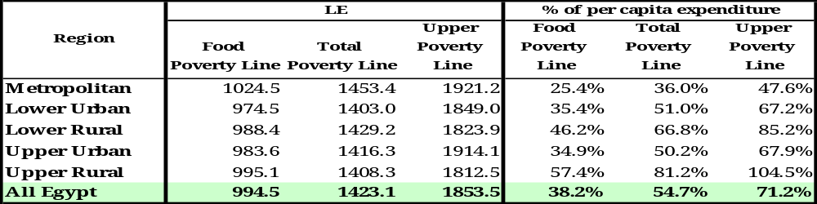
Source: CAPMAS, HIECS 2005, Staff Calculations.
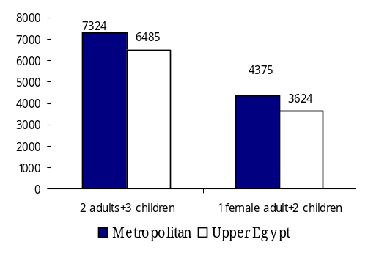
- Household- and region-specific poverty lines take into account even larger variation in needs and local prices. However, accounting for regional differences in relative prices, expenditure patterns, activity levels, and the size and age composition of poor households makes estimated poverty lines vary from one region to another and from one household to another within the same region. In general, Metropolitans had the highest poverty lines followed by Upper Egypt and then Lower Egypt, with urban areas having higher poverty lines than rural areas within regions. Thus, a household of two adults and three children living in Metropolitan areas and spending less than LE 7,324 per year (or LE 610 per month) is considered poor, whereas the same family living in Upper Egypt would need LE 540 per month to escape poverty (Figure 1.1). Finally, the UPL for overall Egypt was estimated at an average of LE 1,854 per year (LE154 per month) per person. This is higher than the TPL by 30 percent. In fact, the non-food component in the estimated UPL is double that of the TPL. The deviation of the UPL from the TPL differs across regions, varying between 28 and 35 percent in rural Lower Egypt and urban Upper Egypt, respectively.
Figure 1.1: Examples of Household Specific Poverty Lines

Overall Poverty and Inequality Measurement
Source: CAPMAS, HIECS 2005, Staff calculations
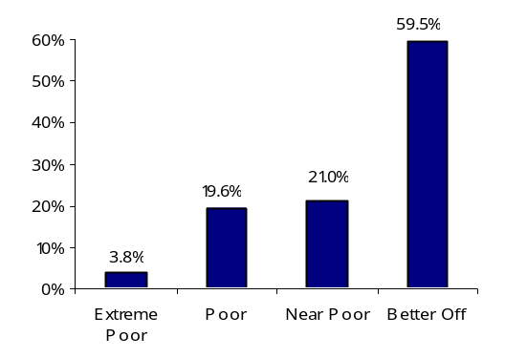
- In 2005, 19.6 percent of the Egyptian population was poor, and 3.8 percent extremely poor. This means that about 13.6 million Egyptians (one out of every five) had consumption expenditure below the poverty line and could not therefore obtain their basic food and non-food needs. Furthermore, 2.6 million of the Egyptian poor could not obtain their basic food requirements even if they spent all their expenditure on food. In addition, there were 14.6 million Egyptians (or 21 percent of the population) who were near-poor (Figure 1.2). These poverty rates are based on comparisons between actual expenditures and the cost of a consumption basket securing 2,470 calories per day per person, in addition to some basic services (except for the extreme poverty definition). Yet, to assess whether poverty is high or low in Egypt it is convenient to use an expenditure threshold that is comparable across countries.
Figure 1.2: Distribution of Egypt’s Population (2005)
Note: Poor includes Extreme Poor
Source: CAPMAS, 2005 HIECS, Staff calculations

- Common thresholds for international comparisons are 1 and 2 PPP dollars per day. In the case of Egypt, the one-dollar PPP was estimated at LE 2.57 in 2005. Accordingly, 3.4 percent of the Egyptians had less than $1 a day consumption (to be exact, $1.08), which is consistent with extreme poverty based on food line in 2005. In the same year, while 42.8 percent had less than $2 a day consumption (more accurately $2.15), and again close to the total number of poor and near-poor provided by the UPL. Figure 1.3 shows the most recent estimate available for the two international thresholds in a sample of countries that could be considered as a reference for Egypt, either because they belong to the same region or because of their importance as emerging economies. While Egypt has a higher poverty rate than the middle-income MENA region's countries and Turkey, it fares relatively better than richer countries like Philippines and Indonesia, and in terms of extreme poverty better than Brazil and Mexico
Figure 1.3: Poverty Incidence: Egypt in An International Perspective (%)
Source: World Bank, WDI, 2006.
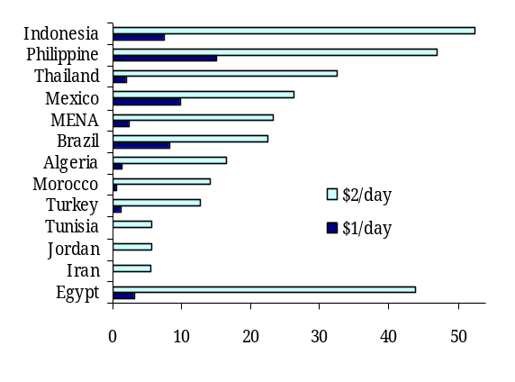

Box 1.2: Aggregate Poverty Measurements
The report relies on three aggregate measures of three dimensions of poverty: incidence, depth, and severity. These are captured by the standard three Foster-Greer-Thorbecke 1984 decomposable poverty measurements: P0, P1, and P2.
- The head count index (PO), which measures the prevalence of poverty, denotes the percentage of population that is poor (as defined by the poverty line) as a proportion of total population. This measure is insensitive to the distribution of the poor below the poverty line.
- The poverty gap index (P1), which measures the depth of poverty, indicates the gap between the observed expenditure levels of poor households and the poverty line. Assuming perfect targeting of transfers, this poverty gap index reflects the minimum amount of consumption that would need to be transferred to pull all the poor up to the poverty line.
- The poverty severity index (P2) measures the degree of inequality in distribution below the poverty line, giving greater weight to households at the bottom of the expenditure (or income) distribution.
Source: World Bank, 2002.
- Despite its prevalence, poverty is neither deep nor severe. The poverty gap index (P1) was 3.6 percent in 2005, and the poverty severity index (P2) was 1 (Box 1.2). Both are relatively low by the standard of middle-income countries. The poverty gap implies an annual poverty deficit per poor person of just LE 266, which means that many poor Egyptians were clustered just below the poverty line. It also means that a perfect targeting of poverty-alleviation transfers would have required LE 3.6 billion per year (in 2005 prices) to lift everyone out of poverty. So, in terms of the poverty gap as a ratio of per capita GDP (less than 4 percent in FY05), poverty in Egypt is shallow and small changes in GDP would result in significant changes in poverty. To illustrate, the percentage of the population whose expenditures place them within LE 50 above or below the respective poverty lines was calculated. About 2.3 percent of the Egyptian population lies between the poverty line and LE 50 above it. This implies that a LE 4 decline in the monthly expenditures of these individuals would bring them below the poverty line. In other words, the overall poverty incidence would increase to 21.9 percent with the slightest shock to their incomes/expenditures. On the other hand, there is another 2.3 percent of the population who lie between the poverty line and LE 50 below it. Thus, an increase in their income/expenditure of just LE 4 per month would easily lift them out of poverty and bring the poverty incidence down to 17.3 percent.
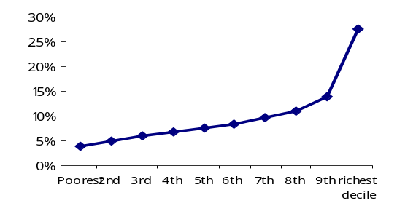
- Expenditure distribution equality was still comparable to other middle-income countries. The Gini coefficient, a measure of inequality, was estimated at 0.32 in 2004/05, indicating a more equitable distribution in per capita expenditure than the average for MENA countries (0.37 on average) or for Latin American countries (0.55). Relatively equitable distribution up to the eighth decile (Figure 1.4) also implies high concentration of population around any poverty threshold – a factor which explains why 40 percent of the population in Egypt are clustered between just $1 and $2 per capita a day (in PPP terms).
Figure 1.4: Distribution of Expenditure

Spatial Dimension of Poverty
Source: CAPMAS, HIECS 2005, Staff calculations
- Poverty had a strong regional dimension in Egypt. Taken as a whole, both urban and rural Upper Egypt regions were the poorest in the country, with poverty rates being 18.6 and 39.1 percent respectively, while Metropolitan areas were the least poor at a 5.7 percent poverty rate. The poverty rate in rural Lower Egypt (16.7 percent), though higher than that in urban Lower Egypt (9.0 percent), was lower by more than half compared to rural Upper Egypt. The differences in poverty measures across regions are statistically significant and the ranking of regions remains unchanged for the other two poverty measures (P1 and P2). Thus, not only did poor households in the Upper Egypt region comprise large proportions of their population, but their expenditure levels, on average, were far below the poverty line, to the extent that their per-capita poverty deficit was 2.2 times that of Egypt overall (Table 1.2). Furthermore, 14 percent of the population in Upper Egypt was extremely poor, living below the FPL; while in Metropolitan areas and Lower Egypt the corresponding rates were 0.8 and 2.5 percent, respectively. Moreover, the share of Upper Egypt to overall poverty is increasing as indicated by distribution-sensitive measures, reflecting the declining standards of living for the poor in this region.
Table 1.2: Poverty Measurements by Region
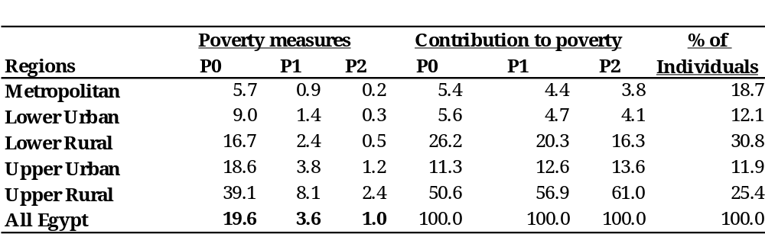
Source: CAPMAS, HIECS 2005, Staff calculations
- Poverty was concentrated in rural areas, but mostly in rural areas of Upper Egypt. In general, rural areas had higher poverty measures than their urban counterparts in both Lower and Upper Egypt (Figure 1.5). While the share of rural areas in the total population was just 56 percent, the poor in these areas accounted for more than 78 percent, extreme poor for 80 percent, and near-poor for 66 percent of the corresponding total number of these groups in Egypt. These groups are mostly concentrated in the rural Upper region, its share in the total number of poor (51 percent), extreme poor (66 percent), and near-poor (31 percent) far exceeding its population share of 27 percent.
Figure 1.5: Distribution of Poverty Groups across Regions, 2005
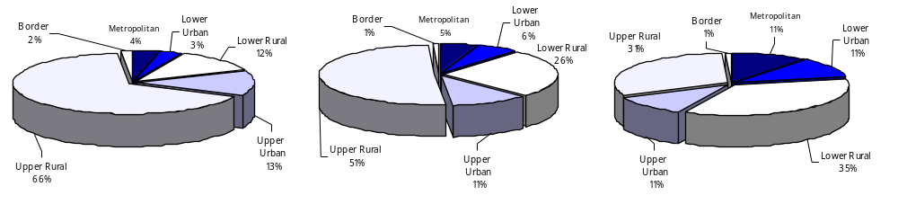
Extreme Poor Poor Near-Poor
- More people are concentrated around the poverty line for the poorest regions in Egypt. While the Metropolitan region had just 1.1 to 0.9 percent of its population clustered in the range of LE 50 below and above the poverty line, respectively, rural Upper Egypt, the poorest region, had between 3.6 and 3.8 percent of its population in this range. Therefore, small changes in expenditures can cause potentially larger swings in poverty for rural Upper Egypt, where most of the poor live.
Source: CAPMAS, HIECS 2005, Staff calculations
- Yet, regional differences mask the specificity of some governorates. While regional differences dominated the poverty map for Egypt, there were some differences in poverty among specific governorates within each region. For example, while Upper Egypt governorates generally had a high incidence of poverty, Upper Egypt’s Fayoum and Giza governorates had relatively low poverty rates (12 to 13 percent) compared to Sharqueya, Behera, and Menufeya in Lower Egypt (17 to 28 percent); see Figure 1.6. The latter governorates also showed the highest rates of near-poor (close to 30 percent of their total population). On the other hand, the governorate where the poor were most underrepresented was Cairo, while the poor were most overrepresented in Assiut. Not only were all poverty measures low in Cairo (P1= 4.6, P1= 0.7 and P2= 0.2), but the capital’s contribution to the total number of poor was just 2.7 percent, while its share in population was 11.5 percent. By contrast, Assiut had the highest poverty measures (P0= 60.6, P1= 15.5 and P2= 5.4), and its population represented only 4.5 percent of Egypt’s total population but 13.9 percent of Egypt’s poor.
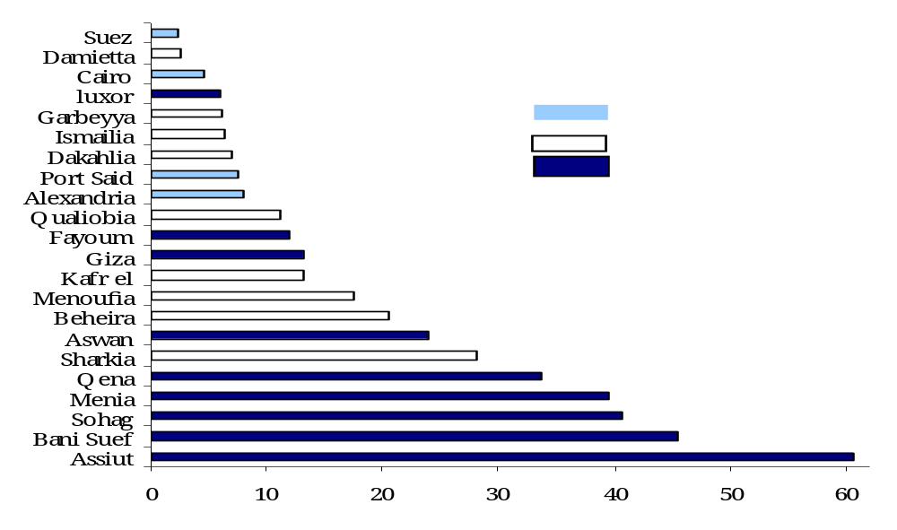
Source: CAPMAS, 2005 HIECS, Staff calculations
Figure 1.6: Poverty Incidence by Governorate
Source: CAPMAS, 2005 HIECS, Staff calculations

Poverty Trends: 1996- 2005
- An increase of poverty – a reversal from the gains of previous years – was witnessed in 2005. All measurements of poverty (as defined using the TPL) increased between 2000 and 2005: the incidence of poverty increased from 16.7 to 19.6 percent, depth of poverty from 3.0 to 3.6 percent, and severity from 0.8 to 1. The increase in the nominal per-capita monthly poverty deficit from LE 30 in 2000 to LE 52 in 2005 (equivalent to LE 38 at 2000 prices), together with the increase in the poverty incidence, resulted in an increase in the required transfers to lift all poor out of poverty from 0.1 to 0.7 percent of GDP between these two years. Over the whole decade (1996-2005), the deterioration in 2005 of these three poverty measures more than offset the improvement seen in 2000. (See Table 1.3).
- Extreme poverty increased as well, from 2.9 to 3.8 percent of Egypt’s population between 2000 and 2005. On the other hand, interestingly enough, the ratio of near-poor to the total population declined from 25.9 to 21 percent. This means that the ratio of Egyptians below the UPL declined from 42.6 to 40.5 percent over the same period. In other words, between 2000 and 2005, some 2.9 percent of Egypt’s population moved down from near poverty to poverty, while 2 percent of the population moved up from near poverty to above the UPL, emphasizing once again the shallowness of poverty in Egypt.
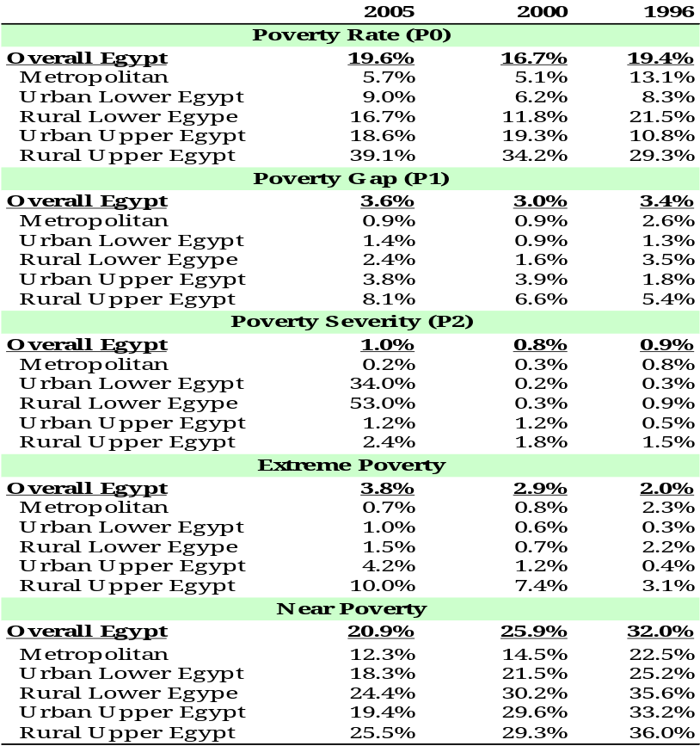
Table 1.3: Poverty Rates across Regions
Source: CAPMAS, 2005 HIECS, Staff calculations

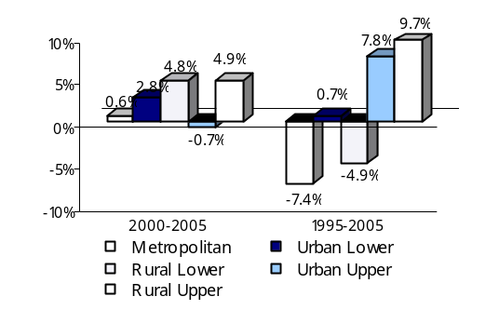
- Changes in poverty varied significantly between regions. When regional poverty is considered, two consistent patterns of poverty evolution emerge between 2000 and 2005. First, the incidence of poverty increased in all regions, except for the urban Upper Egypt region. Second, the increase in poverty was more significant in rural areas (by almost 5 percentage points). However, differences between poverty measures over 1995-2005 followed another pattern. As illustrated in Figure 1.7, while poverty declined significantly in Metropolitan and rural Lower Egypt (down by 7 and 5 percentage points, respectively), it remained almost unchanged in urban Lower Egypt and increased markedly in Upper Egypt (by almost 8 and 10 percentage points in urban and rural areas respectively). The percentage of extreme poor varied tremendously among regions, ranging from as little as 0.7 percent in the Metropolitan region to almost 10 percent in rural Upper Egypt, and that of near-poor from 12.3 percent in Metropolitan areas to close to 25 percent in rural areas.
Figure 1.7: Changes in Regional Poverty Incidence
Source: CAPMAS, 2005 HIECS, Staff calculations
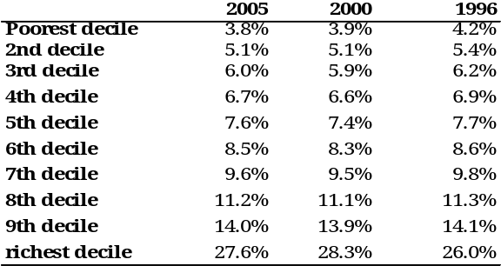
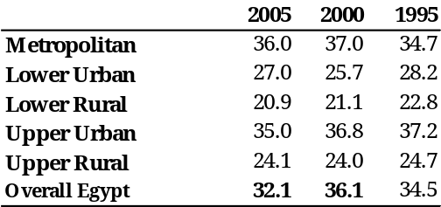
- Income distribution in 2005 was more equitable than in 2000 and 1995. The Gini coefficient (as a measure of inequality) indicates an overall improvement in distribution of per-capita expenditure in Egypt between 2000 and 2005 (down from 36.1 to 32.1), which more than offset a slight deterioration between 1996 and 2000 (up from 34.5 to 36.1). Between 2000 and 2005, only Lower Urban and Upper Rural regions showed an increase in per-capita expenditure inequality, while over the 1995-2005 period, all regions experienced a decline (see Table 1.4). The distribution of consumption expenditure by decile (Table 1.5) shows that changes in the shares of consumption expenditure have been marginal across all deciles over the three dates (1995, 2000, and 2005). Yet, over 2000-2005 the share of the bottom 20 percent remained almost unchanged, while the richest decile's share declined (by 0.7 percentage points) and the shares of all other deciles increased only marginally. On the other hand, over the 1995-2005 period, the shares of all deciles declined except for that of the richest one (up slightly from 26 percent in 1996 to 27.6 percent in 2005).
Table 1.5: Share of Expenditure by Decile
Table 1.4: Gini Inequality Coefficient
Source: CAPMAS, 2005 HIECS, Staff calculations
- The measured increase in poverty between 2000-2005 affected most of Egypt's governorates. Poverty rates increased in 14 of the 22 governorates in the considered regions. The highest increases (ranging between approximately 7 and 18 percentage points) were in three governorates in Upper Egypt, three in Lower Egypt, and one Metropolitan governorate. On the other hand, among the three governorates that witnessed a statistically significant decline in poverty two were from Upper Egypt and one from Lower Egypt. It is worth mentioning that neither of the Upper-Egypt governorates that witnessed a decline in poverty in 2000 (Menia and Quena) could continue the trend in 2005; in fact they were among the worst performers (Figure 1.8).

Figure 1.8: Poverty Change by Governorate 2000-2005
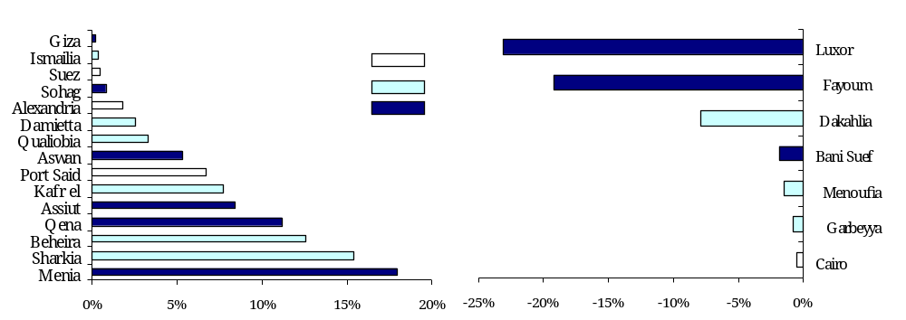

Increase in Poverty Is Not A Statistical Artifact
Source: CAPMAS, 2000 HIECS and 2005 HIECS, Staff calculations

- As mentioned in section II of this chapter, the estimated poverty lines for 2005 are based on a different food basket from the one used to estimate the poverty lines for 2000. Therefore, it is crucial to check whether the conclusion made in section IV about the increase in the poverty rates between 2000 and 2005 is solid. In this section a set of facts and tests are listed to show that the conclusion is indeed robust.
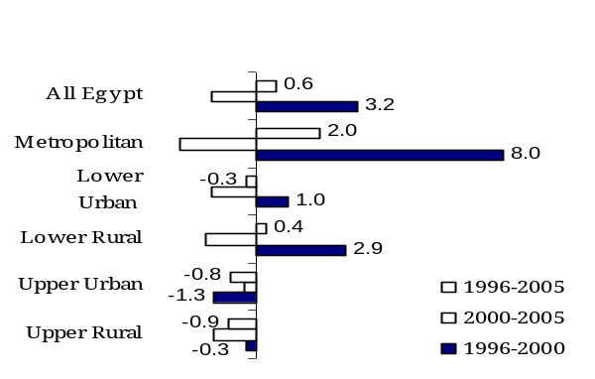
- Average per-capita expenditure declined across all deciles nationally and in all regions. At the national level, real per-capita expenditure declined from LE 2798 in 2000 to LE 2604 in 2005. This represents a real annual decrease in the average real per-capita expenditure (expressed as a welfare ratio to the value of the poverty line) of 1.4 percent. Regions did not experience the same magnitude homogeneously. Average per capita declined slightly in Upper Urban Egypt at 0.4 percent; while the largest decrease of 2.5 percent was observed in the Metropolitan region (see Figure 1.9). On the contrary, over the longer period 1995-2005, the level of per-capita expenditure for overall Egypt increased at an average annual growth of 0.6 percent. While Metropolitans witnessed the highest increase in per capita expenditure (up by 8 percent on average p.a.), only Upper Egypt (both its urban and rural areas) saw a deterioration of 1.3 and 0.3 percent, respectively, on average p.a.). In fact, between 2000 and 2005 middle deciles experienced the smallest decrease, hence smallest deterioration, in their welfare. Moreover the poorest two deciles experienced a lower decline than the average. Indeed, the overall decline in per-capita expenditure was driven by losses of the richest decile of the population (See Table 1.5).
Figure 1.9: Annual Real Growth in Per capita Expenditure, 1996-2005
Source: CAPMAS, 1996, 2000 and 2005 HIECSs, Staff calculations
- The share of food in the consumption expenditure increased. As will be shown in detail in Chapter 2, the share of food in total consumption increased in 2005 to 48 percent, compared to 44 percent in 2000. This was true for the poor and more so for the non-poor; indicating worsening living standards.
- Survey-based real income declined, confirming the direction in the consumption expenditure trend, the share of food in the consumption expenditure and, thereby, poverty. Although data on income from household surveys is always less reliable than on expenditure in most countries including Egypt, it can still provide very valuable information on the trend of changes in income. As per the HIECS data, nominal average household income in overall Egypt increased by 18 percent between 2000 and 2005. This is significantly below the survey-based deflator (reflecting the prices of the good in poverty basket), the CPI, and the FPI which all record a higher cumulative increase in price levels over the same period of 32.5, 33.1, and 47.6 percent, respectively. This strongly supports the conclusion about the poverty trend based on the consumption side. Furthermore, more rapid increase in average nominal income of poor households compared to the better-off confirms the conclusion about reduced inequality of distribution as measured by the Gini coefficient of inequality using consumption data.
18%
11%
26%
20%
55%
21%
19%
21%
23%
19%
26%
19%
0%
10%
20%
30%
40%
50%
60%
Metrop.
Lower
Urban
Lower
Rural
Upper
Urban
Upper
Rural
Overall
Egypt

Extreme Poor
Poor
Near Poor
Better Off
Figure 1.10: Nominal Increases in Average Household Income over 2000-2005, by Region and Poverty Status
Source: CAPMAS, 2005 HIECS, Staff calculations
- While many non-income poverty indicators improved between 2000 and 2005, malnutrition worsened, confirming the direction of income-poverty indicators. As will be discussed in the next chapter, most of the non-income indicators (such as ownership of consumer durables, housing quality, schooling, and some health indicators) indicate that the living standards of the population, including the poor, improved between 2000 and 2005. Yet, acute malnutrition indicators (including wasting and underweight), which reflect the effects of recent food shortages or recent episodes of illness contributing to malnutrition, worsened across all regions (see Table 1.6). On the other hand, the incidence of stunting (a sign of chronic malnutrition resulting from a failure to receive adequate nutrition over a long period of time or of the effects of recurrent or chronic illness), improved. The trend of both chronic and acute malnutrition confirms that the increase in poverty in 2005 was due to a particular food price shock (see Chapter 3) that affected the consumption-measure of poverty in 2004 and 2005 but not other, more permanent, indicators.

- The upward trend in poverty incidence is obtained for a wide range of poverty lines. The assessment of poverty changes over time depends on, and varies with, the poverty line. Accordingly, a dominance analysis was carried out to examine whether or not the same conclusions are obtained if the poverty line is changed and set to a uniform per-capita standard. Curves for the three poverty measures were plotted using a wide range of values for the poverty line (40 percent to 100 percent of average per capita expenditure) for the years 2000 and 2005. As Figure 1.11 shows, for any poverty line in this range the incidence, depth, and severity of poverty in Egypt were higher in 2005 compared to 2000.
Table 1.6 Nutritional Status of Children (Percentage of Children under 5)
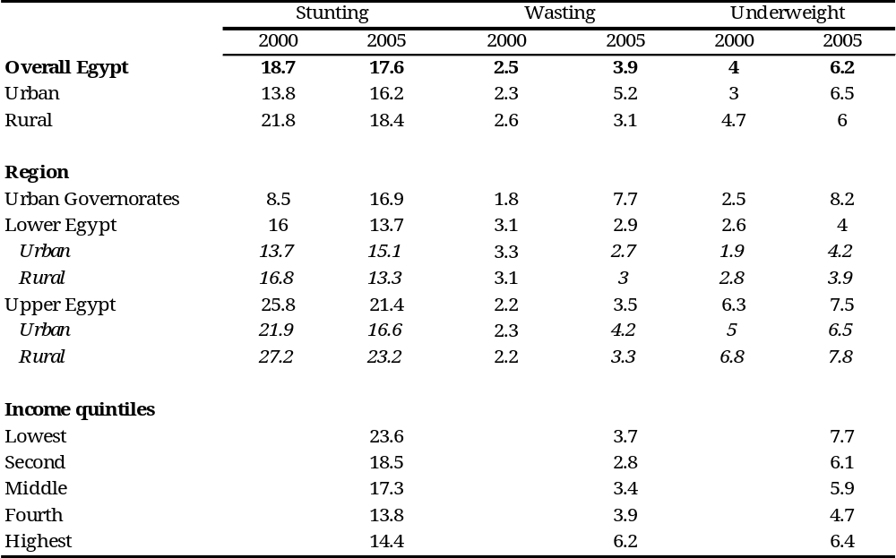

Source: Egypt Demographic and Health Survey, 2005
Figure 1.11: Poverty Incidence and Severity of Poverty Curves

- Increase in measured poverty between 2000 and 2005 is statistically significant as well. As illustrated in Table 1.7, for most regions (with the exception of Metropolitan and Upper Urban), and for Egypt as a whole, 95 percent confidence intervals for headcount indices do not overlap, suggesting that the measured change is statistically significant.
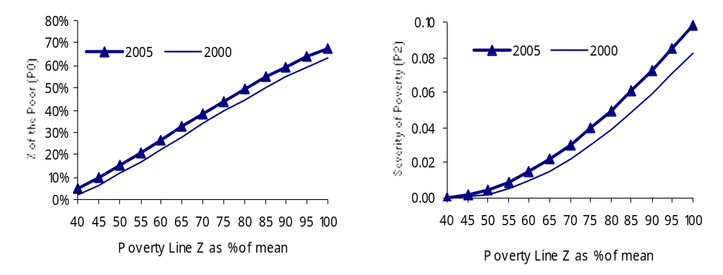
Table 1.7: Confidence Intervals for Poverty Estimates by Region

Source: CAPMAS, 2000 and 2005 HIECSs, Staff calculations

Table 1.7: Confidence Intervals for Poverty Estimates, by Region
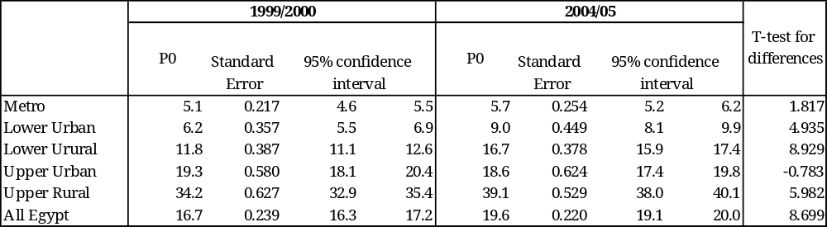
Source: CAPMAS, 200and 2005 HIECSs, Staff calculations
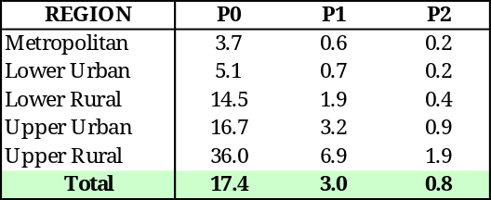
- Using 2005's basket with 2000 survey data produces the same overall trend for poverty. Poverty lines for 2000 were re-estimated by evaluating the 2005 basket of food in the unit prices derived from the 2000 household survey. The cost of calories generated by this basket was then evaluated. The non-food poverty line of 2005 was deflated back to 2000 using the non-food CPI. The resulting overall poverty rate was slightly higher (up by less than 2 percent) than those originally estimated by the 2002 World Bank report using the 2000 HIECS (LE 1018 per capita p.a., compared to LE 999 reported in World Bank (2002)), indicating that in terms of utility the new 2005 poverty basket is likely to be preferable to the 2000 basket, but only slightly so (Table 1.8). Even then, poverty, despite now being measured by the same basket, still shows an increase from 17.4 to 19.6 percent between 2000 and 2005. Using this method, poverty lines for urban areas were lower compared to the original figures of 2000 (thus implying that the new 2005 poverty basket for these areas is “cheaper” than the baseline basket of 2000), and consequently poverty estimates of 2000 for these areas were slightly lower too, which only confirms the direction of the poverty trend (compare Table 1.8 and Table 1.2).
Source: CAPMAS, 2000 and 2005 HIECSs, Staff calculations
Table 1.8: Poverty Estimates of 2000 Based on the Deflated 2005-Food Basket
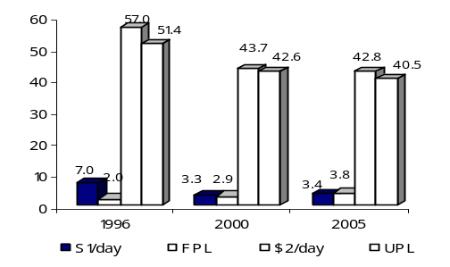
- Using the one-dollar-a-day or the two-dollar-a-day lines and per capita standard in constant prices shows a different trend between 2000 and 2005. From Figure 1.12 and Table 1.2, it is obvious that the estimated poverty rates using the one-dollar-a-day or the two-dollar-a-day definitions are close to the poverty rates using the FPL and the UPL, especially in 2005. Accordingly the two data sets show a stability in extreme poverty and a decline in the ratio of the vulnerable (those under the UPL or the US$2/day) in Egypt between 2000 and 2005. This estimate is, however, based on a unified set of price indices (CPI), as opposed to poverty comparisons based on prices of actual local values of minimum-subsistence baskets. Thus, while these figures confirm the assessment of poverty and near-poverty trends based on the national poverty lines, they less accurately reflect the actual changes in the cost of living.
Source: CAPMAS, 1996, 2000 and 2005 HIECSs, Staff calculations
Figure 1.12: US$1/day and US$2/day Poverty Incidence over Time

Survey and National Accounts Data
- Aggregate expenditure figures computed based on household surveys typically fall short, sometimes by a large margin, of private consumption figures as computed based on national accounts. Egypt is no exception in this respect.
- Per-capita consumption from the household survey is lower than consumption from the national accounts. The household survey of 2005 showed a level of LE 2,604 for nominal per-capita private consumption, as opposed to LE 5,504 calculated from the national accounts (NAs) data. Moreover, the gap between the two sources has been increasing since 1996. As shown in Figure 1.12, the ratio of household survey to national accounts per-capita consumption declined from 52.2 percent in 1996 to 51.8 percent in 2000 and to 47.3 percent in 2005 (Figure 1.13). This happened because nominal consumption based on NAs grew by 36 percent, while survey-based measure increased by 30 percent. The actual gap could be even larger, as Egyptian NAs do not adequately capture the activities of the informal sector, which account for at least one-third of the Egyptian economy (Galal, 2004). Even when taking NAs data at face value, an average underestimation of expenditures by almost LE 2,950 per person in 2005 may be a source of concern, especially when considering that the estimated food poverty line is LE 994.5 (or 33.7 percent of the gap value), and the full poverty line is LE 1,423.1 (or 48.3 percent of the gap value).
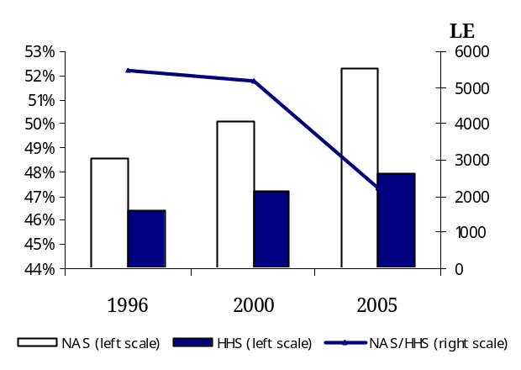
- A gap between national accounts and survey-based measures is less of a problem for poverty measurement than for inequality statistics. If expenditures were underestimated across all households, the “true” poverty line would perhaps be higher (and would include the non-reported types of expenditures by the same amount), producing the same poverty rates and inequality statistics. However, if under-reporting is taking place, especially among the better-off, both the poverty line and true poverty rate will not be affected, but the inequality indicators could be much higher. To verify this assumption, some alternative “corrections” of the expenditure figure estimated for each household in the HIECS can be introduced, leading to the re-estimation of poverty and inequality indicators (Martin Rama, 2003). Yet, applying these corrections requires the availability of data that are not reported in Egypt, for example aggregate private consumption by region, aggregate income types, etc. (See Box 1.3.)
Figure 1.13: Per-capita Nominal Consumption: NAs Versus HH survey
Source: CAPMAS, 2005 HIECS, Staff calculations
Box 1.3: How Well Do National Accounts and Survey Agree?
National accounts estimates of consumption are typically, although not always, larger than survey-based estimates. Furthermore, there is a tendency, both across countries and over time within important countries, for the NAs estimate of consumption to grow more rapidly than the survey-based estimate (Deaton, 2003). There are four main reasons why levels and/or growth rates from these two sources might not agree:
There is noise in both data sources due to measurement errors. These errors are probably uncorrelated between the two sources, given the differences in methods.
Even aside from measurement errors, there is a difference in coverage. Probably the most important difference is that national accounts include spending on goods and services by unincorporated businesses and non-profit organizations (such as charities, religious groups, clubs, trade unions, and political parties). Another difference, likely to matter in developing, primarily rural economies, is that grain consumed by farm animals owned by farm households is hard to separate from human consumption in the NAs; again, the distinction is clear in theory, but it is difficult to implement in practice in developing countries, leading to over-estimation in NAs. Properly designed household surveys can indicate a more accurate level.
Household surveys may underestimate expenditure. There are numerous problems in obtaining credible estimates from standard survey instruments (see, for example, the discussion in Deaton, 1997). Compliance by well-off sampled households is a well-known concern amongst those implementing surveys. It is not uncommon for the rich to systematically refuse to participate in the survey, or be impossible to interview for other reasons (getting past the guard dogs alive, for example). One expects that they will be replaced by more compliant but less well-off respondents. Or interview respondents can forget, or prefer not to reveal, some items. Amongst survey specialists, underestimation is generally thought to be a greater problem for incomes than for expenditures, but it affects some types of expenditures too.
Analysts of the two data sources do not, as a rule, use the same deflators. HH survey has its own implicit deflator. Comparisons of survey means over time generally use a Consumer Price Index of some sort, often using weights calibrated from the survey. There is no guarantee that these different deflators will agree. It is evident that when the levels or growth rates from these two data sources differ there can be no presumption that the NAs is right and the surveys are wrong, or vice versa, since they are not really measuring the same thing and both are prone to errors.
Source: Deaton, 2003 and Ravallion, 2003.

Growth and Distribution
- Over the period 2000-2005, two broad regional growth-distribution patterns characterized the differences in poverty outcomes among regions. The first pattern depicts a negative impact of declined per-capita expenditure on poverty that was larger than the positive effect of reduced inequality in expenditure, leading to a net increase in poverty. This was seen at the national level, in Metropolitan areas, and in urban Upper Egypt. There were, however, some peculiarities in the details of this pattern in each of these regions. To illustrate, at the national level the economic slowdown hit all expenditure deciles (an average decline of 1.4 percent), with the richest decile (down by 1.9 percent) and the poorest decile (down by 1.6 percent) being the most hard-hit. Poverty thus increased by 2.8 percentage points (Figure 1.14 a). Meanwhile, since the decline in per-capita expenditure of all other percentiles was below the average, indicating less deterioration in welfare compared to the overall population, the Gini coefficient decreased from 36.1 to 32.1. In Metropolitan areas, the decline in per-capita expenditure was the highest across all regions (down by 2.5 percent on average). Yet, the poorest two deciles had the lowest rates of decrease (1.24 and 2.0 percent, respectively) and the richest decile the highest (3.1 percent). This led to an improvement in income distribution (the Gini coefficient decreased from 37 to 36) and thus to a mild increase in poverty (0.6 percentage points). In urban Upper Egypt, per capita expenditure witnessed only a marginal decline (down by only 0.4 percent on average) – the lowest across all regions. This was driven by the decline in per capita expenditure of the richest decile (down by 2.1 percent) and to a lesser extent by the poorest two deciles (down by 0.9 and 0.2 percent, respectively). This, with the observed increase in per-capita expenditure of all other deciles, led to a decline in the Gini coefficient (from 36.8 to 35.0), with the poverty rate statistically unchanged (see Figure 1.14 c).
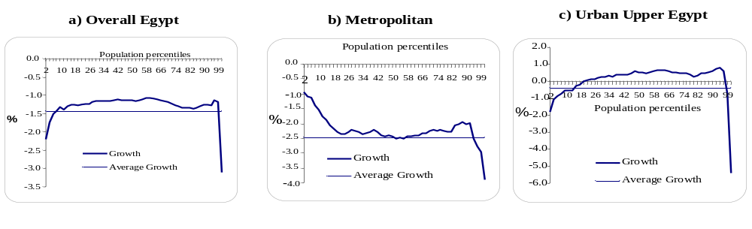
Figure 1.14: Growth Incidence Curve by Region
Notes: The horizontal axis shows the expenditure group arranged in percentile increments from poorest to richest. The vertical axis shows growth in expenditures, in percent, for the particular expenditure group between 2000 and 2005.
- A second pattern combined a decrease in per-capita expenditure with an almost unchanged income distribution. This is found in rural areas, whether in Lower or Upper Egypt (Figure 1.15 a and b). Both regions had a decline in per-capita expenditure (1.6 and 1.3 percent, respectively) around the overall mean of Egypt, and income distribution remained almost unchanged. While in Lower Egypt the decline in per-capita expenditure was more marked in the richest two deciles (down by 1.9 and 1.6 percent, respectively) and the poorest decile (1.9 percent), it was the highest in the bottom 50 percent of the population in Upper Egypt (with rates of decline ranging between 1.5 and 2.2 percent) and the richest decile (down by 1.6 percent). Poverty increased by almost 5 percentage points – the highest increase across all regions. This is mainly due to the fact that most of the near-poor live in rural areas, and they are very likely to fall into the poverty trap with the slightest adverse shocks to their expenditure.
Source: CAPMAS, 2005 HIECS, Staff calculations
Figure 1.15: Growth Incidence Curve in Rural Regions
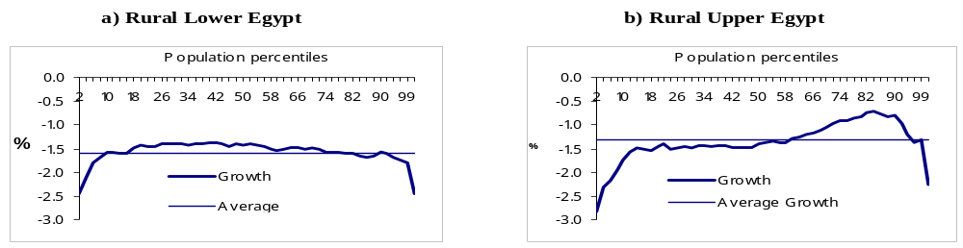

Source: CAPMAS, 2005 HIECS, Staff calculations
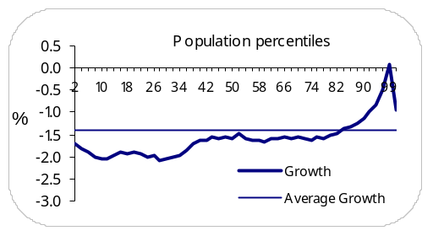
- Urban Lower Egypt had a different pattern of growth. It had a decline in per capita expenditure accompanying by a deteriorating income distribution, together leading to a noticeable worsening of poverty (Figure 1.16). The average decline in per capita expenditure was close to the overall mean of the country (1.4 percent), but the worst hit were the bottom 80 percent of the population in this region (with rates of decline ranging between 1.6 and 2 percent), and particularly the poorest three deciles (with 1.9 to 2 percent rates of decline). This led to deteriorating income distribution (the Gini coefficient increased from 25.7 to 27.0) and a worsening of poverty (up by 2.8 percentage points). It is worth mentioning that the relatively moderate negative poverty outcome in this region compared to rural areas results from the relatively lower percentage of near-poor living there (10.6 percent of the population in urban Lower Egypt versus 31 and 36 percent in rural areas of Lower Egypt and Upper Egypt, respectively).
Source: CAPMAS, 2005 HIECS, Staff calculations
Figure 1.16: Growth Incidence Curve in Urban Lower Egypt
- The overall increase in poverty between 2000 and 2005 was mainly driven by the increase in poverty in rural areas of Egypt, and to a lesser extent by the increase in poverty in urban Lower Egypt. This is validated by a regional decomposition of the change in poverty between the two years (Table 1.9), which shows that poverty increase was mainly due to intra-regional changes (or within region changes)in poverty. Although poverty-measure changes in all regions worked mostly in the same direction, rural Lower Egypt was responsible for more than half the increase in overall poverty (or 1.43 percentage points), followed by rural Upper Egypt with a 28percent contribution (or 0.8 percentage points). Having the least change in poverty, urban Upper Egypt’s contribution to the overall change in poverty was almost zero.
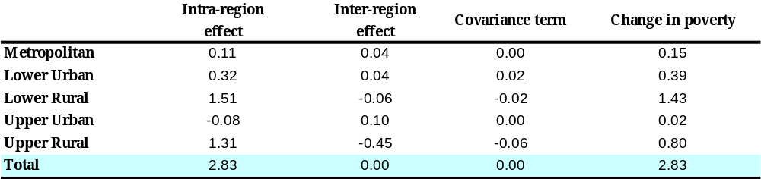
Table 1.9: Regional Contributions to Changes in Poverty between 2000 and 2005
- Likewise, inequality in Egypt was mainly driven by intra-regional inequality. Disaggregating the Theil index of all Egypt into “between” and “within” regions showed that intra-region differences are more important than inter-region differences as a driver of inequality at the national level. Table 1.10 demonstrates that in 2005 just 18.8 percent of inequality as measured by consumption came from differences in average living standards across regions, while 81.16 percent came from inequality within regions. The corresponding figures for 2000 are 17.6 and 82.4 percent. Comparisons over 1996-2005 suggest that inequality between regions is growing.
Source: CAPMAS, 2005 HIECS, Staff calculations

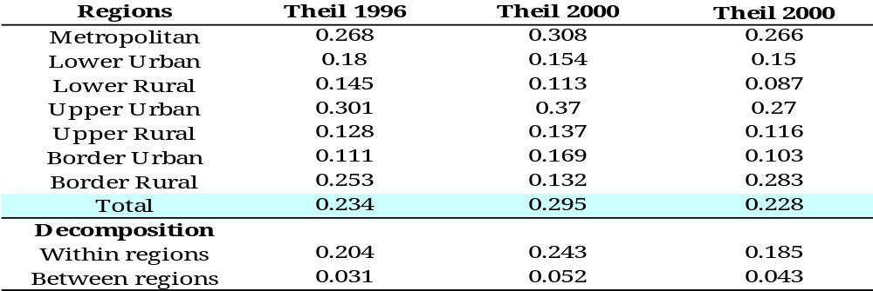
Table 1.10: Inequality Between and Within Regions

Elasticity of Poverty Measures
Source: CAPMAS, 2005 HIECS, Staff calculations

- Regions differ in how much a given growth rate can reduce poverty levels. Elasticity of poverty measures to changes in mean expenditure and inequality may explain the impact of growth and distribution on poverty trends. Calculations of the elasticity of poverty to growth – i.e., the percentage change in the poverty rate given a percentage change in mean regional consumption levels – show that poverty in rural Lower Egypt is more responsive to growth compared to other regions. Poverty in this region is also less sensitive to inequality changes. Consequently, calculations indicated a relatively higher impact of growth and a lower impact of inequality on poverty levels in the Lower Rural region (Table 1.11). On the other hand, the elasticity of poverty measures to the mean expenditure and to the inequality index were least (in absolute terms) for the Upper Rural region, where poverty was highest. Thus, even if rural Upper Egypt could have achieved the same growth rates as rural Lower Egypt, poverty would not have been reduced by the same degree.

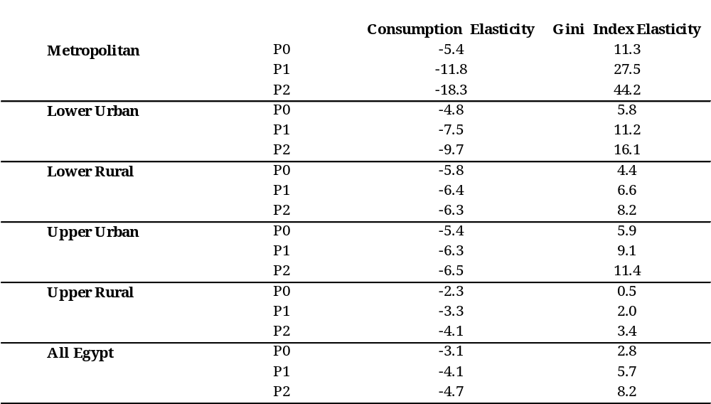
Table 1.11: Elasticity of Poverty Measures to Mean Consumption and Inequality
Source: CAPMAS, 2005 HIECS, Staff calculations

Poverty Map For Egypt
- Recent research has explored a technique that addresses the problem of lack of local data on poverty and inequality by developing “poverty maps”. A poverty map combines survey and census data to estimate consumption-based welfare indicators for small geographic areas such as provinces and villages. Also, developments in geographic information systems – suited for computer analysis – make it possible to present data in the form of maps and overlaying interfaces for cross-comparisons, and to perform spatial analysis assessing the relationships between these data according to their geographic location.

Why Develop a Poverty Map for Egypt?
- A poverty map is essential for geographic targeting. Poverty maps provide a detailed description of the spatial distribution of poverty and inequality within a country. A sufficiently detailed poverty map should make it possible, for the first time in Egypt, to compare poverty across districts, using a nationally consistent methodology. It can also help identify areas where development lags and where investments in infrastructure and services could have the greatest impact on people’s standards of living. When using poverty maps, targeted anti-poverty expenditures and interventions can be deployed to reach the neediest people by the most effective and affordable means, especially in the poorest regions (such as rural Upper Egypt). This is known as geographic targeting.
- For Egypt, as a developing country, geographic targeting offers significant advantages over other methods of targeting. First, it provides a clear criterion for identifying the target population and avoids the informational constraints that impede most other targeted programs. Second, it is relatively easy to monitor and administer, and its implementation can be greatly assisted by local administrative institutions and nongovernmental organizations. Third, geographic targeting has relatively little influence on household behavior since it is difficult and costly to change the place of residence. Fourth, it is possible to combine the location criterion with other criteria based on individual or household characteristics (characteristics targeting) to refine the level of determining eligibility and thereby targeting categories. Fifth, the instruments of geographically targeted programs can include not only direct income transfers to the target population, but also a variety of other measures aimed at increasing the income of the population. Sixth, poverty maps can also help inform decentralization. For instance, they can help inform the level at which a certain type of intervention or service is best managed and controlled by showing the area that benefits from them. They can also be used to inform formula for fiscal transfers that accompany the decentralization of responsibilities. (see Henninger and Snel, 2000). Moreover, the production and distribution of poverty maps results in increased transparency of public decision-making.

Why a New Poverty Map?
- The first attempt to develop a poverty map was made by the Social Fund for Development (SFD) in1993. Derived from 1986 census data using principle-component techniques, several indicators (such as education status, housing conditions, and availability of basic amenities) were combined to obtain a poverty index and an employment index. These indices were estimated at the district level and were used to rank districts and allocate resources accordingly. The second attempt was in 2003 and 2004 when the UNDP estimated a “human development index” at the village level for 19 governorates (out of 27) to be used to target the poorest 58 districts in Egypt. However, the reliability of some indicators (such as estimated per-capita GDP) was questionable. In 2006, the Social Fund for Development (SFD), in collaboration with the Population Council, developed a “Poverty Map Toolkit” based on combining 1996 Census data with the HIECS of 2000. However, because of data-availability problems, per-capita expenditure at the village level, but not at the household level, was estimated; hence no poverty or inequality estimates were provided. The village estimates of per-capita expenditure were then used as a proxy for the poverty level (at the village level) to produce a GIS "Poverty Map".
- One should, however, keep in mind three caveats about the SFD “poverty map” for 2000. First, this map could only be relevant to the year 2000 if there had been no major changes in the economy between 1996 (the census year) and 2000 (the survey year). In other words, the parameters describing the relationship between consumption and household characteristics should be stable over time; unfortunately, the assumption of stability over time is hardly valid for some of the variables used for prediction, such as household size, connection to public water, or possession of durable goods. Second, the map was developed using the expected per-capita expenditure, whereas the true per-capita expenditure for a location differs from the expected values because of sampling and modeling error. Not having reported the errors associated with the estimation of per-capita expenditure, overall precision levels are questionable. Third, and most important, the map does not reflect poverty levels in 2000, as it ranks villages/districts according to the estimated per-capita consumption.
- In this report, two poverty maps based on the two most recent successive Population Censuses of 1996 and 2006 and their concurrent HIECS of 1996 and 2005 are developed. In contrast with the 1996 poverty map, which was developed based on information at the household level, the 2006 map depends on the data available so far from the 2006 Census, which are final but relatively aggregated (see more details in the following sub-section). Maps presented in this study are the first attempt to apply the most up-to-date methodology developed by a team of researchers in the Development Economics Research Group, Poverty Cluster (DECRG-PO) at the World Bank. This method has been implemented in a growing number of developing countries; experience from these efforts suggests that statistically reliable estimates of poverty and inequality are attainable at encouragingly fine levels of spatial detail. (See the methodology details in Annex 1.4.)

Egypt's Poverty Maps for 1996 and 2006
- A model for predicting household consumption was derived for each of the five main regions covered in this report. These regression models, as shown in Annex Tables A1.5- A1.11, perform fairly well in all domains with the 1996 data. Adjusted R² – a measure of fitness of the regression model – ranges between 50 and 70 percent, which is reasonably high in comparison with other country experiences. Furthermore, for a non-negligible fraction of all possible comparisons, at both the village/city and sub-district levels, poverty is sufficiently precisely estimated to permit meaningful comparisons (see Annex Figures A.1.1, where the confidence bands around respective poverty estimates do not overlap).
- The regression results for mapping poverty in 2006 are not, however, as good as those of 1996. Adjusted R² is around 30 percent. This is mainly because while the Census data available so far are not as disaggregated as at the household level, they are aggregated at the enumerator level (of 100-200 households each), not at the village level. Also, not all variables in the Census questionnaire are yet readily available; for instance, data on durable goods possessions and sector of work, which could significantly improve the regression goodness of fit, are not yet available. Therefore, only a relatively limited set of variables was used. This includes household age and gender composition, education status of all household members, school enrollment for all children aged 6-18 years, employment status for all persons aged 15 years and above and their type of work, as well as connection to public water, electricity and sewerage networks. Using the POVMAP package, and combining raw data of 2005 HIECS survey with 2006 Census data, poverty measures of the smallest administrative level (village in rural areas and sub-district in urban areas), their standard errors and Gini coefficient were estimated.

C1. Poverty Map in Urban Areas
- In 1996, poverty rate at the sub-district level ranged from 74 percent (in El-Qarna sub-district in Sohag, with population of 40,000) to 0.5 percent (in Adely sub-district in Port Said, with a population of 7,000). Annex Tables A.1.12 and A.1.13 show that the largest number of the poorest 50 sub-districts in Egypt are located in Menoufeya (eight), Sharkeya and Qena (seven in each). Port Said Suez, Damietta, Ismailia, and Aswan governorates do not show in the poorest 50 sub-district group.
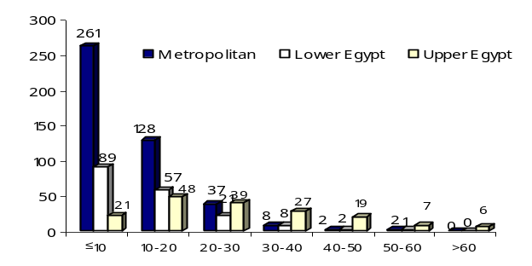
- In 2006, the poverty rate at the same disaggregated level ranged from 65 percent (in Qusya city in Assuit, population about 70,000) to 0.4 percent (in Eastern Abbasseya in Cairo). In 195 of Egypt’s sub-districts, where 4.6 million people live (almost 7 percent of Egypt’s population), poverty incidence was less than 5 percent. On the other hand, in only 16 sub-districts, where 567,000 Egyptians live (or less than 1 percent of the total population), poverty rates were greater than 50 percent (see Figure 1.17).
Figure 1.17: Egyptian Sub Districts by Poverty
Level and Region
Source: CAPMAS, 2005 HIECS and 2006 Population Census, Staff calculations
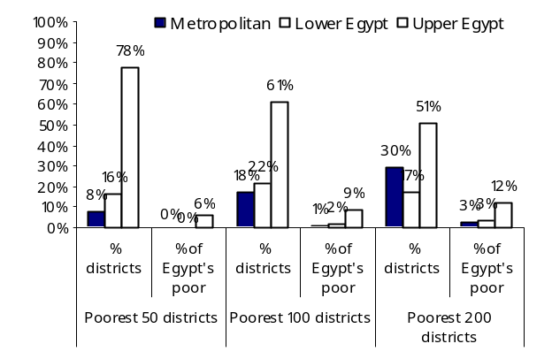
- The poorest districts in Egypt are mostly concentrated in Upper Egypt. Looking at the poorest districts in 2006, as Annex Tables 1.14 indicates, 39 of the 50 poorest sub-districts in Egypt are located in Upper Egypt, of which 16 are in Assiut, seven in Sohag, and five in Quena. Only Fayoum and Luxor in Upper Egypt had no sub-districts among the poorest 50. The poor in these 39 districts represent almost 6 percent of Egyptian poor, but only 1.2 percent of the Egyptian population. Among the three Lower Egypt governorates in the poorest 50, Dakahlia had five sub-districts while the other two governorates each had only one. Port Said and Suez, both Metropolitan governorates, had three and one respectively in the poorest 50. The total number of poor in these sub-districts represents 20 percent of the total number of Egyptian urban poor. If this group is targeted, 20 percent of urban poor will be reached with a leakage ratio of 52 percent. The same pattern of regional distribution of the poorest districts prevails when the poorest 100 and 200 sub-districts are considered, with an increasing share of Upper Egypt in the total number of Egypt’s poor even with a declining share in the number of poorest sub-districts. If the poorest 200 districts are geographically targeted, more than 57 percent of the urban poor (or almost 18 percent of Egypt’s poor) will be reached but with almost 70 percent leakage of benefits to the better-off.
Figure 1.18: Egypt’s Poorest Sub Districts,
by Poverty Level and Region, 2006
Source: CAPMAS, 2005 HIECS and 2006 Population Census, Staff calculations
- Poverty dynamism varies across different areas. While only five sub-districts appeared among the poorest 50 in both 1996 and 2006, 22 and 86 remained among the poorest 100 and 200 sub-districts, respectively. Movements in and out of the latter group are (as expected) less obvious. (See Table 1.12.) Most of the sub-districts (almost 80 percent) that continued to be among the poorest 200 over the last decade are located in Upper Egypt, and mainly in Assiut (16 sub-districts of the 23 in 2006), Quena (10 of 11), Menia (9 of 13), and Sohag (9 of 15). However, most of the newcomers into this group in 2006 are from Cairo (47 of the new s50 poorest sub-districts) in Metropolitan areas, followed by Giza 14 of the new poorest 37) in Upper Egypt and Dakahlya (13 of the new 19 poorest) in Lower Egypt.
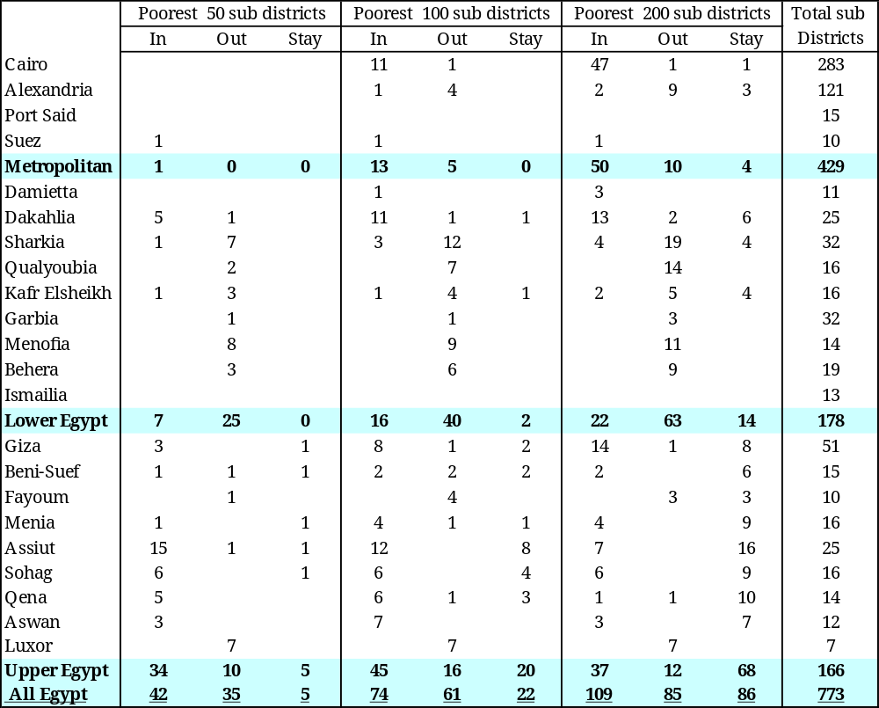
Table 1.12: Transition In/Out of Poverty of the Poorest Sub-Districts in Egypt, 1996-2006
Source: CAPMAS, 1996 and 2005 HIECSs and 1996 and 2006 Population Censuses, Staff calculations

C2. Poverty Map in Rural Areas
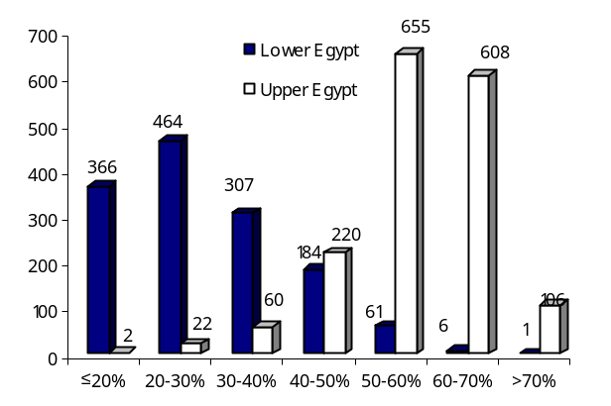
- In 1996, the poorest villages were predominantly in Upper Egypt. Poverty rates ranged between 6.6 percent in Meet El Sarem in Dakahlya to 85.5 percent in El Saayda village in Luxor. Except for one village in Aswan, all the 369 Egyptian villages with a poverty rate lower than 20 percent were in Lower Egypt. Consistent with the HIECS-based poverty estimates, the poorest villages in Egypt were concentrated in the poorest region in the country – namely Upper Egypt. As shown in Figure 1.19, almost 40 percent of Egyptian villages had a poverty incidence ranging between 50 and 70 percent, most of them in Upper Egypt. Furthermore, 95 percent of the poorest villages (whether considering the poorest 100, 500, or 1,000 villages) were in Upper Egypt, mainly in Menia, Beni Souef, Assiut, and Sohag (having altogether around 70 percent of the total poorest villages) and to a lesser extent in Fayoum and Quena. The poverty rate was 74 percent in the poorest 100 villages, indicating that targeting these villages would reduce the leakage to its minimum, as only 26 percent of beneficiaries are non-poor. From Lower Egypt only Behera had one village among the poorest 100 villages, six among the poorest 500 and 14 among the poorest 1,000.
Figure 1.19: Egypt’s Villages by Poverty Level and Region, 1996
Source: CAPMAS, 1996 HIECS and 1996 Population Census, Staff calculations
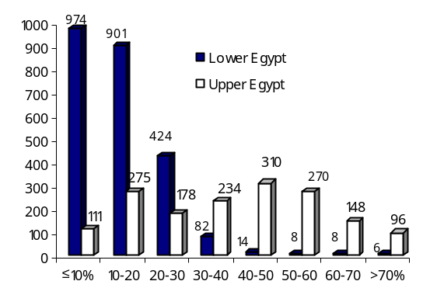
- In 2006, the poorest villages remained highly concentrated in Upper Egypt. According to the estimates reflected in the 2006 map, poverty rates varied between less than 1 percent (in 23 villages mainly in Lower Egypt) and over 90 percent in Kafr Hemid village in Giza. Among 4,039 villages, 371 (or 9 percent) had a poverty incidence lower than 5 percent; only 42 of these villages are located in Upper Egypt. Also, while less than 5 percent of Lower Egypt villages (with 1.2 percent of the Egypt’s population) have a poverty incidence higher than 30 percent, almost two-thirds of Upper Egypt villages (with 16.8 percent of the Egyptian population) exceed that level.
Source: CAPMAS, 2005 HIECS and 2006 Population Census, Staff calculations
Figure 1.20: Egypt’s Villages by Level of Poverty and Region, 2006
- The high concentration of poverty in Upper Egypt is also evident when the poorest villages are considered. The poverty ratio in the poorest 100 villages, where 1.1 percent of Egypt’s population and 4 percent of its poor live, is 76 percent. Consequently, targeting these villages would reduce the leakage to its minimum, as it is expected that most of the remaining 24 percent are near-poor or close to it. Likewise, 61 percent of the poorest 500 villages’ population are poor, representing 22 percent of the overall Egyptian poor. The corresponding figure for the poorest 1,000 villages is 51.8 of all poor (their average poverty rate is estimated at around 38.8 percent).
- Poverty was relatively stagnant in Upper Egypt over the decade. As indicated in Table 1.13, all the villages, that remained among the three selected poorest groups are from Upper Egypt, and mainly in Menia (with 252 villages among the poorest 1,000 villages), Sohag (129), and Assiut (120). Furthermore, more than 90 percent of the villages that joined these groups in 2006 are from Upper Egypt and mainly from the same three governorates (see Table 1.13)

Table 1.13: Transition In/Out of Poverty of the Poorest Villages in Egypt, 1996-2006

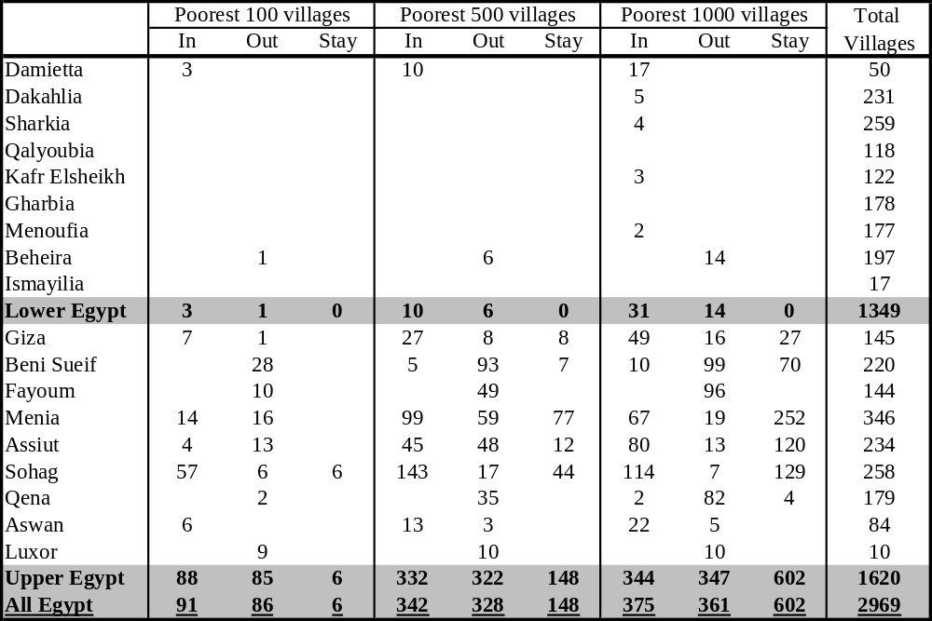
Source: CAPMAS, 1996 and 2005 HIECSs and 1996 and 2006 Population Censuses, Staff calculations

Conclusion
- Even though the results of the poverty maps for 1996 and 2006 presented here are preliminary, they provide useful insights about the nature of poverty and best ways to target the poor:
  - Both 1996 and 2006 maps reveal greater variation in living standards across rural settlements compared to urban, and some villages are characterized by very high poverty rates. These pockets are mainly located in Upper Egypt and mostly in Menia, Assiut, and Suhag.
  - Between 1996 and 2006 estimated poverty remained high for some villages and urban sub-districts, and the preliminary data suggest that between these years there was an increasing concentration of poverty in the poorest rural settlements.
  - Comparison of 1996 and 2006 maps show that among the poorest locations only one half is as poor as 10 years ago, and one half of those who were poor in 1996 managed escape poverty, while many previously non-poor subsided to the ranks of the poorest.
  - Many urban sub-districts classified as poorest are estimated to have moved out of poverty by 2006, suggesting a higher degree of mobility in urban areas.
- A poverty map is a useful tool to identity the poorest pockets, but it is only one of various targeting mechanisms. Even allowing for some possible corrections and improvements as more disaggregated Census data becomes available, it is possible to conclude from poverty mapping that the poorest locations (poorest 1,000 villages and poorest 200 urban districts) account for 57 percent of all poor in Egypt. This means that a large share of the Egyptian poor still live in locations with “average” poverty incidence. Hence poverty mapping needs to be complemented with other targeting methods, especially in urban areas.

Chapter 2: Characteristics of the Poor

In general, Egypt's poverty profile closely resembles poverty patterns in other countries. This section discusses these correlates of poverty and identifies those groups of the population that are at greatest risk of falling into poverty. Regardless of the indicator selected, poverty is markedly higher in rural areas. Large rural households with young children (under 5) and low education levels are at the greatest risk of poverty. Egyptians living in rural Upper Egypt face an especially high risk of poverty. Even when controlling for all observed socio-demographic factors, a rural Upper Egypt household is still likely to consume only 69 percent of what a similar household consumes in other regions.

Introduction
- Counting the poor is an important step towards aligning policies and programs for poverty reduction. Understanding who the poor are is at least as important, if not more. The previous chapter implicitly identified a few of their characteristics. It showed, for instance, that poverty was more prevalent in rural areas and deeper in Upper Egypt. Yet, it did not touch on other characteristics of poor households, composition, or assets. This chapter uses the same HIECS data to identify the household and community characteristics most commonly associated with poverty. The statistical analysis linking poverty (or household expenditures) with household and community characteristics is often called a poverty profile. The poverty profile treats two related yet different questions. The first is, “Who is at risk of poverty?”; the answer should reveal causal factors of poverty, identifying the groups with high incidence of poverty and consequently aiding the design of policy interventions most likely to help the targeted group. The second is, “Who are the poor?”; the answer should help identify which groups are over-represented among the poor and thereby the factors and policies that will likely affect the majority of the poor. Answering both questions would allow for a good understanding of which socioeconomic groups in society suffer the most from income poverty and how large they are, and contribute to the design of an effective poverty-reduction strategy.

Who Are the Poor?
The poverty profile has not changed much between 2000 and 2005: the poor are rural and less educated, hold irregular informal jobs, and live in families with more dependants.

Location and Demographics Are Crucial Determinants of Poverty
- Poverty is higher in rural areas than in urban areas, and particularly high in rural Upper Egypt. Not only is the risk of being poor higher in rural areas (26.8 percent) than in urban areas (13.4 percent, excluding metropolitan areas), but poverty is also more severe in rural than in urban areas. As shown in Chapter 1, poverty is highest in rural Upper Egypt (39.1 percent) and lowest in Metropolitan areas (5.7 percent).

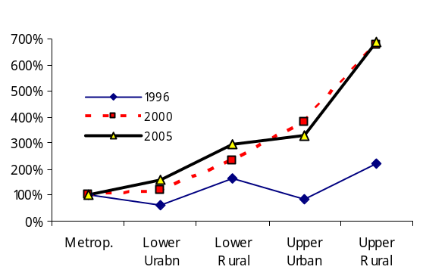
- Relative risk of poverty across regions has not changed by the mid-2000s compared to the early 2000s. In fact, from Figure 2.1, which shows the relative indices of poverty incidence with the Metropolitan region taken as the reference region, the ranking by poverty levels remained broadly similar in 2000 and 2005. There has been some convergence between urban Upper Egypt and rural Lower Egypt. Yet, if compared to 1996, the poverty divide is strikingly different. Between 1995 and 2000, the difference in the prevalence of poverty significantly widened between Metropolitan areas and other regions and between Lower Egypt and Upper Egypt. Moreover, regressions on per-capita consumption suggest that even when controlling for other typical characteristics of poverty (e.g., lower education or size of household), location per se still kept poverty levels higher in rural areas, and particularly in rural Upper Egypt.
Figure 2.1: Regional and Urban-Rural Poverty Divide
Source: CAPMAS, 1996, 2000 and 2005 HIECSs, Staff calculations
- Larger households are at a higher risk of poverty. In 2005, almost half of all Egyptian households had five or more persons. Households consisting of one or two persons had considerably lower poverty rates in 2005 than larger households. For households comprising more than five persons (the median household size in Egypt), poverty rates jumped dramatically. Almost one-third of all households with six or more persons were poor, accounting for 74 percent of all poor individuals in Egypt. Among these households, the risk of being poor was much larger in rural areas (38 percent) than in urban areas (22 percent). Yet, the regional bias in the poverty risk seemed more pronounced than the urban/rural bias. While the poverty incidence of the households with six or more persons was 35 percent in urban Upper Egypt and 52 percent in rural Upper Egypt, the corresponding figures in Lower Egypt were 19 and 29 percent. The difference between the average household size of the poor and the better-off is as much as two persons per household. While 65 percent of the better-off households in 2005 consisted of one to four persons, 80 percent of the poor households had five or more persons. Moreover, near-poor together with poor households living in larger households with six or more people represented almost one-quarter of the total population. This high concentration of poverty among households with many members makes household size a useful proxy for poverty in the design of targeting mechanisms.

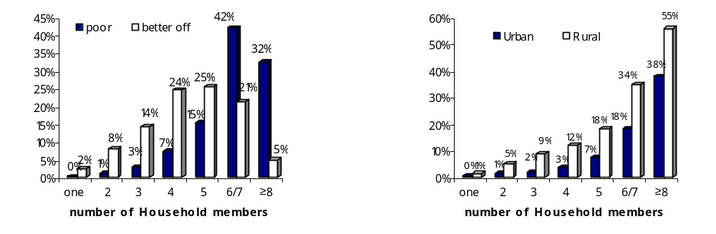
- Poor households have higher dependency ratios than better-off households. Even though the methodology for measuring poverty takes into consideration economies of scale, there is a strong correlation between household size and poverty. This is because the poor tend to support a proportionally higher number of dependants. Having a large number of children (who are too young to contribute to household income) has a strong impact on poverty. An average poor household in Egypt has 69 percent more children (below 15 years) to support than a better-off family (Table Annex A.2 15b).
Figure 2.2: Poor Households Tend to Be
Larger
Figure 2.3: Poverty Risk by Household Size Is Higher in Rural
Source: CAPMAS, 1996, 2000 and 2005 HIECSs, Staff calculations
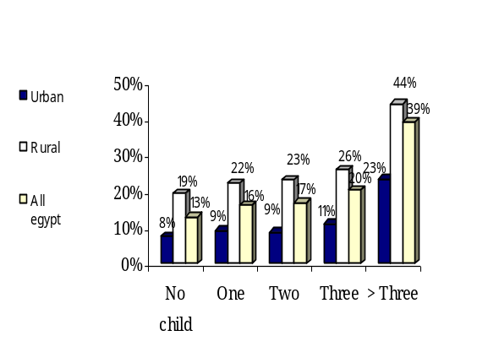
- The risk is particularly high among households with three or more children. Almost 29 percent of those who belonged to households with three or more children under 15 were poor in 2005, compared to 8 percent for those in households without young children. Households with three or more young children hosted nearly half of the poor individuals. There is a very high penalty, in poverty terms, from having more than three children (as seen in Figure 2.4). This pattern is essentially similar to that observed in other countries. However, it is important to note that while the risk of poverty rises sharply with the number of children, 48 percent of the poor with children came from households with one or two children (See Annex Table A.2.13c). Furthermore, one-sixth of the poor belonged to households without children. Thus, a national policy focused only on protecting children against the risk of poverty would bypass one poor person out of six.
Figure 2.4: Increased Incidence of Poverty with Increased Family Size
Source: CAPMAS, 2005 HIECSs, Staff calculations
- Differences between regions in household size and age structure may explain some of the differences in poverty levels among regions. In rural areas, where poverty incidence is 26 percent, the percentage of households with three or more children is about twice that in urban areas, where poverty incidence is 10 percent. Rural households with three or more children contributed 7.8 percentage points to the total poverty headcount (19.6 percent). Furthermore, in rural Upper Egypt, the region with the highest poverty incidence (39 percent), these households contributed 5.7 percentage points to Egypt's national poverty headcount. In other words, just targeting households with more than three children in rural Upper Egypt would mean that 29 percent of all Egypt’s poor are reached.
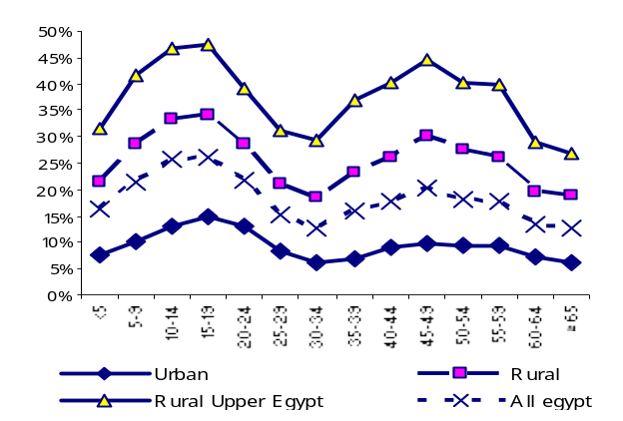
- Relatively more children and younger adults experience poverty firsthand than older age groups. At the national level, 21 percent of young children (under 15 years) lived in poverty in 2005. The poverty risk was the highest (approximately 26 percent) among children between 10 and 14 years and young adults between 15 and 19 years. Poverty risk was lowest among the elderly above 60 years (13 percent) and younger working-age adults between 30 and 44 years (15 percent). Although the prevalence of poverty among individuals aged 20-29 years and 45-59 years was close to 19 percent, it was still below the national average. As shown in Figure 2.5, the probability of poverty appears to be falling monotonically over the life cycle. The pattern was almost the same across all regions, with rural Upper Egypt having, as always, considerably higher poverty incidence across all age groups.
Figure 2.5: Poverty Risk over the Life Cycle, by Region, 2005
Source: CAPMAS, 2005 HIECSs, Staff calculations
- The poor have lower access to health services, leading to higher child mortality rates and higher fertility rates. Annex Table A2.28 shows that the fertility rate among the poor was about 1.5 times the rate for the better-off, as was the under-five-mortality rate. However, the gap between urban and rural better-off in fertility and mortality rates was even wider than the corresponding gap for the poor. High fertility rates among the poor were combined with less access to prenatal care and medically supervised deliveries, which contribute to higher infant and child mortality rates for this group. The 2005 HIECS, which provides information about prenatal and post-natal care, shows that 30 percent of the poor in urban areas and 34 percent in rural areas did not receive any prenatal care, compared to only 11 percent and 22.5 percent of the better-off in urban and rural areas, respectively. Moreover, childbirths were supervised by physicians for some 65 percent of the poor in urban areas and just 44 percent in rural areas. When the poor used health services, they depended largely on public provision: 71 percent of the poor in urban areas and 68 percent in rural areas depended on public health facilities for providing delivery services.

Consumption Patterns
- Household consumption patterns differed between 2000 and 2005 for urban and rural households. Food was the dominant item for all income groups no matter where they lived. Yet, in 2005 food’s share of overall consumption increased to 48 percent (from 44 percent in 2000); see Table 2.1. This would typically indicate a decline in living standards, but may also represent an effect of substitution as prices of food items increased between 2000 and 2005 faster than those of non-food items. The gap in the share of food consumption narrowed between urban (44.5 percent) and rural areas (53 percent) over the same period (from 12 percentage points to 8.5 percentage points). This indicates that the increase in the food share in urban areas was higher than that in rural areas. Expenditures on housing and clothing (as shares of total consumption) remained the second and third most important expenditure items. Yet, the share of housing increased (from 14.7 to 16.1 percent) while that of clothing declined (from 10 to 8.2 percent). Also, while the share of health remained at close to 4 percent of overall consumption spending between 2000 and 2005, the share of education declined from 4.7 percent to 3.2 percent

Table 2.1: Share of Expenditure on Food to Total Expenditure by Region and Poverty Status,
2000 and 2005

Poor
Non-poor
Total
Poor
Non-poor
Total
Poor
Non-poor
Total
1999/2000
50.9
38.6
38.9
56.5
50.1
50.9
55.1
43.2
44.1
2004/05
53.9
44.2
44.5
56.5
52.3
53.0
55.9
47.4
48.2
Urban
Rural
All Egypt
- Consumption patterns also differed between the poor and the better-off. As expected, the poor had a higher share of food expenditure (60 percent) in 2005 than the better-off (46 percent), Figure 2.6. This gap narrowed, though slightly, between 2000 and 2005 (from 11.3 percentage points to 9.7 percentage points, respectively). The extreme poor and near-poor had food shares close to that of the poor (57 percent and 53.6 percent respectively). Finally, among all expenditure items, expenditure on recreation and hotels was the most biased towards the better-off population (2.5 times that of the poor), followed by transportation and communication (2.2 times) and education and health (1.6 times). These gaps between the better-off and the poor were even larger in urban areas.
Source: CAPMAS, 2005 HIECSs, Staff calculations
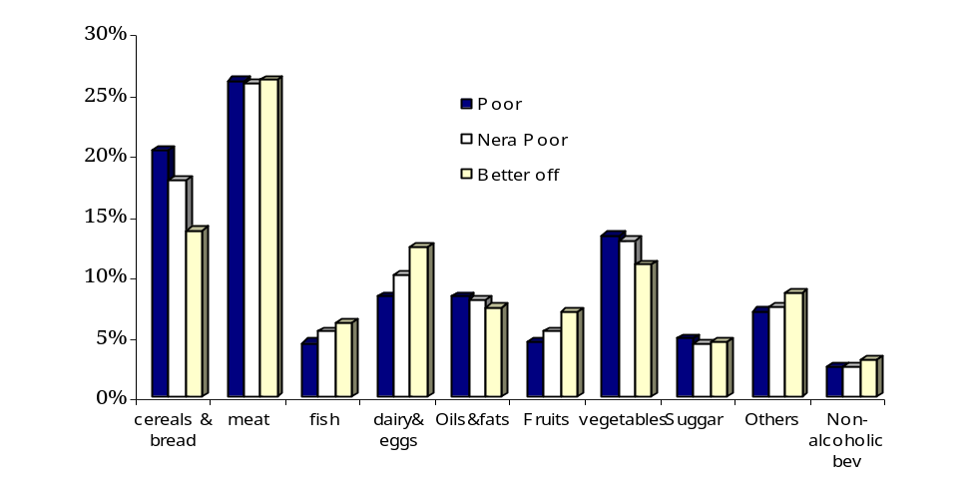
Figure 2.6: Food Consumption Pattern by Poverty Status

- The food consumption patterns of the poor were broadly similar to those of the better off, yet consumption levels were much lower. As a share of total consumption, the poor and near-poor spend more on cereals and bread (by 6.5 percentage points), vegetables (2.4 percentage points), and oil and fats (one percentage point) than the better off, but less on dairy products and eggs (by 4.2 percentage points), fruits (2.4 percentage points) and fish (1.7 percentage points). Surprisingly, the share of meat was almost the same across different groups. Yet, the level of consumption per person – of any food item – was much higher for better-off individuals than for poor. Differences were the highest for dairy products, fruits, and fish (three to four times) and the least for cereals and vegetables (1.6 to 2 times).
Source: CAPMAS, 2005 HIECSs, Staff calculations

Educational Attainment Makes a Considerable Difference
- The overall educational standards of the population remained mediocre. Progress in reducing the illiteracy rate between 2000 and 2005 at the national level was modest (down by 2 percentage points), compared to that witnessed between 1996 and 2000 (down by 4 percentage points). But the gains of the poor in literacy were larger (decline in illiteracy rate by 4.5 percentage points) than the national average, driven by significant progress in rural Upper Egypt and Metropolitan areas (a decline in each of more than 5 percentage points). Surprisingly, urban Lower Egypt lagged behind all other regions in this respect (less than one percentage point decline in illiteracy). Overall, the proportion of illiterate individuals (aged ten years and above) remained high in Egypt, standing close to 29 percent. Meanwhile, individuals who had a university degree or higher increased slightly to 8.5 percent of the population from 7.8 percent over the same period (Figure 2.7).
Figure 2.7 Individual Educational Profile by Poverty Status, 2005

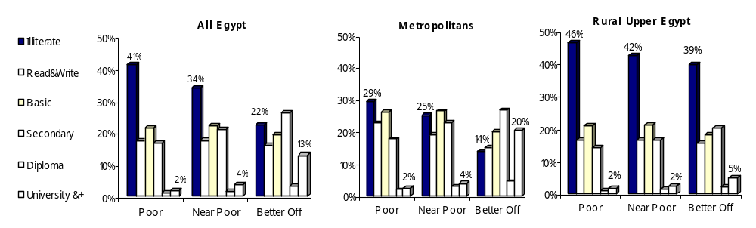
Source: CAPMAS, 2005 HIECSs, Staff calculations
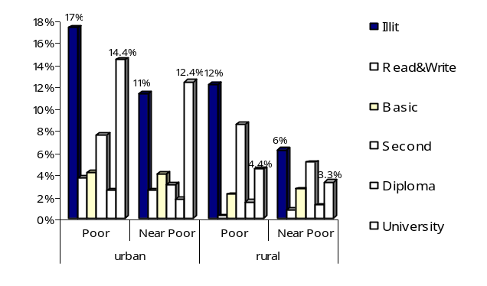
- Low educational attainment remains among the key determinants of poverty. Almost 80 percent of the poor (equivalent to 16 percent of all Egyptians) had only basic education or lower (half are illiterate), while only 3.4 percent had attained a higher-than-average level of education (university degree). Poverty among individuals with low education was slightly less concentrated in 2005 compared to 2000, with corresponding figures being 86 percent with basic education and 1.9 percent with a university degree, respectively. Yet, there were still wide disparities in the educational attainment between the poor and near-poor on one hand and the better-off on the other (see Figure 2.8). Moreover, these disparities were more pronounced in urban areas than in rural areas. More specifically, educational gaps between the poor and better-off in urban areas were the highest: the difference in illiteracy rates was as large as 17 percentage points greater for the better-off, and the urban better-off had many more university graduates among them than the poor (a gap of 14 percentage points). Differences between the poor and better-off were less pronounced in the middle of educational spectrum: for diploma holders, it was a mere 2.5 percentage points, and for the group with literacy, 3.7 percentage points). This pattern of largest gaps for the extremes of the educational attainment spectrum is also observed in rural areas, where gaps were also the widest for illiteracy (there were fewer rural better-off illiterate individuals by 12.2 percentage points compared to the poor) and holders of secondary and vocational degrees (8.5 percentage points), and the lowest for those with literacy (0.2 percentage points) and diploma holders (1.5 percentage points).
Figure 2.8: Educational Gaps with the Better-Off, 2005
Source: CAPMAS, 2005 HIECSs, Staff calculations
- Consequently, education is a powerful shield against poverty, especially in urban areas. Similar to what is observed in other countries, higher educational attainment is associated with lower poverty incidence. At the national level, in 2005 the probability of being poor dropped significantly for individuals with literacy (20 percent) compared to illiterates (26.8 percent). However, the premium for an individual to have a basic education relative to read-and-write skills is practically zero. The most significant difference appeared to kick in at higher levels of education, with a 5 percent risk for university graduates to be poor. Not only was poverty highest for illiterate individuals in every region, but it was also the deepest and most severe (Table 2.2). This was even more obvious in urban areas than in rural areas. Poverty measures for the illiterate were 1.7 times the overall average in the Metropolitan region, while they were 1.4 and 1.2 times higher in urban and rural areas, respectively, confirming a stronger relationship between poverty and education in urban areas compared to rural areas.
Table 2.2: Poverty Is the Highest, Most Severe, and Deepest for Illiterates

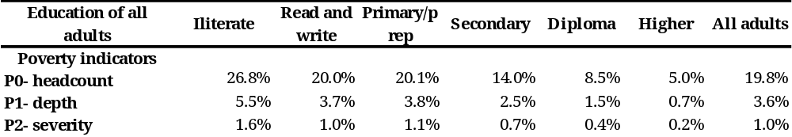
Source: CAPMAS, 2005 HIECSs, Staff calculations

- The strength of the effect of education on poverty changed only marginally over the time period observed, with significant regional variation. While the general relationship between poverty measures and education levels for 2000 was similar to that of 2005, the effect of education on reducing poverty varied markedly across regions (see Figure 2.9), with the poorest regions exhibiting steeper returns, i.e. more of an effect of educational attainment on poverty status.
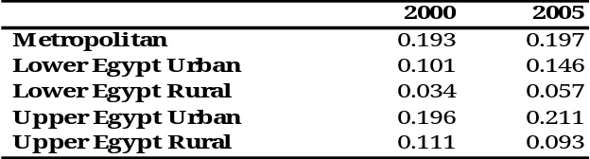
- The analysis of earnings suggests that returns to education increased over the period. The correlation coefficients of average income and years of schooling were higher in 2005 compared to 2000, in all regions except for Rural Upper region (see Table 2.3). Although all education categories showed declines in their average real income over the period 2000-2005 (measured against the poverty line), individuals with low education experienced the highest decline. Therefore, better-educated individuals were relatively “more rewarded” in 2005 than in 2000. This is true for all regions except for urban Upper Egypt, where lower rewards from education were partly responsible for the relatively worse performance in poverty reduction over the time period.
Table 2.3: Correlation Coefficients of Average Real Income and Years of Schooling 2000 and 2005
Source: CAPMAS, 2000 and 2005 HIECSs, Staff calculations

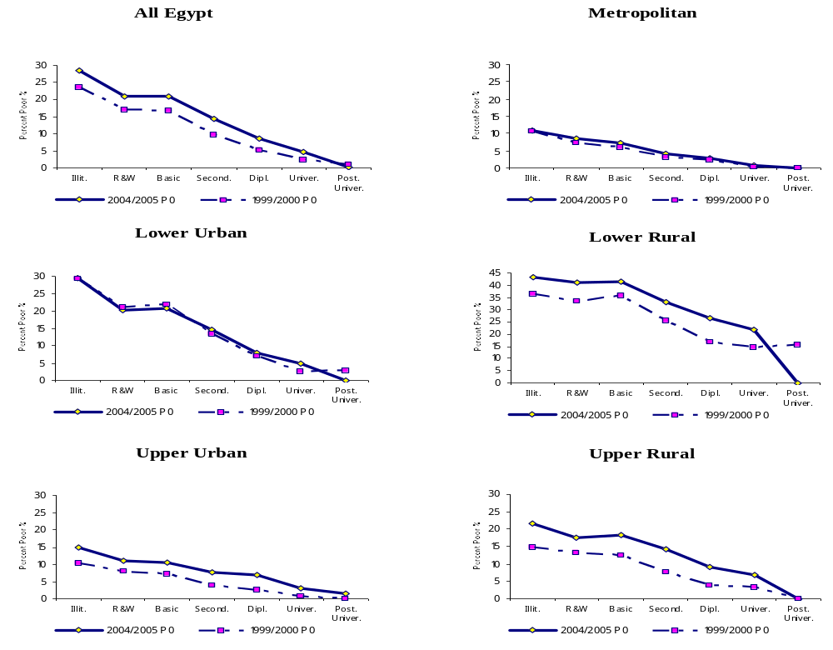
Figure 2.9: Change in Poverty Incidence for Individuals by Educational Attainment
Source: CAPMAS, 2000 and 2005 HIECSs, Staff calculations
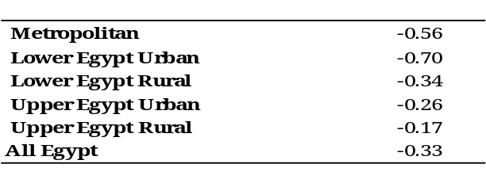
- Despite higher returns, elasticity of poverty changes with respect to changes in mean years of schooling is highest in richer areas and lowest in poorer areas. Impact of education on poverty can be detected by evaluating the percentage change in poverty levels resulting from improvements in educational attainments. The analysis based on the Kakwani measure, which calculates poverty changes with a 1 percent change in years of schooling indicated highest elasticity in Metropolitan and urban Lower Egypt (where an increase in years of schooling of one percent can reduce poverty by 0.56 and 0.7 percent respectively). In other words, an additional one year of schooling would reduce poverty by 4.7 and 5.8 percentage points in Metropolitan and urban Lower Egypt regions (Table 2.4). Upper Egypt regions exhibited the lowest elasticity, and in Rural Upper Egypt poverty could be reduced by only 0.17 percent (1.4 percentage points) with an increase in years of schooling of one percent (one year).
Table 2.4: Elasticity of Poverty Changes to Years of Schooling
Source: CAPMAS, 2005 HIECS, Staff calculations

Income and Labor Markets

D.1 Sources of Income
- For all income groups, income from work is the main source of income, followed by cash transfers and income of agricultural enterprises. Labor is usually and understandably the only valuable asset that the poor have. In Egypt, income from work (wages and earnings from self-employment) remained the first source of income among the poor and near-poor (estimated at around 80 percent for each), and the better-off (64 percent); see Table 2.5 and Annex Table A.2.23. Poor individuals received only 10 percent of total income although they represented 19.6 percent of individuals in the sample. The importance of other income sources varied among different income groups. For the three groups of poor (extreme poor, poor, and near-poor), income from agriculture represented 23 to 24 percent of their total income, compared to 10 percent for the better-off. On the other hand, cash transfers were more important as a source of income for the better-off (22 percent) than any of the poor categories (around 11 percent).
Table 2.5: Income Structure by Poverty Status, 2000-2005 (Percent)
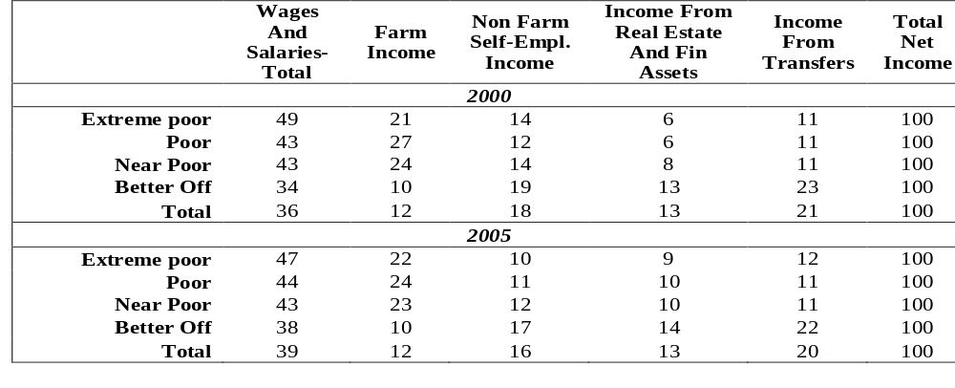
- Poverty can be explained by comparing remuneration of labor for poor and non-poor workers. In 2005, those who were self-employed in agriculture had the lowest average income level among all earners, with only 70 percent of the average income of those who worked for wages and only 45 percent of the average income of the self-employed in non-agriculture activities. Moreover, within each income category, the income of the better-off is twice the income of the poor, reflecting the skills differential between them. Between 2000 and 2005 real wages measured against the poverty line for the poor declined by 5.6 percent, but increased for the non-poor by 1.8 percent, reflecting the changing skills premium. Thus, the increase of wage incomes as a share of total income over the period affected only the better-off (Table 2.5).
Source: CAPMAS, 2005 HIECS, Staff calculations
- The social safety nets did not compensate for differences in earnings: of all cash transfers, earnings-related pensions were the most important component followed by remittances. Whether for the poor or the better-off, government pensions represented the highest share among all transfers (52 percent of transfers for the poor and 63 percent for the better-off). Yet, the poor received only 5 percent of these pensions, compared to 85 for the better-off. This is not surprising, as most of the poor do not work in the formal sector and hence are not covered by any type of insurance. While at the national level remittances from abroad were more important as a source of income than domestic remittances (16 and 10 percent respectively), it was quite the opposite for the poor (9 and 12 percent respectively). The poor received 7.7 percent of total domestic remittances and 3.5 percent of remittances form abroad and the near-poor 9.9 and 7.1 percent respectively; the better-off captured the remaining bulk. It is worth mentioning that out of total remittances – domestic and abroad – that the poor received, almost 70 and 90 percent respectively went to the poor in rural areas (Annex Table A.2.24).
- Government cash assistance was the least important of transfers. Sadat and Social Guarantee transfers represented 5 and 2 percent respectively of the total transfers to the poor, and 0.5 and 0.2 percent respectively of their total income. Although these schemes are designed to assist the poor, only 20 percent of the Sadat pension and 32 percent of the Social Guarantee pension went to the poor. The near-poor received an additional 20 percent of these pensions. This means that the leakage was very high (between 48 and 60 percent). However, these two types of transfers were still better targeted than other types of transfers (Annex Table A.2.24).
- Individuals living in female-headed households (FHHs) depended more than others on transfers. Wages were apparently less important for individuals living in households with female heads (25 percent of total income), compared to those with male heads (45 percent). This gender gap was relatively larger in rural areas (18 versus 37 percent) than in urban areas (30 versus 51 percent). Instead, cash transfers as a source of income were more important for FHHs than MHHs. Cash transfers represented as much as 47 percent of the total income of individuals coming from FHHs in urban areas and 39 percent in rural areas (three and four times the average level respectively). However, the importance of cash transfers was higher for better-off FHHs. While transfers represented 49 percent and 43 percent of their total income in urban and rural areas, respectively, the corresponding figures for poor FHHs were 36 percent and 29 percent. Among transfers, government pensions were the most important (47 percent of the total transfers) for FHHs, followed by remittances from abroad (29 percent). Yet, while FHHs received 72 percent of total remittances from abroad, poor and near-poor FHHs received only 2.2 percent and 5.1 percent respectively of the total remittances. Sadat and Social Guarantee pensions were similarly unequally distributed among FHHs. While all FHHs received 54 percent of Sadat and 44 percent of Social Guarantee pensions, the corresponding figures for poor FHHs were only 8 and 12 percent; and 7 and 6 percent for the near-poor. In any case, even for households not experiencing a poverty spell at the time, the high share of an insecure source of income –such as transfers – points out the vulnerability of FHHs (Annex Table A.2.24).

D.2 Unemployment and Type of Employment

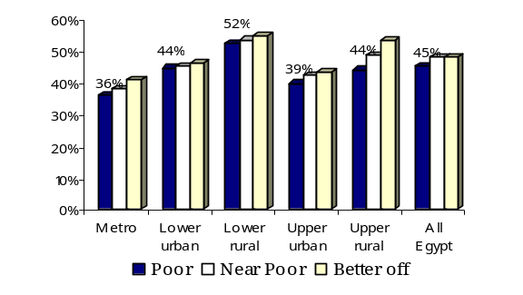
- The poor have limited access to jobs. Most of the poor are in households where someone works, as shown by the analysis of income sources, but their connection with the world of employment is limited. Household members’ lack of ability to participate in income-generating activities is a driver of poverty. The labor-force participation rate of the poor was slightly lower (45 percent) than that of the better-off (47.6 percent). This remains valid across all regions in Egypt (Figure 2.10). Gaps between the poor and the better-off in labor participation were larger in rural areas (46.5 and 54.0 percent respectively) than in urban areas (39.6 and 42.2 percent). At the regional level, the poor had the lowest labor-participation rate in Metropolitan areas (36 percent) and the highest in Lower rural areas (52 percent). Also, the gap between poor and better off was largest in rural Upper Egypt and narrowest in urban Lower Egypt.
Figure 2.10: Labor Participation Rate, 2005
Source: CAPMAS, 2005 HIECS, Staff calculations
- Between 2000 and 20005 unemployment rates declined on average, but increased among the poor. According to HIECS, the unemployment rate declined from 7.8 percent in 1996 to 6.1 and 5.5 percent in 2000 and 2005 respectively. All regions witnessed the same trend. While the least decline was in rural Upper Egypt (from 3.5 to 3.4 percent); urban Upper Egypt had the biggest decline (from 10.1 to 8.2 percent), followed by rural Lower Egypt (from 5.2 to 4.6) and Metropolitan areas (from 7.4 to 6.6 percent). The trend of unemployment rates among the poor was reversed: the rate increased in all regions except urban Upper Egypt, which witnessed a decline from 14.9 to 12.1 percent between 2000 and 2005 (Figure 2.11). Consequently, unemployment rates among the poor in 2005 were higher than among the better-off (on average 6.4 percent for the poor versus 5.0 percent for the better-off). The difference in unemployment rates between the poor and the better-off was the highest in Metropolitan areas (2.2 times) and urban Upper Egypt (1.8 times), and the lowest in rural Upper Egypt (1.4 times). Although only 6.4 percent of the poor were unemployed, the probability of being poor if unemployed was fairly high (21.5 percent); the probability was particularly high in rural Upper Egypt (42.9 percent). Furthermore, the risk of being poor or near-poor if unemployed reached 55.5 percent (Figure 2.12).
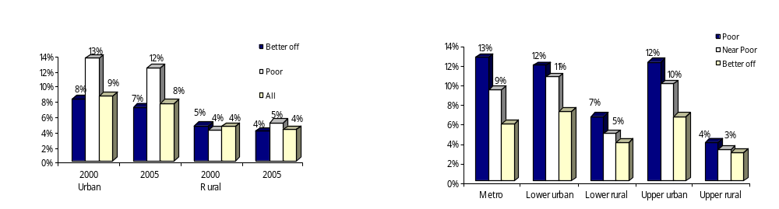
Figure 2.11: Unemployment Rates by Poverty and Location 2000-2005
Figure 2.12: Unemployment Rate by Poverty Status and Region 2005
Source: CAPMAS, 2000 and 2005 HIECSs, Staff calculations
- Chapter 4 discusses trends in unemployment, employment, and earnings and their implications for poverty. Here it is important to stress that between 2000 and 2005 there was a noticeable polarization in access to employment opportunities between the poor and the better-off, and the emergence of a tighter link between unemployment and poverty, especially in urban areas.

Household Head Characteristics: Education, Age and Gender
- The analysis presented so far has focused on individuals, reflecting the fact that the life of each poor person is important to the society. On the other hand, this section shows that the characteristics of the household head very strongly influence individuals' poverty status. This is to say that poverty perpetuates the inter-generational transfer of the various aspects characterizing the poor.
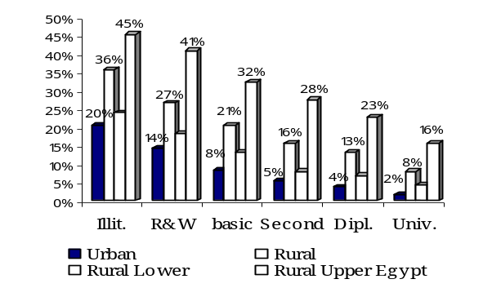
- The majority of the poor lived in households whose heads were illiterate or could merely read and write. In 2005, poverty risk was the highest among the household members with illiterate heads (31.4 percent) or with heads with only literacy skills (21.6 percent). These two groups constituted 58 and 22 percent, respectively, of total poor individuals. In general, poverty risk dropped significantly with higher levels of education for the household head, reaching 3.4 percent for heads with university education. Yet, households where heads had a secondary education were more likely to be poor (11 percent) than those with heads with basic education (6 percent). Only heads with a postgraduate education could guarantee keeping their household members well beyond the reach of poverty. Again, poverty risk was higher in rural than in urban areas, more particularly in rural Upper Egypt where almost two-thirds of the poor came from households with illiterate heads. It is worth noting that educational attainment of household members was strongly affected by the education status of the household head. Individuals coming from households with illiterate heads had a 57 percent probability to be illiterate themselves. The risk was even higher in rural areas (59 percent) than in urban areas (53 percent). This illustrates the danger poverty represents in perpetuating the lack of education, leading to a vicious cycle of poverty and low education (Figure 2.13).
Figure 2.13: Poverty Incidence by Education of Households Head, 2005
Source: CAPMAS, 2005 HIECS, Staff calculations
- Households with heads employed in agriculture suffer from elevated poverty. In 2005, the poverty incidence in this group was 22.6 percent in urban areas and 31.4 percent in rural areas, compared to 9 percent and 23 percent in households with heads employed in other sectors. The highest incidence of poverty (43 percent) was among those from households with agricultural-wage-earning heads. Yet, this group was small as a share of the population (2.2 percent) and the poor (11 percent). The second poorest group comprised households with a self-employed head in agriculture (whether hiring others or not). This group had a poverty risk of 27 percent and comprised 28 percent of the poor people. The lowest incidence of poverty among households with employed heads was for those headed by non-agricultural wage earners (16 percent). Finally, people who belonged to households with heads out of the labor force were less poor on average (16 percent) than those in all other employment categories, indicating that the unemployed and the economically inactive could relatively afford to remain that way because off other sources of income.

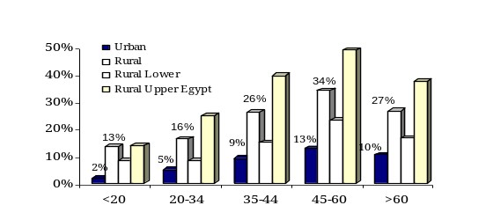
- The poor are primarily in households headed by middle-aged adults. The highest incidence of poverty was among households with heads between 45 and 60 years of age (24 percent) and those between 35 and 45 years (19 percent). Individuals in these households made up 42 percent and 35 percent respectively of the entire poor in 2005. The regional pattern is similar to the national one, with younger household heads being far less likely to be poor in urban areas than in rural areas and in rural Lower Egypt than in rural Upper Egypt. Poverty among households headed by elderly persons (above 60 years) was higher than among those with heads aged 20-34 years in urban areas and stagnated in rural areas (Figure 2.14).
Source: CAPMAS, 2005 HIECS, Staff calculations
Figure 2.14: The Poverty Risk is Highest among the Middle-Age Groups, 2005
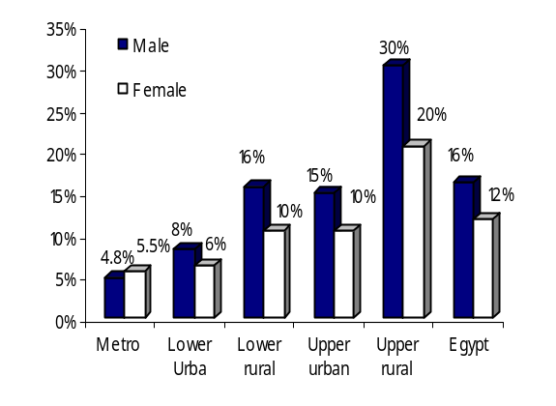
- There were no major gender differences in directly observed poverty levels. In 2005, female-headed households represented a small – but non-negligible – share of the poor (7.5 percent), while individuals living in such households were 10.5 percent of the total population. Data does not support the contention that female-headed households experience greater poverty than male-headed households (Figure 2.15) but rather the opposite. At the national level female-headed households had lower poverty incidence and poverty gaps than male-headed households, with 4.7 percentage points’ difference in headcount ratio. This is also true for all regions except the Metropolitan region. This is not an unusual occurrence, as it has been observed in many countries. Possible reasons behind these findings in the case of Egypt are: (i) the cultural tendency to report any male in the household as the head, even if he is not the breadwinner or even the one who makes the family decisions; and (ii) the fact that the greater majority of female-headed households (70 percent) were widows, who were assumed to be older and thus to have a greater command over assets than the general population (Annex Table A.2.16-A.2.19). However, female-headed households with more than three children were far more likely to be poor in both urban (31 percent) and rural areas (57 percent) by more than three times the average respective level, making them the most vulnerable of all households regardless of the head's gender.
Figure 2.15: Poverty Risk is Lower for Female-Headed Households in All Regions Except for Metropolitans
Source: CAPMAS, 2005 HIECS, Staff calculations
- Controlling for a number of socioeconomic characteristics reveals that female-headed households faces a higher poverty risk. Direct comparison of poverty between male- and female-headed households is therefore incorrect as it neglects significant differences in socioeconomic characteristics that may affect the poverty status. The multivariate model of poverty (Annex 3.1) allows controlling for observable factors and compares male- and female-headed households with the same composition and human capital. This analysis reveals a sizeable disadvantage for FHHs versus MHHs, and may suggest that there are deeply entrenched societal preferences that affect the well-being of women.

Housing Conditions and Access to basic Services
Though at the national level the majority of poor have connection to electricity, water, and sewerage, they lag behind the better-off while rural areas lag behind urban areas. There are also relatively more poor households that do not even have a kitchen or a bathroom.
- Housing conditions and access to public amenities are an important measure of welfare, directly through increased utility and their asset value, and indirectly through their impact on health. Individuals’ health status improves with access to potable water, good housing conditions, and the availability of neighborhood health facilities. Since the HIECS survey does not collect information directly pertinent to the health status of individuals in the sample, access to basic water services, acceptable housing conditions, and the availability of neighborhood health facilities are proxy indicators for health conditions.
- Poor households are less likely to have access to basic infrastructure services. Clearly, income poverty and poor infrastructure coverage tend to go hand-in-hand, revealing the multiple and cumulative aspects of poverty. As shown in Annex Table A.2.25, there is an accumulation of disadvantages among the poor.
- Although almost all poor had electricity connections, there were large disparities in access to the public water system. Almost all Egyptians are connected to electricity. Even in rural areas 98 percent of the poor had such connections. On the other hand, rural areas lagged behind urban areas in accessing public water supplies. While almost all the urban population was connected to the public water system, only 86 percent of the rural population was. There were also marked differences between the poor and the better-off in this respect, with a wider gap in rural areas (10 percentage points) compared to urban areas (only 4 percentage points); see Annex Table A.2.25. Furthermore, the community survey data suggest that the poor in rural areas were somewhat more likely to have low quality of public water delivery service. The difference in quality of potable water between the poor and non-poor in rural areas is more than 3 percentage points, but disparities between urban and rural areas are better-off even more conspicuous, accounting for more than 6 percentage points.
- The sewerage system suffers from modest coverage and service quality. Differences in connection to sewerage system are extremely large – between urban (84 percent) and rural areas (26 percent), as well as between the poor and the better-off .The percentage of better-off connected to the sewerage system was double that of the poor within rural areas and 1.5 times that of the poor within urban areas. As for the quality of public water and sewerage systems, there were large disparities between urban and rural areas and between the poor and better-off. For example, 67 percent of the communities in urban areas and 71 percent in rural areas reported an obstruction or an overflow in the sewerage system.
- Sanitary garbage disposal is not sufficiently widespread. In urban areas, more of the better-off (88 percent) than the poor (66 percent) used proper means of garbage collection. In rural areas the use of public garbage bins was very low, and only about 27 percent of the better-off and 15 percent of the poor disposed of their garbage in a relatively environment friendly way.
- Housing conditions reflect income status. The poor were more likely to live in houses (55 percent) and apartments (28 percent) than in other types of housing. Surprisingly, only 13 percent of the poor lived in rooms in shared apartments and only 2.5 percent in separate rooms. In addition, the poor, especially the rural poor, were less likely to have a tap inside their houses or a separate kitchen and bathroom. Owned houses were predominant in rural areas, regardless of poverty status, but in urban areas, 33 percent of the poor rented a dwelling, compared to 38 percent of the better-off. Most of the urban poor and better-off lived in houses with cement walls, while in rural areas the poor were less likely (by 7 percentage points, as compared to the better-off) to live in such houses.
- The poor owned substantially fewer durable goods. Ownership of durable goods reflects the household’s standard of living; in other words, wealthier households are more likely to possess durable goods. The Egyptian poor reported owning some durable goods that are regarded as very common nowadays, such as refrigerators, black-and-white televisions, gas stoves, and washing machines. The number of better-off households with these goods was larger, with the exception being black-and-white televisions, which are found more commonly in poor households (better-off households preferring color televisions). Also, a minor fraction of the poor owned an automobile; a similarly small fraction reported having a cell phone. However, more widespread ownership of durable goods reflected improvements in living standards. As was expected, ownership of durable goods was lowest in rural regions, especially for the poor (Table 2.6).
Table 2.6: Profile of the Poor by Housing Conditions and Durable Assets, 2000-2005

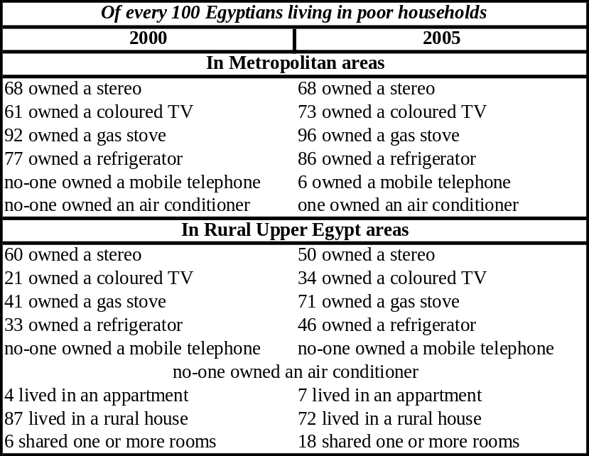
Source: CAPMAS, 2005 HIECS

Children in Poverty
- Children in poor households were highly disadvantaged in literacy, with large regional and gender gaps. Among the children aged 12 to 15 years in Egypt, the poor were illiterate at three times the rate of the better-off. The highest gap between the two groups was witnessed in Metropolitan areas (5.8 times) and urban Upper Egypt (3.4 times), and the least in rural Upper Egypt (1.7 times). This is essentially due to a wider gap in overall child illiteracy between Lower and Upper Egypt in rural areas (2.8 times) than in urban areas (1.8 times). The illiteracy rates for poor and better-off children in rural Upper Egypt were 2.2 times and 1.6 times their corresponding rates in rural Lower Egypt. Furthermore, in rural Upper Egypt, girls, whether poor or better-off, were more than twice as likely as boys to be illiterate. There was also a gender gap in children’s literacy in rural Lower Egypt (1.3 times) and urban Upper Egypt (1.2 times) in favor of boys, particularly among poor children. In contrast, poor girls were more privileged than boys in urban Lower Egypt and Metropolitan areas, with their illiteracy rate 0.6 times and 0.7 times that of poor boys. Children who are deprived of even basic education have very poor labor market prospects in the future. They and their future children may in fact be condemned to poverty for their whole lives.
Box 2.1: Why Do Girls Have Higher Illiteracy Rates in Rural Areas?
The high illiteracy rate of girls in rural areas may be due either to cultural factors or to the unavailability of schools in their neighborhoods, as well as to poverty. The overall result of girls’ illiteracy is largely driven by the economic and cultural conditions prevailing in rural Egypt.
Location of schools is important. Evidence from a Community Survey conducted by CAPMAS in 2005 suggests that 99 percent of urban residents have primary schools in their communities (sub-districts) while 86 percent in rural areas have access to such schools. Preparatory schools exist in almost all sub-districts in urban areas, but only 73 percent of households in rural villages have preparatory schools in their communities. The corresponding figures for secondary schools are 98 percent and 33 percent in urban and rural areas, respectively. However, in rural districts, the poor live in disadvantaged areas where schools, especially secondary schools, are less available. The percentage of the poor who have schools in their villages is 83 percent for primary schools, 70 percent for preparatory schools, and only 30 percent for secondary schools.
Available secondary schools are located 2 km from almost half of both the poor and non-poor in rural areas, but distance is a factor that works against attendance for girls. Shortage of teachers was the main declared reason for dissatisfaction with primary education by 19 percent of rural residents, while for urban residents it was high class density (a complaint also shared by the poor).
- Likewise, poor children, especially girls, were less likely to enroll in schools (Box 2.1). Overall net enrollment rates were 94, 63, and 59 percent for primary, preparatory, and secondary schools respectively. The difference between poor and better-off households in the proportion of enrolled children was more than nine percentage points. Furthermore, the gap between poor and non-poor was wider among girls compared to boys. As shown by Table 2.8 and Annex table A.2.30, almost 12 percent of poor boys and 21 percent of poor girls were not enrolled in basic education, compared to less than 6 percent of children in better-off households. There was also a large gender gap in school enrolment in rural areas, particularly in rural Upper Egypt, where 20 percent of girls were not enrolled. This percentage was even larger for poor girls (26 percent). However, data did show an increase in enrollment rates between 1996 and 2005, with the net primary enrollment rate increasing by 13 percentage points. Enrollment rates improved across the population, but they were not uniform either across regions or between different quintiles. The poor experienced the largest increase, specifically in basic education and secondary education. Increase in university enrollment was about 5 percentage points.

Table 2.7: Percentage of Children (6-15 years) Not Enrolled in School and Illiteracy Rates (Percent of 12-15 years) by Poverty and Location, 2005
- Low enrollment rates are an outcome of two combined factors: lack of access and poor educational quality. Both factors result from location and poverty. Poverty affects school enrollment directly through out-of-pocket expenditure and opportunity costs, and indirectly through parental background contributing to dropout. Students who tend to perform worse and drop out early are likely to be poor. Dropping out has long-term implications for inter-generational transmission of poverty. Most of the adolescents (64 percent) who left school to seek employment before or just after completing the basic education level were from poor or near-poor households.
Source: CAPMAS, 2005 HIECS, Staff calculations

- Consequently, poor children are more likely to work. HIECS data shows that 2.6 percent of children aged 6 to 15 were employed in 2005, compared to 3.3 percent in 2000. This is partly attributed to improvements in school enrollment rates over the same period. Also, the gap between the ratio of working children among the poor and the better-off declined between 2000 and 2005 (from 6.0 and 2.5 percent in 2000 respectively to 4.3 and 2.1 percent in 2005). However, the prevalence of child labor is probably underestimated, as households are typically reluctant to acknowledge that they have underage children working. Examining age and gender, the survey found that male children start working outside the home earlier. Figure 2.16 and Annex Table A.2.21 show the percentage of working children aged 6-15 years. Although substantial differences existed between regions in this respect, the differences were smaller than in 2000. Urban regions had a lower percentage of working children compared to rural regions, ranging from 1.3 percent in Metropolitans to 3.6 percent in rural Upper Egypt, as opposed to 1.8 percent and 4.7 percent respectively in 2000. The corresponding figures for the poor were even higher (5.1 percent of poor children in rural Lower Egypt and 4.3 percent in rural Upper Egypt). The highest ratio of working poor children among urban regions was in Metropolitans (3.7 percent). Obviously, poor households depend partly on their children's earnings on one hand, and cannot afford the cost of education on the other hand. Interestingly, a lower percentage of working children were observed among females than males. Merging this observation with the fact that illiteracy rate among children aged 12-15 was higher for girls than boys, it seems that girls who do not go to school in poor households are kept at home to do domestic work, while boys go to work for income to help their families. This behavior is more pronounced within FHHs than MHHs.
Figure 2.16: Percentage of Working Children Aged 6-15 Years
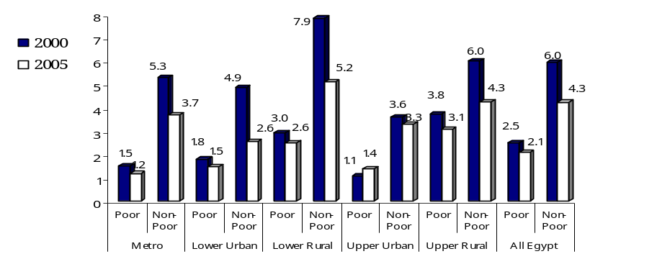

Measuring Exposure to Poverty Risk
Source: CAPMAS, 2005 HIECS, Staff calculations
- Poverty profiles are useful but not enough to understand causes of poverty. Poverty profiles are informative on the levels of poverty and the characteristics of the poor in a society. They also provide important clues on the underlying determinants of poverty (see Ravallion, 1996). However, empirical poverty assessments in recent years have seen a number of attempts to go beyond the poverty-profile tabulations and to engage in a multivariate analysis of living standards and poverty. One of the benefits of such analysis is the ability to assess the impact of a change in a particular factor on the probability of an individual to be poor, when all other factors are kept constant. This identifies which population groups – who may not be currently poor – are likely to become poor. It is thus useful to policy-makers interested in lifting the poor out of poverty and preventing the vulnerable from falling into it, while evaluating the effects on poverty of proposed policy interventions.
- Egypt's poverty profile provides guidelines for the selection of potential variables to include in the vulnerability assessment. The poverty profile presented in the previous section suggests that poverty mostly affects specific groups of the population whose ability to participate in economic progress is limited. The assumption is that vulnerability is affected by four main sets of variables: education, employment, demography, and housing characteristics (see Annex Methodology 2.1 and Annex table A.2.31 for more details on the model). The reference household in the analysis (i) has three children and two adults, (ii) is headed by a 50-year-old male with basic education who is a wage worker in the private sector, (iii) includes an adult female who is a housewife and hence is out of the labor force, and (iv) is connected to the public water and electricity networks, but not to the sewerage network.
- The most important simulation results of changing various characteristics on a household’s probability of falling into poverty are the following:
  - The head’s educational level strongly determines the degree to which a household is vulnerable to poverty, particularly in urban areas. Keeping all other variables at their sample mean levels, and relative to households with illiterate heads, the probability of being poor is 3.4 percent lower for households with heads who have a university degree.
  - Female-headed households are at higher risk of poverty than households with a male head in Egyptian regions. Female-headed households, which constitute about 10.4 percent of Egypt’s population, are about 2 percent more likely to be poor than male-headed households.
  - The risk of poverty increases substantially when the household head loses his job. The impact of a job loss on the probability of being poor is about 7 percent in all regions (although the impact of working status on poverty depends on the sector of employment). Also, if the number of working persons increases by one, the risk of being poor declines by 6 percent in the Metropolitan region.
  - Households with heads working in the public sector are less likely to be poor than households with heads out of the labor force. This is true for all regions except Lower Urban Egypt. The risk of poverty for households with heads in the public sector decreases by 4.5 percent in the Metropolitan region, 3.6 percent in urban Upper Egypt, 13 percent in rural Upper Egypt, and 21 percent in rural Lower Egypt. In the urban Lower region the probability of being poor for this group of households increases by 14 percent.
  - Households with heads holding government jobs have a higher risk of poverty in most of the regions relative to households with heads who are out of the labor force. This is the case for the Metropolitan (11 percent), Upper Urban (7.5 percent), and Lower Urban (34 percent) regions. In contrast, in Upper and Lower Rural Egypt, households with heads employed in the government have a lower risk of poverty than households with heads out of the labor force.
  - Households with heads working in agriculture have higher risks of poverty in all regions relative to households with the heads who are wage-workers in a non-agricultural activity. This is the case in all regions, where poverty increases by about 9 percent for these households.
  - A newborn child increases the poverty risk. However, the effect of childbirth on the probability of being poor was larger in 2000 compared to 2005. Families with a newly born child are 12 percent more likely to be poor in the Metropolitan region and 11.5 percent in rural Upper Egypt.

Chapter 3: Poverty and Macroeconomic Policies

To derive policy lessons from the experience of poverty increase between 2000 and 2005, the chapter starts with an overview of long-term trends of economic performance, then moves to analyze how economic policies have shaped the basic relationship between growth and poverty. The 2000-2005 period was a time of serious economic shocks, with a three-year recession, sluggish growth, and stagnation in rural areas. The progress in poverty reduction witnessed between 2000 and 2005 was stalled, and even temporarily reversed. The chapter also assesses the poverty impact of both the depreciation of the Egyptian pound in 2003 and the food subsidies. The recent acceleration of economic growth (starting 2004) has the potential to bring about a reduction in poverty rates only if combined with policies to help the poor benefit from growth.

Introduction: Connecting The Poor To Growth
- Changes in poverty can be described using a simple framework that links three factors: (i) the rate of growth in real consumption, (ii) the inequality level and its changes, and (iii) the relative pace of changes in the cost of living for the poor as opposed to the overall price level in the economy. These three variables – growth rates, inequality, and inflation – are directly and indirectly influenced by macroeconomic policy instruments. This chapter takes a close look at how the economic growth and economic policies in Egypt between 2000 and 2005 translated into poverty outcomes.
- The poor can benefit from economic growth through three channels. As depicted in Figure 3.1, these channels initially take the form of either self-employment or wage employment, supplemented by transfers. The outcomes for each of these employment states depend on productivity or wage levels determined by the nature of the growth process. Third, public and private transfers influenced by growth affect the poverty outcome at both the household and aggregate levels. Policies actively shape the nature of the growth process, and the distribution of the benefits of growth between the poor and better-off. Public policies can reach the poor directly through targeted transfers, and can also increase the poor’s assets, especially in terms of educational attainment and health status.
Figure 3.1: Connecting the Poor to Growth

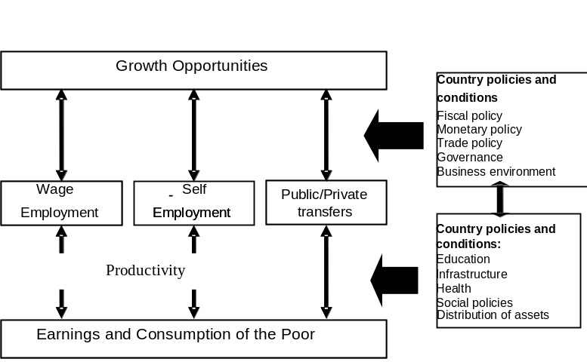
Source: “Pro-Poor Growth in the 1990s” (World Bank, 2005b)

- Long-term trends in the improvement of living standards and the distribution of growth, as well as short-term fluctuations in the growth rate, price levels, and distribution, have a tangible effect. These two perspectives are addressed in sections II and III of this chapter.
- Household surveys in Egypt provide only snapshots of poverty at a certain point in time: 1996, 2000, and 2005. Such snapshots can blur the distinctions between longer-term trends and short-term fluctuations. Chapter 1 of this report described a statistically significant increase in the main poverty indicator – headcount – from 16.7 percent to 19.6 percent, but is this increase a result of a longer-term trend or a cyclical hike?

Economic Growth And Poverty In Egypt
A. Long-term Growth Determinants and Reform Efforts
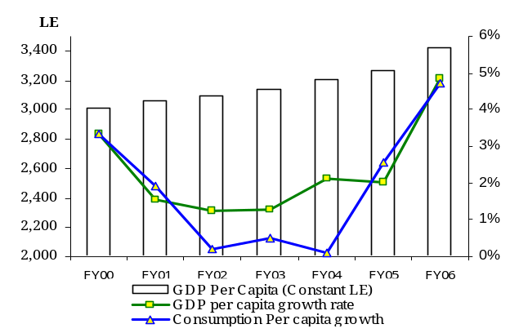
- Economic growth was weak between 2000 and 2005. Since 1983 Egypt had been growing at 4.8 percent on average per annum, but relatively rapid population growth reduced per-capita growth rate to 2.4 percent during 1983-2000 (in line with the average for developing countries). Yet, due to the economic slowdown during 2001-03, the average GDP per capita for 2000-05 was just 1.9 percent per annum (Figure 3.2). Growth of per-capita real consumption was even slower, at 1.4 percent on average. As discussed in Chapter 1, CPI indices in Egypt are known to suffer from a pro-urban bias and the inclusion of a large number of goods with administered prices. Measures of real consumption change based on the household surveys and correcting for deficiencies of price index suggest a decline, not growth, in household real consumption per capita over the period 2000-2005 (See Technical Box 1.1 in Chapter 1 for various reasons for this common discrepancy).
Figure 3.2: Evolution of Real per Capita GDP (%Growth and LE) and Consumption
1996-2006
Source: CBE, Monthly statistical bulletins (various issues), Staff calculations.
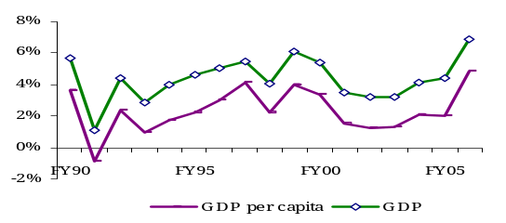
- Acceleration of growth in 2004 put Egypt back on its long-term growth path. Since launching a series of ambitious reforms in 2004, Egypt’s growth has been accelerating in step, reversing the trend of the preceding half-decade (Figure 3.3). The run-up in oil prices in recent years has contributed to a boom in the Middle East region that has certainly supported growth in Egypt (through inflows of capital from the Gulf countries, remittances, and tourism). But non-oil export growth in recent years was equally impressive, averaging (in U.S. dollar terms) 22 percent during FY03-FY05 before turning slightly negative in FY06. Overall, the Egyptian reforms launched in 2004 should be viewed as removing some of the binding constraints to long-term growth (Enders, 2007).
Figure 3.3: Average Annual Growth (%)
Source: CBE, Monthly statistical bulletins (various issues), Staff calculations.
- Of the key long-term economic growth factors, the increase in working-age population, paired with declining fertility, open a demographic window of opportunity. Egypt is going through a stage of demographic transition, with an increasing share of the population of working age and declining dependency rates. This process may result in increases in both the labor force (provided there are enough employment opportunities) and the private savings rate (providing resources for investment). East Asia’s high growth rates in the 1980s were greatly helped by this demographic effect (Bloom et al. argue that demographic changes accounted for as much as a third to half of the high rates of income growth in the East Asian “miracle”). This demographic potential has not yet been put to good use. Over the 1990s the employment growth rate averaged only 2.6 percent, just enough to absorb the new labor-market entry, and left the labor force participation rate – just about 50 percent of the working-age population – almost intact. This is the reason why the recent acceleration of job creation (employment grew at 4.6 percent p.a. according to Labor Market Surveys between 1998 and 2006; see Chapter 4 for detailed discussion) is a new development of crucial importance. Dobronogov and Iqbal, 2005 and Enders, 2007 argue that the quality of the new labor force is adequate, and Egypt fares well in terms of basic and secondary schooling. There is a broad consensus, however, that the skills produced by public education poorly match market needs. Education and quality of human capital may become a critical constraint to growth in the future if Egypt moves up the product ladder toward more sophisticated products.
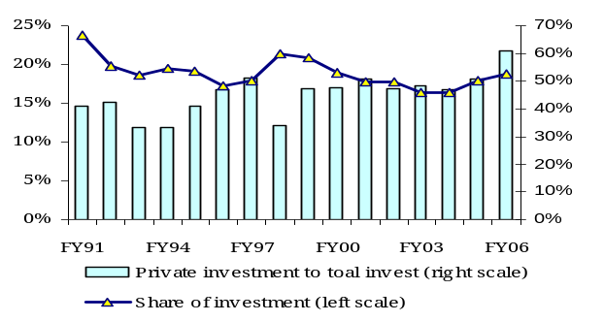
- Two major problems prevented Egypt from achieving a higher growth rate in the 1990s and early 2000s: low investment and slow improvement of productivity. Gross fixed domestic investment in Egypt was well below that in other, fast-growing, lower-middle-income countries (around 19 percent of GDP on average in the late 1990s and early 2000), and has only recently started to grow. This slow capital accumulation, coupled with a weak improvement of the overall total factor productivity, was the main factor behind a rather slow pace of increase in the output per worker (for example, it averaged just 1.3 percent per year over 2001-2004; see IMF, 2005 and Kheir-El-Din and El-Laithy, 2006). This, in turn, implied an overly constrained potential for improvement in real earnings. Increases in real wages in the late 1990s were not commensurate with the increased productivity, and contributed to temporary loss of competitiveness.
Figure 3.4: The Downward Trend of Investment that Started in 1999 and Reversed in 2005
Source: CBE, Monthly statistical bulletins (various issues), Staff calculations
- Main binding constraints for achieving higher investment and higher productivity were: limited access to finance, loss of competitiveness, and poor governance. Both institutional legacies and policy choices contributed to these outcomes. In terms of policies, loose fiscal stance allowed a buildup of deficit, which crowded out private investment. This competition for finance has become apparent with the resurgence of investment demand in the recent period. Currently, Egypt has a high liquidity in the banking sector, yet credit growth, particularly to the private business sector, is low. The problem was exacerbated by state controls on the financial system; as a result, available credit was not efficiently allocated. Another problem was related to the loss of competitiveness as a result of appreciation (the pound was fixed against the US dollar for almost a decade with noticeable inflation). Finally, inefficient government administration and interference in the market mechanism created distortions and losses (Enders, 2007).
- Gradual opening of the economy helped kick-start the movement towards higher productivity. Over time, the key vector of policies has been the gradual opening of the economy (Dobronogov and Iqbal). Structural changes created solid foundations, making the economy resilient to both external mishaps and some bad policy choices. Greater openness of the economy created stronger links to the OECD economies.
- Investment has been increasing since 2004 and reached 21.4 percent of GDP in FY06. The increased share of private investment made for most of this increase: from about 45 percent of total investment on average during FY96 to FY00 to almost 49 percent during FY01to FY05 and to 61 percent in FY06.
- Total factor productivity (TFP) started to grow after 2000. Total factor productivity, especially as an indicator of the efficiency of the use of factors of production, had shown negative or zero contribution to growth between 1990 and 1996, but its improvement started to play a significant role after 2000 (Kheir-El-Din and El-Laithy, 2006).
- Reforms launched in 2004 seem to be appropriate in addressing key constraints to growth – reducing red tape and tax rates, and improving access to foreign exchange. These included easing restrictions on access to foreign currency and savings, simplifying customs regulations, financial sector liberalization (which by late 2006 had shifted more than half of the banking sector to private ownership, along with governance reform at the remaining state banks and, more generally, a modernization and liberalization of financial institutions), and deregulation. But there was insufficient attention to social policy reform issues, including mitigating temporary losses to certain groups arising from the economic reform itself, and building institutions for better-targeted social programs. Directing and coordinating the reforms in a way that is conducive to shared growth will be a challenge discussed later in this report.
B. Growth and Poverty Reduction
- Poverty in Egypt is relatively shallow, but there is significant vulnerability to poverty risks. Limited fiscal space and lack of well-targeted safety nets makes it impossible to rely exclusively on redistribution through the State to alleviate poverty. Only a combination of rapid growth and efforts to provide effective redistribution in favor of the poor can lead to shared economic growth and bring decisive progress in reducing both poverty and vulnerability.
- The degree to which poverty responds to growth is encapsulated in the notion of elasticity. In general, elasticity would be negative, as growth and poverty tend to move in opposite directions – positive growth typically means a decline in poverty, and vice versa. Elasticity of poverty measures to changes in the mean expenditure and inequality may explain the impact of growth and distribution on poverty trends. Here, it is useful to recall the simple arithmetic of poverty reduction: change in poverty can be decomposed into a “growth effect” (the change in poverty in response to changes in average real income or consumption, holding distribution constant) and a “distribution effect” (the change in poverty due to changes in distribution, holding average real income or consumption constant). The growth effect, or growth elasticity, which measures the percent change in poverty for a 1 percent change in mean income with distribution constant, gives us one measure of the responsiveness of poverty to growth.

- The growth elasticity of poverty reduction in Egypt as a whole is -3. This means that a 10 percent growth in real per-capita consumption for everyone will reduce poverty by 30 percent, or – expressing it in percentage of population – will move poverty from 20 percent to 14 percent. This is a high level of elasticity, typical for a middle-income country (Ravallion and Chen, 2001).
- Elasticity with respect to changes in inequality was similar to the growth elasticity for the country as a whole, suggesting that distribution is as powerful a driver of poverty reduction as economic growth: a 1 percent reduction in the Gini coefficient of inequality will reduce poverty by about 0.3 percent.
- In practice, however, the process of development simultaneously affects growth and distribution; additionally this is complicated by changes in relative prices. The actual relationship between growth and poverty can be complex and non-linear. Growth and distribution can reinforce each other or work against each other.
- Between 2000 and 2005, neither growth nor distribution in Egypt changed in a way that reduced poverty; as a result, other factors, namely changes in relative prices, became more important. Survey-measured real average per-capita consumption over this period fell by 7 percent, pushing poverty up. At the same time, inequality (measured by the Gini coefficient) went down by 12 percent, canceling some of the increase in poverty. There were complex distributional changes over the period that affected different groups of the poor and the better-off differently. The way to summarize changes in distribution over time is to draw growth incidence curves, which describe how real consumption changes, not just on average but across the range of the distribution. Figure 3.5 plots the growth in consumption across the percentiles of distribution (from the poorest on the left to the richest on the right), using survey data and consumption deflated by the cost of the poverty line. It shows that there was a more or less uniform change in the middle 90 percent of the distribution, but the poorest 5 percent and the richest 5 percent experienced large losses, particularly pronounced at the top. While this change caused the inequality index (measured by the Gini coefficient) to fall from 0.36 to 0.32, the extreme poor still suffered despite the greater equity. Partly, this complexity of distributional change was driven by a very inequitable increase in the cost of living, which hurt the poor more than any other group.

Figure 3.5: Growth Incidence Curves over Time

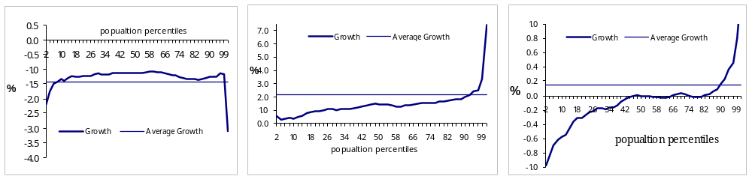
2000- 2005 1996- 2000 1996- 2005

Source: CAPMAS, 1996, 2000 and 2005 HIECSs, Staff calculations

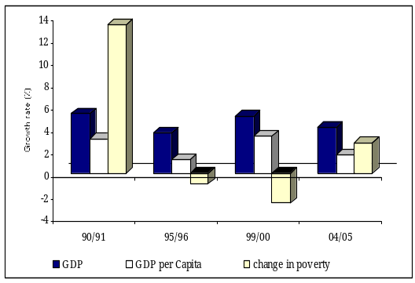
- What matters for poverty reduction is not average growth per se, but rather the growth in income (or consumption) of the poor. Figure 3.6 highlights the importance of the level of growth to the overall change in poverty. Yet, distribution of gains from growth also matters. Economic growth was not distributed uniformly across individuals and households during 1996-2000 and 2000-05. While real per-capita expenditure growth was positive during 1995/96-1999/2000, and higher among the top percentiles, it turned negative for all percentiles during 1999/2000 and 2004/05, but mainly for the top and bottom percentiles. (Such distributional changes have a strong effect on the Gini coefficient, but less effect on poverty.) Following the fall of real consumption for the middle percentiles between 2000 and 2005 (due to relative price changes), some of the near-poor fell into poverty.
Figure 3.6: Economic Growth and Poverty
Source: MOED (national accounts), and CAPMAS, 1991, 1996, 2000 and 2005 HIECSs, Staff calculations
- Data for Egypt suggests that economic growth is a necessary, but not sufficient, condition for poverty reduction. As in other countries, periods of weak economic growth are associated with insignificant changes in poverty, and periods of strong economic growth are associated with significant decreases in poverty. But changes in inequality at times tend to work against the beneficial effects of growth. Changes in relative prices, which affect the poor more than any other group, may result in increasing poverty despite positive GDP growth rates and stable inequality. Moreover, countries perform an upward revision of their poverty baskets as their economies grow. As a result, there is no one-to-one relationship between growth and poverty anywhere, and Egypt is no exception. Although the average growth rates of GDP and GDP per capita were almost the same over FY82- FY91 and FY96- FY00, poverty increased at the end of the former period and declined at the end of the latter (Figure 3.6). On the other hand, economic performance was sluggish over FY91- FY96 and 2000-2005, yet poverty increased in the latter but not in the former..
- Simulations show that poverty changed at a very uneven pace between 2000 and 2005. To fill in the data gaps, Table 3.1 presents a simulated poverty path: changes in consumption are simulated year-by-year using unit-record survey data, taking into account annual growth rates and inequality changes (see Annex Methodology 3.2). As Table 3.1 demonstrates, low growth in per-capita consumption in the first three years accompanied by low inflation rates left poverty almost intact between 1999/2000 and 2002/03 (from 16.7 percent to 17.1 percent, a statistically insignificant change that is impossible to gauge with a survey). In 2003/04, Egypt experienced a relatively higher per-capita consumption, but it was associated with a marked and inequitable increase in consumer (primarily food) prices, which affected the poor disproportionately. Poverty is projected to have increased to 20.2 percent that year. Subsequent growth over 2004/05 helped reduce poverty somewhat to the level observed by the new 2005 HIECS survey (19.6 percent). Thus, the pace of poverty change between 2000 and 2005 was not gradual; it was a crisis-type hike following a period of stagnation.
Table 3.1: Simulated Year by Year Poverty Incidence, All Egypt
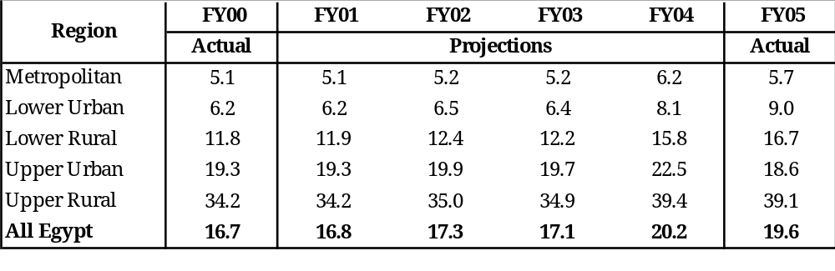

Source: CAPMAS, 2000 and 2005 HIECS and Staff calculations

C. Sources of Growth and the Poor
- International experience has shown that the impact of growth on poverty depends not only on the rate of growth, but also on its composition, and on structural aspects of the economy that determine whether and how this growth reaches the poor (Bardhan, 1996; Islam, 1990; Lipton and Ravallion, 1995). The ongoing cross-country World Bank study (Gutierrez, 2007) uses data on total and sectoral GDP, poverty, population, and employment for the period ranging between 1980 and 2004 on a sample of 36 developing countries. The study finds that, in the short run, the overall employment intensity of growth does not matter for poverty reduction. That is because poverty outcomes are determined by the level of earning and not just employment levels. Hence, the sectoral pattern of employment growth and productivity growth are important. While employment-intensive growth in the secondary sector (manufacturing and construction) appears to be associated with decreases in poverty, employment intensive growth in agriculture increases poverty. Similarly, productivity-intensive growth in agriculture is associated with poverty reduction. Identifying what sectors or activities have acted as growth engines in Egypt will help reveal causes for changes in poverty over 2001-2005.
- The structure of the Egyptian economy is dominated by services. During the overall period 2000-2005, economic growth was primarily driven by the services sector, which grew at an average of 4.3 percent per annum. Growth in the sector was boosted by high growth in tourism (14.2 percent), followed by transport and telecommunications (5.3 percent). Construction was particularly volatile, registering a negative growth rate during the three-year slowdown period (2000/01-2002/03). Since the early 1990s, the share of the services sector has been exceeding 50 percent of GDP, and this share has slightly increased (Figure 3.7). This has implications for the living standards of the Egyptian poor, particularly in the short term: demand from the tourism industry and the service sector may be more broad-based and have multiplier effects on sectors where the poor are employed. In 2005/06, the structure was tilting further towards services (53.7 percent) and away from agriculture.

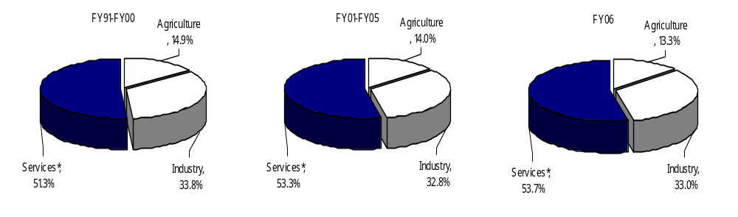
Figure 3.7: The Sectoral Composition of GDP
Source: Ministry of Economic Development, Staff calculations

- These changes had a mixed impact on the poor. Given that the poor tend to be concentrated in agriculture and construction, sluggish or volatile growth in these two sectors, combined with relatively higher growth in sectors mostly located in urban areas (like Suez Canal, Restaurants and Hotels – especially since FY04 – and Trade and Finance ), can imply that urban poor and near-poor will benefit first, but it will take much longer for the rural poor to experience the trickle-down effects of growth. Changes in agriculture are of particular importance.
D. Growth of Agriculture and the Rural Poor
- Agriculture, which plays a pivotal role for the livelihood of the poor, has had sluggish growth over the last decade. This sector supports more than a quarter of the workforce, and has the second largest share of employment after the social services sector. Yet despite its dominant role in employment, especially for rural poor, agriculture plays only a small role as a source of income for the poor, reflecting its low productivity. Only one-quarter of the rural poor’s income is generated by farming, as opposed to a more than 50 percent share of their spending on food (Annex Tables A.2.23 and A.2.27, see also Adams 1991 for historical series). Why do the rural poor have such low levels of productivity? And has agricultural productivity improved over 2000-2005?
- Steady increases in agricultural output since 1990s were achieved through the expansion of cropped area, which was not allocated to the poor. In most low- and middle-income countries, rainfall variation induces large year-on-year fluctuations in farm incomes, which in turn lead to significant short-term changes in measures of consumption poverty. In Egypt, however, nearly all agriculture is irrigated and rainfall variation is not a determinant of yields. Physical output went steadily up between 1991 and 2003, with a single downward movement in 2001. Data from the Ministry of Agriculture and Land Reclamation also showed an increase in livestock holdings in all areas of the country between 1999 and 2004. However, according to FAO data, the 27 percent increase in the real value of gross agricultural output of 1991-2003 was driven by a 17 percent increase in cropped land. Most of this land expansion in Egypt comes from developing “New Land”, which is typically allocated to young graduates or commercial operations. Poor households on the “Old Land” had no possibility of expanding their cropped area, and the slow rate of growth in real land productivity would have locked them in poverty.
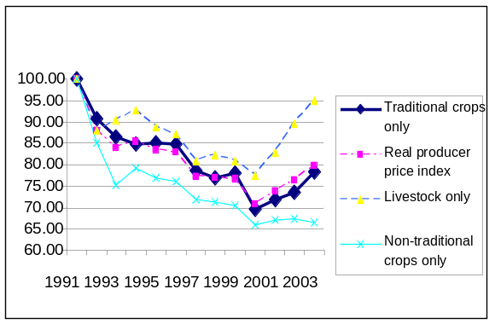
- Agricultural prices were severely affected by the appreciation of the Egyptian pound. The 1991-2003 price trends tell a striking story. The price indices for traditional crops, non-traditional crops, and livestock fell significantly between 1991 and 2000. After 2000, the price index for livestock products recovered to its 1991 value, whereas the traditional and non-traditional crop indices only rose a little after 2000, and finished the period at 22 and 33 percent below their 1991 values (Figure 3.8). These trends are confirmed by Ministry of Agriculture data for the main cereals. There is a probable link to trends for the real exchange rate, which appreciated from 1991 to 2000, then depreciated from 2001 to 2003 before beginning to appreciate again. Given that Egypt’s main field crops (cereals and cotton) are open to world trade, the real exchange rate movements could explain some of the trends in domestic farmgate prices.
Figure 3.8: Agricultural Producer Price Indices, 1991-2003
Source: Ministry of Agriculture and Land Reclamation, Staff calculations
- Why did rural poverty continue to increase after 2000, when the agricultural producer price indices were no longer falling? It is not possible to give a conclusive answer to this question without more thorough research. However, two possible hypotheses come to mind. One is that the assets of poor farming households were eroded and depleted by several years of low prices, which constrained income and consumption even when prices began to recover. Thus, rural incomes might have recovered on average, but not for the poor. Another explanation is that the rural poor had become less dependent on their own agricultural production over time and were more affected by the changes elsewhere (such as changes in consumer prices or wage rates). There is support for both hypotheses in the data.
- Average agricultural productivity increased very slowly. Between 1991 and 2003, the yield indices increased only slightly – by 1 percent per year (FAO data). These yield increases, together with the growth in cropped area and in livestock income, explain the overall moderate increase in real farm income between 1991 and 2003.
- Increase in national average yields conceals significant inter-household variation. Without detailed survey data it is not possible to show which households experienced yield increases and livestock acquisitions below national average. However, it is reasonable to hypothesize that many poorer farmers with limited access to land, credit, and modern agricultural technology were unable to achieve noticeable yield and herd increases.
- Over the most recent period (1998-2006), agriculture absorbed many new workers, resulting in falling labor productivity, especially for the poor. As discussed later in Chapter 4, total agricultural employment increased by 5 to 7 percent per year between 1998 and 2006, mostly in the form of unpaid labor on household farms (figures differ depending on the source of data, see Box 4.1 in the next Chapter for detail). As a sign of depressed productivity in the sector, median monthly earnings per worker in agriculture were the lowest among all sectors (at just LE 286 in 2006), and the sector had the highest share of low wage earners – 73 percent in 2006. (See Chapter 4 for the definition of low earnings). According to the HIECS data, real agricultural wages fell by over 10 percent between 2000 and 2005, reflecting a large number of new entries to the rural labor markets.
- Lower elasticity of poverty in rural areas implies that without higher rates of growth or significant improvements in distribution, reductions in rural poverty can be expected to lag behind reductions in urban poverty. Over time this can lead to an increasing relative risk of poverty, and a further concentration of the poor in rural areas. Conversely, where growth is negative, the increase in poverty amongst rural residents can expectedly be lower than among urban residents.
- Remittances play a minor role as a factor of poverty in Egypt. In some recipient countries, flows of remittances play an increasingly important role in their external balances, and they sometimes compensate for the weaknesses of the agricultural economy as the main source of income for the poor. In Egypt over the period 2000-04, workers’ remittances amounted to about 3.5 percent of GDP: that is US$ 4.4 billion in 2004/05 (IMF, 2005); as a share of GDP it is less than in Jordan, Tunisia and Morocco, but comparable to that in Pakistan (Bougha-Hagbe, 2006). Their contribution to the balance of payments has been close to that of tourism in recent years, and their impact on Egypt’s external position has been historically significant. The time-series analysis of remittances flow shows that they are negatively associated with changes in agricultural value-added; that is, they increase at the time when incomes in rural areas fall, playing a stabilizing role for population incomes (Bougha-Hagbe, 2006). However, micro-level empirical evidence presented in Chapter 2 of this report suggests that the poor receive a disproportionately small share of remittances. Therefore remittances are not a substantial vehicle for poverty reduction in Egypt.

Macroeconomic Environment, Policies and Living Standards
- Policy Stance in the 1990s
- Important structural changes in the Egyptian economy supported the growth spurt in 1996-2000, and the economic impulse was accommodated by expansionary fiscal policy within the currency peg to stabilize inflation. For a while this policy mix worked.
- The significant reduction in the inflation rate was one of the main achievements of the exchange-rate-based stabilization program in the 1990s. This was mainly attributed to the tight monetary policy. The Government followed a tight monetary policy to achieve a balance between the growth of the domestic liquidity and that of GDP to preserve exchange-rate stability. Inflation declined considerably, from 21 percent in FY92 to 2.3 percent in FY01.
- However, the peg to the US$ led to the appreciation of the LE, an increasingly inward-orientation of economic development, and falling FDI and exports. Loss of competitiveness led to the deterioration of Egypt's balance of payments during FY99 and FY00 (a deficit of 2 to 3 percent of GDP) as fiscal and external balance pressures started to build up. A sequence of further shocks put the policies under unsustainable pressure.
- Shocks, Devaluation, and the Poor between 2000 and 2005
- The new phase was initiated by several shocks including the Luxor terrorist attack in 1997, the global financial crisis of 1997-99, falling oil prices in the late 1990s, and domestic financial turmoil in 1998-99. The series of negative shocks continued with the September 11, 2001 terrorist attacks and the subsequent invasion of Iraq (2003). All of these events, in combination with some detrimental policy choices, had severe repercussions for Egypt and sent the economy into a decelerating-growth phase. The recession, which gripped the Egyptian economy for nearly three years in the early 2000s, was exacerbated by the slowdown in world economic growth. The Egyptian stock market collapsed and the Government responded by tightening exchange-rate controls to preserve the exchange-rate anchor for inflation. But the confidence of market actors was lost, and the black market for foreign exchange reappeared, distorting the economic signals.
- Attempts to defend the currency peg in the late 1990s led to a sharp decline in foreign exchange reserves and contributed to domestic liquidity problems. In an attempt to defend the exchange rate, the authorities instituted “administrative controls” on the exchange rate to slow the growth of import payments, hoping that the pressures on the current account were only temporary.These hopes proved unfounded, and the CBE had to consistently draw on its international reserves (down from US$ 20 billion in November 1998 to US$15 billion in January 2000), creating a foreign-exchange shortage and a domestic liquidity squeeze with an accumulation of arrears. This policy stance, despite its attempt at stabilizing the economy, generated a climate of uncertainty that hurt growth. Among other immediate policy responses were expansionary fiscal policies, which further increased deficits from the already high average of 3 percent in 1999/2000 to 6.1 percent in 2002/03.
- A more flexible exchange-rate system, to reduce tensions between different policy targets, was introduced at the end of January 2003, when the Egyptian pound was floated. Immediately the pound depreciated by 20 percent and kept creeping down to LE 6.1 to the dollar (a cumulative 31 percent depreciation) by the end of FY03. However, the real trade-weighted depreciation between 2000 and 2005 was effectively a reversal of the large appreciation between 1995 and 2000.
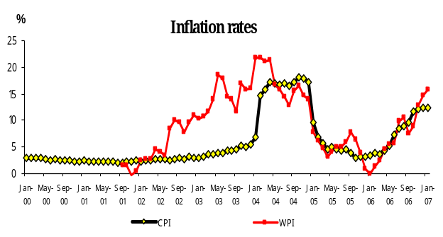
- The dramatic depreciation of the Egyptian pound gave the first push to the resumption of growth in Egypt at a cost of resurgent inflation. Strong current-account inflows and higher interest rates finally allowed Egypt to make the transition to a unified, flexible exchange-rate regime in late 2004, and monetary policy accommodated the liquidity buildup. These measures gave the renewed impetus to growth. Nonetheless, the sharp devaluation fed into both the CPI and WPI increases. In Egypt, the WPI measure of inflation includes more goods with free-market prices, as opposed to the CPI, which includes a large selection of goods with subsidized or administered prices. Thus, originally the CPI remained largely stable at 2.4 percent in FY02 and increased only marginally to 3.2 percent in FY03. The large share of goods with administered prices tended to compress the markups along the distribution process and weaken the transmission of exchange-rate shocks, at least temporarily. The CPI started a slow upward trend in mid-February 2003 and shot up in October 2004. The increase in the CPI was mainly driven by a rise in the prices of food, beverages, and tobacco. In addition, the increased cost of certain imported foodstuffs also raised demand on locally produced goods, prompting a rise in their prices. The WPI, which is more exposed to imported inflation, peaked earlier; starting in mid-2004 both indices started to move in parallel (Figure 3.9).
Figure 3.9: The Exchange Rate Difficulties Seem to Have Fed Through to Prices
Source: CAPMAS, Staff calculations
- The trade-weighted exchange rate depreciated cumulatively by 26 percent between FY00 and FY05, and the exchange rate vis-à-vis the dollar depreciated by 52 percent. These were very large changes. Given that a large number of people in Egypt were just above the poverty line, the direct effect of rapidly rising prices could have pushed many into poverty in a matter of days. Aart Kraay, 2007 used HIECS data to analyze in detail the effects of depreciation on average living standards and on the poor. Some key findings are reported below.
- Because of various administrative controls, increase in prices was much more gradual and overall consumer prices rose by almost 28 percent. There was no full pass-through from the exchange rate to prices for two reasons. First, all goods at the consumer level have a substantial non-traded component built into the price, and this component is not affected by the exchange rate, as it captures both purely non-traded goods and non-traded distribution costs associated with traded goods, neither of which is affected by the exchange rate. Second, administrative controls were instituted over prices, which prevented full pass-through. However, the slowdown was only temporary. International comparisons reported by Kraay, 2007 suggest that observed pass-through in Egypt 2003-2004 was not dramatically slower than that observed elsewhere.
- Price changes have varied considerably across expenditure items and to a lesser extent across regions. Estimates of the long-run impact of the exchange rate on consumer prices vary substantially across products. On average, for the period FY00- FY05, only 19 percent of the movement in the trade-weighted exchange rate was reflected in consumer prices. Estimates of pass-through for food items were much higher than those for non-food items. In particular, pooling all regions, the median estimate of pass-through increase was 0.43 for food items but only 0.07 for non-food items. Food prices increased faster than the overall consumer price index. Taking a simple average across regions, overall consumer prices increased by 28 percent, but food prices increased by 38 percent, implying a 10 percentage-point increase in the relative price of food.
- The increase in the relative price of food was a disaster for the poor. These higher rates of pass-through for food items give a first indication of the distributional consequences of the depreciation of the LE. Since poorer households devote a greater share of expenditure to food items, price changes associated with depreciation have a larger effect on them.
Box 3.1: How Are Exchange Rate Variations Transmitted to Prices?
“Pass-through effect” generally refers to the degree to which exchange-rate changes are reflected in the domestic currency prices of traded goods. If the effect of the depreciation is fully reflected in import prices, pass-through is said to be full or complete. If only a portion of the depreciation is reflected in import prices, pass-through is described as partial or incomplete. Pass-through consists of two stages. In the first stage, changes in exchange rates are transmitted into the border prices of imported goods. Actually, prices are inflated by the increased costs of imported inputs. In the second stage of pass-through, changes in import prices are transmitted to consumer prices. The extent to which those changes are reflected in the consumer price index (CPI) depends on the share of imports in the consumption basket, and on the non-traded component of price covering the cost of wholesale and retail distribution margins, not dependent on the exchange rate (the consumer price of even a purely traded good will increase proportionately less than the devaluation).
Source: Kraay, 2007.
- The real income loss associated with the direct effect of exchange-rate-induced price changes was non-trivial for the vast majority of households, and higher for poorer households. Compensating variation captures the direct effect of price changes as well as the substitution effects. (See technical details on the estimation in Kraay, 2007 or in Annex 3.2). This welfare loss from the devaluation is estimated for the median household at 7.4 percent of initial expenditure, and is about two to three percentage points higher at the lowest-fifth percentile of the income distribution than at the 95th percentile and above. But there is significant heterogeneity across households, even among the poor: not all poor lost equally (see Figure Annex A.32). As income from agriculture does not play a dominant role among the rural poor, there were more net food consumers among the poor (even in rural areas). Thus although some poor could have benefited from the depreciation through higher farmgate prices, the majority would have suffered from food-price increases. A policy implication of this heterogeneity would have been difficulty in instituting any kind of subsidy program that would target the most vulnerable among the poor to the price increases, to offset the effects of the depreciation.
- There are important caveats attached to the analysis presented here. A major limitation of Kraay, 2007 is that it only looks at the welfare impact of devaluation operating through changes in the consumer prices – but any devaluation also affects household incomes, and differently across households. With this caveat in mind it is nevertheless interesting to isolate this specific channel and estimate its effect on the poor. Another caveat is that the depreciation of the LE can be regarded as reversal of a large appreciation between FY95 and FY00. It can be argued that the adverse welfare effects operating through changes in consumer prices between FY00 and FY05 were just reversing earlier windfall gains when the exchange rate was appreciating.
- For Egypt as a whole, the estimated welfare effects of the depreciation can be held responsible for raising the headcount measure of poverty by 5 percentage points (Table 3.2). The effects were lower in the major metropolitan centers of Egypt, with poverty increasing by 2 percentage points from a low base. Rural areas of Egypt saw the largest absolute increase of 6.4 and 6.7 percentage points in Lower and Upper Egypt respectively but from a much higher base. Predicted poverty based on devaluation varied across regions in a pattern quite similar to the actual poverty outcome observed in the 2005 survey, and actual evolution of poverty between 2000 and 2005 in observed poverty incidence closely mirrored predictions reported in Table 3.2. The actual increase in poverty was less than predicted (by a full percentage point) because there were other changes to the economy, specifically positive labor-market developments, described in the next chapter.

Table 3.2: Poverty Impacts of Depreciation-Induced Price Changes: Expected Poverty by 2005
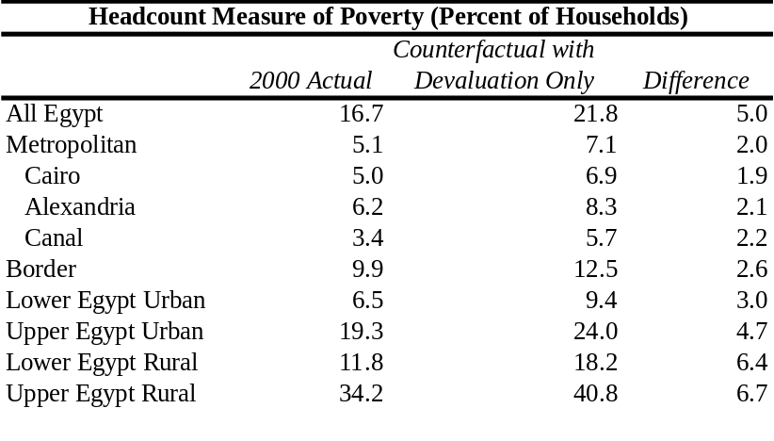

Source: Kraay, 2007.
- Fiscal Policies, Social Safety Nets and Subsidies
- The structure of government revenues and spending in Egypt limits possible pro-poor fiscal response to economic shocks. Protecting the poor from the effects of devaluation may rely on direct help to the poor via safety nets, or compensating changes in taxes. Minimum wage or income policies are called on at times to protect the most vulnerable workers, often in combination with increased transfers. Such instruments were not put in action. Both revenues and spending structure limited the Government’s ability to implement countercyclical fiscal policies. Egypt has a level of expenditure which is thought to be excessive in comparison to both OECD countries and low-income countries, and, as discussed below, their allocation is extremely inertial.
- Fiscal policies allowed a buildup of a large deficit during the economic slowdown, but not because of increased social spending. Egypt entered the period with a sustained path of fiscal consolidation: the budget deficit was cut from more than 15 percent of GDP in FY91 to 1 percent by FY98. Yet, the sharp increase in government investment spending in FY99 (up to 8.4 percent of GDP from 5.6 percent in FY98), which was associated with the financing of the large national projects in the South Valley, Gulf of Suez, East Port Said, and Sinai, reverted the trend. Concurrent with the economic slowdown, the fiscal situation continued to weaken. The fiscal deficit steadily increased from 3.0 percent in FY00 to 5.9 percent in FY03 (old budget classification, Figure 3.10). This was driven by a decline in the ration of revenue to GDP from 23.5 to 20.8 percent over the same period, and insufficient adjustment on the expenditure side.

Figure 3.10: The Weakening Fiscal Situation Slightly Improved with Economic Recovery
a. Fiscal Deficit to GDP b. Revenues to GDP c. Expenditures to GDP
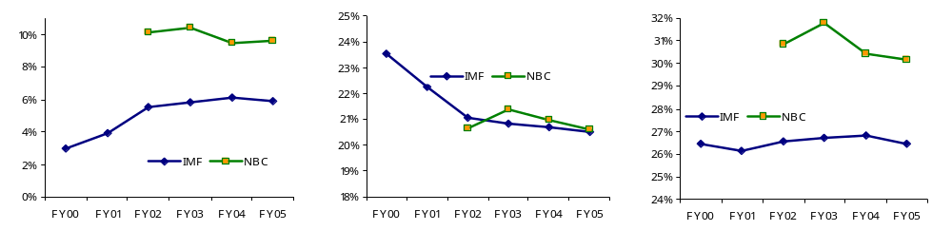

Note: NBC refers to the New Budget Classification and IMF refers to a consistent historic series based on the old budget classification. All reported figures are for the budget-sector definition, which includes the central government, local governments, and the Services Authorities.
Source: CBE, Monthly Statistical Bulletin, and Ministry of Finance, Financial Monthly (various issues)
- As the economy picked up after 2004, there was no significant fiscal consolidation. However, with the economy picking up, the fiscal deficit declined only slightly, from 10.4 percent to around 9.5 percent in FY04 and FY05 (new classification – NBC). Large fiscal deficits that are mainly financed from domestic sources, as in Egypt, absorb available resources that could have been more efficiently used by the private sector. Domestic debt has become a major concern, as its growth has tended to outpace nominal GDP growth, pushing up the ratio of total domestic debt to GDP to 95 percent in FY05 from 81 percent in FY01, and the government domestic debt to 65 from 54 percent of GDP.
- The space for maneuver in expenditure allocation, to ensure a pro-shared growth orientation, was extremely limited. Wage and interest payments, which were the results of previous hiring and borrowing decisions, accounted for 45 to 50 percent of total expenditures over the observed period (Figure 3.11). During FY01-FY03, not only was the sizeable civil service body allowed to expand (by 1 to 2 percent p.a.) but also the real average wage per employee increased significantly (by more than 10 percent on average per annum). Over the same period, the public wage bill increased from 6.5 percent of GDP to 7.6 percent, and interest payments steadily increased from 5.5 to 6.4 percent of GDP.

Figure 3.11: Large Share of Wages and Interest Payments Limited Independent Fiscal Policy FY00-FY05
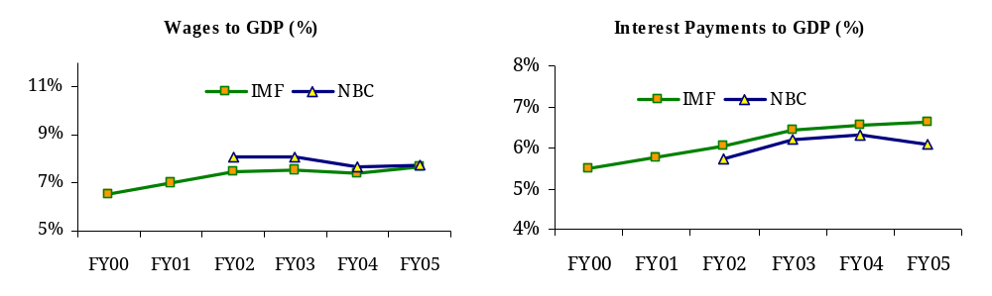
- Adjustment through cutting infrastructure spending was the source of flexibility, but with possible negative effects on growth. The Government attempted to bring down the deficit by cutting investment spending, from 5 percent of GDP in FY00 to 3.7 percent in FY05. A recent study actually showed that spending of this kind would not crowd out private investment; on the contrary, it would help improve its efficiency (Fawzy and Megharbel, 2004).
Source: Ministry of Finance, the Financial Monthly, various issues
- Social spending was pro-cyclical and not effective in protecting the poor. Social spending broadly defined (including education, health, non-energy subsidies, and other social sectors) increased from an average of 7.5 percent of GDP in the 1996-2000 period to 9.8 percent in the 2001-2005 period. However, the overall spending was unbalanced and the increase occurred after the worst period of the crisis was over. From the most recent available data on public spending by functional classification, there was a surge in social-protection expenditures after the crisis. As a share of total government spending, they increased between FY03 and FY06 from 15 percent to over 25 percent, and from 4.5 to 7.6 percent of GDP. Fiscal data shows that in 2005 very little was spent on cash transfers (0.1 percent of GDP) and SFD programs (0.2 percent of GDP), a larger amount was spent on in-kind subsidies for food (1.7 percent of GDP) and a much larger amount on energy products (5.4 percent of GDP)..
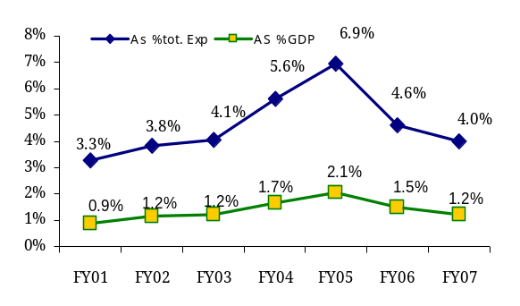
- Food subsidies now represent a significant portion of the budget. The non-energy subsidy bill – consisting mainly of food subsidies – increased from 1.5 percent to 2.6 percent of GDP over the whole period (Figure 3.12). Gradual reductions in spending on food subsidies over 1990s were reversed, most dramatically in FY04 (to LE 8.2 billion, or 4.1 percent of total public spending and 1.7 percent of GDP) and FY05 (to LE 11.2 billion, or 5.6 percent of total spending and 2.1 percent of GDP). The increase was the result of increases in international food prices, especially wheat (the largest component in food subsidies), and the Government’s decision to increase the number of items covered by ration cards from two to seven (see Box 3.2).
Source: Ministry of Finance, Unpublished data
Figure 3.12: Evolution of Food Subsidies
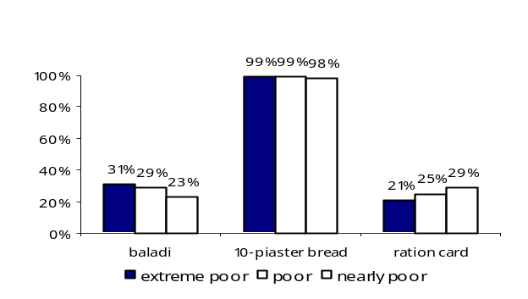
- But food subsidies’ poor targeting and coverage makes them a weak instrument for protecting the poor. A significant proportion of the poor and vulnerable are not reached by any of the food subsidies. The most prevalent of all food subsidies is the one financing cheap bread. Although subsidies on the "five-piaster" baladi bread constitute around 53 percent of all food subsidies, 30 percent of the poor and 25 percent of the vulnerable do not purchase baladi bread, almost no poor and near-poor purchase "10-piaster" bread, and fewer than 40 percent purchase subsidized flour (see Figure 3.13). The corresponding percentages for the near-poor are quite similar. The subsidies, as Figure 3.14 demonstrates, are captured by the better-off. In fact, the poorest quintile of the population receives only 16 percent less than their percentage of the population of the safety-net and subsidy resources, while the wealthiest quintile receives 28 percent more than their percentage of the population. In other words, a rich person receives almost twice as much of the safety net and in-kind subsidies as a poor person! As shown in a recent study (World Bank 2005a), the cost to deliver US$1's worth of social benefit in Egypt is very high by international comparisons and has risen in recent years. The poor and vulnerable are deprived not only of subsidies but of ration-card products. Fewer than 67 percent of the poor and vulnerable hold ration cards, leaving around 33 percent deprived of subsidies on essential food items.
Figure 3.13: Percentage of Poor Who are Not Reached by Food Subsidies
Source: CAPMAS, HIECS 2005, Staff calculations.

Figure 3.14: Distribution of Food Subsidies between the Poor and the Better-off

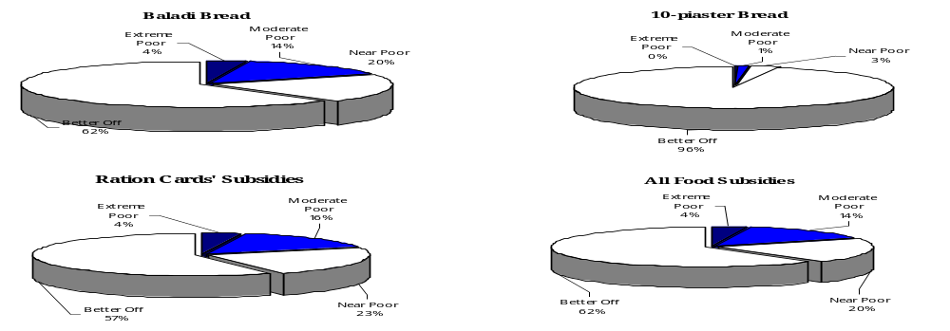
Source: CAPMAS, HIECS 2005, Staff calculations.

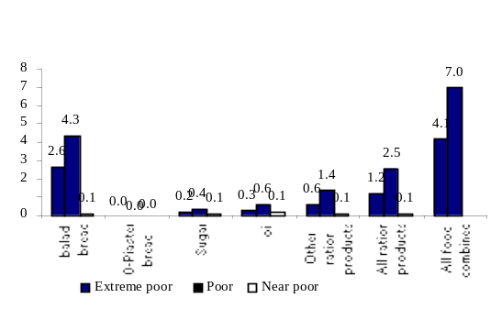
- Despite food subsidies’ poor coverage of the most needy and low adequacy, their effect on living standards and poverty was sizeable. In 2005, a poor person received less than LE 10 (US$2) per month through food subsidies on average, accounting for about only 10 percent of their total consumption expenditure. Yet, without these subsidies, an additional 7 percent of the population would have been poor and of those, 4.3 percent would have been extremely poor. The biggest aid to this poverty outcome was the five-piaster baladi bread subsidies, which helped almost 50 percent of those lifted out of poverty (see Figure 3.15).
Figure 3.15: Percentage of Those Lifted Out of Poverty by Food Subsidies
Source: CAPMAS, HIECS 2005, Staff calculations.

- Energy subsidies are crowding out budget allocations for investment and social expenditure. The study mentioned above (World Bank 2005a) also looked at other types of subsidies. Energy subsidies account for an even larger share of the budget compared to food (estimated at 5 percent of GDP in FY04, although their economic cost is much greater). Their targeting mechanisms are even worse than those of food subsidies. Growing international prices for energy motivated recent reforms (in June 2006) to avoid the risk of a ballooning energy bill. The PSIA study simulation demonstrated that poverty in the country could be reduced by a third (from 19.6 to 13.5 percent) if subsidies were halved and the savings reallocated to households as better-targeted cash transfers.
Box 3.2: Types of Ration Cards
In Egypt rationed goods have existed since World War II. They are available in limited quantities and only to households that hold ration cards. At present, these households are around 60 percent of the population, and exist in both urban and rural areas. There are two types of ration cards: one providing a high subsidy rate and the other a low subsidy rate. Low-subsidy ration cards are theoretically available to all Egyptians, with the exception of anyone who has let their card lapse (by not using it for three consecutive months) and individuals born after 1989. High-subsidy ration cards are actively targeted: only households that meet one or more specified criteria are eligible. This criteria list includes, for example, GOE officials and divorced housewives. Before 2004, subsidized rationed products included sugar and cooking oil (one kg/person/month). Since 2004, and following the pound floatation and subsequent price increases, new items were added to the ration cards: rice and pasta (one kg/person/month up to four persons/family); ghee/margarine, beans and lentils (0.5 kg/person/month up to four persons/family); and tea (50 gm/per person per month up to four persons/family). The subsidy rates for high- and low-subsidy ration cards differ only for sugar and cooking oil.
Source: Kraay, 2007

- On the revenue side, the fiscal stance of Egypt during 2000-2005 was not pro-poor either. Egypt’s fiscal budget relies relatively heavily on non-tax revenues (5.8 of GDP on average during FY01-FY05) and indirect taxes including trade taxes (7.9 percent of GDP on average over the same period). This makes it difficult for Egypt to conduct countercyclical fiscal policies, because both non-tax revenues and indirect taxes are often outside the control of the Government and often pro-cyclical. It is well known that, from a distributional point of view, indirect taxes and excises are usually regressive; the average tax rate decreases with the level of total expenditures or living standard of the household. Wagstaff et al., 1999 present estimates of the Kakwani index of progressivity for indirect taxes in several OECD countries. Except for Spain in 1980, all estimates are negative, implying that the burden of indirect taxes falls disproportionately on the poor.
- The incidence of major taxes in Egypt and their effect on poverty has not been studied yet. Starting 2004, bolder fiscal reforms were undertaken. In August 2004, tariff rates were cut and simplified, reducing the weighted rate from 14 to 9 percent. Subsequent major tax cuts (for both individuals and corporations) in July 2005 widened the tax base and increased payment compliance. This resulted in a surge of tax revenues from 14 percent to 16 percent of GDP, raising the ratio of revenues to GDP from 20.6 percent to 24.2 percent.
- The Government still faces the challenge of curbing the fiscal deficit. Strong expansion in expenditure is underpinned by rising energy prices, increases in public-sector wages, and higher interest payments on domestic debt. So far over-caution about social and political stability has hampered many of the measures that could improve the fiscal stance, such as reforming the civil service sector and targeting subsidies better. In-depth poverty analysis and social-impact analysis of such reforms may help to formulate and implement them so as to minimize negative effects.

Most Recent Developments and Outlook for the Future
- How Is the Most Recent Acceleration of Growth Likely to Affect Poverty?
- The recovery of 2004-2005 is still being sustained in 2007. Growth rose to 6.9 percent in FY06, and is expected to continue at close to 7 percent in the first half of FY07. Investment has been rising since FY04, with increasing FDI (doubling in FY06 compared to FY05). Exports and employment are growing. Inflation and fiscal deficits remain threats to macroeconomic stability, and fiscal consolidation is crucial to sustain growth.
- Growth can help to achieve visible progress in reducing poverty and economic vulnerability. In Egypt, a relatively large number of individuals have equivalent consumption levels close to the poverty line. While poverty in 2005 affected 20 percent of the population, as many as 21 percent were “near-poor” or vulnerable. Hence, the poverty rate is quite sensitive to any economic fluctuation, including rapid changes in prices. The simulation presented below attempts to shed light on which growth pattern will be most beneficial for the poor and lead to eradication of poverty. The primary purpose of this exercise is to assess the likely pace at which the situation will improve. This is done by applying macroeconomic growth data to the micro-level household survey data.
- Simulations for poverty changes taking 2005 as a base suggest that with rapid shared growth in a single year as many as half a million people could be lifted out of poverty. Table 3.3 shows that in a single year, with a real per-capita consumption growth of 3 percent, Egypt could reduce poverty by 2 percentage points (from 19.6 to 17.5 percent), or by 10 percent. Note that the poverty gap, which indicates how far the poor are below the poverty line on average, usually responds even more strongly to faster growth. The critical assumption underlying these projections is that consumption growth is evenly distributed. In other words, everybody, both rich and poor, would experience the same real consumption growth rate.
- Even some deterioration in inequality will not stop poverty reduction engineered by rapid growth. The assumption about stable inequality may be too optimistic a view. Although Egypt currently has a modest level of inequality (and it fell between 2000 and 2005), this could increase in the future, as the experience of other fast-growing countries has demonstrated. To explore the linkages between growth and inequality, Table 3.3. shows the combined effect of growth and changes in its distribution, leading to a given increase or decrease in inequality. To account for possible uneven distribution of growth benefits, the second and third scenario assume a 2 percentage point change (down and up) in inequality as measured by the Gini coefficient. These projections also indicate a decline in poverty incidence to 16.6 and 18.4 percent respectively. A rapid deterioration of inequality (increase in the Gini index by 4.5 percentage points) has the potential to undo the beneficial effects of growth on living standards of the poor.
- How Likely Is It that the Growth Will be Sustained?
- As demonstrated by the simulations, growth is of paramount importance for poverty reduction. But it has to be accompanied by macroeconomic stability to avoid any negative effects on the near-poor. So far, the Egyptian Government has implemented a policy package that may lead to pro-poor growth, but only if complemented by further reforms. How likely is this scenario? The authorities seem to be committed to reforms, indicating the possibility of spell of sustainable growth. A broader overview of current policies can help identify key elements of the pro-poor stance and potential threats to it.
- Egypt continues to open up to world markets, providing the economy with new opportunities. This is a crucial precondition to retaining high growth. The second round of custom tariff reductions in February 2007 brought the weighted average tariff rate to 6.9 percent (from 9.1 percent). Privatization is ongoing, albeit at a slower pace. Reducing the high fiscal deficit by about 1 percent of GDP a year appears to be on track. Continued strong performance of the world economy and of energy prices will continue to boost the Egyptian economy.
- The exchange-rate policy is still revolving around the peg, and between late 2004 and early 2005 the Egyptian pound appreciated by around 6 percent. Since then, appreciation has been kept in a narrow band of less than 2 percent. Consequently, and in response to strong capital inflows, the CBE has apparently intervened in the market to support the Egyptian pound against further appreciation that might hurt the competitiveness of Egyptian exports.
- To preserve macroeconomic stability, the economy has to cope with the effect of new shocks. Avian influenza constitutes a new risk for both the agriculture sector and the economy as a whole. It has already inflicted losses of LE 15 billion on the industry, and its effects may be particularly burdensome for the poor (recent analysis of avian flu effects on poverty in Albania in Dabalen et al., 2007).
- Fiscal policy is aimed at the longer-term objective of reducing the deficit. Some reforms support this stance. So far there was a cut in food subsidies; available data for the last 18 months indicate a reversal of their upward trend. Food subsidies in FY06 fell in absolute terms (to LE 9.4 billion) and as a share of total spending (4.6 percent) and GDP (1.5 percent). The amounts budgeted for FY07 are even less (LE 8.6 billion, or 1.2 percent of GDP). But energy subsidies do not follow this trend. Most action in fiscal consolidation seems to come from increased revenues. The real restructuring of the expenditure side – rationalization and improved targeting – may look imminent given the constraints, but will require strong political support.
- Inflation is the most immediate threat to poverty reduction. Both the CPI and the WPI dropped from 17.3 and 13.9 percent respectively in December 2004 to 3.1 and 1 percent in December 2005. While monetary policy was looser than needed to contain the increase in inflation rates in 2004, evidence suggests that monetary policy has been moderately tightened since then in an attempt to further contain inflation. But prices rose by 7.6 percent in 2006 – and continued rising to reach 12.6 percent in February 2007. More particularly, prices of food and non-alcoholic beverages, which have the largest weight in the CPI basket, surged by almost 16 percent, year-on-year, in December 2006. This recent acceleration of food prices has the potential to be a repeat of scenario of 2003-04 and cancel out part of the growth benefits for the poor and the near-poor.
- Inflationary pressure seems to be associated with a number of factors. Large fiscal deficits provide a demand-side pull for prices. Demand-side pressures are specifically emanating from strengthening domestic demand fuelled by income tax rate cuts and robust economic growth, a buoyant stock market, and large capital inflows. Supply-side shocks, such as the 30 percent rise in average administrative fuel costs implemented in July 2006, had knock-on effects on many sectors such as transport, recreation, and culture. From that perspective, good coordination of economic policies is required to avoid destabilization and protect the poor from paying most of the price of adjustment once again.

Table 3.3: Projected Poverty Incidence for 2006 Starting from 19.6 percent in 2005
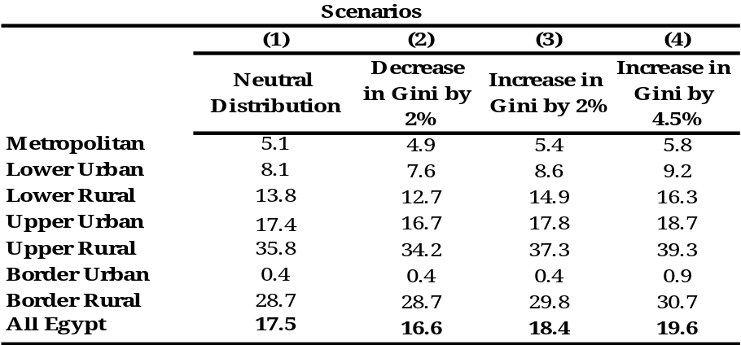
Assuming 3 Percent Per-capita Real Consumption Growth
Source: Staff Calculations

- Outlook for the Future
- Acceleration of economic growth, if sustained, can make a decisive dent in poverty. Applying the same 3 percent growth rate in per-capita consumption to all groups of population, but with a shared character of this growth, the elasticity-similar projection shows that by 2008 growth will reduce poverty to below 15 percent of the population. To put these simulations in context, it is important to note that, according to the national accounts, per-capita real consumption grew by 4.7 percent over FY06 while GDP grew by 6.9 percent. Egypt’s new five-year plan (FY07–FY11) projects an 8 percent average annual growth rate, which seems attainable if global growth and domestic reforms continue. Therefore, applying a 3 percent growth rate in the projections is fairly conservative and sets a reasonable benchmark against which to judge the actual performance in reducing poverty. Simple mathematics show that sustaining equitable growth over the period FY07-FY11 with average per-capita real household consumption growth rate (3 percent p.a.) will reduce poverty prevalence in Egypt to around 10 percent. That will be a significant achievement in poverty reduction that will move Egypt’s living standards closer to its peers. However informative those simulations can be for planning purposes, it is only through actual survey data collection that one can establish the real change in living standards. Chapter 5 discusses in detail the current system for collecting data on poverty trends in its development and objectives.
- Poverty reduction, through a growth process concentrated in urban centers of lower Egypt and metropolitan areas, will hit a limit in reducing poverty in the country overall. Chapter 1 shows significant variation across regions of Egypt in this indicator. Metropolitan and Lower Rural and Urban regions have the highest elasticity, approximately -6. This will mean that with sustained growth and their currently low poverty rates, the ongoing growth spell can eliminate poverty in those areas in five to seven years. Thus, any further growth originating in this part of the country will have zero direct effect on poverty. On the other hand, the elasticity of poverty measures to growth in mean consumption are smallest (only -2) for the Upper Rural region, where poverty is high. Thus even if the Upper Rural region could achieve the same growth rates as the rest of the country, poverty would not be reduced by the same degree.
- What will start to matter are the growth rates in Upper Egypt. Thus the success or failure of poverty reduction in Egypt will be pre-determined by the progress in Rural Upper Egypt. Not only is poverty more widespread there, it is also deeper and more severe: the poverty deficit is 2.2 times that of the overall Egypt. Even though only a quarter of Egyptians live in Rural Upper Egypt, the region accounts for ½ of the national poverty headcount and 60 percent of its cumulated severity. Lower elasticity in that part of the country would suggest that, over time, poverty reduction in Egypt as a whole will slow down. This can only be reversed if there is a convergence over time between Rural Upper Egypt and the rest of country, whereby it starts to grow at rates which exceed the national average.
- The Government of Egypt is committed to reducing regional development disparities, and to helping Upper Egypt realize its potential. The President’s election program (2005) expressed a strong development priority for the Upper Egypt region, and recent budget allocations have begun to attenuate the previous biases. The Bank's dialogue with the Government indicates that the lagging development of Upper Egypt is a pressing social and political concern for the Government, not least because rapid migration from poor areas to Metropolitan areas aggravates excessive agglomeration at growth poles like Cairo. Better studying the potential for out-migration, its determinants and likely destinations will help the authorities manage this process in a way that maximizes poverty reduction among the population of Upper Egypt while keeping associated social costs in receiving areas under control.
- There is limited capacity to expand social spending in favor of rural Upper Egypt, as a sole vehicle of poverty reduction, given the high levels of fiscal deficit. Thus, an effective poverty-reduction strategy will have to rely on growth, but it will also need to mobilize social policy to include lagging areas and groups. This can be done by examining the instruments of the social safety net and subsidies with a view to improving their effectiveness and targeting.
- Rural Upper Egypt's lag in economic development is characterized by four key phenomena:
- dependence upon low-value agriculture, as this is practically the sole primary productive activity (other activities depend almost entirely upon the demand created by farming);
- weak transport links with domestic and foreign markets;
- a (recently-reversed) history of relatively low public investment; and
- low quality of public-service delivery and barriers to accessing these services.
- Therefore, breaking the poverty cycle in the region means moving the whole country on a pro-poor growth path. At this juncture, it is important to have a clearer understanding of the economics of Upper Egypt's growth and income-poverty performance. By conceptualizing the economic causes of Upper Egypt’s lagging development, policy-makers can better frame the role that targeted public investment can play in addressing it. This means quantifying the impacts of weak market linkages, dependence upon agriculture, and public investment in land development and transport. This work is ongoing with the preparation of the study “Growth and Public Services in Upper Rural Egypt”.

Chapter 4. Labor Market Trends and Living Standards in Egypt
This chapter uses two extensive surveys of labor market conditions in Egypt conducted in 1998 and 2006, which, together with HIECS (the main source of data for this report), provide very detailed information on employment status, earnings, and poverty. These sources reveal that between 1998 and 2006 there was a notable improvement in labor-market conditions in Egypt. New jobs are now being created at a faster rate than the growth of the labor force, leading to a drop in the unemployment rate. The private sector has started to function as a new engine of job creation, with private non-agricultural wage employment growing at over 6 percent per annum. This is in sharp contrast with the 1988-1998 period, when the public sector was the main source of new jobs. This growth has been fairly even across the formal and informal components of private sector employment, and has included the poor. Earnings have also increased, but very unevenly, and only some of the poor have benefited from these gains.

Introduction: Poverty and Labor market in Egypt
- Employment characteristics play a central role as a factor of poverty. Chapter 2 discussed in detail the link between poverty and unemployment based on HIECS data, and Section II will examine the trends in unemployment using more detailed information from labor-market surveys. But only a small minority of Egypt’s poor are unemployed. Most of the poor in Egypt live in households where someone works, and income from work is a mainstay of household economy for both the poor and the better-off. Who are the working poor and do they systematically differ from the better-off? In order to provide an answer, this section examines HIECS data for 2000-2005, exploring the labor-market information it collected.

Poverty by Type of Employment
- The working poor were almost equally split between wage and non-wage employment, with big differences between urban and rural areas. The share of wage employment in the labor force was higher in urban regions (67 percent) than in rural regions (39 percent), much lower among the poor (57 percent) than among the better-off (70 percent) in urban areas, and roughly similar among the poor (41 percent) and the better-off (39 percent) in rural areas. Self-employed and unpaid workers were more prevalent among the rural population (56 percent) than among the urban population (25 percent). However, there is a difference in the profile by type of employment (wage versus non-wage) between the poor and the better-off in the urban population (Figures 4.1 and 4.2).

Figure 4.1: Wage Earners by Poverty Status, 2005 (% of Labor Force)
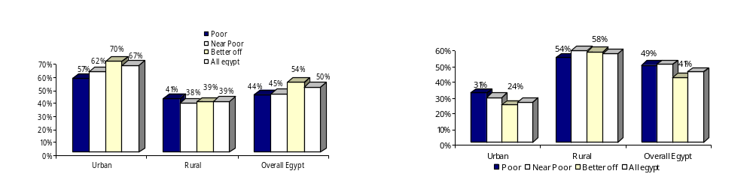

Source: Economic Research Forum (ERF), ELMS 98 and ELMPS 06.

Source: ERF, ELMS 98 and ELMPS 06.

- There were large disparities in poverty risk for the same labor-market group across regions. As shown in Figure 4.3, there were large differences in poverty for the same labor market group (e.g., wage workers) across regions of Egypt, as well as differences between wage workers on the one hand and unpaid family workers on the other.
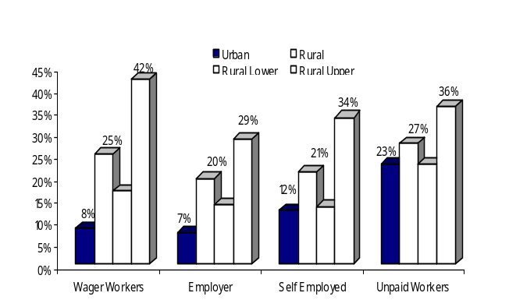
- Rural wage workers were the most stricken by poverty, particularly those living in Upper Egypt. The picture at the national level masks many interesting regional disparities. A closer look shows that poverty incidence among different types of employment was much higher in rural areas than in urban areas, ranging between 20 and 27 percent. Within rural areas, workers in Upper Egypt suffered from a much higher risk of being poor than workers in Lower Egypt. Among all worker groups, in all regions, the wage workers in rural Upper Egypt were the most stricken by poverty (42 percent at risk of poverty); followed by unpaid workers (36 percent). Poor in these two categories represented 20 and 9 percent respectively of the total number of poor; and 3.7 and 1.7 percent of the total Egyptian population. Furthermore, when the near-poor were considered in the calculations, two out of three workers in these two types of employment had a higher risk of being poor or near-poor in rural Upper Egypt. On the other hand, except for unpaid workers – who had a poverty risk of 23 percent – the poverty-risk rates of urban workers were lower than the national average poverty rate of 19.8 percent by at least 8 percentage points. In rural areas during the period 2000-2005, the share of "wage earners" – both regular and irregular wage workers – among the poor had increased. It seems that the category of “self-employed” and “wage workers” absorbed most of the increase in labor-force participation. Among the urban poor, increased share of unpaid work was rapid, offsetting a reduction in the share of wage workers and self-employed among the working-age population (Figure 4.3).
Figure 4.3: Poverty Incidence by Type of Employment, 2005 (%)
Source: ERF, ELMPS 06.

Poverty by Sector of Employment
- The private sector was the largest employer. For all workers in Egypt in 2005, the private sector was the biggest employer, providing jobs for 74 percent of employed individuals; this is similar to Labor Market Survey data for 2006(LMPS06). Yet the private sector itself was not a homogenous field. More than one-third of private-sector jobs (or one-quarter of total employed) were in “outside establishments” (self-employed, working in family businesses). The second biggest employer was the government, with another one-fifth.
- The private sector was also the largest employer of the poor. Almost half of the poor were in private-sector firms, 38 percent worked in outside establishments, and 11 percent were employed by the government (Figure 4.4). The risk of being poor was thus the highest in the private sector (39 percent), especially among those employed informally (the uneducated and unskilled), followed by those employed by outside establishments (28 percent) and the government (10 percent). The private and outside-establishment sectors were particularly prevalent in all rural regions. Additionally, within each region, whether urban or rural, all poverty measures are highest for persons employed in outside establishments, that do not pay wages, compared to other sectors of employment (Figure 4.5).
- Government employment has apparently paid better than the private sector. Only 11 percent of individuals employed in the government were poor, and their contribution to national poverty was far less than their representation in the sample; they formed 12 percent of the poor while they represented 21 percent of all employed persons. This held valid at the regional level too. Urban areas had the highest share of government and public-sector work (35 percent of all employment). Since most government and public-sector jobs were in urban areas, government employment was consequently not as relevant for determining the extent of rural poverty. For every type of employment Upper Rural Egypt demonstrated elevated poverty risks (Figures 4.4 and 4.5; Annex Table A.2.6b and A.2.7b).
Figure 4.5: Poverty Incidence by Sector, 2005
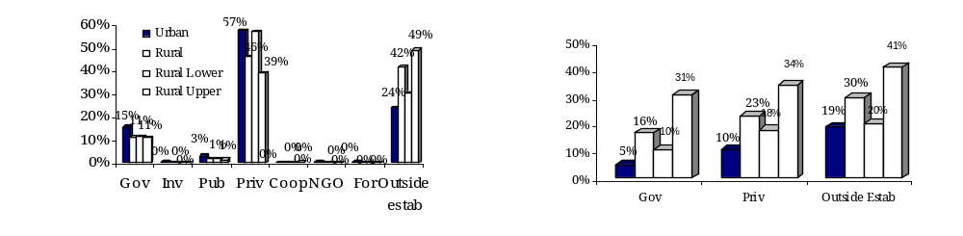
Figure 4.4: Distribution of Poor by Sector, 2005
Source: ERF, ELMPS 06. Source: ERF, ELMPS 06.

- Two-thirds of the rural poor worked in agriculture. Agriculture provided employment for 40 percent of the labor force; and to a higher share of the poor (55 percent) than to the better-off (31 percent). Yet, income from agriculture was less important than other non-farm sources, even for the rural poor. Due to low productivity, agriculture workers in this sector were by far the most likely to be poor (with a poverty risk of 27 percent). Working in the construction sector was equally risky (with a 25 percent poverty risk) but construction workers comprised less than 10 percent of the poor. Although the public sector, trade, and manufacturing combined had 30 percent of the working poor, they implied poverty risk rates (ranging between 9 and 15 percent) that were lower than the national average. In fact, the 2000-2005 period exhibited a decline in the share of agriculture workers (from 39 to 32 percent), which was compensated for by an increase in the share of services workers (from 35.6 to 41.5 percent). This trend was experienced by both the poor and the better-off.
- Poor regions did not differ in terms of occupational structure, but are characterized by lower productivity and wages. While the working poor in urban areas were fairly involved in all economic activities in 2005 – with the highest participation in the trade sector (23 percent of the total working poor) – two-thirds of the working poor in rural areas were engaged in low-productivity agriculture activities. A closer look at the regional level reveals no significant differences between rural Lower Egypt and rural Upper Egypt in the distribution of poor among different activities, but poverty incidence was considerably higher in rural Upper Egypt in all economic activities.
- Quality of employment matters a lot for poverty, with the poor being over-represented among groups with seasonal or casual occupations. The 2005 HIECS provides some evidence regarding the prevalence of visible underemployment among the poor compared to the better-off. Underemployment is defined as working in temporary, seasonal, or casual work, for lower wages. As shown in Annex Table A.2.10a, at the national level, 89 percent of employed individuals had permanent work, 8 percent had casual work, 3 percent had temporary work, and less than 1 percent had seasonal work. Individuals with permanent jobs were less represented among the poor compared to the better-off by 10 percentage points. Casual workers constituted 5.8 percent of better-off employed persons and 17.8 percent of all better-off. Characteristically, they were more likely to be represented in the poor groups, especially in urban areas. The risk of poverty for a person engaged in irregular work was almost double the rate for the population as a whole, and for regularly employed individuals (see Annex Table A.2.10b).

Changes between 2000 and 2005
- Overall employment rates expanded for all groups between 2000 and 2005. According to HIECS data the number of poor wage workers increased by 800,000. At the same time, the poor, especially the extreme poor, experienced an increase in unemployment (see Chapter 2), despite an overall decrease in unemployment. This is a reflection of the increasingly tight link between employment quality and poverty outcomes, driving the increase of extreme poverty in urban regions. The sectoral profile of employment has changed too. The number of poor employed in agriculture increased significantly, as did the poverty risk in the sector (from 22 percent in 2000 to 27 percent in 2005). This trend affected the rural poor but not the urban poor, and especially not the near-poor; on the contrary, the near-poor benefited from increased employment in manufacturing, communications, and construction.
- Between 2000 and 2005, there was a shift from the government and public sectors to the private sector. A close examination of all employment sectors reveals that the share of government employees fell by four percentage points to the benefit of the private and outside-establishment sectors. Other sectors exhibited insignificant changes. This trend held true for the poor and the better-off, and across regions in general. What it entails for the poor depends on the quality of jobs created in the private sector. Unfortunately, HIECS does not contain detailed information about the type of employment and occupation within each sector that determine the earning profile of the employed and explain their poverty outcomes. To get such rich data, this study now turns to specialized surveys of labor-market conditions.
- This overview of links between poverty and employment, based on HIECS data, highlights several factors, which form the center of this chapter:
- Employment offers better chances to escape poverty than non-employment.
- There are big differences between employment types and sectors in terms of poverty risks.
- In general, the working poor are usually informally employed; therefore, understanding prospects of informal-sector workers is crucial to predicting trends in poverty.
- Poverty incidence within a sector changes over time depending on growth in real earnings.
- The objective of this chapter is to examine the dynamics of the Egyptian labor market in terms of employment and pay over the period 1998-2006, and link it with the observed evolution of poverty between 2000 and 2005. To achieve this objective, labor market trends are first examined by means of two comparable cross-sectional LM surveys conducted in 1998 and 2006, and the results compared with those based on HIECS data, the main source of information on poverty in Egypt. Then a more detailed look at labor market transitions over the same period is undertaken using a unique panel component tracing the same individuals over time. More importantly, the chapter explores the linkage between earnings and employment in the informal economy. Movement both to and from informal employment, as well as transitions across low- and high-paying jobs, are analyzed using panel data.

Data and Methodology for Labor-Market Analysis
This section briefly describes the data sources on which the analysis relies, and summarizes the definitions of key labor-market indicators and the concept applied in the analysis section.
- The analysis in this chapter relies on data from two nationwide labor-force sample surveys: the 1998 Egypt Labor Market Survey (ELMS 98) and the 2006 Egypt Labor Market Panel Survey (ELMPS 06); see Box 4.1. Both datasets were implemented by ERF with the assistance of CAPMAS. An additional survey conducted in 1988, the special round of the Labor Force Sample Survey conducted by CAPMAS in October 1988, is used for comparisons with the previous decade. Like HIECS – the main source of poverty data for Egypt – the Labor Market Surveys (LMS) contain a great deal of information on household members’ demographic and socioeconomic characteristics, earnings, housing conditions, ownership of durables, access to basic services, and neighborhood infrastructure. However, detailed information on households’ total income and expenditure is only provided by HIECS, while detailed information on labor-market conditions, employment status, job mobility, migration, and household enterprises are only available in the LMS. Moreover, LMS contains a unique module allowing the researcher to restore work history of a particular individual and thus move beyond the “snapshot” provided by HIECS surveys. Combining information from HIECS and LMS enriches the understanding of poverty causes and links current living standards to labor-market histories.
- Measuring key labor-market indicators. The focus throughout this chapter is only on the working-age population (WAP): the age group 15-64. The labor force includes all those who are either engaged in economic activity for purposes of market exchange or seeking such work. Unemployment – clearly a major concern for the Egyptian society – is measured according to the internationally accepted definition (ILO). The unemployed are defined as individuals who have not worked or have not been attached to a job during the week prior to the interview and have desired to work, have been available for work, and have actively searched for it during the three months prior to the survey.
Box 4.1: Data Sources on Labor Markets: Labor-Market Surveys
The analysis in this chapter relies primarily on data from two nationwide labor market surveys: the 1998 Egypt Labor Market Survey (ELMS 98) and the 2006 Egypt Labor Market Panel Survey (ELMPS 06). The ELMPS 06 is a follow-up survey to the ELMS 98, which was conducted by the Economic Research Forum (ERF) in cooperation with the Egyptian Central Agency for Public Mobilization and Statistics (CAPMAS). The ELMS 98 was carried out on a nationally representative sample of 4,816 households and was designed to be comparable to the October special round of the LFSS in 1988 (LFSS 88). The ELMPS 06 is the second round of what is intended to be a periodic longitudinal survey that tracks labor-market and demographic characteristics of the households and individuals interviewed in 1998, and any new households that might have formed as a result of splits from the original households. The ELMPS 06 sample consists of a total of 8,349 households distributed as follows:
- 3,684 households from the original ELMS 98 survey,
- 2,167 new households that emerged from these households as a result of splits, and
- a refresher sample of 2,498 households.
Of the 23,997 individuals interviewed in 1998, 17,357 (72.3 percent) were successfully re-interviewed in 2006, forming a panel that can be used for longitudinal analysis. The 2006 sample contains an additional 19,743 “new” individuals. Of these, 2,663 individuals joined the original 1998 households, 4,880 joined the split households, and 12,200 were part of the refresher sample of households.
Source: Assaad, 2007
- Employment trends are consistent across all surveys, but the level differs. There are clear differences in the way information is collected and how employment is defined between HIECS and LMS. Most importantly, LMS measures employment for a specific reference period (a week in October), while HIECS asks individuals about their typical employment status over a much longer period of time. It also uses a less strict definition of “gainful” employment that allows for including all types of marginal, intermittent labor attachments to the labor force. Thus, it is not surprising to find some differences in the level of employment between the two surveys (Table 4.1). Such differences are especially noticeable for non-wage work, and particularly for employment in agriculture, where LMS captures less employment than HIECS. However, despite these differences for core employment status there is a similarity in trends and changes over the period.

Table 4.1: Comparison between Labor Market Surveys and HIECS (thousands and percent)
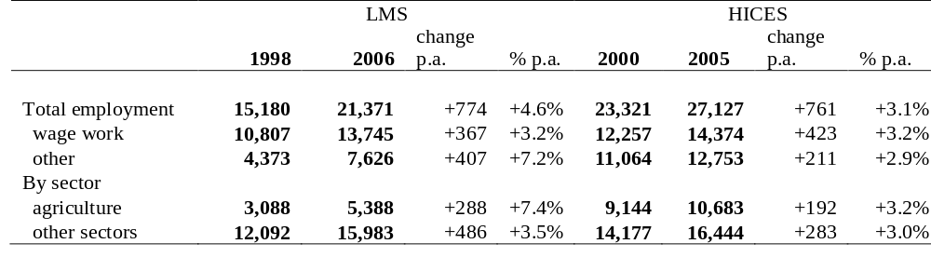
Source: ERF, ELMS 98 and ELMPS 06
- According to both surveys, the majority of employed Egyptians were wage earners. Half of the Egyptian labor force in 2005 were wage earners according to HIECS (Figure 4.6), as opposed to 60 percent according to LMS (Table 4.1). This is close to the corresponding figures from HIECS 2000 and 1996 (49 and 54 percent respectively). The share of wage employment in the labor force was higher in urban regions (67 percent) than in rural regions (39 percent). Self-employed and unpaid workers were more prevalent among the rural population (56 percent) than among the urban population (25 percent).
- Poverty and low earning lines. To examine the links between detailed labor-market outcomes and household poverty, we need to estimate poverty levels for the ELMS 98 and ELMPS 06 household samples. To identify low earners, a low earning line is computed using the per-capita region-specific poverty lines estimated by El-Laithy, Lokshin, and Banerji, 2002 using the data from the 1999/2000 HIECS, and the updated poverty lines of 2004/2005 using the recent HIECS estimated in this report. To compute the low earning line, we first convert the individual region-specific poverty lines to real terms using the consumer price index (taking 2006 as the base year). To account for the fact that each income earner supports more than him- or herself, we scale the 2006 poverty lines by the regional median ratio of household members to working-age employed household members in 2006 to obtain the low earning line. To abstract from changes in either the poverty line or the dependency ratio and keep the focus on earnings, the same low earning line is used to determine low earnings status in 1998, with 1998 earnings expressed in 2006 prices. Since LMS only measures wage earnings from work and does not collect information on other sources of income, the low earnings line is used to assess the quality of jobs of wage workers and not the poverty rate. Low earners could be living in either poor or better-off households. Conversely, poor households could include high earners although they could be poor due to higher than average dependency ratios.

Dynamics of Employment and Wage Growth

Labor Force Participation, Employment and Unemployment
- Overall, participation rates in the market labor force increased between 1998 and 2006. The market labor force in Egypt grew from 17.2 million in 1998 to 23.3 million in 2006, at a rate of 4.1 percent p.a. These growth rates exceeded the growth rates of the working-age population (which has grown at 2.7 percent p.a.), indicating that average labor force participation had gone up during the period under study. As shown in Table 4.2, overall participation rates in the market labor force increased by about 4 percentage points (from 47.2 percent to 51.1 percent). This very large increase reflected increases in participation for both males and females of about the same number of workers, although the relative increase for females was clearly larger. For men, the increase in participation was similar across urban and rural areas, although starting from a higher base in rural areas. Rural women, in contrast, started from a lower base of market labor force participation than their urban counterparts but experienced a more rapid increase over time.
Table 4.2: Labor Force Participation Rates for Working-age Population (15-64)
by Sex and Urban/Rural Location, percentage
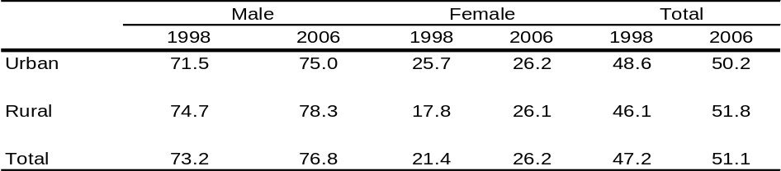
Source: ERF, ELMS 98 and ELMPS 06.
- Unemployment declined. Measured according to the ILO methods, the unemployment rate fell from around 12 percent of the labor force in 1998 to 8 percent in 2006. Urban and rural areas across regions shared in this trend, but rural areas appeared to have experienced a sharper decline in unemployment than urban areas; most surprisingly, the decline was greatest in rural Upper Egypt (Tables 4.3 and 4.4). As shown by Table 4.2, men started with significantly lower unemployment rates than women, but experienced the same rate of relative decline. Male unemployment rates went from 7 percent in 1998 to 4.7 percent in 2006, while female unemployment rates went from 27.6 percent to 18.6 percent. Thus the male-to-female unemployment ratio remained at 4:1. The decline in unemployment was proportionally greater in rural areas, which went from 12.2 percent to 7 percent, as compared to 11 percent to 10 percent in urban areas. Both men and women in rural areas experienced a near halving of their unemployment rates. As already noted in Chapter 2, a similar trend was observed in HIECS between 2000 and 2005.
Table 4.3: Unemployment Rate by Urban and Rural Location and Sex 1998 and 2006
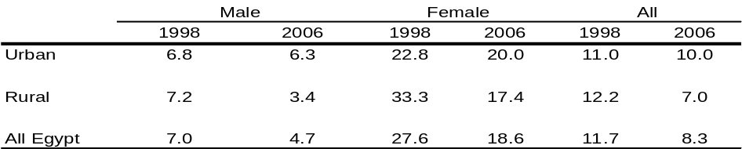
Source: ERF, ELMS 98 and ELMPS 06.

Table 4.4: Unemployment Rate by Region and Sex, 1998 and 2006
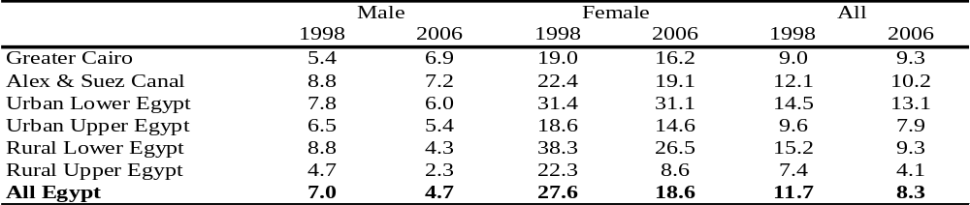
Source: ERF, ELMS 98 and ELMPS 06.

- Educated unemployed youth continued to be of particular concern. Unemployment rates continued to be high for secondary and university graduates. As presented in Table 4.5, the unemployment rate in 2005 was highest among secondary graduates and university-degree holders, whether poor or not and regardless of their place of residence. However, this phenomenon was more pronounced among the poor in urban areas, where one out of two poor but educated persons aged 15-24 was unemployed, than in rural areas, where one out of four was. It seems that even if poor individuals are able to break the vicious circle of lack of education and poverty, they still cannot compete in the job market either because of the low quality of education and labor-market mismatch, or a lack of connections to identify job opportunities. Thus, youth unemployment is frequently aggravated by poverty; it is a cause that produces it, yet it is also a result of it. It has also become a major concern not only because of the idle capacity educated yet unemployed youth represent, but also because of the possible social unrest they may produce (Box 4.2).

Table 4.5: Unemployment Rate of Youth (15-24 Years) by Education and Poverty, 2004-05
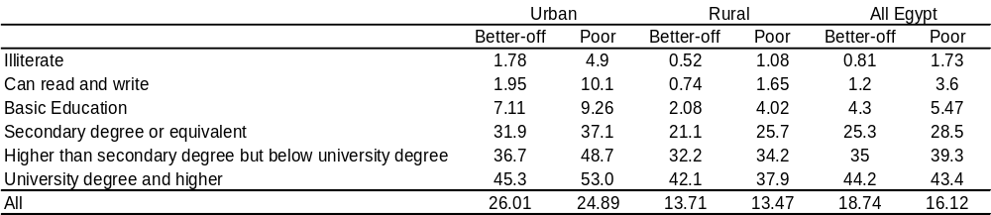
Source: ERF, ELMPS 06.

Box 4.2: Youth Unemployment
Around the world, young people have a hard time finding employment. Survey data from 60 developing countries suggest that, after leaving school, youth spend an average of 1.4 years in temporary or intermittent work and spells of joblessness before permanently entering stable employment. The estimated global unemployment rate for youth increased steadily from 11.7 percent in 1993 to 14.4 percent in 2003. It varies widely across regions, from a low of 7.0 percent in East Asia to 13.4 percent in industrial economies to a high of 25.0 percent in the Middle East and North Africa. Across all markets the youth unemployment rate is two to three times higher than the adult unemployment rate, regardless of the level of aggregate unemployment. MENA’s unemployment rates, however, are among the highest in the world. In the Arab Republic of Egypt, Indonesia, Qatar, and the Syrian Arab Republic, youth make up more than 60 percent of the unemployed. The failure to find employment is also the result of schooling systems that do not impart market-relevant learning and skills. When public-sector wages and benefits are more generous than private-sector compensation, a strong incentive arises for young (usually educated) school leavers to queue for government jobs and stay unemployed for some time after graduation. Substantial wage premiums in the public sector – coupled with job security, tenure, prestige, and other non-wage benefits – influence the decision to voluntarily hold out until a public-sector job opportunity opens. Difficulties in entering the labor market can persist and be very costly to mitigate. Poverty and slow economic growth can exacerbate poor youth outcomes such as child labor, school dropout rates, and joblessness.
Correcting for these failures requires the right mix of policies to ensure that enough opportunities are available for young people, that their skills match employment opportunities, and that second-chance options protect those who fall behind. Some policies, such as improving the investment climate or enhancing the functioning of the labor market, are not youth-specific, but have a disproportionate impact on youth. The priority is to reform labor-market institutions and to build more bridges between school and work to better accommodate new entrants. In most low-income countries, building on basic skills and providing a springboard to rintegrate the most vulnerable will allow youth to gain productive employment.
Recent analysis based on labor-market surveys (Assaad 2007) shows that between 1998 and 2006 youth unemployment in Egypt declined, mainly due to fast private-sector growth. However, gains were dramatically different for young boys versus young girls, with the latter dropping out of the labor force and the former transitioning to their first jobs faster. Thus, while youth as a group have benefited from improved labor-market conditions in Egypt, policy action is needed to redress imbalanced gender effects. Inequality in access to new job opportunities feeds deep dissatisfaction that many youth express.
Source: World Bank, 2007, and Assaad, 2007
- Employment-to-population ratios increased during the 1998-2006 period. As shown in Table 4.6, overall employment-to-population ratios increased from about 42 to 48 percent. The increase in the employment ratio was fairly widespread, affecting both males and females, and urban as well as rural areas. Yet, as in the case of unemployment, the changes were larger in rural areas. Rural females in particular experienced a rise in their employment. This is probably the result of better measuring of market activities previously logged as subsistence activities (see Box 4.3).

Table 4.6: Employment-to-Population Ratios
by Urban/Rural Location and Sex, 1998 and 2006
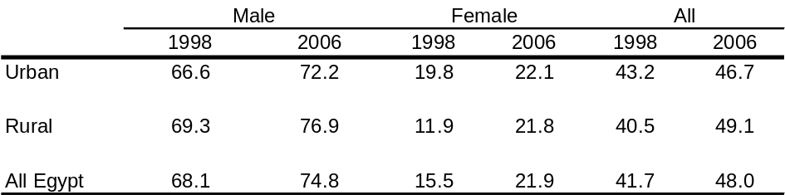
Source: ERF, ELMS 98 and ELMPS 06.

Box 4.3: Is the Improvement in the Female Employment Status a Result of Better
Measurement of Market Activities?
To investigate the unrealistically high growth rate of female employment in the agriculture sector, annual growth rates were calculated using the cross-sectional method, along with an alternative method of measuring growth using the longitudinal recall data of the ELMPS 06 dataset only (see table below). The latter implies the use of the ELMPS 06 question on start date of current job to calculate an alternative growth rate as the average annual inter-temporal difference between, for instance, total agriculture non-wage workers in 2006 and those who started work in that sector before 1998.
The growth-rate figures based on the longitudinal method are markedly smaller than those based on the cross-sectional method. According to the longitudinal figures, the growth of male agriculture non-wage work was higher than that of female (with an overall average annual growth rate of 6.6 percent p.a.). Additionally, the male agriculture non-wage work growth rates reported by both methods are relatively close, in comparison to those of females. Hence, as mentioned above, there is a clear measurement issue of female non-wage work between the two cross-sectional datasets. Clearly, the ELMPS 06 did a better job in capturing non-wage market activity among females, which significantly reduced the instances of misreporting of women’s work. Notwithstanding the measurement issues, the rapid growth of male agricultural non-wage work shows that this sector had undoubtedly experienced very vigorous growth.

Cross-Sectional and Longitudinal Method of Calculating the Growth in Agriculture Wage and Agriculture Non-Wage Work by Sex And Urban/Rural Location, 1998-2006
(Percent)
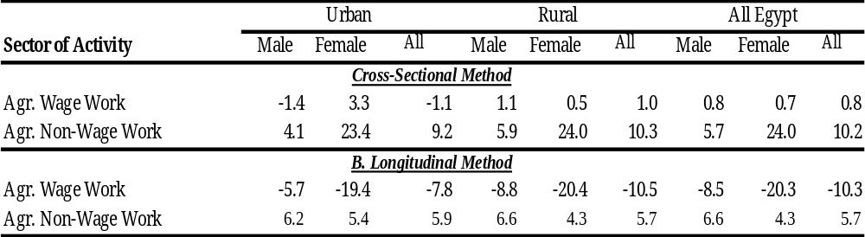
Source: Assaad, 2007
- Employment grew fairly rapidly during 1998-2006. Overall employment growth (Table 4.7) over the 1998-2006 period was 4.6 percent p.a., which is over one-and-a-half times the growth of the working-age population. The growth was more vigorous in rural areas at 5.4 percent p.a. (compared to 3.6 percent p.a. in urban areas). Female employment (Figure 4.6) grew at more than twice the rate of male employment (7.5 vs. 3.8 percent p.a.). Employment increased notably for females, not only in household-based market activities (in which ELMPS 06 might have a better instrument than its predecessor), but also in other forms of employment, for which there are fully comparable data.

Figure 4.6: Employment Growth by Sector and Sex, 1998-2006
(Average Annual Growth Rate)
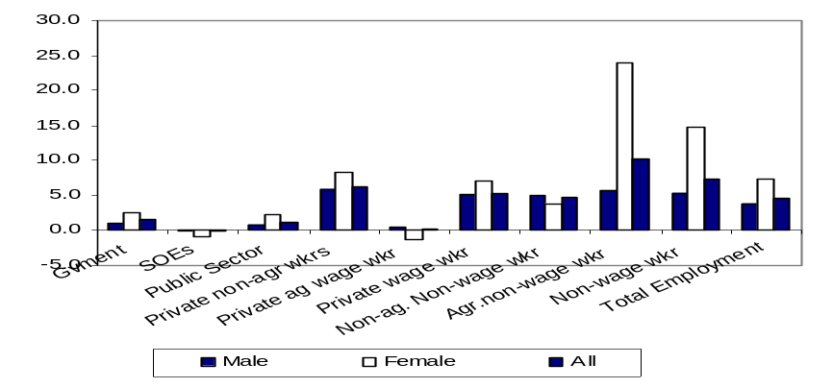
Source: ERF, ELMS 98 and ELMPS 06.

- Important structural changes in employment have occurred, with private regular wage employment being a prime engine for growth. As shown in Table 4.7, Government employment grew at one-third the rate of overall employment growth, while that of state-owned enterprises experienced an absolute decline. This is a considerable change over the previous period (1988-98), where the public sector as a whole had grown by 2.9 percent p.a., compared to only 1.3 percent p.a. in the more recent period, and its government sub-sector, which had grown by 4.9 percent p.a. compared to only 1.6 percent p.a. The share of the public sector in overall employment consequently fell from 38 percent to 29 percent and that of government employment declined from 32 percent to 25 percent. In the meantime, private regular wage work grew vigorously in both urban and rural areas – most noticeably in rural areas – with an overall average annual growth rate of 7.7 percent p.a. This work type’s share of overall employment increased from 21 to 26 percent. Non-wage work, which includes employers, unpaid family workers, and self-employed individuals, also grew very rapidly at about 7.4 percent p.a.
- Agriculture; construction; trade, restaurants and hotels; transport, storage and communications; and financial and business services have all grown substantially from 1998 to 2006. The fastest growth was witnessed in the financial and business services sector, followed by the agriculture sector. Despite the fact that manufacturing was not among the fastest-growing sectors in terms of overall employment, female employment in manufacturing grew at a rapid rate of 5.1 percent p.a. An in-depth investigation of this phenomenon revealed that two sub-sectors were responsible for the bulk of this acceleration: textiles and garments, and food-processing manufacturing. Other fast-growing sectors for women were transport, storage, and communications, with female employment concentrated in the communications sub-sector. The highest growth rate reported in Table 4.7 was for female agriculture work, which grew at the unrealistically high average annual rate of 20 percent p.a. As mentioned before, we believe that these may be exaggerated figures due to improved measurement of women’s home-based market activities in ELMPS 06 (see Box 4.3).
Table 4.7: Employment Growth Rate
by Type of Employment, Economic Activity, Sex, and Urban/Rural Location,
1998- 2006 (percent)

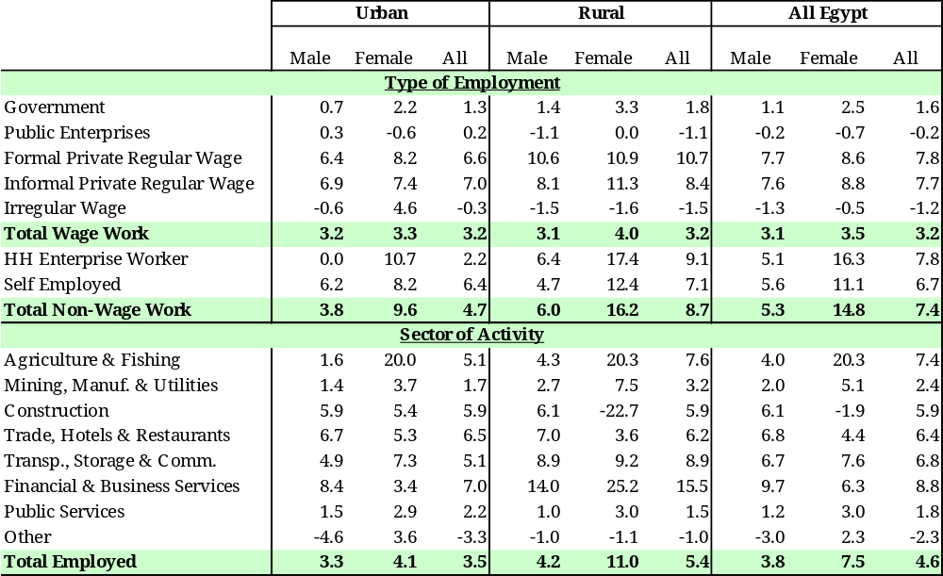
Source: ERF, ELMS 98 and ELMPS 06.

Evolution of the Earnings Profile
- Overall, median real monthly earnings increased between 1998 and 2006. The sharp, 3.7 percent decline of median real monthly earnings in the 1990s from their 1988 levels was reversed in 2006 when these earning rebounded to their 1988 levels, and reached even higher levels for some groups. (See Table 4.) However, it should be kept in mind that earnings data in the ELMS 1998 and ELMPS 06 are only available for wage workers. Moreover, as demonstrated by Figure 4.7, the “window” of the two surveys covers dramatically different periods in terms of wage dynamics. Nevertheless, a number of important observations can be made. While comparisons between 1998 and 2006 yield consistently high real wage growth rates, recorded HIECS comparisons over the period demonstrate stable or declining real wages (remembering that the CPI index used on Figure 4.7 falls short of accounting for changes of cost of living for the poor; see also Annex Tables A.4.10 and A.4.11 for HIECS summary of wages).
Figure 4.7: Growth Rates of the CPI-Deflated Average Wage, 1998-2006
(1997=100)
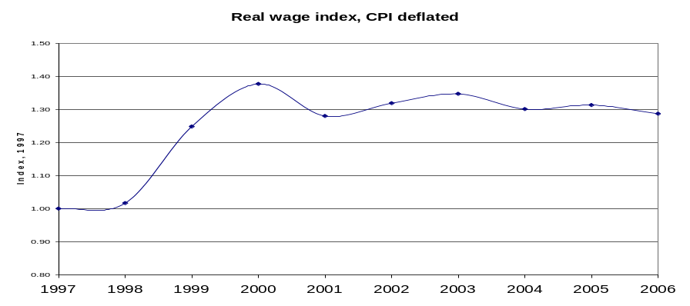
Source: Employment and Wages Bulletin, 2000-2004, ILO LABSTAT 1997-2000, and EIU for 2005-06.
- The differences between wage evolutions for the poorest groups of workers is highlighted in Table 4.8, which shows noticeable deterioration in median wages in agriculture and among poor workers based on HIECS. In the meantime LMS picks up a different trend for agricultural wage due to the difference in the periods covered. These differences have to be taken into consideration when interpreting results regarding the change in low pay based on LMS presented below.

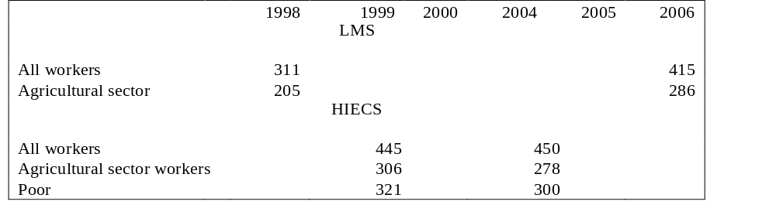
Table 4.8: Real Median Wages: Comparison between the Labor Market Surveys and HIECSs (LE/month in 2006 Prices)
- Young workers had the lowest earnings, and earnings rose steadily with age. As observed elsewhere, the median real monthly earnings of youngest workers was below the average in Egypt. Table 4.6 shows that it was less than half that of the oldest group. The increase in real earnings from 1998 to 2006 was highest for the pre-retirement age group, followed by the youngest two age groups and lowest for the prime age groups (between 35 and 54 years).
Source: ERF, ELMS 98 and ELMPS 06.

- Rural regions had the lowest wages in both 1998 and 2006, with rural Upper Egypt showing the lowest figures. However, the increase in real earnings in both rural regions was more pronounced than in urban regions. This confirms the relatively stronger improvement in rural labor markets just before 2000. Rural regions, especially rural Upper Egypt, suffered the sharpest declines in the 1988-1998 period, and protracted stagnation in the early 2000s.
- The wage profile by education exhibited the expected rising trend with higher levels of education. The main exception was technical high school graduates, whose earnings were not only lower than general high school graduates but also lower than middle school graduates. However, the rate of increase in real earnings for technical secondary graduates was among the highest from 1998 to 2006, exceeding by a wide margin the rate of increase among university graduates. The latter group ended up well below their real values in 1988. As the only group who experienced an increase in unemployment rate, this group’s labor-market performance seems to have been hurt in recent years by a rapid increase in the number of new entrants with university degrees (see Assaad, 2007).
- Growth of real monthly wage earnings was uneven across sectors of activity and institutional sectors. As shown in Table 4.9, agriculture, construction, and public services showed the fastest growth in monthly earnings, but they also had the lowest earnings to begin with (aside from the small residual group “other”). In the meantime, and despite the rapid rise in employment in these sectors, lagging industry groups included trade, restaurants, and hotels, and financial and business services. The decline in average earnings in fast-growing sectors was probably due to the rapid increase in the number of young new entrants, who tend to have lower wages. Among institutional sectors, real earnings rose most rapidly in government and in irregular wage work – two sectors in which employment growth was slow. Contrarily, real earnings rose most slowly in informal private employment – the sector that experienced the most rapid employment growth (Table 4.9). Given the importance of this sector for employment creation, its very low wage levels, especially for women, are a potential source of concern.
- On average, women witnessed a slightly slower growth in their earnings, but due to changes in the structure of employment the gender wage ratio declined. As shown in Table 4.10, between 1998 and 2006 women’s real monthly earnings grew by 3.8 percent, versus 4 percent for men. It is worth noting that female earnings in manufacturing were the only ones to see an absolute decline in real terms, even though manufacturing was one of the fastest-growing sectors for female employment. In addition, not only did the median female employee in the informal private sector earn less than half of a female employee in the government and just over a third of a female employee in public enterprises, but she earned about half of what a male employee with the same employment status did. These differences could well be due to differences in education and experience, but a median monthly earnings level of LE 200 (almost US$35) is well below the low-pay cutoff of LE 368 (or US$ 64) in a sector that is absorbing the vast majority of female new entrants today. On the other hand, the gender wage ratio (male/female) declined on average from 1.3 to 1.1 between 1998 and 2006. This ratio declined in agriculture – the fastest-growing employment engine for women – and in the trade and transport sector, but increased in the financial and business-services sector and in manufacturing – two sectors that also hire women disproportionately (Table 4.10). The gender wage gap also increased in public enterprises and in formal private-sector employment, but declined among irregular wage workers.
Table 4.9: Median Real Monthly Earnings by Background Characteristics 1988- 2006
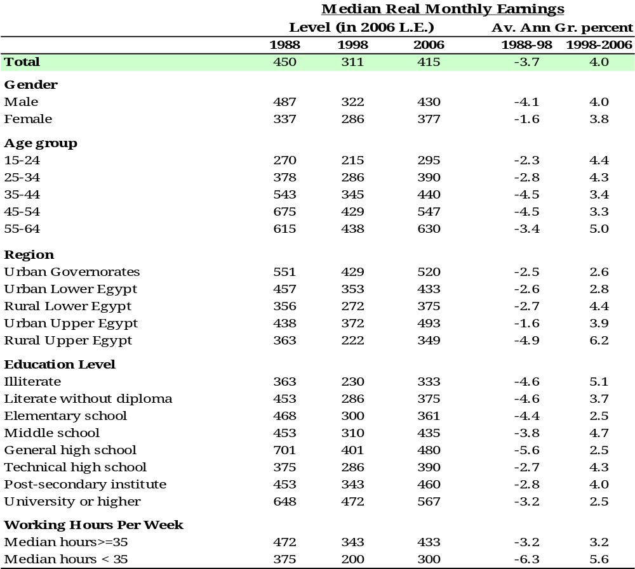
Source: ERF, ELMS 98 and ELMPS 06.

Table 4.10: Distribution of Real Monthly Wage for Wage and Salary Workers by Institutional Sector and Economic Activity (2006=100), 1998- 2006
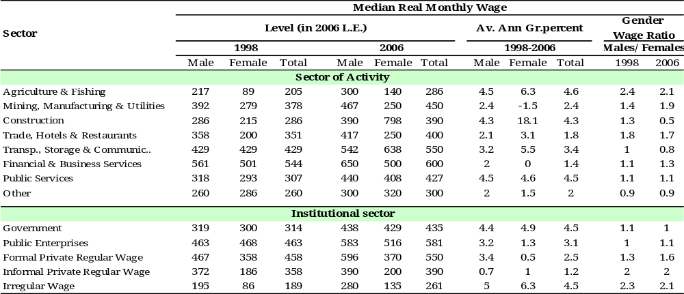
Source: ERF, ELMS 98 and ELMPS 06.

Evolution of the Share of Low Earners
- The share of low earners among wage workers declined between 1998 and 2006 across various individual and employment characteristics. As shown In Table 4.11, the share of wage workers who fall below the previously determined low-earnings cutoff declined at an annual rate of 4.5 percent p.a. (from 61.6 percent in 1998 to 44.8 percent in 2006). If the Food Price Index (FPI) had been used instead of the CPI to inflate 1998 wages, the reduction in the share of low-paying jobs would have been smaller, from 53.0 to 45.5 percent (Table A.4.5). But the direction of change would have been unaltered. It is noteworthy that the decline in this share is another indication of the significant improvement in labor-market conditions over the period under consideration (the process of entry and exit from high- and low-paying jobs is discussed in the following section). On average, males, prime age and older workers, workers in urban governorates, and post-secondary institute workers experienced the greatest decline in the share of low earners.
- The highest shares of low earners were seen in women workers, youngest workers, and rural workers. As shown in Table 4.11, not only did women have a significantly higher share of low earners than men (51 percent versus 43 percent), but also the share among females did not decline as fast as among males (down by 3.8 versus 4.6 percent p.a.). This indicated a lesser improvement in the labor market for low-paid females. The share of low earners was also highest for the youngest workers (almost 70 percent) and declined the least for this group (down by only 2.2 percent per annum). This shows that earnings rise through the life cycle as workers gain experience, but that young workers, who are members of the largest cohort ever of youth, are facing intense competition for jobs. The share of low earners was also higher in rural areas (60 percent in rural Lower Egypt and 54 percent in rural Upper Egypt), but these areas saw some of the fastest reductions, and therefore the fastest improvements, in the condition of low-paid workers. This is consistent with the improvement in rural labor markets seen in the unemployment data.
- The share of low earners generally fell with educational attainment, but with a few exceptions. The most notable was the unexpectedly high share of low earners among technical high school graduates (50 percent). One possible explanation for this is the large increase in the female share of the workforce at this level of education. Since women have significantly lower earnings than men, the share of low earners can increase because of the change in sex composition from lower levels of education. The increase in the share of low earners among general high school graduates should be discounted because there are very few such workers. The vast majority of general high school graduates go on to higher education rather than joining the labor force (see Table 4.11).
- The share of low earners varied across sectors of activity and institutional sectors. The share of low earners was by far the highest in agriculture and fishing, followed by construction, trade, restaurants, and hotels. The fastest decline in the share of low earners was in transport, storage and communications, and public services. On the institutional side, the highest share of low earners was in the two informal wage employment sectors. It declined the fastest in the irregular wage employment sector, which actually contracted in terms of employment. However, the slowest decline in the share of low earnings was in the informal private, regular wage sector, a sector that is growing rapidly and emerging as one of the sectors of greatest vulnerability to poverty next to irregular wage employment. Because of fairly healthy wage increases in government and public enterprises between 1998 and 2006, these two sectors experienced large declines in the share of low-pay jobs. These results essentially confirm the same patterns observed in the change in median wages (see Table 4.11).
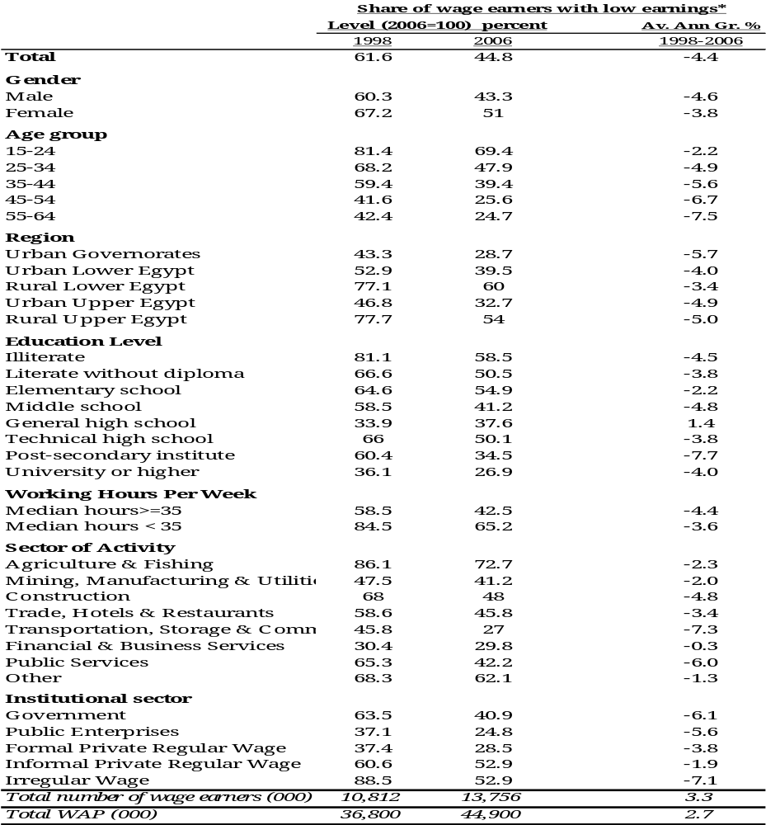
Table 4.11: Share of Low Monthly Wage Earners, Wage and Salaried Workers, 1998- 2006
- The increase in real wages between 1998 and 2006 was across the board. The full distribution of earnings by sex in comparison to the low earnings cutoff, both in terms of density functions and cumulative distributions, showed that wherever one chose to put the low pay cutoff, the share of low-pay workers would have declined during the 1998-2006 period. This is true regardless of the deflator used (CPI or FPI). However, the spread of earnings appeared to be larger in 2006 than in 1998, revealing an increase in inequality. This was especially pronounced among female workers. Also, the distribution of real monthly earnings for each institutional sector of wage employment showed that workers at all pay levels benefited from an increase in real earnings in both the government and public-enterprise sectors (shown by the noticeable shift to the right in the density curves in the top set of figures in Figure A.4.1). The shift for low-paid private-sector workers appeared to be much less pronounced than for higher-paid workers. Private-sector wage workers have therefore an increase in the spread of earnings, or earnings inequality, with a lesser (but still positive) increase in earnings among low-paid workers. This was true of both formal and informal wage workers in the private sector (see Figure A.4.2-4).
Source: ERF, ELMS 98 and ELMPS 06.

- These trends did not have direct implications on poverty changes between 2000 and 2005, because they mostly occurred before 2000. Yet they clearly demonstrate the potential the Egyptian labor market has to generate strong, equitable real-wage growth. Another crucial lesson from these developments will be presented in the next section: workers do move across high- and low-paid sectors, but workers in informal sectors, especially agriculture, are not participating in these positive trends.

Transition across Low and High Paying Jobs: A Longitudinal Analysis
- In this section, results from the panel data are discussed so that one important aspect of the labor market dynamics, namely transitions across pay categories, is captured and abstracted from any compositional changes in the population. (See Box 4.4 for details on the applied methodology.) As discussed in the previous section, the share of wage workers in low-paying jobs went down between 1998 and 2006. This reduction was due to a complex process of entry and exit from high- and low-paying jobs, including new entrants coming into wage labor, retirements from wage labor, or movements to non-wage work. The expected pattern is that (i) more people will move from low- to high-paying jobs over their lives than the other way around, and this is in fact the case; (ii) more new entrants will move into low-paying jobs at the beginning of their careers than into high-paying jobs; and (iii) movements into retirement are more likely to be from high-paying than low-paying jobs. The net change in the proportion of the population in low-paying jobs essentially depends on the relative size of these respective flows. Below, we discuss the results obtained using the CPI as a wage deflator.

Box 4.4: Methodology of the Longitudinal Analysis
The transitions across pay categories, as surveyed individuals are followed from 1998 to 2006, allow us to gauge changes in their pay categories over time. The sample contains people of all ages in 1998, with each individual aging by about 7.25 years over the period.
Jobs are classified here as either low- or high-paying on the basis of a comparison of real monthly earnings to a low-pay threshold. The threshold is calculated from the real per-capita region-specific poverty lines scaled by the median employment dependency ratio in the economy. Although the low-pay cutoff is region-specific, the national figure is LE 368 per month in 2006 constant prices. Both the 1998 and 2006 earnings, expressed in constant 2006 prices, are compared to this cutoff to determine whether the individual is in a high- or low-paying job.
Because earnings data in ELMS 1998 and ELMPS 06 are only available for wage workers, there are no earnings data for non-wage workers. We therefore look at transitions among the following four states: (i) high-paying wage jobs, (ii) low-paying wage jobs, (iii) non-wage jobs, and (iii) non-workers. A fifth (minor) category is created for wage workers with missing wage data. Including non-wage workers and non-workers in the transition matrix allows us to estimate the rates of entry and exit into high- and low-pay jobs from outside the workforce and from non-wage jobs, and thus get a fuller picture of labor-market transitions. As discussed in Chapter 2, non-wage workers have higher poverty risk than wage workers and similar to those outside the labor force, which justifies grouping them together for the mobility analysis.
Source: Assaad, 2007.

- Among all wage workers in 1998, a similar proportion (22 percent) remained in high-paying jobs as remained in low-paying jobs from 1998 to 2006. Table 4.12 shows the transition probabilities within one pay category, from one category to another, and to outside wage employment status relative to the wage category in that state in 1998. As expected, many more moved from low- to high-paying jobs than the other way around (26 vs. 3 percent). On the other hand, counter to expectations, more workers left low-paying jobs than high-paying jobs to employment states outside wage employment (16 vs. 11 percent). This pattern was especially pronounced for women, with 9 percent leaving high-paying jobs to employment states other than wage employment and 20 percent leaving from low-paying jobs. These flows probably reflect the large number of young women working in low-paying jobs in the private sector who left the workforce for marriage, before they were able to accumulate enough experience to graduate into higher-paying jobs. However, the fact that men had higher exit rates from low-paying jobs than high-paying jobs as well shows that many male workers end their career in low-paying jobs.
Table 4.12: Transitions across High- and Low-Paying Jobs for Wage Workers in 1998
by Sex, 1998-2006
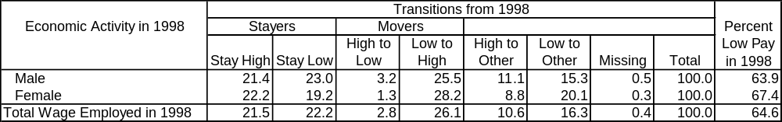
Source: ERF, ELMS 98 and ELMPS 06.

- Among those with wage jobs in 2006, a higher percentage came from out-of-the- workforce or non-wage employment into low-paying jobs than into high-paying jobs (26 vs. 17 percent). As shown in Table 4.13, which illustrates the transition into each of the two wage categories from the other wage category as well as from outside wage employment, relative to wage category in 2006, the difference between the movers to low-paying jobs and high-paying jobs from non-wage workers and non-workers status was particularly pronounced for women (32 vs. 12 percent) – an indication of the proliferation of low-paying jobs for young women in the 1998-2006 period.
Table 4.13: Transitions across High- and Low-Paying Jobs for Wage Workers in 2006,
by Sex, 1998-2006
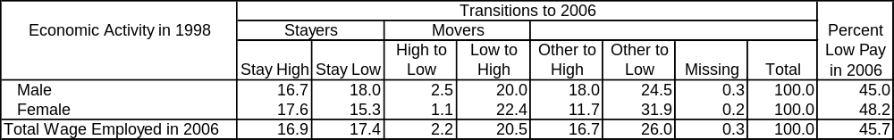
Source: ERF, ELMS 98 and ELMPS 06.

Transition Pattern across Pay Categories by Institutional Sector
- Regular formal employment in the private formal sector was the type of employment with the highest proportion of high-paying jobs to start with, and the highest proportion of stayers. As shown in Table 4.14, this sector was closely followed in this respect by the public enterprises sector, although that sector had seen a higher rate of retirements from high-paying jobs to states other than wage employment, probably reflecting the high rates of retirement from public enterprises.
Table 4.14: Transitions across Pay Categories for Wage Workers in 1998
by Institutional Sector, 1998-2006
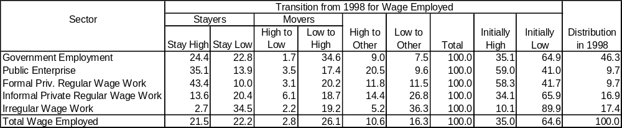
Source: ERF, ELMS 98 and ELMPS 06.

- Jobs in the government and in the informal regular private sector were next in terms of initial share of high-paying jobs. In this case, government employees were much more likely to stay in such jobs than informal regular private wage employees, and more likely to move from low- to high-paying jobs during the period. Besides having a lower probability of transitioning from low- to high-paying jobs, informal regular wage workers also had the highest probability of transition from high- to low-paying jobs, underscoring the greater vulnerability of their labor-market conditions. This category of workers continued to grow rapidly at a rate of 8.3 percent p.a. and therefore, together with irregular workers and non-wage workers, constitutes the group of workers most vulnerable to poverty in the Egyptian labor market.
- The highest initial proportion of low-paying jobs, by a wide margin, was among irregular wage workers. These workers were also the most likely to stay in such jobs. Fortunately, this category of employment has experienced a sharp decline during the period, at an average annual rate of 1.8 percent p.a., without a corresponding rise in unemployment among those who had held them

Transition Pattern Across Pay Categories by Economic Activity
- As expected, agriculture was the sector with the highest share of low-paying jobs initially [does “initially” mean “in 1998”?], and with the highest likelihood for jobs to remain low-paying. As shown in Table 4.15, only 13 percent of wage jobs in agriculture paid above the low-pay threshold in 1998, and only 15 percent managed to move across the threshold from 1998 to 2006. Underscoring the high rate of movement between wage and non-wage employment in agriculture, a high proportion of agricultural wage workers (37 percent) moved from low-paying jobs to employment states other than wage employment.
- Construction was the sector with the second-highest share of low-paid workers. This was expected given its the large proportion of irregular wage workers. However, as shown in Table 4.15, construction workers were one-and-a-half times as likely to move from low- to high-paying jobs as agricultural workers and twice as likely to move the other way around. Construction workers may therefore have a lower incidence of low pay, but are fairly vulnerable to moving in and out of low-paying jobs because of the irregularity of their employment.
- Public services was also a sector with a higher-than-average proportion of low-paying jobs in 1998, but it was also the sector that had the highest rate of transitions to higher-paying jobs over time (36 percent moved from low to high pay as compared to 26 percent on average). The financial and business services sector, which grew fairly rapidly in the period under consideration, was the sector with the lowest share of low-paying jobs, by a wide margin.
Table 4.15: Transitions across Pay Categories for Wage Workers in 1998 by Sector of Economic Activity, 1998-2006
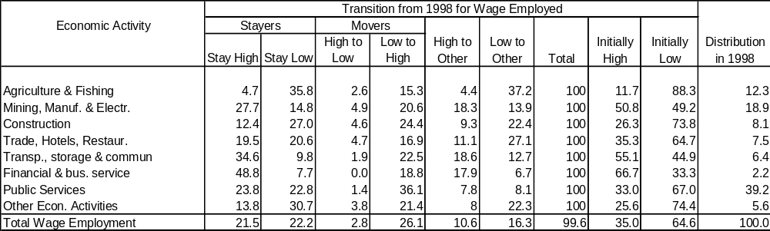
Source: ERF, ELMS 98 and ELMPS 06.

Transition Pattern across Pay Categories by Sector Of Economic Activity within Private Employment
- The proportion of low-paying jobs within the formal private sector was initially low. This proportion was less than 42 percent (Table 4.11), as opposed to an overall average of almost 65 percent for all wage employment, but was highest (64.4 percent) for public-services jobs (dominated by teachers and health professionals). Public-services workers in the formal private sector had one of the highest proportion of those who stay in low-paying jobs (20.4 percent), but also a relatively high proportion of those who moved from low- to high-paying jobs (26.1 percent). Workers in agriculture, trade, restaurants, and hotels were also likely to start in low-paying jobs (58.9 and 52 percent, respectively). However, workers in the trade, restaurants, and hotels sector were by far less likely to transition to higher paying jobs over the period (10.4 percent, versus 37.5 percent in agriculture).
- The initial proportion in low-paying jobs among informal regular private wage workers was much higher at 65.9 percent. As shown in Table 4.16, the most vulnerable among them were public-service workers, who were all in low-paying jobs at the start, followed by agriculture and fishing (78.4 percent), and trade, restaurants, and hotels (69.6 percent). The most likely to move from low- to high-paying jobs in the informal private sector were those in construction (22 percent), closely followed by workers in trade, restaurants, and hotels (21.5 percent) and then by workers in mining, manufacturing, and electricity (19.3 percent). Informal wage workers in transport, storage, and communications had the highest likelihood of staying in high-paying jobs (31.9 percent), but the lowest chance to transition from low- to high-paying jobs (5.5 percent).

Table 4.16: Transitions across Pay Categories for Private Formal Wage Workers in 1998 by Economic Activity, 1998-2006
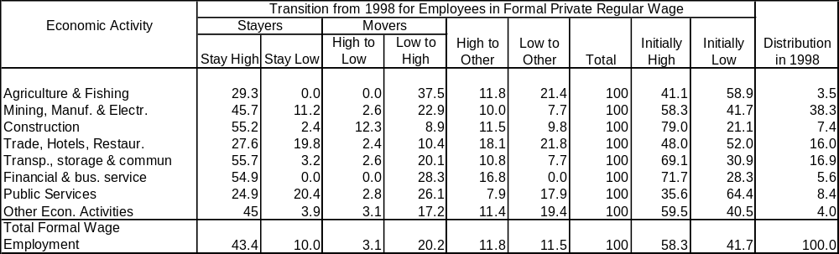
Source: ERF, ELMS 98 and ELMPS 06.
- The high share of low-paying jobs in the fast-growing segments of employment is a key reason behind the negligible effect of increases in employment and wages on poverty reduction. The other part of the story of the developing labor market in Egypt was that many new jobs were not high-quality jobs. They were usually created in activities where productivity was relatively low or the productivity growth was relatively low. A lot of these jobs, as was demonstrated, were in self-employment or in the informal sector; many in agriculture, where productivity is also relatively low; and some in services, where some activities were low-paying. It would of course be an exaggeration to claim that all new jobs were informal or low-productivity jobs. The pattern of job creation has not been uniform. In some sectors, regions, and activities, jobs have been created in new dynamic firms with high productivity and high productivity growth. The picture is mixed, and the key challenge is to build on labor-market dynamism to strengthen the sectors that create high-quality jobs.

Conclusion: Labor Market Trends and Poverty Reduction
- The results of the cross-sectional analysis of the two labor market surveys showed a broad improvement in labor-market conditions for wage workers and those seeking work (the unemployed) over 1998-2006. However, those conditions were not steady or consistent across all dimensions. Although employment steadily expanded over the period for most sectors, this rise did not automatically lead to poverty reduction. What mattered was quality of jobs, but new developments there were not pro-poor. About half of all new employment was in low-productivity occupations, and most of the employed poor were in irregular, low-paying jobs.
- Average and median real wages increased rapidly in 1997-2000 but became stagnant over 2000-2005, with agricultural wages and wages for irregular informal occupations actually declining. These negative trends in real wages were the reason why growth in employment did not have the desired effect on poverty. Moreover, the employment boom that hit the rural poor translated into rapid growth for non-wage employment, especially in the form of unpaid family labor. Since about half of this non-wage employment took place in agriculture, future progress in poverty reduction is still very much linked with what goes on in this sector.
- Irregular wage work, which takes place mostly in agriculture and construction, is also associated with poverty, even more so than non-wage employment, but its prevalence in the Egyptian labor market seems to have dropped.
- The positive news came from growing private wage employment. This type of employment grew quickly and was the largest absorber of new entrants in the Egyptian economy (together with non-wage work). Vulnerable sub-sectors emerged (e.g., female employment in trade), and were concentrated in informal but regular private sector wage employment. As the public sector contracted, these more-precarious forms of employment were the replacement provided by the private sector. Although formal wage employment grew rapidly, it did so from a narrow base, and was unable to absorb those who would have in the past ended up in the public sector.
- Although the results of the longitudinal analysis essentially confirmed the trends identified in the cross-sectional analysis, they gave additional insights into the changes observed over the period. For instance, some sectors, such as informal private wage employment, essentially grew by absorbing a large number of new entrants. Others, such as formal private employment and individual self-employment, grew by absorbing workers from other parts of the labor market. In fact the growth of formal private employment may have been the result of the formalization of the status of existing informal workers resulting from the passage of a more flexible labor law in Spring 2003.
- The dynamic analysis of employment trends by industry also revealed some interesting differences in growth patterns. For instance, while agriculture and transport, storage, and communications grew at about the same rate, agriculture essentially grew by absorbing new entrants, whereas transport, storage, and communications grew by taking in workers from other sectors as well as absorbing new entrants.
- Government workers saw a greater improvement in their earnings over the period, with about a third moving across the low-pay threshold. This group experienced the fastest decline in the incidence of low-paying jobs. In addition, their non-wage benefits were usually superior to those of their private-sector counterparts. Public-enterprise workers had a lower incidence of low-paying jobs to start with, but also experienced significant declines in the incidence of low pay over the period.
- While significant differences still existed in both access to jobs and earnings in the Egyptian labor market, female employment in the private sector – in sharp contrast with the previous decade – grew even more rapidly than male employment. It was not surprising that many of the jobs obtained by female new entrants were low-paying – many of them in textiles and garments and food processing. Nonetheless, the share of low-paying jobs among women declined from two-thirds to just above half. As women often worked as secondary workers in a household, their increased inclusion in paid work, even in low-paying occupations, was a contributing factor to improved living standards.
- Although widespread improvements in labor-market conditions were observed in the 1998-2006 period, some important sources of vulnerability, such as formal wage work, informal wage work, and work in household enterprises, still remained. For achieving a faster pace of poverty reduction, the progress in creating new jobs outside agriculture must be combined with facilitating access to these jobs for the rural and urban poor and improving agricultural productivity.

Chapter 5: Poverty Monitoring and Evaluation
Better targeting of social transfers and reforming the inefficient subsidy system will require supreme political will. A precondition to the success of political coalition in support of the reform is a wide shared consensus on development priorities and challenges. Such consensus can only be based on a shared understanding and access to solid economic data on poverty and living standards, employment and unemployment, and public finance. Yet, data presented in this report is regarded suspiciously by many. Some would say the report embellishes the truth, and that there is no opportunity to check the validity of estimates. How do we move from this mutual mistrust and lack of productive, evidence-based debate to a working poverty-monitoring system – a system that provides the right environment for Government and society to work together towards the ultimate goal of poverty reduction, while facing the many challenges of globalization? This chapter aims to provide a short description of current practices and problems in poverty monitoring; it also proposes some options to improve the situation.

Introduction
- Poverty monitoring and evaluation of public programs are crucial tools in a long-term poverty-reduction strategy. For a poverty strategy to work, putting in place a poverty monitoring and evaluation (M&E) system that generates information is critically important to assess the severity of the poverty problem over space and time and determine the real impact of anti-poverty interventions. Without such a system, the formulation of poverty strategy can become detached from considerations of cost-effectiveness and subject to arbitrariness in choice of interventions.
- Attacking poverty requires comprehensive public social statistics and institutional arrangements that are conducive to efficient and broad use of data. The set-up of a public social statistics program is crucial to help take stock of the poverty situation and to monitor the impact of growth and public policies on poverty reduction. Both income and non-income dimensions of poverty need to be monitored. Non-income indicators, including data collected to measure trends in health and education outcomes across key population groups, may follow income-related dimensions of welfare, but they may also be less responsive to changes in overall economic growth or reductions in income poverty. Social statistics should, at the bare minimum, cover the indicators necessary to measure and monitor progress towards the Millennium Development Goals (MDGs). Additionally, social statistics derived from household surveys could provide a validity check for data collected from various administrative registries and databases. Equally important are the institutional arrangements that enable an efficient use of existing poverty data. Indeed, sustaining a knowledgeable cadre of personnel for poverty monitoring is a challenge. Limited data-sharing and infrequent interactions between data producers and users are also critical impediments for analyzing poverty.
- This chapter documents the progress and problems in some of the important aspects of poverty M&E capacity, and provides some recommendations to improve overall efficiency in data collection and poverty analysis, and hence the M&E of various poverty-reduction interventions.

The Reason for a Monitoring and Evaluation System
- The M&E of the impact of poverty-reduction policies is a useful tool for effective management. Poverty M&E helps policy-makers and other stakeholders gain information on progress in poverty reduction. In other words, M&E shows whether poverty-reduction strategies are being implemented as planned and whether they are achieving their objectives. If actual implementation diverges from the original plan, monitoring provides evidence of problems that need to be identified and solved. Without good M&E systems, it is difficult to find out what works and what does not, and thus to formulate meaningful policies and programs to combat poverty.
- A transparent dissemination of the results of M&E should foster the public support of reform efforts. By helping to attribute poverty outcomes to specific policy interventions, M&E may contribute to the Government’s efforts to communicate reform results to the public in a realistic and transparent manner. This should help restore trust and thereby ensure that the implementation of reforms is sustained and the Government can progress to deeper types of reforms that require public support.
- However, there is often resistance against or reluctance to adopt a systematic approach to M&E. M&E systems – more often than not – reveal problems, while politicians, particularly in developing countries, are usually sensitive to criticism and have a tendency to show only positive results. In addition, M&E, and particularly impact evaluation, does carry a cost in terms of data requirements and methodology. This makes policy-makers even more reluctant to allocate scarce financial resources to support the collection and dissemination of data and in-depth analysis. However, when compared to costs of reforms, especially costs of failed reforms, such an investment – which could help reduce risks of failure and improve the efficiency of public spending – is a very wise use of Government resources. For this reason countries around the world systematically incorporate M&E into their daily policy-making processes (see the most recent review of best practices in Bedi et al., 2006).

The Current Status of Social Statistical and Institutional Capacity
- There has been substantial progress in the coverage, frequency and dissemination of basic data sets in Egypt. Data from a variety of sources (e.g., national accounts data, household surveys, budget data, sectoral ministries, administrative data, community and price surveys, etc.) is the most important component of any outcome-based monitoring system. In fact, significant improvements have occurred in recent years in Egypt with regard to the volume, timeliness and availability of social and economic data, including the publication of many data series on the websites of various public agencies. GDP series are being published on quarterly basis, an industrial production index has been introduced, and unemployment estimates are available on a quarterly basis. Government financial reports – the main source of information for monitoring policies and programs – are becoming substantially more meaningful with the reforms of the accounting and information systems, the improvement of the fiscal systems, and the availability of data on a monthly basis.
- Substantial progress has been made by CAPMAS in the collection of household-level data. CAPMAS is considered the main statistical agency in Egypt and the official source for data and statistics. It has a long history in collecting statistics that dates back to the beginning of the twentieth century. CAPMAS thus has a fairly strong system of quantitative household data collection, timely production of basic statistics, and a qualified staff managing the system. Besides a broad range of surveys covering prices, firms, and workers, CAPMAS also has a standing tradition of conducting household surveys that are meant to be representative at the national and governorate levels and for urban as well as rural populations. These surveys include the Household Income, Expenditure and Consumption Surveys (HIECS), one of the best sources of data for poverty monitoring in Egypt; it has the great advantage of a large sample size that allows for effective poverty monitoring at the governorate and district levels along with the national level. The HIECS contains useful information on educational attainment, labor-market status of household heads, and housing conditions. Furthermore, CAPMAS also conducts a Labor Force Sample Survey (LFSS) every year; this provides further information on economic opportunities and allows for the construction and monitoring of basic labor-market indicators such as labor-force participation, unemployment, and wages. In addition, CAPMAS, with the support of the international Population Council, conducted a panel Labor Market Survey in 2006 (which was extensively used in this report). The sampling design for household surveys is identical across the HIECS and LFSS, which makes the two surveys comparable on all levels. Estimates generated from these household surveys should be representative of the Egyptian population and are considered comparable across surveys and over time.
- Interaction has improved between Cabinet and line ministries; this interaction consequently feeds into policy revisions. However, it is the result of initiatives taken by individual ministers and has not yet been institutionalized.
- Dialogue has broadened between the Government and the civil society. The Ministry of Social Solidarity (MSS) has announced its intentions to increase the participation of the civil society and the private sector through involving them in the Ministry's general policy and emphasizing the corporate social responsibility of the private sector. The MSS invited many NGOs to discuss the Integrated Social Policy in a workshop in late 2006 which the Ministry coordinated and supervised with various line ministries.

Problems Facing the institutional Capacity of Poverty M&E
- The institutional capacity for poverty M&E is undermined by the relative unavailability and poor quality of disaggregated data. More effort should be exerted to improve the consistency of macroeconomic indicators among different data producers. Furthermore, data at the regional and governorate levels, particularly for GDP, investment, agricultural and industrial activities, and public spending by economic classification by sector is either nonexistent or still not up to the required standards.
- Policy-makers in Egypt clearly recognize poverty as a problem, but it still has no official definition. Egypt follows a best-practice approach to poverty reduction, putting it in the centre of its medium-term economic-development strategy. Researchers accept the view of poverty as encompassing low levels of consumption, and have developed an objective absolute poverty line to represent the minimum living standard. Yet, there is no official poverty line in Egypt. There are no systematic and regular poverty publications. This report, prepared chiefly by Egyptian academics based on official survey data, proves that the country has the capacity to establish a national official poverty monitoring system. Yet, in order to meet this overarching objective, a number of gaps need to be addressed.
- The HIECS, while offering fairly detailed income and consumption data, still has gaps in the coverage of non-income dimensions. The lack of data measuring non-income dimensions of poverty undermines Egypt’s capacity to measure the multidimensional aspects of poverty, poverty linkages, and the causes of poverty. The relatively limited coverage of education, health, employment, and environmental indicators in the surveys is especially problematic because critical socioeconomic issues are present in each, and because the lack of data undermines the calculation of key indicators to monitor the MDGs and other desirable indicators. The lack of community-level education data covering aspects of the curriculum, teacher-student ratios, teacher absenteeism, and distance to the communities serviced further prevent obtaining important insights into the determinants of school enrollment and attendance decisions made by households. Social statistics derived from household surveys could provide a validity check for data collected from various administrative registries and databases. Table 5.1 shows the gaps in data needed to measure the MDGS.
- The HIECS also has two gender limitations. The HIECS has a potential advantage for gender analysis, since it allows the linkage of topics from various sections of the survey across different household members. However, it has only a limited ability to obtain information on intra-household distribution of resources. That is, most data is at the household level, making it difficult to determine the exact consumption level of individual male and female household members. In addition, the HIECS cannot capture variations in local contexts, including demographic, cultural, and religious factors that may affect gender differences in welfare. Over the medium term, the best way to address this is to have more comprehensive household surveys that are sensitive to these issues. For example, key questions to analyze are the constraints, opportunities, incentives, and needs of individual household members, perhaps with the help of special modules directly administered to sub-samples of household members (Assaad, 2002; Bamberg et al., 2001).
- The other strategy is to combine qualitative and quantitative data. There are limits to the extent to which household-level data can be used to assess intra-household resource allocation; likewise, there are limits to the feasibility of collecting such information in multi-topic surveys focusing on household monetary welfare. There is a consensus that surveys like HIECS should focus on what they are intended for – measuring income and consumption at the household level. If added emphasis on intra-household allocation will be a source of risk for the quality of the core data, it is not advisable to expand the scope of the survey. Instead, an individual sociological survey can shed light on the much more delicate issues of the decision-making processes within households, gender roles, and command over assets.
- While the data collection and production system is quite strong, accessing data is controlled by strict policies. In this regard it may be noted that CAPMAS has a clear mandate to collect and produce HIECS, but the institutional mandate for producing these estimates, conducting poverty analysis, and drawing out policy implications is less clear. Furthermore, the capacity for such analysis needs to be strengthened, especially as Egypt has a fairly rich set of household survey data that could be used to answer many policy questions that the present poverty assessment has only touched upon. In general, fairly disaggregated and raw data in Egypt is not published, and access to it is controlled by strict practices. Notably, data generated from household income and expenditure surveys is only made available on a discretionary basis. Apparently, no raw HIECS data is allowed to leave the CAPMAS premises. One positive aspect of this policy is the training on data manipulation and analysis which CAPMAS staff get when data users work in CAPAMS premises, allowing CAPMAS a sustained capacity for poverty monitoring. This thrifty attitude toward data sharing results in an under-utilization of data and a waste of resources. Making data freely available to researchers will substantially increase the volume and quality of analysis. In fact, easy access to data will subject it to a broad variety of analytical techniques and consistency checks which should eventually feed back into more effective and dynamic policy-making to combat poverty.
- The involvement of institutions outside the Government in the M&E process is still very weak. The involvement in poverty monitoring of the beneficiaries of poverty-reduction activities is still lacking. Indeed, the participation in the monitoring process of institutions outside the Government, such as research centers, universities, and NGOs, is almost nonexistent. Furthermore, there is no mechanism to coordinate between local-level monitoring activities through civil society organizations (CSOs) and community-based organizations. While CSOs may be represented in a number of working groups within the existing poverty-monitoring system, they have neither strong nor effective participation. This is important because participatory data-collection methods and qualitative information give a different perspective. Reluctance in releasing unit record data can give rise to suspicion, while open access and discussion over data, methods, and results foster transparency and broad acceptance of the findings. It is therefore important to engage all concerned stakeholders in the M&E process for better-informed policy decisions.
- The weak awareness of the importance of getting accurate data undermines the M&E process. The capacity for collecting data from administrative sources is sometimes hampered by lack of coordination mechanisms among key actors that produce information. The capacity of data collection is further weakened by the lack of awareness – whether by data collectors or data providers (the public) – about the crucial role that accurate databases play in the design of policy measures, which in turn affect all aspects of their daily lives.

Challenges for the Future
- The existence of a public social-statistics program is crucial to take stock of the poverty situation and monitor the impact of growth and public policies on poverty reduction.
- Taking stock of existing M&E capabilities is a first step that can be done immediately. A strong and integrated system must exist to collect and analyze key indicators of progress. CAPMAS must institutionalize its position as the central repository of quality data available to all users through building its capacity to maintain and upgrade the database. On the basis of this assessment, the following priority actions are recommended to establish an effective poverty M&E system:
- Assess the current capacity of data collection and analysis for each ministry/statistical department (agency) and the forms of M&E capacity-building they require. The more advanced ministries should focus on building capacity for program budgeting and costing, while those at an earlier stage of institutional and policy development need first to build their capacity for articulating policy, including the ability to define monitorable policy outcomes.
- Build support for the performance-based management system for senior officials to change the mentality and the understanding of progress in the development of monitoring systems.
- Build up M&E capacity at the sub-national level.
    - National agencies can continue to have responsibility for the conduct of data collection and analysis exercises at the national level.
    - Local agencies can develop the capacity to analyze subsets of the national data as well as collect and analyze data to assess the impact of local policies and programs.
- M&E should be a concern for all. Institutional capacity for M&E includes the involvement of a multitude of agencies: central and line ministries, project implementation agencies, national statistical office, program beneficiaries, NGOs, universities, civil society, and development-assistance agencies. In particular, civil society organizations can be of great help in data collection and analysis and in providing training to improve statistical capacity. In this respect, the situation can only be remedied through a determined effort to bring about an “evaluation culture” within government programs. Thus, capacity-building funds are recommended to seek the establishment of an analytical outreach program involving sector ministries, academies, institutes, universities, and research NGOs. A two-pronged strategy has proved effective in other countries: outreach and capacity-building of line agencies, academies and universities in poverty analysis, along with the establishment of an ongoing Study Fund that promotes the use of poverty data to analyze the impact of policies on poverty. It is also important to build links between civil society and private data users.
- Data frequency should be improved in a cost-effective manner. Data collection and analysis are costly and time-consuming, but the infrequency of data limits their efficacy as a flexible policy tool. However, for more regular and effective monitoring, quick-monitoring tools can be used to gather information more frequently such as:
- Annual or biannual household surveys with a smaller sample size (e.g., an annually conducted HIECS with a randomly selected sample of 10,000 households, which would be statistically representative and valid, rather than a 48,000 household survey every five years).
- Smaller panel surveys to better track changes in living conditions.
- Public-perception surveys to gauge the progress in poverty reduction.
- Shortening the considerably long time it takes to process data from household surveys and make them available for analysis. This can be achieved through the following:
    - Data entry can be carried out in the field or in decentralized field offices concurrently with data collection, and errors can be corrected through recall or reinterviewing.
    - Data cleaning can be speeded up considerably by using pre-coded questionnaires and data entry programs that identify entry errors and inconsistencies between variables (for example, a mother who is younger than one of her children).
- The coverage of non-income dimensions of poverty in the HIECS should be improved to better track and assess the non-income dimensions of poverty. With a few modifications of the original survey – revising the questionnaire and adding questions in under-represented analytical areas, such as health-care use and outcomes, and time use by family members – the analysis of non-income dimensions could be immensely improved. The most important types of questions recommended to expand the scope of the HIECS questionnaire are the following:
- Education: besides educational attainment and school enrollment, topics like type of school, dropping out of schools and reasons for it, school quality, and distance to reach educational facilities, as well as detailed information on educational expenditure at the individual level and not only at the household level; for both educational attainment and school enrollment, differentiation between types of education (general and technical).
- Health: health information regarding type of illness, received medical help for each household member, place of receiving such help, distance to and quality of health facilities, health expenditure for each household member, type of health insurance coverage, and questions regarding reproductive health such as care during pregnancy and children’s immunization.
- Employment: months, weeks, and hours of work for each individual and time use; detailed questions to detect accurate unemployment, duration of unemployment, means for seeking jobs, and benefits received by wage workers.
- Agricultural activities: size of farm, livestock, type of crops grown, value of inputs including labor, value of production, total sales, distance to markets.
- Private business activities: type, number, value of production and total sales, access to markets and credit.
- Loans and credit: Access, source, value, use, and repayment arrangements.
- Access to data must be made easier, to facilitate robust analysis that can pave the way to effective and dynamic policy-making. Researchers and policy-makers still need easier access to official statistics. Easy access to unit record data also enables NGOs to carry out independent analysis and increases demand for data, which in turn helps ensure the sustainability of the M&E system. In addition to results, the actual data and the careful documentation of analysis methods should also be made available to the public. Recommendations in this respect include
- Making available all publicly collected data in a conveniently accessible form without the need for case-by-case approval.
- Management of concerns about privacy by removing individual respondent identifiers from the data before making them public.
- Making data available at a detailed level of disagreggation – at household, regional, and macro levels.
- Building a network to facilitate exchange among practitioners, academics, and civil servants in charge of M&E activities.
- Institutionalizing program evaluation systems to allow for better comparisons of alternative uses of public funds will be vital. It is clear that most safety-net programs, especially the food and energy subsidies schemes, have deficient or non-existent information, monitoring, and evaluation systems. Other safety-net programs also lack internal evaluation systems to check whether program objectives are being met. Strengthening such systems is important to ensure that program benefits reach their intended beneficiaries and that administrative costs are reasonable. In this regard, the Ministry of Social Solidarity has already developed plans to meet the needs of the poorest 40 percent of the Egyptian population. The Ministry is paying special attention to reform the subsidy system by improving targeting mechanisms. It also initiated a national project to establish a database comprising the eligible beneficiaries of those subsidies. Other reforms to improve evaluation systems include making evaluation modules a mandatory part of any initiative that seeks public funds. Such a requirement would enforce more attention being paid, at the design stage, to the need for collecting baseline, mid-program, and end-of-program data. It would also encourage the alignment of funding choices more directly with program outcomes and effectiveness.
- The assessing mechanisms for the quality of services provided or the responsiveness of providers to their consumers or clients, especially the poor ones, should be improved. The issue of accountability mechanisms between local authorities and poor people on the one hand, and service providers and poor people on the other, is raw, alive, and important. Poor people often feel voiceless or regard themselves as powerless to begin change. They feel more so when they lack information about their rights to resources being channeled to local service providers, and when they lack mechanisms to exercise any choice in providers. The 2004 World Development Report offers many avenues for strengthening the accountability of providers and administrators to the poorer segments of society. A general element involves the empowerment of community and civic institutions through the provision of regular information to these groups on basic parameters, such as budget and expenditures for their local school or clinic, and a feedback loop to policy-makers on a service-satisfaction “report card”. The development of such accountability mechanisms would bring in the “voices of the poor” regularly and would enable Egypt to deepen the poverty-reduction impact of its public resources and service-delivery system.

Box 5.1: Improving the HIECS for Poverty Analysis
One option to improve the HIECS for poverty monitoring would be to introduce a core HIECS survey with rotating modules. This may offer a holistic approach to monitoring multi-dimensional aspects of poverty that is inherently more sustainable and preferable to an LSMS-type option.
The incorporation of rotating modules in the HIECS with core survey questions to estimate the various non-income dimensions of poverty may require various sample sizes. Therefore, the sample size should be adjusted to reflect the indicators being measured within the rotating modules. In particular, the measurement of non-frequent events, such as child and maternal mortality, indicates that the sample size must be increased for more precise measurement.
Particular emphasis within rotating modules in the HIECS should include the coverage of critical socioeconomic issues and areas where knowledge is lacking. Specifically, CAPMAS may wish to develop rotating modules to: (i) improve the existing education module (enrollment, school attendance, related expenditures, school quality); (ii) introduce a health module (health outcomes, access to and use of health services); (iii) improve the questionnaire on the possession of durables to enable the imputation of the rental value of durable goods (age or purchase date of the durable good, the purchase price at the time of acquisition); and (iii) monitor the incidence and prevalence of gender-based violence.
The particular rotating modules in the HIECS would also need to be complemented with community-level questionnaires to measure the quality and coverage of community-service delivery (school and health facilities) and some of the environmental MDG indicators (land use, carbon dioxide).
Source: World Bank, 2005d.

References

Adams, Richard. 1985. “Development and Structural Change in Rural Egypt, 1952 to 1982.” World Development 13(6): 705-23.
Assaad, Ragui. 2007. “Poverty and the Labor Market in Egypt A Review of Developments in the 1998-2006 Period.” Background Paper.
____________. 2002. “The Transformation of the Egyptian Labor Market: 1988-1998. In Ragui Assaad, ed., The Egyptian Labor Market in an Era of Reform. Cairo: American University in Cairo (AUC) Press.
Astrup, C. and S. Dessus. 2001. “Targeting the Poor Beyond Gaza or the West Bank: The Geography of Poverty on the Palestinian Territories.” Cairo: Economic Research Forum (ERF) Working Paper 0120.
Bamberger, M., M. Blackden, L. Fort, V. Manoukian. 2001. Gender PRSP Sourcebook. Washington, D.C.: World Bank. Available at http://www.worldbank.org/poverty/strategies/chapters/gender/genO427.pdf.
Bardhan, Pranab. 1996. “Efficiency, Equity and Poverty Alleviation: Policy Issues in Less Developed Countries.” Economic Journal 106(438): 1344-1356.
Bedi, Tara, Aline Coudouel, Marcus Cox, Markus Goldstein and Nigel Thornton. 2006. Beyond the Numbers: Understanding the Institutions for Monitoring Poverty Reduction Strategies. Washington, D.C.:World Bank.
Bidani, Benu and Martin Ravallion. 1994. "How robust is a poverty profile?" The World Bank Economic Review, 8(1): 75-102.
Bloom, David E., David Canning, and Pia N. Malaney. 1999. “Demographic Change and Economic Growth in Asia.” Harvard University, Cambridge MA: Center for International Development Working Paper 15. Available at http://www2.cid.harvard.edu/cidwp/015.pdf .
Bouhga-Hagbe J. 2006. “Altruism and Workers’ Remittances: Evidence from Selected Countries in the Middle East and Central Asia.” IMF Working Paper.
Central Agency for Public Mobilization and Statistics (CAPMAS). Household Income, Expenditure and Consumption Surveys for 1995/96, 1999/00, and 2004/05.
____________. Population Census for 1996 and 2006.
Central Bank of Egypt. Monthly Statistical Bulletin, various issues. Cairo, Egypt.
Datt, G., K. Ramadas, D. van der Mensbrugghe, T. Walker, and Q. Wodon. 2003. “Predicting the Effect of Aggregate Growth on Poverty.” In F. Bourguignon and L. Pereira da Silva, eds, The Impact of Economic Policies on Poverty and Income Distribution: Evaluation Techniques and Tools. Washington, D.C, and New York: The World Bank and Oxford University Press.
Datt, G. and T. Walker. 2002. PovStat 2.12, A Poverty Projection Toolkit, User’s Manual. Washington, D.C.:World Bank. Mimeo.
Deaton, Angus. 2003. “Measuring Poverty in a Growing World.” The Review of Economics and Statistics: 87(1):1-19.
____________. 1997. The Analysis of Household Surveys: A Microeconometric Approach to Development Policy .Johns Hopkins University Press. The World Bank.
Demombynes , Gabriel and Johannes G. Hoogeveen. 2004. “Growth, Inequality and Simulated Poverty Paths for Tanzania, 1992-2002.” Washington, D.C.: World Bank Policy Research Working Paper 3432.
Dobronogov, Anton., and Farrukh. Iqbal. 2005. “Economic Growth in Egypt: Constraints and Determinants.” Washington, D.C.: World Bank MENA Working Paper 3068.
Egypt Demographic Health Survey. 2005. Ministry of Health and Population.
El-Laithy, Heba, El-Khawaga and Nagwa Riad. 1999. “Poverty Assessment in Egypt 1991-1996.” Economic Research Monograph. Cairo University Economics Department, Cairo, May.
El-Laithy, H., M. Lokshin, and A. Banerji. 2003. “Poverty and Economic Growth in Egypt, 1995-2000.” Washington, D.C.: World Bank Policy Research Working Paper 42.
Economic Research Forum. 2006. Egypt Labor Market Panel Survey (ELMPS 06).
_____________. 1998. Egypt Labor Market Survey (ELMS 98).
Enders, Klaus-Stefan. 2007. “Egypt – Searching for Binding Constraints on Growth.” Washington, D.C.: International Monetary Fund Working Paper. March 2007 07/57.
Fawzy, Samiha and Nehal El-Megharbel. 2004. “Public and Private Investment in Egypt: Crowding Out or Crowding In?” Cairo: Egyptian Center for Economic Studies Working Paper 96. Only available in Arabic.
Foster, J.E., J. Greer, E. Thorbecke. 1984. “A Class of Decomposable Poverty Indices.” Econometrica 52(3): 761-766.
Galal, Ahmed. 2004. “The Economics of Formalization: Potential Winners and Losers from Formalization in Egypt.” Cairo: Egyptian Center for Economic Studies Working Paper 95.
Gutierrez, Catalina, Carlo Orecchia Pierella Paci and Pieter Serneels. 2007. “Does Employment Generation Really Matter For Poverty Reduction?” Poverty Reduction Group, World Bank. May 21, 2007
Henninger, Norbert and Mathilde Snel. 2002. Where are the Poor?: Experiences with the Development and Use of Poverty Maps. Washington, DC and Arendal: World Resources Institute and UNEP/GRID. This report is also available at http://pdf.wri.org/wherepoor.pdf.
Hentschel, Jesko. and Peter Lanjouw. 1996. “Constructing an Indicator of Consumption for the Analysis of Poverty: Principles and Illustrations with Reference to Ecuador.” World Bank Living Standards Measurement Study. Working Paper 124.

International Monetary Fund. 2006. Arab Republic of Egypt: 2006 Article IV Consultation—Staff Report; Staff Statement; Public Information Notice on the Executive Board Discussion; and Statement by the Executive Director for the Arab Republic of Egypt. IMF Country Report No. 06/253. Washington, D.C.: International Monetary Fund.
____________. 2005. Arab Republic of Egypt: Selected Issues. IMF Country Report 05/179. Washington, D.C.: International Monetary Fund. Available at http://www.imf.org/external/pubs/ft/scr/2005/cr05179.pdf.
Islam, Rizwanul. 1990. “Rural Poverty, Growth and Macroeconomic Policies: The Asian Experience”. International Labour Review 129(6): 694-714.
Lanjouw, Jean Olson, and Peter Lanjouw. 1997. “Poverty Comparisons with Non-Compatible Data: Theory and Illustrations." Washington, D.C.: World Bank Policy Research Working Paper 1709. Processed.
Lipton, Michael and Martin Ravallion. 1995. “Poverty and Policy.” In J. Behrman and T. N. Srinivasan, eds, The Handbook of Development Economics Volume. III. Amsterdam: Elsevier.
Kheir El-Din, Hanaa and Heba El-Laithy. 2006. “An Assessment of Growth, Distribution and Poverty in Egypt: 1990/91-2004/05 Is Poverty Declining in Egypt?” Cairo: Egyptian Center for Economic Studies Working Paper 115.
Kraay, Aart. 2007. “The Welfare Effects of a Large Depreciation: The Case of Egypt, 2000-05.” World Bank Policy Research Working Paper No. 4182, April 2007.
Kremer, Alexander. 2007. Background paper.
Ministry of Finance. Finance Monthly, various issues. Cairo, Egypt.
Minot, N. 2000. “Generating Disaggregate Poverty Maps: An Application to Vietnam.” World Development, Vol. 28(2): 319-331.
Radwan, Samir and Eddy Lee. 1986. Agrarian Change n Egypt: An Anatomy Of Rural Poverty. London, Croom Helm: International Labor Organization.
Ravallion,Martin. 2003. “Measuring Aggregate Welfare in Developing Countries: How Well Do National Accounts and Surveys Agree?” Review of Economics and Statistics 85(3): 645-652.
Ravallion, Martin. 1998. “Poverty lines in theory and practice.” Washington D.C., World Bank Living Standards Measurement Study. Working Paper 133.
______________. 1992. “Poverty Comparisons, A Guide to Concepts and Methods”. Washington D.C., World Bank: Living Standards Measurement Study. Working Paper 88.
Ravallion Martin and Shaohua Chen. 2001. “How Did the World’s Poorest Fare in the 1990s?” Review of Income and Wealth 47(3): 283-300.
Said, Mona. 2006. “The Fall and Rise of Earnings and Inequality in Egypt: New Evidence from the ELMPS 2006.” Paper presented at the Egypt Labor Market Panel Survey (ELMPS06) dissemination conference: Economic Research Forum and Population Council, Cairo. October 30.
Wagstaff, A., E. van Doorslaer, H. van der Burgh, et al. 1999. “Equity in the finance of health care: some further international comparisons.” Journal of Health Economics 18(3): 263–90.
World Bank. 2007. World Development Report 2007. Development and the Next Generation. Washington, D.C.: The World Bank.
____________. 2005a. “Egypt – Toward A More Effective Social Policy: Subsidies and Social Safety Net” MNSED Report 33550-EG, unpublished, Washington, DC: The World Bank.
____________. 2005b. Growth, Poverty and Inequality: Eastern Europe and the Former Soviet Union. Washington D.C. The International Bank for Reconstruction and Development / The World Bank, Europe and Central Asia Region. Available online at http://siteresources.worldbank.org/INTECA/Resources/complete-eca-poverty.pdf.
____________. 2005c. Pro-Poor Growth in the 1990s. Lessons and Insights from 14 countries. Washington, DC: The World Bank.
____________. 2005d. Kosovo Poverty Assessment: Promoting Opportunity, Security, and Participation for All. Poverty Reduction and Economic Management Unit Europe and Central Asia Region. Washington, DC: The World Bank.
___________. 2004a. A Poverty Reduction Strategy for Egypt. Report No. 27954-EGT, Washington, DC: The World Bank.
____________. 2004b. World Development Report 2004. Making Services Work for Poor People. Washington, D.C.: The World Bank.
____________. 2002. Arab Republic of Egypt: Poverty Reduction in Egypt, Diagnosis and Strategy (in two volumes). Joint report with the Ministry of Planning, Egypt.
____________. Measuring Poverty website:
http://web.worldbank.org/WBSITE/EXTERNAL/TOPICS/EXTPOVERTY/EXTPA/0,,contentMDK:20202198~menuPK:435055~pagePK:148956~piPK:216618~theSitePK:430367,00.html

For simplicity, surveys spanning the year 1999/2000 and 2004/05 (Egypt’s fiscal year) are referred to as 2000 and 2005 data.
A minimal food basket based on actual consumption patterns of the poor was estimated for the report. It consists of frugal quantities just ensuring basic survival.
Egyptians who in 2005 reported spending less than LE 995 on average per year are considered extreme poor, and those who reported spending less than LE 1,423 are poor. Those with spending on average between LE 1,424 and LE 1,854 per year are considered “near-poor”. These figures are just illustrative; the report uses actual local prices and lines adjusted to household demographics. Each region and type of household has its own poverty line reflecting actual economic environment and needs.
Devaluation of the pound by 52 percent triggered a process of pass-through mainly through changes in prices of imports, affecting prices of different goods to a different extent. Imported food boosted food prices, which increased by 46 percent.
Over the entire period nominal household final consumption grew by just 30 to 36 percent (from the HIECS and NA data) compared to the CPI increase by 34 percent over the same period, and an increase in the cost of living for the poor by 42 percent.
This ratio is based on the on financial cost rather than the economic cost (using international prices), which is much higher.
Non-poor includes the near-poor and better-off (all who are not neither extremely poor nor absolutely poor). This term is only used when comparison between 2000 and 2005 is made, as in the analysis of 2000 HIECS data, there were only two categories under consideration: the poor (including extreme poor) and better-off.
The meaning and pre-conditions of the demographic window of opportunity are discussed by Iqbal and Dobronogov, 2005.
Low-earnings cut-off is defined as level of wage necessary to bring an average worker and his or her dependants above the absolute poverty line.
From here on the report will refer to the years 1995/96, 1999/2000 and 2004/05 as simply 1996, 2000, and 2005.
Information was collected from October 1995 to September 1996 for the first survey, from October 1999 to September 2000 for the second survey, and from July 2004 to June 2005 for the last survey.
It should be noted that in order to reflect developments in the consumption pattern, few food items were disaggregated in the 2000 survey as compared to the 1996 survey (e.g. instead of one poultry item in the 1996 survey, there were two items (whole and parts) in the 2000 survey); and in the 2005 survey compared to that of 2000 (e.g., instead of one item for sugar in 2000 there were two items, free and subsidized, in 2005). Although some international experience shows that very small changes in the design of the surveys can affect the comparability of poverty data, these minor changes in the HIECS questionnaire should not cast too much doubt on the comparability of consumption across survey rounds, as the sampling aspects, the reference period, the data-collection techniques, and methodology are exactly the same compared to previous surveys (1995 and 2000).
For example, poverty rates for 1990/1991 ranged between 12.6 percent and 22.5 percent in urban areas, and 25.0 percent and 56.4 percent in rural areas.
The food baskets represent a balanced diet of calories, proteins, fats, and carbohydrates for various groups of individuals: The 2005 food basket at Egypt's poverty line includes 273 foods and ensures an intake of 2470 daily calories, 43.4 percent of which come from cereals (200 gm), 10.4 percent from oil and butter (30 gm), and 6.6 percent from sugar (40 gm). The basket includes also small amounts of fresh fish (20 gm), meat and poultry (40 gm), eggs (180gm), milk and milk products (60 gm), and a range of local vegetables (170 gm) and fruits (70 gm).
This is in contrast to some studies that arbitrarily scale up the poverty line by a certain factor (e.g. by 20 or 50 percent) to arrive at the notion of “near poverty”.
“Purchasing Power Parity (PPP) dollars” means dollars with the same purchasing power as in the US. Yet, because goods and services are more expensive in the US than in most developing countries, one PPP dollar per day is the equivalent of much less than a current exchange rate would imply. The 1993 one-dollar PPP is estimated at LE 1.016 (WB, POVCAL). To get the corresponding figures for the years 1996, 2000, and 2005, the LE 1.016 is multiplied by the CPI inflation rates for the periods between 1993 and these three years, consecutively. This yields a one-dollar PPP of LE 1.57, LE 1.90, and LE 2.57 for the three years respectively.
It should be noted that international comparability requires more than just the $1- and $2-per-day lines: namely comparable consumption data, which is not always the case.
If the shock in income is LE 100 per year per person, the estimated figures of the groups clustered around the TPL increase to 4.8 percent above and 4.6 percent below (almost one-quarter of the poor in each case).
The slight decline in poverty incidence is statistically significant only at the 10 percent level of significance.
The increase is statistically significant at 95 percent confidence (See Annex Table 1.5).
Menia (+18 ppts), Quena (+11.2 ppts), and Assiut(+8.5ppts).
Sharqeyia (+15.5ppts), Behera (+12.6ppts), and Kafr-El-Sheikh (7.8 ppts).
Port Said (+6.7 ppts).
Luxor (-23 ppts) and Fayoum (19.2 ppts).
Dakahlia (7.8 ppts).
Price indices were calculated using the Metropolitan region in 2004 as a base, with values of the average poverty line within each region as a deflator. Such a calculation may not be base-independent, as only Laspeyres index fixed weights would allow such consistency; the robustness check using a fixed-weight deflator is discussed below.
The weight-for-height index measures body mass in relation to body length.
Weight-for-age is a composite index of height-for-age and weight-for-height.
Stunting measured through the height-for-age index provides an indicator of linear growth retardation.
Two surveys (2000 and 2005) provide fully consistent comparable data on consumption.
Elbers, Lanjouw and Lanjouw, 2002 and 2003, refine and extend considerably an approach first outlined in Hentschel, Lanjouw, Lanjouw and Poggi, 2000.
Though modeling welfare based on the same data sets of HIECS 2004-05 had produced higher R² (larger than 65 percent), here we had to estimate welfare models with the same limited number of explanatory variables as census data.
The leakage ratio is calculated as the ratio of the non-poor (that might unduly benefit from universal assistance schemes) to the total population.
32 percent of the poorest 1,000 villages in 2006 are in Menia, 24 percent in Suhag and 20 percent in Assiut.
When consumption is evaluated at Metropolitan prices.
The average Egyptian household has become slightly smaller, declining from five members in 2000 to 4.4 members in 2005. Both the poor and non-poor experienced a reduction in household size, especially in rural regions. Specifically, the average poor household size was smaller by one person in 2005, compared to 2000, while the corresponding figure for non-poor households was only 0.6 persons.
Cash transfers include three types of income transfers: government pensions, remittances, and private domestic transfers.
A negligible proportion of households (0.2 percent) reported the age of their households to be less than 20 years. In this analysis these households are dropped.
This refers to practices considered to inflict little harm on the environment.
The comparison here goes back to 1996, as the questionnaire of 2000 did not have a question on children’s enrollment in schools.
The set of explanatory variables includes household size, household demographic variables, shares of individuals with university degrees, illiterate household members, share of unemployed, and characteristics of the household head that include gender, age, age squared, and a set of dummies for the head’s educational level as well as working status and sector of employment.
Although the data allows the simulation of various scenarios, the authors selected only what they perceived to have most relevance for policies aimed directly at reducing poverty.
FY03 refers to the fiscal year that starts in July 2002 and ends in June 2003.
As noted by Ravallion and Chen, 2001, countries, especially middle-income countries, do increase their poverty lines as they get richer, with each percent gain in real income of the economy translating on average into a 0.3 percent increase in the real value of the national poverty threshold.
The change in poverty rates for FY91 (with respect to FY82) and for FY96 (with respect to FY91) are calculated from the rates estimated for these years by EL Laithy et al., 1999. These rates are estimated based on headcount poverty lines rather than household-specific poverty lines, as in the case of the revised estimate for FY96 and the new ones of FY00 and FY05 estimated in (World Bank, 2002) and this report. For FY05 a new set of poverty lines was estimated based on the new data but using the same methodology as in the previous years. In addition, the sample design and/or questionnaire format are not the same across the household surveys before FY96. Consequently, only estimates for the FY96 and FY00 are strictly statistically comparable, as discussed in Chapter 1.
The analysis follows the procedure outlined in Datt and Walker, 2002 and Datt et al., 2003, and implements the extension to the Datt and Walker method suggested by Demombynes and Hoogeveen, 2004 to estimate poverty rates between two household surveys. Unlike the Datt and Walker method, this approach guarantees that the simulated distribution will closely match the distribution in the final survey year.
All the figures of employment and wages in this chapter are based on employment and wage data available from the Ministry of Economic Development. The next chapter will deal with a different data set derived from the Labor Market Survey.
For example, a 10 percent domestic-currency cover for letter of credits for imports.
The CPI gives more weight to subsidized goods such as bread, fuel, medicines, and electricity, while the WPI is more heavily influenced by imported raw materials such as farm products, machinery, and metals (IMF, selected issues, 2005).
This is just a weighted average of the growth rate of the prices of each good, with weights equal to the initial expenditure shares.
In simpler words, the median household would have to be compensated for the devaluation-induced price changes by having 7.4 percent more expenditure. Alternatively, we can say that the devaluation reduced the purchasing power of this household by 7.4 percent.
The first column provides benchmark estimates of the headcount (namely, the percent of households falling below the household-specific poverty lines for 2000) by region. The second column uses the same poverty lines, but replaces the actual distribution of expenditure with the counterfactual distribution reflecting the welfare losses due to depreciation.
The last legal act that stated a specific level for the minimum wage was law No. 53 for 1984, which set the minimum wage at LE 35 per month. In 2003, a new labor code was issued and assigned the determination of the minimum wage to the National Council for Wages, which has not announced any specific level for the minimum wage since then. In 2005, LE 35, which is still by law the minimum monthly wage, represented only 6 percent of monthly per-capita GDP. This is a meaningless level compared to other countries, and has no relevance to actual wage-setting practice. In the government and public business sectors, the actual monthly wage for the lowest grade (6th grade) is LE 168. However, this actual minimum wage is lower than the LE 35 minimum of 1984 adjusted for inflation (LE 214). Finally, in the private sector, where the average wage is usually lower than in the government sector, the monthly actual minimum wage reached LE 154 in 2005.
In the process of migrating to the new budget classification (NBC) in 2005, the authorities made significant revisions to the historical series, and reclassified some operations as above-the-line items (primarily operations of extra budgetary funds), properly accounting many expenditures as above the line (an adjustment IMF staff made to get the augmented fiscal balance presented in recent Article IV staff reports based on the old budget classification). These revisions, starting in 2001/02, resulted in a large upward adjustment of the previous deficit estimates for 2001/02-2003/04. Adoption of the NBC and the move to a cash basis explain a smaller part of the upward revision in the deficit estimates.
Most of these payments are for domestic debt that had been accumulated mainly in the early 90s in the process of sterilizing capital inflows and mopping up excess domestic liquidity.
These include transportation and community and social services.
The economic costs of energy subsidies are more appropriately measured by the opportunity cost (rather than the financial cost); if this measure were used, it would yield a figure of much more than 10 percent of GDP in FY05.
The role and incidence of different subsidies was analyzed using the HIECS data in a recent World Bank report, “Egypt – Towards a More Effective Social Policy: Subsidies and the Social Safety Net” (World Bank, 2005). Its main findings and an updated set of figures are reported in this section.
This is shown by the considerable buildup of international reserves during the last couple of years (from close to US$ 15 billion in late 2004 to US$ 19.3 billion in June 2005, US$ 23 billion in June 2006 and further to US$ 26.2 billion in February 2007).
The conversion of 1998 earnings to 2006 constant prices is done using the official CPI. An alternative calculation using the Food Price Index, which generally rises faster than the overall CPI, is shown in Annex 1.3.
According to population estimates prepared by CAPMAS, the overall average annual population growth rate in the 1998-06 period was exactly the same as in the 1988-98 period, 2.1 percent p.a. The working-age population (aged 15-64) grew faster, at 2.7 percent p.a. This growth differential in favor of the working-age population is typical of the middle stages of the demographic transition, a period that follows the onset of fertility decline (see Bloom and Williamson 1998).
The measured increase in female participation may well be due to improved measurement of women’s market activities in rural areas. See more detailed discussion of this issue in Box 4.1.
It should, however, be kept in mind that these figures are based on place of residence, not place of work, and that many of the rural residents’ jobs may be in urban areas.
Again, keeping in mind the possible measurement issues related to rural female non-wage employment.
A similar trend was observed for real hourly wages (see Said, 2006).
As mentioned above, wages are expressed in 2006 constant prices using the Consumer Price Index as the price deflator. Since the change in the CPI is sometimes considered to understate true inflation, we present in the Appendix an alternative set of tables that use the food price index (FPI) as the price deflator. Since this is the fastest-growing component of the CPI, it probably overstates inflation.
Again, it should be kept in mind that these figures reflect only 64 percent of the employed individuals and 31 percent of the total working-age population (WAP). There was about 37 (0.25 percent of total WAP sample) missing cases of wages in 1998, and about 29 (0.12 percent of total WAP sample) in 2006. The percentages discussed here and presented in Table 12 ignore these missing cases.
As explained earlier, this cutoff is determined as the earnings level that would bring the median household in 2006 (in terms of dependency ratios) to their region-specific poverty line.
Because earnings tend to be understated in surveys, the share of low earners is higher than what would be expected from poverty rates based on consumption data.
or Measuring Growth in a Poor World
Currently, the Ministry of Economic Development.

