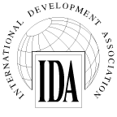
INTERNATIONAL DEVELOPMENT ASSOCIATION
100912
BOARD OF GOVERNORS

Resolution No. 236

Financial Statements, Accountants’ Report and Administrative Budget

RESOLVED:

THAT the Board of Governors of the Association consider the Financial Statements, Accountants’ Report and Administrative Budget, included in the 2015 Annual Report, as fulfilling the requirements of Article VI, Section 11, of the Articles of Agreement and of Section 8 of the By-Laws of the Association.

(Adopted on October 9, 2015)

