Report Number: 44354-TZ v2

The Urban Transition in Tanzania
Public Disclosure Authorized

Urban and Water Unit
Africa Region

World Bank
April, 2009
Table of Contents

ACKNOWLEDGEMENTS i
Preface 2
Introduction 3

CHAPTER 1 DIFFERENT PERSPECTIVES ON “URBAN” 9
Unraveling the Concept of “Urban”: The Politico-Administrative, Human Settlements, Statistical, and Density-Based Perspectives 10
Urbanization in Mainland Tanzania 14
Conclusions 20

CHAPTER 2 POVERTY AND ACCESS TO SERVICES 23
The Urban and Rural Profile 23
Trends in the Urban and Rural Profiles 25
The Urban Profile across the Four Urban Perspectives 27
The Urban Profile in Large and Small Urban Centers 32
Spatial Distribution of Urban Poverty: Evidence from 12 Urban Centers 35
Interurban Poverty Rates: How Much Variation in Poverty Is There across Urban Centers 37
Intraurban Poverty Rates: How Much Variation in Poverty Is There within Urban Centers 40
Conclusions 43

CHAPTER 3 THE URBAN CONTRIBUTION TO GDP 45
Employment 45
Urban GDP 53
Gross Domestic Product Approach 54
Urban Domestic Product Approach 56
Labor Productivity 58
Conclusions 63

CHAPTER 4 URBAN-RURAL LINKAGES 65
Introduction 65
Internal Migration Linkages 65
Urban Migration and Its Contribution to Urban Growth 67
The Profile of Urban Migrants 71
Economic Linkages 73
Fiscal Linkages 73
Remittances 84
Periurban Development 85
Definitions 85
Migration Pattern 90
Economic Activities and Employment 90
Informal Development 92
Conclusions and Policy Implications 93

CHAPTER 5 LAND DEVELOPMENT AND REGULATION 95
Introduction 95
Land Access and Land Delivery 95
Supply of Urban Land 96
Land Delivery Mechanisms 98
Land-Use Planning and Regulation 99
Informal Development 99
Land Use Planning 104
Land Use Planning in Peri-Urban Areas 108
Other Institutional Issues 110
Conclusions and Policy Implications 112

BIBLIOGRAPHY 114

List of Tables
Table 1. A Framework for Urbanization Policies 5
Table 2: Agglomeration, Urbanization and GDP Per Capita – African Countries 7
Table 1.1 Urbanization Level, by Urban Perspective, 2002 15
Table 2.1 List of Selected Urban Centers 37
Table 2.2 Poverty Rate, Selected Urban Centers, 2001 (percentages) 38
Table 3.1 Labor Force by Type of Geographic Area, 1990, 2001, and 2006 45
Table 3.2 Employment Composition in Urban and Rural Wards, 2002 47
Table 3.3 Urban Employment Composition according to the Statistical and Politico-Administrative Perspectives, 2002 48
Table 3.4 Composition of Labor Force by Economic Activity (percentages) 50
Table 3.5 Unemployment Rates by Different Definitions, 2001 and 2006 52
Table 3.6 Average Monthly Income (Wages and Non-Salary) Benfits by Industry (2001 prices, in thousands of T shs) 53
Table 3.7 Urban Contribution to Economic Growth: Gross Domestic Product Approach, 1991–2006 and 2001–06 (percentages) 56
Table 3.8 Gross and Urban Domestic Product, 1990–2006 (percentages) 56
Table 3.9 Gross Value Added per Employee, 2000/01 60
Table 4.1: Local Government Authorities Expenditures, 2003 - 2005 73
Table 4.2 Priority Expenditures: Share of Recurrent and Development items, 2006, % 74
Table 4.3 Source of Revenues of Urban and Rural LGAs in Tanzania: Cumulative Budget of 2006/07, Fourth Quarter 76
Table 4.4 Source of National Government Domestic Revenues, 2005/06 76
Table 4.5 Local Government Own-Source Revenue Instruments in Tanzania, Cumulative Budget of 2006/07, Fourth Quarter 77
Table 4.6 Local Revenue Collections by Source, 2002–2005/6 (percentages) 81
Table 4.7 Intergovernmental Transfers by Sectors in Tanzania, Cumulative Budget of 2006/07, Fourth Quarter 82
Table 4.8 Intergovernmental Transfers in Tanzania, Cumulative Budget of 2006/07, Fourth Quarter 82
Table 4.9 Local Government Expenditures in Tanzania by Sectors, Cumulative Budget of 2006/07, Fourth Quarter 84
Table 4.10 Local Government Expenditures in Tanzania, Cumulative Budget of 2006/07, Fourth Quarter 84
Table 4.11 Household Incomes in Household Surveys (percentages) 85
Table 4.12 Income Shares for Periurban Areas by Source and City 92
Table 5.1 Main Urban Land Uses and Growth Rates in Dar es Salaam, 1982-98 100

List of Figures
Figure 1.1 Urban Hierarchy in Tanzania 9
Figure 1.2 Density Population: Predominantly Urbanized Regions by OECD Country, 1994 14
Figure 1.3 Urban Patterns in Mainland Tanzania, by Urban Perspective, 2002 16
Figure 1.4 Urbanization Rate: Density-Based Perspective Sensitivity Analysis 17
Figure 1.5 Overlay between the Statistical, Politico-Administrative, and Density-Based Urban Perspectives (percentages) 18
Figure 1.6 Differential between Lowest and Highest Urbanization Levels, by Region, 2002 20
Figure 2.1 Access to Water Supply: Urban versus Rural 24
Figure 2.2 Housing Quality: Wall Material, Urban versus Rural 25
Figure 2.3 Access to Basic Services: Urban versus Rural, 1988 and 2002 26
Figure 2.4 Access to Education: Urban versus Rural, 1988 and 2002 27
Figure 2.5 Living Conditions: Politico-Administrative, Density-Based Urban Areas versus Rural Areas 29
Figure 2.6 Access to Water Supply, by Urban Perspective, 2002 30
Figure 2.7 Access to Electricity, by Urban Perspective, 2002 30
Figure 2.8 Access to Sanitation, by Urban Perspective, 2002 30
Figure 2.9 Access to Services: Density-Based Perspective Sensitivity Analysis (persons per square kilometer) 32
Figure 2.10 Living Conditions Indicators: Small versus Large Urban Centers 34
Figure 2.11 Educational Attainment: Small versus Large Urban Centers 34
Figure 2.12 LGA-level Poverty Rate and Poverty Density, 2000/01 36
Figure 2.13 Poverty Rate, Urban versus Rural Parts of LGAs, 2001 (percentages) 40
Figure 2.14 Intraurban Poverty Variation, Lowest and Highest Ward-Level Poverty Rates, Selected Urban Centers, 2001 (percentages) 42
Figure 2.15 Intraurban Poverty Variation Differential between Highest and Lowest Ward-Level Poverty Rates, Selected Urban Centers, 2001 (percentages) 42
Figure 2.16 Percentage of Urban LGA Population Poorer than Rural District Average, Selected Urban Centers, 2001 (percentages) 43
Figure 3.1 Aggregated Economic Activities in Urban Areas by Region, 2002 46
Figure 3.2 Share of Agricultural and Nonagricultural Employment, 2002 49
Figure 3.3 Sectoral Share of GDP, 1966–2006 54
Figure 3.4 Labor Productivity by Sector 59
Figure 3.5 Labor Productivity: Gross Domestic Product Approach 61
Figure 3.6 Labor Productivity: Urban Domestic Product Approach 63
Figure 4.1 Net Urban Migration Rates, 2001/02 (percentages of urban population) 68
Figure 4.2 Urban Turnover, 2001/02 69
Figure 4.3 Urban Growth Components, 1988–2002 and 2001/02 (percentages) 70
Figure 4.4 Migration Rate, Regional Headquarters (percentages of urban population) 70
Figure 4.5 Living Conditions of Urban Migrant Households, by Origin of Migrants 72
Figure 4.6 LGA Revenue Composition, 2004/05 75
Figure 4.7 Shares of LGA Expenditure, 2004/05 75
Figure 4.8 Comparison of per Capita Own-Source Revenue, Cumulative Budget of 2006/07, Fourth Quarter (T shs millions) 79
Figure 4.9 Composition of Local Government Revenues in Tanzania 80
Figure 4.10 Trend in Local Government Revenue Collections 81
Figure 4.11 Per Capita Intergovernmental Transfers, Cumulative Budget of 2006/07, Fourth Quarter 83
Figure 4.12 Periurban Areas of Kigoma: Density-Proximity Approach 87
Figure 4.13 Periurban Areas of Kigoma: Density-Ward Typology Approach 89
Figure 5.1 House Construction in Dar Es Salaam City’s Unplanned Areas 95
Figure 5.2 Estimated Supply and Demand of Plots Compared at Different Times 97
Figure 5.3 Trend in Plot Surveys, 1996/97–2000/01 98
Figure 5.4 Spatial Expansion of the Built-Up Area of Dar es Salaam, 1945–98 101
Figure 5.5 Major Land Uses in Dar es Salaam, 1982 and 1998 102
Figure 5.6 Population Density in Planned and Informal Residential Areas, 1992 103
Figure 5.7 Population Density in Planned and Informal Residential Areas, 1998 104
Figure 5.8: Procedure of Proposing and Approving the General Planning Scheme 106

List of Boxes
Box 1.1 NBS Urban Perspective: Extract from Methodology Report, 2002 Household and Population Census 11
Box 1.2 A Territorial Perspective: OECD Density-Based Urban Perspective 12
Box 2.1 High Density Settlements without Legal Status: The Case of Himo Town in the Kilimanjaro Region 28
Box 4.1 Migration in Mainland Tanzania: Methodological Approach 66

ACKNOWLEDGEMENTS

This report was produced in the World Bank’s water and urban unit for eastern and southern Africa (AFTU1), under the supervision of John McIntire, Country Director, and Jaime Biderman, Sector Manager. The report was prepared by a team guided by Matthew Glasser and led by Uri Raich. The team also included: Zhiyu Jerry Chen, Elisa Muzzini, Tara Lonnberg, and Ephrem Asebe. Background papers were prepared by Furaha Lugoe, Simen Maal, Zara Sarzin, and Wietze Lindeboom. The peer reviewers were: Paul A. Francis, Songsu Choi, and Henry Gordon.

The team wishes to thank the Tanzania authorities and scholars who contributed with information, views and precious insights. Particular thanks are due to the Prime Minister’s Office – Regional Administration and Local Government, the Ministry of Lands and Human Settlement Development, the Association of Local Authorities of Tanzania, and the Tanzania Cities Network. The team acknowledges the important inputs of many colleagues including Judy Baker, Frank Byamugisha, Ralph Karhammar, Rest Lasway, Julie McLaughlin, Barjor Mehta, David Mulongo, Siobhan Murray, Christian A. Peter, Dieter Schelling, and Nimu Waweru.

The work was conducted between November 2006 and June 2008. An intermediate review meeting took place in July 2007 and preliminary results were presented on a workshop in Dar es Salaam in January 2008. The final decision meeting was held in July 2008.

Preface

This report has been prepared at the request of the Government of Tanzania and is part of the ongoing policy dialogue between the World Bank and the Tanzanian authorities. Urban issues have been part of the Bank-GOT dialogue since the mid 1990s, when the first urban projects were approved. These projects supported policy reforms in urban management, service delivery and infrastructure investment. They also financed capacity building and infrastructure in ten cities and towns, including Dar es Salaam.

In 2004, the Bank and key donors supported the Government of Tanzania in a broader approach to help local governments invest in infrastructure. The Local Government Capital Development Grant Project combined a programmatic support with financing of community infrastructure in unplanned and under-served areas of Dar es Salaam.

In 2006, amidst the identification of a new Urban Development and Environmental Management project, the government agreed to prepare a wider analytical that would help the diagnosis and the policy debate around the urban transformation. The idea of a National Urbanization Strategy took hold as a way to understand the nature of the ongoing urban transformation and the key role that the government needs to play to promote an efficient rural-urban transformation as needed for the sustained development of the country.

This report is a contribution to that National Urban strategy. The work started in 2007 with statistical collection and preparation of background papers. The first draft was discussed with the government in middle 2008. The present version includes the results of those discussions and highlights particular issues where a wide discussion and consultation would be most valuable.

Urbanization is not new in Tanzania. Since the country gained its independence in 1961, the country has undergone substantial changes, including the growth of its cities and the migration of people from rural to urban areas. Tanzania’s urban growth rates were twice as fast the overall population growth, but this natural trend was interrupted by public policies aimed at retaining population in the rural areas ( e.g. the rural resettlement policy or villagization of the 1970s and the state ownership and allocation of land for much of the last half-century.

Local government authorities have also undergone several changes in the last four decades. In 1972, the existing local authorities were abolished, and the central government took over responsibility for the provision of basic services. Local government authorities were re-established in 1976, and new local government legislation was adopted in 1982. Since then, systems and local government management has been the object of assistance to improve efficiency and performance in their functions as local development promoters.

Introduction

1. As in most African countries, Tanzania is urbanizing rapidly. Urban population is growing at more than 3.5% a year, or twice than the average population growth, and it is expected that the urbanization rate will jump from 24% in 2002 to 30% in 2005. While definitions of urbanization lead to different conclusions, all of them confirm the trend.

2. Tanzania urbanization trend is expected and predictable. Tanzania is one of the poorest countries in Africa and one of the less dense. Since 1995 the government has taken drastic measures to open the economy, stabilize inflation and open the nation to unprecedented flows of foreign direct aid and private investment. The results has been a spectacular economic growth of about 6 percent a year during 2001 and 2006, which puts Tanzania in the second place of non-oil exporters fastest growers in Africa (after Mozambique, figure 1). And the fourth most diversified after Egypt, Morocco and South Africa (African Economic Outlook, 2007). Exports have diversified and multiplied and investment in infrastructure and communications has been revamped. Education and health are among the priorities of the government who continues to struggle to alleviate extreme poverty among 30% of its population.
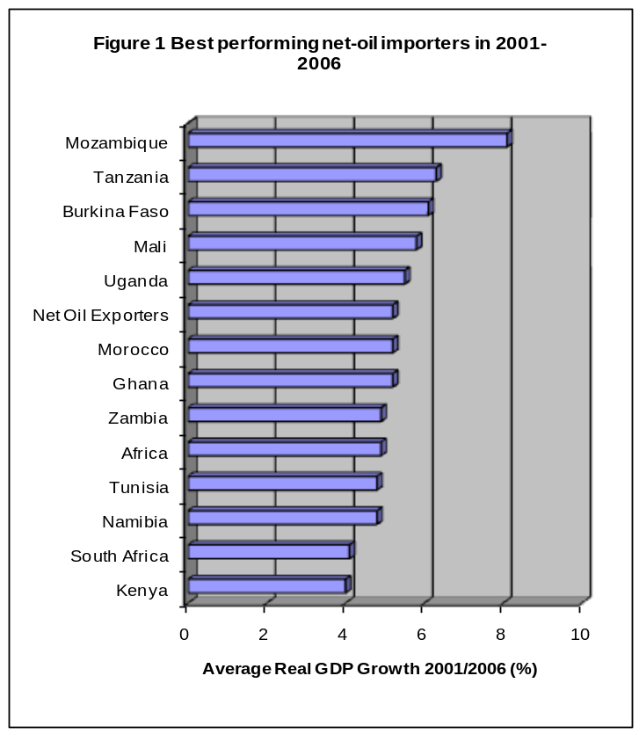
3. The impact of this accelerated growth on urbanization is predictable and part of this development process. Take the case of China, urbanization rates increased significantly since 1995 when China was becoming the world’s manufacturing plant through attracting FDI (Zang, 2008). As well established in the literature and empirical evidence, productivity increases and prosperity require and lead to spatial concentration of production and employment and firms benefit from proximity and agglomeration economies and so do workers and consumers. This economic development and the capacity of the country to sustain high level growth will depend in large part in the capacity of Tanzania cities to respond to the task of helping firms to proper, workers to find jobs and production to enjoy the benefit of agglomeration economies

4. The urban transformation that is in full motion in Africa economies will bring fruition to both cities and rural areas. The latter will benefit from wider markets for their products, greater purchasing power, employment opportunities for their labor surplus and endless opportunities for creative synergies, including remittances from urban workers and demand for non-agricultural farming products.

5. This report tries to shed some light to these trends and transformations. It draws from the framework of the recent World Development Report (Reshaping Economic Geography) to get some insights of how well the urbanization process in unfolding and whether the conditions for efficiency concentration are being met or whether institutional or policy hurdles are hindering the capacity of the country to fully exploit the benefits of density.

6. The report is organized in four chapters. This introduction presents the problem, describes the analytical framework, the African and World Context and the characteristics that need to be present for a responsible and effective urbanization. Chapter 1 discusses the issues involved in measuring urban growth and density and the problem of under-measuring density Chapter introduces key aspects of the recent urbanization in Tanzania, including migration, structure of economy and employment and the estimation of the urban contribution to GDP. Chapter 3 discussed the backbone of any urbanization policy – land management and land markets and how the government is in a position to drastically improve the main constraint of a healthy urbanization process – by unleashing urban land supply and providing the urban actors with the most needed factor: serviced urban land.

7. Chapter 4 discusses the universal provision of basic services and the general picture for rural and urban Tanzania at present. We will discuss the origin of these differences and what would take to achieve convergence of living standards in terms of policies and investment. Chapter 5 discusses the need for substantial infrastructure to improve mobility and connectivity and the funding potential of the different players in the urbanization process, including central and regional authorities. We review the decentralization system in place in Tanzania, the potential to improve the incentives of the local government to improve their capacity to fund additional services, and the nature of the inter-governmental fiscal transfers. Chapter 6 closes the report with conclusions and recommendations.

8. Important issues have been left out of this report: the growth of slums and pre-emptive strategies, local economic development, the need for connectivity infrastructure, and the ongoing changes within cities, specially the changing spatial structure within cities. They will be dealt with in subsequent studies leading to the National Urban Strategy.

Analytical Framework

9. The recent WDR 09 (Reshaping economic Geography) suggests that no developed country has reached their current per capita income without urbanization and vibrant cities. Two hundred years of history of developed countries and plenty of empirical evidence shows that economic growth and density go together (Figure 2) It also suggests that the development process in bumpy and unbalanced but can be inclusive When growth begins, production and employment tends to be concentrated in selected regions and incomes diverge. However, successful countries have been able to ensure a balanced distribution of wellbeing by providing social services across space. Empirical evidence suggests that convergence occurs first in terms of household consumption, then in terms of social services, then in income.

10. Efficient urbanization requires different policies according to the density level of each areas and the context and sequence of policies. The framework provides the organizing principle for the review: growth occurs with concentration of economic activity and policy makers need to facilitate density even if this looks counterintuitive in terms of spatial balance. “The main issue is how to harness the market forces to produce density while achieving integration between urban and rural regions. The set of policies to achieve this include institutions (land and basic services), infrastructure and intervention.” (WDR09, Overview)

11. Governments use that set of policies according to the level of urbanization and density of a particular area. For low density areas, the key instrument is the existence of good institutions that guarantee land property rights, working land markets and universal provision of basic services. As urbanization picks up, areas need not only good institutions but also investment in infrastructure and connectivity to avoid congestion and promote the sharing of prosperity. At high levels of urbanization, the recommendation is for governments to pay attention to particular areas that require specific and targeted actions as the case of slums. Table 1 below summarizes the framework suggested by the WDR09 and supported by ample empirical evidence.

Table 1. A Framework for Urbanization Policies
 | Area
 | Incipient Urbanization | Intermediate urbanization | Advanced urbanization
Urban shares | Less than 25% | About 50% | More than 75%
Dimension of policy  Challenge | Build density | Build density, reduce distance | Build density, reduce distance, eliminate division
Instruments for integration
Institutions | Land rights; basic education, health and water and sanitation | Land use regulations; universal provision of basic and social services | Land use regulation and land taxation; universal provision of basic services
Infrastructure |  | Transport infrastructure | Transport infrastructure; demand management
Interventions |  |  | Slum area development; targeted programs to reduce crime and environmental degradation
Source: WDR09

12. Tanzania rural areas will continue to play a substantial role in terms of growth and equity. Its large agricultural sector that accounts for more than 40% of GDP will remain critical for overall economic growth and poverty reduction. Better infrastructure is crucial to raise agricultural productivity and facilitate access to markets for agricultural products.

The African Context

13. Africa is urbanizing very fast. Over the next twenty years, Africa’s urban areas are forecast to accumulate an extra 290 million residents, bringing the total number of urban residents to 590 million (UNDESA, 2007). According to Glasser and Farvacque (2009), urbanization levels in Africa are still relatively low by global standards – with low population densities and levels of agglomeration. Most of Africa’s urban population resides in cities of 500,000 people of less, but the urban share of larger cities has been growing for the last 30 years and continues. Economic production is relatively sparsely distributed – with a few exceptions in South Africa and along the coast of West Africa. Done right, urbanization can help improve the prospects of the African continent and help it to reach the living standards of relatively more developed regions.
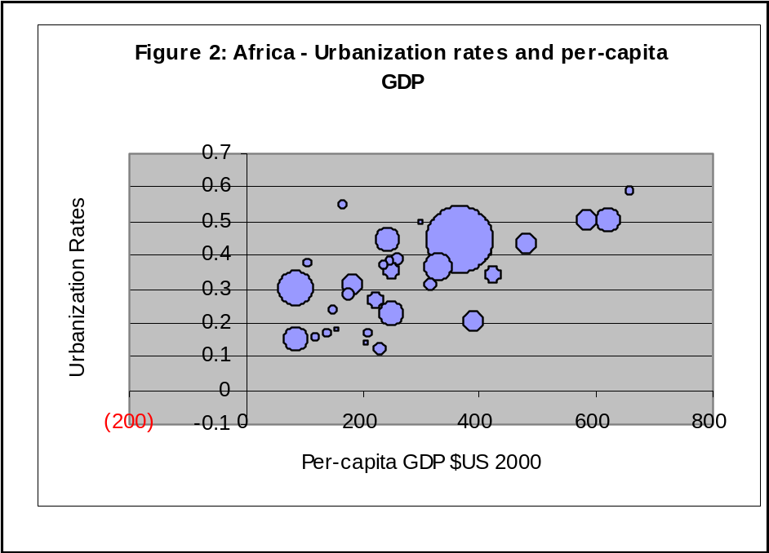

14. Africa faces sever spatial challenges. First, its low density plays against agglomeration economies that are at the center of productivity growth. Second, long distances between countries – due to temperature, deserts and colonialism – have been compounded by armed conflicts that has put a great burden in population displacements and even increased the long distances to density. Second, the partitioning of Africa in 1884 left the continent with the most countries per square kilometer of any region in the world. Each African country has an average of four neighbors; in Latin America the average is 2.3. The region is hurt by low density, long distance and deep divisions. These spatial dimensions reduce proximity between economic agents within Sub-Saharan Africa and between Africa and the rest of the World (WDR09).

15. The average population density in Africa (77 people per Km2) is among the lowest in the world. As mentioned in the WDR09, “a sparsely inhabited continent can overcome this by using its land and people well and by concentrating resources in urban agglomerations. But Africa is the world’s least urbanized continent with only one-third of the population living in urban areas in 2000, while the world average in one-half.

16. Contrary to some thinking, urbanization, done right can help development more in Africa than elsewhere. Despite five decades of low-quality urbanization, living standards in Africa’s cities are much higher than in the countryside. If urbanization can be managed better, along the lines proposed above, significant giants can be expected in productivity and poverty reduction.

17. Several pieces produced recently indicate a set of priorities to guide the urban transformation. First. It is evident that urbanization in Africa (and Tanzania especially) is still very low by global standards. Economic production is relatively sparsely distributed. Within cities, informality, together with slums, are a problem and urban infrastructure and service deficiencies continue to hinder economic development. Second, the discussion on whether urbanization is good for development in Africa seems to have come to a rest. Development requires concentration of production and jobs and the relatively richer African countries are certainly the most dense. Third, the priority for policy makers is to try to solve the critical deficiencies in infrastructure and services not only within but between urban areas. These problems have deepened by unplanned growth which renders upgrading so costly and alert us for the urgency to plan pre-emptively for growth (Glasser and Farvacque, 2008).

Table 2: Agglomeration*, Urbanization and GDP Per Capita – African Countries
 | Agglomeration Index | Urbanization | Rank in | (Const US$) | Rank in | (PPP) | Rank in
 | (2000) | (2000) | Urbanization | (2000) | GDP | (2000) | PPP
Zimbabwe | 0.33 | 0.34 | 18 | 587 | 5 | 2498 | 2
Guinea | 0.25 | 0.31 | 20 | 369 | 12 | 1974 | 3
Ghana | 0.37 | 0.44 | 7 | 250 | 19 | 1920 | 4
Mauritania | 0.27 | 0.40 | 11 | 409 | 9 | 1894 | 5
Cameroon | 0.41 | 0.50 | 4 | 678 | 2 | 1877 | 6
Gambia, The | 0.46 | 0.49 | 6 | 320 | 14 | 1631 | 8
Cote-d'Ivoire | 0.37 | 0.43 | 9 | 622 | 4 | 1582 | 9
Sudan | 0.31 | 0.36 | 16 | 376 | 11 | 1506 | 10
Angola | 0.27 | 0.50 | 5 | 660 | 3 | 1462 | 11
Senegal | 0.48 | 0.41 | 10 | 424 | 7 | 1427 | 12
Togo | 0.31 | 0.37 | 15 | 248 | 20 | 1358 | 13
Uganda | 0.25 | 0.12 | 14 | 244 | 21 | 1167 | 15
Kenya | 0.27 | 0.20 | 28 | 414 | 8 | 1033 | 17
Burkina Faso | 0.14 | 0.17 | 31 | 230 | 23 | 986 | 19
Benin | 0.36 | 0.38 | 12 | 313 | 15 | 974 | 20
Rwanda | 0.11 | 0.14 | 35 | 226 | 24 | 931 | 21
Nigeria | 0.43 | 0.44 | 8 | 391 | 10 | 854 | 23
Madagascar | 0.18 | 0.26 | 25 | 239 | 22 | 843 | 24
Ethiopia | 0.11 | 0.15 | 34 | 122 | 34 | 814 | 25
Mozambique | 0.25 | 0.31 | 21 | 211 | 25 | 799 | 27
Zambia | 0.30 | 0.35 | 17 | 303 | 16 | 785 | 28
Niger | 0.16 | 0.16 | 32 | 153 | 31 | 678 | 30
Burundi | 0.18 | 0.09 | 33 | 109 | 35 | 650 | 31
Malawi | 0.18 | 0.15 | 33 | 151 | 32 | 583 | 33
Tanzania | 0.26 | 0.22 | 27 | 261 | 17 | 524 | 34
Note: Agglomeration index with density more than 150 people/km2, distance one hour, population more than 50,000.

CHAPTER 1 DIFFERENT PERSPECTIVES ON “URBAN”

The percentage of people living in Tanzania’s urban areas will grow from 24 percent in 2005 to 38 percent in 2030 (UN, 2002). During 2005–30, the average population growth rate is expected to be 1.6 percent, while the growth rate in the urban population is expected to be 3.4 percent. By 2030 more than 20 million Tanzanians will be living in cities. Because the UN calculations of urbanization do not use a consistent or standardized definition of “urban area,” but rely on each country’s definition, they must be carefully interpreted. More conservative calculations (Bocquier 2005) estimate that by 2030, the urban population will increase only to 29 percent, which would be equivalent to 16.6 million people living in urban centers.

Some 40 percent of Tanzania’s urban is to be found in Dar es Salaam. As figure 1.1 shows, Dar es Salaam has a very high level of primacy: in 2002 it was 5.2 times the size of the next largest city (Mwanza). Close to 70 percent of the money circulation in Tanzania is concentrated in Dar es Salaam. This primacy drives most of the urban statistics in Tanzania.

Figure 1.1 Urban Hierarchy in Tanzania
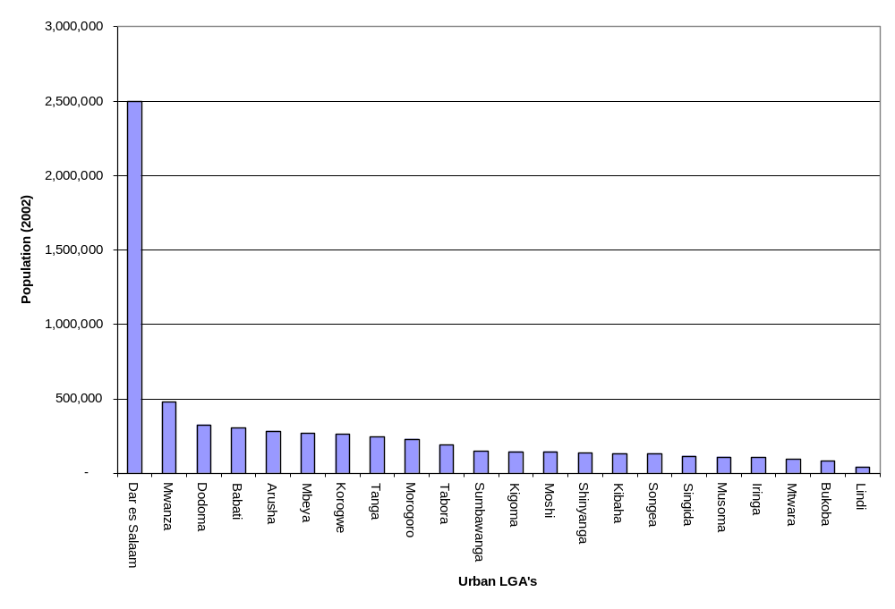
Source: Authors’ calculation based on census data

There is no internationally accepted standard for urban areas. Even within one country, there is often more than one definition in use at any given time. The UN argues that “given the variety of situations in the countries of the world, it is not possible or desirable to adopt uniform criteria to distinguish urban areas from rural areas” (UN 2002, 106). Each country has its own definition—or none at all—of what constitutes an urban area (World Bank, forthcoming). This chapter discusses four different perspectives through which the urban transition can be examined in mainland Tanzania and their implications in terms of urbanization patterns and policy formulation.

Unraveling the Concept of “Urban”: The Politico-Administrative, Human Settlements, Statistical, and Density-Based Perspectives
Three different perspectives on “urban” have been adopted in mainland Tanzania. They are the politico-administrative perspective, adopted by the Prime Minister’s Office, Regional Administration and Local Government (PMO-RALG); the human settlements perspective, embraced by the Ministry of Lands and Human Settlements Development (MoLHSD); and the statistical perspective, adopted by the National Bureau of Statistics (NBS). The three perspectives differ primarily in their spatial unit of analysis. PMO-RALG applies its own categorization of “urban” to politico-administrative entities, the local government authorities (LGAs); the MoLHSD focuses on settlements as the spatial unit of analysis; and the NBS applies the concept of “urban” to enumeration areas (EAs), the smallest statistical unit of analysis in the population and household censuses. None of the three perspectives explicitly accounts for population density. A fourth perspective, using an OECD population density criterion is therefore examined and contrasted with the three above-mentioned urban perspectives.

The politico-administrative perspective. The PMO-RALG urban perspective has its legal base in the Local Government (Urban Authorities) Act 1982 (as amended) (“The Local Government Act”). The Local Government Act provides that “ . . . the Minister may, by order published in the Gazette, establish in any area of mainland Tanzania an appropriate urban authority.” In exercising its functions, “the Minister shall comply with the national policy on the development of urban areas.” Urban LGAs with legal and autonomous status include cities, municipalities, and town councils. (The list of urban LGAs based on the politico-administrative classification is provided in appendix 1.)

The human settlements perspective. The MoLHSD is the custodian of the National Human Settlements Development Policy 2000 (NHSDP). The NHSDP provides a classification of human settlements “ . . . based on population size, level of services, economic base and level of sustenance in annual budget.” Based on the NHSDP, the urban hierarchy in Tanzania comprises four urban strata: cities, municipalities, towns, and townships (or district headquarters). (The MoLHSD list of urban authorities is provided in appendix 1.) Although the first three urban strata overlap with the politico-administrative classification of urban centers, the MoLHSD recognizes a fourth urban stratum: the townships or headquarters of the district councils (that is, the rural LGAs). Townships operate under the district councils and have a semiautonomous status (that is, they have an elected council, but they do not have a budget independent from the district council). The hierarchy of urban centers laid out in the NHSDP is meant to “ . . . facilitate an equitable appropriation of resources and distribution of services within a country.” The government of Tanzania is expected to “ . . . facilitate availability of resources for provision of services and infrastructure to urban centers according to their rank and their development potential and attract investors to locate their investments there” (Tanzania, MoLHSD 2000, 32).
The statistical perspective. The NBS perspective on “urban” is more fine-grained than the two above-mentioned categorizations because it is based on a smaller spatial unit: the enumeration area (EA). The principle followed by NBS in delineating EAs is that “ . . . under no circumstance should an EA cut across the existing boundaries of regions, districts, wards and villages” (Tanzania, NBS 2002). This implies that politico-administrative boundaries can be recomposed for analytical purposes by aggregating EAs. NBS defines an EA as a geographical area or community with a population size of 300–900 individuals. EAs are classified as “urban” or “rural.” This classification is made by the Region Census Committees. Urban EAs are located within a predominantly urban area, contain 300–500 individuals, and usually have their own markets and social service providers (for example, schools and health centers) serving the surrounding vicinity. Rural EAs lack these amenities and contain 700–900 individuals (World Bank 2006b, 90). The NBS classification of EAs is the basis for all nationally representative surveys relying on the National Sampling Framework for sampling purposes. (See box 1.1 for further details on the NBS criteria for classifying EAs as applied to the 2002 Population and Household Census.)
Box 1.1 NBS Urban Perspective: Extract from Methodology Report,
2002 Household and Population Census
More than one criterion was used to define urban areas. All regional and district headquarters were by definition urban areas. The boundaries of these headquarters were identified by two pieces of legislation, namely, the Village Act, 1975, and the Urban Ward Act, 1976, which divided the entire country into urban and rural wards. Some wards adjacent to urban boundaries were also included in urban areas if it were felt that these wards had urban characteristics; i.e., they exceeded certain minimal level of size-density criterion and/or they had “ . . . specialist functions, generally of nonagricultural sort, with many of [their] inhabitants in non-agricultural occupations: many of [their] buildings used for non-domestic purposes (shops, garages, places of entertainment, factories, etc.).” The size-density criterion was vague in so far as no specific numerical values of size and density were identified. The decision of inclusion or exclusion of such wards in urban areas was made by the District/Regional Census Committees. In addition to the regional and district headquarters, certain other areas were included in urban areas. The decision as to whether a certain area was urban or rural was made by the Regional/District Census Committees.
It is also important to note that at times the entire area of a ward other than the wards falling in a regional or district headquarters could not be categorized as urban or rural. These wards were designated as “mixed wards” for the purpose of the census. The Regional/District Census Committees were authorized to identify which enumeration area(s) in such wards should be considered urban. To summarize, the following areas were included in the urban areas in 1978:
(i) Regional and district headquarters with boundaries as identified by the Village Act, 1975 and Urban Ward Act, 1976.
(ii) Areas which fell outside the boundaries of the headquarters but bore physical proximity to them and met (unspecified) size-density criterion and/or possessed other urban characteristics as laid out in an earlier paragraph.
(iii) Areas which did not bear physical proximity to any other urban area but met (unspecified) size-density criterion and/or possessed other urban characteristics as laid out in an earlier paragraph.
Source: Extract from Tanzania, NBS (2002), Methodology Report.
The density-based perspective. Population density is an important gradient in delineating the urban-rural nexus because it can generate the agglomeration economies that are defining features of urban centers. According to the Organization for Economic Co-operation and Development (OECD), a density-based definition of “urban” also has the advantage of being policy-neutral. For these reasons, a fourth urban perspective, based on the OECD population-density threshold, is considered in this study and contrasted with the three other urban perspectives. The OECD adopts a cutoff point of 150 people per square kilometer for all OECD countries (with the exception of Japan); all settlements with population density above that threshold are considered “urban” (OECD 1994). (Figure 1.2 presents average population densities for predominantly urbanized areas in OECD countries. See box 1.2 for a description of OECD methodology.)
Box 1.2 A Territorial Perspective: OECD Density-Based Urban Perspective
The OECD treats “urban” as a spatial or territorial concept. As a result, OECD’s classification of “urban” is not restricted to any particular use of land, degree of economic health, or agriculture-based definition. The OECD’s territorial perspective was developed in the context of the Project on Rural Indicators, conducted in 1994, with the objective of “creating a common international vocabulary and information pool” for rural analysis and policy formulation. As part of this exercise, a conceptual framework was developed, establishing a territorial scheme and identifying a basic set of rural indicators. While the Project was primarily devoted to rural policy formulation, the underlying territorial scheme was structured neutrally, in such a way that could also be used for other purposes, such as for urban or regional statistics.
First, the OECD scheme identifies two “hierarchical levels of geographic detail”: local community level and regional level. The Project selected population density as the most relevant and practical criterion for identifying rural local communities (that is, the lowest hierarchical level of geographical detail). This approach is justified on the ground that population density has the advantage of being policy-neutral, because “ . . . it does not refer to any specific perception of what the rural problems and potentials are.”
To distinguish between rural and urban communities, a quantitative density threshold was determined. The density threshold was set at 150 inhabitants per square kilometer for Europe, North America, Australia, and New Zealand, and 500 inhabitants per square kilometer for Japan. While acknowledging that “setting thresholds always involves some arbitrary judgment,” the decision to use 150 (500 in the case of Japan) as the dividing line was based on a series of considerations that took into account the following:
  - Population density thresholds used by member countries and other international organizations, such as Eurostat (varying between 100 [EC] to 700 [Luxembourg])
  - The national distributions of local community population and area over a gradient of different population-density classes
  - The wide range of settlement patterns across the OECD
The share of rural population was not found to be sensitive to small changes in the threshold, because changing the thresholds to 100 or 200 per square kilometer did not lead to major changes in the share of rural population. Because regions comprise both rural and urban communities, regions were classified for the purpose of the Project as “predominantly rural,” “significantly urban,” and “predominantly urban,” based on the share of population living in rural communities. For the typology of regions, the following thresholds were used: “predominantly rural,” if more than 50 percent of the population lives in rural communities; “significantly rural,” if the share of rural population is between 15 and 50 percent; and “predominantly urbanized,” if less than 15 percent of the population is classified rural.
Source: OECD 1994.
Note: Figure 1.1 presents the average population density in predominantly urbanized areas, by OECD country.
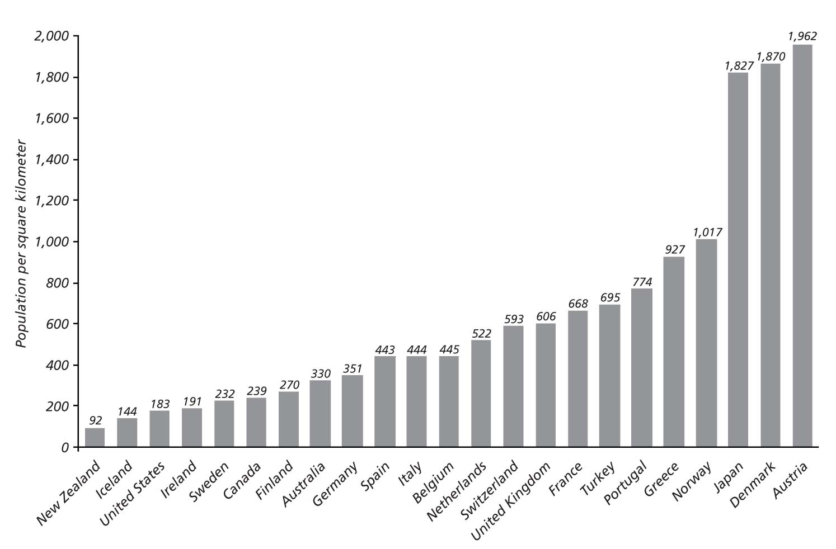
Figure 1.2 Density Population: Predominantly Urbanized Regions
by OECD Country, 1994
Source: OECD 1994.

Urbanization in Mainland Tanzania
In this section, the four urban perspectives outlined in the previous section are mapped, and the underlying urbanization patterns are contrasted and compared, drawing on the population and housing census data.
The urban population in mainland Tanzania quadrupled during 1967–2002. According to the latest four population and housing censuses, the urban population in mainland Tanzania increased from 5.7 percent in 1967 to 22.6 percent in 2002. The comparability of the urbanization levels rests on the assumption that the NBS methodology for defining urban EAs is consistently applied throughout 1967–2002. However, the NBS reliance on predominantly qualitative criteria for EA classification suggests that methodological changes may have occurred since 1967 (box 1.1). Nevertheless, NBS data provide the best available estimates of urbanization trends in mainland Tanzania. As of 2002, urbanization exceeds the national average level (22.6 percent) in three regions: Dar es Salaam, Arusha, and Morogoro, where 94, 31, and 27 percent of the population, respectively, is estimated to live in urban areas. Kagera (6 percent) and Shinyanga (9 percent) are the regions with the lowest levels of urbanization.
Different urban perspectives imply different urbanization levels, ranging from 16.8 to 33.5 percent (table 1.1). The politico-administrative and density-based perspectives result in the highest and lowest estimated urbanization, respectively. The human settlements and the statistical perspectives yield similar and intermediate urbanization levels. Figure 1.3 visually displays the spatial distribution of urban areas based on the four different urban perspectives. The statistical urban perspective, which is EA-based, has been mapped at the ward level, given that the ward is the lowest level of mapping resolution. As shown in Table 1.1, the adjustment does not affect the accuracy of the mapping exercise, given the very small difference in the level of urbanization between the EA- and ward-based statistical urban perspectives. The mapping is likely to slightly overestimate the urbanization of the human settlements perspective, resulting from the adjustment made to fit the resolution of the maps. (See appendix 2 for a summary of the main assumptions made for the mapping exercise). Sensitivity analysis has also been conducted to show how the urbanization level under the density-based perspective is affected by changes in the density threshold: the analysis indicates that urbanization is sensitive to changes in the minimum threshold, but significantly less so for density above 300 persons per square kilometer (figure 1.4).
Table 1.1 Urbanization Level, by Urban Perspective, 2002
Urban perspective | Urbanization  (percentage) | Urban space |  | Average density  (persons/km2)
Urban perspective | Urbanization  (percentage) | Total km² | Percentage of mainland territory | Average density  (persons/km2)
Statistical
EA-based | 22.8 | — | — | —
Ward-based | 20.7 | 27,081 | 3.1 | 260
Politico-administrative | 16.8 | 6,937 | 0.8 | 807
Human settlements | 23.5 | 41,769 | 4.7 | 186
Density-basedª | 33.5 | 27,445 | 3.1 | 415
Source: Authors’ calculations based on census data.
Note: — = not available.
a. 150 persons/km².
Figure 1.3 Urban Patterns in Mainland Tanzania, by Urban Perspective, 2002
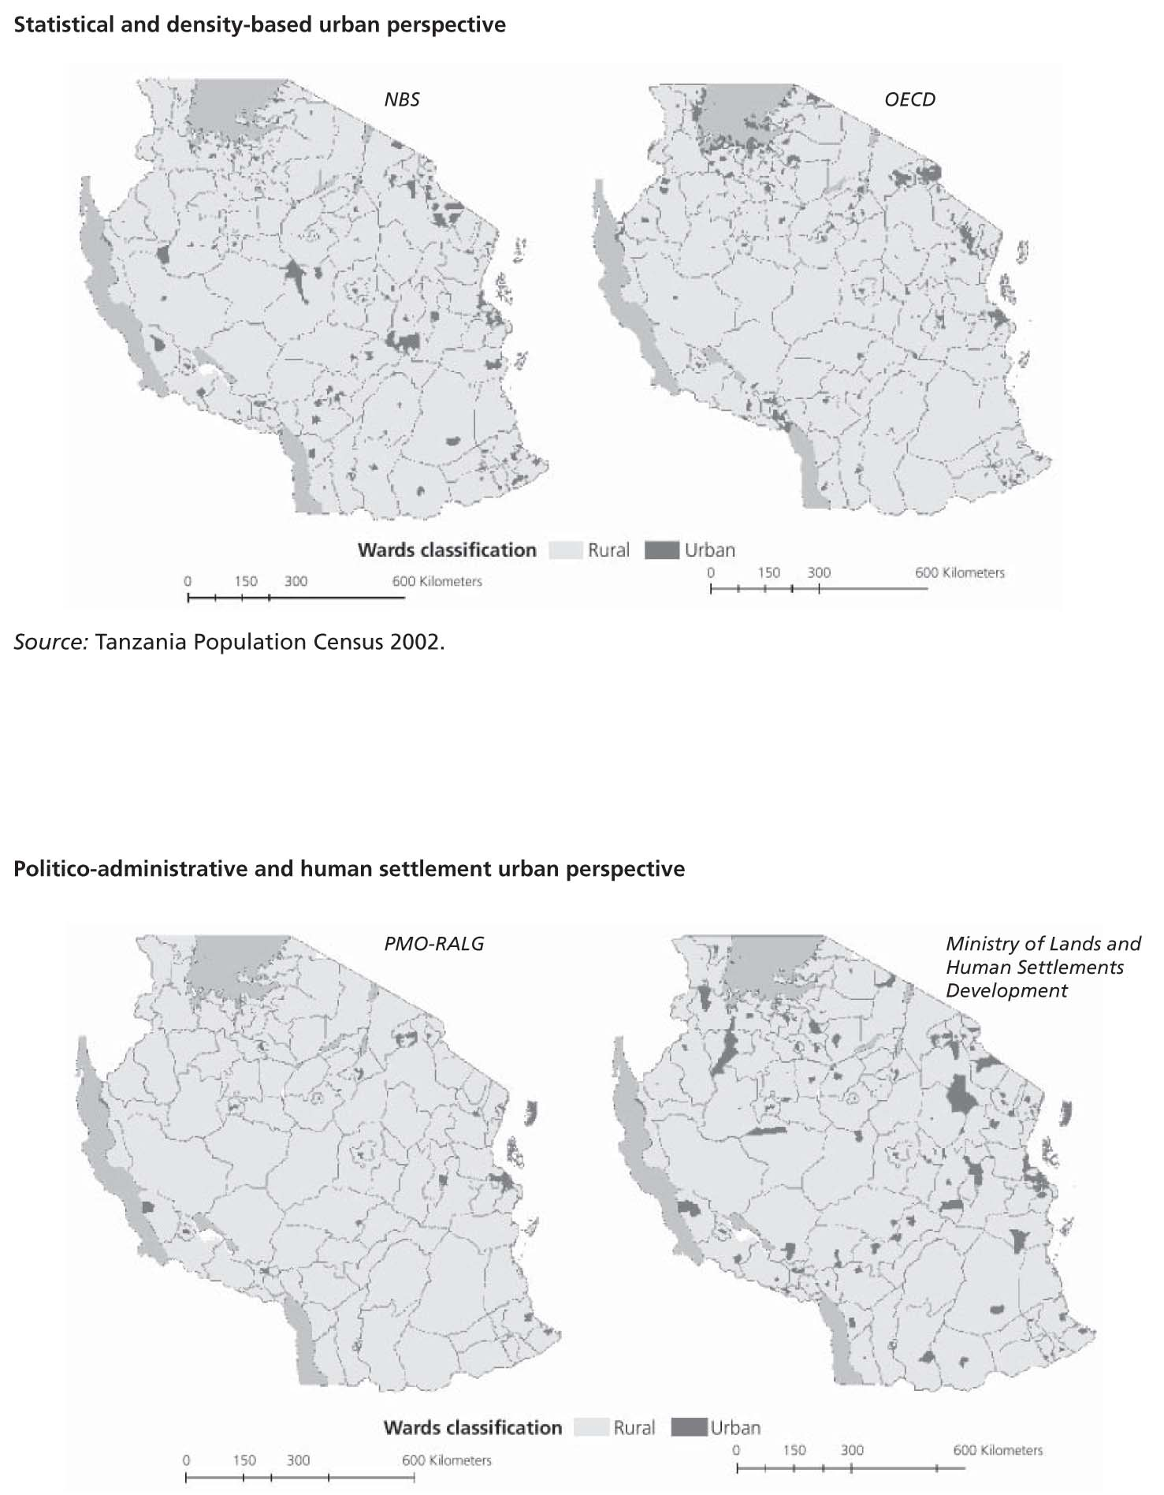
Source: Tanzania, NBS 2002.
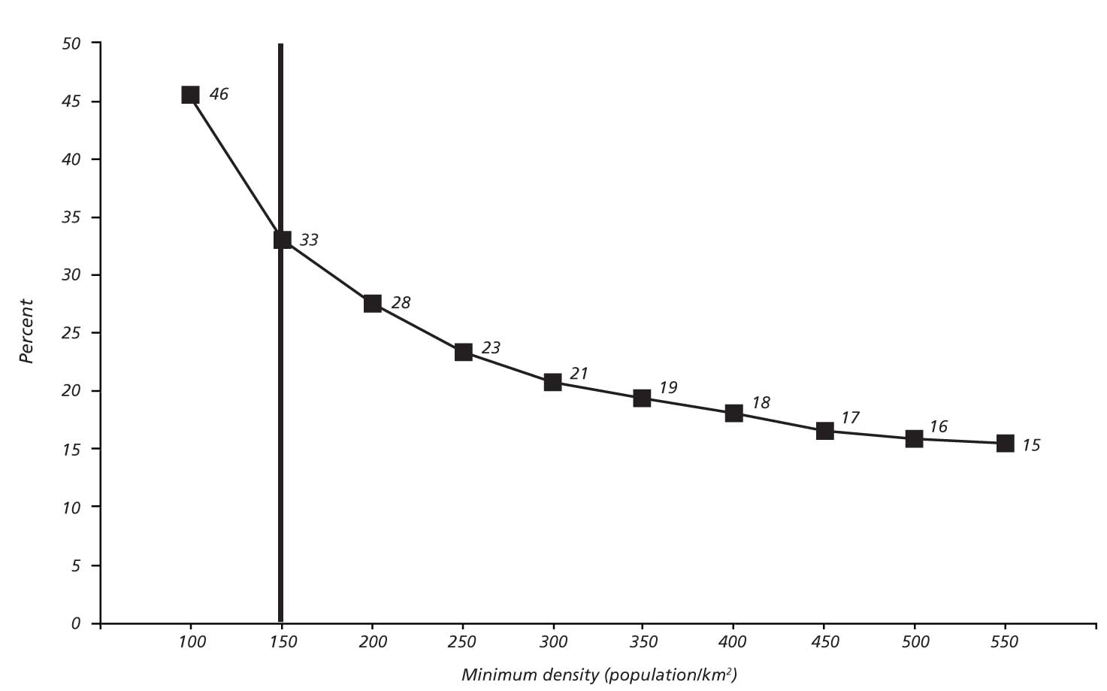
Figure 1.4 Urbanization Rate: Density-Based Perspective Sensitivity Analysis
Source: Authors’ calculations based on census data.
Both the statistical and politico-administrative urban perspectives fail to identify as “urban” a significant share of the population living in high-density settlements. Overlaying the statistical and density-based perspectives reveal some degree of overlap: 18.7 percent of the population meets both urban definitions. On the other hand, 14.8 percent of the population lives in high-density settlements that are not considered “urban,” based on the statistical perspective (figure 1.5). Hence, the statistical perspective fails to account for a significant portion of the population that would be categorized as “urban,” based on a density criterion. Overlaying the politico-administrative and the density-based perspectives yields similar results: on one hand, virtually all of the urban population based on the politico-administrative perspective lives in high-density areas; on the other hand, an additional 17.2 percent of the population in mainland Tanzania lives in high-density areas that are not considered “urban,” based on the politico-administrative perspective.
Different urban perspectives also imply different average urban densities. Urban areas based on the politico-administrative perspective have the highest average density (807 people per square kilometer), followed by urban areas based on the density perspective (415 people per square kilometer). Urban areas based on the human settlements and statistical perspectives have the lowest average density (260 and 186 people per square kilometer, respectively) (table 1.1). The findings imply that townships that are considered “urban” based on the human settlements perspective (but not according to the politico-administrative perspective) have significantly lower densities than the politico-administrative urban areas (that is, cities, municipalities, and towns). More surprisingly, the results imply that most urban areas that are classified as “urban” based on the statistical and human settlements perspectives do not meet the OECD threshold (150 people per square kilometer) because they have (on average) lower densities that the urban areas based on the density perspective. Overall, the empirical findings suggest that (a) there is limited spatial overlap between the urban areas under the OECD perspective and the urban areas under the three other perspectives and (b) the OECD threshold is well above what is considered the minimum density for urban areas based on Tanzanian standards. There is also a striking difference in the urban space (in square kilometers) across the four perspectives. As a share of the mainland territory, the urban space varies from 0.8 percent of the territory under the politico-administrative perspective to 4.7 percent under the human settlements perspective.
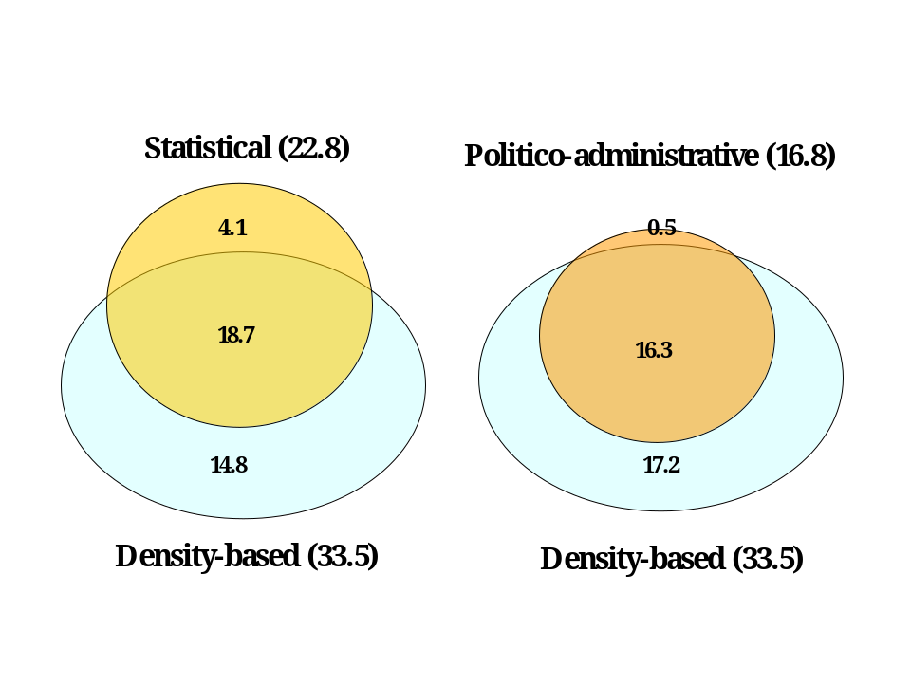Figure 1.5 Overlay between the Statistical, Politico-Administrative,
and Density-Based Urban Perspectives (percentages)
Source: Authors’ calculations based on census data.
The politico-administrative perspective may systematically underestimate urbanization. The politico-administrative perspective gives the lowest urbanization rate in 19 out of 21 regions. In addition, in 6 out of the 7 regions where the highest differential in urbanization is found across urban perspectives, the politico-administrative perspective yields the lowest urbanization estimate. This suggests that the politico-administrative perspective may systematically underestimate the level of urbanization compared with the three other perspectives.
Different urban perspectives imply different spatial patterns of urbanization. The four different urban perspectives result not only in different urbanization levels but also in different spatial patterns of urbanization. As shown in figure 1.3, the politico-administrative perspective features the most dispersed urbanization pattern, as well as the lowest number of urban centers. The highest degree of clustering of urban centers is observed when the density-based perspective is adopted. Based on the density perspective, clusters of urban areas are found in and around Dar es Salaam, Korogwe and Lushoto (Tanga region), Kilimanjaro region, and Arusha Town (Arusha and Arumeru); on the shores of Lake Victoria; and in Rungwe and Kyela districts (Mbeya region) toward Lake Malawi. The statistical and human settlements urban perspectives result in similar spatial patterns of urbanization. As shown in figure 1.3, the two perspectives both identify an urban southern belt from Morogoro along the road to Iringa and continuing to Mbeya. On the other hand, the human settlements perspective includes urban areas in the Sikongo district (Tabora region) and in the Bokombe district (Shinyanga region), which are not marked as “urban” in any of the other maps.
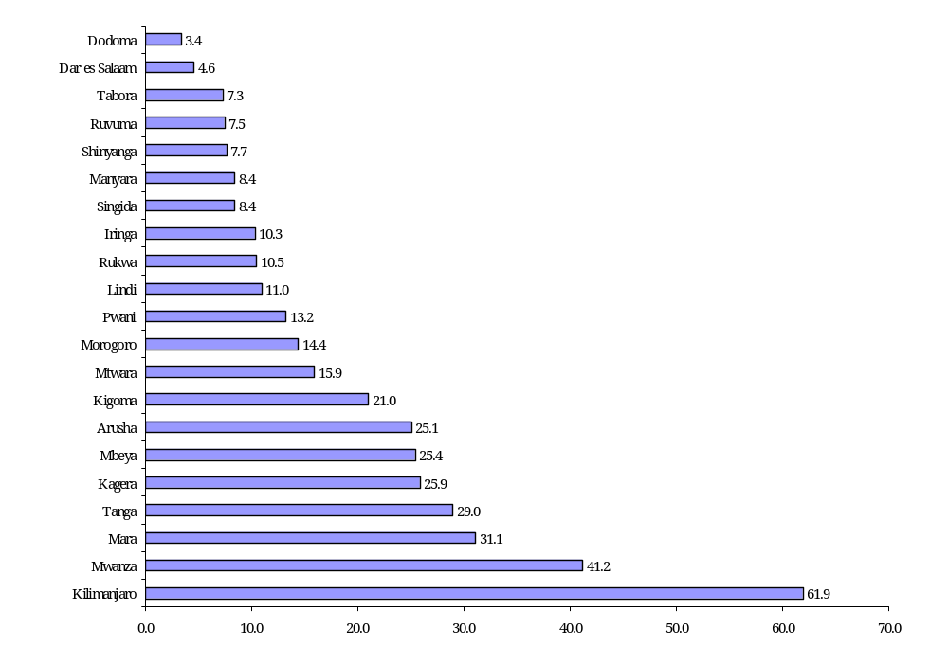
Figure 1.6 Differential between Lowest and Highest Urbanization Levels, by Region, 2002
(percentage points)
Source: Authors’ calculations based on census data.

Conclusions
Relying on urban LGA boundaries significantly and systematically underestimates Tanzania’s urbanization. The largest difference in perspectives on urbanization is found between the politico-administrative perspective (16.8 percent) and the density-based perspective (33.5 percent).
One key policy implication of this conclusion relates to the design of any inter-governmental transfer designed to address the investment needs of urban areas. If fiscal resources are targeted only to urban LGAs (as was proposed under the UDEM framework), then these resources would not benefit people living in relatively high-density areas in rural LGAs. An alternative would be to design an urban grant for the benefit of population centers, regardless of their legal-political status.
A second key policy implication relates to national strategies for growth and economic development. The tremendous economic potential of the relatively dense areas outside of urban LGA boundaries is probably not adequately recognized. These relatively dense areas, particularly when they are reasonably near dynamic urban centers like Dar es Salaam, can generate agglomeration economies which contribute disproportionately to economic growth and transformation. Further analysis could explore the economic justification for adjusting the intergovernmental fiscal framework, e.g. through an urban grant or through fine-tuning the existing Local Government Capital Development Grant (LGCDG) allocation formula, to provide these relatively dense areas with better access to the basic services (e.g. water supply and electricity) that relate directly to productivity.
A third key policy implication relates to regulatory strategies, including those for land use and planning. To the extent that powers and functions of LGAs or regulatory bodies vary, as between urban and rural LGAs, these differences may be inappropriate as to relatively dense areas in rural LGAs. These areas will face many of the same challenges as do urban LGAs, and perhaps even more serious competition for land.
A simple strategy, which could address the above policy implications at least in part, would be to expand the boundaries of urban LGAs to include dense adjacent areas. This would have the advantage of applying the fiscal and regulatory regimes that are designed for urban areas applicable to such areas. However, this risks being a reactive strategy that is always playing “catch-up” with evolving facts on the ground.
A more complex strategy would be to examine each policy issue in turn, and determine e.g. what fiscal arrangements, what development strategies, and what regulatory approaches should be applied to “urban” areas of different types. This strategy would require significant and on-going Government commitment to the analytic, strategic, and implementation challenges of urban policy. Among other things, an institutional home for this urban effort would be needed.

CHAPTER 2 POVERTY AND ACCESS TO SERVICES

This chapter is divided into two sections. Section one analyzes selected indicators from the 2002 and 1988 population and housing censuses to address the following questions: Does being “urban” translate into a distinct advantage in terms of access to basic services, such as improved water supply, sanitation, electricity, and housing quality? Has the urban advantage deepened or lessened over time? To what extent does the urban advantage vary with the urban perspective adopted? What is intrinsically urban about small towns? Section two looks into inter- and intraurban poverty rates across a sample of 12 urban centers that are representative of the geographical and size distribution of urban centers in mainland Tanzania.

The Urban and Rural Profile
Water supply and electricity. There is a marked gap between urban and rural areas in access to improved water supply and electricity. Rural households lag significantly behind urban households with respect to access to basic infrastructure services. In urban areas, about 85 percent of urban households have access to improved water supply, compared with 43 percent of households in rural areas (figure 2.1). Remarkable urban-rural differences also emerge with respect to access to electricity: 34 percent of the urban population has access to electricity, against only 1.3 percent of the rural population.
Despite the urban-rural gap, urban electrification in Tanzania is low, compared with the Sub-Saharan African average. On average, about 50 percent of the urban population in Sub-Saharan Africa is estimated to have access to electricity, well above the 34 percent urban electrification rate for mainland Tanzania (Donkor 2006). The low level of electrification damages the potential of urban economies by affecting productivity and firms’ location decisions.
Sanitation. The majority of both urban and rural populations (83 and 88 percent, respectively) rely on traditional pit latrines. Access to improved sanitation is substantially higher in urban areas (16 percent) than in rural areas (1 percent).
Housing. Major differences between urban and rural areas can be observed in the construction quality of housing. Fifty percent of the urban population lives in dwellings of concrete, cement, and stone, against only 3.1 percent of the rural population (Figure 2.2). Urban dwellers have also better roofing quality: 86 percent of the urban population uses metal sheets, against 32 percent of the rural population.
Literacy and schooling. Eighty-two percent of the urban population is literate, compared with only 57 percent of the rural population, while the average number of years of schooling is 5.4 in urban areas, compared with 3.2 in rural areas.
Employment. Urban residents are less frequently self-employed and more often wage-employed than rural residents. Unemployment of the urban economically active population is 4.2 percent. As would be expected, urban residents are more involved than rural residents in nonagricultural activities. However, agricultural activities are not absent in urban areas.
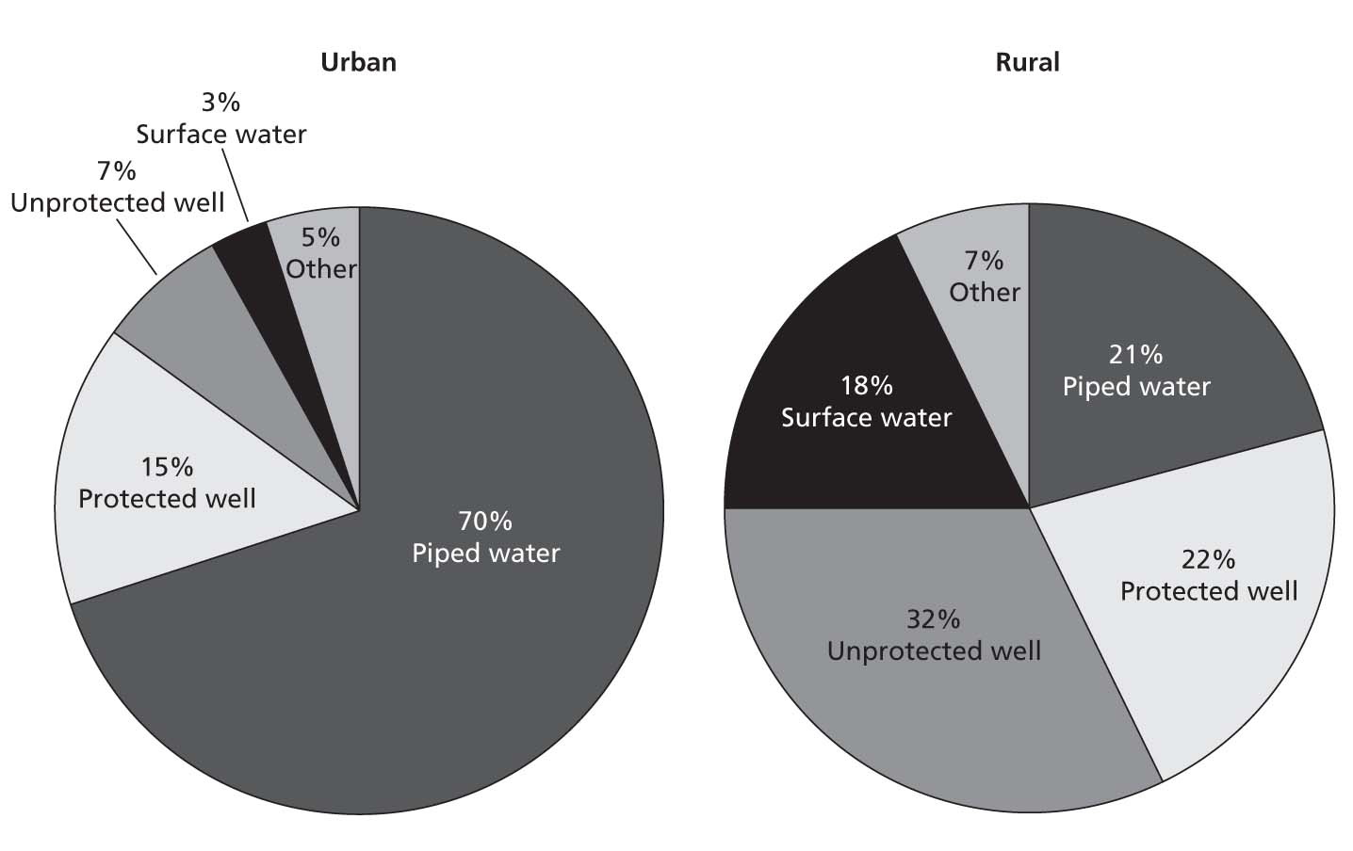
Figure 2.1 Access to Water Supply: Urban versus Rural
Source: Authors’ calculations based on census data.
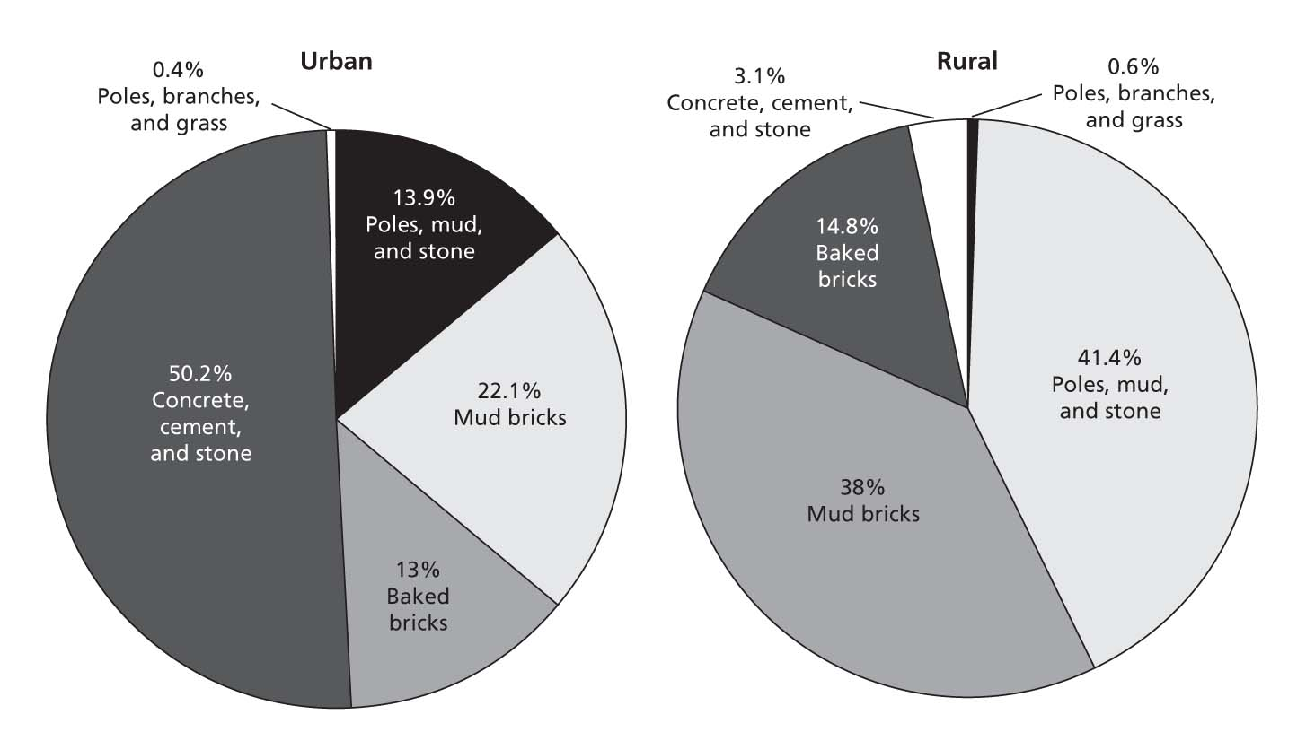
Figure 2.2 Housing Quality: Wall Material, Urban versus Rural
Source: Authors’ calculations based on census data.

Trends in the Urban and Rural Profiles
Little progress in urban access to basic services. Urban access to piped water supply actually declined from 80 to 70 percent during 1988–2002, while access to electricity has increased (from 27 to 34 percent). Urban access to improved sanitation has remained constant at around 12–13 percent (figure 2.3). The lack of progress in enhancing urban access to basic services, particularly water supply, is likely to be related to the rapid urbanization that occurred in the intercensal period of 1988–2002 (from 18 to 22.6 percent). It appears that water service has not been able to keep pace with the growth in urban population.
No significant progress in closing the urban-rural gap in access to basic services. No significant improvement was made in expanding access to basic services in rural areas during 1988–2002 (figure 2.3). As a result, the urban-rural gap in access to electricity and flush toilets remained constant, while the gap in access to piped water supply has decreased (from 61 to 50 percentage points), but only because of the reduction in urban coverage – the antithesis of progress.

Figure 2.3 Access to Basic Services: Urban versus Rural, 1988 and 2002
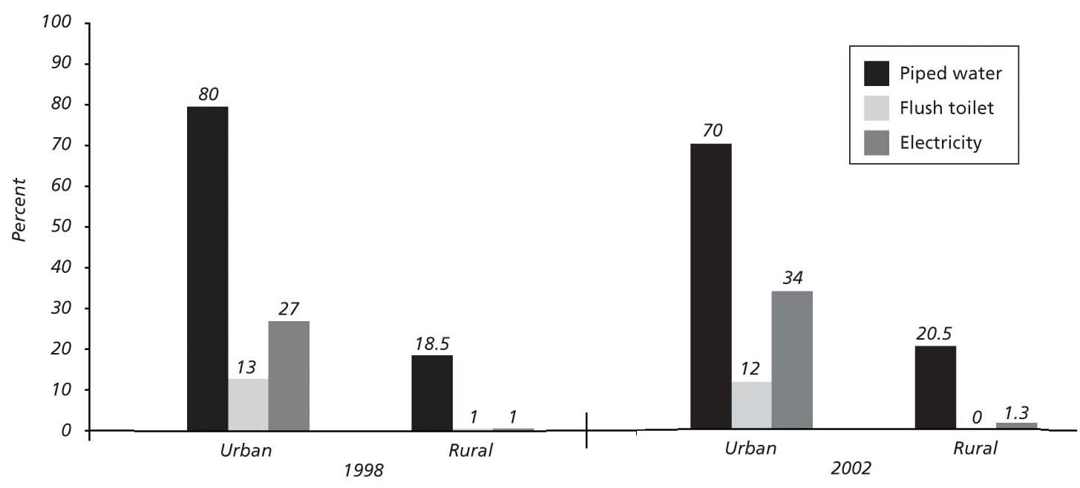
Source: Authors’ calculations based on census data.
Access to education increased significantly in both urban and rural areas. During the 1988–2002 intercensal period, the literacy rate increased by 13 and 9 percentage points in urban and rural areas, respectively. Rural areas performed slightly better than urban: the percentage of population with primary education increased by 9 and 11 percentage points in urban and rural areas, respectively. The urban-rural gap remained broadly constant over time, as a result of the parallel improvement in access to education in both urban and rural areas (figure 2.4).
Figure 2.4 Access to Education: Urban versus Rural, 1988 and 2002
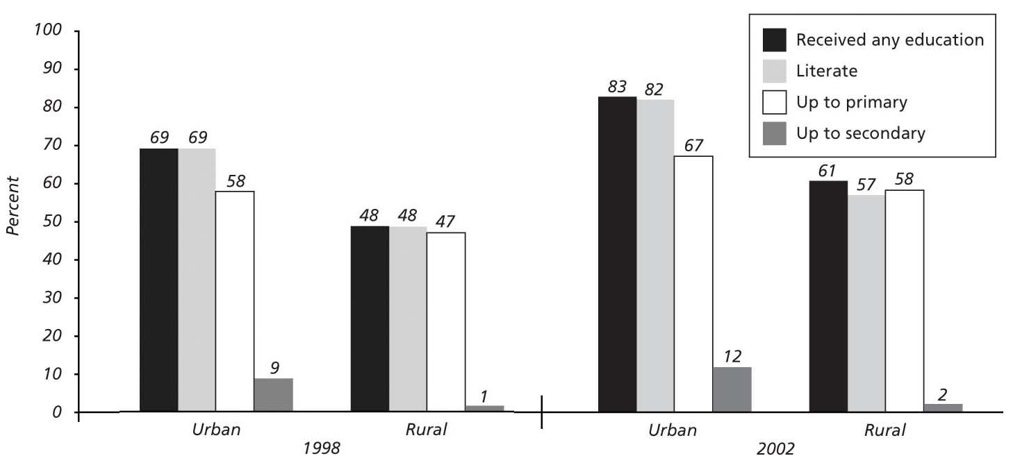
Source: Authors’ calculations based on census data Source: Authors’ calculations based on census data.

The Urban Profile across the Four Urban Perspectives
This section compares the urban profile across the politico-administrative, human settlements, statistical, and density-based urban perspectives.
The urban advantage in terms of access to basic services is the most pronounced under the narrower politico-administrative perspective, while the density-based urban perspective yields the lowest urban advantage. For example, 78 percent of urban households have access to piped water supply under the politico-administrative perspective, against 58 percent of the urban population under the density-based perspective. However, access to improved water supply shows a less stark variation across the four urban perspectives, ranging from 77 to 89 percent (figure 2.6). Access to electricity also varies significantly, according to the perspective adopted (figure 2.7): 39 percent of the politico-administrative urban population has access to electricity, compared with 25 percent of the density-based urban population. These results are consistent with the 2005 Poverty and Human Development Report, reporting overall high access to electricity in urban centers, but lower access in some of the more densely populated areas that do not benefit from a legal urban status. For example, areas with a high population concentration in the Shinyanga and Mwanza regions go without electricity. The difference across urban perspectives is less evident with respect to access to improved sanitation, which ranges from 11 percent (density-based perspective) to 18 percent (politico-administrative perspective) (figure 2.8). The politico-administrative urban population also benefits from higher quality of housing: 63 percent have houses built with concrete, cement, and stones, compared with only 39 percent of the urban population under the density-based perspective. The challenges of providing infrastructure services in high-density settlements with no legal status are exemplified by the case study conducted in the Town of Himo in northern Tanzania as part of a wider research program on urban-rural linkages in the Sub-Saharan Africa region (box 2.1).
Box 2.1 High Density Settlements without Legal Status:
The Case of Himo Town in the Kilimanjaro Region
Himo, a town in the Kilimanjaro region, began to emerge in the 1970s after the nationalization and dismantling of the sisal plantations, when land was allocated as compensation to those who were moved from the valleys and water sources on Mount Kilimanjaro. Located on the main road from Dar es Salaam and Moshi to Kenya, Himo has grown steadily into one of the most important markets in the Kilimanjaro area.
Himo represents a typical case of high-density settlement with no legal status. Himo is a de facto town, with about 80 bars and 70 shops, and it has already been declared a “township”; however, it is still run by a village government that does not have the resources to oversee such a large and complicated settlement. All revenues from Himo accrue to the district council, and Himo benefits only marginally in the redistribution of resources throughout the district. Despite its importance in terms of revenue creation, Himo is significantly underrepresented in the district council. Its anomalous position is summed up by the fact that its boundaries as a “village” are different from its boundaries as a “town.” The main challenges faced by Himo and the surrounding villages have been studied as part of a Sub-Saharan African research program on urban-rural linkages conducted by the International Institute for Environment and Development (IIED) in 2001. The Himo study, based on stakeholder consultations and focus groups, explores how different groups rely on rural-urban interactions and linkages in and around the Town of Himo in the Kilimanjaro region.ª The research was carried out between September 1998 and April 1999 in Himo Town and two surrounding villages (Marawe Kyura and Lotima).
The study found that contrary to what might be expected, Himo Town is conspicuously lacking in social services, compared with the villages on the mountain. For example, Himo has no public health services and only one primary school, which is considered largely inefficient by Himo inhabitants, who prefer to send their children to school in nearby villages. The lack of social services may be partially related to the haphazard manner in which Himo has been developed. Water supply is also insufficient to meet the need of Himo Town. The focus groups revealed that the majority of the inhabitants have to pay for buckets of water from the river, because the bulk of water in the town is taken by the large traders who own guesthouses and bars and have reservoir tanks in their houses. The inability of Himo to control its own revenue collection severely constrains its ability to expand its water supply system. In addition, the lack of sanitation services causes pollution in both Himo and the villages below it. As a result, there has already been one outbreak of cholera.
The Himo case study illustrates the challenges of providing adequate service provision in high-density locations with no legal urban status. These challenges are likely to be particularly acute in the land-scarce mountainous Kilimanjaro region, where a significant number of high-density settlements with no legal status (such as Himo Town) are concentrated.
Source: Diyamett et al. 2001.
a. A similar study was conducted in and around the Town of Lindi in southern Tanzania. Both projects were undertaken by researchers at the University College for Land and Architectural Studies and the Tanzania Gender Networking Programme of Dar es Salaam.
The urban-rural gap in services is wide, regardless of the urban perspective adopted. The urban-rural gap in terms of access to basic infrastructure services persists across all the four urban perspectives, including the density-based perspective, which yields the lowest urban access rates. For example, only 45 percent of the rural population has access to improved water supply, against a range of 77–89 percent for the urban population (figure 2.6). Similarly, urban households, regardless of the urban perspective adopted, have far better access to electricity than do rural households, which have virtually no access (figure 2.7). The gap is also evident with respect to sanitation options (figure 2.8): only 1 percent of rural households have access to improved sanitation, against an average of 15–18 percent in urban areas, depending on the urban perspective adopted. (See figure 2.5 for a comparison of selected indicators of living conditions in politico-administrative and density-based urban areas versus rural areas).
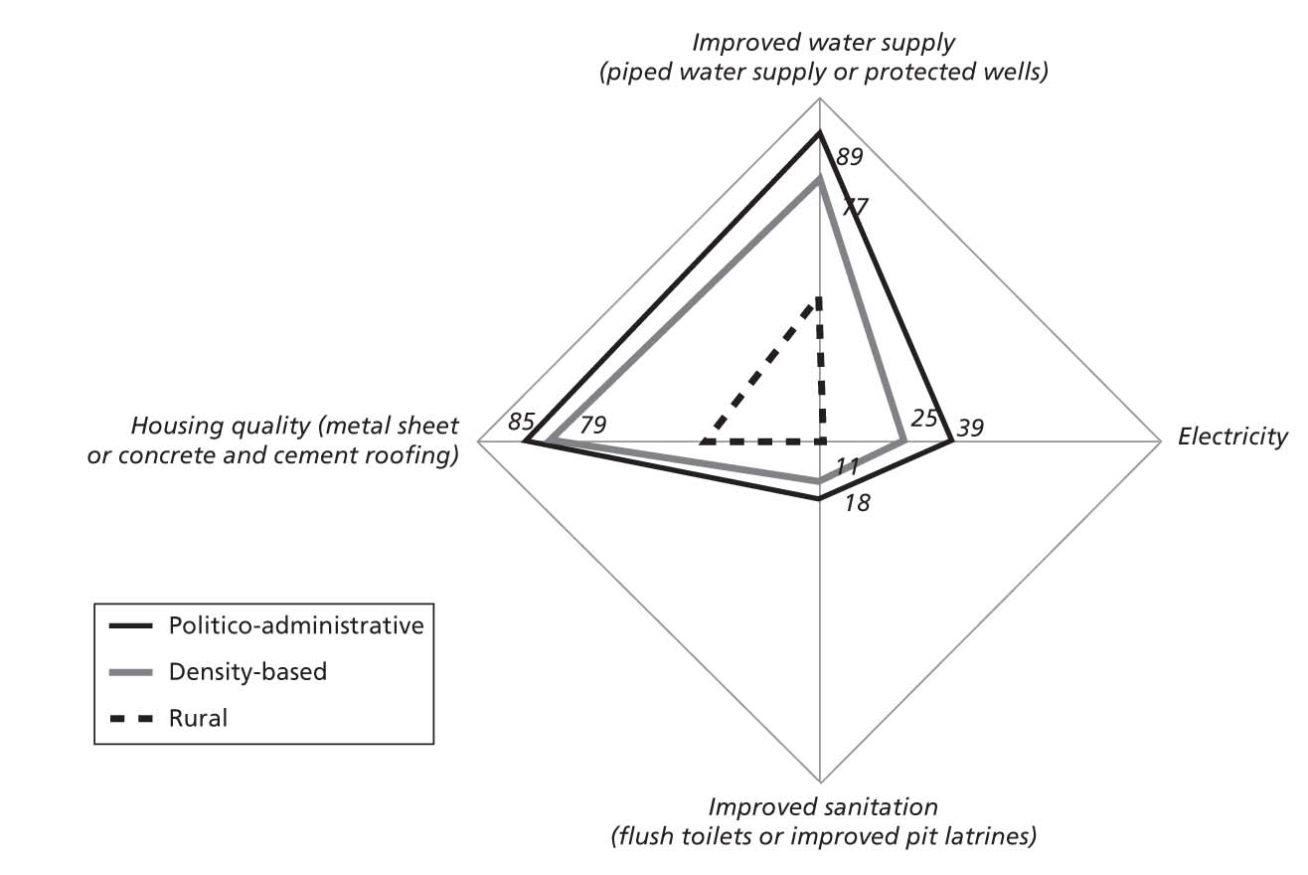
Figure 2.5 Living Conditions:
Politico-Administrative, Density-Based Urban Areas versus Rural Areas
Source: Authors’ calculations based on census data.
Note: “Wall type” is not used as a measure of housing quality because there are areas where houses are traditionally built of mud wall, so the type of wall material is not always correlated with wealth.
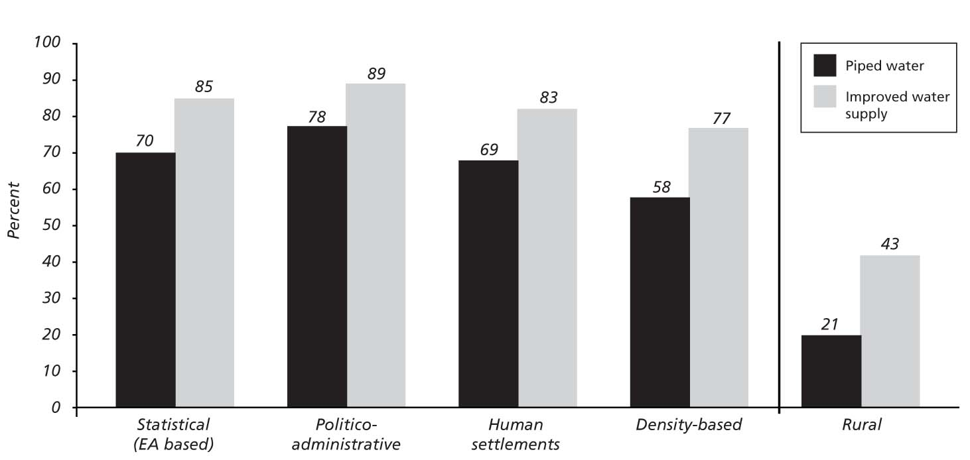
Figure 2.6 Access to Water Supply, by Urban Perspective, 2002
Source: Authors’ calculations based on census data.
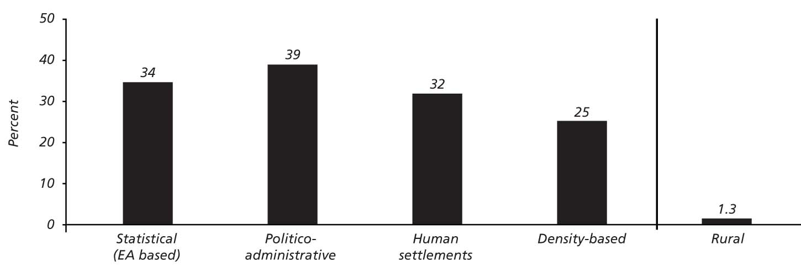
Figure 2.7 Access to Electricity, by Urban Perspective, 2002
Source: Authors’ calculations based on census data.
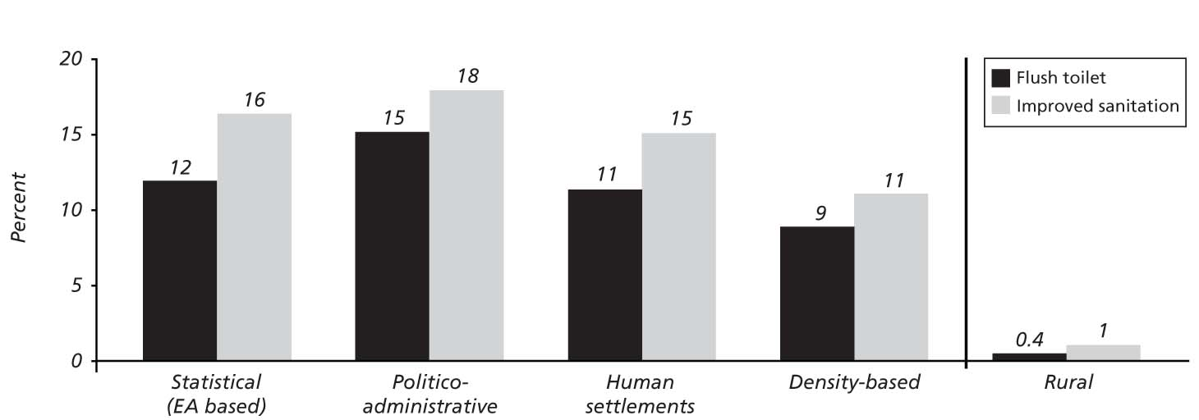
Figure 2.8 Access to Sanitation, by Urban Perspective, 2002
Source: Authors’ calculations based on census data.
Note: Improved sanitation includes flush toilets and improved pit latrines.
The politico-administrative urban perspective is the most in line with the stylized urban profile, consisting of a relatively well-educated, generally wage-employed workforce. Under the politico-administrative urban perspective, urban residents show the highest literacy and education levels; they are also more likely to be wage-employed and less likely to be self-employed than the urban population under the three other urban perspectives. Also, the urban population in politico-administrative urban areas (i.e. urban LGAs) is the least involved in agricultural activities.
Densely populated centers in rural LGAs have a more urban than rural profile. The urban population under the density-based perspective fares worse with respect to key livability indicators, such as access to basic services, than the urban population under the other three urban perspectives. On the other hand, the profile of the population living in high-density settlements is systematically different from the profile of the general rural population: for example, 77 percent of the density-based urban population is literate, against 57 percent of the rural population. Despite the lower standards of living, such high-density settlements resemble much more the “mainstream” urban centers (that is, urban centers that are institutionally and administratively recognized as such) than rural areas with regard to access to basic infrastructure services, education, and economic activities. Figure 2.9 shows how access to services varies with changes in the minimum-density threshold under the density-based perspective. The sensitivity analysis shows that access to services increases with the density threshold, although the increase in access peters out at density thresholds above 300 persons per square kilometer.
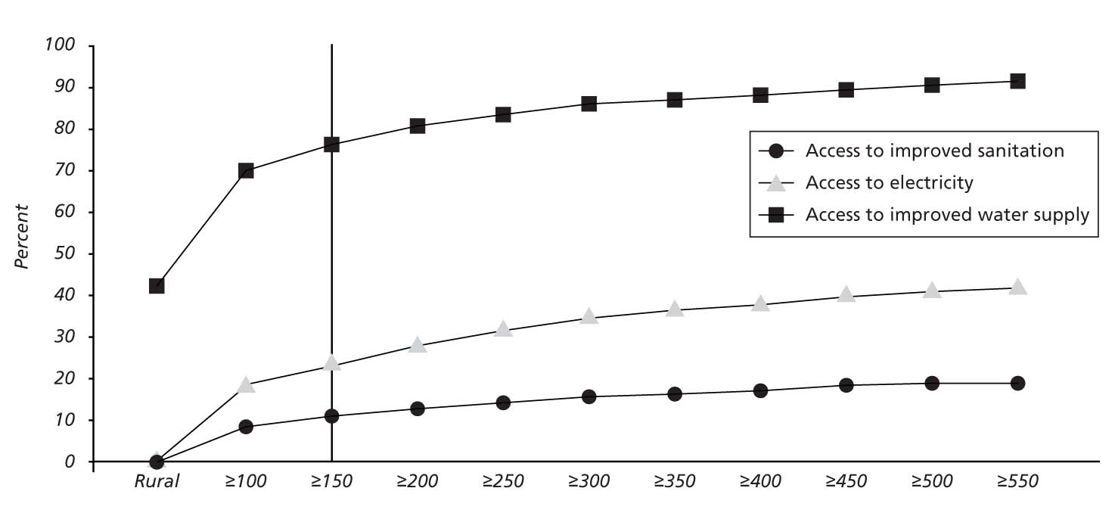
Figure 2.9 Access to Services: Density-Based Perspective Sensitivity Analysis
(persons per square kilometer)
Source: Authors’ calculations based on census data.

The Urban Profile in Large and Small Urban Centers
This section compares household and individual characteristics across large and small urban centers, based on the urban perspective of the Ministry of Lands and Human Settlements Developments (MoLHSD). (For analytical purposes, cities and municipalities are classified as “large urban centers,” while towns and townships are classified as “small urban centers.”)
There are significant differences in access to basic services and housing quality, as between small and large urban centers. Access to improved water supply in large urban areas is 90 percent, compared with only 66 percent in small urban centers. In addition, 18 percent of the population has access to improved sanitation in large urban centers, compared with 6.4 percent in small urban centers. Similarly, access to electricity differs by about 25 percentage points between small and large urban centers. A significant gap is also found with respect to housing quality: 64 percent of the population in large urban centers lives in houses whose walls are made of concrete, cement, or stone, compared with 14 percent of the population in small urban centers (see figure 2.10 and table A3.1 in appendix 3 for a comparison of selected indicators of living conditions in small and large urban centers).
Small towns have an urban imprint with respect to access to services. Despite the gap in access between small and large urban centers, small urban centers perform distinctly better than rural areas with respect to access to basic services. For example, access to improved water supply is 43 percent in rural areas, compared with 66 percent in small urban centers.
Small urban centers fall between rural areas and large urban centers with respect to literacy and schooling. The urban population in small urban centers is significantly less educated than the urban population in large centers, but more educated than the rural population. On average, 84 percent of the urban population in large urban centers is literate, compared with 68 percent of the urban population in small urban centers and 57 percent of the rural population. A similar gap is found with respect to the share of population that has completed primary education (figure 2.11). Average years of education are 5.7, 4.5, and 3.2 in large urban, small urban, and rural areas, respectively.
Small urban economies rely significantly more than large urban economies on agriculture and self-employment. As expected, the population in small urban centers is more frequently self-employed (83 percent) than the population in large centers (61 percent). In addition, only 33 percent of the urban population in small centers is engaged in nonagricultural activities, compared with 77 percent of the population in large centers. Unemployment is also significantly lower in small urban centers (1.7 percent) than in large ones (5 percent).
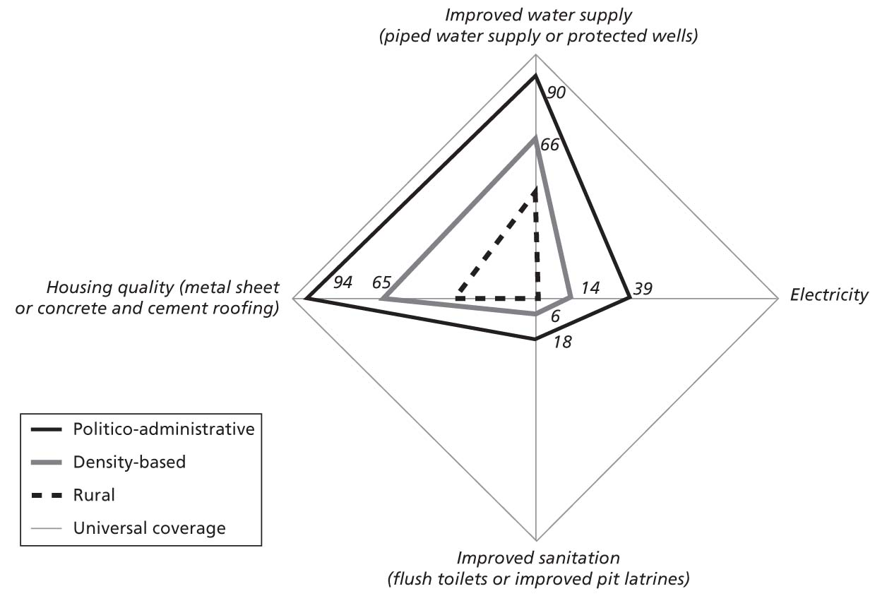
Figure 2.10 Living Conditions Indicators: Small versus Large Urban Centers
Source: Authors’ calculations based on census data.
Note: “Wall type” is not used as a measure of housing quality because there are areas where houses are traditionally built of mud wall, so the type of wall material is not always correlated with wealth.
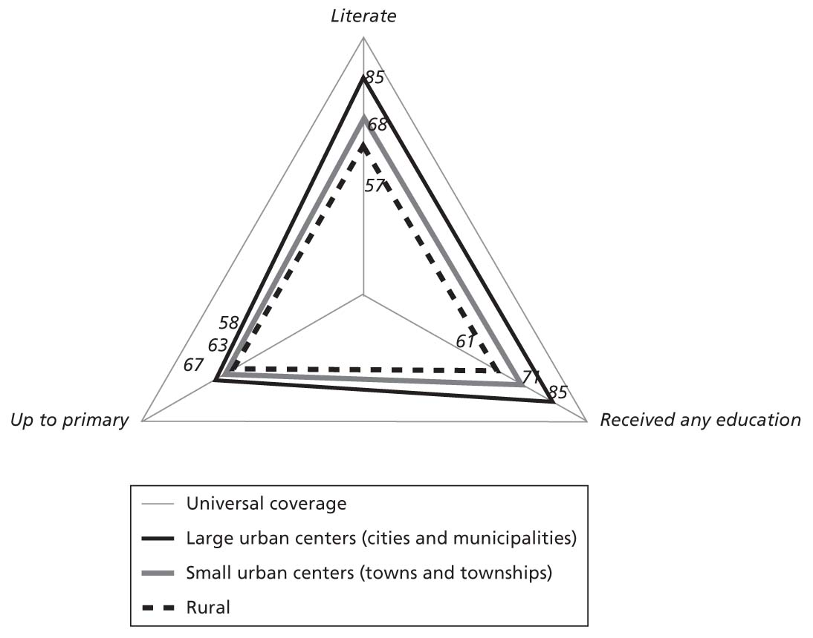
Figure 2.11 Educational Attainment: Small versus Large Urban Centers
Source: Authors’ calculations based on census data.

Spatial Distribution of Urban Poverty: Evidence from 12 Urban Centers
Building on recently conducted poverty mapping, inter- and intraurban poverty rates were compared across 12 urban centers (see box 2.2 for a description of the poverty-mapping exercise). The 12 urban centers are believed to be representative of the geographical and size distribution of urban centers in mainland Tanzania because they are spread across the entire country and cover the whole urban spectrum, encompassing cities, municipalities, towns, and townships. The list of selected urban centers, including three cities, two municipalities, two towns, and five townships is provided in table 2.1.
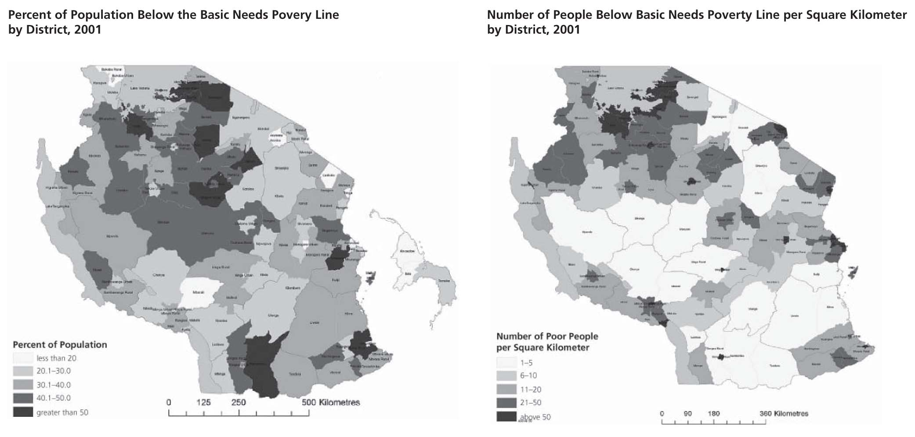
Figure 2.12 LGA-level Poverty Rate and Poverty Density, 2000/01
Source: Tanzania, NBS 2002.
Table 2.1 List of Selected Urban Centers
 | Urban centers | Region | Population (thousands) | Status
1 | Tanga | Tanga | 264 | City
2 | Mwanza | Mwanza | 517 | City
3 | Mbeya | Mbeya | 289 | City
4 | Songea | Ruvula | 131 | Municipality
5 | Kigoma | Kigoma | 144 | Municipality
6 | Lindi | Lindi | 41 | Town
7 | Babati | Manyara | 59 | Town
8 | Mwanga | Kilimanjaro | — | Township
9 | Kilosa | Morogoro | — | Township
10 | Rufiji | Pwani | — | Township
11 | Tarime | Mara | — | Township
12 | Nzega | Tabora | — | Township
Source: Authors’ calculations based on census data.
Note: Population figures are from Urban Development and Environmental Management (UDEM).
— = not available

Interurban Poverty Rates: How Much Variation in Poverty Is There across Urban Centers?
Our poverty-mapping exercise allows a more refined picture of urban poverty for 12 selected urban centers by estimating poverty rates for only the urban parts of the LGAs. In each of these 12 LGAs, urban poverty rates are estimated over the population living in urban EAs only, based on the NBS classification. The LGAs’ population living in rural EAs is thus not counted as “urban” for the purpose of this exercise. Table 2.2 compares the urban and rural LGA-level poverty rates (defined as the percentage of the population below the basic-needs poverty line) for each of the selected urban LGAs. Box 2.3 provides a short summary of the most recent nationwide urban and rural poverty trends.
Table 2.2 Poverty Rate, Selected Urban Centers, 2001
(percentages)
Urban center | Status | District | Poverty rate
Urban center | Status | District | Urban part |  | Rural part
Urban center | Status | District | Estimate | Std. error | Estimate | Std. error
Tanga | City | Tanga | 15.8 | 1.5 | 20.6 | 3.2
Mwanzaª | City | Nyamagana | 15.1 | 2.6 | —^{b} | —
Mwanzaª | City | Ilemela | 24.3 | 3.6 | 28.4 | 6.8
Mbeya | City | Mbeya urban | 12.2 | 1.5 | 13.4 | 2.2
Songea | Municipality | Songea urban | 25.8 | 2.8 | 49.3 | 4.4
Kigoma | Municipality | Kigoma urban | 27.4 | 2.7 | 18.3 | 5.6
Lindi | Town | Lindi urban | 15.8 | 2.2 | 23.9 | 3.3
Babati | Town | Babati | 40.8 | 5.1 | 51.7 | 2.8
Mwanga | Township | Mwanga | 28.4 | 3.6 | 26.0 | 2.2
Kilosa | Township | Kilosa | 24.0 | 1.8 | 31.9 | 3.5
Rufij | Township | Rufij | 43.2 | 2.4 | 31.4 | 3.4
Tarime | Township | Tarime | 49.0 | 5.2 | 29.0 | 5.2
Nzega | Township | Tabora | 15.2 | 3.6 | 36.5 | 10.2
Source: Authors’ calculations based on census data and household and budget survey.
Note: Within each district associated with an urban center, the urban population is defined as the population living in urban EAs, based on NBS definition. The rural population is defined as the district population living in rural EAs.
Std. = Standard.
a. Average poverty rate in Mwanza City is 19 percent.
b. Nyamagana is 100 percent urban.

There is a large variation in poverty rates across the 12 urban centers. The analysis reveals a diversified picture of urban poverty. Poverty rates range from slightly more than 12 percent in Mbeya City to almost 50 percent in the Township of Tarime, against a national urban poverty rate of 26 percent (excluding Dar es Salaam). Cities (on average) show the lowest poverty rates, townships the highest. However, significant variation in the levels of poverty is also found across the sampled cities: for example, the two adjacent LGAs that together constitute Mwanza City show substantially different poverty levels because Nyamagana has a much lower poverty rate (15 percent) than Ilemela (24 percent).
Urban areas are not always pockets of wealth, relative to the surrounding rural areas. Rural districts tend to have higher poverty levels than urban districts. However, a more complex picture is revealed by comparing urban and rural poverty rates within a given district. A comparison of poverty levels in the urban and rural parts of the selected LGAs indicates that in 4 out of the 12 urban centers, the surrounding rural areas have lower poverty rates than the urban centers. Differences are substantial in the Township of Tarime, where rural poverty is estimated to be 20 percentage points below the urban poverty rate. In the rural part of Rufiji district, the poverty estimate is around 31 percent, almost 12 percentage points below the poverty rate in the urban part of the district. In Kigoma, the urban poverty estimates exceed poverty rates in the surrounding rural areas by 9 percentage points. Finally, Mwanga urban shows more than a 2-percentage-point-higher poverty level than Mwanga rural (figure 2.13).
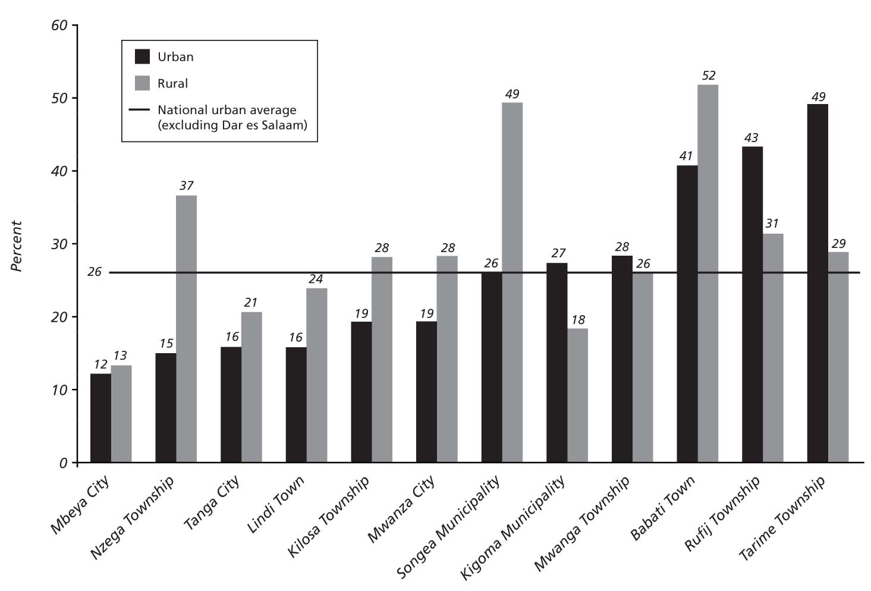
Figure 2.13 Poverty Rate, Urban versus Rural Parts of LGAs, 2001
(percentages)
Source: Authors’ calculations based on census data and household and budget survey.

Intraurban Poverty Rates: How Much Variation in Poverty Is There within Urban Centers?
The interurban comparison is complemented by an intraurban analysis of poverty. The unit of analysis for measuring intraurban variation is the ward level. Ward-level poverty rates are estimated for each of the 12 urban centers, based on the methodology used for the LGA-level poverty-mapping exercise (figures A4.1–A4.12 in appendix 4). Ward-level urban poverty rates are calculated over the urban population living in urban or mixed wards. However, caution is needed in interpreting the results, given that ward-level estimates are substantially less precise than LGA-level estimates, with standard errors reaching more than 10 percent in a few instances, and the EAs sampled for the long-form census questionnaire are representative at the district level, but not necessarily at the ward level.
The analysis shows that urban poverty rates conceal significant intraurban variation. On average, the differential between the lowest and highest ward-level poverty rates is 33 percent across the 12 urban centers. Kilosa is the urban center with the highest intraurban variation in poverty, with poverty rates ranging from 2.3 percent in Kidido ward to 63.4 percent in Magubike ward, both of which are mixed wards. Mbeya and Tanga, the two cities with the lowest urban poverty rates among the selected cities, show a much broader intraurban spread in poverty rates than the average (figure 2.14). For example, Tanga City is the urban center with the second largest intraurban poverty variation, with poverty rates ranging from as low as 0.3 percent to almost 53 percent (figure 2.15).
A significant share of the urban population lives in wards that are poorer than the surrounding rural areas. With the exception of Nzega Township and Babati Town, all urban centers have a number of wards with higher poverty rates than the surrounding district rural areas (figure 2.14). This implies that a significant share of the urban population in the selected urban centers lives in wards with poverty rates above the rural poverty rate (figure 2.16). This is (for example) the case in the four townships, where (on average) almost 70 percent of the urban population lives in wards that are poorer than the surrounding rural areas. Mbeya, the city with the lowest poverty rate (12 percent), has also the highest share of urban population living in wards poorer than surrounding rural areas (36 percent) among the cities. This can be attributed to the relatively low poverty rate in the surrounding rural areas of Mbeya City (rural and urban poverty rates in the LGA are both 12 percent), as well to high intraurban inequality (urban and mixed ward-level poverty rates range from 0 to 44 percent). It is interesting to compare the poverty profile in Mbeya City with that in Mwanza City. The latter has a higher poverty rate (19 percent) than Mbeya City, but a much lower percentage of the population living in wards poorer than the surrounding rural areas (2 percent). This can be attributed to the fact that Mwanza has a significantly more pronounced rural-urban poverty gap (28 and 19 percent, respectively) than Mbeya City and less intraurban inequality (with urban and rural ward-level poverty rates ranging from 12 to 32 percent).
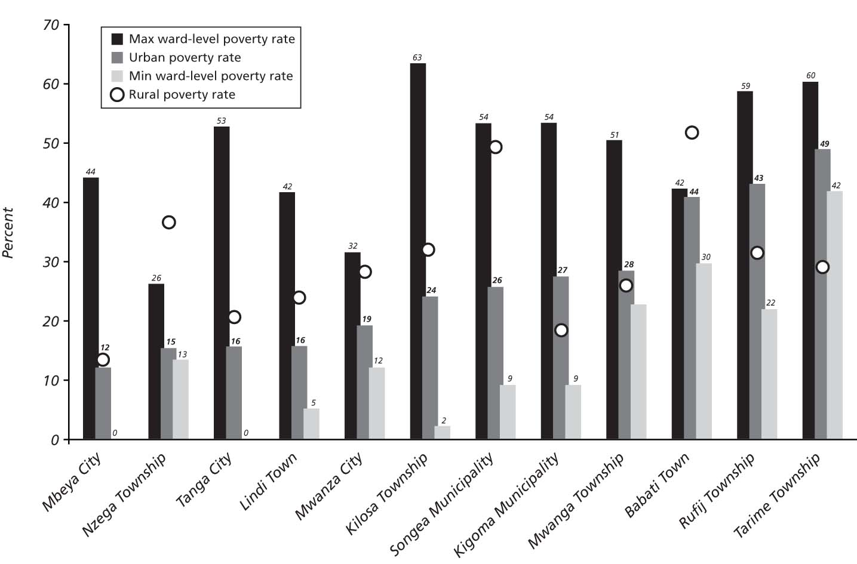
Figure 2.14 Intraurban Poverty Variation,
Lowest and Highest Ward-Level Poverty Rates, Selected Urban Centers, 2001
(percentages)
Source: Authors’ calculations based on census data and household and budget survey.
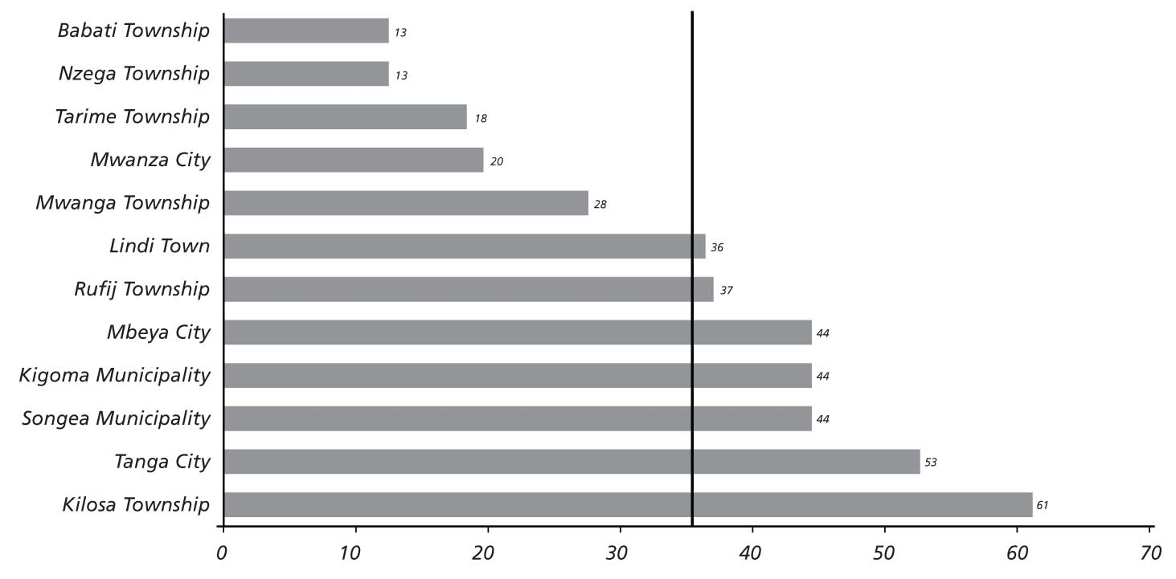
Figure 2.15 Intraurban Poverty Variation
Differential between Highest and Lowest Ward-Level Poverty Rates,
Selected Urban Centers, 2001
(percentages)
Source: Authors’ calculations based on census data and household and budget survey.
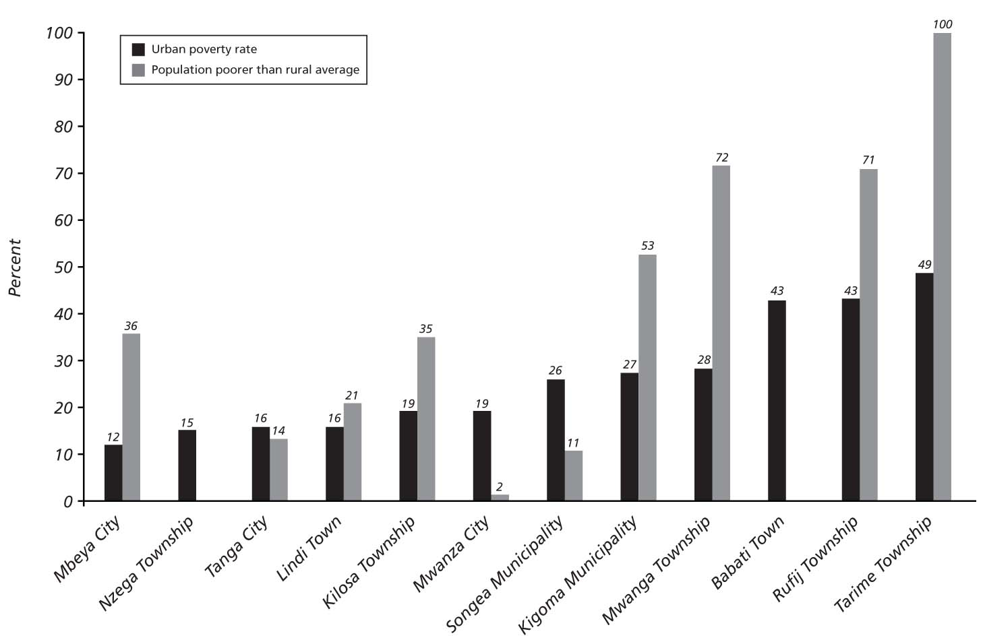
Figure 2.16 Percentage of Urban LGA Population Poorer than Rural District Average,
Selected Urban Centers, 2001
(percentages)
Source: Authors’ calculations based on census data and household and budget survey.

Conclusions
While the statistics show little progress, and in some sectors an actual decline, in the percentage of urban residents with access to basic services, the fact is that many more people now have access than two decades ago – the difficulty arises because urban infrastructure investment is slower than urban population growth. Because urban growth will continue, the key policy implication is that urban infrastructure investment must increase significantly if new urban residents are to enjoy the same levels of service as their predecessors.
Urban, periurban and rural areas have different service delivery challenges, and require different strategies. A three-pronged strategy might consider each group separately:
  - In urban LGAs: focus on extending services and infrastructure, both to improve national productivity and to address the needs of the urban poor. While urban LGAs show the best access to services, access is low by both African and global standards, especially outside of Dar es Salaam. Pockets of urban poverty, which are deeper than in the surrounding rural areas, can be found even in relatively wealthy urban centers. The policy implication is that much more investment is needed to raise all of Dar es Salaam to global standards, and to raise other urban centers to Dar es Salaam’s standards.
  - In periurban areas: service delivery challenges are more profound, and these areas will need even more investment to achieve parity with urban LGAs. In some of these areas, settlement patterns are still being established and there may be an opportunity to channel settlement into reasonably serviceable patterns. This requires pro-active spatial management and a much different approach to planning and land use than has been the case to date.
  - In rural areas: investment might best focus on connectivity and human capital. Because world experience suggests that rural welfare improves with proximity and connection to urban centers, transport and communication are essential. And as the current chapter indicates, urban dwellers have clear advantages, in terms of jobs and education, over their rural cousins - those who want to participate in the growth opportunities of cities will need ever better skills. For today’s rural dwellers, connection to urban centers is essential, for their children the path to mobility and success will often start with a good education.

CHAPTER 3 THE URBAN CONTRIBUTION TO GDP
Urban areas are engines of growth because they have economies of scale, proximity, and agglomeration benefits businesses and households. There is no widely accepted method to assess the economic contribution of urban areas. The objective of this chapter is to examine various estimates of the economic contribution of urban areas in mainland Tanzania. It does so by exploring urban labor markets, producing various estimates of the share of the gross domestic product (GDP) that is explained by the urban economy, and looking into differences in labor productivity between rural and urban economic activities.

Employment
During the 1990s, the labor force grew faster in urban than in rural areas. Data from the Labor Force Survey, summarized in table 3.1, shows that during 1991–2006, Tanzania’s total labor force almost doubled: from 11.2 million to 20.5 million people. The rate of growth was higher in urban areas. During 1991–2001, the urban labor force grew by 6.1 percent annually, while the rural labor force grew by 4.4 percent annually.
Table 3.1 Labor Force by Type of Geographic Area, 1990, 2001, and 2006
 | Total Labor Force (‘000) |  |  | Av. Annual Growth Rate (%)
 | 1991 | 2001 | 2006) | 1991-2001 | 2001-06 | 1991-96
Urban labor force | 1,894 | 3,425 | — | 6.1% | — | —
Rural labor force | 9,401 | 14,402 | — | 4.4% | — | —
Total labor force | 11,295 | 17,828 | 20,568 | 4.7% | 2.9% | 4.1%
Employed | 10,890 (96.4%) | 15,528  (87.1%) | 18,306  (89.0%) | 3.6% | 3.3% | 3.5%
Unemployed | 406  (3.6%) | 2,300  (12.9%) | 2,263  (11.0%) | 18.9% | −0.3% | 12.1%
Source: Team calculations based on Integrated Labor Force Surveys from Tanzania, NBS (1991, 2001b, and 2006b.).
Note: — = not available.
Distribution of urban employment: Figure 3.1, which presents the regional distribution of urban employment by type of economic activity, shows—not surprisingly—that Dar es Salaam occupies the first place by a very wide margin, employing about one-third of the total urban population (28.8 percent), slightly below the proportion of the total urban population that lives there (31 percent). This is followed by Arusha (8.8 percent), Mwanza (7.0 percent), Morogoro (6.1 percent), and Mbeya (5.3 percent). The rest of the regions each employ less than 5 percent of the total urban population, Kagera (1.6 percent), Lindi (2.0 percent), and Manyara (2.0 percent) being at the lower end. In terms of sector composition, 38 percent of the urban labor force is employed in agriculture, 11 percent in industry, and 51 percent in services.
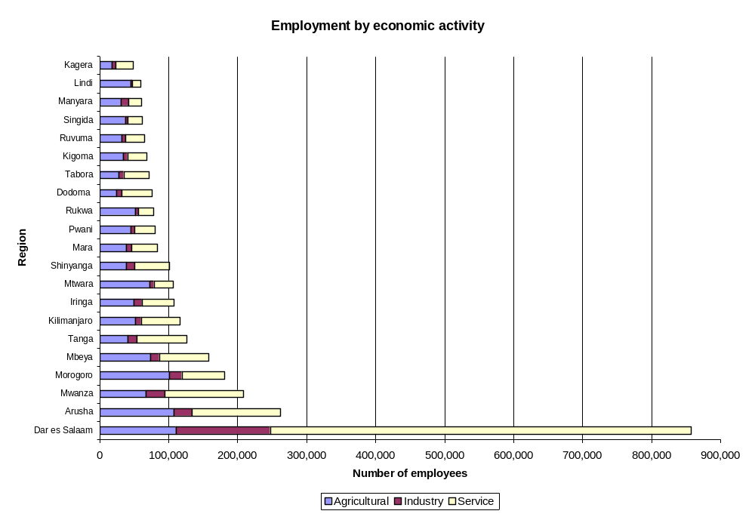
Figure 3.1 Aggregated Economic Activities in Urban Areas by Region, 2002
Source: Authors’ calculations based on Tanzania, NBS (2002).
Table 3.2 shows the average employment pattern for rural and urban wards in all districts of mainland Tanzania. As expected, the labor structure is quite different in rural and urban areas of the country. In rural areas, 93 percent of the labor force is employed in agriculture-based activities. In urban areas, 62 percent of the labor force is employed in non-agriculture-related activities. Trade, commerce, public administration, and education stand out as some of the main sources of urban employment. However, even in the urban areas, agriculture is still an important source of employment, though that importance varies significantly by region.
Table 3.2 Employment Composition in Urban and Rural Wards, 2002
 | Rural employment |  | Urban employment
 | ‘000 | % | ‘000 | %
Agriculture | 9,351 | 83 | 928 | 31
Forest, fishing, and others | 1,173 | 10 | 173 | 6
Mining and quarrying | 34 | 0 | 33 | 1
Manufacturing | 76 | 1 | 176 | 6
Electricity, gas, and water | 7 | 0 | 39 | 1
Construction | 53 | 0 | 94 | 3
Raw food sales | 42 | 0 | 128 | 4
Trade and commerce | 195 | 2 | 689 | 23
Finance and insurance | 4 | 0 | 27 | 1
Transport and communication | 17 | 0 | 101 | 3
Public admin. and education | 191 | 2 | 400 | 13
Other | 175 | 2 | 187 | 6
Total | 11,306 | 100 | 2,974 | 100
Source: District profiles from Tanzania, NBS (2002).
The composition of urban employment across sectors changes according to the definition of “urban.” Table 3.2 presents information based on the “statistical perspective,” which consists of data coming from the enumeration areas classified as “urban” in the 2002 census. However, if those same data are presented only for the legally defined urban LGAs (politico-administrative perspective), the composition of the labor force changes significantly (table 3.3). The proportion of people employed in agriculture-related activities doubles when moving from the politico-administrative perspective to the statistical perspective. In the politico-administrative perspective, employment is higher in activities more commonly associated with urban economies, such as professional, administrative, and technical services. Street vending and craftsmen activities, which are primary components of the informal economy, are also notably higher in the politico-administrative than in the statistical perspective. However, the single most important difference in employment between these two definitions comes from farming activities, which employ 278,000 people if the urban areas are seen through the politico-administrative lens, but more than 1 million people if the statistical perspective is applied. This means that farming is the main activity in those areas that are statistically defined as “urban,” but are not considered “urban” from a politico-administrative perspective. Using the politico-administrative definition of “urban,” street vending is the main source of employment. This last finding is consistent with those of other studies that have found that in the past 10 years, the number of street vendors has been increasing throughout the major cities of Tanzania, especially in Dar es Salaam, whose current street vendor population is estimated at about 700,000 (Lyons and Msoka 2007, 12).
Table 3.3 Urban Employment Composition according to the Statistical and Politico-Administrative Perspectives, 2002
 | Politico-administrative perspective | Politico-administrative perspective  (percentages) | Statistical perspective | Statistical perspective (percentages)
Legislators, administrators, and managers | 37,105 | 2.2 | 47,188 | 1.5
Professionals | 58,631 | 3.3 | 73,711 | 2.4
Technology and associated professionals | 151,344 | 8.4 | 207,867 | 6.8
Clerks | 57,763 | 3.2 | 72,682 | 2.4
Small business | 55,755 | 3.1 | 78,515 | 2.6
Services and shop sales | 253,292 | 14.2 | 340,977 | 11.1
Street vendors | 334,219 | 18.7 | 439,897 | 14.3
Craftsmen | 195,189 | 10.9 | 264,877 | 8.6
Farmers | 278,973 | 15.6 | 1,009,164 | 32.9
Livestock | 13,282 | 0.7 | 27,208 | 0.9
Fishermen | 21,722 | 1.2 | 32,633 | 1.1
Plant operators | 88,470 | 4.9 | 109,311 | 3.6
Elementary occupations | 224,231 | 12.5 | 336,884 | 11
Other | 18,9731 | 1.1 | 26,797 | 0.9
Total | 1,788,949 | 100 | 3,067,714 | 100
Source: District profiles from Tanzania, NBS (2002).
The proportion of the urban labor force engaged in agricultural activities varies dramatically between urban LGAs. Using the politico-administrative perspective, 17 percent of the urban labor force is employed in agricultural activities. This aggregate hides remarkable differences among urban LGAs. As figure 3.2 illustrates, in urban LGAs like Babati and Korogwe, close to 60 percent of the labor force works in agriculture-related activities, while in others like Nyamagana and Ilala, only 6 percent of the labor force is employed in these activities. These differences in the composition of employment are very significant and illustrate the different economic bases of urban LGAs. Although many have a truly urban economic base, about one-third of urban LGAs have more than 25 percent of the labor force employed in agricultural activities.
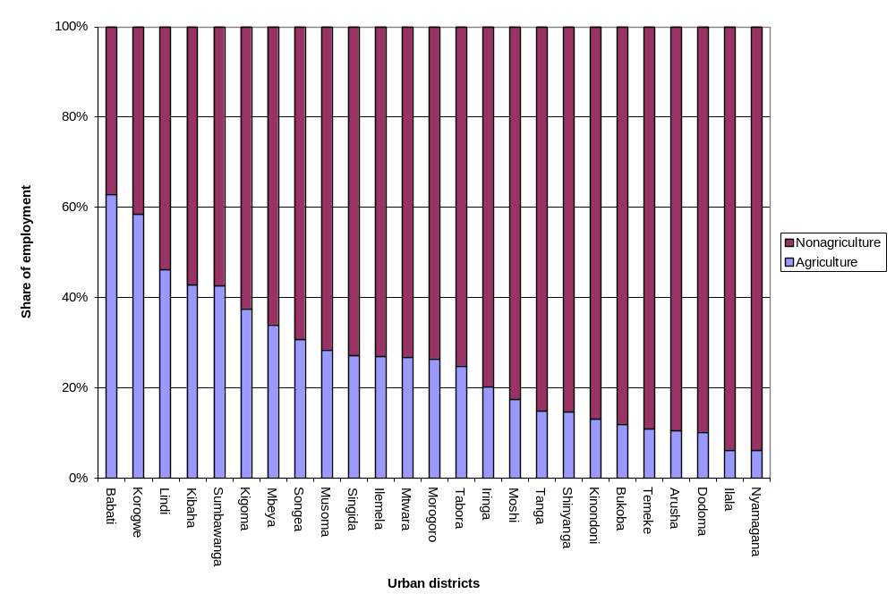
Figure 3.2 Share of Agricultural and Nonagricultural Employment, 2002
Source: District profiles from Tanzania, NBS (2002).

The analysis to here discusses information at only one time. To look at changes in the composition of the labor force over time, we use information from the Household Budget Survey (HBS), which breakdowns of the labor force by economic activity at two points in time. The main difference between the HBS data and the data used thus far from the Integrated Labor Force Survey (ILFS) is a different definition of the labor force that, according to the HBS, includes people between 15 and 60 years of age. HBS data allow a comparison of the relative size of the labor force by type of economic activity between 1991/92 and 2000/01. The HBS coding of urban and rural areas is the same one used by the National Bureau of Statistics (NBS), so these results correspond to what has been called the “statistical definition of urban areas.”
Table 3.4 Composition of Labor Force by Economic Activity
(percentages)
Economic Activity | Dar es Salaam |  | Other urban areas |  | Rural areas |  | Mainland Tanzania
Economic Activity | 1991/  1992 | 2000/  2001 | 1991/  1992 | 2000/  2001 | 1991/  1992 | 2000/  2001 | 1991/  1992 | 2000/  2001
Farming/livestock/fishing | 2.3 | 3.0 | 43.0 | 26.9 | 83.4 | 75.8 | 72.8 | 63.2
Employee: government/civil servant | 8.7 | 3.8 | 9.1 | 5.1 | 2.1 | 1.2 | 3.4 | 1.9
Employee: parastatal/working class | 12.7 | 3.1 | 3.2 | 1.6 | 0.6 | 0.2 | 1.8 | 0.6
Employee: other/working/working class/private sector/NGOs | 9.7 | 16.0 | 4.1 | 9.6 | 1.0 | 1.9 | 2.0 | 4.1
Self-employed with employees/national business community | 17.3 | 5.9 | 13.3 | 4.5 | 2.0 | 1.0 | 4.5 | 1.9
Self-employed without employees/informal | 1.1 | 18.1 | 0.5 | 16.7 | 0.2 | 2.9 | 0.3 | 6.1
Unpaid family worker in the business/informal | 4.8 | 10.5 | 4.7 | 13.0 | 1.1 | 7.5 | 1.8 | 8.5
Housewife/homemaker/household chores | 21.6 | 19.2 | 10.1 | 11.2 | 1.0 | 4.0 | 3.6 | 6.2
Student | 14.7 | 8.6 | 6.4 | 4.3 | 5.7 | 2.0 | 6.3 | 2.8
Nonactive/retiree | 7.2 | 11.6 | 5.4 | 7.2 | 2.9 | 3.5 | 3.5 | 4.6
Total | 100.0 | 100.0 | 100.0 | 100.0 | 100.0 | 100.0 | 100.0 | 100.0
Source: Tanzania, NBS (2002).
The 1990s saw an important increase of employment in informal activities. As table 3.4 illustrates, the categories that showed the largest percentage increases in employment were informal self-employment and unpaid family workers, both of which have a large component of informality. Clearly, the engagement of self-employed people in informal activities is becoming an important source of urban employment. According to the ILFS, the main reasons that drive people to engage in the informal sector are that they are not able to find other work (35.6 percent) and that the family needs additional income (31 percent). From 2001 to 2006, the proportion of households involved in informal activities throughout the nation grew from 35 to 40 percent of the total number of households. In urban areas, this meant that in 2006, a total of 1.3 million households considered the informal sector as their main economic activity. Although the absolute number of households involved in informal sector activities has increased in urban areas to 560,000, the percentage of households involved dropped from 61 to 55 percent between 2001 and 2006 (table A7.1 in appendix 7). Wholesale and retail trade are the main sources of employment in the informal sector (57.5 percent), followed by manufacturing (14.4 percent) and hotels and restaurants (12.9 percent). Despite this rise of employment in informal activities, in 2001 agriculture-related activities employed the largest number of people in Tanzania, equivalent to more than 60 percent of the labor force.
Trends in the composition of the labor force are similar in Dar es Salaam and in other urban areas. In Dar es Salaam, the most dramatic declines during the 1990s were observed in the working class employed in parastatals (from 12.7 to 3.1 percent) and in the formal self-employed (17.3 to 5.9 percent) categories. Conversely, employment grew more in informal activities (self-employed from 1.1 to 18.1 percent and unpaid family workers from 4.8 to 10.5 percent) and in the private/NGO sector (from 9.7 to 16.0 percent). In other urban areas, employment in agricultural activities declined dramatically from 43 to 27 percent during the 1990s, but in 2001 continued to be the most important source of employment. Formal self-employment also declined substantially, from 13.3 to 4.5 percent. As in Dar es Salaam, activities in the informal sector experienced the largest increases during the 1990s. The proportion of people working as informal self-employees grew from 0.5 to 16.7 percent and unpaid family workers from 4.7 to 13 percent.
Unemployment is about four times higher in urban than in rural areas. From 2001 to 2006, the absolute number of the unemployed population remained virtually unchanged, but the proportion of unemployed population in urban areas declined substantially, from 46 to 31 percent in Dar es Salaam and from 26 to 16 percent in other urban areas. In absolute numbers, however, the information presented in table 3.5 illustrates that in 2001 there were almost the same number of unemployed people in urban (1.1 million) as in rural (1.2 million) areas, with Dar es Salaam concentrating almost a half million unemployed people. This means that as a proportion of their respective labor forces, unemployment in urban areas was about four times higher (31 percent) than in rural areas (8.3 percent).
Table 3.5 Unemployment Rates by Different Definitions, 2001 and 2006
 | Dar es Salaam |  | Other urban |  | Rural |  | Total
 | 2001 | 2006 | 2001 | 2006 | 2001 | 2006 | 2001 | 2006
A. Looking for work (percentages) | 20.6 | 16.6 | 4.4 | 3.4 | 0.7 | 0.7 | 2.3 | 2.8
B. Available, not looking for work (percentages) | 5.7 | 4.4 | 5.5 | 2.9 | 2.1 | 0.9 | 2.8 | 1.6
A+B. Standard definition (percentages) | 26.4 | 21.0 | 9.9 | 6.3 | 2.6 | 1.6 | 5.1 | 4.3
C. With marginal attachments to employment (percentages) | 20.1 | 10.3 | 15.9 | 10.0 | 5.6 | 5.5 | 7.8 | 6.7
A+B+C. By Tanzania definition (percentages) | 46.5 | 31.3 | 25.9 | 16.3 | 8.4 | 7.1 | 12.9 | 11.0
Labor force | 1,003,531 |  | 2,421,605 |  | 14,402,442 |  | 17,827,578 | 20,568,328
Total unemployed | 466,642 | — | 627,196 | — | 1,209,805 | — | 2,299,758 | 2,262,516
Source: Tanzania, NBS (2006b).
Note: — = not available.
Despite informality and unemployment, income in urban areas continues to be higher than in rural areas. In urban areas, income comes mostly from employment in cash-based activities and from nonfarm self-employment (table A7.8 in appendix 7). Nationally, agricultural activities still represent about 20 percent of the income in urban areas, but only 2 percent in Dar es Salaam. Despite this relative importance of agricultural income in urban areas, in the past 15 years income has grown more in non-agriculture- than in agriculture-based activities. By adjusting the monthly mean wages for inflation, it is observed that the effective yearly real wage growth rate for legislators, administrators, and managers grew at an average annual rate of 17 percent from 1990 to 2006. Similarly, income for technicians grew almost 11 percent and for professionals 9.6 percent. Conversely, income for agricultural and fishery workers grew the least from 1990 to 2006, at an average annual rate of 1.5 percent (table A7.9 in appendix 7). If instead of looking at income by source of occupation, one looks at income by type of industry, agricultural wages have also seen the slowest growth in the past 15 years. On a monthly basis, in 2006 an agricultural employee earned 30 thousand Tanzanian shillings (T shs), while the mean wage was about T shs 76,000. Jobs in the financial sector paid the highest wages, at a monthly average of T shs 227,000 (table 3.6). As in the case of income, consumption expenditure in urban areas has been growing faster than in rural areas. The mean household expenditure data show that in real terms during the 1990s, income grew by 47 percent in Dar es Salaam and by 13 percent in other urban areas, while in rural areas it grew by 11 percent (table A7.2 in appendix 7).

Table 3.6 Average Monthly Income (Wages and Non-Salary) Benefits by Industry
(2001 prices, in thousands of T shs)
Industry | Monthly Income  ‘000 T shs |  |  | Average annual  real-wage growth rate (%)
Industry | 1991 | 2001 | 2006 | 1991–2001 | 2001–06) | 1991–2006
Agriculture, hunting, forestry | 16 | 15 | 31 | 0.0 | 15.0 | 4.6
Mining and quarry | 24 | 76 | 55 | 12.0 | −6.5 | 5.5
Manufacture | 26 | 103 | 67 | 14.8 | –8.3 | 6.6
Electricity, gas, and water | 23 | 86 | 220 | 14.0 | 20.6 | 16.1
Construction | 28 | 50 | 61 | 6.0 | 4.2 | 5.4
Trade | 19 | 31 | 57 | 5.0 | 12.7 | 7.5
Transport | 30 | 87 | 102 | 11.1 | 3.1 | 8.4
Finance | 33 | 143 | 227 | 15.9 | 9.5 | 13.7
Personal services | 25 | 62 | 64 | 9.4 | 0.6 | 6.4
Total mean | 25 | 50 | 76 | 7.4 | 8.7 | 7.8
Sources: Tanzania, NBS (1991, 2001b, and 2006b.)
Note: T shs = Tanzanian shillings.

Urban GDP
Urban centers can contribute significantly to national economic growth by (a) increasing productivity at the individual, firm, and industry levels via agglomeration economies; (b) increasing household welfare through social mobility and human development; and (c) promoting positive institutional change. Recent research has highlighted the role of urban centers as engines for economic growth by showing that during 1990–2003, industry and services contributed 79 percent of economic growth in Sub-Saharan Africa and 56.3 percent in Tanzania (Kessides 2006). Lack of data and appropriate methodologies (for example, GDP is not separately reported for urban and rural activities) have led researchers to grossly calculate the urban economic base as composed predominantly from industrial and services activities, while the rural economic base consists mostly of agricultural activities. However, as the previous section illustrated, this characterization is not fully accurate because in Tanzania as much as 38 percent of the total urban labor force is employed in agriculture-based activities. Thus, the objective of this section is to explore four different methodologies to more accurately calculate the contribution of the urban centers to the national economy.
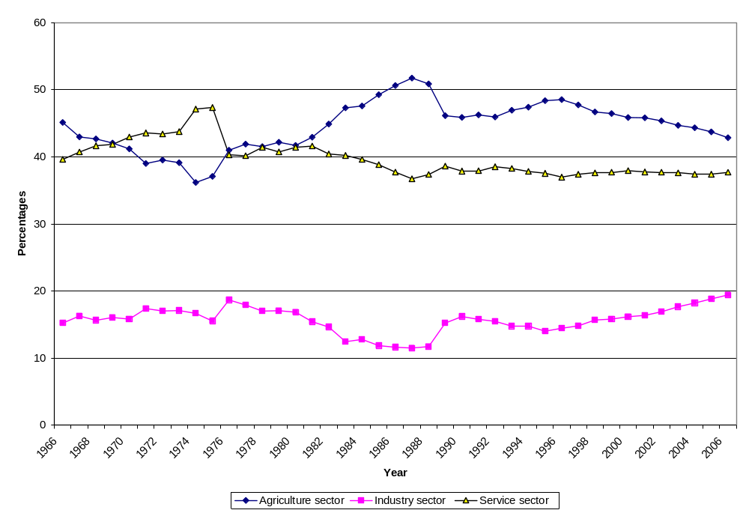
Figure 3.3 Sectoral Share of GDP, 1966–2006
Source: Tanzania, NBS, National Accounts (several years).
In the past 50 years, the sectoral composition of GDP has fluctuated, but 2006 shows a similar composition to that of the 1960s. The increasing importance of agriculture during the 1970s and 1980s and its decline since the 1990s, as shown in figure 3.3, is particularly striking. One of the reasons for the steep increase in the agricultural share of GDP in the mid-1980s had to do with the major economic recovery programs and the privatization of state-owned enterprises. Economic growth has been increasing since 1995, and the main driver has been the industrial sector (the mining and manufacturing industries, in particular). Despite their small size, the industrial and services sectors have seen a steady increase in their contribution to GDP growth since 1996.
The agricultural sector contribution to GDP varies cyclically more than the industrial and services contributions. Agriculture is highly dependent on rainfall because only a small proportion of cultivated agricultural land is irrigated. Since 1996, annual growth in the industrial sector’s contribution to GDP has been higher than both the agricultural and the services sectors (tables A7.3 and A7.4 in appendix 7). The industrial share of real GDP grew from about 14 percent in 1996 to 19 percent in 2006, a period in which the agricultural share declined from 48 to 44 percent. The share of real GDP attributable to services has been relatively stable.

Gross Domestic Product Approach
It is possible to calculate the share of GDP coming from urban areas. One way to do this is through a gross domestic product approach, which uses the following formula:
Urban share of GDP = urban share of labor force in agriculture * GDP from agriculture + urban share of labor force in industry * GDP from industry + urban share of labor force in services * GDP from services
This approach calculates the weighted average of each sector’s contribution to GDP and the share of the urban population employed in each sector. The 2002 Census published district profiles with data on economic activities categorized into the agricultural, industrial, and services sectors, and also on employment in each of these sectors. To calculate the urban share of GDP, national real GDP figures by economic activity were used. The size of the labor force employed in each sector was calculated as the urban-to-total-worker ratio.
Table 3.7 Urban Contribution to Economic Growth: Gross Domestic Product Approach, 1991–2006 and 2001–06
(percentages)
Economic activity | Average annual growth | Share of annual GDP growth | Average share of GDP | Average annual growth | Share of annual GDP growth | Average share of GDP
 | (1991–2006) |  |  | (2001–06)
Agriculture | 1.80 | 41.25 | n.a. | 2.12 | 35.87 | n.a.
Industry | 0.98 | 22.37 | n.a. | 1.56 | 26.40 | n.a.
Services | 1.59 | 36.45 | n.a. | 2.22 | 37.56 | n.a.
Total GDP | 4.37 | 100.00 | 100.00 | 5.91 | 100.00 | 100.00
Urban wardsª | 2.35 | 53.78 | 50.61 | 3.41 | 57.70 | 52.71
Rural wards | 2.02 | 46.22 | 49.39 | 2.50 | 42.30 | 47.29
Urban LGAs^{b} | 1.74 | 39.82 | 36.72 | 2.57 | 43.49 | 38.71
Source: Authors’ calculations based on district profiles from Tanzania, NBS (2002).
Note: n.a. = not applicable.
a. These include urban and mixed wards.
b. According to the politico-administrative definition (PMO-RALG).
Urban areas contribute more than half of the national product. As shown in table 3.7, urban LGAs contributed roughly 37 percent of national GDP in the 1990–2006 period. But if we look more broadly at urban areas (as defined by NBS), that contribution is half again greater, up to 50.6 percent of the GDP (increasing slightly to 52.7 percent if only the 2000–2006 period is considered). These data reinforce the importance of the urban contribution and again focus attention on the role of urban areas that are not legally classified as urban.

Urban Domestic Product Approach
Another way to examine the urban share of GDP is through the urban domestic product (UDP) approach, which takes into account the urban-to-total-wage ratio, according to the following formula:
Urban domestic product = national domestic product * (urban workers / total workers)* (urban wages / total wages)
Wages are calculated from income estimates of the Household Budget Survey (HBS 1990/91 and 2000/01) and the Integrated Labor Force Survey (ILFS 1991, 2001, and 2006). These calculations were made using the same estimates of the urban share of the labor force used in the gross domestic product approach.

Table 3.8 Gross and Urban Domestic Product, 1990–2006
(percentages)
 | Statistical perspective |  |  |  | Politico-administrative perspective
 | 1 | 2 | 3 | 4 | 5 | 6 | 7
1991 | 47 | 46 | 37 | 30 | 34 | 25 | 21
1992 | 49 | — | 40 | 32 | 35 | — | 22
1993 | 49 | — | 42 | 34 | 35 | — | 24
1994 | 49 | — | 44 | 36 | 35 | — | 25
1995 | 49 | — | 46 | 39 | 35 | — | 27
1996 | 50 | — | 49 | 42 | 36 | — | 28
1997 | 50 | — | 51 | 45 | 36 | — | 30
1998 | 52 | — | 54 | 48 | 38 | — | 32
1999 | 53 | — | 57 | 52 | 38 | — | 33
2000 | 53 | — | 59 | 55 | 38 | — | 35
2001 | 53 | 54 | 62 | 58 | 39 | 33 | 37
2002 | 53 | — | 59 | 56 | 39 | — | 35
2003 | 52 | — | 56 | 53 | 38 | — | 33
2004 | 53 | — | 54 | 52 | 39 | — | 32
2005 | 53 | — | 51 | 51 | 39 | — | 31
2006 | 52 | — | 49 | 49 | 39 | — | 30
Average (1990–2006) | 51 | 50 | 51 | 46 | 29 | 29 | 37
Average (2000–06) | 53 | — | 56 | 53 | 33 | — | 39
Source: Authors’ calculations based on Tanzania, NBS (2002); Tanzania, NBS, National Accounts (several years); Tanzania, NBS (1991, 2001a, 2001b, and 2006b).
Note: — = not available.
Column 1 Gross domestic product: NBS definition.
Column 2 Urban domestic product: HBS income data.
Column 3 Urban domestic product: ILFS income data, based on economic activity.
Column 4 Urban domestic product: ILFS income data, based on occupation.
Column 5 Gross domestic product: PMO-RALG definition.
Column 6 Urban domestic product: PMO-RALG definition; HBS income data.
Column 7 Urban domestic product: PMO-RALG definition; ILFS income data, based on economic activity.
This UDP analysis again suggests that urban areas contribute more than half of GDP. Columns 1–4 in table 3.8 present the gross and urban domestic products using the statistical perspective, and columns 5–7 show the results of the politico-administrative perspective. On average, from 1991 to 2006, the GDP estimations using both approaches are quite similar at 51 percent (columns 1 and 3). If occupation data rather than economic activity income data are used, then the estimation is about 5 percent lower (column 4). Columns 5–7 present the comparison of the gross and urban domestic products, but for the politico-administrative perspective. As expected, compared with the statistical perspective, the gross and urban estimations are lower because they use a more restrictive definition of urban areas. In this case, however, the estimations vary between the GDP and UDP approaches: the latter is six percentage points higher than the former.
The urban share of GDP increased faster from a UDP perspective. This is the result of real wages in agriculture remaining unchanged from 1991 to 2001, while real wages in the industrial and services sectors increased sharply. For instance, during this period, the mean monthly wage (in real 2001 prices) in agriculture remained at a level of T shs 15,500, while wages in financial services increased from T shs 33,000 to T shs 142,000 (table 3.6). During 2001–06, the share of urban GDP remained relatively constant using the gross domestic product approach, but substantially declined using the urban domestic product approach, because of the changes in wages during the period. Another reason for the increase in the urban share of GDP during the 1990s and a relative decline after 2001 has to do with changes in labor force participation rates.
Using ILFS income data on consumption and economic activity results in different estimations of the urban share of GDP, but the trend over time is similar. Estimates using income data based on occupation report lower values than those using income data based on economic activities. As for the estimation of the urban share of GDP using a politico-administrative perspective of urban areas, this is lower than the results using the more expansive statistical definition. However, the trends are also similar, showing both lower estimates in the urban domestic product approach than in the gross domestic product approach and an increase in the share of urban GDP in the 1990s, followed by a slight decrease since 2001 (resulting from differences in rural/urban wages and in the labor force participation rates).

Labor Productivity
Labor productivity measures the extent to which labor is efficiently used. An increase in labor productivity is usually associated with increases in real incomes and standards of living. A labor productivity index measures the change in output per marginal change in the input of labor. A labor productivity index can be estimated by dividing real GDP by employment. A labor productivity index for each economic sector can be estimated in the same way, by dividing the real GDP of each sector by the size of the employed population in each sector.
Measuring labor output and input. Output data come from the National Accounts. Based on these data, two measures of real urban and rural GDP are used: a gross domestic product approach and an urban domestic product approach (see Urban GDP section). These two different measures yield different labor productivity indexes. Because information on working hours is limited, employment is used as a measure of labor input. A weakness in this measure is that it does not reflect shifts in the composition of part- and full-time work nor changes in the average number of hours worked by full-time employees.
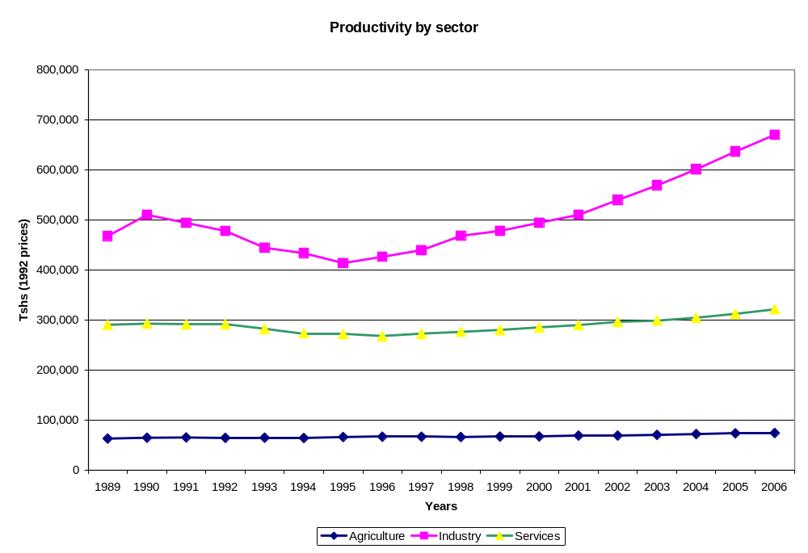
Figure 3.4 Labor Productivity by Sector
Source: Authors’ calculations based on Tanzania, NBS (2002); Tanzania, NBS, National Accounts (several years); and NBS (1991, 2001b, and 2006b).
Note: The data for this graph are shown in table A7.7 in appendix 7.
The industrial sector drives increased productivity. In the past 15 years, the average productivity of the economy has increased by 24 percent. This increase is mostly the result of the rise in industrial productivity, which is the only sector that has seen important increases in productivity in the past 15 years (figure 3.4). There has been a productivity increase of 43 percent in the industrial sector, while the services and agricultural sectors increased only 10 and 17 percent, respectively, in the same period. This means that in 2006 a worker who joined the industrial sector could generate 9 times as much output as if he or she joined the agricultural sector and 4.3 times as much output as if he or she joined the agricultural sector. Agriculture remains the least productive sector of the Tanzanian economy. In 2001, the agricultural sector employed 82 percent of the labor force to produce 44 percent of the GDP, while the nonagricultural sectors employed 18 percent of the labor force and produced the remaining 56 percent of the GDP.
Table 3.9 Gross Value Added per Employee, 2000/01
 | GDP  (T shs millions) | GDP  (percentages) | Labor force | Labor force (percentages) | Average gross value added per worker  (T shs) | Indexª
Agriculture, forestry, fishing, and hunting | 3,406,146 | 43.80 | 13,890,054 | 82.12 | 245,222 | 1
Mining and quarrying | 120,454 | 1.50 | 29,223 | 0.17 | 4,121,890 | 17
Manufacturing | 564,689 | 7.30 | 245,449 | 1.45 | 2,300,637 | 9
Electricity and water | 124,789 | 1.60 | 14,697 | 0.09 | 8,490,780 | 35
Construction | 405,159 | 5.20 | 151,690 | 0.9 | 2,670,967 | 11
Wholesale and retail, trade, hotels, and restaurants | 926,870 | 11.90 | 1,262,968 | 7.47 | 733,882 | 3
Transport and communications | 361,558 | 4.60 | 111,572 | 0.66 | 3,240,580 | 13
Finance, insurance, real estate, and business services | 1,075,806 | 13.80 | 26,501 | 0.16 | 40,594,921 | 166
Public administration and other services | 796,930 | 10.20 | 1,182,671 | 6.99 | 673,839 | 3
Total industries | 7,782,401 | 100 | 16,914,825 | 100 | 460,093 | 2
Source: Authors’ calculations based on Tanzania, NBS (2001a).
a. Gross value added per person in each sector relative to agriculture.
Table 3.9 assigns an agricultural productivity index of 1.0 (equivalent to T shs 245,222) to the gross value added per worker in the agricultural sector to show the differences in productivity in the other sectors. Wholesale and retail, trade, hotel, and restaurant services have about three times the productivity of agriculture. Manufacturing, construction, and transport and communications are 9, 11, and 13 times, respectively, more productive than agriculture. Workers in the financial sector have the highest gross value added in the entire economy, by a wide margin. The gross value added of a worker in the financial sector in 2000/01was 165 times that of the self-employed agricultural worker.
Urban and rural labor productivity. The urban and rural labor productivity indexes are calculated by dividing urban and rural GDP by urban and rural employment. Two measures were used to find the urban/rural GDP, resulting in different labor productivity indexes: gross domestic product approach and urban domestic product approach (see Urban GDP section).
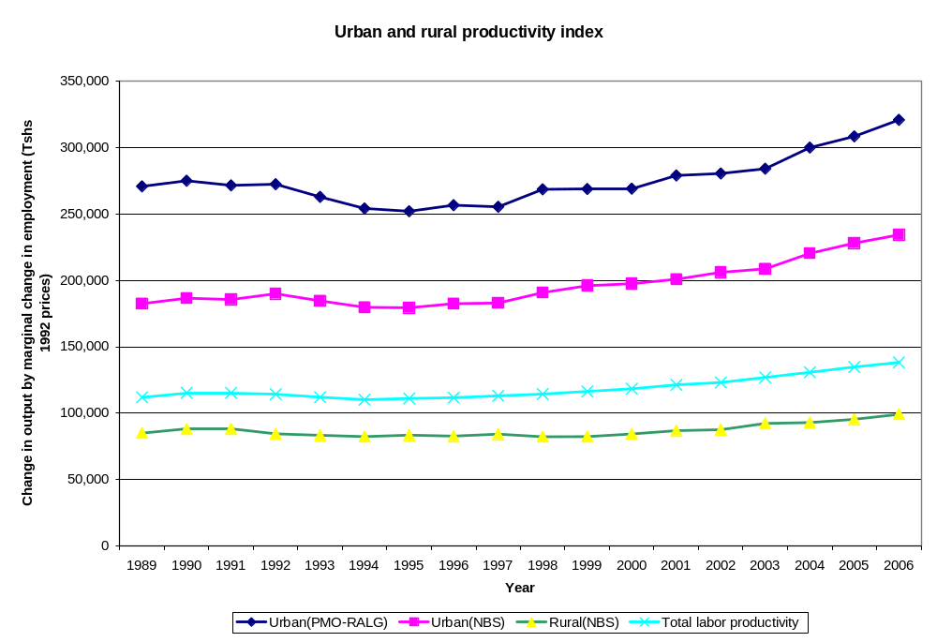
Figure 3.5 Labor Productivity: Gross Domestic Product Approach
Source: Authors’ calculations based on Tanzania, NBS (2002); Tanzania, NBS, National Accounts (several years); and NBS (1991, 2001b, and 2006b).
Urban economies have become increasingly more productive, relative to rural ones, in the past 15 years. Using the GDP approach, we see that in 1989, the output productivity per employee in an urban (statistically defined) area was equal to T shs 183,000, whereas in rural areas it amounted to T shs 85,000 (figure 3.5). By 2006, the levels of productivity changed to T shs 234,000 and T shs 99,000, respectively. This means that while productivity in the urban economy increased by 28 percent, in rural areas productivity grew by only 16 percent. If productivity is estimated for only the urban LGAs, then urban productivity is still higher, at a level of T shs 271,000 in 1989 and T shs 322,000 in 2006. This means that, in comparison with rural areas, in 2006 productivity of labor was 2.3 times higher in urban areas generally, and 3.2 times higher if only the urban LGAs are considered.
The UDP approach also reveals the increasing productivity of urban areas. This approach takes wages into account and looks at the national (not each sector’s) contribution to GDP. As figure 3.6 shows, from 1989 to 2006 productivity in urban areas grew by 47 percent, while in rural areas it grew by only 3 percent. As a result, the productivity gap increased. Although in 1989 productivity in urban areas was 1.4 times higher than in rural areas, by 2006 it grew to double. The increases in urban productivity from 1991 to 2001 are in part the result of the increases in real wages in the industrial and services sectors, while real wages in the agricultural sector kept constant. The year 2006 was a good harvest year, and real wages in agriculture doubled from those of 2001, explaining the rise in agricultural productivity during 2001–06. Because wages in agriculture fluctuate widely, the wage estimates from 1991–2001 and 2001–06 may not be a good approximation. For this reason, the gross domestic product approach may be a better approximation to urban and rural productivity. Although the two productivity measures yield different results (mostly higher increases of urban productivity when estimated with the urban domestic product approach), they both show higher increases in urban than in rural productivity.
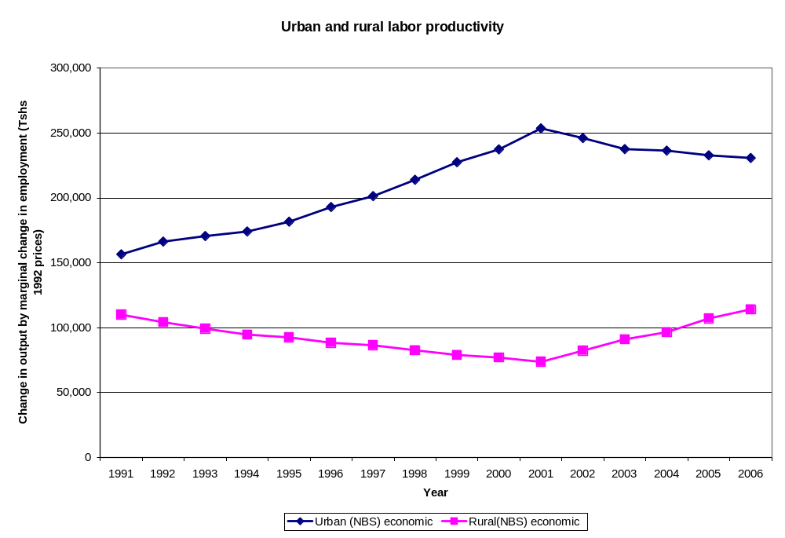
Figure 3.6 Labor Productivity: Urban Domestic Product Approach
Source: Authors’ calculations based on Tanzania, NBS (2002); Tanzania, NBS, National Accounts (several years); and NBS (1991, 2001b, and 2006b).
Note: The data for this graph are in table A7.7 in appendix 7.

Conclusions
Urban areas contribute half of Tanzania’s GDP. Although agriculture employs more people, the share of employment in agriculture is declining. At the same time, informal employment (which is often less productive and less secure, and which escapes most government taxes) has increased substantially, especially in urban areas. A key challenge is to create more productive, secure formal employment for urban residents. Creating these jobs requires private sector investment, and creating the conditions for more private investment requires the usual public inputs in terms of education, infrastructure, services, and a sound investment climate.
Labor productivity in urban areas is higher than in rural areas, and the differential is likely to continue to grow, as elsewhere in the world. Rapid growth in urban productivity has powered the economies of countries like Korea, Brazil, India, and China. Looking ahead, the importance of urban areas in Tanzania’s overall economic growth will continue to increase. According to Satterthwaite (2007, 28), around 97 percent of the world’s GDP is generated by industry and services, and around 65 per cent of the world’s economically active population works in industry and services. Even for low- and middle-income nations, around 90 per cent of GDP and 50 percent of employment come from industry and services. Tanzania is well below these levels, so the potential for the urban economy to expand is significant.
The return on investment on urban infrastructure is likely to vary between Dar es Salaam and secondary cities. The primacy of Dar es Salaam in the national economy can be seen as a strength or a weakness. It is a strength because Dar es Salaam can offer a critical mass of skills, investment, and infrastructure that cannot be matched anywhere else in Tanzania. It can be a weakness because the national economy is tremendously dependent on the success of Dar es Salaam.

CHAPTER 4 URBAN-RURAL LINKAGES

Introduction
The linkages between urban centers and the countryside, including movement of people, goods, capital, and other social transactions, play an important role in processes of rural and urban change (Tacoli 1999). The objective of this chapter is to assess the urban-and-rural linkages during the urbanization process. It does so by looking at three issues: migration linkages, economic linkages, and periurban development between urban and rural areas. There are other linkages which will not be discussed in details due to data limitations. For example, linkage of goods and products — many urban enterprises rely on demand from rural consumers, and access to urban markets and services is crucial for agricultural producers.
There are three types of urbanization in Tanzania: The first is the clustering of people and enterprises around a city (for example, Dar es Salaam). Most functional linkages such as transportation, trade, employment, social services, and land development are related to the focal city. We call this “monocentric urbanization.” The second type is the clustering of people and economic activities around villages or towns (for example, in the areas south of Lake Victoria in Mwanza and Shinyanga). Much of this urbanization has its roots in Tanzania’s former “villagization” policy: migration during the 1980s was steered away from the larger cities toward smaller towns with populations of between 20,000 and 50,000, where urban household self-provisioning of food was more feasible (Tacoli 1999). This type of urbanization led to more spread-out development in regions, as in Mwanza and Shinyanga. We call this “diffuse urbanization.” The third type of urbanization is found mainly along arterial roads that provide access for villages. This type of urbanization usually cuts across administrative boundaries. An example is a belt from Morogoro along the road to Iringa and continuing to Mbeya. We call this “arterial urbanization.”

Internal Migration Linkages
In this section, we focus on internal migration at the region and regional headquarters level. Migration in periurban areas is discussed in the Periurban Development section.
Internal migration is becoming interwoven with urbanization. The importance of internal migration in shaping urbanization is well recognized among government agencies. For example, the Ministry of Lands and Human Settlements Development (Tanzania, MoLHSD 2000, 14) highlights that “it is only through knowledge of the rural-urban migration phenomenon that an effective policy on human settlements can be developed.” Migration impacts urbanization through several channels. First, migration has labor market implications. The skill profile of migrants responds to labor market demand and affects labor supply in the receiving urban centers. Migration creates additional demand for land, housing, infrastructure, and social services in urban centers. .
Four patterns of internal migration can be identified based on the origin and destination of the flows: rural-to-rural, rural-to-urban, urban-to-rural, and urban-to-urban. Only the last three patterns are considered in this section, which focuses on the linkages between internal migration and urbanization. Global experience is clear that rural-to-urban migration is the main direction of mobility, because economic growth reflects and induces a spatial shift in favor of towns. If migration is sequential or step-wise, urban-to-urban migration can be regarded as a “second step” of rural-to-urban migration, because rural migrants sometimes move first to small urban centers until they acquire the capital needed to settle in larger urban centers. Urban-to-rural (or reverse) migration may occur at times, for example, in places affected by economic recession.
Census data allow analysis of migration patterns only over 2001/02. Given that the 1988 census does not include questions related to previous places of residence, migration patterns can be analyzed for only 2001/02, drawing on the latest census. The risk is that 2001/02 may not be a representative migration year, though we do not know of any reason it would not be typical. Census data do not distinguish among different typologies of rural-to-urban migration, such as sequential migration, seasonal migration (that is, rural migrants moving seasonally to urban areas to gain a livelihood during dry seasons), circular migration (that is, young migrants moving to an urban area and then returning home at a later stage of their lives), or lifetime migration (that is, migrants moving permanently to urban areas). Box 4.1 describes in more detail the data sources and the methodology for the analysis.
Box 4.1 Migration in Mainland Tanzania: Methodological Approach
For the purpose of this section, we define migration by comparing the usual residence reported in the 2002 census with the place of residence one year before the census (“the previous residence”). People who reported a previous residence different from their usual residence are classified as “migrants.”
Respondents were asked where they usually lived at the time of the census and where they lived a year before. Both questions were included in the long census questionnaire, which was submitted to 20 percent of the enumeration areas. The region (or country, if outside Tanzania) and the location of the usual and previous residence was recorded. Respondents were given three choices (which unfortunately do not coincide neatly with any of the definitions of “urban” reviewed in chapter 1):
1. Rural
2. Urban as regional headquarters
3. Other urban (that is, district headquarters)
These categories limit the analysis that can be conducted. Intraregional migration can be registered only if migratory flows take place from rural to urban, or from a district headquarters to a regional headquarters. We cannot measure intraregional migration between district headquarters or between rural areas. The regional headquarters is therefore the only spatial unit for which one can measure all in- and out-migratory flows.
A second limitation concerns the analysis of migrant household characteristics. If the de facto place of residence differed from the usual place of residence, individuals were not counted in their usual household (for example, if a rural-to-urban migrant returned to his or her place of origin during August 2002, the migrant was not counted as part of his or her usual household in the urban area, but as part of the rural household the migrant visited). This means that household characteristics cannot be directly linked to the migrant. Hence, rural-to-urban migrant household characteristics are tabulated only when the usual place of residence of the head of the household (in which the migrant was counted) was a regional capital, a district headquarters, or another urban area. In this context, it is safe to link migrant and household characteristics, because one can assume that the urban household is the household where the migrant usually lives.
Finally, the analysis only captures household-level migration, because the long-form questionnaire was administered only to households. The census did not capture migration outside the household context (for example, students moving to student hostels, migrant street children, soldiers, or prisoners).
Two spatial units of analysis are considered for the analysis: (a) a unit including both district and regional headquarters (more or less the MoLHSD definition of “urban”) and (b) a unit including regional headquarters only. The definition of migration and turnover adopted in this section is person-based, so that movement of people in and out of the spatial unit of analysis is counted as a migration flow and added to the turnover. For example, the following are counted as migratory flows for Dodoma Urban LGA: all movements between Dodoma Urban and rural areas (located within and outside the Dodoma region) and all movements between Dodoma Urban and other urban areas (located outside Dodoma Urban). Mobility within Dodoma Urban is not counted. The same methodology is used to calculate migratory flows and turnover for the regional headquarters.
For the country as a whole, turnover is calculated by summing all movements between urban and rural areas. Urban-to-urban flows are not added to the turnover because they do not involve a change in the composition of the urban population as a whole.

Urban Migration and Its Contribution to Urban Growth
Net migration to urban areas is low, but turnover is high. Net urban migration accounted for only 0.6 percent of the urban population in mainland Tanzania in 2002. The low net migration rate conceals a much higher turnover: about 5.3 percent of the urban population moved to or from urban areas in the country, and an additional 2.6 percent of the urban population moved between urban centers.
Net urban migration rates vary across urban areas. Overall, 13 out of 21 regions gained urban population because of net in-migrations. The largest net in-migrations (as a percentage of the urban population) were in Shinyanga (2.2 percent), Mwanza (2.2 percent), and Manyara (2.0 percent). In these regions, mining is the main pull factor attracting in-migrants from rural areas. In Dar es Salaam, net in-migration accounted for 1.3 percent of the urban population. The main urban population losers were the urban areas of Dodoma (−2.5 percent), Tanga (−1.6 percent), and Singida (−1.4 percent). Figure 4.1 shows migration rates in and out of urban settlements at the regional level (box 4.1; also table A8.1, appendix 8).
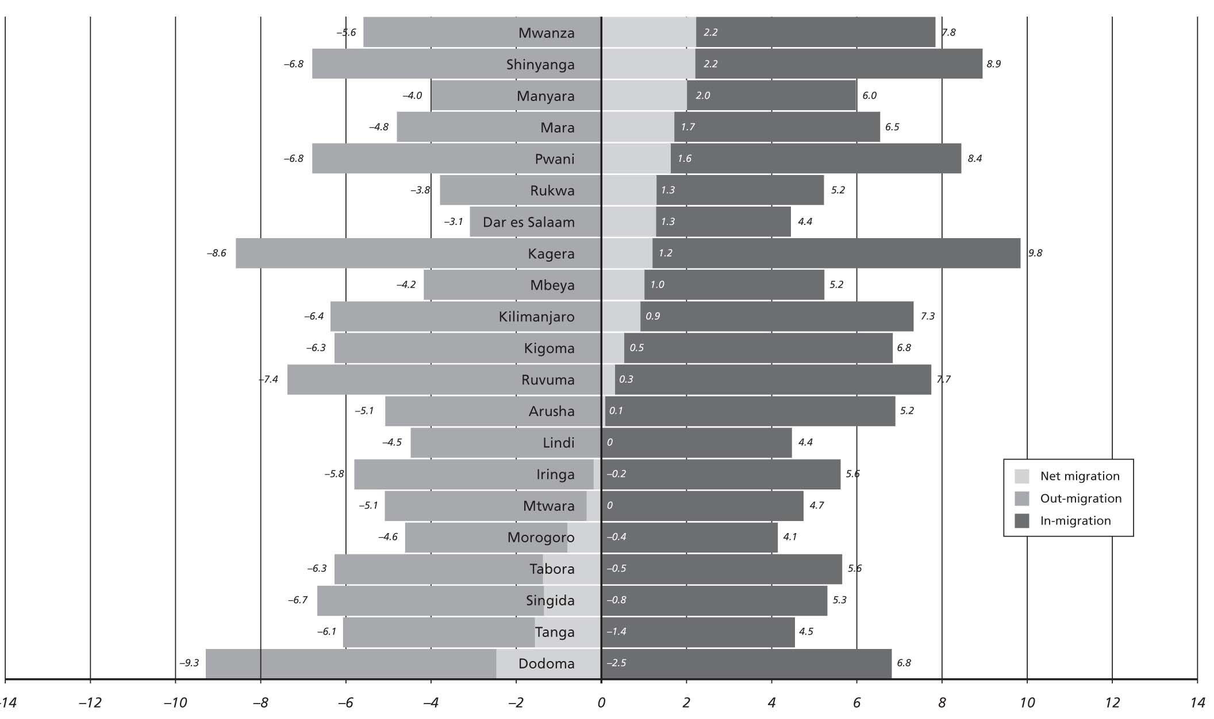
Figure 4.1 Net Urban Migration Rates, 2001/02 (percentages of urban population)
Source: Authors’ calculation based on census data.
Urban turnover ranges from 7.5 to 18 percent and is not highly correlated with net migration. As shown in figure 4.2, there is a significant variation in turnover rates across urban areas, ranging from 7.5 to 18 percent. Surprisingly, Dar es Salaam exhibits the lowest turnover rate among the regions. Little correlation is found between net urban migration and turnover rates (for example, the largest rate of in-migration is observed in urban Kagera, where almost 10 percent of the population was in-migrant in 2001/02; however, almost 9 percent out-migrated, resulting in a net in-migration of only 1.2 percent. Similarly, almost 9 percent of the urban population migrated in or out of urban Lindi in 2001/02, resulting in a net in-migration close to zero.
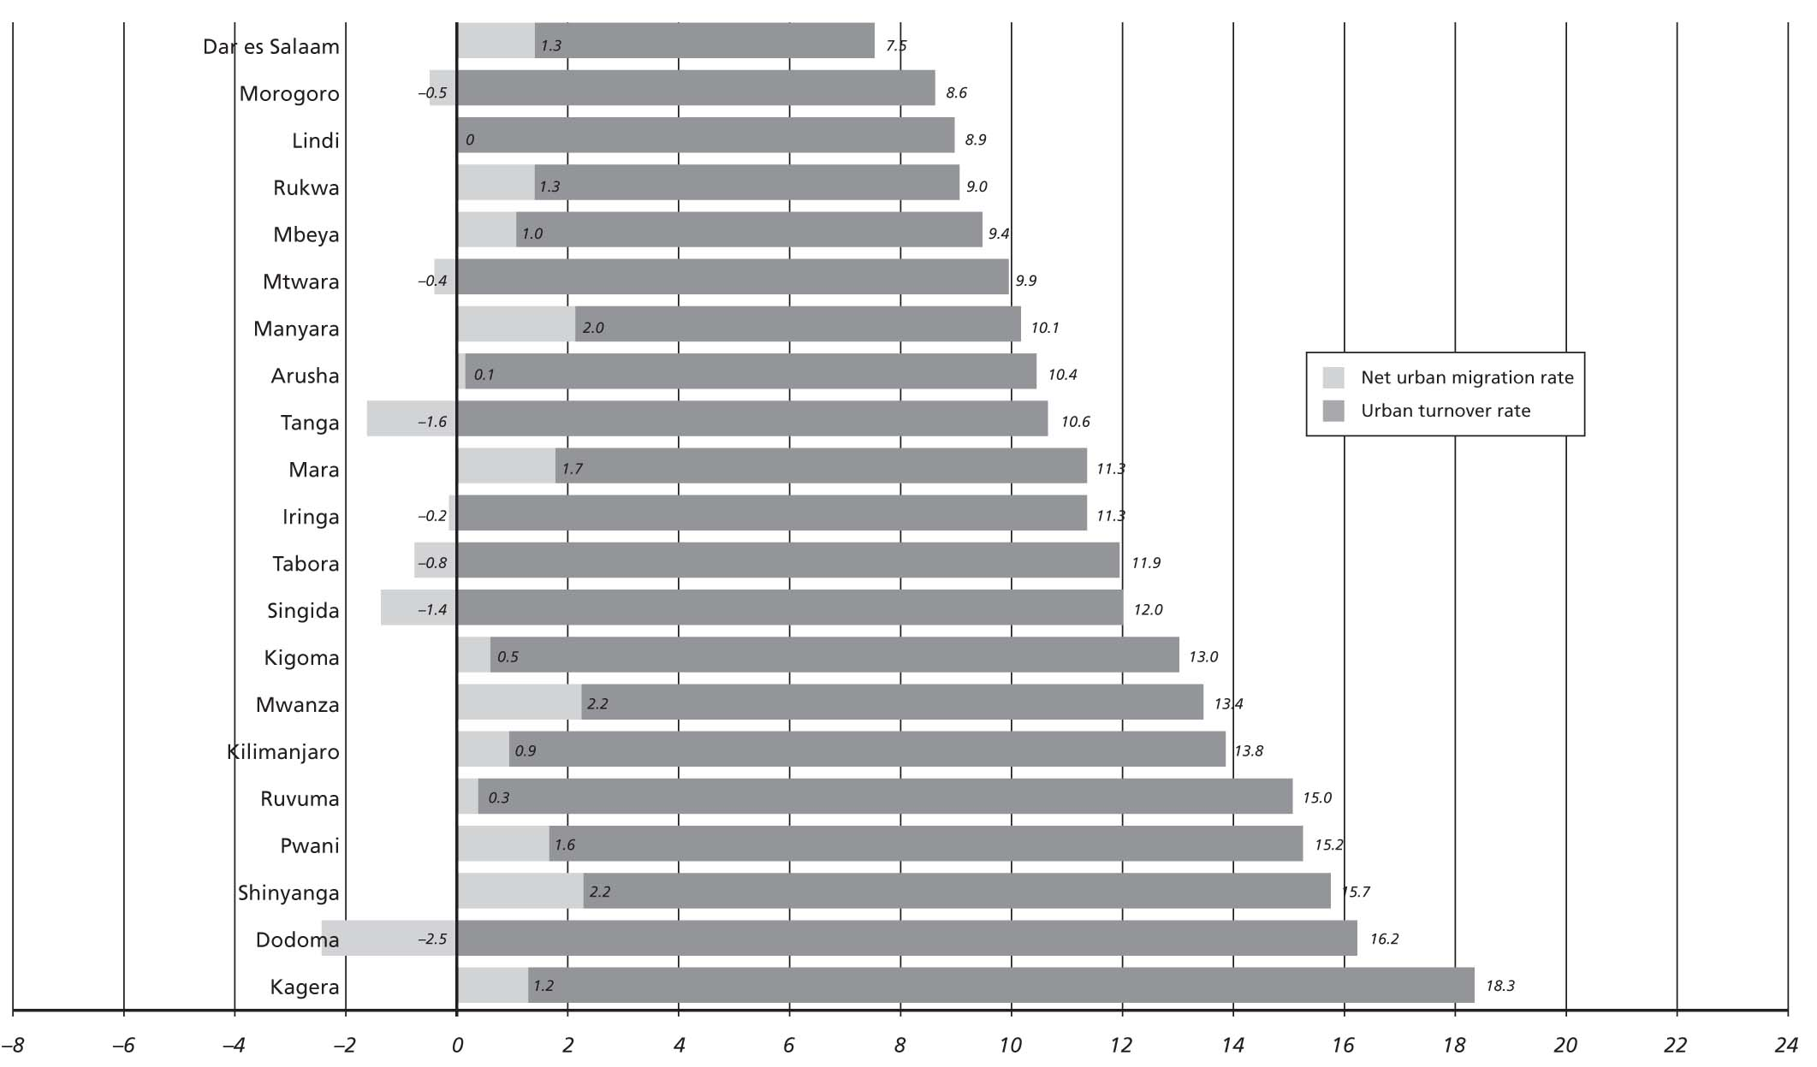
Figure 4.2 Urban Turnover, 2001/02
Source: Authors’ calculation based on census data.
Rural-to-urban and urban-to-urban mobility are both significant. A breakdown of migratory flows by origin and destination shows that rural-to-urban and urban-to-urban mobility are equally important migratory flows. On average, rural-to-urban mobility represents 51 percent of the total turnover, while mobility between urban centers accounts for the remainder. This suggests that migration between urban centers accounts for a significant share of the mobility to and from urban centers, though it does not contribute to net urbanization.
Migration is not the main contributor to urban growth. Urban areas have three main sources of population growth: natural increase (an excess of births over deaths), migration (an excess of individuals moving in, compared with those leaving), and reclassification (whereby urban status is conferred on formerly rural residents and territory). Reclassification typically follows the physical expansion of the built-up area. Figure 4.3 shows the estimated contribution of these three main sources. Net urban migration contributes 17 percent of the overall urban growth during 1988–2001, implying that the bulk of urban growth is driven by natural growth and physical urban expansion. The estimated contribution of migration to urbanization in mainland Tanzania is slightly below the average for African countries: rural-to-urban migration is estimated to have accounted for about 25 percent of urban growth over the 1980s and 1990s in Africa (Brockerhoff 1995).
These findings may appear against the conventional wisdom that migration drives urban growth. This may result from the fact the migration is especially important in peri-urban areas located outside of urban LGA boundaries. The clustering of migrants in periurban areas does not contribute to the official statistics but is in fact a major engine of urbanization. However, at this point there is no clarity in terms of the dynamic and flow of migration among urban, periurban, and rural areas.
Figure 4.3 Urban Growth Components, 1988–2002 and 2001/02
(percentages)
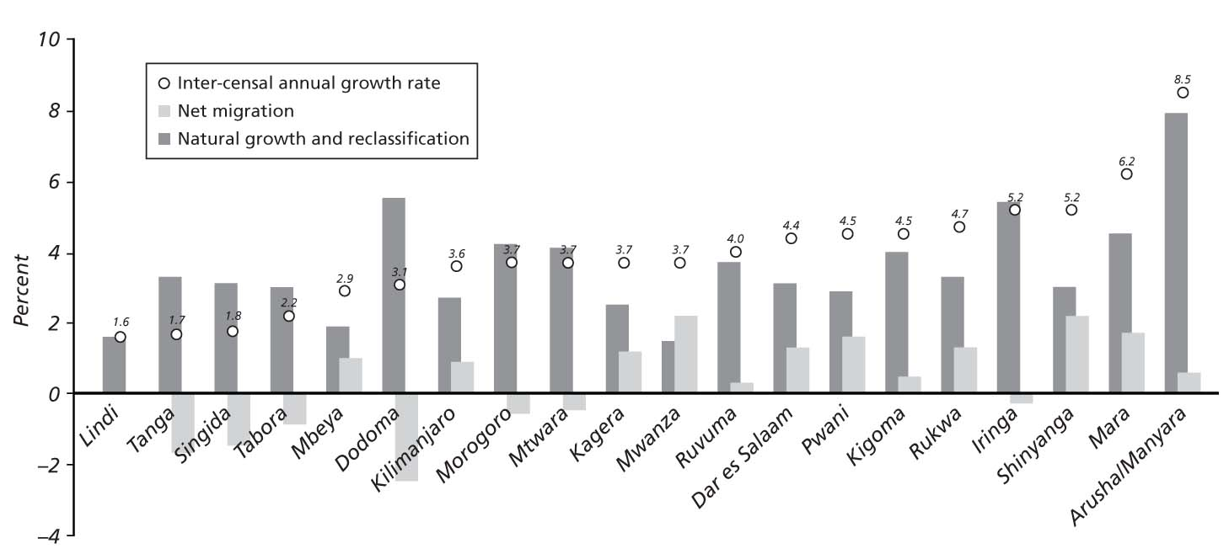
Source: Authors’ calculation based on census data.
Note: The analysis is based on the assumption that 2001/02 was a normal migration year during 1988–2002.

Migration to and from Regional Headquarters
Net migration rates to regional headquarters (urban LGAs) range from +2.9 to −3.0 migrants per 100 inhabitants (figure 4.4). The range of net migration rates among regional headquarters is broader than the range among all urban areas (including district headquarters), which varied from 2.1 to −1.6 percent. Overall, 10 out of 21 regional headquarters LGAs experienced positive net migration rates. The data suggest a negative correlation between the population size and net migration: small urban centers tend to attract migrants at a higher rate than large centers. However, larger centers are more likely to be net gainers of migrants than small urban centers. (In- and out-migration patterns for each regional headquarters are shown in appendix 8.)
Figure 4.4 Migration Rate, Regional Headquarters
(percentages of urban population)
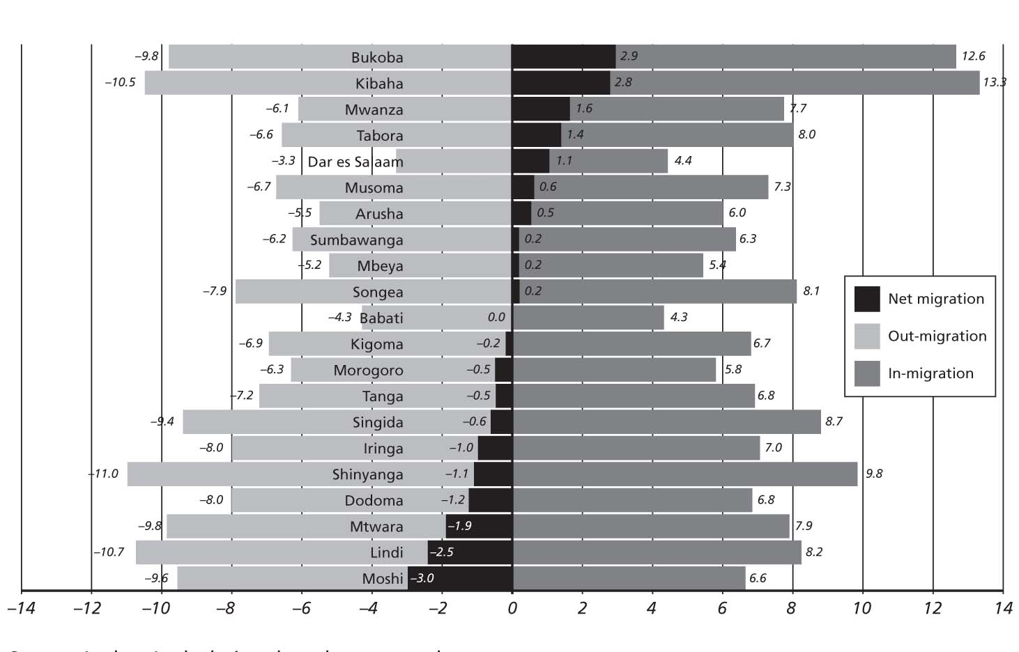
Source: Authors’ calculation based on census data.
Bilateral flows of migration suggest economic linkages between urban centers. The major senders of migrants to regional headquarters are also major recipients of migrants from regional headquarters. For example, Dar es Salaam and urban areas within the Dodoma region are both the largest senders of migrants to Dodoma Urban LGA and the most important recipients of migrants from Dodoma Urban (figures A8.3 and A8.15, appendix 8). These patterns suggest strong economic linkages, expressed (among other things) in migratory flows in both directions.

The Profile of Urban Migrants
Assessing the profile of migrants helps illuminate the socioeconomic changes associated with migration. “The spatial mobility of a population affects not only the distribution of the population but also age and sex structure and other demographic, social and economic characteristics of the population” (Tanzania, NBS 2006a). This section compares the profile of migrants with the profile of nonmigrants with regard to selected livability and socioeconomic indicators. When interpreting the results, one has to keep in mind that the analysis captures only the transitional phase of migration, given that migrants moved sometime in the 12 months preceding the census.

Urban In-Migration
Most migrants to urban areas join existing households. When moving to an urban area, migrants have two options: they can either join an existing household or establish a new household. Census data show that only 26 percent of migrant households are newly established (all members are migrants). The remaining 73 percent join existing households.
Households with at least one migrant tend to have better access to services than households with no migrants. Access to basic services (such as electricity and improved sanitation) is more widespread among households with at least one migrant. Urban migrant households also have better housing quality than nonmigrant households. Households that absorbed migrants from other urban areas are slightly better off than households with rural migrants, with regard to access to basic services (electricity, piped water, and use of improved toilet types), housing quality, and asset ownership (figure 4.5).
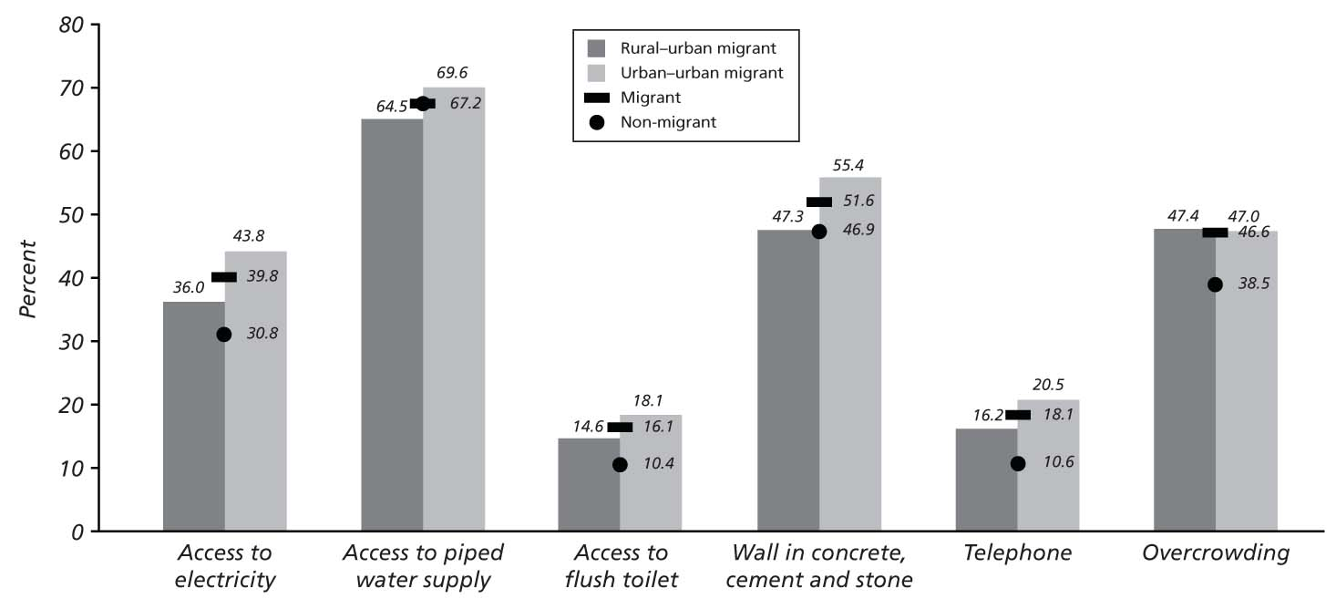
Figure 4.5 Living Conditions of Urban Migrant Households, by Origin of Migrants (percentages)
Source: Authors’ calculation based on census data.
Preexisting urban households absorbing migrants have better access to services than newly established migrant households. The discrepancy is particularly striking with respect to access to electricity: 42 percent of preexisting households absorbing migrants have access to electricity, compared with only 33 percent of newly established migrant households. Similarly, 18 percent of households absorbing migrants have access to flush toilets, compared with only 10 percent of newly established migrant households. A similar gap is found with regard to access to telephones. Differences in access to piped water are minimal. Overall, the results indicate that newly established migrant households may be a particularly vulnerable group in the urban context, especially immediately following their move.
Migrants and nonmigrants have a similar education profile, but differ in their employment status. On average, both migrants and nonmigrants have between five and six years of education. The results are consistent with Tacoli’s (2002) participatory study in Lindi and Himo suggesting that migrants are not poorer than those left behind. In terms of employment, differences between migrants and the receiving population are not very pronounced (for example, 69 percent of nonmigrants are self-employed, compared with 61 percent of the recent migrants).
Urban-to-urban migrants are the most educated group. Urban-to-urban migrants have higher literacy and educational levels than rural-to-urban migrants: 86 percent of urban-to-urban migrants are literate, compared with 78 percent of rural-to-urban migrants. Urban-to-urban migrants have (on average) one year more of education than rural-to-urban migrants and are significantly more likely to have secondary and postsecondary education. Somewhat surprisingly, urban migrants are also more educated than the average resident in the receiving urban areas (for example, 6 percent of urban-to-urban migrants have postsecondary education, against 3.5 percent of nonmigrants)

Economic Linkages
Urban-rural linkages include at least two additional processes, besides physical migration: (a) redistribution through government taxing and spending and (b) remittances by individuals.

Fiscal Linkages
There has been an increase in overall LGA revenues and expenditures and an increasing reliance on central government grants as opposed to own-source revenue. Total LGA revenue (including own-source revenue and intergovernmental transfers) increased from 255 billion Tanzanian shillings (T shs) in 2001/02 to T shs 920 billion in 2006/07. Total LGA expenditure also increased from T shs 255 billion in 2001/02 to T shs 858 billion in 2006/07. Among LGAs’ total revenues, intergovernmental transfers, typically from the central government, increased from 79 percent of total LGA revenues in 2001/02 to 93 percent in 2006/07, while own-source revenue decreased from 21 percent of total LGA revenues in 2001/02 to 7 percent in 2006/07. In 2003, total LGA revenue accounted for 4.4 percent of GDP, while own-source revenues accounted for only 0.5 percent of GDP (table 4.1).
Table 4.1: Local Government Authorities Expenditures, 2003 - 2005
 | Outturn 2003 |  |  | Outturn Jan-June 2004 |  |  | Outturn 2004-05
 | Tshs  Bn | % GDP | % Share | Tshs  Bn | % GDP | % Share | Tshs  Bn | % GDP | % Share
Total Revenue | 434 | 4.4 | 100 | 242 | 4.3 | 100 | 647 | 6.0
Own Source Revenue | 48 | 0.5 | 11 | 18 | 0.3 | 7 | 43 | 0.4 | 7
Central Grants | 340 | 3.5 | 78 | 185 | 3.3 | 76 | 518 | 4.8 | 80
Basket Funds and Non GOT Grants | 46 | 0.5 | 18 | 39 | 0.7 | 16 | 86 | 0.8 | 13
Total Expenditure | 434 | 4.4 |  | 242 | 4.30 |  | 627 | 5.8
Memo item:
LGA Expenditure as % of Total Govt Expenditure | 19 |  |  | 17 |  |  | 19
Source: Authors’ calculations based on Tanzania, NBS (2001a).
a. Gross value added per person in each sector relative to agriculture

.
Education accounts for the biggest share of revenues and expenditures. In 2004/05, block grants, basket funds, and nongovernment grants make up 88.7 percent of LGAs’ total revenues. Of this total, the education block grant amounts to 47 percent of LGA revenues (figure 4.6). LGAs have fungible revenue of just over 11 percent of their total. In terms of the total expenditures across LGAs in Tanzania in 2004/05, 57 percent are spent in the education sector (figure 4.7), while health and administration each claim just over 10 percent. In areas such as education and health, recurrent expenditure far outstrips development expenditure (table 4.2).
Table 4.2 Priority Expenditures: Share of Recurrent and Development items, 2006, %
 | Recurrent Expenditures | Development Expenditures
Agriculture | 57 | 43
Education | 81 | 19
Health | 79 | 21
Roads | 33 | 67
Water | 61 | 39
Source: Public Expenditure Review, 2006.
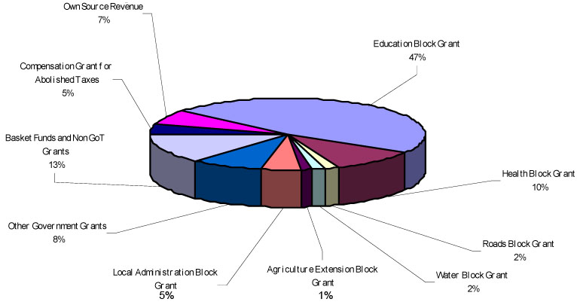
Figure 4.6 LGA Revenue Composition, 2004/05
Source: Public Expenditure Review, 2006.
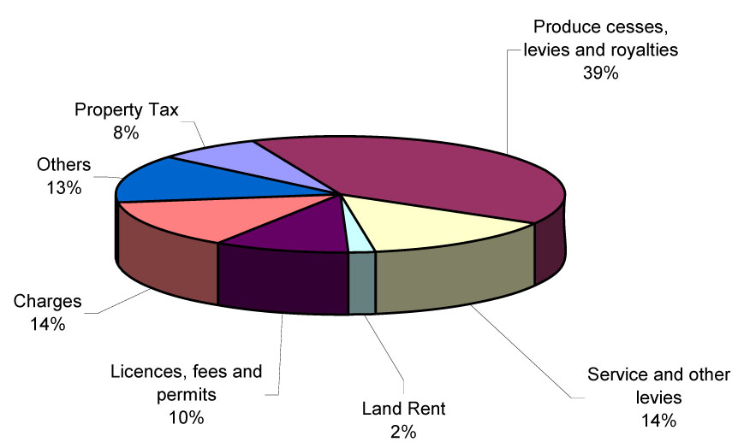
Figure 4.7 Shares of LGA Expenditure, 2004/05
Source: Public Expenditure Review, 2006.
Urban LGAs have more own-source revenue than rural LGAs. In 2006/07, total LGAs’ own-source revenue was T shs 61,411 million. Of that, urban LGAs collected 56.8 percent, with only 21 percent of the total population. Rural LGAs collected 43.2 percent of total own-source revenue, with 79 percent of the total population. Per capita own-source revenue in urban LGAs in 2006/07 was T shs 4,945, while in rural LGAs it was T shs 1,000. Urban LGAs collect from each resident nearly 5 times as much revenue as rural LGAs.
Intergovernmental transfers are mainly directed to rural LGAs. Total intergovernmental transfers in 2006/07 were T shs 859,468 million, of which urban LGAs receive 18 percent and rural LGAs receive 82 percent. A very high percentage of national revenues are derived from the population of urban LGAs. The total national revenue in 2005/06 was about T shs 3.5 trillion, and nearly T shs 2 trillion was collected domestically. Of that total amount of national domestic revenue, 83 percent was collected in Dar es Salaam alone (table 4.4). Other major urban areas like Arusha, Moshi and Tanga are also high-revenue-performing regions. This shows the high urban composition of the national tax base and the redistributive nature of the transfer system from urban to rural areas.
Table 4.3 Source of Revenues of Urban and Rural LGAs in Tanzania: Cumulative Budget of 2006/07, Fourth Quarter
 | Total | Urban LGAs | Urban Share | Rural LGAs | Rural Share
Total Revenue  (T shs millions) | 920,879.3 | 189,208.8 | 20.5% | 731,670.5 | 79.5%
Own-Source Revenue  (T shs millions) | 61,411.1 | 34,870.3 | 56.8% | 26,540.8 | 43.2%
Intergovernmental Transfer  (T shs millions) | 859,468.2 | 154,338.6 | 18.0% | 705,129.6 | 82.0%
In Per Capita Terms
Total Revenue |  | 26.8 |  | 27.6
Own Source Revenue |  | 4.9 |  | 1.0
Transfer |  | 21.9 |  | 26.6
Source: Report Team based on LOGIN data.

Table 4.4 Source of National Government Domestic Revenues, 2005/06
Region | Revenues  (T shs millions) | Percentages | Population
Dar es Salaam | 1,697,321 | 83.19 | 2,497,940
Arusha | 64,413 | 3.16 | 1,292,973
Coast | 2,578 | 0.13 | 889,154
Dodoma | 4,975 | 0.24 | 1,698,996
Iringa | 7,490 | 0.37 | 1,495,333
Kagera | 6,619 | 0.32 | 2,033,888
Kigoma | 2,380 | 0.12 | 1,679,109
Kilimanjaro | 50,816 | 2.49 | 1,381,149
Lindi | 718 | 0.04 | 791,312
Mara | 34,548 | 1.69 | 1,368,602
Mbeya | 28,054 | 1.37 | 2,070,042
Morogoro | 30,232 | 1.48 | 1,759,809
Mtwara | 3,656 | 0.18 | 1,128,523
Mwanza | 40,696 | 1.99 | 2,942,148
Ruvuma | 1,702 | 0.08 | 1,117,166
Shinyanga | 4,889 | 0.24 | 2,805,580
Singida | 953 | 0.05 | 1,090,758
Tabora | 3,599 | 0.18 | 1,717,908
Tanga | 52,632 | 2.58 | 1,642,015
Rukwa | 1,455 | 0.07 | 1,141,743
Manyara | 667 | 0.03 | 1,040,461
Total | 2,040,393 | 100.00 | 33,584,609
Source: Tanzania Revenue Authority (http://www.tra.go.tz/Current_Regional_Statistics.htm). Population Census 2002
Own-source revenue instruments are different for urban and rural LGAs: Urban LGAs rely more on the service levy, while rural LGAs rely more on the produce cess. LGAs derive general revenue from two types of instruments (a) local rates on property and land and (b) local taxes on business activity. In addition, LGAs receive revenues from licenses and permits, user fees and charges, and other revenues (Tanzania, PMO-RALG 2006a). Land rent plays a very small role in both urban and rural LGAs’ own-source revenue because it is collected by LGAs for the central government, with LGAs entitled to only 20 percent of the revenue collected (except in Dar es Salaam which retains none of the land rent). Produce cess accounts for 48.7 percent of rural LGAs’ own-source revenue, while it is only 0.6 percent in urban LGAs (table 4.5). By contrast, the service levy plays a more important role in urban LGAs, accounting for 38.5 percent of own-source revenues. Both urban and rural LGAs receive above 12 percent of their total own-source revenue from “other revenues.”
Table 4.5 Local Government Own-Source Revenue Instruments in Tanzania, Cumulative Budget of 2006/07, Fourth Quarter
 |  | Property rates | Land rent | Produce cess | Service levy | Hotel levy | Licenses | Fees and charges | Other revenues | Total own revenues
Urban LGAs | Revenue  (T shs millions) | 5,216.5 | 734.6 | 201.1 | 13,414.5 | 643.2 | 520.0 | 9,889.4 | 4,251.4 | 34,870.3
Urban LGAs | Share | 15.0% | 2.1% | 0.6% | 38.5% | 1.8% | 1.5% | 28.4% | 12.2% | 100.0%
Rural LGAs | Revenue  (T shs millions) | 259.5 | 598.3 | 12,917.4 | 1,724.0 | 484.8 | 950.1 | 4,742.2 | 4,863.7 | 26,540.8
Rural LGAs | Share | 1.0% | 2.3% | 48.7% | 6.5% | 1.8% | 3.6% | 17.9% | 18.3% | 100.0%
Source: Authors’ calculations based on LOGIN data.
Although property tax collections have been increasing, from 6 percent in 2002 to 10 percent in 2005/06 of the total LGA revenues, they account for a relatively small proportion of local own-source revenue. A number of studies have shown that property taxes in Tanzania can be improved substantially on both efficiency and equity grounds (GSU 2005, PSIA 2006). Recent changes to local tax powers (which abolished the development levy and eliminated the business license as a revenue source, without a replacement local tax in either case) suggest a lack of commitment to strengthening LGAs’ own source revenues. Moreover, legislation in 2008 transferred responsibility for property taxes to the Tanzania Revenue Authority (TRA). All of these changes reduce LGA responsibility and power to raise their own revenues and undermine basic principles of local autonomy and accountability.
Dar es Salaam collects 33 percent of all LGAs’ own-source revenues in Tanzania, followed by Mbeya (7.5 percent) and Mwanza (7.2 percent). In terms of per capita own-source revenue, Dar es Salaam collects more than T shs 7,000 per capita. The urban LGAs in Arusha, Kilimanjaro, and Dar es Salaam collect the highest per capita own-source revenues (figure 4.8). Most urban LGAs collect higher per capita own-source revenues than rural LGAs; in only three regions (Lindi, Shinyanga, and Manyara) do rural LGAs perform better than urban LGAs in collecting local revenue.
In regions where urban LGAs collect more per capita, rural LGAs tend to collect less than rural LGAs in other regions. As a result, regions like Arusha, Kilimanjaro, Morogoro, Mara, Mwanza, and Kagera all have significantly higher per capita own-source revenue in urban LGAs than the national average, while their rural LGAs have lower per capita own-source revenue than the national average (figure 4.8). However, in regions whose urban LGAs perform relatively worse than the national average (for example, regions like Pwani, Lindi, Mbeya, Mtwara, Ruvuma, and Tabora), rural LGAs perform relatively better, and there is a smaller gap between urban and rural LGAs.
Amendments to the Local Government Finance Act in 2003 and 2004 significantly reduced the revenue-raising authority of LGAs and reduced the importance of own-source revenues in the intergovernmental fiscal framework (Sarzin 2007).The first round of amendments provided a restrictive list of revenue sources for LGAs and abolished the development levy and other revenue measures (Tanzania, PMO-RALG 2006a). The second round eliminated the business license as a significant source of local revenue. LGAs’ own-source revenue declined from T shs 57,740 million in 2002 to T shs 42,871 million in 2004/05. Although own-source revenue increased to T shs 49,291 million in 2005/06, this is still lower than the amount collected in 2002. Before the “reforms,” own-source revenue accounted for approximately 21 percent of local government fiscal resources. By 2006/07, own-source revenues accounted for only about 7 percent of total local government finances (Authors’ calculations, based on LOGIN data). Figure 4.9 illustrates this decline in own-source revenues as a percentage of total local government revenues through 2005/06.

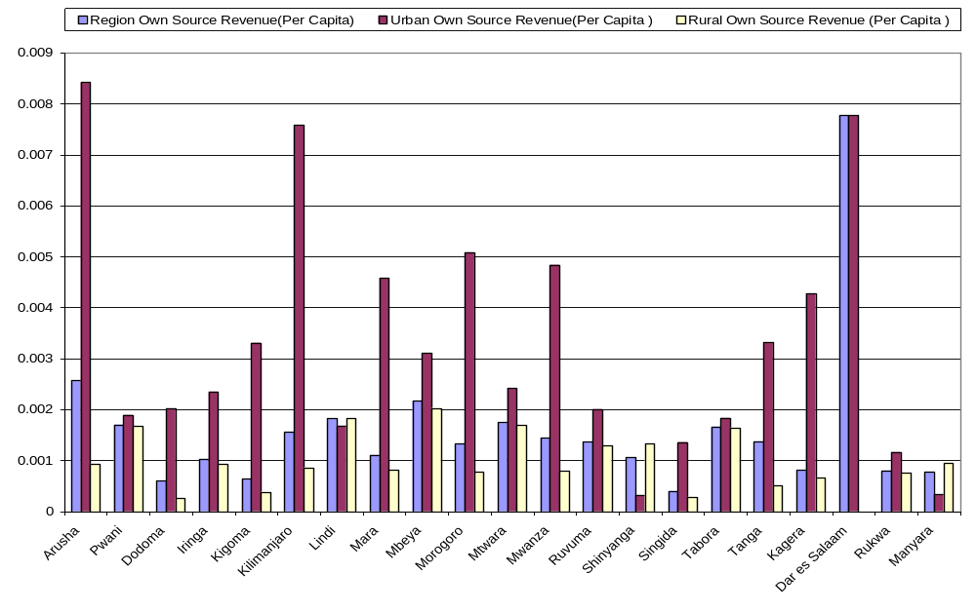
Figure 4.8 Comparison of per Capita Own-Source Revenue, Cumulative Budget of 2006/07, Fourth Quarter
(T shs millions)
Source: Authors’ calculations based on LOGIN data and 2002 population census.
Note: Urban own-source revenue (OSR) per capita = total OSR of urban LGAs/urban population.
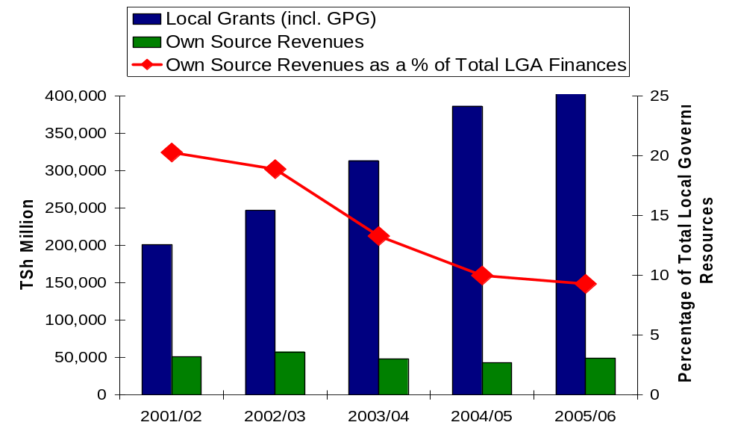
Figure 4.9 Composition of Local Government Revenues in Tanzania
Source: Sarzin 2007.
These “reforms” have dramatically reduced the importance of local revenues, which are now only 1/3 as important as they were five years earlier. Before 2003, most local revenues came from just three sources: (a) the development levy, which alone accounted for 20 percent of own-source revenues; (b) agricultural and livestock taxes; and (c) licenses and fees (including business licenses In rural LGAs, the predominant revenue sources were the development levy, the agricultural cess, and the livestock levy. In urban LGAs, the most productive revenue sources were licenses and fees (including business licenses), the city service levy (CSL), and property taxes, which together accounted for approximately two-thirds of local revenues for a typical urban LGA. (Table 4.6 provides statistics on the relative importance of local revenue sources.) With the abolition of the development levy and other “reforms,” LGAs lost substantial income from own-revenue sources.
Reductions in local control over revenue sources continue. In 2008, the “Financial Laws (Miscellaneous Amendments) Act, 2008” further reduced the tax powers of LGAs by turning collection responsibility over to the Tanzania Revenue Authority, a central agency. It remains to be seen how this legislation will be implemented, and whether the effect will be to reduce or increase local revenues.
Table 4.6 Local Revenue Collections by Source, 2002–2005/6
(percentages)
 | 2002 | 2003 | 2004/05 | 2005/06
Development levy | 20 | 7 | 0 | 0
Property tax | 6 | 6 | 10 | 10
Agricultural cesses | 16 | 19 | 27 | 22
City service levy | 16 | 16 | 25 | 24
Land rent | 1 | 1 | 1 | 2
Licenses and fees | 20 | 25 | 13 | 2
Charges | 10 | 11 | 15 | 26
Other revenues | 11 | 15 | 10 | 15
Source: Tanzania, PMO-RALG 2006a.
Note: Rounding often causes a percentage total to be slightly more or less than 100.
Intergovernmental transfers account for the majority of revenues in both urban and rural LGAs. Intergovernmental transfers constitute 81.5 percent of urban LGAs’ revenue and 96.4 percent of rural LGAs’ revenue (table 4.7).
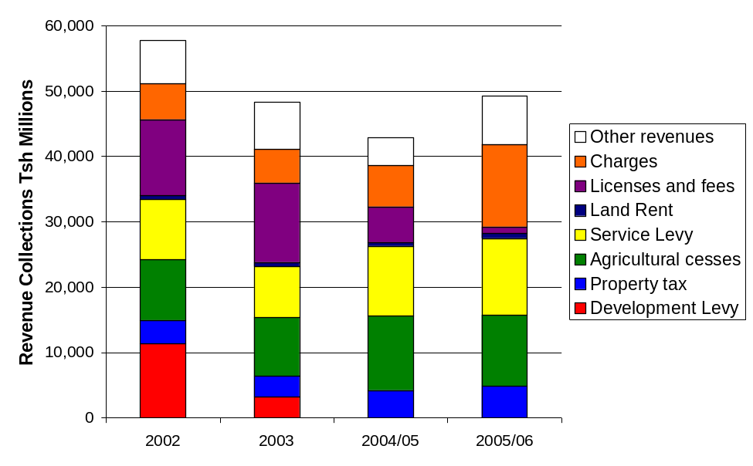
Figure 4.10 Trend in Local Government Revenue Collections
Source: Tanzania, PMO-RALG 2006a, 29.
Intergovernmental transfers (such as education and health block grants) are the revenue sources for both urban and rural LGAs. The central government provides four transfers to LGAs: (a) a set of recurrent sectoral block grants for grant-aided sectors, (b) unconditional general purpose grants, (c) ministerial subventions, and (d) development grants and other development funds. Although rural LGAs get much more revenue than urban LGAs from the central government, the share of revenue is quite similar: more than 75 percent of the total recurrent grants are from the education and health block grants (table 4.8). Recurrent transfers take the majority of intergovernmental transfers: 82 percent for urban LGAs and 78 percent for rural LGAs (table 4.9).
Table 4.7 Intergovernmental Transfers by Sectors in Tanzania, Cumulative Budget of 2006/07, Fourth Quarter
 | Education grants |  | Health grants |  | Other sector grants |  | General purpose grants |  | Total recurrent grants
 | Grant | Share | Grant | Share | Grant | Share | Grant | Share | Total recurrent grants
Urban LGAs  (T shs millions) | 66,626.0 | 60.2% | 17,862.5 | 16.1% | 5,017.3 | 4.5% | 21,178.4 | 19.1% | 110,684.1
Rural LGAs  (T shs millions) | 320,079.6 | 65.4% | 78,948.9 | 16.1% | 28,813.3 | 5.9% | 61,745.4 | 12.6% | 489,586.5
Source: Authors’ calculations based on LOGIN data.
Table 4.8 Intergovernmental Transfers in Tanzania, Cumulative Budget of 2006/07, Fourth Quarter
 | Total intergovernmental transfers | Recurrent transfers |  | Development Grants
 | Total intergovernmental transfers | Transfers | Share | Transfers | Share
Urban LGAs  (T shs millions) | 154,338.6 | 126,429.6 | 81.92% | 27,909.1 | 18.08%
Rural LGAs  (T shs millions) | 705,129.6 | 551,820.7 | 78.26% | 153,308.9 | 21.74%
Source: Authors’ calculations based on LOGIN data.
LGAs generally get more transfers if their own-source revenues are lower than other LGAs, while they get less intergovernmental transfers if their own-source revenues are relatively higher. However, that is not the case for all LGAs. Urban LGAs in Dodoma, Shinyanga, and Manyara have relatively low own-source revenues while they also receive lower shares of intergovernmental transfers from the central government. By contrast, the urban LGAs of Arusha, Morogoro, and Kagera have higher own-source revenues and also receive relatively high levels of intergovernmental transfers. The share of intergovernmental transfers for rural LGAs is much more related to their own-source revenue outturns, except only Dodoma, whose rural LGAs collect fewer revenues per capita and also receive a lower share of intergovernmental transfers (figures 4.8 and 4.11).
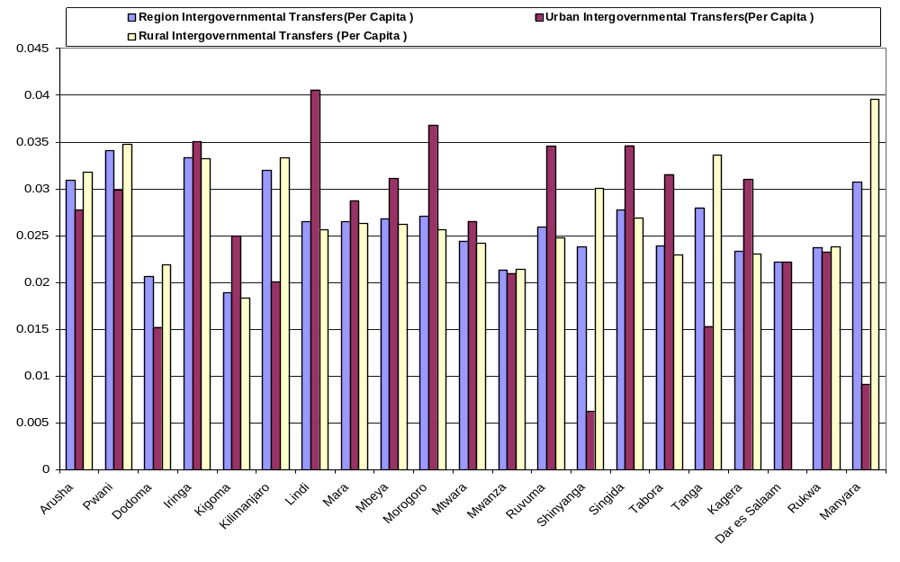
Figure 4.11 Per Capita Intergovernmental Transfers, Cumulative Budget of 2006/07, Fourth Quarter
(T shs millions)
Source: Authors’ calculations based on LOGIN data and 2002 population census.
Note: Urban intergovernmental transfers (IGT) per capita = total IGT of urban LGAs/urban population
Education and health account for more than half of LGAs’ expenditures in both urban and rural LGAs. Five concurrent functions are assigned to LGAs: primary education, primary health care, the maintenance of local and rural roads, agriculture extension services, and public water supply. Education and health take 54 percent of all urban LGAs’ expenditures and 59 percent of rural LGAs’ expenditures (table 4.9. The other three concurrent functions account for only 27 percent of urban LGAs’ and 18 percent of rural LGAs’ expenditures. The overwhelming majority of total expenditures are recurrent expenditures (81 percent for urban LGAs and 78 percent for rural LGAs) (table 4.10).
Table 4.9 Local Government Expenditures in Tanzania by Sectors, Cumulative Budget of 2006/07, Fourth Quarter
 |  | Education | Health | Other recurrent | Development expenditure | Total expenditure
Urban LGAs | Expenditure  (T shs millions) | 77,763.4 | 20,055.0 | 48,556.7 | 34,072.2 | 180,447.1
Urban LGAs | Share | 43.1% | 11.1% | 26.9% | 18.9% | 100.0%
Rural LGAs | Expenditure  (T shs millions) | 324,465.8 | 79,330.6 | 123,554.7 | 150,502.5 | 677,853.7
Rural LGAs | Share | 47.9% | 11.7% | 18.2% | 22.2% | 100.0%
Source: Authors’ calculations based on LOGIN data.
Table 4.10 Local Government Expenditures in Tanzania, Cumulative Budget of 2006/07, Fourth Quarter
 |  | Recurrent expenditure | Development expenditure | Total expenditure
Urban LGAs | Expenditure  (T shs millions) | 146,374.7 | 34,072.2 | 180,447.1
Urban LGAs | Share | 81.1% | 18.9% | 100.0%
Rural LGAs | Expenditure  (T shs millions) | 527,351.5 | 150,502.5 | 677,853.7
Rural LGAs | Share | 77.8% | 22.2% | 100.0%
Source: Authors’ calculations based on LOGIN data.

Remittances
Urban-rural remittances are significant in Africa, generally ranging from 10 to 13 percent of urban incomes (Williamson 1988). Unfortunately, we do not have enough data to conduct any new analysis on remittance in Tanzania. Ellis (1999) provides a recent review of the large-scale sample survey evidence on the rural household income composition in Tanzania. It shows that remittances accounted for 2.3 percent of rural household income in 1969, and that number increased to 2.4 percent in 1976/77, to 4.0 percent in 1980, and to 4.8 percent in 1983 (table 4.12). Although 1991 remittances appeared to drop to 1.1 percent, Ellis argued that this figure contradicted other analysis in Tanzania and that the data were poorly measured in the sample survey from which the 1991 figures derive (Lanjouw, Quizon, and Sparrow 2001). (We will explore remittances in periurban areas in the next section.)
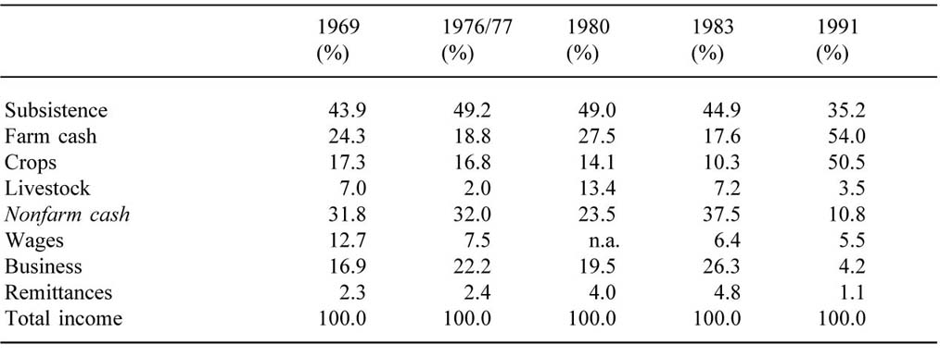
Table 4.11 Household Incomes in Household Surveys
(percentages)
Source: Ellis 1999.

Periurban Development

Definitions
It is as difficult to settle on a single definition for “periurban” as for “urban.” Most of those who have written on the subject use the term “periurban” . It is often used with other terms such as “informal settlement,” “informal land development,” and “periurban interface (PUI).” The term is used differently by various authors, depending on context and perspective. In this section, we propose two ways to define periurban areas in Tanzania: the “density-proximity” approach and the “density-ward typology” approach. Unlike some studies that include areas within urban LGA boundaries as “periurban,” the two definitions we propose both refer to areas outside of urban LGA boundaries. The reason for this is partly that there are many more “errors” of exclusion than of inclusion in Tanzania’s legally defined urban LGAs and partly that dense areas outside of urban jurisdictions are demonstrably less well served and may therefore deserve special attention.

Density-Proximity Approach
The density-proximity approach considers periurban from economic clustering and spatial perspectives. This definition focuses on two aspects of periurban areas: (a) the area should have the density to produce urban functions and activities that differentiate it from rural areas and (b) the area should have a certain level of functional linkages with an urban area so that it functions as a transition zone between urban and rural areas.
Population density is an important factor because density is necessary (though not sufficient) to generate agglomeration economies - density is one way to test whether an area can play an urban function. In chapter 1, we considered the OECD density standard, 150 persons per square kilometer, as one way of differentiating urban areas from rural areas. The density-proximity approach proposes the same threshold for periurban areas.
The density-proximity definition uses proximity as an indicator of linkage. The functional linkages between periurban and urban centers have been broadly discussed in the literature (World Bank 2007b). Such linkages include economic and industrial development, labor and migration, land and housing development, transportation and infrastructure, and social services. Economic and industrial development in periurban areas typically relate to industries in urban centers. Periurban areas are important labor force suppliers for urban economic activities. Migration in periurban areas facilitates the flow of residents and labor markets. For the purposes of this definition, we assume that being spatially proximate to an urban center implies stronger linkages than being farther away.
The first proposed definition of “periurban” includes areas outside of urban LGAs in which: (a) the population density is more than 150 persons per square kilometer and (b) the ward is spatially adjacent to an urban LGA or is linked with an urban LGA through other relatively dense wards. Taking Kigoma as an example, the periurban areas of Kigoma are the five wards located to the northeast of the LGA boundary (figure 4.13).
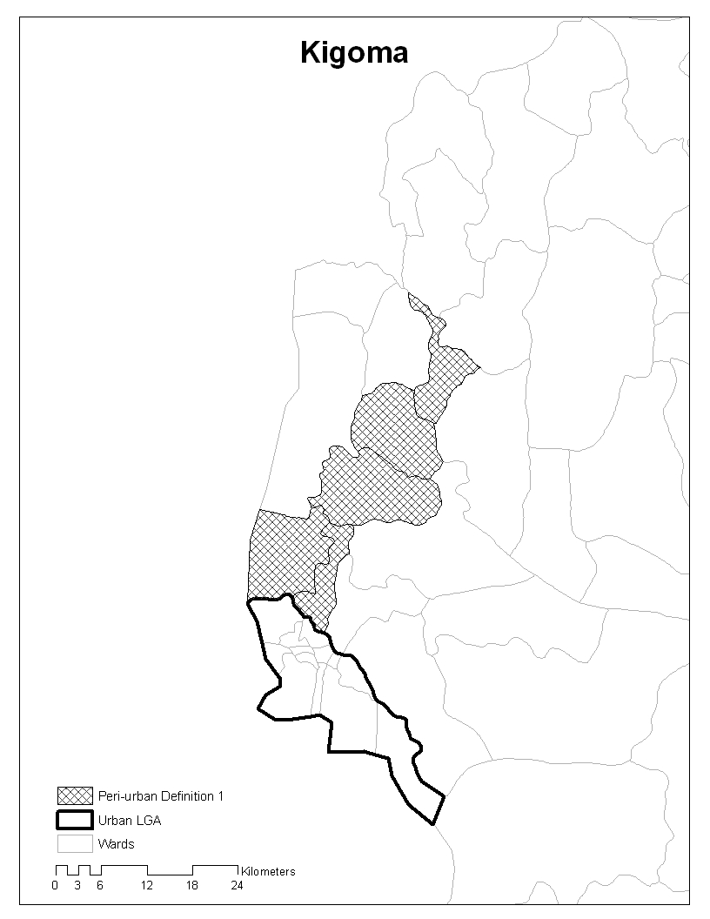
Figure 4.12 Periurban Areas of Kigoma: Density-Proximity Approach
Source: Authors’ analysis based on GIS data.

Density-Ward Typology Approach
A second definition of “periurban” is based on population density and NBS ward typologies. This approach considers ward typology—instead of spatial proximity—as the major indicator of functional linkages. The NBS divided the entire country into urban wards, mixed wards, and rural wards. Unlike the politico-administrative definition of “urban,” this approach is based on whether the ward meets (unspecified) size-density criteria or possesses urban characteristics (or both). NBS designated wards as “mixed wards” for the purpose of the 2002 census when the entire area of the ward could not be categorized as “urban” or “rural.” We again use a population density of 150 persons per square kilometer as the threshold to differentiate two types of mixed wards. We find that these relatively dense mixed wards tend to be located close to the urban wards in urban LGAs, while lower-density mixed wards are mainly located close to rural wards farther away.
Therefore, the second proposed definition of “periurban” includes those mixed wards outside of urban LGA boundaries that have a population density of more than 150 persons per square kilometer. Again, take Kigoma as an example: according to the density-ward typology definition, there is only one ward that can be defined as “periurban” (figure 4.14). However, for some regions, this approach will lead to the same spatial outcome for periurban areas as the density-proximity approach.
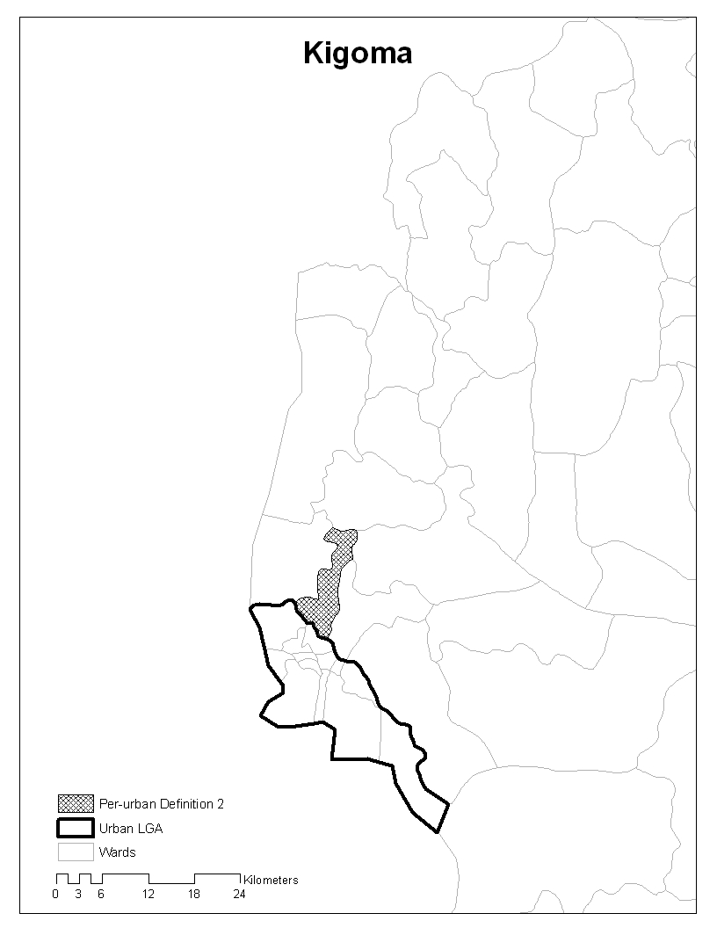
Figure 4.13 Periurban Areas of Kigoma: Density-Ward Typology Approach
Source: Authors’ analysis based on GIS data.
The NBS ward typology and population density are not always positively correlated: some “rural” wards have a population density of more than 150 persons per square kilometer. From the spatial perspective, urban LGAs do not necessarily include only urban wards. Take Dar es Salaam as an example: within the three urban LGAs, there are urban wards, mixed wards, and rural wards. The counterpart hypothesis is that there are also high-density rural wards outside of the urban LGAs, which indicates that population density is not a single factor to define urban and periurban areas.

Migration Pattern
By contrast with urban LGAs, migration—rather than natural increase—is playing the greatest role in shaping the population growth and landscape of the periurban zone (Nelson 2007). Tanzania’s periurban areas are experiencing two flows of migration: an increasing inward migration from rural to periurban areas along with an outward migration from urban to periurban areas. Outward migration from urban to periurban areas is largely attributed to increasing economic hardships resulting from low incomes, unemployment, and high rental charges and food prices in city centers (Kombe 2005). Although more urban poor are moving out to the periurban belt, so too are wealthier urban populations. Cheaper land, retrenchment in the public sector, and a housing subsidy for civil servants have significantly increased immigration to many periurban areas and created a housing boom in the periurban zone among middle- and upper-class residents of Dar es Salaam (Kombe 2005). The landscape of many periurban zones has thus become increasingly residential—as opposed to agricultural—as people have moved to periurban areas while maintaining social and economic ties to the city (Nelson 2007).
Inward migration from rural areas comprises mostly young and often poor rural migrants looking to tap into the opportunities inherent to urban areas, with migration most often being to periurban zones instead of directly from rural areas to cities. Not only is the cost of living much lower in periurban areas than urban centers (Nelson 2007), but the social networks in periurban communities are often essential for helping with rural to urban integration by aiding with access to housing, employment, and other resources. An inequitable urban structure, with the poor being increasingly spatially and socially excluded from the formal opportunities offered by the city, is noted by Kombe (2005) as a direct outcome of urbanization in poverty.
Lower-income populations in periurban areas are being marginalized in the course of rural-urban transformation. Although periurban lands are generally cheaper, accessible periurban lands with vehicular transport connecting them to cities are increasingly being bought and occupied by the high- and middle-income population. This is, in turn, further marginalizing the poor, uneducated, and unskilled to less accessible and less competitive periurban areas (Kombe 2005). As people looking to have a future in urban centers move to less accessible periurban areas because of high costs and competition, they find that they must subsidize their livelihoods with alternative employment (Kombe 2005).

Economic Activities and Employment
We compared employment and GDP data between the politico-administrative definition and the statistical perspective to get a better understanding of economic activities in periurban areas. For example, a water supply study for the Periurban Interface (PUI) area of Tanzania by the Development Planning Unit (DPU) at University College London (UCL) claims the PUI of Dar es Salaam to be a “diverse environment depicting a variety of socioeconomic activities, which is undergoing rapid transformation from rural to urban land use.” Agriculture is the main land use; however, this is gradually being displaced by housing, especially for those who cannot afford to rent a room or a house or buy land in the inner or intermediate city areas (DPU, UCL). The study concludes that new economic activities emerging in the PUI include retail businesses and service areas, artisanship, livestock keeping, quarrying, renting rooms, land selling, and gardening activities. Periurban agriculture in Dar es Salaam constitutes an important source of food for most (65 percent of the city population) households (Mwamfupe 1994; Mwamfupe and Briggs 2000).
Only in periurban areas of the relatively dynamic urban centers does the nonfarm sector appear important in income and income shares. The share of nonfarm employment is an indicator of diversification out of agriculture. Nonfarm employment is expected to be more prominent near urban centers, under the assumption that the incentives for economic diversification associated with agglomeration economies spill over to the surrounding areas. However, findings from Lanjouw, Quizon, and Sparrow (2001) indicate that this may not be the case in six major Tanzanian periurban areas, where nonfarm employment is not more prominent in the periurban areas than in rural areas. Lanjouw, Quizon, and Sparrow (2001) define “periurban” as areas within a 20-kilometer distance from the city perimeter. He bases his study on the 1998 Tanzania Periurban Survey and selects six periurban areas as samples (Dar es Salaam, Mwanza, Moshi, Arusha, Mbeya, and Lindi). In the six periurban regions combined, nonfarm incomes represent 24 percent of total incomes. Among that, 18 percent comes from business activities and around 5 percent from nonagricultural wage-labor activities. Crop income represents 55 percent of incomes in these periurban areas. Other incomes come from livestock products (16 percent); hunting, gathering, and fishing (8 percent); and farm labor and other sources (3 percent and 1 percent, respectively) (table 4.14) (Lanjouw, Quizon, and Sparrow 2001).
Surprisingly, net remittance for these six periurban regions is negative, because (on average) 6 percent of income is sent out of these periurban areas. This is different from the remittance of rural household incomes, which is 2.3–4.8 percent, from 1969 to 1991 (discussed earlier in this chapter). Three out of six periurban areas have positive net remittance rates: Dar es Salaam (4 percent), Moshi (15 percent), and Lindi (7 percent) (table 4.13) (Lanjouw, Quizon, and Sparrow 2001).
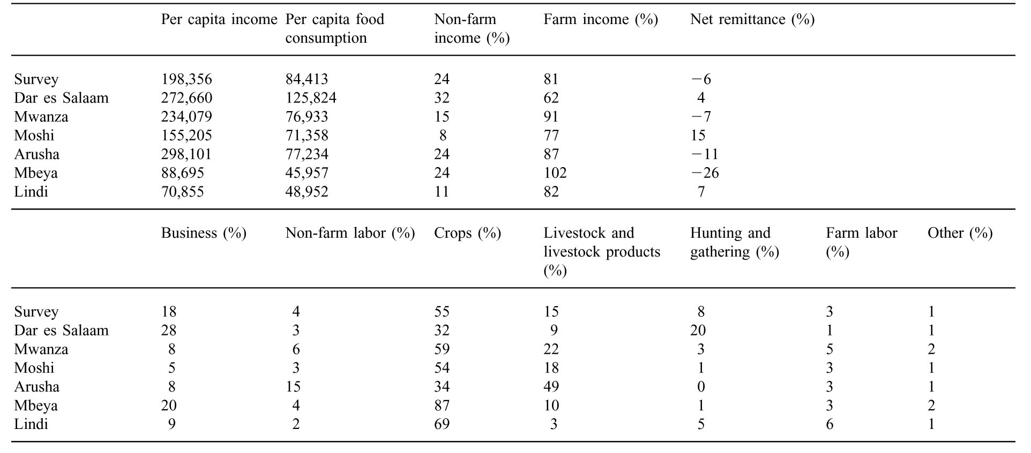
Table 4.12 Income Shares for Periurban Areas by Source and City
Source: Lanjouw, Quizon, and Sparrow 2001.
Agriculture is the major productive activity in periurban areas. Periurban households are well placed to concentrate on the production of agricultural goods, which can be readily sold in the urban marketplace (Lanjouw, Quizon, and Sparrow 2001). Comparing the urban labor force, using both politico-administrative and statistical definitions of “urban,” we find that farming activities constitute the single most important difference in employment between these two definitions. This sector employs 278,000 people in urban LGAs if we use the politico-administrative perspective, but more than 1 million people if the statistical perspective is applied (table 3.3, chapter 3). This shows that farming is the main activity in areas that are statistically defined as “urban,” but are located outside of urban LGA boundaries.
Periurban areas also contribute a relatively important share of GDP. There is a similar gap of urban share of GDP between the politico-administrative and statistical definitions of “urban.” In the politico-administrative approach, urban areas that refer to urban LGAs account for 39 percent of the total GDP in Tanzania. In the statistical approach, urban areas that refer to urban wards and mixed wards occupied 53 percent of the total GDP (table 3.8, chapter 3). The 14 percent gap of the total GDP comes from the urban and mixed wards outside of urban LGAs. We do not have data on how many of these wards are “periurban,” but this provides an idea of the economics of “periurban” in Tanzania.

Informal Development
Of the Sub-Saharan African countries, Tanzania has one of the highest proportions of urban residents living in informal settlements, with most estimating the number to fall between 50 and 80 percent (Kombe 2005). About 60 percent of the existing housing stock is in informal settlements (DPU, UCL). In Dar es Salaam, it is estimated that between 70 and 80 percent of the population live in informal housing areas (DPU, UCL). Some of these informal settlements are located in urban LGAs, while some are located in periurban areas.
Land sales in periurban areas provide an important source of income among the indigenous groups (DPU, UCL). Indigenous residents subdivided land and sold it piece by piece, primarily because of increasing economic hardships (Kombe and Kreibich 2003). Buying and selling of land are mainly done through informal systems and networks without LGAs’ support or control. The informal land delivery sector has attracted—and continues to attract—many people into the periurban area, including land speculators (Kombe 2002 and 1995; Shivji 1998).
Low capacity and high cost in the formal land delivery system contribute to informal development in periurban areas. Even when plans for periurban land have been prepared and approved, they have often not been implemented because neither local nor central government authorities have the resources to provide basic infrastructure services and ensure equitable and prompt compensation to the land developers and owners (Kombe 2005). Attempts by authorities to restrain informal land development by declaring planning areas and preparing detailed planning schemes for periurban land are unlikely to have a significant effect. Unregulated land transactions in periurban areas have, however, often resulted in disorderly spatial patterns. (Kombe 2005).
Most land in periurban areas is obtained informally (Nelson 2007). Informal land markets in periurban Tanzania are flourishing as land is traded through locally administered land transaction systems involving the buyer, seller, witnesses, adjoining landowners, relatives, and friends, with local community leaders authenticating land transfers and enhancing security of tenure. One could say that informal settlements are not unregulated, but rather socially regulated at the local and community levels (Kombe 2005).

Conclusions and Policy Implications
Migration is not the main driver of growth of urban LGAs, but it is in the adjacent periurban areas. Migration into periurban areas comes both inward from rural areas and outward from urban LGAs. Since the burden of serving immigrants is falling primarily on periurban areas, and since the evolving settlement patterns of these areas are to some extent more malleable than in urban LGAs, special attention to these areas may be appropriate. Whether in terms of managing land, planning infrastructure, or ensuring connectivity, these periurban areas may offer the greatest return on current investment.
All LGAs, including urban LGAs, have become more significantly more dependent on intergovernmental transfers over the past five years, as local tax instruments have been progressively eliminated. The collection of property taxes could be significantly improved, but legislation transferring responsibility for property rates to the TRA has disrupted local efforts to improve collections in Dar es Salaam. This is a significant problem, given that Dar es Salaam alone has historically collected a third of all Tanzanian LGAs’ own source revenue. A comprehensive intergovernmental fiscal architecture deserves priority attention, to restore the importance of local taxes and ensure that urban and periurban areas receive the investment needed to lay a foundation for economic growth.
Like many countries, Tanzania has a redistributive intergovernmental transfer system that channels resources from the urban to the rural areas. A very high proportion of the national tax base comes from urban areas; with Dar es Salaam alone accounting for 83 percent of national domestic revenues. From the total transfer pool, 18 percent goes to urban LGAs and 82 percent to rural ones. Although such redistribution may respond to broader national development goals, it does not provide funding for the infrastructure investments needed in urban and periurban areas, which have a great potential to contribute to economic growth.
The labor market implications of migration deserve further investigation. The analysis suggests that rural-to-urban migrants are as educated as the resident population in the receiving urban settlement. Urban-to-urban migrants are, on average, more educated than the resident urban population. Evidence thus suggests that urban migrants are unlikely to be absorbed in the low-skill end of the urban labor market, and they may compete directly with urban residents in the formal labor market. Further research may be warranted to explore how migration is changing the composition of the urban labor force and affecting labor markets in both sending and receiving areas.

CHAPTER 5 LAND DEVELOPMENT AND REGULATION

Introduction
The objective of this chapter is to investigate the major problems and issues of the urban land sector in Tanzania. It does so by analyzing the land access and land delivery as well as the land-use planning and regulation system in Tanzania, with a focus on the recently passed Urban Planning Act 2007 and Land Use Planning Act 2007.

Land Access and Land Delivery
Since 1972, the demand for urban land has significantly exceeded formal supply. There are various figures on land demand in Tanzania, most of which are believed to be significant underestimates. Reporting to the annual surveyors’ conference in 1997, the Director of Surveys and Mapping stated that “the demand for plots is estimated at 157,000 as of March 1993, with 70 percent being residential, 25 percent commercial, and 5 percent other uses. . . . Large urban centers have higher demands, with Dar Es Salaam leading with current needs standing at 30,000 plots annually.” More investigations show that “between 1999 and 2001, the various Dar Es Salaam Local Government Authorities received 243,473 applications” for plots (Kironde, in CASLE [2006]). This estimate was made at a time at which the Public Expenditure Review (PER) study report (Tanzania, Government of 2001) stated that most applicants had lost hope in official land delivery channels and had turned to informal markets to obtain land. While it is extremely hard to estimate real demand, we can get an idea about demand by looking at the number of houses that could not be built in planned areas and are now located in informal development areas. Taking Dar es Salaam as an example, that number has increased from 50,000 in 1972/73 to 500,000 in 2006 (figure 5.1). This is generally consistent with the frequently cited figure that some 70 percent of Dar es Salaam’s 3 million residents (that is, more than 2 million people) now live in informal areas.
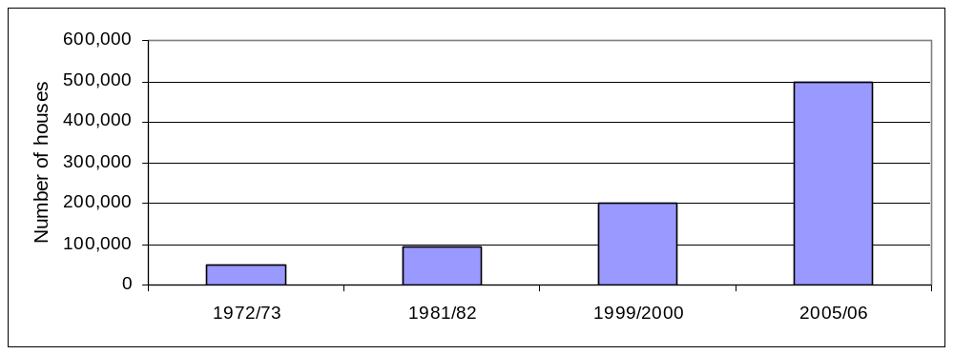
Figure 5.1 House Construction in Dar Es Salaam City’s Unplanned Areas
Source: Lugoe 2007.
As with housing, land for industrial, commercial, housing, hotel, and agricultural developments as well as for public uses, is also difficult to access legally. The Tanzania Investment Centre (TIC) has registered so far 4,210 investment projects, with an annual registration average rate of about 270 new projects. Of the 4,210 projects, 3,280 (or 80 percent thereof) require access to land parcels to be operational, though not all have specifically applied for land TIC estimates that only one-quarter of the serious investors can get land through the existing formal land delivery system. An analysis of data provided in the applications lodged with the Tanzania Investment Centre shows further that the total number of applications for land allocation was 440 for the period 2004–07. The TIC has, however, been able to issue derivative titles to only 13 applicants. The total demand for urban land based on the 440 applications is approximately 80,000 hectares (Mollel, Lugoe, and Kivinge 2008). This is an equivalent of 160,000 industrial-size or commercial plots, based on the assumption that each plot requires a half hectare of land.

Supply of Urban Land
The formal supply system underwent a crisis in 1972, from which it has never recovered. The formal production of urban plots nearly came to a halt starting in 1972/73, with a national average annual output of only 2,000 plots for the more than 100 towns. Assessment of the annual divisional reports shows that the country witnessed an exponential growth in formal plot production in the late 1960s, from 12,000 plots in 1969 to 15,000 in 1972 (Tanzania, MoLHSD 1959-1967). The 15,000-urban-plot output, attained in 1970/71, remained the highest output for nearly 30 years, in spite of the lower capacity levels of that era. Plot production dropped sharply from 1972 because of a decentralization policy change (which will be discussed later). The gloomy scenario of the 1970s continued into the 1980s. Peaks in Figure 5.2 are outputs from special projects, particularly the sites and services project that had been brought on-stream in Dar es Salaam. Formal production of urban plots, especially after 1972, has lagged behind population growth. The number of available urban plots increased slowly while the population increased relatively rapidly. The number of urban plots produced after 1986 is not known because the government stopped publishing data after 1986, but it is estimated that the annual urban plots production is now averaging below 6,000. The population trend has continued and accelerated since 1986; implying an ever-widening gap.
The decentralization policy in 1972 contributed to the dysfunctional plot production system. In 1972, government administration was decentralized to the regions in a political move called “Madaraka Mikoani,” which significantly hindered formal plot production. District councils were abolished and district development directorates (DDDs) were established—under the coordination of the regional development directors (RDDs) (Mollel, in CASLE [2006]). RDDs dealt with most land matters at the regional level, except issuance of title deeds. Formal plot production received little attention, and the underlying systems were starved of resources. Urban cadastral processes, in particular, nearly came to a halt. The natural result, given continued urban growth, was that within a few years, informal settlements mushroomed in towns—and particularly in Dar Es Salaam—as the demand greatly overwhelmed the supply. The production of urban plots went down, demand continued to increase, and before long many towns could not satisfy even 10 percent of the demand (figure 5.2). The diminished total output nationally continued throughout the 1980s and 1990s, until the commencement of the 20,000 Plots Project in 2002.
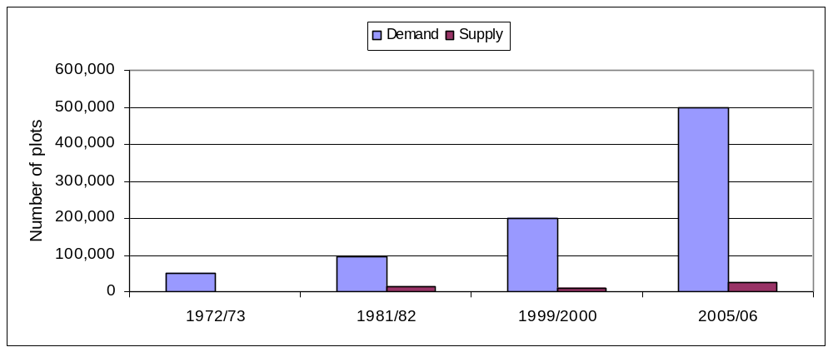
Figure 5.2 Estimated Supply and Demand of Plots Compared at Different Times
Source: Lugoe 2007.
“Villagization” in the 1970s was another factor in the sharp decrease of urban plot production. As noted, the production of urban plots grew in the late 1960s and early 1970s, then decreased sharply in 1971/72. The reassignment of many professional surveyors to the demarcation of village plots was a political priority. It is not clear whether policy makers expected ujamaa villages to control the flow of populations into urban centers enough to deliberately warrant slowing the creation of urban plots.
Inadequate supply continues. Over the past decade, the number of urban plots surveyed and registered per year in Tanzania has been as high as 10,797 in 1999/2000 and as low as 5,429 in 1998/99 (figure 5.3). New formal plots were less than half of these numbers, as more than half were surveys for titling of existing developments (such as government and parastatal housing) and surveys for residents confronted with demolitions or resettlements from hazardous areas to special schemes such as Kinyerezi in Dar es Salaam (Tanzania, Government of 2002). Surprisingly, given this low rate of formal plot delivery, the City of Dar es Salaam alone was registering about 15,000 new house construction permits per year. Therefore, nearly 95 percent of registered houses in the City were built on land from the flourishing alternative market in unplanned, unsurveyed, and largely unserviced urban lands. This is in addition to many unregistered houses. The many informal settlements in the towns and cities of Tanzania have been growing at a rapid rate. In this context, it is not surprising that the scramble for scarce formal lands located in serviced areas is reportedly corrupt. If officials are tempted by such practices, then they would have little incentive to increase supply, which could only reduce the inducements they may be offered.

Land Delivery Mechanisms
Formal land delivery is a four-step process (Mollel, in CASLE [2006]); Mollel and Lugoe 2007). In urban areas, the first step after the declaration of a planning area is the acquisition of land by paying compensation to owners. In the second step, physical planning processes are undertaken. This involves the design of layout(s) for the acquired lands in accordance with agreed land-use and settlement patterns. Then, the town-planning (TP) diagrams are transferred to the ground through cadastral surveying processes that, in Tanzania, are based on fixed land parcel boundaries. The end product of cadastral surveying is the replacement, for purposes of land delivery, of the TP drawing by a registered survey plan and the archiving of corresponding data and information. The final stage is the allocation, through sale, auction, or by other agreed method, of the plots in the survey plan and granting land rights to the recipients.
Various causes contribute to the scarcity of formal plots. Some observers blame the overall underperformance of the established system, while others focus on breakdowns in specific processes. Still others focus on the lack of institutional or financial resources dedicated to the production process. The formal system competes in a real sense with informal land development, which offers potential users the possibility of land at a cheaper cost and through an easier process.
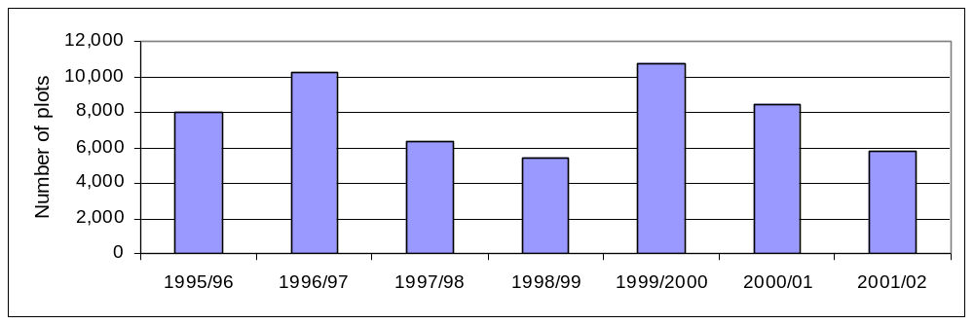
Figure 5.3 Trend in Plot Surveys, 1996/97–2000/01
Source: Lugoe 2007.
LGAs lack incentives to conduct cadastral surveys and formally allocate land for development. The survey of plots is now undertaken only if resources allow and is not responsive to demand. Today’s LGA land surveys are almost wholly projects at the expense of routine survey activities in LGAs. Many councils and municipalities now set aside little or no funding for cadastral surveys and land allocation. Some municipalities have diverted funds from surveying to other activities because formal plot production has a very low priority.
There are at least two ways that incentives encourage greater production of formal plots. The first method is a shift away from reliance on government to produce formal plots. Private developers and private survey firms would be allowed to invest in the technology and skills for efficient land acquisition and subdivision, if the regulatory framework permitted them to do so, and to sell serviced plots on the market. In this model, government regulators could concentrate on the regulatory framework and the supervision and monitoring of cadastral surveying projects, ceding the execution to the private sector. This would require a significant change in mind-set. Tanzania’s experience with private sector involvement is relatively recent. The laws and other regulating mechanisms are deeply rooted, and change may not come easily. For example, in 1995 the national land policy anticipated that surveying of plots would gradually move to the private sector, but 13 years later, very little has happened.
A second method could be less of a change and is rooted in experience in other socialist countries that have sought to benefit from the opportunities of growth associated with rapid urbanization. If LGAs are authorized and expected to sell plots at a profit and to retain the proceeds (for example, for investment in local infrastructure), the profit motive could drive them to greater efficiency. This model has worked successfully in China. This may not be as effective as fully embracing private land development, but may be a practical intermediate step.

Land-Use Planning and Regulation
Land-use planning mechanisms have failed to effectively regulate urban development. As noted, most urban development is informal, without being planned and regulated and with limited or no urban services. Government data shows that only about 11% of land in Tanzania is used legally. Of the Sub-Saharan African countries, Tanzania has one of the highest proportions of its urban residents living in informal settlements, with most estimating the number to fall between 50 and 80 percent (Kombe 2005). This can probably be attributed to the highly centralized land use planning system, as well as the limited supply of legal plots, which was analyzed in the previous session.

Informal Development
Informal practices dominate land development in urban and periurban areas. We will take Dar es Salaam as an example to illustrate the growth of informal settlements. Dar es Salaam is the biggest city in Tanzania and has been leading the curve during the urbanization process in Tanzania—many other cities are now encountering urban challenges similar to those Dar es Salaam has long been facing. Major informal development in Dar es Salaam started in the 1970s and the 1980s and significantly expanded in the 1990s. The spatial expansion of the built-up area of Dar es Salaam from 1945 was mainly along two corridors: a relatively flat coastal plain to the north of the city and a hilly region to the west and southeast of the city (figure 5.4) (Amer 2007). 72 percent of total urban land expansion in Dar es Salaam from 1982 to 1998 was already the result of informal settlements (see table 5.1). Much of the informal development occurs at the outskirts of the built-up area, but is still within the urban LGA boundary (figure 5.5). In 1992, around 37 percent of the built-up area of Dar es Salaam was already informal settlements providing shelter to an estimated 60 percent of the city’s population. By 1998, the area of informal settlements had risen to 48 percent, and recent estimates place the percentage of the population in informal housing as high as 70–80 percent. Dar es Salaam experienced limited nonresidential growth between 1982 and 1998 and high growth in residential areas, primarily informal settlements (figure 5.5). Although unplanned informal areas in Dar es Salaam—including those with medium and high population densities in 1992—have been seeing the largest changes in population densities, with informal settlements consistently densifying, planned residential areas are typically stable in terms of their population, except for newly developing areas (Amer 2007). The relatively cheap prices of informal land and the low hurdles associated with informal plot acquisition and development are reasons why most urban residents end up in informal areas (Kombe 2001).
Higher population densities occur more widely in informal areas. Amer (2007) found that population density in Dar es Salaam follows the general rule that higher-density areas are mostly located in the city core while lower-density areas mainly occur at the periphery. While most planned areas have a low to medium population density, many of the higher density areas are located in informal settlements (figure 5.6). Even with a more rapid rate of formal plot production, enforcement of current formal density restrictions would prevent many of the current high-density residents from living near the city center, with its economic opportunities. Comparing the density map in 1992 with that in 1998, we see that densification is occurring all over the city; with low-density areas mainly in the outskirts at the southwest part of the city (figure 5.7). The largest changes in density occur in informal settlements and (to a large extent) concentrate in the area south of Pugu road.

Table 5.1 Main Urban Land Uses and Growth Rates in Dar es Salaam, 1982-98
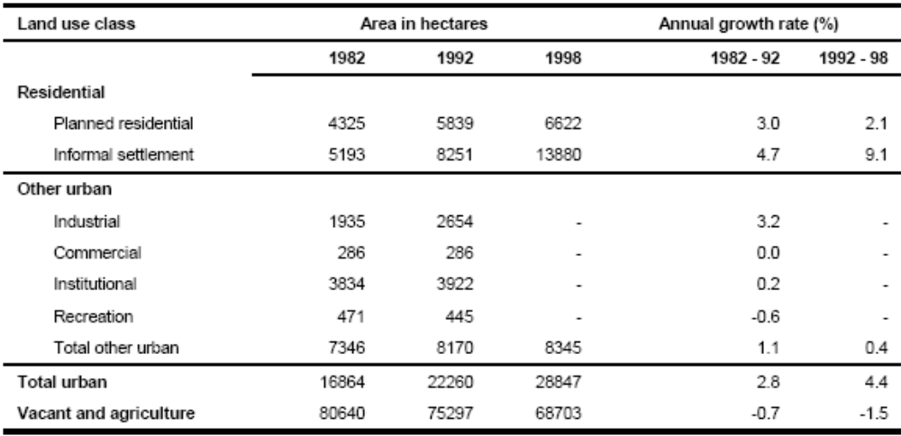
Source: Amer 2007.
Note: — = not available.
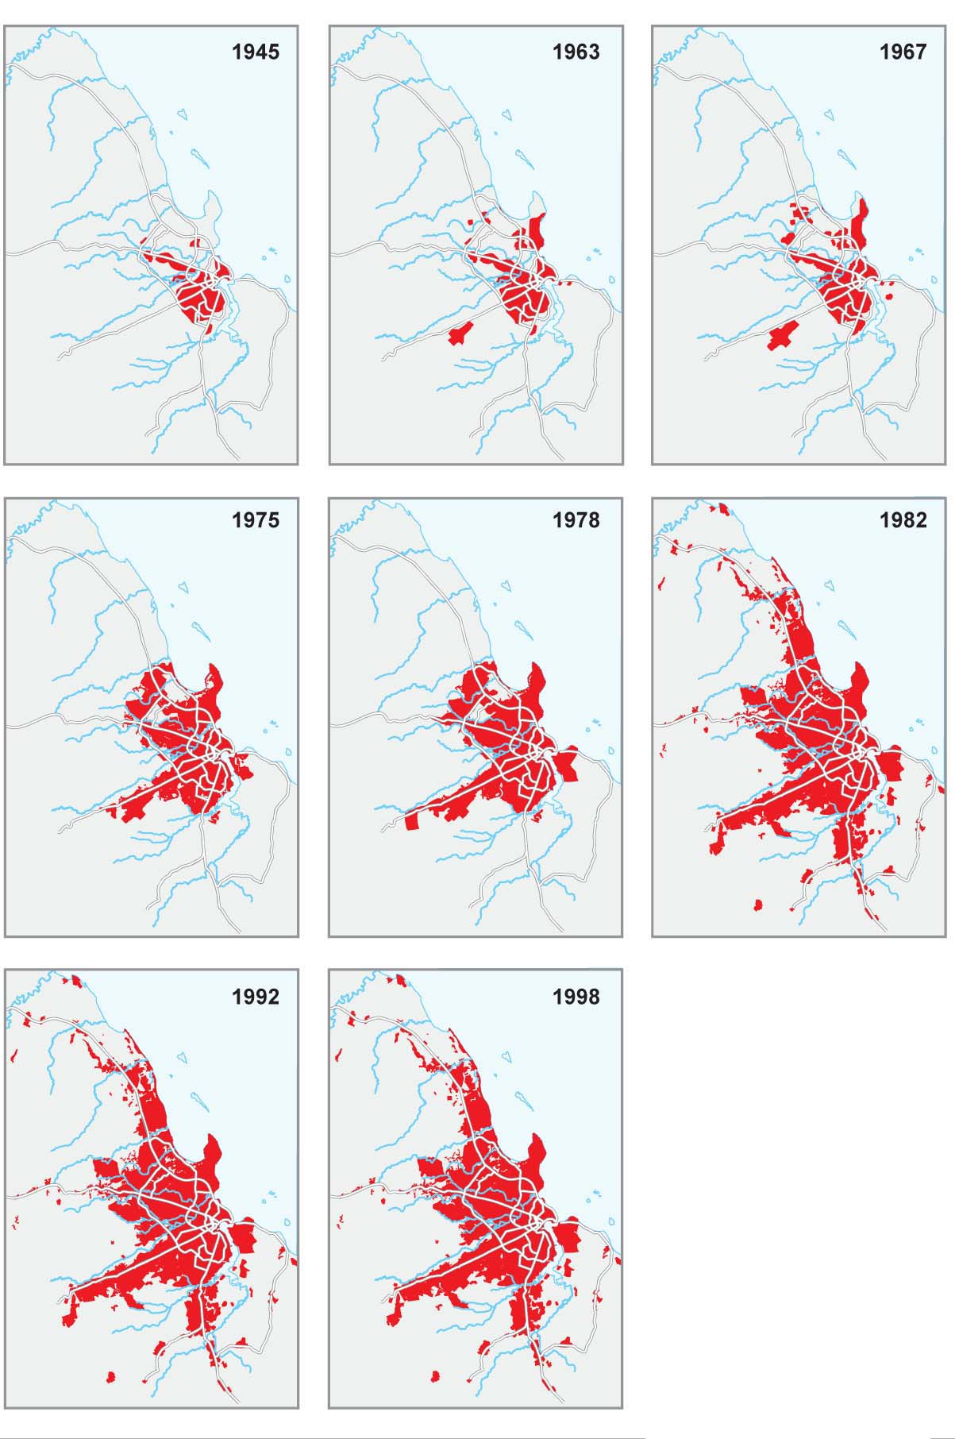
Figure 5.4 Spatial Expansion of the Built-Up Area of Dar es Salaam, 1945–98
Source: Amer 2007.
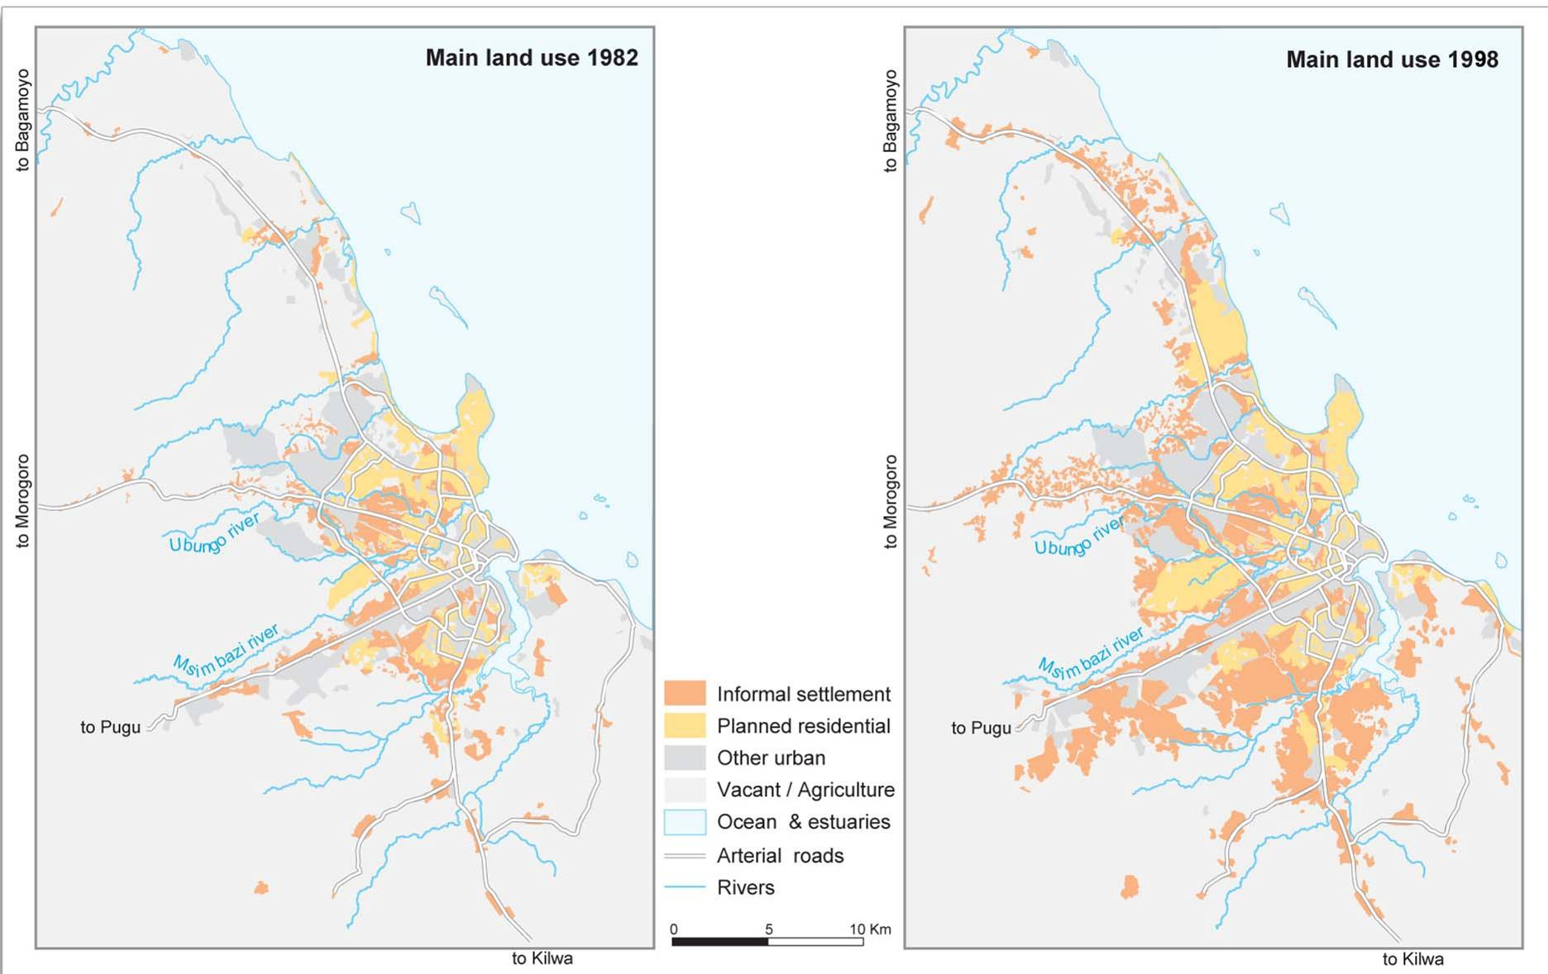
Figure 5.5 Major Land Uses in Dar es Salaam, 1982 and 1998
Source: Amer 2007.
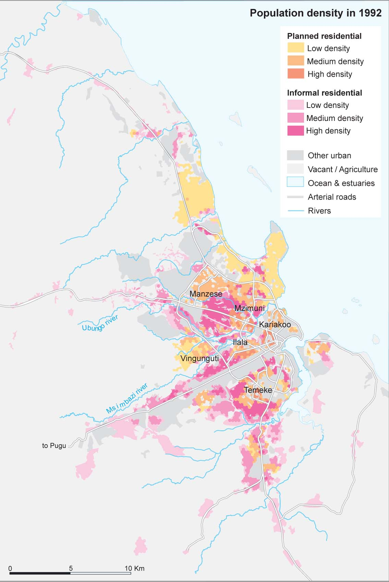
Figure 5.6 Population Density in Planned and Informal Residential Areas, 1992
Source: Amer 2007.
Note: Km = kilometer.
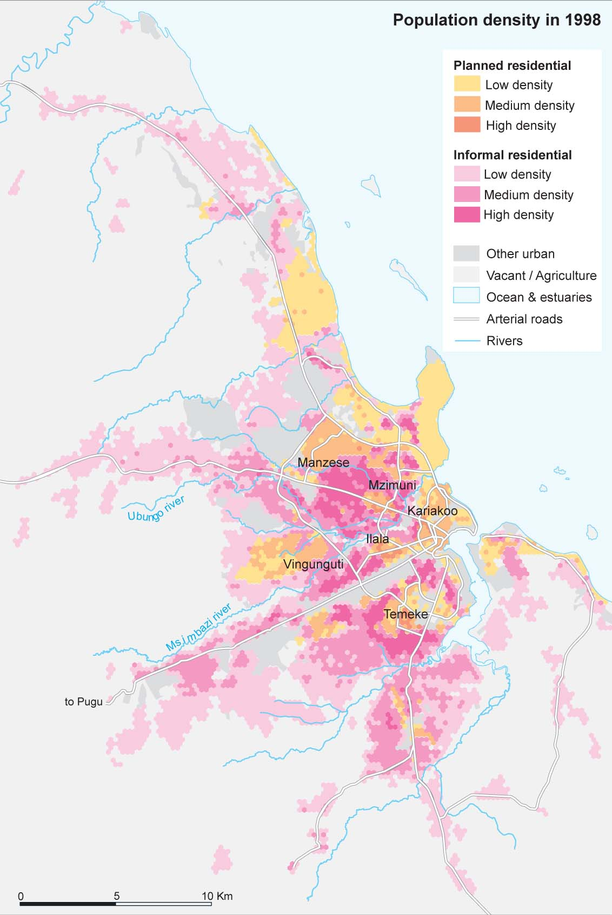
Figure 5.7 Population Density in Planned and Informal Residential Areas, 1998
Source: Amer 2007.
Note: Km = kilometer.

Land Use Planning
Land use and development regulations have failed to effectively control and coordinate land use practices. Previously, there were two main laws which regulated the general facilitation of planning and enforcement of plans for urban and rural areas: (1) the Town and Country Planning Act (Cap 378), (2) the National Environment Management Council Act, (3) the National Land Use Planning Commission Act (No 3 of 1984), (4) the Local Government Act, (5) the Land Act Cap 113, and (6) the Village Land Act Cap 114. Some scholars note that the process of planning under these laws was problematic (Kalenzi 2008). The Town and Country Planning Act, though intended to facilitate comprehensive land use planning for both urban and rural areas, had been used almost exclusively for planning in urban areas. The National Land Use Planning Commission established by the National Land Use Planning Act, which supposedly carried a more comprehensive mandate in respect of land use planning, lacked the authority to supervise the practices of land use planning agencies at any level. Finally, the Local Government Act lacked the ability to coordinate land use planning across regions and sectors.
In 2007, changes to the land regulations increased centralization. The new legislation is the Urban Planning Act 2007, which regulates the planning and development of land in urban areas, and the Land Use Planning Act 2007, which provides for the preparation, administration and enforcement of land use plans at both national and local levels, mainly focusing on planning for non-urban land uses in rural areas. This section will focus on analyzing the Urban Planning Act 2007 since it is directly related with planning and development of urban land.
The Urban Planning Act 2007 sets up four essential steps in the planning process: (i) declaration of planning areas, (ii) general planning scheme, (iii) detailed planning scheme, and (iv) control of development of land and consent for development. There are three levels of agencies with responsibilities under the Act: Planning Authorities at the local level, the Regional Secretariat at the regional level, and the Director of Urban Planning at the national level. According to the Act, every city council, municipal council, town council and township authority becomes a planning authority in its area of jurisdiction. The roles and jurisdictions of the agencies in the planning process are either vaguely defined or inappropriately defined in the Act, as will be analyzed in this section.

Declaration of Planning Area
The declaration of planning areas is centralized. Declarations of planning areas are to be made by the Minister, based on the recommendation by the Regional Secretariat. Local Planning Authorities are to conduct public hearings and recommend planning areas. A planning area sets the spatial jurisdiction within which local Planning Authorities have power to plan and implement. The Director may declare any area with unique development, potential or problems, as a special planning area. (section 24, Urban Planning Act 2007).

General Planning Scheme
Preparation of general planning schemes is local, subject however to review, approval, and amendment by the center. The general planning scheme is meant to guide, among many other things, locations for development and land uses. It provides for planning the whole or part of the area comprised in the scheme, and for controlling the order, nature and direction of development in such area. A local Planning Authority starts the process by passing and publishing a resolution for preparation of a draft general planning scheme.

Figure 5.8: Procedure of Proposing and Approving the General Planning Scheme
Planning Authority passes a resolution for preparation of draft General Planning Scheme

Published in the Gazette

< 6 months

Planning Authority prepares Draft General Planning Scheme
Local Planning Authority
Drafting and Proposing

Planning Authority conducts stakeholders meeting

Submit draft General Planning Scheme to the Regional Secretariat for review

Reject
Regional Secretariat
Reviewing and Commenting
< 2 months

Regional Secretariat submit to the Director with comments

Director publishes draft General Planning Scheme
Director
Approving
Planning Authority conducts a public hearing in the planning area and submits comments to the Director
Director makes modifications, based on comments from
public hearing and Regional Secretariat
< 3 months
Director approves the General Planning Scheme
Director submits to Minister
Minister publishes the General Planning Scheme in the Gazette

Minister
Announcing

Source: Authors’ diagram, based on the Urban Planning Act, 2007

The Planning Authority is to prepare a draft general scheme and submit it to a meeting of stakeholders (landholders, public and private institutions, community based organizations, and non-governmental organizations). However, the local Planning Authority does not approve its own general planning scheme. All the general schemes are to be submitted to the Regional Secretariat and then to the Director. The Director may make alterations or modifications and decide whether the general scheme should be approved or not. A flowchart of proposing and approving a general planning scheme is documented in Figure 5.8.

Detailed Planning Scheme
While general planning schemes set general policy and direction, a detailed planning scheme is meant to regulate and control actual physical changes in urban areas. The detailed planning scheme is meant to ensure coordination of development activities and control land use and development, especially vertical and compact urban development. An approved detailed planning scheme is said to have the force of law and may be enforced by the courts.
The Urban Planning Act 2007 specifies that detailed planning schemes shall be “demand driven.” A landholder may thus prepare a detailed planning scheme for land, without waiting for the local planning authority. This approach is meant to take into account that local planning resources and capacities are relatively low. However, a landholder will only follow this process if he or she perceives that benefits will outweigh the cost and uncertainty involved. Tenure and usage rights are presumably more defensible with an approved planning scheme, but since most urban land is actually developed without benefit of planning schemes, and since there is an active and developed market for such informal land, it is hard to quantify the benefits that accrue from the process.
Roles and responsibilities for preparing and approving detailed planning schemes are vaguely defined. As noted, a landholder may prepare a detailed planning scheme on his land, and in addition, the Act allows a Planning Authority to prepare a detailed planning scheme, following certain procedures (section 19, subsection 1 of the Urban Planning Act 2007). As an overlay, the Act also mentions that “it shall be the obligation of the Minister, the Director, and the Regional Secretariat to assist planning authorities and landholders in preparing detailed planning schemes.” This indicates that the Minister and the Director should be involved in the preparation of detail planning schemes in urban areas, which seems cumbersome and unrealistic at any scale. An additional ambiguity exists in the Act with regard to approving the plan, in that the Act specifies that “the detailed scheme prepared by the landholder shall be forwarded to the Planning Authority for consideration, approval and adoption” (section 19, subsection 2 of the Urban Planning Act 2007), while it is also mentioned that “any amendment or review of detailed planning schemes shall be submitted to the Regional Secretariat for scrutiny…and shall be forwarded to the Director for approval.” The overlapping roles and ambiguity in preparation and approval set forth in the Act are likely to pose a continuing barrier to formalization of development practices.
Any subdivision of land must be approved by the Director at the national level. While local Planning Authorities are meant to control the use and development of land (section 28 of the Urban Planning Act 2007), and the Act forbids development within a planning area without consent of the local Planning Authority (section 29, subsection 1 of the Urban Planning Act 2007), any subdivision of land is to be approved by the Director (section 31, subsection 1 of the Urban Planning Act 2007). Such a centralized mechanism seems unlikely to be able to cope with the demand for subdivision, if there were any significant degree of compliance and enforcement. As a result, the majority of development is likely to continue to be extra-legal. .
There is no linkage in the Urban Planning Act between land subdivision and infrastructure provision. The Urban Planning Act 2007 is silent as to how the various public and private actors that provide electricity, water, roads, schools, hospitals, and other facilities are to be brought into the planning and subdivision process, and as to how these various items of infrastructure are to be financed.

Planning Standards
Most planning standards are set at the national level. According to the Urban Planning Act 2007, each Planning Authority has the power to determine various planning standards, such as planning space standards, density of buildings on land, height, design, and appearance and sitting of buildings, manner of access to land and buildings (section 38 of the Urban Planning Act 2007). However, the standards should be set in accordance with the national standards, and all guidelines for planning standards are set at the national level by the Director. The Director is responsible for issuing guidelines on the planning standards which are mentioned above (section 6, subsection 2 of the Urban Planning Act 2007). For example, the minimum plot size is set at the Ministry level in Tanzania, instead of at the local level. As is discussed elsewhere in this report, these minimum plot sizes impose very high costs, which is one reason that most development occurs informally, and often at higher and more affordable densities.

Financial Incentives
Local authorities lack incentives to regulate and control urban development. Although Urban Planning Act 2007 specifies that a development charge should be paid to the local Planning Authority with every application for planning consent, for many years, land was officially considered to have no value; hence, urban plots were (and sometimes still are) allocated free of charge. In such a system, LGAs do not have a financial incentive to develop and sell land. Policy makers at council level may not fully appreciate the link between a lack of readily available plots for development and the proliferation of informal areas. They may not have an incentive to avoid the added cost of post facto regularization through adequate land delivery. Unless the incentives are fundamentally changed, informal areas will continue to grow, the service backlogs they create will remain a burden, and the possibilities of attracting investment that requires secure tenure will be limited.

Land Use Planning in Peri-Urban Areas

The Land Use Planning Act 2007 provides the basis for planning and controlling development in periurban areas. Many informal settlements emerge in periurban areas outside of urban LGA boundaries, as a consequence of which the Urban Planning Act 2007 does not apply. Rather, the Land Use Planning Act 2007, which empowers district and village councils to control the planning and development of land outside of urban areas applies in these periurban areas. In these areas, the relevant plan is the “land use plan,” which is meant to “establish new or recognize existing settlements and physical infrastructure” (section 28, subsection 1p of Land Use Planning Act 2007).
Land planning is relatively decentralized in periurban and rural areas, as compared to that in urban LGAs. According to the Land Use Planning Act 2007, a local land use planning authority could be either a village council or district council. At the national level, a National Land Use Planning Commission (NLUPC) is established to prepare a national land use framework plan, coordinate regional land use framework plans, coordinate various land use management activities, and guide other related work (section 19, subsection 2 of Land Use Planning Act 2007). Compared to urban areas, local planning authorities in rural areas have more power. They can declare areas within their jurisdiction as planning areas, and are responsible for preparing for their own local land use framework plan as well as ensuring coordination and systematic physical development. Village land use plans can be submitted to Village Assemblies for approval, while national, zonal, regional and district land use plans shall be submitted to the Minister, who may approve or reject them, or impose conditions or modifications (section 34 of Land Use Planning Act 2007).
As in urban LGAs, subdivision in periurban and rural areas is subject to control. The Land Use Planning Act 2007 specifies that subdivision plans shall be prepared and submitted to planning authorities for approval. Planning authorities may approve with or without modifications. Furthermore, local planning authorities in periurban and rural areas also have enforcement power to control and restrict development activities, including particular uses of land, implementation of approved plans, by-laws to regulate density of development, and reservation of land for open spaces.
The chaotic reality of informal settlement makes future connectivity more difficult.” As noted in chapter 4, periurban areas work as transitional areas between urban and rural during the urbanization process. Connectivity between labor and market, between urban and rural, and between residents and services is essential not only for periurban but for urban development as well. However, ongoing informal development in periurban areas is constantly creating land use patterns which will make the future provision of infrastructure and transportation corridors a real challenge. In areas now being settled, proactive steps to define and control corridors to ensure future connectivity could make a real difference. The Land Use Planning Act 2007 provides the tools for such an effort: according to the Act, the National Land Use Planning Commission “may suspend for a period of not more than one year, any development in a planning area or zone until the land use or physical development plan in respect of such area or zone has been approved.” This empowers the Commission to control development in the areas where it considers as the potential connectivity or infrastructure land. It also poses a challenge to local rural authorities to proactively coordinate with urban LGAs. TANESCO, water service authorities, and others to identify and plan for connectivity corridor and infrastructure. It will be a challenge to coordinate the centralized power to suspend informal development with the local power to promulgate and enforce land use plans in a timely fashion. Critical to the success of such an intervention would be coordination between local authorities and the Commission.

Regularization of Informal Development
The legislative framework for regularization of informal development has certain weaknesses. The Urban Planning Act 2007 specifies that any area intended for a scheme of regularization shall be declared as a planning area, and acknowledges that regularization may require amending the general planning or the detailed planning scheme. Unfortunately, the resources and capacities of LGAs have been consistently inadequate to support such regularization and to integrate informal settlements into the formal urban structure by providing basic infrastructure and services (Kombe 2005). Relying on regularization has two fundamental flaws: (a) As an ex post strategy, it is naturally unable to guide urban development; and (b) the legislation requires that areas to be declared regularization areas be substantially built-up – this excludes sparsely built areas with an imminent potential for rapid growth until informal densities become well established. This misses the opportunities that could be offered by timely, effective, and sustainable interventions (Kombe 2005). Regularization in lower-density areas could help the poorest households who own land but lack the capital to invest in construction (Kironde 2003).
The cost of post facto upgrading is much higher than ex ante acquisition, planning, surveying, servicing, and delivery of land (Lugoe 2007). The exemplary work done by certain grassroots actors in acquiring some basic public services without direct support from LGAs or central government shows that the most critical needs of residents in informal areas can be secured without formal and costly upgrading or regularization in accordance with current policy and legislation (Kombe and Kreibich 2003).

Land Tenure System
Formal land rights are based on a “right of occupancy” system. The 1967 Land Acquisition Act placed all land in Tanzania under public ownership, enabling the government to acquire any undeveloped land needed for public purposes and to declare any area a “redevelopment area.” In the formal system, individuals do not own land, but rather the rights to use that land. All land is vested in the President and “leased” to land users for renewable terms of 33, 66, or 99 years under development conditions. Land rights are guaranteed by the state for the term of tenure; a “certificate of occupancy” is issued for general urban lands, and a “certificate of customary right occupancy” for village land under customary tenure. “Certificates of title deed” enable owners to mortgage their properties and secure loans from financial institutions. Pursuant to the Land Use Planning Act 2007, a land use planning authority may, with the consent of the landholders and occupiers concerned and subject to the approval of the land registrar, propose a scheme of re-adjustment of tenure rights.
Informal land rights are not necessarily insecure: Most land-holding and development is informal, and can involve relatively sophisticated transfers of rights through private contract, outside of the regulatory framework. A 1985 court case declared that landholders’ rights would be upheld when their area is later declared a planned area (Majani et al. 2005). Informal land transactions are most often highly decentralized, with decisions and processes being undertaken and concluded by the grassroots actors. Land exchanged on the informal market is considered privately owned, with the people occupying it having recognized authority over the land (Nelson 2007). The legitimacy of land rights in most informal settlements is not via government mandate, but is rather achieved through social recognition. This refers mainly to the acknowledgement of the individual’s right to land by other residents in the area, particularly adjoining landowners, local leaders, relatives, or friends. The possession of a land transfer or selling agreement form, which bears the signatures of the seller, buyer, and witnesses, also contributes towards securing an individual’s land rights (Kombe 2001).

Other Institutional Issues
Inconsistently applied policies and strategies, and ambiguity in responsibilities, complicate land use and development. With regard to allocation, for instance, the legal status of formally allocated and planned land is rather clear, but the allocation of land is much more often inefficient and unregulated, partly because of tensions surrounding whether the central or local government should have the powers of allocation (Kironde 2003). Confused policies, roles, and responsibilities have made the allocation of land to more than one person, and the development of planned lands in opposition to regulations or despite expired terms of tenure, a regular occurrence (Kironde 2003). For institutions to operate effectively, it is important that their roles and responsibilities be clarified (Kauzeni et al. 1993). The current lack of clarity has contributed to the emergence of slums and sprawling, unplanned, and poorly serviced settlements, and it has increased land-use conflicts and disputes in Tanzania’s urban areas. The key roles of landowners, middlemen, developers, local leaders, CBOs, and other institutions are not reflected in the formal division of responsibilities and they are thus denied a substantive official role in land administration and management (Kironde 2003).
Large disparities exist in the ways that local government authorities have interpreted the laws, leading to inconsistent responses to informal settlements. Research undertaken by Kombe (2003) reveals a great deal of interpretations, and different applications of the legal and administrative framework. Some LGA seem to apply the legislation to avoid excessive densification. Others apply the same legislation in a less interventionist way. The different interpretation, the lack of meaningful private partners in the land management calls for a clear effort to improve both the legal framework as its application in practice. .
Certain land-related responsibilities have been informally devolved to lower levels. Informal housing development is considered outside the responsibility of town planners because it takes place on unsurveyed land without approved plans and building control . (On the one hand, LGAs lack formal mandates, funding, and incentives to ensure proper development of lands in their jurisdiction. On the other hand, the quality of local leadership plays a large role in determining what land processes apply in a particular jurisdiction. Significant differences have been noted in the willingness and persistence of subward and ward leaders and community representatives to intervene directly in matters of house construction, land-use change, servicing, and working with LGA officials and councillors.
Effective coordination among institutions is absent. In their research on informal settlements, Kombe and Kreibich (2003) found low levels of awareness and information exchange among and between local communities and LGAs about what is happening in neighborhoods, within a given LGA, and in other LGAs. This was particularly true for local community initiatives regulating informal housing and land development. Given the division of responsibilities for technical leadership and implementation between MoLHSD and the district land offices, efficient institutional linkages are vital. There have been reports of relatively stronger vertical coordination, while the horizontal linkage between the agencies within each level remains deleteriously fragile. The ability to compile information for analysis, to derive trends, and to generate reports is hindered by this lack of coordination among institutions (Derby 2002).

Conclusions and Policy Implications
Tanzania’s urban challenges and opportunities are critically linked to land issues. The two key issues are: 1) the availability of planned and serviced land corresponding to demand; and 2) the centralized and largely ineffective regulatory framework for land development. These have led to massive informality in both urban and periurban areas. Because urbanization will continue, informality will increase unless the land-related systems are fundamentally reformed.
Massive informality is one of the most urgent challenges for Tanzania’s urban areas. Only about 11% of urban land in Tanzania is used legally. While some informal developments happen within urban areas, many are happening in periurban areas. There are major problems of informality:

- Informality blocks connectivity among people and jobs, products and markets, urban and rural, and residents and services.
- Informality generates costly spatial patterns. Drainage ways and rights of way for roads, water, and other network infrastructure are not protected; sites for public facilities are not preserved; and development is fragmented and dispersed. The future provision of adequate services in this context will be unnecessarily expensive, in both financial and social terms.
- Informal development is poorly served by services and infrastructure, resulting in poor living conditions and bottlenecks for economic development and growth.

Dealing with informality: A new approach could be taken to plan for “connectivity corridors.” The Land Use Planning Act 2007 provides such an opportunity for village planning authorities to proactively control development. Significant investment must be made in infrastructure to ensure connectivity. Regardless of formal planning status, people and firms need this connectivity to be productive and generate jobs, and to access basic services such as health and education.
LGAs’ experiments with upgrading informal settlements should be encouraged. Though pro-active interventions are more cost-effective, the millions of Tanzanians already living in informal settlements need access to services and infrastructure if they are to lead decent and productive lives. The development and finance of infrastructure and services should be linked with land development. A sound land development system brings more legal land development and economic activities and would require more infrastructure and services. Meanwhile, a systematic land development market could produce more revenue for LGAs, which they could use to finance infrastructure development.
Plot production: The Tanzanian model for provision of formal and serviced plots relies on government production of these plots, with limited scope for development entrepreneurs to legally acquire, plan, subdivide and sell land parcels on the open market, and limited incentives for LGAs to do so. Since the 1970s, the demand for urban land has significantly exceeded what has been supplied by the government. More than 80% of development is outside of the formal system. The demand for legal and serviced plots is unlikely to be met by the current institutions and processes. To encourage production of formal plots, and specifically of plots that correspond in number and type to market demand, at least two alternatives are worth considering:
- The first and most obvious would be a shift away from reliance on Government production of plots toward a private land development model. This approach is common in developed economies.
- A second approach would preserve the government production model, while providing LGAs (and any other actors involved in the process) with financial and institutional incentives to benefit from plot production. This approach has been effective in China.
More policy discussions and research will be needed in order to compare various options and reform the current system.
Land use planning: There are major disconnects in the regulatory regime for planning: land-use planning has not been effective or relevant to actual land-use patterns on the ground. Local responses to the challenges of urban land use are idiosyncratic and inconsistent. Cooperation and coordination between institutions are more the exception than the rule. The recently passed regulations—the Urban Planning Act 2007 and the Land Use Planning Act 2007—have extended the degree of centralization of land planning and development activities at local levels. Local planning authorities at both urban and rural areas, established by these two Acts, are left with very limited scope to proactively plan, regulate, and intervene in land developments. Coherent and pragmatic institutional rearrangement is badly needed.
Local planning authorities should have primary responsibility for planning and development coordination. Given the pace and scale of development, the centralized approval processes of the current system will continue to create bottlenecks, frustrate local ownership and participatory planning, and is unlikely to be able to adequately consider local conditions and interests. Consideration should be given to increasing the authority, incentives, responsibility, and accountability of LGAs for land use planning and implementation.
To deal with urbanization near urban LGAs, but beyond their boundaries, consideration should be given to either 1) expanding urban LGA boundaries be expanded to include the periurban areas described in Chapter 4 above, or 2) creating intergovernmental arrangements between urban LGAs and their district neighbors that enable and incentivize coherent planning and development.

BIBLIOGRAPHY
Accenture, Markle Foundation, and UNDP (United Nations Development Programme). 2001. “Appendix 3 National ICT Approaches: Selected Case Studies: Tanzania.” In Creating a Development Dynamic: Final Report of the Digital Opportunity Initiative. http://www.opt-init.org/framework/pages/appendix3Case7.html.
AfDB (African Development Bank). 2005. “Republic of Tanzania: Evaluation of Bank Group Assistance to the Education Sector Including Microfinance Project.” Operations Evaluation Department, Tunis.
African Rural Energy Enterprise Development. 2001. “Tanzania Country Assessment 2001.” http://www.areed.org/country/tanzania/tanzania.pdf.
Africon Ltd. 2007. “Cost Estimate for Urbanisation in Dar es Salaam.” Africon Ltd., October 2007.
Amer, Sherif. 2007. “Towards Spatial Justice in Urban Health Services Planning: A Spatial-Analytic GIS-Based Approach Using Dar es Salaam, Tanzania as a Case Study.” PhD diss., Utrecht University. http://igitur-archive.library.uu.nl/dissertations/2007-0202-201526/full.pdf.
Arvidson, Anders, and Mattias Nordström. 2006. “Tanzania: Energy Sector Policy Overview Paper.” Enable, European Community. http://www.enable.nu/publication/ D_1_7_Tanzania_Energy_Policy_Overview.pdf.
Atherton, Frank, Grace Mbekem, and Isabella Nyalusi. 1999. “Improving Service Quality: Experience from the Tanzania Family Health Project.” International Journal for Quality in Health Care 11 (4): 353–56.
Atlas, Cary M., Thomas W. Gilligan, Robert J. Hendershott, and Mark A. Zupan. 1995. “Slicing the Federal Government Net Spending Pie: Who Wins, Who Loses, and Why.” American Economic Review 85 (3, June): 624–29.
Björkdahl, Erik, and Patrick Lundqvist. 2006. “The Abolishment of School Fees in Tanzania.” Master’s thesis, Goteborg University.
Bocquier, Philippe. 2005. “World Urbanization Prospects: An Alternative to the UN Model of Projection Compatible with the Mobility Transition Theory.” Demographic Research 12 (9, May 4): 197–236. http://www.iussp.org/Activities/wgc-urb/bocquier.pdf.
Briggs, J. and D. Mwamfupe, 2000. “Peri-urban development in an era of structural adjustment in Africa: The city of Dar es Salaam, Tanzania.” Urban Studies 37(4): 797-809
Brockerhoff, Martin. 1995. “Fertility and Family Planning in African Cities: The Impact of Female Migration.” Journal of Biosocial Science 27 (3, July): 347–58.
Byerlee, Derek. 1974. “Rural-Urban Migration in Africa: Theory, Policy and Research Implications.” International Migration Review 8 (4, Winter): 543–66.
CASLE (Commonwealth Association of Surveying and Land Economy). 2006. “Proceedings of Africa Region CASLE Conference on Sustainable Land Management in Africa.” Bagamoyo, Tanzania.
CASLE. 2007a. “Proceedings of Africa Region CASLE Conference on Housing and Livelihoods.” Sela-Mukono, Uganda.
CASLE. 2007b. “Proceedings of Africa Region CASLE Conference on Sustainable Human Settlements for Economic and Social Development.” Livingstone, Zambia.
CIDA (Canadian International Development Agency). 2007. “Challenges of Success: Tanzania Is Making a Smart Investment in Primary Education.” http://www.acdi-cida.gc.ca/ CIDAWEB/acdicida.nsf/En/NAT-2685550-JCF.
Conway, Kevin. 2006. “Building the Food Secure City: Incremental Progress Brings about Change.” In Growing Better Cities: Urban Agriculture for Sustainable Development. Case study, Urban Poverty and Environment Program Initiative, IDRC (International Development Research Centre), Ottawa, Canada. http://www.idrc.ca/uploads/user-S/11456409531UA 1 Dar.pdf
Coulson, Andrew. 1982. Tanzania: A Political Economy New York: Clarendon Press of Oxford University Press.
Dale, Peter F., and John D. McLaughlin. 1999. Land Administration. Oxford: Oxford University Press.
Derby, Francis. 2002. “Improving and Facilitating Land Title Registration Processes in Tanzania.” Paper presented at the International Federation of Surveyors (FIG) Congress, April 19–26, in Washington, DC. http://www.fig.net/events/fig_2002/fig_2002_abs/Ts7-15/TS7_15_derby_abs.pdf.
DfID (Department for International Development). 2006. “Keeping Our Promises: Delivering Education for All.” London. http://www.dfid.gov.uk/Pubs/files/education-delivering-promises.pdf.
DILAPS (Dar es Salaam Institute of Land Administration & Policy Studies Limited). 2007. “Aide Memoire.” Conflict-Free Land-Use Awareness Workshop Series. http://www.icsu-africa.org/docs/dilaps_annual_schedule.pdf.
Diyamett, Bitrina, Methew Diyamett, Jovita James, and Richard Mabala. 2001. “The Case of Himo and Its Region, Northern Tanzania.” Working Paper 1, Rural-Urban Interactions and Livelihoods Series, IIED (International Institute for Environment and Development), London.
Dominick, Anna, and Christoph Kurowski. 2004. “Human Resources for Health: An Appraisal of the Status Quo in Tanzania Mainland.” Ifakara Health Research and Development Centre, World Bank, and London School of Hygiene & Tropical Medicine. http://info.worldbank.org/etools/docs/library/206771/TZ%20HRH%20CP1%20Reportappraisal%20final%20version%20January%202005.pdf.
Dongwe, A. B. 2007. “Challenges to the Implementation of the Primary Education Development Programme (PEDP): A Case of Kigoma District in Tanzania.” Prime Minister’s Office, Regional Administration and Local Government, Dar es Salaam.
Donkor, Stephen M. K. 2006. “Changing Africa Urban Landscape: Lighting Up the Dark.” ESI Africa (Edition 3).
Ellis, Frank, and Ntengua Mdoe. 2003. “Livelihoods and Rural Poverty Reduction in Tanzania.” World Development 31 (8): 1367–84.
Ellis, Frank. 1999. “Non-farm Employment in Tanzania: A Partial Case Study.” Photocopy, Natural Resources Institute, Chatham, U.K.
Factbook. 2000. “Estimating Global Road Fatalities.” http://www.factbook.net/AfricaStats. htm.
GEF (Global Environment Facility) and UNDP (United Nations Development Programme). 2003. “Assessing the Spread of Improved Charcoal Stoves in Urban Areas, Tanzania.” http://sgp.undp.org/download/SGP_Tanzania1.pdf.
Georgia State University. 2005. “Final Report: Development of a Strategic Framework for the Financing of Local Governments in Tanzania,” Georgia State University, Atlanta.
Ghanadan, Rebecca. 2004. “Negotiating Reforms at Home: Natural Resources and the Politics of Energy Access in Urban Tanzania.” Working Paper, Brenslauer Symposium on Natural Resources Issues in Africa, Center for African Studies, University of California, Berkeley. http://repositories.cdlib.org/cas/breslauer/ghanadan2004a.
Gumbo, Perege. 2007. “Swedish Ambassador Speaks Out on Power Sector Upgrading.” IPP Media (April 20). http://www.ippmedia.com/ipp/guardian/2007/04/20/88789.html.
Halla, Francos. 2004. “Effectiveness of Participatory Planning on Urban Transportation in Dar es Salaam City, Tanzania.” Paper presented at the Cooperation for Urban Mobility in the Developing World (CODATU) Conference, Bucharest. http://www.codatu.org/english/ publications/proceeding/conference/codatu11/Papers/halla.pdf.
Harpham, Trudy, and Roger Few. 2002. “The Dar es Salaam Urban Health Project, Tanzania: A Multi-Dimensional Evaluation.” Journal of Public Health Medicine 24 (2):112–19.
HEDON Household Energy Network. 2004. “Tanzania Country Report Synthesis.” http://www.hedon.info/goto.php/TanzaniaCountrySynthesis.
Helling, Louis, Rodrigo Serrano, and David Warren. 2005. “Linking Community Empowerment, Decentralized Governance, and Public Service Provision through a Local Development Framework.” Social Protection Discussion Paper 0535, World Bank, Washington, DC. http://siteresources.worldbank.org/INTCDD/544090-1138724740952/ 20802848/decnetralization05.pdf.
IFPRI (International Food Policy Research Institute). 2003. “Dar es Salaam: Urban Livelihood Challenges.” City Profile, Washington, DC. http://www.ifpri.org/themes/mp14/profiles/ daressalaam.pdf.
Ipuge, Y. A. 2003. “Organizing a National Laboratory System: The Tanzania Experience.” Presentation for the Workshop on Building Laboratory Quality Systems: A Route to Reliable Laboratory Data, Gaborone, Botswana, July 27–August 1, Ministry of Health, Tanzania. wwwn.cdc.gov/dls/ila/cd/botswana/Presentations/Tanzania's%20experience-final%20ocean.ppt.
Kaale, B. K. 2005. “Baseline Study on Biomass Energy Conservation in Tanzania.” SADC Programme for Biomass Energy Conservation (ProBEC) and Tanzania Ministry of Energy and Minerals. http://www.eco-ventures.org/files/Briquetting%20docs/tanbaselinestudy.pdf.
Kaitila, Sababu 1987. “The Land Delivery Mechanism in Tanzania – The Implications for a Socialist State.” Habitat International, Published by Pergamon Journals, UK.
Kauzeni, A. S., I. S. Kikula, S. A. Mohamed, J. G. Lyimo, and D. B. Dalal-Clayton. 1993. “Land Use Planning and Resource Assessment in Tanzania: A Case Study.” IIED Environmental Planning Issue 3 and IRA (Institute of Resource Assessment, University of Dar es Salaam) Research Paper 35, IIED, London. http://www.iied.org/pubs/pdfs/ 7751IIED.pdf.
Kessides, Christine. 2006. “The Urban Transition in Sub-Saharan Africa: Implications for Economic Growth and Poverty Reduction.” Working paper, Transport and Urban Development Department, World Bank, Washington, DC. http://www-wds.worldbank.org/ external/default/WDSContentServer/WDSP/IB/2006/10/10/000011823_20061010133622/Rendered/PDF/355640ENGLISH01nglish1full01PUBLIC1.pdf.
Khan, Mahmud M., David R. Hotchkiss, Andrés A. Berruti, and Paul L. Hutchinson. 2003. “Geographic Aspects of Poverty and Health in Tanzania: Does Living in a Poor Area Matter?” Technical Report 30, Partners for Health Reformplus Project, Abt Associates, Inc., Bethesda, MD.
Kilama, Blandina, Wietze Lindeboom, and Roy van der Weide. 2006. “Where Are the Poor in Tanzania? A Methodology Paper on Poverty Mapping.” Photocopy. REPOA, Dar es Salaam.
Kimaryo, Jacob L. 1992. “Development Control as an Urban Development Strategy: The Experience of Tanzania.” Paper presented at an international course in architecture and development, Lund Centre for Habitat Studies, School of Architecture, Lund University, Sweden, April 28, 1992. http://www.urban-research.net/consultants.jkimaryo.92paper1. html.
Kironde, J. M. Lusugga. 2003. “The New Land Act and Its Possible Impacts on Urban Land Markets in Tanzania.” Paper presented at a Lincoln Institute course, “Comparative Policy Perspectives on Urban Land Market Reform in Eastern Europe, Southern Africa, and Latin America,” held July 7–9, 1998. http://66.223.94.76/pubs/PubDetail.aspx?pubid=814.
Kitandu, Enoch J., and Asteria Mlambo. 2007. “Joint Infrastructure Sector Review: Review of Urban Transportation in Tanzania.” Tanzania, Prime Minister’s Office, Regional Administration and Local Government, Dar es Salaam.
Kombe, Wilbard J. 2005. “Land Use Dynamics in Peri-Urban Areas and Their Implications on the Urban Growth and Form: The Case of Dar es Salaam, Tanzania.” Habitat International 29 (1, March): 113–35.
Kombe, Wilbard J., and Volker Kreibich. 2003. “Strategic Planning for Urbanisation in Poverty: Managing Growth in Informal Settlements.” Final Report. http://www.raumplanung.uni-dortmund.de/geo/download/Final_report_3.pdf.
Kombe, Wilbard J. 2001. "Institutionalising the concept of environmental planning and management (EPM): successes and challenges in Dar es Salaam." Development in Practice 11(2/3): 190-207.
Kombe Wilbard, and Kreibich Volker, 2001. “Informal Land Management in Tanzania and the Misconception about its Illegality”. ESF/N-Aerus Annual Workshop, May 23-26, 2001.
Kyessi, A.G. 2002. “Community participation in urban infrastructure provision: servicing informal settlements in Dar es Salaam”. Faculty of Spatial Planning, Dortmund, University of Dortmund.
Lall, Somik, Harris Selod, and Zmarak Shalizi. 2006. “Rural-Urban Migration in Developing Countries: A Survey of Theoretical Predictions and Empirical Findings.” Policy Research Working Paper 3915, World Bank, Washington, DC. http://econ.worldbank.org/external/ default/main?pagePK=64165259&theSitePK=469372&piPK=64165421&menuPK=64166093&entityID=000016406_20060505110833.
Lanjouw, Peter, Jaime Quizon, and Robert Sparrow. 2001. Non-agricultural Earnings in Peri-urban Areas of Tanzania: Evidence from Household Survey Data.” Food Policy 26 (4, August): 385–403.
Lerise, Fred, Anthony Kibadu, Esther Mbutolwe, and Nimrod Mushi. 2001. “The Case of Lindi and Its Region, Southern Tanzania.” Working Paper 2, Rural-Urban Interactions and Livelihoods Series, IIED, London.
Li, Haizheng, and Steven Zahniser. 2002. “The Determinants of Temporary Rural-to-Urban Migration in China.” Urban Studies 39 (12), 2219–35.
Lipumba, Nguyuru, Lucian Msambichaka, and Samuel Wangwe, eds. 1984. Economic Stabilization Policies in Tanzania: Workshop Papers. Economics Department and Economic Research Bureau, University of Dar es Salaam.
Local Government Fiduciary Assessment. 2006. “Tanzania: Public Expenditure Review Annual Consultative Meeting”, White Sands Hotel, Dar es Salaam
LOGIN. Tanzania, Local Government Information Web site: http://www.logintanzania.net/ index.htm.
Lugalla, Joe L. P. 1997. “Economic Reforms and Health Conditions of the Urban Poor in Tanzania.” African Studies Quarterly 1 (2). http://www.africa.ufl.edu/asq/v1/2/2.htm.
Lugg, Rosemary, Louise Morley, and Fiona Leach. 2007. “Country Profiles for Ghana and Tanzania: Economic, Social and Political Contexts for Widening Participation in Higher Education.” Poverty Reduction Programme–funded research project, ESRC (Economic and Social Research Council) and DfID. http://ahero.uwc.ac.za/index.php?module= cshe&action=downloadfile&fileid=81806115512059220173454.
Lugoe, F. N. 1996. “Tanzania Re-examines its Policies on Land.” Surveying World 4 (3).
Lugoe, F. N., compiler and ed. 2002. Tanzania’s Lands Sector at the Turn of the Century. Dar es Salaam: Map & Printer Centre.
Lugoe, F. N. 2007. “Challenges to Tanzania’s Land Administration System and Opportunities Missed.” Land-Based Challenges to Economic Growth, Poverty Reduction and Sustainable Human Settlements, Review Paper 8, DILAPS, Dar es Salaam.
Lugoe, F. N., and C. K. Msemakweli. 1998. “The Status of the Survey and Mapping Frame in Tanzania and How It Affects Land Management.” Journal of Building and Land Management 5 (3).
Lyons, Michal, and Colman Msoka. 2007. “Micro-Trading in Urban Mainland Tanzania: The Way Forward.” Draft of final report. London South Bank University and University of Dar es Salaam.
Mahiga, Augustine. 2006. “Challenges in Education: Developing Effective Educational Systems.” Transcript from the Education in the Developing World conference, sponsored by the Graduate School of Business International Development Club and the Stanford Association for International Development, April. http://www.gsb.stanford.edu/news/ headlines/2006internatldevconf-challengeseducationpanel.shtml.
Majani B.B.K., Magigi Wakuru, and Kyessi Alphonce, 1998. “Geographical Information Infrastructure Application in Urban Land Management in Tanzania: A Strategy to Enhance Communities’ Decision Making in Land Regularization Process in Informal Settlements”. International Seminar, 20-21 April 1998, HIS Seminar on Capacity Building for Urban Management, Rotterdam.
Maliyamkono, Ted, and Hugh Mason. 2006. The Promise. TEMA Publishers, Dar es Salaam.
Mamdani, Masuma, and Maggie Bangser. 2004. “Poor People’s Experiences of Health Services in Tanzania: A Literature Review.” Women’s Dignity Project, Dar es Salaam. http://www.womensdignity.org/Peoples_experience.pdf.
McGranahan, Gordon, and Cecilia Tacoli. 2006. “Rural-Urban Migration in China: Policy Options for Economic Growth, Environmental Sustainability and Equity.” Working Paper 12, Rural-Urban Interactions and Livelihoods Series, IIED, London.
Menda, Aloyce. 2006. “Motor ‘Speed Governors’ Fail to Curb Road Accidents.” Tanzania News Clearing House. http://www.tanzaniagateway.org/news/news/article.asp?ID=57.
Mghweno, J.M. 1999. “Informal settlements in Tanzania: the magnitude of the problem”. The interaction between formal and informal land management in Africa, Dar es Salaam.
Mhando, Enea. 2006. “First Meeting of the National Coordinators for UNESCO’s Teacher Training Initiative for Sub-Saharan Africa: A Note on the Teacher Status in Tanzania.” UNESCO Teacher Training Initiative for Sub-Saharan Africa, March 7–9, BREDA (the UNESCO Regional Office, Dakar, Senegal). http://unesdoc.unesco.org/images/0014/ 001453/145390E.pdf.
Minja, Reynold Matanda. n.d. “Policy Reforms and Programmes in Transport and Communications Sector: United Republic of Tanzania.” unpan1.un.org/intradoc/groups/ public/documents/AAPAM/UNPAN027404.twe.
Mireri, Caleb, Aphonse Kyessi, Nimrod Mushi, and Peter Atekyereza. 2006. “Urban Agriculture in East Africa: Practice, Challenges and Opportunities.” Urban Agriculture Notes, City Farmer, Office of Urban Agriculture, Vancouver, Canada. http://homepage. mac.com/cityfarmer/UrbanagricultureEastAfrica.pdf.
Mkude, Daniel, and Brian Cooksey. 2003. “Country Higher Education Profiles: Tanzania.” INHEA (International Network for Higher Education in Africa) Web site. http://www.bc.edu/bc_org/avp/soe/cihe/inhea/profiles/Tanzania.htm.
Mlole, Bahati. 2002. “Land Policy Challenges for Policy Makers: Tanzania Experience.” Tanzania, Ministry of Lands, Housing and Human Settlements Development, Dar es Salaam.
Mollel, Lazarus L., and F. N. Lugoe. 2007. “Resolution of Urban Conflicts.” Proceedings of Workshop on Conflict-Free Land-Use Awareness, Luther House, Dar Es Salaam.
Mollel, Lazarus L., F. N. Lugoe, and S. L. Kivinge. 2007. “Appraisal of Prime Issues in the Creation of a National Land Bank for Investment.” Dar Es Salaam Institute of Land Administration and Policy Studies.
Mollel, Lazarus L., F. N. Lugoe, and S. L. Kivinge. 2008. “Further Analysis of Investor Applications for Land and the Development of a Costed and Demand-Driven Action Plan.” Dar Es Salaam Institute of Land Administration and Policy Studies.
Molon, M., G. Leoni, et al., Eds. 2001. “Living in developing countries, Dar es Salaam”. Milan, Tre Lune Edizioni.
Montgomery, Mark R., Richard Stren, Barney Cohen, and Holly E. Reed, eds. 2003. Cities Transformed: Demographic Change and Its Implications in the Developing World. Panel on Urban Population Dynamics, Committee on Population, Division of Behavioral and Social Sciences and Education, NRC (National Research Council of the National Academies). Washington, DC: National Academies Press.
Moshiro, Candida, Ivar Heuch, Anne Nordrehaug Åstrøm, Philip Setel, Yusuf Hemed, and Gunnar Kvåle. 2005. “Injury Morbidity in an Urban and a Rural Area in Tanzania: An Epidemiological Survey.” BMC Public Health 5 (11). http://www.pubmedcentral.nih.gov/ picrender.fcgi?artid=548509&blobtype=pdf.
Msolla, Peter. 2007.“Issues of Higher Education in Tanzania.” Tanzania, Ministry of Higher Education, Science and Technology, Dar es Salaam.
Mtatifikolo, Fidelis P. 2004. “Population Dynamics and Socio-economic Development: Analysis of the Regional Dimension in Tanzania.” Economics Department and Demographic Unit, University of Dar es Salaam.
Muhimbili Health Exchange Forum. 2004. “HRH Constraints in Tanzania.” Muhimbili University. http://www.muhef.or.tz/articles/ref%20143.pdf.
Mushi, Nimrod. 2003. “Regional Development through Rural-Urban Linkages: The Dar-es-Salaam Impact Region.” PhD diss., University of Dortmund.
Mutagwaba, Charles. 2005. “Development of School Milk in Tanzania.” Paper presented at the Third International School Milk Conference, Kunming, China, April 11–14, Interim Tanzania Dairy Board, Dar es Salaam. http://www.fao.org/es/esc/common/ecg/188/en/Development_of_School_Milk_in_Tanzania.pdf.
Mutlu, Servet. 1989. “Urban Concentration and Primacy Revisited: An Analysis and Some Policy Conclusions.” Economic Development and Cultural Change 37 (3): 611–39.
Mwamfupe, Davis. 1994. “Changes in agricultural land use in the peri urban zone of Dar es Salaam, PhD Thesis”, University of Glasgow.
Ndunguru, Bernadetta N. 2002.“Integrating Entrepreneurship Education and Training (EET) in Vocational Education and Training Authority in the United Republic of Tanzania.” Concept paper, the Vocational Education and Training Authority, Tanzania. http://unevoc.evtek.fi/tvet_seminar_02/B%20Ndunguru%20-%20Tanzania% 20Intregating%20EE%20in%20TVET.pdf.
Nelson, Sara C. 2007. “Farming on the Fringes: Changes in Agriculture, Land Use and Livelihoods in Peri-Urban Dar es Salaam, Tanzania.” Honors Project, Geography Department, Macalaster College, St. Paul, MN. http://digitalcommons.macalester.edu/cgi/ viewcontent.cgi?article=1008&context=geography_honors.
Ngwilizi, Hassan. 2002. “The Local Government Reform Programme in Tanzania: Country Experience.” Paper delivered at the Commonwealth Advanced Seminar on Leadership and Change in the Public Sector, Wellington, New Zealand, February 25–March 8, 2002. http://www.victoria.ac.nz/commonwealthseminar//papers/2002/Tanzania%20case%20study.pdf.
Nkosi, Milton. 2005. “Tanzania Looks beyond Free Schooling.” BBC One Planet, Tanzania (July 15). http://news.bbc.co.uk/1/hi/world/africa/4687083.stm.
OECD (Organisation for Economic Co-operation and Development). 1994. “Creating Rural Indicators for Shaping Territorial Policy.” Paris.
Partnership for Higher Education in Africa. 2006. “Women’s Scholarship Program Spells Empowerment.” In African Universities: Stories of Change, 6. http://www.carnegie.org/ sub/program/foundationdocs/StoriesOfChange.pdf.
PEFA (Public Expenditure and Financial Accountability Secretariat). 2006. “Local Government Fiduciary Assessment.” Joint Evaluation Report, Public Expenditure Review Annual Consultative Meeting, May 12–13, Dar es Salaam. http://www.logintanzania.net/ docs/pefar_lg_review2006.pdf .
Roseman, Curtis. 1971. “Migration as a Spatial and Temporal Process.” Annals of the Association of American Geographers 61 (3): 589–98.
Rutanbanzibwa, Patrick, Mark Mwandosya, and Robert Nindie. 1994. “Energy Use in the Urban Transport Sector in Tanzania.” Energy, Environment and Development Series, Number 26, SEI (Stockholm Environment Institute) and Sida (Swedish International Development Cooperation Agency), Stockholm.
Sarzin, Zara. 2007. “Local Government Revenue Policies and Their Impacts: A Model for Tanzania and Uganda.” World Bank, Washington, DC. http://siteresources.worldbank.org/ INTPSIA/Resources/490023-1120841262639/psia_tanzania_uganda.pdf.
Satterthwaite, David. 2007. “The Transition to a Predominantly Urban World and Its Underpinnings.” Human Settlements Discussion Paper Series, Theme: Urban Change, Number 4, IIED, London. http://www.iied.org/pubs/pdfs/10550IIED.pdf.
Sawe, E. N. 2005. “National Background Paper.” Presented at national workshop on Development and Energy in Africa, September 12, Dar-es-Salaam. http://www.deafrica. net/workshops/Tanzania%201/Tanzania%20First%20National%20Workshop% 20Proceedings.pdf.
Sawers, Larry. 1989. “Urban Primacy in Tanzania.” Economic Development and Cultural Change 37 (4): 841–59.
Schultz, Paul. 1971. Rural-Urban Migration in Colombia. The Review of Economics and Statistics. 53 (2): 157–63.
Söderbom, Måns, Francis Teal, Anthony Wambugu, and Godius Kahyarara. 2005. “The Dynamics of Returns to Education in Kenyan and Tanzanian Manufacturing.” Working Paper GPRG-WPS-017, GPRG (Global Poverty Research Group), ESRC (Economic and Social Research Council). http://www.gprg.org/pubs/workingpapers/pdfs/gprg-wps-017.pdf.
Steffenson, Jesper, Per Tidemand, and Eke Mwaimpopo. 2004. Country Study, Tanzania. Vol. I of A Comparative Analysis of Decentralisation in Kenya, Tanzania and Uganda. Washington, DC: World Bank.
Tacoli, Cecilia. 1999. “Understanding the Opportunities and Constraints for Low-Income Groups in the Peri-Urban Interface: The Contribution of Livelihood Frameworks.” Strategic Environmental Planning and Management, Peri-Urban Interface Research Project, Development Planning Unit, London. http://www.ucl.ac.uk/dpu-projects/ drivers_urb_change/urb_economy/pdf_Urban_Rural/DPU_PUI_Takodi_opportunities.pdf.
Tacoli, Cecilia. 2002. “Changing Rural-Urban Interactions in Sub-Saharan Africa and Their Impact on Livelihoods: A Summary.” Working Paper 7, Rural-Urban Interactions and Livelihoods Series, IIED, London.
Tanzania, Commission for AIDS. 2005. Tanzania HIV/AIDS Indicator Survey 2003–04. Technical assistance from MEASURE DHS/ORC Macro, NBS, Dar es Salaam. http://www.tgpsh.or.tz/fileadmin/uploads/docs/THIS_FINAL_2005.pdf.
Tanzania, Controller and Auditor General, NAO (National Audit Office). 2006. “Report on the Financial Statement of Local Government Authorities.” NAO, Dar es Salaam.
Tanzania, Government of. 1981. “Towards a National Housing Policy.” Conference proceedings, Dar Es Salaam.
Tanzania, Government of. 1999a. “Land Act No. 4 of 1999.” Dar Es Salaam.
Tanzania, Government of. 1999b. “Village Land Act No. 5 of 1999.” Dar Es Salaam.
Tanzania, Government of 2001. “Report on the Public Expenditure Review Study for the Lands Sector 2000/01”. MoLHSD. DSM.
Tanzania, Government of. 2002. “The Land Disputes Courts Act No. 2 of 2002.” Dar Es Salaam.
Tanzania, Government of. 2004. “The Tanzania Development Vision 2025.” Dar Es Salaam.
Tanzania, Ministry of Communications and Transport. 2003. “National Transport Policy.” Dar es Salaam. http://www.tzonline.org/pdf/nationaltransportpolicy1.pdf.
Tanzania, Ministry of Education and Culture. 2000. “Education in a Global Era: Challenges to Equity, Opportunity for Diversity.” Paper presented at the 14th triennial Conference of Commonwealth Education Ministers (14 CCEM), Halifax, Nova Scotia, Canada, November 26–30.
Tanzania, Ministry of Education and Vocational Training. 2007. “Basic Education Statistics in Tanzania (BEST): National Data, 1995–2005.” NBS, Dar es Salaam.
Tanzania, Ministry of Health. 2004. The Policy Implications of Tanzania’s Mortality Burden. Vol. 1: A Ten-Year Community-Based Perspective. DfID, University of Newcastle Upon Tyne, and AMMP (Adult Morbidity and Mortality Project), Dar es Salaam. http://research. ncl.ac.uk/ammp/site_files/public_html/finrep/volume1.pdf.
Tanzania, Ministry of Health and Social Welfare. 2007. “Health Facilities.” http://www.moh.go.tz/health%20facilities.phd
Tanzania, Ministry of Planning, Economy and Empowerment. 2004. “The Economic Survey 2004.” http://www.tanzania.go.tz/economicsurvey1/2004/part4/information.htm.
Tanzania, Ministry of Planning, Economy and Empowerment. 2007. “The Economic Survey 2006.” Dar es Salaam. http://www.tanzania.go.tz/economicsurvey1/2006/index.html.
Tanzania, MoLHSD (Ministry of Lands and Human Settlements Development)1959 – 1967. “Annual Reports of the Division of Surveys”. Ardhi House, Dar Es Salaam
Tanzania, MoLHSD 1969/70 – 1984/85. “Budget Speeches of the Minister for Lands, Housing and Urban Development”. Government Press. Dar Es Salaam, Tanzania
Tanzania, MoLHSD. 1994. “Land Policy and Land Tenure Structure.” In Report of the Presidential Commission of Inquiry into Land Matters, vol. I. Uppsala, Sweden: Scandinavian Institute of African Studies.
Tanzania, MoLHSD. 1995. “National Land Policy.” Dar Es Salaam.
Tanzania, MoLHSD. 2000. “National Human Settlements Development Policy.” Dar es Salaam.
Tanzania, MoLHSD. 2001a. “Contribution of the Land Sector to Poverty Reduction Strategy in Dar Es Salaam.” Project Write-Up Document of the 20,000 Plots Project, Dar Es Salaam.
Tanzania, MoLHSD. 2001b. “Report on the Public Expenditure Review Study for the Lands Sector 2000/01.” Dar es Salaam.
Tanzania, MoLHSD. 2004. “Report on the Public Expenditure Review Study for the Lands Sector 2003/04.” Dar es Salaam.
Tanzania, MoLHSD. 2005. “Strategic Plan for the Implementation of the Land Laws (SPILL).” Main Consultancy Report, Dar Es Salaam.
Tanzania, MoLHSD. 2006. “MKUKUTA Based MDGs Costing for the Lands Sub-Sector: Draft Final Report.” ESRF (Economic and Social Research Foundation), Dar Es Salaam. http://www.esrftz.org/pdf/mkukutabasedmdgscostingforthelandssubsector.pdf.
Tanzania, NBS (National Bureau of Statistics). 1990. “National Accounts of Tanzania, 1976–1989.” Dar es Salaam.
Tanzania, NBS. 1991. “1990/91 Integrated Labor Force Survey.” Dar es Salaam.
Tanzania, NBS. 2001a. “2000/01 Household Budget Survey.” Dar es Salaam.
Tanzania, NBS. 2001b. “2000/01 Integrated Labor Force Survey.” Dar es Salaam.
Tanzania, NBS. 2002. “2002 Population and Housing Census.” Dar es Salaam. http://www.tanzania.go.tz/census/.
Tanzania, NBS. 2005a. “The Future is in Our Hands: Tanzanian Youth, Reproductive Health and HIV.” Technical assistance from MEASURE DHS/ORC Macro and funding from USAID (U.S. Agency for International Development). Dar es Salaam. http://www. measuredhs.com/pubs/pdf/DM3/tanzania_youth_booklet.pdf.
Tanzania, NBS. 2005b. “Tanzania Demographic and Health Survey (DHS), 2004–2005.” Technical assistance from MEASURE DHS/ORC Macro and funding from USAID (U.S. Agency for International Development). Dar es Salaam. http://www.measuredhs.com/pubs/pub_details.cfm?ID=566.
Tanzania, NBS. 2006a. “Census Analytical Report.” Dar es Salaam. http://www.nbs.go.tz/ Census2002/Analytical%20Report/Volume_X.pdf.
Tanzania, NBS. 2006b. “2005/06 Integrated Labor Force Survey.” Dar es Salaam.
Tanzania, NBS. 2007a. Economic Survey 2006. Dar es Salaam.
Tanzania, NBS. 2007b. “Revised National Accounts Estimated for Tanzania Mainland.” Dar es Salaam.
Tanzania, Office of the Vice President. 2005. “National Strategy for Growth and Reduction of Poverty (NSGRP).” Dar Es Salaam.
Tanzania, PMO-RALG (Prime Minister’s Office, Regional Administration and Local Government). 2004. “Local Government Fiscal Review 2004.” Ministry of Finance, Dar es Salaam. http://www.logintanzania.net/docs/lgfr2004.pdf.
Tanzania, PMO-RALG. 2005. “Local Government Fiscal Review 2005.” Ministry of Finance, Dar es Salaam. http://www.logintanzania.net/docs/lgfr2005.pdf.
Tanzania, PMO-RALG. 2006a. “Local Government Fiscal Review 2006.” Ministry of Finance, Dar es Salaam. http://www.logintanzania.net/docs/lgfr2006.pdf.
Tanzania, PMO-RALG. 2006b. “National Framework for Urban Development and Environmental Management (UDEM) in Tanzania.” 2 vols. Ministry of Finance, Dar es Salaam.
Tanzania, Research and Analysis Working Group. 2005. “Tanzania: Poverty and Human Development Report, 2002, 2003, and 2005.” Poverty Monitoring System, Dar es Salaam. http://hdr.undp.org/en/reports/nationalreports/africa/tanzania/name,3389,en.html.
TGNP (Tanzania Gender Networking Program) and Macro International Inc. 2007. Women’s Health in Tanzania. Dar es Salaam: TGNP and Macro.
Thum, Cordula. 2004. “United Republic of Tanzania: Transport Sector Snapshot.” World Bank, Washington, DC. http://www.worldbank.org/transport/transportresults/regions/ africa/tanzania-thum.pdf.
Uchida, Hirotsugu & Andrew Nelson (2008), “Agglomeration Index: towards a new measure of urban concentration”, background paper for World Development Report 2009.
UCLAS (University College of Lands and Architectural Studies). 2006. “An Overview of the Water Supply and Sanitation System at Metropolitan and Peri-Urban Level: The Case of Dar es Salaam, Tanzania.” Development Planning Unit, University College London.
UN (United Nations). 2002. “World Urbanization Prospects: The 2001 Revision.” ST/ESA/SER.A/216, Department of Economic and Social Affairs, Population Division, New York.
UN. 2008. “United Nations Common Database (UNCDB).” UN Statistics Division. http://unstats.un.org/unsd/cdb/cdb_help/cdb_quick_start.asp.
UNESCO (United Nations Educational, Scientific and Cultural Organization). 2000. “Education for All: The 2000 Assessment: Country Reports, Tanzania (Mainland).” http://www.unesco.org/education/wef/countryreports/tanzania/contents.html.
UNESCO. 2005. “Information and Monitoring Sheet for Statistical Capacity Building in Education, 2003–2005: Tanzania.” http://www.uis.unesco.org/template/pdf/scb/ StateReports/InformationAndMonitoringSheet/Tanzania.pdf.
UNESCO. 2006. “HIV and AIDS Education: Teacher Training and Teaching: A Web-Based Desk Study of 10 African Countries.” Paris. http://unesdoc.unesco.org/images/0014/ 001436/143607E.pdf.
UNFPA (United Nations Population Fund). 2007. “Monitoring ICPD Goals: Selected Indicators.” In State of the World Population 2007, 86–89. http://www.unfpa.org/swp/ 2007/english/notes/indicators/e_indicator1.pdf.
UN-HABITAT (Human Settlements Program). 2004. “Urban Indicators Guidelines: Monitoring the Habitat Agenda and the Millennium Development Goals.” Nairobi.
UNICEF (United Nations Children’s Fund). 2006. “Revised Country Programme Document: United Republic of Tanzania.” http://www.unicef.org/about/execboard/files/06-PL37_Tanzania_Rev1.pdf.
United States, Department of Labor. 1998. “Access to Primary Education.” In By the Sweat & Toil of Children. Vol. V: Efforts to Eliminate Child Labor. Bureau of International Labor Affairs, Washington, DC. http://www.dol.gov/ILAB/media/reports/iclp/sweat5/ welcome.html.
Victus, Prosper A. M., and Mark Mwandosya. 1994. “Industrial Energy Use in Urban Tanzania.” Energy, Environment and Development Series, Number 27, SEI and Sida, Stockholm.
WFP (World Food Programme). 2008. “Where We Work: Tanzania.” Rome. http://www.wfp. org/country_brief/indexcountry.asp?country=834.
Williamson, Jeffrey. 1988. “Migration and Urbanization.” In Handbook of Development Economics, ed. Hollis Chenery and T. N. Srinivasan, vol. 1, ch. 11, 425–65. Harvard University.
World Bank. 2002. “Cities on the Move: A World Bank Urban Transport Strategy Review.” Washington, DC: World Bank. http://www.worldbank.org/transport/urbtrans/ cities_on_the_move.pdf.
World Bank. 2005. “Non-Motorized Transport in African Cities: Lessons from Experience in Kenya and Tanzania.” Sub-Saharan Africa Transport Policy Program (SSATP) Working Paper 80, Washington, DC. http://www4.worldbank.org/afr/ssatp/Resources/SSATP-WorkingPapers/ssatpwp80.pdf.
World Bank. 2006a. “Tanzania: Transport At-A-Glance.” Washington, DC. http://siteresources.worldbank.org/INTTANZANIA/Resources.transport_factsheet_I.pdf; also http://siteresources.worldbank.org/INTTANZANIA/Resources/transport_factsheet_ II.pdf
World Bank. 2006b. “The Rural Investment Climate: It Differs and It Matters.” Report 36543-GLB, Agriculture and Rural Development Department, World Bank, Washington, DC. http://siteresources.worldbank.org/INTARD/Resources/Rural_Investment_Climate_ESW_062806.pdf.
World Bank 2006c. “Local Government Taxation Reform in Tanzania: A Poverty and Social Impact Analysis (PSIA), Report on Economic and Sector Work,” Washington, DC: The World Bank.

World Bank. 2007a. “Joint Assistance Strategy for the United Republic of Tanzania: FY2007–2010.” Report 38625-TZ, World Bank, Washington, DC. http://www-wds.worldbank. org/external/default/WDSContentServer/WDSP/IB/2007/03/09/000020953_ 20070309101003/Rendered/PDF/386250TZ0IDA1R200710045.pdf.

World Bank. 2007b. “No Man’s Land, or Keystone for the Rural-Urban Transformation.” Concept Note for Learning and Analytical Program, FY 2008/09, World Bank, Washington, DC.
World Bank. 2007c. “Tanzania: Low Electricity Tariffs for the Rich.” Draft for a Policy Note, World Bank, Washington, DC.
World Bank. 2007d. “The Use of Charcoal in Tanzania – Environmental Menace or Driver for Rural Economic Development?” Concept Note for a Policy Note, P107475, Washington, DC.
World Bank. Forthcoming. World Development Report 2009. Washington, DC: World Bank.
World Bank and Tanzania, Ministry of Planning, Economy, and Empowerment. 2007. “Tanzania: Sustaining and Sharing Economic Growth.” Country Economic Memorandum and Poverty Assessment, Report 39021-TZ, World Bank, Washington, DC. http://www-wds.worldbank.org/external/default/main?pagePK=64193027&piPK=64187937&theSitePK=523679&menuPK=64187510&searchMenuPK=64187282&theSitePK=523679&entityID=000310607_20070531145958&searchMenuPK=64187282&theSitePK=523679.
Wyss, Kaspar. 2000. “Health Services Delivery in Dar es Salaam: An Overview on Experiences and Key Issues within the Dar es Salaam Urban Health Project.” SDC, Berne.
Wyss, Kaspar. 2003. “Access of the Urban Poor and Vulnerable to Health Care in Africa: SDC Experiences in N’Djaména, Douala and Dar es Salaam.” SDC and the Swiss Tropical Institute, Berne.
Wyss, Kaspar. 2004. “Scaling-Up Anti-Retroviral Treatment and Human Resources for Health: What Are the Challenges in Sub-Saharan Africa?” Swiss Agency for Development and Cooperation (SDC) and the Swiss Centre for International Health, Swiss Tropical Institute, Berne. http://www.eldis.org/vfile/upload/1/document/0708/DOC19315.pdf.
Wyss, Kaspar, and Nicolaus Lorenz. 2002. “Primary Health Care in Sub-Saharan Urban Areas: Current Issues and SDC Experiences in N’Djaména, Douala and Dar es Salaam.” SDC, Berne.

The Urban Sector Engineering Project approved in mid 1990s was followed by the Urban Sector rehabilitation project implemented during 1997-2003
The Urban Transition in Tanzania, 2008, World Bank Report Number 44354-TZ
The main critique to the figures of the UN’s World Urbanization Prospects is that they come from extrapolations that sometimes are based on very few census data points.
Perege Gumbo, The Guardian, 18/07/2008. http://www.ippmedia.com/ipp/guardian/2008/07/18/118726.html
Local Government Act (Urban Authorities) 1982, section V.
Local government authorities can be divided into two groups: urban councils and district councils (the latter have responsibility for rural areas).
When townships’ boundaries fall below ward level, the entire ward is mapped as “urban.”
The comparison of household and housing characteristics between urban and rural areas is based on the original NBS (EA-based) definition applied to the 2002 census data.
Access to improved water supply is defined as access to either piped water supply or protected wells.
Access to improved sanitation is defined as access to either flush toilets or improved pit latrines.
When interpreting the results, one has to consider that the census data may underestimate the urban advantage by failing to account for quality and usage of the facilities.
Engagement in nonagricultural activities is based on answers to census question 19. People engaged in nonagricultural activities are defined as those not classified in categories 9 (farmers), 10 (livestock keepers), and 11 (fishermen).
Access to improved water supply and sanitation cannot be calculated based on 1988 data because no distinction is made in the 1988 census between access to protected and unprotected wells for water supply and between access to improved and traditional pit latrines.
Improved water sources include piped water supply and protected wells.
Because of the large standard errors of some poverty estimates, not all differences are statistically significant at a 5 percent level. The 5.8-percentage-point difference in urban poverty levels between Rufiji and Tarime is not statistically significant, but the 8.5-percentage-point difference between Tanga urban and Ilemela is statistically significant.
Rural areas are defined based on the NBS EA classification into “urban” and “rural.”
This result is, however, not statistically significant at 5 percent.
The Labor Force Survey defines the labor force as composed of people 10 years of age and older.
The composition of these sectors consists of the following categories: (a) agriculture: agriculture, forest, and fishing; (b) industry: mining and quarrying, manufacturing, electricity, gas and water, and construction; and (c) services: raw food sales, trade and commerce, transport and communication, finance and insurance, public administration and education, and others. (The numbers of this figure are presented in table A7.5 in appendix 7.)
The politico-administrative perspective comes from a definition made by the Prime Minister’s Office, Regional Administration and Local Government (PMO-RALG), and the statistical definition comes from the enumerations areas of NBS. (See chapter 1 for a discussion of these two perspectives.)
In 2005, the Institute for Liberty and Democracy (ILD) estimated that 59 percent of small businesses in Dar es Salaam were informal in terms of legal status, and 60 percent in other parts of urban mainland Tanzania (Lyons and Msoka 2007, 12).
Agricultural activities include farmers, livestock, and fishermen. Nonagricultural activities include legislators, administrators, and managers; technology and associated professionals; clerks; small business; services and shop sales; street vendors; craftsmen; plant operators; elementary occupations; and other.
The definitions used in the 1991, 2001, and 2006 ILFSs have changed significantly, so this source cannot be used to make comparisons over time; instead, the HBS data are used for this analysis. Some of the differences between the ILFSs include the following: (a) in the 2001 and 2006 surveys, people with marginal attachment to employment were assigned to the unemployment pool, rather than classified as “employed” (as was done in the 1991 survey); (b) in the 2001 and 2006 surveys, the activities of the population in the week before the interview were used to find the economically active population; however, in the 1991 survey, the period used was four weeks; (c) in the 2006 survey, the lower cutoff working age changed from 10 to 15 years old; (d) the 1991 survey excluded fetching water and collection of firewood for home use, while the 2001 survey included these activities as economic activities.
In contrast, the ILFS defines the labor force as including people 10 years of age and older.
Some people engage in informality as a secondary activity to complement their incomes. Involvement in secondary activities mainly takes place in rural areas (81.9 percent). In 2006, urban areas had 18 percent of the households engaged in secondary activities, which means that households engage in secondary activities mostly as a means to supplement their agricultural income.
For a description of the different definitions of unemployment in Tanzania, see appendix 6.
Estimates of total population involved in each sector were calculated by multiplying the population of all districts for all years, with the economic structure by sector. The number of urban population employed in each sector was calculated by multiplying the district urban population in each year with the urban LGAs’ economic structure. The active labor force was calculated by using the labor force participation rates, which for the urban areas were 0.78 in 1990, 0.89 in 2000, and 0.86 in 2006.
See appendix 5 for a technical discussion on the income data.
Since 2001, real wages in agriculture started to increase (on average) 15 percent per year, to the point that from 2001 to 2006, the mean monthly wage in agriculture doubled in real terms. It has to be noted that 2006 was a very good year for agriculture, while 2003 and 2004 saw severe shortage of rains. Thus, using the annual wage growth between the ILFS surveys to estimate the agricultural wage when 90 percent of the production is heavily dependent on rainfall is imprecise. The gross domestic product approach is based on the yearly agricultural shares of GDP and thus is a more precise measurement of agricultural activities.
During 1991–2001, the urban labor force participation rate increased from 78 to 89 percent; from 2001 to 2006, it declined again to 86 percent. Conversely, during this time, the rural labor force participation rate increased constantly from 86 percent in 1991 to 88 percent in 2001 to 90 percent in 2006.
However, labor productivity is a partial productivity measure and reflects the joint influence of a host of factors. It should not be misinterpreted as technical change or as the productivity of the individuals in the labor force. Labor productivity changes reflect the joint influence of changes in capital; intermediate inputs; technical, organizational, and efficiency changes within and between firms; the influence of economies of scale; and varying degrees of capacity utilization.
The relaxed international definition of “unemployment” is used to find the level of employment that is used as a measure of labor input. Persons currently unemployed either are taking active steps to find work or are available but not actively seeking work. The Integrated Labor Force Surveys of 2001 and 2006 include people with marginal attachment to employment in the unemployment pool.
Estimates of urban and rural employment during 1989–2006 come from the 2002 population census, and estimates of labor force participation rates and unemployment rates come from the Integrated Labor Force Surveys of 1991, 2001, and 2006.
The decline in labor productivity in the beginning of the 1990s was primarily the result of the closing down of many of the state-owned enterprises.
Because the unemployment rate definitions have changed significantly over the years, participation rates have been used to find the active labor force. The labor force mainly excludes young people in school, the retired, and those who are not looking for work. It corresponds closely to the amount of labor supplied to the market, given current conditions, including the level of real wages. The active labor force participation rates were found by removing the population age below 15 from the labor force (appendix 6).
The data on urban domestic product were calculated with information on economic rather than occupational activities. The same analysis was done with occupational data, and the trends are identical.
Wages are estimated from income data available from the Integrated Labor Force Survey for three years: 1991, 2001, and 2006. These are the formulas used to calculate the urban domestic product: Urban domestic product = national domestic product * (urban workers / total workers)* (urban wages / total wages) Urban regional wage estimate = ( percent urban employment in occupation / economic activity) * (mean monthly wage of occupation / economic activity)
Because data on income were imputed between the 1990, 2000, and 2006 periods, the observed trend may be the result of the way in which the calculations were made, and not the reflection of the true yearly productivity.
See Lall, Selod, and Shalizi (2006) for a policy-oriented review of the existing theoretical models underpinning the phenomenon of internal migration.
Lifetime migration statistics can be obtained at the interregional level from the 2002 census data, based on information on respondents’ place of residence at birth. However, it is not possible to characterize lifetime migrants based on the rural-urban dichotomy, given that the census only records the region of birth.
“Net in-migration” is defined as the difference between rural-to-urban migration and urban-to-rural migration, while “turnover” is defined as the sum of the two flows. Urban-to-urban flows are not accounted for because they don’t involve any change in the composition of the urban population in mainland Tanzania.
When calculating turnover for mainland Tanzania, the following migratory flows have been summed: in-migration from rural areas, out-migration to rural areas, and migration between urban areas.
The estimated contributions to urban growth resulting from reclassification and natural growth are combined, because it is not possible to separate them out.
Rural-to-urban migratory flows are estimated to have slowed down recently; however, migration accounted for 50 percent of urban population growth during the 1960s and the 1970s in Africa.
Refer to the Periurban section for detailed analysis of migration in periurban areas.
The correlation between in-migration rate and population size is −0.36 (p-value = 0.108). The correlation between net migration and population size is 0.21 (p-value = 0.348).
No relationship is found between migrants and level of wealth in the Town of Lindi and the Township of Himo. These two urban centers were studied in a research program on urban-rural linkages.
Total fungible revenue in this instance includes both own-source revenues and compensation grants.
The word “cess” is used by Tanzania Government, it refers to “levy or tax.”
“Other revenues” refer to other fees and charges at the local level, such as fines and penalties, plus income from (sale or rent) of property, goods, and services.
For a thorough discussion on local public finances in Tanzania see GSU (2005) and World Bank 2006c. A new paper on urban finances is now under preparation by the World Bank, and is expected to be published in 2009.
The PUI concept is raised in the report of DPU, UCL.
Figure 1.4, chapter 1. Although 95 percent of urban LGAs are relatively dense, more than 44 percent of Tanzania’s relatively dense areas are not part of urban LGAs.
See chapter 2.
Minister Paul Bomani put the annual demand of plots at 12,000 in his budget speech to Parliament in 1985 (Bomani 1985). Kaitila (1987), quoting several sources, places the accumulated demand for plots, by 1983, at about 127,000. Another assessment is provided in the National Land Policy, which puts the accumulated demand for urban plots nationally at 150,000 (Tanzania, MoLHSD 1995). Professor F. N. Lugoe believes that all of these estimates are significantly lower than the actual demand.
Under Section 4 (1) the Land Act, 1999, all land in Tanzania belongs to the state. Land can, however, be owned in three different ways 1) Government granted right of occupancy 2) Tanzania Investment Centre (TIC) derivative rights 3) Sub - Leases created out of granted right of occupancy by the private sector.
From a telephone interview in June 2008 with Lugoe.
Government of Tanzania Mkurabita Report http://www.tanzania.go.tz/mkurabita/PDF/Executive%20Summary.pdf
Mghweno 1999 (quoted from Amer [2007]).
Molon et al. 2001; Kyessi 2002 (quoted from Amer [2007]).
Low density = 0–50 persons per hectare; medium density = 51–250 persons per hectare; and high density = >250 persons per hectare.
http://www.urban-research.net/consultants.jkimaryo.92paper1.html.
Lugoe 2007.
Lugoe 2007.
Particularly the statutory provisions versus informal housing land development, as laid out in the Building Rules Cap 101.
Lugoe 2007.
http://www.urban-research.net/consultants.jkimaryo.92paper1.html.

