The World Bank loan's project

Poverty Relief Route Project of Huaishuguan River
Of Linxia County
Social Assessment Report

Executive Office of Infrastructure Project of Overall Urban-Rural Development of Linxia
April 2018

Chapter 1 Introduction 1
1.1 The task of social assessment 1
1.2 The object and scope of social assessment 2
1.3 The main Contents of Social Assessment 3
1.4 Methods of Social Assessment 6
Chapter 2 Social and Economic Development Status and Traffic Management Status in the Project Area 10
2.1 Definition of project area 10
2.2 Socioeconomic Profile 10
2.3 Linxia County Traffic Management Situation 11
Chapter 3 Stakeholders and Public Participation 17
3.1 Stakeholder Identification 17
3.2 Public consultation and social participation process 21
3.3 Analysis of the needs of major stakeholders 28
Chapter 4 Projects and Minority Nationalities 41
4.1 Overview of Ethnic Minority in the Project Area 41
4.2 Current Minority Policy Framework 48
4.3. Participation in the Process of Informed Participation of Ethnic Minorities 51
4.4 Impact of the Project on Ethnic Minorities 58
4.5 Action Plan 60
Chapter 5 Women's Needs Analysis of the Project 62
5.1 Profile of Women in the Project Area 62
5.2 Women's needs and expectations 65
5.3 Project Impact on Women 71
5.4 Women's Action Plan 76
Chapter 6 Analysis and Strategy of Poverty in the Area 81
6.1 Status Analysis of Poverty 81
6.2 Causes of Poverty 81
6.3 Poverty Reduction Measures in Linxia County 83
6.4 Demand Analysis of Poverty Groups 87
6.5 Project Poverty Reduction 92
Chapter 7 Social Impact Analysis 95
7.1 Positive Impact 95
7.2 Potential Risks 98
Chapter 8 Social Management Plan and Implementation 103
8.1 Social Management Plan 103
8.2 Public Participation Plan 112
Chapter 9 Complaints and Monitoring Evaluation 116
9.1 Complaint procedure 116
9.2 Monitoring and Evaluation 117

Chapter 1 Introduction

1.1 The task of social assessment
Based on the field survey in Linxia County and the basic information and data obtained from the baseline survey, the social assessment team conducted a social assessment of public participation and information disclosure for Huaishuguan River Poverty Alleviation Route in Linxia County, identified major stakeholders closely related, and analyzed the impact of the project on key stakeholders in the economic, environmental, gender, and disadvantaged groups. The team understood the needs of key stakeholders for specific details of project construction (mainly road construction). Then the team optimize the design of the project to ensure that stakeholders within a larger scope participate fairly in the project and make their recommendations effectively reflected. Based on this, the main tasks of this social assessment include:
(1) Identify the project's main stakeholders and their interests and needs, and analyze the stakeholders' specific requirements for project construction;
(2) Understand the main stakeholders' views on the project's possible impact on the economic, environmental, gender, and disadvantaged groups in the project area, as well as other positive and negative impacts that the project may have, and identify the project's social risks;
(3) Understand the public's perception, satisfaction and thoughts of the current status of local road traffic, identify the needs of major stakeholders for the road itself and related infrastructure, and reflect the reasonable appeals of stakeholders and promote their realization;
(4) Through a wide range of informed participation and consultation, a social management plan for project optimization design, improvement of information disclosure, and promotion of public participation were proposed to avoid project risks and promote the realization of project goals.
In addition, in the process of consultation with the public, through the dissemination of project information, experience sharing and other means, the public is fully informed about the project background, objectives and implementation plans, and have them participate it.

1.2 The object and scope of social assessment
The social assessment will focus on the evaluation of the residents within the influence range of the GradeⅡhighway to be built in the Huaishuguan River Poverty Alleviation Route in Linxia County. The townships and villages covered by the proposed project are as follows:
Diaoqi Town: Zhuanzui Village.
Yinji Town: Xinzhai Village, Datanjian Village, Xinfa Village, Datan Village, and Kajiatan Village.
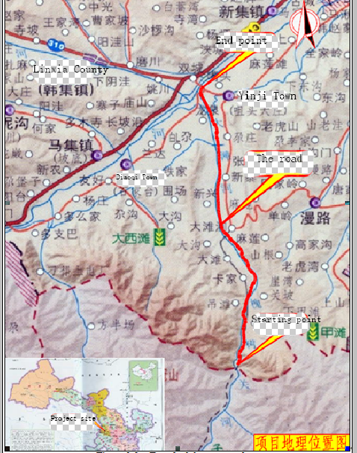
Figure 1-1 Trend of the proposed route

1.3 The main Contents of Social Assessment
The contents of this social assessment mainly include stakeholder analysis, poverty analysis and strategy, women's needs for the project, social impact analysis, project and ethnic minorities, public consultation and participation process, social management plan and implementation, complaints and monitoring assessment. It consists of eight parts.
(1) Analysis of stakeholders
The main stakeholders involved in identification are mainly the social groups and individuals affected in the road construction scope, such as the urban residents, rural residents, trucks and bus drivers, the traffic police force, the transportation bureau, the Development and Reform Bureau, the Civil Affairs Bureau, the Civil Affairs Bureau, the County Women’s Federation and other units, especially the vulnerable groups such as women, the elderly, and the poor. The needs and attitudes of key stakeholders for the project were identified, and the roles played by key stakeholders analyzed, and then the problems were found in the interaction process.
(2) The needs of ethnic minorities for the project
Introduce the general situation of ethnic minorities in the project area, analyze the impact of project implementation on ethnic minorities and their appeals, and prepare an action plan for ethnic minorities to protect the rights and interests of ethnic minorities, safeguard social stability and promote national unity.
(3) Women's demand for the project
Introduce the profile of women in the project area, analyze the impact of project implementation on women and their appeals, and prepare a women's action plan to ensure the rights and interests of women.
(4) Analysis and Strategy of Poverty
Introduce the status of the poor population in the project area, analyze the causes of poverty in the area, introduce related poverty reduction measures, analyze the poverty reduction role of the project and the appeals of the poor, prevent the income gap from widening, and ensure that the disadvantaged population and other vulnerable groups benefit from the project.
(5) Social Impact Analysis
Analyze the different impacts of the project implementation on different interest groups. Its impact is divided into two aspects: positive impact and potential risks. The analysises of the positive impacts and potential risks of the project's main stakeholders will effectively identify ang control the social risks of the project. This social assessment mainly analyzes the positive impact and potential risks of the project on the affected residents and major stakeholders such as trucks and bus drivers.
(6) Public consultation and participation process
Through the consultation and negotiation of the pre-project with major stakeholders, the public’s awareness of specific aspects of the project and other aspects were raised. The public’s needs for project information disclosure were identified. The project would combine the characteristics of the local community with existing public information to establish and improve the information disclosure mechanisms for the project, optimize project design, ensure that different stakeholders are fully and equitably involved in project planning, design, and implementation.
(7) Social Management Plan and Implementation
Through the identification and analysis of project risks, put forward targeted policy recommendations and action plans to avoid or reduce the social risks existing in the project, and put forward action proposals for the project design.
(8) Complaints, Appeals and Monitoring Assessment
In the process of project preparation, construction and operation, in order to timely understand and resolve the impacts and problems that the project brings to stakeholders, ensure participation of communities and village committees as wide as possible, and establish complaints channels. To ensure that project information disclosure, public participation, and the social management plan proposed by the social impact assessment report can be valued and implemented, a monitoring and evaluation mechanism will be established.

1.4 Methods of Social Assessment
In order to ensure the scientificity and effectiveness of the social assessment process and conclusions, this social assessment mainly adopts a variety of social research methods such as literature research, questionnaire surveys, focus group symposiums, in-depth interviews, interviews with key informants, and participatory observation. The data obtained by various ways can be supplemented and verified by each other, so as to comprehensively understand the relevant information disclosure and public participation, making the social evaluation results more accurate.
(1) Document review
Focused on the following documents and materials: 1) “Thirteenth Five-Year Plan” development plan in Gansu Province, “Thirteenth Five-Year” development plan in Linxia Hui Autonomous Prefecture; 2) Project Feasibility Study Report; 3) Latest Statistical Yearbook of Linxia County and Linxia County; 4) Linxia County The “Thirteenth Five-Year Plan” for rural poverty alleviation and development, and the implementation plan for key projects of Linxia County Poverty Alleviation Office; 5) “Summary of Linxia County Women’s Federation 2015 work”, summary of Linxia County Women’s Federation’s work in 2015 and 2016 work plan; 6) Linxia County Minzong Bureau's "Thirteenth Five-Year Plan", the survey report on the basic conditions of ethnic minorities; 7) Linxia County, the basic situation of road traffic and other relevant information.
(2) Questionnaire survey
According to the characteristics of the road construction, the direct impact scope of the project mainly refers to the villages and towns along the road, including 7 townships and villages in Linxia County. For details of the impact, see Table 1-1.
Table 1-1 Distribution of the villages and population and population distribution
Items | Townships | Administrative villages | Population | Minority
Poverty relief route project | Diaoqi | 1 | 152 | 105 | 70%
Poverty relief route project | Yinji | 6 | 13353 | 4005 | 30%
The questionnaire database was established and analyzed by using IBM SPSS 20.0 statistical software. After statistics, there are 100 valid samples. The basic information is shown in Table 1-2.
Table 1-2 Basic information of valid samples
Statistical indicators | Statistics
Gender | Males accounted for 74.8%; females accounted for 25.2%.
Age | The average age is 46 years, the minimum age is 16 years, and the maximum age is 71 years.
Nature of residence | Rural residence accounts for 100%.
Education level | Illiteracy accounted for 9.9%, elementary schools accounted for 27.5%, junior high school accounted for 49%, high school/secondary school accounted for 11.6%, college and above accounted for 2.0%.
Career | Government agencies accounted for 0.3%, public institutions accounted for 1.3%, corporate employees 0.7%, self-employed accounted for 6.3%, freelancers accounted for 4.3%, unemployment unemployed accounted for 1.0%, students accounted for 0.7%, and farmers accounted for 85.4%.
Minimum guarantee | Yes, accounting for 13.6%; No, accounting for 86.4%.
(3) Focus Group Discussion
During the on-site investigation, the social assessment team interviewed Linxia Project Office, Bureau of Statistics, Bureau of Civil Affairs, Poverty Alleviation Office, Environmental Protection Bureau, Human Resources and Social Security Bureau, Civil Affairs Bureau, County Women's Federation, and the Urban Construction Supervision Team involved in the project area. Eighteen related agencies and departments including the Environmental Sanitation Department, the Transportation Management Bureau, the Traffic Police Brigade of the Public Security Bureau, the Development and Reform Bureau, the Agriculture and Animal Husbandry Bureau, the County Traffic Information Platform, the County Information Office, and the agency heads and related personnel. Interviews collected baseline data and data closely related to the project.
The social assessment team held seven focus group symposiums with the general residents (the proportion of women is not less than 30%), the elderly and the disadvantaged groups (mainly ethnic minorities, poverty-stricken families, low-income families, disabled persons, etc.) in Zhuanzui Village of Diaoqi Town, Xinzhai Village, Xinxing Village, Datan Village, Kajiatan Village, and Xinfa Village in Yinji Town, to let them learn more about the aims of the project. The team obtained their opinions and suggestions on traffic conditions, traffic management, and traffic safety.
(4) In-depth interviews
Through personal in-depth interviews, the team had more in-depth understanding of the affected people's production and living conditions, the positive and negative impacts of the project, and some potential risks. Understanding their attitudes, suggestions, and expectations for the designed project, and other practical information that is not convenient for quantitative statistical analysis, will help to find out some of the actual information that is sent to the grassroots, and understand the relevant situations and problems. In this field survey, a total of 7 village collectives were visited and 14 in-depth interviews were conducted (of which 6 were women, accounting for 50%, and 3 were poor people, accounting for 25%).
(5) Interviews with key informants
The agency interviews at the county level were mainly targeted at the heads of the transport authorities, traffic police teams, county women’s federations, poverty alleviation offices, and other agencies; at the township and village level, they are mainly the townships and village committees. The main purpose of the interview is to understand their opinions and suggestions on the project, and to provide suggestions on how to optimize the project through the social action plan. In the survey, the social assessment team conducted a total of 17 key informant interviews.
(6) Participatory observation
Through the investigation and visiting villages and towns, the team made a further refinement of the social assessment on the local economy, society, culture, ecology, as well as the residents living in the daily life, the traffic behavior, and other basic understanding. After then, the team would understand comprehensively the impact of the project on those townships and villages, and provide an objective factual basis for optimizing project design.

Chapter 2 Social and Economic Development Status and Traffic Management Status in the Project Area

2.1 Definition of project area
According to the impact of the proposed project on various types of audiences, various stakeholders are divided into directly affected population and inter-influenced population. The directly affected population is the target group of the main service of the project or the group of the project that directly influences and interferes the normal production and life; the inter- affected population are those whom normal production and life may be affected by the project. And correspondingly, the project area is also divided into two categories: direct affected areas and inter-affected areas. The villages and towns directly affected by the project are along the roads, which involves 7 villages in Diaoqi Town and Yinji Town. The indirect influence area of the project is the entire territory of Linxia County with 395,000 people and an indirect impact area of 1212.4km².

2.2 Socioeconomic Profile
(1) Population situation
Linxia County is located in central Gansu Province, in the southwest of Linxia Hui Autonomous Prefecture and on the south bank of the Yellow River, with a total area of ​​1212.4km². The county administers 17 townships, 2 ethnic townships, 6 towns and 219 administrative villages. The total population is 369,000. There are 9 ethnic groups such as Han, Hui, Dongxiang and Tu, and ethnic minorities account for 40.13% of the total population. .
(2) Economic conditions
By the end of 2015, Linxia County's GDP reached 3.263 billion yuan, with an average annual growth of 16.11%; fiscal revenue reached 222 million yuan, with an average annual increase of 33.18%, of which public budgetary revenue was 148 million yuan. The growth rate was 34.49%; the investment in fixed assets reached 3.008 billion yuan, an average annual increase of 26.11%; and the total retail sales of social consumer goods reached 698 million yuan, an average annual increase of 18.11%. The proportion of the three major industries was adjusted from 29.81:23.19:47 in 2010 to 22.23:15.22:62.55. Compared with 2010, the proportion of value added in the primary industry decreased by 7.58 percentage points, and the proportion of value added in the tertiary industry increased by 15.55 percentage points. The proportion of public and non-public economies was adjusted from 48.73:51.27 to 43.09:56.91. The proportion of agricultural added value in agriculture, forestry, animal husbandry, fishery, and service industries was adjusted from 58.15:10.24:30.33:0.12:1.16 to 66.87:2.3:29.29:0.11:1.43. The proportions of crops, crops, and forages for crop cultivation were adjusted from 80.64:11.53:7.83 to 74.7:20.52:4.78. The income ratio of urban and rural residents was adjusted from 3.90:1 to 3.01:1.

2.3 Linxia County Traffic Management Situation
(1) Status of traffic in Linxia County
The county will build high way S309 from Gancaodian to Jishishan. It is 31 km, built with National Class II Standard. The county will also rebuld the high way from Hanji-Hongtai-Xianfeng with 62.8 km long, and also high way Huangniwan-Luojiaji with 7 km long. The county will rebuild high way Zhangzigou-Hanji-Xiaogou with National Class Ⅲ Standard. The county plans to build up the County City motor station, Tuqiao motor station, Xinji Bridge, and tourism roads from Shuangcheng to Tugoutai, from Yjiji to Huaishu-guan. The county government would set up a bus company to run bus routes from Linxia county city to Shuangcheng and from Shuangcheng to Maji and from Shuangcheng to the economic development zone. In coming 5 years, the county will rebuild 21 bridges and harden the country roads of 2110 km. After those, a better high way network will be formded.
2.3.1 Main Problems in Road Network System
Since the “Twelfth Five-Year Plan”, Linxia County has made great achievements in its transportation infrastructure construction. However, the road layout and infrastructure construction have been difficult to adapt to the needs of the vigorous development of the social economy and the ever-increasing demands of the masses. In general, the main problems in Linxia County's road network system are mainly manifested in the following aspects:
(1) The total traffic volume is insufficient, the comprehensive transportation capacity is poor, and the highway mileage growth is slow. Highway road network density is small, there is no road network with economies of scale; there is no civilian airport, air transport is still blank; based on the severe drought conditions in the region, the congenital conditions of the construction of reservoir terminals and other facilities are insufficient, can not meet the growing needs of residents travel. Over the years of reform and opening up, Linxia County's national economy, total industrial and agricultural output values, passenger and cargo volumes, and turnover volumes have all increased significantly. However, highway construction has lagged behind, which has severely restricted the development of the national economy.
(2) The technical level of highways is low and seriously damaged. First, the existing service life of asphalt roads mostly exceeds the design period with loose road subgrades and surfaces, and urgently needed to be improved. In particular, county-township highways are mostly constructed by manpower in the 1980s, and construction standards and quality are low; load capacity Limited, it has been running for a long time and has been overburdened. In addition, natural disasters such as such as tumbling, landslides, mudslides, and rainstorm were frequent and damaged the roads, and the funds for emergency repairs cannot be guaranteed. As a result, the damaged roads conditions cannot be repaired in time, resulting in safety risks. Second, although there have been major developments in the domestic highways over the years, the technology level is still low and the road surface level is not high.
(3) The layout of the road network is irrational and the access range is large enough. First, there are many broken roads between provinces, counties, rural areas, and villages. The reaching ranges of county road network are insufficient, and the quality is not high. The sections of the national and provincial highways in the area are short, and counties and counties and townships are relatively small. The roads between the township and the county, the city and county are not yet very open.
2.3.2 Main Problems in Traffic Management of Linxia County
The "hardware" problem in traffic management in Linxia County is worth noting, and the "software" problem cannot be ignored. The main problems in traffic management in Linxia County are:
(1) The road maintenance work is weak, resulting in serious damage to the road surface. In particular, the management of rural roads needs to be strengthened.
Linxia County has generally low road grades, and the rural roads are mainly made of grade 4 cement roads. Since the road quality is poor, they are easily damaged by large trucks. The mountain roads are washed by rain and are vulnerable to landslides and mudslides. In this situation, roads maintaince become very important. At the same time, however, the construction of roads in Linxia County still has the problem of “focusing on construction and light maintenance”. The staff of Linxia County Transportation Bureau reported: “Because of the limited financial resources, only the roads that are seriously damaged can be repaired every year. The county and township roads that can do the maintenance every year are only 4 to 5 km.” It means that the roads that can be repaired every year are negligible. "It can't take the car to repair it." therefore, those roads made bumpy rides, loss of vehicle tires and steel plates, and finally increased maintenance costs for passenger cars by 20% to 30%. The cost of vehicles has also increased correspondingly; as a result, the transportation cost and time has increased and the comfort of passengers has also decreased significantly.
The principle of grading management of “County-County Administration, Rural Township-Township Management, Village-Village Road Management” also lead to the fact that the rural roads and village roads are virtually unattended. In the case of poor grades and quality of roads, the neglect of management and maintenance of roads in villages and towns, coupled with the impact of heavy road use and natural disasters, has led to widespread road surface damage in the project area. With the increase in the mileage of rural roads and the gradual improvement of highway infrastructure, it is necessary to strengthen the management of roads, and over-limit transportation is in urgent need of governance. The technical standards of rural roads are relatively low, and their ability to withstand traffic loads is limited. Excessive overloaded vehicles enter rural roads to cause serious damage. Moreover, difficulties in financing become a big problem. However, the overloaded vehicles on the rural roads area never stop increased. In particular, after the provincial lines has increased the management and control of overloaded vehicles, some overloaded vehicles have been transferred to rural roads. The situantion is geting bad.
(2) Traffic safety propaganda is insufficient, and many villagers lack the necessary knowledge of traffic safety
The existing traffic safety propaganda is basically concentrated in the county towns and schools. It is provided in a variety of ways, such as posting traffic safety placards, distributing traffic safety brochures, leaflets, and conducting traffic safety lectures. However, as far as townships and villages are concerned, the basic understanding of the basic traffic safety knowledge of the villagers is very limited, because there is very little publicity about traffic safety knowledge, and the villagers report that they are aware of the safety publicity campaign less than twice a year. In the surveyed villages, two villages (Datan and Xinfa) stated that they did not know that there was a traffic safety training for the village, and even some villagers said they had never heard of such a thing. Even if it does, it is only through the village cadres who convey the knowledge of traffic safety and the form is just single.
The traffic police force, on the other hand, reflects the reasons for the lack of publicity and patrolling. The main reason is that the traffic police force is insufficient and the management area is too large, resulting in a lack of sufficient police force to do a good job in propaganda and patrolling.
(3) There is no electronic monitoring equipment within the project area, resulting in weak supervision
There are no electronic monitoring devices in the important sections and intersections of Linxia County's roads, and there is weak supervision over violations of the roads. This leads the driver to know the law, ignores the traffic rules, and is overloaded with speeding and overloading. The traffic safety risks are great.
(4) Existing traffic safety signs and warning signs blocked by street trees or roadside buildings
Traffic safety signs and warning signs are the only reminders and warnings for roads that lack infrastructure such as zebra crossings, traffic lights, speed bumps, and fences, and are very important for traffic safety. However, the unpolished street trees and some buildings close to the road obstruct traffic safety signs and warning signs, making it impossible for drivers to receive advance traffic warnings, and it is particularly prone to traffic accidents at intersections and sharp bends.
(5) The road transport market has a low degree of hair loss, the transportation structure is irrational, and the transport production level is low, resulting in high residents’ travel time and costs.
The development of the transportation market is not perfect, and it is difficult to form a pattern of large markets, large circulation, and large traffic. The transportation structure is irrational, and the main body of the transport industry is not competitive; the construction of the transportation station is lagging behind and the operation and management are obsolete. Due to lack of capital for station construction and slow infrastructure construction, the number and function of stations cannot meet the needs of the transportation market. There are few public stations, poor conditions, small scale of temporary stations, poor facilities, scattered distribution, and chaotic management. The basic functions are difficult to get normal play. The number of medium-to-high-end, luxury passenger cars, large-tonnage freight cars, containers, refrigerated fresh-keeping vehicles, and LTL transport vehicles is small and rapid passenger transport, tourist passenger transport, and logistics have just started, and the level of transportation informationization is at its origin. Existing passenger and freight transport vehicles are not able to reach more than technical grade 2 or more , have a low degree of transportation informationization. the transportation management methods are a single. These have become factors restricting the leap-forward development of road transport in the project area.
The conflict between supply and demand is big. The passenger transport capacity, especially the urban taxis, is basically saturated. There are many passengers and less passengers, and the actual load rate is low. The rapid development of transport productivity and social economy requires convenient, fast, high-quality and efficient maintenance services and information services that are suitable for them. In addition, logistics services and the function of the existing integrated transport service system are not perfect. Therefore, the basic role of the transportation does not play very well.

Chapter 3 Stakeholders and Public Participation

3.1 Stakeholder Identification
Stakeholders are those individuals or groups that can influence the achievement of a project's goals or be affected by the achievement of project goals. Stakeholders can be divided into major stakeholders and secondary stakeholders.
Based on the nature of the project, the field investigations and interviews with relevant agencies can identify the main stakeholders. They are urban and rural residents within the scope of the direct impact of the new road construction (the residents who live along the road), especially vulnerable groups such as women, children, the elderly, poor households, low-income households, persons with disabilities, and land requisitioned households.
Secondary stakeholders include:
(1) Passenger and freight companies and drivers, project offices, owners, design institutes and other related institutions;
(2) Functional departments of government agencies.
3.1.1 Key stakeholders
(1) Residents along the road in the project area.
The project involves 7 village groups in 2 townships in Linxia County, and the main stakeholders are residents of the 7 village groups. The road to be built is the main road for residents of the southern mountainous area of Linxia County to travel and arrive in the county. Some residents in the project area live directly on both sides of the road. Most residents in the project area need to pass through these main roads to travel, work, and life activities. Therefore, this road plays a crucial role in the production and living of residents along the road.
Therefore, the focus of the project's social impact assessment will focus on the needs and interests of residents along the road.
(2) Residents affected by land acquisition and demolition
① The land acquisition affects the population.
For some sections of the project, local cultivated land will be required. During the project design process, the project design unit fully considers the destructiveness of land expropriation to the local socio-economic development and production and living systems, constantly optimizes the engineering design, and controls and optimizes the road width and construction scale. Reduce the scope of land requisition and demolition to decrease the impact of project construction on local production and life. Therefore, the construction of this project will not cause devastating damage to the original production and living system. However, in the collective land acquisition, the permanent acquisition of arable land affected by this project affects 7 villages in 2 townships of Diaoqi and Yinji towns within the jurisdiction of Linxia County, and a total of 203.87 mu of cultivated land is acquired.
Since the actual conditions of each village are different, the size of the impact of the land acquisition on each village is also different. Therefore, the recovery plan is based on the degree of influence, the actual characteristics of each village and the willingness of the affected people. After full consultation with the village committee and effected persons during the socio-economic survey, different economic recovery programs were identified: mainly monetary compensation and distribution, implementation of agricultural development measures and social security measures, labor skills training, and employment promotion measures.
② Demolition affects residents.
The demolished houses in this project are all rural houses with a total house area of 5,893 m² (including the main houses and miscellaneous houses), all of which require relocation and reconstruction. The demolished rural houses have various problems such as imperfect indoor facilities, obsolete structures, and poor lighting and ventilation conditions, and the supporting conditions around the residences are also bad. The demolition and resettlement activities of this project will provide opportunities for the relocated households to improve their living conditions and environment.
After public participation and consultation with relevant government departments, the resettlement plan for affected villages mainly includes the following types according to the type of rural residents' resettlement:
Full currency compensation: The villages that choose the complete monetary compensation for house demolition and resettlement methods are: Zhuanzui Village in Diaoqi Town. The demolished households can purchase houses in the new rural community basing on the construction cost price according to their own wishes, or they can purchase the house in towns at the market price according to the market price.
3.1.2 Secondary stakeholders
(1) Passenger and Freight Companies and Drivers
Freight drivers and passenger drivers are the main users of the road, and their needs should be given more attention by project implementers. Their main requirements for the proposed project are: to implement the project as soon as possible, and through on-site interviews, most drivers report that they are going to the villages to pick up goods or deliver goods (the goods picked up from the country are generally agricultural products, and the goods sent are generally cement, bricks, etc.) As the roads are narrow and are in good condition, once they are anchored, they usually cost 7,000 yuan to 10,000 yuan to operate on trailers. The narrow roads in rural areas are also likely to lead to the collision of vehicles, and the need for road widening is very urgent.
(2) Project management office, owner, design agency and other related institutions.
According to the survey, the project established ta leader group for the project, and is located in Linxia County Development and Reform Bureau. The main responsibilities of the project office are responsible for organizing and coordinating the business relationships among relevant departments, agencies, and units, and providing guidance, liaison, and supervision on the preparation of the project and the execution of the project.
The design unit of the project is Gansu Kedi Engineering Consulting Co., Ltd., responsible for the preparation of the project proposal and feasibility study report.
The requirements of these related organizations mainly include: It is hoped that through the concerted efforts of all parties, people's livelihood with building the projects will be promoted and successfully completed as soon as possible.
(3) Government related functional departments
Government related functional departments include Linxia County Development and Reform Bureau. In addition, government agencies related to project construction, land acquisition, demolition, and resettlement activities include the Linxia County Transportation Bureau, Land and Resources Bureau, and Land Acquisition Office. The implementation of the project also involves grassroots/village committees and other grassroots workers. Therefore, the requirements of the relevant government departments for the project mainly hope that through the cooperation of various departments, the project can be successfully completed, improve the road network structure of Linxia County, and promote the sustainable development of local traffic.
(4) Ethnic minorities
The project area, Linxia County, belongs to the main distribution area of minority population in Linxia Prefecture of Gansu Province. The minority population in the project area is mainly ethnic minorities such as Hui, Salar, and Dongxiang.
Based on the relevant basic data provided by the Linxia County Project Office and the Linxia County Civil Affairs Bureau, the social assessment team found that the ethnic minority population of Linxia County had 162,572 in total, of which the minority population accounted for 41.74 % of the total population of Linxia County.

3.2 Public consultation and social participation process
Under the close cooperation of the World Bank Project Office of Linxia County, the social assessment team conducted institutional interviews and village groups in 7 villages in 2 townships in Linxia County within the scope of project implementation from July 22 to July 23, 2017. Responsible person symposium, villagers symposium, symposium on vulnerable groups, symposiums of enterprises and institutions, questionnaire surveys, in-depth interviews on individual cases, and on-site inspections on the road, fully listening to various government departments, relevant enterprises and institutions, village cadres, and ordinary villagers Proposed project design and construction recommendations and requirements. For details of public participation activities, see Table 3-3.
3.2.1 Agency interviews
The Linxia Project Office, Statistics Bureau, Civil Affairs Bureau, Poverty Alleviation Office, Environmental Protection Bureau, Human Resources and Social Security Bureau, Municipal Civil Affairs Bureau, District Women's Federation, Urban Construction Monitoring Team, Sanitation Department, and Transportation Authority are involved in the project area. Eighteen agencies and departments including the Public Security Bureau Traffic Police Brigade, Development and Reform Bureau, Agriculture and Animal Husbandry Bureau, District Traffic Information Platform, and the Municipal Roads Department conducted institutional interviews and collected some data closely related to the project.
3.2.2 Situation of Villagers/Residents Seminar in Project Area
The village committees were held in 7 village committees in 2 villages and townships such as Zhuanzui Village in Diaoqi Township, Xinzhai Village, Xinxing Village, Datan Village, Kajiatan Village and Xinfa Village in Yinji County. Responsible people, general residents, women, and 7 disadvantaged groups (elderly people, disabled people, poor people) in 7 special forums. The social evaluation team has heard about the overall situation of various types of residents in the area of ​​project construction areas such as road infrastructure, travel modes, convenience of travel, transportation costs, traffic safety, etc., as well as the traffic situation within the project area for residents of the project area. The status quo and overall needs have been further understood. The social assessment team and the residents of villages, towns, villages, and villages who participated in the symposium were fully effective and rich in the basic conditions of the village groups, road infrastructure, road network improvement, traffic management, and road traffic safety. Constructive communication, on the whole, understands some of the concerns and practical needs of Linxia County's residents in different regions in terms of safety and convenience in traveling.
3.2.3 Situation of seminars for enterprises and institutions
At the same time as the village group discussion meeting was held, and in coordination with the World Bank Project Office of Linxia County, the social assessment team also held two collective forums for related institutions within the project construction area. In Linxia County Public Security Bureau Traffic Police Brigade and Linxia County Transportation Management Bureau, which is closely related to traffic management and traffic safety, a symposium on traffic police symposiums and transportation management personnel was held; it was a passenger transport company that was the mainstay of local transportation business. The freight company held the symposium of Linxia Passenger Transport Company and passenger driver respectively. The in-depth understanding of road infrastructure, traffic management, travel status and potential demand, traffic safety, public transportation, and other difficulties and problems in this project have been further understood. Ideas come from the grassroots, managers, and concrete practitioners.
3.2.4 Questionnaires and interviews
After the social assessment research team held the unit symposium with relevant institutions in the project area, two different research teams entered the village group affected by the project construction, schools and shops along the road to conduct social assessment questionnaires and individual interviews. After this period of efforts, the social assessment team initially completed 100 social questionnaires in Zhuanzui Village, Yinji Town (Xinzhai Village, Xinfa Village, Xinxing Village, Datan Village, and Kajiatan Village) in Yinji County, Linxia County. Evaluate the investigation of the survey questionnaire; and interviews with 6 villager group symposiums.
In the process of conducting questionnaire surveys and in-depth interviews with residents of Linxia County in the project area, the social assessment team, in response to the general issues of concern and concentration in road traffic, clearly identify which areas the stakeholders are focusing on, as well as residents, by sorting through these issues one by one. Where the main appeals and appropriate suggestions can be concentrated, this will help us to focus on and respond to key issues.
Since the result of the survey is mainly to estimate the comparison between various proportions and ratios, the determination of the sample size is based on the sample size when estimating the overall proportion of simple and random sampling. Under the 90% confidence level, the calculation is based on the requirement that the absolute sampling error does not exceed 5%. The sample size to be extracted is:
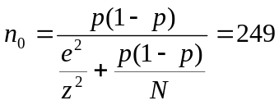
Here, e is the sampling absolute error taken as 0.05, z is 1.645 when the confidence level is 90%, and p(1-p) is taken as the maximum 0.25. Taking into account the accuracy, cost, feasibility of survey implementation and possible non-response due to various reasons, according to the estimation of the response rate, the social assessment team appropriately expanded the above sample size to 320.
The questionnaire survey comprehensively considered the geographic location of the proposed road, the surrounding environment, the size of the residents within the scope of direct influence, and the distance from the nearest community/village to the project implementation site. The survey focused on residents in six villages. A total of 100 questionnaires were distributed and 100 valid questionnaires were recovered, accounting for 100% of the total number of questionnaires. See Table 3-2 for details.
The questionnaire survey includes: 1) The residents’ overall evaluation of the local road conditions, the residents’ travel mode and the evaluation of the traffic status; 2) The information disclosure of the project and its impact, including positive and negative influences; 3) Residents' local traffic evaluation and demand; 4) residents' evaluation of local traffic safety and ways to solve traffic safety problems; 5) household basic conditions, personal basic information.
Table 3-2 Distribution of Resident Survey Questionnaire
County | Township | Villages | Number of questionnaires（N） | Number of valid questionaire(n) | Percentage of valid questionaire(%)
Linxia County | Diaoqi | Zhuanzui | 25 | 25 | 100
Linxia County | Yinji | Xinzhai | 15 | 15 | 100
Linxia County | Yinji | Xinxing | 15 | 15 | 100
Linxia County | Yinji | Datan | 15 | 15 | 100
Linxia County | Yinji | Kajiatan | 15 | 15 | 100
Linxia County | Yinji | Xingfa | 15 | 15 | 100
Total |  |  | 100 | 100 | 100

Table 3-3 Preliminary Participation in Social Impact Assessment of the Guanhe River Poverty Alleviation Channel in Linxia County
Date | Research community/institution | Symposium participants | The specific situation of participants in the symposium | Notes
May 25 - June 26, 2017 | Villages along the Road | The investigation team launched a social assessment questionnaire survey and residents intentional interview.
July 22, 2017, 9:00 AM | Zhuanzui Village, Diaoqi Town | There are 6 women, 4 elderly people, 4 vulnerable people, 8 villagers and 3 village leaders. A total of 25 people. | 1) Women's Forum: 6 people. Among them, there are 2 young people (below 30 years old), 2 middle-aged (30-55 years old), and 2 old (55 years old).  2) Senior Forum: 4 people.  3) Vulnerable group forum: 4 people (2 physically disabled; 2 poor people).  4) The person in charge of the village committee and the villager representatives discussed: 11 people. | The two groups of social assessment surveys were held in the community (4 people in each group, 2 people in charge of the women's forum, and the rest in charge of the vulnerable group forum).  The remaining members of the team entered the village of Zhuanzui Village and conducted questionnaire surveys and interviews.
July 22, 2017, 10:30 AM | Xinzhai Village, Yinji Town | There are 4 women, 4 elderly people, 2 vulnerable people, 2 villagers and 3 village leaders. A total of 15 people. | 1) Women's Conference: 4 people. Among them, there are 2 young people (below 30 years old), 1 middle-aged (30-55 years old), and 1 old (55 years old).  2) Senior Forum: 4 people.  3) Forum for vulnerable groups: 2 people (2 poor people).  4) The person in charge of the village committee and the representatives of the villagers: 7 people. | The remaining members of the research group entered Xinzhai Village and conducted questionnaire surveys and interviews.
July 22, 2017 2:30 PM | Xinxing, Yinji Town | There are 4 women, 4 elderly people, 2 vulnerable people, 2 villagers and 3 village leaders. A total of 15 people. | 1) Women's Conference: 4 people. Among them, there are 2 young people (below 30 years old), 1 middle-aged (30-55 years old), and 1 old (55 years old).  2) Senior Forum: 4 people.  3) Forum for vulnerable groups: 2 people (2 poor people).  4) The person in charge of the village committee and the representatives of the villagers: 7 people. | The remaining members of the research team entered Xinxing Village to conduct questionnaire surveys and interviews.
July 23, 2017 9:00 AM | Datan Village, Yinji Town | There are 4 women, 4 elderly people, 2 vulnerable people, 2 villagers and 3 village leaders. A total of 15 people. | 1) Women's Conference: 4 people. Among them, there are 2 young people (below 30 years old), 1 middle-aged (30-55 years old), and 1 old (55 years old).  2) Senior Forum: 4 people.  3) Forum for vulnerable groups: 2 people (2 poor people).  4) The person in charge of the village committee and the representatives of the villagers: 7 people. | The remaining members of the research team entered the Datan village to conduct questionnaire surveys and interviews.
July 23, 2017 at 10:30 am | Kajiatan Village, Yinji Town | There are 4 women, 4 elderly people, 2 vulnerable people, 2 villagers and 3 village leaders. A total of 15 people. | 1) Women's Conference: 4 people. Among them, there are 2 young people (below 30 years old), 1 middle-aged (30-55 years old), and 1 old (55 years old).  2) Senior Forum: 4 people.  3) Forum for vulnerable groups: 2 people (2 poor people).  4) The person in charge of the village committee and the representatives of the villagers: 7 people. | The remaining members of the research team entered Kajiatan Village to conduct questionnaire surveys and interviews.
July 23, 2017 2:30 PM | Xinfa Village, Yinji Town | There are 4 women, 4 elderly people, 2 vulnerable people, 2 villagers and 3 village leaders. A total of 15 people. | 1) Women's Conference: 4 people. Among them, there are 2 young people (below 30 years old), 1 middle-aged (30-55 years old), and 1 old (55 years old).  2) Senior Forum: 4 people.  3) Forum for vulnerable groups: 2 people (2 poor people).  4) The person in charge of the village committee and the representatives of the villagers: 7 people. | The remaining members of the research team entered Xinfa Village and conducted questionnaire surveys and interviews.
July 23, 2017, 4:30 PM | Datanjian Village, Yinji Town | There are 4 women, 4 elderly people, 2 vulnerable people, 2 villagers and 3 village leaders. A total of 15 people. | 1) Women's Conference: 4 people. Among them, there are 2 young people (below 30 years old), 1 middle-aged (30-55 years old), and 1 old (55 years old).  2) Senior Forum: 4 people.  3) Forum for vulnerable groups: 2 people (2 poor people).  4) The person in charge of the village committee and the representatives of the villagers: 7 people. | The remaining members of the research team entered Xinfa Village and conducted questionnaire surveys and interviews.

3.3 Analysis of the needs of major stakeholders
The main objectives of this project are: to improve urban and rural traffic conditions, road water supply and drainage infrastructure, promote the equalization of basic public service facilities, enable urban and rural residents to share the economic and social development results, constantly optimize the investment environment, and increase the radiation and drive of this poverty alleviation routes to surrounding areas. It will improve resource allocation, industrial clustering and sustainable development capabilities, and promote the process of “three synchronizations” of urbanization, industrialization, and agricultural modernization, and gradually reduce and even eliminate the differences between urban and rural areas.
The main function of this project is to connect Linxia County to the main road network in the south mountains area, so as to improve Linxia County's traffic network system.
In order to understand the opinions, suggestions, and needs of residents of Linxia County and relevant units on the road, the social assessment team has implemented Questionnaire surveys of the townships and villagers involved in the project . Questionnaire surveys, in-depth interviews, and village group seminars were conducted. The following is a detailed analysis of the travel needs of major stakeholders in the project scope and the difficulties encountered in daily life travel, based on full public participation.
3.3.1 Overall evaluation of residents in the project area on local traffic conditions
In the process of investigating the urban and rural residents along the planned road, the social assessment team found that most of the urban and rural residents thought that the problems existing in local traffic were serious. The proportions of very serious and serious totals were as high as 53%. At the same time, residents who think that the traffic problem is not serious only account for 7% of the respondents. 40% of the residents have a general attitude toward the problems existing in local transportation. For the evaluation of local traffic conditions by residents of the project area, see Figure 3-4.
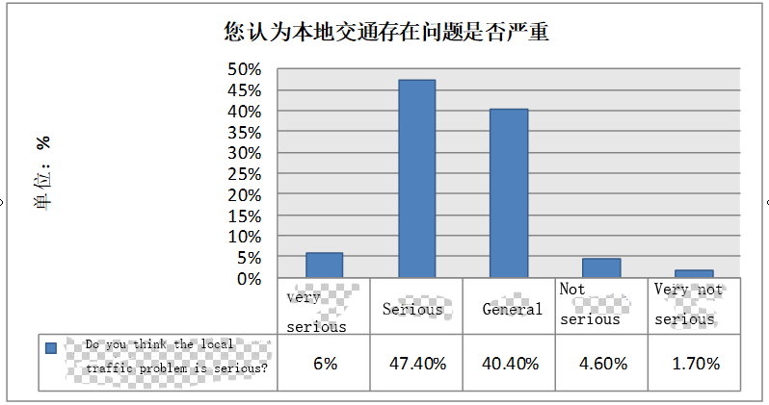

Figure 3-4 Overall Evaluation of Residents' Existing Problems in Local Traffic Conditions
3.3.2 Problems with traffic conditions and analysis of residents' needs
(1) Analysis of existing traffic problems in the project area
The social evaluation team learned from the survey that the traffic problems in the project area are serious. The most prominent of these problems are mainly the mixture of vehicles, the existing dirt roads, roads that have been damaged by poor road repairs, and poor road/sidewalk lighting. Residents believe that the above three cases are very serious and serious, with 76.5%, 73.2% and 59.6% respectively. Among them, the problem is relatively light traffic congestion, and the proportion of serious and serious problems is only 33.4%. For example, it is thought that (the vehicles considered to be very serious and serious proportions are counted together) vehicles in disorder stop obstruct the traffic (58.6%), motor vehicles do not slow down without pedestrians (51.6), village slip roads are hard to reach arterial roads (49.6), and pedestrians problems such as irrationality (48.6), poor road resilience and easy destruction (46%) have all been regarded as relatively serious problems by residents in the project area. Residents of the project area understand the traffic problems, as detailed in Figure 3-5 and 3-6.
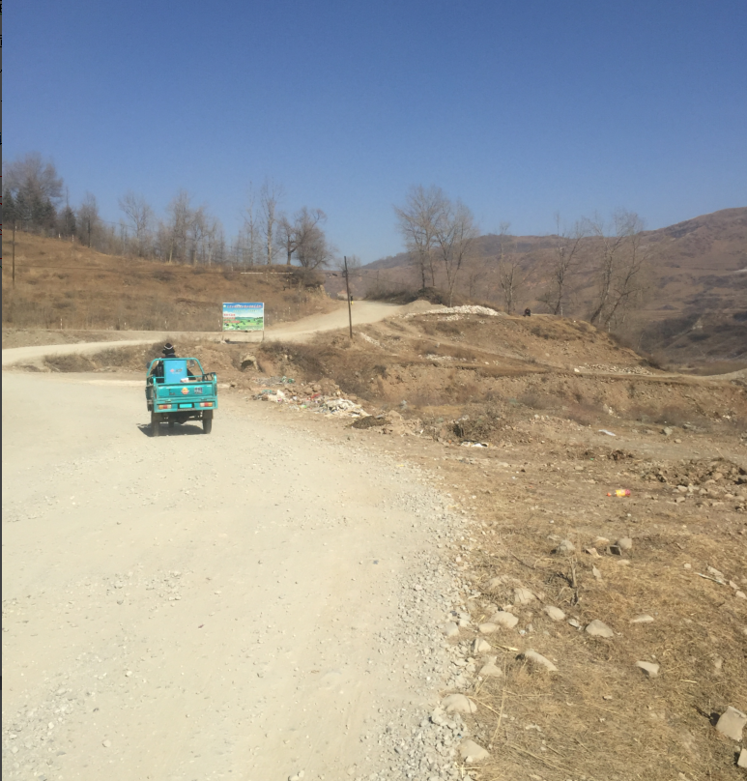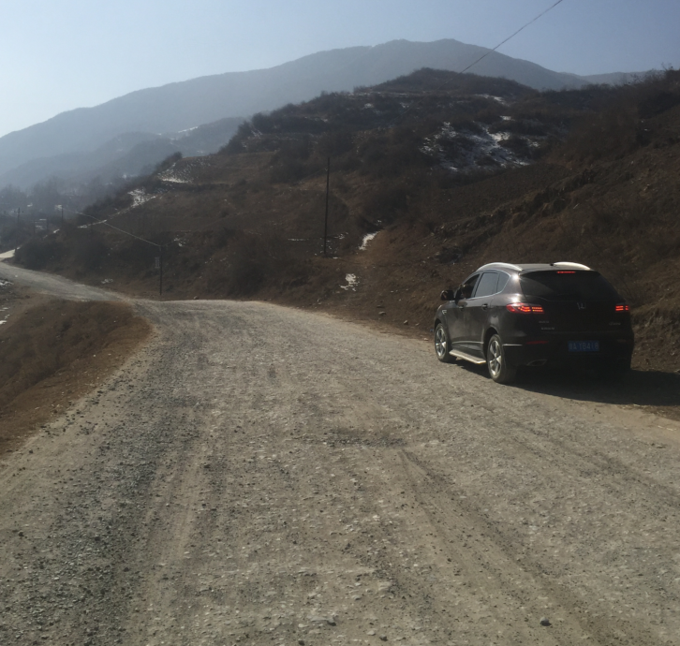
Figure 3-5 The disrepaired road in the project area

Figure 3-6 Analysis of the resident's local transportation problems
(2) Analysis of the needs of residents in the project area for improving traffic problems
In response to the existing traffic problems in the project area, the social assessment team analyzed the data obtained from the questionnaire survey conducted found that the residents of the project area had the right road signs for the specific needs of the current transportation infrastructure. The demand is the strongest, and the total number of road signs that should be improved reaches 82.2%; followed by the demand for improving roads and water supply and drainage facilities. The proportion of roads and water supply and drainage facilities that should be improved is up to 75.2%; again it is a demand for traffic lights on the roads. It will reach 66.9%. Followed by the demand for street lights on the road, it is hoped and hopefully that the percentage of street lights on the road will reach 65.6%. In addition, it is very much hoped and compared that the demand for street trees (61.6%), lane separation belts (46.3), blind roads (42%), flower ponds (42%), and street crossings (40.7%) are also more prominent. For the specific needs of residents, see below. Figure 3-7.
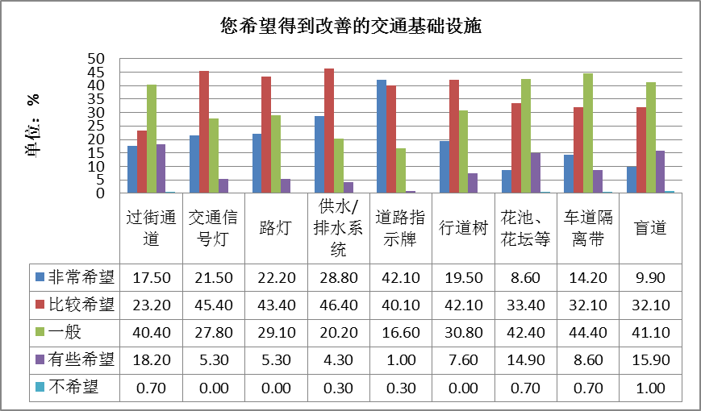
Fig. 3-7 Willingness of residents in the project area to improve traffic infrastructure
Corresponding to the transportation infrastructure that the residents of the project area hope to improve, the residents of the project area expressed the same concerns about the relevant infrastructure needed to be build with the new road. This can be calculated from the residents (thinking that the ratios are very much needed and needed) for zebra crossings (86.5%), traffic safety signs (86.4%), deceleration belts (86%), down road irrigation facilities and drainage facilities (77.2%) Throughout the village, road signs (68.5%), street trees (63.1), and other expressions of strong improvement were clearly recognized. See Figure 3-8 for details.
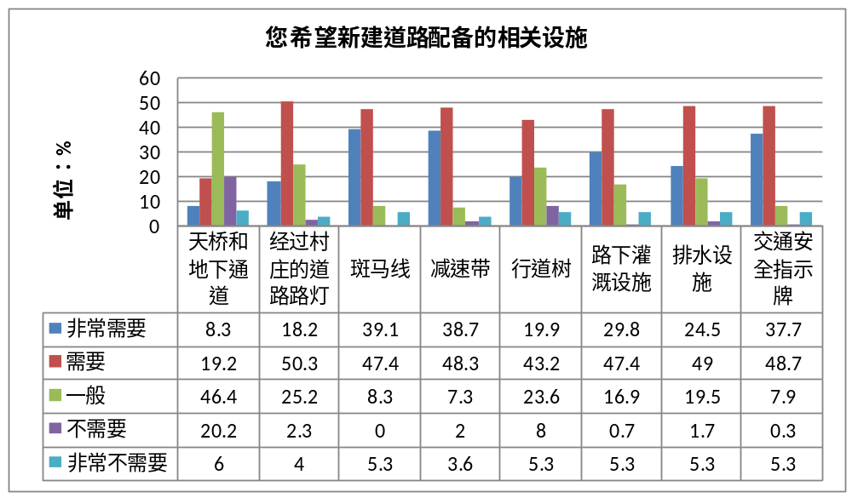
Figure 3-8 Willingness of residents in the project area to improve road supporting facilities
3.3.3 Overall Evaluation and Demand for Urban-rural Shuttles by Residents in the Project Area
(1) Overall evaluation of urban-rural shuttles by residents in the project area
On the whole, the residents in the project area think that the current urban-rural transfer is inconvenient in terms of their daily trips. This suggests that the proportion of inconvenient and inconvenient rides on urban and rural trains is as high as 61.59%. You can find out about one or two. After an in-depth investigation, the social assessment team found that due to the poor road conditions in the project area and the imperfect road network structure, some village groups have not yet opened urban and rural bus routes, and local villagers have difficulties in entering the city.
(2) Residents' needs for urban and rural transportation in the project area
From the field survey, the social assessment team found that the residents of the project area have the following four aspects regarding the specific expectations of the project in improving the convenience of public urban and rural transportation.
①Improve road accessibility and rationally arrange urban and rural bus routes
For the directly affected villages within the scope of project areas where Yinji Township and Diaoqi Township of Linxia County have not yet had the urban and rural bus routes. First of all, it is necessary to start project construction as soon as possible to improve road traffic conditions in the project area and outside the affected villages and towns. Secondly, after the successful road construction, the local transportation and transportation management department needs to arrange the urban and rural trains with freight companies and passenger transport companies. It is convenient for villagers to travel and reduce the costs of their transportation trips to assist in the social and economic development in rural areas.
②Differentiation and implementation of relevant preferential policies for different social groups
For rural senior citizens (60 years old and above), students with a height of 1.2 meters or more who are in compulsory education and poor people (including low-guarantee households, five-guarantee households, etc.), passenger transport companies can give preferential treatment. Even if they only reduce the existing market fare of 10% is very significant for this group of people. This will not only effectively reduce the burden on their travel, but also allow them to share more social development results.
③Improve safety awareness and traffic safety facilities
Focus on raising people's awareness of traffic safety, providing safety training for passenger drivers and freight drivers who drive urban and rural buses, and setting deceleration belts, traffic safety warning signs, reminding signs, etc. at intersections or crossroads with high traffic flow, and take speed limit measures to ensure people's travel safety.
④Improve standards to build high-grade roads and reduce residents' travel costs
The main reason for the higher travel costs of the villagers in the project area is that the existing road infrastructure is in poor condition, and the cost for car maintenance is relatively high, resulting in a higher level of travel fare. When planning the implementation of roads within the project area, it is necessary to strictly follow the existing planning and design standards for construction, build a high-quality and high-standard road, improve public transportation facilities, keep the road smooth and reduce the cost of traveling along villagers.
3.3.4 Overall Evaluation and Demand for Traffic Safety of Residents in the Project Area
(1) Overall evaluation of residents in the project area for local traffic safety
According to the statistical analysis of the results obtained from the questionnaire survey, it is found that the overall evaluation of local traffic safety by the residents in the project area is concentrated between general and dissatisfaction. Of these, 42.1% were ordinary, 36.4% were dissatisfied, and 10.6% were very dissatisfied. Among them, the overall proportion of dissatisfaction accounted for 47%, that is, the overall evaluation of the local traffic safety status for residents in the project area is relatively low.

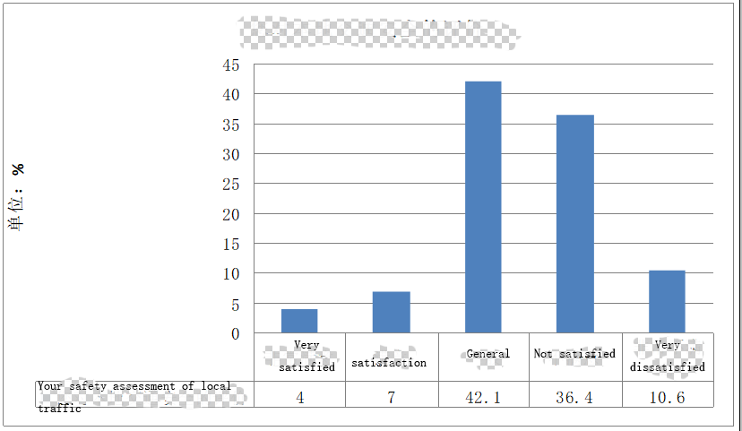
Figure 3-12 Overall evaluation of local traffic safety by residents in the project area
(2) Traffic safety needs of residents in the project area
Residents in the project area believe that the most effective measure to improve the traffic safety situation is to strengthen publicity and education of the traffic safety knowledge of the villagers to 27.9% of the survey sample, and to strengthen the management of road traffic safety by the traffic management department to account for 22.6%. In addition, a village traffic safety supervision team (14.3%) and non-motor vehicle lanes (12.5%) can be established to effectively improve the residents' daily travel safety.

Figure 3-13 Willingness of Residents for improving traffic safety
In addition, according to interviews with villagers in Linxia County, it was found that the specific needs of the villagers for improving traffic safety mainly include the following aspects.
① Optimize road design, improve road construction standards, and ensure traffic safety objectively. It is hoped that the planning road will be implemented and repaired as soon as possible, and new road construction will need to fully respect the villagers' strong desire to widen the road surface, and further improve the construction standards of the subgrade in the process of construction according to the city branch road standards.
Set sidewalks, non-motor vehicle lanes, and motor vehicle lanes, separate motor vehicles and separate people and cars. Set up standardized sidewalks and non-motorized lanes, optimize intersection design such as crossroads for canalization design, and optimize zebra crossing design to improve road safety.
During the interview, most of the villagers stated that in the newly built roads, it would be better to set up street lamps on the main road sections with large people flow, add traffic signs, set traffic lights and deceleration belts at the intersections and the sections that pass through the villages and market towns. The speed limit of the road section prevents traffic accidents caused by excessive speed.
② Through the improvement of traffic management, strengthen the management of unlicensed licenses, speeding and overloaded vehicles, and increase penalties for illegal driving. Traffic safety concerns the immediate interests of every resident, and villagers are more concerned about road safety. With the development of the society and economy and the improvement of people’s living standards, the villagers have higher requirements for their own comfort and safety. This requires greater supervision on the management of road conditions and the rectification of violations to ensure the road sections are safe and unblocked to improve the villagers' safety and happiness index.
③Strengthen traffic safety publicity and training. Through the news media, the dissemination of leaflets, the posting of safety slogans on traffic accident-prone road sections, and the propaganda of the traffic police team to the countryside, the villagers and pedestrians will be provided with knowledge and training on traffic safety. Traffic safety propaganda can be carried out once a year to promote the village and distribute traffic safety materials, flyers, and manuals. The main organization form is the form of holding villagers' congresses. Through the festivals held during the Lantern Festival and Chung Yong Festival, the relevant knowledge is preached. In this way, traffic safety propaganda will surely play a certain role. The villagers have a certain understanding of traffic safety knowledge, and the degree of compliance with traffic rules will also be greatly improved.
3.3.5 Overall Evaluation and Demand for Traffic Management by Residents in the Project Area
(2) The overall evaluation of the status of traffic management by residents in the project area
Residents in the project area are generally less satisfied with the current traffic management. Among them, the degree of satisfaction with road maintenance and conservation was the lowest, and the proportion of dissatisfaction and very dissatisfaction reached 55.3% in total. Residents' ratios (of unsatisfied and very dissatisfied proportions) to the traffic police (53.9%), convenience to the hospital (45%), convenience to the market (44.7%), convenience to the school (35.1 %), and the safety and reliability of public transportation vehicles (32.4%) are also relatively low. For details, see Figure 3-14.

Figure 3-14 Satisfaction of residents in the project area with local traffic management
After the social assessment team visited the relevant units and departments of Linxia County and the residents of the planned roads, they learned from the on-site investigations and interviews with the traffic police force that the residents’ dissatisfaction with the status quo of the traffic management mainly focused on the following aspects.
① The road surface is of low grade and the road maintenance work is weak, resulting in severe road damage. First, the current village and township road grades in Linxia County are relatively low, and the rural roads are mainly grade-four roads, and most of them are filled with large trucks. Most of the road surface has been crushed. Secondly, the problem of “focusing construction and neglecting conservation” is common in the construction of national roads. The project-related areas are no exception. The staff of Linxia County Transportation Bureau reported: “As the finances are limited, only the severely damaged road surface can be repaired after reported. The county and township roads are only 4 to 5km.” It can be seen that the roads that can be maintained every year are minimal, and only “it can't be repaired without going through the car.” This has led to widespread road surface damage in villages and towns, which has caused bumpy driving and depletion of vehicles. With tires and steel plates, the maintenance cost of passenger cars is increased by 20% to 30%, which also increases the transportation time cost and significantly reduces passenger comfort.
②The driver's and villagers' perceptions of safety and the rule of law are poor, and the phenomenon of disobedience to traffic police management is more prominent. In an interview with the traffic police, it was learned that residents do not walk zebra crossing when crossing the road. Young people ride motorcycles too fast and do not slow down at intersections. This is a common practice, regardless of collective traffic safety. It is also possible for the villagers to be insulted when they educate them. In some traffic accidents in townships and villages, there have even been incidents of joint villagers fighting against traffic police control.
③Existing traffic safety signs and warning signs are obstructed by street trees or roadside buildings. Traffic safety signs and warning signs are the only reminders and warnings for roads lacking infrastructure such as zebra crossings, traffic lights, speed bumps, and fences, and are very important for traffic safety. However, the unpolished street trees and some buildings close to the road obstruct the traffic safety signs and warning signs, making it impossible for drivers to receive advance traffic alerts, and it is particularly prone to traffic accidents at intersections, sharp bends and other sections.
(2) Demand for traffic management of residents in the project area
①Improve the quality of roads. Construction of the road with higher standards, strict control of road quality, and improvement of road quality at the source can not only improve the comfort of the villagers, but also reduce the maintenance cost in the later period.
②Repair road damage in time and strengthen road maintenance. The relevant departments such as the Bureau of Transportation and Road Administration should strengthen the inspection of the roads, detect the damage in time, and repair them in time to avoid further damage to the roads, and to increase the damage area and increase the maintenance cost.
③ Strengthen supervision, jointly supervised by the traffic control department and the villagers. The relevant departments such as the Transport Bureau and the highway administration can set up a road maintenance supervision hotline to use the masses to stop and punish illegal road-breaking acts. The AA may set up a vehicle supervision and reporting hotline to report and supervise villagers' violation of the violation of the road surface caused by speeding and overloading of vehicles.
④ Add electronic monitoring equipment. In view of the fact that intersections are frequent traffic accidents, some electronic monitoring equipment may be added to the sections of the project that involve intersections to supervise violations of laws and regulations by the vehicles. This not only serves as a warning to drivers, but also reduces the number of violations of law because of lack of supervision; It can make motor vehicles take the initiative to reduce the speed of vehicles at intersections. It is also conducive to the investigation of traffic accidents and uses effective evidences to make villagers subject to the determination of traffic accident liability.

Chapter 4 Projects and Minority Nationalities

4.1 Overview of Ethnic Minority in the Project Area
4.1.1 Population
(1) Linxia County
At the end of 2015, the total population of Linxia County was 389,760, of which, the agricultural population was 355,345, accounting for 91.15%. Among the total population, the Han population was 227,188, accounting for 58.26%, the Hui people were 128,327, accounting for 32.91%, and the Dongxiang people were 31270, accounting for 8 %, Sala people were 1027, accounting for 0.26%; other ethnic groups 0.22 million, accounting for 0.56%.
4.1.2 Cultural Characteristics of Ethnic Minorities
(1) Hui people
①Features
The ancestors of the Hui people in the project area were mainly due to missionary and commercial activities. They migrated from the Western Regions. Here, Hui men wear white shirts, jackets, and white domes. Women usually wear hijab. For ethnic minorities, Hui people have frequent exchanges with Han culture because of the use of Chinese language. In addition, they are good at doing business and have a relatively high level of education. Therefore, Hui people have active ideological concepts, strong market awareness, and relatively high levels of social and economic development.
② Religion and language
The Hui people believe in Islam. The village heads of the Hui people have mosques. Men need to go to the temple for five times a day when they are free. Women can only pray at home. The mosque is not only a ancestral site, but also communicates information and discusses society and important place of business.
Linxia Hui people do not have their own language and characters, and they generally use common Chinese. However, some Hui people speak Tibetan, and imam speak their own religious language—Arabic.
③ Festival culture
As Hui nationalities believe in Islam, the festivals of the Hui people are the same as those of other peoples who believe in the religion: "Eid al-Fitr," "Guerban Festival," and "Holy Day."
④Living and architectural style
The Hui people live concentratedly. In the family, the old parents usually live with the youngest son and leave the property to the youngest son. At the same time, some families are united family, that is, the parents live with all the sons. .
In terms of housing structure, the houses of the Hui people are mainly flat-roofed galleries and courtyard buildings. The courtyard prefers to grow flowers and vegetables. The front of the room is engraved with various exquisite designs. The upper room is in the middle of the room, and the two sides protrude from the bedroom. Rooms are decoradted with new furniture, wall hangings, Arabic calligraphy, landscape screens, etc.
⑤Planting habits
Agriculture is very important to the Hui people and plays a role in grassroots protection. In terms of agricultural cultivation, the Hui people are good at facing the market and adjusting the planting structure. The majority of Hui people express that “The things are good to sell and in high price, they will be planted”. Hui people pay more attention to intensive cultivation in planting, and have higher skill level in vegetable and fruit cultivation techniques. However, due to poor traffic conditions, fruits and vegetables cannot sell at higher market prices.
⑥ Beef noodle economy
In economic terms, Hui people in the project area have traditionally performed business in different places. In recent years, Linxia Hui nationality engaged in catering services with “beef noodles” in the country, and 1/4 of the labor force in the project area is in this field. The opening of the beef noodle restaurant created a distinctive “beef noodle economy”, and its income accounted for about 60% of the income of local farmers' families.
⑦ Marriage
The Hui people mainly marry within the same ethnic group, and they can also marry an Dongxiang and Salar who share a common belief (Islamic belief). If they marry other people, the other party must be included in Islam and accept the Hui rites and customs. The Hui females generally married earlier, the marriage age is concentrated between the ages of 16 and 19, and the family division after marriage is mainly "Man runs business outside and woman does homework in home." and the wife obeys her husband.
⑧ Diet and behavior
In terms of diet, they mainly have beef and mutton in normal life, and fast pigs, stables, donkeys, dogs, raptors, self-death food, and various kinds of biological blood, prohibiting drinking alcohol and smoking (especially grass smoke); In terms of behavior, gambling, bragging, and adultery are prohibited.
(2) Dongxiang
The Dongxiang clan was formed by the integration of many ethnic minorities living in Dongxiang in the middle of the 14th century. The main components of its ethnic origin are colorists and Mongolians who believe in Islam.
The Dongxiang minority is a non-literate ethnic minority. The social evaluation team learned from the survey that people who mastered the Dongxiang language in the 1950s accounted for about 40% of the Dongxiang people at that time, but now it is only 1.8%, and only small part of the women or teenagers knows the language. Dongxiang ethnicity in Linxia County is currently in a state of endangerment due to the fact that there are no native language characters plus a small number of users. The inheritance faults are quite prominent. Therefore, the Dongxiang language remains only in oral language such as folk songs and legends. Inheritance is only carried out by means of unstable word-of-mouth communication. With the ageing of older persons who master these languages, their national languages are difficult to be effectively maintained.
Since the Dongxiang people of Linxia County share the same beliefs with the Hui people and have lived together for a long time, they tend to be consistent in terms of the customs and marriage, eating habits, and housing structure, with almost no significant differences.
(3) Salar people
The Salar people in Linxia County also believe in Islam. However, unlike the Hui, the Salars have their own language. The Salar language is used mainly in daily life. However, because there is no native chatacter, modern vocabularies in the Salar language borrows heavily from Chinese. In terms of religious beliefs, the Salars and the Hui people in the mixed areas use mosques. Compared to ethnic groups, the Salars have become more dependent on agriculture, both historically and at present.
Since the Salar, Hui, and Dongxiang peoples in Linxia County are all Islamic and have common cultural origins, they have no significant and significant differences in the customs of marriage, eating habits, and housing structure.
(4) The integration of various ethnic groups
The history of the three main ethnic minorities in the project area is inseparable from the relationships. The Hui, Dongxiang, and Salar are Muslims, influenced by the Islamic concept of “all Muslims in the world are brothers”. Through intermarriage, using mosques together and participating in religious activities, the relationship has always been harmonious and harmonious. Based on the same religious beliefs, they have little difference in marriage and burial customs, eating habits, etc., and they marry more and help between them, get along in harmony.
4.1.3 Economic situation
The towns and townships involved in the construction of the project are dominated by agriculture, and the secondary industry is developing rapidly. The tertiary industry such as transportation and service plays a crucial role in local economic development. The Linxia County's primary and tertiary industries accounted for larger national economic composition. Compared with the province and the country, the proportion of the primary and tertiary industries is also relatively large and they are so important in the district development, and the secondary industry has become a shortcoming of Linxia County's economic development and needs to be strengthened. See Table 4-2 for details.
Table 4-2 Economic Status of Gansu Province, Linxia Prefecture, Linxia County and Project Area
Region | GDP（in 100 million Yuan） |  |  | GDP  per capita  (Yuan) | Farmers' net income  (Yuan)
Region | Primary industry | Secondary industry | Tertiary Industry | GDP  per capita  (Yuan) | Farmers' net income  (Yuan)
Gansu province | 954.54 | 2494.77 | 3341.01 | 26165 | 6936
Linxia Prefecture | 36.14 | 44.83 | 130.44 | 10755 | 5245
Linxia County | 7.26 | 4.96 | 20.41 | 9712.4 | 5474
In the project area, the per capita net income of farmers in Diaoqi and Yinji Towns is respectively lower than the average of the same period in the country and Gansu Province. See Table 4-2 for details.
It can be seen that the socio-economic development in Linxia County is still at a low level, and the level of economic development among the various townships within the county is quite different. Strengthening the road construction in Linxia County can effectively promote the transport of agricultural and sideline products and industrial products. Foreign tourists came to visit and improve the economic level of Linxia County.
4.1.4 Education
Through field surveys and in-depth interviews, the social assessment team found that the project area is lack of regional school age education and has fewer kindergartens. Ethnic minorities attach insufficient importance to the education of their children, especially girls, and women’s education is relatively low. This is based on the fact that the educational concept of ethnic minorities in the area is lagging behind. It is believed that girls will sooner or later marry, coupled with Islam, which has more limits on women’s lifestyles and restricts women’s education. On the other hand, the backward education infrastructure and insufficient teacher resources are also important factors that restrict the development of education, which in turn leads to an unpredictable education situation in the region. In addition, the concept of "schoollessness theory" is prevalent in the region. Many ethnic minority people think that there is no role in school. Even if they go to school and graduate, they cannot find a good job or even find a job. They also cannot earn money. The fact that the above factors have been superimposed on the basis of the fact that leds to a serious shortage of schooling for school-age young people and a low level of education for the population.
The overall education situation of the residents in the project area is not significantly different from the average level of Linxia County, but compared with the whole country, the proportion of the primary and secondary schools in the project area is obviously lower, the proportion of junior middle school and above is obviously low too. The facts mean that the education in the area is not optimistic. See Table 4-3 for details of education in the project area and Linxia County.
Table 4-3 Education status of the population in the country, Linxia County and the project area (Unit: %)
Regions | No schooling | Primary school | Junior high school | High school and above
Nation | 4.08 | 27.57 | 41.41 | 26.94
Linxia County | 4.74 | 56.82 | 26.2 | 12.24
Project area | 6.3 | 51.4 | 28.0 | 14.3
On the other hand, according to the statistical results of the survey conducted by the social evaluation team, the education level of Han in the region is better than that of ethnic minorities, especially in the proportion of education in high school and above. There is little difference in the status of receiving cultural education among ethnic groups. The education level of all ethnic groups is shown in Table 4-4.
Table 4-4 Status of Educational Education of Ethnic Minorities (Unit: %)
Regions | No schooling | Primary school | Junior high school | High school and above
Han people | 5.1 | 48.9 | 21.7 | 23.4
Hui people | 7.3 | 56.2 | 25.1 | 11.4
Dongxiang people | 8.9 | 53.4 | 29.3 | 8.1
Sala people | 33.3 | 33.3 | 33.3 | 0
4.1.5 Poverty situation
Linxia County is a national poverty one, the per capita net income of the affected towns and towns in the proposed project area is around 2,500 yuan, and the income is generally low. The income difference between rural residents and urban residents is large. As a whole, the poverty incidence rate of Hui people is similar to that of the Han nationality. The poverty incidence rate is 45.18% and 46.44%, respectively. The poverty incidence rate of the Hui population is slightly lower than the poverty incidence rate of the Han population since Hui people have business culture. At the same time, the Hui beef noodle economy is also an important source of income for the local Hui family.

4.2 Current Minority Policy Framework
The compilation of ethnic minority content in the social assessment report shall be based on the relevant laws and regulations of the ethnic minorities of the People's Republic of China, the relevant regulations of Gansu Province, the policies of the World Bank’s ethnic minorities (OP4.10, BP4.10) and the involuntary resettlement policies ( OP4.12, BP4.12), etc. The main policies include relevant Chinese laws and regulations, relevant regulations of Gansu Province, national support policies, regional development plans for Gansu Province and Linxia County, and the World Bank's ethnic minority policies (OP4.10). , BP4.10), etc. The specific framework and main contents are shown in Table 4-5.
Table 4-5 Policy Framework for Ethnic Minorities in China, Gansu, and the World Bank
Category | Policy and Regulations | Main policy contents and points
National laws and regulations and relevant regulations of Gansu Province | National laws and regulations: "Constitution of the People's Republic of China", "Law of the People's Republic of China on Regional National Autonomy", "Organization Law of the People's Republic of China Village Committee", "Regulations of the People's Republic of China on Administrative Work in Ethnic Minorities Townships" National Business "13th Five-Year Plan".  Relevant regulations of Gansu Province: Regulations of the State Council for the Use of Universal Languages in Gansu Province and Regulations of the People's Congress of Townships and Villages in Gansu Province. | ①In addition to the rights of ethnic autonomous regions to the same local government, the autonomous local power authorities also enjoy the following rights: autonomy and legislative power; autonomous management of local political affairs, local economy, financial affairs, local science, education, and cultural affairs, etc. set the local public security forces, use and develope minority languages, etc.  ②Citizens of the People's Republic of China have freedom of religious belief, and the organs of self-government of national and ethnic autonomous areas guarantee the freedom of religious belief of citizens of all ethnic groups.  ③To formulate regulations for ethnic administrative work to promote the development of economy, culture and other projects in ethnic minority townships, safeguard the legitimate rights and interests of ethnic minorities, and enhance national unity.  ④Except for persons deprived of political rights, citizens who have reached the age of 18 years regardless of ethnic origin, race, sex, occupation, family origin, religion, education, property, or period of residence. All have the right to vote and to be elected.  ⑤The State assists ethnic minorities in accelerating the development of various undertakings such as economic construction and cultural construction in terms of finance, materials, and technology.  ⑥Adhere to the principle of equality of languages ​​and languages ​​of all ethnic groups, guarantee the freedom of all ethnic groups to use their own spoken and written languages, and encourage ethnic groups to learn from each other
National support policy | Supporting the Development Plan for Less Population of Ethnic Minorities | Among the 55 ethnic minorities, 28 ethnic groups with a population of 300,000 or less are supported, including the Salars people
National support policy | State Council's "Several Opinions on Further Supporting Gansu's Economic and Social Development" | ①Recognize the importance of supporting Gansu's economic development. It is necessary to regard poverty alleviation and raising the living standards of the people of all ethnic groups as the starting point and end result of all work, and strive to solve the people’s most concerned, most direct, and most relevant livelihood issues.  ②Support goals:  ③④⑤
World Bank | World Bank Minority Business Policy (OP4.10) and World Bank Procedures (BP4.10) | The World Bank's policy on ethnic minorities aims to ensure that the dignity, rights, economy and culture of ethnic minorities fully respected in the project development process. The main policy contents include:  ①The World Bank recognizes that the characteristics and culture of ethnic minorities are always inextricably linked to the land in which they live and the natural environment they depend on. These special circumstances place ethnic minorities in various types of development projects. Under the influence of different types of risks and different degrees, such as social groups that have lost national characteristics, culture, and traditional vitality, and whose characteristics are significantly different from the mainstream social groups, ethnic minorities often belong to the most marginalized and vulnerable groups in the local population. At the same time, the World Bank also recognizes that ethnic minorities play an important role in sustainable development, and both domestic and international laws increasingly value and protect their rights and interests.  ②Measures taken by the World Bank-financed project include: Avoiding potential negative impacts on the ethnic minority communities, if it is unavoidable, minimizing or mitigating these impacts, or compensating for these impacts. At the same time, the World Bank funded the project to ensure that ethnic minorities gain social and economic benefits with widely gender and generational inclusiveness.  ③If the project affects ethnic minorities, the World Bank project team shall assist the borrower in the entire project cycle to carry out unrestricted pre-informed consultations with the affected communities over the project period. In all stages of project preparation and implementation, information of all projects is provided to ethnic minority communities in a manner consistent with the cultural habits of ethnic minorities, and the affected ethnic minority villages are identified on the basis of social assessments and previous, unrestricted informed consultations to make sure if they support the project..

4.3. Participation in the Process of Informed Participation of Ethnic Minorities
4.3.1 Pre-participation process in minority communities
Since August 2016, the World Bank Project Office of Linxia County has organized a series of socio-economic surveys and consultations with the public. At the same time, during the project preparation period, the feasibility study units, social assessments, and environmental impact assessment units had opened the relevant information of the project, and conducted prior, unlimited, full, and informed consultations and public participation in minority communities.
The preparation of the ethnic minority development action plan is about the aforementioned public participation information, based on household surveys, focus group interviews, interviews with key informants, and stakeholder seminars and other public participation activities.
(1) Project related information, public notice
① In December 2016, when the feasibility study unit carried out on-site inspections, the World Bank Project Office had begun to communicate with the residents in the relevant ethnic minority communities about the proposed project and informed the local people of the relevant project situation and heard about their suggestions and the attitude of the project.
②In March 2017, the National Daily published the relevant contents of the project construction.
③In April 2017, the World Bank Project Office sent out the construction contents to the relevant authorities, towns and villages, and related administrative villages to solicit their opinions.
④In June 2017, the public was invited to participate in the process of environmental impact assessment of the project.
(2) Field survey
From January to April 2017, with the support and assistance of the World Bank Project Office, the World Bank expert team, the feasibility study group, the resettlement planning team, and social economy and environmental impact assessment agency did on-site investigation in many times. Sub-site investigations were conducted simultaneously through visitting and exchanging with leaders at townships, villages, and other levels and some residents.
(3) Socio-economic household survey
On May 16, 2017, the World Bank Project Office conducted a socio-economic household survey on the villages and towns that were affected along the project area. The content of the questionnaire survey mainly included the evaluation of the traffic status of residents (including women, different economic conditions, and different residents). , Solicited the existing questions and opinions about residents' surrounding traffic conditions, understood their support for the project and their needs, and collected 100 valid questionnaires.
(4) Focus group symposium
On July 22 to 23, 2017, the social assessment team held 7 focus group symposiums, paying attention to the residents' expectations, needs and suggestions for the traffic improvement project in the area.
(5) In-depth interviews
In July 2017, in-depth interviews were held with 14 people including township officials, teachers, retired cadres, religious figures, farmers, shop owners, business employees, family women, and bus drivers in the project area. Among them, 6 were minorities and 6 were women. People mainly understand the production and living conditions of residents in the project area, the impact the project will have on him, and their attitudes and opinions on the design and implementation of the project.
(6) Interviews with key informants
In the project preparation stage, the project office, socio-economic survey unit and World Bank project social development consulting experts visited the relevant townships and administrative villages，and in 2017, visit the officers of Linxia County Women’s Federation, Civil Affairs Bureau, Civil Affairs Bureau, Labor and Social Security Bureau, the responsible persons of the Transportation Bureau, Development and Reform Bureau, and Education Bureau. they also conducted 17 key informant interviews to understand the development status of ethnic minorities in the project area of Linxia County, the status of women’s development, and understand the relevant policies and projects implemented by various departments, and understand the relevant department's proposal for the project.
(7) Stakeholder seminars
In the project preparation stage, eight stakeholder seminars were held in different departments of Linxia County and related townships on the potential impacts of the project, risk reduction measures, and corresponding action proposals.
4.3.2 Result of the participation of ethnic minority administrative villages
During the preparation of the project, the project office, together with social assessment and environmental impact assessment unit, conducted preliminary, unlimited, and full informed consultations with ethnic minority. they fully listened to the views of residents of ethnic minority administrative villages on the project in the attitudes, needs and suggestions, and communicated with the Linxia County People's Office, the Women’s Federation, the Civil Affairs Bureau, the Transportation Bureau, the relevant towns and villages, and the related village committees. At the same time, they sought the opinions of the religious people such as the Amam and others during the process, and communicate with the feasibility study unit and project implementation agency for integrating the needs and suggestions of ethnic minorities into the design of the project.
Through the public participation activities of the minority village committees mentioned above, the aim is to minimize the potential negative impacts and risks of ethnic minorities, and to unify the ways and methods acceptable to ethnic minorities to enhance the opportunities for ethnic minorities to benefit from the project. The results of the activities of the minority village committees involved in the activities are shown in Table 4-8.
Table 4-8 Results of preliminary public participation of ethnic minority village committees in this project
Main activities |  | Date | Participants | Main comments and suggestions | Public participation results
Reduce the amount of land acquisition and relocation | A field trip along the road, and interview with minority residents. | December 2016 | World Bank Project Office, Social Assessment Team, Xinfa Village, Zhuanzui Village, DatanVillage Committee | Ethnic minorities hope to avoid the demolition of mosques. The people hope to open up new roads and promote local economic development (it is possible to open tea gardens, farmhouses, etc. along the route).
Resettlement Livelihood Recovery | Through institutional discussions, interviews with key informants, and interviews with residents of village committees, farmers who still have planting needs after land loss can continue to develop agriculture through land circulation. | December 2016 | Project Office, Social Assessment Team, Resettlement Plan group, and Ethnic Minority Planning Unit. | Through interviews with residents in the project area, some of the project area residents have lost their land and hope to continue to engage in agricultural cultivation. | After many consultations and consultations between the World Bank Project Office and relevant units, Linxia County will focus on the development of agricultural facilities, horticultural facilities, characteristic planting, and leisure and sightseeing agriculture during the period of the 13th Five-Year Plan. Landless farmers who are willing to engage in agriculture can be transferred through the land. Ways to develop characteristic agriculture and let the relevant government agencies provide assistance and support
Resettlement Livelihood Recovery | Through interviews with village committees, in-depth interviews with residents, and focus group discussions, Hui residents have a habit of opening beef noodle soup and engaging in catering. | December 2016 | Project Office, Social Assessment Team, Linxia County People's Office | Through interviews with residents in the project area, some Hui residents and Dongxiang residents hope to increase their income through the catering industry. | After several consultations and communication between the PMO and the relevant units, the local government financial award will have a part of funds dedicated to supporting the ethnic minority catering industry, beef beef economy, and the promotion of the recovery of the immigration economy.
Ethnic minority community development | Interview with village committees, in-depth interviews with residents, and focus group discussions to promote the development needs and suggestions of minority village committees in conjunction with project construction | May 2017 | World Bank Project Office, Social Assessment Group, Related Townships, Village Committees | To create ethnic tourism; after the revision of the road conditions, it will focus on the development of farm tourism; the village committee will focus on the Hui ethnic group, which can develop handicrafts such as embroidery and increase the income of women and families. | After many consultations and communication between the project office and relevant units, the project unit will improve the community environment through road pavement and hardening, garbage recycling, road surface rainwater recovery and other facilities renovation, and provide conditions for the development of the community. At the same time, related government agencies will also be responsible for the community to provides necessary support.
Ethnic minority community development | Through the interviews and discussions of residents of the village committee, we will understand the willingness and needs of the residents of the Ye Su Shu nationality to participate in the project. | May 2017 |  | Through interviews with village heads and other relevant persons in charge and residents, the interviewees expressed their desire to participate in the construction of the project, such as the provision of human and material resources for road construction, etc. | After many consultations and communication between the project office and the relevant units, the project office promised to coordinate the construction unit to give priority to the employment of the local labor force during the implementation period, so as to absorb the employment of local rich laborers and hire local resident's vehicles.
4.3.3 Participation plan during project implementation
In order to maximize the realization of the social and economic benefits brought to the local ethnic minorities by the project, and to avoid possible potential risks of the project, it is necessary to take various measures during the project implementation and operation period. To ensure the full and informed participation of local affected people.
(1) During the construction period, when encountering problems involving the vital interests of residents of minority village committees, the local project office and the construction unit must notify the local residents in advance through the village committee, after getting the consent of the overwhelming majority of residents, can it continue to be implemented.
2) The disagreement of the minority in the community does not mean that it is unreasonable. For the disagreement of a few village committee members, the project office and the construction party should take it seriously, and at the same time pay attention to the influence of the grassroots social organizations and individuals such as village committees and families. Do a good job of persuading and explaining , avoiding feelings of conflict and even causing conflicts.
(3) Unrestricted pre-informed consultation venues must be selected within the village to facilitate the immediate participation of village residents. Time must be allocated during the leisure period of production and living of most village residents to ensure that residents can participate in their leisure time.
4.3.4 Complaints and appeals mechanism
In the preparation and implementation of ethnic minorities planning in this project, the minority groups have always attached great importance to the full and informed participation, and established a complaint feedback mechanism. Ethnic minority populations are dissatisfied with any respect of the project or resettlement, or think that if they are subjected to unreasonable and unfair treatment in the project construction process, they can resolve by the relevant procedures.
Since the ethnic minorities project is carried out with the full participation of ethnic minority groups in the project area, a huge controversy may not appear. However, for the minority groups to have channels to appeal, complaints mechanism should be established.

4.4 Impact of the Project on Ethnic Minorities
The social appraisal team used the methods of qualitative analysis and combined with simple frequency statistical analysis to analyze the positive impact and potential risk of the project on minority groups according to questionnaire surveys, household interviews, symposiums, interviews with key figures, and stakeholder discussions. In terms of risks, the impact of the proposed project on the ethnic groups in the project affected area was analyzed.
4.4.1 Positive Effects
1) The implementation of the proposed project will help to improve the transportation infrastructure in the southern part of Linxia County, save time for minority residents to travel, and greatly facilitate the ethnic minorities to go out shopping, seek medical treatment, go to school and participate in religious activities, etc. to reduce travel costs.
(2) To reduce the probability of traffic accidents and make roads safer for ethnic minorities to travel. The main means of transportation for the daily travel of ethnic minorities in the project area is motorbikes. Questionnaire survey statistics show that 57% of ethnic minority people use motorcycles as their first mode of travel, and it accounting for about 80% of traffic accicents totally. The construction of the project will improve the status with setting up traffic safety warning signs, and deceleration belts, etc. This will increase the awareness of motorcycle drivers' traffic safety and reduce the incidence of traffic accidents.
(3) The proposed project will increase some non-technical employment opportunities during the construction period and increase the income of the around residents. For example, residents along the route can transport gravel roads for construction sites, and some women cook for construction workers at construction camps. During the operation of the project, ethnic minority residents in the project area can enhance employment rate through road maintenance, greening, and cleaning.
(4) After the implementation of the project, the ethnic minorities have better contact with the outside world, which is conducive to the transport of agricultural products, increase the purchase price of agricultural products, and increase the income of ethnic minority residents.
4.4.2 Potential risks
(1) Dust and noise generated during project construction and temporary dumping of construction waste will cause temporary adverse effects on the environment of the project area. It will also cause short-term inconvenience of travel and negative impact on the daily lives of ethnic minority residents. At the same time, problems such as construction vehicle travel, waste residue from construction sites, and waste water may pose a threat to the lives of local ethnic minorities, especially the elderly, children, and women.
(2) The proposed project involves land acquisition and demolition of some ethnic minorities. Affected ethnic minority residents will face social risks such as land loss, unemployment, and marginalization. Moreover, the resettlement compensation standard might be low, the payment of compensation funds is not timely and opaque, and resettlement is implemented on time. Problems such as unreasonable methods may trigger dissatisfaction among ethnic minorities and then affect the smooth development of the construction.
(3) Project construction workers and hired migrant workers with different ethnic groups will come to the project area during or after the project construction. They may differ greatly from local ethnic minorities in terms of diet, daily life habits, etc., and may make local ethnic minorities feel uncomfortable and even create conflicts in living customs.

4.5 Action Plan
In order to allow ethnic minority cultures to adapt to the project and benefit from it, on the basis of consultations and on-site inspections with various stakeholders, various education and training are needed to improve the quality of the population, reasonably distribute employment opportunities, and improve the income of the population of ethnic minorities. At the same time, relying on the simultaneous development of other projects in the project area, the project will strengthen the minority village committees and enhance the positive benefits of the project.
At the same time, it is necessary to adopt a series of measures to reduce the negative impacts and the potential risks, including reducing the risk of land acquisition and demolition, adopting livelihoods and increasing income recovery plans, avoiding the impact of project construction on the lives of minority people, and strengthening publicity to protect the security. The project should establish a system of complaints and grievance mechanisms to ensure that ethnic minorities can participate in the project and benefit from it.

Chapter 5 Women's Needs Analysis of the Project

5.1 Profile of Women in the Project Area
5.1.1 Education Status
The questionnaire survey results of the social assessment team showed that the overall educational level of women in the project area is lower than that of men. In the survey sample, the proportion of female illiterates reached 15.8%, which is equivalent to twice the number of males (8%) in the surveyed sample; the female primary school culture accounted for 34.2%, which was significantly higher than the male 25.2%. In junior high school culture, the proportion of women is only 40.8%, while that of men is 51.8%. In high school culture, women account for 6.6%, while men account for 13.3%, and women' high school culture are significantly lower than men's are. Women in the project area (especially Hui women) are generally less educated than men. To a certain extent, it can be said that people in the project area pay less attention to women's education than men. The education situation of men and women in the project area is shown in Figure 5-1.
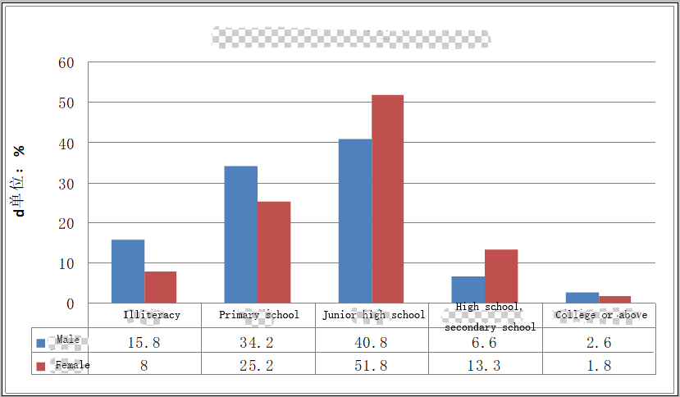 Figure 5-1 Gender education distribution of the survey sample
5.1.2 Gender Division
When the social assessment team visited the village community, it was learned that within the project area, the traditions of "man run business outside, woman do housework in home" continued. The men’s work was the main source of household income. Women were at home doing housework and cultivating fields to ensure annual rations. Occasionally, in the slack season, women will go out for some odd jobs to subsidize the family. At the same time, women’s qualifications are generally low, so they can only engage in non-technical work. Their wage income is relatively low. Women are subject to age limitations when they are looking for a job with the age of over 40.
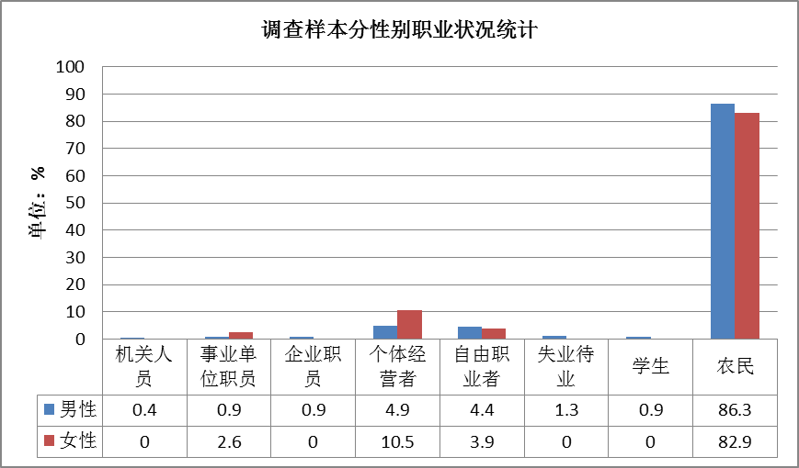 Figure 5-2 Gender occupational status of the survey sample
5.1.3 Participation in Public Affairs
In the project area, women’s social status is lower than that of men. Coupled with the low level of cultural education, the intensity of women’s participation in public affairs and their influence in public affairs are weaker than men’s.
However, in recent years, with the active efforts of government departments at all levels, women's federations and various public welfare organizations (or international organizations), women have more opportunities to participate in public affairs and enjoy public services and various supportive policies on the increase.
Women’s social status in Linxia County has gradually increased, and women’s participation in politics has increased. For increasing women’s participation in decision-making and management, Linxia County has formulated and improved relevant policies to promote women’s participation in decision-making and management. Linxia County actively has taken measures to increase the proportion of women in the NPC deputies, CPPCC members, village committees, and residents' committees, and the proportion of women in the candidates; increase women’s awareness and ability to participate in decision-making and management, and broaden women’s participation in decision-making and management channels. The county promote women's extensive participation in grass-roots democratic management, attach importance to Women’s Federation’s opinions and suggestions, and promote women’s participation in politics for creating a good social environment for women’s participation in decision-making and management. The proportion of women in municipal and district people's congress deputies, members of the CPPCC, and members of the National People's Congress and the CPPCC Standing Committee has gradually increased. The number of women leaders in the county government has gradually increased. The county town government and the county government's department leaders increase the percentage of female cadres.The proportion of women in the board of directors, the board of supervisors, and the management of the company has gradually increased too. In additon, the proportion of female representatives in the staff congress has gradually increased.
Women’s rights awareness has been improved. Linxia County Women’s Federation and other departments made full use of “3•8”, “5•15 International Family Day”, “6·26 International Anti-Drug Day” and other festivals to strengthen the advocation to the “Law for the Protection of Minors”, “Marriage Law”, the Protection of Rights and Interests of Women, the Anti-Drug Law and other laws, together with related departments, to carry out the publicity and education activities such as “Women Learn Law for Women, Family Peace Promotes Harmony”, and enhanced the importance of women's role in keeping social stability.
In the project area, more and more women take part in public affairs activities, increase their ability in various aspects including the skills and capital strength, and as a result enhance their income and improve their status in the family and society.

5.2 Women's needs and expectations
5.2.1 Relationship between women and transportation
(1) Women's travel mode
According to survey statistics, the most important modes of travel for women are motorcycles (47.4%) and walking (34.2%), and the secondary mode is cycling (25%). During the on-site interviews, the social assessment team learned that when women in the project area go to relatively distant places, for example, going to a fair, women will give priority to motorcycles. Everyday life is still up on motorcycles, walking, and bikes. It is necessary to use motorcycles and bicycles especially when delivering and picking up their kids for school. The daily travel mode of people in the project area is divided into gender statistics. See Table 5-1 for details.
From the actual road infrastructure and public transportation configuration of Linxia County in the project area, the traffic network system of Linxia County is still far from meeting the transportation needs of women. Therefore, women in the project area generally support the proposed project and put forward correspondingly ardent expectations regarding the construction to improving the public transportation around them. The following shows the detailed analysis of the specific needs and opinions of women in the project area for the project.
Table 5-1 Gender Distribution of travel modes
Statistical indicators | Female statistics |  |  | Male male statistics
Statistical indicators | Means of traveling | Frequency | Proportion | Means of traveling | Frequency | Proportion
First mode for traveling | Motorcycle | 36 | 47.4% | Motorcycle | 140 | 61.9%
First mode for traveling | walk | 26 | 34.2% | walk | 41 | 18.1%
Secondary mode for traveling | Bicycle | 20 | 26.3% | Bicycle | 55 | 24.3%
Secondary mode for traveling | Electric car | 19 | 25% | Electric car | 47 | 20.8%
(2) The main problems encountered by women in daily travel
①Pavement issues
The women in the villages involved in the project area mainly focus on farming. At the same time, they need to pick up and drop the children for their school. Every day at the road, they can make a minimum of four trips and a maximum of six trips. However, due to poor road conditions, pits, and bumps, they often encounter the following four problems in daily life: First, the transportation costs is high, poor roads would consume more fuel or electricity, and need more maintenance cost accordingly. Second, it would spend more travel time. Because of the potholes on the road, it affects the speed of vehicles. As a result, each trip takes a long time, which can delay women’s work. Sometimes, due to the need to undertake the work of transporting children, it spend too much time on it every day, which results in the female labor force being unable to work outside. Thirdly, to avoiding pits and squatting during driving easily results in accidents of scraping and collision, and would pose potential safety hazards to women. Fourth, when roads are flooded in rainting weather, it is very easy for villagers to get splashing mud and sewage onto the body when they ride a vehicle into a puddle. This, to a certain extent, might increases the housework burden on women in laundry.
②Lane problem
In the daily life, women in the project area mostly walk, ride bicycles and go out on motorcycles. Because existing roads, especially rural roads and even some main roads, are mostly narrow two-way lanes with no non-motorized lanes. When trying to avoiding bad road surface, it is prone to make accidents. In addition, residents along the road often piled up building sand and gravel on the road or at important intersections, it makes the roads narrower, and the convenience and safety for women's travel are greatly reduced.
③ Shuttle problem
Generally, when the resicents had minor illnesses, they would go to see doctors in the township hospitals, while they had to go to Linxia County Hospital in the county town with serious illnesses. At the same time, most elderly people must go to Linxia County Hospital for regular visits and prescriptions. According to elderly women in Xinfa Village, Yinji Town, there is no urban-rural transfer from the village to the county town and motorcycles and bicycle is only choice to the county. It takes a long time and it is very labor-intensive. For the elderly, it is very hard for them to bear both the transportation expenses and the energy.
④ No intersections with street lights in villages and towns
Due to no street lamps in the villages and towns, women generally worry about the safety of the children's late study. Some female laborers work in nearby market towns. They are more worried about their personal safety during the evening shift.
⑤ lack of traffic safety knowledge
After investigation, it was found that women’s lack of traffic safety knowledge, especially women living in the mountainous areas, is very inconvenient because of the inaccessibility of traffic from mountains to Sichuan. Therefore, women in mountainous areas are in a relatively closed environment for a long time. Their nowledge of traffic safe is very poor.
5.2.2 Women's Views and Needs for the Project
(1) Overall evaluation
The results of the social evaluation team's survey showed that the proportion of women with serious and very serious problems in the transportation accounted for 55.3% of the total survey sample; the women who believed that the current traffic problems were not serious or were not serious only accounted for 6.6% of the overall survey samples. In general, women in the project area are not satisfied with the local traffic conditions. Most women think that the local traffic situation needs improvement.
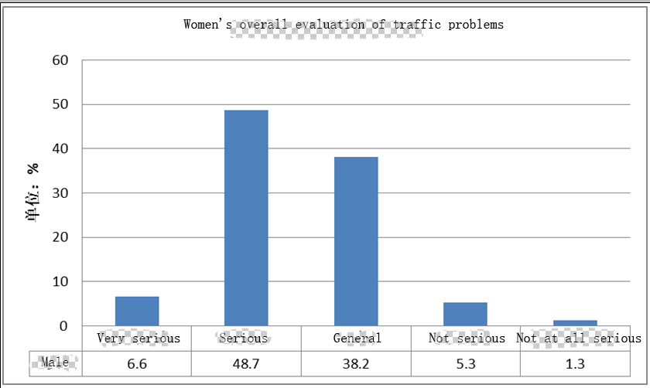
Figure 5-3 Overall Evaluation of Traffic Problems from Women
(2) Evaluation of traffic safety
From the analysis of the statistical results of the questionnaire survey, it can be seen that women in the project area are generally not satisfied with the current traffic safety. Among them, the ratio of dissatisfaction and very dissatisfaction to the current traffic safety situation totaled 56.6%, and the total satisfaction with the current traffic safety situation was only 15.8% of the total; and the women with general traffic safety status accounted for 27.6% of the surveyed population. For details, see Figure 5-5.
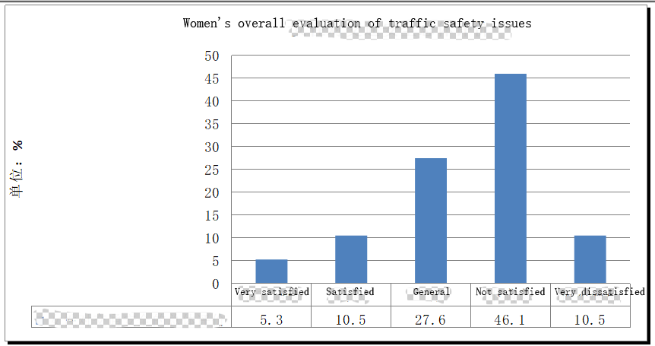 Figure 5-5 Overall Evaluation of Traffic Safety from Women
(3) Evaluation of traffic management
According to interviews by the social assessment team with village residents and passenger transport companies, on the one hand, due to the poor road conditions in the project area, some villages are unable to open traffic, which has caused women in the village group to choose a convenient mode of travel more difficult. On the other hand, through interviews with the Bureau of Transportation and the Urban Construction Brigade, it was learned that due to the lack of management personnel and funds in these departments, regular road maintenance could not be carried out, and funds could only be applied after the road was seriously damaged and it reesults in lack of road maintenance.
The women's dissatisfaction for traffic management in the project area is mainly focused on the setting of traffic lights. Since rural roads do not have street lights and traffic lights, women feel very inconvenient in the evening and feel insecure when crossing the road.
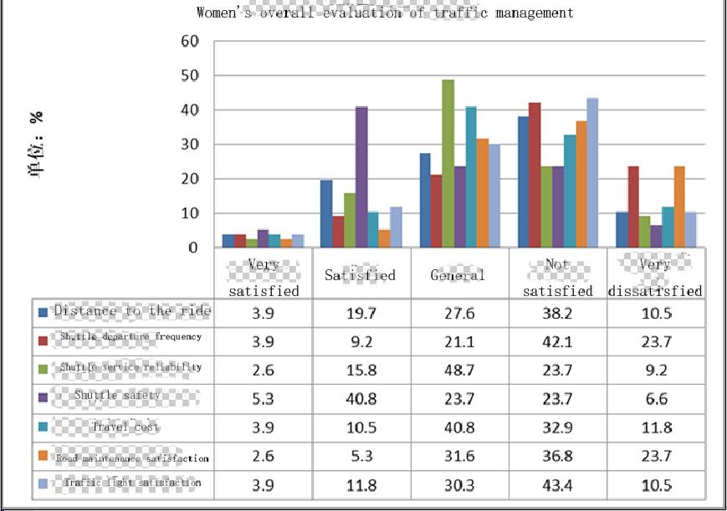

Figure 5-6 Women's Evaluation for Traffic Management
(4) Analysis of Women's Needs for the Project
The various transportation problems that women are concerned about in the project area, as well as their evaluation for the traffic situation, combined with the facts that the social assessment team conducted on-site investigations, in-depth interviews, and symposiums organized to the project, women's demand for the project mainly focuses on the following aspects:
① Need for flat road surface
The main ways for women to travel are motorcycles, bicycles and walking. They think that repairing road potholes and building good roads can increase the safety and convenience of their travel and shorten travel time. Especially in the rainy days, the roads with the potholes pose a great safety hazard. The smoothness of the road can ensure the safety of traveling in bad weather.
② The need for road maintenance
At present, many villages in the project area have built cement roads or tarmac tarmac roads. However, due to the shortage of funding and personnel in the traffic control department, road maintenance work is relatively weak. Women generally believe that even if the roads were repaired, they could not be maintained in time, and the pit situation will be back in a few years. As a result, the effect of road construction could be greatly reduced.
③The need for traffic lights
Women generally believe that the lack of current streetlight settings cause inconvenience trips at night. The first is to worry about the safety of children after school in the evening, followed by the safety of walking on the night road. Especially when women go out to work by bike, they will not have lighting facilities at night when they come home from work. It happens easily traffic accidents due to unclear road conditions. At the same time, in this survey, women also expressed their concern about the lack of traffic lights on rural roads.
④ The need for road width
According to field surveys conducted by the survey team, the currently hardened village roads in the project area are basically 4-6 meters wide. Women think that the current road width is far from satisfying their traffic demand. Especially when a woman is riding a bicycle, once she encounters a car, it is easy to delay time or fall down on the roadside when she trys to avoid the car. Therefore, road widening is also one of the major needs of women.

5.3 Project Impact on Women
The project can bring many direct or indirect positive impacts on the female villagers (residents) in the project area, but there are also some potential risks. In the implementation of the project, it will also cause some negative impact on women, or to a certain extent, women's special needs are ignored.
5.3.1 Positive influence
(1) Improve urban and rural public transportation
In the area, the proportion of rural young and middle-aged laborers (especially male laborers) working outside the country is relatively high, so that thr rural population shows an aging and feminizing trend. After the project is completed, it will enable women and elderly people staying in rural areas to benefit from various aspects.
①After the new road have been built, it will allow the vehicles to run more smoothly, let elderly women use transportation more comfortably, which is conducive to physical and mental health.
② The new road and other auxiliary projects can reduce potential safety hazards, make driving safer, and ensure the safety of passengers' lives and property, as well as ease the safety concerns of women taking their children to and from school.
(2) Provide a safer and more convenient travel environment for women
① Women are more convenient to go out
After the project is completed, the road network in Linxia County will be perfect. The social assessment team had learned from the interview with the passenger freight companies that, they will start to run the urban and rural bus routes due to improvement of the road conditions. At the same time, because the improvement of the road conditions reduces fuel, vehicle wearing, and other costs, the fare will be more favorable for the elderly people, children, and the disabled and other vulnerable groups.
② Save Women's Travel Time
Women in the project area currently used motorcycles or bicycles to transfer children to school. After the new road network is optimized, the cost of public transportation for primary and middle school students will be reduced. They can use the urban and rural bus to get to and from school, and can reduce the number of women sending children to and from school every day, and save more time for them to do production or leisure entertainment.
(3) Provide non-agricultural employment opportunities for women and increase their income
① During the project construction process, women will be provided with a certain number of non-provisional positions.
The implementation of the project will result in some temporary jobs, such as the need for low-tech labor workers and cooking crews for the construction team. These temporary positions can be provided to young women, and let local women increase non-agricultural income.
② After the project is completed, it will provide certain non-technical posts
After the project is completed, the road management will need to recruit new sanitation cleaning workers. The urban construction and sanitation bureaus in the project area all indicated that they will give priority to these posts to the affected residents of the roads along the road and specially the women who have working needs. At present, Linxia County's cleaning staff is paid by 60-80 yuan per day. After the project is completed, it can basically ensure that the women will increase their economic income.
5.3.2 Potential Risks
According to the findings of the social assessment team on the socio-economic survey of the project area, institutional symposiums and women symposiums, and interviews with special groups, the project will benefit women to a certain degree. However, if there is a lack of gender sensitivity in the design, implementation, and operation of the project, it also has the potential risk of making women's needs unnoticed or benefiting from the project. The risks are mainly reflected in the following four aspects:
1) Needs are neglected
Although the design of the project fully listened to the opinions and needs of the female groups and sought to meet the needs of the female groups, it is inevitable that the project in the implementation and operation management would possibly neglect the women's needs, which in turn reduces women's expected benefits in projects, due to the lack of gender sensitivity and the low social status of women . Women in the project area are generally less educated; This situation leads people (including women themselves) to think that the quality of women do not have the ability to participate in major domestic affairs or public affairs. This kind of consideration might have women's needs and suggestions not to be considered in the design stage, implementation stage, and operation management.
①During the construction of the project, the exclusion of female workers or the non-employment of female workers prevented women’s rights from being effectively protected. ②Women and men have the same work content and nature but do not receive the same salary. The social evaluation team learned from the interview that many labor women in Linxia County went to the construction site to work during their leisure time. The work of moving masonry and cement is the same as that of men. However, the salary of women is generally only about 70-80 yuan a day. Male salary is about 100-120 yuan a day. There is a gap of about 20-50 yuan between female salary and male salary. ③Women's recommendations may not be valued and adopted by the relevant departments. ④The road lacks lighting facilities, or insufficient lighting facilities not only affect the evening traffic, but also affect women's activities in the evening. For most women, there is a security risk in the evening, and 56.0% of women think that the lack of lighting on the road is a problem.
(2) Decreased agricultural income of women due to land acquisition
The male labor force in the proposed project will have more short-term migrant jobs, while the female labor force will be left in the village for the most part and assume the majority of agricultural labor. Since the main work of women in the project area is still based on agriculture, which is the most important source of income for women in the project area and guarantees for basic living. After the land is expropriated, the reduction of arable land will lead to a reduction in the land area of some households and a corresponding reduction in the yield of crops obtained from the fields. The female farmers whose land is expropriated will have a corresponding reduction in their agricultural income, and may even cause some of their families to face lack of rations. As a result, they may purchase domestic food from markets and in turn will increase the cost of living.
(3) The traffic safety awareness is not strong
Since the education level of women in the project area is generally low, the life in the mountains is relatively closed and the traffic is extremely inconvenient. After the road is finished, the traffic is relatively convenient. However, this part of women lacks knowledge about traffic safety and there are problems such as incomplete identification of traffic signs. To a large extent, there are some potential security risks.
In the held villagers' forum and in-depth interviews, villagers reported that women (including elderly) are relatively lacking in traffic safety knowledge. Because of their low social status and low education level, women who take part in the traffic safety training activities is easily overlooked. The existing traffic safety training is easy to ignore women's participation through letting the village officials find someone to participate in the training or issuing a text-based leaflet. In addition, women may not have time or energy to attend due to their heavy burden of farm work and housework. In the end, even though the transport gets great improvement, women have potential risks because they lack knowledge of traffic safety.
(4) Women are excluded from technical training and market awareness training
Women in the project area are engaged in most agricultural production tasks within the family, so they should be the most important target group for technology training. However, on the one hand, women bear most of the responsibilities of caring for other members of the family and household work; on the other hand, most of these women are less educated. The time and ability to receive training are limited, and their ability to benefit from the project is low.

5.4 Women's Action Plan
To sum up, the social evaluation team sorted out the special concentration needs of female groups based on questionnaire surveys in the project area, women's forums held, in-depth interviews, and field surveys. In response to the above requirements, the following actions and recommendations are proposed.
(1) In order to ensure that the specific needs of women can be fully considered and meet during project design and construction. It is recommended that women’s representatives be involved in the project management of the project office and related departments; it is recommended that a project implementation community committee be established and safeguarded with a certain percentage of women participate.
(2) Advancing project construction according to existing planning and design standards, improving the quality of the road, reducing travel time and economic costs of women groups, and minimizing the time for women to pick up and go to school, so as not to affect the normal work and economic benefits of women groups. At the same time, it will solve problems such as splashing water and splashing mud on roads that are encountered when walking or cycling on rainy roads to alleviate the family's labor burden, especially for women.
(3) Clearly divide the sidewalks and non-motor vehicle lanes on both sides of the road, implement separation between machines and non-motor vehicles, strengthen the management of non-motor vehicle lanes, impose penalties on the occupation of non-motorized vehicle lanes and violation of regulations on road operations, and maintain non-motor vehicle lanes.
(4) It is recommended that urban and rural bus lines be added along the proposed project to give priority to closer villages, so as to facilitate elderly women and other vulnerable groups to travel. After the completion of the road construction, the urban and rural bus routes will be improved, the trip will be shortened, and the operating costs will be reduced. Bus fares should be appropriately reduced. Primary and secondary school students and the elderly are provided with appropriate fare discounts, while children under 1.2m should be subject to a free-fare policy. For the women who often use the shuttle bus, a discount will reduce their transportation cost burden largely.
(5) Through the community activities, women's congresses, news media, government departments, etc., increase the publicity and education of women's traffic safety knowledge. By strengthening the publicity and education of women's traffic safety knowledge, their awareness of safety can also make their children receive the road safety knowledge in the words and deeds of their female elders. In particular, women must use simple and easy-to-understand methods, such as pictures, videos, and examples, to conduct education and publicity.
(6) It is recommended to add street lighting and other related lighting facilities in the design of this project, which can ensure the safety of women and young people at night, and can also provide illumination for some Han women to participate in collective recreational activities (such as square dancing) at night.
(7) It is recommended that non-technical posts be given priority to village women involved in the project area during project construction and operation. For jobs with low physical requirements such as cleaning, cooking, etc., the employment age range should be appropriately relaxed, and priority should be given to females in the 40 to 50 age group who have difficults to find non-agricultural employment opportunities.
Table 5-2 Women's Action Plan for the Construction
Action | Target population and indicators | Responsibility agency | Sources of funds | Time
Urban and rural traffic
1. Ensure that the sidewalks and non-motor vehicle lanes are clearly divided on both sides of the road and that non-motor vehicles is not separated from motor vehicle. | Female and primary and secondary students based on walking and cycling | Transportation Bureau, Project Office | Project feasibility budget funds 100000 yuan. | During project construction
2. Ensure that security barriers, deceleration belts, road warnings, and signage are installed near residential areas, village entrances, and around schools | All women and students | Transportation Bureau, Project Office | Project feasibility budget funds 50000 yuan | During project construction
3. Ensure that street lights are set up in important road sections to facilitate women’s nighttime travel and leisure activities | All women | Project Office | Project feasibility budget funds 50,000 yuan. | During project construction
4. Regular maintenance on the road surface to prevent pits from appearing again | All women | Transportation Bureau, Project Office | Project feasibility budget funds 50,000 yuan. | After the project is completed
5. Ensure that in the new road section, increase the urban and rural bus routes, increase the number of shuttle buses or city buses, and improve the urban and rural bus routes and stops in the reconstructed road sections. The shuttle bus station should be close to villages and schools. | All women and students | Project Office, Transportation Bureau, Passenger/Bus Company | Project feasibility budget funds 60,000 yuan. | During project construction
6. Free or half-price ticket policy for children under 1.2 meters in height | Female with child | Passenger/Bus Company, Civil Affairs Bureau, Project Office | ----- | During project construction
7. Apply a certain percentage of shuttle preferential policies to students and the elderly | Elderly women and students | Passenger/Bus Company, Civil Affairs Bureau, Project Office | ----- | During project construction
Traffic Safety Promotion
1. Ensure the promotion and popularization of traffic safety knowledge for women groups with low education level (especially for ethnic minority women) | All women, especially women with lower cultural quality | Traffic police brigade, project office | Project feasibility budget funds, traffic police brigade special funds 100,000 yuan. | During project construction
2. Carry out traffic education education regularly (in the slack season) and try to adopt simple and easy-to-understand methods such as cartoons and oral hygiene to educate women and children. | All female and school-age children | Project Office, Transportation Bureau | Project feasibility budget funds 150,000 yuan. | Project construction period and completion period
1. Establish a project implementation community to ensure the participation of a certain percentage of women (especially minority women). | All women | Project Office | Project feasibility budget funds 10000 yuan.
2. Ensure the participation of female representatives in the management of the project office and related departments. | All women | Project Office | Project feasibility budget funds 10000 yuan.
3. 30% of the temporary and long-term non-technical positions generated during project implementation and operation are given priority to special groups such as women. | All women | Project Office, Project Contracting Unit, Urban Construction Sanitation Bureau | ------

Chapter 6 Analysis and Strategy of Poverty in the Area

6.1 Status Analysis of Poverty
Linxia Huaishuguan River Poverty Alleviation Route Project focuses on rural and urban poverty in Linxia County where the project is located. According to the relevant data, the new poverty standard with the per capita income of 2,300 yuan for farmers, the impoverished population of Linxia County in 2015 was about 186,100. The total population of the county is 369,000 people and the poverty rate is 54.4%.
Linxia County belongs to the 11 contiguous and contiguous destitute areas of Liupanshan Mountain. The poverty rate is high with wide region. As a national key county for poverty alleviation, Linxia County has invested heavily in poverty alleviation and development, and has been assisting the poor for many years. Work has led to a significant reduction in the number of people living in absolute poverty, but there are still relatively many poor people. The income level of people who have been out of poverty is generally low, the income difference is relatively large, and the living conditions are relatively bad. The probability of returning to poverty due to disasters, illness, and learning is high.
The direct influence scope of the project (villages and towns along the road ) includes 7 administrative villages in Linxia County. The average per capita income of the affected administrative villages is between 2280 and 3850 yuan. The income is generally low, the income difference is relatively large, and the poverty is in bigger range. Poor relief stability is not so good that the poverty alleviation task is arduous and great responsibe.

6.2 Causes of Poverty
Linxia County has a wide range and a high degree of poverty, and a high rate of returning to poverty. Its poverty is a combination of natural conditions, which are poor ecological environment, lack industrial development and infrastructure, and ideological and cultural aspects that are relatively backward.
(1) Poor natural conditions and fragile ecological environment
Linxia County is an agricultural county that mainly produces grain crops. Linxia County, however, locate at a landform of Qinghai-Tibet Plateau and a mixed Loess Plateau. It also has ploughs and rivers. There are few arable land resources. The per capita arable land is small, only 1.04 mu per person. The per capita arable land is Less than 1 mu. The villagers surveyed by the social assessment team basically do not sell their own food, they can only maintain self-sufficiency, or even self-sufficiency is less sufficient. In addition, Linxia County is the main water supply area after the Qinghai and Gannan regions in the upper reaches of the Yellow River, and it is also an ecological security barrier that connects the Central Plains and the Tibetan region. However, the governance of the Daxia River Basin in the county still lags behind and the ecological environment is fragile.
(2) Rural surplus labor cannot be transferred to non-agricultural industries, restricting the increase of income
Linxia County has an agricultural population of 355,000, accounting for 91.15% of the total population. The urbanization rate is very low, only 13.41%. The rural population has 226,200 laborers, of which the remaining labor force is 126,700, accounting for 56% of the total labor force. The surplus rural labor resources are very abundant. However, due to the small number of non-agricultural employment positons in Linxia County, a large number of surplus labor forces are stranded in the agricultural section. The contradiction between people and land is outstanding, the agricultural efficiency is low, and some surplus labor force is in unemployed state.
(3) Poor infrastructure conditions
The roads in the village and town in Linxia County are relatively short, fundamentally, the construction standards are low, the road is narrow, and the quality is poor. After the completion of the construction, they even are of control. In the course of use, the road surface is seriously damaged and the traffic is affected. the water conservancy facilities is getting old, Xiahuiqu cannal, Dongfengqu cannal and other canals, and it is difficult to play the role of drought protection and irrigation. The backwardness of infrastructure conditions has increased the cost of living for residents and affected regional agricultural production and economy developmen.
(4) The backwardness of cultural and educational undertakings and the occlusion of ideas
Linxia County has a low cultural structure. Most of the population has only elementary and junior high school education. According to the results of the survey conducted by the social assessment team on the villages along the project area, illiteracy accounts for 6.4%, primary schools account for 65.1%, junior high schools account for 22.6%, and high school students account for 12.3. %, especially affected by the traditional culture of ethnic minorities, the degree of emphasis on education is not enough. Most Hui girls have studied at home after graduating from elementary school. Most of the boys also read only junior high school. Many ethnic minority women are not only bound by religious culture but also not only culture. The low level of education, the narrow range of activities, and the occlusion of thoughts have affected their own development and also affected the growth of the next generation.

6.3 Poverty Reduction Measures in Linxia County
Linxia County is located in the central part of Gansu Province and southwest of Linxia Prefecture. It has a total area of 1212.4 square kilometers and consist of 219 administrative villages and 2 communities in 25 townships (19 townships and 6 towns). The total population is 392,600, and the average cultivated land per capita is 1.11 mu. It is a large agricultural county in Linxia Prefecture. The agricultural population accounts for 85.3% of the total population. It is one of national poverty alleviation and development counties and deep poverty-stricken counties in the province. The poverty-stricken population is 113300, and the poverty proportion is 32.4%. It is also included in the Resettlement Counties of the Liujiaxia Reservoir Area. Its financial self-sufficiency rate is only 4.77%. In 2013, the county’s GDP reached 2.646 billion yuan, with yearly increase of 15.8%. Its fixed asset investment was 2.511 billion yuan, with annual increase of 32%. The total retail sales of social consumer goods were 485 million yuan, by an increase of 14.7% yearly, and large-caliber fiscal revenue was 165 million yuan, by an increase of 37.58%. Its fiscal expenditure was 2.481 billion yuan with an increase of 13.25%. The farmers per capita net income was 3637 yuan, by an increase of 14.9%, urban residents per capita cash disposable income 12,626 yuan, by an increase of 10.48%.
Since 2011, a total of 371 million yuan has been invested in various types of funds (134 million yuan is from special fund for poverty alleviation of the central government; 6.78 million yuan from provincial funds, 163 million yuan from county-level matching funds, and 681.3 million yuan self-raised funds). The poor people was reduced from 186100 in 2010 to 113300 in 2013 with a decrease of 72,800, and the poverty level dropped from 51.36% to 32.4% with a decrease of 18.96%. The specific poverty reduction measures are as follows:
(1) Carry out a special poverty alleviation.
Linxia County fully strengthened the joint unit with the provincial and state departments to seek supports for projects, funds, etc., and invite people from various business communities, religious organizations, etc., to take part in poverty relief and support with investment. The cumulative investment has reached 608 million yuan by now.
(2) Focus on people's livelihood
The local government implemented the village affairs supervision committee system in an all-round way. In projects involving the vital interests of the people, such as the construction of roads and the renovation of old and dilapidated houses, followed the people' will and successively implemented projects, such as renovation of old houses, relocation of sites, setting safe drinking water system in rural areas, hardening roads in villages, promoting household biogas, etc. Those have effectively solved the housing difficulties for 18300 households. The rate of water tapped into households, the patency rate of roads in villages, and the utilization ratio of clean energy have reached 95%, 62.8%, and 33%, respectively, and as a result, the production and living conditions for the people has been gradually improving.
(3) Whole-area development to catch out the poverty relief
The local government integrated the funds of various departments and concentrated on the implementation of major events. Four villages including Xinji and Yulin, and 63 villages, including Xinjisiwan and Mainisigouguantan, did a whole-area developement. The Daxia River, Laoyaguan River, and Monigou Rivers carried out the poverty alleviation. Hongtaizhangjia Gully and Huangniwan Niujing River implemented the comprehensive treatment, including road improving, forest recoverying, house reparing, and industry developing. Those effectively boosted the confidence of the development of the poor people. At the same time, in order to create an ecological and civilized county as the goal and greening the entire mountain system, mobilize the participation of all sectors of society to carry out large-scale reforestation, and as a result, 210000 mu of afforestation and 20.5 million trees were totaly planted, and the ecological environment has improved significantly.
(4) Cultivate various industries for poverty relief
The government vigorously implemented various industries like special cultivation, characteristic forest fruit, animal husbandry, labor service, cloth and shoe making, and business promoting for the familys. At the same time, the pollution-free vegetables, dry farming, Pita fruit, walnuts, dairy cows, beef cattle, mutton sheep, pigs, chickens and other traditional industries have continued to be focued on. The County is the province's key cow-breeding and sheep-raising counties. The county is carrying out large-scale skills training to improve the quality of the workforce, and transferred more than 100,000 laborers annually and gained more than 1.2 billion yuan for revenues. In addition, the tile carving, cloth shoes, carving gourds, Tibetan furniture, and other industries have developed rapidly. Now, the county has become the largest tile carving production base and main handmade cloth shoes processing base in the province. The per capita net income of farmers increased from 2660 yuan in 2011 to 3637 yuan in 2013, with a net increase of 977 yuan. The proportion of wage income, family business income, property income, and transfer-payment income is 41.12: 45.15:3.13:10.06.
(5) Strengthen financing to relieve poverty
The government insisted on the combination of gaining support and borrowing outside and gathering inside to enlarge the financing platform, and widely absorb the funds from the whole country to form a strong financial support for poverty alleviation. Actively operate a financing guarantee platform, and fully release loan funds for farmers and women's loans, etc. Encourage private entrepreneurs and religious people and the masses actively injected capital into the community and established a village-level industrial development mutual aid agency to effectively solve the financing problems that have long plagued rural development. In recent years, a total of more than 600 million yuan of various types of loans had been issued, and in particular, the total amount of loans that the County had obtained has ranked third among the 86 counties and cities in the province and first in the prefecture. At the same time, the County encouraged people in general to participate in the poverty alleviation. The County had gained the donated more than RMB 30 million yuan. Till now, the County had finished the renovation of 314 dilapidated households.
(6) Standardize management for poverty alleviation
During the implementation of the poverty alleviation project, the County strictly followed the principle of “special account management and closed operation”, and the poverty alleviation funds are managed and used most effectively. The county county government held several meetings to discuss the overall planning, utilization, and management of poverty alleviation funds. The goverment has formulated the “Opinions on Further Strengthening the Supervision Responsibilities of County-level Poverty Alleviation Funds” and the “Administrative Measures on Financial Assistance Poverty Alleviation Funds of Linxia County”. The fund management system such as the Linxia County Poverty Alleviation and Development Program for Households and the Implementing Regulations for Linxia County Poverty Alleviation Fund for Dangerous House Reform Project ensured the standardization and scientific operation of project funds. At the same time, discipline inspection, finance, and audit departments took the initiative to follow up, effectively intensifying the supervision and inspection of the poverty alleviation fund budget, use, and settlement. If illegal use of some rural poverty alleviation funds was found, the zero-tolerance attitude has all been rectified on it, and the seriousness of the national poverty alleviation policy has been safeguarded.

6.4 Demand Analysis of Poverty Groups
Through the above analysis of poverty, we can see that there are many poor people affected and served in the project area, with large poverty and gripping poverty. To meet the special needs of the poors, absorbing their good suggestions, and evading the negative impact of the project on their production and life, truly respect the needs of poor people, can the construction of the project be able to serve poor groups well, and play a positive role in helping them get out of poverty. Therefore, in the on-the-spot investigation, the social assessment team conducted multi-pronged understanding of the needs of the poverty-stricken groups in the project area, through institutional interviews, village committee discussions, poverty group interviews, and questionnaire surveys. On the one hand, with the development of the social economy and the focus of the government departments, the traffic conditions and travel conditions in the project area have been greatly improved; on the other hand, more and more migrant workers are working out of the villages, and the level of demand for transportation are gradually going up.
The social assessment team found that the needs of the poverty-stricken groups for the proposed project are mainly concentrated in the following aspects. Based on this, the social evaluation team put forward corresponding countermeasures and suggestions.
(1) Hope to improve road conditions, increase infrastructure, and improve travel safety
The road conditions of the village groups involved in the project are generally poor, which has affected people's daily travel, and especially poses a threat to the travel safety of the elderly and the handicapped people. Among the six villages surveyed by the social assessment team, roads in villages and towns are mostly gravel roads; roads are seriously damaged and pavements are pitted. On rainy days, sand and gravel roads or dirt roads are slippery and wet, and water is accumulated on the road's low-lying areas, affecting travel convenience and safety. For example, the trunk road in Datan Village is still a dirt road, and it is impossible to drive the road on the rainy day. However, the elderly and the handicapped are often accompanied by poverty. The way of travel for them is mainly bicycles and walking. Due to limited physical conditions, in poor road conditions, especially when the pavement is uneven, cycling is more likely to make them fall down if it is rainy. Walking is also very inconvenient.
Suggestion: Road hardening should be performed on unhardened major roads. Rebuild the major roads damaged seriously.
(2) Improve road quality, optimize road network, reduce travel costs and time for poor groups
Road quality is inversely proportional to travel costs and travel time. Most of the disadvantaged groups used daily walks (elderly) and bicycles (poor households to reduce transportation expenses) as their daily mode of travel. The bad road conditions would make the travel speed too low, and as a result, travel time was extended accordingly. Some women did not ride motorcycles, and older people did not dare to ride motorcycles because of their slow response to the bad road situation. Poor households tried to choose non-energy-consuming transportation methods because of lack of fuel. Therefore, most of the disadvantaged groups used walking and bicycles as the main means of transportation. In the case of poor road conditions, the travel time cost of most vulnerable groups was too long.
Recommendation: In addition to enhancing the quality of the road surface, on the basis of broadening the existing roads, the road network should be optimized to improve road accessibility and reduce travel time and costs. Newly built roads should reduce the long slopes and shorten the distance. Divide the sidewalks, non-motor vehicle lanes and motor vehicle lanes to reduce the traffic safety risks caused by mixed vehicles and people-vehicle mixed traffic. After the completion of the project, the urban-rural shuttle will be opened as soon as possible.
(3) After the construction of the project is completed, it is hoped that the fares of the urban and rural bus can be adjusted to lower level accordingly, and special fares can be provided for special groups.
Nowadays, the road conditions of township roads are bad, and most villages and towns have not yet opened urban-rural bus routes. The trips are mostly rental cars and motorcycles (motorcycle oil prices are higher). The per capita income of the residents is at least 1800 yuan/year, and the maximum is about 4,000 yuan/year. The travel cost is about 20% to 30% of the annual income. The poverty-stricken groups are eager to expand the urban and rural bus routes appropriately after the construction of the project, and reduce the fares of the shuttle buses to relieve the pressure on daily transportation costs.
In addition, poor old people, students, and people with disabilities expect to provide them with fare discount policies. Even if they only reduce the price of the existing market by 10%, it will make sense for them who have difficulties in living. It can not only effectively reduce the burden on their travel, but also allow them to share more social development results.
(4) During the implementation of the project, it is hoped that priority will be given to the poor to provide some employment opportunities.
The project construction will provide some low-skilled or non-technical jobs. It is hoped that priority can be given to poor groups with labor ability to obtain such jobs, in order to increase their family economic income and improve their living standards. In addition, the poverty-stricken population also hopes that the construction of transportation infrastructure can promote local economic development, and create suitable external conditions for poverty alleviation and prosperity.
(5) Pay attention to the traffic safety training needs of the poor groups
Poverty groups are often accompanied by low levels of cultural education and low social status. In social activities with a public nature, their characteristics and needs were often overlooked. In the traffic safety training, we should pay attention to the characteristics of poor people's cultural level and low participation rate in public affairs, use more vivid and easy-to-understand methods for safety propaganda and training, and encourage them to participate in traffic safety training.
(6) Strengthen road traffic management to ensure people's daily travel safety
The status quo of the mixed human-vehicle road has a greater potential safety hazard for non-motorized drivers and pedestrians. Because poor households, disabled persons, and the elderly are restricted either by economic ability or by physical fitness, they often choose bicycles, and other non-motorized vehicles to travel. However, existing rural trunk roads are mixed with people and vehicles, making it extremely non-motorized drivers and walkers easy to be injured or even dead in traffic accidents. The groups of primary and secondary school students go to school on bicycles or walks, and there are many cars on and off the school hour. It is very prone to accidents on the road sections where non-motorized lanes and sidewalks are not separated. In particular, younger elementary school students often chase each other on the way to school or back to homes while they are very prone to serious traffic accidents.
Recommendation: The school and the traffic police should strengthen cooperation and the management of the road sections near the school during the time of attending school. In the absence of manpower, it is also possible to use the deceleration zone to allow the passing vehicles to slow down when they pass near the school. Equipped with electronic monitoring equipment, they can alert the passing vehicles and increase the vigilance of the driver.

6.5 Project Poverty Reduction
(1) Improve road conditions, optimize routes and road networks, reduce travel time and costs for poor groups, and perfect the travel safety
The improvement of road quality, optimization of routes and road network will make it more convenient for local residents, especially poor groups, to travel and reduce the travel time of poor groups.
The improvement of road infrastructure, such as the addition of deceleration belts, traffic signs, building the seperated belts between the motorting and non-motoring vehicles, etc., can separate people from vehicles, and provide pedestrians and cyclists with better traffic safety protection.
At the same time, the improvement of road conditions will provide the possibility of the opening of urban and rural bus routes and setting of lower fares. If the fares are reduced, the burden of transportation for the poor will be reduced. In particular, elderly people need to go to the county hospital for regular medical treatment. The reduction in the fares of urban and rural bus services or the reduction of transportation costs can ease the burden on those people.
(2) Improve local transportation infrastructure, promote economic development, and create conditions for poverty alleviation and enrichment
The improvement of urban and rural transport infrastructure can further meet the transportation needs of the industrial development in the project area, especially around the proposed road, and drive the development of the second and third industries.
The improvement of urban and rural transport infrastructure can contribute to the transport of agricultural and livestock products and promote the development of the local agricultural economy. During the "Thirteenth Five-Year Plan" of poverty alleviation in Linxia County, the production bases for characteristic agriculture (pollution-free vegetables, seedlings and flowers, and Chinese herbal medicines, etc.) will be vigorously supported, as well as the cultivation of standard cattle and sheep breeding. Good transportation facilities are of great significance to the input of production materials and the output of agricultural products in large-scale, commercialized agricultural production processes.
(3) Increase non-agricultural employment opportunities for poor groups and increase economic income
During the implementation of the project, it is necessary to recruit temporary non-technical workers. These jobs will be given priority to the poor, women and other vulnerable groups in the project area. According to the local wage level, it is expected that non-technical job workers can get 70 to 100 yuan per day.
During the operation of the project, it is necessary to recruit new sanitation workers in urban and rural roads, which can provide a certain amount of long-term employment for vulnerable groups. The relevant departments will ensure that these positions are given priority to the poor people and women groups. At present, the sanitation workers in Dajing Town have an average monthly salary of 950 to 1,000 yuan per month. Drivers of sanitation trucks have a monthly salary of about 2,000 yuan per month. For the lower local income level, the income of these jobs is considerable.
After the completion of the project, traffic volume and passenger flow will increase greatly, and it will be able to drive the development of service industries such as restaurants, grocery stores, repair shops, and hotels. Residents of the project area, including poor groups, can engage self-employment in areas along the roads, have non-agricultural employment position increase economic income.
After the improvement of transportation infrastructure, the development of the tourism industry in the project area will be promoted, which will in turn drive the development of the tourism service industry and the development of the tourism souvenir processing industry. Local residents, including poor groups, can engage in tourism services, such as operating hotels, farmhouses, and ferries. At the same time, local residents, including the poor, can develop characteristic handicrafts as tourist souvenirs, such as woodcarvings, root carvings, gourd carvings, embroidery and handmade cloth shoes, which can enable some residents, especially the poor and women, to realize non-agricultural employment at their homes and increase their income.
(4) Promote social equity and allow poor groups to share development achievements
The proposed project will effectively improve the urban and rural traffic conditions in Linxia County, provide more route choices for rural residents to travel, shorten travel time, reduce travel costs, enhance travel security, and allow villagers to share the fruits of social development. The proposed project will benefit more than 200,000 poor people in the project area. In addition, the positive effects of the project on the surrounding areas will make more people benifit from the project. After the completion of the project, not only can a large number of poor people be provided with better transportation infrastructure, such as better road conditions, lower transportation costs, and reduced transportation burden; it can also bring more development opportunities to the poor, such as the opportunities for non-agricultural employment. They will get new ideas and technologies and have more chances in contact with the outside world. To a certain extent, it can be said that the project will enable the local residents, including a large number of poor people, to benefit and allow them to share the fruits of social and econimic development.

Chapter 7 Social Impact Analysis

7.1 Positive Impact
(1) Increase the frequency of urban and rural bus transfers, shorten travel distances, and reduce travel costs
The Xinzhai, Xinfa, Xinxing, Dayan, and Kajiatan villages along the road are directly affected villages in the area that have not yet the urban-rural buses. After the project is completed, new shuttles will be added to those areas. At the same time, the territorial transportation and transportation management department will rationally arrange urban and rural bus transfers with freight companies and passenger transport companies to facilitate the travel of villagers and reduce their daily travel costs.
The main reason for the higher travel costs of the villagers in the project area is that the existing road infrastructure is in poor condition, and the cost for car maintenance is relatively high, resulting in a higher level of travel fare. After the project road is completed, the facilities for public transport will be greatly improved. As a result, the distance between urban areas and townships will also be shortened, the travel costs and time of villagers will decrease.
(2) Increase employment opportunities and income of residents
①During the road construction process, many temporary or permanent jobs will be created, for example, public service personnel on the road, road surface cleaning, greening and other public welfare jobs. These posts will be given priority to residents in the project area.
②In the project construction process, the project will give priority to the use of local cement, stone, building materials and other materials. Linxia County has a large number of manufacturers of cement, lime, and other building materials. This road construction will further promote the development of these raw material industries, help promote the construction of local infrastructure and enhance investment, and will also increase employment opportunities for local residents to create better conditions for the overall elimination of poverty.
③Not only can the local people use the new road, but also the vehicles from other areas can take the road. Residents along the road can make full use of the better transportation and other advantages to run some kinds of business such as catering, grocery stores, and vehicle maintenance, thereby increasing employment opportunities for the residents, and promoting economic development in the area.
④After the road are built, it can facilitate the transport of local agricultural products and increase the income of the residents along the roads.
⑤54.6% of respondents believe that after the projec can effectively reduce transportation expenses. First of all, good road surface quality can effectively reduce fuel consumption by approximately 30%. Secondly, after the completion of the road construction, public transport routes will surely increase and the fares will also decrease. The Linxia County Transportation Management Department also stated that it will consider increasing the number of public transport lines and appropriately adjusting the fares for the passengers. The elderly, students (in this case, the consultation will mainly refer to students in the compulsory education stage), vulnerable groups, etc. will pay a preferential price on the ticket.
(3) Strengthen the safety, and enhance the awareness of traffic safety of residents
Newly constructed road will be equipped with standardized sidewalks and non-motorized lanes, with optimized intersections such as crossroads for canals, zebra crossing, traffic signs and traffic lights, deceleration belts at crossroads, bridge culverts, and pedestrian crossings, to improve traffic safety. With the development of the society and economy and the improvement of people’s living standards, the villagers have now had higher requirements for their own comfort and safety. This will require greater supervision on the management of road conditions and the rectification of traffic violations to ensure roads are safe and unblocked to improve the villagers' safety and happiness index.
During the construction of the project and after its completion, the villagers and pedestrians will be educated and trained in traffic safety through news media, leaflets, safety placards posted on traffic accident-prone road sections, and publicity by the traffic police team members. Traffic safety propaganda can be carried out once a year by distributing traffic safety materials, flyers, and manuals. The main organization is the form of holding villagers' congresses. Through the festivals like the Lantern Festival and Chong Yang Festival, the relevant knowledge is preached. Traffic safety propaganda can certainly play a role. The villagers have a certain understanding of traffic safety knowledge, and the compliance with traffic rules will be greatly improved.
(4) Improve the natural environment around the village along the road to reduce noise and dust pollution
Residents along the proposed project all reflect the environmental issues of the road, especially dust, noise and environmental health issues. First of all, residents along the project all reflect dust problems. The main reason is that current roads are seriously damaged, with sand and rocks exposuring, or some road sections are earth-rock roads. Dust problems cause huge losses to crops along the roads. This road construction can change the current status of road damage and effectively solve dust problems. At the same time, the trees planted along the road have a certain effect on reducing dust pollution.
(5) Effectively reduce the incidence of traffic accidents and make travel more secure
In terms of traffic safety, 43.7% of the respondents believe that the construction of the road can make travel more secure. After road construction and various related infrastructure constructions are completed, the incidence of road traffic accidents will decline. First, after the pavement is leveled, the phenomenon of uneven pavement will no longer appear, the road will become wider and the rubbing accident will be reduced. Secondly, the setting and placement of the deceleration zone will effectively reduce the speed of the motor vehicles. In particular, motorcycles with the highest potential for road traffic safety in this area will be forced to decelerate at important intersections. Third, traffic safety signs and protective facilities will also work for drivers.
In addition, residents’ travel safety issues are inextricably linked to the public’s safety awareness and traffic knowledge. During and after the implementation of the project, the project office will set aside some special funds to carry out traffic safety propaganda and education, for enhancing traffic safety awareness, minimizing the impact of traffic accidents, and making residents travel safer.

7.2 Potential Risks
(1) Inconvenience caused to residents travelling along the route during the construction period
According to the information obtained by the social assessment team from field surveys, 25.4% of the residents believed that the construction period will cause short-term travel inconvenience (see Table 7-1 for possible potential negative impacts of the project). Judging from the current situation of road construction in the project area, Linxia County has not done enough to ensure residents' travel during road construction. Many residents in the project area reported that the roads that were built before had caused residents to increase travel costs and travel time. This project will also cause inconvenience to residents along the road. However, when the social assessment team visited the field, it was found that the villagers all stated that building a new road is a good thing for the villagers in the long run. Most people can understand and accept the temporary inconvenience and risks caused by short-term construction with dust, and noise pollution. However, residents of the project area also put forward corresponding hopes and needs, that is, hope the project implementation unit to pay attention to such issues during the construction as much as possible, and accordingly do their best during the construction period to minimize such impacts. The villagers hope that the constructors work better at night or idle time, and the project should be completed as soon as possible and opened to traffic as soon as possible so that local residents can enjoy the convenience of the new road.
(2) Dust and noise pollution have an impact on the ecological environment
66.9% of respondents believed that dust and noise pollution will be caused during construction. During the construction, due to earthworks such as surface excavation and subgrade filling, and transportation, loading, unloading and mixing of road materials such as cement and lime, a large amount of dust will be generated and scattered in the surrounding atmosphere. During the transportation and stacking of powdery road building materials, if proper measures are not taken, dust pollution will occur in windy conditions. The noise pollution of roads is mainly caused by construction machinery. Night construction has a great impact on residents along the construction line. At the same time, road construction will use some earth and stone and also do some temporary prefabrication, mixing, and stockpiling, which will inevitably have adverse effects on the ecological environment.
After the completion of the project, the number of vehicles will inevitably increase on the new road, and as a result, it will cause dust and noise pollution to varying degrees, and adversely affect on the ecological environment.
(3) Adversely affect the safety of life and property of local people
During the construction period, various types of construction vehicles will participate in the construction, the risk along the construction line will be relatively high, and the risk factor on local residents during the day trip raise. At the same time, the road construction will also result in the congestion of existing roads, and the incidence of traffic accidents will also go up. In the process of road construction, some migrant workers will participate in the process, and cultural differences will easily lead to conflicts. Uncertain social risks will arise in social security.
In addition, because the project areas are mostly in suburban townships and rural areas, there are many motorcycles, tricycles, bicycles and other vehicles. These vehicles have a low safety factor compared with other models such as trucks and buses. In the event of a traffic accident, the probability of casualties is higher. After the completion of the project construction, the volume of traffic will increase significantly and the number of traffic accidents is likely to increase.
(4) The impact of land acquisition and house demolition
The implementation of the project will result in the occupation of some agricultural land and the demolition of buildings, which will cause some residents to lose their agricultural land and houses. When the project is in construction, it will also occupy certain temporary land and land for excavation. Due to the impact of land acquisition, the production and livelihood activities in the area will be affected. The demolition will affect the normal lives of some residents. The land acquisition and house demolition involve the vital interests of the residents, causing the residents to lose their land and might become unemployed, and make them foce marginalization, disintegration of social organizations, and other social risks. If the resettlement and compensation standards for the affected residents are too low, the payment of compensation fees is not timely and opaque, and the resettlement methods are unreasonable, they may trigger petitions or appeals by the immigrants, causing them to oppose the land acquisition and demolition and hinder the smooth progress of the project. Therefore, in the implementation process, we must pay attention to dealing with a series of problems in land acquisition and demolition, and adopt reasonable and effective measures to effectively, timely, correctly, and properly resolve the contradictions that might emerge. In view of this, the project has formulated a corresponding “Resettlement Plan” to avoid risks that may arise from land acquisition and demolition. For details, see the “Resettlement Plan”.
(5) Improper traffic management or post-maintenance may result in the project's goal being unable to be truly realized
The social assessment team found during field research that, the effective maintenance and maintenance measures for current roads were often lacking, so that the service life of those roads are far less than the service life of the design. The road supporting facilities are related to the entire road network system, the connection of internal and external traffic, and the operation of hardware road projects, which provides a material basis and prerequisites for good traffic. However, how to make good use of these facilities and make full use of them to keep wonerful traffic lies in the management of traffic. Moreover, traffic management is just as important as traffic construction. Only when both of them are organically combined, can the maximum benefits of the traffic system, especially the traffic network, be fully realized. Although the hardware infrastructure such as roads and greening will be improved after the completion of the highway project, it is necessary to strengthen the traffic management and maintenance in the later period if the project wants to achieve normal and effective operation. At present, there are still many problems in technology, information management platform, management system, and concepts of traffic management in the project area. The existence of these problems will affect the realization of project goals to a certain extent.
Of course, these potential risks can all be circumvented by formulating corresponding social management plans. The details of the social management plan for the proposed project are shown in Chapter 8 of this report.
Table 7-1 possible adverse effects of the project
Possible adverse effects of the project | Frequency | Proportation
Short-term inconvenience caused by construction period | 25 | 25%
Dust and noise pollution during construction | 20 | 20.0%
The construction period adversely affects the safety of the lives and property of local people | 7 | 7.0%
Introduce some of the bad habits of the city to the local area | 2 | 2%
Causes the epidemic of AIDS or other infectious diseases | 3 | 3%
Crossing the street is not convenient or safe | 14 | 14.0%
Impact of land acquisition and house demolition | 16 | 16.0%
May cause damage to irrigation canals | 12 | 12.0%
Do not know | 2 | 2.0%
Total | 100 | 100.0%
Remarks: In the statistics here, due to the randomness of the sample selection, when the limit is selected for the three items, the statistical phenomenon of repeated superposition of the frequency appears, but the effective sample size is still 100.

Chapter 8 Social Management Plan and Implementation

8.1 Social Management Plan
The social assessment team fully understood the relevant laws and regulations at all levels and discuss with the main stakeholders such as affected residents/villagers, relevant administrative authorities, passenger transport, freight drivers and enterprises in the project area. After field surveys and statistical analysis, the team identified the major social risks associated with project design and implementation that may affect project construction and development goals, and propose the following action plans to mitigate or avoid social risks.
(1) Strengthen the project construction quality and supervision to ensure that the road and its infrastructure construction meet the requirements of the masses
Due to the possible neglect of the needs of local residents/villagers during the project construction, the project could not achieve the maximization of its social and economic benefits, or even damage the interests of some groups. In order to avoid this problem and ensure that the construction of roads and infrastructure can meet the requirements of the masses, the following measures have been proposed.
①The project office and the Transportation Bureau need to carry out technical monitoring of the project quality during the implementation to ensure that the project construction meets the design standards and satisfies the mass demand for the road and related infrastructure.
②In the project management, the project office and other related departments must have the participation of women and representatives from disadvantaged groups to ensure that the project construction can take into account the characteristics and needs of women and other vulnerable groups.
③Set up feedback channels for the masses, accept the opinions and supervision of the masses on the project construction and the process, and fully respect the daily transportation needs of the masses.
(2) Reducing the negative impact of project construction on daily life of residents
The project during construction period will inevitably affect the daily social life of local residents/villagers. In order to reduce the negative impact of project construction, it is necessary to proceed from the following four aspects.
①The road construction may adopt a half-closed method, and construction shall be carried out during the time when there are few people and traffic (especially avoiding market-day), so as to minimize the adverse impact of the road construction on the residents' daily travel.
②During the construction period, appropriate safety measures shall be taken for the construction road sections. For example, the “forward road construction, pedestrians request bypassing” prompt message shall be set up at the intersection near the construction section, and obvious warning signs shall be set at the construction section to give local residents and property more security.
③Take corresponding measures to mitigate noise, dust and solid waste pollution, and mitigate the adverse effects on local residents' daily lives and production. During the road construction process, noise reduction measures, such as avoiding doing construction at night near the residential and living areas of villages and towns, must be taken. It should take measures to avoid doing construction on windy days, so as to reduce the adverse effects of dust on the lives of nearby residents and the growth of crops near the road. The solid waste generated should be cleared and transported in a timely manner so as to avoid affecting the normal daily life of the residents and causing secondary pollution.
(3) Strengthen information disclosure and public participation
In order to make the project information open, let affected people participate in the design and construction of the project, ensure that the project results can meet the requirements of the masses, achieve maximum social and economic benefits, and strengthen information disclosure and public participation. In terms of the need:
①Use government websites, television, bulletin boards, leaflets or handbooks, etc. to announce relevant information such as project design, implementation progress, and construction results so that the public can understand the progress of the project and supervise project implementation.
②Use government websites, television, bulletin boards, village committee notices, etc., to announce post recruitment information, including non-technical post workers during project implementation, cleaning workers after project completion, recruitment of road maintenance workers, so that the public can obtain recruitment information. , And actively participate in the project construction work.
(4) Strengthen traffic safety education and publicity
In view of the lack of traffic safety knowledge and lack of awareness of traffic safety among residents or villagers in the project area, while strengthening the construction of road infrastructure, it is also necessary to enhance publicity and education of traffic safety knowledge and reduce traffic safety accidents caused by human factors. To this end, put forward the following four suggestions:
①Establish a traffic safety advocacy team responsible for traffic safety advocacy work.
②In the slack season, the public will be encouraged to use the form of publicity to promote traffic safety. Pay attention to the widespread participation of women, the elderly, children and other people who lack knowledge of traffic safety. In the days of holidays and ceremonies, publicity vehicles can run around, publicity stations can be set up in the market, and traffic safety manuals and leaflets can be distributed. In schools, safety education conference, the distribution of greeting cards and other forms can be used for carrying out traffic safety education for primary and middle school students.
③Handbooks on th traffic safety will be issued for migrant workers to gain the traffic safety knowledge.
④Pay attention to the assessment of traffic safety knowledge of motor vehicle drivers (especially passenger and cargo drivers) and the development of traffic safety awareness. The Transport Management Bureau, passenger and freight companies can jointly conduct traffic safety education and assessment for passenger and cargo drivers.
(5) Focu on the management and maintenance work after the road is completed
The existing township roads in the proposed project area have a phenomenon of “focus on building roads, but neglect maintenance”, resulting in serious road damage and shortened service life. Residents or villagers in the project area generally require responsible units and funds to carry out the routine management and maintenance work on the roads. The following three suggestions are proposed:
①Invite road maintenance staff from the residents or villagers in the project area and set up township road maintenance teams. Giving priority to the residents or villagers in the project area as road maintenance workers can not only make them more responsible in road management work, but also raise their economic income.
②Formulate the work responsibilities, assessment methods and work subsidies for road maintenance teams. Allow road maintenance staff to have clear job responsibilities and assessment methods, and provide job subsidies to ensure that they are dedicated to road maintenance work.
③The road maintenance team shall take charge of the management and maintenance of the newly-built and remodeled roads in the course of use, and road infrastructure such as street lights, guardrails, traffic safety warning signs, green belts, drainage channels, etc., and conduct road-breaking actions. If they find serious damage of the road sections, the team should report to the relevant departments to repair them on time.
(6) Support affected resident's Livelihood
The project may have a certain impact on the livelihood of the residents or villagers in the project area, especially on the land acquisition and relocation households. In order to mitigate the negative impact of project construction on its economic income, the project construction will boost the development of vulnerable groups. Correspondingly, the following four suggestions are proposed to promote non-agricultural employment and increase economic income for the residents in the project area (especially women, the poor and the land acquisition and relocation households).
①Temporary or permanent non-technical posts will be generated by the project construction, 30% of which should be given priority to women and poor groups in the project area.
②After the project is completed, the new road and area with tourism resources will be built on both sides of the road to develop the service industry. Relevant departments should encourage women, poor groups, and land-expropriated rural households to start businesses nearby, and provide entrepreneurial support incentives accordingly.
③Provide skills training for land-expropriated farmers, women and poor groups in the project area, and provide intellectual support for the transfer of employment or non-agricultural employment in the local area.
④To formulate preferential policies and encourage local enterprises to preferentially recruit people affected by the project (especially farmers whose land has been requisitioned) to work in enterprises.
In order to make sure that the above proposals are effectively implemented, and ultimately to promote the ultimate realization of the project objectives, the social assessment team has formulated social management plans, information disclosure and public participation plans for the project on the basis of further consultation with various stakeholders. See Table 8-1 for details.
Table 8-1 Social Management Plan
Action proposal | Specific measures or actions | Executor | Time | Sources of funds | Monitoring indicators
1. Strengthen the project construction quality supervision to ensure that the construction of the road and its infrastructure meet the requirements of the masses. | a. The project office and the Transportation Bureau must carry out technical monitoring of the project quality during the implementation of the project to ensure that the project construction meets the design standards.  b. The project office and other related departments must involve women and ethnic minorities in project management to ensure that project construction can take into account the characteristics and needs of women and other groups and ethnic minorities.  c. Establish feedback channel for the masses and accept supervision of the project construction process. | Project Office and Transportation Bureau | Project implementation period | Project feasibility budget funds and transportation bureau special fund 100,000 yuan | a. Pavement quality, road width, bridges, culverts, and supporting street lights, green belts, traffic safety management facilities.  b. Women's participation in project management  c. The result of establishing a mass feedback channel.  d. Cognition and evaluation of the people.
2.Reduce the negative impact on the daily life of residents | a. The method of road construction shall adopt a half-closed method to ease the adverse impact on the daily travel of local residents.  b. Corresponding safety measures shall be taken to the construction road sections to avoid causing personal and property safety threats to local residents.  c. Take corresponding measures to mitigate noise, dust and solid waste pollution, and mitigate the adverse effects on the daily life of residents near the road.  d. Construction workers should respect the customs and habits of local ethnic minorities. | Contractor and other related units | Project implementation period | Project feasibility budget funds 200,000 yuan | a. Half-closed road construction method, corresponding safety measures and pollution control measures during construction  b. Feedback and evaluation of the personnel's work during the construction process.
3. Strengthen information disclosure and public participation | a. Use government websites, television, announcements, flyers/handbooks, etc. to announce project design, implementation progress, construction results, and other relevant information.  b. Use government websites, television, notices, village committee notices, etc., to announce post recruitment information: recruitment of non-technical posts during project implementation, cleaning workers after the completion of the project, and recruitment of road maintenance workers. | Project office, transportation bureau, urban construction sanitation management office, project contractor, television station and other related departments. | During project implementation and after project completion | Project feasibility budget funds and special funds of other related departments: 150,000 yuan. | a. Announcement of project construction information including the channels, methods, time, location, and frequency.  b. Announcement of project recruitment Information and the situation of the people in the area  c. The knowledge level about the project for the people, and the evaluation of information disclosure by the people.
4. Strengthen traffic safety education and publicity | a. Establish a traffic safety knowledge publicity team responsible for traffic safety work.  b. Facing the masses in the project area, at the right time, use the forms that the masses love to hear to promote traffic safety. Attention should be paid to the participation of groups such as women, the elderly and children who lack knowledge of road safety.  c. Attention should be paid to the evaluation of traffic safety knowledge of motor vehicle drivers (especially passenger and cargo drivers) and the development of traffic safety awareness. | Project Office, traffic police brigade, transportation management bureau, freight passenger transport company, school and village committee. | During project implementation and after project completion | Project feasibility budget funds and special funds for traffic police brigade 250,000 yuan. | a. The results of the work of the traffic safety team, including job summary, promotional materials, on-site photos, etc.  b. People's participation in and evaluation on the traffic safety publicity work  c. Changes in traffic safety knowledge and awareness of the public (especially motor vehicle drivers) after they receive traffic safety education and publicity.
5. Pay attention to management and maintenance work after the road is completed | a. The residents in the project area will recruit road maintenance workers and set up township road maintenance teams.  b. Formulate work responsibility, assessment methods and work subsidy methods for the road maintenance team.  c. The Highway Maintenance Team undertakes the management and maintenance of newly constructed and reconstructed roads during use. | Project Office, Transportation Bureau and other related departments | After project completion | Project feasibility budget funds and transportation bureau special funds 300,000 yuan. | a. The formation of township road maintenance team, including membership, job responsibilities, assessment and subsidy methods  b. The team's actual work situation and self-evaluation  c. Feedback and evaluation of the work of the team.
6. Livelihood support for affected residents | a. 30% of temporary or permanent non-technical posts generated by the project construction should be given priority to women and poor groups in the project area.  b. After the completion of the project, both sides of the new road and areas with tourism resources will be able to develop the service industry. Relevant departments should encourage women, poor groups, and land-expropriated farmers to start their own businesses and provide entrepreneurial support benefits.  c. Provide technical training for farmers, women, and poverty-stricken groups affected by land acquisition, and provide support for the transfer of employment or non-farm employment.  d. Formulate preferential policies to encourage local enterprises to prioritize the recruitment of project-affected people (especially land-expropriated farmers) into the company's work. | Project Office, Transportation Bureau and other related departments | During project implementation and after project completion | Project feasibility budget funds and related special funds for poverty alleviation 500,000 yuan. | a. Situation for people affected by the project (especially land-expropriated farmers, women and poor groups) to get employment  b. Supporting policies from related departments for employment and entrepreneurship of project affected people.  c. Development of technical training and participation of affected people (especially land-expropriated farmers, women and poor groups)  d. Feedback and evaluation from the people (especially land-expropriated farmers, women and poor groups).

8.2 Public Participation Plan
Based on questionnaire surveys, symposiums, in-depth interviews, and interviews with key informants, the following information disclosure and public participation plans were developed through participatory observation. See Table 8-2 for details.
Table 8-2 Information Disclosure and Public Participation Plan for the Project
Stages | Participating content | Ways | Implementation units | Participants | Items resolved | Sources of funds
Project preparation stage | Basic project information disclosure | Notification of TV, radio, posting notices, hanging banners, brochures, village committees. | Project Office, Transportation Bureau | Residents in the project area (including vulnerable groups such as women, the poor and elderly groups), residents' committees, and villages' committees. | Open project basic information;  Collect residents' opinions and suggestions;  Answer resident's questions. | Project feasibility budget funds 100000 yuan.
Project preparation stage | Feedback on the needs and suggestions from relevant units and residents in the project area. | Open talks, interviews, questionnaires. | Project Office, Social Assessment Group | Relevant units, residents in the project area, especially those affected by land acquisition and house demolition. | Collect the willingness, needs and suggestions from relevant units, residents for the project;  Pay attention to the opinions of vulnerable groups such as women and low-income people and ensure that the implementation of the project is open, fair and transparent. | Project feasibility budget of 200,000 yuan.
Project implementation stage | Project construction participation | Residents participate in non-technical posts during project construction. | Project Office, Project Contracting Construction Unit. | Residents in the project area (especially vulnerable groups) | Ensure that 30% of the non-technical jobs in the project are provided to the residents in the project area so that they can participate in the project implementation process;  Residents get employment opportunities;  Participate in the construction quality supervision from residents. | Project construction contracting unit 200000 yuan.
Project implementation stage | Feedback from the masses | Supervise phone calls and opinion surveys. | Project Office | Project Office, Project Construction Contractor, resident in project area. | Accept the supervision of the project construction process by the masses and minimize the negative impact of the project construction on the daily life of the people;  Ensure that appropriate safety measures are taken in the construction sections to prevent the construction from threatening the personal safety and property safety of the local people;  Ensure that the project construction personnel respect the culture and customs of local ethnic minorities. | Project construction contractor 100000 yuan.
Project implementation stage | Project Environmental Impact Supervision | Television, posting announcements, accepting public supervision | Project Office, Environmental Protection Bureau. | Project Office, Environmental Protection Bureau, residents of the project Area. | Supervise the pollution of dust, noise, solid waste, etc. in the project implementation process. | Project feasibility budget funds 150000 yuan.
Project operation stage | Formation of township highway maintenance team | Post notice, hold village representative meeting. | Project Office, Transportation Bureau | Project Office, Transportation Bureau, residents of the project area | Undertake the management and maintenance, carry out daily management of the road, protect the road from destructive behavior, and report road and road facilities damage. | Transportation Bureau Road Maintenance Fund 200000 yuan
Project operation stage | Establish a traffic safety education mechanism | Paper-manner promotion (distribution of traffic safety manuals, leaflets, and calendars, desk calendars, and greeting cards with traffic safety knowledge), electronic promotion (electronic screens), traffic police on-site promotion, and safety education publicity meetings. | Project Office, Traffic Police Brigade. | Project Office, Transportation Bureau, residents of the project area. | Carry out traffic safety education for the people (especially for women, the elderly, children and other groups lacking traffic safety knowledge), make them master traffic safety knowledge, consciously abide by traffic safety regulations, and reduce traffic safety accidents caused by violation of traffic safety rules. | Project feasibility budget funds, traffic police force safety promotion funds 150000 yuan.

Chapter 9 Complaints and Monitoring Evaluation

9.1 Complaint procedure
During the process of project preparation, construction and operation, in order to timely understand and resolve the impacts and problems that the project brings to stakeholders, the project should ensure the residents' need for information disclosure and the widest possible participation of the community. It should also combine the status of complaints from residents with the project very well. The proposed project should establish a variety of effective complaint procedure and complaint channels. The basic processing procedure is as follows:
Stage 1: If the residents in the project area are infringed upon any rights in the implementation stage of the project, they may report to the village committee that the village committee or residents can directly contact the township government for settlement. After the township government receives the appeal, it will record the case, and within two weeks, it works with the village committee and residents to study and solve the problem.
Stage 2: If a complainer is dissatisfied with the decision in Stage 1, the complainant can submit a complaint to Linxia PMO after receiving the decision. The project office will make a decision to handle the appeal within 2 weeks.
Stage 3: If the complainant is dissatisfied with the decision of Stage 2, the complainant can submit a complaint to the Linxia State Project Office after receiving the decision. The Linxia Project Office will make a decision to handle the appeal within 2 weeks.
Stage 4: If the complainer is still not satisfied with the decision of the Linxia Project Office, he/she may, upon receipt of the decision, apply to the competent administrative authority in accordance with the Administrative Procedure Law of the People's Republic of China to appeal to arbitration.
Stage 5: If the complainer are still not satisfied with the arbitration decision, after the complainer receives the arbitration decision, the complainer can file a lawsuit with the civil court according to the Civil Procedure Law.

9.2 Monitoring and Evaluation
Monitoring and evaluation are important steps to ensure that this project is implemented in accordance with project objectives, to ensure project information disclosure, public participation, and the social management plan proposed in the social impact assessment report design can be valued and implemented. It is also an important error correction mechanism and participation mechanism for the proposed project. To this end, the project has established a monitoring and evaluation mechanism, including internal supervision and external monitoring and evaluation.
For internal supervision, the World Bank Project Office will monitor and evaluate the implementation progress, the implementation of social management plans, the progress of information disclosure and public participation plans, the use of project funds, and the implementation of rules and regulations.
The external independent monitoring and evaluation will be conducted by the project office to engage an independent monitoring agency approved by the World Bank with experience in monitoring and evaluation of the World Bank project, and to conduct external monitoring of the implementation of the social management plan. The independent monitoring and evaluation unit will regularly conduct follow-up monitoring and evaluation of the implementation activities of social management plans, and put forward consulting opinions, and submit monitoring and evaluation reports to the World Bank.

