**How Does Participation in Value Chains Matter to African Farmers?**

**Nora Dihel, Arti Grover, Claire H. Hollweg, and Anja Slany[1]**

**Keywords:** Economic transformation, Agriculture value chains, Upgrading, Productivity

**JEL codes:** Q12, Q17, O13

**Abstract:** Trade and participation in global value chains can play a key role in economic diversification and development. This paper deepens the discussion about productivity growth and upgrading in agriculture in Africa, and the role of national, regional, and international value chains in supporting such structural change. The analysis in this report is based on quantitative and qualitative surveys undertaken in 2016 in Ghana, Kenya, and Zambia, where 3,935 farmers, 60 aggregators, and 56 buyers in the maize, cassava, and sorghum value chains were interviewed in the three countries. The descriptive results show that farmers who were on a contract saw greater structural transformation; higher output; and better access to seeds, fertilizers, pesticides, technology, and extension services compared with farmers who were not on a contract. To identify more robustly the link between value chain participation and contract farming with productivity and upgrading, we look at the relationship using a variety of empirical methodologies, ranging from ordinary least squares (OLS) and probit regressions to propensity score matching. Based on the empirical evidence, the hypothesis that value chain participation leads to structural transformation cannot be confirmed. Rather, any type of formal or informal agreement which regulates the provision of inputs to production, such as fertilizer, technology, extension services and market information is likely to have a stronger effect on upgrading than value chain participation per se. It remains nevertheless important to understand the impact of government policies on the emergence of value chains given that value chains support contractual arrangements.

**Abstract**

Trade and participation in global value chains (GVCs) can play a key role in economic diversification and development. However, traditional views about how to use trade to leverage growth still dominate the policy discourse. Using trade to move from agricultural production into industrial activities is often seen as the main way to generate trade-led growth and employment, much in line with traditional views of structural transformation.[2] This note takes a more nuanced approach to economic development, focusing on increasing productivity, upgrading, and organizational change within sectors. This approach is particularly relevant in an increasingly globalized and specialized world where borders between economic sectors have become blurred and a focus on tasks has become more meaningful.

In this context, the objective of this new, exploratory analysis is to invigorate and deepen the discussion about productivity growth and upgrading in agriculture in Africa, and the role of national, regional, and international value chains in supporting such structural change. Focusing on maize, cassava, and sorghum in Ghana, Kenya, and Zambia, the project aims to test whether the involvement of farmers in value chains supports structural transformation in the agriculture sector. The project looks at farmers who are suppliers to value chains as well as nonparticipants and dropouts, to shed light on policies that can support farmers to upgrade to higher-value intermediate processes and final outputs and earn a higher and more stable income.

The analysis in this report is based on quantitative and qualitative surveys undertaken in Ghana, Kenya, and Zambia. As part of the main surveys undertaken for this project, 3,935 farmers, 60 aggregators, and 56 buyers were interviewed in the three countries. These surveys were undertaken using different sampling frameworks, including a purposive sample to target farmers on a contract as well as a random sample. The results indicate that market conditions are different for the selected crops—maize, cassava, and sorghum—across the three countries. Maize is clearly a well-established and complex value chain in Kenya and Zambia, with significant government investments and benefits from interest from key stakeholders. The maize sector remains less developed in Ghana. Cassava and sorghum are emerging value chains, with potential to be the next frontier crops to mitigate the impacts of climate change. Moreover, cassava can lead to densification of value chains, as it can be used as an input for various products and processes, which include, inter alia, brewing, metal extraction (copper, gold, and cobalt), ethanol production, starch making, and animal stock feed.

Our descriptive results show that farmers who were on a contract saw greater structural transformation; higher output; and better access to seeds, fertilizers, pesticides, technology, and extension services compared with farmers who were not on a contract. The support received or income and output gains reaped by farmers on informal contracts often exceed the support received by those on formal contracts. However, being part of a contract does not necessarily mean that the farmer is part of a value chain. But it would be safe to say that being part of a contract brings the farmer “close” to a value chain. Therefore, being part of a contract is an essential but not sufficient criterion for a farmer to be part of a value chain. Of the farmers under contract, about 50 to 60 percent of the interviewed farmers in Ghana and Zambia knew about their participation in value chains,[3] and the majority of the interviewed farmers in Kenya had no knowledge about the usage of their crops. In general, farmers on a contract with knowledge about their participation in value chains tend to lead in upgrading and labor productivity.

To identify more robustly the link between value chain participation and contract farming with productivity and upgrading, we look at the relationship using a variety of empirical methodologies, ranging from ordinary least squares (OLS) and probit regressions to propensity score matching.

Based on the empirical evidence, the hypothesis that value chain participation leads to structural transformation cannot be confirmed. While we obtain insignificant coefficient estimates for the indicator variables contract farming and value chain participation in most Propensity score matching specifications the effect of contract farming on economic upgrading seems to be stronger than participation in a value chain alone.

Any type of formal or informal agreement which regulates the provision of inputs to production, such as fertilizer, technology, extension services and market information is likely to have a stronger effect on upgrading than value chain participation. This key policy message emerges from the analysis. It remains nevertheless important to understand the impact of government policies on the emergence of value chains given that value chains support contractual arrangements. For example, in Zambia, the National Cereals and Produce Board and the Food Reserve Agency play dual roles on behalf of the government to manage price stabilization and strategic food reserves. They tend to distort market prices or competition through quotas or taxes, deterring investors from entering the markets and developing value chains. In deciding on future policies in the agriculture sector, it is important for countries to recognize that achieving domestic food security and better integrated value chains and export growth are not mutually exclusive or even opposing objectives and could be complementary in an improved policy environment.

1. **Introduction**

What role do national and international value chains[4] play in driving structural transformation? What is the role of contractual arrangements[5] in facilitating the participation of farmers in value chains? Can value chains lead to sustained productivity growth that transforms the economy through changes within and across sectors? And how can value chains help Africa develop not only by industrializing and moving away from existing activities, but also by doing better in areas of existing comparative advantage, such as the agriculture sector?

To answer these questions, several examples illustrate the situation on the ground. Matumaini, a sorghum farmer in Kenya, uses seeds from Zambia, fertilizers and extension services from Uganda, testing services from South Africa, and bags from China to sell her product to supermarkets in Kenya, Saudi Arabia, and Tanzania. She also sells a particular variety of white sorghum to East African Breweries Limited for clear, cheap beer supplied to national and regional markets.

Kondwani, a maize producer in Zambia, used to sell maize as raw grain in the local market, but after entering into a contractual arrangement with a processor, he now supplies his goods for the production nonalcoholic drinks (such as Maheu) sold in the domestic market or exported to the Democratic Republic of Congo, Kenya, Malawi, and Zimbabwe by distributors based in Zambia or abroad (for instance, Zim-Kings Trading of Zimbabwe).

Similarly, as a result of technical assistance, Ahosepe, a cassava farmer in Ghana, started selling cassava to processors who transform it into high-quality cassava flour (HQCF) that is exported to neighboring countries. Another cassava farmer in Zambia managed to expand her cassava production and diversify into packaged and frozen cassava after buying processing and sealing equipment and obtaining a quality label enabled by her partnership with the Game supermarket. All these farmers have formal and/or informal contractual arrangements with all their buyers or lead firms[6] and participate in national or international value chains.

Participation in value chains in all these case implies “importing to export” and access to imported skills, technology, and critical services—often through contractual arrangements—that offer farmers the opportunity to increase productivity, specialize in bundles of tasks within a larger international production process, and sell agricultural products to regional and global markets. Rather than growing their products with little control over quality and selling commodities without transformation at the basic “ingredient” level with little profit margin, these farmers achieve better bargaining power by entering more complex and sophisticated value chains. The farmers focus on producing higher-quality primary products that grant higher profit margins and can be sold in farther and more demanding markets.[7]

Concretely, this means that the agricultural product is no longer a basic ingredient or commodity, but a complex good, embedding a range of services (such as quality, control logistics, storage facilities, packaging, insurance, distribution, and so on) that contribute to the production technology that enhances the quality of the product. These examples also show that in addition to value addition and higher productivity, participation in value chains can facilitate the shift to activities that are based on new, nonroutine tasks that require a high level of interpersonal interactions, networking, and technological innovation. Therefore, removing the barriers at different points along the value chain and integrating foreign know-how and technology can have a profound, transformative impact on the structure of the agriculture sector at the production, processing, and distribution levels.

***Objective***

Against this background, the objective of our novel exploratory analysis is to invigorate and deepen the discussion about *transformational productivity growth and upgrading within agriculture in Africa* and *the role of value chains and contractual arrangements in supporting such structural transformation*.

This report adopts a broader interpretation of *structural transformation* as opposed to traditional views that emphasize the reallocation of production factors or resources between sectors. The traditional view considers structural change to be fundamentally dependent on modifications in the relative importance of different sectors over time, as measured by their share of output or employment. However, more recent literature on structural transformation stresses the role that productivity growth within sectors can play and the potential of reallocating factors of production between firms within sectors. This can be achieved through (i) *product upgrading*—moving to higher value-added products, and (ii) *process upgrading*—specializing in the tasks and activities of comparative advantage and putting more technology, know-how, and auxiliary services into these tasks that will ultimately translate into value addition and higher productivity.

The forms of structural adjustment most closely investigated in this work are functional upgrading and process upgrading. This does not exclude transitioning over time from an agricultural to a services economy or *intersectoral upgrading* (moving across value chains within agriculture). Nevertheless, the focus chosen allows us to assess closely how African agricultural producers embrace higher value-added production or more productive activities in the same sector or type of commodity or in other sectors/commodities, and how they make the transition from informal production to formal activities with the assistance of more technology, services, and know-how, as well as better linkages to input and output markets.

Focusing on maize, cassava, and sorghum in Ghana, Kenya, and Zambia, the analysis aims to understand whether the involvement of farmers in value chains supports structural transformation within the agriculture sector. The analysis looks at farmers who are suppliers to value chains as well as nonparticipants and dropouts, to shed light on policies that can support farmers to upgrade to higher-value intermediate and/or final outputs and earn a higher and more stable income. The analysis is based on a survey covering 3,935 farmers, 60 aggregators, and 56 buyers, and a pilot survey covering 654 farm households, 41 key informants such as processors and brewers, and eight stakeholders in the three countries.

In our framework, we look at complex production processes involving a variety of forms of participation, ranging from farmers’ access to inputs and services (such as fertilizers, extension services, market linkages, packing material, and so forth) from lead firms or another international source, to farmers selling their products to a buyer for the purpose of exporting. The *impact of value chains on productivity and employment* is examined through various channels. First, forward linkages by selling intermediates can spur production in upstream sectors. Second, backward linkages occur by purchasing international inputs that can be accessed at a lower price and higher quality. Third, domestic firms can experience productivity increases through technology spillovers. Fourth, skills transfers (training) can promote productivity increases.

Usually, inputs and services provided to farmers are primarily based on a contract. Therefore, *farmers on a contract with cooperatives, formal suppliers, wholesalers and large retailers, producers, and processors may have a greater opportunity for their products to enter value chains*. At the same time, we recognize that *farmers without a contract can also develop linkages with value chain participants* (since there is no linear relationship between the farmer and the buyer), which we will try to capture. Figure 1 illustrates the linkages between value chains, contract farming, and structural transformation that we explore in this work.

**Figure 1: Do Value Chains Support Productivity Growth and Upgrading in Agriculture through Contract Farming?**

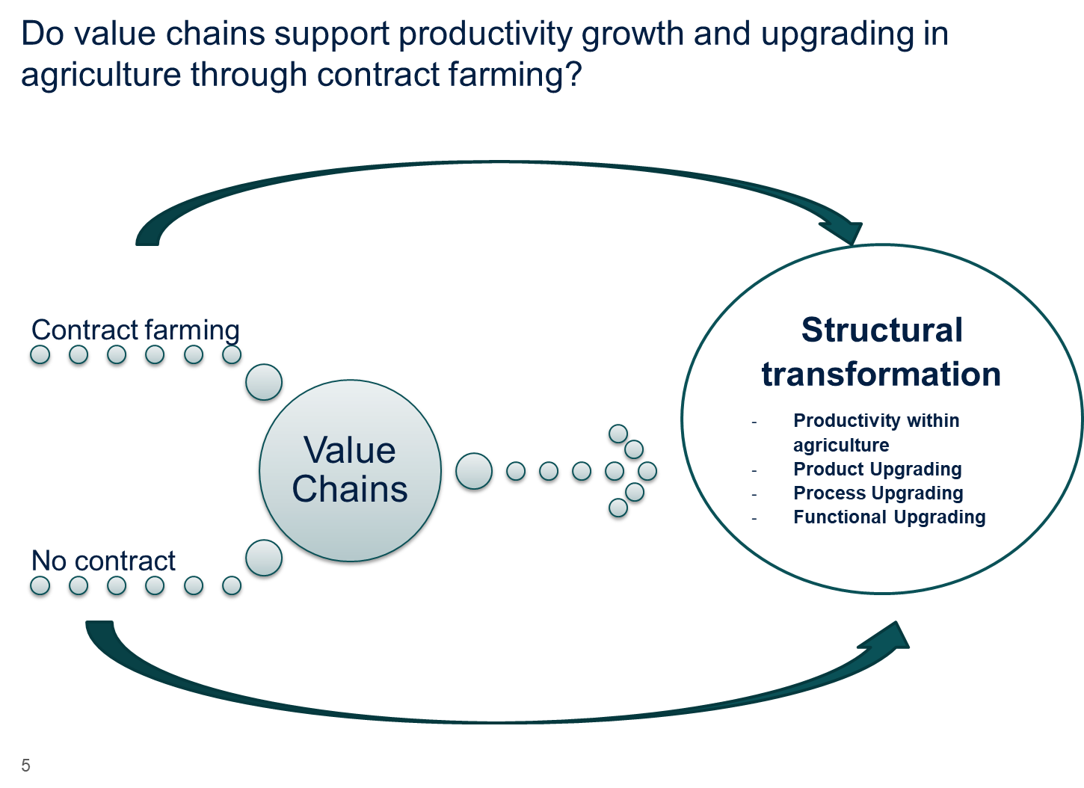

The report is structured as follows. Based on a review of the literature, section 2 presents a new avenue toward structural transformation and discusses the role of contractual arrangements in enabling participation in value chains that can lead to transformational productivity growth. To understand the relationship between contractual arrangements and value chains in maize, we first discuss their key characteristics in sections 3 and 4. Section 3 discusses the well-established value chains in maize and the emerging networks in cassava and sorghum. Section 4 analyzes the various contractual arrangements that dominate the agricultural value chain landscape in Kenya, Ghana, and Zambia, and explores in more depth the role of contractual arrangements in supporting the participation of farmers in value chains in these countries. Section 5 provides descriptive statistics on the impact of value chains on productivity and upgrading and tests empirically[8] whether participation in value chains really matters to farmers. Section 6 concludes and discusses next steps.

1. **A New Avenue Toward Structural Transformation: Key points emerging from a literature review**

***Structural Transformation: A new angle***

Traditional definitions of structural change (or structural transformation) emphasize the reallocation of production factors/resources/economic activity across sectors, and more specifically from low-productivity to high-productivity ones. For example, Rodrik and McMillan (2011) explain that the countries that manage to pull out of poverty and get richer are those that can diversify away from agriculture and other traditional products. As labor and other resources move from agriculture into modern economic activities, overall productivity increases and incomes expand. Rodrik and McMillan describe the two key dynamics in the process of structural transformation: the rise of new industries (economic diversification) and the movement of resources from traditional industries to these newer ones. As such, structural transformation entails the rise of new, more productive activities and the movement of resources from less productive activities to newer activities, increasing overall productivity.

Similar views on structural transformation—defined as the shift of resources from low-productivity to high-productivity uses and the reallocation of production factors (resources) across the broad agriculture, manufacturing, and services sectors—are found in the early literature.[9] Several studies[10] define structural change as the reallocation of economic activity across three broad sectors (agriculture, manufacturing, and services) that accompanies modern economic growth. Other papers[11] define structural change as long-term and persistent shifts in the sectoral composition of economic systems. Structural change in this traditional view is associated with modifications in the relative importance of different sectors over time, measured by their share of output or employment. Within this group, structural change stands for the change in the cross-sector allocation of labor. Sectors are defined as theoretical groups of goods and services varieties, such that (i) technology differs across sectors, and (ii) the sector division is exclusive, that is, a good or a service type can be assigned to only one sector. Other aspects that are taken into account are changes in the location of economic activity, such as the urbanization process, or, in a broader sense, changes in the institutional environment.

Although most definitions of structural transformation focus on sectoral changes, the more recent literature broadens this view. It is in this context that the proposed research aims to contribute to the debate by focusing on transformational productivity growth within existing sectors. This more recent literature considers structural change generated by movements of factors of production between firms, and reallocation of resources from lower to higher productivity activities within the same sector (see, for example, Hsieh and Klenow (2009), Page (2012), and Page and Shimeles (2014)). Indeed, in a world dominated by complex and fragmented production processes, development can be achieved by (i) functional upgrading, that is, by moving to higher value-added tasks, and (ii) process upgrading, that is, by specializing in the tasks and activities of comparative advantage and putting more technology, know-how, and auxiliary services into such tasks, which ultimately translate into value addition and higher productivity. In addition to value addition and higher productivity, these upgrading processes can facilitate the shift to activities that are based on new, nonroutine tasks, such as tasks that require a high level of interpersonal interactions, networking, and technological innovation.

This means that improvements and shifts in production within each sector are an important element of development. Furthermore, transitioning from an agricultural to a services economy or from food crops to cash crops is not the only avenue, as traditional development views suggest. It means instead increasingly embracing higher value-added production or more productive activities in the same sector or type of commodity, or transitioning from informal production to formal activities with the assistance of more technology, services, and know-how as well as better linkages to input and output markets. Africa has grown strongly over the past decade, but exports, driven mainly by minerals and commodities, have not provided the base for structural change, rapid increases in employment in industry, or widespread poverty reduction.

***Economic Growth through Transformational Productivity Increases in Agriculture***

A large body of literature has recognized the role of the agriculture sector in economic development. Given Africa’s natural comparative advantage in agriculture, within-sector increases in productivity are an important alternative to traditional models of structural change (Byerlee, de Janvry, and Sadoulet 2009). In Sub-Saharan Africa, 65 percent of the labor force is employed in the primary sector, accounting for 32 percent of gross domestic product (GDP) (World Bank 2016). As a significant portion of economic activities in all African countries, the agriculture sector is crucial for eradicating poverty and hunger and increasing economywide welfare and growth.

Research finds a significantly positive impact of increasing agricultural productivity on poverty reduction via an increase in output, declining food prices, and therefore, an increase in farm and nonfarm real income.[12] Moreover, productivity growth seems to have a much stronger impact on poverty reduction than building physical infrastructure whose benefits remain limited due to farmers’ low productivity and inability to take advantage of new market opportunities. Rising real income will then stimulate output in nonfarming sectors through forward and backward linkages.[13] The channels through which agricultural productivity growth benefits overall GDP growth are production linkages (the supply of raw materials and demand for manufactured goods, such as farm equipment, and repair services), consumption linkages (higher demand for goods and services), and factor income linkages (seasonal agricultural labor demand).[14] The empirical evidence suggests that growth in agricultural output can indeed foster per capita growth of the non-agriculture sector, although the full potential depends on country conditions, such as economic openness within the economy and between the domestic and world economies.[15]

World Bank (2017) stresses the importance of focusing on agricultural productivity growth as a vehicle for steering structural transformation—rather than prematurely shifting workers to other sectors—and the substantial scope for improving labor productivity in agriculture in Africa. Agricultural transformation based on productivity growth, improved market functioning, and growth in the rural nonfarm sectors is identified as essential for achieving the goal of inclusive growth and prosperity in Sub-Saharan Africa. A key avenue to spur Africa’s structural transformation via agriculture is to increase productivity, by adding value to the region’s natural resources, and foster diversification (that is, product variety and new tasks linked to manufacturing and services). Joining global and regional value chains that link the three economic sectors can foster productivity growth through spillover effects.

***Joining GVCs Can Foster Productivity Growth and Structural Transformation***

World trade, investment, and production are increasingly organized around regional value chains (RVCs) and GVCs—a full range of activities ranging from design, production, and marketing, to logistics, distribution, and support that firms engage in to bring a product to the market. The rise in importance of GVCs and RVCs means that exports represent only part of trade-driven structural change. Measures of trade in value added—as opposed to traditional gross measures of trade—can provide insights into integration into global value chains and the benefits this entails.

The impact of GVCs on productivity and employment occurs through various channels. First, forward linkages by selling intermediates can spur production in upstream sectors. Second, backward linkages occur by purchasing international inputs that can be accessed at lower price and higher quality. Third, domestic firms can experience productivity increases through technology spillovers, and fourth, via skills demand (training). Fifth, GVC participation increases the competition for limited resources, implying positive market restructuring effects (Winkler and Farole 2015).

Although the economic literature has provided strong evidence that openness to trade and investment can be important drivers of productivity growth, studies that analyze the impact of GVC participation on productivity are just beginning to emerge. For instance, Baldwin and Yan (2014) examine the link for Canadian manufacturing firms over 2002–06. They find that although more productive firms are better equipped to join GVCs, GVC starters also become more productive. Using propensity score matching and difference-in-difference methods, the authors estimate that firms experienced 5 percent higher productivity growth after joining a GVC, measured by Statistics Canada’s Annual Survey of Manufactures, compared with non-GVC firms.

In terms of Africa-specific research, Winkler and Farole (2015) test the transmission channel of GVC integration, proxied by the export share and share of imported inputs, on firm-level productivity for Namibia, South Africa, and Swaziland. Using data from the World Bank’s Enterprise Surveys, the authors find a strong positive correlation in all the examined countries, with the highest impact observed in Namibia. Swaziland faces difficulties in turning GVC integration into productivity gains, given its generally low level of investment and reliance on South Africa as a source of inputs and as destination market.

Looking at agriculture-specific studies from various countries and particularly from Honduras, Staritz and Reis (2013)outline the potential benefits of various forms of upgrading in horticulture. Functional upgrading as a shift to production of higher value-added agricultural products can increase the demand for and access to multiple new markets. The constraints to be addressed are certification in global standards and training, such as Global Good Agricultural Practices; transportation infrastructure; and market information in combination with access and tariffs. Furthermore, product upgrading in the horticulture sector—defined as product diversification into multiple different crops and upgrading of products into higher-value products—is expected to generate increased returns to investment for infrastructure and land resources. Process upgrading that involves installation of greenhouse technology and drip irrigation technology, as well as the usage of smaller plots for production to increase efficiency and reduce risks, is anticipated to decrease the risks from disease and climate change, increase returns to investments in water on pesticides, and lower labor costs for irrigation.

It is argued that value chains will generate employment at each stage of the chain and encourage export diversification to meet demand (Sahoo 2010). Another argument for joining GVCs to generate structural transformation in the agriculture sector comes from a more practical side. Agricultural value chains are driven by high-quality products produced with advanced technologies implemented by lead firms, which are usually located in industrialized countries. Exposure to new technology and more efficient production methods through integration into value chains can help increase growth in agriculture.

Although trade and production networks are not new, the speed, scale, depth, and breadth of global interaction has changed and brought new issues to the table for the consideration of governments and participants in such value chains. For example, as GVCs have evolved, it has become easier for less developed countries and small enterprises to participate in several value chains, provided the appropriate policies are put in place. By integrating foreign know-how and technology, they are exporting processed goods, parts, and components that are sold to regional and global markets. The speed, scale, depth, and breadth of such global interaction have increased rapidly in the past three decades. Even nonparticipants realize the challenge of competing against countries that integrate local, low-cost production with imported high tech and skills, and they witness the opportunities associated with participation. The opportunities to drive development through integration into regional and global value chains has put even greater emphasis on open and predictable trade and investment regimes, including efficient trade logistics.

Very few studies look at linkages between value chain integration and economic upgrading. Stöllinger (2017), making use of a global sample of 53 countries observed over 1995–2010, investigates how countries’ participation in GVCs affects structural upgrading. Participation in GVCs is measured by deep cross-country production sharing. Structural upgrading is proxied by the part of labor productivity growth that is due to shifting labor resources toward more productive sectors. The author identifies a sizable structural change effect arising from increasing GVC-related trade for emerging and transition economies. However, the impact appears to be smaller and less robust than the structural impact of trade in general. Therefore, the author argues that the role of GVCs as an industrial policy tool should not be overestimated.

Kummritz, Taglioni, and Winkler (2017) combine two panel data sets of developing and industrialized countries at the sectoral level with a wide range of policy measures at the country level. The study provides evidence that not all countries have gained from participating in global value chains, and country-specific characteristics matter for economic upgrading in global value chains. In a first step, the empirical strategy accounts for the different types of GVC integration and relates GVC participation as a buyer (backward GVC links) and seller (forward GVC links). According to the authors, integrating as a buyer requires a focus on building the infrastructure and strengthening connectivity to global firms to import world-class inputs. GVC participation as a seller shifts the focus toward increasing productivity to be more competitive in the global market.

The results show that global value chain integration increases domestic value added especially on the selling side. The authors also find that the effects of GVC integration on economic upgrading can vary depending on a country’s development stage, the type of GVC integration, and its underlying transmission channels. The transmission channels include backward and forward GVC links, technology spillovers to local firms in the same or related downstream or upstream sectors, skills upgrading transferred through the training of and demand for skilled labor, investments in infrastructure, and pro-competitive market restructuring effects. The authors argue that it might be possible that countries with lower income levels benefit more strongly from backward links and technology spillovers, while higher-income countries show higher gains from forward links and skills upgrading.

***Integration into Agri-Food Value Chains***

Food production can be a lucrative business for a wide range of rural workers. Developing an agri-food industry is seen as a strategy to increase income and foster structural transformation.[16] Agribusiness covers input suppliers, agro-processors, traders, and retailers and involves manufacturing and services. Multinational companies engaging in GVCs outsource tasks to developing countries, enabling firms in developing countries to move up the value chain. Most agri-food value chains are largely driven by these lead firms. Increasing participation in agri-food value chains can have significant economywide spillover effects. For example, in India, roughly 10 percent of manufacturing value added occurs in food-related industries, emphasizing strong intersectoral linkages (McKinsey Global Institute 2014). However, small farmers have often been trapped in subsistence farming due to low yields and poor access to markets. But there are some success stories showing that it is indeed possible to upgrade through participation in global and local value chains. [17] (Box 1 highlights success stories in Africa.)

|  |
| --- |
| **Box 1: African Success Stories** |
| **Organic certification of coffee and cocoa in Uganda.** Thanks to donor support and a local organic movement supporting contract farming schemes, farmers were able to realize value addition through certification. Certification required new, quality organic products (product upgrading) and changing production processes (process upgrading).  **Fresh fruit and vegetable industry in Kenya.** This is another example of successfully entering value chains through a combination of farming infrastructure and logistical support to Kenyan smallholders. With rising demand for fresh fruits and vegetables, the industry managed process upgrading, including improved packaging forms and product upgrading through matching increasing numbers of standards. Marketing institutions such as the Fresh Produce Exporters Association of Kenya, local producer associations, and self-help groups all encouraged, but not controlled, by the Kenyan government, produced an environment that facilitated contract farming (Minot and Ngigi 2004). |

Within agricultural products, productivity growth in staple food crops (for example, maize, rice, or cereals) has the greatest potential for poverty reduction, since these crops are often the single most important component in smallholder farm income.[18] However, limited access to land and capital are among the primary reasons that prevent smallholders from graduation from self-subsistence farming. Making markets work and enabling farmers to sell their products require a strong public sector policy. Successful government investments in food-processing parks need to go along with land market reforms and rural infrastructure development. In addition, improvements in technology and capacity building to satisfy food quality and safety standards must be in place to drive agricultural development. At this stage, the development of value chains is hindered by several barriers, such as lack of skilled workers and infrastructure, uninsured risk, limited access to credit and other resources, and burdensome regulation.

The example of the Green Revolution in Asia is particularly instructive for understanding how investments can have positive impacts on poverty reduction and agricultural growth. For instance, in India, the largest impact was estimated from investments in infrastructure and education as well as research and development, leading to improvements in access to fertilizers, seeds, and irrigation.[19] In contrast, agricultural productivity growth has not been successful in reducing rural poverty in Bolivia, Brazil, and Peru, where growth has benefited mostly large, capital intensive firms. Hence, national policies need to include the poorest households to make a change (Byerlee, de Janvry, and Sadoulet 2009).

For cassava, maize, and sorghum, most of the qualitative and quantitative literature evaluates the potential of and constraints to higher value chain integration. Few studies look at the linkages between value chain integration and economic performance. For instance, the Foundation for Partnership Initiatives in the Niger Delta discusses the upgrading potential for cassava in Nigeria (PIND 2011). The report finds that, in order to produce HQCF theharvesting and transportation costs are high that would increase overall production costs and might even lower profits when stepping into this value chain.[20] Similarly, Fawole, Thomas, and Okoruwa (2011) argue that despite large production of cassava in Nigeria, most farmers did not get much return from their produce because of the high costs of weeding, bush clearing, cassava cuttings, and poor use of fertilizer.

To benefit from value chain upgrading and overcome these constraints, all the studies point to the need for higher market linkages between producers and processors, and simultaneous improvements in marketing, improved technologies, and fertilizer use. Furthermore, it is important to apply a package of appropriate agricultural practices instead of a one-sided practice improvement, which may increase costs and reduce total profitability (Kenya USAID 2015; IFPRI 2010). Contract farming can play a crucial role in overcoming these leakages.

***Making Value Chains Work for Development through Contract Farming and Aggregators***

Regional and global value chains are different from traditional trade and production, as they require sequential production decisions along a full range of activities ranging from design, production, and marketing to logistics and distribution. The customization of goods and services entails intensive contracting between parties (Taglioni and Winkler 2016). For agricultural activities, contract farming can be a useful way to integrate farmers in developing countries into value chains to help them increase productivity through various channels. First, the buyer may provide farmers with inputs, production services, and new technology. Second, as some contracts also specify the price in advance, the price risk is often reduced. And third, the contract can open new markets and provide higher income (Minot 2007; ActionAid International 2015). In addition, economies of scale may arise from the buyer’s logistical network.

A comprehensive review by Minot and Ronchi (2014) shows that contract farming can help integrate small-scale farmers into modern agricultural value chains, providing them with inputs, technical assistance, and assured markets. Although contract farming is not a panacea for value chain integration, the probability of entering a value chain is likely to increase when the farmer has a contract with the buyer of the product. Hence, contract farming is discussed as a major channel for increasing productivity through participation in value chains. However, the potential benefits depend on a complex set of factors (Hoeffler 2006). A clear result emerging from an overview of empirical studies is the increased income for contract farmers (see, for example, Nguyen, Dzator, and Nadolny (2015); Bellemare (2012); and Maertens and Swinnen (2009)).[21] Surveying more than a dozen econometric studies, Minot and Ronchi (2014) find that the estimated change in income for contract farming over the average income for noncontract farming ranges from negative 49 percent to an increase of 600 percent, with most studies predicting an increase of between 25 and 75 percent.

However, there are still few empirical studies on contract farming in staple crops (an example is Maertens and Vande Velde (2017)), compared with the large literature on high-value and commodity export sectors, although staple food supply chains can contribute more to poverty reduction and food security. Swinnen, Vandeplas, and Maertens (2010) argue that the need for specific inputs in the production of staple crops is much lower than in high-value fruits and vegetables, which makes contracting less necessary. Nevertheless, Maertens and Vande Velde (2017) find a significantly positive impact of contract farming on rice farmers’ income.

Summing up, the broader view on structural transformation, which emphasizes transformational productivity growth and various forms of upgrading within sectors, provides a useful organizing framework to analyze the impact of value chains on Africa’s agriculture. In creating this framework, we make use of the assumption that GVCs require intensive contracting between parties. There seems to be consensus in the literature on the positive impact on productivity from contract farming as well as value chains, in particular new modes of linking farmers to consumers, promoting modern inputs, innovation, and upgrading.

To evaluate the link between contract farming and participation in value chains in Africa, we provide qualitative and quantitative assessments based on extensive surveys of farmers, buyers, and aggregators. The hypothesis that we test in the following sections is that participation in value chains—which we show is related to contracting of farmers—is important for structural transformation in agriculture, through productivity effects and upgrading decisions of farmers.

1. **From Well-Established Value Chains in Maize to Emerging Networks in Cassava and Sorghum**

Understanding how value chains are structured will help us understand how farmers participate in those value chains, and the possible impact that participation could have.

***Well-Established Value Chains in Maize***

The maize sector is a well-organized segment with complex structures and a multitude of private and public sector players. Not only is maize an important staple food in most African countries, it also remains a key product in milling, stock feed making, and the production of nonalcoholic drinks, beers, breakfast cereals, and snacks. The finished products from maize—like beer, nonalcoholic drinks (such as Maheu), and breakfast cereals—can be found in the local retail outlets and large supermarket chains in the three countries. The Governments of Kenya and Zambia have invested heavily in the sector and there are clear backward and forward linkages with the various players from the private, public, and nongovernmental sectors (figure 2).

Maize is an important crop across Africa, including our sample of countries. Zambia’s complex maize value chain (depicted in figure 2) shows that key input suppliers include agro-dealers, nongovernmental organizations (NGOs), government, research institutions, seed companies, Zambia National Farmers Union, farmer cooperative societies, and private companies. Many of these input suppliers also provide extension services to farmers. It is important to keep in mind that these inputs are not only provided to maize producers (farmers), but also to the Food Reserve Agency, which buys and sells maize to maintain national strategic reserves. The maize produce is taken up by small- or large-scale aggregators or wholesalers. Oftentimes, maize goes through different marketing platforms or commodity holding companies, which include, inter alia, the Zambia Agricultural Commodities Exchange and the Zambia Grain Traders Association. It then goes to processors and distributors, which include small-scale millers in small towns and large-scale millers and stock feed manufacturers. Food processors include companies such as Yoyo Foods and Trade Kings, which make snacks, breakfast cereals, and nonalcoholic drinks, such as Meheu. Breweries (Zambia Breweries, National Breweries, and Mukwa Breweries) also process maize to manufacture clear and opaque beer. Most of the maize-based products are consumed domestically; however, some products, such as maize grain and Meheu, are exported to regional markets.

**Figure 2: Maize Value Chain in Zambia**

*Input suppliers/extension services support*

Agro-dealers, nongovernmental organizations, government, research institutions, seed companies, Zambia National Farmers Union, farmer cooperative societies, and private companies

Inputs and service providers

Producers

Aggregators /bulkers /accumulators

Marketing platforms

Processors and distributors

Retailers

Consumers

*External regional export markets/consumers*: Zimbabwe, Democratic Republic of Congo, Malawi, and Kenya (grain and processed products)

*Local consumers*: individuals, schools and hospitals, and relief food,

- Grain, processed food, animal feeds, and beer, in villages, towns, urban centers, and cities

*Retailers*: small dukas, retail shopssupermarkets

*Large-scale millers and feedstock* manufacturers

***World Food Programme***

***Distributors and wholesalers of processed products***

*Food processors*: Yoyo foods, Trade Kings, and other,– snacks, breakfast cereals, non-alcoholic drinksMaheu

***Large-scale aggregators / wholesalers***

*Maize farmer-producers*: small-, medium-scale farmers

*Small-scale miller*s in small towns

*Informal cross-boarder imports: Malawi*

*Local village hammermills*

*Food Reserve Agency*(buysand markets national strategic reserves)

***Commodity holding company***

***Small-scale aggregators / brokers/ accumulators***

***Farmer cooperatives***

*Breweries*: clear and opaque beer

Zambia (SABMiller), National, and Mukwa breweries etc.

*Marketing platforms:*milers associations/ Zambia Grain Traders Association

Although the government plays an important role in facilitating linkages in the three countries, in several circumstances government measures seem to hamper competition in the maize sector and hold up the emergence of value chains. For example, in Kenya, the government plays an important role in creating strategic food reserves: the National Cereals and Produce Board buys excess maize at the time of harvest, imports maize in case of deficit, and offers storage and drying services to farmers. Encouraging excess production, creating market distortions, and hoarding by farmers could be several outcomes of such boards. Similarly, in Zambia, the government has strategic objectives for the sector—including food security—but the instruments it uses often have adverse impacts on the ability of farmers to integrate into value chains (and upgrade), while also rarely delivering on the overall objectives.

In deciding on future maize policy, it is important for countries to recognize that achieving domestic food security and better integrated GVCs and export growth are not mutually exclusive or even opposing objectives. They could be complementary in an improved policy environment. With a clear commitment to allowing maize sector participants to have access to foreign markets, there would be good reason for established and emerging commercial farms to re-enter maize production. According to industry sources in Zambia, these farms could fairly easily produce a stable 300,000 tons of maize, which would not only provide the basis for export development, but also create a buffer stock in case of drought. Smallholder farmers would also benefit from clear market signals, including timely and competitive payments associated with export development. However, without a firm commitment from the government to create an environment conducive to entrepreneurship in the agriculture sector, there is little incentive for small or large producers to make on-farm improvements. And agribusiness firms do not have incentives to invest in the kinds of input supply and marketing systems that are needed for many African countries to ensure domestic food security or become the “reliable grain baskets,” as policy makers and other sector participants have long dreamed. To create such an environment without unnecessary regulatory and trade (and nontrade) barriers, the government must play a proactive role in designing and implementing horizontal policies that cut across various sectors, including, inter alia, agriculture, transport, business environment, and trade policy. Prudent vertical policies would also be useful.

***Emerging Value Chains in Cassava and Sorghum***

The potential for forming cassava value chains is immense but insufficiently explored. This drought tolerant crop has the potential to be processed into several products that can also support other value chains in many African countries. Although cassava commercialization has seen a lot of success in some African countries, such as Mozambique, the potential of this crop remains largely unexplored. For instance, Zambia has all the right ingredients to commercialize cassava and move away from reliance on maize, but has made limited progress so far (see box 2). In Ghana, cassava is already one of the country’s staple crops with huge market potential. Cassava is used in the production of several local foods, including *gari*, *kokonte*, *fufu*,and *agbelima*. Processing for these products is usually undertaken by small-scale processors, women workers, or households. A few medium-scale processors, such as Elsa Foods, Josma Agro Industria Limited, Amantin Agro Processing Co. Limited, St Bassa, and Homefood Limited, prepare packaged foods for the domestic and international diaspora markets.

|  |
| --- |
| **Box 2: Cassava Value Chains in Zambia Can Help the Diversification Process** |
| Zambia’s economy relies heavily on commodities, with copper accounting for 85 percent of the country’s exports.a This dependence on commodities has made the country susceptible to external and internal shocks. In recent years, revenues from copper exports have decreased drastically due to a global trend in falling commodity prices and China’s growth slowdown. The agriculture sector holds a lot of promise for helping the country to diversify its export base. However, Zambia relies heavily on maize, making it the dominant crop in production, consumption, and exports. Due to the importance of maize in the economic and political landscape, using the agriculture sector to catalyze economic diversification has been challenging in the past. However, because of the strong dependence of maize on rainfall, maize production has remained volatile in recent years. This year’s maize production has been severely hampered by El Niño–related dry conditions, resulting in pockets of food insecurity in parts of Zambia, prompting the country to import maize from neighboring countries.  These factors have led to renewed interest in alternative drought-tolerant crops, like cassava. Cassava can be an important driver of diversification in Zambia and promises to open new sectors for development. This is due to various factors, including the use of cassava as an input into new products; interest from the government in promoting it as a *food security* crop; and involvement by the private sector, which sees commercialization and export potential. Cassava can lead to densification of value chains, as it can be used as an input for various products and processes, which include, inter alia, brewing, metal extraction (copper, gold, and cobalt), ethanol production, starch making, and animal stock feed.b Densification would lead to more and better domestic jobs and help engage more local firms in regional or global value chains. At the same time, it will promote economic and social upgrading. For example, using cassava starchc during the copper extraction process is not only more cost-effective, but also environmentally friendly, compared with other methods of extraction.  a. In 2014, some of Zambia’s top exports were copper products: copper cathodes ($5.1 billion), refined copper ($1.8 billion), and copper alloys ($139 million).  b. By diversifying the uses of a given product (also known as “densification” in the GVC literature), firms reduce their vulnerability to product-specific shocks transmitted through backward linkages. GVC densification also fosters spillovers from GVC participation and engages more local firms in the supply network.  c. Cassava starch powder can be used as a reagent in the processing of chalcopyrite (a copper sulfide) into copper concentrate. Cassava cyanide can also be used for the extraction of gold and cobalt. |

The cassava value chain in Ghana is dense (figure 3). It consists of various stakeholders, including inputs and service providers, producers (farmers), aggregators, processors, distributors, retailers, and consumers. Input and service providers also provide extension services support. Some of these service providers include the Ministry of Food and Agriculture, Roots and Tubers Improvement and Marketing Programme, NGOs, cassava processors, and breweries. Producers include small- and medium-scale farmers, farmer-based organizations, and commercial estate cassava farming (Caltech ventures) that supply cassava to a mix of large and small and medium-size enterprise processors, cassava *flour* processors (Caltech Ventures, Datco), and cassava *starch* processors (Ayensu starch). Cassava uptake is done by various buyers, including bakeries, wood product manufacturers (cassava plywood glue), spirit producers (ethanol), and breweries (cassava beer). The final product is mostly found in the local market, although some of it is exported.

**Figure 3: Cassava Value Chain in Ghana**

Inputs and service providers

Producers

Aggregators /bulkers /accumulators

Processors and distributors

Retailers

Consumers

**Input suppliers and extension services support**

Agro-dealers, nongovernmental organizations, government, seed companies, community-based organizations, farmer cooperative societies, and private companies

Large-scale aggregators and wholesalers

**Formal imports**: Zambia

**Informal cross-border imports**: Uganda, Tanzania

Large-scale **millers**, **processors,** and **animal feed manufacturers**

**Maize farmer-producers: small-, medium-, and large-scale farmers**

Local village hammermills

Small-scale aggregators and brokers

Community-based organizations and farmer cooperatives

**National Cereals and Produce Board**

(buys , markets, and maintains national strategic reserves)

World Food Programme

**Retailers**: small dukas, retail shops, and supermarkets

**Local consumers**: individuals, schools and hospitals, and relief foods

- Grains, animal feeds, and processed products (maize meal), in villages, towns, urban centers, cities, and refugee camps

Recently, the government, NGOs, and private sector in Zambia have undertaken some initiatives to develop cassava value chains. The government has signaled interest in setting up a cassava value chain partnership that includes relevant government departments, processors and manufacturers of starch or HQCF, financial institutions, researchers, and seed producers. For example, the main objective of the Cassava to Starch Partnership is to reduce poverty through increasing employment by increasing cassava production and processing, bring together all the players found in the cassava value chain. This is a private sector–led partnership supported by the Zambia Cabinet Office to develop the cassava value chain. However, due to the nature of the crop, the cassava value chain faces challenges related to late maturity, short shelf life of fresh tubers, bulkiness, and poor storability. A partnership can help bring all the stakeholders together and provide them a platform where they can collaborate with each other and voice their concerns. For example, cassava has a short post-harvest life, and there are various ways in which storability can be improved, but this requires regular interaction between the various stakeholders, such as seed/tuber researchers, farmers, and buyers.

The private sector is undertaking several initiatives to commercialize cassava. Premiercon (a cassava starch-processing company) is now at the forefront in organizing farmers into clusters in the main cassava growing areas of Zambia (Luapula and Northwestern Provinces) and linking them to the market. Premiercon plans to set up seven processing plants and work with the district cassava-processing associations and other district cooperatives. It is also working with the International Institute of Tropical Agriculture and a private seed producer to multiply the required planting material. This collaboration will help organize farmers and streamline cassava into a viable commercial crop and bring it on board to external markets. One of Premiercon’s largest expected buyers will be a copper mining company, Kalumbila Minerals, which is planning to replace cassava starch, which is currently imported from Australia, with domestically sourced cassava. Zambian Breweries (ZB) is another processor with a keen eye on the cassava value chain. However, ZB faces many logistical challenges. For example, due to the highly perishable nature of cassava and lack of adequate processing, storage, and brewing facilities in Zambia, ZB sends the cassava harvested in Zambia to Angola for brewing, which then comes back into Zambia for packaging and distribution.

Sorghum value chains are complex and face a fair share of challenges. Farmers in Kenya cite impediments such as taxes on sorghum that distort competition in favor of other crops, or crop failure due to pests or bird attacks. However, there is emerging demand for sorghum in the beer industry, with potential in the production of clear and opaque beers. Sorghum is also used in stock feed, with high potential in this growing sector.

Sorghum seems to have a clear forward linkage with a particular processor in each country. For example, East African Breweries Limited is the main buyer of sorghum in Kenya. The government is supporting the development of value chains in sorghum and cassava, as these draught tolerant crops can play an important role in poverty eradication. However, in Zambia, due to inadequate processing, ZB sends the sorghum harvested from Southern Zambia to Zimbabwe for malting. As in the case for cassava, it is brought back into Zambia for packaging and distribution.

Cassava and sorghum are emerging value chains. Governments are interested in their development mainly for poverty eradication. Sorghum and cassava have the potential to be the next frontier crops to mitigate the impacts of climate change. Farmers use both crops as a “backup” crop. Farmers keep cassava in the ground, like an underground bank account, that can be withdrawn from when money is needed promptly, such as for weddings, funerals, school fees, or Christmas. High-starch varieties of cassava are critical for efficient starch and flour production, yet farmers are reportedly often reluctant to invest in such varieties, as farmers’ incentives over the years have been distorted in favor of maize production due to various national policies.

Cassava is grown in the northern parts of Zambia, more specifically, in the Luapula and Northwestern provinces. The Northwestern province shares a border with Angola, so it is easier to move cassava grown in the Northwestern province across the border into Angola. It also takes a shorter amount of time for cassava grown in Luapula to go to Angola (via the Democratic Republic of Congo) than to Lusaka directly. This is primarily due to the poor transport infrastructure and the availability of processing plants already set up by SAB Miller (ZB’s parent company). A similar story can be told for sorghum, which is grown in Zambia’s Southern province. It goes to Zimbabwe (which borders the Southern province) for brewing (in an SAB Miller facility) and then returns to Zambia for bottling, packaging, and distribution.

Summing up, although maize is clearly a well-established and complex value chain, with significant government investments and benefits from interest from key stakeholders in Kenya and Zambia, the maize sector remains less developed in Ghana. Cassava and sorghum are emerging value chains, with potential to be the next frontier crops to mitigate the impacts of climate change. Moreover, cassava can lead to densification of value chains, as it can be used as an input for various products and processes, which include, inter alia, brewing, metals extraction (copper, gold, and cobalt), ethanol production, starch making, and animal stock feed.

In the next step, we look more closely at the relationship between contract farming and the value chains in maize, cassava, and sorghum, based on surveys of farmers, buyers, and aggregators.

1. **What Contractual Arrangements Dominate the Agriculture Value Chain Landscape in Africa?**

Our hypothesis is that farmers on a formal or informal contract with cooperatives, formal suppliers, wholesalers and large retailers, producers, and processors have a greater opportunity for their products to enter value chains. Farmers without any contracts are less likely to produce acceptable products for value chains. Our discussions with various lead firms, especially buyers, also revealed that none of the buyers was buying without a contract.

At the same time, we recognize that farmers without a contract can develop linkages with value chain participants, which we tried to capture in the interviews. We agree that a farmer does not have to have a contract to become part of a value chain, and that the relationship between the farmer and buyer is nonlinear. But for this study (especially for collecting data), we had to have a stylized definition, which is that to be part of a value chain the farmer would have to be part of a contract. This definition also prompted us to say that being part of a contract is a necessary but not sufficient condition of being part of a value chain.

To identify contract farmers who were likely to participate in value chains, surveys covering farmers, buyers, and aggregators were undertaken in Kenya, Ghana, and Zambia. As part of the pilot surveys undertaken for this project, 654 farm households, 41 key informants such as processors and brewers, and eight stakeholders were interviewed in the three countries. The full sample consists of 3,935 farmers, 60 aggregators, and 56 buyers in the three countries (see table 1 for details by country).

***Sampling***

A multifaceted sampling approach was implemented at three distinct levels to determine (i) the target enumeration areas, (ii) the target households per enumeration area (including subsistence farmers), and (iii) the target respondents per household. A combination of purposive and random sampling was employed to identify the farmers for the pilot interviews and the full surveys.

In each of the surveyed countries, we had the following sampling strategy for the full surveys: (i) more than 800 purposively selected contract farmers, and (ii) 400 randomly selected farmers. Our plan was to allocate the sample equally among cassava, maize, and sorghum farmers. However, given that, as opposed to maize, cassava and sorghum crops are not a staple for these countries, it was not possible to cover the crops equally.

**Table 1: Full Sample**

|  |  |  |  |
| --- | --- | --- | --- |
| Country | Farmers | Buyers | Aggregators |
| Ghana | 1,294 | 17 | 25 |
| Kenya | 1,285 | 31 | 24 |
| Zambia | 1,356 | 8 | 11 |
| Total | 3,935 | 56 | 60 |

The key objectives of our empirical research are to assess the impact of contracting arrangements—and ultimately value chain participation—and compare farmers participating in the value chain and/or specific contract arrangements with nonparticipating farmers. A major challenge was to identify contract farmers (an initial way to identify value chain participation), especially those growing sorghum. The pilot surveys taught us that in a random selection of farmers the prevalence of contract farmers is very low, unless the random selection happens to be in an area where a buying scheme was already set up. Based on this finding, our conclusion was that at the national level, only a minority of farmers participate in a scheme. This finding is in agreement with the findings of other studies, such as the Consultative Group to Assist the Poor’s National Survey and Segmentation of Smallholder Households in Tanzania which was conducted in May 2016 (Anderson et al. 2016). The survey found that only 3 percent of farmers in Tanzania are reported to have a contractual arrangement to sell any of their crops or livestock. Thus, we designed a sampling strategy that targets a sufficient number of contract farmers through a purposive selection of enumeration areas.

Identifying contract farmers requires a deep exploration of particular value chains, ranging from processors or other large consumers of the focus crops, to smaller players that aggregate farmers’ produce. From our pilot surveys, we also learned that a top-down approach would not yield sufficient leads to contract farmers. In preparing the full surveys, a team of research assistants undertook a scoping exercise to identify schemes of contract farmers, to ensure sufficient leads before deploying a full team of enumerators. The first few contacts were established by making calls, followed by a scoping trip to the regions where the focus crops are grown. The research assistants collected information on the size of the groups, crops grown, and contact details of the group leaders/representatives.

Contrary to our expectations, the initial investigation revealed that only a few large schemes could be identified in each country. Therefore, several smaller groups were included in the sample, with sample sizes of around 30 to 50 farmers per group. The “control group” is comprised of farmers who were interviewed in the same areas as the farmers operating in a scheme, but at a sufficient distance for them not to be affected by the schemes or programs. The details of the random and purposive sampling are presented in annex B.

***Key Characteristics of Contract Farming from the Surveys***

In line with the findings that emerged from the pilot survey, in the random sample, most farmers in all three countries did not have any contracting arrangements. However, by design, we captured a much larger share of contractual farmers in the purposive sample. Informal arrangements dominate the contractual landscape in Kenya, with 83 percent of all contracts reported to be off-the-record. Kenya also exhibits few farmers with a written contract. By contrast, only 52 and 47 percent of contracts are of an informal nature in Zambia and Ghana, respectively (figure 4).

**Figure 4: Contractual Arrangements (%)**

a. Random sample

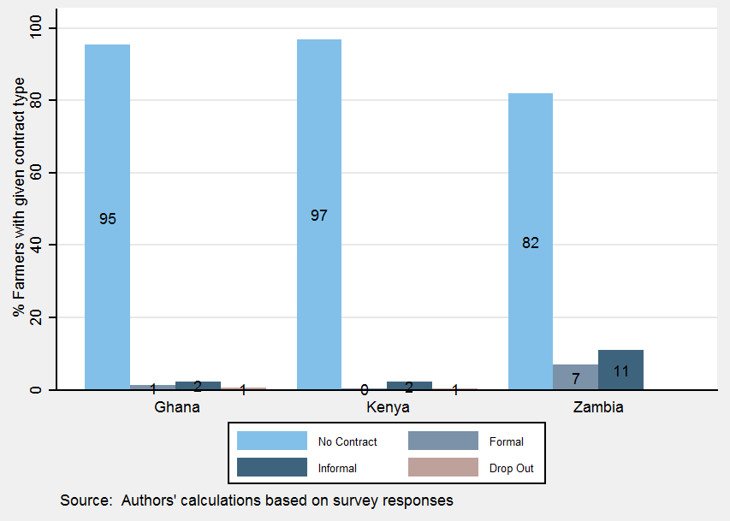

b. Purposive sample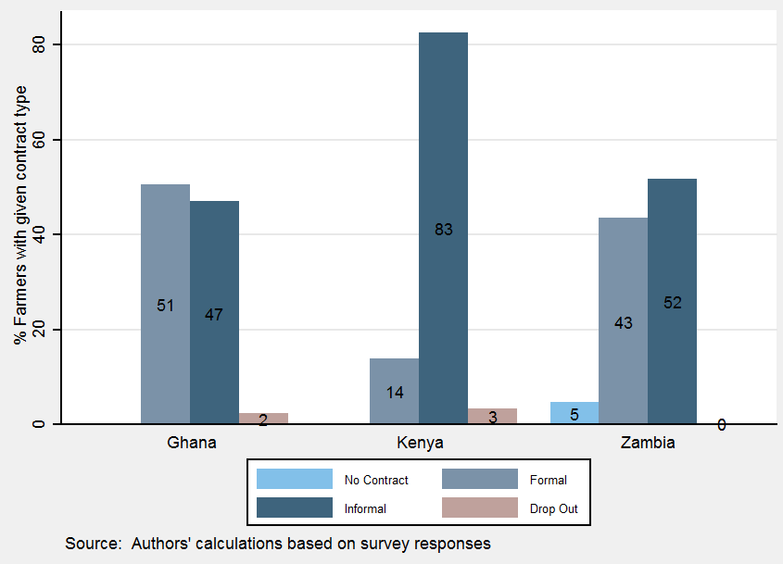

*Source:* Staff calculations based on survey responses.

***Identifying Farmers in Value Chains***

Given that a key objective of our study is to assess the impact of value chains on structural transformation, the full survey also tried to distinguish between farmers in a value chain and farmers not in a value chain. Contract farmers or outgrowers do not necessarily participate in (international) value chains. To establish whether farmers are in a value chain, the farmers were asked about any value addition to their output along the product chain. Given that not many farmers know about what happens to their output in the subsequent stage, we interviewed them about the type of buyers to whom they sell their output. This helped us decipher whether the next-stage buyer could be adding more value to the output. For instance, if the farmer sells her output to a direct consumer, we are certain that the farmer does not participate in a value chain. By contrast, if the output is sold to an exporter or trader, it is more likely that these types of buyers add some value and the farmer is deemed to be participating in a value chain.

To capture value chain participation in the context of our sampled farmers, their buyers were also consulted, because most farmers are not aware of value addition that is done in the remaining stages of the value chain. In the case of contract farmers, a face-to-face interview was conducted with the aggregator or the group’s leader. In the case of randomly selected farmers, follow-up calls were made with their buyers after the data collection. The results show that farmers without any contracts are less likely to produce acceptable products for GVCs. This seems to be confirmed by the respondents to the surveys (figure 5). At the same time, we recognize that farmers without a contract can develop linkages with GVC participants, which we tried to capture in the interviews.

**Figure 5: Farmers’ Knowledge about Their Participation in Value Chains (%)**

a. Random sample



b. Purposive sample



*Source:* Staff calculations based on survey responses.

*Note:* VC = value chain.

The key findings from the interviews on contract farming are summarized as follows:

* The sampled farmers in Ghana seem to be more experienced than those in Kenya and Zambia, with more than half of the respondents engaged in farming for 10-30 years. By contrast, in Kenya, almost half of the respondents (46 percent) have been in farming for fewer than 10 years.
* In Kenya, 22 percent of the respondents farm strictly for subsistence and only 15 percent are pursuing farming as a business. In Ghana and Zambia, more than 30 percent of the respondents were motivated into farming as a business opportunity.
* A common denominator across the farmers in all three countries is that most households (in general, more than 70 percent) had other family members involved in farming, highlighting that family remains an important source of labor.
* In Zambia, about 75 percent of all the respondents get half or more of their total household income from farming; others complement their earnings with income from casual labor arrangements (21 percent) or trade (16 percent).
* In all three countries, the majority of the interviewed farmers have primary or secondary education.
* In all three countries, female-led households are found predominantly in the informal contract group in the purposive sample, and especially so for Kenya. As expected of the random sample, female-led households are dominant among the noncontractual farmers.

Regarding the terms of the contracts, buyers and aggregators in Kenya and Zambia indicated that the contracts include provisions on the rights and obligations of the farmers and post-harvest services (figure 6, panels a and b). The farmers confirmed that their rights and obligations are included in the contracts. However, similar coverage is missing for post-harvest services in our targeted sample of contractual farmers (figure 6, panels c and d). The method of arbitration in case of disputes appears to be clearly addressed in several contracts in Kenya, but not so in Ghana or Zambia. This is consistently true from the perspective of the buyer, aggregator, and targeted sample of contractual farmers.

**Figure 6: Terms of Contracts**

|  |  |
| --- | --- |
| a: Buyers | b: Aggregators |
|  |  |
| c: Farmers: Random sample | d: Farmers: Purposive sample |
|  |  |

*Source:* Staff calculations based on survey responses.

***Transformative Impact of Contractual Arrangements and Value Chains?***

Our hypothesis is that farmers on a formal or informal contract with cooperatives, formal suppliers, wholesalers and large retailers, producers, and processors have a greater opportunity for their products to enter value chains, given better access to inputs, including technology and services, and more support from lead firms.

As expected, farmers under contract seem to have *better access to inputs and technologies*, through the out-grower company[22] or other external sources (table 2). In the random sample, the majority of surveyed contract farmers (over 50 percent) reported using fertilizer for growing their crop as a result of their contractual arrangement. In the purposive sample, a much higher share of farmers in Ghana and Kenya use technology irrespective of being on a contract. In all three countries, randomly selected contract farmers had a greater share of received inputs from the contract providers or intermediaries. Often, the distribution of inputs is supplemented with the provision of market information and dissemination of technical knowledge. However, this was not necessarily true for the purposively selected farmers, where noncontract farmers were a minority.

**Table 2: Usage of Inputs and Technology: Contract versus Noncontract Farmers**

a. Random sample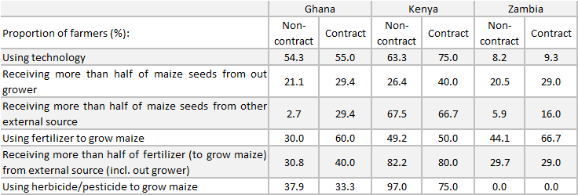

b. Purposive sample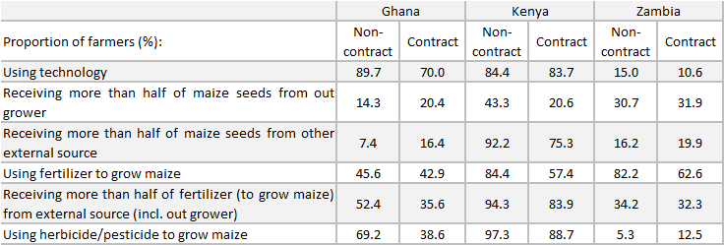

*Note:* For the random sample, the t-test indicates that these differences are significant between contract and noncontract farmers, at least for the variables relating to fertilizer usage and appropriating seeds from external sources. The t-test for equality of means across contract and noncontract farmers for using technology suggests that these differences are not significant. The findings are similar for the cases with those receiving inputs from out-growers, external sources, fertilizers, and so forth (p values ranging from 0.19 in the case of pesticides to 0.8 in the case of technology).

Buyers and aggregators confirmed that farmers receive input support, mainly in the form of pesticides and seeds in Kenya and Ghana (figure 7, panels a to d). The randomly selected farmers emphasized the support received in access to fertilizers and seeds. The purposively targeted contractual farmers in Ghana and Kenya receive support in extension services as well (figure 7, panels e and f). The *support received under contract* varies per country; however, most of the interviewed farmers seem to receive some kind of support, especially in the form of seeds/planting material. The share of contract farmers receiving such support was always larger in the purposive sample vis-à-vis the random sample. In Ghana and Zambia, the support received by farmers on formal contracts often exceeds the support received by those on informal contracts for extension services, seeds, fertilizers, and tractors. This is true irrespective of the sample being random or purposive. For the purposively selected farmers in Kenya, however, the support received by informally contracted farmers is much greater than that received by contractual farmers.

**Figure 7: Input Support**

|  |  |
| --- | --- |
| a. Buyers supporting farmers (%) | b. Buyers providing specific input support (%) |
|  |  |
| c. Aggregators supporting farmers (%) | d. Aggregators providing specific input support (%) |
|  |  |
| e. Randomly selected farmers receiving input support (%) | f. Purposively selected farmers receiving input support (%) |
|  |  |

*Source:* Staff calculations based on survey responses.

The majority of the farmers under contract perceived a *positive to very* *positive impact from the scheme on their production and income*. For example, many farmers reported an increase of half or more in their income and output as a result of contractual arrangements. In all three countries, farmers on informal contracts seem to benefit more from higher income and output increases than their peers on formal contracts. This is true irrespective of the sample being random or purposive. One exception to this is the case of output for purposively sampled farmers in Ghana, where the share of formally contracted farmers reporting higher output is marginally higher than the share reported by the informal ones (figure 8).

**Figure 8: Changes in Income, by Contract Type (%)**

a. Random sample

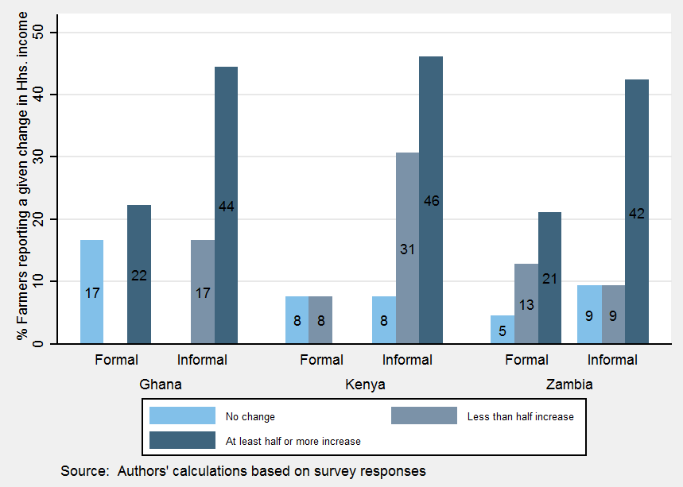

b. Purposive sample

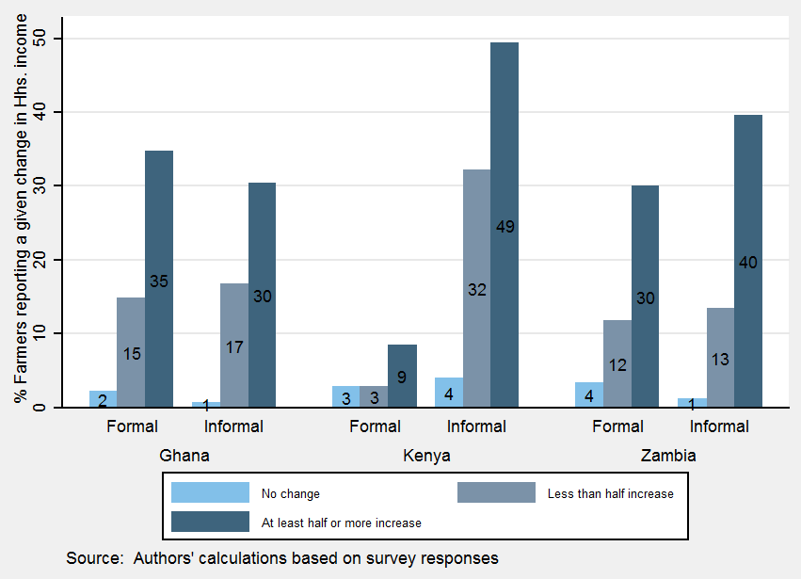

*Source:* Staff calculations based on survey responses.

Farmers on contract reported many benefits from being part of a contract. Some of these include better and more information on how to produce, reduction in transport costs, access to newer crops, increase in profits, and being better able to connect with potential buyers. (Table 3 provides concrete examples.) The shares of farmers reporting such channels of structural transformation remain comparable among countries across the random and purposive samples; however, for Kenya, we observe a remarkable increase among farmers sampled purposively.

**Table 3: Channels of Structural transformation**

a. Random sample

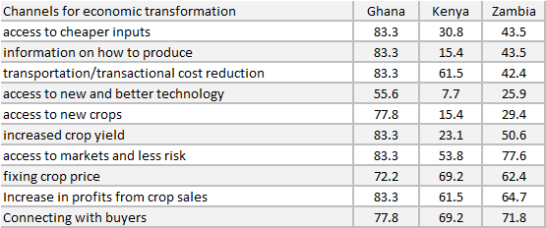

b. Purposive sample

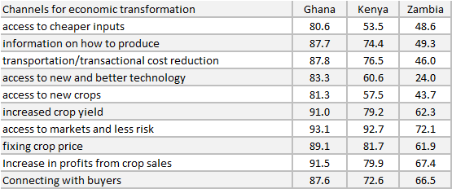

*Source:* Staff calculations based on survey responses.

The farmers also benefit from a variety of services from contract providers. Among the randomly selected farmers, distribution, marketing output, and negotiation are the most important services provided by intermediaries. Among the purposively sampled farmers, information on markets is the top service received by contract farmers in Ghana and Zambia, and collecting produce dominates the services inputs supplied to Kenyan farmers (figure 9).

**Figure 9: Usage of Intermediary Services by Contract Farmers (%)**

a. Random sample

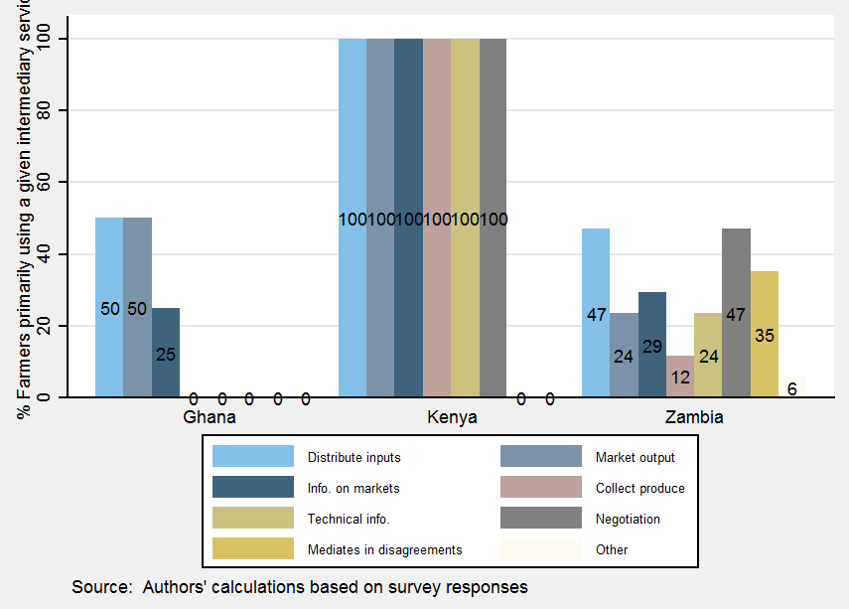

b. Purposive sample

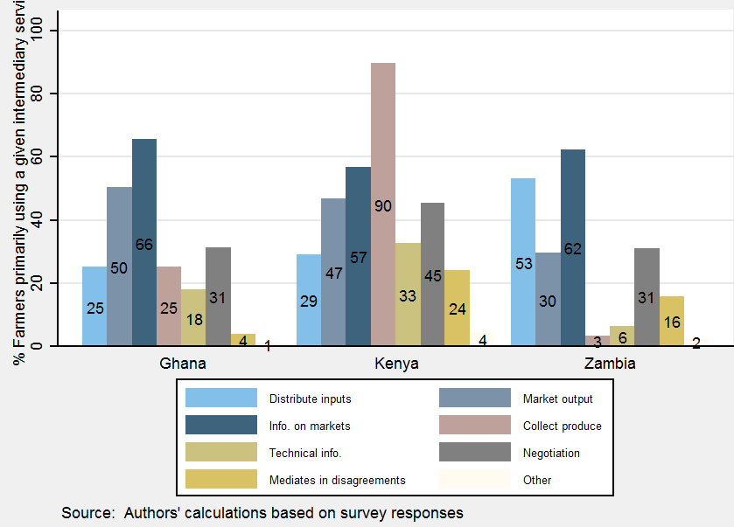

*Source:* Staff calculations based on survey responses.

Finally, as a result of participating in a contract, many farmers engage in new tasks. Ghana emerges as a clear leader, with more than 20 percent of the contract farmers pursuing new activities based on the experience and lessons learned from their contractual arrangements, and more so for the randomly selected farmers (figure 10).

**Figure 10: Farmers Pursuing New Activities as a Result of Contractual Relations**

a. Random sample

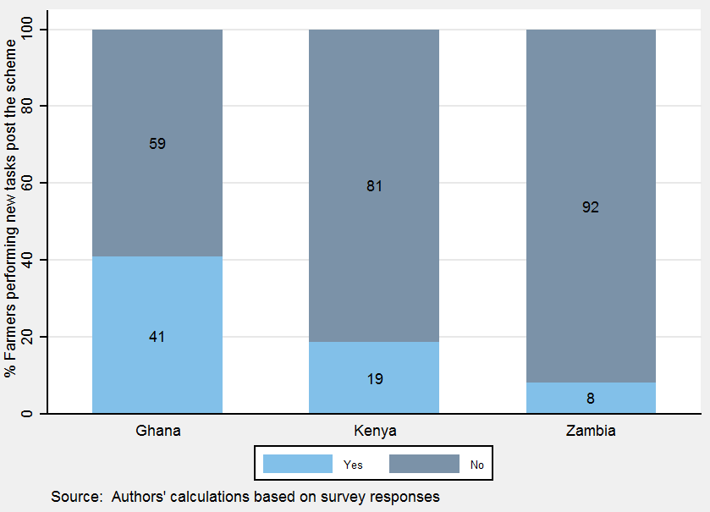

b. Purposive sample

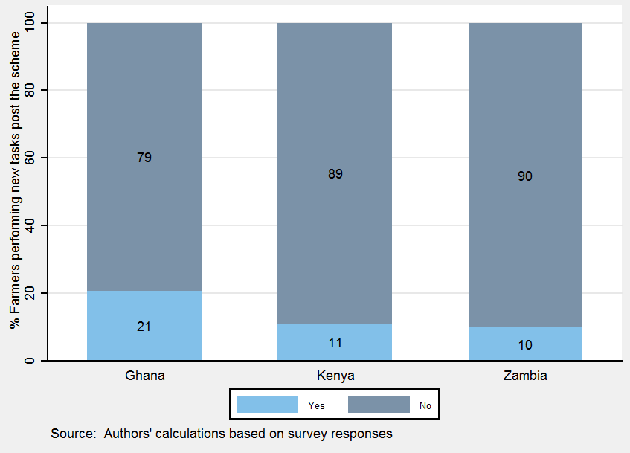

*Source:* Staff calculations based on survey responses.

Although the indicators are not fully comparable, the contract farmers seemed to be more satisfied with their buyer arrangement than the farmers without a contract (stable 4) in the random sample. This result changes slightly for Kenya, where purposively selected contractual farmers report lower happiness than the corresponding noncontractual farmers in the targeted sample. Higher benefits were reported by maize farmers compared with cassava or sorghum farmers, mainly due to the provision of inputs at early stages of production by maize buyers. The reduction in the cost of inputs is attributed to lower marketing, transportation, and storage costs. As a result, the maize value chains in Kenya and Zambia seem to be well developed, have significant government investments, and benefit from interest from key stakeholders.

**Table 4: Happy or Not? Satisfaction with Current Buyer Arrangement**

a. Random sample

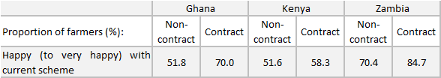

b. Purposive sample

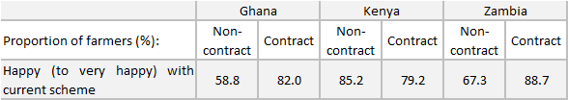

*Note:* The difference in happiness between contractual and noncontractual farmers was significant only at the 20 percent level of significance in the purposive sample, and at the 15 percent level in the case of the random sample.

Most noncontract farmers expressed strong interest in participating in contractual arrangements, but information gaps on potential buyers who offer contracts prevent such arrangements from materializing. Farmers are motivated not only by the larger variety of less expensive and better quality inputs that they are likely to receive as part of a contract, but mostly by access to updated technology, training, and other extension services.

In terms of problems faced by different agents, buyers mainly complained that the farmers do not keep their commitment and sell to other buyers as soon as an opportunity arises (figure 11, panel a). The farmers are most dissatisfied with the decline in prices committed by the buyer. This is noted in the random as well as purposive samples, although the dissatisfaction is higher in the random sample of farmers relative to our targeted sample of contractual farmers (figure 11, panels b and c).

**Figure 11: Complaints**

a. Buyers’ problems with farmers

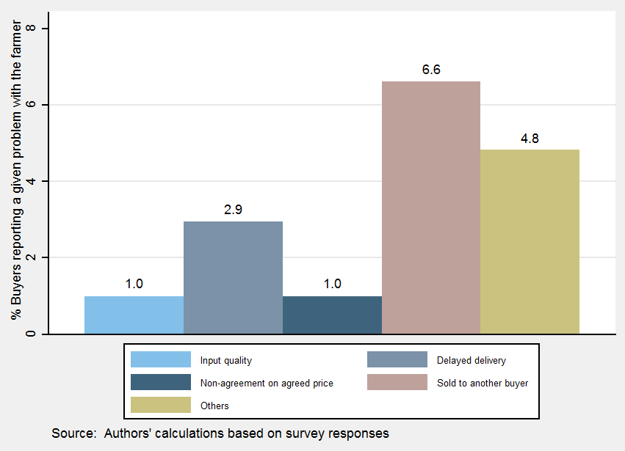

b. Farmers’ complaints: Random sample

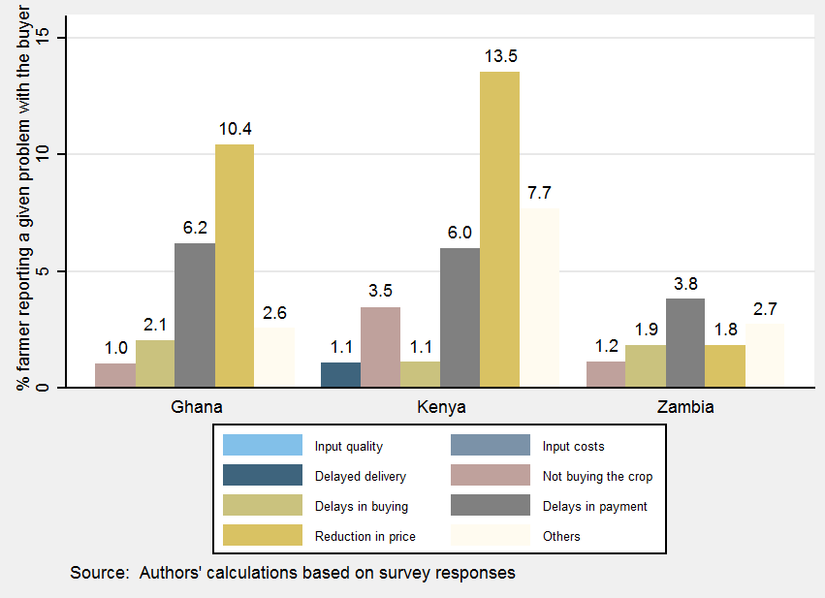

c. Farmers’ complaints: Purposive sample

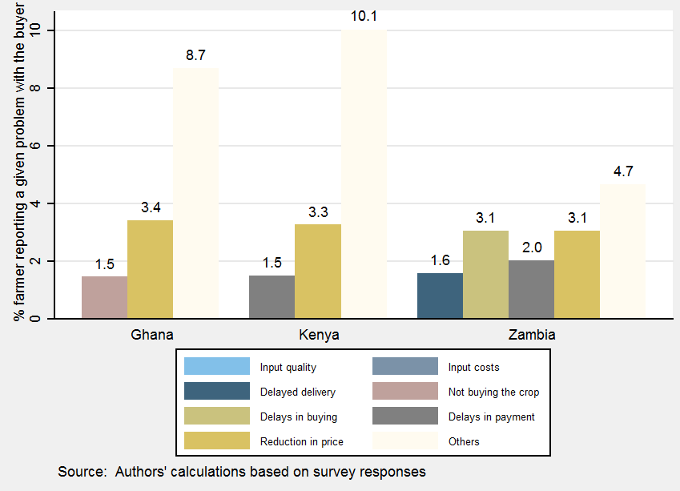

*Source:* Staff calculations based on survey responses.

*Note:* This is an overall graph rather than by country, as the number of respondents by country was very low.

Summing up, the contractual arrangements between farmers and buyers in maize, cassava, and sorghum vary across the countries. Informal arrangements may be negotiated directly by farmers or indirectly by a cooperative or an association on behalf of its members. Such arrangements may involve establishing linkages with or facilitating access to processors or large buyers who sell to processors. Although the cooperatives or associations usually enter into some form of written contract with the processors and buyers (without covering all aspects of the arrangements), the individual arrangements are often of a verbal nature. A common practice is for farmers to have a loan arrangement with a buyer, or a preferential understanding to sell their products to a certain broker.

Our results show that farmers who were on a contract witnessed higher output and better access to seeds, fertilizers, pesticides, technology, and extension services, compared with farmers who were not on a contract. Interestingly, the support received by farmers on informal contracts often exceeded the support received by those on formal contracts in terms of extension services, seeds, fertilizers, and tractors. Many of the farmers reported an increase of half or more in their income and output as a result of contractual arrangements. Surprisingly, in Ghana, farmers on informal contracts benefited from higher income and output increases than their peers on formal contracts. In Zambia, more than 25 percent of the formal contract workers did not report increases in income or output. The farmers also benefited from a variety of services from contract providers. Although information on markets was the top service received by contract farmers in Ghana and Kenya, distribution of inputs dominated the services inputs supplied to Zambian farmers. Finally, as a result of participating in a contract, many farmers in all three countries engaged in new tasks.

It is important that being part of a contract does not necessarily mean that the farmer is part of a value chain. However, it would be safe to say that being part of a contract brings the farmer “close” to a value chain. Therefore, being part of a contract is an important but not sufficient criterion for a farmer to be part of a value chain. In general, farmers on a contract with knowledge about their participation in value chains tend to lead in upgrading and labor productivity.

1. **Does Participation in International Value Chains Really Matter to Farmers?**

Our surveys reveal that the main contractors were processors and traders, specifically the milling companies or the food reserve agencies, seed companies, and breweries. Of the farmers under contract, about 50 to 60 percent of the interviewed farmers in Ghana and Zambia knew about their participation in value chains. The majority of the farmers interviewed in Kenya had no knowledge about the usage of their crops (figure 5). The farmers were often unaware of the final destination of their output beyond their first buyer. This was primarily because the farmers were mostly concerned about being remunerated for the output sold, regardless of whether they were on a contract or part of a value chain. Even if farmers know that the buyer may export their product, they would not necessarily be aware of whether *their* product is being exported, and even if they know that it is being exported, they may not know by *what* amount. This is because a buyer usually purchases from multiple farmers and may export all of the product or part of it.

The explanations received from the Zambian noncontract farmers for not being on a contract highlight two key issues: lack of knowledge of any buyers and lack of trust in engaging with intermediaries. The conditions of price discovery are worse for most noncontract farmers. Buyers’ lack of knowledge also includes that related to spot buyers.

***Key Characteristics of Value Chains from Qualitative Surveys***

Crops produced under contract are mainly sold to contractors or their intermediaries. Most farmers participate in a domestic value chain, with products rarely traded across borders. However, some of the value chains stretch across borders, as some of the processors’ products reach markets outside the country of production.

* For example, maize produced in Zambia is sold to the Democratic Republic of Congo, Malawi, Zimbabwe, and Kenya through the various players in the chain. In addition to exports of raw grain, maize is also sold in processed form, like mealie meal, nonalcoholic drinks, and breakfast cereals, which are the outputs of national maize value chains.
* Cassava produced in Zambia is sold in the Democratic Republic of Congo and used in the copper mining sector as HQCF (85 percent starch), thus fitting into RVCs. Encouraged by the Government of Zambia, there are also efforts by ZB to use HQCF in the brewing industry, to make cassava-based beer.
* Cassava produced in Ghana is used in the brewing (dough) and food (fresh or processed) sectors as well as in the manufacturing industry (HQCF, as a source of starch), with some of the starch being exported.
* Kenya is largely a net importer of maize and gets some of it from Tanzania and Uganda. Kenya largely consumes what it produces within the country, but with transportation from surplus to deficit areas. This function is facilitated by some of the large wholesalers, aggregators, and processors, especially millers.
* We complement these findings with international trade data, which show that many of the value chain products that cross borders stay within Sub-Saharan Africa rather than being exported to other countries in the world.
* Table 5 identifies various products that can be associated to the maize, sorghum, or cassava value chains (or more than one of these). For example, we can identify upstream and downstream products associated to the maize value chain, including maize seed and processed food products, including flour, oil, and bran. In other instances, we can identify products that may use maize as an input, for example, beer. For many of the value chain products identified, exports from Ghana, Kenya, and Zambia are destined to the Sub-Saharan Africa region. There are a few exceptions, including maize from Kenya, maize flour from Ghana and Kenya, sorghum products from Ghana, cassava or cassava flour from Ghana, and other cereal flour and groats/meal of other cereals from Kenya. Zambia’s exports of these GVC products are almost entirely to the continent.
* Of the three countries, Zambia is an important exporter of maize seed and maize, although it exports less of products that require further downstream processing, with the exception of bran. Zambia also exports nonalcoholic beverages made from water with added sugar or other sweeteners, which could use inputs of maize products, such as Maheu. Exports of sorghum products or cassava products are not identified in Zambia’s export data.
* Kenya exports maize seed and maize, as well as sorghum grain and sorghum flour and meal. Kenya also exports unroasted malt, beer from malt, and ethyl alcohol, which could be made from sorghum.
* Of these three value chain crops, cassava exports are the most important for Ghana, which exports fresh or dried cassava and flour from cassava.

**Table 5: Exports of Value Chain Products, 2013 (US$, thousands)**

|  |  |  |  |  |  |  |  |
| --- | --- | --- | --- | --- | --- | --- | --- |
| **HS code** | **HS description** | **Ghana** | | **Kenya** | | **Zambia** | |
|  |  | **World** | **SSA** | **World** | **SSA** | **World** | **SSA** |
| **Maize** | |  |  |  |  |  |  |
| 100510 | Maize seed | 12.18 | 12.18 | 2025.04 | 2024.73 | 30498.19 | 30497.90 |
| 100590 | Maize (excl. seed) | 295.66 | 294.56 | 669.90 | 358.02 | 59495.66 | 59491.74 |
| 110220 | Maize (corn) flour | 392.09 | 286.49 | 90.05 | 70.97 | 36.91 | 36.91 |
| 110313 | Groats and meal of maize (corn) | 16.92 | 0.78 | 2.97 | 2.97 | 257.29 | 257.29 |
| 110423 | Other worked grains of maize (corn), nes | 136.73 |  | 3.10 | 3.10 | 0.07 | 0.07 |
| 110812 | Maize (corn) starch | 2.04 |  | 107.57 | 107.56 | 0.68 | 0.68 |
| 151521 | Crude maize (corn) oil | 0.93 | 0.93 |  |  |  |  |
| 151529 | Maize (corn) oil (excl. crude) and fractions | 77.93 | 77.93 | 238.09 | 238.09 |  |  |
| 230210 | Brans, sharps and other residues of maize | 13.05 | 13.05 | 0.59 | 0.59 | 5039.32 | 5039.32 |
| **Sorghum** | |  |  |  |  |  |  |
| 100700 | Grain sorghum |  |  | 966.56 | 966.56 |  |  |
| 110290 | Other cereal flour, nes | 238.34 | 1.23 | 290.27 | 24.49 | 8.50 |  |
| 110319 | Groats and meal of other cereals, nes | 4.01 |  | 283.76 | 0.56 |  |  |
| 110419 | Rolled or flaked grains of other cereals, nes | 6.59 |  | 1.11 | 1.11 |  |  |
| 110429 | Other worked grains of other cereals, nes | 60.69 |  | 48.65 | 48.65 |  |  |
| 110430 | Cereal germ, whole, rolled, flaked or ground | 0.10 |  | 0.04 | 0.04 |  |  |
| 110819 | Other starches, nes | 0.10 |  | 6.31 | 6.31 | 0.03 | 0.03 |
| 230240 | Brans, sharps and other residues of other cereal | 247.58 | 247.54 | 4.42 | 0.06 | 78.65 | 78.65 |
| **Cassava** | |  |  |  |  |  |  |
| 71410 | Manioc, fresh or dried | 1084.01 | 16.58 | 1.09 |  | 28.71 | 28.71 |
| 110620 | Flour and meal of sago, roots or tubers of 0714 | 1203.54 | 9.15 |  |  | 0.88 | 0.88 |
| 110814 | Manioc (cassava) starch | 47.67 | 6.67 | 0.32 | 0.32 | 2.09 | 2.09 |
| 230250 | Brans, sharps and other residues of leguminous |  |  | 0.03 | 0.03 |  |  |
| 230890 | Other vegetable materials, waste, residues, etc. | 0.72 | 0.72 | 0.53 | 0.53 | 0.79 | 0.79 |
| **Multiple** | |  |  |  |  |  |  |
| 110710 | Malt not roasted | 1.01 | 0.92 | 3649.44 | 3649.44 | 75.70 | 75.70 |
| 110720 | Roasted malt |  |  | 0.02 |  | 0.57 | 0.57 |
| 220210 | Waters (incl. mineral and aerated), with added sugar or other sweeteners | 355.88 | 162.19 | 552.72 | 549.45 | 3393.56 | 3393.34 |
| 220290 | Other nonalcoholic beverages, nes | 2195.97 | 1813.62 | 6257.59 | 6257.59 | 1498.17 | 1498.17 |
| 220300 | Beer made from malt | 372.31 | 105.14 | 13936.23 | 13039.24 | 3.22 | 0.63 |
| 220710 | Undenatured ethyl alcohol, of alcoholic strength | 3281.68 | 3281.38 | 17119.32 | 17119.32 |  |  |
| 220720 | Ethyl alcohol and other denatured spirits | 40.65 | 40.65 | 144.70 | 144.70 | 2.02 | 2.02 |
| 220890 | Other spirituous beverages, nes | 7775.21 | 7755.25 | 3207.93 | 3205.64 | 1.85 | 1.85 |

*Source:* Staff calculations using mirror data from UN Comtrade.

***Key Characteristics of Value Chains from Quantitative Surveys***

Of the farmers who knew the immediate destination of their crops, most believed that their crop was sold within the country. This is true for randomly selected as well as purposively targeted contractual farmers. On the destination of the end product, most farmers in Kenya and Zambia were not aware of where the end product of their crop was sold by the buyer. Among those who were aware, they believed that the end product of their produce was sold within the country. This is true for the randomly selected as well as the targeted sample of contractual farmers. An exception to this is Kenya, where the purposively selected contractual farmers believed that the end product at least traveled to other countries within the region (figure 12).

**Figure 12: Destination of End Products**

|  |  |
| --- | --- |
| a. Destination of end products: Random sample | b. Destination of end products, by value chain participation: Random sample |
|  |  |
| c. Destination of end products: Purposive sample | d. Destination of end products, by value chain participation: Purposive sample |
|  |  |

*Source:* Staff calculations based on survey responses.

*Note:* VC = value chain.

Most value chains in agriculture in Africa are domestic or regional in nature, rather than global. This suggests that addressing integration at the regional level is critical. The following key findings[23] on the specialization, various forms of upgrading, and productivity of farmers participating in contracts and value chains emerged from the full surveys.

*Specialization.*[24] Of the cohort of farmers who moved toward specialization, a very large share of farmers in Ghana and Zambia belonged to the group that was on contracts and also known to be on value chains. This pattern is not observed in Kenya, perhaps due to lack of information on the part of the farmers about their participation in value chains, or our sample bias. This is true only for the purposive sample. For the random sample, there is not much variation across contract type and the interaction with participation in GVCs. An exception to this is Zambia, where we observe a small share of contractual farmers who participate in value chains reporting to specialize (figure 13).

**Figure 13: Specialization of Farmers, by Contract and Value Chain Participation (%)**

a. Random sample

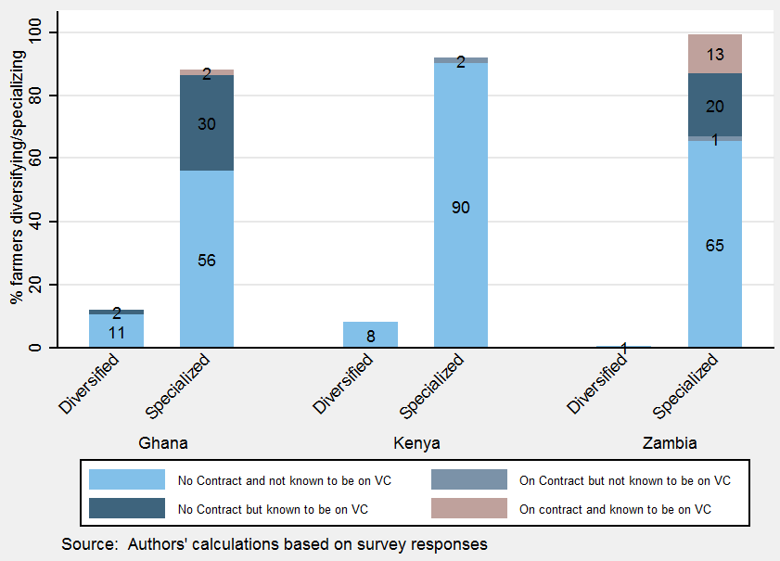

b. Purposive sample

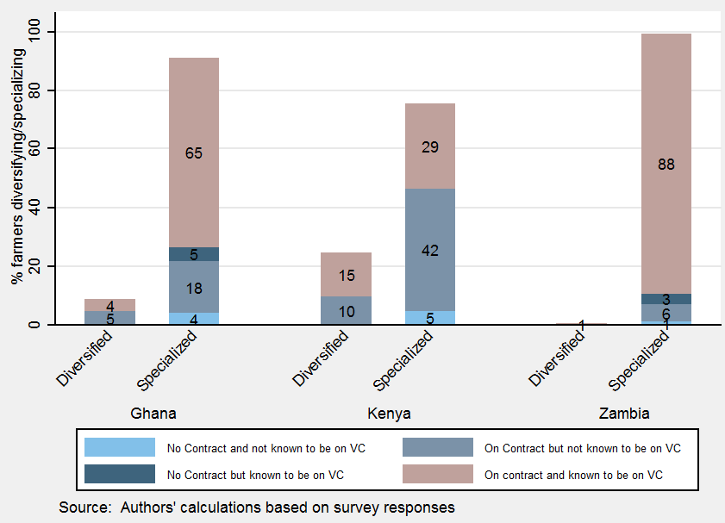

*Source:* Staff calculations based on survey responses.

*Note:* VC = value chain.

*Product upgrading.*[25] Of the universe of farmers who upgraded their planting materials in the hope of improving the quality of their product, a very large share of the purposively targeted farmers in Ghana and Zambia belong to the group that was on contracts and also known to be in value chains. In the case of Kenya, this pattern is not as strong, perhaps due to lack of information on the part of the farmers, or our sample bias. For the randomly selected farmers in Ghana and Kenya, most were neither on contracts nor knew of their participation in value chains when it came to recording improvements in product upgrading. However, in the case of Zambia, there is some difference, where a modest share of randomly selected farmers who improved their products were on contracts and aware of their participation in value chains (figure 14).

**Figure 14: Product Upgrading, by Contract and Value Chain Participation (%)**

a. Random sample

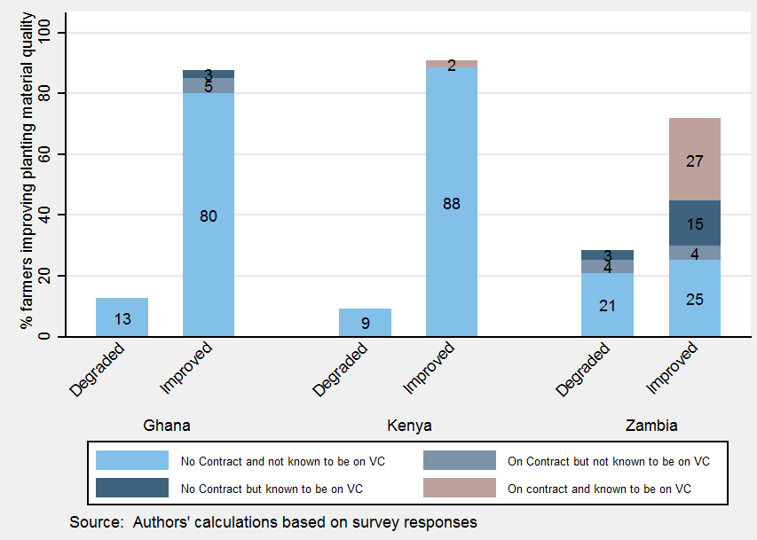

b. Purposive sample

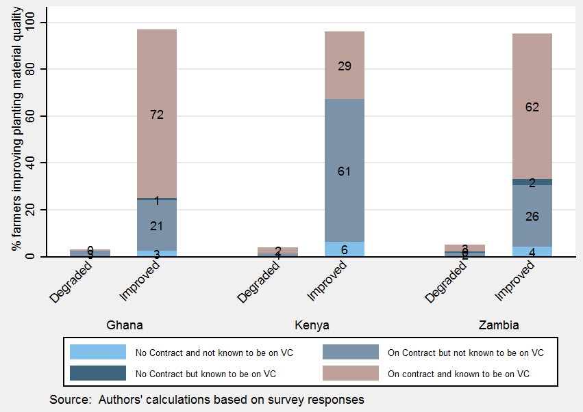

*Source:* Staff calculations based on survey responses.

*Note:* VC= value chain.

*Process upgrading.*[26] Being on a contract as well as having knowledge about participation in value chains seems to be strongly driving the large share of purposively targeted farmers in Ghana and Zambia toward improvement in their planting technique. Although this is also true for Kenya, where 30 percent of the purposively sampled farmers who reported an improvement in their planting technique were on a contract and knew about their participation in value chains compared with 11 percent who were neither on a contract nor knew about being a part of a value chain, this percentage is much smaller than in Ghana and Zambia. In the random sample, however, we note that most of the farmers who upgraded their processes neither were on contract nor knew of their participation in value chains (figure 15).

**Figure 15: Process Upgrading by Contract and Value Chain Participation (%)**

a. Random sample

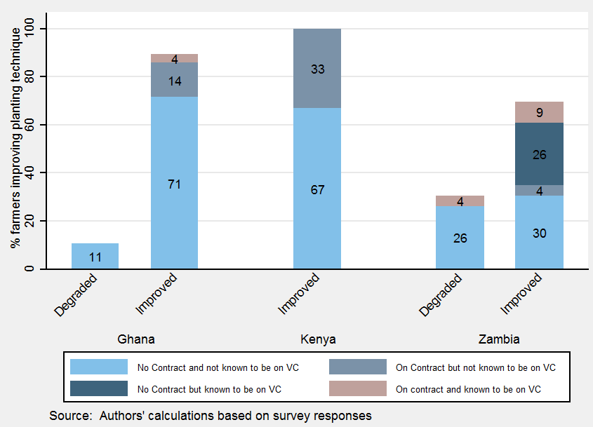

b. Purposive sample

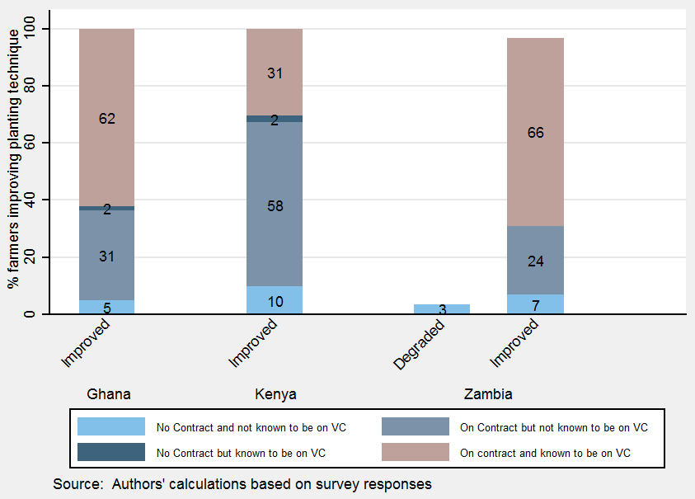

*Source:* Staff calculations based on survey responses.

*Note:* VC = value chain.

*Functional upgrading.*[27] In the cases of Ghana and Zambia, being on a contract and having knowledge about participation in value chains is associated with a high share of purposively sampled farmers undertaking new tasks. However, Kenya differs in this regard, although the share is still higher relative to those who neither were on a contract nor knew about their participation in value chains. Unlike other forms of upgrading, a modest share of randomly sampled farmers upgrading functionally are on contract and are also aware of their participation in value chains (figure 16).

**Figure 16: Functional Upgrading, by Contract and Value Chain Participation (%)**

a. Random sample

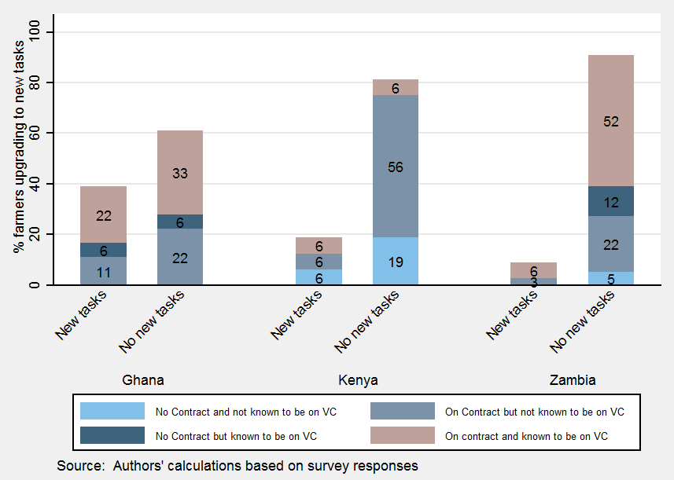

b. Purposive sample

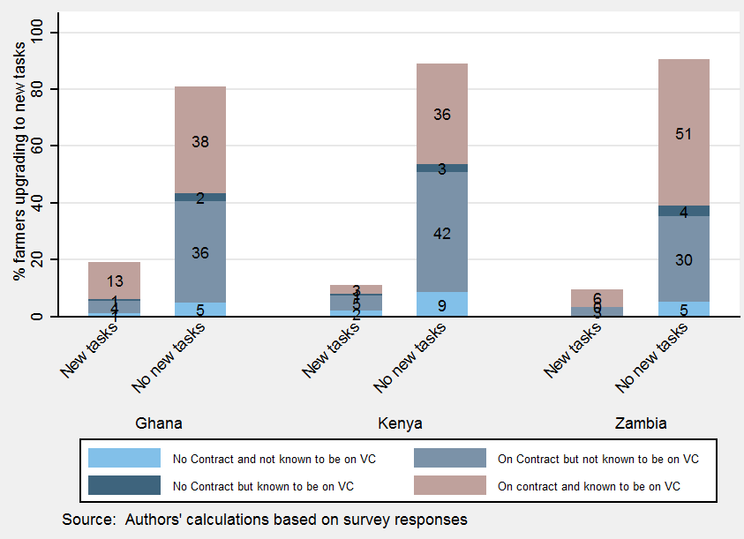

*Source:* Staff calculations based on survey responses.

*Note:* VC = value chain.

*Output.* The average output of maize and sorghum in the three surveyed countries is higher for farmers on contracts and those who know about their participation in value chains relative to those who neither are on a contract nor are aware of their participation in value chains. However, simply being on a contract could be enough to drive higher output of the crop (for example, maize average output per farmer in Kenya). This is not only true for the purposively sampled farmers, but also roughly true for the randomly selected farmers, where at least the knowledge in being on value chains raises the average output, especially that of maize farmers in Zambia (figure 17).

**Figure 17: Output, by Contract and Value Chain Participation (%)**

a. Random sample

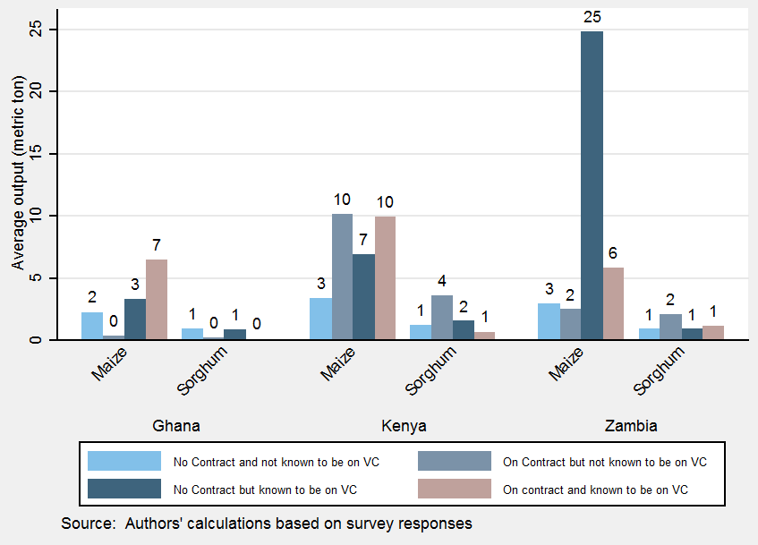

b. Purposive sample

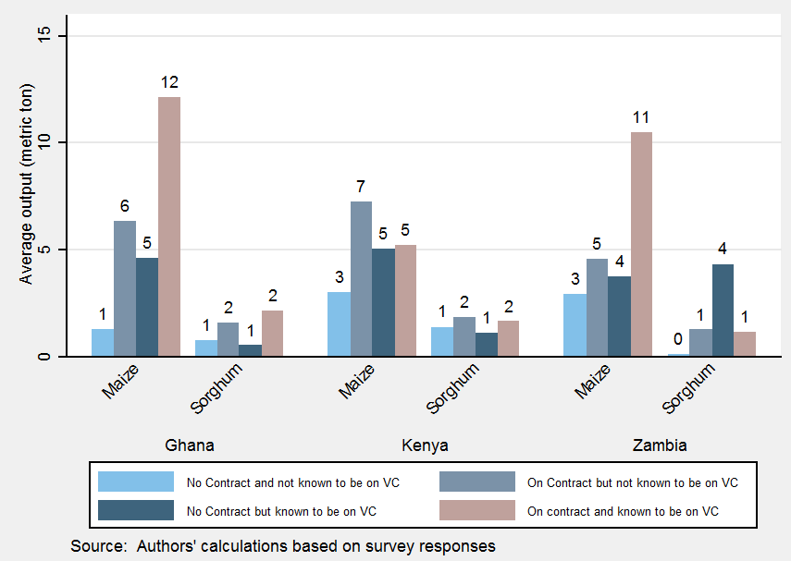

*Source:* Staff calculations based on survey responses.

*Note:* VC = value chain.

*Labor productivity.*[28] Average output per worker in the surveyed countries for maize and sorghum is higher for contractual farmers with information on their participation in value chains, relative to those who neither are on a contract nor aware of their participation in value chains, as well as those on a contract but are unaware of their participation in value chains. This holds true not only for purposively targeted farmers, but roughly also for randomly selected farmers (figure 18).

**Figure 18: Labor Productivity, by Contract and Value Chain Participation (%)**

a. Random sample

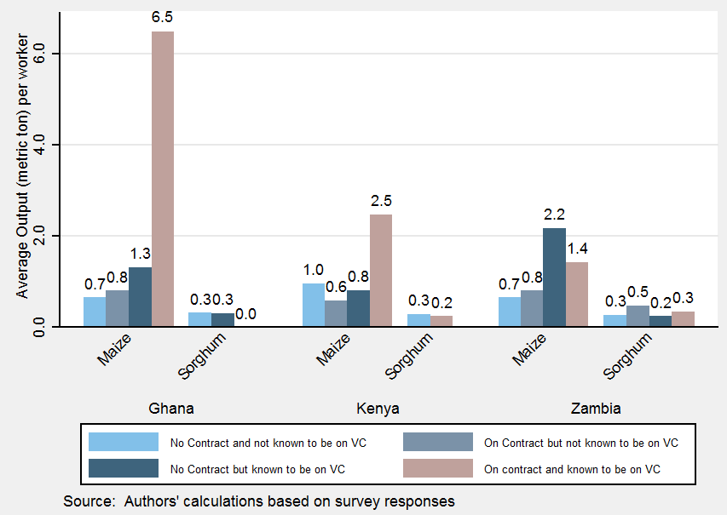

b. Purposive sample

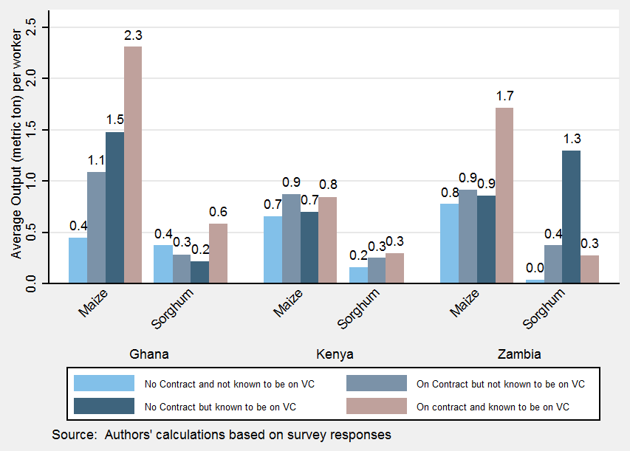

*Source:* Staff calculations based on survey responses.

*Note:* VC = value chain.

A clear message emerging from the interviews with lead firms is the important role played by key processors and buyers in organizing and developing farmers’ capacity to participate effectively and profitably in value chains. Approximately one-third of the farmers on contract mentioned that they receive extension services and training. However, the contract farmers are unable to indicate whether they are participants in a value chain or whether intermediaries are simply selling their products without any value addition. Better linking the farmers and suppliers is essential to inform the development of adequate value chain models for small-scale farmers, who form the bulk of agricultural producers in Sub-Saharan Africa.

***Impact of Value Chains on Structural Transformation: Empirical estimates***

*Empirical Framework/Methodology*

Although the descriptive part of this report points out differences for contract farmers and value chain participants, it is not possible to identify causality from the simple comparison of the means. This section provides comprehensive econometric analysis on the transformational effect of participation in value chains, and aims to address reverse causality and selection bias.

Specification

Measuring value chain participation is a challenge, as it can materialize in different ways and requires valid information from farmers. For example, value chain participation often materializes through contracts as a form of vertical integration, which would suggest that contract farming (formal or informal) could also serve as a proxy for value chain participation. However, we also observe that a farmer can be part of a value chain without a contract. To disentangle the effect of participation in value chains and contract farming on structural transformation, we employ a sensible treatment of the value chain indicator and the contract farming variable separately.

We aim to test the two hypotheses that (i) value chain participants, irrespective of contractual arrangements, are likely to experience upgrading, and (ii) farmers on a formal or informal contract (irrespective of their contract provider) also experience upgrading and productivity increases through the supply of inputs into production, such as fertilizer, extension services, and market information.

We estimate the following specification:

$Y_{i}= f ({VC}_{i}, {Contract}_{i}, X_{i}, d_{j}, c_{n}, p_{k}, ε_{i}, θ)$**(1)**

*Y*𝑖 is the indicator for structural transformation within the agriculture sector, measured by farmers’ *labor productivity* (in logarithm form), *product upgrading*, and *process upgrading* in the baseline specification, and by *specialization* and *functional upgrading* as a robustness check.[29] *X*𝑖 is a vector of household characteristics (household size, age, highest level of education, and land area). The main variables of interest are ${VC}_{i}$ and ${Contract}_{i}.$ ${VC}_{i}$ equals unity if the household sells its produce to a buyer who adds value, and ${contract}_{i}$ equals unity if the household has a contract (formal or informal). 𝑑𝑗, 𝑐𝑛, and 𝑝𝑘 are vectors of regional, country, and crop dummies. $ε_{i}$ denotes the error term and $θ$ is a vector of parameters. Given the challenges in addressing the oversampling of contract farming and value chain participation in our data, we apply equation 1 to the random sample and the purposive sample separately.

Estimation Strategy

We begin estimating equation 1 with simple OLS and probit regressions. However, there are various sources of potential selection bias and therefore endogeneity, which lead to biased and inconsistent OLS and probit estimates. First, farmers can self-select into value chain participation (and contract farming)—the most productive farmers may be those who are more likely to sell their output to a buyer who adds value. Second, lead firms select whom they buy their products from based on specific farmer characteristics, such as access to resources that could also impact the structural transformation variable, such as productivity. Third, there might be additional geographical and crop-specific variables that we cannot observe. Although we can easily control for the third source of selection bias by including regional, country, and crop dummies, the other two sources require estimation techniques that control for observable or unobservable covariates that are correlated with value chain participation.

We apply propensity score matching (PSM) to control for selection bias due to observable heterogeneity. Within a robustness check we also control for selection bias due to unobservables, using a two-step endogenous treatment model. The idea behind PSM is that for every treated (untreated) household, we can find one or more nontreated (treated) households with similar observable characteristics against whom the effect of the treatment can be assessed. The observable characteristics are household size, age, highest level of education, land area, and contract farming.

In addition, a potential bias also arises from the nonprobability sampling strategy. To control for such bias, we apply bootstrapped standard errors. Usually, researchers would apply probability weights to account for oversampling, but this adjustment is only appropriate when the true distribution of the population is known. In the case of an unknown distribution or, generally, insufficient sample size for straightforward statistical inference, Guarte and Barrios (2010) and Adèr, Mellenbergh, and Hand (2008) recommend the bootstrapping resampling method.[30] For the PSM, however, Abadie and Imbens (2008) argue that bootstrapping is not valid when matching with replacement.[31] Since we also refrain from applying probability weights at this stage, we may face a bias in the estimates drawn from the purposive sample because it is not representative for the population. We mainly focus on the estimates obtained from the random sample, as it produces the most reliable results.[32]

*Results*

The main estimation results of the different model specifications and estimation strategies, including OLS, probit, and PSM, are presented in tables 6 and 7.

Table 6 reports the results from simple OLS and probit estimation. With labor productivity as the outcome variable (columns 1 and 2 in table 6), contract farming does not seem to have a significant effect on labor productivity, irrespective of the underlying sample.

***Table 6: Baseline Regression Results: OLS and Probit***

|  |  |  |  |  |  |  |
| --- | --- | --- | --- | --- | --- | --- |
|  | **(1)** | **(2)** | **(3)** | **(4)** | **(5)** | **(6)** |
| **Variable** | **Random sample** | **Purposive sample** | **Random sample** | **Purposive sample** | **Random sample** | **Purposive sample** |
|  | **ln Labor productivity** | | **Process upgrading** | | **Product upgrading** | |
| Contract | 0.165 | 0.0516 | 0.645* | -0.0269 | 0.665*** | 0.169 |
|  | (0.150) | (0.0871) | (0.330) | (0.123) | (0.214) | (0.128) |
| VC | 0.192 | 0.270*** | -0.430 | -0.0828 | -0.375* | -0.175** |
|  | (0.124) | (0.0754) | (0.279) | (0.0823) | (0.206) | (0.0721) |
| Observations | 1,204 | 2,250 | 854 | 2,111 | 1,075 | 2,166 |
| R-squared | 0.386 | 0.349 | 0.136 | 0.266 | 0.183 | 0.209 |

*Note:* Columns 1 and 2: OLS regression; columns 3 to 6: probit regression. Bootstrapped standard errors are in parentheses. Household characteristics (age of household head, education of household head, land area, and size of household) are always included. Country, region, and crop fixed effects are always included. *** p < 0.01, ** p < 0.05, * p < 0.1.

Participation in value chains—proxied by who the farmers sells output to—is positively correlated with labor productivity in the purposive sample.[33] Turning to process upgrading (columns 3 and 4) and product upgrading (columns 5 and 6) as outcome variables, the coefficient estimates now indicate that having a contract is significantly and positively associated with structural transformation in the random sample. In contrast, participation in value chains does not have a positive correlation with the planting technique or the quality of the planting material. Process upgrading and product upgrading are very specific forms of structural transformation, which require access to new inputs and knowledge that might only be provided through a contract rather than through participation in a value chain alone. On the one hand, according to the sample, most of the value chain participants also have a contract with their buyer, so contract farming already captures value chain participation. On the other hand, a contractual arrangement with a non-GVC participant is also likely to provide skills and inputs that will therefore increase the potential of upgrading.

However, the OLS and probit estimates are likely to be biased, because farmers self-select (and are self-selected by firms based on unobservable characteristics) into contract farming and value chains. In the following, we discuss the results from the PSM as a robustness check (table 7). The estimates do not show evidence that value chain participants experience higher labor productivity or upgrading in contrast to nonparticipants who are similar with respect to observable characteristics. Compared with the OLS results, this finding emphasizes the need to control for heterogeneity on the one side, but on the other side, it indicates that value chain participation alone may not trigger structural transformation. Related to this, we employ an alternative setting where contract farming is the treatment variable and find a positive but not significant effect on labor productivity and process and product upgrading in the random sample.[34]

***Table 7: Baseline Regression Results: Propensity Score Matching***

|  |  |  |
| --- | --- | --- |
|  | **(1)** | **(2)** |
| **Variable** | **Random sample** | **Purposive sample** |
| Ln Labor productivity | 0.170 | 0.348 |
| Process upgrading | -0.019 | -0.027 |
| Product upgrading | -0.039 | -0.122 |

*Note:* The control variables are contract farming, age of household head, education of household head, land area, and size of household, with country, region, and crop fixed effects included in each regression. The treatment effect is value chain participation.

The results are comparable to the literature on contract farming only to a small extent. First, the missing significance of the coefficient on contract farming contrasts with past studies, which generally all found a positive effect of contract farming on labor productivity, especially in the OLS setting (Nguyen, Dzator, and Nadolny 2015). A major difference compared with most empirical work on contract farming is the examined variety of crops. Many studies focus on cash crops, such as vegetables and fruits (Maertens and Swinnen 2009); a variety of crops, such as rice, tea, sugar, and tobacco (Maertens and Swinnen 2007; Bellemare 2012), or a specific staple crop, such as rice (Maertens and Vande Velde 2017), which all face different characteristics in the value chain. We control for crop fixed effects in all the estimations because of the potential heterogeneous effects of cassava, sorghum, and maize.

The PSM results estimating the average treatment effect of contract farming are closer to but smaller (and insignificant) than the estimates in the literature. For instance, this can be explained by the finding in Swinnen et al. (2010) that the need for specific inputs in the production of staple crops is much lower than for high-value fruits and vegetables, making contracting less necessary.

Additional differences compared with the literature, which may lead to insignificant results in our study, are the sampling procedure and the inclusion of fixed effects. With the inclusion of regional dummies, we obtain significantly positive results of contract farming when we drop the region-specific dummies. Some regional effects (for example, the Volta region in Ghana, Migori in Kenya, and Tharaka-Nithi in Kenya) capture a large amount of variation in the data, which leads to insignificant results for the remaining variables. Some of the challenges we face in the empirical work are discussed in the robustness checks (see below).

In summary, we cannot confirm the hypothesis that value chain participation leads to structural transformation. Although the reasons and linkages still need to be researched, we cautiously argue at this point that, at least in the probit model, it is contractual arrangements rather than value chains that lead to economic upgrading. Any type of formal or informal agreement that regulates the provision of inputs to production, such as fertilizer, technology, extension services, and market information, is likely to have a stronger effect on upgrading than value chain participation. The hypothesis that the impact on upgrading materializes through the interaction of value chain participation with contract farming is discussed in a robustness check.

*Robustness Checks*

The results from the baseline specification presented in the previous section do not find evidence that there is a direct link between value chain participation and structural transformation. We test this finding against several robustness checks. First, we discuss the results using functional upgrading and diversification as proxies for structural transformation. Second, we argue that the baseline results are still biased because of a selection bias based on unobservables and estimate an endogenous treatment effects model. Third, we discuss the sensitivity of our results to the inclusion of alternative explanatory variables.

Functional Upgrading and Specialization

As a first robustness check, we examine the potential of functional upgrading and specialization as additional forms of structural transformation. This comes with a few caveats. First, f*unctional upgrading* is only captured for contract farmers whereof we cannot estimate the effect of contract farming on structural transformation, but only of value chain participation as a direct proxy. Second, *specialization* is underrepresented in the random sample, which leads to an estimation of the treatment effect of zero. Table 8 presents the PSM estimates as our preferred specification. Interestingly, we find positive and significant treatment effects of value chain participation on *functional upgrading* and *specialization* irrespective of the sample used. Under the circumstances that functional upgrading was only surveyed for contract farmers, the coefficient estimates now indicate that a contract farmer who sells the crop to a value chain is on average more likely to move to higher value-added tasks than a nonparticipant. Similarly, value chain participants seem to experience greater specialization in their output in contrast to nonparticipants. Given the small number of nontreated farmers in this setting and, hence, the lack of a true counterfactual, it is probably not surprising that the treatment effect is highly significant. Although the results point at a relatively strong impact of value chain participation on structural transformation, we treat this finding cautiously and sensitively.

***Table 8: Diversification and Functional Upgrading: PSM Results***

|  |  |  |
| --- | --- | --- |
|  | **(1)** | **(2)** |
| **Outcome variable** | **Random sample** | **Purposive sample** |
| Functional upgrading | 0.243*** | 0.070*** |
| Diversification |  | 0.013*** |

*Note:* The control variables are age of household head, education of household head, land area, and size of household, with country, region, and crop fixed effects included in each regression. The treatment effect is value chain participation. Significant: *** = 1% level.

Endogenous Treatment Effects Model

Our PSM results may still be biased because of unobserved omitted variables that influence self-selection into value chain participation. Therefore, we control for the selection bias due to unobservables in an alternative setup. We estimate the average treatment effect and other parameters of a linear regression model with an endogenous binary treatment variable two-step estimator. The estimator allows for correlation between unobservable factors that affect the treatment as well as unobservable variables that affect the outcome.[35] The main challenge here is finding a valid selection variable. The variable most likely to meet the selection variable criteria is distance to the closest buyer. Distance to the closest buyer proxies for access to information on value chains. Therefore, it is most correlated with the endogenous variable but perhaps affects the outcome variable only through the farmers’ participation in value chains. Thus, the identifying assumption is that proximity to a buyer who has information on value chains for their product does not affect the farmers’ labor productivity and upgrading by itself per se. The advantage of the Heckman procedure against the instrumental variable approach[36] is that it provides a direct test for selection bias. If the Mills ratio, $λ$, is not statistically different from zero, it indicates that there is no selection problem due to unobserved heterogeneity and the PSM results are reliable. Results are reported in table 9.

***Table 9: Robustness Check: Endogenous Treatment Effects Model***

|  |  |  |  |  |  |  |
| --- | --- | --- | --- | --- | --- | --- |
|  | **(1)** | **(2)** | **(3)** | **(4)** | **(5)** | **(6)** |
| **Variable** | **Random sample** | **Purposive sample** | **Random sample** | **Purposive sample** | **Random sample** | **Purposive sample** |
|  | **Labor productivity** | | **Process upgrading** | | **Product upgrading** | |
| Contract | 0.178 | 0.0882 | 0.0551* | -0.0108 | 0.132*** | 0.0319 |
|  | (0.144) | (0.0836) | (0.0334) | (0.0228) | (0.0469) | (0.0248) |
| GVC | 2.382 | -45.48 | 0.0474 | 2.352 | -0.239 | 3.532 |
|  | (3.611) | (36.36) | (0.463) | (2.471) | (1.080) | (4.023) |
| Observations | 1,203 | 2,249 | 1,203 | 2,249 | 1,179 | 2,165 |
| rho | -0.883 | 1 | -0.244 | -1 | 0.312 | -1 |
| sigma | 1.331 | 22.81 | 0.183 | 1.232 | 0.310 | 1.827 |
| lambda | -1.175 | 28.60 | -0.0447 | -1.483 | 0.0966 | -2.237 |
| se(lambda) | 1.160 | 88.58 | 0.219 | 4.783 | 0.397 | 4.605 |

*Note:* Columns 1 and 2: OLS regression; columns 3 to 6: probit regression. Bootstrapped standard errors are in parentheses. Country, region, and crop fixed effects are always included.

Using the selection model, we generally confirm that value chain participation has no effect on structural transformation. Most importantly, the Mills ratio lambda is not significant, irrespective of the model and selection variable.Because of that, the results are similar to the ones obtained with the OLS estimator. We carefully argue that we do not face a severe selection bias based on unobservables, and that our PSM results are unbiased and reliable. However, multicollinearity may be an issue here because of some implausible coefficient estimates. Additional variables that could serve as an instrument for value chain participation were also tested. Although the results are similar, farmers’ motivation, experience in farming, and satisfaction with their buyer (complaints) are not shown to be valid instruments either.

Model Variations

Based on the discussion of the baseline regression results, the effect of value chain participation on structural transformation is likely to be higher when the product is sold to a value chain under a contract, because a formal or informal agreement regulates the provision of inputs into production, such as fertilizer, technology, extension services, market information, and so forth. To test this hypothesis, we employ an alternative specification where the main variable of interest is the interaction term of value chain participation and contract farming (equation 2).

$Y_{i}= f ({VC}_{i}\#{Contract}_{i}, {Contract}_{i}, X_{i}, d_{j}, c_{n}, p_{k}, ε_{i}, θ)$**(2)**

The results are provided in tables 10 and 11 in annex A. Compared with table 6, columns 1 and 2, the interaction of value chain participation with contract farming is indeed larger and also significant in the random sample (0.480**) using simple OLS. However, there is still no positive effect when using the PSM estimator. Similarly, separate inclusion of contract farming and value chain participation also yields insignificant results.

Our results may also be driven by country-specific characteristics. Based on the findings in the descriptive part of the paper, that value chain participants in Ghana experience higher labor productivity, we may expect a sensitivity of the results to the sampled countries. Therefore, equation 1 is estimated only for Ghana, and only for Ghana and Zambia.[37] Although the positive coefficient estimate of value chain participation slightly increases compared with table 6, column 2 when Ghana and Zambia are included, it becomes insignificant when only farmers in Ghana are sampled. Thus, within-country variation in labor productivity may not be driven by contract farming or value chain participation, but rather determined by other country and/or regional characteristics. Indeed, the significance of the coefficient estimates of contract farming and value chain participation increases in most specifications when regional dummies are dropped. The inclusion of regional dummies is one reason why we obtain different results compared with the literature on contract farming. We may argue that within the same region, the treatment effect of contract farming or value chain participation versus nontreated groups might not be significant because of regional spillover effects to noncontract farmers or generally smaller differences in farming.

Furthermore, we compare the results against the inclusion of additional variables that are likely to have a direct influence on labor productivity and upgrading. We test the impact of fertilizer and access to communications and technology to be able to inform about the importance of the provision of various inputs to production. The amount of fertilizer used has a positive and significant effect on product upgrading, but not on process upgrading and labor productivity. Access to communications and technology also seems to have no impact on structural transformation. Most importantly, the variables of interest are robust to this inclusion. The relatively small effect of these inputs may also partly explain the non-significance of contract farming and value chain participation. Related to this, some contractual arrangements might be relatively weak and insufficient to spur upgrading. According to the survey responses, 20 percent of noncontract famers and 12 percent of contract farmers report that they have had a problem with their buyers in the past. We find a significantly negative correlation of farmers’ complaints with the likelihood of having a contract with their buyer. This might also explain the underlying study’s inconsistent results with previous literature. In addition, the observation that most farmers have no access to legal support may raise the question about power relationships between buyers and sellers. Inequalities may lower the benefits to farmers from participating in contract farming and value chain participation.

1. **Conclusion and Next Steps**

What are the appropriate policies that will allow countries in Africa to support employment growth in more productive and higher value-added activities within the agriculture sector?

Our surveys reveal that market conditions are different for the selected crops—maize, cassava, and sorghum—across Ghana, Kenya, and Zambia. Maize is clearly a well-established but complex value chain in Kenya and Zambia. Value chains in maize seem to be well developed, have significant government investments, and benefit from interest from key stakeholders. By contrast, in Ghana the maize sector is less developed.

In Ghana, cassava is the main value chain, receiving the most investment. Cassava has significant untapped potential (mainly as starch) in Zambia and Kenya in the brewing and manufacturing industries. But there are logistical and varietal challenges to overcome before the benefits can be realized. It is important to investigate this value chain further to understand the current and potential regional and international linkages and what can be done to develop them in the near future.

Sorghum has potential in the beer industry but many regulatory challenges remain in all three countries. For example, policy aspects on taxation are important, as they affect the final product and are passed to the farmer by the processor. In Kenya, the government-levied excise tax on sorghum for clear beer has had a negative impact on sorghum production at the farm level. It took several years after the reversal of the taxation for farmers to pick up production of sorghum.

Our results show that farmers who are on a contract witnessed higher output and better access to seeds, fertilizers, pesticides, technology, and extension services, compared with farmers who were not on a contract. Interestingly, the support received by farmers on informal contracts often exceeded the support received by those on formal contracts, for extension services, seeds, fertilizers, and tractors. Many farmers reported an increase of half or more in their income and output as a result of contractual arrangements. In Ghana, farmers on informal contracts benefited from higher income and output increases than their peers on formal contracts. In Zambia, more than 25 percent of the formal contract farmers did not report increases in income or output. Farmers also benefited from a variety of services from contract providers. Although information on markets was the top service received by contract farmers in Ghana and Kenya, distribution of inputs dominated the services inputs supplied to Zambian farmers. Finally, as a result of participating in a contract, many farmers in all three countries engaged in new tasks.

Being part of a contract does not necessarily mean that the farmer is part of a value chain. However, it would be safe to say that being part of a contract brings the farmer “close” to the value chain. Therefore, being part of a contract is an important but not sufficient criterion for a farmer to be part of a value chain. Of the interviewed farmers under contract, about 50 to 60 percent of them in Ghana and Zambia knew about their participation in value chains. In Kenya, the majority of the interviewed farmers had no knowledge about the usage of their crops. In general, farmers on a contract with knowledge about their participation in value chains tend to lead in upgrading and labor productivity.

Based on the empirical evidence, the hypothesis that value chain participation leads to structural transformation cannot be confirmed. While we obtain insignificant coefficient estimates for the indicator variables contract farming and value chain participation in most Propensity score matching specifications the effect of contract farming on economic upgrading seems to be stronger than participation in a value chain alone.

Any type of formal or informal agreement which regulates the provision of inputs to production, such as fertilizer, technology, extension services and market information is likely to have a stronger effect on upgrading than value chain participation. This, a key policy message emerges from the analysis. It is important to understand the impact of government policies on the emergence of value chains. For example, in Zambia, the National Cereals and Produce Board and the Food Reserve Agency play dual roles on behalf of the government to manage price stabilization and strategic food reserves. They tend to distort market prices or competition through quotas or taxes, deterring investors from entering the markets and developing value chains. In deciding on future policies in the agriculture sector, it is important for countries to recognize that achieving domestic food security and better integrated value chains and export growth are not mutually exclusive or even opposing objectives and could be complementary in an improved policy environment.

**References**

Abadie, A. and Imbens, G. W. 2008. “On the failure of the bootstrap for matching estimators.” Econometrica, 76(6):1537–1557.

ActionAid International. 2015. “Contract Farming and Out-Grower Schemes: Appropriate Development Models to Tackle Poverty and Hunger?” Policy discussion paper, ActionAid International, Chard, United Kingdom.

Ader, H. J., Mellenbergh, G. J., and Hand, D. J. 2008. “Advising on research methods: A consultant’s companion.” Johannes van Kessel Publishing, Huizen.

Anderson, J., Marita, C. and Musiime, D. 2016. “National Survey and Segmentation of Smallholder Households in Tanzania”, CGAP.

Baldwin, J., and B. Yan. 2014. “Global Value Chains and the Productivity of Canadian Manufacturing Firms.” Economic Analysis Research Paper Series, Statistics Canada, Ottawa.

Bellemare, M. F. 2012. “As You Sow, So Shall You Reap: The Welfare Impacts of Contract Farming.” *World Development* 40 (7): 1418–34.

Bravo-Ortega, C., and D. Ledermann. 2005. “Agriculture and National Welfare around the World: Causality and International Heterogeneity since 1960.” Policy Research Working Paper 3499, World Bank, Washington, DC.

Byerlee, D., A. de Janvry, and E. Sadoulet. 2009. “Agriculture for Development: Toward a New Paradigm.” <http://are.berkeley.edu/~esadoulet/papers/Annual_Review_of_ResEcon7.pdf>.

Chenery, H., S. Robinson, and M. Syrquin. 1986. *Industrialization and Growth: A Comparative Study*. Washington, DC: World Bank.

Christiaensen, L., and L. Demery. 2018. “Agriculture in Africa: Telling Myths from Facts.” World Bank, Washington, DC.

Datt, G., and M. Ravallion. 1996. “How Important to India’s Growth Is the Sectoral Composition of Economic Growth?” *World Bank Economic Review* 1 (1): 1–15.

de Janvry, A., and E. Sadoulet. 2010. “Agriculture for Development in Sub-Saharan Africa: An Update.” *African Journal of Agricultural and Resource Economics* 5 (1).

Diao, X., and A. N. Pratt. 2007. “Growth Options and Poverty Reduction in Ethiopia: An Economy-Wide Model Analysis.” *Food Policy* 21: 205–28.

Fawole, P., K. A. Thomas, and V. O. Okoruwa. 2011. “Effect of Contract Farming Scheme on Cassava Production Enterprise in Oyo State, Niger.” *Journal of Rural Economics and Development* 20 (1).

Gollin, W. 2010. “Agricultural Productivity and Economic Growth.” In [*Handbook of Agricultural Economics*](https://ideas.repec.org/s/eee/hageco.html), edited by Robert Evenson and Prabhu Pingali, edition 1, 4 (1). Elsevier.

Guarte, J. M. and Barrios, E. B. 2006. “Estimation under purposive sampling. Communications in Statistics - Simulation and Computation”, 35(2):277–284.

Haggblade, S., B. R. Hazell, and T. Reardon. 2007. “Transforming the Rural Nonfarm Economy: Opportunities and Threats in the Developing World.” International Food Policy Research Institute, Washington, DC.

Hoeffler, H. 2006. “Promoting the Kenyan Potato Value Chain: Can Contract Farming Help Build Trust and Reduce Transaction Risks?” European Association of Agricultural Economists 99th Seminar, Bonn, Germany.

Hsieh, D. T., and P. J. Klenow. 2009. “Misallocation and Manufacturing TFP in China and India.” NBER Working Paper 13290, National Bureau of Economic Research, Cambridge, MA.

IFPRI (International Food Policy Research Institute). 2010. “Maize Value Chain Potential in Ethiopia.” Globalization and Markets Program, Project Working Paper, IFPRI, Washington, DC.

Imbs, J., C. Montenegro, and R. Wacziarg. 2011. “The Geography of Structural Change.” http://siteresources.worldbank.org/DEC/Resources/84797-1288039483669/7501129-1317230860662/Imbs_10-01-11.pdf.

Kleemann, L., Abdulai, A., and Buss, M. 2013. “Is organic farming worth its investment? The adoption and impact of certified pineapple farming in Ghana.” Working Paper 1856, Institute for the World Economy, Kiel.

Kongsamut, P., S. Rebelo, and X. Danyang. 2001. “Beyond Balanced Growth.” *Review of Economic Studies* 68: 869–82.

Kummritz, V., D. Taglioni, and D. Winkler. 2017. “Economic Upgrading through Global Value Chain Participation: Which Policies Increase the Value Added Gains?” Policy Research Working Paper 8007, World Bank, Washington, DC.

Kuznets, S. 1955. “Economic Growth and Income Inequality.” *American Economic Review* 65 (1): 2–28.

———. 1966. *Modern Economic Growth: Rate, Structure, and Spread*. New Haven, CT: Yale University Press.

Lewis, W. A. 1954. “Economic Development with Unlimited Supplies of Labour”. *The Manchester School* 22(2): 139-191

Little, P., and M. Watts. 1994. *Living Under Contract: Contract Farming and Agrarian Transformation in Sub-Saharan Africa*. Madison, WI: University of Wisconsin Press.

Maertens, M., and J. F. M. Swinnen. 2009. “Trade, Standards, and Poverty: Evidence from Senegal.” *World Development* 37 (1): 161–78.

Maertens, M., and K. Vande Velde. 2017. “Contract-Farming in Staple Food Chains: The Case of Rice in Benin.” *World Development* 95: 73–87.

McKinsey Global Institute. 2014. “From Poverty to Empowerment: India’s Imperative for Jobs, Growth and Effective Basic Services.” McKinsey Global Institute, Shanghai.

Mellor, J. W. 1995. *Agriculture on the Road to Industrialization*. Baltimore, MD: International Food Policy Research Institute.

Minot, N. 2007. “Contract Farming in Developing Countries: Patterns, Impact, and Policy Implications.” Case Study 6-3, Food Policy for Developing Countries: The Role of Government in the Global Food System, Cornell University, Ithaca, NY.

Minot, N., and M. Ngigi. 2004. “Are Horticultural Exports a Replicable Success Story? Evidence from Kenya and Côte d’Ivoire.” EPTD Discussion Paper No. 120. Environment, Production, and Technology Division, International Food Policy Research Institute, Washington, DC.

Minot, N., and L. Ronchi. 2014. “Contract Farming.” Viewpoint Note 344, World Bank Group, Washington, DC.

Miklyaev, M., S. Afra, M. Schultz, and A. Awantang. 2017. “Cost Benefit Analysis of Mali’s Sorghum and Millet Value Chains.” Development Discussion Paper, 2017-03. EDIRC. Kingston

Ngai, L. R., and C. A. Pissarides. 2007. “Structural Change in a Multisector Model of Growth.” *American Economic Review* 97 (1): 429–43.

Nguyen, A. T., J. Dzator, and A. Nadolny. 2015. “Does Contract Farming Improve Productivity and Income of Farmers? A Review of Theory and Evidence.” *Journal of Developing Areas* 49 (6): 531–38.

Page, J. 2012. “Aid, the Private Sector and Structural Transformation in Africa.” UNU-WIDER Working Paper 2012/21, United Nations University World Institute for Development Economics Research, Helsinki, Finland.

Page, J., and A. Shimeles. 2014. “Aid, Employment, and Poverty Reduction in Africa.” United Nations University World Institute for Development Economics Research, Helsinki, Finland.

PIND (Partnership Initiatives in the Niger Delta). 2011. “A Report on Cassava Value Chain Analysis in the Niger Delta.” Foundation for PIND, Abuja, Nigeria.

Rangarajan, C. 1982. “Agricultural Growth and Industrial Performance in India.” Research Report 33, International Food Policy Research Institute, Washington, DC.

Reardon, T., C. B. Barrett, J. Berdegué, and J. Swinnen. 2009. “Agrifood Industry Transformation and Small Farmers in Developing Countries.” *World Development* 37 (11): 1717–27.

Rodrik, D., and M. McMillan. 2011. “Globalization, Structural Change and Productivity Growth.” NBER Working Paper 17143, National Bureau of Economic Research, Cambridge, MA.

Sahoo, B. B. 2010. “Global Market and Local Players: A Value Chain System of Collaborative Strategies.” *Agricultural Economics Research Review* 23: 535–43.

Schneider, K., and M. K. Gugerty. 2011. “Agricultural Productivity and Poverty Reduction: Linkages and Pathways.” *The Evans School Review* 1 (1).

Singh, S. 2002. “Contracting Out Solutions: Political Economy of Contract Farming in the Indian Punjab.” *World Development* 30 (9): 1621–38.

Staritz, C., and J. G. Reis. 2013. “Global Value Chains, Economic Upgrading, and Gender: Case Studies of the Horticulture, Tourism, and Call Center Industries.” Working Paper, World Bank, Washington, DC.

Stöllinger, R. 2017. “Global Value Chains and Structural Upgrading.” Wiiw Working Paper 138, Vienna Institute for International Economic Studies, Vienna, Austria.

Swinnen, J. F. M., Vandeplas, A., and Maertens, M. 2010. “Liberalization, endogenous institutions, and growth: A comparative analysis of agricultural reforms in Africa, Asia, and

Europe.” The World Bank Economic Review, 24(3):412–445.Swinnen, J. F. M., A. Vandeplas, and M. Maertens. 2010. “Liberalization, Endogenous Institutions, and Growth: A Comparative Analysis of Agricultural Reforms in Africa, Asia, and Europe.” *World Bank Economic Review* 24 (3): 412–45.

Taglioni, D., and D. Winkler. 2016. *Making Global Value Chains Work for Development*. Washington, DC: World Bank Group.

Thirtle, C., L. Lin, and J. Piesse. 2003. “The Impact of Research-Led Agricultural Productivity Growth on Poverty Reduction in Africa, Asia and Latin America.” *World Development* 31 (12): 1959–75.

Timmer, C. P. 1995. “Introduction to Getting Agriculture Moving.” *Food Policy* 20 (5): 379–83.

———. 2002. “Agriculture and Economic Development.” In *Handbook of Agricultural Economics*, 2A, edited by B. L. Gardner and G. C. Rausser, 1487–1546. Amsterdam: North Holland.

———. 2009a. “A World without Agriculture: The Structural Transformation in Historical Perspective.” Henry Wendt Lecture, American Enterprise Institute, Washington, DC.

———. 2009b. “Do Supermarkets Change the Food Policy Agenda?” *World Development* 37 (11): 1812–19.

UNIDO (United Nations Industrial Development Organization). 2011. “Agribusiness for Africa’s Prosperity.” UNIDO, Vienna.

USAID (U.S. Agency for International Development). 2015. “Maize Value Chain Analysis.” Kenya Agricultural Value Chain Enterprises (USAID-KAVES), Nairobi, Kenya.

Winkler, D., and T. Farole. 2015. “Global Value Chain Integration and Productivity: Evidence from Enterprise Surveys in Namibia, South Africa, and Swaziland.” Working Paper 102986, World Bank, Washington, DC.

World Bank. 2016. “Fact Sheet: The World Bank and Agriculture in Africa.” <http://web.worldbank.org/WBSITE/EXTERNAL/COUNTRIES/AFRICAEXT/0,,contentMDK:21935583~pagePK:146736~piPK:146830~theSitePK:258644,00.html>.

World Bank (2017). On the structural transformation of rural africa. World Bank Policy Research Working Paper 7938, The World Bank, Washington, D.C.

Wupper, D. and Sauer, J. (2015). Contributing to contract farming: Is farmer behavior determinedby the past? Technical report, Technical University Munich, Munich.

Yorobe, J. M. and Smale, M. (2012). Impacts of bacillus thuringiensis maize on smallholder income in the Philippines. AgBioForum, 15(2):152–162.

**Annex A: Tables**

***Table 10: Specification Variation: OLS and Probit Regression Results***

|  |  |  |  |  |  |  |
| --- | --- | --- | --- | --- | --- | --- |
|  | **(1)** | **(2)** | **(3)** | **(4)** | **(5)** | **(6)** |
| **Variable** | **Random sample** | **Purposive sample** | **Random sample** | **Purposive sample** | **Random sample** | **Purposive sample** |
| Contract | -0.0245 | -0.0309 | 1.781 | -0.0135 | 0.756** | 0.195 |
|  | (0.151) | (0.0936) | (1.987) | (0.125) | (0.329) | (0.120) |
| VC#Contract | 0.480** | 0.286*** | -1.991 | -0.0606 | -0.439 | -0.122 |
|  | (0.226) | (0.0763) | (2.081) | (0.0964) | (0.368) | (0.0877) |
| Observations | 1,204 | 2,250 | 854 | 2,111 | 1,075 | 2,166 |
| R-squared | 0.387 | 0.349 |  |  |  |  |

*Note:* Columns 1 and 2: OLS regression; columns 3 to 6: probit regression. Bootstrapped standard errors are in parentheses. Household characteristics (age of household head, education of household head, land area, and size of household) are always included. Country, region, and crop fixed effects are always included. *** p < 0.01, ** p < 0.05.

***Table 11: Specification Variation: PSM***

|  |  |  |
| --- | --- | --- |
|  | **(1)** | **(2)** |
| **Outcome variable** | **Random sample** | **Purposive sample** |
| Labor productivity | 0.110 | 0.384 |
| Product upgrading | 0.111 | -0.087 |
| Process upgrading | -0.085 | -0.033 |

*Note:* The control variables are age of household head, education of household head, land area, and size of household, with country, region, and crop fixed effects included in each regression. The treatment effect is value chain participation*Contract.

**Annex B: Sampling**

***Purposive Sampling***

In essence, farmers under a scheme arrangement were purposively selected. The schemes were identified before the data collection commenced and the field teams purposively targeted farmers within these schemes for an interview. In addition, a random sampling approach was employed in the full survey. After completing all the interviews with the farmers of one particular scheme, a random selection of farmers were interviewed in the same area where the target crop could be found but at a distance from where the scheme was carried out.

The scoping trips prior to the fieldwork led to schemes with contract farmers growing one of the target crops, which allowed us to scope a purposive sample of farmers to be considered for the study. For lack of reliable and up-to-date information, the selection of the contract farmers could not be based on a list of the universe of farmers participating in a scheme. Thus, our survey identified farmers based on the information provided by a group’s leaders. In most cases, all the available farmers in the scheme were interviewed, given that the grower schemes were mostly small. However, in other cases, not all the farmers who participated in the scheme could be interviewed.[38] For larger schemes that were spread across a wide area, farmers were selected in a certain area that could be covered by the enumerators in a reasonable amount of time. To complete the surveys in a timely manner, the teams focused on high-density areas and disregarded areas with very few farmers. However, there were few large schemes, and in general the proportion of active farmers in such schemes was rather small. Finally, screening questions were applied to ensure that the selected household was involved in farming in one of our target crops. The selected respondents were the household head or the household head’s spouse.

***Random Sampling***

After our targeted interviews with farmers under a scheme, an additional sample of farmers was randomly selected. For randomly selected farmers, a location in the proximity of the scheme was selected to conduct half the number of the interviews that was achieved under the scheme. However, this target could not be fulfilled in all areas due to lack of sufficient number of farmers growing the target crop. Furthermore, this location was carefully selected to be sufficiently outside the catchment area of the scheme to avoid any sort of contamination of the random sample with the purposive sample. Before selecting the location of the random sample, the survey team would obtain information from the group representatives on the spread of the farmers within the scheme. However, the location was still in the same area as the scheme, to ensure that the physical and climatological conditions would be similar as much as possible. For example, in Kenya, the scheme and the randomly selected sample were located in the same district or division. The “control group” was randomly selected using a skip interval. The skip was based on the number of farmers in an enumeration area divided by the target number of interviews in that area.

The “control group” comprises farmers who were interviewed in the same regions as the farmers operating in a scheme, but at a sufficient distance for them not to be affected by the schemes or programs. To achieve a random sample that is as comparable to the purposive sample as possible, after completing the interviews of each group, a random sample was collected that is proportionate to the number of group members interviewed. To locate the randomly selected farmers, we asked the group’s officials to demarcate the area in which the contract farmers were located. After that, the group officials were asked to advise us on locations outside the area of the scheme, but within the same larger geographical area to keep the main characteristics (environmental conditions and so forth) comparable.

1. Nora Dihel ([ndihel@worldbank.org](mailto:ndihel@worldbank.org)) and Claire H. Hollweg ([chollweg@worldbank.org](mailto:chollweg@worldbank.org)) are Senior Economist and Economist in the Macroeconomics, Trade and Investment (MTI) Global Practice of the World Bank Group. Arti Grover ([agrover1@worldbank.org](mailto:agrover1@worldbank.org)) is Senior Economist in the Finance, Competitiveness and Innovation (FCI) Global Practice of the World Bank Group. Anja Slany ([Anja.Slany@ruhr-uni-bochum.de](mailto:Anja.Slany@ruhr-uni-bochum.de)) is Consultant with the World Bank and Research and Teaching Assistant, Chair of International Economics at Bochum University. The authors thank Michael Ferrantino and Loraine Ronchi for valuable comments. The findings, interpretations, and conclusions expressed in this paper are those of the author and do not represent the views of the World Bank, its Executive Directors, or the countries they represent.
2. This project adopts a broader interpretation of structural transformation as opposed to traditional views that emphasize the reallocation of production factors or resources between sectors. More recent literature on structural transformation stresses the role that productivity growth within sectors can play and the potential from moving factors of production between firms within sectors.
3. Farmers knew that their crop ends up in a value chain.
4. In the literature, value chains have been defined using varying criteria. For our study we define a value chain as: a farmer is part of a value chain if (through a contract) she sells output to a buyer who adds value.
5. Contractual arrangements cover production by farmers under agreement with buyers for their output.
6. Lead firms can be defined as small, medium, or large firms that have forward or backward commercial linkages with a significant number of other firms. In agricultural value chains, these tend to be micro, small, and medium enterprises (MSMEs). Examples of lead firms include buyers, traders, input suppliers, exporters, and processors. Lead firms often provide support to the MSMEs they buy from or sell to, as part of their commercial relationships with them. This could come in the form of training, technical assistance, or inputs.
7. When these markets are abroad and at least part of the production process also takes place abroad, we refer to GVCs (if global/international markets are involved) or regional value chains (if only regional markets are involved).
8. We use OLS and probit regressions as well as propensity score matching.
9. See, for example, Lewis (1954), Kuznets (1955), Chenery, Robinson, and Syrquin (1986), Kuznets (1966), Kongsamut, Rebelo, and Danyang (2001), and Ngai and Pissarides (2007).
10. Herrendorf, Rogerson, and Valentinyi (2013); Imbs, Montenegro, and Waczarg (2011).
11. Chenery, Robinson, and Syrquin (1986).
12. Thirtle, Lin, and Piesse (2003); Datt and Ravallion (1996); Schneider and Gugerty (2011).
13. This view can be characterized as the Mellor-Hypothesis; see Mellor (1995).
14. Haggblade, Hazell, and Reardon (2007); Timmer (1995).
15. For instance, Rangarajan (1982) estimates a growth elasticity of 0.5 percent for India. Similar results are obtained by Timmer (2002) and De Janvry and Sadoulet (2010). Estimates by Bravo-Ortega and Ledermann (2005) for Latin America and the Caribbean are much weaker. Gollin (2010) provides an extensive literature review of the empirical evidence linking growth in the agriculture sector to economic growth.
16. Reardon et al. (2009). Based on a literature review, the study shows that agri-food farming provides higher earnings than traditional farming (Timmer 2009a).
17. UNIDO (2011) provides a detailed discussion of 10 African examples of upgrading in agricultural value chains.
18. Using household surveys and agricultural sample surveys, Diao and Pratt (2007) find that for Ethiopia, growth in cereal staple crop productivity has greater potential to reduce poverty than any other agricultural or non-agriculture sector.
19. Jayne et al. (2010) use case studies from Kenya, Malawi, Mozambique, and Zambia to identify current patterns in smallholder farmer behavior and challenges to agricultural productivity growth.
20. For HQCF, cassava needs to be processed within 24 hours.
21. Some skepticism regarding contract farming has been raised in the literature (Little and Watts, 1994; Singh, 2002). By taking advantage of the land and paying lower wages, contract farming may lead to income inequality and indebtedness. However, a growing body of evidence suggests that modern agricultural value chains effectively internalize many of the inefficiency in traditional agriculture in Africa, and the emergence of new ways of linking farmers to consumers especially by promoting uptake of modern inputs, innovation in post-harvest practices and upgrading of quality control have the potential to boost productivity (The World Bank, 2017).
22. A contractual partnership between growers or landholders and a company for the production of crops for commercial usage.
23. In the graphs shown for the purposive sample, we tested for the outcome being significantly higher in three alternative scenarios. In one scenario, we considered whether farmers on contracts had better outcomes vis-à-vis those not on contracts; in an alternative scenario, we tested whether those farmers who were aware of their participation in value chains showed better outcomes vis-à-vis those who were not aware of their participation; and lastly, we considered whether those farmers who were on contracts and aware of their participation in value chains had better outcomes than those who neither were on contracts nor knew of their participation in value chains. In this setting, we mostly found that farmers on contracts had results that were statistically significantly different from those not on contracts. The outcome variables were comprised of specialization productivity, price, output, income, and all forms of upgrading. The p-values for these tests range from 0.003 in the case of output, 0.029 in the case of labor productivity, and 0.047 for price. The p-values were 0.012 for functional upgrading, 0.003 for product upgrading, 0.001 for process upgrading, and 0.057 for specialization. However, when considering the value chain element, that is, considering farmers who were aware of their participation in value chains vis-à-vis not on value chains or those on contracts as well as those aware of their participation in value chains vis-à-vis those who were neither on contracts nor aware of their participation in value chains, the results were mixed and most often the differences were not statistically significant, with p-values ranging from 0.35 to 0.87.
24. Specialization/diversification is the number of crops produced by a farmer, identified by adding up affirmative responses for the current period and for the previous period. The difference in the number of crops grown in the current period less the previous period is used to measure the change in crop production pattern. A positive difference indicates diversification; a negative difference shows specialization; and no change is measured with a zero difference.
25. Product upgrading in farm production can be measured through the changes in the quality of planting material, particularly seeds. A move from a local/traditional variety to an improved/hybrid variety is defined as product upgrading.
26. Process upgrading in farm production can be measured through the changes in the quality of the planting technique. A move from the traditional/broadcasting technique to better recommended techniques such as line planting is defined as process upgrading.
27. Functional upgrading in farm production can be measured through the farmers diversifying into new and higher value-added tasks, such as food processing, crop marketing, and so on. This was not captured for noncontractual farmers.
28. Labor productivity is measured as output of the given crop per worker for single-crop growers only, as it is difficult for farmers with multiple crops to assign labor to specific plots/crops. Single-crop growers were identified and labor productivity was obtained by dividing the output of each crop by the total employment. The output values were winsorized at the top and bottom 1 percent by country.
29. *Functional upgrading* is only captured for contract farmers; therefore, we do not have a counterfactual for contract farmers. Similarly, *specialization* is underrepresented in the random sample and therefore will only be examined as a robustness check.
30. Bootstrapping is commonly used to adjust standard errors in the literature. For an application in the context of contract farming and agricultural economics. see Yorobe and Smale (2012); Maertens and Swinnen (2009); Wuepper and Sauer (2015); or Kleemann, Abdulai, and Buss (2013).
31. Because of a relatively small sample size, we refrain from estimating PSM without replacement.
32. Despite the lack of information on the true distribution of value chain participation, we also applied probability weights to the purposive sample as part of several robustness checks. We relied on the distribution drawn from the random sample to obtain an estimate of the average treatment effect of value chain participation. However, we feel that this unconventional method leads to an additional bias and refrain from interpreting the results.
33. Contract farming is still not significant in either specification when value chain participation is dropped from the estimation.
34. The results are not reported here to save space, but are available on request.
35. The first-stage probit model is used to calculate the inverse Mills ratio, which is then used as an additional regressor in the second-stage OLS to provide adjusted estimates of the impact of the treatment on the outcome of interest.
36. The instrumental variable approach and Heckman selection model would generally produce similar estimates. However, the Mills ratio is derived under the normality assumption. In the absence of normality, instrumental variables should be preferred.
37. The results are not reported here, but available on request.
38. For instance, the farmers had only started producing under the scheme this season for the first time and had not yet harvested, or the farmers that had only harvested for the last time under the scheme two or more years ago and so on.