Understanding people’s experiences with identification:
A guide for qualitative end-user research on ID

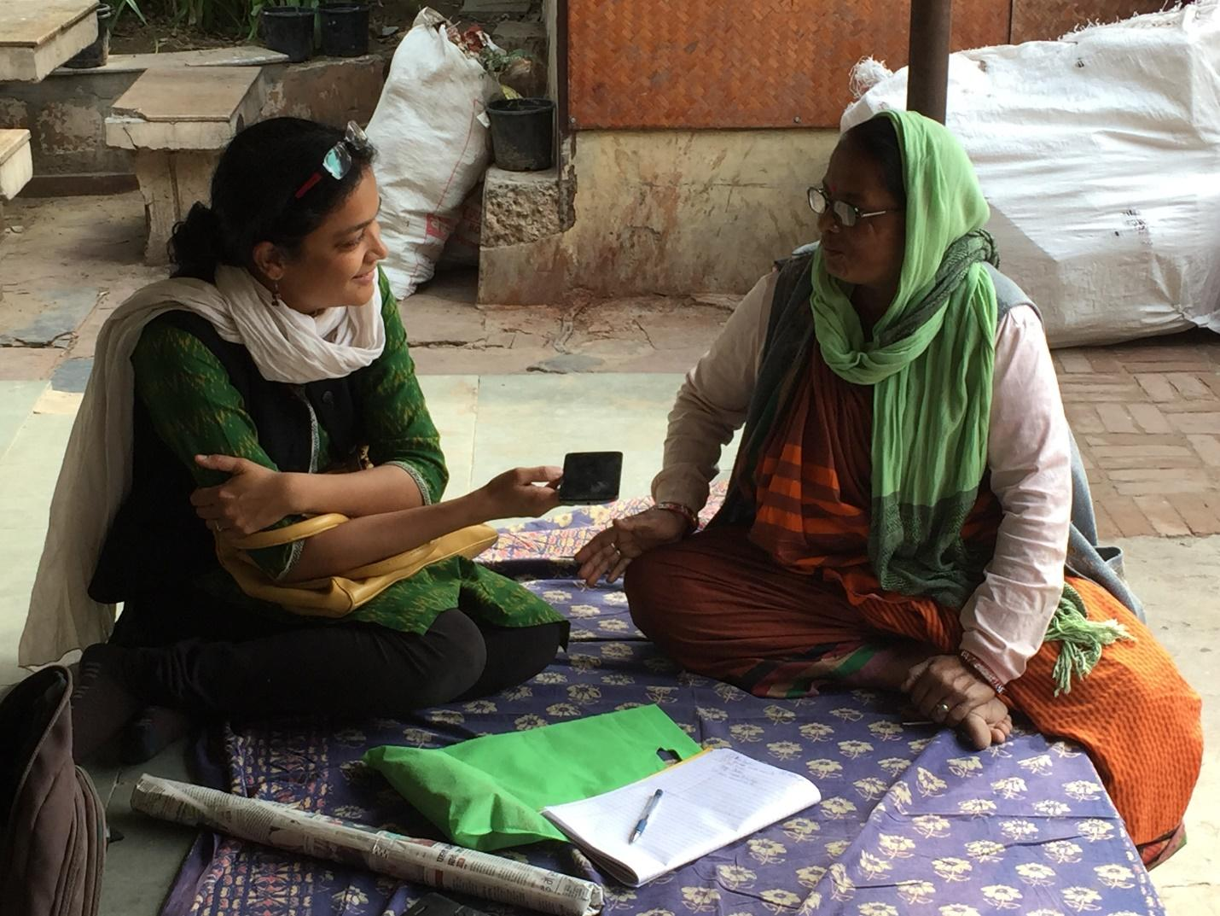
ID4D Initiative
World Bank Group

Cover photo: Interviewing for Caribou Digital’s Identities Project. Photo credit: Savita Bailur
See www.identitiesproject.com

Acknowledgements
This guide was written by Savita Bailur, Research Director at Caribou Digital and Victoria Esquivel-Korsiak, from the World Bank’s ID4D Initiative with inputs from Julia Michal Clark from ID4D. Many thanks go to the ID4D team including Vyjayanti Desai, Luda Bujoreanu, and numerous other contributors and reviewers. Thanks also to the many groups that carried out and participated in qualitative research on end-user experiences with identification, all of which informed the development of this guide.

Contents
Acknowledgements 2
Contents 3
Introduction: the value of qualitative research in ID 5
Why the end-user perspective? 5
Why qualitative research? 7
Qualitative research methods in the context of ID 8
Core research questions 8
Table 1: Linking research questions to interview questions and rationale 8
Overview of research methods 11
Core research methods 12
Focus group discussions (FGDs) 12
Key Informant Interviews (KIIs) 13
Expert KIIs 13
End-user KIIs 14
Process observations and intercepts 15
Additional Research Methods 16
Journey maps 16
Card sorting 16
Letter writing, diaries, collages, and photo journals) 17
Radio shows and phone-ins 18
Implementing qualitative research 19
Costs and Sampling 19
Table 2: Existing qualitative research in ID 19
Consent forms and ethics guidelines 22
Marginalized and vulnerable groups 23
Self-reporting bias 24
Organizing and Analyzing Data for Policy Use 25
Coding qualitative data 26
Creating profiles, archetypes and market segments 26
Appendix A: Useful resources 29
Qualitative studies in ID 29
Quantitative studies in ID 29
General qualitative research references 30
Appendix B: Glossary of terms in identification 32
Appendix C: Consent forms and ethics guidelines 33
Appendix D: Focus group discussion guide 35
Appendix E: Key Information Interview Guides 38
Expert KII Guide - Non-frontline workers 38
Expert KII Guide - Frontline workers 41
Appendix F: End-user interview questions 42
Appendix G: Transaction story/intercept notes 44
Appendix H: Journey Mapping Exercise 45
Appendix I: ID Ranking Exercise 48
Appendix J: Card Sorting Exercises 49
Appendix K: Letter writing, diaries, collages, and photo journals 50
Appendix L: Caribou Digital codes for the Identities Project, India 51

Introduction
In support of its three pillars of action—thought leadership and action, global platforms and convening, and country and regional engagement—the World Bank Group’s Identification for Development (ID4D) Initiative has led multiple qualitative studies focused on people’s (i.e., “end-users’”) experiences with identification and ID systems. These experiences have not only provided useful inputs to existing country operations, they have enabled the development of a standard methodological framework that can be adapted to fit new contexts.
Over the course of 2018, the ID4D Initiative led three qualitative studies on end-user experiences with identification in three countries in in West Africa, East Africa, and East Asia, under the supervision of the ID4D Initiative. The main takeaway from these studies was that it is not a lack of demand for identification, but a lack of accessibility that makes the registration process slow, costly, opaque, and complicated. As a result, many individuals either forgo the registration process altogether, give up during the process due to travel costs and time, or are forced to re-start registration due to life events that change their identity attributes, such as marriage, parenthood, or moving. This has real implications for the coverage, utility, and inclusivity of ID systems. The studies found that by building a digital platform that promotes efficiency and transparency; limiting hardships and indirect costs during the registration process; leveraging local leaders and frontline workers to disseminate information and promote community registration; and addressing registration discrimination by gender, age, and religion, coverage could be increased and ID systems can be built to benefit citizens as well as states.
This Guide distills common methods for researching end-user experiences with ID systems that have either been tried and tested in the studies referenced above, or elsewhere, and which also pull from the rich pool of qualitative research methodologies. It is the objective of this guide to facilitate task teams, governments, and others to carry out end-user research on identification in a variety of contexts to inform the improvement or development of national ID systems. Multiple methods and sample research instruments are presented, and their strengths and weaknesses are discussed, to enable researchers to tailor their approach to the country of focus and to the available resources for the study.

People’s perspectives on ID are essential for developing good ID systems
Uniquely identifying individuals and reliably authenticating their identity is a key enabler to accelerating progress toward achieving the 2030 Agenda for Sustainable Development. Robust, inclusive, and responsible identification (ID) systems can lead to tangible benefits across a range of areas, such as financial inclusion, health services, social protection for the poorest and most vulnerable, and empowerment of women and girls. Yet, more than 1 billion people worldwide cannot prove their identity.
As the Principles on Identification for Sustainable Development state, “individuals are end-users of identification systems, as they require proof of identity to access rights and services. They are at the center of identification systems and have the right to know and exercise appropriate control over how their data is collected, used, stored, and shared”.
Understanding and researching the human experience of ID systems results in designing systems where the end user is front and centre. In order to implement an ID system that has high coverage and is trusted and used by people, implementers first have to understand the end-user perspective. Otherwise design decisions may be made that unintentionally exclude people, erect barriers to access, create incentives and opportunities for fraud, put people’s privacy and trust at risk, or decrease the utility or desirability of the system.

Research that explores how end-users—i.e., people who apply for and use IDs—interact with existing ID systems and engages with them to develop solutions to common problems is therefore a vital tool for system designers and policy-makers in the ID space. Ideally, end-users will be consulted both during the project planning phase, as well as throughout the implementation lifecycle in order to ensure that the system is responsive to evolving demands. Developing a deeper understanding of end-user experiences across a variety of country contexts will contribute to global knowledge on this topic and help develop ID systems that increase access to services while enhancing transparency and personal control and oversight. A focus on end-user experiences will therefore mean:
- Better, more citizen-centric, inclusive systems with wider coverage
- Understanding the incentives and barriers that people face to access or use an ID
- Understanding that is there is not one end-user but many different end-users (or human experiences) and being able to extrapolate for them (e.g. by designing archetypes)
However, ID systems are often implemented after researching use cases rather than the end-users of the system. For example, Nilekani and Shah’s book on India’s Aadhaar, explores the number of use cases where Aadhaar works well (public distribution service including food and cooking gas; healthcare and so on). It does not discuss the human experience - what are the benefits, challenges, transaction costs saved (or added) for the people who apply for and use Aadhaar?
People’s experiences, behaviors, and attitudes related to ID are crucial for surfacing and mitigating barriers to access, adoption, and use.
Studies on identification in a digital age, or “digital identity” are currently proliferating (see Appendix A) precisely to capture these attitudes and experiences. The objective of this is to provide a set of tools to enable further qualitative studies to be carried out routinely and easily as part of the design of all ID-related projects. Adopting a similar approach to end-user studies on ID across various contexts will:
- Reduce start-up effort (avoid “re-inventing the wheel” in research methods)
- Allow these studies to better build on and speak to one another
- Build on better insights on costs and resources, so expectations can be set and managed
The aim of this guide is a useful resource for World Bank task teams, country counterparts, and other practitioners to facilitate and accelerate the inclusion of end-user research in project planning, and to ensure that these studies contribute to a more coherent body of knowledge on ID. In addition, this guide will be helpful for policymakers, development partners, and researchers involved in designing, planning, implementing, and evaluation ID systems.

The benefits of qualitative research methods
Qualitative research typically refers to interviews, focus groups, process observations and other non-numerical methods to gather data. Berg and Lune (2012) state it "refers to the meanings, concepts definitions, characteristics, metaphors, symbols, and description of things" and not to their "counts or measures. This research answers how and when a certain phenomenon occurs." Qualitative research is sometimes blemished by this non-numerical focus and considered “anecdotal” or not generalizable to other situations. However, qualitative research is critical in the field of ID for multiple reasons:

- ID experiences are personal and subjective - capturing them quantitatively (e.g. in a survey) may give an idea of scale (e.g. adoption of ID) but not depth (e.g. why respondents prefer obtaining one credential over another, how the end-user sees the experience). The narratives related during focus groups and interviews are powerful - what people focus on as much as what they leave out is extremely revealing.
- Stories around ID can be sensitive and emotional - capturing these stories quantitatively is challenging as a survey may not surface the nuance of people’s experiences. As well, qualitative research methods enable the interviewer to build rapport and touch on more sensitive subjects which are not well suited to quantitative research methods. For example, in Brazil, focus groups on ID with transgender end-users surfaced that they were frustrated by the inability to change their names or gender on identity documents until they were 18. This is critical information which would not be easily shared by respondents or collected by enumerators in the context of a survey.
- In quantitative research there is a risk of misattribution of causation, Qualitative research can help keep in check. For example, if there are two variables such as (1) poor transport to an ID registration centre and (2) low ID adoption, quantitative research may conclude there is low adoption because of poor transport. This attribution risk can be checked by qualitative research which considers what other factors might be leading to poor adoption.

Of course, carefully thought through quantitative methods design for these issues to some extent, but they need to be engineered, piloted, and corrected (and may still exhibit bias). This process can be time-consuming and expensive, while the cost of rolling out quantitative methods amongst large sample populations is itself prohibitive. Both methods can complement each other, and qualitative studies can be an excellent standalone alternative when quantitative studies are infeasible.

This guide sets out the case for collecting richer stories which highlight people’s lived experiences of obtaining and using ID. Qualitative research methods enable the focus to be on the “how” and “why” of ID, rather than the “what” and “how many”.

Qualitative research methods in the context of ID

Core research questions
End-user research should be focused understanding how people understand, experience, and interact with ID systems and services. While the specific research questions will vary by context, there five broad themes where qualitative methods can provide valuable insight for practitioners:
- Process and experience: What do we know about how people use existing ID systems? How do people obtain and use IDs? What are their attitudes and behaviors towards ID in general (e.g. trust in government, privacy, meaning of ID, etc.)? What are narrative experiences, positive and negative) with past or current ID systems?
- Value proposition and impact: Why do people want specific IDs? What is the value for them? What types of services do people access with IDs or need IDs in order to access?
- Knowledge and influences: What kind of knowledge and resources exist on accessing ID systems (current and planned), including knowledge of procedures, requirements, rights, upcoming plans, etc.? Who influences an individual—where do they obtain knowledge on ID processes?
- Barriers and challenges: What are the barriers to adoption, especially for vulnerable or marginalized groups, such as women, LGBT groups, children, ethnic and religious minorities, nomadic populations, refugees, migrants, and displaced persons? Have people faced routine discrimination in registration processes? What are the direct and indirect costs which make it difficult to obtain an ID?
- Future needs: What future needs will people have regarding ID systems and services? What are ideal solutions for these needs, as defined by people themselves?
In addition to these general questions about ID, qualitative studies can also provide important inputs on specific areas of implementation, such as:
- Preferences on specific design issues: If designers are considering different enrollment strategies or technologies, they can get feedback on these options (e.g. whether people prefer to authenticate their identity via mobile or a smartcard).
- Incentives/disincentives: Designers may also ask specific questions related to people’s incentives to enroll in order to better calibrate rollout and implementation strategies. For example, given lived experiences and people’s attitudes, researchers may ask what changes or features would make participation more or less likely.
As shown in Table 1, these broader research questions can then be mapped to specific interview and focus group questions that yield concrete information to inform program design (see Appendices for a longer list of questions compiled from multiple studies).

Table 1. Linking research questions to interview questions and rationale
Themes | Sample Interview and focus group questions | How this information can be used
Process and experience | - Do you have the following identity documents: [LIST, e.g., birth certificate, national ID, passport, driver’s license, school ID, voter card, ration card, etc.]  - Can you recount the process of getting [a specific] ID?  - Have you ever had to change information on an ID card? How was this experience?  - Have you ever had to file a complaint related to your ID or the process of obtaining it? How was this experience?  - If you do not have any ID, why not?  - How do you feel about the questions asked of you in the process of getting any ID? Do you feel comfortable with the information collected? | These questions help us understand the processes that people go through to obtain and use IDs. They clarify whether there are particular systems people prefer, and whether new systems could build on existing ones. These types of questions can point to failures along the journey of registration, from issues with acquiring breeder documents to prove identity to cumbersome enrollment processes.
Value proposition and impact | - When was the last time you used the ID and for what? Could you describe the experience for me?  - What has getting a specific ID enabled you to do?  - Could you give an example where you could not have done something without your ID?  - Can you give examples of how an ID may have made a big difference in your life? | These questions help us to understand the value people place on IDs and what benefits they have experienced, if any, from having an ID. They also illuminate which services people access with IDs and if there are services that people are unable to access due to lack of an ID. This helps gauge drivers of demand and inform the roll out of ID systems, including authentication services.
Knowledge and influences | - How did you know about getting the ID?  - Who helped you find this information?  - If/when you had to make a complaint how did you know what to do? | These questions help us understand how people learn about ID registration and whether there are particularly effective communication channels or trusted interlocutors. These questions can also indicate trusted community members who could be early adopters and in turn influence others. This has the potential to transform informal intermediaries into formal agents of identification.
Barriers and challenges | - What did it cost you to apply for or get an ID? (prompt for fees, as well as lost work days, travel/waiting time, bribes, etc.)  - What have you found difficult about getting or using an ID that might not be the same for other people?  - Do you have examples of where you feel you might have been discriminated against?  - Have you complained to anyone about the ID process? To whom? What was the result? | These questions provide an essential perspective on the direct and indirect costs which prevent people accessing identification. As well they shine a light on the unique experiences of vulnerable groups who are most often excluded from ID systems both due to direct/indirect costs but also due to discrimination.
Future needs and solutions | - Do you anticipate that you will need new or different IDs in the future? Why and for what?  - If you could a better ID system, what would you change about the current system, and what would you keep the same? | Direct feedback from end-users can improve the design and implementation of ID systems to be more responsive to their evolving needs. These questions help us understand what would be most attractive to an end-user, and what would affect the likelihood of adoption of a new system. As well they can pinpoint key features which should be included in the ID system, as defined by an end-user.
Preferences on specific technologies | - More hypothetical questions or testing of products - e.g. would you like to have a [a mobile ID, an ID with e-signatures, a card or ID-number only etc.]? Why or why not?  - Do you have any preference over particular methods of capturing data (e.g., fingerprints/iris/photo etc.)? | These are very specific questions that test out particular features of new technology, ensuring large scale projects are not rolled-out without checking if they will be accepted. The aim is to concretely identify design choices rather than understand the lived experience of end-users.
Incentives/ disincentives for new systems | - How likely would you be to enroll if you had to travel X kilometers? Y kilometers?  - Would linking the ID to health services make you more or less likely to enroll for an ID?  - What services do you wish you could use your ID to access?  - How would you feel if an ID was mandatory for SIM registration? | These questions test out different potential incentives or disincentives arising from design choices such as making the ID mandatory for accessing a particular service. They are very specific and are aimed at pinpointing services which could be drivers of enrollment.

Overview of research methods
This section details how the general research questions can be answered through core qualitative research methods, such as focus groups, interviews, and process observations, as well as through additional methods like card sorting or radio call-in shows. An overview of various qualitative research methods is provided, alongside their pros and cons and cost implications.
There is a set of core research methods that should be used in all end-user research. Additional methods can be employed where the context, budget, and time allow for more robust study.
Core Research Methods | Additional Research Methods
- Focus group discussions (FGDs)  - Key informant interviews (KIIs)  - With experts (including frontline workers)  - With end-users  - Process observation/intercepts | - Card sorting  - Letter writing and diaries  - Photo journals  - Radio shows and phone-ins

Note that throughout this Guide, we refer to the end-users who participate in research as “respondents” instead of “interviewees”, “focus group participants”, etc. We collectively refer to the tools used for different methods as research “instruments.”

Core research methods

Focus group discussions (FGDs)
It is often advisable to conduct focus groups early in the field work and use this as an opportunity to recruit key informants (either people present in these discussions or through “snowball sampling,” where respondents suggest other potential respondents). Initial focus groups can also surface important themes, groups, or communities that can help better target interviews and other more time-intensive research activities.
Best for | Eliciting experiences from as many end-users as possible efficiently and cost-effectively  Relatively low-cost
What is it? | Focus group discussions or FGDs are one of the most common, useful methods in qualitative research, and a key ingredient in end-user studies on ID. They are most effective when comprised of small groups (6-8 respondents), as more voices may be difficult to hear and manage. See Appendix D for sample questions.  Some criteria for organizing groups (depending on the research question) could be:  - women-only  - youth  - vulnerable populations such as persons with disabilities, LGBT people, minority ethnic or religious groups, displaced persons or refugees, stateless persons, migrants or migratory populations, etc.
Benefits | Useful for eliciting broader perceptions and experiences very quickly, particularly around different communities/demographics.  The spontaneous group dynamic also offers the advantage of generating discussion and interaction between respondents which individual interviews would not surface.
Disadvantages | Not appropriate for very personal/sensitive topics where people may not want to discuss these in public.  They can result in groupthink (everyone agreeing despite differences) or the “Hawthorne Effect” (people modifying their answers knowing they are being observed by others).
Resources and cost | Main costs:  Recruitment of typically 6-8 respondents in a group  Possible compensation to recruitment intermediary (e.g. NGO)  Payment for venue/space (ensuring it is as neutral a space as possible so respondents do not become influenced)  Refreshments and transport  Transcription of FGD  2-3 focus groups of around an hour each can be conducted in a day, depending on transport logistics  Additional costs (costs will rise if these are undertaken):  Respondent compensation (if appropriate)  Photos, video, and multimedia

Key Informant Interviews (KIIs)
There are two primary types of KIIs that are useful for exploring people’s experience with ID systems:
- Expert interviews: Interviews with individuals who—by virtue of their profession or community role—are experts in some aspect of the ID systems and/or well-positioned to speak about specific touch-points of the ID system or the experiences of particular groups. These can be ID system experts, government officials, community leaders, members of civil society, employees of ID or civil registration agencies (e.g. enrollment officers), and employees of service providers which use the IDs (e.g. mobile operators, banks).
- End-user interviews: These are with the ultimate end-users of ID systems - and will surface all the immediate benefits and challenges of obtaining and using IDs.

Expert KIIs
Best for | Understanding high level design/development rationale efficiently and cost-effectively  Low-cost
What is it? | Individual interview with an expert which gives a process- and outcome-oriented perspective on identification from those who oversee implementation, who represent particular communities of interest, or interact with IDs on a daily basis (see Appendix D for sample questions).
Benefits | High-level policy/design responses on ID registration processes, barriers, or use cases
Disadvantages | Time consuming compared to a FGD.  Depend on availability of senior officials which can involve extra coordination.  Tend to reflect an “expert’s” position from a high level which would need to be corroborated with findings from end-user KIIs.
Resources and cost | Telephone/Skype interviews may be more affordable and easier to schedule than meeting in person and ground can be covered before fieldwork begins.  However, KIIs in-country and face-to-face are always valuable.  Main costs:  Travel of researcher to KII (typically respondent’s office)  2-3 expert KIIs of around an hour each can be conducted in a day, depending on transport logistics  Transcribing interviews  *As a courtesy, it is recommended sharing the notes of the interview with the key informant, so they have a chance to review.

End-user KIIs
Best for | Understanding process, experience, and impact of ID systems on the ground.  The least cost-effective of all the core research methods but an essential component.
What is it? | End-user interviews are typically conducted with a varied number of end-users, following an interview guide (see Appendix D for sample questions).
Benefits | Provide in-depth personal perspectives on ID registration processes, barriers, or use cases.  Appropriate for sensitive topics (e.g. an LGBT end-user perspective on ID).
Disadvantages | Time consuming compared to a FGD.  Likely the most expensive of all the core research methods.  Experiences run the risk of being too detailed and personal to generalize about the majority of people’s experiences with IDs.
Resources and cost | Main costs:  Travel of researcher to respondent  Respondent compensation (if appropriate)  Transcribing interviews  2-3 end-user KIIs of around an hour each can be conducted in a day, depending on transport logistics  Additional costs:  Photos and videos (with consent).

Process observations and intercepts
Process observations (also called intercepts) represent an individual’s experience of obtaining or using their ID as it happens.
Best for | A direct understanding on how processes around ID actually happen (rather than relying on respondents’ recollection).  More cost-effective than end-user KIIs.
What is it? | Process observations are conducted where an ID-based transaction occurs (e.g. obtaining a national ID or giving a national ID in order to obtain a SIM card). They quickly determine what the process is and how all parties behaved, whether they were informed on what they needed to do, and what the experience was like for the end-user. See Appendix F for method.
Benefits | First-hand observation of process/transaction, as opposed to being narrated through KII or FGD.
Disadvantages | Can be hectic as individuals are going about their day.  Respondent(s) may be in a rush, thus an interruption can be unexpected and unwelcome.  In public centers, there will likely be a need to clear this with staff (who will need to check with supervisors); this can delay the process and escalate it to higher government officials.
Resources and cost | Main costs:  Travel of researcher to observation site.  Respondent compensation (if appropriate).  2-3 process observations of around an hour each can be conducted in a day, depending on transport logistics.

Additional Research Methods

Journey maps
Best for | Detailing an individual’s specific journey to obtaining an ID and identifying particularly negative or positive parts of the process
What is it? | These typically involve asking respondents to explain and map out (on flipchart paper, for example) their entire journey to obtaining an ID. Respondents can be probed to provide more detail about steps along the way and to recount both position or negative parts of the process (see Appendix G for sample questions).
Benefits | Creative, visual method - more interactive than just a KII.  Can be done as part of a KII to provide a rich visual of the person’s journey.
Disadvantages | Can be a time-consuming exercise.  Requires the interviewer to establish trust and an excellent rapport with the respondent, particularly when the individual comes from a marginalized or vulnerable group and may not readily share their experiences.
Resources and cost | Main costs:  Travel of researcher to respondents.  Familiarization of respondents with requirements.  Respondent compensation (if applicable)  Transcription/design of final journey map  A journey mapping exercise may be undertaken in 1-1.5 hours (including explaining the concept).

Card sorting
Best for | Understanding respondent priorities and preferences (as cards offer options)
What is it? | Card sorting is a way to spark conversation about what matters most to respondents (hierarchies of preference). This exercise is recommended for use in countries where multiple IDs are prevalent and people are likely to already have one or more IDs. The purpose of the activity is to understand the existing ecosystem of IDs, the value placed by the user on specific IDs and why.  The researcher places a set of cards in front of respondents and ask them to order these in terms of their preference – this method helps to understand priorities, for example the most relevant use of ID for people, or what technology they would prefer to interact with.
Benefits | Fosters conversation where respondents might need prompting to actively discuss IDs.
Disadvantages | Can be tedious to translate and produce cards, particularly in context with many languages.  Not appropriate for interacting with mainly illiterate populations.
Resources and cost | Main costs:  Travel of researcher to observation site.  Respondent compensation (if appropriate).  Card production, including testing, translation, and printing  2-3 process observations of around an hour each can be conducted in a day, depending on transport logistics.

Letter writing, diaries, collages, and photo journals)
Best for | Allowing for creativity, which can also be displayed audio-visually and with less text
What are they? | These typically involve asking respondents to write a letter (e.g. to the head of the national ID office), to keep a diary of transactions or processes around ID, to explain and map out their journey to obtaining an ID, or to take photos in contexts where they use IDs (see Appendix H for sample questions). IDEO also piloted collage-making in their 2018 study of an East African country, asking respondents how they would identify themselves as Tanzanian using news clippings
Benefits | Creative, visual methods - more interactive than FGDs or KIIs.
Disadvantages | Place a high burden on respondents who may not see the value of the exercise.  Assume literacy.  Some identification experiences are either so infrequent – either once in a lifetime, annual, monthly or so on (e.g getting a national ID or paying an electricity bill) and/or so embedded (e.g. signing into your phone), that the person may not record the experiences precisely.  Length of time needed may be infeasible for project managers as ID processes may not occur frequently enough within the research period.
Resources and cost | Main costs:  Travel of researcher to respondents.  Respondent time - high burden.  Familiarization of respondents with requirements.  Likely respondent compensation due to high workload.  Collection of findings for diaries and photo journals.  Cost of translation into working language.  A letter-writing exercise amongst respondents may be undertaken in 1-1.5 hours (including explaining the concept).  Diaries and photo journals depend on the research period.

Radio shows and phone-ins
Best for | Working with radio stations and mainstreaming the topic on FM radio  Getting social media and news publicity and additional perspectives  Low-cost
What are they? | These effectively take the form of an FGD, but with the DJ and researcher chairing a panel of experts. Callers can also phone in with perspectives.
Benefits | Mainstreams the discussion quickly into public debate.
Disadvantages | Dependent on radio station/program availability (schedule can change at short notice).  Topics can digress beyond ID in phone-ins (which can also happen in other methods, but the researcher is less likely to have control here).  Can become political (e.g. if anti-government).  Only reaches those with access to radio and with means to call in.
Resources and cost | Main costs:  Radio stations may request compensation but all technical and production costs are likely borne by the station.  Cost of translation into working language (e.g. including subtitling)

Planning and conducting qualitative research
Once research questions have been agreed and tools have been refined, the implementation of the research is dependent on a few critical issues, such as sampling, consent, and self-reporting bias, which are described below.
In general, for end-user research studies, the research team will need to engage local researchers or a firm with experience in qualitative research who can speak the appropriate languages and manage the logistics of field work to reach the communities of interest. We highly recommend working with civil society organizations who already have contacts and trust in communities, while respecting their partnership. As well the research team should build time into the study period for the transcription and coding of the data, for which software exists to aid in the process of organizing the data.

Consent and ethics
Consent is especially important in ID-related research because of the sensitive topic as well as the practical challenge of identifying the individual. A consent form (see Appendix C) should always accompany research instruments. Ideally, the consent form should be audited by an Ethics Review Board (see Appendix C for reference). However, as with all fieldwork on the ground, the way consent is communicated can be more pertinent than the form itself. One method is to show previous published research, including photos, and ask respondents if they would be happy to have their answers portrayed like this. It is critical to emphasize that all names will be given pseudonyms and allow them to choose a specific name if they want. In Brazil, Caribou Digital interviewed a transgender respondent who asked to be called Frida, as she identified with the artist Frida Kahlo. When taking photographs, it is important to ask if respondents would be comfortable having their photos shared and how they would like their photos taken. One respondent in Caribou Digital’s research drew a cartoon of himself, while another Syrian mother suggested a photo of her from the back with her baby’s legs showing. Never take photos of ID cards where personally identifiable information (PII) can be seen. Some photo apps can be used for blurring PII, however the researcher must make sure that the blurring cannot be reversed. The safest method to portray identification is to take photos from a distance and never take photos of PII.
Throughout the consent conversation researchers should re-iterate that their aim is to communicate respondents’ experiences and not to identify or expose them as individuals. Often the focus is misplaced on obtaining a signature on a consent form, rather than clearly explaining the project and obtaining informed consent. Many respondents may not be literate or may not feel comfortable signing, in which case verbal consent is acceptable so long as the respondent has fully understood everything. Furthermore, a signed consent form may actually constitute a data privacy risk to the extent that it is the only written record of someone’s participation. It may be less intimidating or risky if a researcher reads out the form, shows previous research, and gives alternatives and options on how respondents would like to be portrayed. Ideally, report drafts can also be shared with respondents for clarification, but this is dependent on the accessibility of respondents.

Costs and Sampling
There is no one-size-fits-all approach to qualitative research with end-users of ID systems. Qualitative research does not aim to be representative, thus it follows a purposeful sampling strategy which selects respondents based on who can best help answer the core research questions, rather than a random sampling strategy which is more prevalent in quantitative research. How does one determine samples in such a study? In qualitative research sampling ideally continues until redundancy or information saturation is reached--that is, until no new information is emerging. However, the sample size is also affected by the available budget, timeline for the study, ease of carrying out field work, and the core research questions. To date, qualitative projects in ID have undertaken research as follows:

Table 2: Existing qualitative research in ID
Study | Overall costs and time in country | Sample size (including KIIs, FGDs, observations etc.) | Methods
Identification for smallholder farmers in Sri Lanka (GSMA, 2018) |  | Over 40 (smallholder farmers) | 10 ethnographic farm visits  10 reconvened mini groups with “storyboards” – i.e. possible scenarios  Expert KIIs with  GSMA internal teams (mAgri; Digital Identity)  4 agribusiness owners  2 banks  1 local government official  1 mobile network operators  “A handful of informal interviews with factory agents, middle men, government, agricultural agents and bank loan officers”
East African country (IDEO) | $100,000  *** weeks in country | 59 in total | 20 end-user KIIs  8 FGDs  2 observations
Cote d’Ivoire, Pakistan and Tanzania (GSMA) |  | 30 respondents in each country (90 in all) | Kick-off workshop with GSMA team  Expert interviews  In-depth interviews with 6 “seed respondents” in each country  6 FGDs with original seed respondents and their families per country  Community visits and intercepts
East Asian country (Dalberg) | $100,000  *** weeks in country | 81 in total
West African country (Caribou Digital) | $100,000  6 weeks in country (researcher based in country) | 115 in total
India (Caribou Digital 2017) | $250,000  12 weeks in country (research team based in country; 4 weeks per state, further divided into 2 weeks each in urban and rural location in each state) | 150 in total
Jordan, Lebanon and Uganda – identification and refugees (Caribou Digital 2018) |  | 60, 66 and 74 respectively
Brazil, Kenya, Lebanon and Thailand – identification and children (Caribou Digital 2019 - forthcoming for UNICEF) | $200,000 for four countries  2 weeks in each country, visiting two locations per country. | 10+ international KIIs (experts), 6-8 in-country KIIs (experts), 10-12 focus groups and 20-25 end-user interviews (children and parents) in each country

It is rarely possible to begin with a traditional sampling frame in the form of a list of end users or others to be reached through the research, though this may be possible for studies that seek to answer a specific design question for an already existing ID system with a database or who have access to lists of users for particular services which could be tied to ID systems.
In the case of general end-user studies, it is possible to conduct preliminary desk research or literature reviews which can pinpoint broad categories of people or sub-groups that are of particular interest to the study, based on the core research questions. The geography, population demographics, and sociopolitical context of a country should also inform the choice of research locations and the sample. For example, for social risks research in Nigeria, the sociopolitical context demanded that research be conducted in all six geopolitical zones of the country. As the focus was on identifying potential negative impacts, key at-risk populations were identified prior to the study and specifically targeted alongside the targeting of the general population. Diversity across demographic characteristics, geography, etc. is key to capturing a broad understanding of the issues with IDs in every country.
Once broad groups of interest have been identified, snowball sampling is the most applicable method for identifying individual respondents. Under this method, respondents refer the researcher team to others who may be able to contribute or participate. This often leads researchers to respondents that may otherwise be hard to reach.
It is recommended to begin studies with KIIs with civil society organizations, government ministries or agencies, and academic experts to establish the broad groups and physical locations to be reached. These contacts can often point the research team to individuals and can advise on the most appropriate methods for mobilizing focus group respondents based on the country context.
In addition, extreme case sampling is often employed to target and understand the particular experiences of marginalized or vulnerable groups. That is, those people who are in the minority but who have a particularly difficult time accessing and using ID due to their status as part of a certain sub-group or community (e.g. LGBT people). While these cases are not representative of the population as a whole, they are critically important to understanding the experience of people on the margins of society.

Marginalized and vulnerable groups
It can be particularly challenging to reach specific sub-groups or rural communities, as distance, language, and access can all impede the researcher team’s ability to engage respondents.
The split has to be motivated by the research question – for example focus group splits can be rural/urban; wealthier/less wealthy; male/female etc. Diversity along these lines within a country is recommended, unless the focus is on a specific group.
For example, much identification research in development focuses on vulnerable populations like ethnic or religious minorities. This is important if one of the core research questions is to ascertain how their experience differs from someone who may be considered in the “majority”, wealthier, etc. In Caribou Digital’s research in a West African country, women from a minority community felt they were discriminated against when obtaining a national ID not because they were women, but because they were of ethnic origin. However, experiences of marginalization can also cause these communities to be hesitant about speaking with researchers. Here the support of civil society organizations and/or community leaders is key to building trust and enabling access to the community of interest.
Similarly, finding female voices may be a challenge and women likely need to be over-sampled (more women approached than men) and interviewed separately from men. Women are often hesitant to share their opinions and may claim not to know the answers to the questions posed. In Caribou Digital’s India Identities Research, female participants would frequently point the research team to their male relatives, in one case, even a 14-year-old son. Speaking alone to a woman might also be a challenge, even if the researcher is female, thus female-only focus groups may surface issues more fruitfully.

Planning and Implementing Fieldwork

Self-reporting bias
As with much qualitative research, respondent responses in ID research can be skewed for various reasons. Respondents may say they have IDs when they do not to avoid embarrassment or further questioning. This is the primary reason why quantitative surveys often ask respondents which IDs they have AND ask them to produce the IDs for the enumerator. The number of people that report having IDs is regularly higher than the number who can actually produce them. Expired IDs are sometimes also produced, which provide interesting follow-up questions on the extent to which the ID can be used.
Respondent responses may also be different depending on the identity of the interviewer. For example, in Caribou Digital’s research, when a white British male researcher asked “what is the value of your ID” in India he was told it was “to show I am Indian”, while a female Indian researcher was told “it tells the government we exist and they need to serve us”, which has a nuanced difference.
In contrast, someone may not have an ID, but may have intricate workarounds in place to access services through friends and family. A textile weaver in a West African country, for example, stated he did not have an ID but he was observed using his friend’s phone and bank account details for sales. In research on children and ID in Kenya, many who were under 18 were using other people’s M-Pesa (mobile money) accounts as the minimum age for registration for M-Pesa is 18.
To elicit all these nuances, it is much more valuable to ask questions focusing on the end use of ID rather than ID in itself (e.g. “how do you get your LPG (gas)?” or “how do you get paid?” rather than “do you use your ID for LPG?”). It takes a skilled qualitative researcher to probe further beyond what might seem like acceptable answers.
Providing Incentives
Some research strategies involve offering incentives to participants, such as:
- A donation to local partners, e.g. if civil society organizations are facilitating focus groups or interviews
- Mobile phone credits/airtime
- Refreshments and travel costs

Whether or not such incentives are desirable depends very much on the country context. Respondents are giving up time and potentially lost income to answer questions and may expect some form of compensation. However, some researchers feel that monetary incentives (a) might skew responses (people only answer questions for the financial return) and (b) might create tensions particularly in smaller communities. Prior to launching the research, it is useful to develop guidelines for when and how payment might be made:
- have a clear and explicit justification for potentially paying participants (which may be required by an ethics committee, if that applies to the research);
- ensure that participants will still be compensated even if they choose to withdraw from the research at any point;
- consider carefully the cases in which people are consenting because of payment and not because they wish to take part; and
- develop a general policy on describing payments in the consent process.

See Appendix A for references on incentives. Ultimately it is best to take the advice of local researchers and hosts on what is most appropriate given the context in which the research is being undertaken.

Organizing and Analyzing Data for Policy Use
Qualitative data can be presented in powerful text and visuals (some qualitative findings in ID have been presented as reports in Word, others as more visual PowerPoint presentations). Some overarching questions for data analysis include:
- What are the patterns we are seeing across users and what are the archetypes of users or market segments we can see?
- What are the opportunity areas that seem promising given the constraints and motivations of various actors in the system?
- What would it take to launch a truly end-user orientated identification system in the country?
Organizing and sharing findings depends on the planned output - one method is to produce short blogs (e.g. 750 words or roughly 5-minute reads) during the research, and a final report/PowerPoint. This can be supplemented with audio-visual content such as 2-minute videos (see the India Identities Project videos for each “episode”). These can consist of themes, including synthesis from quotes, visuals (e.g. journey maps), profiles, archetypes and market segments. Whether to code data from findings or not is highly dependent on time and budget as it is extremely expensive to code transcripts.

Coding qualitative data
A rigorous analytical process is to run all transcriptions and observations through qualitative software (some examples include Dedoose, Dovetail, nVIVO and Atlas TI). Coding is highly recommended as analyzing text through software makes the analysis much more robust. In addition, as it is likely to be done by teams, checking codes within a team will correct for research bias. Coded text also serves as a useful archive which can be repurposed for future projects. The screenshot below illustrates the coding in Dedoose for Caribou Digital’s Identities Project. Appendix L lists the codes used here.
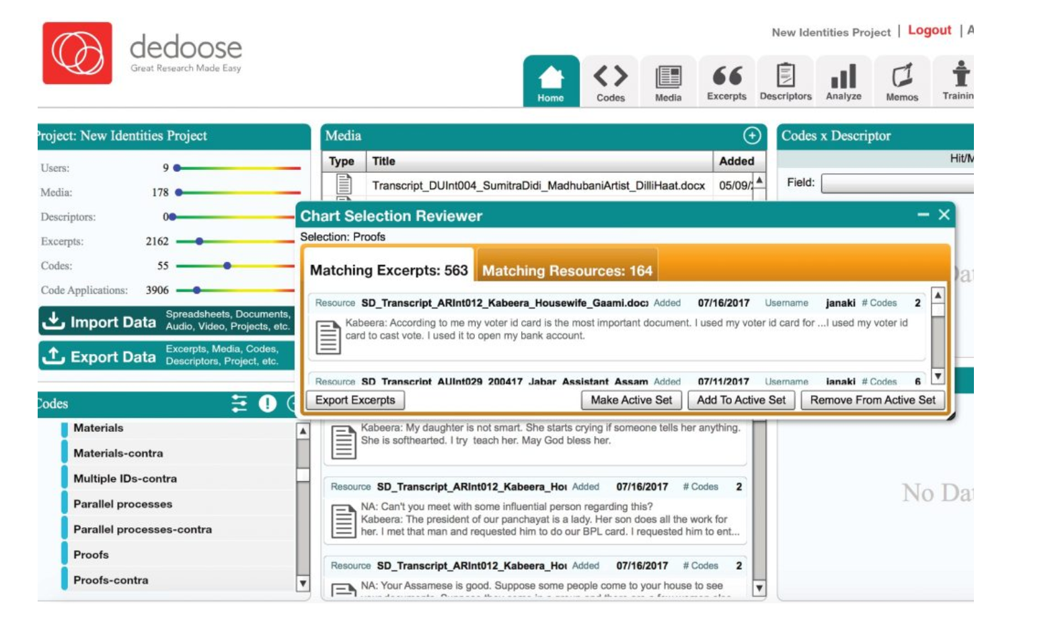
However, coding does substantially increase the cost and time in a project. A simpler method is to pull out quotes and themes according to the core research questions discussed in Section ***. These can be presented in text or visually, for example in profiles, personas and market segments.

Creating profiles, archetypes and market segments
These three techniques differ in the following ways:
- A profile is typically a “real person”. Profiles can be derived from FGD participants and end-user KIIs. See for example GSMA’s (2017) profile of Fahreen (pseudonym) in Pakistan:
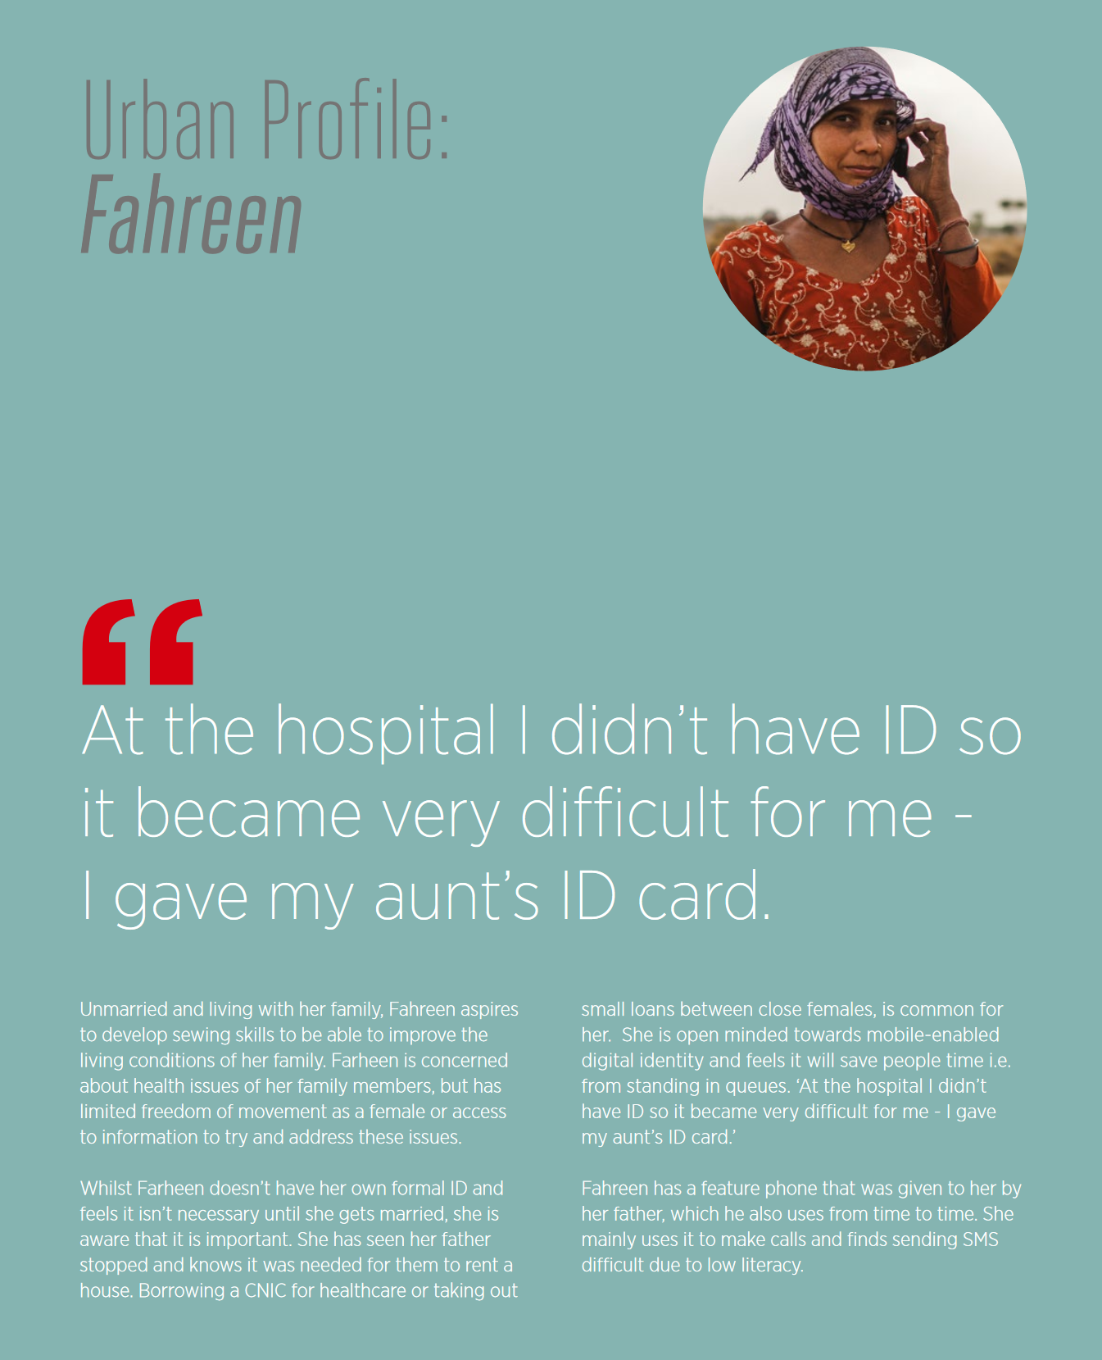
In contrast to a profile, an archetype is a composite of common shared experiences used to illustrate general use, attitude, barriers etc. Details when creating an archetype for identification could include:
- Pseudonym and photo if consent given
- A couple of lines on background and context
- ID needs/user value
- Barriers
- Attitudes
- Ideal solution
IDEO’s study of the East African country listed four archetypes who had different challenges in obtaining IDs were created:
- the left-behind
- the rushed
- the on-my-own terms
- the followers
The argument is that different, targeted policies can be designed for each of these.
- Archetypes/personas can be grouped together to illustrate a market segment we can design for, e.g. in GSMA’s Sri Lanka research on identification for farmers.

Appendix A: Useful resources

Qualitative studies in ID
Digital identity for smal holder farmers in Sri Lanka
https://www.gsma.com/mobilefordevelopment/wp-content/uploads/2018/03/DigitalIdentity_SmallholderFarmers_SriLanka.pdf
GSMA Digital ID Cote d’Ivoire, Pakistan, Tanzania https://www.gsma.com/mobilefordevelopment/wp-content/uploads/2017/02/Driving-Adoption-of-Digital-Identity-for-Sustainable-Development_An-End-user-Perspective-Report.pdf
Caribou Digital Identities Project (2016) https://www.identitiesproject.com/
This was qualitative research conducted with 150 respondents in Karnataka, Delhi and Assam from urban and rural areas. The methods piece https://www.identitiesproject.com/report/appendix-1/ and reflections on conducting the research https://www.identitiesproject.com/report/appendix-2/ are useful on the challenges of conducting qualitative research in ID.
GSMA https://www.gsma.com/mobilefordevelopment/blog/exploring-the-gender-gap-in-identification-policy-insights-from-10-countries/
Contact the World Bank ID4D team for studies by Dalberg in an East Asian country; IDEO in an East African country and Caribou Digital in a West African country (country names kept anonymous)
GSMA end-user research on gender

Quantitative studies in ID
- World Bank (2018) The ID4D global dataset. http://id4d.worldbank.org/global-dataset
This includes:
- The Global ID4D Dataset, based on official figures from ID authorities, voter registration, and UNICEF birth registration data; and
- Representative surveys of over 100,000 end-users from 99 countries, collected in partnership with the World Bank’s Global Findex team.
- Abraham, R, Bennett, E., Bhusal, R., Dubey, S., Li, Q, Pattanayak, A and Shah, N. (2018). IDInsight State of Aadhaar Report 2017-18. IDinsight, New Delhi. https://static1.squarespace.com/static/5b7cc54eec4eb7d25f7af2be/t/5bbd2874c8302561862f03d4/1539123330295/State+of+Aadhaar+Report_2017-18.pdf
The report is based on the largest household survey since Aadhaar’s inception in India on adoption and use of the ID. It shares findings from 2947 rural households in 21 districts across Andhra Pradesh, Rajasthan, and West Bengal. See more here: https://www.omidyar.com/news/largest-ever-survey-aadhaar-provides-data-driven-insights-key-aspects-exclusion-privacy-and

General qualitative research references
Berg, B. L., & Lune, H. (2012). Qualitative Research Methods for the Social Sciences. Harlow, Pearson.
Detailed qualitative methods guide, with a useful section on ethics.

Cyr, J. (2019). Focus Groups for the Social Science Researcher. Cambridge, Cambridge University Press.
Especially useful on how to elicit discussion from quieter respondents in focus groups.

Flick, U. (2018). Designing qualitative research. London, SAGE.
A thorough step-by-step guide from designing a research question to analyzing data.

King, N., Horrocks, C., & Brooks, J. (2018). Interviews in qualitative research. London, SAGE.
In-depth interview methods

Riessman, C. K. (1993). Narrative analysis, London, SAGE.
Even though this is an older book, it contains excellent examples on how to ask open-ended questions, and recognizing and correcting researcher bias.

Saldaña, J. (2015). The coding manual for qualitative researchers. London, SAGE.
Goes into detail on the logic of coding interviews and focus groups, and weights the pros and cons of different software.

For more on incentives, see:

Head, E. (2009) The ethics and implications of paying participants in qualitative research. International Journal of Social Research Methodology. 12(4): 335-44.
Wendler D., Rackoff J.E., Emanuel E.J., Grady C. (2002) The ethics of paying for children's participation in research. Journal of Pediatrics. 141(2): 166–171.

Appendix B: Glossary of terms in identification
Authentication: The process of proving that a person is who they claim to be. Digital authentication generally involves a person electronically presenting one or more “factors” or “authenticators” to “assert” their identity—that is, to prove that they are the same person to whom the identity or credential was originally issued. These factors can include something a person is (e.g., their fingerprints), knows (e.g., a password or PIN), has (e.g., an ID card, token, or mobile SIM card), or does (e.g., their handwriting, keystrokes, or gestures).
Civil registration: The continuous, permanent, compulsory and universal recording of the occurrence and characteristics of vital events pertaining to the population, as provided through decree or regulation in accordance with the legal requirements of each country.
Identification systems: The databases, processes, technology, credentials, and legal frameworks associated with the capture, management, and use of personal identity data for a general or specific purpose.
Identity: A set of attributes (such as name, age, sex, place of birth, address, fingerprints, a photo, a signature, an identity number, date and place of registration, etc.) that uniquely identify a person.
Digital identity: A set of electronically captured and stored attributes and/or credentials that uniquely identify a person.

Appendix C: Consent forms and ethics guidelines
This is a sample consent form for all interviews conducted under the research. These include but are not limited to:
- Key informant interviews (e.g. with experts, ID agency employees, community leaders, members of civil society, etc.)
- Focus group discussions
- End-user interviews

Instructions to the research assistant: Please translate this form into the appropriate language(s) in writing or explain it orally (in the case of FGDs). Make sure you explain it clearly but in a non-intimidating fashion. Once you have explained the consent form, please ask them to sign the form or provide oral consent. Oral consent is acceptable as long as you feel the respondent has understood the purpose of the study. The latter is critical. You can show previous examples of ID research to show how their experiences might be captured and shared.

Informed Consent Form
Date: Names of facilitators:
Respondent details: [Collect respondent details if you feel follow-up interviews possible]
Address Telephone email

Hello. My name is ________. We are conducting research for XXX into the experiences people have obtaining and using different IDs in order to develop better systems. During this discussion, you will be asked some questions about your thoughts and/or experiences of registering with organisations, proving who you are and sharing personal information in your daily life. This discussion is designed to be approximately XXX minutes/hours. However, please feel free to talk about related ideas if you feel the questions we ask are not relevant. Also, if there are any questions you feel you cannot answer or that you do not feel comfortable answering, please say so and we will move on to the next question.
All the information you give us will be kept confidential. We will keep the data in a secure place – on password protected file storage. Upon completion of this project, all data will be stored in a secure location. It may be published but all names will be pseudonyms [show examples of previous research]. You are welcome to choose a name for yourself that we can use.
We would like to record the discussion and transcribe the audio, but we will keep your names anonymous. We would also take photographs of you, but again you have the option to opt out of photographs. You will have the opportunity to approve all photos taken. Photos may be used in print and on the web.
Your participation will help us share your voice and to build better identification systems. If you are not happy with any aspect of this, please say so now. You may also decide not to participate and end the interview at any time. There is no compensation or direct benefit from participation in the interview, and there is no penalty or loss if you decide not to participate.
[FGD ONLY] If you are silent and stay in the focus group we’ll assume that you are happy to proceed, although you may decide to end your participation at any time. Please also note that in participating in this focus group, we should respect and keep other people’s information [i.e. other participants in this group] confidential and private.
Participant’s Agreement:
I am aware that my participation in this interview is voluntary. If, for any reason, at any time, I wish to stop the interview, I may do so. I understand the intent and purpose of this research.
I am aware the data may be used for a research report for international publication. The data gathered in this study are confidential and anonymous with respect to my personal identity unless I specify/indicate otherwise.
I have understood the above form and I consent to participate in today’s interview.

_____________________ ___________________
Participant’s signature Date

Researcher contact details:
Name (email address)
___________________________________

Consent forms should ideally be approved by ethical review boards, but not all organizations have these. Sample guidelines are here:
- The Belmont Report’s Ethical Principles and Guidelines for the Protection of Human Subjects of Research https://www.hhs.gov/ohrp/sites/default/files/the-belmont-report-508c_FINAL.pdf. Particularly useful in highlighting three basic ethical principles: Respect for persons; beneficence (a commitment to securing well-being) and justice in research.
- The Economics and Social Research Council in the UK has a set of guidelines for ethics when considering grants. While these are UK-grant specific, pp. 4-6 on principles and expectations are important. See: https://esrc.ukri.org/files/funding/guidance-for-applicants/esrc-framework-for-research-ethics-2015/
- The National Science Foundation Institutional Review Board (USA) has critical guidelines on human subjects, especially protecting anonymity. See https://www.nsf.gov/bfa/dias/policy/human.jsp

Appendix D: Focus group discussion guide
Introduction
[Observe all courtesies and introduce the research team and the purpose of the discussion.]
The purpose of this exercise is to understand people’s attitudes toward identification, how they use their IDs, what barriers they face in obtaining an ID, and their reasons for not having an ID. We are interested in all your ideas, comments and suggestions. All comments are welcome whether they are considered positive or negative.
Please feel free to discuss and disagree with one another; no idea is right or wrong so, be respectful of the opinions of other people. We would like to have many points of view as possible.
[Explain use of digital recorders and why you need to have the discussions recorded]: We would also want you to speak one at a time so that the tape recorder can pick your voice appropriately and clearly.
Set ground rules before the session
ACCESS TO ID
- How would you identify yourself to someone you did not know?
- What are some of the means of identification that you have in your possession or at home?
  - Probe for birth certificate, driver’s license, voters’ card, international passport, national ID, etc. Listen for others that may be in use in the communities.
- Which credentials do you carry with you? Which ones do you keep at home? Why?
- How long did the process take for you to obtain each of those forms of identification?
- How did you find the process of obtaining an ID credential?
- If you have ever needed to change your information on your ID, how did you find that process?
- What happens if you lose your ID?
  - Probe: How did you find the process of replacing a lost ID?
- Which ID would you like to get that you do not have?
  - Probe: Why do you want this ID?
- What barriers have you faced to accessing an ID?
  - Probe: For example, direct fees; indirect costs including transportation, missed work, bribes; social stigma; fear or mistrust in identification systems; lack of documents needed to apply.

ATTITUDE TOWARDS ID
- Do you think it is important to have proof of identification?
  - Probe: Why or why not?
- Why did you get an identification credential?
- Why might you NOT want an identification credential?
  - Probe: What reasons might there be for choosing to remain unidentified?
- If you had a choice, what would you prefer to show as a form of identification?

GENDER DIFFERENCES
- How does the process of obtaining an ID differ for men and women?
- How does the process of updating information on an ID differ for men and women?
- How do the customs and traditional practices in your community affect the ability of women to register for an ID?
- Are women given more consideration than men or men given more consideration than women when obtaining an ID?
  - Probe: Kindly explain the situation in your community.
- In a family, who keeps the credentials?

USE AND ACCESS TO SERVICES
- How do you use different forms of identification in your life?
  - Probe: What were you trying to access the last time you used your ID?
  - Probe: What ID did you use?
- If you have an ID, what rights and/or services have you been able to access by having identification?
- If you do not have an ID, what rights and/or services have you been unable to access because you lack identification?
- How do you think identification credentials have helped you or not helped you?
  - Probe: What positive or negative changes, if any, have you seen in your life after obtaining/using some identification?
- Can you give an example of a process which uses identification which you think is simple/easy?
  - Probe: In what ways did you find it easy?

DISPLACEMENT (only for FGDs with communities that have likely experienced displacement)

- Is your ability to move freely within or outside of your community affected by whether you have an ID?
  - Probe: Have you experienced harassment by law enforcement or others because you did not have an ID?
- Has this community ever experienced issues that led to displacement of community members?
  - Probe for crises, natural disasters, etc. which might lead to displacement
- What type of ID is most useful for displaced persons to access services, move freely, or return to their home community?
- Have you ever been denied access to a refugee or IDP camp because of lack of an ID?
  - Probe: What ID were you told you needed?

PRIVACY
- How do you feel about giving the government your personal data, for example, for your national ID?
  - Probe for what personal data means to them, give examples if necessary.
- Have you ever been asked to give your fingerprints for registration for any ID?
  - If Yes, probe: How did you feel about giving your fingerprints?
- Do you feel differently about sharing your data with government or with a company?
- Do you trust government organizations with your information?
  - Probe: Do you trust the [ID agency]?
- Are there ways the government could be better protecting your privacy or data?
  - Probe: Are there ways that the system could be made more trustworthy?

DESIGNING FOR THE FUTURE
- What improvements would you like to see, in terms of getting an ID?
- What improvements would you like to see in terms of accessing services with your ID?
- How do you think the identification credential provider (govt/private) could improve communication and outreach campaigns to help increase coverage?

- Is there anything else you would like to tell us?

Appendix E: Key Information Interview Guides

Expert KII Guide - Non-frontline workers
Introduce the research team and reiterate the purpose of the visit:
My name is XXX I am here with XXX to discuss and hear your opinion on the national ID system. We hope the discussion will help improve the process of ID enrolment for people. We appreciate the time you are contributing to this discussion and we would like to assure you that your views will be confidential. Interviews usually take about 45-60 minutes. You may choose to cease your participation at any time during the interview. We will be recording the session solely for documentation purposes. Do we have your consent to proceed?
Ensure the informant signs the consent form.
Activate Tape Recorder
Key Informant Interview Questions:
ACCESS & USE (for all KIIs)
- What means of identification are commonly used in this country and/or community?
  - Probe for birth certificate, driver’s license, voters’ card, international passport, national ID card
  - ii Listen for others that maybe in use.
- What has been the experience of people when registering for the national ID?
- What in your opinion are the key drivers for registration for the national ID?
- What in your opinion are the key barriers to registration for the national ID?
- What do you consider to be the benefits of having a national ID?
- What are the concerns related to obtaining a national ID?
  - Probe for people’s feelings about giving their personal information and biometrics (fingerprints, iris, photo, etc.)
- What entities do people trust with their personal data?
  - Probe for government entities like the ID agency, civil registration agency, other ministries, and probe for private sector like banks and telecommunication companies
- What customs / traditions contribute to enabling women to register for identification?
- What customs / traditions impede women from registering for identification?
- What other factors affects women’s ability to register for identification?
- What types of services do people access with these means of identification?
  - Probe for health, education, banking/mobile money, GSM/mobile phone
- How has having or not having a means of identification limited people’s ability to access services?
  - Probe for which services
- What groups of people do you think have difficulty registering for identification?
- Are you aware of any discrimination for having or not having an ID?
- Are there groups in this community that may not want to be registered or may not have an ID?
  - Probe for the different groups they may be aware of such as religious or ethnic minorities, persons with disabilities, migrants, etc.
- Are you aware of any groups that don’t want to register or don’t want to have an ID?
  - Probe for the perceived reasons why groups may avoid registration.
- Based on your experience in the area, what hatsteps should government take to improve access to ID?
POLICY & IMPLEMENTATION (for KIIs with leadership of ID/CR agencies and service providers)
- What do you consider the key policy and implementation issues around identification systems in your country?
- Given your role as X organization, what are the specific challenges you face related to ID?
- Which actors are shaping the conversation around identification systems in your country?
- What kind of barriers do you think individuals are having in accessing/using identification?
- What value do you think the identification system holds for a user?
  - Probe: How would you convince a user of the benefits of an ID?
- Which identity credentials do you think are most used?
  - Probe: What kind of benefits do they have?
- How does your organization approach user privacy with regards to digital data and/or identification systems?
- (For service providers only) How do you share information about the identification-based service you may have delivered (e.g., MNO)?
- (If user interviews have already been concluded) We heard X about the barriers user experience in accessing the ID. What do you suggest the user do?
FUTURE PLANNING
- How do you think the current identification systems (whether national ID, birth certificates, or other) in your
country can be improved?
- How do you think you could improve communication and outreach campaigns to help increase coverage?
CONCLUSION
- Do you have any questions for us?
- Who else might you recommend we talk to?

Expert KII Guide - Frontline workers

This section presents potential questions for interviewing frontline workers, such as enrollment officers, or other frontline workers who handle IDs, such as those who enroll people for SIM card.

Introduce the research team and reiterate the purpose of the visit: My name is XXX I am here with XXX to discuss and hear your opinion on the national ID system. We hope the discussion will help improve the process of ID enrolment and use for people. We appreciate the time you are contributing to this discussion and we would like to assure you that your views will be confidential. Interviews usually take about 45-60 minutes. You may choose to cease your participation at any time during the interview. We will be recording the session solely for documentation purposes. Do we have your consent to proceed?
Ensure the informant signs the consent form.
Activate Tape Recorder
Questions
- How long have you worked at [organization]?
- Could you describe to me your role at X (e.g., Bank X, national ID office, MNO)?[organization]?

ID-RELATED PROCESSES/PROCEDURES
- How do you record people’s data?
- What are the major challenges you face in completing your daily tasks?
- What do you think would help your job a) in terms of making your job easier (i.e., less challenging/frustrating/etc.), and/or b) in terms of facilitating better services?
- What are the main challenges people raise about
PERSPECTIVE ON END-USER KNOWLEDGE OF ID
- Do people that come to you know the process and requirements for getting an ID?
- How did they find out?
- Does anyone ask you questions about why certain information is needed?

PERSPECTIVE ON END-USER ISSUES AND BARRIERS
- Are there any services that people have been unable to access, despite having an identification credential? If so, why?
- Are there specific groups that you have seen face challenges and why?
- How do you think the identification provider (govt/private) could improve communication and outreach campaigns to help increase coverage?

Appendix F: End-user interview questions
Introduction
[Observe all courtesies and introduce the research team and the purpose of the discussion.]
The purpose of this exercise is to understand your experiences with IDs, including any barriers you have faced in obtaining an ID and what you use IDs for. We are interested in all your ideas, comments and suggestions. All comments are welcome whether they are considered positive or negative.
[Explain use of digital recorders and why you need to have the discussions recorded]
Questions
- What are some of the means of identification that you have?
  - Probe for birth certificate, driver’s license, voters’ card, international passport, national ID, etc.
- Why did you get an identification credential?
- Why might you NOT want an identification credential?
  - Probe: What reasons might there be for choosing to remain unidentified?
- Which IDs do you carry with you? Which ones do you keep at home? Why?
- How did you find the process of obtaining these IDs? How long did it take?
- What barriers have you faced to accessing an ID?
  - Probe: For example, fees; indirect costs like transportation, missed work, bribes; social stigma; fear or mistrust in identification systems; lack of documents needed to apply.
- What happens if you lose your ID or need to change the information on your ID?
- Which ID would you like to get that you do not have?
- Probe: Why do you want this ID?
- How do you use different forms of identification in your life?
  - Probe: What were you trying to access the last time you used your ID? (If necessary give examples of government programs, banking, SIM registration, government to persons payments, etc.)
  - Probe: What ID did you use?
- How do you think identification credentials have helped you or not helped you?
  - Probe: What positive or negative changes, if any, have you seen in your life after obtaining and using identification?
- How does the process of obtaining an ID differ for men and women?
  - Probe: What issues do women face in accessing IDs that might be different from men?
- How do you feel about giving the government personal data, for example, for your national ID?
  - Probe: What does personal data mean to you? (If necessary give examples)
- Have you ever been asked to give your fingerprints for registration for any ID?
  - If Yes, probe: How did you feel about giving your fingerprints?
- Do you trust government organizations with your information?
  - Probe: Do you trust the [ID agency]?
- What improvements would you like to see, in terms of getting an ID?
- What improvements would you like to see in terms of accessing services with your ID?
- Is there anything else you would like to tell us?

Appendix G: Transaction story/intercept notes
A transaction story captures the real world experience of someone applying for an ID and/or using their ID to access a particular service (e.g. registering for SIM card). After receiving permission from the user and agent, the researcher should observe the transaction and note what takes place, how the user is treated, etc. It is not recommended to record audio or video as this is likely to be in a public area - note taking and drawing visuals is most appropriate.
Notes below:
Introduction:
Hello, my name is XXX and I am conducting research to understand people’s experiences [obtaining an ID] / [using an ID to access a particular service]. I am interested in observing your experience here today. Would you be willing to participate? Do I have your permission to take notes about your experience?
Questions for the interviewer/observer:
Name or pseudonym of the user:
- What is the transaction (describe what transaction is taking place, where it is taking place, etc.)
- What is the user’s perspective? What did he/she come to do? How do they feel about being there? Do they seem comfortable/uncomfortable? What is their attitude? Any user feelings about the experience?:
- What is the agent’s perspective? What are their thoughts? Is the agent helpful/unhelpful? Do they suggest alternatives/workarounds, if needed? Do they have any feelings about the transaction (this specific one or in general?)
- What are YOUR thoughts on the transaction? Particularly in relation to questions of privacy, agency and dignity of the user? Do you feel there is a power dynamic present? Do the agent and user know each other? Did you feel the user was treated correctly/respectfully? Did you feel the agent did all they could to facilitate the transaction?

Appendix H: Journey Mapping Exercise
The objective of this exercise it to develop a map of the journey a person took to obtain their ID in order to understand the bottlenecks, frustrations, and opportunities for improvement. The exercise can focus on any of the prevalent IDs or the ID of most interest to the study. This exercise can be done with an individual or adapted to a group.
Method:
Prepare a large flip chart paper to capture the process as the individual describes it. Be sure to note any particularly positive or negative experiences along the journey.
Ask the following questions about the chosen ID of focus:
- On a scale of 1 to 10, how would you rate the process of getting your ID? With 1 being ‘a very easy process’ to 10 being ‘a very difficult process’.
- Why did you rate (number)?
- Could you describe your experience of getting your ID, step by step? [While the participant describes the step by step process, capture the different steps they took on the flip chart. Use probe questions to elicit more detail on the process the person had to follow.]
- [Review the journey map you drew with the participant] These are all the steps and experiences you told me about, is there anything missing from this journey map?
- Is there anything else you would like to share about your experience?
Probe questions for developing the journey map:
- What were the biggest problems you encountered along the way? Why?
- How did you know what documents you needed to obtain the ID?
  - Which documents did you provide for the application?
  - How did you go about gathering those documents?
  - Were you asked for other documents that were not mentioned on the application form or (via the media they learned the process from)?
  - Which documents were the hardest to obtain? Why?
  - If you were not able to show some required documents, how did you resolve this issue?
- How was your experience recording your biometrics such as your photo and your fingerprints [or any additional biometrics collected]?
  - How many attempts did it take to record your fingerprints? How many fingers did you have to try? Could you describe the experience?
  - Did you have any issue with biometrics or photo being recorded? Why? Could you describe the instance?
  - Do you know why these are being recorded?
  - Would you prefer to have anything else in place of it? If yes, then why and what? If no, then why not?
- What made you the most uncomfortable during the process?
  - Did any specific fields that the application asks for make you uncomfortable? [Prompt for religion, gender, photo, etc. as needed depending on the country context]
- What was the most memorable experience during the process?
- Did you face any barriers during the process? If yes, could you describe the instances?
  - Did you have to pay for the application form?
  - Did you pay anyone to help you with the process?
  - Did you pay anyone to speed up the process?
  - Did you need to pay any bribe? Could you describe the instance?
- Did you have any difficulty in filling the form? Could you describe the process?
- Did you receive a receipt or an acknowledgement of your application at any point in the process? Could you recall when and describe what you received?
- Once you got the actual, physical card [for countries with physical ID cards], what did you think of it?
  - [if the card is a smartcard] Did you know there is a chip inside? Do you know what it stores? (prompt if needed that it stores your data and the fingerprints) How do you feel about it?
  - How do you think the design of the card could be made better?
Example of journey map from IDEO’s study
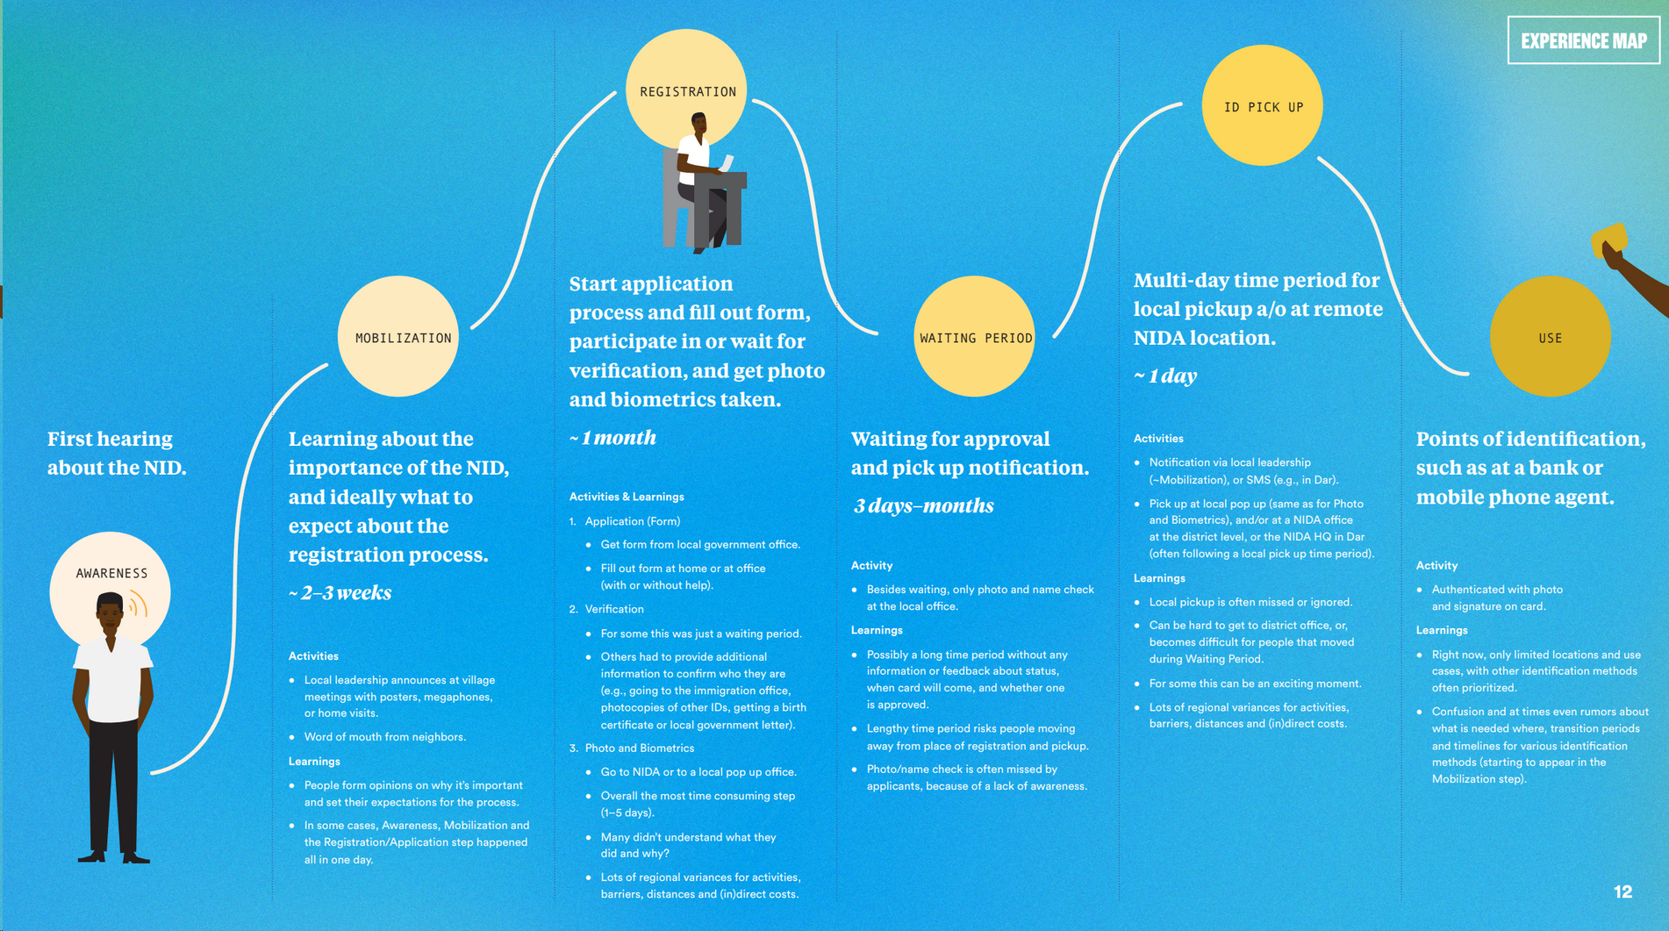
Example of a personal journey map from GSMA’s (2017) study
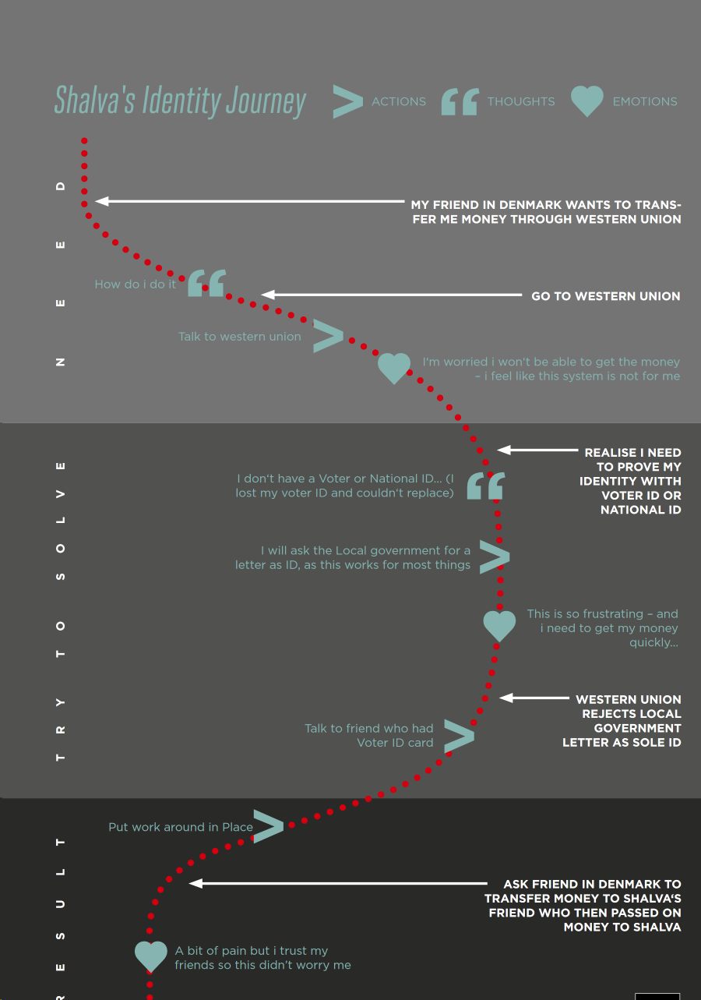

Appendix I: ID Ranking Exercise
Ask the participant to show you all of their ID cards.
[Note any differences in data across ID cards (e.g. name, birth date), where the ID cards were physically stored, etc. If the person says they have a document, but cannot demonstrate it, note why (where is it, who has it, etc.). You will ask questions about the 1-3 most and least important IDs, depending on the overall number of IDs produced.]

Using the IDs they have produced, ask them to rank the IDs from most important to least important. Ask them to re-think and change the order if they feel like it.

After the IDs have been ranked, ask the following questions:

- Why are (the top 1-3 IDs) most important to you?
  - What are the benefits of this ID? [Ask for each of the top 3 IDs]
  - When was the last time you used them? Could you describe how you used them?
  - Was it easy or hard to use them? Whom did you use it with?
  - Did anyone help you? How did you feel?
  - How was the experience of applying for and receiving the [ID valued most by participant]?

- Why are (the bottom 1-3 IDs) least important to you?

- Where do you store your ID cards? [Probe for on their person, at home in a safe place, etc.]

Appendix J: Card Sorting Exercises
ID Usage Cards
What it is: A set of cards describing reasons you would use an ID from an individual perspective (e.g. open a bank account) and that of the government (e.g. track people for taxes).
Rationale/what we hope to learn: What are the reasons for having a card that resonate with people? Do they understand the needs of government requirements and their own priorities?
Tagline Cards
What it is: A set of cards, each with a slogan that could be used to market and communicate ID programs.
Rationale/what we hope to learn: What holds the most value for respondents? Which tone do people prefer for oﬃcial communications?
Specific Technology Cards (e.g. biometrics)
What it is: A set of visual examples showcasing a variety of physical setups of biometric authentication methods.
Rationale/what we hope to learn: What are current perceptions around biometric authentication in general? What are preferences and feelings around diﬀerent technologies and physical setups?
Communication Channel Cards
What it is: A series of cards with illustrations of diﬀerent marketing and advertising channels such as radio and posters.
Rationale/what we hope to learn: How do people learn about new things? Which communication channels will be most eﬀective at spreading awareness and encouraging ID registration?
ETA Notifications Cards
What it is: A set of cards to explore with participant how to improve the lengthy waiting experience between registration and ID pickup.
Rationale/what we hope to learn: Is there is a need for feedback and information during the waiting period (after registration and before ID pickup)? What type of feedback/information is desired? How should it be delivered (channels)?

Appendix K: Letter writing, diaries, collages, and photo journals
Letter-writing (in focus groups or individual interviews)
Ask respondents to either write a letter to a national ID registration office/CRVS (civil registration facility) or dictate what they would like to write. The letter could include:
- What do you think of the institution?
- What do you think it has achieved for you as a citizen?
- How would you like it to improve - give three specific action points it could take?
Collages (in focus groups)
Gather newspapers from the past 1-2 weeks. Ask respondents to cut out words or pictures from the newspapers to see how they identify with these. Ask respondents to create a collage and explain it to the group.
Diaries and photo journals (need identified respondents over a long period of time)
This is much more time-intensive process with guidelines for respondents on recording transactions or events around identification. To our knowledge, they have not been used in qualitative ID research so far but are a potential research method, especially for longitudinal research. The closest example which could be applied in ID research is from financial diaries, especially used in year-long financial diaries kept in Bangladesh, Sri Lanka and India in Portfolios of the Poor - http://www.portfoliosofthepoor.com/.

Appendix L: Caribou Digital codes for the Identities Project, India
The research surfaced three key themes:
- Dynamic, everyday practices around ID
- Vulnerabilities
- Implications for designing new ID systems
We then developed a coding scheme collaboratively for these themes. Each theme had different sub-codes. We loaded transcribed text from interview and focus group into Dedoose and coded them using these sub-codes. Each code also had a “contra” code where evidence contra-indicated the hypothesis, to counteract any bias as researchers.
1. Dynamic Practices
Code 1.1 - ‘Proofs’: People have been managing IDs actively for a long time – including “the poor” (e.g. new way of seeing). Coding for: examples of people’s accounts of pre-Aadhaar credentials; of informal relationships with people of power.
Code 1.2 - ‘Material’: Tangible, material artifacts matter, even in the digital era. Coding for: people describing how they value the physical artefact, using printed / photo-copies of cards, having the oscard but never using itlects the ultimate extra
Code 1.3 - ‘Complexity’: In identity transactions, nothing is as easy (or simple) as it seems. Even the simplest identity transactions have backstories and are full of meaning and significance.
Sub - Code 1.3a - ‘Complexity Process’: Mechanics. Coding for: difficulties in registering for cards / services; difficulties in using cards (eg biometrics not working, people not accepting cards, incorrect details etc)
Sub - Code 1.3a - ‘Complexity Meaning ’: Meaning (belonging, access, nationality, etc). Coding for: understanding of ID credentials as forms of citizenship, belonging, security, intangible empowerment - description of how credentials stimulates feelings
Code 1.4 - Multiple IDs: All day, everyday, people use artefacts and strategies to present parts of their identity selectively and strategically. We call this mosaics. Coding for: examples of people having / valuing multiple credentials and multiple identities (eg daughter and wife), stories of how the details on cards matter (eg surnames etc), feelings of control over what is known about onseself, feelings and descriptions of control
Code 1.5 - Parallel process: Coding for: What are the workarounds people have?
2. Vulnerabilities
Code 2.1 - Formal Static: Formal, static identity systems are in tension with informal, dynamic lives Coding for: examples where the information on a card fails to account for the flexibility / dynamism of people’s identity (eg people changing location / gender etc); where people want to change information on an identity credential
Code 2.2 - Forcibly Credentialed: Moving through a world where legal identity needs to be proved is a hard world for people who can’t. Coding for: examples where (poor / vulnerable) people are forced to show credentials to get things they need (this implicitly means the poorest have to show credentials more than the wealthy)
Code 2.3 - Credentials and Power: The criticality of identity credentials in transactions reinforces positions of power. Coding for: examples of where the credential affects power relationships - either transforming them (giving people a new sense of empowered identity) or increases vulnerability (eg access to use of cards as a form of power, withholding cards as a form of power)
Code 2.4 - Vulnerability: Points of vulnerability - including gender, caste, sexuality, disabilities - show evidence of worsening
Sub-Code 2.4a - Vulnerability Gender: Gender challenges are not monolithic - single mothers, widows and those without support face the greatest pressure. Coding for: examples of how credentials impact on gender vulnerability - mitigating as well as increasing vulnerability.
Sub-Code 2.4b - Vulnerability Caste/Class/Religion: Caste, class and religious differences are at risk of being exploited further through ID. Coding for examples of how credentials mitigate and strengthen caste, class and religious identity.
Sub-Code 2.4c - Vulnerability LGBTQ communities: Coding for particular concerns here
Sub-Code 2.4d - Vulnerability Disabilities: Some types of ID might have particular challenges for persons with disabilities (either acquiring or using)
3. Implications for designing new ID systems
Code 3.1 - Barrier / Driver Context: Revisit barriers and drivers --it’s not just UI, not even UX, its embedded context. Coding for examples of how context - pre-existing identity, norms, values shape how credentials are used or the extent to which users can achieve their goals. For example, how existing gender power dynamics shape access to credentials that female users need to access healthcare.
Code 3.2 - Intermediaries: Design to enable the best in intermediaries whilst mitigating the worst Coding for examples of intermediaries both enabling and constraining individual user aspirations and goals. This includes examples of intermediaries in both access to credentials and use of credentials
Code 3.3 - Multiple Identities: Multiple IDs are a feature not a bug. Coding for the use of multiple identities in ways that users find of value, and that values / uses that would be constrained if limited to a single ID.

Code 3.4 - Systems & Code: How do software systems encode identity? Coding for examples of how people perceive identity systems (eg what data and how it is used). This may be more complex but useful.
Code 3.5 - Privacy: As you listen, remember that people may have trouble describing and understanding systems, and their impacts on them, in the abstract, but they know harms, and they know benefits if you can match their language and worldview. Coding for examples of privacy perception, management and mitigation - particularly around the idea of the harms caused by privacy violations
Code 3.6 - Power: We need to address power dynamics. Coding for examples of how power is manifest in contexts and exists prior to the introduction of credentials, examples of the role of power in the role of intermediaries, in how users are forced to get cards to interact with the state.

2018 estimates from the World Bank‘s Global ID4D Dataset, available at http://id4d.worldbank.org/global-dataset.
http://documents.worldbank.org/curated/en/213581486378184357/pdf/112614-REVISED-English-ID4D-IdentificationPrinciples-Folder-web-English-ID4D-IdentificationPrinciples.pdf
Nilekani, N., & Shah, V. (2016). Rebooting India: Realizing a Billion Aspirations. London, Penguin UK.
Berg, B. L., & Lune, H. (2012). Qualitative Research Methods for the Social Sciences. Harlow, Pearson.
Note that there may be intangible benefits of identification systems, such as national pride in holding an ID or for the credibility to the end-user. For example, in Caribou Digital’s research in India, female waste recyclers in India vociferously campaigned to obtain Aadhaar cards not just for benefits but to be recognized as human beings and to avoid police harassment. See www.identitiesproject.com.
We cover payment in Section *** - while payment for time is respectful, another perspective is that payment may skew answers - respondents may join a FGD to be paid.
For the Identities Project, Caribou Digital partnered with Radio Active, a station in Bengaluru, India, run by professions including waste recyclers, sex workers, domestic help and auto rickshaw drivers, who the station identified as “vulnerable groups”.
This can range from particular minority groups like persons with disabilities or ethnic minorities, but can also include rural versus urban communities, extreme poor versus better off individuals, etc.
See more here: https://research-methodology.net/sampling-in-primary-data-collection/snowball-sampling/
A research project with a focus on women and barriers to identification will be undertaken in 2019 with GSMA, the World Bank and Caribou, which will hopefully explore new methods of researching ID-issues with women. See GSMA’s blog on this https://www.gsma.com/mobilefordevelopment/programme/digital-identity/international-day-of-the-girl-child-working-towards-access-to-id-for-every-woman-and-girl/
See more on researcher thoughts, particularly on asking questions around privacy in ID in https://www.identitiesproject.com/report/appendix-2/.
https://www.identitiesproject.com/episodes/

