SFG3984 V5

Rehabilitation and Conservation of the Stone Surface and Structure of the Church of the Virgin at Gelati Monastery

Sub-project Environmental and Social Screening and
Environmental Management Plan

WORLD BANK FINANCED
SECOND REGIONAL DEVELOPMENT PROJECT (RDP II)

Environmental Screening

This sub-project (SP) is for the conservation of a stone masonry of the Church of the Virgin at Gelati Monastery - UNESCO World Heritage site. Gelati Monastery is located on the mountain plain on the outskirts of the village Gelati, approximately 12 km from Kutaisi, in western Georgia, Imereti Region. The site is connected to the Kutaisi by the asphalted road.
Given its diversity of architectural structures and combination of mosaic with mural paintings from different periods, Gelati Monastery faces a variety of conservation problems differing in nature and complexity. Several projects have been implemented to address these issues, but due to the funding limitation they targeted only the extremely endangered parts of the monastery and couldn’t achieve complete rehabilitation of the church.
The SP will be implemented in combination with the ongoing US Ambassadors Large Grants project and aims at full rehabilitation of masonry structure and conservation of the stone surface of the Church of the Virgin at Gelati Monastery.
Works for conservation of the stone masonry of the Church of the Virgin at Gelati Monastery include:
- Construction of the scaffolding of the whole area of facades;
- Consolidation of wall and stone structure:
- Cleaning of spaces between the stones,
- Cleaning of cement fillings,
- Filliping up the joints and cracks between the masonry stones,
- Replacement of lost stones with new ones,
- Consolidation of powdered and delaminated stones,
- Anchoring the stones (by micro-fiber rope UHTSS (FIDSTEEL3x2-G),
- Anchoring the stones by glass fiber reinforcement,
- Filling up of notches on the surface of stones,
- Consolidation of micro-cracks,
- Cleaning of stone surface from soot,
- Treatment of the stone facing against microflora,
- Post-treatment patina cleaning.
The SP will be implemented by Georgian Arts and Culture Center (Non-profit legal entity).
Permit #09/12/03 for Works on Cultural Heritage Monument is issued February 6, 2014.
Duration of the SP is three years.

(A) IMPACT IDENTIFICATION

Has sub-project a tangible impact on the environment? | The SP has a minor negative environmental impact.
What are the significant beneficial and adverse environmental effects of sub-project? | SP is expected to have positive long term social impact through rehabilitation and conservation of Gelati Monastery - UNESCO World Heritage site. Conservation works will preserve the monument from further damage, natural disasters and severe weather.  The expected negative environmental and social impacts are likely to be short term and limited to the generation of common construction waste and minimal amount of chemical waste, as well as the disruption of the access to the Church for visitors.
May the sub-project have any significant impact on the local communities and other affected people? | No significant negative impact is expected.  The long term social impact will be beneficial (growth of tourist flow, attraction of private sector investment in tourism infrastructure).

(B) MITIGATION MEASURES

Were there any alternatives to the sub-project design considered? | Consideration of alternatives was irrelevant for this SP.
What types of mitigation measures are proposed? | The expected negative impacts of the SP can be easily mitigated by proper storage and handle of chemicals to be used for stones cleaning and treatment, proper disposal of empty boxes of chemicals to the formally agreed site, proper disposal of other types of waste, including removed scaffolding, proper using of personal protective equipment.
What lessons from the previous similar projects have been incorporated into the sub-project design? | The methodology of the treatment was developed on the bases of the experience gained during the implementation of similar actions at Ateni Sioni, Jvari Monastery, Samtavro Monastery, St. George Church at Gelati.
Have concerned communities been involved and have their interests and knowledge been adequately taken into consideration in sub-project preparation? | NA

(C) RANKING

The SP has been classified as environmental Category B according to the World Bank safeguards (OP 4.01) and requires Completion of the Environmental Management Checklist for Small Construction and Rehabilitation Activities.

Social and Cultural Heritage Screening

Social safeguards screening information |  |  |  | Yes | No
1 | Is the information related to the affiliation, ownership and land use status of the sub-project site available and verifiable? (The screening cannot be completed until this is available) |  |  | √
2 | Will the sub-project reduce people’s access to their economic resources, such as land, pasture, water, public services, sites of common public use or other resources that they depend on? |  |  |  | √
3 | Will the sub-project result in resettlement of individuals or families or require the acquisition of land (public or private, temporarily or permanently) for its development? |  |  |  | √
4 | Will the sub-project result in the temporary or permanent loss of crops, fruit trees and Household infra-structure (such as ancillary facilities, fence, canal, granaries, outside toilets and kitchens, etc.)? |  |  |  | √
If answer to any above question (except question 1) is “Yes”, then OP/BP 4.12 Involuntary Resettlement is applicable and mitigation measures should follow this OP/BP 4.12 and the Resettlement Policy Framework
Cultural resources safeguard screening information |  |  | Yes |  | No
5 |  | Will the project require excavation near any historical, archaeological or cultural heritage site? | √

If answer to question 5 is “Yes”, then OP/BP 4.11Physical Cultural Resources is applicable and possible chance finds must be handled in accordance with OP/BP and relevant procedures provided in the Environmental Management Framework.

Environmental Management Plan
PART A: General Project and Site Information
INSTITUTIONAL & ADMINISTRATIVE
Country | Georgia
Project title | Regional Development Project II
Subproject (SP) title | Rehabilitation and Conservation of the Stone Surface and Structure of the Church of the Virgin at Gelati Monastery
Scope of site-specific activity | The Sub-project (SP) is for the conservation of a stone masonry of the Church of the Virgin at Gelati Monastery - UNESCO World Heritage site.  The SP will be implemented in combination to the ongoing US Ambassadors Large Grants project and aims full rehabilitation of masonry structure and conservation of the stone surface of the Church of the Virgin at Gelati Monastery.  Works for conservation of the stone masonry of the Church of the Virgin at Gelati Monastery include:  - Construction of the scaffolding of the whole area of facades;  - Consolidation of wall and stone structure:  - Cleaning of spaces between the stones,  - Cleaning of cement fillings,  - Filliping up the joints and cracks between the masonry stones,  - Replacement of lost stones with new ones,  - Consolidation of powdered and delaminated stones,  - Anchoring the stones (by micro-fiber rope UHTSS (FIDSTEEL3x2-G),  - Anchoring the stones by glass fiber reinforcement,  - Filling up of notches on the surface of stones,  - Consolidation of micro-cracks,  - Cleaning of stone surface from soot,  - Treatment of the stone facing against microflora,  - Post-treatment patina cleaning.
Institutional arrangements (WB) | Task Team Leader:  Ahmed Eiweida |  | Safeguards Specialist:  Darejan Kapanadze
Implementation arrangements (Borrower) | Implementing entity:  Municipal Development Fund of Georgia | Works supervisor:  Consulting company Eptisa Servicios de Ingenieria S.L. Spain |  | Works contractor:  Georgian Arts and Culture Center (Non-profit legal entity)
SITE DESCRIPTION
Name of institution whose premises are to be rehabilitated | Patriarchate of Georgia
Address and site location of institution whose premises are to be rehabilitated | Erekle II square, Tbilisi  Tel: 299 03 78  Gelati Monastery is located in West Georgia, Imereti Region, some 12 km east of the sity Kutaisi and 253 km west from Tbilisi.
Who owns the land?  Who uses the land (formal/informal)? | Patriarchate of Georgia, Gelati Monastery
Description of physical and natural environment around the site | Gelati Monastery - UNESCO World Heritage site is located on the mountain plain on the outskirts of the village Gelati, approximately 12 km from Kutaisi, in western Georgia, Imereti Region. The site is connected to the Kutaisi by the asphalted road. The site is acting Monastery open for visitors. Gelati Monastery is widely visited by local and international tourists.  The ensemble of Gelati Monastery was established by King David the Builder in 1106, with launching of the construction of the Main Church dedicated to the Nativity of the Virgin. The site consists of a group of well-preserved historical monuments dating from the early 12th and 13th centuries. These are three churches: Church of the Nativity of the Virgin, Church of St. George, and Church of St. Nicholas, as well as a bell tower and the Academy. The Monastery also includes several residential buildings dating from the 18th to the 19th centuries. The site is surrounded by a low stone wall with two porches, one in the east that is the current entrance, and another in the south that used to be the original main entrance.  The main church dedicated to the Nativity of the Virgin is located in the centre of the enclosure. Church of the Virgin is covered by yellowish-colored limestone slabs. Visually it seems that limestone slabs were cut in various quarries and resistance appeared to be different. Stones are under different types of injury: mechanical, biological (lichen), caused by precipitation and seasonal temperature changes.  The SP aims at full rehabilitation of masonry structure and conservation of the stone surface of the Church of the Virgin at Gelati Monastery. In particular: consolidation of powdered and delaminated stones, filling cracks by injection of filling materials, anchoring the displaced stones, treatment of against lichen against biological deterioration of the stones by the 4% aqueous solution of benzalkonium chloride, which is widely used as a multi-surface mold, algae and moss remover. Benzalkonium chloride is highly toxic to fish and to aquatic invertebrates, moderately toxic to birds and slightly toxic to mammals. After application, it is safe for humans and environment. Safe work practices will be strictly adhered to all times while applying of biocide and of the ammonium bicarbonate intended for cleaning of stones. Chemicals will be applied in small amounts to target areas with high precision using special applicators and will be collected on-site for disposal. Workers will wear prescribed protective gear.
Locations and distance for material sourcing, especially aggregates, water, stones? | Water will be available at the construction site from the Monastery.
LEGISLATION
National & local legislation & permits that apply to project activity | The SP has been classified as low risk Category B according to the World Bank policies and the ESMF.  Georgian legislation does not require any type of environmental review, approval, or permitting for the SP. Though according to the national regulatory system:  - materials will be obtained from licensed providers,  - waste will be disposed on the nearest municipal landfill in accordance with written agreement with the Solid Waste Management Company of Georgia Ltd.
PUBLIC CONSULTATION
When / where the public consultation process will take /took place | Because of highly technical and localized nature of monument restoration/conservation, the disclosure and communication process was limited to the disclosure of EMP on MDF’s web page and placement of information on the ongoing works on the banner placed in the Monastery yard.
ATTACHMENTS
Attachment 1: Site plan and photos
Attachment 2: Permit for works on cultural heritage monument
Attachment 3: Agreement for conduct of restoration works
Attachment 4: Agreement for waste disposal

PART B: safeguards information
ENVIRONMENTAL /SOCIAL SCREENING
Will the site activity include/involve any of the following? | Activity/Issue | Status | Triggered Actions
 | - Building rehabilitation | [ ] Yes [ ] No | See Section A below
 | - New construction | [ ] Yes [ ] No | See Section A below
 | - Individual wastewater treatment system | [ ] Yes [ ] No | See Section B below
 | - Historic building(s) and districts | [ ] Yes [ ] No | See Section C below
 | - Acquisition of land | [ ] Yes [ ] No | See Section D below
 | - Hazardous or toxic materials | [ ] Yes [ ] No | See Section E below
 | - Impacts on forests and/or protected areas | [ ] Yes [ ] No | See Section F below
 | - Handling / management of medical waste | [ ] Yes [ ] No | See Section G below
 | - Traffic and Pedestrian Safety | [ ] Yes [ ] No | See Section H below
PART C: Mitigation measures
ACTIVITY | PARAMETER | MITIGATION MEASURES CHECKLIST
0. General Conditions | Notification and Worker Safety | - The local construction and environment inspectorates and communities have been notified of upcoming activities,  - The public has been notified of the works through appropriate notification in the media and/or at publicly accessible sites (including the site of the works),  - All legally required permits have been acquired for construction and/or rehabilitation,  - The Contractor formally agrees that all work will be carried out in a safe and disciplined manner designed to minimize impacts on neighboring residents and environment,  - Workers’ PPE will comply with international good practice (always hardhats, as needed masks and safety glasses, harnesses and safety boots),  - Appropriate signposting of the sites will inform workers of key rules and regulations to follow,  - Emergency facilities with adequate medical and surgical equipment for first aid should be provided by contractor,  - Public access restricted to the site in the process of chemical treatment of masonry as required for health safety.
A. General Rehabilitation and /or Construction Activities | Air Quality | - Open fires are strictly prohibited.
 | Noise | - Limit activities to daylight working hours.
 | Water Quality | - Contractor should be required to organize and cover material storage areas. The material storage sites should be protected from washing out during heavy rain falls and flooding through covering by impermeable materials.  - Chemicals should be stored exclusively in the designated sites, with adequate lining of the ground and confinement of possible operation and emergency spills. Spill containment materials (sorbents, sand, sawing, chips etc.) should be available on construction site.
 | Waste management | - Mineral construction wastes will be separated from general refuse, organic, liquid and chemical wastes by on-site sorting and stored in appropriate containers.  - Waste should be removed frequently from the site; site shall be kept clean and tidy,  - After completion of the rehabilitation works scaffolding should be removed and disposed in written agreement with local municipality administration.  - Burning of waste on the SP site is forbidden.  - The records of waste disposal will be maintained as proof for proper management as designed.  - Whenever feasible the contractor will reuse and recycle appropriate and viable materials.
 | Material supply | - Use existing quarries that have appropriate official approval or valid operating license,  - Haul materials in of peak traffic hours, with restricted maximum allowed speed,  - Truck loads with lining.
C. Historic building(s) | Cultural Heritage | Permit #09/12/03 for Works on Cultural Heritage Monument is issued February 6, 2014.
E. Toxic Materials | Toxic / hazardous materials and waste management | - Temporarily storage on site of all hazardous or toxic substances will be in safe containers labeled with details of composition, properties and handling information  - The containers of hazardous substances shall be placed in a leak-proof container to prevent spillage and leaching  - The wastes shall be transported by specially licensed carriers and disposed in a licensed facility.

PART D: Monitoring Plan
Activity | What  (Is the parameter to be monitored?) | Where  (Is the parameter to be monitored?) | How  (Is the parameter to be monitored?) | When  (Define the frequency / or continuous?) | Why  (Is the parameter being monitored?) | Who  (Is responsible for monitoring?)
CONSTRUCTION PHASE
Supply with stones | Purchase of stones from the officially registered suppliers | In the supplier’s office or warehouse | Verification of documents | During conclusion of the supply contracts | To ensure technical reliability and safety of infrastructure | MDF,  Construction supervisor
Transportation of materials and waste;  Movement of construction machinery | Technical condition of vehicles and machinery;  Confinement and protection of truck loads with lining;  Respect of the established hours and routes of transportation | Construction site | Inspection | Unannounced inspections during work hours and beyond | Limit pollution of soil and air from emissions;  Limit nuisance to local communities from noise and vibration;  Minimize traffic disruption. | MDF,  Construction supervisor,  Traffic Police
Generation of construction waste | Temporary storage of construction waste in especially allocated areas;  Timely disposal of waste to the formally designated locations | Construction site;  Waste disposal site | Inspection | Periodically during construction and upon complaints | Prevent pollution of the construction site and nearby area with solid waste | MDF,  Construction supervisor
Toxic / hazardous materials and waste management | Chemicals located on the SP site, appropriately contained and marked clearly as hazardous material;  Security measures are taken against unauthorized removal from the site. | At SP site | Inspection of documents  Inspection of works | In the course of rehabilitation works | Prevent pollution by toxic materials  Protect workers’ health | MDF,  Construction supervisor
Workers’ health and safety | Provision of uniforms and safety gear to workers;  Informing of workers and personnel on the personal safety rules and instructions for handling of chemicals. | Construction site | Inspection | Unannounced inspections in the course of work | Limit occurrence of on-the-job accidents and emergencies | MDF,  Construction supervisor

Attachment 1: Site location and photo illustrations
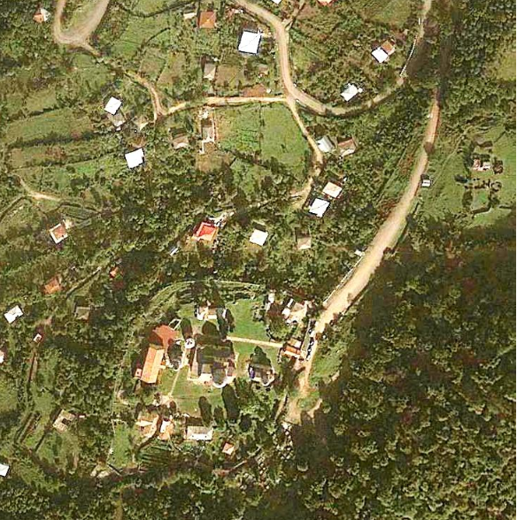
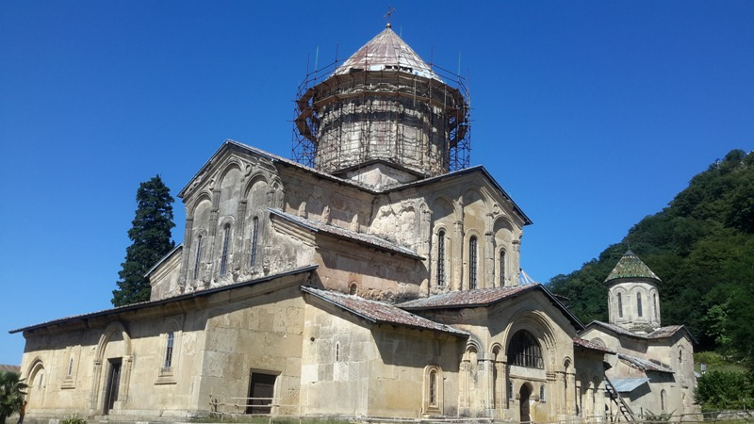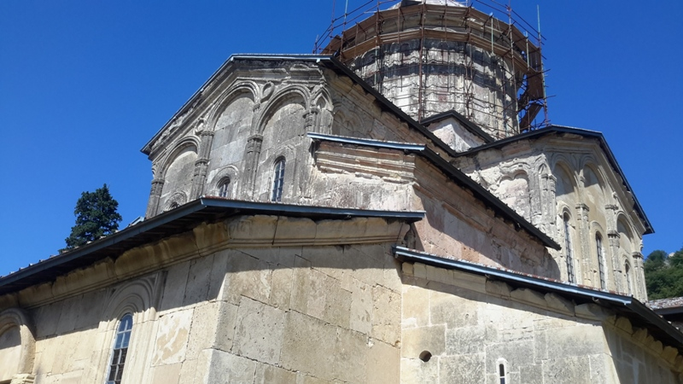
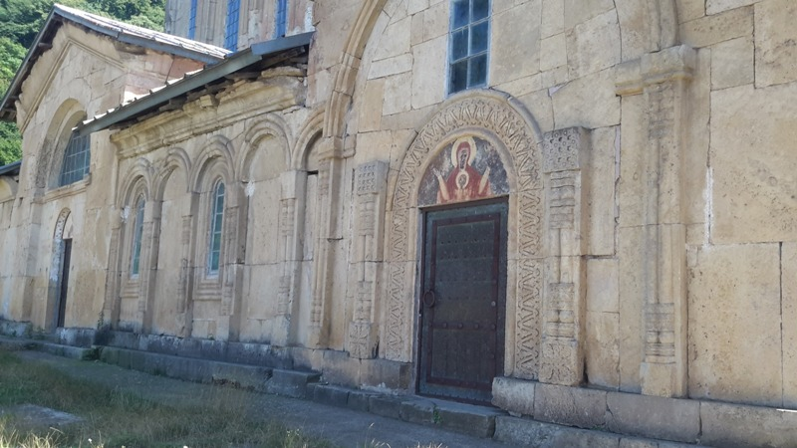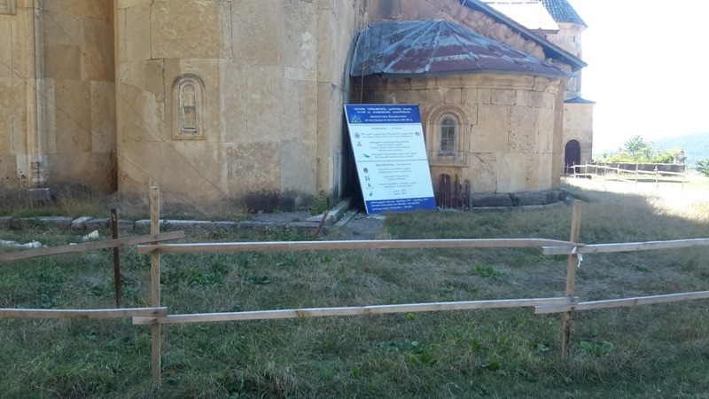

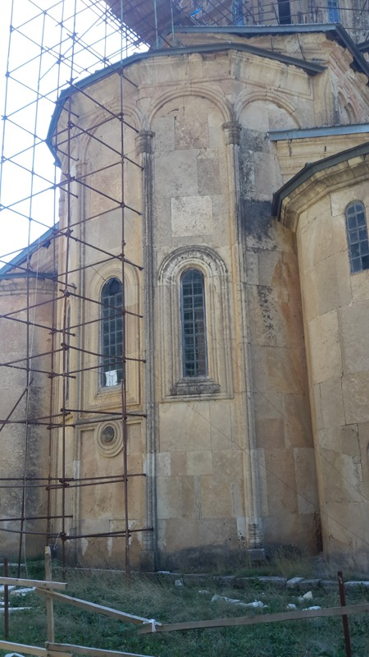
Attachment 2. Permit for Works on Cultural Heritage Monument
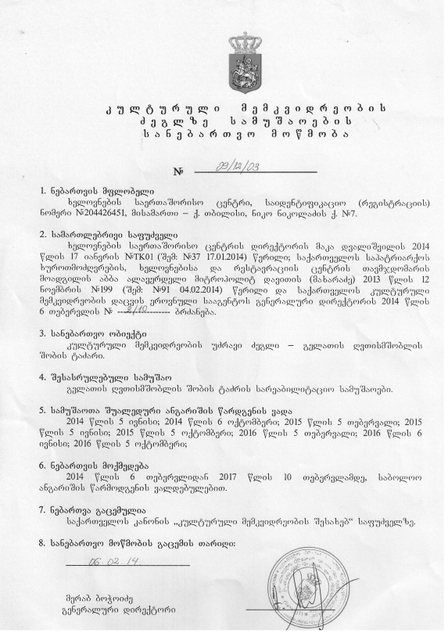
Attachment 3 – Agreement between Georgian Arts and Culture Center and 1+1 Ltd on the conduct of restoration works
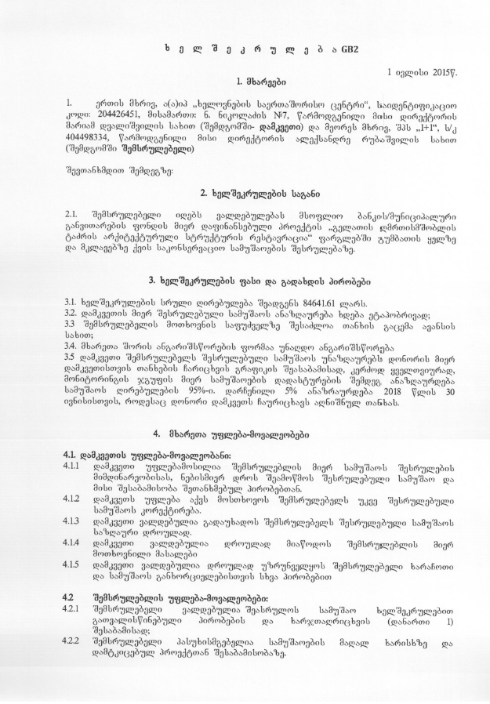
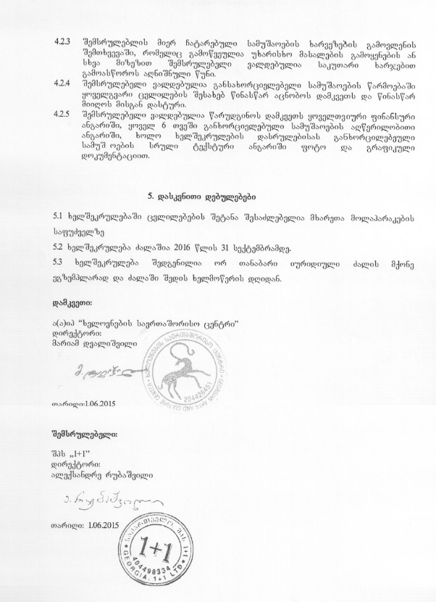
Attachment 4. Agreement between 1+1 Ltd and Solid Waste Company of Georgia on waste disposal
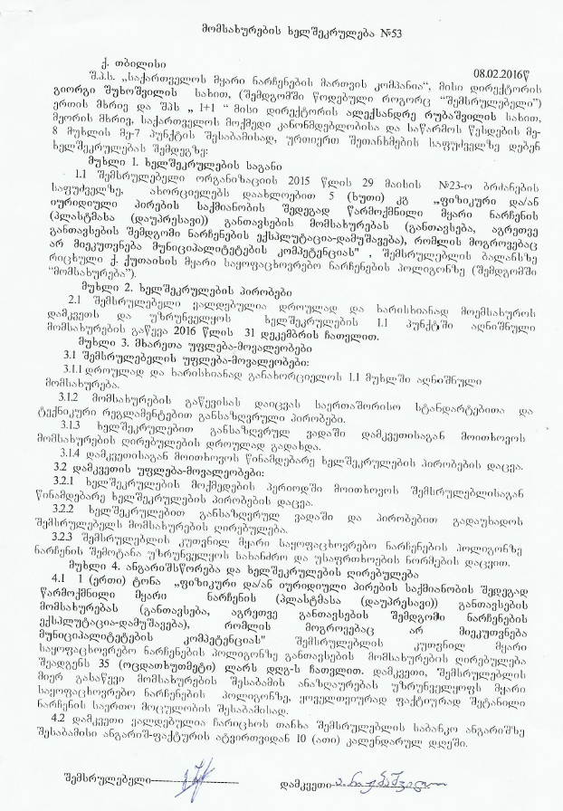
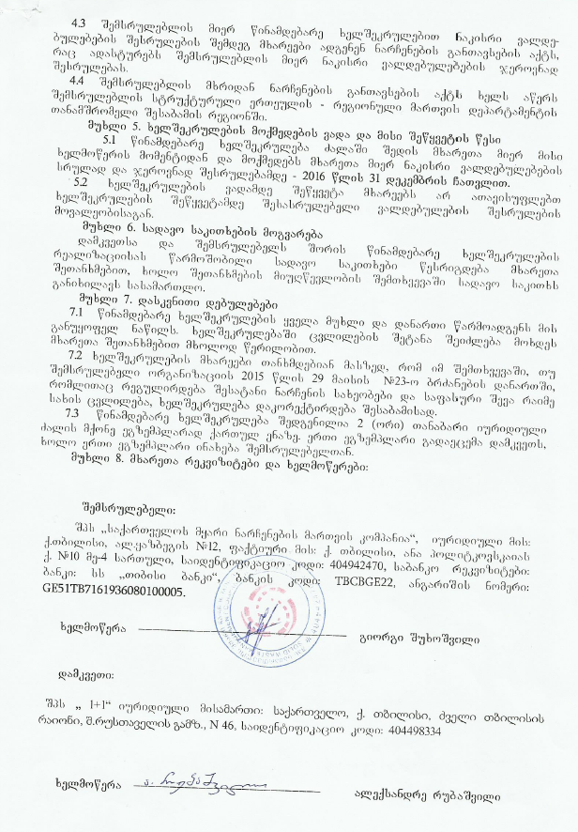

Land acquisitions includes displacement of people, change of livelihood encroachment on private property this is to land that is purchased/transferred and affects people who are living and/or squatters and/or operate a business (kiosks) on land that is being acquired.
Toxic / hazardous material includes but is not limited to asbestos, toxic paints, noxious solvents, removal of lead paint, etc.

