E4682 V4
Sustainable Development Engineering of Resource-Based Cities (Huai’nan City)
The World Bank Financed Project for Comprehensive Treatment and Utilization of Coal Mining Subsidence Area

Social Assessment Report

(Draft to be submitted for review)

Execution Office of the World Bank Financed Project for Comprehensive Treatment and Utilization of Coal Mining Subsidence Area

June 2014

Preface
In September 2013, the Involuntary Resettlement Research Center of China Three Gorges University (hereinafter referred to as CTGU) assumed the work, entrusted by the Anhui Huai’nan WB Project Office, of compiling a special report of social assessment on the World Bank (WB) financed project for comprehensive control and utilization of coal mining subsidence area in the program of sustainable development of resource-based cities (Huai’nan) (hereinafter referred to as Huai’nan WB Project).Earlier in October 2013, CTGU received the “Draft Terms of Reference of the Social Assessment for Anhui Huai’nan Project” provided by the WB experts that was transferred by the project owner Huai’nan WB Project Office. The Draft Terms specifies the scope, goal, content and method of this social assessment and basically shapes up the work of the report compilation. The Draft highlights specific requirements for the goals of the assessment as follows:
(1) To determine the scope of affected area and carry out baseline survey, and come to know the social and economic situations of the affected area through the social assessment.
(2) To make it clear to the project planner and decision maker the demand of the residents, especially that of women and vulnerable population in the affected area, so as to protect their legitimate rights and interests, ensure that they can acquire development opportunities and interests from the project, and aid them in the path toward development through the social assessment;
(3) To enable the project owner to establish appropriate organization network and regulations arrangement in each stage covering selection, design, implementation, monitoring and assessment of the project, enhance communication and understanding between the project owner and the stakeholders, and ensure that various stakeholders, especially women and vulnerable population, can share information, through the social assessment;
(4) To enlighten the project planners and decision makers on the potential social risk and conflict during project implementation through the social assessment so that feasible policy measures can be taken to avoid, eliminate or compensate for these unfavorable influence, and that support from the local communities and residents can be obtained for the project construction to ensure successful implementation of the project.
(5) To bring the project planners’ focus on the role of the project in improving the environment and the social development in the whole area from a long-term and extensive perspective to avoid eagerness for quick success and instant benefits in decision making and the practice of making decisions merely for economic profit of the project or enterprises involved, and diminish shortsighted behaviors in decision makings, through the social assessment;
(6) To draft up social management plan to strengthen positive influence and prevent, alleviate or compensate for negative influence through the social assessment. The timetable for the social management plan is consistent with that for project implementation, with necessary costs covered in the overall budget of the project.
After communicating with the project owner several times, CTGU submitted Terms of Reference, questionnaire and interview outline agreed upon by both parties through negotiation, and carried out a 15-day social assessment field investigation in accordance with the work method and content determined during October 11th-18th 2013, November 6th-10th 2013 and September 1st-3rd respectively with the great support and cooperation by Huai’nan WB Project Office, relevant departments of Huai’nan City and the local government of Datong District. During the field investigation, CTGU has had a profound understanding about the opinions, comments and relevant suggestions from various groups of stakeholders toward the project and collected materials necessary for the social assessment in an all-round way through such work as informal discussion, interview and questionnaire in relevant villages, enterprises and institutions and relevant government departments of Huai’nan City.
CTGU summarized, documented and analyzed relevant materials and questionnaires as soon as the filed investigation was over, and completed the first draft of the social assessment in the first third of December 2013 by combining the results from the physical indicators index of resettlement and from the investigation of household’s socio-economic activities carried out during April 25th-27th and during June 21st-30th 2013 respectively. The draft to be submitted for review has been completed through modification and improvement based on the comments and opinions of the WB experts and the expert panel for project consultation on the first draft in March and April 2014, respectively.
At the end of August, 2014, World Bank replied that additional public consultation on the following two issues should be conducted: (1) According to the “Land Use Plan in the Project Area” approved by the city government of Huai’nan, real estate (housing) development and construction will not be conducted in the project area; (2) There is no legacy of pendent social issues, such as compensation for relocation (from within the area to the outside), appeal and lawsuit of resettled people, dispute on land etc.
As required by World Bank experts, CTGU and the project office conducted two additional forums with the assistance of the government of Jiulong Town, Datong District. Residents from Chonghua Community, Xinjian Community and Chenxiang Village participated in the forum as they all moved out of the project area. The additional survey results have enriched the relevant arguments of the social assessment and formed the report draft
At the assessment conference held from September 17 to September 23, World Bank further put forward the concept of benefited area and believed that the city government of Huai’nan may launch other development projects in the surrounding benefited areas after the implementation of the WB project. In addition to the full use of the positive environmental benefits of the WB project, these development projects may also require land acquisition and demolition. In order to avoid and reduce such land acquisition and demolition of other projects resulted from the implementation of the WB project, and at the same time to enhance the positive influence of the WB project, it is necessary to conduct further investigation and assessment on the basic social and economic situation of the area, the current situation of land use (including the current procedures and methods of land development), the process of land development and the possible land development projects in the future (within the 5-year implementation period), and to establish the monitoring mechanism and management counterplan on the basis of such investigation and assessment. As required by World Bank, CTGU has completed the social assessment supplementary report based on the further investigation and attached it to this report as Appendix 4.
A heartfelt gratitude is hereby extended to the Huai’nan WB Project Office, relevant municipal departments and the local government of Datong District for their proactive cooperation in this social assessment.

Table of Contents

1 Project Overview 7
1.1 Project background 7
1.2 Project components and contents 8
2. Overview of Social assessment Method 13
2.1 Functions of social assessment 13
2.2 Content of social assessment 13
2.3 Investigation method of the social assessment 15
2.4 Analytical framework and steps of social assessment 17
3. Determination of social assessment scope 19
4. Socioeconomic, historical and cultural background of the affected area 21
4.1 Population development situation of the affected area 21
4.2 N4ature resources and property relations of the affected area 22
4.3 Economic development of the project area 25
4.4 Social policy of the project area 27
4.5 Comprehensive environmental treatment of the coal mining subsidence area in Huai’nan 32
5. Result Analysis of Field Survey in Project Affected Areas (See Questionnaire in Appendix 1) 43
5.1 Basic information of respondents 43
5.2 Means of livelihood of locals 45
6. The project social impact analyzing 46
6.1 Porject area and the population
6.2 Positive impact of the project 56
6.3 Arrangements for local people to benefit from land value increase
6.4 Negative impact 67
6.5 Potential risks 71
7. Stakeholder Analysis 73
7.1 Identification of stakeholders 73
7.2 Demands of stakeholders 78
7.3 Analysis on influence of stakeholders 83
8. Analysis on poverty 85
8.1 Overview of poverty of Huai’nan city 85
8.2 Poverty status of Datong district 87
8.3 Relative poverty of the affected areas 91
8.4 Poverty reduction strategy of the project area 92
8.5 Impact of the project on poverty reduction 93
The completion of this project will provide a crucial environment basis for the development strategy of Huai’nan city of advancing toward east and spreading toward south. From a long-term perspective, more job opportunities will be created, which will make poor and low-income groups benefit from it. 94
9. Impact of the project construction on development of women and vulnerable population 95
9.1 Overview of the women in the affected project area 95
9.2 Analysis of the impact of this project on women 100
10. Information Disclosure and Public Participation 103
10.1 Preliminary information disclosure 103
10.2 Public Participation and Consultation in Social Survey 104
10.3 Public participation mechanism 108
11. Social Management Plan 110
11.1 Measure to enhance/promote positive impact 110
11.2 Measures to avoid/reduce negative impact 111
11.3 Measures to avoid potential risks 113
11.4 Measures to meet the needs of main stakeholders 123
11.5 Measures to meet the willingness of women and vulnerable groups 127
Attachment 1: Questionnaire Survey on World Bank funded comprehensive treatment project in coal mining subsidence related to sustainable development engineering for resource-based city (Huai’nan City) 130
Attachment 2: Implementation Scheme of Employment Training for Residents in 9 Coal Mining Subsidence Areas in Huai’nan Municipal World Bank Loan Project 141
Attachment 3 Project and Minority 158
Attachment 4 LAND DEVELOPMENT WITHIN THE BENEFIT BELT 159

1 Project Overview

1.1 Project background
The sustainable development of the ecological environment of Huai’nan has been severely threatened as ground collapse and ecological degeneration of large area were caused and various infrastructures, residential areas and arable land were damaged to different degrees due to coal mining year in and year out.
In recent years, Huai’nan has made the work of comprehensive treatment of the subsidence area a livelihood project of top priority and endeavored to solve the problems of the subsidence area by taking a range of measures. The measures include promulgating Rules for Treating Huai’nan Coal Mining Subsidence Area (2003) in 2003, establishing the “Office of Comprehensive Restoration and Treatment of Coal Mining Subsidence Area in Huai’nan” in 2009, drafting up regulations such as Opinions on Speeding up Village Resettlement and Driving the Work of Comprehensive Treatment in Coal Mining Subsidence Area in 2010, and applying for WB loans for treating Jiu (Jiulonggang) – Da (Datong) coal mining subsidence area in 2012.
The WB financed project for comprehensive treatment and utilization of Huai’nan coal mining subsidence area has been listed in the WB loan candidate project plan for fiscal years 2015~2019 as agreed upon approval by the State Council after being studied by the National Development and Reform Commission (NDRC), the Ministry of Finance and the World Bank. It is planned to apply for a loan of 100 million U.S. dollars from the World Bank.
The reasons why Jiu-Da coal mining area was chosen for remediation in the WB financed project are as follows: 1) Jiu-Da coal mining area, which is located between the old urban area and the new one of Huai’nan and closely adjacent to the northern foot of Shungeng Mountain, is a very important part of the urban development plan of Huai’nan as it is the channel connecting the main urban areas from the south to the north and a central zone after the city is expanded; 2) The technical risk for environmental remediation in Jiu-Da coal mine is greatly reduced as it has been shut down for more than three decades and has basically ceased subsidence; 3) The WB loan will help overcome the financing bottleneck because it is very difficult to raise funds to treat Jiu-Da coal mine subsidence area as it is unclear who are responsible for treating the area due to historical reasons, yet the legacy issues are outstanding with significant negative influence; 4) The overall image of Huai’nan City and the life of neighboring residents are severely compromised and the urban land is greatly wasted in Jiu-Da subsidence area, which has been covered by garbage with pits and ponds everywhere, plus abandoned buildings and messy solid waste dump sites.

1.2 Project components and contents
This project is for comprehensively treating an area of 9.3 km² within Jiu-Da coal mining subsidence area of Huai’nan and the contents include three components: (1) environmental remediation and water system treatment; (2) infrastructure improvement and development and utilization of the project area; (3) Project management and technical assistance. Please refer to Table1-1 for content introductions and goals in detail.
Table 1-1 Introduction to project content
Name of component | Construction content | Goal
1. Environmental remediation and water system treatment | 1) Environmental remediation: environmental remediation of abandoned mining land and vegetation restoration in the project area. | 1) To contain further aggravation of ecological environment and strive to restore the complete vegetation community system and food chain system, and to restore local natural ecosystem; 2) to craft a comprehensive green space integrated with relaxation, recreation, body building and science popularization by integrating and improving scenic elements such as nursery garden and forest within the area through green path to promote interactive development between the new and the old urban areas.
1. Environmental remediation and water system treatment | 2) Water system treatment: restoration of water system in the project area, meeting the requirement of protecting against once-in-30-year mountain flood and flood drainage. | To meet the requirement of preventing once-in-30-year mountain flood and flood drainage and make water quality reach Grade V through water system treatment in subsidence area.
1. Environmental remediation and water system treatment | 3) Closing Datong old dump site: closing Datong dump site to prevent water, soil and air pollution in this area. | To solve once-for-all the issue of old dump site polluting surrounding environment, and reduce the impact of its leachate and landfill gas.
2. Infrastructure improvement and project area development and utilization | 1) Improving and building necessary roads and infrastructures of relevant water supply and sewage draining in the project area, restoring their functions and connect them to other parts of the city. | The infrastructures mainly include 4 roads passing across the area and construction of water supply pipeline work under the roads, diversion and division between water and sewage, achieve formation of trunk road network in the project area, and improve traffic condition, water supply and drainage situations and investment environment in the area.
 | 2) Area development and utilization: supporting facility construction and activities in the area after restoration, integrating resources to serve for local development. | To build re-development and utilization of the project: miniature garden, nursery garden, and flower transaction market.
3. Project management and technical support | 1) Technical research  2) Technical management of project  3) Technical training on personnel  4) Service of guidance and consultation | During the process of establishing execution institutions, drafting up quality management system and quality control system for this project, the WB experts can provide constructive suggestions and personnel training; to amplify the leverage effect of WB loan and government fund through employment training on farmers who lost their land and poor residents.
Component (1) environmental remediation and water management is divided into three sub-components: (I) Environmental remediation; to carry out environmental remediation and vegetation restoration on the abandoned mining land in the project area; (II) Water management: to restore water system in the project area and meet the requirement of protecting against once-in-30-year mountain flood and flood drainage; (III) Closing Datong old dump site: to close Datong dump site, which occupies an area of 11 ha., to prevent water, soil and air pollution in this area.
Component (2) Improvement of infrastructures and project area development and utilization is divided into two sub-components: 1) Improvement of infrastructures: to improve and build necessary roads and relevant water supply and sewage draining infrastructures in the project area, restore their functions and connect to other parts of the city. 2) Area development and utilization: to support facility construction and activity in the area after restoration, integrate resources to serve local development, including miniature garden, seedling cultivation base, flower transaction market, and nursery garden.
Subcomponent (3) is project management and technical assistance. During the process of establishing execution institutions, drafting up quality management system and quality control system for this project, the WB experts can provide constructive suggestions and personnel training; to amplify the leverage effect of WB loan and government fund through employment training on farmers who lost their land and poor residents.
The project name, scale and function for the entire project are shown in Table 1-2. Please refer to Figure 1-1 for the location.
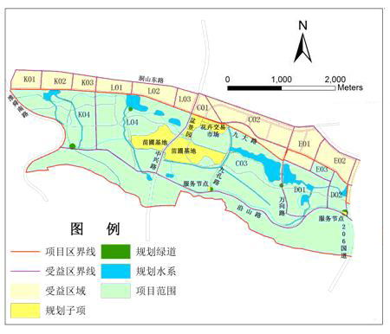
Figure 1-1 Map of Project Location and Surrounding Area Available for Development

The overall goal of this project is to support transformation of Huai’nan City into a green, sustainable modern energy city; to remediate, redevelop and utilize the environment in the coal mining subsidence area, to realize sustainable and sound development of regional economy and society, and to form a coordinated development trend which is friendly to environment and in which human and natural environment depend on each other and coexist harmoniously. It mainly includes: (1) Fundamentally eliminate environmental pollution; (2) ecological environment is positively improved; (3) land functions are restored and utilized in an intensified way; (4) comprehensive development is carried out to an appropriate degree to create jobs for the population in local community; (5) be a good model and play a leading role for the transformation of resource-based cities nationwide. But land acquisition, demolishment, and resettlement of some residents and enterprises will be involved in order to realize the project goal, which will bring temporary barrier for local residents’ livelihood; therefore evaluation and monitoring will be carried out on the realization of these works after the project is implemented, which will need positive and proactive participation of the public. Therefore, it is of extreme importance to carry out the work of social assessment before the project is started.
Table 1-2 Land acquisition scale and functions of the project
Project content | Scale | Function
Green path | 24km long and 4.5m wide | Entertainment, relaxation and fitness
Service points by the road | 12.6 mu | Relaxation, service, and commercial development
Water system | 840.5 mu (occupying land 88.1 mu) | Water system treatment, entertainment, relaxation
Miniature garden | 111 mu | Relaxation, and commercial development
Nursery garden | 819 mu (including 226 mu of collectively-owned land of Chenxiang Village) | Environment improvement, greening, and commercial development
Flower transaction market | 125.3 mu | Environment improvement, and commercial development
Zhongxing Road | 1.36km long and 30m wide | Vital communication line connecting the project area to outside
Jiukong Road | 1.39km long and 10m wide | Grade II road of traffic network in the project area
Wanxiang Road | 1.52km long and 25m wide | Grade II road of traffic network in the project area
Yanshan Road | 4.07km long and 7m wide | Grade II road of traffic network in the project area

2 Overview of Social assessment Method

2.1 Functions of social assessment
Social assessment aim at analyzes and determines the possible social opportunities and risks brought to each stakeholder by implementation of the project through collecting social information in the project-impacted area, so that the project planner and decision maker can rationally plan the priorities of the development. The social assessment to be carried out would help minimize various unfavorable social impact caused by the project, lower social risk and cost by the project implementation and increase social benefit of project investment.

2.2 Content of social assessment
The social assessment for this project would help identify positive and negative impacst that the project may exert on the local social development targets so that the potential risks can be fully identified with rational measures taken to minimize, eliminate or mitigate the social risk and conflict that may cause project failure, and increase the social and environmental benefit from the project investment. The main contents of social assessment include:
1. Collecting benchmark information
The benchmark information includes the characteristics of the population, social culture and political system in the affect communities, and the situation of local land resources and ownership.
2. Determining key stakeholders of the project
They include groups or organizations which directly or indirectly benefit or suffer loss from the project.
3. Carrying out consultation with stakeholders of the project
In every stage from project preparation to implementation, the affected population will be informed in advance for free and full negotiation, and an appropriate appeal or complaint channel and procedure will be established for the vulnerable population.
4. Analyzing positive impacts of the project
All kinds of direct or indirect profits in every field of social life that the project may bring will be evaluated; especially the indirect social profits that can hardly be measured with currency will be focused on. These profits mainly include positive impact on improving the people’s health, improvement of cultural level, progress of ideas and bettering labor conditions. They are not involved in the financial evaluation and environmental impact evaluation, but are one of the important points of social assessment.
5. Analyzing negative impacts of the project and potential social risks
Land acquisition and house demolishment are necessary for the project construction. During project construction the local water conservancy facilities, road and natural environment are likely to be temporarily disturbed, which may cause unfavorable impact on local residents’ work and life. Besides, different groups may have different appeal of interest with regard to the project construction. The social assessment of the project will focus on analyze various potential social risk that the project may bring, especially the potential unfavorable impact on vulnerable population such as women and disabled persons and on such group as land-expropriated farmers.
6. Analyzing and judging local residents’ attitude toward project construction
During the process of analyzing various potential conflicts of interest that may be encountered in project construction, these stakeholders’ will and attitude should be further understood to clarify whether the project construction is supported by local community and residents.
7. Collecting local residents’ suggestions on project planning and implementation
In order to fulfill the goal of the social assessment, during the social assessment process, CTGU the project consultation unit collected opinions and suggestions from local affected population and community, and discussions have be conducted with the affected population about the findings from the social assessment to ensure appropriate conclusion and measures of the social assessment. In order to avoid social conflict and mitigate its negative impact on local residents and community, proper countermeasures are also suggested to the project planner according to the social assessment.
8. Formulating social management plan
In order to strengthen positive influence and prevent, alleviate or compensate for negative influence, a social management plan needs to be formulated. The timetable for the social management plan is consistent with that for project implementation, with necessary costs covered in the overall budget of the project.

2.3 Investigation method of the social assessment

2.3.1 Desk review
1. Collect and review local chronicles of the project-impacted area and other relevant literatures about local conditions and customs.
2. Collect and review annals of statistics reflecting the economic and social situations of the project area, which include the Sixth Demographic Census of Huai’nan City, Annals of Statistics of Huai’nan City, and literatures and materials provided by Statistics Bureau of Datong District, town government of Jiulonggang, Poverty Relief Office of Huai’nan City, Women’s Federation of Huai’nan City, Healty Bureau of Huai’nan City, Human Resources and Social Security Bureau, Education Bureau, Culture Bureau, and Ethnic and Religious Committee.
3. Collect and review literatures such as laws and regulations and policies about the social development of the project area, which include important laws and policies about social development at national level and some important local laws, regulations, documents and policies formulated by Anhui province or Huai’nan city.
4. Collect and review various social and economic development plans and various special develop plans in the project area, which include materials such as the “12th Five-Year Plan” for the social and economic development of Huai’nan City, and Huai’nan urban development plan.
5. Review Project Proposal and Report of Project Feasibility Study compiled by design unit entrusted by the project owner.

2.3.2 Questionnaire
A questionnaire survey was carried out.As an important part of social assessment, the main purpose of the questionnaire for this project is to understand local people’s opinions and attitudes about the impact of the project on local social development, clarify the positive and negative social profit and potential social risk, and provide forward-looking insight for improving the project implementation scheme.

2.3.3 Group discussions
The interactive forum is organized by CTGU in the project-affected area. The participants are various stakeholders (such as project-affected population, disabled persons, women, grassroots cadres). At the forum, the social assessment team, by means of direct dialogue and communication with local people, collects information regarding to their work and life, earnestly listens to the voice of the people, understand their hope and concern, and hear their advice, to enrich local knowledge about the social economy, historical culture, customs, community development and social network of the project-affected area for the project planner, and provide valuable advice about optimizing project design, improving resettlement scheme, and restoring the living standards of the affected population.

2.3.4 Individual in-depth interview
Despite that the project construction may have positive influence on the social and economic development as a whole, but the influence can be very different for individuals. Therefore, when evaluating the social impact of the project, besides macro analysis, more necessary is evaluating project influence on individuals. As a matter of fact, whether the construction of a project has value and social profit, the judgment of project stakeholders is an important foundation; project planning and design should also be optimized from the perspective of stakeholders. Therefore, based on the forum and interview, the social assessment experts also select some households who may suffer great influence of the project to specifically understand their concerns and suggestions about the project construction.

2.4 Analytical framework and steps of social assessment
CTGU designs an analytical framework and steps of social assessment according to the characteristics of the project with reference to previous studies. The specific steps are shown in Figure 2-1.

Determine social impact evaluation scope

Analyzing project-impacted social, economic, institutional and policy background
Sorting out and analyzing field investigation data

Determining stakeholders and analyzing different impacts and appeals
Analyzing impact on and appeal of women, poor and vulnerable population
Public participation
Social management plan
Evaluating social impact and potential risk
Figure 2-1 Main steps of social assessment

3. Determination of social assessment scope
The project is situated in Datong district, Huai’nan city, involving Huaishun Community, Chonghua Community, Xinjian Community, Hongqi Community, Chenxiang Village, Jiulonggang Village under the jurisdiction of Jiulonggang Town, and Zhanhou Community And Kuangnan Community under the jurisdiction of Datong Sub-District. These are all the areas to be directly impacted by the project, and key areas for social assessment as well. This area is located on both sides of Jiu-Da highway – Linyang Road (southern boundary line of the project area), which is not only a populous area, but also an environment-sensitive area (involved in land acquisition and demolishment)
Considering that the environmental and social benefit of the project may have spillover effect as the project is comprehensive environmental improvement, we also select some indirectly affected areas outside the project area as investigation spots, such as areas on both sides of East Dongshan Road (adjacent to the area directly influenced by project), Longhu Park (for population in entertainment and relaxation in Huai’nan), and Haotai Hotel (for nonlocal tourists).
Table 3.1 Social assessment scope and investigation points
Directly affected area | Huaishun community | Questionnaire 1, interview 0, forum 0
Directly affected area | Chonghua community | Questionnaire 75, interview 3, forum 1
Directly affected area | Xinjian community | Questionnaire 14, interview 1, forum 1
Directly affected area | Hongqi community | Questionnaire 13, interview 1, forum 1
Directly affected area | Zhanhou community | Questionnaire 1, interview 2, forum 0
Directly affected area | Kuangnan community | Questionnaire 11, interview 2, forum 1
Directly affected area | Chenxiang village | Questionnaire 12, interview 3, forum 1
Directly affected area | Jiulonggang village | Questionnaire 10, interview 1, forum 1
Directly affected area | Other areas | Questionnaire 3, interview 0, forum 0
Indirectly affected area | Renmin village of Datong sub-district | Questionnaire 1, interview 1, forum 0
Indirectly affected area | TaoYuanju, Datong sub-district | Questionnaire 2, interview 0, forum 1
Indirectly affected area | Longhu Park | Questionnaire 2, interview 1, forum 0
Indirectly affected area | Haotai Hotel | Questionnaire 3, interview 1, forum 0
Indirectly affected area | Other areas | Questionnaire 7, interview 2, forum 0
Total |  | Questionnaire 155, interview 11, forum 7
CTGU determined the work method and content three times from October 11-18, 2013, from November 6-10, 2013, and from September 1-3, 2014 respectively. Under the great support and cooperation of Datong district government and the project-involved communities, together with WB workers, CTGU carried out field investigation by means of forum, in-depth interview and questionnaire and made Table 3-1 from summarizing the above investigation combined with the social and economic result of the resettled households acquired with the same way in the physical index investigation of resettlement two times from April 25-27th, 2013, and from 21-30th June, respectively. In the mean time, the investigators also visited such units as Huai’nan Education Bureau, Human Resources and Social Security Bureau, Statistics Bureau, Finance Bureau, Ethnic and Religious Committee, Women’s Federation, Datong District Government, Jiulonggang Town of Datong district, and Datong sub-district office, and collected relevant data, policies and documents of social-economic-cultural development and interviewed relevant persons to know extensively each unit’s degree of understanding on the project and evaluation on the project impact.

4. Socioeconomic, historical and cultural background of the affected area
Due to the spillover of environmental and social benefits of the project, the areas surrounding the project area and even the whole Huai’nan city are affected by the project and are the benefited area of the project although the project is located in Datong District.

4.1 Population development situation of the affected area
The population and its structure, quality and distribution are the basic background of the socioeconomic development of a region. The population development indexes of Huai’nan city are shown in Table 4-1 according to the sixth census of Huai’nan city.
In terms of population size, the permanent population of Huai’nan city in 2010 was 2.3339 million. Compared with 3.0406 million in 2000, it had increased by 0.2932 million with an average annual growth rate of 1.35%. The number of people per household decreased by 0.51 from 3.58 in the fifth census in 2000 to 2.93, showing the shrinking trend of average household size. According to the statistical data, the permanent population of Huai’nan would reach 2.339 million at the end of 2012.
In terms of gender structure, male population is 1.212 million, which occupies 51.93% of the city’s permanent population; female population is 1.11218 million, which occupies 48.07% of the city’s permanent population. The gender ratio of total population (the population of females as 100) decreased from 109.08 in the fifth census in 2000 to 108.04. In terms of the age structure of population, among the permanent population of the city, the number of people aged at 0-14 is 0.3646 million, which occupies 15.62% of total population; the number of people aged at 15-64 is 1.753 million, which occupies 75.11% of total population; the number of people aged above 65 is 0.2163 million, which occupies 9.27% of total population. Compared with the result of the fifth census in 2000, the number of people aged at 0-14 decreased by 8.48 percent, the number of people aged at 15-64 increased by 6.49 percent, and the number of people aged above 65 increased by 1.99 percent, which shows the arise of aging trend of population.
Table 4-1 Population situation of Huai’nan City
Item |  | Index | Number
Population |  | Permanent population | 2.3339 million
 |  | Average annual growth rate (2000~2010) | 1.35%
 |  | Average number of people per household | 3.07
Population structure | Gender structure | Ratio of male population | 51.93%
Population structure | Gender structure | Ratio of female population | 48.07%
Population structure | Gender structure | Gender ratio | 108.03
Population structure | Age structure | Proportion of population aged at 0-14 | 15.62%
Population structure | Age structure | Proportion of population aged at 14-64 | 75.11%
Population structure | Age structure | Proportion of population aged above 65 | 9.27%
Population quality |  | Illiteracy rate | 6.67%
Population distribution |  | Urbanization rate | 61.79%
 |  | Population density | 9032 per km²
Data source: Communiqué of Huai’nan on Major Figures of the 2010 Sixth Population Census
As for population quality, among the city’s permanent population, the number of people with college education (above junior college education) is 0.1981 million, accounting for 8.49%; the number of people with senior secondary education (including technical secondary education) is 0.3232 million, accounting for 13.85%; the number of people with junior secondary education is 0.9886 million, accounting for 42.35%; the number of people with primary education is 0.502 million , accounting for 21.51%. The number of illiterate people (people over 15 years of age who cannot read) is 0.1557 million and the illiterate rate is 6.67%. Though the illiterate rate is lower than the average rate 8.34% of Anhui province, it is higher than the average rate of the country 4.08%.
As for the distribution of population, 1.4421 million people live in urban areas, which accounts for 61.79% of the city’s permanent population; 0.8918 million people live in rural areas, which accounts for 38.21%. The urban population increased by 287100, the rural population decreased by 6200, and the ratio of urban population increased by 5.2 percent, compared with the fifth census in 2000.

4.2 Natural resources and property relations of the affected area

4.2.1 Mineral resources
Coal: Coal is contained in the underground of Datong and Jiulonggang. Built in the second year of Xuantong’s rein (1910), the Datong Coal Mining Area is adjacent to Shungeng Mountain in the south and is 5 kilometers away from the Huai River in the north. The east-west mineral vein is 5km long from east to west and 3km long from south to north. The coal there is low in sulphur and ash content and is high in volatile matter. The Datong mine was depleted and scrapped in 1979. As early as in the 17th century, people had mined coal in traditional way in Jiulonggang Coal Mining Area. The mine was built in the 19th year of Republic of China (1930), with 31.95 million tons of reserve, 14 working beds, and 23.6m of working thickness. The coal there is fat gas coal containing 20% of oil content, with calorific value of 5000-7000 kcal/kg. The Jiulonggang mine was depleted and scrapped in 1982.
Rock: The affected area is rick in rocks. The resources with high value of development include limestone, alum clay, marble, Taihu rock, quartz stone, calcite, iron ore, terra cotta, stone milk, lightweight ceramsite, and mineral water etc.
Clay: The clay-sourced ancient Shouzhou kiln began in the middle and late Northern and Southern Dynasty, entered its heyday in the Sui Dynasty and Tang Dynasty, and declined in the late Tang Dynasty. The main products include various kettles, basins, bowls, jars, cups, vats and pottery pillow, pottery spinning wheel and glass tube with colors of yellow, dark reddish brown, black, cyan, tawny and purple. These products are exquisitely crafted with even color as bright as a mirror. Lu Yu, the master of tea in ancient China, described it as “purple and tawny yellow as bright as a mirror and sounds like chime”.

4.2.2 Land resources
Datong District has a total area of 202 km². In 2012, the area of arable land in Datong is 252045 mu, some of which is occupied by city suburbs and rural houses. The largest block of arable land in Datong District is in Luohewan, which is composed of moisture soil and soft soil that are good for crops. There are also some downlands and mounds. On Shangyao Mountain and Shungeng Mountain, in rural gardens and beside houses, villages, roads and waters, people plant various cash crops and fruits and breed animals to develop rural economy.
According to Chinese laws and regulations, land in rural areas and suburban areas of cities excluding those belonging to the state prescribed by law is collectively owned by peasants; house sites and privately farmed plots of cropland and hilly land are also collectively owned by peasant. Land owned by peasant collective in Huai’nan is contracted for management by members of the economic collective. Women and men have equal right to contract rural land. The lawful rights and interests of women shall be protected in the contract and no organization or individual shall deprive or infringe women of the right to contract land for management that they deserve. During the term of contract, if a woman gets married and has not obtained contracted land in the new residence, the contract-issuing party shall not take back the land she has contracted previously; if a divorced or widowed woman does not move away or moves away but has not obtained contracted land in the new residence, the contract-issuing party shall not take back the land she has contracted previously.

4.2.3 Land ownership in the project area
The project area contains total 13950 mu (9.3 km²) land. Among these land, 11182mu is state-owned and 2768 mu collectively-owned land. The users of state-owned land are complex, which include Huai’nan Mining Group (9182 mu) as well as governments of Huai’nan City and Datong District (2000 mu). The land ownership is shown in Figure 4-1. As the coal there had been mined for quite a long time and has been almost exhausted, large-scale coal mining was completely ended in 1982. On the basis of the former Datong Coal Mine, Datong District develops some township enterprises such as the Datong No. 11 Mine and expanded the No. 5 Mine, No.1 Mine, No. 2 Mine, No. 4 Mine, No. 8 Mine and the Jiulonggang Cement Plant, which are all the users of state-owned land. After 1998, with the macroscopic regulation of China, small coalpits have been shut down, merged or transformed, brickyards have been closed, the settlements and closed enterprises in the subsidence area have been relocated. Huai’nan Mining Group has conducted comprehensive treatment to the coal mining subsidence area and has built a ecological wetland park there. However, there are some individuals who still rent the state-owned land in the project area to run brickyards, quarries and small building materials factories, which have a great destructive effect on the landscape and have caused disorder in the management and use of land. Huai’nan Welfare Home, Huai’nan Funeral Home, Qishan Cemetery and Qishan Garden are affiliated to the government of Huai’nan City and occupy some state-owned land. For the sake of environmental renovation of the area, recently the government of Datong District required that all the industrial enterprises in the project area should be relocated step by step to transfer the right to use land to the government of Huai’nan City for the use of ecological construction.
The collectively-owned land in the project area is mainly in Chenxiang Village, Jiulonggang Town, where almost all rural settlements have been moved out in the past few years. Some villages have to walk 20-30 minutes from home to their workplace as their house is far away from their farmland.
Figure 4-1 Land ownership in the project area and adjacant area

4.3 Economic development of the project area
Located in the heartland of East China beside the Huai River, Huai’nan is the central city in north Anhui Province. It is also an energy capital of China, a granary of East China, and a key industrial city of Anhui Province. The current economic development situations of Huai’nan can be summarized as the following.

4.3.1 The overall economic strength has been enhanced rapidly, but the economic aggregate and financial strength needs to be expanded and boosted
In 2012, the GDP of Huai’nan reached 78.18 million Yuan; the fixed-asset investment was 63.97 million Yuan; the total fiscal revenue was 16.62 million Yuan, of which local fiscal revenue was 9.86 million Yuan. The rapid growth of economic aggregate has laid a solid foundation to accelerate urban construction and achieve fast rise of Huai’nan.
However, the economic aggregate of Huai’nan is still relatively small and is in the lower middle level among all the cities in Anhui Province. As the financial strength and local fiscal revenue are not high, there is a big financing gap in economic transition, urban and rural construction, environmental improvement, livelihood guarantee, public service improvement and development of other social and economical undertakings.

4.3.2 Industrialization is rapidly advanced, but new industries need to be fostered and developed
In 2012, the added value of industrial enterprises above designated size of Huai’nan was 45.64 billion Yuan and the industrialization rate is 58.4%. Positive results have been achieved through the strategy of booming the city by developing industry; a host of advanced techniques have been applied in industries such as coal-fired power generation and have improved efficiency and enhanced benefits. Other industries, like coal mining machinery, have gained long-term progress; Remarkable achievements have been achieved in the optimization and adjustment of industrial structure. State-owned enterprises have developed steadily, industrial parks have risen rapidly, private enterprises, middle and small-sized enterprises have developed quickly.
However, coal-dominated resource-consuming industries still play a primary role and the proportion of non-coal industries is low. Service industry and high tech industry are not fully developed; especially new industries such as new energy, advanced material, electronic information and biology have a small overall size and develop slowly. As the result of unreasonable industrial structure, the economy of Huai’nan has been largely affected by the situation of coal industry, which results in lack of economic stability and poor anti-risk ability.

4.3.3 Remarkable achievements have been achieved in city construction, but county economy is underdeveloped
In recent years, as the construction of Shan’nan New Town has begun to take shape, the scale of the city has been expanded quickly and city functions have been constantly completed; Great achievements have been obtained in city construction. Significant results have been achieved in city greening and beautification; environmental quality and cultural grade of the city have been promoted; living environment has been improved greatly.
However, as a central city, its capacity of radiation is not strong. County economy is underdeveloped; middle and small-sized towns are in lack of development dynamism; there is an obvious gap in the urban system structure: there are particularly large cities and quite small towns, but middle-sized towns are few.

4.3.4 Environmental pressure is too much and economic development pattern needs to be unceasingly transformed
Massive exploitation of resources has resulted in ecological deterioration and has caused a range of problems such as air pollution, water pollution, soil pollution and ground subsidence. The difficulty in resource conserving and environment protection has increased and treatment of coal mining subsidence area is urgently needed. To accelerate the building of resource-conserving & environmental-friendly society, the economic development pattern of Huai’nan needs to be changed from extensive to intensive.

4.4 Social policy of the project area

4.4.1 The evolvement of social policy of the project area

Before 1978, Huai’nan adopted planned economy system as other places in China did. Under such a system, the state established a social policy system with urban-rural dual structure dominated by government: In urban areas, the state established a social security system for urban populations; the vast majority of urban residents got a life-long job in state-owned enterprises or public institutions, which provide them with social service and social welfare such as medical service, housing, education and pension. In rural areas, on the basis of collective ownership of land, the state established the collective welfare system and farmers enjoyed certain collective insurance as members of a collective.
Since 1978, China began the transition from planned economy to market economy. By the 1990s, Huai’nan had experienced a fundamental transformation in social policy, as other places in China had. At that time, with the governing principle of “giving priority to efficiency with due consideration to fairness”, the state focused on economic growth and ignored social development. The reform of social security system and social welfare at that time indicated an obvious orientation of marketization. Employment policy, education policy, health care policy and housing policy had all experience the transition from state-dominated to market-dominated. The government continuously retreated from social public services. It was at this time that the old urban and rural social security systems broke down gradually and many people lost their basic social security.
In the 21st century, the government began to reconsider the relations between market economy and social policy and refocused on the role of social policy in economic development and social progress. In 2003, the Chinese government put forward a new concept of development (“Concept of scientific development”) and the idea of “building a harmonious society”, and proposed to focus on social development and promote the coordination between social development and the development of economy, politics and culture. In recent years, both the central government and local governments of China have paid considerable attention to social construction and people’s livelihood, and have introduced a large number of social policies which constitutes the main macrocosmic institutional environment of the affected area. The main social policies of the affected area are described as following.

4.4.2 Main social policies of the affected area
The social policy system of the affected area is composed of national laws, regulations and policies and local regulations and policies, which mainly include:
1. Constitution of the People's Republic of China (2004)
2. Law on Regional Ethnic Autonomy of the People's Republic of China (2001)
3. Law on the Protection of the Rights and Interests of women of the People's Republic of China (2005)
4. Education Law of the People's Republic of China (1995)
5. Social Insurance Law of the People's Republic of China (2011)
6. Law on Compulsory Education of the People's Republic of China (2006)
7. Population and Family Planning Law of the People's Republic of China (2002)
8. Special Provisions for the Work Protection of Female Employees (2012)
9. Regulations on Population and Family Planning of Anhui Province (2011 Amendment) (2012)
10. Measures for the Implementation of Law on Compulsory Education of PRC of Anhui Province (2011)
11. Implementation Measures for Reform of Compulsory Education Fund Guarantee Mechanism of Huai’nan City (2012)
12. Notice on Issuing Trial Measures for Social Pension Insurance of Urban and Rural Residents of Huai’nan City (HF [2012] No. 77) (2012)
13. Notice on Issuing Interim Measures for Compensation of Relocation and Resettlement of Rural Residents on Collectively-owned Land in the Coal Mining Subsidence Area of Huai’nan City (HFB [2011] No. 104)
14. Notice of People’s Government of Huai’nan City on Issuing Measures for Compensation for the Expropriation of Collectively-owned Land in Huai’nan City (HF [2013] No. 39)
15. Notice of Issuing Interim Measures for Pension Insurance of Land-expropriated Farmers (HF [2006] No. 69)

4.4.3 Abstract of main social policies of the affected area
1. Policy of protecting women’s rights and interests
Gender equality is a fundamental state policy of China. Constitution of PRC stipulates that women in the People’s Republic of China enjoy equal rights with men in all spheres of political, economic, cultural, social and family life. The fundamental principle of gender equality was established in the 1950 version and 1980 version of Marriage Law and the 2001 amendment of Marriage Law; Law on the Protection of the Rights and Interests of women of the People's Republic of China issued in 1992 and revised in 2005 also stipulates explicitly that women enjoy equal rights with men in all aspects, including family and social life. Besides, the state has fully realized that since women have special physiological needs and interest demands as they not only participate in social production but also undertake the function of population reproduction have special physiological needs and interest demands. National laws also contain terms protecting the special rights that women enjoy exclusively.
Women enjoy equal rights with men in all spheres of political, economic, cultural, social and family life. (Article 2, Law on the Protection of the Rights and Interests of women of the People's Republic of China)
With the exception of the special types of work or post unsuitable to women, no unit may, in employing staff and workers, refuse to employ women by reason of sex or raise the employment standards for women. (Article 23, Law on the Protection of the Rights and Interests of women of the People's Republic of China)
Equal pay for equal work shall be applied to men and women alike. Women shall be equal with men in the enjoyment of welfare benefits. (Article 24, Law on the Protection of the Rights and Interests of women of the People's Republic of China)
All units shall, in line with women's characteristics and according to law, protect women's safety and health during their work or physical labor, and shall not assign them any work or physical labor not suitable to women. (Article 26, Law on the Protection of the Rights and Interests of women of the People's Republic of China)
Women shall enjoy equal rights with men in the contract for management of rural land, the income allotment of economic collectives, use of compensation fee for land collection and requisition and use of house site. (Article 32, Law on the Protection of the Rights and Interests of women of the People's Republic of China)
A woman shall enjoy equal rights with her spouse in possessing, utilizing, profiting from and disposing of the property jointly possessed by the husband and wife according to law, which shall not be affected by the status of income of either party. (Article 47, Law on the Protection of the Rights and Interests of women of the People's Republic of China)
No employers may reduce women’s salaries, dismiss them or terminate labor contract or employment contract with them by reason of pregnancy, giving birth or baby-nursing (Article 5, Special Provisions for the Work Protection of Female Employees)
If a pregnant female employee cannot adapt to her work, employers shall, according to the evidence provided by medical institutions, reduce the amount of labor or arrange other works that she can adapt to. No employers shall extend work hours or arrange night shift for female employees who have been pregnant for over 7 months, and shall schedule certain breaks during working hours. The time pregnant female employees need for antenatal examination during working hours shall be counted in work time. (Article 9, Special Provisions for the Work Protection of Female Employees)
2. Population policy
The government of Huai’nan adopts the policy of family planning: it encourages citizens to marry and bear a child at a late age and advocates that one wife one wife bear only one child; citizens may bear a second child only if they meet the requirements specified by laws and regulations. Here is the abstract of laws and policies concerning population of the affected area:
China being a populous country, family planning is a fundamental State policy. The State adopts a comprehensive measure to control the size and raise the general quality of the population. (Article 2, Population and Family Planning Law of the People's Republic of China)
The State maintains its current policy for reproduction, encouraging late marriage and childbearing and advocating one child per couple. Where the requirements specified by laws and regulations are met, plans for a second child, if requested, may be made. (Article 18, Population and Family Planning Law of the People's Republic of China)
Advocate and encourage late marriage and childbearing. Advocate and encourage that one couple only bear one child. (Article 3, Regulations on Population and Family Planning of Anhui Province)
3. Social security policy
Here is the abstract of Trial Measures for Social Pension Insurance of Urban and Rural Residents of Huai’nan City:
Rural residents at the age of 16 or above who do not have basic pension insurance for urban workers and non-employed urban residents at the age of 16 or above who do not meet the requirements for basic pension insurance for urban workers may voluntarily apply for pension insurance for urban and rural residents.
The fund of pension insurance for urban and rural residents is mainly composed of individual payment, collectively pooled subsidy and government subsidy. Encourage rural economic collectives, other economic organizations, social non-profit organizations and individual insurance buyers to provide funds. Urban and rural residents at the age of 60 or above who have paid for the insurance for 15 years or above accumulatively may receive a pension on a monthly basis.
4. Education policy
Nine-year compulsory education system is adopted by both urban and rural areas of Huai’nan City. All citizens, regardless of ethnic group, race, sex, occupation, property status or religious belief, shall enjoy equal opportunities for education according to law. During compulsory education, students shall not be charged of tuition and fees. The spoken and written Chinese language shall be the basic spoken and written language in teaching in schools and other institutions of education. In schools and other institutions of education in which students of a minority ethnic group constitute the majority, the spoken and written language used by the specific ethnic group or commonly used by the local ethnic groups may be used for instruction. Here is the abstract of laws and regulations concerning education:
All citizens, regardless of ethnic group, race, sex, occupation, property status or religious belief, shall enjoy equal opportunities for education according to law. (Article 9, Education Law of the People's Republic of China, implemented since September 1, 1995)
The State, in light of the characteristics and needs of the different minority ethnic groups, provides assistance to the development of educational undertakings in regions inhabited by the minority ethnic groups. The State supports and assists the development of educational undertakings in the outlying and poverty-stricken areas. The State supports and develops educational undertakings for the disabled. (Article 10, Education Law of the People's Republic of China)
The spoken and written Chinese language shall be the basic spoken and written language in teaching in schools and other institutions of education. In schools and other institutions of education in which students of a minority ethnic group constitute the majority, the spoken and written language used by the specific ethnic group or commonly used by the local ethnic groups may be used for instruction. (Article 12, Education Law of the People's Republic of China, implemented since September 1, 1995)
The State applies a system of nine-year compulsory education. People's governments at all levels shall take various measures to guarantee school-age children and adolescents access to education. Parents or other guardians of school-age children and adolescents as well as social organizations and individuals concerned shall have the obligation to ensure that school-age children and adolescents receive and complete compulsory education for the prescribed number of years. (Article 18, Education Law of the People's Republic of China, implemented since September 1, 1995)
The state shall institute a system of compulsory education and shall not charge for tuition and fees. (Article 2, Law on Compulsory Education of the People's Republic of China, Amended on June 29, 2006)
Local people's governments at various levels shall provide free textbooks to school-age children and adolescents from poor families and living allowance to boarders. (Article 44, Law on Compulsory Education of the People's Republic of China, Amended on June 29, 2006)
If any one of the following cases occurs in people’s governments at county level or above, the people’s government at higher level shall order them to make corrections within a time limit; if the circumstance is serious, the leading persons directly in charge and other persons directly responsible for it shall be given sanctions in accordance with law:
(1) fail to perform the obligation of compulsory education fund guarantee;
(2) fail to make and adjust plans for school establishment according to national and provincial regulations;
(3) occupy position of teachers in an improper or disguised way;
(4) fail to regularly check the safety of school buildings and timely service, reinforce or rebuild school buildings;
(5) fail to establish a working system concerning the care for left-behind children in rural areas and ensure that left-behind children in rural areas could receive compulsory education. (Article 43, Measures for the Implementation of Law on Compulsory Education of PRC of Anhui Province)

4.5 Comprehensive environmental treatment of the coal mining subsidence area in Huai’nan
Huai’nan City thrives because of the coal resource it boasts of. At present it is one of the large coal bases in China. In recent years, the rapid development of coal industry has given great impetus to the economic and social development of Huai’nan. However, coal mining has resulted in a large area of ground subsidence and has caused a host of problems that constantly hinder the socio-economical development of Huai’nan.

4.5.1 Overall situation of the coal mining subsidence area in Huai’nan
The coal mining subsidence area in Huai’nan spreads over one county and five districts of Huai’nan, including 27 towns. As of 2013, the subsidence area is about 220 square kilometers, which accounts for 8.5% of the whole city; the subsidence area involves about 311000 people, accounting for 12.8% of the city’s population. Given that the subsidence area increases by 26 square kilometers per year, it is anticipated that the final subsidence area will eventually reach 682 square kilometers, which accounts for 26.3% of the whole city, and will involve about 610000 people, which accounts for 25% of the city’s population.
Table 4-2 Statistics of coal mining subsidence area in Huai’nan mining district (2013)
Name of subsidence area |  | Size of subsidence area (km²)
Discarded mining district | Jiu-Da subsidence area | 13.52 (9.3 km² is of the project area)
Well area of the old Huai’nan mining district | Xieli subsidence area | 56.36
Well area of the old Huai’nan mining district | Xinli subsidence area | 56.36
Well area of the new Panxie mining district | Panji subsidence area | 150.12
Well area of the new Panxie mining district | Zhangxie subsidence area | 150.12
Well area of the new Panxie mining district | Xinji subsidence area | 150.12
Total |  | 220

4.5.2 Main problems in the coal mining subsidence area
1. Livelihood. Firstly, road subsidence has caused serious damage to infrastructures. According to incomplete statistics, so far 51.7 kilometers of highways at county level or above, 1110 bridges, and 152.2 kilometers of power and telecommunication lines are damaged; the subsidence area even threatens the security of Huai River dam and railways; it has a serious effect on the livelihood of local residents and the development of the region.
Secondly, the livelihood of residents in the subsidence area can hardly be ensured. Due to ground subsidence, many farmers have lost their farmland and houses and have returned to poverty, which has caused a lot of social problems; after various coal mines have been put into production, the coal mining subsidence area expands year after year and more and more farmers will fall into poverty due to loss of land.
2. Environment and resources. Coal mining subsidence is a geological disaster formed by ground subsidence and collapse resulting from underground coal mining. According to the degree of damage, stability and mining cycle of the ground, subsidence area can be divided into stable subsidence area, relatively stable subsidence area and unstable subsidence area.
The problem in environment and resources caused by subsidence is firstly embodied in the huge change of water system. As some coal seams are hundreds of meters deep into the ground, the subsidence may damage the ground and underground water systems and lead to water and soil loss; rivers and underground water in the mining district are easily polluted by slag and waste water, which affects the water quality and water environment of both the upstream and the downstream. The subsidence has also caused separation of integral waters and water systems so that floodwater discharge is obstructed and serious water logging occurs during flood season.
The problem in environment and resources caused by subsidence is also embodied in the huge change of landscape. The fertile farmland has become split hills and sunken land with heaps of gangues; coal ash has become the main inhalable particles in the air. The shantytowns surrounding the mining area have become the slum of the city as well as a scar, showing an image of “modern inside and messy outside”.

4.5.3 Achievements in the comprehensive environmental treatment of coal mining subsidence area in Huai’nan
In recent years, Huai’nan has always taken the comprehensive treatment of coal mining subsidence area as the largest livelihood project and implements centralized relocation, resettlement combined with development and treatment combined with exploitation. The centralized relocation solves housing problem and concentrates the population in urban areas so that the concentration of population will lead to the concentration of market and the development of economy, and thus will push forward the process of urbanization; Resettlement combined with development tackles the employment problem as building industrial parks near the centralized resettlement sites and providing entrepreneurial preferential policy and free skill training to land-lost farmers will promote employment and lead the land-lost farmers to increase income and become rich; Treatment combined with exploitation solves the difficulty of sustained development as it has given full play to the guiding role of financial funds, the driving role of social funds and the demonstrating role of corporate funds and has formed various comprehensive treatment patterns.
1. The comprehensive treatment system has been constantly improved. In order to solve the problem of comprehensive treatment of subsidence area, in 2003 Regulations on the Treatment of Coal Mining Subsidence Area of Huai’nan City (2003) was issued and “Huai’nan Office of Comprehensive Restoration and Treatment of Coal Mining Subsidence Area” was established in 2009; meanwhile, in order to coordinate and implement the comprehensive treatment of coal mining subsidence area, the county (district) governments and coal mining enterprises established special organizations, township (subdistrict) governments and production mine arranged special personnel. In 2010 Opinions on Accelerating Village Relocation and Pushing Forward Comprehensive Treatment in the Coal Mining Subsidence Area was issued, which made it clear the responsibilities of governments at all levels in village relocation and comprehensive treatment, and initially specified mechanisms such as scientific planning and fund guarantee of comprehensive treatment of coal mining subsidence area, employment training of land-lost farmers, livelihood security of residents and stability maintenance. Methods and standard of compensation for relocation and resettlement are determined; relocation and resettlement is listed as livelihood project and “award and subsidy” policy is performed; employment training and assistance are given to residents in subsidence area, special fund at city level for development of coal mining subsidence area is established; policy and fund support is provided in the environment restoration project of the subsidence area.
2. The relocation project has been pushed forward steadily. The comprehensive treatment of Huai’nan coal mining subsidence area was started in the comprehensive treatment project of coal mining subsidence area in Huai’nan mining district approved by the National Development and Reform Commission (hereinafter referred to as NDRC) in January, 2004 and was carried on to 2008. NDRC required, in three years, to build seven residential communities, Jiulong New Village, XinjiaYuan, Wangbei New Village, Fanyu, Kongli, Panyi New Village and Xinhuai, and one residential zone with a total housing area of 1.0242 million square meters to settle 17070 households, to build decentralized houses with a total housing area of 20000 square meters to settle 400 households, to provide monetary compensation to 8558 resettled households, to subsidy, to give subsidy for repairing and reinforcing houses of 83.07 million square meters to benefit 18162 households, to build 7.02 million square meters of supporting buildings (schools/kindergarten/hospitals), and to repair and reinforce some damaged schools, hospitals, roads, bridges, water pipelines, power lines and telecommunication lines. Considering its economic development situation, Huai’nan extended the building area per household in the comprehensive treatment project from 60 square meters to 80 square meters; the total building area reached 1.347 million square meters and the total investment was 1.86 billion Yuan, which was undertaken jointly by the state, governments of Anhui Province and Huai’nan City, enterprises and the affected residents. Of all the investment, NDRC contributed 0.4 billion Yuan, Huai’nan Mining Group contributed 0.8 billion Yuan, and the local government funds and funds raised by affected residents were 0.66 billion Yuan.
Since 2008, Huai’nan has invested 7.72 billion Yuan accumulatively in village relocation in the coal mining subsidence area, has planned and implemented 71 village relocation projects, and has built resettlement houses with a total area of 6.95 million square meters to settle 141000 people in 46700 households; it has made Relocation Plan of Villages in the Coal Mining Subsidence Area in Huai’nan in 2010~2015, and has made annual resettlement plans according to it; it has been striving to complete construction work of the project in 3 years and finish the 6-year project in 4 years; it has launched the pilot project of Guqiao Initial Minery of village relocation “emergency project” in coal mining subsidence area in Anhui Province, the polio project of “centralized relocation” in Fenghuanghu, Fengtai County, pilot project of “population compensation” of the first phase of Panbei in Panji District and the pilot project of “relocation before exploitation” in Pandong New Town in Panji District, and has accumulated experience for relocation and resettlement; it has listed the relocation and resettlement project as a livelihood project of the city and as one of the “top ten industrial projects and top ten urban construction projects” to make schedules; it has established complete project construction supervision mechanism, special person spot supervision mechanism and the mechanism of setting project schedule in reversed order. The relocation project has been pushed forward steadily.
3. The patterns of comprehensive treatment have been constantly enriched. The construction of the project has formed the “agricultural industry aggregation mode” such as the Houhu Ecological Garden and Honghugang, the “new industrial replacement mode” such as Xinseng Logistics Park and Huibang Meat Duck Further Processing Base, the “enterprise joint mode” such as LvxingYuan, and the “circular economy mode” such as Dongchen, Jinqiao, and Jinxu Coal Gangue Brick Factory.

4.5.4 Problems still existed at present
1. “Renting instead of expropriating” subsidence land does not give secure the interests of landless farmers. At present over half of the subsidence lands in Huai’nan are not occupied by expropriation and land compensation has not been paid to the residents; these lands are “rented instead of expropriated” and the residents can only get compensation for green crops and do not receive the benefits of land-lost farmers. As the subsidence area expands year by year, the compensation for green crops that coal mining enterprises pay to the residents increases constantly; but if these enterprises declines and cannot pay the compensation for green crops to the farmers timely, social problems will inevitably occur.
2. It is difficult to solve the legacy issues. As there are a large number of legacy issues with large time span, the responsible subjects of some issues have passed away, and there is a lack of punishment policies and the restriction of coal mining enterprises that do not perform their responsibilities is limited, as a result, it is hard to push forward the subsequent work.
3. There is much difficulty in the comprehensive treatment of the coal mining subsidence area. Such difficulty is mainly embodied in that the effects of the treatment are not significant. Because modern mining technologies are widely used in the coal mines in Huai’nan, the subsidence speed of the subsidence area in Huai’nan is fast and the subsidence area is broad, and it takes a long time for the subsidence area to become stable; therefore, the comprehensive treatment of coal mining subsidence area is a quite tough task.

4.5.5 The formation of Jiu-Da Coal Mining Subsidence Area
Jiu-Da Coal Mining District is composed of Jiulonggang Coal Mine (with a total area of 5 square kilometers) and Datong Coal Mine (with a total area of 3.8 square kilometers). Datong Coal Mine is adjacent to Shungeng Mountain in the south and was initiated in the late Qing dynasty (1909); Jiulonggang Coal Mine is located in the east foot of Shungeng Mountain and was initiated in 1929; the two coal mines are close to each other and were collectively called “Huainna Coal Mine” as early as in 1934. The formation of Jiu-Da Coal Mining Subsidence Area is the result of the concentrated outbreak of many legacy problems, system contradiction and shortage of capital. In the early 20th century, as Datong Coal Mine and Jiulonggang Coal Mine were officially established and capital flooded in, the unceasing and unscrupulous underground coal mining for many decades, especially the predatory mining in the period when Japan aggressed China, caused serious damage to some areas. The many criss-cross tunnels dug at various times have become a major threaten to the future safety of the ground.
After the new China was established, Huai’nan experienced another round of large-scale coal mining. Datong Coal Mine had output 21.6275 million tons of coal in total from 1949 to 1978; Jiulonggang Coal Mine had output 15.8342 million tons of coal in total from 1949 to 1982 when it was closed.
Due to the limitation of the time and the domination of concepts of “exploitation prior to treatment” “exploitation as far as possible”, the unrestrained exploitation of underground coal resource, the ignoring of sustainable development and the backward supporting facilities and measures had caused ground subsidence, damage to the ecological environment and many other problems.
In the past as dominated by planned economy system, coal mines were not enterprises in modern sense; instead, they were production bases of strategic materials of the state. Coal was not a commodity that creates profit but the important material that supported the economic construction of the state. As coal production cost was high but coal was sold at a low price, the coal mining enterprises cannot afford to treat the subsidence and environment even if they are willing to. At the same time, under the planned system of enterprise providing social service and mining prior to marketing, it is hard to make reasonable plan and to coordinate the relation between underground mining and ground construction, thus in some areas, the underground was mined out and the ground was still under construction.
Since the late 1970s and early 1980s, some state-owned coal mines in Datong and Jiulonggang were closed in succession; to solve the contradiction of the decreasing coal output and the urgent need of coal resource for economic development, a large number of local and private small coal mines emerged.
In 1984, Datong district established Datong No.1 Mine, No. 2 Mine and No. 3 Mine. In 1985, No. 4 Mine, No. 5 Mine and No. 6 Mine were established. No. 8 Mine and No. 9 Mine were established in 1986 and No. 10 Mine was established in 1990. Driven by profit and due to neglect in governance, many small mines ignored the safety of production and ground and mined disorderly, which became a new threat to some subsidence area.
With the deep development of market economy, the power decentralization, primary and auxiliary business separation and bankrupt and shut down of enterprises, especially the Huai’nan Mining Bureau being transformed into Huai’nan Mining Group and delegated to Anhui Province, the hidden legacy problems of coal mining subsidence in Huai’nan Mining Bureau gradually emerged. For example, in order to solve the problem of employment, some subordinate enterprises and supporting enterprises opened small coal pits in some scattered plots of land in the closed Jiu-Da Coal Mining District, such as No. 1 Mine and No. 3 Mine of Huai’nan Agriculture and Forestry Department and coal pit of Datong Machinery Factory, which worsen the environmental and social problems in Jiu-Da Coal Mining Subsidence Area.
The subsidence in Jiu-Da Coal Mining District is a serious threat to the houses, roads and water systems there and affects over 20000 people at present. The effects of subsidence are mainly embodied in three aspects: 1) about 5.38 square kilometers of land are occupied or damaged and 60000 mu of fertile farmland are destroyed; 2) more than 10 water pits are formed due to mining subsidence, with the maximum subsidence depth of 22 meters; karst collapse has left more than 40 collapse pits; 3) water and soil are polluted; waste residue and water in the mining area, which contains hazardous substances including sulphur, phosphorus, chlorine, arsenic and fluorine, are discharged into the ground waters and infiltrated into the shallow underground water and cause pollution to the soil and water environment in the mining are and nearby area to a certain degree.
After 1998, with the macroscopic regulation of China, small coal pits have been shut down, merged or transformed. With the support of Huai’nan Mining Group, the government of Huai’nan City conducted comprehensive treatment and shantytown transformation in the coal mining subsidence area and relocated settlements and some closed enterprises in the Jiu-Da Coal Mining Subsidence Area. Jiulong New Village (Chonghua Community) is built for the relocated households from Jiu-Da Coal Mining Subsidence Area, which is planned for 9669 people in 3367 households, among which affected households are 3083 and relocated household are 284; the total land area is 16.51 hectares and the total planned building area is 216100 square meters.
After 2011, Huai’nan replaced the residential quarters in the surrounding areas of the subsidence area with resettlement residential areas built nearby such as Juren Village, TaoYuanju, Xinjian Viallge and so on. Huai’nan Mining Bureau built a small wetland ecological park on the discarded mine.

4.5.6 Comprehensive treatment of the Jiu-Da Coal Mining Subsidence Area
As stated above, the comprehensive treatment of Huai’nan coal mining subsidence area was started in the comprehensive treatment project of coal mining subsidence area in Huai’nan mining district approved by NDRC in January, 2004, the target of which was the subsidence areas caused by state-owned coal mines before 1998, including Jiu-Da Coal Mining Subsidence Area (subsidence areas formed after 1998 and subsidence areas caused by non-state-owned coal mines were not covered in the state subsidies in this project and treatment of such subsidence areas should be conducted by the coal mine owners). All residents living in the subsidence area were required to move out in 3-4 years. Notice of NDRC on accelerating the treatment of Coal Mining Subsidence Areas (2004) stipulated that the building area per household of multi-storey houses in resettlement areas should be 60 square meters and the building area per household of single-storey houses in resettlement areas should be 50 square meters. However, based on the specific situation, Huai’nan extended the building area per household from 60 square meters to 80 square meters. Therefore, the resettlement houses in Jiulong New Village are mostly 78-93 square meters. One household got one house, regardless of the size of the household and the area of its old house. There were no compensation for the old house and the new resettlement house cost 360 Yuan per square meter.
Residents who have moved out of Jiu-Da Coal Mining Subsidence Area and residents who still live there have different opinions on the project. Residents who have moved out the subsidence area and now live in the Jiulong New Village of Chonghua Community are satisfied with the current living environment. In their opinion, the public houses Huai’nan Mining Bureau used to allot to them are all 20-30 square meters with public toilets and the living environment there was poor; people who made enough money would move out to commodity houses they bought. The resettlement houses in Jiulong New Village (Chonghua Community) are 87-93 square meters and cost only 360 Yuan per square meter, which means they can buy a resettlement house with only about 40000 Yuan. Although they are not compensated for their old houses, the deposit they gave Huai’nan Mining Bureau (3000-5000 Yuan) could offset house payment. Besides, in the new residential quarter, kindergartens, schools, roads and public transportation are all supplied and the living conditions are greatly improved.
However, a limited number of residents (about 20-30 households) who still live there are very unsatisfied.

Wang Zhaohu (male, 42, Chonghua Community, laid-off worker): As for house allotment, one household only gets one house, no matter how many houses they used to have and how big their houses were. This is unreasonable. For example, a family of three generations with more than 10 people can only get one house because they only have one house property certificate, but how could three generations live in a house of only about 70-80 square meters with two bedrooms and one living room? They built their own house in the past and the three generations live together in the house of 200+ or 300+ square meters; yet they can only get one house of 70-80 square meters, which is too small for them. That’s why some people haven’t moved out. In the past people didn’t understand the importance of house property certificate. Many people did not apply for house property certificate for their newly built houses as they had an old house property certificate they got many years ago. Now that they have only one house property certificate, they can only get one house, which is too small for them. So they still live there.

Liu Hongqi (female, 47, Chonghua Community, unemployed): Our house belongs to Huai’nan Mining Group. We still live in Kuangdong Village. In the past we bought the house by ourselves with several thousand Yuan; at that time our salary was only a few dozen Yuan. Now they do not return the money and we have to pay for the resettlement house. I don’t have a job, so I cannot afford the resettlement house that costs tens of thousands. More than 20 years ago, we bought the shabby house with only a few Yuan and they told us that we could live in the house without paying any rent or other fees. When the house is broken and the roof leaks, they never repair it for us. My parents used to be miners and I lived with them. Now I live alone and I have no job and no income. It’s not because my house is not in the demolition area, it’s just that I cannot afford the resettlement house.

Han Ronghua (female, 43, Chonghua Community, citizen): My family cannot get a house. We lived in Xixiao Street for more than 20 years. We do not have a household register or a house property certificate because we built our house by ourselves. I want a house.

Concerning their situation, we also interviewed vice governor of Datong District, Mr. Yao.

Yao Guofei (male, 52, vice governor of Datong District)
Our policy is that one household (with a house property certificate) can get one resettlement house of 78-93 square meters with only 360 Yuan per square meter. This is originally a preferential policy for them because people living in the workers’ dormitories of Huai’nan Mining Bureau in the subsidence area are vulnerable groups. Who would be willing to live there? Those are simple one-storey houses built tens of years ago of about 20 square meters with public toilets, they have lived there for tens of years. People who have earned enough money all moved out to the commodity houses they bought. We made the policy to assist those people who live a hard life. A vast majority of them have moved out to resettlement houses, where both living area and living environment are improved. 1700 households have moved out, of which 1600 households used to live in houses provided by Huai’nan Mining Group, and 200 households are common citizens. Only 20-30 households still live there. These households stay there for main three reasons: 1) some residents’ houses are not in the subsidence area; 2) some residents do not meet the requirements of resettlement, for example, some moved here from other places, some built their house without applying for house property certificate, and some do not register their household in Huai’nan; 3) some residents have got resettlement houses but they are not willing to have their old house demolished. For instance, some couples (old workers of Huai’nan Mining group) received resettlement houses but their children did not, so they gave the resettlement houses to their children and they stayed in their old houses. We did not force them to move out, and they still live there. However, the government of Huai’nan is determined to solve the housing problems for these people. After all the residence area is not suitable for living. We plan to solve the problem through shantytown transformation. We have solved such problems through shantytown transformation in other places outside the subsidence area and we have plans for those who still live in the subsidence area.

4.6 Conclusion
Social survey shows that national economy of Huai’nan City and Datong District maintains a high-speed growth continuously, living standard and income level of urban and rural residents have been further improved, laws and regulations has been improved and standardized, social basic services such as education, culture and hygiene can meet the basic requirements of the people and shows a tendency of steady development and continuous improvement.
Socio-economical development of Huai’nan City has been plagued by large areas of ground subsidence caused by coal mining and a series of problems arising from subsidence. In recent years, Huai’nan municipal government has taken a series of measures to solve these issues, which has achieved great success. Comprehensive treatment project of Huai’nan subsidence area has been supported by most local residents since its implementation, and Huai’nan municipal government will properly resettle most residents within the subsidence areas according to (or even higher than) the national regulations. Some nail households who are not qualified for resettlement are not forced to move away. Therefore, no problems left by history such as relocation compensation disputes, appeal or prosecution by displaced population and disputes related to land occur in this project area.
Comprehensive treatment of coal mining subsidence areas is very difficult due to complex governance conditions and fund deficiency. Though relocation and resettlement issues of residents in the subsidence area have been solved preliminarily, the ecological issues rooted in history are rather acute, with some problems left by history and system antinomies mixed, how to reasonably explore and utilize land in subsidence area are not solved very well. Especially the subsidence areas caused by coal mining of state-owned coal mine such as Jiulonggang-Datong coal mining subsidence area. Financing governance becomes a bottleneck due to the missing of responsibility subject of Governance because of long history. Under this kind of background, Huai’nan City applied for World Bank Loan Project in 2012, not only want to restore and governance ecological environment of Jiulonggang-Datong coal mining subsidence area, but also benefit the locals in employment training, infrastructure, land transfer, etc. through appropriate land development.

5 Result Analysis of Field Survey in Project Affected Areas (See Questionnaire in Appendix 1)

5.1 Basic information of respondents
We have issued 180 questionnaires of this social assessment, 175 answered it and 155 were valid. Basic information of respondents are acquired through analysis:
The 155 questionnaires are involving 506 population, among which 259 are male who account for 51.19% and 247 are female who account for 48.81%.
As for age structure, 155 respondents most belong to three age groups, i.e. 36-45 years old, 46-55 years old and 55-65 years old, which accounts for 28.79%, 33.33% and 22.73% respectively. So respondents from 36-65 years old are the primary targets of this questionnaire survey, which accounts for 84.85%. Respondents from 46-55 accounts for the most, among whom most are female.
As for education level, most people who have received junior middle school education among 506 respondents, which accounts for 38%; followed by people who have received primary school education, which accounts for 19%; and people who have received high school education and illiteracy account for 15% respectively; the rest are people who have received junior college education (6%), vocational school or technical school education (4%) and bachelor degree or above education (3%). Compared with data of the sixth population census in Huai’nan City, people who have received junior middle school education are reduced by 4.36%; people who have received high school education (vocational school or technical school education are included) are increased by 4%; people who have received primary school education almost remains the same; but the illiteracy rate is increased by 9%.
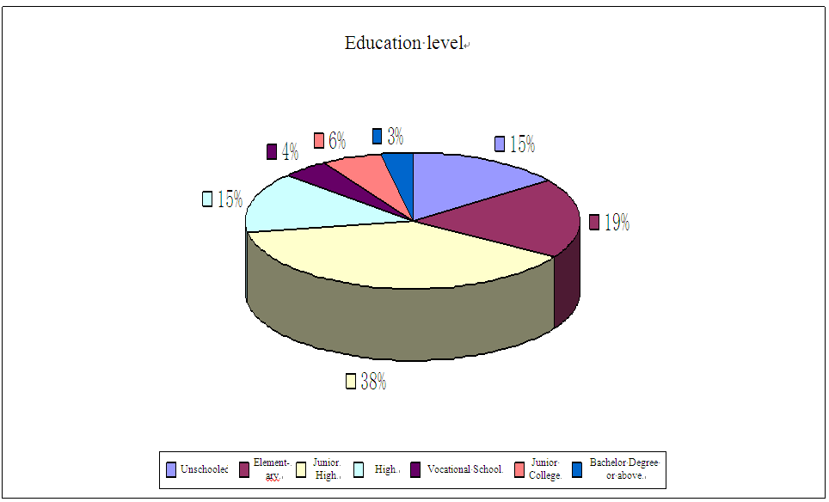
Education level

Figure 5-1 Education level of questionnaire respondents

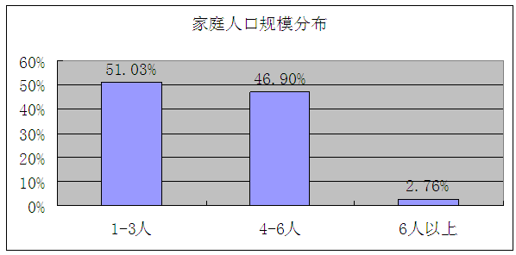
Family Size Distribution
1-3 People
4- 6 people
More than 6 people

Figure 5-2 Family size distribution of questionnaire respondents

As for family size, most families have 1-3 member, which accounts for 51.03%; families with 4-6 member account for 46.9%, only a small part of families have over 6 members, which accounts for 2.76%.

Families, no matter rural or urban, around the project area are nuclear families. Sons will separate from their parents to build their small families after getting married or having their own babies; daughters will leave parents and go to her husband’s home or build their own families after getting married. A family generally has 2-3 members. Limited by living conditions, some young couples can’t afford to buy a new house (urban families) or are not capable or don’t have homesteads to build a new house (rural families), so they still live in the same house or yard with parents and married brothers or unmarried brothers or sisters.

5.2 Means of livelihood
Since this project is located in the ecotone of rural and urban areas of Huai’nan City, so it’s rather difficult to distinct means of livelihood of residents there simply by rural household registration and urban household registration. This report divides the locals into two groups by distinguishing whether they have contracted land or not: one is residents with land, the other is residents without land. Such division not only reflects their difference in means of livelihood, what’s more important is to reflect the different impact they’ve received due to the project. Some residents are the local farmers, especially the farmers in Chenxiang Village, they basically do not live in the project area, but they’re affected by land acquisition and land use right transfer; most residents without land are staffs and their family members of original mining groups or the subordinate companies, miners and their family members of small coal mines (pits) before being shut down. Most of them live in a bad condition; some residents living within the project areas even face the risk of demolition.

6 The project social impacts
The Huai’nan WB Project can improve the living environment and life quality for the local residents, as well as promote local economy development, thus promote the whole Huai’nan economic transition and development by constructing infrastructure at project area and improving investment environment. Therefore, WB requires the project owner not only focus on the project economy benefits and financial sustainability itself, but also the social development and effect of the project to the entire Huai’nan City from a long and comprehensive perspective, and follow up social impact assessment as well.

6.1 Impacted area and its population by the project
The project and its periphery involve 7 communities (Hongqi community, Huaishun community, Chonghua community, Xinjian community, Zhanhou community, Kuangnan community and Qingdeng community), and 3 administrative villages (Chenxiang village, Xiacai village and Jiulonggang township) with approximate 35 thousand population. Moreover, the project enables students go to schools conveniently and people go to hospitals conveniently. From the perspective of environmental and social benefit overflowing, the project benefits the entire Huai’nan city in a way of bringing people to the project area. Because there are many schools, hospitals and business districts in impacted area, people come to school, hospital and work at daytime and go back in the evening. And this population flow thought out the entire city may be even bigger than the population in project area itself. Miniature garden and flower market are open to all city residents as well as people from other places after the project completion, therefore, the beneficiary population could be even bigger than predicted.
About 1928 residents in the project area are mainly from 4 communities, namely, Chonghua community and Hongqi community at Jiulonggang Township, Zhanhou community and Kuangnan community at Datong sub-district office, which includes 5 residential area in total. Theses residents are directly impacted by the project (refer to Table 6-1).
The impacted collective land is mainly at Chenxiang village and Jiulonggang village. Residents at Chenxiang village had moved out by large in the last decades, only parts of their farmland remain in the project area. At Chenxiang village, about 277.7mu land shall be requisitioned and the use right of 1553 mu land shall be transferred. Therefore, these residents, amounting to about 2000 from 410 households, are directly affected the ones living outside the project area (there are 3250 people from 770 households in Chenxiang village in 2012).
Table 6-1 Impacted residential areas in the project area
No. | Residential area | Township or subdistrict community | Households totality | Population | Impact type and scope | Potential social risk | Other
1 | Chongwen village | Hongqi community, Jiulonggang township | 22 | 60 | General positive impact by environment improvement | Low risk | Caused by previous relocation
2 | Kuangbei  village | Chonghua community, Jiulonggang township | 60 | 212 | Substantial positive impact by water supply and environment improvement | Low risk | Caused by previous relocation
3 | Cement plant sides (including Kuangnan village, cement plant dormitory and so on) | Kuangnan community, Datong subdistrict community | 368 | 1500 | Substantial positive impact by road and environment improvement | Low risk | Caused by relocation
4 | No residential area behind the Huai’nan oil agent plant | Zhanhou community, Datong subdistrict community | 6 | 26 | Strong negative impact caused by relocation | High risk | Relocation shall be done because of the project
5 | Funeral parlour dormitory | Kuangnan community | 38 | 130 | Substantial positive impact by environment and road improvement | Low risk
Project area, closely adjacent to Huaishun community, Xianjian community and Tianjia`an community of Jiulonggang township in north, Shungengshan scenic spot in south, covers 27 residential areas with over 26312 population. Residents from these areas benefit from the project by environment and infrastructure improvement (refer to Table 6-2).

Table 6-2: Residential areas adjacent to the project area
No. | Residential area | Township or sub-district community | Households totality | Population | Impact type and scope | Potential social risk | Other
1 | Gaolu village and Jiefang village | Hongqi community, Jiulonggang township | 100 | 400 | General positive impact by environment improvement | Low risk
2 | Collective housing of pharmaceutical plant | Hongqi community, Jiulonggang township | 100 | 500 | General positive impact by environment improvement | Low risk
3 | Jiefang street | Hongqi community, Jiulonggang township | 50 | 200 | General positive impact by environment improvement | Low risk
4 | Vocational school living quarters | Huaishun community, Jiulonggang townshi |  | 3400 | General positive impact by environment improvement | Low risk | There are 1200 people at Dagong village and Huai’nan village, 2200 students in vocational school
5 |  | Hongqi community |  | 3750 | General positive impact by environment improvement | Low risk | ｡
6 | Luzhuang | Jiulonggang village, Jiulonggang township |  | 486 | General positive impact by environment improvement | Low risk
7 | Jiulonggang village | Jiulonggang village, Jiulonggang township |  | 498 | General positive impact by environment improvement | Low risk
8 | Dongguai group | Jiulonggang village, Jiulonggang township |  | 704 | General positive impact by environment improvement | Low risk
9 | Xiaolongchang group | Jiulonggang village, Jiulonggang township |  | 385 | General positive impact by environment improvement | Low risk
10 | Shengang No.1and No. 2 group | Jiulonggang village, Jiulonggang township |  | 329 | General positive impact by environment improvement | Low risk
11 | Shengang No.3and No.4 group | Jiulonggang village, Jiulonggang township |  | 335 | General positive impact by environment improvement | Low risk
12 | Kuangdong village | Chonghua community, Jiulonggang township |  | 1154 | Substantial positive impact by environment and road improvement | Low risk | 1 school
13 | YiYuan village | Chonghua community, Jiulonggang township |  | 893 | Substantial positive impact by environment and road improvement | Low risk | 1 hospital
14 | Xinshi street | Chonghua community, Jiulonggang township |  | 360 | Substantial positive impact by environment and road improvement | Low risk
15 | Jianshe A zone建设A区 | Xinjian community, Jiulonggang township |  | 866 | Substantial positive impact by environment and road improvement | Low risk
16 | Jianshe B zone | Xinjian community, Jiulonggang township |  | 1146 | Substantial positive impact by environment and road improvement | Low risk
17 | Jianshe C zone | Xinjian community, Jiulonggang township |  | 1449 | Substantial positive impact by environment and road improvement | Low risk
18 | Qianjin village | Xinjian community, Jiulonggang township |  | 587 | Substantial positive impact by environment and road improvement | Low risk
19 | Zerun garden |  |  | 3000 | Substantial positive impact by environment and road improvement | Low risk
20 | Xiacai village |  | 200 | 700 | Substantial positive impact by environment and road improvement | Low risk
21 | Chenxiang village |  | 30 | 110 | Substantial positive impact by environment and road improvement | Low risk
22 | Dormitory of Datong road team of Huai’nan Road Adaministriation | Zhanhou community, Datong subdistrict | 10 | 40 | Substantial positive impact by environment and road improvement | Low risk | 5 temporary households
23 | Nixu villag | Kuangnan community, Datong subdistrict | 280 | 843 | General positive impact by environment improvement | Low risk
24 | Renmin village | Kuangnan community, Datong subdistrict | 168 | 589 | General positive impact by environment improvement | Low risk
25 | TaoYuanju buildings | Kuangnan community, Datong subdistrict | 504 | 2500 | General positive impact by environment improvement | Low risk
26 | Lvying village | Datong state forest far (Tianjia`an community) | 150 | 750 | Substantial positive impact by environment and road improvement | Low risk | North Linchang road
 | Qingfeng village | Qingfeng community | 68 | 338 | General positive impact by environment and road improvement | Low risk

There are 36 enterprises in total in the project area, among which 6 are active in business with 487 stuffs, 29 are closed or stop production (refer to Table 6-3), 6 are public service units such as schools and hospitals with 1105 people (refer to Table 6-4).

Table 6-3: Impacted enterprises in the project area
No. | Enterprises Name | Location | Operation status | Staff | Impact type and scope | Potential social risk | Other
1 | Huai’nan oil agent plant | Zhanhou community, Datong subdistrict | Stop production |  | Substantial negative impact caused by relocation | Medium risk
2 | Datong No.10 well | Zhanhou community, Datong subdistrict | Closed |  | General positive impact by environment improvement | Low risk | Located at the north of Huai’nan Datong No. 9 Colliery
3 | Huai’nan Tianhe Industrial Furnace Accessory Factory | Chenxiang village, Jiuonggang township | Active in business | 27 | Strong negative impact caused by relocation | High risk
4 | Datong No. 1 Mining Plant | Chenxiang village, Jiuonggang township | Closed |  | Substantial negative impact caused by relocation | Medium risk
5 | Datong No. 3 Mining Plant | Chenxiang village, Jiuonggang township | Closed |  | Substantial negative impact caused by relocation | Medium risk
6 | Huangjian Paint Factory | Chenxiang village, Jiuonggang township | Stop production |  | Substantial negative impact caused by relocation | Medium risk
7 | Huai’nan Changqing Colliery | Shungeng township, Tianjia`an district | Closed |  | General positive impact by environment improvement | Low risk
8 | Brick and Tile Factory of Huai’nan Machinery plant | Kuangnan community, Datong subdistrict | Closed |  | General positive impact by environment improvement | Low risk
9 | No. 1 well at Huai’nan state forest farm | Kuangnan community, Datong subdistrict | Closed |  | General positive impact by environment improvement | Low risk
10 | Datong Small Colliery of Datong Machinery Plant | Kuangnan community, Datong subdistrict | Closed |  | General positive impact by environment improvement | Low risk
11 | No. 3 well at Huai’nan state forest farm | Kuangnan community, Datong subdistrict | Closed |  | General positive impact by environment improvement | Low risk
12 | Huai’nan Datong No. 9 Colliery | Kuangnan community, Datong subdistrict | Closed |  | General positive impact by environment improvement | Low risk
13 | Huai’nan Jiulong Building Materials Factory | Hongqi community, Jiulonggang township | Closed |  | General positive impact by environment improvement | Low risk
14 | Stone Processing Factory |  | Closed |  | General positive impact by environment improvement | Low risk
15 | Huai’nan Fluorescent Lights Complex |  | Closed |  | General positive impact by environment improvement | Low risk
16 | No. 4 Huai’nan Building Materials Factory | Hongqi community, Jiulonggang township | Closed |  | General positive impact by environment improvement | Low risk | Located at the south of Huai’nan No.14 Middle School
17 | Dynamite Warehouse of No. 4 Huai’nan Building Materials Factory | Hongqi community, Jiulonggang township | Closed |  | General positive impact by environment improvement | Low risk | Located at the former No. 4 Huai’nan Building Materials Factory site
18 | No. 3 Datong Colliery | Chenxiang village, Jiuonggang township | Stop production |  | General positive impact by environment improvement | Low risk | located at the west of former Huai’nan garbage dump
19 | Huai’nan Calcium – magnesium Chemical Plant |  | Stop production |  | General positive impact by environment improvement | Low risk
20 | Dynamaite Warehouse of Dongchen Company No. 4 Branch |  | Stop production |  | General positive impact by environment improvement | Low risk
21 | Machinery Factory of Jiuyi Company | Jiulonggang township | Stop production |  | General positive impact by environment improvement | Low risk
22 | Huai’nan Cement Factory | Kuangnan community, Datong subdistrict | Dismantled |  | General positive impact by environment improvement | Low risk
23 | Huai’nan Fuqiang Commercial Concrete Mixing Co., Ltd. | Kuangnan community, Datong subdistrict | Dismantled |  | General positive impact by environment improvement | Low risk | Located at the southeast of city cement factory
24 | Jiulonggang No. 2 Branch of Huai’nan Dongchen Grou | Jiulonggang township | Closed |  | General positive impact by environment improvement | Low risk | Located at the south of Linchang Road (diagonally opposite to the Jiulonggang government building)
25 | Huai’nan Mingtao Casting Factory | Hongqi community, Jiulonggang township | Stop production |  | General positive impact by environment improvement | Low risk | The former No. 4 Huai’nan Building Materials Factory site
26 | Huai’nan Botai Mining Electrical Equipment Co., Ltd. | Jiulonggang township | Stop production |  | General positive impact by environment improvement | Low risk | Located in the yard of Huai’nan Dongchen Group Jiu`er Branch
27 | Huai’nan LiYuan Sport Products Co Ltd. | Jiulonggang township | Stop production |  | General positive impact by environment improvement | Low risk | Located in the yard of Huai’nan Dongchen Group Jiu`er Branch
28 | Huai’nan Hanman Building Materials Co., Ltd. | Kuangnan community, Datong subdistrict | Active in business | 75 | General positive impact by environment improvement | Low risk
29 | Huai’nan Zhongjian New Building Materials Co., Ltd. |  | Active in business | 85 | General positive impact by environment improvement | Low risk
30 | Huai’nan Tianjie Commercial Concrete Co., Ltd. | Hongqi community, Jiulonggang township | Active in business | 135 | General positive impact by environment improvement | Low risk
31 | Beijing CEC Environment Engineering Materials Co., Ltd. Huai’nan Branch | Hongqi community, Jiulonggang township | Active in business | 35 | General positive impact by environment improvement | Low risk
32 | Huai’nan Qianchengxin New Building Materials Co., Ltd. | Kuangnan community, Datong subdistrict | Active in business | 130 | Substantial positive impact by environment and road improvement | Low risk
33 | Huai’nan Datong No. 9 Colliery | Jiulonggang township | Closed |  | General positive impact by environment improvement | Low risk | It is the same enterprise with Datong No.9 Colliery

Table 6-4: Impacted public service units in the project area
No. | Residential area | Township or subdistrict community | Households totality | Population | Impact type and scope | Potential social risk | Other
1 | "Pit of Tens of Thousands of Corpses" Education Musuem | Kuangnan community, Datong subdistrict | In operation | 5 | General positive impact by environment improvement | Low risk
2 | Anhui Huai’nan Qishanji Gardeing | Kuangnan community, Datong subdistrict | In operation | 620 | Substantial positive impact by environment and road improvement | Low risk | There are 500 drug addicts, 120 working staff in total, and 30 per shift every day.
3 | Datong Funeral and Interment House | Kuangnan community, Datong subdistrict | In operation | 57 | Substantial positive impact by environment and road improvement | Low risk
4 | Christian Church | Kuangnan community, Datong subdistrict | In operation | 5 | Substantial positive impact by environment and road improvement | Low risk | 5 are religious people who live in the church,but 400 people come here only at ceremonies.
5 | Datong Social Welfare Home | Kuangnan community, Datong subdistrict | Active in operation | 410 | Substantial positive impact by environment and road improvement | Low risk | There are 300 adopted children and 110 staff.
6 | Qishanji Culture Cemetery | Kuangnan community | Active in operation | 18 | Substantial positive impact by environment and road improvement | Low risk

Impacted 10 enterprises with about 260 staff (refer to Table 6-5), 7 public service units with 460 staff (refer to Table 7) in surrounding areas.

Table 6-5: Impacted enterprises in surrounding areas
No. | Enterprise Name | Location | Operation status | Staff | Impact type and scope | Potential social risk | Other
1 | Dongfang Building Equipment Leasing Co.Ltd (south of the No. 15 Middle School) | Zhanhou community, Datong subdistrict | Active in business | 30 | Substantial positive impact by environment and road improvement | Low risk | There are 4 steel products Leasing companies, all of which belong to Jiulonggang township.
2 | Former acetylene gas plant | Zhanhou community, Datong subdistrict | Stop production | 45 | Strong positive impact by environment and road improvement (the former garbage dump is closed) | Low risk
3 | Jiemao Solid Materials Co., Ltd. | Zhanhou community, Datong subdistrict | Stop production | 40 | Strong positive impact by environment and road improvement (the former garbage dump is closed) | Low risk
4 | Datong Pyramid Stage Lighting Factory | Zhanhou community, Datong subdistrict | Stop production | 10-20 | Strong positive impact by environment and road improvement (the former garbage dump is closed) | Low risk
5 | Nuojin Chemical Anchor Solid Technology Institution | Zhanhou community, Datong subdistrict | Stop production |  | Strong positive impact by environment and road improvement (the former garbage dump is closed) | Low risk
6 | Kaiwei Synthetic MaterialCo., Ltd. | Zhanhou community, Datong subdistrict | Stop production | 20 | Strong positive impact by environment and road improvement (the former garbage dump is closed) | Low risk
7 | Huai’nan Pertochemical Equipment Factory | Zhanhou community, Datong subdistrict | Stop production | 13 | Strong positive impact by environment and road improvement (the former garbage dump is closed) | Low risk | There are only workers at day time.
8 | Diversified Company of Mining Bureau | Zhanhou community, Datong subdistrict | Stop production |  | Substantial positive impact by environment and road improvement |  | North of Linchang Road, South of Shenghe Machinery Company Branch
9 | Shenghe Machinery Company Branch | Zhanhou community, Datong subdistrict | Active in business | 125 | Substantial positive impact by environment and road improvement |  | South of East Dongshan Road
10 | Shuguang Colliery | Zhanhou community, Datong subdistrict | Sealed |  | Substantial positive impact by environment and road improvement |  | South of East Dongshan Road

Table 6-6: Impacted public service units in surrounding areas
No. | Name of public service unit | Location | Operation status | Staff | Impact type and scope | Potential social risk | Other
1 | No. 14 Middle School | Hongqi community, Jiulonggang township | In operation | 1305 | General positive impact by environment improvement | Low risk | There are 150 faculty and 105 students in the school.
2 | Jiuyi Primary School | Hongqi community, Jiulonggang township | In operation | 384 | General positive impact by environment improvement | Low risk | There are 28 faculty, 2 doormen and 384 students.
3 | Commercial Bank | Huaishun community | Active in operation | 20 | Substantial positive impact by environment and road improvement | Low risk
4 | Insane asylum of Kuangdong Group | Chonghua community | Active in operation | 60 | Substantial positive impact by environment and road improvement | Low risk
5 | Jiu`er Primary school | Xinjian community | Active in operation |  | Substantial positive impact by environment and road improvement | Low risk
6 | Shengang Primary School | Jiulonggang village | Active in operation | 96 | Positive impact by environment improvement | Low risk
7 | Jiulonggang government and its agencies |  |  | 300 | Substantial positive impact by environment and road improvement | Low risk

6.2 Positive impact of the project
The project construction and operation will surely exert extents of impact to the society in all aspects. Generally, impact can be divided into 2 kinds: positive and negative. Impact analysis enables people to effectively identify, control and avoid social risks caused by project implementation.

6.2.1 The project is an innovation of comprehensive environmental treatment of Huai’nan coal mining subsidence, and provides example to similar work.
Treatment of coal mining subsidence is commonly regard as a world difficulty, due to the complex geological conditions which affects the treatment result negatively. This problem exists particularly in China, a country with serious conflict issue between population and land, complex geological conditions risk, insufficient investment fund and incomplete investment mechanisms. These make the treatment even more difficult. In order to make the thoughts of complex treatment clear, the measure effective and the result remarkable, it is crucial to strengthen work to improve residents’ lives, ecological construction and society harmony. Undoubtfully, the idea, combining subsidence risk analysis with the policy mechanism of comprehensive treatment analysis, is innovation, which is positively significant to comprehensive treatment on other subsidence in Huai’nan.
Risk analysis refers to the comprehensive risk analysis on economy, society and ecology. As a kind of geological disaster, coal mining subsidence is caused by human however, and in turn harms human and their property. It is necessary to comprehensively analyze risks from aspects of nature, ecology, economy and society to get well known on subsidence impact, forecast future development direction and take proper control measure.
Kong Degang (former general manager of Huai’nan Agriculture Investment and Development CO., Ltd., male)
Two places in Huai’nan subsidence area were chosen to be pilot sectors in the first National Agriculture Comprehensive Development Projects. As one of the pilot sectors, Lvxing garden, at Xiaji township, Maoji, was leveled and dug to farm or fishing whatever was suitable. By remarkable result, this project was awarded with the second prize of Science and Technology Progress Award in 1992. However, because it did not take future risk in to consideration, this garden is now flooded and becomes a pool. Houhu model was effective, but now I do not recommend this method, because the coal mining plan was not expected to change at that time, and the coal mining restarted at the places where coal mining was not allowed.

Policy mechanism of comprehensive treatment analysis is about building a long-term mechanism of comprehensive environment treatment in coal mining subsidence by system, economy (market), management, politics and law measures with focus on fund raising, fund expenditure mechanism, treatment preparation, construction, management and operation mechanism, which are the common problems to all subsidence treatment. Specialized research would be done in the project to the above-mentioned problems based on the experiences of Jiu-Da subsidence treatment, as well as theories and experiences of subsidence treatment aboard, to offer policy suggestions for comprehensive treatment. The research, combining theories with practice, is strongly capable of explanation and solving problems, and provides a good sample for comprehensive treatment in other subsidence areas.

6.2.2 The completed project provides a good investment environment, promotes the development of real estate and tourism
Based on site investigation, Table 6-7 shows the price of real estate around and the factors that affecting the price. It concludes from the Table that there are many factors affecting the real estate price. Take Lvyingli (refer to Figure 1-1) as a reference. Adjacent to northwest project area, it locates at the intersection of East Dongshan Road and South Shungeng Road, back on Shunshan forest, facing Wetland Park, with convenient traffic and beautiful environment. What`s more, Lvyingli belongs to Tianjia`an district with the best schools and kindergarten in Huai’nan city, and its average housing price is 5000RMB/m² at present. Housing price appreciation in future mainly depends on the whole city development. Instead of being affected directly by environment improvement of the project, the price appreciation is affected indirectly by infrastructure and environment improvement in the whole city. General assessment and analysis on the impact, that the project exerts on the surrounding real estate, can be done by "with/without comparison" method from this effective reference.
As newly developed communities, Juren village – TaoYuanju community are resettlement sites for the former mining group staff who moved out from the coal mining subsidence. They distribute at the north and south sides of East Dongshan Road. There are 6300 households with 21600 population in Juren village, 2000 households with 10,000 population in TaoYuanju. These 2 communities are not as good as Lvyingli no matter in house design or construction (resettlement houses), they are not school district either, therefore, the price here is 3500RMB/m², namely 1500 RMB less than the price of Lvyingli. The project does not affect these 2 communities much, except improving environment (revegetation) and traffic (Linchang Road is related to this project) in the southern communities area. The price appreciation of the 2 communities will never exceed 500RMB/m², namely, appreciation rate will reach to 14.29%.
Ruiwei community, still under planning, will be a residential-commercial community covering an area about 286 mu with five-star hotel developed by Ruiwei Real Estate Co. Ltd. According to Mr. Han, the company manager, the price of Ruiwei community cannot be lower than Juren village-TaoYuanju community, because it is commercial housing with high standard of design and construction, although the location is not as good as 2 communities. The impact that the project brings to this community is as follows: Zhongxing Road will change its location status completely by making it an intersection of Zhongxing Road and East Dongshan Road; environment remediation improves environment of the community south area greatly (revegetation and garbage dump closed). Though Linchang Road does not belong to the project, it will be built because of the project. Therefore, high-class residential housing can be built at the southern area with great potential appreciation of the housing price by 1000RMB/m², namely, appreciation rate will reach to 28.57%.

Table 6-7 Housing price and potential appreciation at the project surrounding areas
Name & location | Presesnt housing price | Impact | Potential appreciation | Land price
Lvyingli | 5000 RMB/m² | Conveniet traffic – intersection of East Dongshan Road and South Huaishun Road;  Beautiful environment – back on Shungengshan forest;  School district – best schools and kindergarden in Tianjia`an district;  Good housing design | Futher appreciation depends on inrestructure improvement in the whole district and real estate development. | 1 million RMB/mu
Juren village – TaoYuanju | 3500 RMB/m² | Conveniet traffic –. Located on 2 sides of East Dongshan Road | The project improves environment and traffic of the south area. Appreciation would be 500RMB/m² by 14.29%. | 0.7 million RMB/mu
Ruiwei community | 3500 RMB/m² | Conveniet traffic –. Located on 2 sides of East Dongshan Road;  Good housing design | The project improves environment and traffic of the south area. Zhongxing Road will improves the traffic here greatly. Appreciation would be 1000RMB/m² by 28.57%. | 0.7 million RMB/mu (Ruiwei`s negotiated price was 0.36 million RMB/mu 3 years ago)
Zerun garden | 3000  RMB/m² | Conveniet traffic – connected with Hefei-Xuzhou highway; good housing design | The project improves environment and traffic of the south area. Appreciation would be 700RMB/m² by 23.33%. | 0.6 million RMB/mu (negotiated price was 0.16 millionRMB/mu in 2008)
Xinjian village | 2000  RMB/m² | Traffic and housing design arenot good. | The project improves environment and traffic of the south area. Appreciation would be 300RMB/m² by 15%. | 0.4 million RMB/mu
New Nongmin village - Old Jiulonggang city | 2000  RMB/m² | Traffic and housing design arenot good | The project improves environment and traffic here. Appreciation would be 300RMB/m² by 15%. | 0.4 million RMB/mu
Opposite to the project area, Wanxiang Shunfa Runze Garden is located at the south of Jiu-Da Road, north of the Hefei-Xuzhou highway. Its first phase project has completed with average housing price of 3000 RMB/ m², and its market is not prominent. This project will improve the southern area of the community greatly in environment and traffic (garbage dump is closed, revegetation, water system treatment, Wanxiang Road is built, Da- Jiu Road improvement). Therefore, the housing price appreciation can be 700 RMB/ m² by 23.33%.
Located at north side of Jiu-Da Road, Xianjian village has 2950 households with 8600 population. Similar to Juren village – TaoYuanju community, this village is newly built as resettlement housing for people from coal mining subsidence with a price of only 2000 RMB/ m². The margin, namely 1500 RMB/ m², between Xinjian village and Juren village – TaoYuanju community reflects the impact of location status and environment. This project improves the traffic and environment of Xinjian village to some extent, but it does not change its location status fundamentally. The housing price appreciation of this village is estimated to be 300 RMB/ m² by 15%. New Nongmin village – Old Jiulonggang city is located at east Jiu-Da Road and its condition is similar to Xinjian village.
The land price baseline is 0.2 million/ mu at present, and market price varies by location status, environment and overall infrastructure. According to investigation, the land price accounts 30% of the housing price at present in Huai’nan city generally. Therefore, the present land price of above-mentioned areas can be calculated (refer to Table 6-2). The environment and infrastructure will be greatly improved at the project completion, then the land price appreciation margin is estimated to be corresponded to housing price mentioned above.
The above analysis is about the direct impact that the project exerts on real estate at surrounding areas. However, the impact, that the project exerts on the macro real estate development pattern and tourism in Huai’nan city, is nonnegligible either.
Mr. Han, manager of Ruiwei Real Estate Co. Ltd., male
Besides environment, the overall infrastructure of the district is important to housing price. Datong district is not as good as Tianjia`an district in this aspect. As a result, people prefer Tianjia`an district to Datong district at decision to buy a house. Residents at Tianjia`an district would never buy houses in Datong district. What`s more, Datong district was ever a coal mining subsidence area with incomplete infrastructure due to historical reason. Because of the complete infrastructure, people prefer living north side of East Dongshan Road than the south side. Therefore, the housing price here is cannot be high. This situation could be changed if the WB Project improves the infrastructure and environment here. There is development potential in real estate, but it needs time, because residents in Datong district live scattered. Land price rises faster than housing price. The Ministry of Land and Resources of PRC released the investigation figure of 620 national real estates in 2009, among which there were 33 real estates in Anhui province. The average rate between land price and housing price of these 33 real estates was 24.55%, 16.8% for the 5 real estates in Huai’nan city, which was the lowest rate. But now the average rate between land price and housing price of these 5 real estates in Huai’nan city reaches to 30% maybe. Datong government offered us a negotiation land price 3 years ago, which was favorable, about 0.36 million RMB/mu. Housing price in surrounding areas was low at that time; for instance, it was about 2000 RMB/m² for TaoYuanju community with rate between land price and housing price of about 25%. But for now, the land price exceeds 0.6-0.7 million RMB/mu. The original intention for us to build a five star hotel then was because there was no high-class hotel in Datong district. Surely the WB Project is good to our hotel by bring more people here for accommodation after the environment and tourism improved. Tourism promotes real estate development, particularly commercial real estate.

6.2.3 The projcet development brings significant impact to society and economy after the WB Project completion
Firstly, the project implementation, management and operation creat considerable jobs for the local people, as well as provide them with oppotunity to do bussiness themselves. Which is helpful to increase residents` income.
Employment in flower market: 8 garden maintanance staff, 4 gardeners, 15 professional management staff, 6 security guards, and 4 sanitation men. There are 37 staff in total in flower market.
Employment in nursery garden: the garden business unit decides the specific staff number for each post according to reality, such as management staff, technical personnel, financial staff, salesman and purchasisng staff. Commom mantainance staff shall be about 27 in total by a ratio of 0.5/ha. Their main work is plants cultivation and conservation, to be specifically, weeding, watering, spraying, seedlings bedding, and grown plants digging, tying and loading.
Employment in miniature garden: staff munber shall be decided by production capacity of the different business units, to be specifically, 1 for small size unit, 2 for medium size unit and 3 for large size unit. There shall be 54 staff in total. Main work in miniature garden includes: daily conservation, processing, shaping and triming.
The futher project development of environmental remediation provides about 100 jobs.
Moreover, flower market provides about 4000 stalls for land-expropriated farmer, relocated residents and other people.
Because of nursery garden and environmental remediation, about 1533mu collective land use right in Chenxiang village shall be transfered. This increases stable income of farmers, while cuts down their farming time and cost, as well as provides them opputunity to engage in other jobs.
A woman, aged 50, a famer in Chenxiang village, lives in Jiulong New Nongmin village
(Investigator came across this woman when doing site investigation of Wanxiang Road. It was noon and the woman was going home to cook meals, so we had a walk-talk.) “There is nobody here, the village was moved out several years ago. What is Land circulation (investigator explained to her what is Land circulation)? Of course we are willing to rent, if we get money without working. We have 6 mu land, some have over 10 mu farm land. We have to walk for 30-40 minutes to get here, so we cannot manage the land well, but only grow wheat and soybean. We live on the mercy of heaven, and income is small. It is quite good to get 1200 RMB/mu. “
Secondly, further project development brings direct economic benefit.
The planned nursery garden area is about 49.1 ha and its annual net income is expected to be about 1.3257 million, when it is estimated on the basis that the net income from plant is 6000 RMB/mu, and effective planting area ratio is 30% in stable production year.
In miniature garden market, the price varies by potted landscape type, size and particularly ornamental value. This differs from the nursery garden market, in which the price is generally stable for the same plant species and size. It is unable to estimate the annual profit of miniature garden at present due to these factors. However, it is affirmative that, as a green sunrise industry, miniature gardening has a prosperous future. Because miniature gardening has a long history in China, many chinese are fond of potted landscape with strong interest. Moreover, miniature gardening develops rapidly in european countries as well.
Thirdly, miniature garden and environmental remediation can reduce or control chemical firtilizer and pesticide, which alleviates environmental pollution, increases forest coverage (up to 35%), keep ecological system balanced. It is significant for agricultural sustainable development and residential environment improvement.

6.2.4 The project skill-training plan is helpful for re-employment of the impacted residents, particularly women.
In order to improve residents` work skills and comprehensive quality, Datong government assumed the work, entrusted by the project office, to compile a five-year implementation scheme of employment training (refer to Attachment 2) on the basis of full market investigation. Datong government and Datong Women's Federation, in cooperation with the WB Project office, commit to integrate resources. Employment training is specialized according to market requirements by investigation, for instance, cloth making and flower sales are especially for women.

Huai’nan Development Department of Women's Federation, department director
At present, employment training, assumed by the women's federation in each district and township in cooperation with Datong Human Resources and Social Security Bureau and Agriculture Section, is implemented every year. There are trainings provided by Huai’nan City Women's Federation independently, such as “women experts skill improvement class”, “learning and competing campaign” (namely, learn knowledge and skills, compete result and contribution). The employment training for women is well implemented in Panji coal mining subsidence area.
Surly the employment training scheme is wonderful, we can combine the trainings together. Now we have specialized training funds consisting of 20000 offered by An`hui Women's Federation and 5000 offered by Huai’nan Finance Bureau every year.
On one hand, women, whose husbands working in colliery with large income, tend to slack themselves, and these women shall be educated and trained to work. People, in the conjunction zone between urban and rural areas, tend to slack off without self-improvement consciousness. Because they have stable income by house rent. On the other hand, there are still many women incapable to do other jobs but farming. These women shall be trained to learn new skills.
Datong Human Resources and Social Security Bureau, Training Center of Employment Service Management Bureau and White-collar Vocational School of Technology commit to the WB Project office and Datong government that they are capable of undertaking this five-year implementation scheme of employment training (refer to Attachment 2).

6.2.5 Closing down the former open garbage dump can completely resolve pollution problem, which effectively improves the environment and living quality for the local residents.
The former Huai’nan Datong garbage dump was located at the north of Laobagou coal mining subsidence area, east of Chenxiang village, 50 meters away from Jiu-Da Road. This dump, mainly domestic garbage, had been in service for 25 years from 1984 to 2006. The drainage trench of Chenxiang village separated the dump into 2 parts from north to south. There was a simple methane guide system at western dump part, but the system did not meet the national standards at construction. There were fire and explosion risks because of no methane guide system. The percolated liquid went into Huaihe River directly without any treatment by drainage trench of Chenxiang village due to no water resistance layer at the dump bottom. This severely contaminated surface water and ground water in surrounding areas. Garbage was possible to slip into the drainage trench of Chenxiang village, due to the steep slope of the garbage pile body at the two sides. Moreover, the garbage dump harmed severely the health of the residents who lived in the community 300m away from the dump.
Mr. Wang, aged 64, from Zhangdaxi Group, Chenxiang village
My house was dismantled. At present, I temporarily live in a rented house in former acetylene gas plant yard (300m north of the garbage dump) waiting for new house. It is at New Nongmin village. The environment here is extremely bad. On one hand, it is close to road (refers to Jiu-Da Road), and the road condition is bad because of heavy traffic, dust and noise. On the other hand, it is not far away from the garbage dump, air is polluted, particularly in summer, swarms of mosquitoes flying in the smelly air. I am unwilling to take my grandson outdoors. If it had been a park here, I can walk around with my grandson often, also, I can do morning exercise.
According to feasibility study report, treatment of former garbage dump would effectively improve contaminated ground water and keep mosquitos down, which is helpful to control illness. The residential medical expenditure would reduce by 1.0626 million RMB.

6.2.6 The project improves road network and other infrastructure. Convenient traffic improves residential life quality.
Traffic condition, water supply, drainage and investment environment are improved by constructing 4 roads and water supplying system under roads to separate rainfall from sewage.
The planned Zhongxing road is one of the roads connecting south and north traffic in Huai’nan city. Zhongxing road will provide residents living along East Dongshan Road a direct way to Nancheng district without making a detour by South Shunhuai Road or 206 State Road. The area on both sides of East Dongshan Road is an important area in Huai’nan East Development Strategy.,Zhongxing Road passes by miniature garden and nursing garden where population will be heavy. What`s more, as a convenient access to the project area, the road enables the project area to be an entertainment and education base in Huai’nan province.
Ms. Su, aged 49, taxi driver
The investigator had a short communication with Ms. Su on the way to Longhu Park. When we briefly informed her about the project, she said she knew that Wetland Park (refers to the small Wetland Park built by the coal mining group). “It is a good place, many Huai’nan residents went there. People will be more likely to go there if it is convenient for people to park cars, throw trash and go to toilet, and environment will be good then. I wish this park would not be as awful as Longhu Park, it jammed badly at peak times there. You can see there are many people and cars today. Why is that? Because the flower market opens every weekends in Longhu Park. It is awful to come here at this time, because the place is not big enough, there is no place to park car, even when we find a vacancy to park, it is difficult to get out. “ She was happy when she was informed that there would be a flower market covering an area of about 100 mu, and said, “it is wonderful, our business will be better if people flow there. The most important thing is, the parking place shall be well designed.”
Well-designed road benefits economy in 4 aspects: saving running cost and time, and reducing traffic accident and damage.
Table 6-8 is a predicting analysis table based on feasibility study report.
Table 6-8 A benefit summary sheet in future characterized years
Year | Saved running cost | Proportion | Saved travel time | Proportion | Accident and damage avoid | Proportion | Total (RMB, YUAN)
2017 | 12378594 | 67% | 3382050 | 18% | 2647081 | 14% | 18407725
2020 | 18888870 | 60% | 7764793 | 25% | 4655131 | 15% | 31308793
2030 | 43415497 | 58% | 19228789 | 26% | 12020278 | 16% | 74664565

6.2.7 The project will improve road condition and living environment greatly
Besides Zhongxing Road, 3 other roads will be built there as accesses to the project area, namely, Jiukong Road, Wanxiang Road and Yanshan Road. Among which, 2 roads are newly built except Wanxiang Road. Wanxiang Road is a muddy country road at present.
As a south boundary line of the project area, Jiu-Da Road is excluded in the project though, Huai’nan city government commits to cooperate with the project to form a complete traffic network by reconstructing these two roads. At present Jiu-Da Road is damaged badly, there are not any green trees on roadsides. It is dangerous that bikes and motor vehicles going on the road when the pits are filled with water in rainy days. While it cannot be better in sunny days either, cloudy dust swirls in the air when vehicles passing. Taxies are unwilling to go there, let alone foot passengers. Taxies rejected us often at knowing our destination.
The condition of Linchang Road is almost the same as Jiu-Da Road, which is muddy without maintenance for years. Many trucks, loaded heavily with coals, waste rock, coal cinder or construction materials, run on this road, which damaged the road severely with pits everywhere. Dust in sunny days, muddy and slippery in rainy days, the road is neither preferred by vehicles nor by foot passengers.
Ms. Zhang, No.10 mine shaft(closed in 2012) keeper, live at roadside of Linchang Road east section
“It is so hard to live here. The road is muddy with pits everywhere. Trucks running on this road are heavily loaded withc oals, waste rock and coal cinder. They damage the road badly. It is almost impossible to walk on this muddy road in rainy days; while in sunny days we dare not to open the door at day time because dust is heavy when trucks pass by. The whole house is immersed in dust cloud. We cannot have it more and we decided to leave here soon, because my husband is not in a good body condition.

6.3 Mechanism of benfit from land appreciation

6.3.1 Land area and ownership
The benefit belt is divided into two parts by the Zhongxing Road under planning, which belong to two different regions in terms of planning. The first part on the west side of Zhongxing Road with an area of 91.84 hectares belongs to the Regulatory Detailed Planning on Quanda Resources Exhausted Area of Huai’nan City, while the second part on the east side of Zhongxing Road with an area of 103.37 hectare belongs to Regulatory Detailed Planning on Jiulonggang Region of Huai’nan City

Based on the documents of land ownership and the two detailed plans, the land area owned by each plot are calculated, as shown in Figure 1-1. The scope and number of each plot conform to the two detailed plans. By calculation, the total land area is 195.21 hectares (2928.15 mu), of which collective land is 49.366 hectares (740.4 mu), belonging to Qingfeng Village of Tianjia’an District, and Niwei Village, Chenxiang Village, Xiacai Village of Datong District. State-owned land is 145.85 hectares (2187.75 mu). The land area owned by each plot is shown in Table 6-9.

Table 6-9 Land ownership and area on the west side of National Highway 206
No. | Actual area | Area of Collective land | Collective unit and population |  | Area State-owned land | User and population
No. | Actual area | Area of Collective land | Unit | Population | Area State-owned land | User | Population
C01 | 14.05 | 2．83 | Chenxiang Village | 25 | 11．22 | Datong Forest Farm | 400
C02 | 45.45 | - |  | 75 | 45．45 | Shunfa Hengye Co., Ltd. | 3,000
E01 | 19.69 | 6.75 | Xiacai Village | 700 | 12.94 | Jiu-yi Company | 300
E02 | 24.18 | - |  |  | 24．18 | Mining Group | 4,048
K01 | 24.24 | 12.45 | Qingfeng Community | 339 | 11.79 | Datong Forest Farm | 750
K02 | 14.50 | 8.60 | Datong Street | 843 | 5.90 | Datong Forest Farm | 589
K03 | 8.52 | 0.00 | —— |  | 8.52 | Mining Group | 2,500
L01 | 11.06 | 0.00 | —— |  | 11.06 | Mining Group
L02 | 18.08 | -  -- |  |  | 18．08 | Huai’nan Municipal Government
L03 | 15.44 | 30．63 | Datong Street | 230 | 15．44 | Huai’nan Municipal Government | 147
Total | 195.21 | 2．83 |  | 2212 | 164．58 |  | 11,734
Note: E01 consists of project area and benefit area. Here it refers to the benefit area.

Among state-owned land, C02, E02 and K03 plots that have completed development is59.42 hectares (891.3 mu), while L02 and L03 plots have completed purchase and reservation, covering 33.52 hectares (502.8 mu). Therefore, state-owned land that can be purchased and reserved in the future is 52.91 hectares (793.65 mu).

Population Profile

The field survey shows that there is a population of 13946 in the region (see Table 6-9), including rural population of 2212 (Qingfeng Village, Chenxiang Village, Xiacai Village, and Datong Street) and urban population (including permanent resident population without local resident) 111734. Among urban population, 9548 people have been resettled through work of renovating shantytowns and purchasing commercial housing.

Land Appreciation and Benefit Mechanism

Urban residents: 11,734 residents live on the benet belt, among which 9,548 have purchased house property in developed living quarter within the area. Their house property will be appreciated along with land appreciation, so they will gain benefit from land value increment. The remaining 2,186 persons will be influenced in the process of state-owned land purchase and reservation. They will be resettled as per local principles. Floor area of resettlement houses is 1.2 times of the original living area. If the resettlement site is outside the area, the land value and its appreciation are not less than that of land within the area.
Rural residents: 2, 212 rural persons with collective land of 49.36 hectares (740.4 mu), including cultivated area of 26.2 hectares (393 mu), distributed in two villages of Chenxiang Village and Xiacai Village, and homestead of 23.16 hectares (347.4 mu), distributed in Chenxiang Village, Xiacai Village, Qingfeng Community and Datong Street. In order to make those people obtain benefit from collective land development in the future, the government will take the following measures:
  - Adjustment of comprehensive section-land price shall be strictly executed once every two years in order to guarantee that the land appreciation can be reflected in new land compensation standard. It shall be adjusted three times during project execution respectively in 2015, 2017 and 2019.
  - Land area expropriated each year shall not exceed 15% of collective land area in order to guarantee that there is land to be expropriated after land appreciation over the next few years so as to make rural population obtain benefit from land appreciation. Collective land expropriated in the area shall not be more than 5 hectares per year during project execution because the collective land is only 30.63 hectares at present.
  - Local resettlement can be conducted for rural residents as per relevant policies. Specific measure is that government transfers state-owned construction land to village collective land for economic development based on 5-10% of actual expropriated village collective land area after compensation as per section-land value and expropriation so as to guarantee that affected famers can obtain benefit from land appreciation in the future.
  - Rural housing resettlement shall be executed in strict accordance with local reconstruction or nearby resettlement principles in order to guarantee that houses of all rural residents can be appreciated with land appreciation.

Monitoring mechanism

At present, the government of China has formed a set of strict monitoring mechanisms and auditing procedures with regard to the land acquisition, demolition and later development in the process of land purchase and reservation. The project of Huainan city is no exception. The first step is that the municipal government formulates policies and plans for land acquisition and demolition in accordance with the national relevant laws and policies(the policies and standards for land acquisition and demolition in this project are in conformity with the policies on land acquisition and demolition implemented in Huainan city currently), and then the people’s governments of districts(counties) subordinate to the region carry out land acquisition and demolition based on the plan, or they entrust qualified real estate companies to implement land acquisition and demolition work. At the same time, the municipal auditing bureau entrusts the district (county) auditing bureau to audit the process of land acquisition and demolition. Afterwards, the municipal auditing bureau is required to examine the audit results in two ways. One way is spot check on the site for the purpose of seeing whether land acquisition and demolition is implemented strictly according to the plan; the other way is auditing accounts. Then the land purchase and reservation department of the government makes payment according to the audit results affirmed by the municipal audit bureau. Before completion of this project, the municipal audit bureau must make an affirmation for the cost of the whole project which includes costs in the earlier stage of land acquisition and demolition, such as assessing and measuring costs and so on. The monitoring arrangements for benefits which this projects brings to local residents in this project are as follows:

- The external monitoring unit for resettlement incorporates the benefit status of local residents because of land appreciation to the report on resettlement monitoring.
- The monitoring range covers all the lands possessing appreciation potential.
- The content of report includes:
- Amount of state-owned lands purchased and stored and collective lands expropriated each year during the construction period of the project
- Population affected by land purchase and reservation and acquisition
- Resettlement location
- Market price of houses for resettlement
- Adjustment on section land value of collective lands
- Amount, location and development and utilization status of collective land to be reserved for resettlement
Distribution of benefits from collective land to be reserved for resettlement

6.4 Negative impact

6.4.1 Permanent land requisition and house demolishing
Because of the project and its construction, it is inevitable to requisition some land permanently or temporarily. judging from the project design, although some designs of the sub-projects were revised and optimized in order to reduce land requisition and demolishing, there are still a few sub-projects need to requisition some state land and homestead. There are 6 households involved.
According to site investigation and communication with the residents, requisition, demolition and relocation are highly concerned. Therefore, compensation and resettlement are crucial to the project and negative impact mitigation.

6.4.2 Enterprises relocation
There are 5 enterprises directly involved in this project, among which, most have stopped production except one, namely, Tianhe Furnace Accessory Factory (refer to Table 6-10).
Table 6-10 Directly impacted enterprises
Name | Operation status
No. 3 Datong colliery | Stop production
No. 1 Datong colliery | Stop production
Huangjian Paint factory | Stop production
Tianhe Furnace Accessory Factory | Active in business
Huai’nan oil agent plant | Stop production

6.4.3 Impact of residents’ normal living during project construction period
Project construction causes noise, dust and traffic jam. To be specifically, pipes bedding may destroy existing infrastructures and roads, which affects normal traffic. Some residents are disturbed by construction noise, dust and traffic disorder. Project owner and construction units are required to arrange construction work scientifically, in order to mitigate impact on residents.

6.5 Potential risks
Besides the positive and negative impact mentioned above, there are still social potential risks identified by CTGU based on analysis of the social economy reality and the project characteristics. These potential risks would affect the project implementation and its goal attainment; they are likely change into negative impact if not properly avoided.

6.4.1 Resettlement risk
In recent years, social conflict, caused by land requisition and relocation, is serious in some places. Our government has been reforming policy and regulation on compensation for land acquisition, regulated the farmland requisition procedure, and raised standards of compensation for land acquisition gradually, in order to placate frustration of land-expropriated farmers, and abate social conflict caused by farmland requisition in urbanization and industrialization process. The report of the18th National Congress of the CPC stated clear that “We should reform the land expropriation system and increase the share of gain in land value to farmers.” Due to frequent adjustment of compensation standards for farmland requisition, famers` expectation on compensation increases consequently. Therefore, this is a new problem for the project to overcome.
Another potential risk is that, the migrants are impacted negatively by the changed life environment or project failure. If so, they could become poverty economically, or frustrated at social adaptation. This harms normal social economy development.

6.4.2 Land lease risks
Available cultivable land per person is less than 0.8 mu in Chenxiang village. Land lease arrangement is not common. There are still uncertainties in land lease contract, time, rent, withdrawal mechanism and so on. The potential risks in land lease are as follows:
(1) Land lease increases in Chenxiang village in recent years; residents expect more compensation and do not cooperate actively. This affects land lea process negatively.
(2) Supervising and management risk. Because many households are involved in land lease event, it is significant for the land cooperation group to manage funds and supervise benefit distribution. If there is any flaw existing in benefit distribution, then supervising risk is inevitable. To much extent, interest conflict in land lease is caused by supervising risk.

(3) Economic dispute risk. Incomplete land lease procedures and legal process cause land disputes hard to mediate due to unclear responsibility, right and interest boundaries. Famers` interests cannot be protected without complete supervising mechanism, which causes economic and contract disputes.

6.4.3 Insufficient public consultation and participation
As working technique, public participation has been extensively adopted in plan, design and implementation of international development assistance project in China since late 1980s. Public participation improves project design and promotes project stakeholders understanding, support and cooperation positively. However, this bottom-up consultation method, which differs from top-down management method in administration, is easily neglected by government officers. Because this is the first WB project in Huai’nan city, the WB office and related government departments may lack of experience in using this method. The following risks would occur:
(1) The project objective and function may not be fully realized. This is a nonprofit environmental remediation project. Only local residents are qualified to judge environment change there. The ultimate objective of the project is to serve local people. The project is possibly unable to get understanding and support from local people without their full participation, as a result, the project quality cannot be guaranteed and its objective and function cannot be fully realized either, or even project commencement and completion would be affected negatively.
(2) Insufficient information dissemination. Women`s rights cannot be protected when women participation is absent. It may be even harder for the disadvantaged groups to get their lives recovered if they do not participate in project consultation to get their special needs satisfied and support policy.

7. Stakeholder Analysis
Stakeholder of project refers to the group or organization which has interests with project design, construction and operation. The first step to make stakeholder analysis is to confirm the composition of stakeholders and the major items concerned by stakeholders and to make an analysis on the influence of stakeholders (the degree of possessing power and status, the organization level, the control ability on strategic resources and the power relations with other stakeholders).
The main purpose of analyzing stakeholders in decision-making and implementation phase of the project is to roughly confirm whether the interest demands of all stakeholders are reflected in decision-making phase of the project. For some groups, especially resettled groups, as their interest demands may be weakened by owners, it may appear that the right to development of resettled groups cannot be ensured, thus affecting the social fairness and justice. It will increase the wealth gap, which is not conducive to the balanced and harmonious development of the society.

7.1 Identification of stakeholders
The interest groups are divided depending on the relation between groups and projects and the degree and nature of its impact on the project, namely, the stakeholders. Stakeholders consist of major stakeholders and other stakeholders. Major stakeholders refer to direct or major beneficiaries, or the groups or organizations which mainly get damages; other stakeholders are the groups or organizations which have indirect impact on the project, such as the project owner and consulting agency of the project and so on.
Based on analysis and field survey on the project, researchers in China Three Gorges University hold the idea that the main stakeholders of this project are divided into the following types: (1) beneficial residents in and around the project area; (2) enterprise and public institutions in and around the project area; (3) resettled residents. Other (minor) stakeholders include: (1) project office and other relevant government departments; (2) consulting agency and construction unit of the project.
1). Major stakeholders
A Residents in and around the project area
Residents in the project area include beneficial residents of the project, resettlement and vulnerable groups emerging due to land acquisition, etc.
Extensive ground subsidence in nine big coal mining subsidence areas causes ecological degradation, resulting in destruction of various kinds of infrastructures, residential area and farmland on different levels. The odors emitted from old garbage dumps and its pollution on the water, in particular, bring greater impact on life of the surrounding residents. The questionnaire above reveals that, 113 persons among 155 respondents, who think that the water pollution is the main pollution problem of their living place, are extremely unsatisfied with their living environment, accounting for 73.68% of all the respondents; the following factor is the dispose of industrial refuse and household refuse and the air pollution (as shown in Figure 10-1). The construction of this project will effectively alleviate these prominent environmental problems so as to improve the living environment of residents in the project area.
Because of resource exhaustion, the mine closure causes negative impact on the life and employment of coal miners. The construction and operation of this project will create extensive job opportunities and entrepreneurial platform. At the same time, a comprehensive training plan is formulated and financial security is also provided for the affected groups, which can ease the employment pressure of local residents to some extent.
The construction of this project will inevitably bring about issues of land acquisition and demolition. According to Resettlement Action Plan, all types of lands needing to be expropriated by sub-projects amount to mu, in which the rural collective land to be expropriated sums to mu; it also involves demolition and relocation of six special households. Therefore, involuntary resettlement inevitably produces. In the meantime, as the project construction may cause unavoidable disturbance and impact on the surrounding residents of the project, the support of these residents is needed for the construction of this project.
B Enterprises in and around the project area
A large number of enterprises are included in the scope of survey. According to property, enterprises are divided into state-owned enterprises (including their subsidiaries), collective enterprises and private enterprises (as shown in Table 7-1).
Table 7-1 List of some industrial and mining enterprises in and around the project area
Sequence number | Name of industrial and mining enterprise | Year of closure and production halt | Ownership | Remarks
1 | Changqing Coal Mine Plant of Huai’nan city | Closed in 2012 | Private enterprise | used to belong to Shungen Town of Tianjia’an District
2 | Bricks and Tiles Plant of Huai’nan factory | Closed in 2009 |  | used to belong to a subordinate enterprise of Dongchen Group
3 | First Well of Agriculture and Forestry of Huai’nan city | Closed in 2005 |  | used to belong to a subordinate enterprise of Dongchen Group
4 | Small Coal Mine Plant of Datong Factory | Closed in 2006 |  | used to belong to a subordinate enterprise of Dongchen Group
5 | The Third Well of Agriculture and Forestry of Huai’nan city | Closed in 2005 |  | used to belong to a subordinate enterprise of Dongchen Group
6 | The Ninth Coal Mine Plant of Datong District of Huai’nan city | Closed in 2012 |  | used to belong to a subordinate enterprise of Dongchen Group
7 | The First Coal Mine Plant of Datong District of Huai’nan city | Closed in 2000 |  | A enterprise set up by Jiulonggang town
8 | Constant-pressure Boiler Factory of Huai’nan city | halted in 2005 | Private enterprise
9 | The Third Coal Mine Plant of Datong District of Huai’nan city | Closed in 2012 | Collective enterprise | Located in the west side of garbage dump of Huai’nan city
10 | The Third Well of Datong District | Closed in 2012 |  | belonging to the same enterprise with the Third Coal Mine Plant of Datong District
11 | Jiulong Building Material Factory of Huai’nan city | Closed in 2005 | Collective enterprise | Collective enterprise set up by the Fourth Factory of Building Materials of Huai’nan city
12 | The Ninth Coal Mine Plant of Datong District of Huai’nan city | Closed in 2012 |  | belonging to the same enterprise with the Ninth Coal Mine Plant of Datong District
13 | The Tenth Coal Mine Plant of Datong District of Huai’nan city | Closed in 2012 |  | Located in the north side of the Ninth Coal Mine Plant of Datong District
14 | Material Factory | Closed in 2010 | Private enterprise
15 | Stone Factory | Closed in 2010 | Private enterprise
16 | Main Factory of Huai’nan Fluorescent Lamp | Closed in 2002 | State-owned enterprise | used to belong to a subordinate enterprise of Dongchen Group of Huai’nan city
17 | The Fifth Coal Mine Enterprise of Datong District of Huai’nan city | Closed in 2000 | Private enterprise | Located in the east side of the Fourteenth Middle School of Huai’nan city
18 | The Fourth Factory of Building Materials of Huai’nan city | Halted in 2000 | State-owned enterprise | Located in the south side of the Fourteenth Middle School of Huai’nan city and closed in 2009
19 | Explosive Magazine of the Fourth Factory of Building Materials of Huai’nan city | Closed in 2000 |  | Located in the site of the former Fourth Factory of Building Materials of Huai’nan city
20 | Metal Structure Factory of Huai’nan city | Halted in 2004 | Collective enterprise | used to belong to a subordinate enterprise of Datong Street, located in the west side of the Ninth Avenue
21 | Huai’nan Ferroalloy Factory (acetylene gas) | Halted in 2002 | Collective enterprise | used to belong to a subordinate enterprise of Datong District, located in the west side of the Ninth Avenue
22 | Huai’nan Calcium-magnesium Chemical Plant
23 | Explosive Magazine of Dongchen Fourth Corporation | Lockout | State-owned enterprise
24 | Machinery Works of Jiuyi Corporation |  | State-owned enterprise
25 | Cement Plant of Huai’nan city |  | Private enterprise | Restructured to Rock Cement Limited Company of Huai’nan city
26 | Fuqiang Product Concrete Mixing Limited Company of Huai’nan city | In relocation | Private enterprise | Located in the southeast side of cement plant of the city
27 | Manhan Building Material Limited Company of Huai’nan city |  | Private enterprise | Located in the south of Qishan Garden in the city, producing and selling all kinds of building stones
28 | Jiulonggang Second Company of Dongchen Group of Huai’nan city |  | Rear office | Located in the south of Tree Farm Road (diagonally opposite Jiulonggang government), belonging to a subordinate enterprise of Dongchen Group
29 | Zhongjian New Building Material Limited Company of Huai’nan city |  | Private enterprise | Used to be Jiulonggang Annular Kilt Company of Huai’nan city before restructuring
31 | Tianjie Product Concrete Limited Company of Huai’nan city |  | Private enterprise | Located in the site of the former Fourth Factory of Building Materials of Huai’nan city (the east side of No.206 national road)
32 | Huai’nan Branch Company of Beijing Zhongdian Environmental Engineering Material Company |  | State-owned enterprise | Located in the site of the former Fourth Factory of Building Materials of Huai’nan city
33 | Mingtao Casting Factory of Huai’nan city |  | Private enterprise | Located in the site of the former Fourth Factory of Building Materials of old Huai’nan city
34 | Longxing Building Material Limited Company of Huai’nan city |  | Collective enterprise | Belonging to a subordinate enterprise of Datong Sub-district
35 | Botai Mining Appliance Limited Company of Huai’nan city |  | Non-governmentally operated enterprise | Located inside Jiuer Company of Dongchen Group of Huai’nan city
36 | LiYuan Sports Goods Limited Company of Huai’nan city |  | Non-governmentally operated enterprise | Located inside Jiuer Company of Dongchen Group of Huai’nan city
37 | Qianchengxin New Building Material Limited Company of Huai’nan city |  | Non-governmentally operated enterprise | Located in the west side of Manhan Building Material Limited Company of Huai’nan city
38 | Jiuyi Brickworks |  | Non-governmentally operated enterprise | A non-governmentally operated enterprise renting the land of Jiuyi Coal Mine Plant
39 | East Architectural Equipment Leasing Company | halted | Non-governmentally operated enterprise | Located in the south side of the Fifteenth Middle School
40 | Jiemao Solid Material Limited Company | halted | Non-governmentally operated enterprise | Located in the large yard of old ferroalloy works
41 | Pyramid Stage Lamp Factory of Datong District | halted | Non-governmentally operated enterprise | Located in the large yard of old ferroalloy works
42 | Ruojin Chemical Anchoring Technology Institute | halted | Non-governmentally operated enterprise | Located in the large yard of old ferroalloy works
43 | Kaiwei Synthetic Material Limited Company | halted | Non-governmentally operated enterprise | Located in the large yard of old ferroalloy works
44 | Diversified Company of Mining Bureau | halted |  | Located in the north of Tree Farm Road and the south of branch company of Shenghe Machinery Company
45 | Shenghe Machinery Branch Company | In production |  | Located in the south of Dongshan East Road
46 | Dawn Coal Mine Enterprise | Lockout |  | Located in the south of Dongshan East Road
47 | Huangjian Coating Factory |  |  | Located in the south of the Ninth Avenue
48 | Refuse Processing Plant |  |  | Located in the north of garbage dump and the south of the Ninth Avenue
49 | Tianhe Boiler Accessories Plant | In production | Private enterprise | Located in the south of Ninth Avenue
50 | Huai’nan Grease Mixture Factory | Halted | Collective enterprise | Located in the northeast of garbage dump and the south of Tree Farm Road

For the sake of environment renovation of the region, the government of Datong district of Huai’nan city recently demands that all the industrial enterprises in the project area, whether closed or in operation, will be demolished step by step.
2) Other stakeholders
Other stakeholders refer to the staff or organization related to the program planning and design and the specific implementation of the project, which includes project owner, consulting and implementation units of the project and related government departments, etc.
A Project owner
As the project owner, the World Bank Office of Huai’nan city takes the multi-aspect responsibilities of argument and research in the earlier stage of project, construction in the middle stage and operation management in the later stage. There is a crucial relationship between whether the project can be implemented and propelled smoothly, and then realize the twin purposes of protecting the ecological environment and gaining good operation benefits, and the mode and method of operating the project.
B Consulting agency and construction unit of the project
As the design unit and the construction unit of the project have relations with the project through the project owner, they are the relatively close stakeholders of the project. The work amount of this project is big and the construction cycle is long. The project design concerns scale and impact of the project as well as whether the project can work smoothly; while during the construction period of project, the construction unit will have a certain impact on residents in the project area and the construction quality of the construction unit will have a direct impact on environment governance.
C Related government departments
The construction and implementation of this project can’t be separated with the support and help of related competent authorities, and the relevant policies the government introduces even have a vital impact on construction and operation of the project. Therefore, the related government departments are also stakeholder groups of this project.
Details about stakeholders of the environmental comprehensive governance project of nine big subsidence areas can be seen in Table 7-2.
Table 7-2 List of stakeholders with the use of world bank loan project to comprehensively govern nine coal mining subsidence area
Project name | Stakeholder | Name of group
World bank loan project for comprehensively governing coal mining subsidence area in sustainable development engineering of a resource-based city (Huai’nan city) | Major stakeholders | (1)Residents in and around the project area  (2)Enterprises in and around the project area  (3)Resettled residents
 | Other stakeholders | (1)Project owner (project office)  (2)Consulting agency of the project  (3)Construction unit of the project  (4)Related government departments

7.2 Demands of stakeholders
The demands of stakeholders varies with their different status in the project. Even though the interest groups are of the same type, their demands differ as the levels of social economic development in the regions located are inconsistent. Aiming at demands of different stakeholders in different regions, researchers in China Three Gorges University obtain relevant information by means of discussions and interviews with various groups.
1). Demands of residents within and surrounding the project area
Residents within and surrounding the project area include beneficial residents of the project, resettled residents and vulnerable population and other major stakeholders..
The survey reveals that the life of residents within and surrounding the project area is impacted by air pollution, water pollution, waste pollution, solid waste pollution and other pollution issues. They urgently hope to alleviate the impact of the above environmental pollution and destruction by means of environmental governance project, only to improve life quality and own a healthy and safe living environment.
By doing a questionnaire survey on residents in the project area, the working group of social assessment analyzes their specific needs. From the statistical analysis on 155 respondents above, 126 respondents (82.65%of them) are in favor of the project construction with the view that their surrounding environment needs to be improved. When asked about the surrounding environmental problems in most need of being governed, they think that the total sequence of environmental governance is water pollution, industrial refuse, household waste and air pollution. Nevertheless, on the basis of interview results, the interest demands of residents in different residential areas are different. For example, in regard to the water problem, residents in Mining North Village hold the idea that the groundwater pollution makes their unable to drink well water, so they have a great expectation for improving the water supply; while residents in Mining South Community think that surface water pollution, noise pollution and air pollution caused by governing the mixing plant (probably referring to Fuqiang Product Concrete Mixing Limited Company of Huai’nan city) in that cement plant are the most significant problems; residents in Red Flag Community deem that the low-lying terrain (subsidence area) of their community causes poor drainage and they suffer from waterlogging; residents near the garbage dump who are disturbed by garbage are inclined to govern industrial refuse and household refuse first and they also hope to transform the Ninth Avenue as soon as possible; although most of villagers in Chenxiang Village don’t live in the vicinity, part of their ploughs that are close to the garbage dump are severely impacted by water pollution and air pollution, hence they express their view of governing the garbage dump as soon as possible.
After hearing of the basic information about the project, residents under investigation show their strong passion to participate in the construction process of project. Among them, 92 respondents express their eagerness to participate in the construction process of the project on the premise that the project office offers them job opportunities, such as doing some work on the construction site, providing raw materials and doing small business near the site and so on. Some of them are even willing to go on working in the project area after completion of the project, which accounts for 60% of all the respondents.
From the analysis and summary of questionnaires and interviews, demands of residents in the project area are mainly manifested in the following aspects: ① governing the water pollution and improving the water supply conditions; ② strengthening collection and dispose of the industrial refuse and household refuse;③ reinforcing the water system governance and improving the traffic conditions;④ participating in the project construction and later management.
2). Demands of enterprises in the project area
Enterprises, whether closed or in operation, need to get reasonable compensation for land and plant, and workers in these enterprises which are in operation need to get rational arrangement.
3). Demands of resettled residents
Land acquisition and demolition is inevitably done in this project and the work and life of resettled residents will be impacted, so they are in great favor of this project on environmental governance. In the meantime, they also hope that: ① the compensation standards and policies on land acquisition and demolition shall be notified as early as possible and make sure they are open, fair and transparent;② the resettlement plan for land compensation shall be reasonable,③ the compensation cost for land acquisition shall be sufficient and be granted in time.
Demolition of six households is involved in bonsai garden construction of this project and they are located in unknown settlements in the west of the former Huai’nan Grease Mixture Factory. Five of their houses are built without license and one household dwells in a public house. According to the field survey, these residents are said to build their houses by themselves with the permission of Mining Group because of their difficult life conditions or work inconvenience, so their houses are tempory without decoration and attached facilities. Besides, they also admit that the living environment there is very poor even without water facilities. Therefore, in support for the project construction, they shall be given reasonable compensation and resettlement.
As there is a psychopath in one household of the relocated residents and he is prone to violence when he falls ill, the Mining Group agreed that they built a house there by themselves in 2003, only to help take care of the patient in need and to separate him from the surrounding people. They support the construction of this project and agree with the resettlement plan as well, but hope to get corresponding care in resettlement.
4). Demands of the project owner (project office), consulting agency, construction unit and other related government departments
Although the Project will be managed by the World Bank project office (including Agricultural Investment company). As the representative of overall interests of Huai’nan city, Huai’nan municipal government is responsible for formulating and issuing a series of policies, laws and regulations applicable within the range of the whole city, such as Notice on Issuing the Interim Measures concerning the Social Endowment Insurance of the Land-Expropriated Peasants (No.77〔2012〕of Huai’nan municipal government), Notice on Issuing the Interim Measures concerning the Compensation for Resettlement of Residents of Rural Collective Land in Coal Mining Subsidence Area of Huai’nan city(No.104〔2011〕of Huai’nan municipal government), Notice of Huai’nan municipal government on Issuing the Compensation and Resettlement Measures for Collective Land Acquisition in Huai’nan city(No.39〔2013〕of Huai’nan municipal government) and Notice on Issuing the Interim Measures concerning the Pension Insurance of the Land-Expropriated Peasants(No.69〔2006〕of Huai’nan municipal government). Take resettlement work for example. On behalf of the nation, Huai’nan municipal government expropriates land for demolition and resettlement and the support work after resettlement is under supervision in the whole process, with the aim at realizing the harmonious resettlement of residents in the project, maintaining the rights of resettled residents and guaranteeing the social stability and economic development. Therefore, as the main body of coordinating finance, urban construction, urban development and reform, gardening, human society and other relevant functional departments and harmonizing the differences and contradictions of interests between Huai’nan municipal government and Datong district government, Huai’nan municipal world bank project office strongly propels Huai’nan Municipal World Bank Project, which greatly performs the related functions of representing the overall interest of Huai’nan city
The project implementation will involve a number of departments, but the project office, after all, mainly performs the function of administrative coordination and doesn’t know much about the professional knowledge concerned in the project. In addition, the world bank project is of high requirement and of urgent task, making the world bank project office be under intensive work pressure. Work staff in the project office often worry about whether the consulting agency of the project can complete the relevant reports in the preparation stage, whether they can succeed in passing approval processes of the project, how they can organize the project to ensure that the project can be implemented smoothly and put into use to live up to their expectation. Their demands are manifested in following aspects:
a. hoping that the world bank can provide guidance as much as possible to enhance their capacity building;
b. hoping that all preparation work can be done on time, making the project be carried out as soon as possible to improve the local ecological environment and to gain better social and economic benefits;
c. hoping that the project can exert practical and demonstration effect to promote the environment governance of the whole coal mining subsidence area and the social and economic development.
The government of Datong district, which is the location of the project, is mainly responsible for carrying out a series of national, provincial and municipal policies and regulations on compensation for land acquisition and demolition and resettlement and fulfilling demolition and resettlement work.
According to Regulation on the Expropriation of Buildings on State-owned Land and Compensation (Order No.590 of the State Council), the main body for land acquisition is the people’s government of district and county. In the process of land acquisition and demolition and resettlement, Datong district government will devote a great many efforts, including manpower and material resources. Its prospective goal is to carry out the project to improve the ecological environment, promote the economic development in the region and benefit a large number of resettled residents. What’s more, the government expects to take use of the radiation effects of the project to improve the investment environment and to accelerate the regional economic and cultural development.
Datong district government plays dual roles in land acquisition, demolition and resettlement. On one side, huge investment of the project is devoted in Datong district, which inevitably accelerates the regional economic development and makes Datong district government become an active supporter of the project; apart from its own interest demands, Datong district government acts as a composition part of the project office and needs to fulfill the resettlement task the superior government endows it with; on the other side, Datong district government is the actual undertaker of resettlement duty, so it owns the internal motivation of bargaining with the project owner and maximizing the relocation fund obtained. The more the fund is obtained, the smaller the potential risk of resettlement will be. In addition to having the consistent demands with the project office, it needs to strive for financial support of the project as much as possible.
Then take resettlement work for example to state the function of consulting agency and construction unit. Since Huai’nan world bank project office entrusts researchers in China Three Gorges University to develop the compiling work of resettlement plan of the project, researchers in China Three Gorges University are supposed to act as a think tank in resettlement process. Commissioned by the project office in resettlement process, they carry on their work objectively and neutrally in accordance with relevant specifications. Therefore, researchers in China Three Gorges University devote their intellectual resources in work with the expectation that the project office can grant them fund in return. The potential risk is that, subject to subjective and objective conditions such as capacity and environment, they cannot complete the tasks the project owner assigns, resulting in difficulties in carrying out resettlement work within the involved range of the project. Hence, they strongly hope that their work can not only satisfy the requirements of the world bank but also be practical and applicable according to local conditions, with the purpose of reducing costs of the project construction and operation, thus doing good for Huai’nan city. Other consulting agencies and construction units share the same wish.
Demands of all stakeholders can be seen in detail in Table 7-3.
Table 7-3 List of demands of all stakeholders in the project on subsidence area governance
Interest group |  | Major demands
Major stakeholders | Residents in the project area | - governing the old garbage dump as soon as possible to improve the environment;  ② eliminating destruction of stirring filed, stone material field, quarry and brick field on the landscape;  ③ improving the construction of such infrastructures as road, water supply and drainage system in the region;  ④ participating in construction and operation of the project to obtain opportunities of employment and income increase;  ⑤ handling the work of compensation for land acquisition and resettlement｡
Major stakeholders | Enterprises in the project area | Enterprises need reasonable compensation and placement.
Other stakeholders | Project owner and Datong district government, etc | ①hoping that the world bank can provide guidance as much as possible to enhance their capacity construction;  ②hoping that all preparation work can be done on time, making the project be carried out as soon as possible to improve the local ecological environment and to gain better economic benefits;  ③hoping that the project can exert practical and demonstration effect to promote the environment governance of the whole coal mining subsidence area and the social and social development
Other stakeholders | Consulting agency, design unit and construction unit of the project | hoping that the project scheme can not only satisfy requirements of the world bank but also be practical and applicable according to local conditions, with the purpose of reducing costs of the project construction and operation, thus doing good for Huai’nan city.

7.3 Analysis of influence of stakeholders
Take the resettlement of residents for example. Among the above stakeholders, Huai’nan municipal world bank project office, as the representative of Huai’nan municipal government, stands for the overall interests of Huai’nan city and takes the responsibilities of formulating and issuing Resettlement Action Plan which can guide compensation plan for land acquisition and demolition and resettlement. Although it plays a supervisory role, it is not directly in charge of land acquisition, demolition and resettlement work; after the feasibility study on the project is completed, the project office becomes project entity or owner. In China, except from providing relevant resettlement fund, the project entity or owner is generally not responsible for the specific work of resettlement. Therefore, the special status of Datong district government has an important correlation with the interests of resettled residents, which should be taken seriously. Besides, in the introduction process of resettlement policies, resettled groups belong to the considered object. Seen from the aspect of actual influence, resettled residents belong to a passive participant. However, what we should pay attention to is that active participation of the resettled groups is not only an important way of maintaining their own interests, but also a concrete manifestation of their striving for self-development. In a word, attaching importance to active participation of the resettled groups is one of the significant guarantees to reduce the negative effects of land acquisition and demolition and to avoid the potential risks of resettlement.

8. Analysis on poverty

8.1 Overview of poverty of Huai’nan city
As a traditional industrial base, Huai’nan city emerges a large number of laid-off workers during the state-owned enterprise reform in the late twentieth century. The industrial structure based on coal and energy, however, means that it is very hard to offer a great number of newly-added labor-intensive jobs in a short period, which makes the difficulty of re-employment of laid-off workers exist all the time. According to statistics, the registered unemployment number of Huai’nan city and towns in 2012 is 21,000 with the registered unemployment rate of 4%; and in 2012, the unemployment insurance companies in the city gave out unemployment compensation of 8,086,000 Yuan in total and granted laid-off employees basic life guarantee fund of 3,970,000 Yuan. They also introduced 81,000 jobs for the unemployed. But the actual unemployment rate may be higher than that one, as the number of the unemployed among economically-active population of the whole city reaches 56,000 in 2012, accounting for 237.29% of the registered unemployment of Huai’nan city and towns.
The number and distribution of people who enjoy the subsistence security in a region can reflect the absolute poverty status of that region. In 2012, the sum of minimum living guarantee of Huai’nan city is 360 Yuan per month. From Table 8-1, the number of full-year urban minimum assurance households in 2012 is 28284 with 58829 persons in total, which accounts for 5.5% of the urban population. Among them, there are 12103 old persons (accounting for 22.04% of the total), 45373 adults (accounting for 52.98% of the total) and 9308 juveniles (accounting for 18.28% of the total). Among the adults who get urban minimum living guarantee, there are 903 in-service staff(3.4%), 14503 flexible employees(48.9%), 5201 registered unemployed persons(16.4%)and 12663 unregistered unemployed persons(31.2%). The expenditure of full-year urban minimum living guarantee is 196,825,000 Yuan and the subsidy fund per person is 2570 Yuan.
Look at the situations of sub-districts (counties), Tianjia’an district has the largest population of 25,600 persons (see Table 8-1). Because the needs for coal and energy increased rapidly in early 21st century, large numbers of rich and high-income people springed up in coal and energy industry, which caused the wealth gap of households in Huai’nan city and towns to greatly speed up. In the meantime, in some old districts (including Datong district) in the north of the city, there are still a larger number of unemployed and laid-off workers and they gradually become the urban poverty group. What’s worse, the environmental pollution produced by heavy chemical industries and the environmental destruction of coal mining subsidence areas cause frequent occurrence of serious diseases in those districts, making this group fall into further poverty.
Table 8-1 Basic conditions of subsistence security of residents in the project area(2012)
District | Number of urban population enjoying subsistence security (ten thousand) | Sum of security  (ten thousand Yuan) | Number of rural population enjoying subsistence security (ten thousand) | Sum of security  (ten thousand Yuan)
Huai’nan city | 5.88 | 1717.4 | 5.03 | 918
Datong district | 0.5 | 132.4 | 0.51 | 60.7
Tianjia’an district | 2.56 | 650.2 | 0.53 | 67.8
Xiejiaji district | 0.66 | 160.5 | 0.42 | 46.9
Bagongshan district | 0.58 | 138.5 | 0.08 | 9
Panji district | 0.48 | 112.1 | 1.48 | 161.1
Fengtai county | 0.22 | 61.5 | 0.34 | 39.5
Maoji district | 0.82 | 462.2 | 1.66 | 532.9
Remark: the data come from Huai’nan Statistical Yearbook(2013).

In the beginning of 2012, the rural poverty standard of Anhui province was adjusted from the average annual income of 1196 Yuan per person to 2300 Yuan per person. Based on the rural poverty standard after adjustment, up till the end of 2012, the population of rural poverty of Huai’nan city was 79,400 persons and the rural poverty incidence was 5.8%, which is far below the national average rate(19.1%). According to the latest data provided by Statistics Bureau of Huai’nan city, the rural poverty standard of Huai’nan city was raised to 2530 Yuan per year in 2013, and the number of poor people decreased to 687202 with the rural poverty incidence further decreasing to 4.85%.
From Table 8-1, it also reveals that rural people of Huai’nan city in absolute poverty mainly live in Panji district and Maoji district. The standard of rural subsistence security of Huai’nan city in 2012 was 1500 Yuan per person each year and 50,300 people in Huai’nan city enjoyed subsistence security at that time, of whom 31,200 people were in Panji district and Maoji district.

Table 8-2: Poverty monitoring conditions of Huai’nan city in Anhui province
(in 2012)
Region | Population in poverty(ten thousand) | Poverty incidence(%)
Key counties of the national poverty alleviation and development plan | 368.45 | 19.1
Key counties of the poverty alleviation and development pan of Anhui province | 134.67 | 12.1
Huai’nan city | 7.94 | 5.8
Source of data: Statistical Yearbook of Anhui province in 2013

8.2 Poverty status of Datong district
The standard of urban subsistence security of Huai’nan city in 2013 is 400 Yuan per person each year. 5155 persons in Datong district conform to this standard, accounting for 7.2% of non-agricultural population. They are mainly old people and unemployed persons (including unregistered unemployed persons), most of whom are women (see Figure 8-3). Seen from the aspects of sub-districts, there are 1701 persons coming from Datong sub-district which owns the largest population number, while Kongdianxiang has the biggest percentage of its population accounting for non-agricultural population of up to 15.8%. Percentages of population in Jiulonggang town and Datong sub-district directly related to the project are only 6.5% and 6.4% respectively, ranking the last one and second to last(see Figure 8-3).
Rural people in poverty of Datong district mainly live in Kongdianxiang located in the east margin of the project area. Kongdianxiang is a national key town in poverty where all five key villages of municipal poverty alleviation are distributed. It is mainly because: 1) frequent natural disasters. Kongdianxiang is a typical hilly area in which water resources are distributed unevenly in time and space. Eight villages along Gaotang Lake in the east of the town possess relatively rich water resources while fourteen villages which are located in the west of that town and along the mountain are short of water resources. Rainy seasons are distributed unevenly with more rain in summer and less rain in spring and autumn, so Kongdianxiang is a typical town prone to waterlogging and drought. It was included in provincial villages and towns needing comprehensive treatment in watershed between Yangtze river and Huai river in 2002. 2) poor transportation. Kongdianxiang is situated in the marginal area and infrastructures there are very insufficient. The auxiliary facilities of water conservancy are incomplete. For example, channels of the reservoir deposit severely and cannot resist drought due to being in disrepair for a long time. Lack of fund for repair and maintenance, roads in the villages are damaged seriously and paving gravel roads in each village cannot be realized.
From the perspective of number of people and household enjoyings rural subsistence security, Table 8-4 detailedly reflects the absolute poverty status of all towns and villages in Datong district. The standard of urban subsistence security of Datong district in 2013 was 1800 Yuan per person each year and 5744 people of 2499 households enjoyed rural subsistence security in 2013, accounting for 5.24% of agricultural population. Seen from the distribution of towns and villages, Kongdianxiang has the biggest number of 2915 persons, but Yaozhen has the largest percentage of its population accounting for the agricultural population of 5.6%, followed by 5.53% of Kongxiangdian. Jiulonggang town, which is directly impacted by the project area, whether in the absolute number of people (507) or in the percentage of its population accounting for the agricultural population(3.71%), is far below other towns and villages.

Table 8-3 Statistical table on urban residents of Datong district of Huai’nan city entitled to subsistence security in 2013
Region | Total non-agricultural population(person) | Proportion of subsistence security residents accounting for non-agricultural population (%) | Households enjoying subsistence security(household) | Number of people enjoying subsistence security (person) |  |  |  | Category of people enjoying subsistence security
 |  |  |  |  | Women | Disabled | Non-three person | Old | Adult |  |  |  | Juvenile
 |  |  |  |  |  |  |  |  | In-service people | Flexible employee | Registered unemployed person | Unregistered unemployed person | Student at school | Other people
Luohe town | 19160 | 7.4 | 752 | 1413 | 675 | 177 | 60 | 375 | 21 | 457 | 43 | 298 | 191 | 28
Jiulonggang town | 18907 | 6.5 | 592 | 1196 | 647 | 199 | 51 | 236 | 12 | 359 | 47 | 125 | 272 | 145
Shangyao town | 6298 | 10.7 | 354 | 679 | 329 | 89 | 38 | 193 | 8 | 62 | 36 | 225 | 132 | 23
Datong sub-district | 30172 | 6.4 | 944 | 1701 | 895 | 311 | 13 | 111 | 3 | 466 | 269 | 193 | 335 | 324
Kongdianxiang | 1528 | 15.8 | 148 | 166 | 28 | 11 | 71 | 132 | 4 | 10 |  |  | 5 | 15
Total | 76065 | 7.2 | 2790 | 5155 | 2574 | 787 | 233 | 1047 | 48 | 1354 | 395 | 841 | 935 | 535

Figure 8-4 Statistical table on rural residents of Datong district of Huai’nan city entitled to subsistence security in 2013
Region | Total agricultural population(person) | Households enjoying subsistence security(household) | Number of people enjoying subsistence security (person) |  |  |  |  | Disabled (person) | People with serious disease(person) | People lack of labor(person) | Student at school | Preschoolers (person) | Other people(person)
 |  |  |  | Women (person) | Minority people(person) | Old (person) | Entitle people(person)
Datong sub-district | 109547 | 2499 | 5744 |  | 1 | 1737 | 67 | 1000 | 624 | 1136 | 637 | 243 | 2104
Shangyao town | 24117 | 574 | 1351 | 2831 |  | 683 | 5 | 277 | 395 | 459 | 158 | 28 | 254
Luohe town | 19140 | 406 | 971 | 536 | 1 | 238 | 4 | 135 | 53 | 244 | 120 | 20 | 399
Jiulonggang town | 13639 | 227 | 507 | 256 |  | 166 | 18 | 87 | 59 | 156 | 105 | 15 | 85
Kongdianxiang | 52651 | 1292 | 2915 | 1453 |  | 650 | 40 | 501 | 337 | 277 | 254 | 180 | 1366

8.3 Relative poverty of the affected areas
From the data above, regardless of rural poverty or urban poverty, this project area is located neither in Huai’nan city nor within the range of the most severe region of Datong district. But just as stated in Chapter 5 of this report, differentiation of living conditions and social stratification still exist obviously in the project area, whose causes directly depend on household income.
Get rid of the questionnaires either filled in by residents with land or without records of household income from 155 effective questionnaires in Figure 3-1 , and take per capita disposable income of a household in the ninety-six questionnaires left as the horizontal axis to draw a curve graph on cumulative frequency of per capita disposable income of a household (Figure 8-1). Seen from the Figure, when the cumulative frequency is 40%, the corresponding per capita disposable income of a household is 8000 Yuan per year. According to the statistical data in 2012, per capita disposable income of an urban household of Huai’nan city is 20733 Yuan and the corresponding cumulative frequency is 92%, which shows that the vast majority of residents in the project area were in relative poverty at that time.

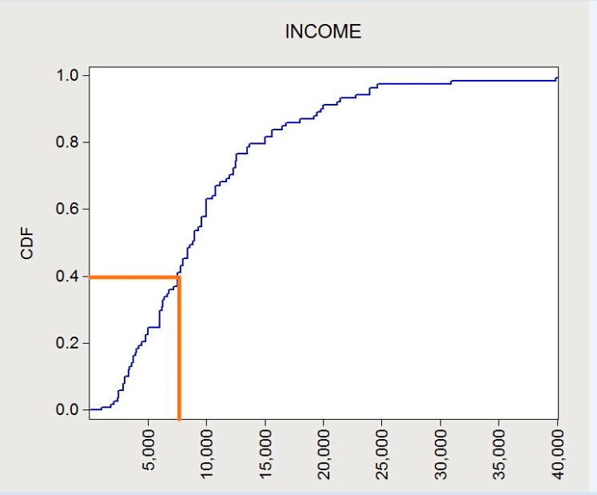
Figure 8-1 Cumulative curve graph of per capita disposable income of a household

8.4 Poverty reduction strategy of the project area
8.4.1 Rural poverty reduction strategy
In May, 2012, Planning Outline on Rural Poverty Alleviation and Development in Twelfth Five-year Plan of Anhui Province was officially released. It is indicated, from the Outline that in conformity with the national poverty-line standard newly published by China, the working range of poverty alleviation in Anhui province further expands and the number of people for poverty alleviation increases substantially. The expanding trend of development gap between cities, regions and different social groups fails to be under effective control and the relative poverty replaces the absolute poverty, which becomes one of the most prominent problems of poverty reduction work.
On October 17th, 2012, Opinions about Accelerating Promoting Poverty Alleviation and Development Work was released in Huai’nan city. It was decided that the following five years would be used to carry out poverty alleviation work in two key districts of poverty alleviation, seventeen key towns and one hundred and eight key villages. The goal is to make twenty thousand people get rid of poverty each year and to realize complete poverty elimination in 2016. At that time, the key villages will reach the acceptance standard of Six Tong Twelve You formulated by Anhui province and the rural per capita net income will increase to be higher than the average level of the whole city.
In order to achieve the goal of entire poverty elimination in five years, Huai’nan city will take the five concrete measures. The first measure is to integrate all kinds of funds and deeply carry out the whole village advance. Huai’nan city will effectively integrate special poverty alleviation funds and project funds of industries and sectors to strengthen the support of infrastructures, public causes and industry development. The second measure is to cultivate characteristic industries to speed up the pace of industries for poverty alleviation. The third measure is to intensify the rural financial services and to build a huge poverty-relief work pattern.
8.4.2 Social security
At present, the social security system covering both urban and rural areas has been set up in Huai’nan city, mainly including pension insurance system for urban and rural residents, basic medical insurance system for urban residents, new rural cooperative medical insurance system and subsistence security system for urban and rural residents. Besides, aiming at poor and low-income residents, Public Finance sets up a special fund to provide relief and aid for serious illness, disaster and the disabled, support system for rural old men enjoying five guarantees and non-three persons, relief and aid for vagrants and beggars, renting allowance for low-income groups, rural drinking water safety fund and aid for stay-at-home children, etc.
Social security system is the last guarantee to ensure that poor and low-income groups can obtain basic living guarantee. In 2012, the expenditure of whole-city subsistence security was 196,825,000 Yuan and per capita subsidy was 2570 Yuan (see Figure 8-1).
In 2012, there were 22272 households and 50311 persons enjoying full-year rural subsistence security in Huai’nan city and rural subsistence security fund of 82,804,000 Yuan were given out with per capita subsidy of 154.2 Yuan (see Figure 8-1); 14682 rural persons for five guarantees were supported, among whom 6127 persons were supported collectively and 8555 persons were supported dispersedly; per capita standard for collective support was 4800 Yuan per year while it was 1500 Yuan per year for dispersed support.

8.5 Impact of the project on poverty reduction
As a project of public infrastructure construction, this project is predicted to have impact on poor and low-income groups in the project area from two aspects.
8.5.1 Direct impact
The direct impacts on poor and low-income groups are mainly manifested from the following aspects: (1)creating temporary and permanent newly-added job opportunities for local people;(2)providing training on employment skills to enhance skills of obtaining wealth of residents;(3) relieving the pollution of old garbage dump on surrounding environment and eliminating the breeding environment of mosquitoes and flies to lower the probability of suffering from diseases due to pollution and to reduce the medical burden of poor groups;(4)reducing the everyday time and fees of poor groups for going to work or study.
Degree of impact of the project on poverty reduction can be seen in Analysis on social impact of project of Chapter 6.
8.5.2 Indirect impact

The completion of this project will provide a crucial environment basis for the development strategy of Huai’nan city of advancing toward east and spreading toward south. From a long-term perspective, more job opportunities will be created, which will make poor and low-income groups benefit from it.

9 Impact of the project construction on development of women and vulnerable population

9.1 Overview of the women in the affected project area
Education: The social assessment survey of project impact indicates that the education level of the affected population in the project area is generally low, especially for women. Since the proportion of the population with education level of senior high school or above is very low, there is no point in comparing male and female population with education level of senior high school or above. Then the comparison between male and female population with education level of junior high school or below is more typical. The proportion of population with education level of junior high school is the highest both in male and in female, but the proportion in female (33.33%) is significantly lower than that in male (47.22%); the proportion of population with education level of primary school in female (20.2%) is also lower than that in male (22.15%). On the contrary, the illiteracy rate of female (28.28%) is much higher than that of male (10.19%). The education level of the surveyed population is shown in Figure 9-1.
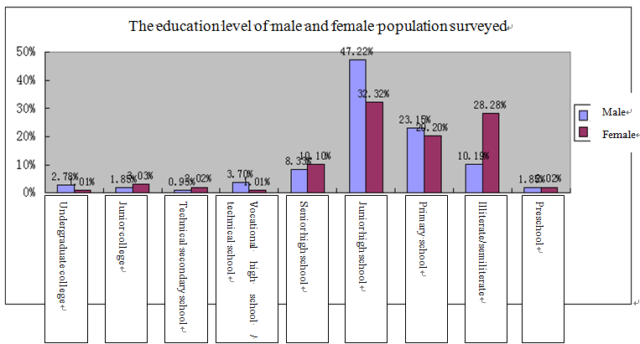
Figure 9-1 The education level of male and female population surveyed
Income and status in family: Status in family is the basis of social and political status, while income is the foundation of status in family. According to the survey of the proportion of women’s income in the total income of the family, the proportion of women’s is far lower than that of men’s (as shown in Table 9-1); For 75% of the surveyed households, the proportion of women’s income in the total income of the family is below 10%, and for 84.38% of the households, the proportion is below 30%.
Table 9-1 The proportion of women’s income in the total income of the family
Below 10% | 10%—30% | 30%—50% | 50%—80% | Above 80%
75.00% | 9.38% | 9.38% | 0.00% | 6.25%
From the social economic survey of household, it is made clear that the main income of household comes from men who work outside. They used to work in the enterprises (coal mine plants in particular) in the project area, but as most of these enterprises are closed at present, they are dispersed to work in other coal mine plants of the mining group or other enterprises, even work in other cities such as Hefei and Xiamen and so on. They can not go home on a daily basis, so the family members investigators get in touch with are generally housewives of over 40 years old (as shown in Figure 9-2). Because of the obstable of low personal qualities and burden of housework (such as taking care of the elderly and children), most of them have to stay at home and undertake the burdensome housework instead of working outside, which deprives them of working chances and leads them to be in a weak social and economic status (as shown in Table 9-2).

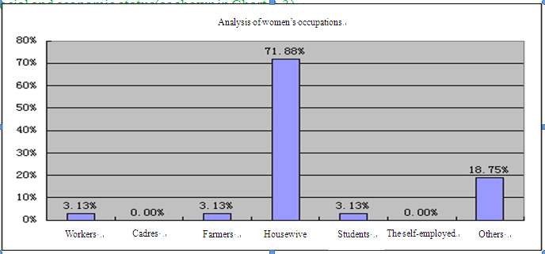
Figure 9-2 Occupation composition of women

Table 9-2 factors that most influence women working outside
1 | The administering of family property
2 | The decision of production type
3 | The decision of house selection/building
4 | The decision of division of labor
5 | The decision of purchasing expensive goods
6 | The decision of children’s education and career choice
7 | Instructing children’s lessons
8 | Attending the villagers’/residents’ meeting
9 | The decision of investment or loan
10 | Attending the wedding ceremony and funeral of neighbors

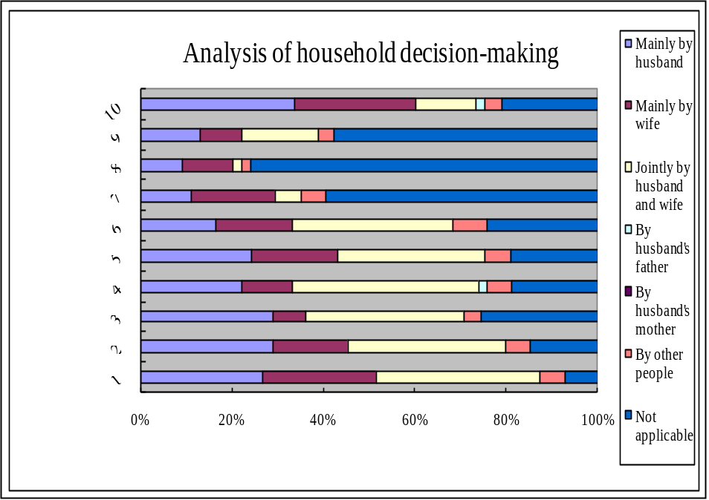

Figure 9-3 Analysis of status in household decision-making
As to the household decision-making, the proportion of decision-making jointly by both husband and wife is the highest (as shown in Figure 9-3). The proportion of decision-making jointly by both husband and wife in “the administering of family property”, “the decision of production type”, “the decision of house selection/building”, “the decision of children’s education and career choice” are all above 30%, the proportion in “the decision of division of labor” is even higher than 40%. All of these show that women are playing an important role in household decision-making. However, it still can be seen from the separate analysis of husband and wife that men and women are playing different roles in a family and that the status of women in a family is relatively lower. For example, as to “attending the villagers’/residents’ meeting”, the proportion of women is higher than that of men. One reason is that such activities are seldom held, as shown in the survey that the proportion of “not applicable” is 75.93%. The other reason is that the husband is working outside and generally has no time for such activities in the daytime of workdays. However, as to “attending the wedding ceremony and funeral of neighbors”, the proportion of men is much higher than that of women. This is because such activities usually occur on holidays and men could afford the time to attend. Thus it can be seen that in the activities that show the social status of the family, women only plays a supplementary role as a “massager”. As to “instructing children’s lessons” and “the decision of children’s education and career choice”, the proportion of women is higher than or equal to that of men. This is because women are mainly engaged in housework and have more time to take care of children and educate them.
The role difference and the relatively lower status of women in family are more obvious in the division of housework. As to the statement “The best way to run a household well is that the husband works outside and the wife does the housekeeping”, the proportion of “agree very much” and “generally agree” is as high as 60.54%, the proportion of “do not agree much” and “strongly disagree” is below 10%. As to the statement “Job opportunities shall be given priority to men”, the proportion of “agree very much” and “generally agree” reaches 76.92%, while the proportion of “do not agree much” and “strongly disagree” is only 3.85%. The similar proportions occur in other items as well, for example, as to the statement “Major decisions shall be made by husband” and “Housework shall be done by wife”, the proportion of “agree very much” and “generally agree” is far higher than the proportion of “do not agree much” and “strongly disagree”.
Social and political status: The relatively low status of women in family and the traditional thought that men should work outside and women should do housekeeping have determines that the social and political status of women could never be truly equal to that of men; however, most people believe that the influence of women on public affairs is gradually rising. In the survey, we find that the secretary and the chief of Chenxiang Village, which is the most heavily affected village, are both women. In the interview, it is told by them that 80% of the current cadres of the village are female.
In China, to a large extent, it is considered that women should take care of the family. The traditional thought keeps many women out of their own career. In the survey, women’s statements such as “My career is just my husband’s career” and “Only if my husband succeeds will I succeed” are often heard. Such statements coming from women themselves show that traditional thoughts are deeply influencing people’s concepts, and they also indicate the social pressure women will face in order to promote their status.
The role difference and the relatively lower status of women in family are of certain risks in terms of women, family and society. Director Jin of Development Department of Huai’nan Women’s Federation told us: “Women have low income, and thus have low status in family; as a result, they have no basis for other things. For example, in the questionnaire or in the simple interviews, you can find that women have equal right to sign and right to be informed and can administer family finance and decide children’s education and investment jointly with their husband. However, if women have no income, once something happens to the family or to their marriage, women will immediately get into trouble, and the right to sign, the right to administer family finance and the right to attend activities will all be disembodied. Nevertheless, women would not tell others about these problems, and the situation may not be reflected in your questionnaire. We get this point through long time of work. So women should stand on their own feet. From grass-roots work, we also observe that a family can be stable if the wife has a good job.”

9.2 Analysis of the impact of this project on women

9.2.1 Positive impact
1. Improving living environment
According to the survey of household, society and economy, the main houses in the project area are all relatively old single-storey house with poor structure and facilities. For example, as there is no tap water in Mining North village, the project office promises to solve their water usage problem by means of bringing in tap water from neighboring places. Therefore, the construction of this project could improve their living environments. In addition, through the close of the garbage dump, the restoration of vegetation and the treatment of river system, the environment in the project area will be greatly improved, which is beneficial to the living environment of the whole project area and its neighboring area.
2. Increasing job opportunities
In the project design stage, the needs and suggestions of women should be considered; in the project implementation stage, it is ensured that unskilled jobs will be given priority to vulnerable groups including women; vocational skill training will be provided in the project and the dress making work will exclusively open for women; it is ensured that women are allowed to sign to receive compensation for expropriated land, and so on.
3. Increasing economic income
Most women are looking forward to the construction of the project. They think that the construction of the project will bring them far more opportunities than risks. For example, the construction of the project will make the environment more beautiful and the traffic more unobstructed, thus the cost of travelling will be reduced and it will be safer and more convenient for their husband to go out to work and their children to go to school. In particular, the construction of roads and the improvement of environment will promote the development of ecological agriculture and tourism there, bringing more opportunities for development.
4. Reducing burden of housework
From the field survey and the interviews, we know that in most families, men go out to work while women and the elderly become the main undertakers of agricultural production. In this project, part of the collective land owned by Chenxiang Village will be exproprited, and the land use right of some villagers will be transfered, which will reduce the intensity and time of agricultural labor of the women and the elderly who undertake the main agricultural labor as their husband go out for work, and will relieve some women out of the intensive agricultural labor who will otherwise have opportunities to attend in other social and economic activities.

9.2.2 Negative Impact
The land acquisition for the project construction could relieve part of the agricultural labor of the women and the elderly in Chenxiang Village, thus they will have opportunities to attend in other social and economic activities. However, the land acquisition will also reduce their income, and if it is not compensated by other methods, their status in family will probably be further lowered. Therefore, the social security after land acquisition becomes their prior concern. Thus it can be seen that it is a fundamental security method for women to provide a reliable pension security for the farmers including women, and it is also of important significance to promote the social and economic status of women.

3.6.3 Impact on vulnerable population
This project involves the house demolition of six households, one of which is a family with one disabled person. The disabled person is a psychopath of over 40 years old and he cannot take care of his own life and completely depends on the care of his parents who are retired workers in Ferroalloy Works of Huai’nan city living on retirement pension. When the patient falls ill, he tends to do violent behaviors. As a result, this household was permitted by Ferroalloy Works of Huai’nan city to build a house alone there, which did good to look after and manage the patient alone and inhibited him from hurting others. But their house needs to be demolished for bonsai garden construction of this project, which is bound to bring inconvenience to their life. The patient’s parents support the construction of this project and agree with the relocation plan with the request for getting corresponding care.
The following ways will be adopted in this project for indirect poverty reduction and aiding vulnerable population so as to facilitate the inclusive development of Huai’nan city: (1)providing temporary and permanent newly-added job positions to promote employment;(2)improving the life and the living environment of the surrounding residents to reduce risks of suffering from illness and medical burden;(3)improving the ecological environment and infrastructures to prompt appreciation of the surrounding lands;(4) enhancing the level of public services and improving the investment environment of the city to promote the overall development.

10 Information Disclosure and Public Participation

10.1 Preliminary information disclosure
Public participation and consultation during project preparation is mainly done in two ways: (1) through mass media to deliver project related information; (2) inform the public related information and conduct public participation and consultation after a large number of site inspection and field investigation by the professional design team during project preparation.
This project has been publicized a lot on Huai’nan municipal government information publicity website, major local medias and other public medias since September, 2012. The writer of this paper has searched out about 25,300 related inks (shown in Figure 5-1) by entering key words “World Bank funded project for comprehensive treatment of coal mining subsidence area in Huai’nan City” at http://www.idea123.cn/, which not includes information released and disclosed via mass media such as TV, newspaper, radio, etc.
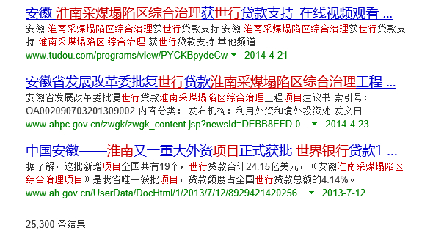

Figure 10-1 Search result of “World Bank funded project for comprehensive treatment of coal mining subsidence area in Huai’nan City”

10.2 Public Participation and Consultation in Social Survey
Social survey in pre-project preparation is one of the most important public participations and consultations during the whole pre-project preparation. The detailed social survey is shown in chapter 3 (Table 3-1) and chapter 5; the followings are the analysis results of public understanding and attitude towards the project.

10.2.1 Understandings toward surrounding environmental problems
The questionnaire analysis shows that water environment treatment is the problem of most concern (73.68%), followed by industrial refuse (59.65%) and household refuse (52.63%), air pollution (64.4%) comes fourth, closely followed by greenland construction (60%). Residents’ feelings are basically consistent with the project content (waste yard treatment, water system improvement, shut down polluting enterprises and develop green industry), and also are in line with our field interviewing results.
Table 10-1 Understandings toward environmental problems of residents surveyed
 | Very important | Important | Fair | Less important | Much less important
Water pollution treatment | 73.68% | 26.32% | 0.00% | 0.00% | 0.00%
Air pollution treatment | 47.37% | 38.60% | 12.28% | 1.75% | 0.00%
Soil fertility decline treatment | 31.58% | 31.58% | 26.32% | 10.53% | 0.00%
Collection and disposition of industrial waste | 59.65% | 35.09% | 5.26% | 0.00% | 0.00%
Collection and disposition of household garbage | 52.63% | 42.11% | 5.26% | 0.00% | 0.00%
Greenland construction | 36.84% | 36.84% | 26.32% | 0.00% | 0.00%
Noise control | 33.33% | 35.09% | 31.58% | 0.00% | 0.00%
Restrict usage of disposable | 40.35% | 47.37% | 12.28% | 0.00% | 0.00%
Soil alkalization treatment | 19.30% | 21.05% | 49.12% | 10.53% | 0.00%

Li Chunyan female 30 years old Kuangbei Village
Her husband worked in Ninth-second company before and now has been to Xiamen to grow vegetables. She has two children, one is eight, the other is only two years old, so she can only stay at home to look after them. She told us that the biggest life issue here was water. There is no tap water and they only can get water from other residential areas or Ninth-second mine (rear office). The well water cannot be used because it has been polluted, so it only can be used to wash clothes.

Mr. Duan, director of the funeral parlour
There is a mixing plant (it may refer to Fuqiang Commercial Concrete Mixing Co. Ltd. in Huai’nan City) beside, they discharge coarse screenings arbitrarily and create loud noise, which makes us think the local environment is rather dirty, disorder and bad. Road management is lack of standardization. Dustman who is responsible for cleaning the road just dumps the garbage along the road, which results in more and more garbage. Even though it’s rather dusty when cars driving past, we still have to pay cleaning fees. But it’s not the dustman to be blamed for, because the dust is too much that they can’t finish at all.

10.2.2 Understanding and attitude towards environmental treatment project
The questionnaire analysis shows that only part of the respondents (37.8%) know the environmental treatment project in subsidence area. From the point of access to information, it’s mainly from media (29%) and government at different levels (18%). It’s obvious that the channel for affected population to get information is rather narrow because the project is only at feasibility study period.
After we introduced the main contents of the project, over 80% residents thought that the environmental treatment was very important or important, over 80% residents said they’d like to cooperate with the government sectors for the project construction (see Table 10-2 and Figure 10-3). It’s obvious that this project has got wide support among peoples.

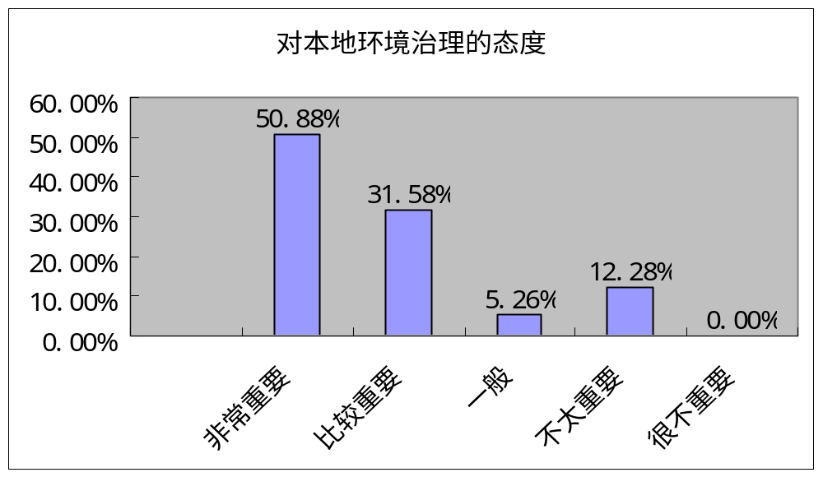
Attitude towards treatment of local environment
Imperative
Important
Very
Important
Important
Not so
Important
Not
Important
Figure 10-2 Attitude towards local environmental problem treatment

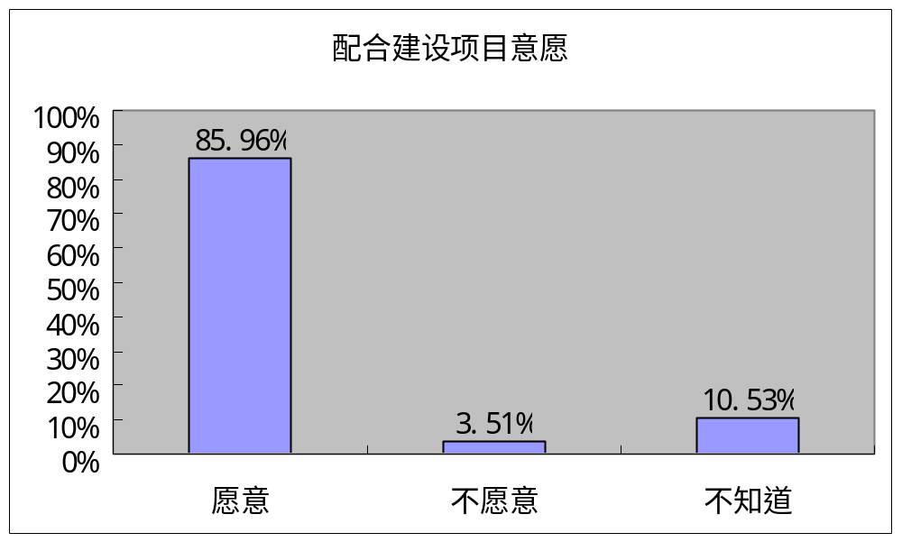
Project construction coordination
Willing
Unwilling
Not sure
Figure 10-3 Willingness of local residents to cooperate with project construction
As for influence brought by environmental management project, 63.16% residents think it will bring benefits to the region, 28.07% residents say they don’t know, 8.77% residents think they are not sure about its influence, but no one think it won’t bring benefits. Further analysis on what specific benefits it will bring shows that what residents mentioned most is “living condition improvement” (88%), because Huai’nan City has already began comprehensive treatment in coal subsidence areas, and the governance way is to shut down enterprises and relocate residents. “water quality improvement” (61%) comes second, followed by “air purification” (58%).

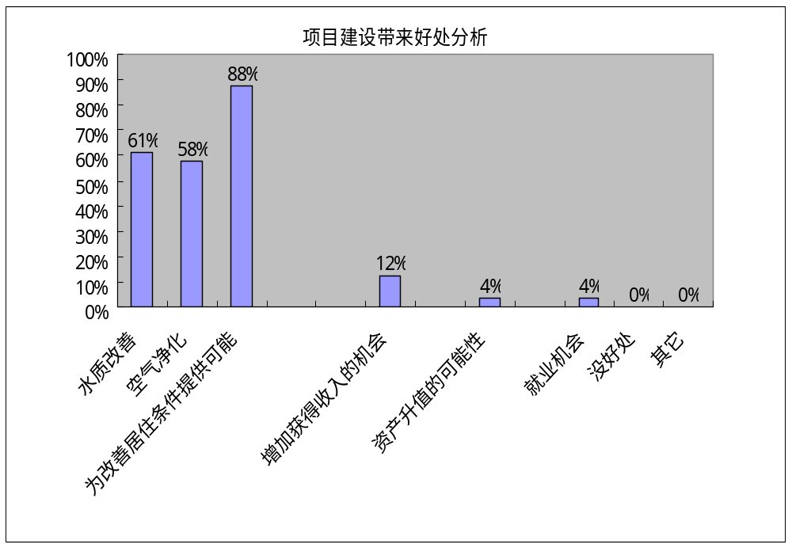
Figure 10-4 Benefits brought by project construction
The survey data shows the residents within and surrounding the project are influenced by environmental pollution in subsidence area for a long time. Hence, residents greatly support the project construction, hoping the project can reduce the surrounding environmental pollution and improve living conditions and environment. However, since the former integral control of environmental pollution didn’t completely solve their living environments or even generated some new problems (such as new environmental problems generated by illegal brick factory, quarry, stirring plant, stone factory, small coal mine), which made part of the residents doubt about the implementation effect of the project. They may misunderstand or conflict with the project implementation if they can’t totally understand the project contents and implementation plan.

10.2.3 How to reduce negative influence brought by the project
The project will expropriate some land inevitably, the survey of residents in Chenxiang Village and Jiulonggang Village shows that most residents give a very positive response to reduce these negative influences. 60% residents said they’d like to get more opportunities to work, 35% residents said they’d like to run non-agricultural business by the compensation money, which shows most of the residents give a positive response to the negative influences brought by the project. Under conditions of proper way and mechanism, they show a relatively strong willingness to participate if the project can provide job opportunities for them; only small part of residents concern about their own abilities and show a weak willingness to participate.

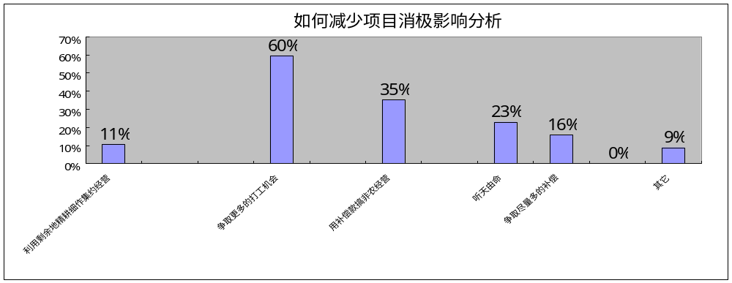

Figure 10-5 How to reduce negative influence brought by the project

10.3 Public participation mechanism
Complete public participation mechanism needs to be set up during the entire project period, including periodical information disclosure system, complaints and appeals, public consultation system, etc.
1. Information disclosure system
During project preparation, implementation and operation, in order to guarantee stakeholders to get timely information related to project and have equal opportunity to put forward their own suggestions and opinions for corresponding problems, and to make it easier for project owners and unit in charge of construction to know the project progress and make scientific decision based on actual situation at the same time, information disclosure shall be conducted in each phrase and to release and collect related information to ensure unobstructed information and information communication among different sectors, so as to push forward smooth implementation of the project.
Establish periodical information disclosure system and set up fixed information exchange channels. Post project information that is closely related to stakeholders and of much concern in public place in communities. Moreover, it’s also can inform the stakeholders of implementation progress by group conference, representative meeting, slogan, TV, radio, newspaper, leaflet and other means.
2. Appeal and complaint mechanism
Appeal and complaint mechanism of affected population shall be established and clarified during the entire project progress. The project office can appoint a specific person and disclose his/her contact information, he/her shall be responsible for collecting opinions and suggestions from the affected population and shall give necessary feedback and response for the accepted opinions and suggestions within two weeks.
3. Public consultation mechanism
As for related issues of affected population, it needs to have full consultation with each affected person and carry out work based on consultative results. For example, it’s suggested to hold village meeting when determining land use right transfer rent. Full consultation with each affected person and related villages is also needed to determine resettlement way.
Moreover, during public participation, it requires to help main stakeholders to set up project subject consciousness and lead them to rethink what influence their production method and life style have brought to environment, as well as how to protect environment by starting with themselves, which aims to eliminate main stakeholders’ concerns and worries towards the project and help them actively participate in the project implementation and operation. During project preparation, implementation and operation phases, it requires full propaganda of project contents and aim; special attention shall be given to community cadres, whom will be needed in publicizing, mobilizing and reflecting residents’ needs, finding problems existing in project implementation, coordinating contradictions as well as in follow-up management. During project construction phase, recruit stakeholders to participate in project construction as far as possible, give them priorities to provide paid labor for the project and allow them to provide logistic service for project construction.

11 Social Management Plan

11.1 Measure to enhance/promote positive impact

11.1.1 This project will innovate the comprehensive treatment mode of environment in coal mining subsidence area in Huai’nan city, which sets up a good example for relevant works
Two research topics have been put forward: risk analysis of subsidence areas and comprehensive treatment policy mechanism analysis, analyze treatment theory and experience of Jiulonggang-Datong coal subsidence area.

11.1.2 It will create a good investment environment and promote the development of real estate and tourism after the completion of the project

Publicize the project contents and significance in media and public places by taking full advantage of public participation, so as to increase the public’s understanding towards the project, making them recognize the project surrounding is a good place integrating living, business and leisure.

11.1.3 Redevelopment items of the project can provide many jobs and entrepreneurial opportunities and increase peasants’ income
Not only include some temporary and non-technical job opportunities generated during project construction, but also many permanent jobs and entrepreneurship platform in later operation management. Periodically publicize project progress and labor demand to the public.

11.1.4 The skill training plan of the project will effectively help the affected residents, especially to realize the reemployment goal of women
A detailed employment training plan that taking women employment characteristics into consideration has been set up. Training agency, Human Resources and Social Security Bureau of Datong District will sign agreement with the project office, which aims to clarify each parties’ responsibilities and tasks, so as to ensure successful implementation of future training plan.

11.1.5 The closure treatment of the old wasteyard can solve the pollution problem arising from exposed garbage and effectively control the influence of garbage on the surrounding environment, which will directly improve the quality of life and living environment of the surrounding residents
In order to reduce pollution hazard of the wasteyard as much as possible, the designed plan will change its route to pass through a flood control furrow, so the spare space can be used to contain garbage of other scattered wasteyard within the project area to conduct centralized treatment. A detailed follow-up observation plan has been set up to monitor

11.1.6 It will enhance the road network and other infrastructures within the project area, save travel time and improve the quality of life of residents after the completion of the project changes of underground water and surface water.
The design unit takes service facility such as parking lot, bus station and infrastructures such as water supply and sewage and lightning into consideration in the design.

11.1.7 It will greatly improve the original road condition and local environment after completion of the project
Jiulonggang-Datong Road reconstruction project has been completed in the first half year of 2014, and Linchang Road is under construction now.
11.1.8 A mechanism will be set to make sure that residents in the benefit belt share the benefit from land appreciation

11.2 Measures to avoid/reduce negative impact

11.2.1 Measures to reduce land acquisition and demolition influence
Do a good job in project preparation and design, avoid and reduce land acquisition and demolition of the project as far as possible through optimized design; try to use non-agricultural land and state-owned land, right of collective land shall be transferred as far as possible, so as to reduce land acquisition impact upon peasants. As for the inevitable permanent land acquisition, do a good job in compensation resettlement in strict accordance with relevant policies.
Divert the project that pass through old residential areas of Qishan horticultural farm along the mountain road to the south and rebuild on the existing road as far as possible, which will reduce demolition area of 422.75m² at least.
The existing plan suggests to occupy some buildings for planned water system and planned green-way, which can totally be avoided during project construction and demolition shall be avoided as far as possible.
The planned nursery garden involves 1553mu local collective land. Based on principal of trying to avoid land acquisition, it’s suggested to centralize part of the collective land by transferring use right to develop new agricultural industries such as efficient forestry, nursery garden, flower, etc., which aims to improve comprehensive benefits of agricultural development and make land contractors can enjoy benefits bringing by the project .
Qualified assessment agency approved by both parties assesses the demolished factories and mines and give reasonable compensation and resettlement.

11.2.2 Avoid/reduce disturbance for residents’ normal life during project construction
Traffic problem: a. The project office shall communicate with the unit in charge of construction to adopt section construction during construction period, so as to reduce impact on residents’ traffic; b. Inform residents construction information by local radio, TV or by posting notice, so they can prepare in advance; ensure construction period strictly on the premises of guaranteeing the engineering quality; c. Propaganda traffic safety by adding guideposts to limit car speed.
Noise problem: a. The project office shall communicate with the unit in charge of construction to abide by noise standard strictly and take measures to reduce sound pollution as far as possible, which aims to reduce noise impact on surrounding residents; b. Noisy construction during night is prohibited and night work shall try to be avoided.
Problems of raise dust, tail gas and household refuse: a. Watering of approaching road and construction road periodically to prevent raise dust pollution; b. Clean and disinfect household refuse and key pollution source in construction site, regularize related behaviors of constructors.
Disease transmission problem: a. Basic medical institutions shall strengthen awareness and prevention of AIDS and venereal disease; b. Conduct periodical health examination and epidemic prevention for administrative staffs and contractors, disinfect living quarters, offices and temporary work sheds, and propaganda and manage environmental and health consciousness for constructors.
Set up corresponding complain and appeal mechanism for problems mentioned above (see details in Project Environmental Impact Assessment And Resettlement Report ).

11.3 Measures to avoid potential risks

11.3.1 Avoid resettlement risks
a. Work out a resettlement plan and social impact assessment, conduct fully public participation and consultation, let them participate in the project design and ensure their interest demand has been taken into consideration; b. Give reasonable compensation, implement livelihood recovery measures. Give reasonable compensation to the affected population for their land and houses, especially give subsidies to vulnerable population such as female-headed household, disabled ones, etc. during building reconstruction; carry out resettlement work on combination of technical and skill training by the local government; the non-technical posts shall be provided for the displaced person; c. Set up complain and appeal mechanism to solve problems during compensation and resettlement work. The resettlement plan has been approved (see Resettlement Action Plan of this project).

11-3-2 Avoid land use right transfer risks
Relatively complete law and regulation system on management and disputes of rural land management right transfer has been set up currently. For example, agricultural department has issued some normative documents, including Law of the People’s Republic of China on Regulation on Certificate of Rural Land Contracting Management Right (officially implemented on January 1st, 2004 ), Regulation on Rural Land Contracting Management Right transfer (officially implemented on March 1st, 2005) and Working Regulations on Pilot Registration of Rural Land Contracting Management Right (provisional) (issued in June, 2012). Especially the Law of the People’s Republic of China on Mediation and Arbitration of Rural Land Contracting Management Right that was approved at the Ninth Meeting of Standing Committee of the Eleventh National People’s Congress and was implemented on January 1st, 2010, which provides powerful legal basis for handling and solving rural land transfer disputes. Article 2 of this law clearly stipulate that rural land contracting management disputes include “disputes arising from sub-contracting, rent, exchange, transfer, becoming a shareholder of rural land contracting management right transfer”. Anhui province and Huai’nan City have issued relevant local policies and laws and regulations that aim to standardize land transfer, including Opinions of People’s Government of Anhui Province on Issues Concerning Rural Land Contracting Management Right Transfer and Opinions of Huai’nan Municipal Government on Implementing Opinions of People’s Government of Anhui Province on Issues Concerning Rural Land Contracting Management Right Transfer.
Each county, town and village in Huai’nan City has set up land transfer service center, and each district and county has set up arbitral institution for disputes of land contracting management right, land transfer mechanism and land transfer disputes mediation mechanism have been set up preliminarily, which play a good role in avoiding and reducing land transfer risks. Its general working procedures are as follows:
(i) Set up rural land transfer service institutes at three levels of district, township (town) and village. The district sets up rural land transfer service center which shall be borne to the Agriculture and Forestry Bureau and shall be set in district administrative center; township (town) sets rural land transfer service center which shares staffs with agricultural economy management station and is responsible for specific work of land transfer services in its own township (town); village sets up rural land transfer service station that is directly responsible for local rural land transfer services; thus to form rural land transfer service institutes at three levels of district, township (town) and village. The main responsibilities of rural land transfer service institutes include: firstly, be responsible for registration and information disclosure of land transfer supply and demand; secondly, be responsible for coordination and guidance for both sides of land transfer, conduct land assessment, contract verification, laws and regulations and policy consult, etc.; thirdly, be responsible for follow-up service and dispute mediation after land transfer; fourth, be responsible for land transfer supervision, ensure the agricultural use and moderate scale management of land.
(ii) Standardize transfer formalities. Township (town) rural land transfer service center shall hold training courses on normative contract of land transfer and land transfer related policies under the guidance of district rural land transfer service center. Township (town), village rural land transfer service institutes shall provide the two sides land transfer contract of standard format free of charge and guide the two sides during land transfer. Township (town) rural land transfer service center shall process in time if the party involved apply to verify the land transfer contract. Rural land transfer service center shall point out and help to correct clauses that violate laws, regulations and policies in the land transfer contract.
(iii) Set up record, registration and archives management system. Township (town) rural land transfer service center shall register land contracting management right transfer situation, appoint specific personnel to be responsible for registration of land contracting management right transfer situation, collection, collation and filing of land transfer materials, establish duty security system and information reserve pool on the principle of one Figure for one household, one volume for one village and one cabinet for one township (town).
(iv) Handle rural land transfer disputes timely and properly. Sides involved in land transfer disputes can solve disputes through negotiation, or apply for mediation by township (town) people’s government or village committee. They may file a lawsuit in a people’s court if sides involved do not want to negotiate or mediation fails to reach an agreement.
Apart from the above procedures and methods, this project particularly emphasizes the following aspects and measures:
Work out transfer plan strictly: transfer plan can clarify objective, principle, form, procedures, mode and approach of land transfer, maintain lawful rights and interests of both sides involving land transfer, work out detailed measures and working procedures for implementing the plan (see detailed land transfer plan in Appendix 1 of Resettlement Action Plan).
Raise land transfer price appropriately: rent of this project is 1200 Yuan/year, compensate green crops of one season in the first year. The following rent shall be adjusted along with fluctuation of conservation price of national grain purchasing. The rent shall remain unchanged if market grain price is lower than the conservative price; the rent shall be raised in proportion if market grain price is higher than the conservative price, which is determined upon wide survey. Land transfer price that farms transfers by themselves in Jiulonggang Town is relatively low these years, most are 800-1200 Yuan.
Strengthen supporting facilities of land transfer:
a. Improve social security system: most farms still regard land as their basic living guarantee. So multi-level rural security system shall be set up and improved, including rural social relief, social welfare, veteran benefit and placement, social mutual aid, rural cooperative medical service, etc., so as to solve land transferor’s worries behind.
b. Implement farmers-benefiting subsidy polices. Issues concerning different farmers-benefiting subsidy polices during land transfer contract period shall be negotiated by both sides involved in land transfer according to regulations and the consultations shall be specified in the land transfer contract, the transferor shall enjoy the benefits if it’s not been specified.
c. Properly handle employment issues of transferred farms. As for farmers who have transfer all their land shall enjoy equal rights with land-expropriated farmers. They shall be given priority in job training and employment; they can enjoy relevant preferential policies of laid-off workers in cities and towns when starting their own business.
Other measures:
a. Improve farmer’s motivation of land transfer. Further strengthen publicity of relevant regulations concerning land contracting management right transfer, improve understanding and legal consciousness on relevant regulations concerning land contracting management right transfer of cadres and mass peasants and improve farmer’s self-consciousness and initiative on land transfer. Meanwhile, formulate reward policy to encourage farmers to transfer land. For example, farmers whose land being transferred has reached a certain area shall obtain corresponding reward subsidies, including soft loan, increase loan limit, etc.
b. Strengthen farmer’s risk prevention awareness. Farmers shall have preparedness during land transfer in order to avoid risks. Land transfer period shall be short-term transfer preferably, so as to lower the farmer’s risks of losing job and losing land or small profits; transfer management right only, but not transfer contracting right to avoid risk of losing land, which also vitalize rural land resources.

11.3.3 Avoid public under participation risks
a. Design unit shall conduct field survey in residential areas along construction site to fully understand reasonable demand of local residents; optimize the project design to fully realize project objectives and develop the project functions.
b. Strengthen publicity and education of environmental protection to local residents, try to strengthen residents own environmental consciousness to make them protect environment in their daily life, reduce pollution and participate in project implementation and management actively.
c. Work out public participation plan, set up appeal and complain mechanism. (see Resettlement Action Plan)

Table 11-1 Environmental and Social Management Plan
Social factor | Impact | Measures to enhance/promote positive impact | Timing | Budget (0.01 million Yuan) | Implementer | Supervisor | Monitoring indexes | Frequency
1-Positive impacts
Governance model | Sets up a good example for other relevant works | Strengthen researches on risk analysis and comprehensive treatment policy mechanism analysis |  | 160 | Research unit | Project office | Publish research findings
Improve investment environment，make land appreciate in the benefit belt | Promote the development of real estate, tourism and relevant industries, bring about the benefits to the residents in the benefit belt | Strengthening publicity of project contents and significance, full resettlement price and per local princiles, adjustment of comprehensive section-land price once every two years, no more than 15% of collective land area expropriated each year, 5-10% of actual expropriated collective land area transferred to the village for economic development | Entire project period | included in RAP | Project office and consultative unit | Independently external monitoring agency | Amount of state-owned lands purchased and stored and collective lands expropriated each year during the construction period of the project; population affected by land purchase and reservation and acquisition; resettlement location; market price of houses for resettlement; adjustment on section land value of collective lands; amount, location and development and utilization status of collective land to be reserved for resettlement | 1 time/year
Redevelopment items construction | Increase employment and entrepreneurial opportunities | Give priority to project affected local residents concerning employment and entrepreneurial |  |  | Datong District | Project office | Quantity of employment of non-technical post during project construction | 2 times/year
Employment training plan | Strengthen re-employment ability of local residents | Project office, Human Resources and Social Security Bureau of Datong District will sign cooperation agreement with the training agency |  | 100 | Datong District | Project office | 965 person in total, qualified rate shall be over 90%, employment rate that year shall be over 85% | 2 times/year
Closure treatment of wasteyard | Solve pollution arising from garbage thoroughly | Change route of flood control furrow, greening, strengthen monitoring of underground water and surface water |  | Included in construction cost | Construction unit | Project office | See Environment Assessment | See Environment Assessment
Improve road network and other infrastructures | Reduce travel time and improve living quality | Design unit shall take public services such as parking lot and bus transfer into consideration in the design |  | / | Design unit | Project office | / | /
Reconstruct original road | Eliminate damage and raise dust of original road, make it safer, cleaner, and more expedite | Jiulonggang-Datong Road reconstruction project has been completed and Linchang Road is under construction now | / | / | / | / | / | /
Social factor | Impact | Measures to avoid/reduce negative influences | Timing | Budget (0.01 million Yuan) | Implementer | Supervisor | Monitoring indexes | Frequency
2-Negative impact
land acquisition and demolition | Road, bonsai garden, and green-way occupy mu land of Chenxiang Village, four private houses need to be demolished for bonsai garden | a. Try to use non-agricultural land and state-owned land, right of collective land shall be transferred as far as possible, so as to reduce land acquisition impact upon peasants; b. Avoid and reduce land acquisition and demolition of the project as far as possible through optimized design; c. As for the inevitable permanent land acquisition, do a good job in compensation resettlement in strict accordance with relevant policies. | Entire project period | Included in resettlement cost | Design unit and project office | Project office and resettlement external monitoring agency | See resettlement monitoring indexes | See resettlement monitoring frequency
Enterprise relocation | Involving 9 enterprises, two of which are still running. | a. Hire qualified assessment agency approved by both parties conducts assets appraisal; b. Give reasonable compensation for enterprises that have already shut down; c. Offer good relocation and resettlement for enterprises that are still running. | 2014-2020 | Included in resettlement cost | Design unit and project office | Project office and resettlement external monitoring agency | See resettlement monitoring indexes | See resettlement monitoring frequency
Disturb residents during construction | Traffic jams, noise, raise dust pollution are produced inevitably during construction, which will disturb residents’ normal life and production. | Traffic problem: a. The project office shall communicate with the unit in charge of construction to adopt section construction during construction period, so as to reduce impact on resident’s traffic; b. Inform residents construction information by local radio, TV or by posting notice, so they can prepare in advance; ensure construction period strictly on the premises of guaranteeing the engineering quality; c. Propaganda traffic safety by adding guideposts to limit car speed; d. Safety emergency plan shall be carried out in case of any traffic accidents outside plan.  Noise problem: a. The project office shall communicate with the unit in charge of construction to abide by noise standard strictly and take measures to reduce sound pollution as far as possible, which aims to reduce noise impact on surrounding residents; b. Noisy construction during night is prohibited and night work shall try to be avoided.  Problems of raise dust, tail gas and household refuse: a. Watering of approaching road and construction road periodically to prevent raise dust pollution; b. Clean and disinfect household refuse and key pollution source in construction site, regularize related behaviors of constructors. | Entire project period | Included in environment assessment cost | Construction unit, project office, basic medical institutions, disease control and prevention center | Project office, engineering supervisor, external monitoring and evaluation, environmental protection agency, disease surveillance | See Environment Assessment | Traffic, noise, raise dust, tail gas, household refuse: 3 times/year; disease transmission shall be according to requirements of disease control and prevention center; appeal and complain: 2 times/year
3-Potential risks
Resettlement risks | Improper resettlement, cannot timely and full funding of compensations, compensation standard expectancy of displaced population has been rising constantly | a. Work out a resettlement plan and social impact assessment, conduct fully public participation and consultation, let them participate in the project design and ensure their interest demand has been taken into consideration; b. Give reasonable compensation, implement livelihood recovery measures. Give reasonable compensation to the affected population for their land and houses, especially give subsidies to vulnerable population such as female-headed household, disabled ones, etc. during building reconstruction; carry out resettlement work on combination of technical and skill training by the local government; the non-technical posts shall be provided for the displaced person; c. Set up complain and appeal mechanism to solve problems during compensation and resettlement work. The resettlement plan has been approved | Entire project period | Included in resettlement cost | Project office and village committee | Project office and resettlement external monitoring agency | See resettlement monitoring indexes | See resettlement monitoring frequency
Land transfer risks | Lack experience on land transfer, many uncertainties still exist, such as form and time of land transfer, signing and management of contract, rent determination, exist mechanism, etc. | a. Work out transfer plan strictly  b. Assess value of land transfer scientifically.  c. Improve disputes mediation mechanism on land transfer  d. Improve supporting facilities of social security system.  e. Provide opportunities of employment and increase income of rural residents within project area. | 2015-End of second round of contract period | Included in resettlement cost | Project office and village committee | Project office and external monitoring agency | Household income, social security; Quantity of employment of non-technical post during project construction; quantity of land transfer; contract; | 2 times/year
Public participation | Lay particular stress on up-down guidance and command but down-up feedback and consultations are ignored, two-way participation is not balanced; relocated person, original residents don’t know the project and resettlement information and delay or reject the project; benefit of replaced population and other stakeholders are lost, and their question, demand and suggestions can’t be expressed in an effective way | a. Design unit shall conduct field survey in residential areas along construction site to fully understand reasonable demand of local residents; optimize the project design to fully realize project objectives and develop the project functions.  b. Strengthen publicity and education of environmental protection to local residents, try to strengthen residents own environmental consciousness to make them protect environment in their daily life, reduce pollution and participate in project implementation and management actively.  c. Work out public participation plan, set up appeal and complain mechanism. (see Resettlement Action Plan) | 2013-2020 | / | Project office and village committee, relevant safeguard stability system at four levels of county, township, village, group, staffs of comprehensive treatment office, Bureau for letters and calls | Project office and external monitoring agency | Implementation of Public participation; appeals and complains | 2 times/year

11.4 Measures to meet the needs of main stakeholders
(1) Residents around the old wasteyard (such as residents in courtyard of old acetylene gas plant, Runze Garden Community and residents behind Huai’nan octyldodecanol plant) have been deeply impacted by the pollution around, they urge to treat the old wasteyard and improve environment. Most residents in Chenxiang Village do not live nearby, but their cultivated lands which are around the wasteyard are severely polluted, so they strongly demand to deal with environmental pollution of the wasteyard. The project office has given top priority to environment treatment of the old wasteyard.
(2) Residents of Kuangnan Community complain about damages and noise caused by the stirring plant, Datong District government of Huai’nan City has worked out a plan that to demolish industrial enterprises within the project area systematically, which is expected to be done before project commencement.
(3) Residents of Kuangbei Residential Committee complain about the difficulty to get drinking water, they require to improve living conditions and environment. The project office suggests the design unit to take drinking water issue of these residents into consideration
(4) For issues of land acquisition in Chenxiang Village, the project office promises 1) land compensation of relocated population shall be open, fair and transparent, avoid land disputes due to unfair or uneven distribution; full amount of land compensation fees shall be paid to the relocated population in a timely manner, so as to conduct production and development timely and resume production; 2) give priority to solving employment of land-expropriated farmers; 3) endowment insurance shall be given to the land-expropriated farmers.
(5) Compensation and resettlement for the relocated households: 1) unlicensed buildings shall be compensated based on the cost price and economically affordable houses shall be provided for them to purchase; 2) 30m² housing per person shall be provided for person who lives in public house and only has a single house; 3) appropriate compensation shall be provided during transitional period of resettlement.
(6) Project owner (project office), Datong District and related government departments, etc. expect 1) the World Bank can provide guidance as much as possible to strengthen their capability building; 2) invite expert team to help all preparation work, which shall be completed in time, so as to ensure implement the project as soon as possible, improve local ecological environment and gain good economic benefits; 3) set up expert consultant team of different departments of municipal government to guide work of preparation, implementation and operation, thus to play an effective demonstrative role of the project and promote the environment treatment and social and economical development of the entire mine subsidence area.
(7) consultative unit, construction unit, ect. expect their work not only can meet the requirements of the Word Bank, but also can be practical and realistic and act according to the local conditions, thus to lower the construction and operation cost and do good to Huai’nan City. Other consultative units and construction units also have the same expectation.
Table 11-2 social management plan to meet needs of main stakeholders
Recommended action | Target population | Enforcement body | Time | Concrete actions | Capital source | Monitoring indexes
1. Take measures to deal with the old wasteyard as soon as possible, improve environment | Residents around wasteyard (such as residents in courtyard of old acetylene gas plant and Runze Garden Community), residents in Chenxiang Village | Project office, Datong District, design unit and construction unit | 2015-2017 | The project office has given top priority to enclosed treatment of the old wasteyard. | Project funding | See environmental impact assessment report
2. Eliminate damages from stirring plant, quarry, stone factory, brick factory, etc. as soon as possible | Residents of Kuangnan Community, on both sides of road to cement plant, residents of funeral parlor, Qishan horticultural farm | Project office, Datong District, design unit and construction unit | 2014-The end of the year 2015 | In order to improve the local environment, Datong District in Huai’nan City requires all the industrial enterprises within the project area shall be demolished systematically. The cement plant has already been demolished. | Investment of Huai’nan municipal government | See environmental impact assessment report
3. Improve the local infrastructure construction, especially the water supply | Kuangbei Village | Project office, Datong District, design unit and construction unit | 2016-The end of the year 2017 | The water supply issue in this residential area has been included in the project by the project office | Project funding | Water supply facility, time and amount
4. Handle land compensation and resettlement. Solve employment of farmers involved in land transfer | Land-expropriated farmers and farmers involved in land transfer in Chenxiang Village | Project office, Datong District government, Chenxiang Village committee | 2015-The end of the year 2016 | 1) Land compensation of relocated population shall be open, fair and transparent, avoid land disputes due to unfair or uneven distribution; full amount of land compensation fees shall be paid to the relocated population in a timely manner, so as to conduct production and development timely and resume production.  2) Give priority to solving employment of land-expropriated farmers | Investment of relocated population | 1) Information disclosure  2) Satisfaction of relocated population
5. Handle house demolition resettlement | 6 relocated households in Zhanhou Community | Project office, design unit, construction unit, relevant township, town and village committee | 2015-2019 | 1) Unlicensed buildings shall be compensated based on the cost price and economically affordable houses shall be provided for them to purchase by preferential price;  2) 30m² housing per person shall be provided for person who lives in public house;  3) Appropriate compensation shall be provided during transitional period of resettlement. | Investment of relocated population | 1) Information disclosure  2) House compensation standard  3) Satisfaction of relocated population
6. Properly handle compensation for enterprise relocation | 5 enterprises need to be demolished | Project office, design unit and construction unit | 2015-2020 | 1) Hire qualified assessment agency approved by both parties conducts assets appraisal  2) Give monetary compensation to enterprises that are still running based on their willingness  3) fully compensate the enterprises that has been shut down based on policies and standards | Investment of relocated population | 1) Information disclosure
7. Capability building of the project owner | Project office | Project office | 2014-2020 | 1) The world bank provides assistance as much as possible  2) Hire expert team of world bank to complete preparation work  3) Set up expert consultant team of different departments of municipal government to guide work of preparation, implementation and operation | Project investment

11.5 Measures to meet the willingness of women and vulnerable groups

11.5.1 Promote participation of women in the project
1) Demands and suggestions of women shall be considered during project design.
2) Set up open and transparent mechanism of compensation information for land acquisition and demolition and guarantee women can get access to the same right for compensation and the right to know public information. The precondition to sign the compensation agreement for land acquisition and demolition and to distribute money is that the female family members have been well-informed.
3) Ensured that non-technical jobs will be provided prior to vulnerable groups including women during project implementation
4) Ensured that women are allowed to sign to receive compensation for expropriated land

11.5.2 Labor skill training for women
1) Develop an employment training plan considering women features;
2) Set up menu-like recruitment and training system and form a coordinated service of labor demands of enterprises, professional training and women’s personal interests, so as to reduce their blindness of employment;
3) Give a full play of women’s organizations such as Women’s Federation and Family Planning Association, integrate the development of women and their access to opportunities with the activities of these organizations, and appeal and lead women to enjoy opportunities brought by development;
4) Encourage women to start up their own business in floral trade market, and provide preferred small loans for women’s start-up businesses.

11.5.3 Provide land-expropriated farmers endowment insurance covering women and guarantee economic status of women

11.5.4 As for special requirements of the disabled families, Dadong District government has already handled minimum living allowance for that patients and sent them to hospital for treatment

Table 11-3 Social management plan to promote women development
Action plan | Target population | Execution organization | Date | Specific actions | Capital source | Monitoring index
1. Promote participation in the project | Affected women | Project Office, Datong District government, design unit, construction unit, Women's Federation, Jiulonggang Town government, Sub-district office of Datong District and relevant neighborhood committees and village committees | 2013-2020 | 1) Demands and suggestions of women shall be considered during project design.  2) Set up open and transparent mechanism of compensation information for land acquisition and demolition and guarantee women can get access to the same right for compensation and the right to know public information. The precondition to sign the compensation agreement for land acquisition and demolition and to distribute money is that the female family members have been well-informed  3) Ensured that non-technical jobs will be provided prior to vulnerable groups including women during project implementation  4) Ensured that women are allowed to sign to receive compensation for expropriated land | Resettlement capital and project capital | 1) Number of people attending the symposium and interview and times and suggestions during project design.  2) Number of women working on unskilled post during project execution  3) Percentage of women signature during receiving compensation
2. Labor skill training for women | Affected women | Project Office, Datong District government, design unit, construction unit, Women's Federation, Jiulonggang Town government, Sub-district office of Datong District and relevant neighborhood committees and village committees, Municipal Agricultural Bureau and Municipal Social Security Office | 2015-2020 | 1) Develop an employment training plan considering women features;  2) Set up menu-like recruitment and training system and form a coordinated service of labor demands of enterprises, professional training and women’s personal interests, so as to reduce their blindness of employment;  3) Give a full play of women’s organizations such as Women’s Federation and Family Planning Association, integrate the development of women and their access to opportunities with the activities of these organizations, and appeal and lead women to enjoy opportunities brought by development  4) Encourage women to start up their own business in floral trade market, and provide preferred small loans for women’s start-up businesses. | Training expenditure of municipal and district Women’s Federation, Agricultural Bureau, Human Resource and Social Security Bureau, Poverty Relief Office and other relevant organizations | 1) Number of women taking part in the training and times and suggestions.  2) Time and ways of the training
3.Protect women’ legitimate rights and interests | Affected women | Project Office, Datong District government and Municipal Human Resource and Social Security Bureau | 2014-2020 | Provide land-expropriated farmers endowment insurance covering women and guarantee economic status of women | Resettlement expenditure | See Resettlement Action Plan
4. The demand of vulnerable groups shall be considered during resettlement. | Disabled household affected by the demolishment | Project Office and Datong District government | 2015-2020 | Dadong District government has already handled minimum living allowance for that patient and sent him to hospital for treatment | Datong District

Attachment 1: Questionnaire Survey on World Bank funded comprehensive treatment project in coal mining subsidence related to sustainable development engineering for resource-based city (Huai’nan City)

Dear residents:
According to the arrangement of the municipal government, we are trying to conduct the resident survey on environment improvement of this city, which needs your help. Please tick (√) on the selection meeting your opinion or situation as per prompts on the questionnaire survey. Thank you very much!

No.: Name:
Street (town) name: Date:
Committee: Name of investigator:

I. General information
A1 Who is head of your household?
(1) I (2) spouse (3) son (4) daughter (5) father
(6) mother (7) daughter-in-law (8) brother (9) others
A2 How many people in your family? Family members: (please fill in the family member information table, attention: write down on the first row to answer the information of survey respondents).
Member No. | Relationship with head  1. I  2. Spouse  3. Children  4.Daughter-in-law and son-in-law  5. Grandchildren  6. Parents  7. Grandparent  8.Brothers and sisters  9. Others  (Please specify) | Gender  1. Male  2. Female | Age | Nationality  1. Han  2. Mongol  3. Hui  4. Other  (Please specify) | Education background  1. Never  2. Primary  3. Junior  4. Senior  5. Technical school  6. Junior college  7. University or above | Marriage status  1. Single  2. Married  3. Divorced  4. Widowed  5. Separated | Occupation  1. Be engaged in agriculture at home  2. Be engaged in non-agriculture at home  (specify the detailed occupation)  3. Migrant workers  4. Government staffs (including contract staff and retired staff)  5. Teacher  6. Student  7. No job without labor force  8. Keep house  9. Early retired, laid-off or unemployed  10. Others | Registered Type  1. agricultural  2. Non- agricultural

II. Living and travel

B1 How were you acquired with your house?
(1) Assigned by my or families’ unit, but the property right has already been bought
(2) Assigned by my or families’ unit, but the property right has not been bought
(3) Private house (self-built or inherited from an ancestor)
(4) Commercial residential building purchased
(5) Rented house
(6) Others (Please specify)
B2 If the house has already been bought, how much did you pay for it? Million Yuan
B3 If the house is private, when was this house built? Year Cost: Yuan
B4 Building area (m²) Area of storeroom (if any) (m²)
B5 The structure of your house is: (1) brick-concrete structure (2) brick-wood structure (3) earth-wood structure (4) earth-concrete structure (5) simple house
B6 If your house has been rented or used for business (1) Yes (2) No
If yes, rooms rented, rooms used for business
B7 If the house you are living is rented, how much is the rent per month? Yuan
B8 Could I ask you if you satisfy the following conditions in the place where you are living
 | Very good | Good | Fair | Needs improvement | Very poor
Work (distance)
Transportation
Shopping
Hospital
Primary school
Middle school
Water supply
Public security
Air quality
Green

B9 Generally, what do you thinks of your house situation?
(1) Very good (2) Good (3) Fair (4) Needs improvement (5) Very poor

III. Production and operation
C1 The total number of contacting or owning the land: Mu Fen, including:
Orchard | Vegetable field | Paddy field | Fishpond | Mountainous region | Homestead land | Ground(land on Non-residential base and open space) | Total

C2 Main output and sales
Type of products | Output | Quantity of use for family | Quantity of sale as products | Place of sale
Grain (Jin)
Vegetable (Jin)
Fruit (Jin)
Breed (Pig) (head)
Sheep
Cow

C3 Mainly operation activities engaged in your family at present? (Multiple choice)
(1) Grain (2) Other cultivation (3) Forestry (4) Animal husbandry
(5) Fishery (6) Avocation (7) Industry (8) Transportation
(9) Construction (10) Business (11) Service (12) Others
C4 Generally, when are you engaged in productive labor in year?
C4A How many days do you work for agricultural production? Day
C4B How many days do you work for non-agricultural production? Day
C4C How many days do you go out for work? Day
C4D Where did you go for work?
C4E What kind of job have you done outside? __________________
C4F How much is your average outside income per month? _____Yuan
C5 Generally, when is your wife/husband engaged in productive labor?
C5A How many days does your wife/husband work for agricultural production? Day
C5B How many days does your wife/husband work for non-agricultural production? Day
C5C How many days does your wife/husband go out for work? Day
C5D Where did your wife/husband go for work?
C5E What kind of job have your wife/husband done outside? __________
C5F How much is your wife/husband’s average outside income per month? _____Yuan
C6 As you know, which mainly technology is used by rural production at your living area at present? (Multiple choices)
(1) Machinery (Tractors and harvesters etc.)
(2) Planting technology (fruit tree and greenhouse vegetable etc.)
(3) Cultivation technique (Breed and aquaculture)
(4) Folk craft technique (embroidery and knit)
(5) Others (please specify)
C7 How do you think of economic benefit from the technologies used
(1) Good (2) Fair (3) Poor (4) Loss
C8 The role of women in the production technology:
C8A Farm machinery (1) leading role (2) helping role (3) no big role
C8B Planting technology (1) leading role (2) helping role (3) no big role
C8C Cultivation technology (1) leading role (2) helping role (3) no big role
C8D Folk craft technology (1) leading role (2) helping role (3) no big role
C9 Source of technologies used (Multiple choices)
(1) Promoted by the government (2) Introduced by relatives
(3) Impacted by the village and neighborhoods (4) Learned from the city
(5) Helped by friends (6) Learned by self though journal or TV

IV. Income and expenditure
D1 The total income of your family business the whole last year is about: Yuan, including:
D2 After deducting each cost, the estimated net annual income you earn by cultivated land per Mu is about Yuan
The estimated net annual income you earn by forest land per Mu is about Yuan
The estimated net annual income you earn by water per Mu is about Yuan
D3 Constituents of total income last year
Item | Planting | Fishery | Breed | Industry | Construction | Business and clothing | Transportation | Work in the city | Wage | Others | Total
Income
(Yuan)

D4 Transportation and communication tools used by your families
Name | Yes |  | No |  |  |  |  |  | Yes |  | No
 |  |  | Intend to buy |  | Don’t intend to buy |  |  |  |  |  | Intend to buy |  | Don’t intend to buy
Motorcycle |  |  |  |  |  |  |  | Car
Tractor |  |  |  |  |  |  |  | Bicycle
Suction pump |  |  |  |  |  |  |  | Agricultural motor vehicles

D5 Expenditure of your family last year Yuan, including:
(1) Food costs Yuan (including: rice, noodle, meal, fish, egg and vegetable and so on)
(2) Clothing cost Yuan
(3) Education cost Yuan (including tuition and textbooks)
(4) Health care cost Yuan (including seeing the doctor, medicines or hospitalization etc.)
(5) Transportation cost Yuan (go to village, town or other city for study, work or visiting)
(6) Cost of all social transaction Yuan
(7) Cost of supporting the elderly Yuan
(8) Entertainment cost Yuan
(9) Fuel cost Yuan
(10) Utilities cost Yuan
(11) Telephone bill Yuan
(12) Other Yuan
(13) Savings cost Yuan
D6 What do you think of your financial situation in the village /community
(1) Superior (2) Better (3) Medium (4) Lower (5) Inferior
D7 How do you feel about the importance of the following factors on family to get rich?
(1) Be knowledgeable and brainy and know how to do business
(2) There are family working in the city
(3) Build a business (4) Engaged in the characteristic planting
(5) Hard-working (6) Have many lands and greenwood
(7) Good opportunity (8) Others ( )
The first: The second: The third:
D8 In your opinion, which factors are the main causes of low income and poverty for a family?
(1) Illiteracy, no ability and poor earning capacity (2) Funding shortage and information block
(3) Poor economic base (4) Less workforce or workforce loss
(5) Less production resources (6) Less job opportunity
(7) Have many children and heavy burden (8) Lazy and complacent
(9) There is an ill person in family
(10) Inconvenience traffic and difficulty on economic transaction outside
The first The second The third

V. Division of labor and decision

E1 Who decides/participates the following things?
 | Dominated by husband | Dominated by wife | Decided by couples | Father-in-law | Mother-in-law | Others |  | No existence
 |  |  |  |  |  | Male | Female | No existence
Management of family property (deposit and title deed for house)
Decision on type of production engaged
Selection/building of house
Decision on division of labor
Decision on purchase of high-grade goods/large production tools
Decision on education and occupation of children
To guide children to study
Participating in village/community meeting
Deciding investment or loan
Participating in wedding or funeral of neighborhood

E2 The best way of improving a family is that the husband works and makes a living outside and the wife manages at home. What’s your opinion?
(1) Strongly agree (2) Agree (3) Not clear (4) Disagree (5) Strongly disagree
E3 If the job opportunity is not enough; priority shall be given to the man. What’s your opinion?
(1) Strongly agree (2) Agree (3) Not clear (4) Disagree (5) Strongly disagree
E4 If the economic difficulty cause that the children can’t be educated, couples shall try their best to make the son go to school. What’s your opinion?
(1) Strongly agree (2) Agree (3) Not clear (4) Disagree (5) Strongly disagree
E5The husband shall have priority to make major decision in a family. What’s your opinion?
(1) Strongly agree (2) Agree (3) Not clear (4) Disagree (5) Strongly disagree
E6The housework (taking care of children, washing and cooking) shall be done by the wife. What’s your opinion?
(1) Strongly agree (2) Agree (3) Not clear (4) Disagree (5) Strongly disagree
E7 As you know, influence of women on local public affairs is:
(1) Leading role (2) Gradually grown (3) Gradually declined
(4) No effect (5) Others

VI. Social connection
F1Who will you call help firstly if you have financial difficulty? (Choose two items)
(1) Husband’s relatives (2) Wife’s relatives (3) Married son
(4) Married brother (5) Village cadres (6) Township cadres
(7) Neighbors (8) Classmates (9) Current colleagues
(10) Current leader (11) Friends (12) Previous unit
(13) Others
F2 Who will you call help firstly if you meet family dispute? (Choose two items)
(1) Husband’s relatives (2) Wife’s relatives (3) Married son
(4) Married brother (5) Village cadres (6) Township cadres
(7) Neighbors (8) Classmates (9) Current colleagues
(10) Current leader (11) Friends (12) Previous unit
(13) Others

VII. Project impact and expectation
G1 How do you think of problems related to the city/region where you live and environment?
 | Very important | Important | Fair | Less important | Much less important
Water pollution control, water resource conservation and water environment treatment
Air pollution control
Soil pollution control
Collection and disposition of industrial waste
Collection and disposition of household garbage
Greenland construction
Noise control
Not throw paper, plastic and rubbish in random
Soil salinization treatment
G2 If environment improvement shall be carried out in the area where you live (such as governance of abandoned dump and construction of green belt), you need to relocate or your land needs to be expropriated under the condition that constructor will compensate you. What’s your opinion?
(1) Very willing (2) Willing (3) Fair (4) Reluctant (5) Extremely reluctant
G3 Did you know that governance of abandoned dump and construction of green belt will be performed in this area?
(1) Yes (2) No
G4 If yes, how do you know? (Multiple choice)
(1) Broadcast, TV or newspaper(2) Notice issued by government/department at all levels
(3) Relative or friends (4) Neighbors (5) Others
G5 In your opinion, what kinds of influence can governance of abandoned dump and construction of green belt generate for your family?
(1) Occupy your land (2) Need relocation
(3) Both (1) and (2) (4) No direct effect
G5 Do you think that this project will bring development opportunity for you?
(1) Yes (2) No (3) Not sure (4) Don’t know
G6 What are the benefits of the project for you? (Multiple choice)
(1) Water quality improvement (2) Air purification
(3) Possible to improve housing conditions
(5) Increase income earning opportunities (6) Possible to improve the asset
(7) Give job opportunities (8) No benefit (9) Others ( )
G7 Do you think that the project will bring benefit for your village (or community)?
(1) Yes (2) No (3) Not sure (4) Don’t know
G8 If you will cooperate with the government or relevant units for construction of the project?
(1) Yes (2) No (3) Don’t know (No answer)
G8 If your land will be expropriated for this project, what kinds of compensation do you want? (Multiple choice)
(1) Monetary (2) Land (3) Job opportunities
(4) Handle social insurance using land compensation (5) Others
G9 If compensation is offered by monetary, what kinds of way do you want?
(1) One-time payment (2) Amortization (3) Whatever
G10 If you are willing to relocate for construction of the project?
(1) Yes (2) Yes if the compensation is appropriate (3) No (4) No answer
G11 If yes, what kinds of compensation do you want?
(1) Money to built by self (2) Built new house (3) Low-rent housing (4) Others
G12 If you will relocate, what do you think about the location of building reconstruction?
(1) Unified planning and concentrated construction
(2) Select the resettlement location by self (3) Others
G13 In what way you and your families try to reduce the negative influence arising from land expropriation (Choose two items).
(1) Make full use of the rest of the cultivated land for intensive cultivation and management
(2) Strive for more job opportunities to increase non-agricultural income
(3) Perform the non-agricultural income by compensation to make up the loss
(4) Don’t know how to make up the loss and resign the fate
(5) Make sure that the compensation can obtained as many as possible by various protests
(6) Others (please specify)
G14 If you are not satisfied with the land requisition and compensation, what kinds of way you will take to express (Choose three items)
(1) Tolerance (2) Visit alone
(3) Solve problem by directly visiting relevant government or administrative department alone
(4) Solve problem by judicial channel alone (5) Visit with others
(6) Visit relevant government or administrative department with others
(7) Follow the crowd (8) Others (Please specify)
G15 What’s your attitude on your unit/village/community’s work?
(1) Very concern, and put forward own comment/suggestion often
(2) Regardful, but I don’t say generally
(3) Just do own jobs and don’t want to care other things
(4) Concern, and put forward own comment/suggestion sometimes
(5) No interest on things of unit/village/community
The following questions is provided for women
1. How old are you?
(1) 20 or below (2) 20－25 (3) 25－35 (4) 35－45 (5) 45 or above
2. What’s you occupation
(1) Worker(types) (2) Cadre (3) Farmer (4) Housewife (5) Student
(6) Individual household (7) Liberal professions (8) Others ( )
3. Do you make decision in your family?
(1) Yes (2) No(3) Decide with husband (4) I decide trivial matters (5) Others
4. Do you think what factors influenced your job?
(1) No chance (2) Need to take care of families (3) No ability (4) Don’t want to work
(5) Family object (6) Others
5. Do you take part in community activities positively?
(1) Yes (2) Do it if there are something happen (3) Just want to know
(4) No (5) No interest
6. Do you think that the project has negative effect on you?
(1) Resettlement and compensation is bad for women (2) It is hard to adapt to new life
(3) Daily life becomes inconvenience
(4) The family status has been weaken
(5) The life expenditure pressure has been increased (6) Others
7. Do you think that the project has positive effect on you?
(1) Enhance the job opportunity (2) Dispense “agriculture”
(3) Enjoy city life and civilization (4) Guarantee the pension
(5) Obtain more participation and development opportunity (6) Others
8. What is the percentage of women income in family?
(1)10% or below (2) 10－30％ (3) 30－50％ (4) 50－80％ (5) 80 or above

Attachment 2: Implementation Scheme of Employment Training for Residents in 9 Coal Mining Subsidence Areas in Huai’nan Municipal World Bank Loan Project

The comprehensive treatment of the nine coal mining subsidence areas is an important foreign-funded livelihood project which is sanctified by the State Council. The implementation of this scheme will change the terrible ecological environment, create enough job opportunities for residents in coal mining subsidence areas and peasants in the surrounding areas, improve their incomes, construct and restore the comfortable ecological environment based on local conditions, which has a critical and profound demonstration significance over exploiting new development mode for economic transition and sustainable development of resource-based cities. To help residents in the project area achieve full employment, solve issues for basic living and long-term development, this implementation scheme is developed based upon actual surveys and needs from local employment market, in compliance with requirements of Municipal Party Committee, Municipal Government, Huai’nan Coal Mining Group and involuntary resettlement policies of the World Bank.

I Overall Goal
      - Total number of trainees who will participate in the training: 965 people are expected to complete vocational training lessons during 2015-2019.
      - All trainees must take part in a strict post-training examination. The eligible proportion shall be above 90%.
      - The eligible people above shall take part in appraisal of professional technical ability organized by municipal vocational skill testing agencies. The eligible proportion shall be above 80%.
      - A guarantee shall be given that people who passed post-training examination and certified by relevant vocation skill testing agencies will be recommended by District Department of Human Resource and Social Security to relevant enterprises as well as will be employed in the year. The employment rate for all trainees shall be no less than 85% in this year.
      - All workers shall enjoy equal salary treatment of the same type of job and same position. Additionally, their incomes will grow with development of enterprises, enabling their household living standards to be enhanced gradually.

II Basic principle
            - Vigorously providing support to relevant people and promote development in relevant areas. With a view to restoring the human capital loss from resettlement of affected residents, skill training shall be given to restore and improve the employment ability of affected residents.
            - Emphasizing critical points and highlighting prominent features. Skill training shall be provided to all active labor force, especially the land-expropriated peasants and residents who have difficulty in finding jobs in order to facilitate the labor transfer. The training must be market-oriented and be focused on service industry and manufacturing industry with a view to improving trainees’ competitiveness in employment market and achieving stable employment.
            - Combining employment guidance with employment assistance. The group with good abilities shall be given employment services, as they will be encouraged and promoted to become self-employed by using market opportunities; The group who has difficulty in finding jobs shall be given major support with employment assistance.
            - Planning and arranging as whole, laying emphasis on coordination works. More efforts shall be made to enhance the compliance of current education and training policies. There shall be no duplication, no replacement for policy measures. Actions shall be implemented based upon the principle of Arranging as Whole and Implementing Step-by-step.

III Overall plan for training
Training objects:
      - All residents and land-expropriated peasants, with labor ability and desire to work, in the nine coal mining subsidence areas within statuary working age;
      - All residents who are willing to take part in skill training, with labor ability and desire to work in the surrounding area.
According to actual investigation, the project area and surrounding area involves a total of 6 communities (incl. Hongqi Community, Huaishun Community, Chonghua Community, Xingjian Community, Zhanhou Community, Kuangnan Community ) and an administrative village (Chengang Village)in Jiulonggang Town, Datong District and Datong Sub district Office. Total population directly and indirectly affected by the project reaches nearly 20,000. Among them, there are 6 affected households, involving 26 people, 10 of which are labor forces, 8 of which need skill training (see Table 1). Only one plant currently in operation, i.e. Tianhe Industrial Boiler Accessories Factory, is involved in demolition. A total of 21 workers are involved and may need further skill training for reemployment.
In the scheme, 307 and 311 Mu of Collectively owned land will be expropriated and circulated respectively, which nearly involve all households in Chengang Village. As there are 1015 labor forces in Chengang Village in 2012, all of them shall be covered by the training scheme.
Table 1 Training objects directly affected by the project
Type |  | Population(人)
People who need training for the reason of demolition | House demolition | 8
People who need training for the reason of demolition | Enterprise demolition | 21
People who need training for the reasons of land expropriation and land circulation |  | 1015
Total |  | 1044

According to community surveys, a trainee list is delivered in prefectures of Jiulonggang Town and Datong Street involved in project area. The list is made based upon long-term follow-up and investigation.
Table 2. The population in need of skill training in the affected community
Jiulonggang Town | Huaishun Community | 234
Jiulonggang Town | Xingjian Community | 252
Jiulonggang Town | Hongqi Community | 251
Jiulonggang Town | Chonghua Community | 274
Jiulonggang Town | Sub total | 1011
Datong Street | Zhanhou Community | 271
Datong Street | Junan Community | 258
Datong Street | Yuanwang Community | 293
Datong Street | Jubei Community | 305
Datong Street | Kuangnan Community | 198
Datong Street | Sub Total | 1325
Total |  | 2336
By adding the two parts above, we can conclude that the total population, directly and indirectly affected by the project, which is in need of training, is 3380.

Training task:
Despite 3380 people in need of training theoretically, many of them are not required to enter this training scheme. For example, about 1/3 of labor forces remain in workplace or don’t want to change their jobs ;In the trainee list offered by Jiulonggang Town and Datong street, Yuanwang Community (293 people) and Jubei Community (305 people), Datong Street are not adjacent to the project area, showing that those two are not affected areas. Most of the rest people have been provided helps from other job placement plan (in recent years, Huai’nan City stepped up efforts to enhancing vocational training. In its 12th Five-Year Plan, it puts forward a goal of ensuring all people in need of training can enjoy a training opportunity at least. ) Based on the total number of trainees and actual conditions of employment training agencies, under the premise of ensuring training quality and post-training job placement, the training schedule is made as follows: the training quantity is decided at a rate of 30% and 965 people are expected to obtain training services within 5 years. An average of 180-210 people every year is arranged for vocational skill training for relevant jobs.

Training method:
To ensure training quality, a combined training program integrating theory teaching and practical operation will be launched. The training hours for practical operation will be no less than 60 of the total training hours. Based on the characteristics of different jobs, a certain amount of training hours shall be allocated through watching and learning from others’ operation for teaching of some job types, such as green workers, salesmen and security staff.

Job selection:

The jobs available in training scheme are selected on the basis of employment demands of enterprises in Economic Development Area in Huai’nan City and Datong Industrial Zone, including CNC lathe, electrician, maintenance man, clothing production worker, green worker, security staff, salesman and cleaner.

According to the analysis of project requirements, there are above 200 job vacancies in merely the gardening and greening industry and more than 4000 job vacancies in flower nursery and marketing. According to surveys of employment demands from 62 enterprises in the Industrial Zone, in the future 3 years, 3475 technicians, 505 salesmen and 830 managers are required. Plus, the enterprises above only accounts for 30% of all enterprises in the zone. However, recruitment difficulty exists for jobs such as CNC lathe and cloth production.

Training location:
Based on actual conditions, most of training courses are carried out in Public Employment Training Base in Datong District. The Public Employment Training Base in Datong District covers an area of 600 m², integrating standard audio-visual rooms, theory lecture rooms and offices, with a capacity of 100 people for a training session. At present, it delivers 8 free training courses, including computer, electric welding, lathe, appliance repair, Chinese cuisine, Chinese style pasta, multimedia work production and words typing with good quality. By taking the Public Employment Training Base in Datong District as main training place and other relevant training places as supplementary, we are fully capable of achieving the training tasks for the 6 training courses.

IV.Specific training arrangement

A. CNC lathe training
1. Course tasks and description
Through training, trainees will be equipped with basic theoretical knowledge and operation skills. After training, trainees shall be well prepared with knowledge and essential independent CNC lathe operation skills to be eligible technicians in accordance with requirements of enterprises.
Theory teaching shall be defined as basic learning and skill training shall be emphasized, which enable trainees to master operation skills and relevant basic theories.
2. Course content and total course hours
Main course content includes processing preparation, CNC programming, CNC lathe operation, part manufacturing, daily maintenance and fault diagnosis for CNC lathe. Total course hours: 480 hours.
3. about trainers
3 senior trainers will be hired to teach lathe operator machinery foundation, CNC processing, and maintenance for CNC lathe.
4. Teaching material
Training Textbook for CNC Lathe, compiled by Ministry of Labor and Social Security
5.Place for practical teaching
Tangxing Hydraulic Machinery Co., Ltd
6､Training cost
The training provides 480 hours of courses in 60 days, with 8 hours per day.
Budget for training: training cost mainly includes expenses for teacher salaries, materials, equipments, water & electricity, books, management and site. See details in the table below (unit: RMB)
Job type | Number of trainees | Expense |  |  |  |  |  |  | Total | Per capita
Job type | Number of trainees | Teacher | Material | Equipment | Water & Electricity | Book | Management | Site | Total | Per capita
CNC lathe | 140 | 60480 | 37240 | 81200 | 3360 | 2800 | 5600 | 19600 | 21280 | 1502

B. Electrician training
1.Training objective
Train some electricians with a certain vocational skills and prepare them with basic electrician training knowledge, vocational knowledge and operating skills.
2.Knowledge requirements
Trainees shall be equipped with junior high school education level or above.
3.Course content and total course hours
In accordance with national vocational standard for electricians and actual conditions, course content and hours are determined. Course content includes basic knowledge and vocational knowledge for electricians. The training provides 360 hours of training courses.
4.About trainers
3 senior trainers are hired to teach lathe operator machinery foundation, CNC processing, and maintenance for CNC lathe.
5.Place for Practical teaching
Relevant enterprises in the area
      - Training cost
The training provides 360 hours of courses in 45 days, with 8 hours per day.

Budget for training: training cost mainly includes expenses for teacher salaries, materials, equipments, water & electricity, books, management and site. See details in the table below (unit: RMB)
Job type | Number of trainees | Cost |  |  |  |  |  |  | Total | Per capita
Job type | Number of trainees | Teacher | Material | Equipment | Water&Electrician | Book | Management | Site | Total | Per capita
Electrician | 140 | 45360 | 65800 | 42000 | 1960 | 1680 | 3360 | 8400 | 168560 | 1204

C. Clothing production training
1. Training goal
Train some clothing production workers with certain vocational skills, who will be adept in basic knowledge and vocational skills of clothing production, as well as be qualified as front-line clothing production workers.
2. Course content and total course hours:
In accordance with national vocational standard for clothing production and actual conditions, course content and hours are determined. Course content includes anthropometry, clothing specification, operation and maintenance of clothing equipment, cutting process and sewing process. In compliance with overall requirements of the labor and social security department on skilled off-farm worker, total course hours are determined to be 120.
3. Teaching organization and implementation
Teaching material:
Clothing Production Worker, compiled by Ministry of Labor and Social Security
Placement: All trainees will be grouped according to their education level, speciality and their own requirements.
Teacher: Chen Yun, clothing production technician (previously worked at Suzhou Clothing School)
4. Place for Practical teaching
Dezhong Knitting Fabric Co., Ltd.
5. Training Cost
The training provides 120 hours of courses in 15 days, with 8 hours per day.
Budget for training: training cost mainly includes expenses for teacher salaries, materials, equipments, water & electricity, books, management and site. See details in the table below (unit: RMB)

Job type | Number of trainees | Cost |  |  |  |  |  |  | Total | Per capita
Job type | Number of trainees | Teacher | Material | Equipment | Water & Electricity | Book | Management | Site | Total | Per capita
Clothing production | 275 | 29700 | 110000 | 66550 | 825 | 4125 | 11000 | 24750 | 246950 | 898

D. Green worker training
1. Training goal:
The training shall equip trainees with preliminary theoretical knowledge and operation skills of green workers and enable them to reach the ranking standards for green workers issued by Ministry of Construction.
2. Course content and total course hours
With regard to theory class, the training is intended to provide: basic knowledge of plant, soil fertilizer, plant diseases and insect pests, as well as knowledge about the morphology, habit and cultivation of local plants and flowers. With regard to operation class, the training is intended to enable trainees to master basic skills for green planting, plant cultivation and nursery according to requirements on workmanship and progress schedule. Total course hours are determined to be 200.
3. Teaching organization and implementation
Teaching material: Training Textbook for Landscapers, compiled by Shanghai Municipal Bureau of Parks
Placement: All trainees will be grouped according to their education level, speciality and their own requirements.
Teacher: employ local experienced forestry engineers and landscapers as teachers. The course combines theory with practice.
4. Place for Practical teaching
Sanitation office in Datong District and Nursery Garden in Huai’nan City
5. Training Cost
Total course hours are determined to be 200 in 25 days, with 8 hours per day.
Budget for training: training cost mainly includes expenses for teacher salaries, materials, equipments, water & electricity, books, management and site. See details in the table below (unit: RMB)

Job type | Number of trainees | Cost |  |  |  |  |  |  | Total | Per capita
Job type | Number of trainees | Teacher | Material | Equipment | Water & Electricity | Book | Managment | Site | Total | Per capita
Green worker | 140 | 23474 | 78247 | 65205 | 2608 | 2608 | 10433 | 7825 | 190400 | 1360

E. Teaching programme for marketing salesmen
1. Teaching goal
The training will equip trainees with basic theory, knowledge, skills and methods of marketing in a comprehensive and systematic way. After training, trainees will master basic procedures and methods for organizing and controlling marketing activities, as well as will be capable of correctly analyzing and solving marketing management problems.
2. Course content and total course hours
The course content includes marketing, consumer behaviors, market research and product, which are taught in the following parts such as summary, marketing, product strategy, and promoting and distribution strategy. Marketing practice is required. Total course hours are determined to be 160.
3. Teaching material
Basic knowledge of Marketing
4. About teachers
Two experienced trainers in marketing teaching and practice are hired
5. Training place
Public employment training base in Datong District
6. Training cost
Total course hours are determined to be 160 hours in 20 days, with 8 hours per day
Budget for training: training cost mainly includes expenses for teacher salaries, materials, equipments, water & electricity, books, management and site. See details in the table below (unit: RMB)
Job type | Number of trainees | Cost |  |  |  |  |  |  | Total | Per capita
Job type | Number of trainees | Teacher | Material | Equipment | Water& Electricity | Book | Management | Site | Total | Per capita
Marketing | 220 | 31692 | 20633 | 57771 | 1651 | 13755 | 11004 | 7825 | 150260 | 683

F. Teaching programme for security staff

1. Training goal
Excellent security staff

2. Course content and total course hours
Theoretical course content includes basic theoretical knowledge of security staff, professional ethics of security staff, relevant basic law, relevant law & regulation and security etiquette.
Skills practice: general fitness, unarmed combat, unarmed binding, field first aid, general rescue, computer operation skills, comprehensive review, practice and examination
Total course hours: 160

3. About teachers
2 Experienced trainers are employed

4. Training place
Huai’nan White Collar Vocational Technical Training School

5. Training cost
Total course hours are determined to be 160 hours in 20 days, with 8 hours per day.
Budget for training: training cost mainly includes expenses for teacher salaries, materials, equipments, water & electricity, books, management and site. See details in the table below (unit: RMB)
Job type | Number of trainees | Cost |  |  |  |  |  |  | Total | Per capita
Job type | Number of trainees | Teacher | Material | Equipment | Water & Electricity | Book | Management | Site | Total | Per capita
Security staff | 50 | 3852 | 3908 | 12383 | 413 | 2752 | 5504 | 13759 | 38700 | 774

5. Total Budget
Total budget for training is shown in the table below:
Training type | Number of trainees(person) | Unit cost(RMB per day per person) | Course length(day) | Total(RMB)
CNC lathe training | 140 | 1502 | 60 | 210,280
Electrician training | 140 | 1204 | 45 | 168,560
Clothing production training | 275 | 898 | 15 | 246,950
Green worker training | 140 | 1360 | 25 | 190,400
Salesman training | 220 | 683 | 20 | 150,260
Security staff training | 50 | 774 | 20 | 38700
Total | 965 | / | / | 1,005,150

6. Implementation plan
Develop a five-year training plan for 6 job types covering 970 people during 2015-2019. Considering the labor shortage today, training for CNC lathe workers and clothing production workers will be paid greater attention with more trainees to be assigned in the said fields in the first two years. On the other hand, number of trainees for salesmen will be reduced since demand for salesmen is less affected by time. Training for security staff will be arranged in the last two years to make full use of training resources. In case that enterprises needs change, the training plan will be correspondingly upgraded and submitted to relevant authorities in the five years.
Specific implementation plan is shown in the table below.
Annual number of trainees  Training type | 2015 | 2016 | 2017 | 2018 | 2019 | 合计
CNC lathe worker training | 42 | 42 | 28 | 14 | 14 | 140
Electrician training | 28 | 28 | 28 | 28 | 28 | 140
Clothing production training | 82 | 82 | 57 | 27 | 27 | 275
Green worker training | 28 | 28 | 28 | 28 | 28 | 140
Salesman training | 28 | 27 | 55 | 55 | 55 | 220
Security staff training |  |  |  | 25 | 25 | 55
Total | 208 | 207 | 196 | 177 | 177 | 965

7. Organization and management
1). Organization
The Leading Group of Vocational Training for Residents in Coal Mining Subsidence Areas in Huai’nan World Bank Loan Project is initiated by Human Resources and Social Security Bureau of Datong District, formed by leaders from Human Resources and Social Security Bureau of Datong District, local Association for Science and Technology, local Labor Union, Management Committee for two zones and two parks, Economic Development Area, White Collar Vocational Technical Training School, which points to implementation, management, daily supervision and inspection of this training scheme.
2). Supporting measures
1. Implement management by objective
Human Resources and Social Security Bureau of Datong District, jointly with Labor Union, Association for Science and Technology, Local Labor Union and Women’s Federation, will put forward skill training tasks for helping residents in subsidence areas and clarify objectives, tasks and responsible persons with a level-to-level accountability mechanism. The quarter report system and regular circulation system will be established to provide details about vocational training progress for residents in subsidence area. Improve the examination methods by combining routine check-up and phased examination.
2. Establish working mechanism
Vocational training for residents in subsidence areas shall be adhered to the principle of market orientation, social orientation by means of combining training services offered by government with those funded by government, market allocation of training resources with government regulation, free training with reasonable allowance, as well as public training services with social training services.
a. Within the overall outline of the training plan, the yearly plan shall be constituted during 2015-2019;
b. for every year, number of certified trainees shall be 200. The training scale shall be further expanded by keeping continuous development;
c. Training agency: Public employment training base in Datong District: Huai’nan White Collar Vocational Technician Training School｡
3. Strengthen supervision and inspection

A. Supervision department and supervision scope
Human Resources and Social Security Department of Datong District shall be responsible for overall supervision of training quality, so as to ensure training services offered by the designated training agencies above.

B. Supervisory system
a. Inspection system at the beginning of training courses. Inspectors shall attend the first class for every session of training courses to verify the identities of trainees and trainers publicize policies associated with employment and training, and recorded relevant information. In the event of failure to attending the first class, a supplementary inspection shall be carried out before the completion of training.
b. Verification system throughout training process. During the training process, inspectors shall conduct actual sampling examination at least twice a week. In the event of failure to achieving actual sampling examination, a telephone sampling examination shall be made. Sampling number shall be no less than 30% of total number of trainees and information shall be recorded and archived. Place emphasis on implementation status of teaching programme, examine teachers’ lesson plan, whether the instruction diaries match teaching programme, teaching progress and actual teaching status, whether actual course duration reaches the standard, whether the training and practice places meet relevant requirements, whether there are enough practice opportunities and materials, whether the trainees are consistent with the training registration list.
c. Patrol system for appraisal examination. At the appraisal examination, Inspectors shall go on a tour of inspection in the examination rooms to check whether the examination taker is the trainee himself and whether the examination is carried out under relevant requirements and regulations. Relevant information shall be recorded and archived.
d. Sampling inspection system for employment status. By selecting a number of trainees from database, a telephone follow-up inspection shall be carried out for employment status of trainees. Sampling number shall be no less than 20% of total number of trainees. Relevant information shall be recorded and archived.
e.Violation handling and examination system. Any irregularities that are detected shall be pointed out immediately by inspectors and shall be corrected within a limited period with the rectification report required to be submitted. In cases of serious violation, suspension of business operations may be ordered and business licenses be revoked.

C. duties of designated training agencies
a. Designated training agencies shall train trainees and establish proper teaching procedures with appropriate teaching facilities and equipments, teachers, teaching plan and programs in accordance with the bidding documents.
b. Designated training agencies shall offer training courses within the job type scope defined in the bidding documents. No transfer and subcontract are allowed to any third party.
c. Training agencies shall be equipped with relevant training equipment and practice facilities. No other places and facilities are allowed to be rented for training. Training places are not allowed to change at will. Whether there are actual demands for
d. Any training agencies involved in fraudulently obtaining the State's construction funds by means of false declaration, imitation, connected transaction or else shall be dealt with seriously. If it is serious, the qualifications of the agency shall be suspended or revoked. If a crime has been constituted,criminal liability shall be investigated according to law.
4. Strengthen guidance and services
Public employment service agency shall routinely investigate and release the supply and demand status of labor market, release occupational supply and demand as well as salary level for residents in subsidence areas, guide training agencies to develop courses on demand, organize activities training and job placement for residents in subsidence areas. Occupational skill appraisal agency shall deliver timely, convenient occupational skill appraisal services to the residents, as well as help the self-employed laborer, especially women and other vulnerable group apply for petty loan and other subsidies.
If the training scheme for residents in subsidence areas in Huai’nan World Bank Loan is approved, Human Resources and Social Security Bureau of Datong District shall earnestly implement the scheme and making great contribution to social and economic development as well as improvement of people’s livelihood of Datong District.
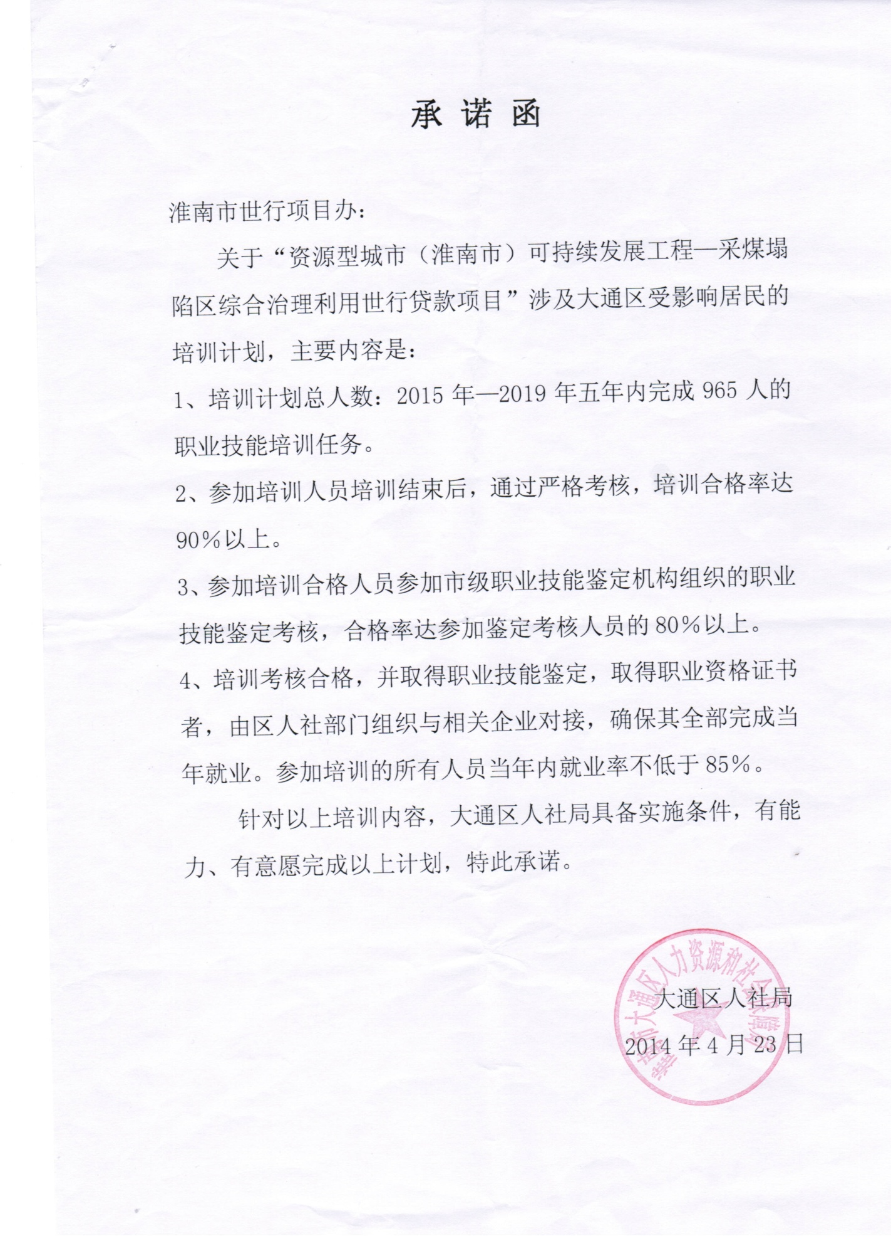

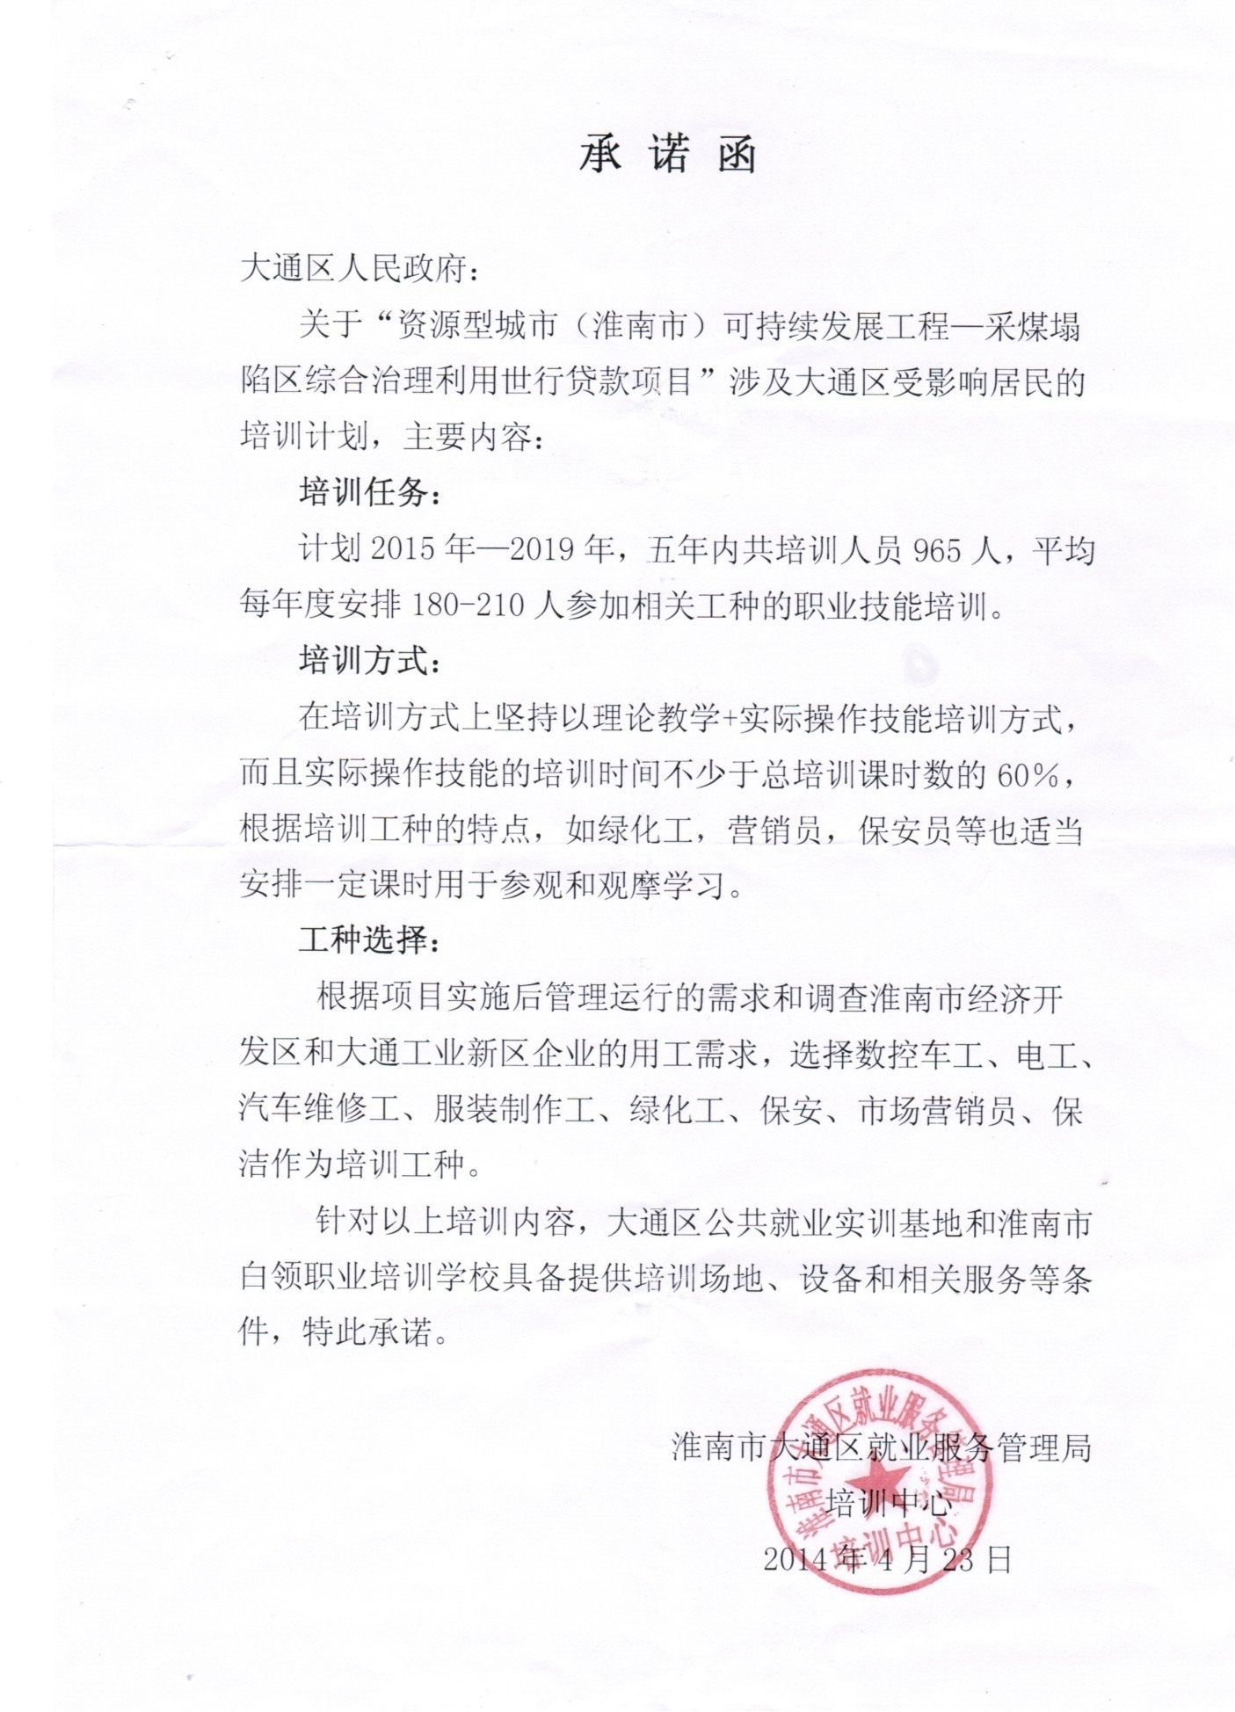

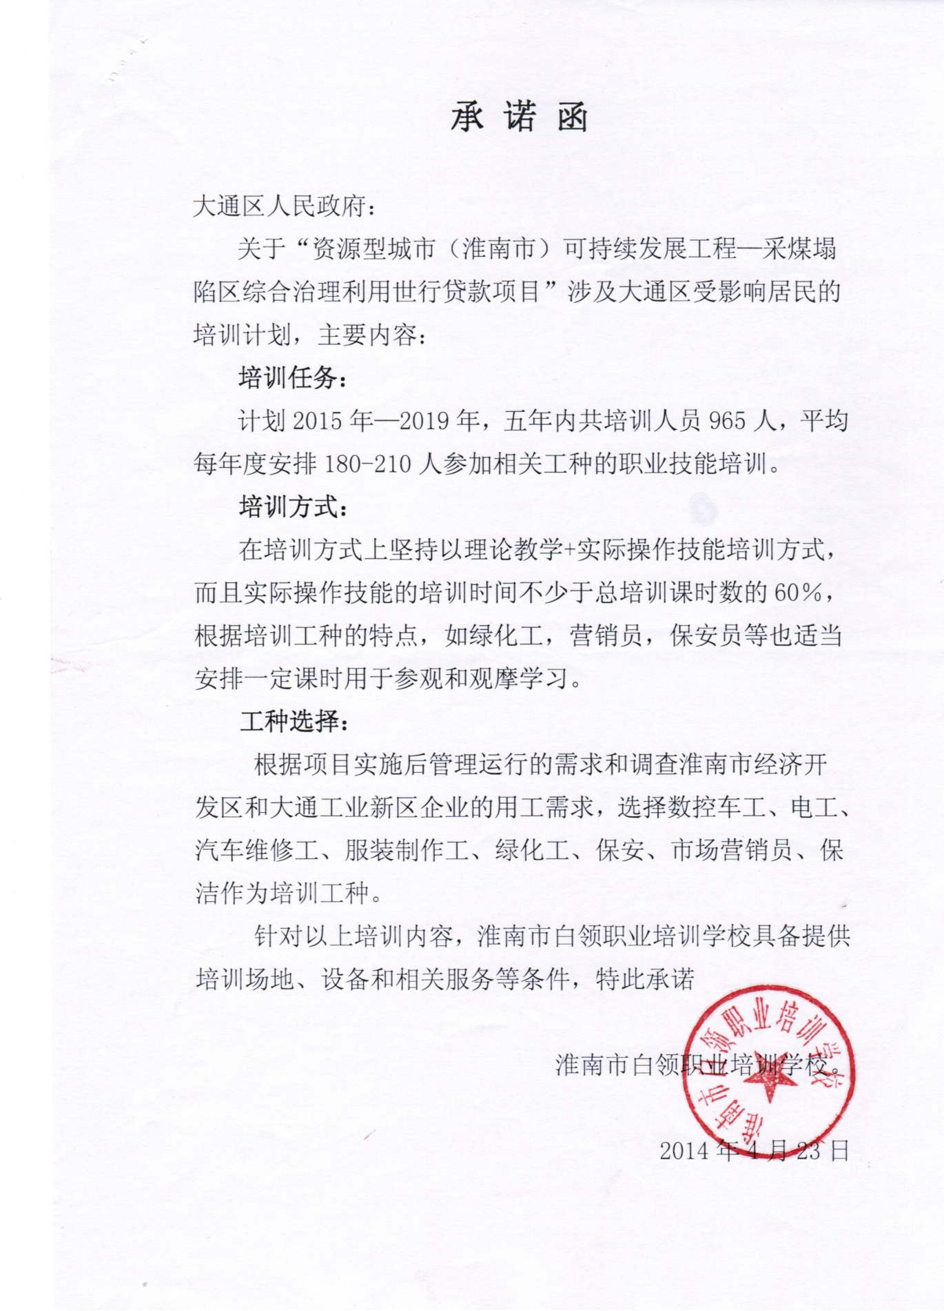

Attachment 3 Project and Minority
To evaluate the influence of the project on minorities and prevent the potential social risk, China Three Gorges University (hereinafter refers to as Three Gorges University) obtained an understanding of the minorities in the project area by means of making field surveys and holding informal discussions with citizens.
In Huai’nan City, most of minority peoples live together over vast area while some of them live in individual concentrated communities in small areas. There are three minority towns in the city, accounting for 1/3 of the whole province. There are 34 minority ethnic groups living in 13 minority villages and 1 minority community. The minority population is 32,000, occupying 1.6% of the total in the city, 96% of which are the Hui ethnic group. 13,5000 Hui people are scattered in cities and towns, while rest of them live in concentrated minority towns and minority villages. There are 3 ethnic minority middle schools and 13 ethnic minority elementary schools, with 5329 students including 1828 from the Hui ethnic group. At present, there are 430 minority cadres, including a deputy mayor, 16 cadres at county level, 1 NPC representative, 3 member of provincial People’s Congress and 2 provincial CPPCC members . In Huai’nan City, there are 9 members of the 15th municipal People’s Congress and 34 members of the 14th municipal CPPCC Committee from minority ethnic groups , respectively accounting for 2.8% and 7% of the total numbers. All these figures surpass the proportion covered by the population of the minority ethnic groups in the total population in the city.
In recent years, all ethnic groups live and work together in harmony, showing a bright prospect for development. In 2012, 3 minority towns reported a GDP of 0.604 billion Yuan and fiscal revenues reached 66 billion Yuan, with rural per capital net income totaled 7,405 Yuan. In 13 minority towns, rural per capital net income reached 7665 Yuan, increased by 13%, 25%, 17% and 18% respectively as compared to those in 2011. The rural per capital net incomes in minority towns and minority villages are 245 Yuan and 509 Yuan higher than the average income in the province. In 2009, Huai’nan City was awarded the honor of The Whole Country’s Ethnic Solidarity and Progress Model of Collective by the State Council. In 2011, Huai’nan Municipal Committee of CPC and Huai’nan government were awarded the title of Advanced Unit for Joint Development by Leading Group for Ethnic and Religious Affairs of Anhui Province.
According to the policies and standards specified in OP4.10 by the World Bank, minority ethnic group refers to the minority group in general sense, i.e. the vulnerable group with unique social culture. It has the following characteristics to different degrees.
1. Identify itself as a member of a unique minority ethnic group and the identification conclusion is recognized by others.
2. Collectively live in the area or ancestral hometown with unique geographic characteristics and make a living by natural resources within the area or ancestral hometown.
3. Have a traditional cultural, economic, social or political system varying from mainstream society and culture.
4. Usually have a unique minority language different from official language in the country or in the region.
Based on the standards above, Three Gorges University obtained an understanding about the population and living status for minority ethnic groups in the project area by means of surveys. The results show there is no minority ethnic community (yet with a relatively higher population of minority ethnic groups)

Attachment 4. Lnad development within the benefit belt
The World Bank-funded comprehensive treatment project in coal mining subsidence areas in Huai’nan City is an environment management project, which usually brings a favorable spillover effect on the surrounding areas. The implementation of this project will bring benefits to an area which is 3 km in length and 1.5 km in width. The beneficiary area starts from Huaishun South Road in west and end at 206 State Road , starts from Linyang Road-Jiuda Road segment (the north border in the project area) and ends at Dongshan East Road-Huai’nan Link of Hexun Expressway-Huai Fu Railway, with an area of 1.95 km² and a population of more than 13946.
According to the World Bank, there are some development projects preceding the preparation phase of the World Bank loan project. The implementation of this project may also affect other new development projects launched by Huai’nan government. While making full use of the positive environmental effect brought by the World Bank project, those government projects may be involved with land expropriation and demolishing. To inhibit and slow down those potential activities as well as increase the positive influence of the World Bank loan, it is necessary to make a deeper survey and appraisal on the social and economic base line, land use status (including the procedures and methods for land development), land development process and possible development projects in the future (during the five-year project implementation) in the project area. On the basis of surveys, the supervision mechanism and management countermeasure shall be prepared. This supplementary report is made to meet this requirement of the World Bank.

1. Planning Status
Bordered by the underway Zhongxing Road , the beneficiary area can be divided into two sub areas. Located at the western side of Zhongxing Road, the sub area is part of Specific Plan for Management of Resource Exhaustion Area in Quanda District, Huai’nan City, covering an area of 91.84 ha. Located at the eastern side of Zhongxing Road, the sub area is part of Specific Plan for Management of Resource Exhaustion Area in Jiulonggang District, Huai’nan City, with 103.37 ha.

3.1 Specific Plan for Management of Resource Exhaustion Area in Quanda District
Jointly established by China City Designing Studying Institute and Huai’nan City Designing Studying Institute in December, 2007, the plan covers an area of 15.47, beginning in the east from Hehuai Road and in the north from Shungeng Mountain and ending at Zhongxing Road in the west and in the Hefu Railway in the south. Land use includes urban development (1201 ha).and non urban development ( 346 ha.) for restoring coal mining subsidence area.
The development goal and functional orientation for this area: the resources exhaustion area with redevelopment opportunities are integral part of Green Energy Huai’nan City. As the ecological center in the city, it provides important link and mainly functions as a residence and administration region to enterprises and public institutions. Meanwhile, it integrates lots of functions such as commercial services, recreation and entertainment, which enables it to develop into a high quality down area with organic and comprehensive functions. The beneficiary area shall bear functions such as residence and commercial services.

The plan adopts a spatial structure of Two Zones, Four Axles and Five Districts. Two Zones means Residential Zone on the east of Huizhan Road and Comprehensive Function Zone on the both ends of Dongshan Road; Four Axles means Laolongyan Water System Landcape Axle, Dongshan Water System Landcape Axle, Huaishun Road Green Belt Landcape axle, Tiandanan Road History axle; Five Districts means Longquan District, Dongshan Commercial District, Datong New District, Datong Coal Mine Environment Restoration District.

3.2 Specific Plan for Management of Resource Exhaustion Area in Jiulonggang District, Huai’nan City.

The plan is jointly developed by Shanghai Landscape Architecture Design Institute Co.,Ltd and Huai’nan Urban and Rural Planning Bureau in August, 2011. The planning area begins in the east from Zhengdong Road and in the south from Yanshan Road and ends at Zhongxing Road in the west and railway line and link line of Hexun Highway, covering an area of 10.28 km2, 3.06 km2 of which in Wanxiang Jiulongcheng has been approved.

The development goal of Jiulonggang District is to become a demonstration area for economic transition of resource-focused town and a ecological livable town with a unique charm, integrating history culture, scientific education and recreation. The beneficiary area supports the functional orientation focusing on splendid Huai’nan history and favorable ecological environment.

The overall development goal of Jiulonggang District: Depending on the favorable ecological environment mainly in Shungeng Mountain, more efforts shall be made to develop a new Jiulonggang District integrating rich natural resources, robust economic momentum and prosperous local business on the footing of the actual social and economic conditions to meet the demands for city upgrade. Works shall be done to excavate the historic value of the origin of Huai’nan city, enhance the tourism value of coal mine heritages and historic heritages (Under the black sun and on the yellow earth, there stood 8 houses) , develop Jiulonggang District into an important area for city image demonstration, recreation and tourism, as well as turn it from resource focused district into a demonstration area focusing on recreational experience and residence. The beneficiary area, as part of planning area, will become a comprehensive community integration residential, commercial, cultural and recreational uses.

The plan of Jiulonggang District adopts a spatial structure of One Axle, One Zone, Two Cores and Five Clusters. One Axle means the main development axle on the east-west axle. One Zone means the ecological green zone on the east-west axle of Shungeng Mountain. Two Cores include a commerce-focused development core in the west and the development core integrating residential, office and recreational uses in the west. Five Clusters include the commercial and residential cluster in the northwest, the Wanxiang Jiulongcheng cluster in the southwest, the complementary placement cluster in the northeast, scientific education and recreation cluster in the south and the core development cluster in the mid-east. The beneficiary area is part of the north residential zone in Wanxiang Jiulongcheng cluster and core development cluster.

Within the scope of Specific Plan for Management of Resource Exhaustion Area in Jiulonggang District, Huai’nan City, some plots, such as International Motor City, Jiulonggou Jianshe Village, Wanxiang Zerun Park and Longgang Garden are being planned and developed.

Among them, Jiulonggang Jianshe Village and the north residential zone of Wanxiang Runzhe Park are situated in the beneficiary area. Based on the information during the post-implementation, only a land grant fee of 400 Mu has been paid in the north residence zone of Wanxiang Runzhe Park in which 836 Mu are expected to develop (at the negotiated price in 2008: 160,000 Yuan/Mu). 200 Mu are assigned to the Phase 1 project of construction of Runzhe Park (opened on October 22,2011) which covers an area of 750000㎡. The development of Jiulonggang Jianshe Village is a plan launched 5 years ago. According to surveys, the plan was originally put forward by a Shanghai company and involved about 400 Mu (each 200 Mu in Chenggang Village and Xiachai Village). However, the plan is abandoned now. Longgang Park is a shantytown transformation project launched by Datong District. However, because of failure to obtaining investment, the report has not been submitted yet. Now it turns into a part of Huai’nan City shantytown transformation project and has been reported to Anhui Province for approval. At present, the project is waiting for investment.

2. Preparation procedures prior to land development
2.1 Collection and storage of state owned land
Land banking is the practice of legally aggregating land for initial development, storage and supply by land resource administration departments at city and county level with a view to regulating land market, promoting the realization of the goal of fully using land resources. According to the Measures for Land Reserve Administration (No. 277 [2007] of the Ministry of Land and Resources) jointly issued by the Ministry of Land and Resources, Ministry and Finance and People’s Bank of China, the municipal government formulated Implementation Methods for Land Reserve in Huai’nan City to guide the specific implementation.
2.2 Responsible Department: Land Reserve Development Center
2.3 Land reserve scope
2.3.1 Lands which have been applied for conversion from agricultural land use to non-agricultural land use and has been not approved for land requisition.
2.3.2 Lands involved in shantytown (dilapidated houses) renovation project, urban redevelopment project and idle land which has been recovered according to the law.
2.3.3 Lands whose uses are required to transform due to removal, dissolution, cancellation, bankruptcy, industrial restructuring or other reasons of the unit.
2.3.4 Lands involved in urban and rural planning and land reclamation project in which land requisition are determined by government.
2.3.5 lands which are purchased by exercising preemptive right
2.3.6 Other lands which are purchased according to the law
2.4 Preparations prior to land reserve
2.4.1 Compilation of plan:
In accordance with social and economic development plan, overall planning for land use, overall urban and rural planning, annual plan for land use and land market status, a land reserve plan for next year shall be formulated by Municipal Land Reserve Development Center, municipal departments for land & resources, planning, finance and People ’Bank of China for approval of municipal government at the end of December every year.
The annual land reserve plan shall include:
a) scale of reserve land;
b) initial preparation scale of reserve land
c) supply scale of reserve land
d) temporary utilization plan of reserve plan
e) capital expenditure planning for land reserve
2.5 Compilation and implementation plan: Based on the annual land reserve plan, an implementation plan for land reserve project shall be compiled by Municipal Land Reserve Development Center for approval of municipal government.
The implementation plan for land reserve project shall include:
a) project overview;
b) construction scale;
c) project planning
d) main preparation
e) cost calculation
f) capital plan
g) Other attachment
2.6 The state owned land which has been lawfully recovered shall be subjected to land reserve procedures according to the following procedures:
a) Submission for approval; With regard to the lawfully recovered state owned land, Municipal Department of Land and Resources and Land Reserve Development Center shall jointly prepare a reclamation plan for state owned construction land to apply for approval of the municipal government;
b) Issuance of land reclamation notice. Municipal Department of Land and Resources issues a notice of land reclamation to original user of the state owned land according to the approval and decision by municipal government.
c) Cancellation of registration. Where a state owned construction land is taken back without compensation, the cancellation of registration will be conducted by the Municipal Department of Land and Resources; where a state owned construction land is taken back with compensation, an agreement for compensation will be signed between Municipal Land Reserve Development Center and the original user of state owned construction land before cancellation of registration is conducted by the municipal land and resource department;
d) Incorporation into land reserve. After completing cancellation of registration for the recovered state owned construction land, Municipal Land Reserve Development Center applies for registration procedures for land reserve;
2.7 land reserve registration will be conducted in accordance with the following procedures for purchasing state own construction land.
a) Declaration of intent to purchase: the original user of state owned land applies for land acquisition to Municipal Land Reserve Development Center, or Municipal Land Reserve Development Center issues land reserve notice for relevant lands in accordance with land reserve plan approved by municipal government. Where a land acquisition plan involves a number of state owned construction land users, the acquisition shall be conducted by the local district government.
b) Examination of the actual site. Municipal Land Reserve Development Center, together with Municipal Department of Land and Resources ;
c) Verification of the planning. Municipal Land Reserve Development Center verifies conditions for implementing the planning from the municipal urban and rural planning department;
d) Evaluation and measurement: A qualified evaluation agency will be jointly chosen by Municipal Land Reserve Development Center and original user of state owned construction land to evaluate and measure the planned land, the above-ground buildings and underground infrastructure in order to determine a specific compensation fee.
Compensation fee for allotted land will be determined on the basis of the current confirmed evaluation price for original approval use; Compensation fee for transferred land will be determined on the basis of the current recorded evaluation price for original approval use.
Compensation fee for the above-ground buildings and underground infrastructures will be determined based on the recorded evaluation price (Compensation fee for underway projects will be evaluated and determined by a qualified intermediary agency jointly authorized by the municipal auditing body and Land Reserve Development Center ) other related compensation will be determined on the basis of the current compensation standard for removal in the city.
e) Submission for approval. A land acquisition plan prepared by Municipal Land Reserve Development Center will be submitted to the municipal government for approval;
f) Signing of agreement. After the land acquisition plan is approved, an acquisition contract for the state owned construction land will be signed by and between Municipal Land Reserve Development Center and the original user of state owned construction land.
After the contract is signed, the original contract for the use right of state owned construction land will be terminated upon the effective date of the land acquisition contract;
g) Payment of compensation fee. Municipal Land Reserve Development Center pays a compensation fee to the original user of state owned construction land in accordance with the contract.
h) Delivery of land. The original user of state owned construction land delivers the land, above-ground buildings and underground infrastructures to Municipal Land Reserve Development Center in accordance with the contract;
i) Changes of ownership. Municipal Land Reserve Development Center applies for approval and issuance of land ownership certificate to Municipal Department of Land and Resources. Where the person involved chooses to exchange the property right, relevant procedures shall be conducted in accordance with the relevant State regulations.
2.8 Development and Utilization:
a) Initial preparation: initial preparation works such as removal of above-ground building and underground infrastructures and land leveling shall be done prior to the supply of reserve land in order to fulfill the supply conditions.
Works concerning reserve lands such as housing demolition and resettlement shall be organized by local district governments. Relevant expenses for demolition and resettlement shall be audited by Municipal Land Reserve Development Center and municipal departments for auditing and supervision prior to the payment.
b) Land use. Prior to the supply of reserve land, the reserve land can be rented, mortgaged or subject to change in use independently or with the above-ground buildings and underground infrastructures.
2.9 Land supply:
a) Municipal Land Reserve Development Center, together with Municipal Department of Land and Resources or other agencies, compiles a land supply plan.
The reserve land shall be assigned through bid invitation, auction and quotation.
b) After a reserve land is acquired, Municipal Department of Land and Resources will forward copies of acquisition confirmation and contract on assignment of state owned construction land to Municipal Land Reserve Development Center.
c) After confirming that the land price has been paid by the bidder in accordance with the contract, Municipal Land Reserve Development Center shall conduct land delivery procedures.
2.10 Capital sources for land reserve:
a) Compensation fees for land acquisition and housing demolition, land development cost and other expenditures allocated by Municipal Bureau of Finance from the land assignment prices;
b) Capitals allocated for land reserve by Municipal Bureau of Finance from state owned land income fund ;
c) Capitals allocated for land reserve by Municipal Bureau of Finance from net income of land assignment;
d) Bank loans and loans from other financial institutions applied for by Municipal Land Reserve Development Center in accordance with relevant regulations;
e) Capitals allocated for land reserve by the Municipal Bureau of Finance from land assignment business expense;
f) Other capitals allocated for land reserved upon the approval of the Municipal Bureau of Finance;
g) Interest income resulted from the capitals above
The loans applied for by the Municipal Land Reserve Development Center shall be consistent with the annual land reserve plan and budget for land reserve project as well as shall be incorporated into the unified local government debt management system in accordance with the relevant local policies.
The collectively owned lands which are required to be reclaimed for land reserve shall be subjected to relevant procedures in accordance with relevant regulations in the city. Works for compensation and resettlement shall be done in accordance with the relevant national, provincial and municipal regulations.

3. General procedures for expropriation of collectively owned land
3.1 Declaration procedure for land expropriation:
3.1.1 Obtain information about the rural collective economic organization and peasant households involved in land expropriation. Before the land requisition plan is carried out, a written notice shall be given to the rural collective economic organization and peasant households for the purpose of land expropriation, location, compensation standard and resettlement practices.
3.1.2 Confirm of land expropriation investigation result. The investigated results of pre-expropriated land ownership, category,acreage, and the ownership, category, quantity and status of the things immovably attached to the pre-expropriated land shall be collectively confirmed with relevant rural collective economic organizations, households and owners of the attachment things. Organization members, who cannot present the site confirmation in prescribed time at receiving paper notice, shall invite notarial institution, representatives of the collective economy organization, or village leaders to present site confirmation.
3.1.3 Organize hearing of land expropriation. Notify relevant rural collective economy organizations and households about compensation standards, resettlement methods and their hearing rights before report and scheme approval. Party shall be arranged to hearing at application. It regard as a waiver of hearing that party do not apply within prescribed time.

3.1.4 Report and approval. Relevant land expropriation materials shall be filed up. Farm land usage conversion plan, farmland compensation plan, land employ plan and expropriation application shall be approved by local municipal government first, then submit to government with approval right of higher levels. Forest land expropriation shall be approved by forest administrative department first.

3.2 Land expropriation implement procedure:
3.2.1 Land expropriation announcement. Municipal government shall make announcement at the village (township) involved in land expropriation about the name of department approving land expropriation, approval document number, expropriated land usage, acreage, compensation standards, resettlement method and compensation registration time within 10 days at receiving approval papers after the land expropriation scheme was legally approved. It shall make clear in the announcement that buildings and the things immovably attached to the pre-expropriated land will be expropriated all over. Compensation and resettlement shall be implemented in accordance with this scheme.

3.2.2 Compensation registration. The pre-expropriated land owners and right holders shall get registered with land ownership certificate or other valid certificate within 15 days at land expropriation announcement. Absent registration shall be subject to land register book and notarized investigation result.

3.2.3 Announcement of compensation and resettlement plan. The municipal administrative department of land and resourcesshall, together with relevant departments, draft the compensation and resettlement plan in accordance with the approved land expropriation scheme, make announcement at the relevant village (township), and listen to the opinions of rural collective economy organizations and households for 15 days. The plan of compensation and resettlement, approved by municipal government, shall be implemented by the municipal administrative department of land and resources. The plan of compensation and resettlement shall include the compensation standards of the pre-expropriated building and the things immovably attached to the pre-expropriated land.
3.2.4 Expropriated land turnover. Compensation and resettlement fee shall be paid in full within 3 months at the approval of compensation and resettlement plan. Rural collective economy organizations and households shall turn over the expropriated land within 30 days at full payment.

4. Land exploration status and assessment

Table 2 is formed on the basis of comparison with the above 2 plans on population and land employment status by site investigation. It shows that the 2 areas are explored to some extent. Only TaoYuanju community (K-03 area) is explored by plan in the west area of Zhongxing Road, and its land usage and resident quantity meet the plan requirement. Though L-02 and L-03 area are for ecology remediation, parts of them, namely over 170 mu, can be used for construction by the demonstration of Planning Bureau. This area is cleaned up and ready to become ecological business and residential development district covering an area of 286 mu (including green are).
The east area of Zhongxing Road is used for Xinjian community, namely, the A, B, C zones of the community (parts of E-01areaand E-02area), its land usage and resident quantity meet the plan requirement. An area of 836 mu (C-01､C-02) is going to be explored at the northern residential area of WanxiangZerunYuan garden community. Transfer fee (negotiation price) is paid for 400 mu of this area at present. ZerunYuan garden phase I (opening ceremony was at 2011.10.22) covers an area of 200 mu in this area with construction area of 750000m².

Table 2: Population, Status, Evaluation and Future Prospects of Planned Areas
Region | Plan Requirements |  |  | Status and Evaluation | Future Development, Methods and Schedule
Plan No. | Land Area | Population | Land Type | Status and Evaluation
Plan No. | (acre)
K-01 | 24.24 | 7000 | Residential community | Currently undeveloped, except for 750 residents in Lüyin Village and 339 in Qingfeng Village, mostly vacant land | Of which 182 mu planned for acquisition; land expropriation and building demolition will commence by the end of 2014, to be developed into residential community in the future
K-02 | 14.5 | 3100 | Mixed use | Currently undeveloped, 1382 residents in Renmin Village and Niwei Village | Acquisition to be conducted after the abovementioned land plot has been acquired
K-03 | 8.52 | 2200 | Residential community | Developed into New Eco Village – Taoyuan Ju Neighborhood, with good greenery in accordance with plan, current residents: 2500 in 504 households | The community’s greenery will connect with the forest to the north of the project zone
L-01 | 11.06 | 2100 | Residential community | Currently undeveloped, mainly farmland and factory buildings (single-storey) | No plan for development
L-02 | 18.07 | —— | Ecological recovery | 170 mu land already acquired; except for 48 mu farmland still in submission process, the collective construction land has been submitted for approval; over 100 households completely resettled | According to feasibility report by planning departments, the 170 mu land can be used as construction land. This plot is part of old city renovation project. Ruiwei Real Estate Co., Ltd intends to develop it into an eco commerce and residential community
L-03 | 15.44 | —— | Ecological recovery
C-01 | 14.5 | 880 | Mixed use | Currently undeveloped, mainly factory buildings and residential land, 30 to 50 scattered residents | Acquisition to be concurrent with construction of Zhongxing Road in mid-2015
C-02 | 45.43 | 7180 | Residential | Use rights of 400 mu leveled land already given to developers, 200 mu of which developed into Zerun Yuan I neighborhood, with about 3000 residents. Other lands are farmlands of Chenxiang Village and Xiacai Village, and institutions like Jiulonggang Town Government, with about 300 residents. | Wanxiang Group’s Zerun Yuan Project already submitted for approval, 836 mu of which are located in this plot. However, only the use right transfer price (contract price) of 400 mu land has been paid, of which 200 mu was used for Zerun Yuan I (opening in Oct 22, 2011), building area 750000 m²
E-01 | 27.88 | 7240 | Residential | Currently undeveloped, mainly cultivated land of Chenxiang Village and Xiacai Village and employers of Jiulonggang Town Government, 800 population |  | No plan for development
E-02 | 24.18 | 2580 | Commercial & residential | Already developed into new neighborhoods: Jianshe A to C, Qianjin Village, etc, about 4000 residents, in accordance with plan

Table 3 shows the comparison between planned roads and existing roads in the project zone. It can be seen that the main trunk roads have been completed following the plan (with the exception of Zhongxing Road), but the secondary roads have not been built.
Table 3: Planned Roads and Existing Roads
Name | Type | Start & End Points | Length (m) | Boundary width (m) | Status & Remark
Dongshan East Road | Mixed use | Chendong Road – Zhongxing Road | 6024.11 | 60 | Completed, same as plan
Huaishun Road | Transportation | Railway – Yanshan Road | 1549.20 | 40 | Completed; the part in the project zone is “Huaishun South Road”, same as plan
Zhongxing Road | Transportation | Railway – Yanshan Road | 3010.15 | 60 | Estimated completion in 2016
Linchang Road | Resident living | Guangchang Road – Zhongxing Road | 6738.22 | 25 | Under construction, estimated completion prior to project commencement, same as plan
Zhendong Road |  |  |  | 25 | Not built
Xiaying Road |  |  |  | 20 | Not built
Kuangxin Road |  |  |  | 25 | Not built
Note: the length here refers to the length of the road within the project zone.

5. Future Development, Method and Schedule Estimation
5.1 The acquisition plans for land plots K01 and K02 in Table 2 have been submitted for approval, of which 182 mu (east side of Lüyin village and west side of Niwei Village) has an implantation plan made, with land acquisition and building demolition to commence by the end of 2014. Other parts will be purchased in mid-2015. Relocated populations will be resettled through purchase of resettlement houses in Shangzhen, Tianjia’an District, 500 meters to the west of this place.
5.2 While L02 and L03 are ecological recovery areas, the feasibility report of planning departments suggest that 170 mu of which can be used for construction. With the exception for 48 mu of farmland, this rural construction land plan has been submitted for approval. The land expropriation and building demolition has been completed, with over 100 households affected (planned to be relocated to Dongshan East Road No.3 community, about 1 km to the east of this place). This plot is part of old urban area renovation project. Ruiwei Real Estate Co., Ltd plans to develop it into a 286 mu (greenery area included) ecological commercial & residential community.
5.3 The segment of Zhongshan Road in the south of the project zone will be started in mid-2015, to be completed in 2016.
5.4 Linchang Road is under construction, to be completed prior to the commencement of the World Bank-funded project.
5.5 Since 2013, Huai’nan has started a large scale old urban area renovation project, consisting of rebuild of squatter settlements, demolition of illegal buildings, and renovation of roads. 6 such municipal-level key projects are found in Datong District, one of which covers the Jiulonggang Nanmenkou area. Its borders are marked by Jiulonggang Vocational School to the east, Jiulonggang No.1 Primary School to the south, small coal mines to the west, and food market to the north. This project occupies about 265 mu of state-owned land, with 73,400 m² of buildings to be demolished, about 2000 residents in 600 households to be relocated, who needs 41 mu of construction land for resettlement, in a total of 224 mu land that can be used for development. This area used to be site of the Longgang Huayuan Project, which was never commenced, and has now been designated a municipal-level squatter settlement rebuild project. The rebuild project has received approval from province-level authorities, and is now searching for investors.

6. Resettlement Plan and Remarks for Huai’nan Squatter Settlement Rebuild Project
The large scale squatter settlement rebuild project started in 2013 involves large amount of land expropriation and building demolition works. Based on data provided by Huai’nan Urban Construction Investment Co., Ltd, in the next few years, the municipal-level key rebuild projects of Huai’nan will involve the resettlement of over 190,000 residents, and demolition of 10,933,500 m² of buildings. Detailed resettlement plans have been made by Huai’nan government. A summary has been provided below:

6.1 Compensation
Resettled residents may choose between two compensation methods, monetary compensation and property right exchange.
For monetary compensation, the residents and authorities will agree upon an appraisal agency, which will evaluate the building and its attachments, and monetary compensation will be paid based on the appraised value. If residents have chosen monetary compensation, they cannot switch to property right exchange after the appraisal result has been released.
For right exchange, the principle of “one compensation for one expropriated building” will be followed. The difference between prices of old and new houses will not be accommodated if it is within the balance range. If the floor area of expropriated house exceeds the new house chosen by the displaced resident, monetary compensation will be given based on the old house’s evaluated price. If the new house’s area is larger than the old house, the exceeded part will be paid for by the resident in cash, in accordance of the following criteria:
1) Resettlement house options: 65 m², 85 m², 105 m², 125 m²
2) For expropriated house less than 45㎡, the expropriated person shall purchase the difference area between expropriated house and resettlement house based on 1700 Yuan/㎡; the difference area from resettlement house with 45㎡-65㎡ shall be purchased based on 2400 Yuan/㎡.
For expropriated house with more than 65㎡, if the difference area between resettlement house and original house is within 1-10㎡ (including 10㎡), expropriated person shall purchase it based on 2500 Yuan/㎡, 2900Yuan/㎡ for more than 10-20㎡ (including 20㎡) and 3400Yuan/㎡ for more than 20㎡.
Expropriated household is not allowed to select resettlement house that its floor area is more than 2.5 times of that of expropriated house. If expropriated house area is less than the smallest resettlement house, which can be chosen.

6.2 Relocation Sites
Local relocation is adopted for resettlement of renovation project for World Bank Project area and surrounding shanty town, i.e. it is relocated near original settlements. Resettlement location of Tianjiaan District is Shangzheng (see figure 2). The Shangzheng, located in heartland, is 500m away from the project area to the west as shown in figure 2. Both infrastructure and position are better than before.
Figure 2 Shangzheng: Tianjiaan District resettlement site
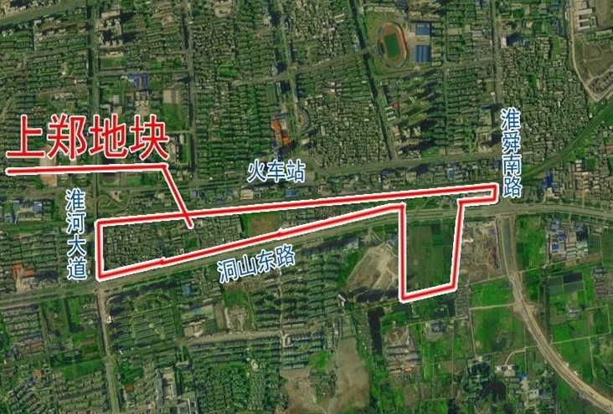
The resettlement site of Datong District is in No.3 Dongshan East Road, which is located in north side of Dongshan East Road with 1 km away from project area to the north (see figure 3). The comprehensive site of Dongshan East Road indicated by arrow in the figure 3 is No. 3 Dongshan East Road with improved public service facilities better than expropriated area like infrastructure, schools and hospital around.

Figure 3 No.3 Dongshan East Road of Dadong District resettlement site
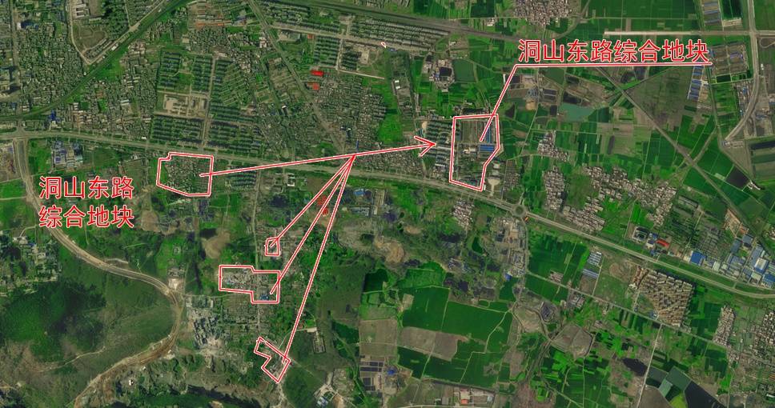

6.3 Compensation for temporary relocation
As for the relocation house problem of the residents to be resettled who choose equity exchange, temporary relocation allowance is calculated based on 10 Yuan/m² of floor area of the house to be expropriated. If the temporary relocation allowance per month is less than 300 yuan, remover shall pay 300 yuan. Payment period of the temporary relocation allowance shall be in four months from the removal date to the date of delivering the resettlement house. If remover fails to deliver the resettlement house in over thirty months from the removal date, the temporary relocation allowance per month doubles since the due month; the residents who choose monetary compensation for resettlement house have no temporary relocation allowance.

6.4 Allowance for house expropriation and relocation
Relocation allowance is calculated based on 5 Yuan/m² of floor area of the house to be expropriated. If the relocation allowance is less than 300 yuan, remover shall pay 300 yuan.

6.5 Housing demolition and compensation on the collective-owned land
There are two ways of housing demolition and compensation on the collective-owned land: monetary compensation and and property right exchange. The dislocated persons can choose one of them. The standard of monetary compensation is set according to the cost price: generally 780 yuan/m².
The principle of property right exchange is that dislocated persons will be resettled as per local. Building area of original houses within 30m2/person can change equal area of new houses without any price difference.

6.6 Evaluation
The resettlement plan is made to protect the basic rights and interests of resettled residents. In regard to compensation mode, because compensation fund cannot be enough for them to purchase a new house of the same size in situ according to the appraised price instead of the resettlement price, the monetary compensation is only the choice for a few residents who don’t need an existing house(if they have several residential houses), or need money urgently or don’t live in Huai’nan city at all. Most of residents to be resettled will generally choose equity exchange as their living conditions get improved in new houses exchanged. In regard to resettlement site, condition of infrastructures, public service, environment and location of the resettlement sites are superior to those of the project area and surrounding areas. These aspects cannot be completely changed even though the world bank project is implemented.
In the resettlement plan, life arrangement of resettled residents is only taken into account while work arrangement of them is excluded. Residents living in the sheds are generally in poor economic conditions with low income, and some of them are even laid-off staff, unemployed persons and other low-income population. In addition to improvement of living conditions, they urgently hope to increase their income. Seen from this perspective, the sub-items of land development and relevant vocational training in the World Bank project are of important significance, which will benefit the residents in and around the project area.
Besides, in the newly-developed project of the beneficial area, community greening of the south side in the project area should be combined with ecological restoration of the north side, which can not only make the landscape in harmony but also keep the ecological functions of both sides in conformity.

7. Supervision and Auditing
At present, a rigorous supervision and auditing system is already in place for land expropriation and follow-up development in China. Huai’nan is no exception. The municipal government would first prepare land acquisition and demolition policies and programs according to relevant national laws and policies (Huai’nan municipal executed land acquisition and demolition policies and standards of this project is consistent with those of this project), and then local District (County) People’s Government perform the land acquisition and demolition as per the program or they delegate qualified real estate agency to do. At the same time, Municipal Audit Bureau delegate district (county) audit institution to audit the land acquisition and demolition process. Municipal Audit Bureau conduct audit review by two ways: one is local random inspection to check if it is performed in strictly accordance to land acquisition and demolition policies; the other is to check the account. Purchasing and Storage Department pay as per audit result confirmed by the Municipal Audit Bureau. Before completion, the Municipal Audit Bureau shall confirm the cost of the whole project, including up-front fees of the project like assessment and measurement fees and so on. After bidding, auction and listing, GOC issues a series of rigorous supervision and management measures for further land development. Firstly, owner who desires to conduct land development shall handle land certificate with Land Grant Contract to the Land Ministry. They will audit if the land area and location meet relevant requirements. Secondly, owner shall handle Land Use Permit with Land Certificate and development planning schedule to Planning Bureau, they will check if the development planning schedule meets relevant urban planning requirements. Thirdly, owner shall handle Construction Permit and pay project quality deposit to Construction and Engineering Bureau, they will check if the owner is qualified to conduct the project construction. Finally, owner shall handle pre-sale housing permit to Housing Authority, they audit the project construction cost and housing price.
Thus it is can be seen that there are rigorous supervision and auditing procedures and systems for land planning, purchasing and storage, development and housing procurement. The procedures and systems are based on relevant laws and policies. All supervision and audit development are independent of each other and have no relationship of administrative subordination. Advanced monitoring means and professional contents meet totally World Bank requirements. By consulting with Project Office, the above development project will be reported to the World Bank at the stage of feasibility study. For following execution process, monitoring report will be submitted to the World Bank annually. The monitoring report consists of review (audit), supervision and check results from all Huai’nan municipal function departments.

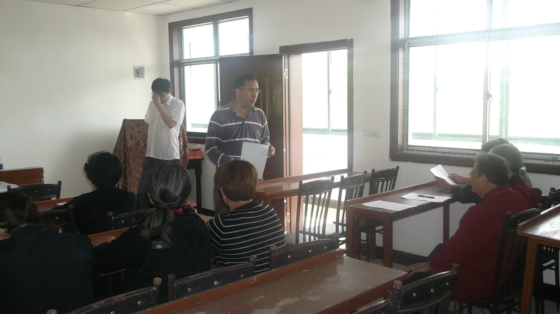

Symposium
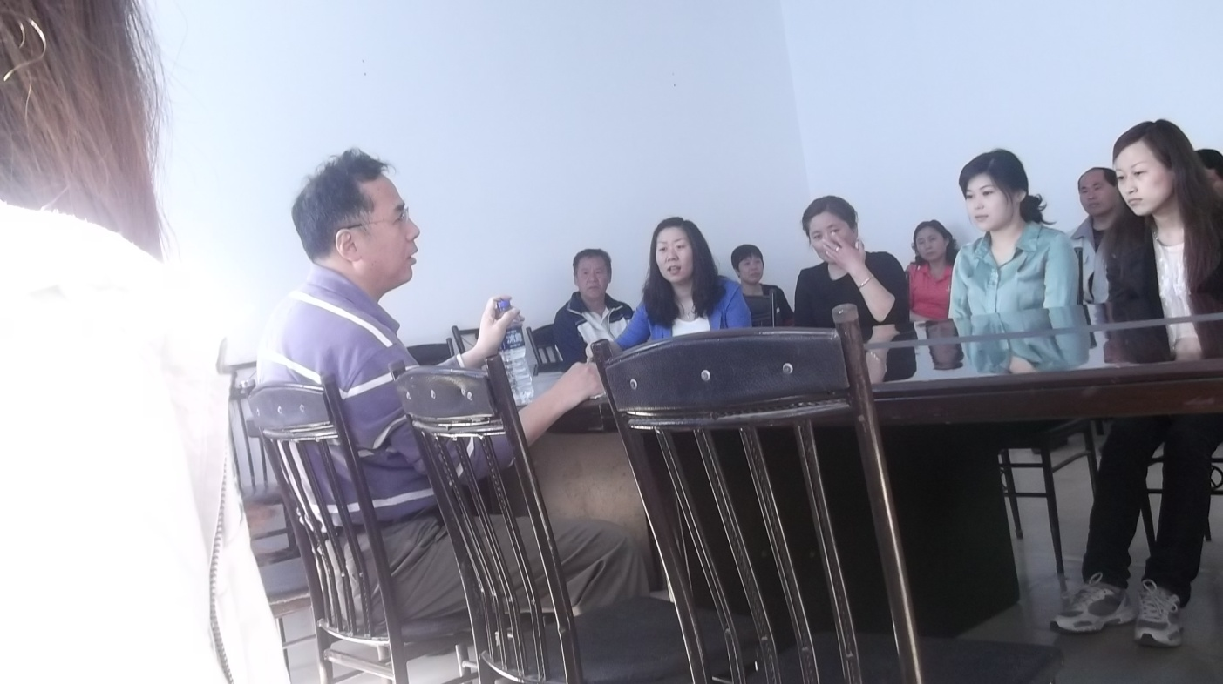

Questionnaire survey
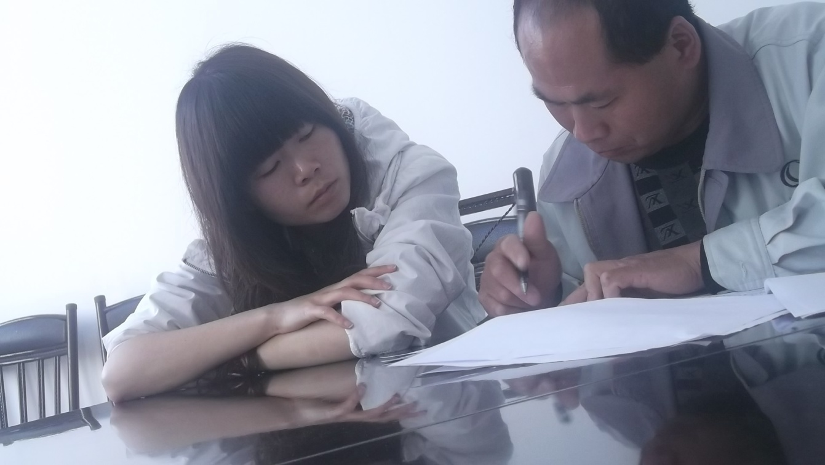
Interview survey

